Volume 21. Humanoid Electrical Architecture

Chapter 07. Hand Electrical Architecture

07.01. Finger Actuators
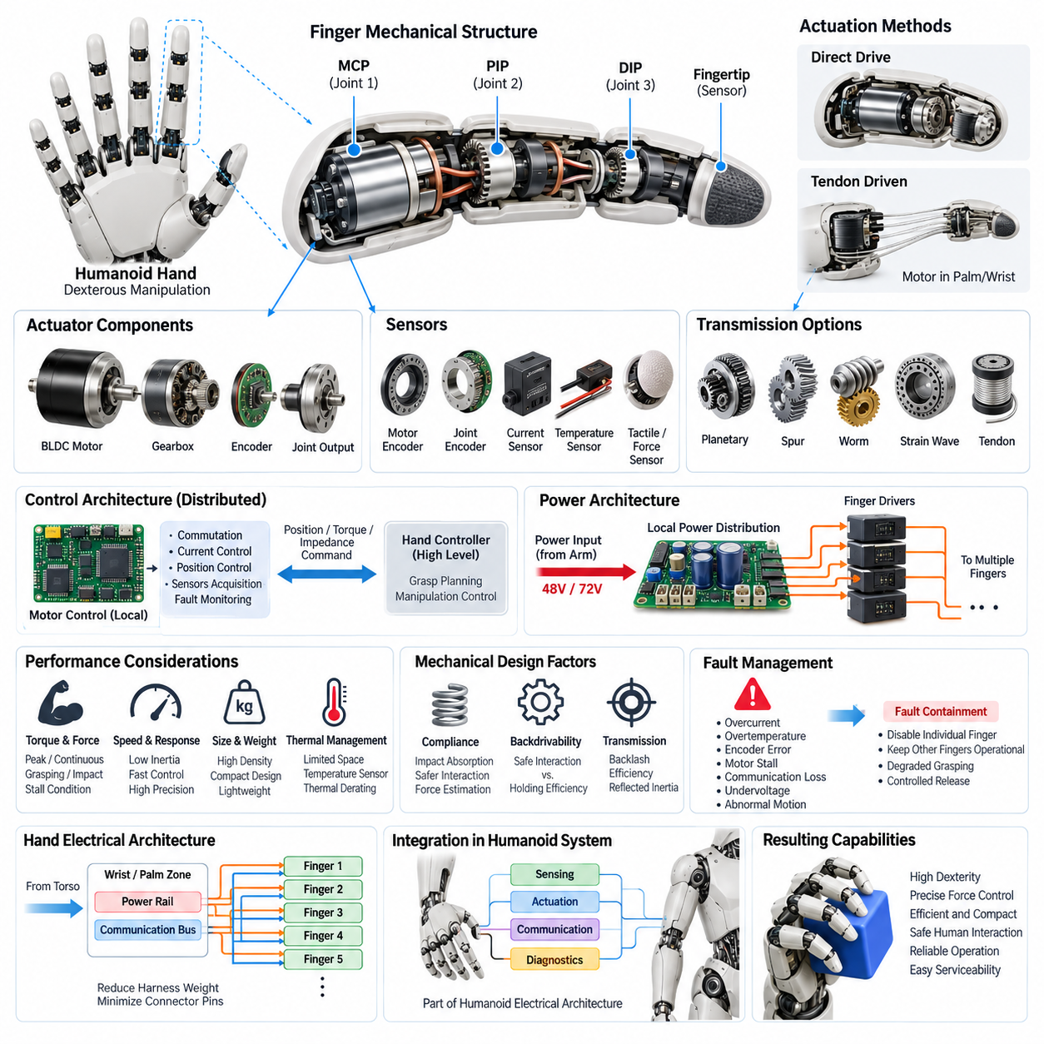
Finger actuators form the mechanical-to-electrical conversion layer that gives a humanoid hand controlled mobility at each digit. Unlike large shoulder or leg joints, finger joints operate within extremely limited volume while requiring multiple degrees of freedom, low reflected inertia, fast response, and precise force regulation. Their electrical architecture must therefore optimize actuator density, wiring complexity, thermal behavior, sensing, and controllability simultaneously.
A humanoid finger typically contains several articulated joints corresponding functionally to the metacarpophalangeal and interphalangeal joints of the human hand. Not every mechanical joint requires an independent motor. Fully actuated designs assign a dedicated actuator to each controlled degree of freedom, while underactuated designs mechanically couple multiple joints through tendons, linkages, gears, or differential mechanisms to reduce actuator count and hand mass.
Compact brushless DC motors are well suited to high-performance finger actuation because they provide favorable power density, controllable torque, long operating life, and efficient bidirectional operation. Small permanent-magnet motors may be combined with planetary, spur, worm, or strain-wave reduction mechanisms. The reduction ratio transforms motor speed into the higher joint torque required for gripping while strongly influencing backlash, efficiency, reflected inertia, and backdrivability.
Tendon-driven actuation provides another important architecture for anthropomorphic hands. Motors can be positioned in the palm, wrist, or forearm rather than directly inside each finger segment, and tensile elements transmit mechanical force to the joints. This reduces distal mass and finger inertia while allowing larger actuators to be used remotely, but introduces tendon elasticity, friction, routing constraints, hysteresis, pretension requirements, and additional calibration challenges.
Actuator sizing begins with the required fingertip force and maps that requirement backward through finger geometry, moment arms, transmission efficiency, and joint configuration. Peak torque is required during strong grasping or transient contact, whereas continuous torque is constrained primarily by motor and driver temperature. Designers must therefore distinguish continuous manipulation, intermittent gripping, impact loading, and stall conditions rather than selecting motors solely from nominal torque ratings.
Each independently controlled actuator normally requires position information for closed-loop motion control. Motor-side magnetic or optical encoders provide rotor position for commutation and velocity estimation, while joint-side encoders can measure the actual finger angle after the transmission. Dual sensing is particularly valuable where gear backlash, tendon stretch, compliance, or differential mechanisms create a significant difference between motor rotation and physical joint displacement.
Current sensing within the motor drive provides an economical estimate of actuator torque because motor torque is related to phase current through the motor torque constant. This estimate can support grasp-force regulation, contact detection, overload protection, and collision response. However, gearbox friction and nonlinear transmission behavior reduce its accuracy at the fingertip, so sophisticated hands combine current estimation with joint torque, tendon tension, force, or tactile sensing.
The finger actuator control loop is generally distributed close to the motors to minimize latency and wiring burden. A local microcontroller or motor-control device performs commutation, current regulation, velocity estimation, position control, sensor acquisition, and fault supervision. Higher-level hand controllers then issue position, torque, impedance, or grasp commands instead of directly controlling every motor phase, separating fast deterministic control from manipulation planning.
Electrical distribution becomes difficult as actuator count increases because a dexterous hand may contain many motors, encoders, sensors, and associated electronic channels within a compact structure. Rather than routing individual power and control conductors from the torso to every finger, the wrist or palm can act as a local electrical zone. Shared power rails and communication buses feed distributed finger electronics, substantially reducing harness mass and connector pin count.
Power architecture must accommodate highly dynamic and simultaneous actuator loads. Closing several fingers around an object can produce a short current peak much larger than the average hand consumption, while holding an object may create sustained thermal loading. Local bulk capacitance, appropriately sized conductors, current limiting, driver protection, and coordinated power budgeting help prevent transient voltage collapse from propagating from the hand into the arm electrical system.
Thermal management is especially restrictive because finger phalanges provide little surface area for heat spreading and normally cannot accommodate active cooling hardware. Motor copper loss, gearbox friction, and switching loss therefore establish practical continuous-force limits. Temperature sensors placed near motor windings or driver stages allow the controller to implement thermal derating, reducing allowable current progressively before temperatures reach damaging levels.
Mechanical compliance can significantly improve actuator behavior during physical interaction. Elastic elements incorporated into tendons, transmissions, fingertips, or dedicated series-elastic structures absorb impacts and reduce contact-force sensitivity to small position errors. Compliance also supports safer interaction with humans and fragile objects. Its presence, however, changes control dynamics and may require force estimation or additional sensing to reconstruct actual joint and fingertip states.
Backdrivability is another fundamental actuator characteristic. A highly backdrivable finger can yield naturally when external forces are applied, improving manipulation safety and enabling compliant behavior, whereas a high-ratio non-backdrivable transmission can hold loads with reduced electrical effort. Humanoid hand design therefore requires a deliberate compromise among holding efficiency, force capability, positioning accuracy, mechanical robustness, compliance, and interaction quality.
Fault management should prevent a single finger actuator failure from disabling the complete hand or creating excessive gripping force. Local electronics can detect overcurrent, overtemperature, encoder disagreement, stalled motors, communication loss, supply undervoltage, and abnormal motion. Fault containment may disable an individual actuator or finger while leaving unaffected digits operational, enabling degraded grasping and controlled release rather than an abrupt total-hand shutdown.
Finger actuator architecture ultimately determines much of a humanoid hand's dexterity, weight, energy consumption, responsiveness, and serviceability. The broader volume places this subsystem within the dedicated Hand Electrical Architecture chapter, alongside tactile sensing, force sensing, micro motor drives, dexterous hand architecture, and hand diagnostics. This separation emphasizes that actuator design must operate as part of an integrated sensing, drive, communication, and diagnostic system.

07.02. Tactile Sensors
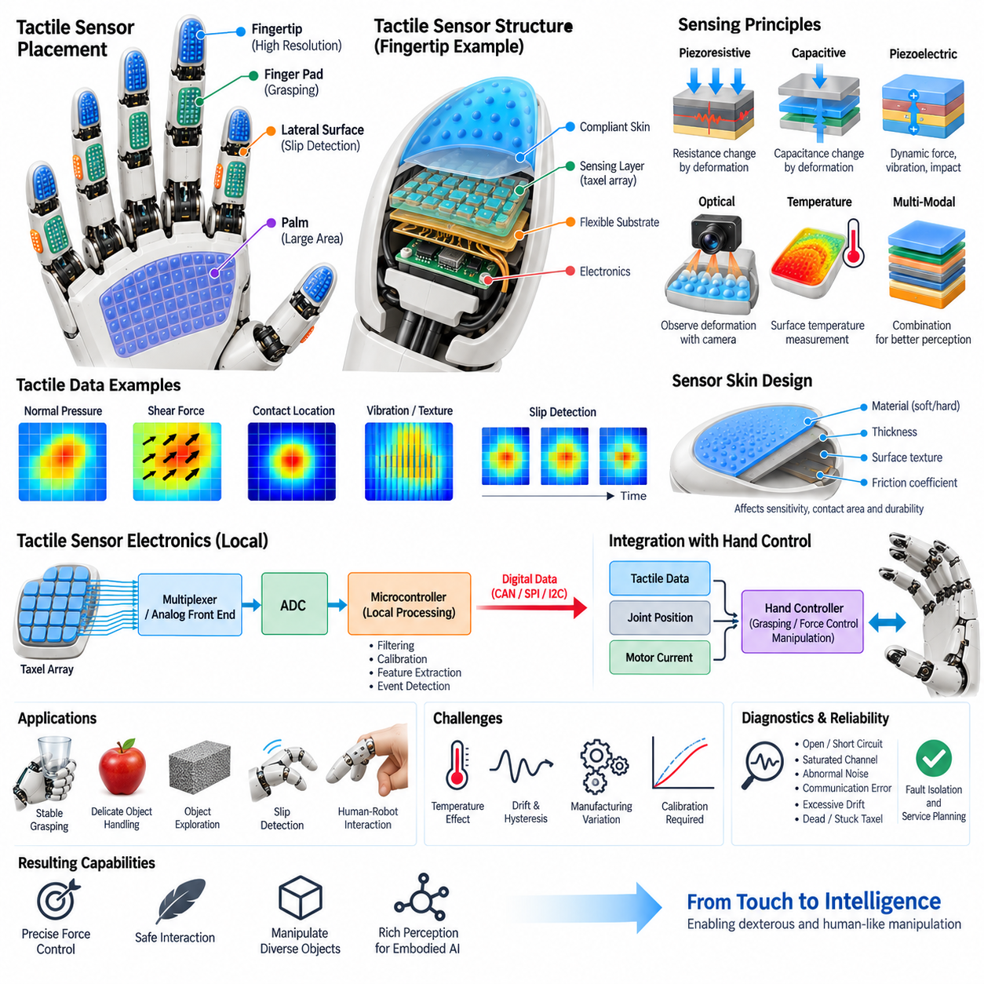
Tactile sensors provide a humanoid hand with distributed information about physical contact between the fingers, palm, and surrounding environment. While joint encoders describe actuator motion and force sensors estimate mechanical loading, tactile sensing measures interaction directly at the contact surface. This capability is essential for stable grasping, object exploration, slip detection, manipulation of fragile items, and human-robot interaction.
A dexterous humanoid hand may distribute tactile sensing elements across the fingertips, finger pads, lateral finger surfaces, and palm. Fingertips generally require the highest spatial resolution because they perform precision grasping and exploratory contact, whereas the palm can use larger sensing regions for detecting broad contact during power grasps. Sensor placement must therefore reflect expected contact probability, manipulation function, available packaging volume, and wiring complexity.
Tactile sensing can measure several physical quantities, including normal pressure, shear force, contact location, vibration, deformation, and temperature. No single sensing principle provides optimal performance for every quantity. Practical humanoid hands consequently use either multimodal tactile devices or combinations of different sensor technologies, allowing the controller to distinguish simple touch from pressure distribution, sliding contact, impact, or thermal interaction with an object.
Piezoresistive tactile sensors detect contact through resistance changes produced by mechanical deformation. Their relatively simple electrical interface, compact structure, and low manufacturing cost make them suitable for dense sensor arrays. However, hysteresis, temperature dependence, drift, and device-to-device variation can influence measurement accuracy. Calibration and compensation algorithms are therefore important when pressure values are used for quantitative grasp-force control.
Capacitive tactile sensors measure changes in capacitance caused by displacement or deformation between conductive structures. They can provide high sensitivity to small forces and can be fabricated as compact arrays beneath compliant fingertip surfaces. Their performance depends strongly on electrode geometry, dielectric materials, shielding, and analog front-end design. Parasitic capacitance and electromagnetic interference must be controlled carefully in electrically dense robotic hands.
Piezoelectric sensing is particularly useful for detecting dynamic events such as vibration, impact, texture variation, and the onset of slip. Mechanical deformation produces an electrical signal that can be processed with high temporal resolution. Because piezoelectric elements are generally better suited to changing forces than static loads, they are often complementary to pressure sensors rather than replacements for them in a humanoid tactile architecture.
Optical tactile sensing provides another approach by observing deformation of an elastic contact surface using internal cameras, photodiodes, or other optical components. Surface displacement patterns can reveal contact geometry, force distribution, texture, and incipient slip with very high spatial information content. The tradeoff is increased sensor thickness, computational processing, optical alignment requirements, power consumption, and integration complexity compared with simpler electrical sensor arrays.
The compliant skin covering a tactile sensor is part of the measurement system rather than merely mechanical protection. Elastomer hardness, thickness, surface texture, friction coefficient, and geometry determine how external forces propagate toward sensing elements. A softer layer can increase contact area and protect objects but may reduce spatial sharpness. Mechanical design and sensor calibration must therefore be developed together to obtain predictable tactile response.
A tactile array may contain dozens or hundreds of individual sensing elements, commonly called taxels, distributed across a relatively small hand surface. Connecting every taxel directly to the central controller would create excessive wiring and connector requirements. Local multiplexers, analog front ends, ADCs, and microcontrollers can aggregate measurements near the sensor array and transmit processed tactile data through a shared digital communication interface.
Local tactile electronics must balance sampling rate, spatial resolution, bandwidth, power consumption, and processing latency. High-resolution arrays can generate substantial data even when individual measurements are small. Instead of continuously transmitting every raw sample at maximum frequency, local processing can perform filtering, baseline compensation, contact segmentation, feature extraction, or event detection and forward only information required by the higher-level manipulation controller.
Tactile data becomes especially valuable when combined with finger actuator and joint information. Joint position identifies hand configuration, motor current provides an approximate actuator torque, and tactile arrays reveal where physical contact actually occurs. Combining these signals allows the hand controller to estimate grasp state more reliably than any single sensor modality and supports position, force, impedance, and hybrid manipulation strategies.
Slip detection is one of the most important functions enabled by tactile sensing. An object may begin moving relative to the fingertip before joint position changes significantly enough to reveal the problem. High-frequency vibration, changing shear patterns, or migration of the pressure distribution can indicate incipient slip. The controller can then increase grip force, modify finger posture, or redistribute contact forces before the object is lost.
Tactile sensing also enables controlled interaction with delicate or uncertain objects. Rather than commanding a predetermined finger position and relying only on actuator limits, the controller can detect initial contact and progressively regulate force. This approach allows the same hand to manipulate objects with different dimensions, stiffness, surface friction, and shape while reducing the probability of crushing an object or applying unnecessary actuator torque.
Calibration is challenging because tactile measurements are affected by manufacturing tolerances, material aging, temperature, mechanical preload, and repeated deformation. Calibration may include zero-offset correction, gain normalization, force-response characterization, temperature compensation, and mapping between taxel coordinates and physical hand geometry. Periodic self-checking can detect drift or damaged sensing regions and maintain consistent performance throughout the hand's operational life.
Tactile sensor diagnostics should identify open circuits, short circuits, saturated channels, abnormal noise, communication errors, excessive drift, and taxels that remain permanently active or inactive. A localized failure should ideally degrade only the affected sensing region rather than disable the complete hand. Diagnostic status can be reported to the hand controller, system health manager, and maintenance software for fault isolation and service planning.
The tactile sensing subsystem ultimately connects physical contact with higher-level embodied intelligence. Within the Hand Electrical Architecture, it operates alongside finger actuators, force sensing, micro motor drives, dexterous hand control, and hand diagnostics. By transforming distributed contact phenomena into synchronized digital information, tactile sensors allow a humanoid robot to perceive not only where its hand is moving, but also how that hand is physically interacting with the world.

07.03. Force Sensing
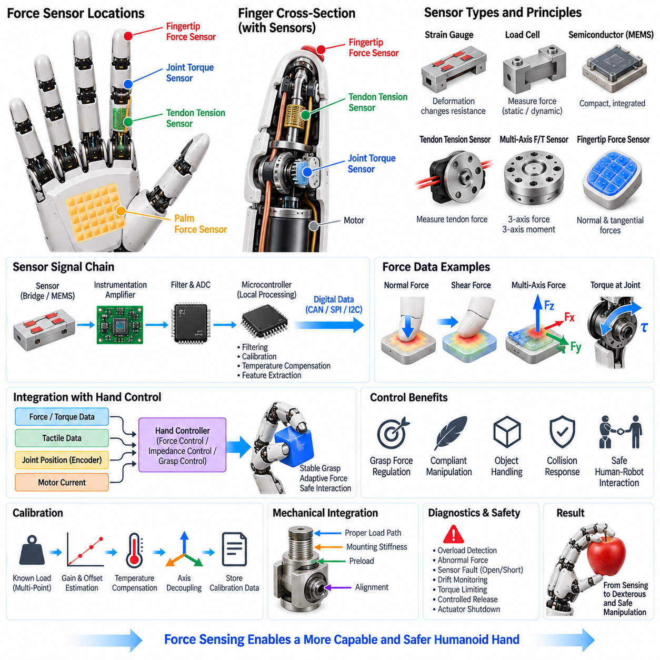
Force sensing provides a humanoid hand with quantitative information about mechanical interaction that cannot be obtained reliably from position sensing alone. While tactile sensors primarily describe distributed surface contact, force sensing measures the magnitude and direction of mechanical loads acting on a joint, tendon, fingertip, palm, or end-effector interface. This information supports grasp-force regulation, compliant manipulation, contact detection, object handling, collision response, and safe human-robot interaction.
Force sensing can be implemented at several locations within the hand depending on the required control objective. Joint torque sensors measure mechanical torque directly at individual finger joints, while tendon tension sensors measure the tensile force transmitted through tendon-driven mechanisms. Fingertip force sensors measure interaction forces at the contact surface, and multi-axis force/torque sensors can simultaneously measure several components of force and moment. Sensor placement therefore determines what physical quantity can be observed and how directly it can be used for control.
Strain-gauge load cells provide a widely used approach for measuring static and dynamic mechanical loads. Mechanical deformation of an elastic structure changes the resistance of bonded or integrated strain gauges, and a bridge circuit converts this small resistance variation into an electrical signal. High-resolution instrumentation amplifiers and stable excitation are required because the useful signal can be very small compared with electrical noise, temperature effects, and common-mode disturbances generated by nearby motor drives.
Semiconductor strain sensors and MEMS-based force sensors can provide compact alternatives where packaging volume is extremely limited. Their small dimensions allow sensing elements to be integrated into finger joints, tendon mechanisms, or miniature force interfaces. However, their measurement characteristics may vary with temperature, mechanical stress, packaging conditions, and manufacturing tolerances. Appropriate compensation, calibration, and mechanical isolation are therefore necessary when these sensors are used for precision force control.
Joint torque sensing is particularly important when the hand must regulate mechanical interaction rather than simply follow position commands. A torque sensor can be positioned between the motor transmission and the joint output so that the controller observes the actual transmitted torque. This allows the system to distinguish commanded actuator motion from the mechanical response of the finger and provides a more direct feedback signal for impedance control, force control, contact detection, and overload protection.
Tendon-driven hands can use tension sensing to estimate the force transmitted through each tendon. Because tendon tension is directly related to actuator loading and joint torque through the mechanical transmission, the measurement can provide useful information without placing a conventional torque sensor at every joint. However, tendon friction, routing curvature, elasticity, pretension, and hysteresis can introduce differences between measured tendon force and actual fingertip force. These effects must be considered in the control model.
Fingertip force sensing provides the most direct measurement of interaction between the hand and an object. A compact force-sensitive structure can measure normal and, when designed appropriately, tangential components of contact force. This information enables the controller to determine whether an object has been contacted, whether sufficient gripping force is being applied, and whether the contact load is moving toward an unsafe level. Fingertip sensing is therefore highly complementary to the distributed information provided by tactile sensor arrays.
Multi-axis force/torque sensing can provide a richer representation of physical interaction. A six-axis sensor can theoretically resolve three force components and three moment components around a defined coordinate frame. Such information is valuable for dexterous manipulation because contact forces may not act through the center of the fingertip or palm. Estimating both force and moment allows the controller to reason about grasp stability, object motion, contact geometry, and mechanical equilibrium.
Force sensing must be integrated closely with actuator control. Motor current can provide an indirect estimate of actuator torque, while encoder measurements describe actuator and joint position. A dedicated force or torque sensor provides an additional physical measurement that can correct errors caused by gearbox friction, transmission compliance, backlash, and model uncertainty. Combining current, position, velocity, and force measurements produces a more robust representation of the actual mechanical state of the hand.
The electrical interface for force sensors depends on the sensing technology and required accuracy. Strain-gauge systems commonly require bridge excitation, instrumentation amplification, filtering, and high-resolution analog-to-digital conversion. Local electronics can perform signal conditioning and transmit calibrated force measurements through a digital communication bus. Placing the signal-conditioning circuitry close to the sensor reduces the length of low-level analog wiring and helps protect small measurement signals from motor-driver switching noise.
Calibration is a fundamental requirement because force sensors must translate electrical output into physically meaningful force or torque values. Calibration may include zero-offset determination, gain estimation, multi-point loading, temperature compensation, axis decoupling, and mechanical coordinate transformation. For multi-axis sensors, cross-axis sensitivity must also be characterized because a load applied in one direction can produce a measurable response in other channels. Calibration data should remain associated with the individual sensor throughout its service life.
Mechanical integration strongly affects force measurement accuracy. The sensing structure must transfer the intended load through the measurement element while minimizing unintended parallel load paths. Mounting stiffness, preload, fastener torque, structural deformation, cable routing, and sensor alignment can all influence the measured result. A poorly designed mechanical interface may cause the sensor to report an apparently precise electrical value that does not accurately represent the physical force acting on the finger.
Force sensing also contributes directly to safety and fault management. Excessive joint torque, abnormal tendon tension, unexpected contact force, or rapidly changing load can indicate collision, actuator malfunction, object entrapment, or an unstable grasp. The local controller can compare measured force against expected operating ranges and initiate torque limiting, motion reduction, controlled release, or actuator shutdown when necessary. Force feedback therefore provides an important protective layer between mechanical actuation and physical interaction.
The final force-sensing architecture should combine direct measurements with model-based estimates rather than depending on a single signal. Tactile sensors identify where contact occurs, force sensors quantify the resulting mechanical load, encoders describe configuration, and motor-current measurements provide actuator-level information. Together, these signals enable the humanoid hand to transition from position-only control toward force-aware and impedance-based manipulation, providing more precise, adaptive, and physically safe interaction with objects and people.

07.04. Micro Motor Drives
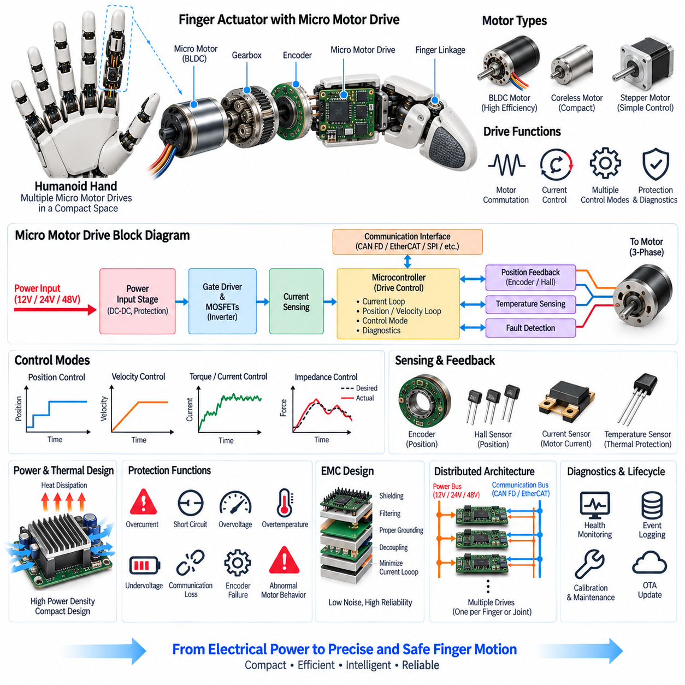
Micro motor drives provide the electrical interface between the humanoid hand controller and the small motors that actuate individual fingers and mechanisms. Because a hand contains many compact actuators within a highly constrained volume, each drive must combine motor commutation, current regulation, sensing, protection, communication, and local control in a small electronic design. The drive therefore becomes a critical building block connecting power, computation, sensing, and mechanical motion.
A typical micro motor drive consists of a power input stage, switching power devices, gate-drive circuitry, current sensing, a microcontroller, communication interfaces, and protection circuits. For brushless DC motors, the drive controls multiple motor phases by switching semiconductor devices according to rotor position. The resulting electrical currents generate electromagnetic torque, allowing the controller to regulate motor speed, position, and torque through closed-loop control.
Pulse-width modulation is commonly used to regulate the effective voltage applied to the motor phases. The switching frequency and modulation strategy influence motor efficiency, acoustic noise, electromagnetic interference, current ripple, and thermal loss. A compact hand drive must therefore select switching parameters carefully because many drives may operate simultaneously inside the palm or wrist. Coordinated electrical design is necessary to prevent the aggregate switching activity from degrading sensor or communication performance.
Current regulation is one of the most important functions of a micro motor drive because motor current is closely related to generated torque. The drive measures phase or bus current and adjusts the switching commands to maintain the requested current. Fast current-loop response allows the actuator to react quickly to changing loads and provides a foundation for higher-level velocity, position, torque, and impedance control. Accurate current measurement is particularly important during low-force manipulation and near-stall operation.
Rotor position information is required for efficient commutation and accurate motor control. Hall sensors, magnetic encoders, incremental encoders, or other position sensing methods may provide the necessary information depending on actuator size and performance requirements. Sensorless estimation can also be considered when reducing component count is more important than very low-speed observability. For dexterous finger motion, however, reliable position feedback is generally important because precise and repeatable movement is a primary requirement.
The drive should support multiple control modes so that the same hardware can participate in different manipulation strategies. Position control is appropriate for basic finger movement, while velocity control can regulate motion during coordinated actions. Torque or current control is more suitable for physical interaction, and impedance control can combine motion and force behavior to achieve compliant manipulation. The local drive executes fast deterministic loops while the higher-level hand controller manages grasp planning and coordinated finger behavior.
Communication between distributed motor drives and the hand controller must provide sufficiently low latency and predictable timing. A local drive can receive target position, velocity, torque, or current commands and return encoder position, estimated torque, motor current, temperature, and diagnostic information. Depending on the overall architecture, interfaces such as CAN FD, EtherCAT, SPI, or other digital links may be appropriate. The communication architecture should minimize wiring while maintaining synchronization between multiple finger actuators.
Power density is a major constraint because the drive electronics must fit inside the palm, wrist, or finger while handling dynamic motor currents. Semiconductor losses, copper losses, switching losses, and regulator losses generate heat that must be transferred through the available mechanical structure. Thermal sensors can monitor critical components, while current limiting and thermal derating can progressively reduce actuator capability when temperatures approach defined operating limits.
Protection functions should be integrated into the local motor drive rather than relying exclusively on higher-level software. Overcurrent, short circuit, undervoltage, overvoltage, overtemperature, communication loss, encoder failure, and abnormal motor behavior should be detected locally whenever practical. The drive can then enter a predefined safe state, reduce output torque, disable the affected motor, or report the fault to the hand controller. Local fault containment prevents one actuator problem from unnecessarily disabling the complete hand.
Electromagnetic compatibility is particularly important because micro motor drives operate switching power electronics close to sensitive tactile, force, and encoder signals. Fast switching edges can generate conducted and radiated noise that interferes with low-level sensor measurements or communication. Appropriate PCB layout, grounding, filtering, decoupling, current-loop minimization, shielding, and controlled switching transitions should therefore be considered from the beginning of the drive design rather than added after functional development.
Mechanical and electrical integration must be treated as a single design problem. The motor, gearbox, encoder, torque sensor, drive electronics, connector, and thermal path occupy the same limited actuator envelope. Connector orientation, PCB thickness, mounting structure, cable routing, vibration resistance, and service access can strongly influence the final actuator package. A highly efficient motor drive is not sufficient if its packaging increases finger mass or prevents reliable assembly and maintenance.
The distributed drive architecture also supports scalable hand design. Instead of connecting every motor directly to a centralized controller, each finger or actuator group can contain local electronics that perform time-critical control and sensor acquisition. Shared power distribution and communication buses then connect multiple drives through the wrist or palm. This approach reduces long analog signal paths, simplifies harness design, and allows the number of actuators to increase without creating an impractical centralized wiring structure.
Diagnostics and lifecycle management should be incorporated into the micro motor drive from the beginning. The drive can continuously monitor current, voltage, temperature, encoder consistency, communication status, and operating time while recording abnormal events. These measurements support production testing, calibration, field service, predictive maintenance, and replacement decisions. A standardized diagnostic interface also allows the same hand-level software to manage different actuator variants without changing the fundamental control architecture.
Micro motor drives ultimately transform compact electrical power and digital commands into precisely controlled mechanical behavior at the fingers. Their performance directly affects response time, force accuracy, energy efficiency, thermal stability, noise behavior, reliability, and safety of the complete hand. Within the Humanoid Electrical Architecture, micro motor drives therefore form the bridge between finger actuators, tactile and force sensing, distributed hand control, communication, power distribution, and diagnostics.

07.05. Dexterous Hand Architecture
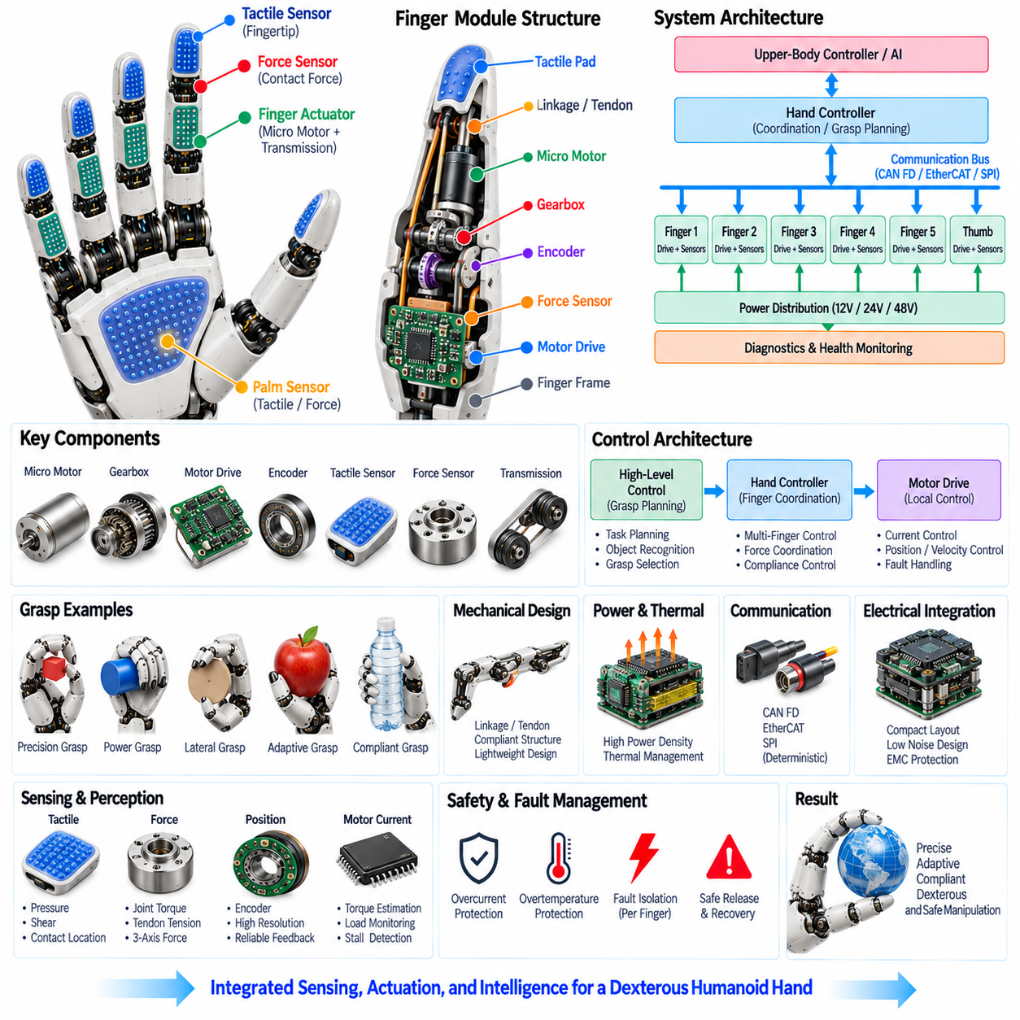
A dexterous hand architecture integrates multiple finger actuators, tactile sensors, force sensing, micro motor drives, mechanical transmissions, local controllers, power distribution, and communication interfaces into a coordinated manipulation system. Unlike a simple gripper, a dexterous hand must independently or cooperatively control many degrees of freedom while maintaining compact packaging and low mass. The architecture therefore treats sensing, actuation, computation, communication, and mechanical structure as an integrated subsystem of the humanoid robot.
The mechanical structure normally includes multiple fingers, a thumb, palm structures, joint transmissions, and compliant contact surfaces. Finger configurations can vary according to the intended manipulation capability, but the architecture must support both precision grasps and power grasps. The thumb provides an important opposition function and significantly expands the reachable contact configurations. Mechanical coupling may be introduced through tendons, linkages, or differential mechanisms when reducing actuator count and distal mass is more important than fully independent joint control.
Each finger is supported by compact actuators and micro motor drives that convert electrical commands into controlled joint motion. Position, velocity, and torque control can be implemented locally at the actuator level, while a higher-level hand controller coordinates multiple fingers. This distributed approach reduces centralized wiring and allows fast local control loops to operate independently from slower manipulation planning. The actuator architecture must also accommodate thermal limitations, transmission efficiency, backlash, compliance, and mechanical durability.
Tactile sensing provides distributed information about where and how the hand contacts an object. Sensors may be placed on fingertips, finger pads, lateral surfaces, and the palm, with higher spatial resolution generally required at precision-contact regions. Tactile information can reveal pressure distribution, shear, vibration, contact location, and slip. When combined with actuator position and force measurements, these signals allow the controller to distinguish free motion, initial contact, stable grasping, sliding contact, and object release.
Force sensing complements tactile sensing by providing quantitative information about mechanical loads. Joint torque sensors, tendon tension sensors, fingertip force sensors, and multi-axis force/torque sensors can be selected according to the required control objective. Force information enables the hand to regulate grasp strength, detect abnormal loading, implement impedance behavior, and respond to unexpected contact. The architecture should combine direct measurements with motor-current estimates and mechanical models to obtain a robust representation of hand interaction.
Micro motor drives provide the distributed electrical interface between the hand controller and individual actuators. Each drive can perform commutation, current regulation, position or velocity control, sensor acquisition, thermal monitoring, fault detection, and communication. Interfaces such as CAN FD, EtherCAT, SPI, or other suitable digital links can connect local drives to the hand control system. The drive network must provide predictable timing and sufficiently low latency for coordinated multi-finger motion.
The hand power architecture must support simultaneous dynamic loads from multiple actuators without excessive voltage drop or thermal stress. A local power-distribution zone in the palm or wrist can supply multiple finger drives through shared power rails, while local bulk capacitance and protection circuits manage transient current demand. Power monitoring, current limiting, thermal derating, and localized fault isolation prevent one actuator or electrical event from unnecessarily disabling the complete hand.
Communication architecture is responsible for synchronizing commands and measurements among the hand controller, motor drives, tactile electronics, force sensors, and higher-level humanoid systems. Time-sensitive actuator control should remain close to the physical devices, while manipulation commands can be exchanged with the upper-body controller or real-time control system. The network should support deterministic or predictable communication where required and provide diagnostic information in addition to normal motion and sensor data.
The hand controller coordinates individual actuator commands into meaningful grasp and manipulation behavior. Position control can provide basic finger trajectories, while torque and impedance control support compliant interaction. Higher-level algorithms can use tactile and force feedback to continuously modify finger posture, contact force, and object stabilization. This creates a closed interaction loop in which sensing influences actuation rather than treating the hand as a simple position-controlled mechanism.
Dexterous manipulation requires coordination across multiple fingers rather than independent finger operation. The controller must consider contact geometry, grasp stability, force distribution, finger workspace, actuator limits, and object properties when generating coordinated motion. A stable grasp may require one finger to increase force while another reduces force or changes position. The architecture therefore needs sufficient communication bandwidth and control synchronization to coordinate several actuators with low latency.
Mechanical compliance is an important element of the architecture because physical interaction introduces uncertainty in object position, stiffness, friction, and contact geometry. Compliance can be provided through flexible materials, elastic transmissions, tendon structures, or dedicated series-elastic mechanisms. Combined with force and tactile feedback, mechanical compliance allows the hand to absorb small impacts, maintain stable contact, and interact more safely with fragile objects or humans.
The electrical architecture must remain compact because the hand contains a high concentration of motors, sensors, processors, connectors, and wiring within a small physical volume. Local electronics reduce long analog signal paths and allow sensor processing close to the measurement point. Shared communication and power networks reduce harness complexity, while careful grounding, filtering, shielding, and electromagnetic compatibility design protect sensitive tactile and force signals from motor-drive switching noise.
Fault containment is required to prevent individual actuator or sensor failures from propagating across the complete hand. Local drives and sensor controllers should detect overcurrent, overtemperature, encoder errors, communication loss, abnormal force, sensor faults, and other abnormal conditions. Depending on severity, the affected actuator or finger can be disabled while the remaining fingers continue operating in a degraded mode. This approach supports controlled release and safe recovery rather than an uncontrolled loss of hand functionality.
The dexterous hand architecture ultimately forms a closed physical interaction system in which mechanical motion, electrical power, distributed computation, tactile perception, force measurement, communication, and diagnostics operate together. Within the Humanoid Electrical Architecture, it follows the dedicated finger actuators, tactile sensors, force sensing, and micro motor drive elements and provides the integrated foundation for higher-level hand diagnostics and manipulation functions. By combining these elements into one coordinated subsystem, the humanoid hand can progress from simple grasping toward precise, adaptive, compliant, and dexterous manipulation.

07.06. Hand Diagnostics [w/Code]
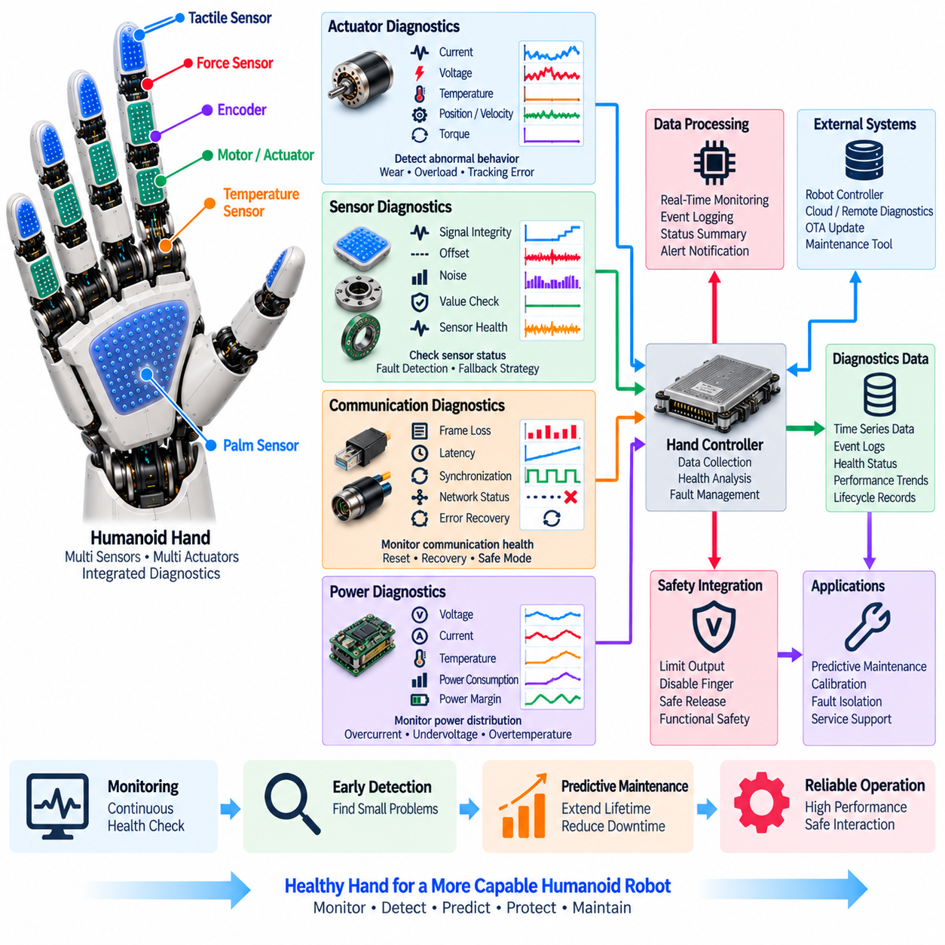
Hand diagnostics provides the health-monitoring layer for the humanoid hand, supervising actuators, sensors, motor drives, communication links, power distribution, and local control electronics as one integrated subsystem. The architecture must detect abnormal conditions without interrupting normal dexterous manipulation and must distinguish temporary operating events from genuine faults. Because Chapter 07 places diagnostics after finger actuators, tactile sensors, force sensing, micro motor drives, and dexterous hand architecture, the diagnostic layer functions as the final integration point for the complete hand electrical system.
Actuator diagnostics continuously evaluate the electrical and mechanical behavior of each finger actuator. Motor current, supply voltage, temperature, position, velocity, and estimated or measured torque provide the primary diagnostic signals. Abnormal current may indicate overload or increased friction, while temperature rise can reveal excessive continuous loading or inadequate thermal performance. Position tracking error, unexpected velocity, vibration, or torque deviation can indicate transmission wear, encoder problems, mechanical obstruction, or actuator degradation.
Sensor diagnostics verify the health of tactile sensors, force sensors, encoders, temperature sensors, and other measurement devices integrated into the hand. Diagnostic logic can examine signal range, continuity, offset, noise level, update rate, and consistency with related measurements. A sensor that remains permanently active, produces implausible values, or stops updating should be identified as abnormal. Cross-checking multiple sensing sources is particularly valuable because tactile, force, position, and motor-current information can provide independent evidence about the physical state of the hand.
Micro motor drive diagnostics monitor the electronic devices responsible for commutation, current regulation, local control, and actuator protection. Overcurrent, short circuit, undervoltage, overvoltage, overtemperature, gate-drive faults, communication loss, and encoder errors should be detected as close to the affected drive as practical. Local detection allows the drive to enter a predefined safe state quickly instead of waiting for a higher-level controller to identify the problem. Diagnostic status can then be reported to the hand controller for coordinated fault management.
Communication diagnostics supervise the links connecting the hand controller, distributed motor drives, tactile electronics, force-sensing modules, and higher-level robot systems. Frame loss, excessive latency, communication timeout, synchronization errors, corrupted data, and unexpected node behavior can affect coordinated finger motion even when the mechanical hardware remains healthy. The diagnostic architecture should therefore monitor both communication quality and node availability, allowing a failed connection to be isolated and recovered without unnecessarily disabling unaffected hand functions.
Power diagnostics monitor the electrical supply delivered to the distributed hand electronics and actuators. Voltage, current, temperature, instantaneous power, and available power margin can be evaluated continuously. Simultaneous finger movement may create transient current demand, while sustained grasping can create thermal loading. Overcurrent, undervoltage, excessive voltage drop, abnormal power consumption, and thermal stress should therefore be detected before they propagate into actuator or controller faults. Local protection and power derating can preserve partial functionality during abnormal conditions.
Diagnostic processing should be distributed between local actuator electronics and the hand controller. Fast protection decisions belong close to the motor drive or sensor interface, while the hand controller can correlate information from multiple devices and determine whether a fault is isolated or systemic. This hierarchy allows rapid local response while maintaining a complete system-level view. The controller can classify diagnostic states as normal, warning, degraded, or critical and coordinate the appropriate response according to the severity and persistence of the condition.
Fault isolation is essential because the failure of one finger, sensor, or motor drive should not automatically disable the complete hand. When an individual actuator becomes abnormal, the controller may limit its torque, stop its motion, or disable that finger while allowing the remaining fingers to continue operating. A failed tactile region may be excluded from grasp estimation, while redundant or model-based information can maintain limited functionality. This degraded-mode behavior is particularly important for safe release and controlled recovery during physical interaction.
Event logging provides a historical record of diagnostic conditions rather than reporting only the instantaneous state. The system can record fault codes, timestamps, actuator conditions, sensor values, communication status, thermal conditions, and recovery actions associated with abnormal events. Historical information helps engineers distinguish repeated intermittent failures from isolated events and provides evidence for maintenance and root-cause analysis. Diagnostic records can also support production testing, field service, calibration verification, and lifecycle engineering.
Predictive maintenance can extend hand reliability by analyzing long-term diagnostic trends rather than waiting for complete component failure. Increasing motor current at similar loads, progressively larger position errors, rising operating temperature, increasing sensor noise, or repeated communication faults can indicate gradual degradation. Trend analysis can identify components that require inspection, recalibration, lubrication, replacement, or other service before a failure interrupts operation. This transforms diagnostics from a reactive protection function into a lifecycle management capability.
Safety integration connects hand diagnostics with the robot's broader functional safety behavior. Severe overcurrent, excessive joint torque, abnormal force, sensor inconsistency, thermal runaway, or loss of communication may require immediate limitation of actuator output. Depending on the condition, the hand can reduce force, stop an affected finger, enter a degraded state, or perform a controlled release. Diagnostic decisions should therefore be coordinated with higher-level safety functions so that protective actions remain predictable and do not create additional mechanical hazards.
Remote diagnostics and maintenance can extend the usefulness of hand diagnostic data beyond the local controller. Selected health information, event records, fault histories, and performance trends can be transmitted to higher-level robot controllers or maintenance systems when the system architecture permits. This information can support service planning, fleet-level reliability analysis, software-based troubleshooting, and future integration with OTA and predictive-maintenance functions. The diagnostic interface should remain structured and standardized so that different hand hardware variants can be managed consistently.
Hand diagnostics ultimately provide the health-awareness layer that connects the physical hand to reliable long-term operation. Actuator behavior, sensor integrity, motor-drive status, communication quality, power condition, safety response, event history, and degradation trends should be interpreted as parts of one integrated diagnostic model rather than as isolated checks. Within the Volume 21 architecture, Hand Diagnostics completes the Chapter 07 Hand Electrical Architecture after the actuator, sensing, drive, and dexterous-hand elements, establishing the foundation for reliable operation, fault containment, serviceability, and future predictive maintenance.

