Volume 21. Humanoid Electrical Architecture

Chapter 04. Joint Module Architecture

04.01. Actuator Module
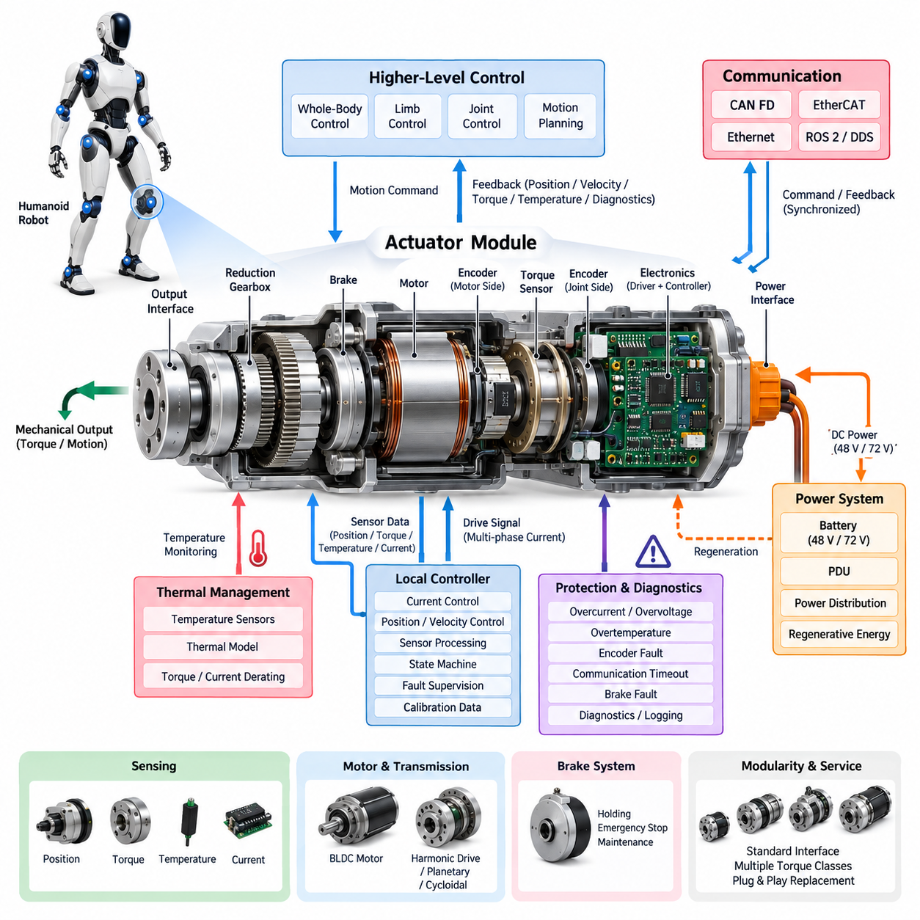
A humanoid actuator module is the fundamental electromechanical unit that converts electrical energy and digital motion commands into controlled joint movement. Unlike a conventional industrial motor assembly, the module must combine high torque density, compact packaging, low mass, precise sensing, fast control response, and safe interaction with humans. Its architecture therefore integrates mechanical, electrical, sensing, communication, thermal, and control functions into a tightly coordinated subsystem.
The actuator module normally contains an electric motor, reduction mechanism, position sensing, optional torque sensing, motor drive electronics, temperature monitoring, mechanical bearings, and structural interfaces. Depending on the joint, a brake or locking mechanism may also be integrated. These elements form a local motion unit that receives power and commands from the humanoid electrical architecture and returns position, velocity, torque, temperature, current, and diagnostic information.
Motor selection is strongly influenced by the torque-speed envelope of the joint. Brushless permanent-magnet motors are well suited to humanoid applications because they provide high efficiency, controllability, and power density. A high-torque joint such as the hip or knee may require a larger motor and reduction ratio, while wrist, neck, or finger mechanisms emphasize low inertia and compact dimensions. The motor and transmission must therefore be treated as one integrated actuator rather than independently optimized components.
Reduction mechanisms allow a relatively high-speed motor to generate the torque required for human-scale motion. Harmonic drives, planetary gearboxes, cycloidal mechanisms, and other compact reducers can be selected according to torque density, backlash, efficiency, stiffness, mass, and durability requirements. Transmission compliance and friction directly affect control quality, particularly when the humanoid performs force-controlled manipulation, dynamic walking, or physical interaction with its environment.
Electrical power enters the actuator through a local power interface connected to the robot's main distribution architecture. In the proposed humanoid structure, joint modules operate as downstream loads of the 48 V or 72 V power system described in the preceding power architecture chapter. Local conversion and filtering may provide the voltage domains required by gate drivers, processors, encoders, torque sensors, and communication circuits while isolating sensitive electronics from motor switching disturbances.
The motor driver converts the DC supply into controlled multiphase currents for the actuator motor. Current control forms the innermost electrical control loop because motor torque is closely related to phase current. Position and velocity loops operate above this layer, while higher-level joint, limb, balance, and whole-body controllers generate motion targets. This hierarchical arrangement allows fast local control to continue at the actuator level without requiring every switching or current-control operation to pass through the central computer.
Accurate position feedback is essential because small joint errors can accumulate across the humanoid kinematic chain. An actuator may use motor-side and joint-side encoders to distinguish rotor motion from actual output motion. Dual sensing can reveal gearbox deflection, backlash, slippage, or abnormal transmission behavior. Absolute encoders are especially useful because they preserve meaningful joint position after power cycling and reduce the need for potentially unsafe initialization movements during robot startup.
Torque sensing extends the actuator from a position-controlled device into an interaction-aware joint module. Torque may be estimated from motor current or measured directly using strain-based, magnetic, optical, or other sensing technologies. Direct output-side sensing can capture external forces and transmission effects that are difficult to infer from motor current alone. This capability supports compliant manipulation, collision detection, contact estimation, impedance control, and stable locomotion over uncertain terrain.
Thermal behavior is a primary design constraint because humanoid joints repeatedly generate high torque inside compact enclosures. Temperature sensors should monitor critical locations such as motor windings, power semiconductor regions, gearbox structures, or actuator housings. Local control software can progressively reduce allowable current or torque as thermal limits are approached rather than waiting for an abrupt shutdown. Thermal models may additionally estimate internal temperatures that cannot be measured economically with dedicated sensors.
Mechanical brakes can be incorporated where loss of torque would create unacceptable motion or energy release. Leg joints may require holding capability during shutdown, while other joints may rely on transmission characteristics or controlled electrical braking. Brake control must be coordinated with motor torque so that engagement does not create shock loading. The architecture should also distinguish normal holding, emergency stopping, maintenance locking, and power-loss behavior because these conditions impose different safety requirements.
Communication connects the actuator to higher-level real-time control. The humanoid architecture identifies CAN FD and EtherCAT as principal joint-level communication candidates, with Ethernet and ROS 2/DDS serving broader system functions. EtherCAT is attractive for tightly synchronized multi-axis motion, whereas CAN FD can provide robust distributed communication for modules with moderate bandwidth requirements. Regardless of protocol, deterministic command delivery and timestamp-consistent feedback are important for coordinated whole-body movement.
A local microcontroller or motion-control processor can manage current regulation, encoder acquisition, sensor filtering, communication, state machines, and fault supervision. This distributed intelligence reduces the real-time burden on central computing resources and allows faults to be handled close to their physical source. The local controller can enforce current, velocity, position, temperature, and torque limits even if a higher-level command becomes invalid or communication with the main controller is temporarily disrupted.
Actuator protection must address electrical and mechanical failure modes simultaneously. Overcurrent, short circuit, overvoltage, undervoltage, phase loss, encoder failure, excessive temperature, communication timeout, excessive velocity, unexpected torque, and brake faults can be supervised locally. Faults should be classified according to severity so that the module can choose an appropriate response, ranging from warning and torque derating to controlled stopping, brake engagement, power isolation, or emergency shutdown.
Regenerative energy is another important consideration because a humanoid frequently decelerates joints or lowers gravitational loads. During these conditions the motor can operate as a generator and return energy to the DC bus. The actuator and power distribution system must tolerate reverse energy flow without exceeding bus voltage limits. Coordinated regeneration across multiple joints can improve overall efficiency, but it requires the actuator, motor driver, PDU, battery, and protection strategy to be designed as one energy-management system.
Modularity simplifies humanoid manufacturing and maintenance. A standardized actuator family can share power connectors, communication interfaces, diagnostic protocols, firmware structure, and mechanical mounting principles while providing several torque classes. This approach reduces the number of unique electrical components and enables replacement at the joint-module level. Identification data stored locally can describe actuator type, serial number, calibration parameters, firmware version, operating limits, and accumulated service information.
Calibration data is particularly important because nominally identical actuator modules exhibit differences in encoder offset, torque-sensor zero point, motor constants, friction, transmission compliance, and mechanical alignment. Factory calibration parameters can be stored in nonvolatile memory and automatically loaded when the module is installed. Higher-level software can then recognize a replacement actuator and verify that its configuration is compatible with the assigned joint before enabling full torque operation.
The actuator module ultimately acts as the boundary between whole-body intelligence and physical motion. Higher layers determine desired behavior, but the joint module must execute those intentions with deterministic timing, accurate sensing, controlled energy conversion, and local safety supervision. The surrounding chapter therefore separates motor driver, encoder interface, torque sensor, brake system, and diagnostics into dedicated sections, while the actuator module provides the integrated architectural foundation connecting all of these functions.

04.02. Motor Driver
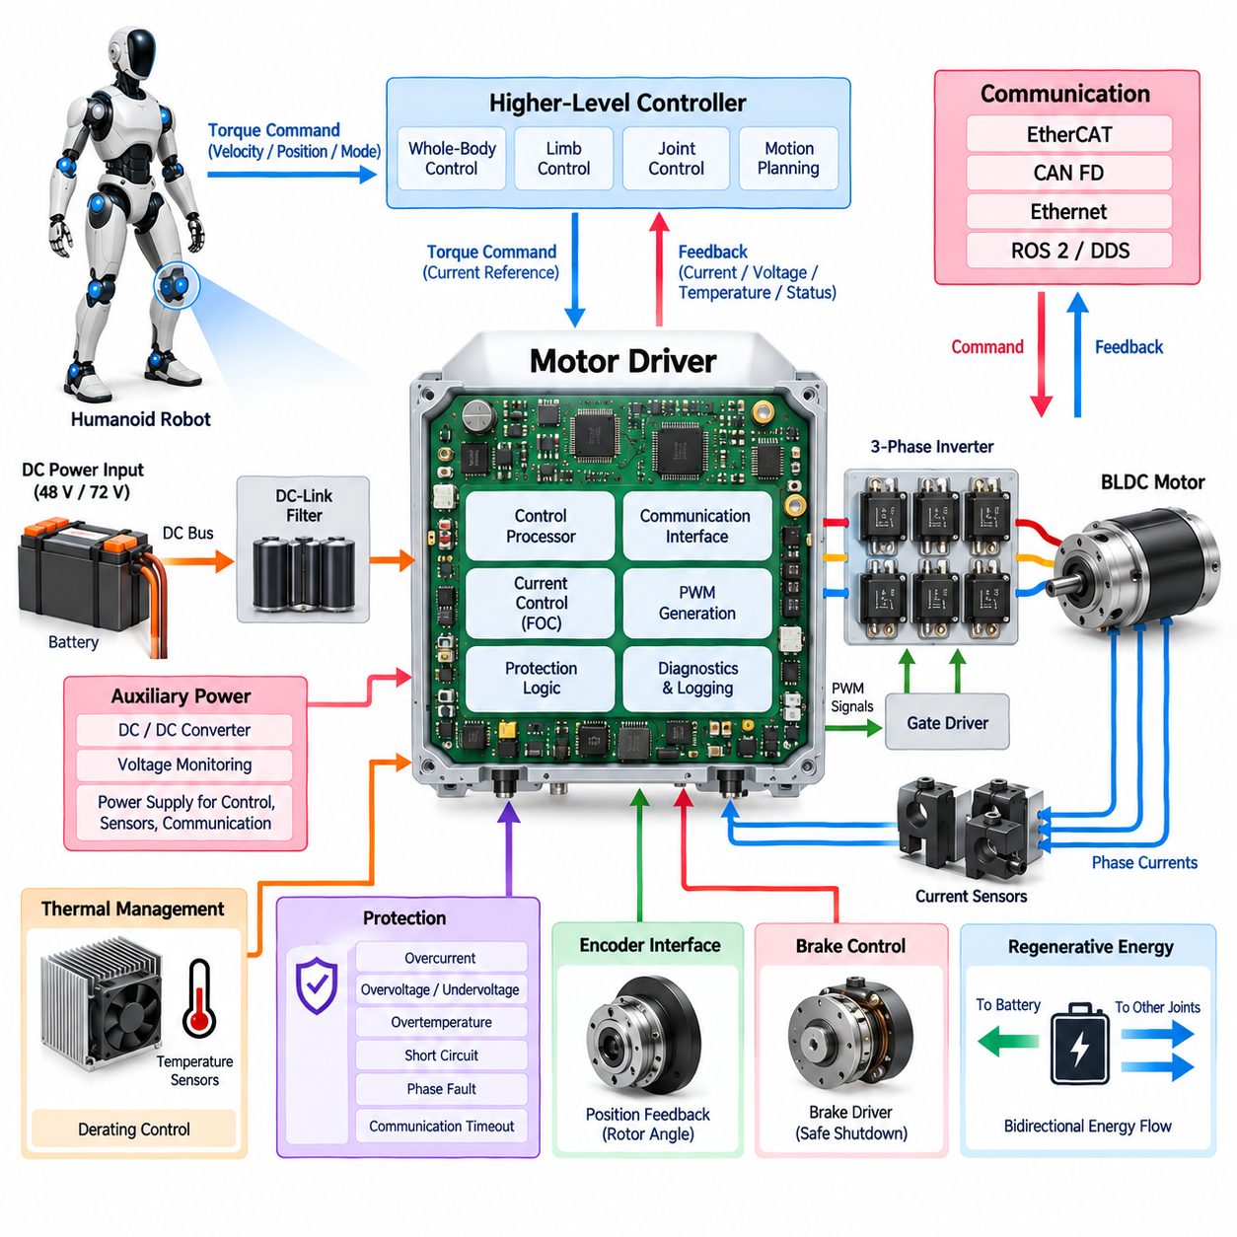
The motor driver is the power-electronic and real-time control interface between the humanoid electrical power system and each joint motor. It converts DC-bus energy into accurately regulated multiphase current while translating joint-level torque commands into electromagnetic torque. Because dozens of actuators may operate simultaneously, driver efficiency, current accuracy, switching behavior, thermal performance, communication latency, and fault response directly influence whole-body motion quality.
A typical humanoid joint driver consists of a three-phase inverter, gate-driver circuitry, current sensors, DC-link filtering, voltage monitoring, temperature sensing, a real-time controller, communication interfaces, and protection circuits. These functions may be integrated inside the actuator housing or implemented on a closely coupled electronics module. The architecture follows the joint-module structure in which the motor driver operates together with encoder, torque sensor, brake, and diagnostic functions.
For a brushless permanent-magnet motor, the inverter commonly uses six power semiconductor switches arranged as three half bridges. By controlling the switching states of these devices, the driver synthesizes phase voltages from the DC supply and regulates current through the motor windings. MOSFET-based stages are particularly suitable for compact 48 V and 72 V humanoid systems, although device selection depends on voltage margin, current demand, switching frequency, losses, packaging, and thermal constraints.
Pulse-width modulation controls the effective voltage applied to each motor phase. Higher switching frequencies can reduce current ripple and audible components while improving control resolution, but they also increase semiconductor switching losses and electromagnetic interference. The optimum switching strategy therefore represents a compromise among efficiency, torque smoothness, acoustic behavior, thermal loading, EMC performance, and controller bandwidth rather than simply maximizing switching frequency.
Field-oriented control is commonly used to achieve smooth and precise torque production. Measured phase currents are transformed into a rotating reference frame aligned with rotor position, allowing flux-producing and torque-producing current components to be controlled independently. The current controller then calculates voltage commands that are converted into inverter switching signals. Accurate rotor-angle information from the encoder is therefore tightly coupled to motor-driver performance.
The current loop is normally the fastest closed-loop function within the joint actuator. Torque, velocity, and position loops operate at progressively higher architectural levels or lower update rates. This hierarchy allows the driver to react rapidly to electrical disturbances while the joint controller manages mechanical behavior. Higher-level limb and whole-body controllers can consequently request torque or motion without directly controlling individual power-semiconductor switching events.
Current measurement is essential for both control and protection. Phase currents can be measured using shunt resistors, Hall-effect sensors, magnetic sensors, or other isolated techniques depending on accuracy, bandwidth, packaging, and isolation requirements. Sensor placement must support reliable reconstruction of motor currents throughout the PWM cycle. Offset, gain error, noise, temperature drift, and sampling timing must be considered because current-measurement error directly becomes torque-control error.
DC-bus voltage monitoring provides another important input to the driver. Supply voltage changes as battery state, wiring losses, simultaneous joint loading, and regenerative operation alter the electrical operating condition. The controller can compensate modulation commands for these variations while protection logic supervises undervoltage and overvoltage limits. Coordinating the motor driver with the 48 V or 72 V power architecture is therefore necessary for predictable joint behavior under dynamic whole-body loads.
Regenerative operation occurs whenever mechanical energy drives the motor in a direction that returns electrical power through the inverter. Walking, landing, lowering a payload, decelerating an arm, or controlling a descending body segment can create this condition. The motor driver must support bidirectional energy flow while preventing excessive DC-bus voltage. Regenerated energy may be absorbed by other active joints, returned to the battery, or managed by the wider power-distribution architecture.
Gate-driver circuitry forms the electrical boundary between low-voltage control logic and high-current power switches. It must provide sufficient gate current for rapid switching while maintaining correct dead time between complementary devices. Undervoltage lockout, desaturation or overcurrent detection, Miller-clamp functions, and controlled shutdown mechanisms may be incorporated according to semiconductor technology. Poor gate-drive design can produce excessive losses, false switching, or destructive shoot-through faults.
Thermal management is critical because conduction and switching losses are concentrated in a small joint enclosure. The driver should monitor semiconductor, PCB, or heat-spreader temperatures and coordinate these measurements with motor thermal information. Rather than relying only on a fixed shutdown threshold, the controller can apply progressive current and torque derating as thermal margin decreases. This preserves useful motion capability while protecting the actuator from cumulative thermal damage.
The driver PCB requires careful layout because high-current switching paths coexist with sensitive sensing and communication circuits. DC-link capacitors should be positioned to minimize high-frequency current-loop area, while gate-drive traces, phase outputs, current-sense paths, digital grounds, and communication interfaces require deliberate routing. Grounding, shielding, filtering, and common-mode control become particularly important when many joint drivers switch simultaneously within the humanoid body.
Electromagnetic compatibility affects both the actuator itself and surrounding robot electronics. Rapid voltage and current transitions can couple noise into encoders, torque sensors, cameras, IMUs, communication networks, and central computing systems. Switching slew rate, cable geometry, motor-phase routing, shielding termination, filtering, grounding strategy, and enclosure design must therefore be coordinated. The motor driver cannot be treated as an isolated power board because it is one of the robot's strongest repetitive EMI sources.
Real-time communication allows the driver to receive torque, velocity, position, mode, and limit commands while returning measured current, voltage, temperature, status, and fault information. The humanoid architecture identifies EtherCAT and CAN FD as major communication options at the joint level. EtherCAT supports tightly synchronized multi-axis operation, while CAN FD offers robust distributed control. Communication timeout supervision must ensure that stale commands cannot continue producing uncontrolled torque.
Protection logic must respond faster than higher-level software when destructive electrical conditions occur. Hardware or firmware mechanisms can detect overcurrent, short circuit, bus overvoltage, undervoltage, excessive temperature, invalid rotor position, phase abnormalities, or power-stage faults. Severe events may require immediate PWM inhibition, while less critical conditions can trigger controlled torque reduction. Fault severity and recovery rules should be deterministic so that identical failures produce predictable actuator behavior.
Safe shutdown requires coordination among the motor driver, local controller, brake system, and power distribution unit. Simply disabling the inverter may allow a gravity-loaded joint to move, while abruptly engaging a brake under high torque may create mechanical shock. A controlled sequence can reduce motor torque, bring the joint toward an appropriate state, engage the brake where required, verify holding status, and then disable the power stage. Emergency conditions may require a faster path that prioritizes immediate risk reduction.
Driver diagnostics should capture operating information before and during abnormal events. Peak current, DC voltage, semiconductor temperature, motor temperature, command torque, measured velocity, encoder status, communication state, and fault flags can be recorded in local event buffers. These records allow service software to distinguish electrical faults from mechanical overloads, sensor failures, communication problems, or thermal limitations and provide valuable input for predictive maintenance.
Calibration ensures consistent torque production across a population of actuator modules. Current-sensor offsets and gains, phase relationships, rotor electrical-angle alignment, motor parameters, voltage measurement scaling, and thermal coefficients may require factory or service calibration. Relevant parameters can be stored in local nonvolatile memory so that replacement drivers or complete actuator modules retain their validated configuration and can be checked automatically during system initialization.
The motor driver therefore performs far more than simple DC-to-AC power conversion. It is a deterministic energy-control node that combines power electronics, high-speed current regulation, sensing, thermal management, communication, diagnostics, regeneration, and local protection. Within the humanoid joint-module architecture, its performance establishes the practical connection between high-level motion intelligence and the precise electromagnetic forces that ultimately move the robot's body.

04.03. Encoder Interface
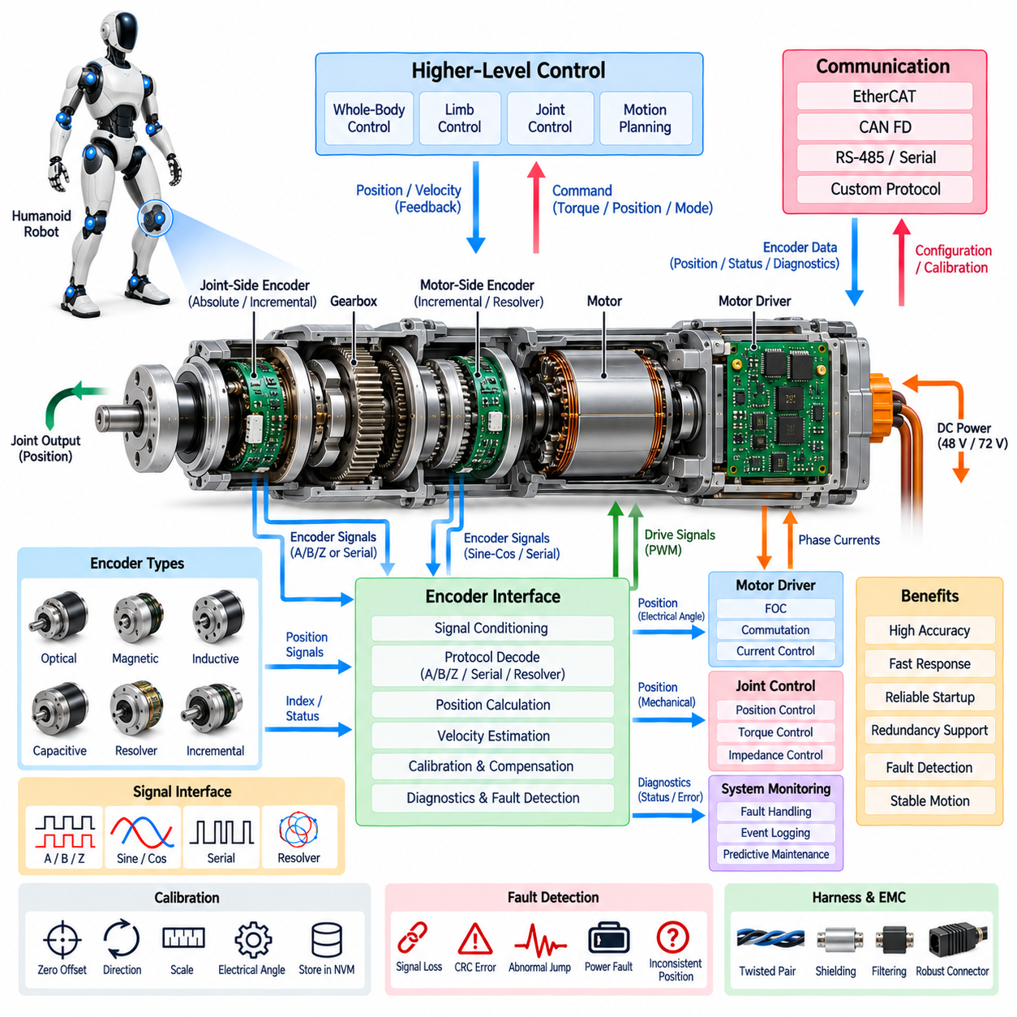
The encoder interface provides the primary position-feedback path between the mechanical joint and the humanoid real-time control system. It converts rotor or joint displacement into accurate digital position information that can be used for motor commutation, velocity estimation, torque control, joint positioning, and whole-body coordination. Because position errors propagate through the robot's kinematic chain, encoder accuracy, latency, synchronization, resolution, and fault detection directly influence motion quality and stability.
Within the humanoid joint-module architecture, the encoder interface operates closely with the actuator module, motor driver, torque sensor, brake system, and local diagnostics. The architecture treats the encoder as a dedicated joint function rather than merely an accessory to the motor driver. This separation allows sensing requirements, electrical interfaces, calibration, redundancy, and diagnostic behavior to be engineered systematically for different humanoid joints.
A joint actuator may contain both motor-side and joint-side encoders. The motor-side encoder measures rotor position with sufficient bandwidth for electrical commutation and field-oriented control, while the joint-side encoder measures the actual mechanical output after the reduction mechanism. Comparing these two measurements provides information about gearbox deformation, backlash, compliance, slippage, mechanical offset, or abnormal transmission behavior that cannot be observed reliably from a single sensor.
Absolute encoders are particularly valuable in humanoid robots because they provide a meaningful angular position immediately after power-up. Unlike purely incremental sensing, an absolute interface can reduce or eliminate initialization movements required to establish a reference position. This is important for a robot that may start while standing, carrying a load, or interacting with a person, where uncontrolled homing motion could create instability or collision risk.
Incremental encoders can nevertheless provide high-resolution relative motion information and may be useful where cost, bandwidth, size, or motor-control requirements favor their characteristics. Quadrature signals provide direction and displacement information, while an index signal can establish a periodic mechanical reference. In some actuator designs, incremental motor feedback can be combined with an absolute joint-side sensor to balance high-speed control performance with reliable startup position knowledge.
Encoder technologies may include magnetic, optical, inductive, capacitive, or resolver-based sensing depending on the joint environment and performance requirements. Optical encoders can provide very high resolution, while magnetic and inductive technologies can offer greater tolerance to contamination, vibration, compact packaging, or mechanical integration constraints. Selection should consider accuracy, repeatability, operating temperature, shock, electromagnetic environment, lifetime, size, mass, and required functional robustness.
The electrical interface between the encoder and local controller must preserve signal integrity in an environment dominated by rapidly switching motor currents. Depending on encoder technology, the interface may use differential digital signaling, serial communication, quadrature channels, analog sine-cosine signals, or resolver excitation and demodulation. Differential signaling is advantageous for rejecting common-mode interference, particularly when sensing conductors pass near motor phases or power electronics.
Serial encoder interfaces can reduce wiring while providing high-resolution position and additional status information. A serial frame may contain absolute angle, revolution count, sensor status, warning flags, and error-detection information. Clocked synchronous protocols can provide deterministic acquisition, while CRC or parity mechanisms help detect corrupted data. The communication cycle must be sufficiently fast and predictable to support the control-loop bandwidth assigned to the joint.
Sampling timing is as important as nominal encoder resolution. In a multi-joint humanoid, position measurements acquired at inconsistent times can create apparent body deformation or phase error even when each individual sensor is accurate. Encoder acquisition should therefore be coordinated with the local current-control cycle and the wider system time base. Deterministic sampling and timestamping allow higher-level controllers to reconstruct a coherent representation of the robot's posture and motion.
Velocity is commonly derived from successive encoder measurements rather than measured by a separate sensor. Simple numerical differentiation can amplify quantization noise, especially at low speed, so filtering or observer-based estimation may be required. Excessive filtering introduces phase delay, while insufficient filtering produces noisy velocity feedback. The encoder interface must therefore balance resolution, sampling frequency, estimation method, and latency according to the dynamic requirements of each joint.
Motor-side position has an additional electrical function because field-oriented control requires accurate rotor electrical angle. Mechanical encoder position must be transformed according to the motor pole-pair count and calibrated electrical offset. An angular alignment error can reduce torque production, increase current consumption, create torque ripple, or generate unwanted heating. Rotor-angle calibration is consequently a critical part of integrating the encoder interface with the motor driver.
Joint-side sensing provides a position reference closer to the physical output that interacts with the environment. It can capture effects introduced by the gearbox, couplings, structural compliance, and mechanical tolerances. This information is particularly useful for precision manipulation, balance control, contact tasks, and coordinated limb movement. For high-performance joints, combining motor-side and output-side sensing enables more sophisticated control and mechanical-state estimation than either sensor alone.
Encoder calibration establishes the relationship between raw sensor values and meaningful robot joint coordinates. Calibration may include zero offset, direction, scale, electrical-angle alignment, joint reference position, and compensation for systematic sensor errors. These parameters can be stored in nonvolatile memory associated with the actuator module. When a module is replaced, the robot can verify its calibration identity and configuration before enabling unrestricted motion.
Signal integrity requires careful harness and connector design. Encoder conductors should be routed to minimize coupling from motor phase cables, switching nodes, DC power paths, and brake circuits. Twisted differential pairs, controlled shielding, appropriate grounding, filtering, and connector pin assignment can reduce electromagnetic interference. Power supplied to the encoder may also require local filtering or regulation so that switching transients do not corrupt measurements or reset sensor electronics.
Fault detection must distinguish plausible joint motion from invalid or degraded sensing. The interface can detect missing frames, CRC errors, illegal transitions, signal loss, excessive position jumps, inconsistent velocity, supply abnormalities, or internal encoder diagnostic flags. Dual-encoder systems provide additional plausibility checking because motor-side and joint-side motion should remain related through the known transmission ratio except for expected compliance and backlash.
A disagreement between redundant or dual position measurements should not automatically produce the same response for every joint. Small discrepancies may indicate elastic deformation under load, whereas large or persistent errors may indicate sensor failure, mechanical slip, damaged gearing, or incorrect calibration. Diagnostic logic can therefore apply position-dependent, velocity-dependent, and torque-dependent plausibility limits before escalating from a warning to torque restriction, controlled stopping, or safe shutdown.
The encoder interface also participates in startup and shutdown sequencing. During initialization, the controller verifies sensor communication, validity, calibration data, and mechanical plausibility before enabling motor torque. During shutdown, position information can support controlled deceleration and brake engagement. If encoder feedback becomes unavailable while the actuator is producing significant torque, the local controller must transition rapidly to a predefined safe behavior rather than relying solely on higher-level software.
Diagnostic logging can preserve encoder information surrounding abnormal events. Raw position, calculated velocity, communication errors, CRC status, motor-side and joint-side disagreement, supply voltage, temperature, torque, and operating mode can be captured in synchronized event records. These data help distinguish encoder electronics faults from gearbox problems, wiring intermittency, electromagnetic interference, mechanical impacts, or calibration errors during field service.
Serviceability benefits from treating the encoder as part of a modular actuator architecture. Sensor identity, resolution, protocol, firmware revision, calibration values, installation orientation, and compatibility information can be associated with each module. Replacement procedures can then include automatic identification and validation rather than relying entirely on manual configuration. This becomes increasingly important when a humanoid contains many joints with different ranges, torque classes, and sensing requirements.
The encoder interface therefore serves as more than a digital angle measurement channel. It is a synchronized state-observation subsystem connecting mechanical motion, motor commutation, joint control, diagnostics, calibration, and functional safety. Together with the motor driver, torque sensor, brake system, and actuator diagnostics defined within the joint-module chapter, it enables the humanoid controller to know not only what motion was commanded, but what motion actually occurred.

04.04. Torque Sensor
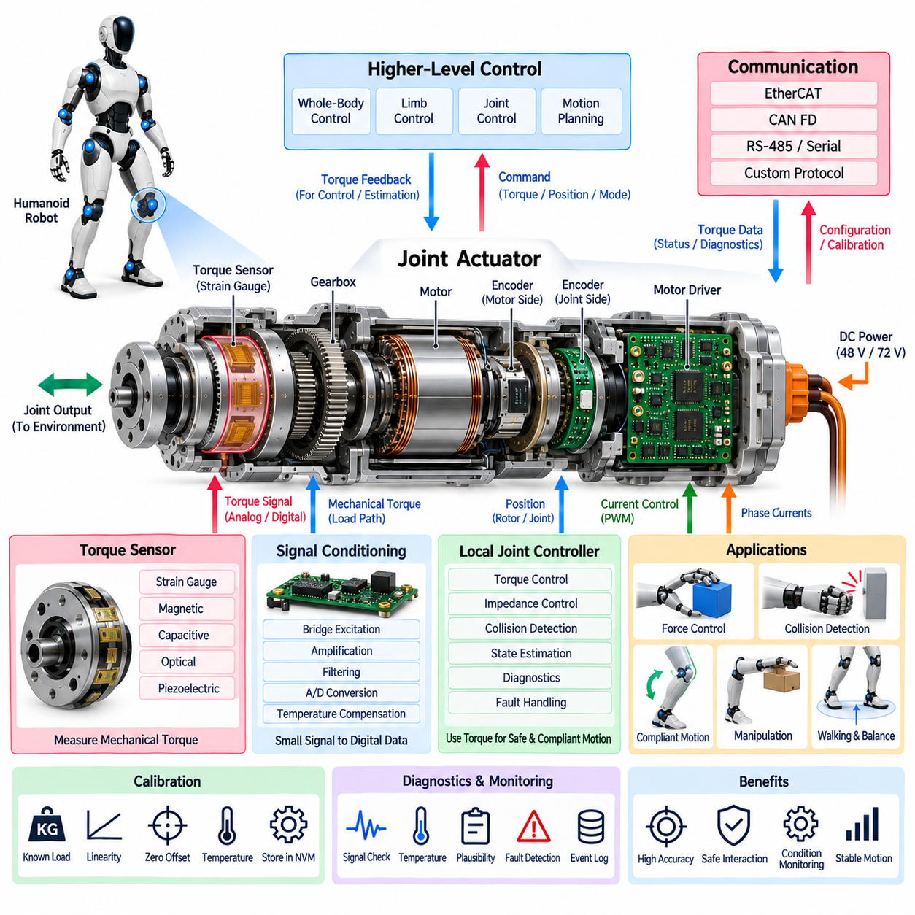
A torque sensor provides direct information about the mechanical effort transmitted through a humanoid joint and therefore forms a critical feedback element between the actuator and the physical environment. Unlike position sensing, which describes where a joint is located, torque sensing reveals how strongly the joint is interacting with loads, structures, objects, or people. This information enables compliant behavior, contact awareness, force regulation, collision detection, and stable whole-body motion.
Within the humanoid joint-module architecture, the torque sensor operates alongside the actuator module, motor driver, encoder interface, brake system, and local diagnostic functions. Its measurement can be processed by the local joint controller and transmitted to higher-level limb and whole-body controllers. This arrangement allows mechanical interaction to become an observable system state rather than relying exclusively on commanded motor current or predicted dynamic models.
Joint torque can be estimated indirectly from motor current because electromagnetic motor torque is approximately related to the torque constant and controlled current. This approach requires little additional hardware and is useful for many control functions. However, current-based estimation also contains motor losses, gearbox friction, transmission efficiency, temperature effects, and parameter uncertainty, so it does not always represent the actual torque delivered at the mechanical joint output.
Direct torque sensing places a measurement element in the mechanical load path so that transmitted force produces a measurable deformation or physical response. Strain-gauge structures are widely applicable because very small elastic deformation can be converted into an electrical signal. Other implementations may use magnetic, capacitive, optical, piezoelectric, or specialized force-sensing principles according to required range, bandwidth, packaging, environmental robustness, and mechanical architecture.
Sensor placement determines what physical quantity is actually observed. A motor-side sensor primarily reflects torque before the reduction mechanism, whereas an output-side sensor can measure torque after gearbox friction, compliance, and transmission losses. For interaction-sensitive humanoid joints, output-side measurement is especially valuable because it represents the mechanical effort closer to the point where the limb acts on the environment. Packaging constraints may nevertheless require different configurations for different joints.
A strain-based torque sensor typically incorporates an elastic element designed to deform predictably under torsional load. Strain gauges attached to appropriate regions of this structure form an electrical bridge whose output changes with deformation. The mechanical geometry must provide sufficient sensitivity while retaining stiffness, fatigue life, overload capability, and structural safety. Sensor mechanics and joint mechanics therefore cannot be designed independently when high-quality torque feedback is required.
The raw signal generated by a strain bridge is usually small and requires precision analog signal conditioning. Instrumentation amplification, bridge excitation, low-noise filtering, offset control, and analog-to-digital conversion may be integrated close to the sensing element. Locating the electronics near the sensor reduces susceptibility to interference but introduces packaging and thermal challenges. The resulting digital torque value can then be transmitted to the local actuator controller through a short internal interface.
Sampling bandwidth must match the physical phenomena that the controller needs to observe. Slow measurements may be sufficient for static load monitoring, but dynamic locomotion, collision detection, force control, and impedance control require substantially faster feedback. Excessive filtering can hide impact transients and introduce phase delay, while insufficient filtering can pass structural vibration and electrical noise into the control loop. Filter design must therefore consider both control stability and event detection.
Torque sensing is central to impedance and compliant control. Rather than forcing the joint to follow position commands with very high stiffness, the controller can regulate the relationship between displacement, velocity, and interaction force. This allows the robot to yield when encountering unexpected resistance while still maintaining controlled motion. Such behavior is particularly important for humanoids designed to manipulate objects, use tools, walk in human environments, or physically collaborate with people.
Whole-body control can use torque feedback from many joints to estimate how forces propagate through the robot. During standing and walking, measured joint loads help characterize support conditions and dynamic balance. During manipulation, arm torque measurements can reveal contact forces or unexpected obstruction. When combined with encoder, IMU, and foot-sensor information, distributed torque measurements provide a richer representation of the robot's physical state than motion feedback alone.
Collision detection is another important function. A difference between commanded or expected torque and measured mechanical torque may indicate external contact, an obstruction, or an impact. Detection thresholds must account for normal acceleration, gravity, gearbox behavior, and task-dependent forces so that intended motion is not mistaken for a collision. Fast local processing can respond before a central AI or planning computer completes a higher-level interpretation of the event.
Torque sensors also provide useful information about actuator health. Increasing friction, gearbox damage, bearing degradation, misalignment, structural deformation, or lubrication problems can alter the relationship between motor current, joint motion, and measured output torque. Long-term comparison of these signals can therefore support condition monitoring and predictive maintenance. The torque sensor becomes not only a control device but also an important diagnostic observer of mechanical transmission behavior.
Temperature compensation is necessary because both sensing elements and mechanical structures can change characteristics with temperature. Strain-gauge resistance, amplifier offset, bridge sensitivity, adhesive properties, and elastic modulus may vary across the actuator operating range. Local temperature measurements can be used to compensate torque calculations through calibrated coefficients or models. Without such compensation, thermal drift may appear as a false external force or gradually distort torque-control accuracy.
Calibration establishes the relationship between sensor output and actual mechanical torque. Known loads can be applied in positive and negative directions across the intended operating range to determine zero offset, sensitivity, linearity, hysteresis, and cross-axis effects. Calibration parameters may be stored in actuator nonvolatile memory together with encoder and motor parameters. Recalibration procedures may also be required after mechanical repair, sensor replacement, or significant structural modification.
Mechanical overload protection must prevent exceptional loads from permanently damaging the sensing structure. The sensor should tolerate transient forces beyond its normal measurement range with an appropriate safety margin. Mechanical stops, load paths, structural geometry, or software torque limits can contribute to overload protection. A sensor that remains electrically functional but has undergone permanent mechanical deformation can generate plausible yet incorrect measurements, making post-overload diagnostics especially important.
Electrical integrity is equally important because torque signals may be located close to motor phases, inverter switching nodes, and brake wiring. Differential bridge connections, shielding, twisted conductors, filtered excitation, careful grounding, and local conversion to digital data can reduce electromagnetic interference. Diagnostic mechanisms can supervise sensor supply voltage, bridge continuity, ADC range, communication integrity, and signal plausibility to distinguish genuine mechanical loads from electrical disturbances.
Redundant torque information can be obtained through multiple sensing principles rather than necessarily duplicating the same sensor. Direct measured torque can be compared with motor-current-based torque estimation, predicted dynamic torque, or load information from other body sensors. Significant disagreement provides a useful fault indicator. Because each source contains different uncertainties, plausibility limits should reflect operating speed, acceleration, temperature, joint position, and expected transmission losses.
A torque-sensor fault must lead to behavior appropriate to the function of the affected joint. Some joints may continue operating with reduced performance using current-based torque estimation, while safety-critical or contact-sensitive functions may require restricted torque, increased position-control caution, controlled stopping, or shutdown. The system should distinguish loss of communication, excessive offset, saturation, implausible dynamics, calibration failure, and mechanical overload rather than representing every condition as a generic sensor error.
Time synchronization is important when torque data are combined with position, velocity, current, IMU, and contact measurements. Even a precise torque measurement can become misleading if it represents a significantly different instant from the corresponding joint motion. Local timestamping or synchronized acquisition allows the controller to correlate mechanical force with actuator state. This becomes particularly important during impacts, fast walking, manipulation transitions, and high-bandwidth force-control tasks.
Diagnostic logging should capture torque-related information around abnormal events. Measured torque, estimated motor torque, encoder position, velocity, phase current, temperature, operating mode, saturation state, and fault flags can be stored together in synchronized records. These data help engineers determine whether an event originated from external contact, excessive commanded force, transmission friction, sensor drift, mechanical damage, or control instability and provide valuable evidence during field-service analysis.
Modular actuator design allows torque-sensor calibration and identity to remain associated with the joint hardware. Sensor type, serial number, measurement range, calibration coefficients, zero history, temperature compensation data, and service information can be stored locally. When an actuator is replaced, system software can verify that the installed torque range and calibration are compatible with the assigned joint before allowing unrestricted operation, reducing configuration errors during maintenance.
The torque sensor therefore acts as the mechanical interaction observer of the humanoid joint. Together with the encoder interface, which measures motion, and the motor driver, which controls electromagnetic torque, it closes the information loop between electrical commands and physical forces. Integrated with braking and diagnostics in the joint-module architecture, torque sensing enables precise force control, compliant interaction, collision awareness, mechanical health monitoring, and safer physical behavior.

04.05. Brake System
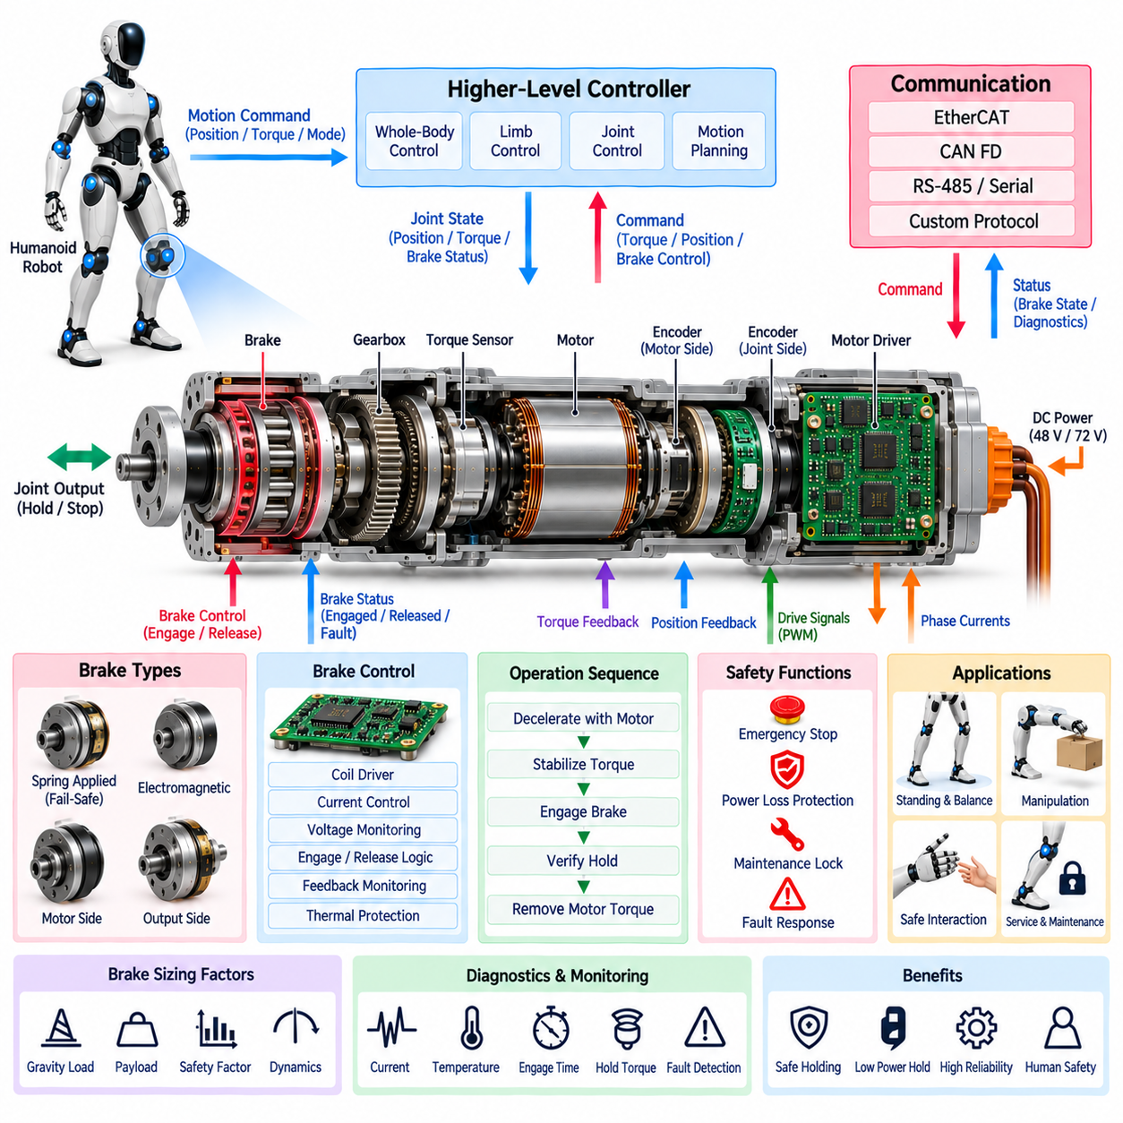
The brake system provides controlled holding and stopping capability when motor torque alone cannot guarantee a safe or stable humanoid joint state. Unlike normal motor control, which continuously produces electromagnetic torque, a mechanical brake can maintain joint position with little or no electrical power. This capability is especially important for gravity-loaded joints, emergency conditions, power loss, maintenance operations, and operating states in which unintended motion could endanger the robot or nearby people.
Within the humanoid joint-module architecture, the brake operates as an integrated function alongside the actuator module, motor driver, encoder interface, torque sensor, and diagnostics. Brake behavior must therefore be coordinated with electrical torque production, measured joint position, mechanical load, and system safety state. The architecture treats braking as a dedicated joint function because engagement and release directly affect both mechanical motion and electrical control.
A humanoid brake can perform several distinct functions. It may hold a joint stationary when the robot is powered down, prevent gravity-driven movement after motor torque is removed, support emergency stopping, secure the mechanism during maintenance, or provide a safe state following a detected fault. These functions impose different requirements for holding torque, engagement speed, allowable slip, power consumption, wear, response time, and interaction with the motor controller.
Spring-applied, electrically released brakes are attractive for joints requiring fail-safe holding. In this arrangement, mechanical spring force engages the brake when electrical power is absent, while an electromagnetic mechanism releases it during normal operation. A loss of control power therefore tends to move the mechanism toward a mechanically held state. However, fail-safe engagement alone does not guarantee system safety because sudden braking of a moving or heavily loaded joint can generate large impact forces.
Electromagnetic brakes can be integrated near the motor shaft or elsewhere in the transmission path. Motor-side placement can reduce the required brake torque because the gearbox multiplies holding torque at the joint output, allowing a smaller and lighter brake. Output-side placement can provide more direct mechanical holding if transmission integrity is uncertain, but it may require substantially greater torque capacity. The location must therefore be selected together with gearbox ratio, failure assumptions, packaging, mass, and safety objectives.
Brake sizing begins with the maximum mechanical load that must be held under defined operating and fault conditions. Gravity torque, payload, limb configuration, external forces, dynamic margin, gearbox efficiency, and required safety factor influence the necessary holding capacity. A brake designed only for nominal static load may be inadequate during abnormal posture or impact. Conversely, excessive brake capacity can increase actuator mass, inertia, packaging volume, power demand, and mechanical shock during engagement.
Holding and dynamic stopping should be distinguished during design. Many compact joint brakes are primarily intended to hold a stationary shaft rather than repeatedly absorb the kinetic energy of a moving limb. Dynamic braking generates frictional heat and wear, and repeated emergency stops can reduce brake life. Whenever possible, the motor should first decelerate the joint electrically before the mechanical brake engages, reserving high-energy mechanical stopping for conditions in which controlled motor braking is unavailable.
Normal brake engagement therefore requires a coordinated sequence. The joint controller can reduce commanded velocity, use the motor to approach zero speed, regulate torque to stabilize the load, command brake engagement, verify that holding has been achieved, and only then remove motor torque. This sequence minimizes mechanical shock and prevents the joint from dropping or rebounding during the transition from electromagnetic torque to mechanical holding.
Brake release requires similar coordination in the opposite direction. Applying motor torque before releasing the brake can preload the joint against gravity or external load so that the mechanism does not suddenly move when the brake opens. After release is confirmed, the motor controller assumes full control of joint motion. This torque handover is particularly important for knees, hips, ankles, shoulders, and other joints that may support substantial body or payload forces.
The local controller manages brake commands according to actuator state and higher-level safety requests. Brake control may include an electromagnetic coil driver, current regulation, voltage monitoring, switching protection, and feedback inputs. The controller must distinguish commanded engagement from actual mechanical engagement because an electrical command does not guarantee that friction surfaces, locking elements, or release mechanisms have physically reached the intended state.
Brake-state feedback can be implemented through position switches, current signatures, magnetic sensing, mechanical indicators, or indirect consistency checks using encoder and torque information. A release command followed by no joint response may indicate a brake that remains engaged, while unexpected motion after an engagement command may indicate insufficient holding torque or mechanical failure. Combining direct and indirect observations improves diagnostic confidence without requiring identical redundant sensors.
Electrical brake control must consider coil characteristics and thermal behavior. Electromagnetic release mechanisms can require relatively high initial current to overcome spring force, followed by lower holding current once the brake is fully released. A boost-and-hold strategy can reduce continuous power consumption and heating. Coil resistance changes with temperature, so current-controlled drive and thermal supervision can provide more predictable operation than a simple fixed-voltage command.
Because the brake is part of a safety-related motion chain, its electrical supply should be considered carefully during power-distribution design. The desired response to loss of the 48 V or 72 V actuator supply, local low-voltage power, communication, or controller operation must be explicitly defined. A fail-safe brake may engage when electrical energy disappears, while the sequencing logic must still manage stored mechanical energy and avoid creating a more dangerous condition through uncontrolled abrupt locking.
Emergency stopping requires a different priority from normal shutdown. If an imminent collision or unstable condition is detected, the system may not have sufficient time for a gradual deceleration sequence. The safety controller can request rapid torque reduction or active motor braking followed by mechanical engagement according to joint velocity and load. The exact response should account for whether immediate locking, controlled energy dissipation, or continued limited motion produces the lowest overall physical risk.
Power-loss behavior is particularly important in humanoid legs because gravity can rapidly convert potential energy into uncontrolled joint motion. If electrical torque disappears simultaneously from several joints, mechanically locking every joint immediately may not always create a stable whole-body outcome. Brake strategy should therefore be coordinated with system-level safety architecture, mechanical design, passive stability, energy storage, and the expected posture of the robot during failure.
The brake also interacts with regenerative motor operation. During normal deceleration, the motor driver can convert joint kinetic energy into electrical energy and return it to the DC bus before mechanical engagement occurs. This reduces brake wear and can improve system efficiency. Mechanical braking then provides final holding or backup stopping capability. Coordinated regenerative, electrical, and mechanical braking creates a more capable joint system than relying on any single mechanism alone.
Thermal monitoring is required when the brake experiences repeated actuation or dynamic stopping. Coil heating can affect release force, while frictional heating can change braking characteristics and accelerate wear. Temperature may be measured directly or estimated using operating history and thermal models. The controller can restrict repeated high-energy brake events or issue maintenance warnings when accumulated thermal or usage limits approach validated boundaries.
Brake diagnostics should monitor command state, electrical current, supply voltage, engagement or release feedback, joint velocity, measured torque, temperature, and actuation timing. A brake that requires progressively more time or current to release may indicate contamination, mechanical wear, spring degradation, misalignment, or thermal effects. Monitoring trends over the actuator lifetime can therefore support condition-based service before a complete braking failure occurs.
Fault cases include failure to engage, failure to release, insufficient holding torque, unintended engagement, electrical open circuit, short circuit, excessive coil current, overheating, sensor disagreement, and mechanical wear. Each fault has a different consequence. Failure to engage can permit uncontrolled motion, while unintended engagement during high-speed operation can damage the transmission. Diagnostic logic must therefore identify both loss of braking capability and braking that occurs when it is not requested.
Encoder and torque-sensor information provide important plausibility checks for brake operation. After engagement, encoder motion should remain within an allowed range under expected load, while torque measurements can indicate whether the brake is carrying the mechanical load as intended. During release, motor torque and joint motion should become consistent with the commanded state. These cross-checks connect the brake to the broader joint sensing and diagnostic architecture.
Maintenance and service procedures require a defined method for mechanically securing or releasing the joint. A service technician may need to move a limb when the robot is unpowered, replace an actuator, or inspect a transmission. Manual brake release, mechanical locking provisions, service tools, or controlled maintenance modes can be incorporated according to joint design. Such mechanisms must prevent accidental release of stored gravitational or elastic energy.
Modular actuator construction allows the brake specification and service history to remain associated with each joint module. Brake type, rated holding torque, coil parameters, actuation count, thermal history, calibration or release characteristics, and fault records can be stored locally. When an actuator is replaced, the system can verify that the installed brake capability matches the torque class and safety requirements of the assigned humanoid joint.
The brake system therefore acts as the mechanical authority that can preserve or recover a controlled joint state when continuous motor torque is inappropriate or unavailable. Integrated with the motor driver, encoder, torque sensor, local controller, and diagnostic functions, it supports normal holding, controlled shutdown, emergency response, maintenance safety, and power-loss protection. Effective humanoid braking depends not merely on stopping motion, but on coordinating electrical torque, mechanical load, timing, sensing, and system-level safety behavior.

04.06. Diagnostics [w/Code]
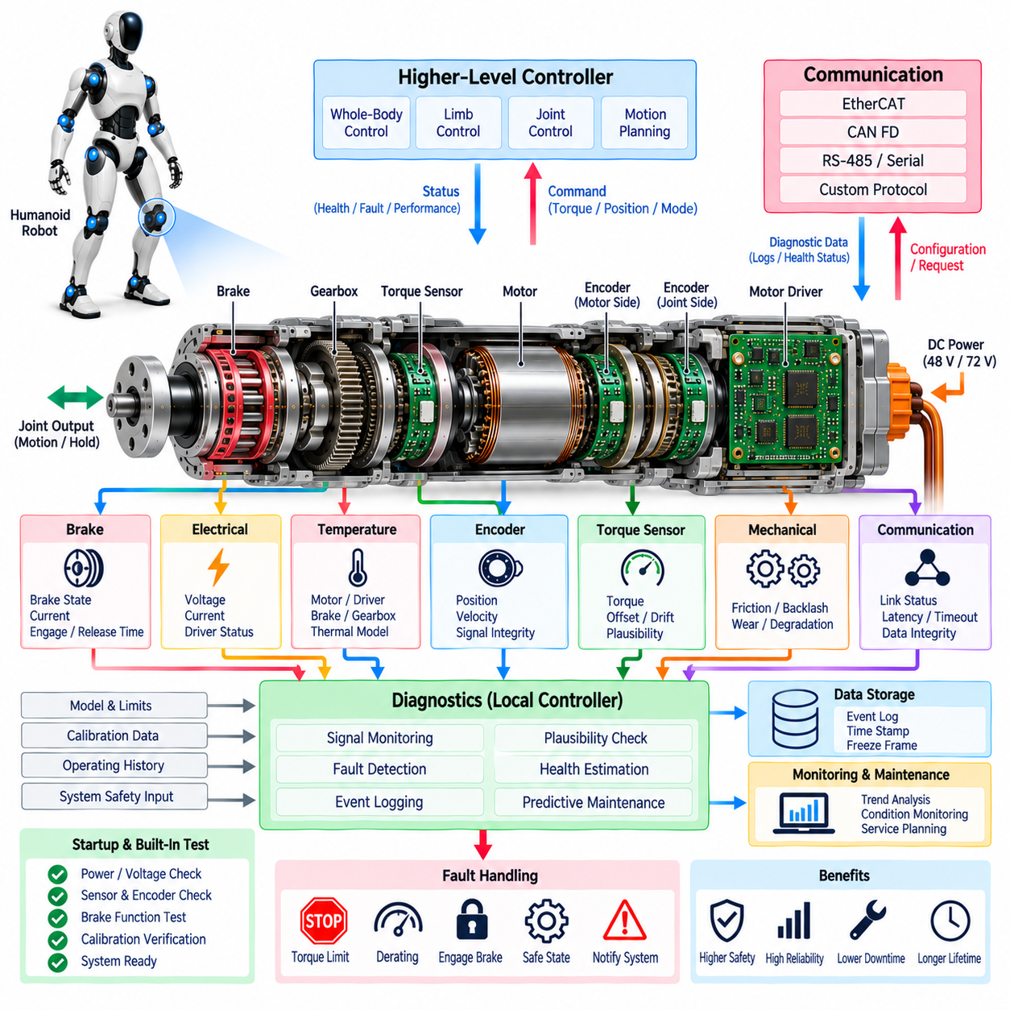
Diagnostics provides continuous observation of the humanoid joint module so that electrical, mechanical, sensing, thermal, communication, and control abnormalities can be detected before they develop into unsafe motion or permanent hardware damage. Rather than operating as a separate maintenance feature, diagnostic logic is embedded throughout the actuator, motor driver, encoder, torque sensor, brake, and local controller, creating an integrated view of joint health and operating capability.
The joint diagnostic architecture combines direct fault detection with cross-checking among multiple measurements. Motor current, DC-bus voltage, encoder position, joint velocity, measured torque, motor temperature, power-stage temperature, brake state, communication status, and controller state can be evaluated simultaneously. Relationships among these signals provide stronger evidence of abnormal behavior than any single measurement and help distinguish electrical faults from mechanical or sensing problems.
Local diagnostics should operate close to the actuator because some failures require a response faster than communication with the central controller can provide. A local microcontroller or motion-control processor can supervise current limits, position validity, torque plausibility, temperature, communication timing, brake state, and power-stage status during every control cycle. Critical conditions can therefore trigger immediate protective action even if the higher-level computing system is delayed or unavailable.
Electrical diagnostics supervise the power path from the joint supply to the motor windings. Relevant conditions include overcurrent, short circuit, DC-bus overvoltage, undervoltage, phase imbalance, gate-driver faults, abnormal switching behavior, and unexpected regenerative energy. Hardware protection may react within microseconds to destructive events, while firmware performs slower plausibility analysis and determines whether the actuator can continue operating, requires derating, or must enter a safe state.
Motor-driver diagnostics can compare commanded current with measured phase current and expected motor response. A persistent difference may indicate current-sensor error, inverter malfunction, wiring damage, phase loss, motor winding problems, or mechanical obstruction. Driver temperature and DC-bus behavior provide additional context. Combining electrical measurements with encoder and torque information allows the diagnostic system to determine whether abnormal current originates from the power electronics or the mechanical load.
Encoder diagnostics verify not only communication integrity but also physical plausibility. Missing frames, CRC errors, invalid absolute positions, illegal incremental transitions, excessive position jumps, unexpected direction, or unrealistic velocity can indicate sensor or interface failure. When motor-side and joint-side encoders are available, their measurements can be compared through the known transmission ratio to identify gearbox slip, excessive backlash, structural deformation, or sensor disagreement.
Torque-sensor diagnostics supervise zero offset, measurement range, saturation, noise, communication, temperature effects, and consistency with motor-current-based torque estimation. A slowly changing offset may indicate thermal drift or sensor aging, while a sudden disagreement can indicate impact, sensor failure, mechanical damage, or transmission problems. Diagnostic thresholds should vary with joint position, acceleration, speed, temperature, and expected friction rather than relying exclusively on fixed limits.
Brake diagnostics determine whether commanded brake behavior matches actual joint behavior. Coil current, supply voltage, engagement feedback, release feedback, actuation time, joint velocity, and torque can be evaluated together. A brake that requires increasing release time or current may be degrading even though it still functions. Failure to engage, failure to release, unintended engagement, insufficient holding torque, overheating, and electrical faults should be represented as distinct diagnostic conditions.
Thermal diagnostics protect components whose allowable performance changes with temperature. Motor windings, inverter switches, brake coils, bearings, gearboxes, and local electronics may experience different thermal time constants and operating limits. Direct temperature sensors can be combined with thermal models that estimate inaccessible internal temperatures. Instead of waiting for an absolute shutdown threshold, the controller can progressively reduce available current and torque as thermal margin decreases.
Mechanical diagnostics use relationships among commanded torque, measured torque, current, position, velocity, and temperature to identify degradation that may not generate an immediate electrical fault. Increased friction, bearing wear, gearbox damage, lubrication loss, mechanical looseness, misalignment, or structural deformation can gradually alter these relationships. Tracking changes over time enables the actuator to become a source of condition-monitoring data rather than reporting only catastrophic failures.
Communication diagnostics supervise both data integrity and timing. EtherCAT, CAN FD, or other joint-level networks should detect missing messages, sequence errors, corrupted frames, synchronization loss, excessive latency, and communication timeout. A valid command that arrives too late may be as dangerous as corrupted data in a high-bandwidth motion system. The local controller must therefore define how long the previous command remains acceptable before torque is restricted or removed.
Time synchronization itself can be monitored as a diagnostic quantity. Position, torque, current, IMU, and contact information may individually appear correct while producing an inconsistent system state if their timestamps are misaligned. The joint controller can supervise local clock synchronization, sample timing, and communication-cycle consistency. Detecting timing degradation is particularly important for dynamic walking, coordinated manipulation, collision detection, and whole-body control.
Diagnostic faults should be classified according to severity and required response rather than represented by a single generic error state. Informational events may require only logging, while warnings can indicate reduced margin or maintenance need. Recoverable faults may trigger torque derating or restricted operation. Critical faults can require controlled stopping, brake engagement, power-stage shutdown, or escalation to the robot-level emergency safety system.
Fault response should consider the mechanical consequence of disabling an actuator. Removing motor torque from a lightly loaded arm joint may be acceptable, while the same action at a gravity-loaded knee or hip could destabilize the entire robot. Diagnostic logic must therefore communicate fault type and severity to the joint and system safety controllers. The resulting response can coordinate motor torque, braking, neighboring joints, balance control, and power distribution rather than treating each actuator independently.
Transient faults should be distinguished from persistent or repeated failures. A single communication error or brief voltage disturbance may not justify immediate permanent shutdown, but repeated occurrences can indicate deteriorating wiring, connectors, power quality, or electronics. Diagnostic counters, debounce logic, persistence timers, and recurrence statistics allow the system to avoid unnecessary shutdowns while still identifying developing reliability problems.
Event logging is essential for understanding failures that cannot be reproduced during service. A circular local buffer can continuously retain recent current, voltage, position, velocity, torque, temperature, brake state, communication status, controller mode, and fault flags. When a significant event occurs, data from before and after the trigger can be preserved. This creates a joint-level equivalent of a flight recorder that captures the conditions surrounding abnormal behavior.
Diagnostic records should contain synchronized timestamps and configuration information so that events from multiple joints can be reconstructed at system level. During a fall, collision, power disturbance, or network failure, several actuators may report faults almost simultaneously. Accurate timing allows engineers to identify the initiating event and distinguish primary faults from secondary consequences. Robot-level logging can merge these local records with IMU, battery, perception, and safety-controller data.
Fault codes should identify both the affected subsystem and the nature of the detected condition. A structured diagnostic scheme can distinguish motor-driver overcurrent, encoder communication loss, torque-sensor saturation, brake release failure, thermal derating, network timeout, or calibration mismatch. Associated severity, occurrence count, operating state, and freeze-frame data make each code more useful for service technicians and automated maintenance software than a simple fault indicator.
Startup diagnostics verify that the joint is ready before unrestricted torque is enabled. The controller can check supply voltages, firmware integrity, calibration data, encoder validity, torque-sensor zero condition, brake state, temperature, communication, and actuator identity. Motor torque should remain inhibited or limited until mandatory checks are completed. This prevents an incorrectly configured, damaged, or partially connected actuator from immediately entering normal operation after power-up or replacement.
Built-in test functions can extend startup checks into maintenance and manufacturing processes. Controlled low-energy commands can verify motor phases, encoder direction, brake release, torque response, and sensor consistency without requiring full joint operation. Such tests are useful after actuator replacement or repair because they provide a repeatable method for confirming wiring, calibration, mechanical assembly, and firmware compatibility before the robot returns to unrestricted motion.
Calibration integrity is itself a diagnostic concern. Encoder offsets, torque coefficients, current-sensor gains, motor electrical-angle alignment, thermal parameters, and brake characteristics may be stored in local nonvolatile memory. Checksums, version identifiers, hardware identity, and compatibility rules can verify that the correct parameter set is being used. A valid sensor with incorrect calibration can produce plausible but dangerous data, so configuration faults must be treated separately from hardware failures.
Long-term diagnostic data enable predictive maintenance by identifying trends before operational limits are exceeded. Increasing motor current for the same task, rising gearbox temperature, growing encoder disagreement, torque-offset drift, longer brake release time, or increasing communication errors can reveal gradual degradation. Maintenance can then be scheduled according to measured condition and usage rather than relying only on fixed operating-hour intervals.
A modular actuator architecture benefits from storing health information locally with the hardware. Serial number, firmware revision, calibration history, operating hours, peak temperatures, overload events, brake cycles, fault counters, and service records can remain associated with the actuator throughout its life. When a module is moved or replaced, the robot can automatically evaluate its identity, compatibility, remaining capability, and maintenance status before enabling normal operation.
Diagnostics therefore forms the joint module's continuous health-awareness layer. It connects the actuator, motor driver, encoder, torque sensor, brake, communication interface, and local controller into a coherent fault-observation and response system. By combining real-time protection, cross-sensor plausibility checking, event recording, degradation tracking, startup validation, and predictive maintenance, diagnostics helps transform each humanoid joint from a collection of components into a manageable, observable, and safer intelligent subsystem.

