Volume 21. Humanoid Electrical Architecture

Chapter 15. Manufacturing and Service

15.01. Production Test
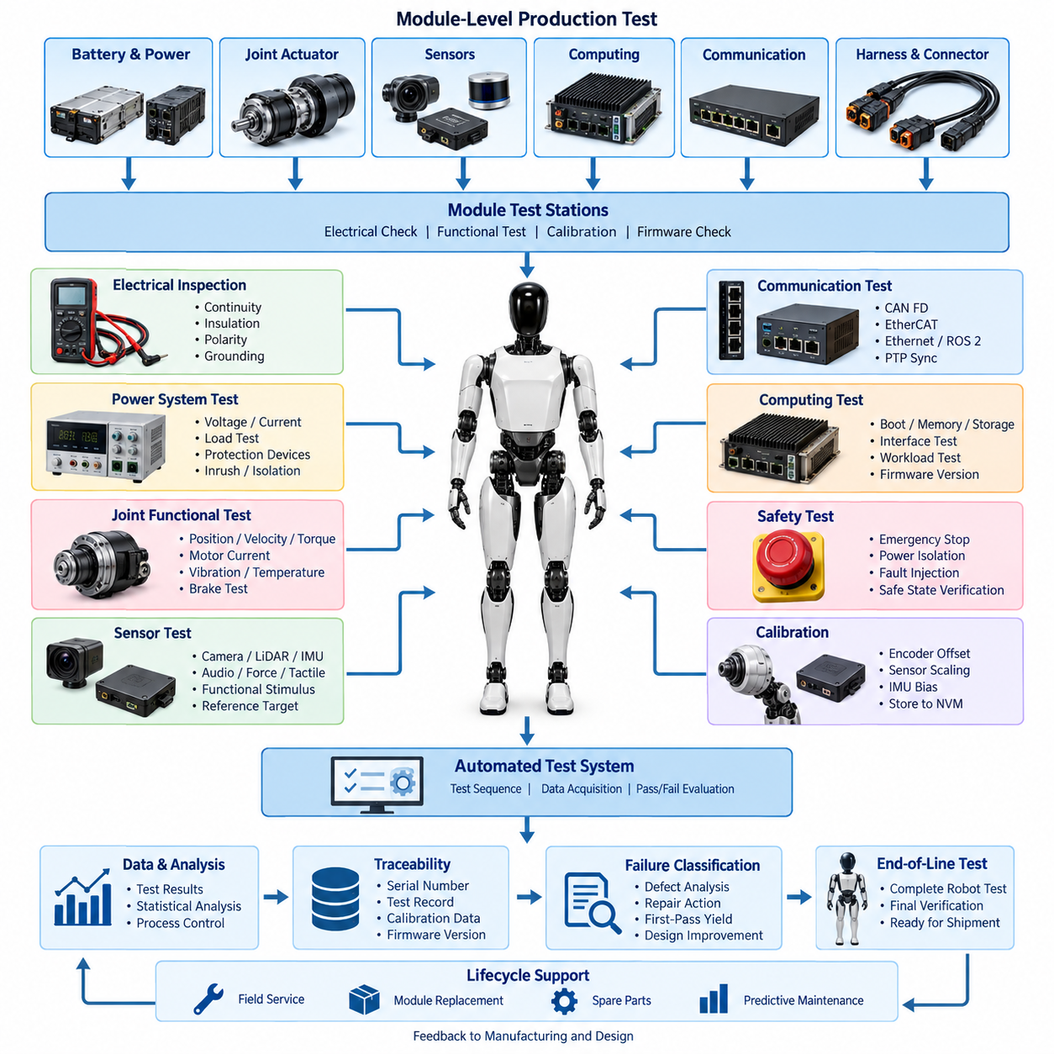
Production testing for a humanoid robot verifies that every manufactured unit conforms to electrical, mechanical, communication, sensing, computing, and safety requirements before it proceeds to final system validation. Unlike prototype testing, production testing must be repeatable, automated where practical, traceable to individual serial numbers, and sufficiently fast to support manufacturing throughput without sacrificing defect detection capability.
The production test architecture should follow the modular structure of the humanoid itself. Battery modules, power distribution units, joint actuators, motor drives, encoders, torque sensors, brakes, perception modules, computing units, communication interfaces, and harness assemblies can first be tested independently. Module-level screening prevents defective components from propagating into higher-cost torso, arm, leg, hand, and complete-robot assembly stages.
Electrical inspection begins with verification of wiring continuity, insulation integrity, connector engagement, polarity, grounding, shielding, and protection devices. Automated fixtures can measure resistance between defined terminals and detect open circuits, shorts, excessive contact resistance, or incorrect pin assignments. Power rails are then energized in controlled stages so abnormal current consumption, undervoltage, overvoltage, leakage, or unexpected inrush behavior can be identified safely.
Power-system testing is particularly important because the humanoid architecture may contain high-current actuator buses together with multiple low-voltage supplies for sensors, communication devices, and computers. Battery interfaces, PDU outputs, DC-DC converters, contactors, fuses, pre-charge circuits, and emergency isolation paths should therefore be measured under representative electrical loads. Recorded voltage, current, temperature, and switching characteristics provide evidence that power distribution operates within specified limits.
Joint modules require automated functional testing because a humanoid can contain many tightly coordinated actuators. Each production station should command controlled position, velocity, and torque profiles while monitoring motor current, encoder position, torque feedback, temperature, vibration, and communication status. The resulting signatures can reveal assembly problems such as excessive friction, incorrect encoder alignment, abnormal gearbox behavior, brake drag, wiring errors, or improperly configured motor-drive parameters.
Calibration can be integrated directly into production testing rather than treated as an independent downstream activity. Encoder offsets, joint zero positions, torque-sensor offsets, current-sensor scaling, IMU biases, foot force sensors, tactile elements, and other measurable parameters can be calculated and stored in nonvolatile configuration data. Calibration records should remain associated with the hardware serial number so replacement modules can later be identified, validated, and restored to a known configuration.
Communication testing verifies every network interface used by the distributed humanoid architecture. CAN FD nodes can be checked for addressing, bitrate configuration, error counters, message timing, and bus termination, while EtherCAT devices can be validated for topology, distributed-clock behavior, state transitions, and cyclic communication. Ethernet, ROS 2 DDS, and PTP-related interfaces should likewise be exercised to confirm connectivity, bandwidth, discovery, timing, and synchronization behavior.
Sensor production tests should combine electrical verification with functional stimulus whenever possible. Cameras can observe calibrated visual targets, LiDAR units can measure reference surfaces, IMUs can be exposed to known orientations or motion, microphones can receive controlled acoustic signals, and force or tactile sensors can be subjected to calibrated loads. Testing against physical references helps distinguish defective sensors from failures caused by cabling, power delivery, configuration, synchronization, or software.
Computing hardware requires its own manufacturing checks before complete robot integration. Real-time controllers, AI computers, GPUs, storage devices, network interfaces, and thermal monitoring circuits should complete boot, memory, storage, interface, and workload tests. Firmware and software versions must also be verified because a mechanically correct robot assembled with incompatible firmware, configuration data, or AI runtime components may exhibit failures that resemble electrical hardware defects.
Safety-related production tests must verify actual protective behavior rather than merely confirm component presence. Emergency-stop circuits, power isolation, actuator disable paths, brake engagement, collision-related interfaces, redundant sensors, watchdogs, and safety communication should be deliberately exercised. Fault injection can verify that defined failures cause the expected transition to a safe or degraded operating state and that safety faults are correctly reported to diagnostic systems.
Automated test equipment should communicate with the robot through controlled manufacturing interfaces and collect measurements directly from test instruments and embedded diagnostic functions. A production test controller can sequence power activation, network discovery, firmware checks, actuator exercises, sensor stimulation, safety tests, and result evaluation. Automation reduces operator-dependent variation while allowing experienced technicians to investigate units that fail predefined acceptance limits.
A useful production strategy combines deterministic specification limits with statistical analysis. Simple characteristics such as supply voltage or termination resistance can use fixed pass/fail thresholds, whereas actuator current, friction estimates, sensor noise, thermal response, or communication latency may benefit from comparison with distributions collected from known-good units. Statistical process control can reveal manufacturing drift before individual products exceed formal specification boundaries.
Traceability transforms production testing from a temporary factory operation into lifecycle engineering data. Each test record should identify the robot serial number, module serial numbers, hardware revisions, firmware versions, calibration parameters, test-station identity, fixture revision, operator or automated process, timestamp, measured values, and final disposition. This information creates a baseline against which later field diagnostics and predictive-maintenance observations can be compared.
Failures should be classified rather than represented only by a generic test result. A failed unit may contain a component defect, assembly error, calibration deviation, firmware mismatch, configuration problem, connector fault, harness defect, or test-fixture issue. Recording structured failure codes and repair actions enables manufacturing engineers to calculate first-pass yield, identify recurring defects, improve supplier quality, and determine whether design changes are needed to improve manufacturability.
Production tests must also be designed for maintainability. Fixtures, adapters, reference loads, sensor targets, cables, and test software evolve as the humanoid hardware changes, so test configurations require revision control comparable to product engineering data. Golden units and calibrated reference equipment can be used to confirm that a test station remains healthy and to prevent fixture degradation from being incorrectly interpreted as increasing product failure rates.
The final objective is not simply to produce a PASS indication but to establish objective evidence that the manufactured humanoid matches its intended electrical architecture. Production testing connects design requirements, manufacturing processes, calibration, diagnostics, safety, and lifecycle records into one traceable quality system. This verified manufacturing baseline then provides the foundation for end-of-line testing, field service, modular replacement, spare-parts management, and long-term lifecycle management.

15.02. End of Line Test
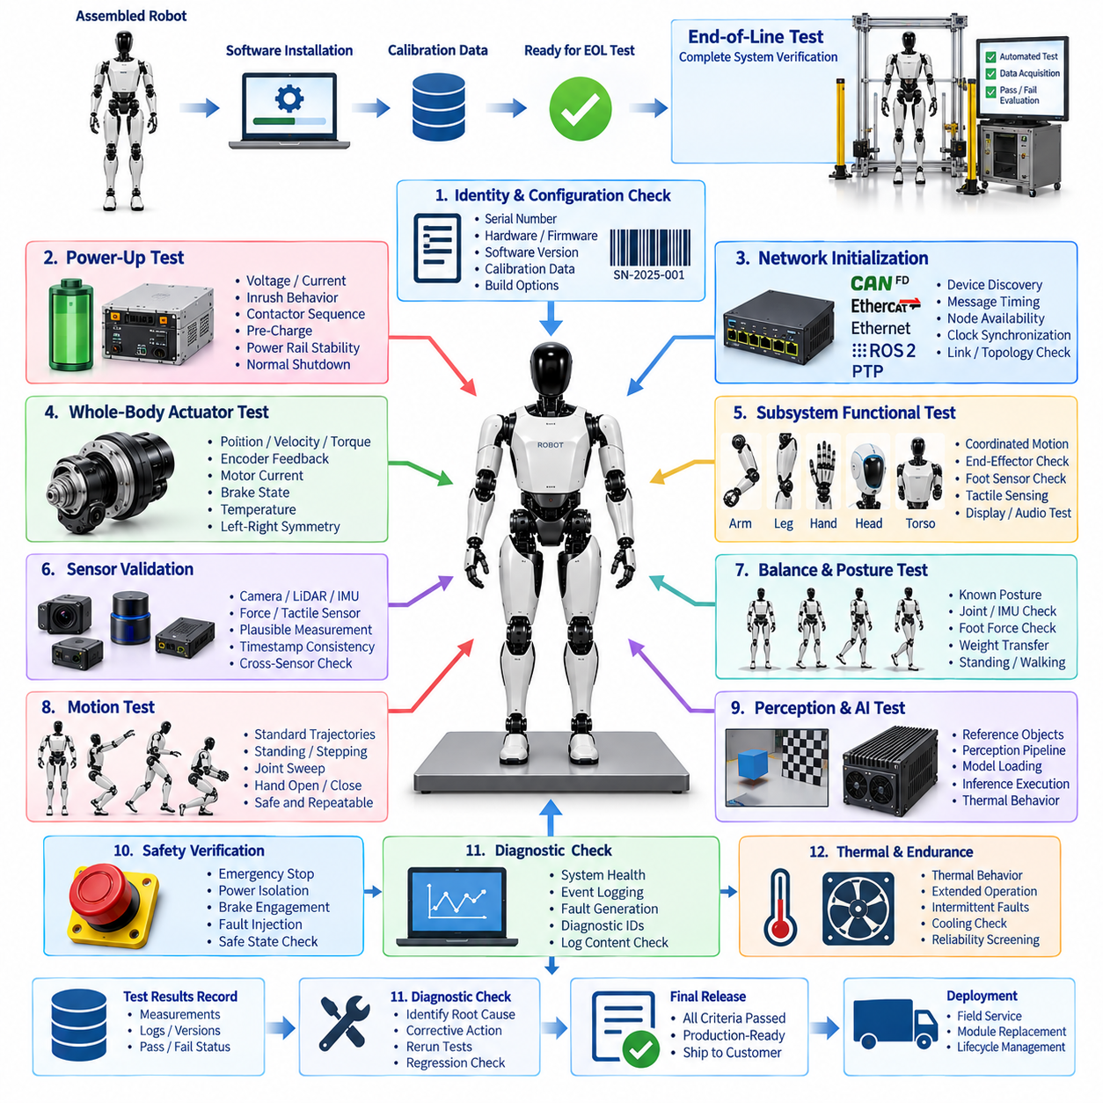
End-of-line testing is the final integrated verification performed after the humanoid robot has completed mechanical assembly, electrical integration, software installation, and production-level calibration. Its purpose is to determine whether the complete robot behaves as an operational system rather than merely confirming that individual modules passed earlier tests. The EOL process therefore evaluates interactions among power, actuation, sensing, communication, computing, diagnostics, and safety functions.
Unlike module-level production testing, end-of-line testing examines the assembled humanoid under conditions representative of actual operation. The robot should boot from its production configuration, initialize all distributed controllers, establish communication networks, synchronize clocks, load calibration parameters, and report system health without manual correction. Any configuration mismatch or integration defect discovered at this stage must be resolved before the unit can be released.
The EOL sequence normally begins with identity and configuration verification. The robot serial number, module identifiers, hardware revisions, firmware versions, software packages, calibration datasets, and manufacturing options are compared with the intended build configuration. This prevents a physically functional robot from leaving production with an incorrect controller, incompatible firmware, outdated AI runtime, wrong calibration file, or unintended hardware option.
A controlled power-up test verifies the complete energy path from the battery system through the PDU, converters, protection devices, controllers, sensors, computers, and actuators. Voltage, current, inrush behavior, contactor sequencing, pre-charge operation, and power-rail stability can be monitored throughout startup. The test should also confirm orderly shutdown and verify that abnormal power conditions are detected and recorded by the diagnostic architecture.
Network initialization is evaluated after electrical stability has been established. CAN FD, EtherCAT, Gigabit Ethernet, ROS 2 DDS, and other configured communication domains must discover their expected devices and reach defined operational states. Message timing, packet errors, node availability, distributed-clock behavior, and PTP synchronization can be monitored to detect topology errors, termination problems, unstable links, or incorrectly configured devices.
Whole-body actuator verification confirms that all installed joints respond correctly within the assembled mechanical structure. Each joint can execute low-risk position, velocity, and torque trajectories while the EOL controller observes encoder feedback, motor current, torque response, brake state, temperature, and communication status. Left-right symmetry and expected motion ranges provide additional methods for detecting incorrect assembly, reversed orientation, excessive friction, or calibration errors.
The arm, leg, hand, head, and torso subsystems should subsequently be tested as coordinated functional groups. Arm testing can verify shoulder-to-wrist motion and end-effector interfaces, while leg testing can evaluate hip, knee, ankle, and foot-sensor relationships. Hand tests can exercise finger actuators and tactile sensing, and head tests can confirm perception devices, microphones, speakers, displays, and associated computing interfaces.
Sensor validation at EOL verifies not only individual sensor operation but also their installed geometry and system-level data availability. Cameras, LiDAR, IMUs, force sensors, tactile sensors, joint encoders, and other perception sources should produce plausible measurements from their final mounting positions. Timestamp consistency and cross-sensor relationships are particularly important because perception and balance algorithms depend on correctly synchronized and calibrated observations.
Balance and posture testing provides an important transition from component verification to humanoid-level behavior. With appropriate physical restraints or a controlled support fixture, the robot can establish a known posture and compare joint states, IMU orientation, foot forces, and commanded torque distributions. Progressive tests may then confirm stable standing and controlled weight transfer while monitoring whether the balance-control interface receives consistent sensor and actuator information.
Functional motion testing should use standardized trajectories that are safe, repeatable, and sufficiently sensitive to integration defects. Depending on the robot design, these may include standing, joint sweeps, arm positioning, hand opening and closing, controlled stepping, or short walking sequences. The objective is not to demonstrate maximum dynamic performance but to prove that the production unit can execute representative coordinated motions within defined acceptance limits.
Perception and AI computing can also be checked using controlled EOL scenarios. Reference objects, visual targets, known spatial features, or predefined sensor inputs allow the system to confirm that perception data reaches the appropriate computing pipeline. AI computers and GPUs can execute standardized workloads to verify model loading, inference execution, resource availability, thermal behavior, and communication with the real-time control architecture.
Safety verification must remain independent of successful normal operation. Emergency stops, actuator disable commands, power isolation, brake engagement, watchdog responses, communication-loss handling, and relevant collision or protective functions should be deliberately exercised. The system must demonstrate the specified transition to a safe or degraded state, while diagnostic logs should capture the initiating fault, affected subsystem, system response, and recovery conditions.
Diagnostic completeness is another important EOL criterion because a robot that operates correctly but cannot identify future faults creates significant field-service risk. The EOL station should query health information from major modules, verify event logging, confirm diagnostic identifiers, and intentionally generate selected recoverable faults. Recorded events must contain sufficient information to associate the condition with the correct robot, module, timestamp, operating state, and software configuration.
Thermal and endurance screening may be incorporated when manufacturing time permits. Running actuators, computers, communication devices, and sensors for a defined period can reveal intermittent connectors, marginal cooling, unstable power electronics, memory faults, or components that fail only after reaching operating temperature. Test duration should be optimized using reliability evidence because excessively long EOL cycles can become a major manufacturing bottleneck.
Automated EOL equipment should execute standardized procedures and collect objective measurements rather than depending primarily on operator judgment. The test system can control fixtures, safety restraints, external targets, network analyzers, power instrumentation, and robot commands while continuously acquiring results. Acceptance limits should be version-controlled so that every manufactured unit is evaluated against the requirements applicable to its specific hardware and software configuration.
All EOL results should become part of the robot's permanent manufacturing record. The dataset can include serial numbers, configuration information, calibration versions, measured values, test results, diagnostic logs, software versions, failure history, repair actions, retest status, and final release authorization. This record establishes the reference condition of the robot at the moment it leaves manufacturing and supports later comparison with field-service data.
A failed EOL test should initiate a controlled repair-and-retest process rather than allowing informal adjustment followed by shipment. The failed subsystem must be identified, corrective action recorded, affected tests repeated, and any broader regression testing performed when the repair could influence other functions. Repeated failures across multiple robots should feed manufacturing quality analysis and may indicate supplier, process, software, calibration, or design problems.
The final release decision combines configuration correctness, electrical integrity, communication stability, actuator performance, sensor validity, computing operation, diagnostic completeness, functional behavior, and safety verification. A humanoid should be considered production-ready only when the complete evidence set satisfies defined acceptance criteria. End-of-line testing therefore forms the formal boundary between manufacturing integration and subsequent shipment, deployment, field service, modular replacement, and lifecycle management.

15.03. Field Service
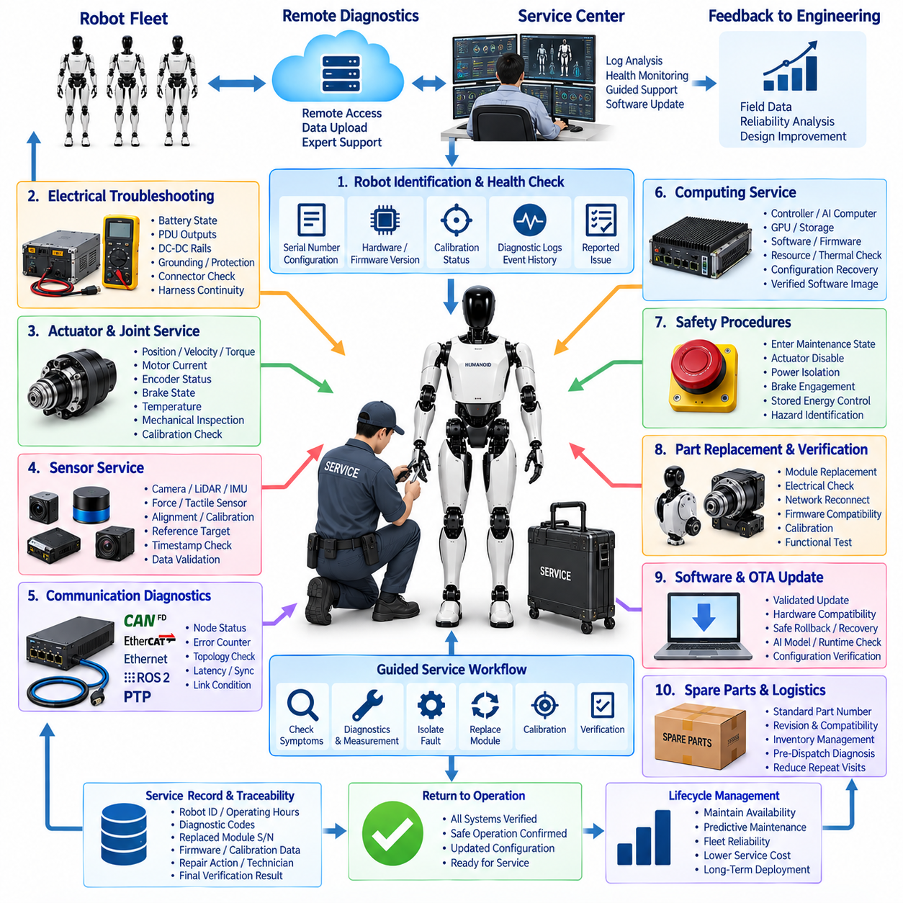
Field service for a humanoid robot provides the processes, tools, diagnostic capabilities, and technical information required to maintain safe and reliable operation after deployment. Unlike factory production testing, field service must operate under less controlled conditions and often with limited equipment. The service architecture should therefore enable technicians to identify faults quickly, isolate affected modules, restore functionality, and verify the robot before returning it to operation.
A humanoid field-service strategy should reflect the modular organization of the electrical architecture. Arms, legs, hands, head modules, joint actuators, battery assemblies, power distribution units, sensors, computing devices, communication nodes, and harness sections should expose identifiable service boundaries. Clear module interfaces reduce troubleshooting complexity and allow defective assemblies to be replaced without unnecessary disassembly of unrelated robot structures.
Service activity normally begins with robot identification and health assessment. The technician should confirm the robot serial number, hardware configuration, firmware and software versions, calibration status, operating history, and reported fault condition. Diagnostic systems can then retrieve active and historical events from distributed controllers, allowing the service process to distinguish persistent hardware failures from intermittent communication, configuration, thermal, power, or software-related problems.
Remote diagnostics can reduce the need for immediate physical intervention. When network connectivity and security policies permit, authorized service personnel may retrieve health information, diagnostic logs, temperatures, voltages, communication statistics, software versions, and selected operational data. Remote analysis can determine whether the problem can be corrected through configuration, software recovery, or guided inspection, or whether an on-site technician and replacement hardware are required.
Electrical troubleshooting should proceed through controlled measurements rather than trial-and-error replacement. Battery state, PDU outputs, DC-DC converter rails, grounding paths, protection devices, connector integrity, and harness continuity can be examined according to predefined diagnostic procedures. Voltage and current measurements should be interpreted together with stored diagnostic events so that a downstream short circuit, degraded connector, overloaded actuator, or unstable supply can be differentiated efficiently.
Joint and actuator faults require access to both electrical and mechanical diagnostic information. Service tools should display commanded and measured position, velocity, torque, motor current, encoder status, brake state, temperature, and communication condition. Comparing these signals can help distinguish a motor-drive problem from encoder misalignment, excessive mechanical friction, brake malfunction, gearbox degradation, wiring damage, or incorrect calibration parameters.
Sensor service should preserve the geometric and temporal relationships required by perception and control. Replacement of a camera, LiDAR, IMU, force sensor, tactile device, or joint encoder may require calibration or validation after installation. The service procedure should therefore define reference targets, known poses, loading conditions, or automated routines that confirm sensor orientation, offset, scaling, timestamp behavior, and data availability before normal operation resumes.
Communication diagnostics are essential because distributed humanoid systems depend on several interconnected networks. CAN FD, EtherCAT, Ethernet, ROS 2 DDS, and PTP-related problems may appear as actuator, sensor, or computing failures even when the endpoint hardware is healthy. Service tools should expose node status, error counters, topology information, communication latency, synchronization state, and link condition so technicians can identify the actual source of a network-related fault.
Computing service covers real-time controllers, AI computers, GPUs, storage devices, network interfaces, firmware, and runtime software. A technician should be able to determine whether a failure originates from hardware, corrupted storage, incompatible firmware, resource exhaustion, thermal protection, or software configuration. Recovery procedures should use controlled software images and verified configuration packages rather than untracked manual changes that could compromise system consistency.
Safety must govern every field-service operation. Before technicians access joints, power electronics, batteries, or internal wiring, the robot should enter a defined maintenance state with appropriate actuator disable, power isolation, brake engagement, and stored-energy controls. Emergency-stop functions and other protective mechanisms should remain available where required, while service documentation should clearly identify hazardous voltage, moving mechanisms, pinch points, hot surfaces, and heavy modules.
After a component is repaired or replaced, the robot should not immediately return to normal operation. A post-service verification sequence should confirm electrical integrity, network connectivity, module identification, firmware compatibility, calibration status, diagnostic health, and relevant functional behavior. If a joint module is replaced, for example, encoder alignment, torque sensing, brake operation, motion limits, and coordinated control may all require verification before the robot is released.
Calibration management is especially important for modular field replacement. Calibration parameters may belong to an individual sensor or actuator, to its installed location, or to relationships between several components. Service software should therefore determine which calibration data can follow a replacement module and which values must be regenerated after installation. Updated calibration records should be associated with both the robot and the newly installed module.
Service tools should provide guided diagnostic workflows that convert complex system information into repeatable troubleshooting procedures. Instead of requiring every technician to understand the complete humanoid architecture, the tool can lead the user from observed symptoms through health checks, measurements, isolation tests, replacement decisions, calibration, and verification. Expert-level raw data should remain accessible for engineering investigation when standard procedures cannot resolve the fault.
Traceability should continue throughout the field-service lifecycle. Each intervention should record the robot identifier, operating hours, reported symptom, diagnostic codes, affected module, removed and installed serial numbers, firmware versions, calibration changes, measurements, repair actions, technician identity, and final verification result. This service history provides evidence for warranty decisions and creates valuable data for reliability engineering and predictive maintenance.
Field-service data should also feed back into manufacturing and engineering. Repeated connector failures may indicate insufficient retention, recurring harness damage may reveal routing problems, and repeated actuator replacements may expose thermal or load assumptions that were not representative of actual operation. Aggregating service records across a robot fleet allows engineering teams to identify systematic weaknesses that cannot be recognized from isolated individual failures.
Software and over-the-air update mechanisms should be coordinated with service processes. A field problem may be corrected by a validated software update, but the service system must verify compatibility among hardware revisions, firmware, calibration data, AI models, and runtime components. Update failures should support controlled rollback or recovery so that a service action does not leave the robot in an undefined configuration or unusable state.
Spare parts and service logistics directly affect robot availability. Frequently replaced modules should be identifiable through standardized part numbers, revision information, compatibility rules, and serialized records. Diagnostic information should help determine which replacement component is required before dispatch whenever possible, reducing repeated site visits and unnecessary inventory. Modular replacement therefore connects electrical architecture decisions directly with operational service cost.
The field-service architecture should ultimately minimize mean time to diagnose and mean time to repair while preserving safety and configuration integrity. Effective service combines onboard diagnostics, remote access, modular hardware, controlled replacement, calibration management, traceable records, and post-repair verification. These capabilities transform the humanoid from a complex prototype into a maintainable product that can support long-duration deployment, fleet operation, and systematic lifecycle management.

15.04. Modular Replacement
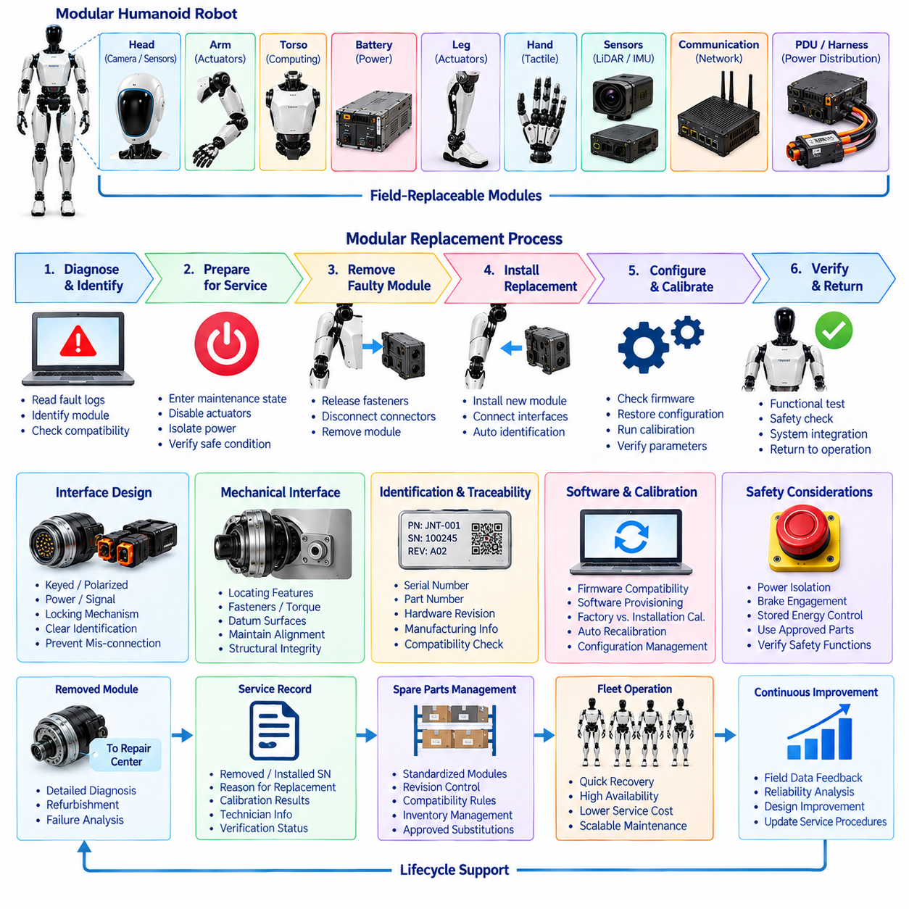
Modular replacement is a service-oriented design strategy that allows a humanoid robot to recover from hardware faults by exchanging complete functional modules instead of repairing individual components inside the deployed robot. The approach converts complex field repair into a controlled remove-and-replace operation, reducing service time while protecting electrical, mechanical, software, calibration, and safety integrity across the system.
A replacement architecture should be defined during product design rather than added after manufacturing begins. Arms, legs, hands, joint actuators, perception assemblies, battery modules, computing units, communication devices, power distribution components, and selected harness sections can be organized as field-replaceable units. Each boundary should provide clear mechanical attachment, electrical connection, communication interfaces, identification, and service access.
The appropriate replacement level depends on reliability, cost, accessibility, calibration complexity, and expected repair time. Replacing an entire leg for a minor connector fault may be unnecessarily expensive, while disassembling a high-density joint module in the field may require specialized tools and create additional risk. Service engineering should therefore establish a hierarchy of replaceable assemblies that balances module cost against diagnostic and repair effort.
Mechanical modularity requires repeatable mounting interfaces that preserve alignment and structural integrity after replacement. Locating features, fasteners, torque specifications, keyed interfaces, and mechanical datum surfaces should enable technicians to reinstall a module without introducing excessive positional variation. For load-bearing components such as legs and major joints, replacement procedures must also ensure that structural load paths and locking mechanisms are restored correctly.
Electrical interfaces should minimize opportunities for incorrect installation. Connectors can use keying, polarization, coding, locking mechanisms, and clear service identification to prevent cross-connection or incomplete engagement. Power and signal interfaces should be arranged so that high-current actuator circuits, low-voltage electronics, communication links, grounding, shielding, and safety circuits reconnect predictably when a module is exchanged.
Power isolation is required before modules containing actuators, batteries, converters, or exposed electrical interfaces are removed. The service sequence should place the robot in a defined maintenance state, disable motion, engage necessary brakes, isolate hazardous energy, and verify that stored electrical or mechanical energy has been controlled. Reconnection should follow a controlled sequence that prevents unexpected actuator activation, excessive inrush current, or unsafe power states.
Every replaceable module should carry an unambiguous identity. A serial number, part number, hardware revision, manufacturing information, and compatibility data can be stored physically and electronically. When a replacement is installed, the robot or service tool should identify the new module automatically where possible and compare its revision and capabilities against the system configuration before enabling normal operation.
Software compatibility becomes part of hardware replacement in a distributed humanoid architecture. A new joint controller, sensor module, or computing unit may contain a different firmware version from the removed device. The service system should determine whether the installed firmware is compatible, whether an update is required, and whether rollback is possible. Configuration management prevents mechanically compatible modules from producing system-level faults because of software differences.
Calibration data requires special treatment because different parameters belong to different physical relationships. Some values, such as sensor factory coefficients, may belong permanently to the replacement module, while joint zero offsets or camera extrinsics may depend on the installed position. The service workflow must distinguish reusable factory calibration from installation-dependent calibration and automatically request recalibration when the replacement changes a critical geometric or sensing relationship.
Joint-module replacement illustrates the interaction among these requirements. After a failed actuator assembly is removed, the replacement must be mechanically seated, electrically connected, identified, and checked for firmware compatibility. Encoder alignment, torque sensing, brake function, current response, motion limits, temperature monitoring, and communication status should then be verified before coordinated motion is permitted. This converts replacement into a controlled system integration procedure.
Sensor modules require similarly disciplined verification. A replacement camera, LiDAR, IMU, tactile sensor, or force sensor may communicate correctly while still providing inaccurate system information because of mounting or calibration errors. Reference targets, known poses, calibrated loads, or automated routines can verify orientation, offset, scaling, timestamp behavior, and data consistency before the sensor is accepted by perception or control functions.
Computing modules should support replacement through controlled software provisioning. When a real-time controller, AI computer, GPU platform, or storage device is exchanged, approved firmware, operating software, runtime components, AI models, security credentials, and configuration data should be restored from managed sources. Automated provisioning reduces manual configuration errors and allows the replacement computer to return to a known and traceable system state.
Communication interfaces must also recover predictably after replacement. CAN FD addresses, EtherCAT topology positions, Ethernet configuration, ROS 2 DDS parameters, and PTP synchronization settings may depend on module identity or physical location. The service process should confirm network discovery, node status, message timing, error counters, link quality, and synchronization before declaring the replaced module operational within the distributed architecture.
Safety-related modules require stronger replacement controls than ordinary functional components. Emergency-stop devices, safety controllers, redundant sensors, brakes, power isolation components, and other protective elements should use approved replacement parts and defined verification procedures. Replacement must not silently alter a safety function, and the affected protective behavior should be tested before the robot is returned to unrestricted operation.
Post-replacement verification should be proportional to the scope of the repair. A localized replacement may require electrical, communication, calibration, diagnostic, and functional checks of the affected subsystem, while replacement of a major computing, power, or structural module may require broader regression testing. The objective is to verify not only that the new component works but also that neighboring systems remain correctly integrated.
Traceability connects modular replacement with manufacturing, field service, and lifecycle management. Service records should identify the removed module, installed module, serial numbers, revisions, reason for replacement, diagnostic evidence, firmware changes, calibration results, technician actions, and final verification status. The robot configuration record must then be updated so future diagnostics accurately represent the hardware actually installed in the machine.
Modular replacement also influences spare-parts strategy. Standardized interfaces and controlled compatibility can allow a smaller number of service modules to support multiple robot revisions, while uncontrolled variation increases inventory and logistics complexity. Engineering teams should therefore manage backward compatibility, superseding part numbers, revision rules, and approved substitutions as part of the same configuration system used for manufacturing and service.
The long-term objective is to separate rapid operational recovery from detailed component repair. A defective field-replaceable module can be exchanged quickly at the deployment site and transferred to a specialized repair center for deeper diagnosis, refurbishment, or failure analysis. This architecture reduces mean time to repair, improves robot availability, preserves service quality, and creates a scalable maintenance model for large humanoid fleets.

15.05. Spare Parts Strategy
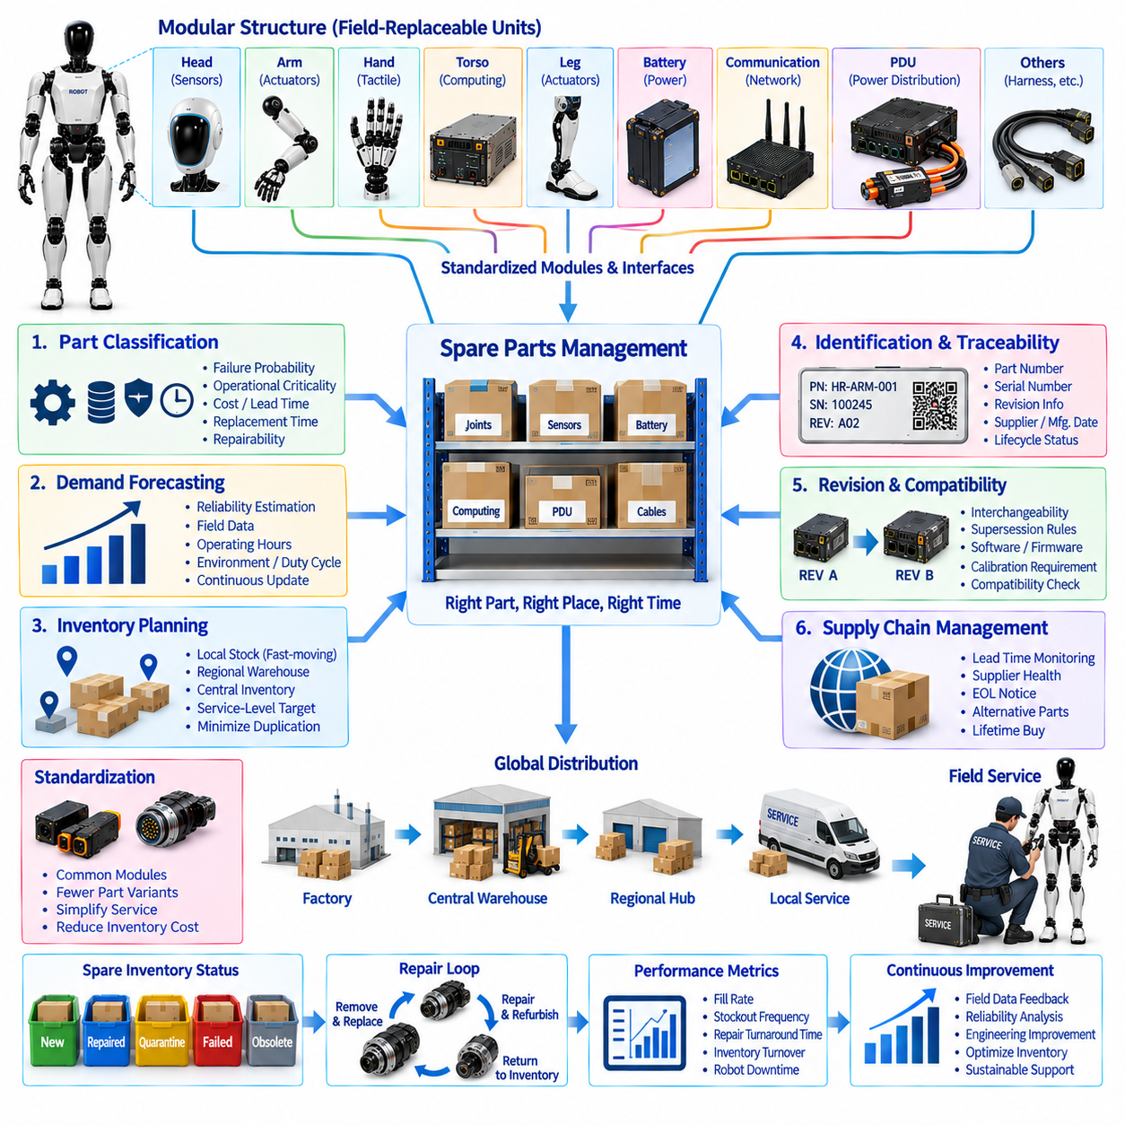
A spare parts strategy for humanoid robots defines how replacement components and modules are selected, stocked, identified, distributed, and controlled throughout the operational lifecycle. Because a humanoid combines many actuators, sensors, computers, power devices, communication interfaces, and specialized mechanical assemblies, unmanaged spare inventory can become expensive and difficult to maintain. The strategy should therefore balance robot availability, repair speed, inventory cost, and configuration integrity.
The spare-parts architecture should align directly with the modular replacement concept used by the robot. Field-replaceable units such as joint actuators, hands, perception modules, battery assemblies, computing devices, communication nodes, power distribution components, and selected harness assemblies should have defined service identities. This allows diagnostics, replacement procedures, inventory systems, and service records to reference the same standardized module structure.
Part classification provides the foundation for inventory planning. Components can be grouped according to failure probability, operational criticality, replacement time, procurement lead time, cost, and repairability. A low-cost connector used frequently may justify local stocking, while an expensive computing module with a low failure rate may be maintained at a regional service center. Safety-critical parts require additional controls even when their expected consumption is low.
Criticality should consider the effect of a missing spare on robot operation rather than only the price of the component. Failure of a cosmetic cover may permit continued operation, whereas failure of a joint actuator, battery module, safety controller, or essential perception device may immobilize the robot. Parts that can create extended downtime should therefore receive higher service priority and stronger availability targets within the logistics network.
Demand forecasting should combine engineering reliability estimates with actual field-service data. Early in a product lifecycle, failure-rate assumptions, qualification results, supplier information, and accelerated testing may provide the primary estimates. As deployed fleets accumulate operating hours, actual replacement frequency, environmental conditions, duty cycles, and failure modes should progressively replace assumptions. The spare-parts model should therefore evolve continuously with fleet experience.
Inventory levels can be established using expected demand, replenishment lead time, service-level targets, and acceptable downtime. Local service locations may hold fast-moving or mission-critical modules, while regional warehouses can support lower-frequency and higher-cost assemblies. Central inventory can retain specialized components requiring advanced repair capability. This multi-level structure reduces excessive duplication while maintaining rapid access to important replacement parts.
Standardization is one of the strongest methods for controlling spare-parts complexity. If the same actuator, sensor, connector, communication module, or computing unit can be used across several joints or robot revisions, fewer unique spare items are required. Common interfaces also simplify technician training, diagnostic procedures, repair tools, and stocking. Standardization should therefore be considered an important lifecycle requirement during electrical and mechanical architecture design.
Every spare part should have controlled identification information. Part numbers, serial numbers where applicable, hardware revisions, supplier information, manufacturing dates, compatibility data, and lifecycle status should be maintained in a configuration-management system. Serialized modules such as actuators, batteries, safety controllers, and computers should remain traceable from manufacturing through storage, installation, removal, repair, refurbishment, and retirement.
Revision management becomes increasingly important as the humanoid design evolves. A replacement part may have the same basic function but different electronics, firmware, connector details, calibration characteristics, or thermal performance. Engineering must define whether revisions are fully interchangeable, conditionally compatible, or incompatible. Service personnel should not be expected to determine compatibility manually from appearance or part-number similarity.
Supersession rules allow newer parts to replace older versions without creating unnecessary inventory. When engineering releases an improved actuator, controller, sensor, or harness, the configuration system should specify which previous part numbers it replaces and whether software updates, adapters, calibration, or additional verification are required. Controlled supersession gradually reduces obsolete stock while preserving support for earlier robot configurations.
Software and firmware must be treated as part of spare compatibility. A physically interchangeable controller may require a particular firmware release, network configuration, AI runtime, or calibration dataset. When a spare module is issued, the service system should identify the target robot configuration and determine the approved software combination. Automated provisioning can then prepare the replacement before or immediately after installation.
Calibration requirements also influence how spares are stored and dispatched. Some modules can carry factory calibration data, while others require installation-dependent calibration after replacement. Inventory records should identify the calibration status and any special equipment required for installation. A spare sensor that cannot be calibrated at the deployment location may need to be paired with a service fixture or handled through a higher-level maintenance facility.
Repairable modules should support a closed-loop logistics process. A failed field-replaceable unit can be removed from the robot, replaced immediately from service inventory, and returned to a repair center. After diagnosis, repair, calibration, and verification, the refurbished module can re-enter approved spare inventory if it satisfies defined acceptance criteria. This repair loop can reduce lifecycle cost compared with discarding expensive assemblies after every field failure.
Service inventory should distinguish new, repaired, quarantined, failed, obsolete, and engineering-controlled parts. A module returned from the field should not automatically become available for reuse merely because it appears functional. Its failure history, diagnostic results, repair actions, calibration status, and verification results should be reviewed. Digital inventory status prevents questionable hardware from circulating repeatedly through the deployed fleet.
Supply-chain risk should be included in spare planning. Long-lead semiconductor devices, specialized connectors, custom motors, encoders, batteries, and computing platforms may become unavailable before the robot itself reaches end of life. Engineering and procurement should monitor lead times, supplier health, component lifecycle notices, and end-of-life announcements so alternative parts or lifetime buys can be prepared before shortages interrupt service operations.
Geographic deployment changes the optimal stocking model. A concentrated fleet near one service center can share inventory efficiently, while robots distributed across countries or remote industrial sites may require strategically positioned spares. Transportation time, customs procedures, hazardous-goods restrictions for batteries, local technician capability, and customer uptime requirements should therefore be considered when determining where different categories of spare modules are stored.
Spare-parts performance should be measured using operational metrics rather than inventory quantity alone. Fill rate, stockout frequency, replenishment time, emergency shipment frequency, repair turnaround time, inventory turnover, obsolete stock, and robot downtime attributable to unavailable parts provide useful indicators. These measurements reveal whether the inventory strategy is supporting fleet availability efficiently or simply accumulating unused hardware.
Field-service and reliability data should continuously feed the spare-parts planning process. If a particular joint actuator begins failing more frequently than expected, inventory targets can be increased while engineering investigates the root cause. Conversely, consistently reliable modules may justify reduced stock. This feedback loop connects diagnostics, service records, reliability engineering, procurement, manufacturing, and inventory management into a common lifecycle process.
The long-term objective is to guarantee service continuity without maintaining excessive inventory. An effective strategy combines modular design, criticality classification, demand forecasting, multi-level stocking, standardized parts, revision and compatibility control, repair loops, supply-chain monitoring, and field-data feedback. For large humanoid fleets, spare parts management becomes a core engineering capability that directly determines availability, maintenance cost, and sustainable lifecycle support.

15.06. Lifecycle Management
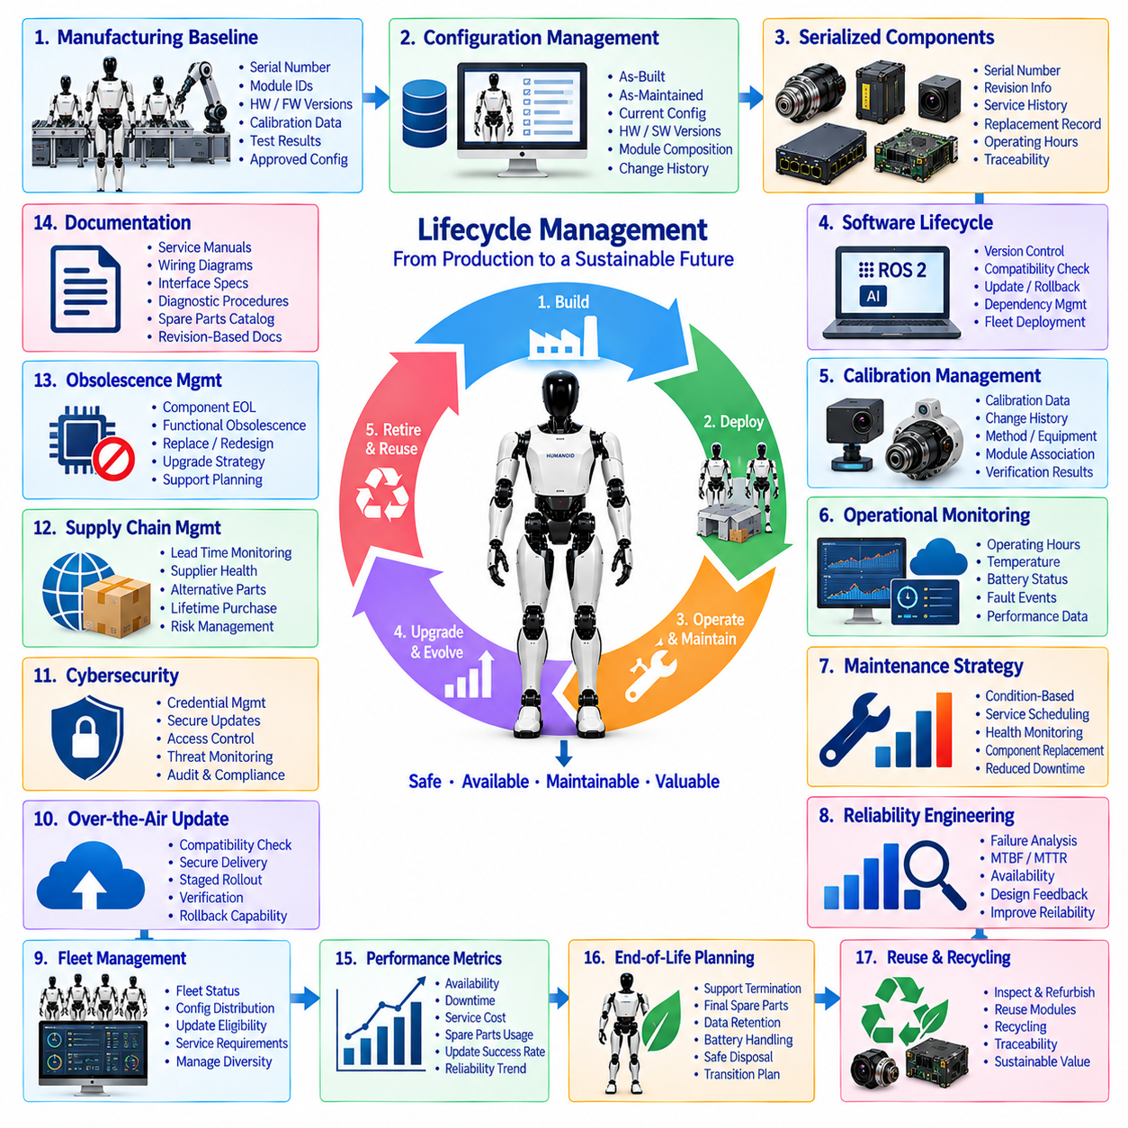
Lifecycle management for a humanoid robot coordinates hardware, software, configuration, maintenance, reliability, supply chain, and service information from manufacturing through deployment and eventual retirement. Because a humanoid is a long-lived cyber-physical system whose components evolve at different rates, lifecycle management must preserve a known system state while allowing controlled upgrades, repairs, replacements, and operational improvements throughout years of service.
The lifecycle begins with a verified manufacturing baseline. Production and end-of-line records establish the robot serial number, installed module identities, hardware revisions, firmware and software versions, calibration parameters, test results, and approved configuration. This baseline represents the initial authoritative state of the robot and provides a reference against which future maintenance actions, updates, failures, replacements, and configuration changes can be evaluated.
Configuration management must track the physical and digital composition of each robot throughout its life. Joint modules, sensors, batteries, computers, communication devices, power distribution components, harnesses, firmware, AI models, and calibration datasets may all change independently. The lifecycle system should therefore maintain an as-built, as-maintained, and currently deployed configuration rather than assuming that every robot continues to match its original manufacturing specification.
Serialized components provide the foundation for hardware traceability. Major actuators, batteries, safety controllers, perception modules, computing units, and other critical assemblies should remain associated with their manufacturing and service histories. When a module is replaced, the removed and installed serial numbers, revision information, reason for replacement, operating hours, and verification results should update the robot configuration record and the histories of both modules.
Software lifecycle management is equally important because software may change more frequently than physical hardware. Firmware, operating systems, middleware, ROS 2 components, control software, AI runtimes, models, configuration files, and diagnostic applications should use controlled versioning and compatibility rules. A software release should identify the supported hardware revisions and dependencies so updates do not create undocumented combinations across the deployed fleet.
Calibration information should be managed as configuration-controlled engineering data rather than temporary service information. Joint offsets, torque-sensor coefficients, camera extrinsics, IMU parameters, force-sensor calibration, and other values can change after repair or module replacement. Each update should preserve the previous state, reason for change, calibration method, applicable module identity, timestamp, and verification result so the robot's measurement history remains reconstructable.
Operational monitoring extends lifecycle management into daily robot use. Onboard diagnostics can collect operating hours, joint cycles, temperatures, battery usage, fault events, communication statistics, thermal excursions, and selected performance indicators. These records help engineering teams understand how real operating conditions differ from design assumptions and provide the evidence needed to improve preventive maintenance, reliability predictions, and component replacement intervals.
Maintenance policies should evolve from fixed schedules toward condition-based decisions where sufficient diagnostic evidence exists. Components subject to wear, thermal stress, battery aging, connector degradation, or repeated mechanical loading may exhibit measurable indicators before functional failure. Combining service history with health-monitoring data can allow maintenance actions to be scheduled according to actual condition rather than replacing components solely because a predetermined calendar interval has expired.
Reliability engineering should use lifecycle data to evaluate failure rates, recurring fault modes, mean time between failures, mean time to repair, and subsystem availability. Patterns observed across multiple robots can reveal weaknesses that are difficult to identify during qualification testing. Reliability findings should feed back into design revisions, supplier improvement, manufacturing controls, diagnostic thresholds, service procedures, spare-parts planning, and future robot architectures.
Fleet-level management becomes increasingly important as the number of deployed humanoids grows. Individual robots may operate with different hardware revisions, software releases, replacement histories, and environmental exposure. A fleet management system should therefore provide visibility into configuration distribution, health status, update eligibility, service requirements, and outstanding technical actions, allowing operators to manage diversity without losing control of system compatibility.
Change management should ensure that modifications are evaluated before deployment. A new actuator revision, sensor supplier, computing platform, firmware release, AI model, or wiring change may influence interfaces beyond the modified component. Engineering change procedures should identify affected requirements, compatibility constraints, calibration needs, safety implications, validation activities, spare-parts impact, service documentation, and rollout strategy before the change becomes an approved fleet configuration.
Over-the-air updates can support efficient lifecycle evolution when implemented with configuration control and recovery mechanisms. Update systems should verify robot identity, hardware compatibility, software dependencies, available storage, power condition, and communication integrity before installation. Secure delivery, integrity checking, staged deployment, post-update verification, and rollback capability reduce the risk that a software improvement creates widespread fleet unavailability.
Cybersecurity must remain active throughout the lifecycle rather than being treated as a one-time development activity. Credentials, certificates, software signatures, access permissions, communication policies, and security updates may require renewal or replacement as threats and infrastructure evolve. Service access and remote diagnostics should remain authenticated and auditable, while obsolete software components should be identified before they become unsupported security liabilities.
Supply-chain lifecycle management addresses the possibility that critical components become unavailable while deployed robots still require support. Semiconductor devices, sensors, connectors, batteries, motors, computing platforms, and communication modules may reach supplier end-of-life earlier than the robot. Lifecycle monitoring should identify such risks early enough to qualify alternative components, redesign affected modules, execute lifetime purchases, or establish controlled replacement paths.
Obsolescence management should distinguish between component discontinuation and functional obsolescence. A part may remain physically available but become unsuitable because software support, cybersecurity updates, computational capability, or service tooling has ended. Engineering should evaluate whether to retain, replace, redesign, or upgrade affected subsystems based on fleet size, remaining service life, safety requirements, cost, and operational impact.
Documentation must evolve together with the product. Wiring diagrams, interface definitions, service manuals, diagnostic procedures, calibration instructions, software compatibility matrices, spare-parts catalogs, and safety information should correspond to specific hardware and software revisions. Technicians must be able to retrieve the documentation applicable to the actual configuration of the robot being serviced rather than relying on a generic manual that may describe an earlier design.
Lifecycle decisions should be supported by measurable operational and economic indicators. Availability, downtime, maintenance frequency, repair turnaround time, spare-parts consumption, battery replacement rate, software update success, recurring fault frequency, service cost, and reliability trends can be monitored across the fleet. These indicators help determine whether a subsystem should continue to be repaired, receive an engineering upgrade, or be replaced by a newer architecture.
End-of-life planning should begin before the final units become uneconomical to maintain. Engineering and service organizations should define criteria for support termination, final spare-parts provisioning, software maintenance, data retention, battery handling, hazardous-material processing, reusable module recovery, and secure removal of credentials or stored information. Controlled retirement prevents unsupported robots from remaining indefinitely in uncertain safety and configuration states.
Reusable modules and materials can be recovered when robots are retired. Computing units, sensors, actuators, structural assemblies, and serviceable electronics may be inspected, refurbished, repurposed, or recycled according to technical and economic criteria. Their configuration and service histories should remain traceable so recovered components are not returned to operational inventory without appropriate inspection, calibration, and verification.
The ultimate objective of lifecycle management is to preserve safety, availability, maintainability, configuration integrity, and economic value from production release to retirement. By connecting manufacturing records, field service, modular replacement, spare-parts strategy, diagnostics, software updates, reliability analysis, supply-chain monitoring, and controlled end-of-life processes, the humanoid can be managed as an evolving engineered product rather than a static machine.

