Volume 21. Humanoid Electrical Architecture

Chapter 13. Diagnostics and OTA

13.01. Health Monitoring
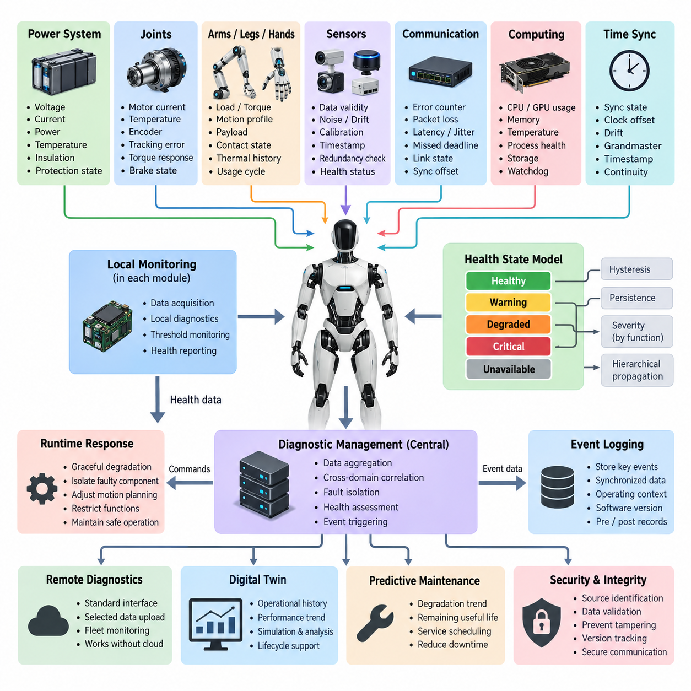
Health monitoring in a humanoid robot is the continuous observation and interpretation of electrical, computational, mechanical, communication, and sensor conditions that indicate whether the system can continue operating safely and reliably. Unlike a simple fault detector that reacts after a component fails, the health-monitoring layer maintains a system-wide view of operating margins, degradation trends, abnormal behavior, and the confidence of critical subsystems throughout the robot lifecycle.
The architecture is naturally distributed because a humanoid contains many independently controlled modules, including joints, arms, legs, hands, perception devices, power converters, communication interfaces, and computing nodes. Local controllers collect detailed measurements close to each component, while higher-level diagnostic services aggregate summarized health information. This hierarchy limits network traffic while preserving sufficiently detailed evidence for root-cause analysis when an abnormal condition occurs.
Electrical health begins with continuous supervision of voltage, current, power, temperature, insulation-related conditions, and protection states. Battery modules, power distribution units, DC/DC converters, motor drives, and local electronic controllers should report both instantaneous measurements and accumulated operating statistics. Monitoring thresholds should distinguish normal variation, warning regions, derated operation, and conditions requiring protective shutdown rather than treating every threshold crossing as an identical fault.
Joint health is especially important because humanoid motion depends on coordinated operation of many actuators. Each joint controller can monitor motor current, winding temperature, driver temperature, encoder consistency, commanded versus measured position, velocity tracking error, torque response, brake state, and communication quality. A slowly increasing tracking error or current demand may reveal friction, mechanical wear, alignment changes, or actuator degradation before the joint becomes incapable of completing commanded motion.
The arms, legs, and hands require health information to be interpreted in the context of their different workloads. Leg actuators experience repeated high loads associated with support, balance, impact, and walking, whereas arm and hand modules may experience highly variable manipulation forces and repetitive fine motion. Health limits therefore should not rely only on universal fixed thresholds. Operating mode, commanded torque, motion profile, payload, contact state, and thermal history provide essential context for interpreting measurements correctly.
Sensor health monitoring determines whether perception and control data remain trustworthy rather than merely checking whether a sensor is transmitting. Cameras, LiDAR, IMUs, encoders, force sensors, tactile arrays, microphones, and other devices can be evaluated for missing samples, frozen values, saturation, excessive noise, timestamp errors, calibration drift, implausible ranges, and disagreement with redundant information. A sensor may therefore be classified as degraded even while its electrical interface and communication link remain active.
Communication health is evaluated across the heterogeneous networks connecting the humanoid architecture. CAN FD, EtherCAT, Gigabit Ethernet, ROS 2 DDS, and time-synchronization services can expose error counters, packet loss, latency, jitter, missed deadlines, bus utilization, link state, synchronization offset, and node availability. Monitoring these parameters makes it possible to distinguish a malfunctioning device from a healthy device whose data cannot reach the required controller within the necessary timing constraints.
Compute health covers the real-time controllers, AI computers, GPU resources, storage devices, and supporting operating-system services. Useful indicators include CPU and GPU utilization, memory consumption, thermal state, clock throttling, process responsiveness, storage capacity, I/O errors, watchdog status, and execution deadline violations. Because high utilization may be expected during demanding perception or AI workloads, health evaluation should consider sustained resource saturation and deadline impact rather than interpreting peak utilization alone as failure.
Time synchronization itself becomes a monitored resource in a distributed humanoid. Motion control, sensor fusion, perception, logging, and event reconstruction depend on measurements being associated with a consistent temporal reference. The diagnostic system should therefore supervise synchronization state, clock offset, drift, grandmaster availability, and timestamp continuity. Loss of synchronization may require degraded operation even when all sensors and computing nodes continue producing apparently valid data.
A unified health model converts heterogeneous measurements into understandable subsystem states. A practical state representation may distinguish healthy, warning, degraded, critical, and unavailable conditions while retaining the underlying measurements and diagnostic evidence. State transitions should include hysteresis and persistence logic so that brief transients do not repeatedly change the robot's reported condition. Severity must also reflect functional importance because identical electrical anomalies can have very different consequences in different components.
Health information should propagate upward from components to modules, body regions, and finally the robot-level supervisor. For example, an encoder anomaly can first affect a joint health state, which then influences leg availability, balance-control capability, and overall locomotion status. This hierarchical propagation prevents the supervisory computer from processing every raw diagnostic signal while still allowing a critical local problem to influence robot-level decisions within a deterministic and bounded response time.
The monitoring architecture should support graceful degradation instead of defining health only as operational or failed. If redundant sensing remains available, the robot may isolate a faulty channel and continue with reduced confidence. If an actuator becomes thermally constrained, motion planning may reduce velocity, acceleration, or torque demand. If perception capability decreases, navigation or manipulation functions can be restricted. Health monitoring therefore becomes an input to runtime capability management as well as maintenance diagnostics.
Diagnostic confidence can be improved by correlating multiple indicators rather than relying on isolated thresholds. Rising motor current combined with increasing tracking error and temperature provides stronger evidence of joint degradation than any single measurement. Similarly, missing perception frames accompanied by Ethernet packet loss suggest a network problem, while missing frames with a healthy link may indicate a sensor or software issue. Cross-domain correlation is fundamental to reducing false alarms and accelerating fault isolation.
Event logging complements continuous monitoring by preserving the conditions surrounding significant health transitions. When a warning, degradation, reset, watchdog event, or shutdown occurs, the system should retain synchronized measurements, timestamps, operating mode, software versions, component identifiers, and relevant events before and after the transition. This information creates the evidence required for field diagnosis and provides the foundation for the event logging and remote diagnostic functions that follow within the diagnostics architecture.
Health monitoring should also provide standardized interfaces for remote diagnostics and fleet-level observation without making cloud connectivity a prerequisite for safe robot operation. Essential detection, classification, and protective responses remain onboard, while selected summaries and diagnostic records may be transmitted to external service systems. This separation allows the humanoid to maintain deterministic local behavior during network outages while still benefiting from centralized fleet analytics when connectivity is available.
The same accumulated health history becomes valuable for digital-twin and predictive-maintenance functions. Trends in temperature, actuator loading, vibration-related indicators, tracking performance, communication errors, battery behavior, and component operating hours can be associated with each physical module over time. Rather than waiting for a fixed service interval, maintenance systems can use this history to identify components whose observed degradation indicates that inspection or replacement should be scheduled earlier.
Security and integrity are important because diagnostic information can directly influence robot behavior. Health messages should identify their source, preserve consistent timestamps, reject malformed or stale data, and prevent unauthorized modification of diagnostic states or thresholds. Software and configuration versions should also be associated with recorded health data so that unexpected behavior can be correlated with firmware changes, parameter updates, maintenance operations, or OTA software deployment.
A robust implementation separates monitoring from the function being monitored wherever practical. Independent watchdogs, redundant observations, supervisory controllers, and cross-checks prevent a failed application from simply reporting itself as healthy. At the same time, monitoring must avoid creating excessive computational or network overhead. Sampling frequency, diagnostic depth, data retention, and reporting rates should therefore be engineered according to component dynamics, safety relevance, available bandwidth, and diagnostic value.
Ultimately, humanoid health monitoring forms the operational foundation for the complete diagnostics and OTA architecture defined for the platform. It connects component-level measurements with event logging, remote diagnostics, digital-twin representations, OTA lifecycle information, and predictive maintenance. By continuously transforming raw electrical and software observations into trustworthy system-level health states, the robot gains the ability to detect degradation early, isolate faults, adapt its capabilities, support service personnel, and preserve safe operation throughout its lifecycle.

13.02. Event Logging [w/Code]
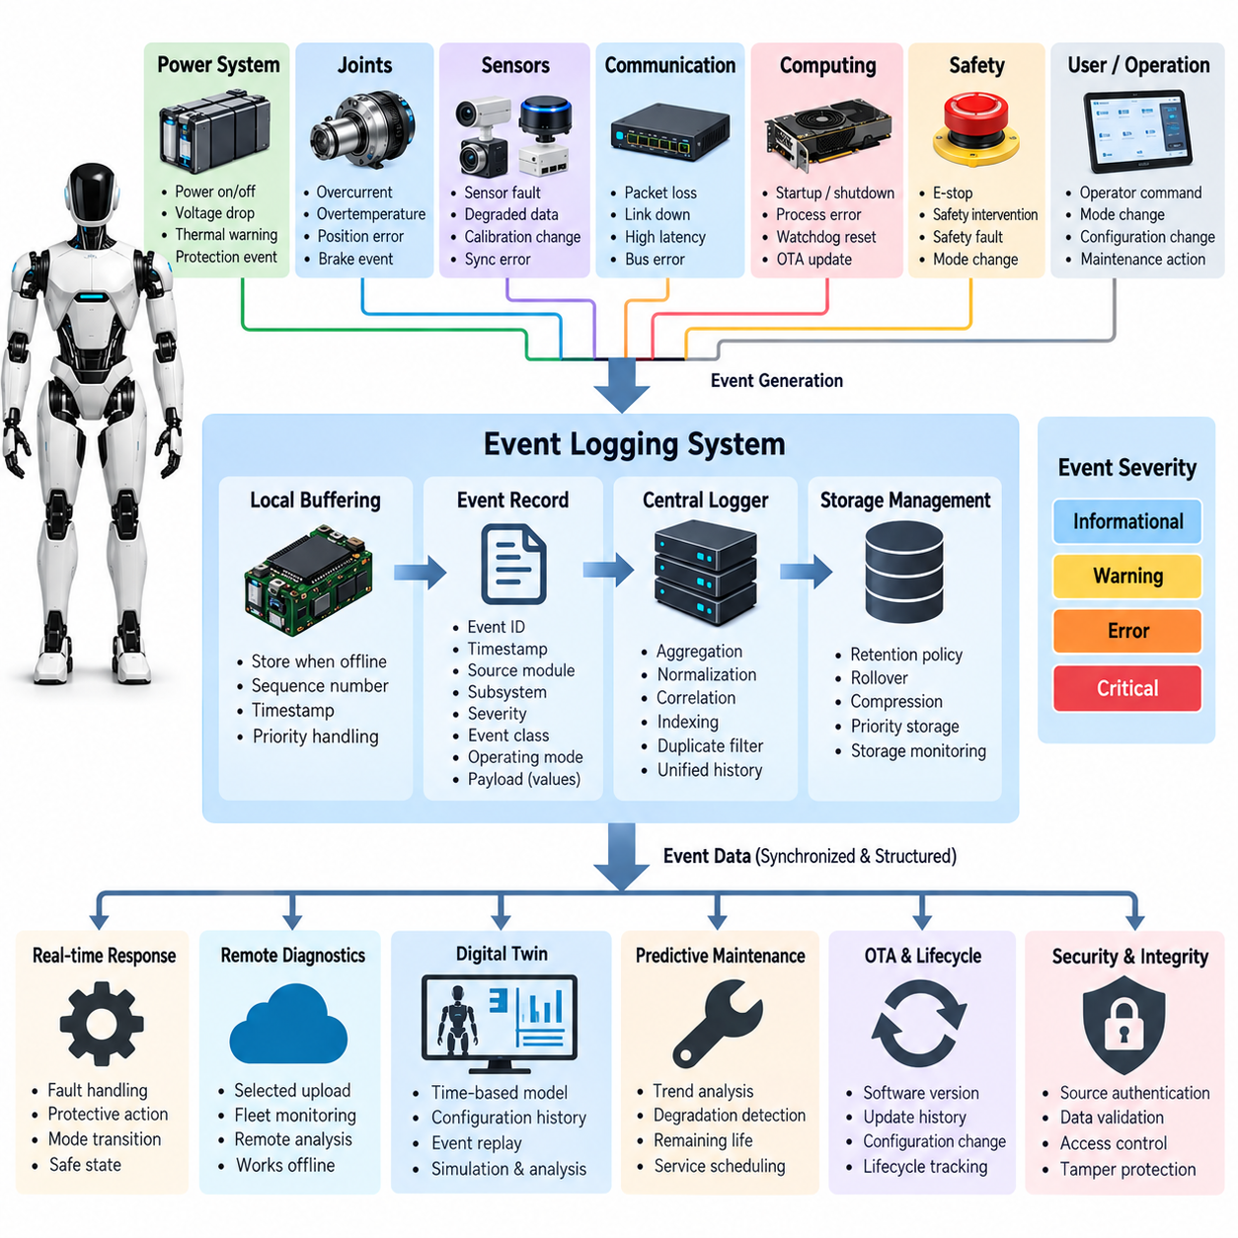
Event logging in a humanoid robot provides a persistent and time-correlated record of significant conditions, transitions, faults, commands, and system activities occurring during operation. While health monitoring continuously evaluates the current condition of components, event logging preserves selected evidence for later analysis. Within the diagnostics and OTA architecture, it forms the historical layer connecting real-time observations with remote diagnostics, digital twins, maintenance, and lifecycle management.
An event should represent a meaningful change rather than every raw measurement generated by the robot. Typical events include power transitions, controller startup and shutdown, actuator faults, sensor degradation, communication loss, watchdog resets, safety interventions, thermal warnings, synchronization failures, software exceptions, configuration changes, and operator commands. Selecting events carefully prevents the logging system from becoming an uncontrolled stream of low-value data while retaining information needed to reconstruct important situations.
A useful event record combines a standardized header with context-specific diagnostic information. The header can contain an event identifier, timestamp, source module, subsystem, severity, event class, operating mode, and sequence number. Additional payload fields may contain measured values, threshold limits, error counters, state transitions, or related component identifiers. A consistent format allows logs from joints, sensors, power electronics, computers, and communication networks to be interpreted by common diagnostic tools.
Accurate timestamps are fundamental because a humanoid executes many distributed processes simultaneously. Joint controllers, perception computers, safety controllers, network devices, and AI processors may observe different symptoms of the same physical event. When their clocks share a synchronized time base, these observations can be ordered and correlated. PTP-based synchronization and local monotonic clocks can therefore support reconstruction of the sequence from an initiating anomaly to subsequent system responses and protective actions.
Event severity should communicate the operational importance of a recorded condition. Informational events describe expected transitions such as startup or mode changes, while warning events indicate conditions requiring observation. Error or degraded events identify loss of capability, and critical events indicate conditions requiring immediate protective action. Severity classification should remain consistent across subsystems so that diagnostic software can prioritize events without requiring detailed knowledge of every individual component implementation.
Event sources should be uniquely identifiable throughout the robot. A source identifier may represent a particular joint controller, battery module, motor drive, camera, LiDAR, compute node, communication interface, or software process. For modular humanoids, identification should also distinguish physical location and replaceable module instances. This makes it possible to determine whether repeated events follow a specific component after service or remain associated with a particular robot location or operating condition.
Distributed event generation requires local buffering because communication to the central diagnostic computer cannot always be guaranteed. A joint controller or sensor node should be able to retain important events temporarily when the network is congested, disconnected, or restarting. Sequence numbers and timestamps allow buffered records to be merged later without losing their original ordering. Critical events may receive higher retention and transmission priority than informational records when local memory or communication bandwidth becomes constrained.
The central event logger aggregates records from distributed modules and maintains a unified operational history. It can normalize event formats, validate timestamps, associate related records, remove unnecessary duplicates, and index events by time, subsystem, severity, or operating state. Central aggregation does not eliminate local logging; instead, the two layers complement each other. Local logs preserve evidence near the source, while centralized records provide the cross-system perspective required for complete fault reconstruction.
Pre-trigger and post-trigger data significantly increase the diagnostic value of critical events. When a major fault occurs, the system can preserve a short rolling buffer containing measurements and states from the period immediately before the trigger and continue recording for a defined period afterward. This creates a diagnostic snapshot that shows not only the detected failure but also the conditions that developed before it and the responses that followed, making intermittent or cascading faults easier to investigate.
Cross-domain correlation converts isolated records into a meaningful failure sequence. For example, a voltage-drop event may be followed by motor-drive undervoltage warnings, communication interruptions, joint-control errors, and a balance-controller transition into a safe state. If these records are synchronized and correlated, diagnostic software can identify the power disturbance as the likely initiating condition rather than treating every downstream symptom as an independent failure requiring separate investigation.
Storage management is necessary because humanoid robots can generate large quantities of operational data over long deployments. The logging architecture should define retention periods, maximum storage allocation, rollover behavior, compression policies, and event priorities. Low-severity records may be overwritten after a defined interval, while critical safety or failure records can be protected for longer periods. Storage utilization itself should be monitored so that exhausted storage does not silently disable diagnostic evidence collection.
Event logging should distinguish persistent lifecycle records from high-rate temporary diagnostic traces. Lifecycle records may contain firmware installation, calibration, module replacement, configuration changes, maintenance actions, accumulated operating hours, and significant failures. Temporary traces may contain detailed sensor, actuator, or network data surrounding a specific event. Separating these data classes allows the robot to retain long-term service history without permanently storing every high-bandwidth signal generated during normal operation.
Software context is essential for interpreting events in a system that supports OTA updates. Each relevant diagnostic record should be associated with firmware or software versions, configuration identifiers, calibration versions, and potentially model versions used by AI functions. If abnormal behavior appears after an update, engineers can compare events before and after deployment and determine whether the behavior correlates with a particular software release, parameter set, or configuration change.
The event logger must remain useful during abnormal shutdown conditions. Important records should be committed using mechanisms that minimize loss if power disappears unexpectedly, while avoiding excessive write activity that shortens storage-device life. Critical events may be written to protected nonvolatile storage, whereas high-rate data can remain buffered until a trigger occurs. Power-fail handling, controlled flushing, and robust file or database structures help preserve diagnostic integrity after resets or emergency shutdowns.
Security and integrity protections prevent logs from becoming unreliable or misleading. Event records should preserve source authenticity, timestamp consistency, access control, and protection against unauthorized modification or deletion. Integrity checks can identify corrupted records, while secure diagnostic interfaces restrict who can retrieve or alter logging configurations. Because logs may reveal detailed robot behavior, operational environments, and software states, exported records should also follow appropriate confidentiality and data-access policies.
Event logging is closely connected to remote diagnostics. Rather than continuously transmitting every robot measurement to an external server, the onboard system can upload selected events, summaries, and diagnostic snapshots according to severity and service requirements. Engineers can then inspect fault sequences remotely while the robot retains complete local evidence. This approach reduces communication bandwidth requirements and allows essential diagnostic recording to continue even when cloud or fleet connectivity is unavailable.
Digital-twin systems can use event history to maintain a time-aware representation of the physical robot. Component replacements, calibration changes, accumulated faults, thermal events, actuator overloads, and software updates can update the digital representation of each module. Event records therefore provide more than troubleshooting information; they establish a chronological link between the physical configuration, operational history, and virtual representation used for simulation, analysis, service planning, and lifecycle tracking.
Predictive maintenance can also exploit structured event histories. Repeated warnings, increasing fault frequency, thermal-limit events, communication retries, actuator overloads, or calibration-related events may reveal degradation trends that are difficult to recognize from a single operating session. When combined with health-monitoring measurements, event statistics can help estimate remaining service life, identify components requiring inspection, and schedule maintenance before degradation develops into an operational failure.
A well-designed event-logging architecture therefore acts as the memory of the humanoid diagnostic system. It transforms transient runtime conditions into synchronized, structured, searchable, and trustworthy engineering evidence. By connecting component events with health monitoring, OTA versions, remote diagnostics, digital twins, and predictive maintenance, the architecture enables engineers to reconstruct failures, understand causal sequences, verify corrective actions, and continuously improve reliability throughout the humanoid robot lifecycle.

13.03. OTA Update [w/Code]
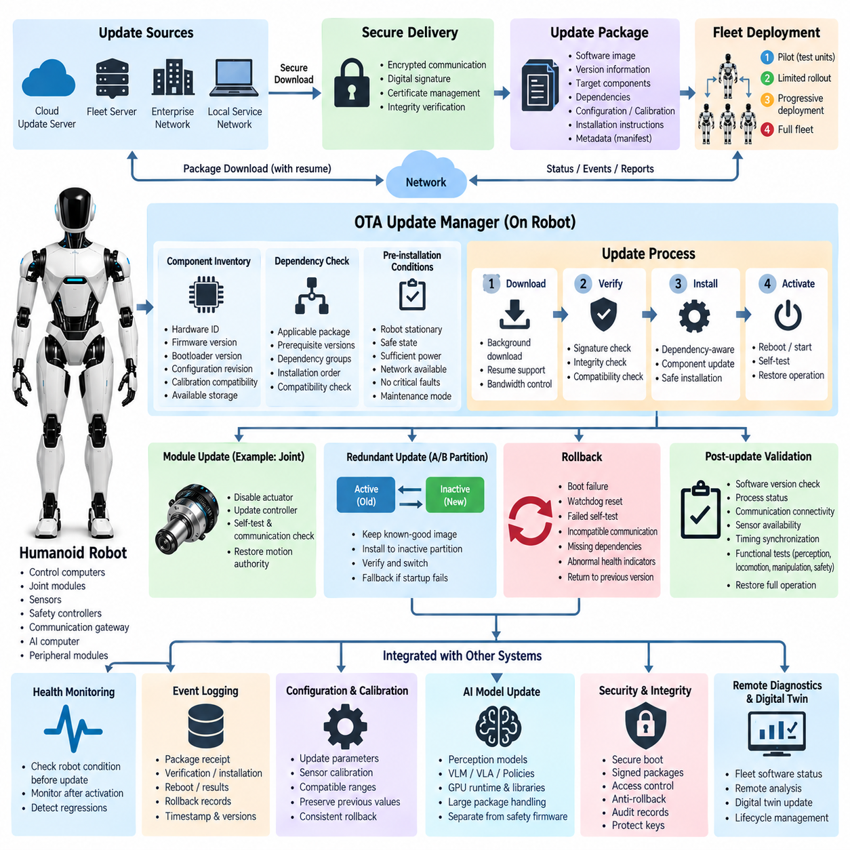
Over-the-air update is the mechanism that allows a humanoid robot to receive, validate, install, activate, and manage new software without requiring direct physical access to every electronic controller. In a distributed humanoid architecture, OTA extends beyond updating a central computer because joint controllers, perception computers, safety-related processors, communication gateways, AI runtimes, and peripheral modules may each contain independently versioned firmware or software.
The OTA architecture should begin with a complete inventory of updateable components and their dependencies. Each electronic module can expose hardware identity, firmware version, bootloader version, configuration revision, calibration compatibility, and available storage. The central update manager uses this information to determine whether a proposed package is applicable to the specific robot configuration and whether prerequisite software or hardware versions are already present.
An update package should contain more than executable software. It normally includes the software image, version information, target component identifiers, dependency rules, integrity information, installation instructions, and compatibility metadata. Humanoid platforms may additionally associate calibration data, AI models, communication configurations, or parameter sets with particular releases. A machine-readable manifest allows the update manager to evaluate the package before modifying any operational component.
Secure package delivery is essential because unauthorized software could directly affect physical robot behavior. Update packages should be digitally signed by an authorized release authority, and the robot should verify authenticity and integrity before installation. Encrypted communication protects packages during transport, while certificate and key management establish trust between the robot and update infrastructure. Verification should occur again before activation so corrupted or substituted software cannot enter the executable chain.
OTA communication may use local service networks, enterprise infrastructure, fleet networks, or cloud connectivity depending on deployment conditions. Large packages should support interrupted-transfer recovery so temporary network loss does not force the entire download to restart. Download bandwidth can also be controlled according to robot workload and network availability. Safety-critical control traffic must retain priority, ensuring that software distribution never interferes with deterministic control or emergency communication.
The update process should separate downloading from installation and activation. A robot may download and verify a package while performing permitted tasks, but installation should occur only when operational conditions are appropriate. The update manager can require the robot to be stationary, mechanically stable, sufficiently charged, connected to external power, or placed in a designated maintenance state before modifying critical controllers. These preconditions reduce the probability of an interrupted or unsafe update.
Distributed updates require dependency-aware sequencing. A communication protocol change, for example, may require coordinated updates to a central controller and several joint modules. Updating only one side could temporarily make the system incompatible. The OTA manager should therefore understand dependency groups, required installation order, minimum compatible versions, and components that must be updated atomically. Coordinated scheduling prevents mixed software states from creating unpredictable behavior.
Humanoid joint modules require particular care because actuator firmware directly influences motion. Updating a motor controller, encoder interface, torque-control algorithm, or brake controller should occur while the associated actuator is disabled or placed in a verified safe state. After installation, the module can perform startup self-tests and communication checks before motion authority is restored. Failure to satisfy these checks should prevent the affected joint from returning automatically to normal operation.
A robust OTA design commonly uses redundant or recoverable software storage. An A/B partition strategy allows the currently validated image to remain available while a new image is written to an inactive partition. After verification, the bootloader attempts to start the new version and confirms successful initialization. If startup fails, the system can return to the previous known-good image rather than leaving the controller unusable because of an incomplete installation.
Rollback is therefore a fundamental OTA capability rather than an exceptional recovery feature. Rollback criteria may include boot failure, watchdog reset, failed self-test, incompatible communication, missing dependencies, abnormal health indicators, or failure to reach a defined operational checkpoint. The previous software version and essential configuration data should remain available until the new release has completed sufficient validation to be accepted as the new known-good baseline.
Post-update validation determines whether installation success also corresponds to functional success. The robot can verify software versions, process status, communication connectivity, sensor availability, actuator readiness, timing synchronization, configuration consistency, and diagnostic health. Higher-level checks may confirm that perception, locomotion, manipulation, and safety services can initialize correctly. Only after the required validation sequence passes should the updated robot or subsystem regain full operational authority.
Health monitoring is closely integrated with OTA because the condition of the robot determines whether an update should begin and whether a new version remains acceptable after activation. Thermal warnings, unstable power, storage errors, communication degradation, or existing critical faults can postpone installation. After activation, the health-monitoring system can observe error rates, resource utilization, resets, timing behavior, and subsystem availability to identify regressions associated with the new release.
Event logging provides the chronological evidence needed to audit every update. Important records include package receipt, signature verification, installation start, component update results, reboot events, validation results, rollback decisions, operator authorization, and final software state. These events should be associated with timestamps, component identities, old and new versions, and update transaction identifiers so engineers can reconstruct exactly how a robot transitioned between software configurations.
Configuration and calibration management should be coordinated with software updates rather than treated as unrelated operations. New actuator firmware may require different control parameters, while perception software may depend on specific sensor calibration or model files. The update manifest should therefore specify compatible configuration ranges and required migrations. Previous values should be preserved when possible so rollback restores a coherent combination of software, parameters, and calibration data.
AI-enabled humanoids introduce another update domain because perception models, vision-language models, vision-language-action models, policies, and other learned components can evolve independently from conventional firmware. Model packages may be significantly larger and may require specific GPU runtimes, libraries, memory capacities, or preprocessing pipelines. The OTA system should manage these dependencies explicitly and distinguish model deployment from safety-critical controller firmware while maintaining a unified version history.
Fleet operation requires controlled deployment rather than simultaneous updates to every robot. New releases can first be installed on development or validation units, followed by a limited production group and then progressively expanded after operational evidence is reviewed. This staged rollout limits exposure to unexpected regressions. Deployment policies can also consider robot location, mission schedule, battery condition, network quality, hardware revision, and maintenance windows before selecting update targets.
The central fleet service should maintain visibility of software configuration across deployed robots. Operators need to identify which robots are current, which are awaiting updates, which failed installation, and which were rolled back. However, cloud connectivity should not be required for basic recovery. Each robot must retain enough local boot, verification, rollback, and diagnostic capability to recover safely when external communication is interrupted during or after an update operation.
Safety-related software requires stronger governance than ordinary application software. Updating functions associated with emergency stopping, actuator limitation, collision detection, balance protection, or safety communication may require additional verification and controlled authorization. The OTA mechanism should preserve the relationship between the released binary, validated configuration, test evidence, and approved software version so field deployment does not unintentionally invalidate assumptions established during safety verification.
Cybersecurity must cover the complete OTA lifecycle from release creation to execution on the robot. Secure boot establishes trust at startup, signed packages authenticate released software, protected keys maintain cryptographic identity, and access control restricts update authorization. Anti-rollback mechanisms may prevent installation of vulnerable obsolete releases, although controlled recovery paths must still exist. Audit records provide evidence of who authorized an update, what was installed, and whether verification succeeded.
Ultimately, OTA update capability transforms software maintenance from a manual service activity into a controlled lifecycle process for the humanoid platform. When integrated with health monitoring, event logging, remote diagnostics, digital twins, and predictive maintenance, OTA enables software defects to be corrected, capabilities to evolve, AI models to improve, and fleet configurations to remain manageable. The objective is not simply remote installation, but trustworthy transition from one validated robot configuration to another while preserving safety, recoverability, traceability, and operational continuity.

13.04. Remote Diagnostics
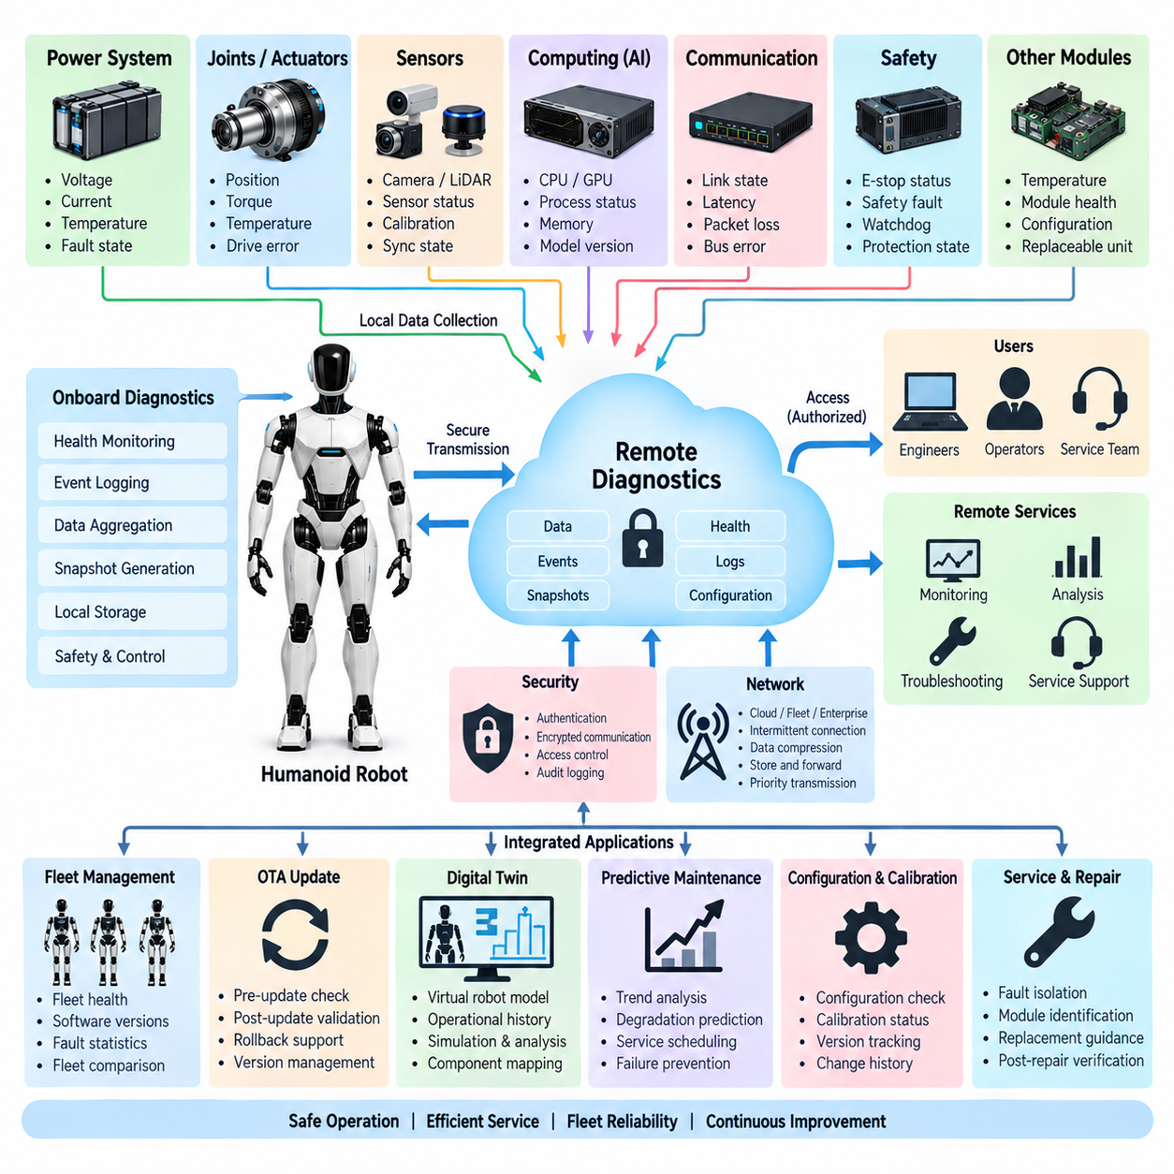
Remote diagnostics enables engineers, operators, and service systems to evaluate the condition of a humanoid robot without requiring physical access to the machine. It extends onboard diagnostics by securely exposing selected health states, event records, software information, configuration data, and diagnostic measurements to authorized external systems. Within the humanoid diagnostics architecture, it connects local monitoring with fleet operations, maintenance, OTA management, digital twins, and engineering analysis.
The architecture should preserve a clear boundary between onboard diagnostic authority and remote observation. Functions required to detect hazardous conditions, execute protective actions, isolate faults, or maintain balance must remain locally available and deterministic. Remote infrastructure may request information or initiate permitted service procedures, but loss of cloud or network connectivity must never prevent the robot from performing essential diagnostics or transitioning to a safe operating condition.
Diagnostic information originates from distributed components including joint controllers, motor drives, battery modules, power distribution units, sensors, perception computers, communication interfaces, safety controllers, and AI computing nodes. Local diagnostic agents collect detailed measurements and convert them into standardized health states and events. A central onboard diagnostic service then aggregates this information before selected data is exposed through the remote diagnostic interface.
A remote diagnostic data model should provide consistent identification of robots, modules, software processes, and replaceable components. Each diagnostic item can include a source identifier, timestamp, health state, severity, diagnostic code, measured value, operating context, and software version. Standardized representation allows service tools to interpret information from heterogeneous components without requiring a different communication mechanism for every actuator, sensor, or computing platform.
Health summaries provide the first level of remote visibility. Instead of transmitting every raw signal continuously, the robot can report subsystem states such as healthy, warning, degraded, critical, or unavailable. Engineers can then navigate from the robot-level state into body regions, modules, and individual diagnostic parameters. This hierarchical approach reduces communication traffic while allowing detailed information to be retrieved when investigation of a particular abnormal condition is required.
Event logs provide the historical context needed to understand how the current condition developed. A remote engineer may retrieve events surrounding a joint fault, power disturbance, communication interruption, watchdog reset, safety intervention, or software update. Because records contain synchronized timestamps and source identities, events from multiple subsystems can be correlated to reconstruct the sequence from an initiating condition through secondary symptoms to the final protective response.
Remote diagnostics should support selective acquisition of higher-resolution data when summarized information is insufficient. An engineer investigating an actuator anomaly may request motor current, temperature, torque, position tracking, or communication statistics for a limited period. Similarly, perception problems may require sensor status, frame counters, synchronization information, or resource utilization. Controlled diagnostic sessions avoid continuously uploading high-bandwidth data that has little value during normal operation.
Snapshot mechanisms can capture a coherent representation of robot condition at a particular time or diagnostic trigger. A snapshot may contain health states, active faults, software versions, configuration identifiers, network status, battery condition, actuator availability, sensor status, and selected recent events. Such snapshots are valuable for intermittent problems because they preserve operating context that may disappear before an engineer connects to the robot or begins an interactive diagnostic session.
Remote diagnostic commands require stricter control than passive data retrieval because they may change robot state. Permitted actions can include requesting self-tests, clearing eligible diagnostic records, restarting noncritical services, collecting additional traces, or entering a maintenance mode. Commands affecting actuators, safety functions, configuration, or software should require explicit authorization and appropriate local preconditions. Remote access should never bypass the robot's safety supervisor or established operational interlocks.
Communication design must tolerate unreliable or bandwidth-limited connections. Diagnostic messages can be prioritized according to severity, with critical fault notifications transmitted ahead of routine statistics. Store-and-forward mechanisms allow important records to remain onboard when connectivity is unavailable and upload later when communication is restored. Compression, batching, rate limiting, and selective subscriptions reduce bandwidth while preserving the evidence required for effective diagnosis.
Fleet-level diagnostics extends the concept from an individual robot to a population of deployed humanoids. A fleet service can compare health states, fault frequencies, software versions, operating hours, thermal events, communication errors, and maintenance history across robots. Patterns that appear insignificant on one unit may become obvious when observed across many systems. Fleet analysis therefore provides a powerful mechanism for identifying systematic hardware, software, manufacturing, or environmental problems.
Remote diagnostics and OTA update management are closely related because diagnostic evidence can determine whether an update should be deployed, postponed, or rolled back. Before installation, the service can verify robot health, battery condition, software versions, storage availability, and active faults. After activation, diagnostic data can reveal increased reset frequency, resource consumption, communication errors, or functional degradation. These observations provide evidence for accepting a release or initiating rollback.
Configuration and calibration information should accompany diagnostic data because identical software can behave differently when parameters or calibration values differ. Remote tools should be able to identify relevant configuration revisions without automatically changing them. When modification is authorized, previous values and transaction history should remain traceable. This enables engineers to distinguish a software defect from incorrect configuration, calibration drift, incompatible hardware revision, or an incomplete service operation.
Digital-twin integration gives remote diagnostics a structured representation of the physical robot. Diagnostic states can be mapped to corresponding virtual components such as joints, batteries, sensors, network interfaces, and compute nodes. Engineers can inspect operational history, component replacements, configuration changes, and accumulated faults through this representation. The digital twin may also support replay and simulation to investigate how observed failures influence higher-level humanoid behavior.
Predictive maintenance uses remotely collected diagnostic history to move service activity from reactive repair toward condition-based maintenance. Trends such as increasing actuator temperature, repeated torque errors, growing communication retry counts, battery degradation, calibration instability, or recurring watchdog events can indicate developing problems. Fleet analytics can compare these trends with similar components and operating histories to prioritize inspection or replacement before functional failure occurs.
Cybersecurity is fundamental because remote diagnostics creates an external path into a physical robotic system. Mutual authentication, encrypted communication, role-based access control, certificate management, secure session establishment, and audit logging should protect diagnostic interfaces. Access privileges should follow the principle of least privilege so an observer who can read health data does not automatically receive authority to execute service commands, modify configurations, or initiate software updates.
Diagnostic data itself may require confidentiality protection. Logs and sensor-related records can reveal robot location, operational schedules, environmental information, customer processes, software architecture, or system vulnerabilities. The architecture should therefore control which data is collected, retained, transmitted, and accessible to different roles. Sensitive information can be filtered or minimized before external transmission while preserving the engineering evidence necessary for fault investigation.
Remote sessions should be fully traceable. The robot and service infrastructure can record connection time, authenticated identity, requested information, executed commands, configuration changes, diagnostic results, and session termination. These records complement normal event logging and create an audit trail for maintenance and cybersecurity investigations. When several engineers or automated services interact with a robot, session traceability helps determine whether observed changes resulted from faults, updates, or service actions.
Serviceability improves when remote diagnostics is designed around modular replacement. Once analysis isolates a problem to a joint controller, sensor module, power converter, or computing unit, the service system can identify the affected module, hardware revision, software state, calibration requirements, and replacement procedure. After replacement, remote diagnostics can verify module identity, communication, configuration, calibration status, and health before the robot returns to normal operation.
The remote diagnostic architecture should ultimately reduce the distance between a physical failure and an engineering decision without transferring safety responsibility away from the robot. Onboard monitoring detects and manages immediate conditions, event logging preserves evidence, remote services provide deeper analysis, OTA delivers validated corrections, digital twins maintain lifecycle context, and predictive maintenance identifies emerging degradation. Together these functions create a closed diagnostic lifecycle supporting safe operation, efficient service, fleet reliability, and continuous improvement of the humanoid platform.

13.05. Digital Twin
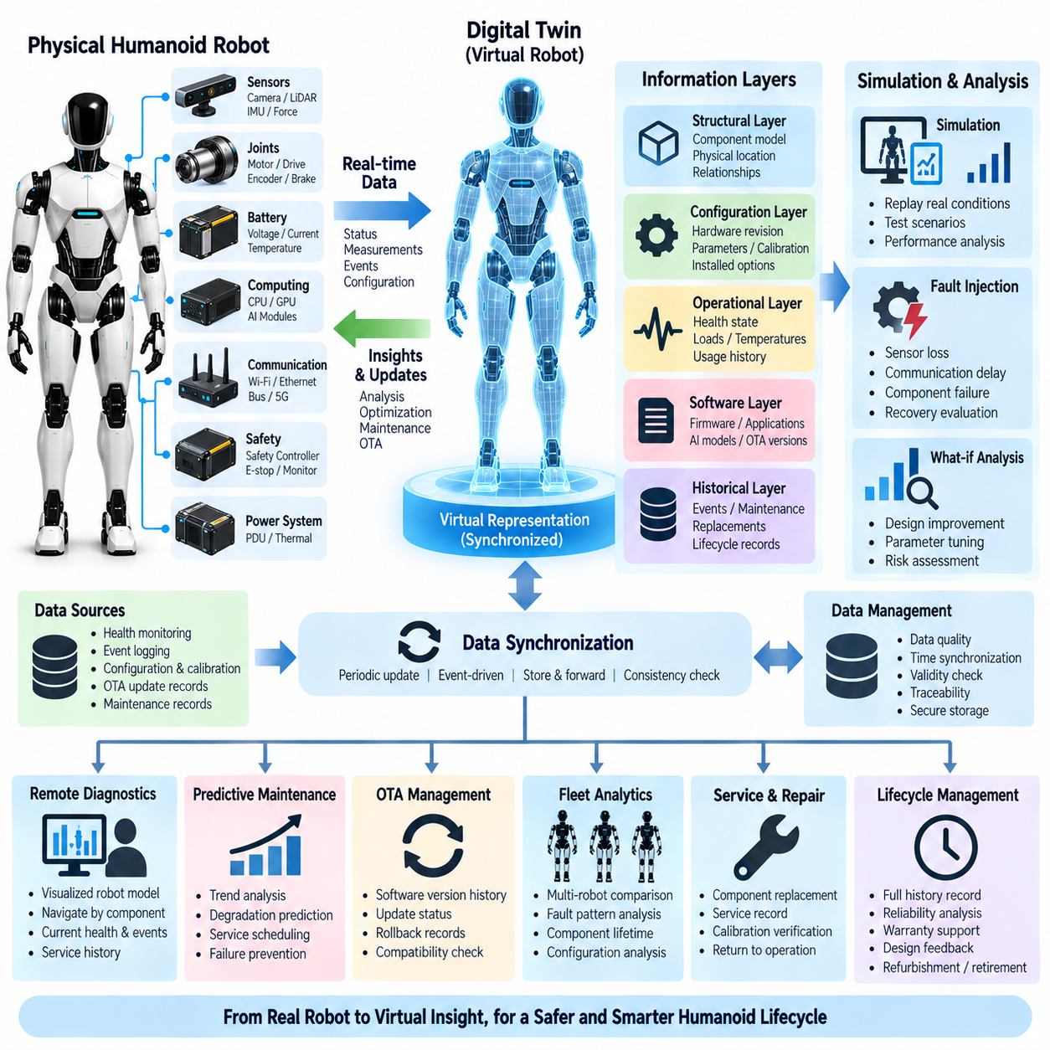
A digital twin for a humanoid robot is a continuously maintained virtual representation of the physical robot, its components, configuration, software state, operating history, and diagnostic condition. Within the diagnostics and OTA architecture, the digital twin connects real-time health monitoring and event records with engineering analysis, remote diagnostics, maintenance, and lifecycle management. It represents not only robot geometry, but also the evolving operational identity of the physical system.
The twin should reflect the modular structure of the humanoid. Virtual entities can represent the battery, power distribution units, joint modules, arms, legs, hands, perception sensors, communication interfaces, computing nodes, and safety controllers. Each entity is associated with the corresponding physical component through a unique identifier, allowing diagnostic measurements, configuration information, replacement history, and software versions to remain attached to the correct hardware throughout its service life.
A useful digital twin contains several complementary information layers. A structural layer describes component relationships and physical locations, while a configuration layer records hardware revisions, parameters, calibration values, and installed options. Operational and diagnostic layers capture health states, faults, temperatures, loads, communication quality, and accumulated usage. A software layer identifies firmware, applications, AI models, and OTA versions, creating a unified representation of the robot's current configuration.
Synchronization between the physical robot and its digital representation is fundamental. Onboard diagnostic services can periodically transmit health summaries, configuration changes, component states, and selected measurements to update the twin. Important events may trigger immediate synchronization, while less critical information can be transferred at lower rates. The architecture should tolerate temporary network loss by preserving relevant records locally and reconciling the twin when communication becomes available again.
Time awareness distinguishes a diagnostic digital twin from a simple configuration database. The twin should preserve how the robot changes over time rather than storing only its latest state. Component replacements, calibration operations, software updates, fault occurrences, thermal excursions, maintenance actions, and operating-hour accumulation form a chronological history. Engineers can therefore inspect both the current robot configuration and the sequence of changes that produced it.
Event logging provides much of the historical evidence required by the digital twin. Synchronized event records can be mapped to virtual components and placed on a common timeline. A joint overtemperature event, communication interruption, safety intervention, controller reset, or OTA installation becomes part of the history of the corresponding component and robot. This mapping allows engineers to navigate from a virtual component directly to the events that describe its operational behavior.
Health monitoring provides the dynamic condition of twin components. A virtual joint can expose motor temperature, tracking performance, torque behavior, communication state, and diagnostic severity, while a battery entity can represent voltage, current, temperature, state of charge, and accumulated operating statistics. The twin does not need every raw measurement continuously; selected health indicators and trends can provide an efficient representation while detailed traces remain available for deeper investigation.
Configuration and calibration traceability are particularly important because humanoid performance depends on many interacting parameters. The twin can record controller parameters, sensor calibration revisions, joint offsets, communication configurations, safety settings, and AI model dependencies. When abnormal behavior appears, engineers can compare the affected robot with a known-good configuration and determine whether the difference originates from hardware, software, calibration, or parameter changes.
OTA integration allows the digital twin to maintain a precise software history. Before an update, the twin can record the current software configuration and compatibility state. During deployment, update events and results are associated with the target components. After activation, the twin records new versions and subsequent health behavior. If rollback occurs, the software state and associated diagnostic evidence remain traceable, allowing engineers to analyze why the new release was rejected.
Remote diagnostics uses the digital twin as an intuitive engineering interface to a geographically distant robot. Instead of examining unrelated diagnostic codes, an engineer can navigate through a structured representation of the robot and inspect the affected body region, module, sensor, controller, or network connection. Current health, recent events, software state, configuration, and service history can be presented together, reducing the time required to understand the context of a reported failure.
Simulation adds analytical value beyond simple visualization. A digital twin can provide the configuration and state information required to recreate selected operating conditions in an engineering simulation environment. Recorded actuator loads, joint states, sensor conditions, fault events, or communication behavior may be replayed to investigate a failure scenario. The objective is not necessarily perfect reproduction of all physics, but a sufficiently representative environment for testing hypotheses and corrective actions.
Fault injection can be combined with simulation to evaluate how the system responds to abnormal conditions. Engineers may reproduce sensor loss, communication delay, actuator degradation, power disturbances, or compute failures in the virtual environment without intentionally exposing the physical robot to unnecessary risk. Results can support diagnostic rule development, software validation, recovery strategy evaluation, and verification that a proposed correction does not introduce unacceptable behavior elsewhere in the system.
Predictive maintenance benefits from the twin's accumulated operational history. Each component can maintain indicators such as operating hours, thermal exposure, actuator load cycles, fault counts, communication errors, battery cycles, and maintenance actions. Trend analysis can compare these indicators with historical behavior or similar components across a fleet. The twin therefore becomes a structured source for estimating degradation and determining when inspection, calibration, or replacement should be considered.
Component replacement must update both the physical robot and its digital representation. When a joint module, sensor, compute unit, or power component is replaced, the old component's history should remain preserved while the new component receives a distinct identity and service record. Installation time, hardware revision, firmware version, calibration status, and verification results can be recorded. This prevents the lifecycle history of different physical components from being incorrectly merged.
Fleet-level digital twins extend the concept beyond a single humanoid. Individual robot twins can contribute standardized health, configuration, event, and maintenance information to fleet analytics. Engineers can compare fault frequencies, component lifetimes, software behavior, thermal trends, and configuration differences across deployed robots. Systematic patterns can reveal design weaknesses or manufacturing variation that would be difficult to recognize by examining isolated robots independently.
The digital twin should not become part of the safety-critical control loop unless specifically engineered and validated for that purpose. Essential balance control, collision response, actuator protection, emergency stopping, and local fault handling must continue onboard even when the twin or network is unavailable. The digital twin primarily supports observation, analysis, service, validation, and lifecycle decisions, preserving a clear separation between remote engineering functions and deterministic robot safety functions.
Data quality directly determines twin quality. Incoming information should therefore be associated with source identity, timestamp, validity state, software version, and synchronization quality where appropriate. Missing or stale data should be represented explicitly rather than interpreted as a healthy condition. Consistency checks can identify conflicting configuration records or impossible state combinations, preventing engineers and automated analytics from making decisions based on an inaccurate virtual representation.
Cybersecurity and access control are required because the twin can contain detailed information about robot architecture, software, operating environments, faults, and maintenance activities. Authentication, authorization, encrypted communication, audit logging, and data integrity protection should apply to twin services. Different roles may receive different visibility or modification rights, particularly when digital-twin functions are connected to remote diagnostics, configuration management, or OTA operations.
Lifecycle management is one of the strongest reasons to maintain the twin beyond immediate troubleshooting. A robot may undergo numerous software releases, component replacements, calibration procedures, repairs, and configuration changes over years of operation. The digital twin preserves continuity across these changes and provides engineering evidence for reliability analysis, service planning, warranty decisions, design improvement, and eventual retirement or refurbishment of components and complete robots.
Ultimately, the digital twin serves as the persistent engineering representation that connects the physical humanoid with its diagnostic and lifecycle information. Health monitoring describes current condition, event logging preserves what happened, remote diagnostics provides engineering access, OTA records software evolution, and predictive maintenance interprets degradation trends. Integrated through the twin, these functions create a traceable relationship between physical configuration, operational history, virtual analysis, and future service decisions throughout the humanoid lifecycle.

13.06. Predictive Maintenance
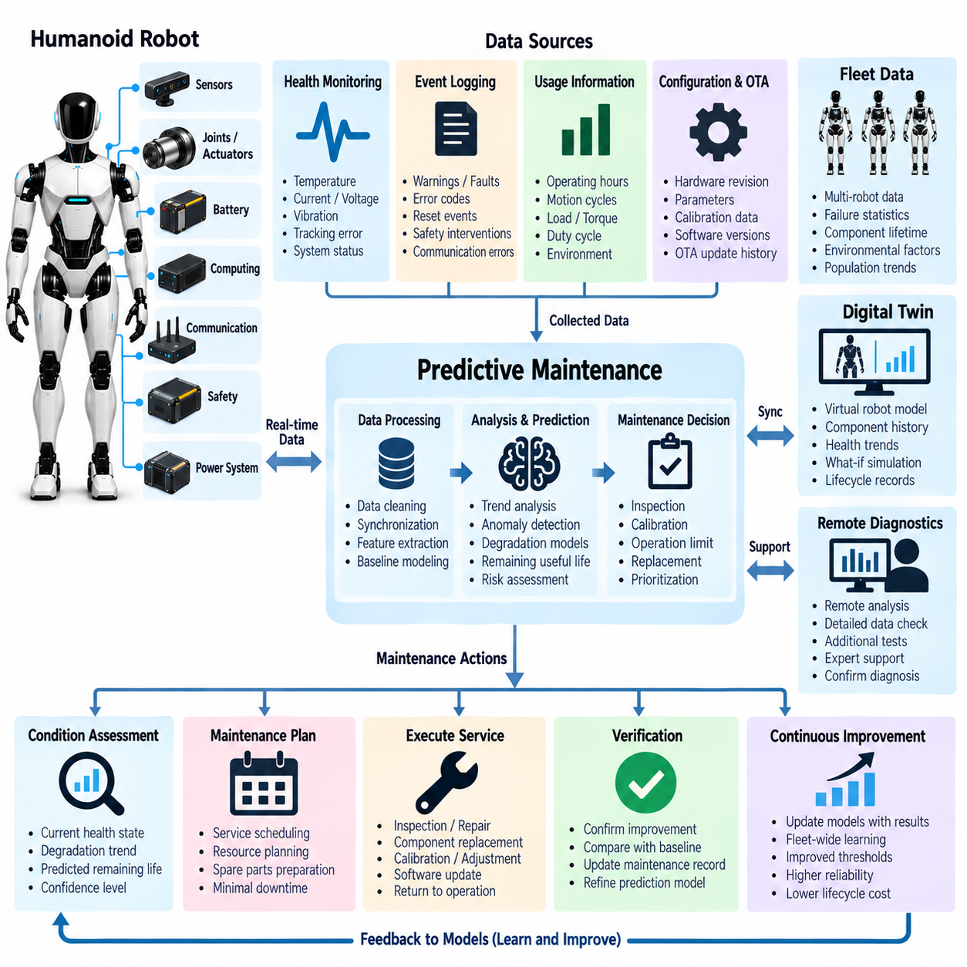
Predictive maintenance for a humanoid robot uses operational data, diagnostic history, and degradation indicators to estimate when components are likely to require inspection, calibration, repair, or replacement. Unlike fixed-interval maintenance, which services equipment according to elapsed time alone, predictive maintenance evaluates the actual condition and usage of the robot. Within the diagnostics architecture, it converts accumulated health information into practical maintenance decisions.
Humanoid robots are particularly suitable for predictive maintenance because they contain many repeatedly loaded electromechanical components. Joint actuators, bearings, gearboxes, brakes, encoders, batteries, cooling devices, connectors, sensors, and computing systems experience different combinations of load, temperature, vibration, motion cycles, and environmental exposure. Their degradation therefore depends not only on operating hours but also on how intensively and under what conditions each component has been used.
Health monitoring provides the continuous measurements required to observe degradation. Joint controllers can report motor current, winding temperature, driver temperature, tracking error, torque response, encoder consistency, and communication quality. Battery systems provide voltage, current, temperature, state of charge, and cycle information, while compute nodes provide thermal and resource statistics. These signals become more valuable when analyzed as trends rather than isolated instantaneous measurements.
Event logging complements continuous measurements by preserving discrete evidence of abnormal behavior. Repeated overtemperature warnings, torque-limit events, communication retries, encoder inconsistencies, watchdog resets, undervoltage events, or safety interventions may indicate deterioration even when the robot continues operating normally. The frequency, duration, severity, and combination of these events can therefore become maintenance indicators that reveal problems before a permanent failure occurs.
Usage information provides essential context for interpreting component condition. Two identical joints may have the same operating hours but very different remaining life if one repeatedly supports high loads while the other performs light motions. Maintenance models should therefore consider accumulated torque, motion cycles, velocity, acceleration, impact exposure, thermal history, payload, duty cycle, and operating mode. Condition assessment becomes more meaningful when degradation is normalized by actual mechanical and electrical stress.
Trend analysis is one of the fundamental predictive techniques. Instead of treating a motor temperature of a particular value as a fault by itself, the system can determine whether temperature under comparable load conditions has gradually increased over weeks or months. Similar trends may appear in current consumption, tracking error, communication retries, battery resistance, or cooling performance. Persistent deviation from a historical baseline can indicate progressive degradation requiring investigation.
Baseline models should represent expected behavior under relevant operating conditions. A humanoid joint naturally produces different current and temperature profiles during standing, walking, lifting, or dynamic manipulation. Comparing all measurements against one fixed threshold can therefore create false alarms. Baselines can account for commanded torque, velocity, ambient temperature, payload, robot posture, and task type so that deviations reflect unusual component behavior rather than normal changes in workload.
Cross-signal correlation improves diagnostic confidence because many degradation mechanisms affect several measurements simultaneously. Increasing motor current together with rising temperature and worsening position tracking may provide stronger evidence of joint friction or mechanical deterioration than any single indicator. Similarly, repeated compute throttling combined with increasing fan activity and temperature can indicate cooling degradation. Correlation helps separate persistent physical problems from temporary measurement variation.
Predictive maintenance can use statistical models, engineering rules, machine-learning methods, or combinations of these approaches. Rule-based indicators are useful when degradation mechanisms and acceptable limits are well understood. Statistical methods can identify deviations from historical distributions, while machine-learning models can detect complex multivariable patterns. The selected method should remain interpretable enough that engineers can understand why a maintenance recommendation was generated and what evidence supports it.
Remaining useful life estimation attempts to predict how much operation may remain before a component reaches a defined service limit. Such estimates can use accumulated cycles, degradation slopes, historical failure populations, thermal stress, or learned condition models. For humanoids, remaining useful life should generally be expressed with uncertainty rather than as an exact failure time because robot tasks, loads, environments, and future operating conditions can change significantly.
Maintenance decisions should therefore combine predicted risk with operational importance. A degrading finger actuator may permit temporary reduced manipulation capability, while deterioration in a load-bearing leg joint may require much earlier intervention because failure could affect balance and safety. Component criticality, redundancy, fault tolerance, service accessibility, replacement cost, and mission schedule should influence how diagnostic predictions are converted into inspection or replacement priorities.
Digital twins provide a structured environment for maintaining predictive-maintenance information throughout the robot lifecycle. Each virtual component can store installation date, hardware revision, software state, calibration history, operating hours, accumulated loads, health trends, faults, and previous maintenance actions. When a physical module is replaced, its historical record remains associated with the removed component while the replacement begins a new traceable lifecycle within the robot configuration.
Fleet analytics significantly strengthens predictive maintenance when many humanoids use comparable components. Data from multiple robots can reveal whether a particular actuator revision, sensor batch, connector type, software release, or operating environment is associated with elevated failure rates. A component that appears only slightly abnormal on one robot may become important when similar degradation is observed across the fleet. Population statistics also improve expected-life and failure-risk estimates.
Remote diagnostics allows maintenance specialists to investigate predictive warnings before dispatching service personnel. Engineers can review health trends, recent events, configuration, software versions, and high-resolution diagnostic snapshots from a distant location. Additional measurements or self-tests may be requested when necessary. This process can distinguish genuine degradation from configuration problems or temporary operating conditions and can help determine which replacement parts and tools are required.
OTA updates can affect predictive indicators and must therefore remain connected to maintenance history. A new motor-control algorithm, thermal-management strategy, sensor-processing function, or AI model may change measured behavior without corresponding physical degradation. Predictive systems should associate measurements with software and configuration versions so changes following an update can be recognized. Conversely, OTA may deliver improved diagnostic algorithms or corrected thresholds without requiring physical service.
Maintenance recommendations should be generated with graded urgency rather than as a simple failure prediction. The system may identify a component for observation, recommend inspection during the next planned service window, request calibration, restrict demanding operation, or require replacement before further use. This graded approach allows maintenance resources to be allocated according to evidence and risk while avoiding unnecessary replacement of components that still provide acceptable performance.
After maintenance, verification closes the diagnostic loop. Replacement, lubrication, adjustment, connector repair, cooling-system cleaning, or calibration should be followed by measurements confirming that the abnormal indicators have returned toward the expected baseline. The maintenance action and verification results should be logged and associated with the affected component. These outcomes also provide valuable labeled evidence for improving future degradation models and diagnostic thresholds.
Data quality is critical because inaccurate measurements can produce misleading maintenance predictions. Predictive algorithms should consider sensor validity, timestamp synchronization, missing samples, calibration state, software version, and operating context before interpreting trends. Missing or stale information should reduce prediction confidence rather than being silently treated as normal. Confidence values can help engineers distinguish strong degradation evidence from preliminary indications requiring additional observation.
Cybersecurity and traceability remain important because maintenance recommendations may influence whether a robot is permitted to operate. Diagnostic data, model versions, threshold changes, maintenance records, and generated predictions should be protected against unauthorized modification. Audit records should identify relevant software, configuration, data sources, and service actions so engineers can reconstruct why a recommendation was produced and determine whether subsequent maintenance resolved the observed condition.
Ultimately, predictive maintenance converts the diagnostic history of the humanoid into forward-looking engineering knowledge. Health monitoring provides current measurements, event logging preserves abnormal occurrences, remote diagnostics supports investigation, the digital twin maintains lifecycle context, OTA records software evolution, and fleet analytics reveals population-level patterns. Together, these functions enable maintenance to move from scheduled or reactive repair toward condition-based intervention that improves availability, reliability, service efficiency, and safe operation throughout the humanoid lifecycle.

