Volume 03 Real Time Operating Systems

02. FreeRTOS

02.01 FreeRTOS Architecture Overview: Porting / Kernel Config
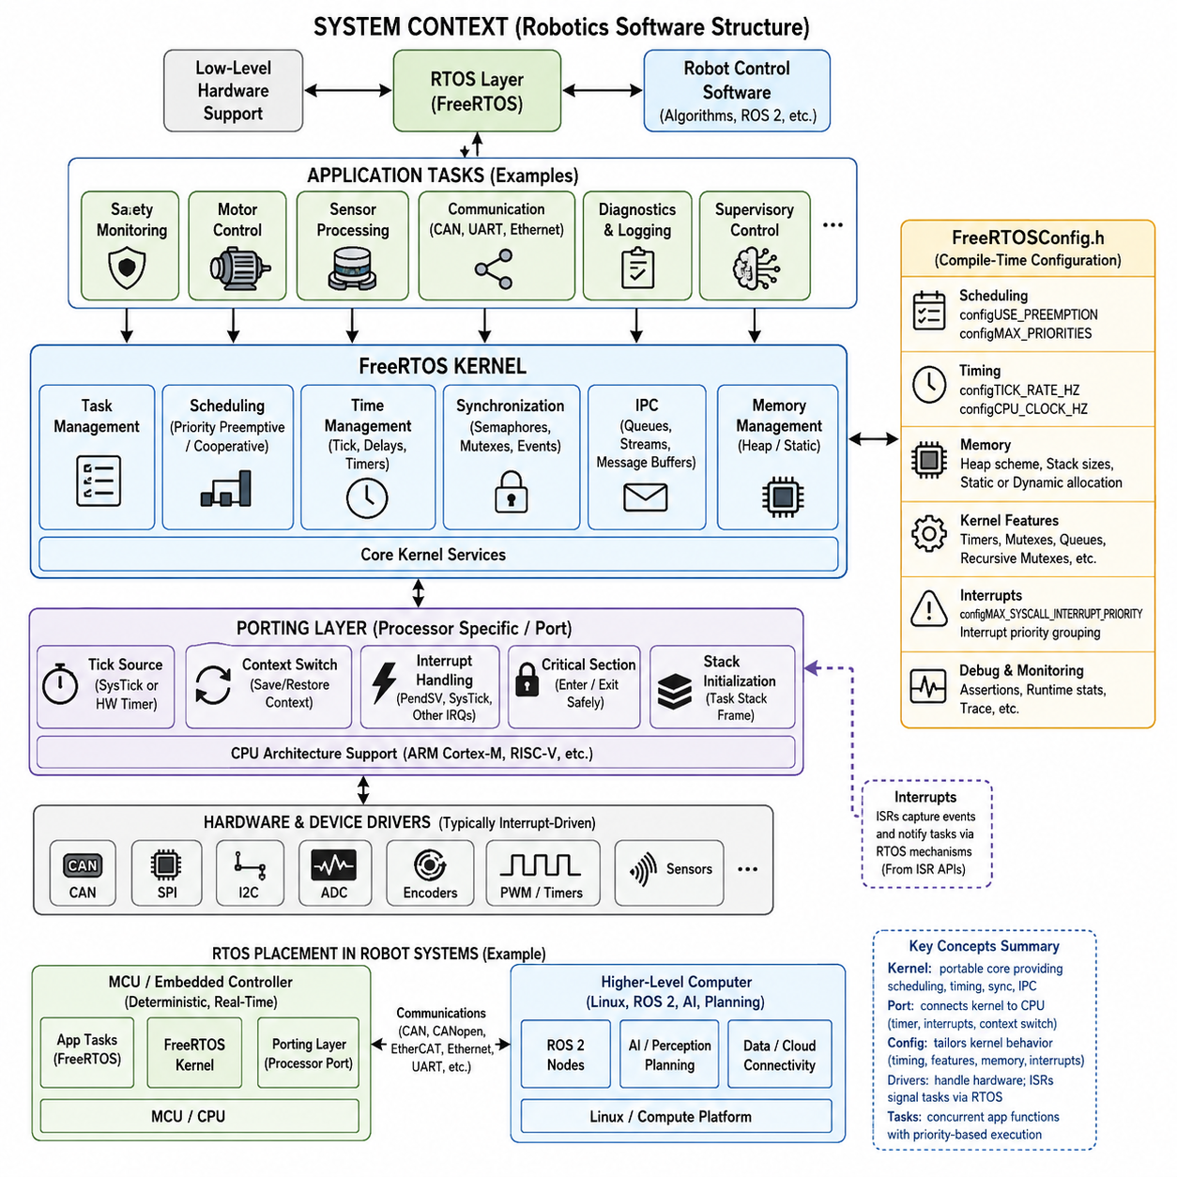
FreeRTOS is a compact real-time operating system kernel designed primarily for microcontrollers and resource-constrained embedded processors. Within the robotics software structure, it belongs to the RTOS layer between low-level embedded hardware support and higher-level robot control software. Its architecture emphasizes deterministic scheduling, small memory footprint, portability, and explicit control over timing-sensitive execution.
The core architecture is organized around a small kernel that manages tasks, scheduling, timing, synchronization, and inter-task communication. Application functions are normally decomposed into independent tasks, each represented by a task control block and an associated stack. The scheduler determines which ready task executes according to priority and scheduling configuration, while blocked tasks consume no processor time until their waiting conditions are satisfied.
FreeRTOS normally uses priority-based preemptive scheduling, although cooperative scheduling can also be configured. When preemption is enabled, a higher-priority task that becomes ready can immediately replace a lower-priority running task. This behavior makes the kernel suitable for robot controllers where safety monitoring, motor feedback processing, communication handling, and supervisory functions may require clearly differentiated response priorities and bounded execution behavior.
A FreeRTOS application is constructed from the kernel source, portable processor-specific code, configuration definitions, and application software. Most kernel functionality is processor independent, while architecture-dependent operations are isolated within the portable layer. This separation allows the same task, queue, semaphore, and timer APIs to operate across different MCU families while only a relatively small portion of the kernel must be adapted to a processor architecture.
Porting FreeRTOS therefore focuses primarily on connecting the kernel to the target processor's interrupt, timer, stack, and context-switching mechanisms. A port must establish the scheduler tick source, initialize task stack frames, save and restore processor context, enter and exit critical sections safely, and trigger context switches when scheduling decisions require them. CPU architecture details such as register sets and interrupt behavior are consequently concentrated in the port layer.
The SysTick peripheral is frequently used as the kernel tick source on Arm Cortex-M microcontrollers, although another hardware timer may be selected when required by the platform. Each tick allows the kernel to update timing information and determine whether delayed tasks should become ready. The configured tick frequency therefore influences timing resolution, interrupt overhead, timeout granularity, and the behavior of periodic software activities implemented through RTOS timing services.
Context switching is another fundamental responsibility of the processor port. When execution changes from one task to another, the processor state of the current task must be preserved and the state of the selected task restored. Cortex-M ports can exploit architectural mechanisms such as PendSV for deferred context switching and SysTick for periodic kernel timing, allowing FreeRTOS to implement task switching with relatively low software overhead and predictable processor behavior.
FreeRTOSConfig.h acts as the central compile-time configuration interface between the kernel and a particular application. Rather than modifying kernel source code directly, developers normally select kernel behavior through configuration macros. These settings control features such as preemption, tick frequency, maximum task priorities, minimal stack size, heap usage, software timers, mutexes, recursive mutexes, queue capabilities, runtime statistics, assertions, and optional API inclusion.
Several configuration parameters directly affect real-time behavior. configUSE_PREEMPTION determines whether priority-based preemption is enabled, while configTICK_RATE_HZ establishes kernel tick frequency. configMAX_PRIORITIES defines the available priority range, and configCPU_CLOCK_HZ may describe the processor clock where required by the port. These values should be selected as part of the timing architecture rather than treated merely as software build options.
Kernel configuration also determines the memory model exposed to the application. FreeRTOS can support dynamically created kernel objects through its heap management implementations, while static allocation permits tasks, queues, semaphores, and other objects to use memory supplied by the application. In deterministic robot firmware, static allocation can be particularly useful because memory consumption is established explicitly and runtime allocation behavior can be minimized or eliminated.
Interrupt configuration requires special attention during porting because FreeRTOS distinguishes interrupts that may call kernel-aware APIs from interrupts that must remain independent of the kernel. On processors supporting interrupt priorities, configuration values establish the priority boundaries governing these interactions. Incorrect priority configuration can create subtle failures because an interrupt operating outside the permitted range must not invoke FreeRTOS functions that manipulate scheduler-managed objects or require kernel synchronization.
The kernel itself remains deliberately separate from hardware device drivers. FreeRTOS schedules execution and supplies synchronization and communication mechanisms, but peripherals such as CAN controllers, SPI devices, motor-control timers, ADCs, encoders, and sensors are normally managed by MCU-specific drivers or hardware abstraction layers. Interrupt service routines can capture hardware events and transfer information toward tasks through appropriate RTOS synchronization mechanisms.
This separation is particularly important in robotics because different timing domains coexist within one controller. Extremely fast current-control or PWM functions may remain directly interrupt driven, while slower velocity, position, communication, diagnostics, and supervisory functions execute as FreeRTOS tasks. The kernel therefore does not replace hardware-level real-time control; it provides an execution framework that coordinates concurrent activities while preserving priority relationships and predictable response paths.
A practical porting process begins by selecting a FreeRTOS port that matches the processor architecture and compiler, integrating the required kernel source files, defining FreeRTOSConfig.h, and connecting the timer and interrupt infrastructure. The developer then validates scheduler startup, task switching, delays, interrupt-to-task signaling, critical sections, stack usage, and timing behavior before integrating complex application functions. Port correctness must be established before application timing results can be trusted.
Kernel configuration should also be treated as part of the system architecture and configuration management process. Changes to tick frequency, priority count, stack sizes, interrupt priority limits, timer-task parameters, or enabled APIs can alter timing, memory consumption, and execution behavior throughout the firmware. Production robot software should therefore version and review FreeRTOSConfig.h together with the application rather than regarding it as a generic platform header.
For robot systems, FreeRTOS commonly occupies the MCU-level deterministic execution layer beneath higher-level computing environments. A motor controller, joint controller, sensor node, battery controller, or safety-oriented embedded subsystem can execute FreeRTOS while exchanging commands and state with Linux or ROS 2 computers through CAN, CANopen, EtherCAT, Ethernet, UART, or other interfaces. This placement is consistent with the broader robotics software hierarchy in which RTOS technology forms a dedicated real-time operating-system domain.
The architectural value of FreeRTOS ultimately comes from combining a small portable kernel with processor-specific porting and application-specific configuration. The kernel provides reusable scheduling and synchronization semantics, the port translates those semantics into actual processor operations, and FreeRTOSConfig.h specializes kernel behavior for the target system. Understanding these three layers is essential before progressing to task APIs, queue-based IPC, synchronization objects, timers, memory management, networking, and robot-control implementations.

02.02 Task Creation and Management API [w/Code]
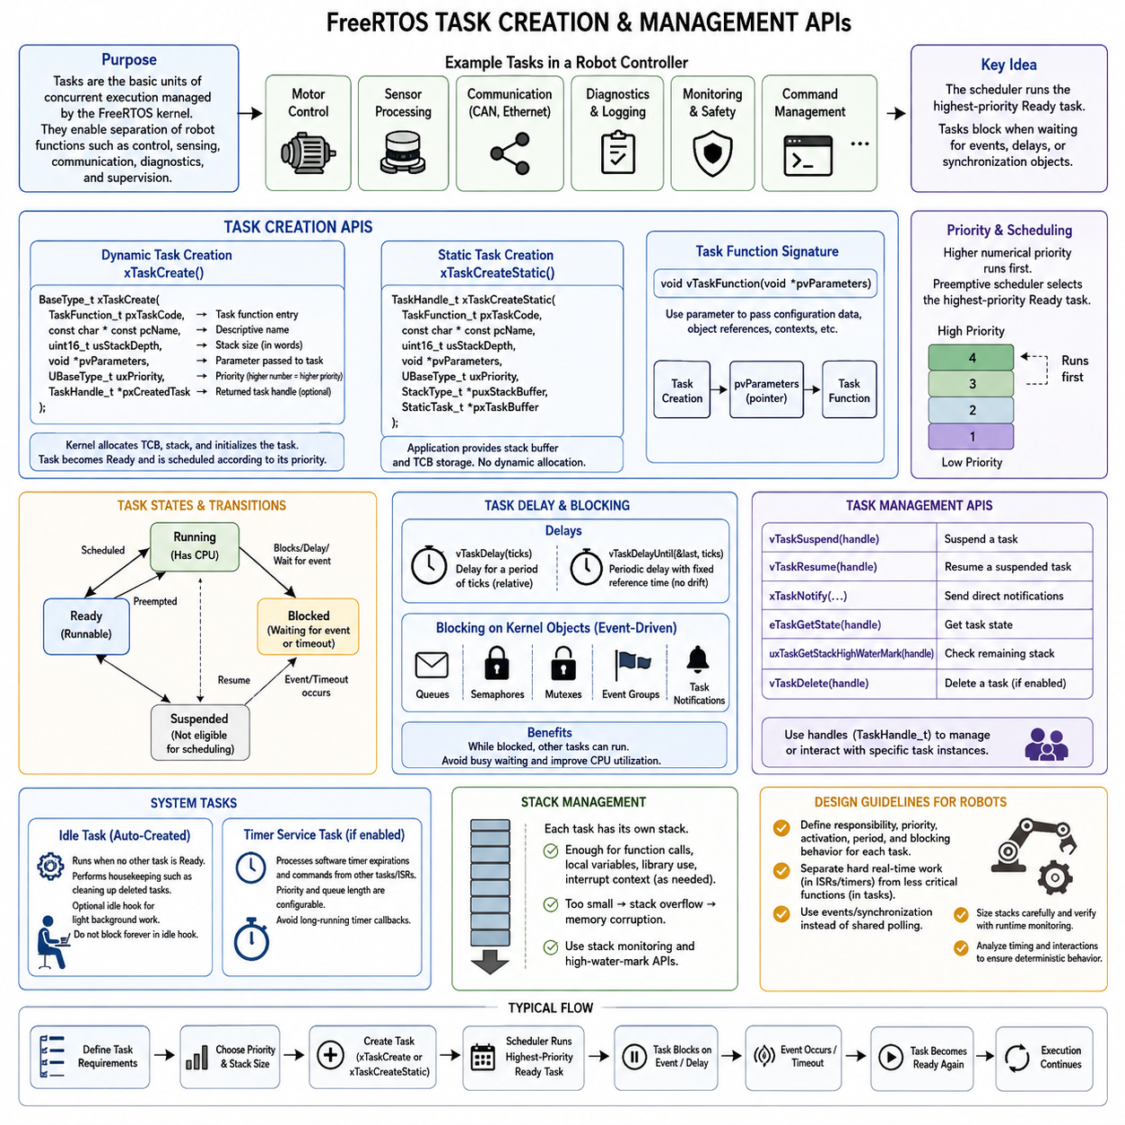
FreeRTOS represents application concurrency through tasks, which are independently scheduled execution contexts managed by the kernel. A task is typically implemented as a C function that can execute repeatedly for the lifetime of the system, while the kernel maintains its execution state, priority, stack, and scheduling information. In robotics, tasks provide a natural structure for separating motor control, sensing, communication, diagnostics, and supervisory functions.
Each FreeRTOS task is associated with a Task Control Block, or TCB, containing information required by the scheduler to manage that task. The kernel also provides each task with its own stack for local variables, function calls, and saved processor context. Although application developers normally interact with tasks through the FreeRTOS API rather than manipulating these internal structures directly, understanding the TCB and stack relationship is important for memory sizing and debugging.
Dynamic task creation is commonly performed with xTaskCreate(), which receives a task function, descriptive name, stack depth, optional parameter pointer, priority, and optional task handle destination. When creation succeeds, FreeRTOS allocates the required task-management structures and stack using its configured memory-management mechanism. The task becomes eligible for scheduling according to its initial state and priority once the scheduler is operating.
Applications requiring explicit memory ownership can instead create tasks statically with xTaskCreateStatic(). In this approach, the application supplies the task stack and storage required for the task control structure rather than requesting them dynamically from the FreeRTOS heap. Static creation is valuable in deterministic embedded and robot controllers because memory requirements can be established before runtime and unexpected allocation failures can be avoided during normal operation.
A FreeRTOS task function normally accepts a single void pointer parameter, allowing configuration data, object references, device contexts, or application structures to be passed when the task is created. This enables one task implementation to support multiple instances without relying heavily on global variables. For example, the same motor-control task function could receive different motor channel structures when instantiated for several independent actuators.
Task priority is one of the most important parameters supplied during task creation. Higher numerical priorities normally represent more urgent execution requirements, and the scheduler selects the highest-priority task that is currently ready to run. Priority assignment should therefore reflect timing and response requirements rather than software importance alone. A short emergency-monitoring task may require higher priority than a computationally larger logging or communication task.
Task states describe whether a task can currently execute. A task in the Ready state is capable of running but may be waiting for processor access, while the Running task currently owns the processor. A Blocked task waits for an event or timeout, and a Suspended task is explicitly excluded from scheduling until resumed. Understanding these transitions is fundamental because efficient FreeRTOS applications spend substantial time blocked rather than continuously polling hardware or shared state.
vTaskDelay() allows a task to enter the Blocked state for a specified number of kernel ticks. This is useful when approximate periodic delays are sufficient, but repeated use can allow execution-time variations to influence the actual activation period. vTaskDelayUntil() is better suited to periodic activities because it schedules the next wake-up relative to a maintained reference time, helping reduce accumulated drift in cyclic control, sampling, monitoring, and communication tasks.
Tasks can also block while waiting for kernel objects such as queues, semaphores, mutexes, event groups, or task notifications. This event-driven execution model is usually preferable to busy waiting because processor time becomes available to other tasks while no useful work exists. In a robot controller, a sensor-processing task can remain blocked until new data arrives, while a communication task can sleep until a message or transmission event requires attention.
FreeRTOS provides task handles through the TaskHandle_t type so that application code can refer to specific task instances after creation. Handles are used by management APIs that suspend, resume, notify, query, or otherwise interact with tasks. Retaining a handle is particularly useful when supervisory software must control another task, although designs should avoid excessive direct task-to-task control when synchronization objects or event-driven communication provide cleaner architectural separation.
A task can be suspended with vTaskSuspend() and returned to scheduling with vTaskResume(), while appropriate ISR-specific mechanisms are required when resumption originates from an interrupt context. Suspension differs from normal blocking because a suspended task does not automatically become ready after a timeout. It is therefore useful for explicit operating-mode control, but ordinary synchronization and timing requirements are generally better represented by blocking on kernel events.
Task deletion is supported through vTaskDelete() when enabled by the kernel configuration. Deleting a task removes it from scheduling and allows kernel-managed task resources to be reclaimed according to the FreeRTOS implementation and allocation model. However, application-owned resources such as peripheral state, dynamically allocated application buffers, open interfaces, or synchronization relationships may require explicit cleanup before deletion to prevent resource leaks or inconsistent system state.
The idle task is created automatically when the scheduler starts and executes whenever no application task is ready. Besides providing a valid execution context, it performs kernel housekeeping associated with tasks that have deleted themselves. Applications may optionally configure an idle hook for lightweight background activity, but the hook must not perform operations that indefinitely block the idle task because doing so can interfere with kernel maintenance and low-priority execution behavior.
FreeRTOS also creates a timer service task when software timers are enabled. This task processes software timer expirations and associated callback functions, and its priority and queue length are determined through kernel configuration. Although it is not an ordinary application task, its scheduling characteristics interact with application workloads. Long-running timer callbacks should therefore be avoided because they can delay processing of other timer-related commands and expirations.
Stack sizing is a critical part of task management in resource-constrained controllers. Each task requires enough stack for nested function calls, local variables, library operations, interrupt-related context requirements where applicable, and temporary processing. Excessively large stacks waste scarce RAM, while insufficient stacks can corrupt memory and cause unpredictable failures. FreeRTOS stack monitoring facilities and high-water-mark APIs can help determine realistic margins during testing.
Runtime task-management APIs can also provide information useful for diagnostics and verification, including task state, priority, stack margin, and scheduler statistics when corresponding configuration options are enabled. Such information is valuable during integration because apparently functional firmware may still contain starvation, excessive CPU utilization, insufficient stack capacity, or incorrect priority relationships. Runtime observation should therefore complement static task architecture and timing analysis.
For robot firmware, a practical task architecture often separates hard timing-sensitive activities from less critical background functions. Fast hardware control may remain inside timer or peripheral interrupt mechanisms, while FreeRTOS tasks coordinate velocity or position control, sensor processing, CAN or CANopen communication, fault monitoring, diagnostics, and command management. This preserves rapid hardware response while allowing the RTOS scheduler to organize concurrent software activities predictably.
Effective task management therefore requires more than calling task-creation APIs. Developers must define task responsibilities, priorities, activation mechanisms, execution periods, blocking behavior, stack sizes, resource ownership, and termination rules as one coherent real-time architecture. FreeRTOS task APIs provide the mechanisms, while system-level timing analysis determines how those mechanisms should be used to construct deterministic and maintainable robot controllers within the broader RTOS software structure.

02.03 Queue-Based IPC Implementation [w/Code]
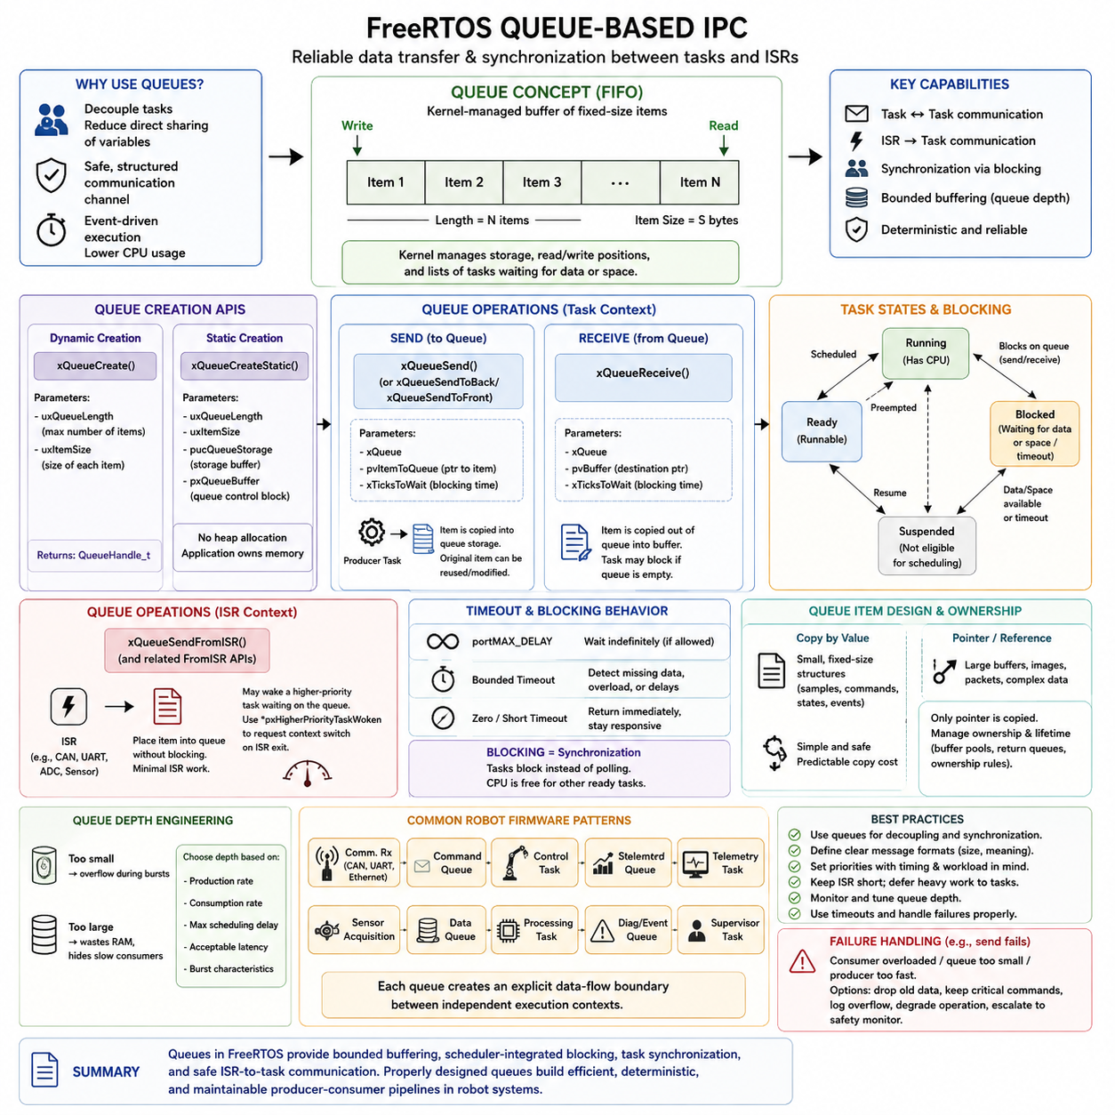
FreeRTOS queues provide a structured inter-process communication mechanism for transferring data between concurrently executing tasks and between interrupt service routines and tasks. Although FreeRTOS tasks share the same address space, queues establish controlled communication channels that reduce direct dependence on shared variables. This makes them especially useful in robot firmware where sensing, control, communication, diagnostics, and supervisory functions execute independently.
A queue can be understood as a kernel-managed first-in, first-out data buffer containing a predefined number of fixed-size items. When the queue is created, the application specifies both the maximum number of items and the size of each item. FreeRTOS then manages the queue storage, read and write positions, and lists of tasks waiting for data or available space, allowing communication and task synchronization to be handled through one consistent kernel object.
Dynamic queue creation is normally performed with xQueueCreate(), which specifies the queue length and item size. If creation succeeds, the function returns a QueueHandle_t used by subsequent queue operations. Applications requiring deterministic memory ownership can instead use xQueueCreateStatic(), supplying both the queue storage area and control structure explicitly so that queue creation does not depend on runtime heap allocation.
The most common sending operation is xQueueSend(), with related APIs supporting insertion at the front or back of a queue. The sender provides the address of an item and an optional blocking time that determines how long the calling task may wait when the queue is full. FreeRTOS copies the item into queue-managed storage, meaning that the sender can normally reuse or modify its original local variable after the send operation has completed successfully.
Receiving is typically performed with xQueueReceive(). If an item is available, FreeRTOS copies it from the queue into the destination object supplied by the receiving task. When the queue is empty, the task may either return immediately or enter the Blocked state for a specified timeout. A blocked receiver consumes no processor time while waiting, allowing the scheduler to execute other ready tasks until data arrives or the timeout expires.
This blocking behavior allows queues to serve simultaneously as communication and synchronization mechanisms. A sensor task does not need to continuously check whether another component has produced new measurements. Instead, it can wait on the corresponding queue and become Ready when data is inserted. The scheduler can then execute it according to priority, producing an event-driven architecture with lower CPU consumption and clearer timing relationships than continuous polling.
Queue operations can also specify portMAX_DELAY when the configuration permits a task to wait indefinitely for an operation to become possible. Short or zero timeout values are useful when a task must remain responsive to other responsibilities, whereas bounded blocking periods allow software to detect missing data or overloaded consumers. Timeout selection should therefore reflect the real-time behavior of the subsystem rather than being chosen merely for programming convenience.
Interrupt service routines require dedicated queue APIs because ordinary task-level functions can perform operations that are inappropriate inside interrupt context. xQueueSendFromISR() and related FromISR functions allow an interrupt to place data into a queue without using task-context blocking behavior. A typical example is a CAN, UART, ADC, or sensor interrupt capturing newly available information and forwarding a compact event or data object to a processing task.
An ISR queue operation may cause a higher-priority task waiting on the queue to become Ready. FreeRTOS therefore provides a mechanism through which the ISR can determine whether a context switch should be requested when interrupt processing finishes. This enables low-latency interrupt-to-task handoff: the ISR performs only essential hardware-level work, while more expensive parsing, filtering, control calculations, or protocol processing occurs in the awakened task.
Queue item design strongly influences efficiency. Small structures containing sensor samples, commands, state changes, timestamps, or event descriptors can be copied directly through queues with predictable behavior. Large payloads are more expensive because queue operations copy the complete item. For large buffers, images, network packets, or complex data blocks, applications may instead queue pointers or references while managing the ownership and lifetime of the referenced memory carefully.
Passing pointers through a queue changes the synchronization problem because FreeRTOS copies only the pointer value rather than the underlying object. The sender must not overwrite, free, or reuse the referenced memory while the receiver still depends on it. Buffer pools, ownership-transfer conventions, or explicit return queues can provide deterministic lifetime management. Such patterns are particularly important in high-throughput sensor and communication pipelines where repeated copying would consume excessive CPU time.
Queue depth must also be engineered rather than selected arbitrarily. A queue that is too short can overflow during temporary bursts, while an excessively large queue consumes RAM and may conceal a receiver that cannot keep pace with producers. The appropriate depth depends on production rate, consumption rate, maximum scheduling delay, acceptable buffering latency, and burst characteristics. Robot communication channels should therefore be sized using timing and workload assumptions.
FreeRTOS provides mechanisms for inspecting queue conditions, such as determining the number of messages waiting or the available capacity, but applications should avoid constructing synchronization logic entirely around repeated queue-state polling. Queue state can change immediately after it is observed because other tasks or interrupts execute concurrently. Blocking send and receive operations generally provide safer synchronization semantics and allow the scheduler to coordinate execution directly.
Queues can support many common robot firmware patterns. A communication receiver can place decoded commands into a command queue, a control task can consume them, and another queue can transfer status information toward a telemetry task. Sensor acquisition functions can publish measurements to processing tasks, while fault-detection logic can forward diagnostic events to a supervisory task. Each queue creates an explicit data-flow boundary between otherwise independent execution contexts.
Priority relationships remain important because a queue does not determine which task should execute globally; it only influences whether tasks are Ready or Blocked. When a send operation wakes a high-priority consumer, preemptive scheduling may cause that consumer to execute immediately. Consequently, queue-based architecture must be designed together with task priorities, execution times, interrupt priorities, and expected message rates to achieve predictable end-to-end response latency.
Queue failure handling should be considered part of the application architecture. A failed non-blocking send may indicate that the consumer is overloaded, the queue is undersized, or data is being produced faster than the system can process it. Depending on the information type, software may discard old measurements, preserve critical commands, record an overflow diagnostic, trigger degraded operation, or escalate the condition to a safety-monitoring function.
For deterministic robot controllers, message contents and ownership rules should remain explicit. Fixed-size command and status structures are often easier to validate than loosely shared global data because the producer-consumer interface becomes visible in the software architecture. Message definitions can include sequence counters, timestamps, validity information, source identifiers, and command types when necessary, allowing receiving tasks to detect stale, missing, duplicated, or invalid information.
Queue-based IPC therefore provides more than simple data transfer. It combines bounded buffering, scheduler-integrated blocking, task synchronization, and safe interrupt-to-task communication within a single FreeRTOS abstraction. Used appropriately, queues help transform a collection of concurrent firmware functions into explicit producer-consumer pipelines, providing a strong foundation for later semaphore, mutex, timer, networking, and robot-control designs within the FreeRTOS portion of the RTOS architecture.

02.04 Mutex and Semaphore Usage Patterns [w/Code]
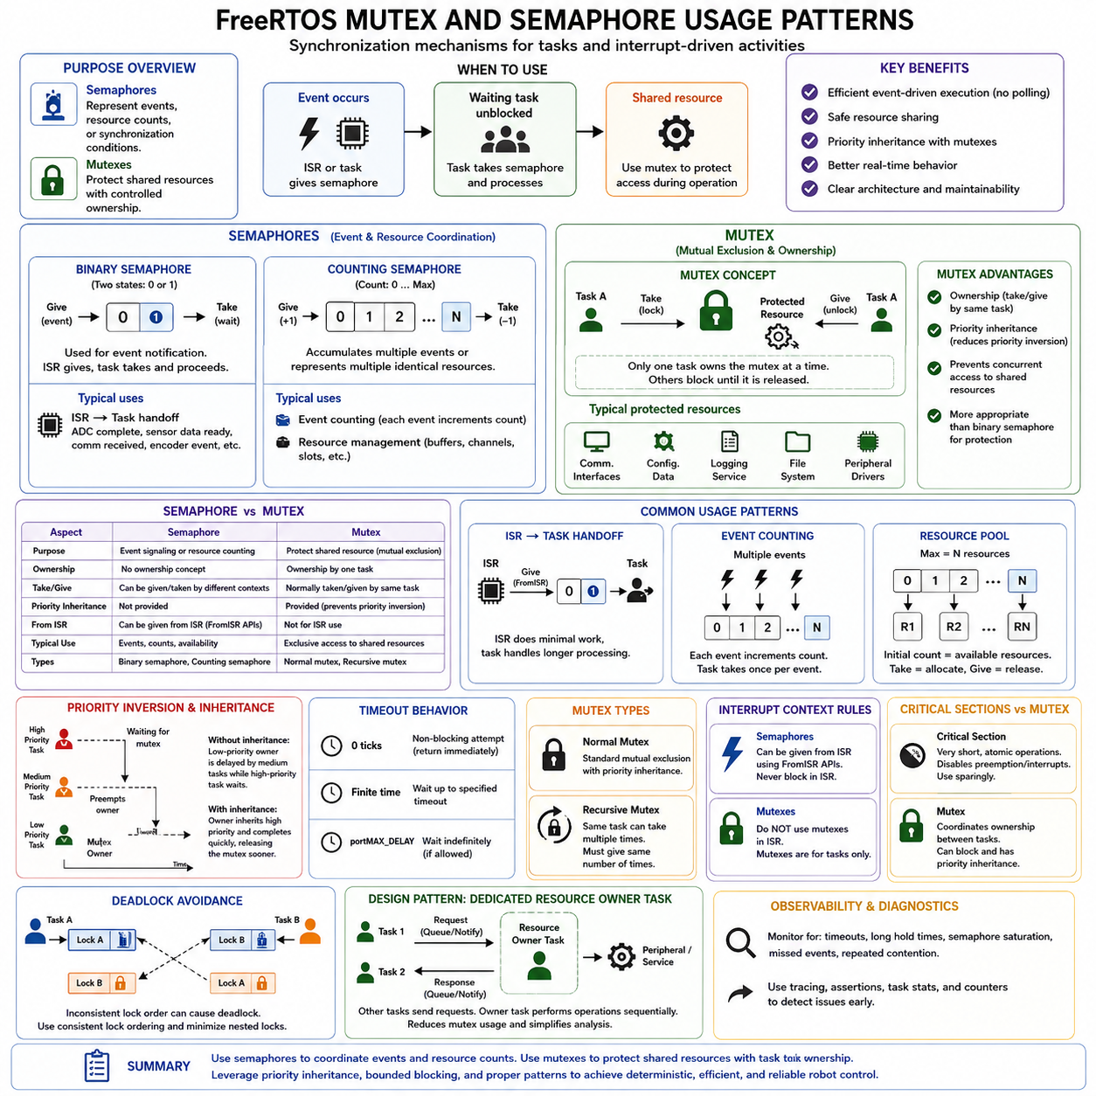
FreeRTOS provides semaphores and mutexes as synchronization mechanisms for coordinating concurrent tasks and interrupt-driven activities. Although both are implemented using kernel objects related to queues, their intended purposes differ. Semaphores primarily represent events, resource counts, or synchronization conditions, while mutexes protect shared resources that require controlled ownership. Choosing the correct mechanism is essential for predictable real-time robot firmware.
A binary semaphore represents a synchronization condition with two logical states: available or unavailable. One execution context can give the semaphore to signal that an event has occurred, while another task takes it before continuing. This pattern is particularly useful for event notification because the waiting task can remain Blocked without consuming CPU time until the semaphore becomes available, allowing efficient event-driven execution instead of continuous polling.
Binary semaphores are commonly used to transfer execution from an interrupt service routine to a task. A hardware interrupt can perform the minimum required device-level operation and then give a semaphore using an ISR-safe API. A higher-level task waiting on that semaphore becomes Ready and performs longer processing outside interrupt context. This pattern is suitable for ADC completion, sensor data arrival, communication reception, encoder events, and similar hardware-triggered activities.
A counting semaphore extends the binary concept by maintaining a count between zero and a configured maximum value. Giving the semaphore increments the count when capacity remains, while taking it decrements the count when a token is available. Counting semaphores can therefore represent multiple pending events or a finite number of identical resources, making them useful when individual occurrences must be accumulated rather than represented by a single available/unavailable state.
One common counting-semaphore pattern is event counting. If several interrupts or producer activities occur before a consumer task executes, each event can increment the semaphore count. The consumer then processes one unit of work for each successful take operation. Another pattern is resource management, where the initial count represents the number of available buffers, communication channels, hardware slots, or other equivalent resources that may be used concurrently.
A mutex, or mutual-exclusion object, has a different purpose. It protects a resource that should normally be accessed by only one task at a time. A task takes the mutex before entering the protected critical region and gives it after completing the operation. Other tasks attempting to acquire the same mutex can block until ownership is released, preventing concurrent modifications that could corrupt shared state or produce inconsistent peripheral transactions.
Typical mutex-protected resources include shared communication interfaces, configuration structures, logging services, file systems, and peripheral drivers that are not inherently reentrant. For example, multiple tasks may need to transmit through one shared communication driver. A mutex can serialize access so that one complete transaction finishes before another begins. The protected region should nevertheless remain short because holding a mutex prevents other dependent tasks from progressing.
The defining distinction between a mutex and a binary semaphore is ownership. A mutex is normally acquired and released by the same task and represents temporary ownership of a shared resource. A binary semaphore does not express this ownership relationship and is therefore better suited to signaling. Treating the two mechanisms as interchangeable can hide design intent and can also eliminate important scheduling behavior that FreeRTOS provides specifically for mutexes.
FreeRTOS mutexes support priority inheritance to reduce the effects of priority inversion. Priority inversion occurs when a high-priority task waits for a mutex held by a lower-priority task while intermediate-priority tasks prevent the lower-priority owner from running. With priority inheritance, the mutex owner can temporarily inherit a higher priority so that it can complete the protected operation and release the resource sooner, reducing blocking of the high-priority task.
Priority inheritance mitigates priority inversion but does not eliminate the need for careful architecture. Long critical regions, nested mutex dependencies, excessive shared-resource access, and poorly selected task priorities can still create substantial blocking latency. Real-time robot software should therefore minimize mutex holding time, understand worst-case blocking relationships, and avoid performing unpredictable or unnecessarily expensive operations while a high-contention resource remains locked.
Recursive mutexes support situations in which the same task must acquire the same logical mutex more than once before releasing it. This may occur when layered functions share a protected resource and one protected function calls another function that requires the same lock. Recursive mutexes maintain an acquisition count, requiring corresponding release operations, but they should be used deliberately because excessive recursive locking can make ownership and timing behavior difficult to analyze.
Semaphore and mutex operations commonly allow a timeout to be specified when attempting to acquire an object. A zero timeout performs an immediate non-blocking attempt, while a finite timeout allows the task to wait for a bounded interval. When appropriate configuration conditions are satisfied, an indefinite wait can also be requested. Real-time systems should choose these waiting policies according to timing requirements, failure recovery behavior, and the criticality of the protected operation.
Interrupt context imposes an important design boundary. Semaphores can be given from an ISR using appropriate FromISR APIs, enabling efficient interrupt-to-task synchronization. Mutexes, however, are ownership-oriented task synchronization objects and should not be used from interrupt service routines. An ISR does not behave like a schedulable task owner and must not block waiting for a resource. Interrupt handlers should instead perform bounded work and defer complex processing to tasks.
Critical sections and mutexes should also not be confused. A critical section typically prevents specific forms of preemption or interrupt interference for a very short sequence of operations, while a mutex coordinates ownership between tasks and may cause a waiting task to block. Critical sections are appropriate for extremely short atomic operations on kernel- or hardware-sensitive state, whereas mutexes are better suited to longer task-level access to shared software or peripheral resources.
Deadlock becomes possible when multiple mutexes are acquired in inconsistent orders. For example, one task may hold mutex A while waiting for mutex B, while another task holds B and waits for A. Neither can continue. Robot firmware should therefore define consistent lock-ordering rules, minimize nested locking, avoid unnecessary shared ownership, and consider message passing or dedicated resource-manager tasks when complex synchronization relationships begin to emerge.
A useful architectural pattern is to assign a peripheral or service to a dedicated owner task rather than allowing many tasks to lock the resource directly. Other tasks send requests through queues or notifications, and the owner performs the actual operation sequentially. This can remove many mutex dependencies and make execution flow easier to analyze, although it introduces message-transfer and scheduling latency that must be considered in timing-sensitive systems.
For robot controllers, semaphore and mutex selection should follow the meaning of the interaction. Hardware event notification naturally maps to a binary semaphore or lightweight notification mechanism, repeated event accumulation can use a counting semaphore, and exclusive task-level access to a shared resource maps to a mutex. Recursive mutexes should remain specialized tools rather than default synchronization objects, especially where deterministic timing and straightforward verification are required.
Synchronization failures should be observable during development and field operation. Unexpected acquisition timeouts, excessive mutex hold times, semaphore saturation, missed event handling, and repeated contention can indicate architectural or timing problems. Runtime tracing, assertions, task statistics, and carefully designed diagnostic counters can reveal these conditions before they become intermittent control failures that are difficult to reproduce in deployed robot systems.
Effective use of FreeRTOS synchronization therefore depends on matching each kernel primitive to a precise concurrency problem. Semaphores coordinate events and resource counts, mutexes establish task ownership and protect shared resources, priority inheritance limits specific inversion effects, and blocking allows CPU time to be used efficiently. Together with queues and task management, these mechanisms form the synchronization foundation for deterministic motor controllers, sensor nodes, communication modules, and other real-time robot subsystems.

02.05 Software Timer Design [w/Code]
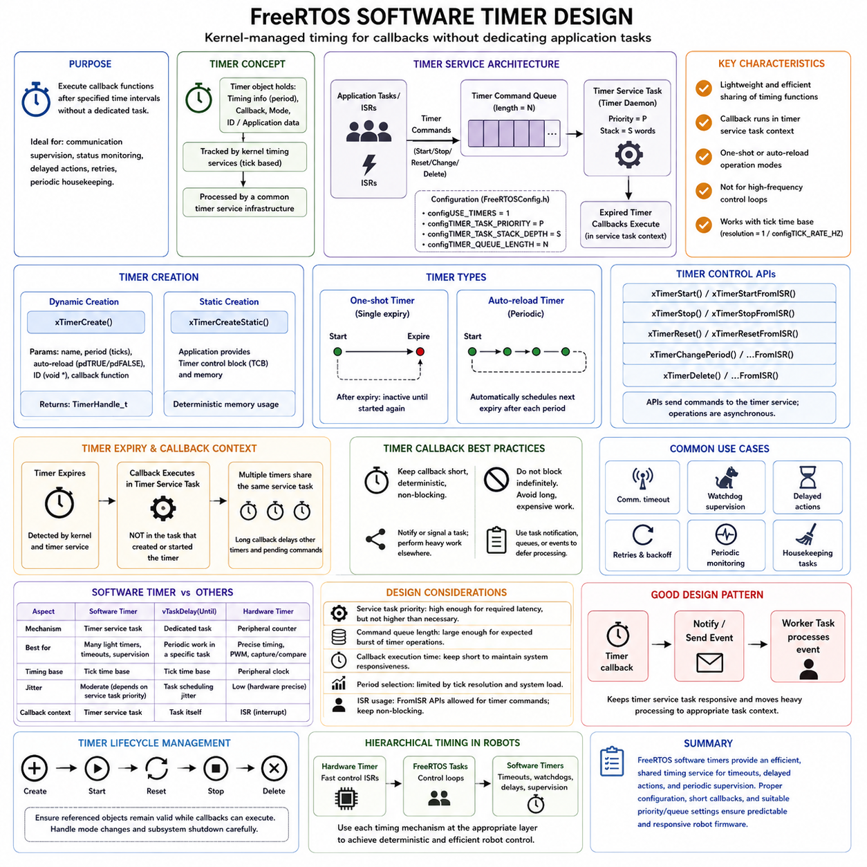
FreeRTOS software timers provide a kernel-managed mechanism for executing callback functions after specified time intervals without requiring a dedicated application task for every timed activity. They are useful for relatively lightweight timing functions such as communication supervision, status monitoring, delayed actions, retry control, and periodic housekeeping. Software timers complement task delays and hardware timers rather than replacing timing mechanisms required for strict low-level control.
A software timer is represented by a kernel object containing timing information, callback association, operating mode, and application-defined identification data. Unlike a hardware timer, it does not directly depend on a dedicated peripheral counter for each instance. FreeRTOS tracks timer expiration using kernel timing services and processes expired timers through a common timer service infrastructure, allowing many logical timers to coexist with relatively little application-level scheduling code.
Software timers are enabled through FreeRTOSConfig.h using the corresponding timer configuration option. When enabled, FreeRTOS creates a timer service task, sometimes called the timer daemon task, together with a command queue used to receive timer-related requests. Configuration parameters determine characteristics such as the timer service task priority, its stack depth, and the length of the timer command queue, making timer behavior part of the overall scheduling architecture.
A timer is normally created dynamically using xTimerCreate(), which defines a descriptive name, timer period, reload behavior, timer identifier, and callback function. Applications requiring explicit memory ownership can use xTimerCreateStatic() and provide the timer control storage themselves. As with tasks and queues, static creation can be attractive in deterministic robot firmware because kernel object memory requirements can be established before runtime.
FreeRTOS supports one-shot and auto-reload software timers. A one-shot timer expires once after it is started and then becomes inactive until explicitly started again. An auto-reload timer automatically schedules its next expiration after each period, making it suitable for recurring activities. The choice should represent the actual timing semantics of the function rather than using periodic timers for operations that logically require only a single delayed event.
Creating a software timer does not necessarily start it immediately. Timer operation is controlled through APIs that start, stop, reset, change the period, or delete the timer. These operations generally send commands to the timer service infrastructure rather than directly executing timer processing inside the calling task. Consequently, the command queue and timer service task scheduling behavior influence how quickly requested timer operations are actually processed.
When a timer expires, its callback function executes in the context of the timer service task rather than in the task that originally created or started the timer. This distinction is fundamental to correct timer design. Multiple software timer callbacks share the same service task execution context, meaning that one callback that runs for too long can delay the processing of other expired timers and timer commands waiting behind it.
Timer callback functions should therefore remain short, deterministic, and non-blocking. A callback can update small state variables, signal another task, send lightweight events, or initiate deferred processing, but computationally expensive algorithms or long peripheral transactions should normally execute elsewhere. Blocking indefinitely inside a timer callback is particularly dangerous because it prevents the shared timer service task from servicing other software timers.
A useful design pattern is for the timer callback to notify an application task rather than perform the complete timed operation itself. For example, expiration of a communication watchdog timer can send a task notification or event indicating that a message deadline has been missed. The responsible task then performs diagnostics, state transitions, recovery logic, or communication reinitialization within its own scheduling context, keeping the timer infrastructure responsive.
One-shot timers are well suited to delayed actions and timeout supervision. A robot controller can start a timer after transmitting a request and treat expiration as a missing-response event unless the timer is stopped or reset when the expected response arrives. Similar patterns can implement delayed state transitions, command expiration, actuator settling intervals, temporary warning periods, or retry delays without creating separate tasks that exist only to wait.
Auto-reload timers are useful for moderate-frequency periodic software activities such as health monitoring, telemetry updates, diagnostic sampling, status LED management, or maintenance counters. However, they should not automatically be selected for high-frequency control loops requiring tightly bounded jitter. Motor current control, PWM generation, precise encoder sampling, and similar hard timing functions are usually better driven directly by hardware timers and interrupt mechanisms.
The period of a software timer is expressed using the FreeRTOS tick time base, so timing resolution is related to configTICK_RATE_HZ. Requested periods must therefore be interpreted within kernel tick granularity. A software timer also experiences scheduler-related latency because expiration detection and callback execution depend on the timer service task being scheduled. Its timing behavior is consequently deterministic only within the limits imposed by tick resolution, priority, and system workload.
Timer service task priority deserves careful consideration. If its priority is too low, CPU-intensive higher-priority tasks may delay callback execution even after a timer has logically expired. If it is unnecessarily high, timer callbacks may interfere with more critical application processing. The priority should therefore reflect the latency requirements of timer-driven functions, while callbacks themselves should remain sufficiently short to prevent the service task from becoming a source of scheduling interference.
The timer command queue also has finite capacity. Starting, stopping, resetting, or changing many timers rapidly can generate multiple commands, and insufficient queue capacity can cause timer API requests to fail or wait depending on the calling context and timeout. Queue length should therefore reflect the expected number and burst characteristics of timer operations, particularly during initialization, communication recovery, mode transitions, or fault handling.
FreeRTOS provides FromISR variants for appropriate timer commands when timer control must originate from interrupt context. As with other ISR-safe APIs, these operations must remain non-blocking and may cause a higher-priority task to become ready. Nevertheless, frequent timer manipulation directly from high-rate interrupts should be evaluated carefully because it can increase timer command traffic and create unnecessary load on the timer service infrastructure.
Software timers, task delays, and hardware timers solve different timing problems. vTaskDelayUntil() is often appropriate when a dedicated task performs periodic work, because the timing and workload remain associated with that task. Software timers are attractive when many lightweight timeout or periodic events must share one timer infrastructure. Hardware timers remain preferable where precise timestamps, PWM, capture/compare functions, or low-jitter interrupt activation are required.
In robot firmware, these mechanisms are often combined hierarchically. A hardware timer may execute a fast motor-control interrupt, periodic FreeRTOS tasks may perform velocity or position control, and software timers may supervise communication timeouts, watchdog conditions, diagnostic intervals, and delayed state-machine events. Separating these timing domains prevents convenience-oriented software timers from being incorrectly used for control functions whose deadlines require hardware-level timing guarantees.
Timer lifecycle management should also be explicit. Applications must understand when each timer is created, started, reset, stopped, and deleted, and how mode changes or subsystem shutdown affect pending expirations. Timer identifiers can associate callbacks with application-specific context, but the lifetime of referenced objects must remain valid whenever the callback can execute. Poor lifecycle management can otherwise produce stale references or unexpected callbacks after state transitions.
Effective software timer design therefore depends on treating the timer service as a shared scheduling resource. Timer periods, service-task priority, command-queue capacity, callback execution time, and interactions with application tasks collectively determine observable timing behavior. Used appropriately, FreeRTOS software timers provide an efficient foundation for timeouts, delayed actions, periodic supervision, and event-driven robot firmware while hardware timers and dedicated periodic tasks remain responsible for stricter real-time control.

02.06 FreeRTOS Memory Management: heap 1 to 5 [w/Code]
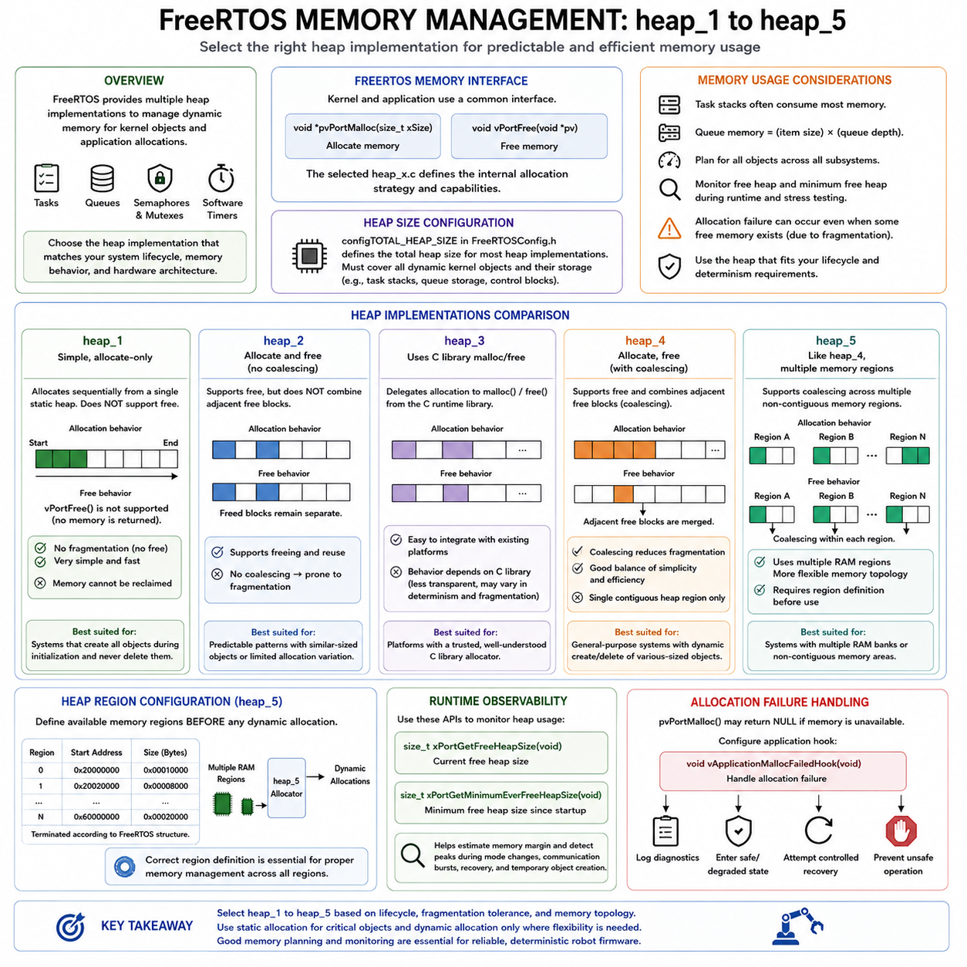
FreeRTOS memory management is designed to support embedded systems where RAM is limited and allocation behavior must remain understandable and controllable. Kernel objects such as tasks, queues, semaphores, mutexes, and software timers may require memory when created dynamically. Instead of prescribing one universal allocator, FreeRTOS provides several heap implementations, commonly identified as heap_1 through heap_5, allowing developers to select behavior appropriate to the target system.
Dynamic kernel allocation is performed through the FreeRTOS memory interface rather than requiring application code to depend directly on a particular allocator implementation. Functions such as pvPortMalloc() and vPortFree() form the basic allocation interface used by the kernel and may also be used by applications where appropriate. The selected heap_x.c implementation determines how these operations behave internally and what capabilities, limitations, and fragmentation characteristics apply.
The amount of memory available to most FreeRTOS heap implementations is commonly controlled through configTOTAL_HEAP_SIZE in FreeRTOSConfig.h. This memory must accommodate dynamically created kernel objects and their associated storage requirements. Task stacks can represent a significant portion of consumption, while queues require storage based on queue depth and item size. Memory planning should therefore consider the complete object architecture rather than only the number of tasks.
heap_1 provides the simplest allocation strategy. It allocates memory sequentially from a statically defined heap region but does not support freeing allocated blocks. Each allocation advances through the available memory until the heap is exhausted. Because no blocks are returned, the implementation is extremely simple and avoids external fragmentation caused by repeated allocation and deallocation, making its runtime behavior straightforward to understand.
The primary limitation of heap_1 is that vPortFree() cannot return memory for reuse. It is therefore suitable for systems in which all dynamically allocated objects are created during initialization and remain active for the entire operating lifetime. A robot controller that creates its tasks, queues, and synchronization objects once during startup and never deletes them can use this model effectively when the resulting fixed allocation pattern satisfies system requirements.
heap_2 introduces memory deallocation and allows previously allocated blocks to be reused. It maintains free memory blocks and can return released storage to the available heap. However, it does not combine adjacent free blocks into larger regions. Consequently, repeated allocation and release of differently sized objects can divide the heap into small separated areas, creating fragmentation even when the total amount of free memory appears sufficient.
Because heap_2 does not coalesce adjacent free regions, it is most appropriate when allocation and deallocation involve objects of similar sizes or follow highly predictable patterns. It is less attractive for general-purpose dynamic memory behavior where block sizes vary substantially over time. Modern FreeRTOS applications generally have better alternatives when memory must be repeatedly allocated and released, but understanding heap_2 illustrates the relationship between allocator simplicity and fragmentation.
heap_3 differs significantly because it delegates memory management to the standard C library malloc() and free() functions. FreeRTOS wraps these functions with the required scheduler or critical-section protection so they can be used within the kernel environment. The actual allocation strategy, fragmentation behavior, and heap location therefore depend primarily on the C runtime library and platform configuration rather than on a FreeRTOS-specific allocator algorithm.
Using heap_3 can be convenient when an existing platform already provides a trusted and appropriately configured C library allocator. However, its behavior may be less transparent from the perspective of deterministic embedded design. The developer must understand the underlying malloc() implementation, memory limits, thread-safety assumptions, execution-time variation, and fragmentation characteristics before relying on it in timing-sensitive robot firmware.
heap_4 is one of the most commonly useful FreeRTOS allocation implementations. Like heap_2, it supports both allocation and freeing, but it additionally combines adjacent free blocks when memory is returned. This coalescing behavior significantly improves resistance to fragmentation because neighboring free regions can become a larger reusable block. heap_4 therefore provides a practical balance between flexibility, implementation simplicity, and embedded-system memory efficiency.
The heap_4 allocator manages free blocks within a contiguous heap area and searches for suitable space when pvPortMalloc() is called. When vPortFree() returns a block, the allocator can merge it with neighboring free blocks where possible. Fragmentation is not mathematically eliminated, but coalescing makes heap_4 much more suitable than heap_2 for applications that create and delete differently sized objects during operation.
heap_5 extends the general allocation behavior of heap_4 by allowing the FreeRTOS heap to span multiple separate memory regions. This capability is valuable on processors and microcontrollers that provide several non-contiguous RAM banks or memory areas with different addresses. Instead of requiring the heap to occupy one contiguous block, the application defines a set of memory regions that FreeRTOS can manage as part of the dynamic allocation space.
Before using heap_5, the application must define the available memory regions through the appropriate initialization mechanism before dynamic allocation begins. Region definitions describe the starting address and size of each usable area and are terminated according to the required FreeRTOS structure format. Correct initialization is essential because the allocator depends on this memory map when managing blocks distributed across separate physical regions.
The choice between heap_1 through heap_5 should reflect the system's lifecycle and hardware architecture. heap_1 favors simple allocate-once systems, heap_2 permits freeing but has limited fragmentation management, heap_3 relies on the platform C library, heap_4 supports allocation and freeing with adjacent-block coalescing, and heap_5 extends this approach across multiple memory regions. The implementations therefore represent different memory-management policies rather than progressively numbered performance levels.
Memory fragmentation is especially important in long-running robot controllers. A system may report free memory while still being unable to satisfy a large allocation request because the available space has been divided into smaller non-contiguous blocks. Allocators that coalesce free blocks reduce this risk, but deterministic firmware should still avoid unnecessary runtime allocation and unpredictable object creation patterns where practical, particularly in safety- or timing-sensitive subsystems.
FreeRTOS provides functions that help observe heap conditions during execution. The amount of currently available heap and the minimum amount that has remained available since startup can be monitored to estimate memory margin. These measurements are valuable during stress testing because normal operation may not reveal transient peaks caused by mode changes, communication bursts, recovery operations, or temporary creation of kernel and application objects.
Allocation failure should be treated as an explicit system condition rather than assumed to be impossible. FreeRTOS can be configured to provide an application hook when pvPortMalloc() cannot satisfy a request. Production firmware can use this mechanism to record diagnostics, transition into a safe or degraded operating state, or trigger controlled recovery behavior. Continuing operation without understanding a failed kernel-object allocation can produce incomplete initialization and unpredictable subsystem behavior.
Dynamic and static allocation can also coexist within one FreeRTOS application when configuration permits. Critical tasks, queues, and synchronization objects can use static allocation so their memory is guaranteed, while less critical or lifecycle-dependent components can use dynamic allocation. This hybrid strategy can provide flexibility without making fundamental control and safety functions dependent on the availability or fragmentation state of the runtime heap.
For robot firmware, memory policy should therefore be defined as part of the real-time software architecture rather than selected only during compilation. Developers should identify which objects exist permanently, which may be created or deleted during operation, how much stack and queue storage is required, and whether multiple RAM regions must be used. Selecting heap_1 through heap_5 then becomes an architectural decision tied directly to determinism, memory topology, lifecycle behavior, and reliability.

02.07 FreeRTOS Plus TCP/IP Stack Integration [w/Code]
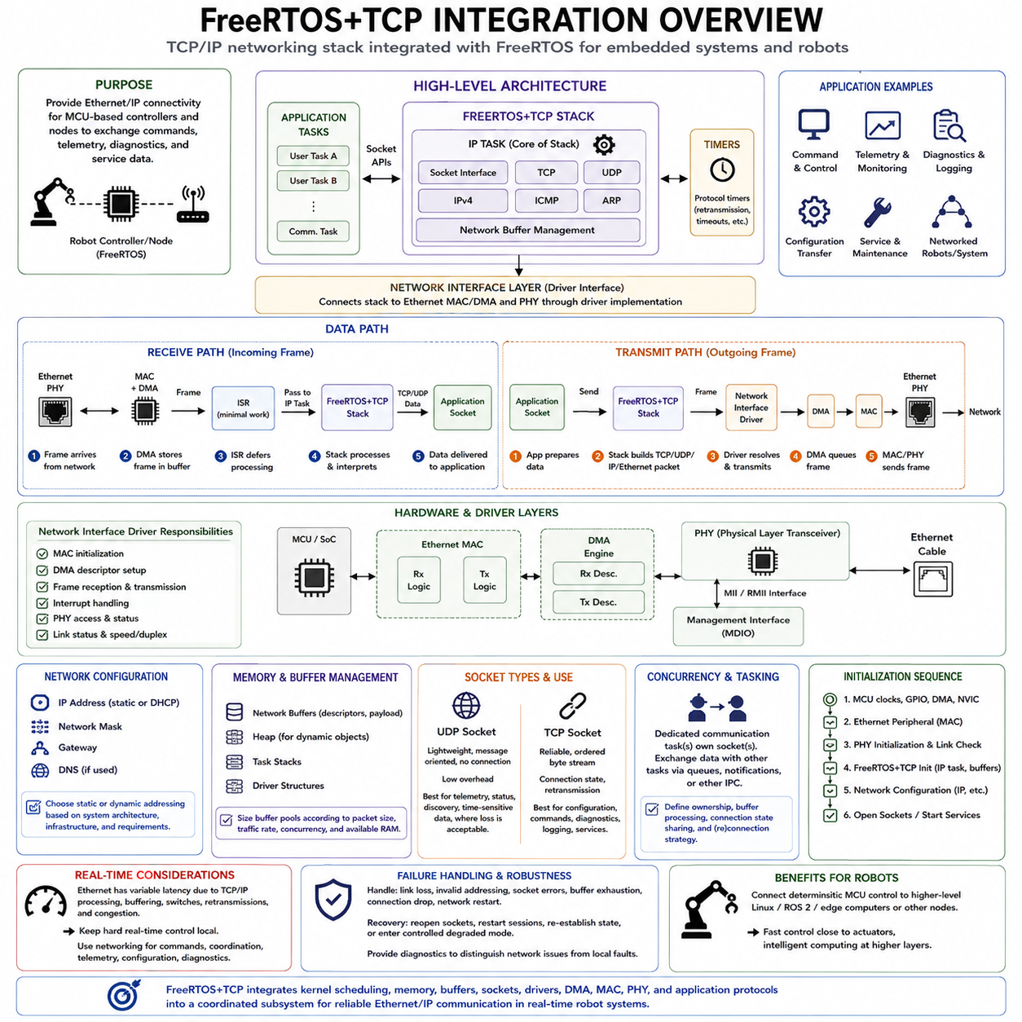
FreeRTOS+TCP is a TCP/IP networking stack designed to integrate with the FreeRTOS kernel and provide network communication for embedded systems. It extends an RTOS-based controller beyond local task execution and peripheral communication by introducing Ethernet and Internet Protocol connectivity. In robot firmware, this enables MCU-level controllers and embedded nodes to exchange commands, telemetry, diagnostics, and service data with higher-level computers and networked devices.
The networking architecture separates application logic from lower-level Ethernet hardware handling. Application tasks interact with the stack through socket-oriented APIs, while FreeRTOS+TCP processes protocols such as IPv4, TCP, UDP, ARP, ICMP, and related network functions. Beneath the stack, a network interface layer connects protocol processing to the Ethernet MAC, DMA mechanisms, PHY device, and MCU-specific driver implementation.
A central component of FreeRTOS+TCP is the IP task, which manages much of the protocol-stack processing in a dedicated FreeRTOS task context. Network events generated by applications, timers, and Ethernet reception are coordinated through this execution environment. Centralizing protocol processing reduces the need for multiple application tasks to manipulate shared network-stack state directly and creates a clearer boundary between application concurrency and network protocol execution.
The Ethernet receive path commonly begins when the MAC or DMA hardware detects an incoming frame. An interrupt service routine performs only the minimum required hardware handling and defers substantial processing to a task or network interface mechanism. The received frame is then presented to the FreeRTOS+TCP stack, where Ethernet and IP information is interpreted before relevant TCP or UDP data becomes available to an application socket.
Transmission follows the reverse architectural direction. An application task prepares data and uses a socket API to request transmission. The stack creates the required transport and network protocol information, associates the packet with the destination, resolves link-layer addressing where necessary, and forwards the resulting Ethernet frame toward the network interface driver. The MAC and DMA hardware then perform the physical transmission through the Ethernet PHY.
FreeRTOS+TCP uses network buffers to hold packet data as frames move through the networking subsystem. Buffer management is therefore a major integration consideration because insufficient descriptors or packet storage can cause reception or transmission failures under burst traffic. Excessively large buffer pools consume valuable MCU RAM. The number and size of buffers should consequently be selected according to expected packet sizes, traffic rates, concurrency, and available memory.
The network interface driver forms the hardware-dependent boundary of the integration. It is responsible for connecting FreeRTOS+TCP to the target MCU Ethernet controller and normally handles MAC initialization, DMA descriptor configuration, frame reception, frame transmission, interrupt interaction, and PHY-related operations. This layer is comparable to other FreeRTOS porting boundaries because the protocol stack remains largely portable while hardware-specific behavior is isolated.
The physical layer device, or PHY, converts between the Ethernet controller's digital interface and signals transmitted over the physical network medium. Depending on the hardware, the MCU MAC may communicate with the PHY through interfaces such as MII or RMII, while a management interface is used to configure and inspect PHY registers. Link detection, speed negotiation, duplex configuration, and cable status therefore become part of the complete networking integration.
Network initialization requires both hardware and protocol configuration. The Ethernet peripheral, clocks, GPIO functions, DMA resources, interrupts, and PHY must be initialized correctly before reliable packet transfer can occur. FreeRTOS+TCP must also be configured with addressing and network parameters appropriate to the system, such as an IP address, network mask, gateway, and DNS information when these capabilities are required by the application.
Address configuration may be static or dynamically obtained depending on the system architecture and enabled features. Static addressing is often useful for fixed industrial or robot-control networks where device identities and routes are predetermined. Dynamic mechanisms can simplify deployment in general network environments. The choice should consider startup dependencies, infrastructure availability, recovery behavior, service discovery, and the need for predictable communication endpoints.
UDP sockets are particularly useful for lightweight robot communication where low overhead and message-oriented transfer are more important than guaranteed delivery. Sensor information, periodic status, discovery traffic, or time-sensitive telemetry may use UDP when the application can tolerate packet loss or implement its own sequence and validity checks. Because UDP does not establish a reliable stream, application-level protocol design remains responsible for handling missing or reordered information where necessary.
TCP sockets provide reliable, ordered byte-stream communication and are appropriate when data integrity and delivery are more important than minimum protocol overhead. Configuration transfer, command sessions, diagnostics, logging, or service communication can benefit from TCP. However, reliability introduces connection state, retransmission, buffering, and potentially variable latency, so TCP should not automatically be used for hard real-time control messages whose timing requirements exceed what general network transport can guarantee.
Socket operations interact directly with FreeRTOS task scheduling. A task can block while waiting for received data, available transmission conditions, or connection events rather than continuously polling the network. Appropriate timeout configuration allows the task to remain responsive to failures and other responsibilities. This scheduler-integrated blocking model is consistent with queue, semaphore, and notification patterns used elsewhere in FreeRTOS and supports event-driven network application design.
Network communication introduces concurrency and ownership considerations similar to other shared resources. Applications should define which tasks own sockets, how received buffers are processed, how connection state is shared, and how shutdown or reconnection is coordinated. Dedicated communication tasks can simplify these relationships by owning network sessions and exchanging commands or status with control tasks through queues, notifications, or other FreeRTOS IPC mechanisms.
Memory architecture becomes especially important when networking is added to a small MCU system. Task stacks, queues, heap allocations, network descriptors, packet buffers, driver structures, and application payloads all compete for RAM. Integration should therefore include worst-case memory analysis and runtime monitoring rather than simply confirming that the system boots. Communication bursts and simultaneous connections may expose memory peaks that do not appear during basic functional testing.
Real-time design must also distinguish networking latency from local control timing. Ethernet can provide high bandwidth and low average latency, but TCP/IP processing, buffering, task scheduling, switch behavior, retransmissions, and network congestion introduce timing variability. Fast motor current loops, PWM generation, and immediate safety responses should remain within deterministic local control layers, while Ethernet networking is better suited to commands, coordination, telemetry, configuration, and supervisory interaction.
In a robot architecture, FreeRTOS+TCP can therefore form the communication bridge between deterministic MCU-level control and higher-level edge computing. A FreeRTOS motor or sensor controller can maintain local hardware timing while exchanging structured data with Linux, ROS 2, an edge computer, or another embedded node through Ethernet. This separation allows fast control to remain close to the actuator while computationally intensive perception, planning, and coordination execute at higher system layers.
Robust integration requires fault handling for link loss, invalid addressing, socket failures, buffer exhaustion, connection interruption, and network restart. Communication state should be observable through diagnostics so that the application can distinguish a local controller failure from a network problem. Recovery behavior may include reopening sockets, restarting sessions, re-establishing application state, or entering a controlled degraded mode while preserving essential local control functions.
Effective FreeRTOS+TCP integration ultimately combines kernel scheduling, memory management, network buffers, socket APIs, Ethernet drivers, DMA, MAC, PHY, and application protocol design into one coordinated subsystem. The networking stack should not be treated as an isolated library added after firmware development. When designed as part of the real-time architecture, it provides a practical path from deterministic embedded control toward distributed robot systems connected through Ethernet and IP-based communication.

02.08 FreeRTOS Tracing and Debugging with Tracealyzer
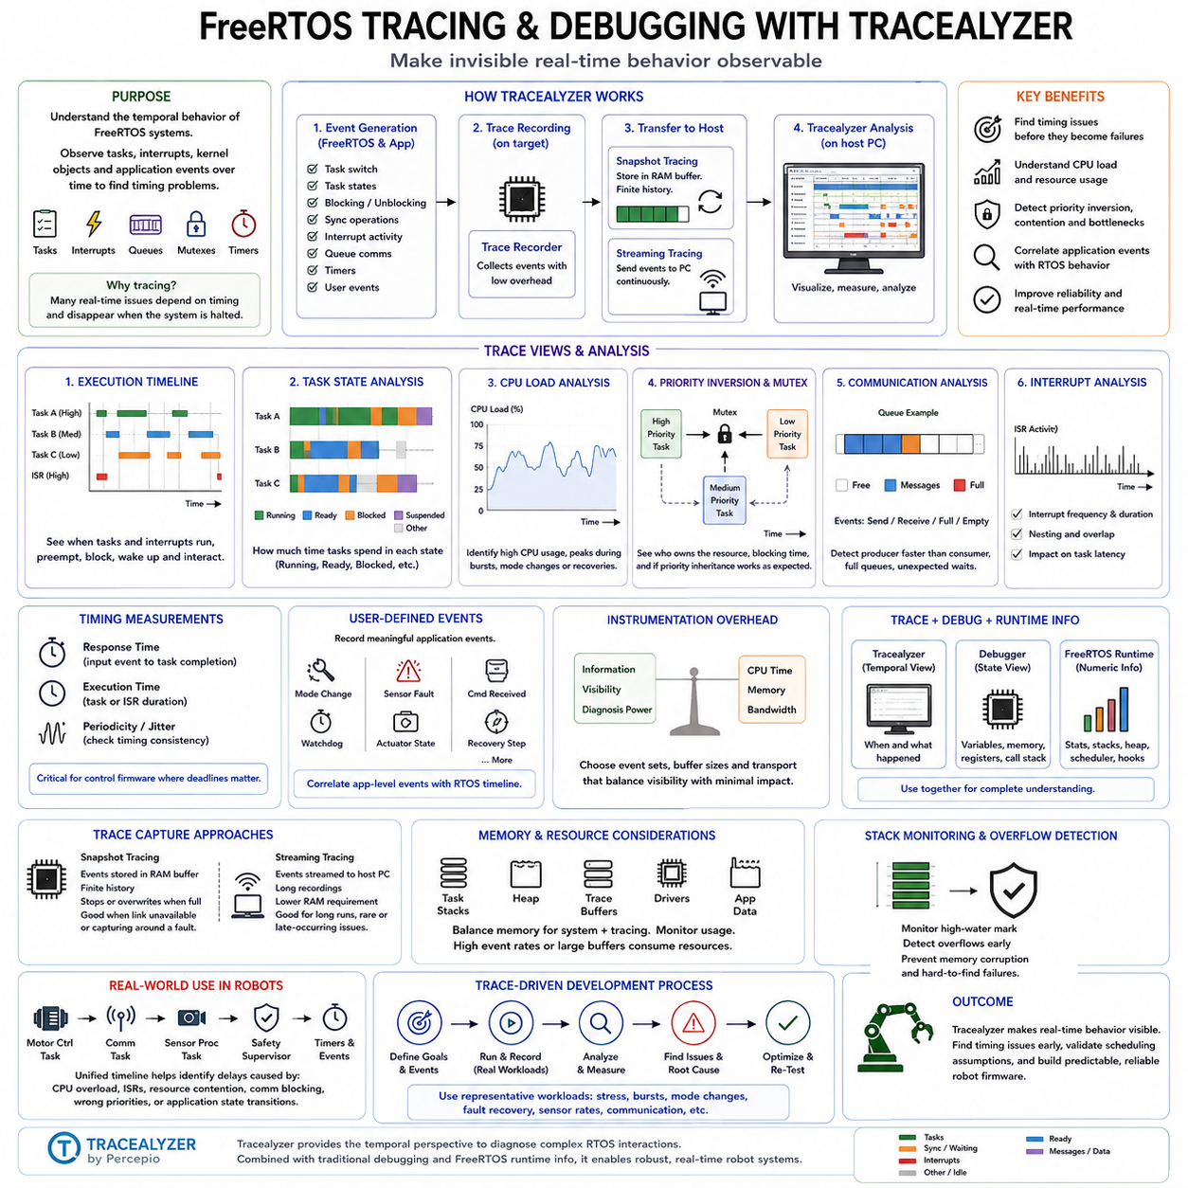
FreeRTOS tracing and debugging focuses on observing how tasks, interrupts, queues, semaphores, mutexes, timers, and other kernel objects behave over time. Conventional debugging can inspect variables and stop execution at breakpoints, but many real-time failures depend on timing and disappear when execution is halted. Tracealyzer provides event-based visualization that helps developers understand the temporal behavior of a running FreeRTOS system.
Tracealyzer operates by collecting execution events generated by the FreeRTOS kernel and application instrumentation. Events can represent task switches, task activation, blocking, synchronization operations, interrupt activity, queue communication, and user-defined events. The resulting trace forms a chronological record of system behavior, allowing developers to reconstruct what occurred before a deadline miss, communication failure, unexpected delay, or control anomaly.
A trace recorder is integrated into the target firmware to capture relevant events while the embedded system executes. Depending on the configuration and target resources, trace information can be stored temporarily in target RAM or transferred continuously to a host computer. This distinction creates two common operating approaches: snapshot tracing for bounded event histories and streaming tracing for longer observation periods and continuous analysis.
Snapshot tracing records events into a finite target-side buffer. When the buffer becomes full, recording behavior depends on the configured mode, such as stopping collection or overwriting older events. Snapshot operation is useful when communication with the development computer is unavailable or when the developer needs to capture the events surrounding a specific failure. The available trace duration depends on event frequency, recorder configuration, and allocated buffer memory.
Streaming tracing transfers trace data from the target to the host while the system is operating. This enables longer recordings without requiring enough MCU RAM to store the complete history locally. The transport mechanism depends on the development environment and hardware interface. Streaming is particularly valuable for failures that occur only after extended operation, although the communication path and recorder overhead must be considered when evaluating timing-sensitive behavior.
One of the most important Tracealyzer views is the execution timeline, which shows when tasks and interrupts execute and how execution moves between contexts. A developer can inspect task preemption, blocking intervals, wakeups, and interrupt interference in chronological order. This makes priority-based scheduling visible rather than theoretical and helps explain why a task that appears logically correct may still execute too late under a particular workload.
Task-state analysis can reveal how much time tasks spend in Running, Ready, Blocked, or other relevant states. A task that remains Ready for a long period may be prevented from running by higher-priority execution, while excessive blocking may indicate synchronization or communication delays. Observing these states over time helps distinguish CPU scheduling problems from cases where a task is simply waiting for data, a semaphore, a notification, or a timeout.
CPU load analysis provides another system-level perspective. Instead of considering only whether individual functions execute correctly, developers can examine processor utilization and identify tasks or interrupt activity consuming significant execution time. Changes in CPU load during communication bursts, sensor processing, fault recovery, or operating-mode transitions can reveal conditions where apparently sufficient processor capacity approaches saturation under realistic workloads.
Trace information is especially useful for investigating priority inversion and mutex behavior. When a high-priority task waits for a resource held by a lower-priority task, the trace can show the ownership relationship, blocking duration, and execution of competing tasks. This allows developers to determine whether priority inheritance is operating as expected and whether long critical sections or inappropriate resource-sharing architectures are increasing response latency.
Inter-task communication can also be examined through queue, semaphore, mutex, event, and notification activity. A trace may reveal that a producer generates messages faster than a consumer processes them, that a queue frequently becomes full, or that a task waits unexpectedly for synchronization. Such behavior is difficult to understand from isolated variable values because the failure often results from the sequence and timing of interactions rather than from one incorrect value.
Interrupt analysis is important because interrupt service routines can influence task latency even when task priorities are configured correctly. Trace visualization can expose interrupt frequency, duration, nesting, and the relationship between ISR execution and task activation. In robot controllers with high-rate encoder, communication, or sensor interrupts, this information helps identify situations where excessive interrupt workload reduces the CPU time available for scheduled control tasks.
Timing measurements can be derived from trace events to evaluate response time, execution duration, periodicity, and jitter. For example, developers can examine the interval between a periodic task activation and completion or measure the delay from an interrupt-generated event to the execution of the task that processes it. These measurements are directly relevant to control firmware because functional correctness alone does not guarantee that calculations or actuator commands occur within required deadlines.
User-defined trace events extend analysis beyond kernel activity. Application code can record meaningful events such as control-mode transitions, sensor faults, command reception, watchdog conditions, actuator state changes, or recovery stages. When these events appear on the same timeline as task scheduling and interrupts, developers can correlate application-level behavior with RTOS execution and determine which system activity preceded a particular robot response.
Tracing should be designed with awareness of instrumentation overhead. Recording events consumes execution time, memory, and potentially communication bandwidth, so the tracing configuration should capture sufficient information without unnecessarily disturbing the system being measured. Developers should compare traced and normal operation where timing margins are small and select event sets, buffering strategies, and streaming mechanisms appropriate to the diagnostic objective.
Tracealyzer complements rather than replaces traditional debugging tools. A source-level debugger remains useful for examining variables, memory, registers, call stacks, and specific control paths, while trace analysis explains temporal interactions across the complete system. Combining both approaches is powerful: tracing identifies where and when abnormal behavior occurs, after which conventional debugging can inspect the detailed software state responsible for that behavior.
FreeRTOS also provides runtime information that can support debugging independently of graphical tracing. Task statistics, stack high-water marks, heap information, scheduler state, and application hooks can help detect resource exhaustion or abnormal execution. When these diagnostics are correlated with Tracealyzer recordings, developers gain both numerical resource information and a chronological view of the events that produced the observed condition.
Stack problems are particularly important in embedded debugging because insufficient task stack allocation can corrupt memory and cause failures far from the original overflow. Monitoring stack usage and enabling appropriate stack-overflow detection mechanisms helps establish whether task stacks have adequate margins. Trace data can then provide contextual information about workload and execution conditions surrounding failures that appear only during specific modes or communication activity.
In robot firmware, tracing can connect multiple timing domains into one diagnostic model. A motor-control task, CAN or Ethernet communication task, sensor-processing task, safety supervisor, and software timers may all interact while interrupts occur asynchronously. A unified timeline allows engineers to determine whether a control delay originated from CPU overload, interrupt interference, resource contention, communication blocking, incorrect priority selection, or an application-level state transition.
Effective tracing therefore becomes part of real-time verification rather than only a tool used after software failure. Representative workloads, stress conditions, communication bursts, sensor rates, mode transitions, and fault-recovery scenarios can be recorded and compared against expected timing behavior. By combining FreeRTOS runtime diagnostics with Tracealyzer visualization, developers can validate scheduling assumptions and expose concurrency or latency problems before deployment.
The overall objective of FreeRTOS tracing and debugging is to make invisible real-time behavior observable. Tasks, interrupts, synchronization, communication, resource usage, and application events become a measurable sequence rather than isolated software components. Tracealyzer provides the temporal perspective needed to diagnose complex RTOS interactions, while conventional debugging and runtime monitoring provide detailed state information, together supporting predictable and reliable robot firmware.

02.09 MISRA C Compliant FreeRTOS Code Guidelines
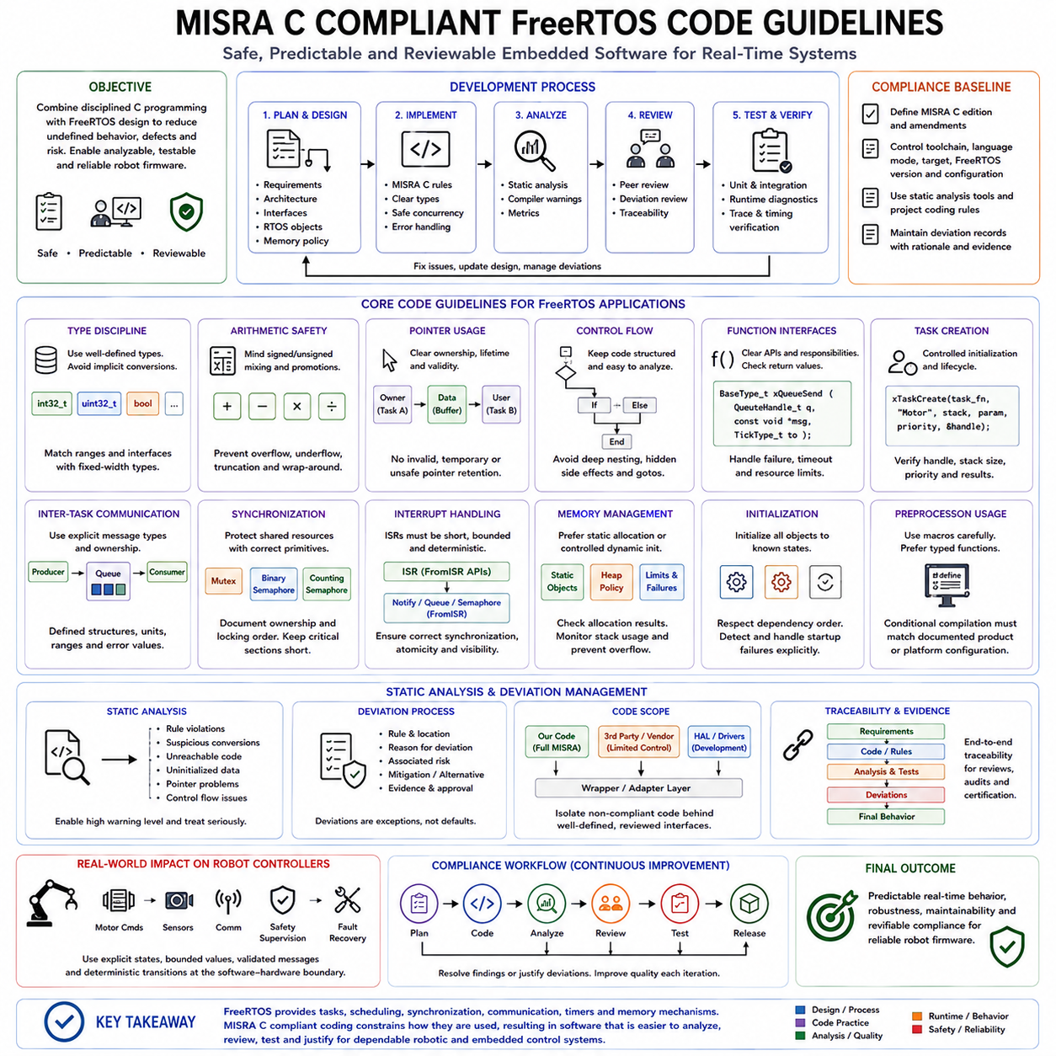
MISRA C compliant FreeRTOS development combines real-time operating system design with disciplined C programming practices intended to reduce undefined behavior, implementation-dependent behavior, ambiguous constructs, and common sources of software defects. The objective is not merely to make FreeRTOS applications compile successfully, but to create embedded software whose control flow, data usage, interfaces, concurrency, and failure behavior can be reviewed systematically and verified with greater confidence.
MISRA C should be treated as part of the software engineering process rather than as a formatting convention applied after implementation. Requirements, architecture, interfaces, coding rules, static analysis, reviews, testing, and deviation management should support one another. In a FreeRTOS project, this means that task structures, interrupt interfaces, shared resources, memory allocation policies, and communication mechanisms should be designed with compliance and analyzability in mind before detailed application code is written.
A compliant project should define exactly which MISRA C edition and amendment set forms the coding baseline, because the applicable rules depend on the selected standard and project context. Compiler version, language mode, target architecture, FreeRTOS version, configuration options, static-analysis tools, and project-specific coding rules should also be controlled. This establishes a reproducible compliance environment instead of allowing individual modules to be evaluated against different assumptions.
Type discipline is particularly important in embedded and real-time software. Developers should avoid relying on implicit conversions whose results may depend on integer width, signedness, promotion rules, or platform implementation. Expressions involving counters, time values, hardware registers, message fields, and arithmetic should use intentionally selected types and explicit conversions where required. Fixed-width integer types can help express interface widths when their representation matches the hardware and protocol requirements.
Signed and unsigned arithmetic requires careful treatment because comparisons or calculations can change meaning when operands are converted implicitly. Loop counters, buffer indexes, queue lengths, tick values, sensor values, and error codes should therefore use types that reflect their actual range and semantic purpose. Range assumptions should remain visible in the design, and arithmetic that may overflow, underflow, truncate, or wrap should be identified rather than accepted as an accidental property of the C implementation.
Pointer usage should be constrained and understandable. FreeRTOS APIs frequently use pointers for task parameters, queue data, callback context, buffers, and handles, but application code should preserve clear ownership and lifetime rules. Pointer conversions should not be used merely to bypass type checking, and pointers to temporary or invalid objects must never be retained by asynchronous tasks or callbacks. Interface structures are often preferable to loosely interpreted generic memory when several fields must cross task boundaries.
Control flow should remain structured and easy to analyze. Deeply nested conditions, hidden side effects, complicated expressions, uncontrolled jumps, and code whose behavior depends on evaluation order make verification difficult. Task functions commonly contain long-running loops, but each loop should have a clear purpose and understandable blocking behavior. Conditions controlling safety actions, communication states, actuator commands, and fault recovery should be explicit enough for reviewers and analysis tools to determine the intended execution paths.
Function interfaces should clearly communicate responsibilities and data flow. Parameters should have well-defined types, return values should be checked where failure is possible, and functions should avoid unnecessary global-state dependencies. FreeRTOS API calls such as task, queue, semaphore, timer, and memory operations can report failure or timeout conditions, and ignoring these results may hide resource exhaustion or synchronization failures that later appear as unrelated system behavior.
Task creation should follow controlled initialization patterns. Task entry functions must use the required FreeRTOS function signature, while task parameters should reference objects whose lifetime remains valid for as long as the task may access them. Task priorities, stack sizes, handles, and creation results should be intentionally defined and verified. Dynamically creating and deleting tasks during unrestricted runtime operation can complicate both memory behavior and safety analysis, so lifecycle policies should be established at the architectural level.
Inter-task communication should use explicit message definitions with clear ownership and validity rules. Queues are particularly useful because they can transfer defined data structures between execution contexts without exposing uncontrolled shared state. Message structures should avoid uninitialized padding or fields becoming meaningful protocol data, and producers and consumers should agree on units, ranges, enumerations, and error values. This makes communication behavior easier to review and test.
Shared resources require equally disciplined synchronization. A mutex should protect a clearly identified resource, and its ownership and locking order should be documented to reduce deadlock risk. Binary and counting semaphores should represent synchronization or resource-counting semantics rather than being used interchangeably without justification. Critical sections should remain short and should not become a convenient replacement for a well-designed concurrency architecture, particularly when interrupt latency is safety relevant.
Interrupt service routines require stricter constraints because they execute asynchronously and can directly affect system latency. ISR code should remain short, bounded, and limited to operations appropriate for interrupt context. FreeRTOS APIs intended for ISR use, normally identified by the FromISR form, must be used instead of task-context APIs where required. Data shared between interrupts and tasks must be designed with correct synchronization, atomicity, visibility, and ownership assumptions rather than relying only on volatile declarations.
Memory management policy should also be defined explicitly. Safety-oriented systems often benefit from static allocation or from completing dynamic allocation during controlled initialization so that runtime behavior does not depend on unpredictable allocation patterns. When dynamic allocation is permitted, allocation failures, heap limits, fragmentation characteristics, and object lifetimes must be addressed. Stack usage should also be measured because stack overflow can corrupt unrelated memory and defeat otherwise disciplined coding practices.
Initialization deserves special attention because uninitialized variables, structures, buffers, handles, and state values can create nondeterministic behavior. Objects should be placed into known states before use, and initialization order should respect dependencies between hardware drivers, FreeRTOS kernel objects, communication services, and application tasks. Startup failures should be detected and handled explicitly rather than allowing partially initialized subsystems to enter normal robot operation.
Preprocessor usage should be controlled because extensive macro logic can obscure types, evaluation behavior, and control flow. FreeRTOS itself uses configuration macros extensively, but application-level macros should not unnecessarily reproduce function-like behavior when typed functions provide clearer semantics. Conditional compilation should correspond to documented product or platform configurations, and every supported configuration should be analyzed and tested rather than assuming that inactive branches are harmless.
Static analysis is a central element of MISRA-oriented development. A qualified or appropriately selected analysis tool can identify rule violations, suspicious conversions, unreachable code, uninitialized data, pointer problems, control-flow issues, and other defects that ordinary compilation may not report. Compiler warnings should also be enabled at a suitably strict level and treated systematically. Passing compilation without warnings is useful, but it is not equivalent to demonstrating MISRA compliance.
Not every MISRA rule can necessarily be applied identically to every component, especially when third-party software, hardware access, compiler extensions, or RTOS interfaces impose constraints. Where a permitted deviation is necessary, it should be deliberate, documented, reviewed, and supported by a technical rationale. A deviation record should explain the affected rule, location, reason, associated risk, and evidence showing that the alternative implementation remains acceptably safe and controlled.
FreeRTOS kernel code, hardware abstraction layers, vendor drivers, middleware, and application code should also be distinguished in the compliance strategy. A project should define which software is developed under its own MISRA process, which components are externally supplied, and how externally supplied code is evaluated or isolated. Wrappers can provide controlled interfaces around non-compliant or implementation-specific components so that such behavior does not spread unnecessarily through the application architecture.
For robot controllers, these practices are especially valuable at the boundary between software and physical action. Motor commands, actuator enable states, sensor validity, communication timeouts, safety supervision, and fault recovery should use explicit states, bounded values, validated messages, and deterministic transitions. MISRA-oriented code discipline therefore complements FreeRTOS scheduling and synchronization by reducing ambiguity inside the software that ultimately controls physical hardware.
A practical compliance workflow combines coding standards, automated static analysis, compiler diagnostics, peer review, unit and integration testing, runtime diagnostics, and trace-based timing verification. Findings should be resolved or formally justified rather than merely counted. The resulting evidence provides traceability between coding requirements, identified violations, approved deviations, tests, and final software behavior, making compliance an engineering activity rather than a one-time tool report.
MISRA C compliant FreeRTOS development ultimately aims to make real-time firmware predictable not only in timing but also in language behavior and software structure. FreeRTOS provides tasks, scheduling, synchronization, communication, timers, and memory mechanisms, while disciplined MISRA-oriented coding constrains how application software uses those mechanisms. Together they support firmware that is easier to analyze, review, test, maintain, and justify for dependable robotic and embedded control systems.

02.10 FreeRTOS Robot Joint Control Implementation [w/Code]
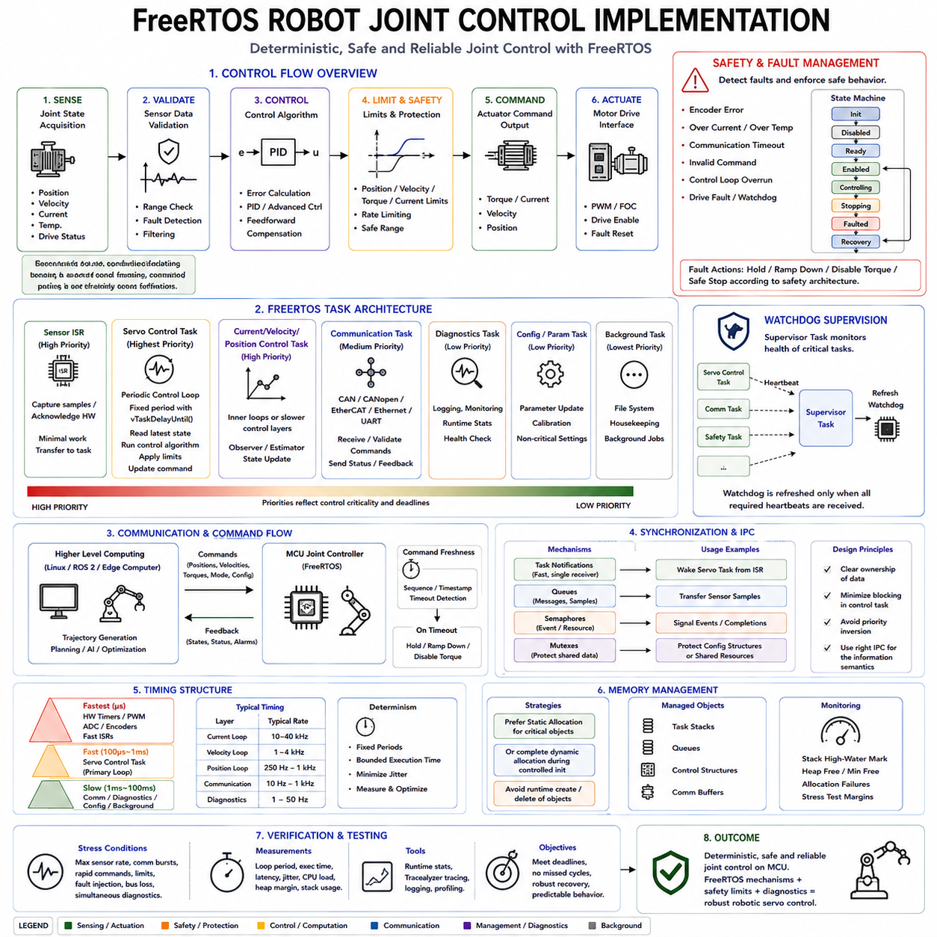
A FreeRTOS robot joint controller combines deterministic scheduling, sensor acquisition, control computation, actuator command generation, communication, and safety supervision within an MCU-level real-time architecture. The joint controller represents a practical integration of the FreeRTOS mechanisms introduced throughout this chapter, including tasks, queues, synchronization objects, timers, memory management, diagnostics, and interrupt handling.
The basic control path begins with joint-state acquisition and ends with an actuator command. Encoder position, velocity, current, temperature, and drive-status information are acquired from local peripherals or a motor drive. The controller validates this feedback, compares the measured state with the commanded joint reference, executes the control algorithm, applies safety limits, and produces torque, current, velocity, or position commands for the actuator interface.
Joint control should be divided into timing domains according to required determinism. Very fast electrical functions such as PWM generation, ADC triggering, current sampling, and portions of field-oriented control may execute from hardware timers and interrupt service routines. FreeRTOS tasks can then execute slower current supervision, velocity control, position control, communication, diagnostics, and state management without forcing every function into the same scheduling mechanism.
A periodic joint-control task can implement the primary servo loop when its required frequency is compatible with RTOS scheduling. The task should execute at a fixed period, acquire the latest validated joint state, calculate the control error, execute PID or another controller, apply limits, and update the command output. vTaskDelayUntil() is preferable to accumulating relative delays because it maintains periodic execution relative to a defined timing reference.
Priority assignment should reflect control criticality rather than software complexity. Safety and time-critical control tasks normally require higher priorities than diagnostics, logging, configuration, or background communication. However, assigning every important function a high priority defeats the scheduling hierarchy. Execution time, activation rate, blocking behavior, and resource dependencies should be analyzed together so that the servo task can meet its deadline under worst-case system workload.
Sensor acquisition may be interrupt-driven when hardware produces data asynchronously or at high frequency. An ISR should perform minimal work, capture or acknowledge the hardware event, and transfer processing to an appropriate task using a queue, task notification, semaphore, or DMA completion mechanism. This keeps interrupt latency bounded while allowing filtering, validation, state estimation, and control calculations to execute in normal task context.
Task notifications are particularly efficient when an interrupt or another task only needs to wake one control task or communicate a small event value. Queues are more appropriate when complete samples, commands, or structured status messages must be transferred. The communication mechanism should therefore match the information semantics instead of using one FreeRTOS primitive for every interaction. Clear ownership also prevents uncontrolled sharing of sensor and command buffers.
The control algorithm commonly operates on a reference state and measured feedback. A position controller may calculate an error from desired and measured position, while velocity and torque terms can provide additional feedback or feedforward compensation. Regardless of the mathematical controller, the implementation must define units, numeric ranges, saturation behavior, update frequency, and invalid-input handling so that software behavior remains predictable near physical limits.
Actuator commands should never be sent directly from an unconstrained controller output. Position, velocity, acceleration, torque, current, and command-rate limits can be applied before values reach the motor drive. Saturation and rate limiting protect both the mechanism and power electronics, while software limits can enforce permissible joint ranges. Hardware protection remains necessary because software supervision alone cannot provide complete protection against every electrical or computational failure.
A joint controller also requires an explicit state machine. Typical operating states can represent initialization, disabled, ready, enabled, controlling, stopping, faulted, and recovery conditions. Transitions should occur only when defined conditions are satisfied, such as valid sensor feedback, successful drive initialization, communication availability, safety permission, or fault clearance. This prevents actuator behavior from depending on loosely related flags distributed across multiple tasks.
Communication tasks connect the local joint controller to higher-level robot computing. CAN, CANopen, EtherCAT, Ethernet, UART, or another field interface may deliver target positions, velocities, torques, mode commands, synchronization information, and configuration data. The communication task should validate incoming messages and update a controlled command interface rather than allowing network or bus processing to manipulate actuator outputs directly.
Command freshness is important because a mathematically valid command can become unsafe when communication stops. Each command can therefore carry timing or sequence information, while a timeout mechanism detects stale references. A FreeRTOS software timer, periodic supervisory task, or timestamp comparison can identify communication loss. The controller can then hold, ramp down, disable torque, or enter another predefined safe behavior according to the robot's safety architecture.
Shared data between communication, control, diagnostic, and safety tasks must have explicit synchronization rules. A mutex may protect configuration structures that are accessed infrequently, while high-rate control data may be better handled using queues, notifications, double buffering, or carefully designed atomic exchanges. The servo loop should avoid waiting unpredictably for low-priority tasks because resource contention can convert otherwise correct control software into a timing failure.
Memory behavior should remain deterministic throughout normal joint operation. Critical tasks, queues, control structures, and communication buffers can be statically allocated, or all required dynamic allocation can be completed during controlled initialization. Runtime creation and deletion of objects should be minimized when it provides no architectural benefit. Stack high-water marks and heap margins should be measured under maximum communication, diagnostic, and fault-handling workloads.
Fault supervision operates in parallel with normal control. Encoder errors, excessive current, overtemperature, communication timeout, invalid command values, control-loop overruns, drive faults, and watchdog conditions should be converted into explicit fault states. Fault handling should distinguish conditions that allow controlled degradation from those requiring immediate actuator shutdown, while the low-level hardware protection path remains capable of disabling dangerous outputs independently of ordinary task execution.
A watchdog mechanism can supervise whether essential tasks continue to execute correctly. Rather than allowing every task to refresh a hardware watchdog independently, a supervisory design can require critical tasks to report health within defined intervals. The supervisor refreshes the hardware watchdog only when the required conditions are satisfied. This prevents a partially failed system from appearing healthy merely because one surviving task continues to execute.
Timing diagnostics are essential because joint-control correctness depends on when calculations execute as well as on their mathematical result. Runtime statistics and tracing can measure control-task execution time, activation period, response latency, interrupt interference, and jitter. Tracealyzer or similar instrumentation can correlate communication events, ISR activity, task scheduling, synchronization, and fault transitions to determine why a servo deadline was occasionally missed.
The complete joint controller can therefore be viewed as a hierarchy rather than a single control task. Hardware timers, ADCs, PWM units, encoder interfaces, and fast ISRs form the lowest timing layer. FreeRTOS schedules servo, communication, safety, and diagnostic tasks above this hardware layer, while queues, notifications, semaphores, and timers coordinate their interaction. Higher-level trajectory generation or robot planning supplies references without directly controlling low-level electrical timing.
This separation is particularly important when an MCU controller communicates with Linux, ROS 2, or an edge computer. Higher-level computing can perform trajectory generation, perception, planning, optimization, or AI inference at lower and potentially variable update rates, while the FreeRTOS controller maintains the faster local joint-control cycle. Loss or delay of the upper-level connection should therefore not immediately destroy the deterministic timing behavior required at the actuator.
Verification should test the controller under conditions more demanding than nominal motion. Maximum sensor rates, communication bursts, simultaneous diagnostics, rapid command changes, limit conditions, injected sensor faults, bus interruptions, task overruns, and recovery sequences should be exercised while timing and resource usage are measured. The objective is to verify not only correct motion but also predictable behavior when computation, communication, and physical conditions become unfavorable.
A FreeRTOS robot joint-control implementation ultimately demonstrates how RTOS mechanisms become a physical control system. Deterministic scheduling provides timing, interrupts connect hardware events, IPC transfers state and commands, synchronization protects shared resources, timers supervise timeouts, memory policies maintain resource stability, and diagnostics expose execution behavior. Combined with explicit safety limits and state management, these mechanisms form a dependable MCU-level foundation for robotic servo control.

