Volume 03 Real Time Operating Systems

03. Zephyr

03.01 Zephyr RTOS Architecture: Kernel, Driver Model, DevTree
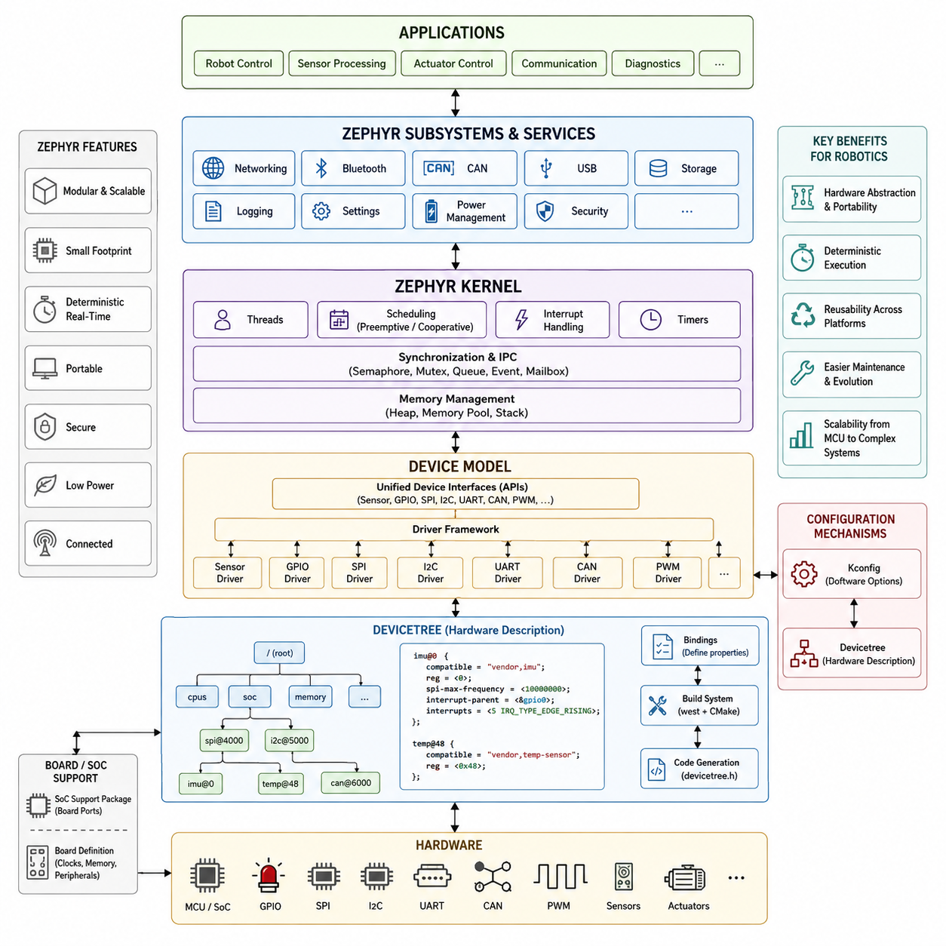
Zephyr is designed as a modular real-time operating system for resource-constrained embedded devices, while still providing an architecture capable of supporting complex connected robotics platforms. Its structure separates kernel services, hardware abstraction, device drivers, networking, middleware, and application components. This modular organization allows developers to configure only the capabilities required by a target system, reducing memory footprint while preserving scalability from small sensor controllers to sophisticated robotic subsystems.
At the center of Zephyr is a compact real-time kernel responsible for thread scheduling, interrupt processing, synchronization, timing, and memory-related services. Threads execute according to priority and scheduling policies, allowing time-critical control activities to preempt less important background processing. Kernel objects such as semaphores, mutexes, message queues, events, and timers provide structured mechanisms for coordinating concurrent software components without forcing applications to implement low-level synchronization mechanisms independently.
Zephyr supports both cooperative and preemptive threads, enabling developers to select execution behavior according to timing requirements. Preemptive scheduling is appropriate for control, communication, and sensor-processing functions that must respond within bounded time intervals, while cooperative execution can simplify carefully controlled processing sequences. Interrupt service routines handle urgent hardware events, and deferred processing can transfer longer operations into thread context to keep interrupt latency predictable and system responsiveness high.
A major architectural characteristic of Zephyr is its unified device model. Hardware peripherals are represented as devices that expose standardized interfaces to application software and higher-level subsystems. Drivers connect physical hardware such as GPIO controllers, UART interfaces, SPI and I2C buses, CAN controllers, sensors, PWM modules, and Ethernet devices to these interfaces. Applications therefore interact with hardware through consistent APIs instead of depending directly on MCU-specific register definitions, improving portability across processor families and board designs.
The driver architecture is layered so that common subsystem APIs remain largely independent of the underlying hardware implementation. A sensor application, for example, can use Zephyr's sensor interface while the actual device driver communicates with the sensor through SPI or I2C. Similarly, network applications can operate through networking APIs while Ethernet, Wi-Fi, or other communication hardware is handled underneath. This separation is especially useful in robotics, where sensor, actuator, and communication hardware may change between product generations.
Zephyr's DeviceTree mechanism provides the structural description that connects software drivers to actual hardware resources. Instead of embedding board-specific addresses, interrupt numbers, GPIO assignments, bus relationships, and peripheral configuration directly in application source code, these properties are represented declaratively. DeviceTree therefore acts as a hardware description layer that tells the operating system which devices exist, where they are connected, and which resources they require when building firmware for a particular board.
A DeviceTree description is organized as a hierarchy of nodes representing processors, buses, controllers, memory regions, peripherals, sensors, and other hardware components. Nodes contain properties describing information such as register addresses, interrupt lines, clock sources, communication frequencies, GPIO pins, and compatibility identifiers. Parent-child relationships can describe physical topology, such as an IMU connected to an SPI controller or an environmental sensor attached to an I2C bus, making the hardware configuration readable as a structured system model.
The compatible property provides an important connection between DeviceTree and the Zephyr driver model. It identifies the hardware type associated with a node and enables the build system to associate that hardware description with an appropriate driver implementation and binding definition. DeviceTree bindings define the expected properties and semantic structure for particular hardware classes. Together, nodes, compatible identifiers, bindings, and drivers form a systematic path from physical hardware configuration to software-visible device instances.
Zephyr combines DeviceTree with Kconfig rather than treating them as competing configuration mechanisms. DeviceTree primarily describes hardware existence and connectivity, whereas Kconfig controls which software capabilities and implementation options are enabled. A board may declare a CAN controller or SPI peripheral through DeviceTree, while Kconfig determines whether the associated driver subsystem and related software features are compiled. This distinction helps maintain a clean boundary between hardware topology and software policy.
The build process transforms DeviceTree information into compile-time definitions that drivers and applications can reference efficiently. This approach avoids requiring a heavyweight dynamic hardware discovery mechanism on small embedded targets. Because much of the configuration is resolved during compilation, Zephyr can retain the abstraction advantages of a sophisticated operating system while producing compact firmware suitable for microcontrollers with limited RAM and flash. Invalid hardware descriptions can also be detected earlier during development rather than appearing only as runtime failures.
Board and System-on-Chip support layers further connect the generic Zephyr architecture to specific hardware platforms. SoC definitions describe processor-level capabilities and integrated peripherals, while board definitions describe concrete hardware configurations such as clocks, memory, communication interfaces, LEDs, connectors, and enabled peripherals. Application-specific overlays can modify or extend the base DeviceTree without rewriting the original board definition, allowing one firmware architecture to support multiple robot controller variants with relatively small configuration changes.
For robotics, this architecture provides a useful separation between reusable software behavior and rapidly changing hardware configurations. A sensor-node application can maintain the same thread structure, communication logic, diagnostics, and sensor-processing pipeline while DeviceTree overlays select different sensors, buses, interrupt pins, or board revisions. Driver APIs isolate application logic from device-specific implementation details, while kernel scheduling provides the deterministic execution foundation required for periodic sampling, actuator supervision, communication, and fault monitoring.
Zephyr's subsystem architecture extends beyond basic kernel and driver services into networking, storage, logging, power management, security, Bluetooth, CAN, USB, and other embedded capabilities. These subsystems commonly reuse the same device model and configuration infrastructure, allowing hardware resources to participate in larger software stacks without exposing low-level implementation details to applications. The result is an architecture in which kernel services provide execution, drivers provide hardware access, and subsystems provide reusable functional capabilities.
This organization becomes particularly valuable when a robot contains multiple distributed embedded controllers. Motor controllers, battery-management interfaces, safety nodes, sensor gateways, and communication modules may use different MCU families while following a common Zephyr software architecture. DeviceTree captures each controller's hardware topology, drivers normalize peripheral access, kernel services manage deterministic execution, and communication subsystems connect the controller to CAN, Ethernet, Bluetooth, or other networks used by the wider robotic platform.
The architectural flow can therefore be understood as a progression from physical hardware toward application behavior. DeviceTree describes hardware resources and topology, bindings define how those descriptions are interpreted, drivers translate generic subsystem operations into hardware-specific transactions, kernel mechanisms provide scheduling and synchronization, and higher-level services expose networking, storage, security, and communication capabilities. Applications operate above these layers and can consequently focus more strongly on robot functionality instead of processor-specific hardware details.
In practical robot development, the greatest advantage of this architecture is controlled portability. Hardware differences are not completely hidden, because embedded systems still require careful management of interrupts, DMA, timing, memory, buses, and electrical interfaces. Zephyr instead places those differences into well-defined architectural locations. This makes it possible to replace a microcontroller, sensor, communication interface, or board revision while limiting the amount of application software that must change and preserving established real-time behavior.
Zephyr's kernel, driver model, and DeviceTree should therefore be considered complementary parts of one embedded software architecture rather than independent features. The kernel governs when software executes, the driver framework defines how software accesses devices, and DeviceTree specifies what hardware exists and how it is connected. Together they establish a configurable foundation suitable for reusable robotic firmware, distributed sensor and actuator nodes, communication gateways, and embedded controllers that must evolve across multiple hardware generations.

03.02 Zephyr Build System: west / CMake Configuration [w/Code]
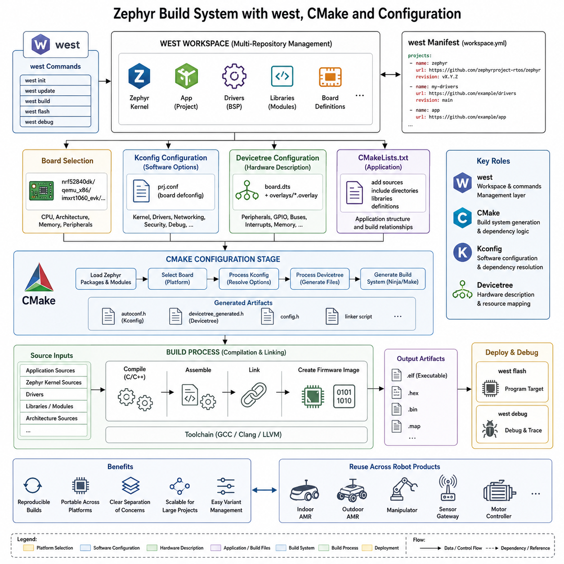
Zephyr uses a highly structured build system that combines west, CMake, Kconfig, DeviceTree, and the underlying compiler toolchain into a unified workflow. This architecture allows the same application source to be configured for many microcontrollers and development boards without manually rewriting platform-specific build scripts. The build process resolves software options, hardware descriptions, dependencies, generated headers, libraries, and final executable images before firmware is programmed onto the target device.
CMake acts as the primary build configuration engine within Zephyr. An application normally provides a CMakeLists.txt file that identifies the project and its application source files, while Zephyr supplies the larger collection of CMake modules required to construct the complete firmware image. Instead of manually specifying every compiler option, include directory, library, and hardware dependency, developers rely on Zephyr's build infrastructure to derive these settings from the selected board and configuration.
The environment variable ZEPHYR_BASE identifies the location of the Zephyr source tree and provides an important reference point for the build infrastructure. When CMake configures an application, it loads Zephyr's package definitions and build logic, identifies the selected target board, processes configuration information, and creates an internal build graph. Application code consequently becomes one component within a larger firmware build containing the kernel, drivers, libraries, architecture support, and enabled subsystems.
A typical build begins by selecting a board that represents the target hardware platform. The board selection determines important architectural information including processor family, CPU architecture, memory layout, supported peripherals, and default hardware configuration. Zephyr then combines these board definitions with application-specific configuration so that one application can be rebuilt for different supported platforms while retaining most of its source-level implementation.
Kconfig provides the software configuration dimension of this process. Configuration symbols determine whether kernel capabilities, drivers, communication protocols, debugging facilities, networking components, security mechanisms, and other features are included. The application commonly expresses its requirements through a prj.conf file, while board defaults and subsystem dependencies contribute additional configuration information. The resulting configuration becomes a resolved set of options used throughout compilation.
Kconfig dependencies are particularly important because embedded software features rarely operate independently. Enabling a network protocol may require networking buffers, a network interface, specific drivers, and synchronization facilities. Zephyr's configuration system evaluates dependencies and relationships between these options rather than treating each setting as an isolated compiler flag. This reduces inconsistent configurations and helps developers understand which capabilities must exist together within a complete embedded software system.
DeviceTree provides the hardware configuration dimension that complements Kconfig. While Kconfig generally answers which software capabilities should be enabled, DeviceTree describes which hardware resources exist and how they are connected. During configuration, the selected board's DeviceTree description can be combined with application overlays to modify peripheral status, GPIO assignments, communication buses, sensor connections, memory regions, or other hardware characteristics without changing the application source code.
The build system processes DeviceTree source and binding information to generate compile-time hardware descriptions accessible to drivers and applications. Drivers can therefore obtain addresses, interrupts, GPIO specifications, bus relationships, and other hardware parameters through generated definitions rather than hard-coded constants. This approach tightly connects the build system with Zephyr's device model and allows hardware configuration errors to be identified earlier in the development process.
West provides the higher-level workspace and command-line management layer surrounding this build architecture. It is designed to manage Zephyr projects that may consist of the Zephyr kernel together with multiple repositories, modules, vendor libraries, board support packages, and application components. Rather than treating firmware development as a single isolated repository, west provides mechanisms for maintaining a coordinated workspace containing all software components required by a particular embedded platform.
The west manifest is central to multi-repository workspace management. A manifest defines projects, repository locations, revisions, and related workspace information so that developers can reproduce a consistent collection of source components. This becomes increasingly valuable when robotics firmware depends on Zephyr itself, custom device drivers, communication libraries, board definitions, shared control software, and vendor-specific modules maintained as separate repositories.
West also provides a convenient interface to common development operations. Commands such as west build invoke the underlying Zephyr and CMake build process, while west flash integrates board-specific programming tools and west debug can connect the build output with supported debugging infrastructure. West therefore does not replace CMake or the compiler; instead, it coordinates development activities and presents a consistent command interface above several lower-level tools.
When west build is executed, CMake first performs the configuration stage and creates the build system appropriate for the selected environment. Kconfig resolves software configuration, DeviceTree processing resolves hardware descriptions, and generated files are produced for subsequent compilation. The build backend then compiles application code together with the required Zephyr kernel components, drivers, libraries, and architecture-specific sources before linking them into the final firmware image.
Zephyr commonly supports out-of-tree builds, where generated build artifacts are stored separately from application source code. This separation keeps source directories clean and allows different configurations of the same application to coexist. A developer can maintain independent build directories for different boards, debugging configurations, release configurations, or hardware revisions, making it easier to compare targets and automate firmware generation in continuous integration and deployment pipelines.
Configuration changes must be understood in terms of their position within the build pipeline. Modifying prj.conf primarily changes software features through Kconfig, while modifying a DeviceTree overlay changes the target hardware description. Changing CMakeLists.txt generally changes application source composition or build relationships, and changing the west manifest modifies the repositories or modules available in the workspace. Maintaining these responsibilities separately prevents configuration files from becoming tightly coupled and difficult to maintain.
For robotics systems, this separation is especially useful because hardware and software often evolve at different rates. A sensor node may move from one MCU board to another while retaining its application logic, or a robot controller may replace an IMU, CAN interface, encoder, or communication module without redesigning the entire firmware. Board definitions and DeviceTree overlays capture hardware changes, while Kconfig and application configuration control the required software capabilities.
The same architecture also supports product variants efficiently. Indoor AMRs, outdoor AMRs, manipulators, sensor gateways, and distributed motor controllers may share substantial firmware components while requiring different communication interfaces, sensors, memory configurations, or diagnostic capabilities. Separate board definitions, configuration fragments, overlays, and build directories allow these variants to be generated from a common codebase while maintaining explicit control over each target's resulting firmware.
A well-designed Zephyr project therefore treats west, CMake, Kconfig, and DeviceTree as complementary layers rather than interchangeable configuration tools. West manages the workspace and development commands, CMake organizes the build graph and compilation process, Kconfig determines software functionality, and DeviceTree describes hardware topology. Their combined output produces a target-specific firmware image containing only the kernel services, drivers, subsystems, and application components required by the selected embedded platform.
For scalable robot firmware development, this build architecture provides reproducibility as well as portability. A defined west workspace establishes source versions, configuration files establish software behavior, DeviceTree captures hardware structure, and CMake coordinates compilation into deterministic build artifacts. These mechanisms make it practical to maintain multiple embedded controllers and hardware generations while preserving a common software architecture, automated builds, traceable configurations, and repeatable firmware deployment across a robotic system.

03.03 Zephyr Threads, Queues, Mailboxes [w/Code]
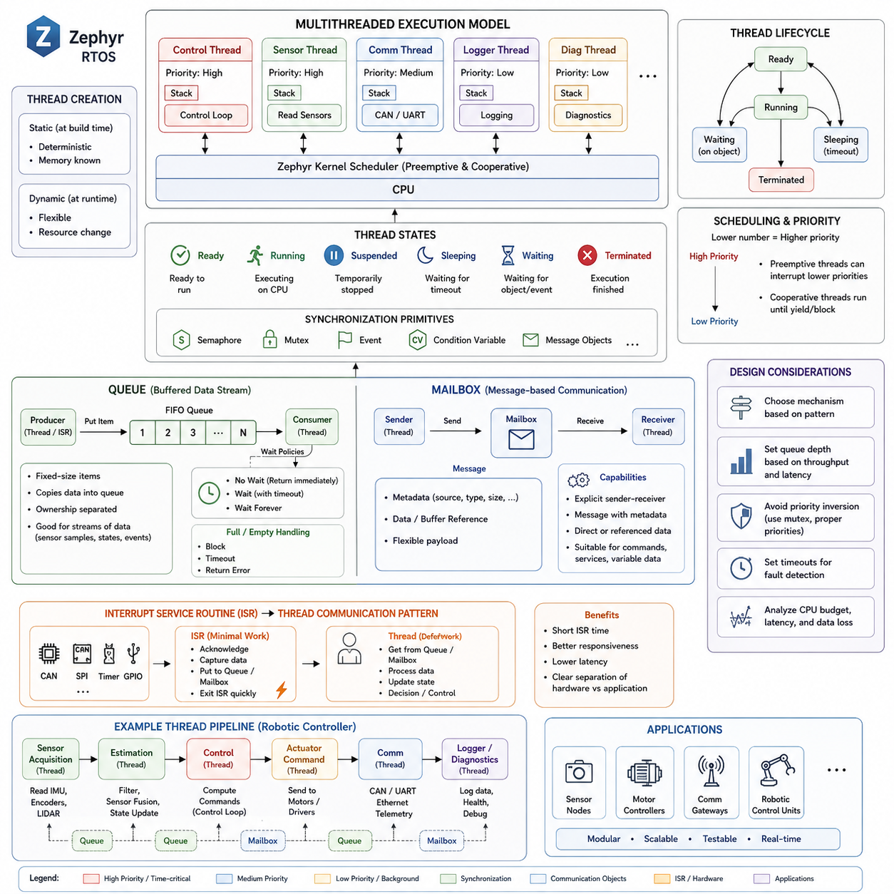
Zephyr provides a multithreaded execution model that allows embedded applications to divide complex behavior into independent threads with explicit priorities, stack sizes, and scheduling properties. Each thread represents a schedulable execution context managed by the kernel, making it possible to separate time-critical control, sensor acquisition, communication, diagnostics, and background processing. This organization is particularly useful for robotics systems where several activities must progress concurrently while maintaining predictable timing.
A Zephyr thread contains its own stack and execution state together with scheduling information maintained by the kernel. Threads may be created statically during compilation or dynamically during runtime, depending on system requirements and configuration. Static creation is often attractive for deterministic embedded systems because memory requirements can be established before execution, while dynamic creation provides flexibility when application behavior requires runtime changes in processing resources.
Thread priorities determine which runnable thread receives processor time when multiple threads are ready simultaneously. Zephyr distinguishes cooperative and preemptive priority ranges, allowing developers to construct different scheduling behaviors within the same application. A higher-priority preemptive thread can interrupt lower-priority execution when it becomes ready, whereas cooperative threads continue executing until they explicitly yield, block, or otherwise allow another thread to run.
The thread lifecycle is closely related to kernel scheduling states. A thread may be ready for execution, actively running, suspended, sleeping, waiting for a kernel object, or terminated. Operations such as sleeping for a defined period or waiting for communication automatically remove the thread from active competition for CPU time. When the timeout expires or the required event occurs, the kernel makes the thread eligible for scheduling again according to its priority.
Thread synchronization becomes essential when multiple execution contexts share hardware, data structures, or communication resources. Zephyr provides kernel mechanisms such as semaphores, mutexes, events, condition variables, and message-oriented objects to coordinate these activities. Rather than continuously polling for data, a thread can block while waiting for a synchronization object, allowing the processor to execute other useful work and improving both responsiveness and power efficiency.
Queues provide a straightforward mechanism for transferring fixed-size data items between threads or between interrupt and thread contexts. A producer places an item into a queue, and a consumer retrieves it when processing capacity becomes available. Because the queue stores copies of the supplied data items, ownership is clearly separated between producer and consumer, which can simplify concurrency management compared with sharing mutable application structures directly.
Zephyr message queues are particularly suitable for periodic sensor samples, command structures, state updates, event records, and other relatively small fixed-format messages. A sensor acquisition thread, for example, can periodically read an IMU and place measurement structures into a queue. A processing thread can independently retrieve these measurements, perform filtering or estimation, and forward resulting state information without requiring both threads to execute at exactly the same time.
Queue operations can use different waiting policies depending on real-time requirements. A thread may wait indefinitely for data, wait for a specified timeout, or return immediately if the queue is empty or full. These alternatives allow communication behavior to be matched to timing constraints. A control task may avoid indefinite blocking, while a background logging task may safely wait until new information becomes available before consuming processor resources.
Queue capacity must be selected carefully because it represents a tradeoff between memory consumption and tolerance to temporary differences between producer and consumer rates. If a producer generates data faster than the consumer can process it, the queue eventually becomes full. Increasing capacity can absorb short bursts, but it cannot solve a persistent throughput mismatch. Real-time design therefore requires analysis of production rates, processing latency, queue depth, and acceptable data loss behavior.
Mailboxes provide a more flexible message-oriented communication mechanism for transferring information between threads. Unlike simple fixed-item queues, mailbox communication is based on messages containing metadata describing the transferred information. This allows sender and receiver threads to exchange structured messages while the kernel coordinates the communication relationship. Mailboxes are therefore useful when communication requires more explicit sender-receiver interaction than a basic buffered queue provides.
A mailbox message can describe the data being transferred as well as information associated with the communication operation. Depending on the application design, data may be transferred directly or through memory referenced by the message. This provides greater flexibility for larger or variable communication payloads, but it also requires careful consideration of buffer ownership and lifetime so that referenced memory remains valid until the receiving thread has completed the required operation.
The distinction between queues and mailboxes is therefore architectural rather than simply syntactic. Queues naturally model buffered streams of homogeneous fixed-size items where producers and consumers operate relatively independently. Mailboxes better represent explicit message exchanges between threads when metadata, addressing, or more flexible transfer semantics are useful. Selecting the correct mechanism can reduce unnecessary copying, simplify ownership rules, and make communication behavior easier to reason about.
Thread communication should also consider interrupt service routines because many embedded data flows originate from hardware interrupts. An ISR may receive a CAN frame, detect completion of an SPI transfer, process a timer event, or respond to a GPIO transition. Rather than performing extensive computation inside interrupt context, the ISR can transfer minimal information through an appropriate kernel object and allow a scheduled thread to perform the more expensive processing.
This pattern separates immediate hardware response from application-level computation. For example, an interrupt may indicate that a sensor sample is available, while a dedicated acquisition thread performs the actual processing and places the resulting data into a queue. Another thread may consume that data for estimation or control. Such pipelines reduce interrupt execution time and establish explicit boundaries between hardware interaction, data processing, control decisions, and communication.
Timeout behavior is another important part of Zephyr inter-thread communication. Kernel APIs commonly allow operations to specify whether they should return immediately, wait for a finite interval, or block indefinitely. Finite timeouts are valuable in robot controllers because failure to receive expected information can itself represent a fault condition. A control thread can therefore detect missing sensor updates or communication failures instead of remaining permanently blocked.
Careful priority assignment is necessary when communication connects threads operating at different criticality levels. A high-priority control thread should not become indirectly dependent on a slow background task unless that dependency is intentionally designed and bounded. Queue lengths, processing budgets, timeout values, and synchronization relationships must therefore be considered together with scheduling priorities to prevent communication architecture from undermining real-time guarantees.
In a robotic embedded controller, threads, queues, and mailboxes can collectively form a structured processing pipeline. Separate threads may handle sensor acquisition, state estimation, actuator commands, CAN communication, safety supervision, diagnostics, and logging. Queues provide buffered data flow between periodic processing stages, while mailboxes can support more explicit command or service exchanges. Kernel scheduling determines when each stage executes according to system priority.
This architecture supports modularity because each thread can focus on a well-defined responsibility while communication occurs through explicit kernel-managed interfaces. It also improves testability because producers and consumers can be evaluated independently using controlled messages. When combined with Zephyr's driver model, DeviceTree configuration, and build system, these concurrency mechanisms provide a practical foundation for scalable sensor nodes, motor controllers, communication gateways, and distributed robotic control units.

03.04 Writing Zephyr Device Drivers [w/Code]
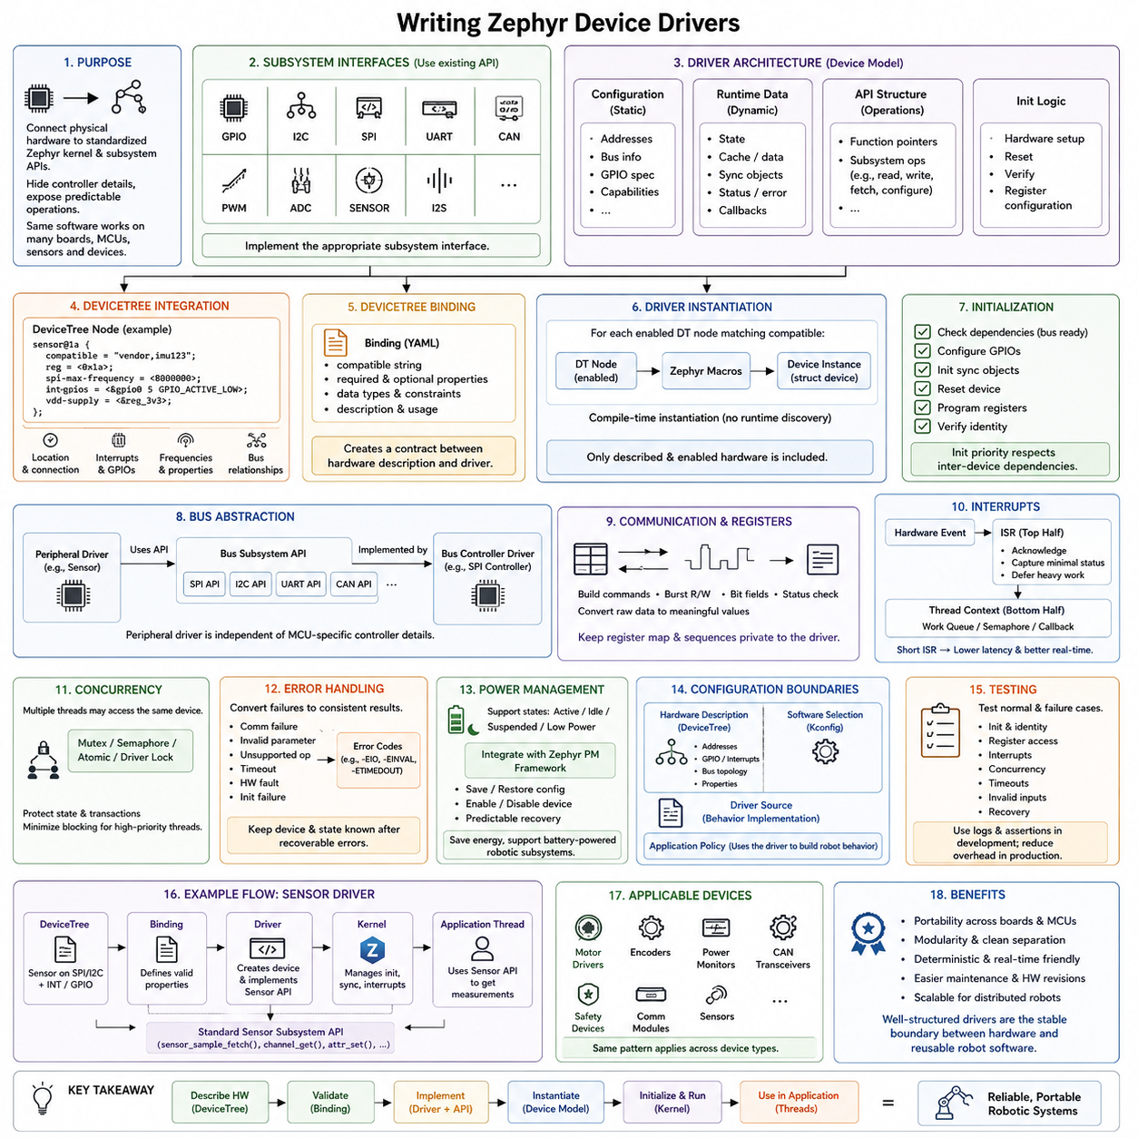
Zephyr device drivers form the hardware-facing layer that connects physical peripherals to standardized kernel and subsystem APIs. Instead of allowing application code to access registers directly, Zephyr represents hardware through device objects and subsystem interfaces. A properly designed driver hides controller-specific details while exposing predictable operations to applications, enabling the same software architecture to operate across different boards, microcontrollers, sensors, communication devices, and robotic controller variants.
Writing a Zephyr driver normally begins by identifying the subsystem to which the hardware belongs. GPIO, I2C, SPI, UART, CAN, PWM, ADC, sensors, and other device classes already define common APIs and behavioral expectations. A new driver should implement the appropriate subsystem interface rather than inventing an application-specific abstraction whenever possible. This preserves compatibility with existing Zephyr applications and allows higher-level software to use different hardware implementations through the same interface.
The Zephyr device model organizes each driver instance around configuration data, runtime data, an API structure, and initialization logic. Configuration data normally contains information that does not change while the system is running, such as peripheral addresses, bus relationships, GPIO specifications, or hardware capabilities. Runtime data stores mutable state such as cached measurements, synchronization objects, transfer status, error information, and callback references required during device operation.
The driver API structure contains function pointers implementing operations defined by the corresponding Zephyr subsystem. A sensor driver may provide functions for fetching samples, reading channels, configuring attributes, or registering triggers, while a communication driver implements operations appropriate to its protocol. Applications invoke the standardized subsystem API, which dispatches the request to the selected driver's implementation. This architecture separates application behavior from the internal implementation of a particular hardware device.
DeviceTree is a central component of driver integration because it describes where the physical device exists and how it is connected. A DeviceTree node can specify the compatible identifier, bus address, interrupt line, GPIO pins, operating frequency, and other hardware properties required by the driver. The driver obtains these values through compile-time DeviceTree macros instead of embedding board-specific constants directly in source code, allowing one driver implementation to support many board configurations.
A DeviceTree binding defines the expected structure of nodes representing a particular device. The binding associates a compatible string with required and optional properties and documents how those properties should be interpreted. When a custom sensor or controller is introduced, an appropriate binding allows the build system to validate its hardware description. This creates a formal contract between the DeviceTree hardware representation and the source code that initializes and operates the device.
Driver instantiation connects DeviceTree nodes with Zephyr device objects. Zephyr macros can generate configuration structures and device instances for each enabled hardware node matching a compatible driver. This compile-time approach is important for resource-constrained embedded systems because it avoids requiring a large runtime discovery framework. Only hardware described and enabled for the selected target needs to become part of the resulting firmware configuration.
Initialization establishes the hardware state required before applications begin using the device. A driver may verify that its underlying bus controller is ready, configure GPIO lines, initialize synchronization objects, reset the peripheral, program registers, and confirm device identity. Initialization priority must also respect dependencies between devices. A sensor connected through SPI, for example, cannot be fully initialized before the SPI controller required to communicate with it becomes available.
Bus-based drivers should use Zephyr's existing bus APIs instead of controlling bus-controller registers directly. An SPI sensor driver communicates through the SPI subsystem, while an I2C peripheral uses the I2C API. DeviceTree can describe both the peripheral and its parent bus relationship. This layered design makes the peripheral driver less dependent on a specific MCU because the underlying SPI or I2C controller driver absorbs processor-specific hardware differences.
Register-level communication remains an important responsibility inside many drivers. The implementation may need to construct command bytes, perform burst reads and writes, manipulate register bit fields, verify status values, and convert raw device representations into meaningful software values. These low-level operations should normally remain private to the driver so that application code does not become dependent on register maps or communication sequences specific to one hardware revision.
Interrupt-driven devices require careful separation between interrupt service routines and normal thread-context processing. The ISR should usually acknowledge the hardware event, capture minimal status information, and defer expensive work when possible. Semaphores, work queues, callbacks, or other appropriate kernel mechanisms can transfer processing into thread context. Keeping interrupt execution short reduces latency for other interrupts and helps preserve predictable real-time behavior across the embedded controller.
Concurrency must also be considered when multiple threads can access the same device. A driver may require a mutex, semaphore, atomic operation, or subsystem-specific locking mechanism to protect internal state and hardware transactions. The synchronization strategy should minimize blocking, particularly when high-priority control threads depend on the device. Driver-level locking should therefore be designed together with the application's scheduling and timing requirements rather than added only after race conditions appear.
Error handling is part of the driver's external contract. Communication failures, invalid parameters, unsupported operations, device timeouts, hardware faults, and initialization failures should be converted into consistent error results that applications can interpret. A robust driver should leave the device and internal state in a known condition after recoverable errors whenever possible. Robotics applications can then integrate these results into diagnostics, degraded-operation strategies, or safety supervision mechanisms.
Power management may require additional driver behavior because embedded devices often transition between active, idle, suspended, and low-power states. A power-aware driver must coordinate peripheral state with Zephyr's power-management framework, preserving or restoring configuration when necessary. Sensor nodes and battery-powered robotic subsystems particularly benefit from drivers that can disable unused hardware while maintaining predictable recovery when the device is needed again.
Driver configuration should remain separated from application policy. Hardware addresses, GPIO connections, interrupt assignments, and bus topology belong primarily in DeviceTree, while software feature selection belongs in Kconfig. The driver source implements device behavior, and the application determines how that behavior contributes to the robot. Maintaining these boundaries makes hardware revisions easier because changes can often be handled through configuration rather than modifications to control or application logic.
Testing should cover both normal behavior and hardware failure conditions. Driver development can begin with API-level tests and controlled communication sequences before being integrated into a complete robot application. Developers should verify initialization, register access, interrupt behavior, concurrency, timeout handling, invalid inputs, and recovery from communication failures. Logging and assertions can provide additional visibility during development, while production configurations can reduce diagnostic overhead when necessary.
A robotics sensor driver illustrates the complete architectural path. DeviceTree describes a sensor attached to SPI or I2C together with interrupt and GPIO resources. The binding defines valid hardware properties, the driver creates a device instance and implements the sensor subsystem API, and the kernel manages synchronization and interrupt processing. Application threads then request measurements through the standardized sensor interface without needing to know the sensor's register protocol or physical bus implementation.
The same pattern extends to motor-control interfaces, encoders, power monitors, CAN transceivers, safety devices, and communication modules. Well-structured drivers create a stable boundary between changing hardware and reusable robot software. Combined with DeviceTree, Kconfig, Zephyr's device model, and its build infrastructure, custom driver development becomes a systematic method for integrating new hardware while preserving portability, modularity, deterministic execution, and maintainability across distributed robotic embedded systems.

03.05 Zephyr Network Stack: Bluetooth, CAN, Ethernet [w/Code]
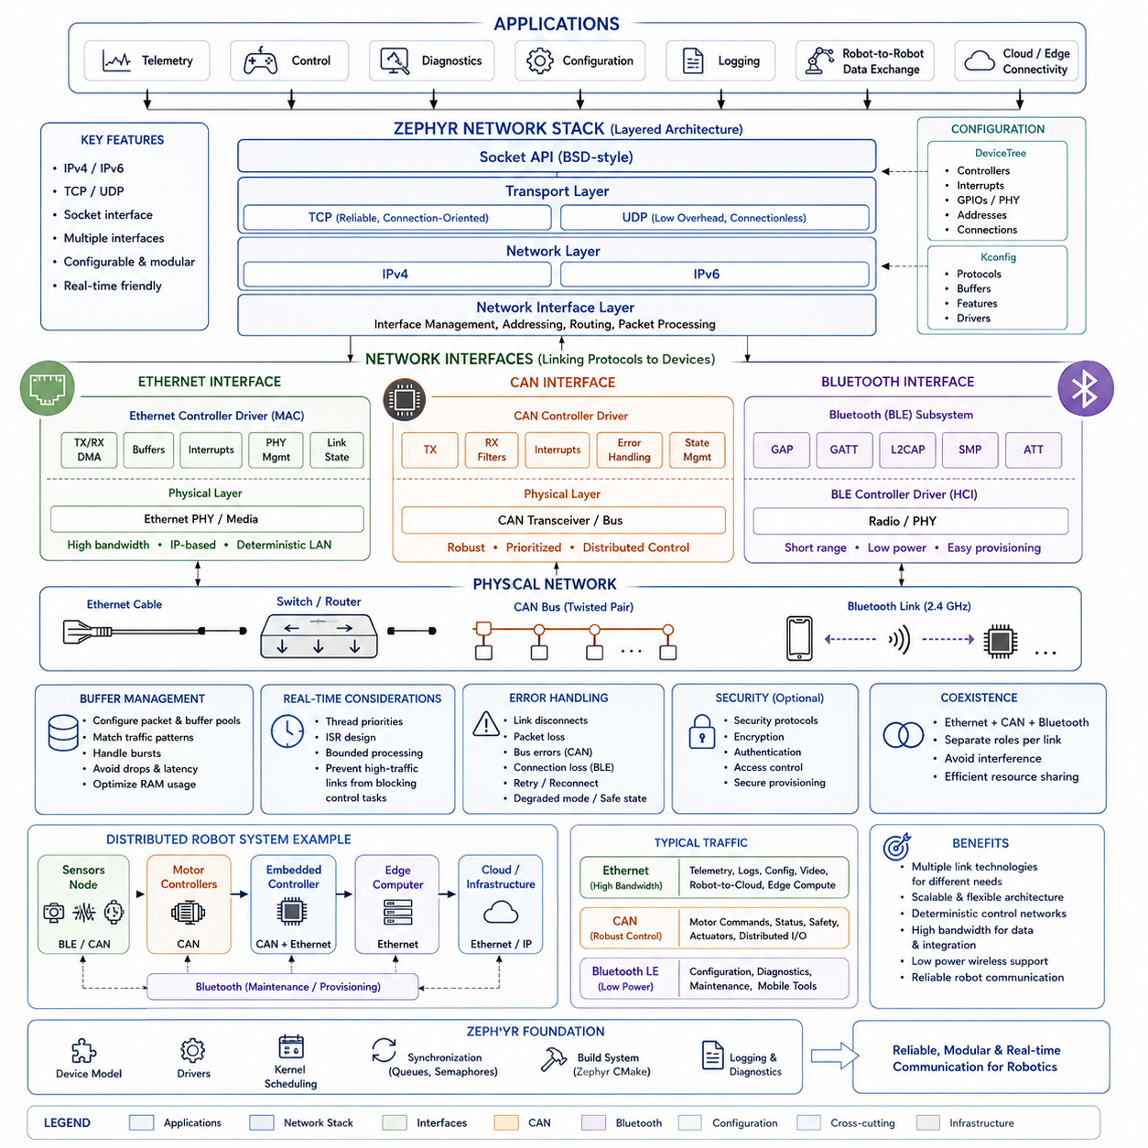
Zephyr provides an integrated networking architecture designed for embedded and real-time systems that must communicate through multiple physical interfaces while preserving a consistent software model. Its communication capabilities include an IP networking stack, Bluetooth, CAN, and Ethernet subsystems that can coexist within the same firmware. This allows sensor nodes, motor controllers, gateways, and distributed robot controllers to exchange information through interfaces appropriate to their bandwidth, range, latency, and reliability requirements.
The Zephyr network stack follows a layered architecture in which applications operate above transport and network protocols while network interfaces connect those protocols to physical communication hardware. This separation reduces application dependence on a particular network controller. Socket-oriented applications can communicate using familiar networking abstractions while lower layers handle packet processing, interface configuration, addressing, protocol execution, and transmission through the selected network device.
Zephyr supports IPv4 and IPv6 networking together with commonly required transport protocols such as TCP and UDP. TCP provides reliable connection-oriented communication where ordered delivery and retransmission are important, while UDP offers lower protocol overhead for applications that can tolerate or explicitly manage packet loss. Embedded designers can therefore select communication behavior according to the timing and reliability requirements of telemetry, commands, diagnostics, configuration, or robot-to-controller data exchange.
The socket interface provides an important abstraction between applications and the underlying network stack. Applications can create sockets, bind addresses, establish communication endpoints, and send or receive data without directly controlling Ethernet frames or network-controller registers. This model also makes embedded networking conceptually closer to conventional Linux and POSIX-style network programming, which can simplify migration of communication software between MCU-based controllers and more powerful edge-computing platforms.
Network interfaces represent the connection between protocol processing and actual communication devices. An interface may correspond to an Ethernet controller or another supported networking technology, while the associated driver handles hardware-specific transmission and reception. DeviceTree describes the physical controller, interrupts, memory resources, PHY relationships, and board connections, while Kconfig determines which networking capabilities, protocols, buffers, and drivers become part of the firmware.
Ethernet is particularly important for robotic controllers requiring higher bandwidth, deterministic local connectivity, or integration with edge computers and industrial networks. Zephyr's Ethernet subsystem separates generic network processing from Ethernet-controller drivers so that applications do not need to depend on a specific MAC implementation. Ethernet can carry IP-based telemetry, diagnostics, configuration, command traffic, and other data between embedded controllers, robot computers, gateways, and external infrastructure.
An Ethernet controller driver manages the hardware-facing operations needed to transmit and receive frames. Depending on the platform, this may involve DMA descriptors, packet buffers, interrupts, PHY configuration, link-state monitoring, and hardware capabilities such as checksum assistance. The network stack receives packets through the interface and passes them upward through protocol processing, while outgoing application data follows the reverse path toward the Ethernet hardware.
Buffer management is critical because embedded networking operates under constrained RAM while potentially receiving bursts of packets. Zephyr therefore requires careful configuration of network packet and buffer resources according to expected traffic. Excessive allocation wastes scarce memory, whereas insufficient capacity can cause dropped packets or increased latency. Robot communication design should consider packet size, message frequency, burst behavior, processing time, and available memory together rather than tuning buffers independently.
Bluetooth provides wireless connectivity for embedded devices that require short-range communication, provisioning, configuration, sensing, or peripheral interaction. Zephyr includes Bluetooth functionality as an integrated subsystem rather than requiring applications to implement the protocol stack directly. This allows embedded applications to use Bluetooth services and connections while controller-specific radio behavior remains separated through lower-level interfaces and hardware support.
Bluetooth Low Energy is especially useful for low-power sensor nodes, maintenance interfaces, commissioning tools, and mobile-device connectivity. A robot subsystem can expose configuration or diagnostic information without requiring a wired connection, while battery-operated devices can communicate intermittently to conserve energy. Bluetooth communication is generally complementary to higher-bandwidth robot networks rather than a replacement for every control link, particularly where strict latency or large continuous data streams are required.
CAN provides a different communication model optimized for robust distributed embedded control. Rather than using host-oriented IP addressing, classical CAN communication is based on message identifiers that represent priority and message meaning. Zephyr's CAN subsystem exposes standardized APIs for configuring controllers, transmitting frames, receiving selected identifiers, and handling controller state, allowing application software to remain relatively independent of the particular CAN peripheral integrated into an MCU.
CAN arbitration provides deterministic priority behavior at the bus-access level because frames with dominant higher-priority identifiers win arbitration without corrupting competing transmissions. This characteristic makes CAN useful for motor controllers, battery systems, safety-related status, actuator commands, and distributed embedded nodes. However, overall real-time performance still depends on bus load, message periods, identifier assignment, frame length, software scheduling, and error conditions, so system-level timing analysis remains necessary.
CAN reception can be organized using filters so that a controller processes only frames relevant to a particular application function. Received frames may trigger callbacks or be transferred into thread-level processing through queues or other kernel mechanisms. Keeping interrupt-context processing short is important, especially when CAN traffic coexists with motor control or sensor acquisition. The communication architecture should therefore separate immediate frame reception from more expensive decoding, state management, and application logic.
Bluetooth, CAN, and Ethernet occupy different positions within a robotic communication architecture. CAN is well suited to compact, robust control networks connecting embedded devices; Ethernet provides greater bandwidth and integration with IP-based computing infrastructure; Bluetooth provides convenient short-range wireless connectivity and low-power peripheral communication. Zephyr allows these technologies to coexist so that each link can be assigned according to its physical and functional requirements instead of forcing one protocol to serve every purpose.
A distributed robot can therefore use CAN between a local MCU and motor controllers, Ethernet between an embedded controller and an edge computer, and Bluetooth for service or commissioning access. The application architecture can place communication-specific processing behind defined interfaces while queues, threads, callbacks, and synchronization mechanisms connect networking activities with control and sensing tasks. This prevents communication protocols from becoming tightly coupled to the core robot-control logic.
Real-time communication requires attention to thread priorities and processing paths in addition to protocol selection. Network receive threads, driver interrupts, application processing, and control threads compete for CPU resources. High-volume Ethernet traffic should not be allowed to delay safety or actuator-control tasks, while CAN processing must meet deadlines associated with control messages. Priority assignment, buffer sizing, interrupt design, and bounded processing therefore become part of the networking architecture.
Error handling must also extend across communication layers. Ethernet links may disconnect, CAN controllers may encounter bus errors or state transitions, Bluetooth connections may be lost, and packet transmission may fail because resources are unavailable. Applications should distinguish temporary communication failures from persistent faults and define appropriate recovery behavior. Robot systems may reconnect, retry, enter degraded operation, report diagnostics, or initiate a safe state depending on communication criticality.
Zephyr's networking architecture ultimately provides a common embedded foundation for heterogeneous robot communication. The network stack supplies IP connectivity, Ethernet connects high-bandwidth local infrastructure, CAN supports robust distributed control, and Bluetooth enables flexible wireless interaction. Combined with DeviceTree hardware descriptions, standardized drivers, kernel scheduling, and configurable build options, these subsystems allow communication interfaces to evolve while preserving modular application software across sensor nodes, controllers, gateways, and distributed robotic platforms.

03.06 Zephyr Low-Power Design: Power Management API [w/Code]
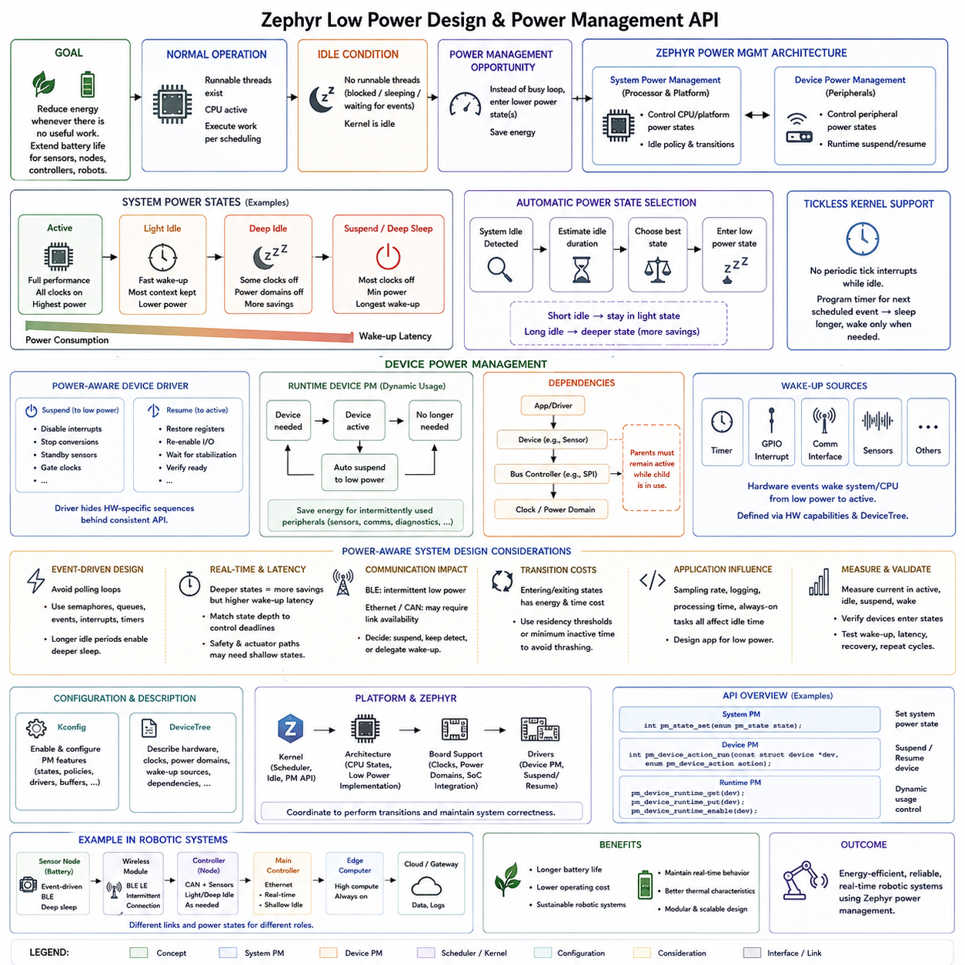
Low-power design in Zephyr is based on reducing energy consumption whenever the processor or peripheral devices do not need to perform useful work. Instead of keeping the CPU continuously active, the operating system can recognize idle periods and transition the system into lower-power states. This behavior is especially important for battery-powered sensors, wireless nodes, portable controllers, and robotic subsystems that must operate for long periods with limited available energy.
The fundamental principle is that power consumption should follow actual computational demand. When runnable threads exist, the processor remains available to execute application work according to kernel scheduling rules. When all relevant threads are blocked, sleeping, or waiting for events, the kernel reaches an idle condition. Zephyr can use this opportunity to reduce processor activity rather than repeatedly executing an empty software loop and wasting energy.
Zephyr's power-management architecture separates system-level power states from individual device power states. System power management controls the operating condition of the processor and broader platform, while device power management controls peripherals such as sensors, communication controllers, ADCs, SPI devices, or other hardware blocks. This separation allows the system to reduce power selectively instead of requiring every component to enter or leave a low-power state simultaneously.
System power states typically represent progressively deeper reductions in activity and energy consumption. A light idle state may preserve most processor context and provide very fast wake-up, while deeper states may disable clocks, power domains, or additional hardware resources. Deeper power states generally save more energy but introduce greater entry and exit overhead. Selecting the appropriate state therefore requires balancing energy savings against wake-up latency and real-time response requirements.
Zephyr can perform automatic power-state selection when the system becomes idle. The power-management policy evaluates how long the processor is expected to remain inactive and determines whether entering a particular low-power state is beneficial. If the next scheduled event occurs very soon, the energy and timing cost of entering a deep state may exceed its benefit. Longer idle intervals provide greater opportunities for deeper power reduction.
This relationship makes timer behavior important to low-power operation. Periodic tasks that wake the processor unnecessarily can prevent the system from remaining in an efficient sleep state. Applications should therefore avoid high-frequency polling when event-driven processing can be used instead. Threads can block on semaphores, queues, events, interrupts, or timers and allow the scheduler to expose longer idle intervals that the power-management subsystem can exploit.
Tickless kernel operation further supports low-power design by avoiding unnecessary periodic timer interrupts while the processor is idle. Instead of waking at every operating-system tick, the kernel can program a timer for the next meaningful scheduled event. The CPU may then remain asleep for a longer continuous interval. This approach is particularly effective for sensor nodes and controllers whose workload consists of short processing bursts separated by relatively long inactive periods.
Device power management extends these savings beyond the CPU. A peripheral may consume significant power even when no application is actively using it, particularly when clocks, analog circuits, radios, or external sensors remain enabled. Zephyr's device power-management mechanisms allow supported drivers and applications to coordinate transitions between operational and reduced-power conditions, enabling unused hardware resources to be suspended when appropriate.
A power-aware device driver must understand the state transitions supported by its hardware. Suspending a device may require disabling interrupts, stopping conversions, placing an external sensor into standby, or shutting down a peripheral clock. Resuming may require restoring registers, re-enabling communication, waiting for hardware stabilization, and verifying readiness. The driver should hide these hardware-specific sequences behind a consistent device-management interface.
Runtime device power management is useful when peripheral usage changes dynamically during normal operation. Instead of keeping a device active for the entire lifetime of the firmware, software can request the device when needed and allow it to return to a lower-power state when no longer in use. This model is valuable for environmental sensors, auxiliary communication interfaces, diagnostic hardware, and other peripherals that operate intermittently rather than continuously.
Dependencies between devices must be considered when managing power. A sensor connected through an SPI controller cannot communicate if the SPI controller or its associated clock domain has already been suspended. Similarly, a network device may depend on a PHY, bus controller, or other supporting resource. Power-management design must therefore account for the dependency chain so that parent resources remain available whenever dependent devices require them.
Wake-up sources determine which events can return the system from a reduced-power state to active execution. Depending on the hardware platform, wake-up may originate from timers, GPIO interrupts, communication interfaces, sensors, or other external events. DeviceTree and platform configuration can participate in describing relevant hardware capabilities. The selected low-power state must preserve the resources required to detect the wake-up event expected by the application.
Wake-up latency is especially important in real-time robotic systems. A deeply sleeping processor may save substantial energy but require too much time to resume for a safety-related input or time-critical actuator command. Consequently, low-power policy cannot be designed independently of control deadlines. Critical control loops may require shallow idle states, while monitoring or standby modes can permit deeper system suspension when rapid response is temporarily unnecessary.
Communication interfaces also influence power behavior. Bluetooth Low Energy can support intermittent low-energy communication, while Ethernet or continuously active CAN networks may impose different availability requirements. A robot controller must determine whether a communication interface can be suspended, whether it must remain capable of detecting traffic, or whether another device is responsible for wake-up. Communication availability and energy reduction therefore need to be designed together.
Power management interacts directly with application architecture. Polling loops, unnecessary periodic logging, excessive sensor sampling, and permanently active communication tasks reduce the opportunities available for sleeping. Event-driven threads, bounded processing, adaptive sampling, and deliberate peripheral activation create longer idle periods. Effective low-power design therefore begins at the application level rather than being achieved only by enabling a kernel configuration option.
Energy optimization should also consider the cost of repeatedly transitioning between power states. Rapidly suspending and resuming a device can consume more energy than leaving it active for a short interval and may increase latency or reduce hardware lifetime in some systems. Practical policies can therefore use residency thresholds or minimum inactive periods to determine when a lower-power state provides a genuine system-level advantage.
Kconfig is used to enable and configure relevant Zephyr power-management capabilities, while DeviceTree describes hardware characteristics and relationships needed by the platform and device drivers. The kernel, architecture-specific implementation, board support, and drivers then cooperate to perform the actual transitions. This division preserves Zephyr's broader design principle in which software policy, hardware description, and device implementation remain clearly separated.
Testing low-power firmware requires more than verifying functional correctness. Developers should measure current consumption in active, idle, suspend, and wake-up transitions and confirm that expected devices actually enter their intended states. Wake-up sources, latency, timer accuracy, communication recovery, and repeated suspend-resume cycles should also be validated. Measurement with real hardware is essential because software state alone does not guarantee that physical power consumption has been reduced.
In robotic embedded systems, Zephyr power management provides a coordinated path from application inactivity to hardware energy reduction. Threads expose idle opportunities, the kernel selects appropriate system states, device drivers suspend unused peripherals, and hardware wake-up sources restore execution when required. When combined with event-driven software, carefully selected timing policies, and measured power behavior, these mechanisms enable energy-efficient sensor nodes, wireless modules, standby controllers, and distributed robotic devices without abandoning deterministic real-time operation.

03.07 Zephyr Security Features: PSA Certified
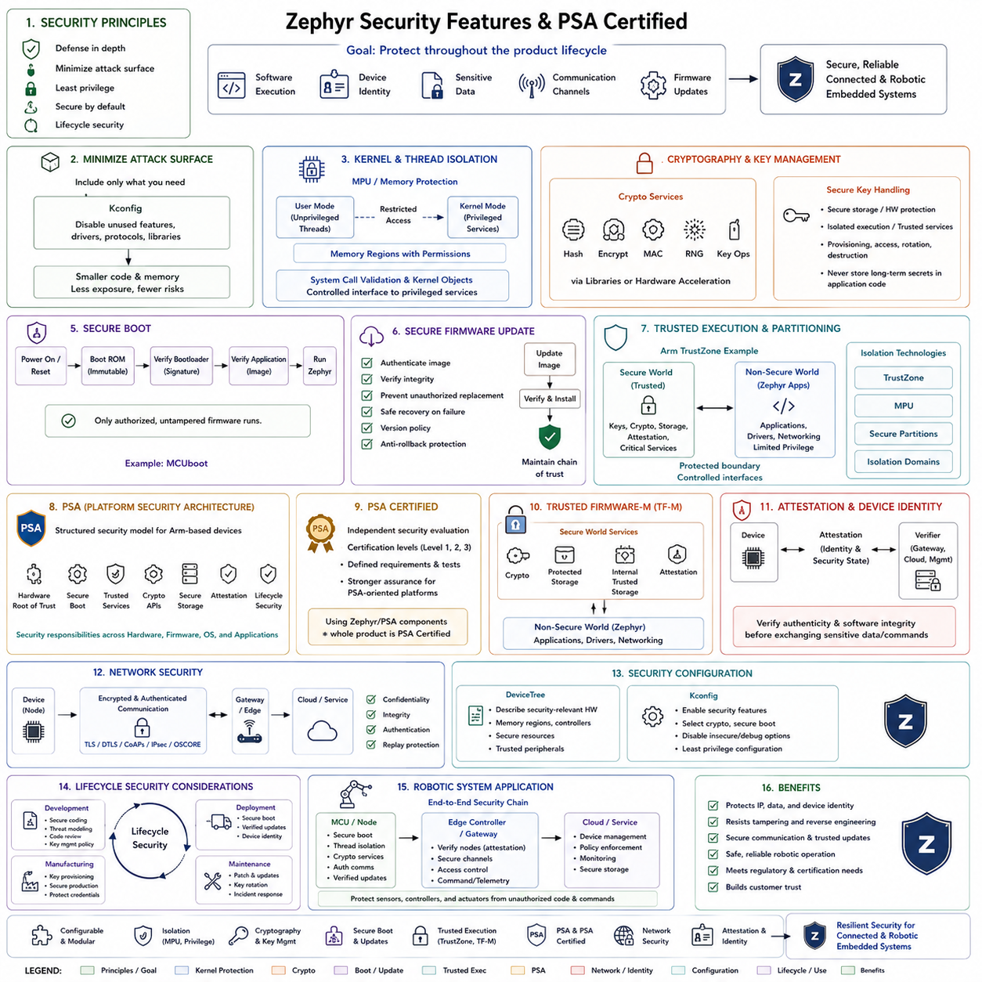
Zephyr security is built around the principle that embedded systems must protect software execution, device identity, sensitive data, communication channels, and firmware updates throughout the product lifecycle. Rather than treating security as a single feature, Zephyr combines kernel isolation, cryptographic services, secure boot mechanisms, hardware security capabilities, networking protections, and standardized security frameworks to establish multiple defensive layers within connected embedded and robotic devices.
The security architecture begins with minimizing the trusted computing base and reducing unnecessary software exposure. Zephyr's configurable design allows applications to include only the kernel services, drivers, protocols, and libraries required by the target system. Removing unused components reduces memory consumption while also decreasing the potential attack surface. Kconfig therefore contributes indirectly to security by allowing developers to disable functionality that the deployed product does not require.
Kernel-level protection helps separate application execution from privileged system resources. On supported processor architectures, Zephyr can use a memory protection unit, or MPU, to establish memory regions with defined access permissions. User-mode threads can execute with restricted privileges, while kernel services remain protected. If compromised or defective application code attempts unauthorized access, hardware-enforced memory boundaries can limit its ability to corrupt kernel memory or unrelated system components.
Thread isolation can be combined with Zephyr kernel objects and system-call validation to establish controlled interaction between unprivileged software and trusted kernel services. Applications request privileged operations through defined interfaces rather than directly manipulating protected resources. This architecture supports the principle of least privilege, where each software component receives only the access necessary for its intended function, reducing the consequences of programming errors or malicious behavior.
Cryptography provides another major security layer. Zephyr can integrate cryptographic libraries and hardware acceleration capabilities to support operations such as hashing, encryption, authentication, random-number generation, and key-related functions. Applications can use these capabilities to protect stored information and communication traffic. Hardware cryptographic engines can improve performance and reduce CPU load while also helping isolate sensitive operations from ordinary application processing.
Secure key handling is especially important because cryptographic algorithms provide limited protection if secret keys can be easily extracted or modified. Depending on the target hardware, keys may be protected through secure storage, dedicated security hardware, isolated execution environments, or platform-specific trusted services. A robust design avoids embedding long-term secrets directly in ordinary application code and establishes controlled interfaces for key provisioning, access, rotation, and destruction.
Secure boot establishes trust from the beginning of system execution. Instead of executing any firmware image present in memory, a secure boot process verifies that software is authorized and has not been modified before transferring control to it. Zephyr deployments can use bootloader technologies such as MCUboot, where cryptographic signatures and image validation support authenticated firmware startup and secure firmware update workflows.
Firmware update security extends the chain of trust beyond initial boot. Connected devices may receive software updates throughout years of operation, making the update mechanism a critical attack surface. Update systems should authenticate firmware images, verify integrity, prevent unauthorized replacement, and recover safely from interrupted installations. Version policies and anti-rollback protection may also be required so that attackers cannot reinstall an older image containing known vulnerabilities.
Partitioning and trusted execution technologies provide stronger isolation on supported hardware. Arm TrustZone-based systems, for example, can separate secure and non-secure execution environments so that sensitive services operate outside the normal application domain. Secure firmware can manage cryptographic keys, trusted storage, attestation, and other critical operations while non-secure Zephyr applications interact with those capabilities through controlled interfaces rather than directly accessing protected resources.
Platform Security Architecture, commonly called PSA, provides a structured security model for Arm-based connected devices. PSA defines concepts for hardware roots of trust, secure boot, trusted services, cryptographic interfaces, storage, attestation, and lifecycle security. Its purpose is not merely to add encryption but to establish a consistent architecture in which security responsibilities are distributed across hardware, firmware, operating-system services, and application software.
PSA Certified complements the architectural model with an independent security evaluation framework. Certification levels provide progressively stronger assurance based on defined security requirements and evaluation activities. For products built with Zephyr on PSA-oriented hardware, the certification framework can help developers reason about the security capabilities of the underlying platform. However, using Zephyr or PSA-compatible components does not automatically make the complete final product PSA Certified.
Trusted Firmware-M is commonly associated with PSA-oriented microcontroller security architectures. It provides secure-world services for supported Arm platforms and can work with non-secure software such as Zephyr. Services may include cryptography, protected storage, internal trusted storage, and initial attestation. This arrangement creates a boundary where security-sensitive functionality is concentrated within a smaller trusted environment while ordinary embedded applications execute with more limited privileges.
Attestation allows a device to provide evidence about its identity and security state to another trusted party. In distributed IoT or robotic systems, a gateway or management platform may need assurance that a controller is genuine and running expected software before accepting sensitive commands or data. Attestation mechanisms can contribute to device authentication and fleet trust, particularly when many embedded nodes are deployed across physically accessible environments.
Network security must protect information after the device becomes connected. Depending on the enabled protocol stack and application requirements, encrypted and authenticated communication can be established using appropriate security protocols and cryptographic libraries. Transport protection helps prevent unauthorized observation or modification of commands, telemetry, configuration information, and credentials as data moves between embedded nodes, gateways, edge computers, or remote services.
DeviceTree and Kconfig also influence the security architecture. DeviceTree describes security-relevant hardware resources such as memory regions, controllers, and platform devices, while Kconfig determines which software security features become part of the firmware. These configuration mechanisms should be managed carefully because enabling unnecessary debugging interfaces, insecure protocols, or excessive privileges can weaken an otherwise well-designed security architecture.
Debug and development interfaces require particular attention when moving from prototype to production. Interfaces that are valuable during development may provide powerful access to memory, firmware, or processor state if left unrestricted in deployed hardware. Production security therefore requires explicit policies for debug access, boot configuration, firmware signing keys, manufacturing credentials, and recovery mechanisms. Security must cover manufacturing and maintenance processes as well as normal runtime execution.
Robotic systems add physical consequences to embedded security failures. A compromised sensor node may provide false measurements, while an attacked motor controller or communication gateway may influence actuator behavior. Security mechanisms must therefore work together with functional safety and fault-management architecture. Authentication, isolation, secure updates, communication protection, and trusted execution reduce the possibility that unauthorized software or commands can propagate into physical robot behavior.
A distributed robot can apply these mechanisms across multiple layers. A microcontroller may boot authenticated firmware, isolate unprivileged application threads, use protected cryptographic services, authenticate network communication, and accept only verified software updates. An edge controller can then establish trust relationships with embedded nodes before exchanging commands or telemetry. This creates a security chain extending from hardware identity and firmware integrity to communication and system-level operation.
Zephyr security should ultimately be treated as a lifecycle architecture rather than a collection of independent options. Secure boot establishes the initial root of trust, isolation limits software privileges, cryptography protects data and identity, secure communication protects interfaces, and authenticated updates preserve trust after deployment. Combined with PSA-oriented hardware and certification practices where appropriate, these mechanisms provide a structured foundation for resilient connected sensors, controllers, gateways, and distributed robotic systems.

03.08 Zephyr Robot Sensor Node Implementation [w/Code]
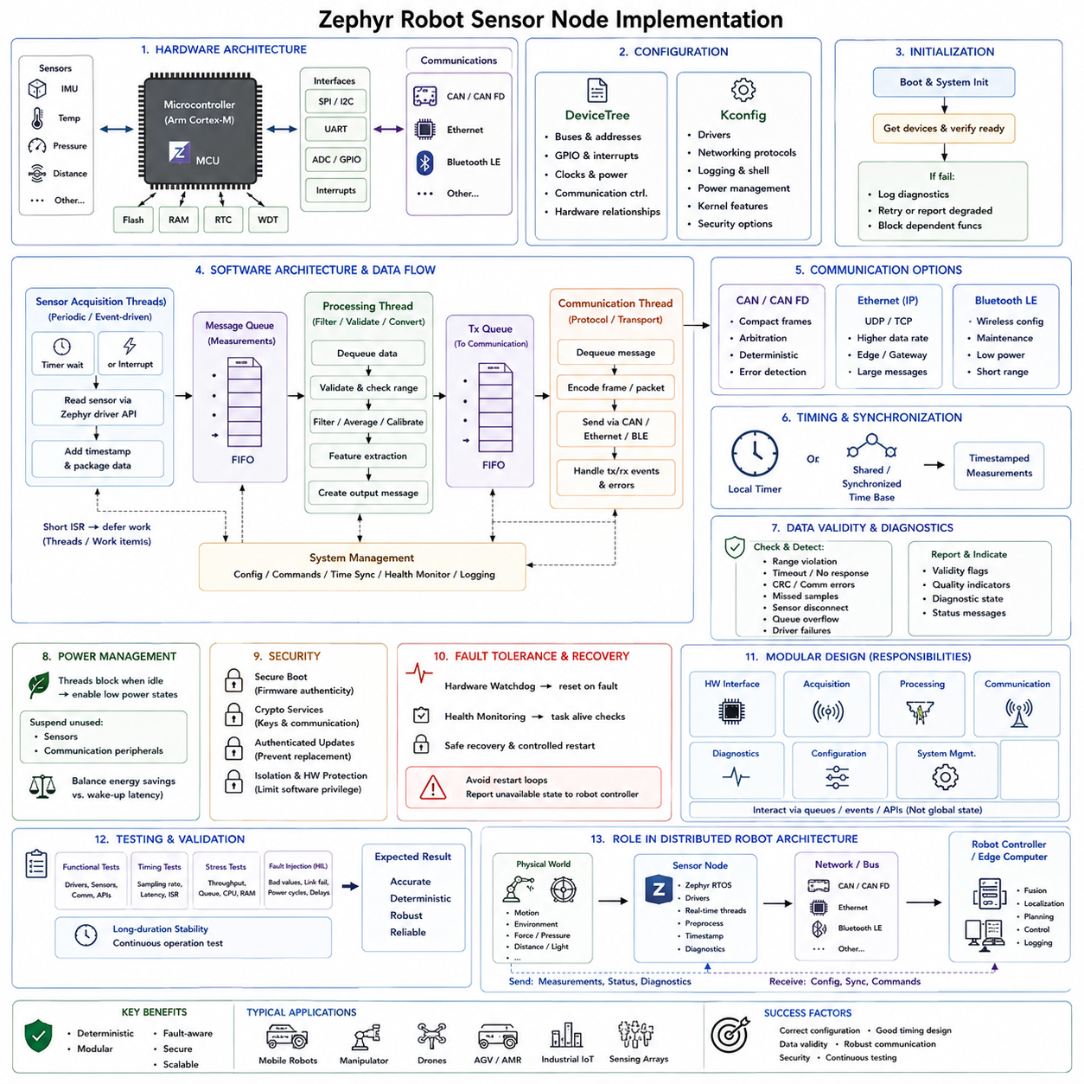
Zephyr provides a practical foundation for implementing distributed robot sensor nodes because it combines deterministic real-time scheduling, standardized device drivers, communication stacks, power management, and embedded security within a compact RTOS. A sensor node can acquire physical measurements, preprocess them locally, monitor device health, timestamp observations, and transmit structured information to higher-level robot controllers without requiring a large general-purpose operating system.
A typical robot sensor node consists of a microcontroller connected to sensors through interfaces such as SPI, I2C, UART, GPIO, or ADC. The same controller may communicate with the robot through CAN, Ethernet, Bluetooth, or another supported interface. Zephyr organizes these hardware resources through its device model and DeviceTree, allowing board-specific connections to remain separated from most application logic and making the firmware easier to migrate between hardware platforms.
DeviceTree describes the physical configuration of the node, including buses, sensor addresses, interrupt lines, GPIO assignments, communication controllers, and other hardware relationships. Drivers obtain hardware configuration from this description rather than embedding board-specific constants throughout application code. Kconfig complements DeviceTree by selecting software capabilities such as drivers, networking protocols, logging, power management, and kernel features required by the sensor-node firmware.
During initialization, the application obtains references to required devices and verifies that each device is ready before normal operation begins. A sensor that fails initialization should not silently enter the acquisition loop because invalid measurements could propagate into robot perception or control. The node can instead record diagnostic information, report degraded status, retry initialization where appropriate, or prevent dependent functions from starting until the required hardware becomes available.
Sensor acquisition should normally be organized around timing and event requirements rather than a single continuous polling loop. Periodic sensors can be sampled by threads awakened according to defined intervals, while event-driven devices can use interrupts to indicate that new data is available. Interrupt service routines should remain short and transfer processing work to threads, queues, work items, or other deferred execution mechanisms so that interrupt latency remains controlled.
For a periodic inertial, temperature, distance, or environmental sensor, an acquisition thread can wait until its next sampling point, read the device through the Zephyr sensor or driver interface, and package the result into an internal message. The sampling frequency should reflect the physical dynamics being observed. High-rate motion sensors may require frequent acquisition, whereas temperature or battery measurements can operate at much lower rates and therefore consume fewer processing and communication resources.
Queues provide a useful boundary between acquisition and downstream processing. A sensor thread can place measurements into a message queue without directly controlling every subsequent operation. Another thread can remove messages, perform filtering or validation, and prepare communication frames. This producer-consumer architecture reduces coupling between hardware timing and network timing and prevents temporary communication delays from immediately disrupting sensor acquisition.
Synchronization becomes important when multiple sensors contribute to a common robot state. Measurements should include timing information so that higher-level software can determine when observations were captured. Depending on the system architecture, timestamps may originate from a local hardware timer or from a synchronized time base shared with other nodes. Accurate timing is particularly important when combining IMU, wheel encoder, LiDAR, camera, or actuator information across distributed controllers.
Local preprocessing can reduce the amount of data transmitted from a resource-constrained node. Instead of forwarding every raw sample, firmware may perform calibration, unit conversion, range checking, averaging, filtering, event detection, or simple feature extraction. The amount of processing should remain compatible with MCU resources and real-time deadlines. Safety-relevant raw information may still need to be preserved or transmitted when higher-level diagnostics require access to original measurements.
The communication thread converts internal sensor information into the protocol expected by the rest of the robot. A CAN-based node may encode compact measurements into CAN or CAN FD frames, while an Ethernet-connected node may use UDP, TCP, or application-specific messaging. Bluetooth can provide wireless configuration or maintenance functions. Separating sensor acquisition from communication allows the same sensing logic to be reused even when the external transport changes.
CAN is particularly suitable for distributed low-level robot nodes because arbitration, message identifiers, error detection, and deterministic bus access characteristics support controller-oriented communication. Zephyr CAN APIs and drivers allow firmware to configure controllers, install receive filters, transmit frames, and process bus events. A robot sensor node can therefore publish measurements and diagnostic status while receiving configuration, synchronization, or control-related messages from a central controller.
Ethernet becomes attractive when sensor data volume exceeds what low-level field buses can efficiently transport. A node equipped with an Ethernet controller can use Zephyr's network stack to exchange larger messages with an edge computer or gateway. The architecture should still control buffering and transmission rates because network congestion or a disconnected receiver must not block time-critical sensor acquisition. Communication failures should be isolated from the primary measurement path whenever possible.
A robust node continuously evaluates data validity and hardware health. Range violations, communication timeouts, CRC errors, missed samples, sensor disconnection, queue overflow, and internal driver failures should be converted into explicit diagnostic states. Measurements can carry validity flags or quality indicators so that downstream software distinguishes trustworthy observations from degraded data rather than interpreting every numeric value as valid.
Watchdogs and fault-recovery mechanisms improve resilience when the sensor node operates unattended. A hardware watchdog can reset the MCU if critical firmware execution becomes unresponsive, while software health monitoring can verify that acquisition and communication tasks continue to execute within expected intervals. Recovery should be designed carefully so that repeated faults do not produce uncontrolled restart loops or cause a robot controller to interpret unavailable sensors as healthy devices.
Power management is useful for battery-powered or intermittently active robot nodes. Threads should block when no work is required, allowing Zephyr to expose idle periods to the power-management subsystem. Sensors and communication peripherals may be suspended when operational requirements permit. However, nodes participating in high-rate control, collision detection, or safety monitoring may need to remain continuously responsive, making deterministic wake-up latency more important than maximum energy savings.
Security becomes increasingly important when sensor nodes support remote configuration, network communication, or firmware updates. Secure boot can establish firmware authenticity, cryptographic services can protect credentials and communication, and authenticated updates can prevent unauthorized firmware replacement. User-mode isolation and hardware protection mechanisms can further restrict software privileges on supported platforms, reducing the possibility that one compromised component controls the entire node.
A practical Zephyr implementation benefits from separating firmware into hardware interface, acquisition, processing, communication, diagnostics, configuration, and system-management responsibilities. These functions can communicate through defined queues, events, or APIs instead of sharing unrestricted global state. Such modularity improves testability and makes it easier to replace a sensor, communication interface, or processing algorithm without redesigning the complete application.
Testing should begin with individual drivers and progress toward integrated timing behavior. Developers should verify sensor accuracy, sampling intervals, interrupt latency, queue behavior, communication throughput, fault handling, CPU utilization, memory consumption, and long-duration stability. Hardware-in-the-loop testing can inject abnormal sensor values, communication failures, delayed responses, and power transitions to verify that the node continues to provide predictable behavior under realistic robot operating conditions.
Within a distributed robot architecture, the Zephyr sensor node forms the bridge between physical sensing and higher-level intelligence. Sensors capture physical phenomena, Zephyr drivers expose the hardware, real-time threads acquire and preprocess observations, queues isolate processing stages, and communication interfaces deliver timestamped data and diagnostics to robot controllers or edge computers. This layered implementation produces sensor nodes that are deterministic, modular, power-aware, fault-aware, and suitable for integration into scalable robotic systems.

03.09 FreeRTOS vs Zephyr: Selection Criteria Matrix
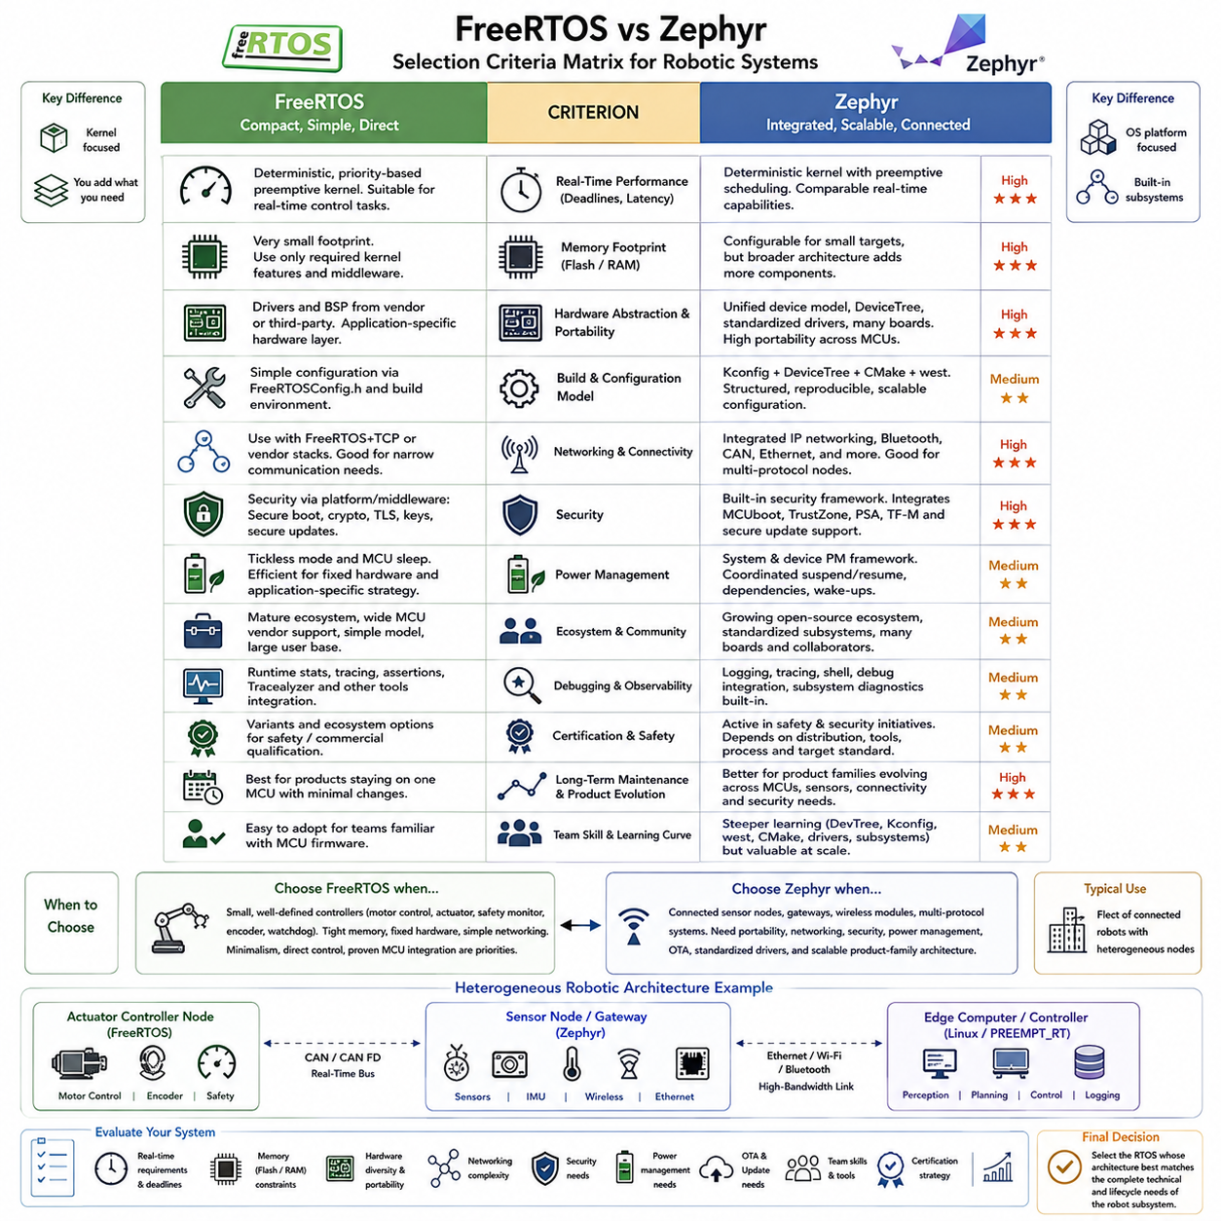
Selecting between FreeRTOS and Zephyr should begin with the architecture and lifecycle of the embedded product rather than with a simple comparison of kernel speed. Both can provide deterministic MCU-level execution suitable for robotic systems, but they represent different development philosophies. FreeRTOS emphasizes a compact kernel and direct application integration, whereas Zephyr provides a broader operating-system framework that integrates kernel services, drivers, configuration, networking, security, power management, and tooling.
FreeRTOS is particularly attractive when the required software architecture is small, clearly bounded, and centered on deterministic tasks. A motor controller, actuator interface, safety monitor, or dedicated sensor processor may need scheduling, queues, semaphores, timers, and interrupt integration without requiring a large platform framework. In these systems, the small conceptual footprint of FreeRTOS can make firmware behavior relatively straightforward to understand, configure, verify, and maintain.
Zephyr becomes increasingly attractive as the MCU evolves from a dedicated controller into a connected embedded computing node. Its kernel is surrounded by standardized subsystems for devices, networking, storage, power management, security, logging, and system configuration. This integrated architecture reduces the amount of platform infrastructure that an engineering team must independently assemble when a product requires multiple communication technologies, diverse sensors, secure updates, or reusable board support.
Real-time behavior alone usually does not provide a decisive distinction because both systems can support priority-based preemptive execution and deterministic embedded designs when correctly configured. The important criterion is whether the application's deadlines, interrupt latency, scheduling behavior, and worst-case execution requirements can be demonstrated on the selected hardware. RTOS selection should therefore be based on measured worst-case behavior rather than general assumptions about which kernel is faster.
Memory footprint can favor FreeRTOS in highly constrained designs because applications can use a relatively small set of kernel functions and add only the middleware they require. This is useful for inexpensive MCUs with limited Flash and SRAM. Zephyr can also be configured for constrained targets, but its broader architecture introduces additional configuration and subsystem considerations. The practical comparison should use representative application builds rather than comparing nominal kernel sizes in isolation.
Hardware abstraction represents a significant architectural difference. FreeRTOS primarily provides kernel functionality, while hardware drivers and board support commonly come from MCU vendors, middleware packages, or application-specific layers. Zephyr provides a unified device model, DeviceTree-based hardware description, standardized driver APIs, and extensive board definitions. Zephyr can therefore offer stronger portability when the same firmware architecture must support multiple MCU families, boards, sensors, and communication controllers.
The build and configuration models also differ substantially. A FreeRTOS application can remain comparatively direct, with kernel behavior commonly controlled through FreeRTOSConfig.h and the surrounding project build environment. Zephyr uses Kconfig, DeviceTree, CMake, and west as coordinated parts of its development workflow. This requires a greater initial learning investment but provides structured dependency management and reproducible configuration as projects grow across multiple boards and software modules.
Networking requirements can strongly influence the decision. FreeRTOS can be combined with networking solutions such as FreeRTOS+TCP and vendor middleware, making it suitable when a product needs a defined and relatively narrow communication stack. Zephyr integrates networking more broadly, including IP networking and technologies such as Bluetooth, CAN, and Ethernet. A sensor gateway or connected robot node supporting several communication interfaces can therefore benefit from Zephyr's unified networking environment.
Security is another criterion that becomes more important as devices become remotely accessible. FreeRTOS systems can implement secure boot, cryptography, TLS, protected keys, and secure firmware updates by combining appropriate platform and middleware components. Zephyr provides these capabilities within a broader security-oriented architecture and can integrate with technologies such as MCUboot, Arm TrustZone, PSA-oriented services, and Trusted Firmware-M on supported platforms.
Power management should be evaluated according to the node's actual operating profile. FreeRTOS applications can implement efficient low-power behavior through tickless operation and MCU-specific sleep mechanisms, particularly when the hardware platform is fixed and the power strategy is application-specific. Zephyr provides more structured system and device power-management frameworks, which can simplify designs containing multiple peripherals that require coordinated suspend, resume, dependency, and wake-up handling.
Development ecosystem is therefore a major selection factor. FreeRTOS benefits from broad MCU vendor support, extensive commercial use, a relatively simple kernel model, and a large body of embedded development experience. Zephyr provides an increasingly comprehensive open embedded platform with standardized subsystems and board support. The appropriate choice depends partly on whether the organization prefers a compact kernel surrounded by selected components or an integrated RTOS platform with common infrastructure.
Debugging and observability requirements should also be considered. FreeRTOS supports runtime statistics, tracing, assertions, and integration with commercial or vendor debugging environments, while tools such as Tracealyzer can provide detailed visualization. Zephyr provides logging, tracing, shell facilities, debugging integration, and subsystem diagnostics within its framework. Complex connected nodes can benefit from this integrated observability, while small controllers may require only lightweight instrumentation.
Certification and safety requirements cannot be evaluated solely from the RTOS name. A safety-related product must consider the exact kernel distribution, qualified components, development process, toolchain, evidence, and target certification standard. FreeRTOS has variants and ecosystem offerings aimed at safety and commercial qualification scenarios, while Zephyr also participates in safety and security initiatives. The certification strategy should therefore be evaluated for the specific product configuration rather than inferred from upstream projects.
Long-term maintenance changes the selection criteria significantly. A simple controller that remains on one MCU for many years may benefit from FreeRTOS because its limited architecture can minimize unnecessary dependencies and migration work. A product family expected to evolve across processors, sensors, network interfaces, and security requirements may gain more from Zephyr's standardized hardware descriptions and subsystem APIs. The expected product roadmap should therefore influence the initial RTOS decision.
Team capability is equally important. Engineers experienced with conventional MCU firmware can often understand the FreeRTOS task, queue, semaphore, timer, and configuration model quickly. Zephyr introduces additional abstractions including DeviceTree, Kconfig, west, CMake integration, device binding, and subsystem configuration. This complexity can initially slow development, but the investment becomes advantageous when teams manage reusable firmware across many products and hardware variants.
For low-level robotic control, FreeRTOS remains a strong choice when the MCU has a narrowly defined responsibility such as motor current control, joint servo management, encoder processing, watchdog supervision, or deterministic actuator communication. The application can remain small, statically structured, and tightly coupled to known hardware. In this case, introducing a broader operating-system framework may provide limited benefit relative to the additional integration and configuration complexity.
Zephyr is particularly suitable for intelligent sensor nodes, wireless modules, gateways, and distributed controllers whose responsibilities extend beyond a single control loop. A node combining several sensors, CAN communication, Ethernet or Bluetooth connectivity, diagnostics, low-power operation, security, and OTA firmware management can reuse Zephyr's integrated subsystems. The resulting architecture can also be replicated across a fleet of heterogeneous robotic devices with less platform-specific application code.
The selection matrix should therefore compare criteria such as real-time requirements, memory constraints, hardware diversity, networking complexity, security, power management, OTA needs, portability, development tooling, certification strategy, team experience, and long-term product evolution. These criteria should be weighted according to the actual robot subsystem. A feature that is essential for a wireless sensor node may have almost no value for a dedicated motor-control MCU.
A robot does not necessarily need to standardize every microcontroller on one RTOS. FreeRTOS can serve compact and tightly bounded actuator controllers while Zephyr serves connected sensor and communication nodes, provided that interfaces, timing contracts, diagnostics, security policies, and update procedures are consistently defined. This heterogeneous approach allows each RTOS to be positioned according to subsystem requirements rather than forcing one software architecture onto every embedded controller.
The final decision is therefore not that FreeRTOS is universally simpler or that Zephyr is universally more capable. FreeRTOS is often advantageous when minimalism, direct control, mature MCU integration, and narrowly scoped deterministic firmware dominate the requirements. Zephyr becomes increasingly compelling when hardware portability, integrated connectivity, security, power management, standardized drivers, OTA capability, and product-family scalability become important. The correct selection is the RTOS whose architecture most closely matches the complete technical and lifecycle requirements of the robot subsystem.

03.10 Zephyr MCUboot OTA Integration Design [w/Code]
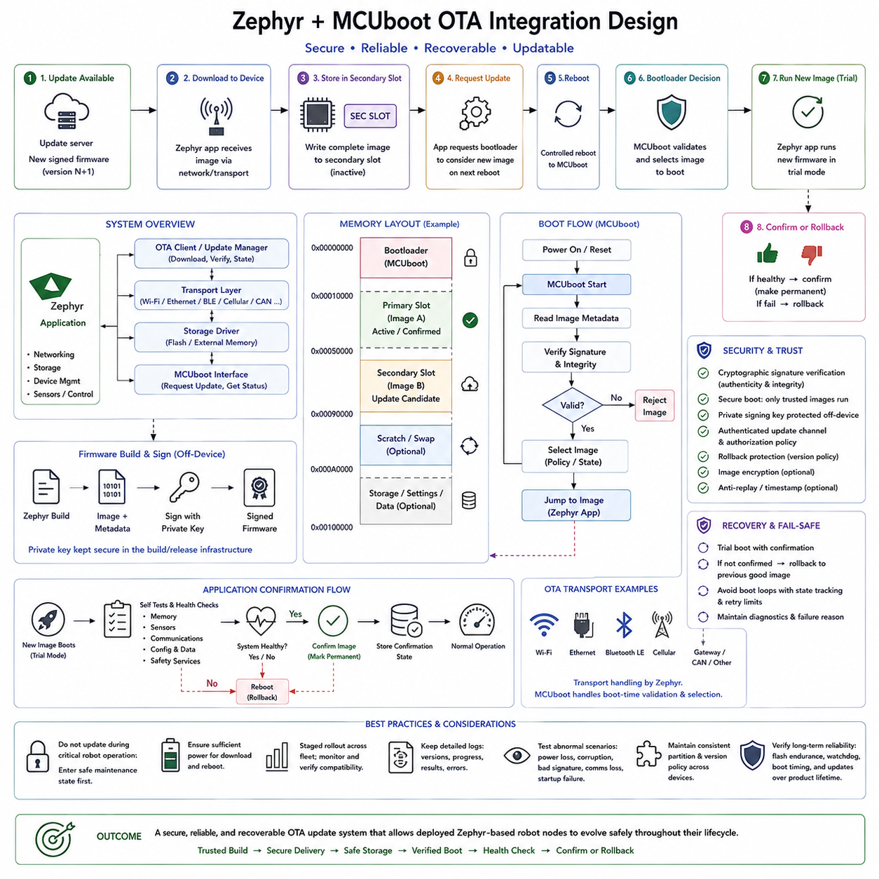
Zephyr and MCUboot can be integrated to create a secure over-the-air firmware update architecture for embedded and robotic devices. Zephyr provides the application, networking, storage, and device-management environment, while MCUboot establishes a trusted boot process that validates firmware before execution. Together they allow a deployed node to receive a new software image, store it safely, verify its authenticity and integrity, activate it through a controlled reboot, and recover when an update fails.
MCUboot operates as a bootloader positioned between processor reset and the Zephyr application. After power-on or reset, execution begins in the boot environment rather than directly entering the application image. The bootloader examines firmware metadata and determines which image should execute. Cryptographic verification can ensure that only firmware produced by an authorized development or release process becomes eligible for execution on the device.
A typical MCUboot design divides nonvolatile memory into bootloader and firmware image regions. The primary slot contains the currently executable application, while a secondary slot can contain a candidate update image. Additional storage may be reserved for configuration, scratch operations, recovery information, or application data depending on the update strategy and hardware platform. The exact partition layout must be designed according to available Flash capacity and update requirements.
The Zephyr application normally runs from the primary image slot while continuing its sensor, communication, or control responsibilities. When an update becomes available, the running firmware receives the candidate image through an appropriate transport mechanism and writes it into the designated update region. Separating download from activation allows the device to receive firmware without immediately replacing the currently operational image.
OTA transport is logically independent from MCUboot itself. Firmware may arrive through Ethernet, Wi-Fi, Bluetooth, cellular communication, a gateway, or another product-specific channel supported by the system architecture. Zephyr networking and management components can handle the transfer, while MCUboot focuses on boot-time image selection and validation. This separation allows the same trusted boot mechanism to support different communication technologies across multiple robot products.
Firmware images should be produced through a controlled build and signing process. After the Zephyr application is compiled and linked, image metadata and a cryptographic signature can be added using the MCUboot image tooling. The private signing key should remain protected within the development or release infrastructure, while the deployed device contains the information required to verify signatures. Compromise of the signing key would undermine the trust model of the entire update system.
Image validation protects both authenticity and integrity. Authenticity confirms that the firmware originated from an authorized signer, while integrity confirms that the image has not been modified after signing. Hashing and digital signatures are therefore fundamental to the update chain. The bootloader should reject corrupted, incomplete, or unauthorized images rather than transferring execution to firmware whose origin or contents cannot be trusted.
Version management adds another layer to the design. Firmware metadata can identify software versions so that the device, update service, and maintenance tools understand which image is installed or pending. Security-sensitive products may require rollback protection to prevent an attacker from intentionally reinstalling an older firmware version containing known vulnerabilities. Version policy must therefore be coordinated with the product's release and recovery strategy.
The download process must tolerate interrupted communication. A robot may lose wireless connectivity, power, or network access while receiving a large image. Firmware should therefore remain inactive until the complete image has been received and required checks have succeeded. Partial downloads must not overwrite the known-good executable firmware. Resumable transfers or chunk-based validation can further improve reliability when communication channels are unstable or expensive.
After a complete candidate image has been stored, the running Zephyr application can request that the bootloader consider it during the next boot. The device then performs a controlled reboot, allowing MCUboot to evaluate the pending image. Depending on the configured upgrade mode, the bootloader can swap, overwrite, directly select, or otherwise manage image slots according to the capabilities and memory organization of the target platform.
A trial boot mechanism is valuable because cryptographically valid firmware can still contain functional defects. A newly installed image may fail to initialize a sensor, communicate with the robot network, meet timing requirements, or complete application startup. The update architecture can therefore treat the new firmware as provisional until the application demonstrates that it is operational and explicitly confirms the image.
Image confirmation forms a critical boundary between installation and permanent acceptance. After the new Zephyr firmware boots, it can perform self-tests and verify important subsystems such as memory, sensors, communication interfaces, configuration data, and safety-related services. Only after the required health criteria have been satisfied should the application mark the image as confirmed. This converts successful booting into verified operational acceptance.
If the candidate firmware fails before confirmation, the system can revert to a previously known-good image when the selected MCUboot update strategy supports rollback. This behavior prevents a defective update from permanently disabling an unattended device. Recovery logic should also avoid endless reboot cycles by maintaining explicit update states and diagnostic information that allow the robot controller or maintenance system to understand why the upgrade failed.
Zephyr's flash and partition configuration must remain consistent with MCUboot's expectations. DeviceTree and build configuration describe memory regions, Flash devices, image slots, and related platform resources. Incorrect partition sizes or offsets can cause image corruption or boot failure even when the application itself is correct. Bootloader and application projects must therefore share a carefully controlled memory map as part of the platform configuration.
Security must extend beyond boot-time signature verification. The OTA service should authenticate update requests, protect management credentials, and use secure communication where appropriate. Authorization policy should determine which server, gateway, technician, or fleet-management component can initiate an update. A valid signed image should not automatically imply that every network participant is allowed to trigger installation at any operational moment.
Robotic systems also require update coordination with physical operation. Firmware should generally not be activated while a mobile robot is driving, a manipulator is carrying a load, or a safety-critical controller is executing an active mission. The higher-level robot controller can place the node into a safe maintenance state, verify sufficient battery power and communication availability, perform the update, reboot the device, and confirm that the node has returned to a valid operational state.
A distributed robot may contain many MCU-based nodes, making fleet-level update orchestration important. Sensor nodes, actuator controllers, gateways, and communication modules may have interdependent firmware versions. Updates can therefore require compatibility rules, staged deployment, dependency checking, and controlled sequencing. Updating a small group of devices first provides an opportunity to detect unexpected behavior before distributing the same firmware across an entire robot fleet.
Diagnostics and observability should accompany every stage of the OTA process. Useful information includes the running firmware version, candidate version, download progress, image validation result, boot state, confirmation status, rollback reason, and failure counters. These records allow local service tools or remote management systems to distinguish network transfer problems from signature failures, bootloader errors, application crashes, or post-update health-check failures.
Testing must include abnormal update scenarios rather than only successful installations. Engineers should interrupt power during downloads, corrupt candidate images, provide invalid signatures, simulate insufficient storage, force communication loss, trigger application startup failures, and verify rollback behavior. Repeated update cycles should also be tested on real hardware to confirm Flash behavior, boot timing, partition correctness, watchdog interaction, and long-term reliability.
A well-designed Zephyr and MCUboot OTA architecture therefore forms a complete trust and recovery loop rather than a simple remote file-transfer mechanism. The firmware is built and signed, securely delivered, stored separately from the active image, validated, activated through the bootloader, tested after startup, and finally confirmed or rolled back. This controlled sequence enables distributed robotic nodes to evolve after deployment while preserving firmware authenticity, operational availability, recoverability, and lifecycle security.

