Volume 03 Real Time Operating Systems

08. Real-Time Networking

08.01 Real-Time Ethernet Standards: TSN / IEEE 802.1Qbv
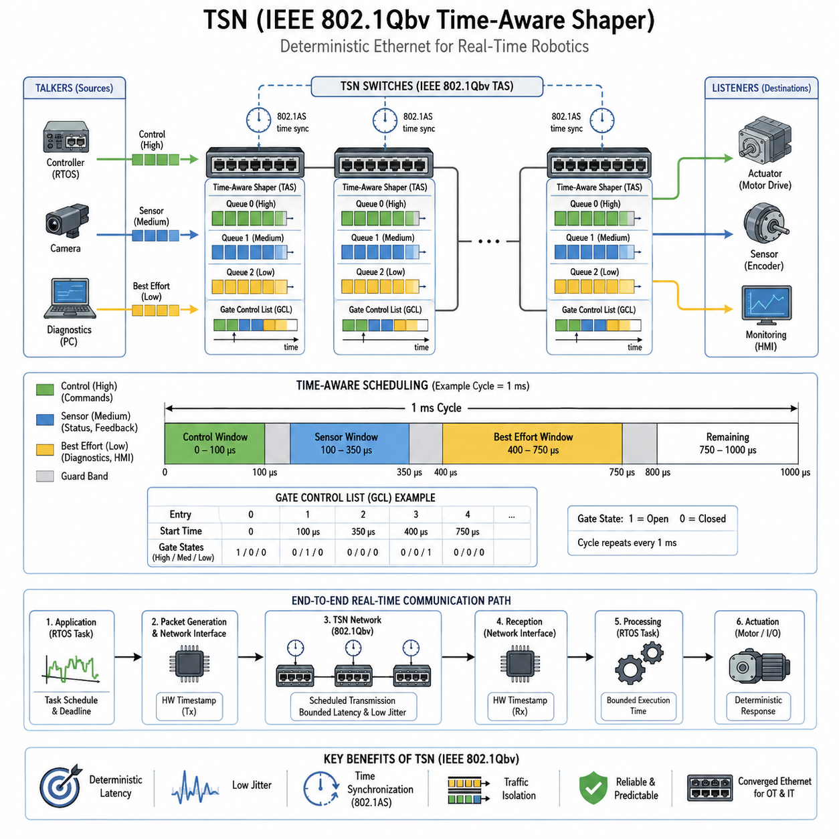
Real-time Ethernet extends conventional Ethernet from a best-effort communication technology into a network infrastructure capable of supporting bounded latency, low jitter, synchronized operation, and predictable delivery. These properties are essential in distributed robotic systems where motor controllers, sensors, safety devices, edge computers, and real-time operating systems must exchange data according to precise timing constraints rather than average network performance.
Time-Sensitive Networking, commonly called TSN, is a family of IEEE 802.1 technologies designed to provide deterministic communication over standard Ethernet. Instead of defining an entirely separate industrial network, TSN introduces mechanisms for time synchronization, traffic scheduling, bandwidth reservation, redundancy, and traffic shaping. This allows critical control traffic and ordinary Ethernet traffic to coexist on a common physical network while receiving different timing guarantees.
A central requirement of TSN is that participating devices operate with a sufficiently consistent understanding of network time. IEEE 802.1AS provides generalized Precision Time Protocol mechanisms for distributing synchronized time across Ethernet bridges and endpoints. Once controllers, switches, sensors, and actuators share a common time reference, transmission events can be coordinated according to schedules rather than depending only on packet arrival order and conventional queue arbitration.
IEEE 802.1Qbv introduces the Time-Aware Shaper, or TAS, which is one of the most important mechanisms for deterministic Ethernet communication. Each Ethernet output port contains traffic queues associated with different priorities. Instead of allowing these queues to transmit whenever the link becomes available, Qbv controls transmission gates according to a predefined time schedule, creating specific intervals during which selected traffic classes are permitted to transmit.
The transmission schedule is represented through a Gate Control List, commonly abbreviated GCL. Each GCL entry specifies which traffic gates are open or closed for a defined interval. The entries repeat according to a configured cycle time. A control network can therefore allocate one time window for high-priority servo commands, another for sensor information, and additional windows for diagnostic or best-effort traffic, producing a predictable repeating communication pattern.
Consider a robotic controller operating with a 1 ms control cycle. A scheduled Ethernet network can reserve an early portion of every cycle for synchronized command frames transmitted from the central controller toward joint or drive controllers. A following window can carry actuator status and feedback information, while remaining bandwidth handles monitoring and noncritical communication. Network behavior consequently becomes aligned with the timing structure of the robot control software.
This scheduled approach differs fundamentally from ordinary priority-based Ethernet. Priority mechanisms can ensure that important packets are transmitted before lower-priority packets, but they cannot always prevent a low-priority frame that has already started transmission from temporarily occupying the link. TSN scheduling introduces controlled transmission windows so that interfering traffic can be restricted before a critical communication interval begins, significantly reducing uncertainty in packet delivery.
Guard bands may be introduced before scheduled transmission windows to prevent lower-priority Ethernet frames from overlapping time-critical intervals. Because an Ethernet frame normally cannot simply be interrupted once transmission begins, the network must ensure that sufficient time remains before opening a scheduled gate. Frame preemption mechanisms can further reduce this blocking interval by allowing suitable lower-priority traffic to be interrupted and resumed around more urgent traffic.
Deterministic communication depends on more than the behavior of a single switch. Every bridge along an end-to-end communication path must maintain compatible synchronization, scheduling, queue configuration, and forwarding behavior. The designer therefore analyzes the complete path from a transmitting task through the network interface, switches, physical links, receiving interface, interrupt processing, and destination task. Network determinism alone cannot guarantee application-level real-time behavior.
TSN is especially valuable when multiple traffic classes must share one Ethernet infrastructure. Hard or tightly bounded control messages can receive scheduled windows, while camera metadata, diagnostics, configuration messages, ROS 2 communication, logging, and maintenance traffic use other queues or remaining bandwidth. This convergence can reduce separate network wiring while preserving logical and temporal isolation between communication flows with very different criticality requirements.
In robotics, the relationship between the RTOS scheduler and TSN scheduler is particularly important. A packet scheduled for transmission at a precise network time must first be generated by the corresponding real-time task before its gate opens. If the task experiences excessive scheduling latency or execution-time variation, the packet may miss its assigned transmission window. Network scheduling must therefore be coordinated with task periods, deadlines, wake-up times, and worst-case execution behavior.
The receiving side has a similar dependency. Predictable Ethernet arrival does not automatically produce predictable actuator response if packet processing is delayed by interrupt contention, driver execution, memory allocation, protocol processing, or low-priority application threads. High-quality real-time designs therefore treat communication latency as an end-to-end budget containing task execution, protocol processing, queuing, transmission, switching, reception, and final control activation rather than considering network latency independently.
Hardware timestamping is important when validating these timing guarantees. Software timestamps can include unpredictable delays introduced by scheduling and network-stack execution, whereas timestamps captured close to the Ethernet MAC or PHY provide a more accurate representation of actual frame transmission and reception. Measurements across many control cycles can reveal worst-case latency, jitter, synchronization error, missed transmission windows, and abnormal queue behavior under realistic network load.
TSN should also be distinguished from specialized real-time Ethernet technologies such as EtherCAT and PROFINET IRT, which are addressed separately within the real-time networking structure of this volume. TSN provides standardized Ethernet mechanisms that can serve as a deterministic networking foundation, while individual industrial protocols define their own communication models, device integration methods, control semantics, and implementation requirements.
For distributed robots, TSN becomes particularly attractive when computing is divided among MCU-based controllers, embedded Linux computers, edge AI processors, smart sensors, and networked actuators. High-level perception and AI inference may operate at tens of milliseconds, navigation and motion control at shorter periods, and servo loops at sub-millisecond or millisecond scales. Scheduled networking provides a mechanism for separating these temporal domains while maintaining coordinated data exchange.
A practical architecture therefore combines synchronized clocks, deterministic task scheduling, bounded execution time, scheduled Ethernet transmission, appropriate queue isolation, hardware timestamping, and continuous latency monitoring. IEEE 802.1Qbv should not be viewed merely as a switch configuration feature; it forms part of a larger end-to-end real-time architecture in which computation and communication schedules are jointly designed to preserve deadlines across distributed robotic components.
The engineering objective is ultimately not to make every Ethernet packet equally fast, but to make the delivery of critical information predictable. TSN achieves this by transforming selected portions of Ethernet bandwidth into explicitly scheduled communication resources while allowing conventional traffic to coexist. For robotic systems, this provides a bridge between flexible high-bandwidth Ethernet networking and the deterministic timing discipline required by distributed sensing, control, and coordinated actuation.

08.02 EtherCAT Protocol: Distributed Clocks / PDO Design [w/Code]
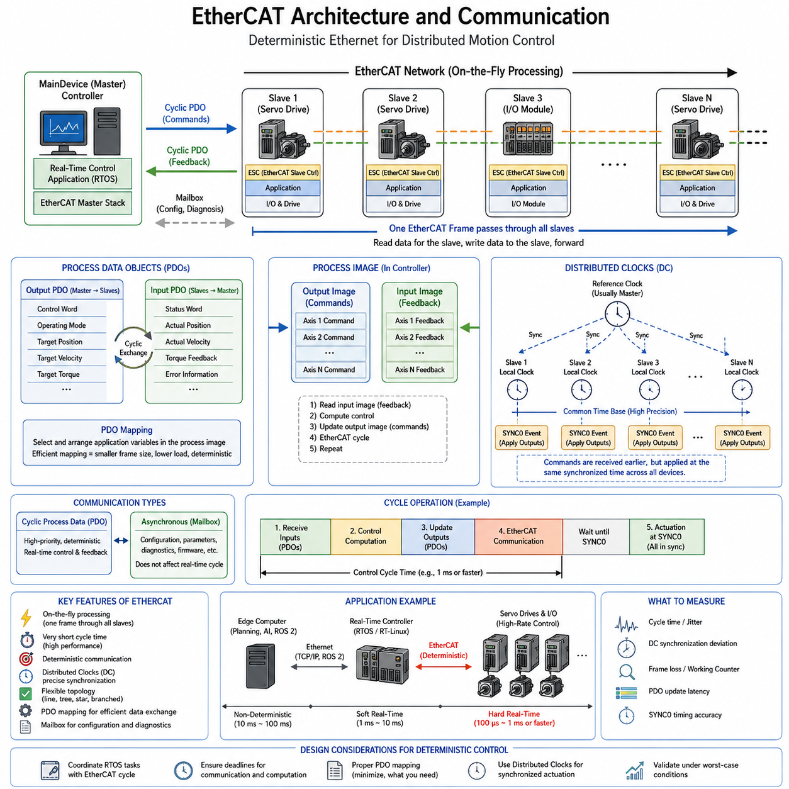
EtherCAT is a deterministic Industrial Ethernet technology designed for high-performance automation and distributed motion-control systems. Unlike conventional Ethernet communication, where individual devices receive, process, and retransmit separate frames, EtherCAT processes data while a frame passes through each slave device. This on-the-fly mechanism minimizes communication overhead and enables very short, predictable cycle times for coordinated robotic control.
An EtherCAT network typically consists of one MainDevice, traditionally called the master, and multiple SubDevices or slaves connected through an Ethernet-based physical topology. The MainDevice controls communication timing and initiates EtherCAT frames, while slave controllers process designated data directly as frames traverse the network. Line, tree, star, and branched structures can therefore be constructed without requiring conventional Ethernet switching behavior between every field device.
The fundamental efficiency of EtherCAT comes from processing one Ethernet frame across multiple devices. Instead of transmitting an independent request and response for every actuator or sensor, the MainDevice places process data for many nodes into one or several EtherCAT datagrams. Each EtherCAT Slave Controller reads data addressed to its logical location and inserts return data into the passing frame with minimal forwarding delay.
This processing model is particularly effective for robotic systems containing many synchronized axes. A manipulator, humanoid, mobile platform, or automated machine may contain numerous servo drives that require position, velocity, torque, status, and diagnostic information every control period. EtherCAT aggregates these distributed exchanges into deterministic cyclic communication, allowing the controller to treat many physical devices as a coordinated real-time I/O system.
EtherCAT communication includes cyclic process data and asynchronous configuration or diagnostic communication. Cyclic data is optimized for repeated real-time exchanges between the controller and field devices, while less time-critical information can be transferred separately. This distinction is important because servo commands and feedback must meet strict deadlines, whereas configuration parameters, device identification, and detailed diagnostics normally tolerate substantially longer response times.
Process Data Objects, or PDOs, provide the principal mechanism for cyclic real-time application data. Output PDOs carry commands from the controller toward slave devices, while input PDOs return measured states and feedback. In a servo drive, mapped data may include control words, operating modes, target position, target velocity, or target torque, together with status words, actual position, actual velocity, torque feedback, and error information.
PDO mapping determines exactly which application variables participate in each cyclic exchange and how they are arranged within the process image. Efficient mapping is important because unnecessary variables increase frame size and communication workload. A real-time design should therefore include only information required at the corresponding control rate, while slower diagnostics and configuration parameters are handled through appropriate asynchronous mechanisms rather than occupying every high-frequency control cycle.
The controller commonly maintains a process image representing cyclic input and output data for the entire network. Before transmission, the real-time control task updates command values in the output region. EtherCAT communication then distributes these values to the corresponding devices and collects their feedback into the input region. The next control iteration reads this synchronized feedback, computes new commands, and repeats the communication-control sequence.
Synchronization becomes critical when several actuators must execute commands at nearly the same physical instant. Communication alone does not guarantee this because propagation delays, oscillator differences, and local execution timing can cause individual devices to operate at slightly different times. EtherCAT Distributed Clocks, commonly abbreviated DC, provide a network-wide timing mechanism that aligns local device clocks with very high precision and enables coordinated execution across distributed nodes.
Distributed Clocks use hardware clocks implemented in compatible EtherCAT slave controllers. One suitable clock is selected as the reference, and timing relationships between devices are determined so that propagation delays and clock offsets can be compensated. The slave clocks are continuously adjusted relative to the reference time, creating a shared temporal basis that is substantially more precise than synchronization performed only by software tasks running independently on each processor.
The synchronized clock system allows devices to generate local events such as SYNC0 and SYNC1 at precisely controlled times. A servo drive can therefore receive its command data during the EtherCAT communication phase but apply that data at a defined synchronization event. Multiple drives then update their control functions according to the same distributed time reference rather than simply reacting whenever individual Ethernet frames happen to arrive.
This separation between communication time and execution time is fundamental to deterministic multi-axis control. The MainDevice can transmit PDO data before the required actuation instant, while Distributed Clocks define when the associated control operation actually occurs. Small variations in frame arrival can therefore be isolated from the physical control event, provided that communication completes within its allocated deadline and the synchronization accuracy remains within system requirements.
A typical cyclic EtherCAT controller coordinates the RTOS task schedule with the EtherCAT communication cycle. At the beginning of a period, synchronized input PDOs are obtained from sensors and servo drives. The control algorithm calculates new position, velocity, or torque commands, updates the output process image, and initiates or completes the corresponding EtherCAT transfer before the next synchronization event. This pattern repeats at a fixed control frequency.
Cycle-time selection depends on actuator dynamics, controller computation time, network size, frame length, device processing delays, and required synchronization accuracy. High-performance motion systems may operate at sub-millisecond periods, while less demanding robotic subsystems can use longer cycles. The important engineering requirement is not simply achieving the shortest possible period, but proving that communication and computation consistently complete before their deadlines under worst-case operating conditions.
EtherCAT also supports mailbox-based protocols for communication that does not belong in the cyclic process-data path. These mechanisms can carry configuration, parameter access, diagnostics, firmware-related information, and higher-level protocol services. Separating mailbox traffic from critical PDO exchanges allows the network architecture to preserve deterministic cyclic behavior while still providing flexible device management and commissioning capabilities required in practical industrial systems.
In many motion-control applications, EtherCAT is combined with standardized drive profiles such as CANopen over EtherCAT, commonly called CoE. This allows familiar object-dictionary concepts and standardized drive parameters to operate over the EtherCAT transport mechanism. Servo systems can consequently expose structured control and status objects while EtherCAT supplies the high-speed deterministic communication and Distributed Clocks required for tightly synchronized motion.
The RTOS and EtherCAT stack must be designed as one timing system rather than as independent components. A deterministic network cannot compensate for a control task that wakes too late, experiences excessive preemption, allocates memory unpredictably, or misses its PDO update deadline. Real-time implementations therefore coordinate task priorities, CPU affinity, interrupt handling, DMA operation, memory behavior, EtherCAT cycle timing, and Distributed Clock synchronization.
Performance validation should measure complete control-loop behavior rather than Ethernet throughput alone. Important observations include EtherCAT cycle duration, worst-case communication latency, cycle jitter, Distributed Clock deviation, missed frames, Working Counter anomalies, late PDO updates, and synchronization-event timing. Hardware timestamps, oscilloscope measurements, drive traces, RTOS tracing, and controller diagnostics can be combined to identify whether timing errors originate in software, networking, or device execution.
For a distributed robot, EtherCAT can form the deterministic lower-level control network beneath higher-level computing systems. An edge computer may execute perception, planning, AI inference, or ROS 2 functions at comparatively slower rates, while an RTOS or real-time Linux controller exchanges cyclic PDOs with motor drives and I/O modules at much higher frequencies. This creates a clear temporal boundary between computational intelligence and deterministic physical actuation.
The resulting architecture combines efficient on-the-fly frame processing, cyclic PDO exchange, precise Distributed Clocks, synchronized execution events, and deterministic RTOS scheduling. EtherCAT should therefore be understood not merely as a fast Ethernet protocol, but as a distributed real-time control architecture. Its principal value in robotics is the ability to coordinate many networked actuators and sensors as one temporally synchronized control system.

08.03 PROFINET IRT Real-Time Communication Setup
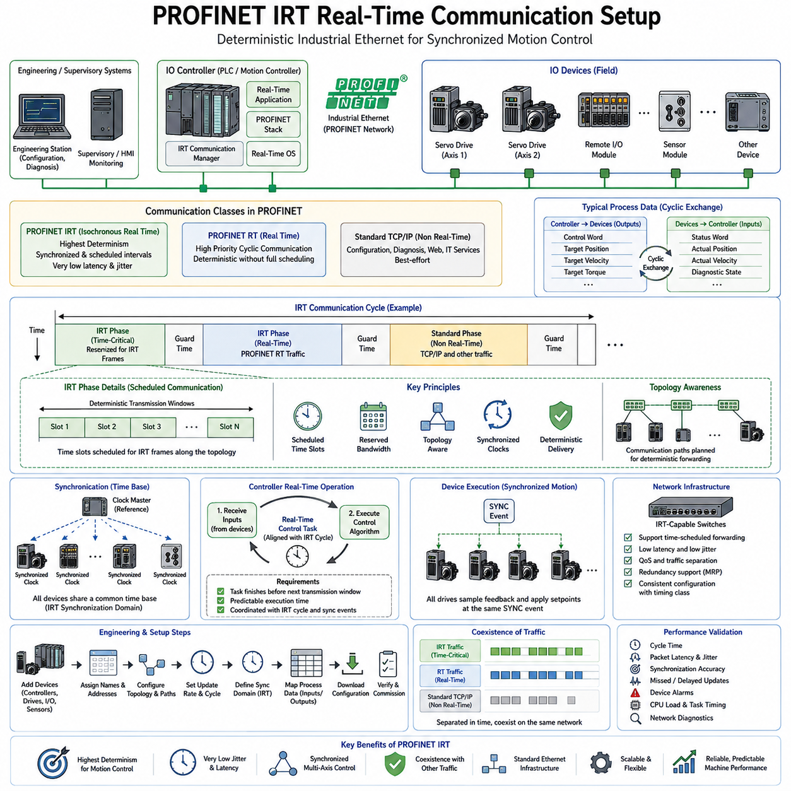
PROFINET is an Industrial Ethernet communication system designed to connect controllers, distributed I/O, drives, sensors, and automation equipment over standardized Ethernet infrastructure. It supports communication ranging from ordinary TCP/IP traffic to deterministic real-time control. Within this architecture, PROFINET IRT, or Isochronous Real Time, provides the highest level of timing determinism for tightly synchronized motion and distributed control applications.
PROFINET communication is commonly organized around an IO Controller, IO Devices, and engineering or supervisory systems. The IO Controller manages cyclic process communication and typically executes the primary control application, while IO Devices represent remote I/O modules, servo drives, sensors, and other field equipment. Engineering stations configure device relationships, network parameters, update rates, synchronization domains, and application-specific process-data structures.
PROFINET provides different communication classes because not every Ethernet message requires the same timing behavior. Standard TCP/IP communication can handle configuration, diagnostics, web services, and other noncritical data. PROFINET Real Time, or RT, prioritizes cyclic automation traffic without requiring fully scheduled Ethernet operation, while IRT introduces synchronized and reserved communication intervals for applications requiring tightly bounded latency and very low jitter.
The essential principle of IRT is temporal separation of network traffic. Instead of allowing all Ethernet frames to compete continuously for transmission opportunities, the communication cycle is divided into controlled time intervals. Highly deterministic IRT frames are transmitted during reserved phases, while ordinary real-time and best-effort Ethernet traffic can use other portions of the cycle. This creates predictable network access for critical control information.
An IRT cycle can therefore be understood as a repeating communication schedule coordinated across participating devices and switches. Within each cycle, a reserved interval transports time-critical process data according to a predetermined communication plan. Additional intervals provide bandwidth for less critical PROFINET traffic and conventional Ethernet communication. The cycle repeats continuously, creating a stable temporal framework for distributed control and synchronized actuator operation.
Precise clock synchronization is required because network devices must agree on when these scheduled communication intervals begin and end. PROFINET IRT establishes a synchronized timing domain in which participating controllers, switches, and field devices maintain closely aligned local clocks. This common time base allows frame forwarding and application events to be coordinated according to known network time rather than uncontrolled packet arrival behavior.
The synchronization mechanism typically establishes a clock master and distributes timing information through the real-time network. Each synchronized device compensates for timing differences so that its local clock remains aligned with the communication domain. Accurate synchronization is particularly important for motion-control applications because multiple servo drives may need to sample feedback or apply new setpoints at almost the same physical instant.
IRT communication also depends on topology information because deterministic scheduling requires knowledge of how frames travel through the network. Engineering tools identify communication paths and calculate when critical frames should be transmitted and forwarded. Switch behavior, propagation delay, device position, and scheduled transmission opportunities can therefore be considered during configuration instead of leaving frame delivery entirely to dynamic Ethernet arbitration.
A typical setup begins by defining the PROFINET devices and assigning their logical relationships to the IO Controller. Device names, network addresses, module structures, process-data mappings, update periods, and synchronization parameters are configured through the engineering environment. Devices participating in IRT are then associated with the appropriate synchronization domain and communication schedule so that their real-time exchanges follow a coordinated timing model.
Process data exchanged between the controller and IO Devices normally contains compact cyclic information required by the control application. For servo drives, this can include control words, target position, target velocity, target torque, status words, actual position, actual velocity, and diagnostic state. Remote I/O devices similarly exchange digital and analog values. Efficient mapping reduces communication load and keeps high-frequency cycles focused on essential control variables.
The controller's real-time task schedule must be coordinated with the PROFINET update cycle. Input data should become available early enough for the control algorithm to process feedback, calculate the next command, and update output data before the corresponding network transmission deadline. If the control task wakes too late or its execution time varies excessively, deterministic network transmission cannot by itself guarantee that valid control data reaches the actuator on time.
Synchronized motion additionally requires coordination between network communication and device-level application execution. Servo drives can receive cyclic setpoints through IRT and execute control functions according to the shared timing reference. Multiple axes can consequently sample feedback, update setpoints, and initiate motion-related operations with tightly controlled temporal relationships. This property makes IRT suitable for coordinated machines, robotic mechanisms, and other multi-axis automation systems.
Network switches are critical components in an IRT architecture. Conventional Ethernet switches primarily forward traffic according to address tables, queues, and priority mechanisms, whereas IRT-capable infrastructure participates in deterministic communication behavior. The engineering design must therefore ensure that devices and network components along critical communication paths support the required PROFINET real-time capabilities and are configured consistently with the intended timing class.
IRT does not mean that all traffic on the network becomes hard real-time traffic. One of its important architectural benefits is the coexistence of deterministic control communication with less critical Ethernet services. Diagnostics, engineering access, supervisory communication, and ordinary TCP/IP data can remain available while reserved resources protect time-critical process traffic. The designer must nevertheless control bandwidth and traffic patterns so noncritical communication cannot disturb required deadlines.
The distinction between PROFINET RT and IRT is therefore primarily a question of determinism and synchronization requirements rather than simply network speed. RT is appropriate for many factory automation and distributed I/O applications where millisecond-class cyclic communication is sufficient. IRT targets more demanding applications in which coordinated motion, small cycle times, bounded latency, and very low communication jitter are necessary for stable and repeatable physical behavior.
When PROFINET IRT is integrated with an RTOS or real-time Linux controller, network configuration must be considered together with CPU scheduling. Real-time threads, interrupt handling, network drivers, DMA operations, memory behavior, and application execution all contribute to the end-to-end timing path. CPU overload or poorly prioritized software can introduce delays even when the Ethernet network itself provides deterministic transmission windows.
A useful timing model follows the complete path from sensor acquisition to physical actuation. Sensor data is sampled, transferred into the device communication interface, transmitted during the appropriate IRT interval, received by the controller, processed by the control task, converted into new output commands, transmitted during a subsequent scheduled interval, and finally applied by the actuator. Every stage consumes part of the total control-loop latency budget.
Commissioning therefore requires more than confirming basic Ethernet connectivity. Engineers should verify device discovery, controller-device relationships, topology, synchronization status, update times, process-data mapping, communication alarms, and cyclic operation. After functional communication is established, the system should be tested under realistic network and CPU loads to determine whether timing requirements remain satisfied when diagnostics and other concurrent traffic are active.
Performance validation should focus on worst-case behavior rather than average throughput. Important observations include cycle time, packet latency, communication jitter, synchronization accuracy, missed or delayed updates, device alarms, and control-task timing. Network diagnostics, controller traces, hardware measurements, drive traces, and RTOS profiling can be correlated to identify whether abnormal timing originates from the application, operating system, network, or field device.
In a distributed robotic architecture, PROFINET IRT can provide the deterministic layer connecting a real-time controller to servo drives, distributed I/O, and synchronized field equipment, while higher-level edge computers execute perception, planning, AI inference, ROS 2, visualization, and fleet communication at slower rates. This separation prevents variable AI workloads from directly determining the timing of safety-sensitive or high-frequency physical control.
PROFINET IRT should ultimately be treated as part of an end-to-end deterministic control architecture rather than merely as a faster form of Ethernet. Its effectiveness comes from combining synchronized clocks, scheduled communication, topology-aware configuration, cyclic process data, deterministic controller execution, and synchronized device behavior. Together, these mechanisms allow distributed automation and robotic components to operate according to a coordinated and predictable real-time schedule.

08.04 TSN Scheduled Traffic (TAS) Configuration [w/Code]
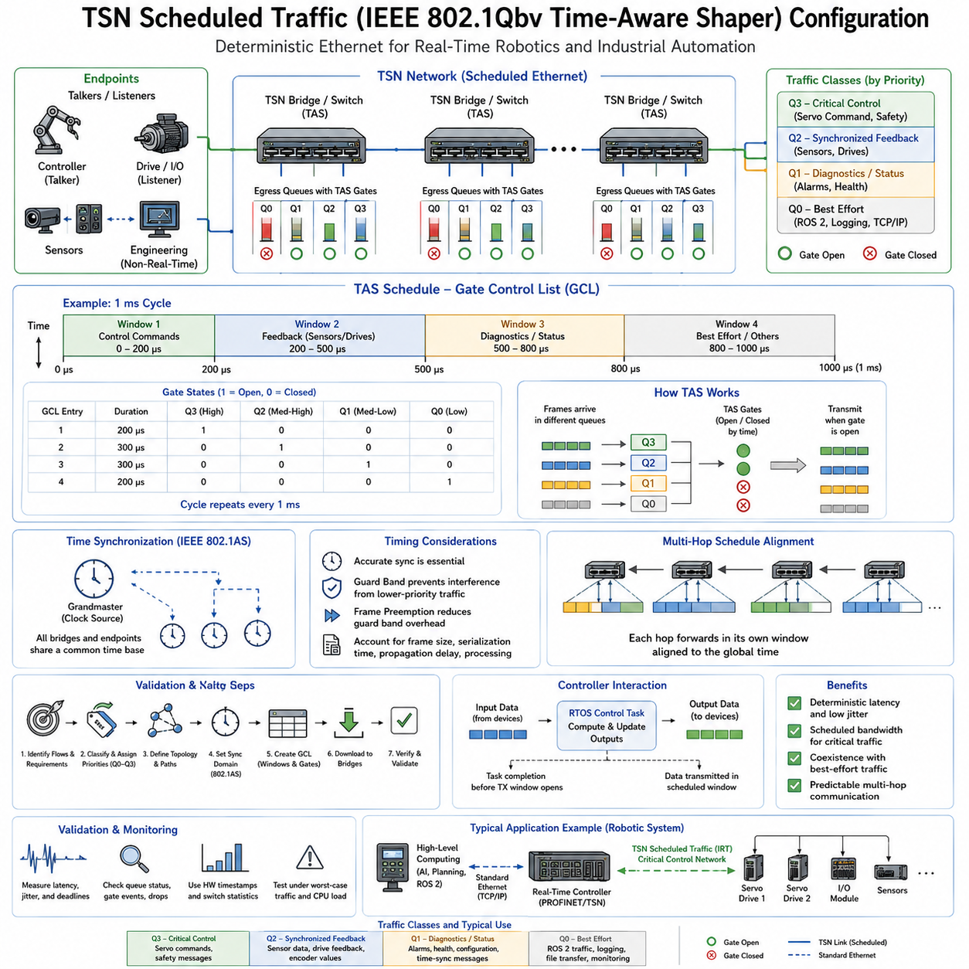
Time-Sensitive Networking Scheduled Traffic provides deterministic Ethernet communication by controlling exactly when selected traffic classes are allowed to transmit. IEEE 802.1Qbv defines the Time-Aware Shaper, or TAS, which introduces time-controlled gates for Ethernet egress queues. Instead of relying only on packet priority, TAS creates repeating transmission windows that reserve network access for time-critical robotic and industrial traffic.
A TAS-capable Ethernet port contains multiple traffic queues representing different classes of service. Each queue is associated with a transmission gate that can be either open or closed. Frames waiting in an open queue may be transmitted according to the configured scheduling rules, while frames in a closed queue remain buffered. By coordinating these gate states over time, the network converts ordinary shared Ethernet bandwidth into scheduled communication resources.
The behavior of these gates is defined by a Gate Control List, commonly abbreviated GCL. Each GCL entry specifies a gate-state pattern and the duration for which that pattern remains active. After the final entry completes, the schedule normally repeats according to a configured cycle time. The GCL therefore acts as a temporal program describing which traffic classes may access an Ethernet link during each portion of the communication cycle.
A practical configuration begins by identifying the communication flows and their timing requirements. Servo commands, safety messages, synchronized sensor feedback, navigation information, diagnostics, and best-effort traffic should not automatically receive identical treatment. Designers classify flows according to period, deadline, maximum frame size, acceptable jitter, criticality, and required bandwidth before assigning them to appropriate Ethernet priorities and TAS queues.
For example, a robotic network operating with a 1 ms communication cycle may reserve the first portion of each cycle for high-priority control commands. A second window can carry synchronized sensor and actuator feedback, while later intervals allow diagnostics, ROS 2 messages, logging, or other noncritical traffic. The exact allocation depends on frame sizes, link speed, topology, propagation delay, processing time, and the end-to-end deadlines of the application.
TAS configuration depends on a synchronized network time base because every participating bridge must interpret the schedule consistently. IEEE 802.1AS time synchronization is commonly used with TSN to align clocks across controllers, switches, and endpoints. The GCL is then executed relative to this shared notion of time. Without adequate clock synchronization, nominally identical gate schedules could open at different physical times and destroy deterministic end-to-end behavior.
Several timing parameters define the operational schedule. The base time identifies when a configured schedule becomes active relative to network time, while the cycle time defines the duration before the GCL pattern repeats. Individual entries specify their own time intervals and gate states. Correct configuration requires these values to form a coherent schedule that fits within the intended communication period and remains aligned across all relevant network ports.
Guard bands are often necessary when a scheduled high-priority window follows lower-priority traffic. A large best-effort Ethernet frame that begins transmission immediately before a critical window could continue occupying the link after that window should have started. Closing the lower-priority gate sufficiently early prevents such interference. The required guard time depends largely on maximum interfering frame size and physical link transmission rate.
Frame preemption can reduce the bandwidth cost of large guard bands. Instead of waiting for an entire lower-priority frame to finish, supported Ethernet mechanisms can divide suitable traffic into preemptable and express classes. Critical express traffic can then interrupt eligible lower-priority transmission and use the link sooner. TAS and frame preemption can therefore complement each other when high utilization and tightly bounded latency are both required.
The schedule must also account for frame transmission duration rather than treating every packet as an instantaneous event. A frame occupies the physical link for a finite serialization time determined by its size and link speed. Additional overhead, propagation delay, bridge forwarding behavior, and implementation-specific timing margins must also be considered. An apparently sufficient transmission window may otherwise become too short under worst-case conditions.
Multi-hop networks make TAS configuration more challenging because a critical frame may traverse several scheduled switches before reaching its destination. Opening the same gate at the same time on every switch is not necessarily sufficient. The frame must arrive at each downstream port before the corresponding transmission opportunity. End-to-end schedule design therefore considers forwarding order, propagation delay, queue residence time, and synchronization error along the entire route.
A useful design approach treats scheduled traffic as a pipeline through the network. A controller releases a control frame during an assigned source window, the first bridge forwards it during a compatible slot, and downstream bridges provide subsequent transmission opportunities according to expected arrival times. Properly constructed schedules prevent unnecessary queue waiting and provide a calculable upper bound for end-to-end communication latency.
The RTOS application schedule must be coordinated with this network pipeline. A control task responsible for generating scheduled traffic must complete its computation before the corresponding TAS gate opens. If the packet becomes ready after its transmission window has closed, it may wait until the next communication cycle, producing a delay much larger than normal network jitter. Task release time and network transmission time must therefore be designed together.
Reception timing requires similar attention. When a sensor or control frame arrives predictably, the receiving application should be scheduled so that it can consume the data without unnecessary software delay. Interrupt processing, network-driver execution, DMA completion, protocol-stack activity, thread priorities, and memory contention can all increase application-level latency. TAS guarantees at the Ethernet layer do not automatically create deterministic software execution above that layer.
Queue assignment is another critical configuration decision. IEEE 802.1Q priority information can classify frames into traffic classes that are mapped onto egress queues. The designer must ensure that critical traffic reaches the intended scheduled queue throughout its network path. Incorrect priority mapping, VLAN configuration, or bridge policy can place a deterministic flow into an unscheduled queue and invalidate the timing assumptions used during system design.
Configuration should preserve bandwidth for noncritical traffic rather than simply keeping high-priority gates open continuously. If deterministic queues monopolize the link, engineering access, diagnostics, software updates, monitoring, and other services may experience unacceptable starvation. Effective TAS design reserves only the bandwidth required for critical flows and deliberately creates communication opportunities for lower-priority traffic while maintaining all real-time deadlines.
Schedule validation must examine worst-case traffic rather than only nominal operation. Tests should include maximum expected frame rates, simultaneous sensor activity, diagnostic traffic, large best-effort transfers, CPU load, and other conditions likely to create contention. Engineers should observe whether every scheduled frame enters the correct queue, becomes ready before its gate opens, traverses each bridge within its allocated slot, and reaches the destination before its deadline.
Hardware timestamping provides an effective method for measuring TAS performance. Transmission and reception timestamps close to the Ethernet MAC can be compared against the expected schedule to determine actual release time, latency, jitter, and synchronization error. Switch statistics and queue counters can additionally reveal delayed frames, unexpected queue occupancy, gate violations, or packet loss that may remain invisible when only application-level measurements are examined.
In a distributed robotic architecture, TAS can separate communication domains without requiring completely independent physical networks. High-frequency motor or actuator commands can occupy tightly controlled windows, synchronized sensor traffic can use another scheduled class, and edge-computing or ROS 2 traffic can use remaining bandwidth. The network consequently supports different temporal requirements while preserving standard Ethernet connectivity between heterogeneous computing components.
The complete configuration should therefore connect application periods, RTOS scheduling, traffic classification, queue mapping, clock synchronization, GCL entries, guard bands, bridge schedules, and endpoint processing into one timing model. IEEE 802.1Qbv is most effective when treated as part of an end-to-end real-time architecture rather than an isolated switch feature. Proper TAS configuration transforms Ethernet transmission opportunities into predictable resources that can be budgeted alongside computation time.
The engineering objective is not simply to configure a repeating gate table, but to guarantee that critical information moves through the entire distributed system within known temporal boundaries. When synchronized clocks, correct traffic classification, carefully calculated GCL schedules, deterministic software execution, and worst-case validation are combined, TSN Scheduled Traffic can provide the predictable communication foundation required for tightly coordinated robotic sensing and control.

08.05 UDP-Based Real-Time Communication Optimization [w/Code]
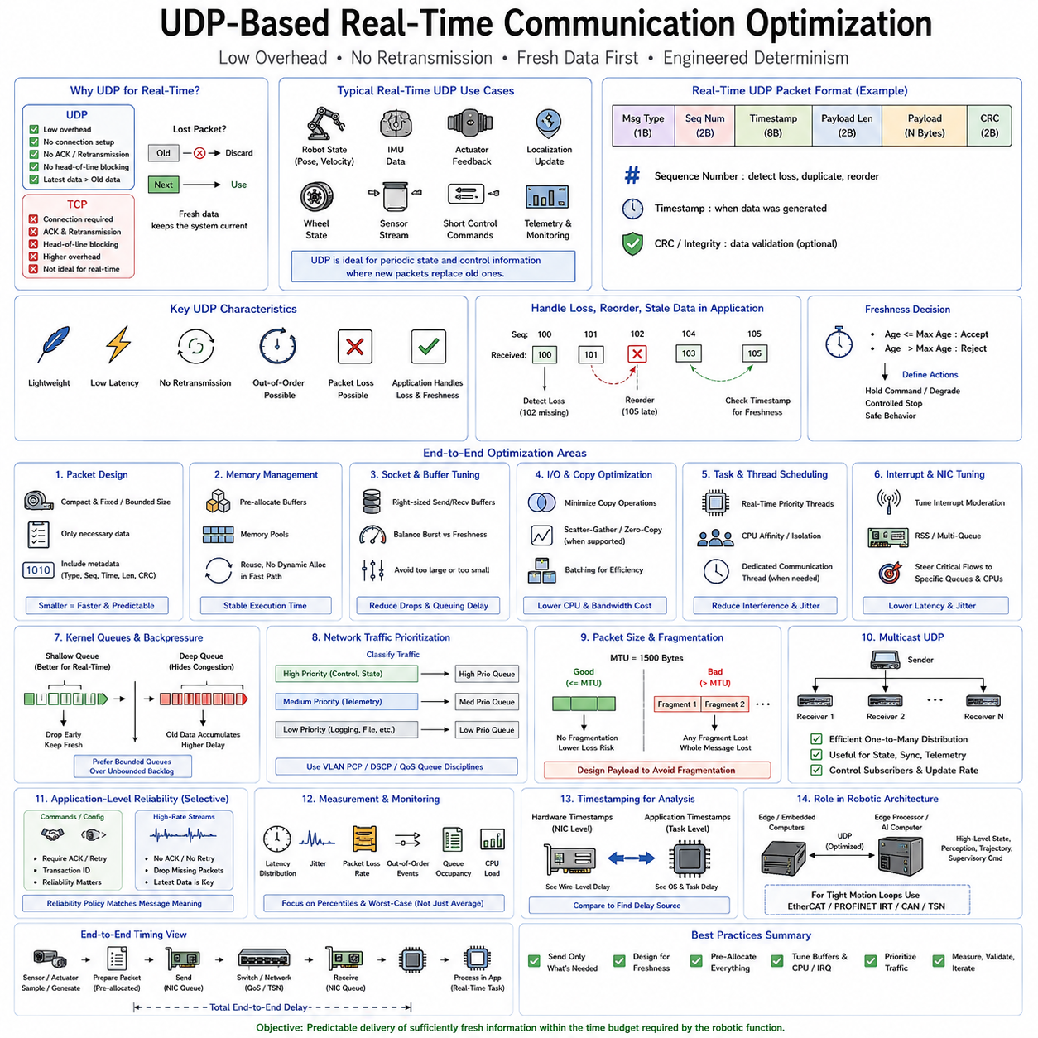
UDP is widely used for real-time robotic communication because it provides a lightweight transport mechanism with minimal protocol overhead and no mandatory connection establishment, acknowledgment, retransmission, or in-order delivery. Unlike TCP, UDP does not attempt to recover every lost packet before delivering later data. This behavior is valuable when fresh sensor or control information is more important than recovering obsolete messages.
The absence of retransmission does not make UDP inherently deterministic. Packets can still experience variable application scheduling delays, kernel processing, queueing, interrupt latency, switch contention, packet loss, or reordering. Real-time UDP design therefore focuses on controlling the complete communication path rather than simply selecting UDP as the transport protocol. Predictability must be engineered across the application, operating system, network interface, and physical network.
UDP is particularly suitable for periodic state information where new packets supersede old ones. Robot pose, velocity, wheel state, IMU measurements, actuator feedback, localization updates, and short control commands are common examples. If a 1 kHz control stream loses one packet, waiting for retransmission may be less useful than processing the next fresh sample. The application must therefore explicitly define how loss, duplication, reordering, and stale data are handled.
A compact packet format reduces serialization time, memory copying, cache pressure, and processing overhead. Real-time messages should contain only information required by the receiving task, together with essential metadata such as message type, sequence number, timestamp, payload length, and integrity information when required. Fixed-size or bounded-size messages are particularly useful because they make memory consumption and processing time easier to predict.
Sequence numbers allow the receiver to identify missing, duplicated, or reordered datagrams without introducing transport-layer retransmission. Timestamps provide information about when data was generated rather than merely when it was received. Together, these fields allow a control application to reject stale information, estimate communication delay, detect packet gaps, and decide whether the latest state remains valid enough for the current control cycle.
Real-time UDP applications should avoid unnecessary dynamic memory allocation in the high-frequency communication path. Buffers can be allocated during initialization and reused throughout operation. Fixed memory pools, preallocated packet structures, and bounded queues reduce unpredictable allocator delays and fragmentation. The objective is to ensure that packet preparation and reception have stable execution costs even after the system has been operating for long periods.
Copy operations should also be minimized because every additional transfer between application buffers, kernel buffers, and driver memory consumes CPU time and memory bandwidth. Techniques such as scatter-gather I/O, memory reuse, batching, and appropriate zero-copy mechanisms can reduce overhead where the operating system and network interface support them. Optimization should nevertheless preserve clear buffer ownership so concurrent tasks do not introduce race conditions.
Socket configuration strongly influences behavior under real-time load. Send and receive buffer sizes must be large enough to absorb expected short bursts without creating excessive queueing delay. Oversized buffers can hide congestion by allowing stale packets to accumulate, while undersized buffers increase packet drops. The correct configuration balances temporary burst tolerance against the requirement that received data remain sufficiently fresh for the application.
Blocking behavior must be chosen according to the task architecture. A dedicated communication thread may efficiently block while waiting for data, whereas a periodic real-time control task may use nonblocking operations or controlled polling to avoid indefinite suspension. Timeout values should be bounded and related to application deadlines. No network operation in a hard timing path should be allowed to block unpredictably beyond the control cycle's available budget.
Linux-based real-time systems can improve UDP behavior through careful thread scheduling and CPU placement. Communication threads may use real-time scheduling policies where appropriate, while CPU affinity can isolate critical processing from unrelated workloads. Network interrupts and receive processing can also be assigned deliberately to selected CPUs. The goal is to reduce interference between packet handling, control computation, AI workloads, logging, and general operating-system activity.
Interrupt handling has a major influence on packet latency and jitter. A network interface generates hardware events that trigger driver and kernel processing before the application receives a datagram. Under high traffic rates, interrupt moderation can reduce CPU overhead by grouping events, but excessive moderation increases latency. Real-time optimization therefore requires balancing interrupt frequency, CPU utilization, throughput, and worst-case packet delivery time.
Network Interface Card queues and Receive Side Scaling can distribute packet processing across multiple CPU cores, which is useful for high-throughput systems. However, uncontrolled distribution can cause cache migration and scheduling variation. Critical UDP flows may benefit from steering packets toward specific receive queues and CPUs so that network processing remains close to the real-time application thread and avoids unnecessary cross-core movement.
Kernel socket buffers and network queues must be considered as part of the latency path. Increasing queue capacity does not necessarily improve real-time performance because deeper queues can increase residence time. Real-time systems often prefer bounded queues and explicit packet dropping over uncontrolled backlog growth. When new state replaces old state, discarding obsolete packets can preserve temporal correctness better than eventually delivering every buffered datagram.
Traffic prioritization can further improve UDP performance on shared Ethernet networks. VLAN Priority Code Point values, differentiated services markings, or operating-system queue disciplines can classify critical datagrams separately from logging, file transfer, visualization, and other traffic. Priority mechanisms reduce contention but should not be confused with strict determinism. For stronger guarantees, UDP traffic may operate over a TSN network with scheduled transmission resources.
Packet size should remain compatible with the effective network Maximum Transmission Unit. IP fragmentation introduces additional processing and increases the probability that an entire logical message is lost when one fragment disappears. Real-time protocols should therefore design payload sizes to avoid fragmentation whenever practical. Large sensor information can be divided at the application level using bounded fragments with explicit identifiers and timing policies when necessary.
Multicast UDP can efficiently distribute identical state information to multiple consumers without requiring the sender to transmit a separate copy for each destination. This is useful for robot state, synchronization information, telemetry, or shared perception results. However, multicast traffic must be carefully controlled because unnecessary subscribers, switch flooding, or excessive update rates can consume network bandwidth and increase contention for more critical communication.
Application-level reliability should be selective rather than automatically reproducing TCP. Critical configuration commands may require acknowledgments, retries, or transaction identifiers, while high-rate sensor streams may simply discard missing packets. Some commands may use redundant transmission, validity periods, or sequence checks instead of waiting for acknowledgment. Reliability policy should reflect the temporal meaning and safety importance of each message type.
The sender and receiver should also define freshness constraints. A packet can arrive successfully yet still be useless if its timestamp indicates that it exceeded the maximum acceptable age. Real-time communication therefore requires both transport validity and temporal validity. Control software can maintain a freshness timer and transition to degraded operation, command hold, controlled stop, or another predefined safe behavior when required updates are not received within the allowed interval.
Measurement is essential because average UDP latency can hide rare delays that destabilize a control system. Engineers should collect packet latency distributions, jitter, packet-loss rate, out-of-order events, socket queue occupancy, scheduling latency, interrupt timing, and CPU load. Percentiles and maximum observed delays are often more meaningful than average values when determining whether a communication path can satisfy a real-time deadline.
Hardware timestamping can separate actual network delay from software scheduling delay. Transmit and receive timestamps captured near the network interface provide a clearer view of wire-level behavior, while application timestamps reveal additional operating-system and task latency. Comparing these measurements allows engineers to determine whether jitter originates from the physical network, network driver, kernel stack, or real-time application itself.
In a robotic architecture, optimized UDP is often appropriate between embedded computers and edge processors where low latency and flexible Ethernet communication are required but specialized fieldbus determinism is unnecessary. High-level state, perception results, trajectories, or supervisory commands can use UDP, while motor-current or tightly synchronized servo loops remain on EtherCAT, PROFINET IRT, CAN-based control, or TSN depending on system requirements.
A robust architecture therefore treats UDP as one layer within an end-to-end timing design. Packet structure, timestamps, sequence numbers, memory allocation, socket buffers, thread priorities, CPU affinity, interrupt routing, queue disciplines, Ethernet priorities, and application safety behavior must be designed together. The objective is not guaranteed delivery of every packet, but predictable delivery of sufficiently fresh information within the time budget required by the robotic function.

08.06 Socket Buffer Tuning and Kernel Network Stack Optimization [w/Code]
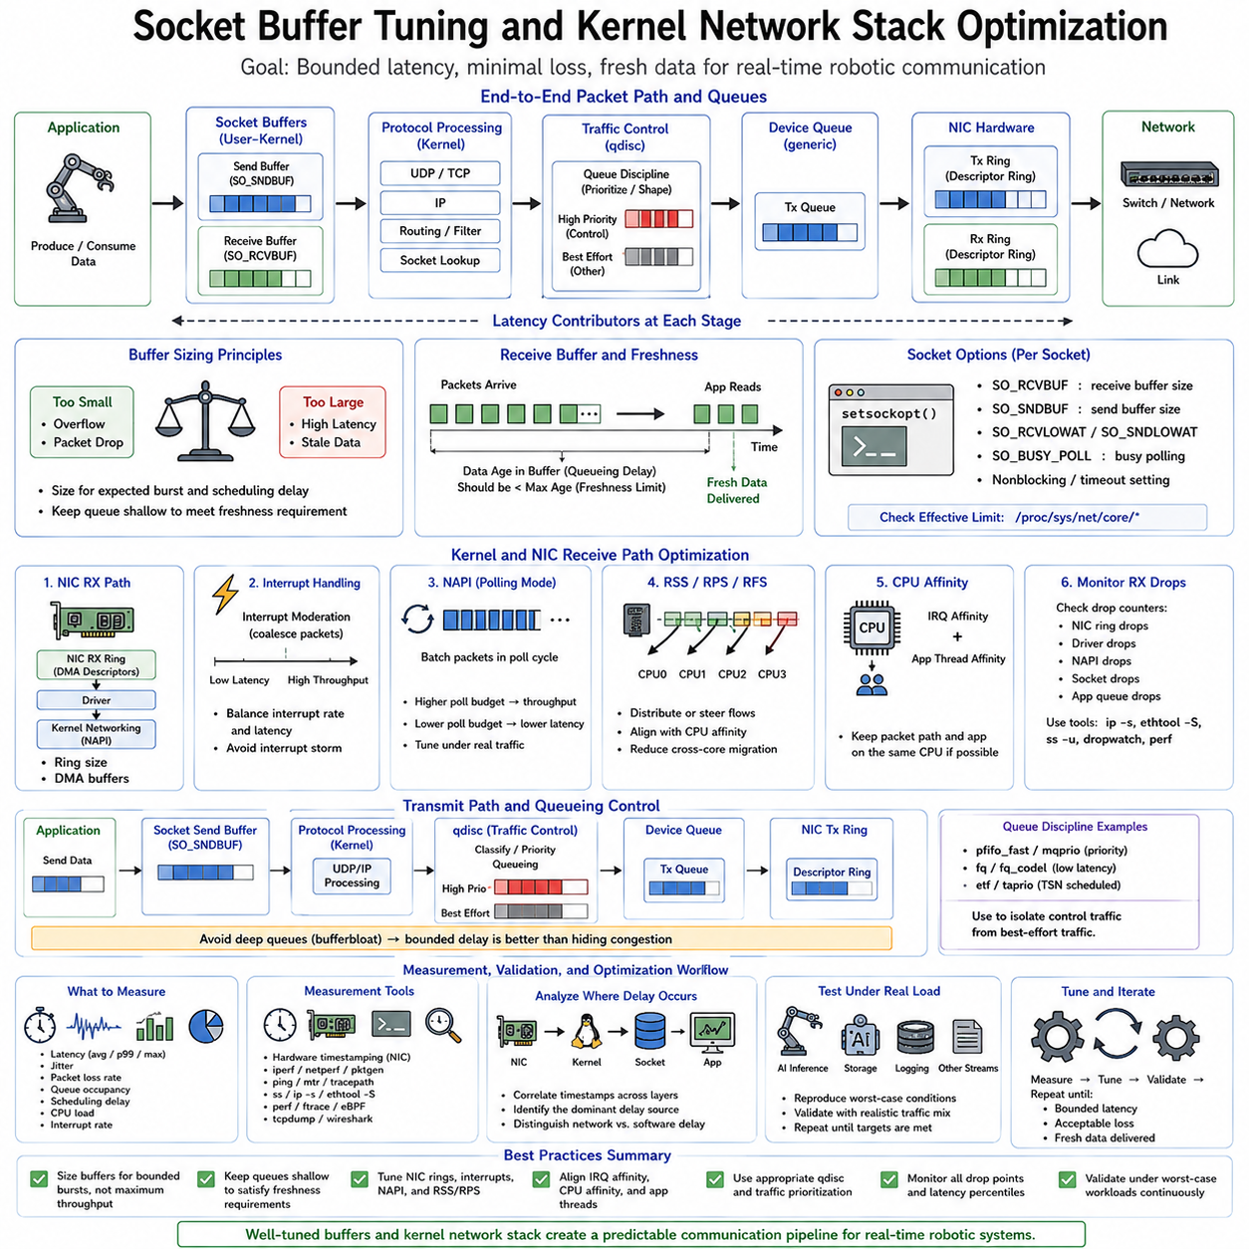
Socket buffer tuning is an important part of real-time network optimization because packets pass through multiple queues before reaching an application. A packet may wait in the Network Interface Card, kernel receive path, protocol processing queues, socket buffers, and finally the application. Each buffering stage protects against temporary bursts, but excessive buffering can increase latency and allow stale data to accumulate.
Linux socket communication normally uses kernel-managed send and receive buffers between the application and network stack. The receive buffer temporarily stores incoming data until the application consumes it, while the send buffer holds outgoing data waiting for protocol and device processing. Buffer capacity therefore affects packet loss, burst tolerance, memory usage, throughput, and queueing delay, making its configuration important for real-time communication.
Large socket buffers are often beneficial for bulk data transfer because they absorb traffic bursts and help maintain throughput. Real-time systems have a different objective. A large receive buffer may preserve every packet while increasing the age of data delivered to the control application. For robotic state and sensor streams, receiving an old packet late can be less useful than dropping it and processing a newer sample immediately.
Very small buffers create the opposite problem. Short bursts caused by scheduling delays, interrupt processing, or temporary CPU contention can overflow the socket queue before the application has an opportunity to read it. The correct buffer size therefore provides enough capacity for expected short-term variation while preventing an uncontrolled backlog. Buffer tuning should be based on packet rate, packet size, application period, and maximum tolerable data age.
Applications can configure socket buffer sizes through socket options such as SO_RCVBUF and SO_SNDBUF. The operating system also maintains system-level limits controlling how large these buffers may become. Real-time tuning therefore requires understanding both application requests and kernel limits. Increasing a socket option without checking the effective kernel configuration may not produce the intended capacity, while excessive global limits can encourage unnecessary memory consumption.
Buffer sizing should be derived from the communication workload rather than selected arbitrarily. If a stream produces packets at a known frequency and each packet has a bounded size, the approximate amount of data arriving during the maximum expected scheduling delay can be estimated. Additional margin can absorb short bursts, but the queue should remain sufficiently shallow that buffered information cannot exceed the freshness requirements of the control function.
Receive processing begins before the socket buffer itself. The Network Interface Card places incoming frames into hardware receive queues, often using descriptor rings backed by DMA buffers. The driver then processes completed descriptors and passes packets into the kernel networking subsystem. Ring size, interrupt behavior, CPU scheduling, and packet-processing rate can therefore affect latency before the application-level socket queue is even reached.
Large NIC receive rings can reduce packet loss during traffic bursts, but they can also create additional queueing capacity. Under sustained overload, packets may remain in hardware queues before the kernel processes them. Real-time optimization therefore follows the same principle at both hardware and software levels: enough buffering to tolerate bounded disturbances, but not so much that congestion is transformed into hidden latency.
Linux commonly uses NAPI to balance interrupt-driven and polling-based packet processing. At low traffic rates, interrupts provide responsive packet handling, while under heavier load NAPI processes multiple packets efficiently through polling. This improves throughput and prevents interrupt storms, but the amount of work performed in each processing cycle can influence latency experienced by critical flows. Real-time systems should evaluate NAPI behavior under realistic traffic conditions.
Interrupt moderation is another important parameter. A NIC may delay interrupts briefly so that several packets can be processed together, reducing CPU overhead and improving throughput. For latency-sensitive control traffic, excessive interrupt coalescing can introduce additional delay and jitter. Disabling all moderation is not always optimal either, because excessive interrupt frequency can overload the CPU. Configuration must balance interrupt cost against the required worst-case latency.
Receive Side Scaling, or RSS, distributes incoming network flows across multiple hardware queues and CPU cores. This improves scalability on multicore systems, particularly when processing high network throughput. However, real-time applications may prefer predictable CPU placement over maximum distribution. Steering a critical flow toward a known receive queue and CPU can reduce cache migration, scheduler interference, and cross-core packet processing.
Receive Packet Steering and Receive Flow Steering provide additional software mechanisms for controlling where network processing occurs. These features can improve load distribution when hardware RSS capabilities are limited, but unnecessary migration between CPUs can increase timing variation. A real-time design should align packet processing, interrupt affinity, and application thread affinity whenever possible so that critical data follows a stable CPU execution path.
The transmit path contains similar queueing stages. Application data enters the socket send buffer, passes through protocol processing and traffic-control mechanisms, enters the network-device queue, and is eventually placed into the NIC transmit ring. Congestion at any stage can increase latency. Measuring only the time spent inside the application therefore provides an incomplete picture of actual communication timing.
Linux queue disciplines, commonly called qdiscs, control how packets wait before transmission through a network interface. General-purpose configurations are designed to balance throughput and fairness among competing flows, while real-time applications may require explicit prioritization or bounded queues. Traffic-control mechanisms can classify control packets separately from logging, visualization, file transfer, and other traffic so that noncritical communication does not create excessive delay.
Queue depth should be controlled throughout the transmit path. A deeply buffered network interface can continue accepting packets even when the physical link is congested, causing application-visible transmission to appear successful while frames remain queued for significant periods. This phenomenon contributes to bufferbloat. Real-time systems generally prefer early indication of overload and bounded delay rather than maintaining throughput by accumulating increasingly stale packets.
Busy polling can reduce wake-up latency in specialized low-latency applications by allowing a thread to actively check for received packets instead of relying entirely on interrupt-driven wake-up. This can improve latency consistency at the cost of increased CPU utilization and power consumption. It should therefore be applied selectively to critical communication threads and evaluated against the computational requirements of the rest of the robotic system.
Memory allocation inside the networking path can also affect predictability. The kernel must manage packet buffers and descriptors while the application may allocate its own message structures. Real-time software should preallocate reusable application buffers where possible and avoid unnecessary allocation in high-frequency loops. Memory locking and careful resource provisioning can further reduce page faults and other unpredictable delays in real-time Linux environments.
CPU isolation can complement network-stack tuning. A real-time communication task may execute on an isolated CPU while unrelated workloads are moved elsewhere. Network IRQ affinity and packet-processing work should then be coordinated with this arrangement. Simply isolating an application thread while network interrupts execute unpredictably across other CPUs can still introduce cross-core communication, cache effects, and scheduling variability.
Protocol processing itself contributes to latency. UDP normally requires less transport-layer state and processing than TCP, but both protocols still traverse IP routing, filtering, socket lookup, queueing, and device-driver layers. Firewall rules, packet filtering, virtual network devices, containers, bridges, and network namespaces can add processing stages. A real-time deployment should remove unnecessary layers from critical communication paths while preserving required security and isolation.
Monitoring kernel statistics is essential when tuning buffers and queues. Packet drops may occur in NIC rings, driver processing, kernel backlog queues, socket receive buffers, or application-level queues. Looking only at application packet-loss counts does not reveal where congestion originates. Interface statistics, socket statistics, queue counters, kernel tracing, and driver information should be correlated to identify the exact stage responsible for loss or delay.
Latency measurement should distinguish network delay from kernel and application delay. Hardware timestamps near the NIC can estimate actual transmission and reception timing, while kernel and application timestamps reveal additional processing delays. RTOS or Linux tracing can then correlate packet arrival with interrupt handling, scheduler activity, socket wake-up, and application execution, producing an end-to-end explanation of observed jitter.
Optimization should always be validated under worst-case concurrent workloads. A configuration that performs well on an idle system may fail when AI inference, storage access, visualization, logging, or additional sensor streams consume CPU and memory bandwidth. Tests should reproduce realistic packet rates and background traffic while recording maximum latency, high-percentile latency, packet drops, queue occupancy, CPU load, and scheduling delays.
For robotic systems, the objective of socket and kernel tuning is not maximum network throughput but bounded communication delay. NIC rings, interrupt moderation, kernel queues, socket buffers, CPU affinity, application scheduling, and traffic control should be configured as one coordinated pipeline. When each queue is intentionally bounded and processing resources are aligned, Linux networking can provide substantially more predictable behavior for real-time robotic communication.

08.07 DDS Real-Time QoS Parameter Settings [w/Code]
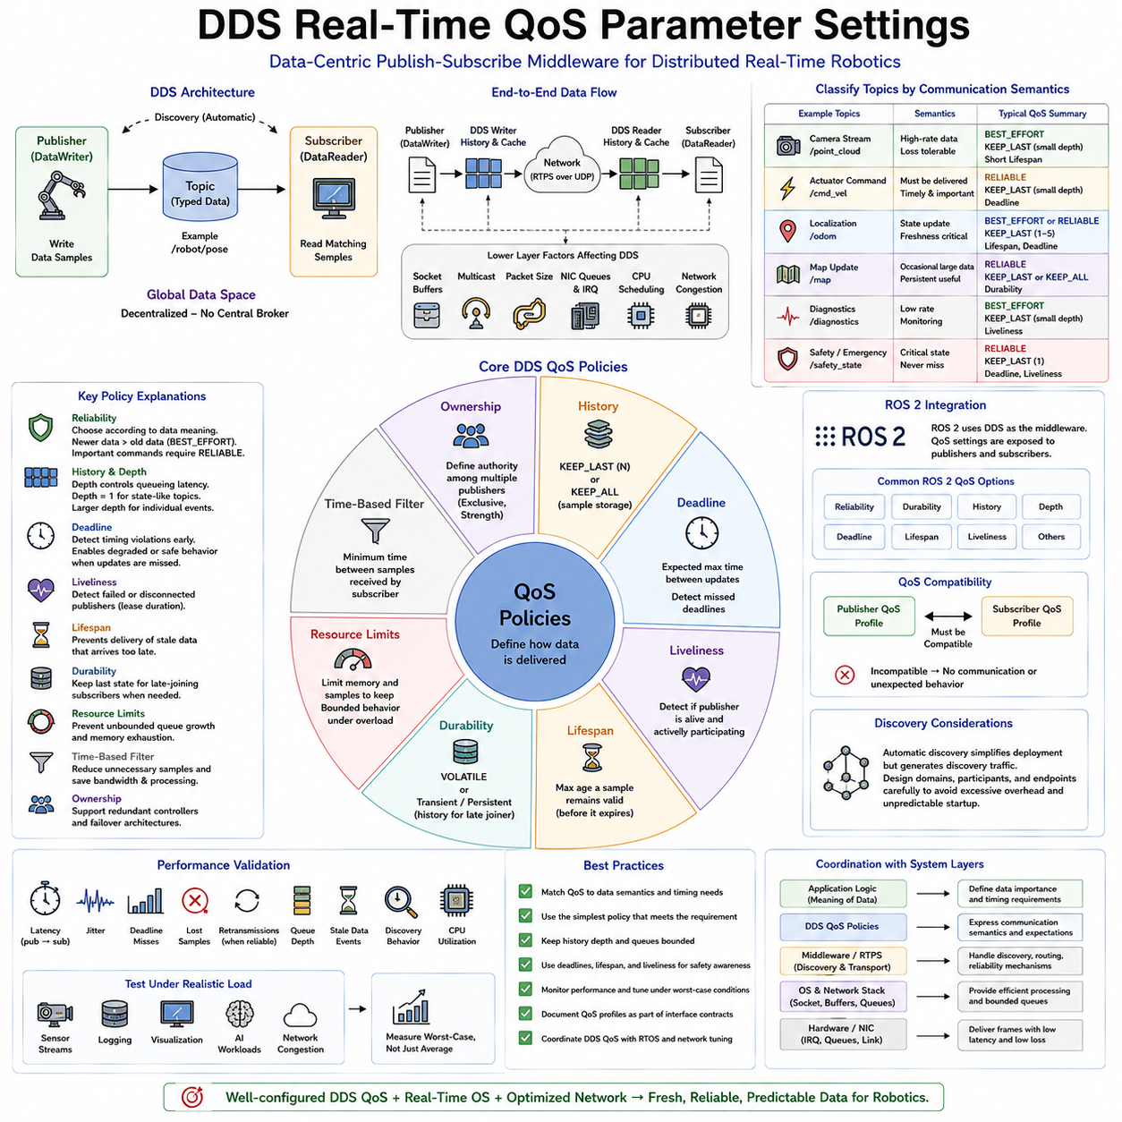
Data Distribution Service, or DDS, is a data-centric publish-subscribe communication standard widely used in distributed real-time systems and robotics. Instead of requiring applications to manage explicit point-to-point connections, DDS organizes communication around typed data topics. Publishers write data samples to topics, subscribers receive matching samples, and the middleware manages discovery, delivery, filtering, reliability, and timing behavior according to configured Quality of Service policies.
DDS communication is built around a Global Data Space in which distributed participants exchange information through DataWriters and DataReaders. A DataWriter publishes samples associated with a Topic, while a compatible DataReader subscribes to that Topic. Participants can discover each other dynamically without a centralized broker. This decentralized architecture is well suited to robotic systems containing multiple controllers, sensors, edge computers, and software components that may start or stop independently.
Quality of Service, commonly abbreviated QoS, is central to DDS because different robotic data streams have fundamentally different communication requirements. A high-rate camera stream, actuator command, localization estimate, map update, diagnostic message, and emergency state should not necessarily use the same delivery policy. DDS QoS allows communication semantics to be configured per data flow instead of forcing every topic to use one universal networking behavior.
The Reliability QoS policy determines whether communication operates with BEST_EFFORT or RELIABLE semantics. BEST_EFFORT minimizes recovery overhead and accepts that some samples may be lost, making it appropriate for high-frequency information where newer data quickly replaces older data. RELIABLE communication attempts to ensure delivery through protocol mechanisms such as acknowledgments and retransmission, which is useful when losing an important command or state transition is unacceptable.
Reliability should be selected according to the meaning of the data rather than assuming that RELIABLE is always superior. Retransmitting an old sensor sample can increase latency and network load even though a newer measurement is already available. Conversely, configuration commands or important state changes may require reliable delivery. Real-time DDS design therefore balances information freshness, delivery assurance, bandwidth consumption, and deadline requirements for each Topic.
The History QoS policy determines how many data samples are retained for communication. KEEP_LAST stores only a configured number of recent samples, while KEEP_ALL attempts to preserve all relevant samples subject to resource limits. Real-time robotic state streams commonly use KEEP_LAST with a small depth because the newest sample is most valuable. Large histories can increase memory consumption and allow obsolete information to accumulate when consumers fall behind.
History depth is closely related to queueing latency. If a subscriber processes data more slowly than a publisher generates it, a deep queue can preserve many samples but eventually deliver information that is temporally outdated. A depth of one is useful for state-like topics where only the latest value matters, while larger depths may be appropriate for events that must be processed individually. Queue depth should therefore reflect application semantics rather than convenience.
The Deadline QoS policy expresses the expected maximum interval between successive data updates. If a publisher is expected to produce actuator feedback every millisecond or localization information every defined period, DDS can detect when the expected update deadline is missed. Deadline monitoring does not automatically repair the communication failure, but it provides middleware-level visibility that applications can use to detect timing violations and initiate degraded or safe behavior.
Liveliness QoS addresses whether a publishing entity is still operational and actively participating in the system. DDS can monitor liveliness according to configured policies and lease durations, allowing subscribers to detect when expected publishers disappear or stop asserting activity. In distributed robotics, this can help identify failures of controllers, perception processes, sensor gateways, or other components whose continued operation is required by higher-level functions.
The Lifespan QoS policy limits how long a data sample remains valid for delivery. Once its configured lifetime expires, the middleware can treat the sample as obsolete. This is especially useful for real-time state information because successful delivery alone does not guarantee usefulness. A delayed velocity command, obstacle observation, or robot pose may become dangerous or meaningless after its temporal validity has expired.
Durability QoS determines whether previously published information should remain available to subscribers that join later. VOLATILE communication normally exposes only samples produced while participants are actively connected, while more persistent durability modes can retain selected historical state. Dynamic configuration or system-state information may benefit from durability, whereas high-rate sensor streams normally do not require old samples to be delivered to newly joining subscribers.
Resource Limits QoS constrains how much memory and how many samples DDS may maintain for communication. These limits are particularly important in real-time systems because unbounded queue growth can create memory pressure and unpredictable execution behavior. Resource limits should be coordinated with History settings, expected publisher rates, subscriber processing rates, and maximum burst conditions so middleware behavior remains bounded during overload.
Time-Based Filter QoS allows a subscriber to specify the minimum interval between samples it needs to receive. A sensor may publish at a high frequency while a visualization or supervisory component requires only a fraction of those updates. Filtering unnecessary samples near the communication layer can reduce processing and bandwidth consumption. This helps prevent slower consumers from creating avoidable load on a distributed robotic system.
Ownership QoS can define which publisher is responsible for a particular data instance when multiple writers provide equivalent information. With exclusive ownership, publisher strength can determine which writer currently controls the data. This mechanism can support redundant controllers or failover architectures, although system-level safety logic must still define how authority transitions occur and how conflicting commands are prevented during faults.
Partition and topic organization provide logical separation among communication domains. Large robotic systems may contain motion-control, perception, localization, diagnostics, safety, and fleet-management data that should not all interact indiscriminately. Carefully designed topic names, namespaces, domains, and partition policies reduce accidental coupling and make it easier to assign QoS profiles according to the timing and reliability requirements of each functional subsystem.
DDS implementations commonly use RTPS, the Real-Time Publish-Subscribe interoperability protocol, for communication between participants. RTPS handles discovery and data exchange over transports that frequently include UDP. DDS therefore does not eliminate lower-level network considerations. Socket buffers, multicast behavior, packet size, network priorities, NIC queues, CPU scheduling, and physical Ethernet congestion can still influence the latency and jitter observed by DDS applications.
Discovery traffic requires particular attention when many DDS participants are present. Automatic discovery simplifies distributed deployment, but large numbers of participants, endpoints, or rapidly changing processes can generate additional multicast and metadata traffic. Production systems should design domain boundaries and participant structures carefully so discovery overhead does not unnecessarily compete with critical cyclic communication or produce unpredictable startup behavior.
DDS thread scheduling must also be considered in real-time implementations. Middleware receive threads, event-processing threads, application callbacks, control tasks, and operating-system network processing may execute at different priorities. A correctly configured Deadline or Reliability policy cannot compensate for a subscriber callback that is delayed by lower-priority scheduling decisions. DDS QoS and RTOS or real-time Linux scheduling must therefore be designed together.
A useful robotic QoS architecture classifies topics by communication semantics. High-rate sensor or state streams often favor BEST_EFFORT, KEEP_LAST, small queue depths, and short validity periods. Important commands or discrete state transitions may use RELIABLE delivery with bounded histories. Configuration and persistent system state may use durability, while safety monitoring can combine Deadline, Liveliness, and application-level watchdog behavior to detect missing or failed components.
ROS 2 uses DDS implementations as its primary middleware foundation, making DDS QoS directly relevant to robotic software integration. ROS 2 exposes QoS concepts such as reliability, durability, history, depth, deadline, lifespan, and liveliness to application developers. Publishers and subscribers must use compatible QoS configurations; otherwise endpoints may fail to communicate or may exhibit behavior different from what developers expect from conventional socket-based messaging.
QoS compatibility should therefore be verified explicitly during system integration. A publisher configured for one reliability or durability expectation may not satisfy the requested policy of a subscriber. Engineers should treat QoS profiles as part of the interface contract between software components, documenting them together with Topic types, update rates, deadlines, data ownership, and failure behavior rather than leaving middleware settings as undocumented implementation details.
Performance validation should measure actual end-to-end behavior under realistic load. Important metrics include publication-to-subscription latency, jitter, deadline misses, lost samples, retransmissions, queue depth, stale-data events, discovery behavior, CPU utilization, and memory consumption. Tests should include simultaneous sensor streams, logging, visualization, AI workloads, and network congestion so QoS settings are validated against worst-case operating conditions rather than an idle system.
DDS QoS should ultimately be viewed as a mechanism for expressing the temporal and delivery semantics of distributed robotic information. Reliability, History, Deadline, Liveliness, Lifespan, Durability, Resource Limits, filtering, and ownership each control a different aspect of communication behavior. When these policies are matched to application meaning and coordinated with RTOS scheduling and network configuration, DDS can provide a flexible and predictable communication foundation for complex real-time robotic systems.

08.08 5G URLLC and Robot Real-Time Control Integration
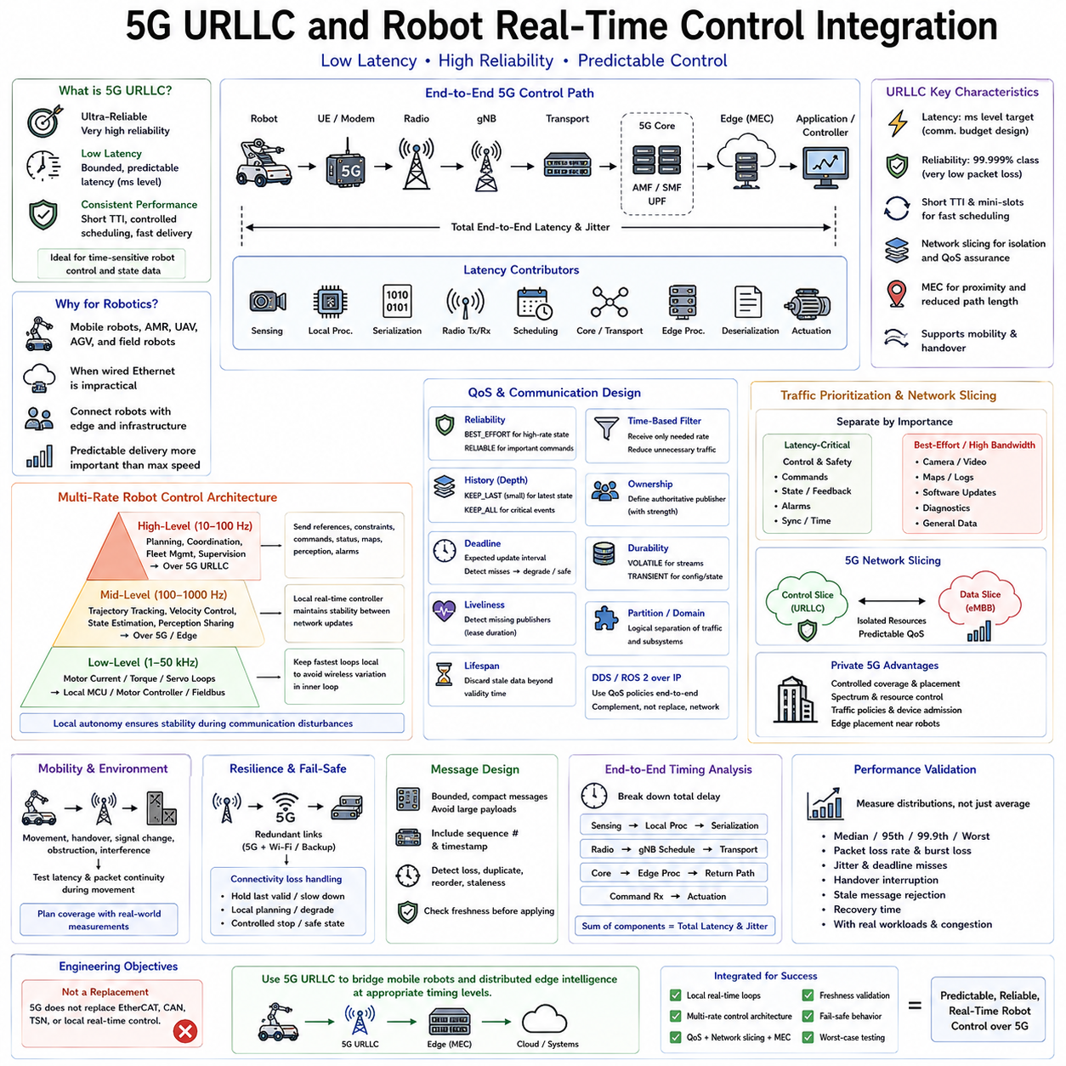
5G Ultra-Reliable Low-Latency Communication, commonly called URLLC, is designed for wireless applications that require both bounded latency and very high communication reliability. In robotics, it provides a communication option between mobile robots, edge computers, controllers, and infrastructure when wired Ethernet is impractical. Its value is not simply higher wireless speed, but predictable delivery of time-sensitive control and state information.
Conventional mobile broadband primarily optimizes aggregate throughput and user capacity, whereas URLLC emphasizes short transmission intervals, controlled scheduling, reliability, and rapid packet delivery. Robotic control traffic often consists of relatively small packets carrying commands, state estimates, trajectories, alarms, or synchronization information. For these workloads, predictable latency and packet availability can be more important than maximum data throughput.
A robot connected through 5G normally communicates through a User Equipment interface to the radio access network and then toward an application or edge-computing service. The complete control path can include the robot processor, modem, radio interface, base station, transport network, 5G core functions, edge server, and application software. Every stage contributes latency and jitter, so radio latency alone cannot represent the complete real-time control performance.
Multi-access Edge Computing, or MEC, is important when 5G is used for robotic control because it places computation closer to the radio access network. Sending every control-related packet through a distant cloud increases propagation delay and introduces additional network variability. Locating perception, coordination, trajectory generation, or supervisory control services at a nearby edge platform can significantly shorten the communication path and improve temporal predictability.
A practical robotic architecture should separate control loops according to their timing requirements. High-frequency motor-current, torque, and servo loops generally remain inside the robot on an MCU, motor controller, RTOS, or deterministic field network. Slower navigation, trajectory correction, collaborative coordination, perception sharing, or supervisory commands can cross the 5G network. This hierarchy prevents wireless variation from directly destabilizing the fastest physical control loops.
For example, a mobile robot may execute wheel-current control at tens of kilohertz inside the motor drive, velocity control at hundreds of hertz or higher on a local real-time controller, and motion planning at tens of hertz on an edge computer. A 5G connection can then carry trajectories, localization corrections, fleet coordination, or remote supervisory commands without becoming part of every inner-loop actuator update.
This multi-rate architecture is fundamental because the phrase real-time control does not imply that every computation must occur remotely at the same frequency. Local controllers can maintain stability between network updates, while higher-level systems periodically provide references or constraints. The robot therefore remains physically controllable during short communication disturbances rather than depending continuously on a remote server for every actuator command.
URLLC reliability should also be interpreted in terms of application requirements. Wireless channels are affected by interference, fading, mobility, handovers, obstruction, and network load. Even highly reliable communication cannot eliminate every possible packet delay or loss. Robot software must therefore define acceptable latency, packet-loss probability, consecutive-loss limits, and recovery behavior rather than assuming that the network will always satisfy an ideal timing value.
Sequence numbers and timestamps are useful for detecting missing, duplicated, reordered, or stale control messages. A successfully delivered packet may still be unusable if it arrives after its command validity interval. Receivers should evaluate both message integrity and temporal freshness before applying data. A delayed trajectory correction or velocity command should not automatically be executed merely because the network eventually delivered it successfully.
Application protocols should be designed around bounded and compact messages. High-frequency control information should avoid unnecessary payload size, serialization complexity, dynamic allocation, and excessive protocol processing. UDP or suitable real-time middleware can be used where freshness is more important than retransmitting every lost message, while selected configuration or transactional operations may require stronger reliability mechanisms.
DDS and ROS 2 can operate above IP networks and provide useful communication semantics for distributed robotic systems using 5G. DDS QoS policies such as Reliability, Deadline, History, Lifespan, and Liveliness can express whether samples may be lost, how long they remain useful, how frequently they are expected, and whether publishers remain active. These middleware policies complement the network but do not replace lower-layer latency engineering.
Traffic prioritization is essential when control information shares a 5G connection with camera streams, maps, logs, software updates, and other high-bandwidth traffic. The communication architecture should distinguish latency-critical control and safety-related messages from bandwidth-oriented perception or maintenance data. Appropriate QoS treatment prevents a large noncritical transfer from consuming resources required by smaller but more time-sensitive packets.
5G network slicing can provide logically separated network resources for services with different performance requirements. A robotic deployment may conceptually separate control communication from telemetry, video, maintenance, or general enterprise traffic. However, a slice should not automatically be interpreted as a hard real-time guarantee. Its usefulness depends on how radio, transport, core, scheduling, and operational resources are actually provisioned.
Private 5G networks are particularly relevant to factories, warehouses, ports, campuses, mines, and large robotic facilities because network deployment and resource policies can be controlled more directly than on a public mobile network. Coverage, base-station placement, spectrum strategy, mobility behavior, device admission, traffic policies, and edge-computing placement can be engineered around the robotic workload rather than around general consumer traffic.
Mobility introduces timing problems that do not exist in fixed wired networks. An AMR, outdoor robot, or UAV can move between radio coverage regions, experience changing signal conditions, or require handover between cells. Control architecture must therefore evaluate latency and packet continuity during movement rather than only when the robot is stationary near a base station. Handover behavior should be included in worst-case communication testing.
Coverage planning must also consider the physical environment. Metal structures, machinery, walls, vehicles, containers, people, and outdoor terrain can alter radio propagation. A system that performs well during an initial demonstration may behave differently after equipment is installed or traffic patterns change. Real-time robotic deployment therefore requires radio measurements under representative operational conditions instead of relying only on theoretical coverage estimates.
Redundancy can increase resilience for robots whose operation depends on wireless connectivity. Depending on system criticality, a robot may combine 5G with Wi-Fi, another cellular connection, or local autonomous operation. Redundant communication does not automatically provide deterministic behavior, but it can prevent a single radio-path failure from immediately disabling higher-level functions. Switching logic must itself be bounded and carefully validated.
Loss of connectivity must be treated as a normal design condition rather than an impossible event. The robot should define what happens when updates become late, unreliable, or unavailable. Depending on the function, it may continue temporarily using the last valid trajectory, reduce speed, switch to local planning, enter a degraded operating mode, execute a controlled stop, or transition to another predefined safe state.
End-to-end timing analysis should divide the control path into explicit latency components. Sensor acquisition, local preprocessing, application scheduling, protocol serialization, modem processing, radio transmission, base-station scheduling, transport networking, edge processing, return transmission, command reception, and actuator execution all consume time. The total delay and its variation determine whether the remote or distributed control function is practically usable.
Time synchronization is valuable when measurements and commands are produced across several distributed computing nodes. Synchronized clocks allow engineers to determine when sensor information was generated, how long processing consumed, and how much time was spent in communication. Without a consistent time reference, it becomes difficult to separate network delay from computation delay or identify the actual source of end-to-end jitter.
Performance validation should therefore measure latency distributions rather than only average latency. Important metrics include median and high-percentile delay, worst observed delay, packet-loss rate, consecutive packet losses, jitter, handover interruption, application deadline misses, stale-message rejection, and recovery time. Testing should also include concurrent video traffic, AI workloads, network congestion, robot movement, and degraded radio conditions.
For distributed robotic systems, 5G URLLC is most effective when integrated as part of a hierarchical real-time architecture. Deterministic local controllers maintain fast physical loops, edge processors execute perception and planning, and 5G provides low-latency connectivity for coordination across mobile components. This structure allows wireless communication to extend the control system without making the robot's fundamental stability dependent on every remote packet.
The engineering objective is therefore not to replace EtherCAT, CAN, TSN, or local real-time control with 5G. Instead, 5G URLLC can bridge mobile robots and distributed edge intelligence at timing levels appropriate for wireless communication. When local autonomy, multi-rate control, QoS, edge computing, freshness validation, fail-safe behavior, and worst-case testing are designed together, 5G can become a practical real-time communication layer for advanced robotic systems.

08.09 Real-Time Network Jitter Measurement and Visualization
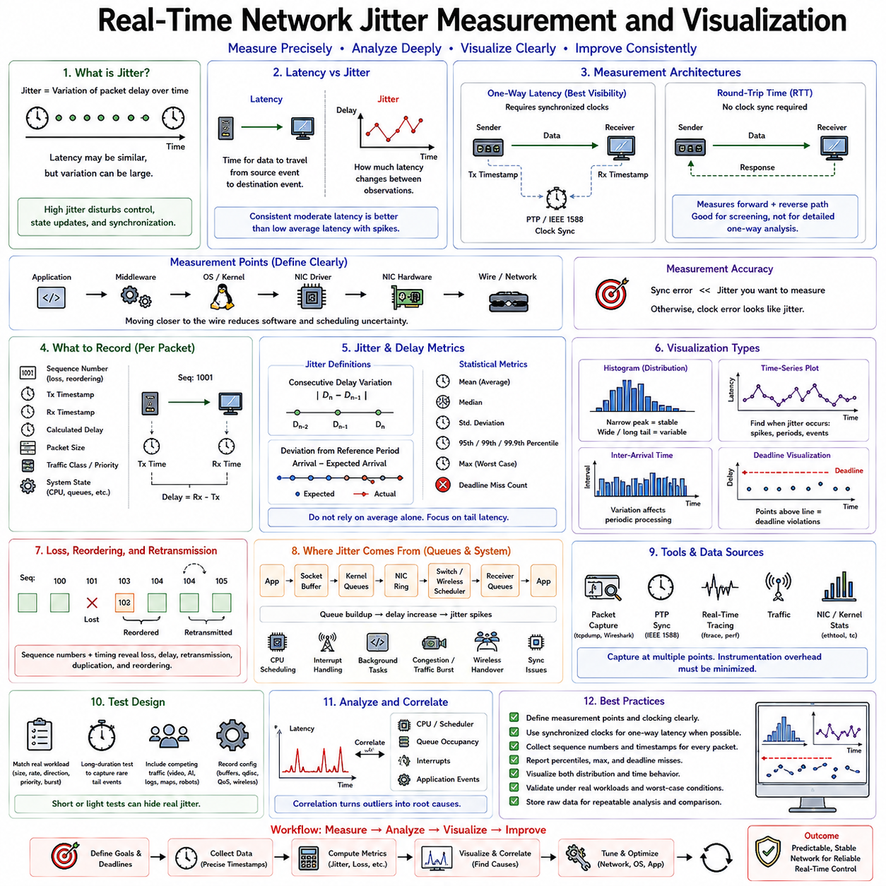
Network jitter is the variation in packet delay over time, and it is one of the most important indicators of communication predictability in distributed real-time systems. Two packets may have similar average latency while experiencing very different timing variation. For robotic control, this variation can disturb periodic data exchange, delay state updates, and reduce the temporal consistency required by controllers, estimators, and synchronized sensors.
Latency and jitter should be treated as related but different quantities. Latency represents the time required for information to travel from a defined source event to a destination event, whereas jitter describes how much that latency changes between observations. A network with consistently moderate latency may be easier to use for deterministic control than one with a lower average latency but occasional large delay spikes.
Real-time network measurement must first define precise observation points. Application-to-application latency includes software processing and scheduling, while kernel or hardware timestamps can measure communication closer to the network interface. Without clearly defined measurement boundaries, results from different tools cannot be compared reliably. Engineers should therefore document exactly where each timestamp is generated and what processing stages lie between them.
Round-trip time is a convenient measurement when synchronized clocks are unavailable. A sender transmits a packet, the receiver returns a response, and the sender measures the elapsed interval using one local clock. This avoids clock-offset errors but combines forward and reverse paths into one value. Asymmetric routing, scheduling, or queueing can therefore remain hidden, making round-trip measurements useful for screening but insufficient for detailed one-way analysis.
One-way latency provides better visibility into directional communication behavior but requires synchronized clocks at the transmitting and receiving systems. Precision Time Protocol, commonly implemented using IEEE 1588, can provide a shared time reference when the network and hardware support suitable timestamping. The synchronization error must be significantly smaller than the jitter being investigated; otherwise clock uncertainty can be mistaken for network variation.
Software timestamps are relatively easy to obtain but include uncertainty from system calls, scheduler delays, protocol processing, and application execution. Kernel timestamps move the observation point closer to packet processing, while hardware timestamps generated by a capable NIC can measure transmission and reception near the physical interface. Comparing timestamps across these layers helps separate network delay from operating-system and application delay.
A useful measurement record contains more than a single latency value. Each sample should include a sequence number, transmission timestamp, reception timestamp, calculated delay, packet size, traffic class, and relevant system state when practical. Sequence numbers reveal packet loss and reordering, while timestamps expose timing variation. Additional CPU, queue, or scheduler information can later explain why particular outliers occurred.
Jitter can be represented in several ways depending on the engineering objective. Consecutive delay variation measures the difference between neighboring latency samples, while deviation from a reference period shows how packet arrivals drift relative to expected timing. Statistical dispersion such as standard deviation can summarize normal variability, but real-time analysis should not rely on one statistical definition because rare delay spikes often dominate system risk.
Average latency is particularly dangerous when used alone. A communication path may show an excellent mean while occasionally producing delays several times larger than normal. Those rare events may cause missed control deadlines even though they barely affect the average. Measurements should therefore report median, high-percentile values such as the 95th, 99th, or 99.9th percentile, maximum observed latency, and deadline-miss counts.
Histograms provide an effective visualization of latency distributions. A narrow peak indicates relatively consistent communication, whereas a wide distribution suggests significant timing variation. Multiple peaks may reveal different operating modes such as interrupt moderation, scheduler interference, retransmission, or network congestion. A long tail is particularly important because it indicates rare but potentially severe latency events that average values conceal.
Time-series plots complement histograms by showing when jitter occurs. Plotting latency against time can reveal periodic spikes, startup effects, congestion episodes, CPU workload interference, handovers, or synchronization disturbances. When network latency is plotted alongside CPU utilization, scheduler activity, queue occupancy, or application events, correlations can become visible that would be impossible to identify from aggregate statistics alone.
Inter-arrival time is another valuable measurement for periodic robotic traffic. If a sensor or controller is expected to transmit every millisecond, the receiver can measure the interval between successive packet arrivals. Variation in this interval directly affects downstream periodic processing. Inter-arrival analysis can reveal packet bunching, scheduling irregularity, delayed transmissions, and situations where several packets arrive together after waiting in a queue.
Deadline-based visualization connects network behavior directly to control requirements. Instead of displaying latency only as an abstract number, a plot can include the maximum acceptable communication deadline. Samples exceeding that threshold become deadline violations. This representation is especially useful because a 2 ms delay may be harmless for one robotic function but unacceptable for another whose communication budget is only 1 ms.
Packet loss and jitter should be analyzed together. A network may appear to have low latency because packets experiencing severe congestion are dropped rather than delivered late. Conversely, reliable protocols may recover lost packets through retransmission while producing large latency spikes. Sequence-number analysis combined with timing measurements distinguishes packet loss, delayed delivery, retransmission effects, duplication, and reordering.
Queue occupancy is often a direct explanation for observed jitter. Packets may wait in NIC descriptor rings, kernel backlog queues, socket buffers, traffic-control queues, switches, wireless schedulers, or application queues. Monitoring these queues while measuring packet latency can identify where delay begins to accumulate. A growing queue followed by a latency spike strongly suggests congestion or temporary processing starvation.
Operating-system scheduling can create network jitter even when the physical network is stable. A packet may arrive at the NIC on time but wait before an interrupt, kernel thread, middleware thread, or application task executes. Real-time Linux tracing tools can correlate packet events with context switches, interrupt handling, preemption, and scheduling latency, helping distinguish actual network variation from host-processing variation.
Packet capture tools provide another observation layer. Capturing traffic at different points can reveal transmission timing, packet ordering, protocol behavior, retransmissions, and traffic interactions. However, packet capture itself can introduce CPU and storage overhead, particularly at high rates. Measurement systems should therefore be designed so that instrumentation does not significantly alter the timing behavior being measured.
Controlled traffic generation is useful for establishing a reproducible baseline. Test streams should approximate the packet size, frequency, direction, priority, and burst characteristics of the actual robotic workload. Measurements with only low-rate synthetic packets may underestimate jitter that appears when camera streams, logging, map transfer, AI processing, or multiple robots compete for network and computing resources.
Visualization should support comparison between configurations. Before-and-after latency distributions can demonstrate the effect of changing socket buffers, qdisc settings, interrupt moderation, CPU affinity, TSN scheduling, DDS QoS, or wireless parameters. Identical axes and statistical metrics should be used so improvements are not created visually by different scales. Configuration metadata should also be stored with each measurement dataset.
Long-duration testing is necessary because rare timing failures may not appear during short experiments. A system can operate normally for thousands of packets before a scheduler disturbance, background task, link event, or queue burst creates a severe outlier. Real-time validation should therefore collect enough samples to characterize both normal behavior and low-probability tail events under representative operating conditions.
Measurement overhead must itself be evaluated. Frequent logging, console output, file writes, visualization updates, or high-resolution tracing can interfere with the real-time workload and produce artificial jitter. A better architecture records compact timestamp data into preallocated memory or efficient buffers during the experiment and performs expensive statistical analysis and visualization afterward whenever possible.
For robotic networks, the final objective is not simply to produce attractive latency graphs but to connect communication timing with system behavior. Jitter measurements should be interpreted against control periods, sensor update intervals, estimator deadlines, synchronization requirements, and safety limits. The same measured network may therefore be acceptable for mapping traffic while being unsuitable for a tightly coupled motion-control function.
A complete real-time network analysis combines synchronized timestamps, packet sequence tracking, latency distributions, inter-arrival measurements, queue statistics, operating-system tracing, and workload information. Visualization then becomes a diagnostic tool linking outliers to their probable causes. By focusing on worst-case behavior and tail latency rather than averages alone, engineers can systematically identify and reduce network jitter in distributed robotic systems.

08.10 Robot Distributed Control Network Latency Optimization
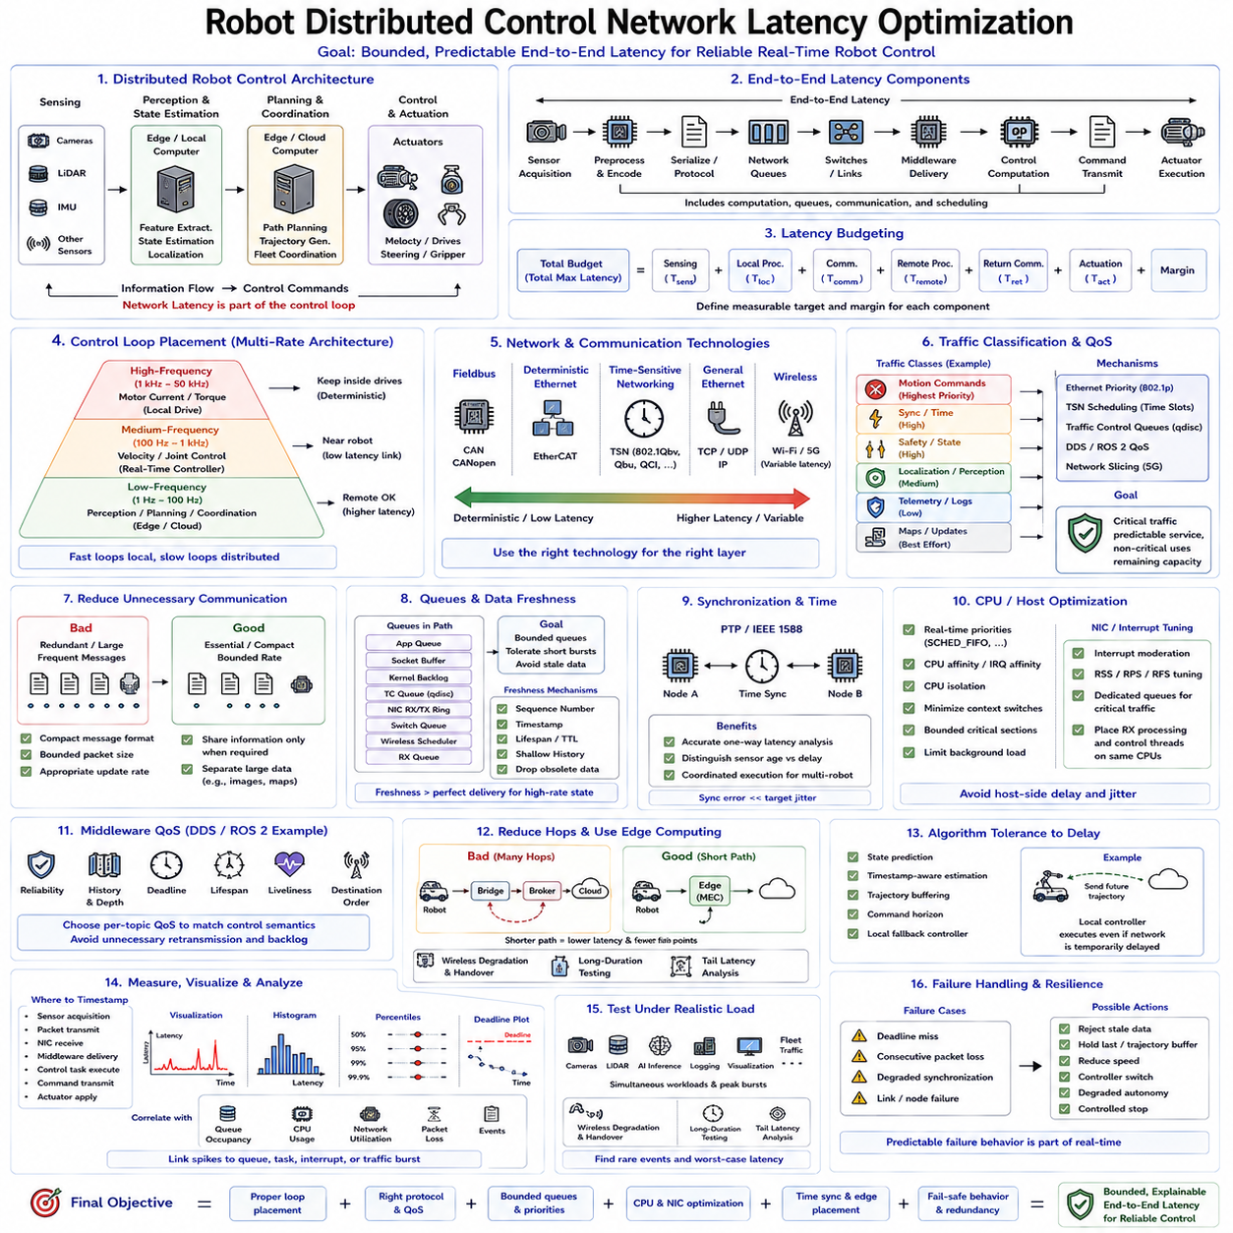
Distributed robot control divides sensing, estimation, planning, coordination, and actuation across multiple computing nodes connected by communication networks. This architecture improves scalability and allows specialized controllers, edge computers, sensors, and robots to cooperate, but network delay becomes part of the control path. Latency optimization must therefore consider communication, computation, scheduling, and control behavior as one integrated real-time system.
End-to-end latency begins when information is generated and ends when its effect reaches the intended consumer or actuator. A sensor sample may pass through acquisition, preprocessing, serialization, protocol processing, network queues, switches, middleware, application scheduling, control computation, and command transmission before reaching an actuator. Optimizing only the physical link can therefore leave major software and queueing delays unresolved.
A useful first step is to define a latency budget for every distributed control function. The total allowable delay can be divided among sensing, local processing, communication, remote computation, return transmission, and actuation. Each component should have a measurable timing target and margin. This decomposition converts a vague requirement such as “low latency” into engineering constraints that can be measured and optimized independently.
Distributed control should use a hierarchical multi-rate architecture rather than placing every control loop across the network. Motor-current and torque loops normally remain inside local drives, while velocity or joint control executes on nearby real-time controllers. Perception, planning, fleet coordination, and supervisory functions can operate on edge computers at slower rates. Keeping the fastest loops local reduces sensitivity to network jitter and packet loss.
Control-loop placement should be determined by required update frequency, tolerated delay, failure consequences, and computational demand. A function requiring deterministic sub-millisecond response may belong on an MCU, FPGA, or local RTOS node, whereas trajectory planning with a tens-of-milliseconds budget can execute remotely. The network should connect control layers at timing boundaries appropriate to their dynamics instead of being treated as a transparent extension of local memory.
Different network technologies can serve different layers of this hierarchy. CAN or CANopen may connect embedded controllers and actuators, EtherCAT can provide deterministic high-rate machine control, TSN can coordinate time-sensitive Ethernet traffic, and conventional Ethernet can carry higher-level data. Wireless technologies such as Wi-Fi or 5G can extend connectivity to mobile platforms where physical cabling is impossible, but their timing variability must be considered explicitly.
Latency optimization begins with reducing unnecessary communication. Distributed applications should transmit information required for control rather than repeatedly transferring redundant state. Compact message formats, bounded packet sizes, efficient serialization, and appropriate update frequencies reduce network load and processing overhead. Large images or point clouds should not compete directly with small control messages unless bandwidth and traffic isolation have been intentionally engineered.
Traffic classification separates communication according to timing importance. Motion commands, synchronization data, safety states, localization updates, sensor streams, logs, maps, and software transfers have different deadlines. Critical traffic should receive predictable service while best-effort data uses remaining capacity. Ethernet priority mechanisms, TSN scheduling, traffic-control queues, DDS QoS, and network slicing can implement this separation at different layers.
Queueing is frequently a larger source of latency variation than physical transmission. Packets can wait in application queues, socket buffers, kernel backlogs, traffic-control queues, NIC descriptor rings, switches, wireless schedulers, and receiver queues. Increasing buffer sizes may reduce packet loss while creating long hidden delays. Real-time optimization therefore favors intentionally bounded queues that tolerate short bursts without allowing stale control information to accumulate.
Data freshness is often more important than perfect delivery for high-frequency state streams. If position, velocity, or sensor information is updated continuously, retransmitting an old sample may provide less value than delivering the newest state immediately. Sequence numbers, timestamps, lifespan limits, and shallow histories allow receivers to reject obsolete information. Important discrete commands can use stronger reliability where every event must be preserved.
Time synchronization provides the foundation for detailed one-way latency analysis. PTP or another suitable synchronization mechanism allows distributed nodes to compare timestamps using a common time reference. Engineers can then distinguish sensor age, communication delay, processing delay, and actuator-command age. Accurate synchronization also supports coordinated execution when multiple robots or controllers must perform actions according to a shared timeline.
CPU scheduling must be optimized together with network scheduling. A packet delivered quickly to a computer still experiences excessive latency if the corresponding application thread cannot run. Real-time priorities, CPU affinity, IRQ affinity, CPU isolation, bounded critical sections, and controlled background workloads can reduce host-side delay. Network receive processing and the consuming control task should follow predictable execution paths whenever possible.
Interrupt and NIC configuration can significantly affect latency. Interrupt moderation reduces CPU overhead by grouping packets but may delay time-sensitive traffic. RSS distributes network processing across multiple CPU cores but can introduce cache migration and cross-core communication. For critical flows, assigning NIC queues, interrupts, network processing, and application threads to coordinated CPU resources can improve consistency more than maximizing aggregate throughput.
Middleware configuration also affects distributed control timing. DDS or ROS 2 communication should use QoS settings appropriate to each Topic rather than one default profile for the entire robot. Reliability, History, Depth, Deadline, Lifespan, and Liveliness determine how messages are retained, recovered, monitored, and expired. Incompatible or overly conservative QoS settings can create retransmission, queueing, memory use, or communication behavior that conflicts with control requirements.
Distributed architectures should minimize unnecessary processing hops. Routing a control message through multiple bridges, containers, brokers, gateways, or cloud services increases both delay and failure opportunities. Critical paths should be kept short and understandable. Edge computing can place perception, planning, and coordination closer to robots, reducing transport distance while preserving centralized computational capability where local embedded processors are insufficient.
Control algorithms should also tolerate bounded communication delay rather than assuming zero-delay networking. State prediction, timestamp-aware estimation, trajectory buffering, command horizons, and local fallback controllers can maintain useful behavior between remote updates. In some applications, transmitting a short future trajectory is more robust than transmitting only an instantaneous command because the local controller can continue execution during temporary network variation.
Packet loss, delay, and jitter must be considered together. A reliable protocol may recover lost information but increase latency through retransmission, while a best-effort protocol may maintain freshness at the cost of occasional loss. The correct behavior depends on whether the message represents continuously refreshed state, a unique event, a configuration transaction, or a safety-critical command. Communication semantics should therefore follow control semantics.
Redundancy can improve availability in distributed robot networks. Critical systems may provide multiple Ethernet paths, redundant switches, dual controllers, alternative wireless links, or local autonomous fallback. Redundancy must be engineered carefully because duplicated paths can introduce synchronization, ordering, or failover complexity. Recovery time and transition behavior should be measured rather than assuming that redundant hardware automatically guarantees continuous real-time operation.
Network congestion should be treated as a system-level resource problem. Camera streams, LiDAR data, AI inference results, logging, remote visualization, software updates, and multiple robots may compete for the same links and CPUs. Capacity planning should include peak and burst traffic rather than average bandwidth alone. Critical control traffic should retain its latency budget when noncritical communication approaches its maximum expected operating load.
Measurement should cover the entire control chain rather than only ping or link-level latency. Useful timestamps include sensor acquisition, packet transmission, NIC reception, middleware delivery, control-task execution, command transmission, and actuator application. Combining hardware timestamps, network captures, kernel tracing, application instrumentation, and synchronized clocks allows engineers to identify which component consumes the latency budget.
Visualization helps convert timing measurements into engineering decisions. Time-series plots reveal transient spikes, histograms expose latency distributions, percentile statistics characterize tail behavior, and deadline plots show direct control violations. Queue occupancy, CPU scheduling, network utilization, and packet loss should be correlated with these timing results. A latency spike becomes actionable when it can be linked to a specific queue, task, interrupt, or traffic burst.
Worst-case testing is essential because distributed systems often appear stable under light load. Validation should reproduce simultaneous sensing, AI inference, storage activity, logging, visualization, fleet traffic, and network congestion. Mobile systems should additionally test wireless degradation and handovers. Long-duration experiments are required to expose rare scheduling events and tail-latency failures that short benchmark runs may completely miss.
Failure handling must be part of latency design. Each distributed control interface should define what happens when a deadline is missed, packets are lost consecutively, synchronization is degraded, or communication disappears. Depending on the function, the receiver may reject stale data, hold a bounded trajectory, reduce speed, switch controllers, enter degraded autonomy, or perform a controlled stop. Predictable failure behavior is part of real-time performance.
The final optimization objective is not the smallest possible average network delay but a bounded and explainable end-to-end control latency. Control-loop placement, protocol selection, QoS, queue depth, traffic priority, CPU scheduling, synchronization, edge placement, and fail-safe behavior must be engineered together. When each layer has a defined timing budget and measurable responsibility, distributed robotic control can remain predictable even under realistic computational and network load.

