Volume 03 Real Time Operating Systems

07. Memory Management

07.01 Embedded Memory Hierarchy: Cache, SRAM, DRAM
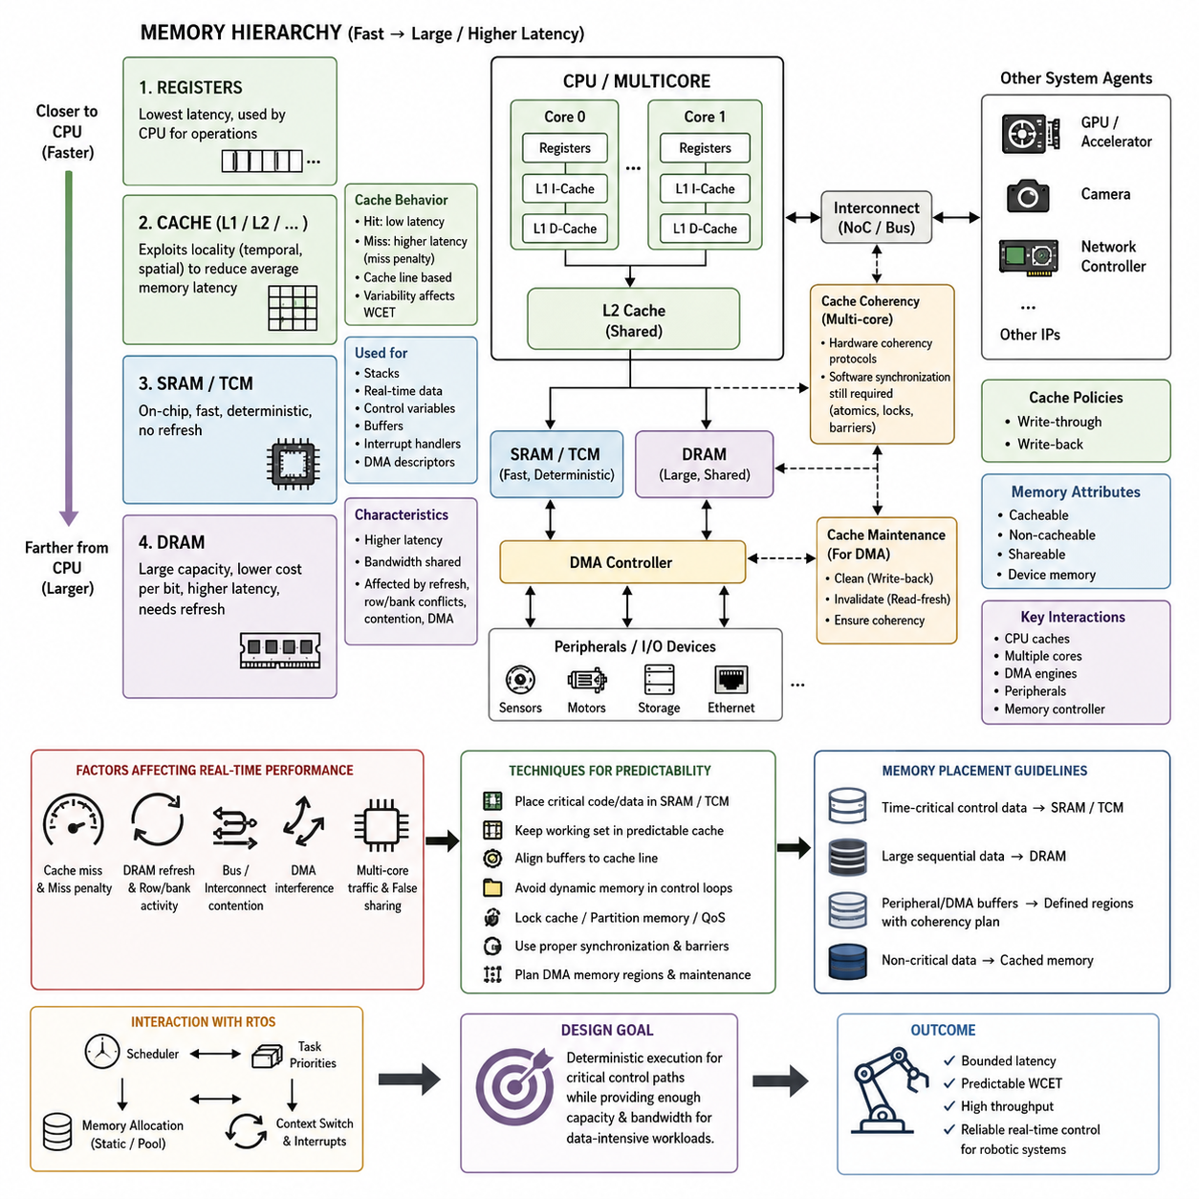
In an embedded real-time system, memory is not a single uniform resource but a hierarchy of storage technologies with different latency, capacity, bandwidth, power, and predictability characteristics. Registers sit closest to the processor, followed by one or more cache levels, tightly coupled or on-chip SRAM, and larger external DRAM. The hierarchy exists because the fastest memory technologies are expensive in silicon area and power, while high-capacity memory is generally slower.
Processor registers provide the lowest-latency storage and directly support arithmetic, address calculation, control flow, and temporary values used by executing instructions. Their capacity is extremely limited, so compilers continuously move data between registers and the surrounding memory hierarchy. Register allocation therefore influences execution efficiency, but embedded software usually manages registers indirectly through compiler optimization except for low-level context switching, interrupt handling, and device access.
Cache memory reduces the effective latency gap between a fast processor core and slower main memory. Frequently or recently accessed instructions and data are retained in small, high-speed cache structures so that subsequent accesses can be served without reaching SRAM or DRAM. Modern embedded processors may contain separate instruction and data L1 caches and a larger unified L2 cache, while higher-performance SoCs can include additional shared cache levels between multiple CPU cores and external memory.
Caches exploit temporal locality and spatial locality. Temporal locality means that recently accessed information is likely to be accessed again, while spatial locality means that nearby addresses are likely to be referenced within a short period. Rather than transferring only the requested byte or word, a cache normally operates on cache lines containing contiguous memory. This greatly improves average performance for sequential code, arrays, buffers, and structured data, but it can also introduce timing variability.
A cache hit allows the processor to obtain data with relatively low latency, whereas a cache miss requires retrieval from a lower memory level. The resulting miss penalty can include cache-line replacement, memory-controller arbitration, bus transactions, and DRAM access. For general computing this variability is usually acceptable because average throughput dominates. In hard real-time systems, however, the difference between cache-hit and cache-miss execution paths directly affects worst-case execution time and scheduling analysis.
SRAM provides deterministic, high-speed storage without the refresh operations required by DRAM. Microcontrollers commonly integrate SRAM on the same chip as the CPU and use it for stacks, task control structures, communication buffers, variables, and real-time working data. Some processors also provide tightly coupled memory, or TCM, which bypasses normal cache behavior and offers predictable processor access. Such memory is particularly valuable for interrupt handlers and time-critical control algorithms.
Because embedded SRAM capacity is limited, memory placement becomes an architectural decision rather than merely a linker detail. Critical task stacks, DMA descriptors, control-state variables, and high-frequency buffers can be deliberately placed in specific SRAM banks or TCM regions. Less time-sensitive information may remain in cached memory. Linker scripts and memory sections therefore become important mechanisms for translating real-time memory requirements into the physical organization of the target processor.
DRAM provides much greater capacity at a lower cost per bit and is therefore widely used in embedded Linux systems, edge computers, robotics processors, and AI-capable SoCs. Unlike SRAM, DRAM stores information in cells that require periodic refresh and complex row and bank operations. Memory controllers hide much of this complexity, but access latency still depends on refresh activity, row-buffer state, bank conflicts, request ordering, and competition among processors and hardware accelerators.
A modern robotic computing platform may contain CPUs, GPUs, neural accelerators, camera interfaces, network controllers, and DMA engines that all compete for shared DRAM bandwidth. Consequently, a CPU task can experience memory delays even when its own execution behavior has not changed. Large perception tensors, image streams, point clouds, and AI inference workloads can generate substantial memory traffic. Real-time architecture must therefore consider memory bandwidth and contention together with CPU scheduling and task priority.
DMA illustrates why the memory hierarchy must be understood as a system rather than only from the CPU perspective. A DMA controller can transfer sensor or communication data directly between a peripheral and memory without repeatedly involving the processor. However, when a CPU cache contains another copy of the same memory region, software or hardware must maintain coherency. Incorrect cache invalidation or write-back handling can cause the CPU or peripheral to observe stale data even though the physical transfer completed correctly.
Cache policies determine how modifications propagate through the hierarchy. Write-through caching sends updates toward lower memory immediately, simplifying some consistency behavior at the cost of additional traffic. Write-back caching retains modified data in the cache until eviction or an explicit maintenance operation, improving bandwidth efficiency but increasing coherency complexity. Cacheable, non-cacheable, shareable, and device-memory attributes must therefore match how each memory region is actually used by CPUs and peripherals.
Multicore processors introduce another dimension because several cores may cache copies of the same memory location. Hardware cache-coherency protocols can maintain a consistent shared-memory view, but synchronization still requires correct software semantics. Atomic operations, memory barriers, locks, and ordering rules remain necessary when tasks exchange data concurrently. Cache-line placement also matters because unrelated variables modified by different cores can produce false sharing and unnecessary coherency traffic.
Memory hierarchy design has a direct relationship with determinism. Average memory latency alone is insufficient for real-time analysis because deadlines depend on the longest credible access path. Cache misses, DRAM refresh, bus contention, page activity, DMA interference, and multicore traffic can collectively create latency tails much larger than typical measurements. Designers therefore distinguish throughput optimization from worst-case latency control and identify which execution paths must remain predictable under maximum system load.
Several techniques can reduce this uncertainty. Time-critical code and data can reside in SRAM or TCM, working sets can be sized to fit predictable cache regions, buffers can be aligned to cache-line boundaries, and unnecessary dynamic memory traffic can be removed from control loops. Some processors support cache locking, memory partitioning, or quality-of-service mechanisms that reserve cache capacity or memory bandwidth. These mechanisms trade resource flexibility for stronger temporal isolation.
The appropriate hierarchy also depends on the task. A high-frequency motor-control loop may require only a small amount of SRAM and benefit more from deterministic access than from large cache capacity. Navigation and SLAM require larger maps and sensor buffers, making DRAM unavoidable. Vision and AI inference often depend heavily on cache reuse and external memory bandwidth. A robotic platform therefore normally combines multiple memory technologies rather than attempting to optimize every workload with one memory type.
Memory optimization should consequently begin with access behavior rather than capacity alone. Engineers should identify the working set, access frequency, locality, sharing pattern, DMA interaction, and deadline sensitivity of each major data structure. Frequently accessed deterministic state belongs near the processor, large sequential datasets can exploit caches and DRAM bandwidth, and peripheral buffers require explicit coherency planning. This approach connects software data organization directly to physical memory behavior.
Within an RTOS, these hardware properties interact with task scheduling and memory allocation. A high-priority task may be scheduled immediately yet still execute slowly because its instructions or data are absent from cache or because shared memory is congested. Conversely, carefully placed code and preallocated working memory can make execution considerably more repeatable. Real-time performance must therefore be analyzed as the combined behavior of scheduler, processor, cache, interconnect, memory controller, and physical memory.
For robotic systems, the practical objective is not simply to maximize memory speed but to construct a hierarchy in which critical control paths remain bounded while data-intensive workloads retain sufficient capacity and throughput. Cache provides speed through locality, SRAM provides fast and relatively deterministic working storage, and DRAM provides scalable capacity. Understanding how these layers interact establishes the foundation for static allocation, memory pools, MPU and MMU protection, cache coherency, DMA management, and AI inference memory optimization addressed later in the memory-management architecture.

07.02 Static Memory Allocation: Pool Allocator [w/Code]
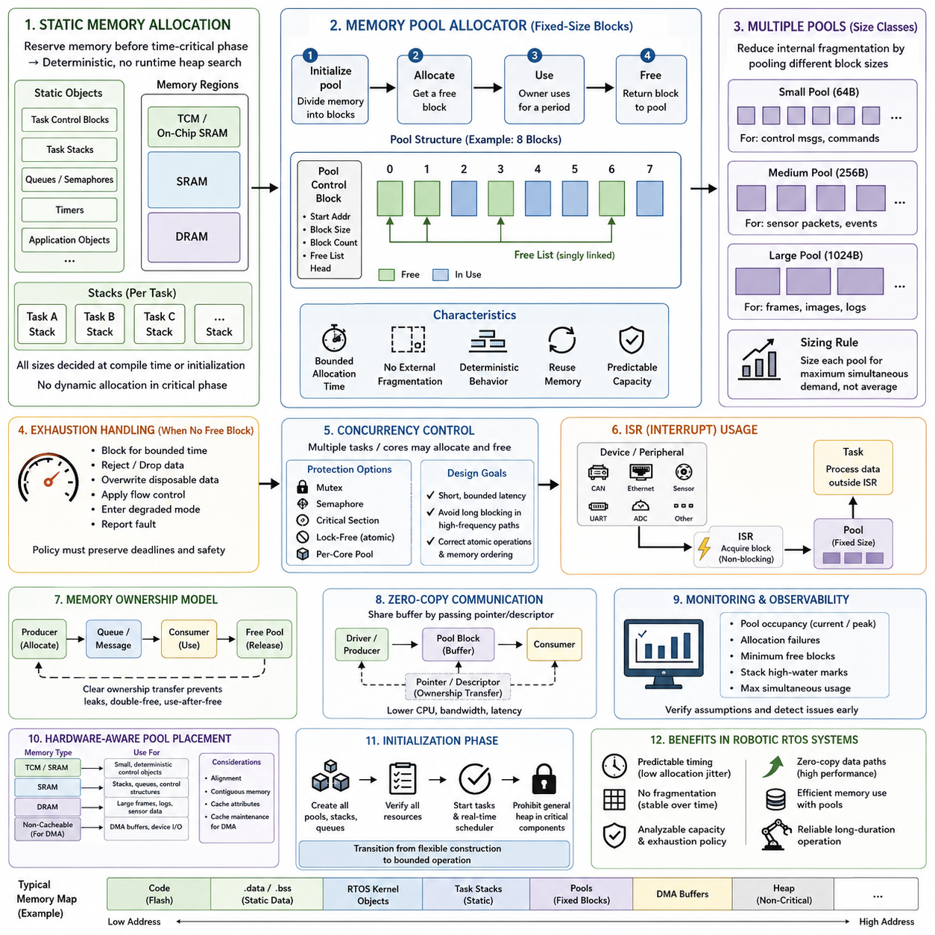
Static memory allocation is a memory-management strategy in which required storage is reserved before the time-critical execution phase begins. In embedded and real-time systems, this usually means that task stacks, control structures, communication buffers, queues, and application objects are assigned fixed memory locations or preallocated regions. The primary advantage is predictability: allocation does not depend on searching a fragmented heap while a real-time task is running.
Unlike general-purpose applications, an RTOS-based controller often cannot tolerate unpredictable allocation latency or allocation failure during operation. Dynamic allocators such as malloc() may search free lists, split blocks, merge adjacent regions, or update allocator metadata. The execution time of these operations can vary with heap state. Static allocation removes much of this uncertainty by determining memory ownership and capacity during compilation, initialization, or a controlled startup phase.
Static objects can be placed in global or static storage regions whose addresses and sizes are determined by the linker. RTOS kernels may also allow applications to provide memory explicitly for task control blocks, stacks, queues, semaphores, timers, and other kernel objects. This approach gives the application direct control over how much memory exists and where it resides, while eliminating dependence on a general-purpose runtime heap for critical kernel resources.
Stack allocation is another important part of deterministic memory design. Each real-time task normally receives a predefined stack sized for its expected call depth, local variables, interrupt interaction, and library usage. If stack sizes are selected conservatively and verified through high-water-mark measurement or runtime monitoring, the system can operate without requesting additional stack memory. Stack overflow detection remains essential because fixed allocation converts uncontrolled growth into a clearly defined capacity boundary.
The main limitation of purely static allocation is reduced flexibility. Memory must often be reserved for worst-case demand even when the typical workload uses only a fraction of that capacity. If ten communication channels might simultaneously require large buffers, reserving ten permanent buffers guarantees availability but may waste SRAM during normal operation. Embedded systems therefore frequently combine fixed allocation with memory pools to preserve determinism while allowing controlled reuse of storage.
A memory pool is a preallocated region divided into reusable blocks. Instead of requesting arbitrary-sized memory from a general heap, tasks acquire a block from the pool, use it for a bounded period, and return it when processing is complete. Because the memory already exists, runtime allocation becomes a resource-management operation rather than a request to expand or reorganize the heap. This makes pool behavior easier to analyze and constrain for real-time execution.
The simplest pool uses fixed-size blocks. During initialization, a contiguous memory region is divided into equally sized elements and linked into a free list. Allocation removes one available element, while deallocation returns it to the list. Both operations can often be implemented with constant or tightly bounded execution time. Fixed-size pools also eliminate external fragmentation because every free block can satisfy any request belonging to that particular pool.
Internal fragmentation can still occur when an object is significantly smaller than the block assigned to it. For example, storing a 100-byte message in a 256-byte block wastes the unused portion until the block is released. A common solution is to maintain several pools for different size classes, such as small control messages, medium sensor packets, and large communication frames. Requests are directed to the smallest suitable pool while maintaining predictable allocation behavior.
Pool sizing should be derived from maximum simultaneous resource demand rather than average usage. A communication pipeline, for example, may require blocks for data being received, queued, processed, transmitted, and temporarily retained by another task at the same time. The designer must therefore analyze object lifetime and concurrency. If a pool contains too few blocks, deterministic allocation time remains meaningless because the system can still exhaust the resource when demand reaches its legitimate peak.
Exhaustion behavior must be explicitly defined. A safety-critical or real-time system should not assume that pool allocation will always succeed merely because memory was preallocated. Depending on the application, exhaustion may cause the requesting task to block for a bounded interval, reject incoming data, overwrite an explicitly disposable sample, trigger flow control, enter a degraded mode, or report a fault. The selected policy must preserve system deadlines and safety requirements.
Memory pools also simplify fragmentation management. General heaps can develop external fragmentation when free memory becomes separated into regions that are individually too small for a requested object despite sufficient total free capacity. Fixed-block pools cannot experience this form of fragmentation. Their memory topology remains stable over long operating periods, which is particularly valuable for robots, industrial controllers, and autonomous systems expected to operate continuously without rebooting.
Concurrency introduces additional requirements because several tasks, interrupt handlers, or processor cores may attempt to acquire and release blocks simultaneously. A pool can be protected with a mutex, semaphore, critical section, or other synchronization primitive, but the synchronization mechanism itself contributes latency and possible contention. For high-frequency paths, lock-free free lists or per-core pools may reduce interference, although they require careful atomic operations and memory-ordering semantics.
Interrupt service routines require especially careful pool design. An interrupt should generally avoid an allocator that can block, wait for a mutex, or perform an unbounded search. A dedicated fixed-size pool can instead provide immediately available buffers for incoming sensor, CAN, Ethernet, or other device data. The interrupt handler obtains a block, records or references the data, and transfers ownership to a task that performs the more expensive processing outside interrupt context.
Memory ownership is therefore as important as allocation itself. Every block should have a clearly defined owner and a clear transition between producer, queue, consumer, and free-pool states. Ambiguous ownership can produce double-free errors, use-after-free faults, memory corruption, or permanent pool leakage. In message-based RTOS architectures, ownership transfer can be designed as part of the communication protocol so that the receiving task becomes responsible for eventually returning the block.
Pools can also support zero-copy communication. Instead of copying a large sensor frame from a driver buffer into a queue and then into an application buffer, the system can allocate one pool block and exchange a pointer or descriptor between components. This reduces CPU utilization, memory bandwidth, and latency. However, the performance advantage depends on strict lifetime management because a buffer cannot be reused until every component that legitimately references it has finished.
Hardware characteristics should influence pool placement. Small deterministic control objects can reside in on-chip SRAM or tightly coupled memory, while larger frame pools may reside in external DRAM. DMA buffers may require alignment, contiguous regions, specific cache attributes, or explicit cache maintenance. A pool allocator can encode these constraints into separate pools so that requesting a particular pool implicitly selects memory with the correct physical and architectural properties.
Initialization is normally the preferred time to construct pools, queues, stacks, and other memory resources. Startup code can verify that every required region was created successfully before actuators are enabled or real-time scheduling begins. After initialization, the system can prohibit general heap allocation in critical components. This creates a clear transition from a flexible construction phase to a bounded operational phase in which memory consumption is intentionally constrained.
Monitoring remains useful even when allocation is deterministic. Pool occupancy, allocation failures, minimum free-block count, stack high-water marks, and maximum simultaneous usage provide evidence that design assumptions remain valid under field workloads. These metrics can reveal underestimated concurrency, abnormal message retention, or slow consumers before they become failures. Real-time memory management therefore combines predetermined capacity with runtime observability rather than treating static allocation as sufficient by itself.
For robotic RTOS architectures, static allocation and pool allocators provide a practical compromise between absolute fixed memory assignment and unrestricted dynamic allocation. Critical tasks retain predetermined stacks and control data, while reusable pools support bounded variability in sensor, network, and IPC workloads. The resulting design reduces fragmentation and allocation jitter, makes memory exhaustion analyzable, supports zero-copy data paths, and creates a stronger foundation for deterministic long-duration operation.

07.03 Dynamic Memory Allocation: Risks and Alternatives [w/Code]

Dynamic memory allocation allows software to request and release memory while a system is running, typically through mechanisms such as malloc(), calloc(), realloc(), new, and corresponding deallocation operations. This flexibility is valuable when object sizes, lifetimes, or quantities cannot be fully predicted during initialization. In real-time embedded systems, however, the convenience of runtime allocation introduces timing, reliability, and safety risks that must be evaluated explicitly.
A general-purpose heap allocator manages a region of memory containing allocated and free blocks of different sizes. When a request arrives, the allocator may search metadata structures for a suitable free region, split a larger block, update bookkeeping information, and later merge adjacent blocks during deallocation. The amount of work therefore depends on the current heap state, making allocation latency difficult to bound compared with static allocation or fixed-size memory pools.
This variability directly conflicts with real-time determinism. A high-priority control task may call an allocator at a moment when the heap is heavily fragmented or when another task is modifying allocator metadata. Even if typical allocation takes only microseconds, an occasional long path can increase worst-case execution time and cause deadline violations. Average allocator performance is therefore insufficient when analyzing hard or safety-critical real-time workloads.
External fragmentation is one of the most significant long-term risks. As differently sized objects are repeatedly allocated and released, free memory can become divided into many small noncontiguous regions. The total amount of available memory may appear sufficient while no individual region is large enough to satisfy a particular request. A robot that operates continuously for days or months can therefore encounter allocation failure even without a conventional memory leak.
Internal fragmentation creates a different form of inefficiency. Allocators commonly round requested sizes to alignment boundaries or predefined size classes, causing allocated blocks to contain unused space. Metadata associated with each block also consumes memory. These overheads may be insignificant on a workstation but become important in microcontrollers and embedded processors with limited SRAM, where a relatively small amount of wasted memory can reduce the capacity available to critical tasks.
Allocation failure is especially dangerous when software assumes that a requested block will always be available. A failed allocation followed by unchecked pointer use can lead to crashes, corrupted state, or undefined behavior. Even correctly handled failures can disrupt control or communication pipelines if the application has no defined degraded mode. Real-time software should therefore treat memory exhaustion as an expected resource condition with an explicit response rather than as an impossible event.
Memory leaks represent another major runtime risk. A leak occurs when allocated memory is no longer useful but is never returned to the allocator. Small leaks may remain invisible during short laboratory tests yet gradually consume the heap during long-duration deployment. Repeated message processing, exceptional error paths, connection handling, and dynamically created objects are common sources. Long-lived robotic systems must therefore consider cumulative memory behavior over operational time rather than only peak usage during short tests.
Incorrect deallocation can be even more destructive than leakage. Double-free errors may corrupt allocator metadata, while use-after-free errors allow software to access memory that has already been reassigned to another object. Buffer overruns can damage neighboring blocks or allocator control structures. These failures are often difficult to reproduce because their visible effects depend on allocation order, timing, task interleaving, and the subsequent reuse of corrupted memory.
Concurrency further complicates dynamic allocation. Multiple RTOS tasks or processor cores may request memory simultaneously, requiring the allocator to protect shared heap structures with locks, critical sections, or atomic mechanisms. A high-priority task can consequently wait while a lower-priority task operates inside the allocator. This introduces contention and may contribute to priority inversion unless the allocator and synchronization strategy are specifically designed for real-time behavior.
Interrupt context imposes stronger restrictions. An interrupt service routine should generally avoid conventional dynamic allocation because the allocator may lock, block, or execute for an unpredictable duration. An ISR that waits for memory-management synchronization can increase interrupt latency and interfere with other time-critical activities. Preallocated buffers, dedicated fixed-size pools, ring buffers, or lock-free structures are therefore usually preferable for interrupt-driven sensor and communication paths.
Dynamic allocation can also interact poorly with caches, DMA, and hardware memory requirements. A returned heap block may satisfy software capacity requirements but fail to provide the alignment, physical continuity, cache attributes, or memory region expected by a peripheral or accelerator. DMA buffers often require more explicit control. Dedicated DMA pools or statically defined regions can encode these constraints and prevent general heap behavior from becoming part of the device data path.
The simplest alternative is complete static allocation. All task stacks, queues, control structures, buffers, and application objects required during operation are reserved before real-time execution begins. This provides highly predictable memory availability and eliminates runtime heap fragmentation. Its disadvantage is reduced flexibility because memory must usually be dimensioned for worst-case demand, potentially leaving substantial capacity unused during normal operation.
Fixed-size memory pools provide a more flexible deterministic alternative. A known region is divided into reusable blocks that can be acquired and returned with constant or tightly bounded operations. Because all blocks within a pool have the same size, external fragmentation is eliminated. Multiple pools with different block sizes can support control messages, sensor packets, network frames, and larger data objects while reducing the internal waste associated with using one universal block size.
Object pools extend this principle by preconstructing a fixed number of frequently used objects and recycling them rather than repeatedly creating and destroying them. This approach is useful for messages, descriptors, state objects, transactions, and communication structures whose maximum simultaneous population can be estimated. Initialization cost is moved outside the critical execution phase, and runtime behavior becomes primarily an ownership and lifecycle-management problem rather than unrestricted memory allocation.
Ring buffers are particularly effective for continuous data streams. A fixed region is organized as a circular sequence of slots, with producer and consumer indices controlling access. Sensor samples, telemetry, logs, and communication frames can move through the system without heap operations. When the buffer becomes full, the design can apply an explicit policy such as rejecting new data, overwriting the oldest disposable sample, or applying backpressure to the producer.
Arena or region allocation provides another compromise when many temporary objects share a common lifetime. A large memory region is reserved in advance, and individual allocations advance a pointer through that region with minimal bookkeeping. Instead of freeing objects independently, the entire arena is reset when the processing phase finishes. This technique can make allocation extremely fast and predictable, although it is suitable only when object lifetimes can be organized around clear processing phases.
A practical embedded architecture may also permit dynamic allocation during startup while prohibiting it after the system enters operational mode. Configuration parsing, device discovery, model loading, and communication initialization can use flexible allocation before hard deadlines become active. Once resources have been validated, the application transitions into a steady state using static buffers, pools, arenas, and fixed task structures. This separates construction-time flexibility from runtime determinism.
If runtime dynamic allocation cannot be eliminated, its use should be isolated from critical control paths. Non-real-time logging, user interfaces, diagnostics, map management, or background services may use a bounded heap while motor control, safety monitoring, sensor acquisition, and deterministic IPC rely on preallocated resources. Separate heaps or memory domains can further prevent noncritical workloads from exhausting memory reserved for higher-criticality functions.
Instrumentation is essential for validating any remaining dynamic behavior. Systems can monitor current heap usage, minimum free memory, maximum allocation latency, allocation failures, fragmentation indicators, and per-component consumption. Stress testing should reproduce long operating periods and unusual allocation sequences rather than merely verifying normal startup. Tools such as AddressSanitizer, Valgrind, heap tracing, and RTOS-specific diagnostics can help identify leaks, invalid accesses, and ownership defects during development.
The fundamental design principle is therefore not that dynamic allocation is universally forbidden, but that unpredictable allocation should not control the timing or availability of critical real-time functions. Static allocation provides maximum predictability, pools provide bounded reuse, ring buffers support streaming, arenas support phase-oriented temporary storage, and carefully isolated heaps retain flexibility where deadlines are less strict. Selecting among these mechanisms according to object lifetime and criticality produces a more robust memory architecture.
For robotic RTOS systems, this separation is especially important because control loops, sensor pipelines, networking, and AI workloads may coexist on the same platform. Critical paths should retain guaranteed memory and bounded execution behavior, while variable workloads are contained within explicitly managed resources. By replacing unrestricted heap dependence with static regions, pools, ring buffers, arenas, monitoring, and defined exhaustion policies, the system becomes more deterministic, diagnosable, and reliable during long-duration autonomous operation.

07.04 Memory Protection Unit (MPU) Configuration [w/Code]
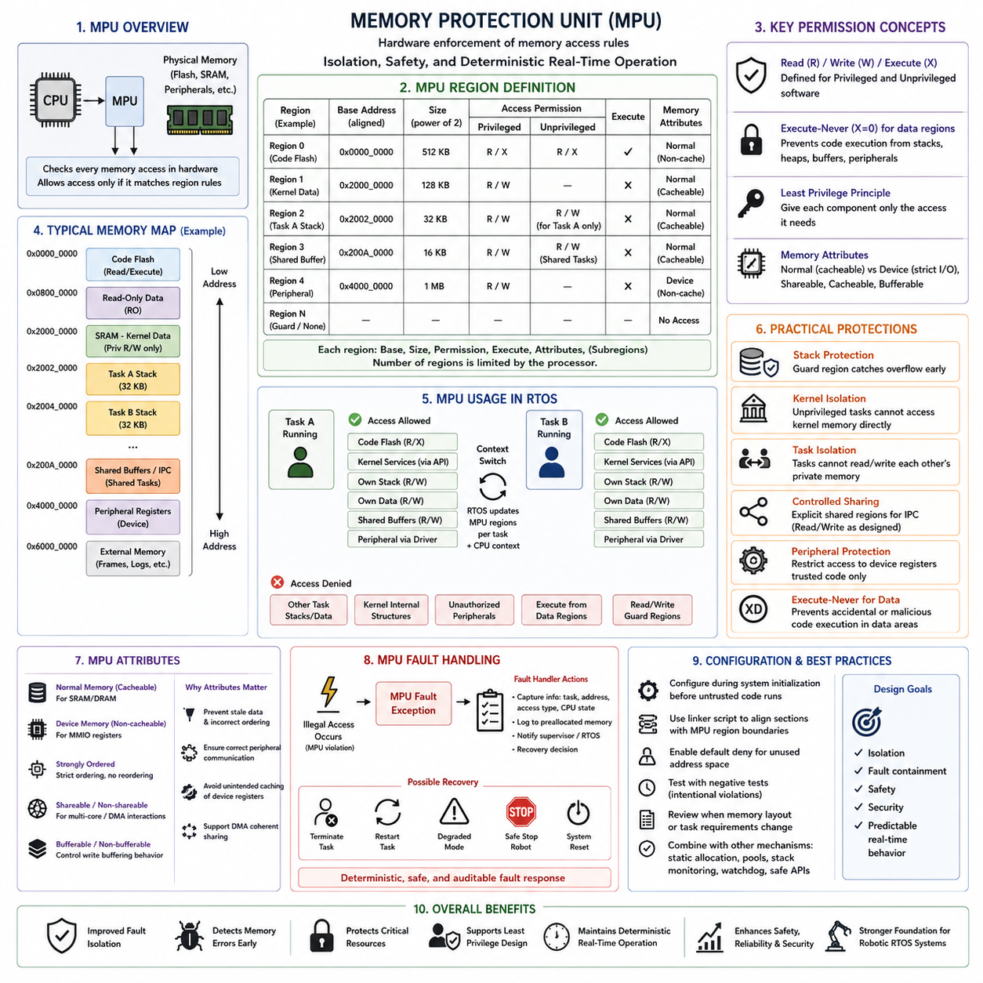
A Memory Protection Unit (MPU) is a hardware mechanism that controls how software accesses physical memory regions without providing the full virtual-memory translation of a Memory Management Unit. It is widely used in microcontrollers and real-time embedded processors where deterministic execution, low overhead, and fault containment are more important than large virtual address spaces. The MPU allows firmware or an RTOS to define regions and enforce access permissions directly in hardware.
An MPU divides the processor address space into a limited number of configurable regions. Each region normally contains a base address, size, access permissions, execution attributes, and memory-type properties. Depending on the processor architecture, additional controls may define cacheability, shareability, or subregions. Once configured and enabled, every relevant processor memory access is checked against these rules before the operation is allowed to complete.
Region configuration must reflect the physical memory map of the embedded platform. Flash memory may contain executable program code, SRAM may contain task stacks and application data, peripheral address ranges may expose memory-mapped device registers, and external memory may contain large buffers. Rather than treating the entire address space uniformly, the MPU assigns different permissions and attributes according to the intended purpose of each region.
Access permissions commonly distinguish privileged and unprivileged software and control whether a region can be read, written, or executed. Kernel code may require privileged read and execute access, while application data normally requires read and write access but no instruction execution. Peripheral registers may be writable only by trusted drivers. These distinctions implement the principle of least privilege by giving each software component only the memory capabilities necessary for its function.
Execute-never protection is particularly important because data regions should generally not contain executable instructions. Marking stacks, heaps, communication buffers, and peripheral regions as non-executable prevents the processor from treating their contents as code. Conversely, program regions can often be configured as read-only and executable. Separating writable data from executable code reduces accidental control-flow corruption and provides an important defense against several classes of software faults.
An RTOS can use the MPU to isolate tasks from one another. Each task may receive access to its own stack, private data, and explicitly shared communication regions while being denied access to memory owned by other tasks or the kernel. During a context switch, the RTOS can update task-specific MPU regions together with CPU register state. The newly scheduled task therefore executes inside a hardware-enforced memory boundary corresponding to its assigned resources.
Task stack protection is one of the most practical MPU applications. A stack region can be surrounded by an inaccessible guard region or configured so that accesses outside the permitted range generate a fault. If excessive recursion, large local variables, or corrupted stack pointers cause an overflow, the invalid access can be detected near its origin instead of silently overwriting another task, kernel object, or control variable.
Kernel isolation provides another protection boundary. RTOS kernel memory, scheduler structures, interrupt tables, and critical system configuration can be made inaccessible to ordinary unprivileged tasks. Applications interact with protected kernel services through controlled system calls or RTOS APIs rather than directly modifying internal structures. A defective application task can therefore fail without automatically gaining the ability to corrupt the scheduler or other system-wide resources.
Shared memory requires deliberate configuration because isolation and communication must coexist. Two tasks exchanging data through a shared buffer need permission to access the same MPU region, while unrelated tasks should remain excluded. Access may be read-write for both participants or asymmetric, such as writable by a producer and read-only by a consumer. This transforms memory sharing from an implicit property of a common address space into an explicitly defined interface.
Peripheral protection follows the same principle. Memory-mapped I/O registers for motors, CAN controllers, timers, GPIO, watchdogs, or safety devices should not necessarily be accessible by every application task. Driver or supervisory software can receive privileged access while ordinary tasks communicate through controlled interfaces. Preventing arbitrary register writes reduces the probability that a software defect directly changes actuator behavior or disables safety-related hardware.
Memory attributes must be configured as carefully as access permissions. Normal SRAM or DRAM can use attributes appropriate for ordinary cached memory, while device registers require device-memory semantics that prevent inappropriate caching or reordering. Shared buffers used with DMA may require specific cache and shareability behavior. Incorrect attributes can produce stale data, unexpected ordering, or peripheral communication failures even when read and write permissions themselves are correct.
MPU region alignment and size restrictions influence the software memory layout. Many architectures require region base addresses and sizes to satisfy specific alignment rules, and the number of simultaneously active regions is limited. Linker scripts therefore become closely connected to MPU design. Code, kernel data, task stacks, shared buffers, DMA areas, and peripheral ranges should be arranged so that important protection boundaries can be represented efficiently with the available hardware regions.
Region overlap can sometimes be used to create more precise protection. A large SRAM region might provide general read-write access while a smaller overlapping region applies stronger permissions to a sensitive area. The effective behavior depends on the priority and matching rules defined by the processor architecture. Such techniques can conserve MPU regions, but overly complex overlap schemes make verification difficult and should be used only when their behavior is clearly understood.
MPU configuration should normally occur during controlled initialization before untrusted or application-level tasks begin executing. Firmware first establishes the basic memory map, defines privileged kernel and device regions, configures default access behavior, and enables fault handling. The RTOS can then install task-specific regions as tasks are created or scheduled. Protection should become active before the system begins normal autonomous operation rather than being added after critical services are already running.
When an illegal access occurs, the processor raises a memory-protection fault instead of silently completing the transaction. The fault handler should capture useful diagnostic information such as the offending task, processor state, fault address, access type, and relevant system status. Depending on system criticality, recovery may terminate or restart a task, transition the robot into a degraded mode, command a safe stop, or reset the processor under controlled conditions.
Fault handling must itself be deterministic and trustworthy. A protection violation should not lead to complex memory allocation, uncontrolled logging, or lengthy recovery inside a high-priority exception context. Essential diagnostic information can be stored in preallocated memory and processed later by a supervisory task. Safety-related systems should define beforehand which MPU violations are recoverable and which indicate corruption severe enough to require immediate transition to a safe state.
The MPU also supports debugging and software integration by converting otherwise silent memory corruption into observable faults. Incorrect pointers, stack overflow, unauthorized peripheral access, accidental writes to read-only configuration, and execution from data regions can be detected close to the point of failure. This reduces the distance between the original defect and its visible consequence, making root-cause analysis considerably easier than debugging memory corruption discovered much later.
Protection design should be validated with intentional negative tests rather than only normal functional testing. A task can deliberately attempt to read another task's private memory, write protected kernel data, execute instructions from a non-executable region, or access an unauthorized peripheral. Successful rejection demonstrates that the configured boundaries actually enforce the intended architecture. Region configuration should also be reviewed whenever linker layouts or task memory requirements change.
An MPU does not eliminate the need for correct software. A task can still corrupt data inside a region that it legitimately owns, misuse an authorized peripheral, or produce logically incorrect output. MPU protection instead limits the propagation of faults by establishing hardware-enforced boundaries. It should therefore complement static allocation, memory pools, stack monitoring, safe APIs, privilege separation, watchdogs, and other defensive mechanisms rather than being treated as a complete safety solution.
For robotic RTOS platforms, MPU configuration creates a practical containment layer between control, communication, sensing, application, and kernel resources. Critical motor and safety interfaces can remain privileged, task stacks can be isolated, shared IPC buffers can be explicitly authorized, and accidental execution from writable memory can be prevented. Combined with deterministic memory allocation, this produces a memory architecture that improves fault isolation, diagnosability, security, and predictable real-time operation.

07.05 Virtual Memory and MMU: Embedded Linux Perspective
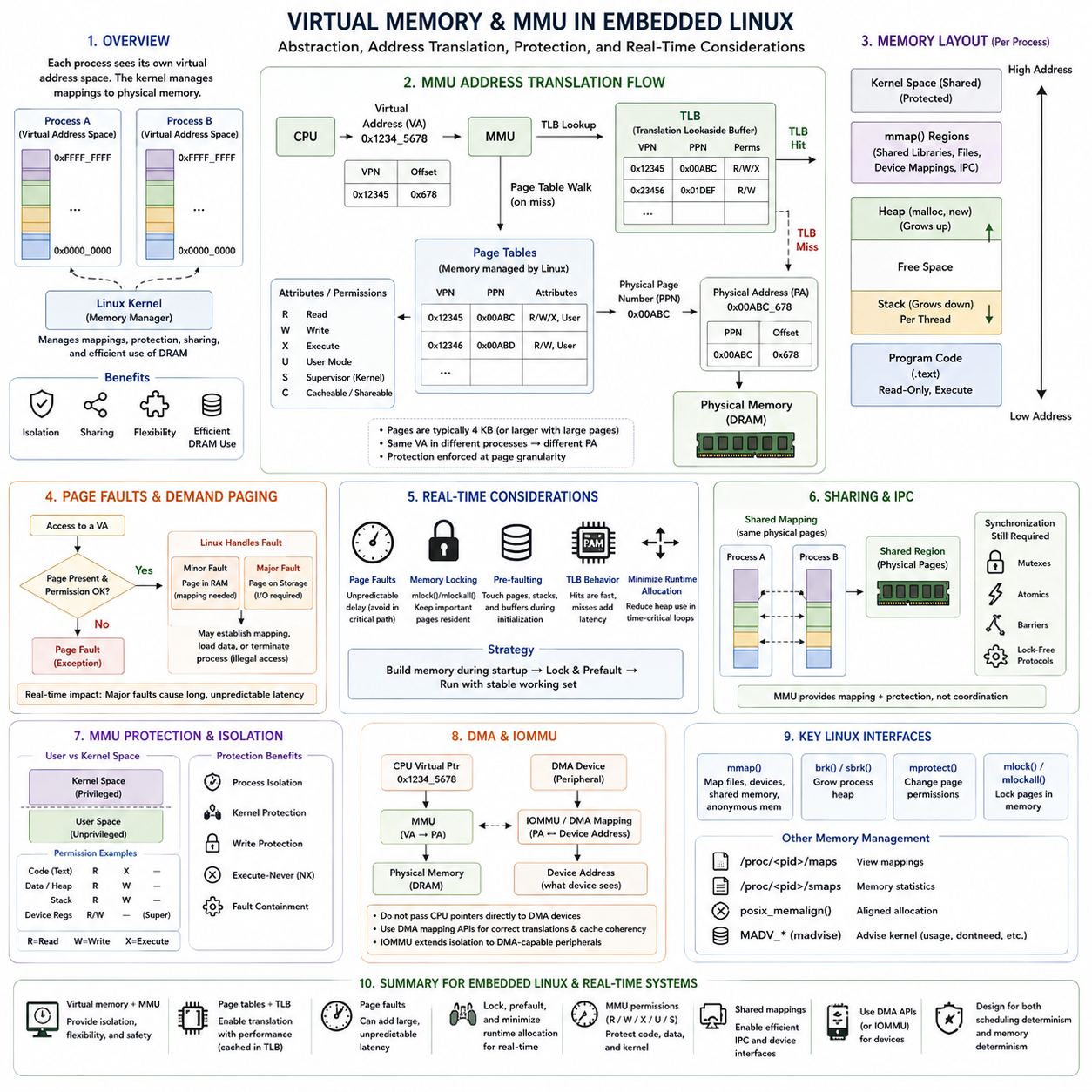
Virtual memory is a memory-management abstraction that allows software to operate in a virtual address space rather than directly using physical memory addresses. In Embedded Linux, each user process normally receives its own virtual address space, while the kernel manages mappings between virtual pages and physical memory. This abstraction enables process isolation, flexible memory placement, controlled sharing, and efficient use of DRAM while hiding much of the physical memory organization from applications.
The Memory Management Unit, or MMU, is the processor hardware responsible for translating virtual addresses generated by the CPU into physical addresses used by memory and devices. Unlike an MPU, which primarily checks permissions over physical address regions, an MMU performs address translation using page tables. Modern ARM and x86 processors used in embedded Linux platforms normally integrate an MMU because full Linux memory management depends heavily on virtual addressing and page-based protection.
When a process accesses memory, the CPU produces a virtual address containing information that identifies a virtual page and an offset within that page. The MMU translates the virtual page through page-table structures maintained by the operating system and combines the resulting physical page location with the offset. This mechanism allows identical virtual addresses in different processes to refer to completely different physical memory locations without creating conflicts.
Page tables contain the mapping information required for translation. Each page-table entry normally identifies a physical memory page together with attributes describing whether the page is readable, writable, executable, cacheable, shared, or accessible from user mode. Linux configures and modifies these structures as processes are created, memory is allocated, files are mapped, and permissions change. Page tables therefore form both an address-translation mechanism and an important protection boundary.
Performing a complete page-table walk for every memory access would introduce excessive overhead, so processors use a Translation Lookaside Buffer, or TLB. The TLB caches recently used virtual-to-physical address translations and their permission information. A TLB hit allows translation to proceed quickly, whereas a TLB miss requires hardware or software to walk the relevant page-table hierarchy before the translation can be cached and execution can continue.
The TLB introduces another source of timing variability that matters in real-time Linux. Execution time may differ depending on whether required translations are already present in the TLB, just as cache behavior affects data-access latency. Context switches can also influence translation state because different processes use different address spaces. Modern processors use mechanisms such as address-space identifiers to reduce unnecessary TLB invalidation, but translation behavior must still be considered when analyzing latency-sensitive workloads.
Virtual memory provides strong process isolation because one user process normally cannot directly address another process's private memory. If software attempts to access an unmapped page or violates page permissions, the processor raises a memory-management exception. Linux handles the resulting fault according to its cause. Valid demand-related faults may cause a mapping to be established, while illegal accesses can result in signals and termination of the offending process.
Page faults are particularly important from a real-time perspective. A minor page fault may require kernel processing to establish or update a mapping even when the underlying data is already available in memory. A major page fault may require data to be obtained from storage, producing dramatically longer and less predictable latency. Hard or strict real-time threads should therefore avoid execution paths where page faults can unexpectedly occur after time-critical processing has begun.
Linux commonly uses demand paging so that physical memory does not need to be assigned immediately for every virtual region. Pages can be established when they are actually accessed, improving memory efficiency for general workloads. This behavior is advantageous for desktop and server computing but can be undesirable in deterministic control paths. Embedded real-time applications frequently touch or prefault required pages during initialization so that the relevant mappings and physical memory are established before deadlines become active.
Memory locking provides an important mechanism for real-time Linux applications. Interfaces such as mlock() and mlockall() can prevent selected process pages from being paged out or otherwise becoming unavailable through normal virtual-memory management. A real-time application can lock its current and future mappings, allocate required buffers and stacks, and touch the pages before entering its critical loop. This reduces the probability of unexpected memory-management latency during operation.
Stack behavior also requires attention because virtual address space may be reserved without every stack page being physically established in advance. If a real-time thread grows its stack into an untouched page while executing a deadline-critical operation, a page fault can occur. Applications can therefore preallocate sufficient stack space and deliberately access it during initialization. This follows the broader real-time principle of moving uncertain resource acquisition out of the operational control phase.
Heap allocation in Linux is also built on virtual-memory mechanisms. User-space allocators manage application-level blocks while obtaining larger regions from the kernel through mechanisms such as brk() or mmap(). Consequently, a successful malloc() call does not necessarily mean that every corresponding physical page has already been accessed and prepared. Real-time applications must distinguish between reserving virtual address space and ensuring that the required physical memory is actually resident and ready.
Memory-mapped files provide another major use of virtual memory. The mmap() interface can map files, shared-memory objects, device regions, or anonymous memory directly into a process address space. Processes can then access mapped data through normal load and store instructions rather than explicit read and write calls. This mechanism is widely used for shared-memory IPC, high-performance data exchange, device interfaces, and large datasets in robotics and embedded Linux systems.
Shared mappings allow multiple processes to reference the same physical pages through their own virtual address spaces. This enables efficient shared-memory IPC because large images, point clouds, sensor frames, or control data do not need to be repeatedly copied between processes. Synchronization is still required because the MMU provides mapping and protection but does not automatically coordinate concurrent software access. Mutexes, atomics, memory barriers, or lock-free protocols remain necessary.
The MMU also separates user space from kernel space. Kernel code and critical operating-system structures are mapped with permissions that ordinary user processes cannot access directly. System calls provide controlled transitions into privileged kernel services. If an application contains an invalid pointer or writes beyond an intended buffer, page-level protection can often prevent the fault from directly modifying kernel memory, providing substantially stronger isolation than a single unrestricted physical address space.
Memory permissions support write protection and execute-never behavior in addition to process isolation. Program code can be mapped as readable and executable but not writable, while stacks and ordinary data can be mapped as readable and writable but non-executable. This separation supports both reliability and security by reducing opportunities for corrupted data to become executable instructions. Linux and the processor cooperate to enforce these page-level attributes through the MMU.
Large pages can reduce translation overhead for large contiguous memory workloads. Mapping a large region with fewer, larger pages reduces the number of page-table entries and can improve effective TLB coverage. This can benefit large robotic maps, image-processing buffers, and AI workloads, although large-page allocation introduces its own memory-management considerations. The appropriate page size therefore represents a tradeoff among translation efficiency, memory flexibility, fragmentation, and deployment requirements.
DMA introduces an important distinction between CPU virtual addresses and addresses visible to hardware devices. A CPU pointer cannot automatically be given to every DMA-capable device because the device may operate in a different address domain. Linux device drivers use DMA mapping APIs to establish appropriate device-visible mappings, maintain cache coherency where required, and satisfy platform constraints. Systems with an IOMMU can extend address translation and isolation concepts to DMA-capable peripherals.
Embedded Linux real-time design therefore requires coordination among the scheduler, MMU, page tables, TLB, caches, allocator, and physical memory. Assigning a thread SCHED_FIFO or another real-time policy does not by itself guarantee deterministic execution if the thread can encounter page faults, allocate memory unpredictably, or compete heavily for memory bandwidth. Scheduling determinism and memory determinism must be engineered together rather than treated as independent concerns.
A common strategy is to perform flexible memory construction during startup and establish a stable memory working set before real-time operation begins. Required code paths are exercised, buffers and stacks are allocated, relevant pages are touched, important mappings are locked, and dynamic allocation is minimized inside critical loops. The operational phase can then rely primarily on resident memory and pre-established mappings while Linux continues to provide process isolation and virtual-address protection.
For robotic Embedded Linux systems, virtual memory and the MMU provide capabilities that are difficult to obtain with simple physical-memory protection alone. They isolate processes, support controlled sharing, simplify large-memory applications, protect kernel resources, and enable sophisticated IPC and device mappings. Real-time performance depends on controlling the variability these mechanisms can introduce, particularly page faults, TLB activity, allocation, and memory contention, while retaining the flexibility and protection advantages of Linux virtual memory.

07.06 Cache Coherency and Multi-Core Memory Design
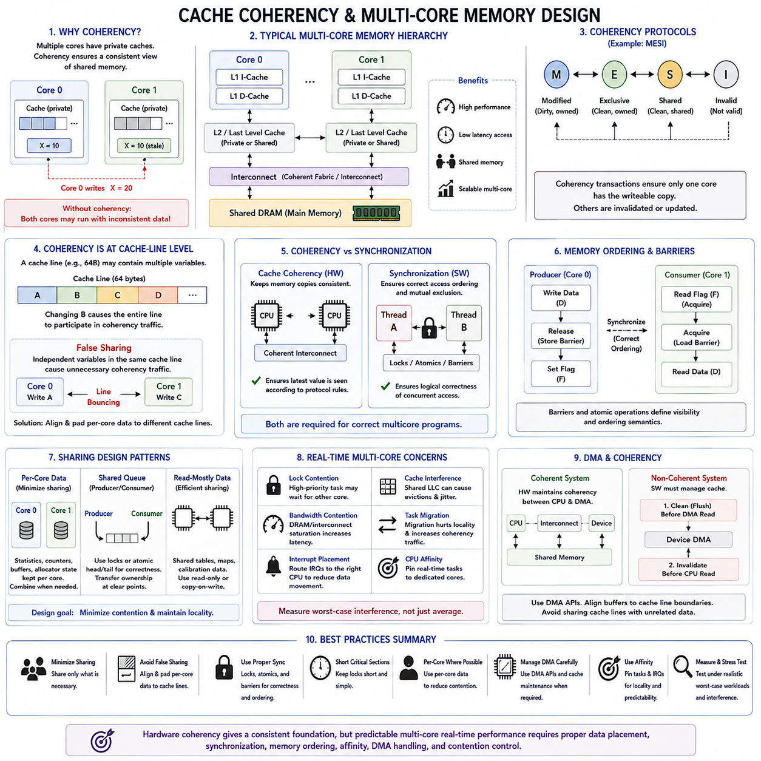
Cache coherency is the mechanism that ensures multiple processor cores observe a consistent view of shared memory even when each core maintains private cache copies of the same data. In a multicore embedded system, Core 0 may modify a variable in its local cache while Core 1 still holds an older copy. Without a coherency mechanism, both processors could execute correctly from their individual perspectives while operating on mutually inconsistent system state.
Modern multicore processors typically contain private L1 instruction and data caches, while larger L2 or last-level caches may be private or shared depending on the architecture. External DRAM is normally shared by all cores and other bus masters. This hierarchy improves performance because most memory operations are served close to the CPU, but it creates multiple temporary copies of data whose consistency must be coordinated whenever memory is shared.
Cache coherency protocols track the state of cache lines and coordinate ownership among processor cores. Protocol families such as MESI represent lines using states conceptually corresponding to Modified, Exclusive, Shared, and Invalid. When one core intends to modify a line that another core has cached, coherency transactions invalidate or update competing copies so that stale versions are not subsequently treated as valid shared data.
Coherency operates at cache-line granularity rather than at the level of individual application variables. A cache line may contain several unrelated variables, and changing one variable can cause the entire line to participate in coherency traffic. This characteristic explains why software data layout affects multicore performance. Variables that are independently modified by different cores should not automatically be placed together merely because their logical data sizes are small.
False sharing occurs when independent variables used by different cores occupy the same cache line. Although the threads do not logically share those variables, repeated writes force ownership of the cache line to move between cores. The resulting cache-line bouncing can substantially increase latency and interconnect traffic. Alignment and padding can separate frequently modified per-core data and reduce this unnecessary coherency activity.
Hardware coherency does not eliminate the need for software synchronization. A coherent cache system ensures that memory copies follow architectural consistency rules, but it does not determine whether two tasks are logically allowed to update the same data simultaneously. Mutexes, spinlocks, atomic operations, semaphores, and lock-free algorithms are still required to coordinate concurrent access and preserve application-level invariants.
Memory ordering is closely related but distinct from cache coherency. Modern processors may execute or expose memory operations in an order different from the simple instruction sequence when doing so improves performance. A producer may write data and then update a ready flag, while a consumer checks that flag before reading the data. Without appropriate ordering semantics, the consumer must not assume that observing the flag automatically guarantees visibility of every preceding memory operation.
Memory barriers and atomic operations provide mechanisms for establishing the required ordering. Acquire operations prevent relevant later accesses from moving before synchronization, while release operations ensure preceding accesses become appropriately ordered before publication. Full barriers impose stronger constraints when necessary. Correct multicore programming therefore requires both coherent data propagation and explicitly defined ordering between synchronization and shared-memory operations.
Locks can introduce significant latency in real-time multicore systems. If a high-priority task requires a lock currently held by another core, its execution becomes dependent on work occurring elsewhere in the processor. Long critical sections, nested locks, and heavy contention can therefore increase worst-case response time. Shared data structures should be designed to minimize lock duration and frequency rather than assuming hardware coherency makes synchronization inexpensive.
Per-core data is one effective technique for reducing shared-memory contention. Statistics, temporary buffers, allocator state, queues, and frequently updated counters can sometimes be maintained separately for each CPU and combined only when necessary. This reduces cache-line migration and lock contention while improving locality. The design trades immediate global consistency for lower interference, which is often appropriate for telemetry and noncritical aggregate information.
Shared queues require more deliberate design because producer and consumer cores intentionally exchange data. A queue may use locks for simplicity or atomic head and tail indices for a bounded lock-free implementation. Data ownership should transfer at a clearly defined synchronization point. Once the producer publishes an element, the consumer must observe fully initialized contents, and the producer must not reuse the storage until ownership has legitimately returned.
CPU affinity can improve predictability by keeping selected real-time tasks on designated cores. When a task repeatedly migrates between processors, its working set may need to be re-established in another core's private caches, increasing cache misses and coherency activity. Pinning a control task to one CPU can preserve locality and simplify timing analysis, although affinity alone does not isolate the task from shared-cache, interconnect, or DRAM interference.
Cache coherency also interacts with interrupt placement. If a device interrupt is handled on one core while the associated processing task runs on another, descriptors and buffers may repeatedly cross cache boundaries. Routing interrupts and their primary processing tasks to the same or nearby CPU can reduce data movement. Conversely, deliberate separation may be useful when balancing workload, so interrupt affinity should be treated as part of the multicore memory architecture.
DMA introduces another coherency domain because peripherals can access memory without executing CPU cache operations. In a hardware-coherent system, the interconnect may maintain consistency between DMA transactions and CPU caches automatically. In non-coherent systems, software must explicitly clean modified cache lines before device reads and invalidate appropriate lines before the CPU consumes device-written data. Failure to follow this protocol can produce stale or corrupted buffers.
Cache-line alignment is particularly important for DMA buffers. If a DMA buffer shares a cache line with unrelated CPU data, cleaning or invalidating the line for DMA can unintentionally affect neighboring information. Buffers should therefore satisfy the alignment and size requirements of the processor and device architecture. Dedicated DMA pools can make these requirements systematic rather than relying on every driver or application component to reproduce them correctly.
Shared last-level caches create additional interference even when tasks do not communicate. Two cores executing unrelated workloads can compete for the same cache capacity and replacement resources. A large AI, vision, or networking workload may evict cache lines used by a real-time control task. Consequently, logical software isolation does not automatically provide temporal isolation when cores continue to share cache, memory controllers, interconnects, and DRAM bandwidth.
Some processors provide cache partitioning, way allocation, memory bandwidth control, or quality-of-service mechanisms to reduce this interference. Critical cores can receive reserved cache capacity or higher-priority access to selected memory resources. These mechanisms can improve temporal isolation, but they reduce the amount of hardware available for flexible sharing. Their effectiveness should be measured under realistic worst-case concurrent workloads rather than inferred from isolated benchmarks.
NUMA-like effects may also appear in larger embedded and edge platforms where memory access cost depends on the processor, cluster, accelerator, or memory controller involved. Even when the software sees one address space, accessing local memory may be faster than reaching memory associated with another processing domain. Task placement and memory placement should therefore be considered together when optimizing high-bandwidth robotics and AI pipelines.
Linux and RTOS multicore environments provide different abstractions, but the underlying hardware problems remain similar. Linux offers CPU affinity, scheduler domains, atomic primitives, synchronization APIs, and architecture-specific memory barriers, while SMP-capable RTOS kernels provide corresponding mechanisms with lower-level control. In both cases, correct design requires understanding which data is private, which is shared, who modifies it, and how ownership changes.
Real-time analysis must extend beyond average cache performance. A control task can have stable instruction execution yet suffer latency because another core repeatedly invalidates shared lines, occupies a common cache, holds a required lock, or saturates DRAM. Stress testing should therefore execute realistic competing workloads while measuring response-time tails, cache misses, lock contention, memory bandwidth, migrations, and other multicore interference effects.
A practical robotic architecture often separates high-frequency control state from large shared perception data. Control variables and task-local working sets can remain close to dedicated CPU cores, while images, point clouds, maps, and AI tensors use shared memory designed for high bandwidth. Explicit queues or ownership-transfer interfaces connect these domains, reducing uncontrolled sharing and making synchronization points visible in the system architecture.
The central multicore memory-design principle is to minimize unnecessary sharing while making necessary sharing explicit. Hardware cache coherency provides a consistent foundation, but predictable operation additionally requires suitable data placement, synchronization, memory ordering, CPU and interrupt affinity, DMA handling, and contention control. Together these techniques allow multicore embedded systems to exploit parallel processing without allowing shared-memory behavior to undermine real-time determinism.

07.07 DMA Memory Management: Cache Flush / Buffer Alignment [w/Code]
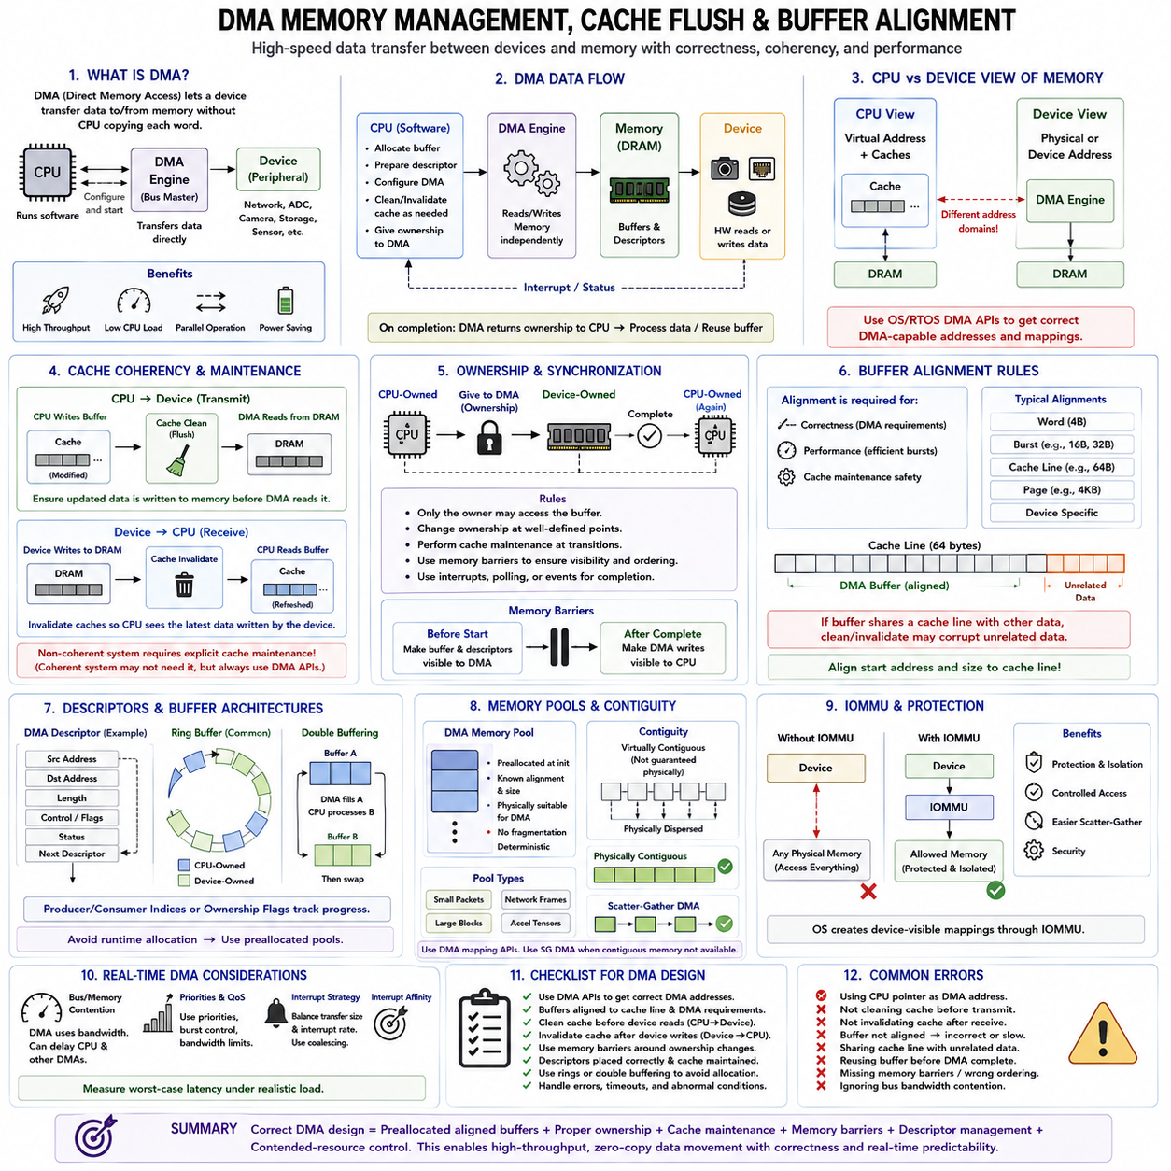
Direct Memory Access (DMA) allows peripherals and hardware accelerators to transfer data between devices and memory without requiring the CPU to execute an instruction for every transferred word. In embedded systems, DMA is essential for high-rate interfaces such as Ethernet, CAN, ADC, cameras, storage, and sensor streams. It reduces CPU load and supports parallel operation, but introduces memory-management requirements involving ownership, coherency, alignment, and synchronization.
A typical DMA transaction involves a device, a DMA engine or bus-master interface, system memory, and software running on the CPU. Software prepares a memory buffer and descriptor, configures the transfer, and gives ownership to the hardware. The DMA engine then reads or writes memory independently of normal CPU execution. When the operation completes, an interrupt or status mechanism returns control and buffer ownership to software for subsequent processing.
DMA creates an important distinction between the CPU's view of memory and the device's view. The CPU may access data through caches and virtual addresses, while a peripheral accesses memory through physical or device-visible addresses. A pointer that is valid for CPU software is therefore not automatically a valid DMA address. RTOS platforms and Embedded Linux drivers must use architecture-specific DMA mechanisms to establish the correct mapping between these address domains.
Cache coherency becomes critical when CPU caches contain copies of memory used by DMA. Suppose the CPU modifies a transmit buffer but the updated cache line remains only in a write-back cache. If a non-coherent DMA device reads DRAM directly, it may obtain the older memory contents. Conversely, if DMA writes new receive data into DRAM while the CPU retains an older cached copy, subsequent CPU reads may observe stale data instead of the newly received information.
Cache cleaning, often informally called cache flushing, resolves the first situation by ensuring modified cache data is written toward memory before a DMA device reads it. For a CPU-to-device transfer, software finishes constructing the buffer and then performs the required cache maintenance before transferring ownership to DMA. Memory ordering must also guarantee that descriptor and data updates become visible before the hardware is instructed to begin the transaction.
Cache invalidation addresses the opposite direction. When a device writes data into memory, cached copies of the affected region may no longer represent the current contents. Before the CPU consumes the completed DMA buffer on a non-coherent platform, appropriate cache lines must be invalidated so subsequent loads obtain the device-written data. The exact sequence depends on processor architecture, cache policy, DMA direction, and the operating-system or driver API.
Bidirectional DMA buffers require particular care because both CPU and device may modify the same region at different stages. Ownership transitions must define when the CPU is allowed to access the buffer and when the device controls it. Cache maintenance should occur at these transitions rather than being applied arbitrarily. A clear ownership protocol prevents simultaneous unsynchronized access and makes coherency requirements easier to reason about and verify.
Hardware-coherent platforms can reduce explicit cache-maintenance requirements. A coherent interconnect may snoop CPU caches or otherwise ensure that DMA transactions observe consistent memory contents. However, software should not assume coherency merely because the CPU cores themselves are cache coherent. CPU-to-CPU coherency and device-to-CPU coherency are distinct architectural properties, and the supported DMA API should remain the authoritative interface for driver code.
Buffer alignment is another fundamental DMA design requirement. DMA engines may require addresses to be aligned to word, burst, cache-line, page, or device-specific boundaries. Proper alignment also improves transfer efficiency because hardware can perform full-width bus transactions without splitting accesses across boundaries. For high-bandwidth interfaces, alignment can influence not only correctness but also memory-bus utilization and sustained transfer performance.
Cache-line alignment deserves special attention on non-coherent systems. If a DMA buffer occupies only part of a cache line while unrelated CPU data occupies the remainder, cleaning or invalidating that line affects both objects. This creates the possibility of unexpected data loss or coherency errors. Aligning DMA buffers to cache-line boundaries and sizing them appropriately prevents unrelated software objects from sharing cache lines subject to DMA maintenance operations.
DMA descriptors also require controlled memory placement. A descriptor may contain source and destination addresses, transfer lengths, ownership flags, status fields, and links to subsequent descriptors. Both software and hardware can access these structures, so descriptor alignment, visibility, ordering, and cache behavior must satisfy the DMA controller specification. Descriptor rings are commonly used for continuous Ethernet, storage, sensor, and communication traffic.
Ring-buffer architectures work particularly well with DMA because a fixed collection of buffers and descriptors can circulate between hardware and software without runtime heap allocation. Hardware fills or consumes one buffer while software processes another. Producer and consumer indices track progress, and ownership flags identify which side may access each element. This supports sustained streaming while maintaining bounded memory usage and avoiding fragmentation.
Double buffering is a simpler version of the same principle. While DMA fills buffer A, the CPU processes buffer B; after completion, their roles are exchanged. This overlaps computation and data transfer and can improve throughput significantly. Triple buffering or deeper queues may absorb larger timing variations, but additional buffers increase memory consumption and latency. Buffer depth should therefore reflect expected producer-consumer timing rather than being increased without analysis.
Zero-copy processing can further reduce CPU overhead and memory bandwidth. Instead of copying DMA data into separate application buffers, software can transfer ownership of the DMA buffer directly to the next processing stage. A camera frame, network packet, or sensor block may move through driver, processing, and communication components using descriptors or references. The major challenge becomes controlling lifetime so the DMA engine cannot reuse the buffer prematurely.
Memory pools are useful for enforcing DMA-specific constraints. A dedicated DMA pool can provide buffers with known alignment, size, physical placement, and cache properties. Because the buffers are created during initialization, real-time tasks avoid unpredictable heap allocation. Separate pools can be defined for small control packets, network frames, large sensor blocks, or accelerator tensors, allowing memory organization to reflect both hardware constraints and workload characteristics.
Physical continuity may be required by some DMA engines, particularly when scatter-gather support is unavailable or limited. Virtual memory can make a CPU buffer appear contiguous even though its physical pages are distributed across memory. Drivers must therefore use suitable allocation and mapping facilities rather than assuming a virtually contiguous application buffer is physically contiguous. Scatter-gather DMA can instead describe multiple physical segments as one logical transfer.
An IOMMU can provide address translation and protection for DMA-capable devices. Rather than exposing arbitrary physical memory directly, the operating system creates device-visible mappings that restrict which pages a peripheral may access. This improves isolation and can simplify scatter-gather behavior by presenting a more convenient device address space. The translation itself introduces architectural complexity, so mappings should normally be established through the operating system's DMA interfaces.
Real-time DMA design must also account for bus and memory contention. DMA reduces CPU instruction overhead but does not eliminate competition for shared interconnect and DRAM bandwidth. A high-rate camera, GPU, network controller, or storage device can consume enough bandwidth to delay CPU memory accesses or other DMA channels. Transfer priorities, burst lengths, bandwidth limits, and quality-of-service mechanisms may therefore affect worst-case control latency.
Interrupt behavior is part of the DMA data path as well. Generating an interrupt for every small transfer can produce excessive CPU overhead, while excessive interrupt coalescing can increase data-delivery latency. Real-time systems must select transfer sizes and notification policies that balance throughput against response time. Interrupt affinity can also place DMA completion handling near the CPU that will process the data, reducing unnecessary cache-line movement between cores.
Memory barriers are required when ownership or control information is shared with DMA hardware. Software must ensure that buffer contents and descriptor fields are globally visible before setting a hardware ownership flag or writing a device doorbell register. Likewise, completion status must be observed with the ordering required by the architecture before software consumes returned data. Cache maintenance and memory ordering solve related but different problems and should not be confused.
Robust DMA software should explicitly model buffer states such as free, CPU-owned, device-owned, completed, and processing. Illegal transitions can then be detected rather than producing silent corruption. Timeout handling is also necessary because a device may fail to return ownership due to hardware faults, driver errors, or communication problems. Diagnostics should record transfer failures, descriptor exhaustion, alignment violations, overruns, underruns, and abnormal completion latency.
For robotic embedded systems, DMA memory management connects high-rate sensing and communication directly with real-time memory architecture. Correct designs combine preallocated aligned buffers, explicit ownership transfer, architecture-approved DMA mapping, cache clean and invalidate operations where required, memory barriers, and bounded queues. These mechanisms enable high-throughput zero-copy data movement while preventing stale data, corruption, fragmentation, and unpredictable allocation from entering critical control paths.

07.08 Memory Leak Detection: Valgrind / AddressSanitizer
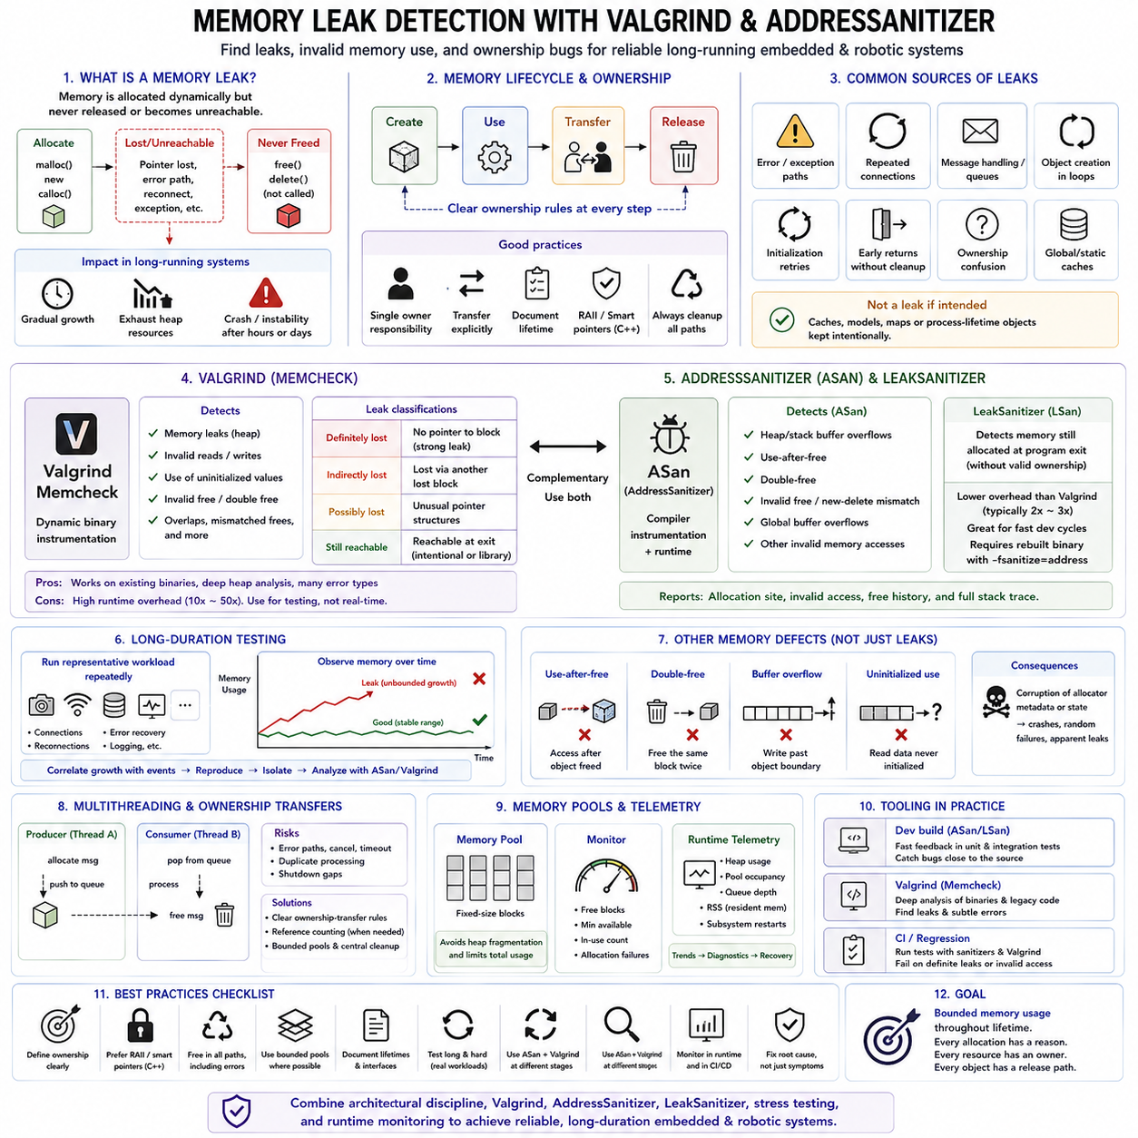
Memory leaks occur when dynamically allocated memory is no longer needed by the application but remains allocated because the program has lost the ability or responsibility to release it. In embedded and robotic systems, even a small repeated leak can gradually consume available heap memory during long-duration operation. The system may initially behave normally and fail only after hours, days, or weeks, making memory-leak detection an important part of reliability validation.
A typical leak begins with memory obtained through malloc(), calloc(), realloc(), new, or a framework-specific allocation function. If the corresponding free(), delete, or resource-release operation is never executed, the allocated block remains unavailable for reuse. Leaks frequently appear in exceptional paths, repeated message handling, communication reconnection, object creation, initialization retries, and error recovery where normal cleanup logic is bypassed.
Memory leaks should be distinguished from high but legitimate memory consumption. A process may intentionally retain caches, buffers, models, maps, or other objects throughout its lifetime. The important question is whether memory ownership and lifetime match the intended architecture. A steadily increasing resident memory footprint during a repeated workload is suspicious, but identifying the responsible allocation usually requires dedicated instrumentation rather than simple observation of total memory usage.
Leak detection begins with clear ownership rules. Every dynamically allocated object should have an identifiable owner responsible for releasing it, transferring it, or intentionally retaining it. In C, this responsibility must often be expressed through conventions and cleanup paths. In C++, RAII, smart pointers, containers, and deterministic destructors can encode ownership more directly and reduce the number of manual allocation and deallocation pairs that developers must track.
Valgrind is a dynamic analysis framework widely used on Linux systems for detecting memory-management defects in native applications. Its Memcheck tool executes a program under instrumentation and observes memory accesses and allocation behavior. It can identify leaked heap blocks, invalid reads and writes, use of uninitialized values, incorrect deallocation, and several other errors that may otherwise remain hidden during ordinary functional testing.
Memcheck classifies leaked memory according to whether references to allocated blocks remain reachable. Definitely lost memory represents allocations for which no usable pointer remains and is normally the strongest indication of a true leak. Indirectly lost memory is reachable only through another lost block. Possibly lost and still reachable categories require interpretation because they can represent unusual pointer structures, retained libraries, caches, or intentional process-lifetime allocations.
Valgrind's major advantage is that it can analyze many existing Linux binaries with relatively limited source-code modification. This makes it useful for integration testing, legacy C or C++ applications, middleware, communication services, and robotic processes. Its major disadvantage is execution overhead. Instrumented programs can run substantially slower than native execution, so Valgrind is generally a development and test tool rather than something used inside timing-critical production control loops.
AddressSanitizer, commonly abbreviated ASan, uses a different approach. The compiler inserts instrumentation into the program during compilation, and a runtime library tracks the validity of memory accesses. ASan is particularly effective at detecting heap and stack buffer overflows, use-after-free, double-free conditions, and other invalid memory operations. LeakSanitizer can additionally detect memory that remains allocated when the program terminates.
ASan typically provides much lower runtime overhead than heavyweight binary instrumentation, making it practical for frequent development testing and many automated test suites. A program must normally be rebuilt with sanitizer support, and debug information should be retained to produce meaningful stack traces. When an invalid access occurs, the sanitizer can report the allocation site, failing access, deallocation history, and call stack, greatly reducing the distance between memory corruption and root-cause analysis.
Valgrind and ASan therefore complement rather than completely replace one another. ASan is well suited to rapid compile-test-debug cycles because failures are detected close to the offending instruction with relatively manageable overhead. Valgrind is valuable when inspecting existing Linux executables, performing detailed heap analysis, or checking software that has not been built with sanitizers. Mature projects often use both tools at different stages of validation.
LeakSanitizer, often integrated with AddressSanitizer, focuses specifically on allocations that remain live at process termination without valid ownership paths. It records allocation metadata and examines reachable memory to identify unreachable blocks. This is useful for command-line tests and finite integration scenarios where the process exits naturally. Long-running daemons and robotic services require additional strategies because waiting for process termination may not reveal operational growth patterns conveniently.
Long-duration testing is therefore essential for embedded Linux applications. A representative workload should repeatedly exercise sensor connections, network sessions, message queues, configuration changes, logging, error recovery, and other paths that create or destroy resources. Memory usage can be sampled over time while the workload repeats. Stable systems should eventually reach a bounded operating range rather than showing persistent growth proportional to the number of processed cycles or events.
Memory growth should be correlated with workload events. If memory increases whenever a camera is restarted, a network client reconnects, a map is reloaded, or an AI pipeline is reinitialized, the repeated operation provides a useful reproduction path. Developers can then isolate that subsystem and run it under ASan or Valgrind. Reproducibility is extremely valuable because many memory leaks originate in uncommon cleanup paths that normal steady-state testing rarely exercises.
Not every memory defect is a leak. Use-after-free occurs when software continues using a block after its ownership has ended, while double-free attempts to release the same allocation more than once. Buffer overflow writes beyond the valid object boundary, and uninitialized-memory use consumes data that has never received a defined value. These faults can corrupt allocator metadata or application state and may later appear as unexplained allocation failures, crashes, or apparent leaks.
Multithreaded programs make diagnosis more difficult because ownership can move between tasks. A producer may allocate a message, place it into a queue, and expect a consumer to release it. Error paths, queue cancellation, shutdown, timeout, or duplicate processing can break that contract. Explicit ownership-transfer rules, reference counting where appropriate, bounded pools, and centralized cleanup responsibilities can make both prevention and debugging substantially easier.
Memory pools reduce exposure to conventional heap leaks because the total number of blocks is bounded, but they can still experience logical resource leaks. A task that obtains a pool block and never returns it gradually exhausts the pool even though no malloc() leak exists. Monitoring free-block counts, minimum available capacity, outstanding ownership, and allocation failures is therefore valuable for both dynamic heaps and deterministic pool-based embedded architectures.
Production systems usually cannot run continuously under Valgrind or ASan because of performance, memory, and timing overhead. Instead, lightweight runtime telemetry can track heap usage, allocator failures, pool occupancy, queue depth, process resident memory, and subsystem restart counts. Unexpected trends can trigger diagnostics or controlled recovery. Development builds then reproduce the condition with stronger instrumentation to identify the exact allocation or invalid access responsible.
Sanitizer builds should be separated from performance and real-time qualification builds. Instrumentation changes instruction timing, memory layout, stack usage, and cache behavior, so latency measurements collected under ASan or Valgrind do not represent final production timing. Functional memory-safety testing and worst-case real-time validation therefore serve different purposes. The former finds defects, while the latter measures the behavior of the optimized deployment configuration.
Automated testing can make memory analysis part of continuous integration. Unit tests and integration tests can be compiled with sanitizers, while selected executable scenarios can run under Valgrind and fail when definite leaks or invalid accesses are reported. Regression testing is especially important because memory defects can return when ownership rules, exception handling, message structures, or third-party libraries change during development.
Tool reports should be treated as diagnostic evidence rather than merely error counts. Stack traces should be traced back to the allocation, ownership transfer, and expected release path. Suppressions may be appropriate for verified third-party or process-lifetime allocations, but broad suppression can hide genuine regressions. The objective is to understand why memory remains allocated or becomes invalid and then correct the lifecycle architecture responsible for the defect.
A robust robotic memory strategy combines prevention, detection, and containment. Critical real-time paths minimize dynamic allocation through static buffers and memory pools, while flexible Linux services use disciplined ownership and bounded allocation. ASan detects memory corruption early during development, Valgrind provides detailed dynamic analysis, long-duration tests expose gradual resource growth, and runtime telemetry identifies abnormal trends that appear only under realistic operation.
The final goal is not simply to achieve a leak-free report at program termination but to demonstrate bounded memory behavior throughout the intended operating lifetime. Every persistent allocation should have a reason, every temporary allocation should have a defined release path, and every shared object should have clear ownership. Combining architectural discipline with Valgrind, AddressSanitizer, LeakSanitizer, stress testing, and runtime monitoring creates a stronger foundation for reliable long-duration embedded and robotic software.

07.09 AI Inference Memory Optimization: Tensor Memory Pooling

AI inference memory optimization is the process of reducing and controlling the memory required to execute trained neural networks under fixed hardware limits. In embedded and robotic systems, inference often competes with perception, localization, planning, communication, and control for the same DRAM or accelerator memory. Efficient deployment therefore requires managing not only model parameters but also activations, temporary workspaces, input buffers, outputs, and runtime metadata.
The memory footprint of an inference pipeline can be divided conceptually into persistent and temporary regions. Persistent memory includes model weights, constant tensors, calibration parameters, and long-lived runtime objects. Temporary memory contains intermediate activations, operator workspaces, transformed tensors, and scratch buffers created while executing the graph. Peak memory is determined by the maximum combination of these objects that remains live at any point during inference.
Tensor lifetime analysis is fundamental to memory optimization. An intermediate tensor only needs storage from the moment its producing operator finishes until its final consumer completes. After that point, the underlying memory can be reused by another tensor whose lifetime does not overlap. In a large neural network, many intermediate tensors exist sequentially rather than simultaneously, creating substantial opportunities for memory reuse without changing the mathematical behavior of the model.
Tensor memory pooling applies this observation by allocating a bounded memory region and repeatedly assigning portions of it to temporary tensors. Instead of requesting heap or device memory for every operator execution, the inference runtime obtains blocks from a preallocated pool. When a tensor reaches the end of its lifetime, its block becomes available for another compatible tensor. This reduces allocator overhead, fragmentation, and unpredictable runtime allocation behavior.
A static memory planner can optimize reuse before inference begins when the computational graph and tensor shapes are known. The planner calculates tensor sizes and lifetimes, identifies non-overlapping intervals, and assigns them to shared storage locations. The result resembles register allocation in a compiler: tensors that are never simultaneously live can occupy the same physical memory. Static planning is particularly attractive for deterministic embedded inference workloads.
Dynamic tensor shapes complicate this approach because required memory can change with image dimensions, sequence length, batch size, point-cloud density, or other runtime inputs. A practical system may define maximum supported shapes and reserve memory for those bounds, or maintain several pools for common size classes. Fully dynamic allocation offers flexibility but can increase fragmentation and latency variation, making bounded-shape execution preferable for many real-time robotic pipelines.
Memory alignment remains important for tensor pools. CPUs, GPUs, NPUs, and vector engines frequently require or benefit from aligned addresses for SIMD instructions, cache-line access, DMA, and accelerator transfers. A tensor allocator should therefore round offsets and sizes according to backend requirements rather than packing tensors at arbitrary byte boundaries. Slight padding overhead can provide significantly better compatibility and predictable transfer performance.
Model parameters are another major memory consumer. Quantization reduces parameter storage by representing weights and sometimes activations with lower-precision formats such as FP16, BF16, INT8, or lower-bit representations where supported. Moving from FP32 to FP16 approximately halves raw weight storage, while INT8 can reduce it further. Actual savings depend on operator support, scale metadata, alignment, kernel implementation, and whether temporary higher-precision buffers are required.
Quantization can also reduce activation memory and memory bandwidth, which may be as important as reducing model size. Many inference workloads are limited by moving tensors between memory and compute units rather than arithmetic throughput alone. Smaller tensor representations allow more data to remain in caches and reduce DRAM traffic. However, precision reduction must be validated against application-level accuracy, robustness, and safety requirements rather than selected only for memory savings.
Operator fusion reduces intermediate tensor materialization. Separate convolution, bias, activation, normalization, or elementwise operations may otherwise write an intermediate tensor to memory and immediately read it again. A fused kernel performs multiple logical operations within one execution stage, retaining intermediate values in registers or local accelerator storage where possible. This decreases temporary memory, memory traffic, kernel-launch overhead, and often inference latency.
In-place operations can provide another form of reuse when an operator's output can safely overwrite its input. Activation functions and selected elementwise operations are common candidates. In-place execution must be based on graph dependency analysis because another operator may still require the original input. Incorrect reuse can silently corrupt inference results, so memory planners must distinguish tensors that are dead from tensors that merely appear temporarily unused.
Workspace memory is often overlooked when estimating inference requirements. High-performance convolution, attention, matrix multiplication, sorting, and transformation kernels may request substantial temporary workspace to achieve higher speed. Two implementations of the same operator can therefore have very different memory-latency tradeoffs. Embedded deployments should select algorithms using both execution time and peak workspace constraints instead of assuming the fastest isolated kernel is always the best system-level choice.
Batch size strongly influences activation memory. Server inference often increases batch size to improve throughput, but robotic inference commonly prioritizes latency and bounded memory over aggregate throughput. Batch size one is therefore common for camera frames, LiDAR processing, control-related networks, and online perception. When batching is useful, its memory effect should be analyzed because activations and intermediate buffers may scale directly with the number of samples processed together.
Zero-copy data paths can reduce memory duplication between sensing and inference. A conventional pipeline may capture an image into one buffer, copy it into preprocessing memory, create another tensor, and then transfer it to accelerator memory. Shared buffers, mapped memory, DMA-capable allocations, or backend-specific import mechanisms can remove some copies. The optimization must preserve ownership, synchronization, alignment, and cache-coherency requirements across devices.
Preprocessing should also be included in memory planning rather than treated as an external stage. Image resizing, color conversion, normalization, voxelization, point-cloud filtering, and tensor layout conversion can create large temporary buffers before the neural network even starts. Fusing preprocessing operations, reusing staging buffers, and writing directly into inference-ready tensor layouts can significantly reduce peak memory and unnecessary memory bandwidth.
Multi-model robotic systems require system-level pooling because several networks may execute concurrently or sequentially. Object detection, segmentation, depth estimation, localization, language models, and planning networks can each reserve large independent workspaces. If their execution schedules are known, temporary memory can sometimes be shared across models. Scheduling inference and memory together can therefore reduce peak usage more effectively than optimizing each network independently.
Concurrency creates the opposite problem when models or inference requests overlap. A memory pool sized for one execution may be insufficient when two contexts simultaneously require temporary tensors. The system must explicitly define the maximum number of concurrent inference contexts and reserve memory accordingly. Unbounded asynchronous requests can convert an otherwise efficient allocator into an unpredictable memory-growth mechanism, so queues and concurrency limits are important.
CPU and accelerator memory should be treated as separate but connected resources. A discrete GPU may have dedicated device memory, while integrated GPUs and NPUs may share physical DRAM with the CPU. Unified memory can simplify programming but does not eliminate bandwidth, migration, cache, or ownership costs. Memory placement should reflect where tensors are produced and consumed, minimizing unnecessary transfers across PCIe, coherent interconnects, or shared memory fabrics.
Fragmentation can still occur even when total free memory appears sufficient. Repeatedly allocating tensors of different sizes may leave free regions that cannot satisfy a large contiguous request. Size-class pools, slab-like allocators, fixed execution arenas, and static planners reduce this risk. Monitoring the largest free block in addition to total free memory can reveal fragmentation that simple memory-usage statistics would otherwise hide.
Real-time inference requires bounded allocation latency as well as bounded capacity. Allocating accelerator memory during every control cycle can introduce synchronization and unpredictable delays inside the runtime or driver. A stronger architecture allocates model weights, execution contexts, tensor arenas, DMA buffers, and major workspaces during initialization. The steady-state inference loop then reuses these resources without relying on general-purpose allocation in timing-critical paths.
Memory optimization must be measured at peak operating conditions rather than only after model loading. Profiling should capture parameter memory, activation peaks, workspace peaks, preprocessing buffers, concurrent models, input queues, and device-transfer staging areas. Long-duration tests should also verify that repeated inference does not gradually increase reserved or active memory because of allocator caching, graph recompilation, dynamic shapes, or leaked runtime objects.
For robotic AI systems, the most effective strategy combines model compression with deterministic runtime memory architecture. Quantization reduces persistent and activation storage, graph optimization removes unnecessary intermediates, tensor lifetime analysis enables reuse, and preallocated memory pools prevent fragmentation and allocation jitter. Zero-copy paths and coordinated multi-model scheduling further reduce duplication while maintaining predictable resource boundaries.
The central principle is to treat memory as a planned execution resource rather than a passive container for tensors. Every weight, activation, workspace, input, and temporary buffer should have a known size, lifetime, location, and owner. When tensor pooling, static planning, alignment, quantization, operator fusion, bounded concurrency, and profiling are integrated into deployment design, high-performance AI inference can operate within constrained embedded memory while preserving predictable real-time behavior.

07.10 Robot Embedded Memory Optimization Case Study

A robot embedded memory optimization case study should begin with the complete runtime memory path rather than with individual allocation functions. A representative mobile robot may contain an RTOS-based motor controller, an embedded Linux computer for navigation, and a GPU or NPU for perception and AI inference. Each layer has different timing requirements, memory capacities, cache behavior, and failure consequences, so optimization must be performed as a coordinated system architecture.
The initial implementation often evolves organically. Sensor drivers allocate buffers independently, middleware creates message copies, perception modules reserve temporary workspaces, and control software uses dynamic objects for convenience. The system may operate correctly during short demonstrations but exhibit increasing memory consumption, fragmentation, cache interference, or allocation latency during extended operation. These symptoms indicate that memory has become an unmanaged shared resource rather than a planned execution resource.
The first optimization step is to classify memory according to function and lifetime. Control state, task stacks, communication descriptors, sensor buffers, maps, AI model parameters, tensor activations, logging queues, and diagnostic data should not be treated identically. Long-lived objects can be allocated during initialization, periodic data can use fixed buffers or pools, and short-lived computational data can share bounded workspaces when their lifetimes do not overlap.
The hard real-time controller should minimize dynamic allocation after startup. Motor commands, encoder samples, safety states, control-loop variables, CAN or CANopen frames, and task communication objects can normally be represented using statically allocated structures or fixed-size memory pools. This removes heap-allocation jitter from the control path and makes the maximum memory requirement calculable before deployment, improving both timing predictability and fault containment.
Task stacks should be sized from measurement rather than arbitrary margins. Excessively large stacks waste scarce SRAM, while undersized stacks can corrupt adjacent memory and create difficult intermittent failures. Stack high-water marks collected under worst-case control, communication, diagnostics, and error-handling workloads provide evidence for selecting safe sizes. Guard regions or MPU protection can additionally detect stack overflow before corruption propagates into critical control data.
Sensor acquisition requires a different strategy because cameras, LiDAR, radar, and network interfaces move large amounts of data through DMA. Dedicated aligned DMA buffer pools can be created during initialization, with explicit ownership states such as free, device-owned, CPU-owned, and processing. Cache clean or invalidate operations are applied where required by the hardware architecture, and memory barriers ensure that descriptors and buffer contents become visible at correct ownership transitions.
Copy reduction can produce substantial savings in the perception pipeline. A camera frame should not be repeatedly copied from capture memory to middleware, preprocessing, inference input, and postprocessing buffers when compatible shared-memory or zero-copy mechanisms are available. Buffer references and ownership transfer can allow the same physical storage to progress through several stages, reducing peak memory, DRAM bandwidth, CPU utilization, and end-to-end perception latency.
Zero-copy operation must nevertheless remain controlled. A buffer cannot be returned to the camera or DMA engine while inference or another consumer still references it. Reference counting, explicit state transitions, bounded queues, or pipeline-specific ownership rules can prevent premature reuse. The objective is not simply to eliminate copies, but to establish a deterministic buffer lifecycle in which every component knows when it may read, modify, transfer, or release memory.
The AI inference subsystem is optimized around tensor lifetime rather than conventional object lifetime. Model weights and persistent runtime structures are loaded once, while intermediate activations and operator workspaces use a preallocated tensor arena or memory pool. Tensors whose lifetimes do not overlap can reuse the same storage. Quantization, operator fusion, in-place operations, and bounded input shapes further reduce model memory, temporary storage, and memory bandwidth requirements.
Inference concurrency must also be controlled. Running detection, segmentation, depth estimation, and planning networks simultaneously may create a peak memory requirement far larger than the sum expected from sequential profiling. When application latency permits, models can be scheduled so that large temporary workspaces are shared over time. When concurrency is required, the maximum number of simultaneous execution contexts should be explicitly bounded and included in memory-capacity analysis.
The navigation computer may still require dynamic memory because maps, planning structures, middleware messages, and variable-length data cannot always be represented efficiently with fixed buffers. Dynamic allocation is therefore not prohibited, but separated from hard real-time paths and monitored. Size-class allocators, bounded caches, reusable containers, reserved capacities, and subsystem-specific pools can reduce fragmentation and prevent frequent general-purpose heap operations during steady-state execution.
Multicore memory placement becomes important when perception, planning, networking, and control-related processes execute on different CPU cores. Frequently modified per-core data should be separated to avoid false sharing, while critical tasks can use CPU affinity to preserve cache locality. Large shared data structures should have clearly defined synchronization and ownership rules. This reduces cache-line bouncing, lock contention, and unpredictable interference between high-bandwidth and latency-sensitive workloads.
Memory bandwidth must be treated as a finite real-time resource. A system can have sufficient free DRAM and still miss deadlines because cameras, AI inference, DMA, logging, and CPU tasks simultaneously saturate the memory subsystem. Profiling should therefore measure bandwidth and latency under concurrent worst-case workloads. Reducing unnecessary copies and intermediate tensors often improves timing more effectively than merely increasing total memory capacity.
Logging and diagnostics are common sources of hidden memory growth. An overloaded logging thread may accumulate messages faster than storage or network output can consume them. Diagnostic histories, image snapshots, failed communication packets, and telemetry queues can produce similar behavior. All such queues should have explicit capacity limits and overflow policies so that a secondary monitoring function cannot gradually consume memory required by navigation or control.
Error recovery must be included in the memory case study because leaks frequently occur outside normal execution. Repeated camera reconnection, network recovery, AI engine reinitialization, map reload, or device reset can leave buffers, threads, descriptors, or runtime objects behind. Stress tests should repeatedly trigger these transitions while monitoring heap usage, pool occupancy, file descriptors, GPU memory, and process resident memory to verify that resources return to a stable baseline.
Development builds can use AddressSanitizer and LeakSanitizer to identify invalid memory access and leaked allocations, while Linux processes can additionally be examined with Valgrind. These tools are especially useful after reproducing memory growth through a repeated subsystem operation. Because instrumentation changes execution timing and memory layout, sanitizer results should be used for functional memory-safety analysis rather than as evidence of final real-time performance.
Production monitoring should use lightweight metrics instead of heavyweight instrumentation. Useful measurements include heap utilization, largest free block, memory-pool occupancy, minimum free blocks, queue depth, stack high-water marks, process resident memory, accelerator memory, allocation failures, and subsystem restart counts. Trends are often more informative than individual values because a slow monotonic increase can reveal a leak or resource-retention problem long before an allocation fails.
A useful validation scenario runs the complete robot under realistic maximum load for many hours while repeatedly exercising perception, navigation, communication, control, logging, and recovery paths. Memory should rise during initialization and workload transitions but eventually remain within defined bounds. Temporary peaks should return toward expected baselines, pools should recover released blocks, and repeated operational cycles should not produce proportional growth in CPU or accelerator memory.
The optimized architecture therefore separates memory into deterministic control resources, DMA-oriented sensor buffers, reusable perception storage, tensor inference arenas, and bounded dynamic memory for flexible Linux services. Each region has explicit allocation timing, ownership, capacity, alignment, and release rules. This separation prevents one subsystem from silently consuming resources required by another and makes memory behavior easier to measure, reason about, and certify.
The practical result is more than reduced memory consumption. Preallocation removes allocation jitter, pooling reduces fragmentation, zero-copy paths reduce bandwidth, tensor reuse lowers AI peaks, cache-aware placement reduces multicore interference, and bounded queues prevent uncontrolled growth. Together these techniques improve response-time stability and allow the robot to operate closer to the real limits of its embedded hardware without sacrificing reliability.
The central lesson of the case study is that robot memory optimization should be designed across the entire sensor-to-control pipeline. Memory capacity, lifetime, ownership, alignment, cache behavior, bandwidth, concurrency, and failure recovery are interconnected. When these properties are explicitly planned and validated under worst-case operation, embedded memory becomes a predictable system resource capable of supporting long-duration real-time robotics rather than a hidden source of latency and failure.

