Volume 04 Robot Control Software

02. PID and Advanced Control

02.01 PID Control Theory: Continuous and Discrete Implementation [w/Code]
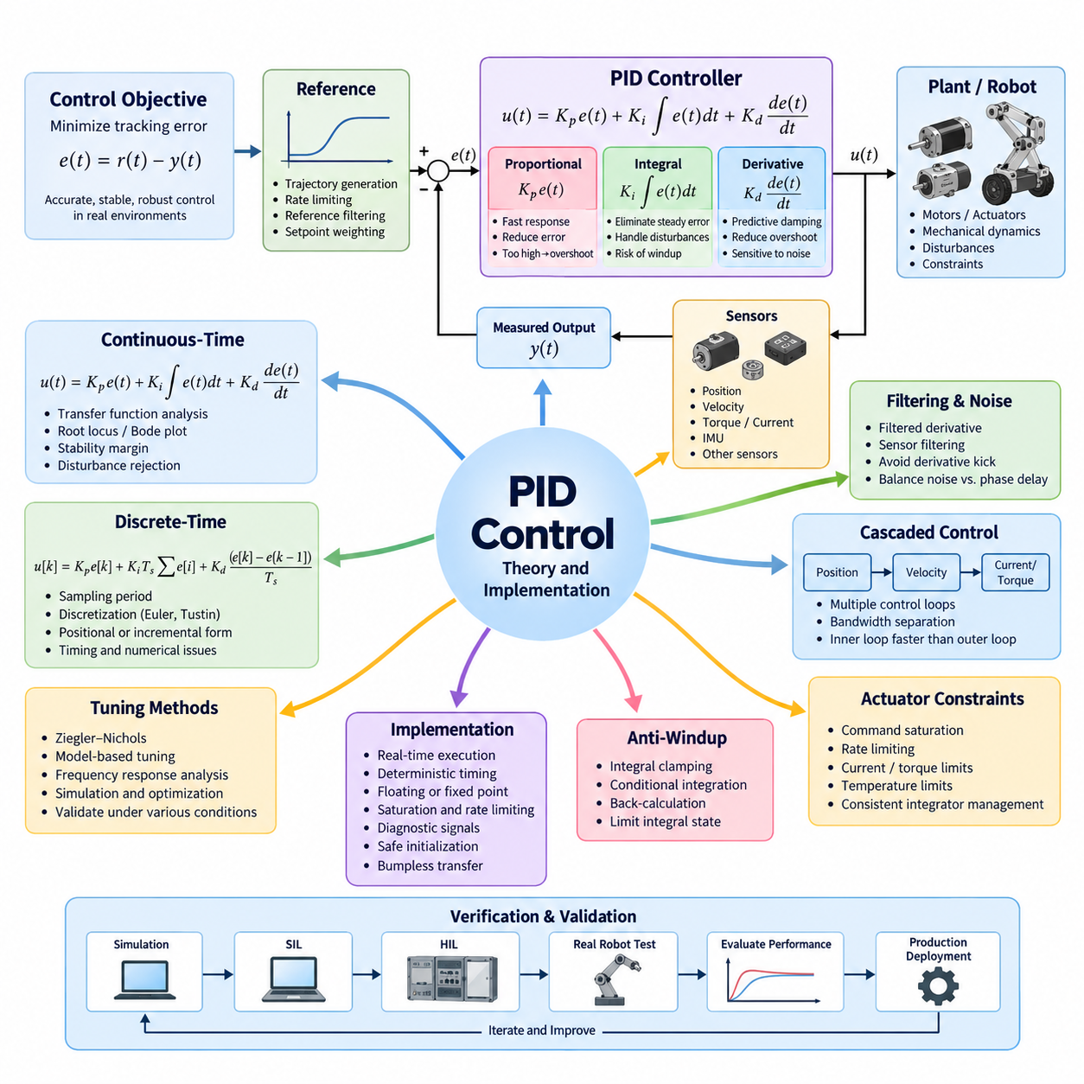
Proportional–Integral–Derivative control is one of the most widely used feedback control methods in robotics, industrial automation, motion control, and embedded systems. A PID controller continuously evaluates the difference between a desired reference and the measured system output, then generates a corrective command from proportional, integral, and derivative actions. Its practical value comes from combining simple mathematical structure with effective closed-loop performance.
The fundamental control objective is to reduce the tracking error e(t)=r(t)−y(t), where r(t) represents the reference command and y(t) represents the measured output. In continuous time, the controller is commonly expressed as u(t)=Kp e(t)+Ki∫e(t)dt+Kd de(t)/dt. The three gains determine how strongly the controller reacts to present error, accumulated historical error, and the instantaneous rate of error change.
The proportional term provides an immediate response according to the magnitude of the current error. Increasing Kp generally improves responsiveness and reduces tracking deviation, but excessive proportional gain can produce oscillation, overshoot, actuator saturation, or instability. A proportional controller alone may also leave a steady-state error when controlling systems that require a persistent control effort to maintain the desired operating point.
The integral term accumulates error over time and provides the corrective action required to eliminate persistent steady-state error. This is particularly important when the plant experiences constant disturbances, payload variations, friction, gravity, or modeling uncertainty. However, excessive integral action can increase overshoot and settling time. When an actuator reaches its physical limit, continued error accumulation can also create integral windup.
Anti-windup mechanisms are therefore important in practical PID implementations. Common approaches include integral clamping, conditional integration, and back-calculation based on the difference between the requested and saturated actuator commands. The integral state may also be bounded according to known actuator capability. These techniques prevent excessive stored integral action and allow the controller to recover more rapidly after saturation disappears.
The derivative term responds to the rate at which the error changes and can provide predictive damping that reduces overshoot and improves transient behavior. Direct differentiation, however, strongly amplifies measurement noise. Practical controllers therefore usually employ a filtered derivative rather than an ideal differentiator. Derivative action may also be applied to the measured output instead of the error to avoid a large derivative kick when the reference changes abruptly.
Continuous-time PID theory provides a useful analytical basis for controller design. Plant and controller transfer functions can be combined to examine closed-loop poles, frequency response, stability margins, disturbance rejection, and reference tracking. Root-locus, Bode-plot, and state-space analyses can help determine how PID gains influence bandwidth, damping, robustness, and sensitivity before the controller is implemented on actual hardware.
Digital controllers execute PID calculations at discrete sampling instants. If the sampling interval is Ts, the continuous error e(t) becomes the sequence e[k]. A basic discrete implementation can approximate the integral using accumulated samples and the derivative using finite differences. The resulting controller may be represented as u[k]=Kp e[k]+Ki Ts Σe[i]+Kd(e[k]−e[k−1])/Ts, although practical implementations usually add filtering and saturation logic.
The sampling period is a fundamental design parameter rather than merely a software scheduling value. Sampling that is too slow introduces phase delay, reduces achievable bandwidth, and can destabilize a controller that performs well in continuous analysis. Sampling unnecessarily fast increases processor load and sensitivity to sensor noise. The selected control frequency should therefore reflect plant dynamics, sensor update rates, actuator bandwidth, communication latency, and computational execution time.
Several mathematical transformations can convert a continuous PID controller into a discrete form. Forward Euler provides a simple approximation but may introduce significant numerical error. Backward Euler generally offers better numerical robustness, while the bilinear or Tustin transformation provides useful correspondence between continuous and discrete frequency characteristics. The appropriate method depends on sampling frequency, required accuracy, computational constraints, and control bandwidth.
PID software can be implemented in positional or incremental form. The positional form directly calculates the complete actuator command from the proportional, integral, and derivative components. The incremental form calculates the change in command relative to the previous cycle. Incremental implementations can be advantageous for some embedded actuators and legacy control architectures, while positional implementations often provide clearer state management and saturation handling.
Real control software must account for timing uncertainty and numerical limitations. The controller should preferably execute from a deterministic periodic task with a known sampling interval. When timing variation cannot be avoided, the measured elapsed time may be used in integration and differentiation calculations. Floating-point precision is normally sufficient for modern robotic computers, while fixed-point implementations require careful scaling, overflow protection, and quantization analysis.
Sensor noise must be considered when tuning derivative action and selecting feedback filtering. Excessive filtering introduces additional phase delay, while insufficient filtering allows noise to propagate into the actuator command. A practical design coordinates sensor filtering, derivative filtering, controller bandwidth, and sampling frequency as one system. Filters should therefore be evaluated using closed-loop behavior rather than selected independently from the control algorithm.
Actuator constraints must also be represented explicitly. Motors, hydraulic systems, steering mechanisms, brakes, and robotic joints have limits on command magnitude, velocity, acceleration, current, torque, and temperature. The PID output should pass through appropriate saturation and rate-limiting functions. Integrator management must remain consistent with these constraints so that internal controller states continue to represent physically achievable system behavior.
Controller tuning determines the balance among response speed, overshoot, steady-state accuracy, disturbance rejection, and robustness. Classical methods such as Ziegler–Nichols can provide initial gains, but modern robotic systems frequently require model-based tuning, frequency-response analysis, simulation, or automated optimization. Final tuning should be validated across payload, friction, battery voltage, temperature, surface condition, and other expected operating variations.
Setpoint processing can further improve practical behavior. Instead of applying abrupt reference changes directly to all PID terms, the command may pass through trajectory generation, rate limiting, or reference filtering. Setpoint weighting can independently adjust proportional and derivative responses to reference changes while preserving disturbance rejection characteristics. These techniques are particularly useful for position, velocity, steering, and mobile-robot motion controllers.
A production PID controller should expose internal states for diagnostics and calibration. Useful signals include reference, measurement, error, proportional contribution, integral state, derivative contribution, unsaturated command, final saturated command, sampling interval, and saturation status. Logging these quantities allows engineers to distinguish tuning problems from sensor noise, mechanical friction, actuator limitations, communication delay, or incorrect system modeling.
Safe initialization and mode transitions are equally important. When control changes between disabled, manual, autonomous, or different operating modes, controller states should not generate discontinuous actuator commands. Bumpless transfer techniques initialize or track the integral state so that the new controller output matches the existing command. Reset policies should explicitly define what happens after faults, emergency stops, communication losses, or reference changes.
PID control is often organized as cascaded loops in robotic systems. A position controller may generate a velocity reference, while a velocity controller generates torque or current commands for an inner motor loop. Inner loops normally operate at higher bandwidth and sampling frequency than outer loops. Each loop should be designed with sufficient bandwidth separation so that the slower controller can treat the faster inner dynamics as approximately settled.
Verification should cover both mathematical correctness and real-time implementation behavior. Simulation can evaluate nominal tracking and disturbances, while software-in-the-loop and hardware-in-the-loop testing can expose discretization, saturation, timing, communication, and numerical effects. Hardware testing should additionally evaluate actuator limits, sensor faults, load changes, noise, thermal conditions, and emergency transitions before PID parameters are released for production use.

02.02 PID Tuning Methods: Ziegler-Nichols / Auto Tuning [w/Code]
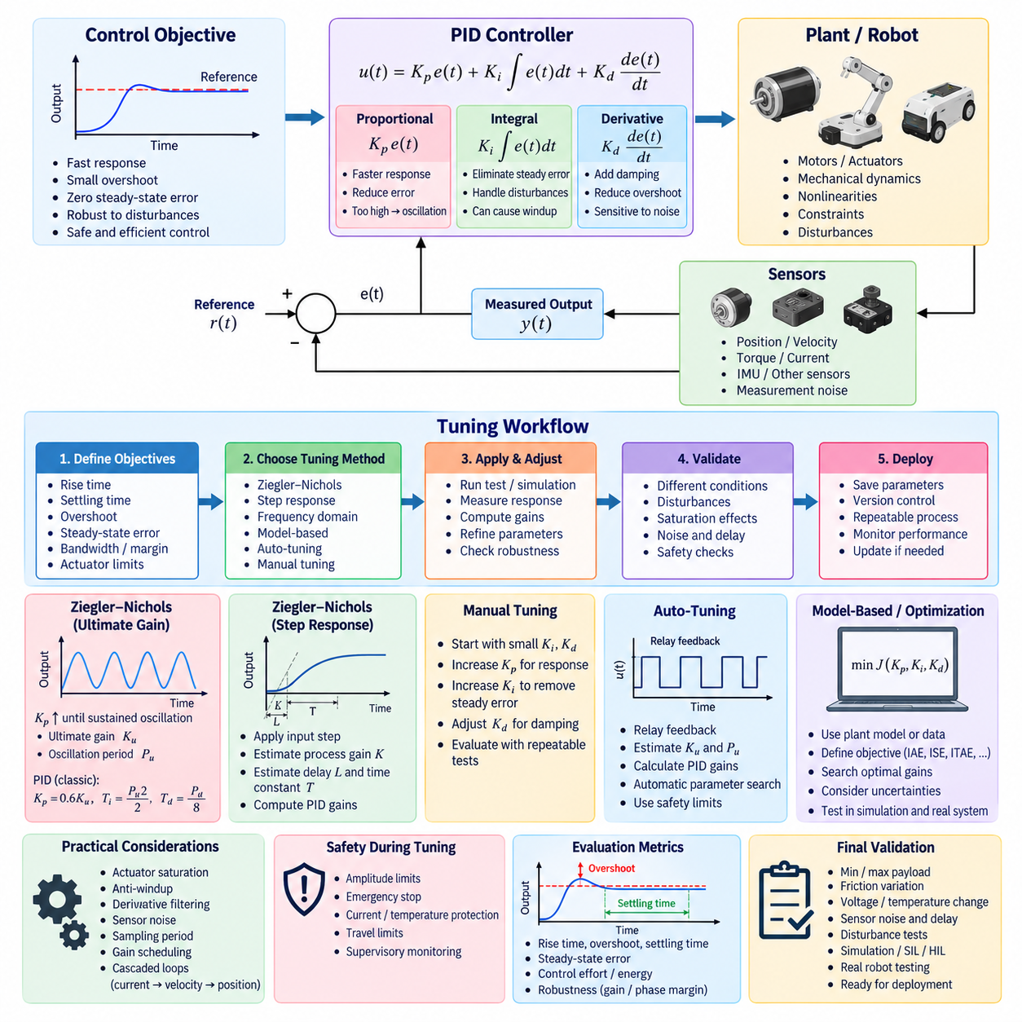
PID tuning determines how the proportional, integral, and derivative gains are selected to achieve the required balance among responsiveness, stability, overshoot, settling time, steady-state accuracy, and disturbance rejection. Although the PID structure is mathematically simple, appropriate gain selection depends strongly on plant dynamics. Practical tuning therefore combines analytical knowledge, experimental methods, simulation, and increasingly automated optimization techniques.
The proportional gain Kp primarily determines how strongly the controller reacts to instantaneous error. Increasing Kp generally accelerates the response and reduces tracking error, but excessive gain can cause oscillation or instability. The integral gain Ki eliminates persistent steady-state error by accumulating error over time, while excessive integral action may increase overshoot and windup. The derivative gain Kd adds damping but can amplify measurement noise.
A useful tuning process begins by defining measurable control objectives rather than adjusting gains without explicit criteria. Typical requirements include rise time, settling time, maximum overshoot, steady-state error, control bandwidth, phase margin, disturbance recovery, actuator utilization, and noise sensitivity. Robot applications may additionally impose limits on acceleration, jerk, torque, current, vibration, positioning accuracy, and mechanical stress during transient operation.
The Ziegler–Nichols method is a classical empirical tuning technique that provides initial PID parameters from experimentally observed plant behavior. One common approach is the closed-loop ultimate-gain method. Integral and derivative actions are initially disabled, and proportional gain is gradually increased until the closed-loop system exhibits sustained oscillation. The corresponding proportional gain is identified as the ultimate gain Ku, while the oscillation period is recorded as Pu.
Once Ku and Pu are obtained, predefined Ziegler–Nichols relationships can estimate controller parameters. In the classical PID form, a frequently used starting point is Kp=0.6Ku, Ti=Pu/2, and Td=Pu/8, with integral and derivative gains derived according to the selected PID parameterization. These values are starting estimates rather than universally optimal settings, and additional tuning is normally required for the actual robot or actuator.
The ultimate-gain experiment must be applied carefully because intentionally driving a physical system toward sustained oscillation can be unsafe. Robots may encounter mechanical limits, excessive motor current, vibration, thermal stress, payload instability, or structural resonance before the theoretical ultimate gain is reached. Consequently, experimental amplitude limits, emergency-stop logic, current protection, travel limits, and supervisory monitoring should be active throughout the procedure.
Another Ziegler–Nichols approach uses the open-loop step response of the plant. A known input step is applied and the resulting process response is analyzed to estimate parameters representing process gain, apparent delay, and dominant time constant. Tuning relationships then convert these characteristics into controller gains. This approach avoids deliberately creating closed-loop sustained oscillations, although accurate identification may be difficult for nonlinear, integrating, or strongly coupled robotic systems.
Classical Ziegler–Nichols tuning tends to produce relatively aggressive responses and may generate more overshoot than is desirable for precision robotics. The method was developed as a general practical rule rather than an optimization procedure for modern mechatronic systems. Therefore, gains obtained from it should normally be refined according to application-specific requirements such as smooth motion, low vibration, energy efficiency, actuator protection, payload stability, and human–robot interaction.
Manual tuning remains useful when engineers understand the physical system and can directly observe its response. A common practical sequence begins with small integral and derivative gains and adjusts proportional action until adequate responsiveness is obtained. Integral action is then increased to remove residual steady-state error, followed by derivative adjustment to improve damping. Each change should be evaluated using repeatable reference and disturbance scenarios rather than subjective observation alone.
Step-response analysis provides quantitative information for this refinement process. Reference commands can be applied while recording position, velocity, torque, or other controlled variables together with the actuator command. Rise time, peak overshoot, settling time, steady-state error, oscillation frequency, and saturation duration can then be calculated. Comparing these metrics across gain sets provides a more systematic tuning process and creates traceable engineering evidence.
Frequency-domain tuning offers another systematic approach. If a plant model or measured frequency response is available, controller parameters can be adjusted to obtain desired crossover frequency, gain margin, phase margin, and sensitivity characteristics. This is particularly useful when the controller must remain stable across variations in payload, inertia, friction, or actuator dynamics. The resulting design can explicitly trade control bandwidth against robustness and measurement-noise amplification.
Model-based tuning uses an analytical or identified mathematical representation of the controlled system. Motor electrical dynamics, mechanical inertia, damping, transmission characteristics, steering dynamics, or robot-joint behavior may be incorporated into the plant model. PID gains can then be calculated or optimized in simulation before hardware testing. The model does not need to reproduce every physical detail, but it should capture the dynamics that dominate the intended control bandwidth.
Auto-tuning automates part or all of the gain-selection process by stimulating the plant, observing its response, estimating relevant dynamic properties, and calculating controller parameters. This can reduce commissioning time when many motors, joints, or robots require similar calibration. Auto-tuning is especially useful in manufacturing environments where controllers must be configured repeatedly, but its excitation procedure and parameter limits must remain compatible with hardware safety constraints.
Relay feedback is a widely used auto-tuning technique that replaces or supplements proportional control with a controlled switching excitation. The resulting oscillation can provide estimates of ultimate gain and oscillation period without manually increasing proportional gain toward instability. From these measurements, tuning rules can generate PID parameters. Relay amplitude, hysteresis, excitation duration, actuator limits, and termination conditions must be selected carefully to obtain useful identification data safely.
More advanced auto-tuning can formulate gain selection as an optimization problem. Candidate values of Kp, Ki, and Kd are evaluated against an objective function constructed from tracking error, overshoot, settling time, control effort, energy consumption, or other performance measures. Integral criteria such as IAE, ISE, ITAE, or combinations of several metrics can quantify response quality. Constraints can reject gain combinations that cause instability, saturation, or unacceptable motion.
Optimization may be performed in simulation using numerical search, gradient-free algorithms, evolutionary methods, Bayesian optimization, or other parameter-search techniques. Simulation allows a large number of gain combinations to be explored without repeatedly stressing physical hardware. However, gains optimized only for a nominal simulation model may perform poorly when transferred to the real robot, so uncertainty in mass, friction, delay, sensor noise, and actuator characteristics should be represented during evaluation.
Gain scheduling can extend PID tuning when one fixed parameter set cannot provide adequate performance across the entire operating range. Different gains may be selected according to payload, velocity, joint configuration, battery voltage, steering angle, flight condition, or another measurable operating variable. Transitions between gain sets should be smooth to prevent discontinuous actuator commands, and every scheduled region should be verified for stability and acceptable transient performance.
Tuning should always consider saturation and anti-windup behavior because actuator limits can significantly alter the apparent response of a PID controller. A gain set that appears slow may actually be constrained by maximum current, torque, velocity, or command limits. Increasing gains under these conditions may only increase saturation duration and integral accumulation. Controller outputs, saturation flags, integral states, and physical actuator variables should therefore be recorded together during tuning.
Derivative filtering must also be treated as part of the tuning problem rather than as an independent post-processing function. Increasing derivative gain can improve damping, but stronger derivative action may require additional filtering to suppress sensor noise. Additional filtering introduces phase delay and can reduce stability margin. Consequently, Kd, derivative-filter bandwidth, sampling frequency, and sensor characteristics should be evaluated together during controller calibration.
For cascaded control architectures, tuning normally proceeds from the innermost loop outward. A motor current or torque loop is stabilized first, followed by velocity control and then position control. Each inner loop should achieve sufficient bandwidth and robustness before the outer loop is tuned. This sequencing prevents poorly tuned inner dynamics from being incorrectly compensated by outer-loop gains and helps maintain clear bandwidth separation between control layers.
Production tuning requires parameter traceability and repeatability. Each gain set should be associated with controller software version, hardware configuration, actuator type, payload condition, sampling period, filter parameters, and test results. Parameters should be stored through a controlled calibration mechanism rather than embedded as undocumented constants in source code. This allows engineers to reproduce performance, compare revisions, investigate failures, and safely deploy updates across multiple robot platforms.
Final validation should cover more than the nominal tuning condition. The controller should be evaluated with minimum and maximum payloads, expected friction variation, battery or supply-voltage changes, temperature variation, sensor noise, communication delay, actuator saturation, external disturbances, and representative trajectories. Simulation, software-in-the-loop, hardware-in-the-loop, and physical robot testing can progressively increase confidence before the tuned parameters are released for operational deployment.

02.03 Anti-Windup Technique Implementation [w/Code]
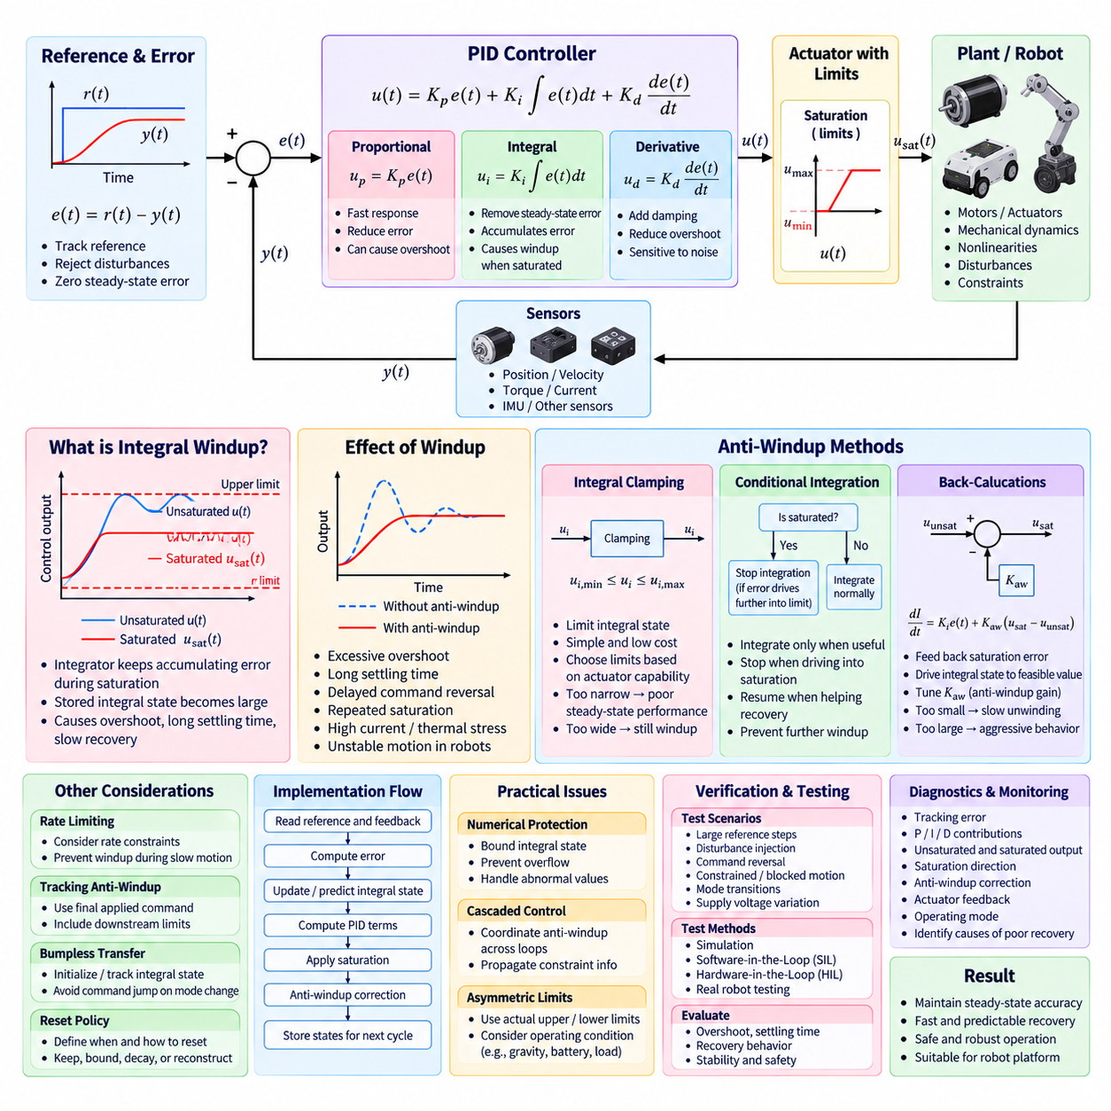
Integral windup occurs when the integral component of a PID controller continues accumulating error while the actuator is unable to produce the requested control action. This commonly happens when the controller output exceeds physical limits such as maximum motor current, torque, voltage, velocity, steering angle, or valve position. The stored integral error can become much larger than the value required for normal closed-loop operation.
When actuator saturation occurs, the commanded control value u(t) and the actual applied value no longer match. Although the plant receives only the saturated command, the integral term may continue integrating the persistent tracking error as if additional control authority were available. When the error eventually decreases or changes direction, the accumulated integral state continues driving the actuator toward the previous saturation limit and delays recovery.
Windup can significantly degrade transient performance. Typical symptoms include excessive overshoot, long settling time, delayed reversal of actuator commands, repeated saturation, and slow recovery after large reference changes or disturbances. In robotic systems, these effects may also produce abrupt motion, increased motor current, unnecessary thermal loading, mechanical stress, or unstable interaction with the environment, particularly when high integral gains are used.
Anti-windup techniques modify the integral behavior whenever the controller output is constrained. Their objective is not to remove integral action, because integration remains valuable for eliminating steady-state error, but to prevent the integral state from representing control effort that the actuator cannot physically deliver. A practical implementation therefore coordinates PID calculation, actuator saturation, integral-state management, and operating-mode logic.
The simplest approach is integral clamping. The accumulated integral state is restricted to predefined minimum and maximum values so that it cannot grow indefinitely. If the integral contribution is represented by ui, software can apply limits such as ui,min ≤ ui ≤ ui,max after every integration step. These limits should be selected according to actuator capability and the amount of integral authority required during normal operation.
Integral clamping is straightforward and computationally inexpensive, making it suitable for embedded motor controllers and high-frequency control loops. However, fixed limits do not explicitly consider whether actuator saturation is caused by proportional, integral, or derivative action. If the clamp range is too narrow, steady-state disturbance rejection may deteriorate, while an excessively wide range may still allow substantial windup before the integral limit is reached.
Conditional integration provides a more dynamic solution. Integration proceeds normally while the actuator is unsaturated, but the integral update is suspended when the output reaches a limit and the current error would drive the controller further into saturation. If the error acts in the opposite direction and helps return the command toward the feasible region, integration can resume. This preserves useful integral action while preventing further accumulation in the harmful direction.
A discrete conditional integrator may first calculate a candidate integral state using Icandidate[k]=I[k−1]+Ki Ts e[k]. The controller then evaluates the resulting unsaturated output and compares it with actuator limits. The candidate state is accepted when the command is feasible or when integration assists recovery from saturation. Otherwise, the previous integral state is retained until the controller can move away from the saturation boundary.
Back-calculation is a widely used anti-windup method that explicitly feeds the saturation difference back into the integrator. The controller first computes an unsaturated command uunsat and then applies actuator limits to obtain usat. The difference usat−uunsat represents the amount of control action that cannot be realized. This difference is multiplied by an anti-windup gain and used to drive the integral state toward a value consistent with the achievable actuator output.
In continuous form, the integrator can be modified using an expression such as dI/dt=Ki e(t)+Kaw[usat(t)−uunsat(t)], where Kaw is the anti-windup gain. During normal unsaturated operation, usat equals uunsat and the additional feedback term becomes zero. During saturation, the correction term unwinds the integral state. The rate of this recovery depends on Kaw and should be coordinated with the dynamics of the primary control loop.
The back-calculation gain must be tuned carefully. If Kaw is too small, the integrator may unwind too slowly and much of the original windup behavior remains. If it is excessively large, the integral state may change abruptly and introduce undesirable transient behavior. An anti-windup time constant is often used to parameterize this response so that integral-state correction occurs rapidly enough without interfering with the intended closed-loop dynamics.
Tracking anti-windup generalizes this concept by forcing the internal controller state to follow the control value that is actually applied to the plant. This is useful when the final actuator command is modified not only by amplitude saturation but also by rate limiting, torque limiting, safety supervision, traction control, power management, or another downstream function. The tracking signal should represent the effective command after all relevant limitations.
Anti-windup design must therefore consider the complete actuator command path. A controller may generate a torque request that subsequently passes through current limits, velocity-dependent torque limits, thermal derating, battery power constraints, acceleration limits, or safety overrides. If the integrator only observes the first saturation block, it may still accumulate error against constraints introduced later. Feedback of the final applied command can provide more consistent behavior.
Rate saturation can create windup even when the absolute command remains within its amplitude limits. For example, a steering or joint actuator may be unable to change position or torque as rapidly as requested. The controller can then accumulate integral error while waiting for the actuator to catch up. Anti-windup logic should therefore consider both magnitude and rate constraints when these limitations materially affect closed-loop behavior.
Bumpless transfer is closely related to integral-state management. When control changes between manual, autonomous, disabled, position, velocity, or other operating modes, an existing integral state may be incompatible with the new actuator command. The integrator can be initialized or tracked so that the controller output begins near the currently applied command. This prevents sudden command jumps when closed-loop control is enabled or a controller mode is switched.
Integrator reset policies should be explicitly defined rather than implemented as unconditional clearing. Resetting the integral state to zero may be appropriate after some faults or initialization events, but it can also remove the control effort needed to compensate gravity, friction, or constant load. Depending on the application, the integral state may instead be retained, bounded, smoothly decayed, initialized from operating conditions, or reconstructed from the current actuator command.
Discrete-time implementation requires consistent handling of sampling period and update order. A typical control cycle reads the reference and feedback, calculates error, updates or predicts the integral state, evaluates PID terms, computes the unsaturated output, applies actuator constraints, performs anti-windup correction, and stores states for the next cycle. The exact sequence should remain deterministic so that controller behavior can be reproduced in simulation and embedded software.
Numerical protection is also important. Integral states should have explicit bounds even when back-calculation or conditional integration is used, providing protection against software defects, abnormal sensor values, extremely long saturation periods, and arithmetic overflow. Fixed-point controllers require particular attention to scaling and accumulator range, while floating-point implementations should still check invalid values and maintain physically meaningful limits.
Cascaded controllers require coordinated anti-windup handling because saturation in an inner loop can invalidate assumptions made by an outer loop. For example, a position controller may request a velocity that the velocity or torque loop cannot achieve. If the position integrator continues accumulating error, substantial windup can occur even though its own numerical output has not reached a local software limit. Constraint information can therefore be propagated between control layers.
Robotic applications often require asymmetric limits. A mobile robot may have different acceleration and braking capability, a manipulator joint may support different positive and negative torques because of gravity, and an aerial vehicle may have operating-point-dependent thrust margins. Anti-windup logic should use the actual upper and lower limits applicable to the current operating condition rather than assuming a symmetric fixed saturation range.
Diagnostics should expose the internal variables needed to identify windup behavior. Useful signals include tracking error, proportional contribution, integral state, derivative contribution, unsaturated output, saturated output, saturation direction, anti-windup correction, actuator feedback, and operating mode. Recording these signals allows engineers to determine whether poor recovery is caused by PID tuning, actuator limitations, incorrect anti-windup parameters, or downstream command constraints.
Verification should include deliberate saturation scenarios rather than only small-signal tracking tests. Large reference steps, abrupt load disturbances, blocked or constrained actuator motion, command reversals, mode transitions, supply-voltage reduction, and temporary safety limits can reveal windup behavior. Simulation and software-in-the-loop testing can verify algorithm logic, while hardware-in-the-loop and physical robot testing confirm interaction with real actuator limits.
A successful anti-windup implementation should allow the PID controller to retain its steady-state accuracy while recovering rapidly and predictably from actuator constraints. Integral clamping offers simplicity, conditional integration prevents harmful accumulation, and back-calculation or tracking methods provide more explicit coordination with the applied command. The selected technique should match actuator dynamics, controller architecture, safety requirements, and computational constraints of the robot platform.

02.04 Filter-Based Derivative Improvement [w/Code]
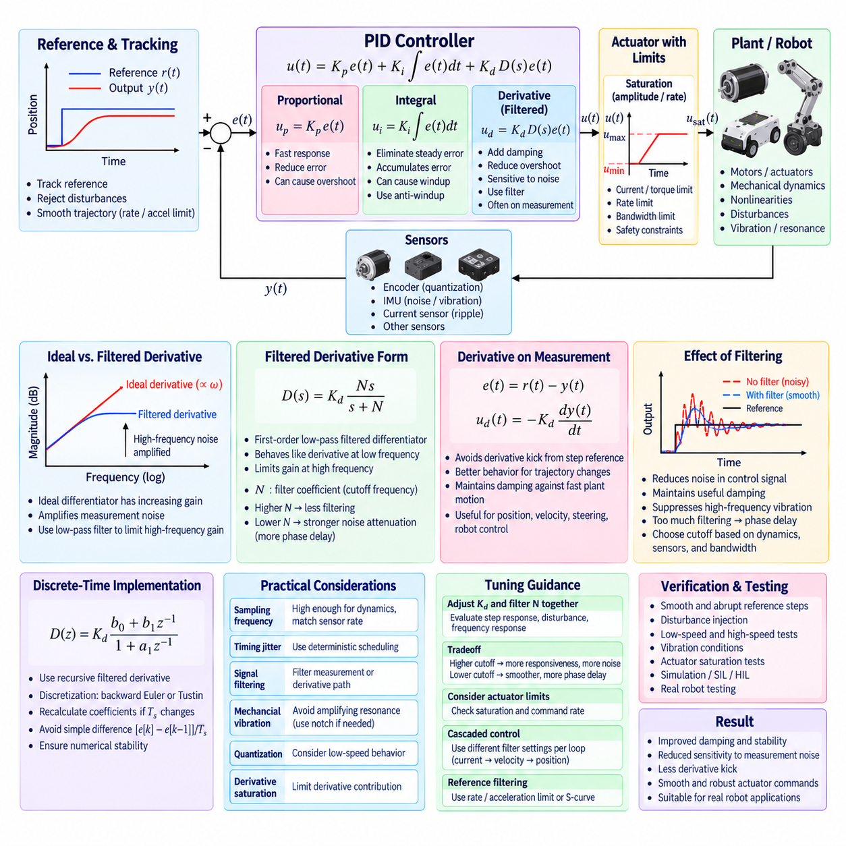
Derivative action in a PID controller improves damping by responding to the rate of change of the control error. It can reduce overshoot, suppress oscillation, and improve transient stability when the plant responds rapidly. However, differentiation inherently emphasizes high-frequency components, making the derivative term particularly sensitive to sensor noise, quantization, vibration, communication jitter, and other disturbances commonly present in robotic systems.
An ideal derivative term is expressed as ud(t)=Kd de(t)/dt. In theory, this provides a control contribution proportional to the instantaneous slope of the error. In practice, an ideal differentiator has increasing gain as frequency rises, so even small high-frequency measurement fluctuations can produce large derivative outputs. The resulting actuator commands may become noisy, oscillatory, or physically demanding despite relatively smooth motion of the actual robot.
Measurement noise is unavoidable in real control systems. Encoders contain quantization effects, IMUs exhibit vibration and electronic noise, current sensors include switching ripple, and position measurements may contain communication or estimation artifacts. Direct differentiation amplifies these components because rapid sample-to-sample changes appear as large derivatives. Consequently, an unfiltered derivative term is rarely appropriate for production robot control software.
A practical solution replaces the ideal derivative with a filtered derivative. A commonly used continuous-time form is D(s)=Kd Ns/(s+N), or equivalently a first-order low-pass filtered differentiator. At lower frequencies the controller behaves approximately like the desired derivative action, while at higher frequencies the filter limits gain. This prevents measurement noise from being amplified indefinitely and makes derivative control suitable for implementation on physical hardware.
The filter parameter determines the tradeoff between derivative effectiveness and noise attenuation. A high filter cutoff allows the derivative term to follow rapid changes more accurately but passes more high-frequency noise. A lower cutoff suppresses noise more strongly but introduces additional phase delay and weakens derivative action within the control bandwidth. Filter selection must therefore be coordinated with plant dynamics, sensor quality, sampling frequency, and desired closed-loop bandwidth.
Derivative filtering can also be expressed using a derivative time constant Td and a filter coefficient N. In common PID formulations, the derivative element may be represented as Td s/(1+Td s/N). Larger N values make the response closer to an ideal differentiator over a wider frequency range, whereas smaller values provide stronger filtering. The exact interpretation depends on the PID parameterization used by the controller implementation.
Applying derivative action to the measured output rather than directly to the tracking error provides another important improvement. Because e(t)=r(t)−y(t), an abrupt reference change can produce an instantaneous change in error. Differentiating this signal generates a large derivative kick even though the physical plant has not yet moved. Derivative-on-measurement calculates the derivative primarily from y(t), avoiding a large command spike caused by a step change in the reference.
With derivative-on-measurement, the derivative contribution commonly takes the form ud(t)=−Kd dy(t)/dt. The negative sign follows from the relationship between error and measured output. This configuration preserves damping against rapid plant motion while substantially reducing sensitivity to reference discontinuities. It is especially useful for position, velocity, steering, manipulator, and mobile-robot controllers that receive trajectory or setpoint changes during operation.
Reference filtering and trajectory generation can further reduce derivative-related transients. Instead of applying discontinuous setpoints directly to the PID controller, the reference may be processed using rate limits, acceleration limits, S-curve profiles, or low-pass filtering. This reduces abrupt error changes before they reach the controller. Such processing complements derivative filtering but should not be used as a substitute for appropriate measurement-noise treatment.
Discrete-time implementation requires a numerical representation of the filtered derivative. A simple raw difference such as [e[k]−e[k−1]]/Ts is highly sensitive to noise and sampling variation. Instead, the derivative state can be recursively filtered so that the new derivative estimate combines the previous filtered value with the latest measured difference. The coefficients should be derived consistently from the selected continuous filter and actual sampling period Ts.
Discretization can be performed using methods such as backward Euler or the bilinear Tustin transformation. Backward Euler offers straightforward and numerically robust implementation, while Tustin can provide better correspondence between continuous and discrete frequency characteristics. Regardless of method, filter coefficients should be recalculated whenever the sampling period changes significantly rather than assuming that continuous-time parameters can be copied directly into digital software.
Sampling frequency strongly affects derivative performance. When the control period is too long, derivative estimates become delayed and may fail to represent important plant dynamics. When sampling is extremely fast relative to sensor quality, small quantization changes can dominate the calculated derivative. The control-loop frequency should therefore provide sufficient resolution for relevant dynamics while remaining consistent with sensor update rate, timestamp accuracy, computation time, and actuator bandwidth.
Timing jitter can introduce derivative noise even when the sensor measurement itself is clean. If a controller assumes a fixed Ts while actual execution intervals vary, identical changes in measurement may correspond to different physical rates. Real-time control software should therefore use deterministic scheduling whenever possible. If meaningful timing variation remains, the actual measured time interval can be incorporated into derivative calculations with appropriate numerical protection.
Additional signal filtering may be required before derivative computation when sensors contain significant noise. A low-pass filter can be applied to the measured signal, but excessive filtering adds phase lag to the feedback path and may reduce stability margin. Filtering only the derivative path often preserves proportional and integral responsiveness better than heavily filtering the entire feedback signal. The appropriate architecture depends on sensor characteristics and control objectives.
Mechanical vibration deserves particular attention because derivative action may convert structural resonance into high-frequency actuator commands. Motors, gearboxes, flexible links, tires, steering mechanisms, and robot structures can exhibit resonant frequencies that appear in sensor signals. The derivative filter cutoff should avoid unnecessarily amplifying these modes. In demanding applications, notch filters or dedicated vibration filters may supplement the basic derivative low-pass filter.
Sensor quantization also affects derivative estimation at low velocities. An encoder may report an unchanged position for several samples and then suddenly increment by one count, creating a pulse-like raw derivative. Filtering smooths these discrete transitions but can introduce delay. Velocity estimation based on timestamps, observer methods, or dedicated encoder processing may provide a better derivative-related signal than direct differentiation of low-resolution position measurements.
Derivative saturation should be considered independently from total PID output saturation. A sudden measurement anomaly can create a large derivative contribution even when proportional and integral terms remain normal. Limiting the derivative state or derivative contribution can prevent unrealistic actuator commands. Such limits should be selected from physically meaningful velocity, acceleration, torque, or command-rate expectations rather than arbitrary numerical values.
The interaction between derivative filtering and actuator constraints must also be evaluated. High-frequency derivative commands may encounter current limits, torque limits, command-rate limits, or actuator bandwidth restrictions. In this situation, increasing Kd may not provide additional damping and can instead increase saturation activity. Controller logs should therefore include derivative contribution, filtered derivative state, actuator command, saturation status, and measured motion during tuning.
Filter tuning should be performed together with PID gain tuning. Increasing Kd while maintaining the same filter parameters changes both damping and noise response, while changing filter cutoff alters the effective derivative behavior across frequency. Engineers should evaluate step responses, disturbance recovery, frequency response, actuator effort, and noise sensitivity across candidate combinations rather than selecting Kd and filter parameters independently.
For cascaded controllers, derivative filtering should reflect the bandwidth of each control layer. An inner current or velocity loop may operate at a much higher frequency than an outer position loop and therefore require different filter characteristics. Reusing identical derivative-filter parameters across all loops can introduce inappropriate phase delay or insufficient noise suppression. Each loop should be treated according to its sensor source, dynamics, and sampling rate.
Diagnostics are essential for determining whether derivative behavior is beneficial or harmful. Useful signals include raw measurement, filtered measurement, raw derivative estimate, filtered derivative value, derivative contribution, reference, error, final actuator command, sampling interval, and saturation state. Frequency-domain analysis or logged time-series data can reveal whether derivative activity corresponds to genuine plant motion, sensor noise, mechanical resonance, or timing artifacts.
Verification should include both smooth and abrupt reference trajectories, stationary sensor-noise tests, disturbance injection, low-speed motion, rapid motion, vibration conditions, and actuator saturation. Software-in-the-loop testing can verify filter equations and discretization, while hardware-in-the-loop testing exposes timing and sensor-interface effects. Physical robot tests are necessary to confirm that the selected filtering provides useful damping without excessive delay.
A well-designed filtered derivative preserves the principal advantage of derivative control while limiting its sensitivity to high-frequency disturbances. Combining derivative-on-measurement, appropriate low-pass filtering, deterministic sampling, numerical limits, and sensor-aware tuning produces a derivative term suitable for real robot software. The final design should achieve improved damping and transient response without introducing unnecessary noise, actuator stress, or loss of stability margin.

02.05 Cascade PID Structure Design [w/Code]
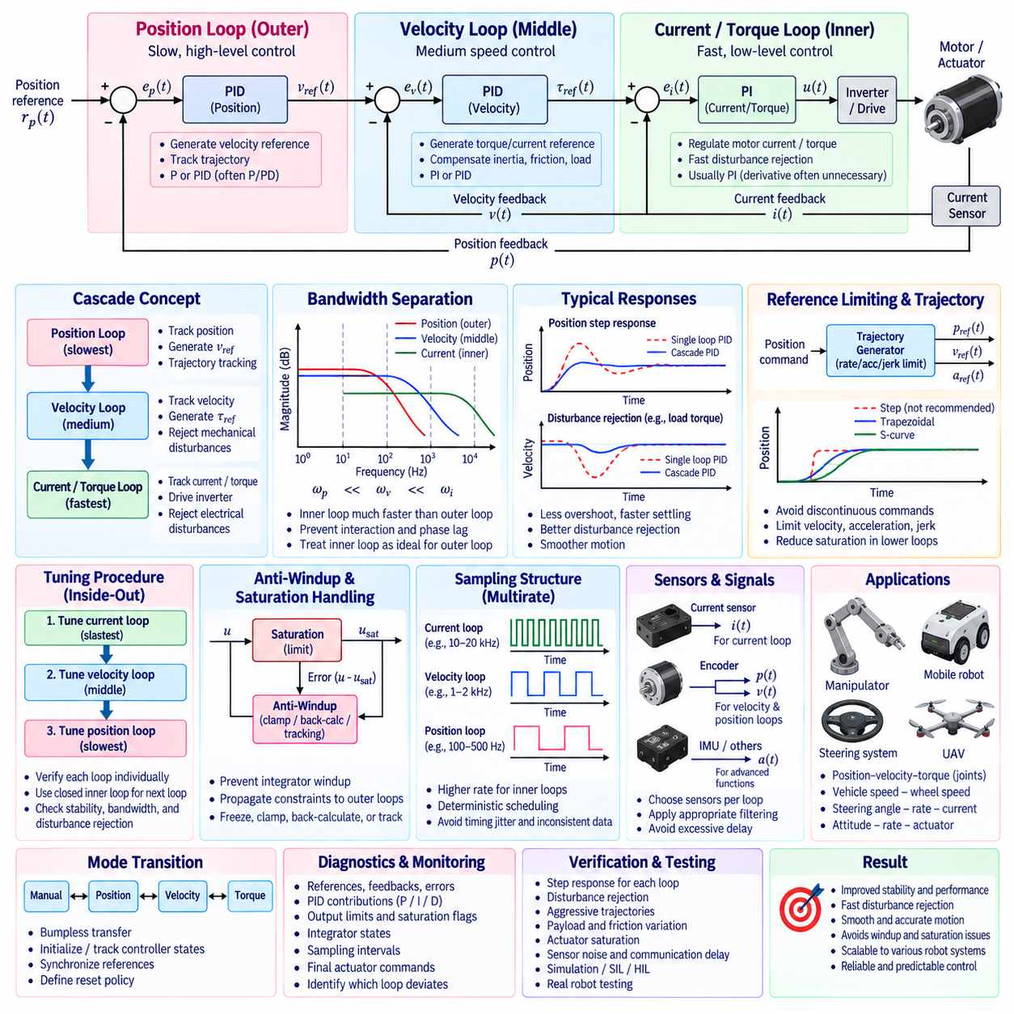
Cascade PID control organizes multiple feedback controllers in nested loops so that slower high-level variables are regulated through faster low-level dynamics. Instead of commanding an actuator directly from a position error, for example, an outer position controller can generate a velocity reference, while an inner velocity controller generates torque or current commands. This hierarchy matches the physical structure of many robotic actuators and motion systems.
A typical cascade architecture contains two or three control layers. A position loop may operate as the outer loop, a velocity loop as the intermediate loop, and a current or torque loop as the innermost loop. Each controller receives a reference from the layer above and produces the reference for the layer below. The innermost controller ultimately generates a command that can be translated into motor voltage, PWM duty, inverter current, or actuator effort.
The principal advantage of cascade control is that fast disturbances can be corrected by inner loops before they significantly affect slower outer variables. A current controller can reject electrical disturbances and regulate motor torque rapidly, while a velocity controller handles mechanical speed dynamics. The position controller can then focus on trajectory tracking without directly compensating every fast electrical and mechanical effect occurring inside the actuator.
Bandwidth separation is fundamental to successful cascade design. Inner loops should respond significantly faster than the outer loops that depend on them. When the inner loop settles rapidly, the outer controller can approximately treat it as an ideal controlled subsystem. If loop bandwidths are too close, controllers may interact strongly, introduce excessive phase lag, amplify oscillation, or produce tuning behavior that cannot be understood independently.
A practical design therefore begins with the innermost loop. For an electric motor, the current or torque controller is tuned first because electrical dynamics are normally faster than mechanical velocity and position dynamics. Once the inner loop achieves adequate stability, bandwidth, and disturbance rejection, the velocity loop is tuned around the closed inner system. The position controller is tuned last after the velocity dynamics have become sufficiently predictable.
The current loop commonly regulates measured phase, q-axis, or equivalent motor current against a current reference. Since motor torque is closely related to current for many actuator types, this loop provides fast torque regulation. PI control is frequently sufficient because derivative action may be unnecessary in fast electrical loops containing noisy current measurements. Current limits, inverter saturation, sampling synchronization, and anti-windup must be explicitly considered.
The velocity loop receives a speed reference and produces a torque or current reference for the inner controller. It compensates inertia, friction, load changes, and mechanical disturbances while maintaining the desired speed response. PI or PID control can be used depending on system characteristics. Because the velocity controller does not directly command the inverter, its output limits should correspond to the achievable torque or current range of the inner actuator loop.
The outer position loop compares the commanded position with measured position and generates a velocity reference. In many robotic applications, proportional or PD behavior may be sufficient when the inner velocity loop already provides integral regulation. Adding integral action at every cascade level can create unnecessary interaction and windup. The control structure should therefore assign integral action according to the physical disturbance and steady-state accuracy requirements of each layer.
Reference limits are essential between cascade layers. The position controller should not request a velocity beyond the robot's safe operating range, and the velocity controller should not request torque beyond motor or transmission capability. Acceleration, jerk, current, thermal, and power limits may also constrain intermediate references. These limits convert physical hardware capability into explicit software constraints and prevent outer loops from continuously requesting impossible behavior.
Saturation in an inner loop must be communicated or reflected appropriately to outer controllers. If the torque loop reaches its current limit while the velocity and position integrators continue accumulating error, severe cascade windup can occur. Anti-windup strategies can freeze, clamp, back-calculate, or track outer-loop integral states according to downstream saturation. Constraint propagation is therefore an important part of production cascade control software.
The sampling architecture should also follow the dynamic hierarchy. The current loop typically executes at the highest frequency, the velocity loop at a lower frequency, and the position loop at a still lower frequency. This multirate structure reduces unnecessary computation while preserving adequate resolution for each physical process. Loop periods should be deterministic, and data exchange between rates should avoid inconsistent samples, excessive latency, or uncontrolled timing jitter.
For example, a motor current controller may execute at several kilohertz or higher while a velocity loop executes at a lower rate and a position loop operates more slowly. Exact frequencies depend on motor electrical dynamics, inverter characteristics, sensor bandwidth, mechanical resonance, processor capability, and communication architecture. Fixed numerical ratios should not replace bandwidth analysis because different robot actuators can require substantially different loop rates.
Sensor selection follows the same layered organization. Current sensors provide feedback to the innermost loop, encoder-derived velocity or a velocity estimator supports the intermediate loop, and encoder position provides feedback to the outer loop. Each signal requires appropriate filtering and timing. Excessive filtering in an inner loop can reduce phase margin, while noisy velocity estimation can cause intermediate-loop oscillation that propagates into position behavior.
Feedforward terms can be integrated into cascade control without replacing feedback regulation. A position trajectory may provide desired velocity and acceleration, allowing velocity feedforward or torque feedforward to reduce tracking error. For manipulators, model-based gravity, friction, or inertia compensation can be added to the torque reference. Feedback controllers then correct modeling errors and disturbances instead of generating the entire control effort from tracking error alone.
Trajectory generation should be coordinated with cascade limits. Position commands that contain discontinuities can immediately demand excessive velocity, acceleration, and torque from lower layers. Trapezoidal or S-curve motion profiles can generate position, velocity, and acceleration references that respect physical constraints. Proper reference shaping reduces saturation and allows each PID loop to operate within the dynamic range for which it was tuned.
Mode transitions require careful state management. Switching between position, velocity, torque, manual, and autonomous control can change which cascade layers are active. Controller states should be initialized or tracked so that enabling a new loop does not create a sudden reference or actuator command. Bumpless transfer, integrator tracking, reference synchronization, and explicit reset policies help maintain smooth behavior during transitions.
Cascade structures are also useful beyond conventional motor drives. Steering systems may contain steering-angle, steering-rate, and motor-current loops. Manipulators can combine joint position, velocity, and torque regulation. Mobile robots may use vehicle velocity control above wheel-speed loops, while UAV flight controllers commonly organize position, velocity, attitude, angular-rate, and actuator-related loops according to progressively faster dynamics.
More complex robots may contain cascade relationships across multiple software components or processors. A high-level motion controller can generate references transmitted to distributed joint controllers over a communication network. Network delay, packet jitter, synchronization, and command update frequency then become part of the effective cascade dynamics. Fast inner loops are usually kept close to the actuator so that network uncertainty does not directly affect the highest-bandwidth control functions.
Fault handling must respect the hierarchy of the cascade architecture. A current-sensor failure may invalidate the torque loop and therefore every outer controller depending on it. A velocity-estimation fault may require transition to a degraded mode even when position sensing remains available. Each layer should report validity, saturation, fault, and readiness information so that supervisory software can determine whether higher-level control commands remain safe to execute.
Diagnostics should expose both individual-loop behavior and interactions between loops. Useful signals include references, feedback values, errors, PID contributions, output limits, saturation flags, integrator states, sampling intervals, and final actuator commands for every layer. Logging the complete chain from position reference through velocity and torque commands makes it possible to determine which loop first deviates from expected behavior during a transient or disturbance.
Tuning validation should test each loop individually before evaluating the complete cascade. Inner-loop step responses, disturbance rejection, noise sensitivity, and saturation behavior should first satisfy their requirements. The next outer loop can then be enabled and tested while the verified inner loop remains active. This staged procedure reduces tuning complexity and helps separate local controller problems from interaction effects between different control layers.
System-level testing should include aggressive trajectories, payload changes, friction variation, actuator saturation, command reversals, sensor noise, communication delay, and mode transitions. Simulation and software-in-the-loop testing can verify controller logic and multirate scheduling, while hardware-in-the-loop testing can expose realistic interfaces and timing effects. Physical robot testing finally confirms whether the assumed bandwidth separation remains valid under actual mechanical conditions.
A well-designed cascade PID architecture transforms a complex actuator or robot into a hierarchy of manageable dynamic subsystems. Fast inner loops regulate actuator-level behavior, intermediate loops control mechanical motion, and slower outer loops track task-level references. Proper bandwidth separation, inside-out tuning, constraint propagation, anti-windup, deterministic scheduling, and coordinated diagnostics allow these nested controllers to operate as one stable and predictable control system.

02.06 Feedforward Control Integration [w/Code]
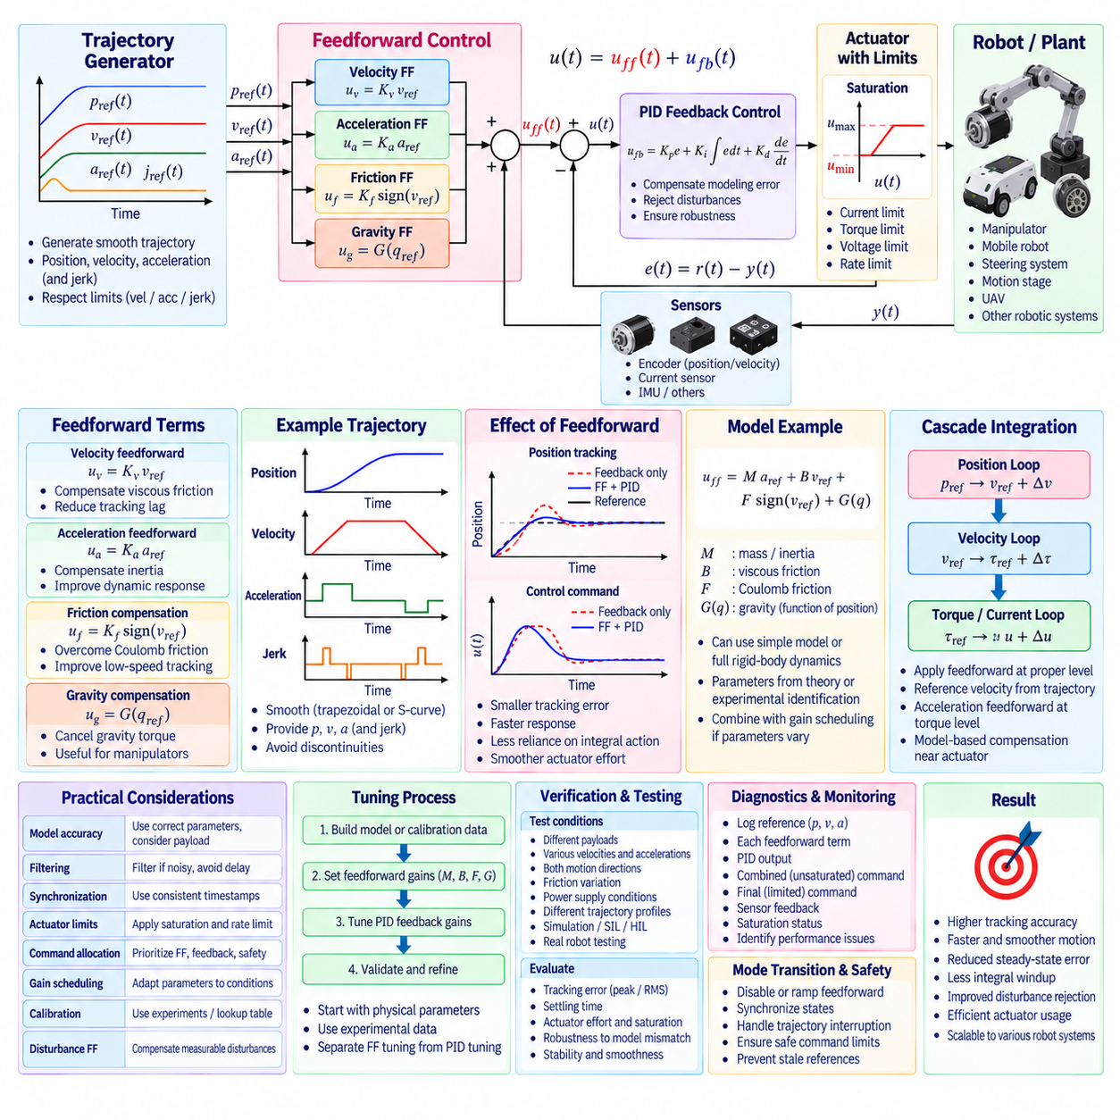
Feedforward control improves motion performance by generating part of the actuator command from the desired system behavior before a tracking error develops. Unlike feedback control, which reacts to the difference between reference and measured output, feedforward predicts the control effort required to follow a commanded trajectory. In robotic systems, combining feedforward with PID feedback can improve tracking accuracy, response speed, and disturbance recovery.
The fundamental structure separates the control command into feedforward and feedback components. The total command can be expressed as u(t)=uff(t)+ufb(t), where uff represents the predicted control effort and ufb represents the correction generated by the PID controller. The feedforward path handles known or predictable dynamics, while the feedback path compensates modeling errors, external disturbances, sensor uncertainty, and other effects that cannot be predicted accurately.
A simple example is velocity feedforward in a position-control system. When a trajectory generator provides both desired position and desired velocity, the desired velocity can contribute directly to the actuator or inner-loop reference instead of requiring position error to generate all motion. The feedback controller then corrects the remaining position deviation. This reduces tracking lag, particularly during continuous motion where relying entirely on proportional error would require persistent tracking error.
Acceleration feedforward extends this concept by compensating the inertial effort required to accelerate the mechanism. For a simplified mechanical system with equivalent mass or inertia M, the required force or torque contains a term proportional to desired acceleration. A feedforward command such as uff=Maff ades can therefore anticipate acceleration demand. This is especially valuable for high-performance manipulators, mobile robots, steering actuators, and motion stages following dynamic trajectories.
Velocity-dependent feedforward can compensate predictable viscous friction or damping. If the system contains a force approximately proportional to velocity, a term such as Bff vdes can be added to the command. Coulomb friction compensation may also provide a direction-dependent offset based on the sign of commanded motion. These terms reduce the amount of feedback error required to overcome mechanical resistance and can improve low-speed and steady-motion tracking.
Gravity compensation is an important feedforward function in robotic manipulators and other mechanisms operating against gravity. Joint torque required to maintain a configuration can be estimated from robot geometry, link masses, payload, and joint angles. Adding this predicted gravity torque to the actuator command allows the feedback controller to regulate deviations around the desired state instead of continuously generating large integral action simply to support static load.
For a mechanical axis, several feedforward terms can be combined into a model such as uff=Mff ades+Bff vdes+Fff sign(vdes)+G(qdes). The exact formulation depends on system physics and available trajectory information. More sophisticated robots may use full rigid-body dynamics including inertia matrices, Coriolis and centrifugal effects, gravity, friction, and known external loads to calculate nominal actuator forces or torques.
Feedforward accuracy depends directly on model quality. Incorrect mass, inertia, friction, motor constants, transmission ratios, payload estimates, or actuator characteristics can produce commands that are too large or too small. Feedforward should therefore not be treated as a replacement for feedback. A robust architecture allows the model to provide most of the predictable control effort while retaining sufficient feedback authority to correct uncertainty and changing operating conditions.
Trajectory generation is closely connected to feedforward control because useful feedforward signals often originate from trajectory derivatives. A motion planner may generate synchronized desired position, velocity, acceleration, and sometimes jerk. These signals can be delivered simultaneously to the control system. Smooth trajectories are particularly beneficial because discontinuous velocity or acceleration references can generate unrealistic feedforward commands and immediately drive actuators into saturation.
In a cascaded PID architecture, feedforward terms can be introduced at different levels. Desired trajectory velocity may be added to the velocity reference generated by the position controller, while desired acceleration may contribute to the torque reference generated by the velocity controller. Model-based torque compensation can be inserted near the actuator command. Each term should be applied at the layer corresponding to the physical quantity it represents.
This layered integration reduces unnecessary work by outer feedback loops. For example, a position controller can generate only the velocity correction required to eliminate position error while the trajectory generator supplies nominal desired velocity. The velocity controller can similarly generate corrective torque while acceleration feedforward supplies the nominal inertial torque. The resulting cascade structure separates planned motion from error correction and can improve both interpretability and tuning.
Reference feedforward and disturbance feedforward should be distinguished conceptually. Reference feedforward predicts the control effort required to execute a known command, while disturbance feedforward compensates a measurable disturbance before it significantly changes the controlled output. If payload force, road grade, aerodynamic load, or another disturbance can be measured or reliably estimated, an appropriate compensation term may be added directly to the actuator command.
Static calibration can provide simple feedforward models when complete physics-based modeling is unnecessary. Engineers can experimentally determine command values required to maintain different velocities, loads, or operating points and store these relationships as coefficients, lookup tables, or maps. Interpolation between calibrated points can then generate feedforward commands during operation. This approach is practical for systems with repeatable but difficult-to-model nonlinear characteristics.
Gain scheduling can be combined with feedforward when system parameters vary with operating condition. Different feedforward coefficients may be required for different payloads, battery voltages, joint configurations, vehicle speeds, temperatures, or transmission states. Scheduled parameters should change smoothly, and transitions should not create discontinuous commands. Parameter sets should remain traceable to the hardware configuration and calibration conditions from which they were derived.
Actuator constraints must be considered after feedforward and feedback contributions are combined. Even when each component appears reasonable independently, their sum may exceed current, torque, voltage, speed, or power limits. The final command should therefore pass through appropriate saturation and rate limiting. The feedback controller, particularly its integrator, must recognize the effective applied command so that additional feedforward does not indirectly create integral windup.
Command prioritization may become important when saturation occurs. In some architectures, feedforward represents nominal physical effort while feedback represents corrective authority required for stability and disturbance rejection. Simply clipping their sum can reduce available correction in an uncontrolled manner. Depending on the application, control software may explicitly allocate actuator authority among nominal feedforward, feedback correction, safety functions, and other command sources.
Filtering feedforward signals requires care because delay can reduce their predictive advantage. Desired velocity and acceleration generated directly by a smooth trajectory planner may not require the same filtering used for noisy measured signals. However, feedforward terms derived from estimated states, measured disturbances, or numerically differentiated references may contain noise. Filtering should suppress unwanted components without introducing enough delay to misalign the feedforward action with the physical motion.
Timing synchronization is especially important for feedforward integration. Desired position, velocity, acceleration, and model-based actuator commands should correspond to the same trajectory timestamp. If acceleration feedforward arrives later than the associated position command, the predictive action may become ineffective or even degrade tracking. Distributed robot controllers therefore require consistent timestamps, deterministic scheduling, bounded communication latency, and clearly defined update semantics.
Feedforward tuning should begin with physically meaningful parameters whenever possible. Motor torque constants, transmission ratios, equivalent inertia, vehicle mass, friction coefficients, and gravity models provide useful initial values. Experimental data can then refine these parameters by comparing predicted effort with actual actuator effort during representative motion. Calibration should distinguish errors in the feedforward model from deficiencies in PID feedback tuning.
Performance evaluation should compare feedback-only and feedforward-plus-feedback operation under identical trajectories. Useful metrics include peak and RMS tracking error, phase lag, settling behavior, actuator effort, integral contribution, saturation duration, and energy consumption. A successful feedforward implementation should normally reduce the correction demanded from feedback without causing excessive command peaks, oscillation, or sensitivity to model uncertainty.
Diagnostics should expose each command contribution separately. Logging desired position, velocity, acceleration, PID output, individual feedforward terms, combined unsaturated command, final constrained command, actuator feedback, and saturation state allows engineers to understand how control effort is generated. Without this visibility, an incorrect feedforward coefficient may be mistaken for poor PID tuning or an actuator problem.
Verification should cover nominal and mismatched model conditions. Tests should include different payloads, velocities, accelerations, directions of motion, friction levels, supply conditions, and trajectory profiles. Feedforward should improve nominal performance while the feedback system remains stable and capable when the model is inaccurate. Simulation, software-in-the-loop, hardware-in-the-loop, and physical robot testing can progressively verify this behavior.
Safety-related transitions must also account for feedforward state and command generation. When a trajectory is interrupted, control mode changes, or emergency behavior becomes active, stale velocity or acceleration feedforward must not remain applied. References and model states should be synchronized with the new operating mode, and feedforward contributions should be disabled, ramped, or reconstructed according to explicitly defined transition logic.
A well-integrated feedforward architecture complements rather than competes with PID feedback. The feedforward path predicts the actuator effort required for planned motion, while the feedback path corrects residual error and uncertainty. By combining trajectory-based velocity and acceleration terms, physical model compensation, constraint handling, synchronized execution, calibration, and diagnostics, robotic control software can achieve accurate and responsive motion with reduced dependence on tracking error.

02.07 State Space Control and LQR Design [w/Code]
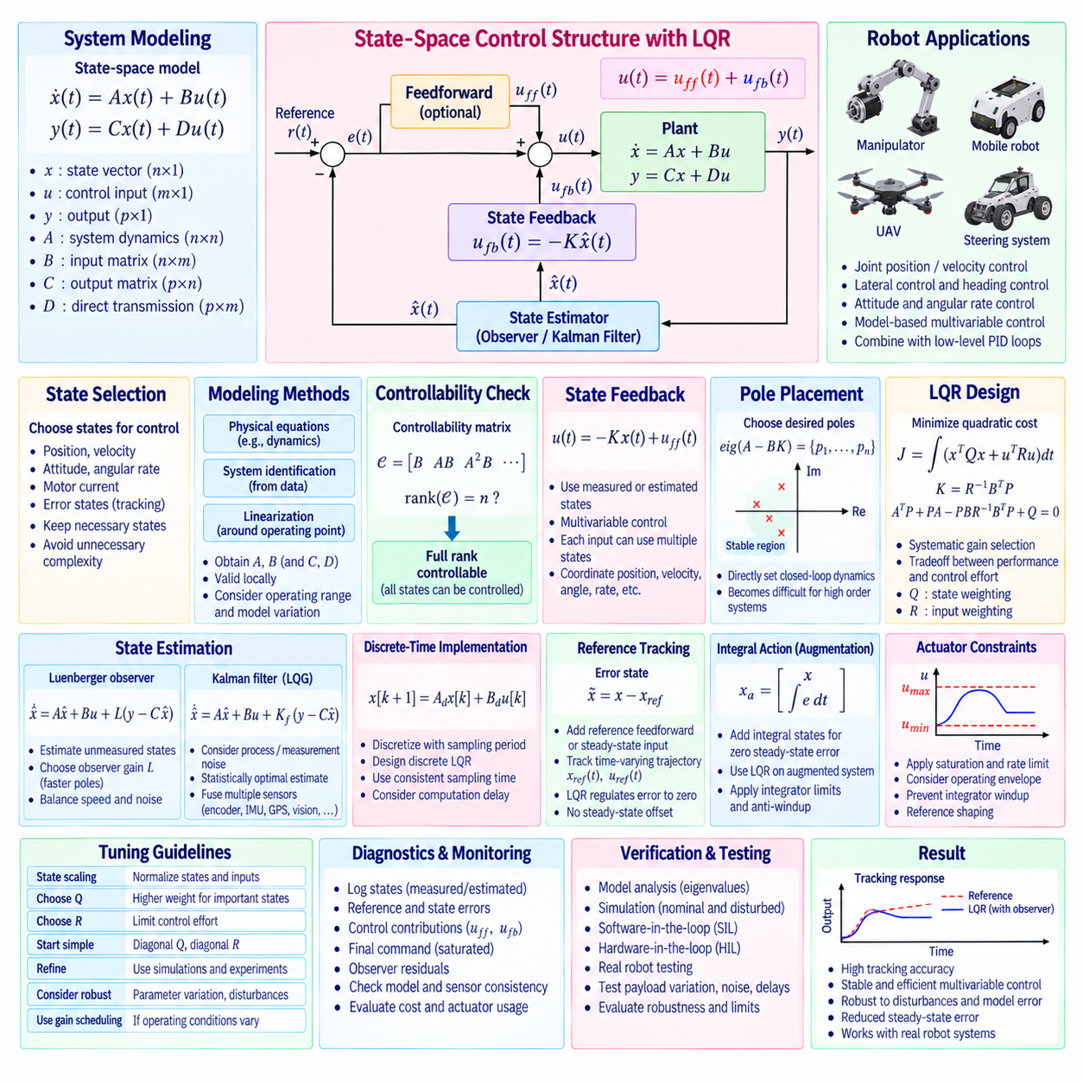
State-space control represents a dynamic system through a set of internal state variables rather than describing only the relationship between input and output. This approach is especially useful for robotic systems with multiple coupled variables, actuators, and sensors. Position, velocity, attitude, angular rate, motor current, or other physical quantities can be combined into a state vector, allowing the controller to consider the system dynamics as an integrated multivariable problem.
A continuous-time linear state-space model is commonly written as ẋ(t)=Ax(t)+Bu(t) and y(t)=Cx(t)+Du(t). The vector x contains the system states, u represents control inputs, and y represents measured or controlled outputs. Matrix A describes internal system dynamics, B describes how actuators influence the states, C maps states to outputs, and D represents any direct relationship between input and output.
The choice of state variables is important because they should capture the dynamics required for control. For a mobile robot, states may include lateral position error, heading error, lateral velocity, and yaw rate. A manipulator model may include joint positions and velocities, while a UAV model can include position, velocity, attitude, and angular rates. The selected states should provide a meaningful mathematical representation without introducing unnecessary model complexity.
State-space models can be derived from physical equations, system identification, or a combination of both. Nonlinear robot dynamics are often expressed first using equations of motion and then linearized around a selected operating point or trajectory. The resulting linear model provides matrices A and B suitable for controller design. Because linearization is locally valid, operating range and model variation must be considered when applying the controller to the actual robot.
Controllability determines whether the available actuators can move the system states as required. For a linear system, the controllability matrix is formed from B, AB, A²B, and subsequent terms. Full rank indicates that all modeled states can theoretically be controlled through the available inputs. Checking controllability before designing state feedback prevents attempts to regulate dynamic modes that the actuator configuration cannot influence.
State feedback uses the estimated or measured state vector directly to calculate the control command. A common form is u(t)=−Kx(t)+uff(t), where K is the feedback gain matrix and uff may contain reference or feedforward terms. Unlike independent PID loops, state feedback can coordinate several state variables simultaneously. Each actuator command may therefore respond to combinations of position, velocity, angle, rate, and other dynamic states.
Pole placement is one method for selecting the state-feedback gain K. The designer specifies desired closed-loop pole locations according to stability and transient-response requirements, and K is calculated so that the eigenvalues of A−BK match those targets. This gives direct control over theoretical closed-loop dynamics, but selecting suitable poles becomes more difficult as system dimension increases and interactions among states become more complex.
Linear Quadratic Regulator, or LQR, provides a systematic alternative for selecting the state-feedback gain. Instead of manually assigning every closed-loop pole, LQR defines a performance objective that balances state regulation against control effort. For the continuous-time case, the cost is commonly written J=∫(xᵀQx+uᵀRu)dt. The controller seeks a feedback law that minimizes this quadratic cost while satisfying the modeled system dynamics.
The weighting matrix Q determines how strongly deviations in individual states are penalized. Large weights can be assigned to states whose errors are particularly undesirable, such as position deviation, body angle, heading error, or velocity error. Off-diagonal terms can represent relationships between states, although diagonal Q matrices are frequently used as an understandable starting point. State scaling should be considered because different states may use very different physical units.
The weighting matrix R penalizes control effort. Increasing R generally produces less aggressive actuator commands, while decreasing R allows stronger control action to reduce state errors more rapidly. The selection of Q and R therefore represents an engineering tradeoff among tracking performance, actuator capability, energy consumption, smoothness, and robustness. They are design parameters rather than direct physical gains comparable to PID coefficients.
For continuous-time LQR, the optimal gain is obtained from the continuous algebraic Riccati equation. After solving for the matrix P, the feedback gain can be calculated as K=R⁻¹BᵀP. The resulting closed-loop system is described by ẋ=(A−BK)x when no external reference is present. Numerical control libraries normally solve the Riccati equation directly, allowing engineers to focus on modeling, weighting selection, and validation.
Digital robot controllers require a discrete-time model such as x[k+1]=Ad x[k]+Bd u[k]. The continuous model can be discretized according to the actual sampling period, or a discrete model can be identified directly from data. Discrete LQR then minimizes a corresponding sampled-data cost and solves a discrete algebraic Riccati equation. Controller design must use a sampling period consistent with the deployed real-time implementation.
Reference tracking requires additional design because basic LQR naturally regulates states toward zero. Desired operating states can be introduced by defining an error state x̃=x−xref and applying feedback to that error. Reference feedforward or steady-state input terms may also be calculated so that the system reaches a nonzero target without persistent offset. For trajectory tracking, xref and the nominal control input can vary continuously with time.
Integral action can be incorporated by augmenting the state-space model with integrated output or tracking errors. This creates an augmented state vector containing both physical states and integral states. LQR applied to this augmented system can provide zero steady-state error against constant disturbances or model mismatch. However, integral-state limits and anti-windup remain necessary when actuators saturate, just as they are in conventional PID control.
Not every required state can be measured directly. Position may be available from an encoder while velocity must be estimated, or a robot may measure acceleration and angular rate while other dynamic states remain hidden. A state observer estimates unavailable states using the model, known actuator inputs, and measured outputs. The estimated state x̂ can then replace the complete measured state in the feedback law.
A Luenberger observer is a deterministic state estimator commonly expressed as x̂̇=Ax̂+Bu+L(y−Ĉy), where the innovation term corrects model prediction using measurement error. The observer gain L determines estimation dynamics. Observer poles are generally selected faster than the dominant controller dynamics, but excessively fast estimation can amplify measurement noise. Observer bandwidth therefore requires the same practical balance between responsiveness and noise sensitivity found elsewhere in control design.
Kalman filtering extends state estimation by explicitly considering process uncertainty and measurement noise. A Kalman filter combines model prediction with sensor measurements according to covariance assumptions and produces statistically weighted state estimates. In robotics, this framework can combine encoder, IMU, GNSS, vision, or other sensor information. LQR combined with a Kalman estimator forms the classical Linear Quadratic Gaussian, or LQG, control architecture.
Actuator constraints are not inherently represented by basic LQR. The optimal mathematical command may exceed available current, torque, steering angle, motor voltage, or command-rate limits. Practical implementations therefore apply saturation and rate constraints after computing state feedback. Persistent saturation can invalidate the behavior predicted by the unconstrained linear design, so operating envelopes, command limits, reference shaping, and anti-windup for augmented integral states must be considered.
Model accuracy strongly influences state-space control performance. Errors in mass, inertia, tire characteristics, payload, actuator gain, friction, center of gravity, or time delay change the actual dynamics relative to matrices A and B. Robustness should therefore be evaluated through parameter variation and disturbance testing. Gain scheduling or multiple linear models may be used when the robot operates across conditions that cannot be represented adequately by one fixed linearization.
State and input normalization can make LQR tuning more intuitive. One practical approach is to define acceptable maximum deviations for each state and input and scale Q and R according to those ranges. This prevents variables with large numerical magnitudes from dominating the cost merely because of their units. After an initial design, weights can be refined by examining transient response, control effort, stability margins, and actuator utilization.
State-space control can coexist with conventional cascade PID structures. An LQR controller may operate as a vehicle-level lateral controller while low-level steering-angle and motor-current loops remain PID controlled. A manipulator may use model-based state feedback to generate torque references while embedded drives regulate motor current. This layered architecture allows advanced multivariable control to use proven high-bandwidth actuator controllers.
Real-time implementation requires deterministic state acquisition, estimation, matrix computation, and actuator output. State values should correspond to consistent timestamps, especially when measurements arrive from sensors operating at different rates. Computational delay effectively changes the controlled dynamics and can reduce stability margin. Matrix dimensions, numerical precision, memory allocation, and worst-case execution time should therefore be evaluated for the target processor.
Diagnostics should expose the state vector, estimated states, reference states, state errors, control contributions, actuator commands, saturation status, and observer residuals. Comparing measured and estimated quantities helps identify modeling or sensor problems. Recording the cost-related states and control effort also provides insight into whether LQR behavior matches the intended Q and R priorities under real operating conditions.
Verification should begin with the mathematical model and progress through simulation, software-in-the-loop, hardware-in-the-loop, and physical robot testing. Tests should include initial-state disturbances, reference changes, sensor noise, actuator saturation, model mismatch, payload variation, delays, and external disturbances. Eigenvalue analysis and time-domain responses should be complemented by practical robustness and actuator-limit evaluation.
A well-designed state-space and LQR controller provides a unified framework for controlling coupled robotic dynamics. State feedback coordinates multiple variables, LQR converts performance priorities into an optimal gain matrix, and observers provide states that cannot be directly measured. When combined with realistic models, reference tracking, constraint handling, deterministic execution, estimation, and systematic verification, the approach supports stable and efficient multivariable robot control.

02.08 Model Predictive Control (MPC) Introduction [w/Code]
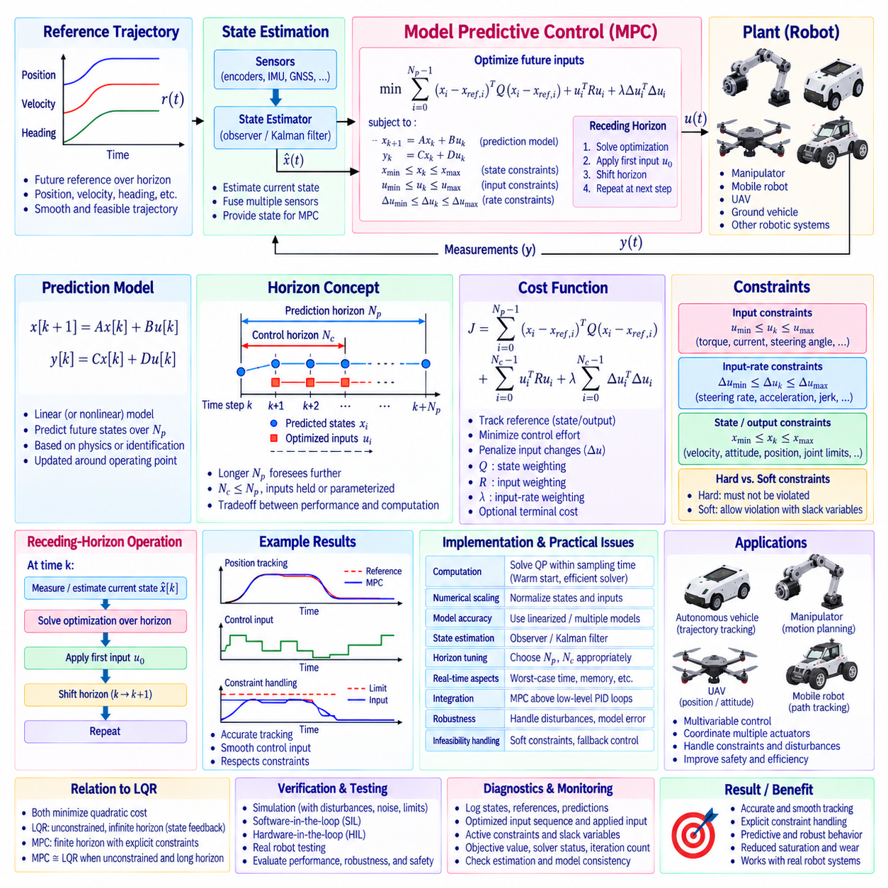
Model Predictive Control, or MPC, is an optimization-based control method that predicts future system behavior over a finite time horizon and selects control inputs that best satisfy defined objectives and constraints. Unlike a controller that reacts only to the current error, MPC evaluates how present control decisions influence future states. This predictive capability is valuable for robots that must coordinate multiple dynamic variables while respecting physical limits.
The fundamental MPC process uses a mathematical model of the controlled system to predict a sequence of future states. At every control cycle, the controller measures or estimates the current state, predicts system evolution across a prediction horizon, and solves an optimization problem for a sequence of future control inputs. Only the first optimized command is applied, after which the entire calculation is repeated using newly available state information.
This repeated procedure is called the receding-horizon principle. If the optimized input sequence is {u0,u1,…,uN−1}, MPC applies only u0 to the plant. At the next sampling instant, updated measurements are incorporated and a new optimization problem is solved. Re-optimization continuously compensates for disturbances, modeling errors, and changing conditions while retaining the ability to anticipate future behavior.
A linear discrete-time prediction model can be written as x[k+1]=Ax[k]+Bu[k], with y[k]=Cx[k]+Du[k] when an output equation is required. Starting from the current state x[k], this model predicts future states according to candidate control inputs. The same state-space modeling principles used for state feedback and LQR therefore provide an important foundation for understanding linear MPC.
The prediction horizon Np determines how far into the future the controller evaluates system behavior. A longer horizon allows MPC to anticipate events and constraints farther ahead, but it increases computational effort. A horizon that is too short may produce shortsighted control decisions, while an unnecessarily long horizon can increase solver time without significant performance improvement. Horizon selection should reflect dominant system dynamics and available computation.
A control horizon Nc may also define how many future control moves are independently optimized. Beyond this horizon, inputs may be held constant or parameterized according to the chosen formulation. Using a shorter control horizon can reduce the number of optimization variables and improve real-time computational efficiency. Prediction and control horizons therefore provide important design parameters for balancing performance and computational cost.
The MPC objective is typically represented by a cost function that penalizes predicted tracking error and control effort. A simplified quadratic objective may contain terms such as Σ(xi−xref,i)ᵀQ(xi−xref,i)+ΣuiᵀRui. The matrix Q determines the relative importance of state or tracking errors, while R penalizes actuator usage. Additional terms can penalize input changes, terminal-state error, energy consumption, or other application-specific objectives.
Penalizing changes in control input is particularly useful for robotic actuators. A term based on Δu can discourage abrupt command variations, producing smoother steering, torque, velocity, or acceleration commands. This can reduce mechanical shock, tire slip, drivetrain stress, and unnecessary energy consumption. The relative weights among tracking error, control magnitude, and control-rate variation determine how aggressively the optimizer follows the desired trajectory.
Explicit constraint handling is one of the major advantages of MPC. Input constraints can represent motor current, torque, steering angle, voltage, thrust, or braking limits. Input-rate constraints can restrict steering rate, torque change, acceleration, or jerk. State and output constraints can represent velocity limits, allowable attitude, lateral deviation, joint boundaries, obstacle-related regions, or other physical and operational restrictions.
Constraints may be classified as hard or soft. Hard constraints must never be violated within the mathematical optimization problem, while soft constraints permit limited violation by introducing slack variables and corresponding penalties. Soft constraints are useful when strict enforcement could make the optimization problem infeasible. Safety-critical limits, however, require careful architectural treatment and should not rely solely on arbitrary optimization penalties.
At each control cycle, the prediction model, objective function, initial state, reference trajectory, and constraints are assembled into an optimization problem. Linear MPC with quadratic objectives and linear constraints is commonly formulated as a quadratic programming problem. A numerical solver computes the control sequence that minimizes the objective while satisfying the specified constraints. Real-time feasibility depends heavily on problem dimension and solver efficiency.
Reference trajectories can contain future position, velocity, heading, attitude, or other desired states across the horizon. Because MPC sees these future references before they occur, it can begin adjusting the system in advance. A mobile robot approaching a curve can prepare steering before reaching the highest curvature, while a manipulator can coordinate joint motion before a demanding trajectory segment. This preview behavior distinguishes MPC from purely reactive control.
MPC naturally supports multivariable systems because one optimization problem can coordinate multiple states and actuator inputs simultaneously. For a ground vehicle, steering and longitudinal acceleration may be considered together with lateral position, heading, yaw rate, and velocity. For a UAV, thrust and attitude-related inputs can be coordinated with position and velocity states. Coupling between variables is represented directly through the prediction model.
State estimation remains important because MPC requires an initial state for every optimization cycle. Direct sensor measurements may be combined with observers, Kalman filters, or other estimation methods to produce the current state estimate. Prediction quality depends on both model accuracy and state-estimation accuracy. Sensor latency, asynchronous measurements, estimation delay, and timestamp inconsistency can degrade the quality of the predicted trajectory.
Linear MPC is often designed around a linearized model valid near a selected operating condition. When robot dynamics vary substantially with speed, payload, configuration, or operating region, multiple models or gain-scheduled MPC formulations may be used. Successive linearization can update the model around the current trajectory. More advanced nonlinear MPC directly uses nonlinear dynamics but generally requires substantially greater computational effort.
MPC has a close conceptual relationship with LQR. Both approaches can minimize quadratic costs based on state deviation and control effort. LQR produces a state-feedback gain for an unconstrained linear system, whereas MPC repeatedly solves a finite-horizon optimization problem and can explicitly incorporate constraints. Under particular unconstrained conditions and sufficiently long horizons, MPC behavior can approach that of corresponding optimal linear state feedback.
Actuator saturation is handled more systematically in MPC than in unconstrained state feedback because actuator limits can be included directly inside the optimization problem. The controller can anticipate that a future command would exceed a limit and modify earlier actions accordingly. This predictive constraint management can reduce the repeated saturation and recovery behavior that occurs when limits are applied only after an unconstrained controller has generated its command.
Constraint feasibility must nevertheless be managed carefully. Disturbances, model mismatch, or an unrealistic reference may create a condition in which no control sequence satisfies all constraints. Constraint prioritization, soft constraints, terminal conditions, reference governors, or fallback control strategies can be used to maintain operation. The controller should detect solver infeasibility explicitly rather than treating a missing optimization solution as an ordinary command.
Real-time computation is one of the primary engineering challenges of MPC. The complete optimization must finish within the control period with sufficient timing margin. Solver execution time can vary according to active constraints and numerical conditioning, so average computation time alone is insufficient. Worst-case execution time, iteration limits, processor loading, memory behavior, and solver termination status should be monitored during implementation.
Warm starting can improve computational efficiency by initializing the new optimization with information from the previous solution. Since consecutive control problems are often similar, the prior optimal trajectory provides a useful initial estimate. Sparse matrix methods, precomputed model structures, reduced horizons, efficient quadratic-programming solvers, and carefully selected numerical scaling can further reduce execution time for embedded robotic applications.
Numerical scaling is important when states and inputs have very different magnitudes or units. Position may be measured in meters, heading in radians, velocity in meters per second, and actuator effort in amperes or newton-meters. Poor scaling can make the optimization numerically difficult and slow convergence. Normalization based on expected operating ranges helps produce meaningful weighting matrices and improves solver conditioning.
MPC can operate above conventional low-level control loops. A vehicle-level MPC may calculate steering-angle and acceleration references while embedded PID controllers regulate steering motors and wheel torque. A manipulator MPC may generate joint torque or velocity references while inner motor drives regulate current. This hierarchical arrangement keeps high-frequency actuator regulation separate from computationally heavier predictive optimization.
Diagnostics should record the estimated state, reference trajectory, predicted state trajectory, optimized input sequence, applied first command, active constraints, slack variables, objective value, solver status, iteration count, and execution time. These signals reveal why the optimizer selected a particular action. They are especially useful for distinguishing poor model prediction, restrictive constraints, incorrect weights, state-estimation errors, and solver-performance problems.
Verification should begin with deterministic simulations in which model behavior and constraints can be inspected directly. Testing should then introduce disturbances, sensor noise, model mismatch, payload changes, actuator limits, reference discontinuities, communication delay, and computational load. Software-in-the-loop and hardware-in-the-loop environments can verify solver integration and timing before the controller is enabled on physical robotic hardware.
A production controller also requires a defined response to solver failure or timing overrun. The system may hold a previously validated command briefly, switch to a simpler backup controller, command a controlled stop, or enter another safe operating mode according to application requirements. Solver health should therefore be integrated with supervisory control and diagnostics rather than assuming that optimization always returns a valid solution.
Model Predictive Control extends state-space control by combining prediction, optimization, multivariable coordination, and explicit constraint handling within a repeating real-time process. Its principal strength is the ability to evaluate future consequences before applying the current command. With an appropriate model, carefully selected horizons and weights, efficient optimization, reliable estimation, constraint management, and fallback behavior, MPC provides a powerful framework for advanced robotic motion control.

02.09 Adaptive Control and Self-Tuning
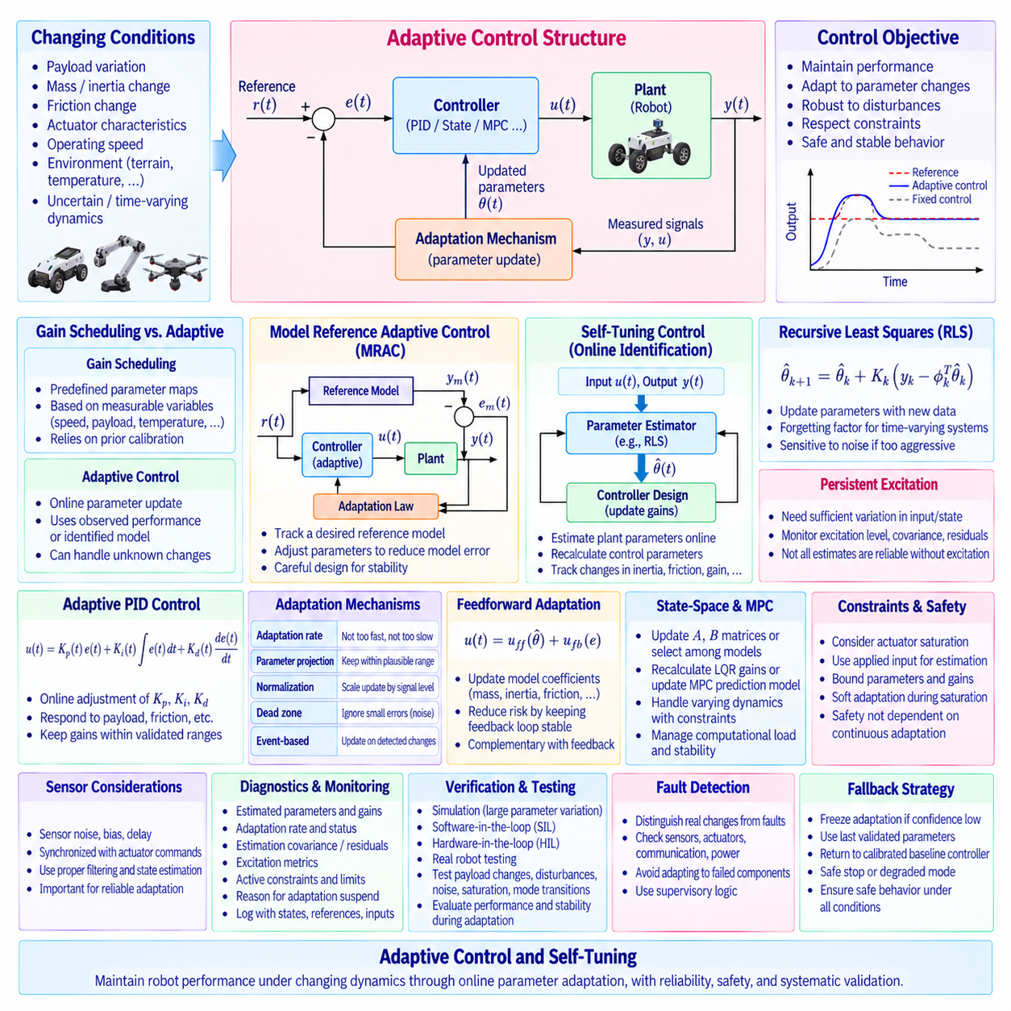
Adaptive control extends conventional feedback control by allowing controller parameters or internal models to change automatically as the controlled system changes. A fixed controller is designed for an assumed range of dynamics, while an adaptive controller attempts to maintain acceptable performance when mass, payload, friction, actuator characteristics, operating speed, or environmental conditions vary. This capability is particularly valuable for robots whose dynamics cannot be represented accurately by one fixed parameter set.
The basic adaptive-control architecture contains a plant, a feedback controller, measured signals, and an adaptation mechanism. The controller generates the actuator command using parameters such as gains or model coefficients, while the adaptation mechanism observes system behavior and updates those parameters. Adaptation therefore operates at a supervisory level around the ordinary control loop, modifying how the controller behaves without eliminating the fundamental feedback structure.
Adaptive control should be distinguished from simple gain scheduling. Gain scheduling selects controller parameters from predefined maps according to measurable operating variables such as speed, payload, temperature, or configuration. Adaptive control instead modifies parameters online using observed control performance or identified system behavior. Gain scheduling relies primarily on prior calibration, whereas adaptation can respond to changes that were not completely characterized during development.
One important architecture is model reference adaptive control, or MRAC. A reference model defines the desired dynamic response, and the actual plant output is compared with the response of that model. The difference generates an adaptation signal that adjusts controller parameters so that the plant increasingly behaves like the reference model. The adaptation law must be designed carefully because aggressive parameter updates can destabilize the closed-loop system.
Another major approach is self-tuning control based on online system identification. The controller estimates plant parameters from measured inputs and outputs and then recalculates control parameters according to the updated model. This structure separates estimation and control design conceptually. Recursive identification can track changes in inertia, damping, actuator gain, or other parameters, while the controller uses the identified model to update PID gains, state-feedback gains, or related control coefficients.
Recursive Least Squares, or RLS, is a common technique for online parameter estimation. Instead of identifying a complete model from a fixed batch of data, RLS updates parameter estimates whenever new measurements become available. A forgetting factor can give greater importance to recent data so that the estimator follows slowly changing system characteristics. However, excessive forgetting can make parameter estimates sensitive to noise and temporary disturbances.
Persistent excitation is important for reliable online identification. If the robot operates for long periods with little variation in command or state, measured data may not contain enough information to distinguish unknown model parameters. An adaptive controller should not assume that every parameter estimate is trustworthy simply because an estimator produces a numerical value. Excitation level, covariance, residuals, and parameter confidence should therefore be monitored.
Adaptive PID control is a practical form of self-tuning control. Instead of using fixed Kp, Ki, and Kd values, the system adjusts these gains according to identified dynamics or observed performance. For example, increased payload may require different proportional and integral behavior, while changes in friction may alter the gain required for accurate low-speed motion. Adaptation should remain bounded within validated gain ranges to prevent unsafe controller configurations.
The adaptation rate determines how quickly controller parameters respond to changing conditions. Slow adaptation may fail to compensate rapid system variation, while excessively fast adaptation can interpret measurement noise or temporary disturbances as permanent changes in plant dynamics. Adaptation dynamics are therefore normally designed slower than the primary feedback loop so that controller updates do not interfere directly with fast closed-loop stabilization.
Parameter projection and bounding are important safety mechanisms. Estimated physical parameters can be restricted to plausible ranges, and adaptive controller gains can be constrained to previously validated regions. If an estimator attempts to produce negative mass, unrealistic actuator gain, or extreme PID coefficients, projection logic can prevent the value from entering the controller. Such constraints provide practical protection against numerical errors, sensor faults, and poor excitation.
Normalization can improve adaptation when signal magnitudes vary significantly. An adaptation law driven directly by large errors or regressors may produce excessive parameter changes, while very small signals may result in ineffective updates. Normalized adaptation scales the update according to available signal energy or regressor magnitude. This helps maintain more consistent adaptation behavior across different velocities, payloads, trajectories, and operating conditions.
Dead zones can prevent adaptation from reacting continuously to small measurement noise. When tracking error or estimation residual remains below a selected threshold, parameter updates may be suspended. Adaptation resumes when the error becomes large enough to indicate meaningful model mismatch. The threshold should reflect sensor noise and expected disturbances because an excessively large dead zone can prevent the controller from adapting to legitimate changes.
Adaptation can also be triggered by events rather than executed continuously. A robot may update parameters after detecting a payload change, tool replacement, battery condition change, terrain transition, or significant performance degradation. Event-based adaptation reduces unnecessary parameter movement during stable operation. It also allows control software to associate each parameter update with a recognizable change in operating condition, improving diagnostics and traceability.
Self-tuning control can operate at different levels of a cascade architecture. An inner current loop may remain fixed because its electrical dynamics are predictable and safety critical, while velocity or position gains adapt to mechanical load changes. Alternatively, estimated inertia or friction can update feedforward terms without modifying stabilizing feedback gains. Selecting which parameters are allowed to adapt is often more important than maximizing the number of adaptive variables.
Feedforward compensation and adaptive control are naturally complementary. Online estimates of mass, inertia, friction, gravity load, or actuator gain can update feedforward model coefficients while fixed feedback loops maintain stability. This architecture reduces the risk associated with continuously modifying stabilizing gains. The adaptive mechanism improves prediction of required control effort, and the feedback controller compensates the remaining estimation errors and disturbances.
State-space controllers can also use adaptive models. Estimated A and B matrices may be updated as operating conditions change, followed by recalculation of state-feedback or LQR gains. However, repeatedly redesigning a multivariable controller online introduces computational and stability concerns. Practical implementations may instead select among validated models, update only specific physical parameters, or perform controller redesign at a slower supervisory rate.
Adaptive concepts can be integrated with MPC by updating the prediction model from online identification. Adaptive MPC can compensate for changes in vehicle mass, tire behavior, actuator response, or payload while preserving explicit constraint handling. Because inaccurate model updates can directly alter predicted trajectories, adaptation must be bounded and validated. Solver feasibility and computational timing must remain acceptable while model parameters are changing.
Sensor quality has a strong influence on adaptation because parameter updates are derived from measured behavior. Bias, noise, delay, timestamp errors, or unmodeled filtering can be interpreted incorrectly as changes in physical dynamics. An adaptive system therefore requires reliable signal conditioning and state estimation. Parameter estimation should use signals that are synchronized with actuator commands and represent the actual physical response with known latency.
Actuator saturation can corrupt adaptation if it is not explicitly recognized. When the commanded control input differs from the applied input because of current, torque, voltage, or rate limits, an estimator using the unconstrained command may infer incorrect plant parameters. Adaptive algorithms should use the actual applied command whenever possible and monitor saturation status. Parameter updates may also be suspended during severe saturation or safety intervention.
Mode transitions require explicit management of adaptive states. Parameters learned during one operating mode may not be appropriate after switching from autonomous to manual control, changing tools, modifying payload, or entering a degraded state. Software should define whether adaptive parameters are retained, reset, blended, or replaced by calibrated defaults. Bumpless parameter transitions help prevent abrupt changes in actuator commands when adaptation modes change.
Adaptive control introduces additional diagnostics beyond conventional feedback signals. Useful information includes current parameter estimates, controller gains, adaptation rate, estimator covariance, identification residuals, excitation metrics, parameter limits, update enable status, and reasons for adaptation suspension. Logging these signals together with references, states, errors, and actuator commands makes adaptive behavior explainable during development and field operation.
Fault detection should distinguish genuine plant variation from sensor or actuator failures. A sudden apparent change in motor gain may actually result from a damaged sensor, communication problem, mechanical obstruction, or power limitation. Blindly adapting to such faults can hide the underlying problem and potentially degrade safety. Supervisory logic should therefore evaluate fault indicators before allowing large or persistent adaptive parameter changes.
Verification must examine both control performance and parameter evolution. Tests should include nominal operation, payload changes, friction variation, actuator aging, battery-voltage changes, sensor noise, disturbances, poor excitation, saturation, and abrupt operating transitions. The controller should remain stable not only after adaptation converges but also throughout the transient period while parameters are being updated.
Simulation provides an effective environment for exploring large parameter variations and deliberately incorrect initial estimates. Software-in-the-loop testing can verify estimator equations, adaptation logic, parameter limits, and update timing. Hardware-in-the-loop testing can introduce realistic sensor noise, actuator interfaces, and timing behavior. Physical robot testing then confirms whether the adaptation responds to real mechanical variation without excessive parameter drift or unstable transients.
A production adaptive controller should always have a defined fallback strategy. If estimation confidence becomes poor, parameters reach suspicious limits, excitation disappears, or adaptive performance degrades, the system can freeze adaptation and continue with the last validated parameters or return to a calibrated baseline controller. Safety should not depend on an estimator continuously producing accurate parameters under every possible operating condition.
Adaptive control and self-tuning provide a framework for maintaining robotic control performance as system dynamics evolve. Their value comes from combining stable feedback control with controlled online learning of model parameters, gains, or feedforward coefficients. Bounded adaptation, reliable identification, appropriate excitation, saturation awareness, diagnostics, fallback behavior, and systematic validation are essential for converting adaptive-control theory into dependable real-time robot software.

02.10 Sliding Mode Control (SMC) Robot Application [w/Code]
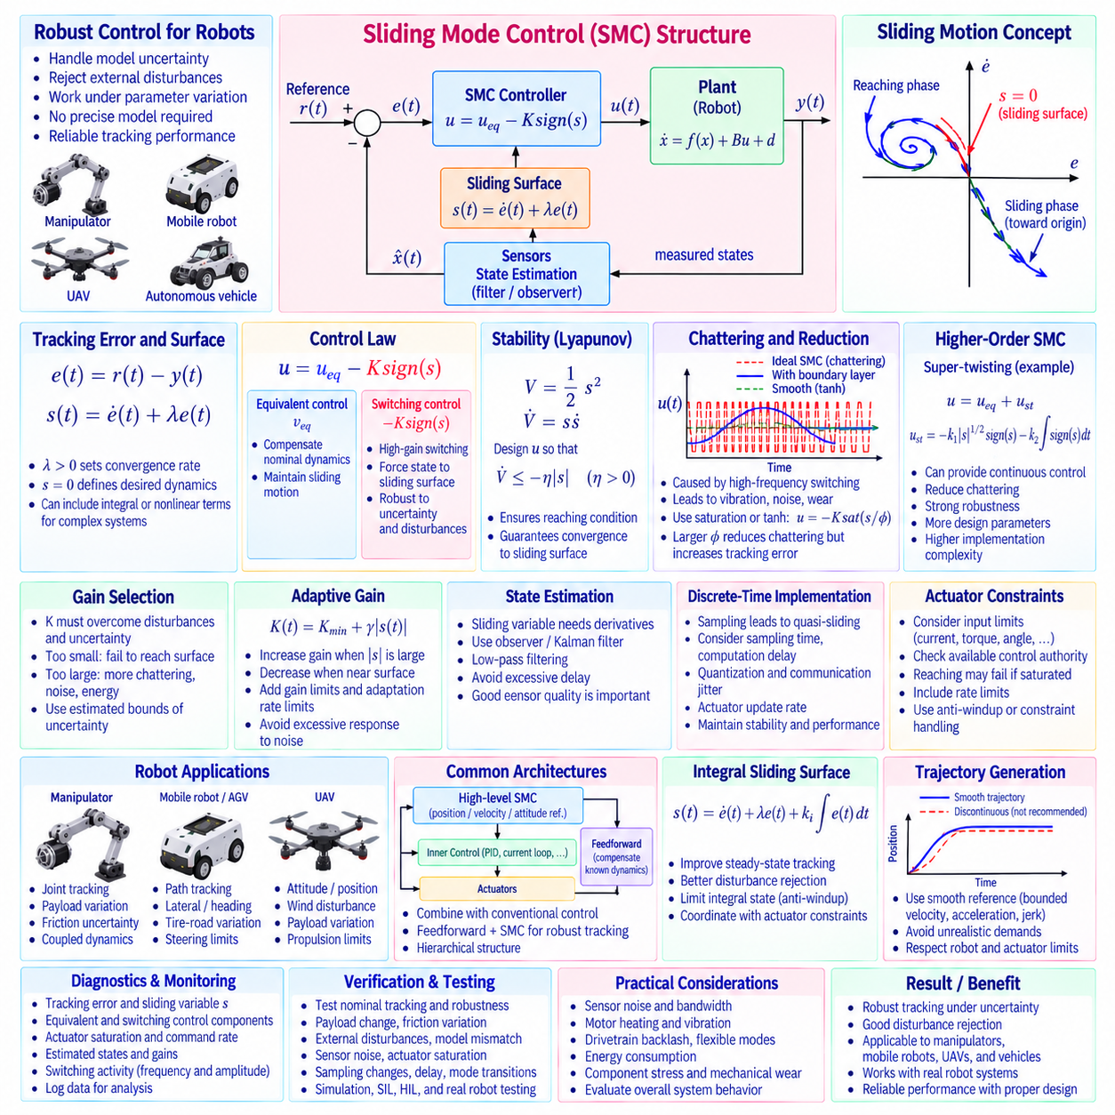
Sliding Mode Control, or SMC, is a nonlinear control method designed to maintain robust system behavior despite modeling uncertainty and external disturbances. Instead of relying only on an accurate nominal plant model, SMC defines a desired dynamic condition called a sliding surface and drives the system state toward that surface. Once the trajectory reaches it, the closed-loop dynamics are governed primarily by the designed sliding behavior rather than by uncertain plant parameters.
The basic SMC design begins by defining a tracking error between the desired and measured states. For a position-control problem, the error may be written as e(t)=r(t)−y(t). A common first-order sliding variable is s(t)=ė(t)+λe(t), where λ>0 determines the desired error convergence behavior. The control objective is divided conceptually into two phases: reaching the surface s=0 and maintaining motion along that surface toward the desired equilibrium.
When the system reaches the sliding surface, the relation s=0 imposes ė+λe=0. This equation produces exponentially decreasing tracking error for an appropriately selected positive λ. The sliding surface therefore converts the original control objective into a lower-dimensional dynamic condition. More complex surfaces can include additional state errors, integral terms, nonlinear functions, or coupled variables depending on the order and structure of the robotic system.
A conventional SMC law generally contains an equivalent-control component and a switching-control component. The equivalent term compensates the nominal system dynamics and maintains motion near the sliding surface, while the switching term forces the state toward the surface despite bounded uncertainty. A simplified structure can be expressed as u=ueq−K sign(s), where K is selected sufficiently large to overcome expected disturbances and modeling errors.
The sign function produces a discontinuous control action that changes according to which side of the sliding surface the system occupies. This high-gain switching mechanism is the source of SMC robustness because it strongly opposes deviations from the desired sliding condition. If uncertainty and disturbance bounds are known, the switching gain can be selected so that the reaching condition is satisfied and the system trajectory moves consistently toward the surface.
Stability analysis is commonly performed using a Lyapunov function such as V=1/2 s². Its derivative is V̇=sṡ, and the controller is designed so that V̇ remains negative whenever s≠0. A reaching condition such as sṡ≤−η|s|, with η>0, ensures that the trajectory approaches the sliding surface. This Lyapunov-based formulation provides a systematic way to connect controller design parameters with closed-loop stability requirements.
A major practical limitation of ideal SMC is chattering, which is rapid switching of the control command around the sliding surface. Real actuators cannot switch infinitely fast, and high-frequency commands can excite structural resonance, increase motor heating, produce acoustic noise, accelerate mechanical wear, and interact poorly with sampled digital control. Chattering reduction is therefore a central requirement when SMC is implemented on physical robots.
One common method replaces the discontinuous sign function with a continuous saturation function inside a boundary layer. The switching term can be written as −K sat(s/ϕ), where ϕ defines the boundary-layer thickness. Outside the boundary layer the controller behaves similarly to conventional SMC, while near the sliding surface the command changes smoothly. Increasing ϕ reduces chattering but generally introduces greater residual tracking error.
Smooth approximations such as hyperbolic tangent functions can also replace the ideal switching function. A term such as tanh(s/ϕ) provides continuous control near the sliding surface and is convenient for digital implementation. However, smoothing changes the ideal invariance properties of sliding-mode theory. The design must therefore balance robustness, tracking accuracy, actuator bandwidth, measurement noise, and acceptable command activity.
Higher-order sliding-mode methods provide another approach to reducing chattering while preserving strong robustness properties. The super-twisting algorithm is a widely known second-order technique that can generate a continuous control signal under appropriate assumptions while driving both the sliding variable and its dynamics toward the desired condition. Such methods can improve practical behavior but introduce additional design parameters and implementation complexity.
Switching-gain selection is critical. A gain that is too small may fail to overcome disturbances and parameter uncertainty, preventing reliable convergence to the sliding surface. A gain that is unnecessarily large increases chattering, actuator effort, noise sensitivity, and energy consumption. Robust design therefore requires realistic estimates of uncertainty and disturbance bounds rather than simply choosing the largest available switching gain.
Adaptive switching gains can reduce this tradeoff when disturbance bounds are unknown or vary during operation. The gain may increase when the system moves away from the sliding surface and decrease when the tracking condition becomes stable. Such adaptation can reduce excessive control activity while preserving robustness. Gain limits and adaptation-rate limits should be included so that temporary sensor noise or abnormal conditions do not generate extreme switching gains.
Measurement quality strongly influences SMC because the sliding variable often contains state derivatives or combinations of rapidly changing signals. Direct numerical differentiation of noisy position measurements can create severe switching activity. Velocity observers, Kalman filters, low-pass filtering, or other state-estimation methods may therefore be required. Filtering must be designed carefully because excessive phase delay can degrade the reaching behavior and closed-loop stability.
Discrete-time implementation introduces additional considerations because a digital controller updates commands only at sampling instants. The ideal continuous sliding motion becomes a finite neighborhood around the surface, sometimes described as quasi-sliding behavior. Sampling time, computation delay, quantization, communication jitter, and actuator update rate determine how closely the physical implementation approximates the theoretical sliding condition.
Actuator limits must be incorporated into practical SMC design. Motor current, torque, steering angle, hydraulic pressure, thrust, voltage, and command-rate limits can prevent the requested switching action from being realized. If the control law demands more authority than the actuator can provide, the reaching condition may no longer hold. Controller design should therefore compare required robust control authority with physically available actuator capability.
SMC is particularly useful for robotic systems affected by substantial parameter variation. A manipulator may experience changing payload and uncertain joint friction, while a mobile robot may encounter changes in tire-ground interaction, slope, and vehicle mass. UAV dynamics can vary with payload, wind, and aerodynamic uncertainty. In these systems, sliding-mode techniques can provide robust tracking without requiring every uncertain parameter to be estimated precisely online.
For robot manipulators, a sliding surface can be constructed from joint position and velocity errors. The equivalent-control component compensates nominal inertia, Coriolis, centrifugal, and gravity effects, while the robust switching component compensates bounded modeling error and disturbances. Multi-joint systems require careful treatment of coupled dynamics, actuator limits, sensor noise, and flexible structural effects that may be excited by aggressive switching.
For mobile robots and autonomous ground vehicles, SMC can be applied to heading, lateral position, yaw rate, velocity, or path-tracking errors. A sliding variable may combine lateral and heading errors so that convergence toward the surface produces the desired path-following dynamics. Tire saturation, changing friction, steering limits, vehicle speed, and road curvature should be considered because they determine the achievable control authority and practical robustness.
For UAVs and aerial robots, SMC can regulate attitude, angular rate, altitude, position, or trajectory tracking under aerodynamic uncertainty and external disturbances such as wind. The switching component can compensate bounded uncertainties that are difficult to model exactly. However, propulsion bandwidth, motor dynamics, structural vibration, sensor noise, and command saturation constrain how aggressively switching-based control can be implemented.
SMC can be combined with conventional control architectures rather than replacing every control layer. A high-level sliding-mode controller may generate torque, velocity, steering, or attitude references while faster inner PID loops regulate actuators. Feedforward terms can compensate known dynamics, leaving SMC to address residual uncertainty. This hierarchical structure can simplify implementation and isolate high-frequency actuator regulation from the robust outer-loop design.
Integral sliding surfaces can improve steady-state tracking and disturbance rejection by incorporating accumulated error into the sliding variable. However, integral action introduces concerns similar to conventional integral control, including accumulation during actuator saturation. Integral states should therefore be bounded or coordinated with actuator constraints. The sliding-surface design should reflect the complete closed-loop architecture rather than adding integral action without considering existing inner loops.
Trajectory generation remains important even with robust SMC. Discontinuous position or velocity references can demand unrealistically large acceleration and switching effort. Smooth trajectories with bounded velocity, acceleration, and jerk reduce control stress and make uncertainty bounds easier to satisfy. Robustness should not be used as a substitute for generating physically feasible references that respect robot and actuator capabilities.
Diagnostics should monitor tracking error, sliding variable s, switching or robust-control contribution, equivalent-control contribution, actuator saturation, command rate, estimated states, and execution timing. The frequency and amplitude of switching activity are particularly useful indicators of poor tuning, excessive sensor noise, insufficient model compensation, or mechanical resonance. Logging these signals helps distinguish genuine disturbance rejection from undesirable chattering.
Verification should evaluate both nominal tracking and robustness. Tests should introduce payload changes, friction variation, external disturbances, model mismatch, sensor noise, actuator saturation, sampling changes, delay, and reference transitions. Simulation allows uncertainty bounds and disturbances to be varied systematically, while software-in-the-loop and hardware-in-the-loop testing verify numerical implementation, timing, interfaces, and actuator constraints before physical robot testing.
Physical validation should specifically examine effects that ideal simulations may hide, including motor heating, vibration, drivetrain backlash, flexible modes, tire dynamics, current limiting, quantization, and sensor bandwidth. A controller that appears stable mathematically may still generate unacceptable mechanical activity. Chattering amplitude, energy consumption, thermal loading, tracking accuracy, and component stress should therefore be evaluated together.
Sliding Mode Control provides a powerful framework for robust nonlinear robot control because it can maintain desired behavior despite bounded uncertainty and disturbances. Its practical success depends on more than the theoretical switching law: sliding-surface design, gain selection, chattering reduction, state estimation, sampling, actuator constraints, trajectory generation, diagnostics, and systematic verification must be considered together. Properly engineered SMC can provide reliable robust tracking for manipulators, mobile robots, autonomous vehicles, and aerial robotic systems.

