Volume 04 Robot Control Software

12. Control Case Studies

12.01 Indoor AMR Differential Drive Control SW Integration
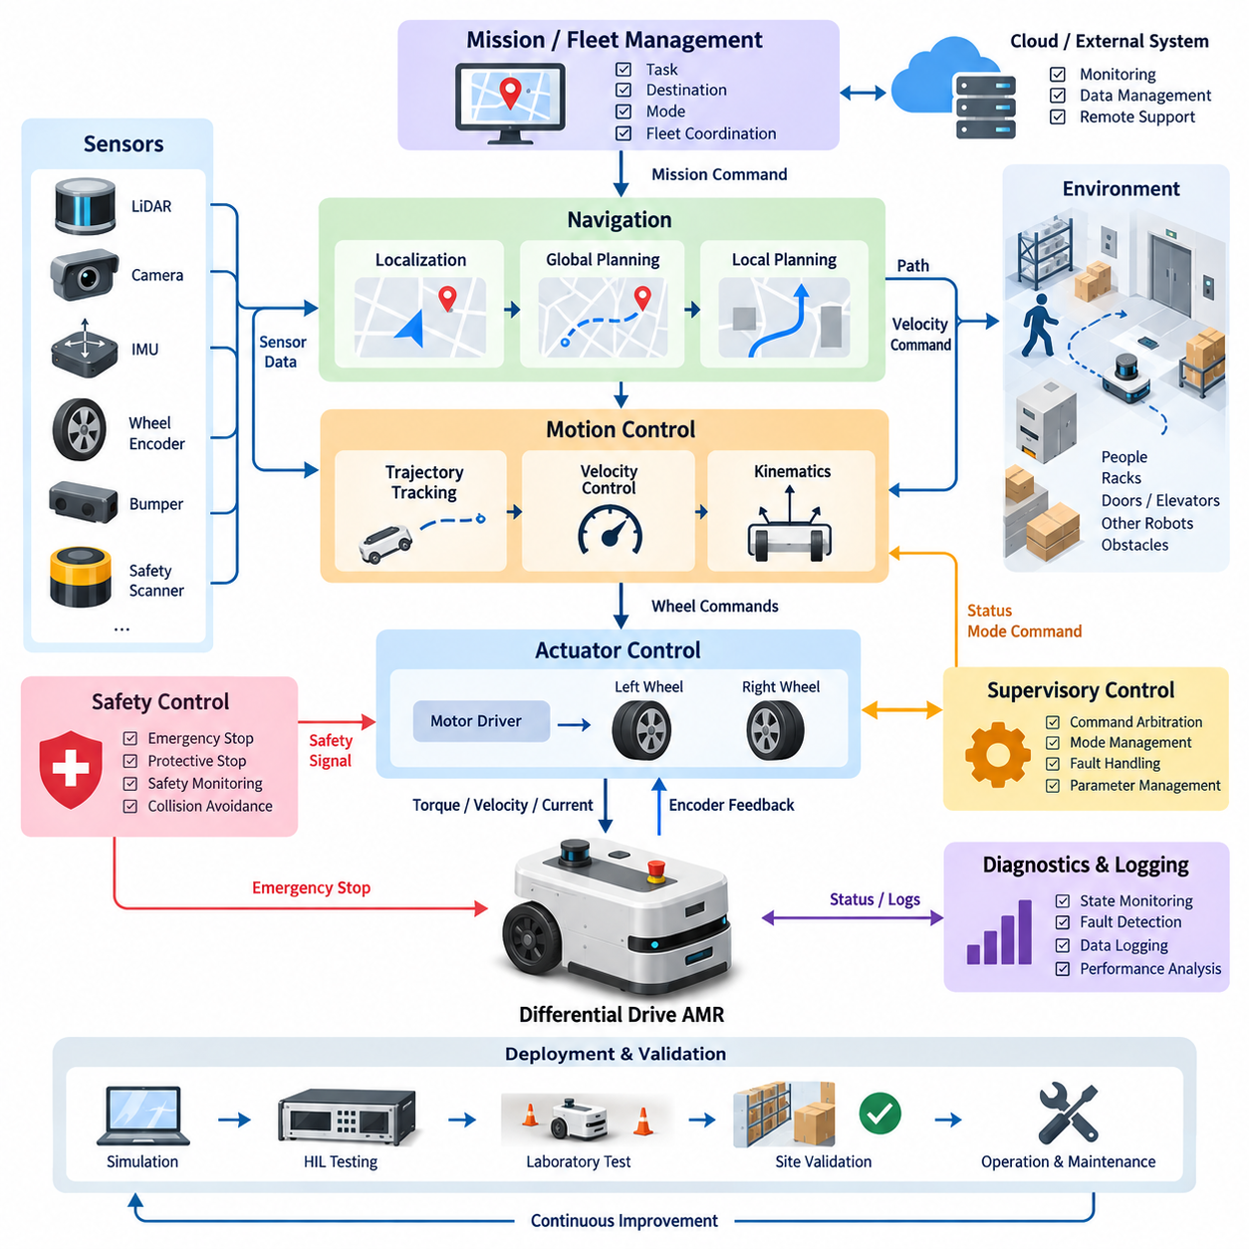
Indoor autonomous mobile robots using differential drive are widely deployed in factories, warehouses, hospitals, and logistics centers because the mechanical architecture is simple, compact, and capable of precise low-speed maneuvering. Control software integration transforms this basic two-wheel kinematic structure into a complete autonomous system by coordinating localization, planning, velocity control, motor control, safety supervision, diagnostics, and communication through clearly defined real-time interfaces.
A typical differential-drive AMR contains independently driven left and right wheel groups, wheel encoders, motor drives, an inertial measurement unit, safety sensors, and one or more LiDAR or vision sensors. The software converts desired linear and angular velocities into individual wheel-speed references according to the robot geometry. Accurate wheel radius and track-width parameters are therefore essential because systematic calibration errors directly produce longitudinal distance and heading errors during navigation.
The control architecture is commonly divided into mission, navigation, motion-control, and actuator layers. A fleet or mission manager supplies destinations and operational commands, while the navigation layer estimates robot pose and generates a collision-free path. A local planner converts the path into feasible velocity commands, and the motion controller calculates left and right wheel references. The actuator layer finally executes torque, velocity, or current control through embedded motor-drive loops.
Localization integrates wheel odometry with IMU, LiDAR, camera, or other environmental measurements. Encoder data provide high-rate incremental motion information but accumulate errors because of wheel-radius uncertainty, floor irregularities, slip, and mechanical tolerances. IMU measurements improve short-term angular estimation, while LiDAR-based localization or visual localization provides environmental references that constrain accumulated drift. Sensor fusion therefore provides a stable pose estimate required by the navigation and control loops.
Differential-drive kinematics provide a compact interface between navigation commands and wheel actuators. A commanded forward velocity determines the common component of left and right wheel motion, whereas angular velocity creates a differential component between them. Software must also apply limits for maximum wheel speed, acceleration, deceleration, and angular rate. These constraints prevent mathematically valid navigation commands from exceeding motor, gearbox, tire-friction, battery, or payload-dependent physical limits.
The velocity-control layer should compensate for differences between nominal kinematic commands and actual vehicle behavior. Separate wheel-speed controllers can use encoder feedback to regulate each motor, while an upper-level controller corrects linear and angular motion. PID-based control remains common because of its simplicity and deterministic execution, but feedforward terms, gain scheduling, disturbance observers, or model-based compensation can improve performance when payload, floor friction, battery voltage, and operating speed vary significantly.
Trajectory tracking connects the local planner to the low-level wheel controllers. Instead of independently executing discrete velocity commands, the controller continuously evaluates position, heading, curvature, and velocity errors relative to the planned trajectory. The resulting corrections must remain smooth enough to avoid wheel slip and oscillation. At low speeds, special handling is often required because encoder quantization, drivetrain backlash, static friction, and motor dead zones become proportionally more significant.
Indoor AMRs frequently operate near people, racks, doors, elevators, production equipment, and other robots, so safety control must remain functionally separated from ordinary navigation whenever required by the system safety concept. Safety scanners, emergency-stop circuits, bumper sensors, drive enable signals, and safety controllers can enforce protective stopping independently of high-level autonomy. The motion software must nevertheless coordinate controlled deceleration and stopping so that routine obstacle responses do not unnecessarily trigger emergency behavior.
Command arbitration is essential because several software components may request motion simultaneously. Autonomous navigation, docking, manual control, maintenance functions, recovery behavior, and safety mechanisms should not directly compete for actuator access. A supervisory state machine or command multiplexer establishes explicit priorities and ownership. Transitions between operating modes should reset or synchronize controller states to prevent residual integrator values or stale velocity commands from causing unexpected motion.
Docking introduces tighter accuracy requirements than normal corridor navigation. The robot may switch from global localization and path following to a dedicated docking controller using LiDAR reflectors, fiducial markers, cameras, proximity sensors, or charging-station references. Velocity is progressively reduced as alignment accuracy increases. The controller should handle unsuccessful approaches through bounded retries, controlled retreat, localization verification, and fault reporting rather than repeatedly applying uncontrolled corrective motion.
Communication architecture strongly affects control reliability. High-level modules may exchange pose, path, status, and velocity information through middleware such as ROS 2, while deterministic field buses or industrial Ethernet connect embedded controllers and motor drives. Message timestamps, update periods, sequence information, timeout supervision, and coordinate-frame definitions must be specified explicitly. A valid command that arrives too late can be as dangerous or ineffective as an incorrect command.
Real-time execution requires different timing classes across the software stack. Motor current and velocity loops normally execute faster than vehicle-level motion control, while localization, local planning, and mission management operate at progressively lower rates. Integration should therefore avoid assuming that every module shares a common cycle. Buffers, timestamps, interpolation, prediction, and watchdogs are used to manage asynchronous data while maintaining deterministic actuator behavior and bounded command latency.
Fault handling should cover sensor loss, encoder disagreement, motor-drive faults, localization degradation, communication timeout, excessive tracking error, battery abnormalities, and computational overload. Each fault is classified according to its effect on controllability and safety. The supervisory controller may reduce speed, disable autonomous operation, execute a controlled stop, or request emergency shutdown. Diagnostic information should preserve timestamps, operating states, command values, measured responses, and fault transitions for later analysis.
Payload variation can significantly influence an AMR even when its geometric kinematics remain unchanged. Increased mass changes acceleration capability, braking distance, motor current, tire deformation, and sensitivity to floor conditions. A production control system can therefore select acceleration limits, controller gains, and stopping profiles according to payload state. Where payload estimation is available, these parameters may be adjusted automatically while remaining inside validated operating envelopes.
Software integration also requires consistent coordinate systems and units. Map, odometry, robot-base, sensor, and wheel frames must form an unambiguous transformation hierarchy, and conventions for positive rotation, velocity, distance, and timestamps must remain identical across modules. Many integration defects originate not in control algorithms but in mismatched frames, signs, scaling factors, stale transforms, or inconsistent assumptions concerning whether commands represent wheel, body, or trajectory quantities.
Simulation and hardware-in-the-loop testing reduce risk before deployment. A digital robot model can verify kinematics, command arbitration, trajectory tracking, state transitions, and fault responses under repeatable scenarios. Hardware-in-the-loop environments additionally connect actual controllers, communication interfaces, or motor drives to simulated robot dynamics. The same software configuration should then progress through simulation, laboratory testing, controlled facility trials, and production-site validation with traceable parameter changes.
Performance validation should evaluate more than final positioning accuracy. Relevant measurements include lateral and heading tracking error, velocity error, stopping distance, command latency, localization stability, wheel slip, docking repeatability, CPU utilization, communication jitter, and recovery time after disturbances. Tests should cover straight motion, curves, narrow passages, intersections, rotations, obstacle encounters, payload changes, degraded sensing, and repeated long-duration operation to reveal faults that short demonstrations may hide.
A robust integration strategy treats configuration as part of the control system. Wheel geometry, encoder resolution, motor limits, controller gains, acceleration constraints, safety parameters, sensor transforms, network addresses, and software versions should be managed under configuration control. Calibration results should be associated with individual robots when necessary. This prevents undocumented parameter changes from creating behavioral differences between nominally identical AMRs deployed across multiple customer sites.
Operational logging closes the loop between development and field performance. Time-synchronized logs can correlate navigation decisions with localization estimates, wheel commands, encoder responses, safety events, and motor-drive diagnostics. Automated analysis can identify increasing tracking error, abnormal current consumption, repeated localization corrections, or deteriorating docking performance. Such information supports preventive maintenance while providing engineers with reproducible evidence when investigating intermittent field failures.
The completed indoor differential-drive AMR control software is therefore not merely a pair of wheel-speed controllers connected to a navigation algorithm. It is an integrated hierarchy in which mission commands become validated trajectories, trajectories become constrained body velocities, body velocities become synchronized wheel references, and actuator feedback returns through localization and supervision. Reliable operation emerges from the coordinated design of control laws, timing, interfaces, safety mechanisms, diagnostics, calibration, and verification.

12.02 Outdoor AMR Steering / Drive Compound Control Case
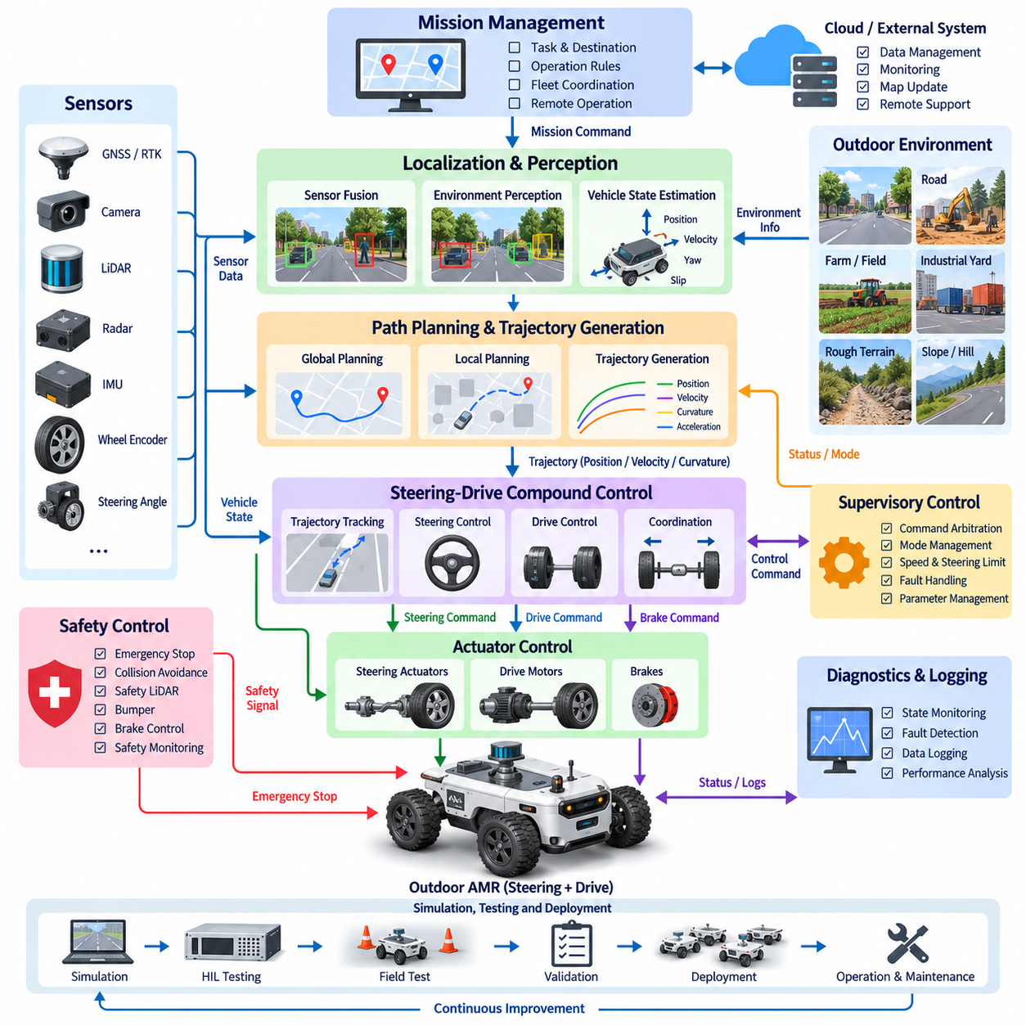
Outdoor autonomous mobile robots operate under substantially more variable conditions than indoor AMRs because steering, traction, terrain interaction, and vehicle dynamics must be controlled simultaneously. A steering-drive compound control architecture coordinates steering actuators and propulsion motors as one motion system rather than treating them independently. This integration is essential for robots operating on roads, construction sites, farms, campuses, industrial yards, and other unstructured outdoor environments.
The vehicle platform may employ front-wheel steering, four-wheel steering, independent wheel drive, six-wheel drive, or combinations of these mechanisms. Unlike differential-drive robots that generate yaw primarily through wheel-speed differences, steering-based platforms generate lateral motion through wheel orientation while propulsion controls longitudinal force. Compound control software must therefore transform desired vehicle velocity, curvature, and yaw behavior into synchronized steering-angle and wheel-speed commands consistent with mechanical geometry.
The software architecture typically separates mission management, localization, path planning, trajectory generation, vehicle motion control, actuator control, and safety supervision. Mission commands define destinations and operational constraints, while navigation produces a geometrically feasible route. A trajectory planner then assigns velocity and curvature profiles. The compound motion controller converts these references into coordinated steering and drive commands before embedded controllers regulate individual steering motors and propulsion actuators.
Outdoor localization commonly combines GNSS, RTK corrections, IMU measurements, wheel encoders, steering-angle sensors, LiDAR, cameras, and sometimes radar. GNSS provides global position information but can degrade near buildings, vegetation, tunnels, or other signal-blocking structures. Wheel odometry and IMU measurements provide higher-rate local motion estimates, while environmental perception constrains accumulated drift. Sensor fusion must maintain a continuous vehicle state even when individual positioning sources temporarily become unreliable.
Vehicle-state estimation extends beyond position and heading because compound control depends on steering angle, wheel velocity, yaw rate, longitudinal acceleration, and potentially lateral velocity or tire slip. Estimators can compare predicted vehicle motion with measured responses to detect inconsistencies. When the commanded steering geometry predicts a particular yaw rate but the IMU reports significantly different behavior, the system can identify possible tire slip, steering error, uneven terrain, or reduced surface friction.
Path planning for steering vehicles must respect nonholonomic constraints and minimum turning radius. A path that is geometrically collision-free may still be impossible for the robot to follow if curvature changes exceed steering capability. The planner should therefore consider vehicle dimensions, wheelbase, steering limits, articulation characteristics, and direction changes. For large outdoor AMRs carrying heavy payloads, swept-path analysis is particularly important because rear wheels and vehicle corners follow different trajectories from the steering axle.
Trajectory generation converts the geometric path into a time-dependent reference containing position, heading, curvature, velocity, and acceleration. Velocity must be reduced before sharp curves rather than after the steering maneuver has already started. Terrain slope, payload, surface condition, obstacle proximity, and stopping distance can further modify the speed profile. Smooth curvature and acceleration transitions reduce steering actuator stress, tire scrub, cargo disturbance, and transient tracking errors.
Steering control translates desired curvature into actuator commands according to the vehicle configuration. For Ackermann-type steering, inner and outer wheels require different steering angles so that their projected axes approximately intersect at a common instantaneous center of rotation. Four-wheel steering introduces additional modes such as opposite-phase steering for tighter turns and same-phase steering for lateral displacement. Software must explicitly manage transitions between these steering configurations to avoid discontinuous wheel commands.
Drive control determines the propulsion demand required to achieve the requested longitudinal velocity while respecting acceleration and torque limits. Independent wheel motors may require different speed references during cornering because wheels travel along different radii. Applying identical wheel speeds during a turn can create tire scrub, increased current consumption, and tracking error. Compound control therefore calculates wheel-speed references from steering geometry while closed-loop motor controllers compensate for drivetrain disturbances and load variations.
The central coordination layer synchronizes steering and propulsion. During a turn, steering actuators should approach the required angle before excessive propulsion torque is applied, particularly at low speed or on high-friction surfaces. During high-speed motion, abrupt steering commands must be restricted according to stability constraints. Command scheduling can coordinate steering rate, wheel acceleration, and vehicle velocity so that the requested maneuver remains dynamically achievable instead of merely satisfying geometric kinematics.
Trajectory tracking continuously compares the estimated vehicle state with the planned trajectory. Lateral error, heading error, curvature error, and longitudinal velocity error can be processed by geometric, PID, model-based, or predictive controllers. Pure Pursuit and Stanley-type methods provide practical geometric solutions, while model predictive control can explicitly handle steering, velocity, acceleration, and actuator constraints. The selected method must remain robust across the intended range of speeds, payloads, and surface conditions.
Low-speed operation presents different control challenges from normal outdoor travel. Steering backlash, tire deformation, motor dead zones, and encoder quantization become more visible during precise docking or narrow-space maneuvering. At higher speeds, steering delay, lateral dynamics, tire forces, and stability become increasingly important. Gain scheduling or mode-dependent controllers can therefore adjust tracking parameters according to speed, payload, steering configuration, and estimated terrain condition.
Terrain interaction is a major distinction between indoor and outdoor control. Gravel, grass, mud, slopes, drainage channels, curbs, and uneven pavement can produce wheel slip or transient loss of contact. The controller should avoid assuming that commanded wheel velocity directly represents vehicle velocity. Comparing wheel encoders with GNSS, IMU, and visual or LiDAR motion estimates can provide slip indicators that allow acceleration, torque, or speed limits to be reduced when traction deteriorates.
For multi-axle or six-wheel platforms, load distribution and wheel-ground interaction further complicate compound control. Different wheels can experience different normal forces as the robot crosses uneven terrain. A simple equal-torque strategy may cause lightly loaded wheels to spin while heavily loaded wheels provide insufficient traction. Where actuator hardware permits, torque allocation can account for estimated wheel load, slip state, motor capability, and thermal limits while preserving the vehicle-level motion request.
Payload variation strongly affects outdoor AMR dynamics. Increased payload raises inertia, braking distance, tire loading, drivetrain demand, and rollover sensitivity while reducing available acceleration margin. The supervisory controller can select validated speed, acceleration, steering-rate, and braking limits according to payload state. If load sensors or suspension measurements are available, the system can additionally detect asymmetric loading that may influence steering response and vehicle stability.
Slope control requires coordinated propulsion and braking behavior. On an uphill section, additional drive torque may be required to maintain the target velocity, whereas downhill travel can require regenerative or mechanical braking to prevent acceleration beyond the reference. Hill-start and hill-hold functions should prevent unintended rollback. Steering commands may also need tighter limits on steep or cross-sloped terrain where aggressive lateral acceleration could reduce stability margins.
Obstacle avoidance must generate commands compatible with steering geometry. A local planner cannot assume that the vehicle can rotate instantaneously toward a newly opened direction. Emergency avoidance, normal replanning, and controlled stopping should account for current steering angle, steering rate, vehicle velocity, and available braking distance. For large robots, obstacle inflation should consider the complete swept envelope rather than only the instantaneous rectangular footprint.
Safety supervision operates alongside normal motion control and can impose independent velocity limits or stopping commands. Emergency-stop circuits, safety LiDAR, bumpers, drive enable signals, brake controllers, and steering-state monitoring may participate in the safety architecture. Compound control should support predictable controlled stopping whenever sufficient time exists while allowing safety hardware to remove propulsion or apply braking independently when an immediate protective response is required.
Command arbitration prevents autonomous navigation, remote operation, docking, recovery, maintenance, and safety functions from issuing conflicting steering or drive commands. A supervisory state machine establishes command ownership and defines legal transitions between operating modes. Mode transitions should verify steering position, vehicle speed, brake state, localization validity, and actuator readiness before motion authority is transferred, preventing stale or incompatible commands from propagating to the vehicle.
Communication timing is critical because steering and propulsion commands must represent the same intended vehicle state. Distributed controllers may communicate through CAN, CAN FD, EtherCAT, industrial Ethernet, or other deterministic networks while high-level autonomy uses middleware such as ROS 2. Timestamps, sequence counters, watchdogs, command validity periods, and synchronized clocks help detect delayed or missing messages. A steering command paired with an outdated velocity command can otherwise produce an unintended maneuver.
Fault management should address steering actuator failure, wheel-speed disagreement, motor overcurrent, brake faults, sensor degradation, localization loss, communication timeout, excessive slip, and trajectory-tracking divergence. Fault responses depend on remaining controllability. The system may reduce speed, constrain steering, transition to degraded operation, perform a controlled stop, or activate an emergency state. Diagnostic logs should preserve both commands and measured responses so that the physical origin of the fault can later be reconstructed.
Simulation is particularly valuable because compound steering-drive behavior involves interactions that are difficult to reproduce safely during early development. Vehicle models can evaluate steering geometry, actuator delay, tire slip, slope behavior, payload variation, and fault conditions. Hardware-in-the-loop testing can connect real steering controllers, motor drives, network interfaces, and supervisory ECUs to simulated vehicle dynamics before full-scale outdoor testing begins.
Validation should progressively cover flat pavement, curves, slopes, rough terrain, low-friction surfaces, narrow passages, obstacle avoidance, docking, payload changes, and degraded sensor conditions. Performance metrics can include lateral tracking error, heading error, steering error, wheel-speed error, stopping distance, slip ratio, command latency, energy consumption, actuator temperature, and recovery behavior. Long-duration tests are necessary because thermal effects, calibration drift, mechanical wear, and intermittent communication faults may not appear during short demonstrations.
A production-ready compound control system also requires disciplined calibration and configuration management. Wheelbase, track width, steering ratio, steering offsets, tire radius, encoder scale, actuator limits, controller gains, sensor transforms, payload parameters, and network configuration must remain traceable. Vehicle-specific calibration data should be separated from common software so that multiple robot variants can share the same control architecture without introducing undocumented behavioral differences.
The integrated outdoor AMR control system ultimately forms a closed hierarchy from mission intent to physical tire-ground interaction. Navigation defines where the robot should travel, trajectory generation defines how it should move, compound control determines coordinated steering and propulsion behavior, actuator controllers execute the commands, and state estimation returns measured motion to the control loops. Reliable outdoor autonomy emerges when geometry, dynamics, traction, timing, safety, diagnostics, and validation are engineered as one coordinated control system.

12.03 7-DOF Manipulator Grasping Control SW Case
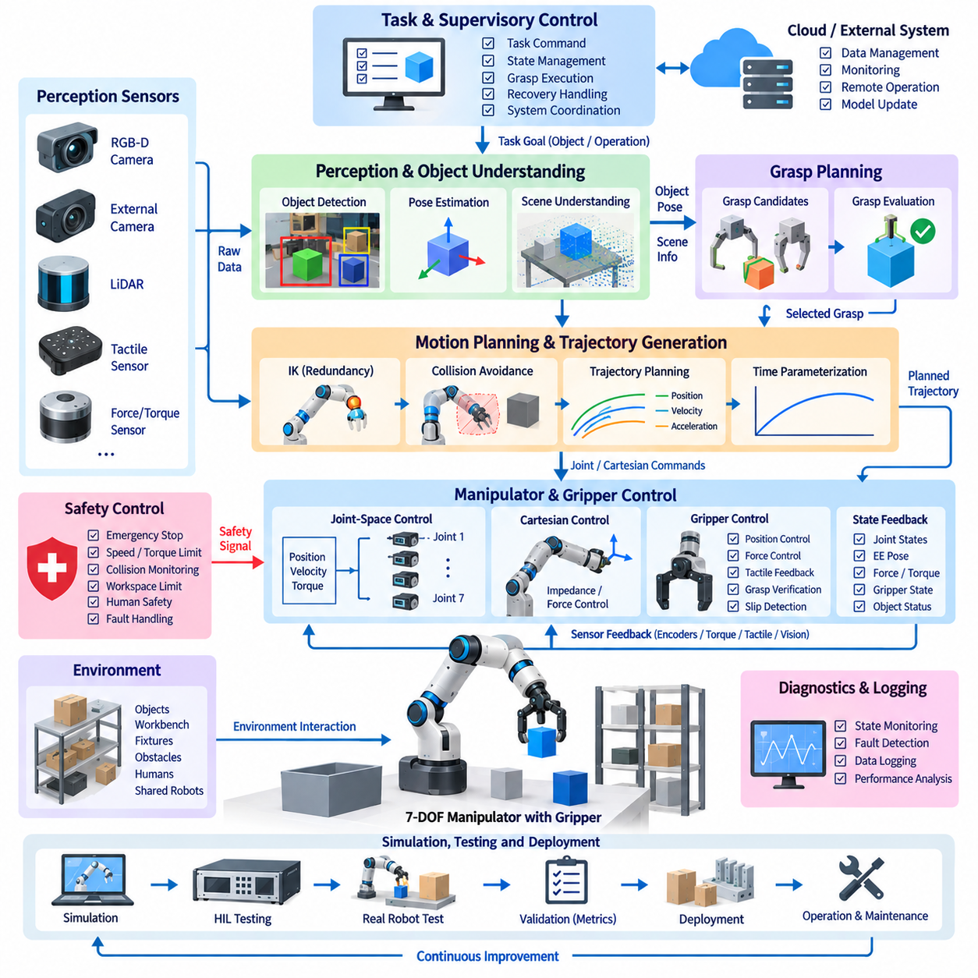
A seven-degree-of-freedom manipulator provides greater motion redundancy than a conventional six-axis industrial robot, allowing the arm to achieve a desired end-effector pose while retaining freedom to optimize posture. In grasping applications, this redundancy can be exploited to avoid obstacles, maintain joint margins, improve manipulability, and approach objects from favorable directions. Control software must coordinate perception, planning, kinematics, dynamics, trajectory execution, grasp control, and safety as one integrated system.
The manipulator typically consists of seven actuated joints, joint encoders, motor drives, torque or current sensing, an end-effector, and one or more perception sensors. The gripper may include position, force, tactile, or proximity sensing depending on the application. A wrist-mounted RGB-D camera can provide close-range object information, while external cameras observe the overall workspace. Every sensor and actuator must be represented through calibrated coordinate frames and synchronized interfaces.
The software architecture can be divided into perception, task planning, grasp planning, motion planning, manipulator control, gripper control, and supervisory layers. A task command identifies the target object and desired operation. Perception estimates object pose and surrounding geometry, grasp planning generates candidate contact configurations, and motion planning determines a collision-free arm trajectory. Real-time controllers then execute joint and gripper commands while monitoring feedback and operational constraints.
Object perception begins with detecting or segmenting the target from RGB, depth, point-cloud, or multimodal sensor data. The perception system estimates object position, orientation, dimensions, and potentially semantic or geometric properties relevant to grasping. Pose uncertainty should be retained whenever possible because a mathematically precise grasp generated from an uncertain perception result can fail physically. Confidence information can therefore influence approach distance, velocity, and grasp strategy.
Coordinate transformation is fundamental to manipulator integration. Object poses detected in a camera frame must be transformed into the robot base frame before motion planning and control. The transformation chain may include world, robot base, shoulder, wrist, camera, tool, and grasp frames. Hand-eye calibration errors directly affect grasp accuracy, so calibration parameters should be verified systematically rather than compensated through arbitrary offsets embedded inside application software.
Grasp planning determines where and how the end-effector should contact an object. Candidate grasps can be generated from geometric models, point clouds, learned grasp networks, predefined object templates, or combinations of these approaches. Each candidate can be evaluated according to collision risk, reachability, contact quality, approach clearance, force closure, manipulator posture, and distance from joint limits. The highest-quality geometric grasp is not necessarily the best executable grasp for the complete arm.
Seven degrees of freedom introduce redundancy into inverse kinematics because multiple joint configurations can realize the same six-dimensional end-effector pose. The controller or planner can use the remaining degree of freedom to optimize secondary objectives. Typical objectives include maximizing manipulability, avoiding singularities, maintaining elbow clearance, minimizing joint displacement, preserving cable routing, and keeping joints away from mechanical limits. Redundancy resolution is therefore a central capability rather than an incidental feature.
Inverse kinematics converts desired tool poses into feasible joint configurations while respecting position, velocity, and joint-range constraints. Analytical methods may be available for specific structures, but numerical solvers provide greater flexibility for arbitrary seven-axis manipulators. Iterative solvers should consider convergence, initial posture, singularity proximity, and solution continuity. Sudden transitions between equivalent inverse-kinematic solutions can otherwise generate large joint movements even when end-effector motion is small.
Motion planning connects the current manipulator configuration to a pre-grasp configuration without colliding with the robot, environment, or target object. Sampling-based planners such as RRT variants are widely applicable, while optimization-based methods can generate smoother trajectories under complex constraints. The planning scene should contain the robot geometry, workbench, fixtures, obstacles, target object, and relevant uncertainty margins. Self-collision checking is particularly important because redundant arms can assume highly folded postures.
The grasp sequence is normally decomposed into several motion phases even when implemented as one task. The manipulator first moves toward a collision-free pre-grasp pose, performs a controlled approach, closes the gripper, verifies object acquisition, retreats from the source location, and transports the object toward its destination. Separating these phases allows different velocity, force, collision, and perception policies to be applied according to the physical risk associated with each stage.
Trajectory generation converts planned joint configurations or Cartesian waypoints into time-parameterized references. Joint velocity, acceleration, jerk, torque, and actuator limits should be respected throughout the trajectory. Smooth interpolation is particularly important when carrying fragile or loosely constrained objects. Time scaling can reduce motion speed near obstacles or during final approach while allowing higher velocity in open workspace regions where positioning uncertainty has less influence on grasp success.
Joint-space control provides deterministic regulation of individual joint positions or velocities. Cascaded position, velocity, and current loops are commonly implemented across robot and motor-drive controllers. Feedforward velocity, acceleration, gravity, and friction compensation can improve tracking accuracy beyond basic feedback control. The seven joints must remain temporally synchronized because small phase differences between joint trajectories can produce significant Cartesian deviation at the end-effector.
Cartesian control regulates the end-effector directly in task space. Desired position and orientation errors can be converted into joint velocities or torques through the manipulator Jacobian. Redundancy enables null-space motion, allowing secondary joint objectives to be pursued without significantly disturbing the primary end-effector task. Damped pseudoinverse methods can improve behavior near singular configurations, while optimization-based controllers can incorporate joint, collision, and velocity constraints explicitly.
Dynamic control becomes increasingly important as manipulator speed and payload increase. The commanded joint torques may compensate for inertia, Coriolis effects, gravity, friction, and external loads. Computed-torque or inverse-dynamics approaches can improve trajectory tracking when an adequate robot model is available. Model errors should nevertheless be expected because payload mass, center of gravity, joint friction, cable forces, and mechanical wear can vary during actual operation.
The final grasp approach often requires more compliant behavior than free-space motion. Pure position control can generate excessive contact force when object pose or surface geometry differs slightly from the estimated model. Impedance control, admittance control, force control, or hybrid position-force control can provide controlled compliance. These methods allow the end-effector to accommodate small positioning errors while regulating interaction forces within limits appropriate for the object and gripper.
Gripper control must be coordinated with manipulator motion rather than treated as a simple binary open-close function. Finger position, closing velocity, motor current, contact force, tactile distribution, and object displacement can contribute to grasp execution. The controller may initially close rapidly through free space and then reduce velocity after contact detection. Force or current limits prevent unnecessary compression, while tactile feedback can identify asymmetric or unstable contact conditions.
Grasp verification determines whether the object has actually been acquired before transport begins. Verification can combine gripper opening width, motor current, force sensing, tactile information, visual confirmation, or estimated object motion. A successful close command does not guarantee a successful grasp because the fingers may close without contacting the target or may contact it insecurely. Explicit verification prevents failed grasps from propagating into subsequent transport and placement operations.
Slip detection becomes important during object transport. Tactile sensors, force-torque measurements, motor current, or visual observations can indicate relative movement between the object and gripper. When incipient slip is detected, the controller may increase gripping force within validated limits, reduce manipulator acceleration, modify orientation, or initiate a controlled recovery. Excessive gripping force should not be the default response because fragile or deformable objects may be damaged.
Payload estimation can improve dynamic compensation after grasping. The manipulator may estimate payload mass and center-of-gravity characteristics from joint torque, motor current, acceleration, or force-torque measurements. Updated payload parameters improve gravity compensation and trajectory control while allowing supervisory software to enforce payload-dependent acceleration and posture restrictions. Large discrepancies between expected and estimated payload can also indicate an incorrect grasp or unexpected object condition.
Collision avoidance remains active during both planning and execution. Offline trajectory validation cannot account for every environmental change, especially when humans, mobile robots, or movable objects share the workspace. Real-time distance monitoring can reduce velocity or trigger replanning as obstacles approach protected regions. Redundant joint motion can also reposition the elbow or wrist away from obstacles while maintaining the required tool pose, providing an important advantage of seven-axis manipulators.
Safety supervision should remain distinct from ordinary manipulation logic where required by the system safety architecture. Joint limits, speed limits, torque thresholds, workspace boundaries, emergency-stop signals, protective stops, and communication watchdogs constrain robot operation. Faults such as encoder disagreement, excessive following error, motor overcurrent, unexpected contact, controller timeout, or loss of perception can cause controlled deceleration, motion inhibition, or emergency stopping depending on severity.
Supervisory control coordinates perception, planning, motion, grasping, verification, recovery, and fault handling through explicit operating states. A failed perception result may request another observation, an unreachable grasp may trigger alternative candidate selection, and an unstable grasp may cause controlled release and retry. Recovery behavior should be bounded and observable rather than relying on indefinite repetition. Each transition should preserve sufficient context for diagnostics and task-level reasoning.
Communication and timing strongly influence manipulation performance because perception and planning operate at different rates from real-time joint control. High-level modules may communicate through ROS 2 or similar middleware, while embedded motor controllers use deterministic buses such as EtherCAT. Commands should contain timestamps, validity intervals, trajectory identifiers, and execution states. Time synchronization is especially important when combining camera observations with rapidly changing manipulator configurations.
Simulation and digital models allow grasping software to be evaluated before physical execution. Robot kinematics, collision geometry, joint limits, gripper behavior, sensor viewpoints, and workspace objects can be reproduced in a virtual environment. Hardware-in-the-loop testing can further connect real controllers or communication hardware to simulated robot dynamics. Simulation should test successful tasks as well as unreachable objects, perception errors, collision risks, grasp failures, communication loss, and actuator faults.
Validation should measure more than whether an object is eventually moved successfully. Relevant metrics include perception accuracy, grasp success rate, approach error, joint tracking error, Cartesian tracking error, planning time, cycle time, contact force, slip frequency, collision margin, recovery success, and computational latency. Tests should cover different object shapes, sizes, masses, surface properties, orientations, clutter levels, approach directions, and payload conditions to expose weaknesses hidden by repetitive demonstrations.
Configuration management is essential when deploying the same manipulation software across multiple robots or end-effectors. Joint offsets, kinematic parameters, torque constants, tool transforms, camera calibration, gripper geometry, controller gains, collision models, payload definitions, and software versions must remain traceable. Robot-specific calibration should be separated from common algorithms so that software updates do not unintentionally invalidate previously verified geometric or dynamic parameters.
Operational logging provides the evidence needed to improve grasp performance after deployment. Time-synchronized records can associate images, object poses, grasp candidates, planner decisions, joint trajectories, motor currents, contact forces, supervisory states, and failure events. Analysis of repeated failures can distinguish perception problems from planning, calibration, control, or mechanical issues. This converts individual unsuccessful grasps into structured information for systematic improvement.
An integrated seven-DOF grasping system therefore forms a closed perception-planning-control loop rather than a sequence of isolated algorithms. Perception determines the object and environment state, grasp planning defines feasible contact strategies, redundancy-aware motion planning selects an executable arm posture, real-time control coordinates seven joints and the gripper, and sensory feedback verifies physical interaction. Reliable grasping emerges when geometry, dynamics, compliance, redundancy, timing, safety, diagnostics, and recovery are engineered as one coherent control software architecture.

12.04 Quadruped Stair Climbing Control Case
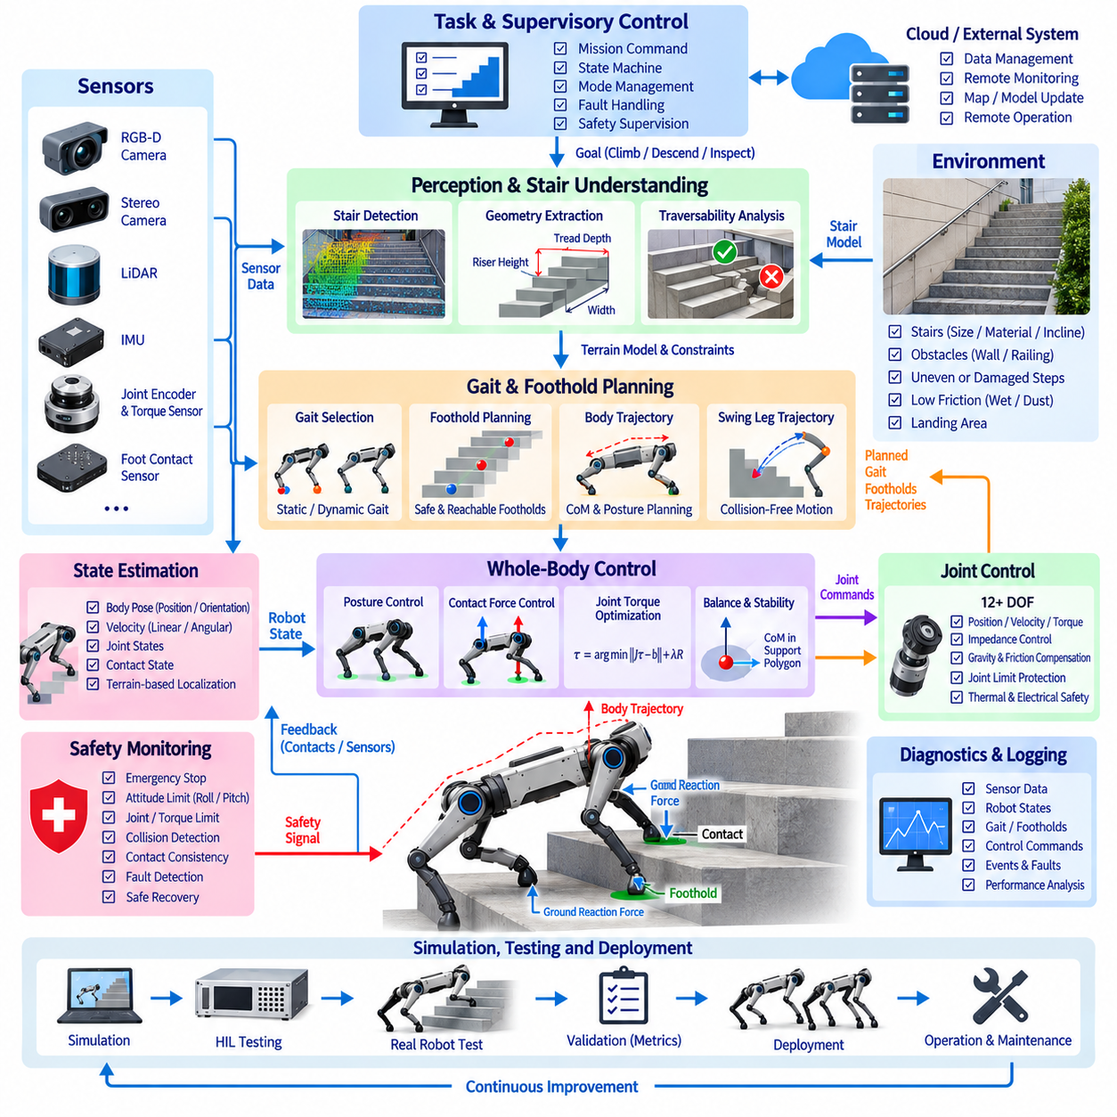
Quadruped stair climbing is a demanding locomotion problem because the robot must coordinate body posture, foothold placement, contact forces, and dynamic stability while moving through a discontinuous three-dimensional environment. Unlike level-ground walking, each step changes the available support geometry and introduces possible collisions between the feet, legs, body, and stair structure. Reliable control therefore requires tightly integrated perception, state estimation, gait planning, whole-body control, and safety supervision.
A typical quadruped platform contains twelve or more actuated joints, joint encoders, motor current or torque sensing, an IMU, foot-contact sensors, and environmental perception sensors such as LiDAR, stereo cameras, or depth cameras. Stair climbing depends on accurate knowledge of both robot configuration and surrounding geometry. Sensor timestamps and coordinate transformations must therefore remain consistent so that detected stair surfaces correspond correctly to the robot pose used by the controller.
Environmental perception identifies stair location, orientation, tread depth, riser height, width, inclination, edges, and available landing regions. Depth images or point clouds can be converted into geometric representations suitable for foothold planning. The perception system should distinguish traversable stair surfaces from walls, railings, obstacles, and missing or damaged steps. Geometric uncertainty must also be represented because small errors in edge location can significantly affect foot placement.
Robot state estimation combines IMU measurements, joint encoder data, foot contacts, actuator feedback, and environmental observations. The estimator determines body position, orientation, linear and angular velocity, joint configuration, and contact state. During stair climbing, vertical position and body pitch become particularly important. Contact-based odometry can reduce drift, while visual or LiDAR localization can provide external constraints when repeated impacts and rapid leg motions degrade inertial estimates.
Before climbing begins, the robot should establish an approach configuration aligned with the staircase. Misalignment increases lateral foot-placement demands and can reduce the available support margin. A high-level planner determines whether the detected staircase satisfies geometric and mechanical limits such as maximum riser height, minimum tread depth, stair width, and required clearance. If these conditions are violated, the system should reject the maneuver rather than attempting an uncontrolled climb.
Stair representation can be expressed as a sequence of planar support regions and vertical transitions rather than a conventional continuous terrain map. Each tread provides a candidate contact surface, while stair edges define collision constraints. This representation allows the planner to reason explicitly about which feet can occupy which steps. For irregular stairs, the model may include individual tread heights and orientations rather than assuming a uniform staircase geometry.
Gait planning determines the sequence in which the four legs transition between support and swing states. Static or quasi-static gaits provide large stability margins by maintaining three supporting legs during most transitions, making them suitable for slow climbing and heavy payloads. More dynamic gaits can increase speed but require accurate force control and state estimation. The selected gait should reflect stair geometry, robot capability, payload, friction, and required safety margin.
Foothold planning selects contact positions for each foot on successive stair treads. Candidate footholds should remain sufficiently far from stair edges while respecting leg reachability, joint limits, self-collision constraints, and body progression. The planner must consider future contacts rather than selecting each foothold independently. A locally convenient foot placement can create an unreachable configuration several steps later, so multi-step planning improves robustness during long stair sequences.
Swing-leg trajectory generation moves a foot from its current support location to the next foothold without striking the stair riser or edge. The trajectory usually requires greater vertical clearance than level-ground walking. A waypoint above the stair edge can provide a safe intermediate path before the foot descends toward the target tread. Swing height should include perception uncertainty and tracking error while avoiding unnecessarily large motions that consume energy and reduce stability.
Foot landing requires controlled transition from swing motion to load-bearing contact. A purely position-controlled foot can strike the tread with excessive impact if the estimated stair height is inaccurate. Contact detection based on force, torque, motor current, or kinematic consistency can terminate the downward motion when the surface is reached. Compliant control then allows the leg to establish stable support without generating unnecessarily large impact forces.
Body trajectory planning coordinates the center of mass and torso orientation with the foothold sequence. During ascent, the body must rise progressively while remaining within the feasible workspace of the supporting legs. Pitch can be adjusted according to staircase inclination, but excessive body rotation may reduce joint margins or sensor visibility. Smooth center-of-mass motion reduces load transfer disturbances and helps maintain predictable ground reaction forces during contact transitions.
Static stability can be evaluated using the projection of the center of mass relative to the support polygon formed by contacting feet. During slow climbing, the controller can intentionally shift the body toward supporting legs before lifting another foot. Dynamic locomotion requires more general criteria such as centroidal momentum or capture-related measures. In both cases, stair edges reduce usable support regions, making accurate contact geometry essential for stability assessment.
Whole-body control coordinates all joints and contact forces to satisfy multiple objectives simultaneously. Typical objectives include tracking body position and orientation, following swing-foot trajectories, maintaining stance-foot contacts, regulating ground reaction forces, and respecting joint or torque limits. Optimization-based controllers can assign priorities or weights to these objectives while solving for joint accelerations, torques, or contact forces consistent with the robot dynamics.
Contact-force distribution becomes particularly important when the four feet occupy different stair heights. Supporting legs experience different configurations and mechanical leverage, so equal force distribution is generally inappropriate. The controller can allocate ground reaction forces according to center-of-mass location, desired body acceleration, friction limits, and actuator capability. Force constraints should prevent negative normal force and excessive tangential force that could cause slipping.
Friction estimation influences whether a planned foothold is physically usable. Dry concrete, metal stairs, wet surfaces, dust, and debris can provide substantially different traction. Slip can be detected by comparing expected stance-foot motion with joint, IMU, force, and external localization measurements. When reduced friction is detected, the controller can lower body acceleration, increase support duration, modify force distribution, or transition toward a more conservative gait.
Joint-level control executes the references generated by whole-body control. Position, velocity, torque, or impedance loops may be combined depending on actuator architecture. Accurate torque tracking is valuable for controlling ground reaction forces, while impedance behavior provides robustness against terrain-height errors and impacts. Gravity, friction, and actuator dynamics compensation can improve performance, but commanded torques must remain inside thermal, electrical, and mechanical operating limits.
Joint limits and kinematic singularities require continuous supervision because stair climbing can push legs toward extreme extension or folding. A foothold may be reachable at initial contact yet become problematic as the body advances upward. Redundancy-aware posture optimization can preserve joint margins across future phases of the gait. The planner should therefore evaluate the complete support interval rather than checking only the configuration at the instant of touchdown.
Collision avoidance extends beyond external obstacles. A front leg can strike a stair riser during swing, the knee can collide with a stair edge, or the body underside can contact the staircase when transitioning between levels. Self-collision between legs is also possible during narrow or highly folded configurations. Collision geometry should therefore be included in both planning and real-time monitoring, with safety margins reflecting model and perception uncertainty.
Disturbance rejection is necessary because contact conditions can change unexpectedly. A foot may land partially on an edge, slip after loading, or encounter a tread height different from the perceived model. The controller should detect abnormal force, position, or velocity responses and modify the motion before stability is lost. Recovery may include lowering the swing foot, widening support, shifting the body, replacing a foothold, or stopping in a stable stance.
Ascending and descending stairs require different control strategies. During ascent, actuator torque and leg reachability often dominate because the robot must lift its body against gravity. During descent, impact management and controlled lowering become more important because gravitational potential energy must be dissipated safely. The robot may also have reduced visual coverage of lower steps, requiring conservative foothold placement and stronger reliance on local sensing.
Supervisory control manages the complete climbing state machine, including approach, stair detection, alignment, gait initialization, ascent or descent, landing transition, completion, and recovery. Each transition should verify prerequisites such as localization confidence, valid stair geometry, sufficient foothold quality, actuator readiness, and stable contact. Explicit state management prevents perception or planning failures from propagating directly into unsafe leg commands.
Safety supervision should independently monitor body attitude, joint limits, motor temperature, torque, communication status, contact consistency, and stability indicators. Excessive roll or pitch, unexpected loss of multiple contacts, actuator faults, or rapidly increasing tracking errors may require immediate intervention. Depending on the condition, the robot can freeze the gait, lower its body, establish additional contacts, execute a controlled stop, or disable motion.
Communication timing is critical because state estimation, perception, gait planning, whole-body control, and joint control operate at different frequencies. High-level terrain perception may update relatively slowly, while joint and torque control require much faster deterministic execution. Timestamps, synchronized clocks, buffers, interpolation, prediction, and watchdogs allow asynchronous information to be integrated without applying outdated terrain or contact information to rapidly changing robot states.
Simulation provides a controlled environment for developing stair-climbing behavior before risking physical hardware. Stair dimensions, friction, actuator limits, payload, sensor noise, contact stiffness, and external disturbances can be varied systematically. Dynamic simulators can reveal instability, collisions, torque saturation, or poor foothold sequences. Hardware-in-the-loop testing can additionally verify real controllers, communication networks, and timing behavior against simulated robot dynamics.
Validation should include stairs with different riser heights, tread depths, inclinations, widths, materials, and friction conditions. Tests should also cover approach-angle errors, payload variation, perception noise, partial footholds, unexpected obstacles, sensor degradation, and actuator limitations. Relevant metrics include foothold error, body attitude error, contact force, slip rate, stability margin, joint torque, energy consumption, climbing speed, recovery success, and completion rate.
Operational logging should synchronize perception data, stair models, estimated robot states, planned footholds, gait phases, joint trajectories, actuator torques, contact forces, stability indicators, and supervisory transitions. When a climb fails, these records allow engineers to determine whether the primary cause originated in perception, state estimation, planning, control, contact mechanics, or hardware. Repeated field data can then guide systematic improvements rather than isolated parameter adjustments.
An integrated quadruped stair-climbing controller therefore forms a continuous perception-planning-control-feedback loop. Terrain perception converts stairs into feasible support regions, state estimation determines the robot configuration, foothold and gait planning define contact transitions, whole-body control coordinates body motion and ground forces, and joint controllers execute the resulting commands. Robust stair traversal emerges when geometry, contact dynamics, stability, compliance, safety, timing, recovery, and validation are designed as one coherent locomotion control system.

12.05 Humanoid Walk and Carry WBC Case
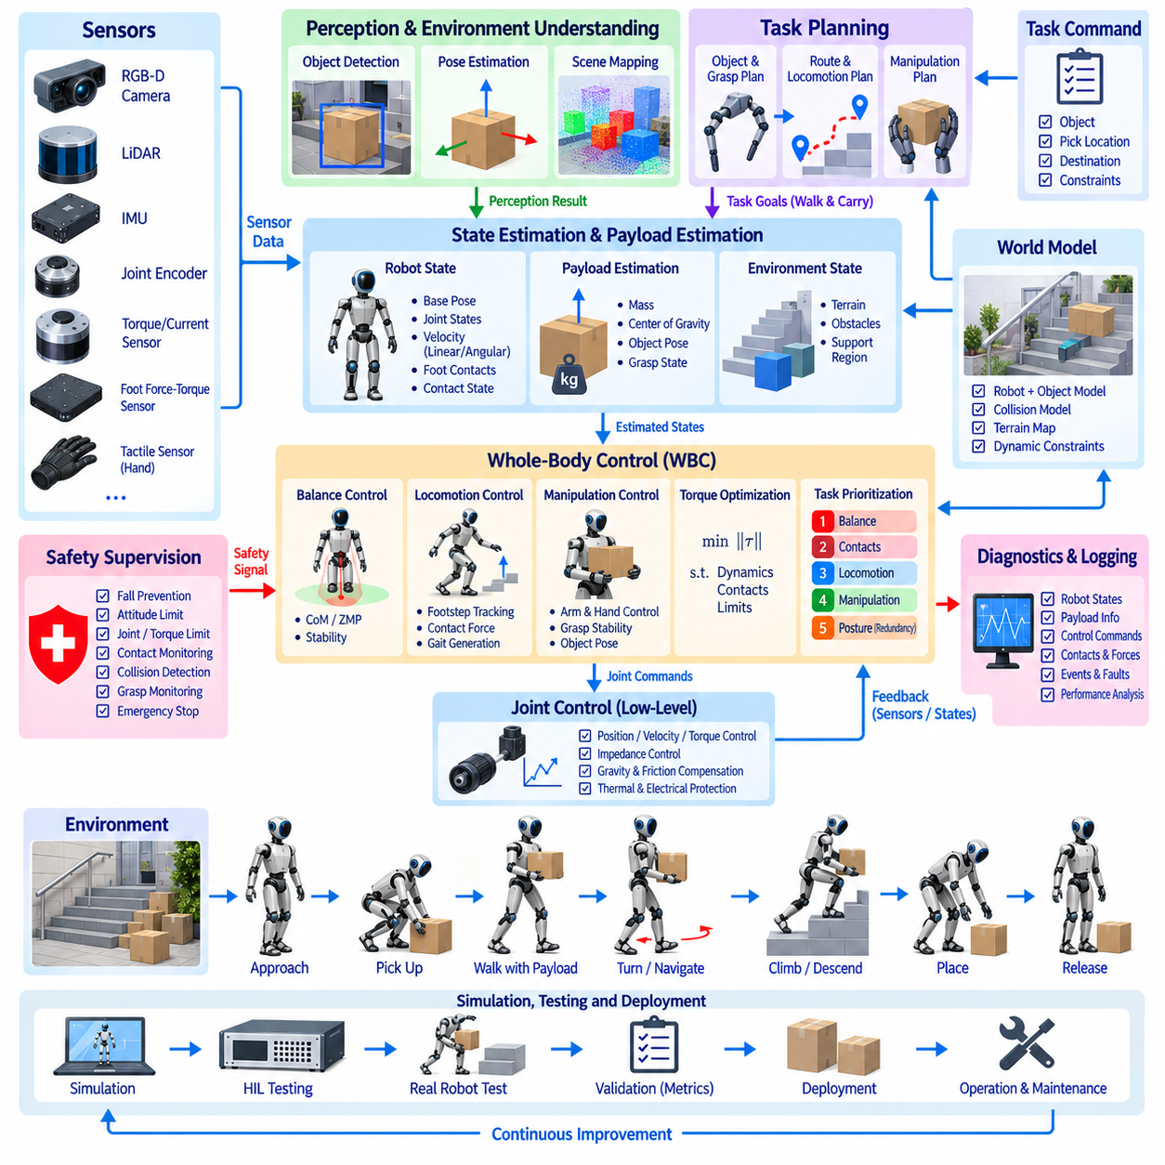
Humanoid walk-and-carry control combines biped locomotion with manipulation while the robot transports an object using one or both arms. Unlike unloaded walking, the carried payload changes the total mass, center of mass, inertia, joint loading, and balance characteristics of the complete robot. Whole-body control must therefore coordinate legs, torso, arms, contacts, and payload dynamics within one unified motion-control framework.
A humanoid platform typically includes actuated legs, waist, torso, arms, wrists, and grippers together with joint encoders, torque or current sensing, an IMU, foot force-torque sensors, and environmental perception sensors. Carrying tasks additionally require information about grasp state, payload mass, and object pose. All sensor measurements must share calibrated coordinate frames and consistent timing so that locomotion and manipulation operate on the same estimated robot state.
The software architecture integrates perception, task planning, state estimation, locomotion planning, manipulation planning, whole-body control, joint control, and safety supervision. A task command specifies the object, pickup location, destination, and transport requirements. Higher-level planners generate grasp and walking objectives, while whole-body control resolves them into coordinated joint motion and contact forces that remain compatible with balance and actuator constraints.
State estimation determines base pose, body orientation, linear and angular velocity, joint states, foot contacts, and the configuration of the carried object. IMU measurements can be fused with joint kinematics, foot force sensing, vision, or LiDAR localization. During locomotion, reliable contact-state estimation is essential because incorrect assumptions about which foot supports the body can corrupt the estimated base motion and destabilize subsequent control calculations.
Payload estimation becomes particularly important after grasping. The controller may estimate object mass and center of gravity using wrist force-torque measurements, joint torque observations, motor currents, or known object models. The estimated payload is incorporated into the robot dynamic model so that gravity compensation and balance calculations reflect the combined robot-object system rather than the unloaded humanoid alone.
The total center of mass changes when the robot picks up an object. A heavy object held in front of the torso shifts the combined center of mass forward, while asymmetric one-handed carrying introduces lateral and rotational effects. The controller can compensate through torso inclination, arm configuration, pelvis motion, and foot placement. These adjustments should emerge from coordinated whole-body objectives instead of independent corrections that may conflict with each other.
Walking planning determines footsteps, timing, support phases, and desired body progression toward the destination. The planner must account for the altered dynamics caused by the payload and may reduce step length, walking speed, or turning rate accordingly. Footsteps should preserve sufficient support margins while remaining compatible with environmental constraints such as narrow passages, uneven surfaces, obstacles, and required manipulation clearance.
Biped balance can be represented using center-of-pressure, zero-moment-point, capture-point, divergent-component-of-motion, or centroidal-dynamics formulations depending on the control architecture. These representations relate body motion and contact forces to the available support region. During payload transport, balance references must include the payload contribution because arm motion or object acceleration can generate significant disturbances even when foot positions remain unchanged.
Whole-body control coordinates multiple objectives through the full humanoid dynamics. Typical objectives include maintaining balance, tracking pelvis and torso motion, controlling swing-foot trajectories, preserving stance-foot contacts, maintaining the object pose, regulating hand forces, and respecting joint limits. Optimization-based formulations such as quadratic programming can solve these objectives simultaneously while enforcing rigid-body dynamics, friction, torque, and contact constraints.
Task prioritization determines how the robot behaves when all desired objectives cannot be satisfied simultaneously. Balance and contact constraints normally receive higher priority than exact hand or object tracking. If the robot approaches a stability limit, the controller may permit small payload-position deviations, modify torso posture, or adjust footsteps rather than sacrificing support stability. Explicit priorities make these compromises predictable and easier to validate.
Centroidal control provides a useful bridge between locomotion planning and full-body dynamics. Desired linear and angular momentum trajectories can be generated from walking and payload objectives, while the controller determines contact forces required to realize them. Because moving a carried object changes angular momentum, coordinated arm and torso behavior can reduce unwanted rotational disturbances and improve balance during acceleration, deceleration, and turning.
Footstep adjustment provides an important mechanism for recovering balance. If the combined robot-payload center of mass moves beyond the expected region, modifying the next foothold can restore a viable support configuration. The controller may alter step position, width, or timing within validated limits. This strategy is especially useful when disturbances are too large to reject through ankle, hip, or torso motion while keeping the original footsteps unchanged.
Swing-foot trajectory generation must provide sufficient ground clearance while preserving smooth body motion. Abrupt leg acceleration can disturb the payload and create unwanted upper-body motion. The swing trajectory therefore coordinates foot height, horizontal progression, landing velocity, and timing with the support-leg dynamics. Terrain information may modify the trajectory when the robot crosses thresholds, ramps, uneven flooring, or other non-flat surfaces.
Foot contact control manages the transition between single and double support. Force-torque sensors can confirm touchdown and estimate load distribution between the feet. Premature or delayed contact should be handled through compliant behavior rather than rigidly forcing the planned trajectory. Smooth load transfer is particularly important while carrying because sudden changes in ground reaction force can produce payload oscillation and large corrective upper-body motion.
Arm control maintains the required relationship between the hands and carried object while the lower body walks. For two-handed carrying, both hands form a closed kinematic relationship through the object, requiring coordinated position and force control. Small geometric inconsistencies between hand commands can otherwise create internal forces. The controller should regulate object pose while limiting unnecessary squeezing, twisting, or opposing forces between the arms.
Grasp stability must be preserved throughout transport. Finger position, gripping force, wrist force-torque data, tactile sensing, and object motion can be monitored for signs of slip or contact degradation. When instability is detected, the robot may increase gripping force within safe limits, reduce walking acceleration, modify object orientation, or stop. Manipulation control and locomotion control should therefore exchange grasp-quality information continuously.
Object trajectory planning should consider both manipulation convenience and locomotion stability. Holding the payload close to the torso generally reduces gravitational moment and arm torque, but the object must not collide with the body or obstruct leg motion and perception. Large or fragile objects may require restricted orientation, acceleration, or clearance. The transport pose can consequently change as the robot passes through different environmental conditions.
Redundancy resolution is fundamental because humanoids possess many more joints than required for a single end-effector or balance objective. Null-space or optimization-based methods can use this redundancy to avoid joint limits, reduce energy consumption, improve manipulability, maintain sensor visibility, and preserve collision clearance. However, secondary posture objectives must never interfere with higher-priority balance, contact, or payload-control requirements.
Joint-level control executes the position, velocity, acceleration, or torque references produced by whole-body control. Torque-controlled humanoids can regulate contact forces and dynamic interaction directly, while impedance control provides compliance against modeling errors and unexpected contacts. Gravity, friction, actuator dynamics, and payload compensation improve tracking, but commanded values must remain within motor current, torque, velocity, temperature, and mechanical limits.
Collision avoidance must consider the complete robot and carried object. Arms can collide with the torso, the payload can strike the legs during walking, and the object can contact walls or obstacles even when the humanoid body itself has sufficient clearance. The planning scene should therefore include an updated payload geometry attached to the hands. Real-time distance monitoring can reduce speed, modify posture, or request replanning when clearance becomes insufficient.
Turning while carrying is more demanding than straight walking because the payload contributes additional rotational inertia. Rapid yaw motion can produce large hand forces and angular momentum that must be balanced through the feet and body. The controller can reduce turning speed, increase step width, reposition the object, or distribute rotation across multiple steps. Large payloads may therefore require dedicated turning strategies rather than ordinary walking commands.
Acceleration and braking should also be payload-aware. Sudden forward acceleration causes the carried mass to generate an opposing inertial effect, while rapid deceleration can shift the combined balance state toward the front of the support region. Walking planners can limit acceleration and jerk according to payload properties. Whole-body control then coordinates torso, arms, pelvis, and ground reaction forces to prevent unnecessary object oscillation.
Disturbance rejection must address external pushes, unexpected foot contact, payload movement, and grasp changes. Small disturbances may be compensated through ankle, hip, torso, or arm responses while maintaining the planned footsteps. Larger disturbances can require step adjustment or emergency placement of a foot. If payload retention conflicts with fall prevention, supervisory logic should apply predefined safety priorities appropriate to the robot and operating environment.
Supervisory control coordinates pickup, payload verification, walking initialization, transport, turning, obstacle negotiation, placement, release, and recovery. Each state transition should verify relevant conditions such as stable grasp, valid payload estimate, sufficient balance margin, localization confidence, actuator readiness, and clear walking space. Explicit task states prevent manipulation failures from propagating unnoticed into dynamic locomotion.
Safety supervision independently monitors body attitude, support contacts, joint limits, actuator temperature, torque, communication health, grasp state, and stability indicators. Excessive tilt, loss of support, severe slip, actuator faults, or rapidly growing tracking errors may trigger reduced motion, controlled stopping, additional support steps, or other validated protective responses. Safety thresholds may become more conservative as payload mass or dimensions increase.
Communication timing is critical because perception, walking planning, manipulation, whole-body optimization, and embedded joint control operate at different frequencies. Time synchronization, timestamps, trajectory identifiers, command validity intervals, buffers, interpolation, and watchdogs prevent stale information from entering fast control loops. Payload state and foot-contact information require especially consistent timing because both directly affect dynamic balance calculations.
Simulation allows combined locomotion and manipulation behavior to be evaluated before hardware testing. Dynamic models can vary payload mass, center of gravity, friction, actuator limits, walking speed, grasp configuration, and external disturbances. Hardware-in-the-loop testing can additionally validate controllers and communication interfaces. Failure scenarios such as slip, unexpected object motion, contact loss, torque saturation, and delayed sensor information should be included deliberately.
Validation should cover different payload masses, dimensions, grasp configurations, walking speeds, turns, starts, stops, narrow passages, uneven terrain, and disturbance conditions. Relevant metrics include center-of-mass tracking, balance margin, foot placement error, ground reaction force, joint torque, hand force, object-pose error, grasp stability, walking speed, energy consumption, recovery performance, and task completion rate.
Operational logging should synchronize estimated robot states, payload parameters, footsteps, support phases, whole-body objectives, joint commands, contact forces, hand forces, grasp information, stability indicators, and supervisory events. These records allow failures to be separated into perception, planning, balance, manipulation, actuator, or contact-related causes. Field data can then support systematic controller improvement and payload-dependent parameter refinement.
An integrated humanoid walk-and-carry system ultimately treats the robot and payload as one dynamically coupled system. Walking determines changing support contacts, manipulation maintains the required payload relationship, whole-body control coordinates momentum and contact forces, and joint controllers execute the resulting motion while sensory feedback closes the loop. Reliable transport emerges when locomotion, manipulation, balance, payload dynamics, compliance, safety, timing, and recovery are engineered within one coherent whole-body control architecture.

12.06 2.5t Cargo UAV Auto Landing Control Case
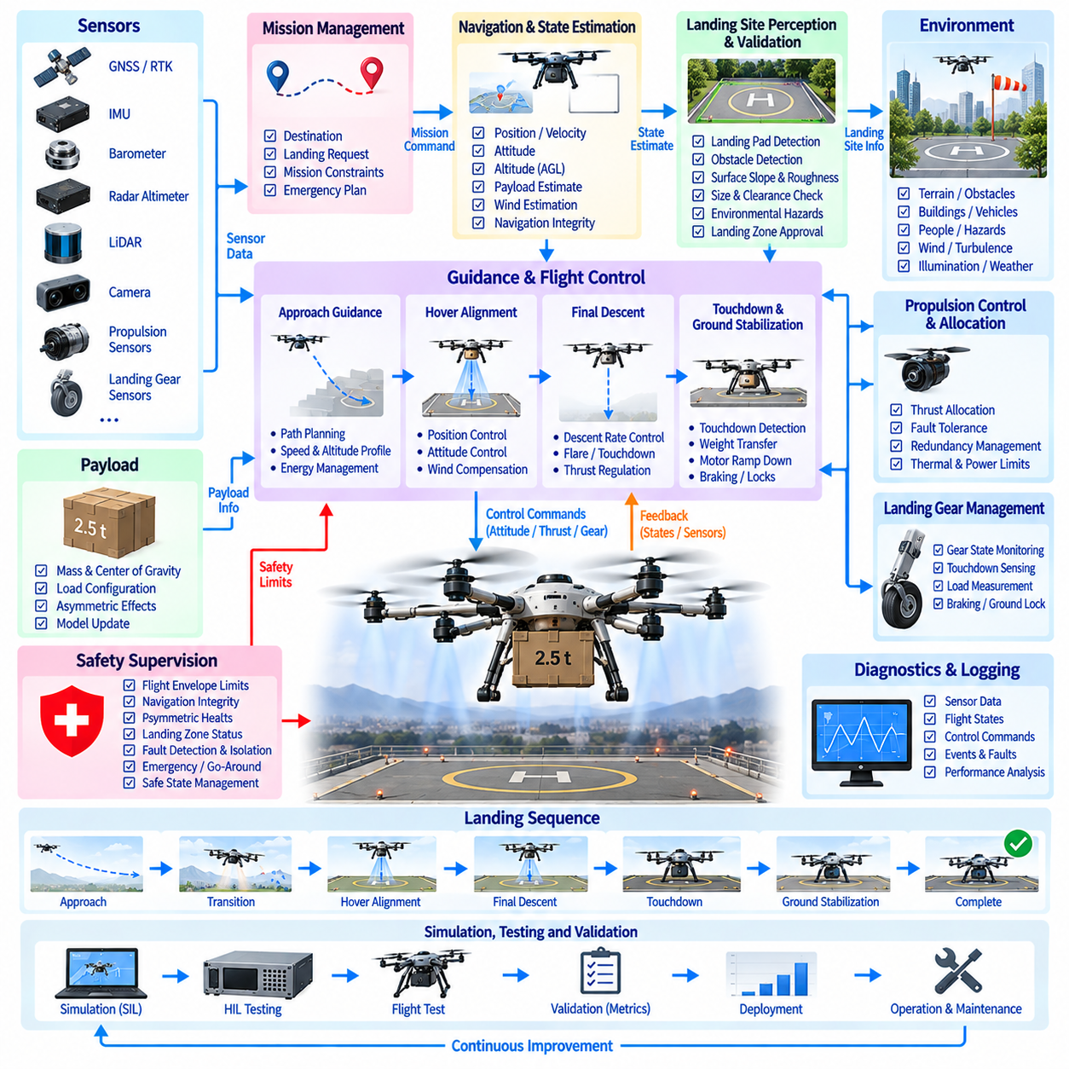
A 2.5-ton cargo UAV requires an automatic landing control system that coordinates navigation, flight dynamics, propulsion, landing-site perception, and safety under significantly higher kinetic energy and inertia than small unmanned aircraft. Landing is a mission-critical phase because altitude decreases while maneuvering margin becomes progressively smaller. The control software must therefore transform approach guidance into precise, stable, and fault-tolerant touchdown behavior.
The aircraft architecture may use multirotor, distributed electric propulsion, hybrid-electric VTOL, or another vertical-lift configuration suitable for heavy cargo transport. Flight-control computers receive data from GNSS, RTK, IMU, radar altimeter, barometric sensors, LiDAR, cameras, propulsion controllers, and landing-gear sensors. Automatic landing integrates these heterogeneous measurements into a consistent estimate of aircraft position, velocity, attitude, altitude, and landing-zone state.
The software architecture is commonly divided into mission management, navigation, landing-site perception, guidance, flight control, propulsion control, landing-gear management, and safety supervision. Mission logic defines the destination and initiates the landing sequence, while navigation guides the UAV toward the terminal approach region. Landing control progressively assumes tighter authority as the vehicle transitions from approach to descent, hover alignment, final descent, touchdown, and ground stabilization.
State estimation is fundamental because landing requires accurate relative motion with respect to the landing surface rather than only global navigation coordinates. GNSS/RTK can provide precise horizontal positioning in favorable conditions, while IMU measurements provide high-rate attitude and acceleration information. Radar or laser altimeters improve height-above-ground estimation, and vision or LiDAR can estimate relative landing-pad pose when satellite navigation becomes degraded or insufficiently precise.
Sensor fusion should explicitly address different measurement rates, delays, noise characteristics, and failure modes. An extended Kalman filter, error-state filter, factor-graph estimator, or equivalent architecture can combine inertial propagation with external corrections. During the final meters of descent, relative altitude and horizontal velocity become particularly important. The estimator should also provide confidence or integrity information so that guidance can react appropriately to degraded navigation quality.
Landing-site perception determines whether the intended touchdown region remains safe and usable. Cameras, LiDAR, radar, or multimodal sensing can identify landing markers, terrain slope, obstacles, vehicles, people, surface irregularities, and temporary hazards. For a heavy cargo UAV, the required clear area is substantially larger than the physical landing gear footprint because rotor clearance, downwash, navigation uncertainty, and emergency maneuver margins must also be considered.
Landing-zone validation evaluates geometry and operational suitability before committing to descent. The system can check surface slope, roughness, dimensions, obstacle clearance, approach corridor, expected load-bearing capability, and localization confidence. A previously approved landing location should not automatically remain valid if perception detects a new obstacle or environmental change. The control architecture therefore treats landing-site approval as a continuously monitored condition rather than a one-time mission input.
Approach guidance generates a feasible path from cruise or transition flight to the terminal landing region. The trajectory must respect velocity, acceleration, attitude, climb-rate, descent-rate, and propulsion constraints. Heavy aircraft require early energy management because large velocity changes cannot be produced instantaneously. Guidance should reduce horizontal speed progressively while maintaining sufficient altitude and propulsion reserve for stabilization or a missed-approach maneuver.
The terminal approach establishes the aircraft near the landing site with controlled horizontal velocity and heading. Depending on the vehicle configuration, the UAV may transition from wing-borne or forward flight into vertical-lift operation before final descent. Transition management must account for changing aerodynamic effectiveness and propulsion authority. The controller should avoid entering low-altitude flight before the vehicle has achieved a stable configuration appropriate for vertical landing.
Hover alignment positions the UAV above the selected touchdown reference while controlling lateral position, altitude, heading, and velocity. Wind and payload asymmetry can produce continuous disturbances, so position control must work together with attitude and propulsion control. The guidance system should define acceptable alignment envelopes rather than demanding mathematically perfect position. Descent begins only when position, velocity, attitude, and navigation confidence remain inside validated limits.
Position control converts horizontal and vertical trajectory errors into acceleration or force demands. These commands are then translated into attitude and thrust references consistent with vehicle dynamics. For a heavy UAV, command shaping is important because aggressive corrections can create large attitude excursions, cargo loads, and propulsion transients. Acceleration, jerk, tilt angle, and vertical-speed limits should therefore be explicitly incorporated into the landing controller.
Attitude control regulates roll, pitch, and yaw while the aircraft tracks landing guidance. Inner-loop angular-rate control generally operates faster than outer position and velocity loops, creating a cascaded flight-control structure. Accurate attitude stabilization is especially important near the ground because excessive tilt reduces vertical thrust margin and can produce lateral touchdown velocity. Controller bandwidth should account for actuator dynamics, structural modes, and propulsion response.
Thrust allocation converts total force and moment commands into individual rotor, propulsor, or motor commands. Distributed propulsion provides redundancy but introduces allocation constraints when actuators differ in available thrust, efficiency, temperature, or fault status. Optimization-based control allocation can redistribute commands while respecting actuator limits. During landing, sufficient reserve should remain available to reject gusts or arrest descent rather than operating all propulsion units continuously near saturation.
Payload characteristics directly influence landing dynamics. A 2.5-ton cargo UAV may experience substantial changes in total mass and center of gravity between loaded and unloaded missions. Cargo location can also introduce asymmetric moments. Payload mass and center-of-gravity estimates should therefore update the dynamic model, hover thrust, control allocation, and landing limits. Unexpected differences between planned and estimated payload conditions should trigger additional validation before final descent.
Wind estimation is critical during terminal landing because low-altitude turbulence, building wakes, and gusts can rapidly disturb a large vehicle. The controller can estimate wind using differences between air-relative and ground-relative motion, inertial response, propulsion demand, or dedicated sensors. Guidance can compensate for steady wind while disturbance-rejection loops handle faster variations. Excessive wind or gust conditions should prevent commitment to touchdown.
Ground effect changes aerodynamic and propulsion behavior as the UAV approaches the surface. Rotor-induced flow interacting with the ground can alter required thrust, vertical response, and vehicle stability. For large distributed-propulsion aircraft, the effect may vary across rotors when the surface is sloped or uneven. The controller should accommodate these changes through validated models, adaptive compensation, robust feedback, or conservative descent profiles rather than assuming free-air behavior remains unchanged.
Downwash is both a control and operational constraint for heavy cargo UAVs. Strong rotor flow can move debris, disturb nearby equipment, affect people, and alter local visual conditions through dust or snow. Landing-site perception may degrade precisely when the vehicle approaches the ground. The system should therefore preserve redundant altitude and velocity sensing and detect sudden loss of visual quality instead of relying exclusively on camera-based terminal navigation.
Final descent begins only after landing-zone validity and aircraft stabilization criteria are satisfied. Vertical speed is reduced according to altitude so that touchdown energy remains within landing-gear and structural limits. Horizontal velocity should converge toward a small validated value while attitude remains near the allowed touchdown envelope. A staged descent profile can provide intermediate gates where the controller verifies conditions before allowing further reduction in altitude.
Landing gates create explicit decision points throughout terminal descent. Each gate can verify navigation integrity, landing-zone clearance, horizontal error, vertical speed, attitude, propulsion reserve, wind condition, and system health. If criteria are not satisfied, the aircraft can hold, climb, reposition, or execute a go-around depending on altitude and available energy. This prevents a single early decision from forcing the aircraft to continue an unsafe landing sequence.
Flare or descent-rate shaping may be required before touchdown depending on aircraft configuration and landing-gear capability. The controller reduces vertical kinetic energy while maintaining sufficient thrust authority to avoid oscillatory altitude corrections. Heavy vehicles should avoid aggressive late-stage thrust changes because propulsion delay can produce repeated overshoot. Smooth vertical acceleration and jerk profiles provide more predictable touchdown loads and passenger-independent cargo protection.
Touchdown detection should combine multiple signals rather than relying on altitude alone. Landing-gear load sensors, strut compression, vertical acceleration, motor response, wheel switches, or persistent zero-height measurements can indicate ground contact. The controller must distinguish true touchdown from temporary contact or sensor noise. Once contact is confirmed, flight-control objectives transition from airborne stabilization toward weight transfer and ground stabilization.
Weight transfer should occur progressively so that propulsion thrust is not removed before the landing gear supports the aircraft securely. Uneven terrain or asymmetric contact can cause one gear assembly to touch before others. The controller can monitor gear loads, roll and pitch response, and vertical motion while gradually reducing thrust. If contact geometry becomes abnormal, sufficient propulsion authority may need to remain available for unloading the gear or initiating an immediate recovery.
Ground stabilization manages the transition from partially supported flight to a fully landed state. Propulsion commands are reduced according to validated sequencing, while attitude-control integrators and airborne control modes are reset or transitioned carefully. Landing-gear brakes, locks, or ground restraints may then become active. Premature mode switching can create command discontinuities, so touchdown and ground states should be governed by an explicit supervisory state machine.
A go-around capability is essential because automatic landing must remain reversible until the aircraft reaches a condition where committed touchdown is safer than renewed flight. Triggers may include obstacle intrusion, navigation degradation, excessive lateral error, unstable descent, wind exceedance, propulsion fault, or invalid landing-zone perception. The go-around trajectory should already be defined before descent begins and should preserve obstacle clearance and propulsion margins.
Fault-tolerant control is especially important for distributed-propulsion cargo UAVs. Motor, inverter, sensor, communication, or flight-control faults can occur during the landing sequence. Fault detection and isolation identify the affected subsystem, while control allocation determines whether sufficient authority remains. The aircraft may continue landing, hold, divert, or execute an emergency descent depending on fault severity, altitude, remaining redundancy, and validated contingency logic.
Safety supervision independently monitors flight-envelope limits, navigation integrity, propulsion health, battery or fuel state, landing-zone status, communication, and flight-control performance. Excessive attitude, descent rate, position error, actuator saturation, or estimator disagreement should generate graduated responses. Safety logic must remain coordinated with normal control without depending on a single high-level software component for all protective actions.
Real-time communication and synchronization are critical because perception, navigation, guidance, flight control, propulsion, and landing-gear systems operate at different frequencies. Time-stamped measurements, synchronized clocks, sequence counters, command validity intervals, and watchdogs prevent delayed information from being interpreted as current state. Deterministic communication becomes increasingly important in the fast inner loops that directly influence attitude and thrust.
Simulation should reproduce vehicle mass properties, propulsion dynamics, aerodynamic behavior, ground effect, wind, landing-gear contact, sensor noise, and navigation faults. Monte Carlo testing can vary uncertain parameters across large numbers of landing scenarios. Software-in-the-loop and hardware-in-the-loop environments allow flight-control computers, networks, sensors, and propulsion interfaces to be evaluated before flight testing. Rare failure cases should be deliberately exercised.
Flight validation should progress from nominal approaches to increasingly demanding conditions, including payload variation, center-of-gravity offsets, crosswinds, gusts, degraded GNSS, perception uncertainty, uneven landing surfaces, actuator limitations, and go-around scenarios. Relevant metrics include position error, horizontal velocity, descent rate, attitude error, thrust reserve, touchdown load, navigation integrity, control latency, landing dispersion, and successful recovery behavior.
Operational logging should synchronize navigation estimates, perception outputs, landing-zone assessments, guidance trajectories, flight-control commands, actuator responses, wind estimates, payload parameters, landing-gear loads, faults, and supervisory transitions. Post-flight analysis can reconstruct the complete landing sequence and distinguish perception, estimation, guidance, control, propulsion, or mechanical causes when abnormal behavior occurs.
An integrated 2.5-ton cargo UAV automatic landing system therefore forms a closed perception-estimation-guidance-control-safety loop extending from terminal approach to secure ground state. Landing-site perception validates where the aircraft can land, state estimation determines relative motion, guidance shapes the approach and descent, flight control coordinates attitude and thrust, and touchdown logic manages contact and weight transfer. Reliable heavy-UAV landing emerges when payload dynamics, propulsion reserve, navigation integrity, ground interaction, fault tolerance, and go-around capability are engineered as one coherent control architecture.

12.07 Motor Failure Fault Tolerant Control Field Case
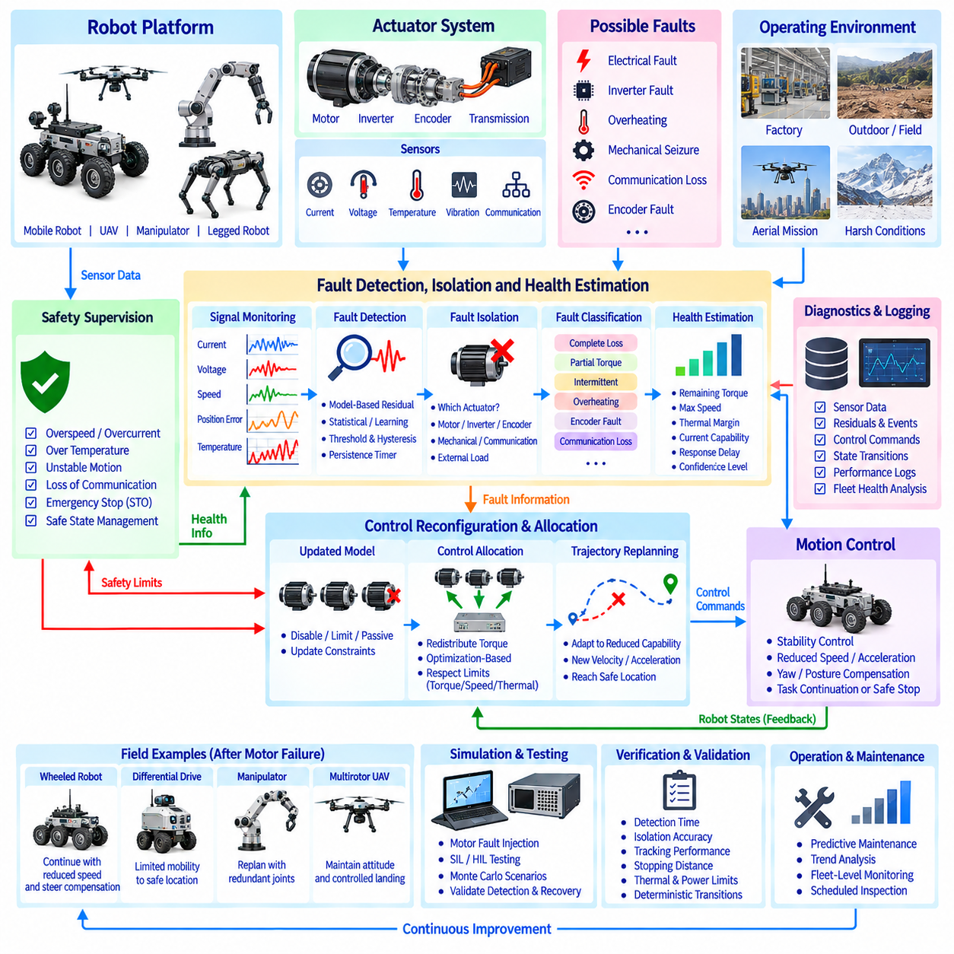
Motor failure fault-tolerant control is designed to preserve safe and predictable robot behavior when one or more propulsion or joint actuators lose performance during operation. A motor fault can immediately alter available force, torque, controllability, and dynamic stability. The control software must therefore detect abnormal behavior rapidly, determine the remaining actuator capability, reconfigure control objectives, and guide the system toward continued operation or a controlled safe state.
A field-deployed robotic platform typically contains motors, inverters, encoders, current and voltage sensors, temperature sensors, communication interfaces, mechanical transmissions, and supervisory controllers. Motor faults may originate from electrical, electronic, thermal, mechanical, communication, or sensor failures. Because several faults produce similar external symptoms, fault-tolerant control should combine multiple measurements rather than relying on a single diagnostic signal.
The control architecture can be divided into actuator monitoring, fault detection and isolation, health estimation, control reconfiguration, motion control, safety supervision, and diagnostics. During normal operation, these functions continuously observe actuator behavior without disturbing the primary task. When an abnormal condition appears, the architecture transitions from nominal control toward degraded control using predefined limits and dynamically estimated residual capability.
Fault detection begins by comparing commanded and measured actuator behavior. Useful signals include motor current, phase current balance, voltage, rotor speed, position tracking error, torque estimate, temperature, vibration, and communication status. Model-based residuals can compare expected motor response with measured response, while statistical or learning-based methods can identify patterns that deviate from normal operating distributions.
Fault isolation determines which actuator or subsystem is responsible for the abnormal response. A large tracking error alone cannot distinguish a motor failure from encoder malfunction, mechanical blockage, communication delay, or excessive external load. Isolation logic therefore evaluates relationships among current, velocity, torque, position, temperature, and network information. Correct isolation is essential because an inappropriate recovery command can worsen the original fault.
Fault classification describes the type and severity of degradation. Typical categories include complete loss of torque, partial torque reduction, intermittent operation, excessive friction, encoder failure, inverter fault, overheating, phase loss, communication timeout, and mechanical seizure. Classification does not need to identify every physical root cause immediately, but it must provide sufficient information for the controller to determine what commands remain safe.
Actuator health estimation expresses remaining capability quantitatively rather than using only healthy or failed states. A degraded motor may still provide limited torque, speed, or operating duration. Health parameters can include available positive and negative torque, maximum speed, thermal margin, current capability, response delay, and confidence level. These values allow the controller to exploit usable capability without commanding the actuator beyond its degraded limits.
Detection thresholds require careful design because field measurements contain noise, transient loads, impacts, and communication jitter. Thresholds that are too sensitive create false fault declarations, while insensitive thresholds delay intervention. Persistence timers, hysteresis, adaptive thresholds, operating-point-dependent limits, and multi-signal voting can improve robustness. Fault logic should distinguish short transients from persistent degradation while maintaining sufficiently rapid response to dangerous failures.
Once a fault is confirmed, control reconfiguration updates the system model and available actuator set. The failed actuator may be disabled, torque-limited, switched to a passive state, or retained with reduced authority depending on fault type. The controller then redistributes control effort among healthy actuators. Reconfiguration should avoid discontinuous commands because abrupt changes in torque allocation can destabilize the robot even when sufficient residual authority exists.
Control allocation is particularly important for overactuated systems such as multi-wheel robots, multi-rotor aircraft, and redundant manipulators. Multiple actuators can contribute to the same generalized force or motion objective. Optimization-based allocation can minimize tracking error while respecting actuator-specific torque, speed, thermal, and fault constraints. A failed motor is represented by reduced or zero authority, allowing remaining actuators to compensate within physically feasible limits.
For a mobile robot, loss of one drive motor can create asymmetric longitudinal force and yaw moment. A four-wheel or six-wheel platform may continue moving by reducing speed and redistributing traction to healthy wheels. Steering commands may also be adjusted to compensate for asymmetric drive capability. The controller should reduce acceleration and curvature demands so that continued motion remains within the traction and thermal limits of the surviving actuators.
For a differential-drive platform, a severe failure of one drive side can eliminate normal bidirectional velocity control. Limited mobility may still be possible through controlled motion of the healthy side, mechanical disengagement, or specialized degraded-mode strategies. The objective should change from nominal path tracking to reaching a nearby safe location when feasible. Attempting to preserve normal trajectory performance can create excessive yaw or overload the remaining drive.
For a manipulator, a joint motor failure can reduce available degrees of freedom or lock a joint mechanically. Redundant manipulators may preserve end-effector control by treating the failed joint as fixed and resolving motion through the remaining joints. Inverse kinematics and whole-body optimization must update the kinematic constraints immediately. Reachability, manipulability, collision clearance, and payload capability should then be reevaluated under the degraded configuration.
For a multirotor or distributed-propulsion aircraft, motor failure directly changes available thrust and moment generation. Redundant propulsion layouts may retain controllability after one propulsion unit fails, but achievable force and moment envelopes become smaller. Control allocation must prioritize attitude stabilization and vertical-force requirements over less critical objectives. Depending on architecture and flight condition, the appropriate response may be continued flight, diversion, or immediate emergency landing.
Trajectory replanning converts reduced actuator capability into achievable motion objectives. The planner should receive updated limits for acceleration, velocity, turning rate, payload, slope, or reachable workspace. A previously feasible trajectory may become unsafe after a motor fault because it assumes unavailable torque or braking capability. Replanning therefore prevents the motion controller from repeatedly attempting commands that the degraded system can no longer execute.
Dynamic stability must be reevaluated whenever actuator authority changes. Reduced propulsion or joint torque can decrease the ability to reject disturbances, brake motion, or recover from tracking errors. The controller may enlarge safety margins, reduce speed, modify posture, increase support duration, or restrict operating regions. Fault tolerance is not simply maintaining movement; it is maintaining movement whose stability requirements remain compatible with the remaining hardware.
Thermal management becomes important after control redistribution because healthy motors may carry additional load. A recovery strategy that successfully compensates for one failed motor can subsequently overheat neighboring actuators. Temperature, current, estimated losses, and thermal models should therefore influence degraded-mode control allocation. Torque limits may be reduced progressively as thermal margin decreases, preventing secondary failures caused by prolonged overload.
Power-system constraints must also be considered. Redistribution can increase peak current demand from batteries, converters, cables, or power distribution units. A motor fault caused by an inverter short circuit or electrical abnormality may require isolation before other actuators can operate safely. The supervisory controller should distinguish mechanical loss of capability from electrical faults that can propagate through shared power infrastructure.
Mechanical braking and passive behavior can support fault recovery. If an actuator cannot generate controlled torque but its brake remains available, the system may lock the affected joint or wheel and reconfigure around that constraint. Conversely, a seized motor can create large drag forces that differ fundamentally from a free-spinning failed motor. The control model must represent the actual mechanical state because identical zero-command assumptions can produce very different vehicle responses.
Fault-tolerant control should distinguish fail-operational and fail-safe objectives. Fail-operational behavior maintains a reduced mission capability after a fault, whereas fail-safe behavior prioritizes transition to a condition with acceptable residual risk. The choice depends on available redundancy, environment, payload, fault severity, and system safety requirements. A controller should not continue operation merely because some motion remains mathematically possible.
Supervisory control manages transitions among nominal, warning, degraded, recovery, safe-stop, and emergency states. State transitions should depend on confirmed fault information, residual control authority, environment conditions, and task criticality. Recovery attempts should be bounded in number and duration. Repeatedly resetting a fault without understanding whether actuator capability has returned can create oscillation between unsafe operating states.
Safety supervision should remain independent of ordinary recovery logic where required by the system architecture. Overspeed, overcurrent, excessive temperature, unstable attitude, uncontrolled motion, communication loss, or insufficient braking capability can override mission commands. Emergency-stop and safe-torque-off functions may disable actuator energy when continued control presents greater risk than stopping. Their behavior must be coordinated with mechanical brakes and gravitational loads.
Communication faults require special treatment because loss of motor feedback can resemble physical actuator failure. Sequence counters, timestamps, heartbeat messages, cyclic redundancy checks, and timeout supervision can distinguish stale or corrupted data from valid measurements. If actuator state becomes unknown, the controller should use conservative assumptions about available torque rather than continuing to command the motor as though feedback remained trustworthy.
Fault recovery requires evidence that the actuator has returned to a usable state. Temperature reduction, restored communication, stable encoder feedback, normal current response, and successful low-torque test commands may support recovery validation. Reintegrating an actuator should occur gradually to avoid torque discontinuities. Some faults should remain latched until maintenance inspection even if measurements temporarily return to normal.
Diagnostics and event logging are essential for field cases because intermittent failures may disappear before maintenance personnel inspect the robot. Logs should preserve pre-fault and post-fault sensor histories, commands, residuals, thresholds, state transitions, control allocations, temperatures, currents, network events, and recovery actions. A circular buffer can retain data preceding the trigger, providing valuable evidence for identifying the initiating event rather than only its consequences.
Field validation should deliberately inject representative faults under controlled conditions. Tests can include motor disablement, torque derating, encoder dropout, communication delay, thermal limiting, increased friction, inverter faults, and simulated mechanical blockage. Each test should evaluate detection time, isolation accuracy, transient stability, residual tracking performance, recovery behavior, stopping distance, actuator loading, and the absence of secondary faults.
Simulation and hardware-in-the-loop testing allow dangerous fault combinations to be evaluated before physical field trials. Motor dynamics, inverter limits, network delays, mechanical loads, sensor faults, and thermal behavior can be varied systematically. Monte Carlo testing can explore uncertainty in fault timing and operating conditions. Hardware-in-the-loop environments additionally verify real controller timing, communication, diagnostic logic, and reconfiguration behavior.
Verification should confirm not only that a fault is detected but that every subsequent control transition remains deterministic and bounded. Requirements can specify maximum detection latency, allowed tracking deviation, degraded torque limits, stopping distance, thermal margin, and transition time to a safe state. Traceability between fault hypotheses, detection logic, control responses, tests, and logged evidence makes the fault-tolerant architecture auditable and maintainable.
Operational deployment benefits from fleet-level health analysis. Repeated current anomalies, temperature growth, torque bias, vibration, or encoder errors across multiple missions can reveal degradation before a hard failure occurs. Predictive maintenance models can use these trends to schedule inspection or replacement. However, predictive health information should complement rather than replace deterministic protection mechanisms required for immediate fault response.
An integrated motor-failure fault-tolerant control system therefore forms a closed monitoring-diagnosis-reconfiguration-control-safety loop. Actuator monitoring detects abnormal behavior, fault isolation identifies the affected capability, health estimation quantifies remaining authority, control allocation redistributes effort, and motion planning adapts the mission to achievable performance. Reliable field operation emerges when detection, degraded control, thermal and power constraints, safety transitions, recovery, validation, and diagnostics are engineered as one coherent control architecture.

12.08 Control SW Performance Improvement: Latency Minimization
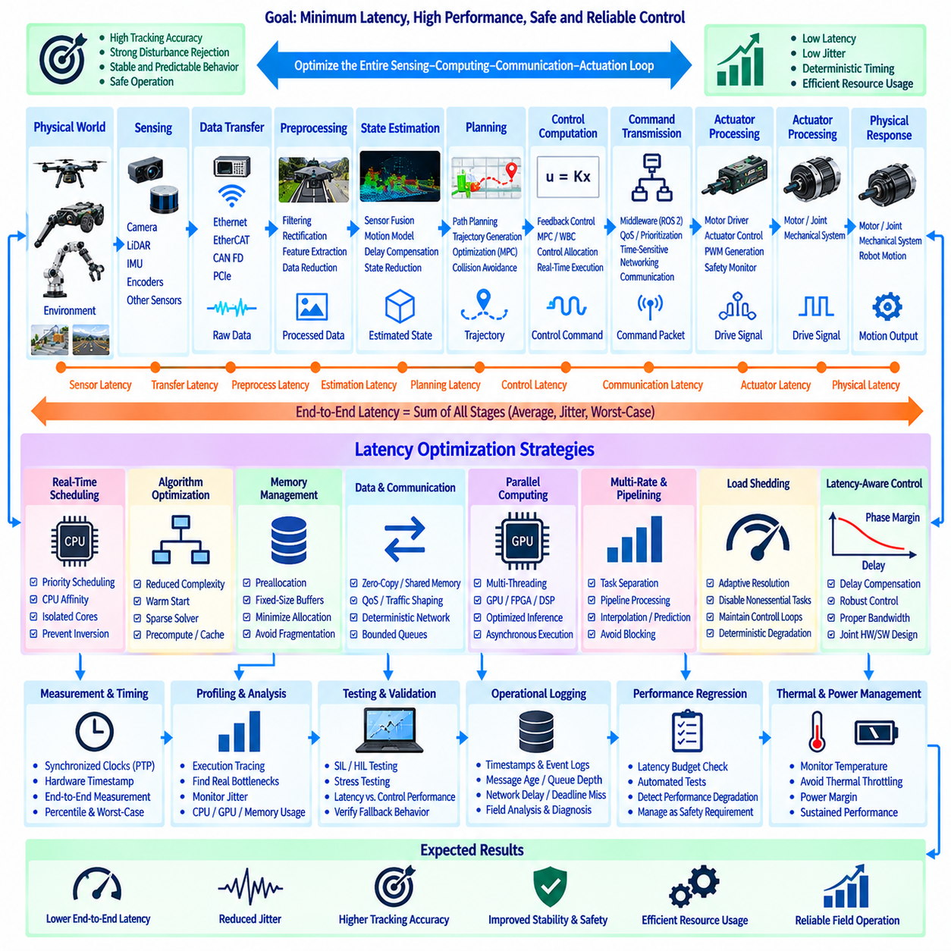
Control software performance improvement for latency minimization focuses on reducing the time between sensing a physical state, computing the required response, issuing an actuator command, and observing its effect. In robotic and autonomous systems, latency directly influences tracking accuracy, stability margin, disturbance rejection, and safety. Optimization must therefore address the complete sensing-computation-communication-actuation loop rather than only accelerating an individual algorithm.
End-to-end latency can be decomposed into sensor acquisition, data transfer, preprocessing, state estimation, planning, control computation, command transmission, actuator processing, and physical response. Each stage contributes both average delay and timing variation. A system with low average latency but large jitter may perform worse than a slightly slower deterministic system because control algorithms depend on predictable timing relationships between measurements, states, and commands.
The first optimization step is accurate latency measurement. Every important event should receive a timestamp from a synchronized time base so that engineers can reconstruct the complete control path. Sensor exposure, packet arrival, callback execution, algorithm completion, command publication, drive reception, and actuator response can be measured separately. Percentile latency and worst-case latency are generally more informative for real-time control than average execution time alone.
Clock synchronization is essential when measurements cross processors, sensors, embedded controllers, and network interfaces. Precision Time Protocol, hardware timestamps, synchronized monotonic clocks, or equivalent mechanisms can establish a common temporal reference. Without synchronization, measured communication delay can be confused with clock offset or drift. Accurate timing infrastructure should therefore be treated as part of the control architecture rather than as a diagnostic accessory.
Control-loop frequency should be selected according to plant dynamics rather than maximized without analysis. Motor current loops may operate at several kilohertz, velocity and torque loops at lower rates, and trajectory or whole-body controllers at hundreds of hertz. Perception and global planning can operate more slowly. Separating functions by required bandwidth prevents computationally expensive tasks from unnecessarily blocking fast control loops.
Real-time task scheduling assigns processor resources according to timing criticality. High-priority control threads should not wait behind logging, visualization, mapping, or background communication tasks. Real-time operating-system policies, fixed-priority scheduling, CPU affinity, and isolated processor cores can reduce scheduling uncertainty. Priority inversion must be prevented when high-priority tasks share locks or resources with lower-priority software components.
Execution-time profiling identifies where computation is actually consumed. Function-level timing, tracing, hardware performance counters, and system profilers can reveal expensive matrix operations, memory copies, serialization, synchronization waits, cache misses, and unexpected operating-system activity. Optimization should target measured bottlenecks rather than assumed ones. A slow algorithm may not be the dominant problem if data movement or scheduling delay consumes most of the control cycle.
Algorithmic optimization reduces computational complexity while preserving required control performance. Large optimization problems can sometimes be reduced through sparse formulations, warm starting, precomputed matrices, reduced-order models, or simplified constraints. Repeated trigonometric functions and coordinate transformations may be cached when valid. Numerical solvers should use termination tolerances that reflect physical control accuracy rather than unnecessarily pursuing mathematical precision beyond sensor and actuator resolution.
Model predictive control and optimization-based whole-body control can introduce significant computational latency because they solve constrained problems repeatedly. Warm starts from the previous solution, fixed sparsity patterns, efficient quadratic-programming solvers, horizon reduction, and hierarchical update rates can reduce computation. Slow model updates can be separated from fast optimization loops so that expensive parameters are recalculated only when their underlying physical state changes meaningfully.
Memory management strongly affects real-time predictability. Dynamic memory allocation inside high-frequency loops can create nondeterministic delays due to allocation, fragmentation, or garbage collection. Buffers, vectors, matrices, and message objects should therefore be preallocated where practical. Fixed-size data structures and bounded queues make execution time easier to analyze and prevent unexpected memory pressure from propagating into control-loop jitter.
Data copies should be minimized because high-bandwidth sensors can consume substantial memory bandwidth before control computation even begins. Zero-copy transport, shared memory, loaned messages, direct memory access, and reference-based interfaces can reduce redundant movement of images, point clouds, and state vectors. However, zero-copy designs require careful ownership and lifetime management so that performance improvement does not introduce race conditions or stale data.
Communication architecture can dominate latency in distributed robotic systems. Ethernet, EtherCAT, CAN FD, shared memory, PCIe, and middleware each provide different timing characteristics. High-rate actuator control should use deterministic communication when required, while large perception data may use throughput-oriented networks. Mixing both traffic classes without prioritization can cause bursts of camera or logging traffic to delay safety-critical control messages.
Network quality of service can prioritize time-critical messages and bound interference from lower-priority traffic. Traffic shaping, VLAN separation, scheduled Ethernet, time-sensitive networking, or dedicated actuator networks may be appropriate depending on system scale. Packet size, serialization overhead, switch latency, queue depth, and retransmission behavior should be measured. High nominal network bandwidth does not guarantee low control latency when queues are poorly managed.
Middleware configuration significantly affects software timing. Publish-subscribe systems such as ROS 2 can be tuned through quality-of-service policies, executor design, callback groups, intra-process communication, and transport selection. Reliable delivery may be appropriate for commands that must not be lost, while sensor streams may benefit from bounded queues and best-effort behavior when new data is more valuable than delayed old data. Queue depth should reflect control semantics rather than default settings.
Stale-data prevention is as important as raw speed. If a perception pipeline produces results slower than the incoming sensor rate, queues can accumulate and the controller may receive accurate but outdated information. Bounded queues, latest-sample semantics, frame dropping, and deadline monitoring prevent latency from growing invisibly. Control software should explicitly know the age of every measurement used for state estimation and command generation.
State estimation can compensate for unavoidable sensor and communication delay by propagating measurements to the current control time. IMU integration, motion models, and timestamp-aware filters allow delayed observations to correct past states before prediction is carried forward. This approach does not eliminate latency, but it reduces the control error caused by acting on an old state. Prediction uncertainty should increase appropriately as measurement age grows.
Multi-rate architecture allows each subsystem to operate at the frequency required by its dynamics. A high-rate inner torque controller can run independently of a slower whole-body controller, while trajectory planning and perception update at still lower frequencies. Interpolation and prediction connect these layers. This structure prevents a slow perception frame or planner iteration from directly determining the timing of the actuator-control loop.
Pipelining improves throughput by allowing different processing stages to execute concurrently. While one sensor frame is being processed, state estimation can use the previous frame and control computation can operate on the latest available estimate. Pipeline depth must remain bounded because excessive buffering increases total delay. The objective is not maximum throughput alone but minimum age of information when the control decision is executed.
Parallel computing can reduce latency when algorithms contain independent operations. CPU multithreading can accelerate perception preprocessing, collision checking, dynamics computation, or optimization assembly. GPUs can efficiently process neural networks, image operations, and large parallel numerical workloads. However, kernel-launch overhead and CPU-GPU memory transfers can offset acceleration for small control computations, so hardware assignment should be based on measured end-to-end timing.
GPU inference optimization is especially relevant when learned perception or control models operate inside the feedback loop. Reduced precision, optimized inference engines, graph compilation, operator fusion, fixed input shapes, and batched or asynchronous execution can reduce processing time. For latency-sensitive control, batch size one is often preferable to throughput-oriented batching. Model size should be selected according to the required deadline as well as prediction accuracy.
Hardware acceleration can also include FPGA, DSP, dedicated vision processors, or microcontroller peripherals. Functions such as encoder acquisition, PWM generation, filtering, timestamping, or safety monitoring can be moved closer to the hardware to reduce software-path delay. The objective is not to accelerate every function but to place deterministic, high-frequency operations at the computational layer where they can execute with the smallest bounded latency.
Lock contention is a common source of unpredictable delay in multithreaded control software. Long critical sections, shared global state, and blocking synchronization can prevent a high-priority controller from executing on time. Lock-free queues, double buffering, read-copy-update patterns, and carefully bounded mutex usage can reduce contention. Shared-data architecture should prioritize deterministic access over programming convenience in timing-critical paths.
Input/output operations should be removed from high-frequency control loops whenever possible. File writing, console printing, database access, network diagnostics, and visualization can block unexpectedly. Real-time threads should place diagnostic data into bounded buffers that lower-priority workers process asynchronously. Logging remains essential, but the logging architecture must ensure that recording a timing problem does not itself create the timing problem.
Control computation can be divided into hard real-time and soft real-time components. Motor commutation, actuator protection, and fast stabilization may require strict deadlines, while mapping, object recognition, and mission planning can tolerate variable execution times. Explicitly classifying these requirements helps engineers choose appropriate operating systems, processors, communication buses, and fallback behavior instead of applying the same timing assumptions to the entire software stack.
Deadline monitoring should be integrated into runtime supervision. Each periodic task can report execution start, completion, deadline miss, and data age. Repeated deadline violations can trigger workload reduction, controller-rate changes, degraded perception modes, or a safe transition. A system should not continue operating indefinitely under computational overload while assuming that delayed commands remain equivalent to timely ones.
Load shedding provides controlled behavior when computational demand exceeds available resources. Nonessential visualization, high-resolution logging, secondary perception models, or background optimization can be reduced or disabled before critical control loops are affected. Perception resolution or model complexity may also be adjusted dynamically. Load-shedding priorities should be predefined and validated so that overload response remains deterministic rather than depending on uncontrolled resource competition.
Latency-aware control design incorporates delay directly into controller development. Phase margin decreases as delay increases, and a controller tuned on an ideal zero-delay model may become oscillatory when deployed on real hardware. Delay compensation, prediction, lower controller bandwidth, Smith-predictor concepts, or robust-control techniques can improve tolerance. Software optimization and control-theoretic design should therefore be performed together rather than as independent activities.
Jitter analysis examines variation in sampling, computation, communication, and actuation timing. Even when the maximum delay is acceptable, inconsistent intervals can degrade numerical differentiation, filtering, and feedback stability. Controllers should use measured time intervals where appropriate instead of assuming a perfectly constant sample period. Sources of jitter should be traced to scheduling, interrupts, network queues, memory activity, thermal throttling, or competing workloads.
Thermal and power behavior can indirectly increase latency. CPUs and GPUs may reduce clock frequency when temperature or power limits are reached, causing algorithms that passed laboratory timing tests to miss deadlines during extended operation. Performance validation should therefore include sustained workloads at realistic environmental temperatures. Processor utilization and thermal margin should leave sufficient reserve for transient computational demand and long-duration missions.
Performance testing should measure best-case, typical, percentile, and worst-observed timing under representative workloads. Tests should include maximum sensor traffic, logging, network activity, perception load, control computation, and fault-handling tasks operating simultaneously. Stress testing can expose rare scheduling interactions that do not appear during nominal demonstrations. Timing measurements should be correlated with control tracking and stability metrics rather than evaluated in isolation.
Hardware-in-the-loop testing is valuable for evaluating latency because real controllers, communication interfaces, and software stacks can operate against simulated plant dynamics. Artificial delays, jitter, packet loss, CPU overload, and sensor-rate changes can be injected systematically. Engineers can determine the point at which tracking quality or stability begins to degrade and verify that deadline monitoring and fallback strategies activate before unsafe behavior develops.
Operational logging should preserve timestamps, execution times, queue depths, message ages, CPU and GPU utilization, network delay, deadline misses, actuator response, and control errors. These records allow field problems to be separated into algorithmic, computational, communication, or hardware causes. Long-term analysis can reveal gradual latency growth caused by software changes, thermal behavior, increased perception complexity, or additional background services.
Performance regression testing prevents later software modifications from silently degrading timing. Every important control-software release can be tested against latency budgets for sensing, estimation, planning, control, communication, and actuation. Automated tests should flag statistically significant increases as well as deadline violations. Timing requirements should therefore be managed with the same discipline as functional correctness and safety requirements.
An integrated latency-minimization strategy ultimately treats control performance as an end-to-end timing problem. Accurate timestamps reveal where delay originates, real-time scheduling protects critical tasks, efficient algorithms and memory paths reduce computation, deterministic networks bound communication, and multi-rate prediction keeps control synchronized with physical motion. Reliable performance emerges when latency, jitter, deadlines, computational load, thermal limits, and feedback stability are optimized as one coherent control-software architecture.

12.09 Control SW ISO 13849 Certification Case
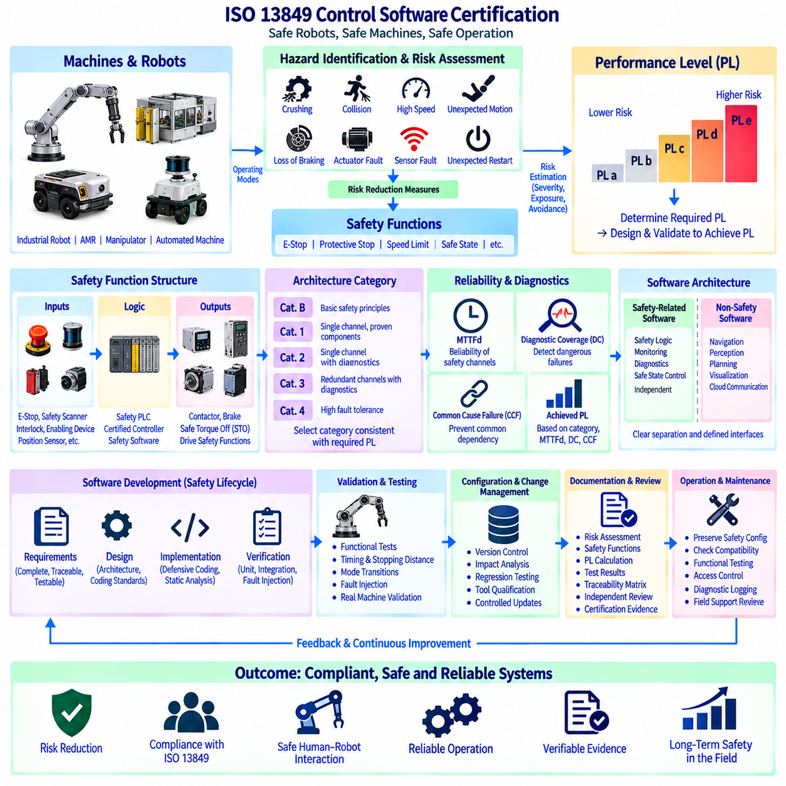
ISO 13849 certification for control software focuses on demonstrating that safety-related parts of a machine control system reduce risk with sufficient and verifiable reliability. For robots, AMRs, manipulators, and automated machinery, software participates in functions such as emergency stopping, motion inhibition, speed limitation, protective stopping, and safe state transitions. Certification therefore begins with safety functions rather than ordinary functional performance.
The engineering process starts with machine risk assessment and identification of hazardous situations across operating modes. Hazards may arise from unintended motion, excessive speed, crushing, collision, loss of braking, actuator faults, sensor failures, or unexpected restart. Each required risk-reduction measure is translated into a safety function with defined inputs, logic, outputs, activation conditions, response time, and safe-state behavior.
ISO 13849-1 uses the required Performance Level, commonly expressed from PL a through PL e, to characterize the risk reduction required from a safety-related control function. The required level is determined through the applicable risk-estimation process considering factors such as injury severity, exposure, and possibility of avoidance. The design must then demonstrate that the implemented safety-related control system achieves at least the required performance.
A safety function should be described independently from its implementation. For example, a protective stop may specify that detection of a person inside a hazardous zone causes hazardous motion to stop within a defined time and prevents restart until validated conditions are satisfied. This functional definition establishes measurable requirements before decisions are made about sensors, safety controllers, communication, drives, or software architecture.
The safety-related parts of control systems can be decomposed into input, logic, and output subsystems. Inputs may include emergency-stop switches, safety laser scanners, interlocks, enabling devices, or position sensors. Logic may execute in a safety PLC or certified controller, while outputs may control contactors, brakes, Safe Torque Off, or other drive safety functions. Software must preserve the intended safety behavior across these subsystem boundaries.
Architecture category is an important element of ISO 13849 design. Categories B, 1, 2, 3, and 4 describe structural characteristics associated with fault resistance, diagnostics, and behavior under faults. Higher-risk applications often require architectures with redundancy and diagnostic coverage rather than a single unmonitored control path. Category selection must be consistent with the required Performance Level and the quantitative reliability characteristics of the implemented system.
Mean Time To Dangerous Failure, or MTTFd, represents the reliability contribution of safety-related channels. Component failure data, operating conditions, duty cycles, and established reliability values are used to estimate dangerous failure behavior. For electromechanical devices, switching frequency can significantly affect lifetime calculations. Software itself is not treated merely as another component failure rate; systematic software measures are addressed through lifecycle and design requirements.
Diagnostic Coverage, or DC, represents the effectiveness of diagnostics in detecting dangerous failures. Cross-monitoring, plausibility checks, feedback monitoring, test pulses, watchdogs, communication supervision, and redundant comparisons can increase diagnostic capability. Diagnostics should detect faults early enough for the system to reach or maintain a safe state. Detection without an appropriate reaction does not by itself provide the required safety function.
Common Cause Failure, or CCF, must be considered when redundant channels are used. Two nominally independent channels can fail together because of shared power, environmental stress, wiring, software dependencies, electromagnetic interference, or common design errors. Physical separation, diversity, independent protection, environmental controls, and disciplined architecture can reduce this risk. Redundancy is meaningful only when common dependencies are systematically addressed.
The combination of category, MTTFd, diagnostic coverage, and common-cause-failure measures contributes to determination of the achieved Performance Level. Safety calculations should correspond to the actual implemented architecture rather than an idealized block diagram. Component substitutions, wiring changes, firmware revisions, or altered diagnostic intervals can affect the result and therefore require controlled evaluation through configuration and change management.
Software architecture should separate safety-related control from ordinary application functions as clearly as practical. Navigation, perception, visualization, cloud communication, and mission planning may execute complex non-safety software, while independent safety logic supervises conditions that can lead to hazardous motion. This separation reduces unnecessary coupling and makes it easier to establish clear assumptions, interfaces, failure responses, and verification boundaries.
Safety-related embedded software requires disciplined development methods. Requirements should be complete, unambiguous, traceable, and testable. Software architecture should define modules, interfaces, data flow, timing, initialization, fault handling, and safe-state behavior. Defensive programming, controlled language subsets, coding standards, static analysis, peer review, and restricted use of complex constructs can reduce systematic faults introduced during implementation.
Safety-related application software also requires lifecycle control even when it is configured using certified safety PLC tools. Function blocks, parameters, timers, logical conditions, reset behavior, and safety-zone configurations must correspond to validated requirements. Certification of the development tool or controller does not automatically certify the application logic. The machine manufacturer or integrator remains responsible for validating the implemented safety functions in the final machine.
Traceability connects hazards to safety functions, safety requirements, software requirements, implementation elements, and verification evidence. A traceability matrix can show which test demonstrates each requirement and which safety function addresses each identified hazard. Bidirectional traceability also helps determine the impact of a software modification. Without traceability, apparently small changes can unintentionally invalidate previously verified safety assumptions.
Timing requirements must be treated as explicit safety parameters. A protective function has a total response time consisting of sensor detection, communication, logic processing, output switching, drive reaction, and mechanical stopping time. Safety distance calculations may depend directly on this value. Software scheduling, communication delays, filtering, and diagnostic intervals must therefore remain within validated bounds under worst-case operating conditions.
Emergency-stop behavior must be clearly distinguished from normal operational stopping. The emergency-stop function supplements other protective measures and should produce the defined safe response when manually activated. Software may supervise state transitions, reset conditions, and diagnostics, but the architecture must ensure that a software failure cannot silently defeat the required emergency-stop behavior. Restart must require appropriate deliberate conditions rather than occur automatically.
Safe Torque Off, or STO, is frequently used to prevent a drive from producing torque that can cause hazardous motion. STO may form part of a larger safety function but does not necessarily provide mechanical braking or prevent motion caused by gravity or external forces. The system design must therefore consider vertical axes, stored energy, suspended loads, and coasting motion when determining whether STO alone is sufficient to achieve the required safe state.
Safe speed and safe motion functions can allow productive operation while limiting hazardous movement. Examples include safely limited speed, safe direction, safe position, or monitored standstill where supported by the drive and safety architecture. Software must ensure that transitions between normal and restricted modes cannot bypass monitoring. Mode selection, parameter limits, sensor validity, and operator authorization should be included in the safety requirements.
Mobile robots introduce additional safety considerations because hazardous zones move with the machine. Safety scanners, bumpers, speed monitoring, braking performance, steering behavior, and localization-dependent application functions may interact. Protective field sizes can depend on vehicle speed and stopping distance. Safety control should remain valid when ordinary autonomous navigation fails, because a navigation planner is generally not a substitute for an independently engineered protective function.
Fault reaction is defined according to the safety architecture and detected failure. A single fault may permit continued operation when redundancy maintains the safety function, while another fault may require immediate protective stopping. Diagnostic logic should prevent accumulation of undetected faults beyond the assumptions used for the achieved Performance Level. Fault reset should not automatically restore hazardous motion without confirming that required safety conditions are satisfied.
Verification confirms that design outputs satisfy their specified requirements. Software verification can include requirements review, architecture review, code review, static analysis, unit testing, integration testing, boundary testing, and fault-injection testing. Test environments should reproduce relevant timing and interface behavior. Safety-related logic requires evidence for both normal operation and abnormal conditions because many critical requirements concern behavior during faults.
Validation confirms that implemented safety functions actually provide the intended risk reduction on the completed machine. Testing should exercise emergency stops, guards, scanners, speed limits, drive safety functions, communication failures, sensor faults, reset sequences, power cycles, and representative operating modes. Measured stopping times and distances should be compared with assumptions used during risk assessment and safety-system design.
Fault injection provides direct evidence that diagnostic and fault-reaction mechanisms behave as intended. Engineers can simulate disconnected sensors, stuck signals, channel disagreement, communication timeout, corrupted state information, output faults, or controller restart. Tests should verify detection, reaction time, safe-state transition, diagnostic reporting, and restart behavior. Fault combinations should reflect the architectural assumptions and reasonably foreseeable failure scenarios.
Configuration management is essential because certification evidence applies to a specific controlled implementation. Source code, compiler versions, safety-controller firmware, parameter sets, network configuration, safety PLC projects, drive configuration, hardware revisions, and test procedures should be versioned. Released software should be reproducibly buildable where applicable, and the exact software installed on the validated machine should be identifiable.
Change management evaluates whether a modification affects safety requirements or existing verification evidence. A seemingly minor change to a timer, filter, communication rate, motor parameter, or sensor configuration can change response time or diagnostic behavior. Impact analysis determines which requirements, calculations, tests, and documents must be repeated. Regression testing ensures that unchanged safety functions continue to behave as previously validated.
Tool qualification or confidence in software tools may need consideration depending on how tools can influence safety-related outputs and whether errors can be detected by subsequent verification. Compilers, code generators, configuration environments, static analyzers, and test tools should be controlled appropriately. Tool versions and settings should be recorded so that generated binaries and safety configurations remain reproducible throughout the product lifecycle.
Documentation provides the evidence needed to demonstrate systematic engineering. Typical records include risk assessment, safety-function specifications, Performance Level calculations, architecture descriptions, component reliability information, software requirements, design records, reviews, test specifications, test results, traceability, configuration records, and validation reports. Documentation should describe the implemented machine rather than merely reproduce generic standard terminology.
Independent review improves confidence by challenging assumptions that may be overlooked by the original development team. Reviewers can examine hazard coverage, Performance Level determination, architectural assumptions, diagnostic behavior, software traceability, test completeness, and unresolved anomalies. External certification or assessment bodies may request additional evidence depending on the product, market, and conformity route, so organized engineering records substantially reduce later certification effort.
Operational diagnostics should preserve safety events without interfering with the safety function itself. Logs may include emergency-stop activation, protective-field interruption, safety-controller faults, drive safety events, reset requests, communication errors, and relevant timestamps. These records support maintenance and field investigation, but diagnostic logging must not introduce blocking operations or dependencies that compromise deterministic safety behavior.
Field maintenance must preserve the validated safety configuration. Replacement sensors, drives, controllers, or firmware should be checked for compatibility with the certified architecture and parameter assumptions. Maintenance procedures should include functional testing of affected safety functions before the machine returns to service. Unauthorized parameter changes should be prevented or detectable through access control, checksums, configuration signatures, or controlled service tools.
An integrated ISO 13849 control-software certification case therefore connects risk assessment, safety functions, Performance Level requirements, architecture, reliability measures, software lifecycle controls, verification, and machine-level validation. Certification evidence becomes credible when each hazardous situation can be traced to an implemented and tested risk-reduction function. Reliable compliance emerges from treating functional safety as a controlled lifecycle property of the complete machine rather than as a final software test or documentation exercise.

12.10 Future AI-Based Control SW Roadmap
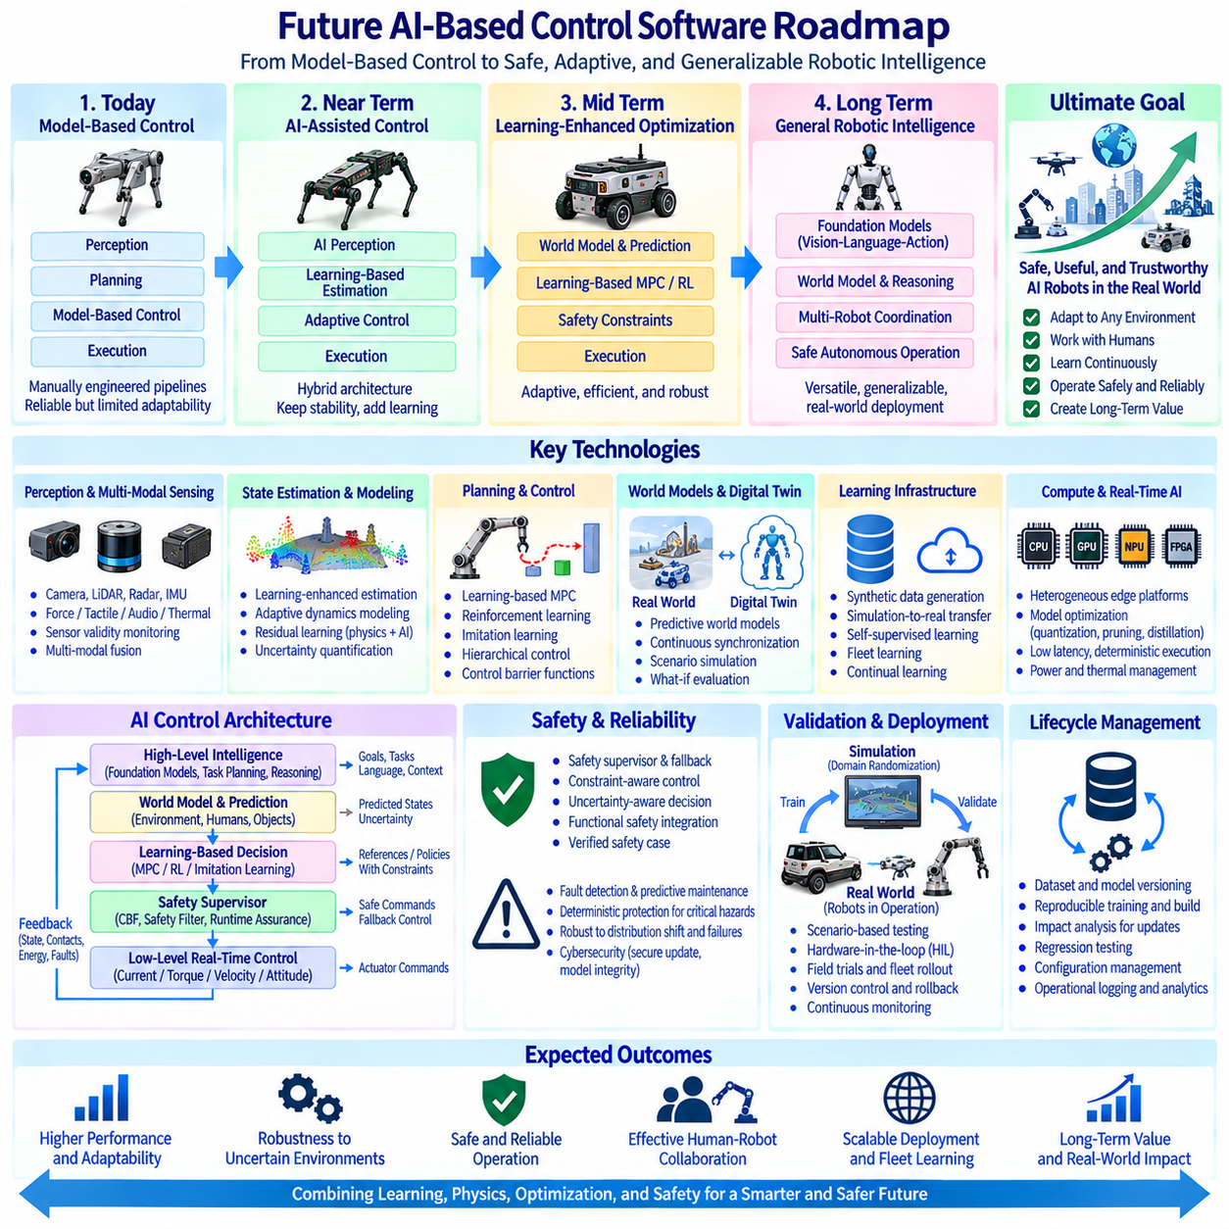
Future AI-based control software is expected to evolve from manually engineered control pipelines toward hybrid architectures that combine physical models, optimization, learning, and runtime adaptation. Classical feedback control will remain important for stability and deterministic execution, while AI will increasingly provide perception-conditioned policies, model adaptation, prediction, and decision support. The roadmap is therefore an integration path rather than a simple replacement of conventional controllers.
The near-term architecture will increasingly separate deterministic inner control loops from intelligent outer layers. Current, torque, velocity, attitude, and stabilization loops can remain model-based and real-time, while AI estimates disturbances, predicts contact conditions, selects controller parameters, or generates references. This separation allows learning components to improve performance without directly removing established stability and actuator-protection mechanisms.
Learning-enhanced state estimation will become an important foundation. Neural networks can estimate terrain properties, payload characteristics, wheel slip, contact state, actuator degradation, aerodynamic disturbances, or unmodeled dynamics from multimodal sensor histories. These estimates can augment Kalman filters, observers, and physical models. Confidence and uncertainty information will be necessary so that controllers can reduce dependence on learned estimates when observations differ from training conditions.
Adaptive dynamics modeling will reduce the gap between nominal mathematical models and real machines. Learned residual models can estimate forces or moments that rigid-body, tire, aerodynamic, or actuator models fail to represent accurately. Instead of replacing physics completely, residual learning can correct model prediction errors online. This physics-plus-learning structure can provide better generalization and clearer safety boundaries than unconstrained end-to-end policies.
Model Predictive Control will increasingly incorporate learned models and learned cost functions. AI can estimate local dynamics, friction, disturbance distributions, or terminal costs while MPC continues to enforce explicit constraints. Such Learning-Based MPC can adapt to payload, terrain, battery state, actuator degradation, and changing environments. Runtime monitoring must ensure that learned predictions remain within validated confidence regions before they influence safety-critical commands.
Reinforcement Learning will expand from simulation demonstrations toward carefully bounded control functions. Policies can optimize locomotion, manipulation, energy consumption, recovery behavior, or complex coordination where analytical tuning is difficult. However, unrestricted reinforcement-learning output is unsuitable for many safety-critical systems. Practical architectures will place policy actions behind constraint filters, safety supervisors, control barrier functions, or optimization layers that enforce allowable states and actuator limits.
Imitation Learning and behavior cloning can accelerate development when expert demonstrations are available. Human teleoperation, conventional controllers, optimization-generated trajectories, or high-quality simulation can provide demonstrations for complex tasks. Learned policies can then reproduce useful behavior while reducing online computation. Dataset diversity remains critical because policies trained on narrow demonstrations can fail abruptly when environmental conditions, payloads, or contact situations change.
Foundation models for robotics may provide reusable representations across perception, language, planning, and action. Vision-language-action models can interpret task descriptions, visual scenes, and robot states to produce high-level action sequences or motion intentions. In control architectures, these models are more likely to supervise or parameterize lower-level controllers than directly replace high-frequency feedback loops. Clear interfaces between semantic reasoning and physical control will therefore become increasingly important.
World models will provide predictive representations of how robots, objects, humans, and environments evolve over time. A controller can evaluate candidate actions inside a learned predictive model before applying them to hardware. This capability supports planning, collision avoidance, manipulation, locomotion, and failure recovery. Reliable world models must represent uncertainty because incorrect confident predictions can be more dangerous than explicitly uncertain ones.
Digital twins will become continuously synchronized operational models rather than offline engineering simulations. Sensor data from deployed robots can update actuator parameters, payload estimates, thermal states, battery characteristics, and environmental models. The digital twin can evaluate controller changes, predict maintenance needs, and reproduce field incidents. Fleet data can then improve models that are validated in simulation before controlled deployment back to physical robots.
Simulation-to-real transfer will remain central to scalable AI control development. Domain randomization can vary mass, friction, sensor noise, delay, terrain, lighting, contact properties, and actuator characteristics during training. System identification can narrow the simulation-real gap using measurements from hardware. Combining randomization with calibrated physical models allows policies to experience broad conditions while maintaining sufficient similarity to the target machine.
Synthetic data generation will expand the range of rare and hazardous situations available for training. Simulation can create actuator failures, extreme terrain, unusual payloads, collisions, sensor degradation, weather conditions, or emergency scenarios that would be expensive or unsafe to reproduce repeatedly in the field. Synthetic data should be combined with real-world validation because simulated diversity cannot guarantee that all relevant physical effects have been represented correctly.
Multi-modal learning will combine cameras, LiDAR, radar, IMU, force sensors, joint states, audio, thermal sensing, and system diagnostics. Temporal models can infer latent physical conditions that are difficult to observe from one sensor alone. Control policies can use these representations to adapt contact force, speed, posture, trajectory, or manipulation strategy. Sensor validity monitoring remains necessary because additional modalities also create additional failure and synchronization modes.
Self-supervised learning can exploit the large amount of unlabeled operational data produced by robot fleets. Models can learn representations by predicting future observations, reconstructing masked sensor information, estimating motion consistency, or comparing multiple sensor modalities. These representations can reduce dependence on expensive manual labels. For control applications, learned features must still be evaluated according to downstream stability, robustness, and failure behavior rather than representation quality alone.
Fleet learning will allow knowledge to accumulate across many deployed robots. Individual machines can upload selected trajectories, faults, environmental observations, and performance statistics to centralized training infrastructure. Updated models can be validated and distributed back to compatible platforms. Deployment should use version control, staged rollout, rollback capability, and hardware-specific qualification so that a model improvement on one configuration does not unintentionally degrade another.
Continual learning can enable adaptation after deployment, but uncontrolled online learning introduces configuration and safety challenges. A robot that modifies its own policy continuously may no longer correspond to the version that was tested and validated. Near-term systems will therefore favor bounded adaptation, parameter estimation, or offline retraining from collected field data. Any learned update influencing safety-critical behavior should pass defined verification gates before becoming operational.
AI-based fault detection and predictive maintenance will increasingly share information with control software. Neural models can identify subtle patterns in motor current, vibration, temperature, network timing, battery behavior, or tracking residuals before conventional thresholds are exceeded. The controller can then reduce load or adjust mission planning. Deterministic protection should remain available for immediate hazards because statistical prediction cannot guarantee detection of every dangerous failure.
Runtime assurance will become a key architecture for deploying advanced AI controllers. An AI policy can operate while a simpler verified safety controller continuously evaluates whether predicted states remain inside an acceptable operating envelope. If safety conditions are violated, authority transfers to a fallback controller or safe-state manager. This architecture separates high-performance learning from minimum guaranteed safety behavior and provides a practical migration path toward more autonomous control.
Control Barrier Functions and safety filters can constrain commands generated by learned policies. Before an AI command reaches the actuator, an optimization layer can modify it to preserve collision distance, joint limits, stability constraints, speed limits, or other safety invariants. The AI policy remains free to optimize behavior within the safe region. Such supervisory mathematical constraints can provide an interpretable boundary between learned decision making and physical execution.
Uncertainty-aware control will become increasingly important as AI enters safety-critical loops. Neural networks should provide confidence estimates, ensembles, distributions, or out-of-distribution indicators where appropriate. High uncertainty can trigger reduced speed, increased safety margins, additional sensing, human intervention, or fallback control. A future controller should therefore reason not only about the predicted state but also about how trustworthy that prediction is.
Compute architecture will evolve toward heterogeneous edge platforms combining CPUs, GPUs, NPUs, FPGAs, and safety microcontrollers. High-rate deterministic control can remain on real-time processors, neural inference can execute on accelerators, and independent safety monitoring can operate on isolated hardware. Scheduling and data movement across these processors will become part of control-system design because AI performance is meaningful only when inference deadlines are satisfied consistently.
Real-time AI optimization will require models designed for latency as well as accuracy. Quantization, pruning, distillation, operator fusion, graph compilation, sparse execution, and hardware-specific optimization can reduce inference time and power consumption. Smaller specialized models may outperform very large general models in fast feedback loops. Model selection will increasingly consider worst-case latency, memory footprint, thermal behavior, and deterministic execution together with task accuracy.
Hierarchical control will connect semantic planning with dynamic execution. A foundation model or task planner may decide what the robot should accomplish, a motion planner determines feasible trajectories, an optimization layer coordinates constraints, and real-time controllers generate actuator commands. Feedback should flow upward as well as downward so that high-level reasoning receives information about feasibility, contact, energy, faults, and safety restrictions before issuing new objectives.
Human-AI collaboration will remain important for complex or uncertain missions. Operators can specify goals, approve unusual actions, provide demonstrations, or intervene when confidence is low. AI can summarize robot state, explain constraints, recommend recovery options, and reduce operator workload. Interfaces should clearly distinguish autonomous decisions, safety-system interventions, and human commands so responsibility and system behavior remain understandable during abnormal events.
Verification of AI-based control will require broader evidence than conventional nominal testing. Scenario-based testing, adversarial conditions, distribution shifts, fault injection, Monte Carlo simulation, hardware-in-the-loop testing, and controlled field trials can explore behavior across large operating spaces. Coverage metrics should consider environment, robot state, model uncertainty, safety constraints, and failure modes. Testing must evaluate closed-loop behavior rather than neural-network accuracy alone.
Safety cases will increasingly combine deterministic evidence with statistical evidence. Traditional safety mechanisms can establish guaranteed limits for selected functions, while AI performance may be supported by datasets, scenario coverage, uncertainty analysis, and monitored operational evidence. Clear architectural boundaries are essential so that statistical claims do not silently replace deterministic protections. Certification strategies will likely evolve toward assurance of both the learning process and the runtime containment mechanisms.
AI model lifecycle management will become part of control-software configuration management. Training datasets, preprocessing, model architecture, weights, hyperparameters, compiler versions, inference engines, hardware targets, calibration data, and validation results should be traceable. A deployed model should be uniquely identifiable and reproducible. Model updates should undergo impact analysis and regression testing just as conventional safety-relevant software changes do.
Cybersecurity will become increasingly coupled with AI control safety. Manipulated sensor inputs, corrupted models, unauthorized parameter updates, adversarial observations, or compromised fleet-learning pipelines can alter physical robot behavior. Secure boot, signed models, authenticated updates, access control, network segmentation, and runtime integrity monitoring should therefore protect the AI lifecycle. Safety analysis must consider malicious as well as accidental causes of unsafe commands.
The longer-term roadmap points toward robots capable of combining learned world models, adaptive dynamics, multimodal foundation models, optimization, and verified safety supervision in a unified architecture. Such systems may predict consequences, adapt controllers, transfer skills, diagnose degradation, and coordinate multiple robots with less manual engineering. Their autonomy will depend on maintaining explicit boundaries between exploratory intelligence and guaranteed physical constraints.
An integrated future AI-based control roadmap therefore progresses from AI-assisted estimation and tuning, through learning-enhanced optimization and bounded policies, toward predictive world-model control and increasingly general embodied intelligence. Classical control, real-time computing, safety supervision, simulation, fleet learning, and lifecycle assurance remain foundational throughout this transition. The most robust future architecture will combine learning capability with physical models, deterministic constraints, measurable uncertainty, and verifiable fallback behavior.

