Volume 04 Robot Control Software

01. Control Software Fundamentals

01.01 Role of Control Software: Bridging Physical and Digital
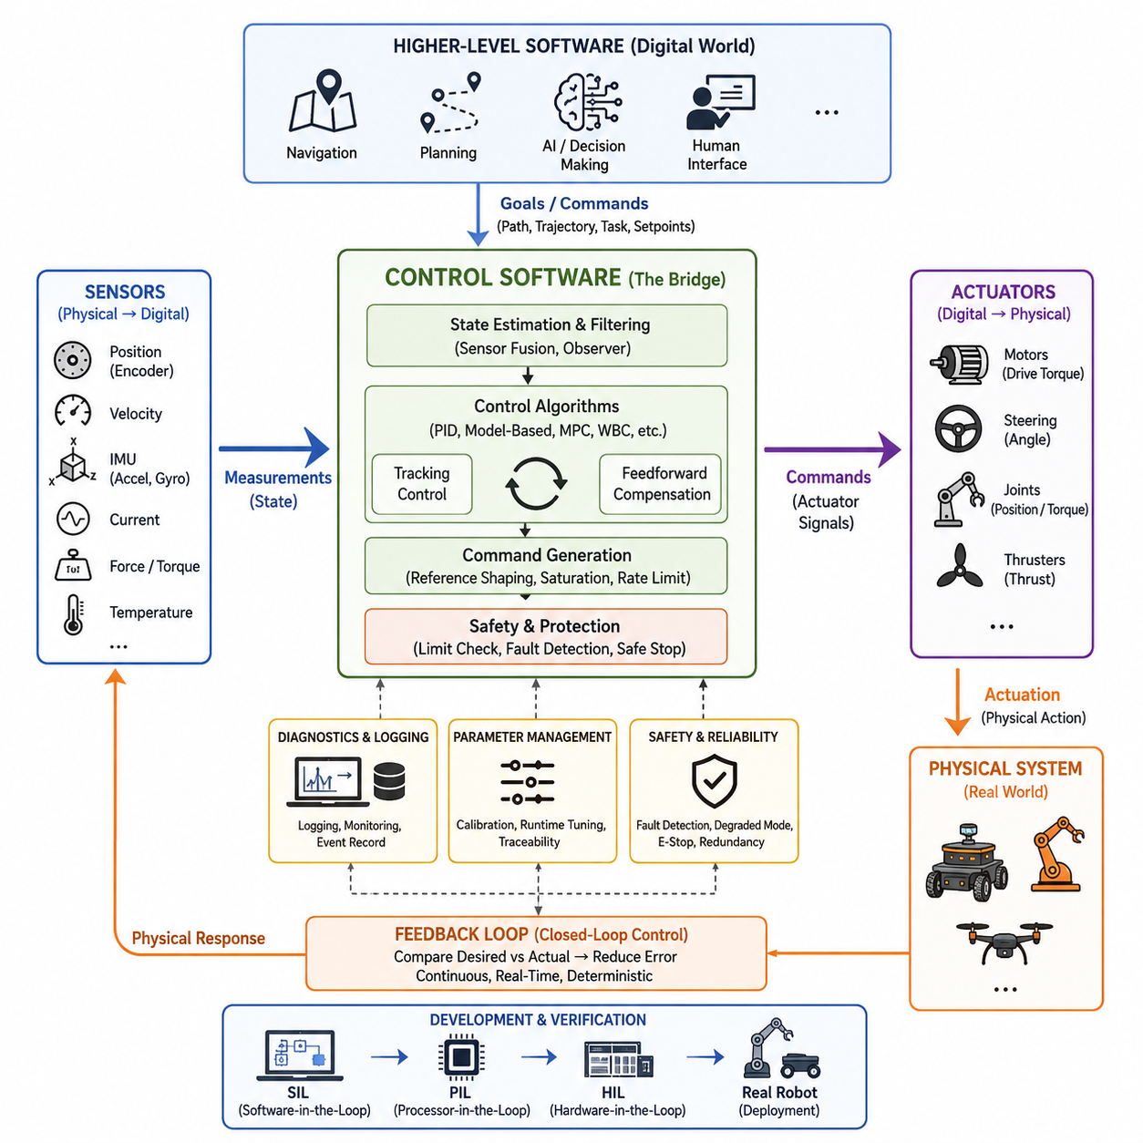
Control software is the operational bridge between digital computation and physical behavior. A robot may receive goals from navigation, planning, autonomy, or human interfaces, but those goals remain abstract until control software converts them into commands that actuators can execute. It therefore connects software representations such as position, velocity, torque, and trajectory with motors, steering mechanisms, joints, and other physical devices.
The digital side of a robotic system describes the world through numerical states, models, commands, and constraints. The physical side consists of mechanisms whose motion is affected by inertia, friction, gravity, payload, disturbances, actuator limits, and environmental interaction. Control software continuously reconciles these two domains by observing physical responses, comparing them with desired behavior, and calculating corrective commands that reduce the difference.
This bridging function is fundamentally based on feedback. Sensors measure quantities such as position, velocity, acceleration, current, force, orientation, or steering angle and convert physical phenomena into digital signals. Control algorithms process these measurements together with reference commands and system models. Their outputs are then transformed into electrical or communication commands that drive actuators, completing a closed interaction between computation and physical motion.
Control software occupies a distinctive position in the overall robotics software architecture. Higher-level software determines what the robot should accomplish, while lower-level firmware and device drivers interact directly with hardware. The control layer translates objectives such as “move at this velocity,” “follow this trajectory,” or “maintain this joint position” into dynamically feasible actuator behavior. This makes control software an execution layer between intention and physical realization.
The bridge is not simply a conversion from one command format to another. Physical systems evolve continuously in time, whereas software normally executes calculations at discrete sampling intervals. Control software must therefore sample sensor information, estimate the current state, calculate control outputs, and update actuators rapidly enough to preserve stability and responsiveness. Timing accuracy, deterministic execution, latency, and jitter become part of the control problem itself rather than ordinary implementation details.
A useful conceptual distinction is between command generation and command realization. A motion planner may generate a desired path or trajectory without directly controlling motor currents or joint torques. Control software receives this desired behavior and progressively converts it into references appropriate for the physical system. Depending on the architecture, trajectory commands may become position references, velocity references, torque requests, motor-current commands, and finally switching or drive signals handled by lower hardware layers.
Feedback also allows the digital system to recognize that commanded behavior and actual behavior are rarely identical. Wheels can slip, steering mechanisms can exhibit backlash, manipulators can experience unexpected loads, and motors can produce different responses as temperature or battery voltage changes. Control software measures these deviations and continuously compensates for them. The robot therefore behaves as a closed-loop cyber-physical system rather than as a machine executing a fixed sequence of commands.
Different robotic platforms emphasize different physical variables, but the bridging principle remains consistent. A differential-drive AMR coordinates wheel velocities to produce translational and rotational motion. An Ackermann-steered outdoor robot coordinates propulsion and steering angle. A manipulator controls joint position, velocity, torque, and end-effector interaction, while a quadruped additionally manages contact forces, balance, and gait. UAV control must regulate attitude, thrust, altitude, position, and aerodynamic disturbances.
The control layer must also enforce physical constraints that higher-level software may not represent with sufficient detail. Actuators have maximum current, torque, speed, acceleration, temperature, and operating ranges. Mechanical systems have joint limits, steering limits, friction characteristics, and structural constraints. Control software incorporates these limits into command generation, saturation handling, trajectory shaping, protection logic, and constraint-aware algorithms so that digitally requested behavior remains physically achievable.
Because physical systems contain uncertainty, control software frequently relies on estimated rather than perfectly measured states. Sensor noise, quantization, communication delay, sampling differences, and unobservable variables can make raw measurements insufficient for stable control. Filtering, observers, sensor fusion, and state estimation can therefore become closely coupled with the controller. The resulting state representation provides a more reliable digital description of the physical system from which control decisions can be calculated.
Control software also establishes an important boundary between autonomy and deterministic machine behavior. AI, navigation, reinforcement learning, or planning algorithms may produce sophisticated decisions, but their outputs should not automatically bypass physical constraints. A control layer can convert high-level decisions into bounded references while enforcing rate limits, stability requirements, actuator capabilities, and safety conditions. This separation allows increasingly intelligent decision systems to coexist with predictable real-time execution.
The same principle becomes especially important in Physical AI systems. Learned policies may determine actions from images, language, maps, latent states, or multimodal observations, yet the final interaction with the physical world still occurs through actuators. Control software provides the structured interface through which learned actions become velocities, forces, torques, steering commands, or motion references. It can therefore isolate rapidly evolving AI models from hardware-specific execution requirements and deterministic control loops.
Safety is inseparable from this bridging role because an incorrect digital value can create immediate physical consequences. Control software must detect invalid commands, sensor failures, communication loss, excessive tracking error, actuator faults, and unsafe operating conditions. Depending on system requirements, it may limit motion, enter a degraded operating mode, execute a controlled stop, or request hardware-level shutdown. Digital fault handling thus becomes directly connected to physical risk reduction.
Diagnostics and observability provide the reverse bridge from the physical system back into engineering processes. Control software can record references, measured states, tracking errors, actuator outputs, timing information, saturation events, fault flags, and protection states. These data enable engineers to reconstruct physical behavior from software logs, compare simulation with real machines, tune parameters, identify failures, and validate modifications without treating hardware behavior as an opaque outcome.
Simulation further demonstrates the importance of maintaining a clear control interface. The same controller can often interact with a simulated plant during Software-in-the-Loop testing, with processor hardware during Processor-in-the-Loop testing, with real controllers and simulated mechanisms during Hardware-in-the-Loop testing, and eventually with the actual robot. A stable interface between controller and plant enables progressive verification while reducing the gap between digital development and physical deployment.
Ultimately, control software transforms computation into disciplined physical action while transforming physical response back into usable digital information. Its purpose is not merely to operate motors but to maintain a continuous, timed, constrained, observable, and safe relationship between desired behavior and actual behavior. This foundational role explains why control software precedes detailed topics such as PID, motor control, motion control, whole-body control, fault tolerance, and safety control in a robotics software architecture.

01.02 Control Loop Structure: Sense, Compute, Actuate
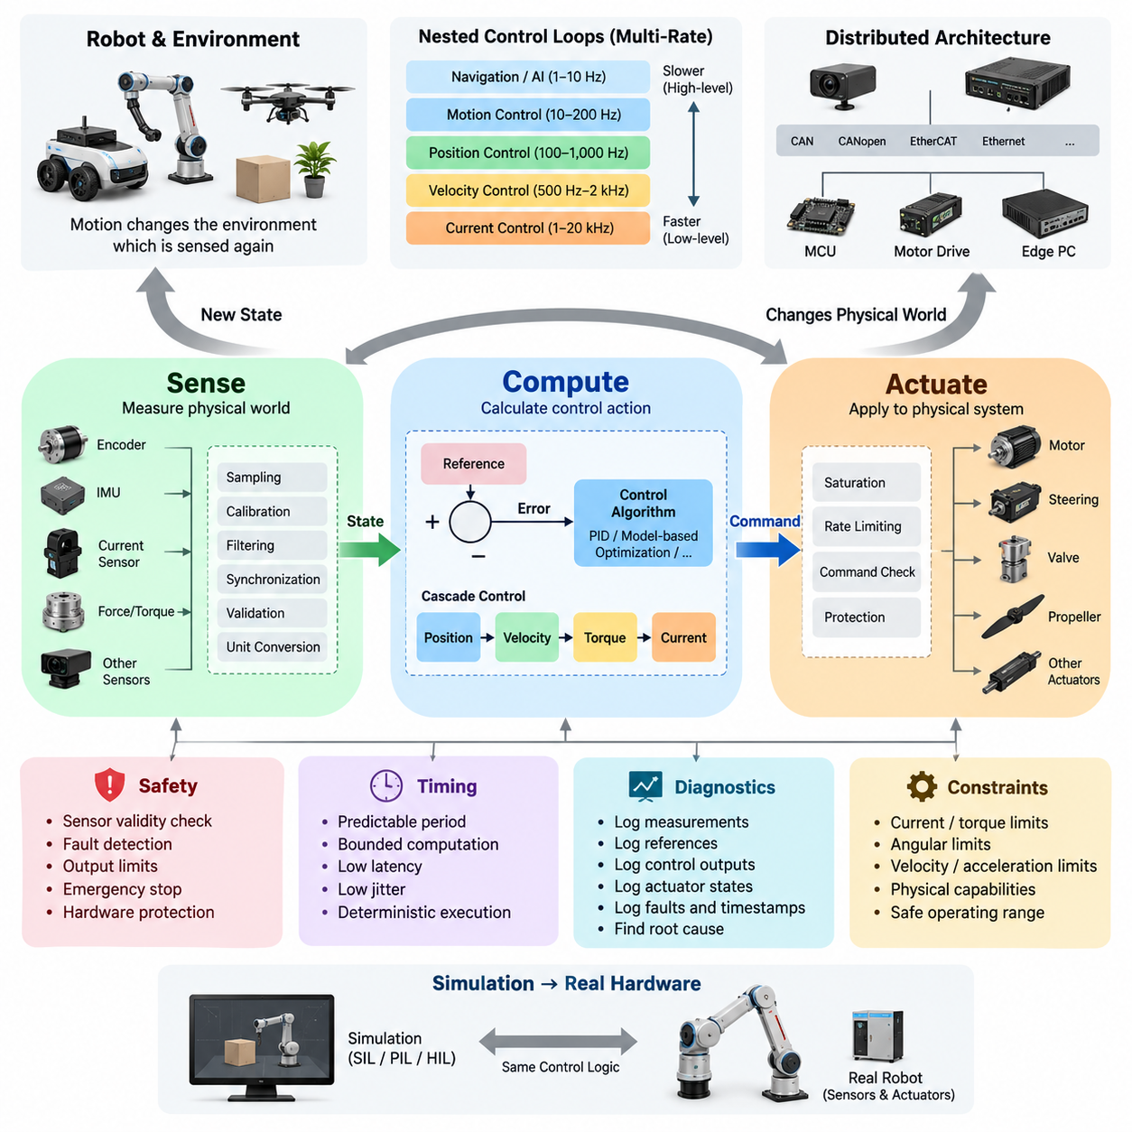
A control loop is the fundamental execution pattern that allows a robot to interact continuously with the physical world. Its basic structure can be understood as Sense, Compute, and Actuate. Sensors observe the robot and its environment, computation determines the appropriate response, and actuators apply that response to the physical system. The resulting motion changes the next sensor measurements, creating a continuously repeating closed-loop process.
The Sense stage converts physical phenomena into information that software can process. Encoders measure position or velocity, IMUs measure acceleration and angular motion, current sensors observe electrical behavior, and force or torque sensors measure mechanical interaction. Each measurement represents only a partial observation of the physical system, so sensing is not simply reading values but constructing a usable digital description of the robot’s current condition.
Sensor measurements are acquired at discrete moments determined by sampling rates and hardware timing. Before entering the controller, raw signals may require scaling, calibration, filtering, synchronization, validity checking, or conversion into engineering units. An encoder count may become an angular position, ADC data may become motor current, and multiple IMU measurements may contribute to an orientation estimate. This processing establishes reliable input for subsequent control calculations.
The Compute stage transforms sensed information and desired references into control decisions. A controller normally compares the desired state with the measured or estimated state and calculates the error between them. Control algorithms then determine how strongly the system should respond. Depending on the application, this computation may involve PID control, feedforward compensation, state-space methods, model-based control, optimization, or more advanced algorithms.
A simple conceptual relationship is reference minus measured state equals control error. If a wheel should rotate at a target velocity but is moving too slowly, the controller increases the command. If the measured velocity exceeds the target, the command is reduced. This repeated correction mechanism allows the robot to reject disturbances and compensate for differences between mathematical assumptions and actual physical behavior.
Computation may contain several layers rather than a single controller. A position controller can generate a velocity reference, a velocity controller can generate a torque reference, and a motor controller can convert torque demand into current commands. Such cascade control structures allow different physical dynamics to be handled at appropriate rates. Inner loops are commonly faster because electrical and mechanical actuator dynamics require more rapid correction than higher-level motion objectives.
The Actuate stage converts calculated control outputs into physical effects. Software commands may become PWM duty cycles, motor-current references, torque commands, steering angles, valve positions, or thrust requests. Motor drives and power electronics then transform these commands into voltage and current applied to actuators. The actuators generate force or torque, causing wheels, joints, steering systems, propellers, or other mechanisms to move.
Actuation is constrained by the capabilities of real hardware. A software controller may mathematically request an arbitrarily large output, but motors have current and torque limits, steering systems have angular limits, and mechanical structures have allowable velocity and acceleration ranges. Therefore, the Actuate stage commonly includes saturation, rate limiting, command validation, and protection logic so that calculated outputs remain within physically achievable and safe operating boundaries.
Once actuation changes the physical system, the resulting state is measured again by sensors. This closes the feedback loop: Sense produces measurements, Compute determines corrections, Actuate changes the physical system, and the changed physical system generates new measurements. Control is therefore not a one-time calculation. It is a continuous cyclic interaction in which each iteration depends on the physical consequences of previous control actions.
The timing of this cycle strongly influences control quality. If sensing, computation, and actuation occur too slowly, the controller responds to outdated information and may produce poor tracking or instability. If execution timing varies unpredictably, control behavior can also vary even when the algorithm itself is unchanged. Control software therefore requires predictable sampling periods, bounded computation time, controlled communication latency, and sufficiently low timing jitter.
Different control loops may operate at different frequencies within the same robot. Motor-current control may execute at several kilohertz or higher, velocity control at a lower rate, motion control at hundreds of hertz, and navigation or AI-based decision processes at tens of hertz or below. This multi-rate structure allows fast physical dynamics to remain locally controlled while slower upper layers generate increasingly abstract goals and references.
The Sense–Compute–Actuate structure also explains why communication architecture matters in distributed robotic systems. Sensors, controllers, motor drives, and edge computers may reside on different processors connected through CAN, CANopen, EtherCAT, Ethernet, or other communication mechanisms. When information crosses these boundaries, transmission delay, update frequency, message loss, synchronization, and timestamp accuracy become part of the effective control loop.
Not every control loop must pass through the robot’s highest-performance computer. Fast actuator loops are often executed close to the hardware on motor controllers, microcontrollers, or dedicated real-time processors. Higher-level computers can operate slower loops for trajectory generation, navigation, perception, or AI decision making. This hierarchical arrangement prevents slow perception or planning cycles from directly determining the update rate required for stable low-level actuator control.
For example, an autonomous mobile robot may receive camera perception at tens of frames per second while wheel-current regulation executes thousands of times per second. The perception system does not need to generate every motor update. Instead, it provides higher-level state information or motion objectives, while local controllers continuously regulate the actuators between those updates. Sense–Compute–Actuate therefore exists simultaneously at several nested levels of the robot.
Safety mechanisms can also operate across the loop. Sensor validity checks can reject implausible measurements during Sense, computational monitors can detect excessive errors or unstable commands during Compute, and actuator limits can prevent unsafe outputs during Actuate. Independent emergency-stop or hardware protection mechanisms may operate outside the normal control path. Safe robotic control consequently requires protection throughout the entire information-to-action chain.
Diagnostics make the loop observable to engineers. Recording sensor measurements, reference values, control errors, controller outputs, actuator states, timestamps, and fault conditions allows developers to determine where undesirable behavior originates. A tracking problem may result from noisy sensing, delayed computation, incorrect controller parameters, actuator saturation, or physical disturbances. Structured logging makes these causes distinguishable rather than treating the robot as a black box.
The same Sense–Compute–Actuate abstraction can be preserved from simulation to real hardware. In simulation, the Sense stage reads a simulated robot state and the Actuate stage applies commands to a physics model. On the real robot, sensors and actuators replace these simulated interfaces while the control logic can remain largely unchanged. This separation supports SIL, PIL, HIL, and physical testing while maintaining a consistent conceptual control structure.
Ultimately, Sense–Compute–Actuate is more than a sequence of three software operations. It represents the continuous causal relationship between observation, decision, and physical action that defines closed-loop robotic control. Reliable sensing provides knowledge of the current state, deterministic computation determines an appropriate response, and constrained actuation changes the physical world. Repetition of this cycle enables a robot to regulate motion, reject disturbances, maintain stability, and execute higher-level objectives in real time.

01.03 Discrete-Time Control: Sampling Theory / z-Transform
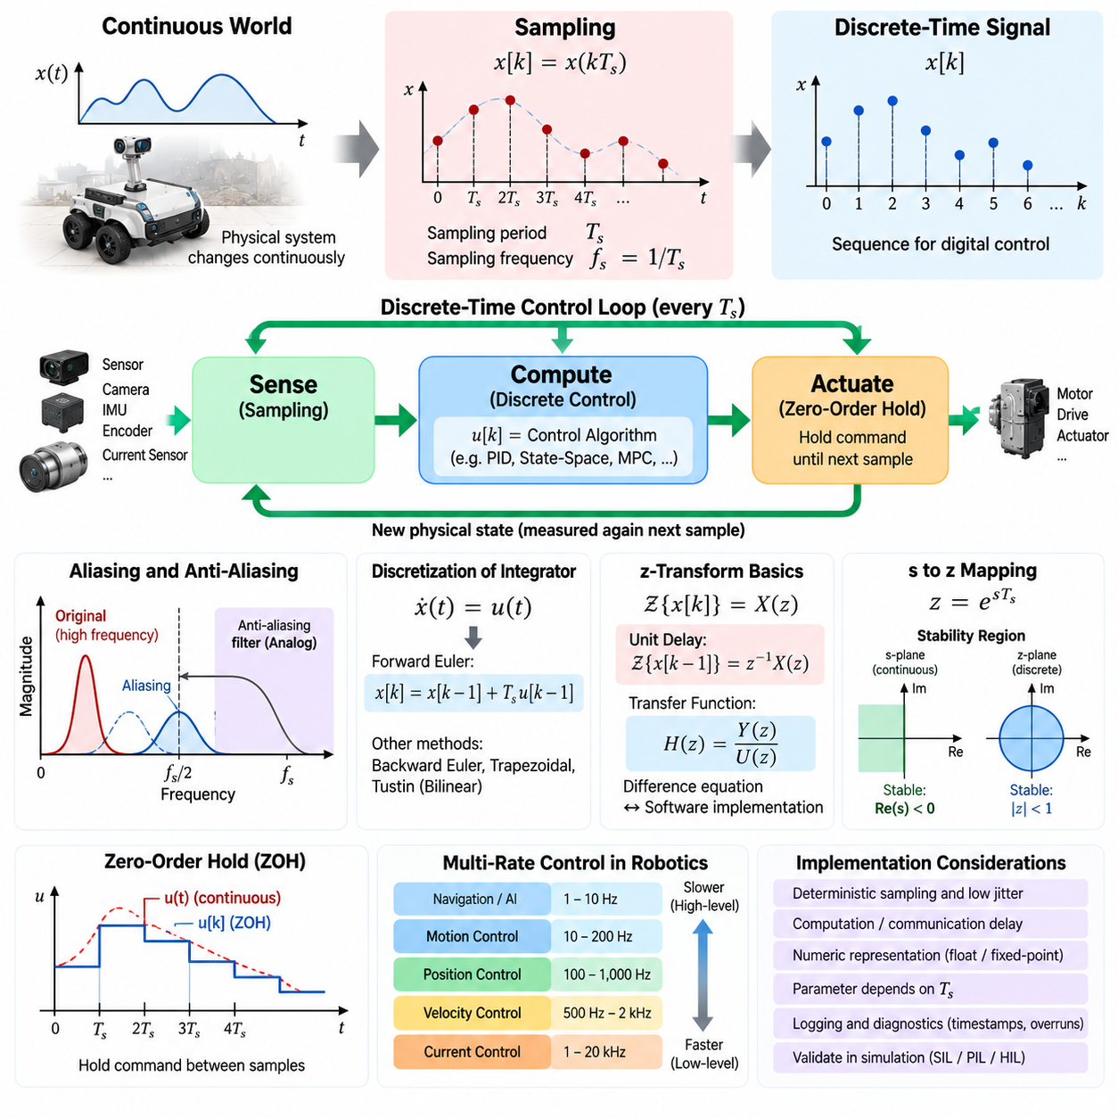
Digital control software operates on discrete samples rather than on continuously available signals. Although the physical robot evolves continuously, sensors are read, calculations are executed, and actuator commands are updated at specific time intervals. This conversion from continuous physical behavior to discrete numerical processing is fundamental to embedded and real-time robot control.
A continuous-time signal \(x(t)\) becomes a discrete sequence when it is observed at sampling instants separated by a sampling period \(T_s\). The resulting sequence can be written as \(x[k]=x(kT_s)\), where \(k\) represents the sample index. The corresponding sampling frequency is \(f_s=1/T_s\), linking software execution timing directly to the mathematical representation of the controlled system.
Sampling frequency must be selected according to the dynamics that the controller must observe and regulate. If sampling is too slow, important changes can occur between measurements and the digital representation no longer describes the physical behavior adequately. Faster sampling generally improves temporal resolution, but also increases processor load, communication traffic, sensor bandwidth requirements, and sensitivity to measurement noise.
The Nyquist sampling principle provides a basic theoretical boundary for representing frequency content in sampled signals. A sampling frequency should exceed twice the highest frequency that must be represented to avoid aliasing. Control engineering normally requires additional margin because merely satisfying the Nyquist boundary does not guarantee satisfactory closed-loop performance, phase margin, disturbance rejection, or practical filtering behavior.
Aliasing occurs when frequency components above the representable sampling range appear as incorrect lower-frequency components after sampling. Once aliasing enters the sampled data, software cannot reliably reconstruct the original information. Analog anti-aliasing filters are therefore commonly applied before analog-to-digital conversion, while digital filtering can subsequently reduce noise within the sampled signal bandwidth.
Discrete-time control also introduces the concept of delay. A measurement is sampled, processed, and eventually converted into an actuator command, so the physical plant responds after some finite interval. Sensor acquisition, task scheduling, computation, communication, and actuator update delays can accumulate. Even when individually small, these delays introduce phase lag and can reduce stability margins in fast control loops.
A deterministic sampling period is therefore as important as the nominal sampling frequency. If a controller is designed for a 1 ms period but actual execution varies unpredictably between samples, numerical calculations no longer correspond precisely to the assumed timing model. This timing variation, called jitter, can affect derivative calculations, numerical integration, state estimation, filtering, and ultimately closed-loop stability and performance.
Continuous control equations must be converted into forms suitable for execution at discrete sampling instants. For example, a continuous integrator cannot be evaluated directly by a processor as an uninterrupted operation. Numerical approximations such as forward Euler, backward Euler, or trapezoidal integration convert continuous relationships into difference equations that use present and previous sampled values.
A simple continuous integrator described by \(\dot{x}(t)=u(t)\) can be approximated using \(x[k]=x[k-1]+T_su[k-1]\) with forward Euler integration. The equation demonstrates an important property of discrete control software: previous states must be stored in memory. Digital controllers are therefore inherently stateful because past measurements, errors, filter states, and controller outputs influence future calculations.
The z-transform provides a mathematical framework for analyzing these discrete-time sequences and difference equations. It plays a role in discrete-time control similar to the role of the Laplace transform in continuous-time analysis. A sequence \(x[k]\) can be represented in the z-domain, allowing delays, difference equations, digital filters, controllers, and sampled plant models to be expressed algebraically.
A one-sample delay has a particularly simple z-domain representation of \(z^{-1}\). This makes the z-transform closely related to actual software implementation because storing a previous value effectively implements a unit delay. Expressions containing \(z^{-1}\), \(z^{-2}\), and higher powers can therefore be translated naturally into software variables containing values from previous execution cycles.
Discrete transfer functions can describe relationships between sampled inputs and outputs. A general controller may be represented as a ratio of polynomials in \(z^{-1}\). When rearranged into a difference equation, the controller output becomes a weighted combination of current and previous inputs together with previous outputs. This form is directly implementable using arithmetic operations and stored state variables.
The relationship between the continuous s-domain and discrete z-domain depends on the sampling process and discretization method. For sampled systems, the mapping \(z=e^{sT_s}\) provides an important conceptual connection. Continuous poles and system dynamics are transformed into corresponding locations in the z-plane, allowing engineers to evaluate how sampling changes stability and transient behavior.
Stability criteria also change when moving from continuous to discrete control. For a continuous linear system, stable poles lie in the left half of the s-plane. For a discrete system, stable poles must lie inside the unit circle of the z-plane. Poles approaching the unit circle generally correspond to slower decay or increased oscillatory persistence, while poles outside the unit circle indicate unstable sampled behavior.
Several methods can convert continuous controller models into discrete implementations. Forward Euler is computationally simple but can introduce significant approximation error. Backward Euler generally provides different stability characteristics, while the bilinear or Tustin transformation maps continuous dynamics into discrete form with useful frequency-domain properties. The appropriate method depends on sampling rate, controller bandwidth, numerical requirements, and system dynamics.
Zero-order hold behavior is also important because actuator commands are usually maintained between control updates. A digital controller calculates a command at one sample and the actuator interface commonly holds that value until the next update arrives. The physical plant therefore receives a piecewise-constant input rather than an ideal continuously changing command, and this behavior should be considered during controller modeling and simulation.
Sampling periods frequently differ across a robotic control architecture. Motor current regulation may operate at several or tens of kilohertz, velocity control at lower frequencies, position and motion loops at hundreds of hertz, and navigation or AI processes at still lower rates. Each loop should be designed according to the bandwidth and timing requirements of the physical dynamics under its responsibility.
Multi-rate control introduces communication and synchronization requirements between loops. A fast inner controller may execute many times before receiving a new reference from a slower outer controller. Software must define how references are held, interpolated, validated, timestamped, or rejected when updates are delayed. Without explicit timing semantics, independently correct control modules can interact incorrectly when integrated.
Real-time implementation must also consider numerical representation. Sampling periods, accumulated states, filter coefficients, and controller gains may be represented using floating-point or fixed-point arithmetic. Limited precision, overflow, quantization, and accumulated numerical error can alter theoretical controller behavior, especially on microcontrollers or safety-oriented processors with constrained computational resources.
The sampling period should consequently be treated as a controlled software parameter rather than an incidental scheduling result. Controller coefficients, filters, observers, trajectory generators, and diagnostic thresholds may all depend on \(T_s\). Changing task frequency without recalculating associated parameters can silently change system dynamics even when the control source code and nominal gains appear unchanged.
Simulation provides an effective way to evaluate these effects before hardware deployment. A continuous plant model can be combined with sampled sensors, discrete controllers, computation delays, zero-order holds, communication latency, quantization, and jitter. SIL, PIL, and HIL environments can progressively reveal whether the theoretical discrete-time design remains valid under increasingly realistic software and hardware timing conditions.
Diagnostics should record actual execution timing in addition to control variables. Timestamps, measured cycle periods, deadline overruns, computation duration, delayed sensor messages, and actuator update times allow engineers to distinguish control-algorithm problems from timing problems. A controller that appears unstable because of incorrect tuning may instead be operating with excessive latency, jitter, or missed samples.
Discrete-time theory therefore connects mathematical control design directly with real-time software architecture. Sampling determines when the physical world becomes visible to software, difference equations determine how sampled information evolves, and the z-transform provides a systematic framework for analyzing those relationships. Together they establish the theoretical foundation for implementing continuous robotic behavior on discrete digital computers.

01.04 Control SW Architecture: HAL, Control Core, Upper SW
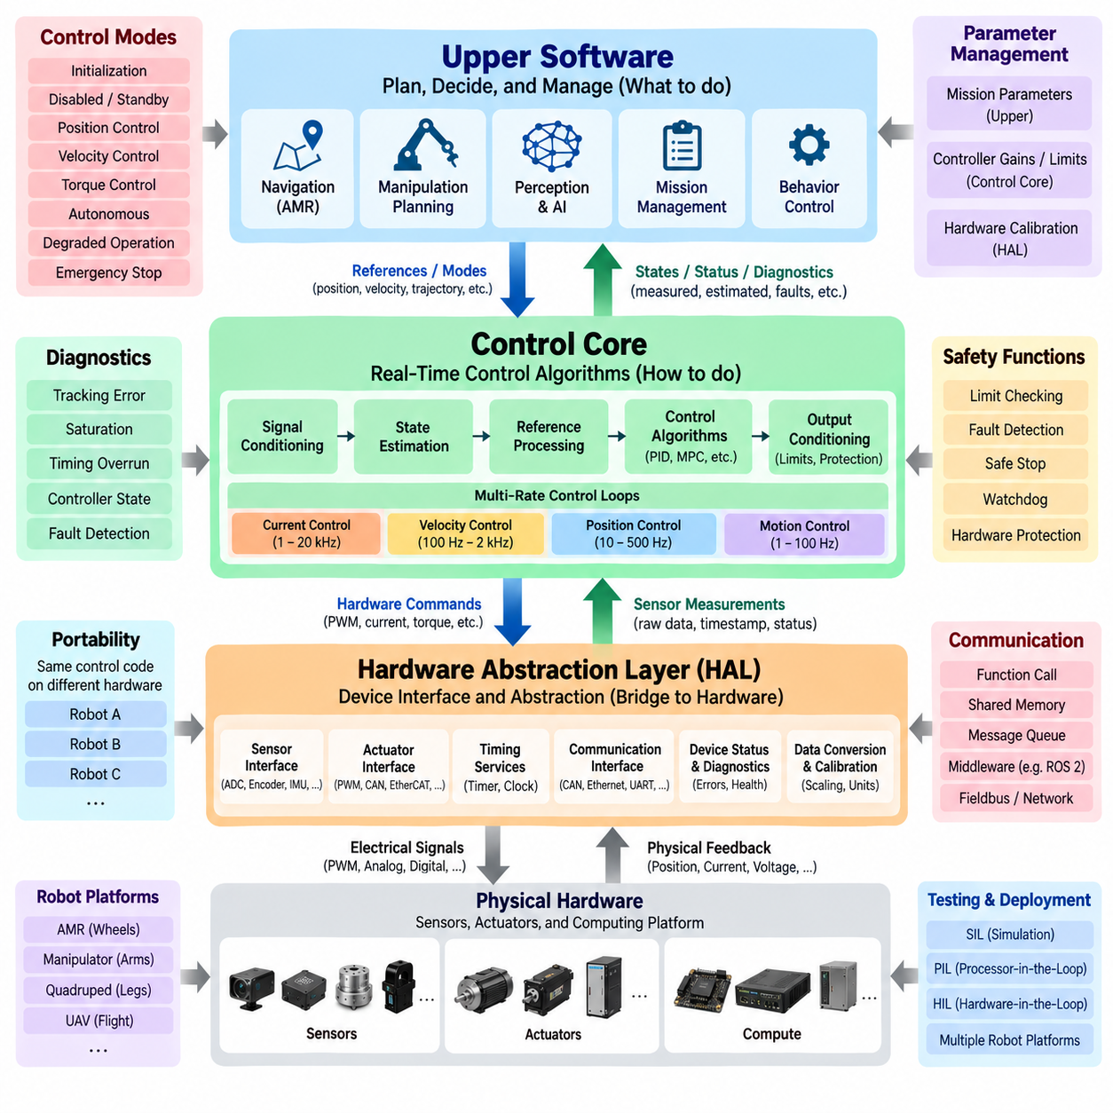
Control software architecture defines how hardware-specific interfaces, deterministic control algorithms, and higher-level robot functions are separated while still cooperating as one real-time system. A practical architecture commonly consists of a Hardware Abstraction Layer, a Control Core, and Upper Software. These layers establish clear responsibilities and reduce direct dependencies between control logic and specific hardware devices.
The Hardware Abstraction Layer, or HAL, forms the lowest software boundary between physical devices and control algorithms. It hides implementation details associated with sensors, motor drivers, communication peripherals, timers, ADCs, encoders, PWM generators, GPIO, and other hardware resources. The Control Core can therefore interact with standardized software interfaces rather than directly manipulating device registers or vendor-specific APIs.
A HAL does more than provide simple device access. Raw hardware values frequently require conversion into representations suitable for control software. Encoder counts may be converted into joint position, ADC values into current or voltage, and timer counts into velocity or elapsed time. Calibration coefficients, polarity conventions, scaling factors, unit conversion, validity information, and timestamps can be handled near this boundary.
Hardware abstraction improves portability because the control algorithm does not need to change whenever the underlying electronics are replaced. A controller originally connected to one encoder, motor drive, or MCU can be migrated to another implementation if the new HAL provides the same logical interface and behavioral contract. This separation is particularly valuable when one control software platform supports multiple robot products or hardware generations.
The HAL should expose deterministic and well-defined interfaces rather than allowing arbitrary hardware access from upper layers. Typical interfaces provide sensor acquisition, actuator command transmission, timing services, device status, and diagnostic information. Their behavior should define units, valid ranges, update rates, timestamps, error conditions, and expected execution characteristics so that higher software layers can use hardware information consistently.
Above the HAL, the Control Core contains the algorithms responsible for real-time regulation of the physical robot. This layer may include current, torque, velocity, position, steering, attitude, force, impedance, or motion controllers depending on the platform. It processes measured or estimated states together with references and calculates actuator commands while maintaining the timing behavior required for closed-loop stability.
The Control Core should remain focused on deterministic control rather than becoming a general-purpose application layer. Controller state, filters, observers, feedforward terms, feedback calculations, saturation logic, rate limits, and control-mode transitions belong naturally within this region. Keeping these functions together makes execution timing, data flow, parameter dependencies, and control-state transitions easier to analyze and verify.
A common internal structure separates signal conditioning, state estimation, reference processing, control calculation, and output conditioning. Measurements received through the HAL are validated and transformed into controller inputs. References arriving from upper software are checked and constrained. The control algorithm calculates the requested response, after which output limits and protection logic ensure that commands remain compatible with actuator capabilities.
Control Core execution is often organized as several nested loops operating at different rates. A fast motor-current loop may run at kilohertz frequencies while velocity and position loops execute more slowly. Motion or vehicle-level control may run at still lower frequencies. Scheduling must preserve these timing relationships because changing execution rates can alter controller behavior even when the mathematical algorithms themselves remain unchanged.
Upper Software provides higher-level objectives rather than directly controlling hardware at every cycle. Depending on the robot, this layer can include trajectory generation, motion planning, navigation, manipulation planning, mission management, behavior control, perception integration, or AI-based decision functions. Its primary responsibility is to determine what the robot should accomplish and provide suitable references or modes to the Control Core.
The interface between Upper Software and the Control Core is therefore an important architectural boundary. Upper layers may provide target position, velocity, acceleration, torque, steering angle, trajectory points, gait commands, or operating modes. The Control Core returns measured states, estimated states, execution status, limit conditions, faults, and diagnostic information so that higher-level functions can understand the result of requested actions.
Upper Software typically operates with weaker timing requirements than low-level control. A navigation planner may update at tens of hertz while an actuator controller runs thousands of times per second. The Control Core must continue operating safely and predictably between upper-level updates. Reference holding, interpolation, timeout detection, command freshness checking, and fallback behavior prevent irregular application timing from propagating directly into fast physical control loops.
Data ownership should be clearly defined across architectural boundaries. Sensor values originate from hardware interfaces, processed states belong to the appropriate estimation or control modules, and references originate from authorized upper-level components. Shared writable variables between unrelated modules should be minimized because uncontrolled data modification makes timing, debugging, safety analysis, and software integration increasingly difficult as system complexity grows.
Communication between layers can be implemented through function interfaces, shared-memory structures, message queues, middleware, fieldbus communication, or network protocols depending on processor distribution. When layers execute on different processors, communication latency and synchronization become architectural concerns. Timestamps, sequence counters, validity flags, timeout rules, and deterministic message periods help preserve the intended control behavior across distributed computing nodes.
The architecture must also define control modes and authority. A robot may support initialization, disabled, standby, position control, velocity control, torque control, autonomous operation, degraded operation, and emergency states. Mode transitions should occur through controlled state machines rather than arbitrary command changes. Each mode defines which references are accepted, which controllers are active, and which actuator outputs are permitted.
Safety functions cross all three architectural layers but should not depend entirely on normal application behavior. The HAL can report hardware faults and enforce low-level protection, the Control Core can detect excessive tracking errors or invalid states, and Upper Software can request controlled stops when mission conditions become unsafe. Independent safety controllers or hardware protection may additionally override normal commands when required.
Diagnostics should similarly extend across the complete architecture. HAL diagnostics identify communication errors, sensor failures, encoder problems, or actuator faults. Control Core diagnostics expose tracking error, saturation, timing overruns, unstable states, and controller mode. Upper Software records mission context and command history. Correlating these records through synchronized timestamps allows engineers to trace failures across layer boundaries.
Parameter management requires architectural separation from executable control logic. Hardware calibration parameters may belong near the HAL, controller gains and limits belong to the Control Core, and mission or behavior parameters belong to Upper Software. Each parameter should have defined units, ranges, defaults, ownership, and version information so that calibration changes do not become uncontrolled modifications to software behavior.
A well-designed architecture also improves testing. HAL interfaces can be replaced by simulated devices during Software-in-the-Loop testing, while the same Control Core executes against mathematical plant models. Processor-in-the-Loop and Hardware-in-the-Loop testing progressively replace simulated interfaces with actual processors and hardware. Clear layer boundaries make these substitutions possible without rewriting the controller for every validation environment.
The same separation supports multiple robot platforms. An AMR may connect the Control Core to wheel drives and steering actuators, a manipulator to joint servo drives, a quadruped to multiple joint motors, and a UAV to propulsion and flight-control hardware. Platform-specific HAL implementations and control modules can change while common interfaces, diagnostic mechanisms, timing concepts, and upper-level integration patterns remain reusable.
Deployment architecture may place these layers on one processor or distribute them across several computing units. A microcontroller can execute the HAL and fast motor control, a real-time processor can execute vehicle or joint control, and an edge computer can execute ROS 2, navigation, perception, or AI. The logical layering remains valuable even when physical deployment boundaries differ from software boundaries.
Fault containment is another benefit of architectural separation. A failure in perception or mission planning should not automatically stop the execution of a stable low-level control loop, while a hardware fault should be prevented from appearing as an ordinary valid measurement. Defined interfaces, validity states, watchdogs, command timeouts, and degraded modes allow faults to be detected and contained near the layer where they originate.
The architecture should avoid both excessive coupling and excessive abstraction. Direct hardware dependencies inside control algorithms make reuse and testing difficult, while overly generic interfaces can hide timing or physical characteristics that controllers genuinely require. Effective abstraction preserves important information such as timestamps, update rates, actuator limits, and sensor validity while hiding implementation details that are irrelevant to the control algorithm.
HAL, Control Core, and Upper Software consequently form a hierarchy from physical hardware toward increasingly abstract robot behavior. The HAL provides consistent access to devices, the Control Core converts references and measured states into deterministic physical control, and Upper Software generates goals and coordinates complex behavior. Clear interfaces between these layers create control software that is portable, testable, diagnosable, scalable, and suitable for real-time robotic systems.

01.05 Control SW Quality: Determinism, Safety, Diagnostics
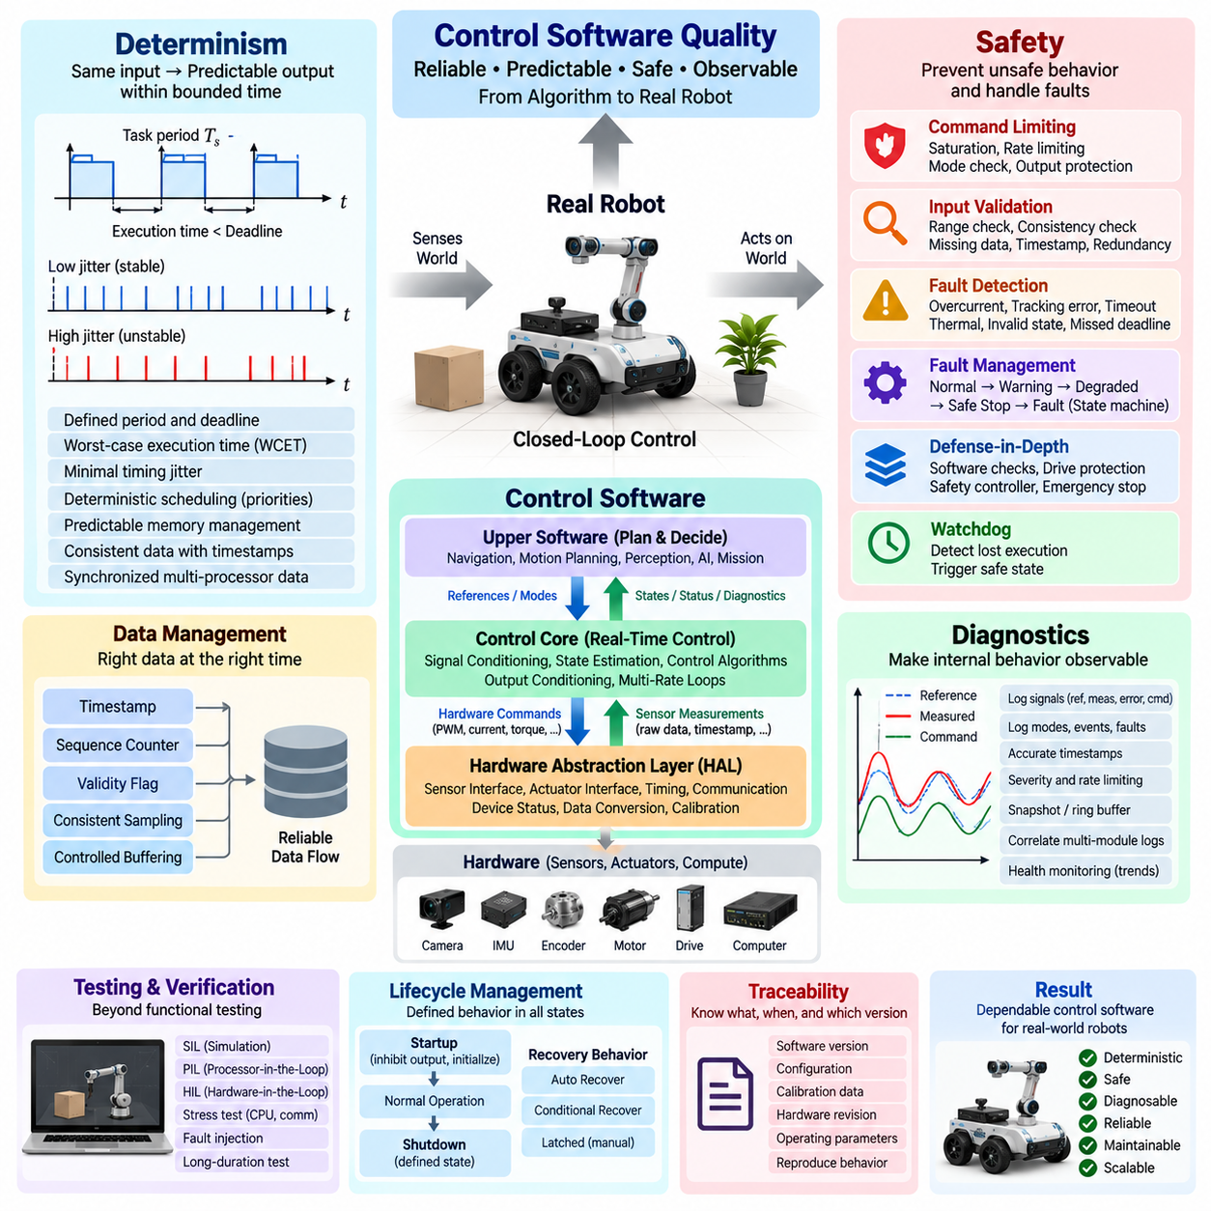
Control software quality determines whether a mathematically correct controller can operate reliably in a real robotic system. High-quality control software must produce predictable outputs, respect timing constraints, handle abnormal conditions safely, and provide sufficient internal visibility for diagnosis. Determinism, safety, and diagnostics are therefore fundamental engineering properties rather than optional features added after controller implementation.
Determinism means that control software responds predictably when given defined inputs under defined operating conditions. In real-time systems, this includes not only obtaining the correct numerical result but also producing it within a bounded time. A control calculation that occasionally produces the correct output too late may be functionally correct from an algorithmic perspective but unacceptable for physical closed-loop control.
Execution timing should therefore have a defined period, deadline, and worst-case execution time. A task designed to execute every 1 ms must complete its required computation before the next scheduled cycle or before its specified deadline. Average execution time alone is insufficient because rare timing overruns can disturb control behavior. Worst-case conditions, interrupt interference, communication delays, and operating-system scheduling must also be considered.
Timing jitter is another important quality characteristic. Even when every control cycle meets its deadline, variation in the actual execution interval changes the effective sampling period. This can influence numerical integration, derivative calculations, filters, observers, trajectory interpolation, and feedback stability. Real-time control architectures consequently attempt to minimize jitter through deterministic scheduling, prioritized tasks, bounded communication, and predictable memory behavior.
Determinism also applies to data flow. A controller should know which sensor sample is being processed, when it was acquired, and whether all required inputs belong to a consistent time interval. Timestamps, sequence counters, synchronized clocks, validity flags, and controlled buffering help prevent old or mismatched data from entering control calculations. This becomes especially important when sensors and controllers are distributed across multiple processors.
Memory management can directly affect deterministic behavior. Dynamic allocation, unpredictable garbage collection, excessive copying, page faults, or uncontrolled resource contention can introduce variable latency into real-time execution. Critical control paths therefore commonly use preallocated memory, bounded data structures, fixed-size buffers, and carefully controlled synchronization mechanisms so that execution characteristics remain predictable during long-term operation.
Safety requires the control software to recognize that mathematically valid commands are not necessarily physically safe commands. Motors, joints, steering systems, batteries, structures, and payloads have finite operating limits. Control outputs should therefore be checked against current, torque, position, velocity, acceleration, temperature, voltage, and other relevant constraints before they are applied to physical hardware.
Command limiting should be designed as part of the control architecture rather than as an external patch. Saturation prevents commands from exceeding absolute limits, while rate limiting restricts how rapidly commands can change. Additional logic can verify command direction, mode compatibility, actuator availability, and system state. These mechanisms reduce the possibility that controller transients, corrupted references, or integration errors produce unsafe physical motion.
Input validation is equally important because unsafe behavior can originate from incorrect measurements rather than incorrect commands. Sensor values should be checked for range violations, impossible rates of change, missing updates, invalid timestamps, communication errors, and disagreement between redundant measurements. A controller should not automatically treat every received numerical value as a valid representation of the physical robot state.
Fault detection allows the software to distinguish normal disturbances from conditions requiring protective action. Examples include encoder loss, motor overcurrent, excessive tracking error, communication timeout, thermal overload, invalid state estimation, actuator saturation, and missed control deadlines. Detection thresholds should account for expected physical behavior so that genuine faults are identified without causing excessive false alarms during normal transient operation.
Once a fault is detected, the required response depends on its severity and the available system capability. Some faults may permit continued operation with reduced performance, while others require controlled deceleration, actuator disablement, or an immediate emergency response. The software should define explicit transitions between normal, warning, degraded, safe-stop, and fault states instead of allowing each module to respond independently.
A fault-management state machine provides a structured mechanism for these transitions. Faults can be classified by severity, persistence, affected subsystem, and recoverability. Temporary communication loss may require a timeout and controlled hold, while persistent sensor failure may force degraded operation. Critical actuator or safety faults may require immediate transition to a protected state that cannot be exited without defined recovery conditions.
Safety-related control should follow a defense-in-depth approach. Software limit checks provide one protection layer, local motor drives may provide current and temperature protection, safety controllers may monitor critical signals independently, and hardware circuits can implement emergency stop or Safe Torque Off functions. No single software component should be assumed capable of protecting the robot against every possible failure.
Watchdogs provide another mechanism for detecting loss of expected software execution. A hardware or software watchdog can monitor whether critical tasks continue to execute within defined timing boundaries. If a controller becomes blocked, crashes, or fails to refresh the watchdog, the system can enter a predetermined safe state. Watchdog behavior should itself be deterministic and independent enough to remain effective when normal control execution fails.
Diagnostics provide the observability required to understand both normal and abnormal control behavior. Useful diagnostic information includes references, sensor measurements, estimated states, control errors, controller outputs, actuator states, mode transitions, saturation events, faults, execution periods, and computation times. Without these records, complex robot behavior can become difficult to distinguish from unexplained physical malfunction.
Diagnostic data should include accurate timestamps so that events from different software modules and processors can be correlated. A motor fault may appear after a trajectory command, a communication delay, and increasing tracking error. If these events are recorded against synchronized time, engineers can reconstruct the sequence that produced the failure. Unsynchronized logs can make the same investigation ambiguous or misleading.
Logging must nevertheless be designed so that diagnostics do not damage real-time performance. Writing large amounts of data synchronously from a high-frequency control loop can introduce latency and jitter. Real-time tasks can instead place bounded diagnostic records into preallocated buffers, while lower-priority tasks transfer them to persistent storage, telemetry systems, or external analysis tools without blocking critical controller execution.
Diagnostic severity and reporting policy should distinguish informational events, warnings, recoverable faults, and critical faults. Repeated identical events may require rate limiting to prevent log flooding, while critical transitions should preserve sufficient context for post-event analysis. Snapshot buffers or ring buffers can retain measurements from before and after a fault, providing engineers with a time window around the event rather than only the final error code.
Control software quality also depends on traceability. A recorded fault should be associated with the software version, controller configuration, calibration data, hardware revision, and relevant operating parameters. Two robots running nominally identical software may behave differently if their calibration or parameter sets differ. Diagnostic records should therefore identify the complete configuration required to reproduce observed behavior.
Health monitoring extends diagnostics from individual faults to continuous assessment of system condition. The software can monitor communication quality, sensor update rates, actuator temperature, supply voltage, control error statistics, computational load, deadline margins, and resource usage. Trends in these values may reveal degradation before a hard failure occurs and can support preventive maintenance or controlled reduction of operating capability.
Quality requires clearly defined behavior during startup and shutdown as well as normal operation. Sensors may not yet be initialized during startup, actuator states may be unknown, and communication interfaces may become available at different times. Control output should remain inhibited until required initialization conditions are satisfied. Shutdown should similarly transition actuators and stored states into defined conditions rather than simply terminating software execution.
Recovery behavior must also be explicit. Automatically clearing every fault can cause repeated unsafe restart cycles, while requiring manual recovery for every temporary anomaly can unnecessarily reduce availability. Faults should therefore define whether they are automatically recoverable, conditionally recoverable, or latched until operator intervention. Recovery should verify that the original unsafe condition has actually disappeared before normal control authority is restored.
Verification of determinism, safety, and diagnostics requires more than normal functional testing. Stress tests can increase CPU load, communication traffic, and sensor update rates to evaluate timing margins. Fault injection can simulate disconnected sensors, delayed messages, corrupted data, actuator failures, and missed deadlines. SIL, PIL, and HIL environments allow these abnormal conditions to be reproduced systematically before field deployment.
Long-duration testing is particularly important because some quality problems do not appear during short demonstrations. Memory leaks, counter overflow, buffer accumulation, thermal changes, timing drift, and rare race conditions may emerge only after hours or days of continuous operation. Control software intended for industrial robots should therefore demonstrate stable timing, bounded resource usage, consistent diagnostics, and safe fault handling over representative operating durations.
Ultimately, control software quality is demonstrated by predictable behavior under both expected and unexpected conditions. Determinism ensures that calculations and data arrive when required, safety mechanisms constrain the physical consequences of faults or invalid commands, and diagnostics make internal behavior observable and traceable. Together these properties transform a control algorithm into dependable software suitable for real robotic operation.

01.06 Control Parameter Management: Calibration / Runtime Tuning
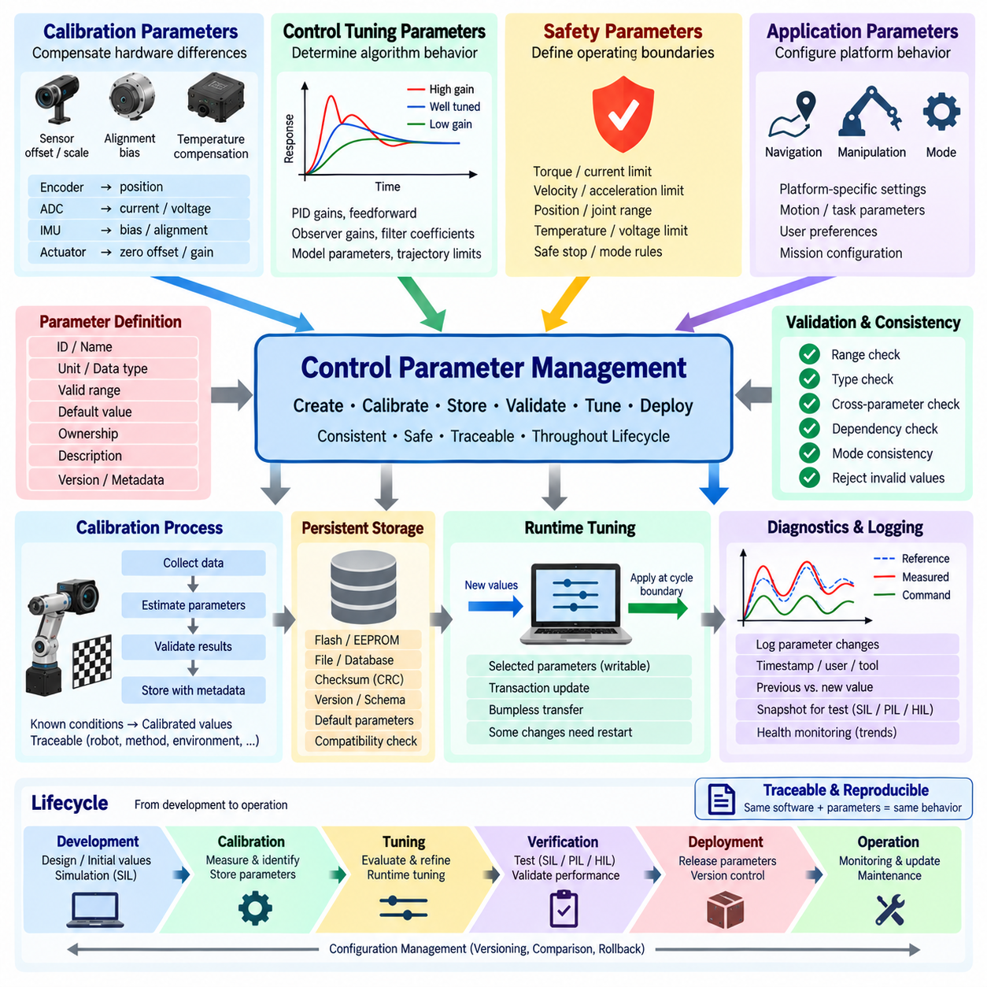
Control parameter management defines how numerical values that influence controller behavior are created, calibrated, stored, validated, modified, and deployed throughout the robot lifecycle. Parameters include controller gains, limits, offsets, scaling factors, filter coefficients, physical constants, and timing values. Managing them separately from executable code allows control behavior to evolve without uncontrolled source-code modification.
Parameters should be classified according to their purpose and ownership. Hardware calibration values describe physical devices, control parameters determine algorithm behavior, safety parameters define allowable operating boundaries, and application parameters configure platform-specific performance. This separation prevents a tuning change from unintentionally modifying hardware interpretation or safety constraints and clarifies which engineering function is authorized to modify each value.
Calibration parameters compensate for differences between ideal mathematical models and actual hardware. Sensors may contain offset, scale, alignment, bias, or temperature-dependent errors, while actuators can exhibit mechanical zero offsets, gain differences, dead zones, and nonlinear response. Calibration converts raw measurements and commands into physically meaningful quantities so that the Control Core operates on consistent engineering units.
Sensor calibration commonly establishes relationships between raw electrical values and physical measurements. Encoder counts may be mapped to angular position, ADC readings to current or voltage, and IMU measurements corrected for bias and alignment. Calibration data should normally be associated with the specific hardware configuration from which it was obtained because replacing a sensor, actuator, gearbox, or mechanical assembly may invalidate previous values.
Control tuning parameters determine how aggressively and accurately the robot responds to references and disturbances. PID gains, feedforward coefficients, observer gains, filter constants, model parameters, trajectory limits, and compensation terms are typical examples. These parameters affect stability and transient behavior directly, so their modification requires greater control than ordinary application settings such as user preferences or mission configuration.
Parameter definitions should contain more information than a numerical value alone. Each parameter should have a unique identifier, engineering unit, data type, valid range, default value, ownership, description, and applicable software or hardware version. Additional metadata may specify whether the parameter is writable during runtime, requires a controller restart, is safety related, or must be modified only through a controlled calibration procedure.
Range checking provides the first level of protection against invalid parameter values. A negative sampling period, impossible wheel radius, excessive torque limit, or controller gain far outside the validated range should not be accepted simply because it can be represented numerically. Parameter validation can include minimum and maximum limits, enumeration checks, consistency rules, dependency checks, and verification against the current operating mode.
Cross-parameter validation is important because individually valid values may form an invalid combination. Maximum velocity should be consistent with acceleration and braking capability, current limits should correspond to motor and drive ratings, and controller coefficients should match the configured sampling period. Validation therefore needs to evaluate relationships between parameters rather than treating every value as an independent configuration item.
Persistent storage allows calibrated and tuned values to survive power cycles. Parameters may be stored in flash memory, EEPROM, files, databases, or configuration packages depending on the computing platform. Stored data should include integrity information such as checksums or CRCs where appropriate, together with schema or version identifiers that allow software to determine whether a parameter set is compatible with the current implementation.
Default parameters provide a known configuration when persistent data is missing, corrupted, or incompatible. Defaults should represent intentionally defined behavior rather than arbitrary development values. Safety-critical limits should not silently fall back to permissive values. The startup process should identify whether parameters were loaded successfully, whether defaults were substituted, and whether the resulting configuration is authorized for normal operation.
Parameter versioning becomes essential as control software evolves. A new controller implementation may introduce additional parameters, change units, modify valid ranges, or reinterpret existing values. Parameter schemas should therefore evolve together with software versions. Migration logic can convert compatible older configurations, while incompatible configurations should be rejected rather than interpreted according to assumptions that may no longer be valid.
Calibration and tuning should be distinguished conceptually. Calibration attempts to identify or compensate for physical characteristics so that measurements and commands correspond correctly to the real system. Tuning adjusts controller behavior to achieve desired stability, response speed, damping, tracking accuracy, and disturbance rejection. Mixing these activities can hide hardware errors by compensating for them with inappropriate controller gains.
A structured calibration workflow typically begins with known physical conditions or reference measurements. The system collects raw data, estimates calibration coefficients, evaluates residual error, and stores validated results. The procedure should record which robot, sensor, actuator, software version, calibration method, reference equipment, and environmental conditions produced the resulting parameter set so that the calibration remains traceable.
Controller tuning should similarly follow a controlled engineering process. Initial values may originate from analytical models, simulation, system identification, previous platforms, or conservative baseline configurations. Engineers then evaluate response characteristics such as rise time, overshoot, settling time, steady-state error, oscillation, control effort, and disturbance rejection before accepting a new parameter set for deployment.
Runtime tuning allows selected parameters to be changed while the control software is executing. This capability can significantly accelerate controller development because engineers can observe the effect of gain or filter changes without rebuilding and restarting the complete system. However, unrestricted runtime modification can create unstable or unsafe behavior, so only explicitly designated parameters should be writable during operation.
Runtime parameter updates require transactional behavior when several values must change together. Updating one gain before another may temporarily create an inconsistent controller configuration. A safer mechanism receives a complete candidate parameter set, validates all values and dependencies, and then activates them together at a defined control-cycle boundary. The controller therefore observes either the old configuration or the complete new configuration, not an intermediate state.
Some parameter changes can be applied immediately, while others require controlled transitions. A small filter coefficient adjustment may be acceptable during operation, but changing control mode structure, sampling period, sensor scaling, or major gain values may require controller reset or actuator disablement. Parameter metadata should specify the permitted update policy so that software can enforce appropriate behavior automatically.
Bumpless parameter transfer is desirable when runtime tuning occurs during active control. A sudden gain or limit change can cause discontinuity in controller output even if both parameter sets are individually stable. Internal integrator states, filter states, feedforward terms, and output limits may require coordinated adjustment so that the actuator command changes smoothly rather than producing an unintended mechanical transient.
Safety parameters require stronger protection than ordinary tuning values. Maximum torque, velocity, steering angle, joint range, thermal threshold, or braking limit should not be freely modified through the same interface used for experimental gain tuning. Access control, restricted operating modes, authenticated tools, approval procedures, or immutable hardware limits may be used to prevent convenience-oriented tuning from weakening safety boundaries.
Parameter communication is important in distributed robot architectures. A tuning tool may execute on an engineering PC while controllers run on MCUs, real-time processors, motor drives, or edge computers. Parameter messages should identify the target device, parameter version, requested value, transaction state, and update result. Communication loss must not leave different processors with partially updated configurations.
A central parameter service can provide a consistent interface for reading, writing, validating, storing, and reporting parameters across software modules. Individual controllers should consume approved parameter sets rather than directly parsing arbitrary configuration files. This reduces duplicated validation logic and creates a clear location for version control, permissions, persistence, diagnostic reporting, and synchronization across distributed components.
Diagnostics should record parameter changes because tuning modifies the behavior of the robot without necessarily changing executable software. Logs should identify the previous value, new value, timestamp, parameter-set version, affected controller, and update result. When practical, the identity of the tool or engineering session that initiated the change should also be retained so that unexpected behavior can be correlated with configuration history.
Parameter snapshots improve reproducibility during testing. A test result is meaningful only when the software version, hardware configuration, calibration data, and active control parameters are known. SIL, PIL, HIL, bench, and vehicle tests should therefore preserve the parameter set used during execution. This allows engineers to reproduce a successful configuration or investigate why two nominally identical tests produced different behavior.
Configuration comparison tools can identify differences between robots, software releases, or tuning sessions. Instead of manually examining hundreds of values, engineers can compare parameter sets and highlight changed gains, limits, calibration coefficients, or versions. Such comparison is particularly valuable in fleet environments where small configuration differences can explain why one robot behaves differently from otherwise identical units.
Production deployment requires a controlled transition from development tuning to released parameters. Experimental values should not automatically become production configurations merely because they performed well during one test. Accepted parameter sets should pass defined verification, receive version identification, and be associated with compatible software and hardware releases. Production systems should load only configurations that satisfy the intended release policy.
Rollback capability provides protection when a new parameter set produces unexpected behavior. The system can retain a previously validated configuration and restore it if the new configuration fails validation or operational acceptance. Rollback should itself be controlled and traceable because returning to an older parameter set may be unsafe if the hardware or software architecture has changed since that configuration was created.
Ultimately, control parameter management connects physical calibration, controller tuning, runtime experimentation, verification, and production deployment into one controlled lifecycle. Calibration ensures that software represents the real hardware correctly, tuning shapes closed-loop behavior, runtime mechanisms support efficient engineering, and validation protects system integrity. Traceable parameter sets make robot behavior reproducible, diagnosable, maintainable, and safe.

01.07 Control SW Version Control and Parameter Traceability
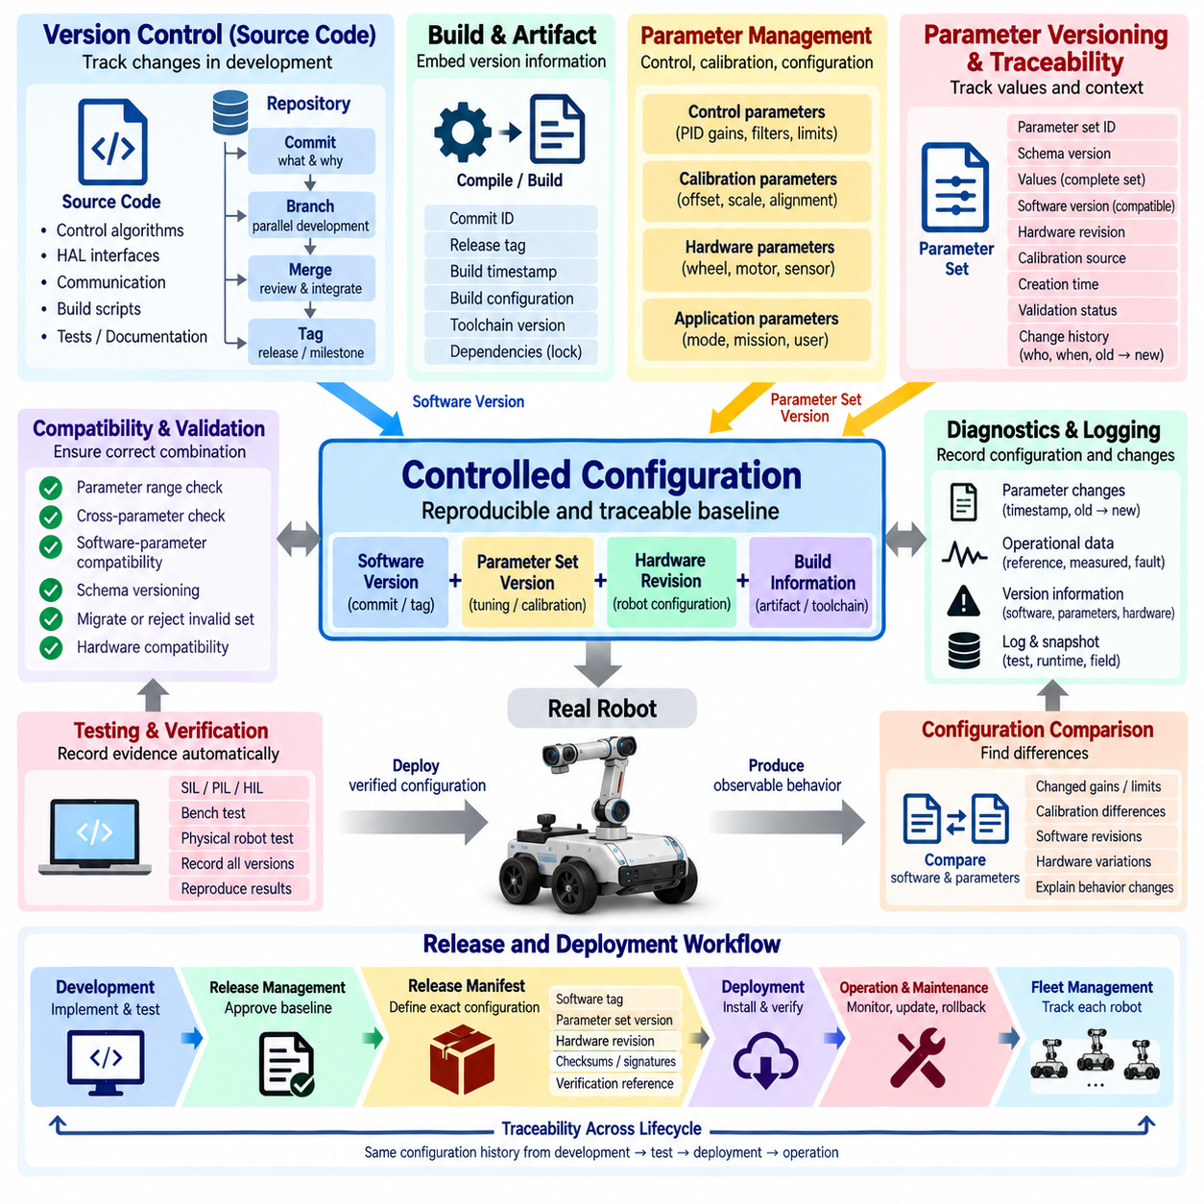
Control software version control establishes a reproducible history of how source code, configuration, interfaces, and controller behavior evolve throughout development and deployment. In robotic systems, identifying the software version alone is not sufficient because behavior also depends on calibration values, controller gains, hardware revisions, and runtime configuration. Traceability must therefore connect code and parameters as one controlled configuration.
A version-controlled repository should contain the source files required to reconstruct a specific control software release. Control algorithms, Hardware Abstraction Layer interfaces, communication definitions, build scripts, configuration schemas, tests, and relevant documentation should evolve under the same configuration-management process. Each committed change creates a historical reference that allows engineers to determine when and why implementation behavior changed.
A commit represents a defined state of the software rather than merely a backup copy. Meaningful commit identifiers provide immutable references to particular source configurations, while commit messages describe the engineering purpose of each change. When a robot test reveals unexpected behavior, the recorded commit identifier allows the development team to return to the exact software baseline used during that experiment instead of approximating it from later code.
Branches support parallel development while protecting validated baselines. New control algorithms, hardware adaptations, diagnostic functions, and experimental features can be developed independently before integration. A controlled merge process allows reviewed changes to enter the main development baseline. Release branches may preserve production configurations while subsequent development continues, reducing the risk that unfinished modifications are introduced into deployed robot software.
Tags provide human-readable identifiers for important repository states such as validated builds, integration milestones, or production releases. A tag can associate a specific source commit with a software release such as a controller version or platform baseline. The release identifier should also be accessible from the running robot so that diagnostic tools can determine which executable software is actually operating without requiring access to the development repository.
Source version information should propagate into the build artifact. Firmware, executables, containers, or deployable packages can embed the commit identifier, release tag, build timestamp, build configuration, and toolchain information. This allows an installed binary to be traced back to its source. Without embedded build identity, a binary file copied between engineering computers can become disconnected from the code that originally produced it.
Build reproducibility strengthens version traceability. Given the same source revision, dependencies, compiler configuration, build options, and toolchain, engineers should be able to reproduce functionally equivalent software artifacts. Dependency versions should therefore be controlled rather than implicitly taking the newest available library. Containers, lock files, manifests, or documented toolchain environments can reduce variation between development and production builds.
Control behavior, however, cannot be reconstructed from executable software alone. PID gains, filter coefficients, limits, calibration offsets, wheel dimensions, sensor alignment, actuator constants, and sampling parameters may substantially alter physical behavior without changing source code. Parameter sets therefore require their own version identity and must be linked explicitly to the software versions with which they were validated.
A parameter-set version should identify a complete and internally consistent configuration rather than an arbitrary collection of individual values. The set can contain control parameters, calibration references, hardware-dependent constants, and configuration metadata. When one value changes, the resulting configuration should be distinguishable from the previous set so that test results can be associated with the exact parameters that were active during execution.
Parameter traceability should record both values and context. Useful metadata includes parameter-set identifier, schema version, creation time, compatible software version, hardware revision, robot identifier, calibration source, and validation status. For runtime tuning, the system should additionally record which parameter changed, its previous and new values, when the change occurred, and whether the update was temporary, persisted, or later reverted.
Software and parameter compatibility must be explicitly managed because parameter meaning can evolve with the code. A software update may introduce a new gain, remove an obsolete parameter, change units, modify valid ranges, or reinterpret an existing field. Schema versioning allows the software to recognize these differences. Compatible older configurations may be migrated, while incompatible parameter sets should be rejected rather than silently interpreted incorrectly.
Hardware configuration adds another dimension to traceability. The same control software and parameter set may not behave identically when motor type, gearbox ratio, encoder resolution, sensor installation, wheel diameter, or mechanical assembly differs. A reproducible control baseline should therefore identify the relevant hardware revision and calibration state together with software and parameters rather than assuming that all physical robots are equivalent.
The resulting configuration can be viewed as a controlled baseline composed of software version, parameter-set version, calibration data, hardware revision, and build information. This baseline represents the actual technical state of the robot at a specific point in time. Test reports and diagnostic records should reference this combined identity so that observed physical behavior can be associated with a reconstructable engineering configuration.
Runtime parameter tuning creates a particular traceability challenge because robot behavior can change without creating a new software build. A controller may begin a test with one gain set and finish with another after several tuning adjustments. Diagnostic logging should therefore record parameter-change events against synchronized timestamps, allowing measured responses and faults to be correlated with the configuration that was active at each moment.
Parameter snapshots provide a practical method for preserving runtime configuration. At important test boundaries, the system can capture the complete active parameter set together with software and hardware identity. A snapshot taken before and after tuning enables engineers to compare configurations directly. This is more reliable than recording only the values believed to have changed because unnoticed settings may also influence the result.
Configuration comparison should be supported as a normal engineering workflow. Two parameter sets can be compared to identify changed gains, limits, calibration coefficients, modes, or schema versions. Software revisions can similarly be compared through repository history. Combining these comparisons helps determine whether behavioral differences originate from source-code changes, parameter tuning, hardware calibration, or several factors acting together.
Testing should generate traceability evidence automatically whenever practical. SIL, PIL, HIL, bench, and physical robot tests can record the source revision, build identifier, parameter-set version, calibration revision, hardware configuration, and test scenario at startup. Automated collection reduces dependence on engineers manually entering configuration information and lowers the probability that important metadata is missing from a test report.
Release management converts a development configuration into an approved deployment baseline. A release should identify the exact source revision and approved parameter set, together with compatible hardware and calibration requirements. Verification results can then be associated with that baseline. Production deployment should use released artifacts rather than rebuilding source code independently on each robot or manually copying experimental parameter files.
A release manifest can provide the authoritative relationship between these elements. It may identify executable artifacts, checksums, software tag, parameter-set version, schema version, supported hardware revision, calibration requirements, and verification references. The manifest becomes a compact description of what constitutes the approved control configuration and can be used by deployment tools to verify that all required components belong together.
Integrity verification helps ensure that the deployed system actually matches the released configuration. Checksums, cryptographic hashes, package signatures, or secure update mechanisms can detect unintended modification or corruption of software and configuration data. At startup or during maintenance, the robot can compare installed artifacts with expected identifiers and report mismatches through diagnostics rather than operating under an unknown configuration.
Rollback is an important part of controlled version management. If a new software or parameter release produces unacceptable behavior, engineers should be able to restore a previously validated baseline. Rollback must restore compatible software and parameters together rather than reverting only one component. An older parameter set combined with newer software may create a configuration that was never tested and therefore cannot be assumed safe.
Field updates require the same traceability discipline as laboratory development. Before an update, the existing configuration should be recorded; during deployment, the target release should be verified; and after installation, the robot should report the active version information. If deployment fails, recovery procedures should return the system to a known state rather than leaving partially updated software or parameter components.
Fleet operation increases the importance of configuration identity because nominally identical robots can gradually diverge. Individual units may receive different repairs, calibrations, parameter updates, or software releases. A fleet-management system should therefore be able to determine which baseline each robot is running. Configuration differences can then be correlated with performance, failures, maintenance history, or environment without assuming fleet-wide uniformity.
Diagnostics should expose version and traceability information alongside operational data. Fault logs can include software build identity, parameter-set version, hardware revision, calibration revision, operating mode, and relevant parameter-change history. When a fault occurs in the field, this context allows engineers to determine whether the event is associated with a particular release or configuration instead of treating every failure as an isolated incident.
Change control should preserve the reason behind modifications, not only the modified values. A controller gain may change because of a new motor, improved system identification, stability testing, or compensation for a mechanical redesign. Linking commits, parameter revisions, issue records, test evidence, and release approvals creates an engineering history that explains both what changed and why the change was accepted.
Traceability also supports verification and regression testing. When a software or parameter change is proposed, engineers can identify affected functions and repeat the relevant tests against the new baseline. Results can be compared with previous validated configurations. This establishes evidence that intended improvements were achieved while previously acceptable control behavior, timing, diagnostics, and safety properties were not unintentionally degraded.
Ultimately, control software version control and parameter traceability establish a reproducible chain from engineering intent to physical robot behavior. Source revisions identify the implemented algorithms, build records identify the executable artifact, parameter sets define controller configuration, calibration represents physical hardware, and release records connect these elements to verification evidence. Together they allow robot behavior to be reproduced, compared, diagnosed, audited, and safely maintained throughout its lifecycle.

01.08 Control SW Dev Tools: Simulink Codegen vs Manual
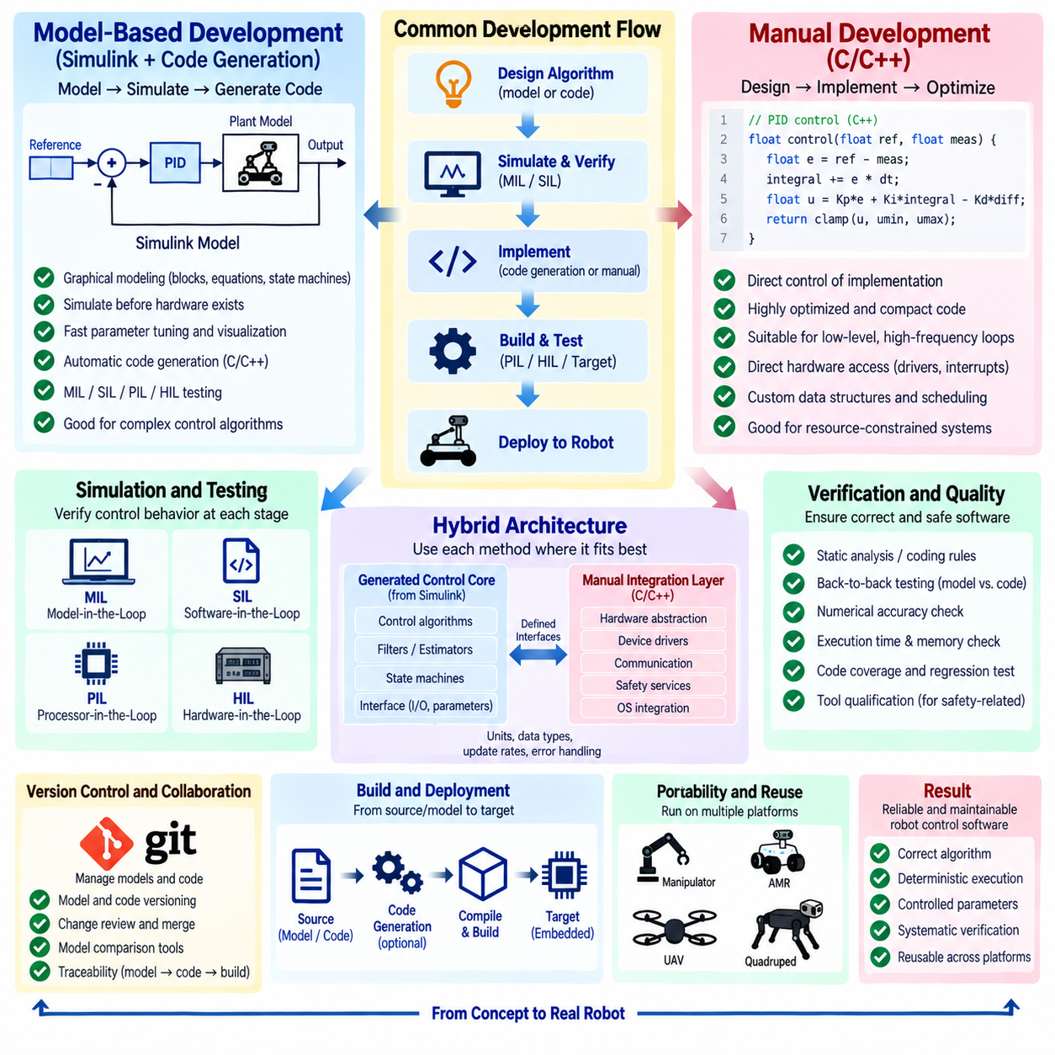
Control software development tools influence how control algorithms move from mathematical concepts to executable real-time software. Two common approaches are model-based development using environments such as Simulink with automatic code generation and manual implementation using languages such as C or C++. Both can produce high-quality robot controllers, but they differ in modeling workflow, verification, implementation control, maintainability, and deployment efficiency.
Model-based development represents controller behavior using graphical blocks, equations, state machines, signal connections, and parameterized subsystems. Engineers can express filters, PID controllers, state estimators, plant models, mode logic, and actuator dynamics within an executable model. Because the model can be simulated before target hardware exists, algorithm design and system-level behavior can be evaluated early in the development lifecycle.
Simulink-style environments are particularly effective when controller development depends heavily on dynamic-system analysis. A plant model can be connected directly to the controller model, allowing engineers to examine tracking response, stability, saturation, disturbances, sensor noise, and actuator limits. Parameters can be modified rapidly, and simulation results can be visualized without repeatedly rebuilding and deploying embedded software to physical hardware.
Executable models also create a common representation between control theory and software implementation. Equations developed during controller design can be converted into blocks and tested against simulated robot dynamics. This reduces the conceptual gap between algorithm engineers and implementation engineers. However, the model itself must be treated as an engineering artifact with architecture rules, naming conventions, interfaces, version control, reviews, and verification requirements.
Automatic code generation converts validated model elements into source code suitable for embedded or real-time targets. Generated code may implement mathematical operations, filters, state machines, lookup tables, controller equations, and signal interfaces according to configured generation rules. The resulting C or C++ can then be compiled for an MCU, real-time processor, or other control computer using the target platform's normal compiler and build environment.
Code generation can improve development efficiency when the same algorithm must be repeatedly modified, tested, and deployed. Changes made in the model can propagate systematically into implementation code, reducing the need to manually translate equations after every design iteration. This is valuable for controllers containing many states, lookup tables, filters, or mode transitions where hand conversion can introduce transcription errors and inconsistencies.
A major advantage of model-based development is the ability to build verification around the model. Model-in-the-Loop testing can evaluate control behavior entirely in simulation, while Software-in-the-Loop can execute generated software representations against simulated plants. Processor-in-the-Loop and Hardware-in-the-Loop testing progressively introduce target processors and physical interfaces, creating a continuous verification path from algorithm design to deployed implementation.
Generated code does not eliminate the need for software engineering. Engineers must configure data types, sample times, execution order, memory usage, interfaces, numerical precision, initialization, and target-specific behavior. Poorly structured models can generate poorly structured software, while inappropriate solver or data-type settings can produce incorrect real-time behavior. Code generation automates translation, not engineering judgment.
Generated code quality should therefore be evaluated for execution time, memory consumption, numerical behavior, readability where required, and compliance with project coding constraints. Optimization settings may trade readability for speed or code size. For resource-constrained controllers, engineers should inspect whether generated operations create unnecessary copies, conversions, intermediate variables, or computational overhead that could threaten real-time deadlines.
Manual control software development provides direct control over implementation details. Engineers write controller equations, filters, state machines, interfaces, memory structures, and scheduling logic explicitly in C, C++, or another target language. This approach can produce compact and highly optimized software, especially when hardware resources are limited or when precise control over memory layout, execution order, interrupts, and peripheral access is required.
Manual implementation is often appropriate for low-level control loops that execute at very high frequencies. Motor current control, PWM-related processing, encoder capture, interrupt-driven functions, and tightly coupled device logic may require direct interaction with MCU peripherals or specialized processor features. Handwritten software allows engineers to exploit hardware capabilities without introducing abstraction or generated structures that are unnecessary for the target.
The main challenge of manual implementation is maintaining consistency between control design and source code. Mathematical equations may exist in documents, MATLAB scripts, Python simulations, or engineering notebooks, while the deployed controller is implemented separately. Every algorithm modification must be transferred correctly into code. Without disciplined review and testing, differences can gradually develop between the analyzed controller and the controller actually running on the robot.
Manual code also places greater responsibility on the developer for numerical implementation. Continuous-time equations must be discretized correctly, state variables initialized, saturation handled, units maintained, and floating-point or fixed-point behavior understood. Indexing errors, sign mistakes, incorrect update order, and unintended integer conversions can produce failures that are difficult to identify from source inspection alone.
Model-based and manual development should not be viewed as mutually exclusive choices. A practical robot controller can use generated code for algorithm-intensive functions while retaining handwritten software for Hardware Abstraction Layers, communication drivers, operating-system integration, safety services, and device-specific optimization. Clearly defined interfaces allow each development method to be used where it provides the strongest engineering advantage.
A hybrid architecture commonly places the control algorithm inside a portable module with explicit inputs, outputs, states, and parameters. The algorithm may be modeled and generated independently of the target hardware, while handwritten integration software supplies sensor data and applies actuator commands. This separation allows the generated Control Core to remain reusable across platforms while hardware-specific software handles timing, drivers, communication, and deployment.
Interface design is critical in such hybrid systems. Generated and manual modules must agree on units, data types, update rates, memory ownership, initialization sequence, error handling, and parameter semantics. An interface mismatch can produce failures even when both modules are individually correct. Interface definitions should therefore be version controlled and verified with automated tests rather than relying on informal assumptions between development teams.
Version control presents different practical challenges for graphical models and text-based source code. Manual C or C++ changes can usually be reviewed through line-based differences, while graphical models may require specialized comparison tools to understand structural changes. Teams using model-based development should establish model-diff, merge, naming, hierarchy, and ownership practices so that models remain manageable as multiple engineers contribute.
Continuous integration can support both approaches. Each source or model change can trigger model checks, code generation, compilation, static analysis, unit tests, SIL simulations, and regression tests. Automated pipelines reduce dependence on individual engineering workstations and provide evidence that the control software remains buildable and behaviorally consistent after modifications. Generated artifacts should also be traceable to the exact model revision that produced them.
Testing strategy should compare behavior across development stages. The same input vectors and reference scenarios can be applied to the design model, generated implementation, handwritten implementation, and target processor. Outputs can then be compared within defined numerical tolerances. Back-to-back testing is particularly useful for demonstrating that generated or manually translated code preserves the intended behavior of the reference control algorithm.
Static analysis and coding-rule checks remain important regardless of implementation method. Handwritten code may contain memory errors, undefined behavior, or unsafe language constructs, while generated code may require configuration to satisfy project rules. Compiler warnings, static analyzers, runtime instrumentation, and code-coverage tools can complement simulation-based verification by examining software properties that are not visible from control response alone.
Debugging workflows also differ. Model-based tools provide signal visualization and simulation scopes that make internal controller behavior easy to inspect before deployment. Manual software typically relies more heavily on debuggers, trace buffers, telemetry, logging, and target instrumentation. On real robots, both approaches benefit from consistent diagnostic signals that expose references, measurements, states, errors, outputs, timing, and mode transitions.
Tool qualification and process control become more important when generated software is used in safety-related applications. Development teams need confidence that model transformations, code-generation settings, and verification tools behave as intended for the required assurance level. Even when formal qualification is not required, tool versions and generation configurations should be controlled because changing the toolchain can change the resulting software artifact.
Portability is another consideration. A well-designed model can generate algorithm code for multiple targets, but portability depends on avoiding unnecessary target-specific dependencies inside the model. Manual code can also be portable when hardware access is isolated behind clear abstraction layers. In either approach, separating control mathematics from device drivers, middleware, and operating-system services improves reuse across AMRs, manipulators, quadrupeds, UAVs, and other robot platforms.
The choice between code generation and manual implementation should therefore be based on system constraints rather than development ideology. Model-based development is attractive for rapid algorithm iteration, simulation, complex control logic, and systematic verification. Manual development is attractive for low-level optimization, specialized hardware interaction, compact runtime environments, and situations where engineers require precise control over implementation details.
Team capability and long-term maintenance should also influence the decision. A sophisticated model-based workflow provides little benefit if future engineers cannot maintain the models or toolchain, while highly optimized handwritten code can become equally difficult to maintain if its assumptions are undocumented. The selected workflow should preserve understandable architecture, reproducible builds, test evidence, parameter traceability, and sufficient documentation for engineers who inherit the controller.
Ultimately, the development tool is not the primary measure of control software quality. Reliable robot control results from correct algorithms, deterministic execution, controlled parameters, clear interfaces, systematic verification, and maintainable implementation. Simulink and automatic code generation can accelerate the path from model to software, while manual coding provides detailed implementation control. A disciplined hybrid strategy often combines both to create efficient, verifiable, and reusable robot control software.

01.09 Control SW Test Strategy: HIL, SIL, PIL
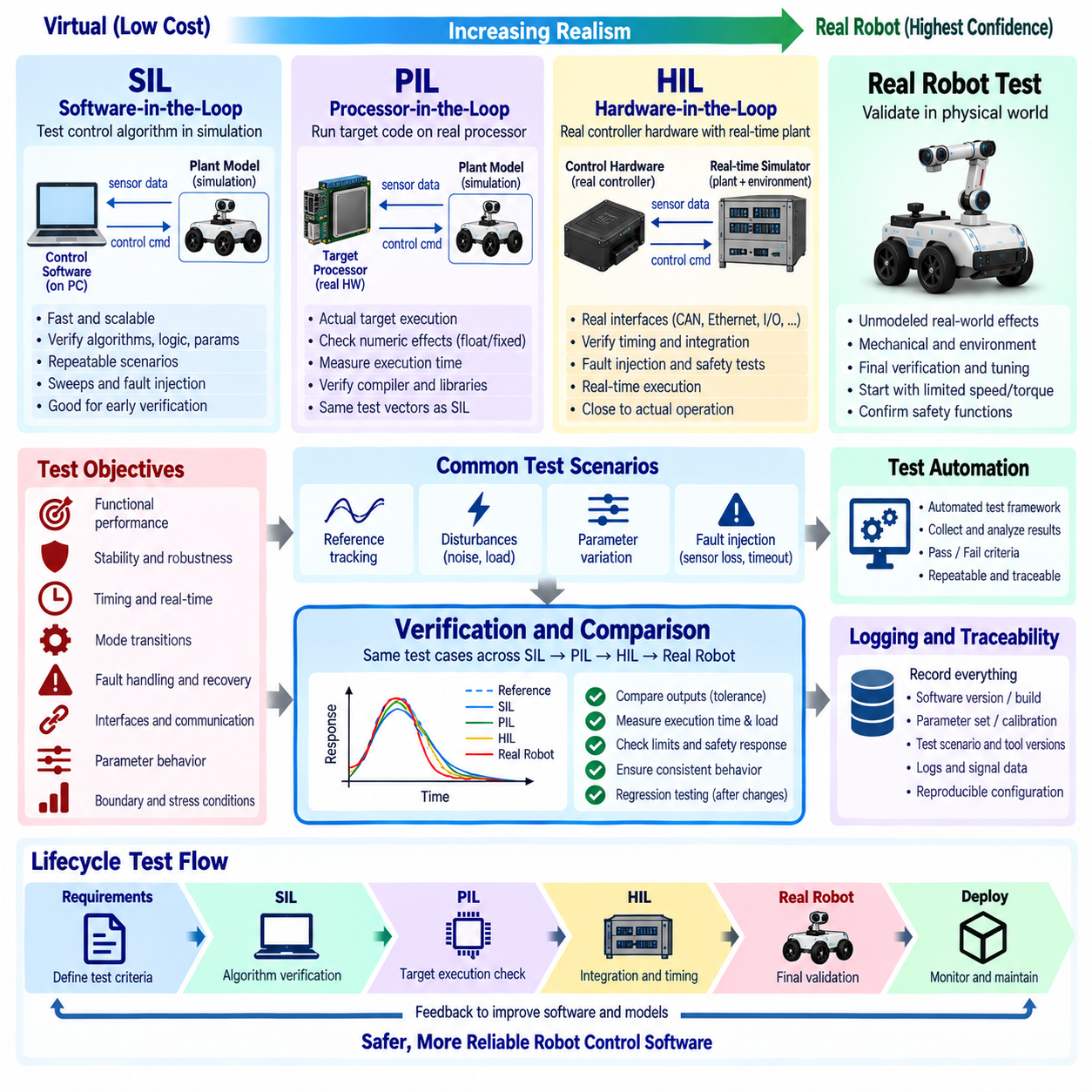
Control software testing verifies that algorithms, implementation code, timing behavior, interfaces, parameters, and fault responses remain correct before a robot is exposed to physical risk. Because control software directly influences motors and mechanical motion, testing should progress from inexpensive virtual environments toward increasingly realistic hardware. SIL, PIL, and HIL provide complementary stages for reducing uncertainty before full robot testing.
A structured test strategy begins with requirements and expected behavior rather than with individual test tools. Each control function should have measurable criteria for reference tracking, stability, accuracy, timing, saturation, mode transitions, fault handling, and recovery. Tests should include nominal operation, boundary conditions, abnormal inputs, communication failures, and physical constraints so that verification covers more than successful demonstrations.
The test environment should reproduce the closed-loop relationship between controller and plant. A controller cannot be evaluated adequately by checking output calculations independently because its commands change the physical system, which then produces new sensor feedback. Robot dynamics, actuators, sensors, disturbances, delays, and environmental interactions should therefore be represented with sufficient fidelity for the objective of each verification stage.
Software-in-the-Loop testing executes the control software in a software-based simulation environment while the robot plant is represented mathematically. The controller receives simulated sensor data and produces actuator commands exactly as it would conceptually during real operation. SIL allows engineers to exercise large numbers of scenarios rapidly without damaging hardware and is therefore well suited to early functional verification and regression testing.
SIL can verify controller equations, discrete-time implementation, state machines, filters, estimators, saturation logic, and parameter behavior. Reference trajectories can be repeated exactly, disturbances can be injected at controlled times, and internal signals can be recorded without physical instrumentation limitations. Automated simulations can sweep gains, payloads, friction, sensor noise, initial conditions, or environmental parameters to explore a wide operating region efficiently.
The usefulness of SIL depends strongly on the quality of the plant model. A simple model may be sufficient for verifying control logic but may not predict real robot performance accurately when actuator dynamics, backlash, tire slip, structural flexibility, or sensor delays are important. Simulation fidelity should therefore match the test objective. Increasing model complexity without a clear verification purpose can increase maintenance cost without improving useful evidence.
Processor-in-the-Loop testing introduces the actual target processor or an equivalent execution target while the surrounding plant remains simulated. Instead of executing only a host-computer representation of the controller, the compiled target software runs using the processor architecture, numerical representation, compiler behavior, and execution environment closer to deployment. PIL therefore bridges the gap between software simulation and real embedded execution.
PIL is particularly useful for detecting implementation effects that may not appear in SIL. Floating-point differences, fixed-point quantization, compiler optimization, data alignment, processor-specific libraries, and execution-time limitations can influence controller behavior. The same test vectors used in SIL can be applied to PIL, and outputs can be compared within defined tolerances to determine whether target implementation preserves the intended algorithm.
Execution-time measurement becomes increasingly important during PIL. A controller that produces numerically correct outputs but exceeds its required control period cannot be considered valid for real-time operation. Engineers can measure average and worst-case execution time, processor load, memory usage, and timing variation. Stress conditions should also be considered because communication, interrupts, diagnostics, and other tasks may compete for processing resources.
Hardware-in-the-Loop testing connects the actual controller hardware to a real-time simulation of the robot and its environment. The controller operates through realistic electrical or communication interfaces while the simulator calculates plant response fast enough to close the control loop in real time. From the controller's perspective, simulated sensors and actuators appear similar to physical devices even though the mechanical robot is not moving.
HIL enables verification of software, processor, communication, I/O, timing, and hardware integration within one controlled environment. CAN, CANopen, EtherCAT, Ethernet, PWM, analog signals, digital I/O, encoder interfaces, or other target interfaces can be included according to the controller architecture. This makes HIL valuable for identifying integration problems that cannot be reproduced when controller functions are tested only as isolated software modules.
Real-time simulation is fundamental to HIL because the plant model must advance according to the same timing constraints experienced by the physical controller. If the simulator cannot complete calculations within its required step size, feedback timing becomes unrealistic. HIL models may therefore require simplification or specialized real-time hardware so that sufficient physical fidelity is maintained while deterministic execution deadlines are satisfied.
Fault injection is one of the strongest advantages of SIL and HIL. Tests can introduce encoder loss, frozen sensor values, communication timeout, excessive noise, actuator saturation, overtemperature signals, invalid messages, delayed packets, or power-related events in a repeatable manner. Dangerous conditions that would be difficult or unsafe to create on a physical robot can therefore be evaluated systematically without risking personnel or expensive equipment.
Fault tests should verify not only whether a fault is detected but also how the controller responds afterward. The software may need to issue a warning, reduce performance, hold position, stop motion, disable an actuator, or enter a latched fault state. Recovery behavior should also be tested to confirm that normal control authority is restored only after defined conditions are satisfied and that repeated faults do not create unsafe restart cycles.
Interface testing becomes progressively more realistic from SIL through PIL to HIL. SIL may verify logical software interfaces, PIL adds target data representation and processor behavior, and HIL introduces actual communication and electrical boundaries. This staged progression helps isolate defects. When a failure first appears in HIL after passing SIL and PIL, engineers can focus investigation on timing, communication, hardware interfaces, or integration rather than the basic algorithm.
Back-to-back testing provides continuity across these stages. Identical reference inputs and test scenarios can be executed against a model, SIL implementation, PIL target, and HIL system. Selected outputs are compared within defined numerical and temporal tolerances. Differences should be explained rather than simply accepted, because divergence may indicate discretization changes, numerical precision effects, interface conversions, timing delays, or implementation defects.
Regression testing ensures that previously verified behavior remains acceptable after software or parameter modifications. Automated SIL is particularly useful because large test suites can execute frequently as part of continuous integration. Selected PIL and HIL regression tests can then verify target-specific and integration behavior. This layered strategy balances execution cost with confidence instead of requiring every software change to begin with full physical robot testing.
Test coverage should include normal operating regions as well as boundaries. Maximum velocity, acceleration, torque, steering angle, joint range, payload, sensor rate, communication load, and controller saturation may expose behavior that does not appear during moderate operation. Boundary tests should verify that limits are enforced smoothly and that the controller remains stable when commands or measurements approach the edges of the validated operating envelope.
Robustness testing evaluates sensitivity to uncertainty rather than only one nominal model. Robot mass, inertia, friction, payload, battery voltage, sensor bias, latency, and environmental conditions may vary during actual operation. Simulation makes these variables relatively easy to sweep or randomize. Monte Carlo or parameter-variation tests can reveal combinations that reduce stability margins or tracking performance before those combinations occur in field operation.
Timing tests should evaluate sampling periods, jitter, deadline misses, communication latency, and synchronization between distributed controllers. Artificial delays can be inserted to determine how much latency the control loop tolerates before performance becomes unacceptable. Multi-rate architectures should verify that fast current or torque loops and slower position, motion, or supervisory loops exchange data consistently without using stale or temporally inconsistent information.
Test automation improves repeatability and enables objective comparison. A test framework can configure initial conditions, execute scenarios, collect signals, calculate performance metrics, and automatically determine pass or fail status. Rise time, overshoot, settling time, steady-state error, tracking error, control effort, deadline margin, and fault-response time can become quantitative acceptance criteria rather than judgments based only on plotted curves.
Logging and traceability are essential because test results are meaningful only when the tested configuration can be reconstructed. Every test should identify the software revision, build artifact, parameter-set version, calibration data, target hardware, plant-model version, test scenario, and relevant tool versions. Runtime parameter changes should also be recorded so that unexpected results can be correlated with the exact configuration active at the time.
Physical robot testing remains necessary because no simulation reproduces every real-world effect. Mechanical compliance, unmodeled friction, electromagnetic interference, thermal behavior, sensor installation errors, terrain interaction, and unexpected environmental conditions can reveal limitations not observed in virtual testing. However, physical tests should begin after lower-cost SIL, PIL, and HIL stages have already removed defects that do not require real hardware to discover.
The transition to physical testing should be incremental. Initial tests can use reduced velocity, torque, acceleration, workspace, or payload limits before expanding toward the intended operating envelope. Emergency-stop functions, communication loss responses, and safety limits should be verified before aggressive controller tuning. This approach reduces the consequence of remaining defects while engineers compare measured robot behavior with earlier simulation and HIL results.
Test failures should feed back into both software and models. If a physical robot behaves differently from HIL, the difference may reveal a controller defect, an interface problem, or an inaccurate plant model. Updating the simulation model using measured data improves future verification. The objective is not to force real behavior to match simulation but to understand why differences occur and continuously improve both implementation and test fidelity.
A mature control software strategy therefore forms a verification ladder from simulation toward reality. SIL provides fast and scalable software verification, PIL confirms target implementation and computational behavior, HIL validates real-time hardware and interface integration, and physical robot testing confirms operation in the actual mechanical environment. Each stage removes a different class of uncertainty and supplies evidence for the next.
Ultimately, SIL, PIL, and HIL are most effective when treated as connected parts of one lifecycle rather than independent test activities. Shared scenarios, measurable acceptance criteria, automated regression, fault injection, timing verification, and configuration traceability create continuity from algorithm design to field deployment. This layered strategy reduces physical risk while improving confidence that robot control software is correct, deterministic, robust, diagnosable, and safe.

01.10 Common Control SW Design Principles per Robot Platform
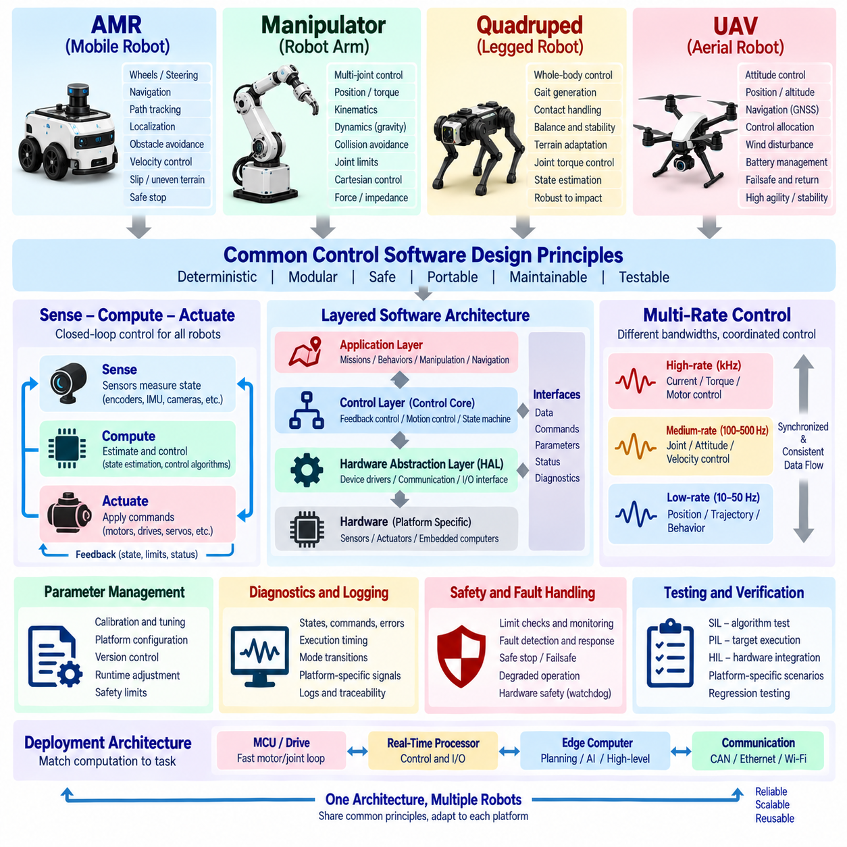
Robot control software should preserve common architectural principles while adapting control functions to the physical characteristics of each robot platform. An AMR, manipulator, quadruped, and UAV differ greatly in dynamics, actuators, sensing, constraints, and failure consequences, yet all require deterministic feedback, explicit interfaces, controlled parameters, diagnostics, and safe state transitions. A reusable architecture separates these common principles from platform-specific control logic.
A common foundation begins with the Sense–Compute–Actuate control loop. Sensors measure physical state, the controller estimates relevant variables and calculates commands, and actuators apply forces or motion to the robot. Regardless of platform, this loop requires consistent units, synchronized data, bounded execution time, validated inputs, command limits, and feedback of actuator or system state. Platform differences mainly determine which signals and dynamics dominate the loop.
Layered software architecture improves portability across robot types. Hardware Abstraction Layers isolate encoders, IMUs, motor drives, force sensors, GNSS receivers, communication buses, and other devices from controller algorithms. The Control Core implements deterministic feedback functions, while upper software provides trajectories, navigation, manipulation goals, behaviors, or missions. Clear boundaries allow hardware and algorithms to evolve with reduced cross-layer coupling.
Multi-rate control is another common principle because physical processes operate at different bandwidths. Fast loops may regulate current, torque, or motor velocity, while slower loops control position, vehicle motion, body attitude, trajectory tracking, or supervisory behavior. Each loop should have a defined sampling period and data interface. Rate transitions must prevent stale, duplicated, or temporally inconsistent information from destabilizing nested control structures.
Mobile robots such as AMRs primarily control translational and rotational motion over a ground surface. Their control software typically converts path or velocity references into wheel, steering, or drive commands while considering kinematic constraints. Differential-drive, skid-steer, Ackermann, and omnidirectional platforms require different motion mappings, but each needs velocity regulation, localization feedback, path tracking, acceleration limiting, and controlled stopping behavior.
AMR control must account for interaction with the ground and operating environment. Wheel slip, uneven friction, payload changes, slopes, and localization errors can cause the measured vehicle state to differ from ideal kinematic predictions. Controllers should therefore combine encoder, IMU, LiDAR, GNSS, or other available feedback according to platform capability. Motion limits should also reflect braking distance, steering geometry, stability, and nearby obstacles.
Manipulator control focuses on coordinated motion of multiple joints and the resulting end-effector behavior. Joint position, velocity, torque, and current loops are commonly arranged hierarchically, while higher-level functions generate joint trajectories or Cartesian references. Kinematic transformations connect joint space and task space, and dynamic compensation may account for gravity, inertia, friction, payload, and coupling between joints.
Manipulator software must manage joint limits, singularities, collisions, and interaction forces explicitly. A trajectory that is geometrically valid at the end effector may require excessive joint velocity or approach a mechanical limit. Control functions should therefore enforce joint-level constraints while higher layers consider workspace constraints. Force, impedance, or admittance control may be added when the robot physically interacts with tools, objects, or humans.
Quadruped robots introduce strongly coupled whole-body dynamics. Control software must coordinate multiple legs while maintaining body stability, contact consistency, and locomotion objectives. Joint-level torque or position control operates beneath gait generation, foot trajectory control, state estimation, and whole-body control. Contact state becomes a critical variable because each foot alternates between supporting the body and moving through a swing phase.
Quadruped control depends heavily on accurate estimation of body orientation, velocity, joint state, and foot contact. IMU measurements, encoders, contact sensors, and kinematic constraints can be fused to estimate states that cannot be measured directly. Terrain uncertainty and impact forces require robust control and rapid feedback. Safety behavior should consider loss of balance, unexpected contact, actuator overload, and the possibility of controlled posture reduction or shutdown.
UAV control software must continuously maintain vehicle stability while simultaneously following position, velocity, altitude, or trajectory references. Multirotor architectures commonly use nested loops in which fast angular-rate control supports attitude control, while slower velocity and position loops generate attitude or thrust references. The timing and stability of inner loops are particularly important because loss of attitude control can rapidly lead to loss of the vehicle.
UAV state estimation commonly integrates IMU, barometer, GNSS, magnetometer, and other navigation sensors. Sensor quality, vibration, bias, delay, and synchronization directly affect flight-control performance. Control allocation converts desired forces and moments into individual motor or actuator commands while respecting saturation and actuator capability. Battery condition, payload, center of gravity, wind, and propulsion degradation can further modify the available control authority.
Despite these differences, actuator command management is common to every platform. Raw controller outputs should not be sent directly to hardware without validation. Saturation, rate limits, dead zones, command plausibility checks, and actuator availability should be considered. A manipulator torque command, AMR wheel-speed command, quadruped joint command, or UAV motor command differs physically, but each must remain inside a verified operating envelope.
State estimation should also follow common interface principles even when estimation algorithms differ. Controllers should receive states with defined units, coordinate frames, timestamps, validity information, and uncertainty where appropriate. AMRs may emphasize planar pose and velocity, manipulators joint and end-effector state, quadrupeds body and contact state, and UAVs six-degree-of-freedom motion. The interface contract should remain explicit and deterministic.
Coordinate-frame management becomes increasingly important as control software spans multiple subsystems. Sensor frames, body frames, joint frames, world frames, map frames, and task frames must be transformed consistently. A sign error or incorrect frame convention can produce physically dangerous commands even when the controller equations are correct. Frame definitions should therefore be documented, version controlled, and verified through tests.
Control modes should be represented explicitly for every platform. Robots may transition between initialization, standby, manual control, autonomous control, calibration, degraded operation, safe stop, and fault states. Platform-specific modes can be added, such as manipulator gravity compensation, quadruped stand mode, AMR docking, or UAV landing. Mode transitions should define control authority, valid references, initialization behavior, and permitted actuator outputs.
Safety architecture must reflect platform-specific physical risks while preserving common principles. AMRs require controlled braking and collision-related motion limits, manipulators require joint and workspace protection, quadrupeds require balance and contact-aware protection, and UAVs require flight-critical failsafe behavior. In every case, software safety checks should be combined with actuator protection, communication monitoring, watchdogs, and independent hardware safety where appropriate.
Fault handling should distinguish between faults that permit degraded operation and those requiring immediate protective action. Loss of one localization source may allow an AMR to reduce capability, while loss of critical attitude estimation may require a UAV failsafe response. A manipulator may stop affected joints after encoder disagreement, whereas a quadruped may need coordinated whole-body action. Fault response must therefore consider system-level physical consequences.
Parameter management should separate reusable controller structure from platform calibration and tuning. Wheel radius, track width, joint zero offsets, link parameters, motor constants, vehicle mass, inertia, thrust coefficients, controller gains, and safety limits should not be scattered through source code. Structured parameter sets allow the same software architecture to support variants while preserving validation, version compatibility, runtime tuning policies, and traceability.
Diagnostics should expose both common and platform-specific information. All platforms benefit from references, measurements, estimated states, control errors, outputs, execution timing, mode transitions, saturation events, and faults. Additional signals may include AMR localization quality, manipulator joint torque, quadruped contact state, or UAV attitude-estimator status. Consistent diagnostic conventions simplify testing and fleet-level maintenance across different robots.
Testing should reuse a common verification philosophy while adapting plant models and scenarios to each platform. SIL can verify algorithms against simulated dynamics, PIL can confirm target execution, and HIL can validate hardware interfaces and timing before physical operation. Platform-specific scenarios then evaluate wheel slip, manipulator payload, leg contact, wind disturbance, sensor failure, actuator saturation, or other conditions representative of the robot's physical environment.
Reusable software should be designed around capabilities rather than assumptions about one robot. Interfaces such as motion reference, actuator command, estimated state, fault status, and parameter service can remain common while platform adapters provide specific implementations. This approach supports shared infrastructure for scheduling, diagnostics, communication, logging, configuration, and testing without forcing fundamentally different robot dynamics into one universal controller.
Deployment architecture should also match computational requirements. Fast motor or joint loops may execute on MCUs or dedicated drives, deterministic motion control may run on real-time processors, and planning or AI functions may execute on edge computers. The exact distribution differs among AMRs, manipulators, quadrupeds, and UAVs, but communication latency, synchronization, failure isolation, and ownership of each control function must always be defined explicitly.
Platform adaptation should avoid both extremes of complete duplication and excessive generalization. Duplicating the entire control stack for every robot increases maintenance effort and causes common functions to diverge. Conversely, forcing every platform into identical abstractions can hide important physical differences. A better design shares infrastructure and architectural patterns while allowing specialized control algorithms, state definitions, safety logic, and dynamics where required.
Ultimately, common robot control software design is based on stable engineering principles applied to different physical systems. Deterministic execution, layered architecture, multi-rate feedback, explicit interfaces, controlled parameters, state estimation, diagnostics, safety, and systematic testing can be shared across platforms. AMRs, manipulators, quadrupeds, and UAVs then specialize these foundations according to their motion, dynamics, sensing, actuation, and failure characteristics.

