Volume 04 Robot Control Software

11. UAV Flight Control Software

11.01 UAV Flight Control SW Architecture Overview
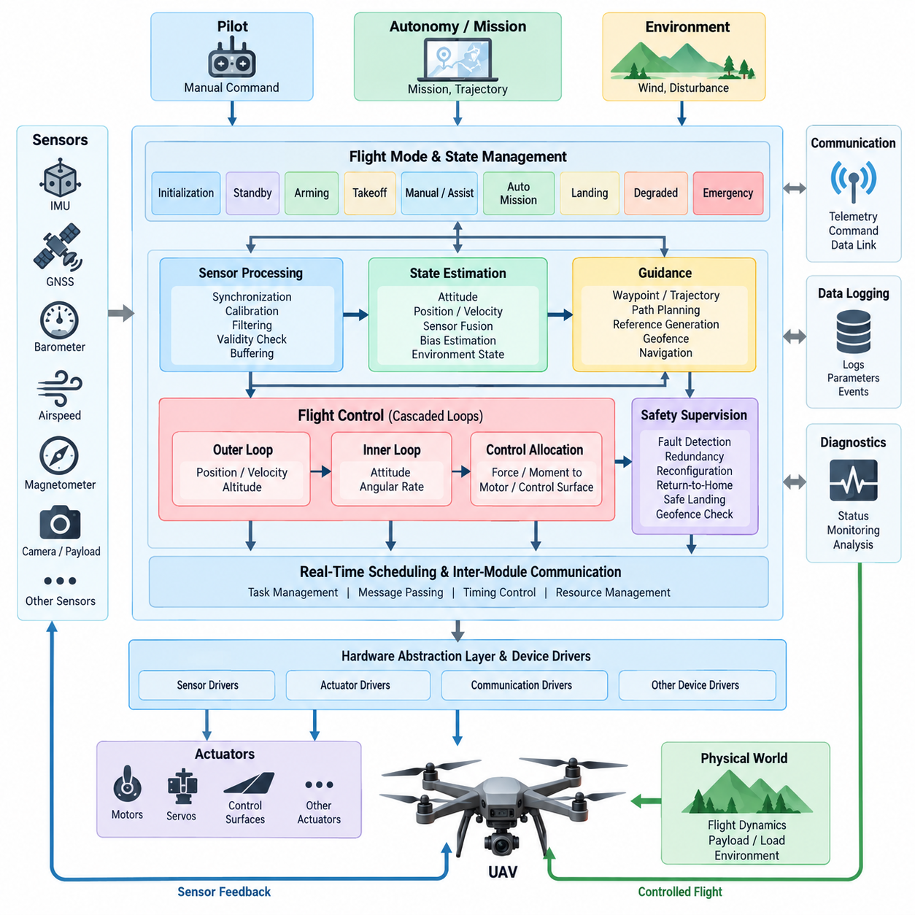
A UAV flight control software architecture is the real-time computational framework that transforms pilot commands, autonomous mission objectives, and sensor measurements into safe actuator commands. It forms the control core between the aircraft hardware and higher-level autonomy software, continuously coordinating estimation, guidance, control, actuator allocation, health monitoring, and safety functions under strict timing constraints.
At the lowest software boundary, the hardware abstraction and device-driver layer interfaces with inertial sensors, GNSS receivers, barometers, air-data sensors, magnetometers, motor controllers, servos, and communication buses. This layer converts device-specific measurements into standardized data structures while providing deterministic actuator interfaces, allowing the flight-control algorithms to remain largely independent of individual sensor and actuator implementations.
Sensor acquisition is normally organized around multiple update rates because UAV sensors operate at significantly different frequencies. IMU measurements may arrive at hundreds or thousands of samples per second, while GNSS, barometric, airspeed, or payload measurements operate more slowly. Timestamping, synchronization, calibration, filtering, validity checking, and buffering therefore become fundamental architectural services before measurements enter estimation and control functions.
The state-estimation layer converts these heterogeneous measurements into a coherent representation of aircraft motion. Typical estimated states include attitude, angular velocity, position, velocity, altitude, acceleration, sensor biases, and selected environmental variables. Attitude and heading reference algorithms and more comprehensive sensor-fusion estimators provide the feedback information required by the control loops, separating noisy physical measurements from usable control states.
Flight-control functions are commonly implemented as cascaded loops with progressively different dynamic bandwidths. Fast inner loops regulate angular rates and attitude, while slower outer loops regulate altitude, velocity, and position. Each outer controller generates references for the controller beneath it, producing a hierarchical path from trajectory objectives to forces, moments, and finally actuator commands while preserving manageable control-loop complexity.
The control architecture must explicitly separate guidance objectives from stabilization. Guidance determines where the aircraft should move by generating position, velocity, heading, altitude, or trajectory references. Stabilization determines how the aircraft physically follows those references despite aerodynamic disturbances, modeling uncertainty, actuator limitations, and sensor noise. This separation enables navigation algorithms to evolve without unnecessarily modifying safety-critical low-level control logic.
Control allocation translates desired forces and moments into commands appropriate for the aircraft configuration. A multirotor uses a mixing relationship to distribute thrust and torque among individual propulsion units, whereas fixed-wing aircraft coordinate throttle and aerodynamic control surfaces. VTOL platforms require both mechanisms and additional transition logic because actuator effectiveness changes substantially between hovering, transitional, and wing-borne flight regimes.
A flight mode and state-management layer coordinates these control functions according to operational context. Typical states include initialization, standby, arming, takeoff, manual or assisted flight, autonomous mission execution, landing, degraded operation, and emergency handling. Explicit transition conditions prevent incompatible functions from becoming active simultaneously and provide a deterministic mechanism for transferring authority between pilot, autonomy, and safety functions.
Real-time scheduling is central to flight-control software because correctness depends not only on calculated values but also on when those values become available. High-rate estimation and attitude-control tasks require predictable execution periods and bounded latency, while navigation, telemetry, logging, and mission functions may operate at lower priorities. The architecture must therefore control task periods, priorities, communication paths, execution budgets, and deadline monitoring.
Inter-module communication should preserve clear ownership of data and command authority. Sensor data flow upward toward estimation and navigation, references flow downward toward controllers, and status information propagates across diagnostic and supervisory functions. Message queues, shared-memory structures, publish-subscribe mechanisms, or real-time middleware may be used, but uncontrolled coupling between modules should be avoided because it complicates timing analysis, verification, and fault containment.
Safety supervision operates alongside the nominal control path rather than being treated as a final software add-on. The supervisor monitors sensor validity, estimator consistency, actuator status, battery and power conditions, communication health, control saturation, geofence conditions, and execution timing. Detected faults can trigger redundancy switching, controller reconfiguration, flight-mode degradation, return-to-home behavior, controlled landing, or other predefined contingency responses.
Redundancy becomes increasingly important as UAV size, payload, and operational consequence increase. Multiple IMUs, navigation sources, communication links, power channels, or flight computers can be monitored through consistency checks and voting logic. Software architecture must define which component detects a disagreement, how a faulty channel is isolated, how control authority is transferred, and how the aircraft maintains stable flight while the reconfiguration occurs.
Cargo UAVs introduce additional control-software requirements because aircraft dynamics can change significantly between unloaded and loaded conditions. Payload mass, center-of-gravity location, load motion, fuel or battery state, and aerodynamic configuration can alter control effectiveness. Parameter scheduling, adaptive control, disturbance estimation, and load-state monitoring can therefore augment conventional feedback control while preserving a stable baseline controller for predictable behavior.
The boundary between flight control and autonomy should remain deliberately structured. Mission planning, obstacle avoidance, route optimization, perception, and AI-based decision functions may generate trajectories or constrained references, but the flight-control layer should validate those requests against dynamic, actuator, and safety limits. This creates a controlled interface through which sophisticated autonomy can command the aircraft without directly bypassing deterministic stabilization functions.
Diagnostics and observability are equally important architectural elements. Flight-control software should record sensor states, estimator outputs, controller references, tracking errors, actuator commands, mode transitions, faults, timing measurements, and configuration parameters. Consistent logging supports post-flight analysis, controller tuning, anomaly investigation, regression testing, and traceability between observed aircraft behavior and the exact software and parameter configuration used.
Development architecture should support simulation before flight hardware is exposed to new software. Software-in-the-loop execution validates algorithms against aircraft models, while hardware-in-the-loop testing evaluates the compiled flight software with representative processors, interfaces, timing behavior, and simulated sensors and actuators. Automated scenarios can repeatedly exercise normal operation, disturbances, sensor failures, actuator faults, communication loss, and boundary conditions.
Configuration management must cover control parameters as rigorously as executable software. Gains, filters, actuator limits, sensor calibration constants, aerodynamic coefficients, mixer parameters, and safety thresholds can fundamentally change flight behavior without changing source code. Each validated aircraft configuration should therefore bind software version, hardware configuration, parameter set, calibration data, and test evidence into a traceable release baseline.
A modular UAV flight-control architecture ultimately creates a disciplined separation between physical interfaces, estimation, guidance, control, allocation, supervision, and higher-level autonomy. This structure supports multirotor, fixed-wing, VTOL, and cargo UAV platforms while allowing platform-specific dynamics to be introduced through controlled modules and parameters. It also provides the architectural foundation for subsequent attitude estimation, controller design, mixing, transition control, adaptive control, and SIL/HIL verification topics.

11.02 Attitude Estimation AHRS: Mahony / Madgwick [w/Code]
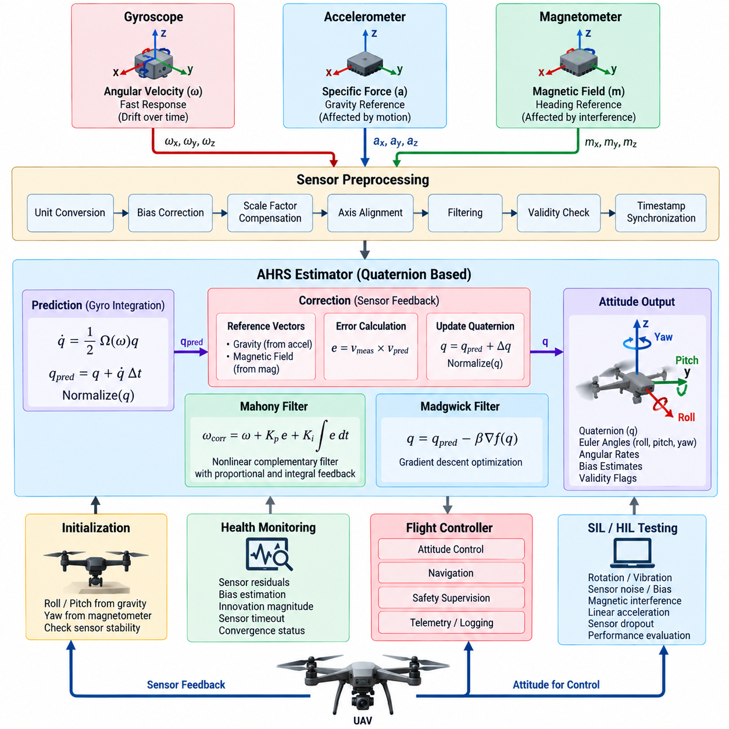
Attitude estimation provides the flight controller with a continuous estimate of the UAV orientation relative to a navigation or Earth-fixed reference frame. An Attitude and Heading Reference System, or AHRS, typically combines gyroscope, accelerometer, and magnetometer measurements to estimate roll, pitch, and yaw. Reliable attitude information is essential because the inner flight-control loops depend directly on orientation and angular-rate feedback.
A three-axis gyroscope measures angular velocity around the aircraft body axes and provides the fastest information about rotational motion. Integrating these angular rates produces an orientation estimate with excellent short-term response, but even small sensor bias and noise accumulate over time. Pure gyroscope integration therefore suffers from drift, making additional absolute or low-frequency references necessary for maintaining a bounded attitude error during extended flight.
The accelerometer measures specific force along three body axes. During stationary or approximately constant-velocity flight, gravity dominates the low-frequency acceleration vector, allowing roll and pitch to be referenced against the local vertical direction. During aggressive maneuvers, however, translational acceleration contaminates this gravity observation. An AHRS must therefore avoid treating every instantaneous accelerometer measurement as a perfect attitude reference.
A magnetometer measures the local magnetic-field vector and provides information that can constrain heading drift. After calibration and tilt compensation, the measured magnetic direction can serve as a long-term yaw reference. Magnetic measurements are vulnerable to hard-iron effects, soft-iron distortion, electric currents, motors, structural materials, and external magnetic disturbances, so practical UAV software must validate magnetic data before applying heading corrections.
Sensor preprocessing is consequently an important part of the AHRS pipeline. Raw measurements are converted into consistent units and coordinate conventions before bias correction, scale-factor compensation, axis alignment, filtering, and validity checks are applied. Accurate timestamps are also important because an incorrect sampling interval directly affects gyroscope integration. Calibration quality can therefore influence attitude performance as strongly as the mathematical estimator itself.
Orientation can be represented by Euler angles, rotation matrices, or quaternions. Euler angles provide intuitive roll, pitch, and yaw outputs but contain singularities, while rotation matrices require more state variables and orthogonality maintenance. Quaternions are widely used internally in UAV attitude estimation because they represent three-dimensional orientation compactly, avoid gimbal lock, and support efficient incremental updates from gyroscope measurements.
A quaternion-based estimator propagates attitude by converting measured angular velocity into quaternion motion over each sampling interval. The propagated quaternion must be normalized periodically to prevent numerical errors from violating the unit-length constraint. This prediction follows rapid rotational motion accurately, but its long-term accuracy remains limited by gyroscope bias, which motivates feedback corrections derived from accelerometer and magnetometer reference vectors.
The Mahony filter addresses this problem through nonlinear complementary filtering with feedback. It compares reference directions predicted from the current attitude with directions measured by the accelerometer and, when available, the magnetometer. Their mismatch produces an attitude-error vector that is fed back to correct the measured angular rate before quaternion integration. This structure combines high-frequency gyroscope response with low-frequency reference correction.
Mahony filtering commonly includes proportional and integral feedback terms. The proportional component produces an immediate correction proportional to the estimated orientation error, while the integral component can compensate slowly varying gyroscope bias. Larger gains increase correction speed but can make the estimate more sensitive to acceleration or magnetic disturbances. Gain selection must therefore reflect UAV dynamics, sensor quality, sampling frequency, and expected operating conditions.
The Madgwick filter approaches sensor fusion from a different computational perspective. It formulates attitude correction as an optimization problem that minimizes the difference between measured reference vectors and their directions predicted by the estimated orientation. A gradient-descent step determines the corrective direction, which is combined with quaternion propagation from gyroscope measurements to produce the updated attitude estimate.
A principal Madgwick tuning parameter controls the magnitude of the gradient-based correction relative to gyroscope integration. Strong correction can suppress gyro drift rapidly but may inject accelerometer or magnetometer disturbances into the orientation estimate. Weak correction provides smoother short-term behavior but allows greater drift. The parameter therefore represents a practical compromise between dynamic responsiveness, noise rejection, and long-term convergence.
Mahony and Madgwick filters are attractive for embedded UAV flight computers because both can provide quaternion attitude estimation without the full computational and modeling complexity of an extended Kalman filter. Their mathematical formulations differ, but both exploit complementary sensor characteristics: gyroscopes capture rapid rotational dynamics, accelerometers constrain the gravity direction, and magnetometers can provide a heading reference when magnetic conditions are trustworthy.
Practical AHRS software should support operation when one reference sensor becomes temporarily unreliable. Excessive acceleration can reduce confidence in the gravity observation, while magnetic anomalies can require rejection or reduced weighting of magnetometer corrections. The estimator can continue propagating attitude from gyroscope data during these periods and gradually restore reference corrections after measurements return to physically plausible ranges.
Initialization also requires explicit handling because quaternion propagation needs a reasonable starting orientation. Roll and pitch can usually be initialized from the measured gravity direction when the aircraft is stationary, while heading may be initialized from calibrated magnetic data or another navigation source. Software should verify sensor stability before initialization and prevent arming when attitude uncertainty or sensor consistency remains outside acceptable limits.
The estimator operates within a real-time data path connecting sensor drivers to the flight-control loops. IMU acquisition may execute at a high rate, while attitude updates and controller execution occur at defined deterministic periods. The resulting quaternion, Euler angles, angular rates, bias estimates, validity flags, and estimator status can be published to attitude control, navigation, safety supervision, telemetry, and diagnostic modules.
Attitude estimation must also provide explicit health information rather than only orientation values. Useful indicators include accelerometer and magnetometer residuals, quaternion normalization error, gyroscope bias estimates, innovation magnitude, sensor timeout status, and convergence state. Flight-control supervision can use these indicators to reject invalid estimates, switch redundant sensors or estimators, restrict flight modes, or initiate degraded and emergency responses.
Software-in-the-loop and hardware-in-the-loop testing should exercise AHRS behavior across representative rotational motion, vibration, sensor noise, bias, magnetic interference, linear acceleration, timing jitter, and sensor dropout. Recorded flight datasets can be replayed deterministically to compare estimator revisions. Automated tests should evaluate convergence, drift, transient response, computational load, and recovery after temporary reference-sensor rejection.
In a complete UAV flight-control architecture, Mahony or Madgwick AHRS therefore forms the bridge between raw inertial measurements and attitude-control feedback. Its effectiveness depends not only on the fusion equations but also on calibration, timing, coordinate conventions, sensor validation, tuning, numerical stability, and fault handling. A robust implementation delivers deterministic orientation information that subsequent attitude, altitude, position, VTOL, and adaptive control functions can safely consume.

11.03 Attitude Controller Design [w/Code]
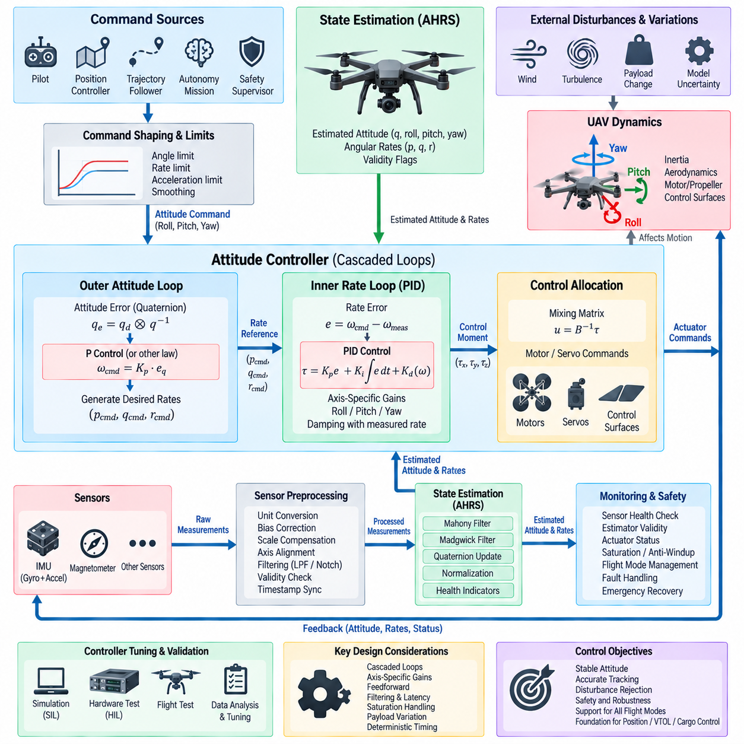
The attitude controller is the core stabilization function that converts desired UAV orientation into commanded rotational moments or angular-rate references. It operates downstream of the attitude estimator and upstream of control allocation, using estimated roll, pitch, yaw, and angular velocity as feedback. Its primary objective is to maintain stable orientation while tracking commands despite aerodynamic disturbances, modeling errors, payload variation, and actuator limitations.
A practical attitude-control architecture is usually organized as cascaded loops. The outer attitude loop compares the commanded orientation with the estimated orientation and generates desired body angular rates. The faster inner rate loop compares these references with measured gyroscope rates and produces roll, pitch, and yaw control efforts. This bandwidth separation allows the inner loop to reject rapid disturbances before they significantly affect the slower attitude dynamics.
Attitude commands may originate from a pilot, position controller, trajectory follower, autonomous mission system, or safety supervisor. Regardless of their source, commands should pass through limits that constrain maximum tilt angle, angular rate, angular acceleration, and other platform-specific boundaries. Command shaping prevents discontinuous references from exciting structural dynamics or demanding actuator responses beyond the physical capabilities of the aircraft.
For moderate-angle operation, attitude errors can be interpreted through roll, pitch, and yaw differences, but direct Euler-angle subtraction becomes problematic near singular configurations and during large rotations. Quaternion-based error calculation provides a more general solution. The desired and estimated orientations are combined to form an error quaternion whose vector component represents the shortest rotational correction required to align the aircraft with the commanded orientation.
The attitude error is transformed into a desired angular-rate vector through proportional feedback or another outer-loop control law. Increasing the proportional gain produces faster orientation convergence, while excessive gain can create oscillation or demand angular rates that the propulsion system cannot achieve. The commanded rate should therefore be constrained according to aircraft inertia, actuator authority, expected disturbance levels, and safe maneuvering limits.
The inner angular-rate controller directly regulates rotational dynamics and normally executes at a higher frequency than the attitude loop. A PID-type structure is commonly used because the proportional term provides immediate error correction, the integral term compensates persistent disturbances and modeling bias, and the derivative-related behavior can improve damping. In practice, measured angular rate itself is often used to obtain damping without differentiating noisy error signals.
Roll, pitch, and yaw axes have different dynamic characteristics and should not automatically use identical controller gains. Multirotor roll and pitch dynamics may be approximately symmetric, whereas yaw authority is often weaker because it depends on reaction torque rather than differential thrust moments. Vehicle geometry, inertia tensor, propeller characteristics, motor response, aerodynamic surfaces, and payload distribution must therefore be considered when selecting axis-specific gains.
Feedforward control can improve tracking by acting on commanded motion before feedback error develops. Desired angular rate, angular acceleration, or model-based torque terms may be added to the feedback output, particularly during aggressive maneuvering or trajectory tracking. Feedback remains responsible for correcting uncertainty and disturbances, while feedforward reduces phase lag and allows the aircraft to follow rapidly changing references with smaller tracking errors.
Controller output must respect actuator saturation. Motors, servos, and aerodynamic control surfaces have finite force, torque, speed, and travel limits, so a requested control moment may not always be achievable. Saturation handling should preserve the most safety-critical control objectives while preventing internal controller states from growing without bound. Anti-windup logic is especially important for integral terms when sustained actuator saturation occurs.
Control allocation converts roll, pitch, yaw, and collective-force demands into individual actuator commands. For a multirotor, a mixing matrix maps desired forces and moments to motor thrust commands according to rotor position and rotation direction. The attitude controller should remain logically separated from this allocation layer so that the same control principles can be adapted to quadrotor, hexarotor, octocopter, VTOL, or other configurations.
Filtering must balance noise suppression against control latency. Gyroscope measurements contain high-frequency noise and vibration that can propagate through the rate controller, but excessive low-pass filtering introduces phase delay and can reduce stability margins. Notch filters may be applied to dominant structural or propulsion frequencies, while low-pass filters suppress broadband noise. Filter parameters should be designed together with controller bandwidth rather than tuned independently.
Sampling frequency and execution timing are fundamental software design parameters. The angular-rate loop typically requires a higher update frequency than the attitude loop, while both should execute with predictable periods and bounded jitter. Sensor sampling, estimator updates, controller computation, and actuator output should be temporally coordinated because variable latency effectively changes the closed-loop dynamics and can degrade phase margin, disturbance rejection, and tracking accuracy.
Payload variation is particularly important for cargo UAVs because changes in mass and center of gravity modify rotational inertia and control effectiveness. A controller tuned for an unloaded aircraft may respond differently when carrying a heavy or asymmetrically positioned payload. Gain scheduling, inertia-dependent parameters, disturbance observers, or adaptive mechanisms can compensate for these variations while maintaining a validated baseline controller as the predictable stabilization foundation.
The attitude controller must cooperate with flight-mode and safety logic. During arming, takeoff, landing, VTOL transition, degraded operation, or emergency recovery, different attitude limits and controller parameters may be required. Mode transitions should avoid abrupt changes in references, gains, or integrator states. Bumpless transfer techniques and controlled state initialization help prevent command discontinuities when control authority moves between modes or controllers.
Fault handling should prevent invalid feedback from directly driving actuators. The controller should consume estimator validity flags, sensor-health information, actuator status, and timing supervision results in addition to numerical attitude values. If orientation confidence becomes unacceptable or actuator authority is reduced, supervisory software may restrict maneuverability, reconfigure allocation, switch redundant channels, enter a degraded mode, or command an emergency recovery procedure.
Controller tuning should progress from mathematical models and simulation toward increasingly realistic test environments. Initial gains can be derived from simplified rotational dynamics and desired bandwidth, followed by software-in-the-loop evaluation with nonlinear aircraft models. Hardware-in-the-loop testing then exposes the controller to actual processor timing, communication delays, actuator interfaces, sensor models, saturation behavior, and injected faults before controlled flight testing begins.
Flight-test tuning should rely on recorded quantitative data rather than subjective observation alone. Commanded and estimated attitude, angular-rate references, measured rates, controller errors, proportional and integral contributions, actuator commands, saturation events, vibration spectra, and timing information provide evidence for tuning decisions. Step responses, frequency characteristics, disturbance recovery, overshoot, settling time, and control effort can then be compared across software revisions.
A robust UAV attitude controller therefore combines geometric attitude-error computation, cascaded attitude and rate loops, appropriate feedback and feedforward terms, saturation management, filtering, deterministic timing, and safety supervision. Its design provides the stabilization foundation on which altitude, position, navigation, VTOL transition, and cargo-adaptive control functions depend, while maintaining a clear interface between state estimation and actuator allocation.

11.04 Altitude and Position Controller Design [w/Code]
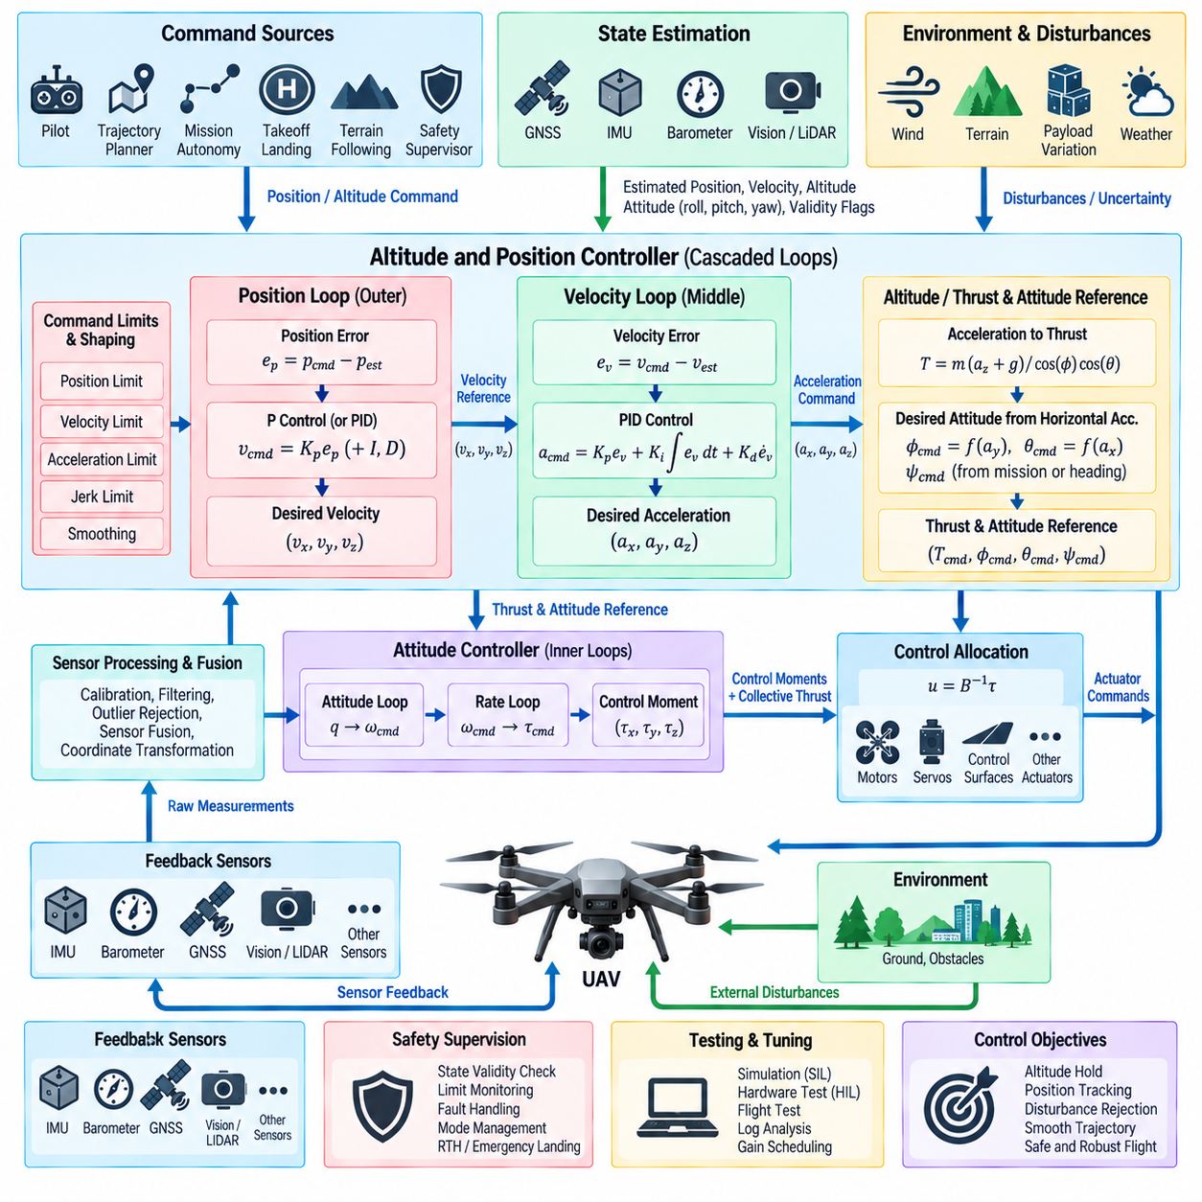
Altitude and position control extend UAV stabilization beyond orientation by regulating translational motion relative to a local or global reference frame. These controllers receive estimated position, velocity, altitude, and attitude states and transform navigation or trajectory commands into thrust and attitude references. They normally operate outside the faster attitude and angular-rate loops, creating a hierarchical control structure from spatial objectives to actuator commands.
A cascaded architecture is commonly used because position dynamics evolve more slowly than attitude dynamics. The outer position loop compares commanded and estimated position and generates desired velocity, while the velocity loop converts velocity error into desired acceleration or force. These commands are subsequently translated into collective thrust and desired attitude, allowing the fast attitude controller to realize the orientation required to produce the commanded translational acceleration.
Altitude control forms the vertical component of this architecture. The altitude reference may originate from pilot input, autonomous trajectory generation, takeoff and landing logic, terrain-following functions, or safety supervision. Estimated altitude can be obtained from barometric pressure, GNSS, range sensors, visual or LiDAR measurements, and inertial navigation. Sensor fusion is important because each altitude source has different noise, drift, latency, and operating limitations.
The altitude position loop compares desired vertical position with estimated altitude and produces a vertical-velocity reference. A proportional controller is often sufficient at this level when combined with appropriate limits and trajectory shaping. The commanded climb or descent rate must be bounded to prevent excessive vertical motion, while acceleration and jerk constraints can smooth transitions between hover, climb, descent, and landing phases.
The vertical-velocity loop converts climb-rate error into vertical acceleration or thrust demand. Proportional and integral feedback can compensate for tracking error and persistent force imbalance caused by uncertain aircraft mass or aerodynamic effects. Gravity compensation is normally included so that the feedback controller regulates deviations around the thrust required to support aircraft weight rather than continuously generating the complete gravitational compensation term.
Collective thrust must be adjusted according to vehicle attitude because tilted flight changes the vertical component of total rotor thrust. When the aircraft rolls or pitches to generate horizontal acceleration, additional total thrust may be required to maintain altitude. A practical controller therefore coordinates vertical-force demand with attitude and limits compensation near extreme tilt angles where maintaining altitude and satisfying lateral commands may become physically incompatible.
Horizontal position control typically operates in a local navigation frame such as North-East-Down or East-North-Up. Position errors along the horizontal axes generate desired horizontal velocities, which are then compared with estimated velocity. The velocity controller produces acceleration commands that specify how the aircraft should change its translational motion while remaining separated from the lower-level attitude stabilization implementation.
The desired three-dimensional acceleration vector can be converted into a required thrust vector. Its vertical component contributes to collective thrust, while its horizontal components determine the direction in which the vehicle must tilt. Combined with a desired yaw or heading reference, this thrust direction defines the commanded roll and pitch orientation supplied to the attitude controller. This transformation provides the fundamental connection between position control and attitude control.
Command limits are essential throughout the cascaded structure. Position error should not generate unlimited velocity, and velocity error should not generate unlimited acceleration or tilt. Maximum climb rate, descent rate, horizontal speed, acceleration, jerk, tilt angle, and thrust must reflect propulsion capability and operational safety requirements. Layered saturation prevents large navigation errors from propagating directly into aggressive or physically impossible actuator demands.
Integral control requires anti-windup protection because thrust or attitude limits can prevent the requested acceleration from being realized. Without protection, the integrator may continue accumulating error during saturation and produce substantial overshoot when control authority becomes available again. Conditional integration, integrator clamping, or back-calculation can constrain this internal state while retaining the ability to compensate persistent disturbances such as steady wind or mass uncertainty.
Feedforward terms improve trajectory tracking when desired velocity and acceleration are available from the trajectory generator. Instead of waiting for position error to develop, the controller can apply known velocity and acceleration references directly while feedback corrects modeling errors and external disturbances. This combination is particularly useful for smooth autonomous trajectories, high-speed flight, precision landing, and cargo operations where large tracking errors may be undesirable.
Wind represents a major disturbance for horizontal position control. A sustained wind produces a force that must be counteracted by an appropriate aircraft tilt and thrust vector to maintain position. Integral feedback or disturbance observers can estimate the required steady correction, while velocity and acceleration feedback handle transient effects. Strong-wind operation must still respect maximum tilt and thrust limits because control authority remains physically bounded.
State-estimation quality strongly affects position-control performance. GNSS may provide globally referenced position but can suffer from multipath, interference, outages, or limited update rates. Inertial navigation provides rapid motion estimates but accumulates drift, while visual, LiDAR, radar, or range-based localization can provide complementary information. The controller should consume validated fused states rather than directly depending on a single positioning sensor.
Reference frames and coordinate transformations must be handled consistently throughout the software. Navigation commands may be expressed in a world-fixed frame, whereas thrust and attitude commands ultimately act in the aircraft body frame. Incorrect axis definitions, sign conventions, heading transformations, or altitude conventions can create severe control errors. Frame definitions should therefore be explicit, tested, and shared consistently between estimation, navigation, control, and logging modules.
Cargo UAVs require special consideration because payload mass directly changes the thrust needed for hover and acceleration. Center-of-gravity variation can also couple translational commands with attitude behavior. Mass estimation, payload-state information, gain scheduling, adaptive thrust models, or disturbance estimation can improve performance across different loading conditions while preserving conservative limits that ensure sufficient thrust reserve for stabilization and emergency maneuvers.
Takeoff and landing require mode-specific altitude and position behavior. During takeoff, thrust should increase in a controlled manner while ground contact and estimator validity are considered. Landing requires progressively controlled descent, horizontal alignment, ground detection, and touchdown logic. Integrator states and reference trajectories should be managed carefully during these transitions to avoid sudden thrust changes when the aircraft enters or leaves ground-contact conditions.
Safety supervision must continuously evaluate whether position and altitude commands remain achievable. Loss of navigation data, excessive estimator uncertainty, thrust saturation, geofence violation, abnormal vertical speed, or insufficient propulsion margin may require limiting commands or changing flight mode. Depending on system design, responses can include position-control degradation, altitude hold, return-to-home, controlled landing, or other predefined emergency behavior.
Verification should progress from mathematical simulation to software-in-the-loop, hardware-in-the-loop, and controlled flight testing. Test scenarios should include position steps, trajectory tracking, climb and descent, wind disturbances, sensor noise, GNSS dropout, payload changes, thrust saturation, and mode transitions. Logged position, velocity, acceleration, thrust, attitude references, saturation states, and timing data allow quantitative evaluation of tracking and robustness.
A well-designed altitude and position controller therefore combines cascaded position and velocity loops, gravity and attitude compensation, thrust-vector generation, feedforward tracking, saturation management, anti-windup, coordinate transformation, and safety supervision. Integrated with state estimation and the faster attitude controller, it converts navigation objectives into dynamically feasible flight commands and provides the control foundation for autonomous navigation, VTOL operation, precision landing, and cargo missions.

11.05 Multirotor Mixing Matrix Design [w/Code]
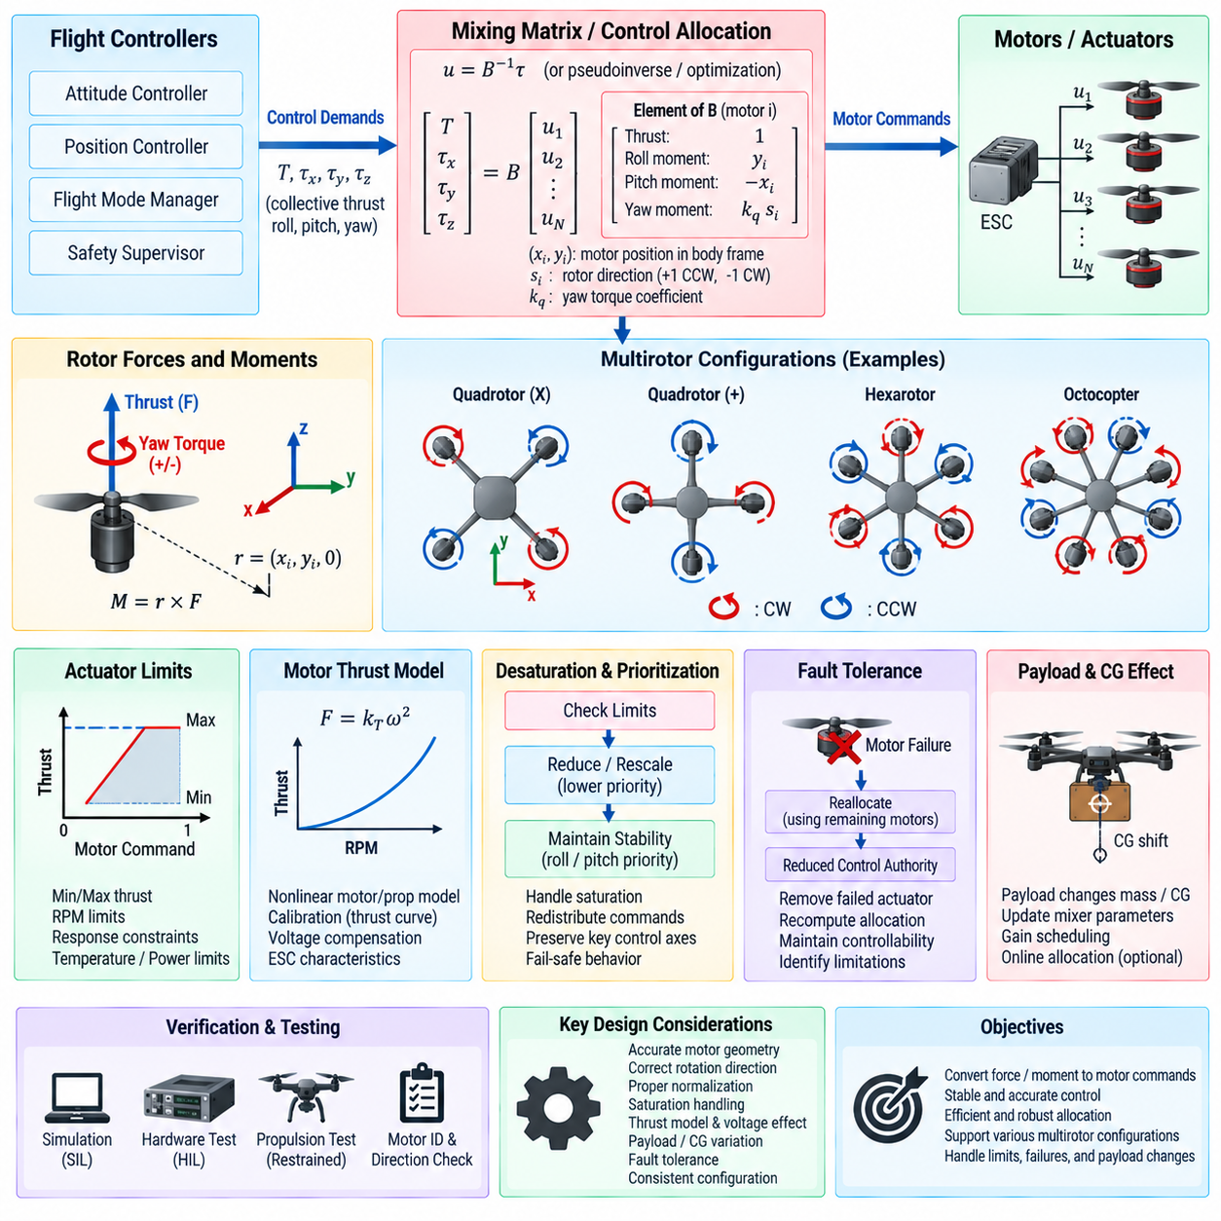
A multirotor mixing matrix provides the mathematical interface between the flight controller and individual propulsion units. The controller generates desired collective thrust and body moments around roll, pitch, and yaw axes, while the mixer converts these demands into motor-specific thrust commands. This separation allows attitude and position controllers to operate in vehicle-level coordinates without directly managing the geometry and rotation direction of every rotor.
The mixer is based on the physical relationship between rotor thrust, rotor location, and the forces and moments acting on the aircraft body. Each rotor contributes vertical or approximately axial thrust, while its distance from the center of gravity creates roll and pitch moments. Rotor aerodynamic drag also produces reaction torque around the yaw axis, with the sign determined by whether the propeller rotates clockwise or counterclockwise.
For a conventional multirotor, the control-demand vector can be expressed using collective thrust and three body moments. A corresponding actuator vector contains the thrust commands for each rotor. These quantities are related through an allocation matrix whose columns describe the force and moment contribution of each motor. The matrix therefore represents aircraft geometry and propulsion configuration in a form directly usable by control software.
Rotor position is fundamental to constructing the roll and pitch coefficients. If a rotor is located at position r relative to the vehicle center of gravity and produces thrust F, its moment contribution follows the cross-product relationship between position and force. The resulting lever arms determine how effectively each rotor produces roll or pitch torque, so accurate motor coordinates and consistent body-axis conventions are essential.
Yaw allocation depends primarily on rotor reaction torque rather than geometric lever arm. Adjacent rotors are normally configured with alternating clockwise and counterclockwise rotation so that their nominal reaction torques cancel during balanced hover. A yaw command deliberately changes the balance between these rotor groups, generating a net body torque while attempting to preserve the requested collective thrust and other rotational moments.
Quadrotor configurations illustrate the basic mixing principle. In an X configuration, each rotor contributes simultaneously to roll and pitch because none lies directly on only one principal body axis. In a plus configuration, individual rotors align more directly with the roll or pitch axes. The resulting coefficient values differ, but both configurations can be represented using the same generalized allocation-matrix formulation.
Aircraft with six or eight rotors extend the same concept with additional actuator columns. Hexarotor and octocopter configurations provide more control degrees of freedom and can offer redundancy when propulsion capability remains after a motor failure. Because the system becomes overactuated, multiple combinations of rotor thrust may produce the same desired vehicle force and moment, allowing the allocation algorithm to optimize secondary objectives.
The control allocator determines actuator commands from the desired force and moment vector. For a square, nonsingular system, a matrix inverse may provide a direct solution, while overactuated configurations commonly use a pseudoinverse or optimization-based allocation method. Weighted least-squares or constrained optimization can prioritize important control axes, minimize actuator effort, preserve thrust margin, or redistribute commands around unavailable motors.
The mathematical mixer must account for actuator limits because computed rotor commands cannot exceed physical propulsion capability. Each motor has minimum and maximum usable thrust, rotational-speed limits, transient response constraints, and potentially temperature or power restrictions. Simple clipping can distort the commanded force and moments, so practical allocation should manage saturation while preserving the most important stabilization objectives whenever possible.
Desaturation algorithms redistribute motor commands when one or more actuators approach their limits. For example, a large collective-thrust request combined with roll, pitch, and yaw commands may exceed available motor authority. The allocator can reduce or rescale lower-priority components to recover feasible motor commands. Control priorities are platform dependent, but maintaining attitude stability generally requires careful protection of roll and pitch authority.
Mixer normalization is important because flight-control software often operates with normalized control variables rather than direct force units. Matrix coefficients may be scaled so that collective thrust and body-axis commands occupy defined numerical ranges. The normalization convention must remain consistent with motor models, controller output limits, actuator drivers, and logging, otherwise apparently valid commands can produce incorrect physical force or asymmetric control response.
Real propulsion systems are nonlinear, so mixer output may require conversion through a thrust model before reaching the motor controller. Rotor thrust is approximately related to the square of rotational speed under simplified conditions, but motor, propeller, voltage, airflow, and electronic speed controller characteristics introduce additional nonlinearities. A calibrated thrust curve can map normalized mixer output to a command that more accurately produces the intended force.
Battery voltage variation can further alter the relationship between command and generated thrust. As voltage decreases during flight, the same motor command may produce different rotational speed and thrust unless the propulsion system compensates internally. Feedforward voltage compensation or calibrated motor models can improve consistency, particularly for heavy cargo UAVs where thrust reserve and accurate collective-force generation are important for maintaining altitude.
Payload changes influence mixer performance indirectly through mass, center-of-gravity displacement, and inertia variation. If the center of gravity moves away from the geometric center assumed by the allocation matrix, rotor lever arms relative to the true center of gravity change. Large cargo UAVs may therefore require configuration-dependent mixer parameters, center-of-gravity compensation, or online allocation updates based on measured or estimated payload conditions.
Fault-tolerant control places additional requirements on the mixing matrix. When a motor or propulsion channel fails, its available thrust should be removed or constrained and the allocation problem recomputed using the remaining actuators. Whether full roll, pitch, yaw, and thrust control remains achievable depends on vehicle geometry and redundancy. The allocator should explicitly identify reduced control authority rather than requesting physically impossible combinations.
Software implementation should keep vehicle geometry, rotor direction, actuator numbering, and mixer coefficients traceable as configuration data. A mismatch between logical motor numbering and physical wiring can produce immediate instability even when the control algorithms are mathematically correct. Automated configuration checks, motor identification tests, rotation-direction verification, and low-thrust actuator tests should therefore precede unrestricted flight operation.
Simulation provides an efficient environment for validating the mixing matrix before hardware testing. Unit tests can verify the expected motor response to isolated collective, roll, pitch, and yaw commands, while software-in-the-loop simulation can evaluate combined maneuvers and saturation behavior. Hardware-in-the-loop and restrained propulsion tests can subsequently confirm actuator mapping, command scaling, timing, and failure-handling behavior.
A robust multirotor mixing design therefore combines aircraft geometry, rotor rotation direction, thrust and reaction-torque characteristics, actuator constraints, normalization, desaturation, and fault handling within a clearly defined control-allocation layer. By converting vehicle-level force and moment demands into feasible propulsion commands, the mixer forms the critical bridge between attitude control and the physical actuators of quadrotor, hexarotor, octocopter, and cargo UAV platforms.

11.06 Fixed-Wing Control: TECS / L1 Navigation SW
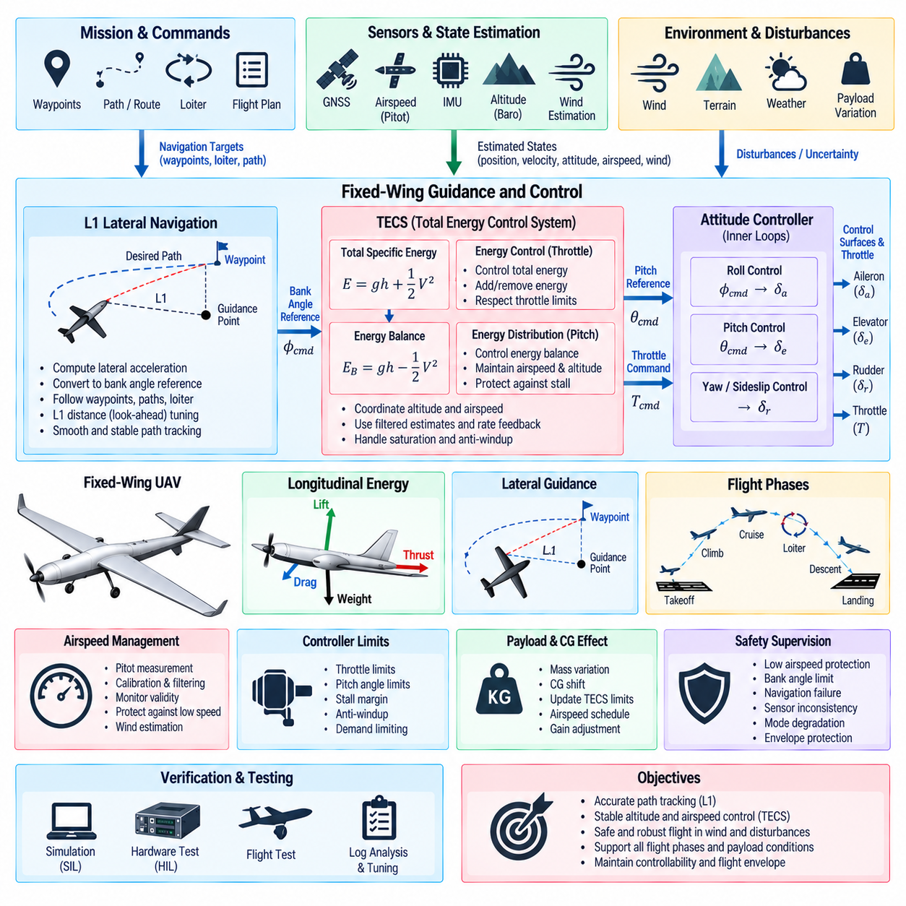
Fixed-wing flight-control software differs fundamentally from multirotor control because aerodynamic lift, airspeed, flight-path angle, and coordinated turning determine vehicle motion. The aircraft cannot normally generate arbitrary lateral or vertical forces while maintaining attitude independently. Its control architecture therefore coordinates throttle, pitch, roll, and aerodynamic control surfaces while preserving sufficient airspeed and acceptable angle-of-attack margins throughout the mission.
A typical fixed-wing control stack separates lateral navigation from longitudinal energy management. L1 navigation generates lateral guidance commands that steer the aircraft toward paths, waypoints, or loiter patterns, while Total Energy Control System, or TECS, coordinates altitude and airspeed through throttle and pitch. Inner attitude and angular-rate controllers then translate these higher-level references into aileron, elevator, rudder, and propulsion commands.
TECS interprets longitudinal flight as an energy-management problem rather than independently controlling altitude and airspeed. Aircraft total specific energy contains gravitational potential energy associated with altitude and kinetic energy associated with airspeed. Climbing increases potential energy, accelerating increases kinetic energy, and propulsion supplies energy to the aircraft while aerodynamic drag continuously removes part of it from the system.
The total specific energy can conceptually be represented by the sum of gravitational and kinetic terms, while the difference between these terms describes how energy is distributed between altitude and speed. TECS exploits this relationship by assigning throttle primarily to total-energy control and pitch primarily to energy distribution. This coordinated structure reduces the conflict that can occur when independent altitude and airspeed controllers demand incompatible actions.
When the aircraft is below both commanded altitude and desired airspeed, additional propulsion energy may be required. If altitude is low but airspeed is excessive, the controller can redistribute kinetic energy toward potential energy by commanding a climb. Conversely, when airspeed becomes dangerously low during a climb, TECS can reduce pitch demand to protect speed even when this temporarily compromises altitude tracking.
Airspeed estimation is consequently critical to fixed-wing control. Pitot-static measurements can provide indicated or calibrated airspeed, while inertial and GNSS information may contribute to state estimation and wind estimation. Airspeed sensors are vulnerable to blockage, icing, calibration errors, pressure disturbances, and installation effects, so control software should monitor validity and avoid treating a questionable measurement as an unquestioned control reference.
TECS normally contains filtered estimates and rate-based control states because altitude and airspeed measurements contain noise and operate at different update frequencies. Height rate, acceleration, energy rate, and energy-balance errors can be used to produce smooth throttle and pitch commands. Filtering must suppress measurement noise without introducing excessive delay, since delayed energy estimates can create oscillatory altitude and speed responses.
Throttle commands are bounded by propulsion-system limits, while pitch commands must respect aircraft performance and stall margins. Saturation management becomes especially important during steep climbs, rapid altitude changes, heavy payload operation, or strong disturbances. Anti-windup and demand limiting prevent internal controller states from accumulating unrealistic requests when the available propulsion or aerodynamic authority cannot satisfy the commanded trajectory.
L1 navigation provides the complementary lateral guidance function. Instead of directly commanding a roll angle from cross-track error alone, the guidance law determines the lateral acceleration needed to converge smoothly toward a desired path. This acceleration demand is then converted into a bank-angle reference, which is tracked by the inner attitude controller while maintaining coordinated and dynamically feasible turning behavior.
The L1 concept uses a virtual guidance point located ahead of the aircraft along the desired path. The relationship between aircraft velocity, the guidance point, and path geometry determines the lateral acceleration command. Looking ahead prevents excessively aggressive correction of instantaneous cross-track error and produces smoother interception behavior than guidance methods that simply steer directly toward the nearest path point.
The effective L1 distance or guidance period determines the responsiveness of path tracking. A shorter look-ahead behavior can produce tighter tracking but may result in aggressive bank commands and greater sensitivity to navigation noise. A longer guidance scale produces smoother motion but permits larger path deviations. Parameters should therefore reflect aircraft speed range, maneuverability, mission geometry, and allowable lateral tracking error.
Waypoint navigation can be implemented by defining line segments between successive mission points and applying L1 guidance to intercept and follow each segment. As the aircraft approaches a waypoint, transition logic determines when guidance should advance to the next path segment. Appropriate acceptance radii and switching criteria prevent unnecessary overshoot, oscillation, or abrupt turns while maintaining predictable mission progression.
Loiter control extends the same lateral-guidance principles to circular or curved paths. The software must first capture the desired orbit and then maintain the specified radius and direction. Wind can substantially affect ground-referenced circular motion, so guidance must continuously adapt the required bank and lateral acceleration. Limits are necessary when wind or airspeed conditions make the requested ground track physically difficult to maintain.
Wind highlights the distinction between air-relative and ground-relative motion. TECS is strongly concerned with airspeed because aerodynamic performance depends on airflow over the aircraft, whereas navigation primarily evaluates motion relative to the ground. A fixed-wing control system therefore benefits from estimating wind velocity and maintaining consistent relationships among airspeed, groundspeed, heading, course, and desired path geometry.
The inner attitude-control loops execute faster than TECS and L1 guidance. Roll commands from lateral guidance are converted into aileron control, pitch commands from TECS are translated into elevator action, and yaw or sideslip control may coordinate rudder behavior. Rate loops provide rapid damping and disturbance rejection, allowing the slower navigation and energy controllers to operate on a stabilized aircraft response.
Flight-mode management coordinates these controllers during takeoff, cruise, waypoint navigation, loiter, approach, landing, and emergency operation. Takeoff may require predefined pitch and throttle strategies before normal TECS authority becomes appropriate, while landing requires coordinated descent-path, airspeed, flare, and throttle behavior. Smooth transitions must preserve controller states and avoid discontinuities in pitch, bank, or propulsion commands.
Cargo fixed-wing UAVs require additional attention to mass, center of gravity, and aerodynamic configuration. Increased mass changes required lift, stall speed, climb performance, and energy response, while center-of-gravity displacement affects longitudinal stability and elevator authority. TECS limits, airspeed schedules, controller gains, and navigation constraints may therefore be adjusted according to validated payload configurations and available propulsion margin.
Safety supervision must protect the aircraft when navigation or energy objectives cannot simultaneously be achieved. Low airspeed, excessive bank, propulsion saturation, navigation failure, sensor disagreement, or severe wind can require command limiting or mode degradation. Stall prevention and preservation of controllability generally require explicit envelope constraints that override ordinary trajectory tracking when the aircraft approaches unsafe operating boundaries.
Verification should combine software-in-the-loop, hardware-in-the-loop, and flight-test analysis across realistic fixed-wing conditions. Tests should cover altitude and airspeed steps, climbs, descents, waypoint interception, crosswind tracking, loiter capture, payload variation, sensor failures, throttle saturation, and mode transitions. Logged energy states, TECS outputs, L1 acceleration commands, bank references, actuator commands, and tracking errors support quantitative tuning.
An integrated TECS and L1 navigation architecture therefore divides fixed-wing guidance into coordinated longitudinal energy management and lateral path control. TECS balances altitude and airspeed through pitch and throttle, while L1 guidance transforms geometric path error into feasible lateral acceleration and bank commands. Together with fast attitude loops, state estimation, envelope protection, and safety supervision, they provide a practical software foundation for autonomous fixed-wing UAV flight.

11.07 VTOL Transition Control Software [w/Code]
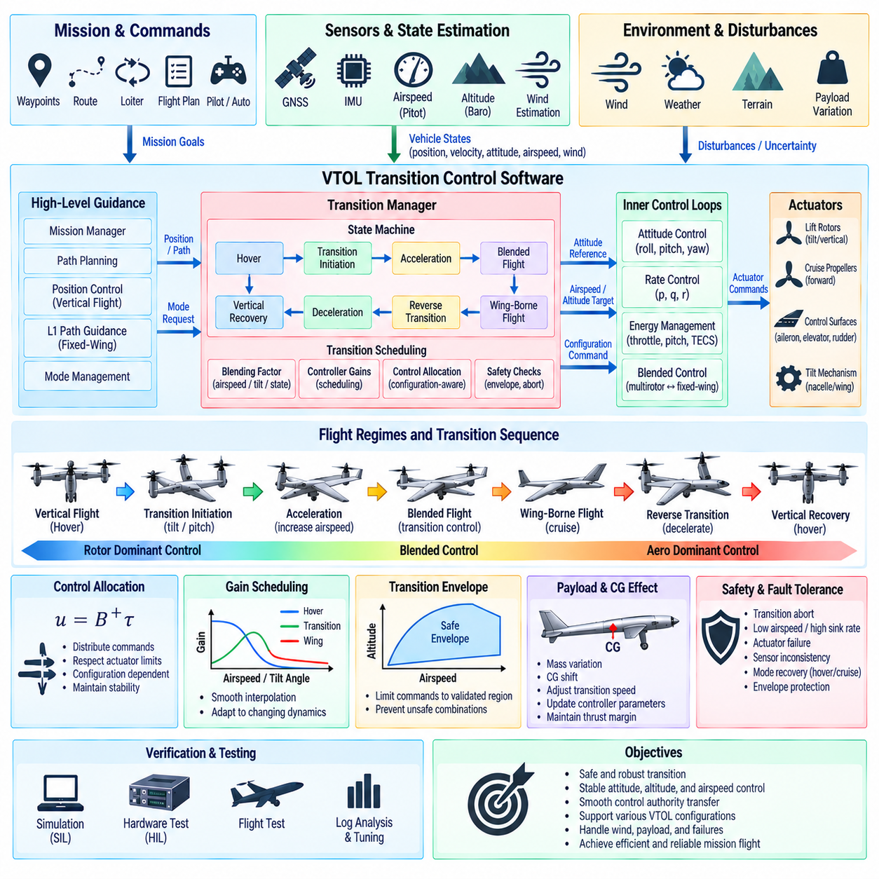
VTOL transition control software manages the continuous change between rotor-borne vertical flight and wing-borne forward flight. Unlike a conventional multirotor or fixed-wing aircraft, a VTOL platform experiences major changes in aerodynamic forces, actuator effectiveness, and control authority during transition. The software must coordinate propulsion, attitude, airspeed, and configuration while maintaining stability throughout this highly coupled flight regime.
The transition controller normally operates between high-level guidance and lower-level attitude, rate, and actuator-control functions. Mission logic determines when a transition is required, while the transition manager generates intermediate references and configuration commands. Inner controllers stabilize the aircraft continuously, allowing the supervisory transition logic to modify thrust distribution, attitude targets, airspeed objectives, and aerodynamic-control authority in a controlled sequence.
VTOL architectures include tiltrotor, tilt-wing, tailsitter, lift-plus-cruise, and other hybrid configurations, each requiring different transition strategies. A tiltrotor changes propulsion direction, while a lift-plus-cruise vehicle transfers lift from dedicated vertical rotors to aerodynamic wings and forward propulsion. The software architecture should therefore separate common transition-management logic from configuration-specific actuator geometry and aerodynamic models.
Transition is fundamentally a control-authority transfer problem. During hover, rotor thrust directly provides most of the forces and moments required for stabilization. As forward airspeed increases, the wings generate increasing aerodynamic lift and conventional control surfaces become more effective. The controller must gradually transfer responsibility between these mechanisms without creating a region where neither propulsion nor aerodynamic surfaces provide sufficient control authority.
A transition state machine provides a deterministic framework for managing this process. Typical states include hover, transition initiation, acceleration, blended flight, wing-borne flight, reverse transition, deceleration, and vertical-flight recovery. Entry and exit conditions should depend on validated flight states rather than elapsed time alone, because wind, payload, propulsion performance, and atmospheric conditions can significantly change transition dynamics.
Forward transition usually begins by commanding acceleration while maintaining adequate vertical lift. Depending on aircraft configuration, the software may tilt rotors, change wing or nacelle angle, increase forward propulsion, or command an appropriate pitch attitude. As airspeed rises and wing lift becomes reliable, vertical propulsion demand can progressively decrease while the fixed-wing control system assumes increasing responsibility for flight-path regulation.
Reverse transition requires the opposite transfer but is not simply the forward sequence executed backward. The aircraft must reduce forward speed while restoring sufficient rotor-borne lift before aerodynamic lift becomes inadequate. Propulsion spool-up, rotor orientation, pitch attitude, altitude margin, and deceleration must be coordinated carefully. Poor sequencing can produce excessive sink rate, loss of airspeed margin, or abrupt changes in attitude and acceleration.
Blended control is commonly used to avoid abrupt switching between multirotor and fixed-wing controllers. A blending factor can vary from rotor-dominant control to aerodynamic-dominant control according to airspeed, transition progress, tilt angle, or another validated scheduling variable. Controller outputs, gains, or actuator effectiveness models are interpolated so that control authority moves progressively between flight regimes instead of changing instantaneously.
The blending variable must be selected carefully because no single measurement perfectly describes transition state. Airspeed directly relates to aerodynamic effectiveness but can be unreliable at low speed, while tilt angle describes mechanical configuration without guaranteeing sufficient wing lift. Practical software can combine airspeed, attitude, actuator position, acceleration, and transition-state logic to determine whether a particular control mechanism can safely assume greater authority.
Control allocation becomes especially important during blended flight because several actuator groups may simultaneously influence the same body axis. Lift rotors, cruise propellers, tilting propulsion units, ailerons, elevators, rudders, and differential thrust can all contribute to force and moment generation. The allocator should use configuration-dependent effectiveness information to distribute commands while respecting actuator limits and preserving stability margins.
Gain scheduling allows inner-loop controllers to accommodate the large dynamic changes occurring during transition. Gains appropriate for hover may not provide suitable response during high-speed wing-borne flight, while fixed-wing gains may be ineffective before aerodynamic surfaces receive sufficient airflow. Scheduling parameters can depend on airspeed, tilt angle, dynamic pressure, or transition phase, with smooth interpolation preventing discontinuities between validated operating points.
Airspeed and dynamic pressure are important indicators of aerodynamic-control effectiveness. Below a certain airflow level, an elevator or aileron may generate little useful moment even if commanded to full deflection. As dynamic pressure increases, the same deflection can produce substantially greater force. Transition software should therefore coordinate control-surface authority with estimated aerodynamic effectiveness rather than assuming constant actuator gain across the complete envelope.
Altitude management is another central requirement because transition can temporarily alter vertical-force balance. During forward acceleration, part of the available thrust may be redirected horizontally before the wings generate enough lift to compensate. The controller may need additional collective thrust, pitch adjustment, or altitude-reference shaping to prevent undesirable descent. Adequate thrust reserve should be maintained throughout the transition corridor.
Energy management becomes increasingly relevant as the vehicle approaches fixed-wing flight. Once aerodynamic lift dominates, airspeed must remain above safe operating limits and the control strategy can progressively adopt fixed-wing energy-management principles. TECS or an equivalent longitudinal controller may be introduced through blending logic, allowing throttle and pitch to regulate altitude and airspeed after sufficient aerodynamic authority has been established.
Navigation guidance must also transition between vehicle models. Hover and low-speed flight can follow position and velocity vectors with multirotor-like control, whereas wing-borne flight requires dynamically feasible paths and banked turns. The transition manager should coordinate the handover from position-based guidance to fixed-wing path guidance such as L1 navigation without introducing sudden changes in heading, roll demand, trajectory, or control authority.
Payload mass and center-of-gravity variation can significantly modify the transition corridor. A heavier aircraft requires greater lift and propulsion force, while a shifted center of gravity changes pitch equilibrium and actuator requirements. Cargo VTOL software may therefore use payload configuration, estimated mass, center-of-gravity information, or scheduled limits to modify transition airspeed, acceleration, pitch constraints, thrust reserve, and controller parameters.
Safety logic should define explicit transition abort and recovery conditions. Insufficient airspeed, excessive sink rate, abnormal attitude, actuator failure, propulsion degradation, sensor disagreement, or inability to reach the required configuration may make continued transition unsafe. Depending on the current state and available control authority, the system can return toward hover, continue toward wing-borne flight, restrict commands, or initiate another predefined recovery mode.
Fault tolerance is complicated by the changing effectiveness of redundant actuators. A failed lift motor may be critical during hover but less influential after the wing supports most of the aircraft weight, whereas a failed aerodynamic surface may become more significant as forward speed increases. Fault-management software should therefore evaluate failures in the context of transition state and determine whether remaining actuators can support the intended flight regime.
Transition-envelope protection prevents commands from driving the aircraft into combinations of airspeed, attitude, tilt angle, thrust, or configuration that have not been demonstrated as controllable. Validated transition corridors can define allowable relationships among these variables. Supervisory software can limit pilot or autonomy commands to keep the aircraft inside the envelope while still permitting sufficient maneuver authority for disturbance rejection and recovery.
Verification requires extensive simulation because transition combines nonlinear aerodynamics, propulsion dynamics, actuator scheduling, and changing control effectiveness. Software-in-the-loop testing should cover nominal and reverse transitions across wind, payload, and initial-condition variations. Hardware-in-the-loop testing should additionally evaluate actuator delays, sensor timing, propulsion response, configuration mechanisms, communication faults, and controller execution behavior.
Flight testing should expand the validated transition envelope progressively rather than immediately exercising the complete operating range. Recorded airspeed, altitude, attitude, angular rates, actuator positions, thrust commands, blending factors, controller outputs, and safety margins provide quantitative evidence for tuning. Particular attention should be given to the regions where control authority transfers between propulsion and aerodynamic surfaces.
Robust VTOL transition control software therefore integrates state-machine supervision, blended control, gain scheduling, configuration-dependent control allocation, energy management, navigation handover, envelope protection, and fault recovery. By coordinating rotor-borne and wing-borne control authority as a continuous process, it enables a hybrid UAV to move safely between hover and efficient forward flight while preserving stable, predictable, and verifiable behavior.

11.08 Cargo UAV Adaptive Control for Load Variation
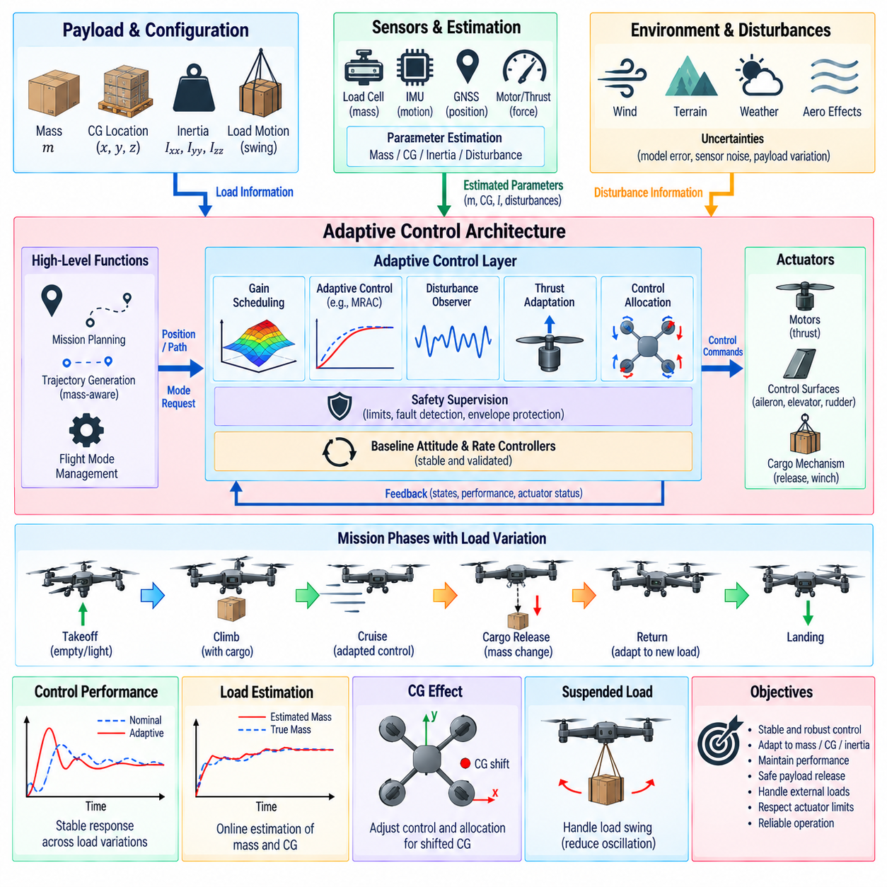
Cargo UAV control becomes significantly more challenging when payload mass, center of gravity, inertia, and load motion vary between missions or during flight. A controller tuned for one nominal configuration may exhibit slower response, excessive overshoot, reduced stability margin, or actuator saturation under another configuration. Adaptive control addresses these variations by modifying selected control parameters while preserving a stable baseline flight-control structure.
Payload variation affects both translational and rotational dynamics. Increased mass requires greater thrust for hover, climb, and acceleration, while changes in the inertia tensor alter angular acceleration produced by a given control moment. A displaced center of gravity creates additional coupling between forces and moments. The control system should therefore distinguish changes in total mass from changes in payload location and distribution whenever sufficient information is available.
A practical cargo UAV architecture normally retains validated inner attitude and rate controllers as the stabilization foundation. Adaptive functions operate around this baseline by estimating uncertain vehicle parameters, scheduling controller gains, adjusting feedforward terms, or modifying control allocation. This layered approach prevents the entire stabilization function from depending on unconstrained online adaptation and allows conventional safety limits to remain active during parameter changes.
Payload information can originate from preflight configuration data, load cells, landing-gear force sensors, cargo-interface sensors, motor-thrust observations, or dynamic estimation during flight. Known cargo mass can be loaded directly into the flight computer before takeoff, while unknown or changing payload conditions may require online estimation. Combining measured and estimated information improves confidence and provides cross-checking against incorrect loading data.
Mass estimation can exploit the relationship between commanded thrust and measured vertical acceleration. During suitable flight conditions, the controller knows approximately how much propulsion force is being requested and can compare this with the resulting vehicle acceleration. Gravity, aerodynamic forces, attitude, and propulsion-model uncertainty must be considered because an incorrect thrust model can otherwise appear as an incorrect mass estimate.
Center-of-gravity estimation is particularly important when cargo can be positioned asymmetrically. A shifted center of gravity changes the moment arms between propulsion forces and the actual mass center, creating steady attitude-control effort or asymmetric motor loading. Persistent trim commands, actuator-force distribution, measured angular response, and dedicated load sensors can provide information for estimating or validating the effective center-of-gravity location.
The inertia tensor determines how rotational moments produce angular acceleration. Heavy or spatially distributed cargo can substantially increase roll, pitch, or yaw inertia even when the center of gravity remains close to its nominal location. Online inertia estimation is more difficult than mass estimation because sufficient rotational excitation is required. Practical systems may therefore use predefined payload classes or scheduled inertia models supplemented by bounded adaptive correction.
Gain scheduling provides a relatively deterministic method for accommodating known load configurations. Controller gains, acceleration limits, thrust parameters, and filter settings can be stored for validated ranges of mass, center of gravity, or inertia. Intermediate operating points are obtained through controlled interpolation. Scheduling is especially attractive for certified or safety-critical systems because parameter variation remains inside a predefined and testable envelope.
Adaptive control extends this capability when vehicle parameters cannot be known accurately in advance. An adaptive law can modify selected gains or model parameters according to observed tracking errors and estimated dynamic behavior. Adaptation should be bounded by physically meaningful limits and should operate more slowly than the primary stabilization loops. This separation prevents transient sensor noise or aggressive maneuvers from causing rapid and potentially destabilizing parameter changes.
Model Reference Adaptive Control, or MRAC, provides one conceptual approach. A reference model defines the desired closed-loop response, and the adaptive mechanism adjusts controller parameters to reduce the difference between actual aircraft behavior and that reference. For cargo UAV applications, the method can compensate for changes in mass or inertia, but adaptation laws require careful stability analysis, parameter constraints, excitation considerations, and robustness against measurement noise.
Disturbance observers offer another useful mechanism for load-related uncertainty. Instead of explicitly identifying every physical parameter, an observer estimates the combined effect of unknown forces and moments acting on the vehicle. The estimated disturbance can then be compensated through feedforward control. This approach can address payload uncertainty, steady wind, aerodynamic bias, and moderate center-of-gravity effects while leaving the nominal feedback controller unchanged.
Thrust adaptation is essential because propulsion commands depend directly on vehicle weight. The hover-thrust estimate should increase when payload mass increases and decrease after cargo release. An accurate hover estimate reduces the amount of integral action required by the altitude controller and improves vertical response. Voltage variation, propeller efficiency, air density, and motor characteristics should be separated from mass effects whenever possible to avoid incorrect adaptation.
Cargo release introduces a particularly rapid dynamic change. A UAV that suddenly loses a significant portion of its payload experiences an immediate increase in thrust-to-weight ratio if motor commands remain unchanged. The control software should detect or anticipate release events, update mass and hover-thrust estimates, manage integrator states, and limit transient acceleration. Known release commands can provide feedforward information before estimator convergence occurs.
Suspended or flexible loads introduce dynamics beyond simple mass and inertia variation. A load attached by a cable can swing relative to the aircraft and create time-varying forces and moments. Aggressive acceleration may excite pendulum motion that feeds back into position and attitude control. Swing estimation, trajectory shaping, acceleration limiting, input shaping, or dedicated load-damping control may therefore be required for external-load cargo missions.
Control allocation should adapt when payload variation changes actuator loading or available control margin. A center-of-gravity shift can cause some motors or control surfaces to operate closer to saturation than others during nominal flight. Allocation algorithms can redistribute effort among redundant actuators while respecting thrust, power, thermal, and structural limits. Remaining authority should be monitored continuously to preserve sufficient margin for disturbance rejection.
Trajectory generation should account for the current load state rather than assuming identical maneuverability for every mission. Heavy payloads generally reduce climb capability, acceleration, braking performance, and available thrust reserve. The planner or guidance system can apply mass-dependent velocity, acceleration, jerk, bank-angle, and climb-rate limits. This prevents high-level autonomy from requesting trajectories that the adapted low-level controller cannot safely execute.
Adaptive functions require confidence management because incorrect parameter estimates can be more harmful than using conservative nominal values. Each estimated mass, center-of-gravity position, inertia parameter, or disturbance state should have validity criteria and plausible bounds. Adaptation can be frozen, limited, or reset when sensor quality deteriorates, excitation is insufficient, residuals become inconsistent, or the estimated parameters move outside the validated physical envelope.
Faults must also be distinguished from ordinary payload variation. A loss of motor effectiveness, damaged propeller, sensor bias, or structural problem can produce behavior resembling increased mass or shifted center of gravity. If an adaptive controller simply compensates for every discrepancy, it may conceal an emerging failure. Diagnostic logic should therefore compare adaptation trends with actuator health, sensor consistency, propulsion models, and known payload events.
Safety supervision should maintain authority over all adaptive functions. Hard limits on attitude, angular rate, airspeed, thrust, actuator commands, structural load, and flight envelope should not be relaxed automatically by an adaptive algorithm. If estimated vehicle parameters imply insufficient performance margin, the system should reduce maneuver demands, restrict flight modes, return to a safe operating condition, or initiate an appropriate landing strategy.
Verification requires testing across the complete validated payload envelope rather than only at nominal mass. Software-in-the-loop simulation can systematically vary mass, center of gravity, inertia, wind, sensor error, and propulsion effectiveness. Hardware-in-the-loop testing can evaluate estimator timing, adaptation rates, actuator saturation, cargo-release events, and injected faults. Flight tests should progressively cover representative loading configurations and maneuver conditions.
Logged data should include payload configuration, estimated mass and center of gravity, adaptive parameters, controller gains, hover-thrust estimate, disturbance estimates, tracking errors, actuator commands, saturation margins, and estimator confidence. Comparing these signals across repeated maneuvers allows engineers to determine whether adaptation improves performance consistently or merely compensates for errors that should instead be corrected in modeling, calibration, or hardware.
A robust cargo UAV adaptive-control architecture therefore combines a validated baseline controller with payload sensing, parameter estimation, gain scheduling, bounded adaptation, disturbance compensation, adaptive control allocation, and safety supervision. By treating load variation as a measurable and manageable change in vehicle dynamics, the system can maintain predictable attitude, position, and trajectory performance across diverse cargo configurations without sacrificing control limits or fault awareness.

11.09 Flight Control SW SIL / HIL Test Automation
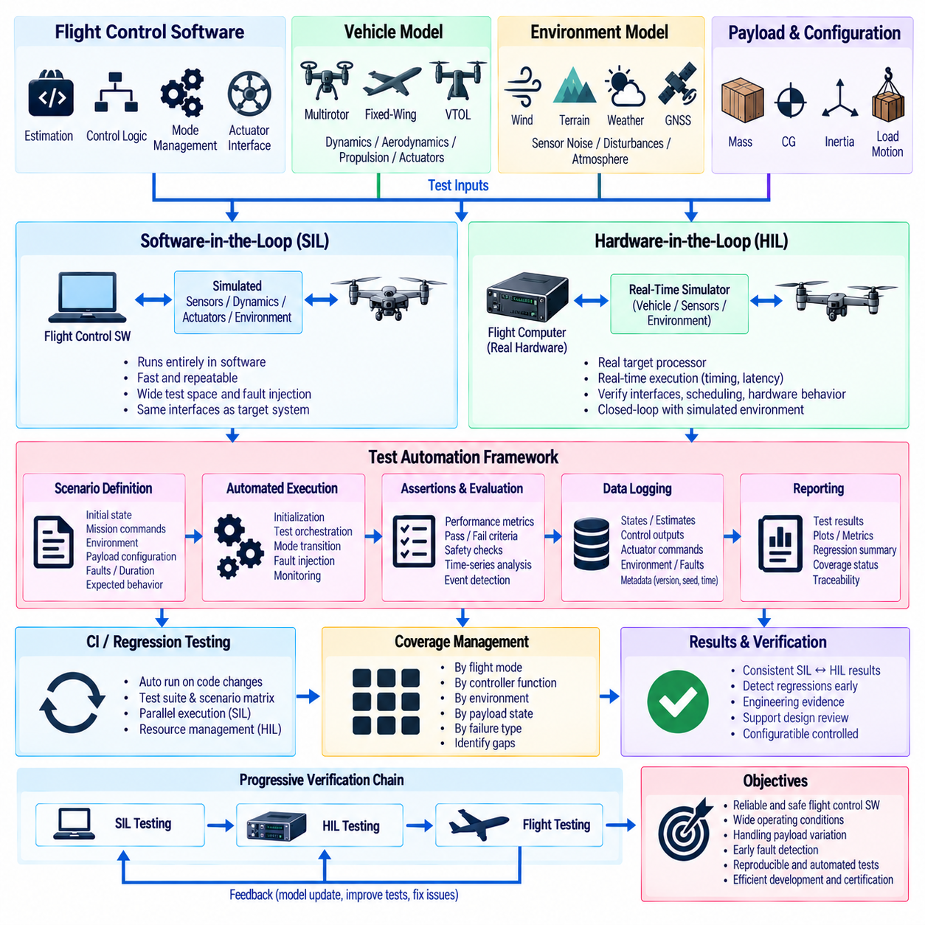
Flight-control software requires systematic verification because defects in estimation, control logic, timing, mode management, or actuator interfaces can directly affect vehicle stability. Software-in-the-loop and hardware-in-the-loop testing provide controlled environments in which these behaviors can be exercised before flight. Test automation extends these methods by executing repeatable scenarios, collecting evidence, and evaluating results without relying on manual operation.
Software-in-the-loop, or SIL, testing executes flight-control software against simulated vehicle dynamics, sensors, actuators, and environmental models. The controller receives synthetic measurements that resemble real flight data and produces actuator commands that influence the simulated aircraft. Because the complete experiment runs in software, engineers can rapidly modify scenarios, inject failures, repeat tests, and explore operating conditions that would be expensive or unsafe to reproduce physically.
A SIL environment should preserve the interfaces and execution behavior of the target flight-control architecture as closely as practical. Sensor messages, coordinate frames, units, timestamps, control modes, actuator commands, and communication protocols should correspond to the deployed system. Differences between simulation interfaces and flight interfaces increase the risk that software passes simulation tests but fails when integrated with actual avionics.
The vehicle model determines how effectively SIL testing represents real aircraft behavior. Multirotor models should represent rigid-body dynamics, rotor thrust, motor response, aerodynamic drag, and ground interaction, while fixed-wing and VTOL models require aerodynamic forces, control-surface effectiveness, propulsion behavior, and transition dynamics. Model fidelity should match the verification objective rather than maximizing complexity without measurable benefit.
Environmental models extend the test space beyond ideal flight. Wind, turbulence, atmospheric density, terrain, GNSS conditions, magnetic disturbances, sensor noise, and communication delay can be varied systematically. Cargo UAV simulations can additionally vary payload mass, center of gravity, inertia, suspended-load motion, and cargo-release events. Parameter sweeps expose combinations that may not appear during a small number of manually selected test flights.
Hardware-in-the-loop, or HIL, testing introduces the real flight-control computer into the simulation loop. The target processor executes production software while a real-time simulator calculates vehicle dynamics and generates sensor signals. Actuator outputs are returned to the simulator, closing the control loop. This arrangement verifies not only control algorithms but also processor timing, device interfaces, communication behavior, scheduling, and hardware-dependent software.
Real-time execution is essential in HIL because the flight computer expects sensor and actuator interactions at physical rates. IMU data may arrive hundreds or thousands of times per second, while GNSS, barometric altitude, airspeed, and mission messages operate at lower frequencies. The HIL system must preserve timing relationships, jitter, latency, and synchronization sufficiently well to reveal defects that ordinary non-real-time simulation may hide.
Test automation begins with machine-readable scenario definitions. Each test should specify the initial vehicle state, mission commands, environmental conditions, payload configuration, injected faults, execution duration, and expected behavior. Separating scenario data from test-control software allows the same automation framework to execute many configurations and enables engineers to review test intent without modifying simulation or flight-control source code.
Automated initialization is necessary for reproducible results. The framework should reset simulator states, controller parameters, estimator conditions, flight modes, payload configuration, and random seeds before each run. It should also verify that required processes, communication links, and hardware interfaces are healthy before beginning the scenario. A failed initialization should terminate or invalidate the test rather than producing misleading performance data.
A test orchestrator coordinates the complete execution sequence. It can launch the simulator, start or reset the flight controller, configure parameters, arm the virtual aircraft, apply mission commands, inject disturbances, trigger mode transitions, and terminate the run. The orchestrator should monitor synchronization and execution status continuously so that infrastructure failures can be distinguished from genuine flight-control failures.
Fault injection is one of the strongest advantages of automated SIL and HIL testing. The framework can introduce GNSS loss, IMU bias, airspeed failure, delayed messages, actuator degradation, motor failure, communication dropout, incorrect payload information, or power-related limitations at precisely defined times. Repeating the same fault across software revisions allows developers to determine whether recovery behavior remains consistent.
Assertions convert expected flight behavior into measurable pass-or-fail criteria. Examples include maximum attitude error, altitude deviation, path-tracking error, settling time, overshoot, minimum airspeed, actuator saturation duration, estimator convergence, and mode-transition time. Safety requirements can additionally define prohibited states, such as excessive bank angle, loss of control authority, invalid actuator output, or violation of a transition envelope.
Not every requirement is represented adequately by a single threshold. Time-series behavior may require evaluating whether an error remains within bounds for a specified duration, whether oscillations decay, or whether recovery occurs within an allowed interval after a fault. Automated analysis can compute statistical measures, frequency characteristics, control margins, and event sequences to detect subtle degradation that might be overlooked during visual log inspection.
Logging should provide traceability from each test result back to the software and configuration that produced it. Recorded metadata can include software commit, firmware version, parameter set, simulation model version, hardware identifier, scenario definition, random seed, and execution timestamp. Flight data should include estimator states, controller outputs, actuator commands, mode states, faults, safety flags, and relevant environmental variables.
Regression testing uses this traceability to determine whether a software modification changes previously verified behavior. A standard suite can execute automatically after updates to estimators, controllers, navigation logic, drivers, or configuration parameters. Results are compared with acceptance criteria and, where appropriate, validated baseline behavior. Failures should identify the scenario, requirement, signal, and time interval responsible for the regression.
Continuous integration can connect source-code changes directly to automated flight-control verification. Lightweight unit and SIL tests may run for every relevant commit, while larger scenario matrices and HIL campaigns can execute on scheduled or controlled hardware resources. Test selection can reflect the affected software components so that rapid feedback is obtained without unnecessarily executing every expensive HIL scenario after every minor change.
Parallel execution significantly improves SIL test coverage. Since many software simulations do not require dedicated physical hardware, multiple scenarios can run simultaneously across CPU or GPU resources. Wind conditions, payload configurations, controller parameters, initial states, and fault combinations can be distributed as independent jobs. Large parameter sweeps help identify boundary conditions and interactions that deterministic nominal tests may miss.
HIL automation requires additional resource management because flight computers, I/O devices, real-time simulators, and power interfaces are finite physical assets. The framework should reserve hardware, verify device identity, load the correct firmware, establish communication, execute tests, recover from failures, and release resources safely. Automated power cycling or watchdog recovery can restore a test station after software crashes without corrupting subsequent results.
SIL and HIL results should be related rather than treated as independent verification activities. A scenario that succeeds in SIL can be promoted to HIL using equivalent initial conditions and acceptance criteria. Differences between the two environments may reveal timing effects, numerical differences, interface assumptions, or hardware limitations. Maintaining common scenario definitions and analysis functions improves correlation and reduces duplicated verification effort.
Coverage management helps determine whether the automated campaign represents the intended operational envelope. Tests can be classified by flight mode, controller function, environmental condition, payload state, failure type, and requirement. Coverage matrices reveal untested combinations such as heavy payload with crosswind, VTOL transition with degraded propulsion, or fixed-wing navigation during airspeed-sensor faults, guiding targeted expansion of the test suite.
Automated reporting transforms raw simulation logs into engineering evidence. Each execution can produce a concise result containing pass or fail status, requirement identifiers, key metrics, detected anomalies, plots, and links to detailed logs. Campaign-level summaries can show regression trends and coverage status. Consistent reporting reduces manual interpretation and supports design reviews, safety assessment, and configuration-controlled verification records.
Simulation cannot eliminate the need for flight testing because aerodynamic modeling, sensor behavior, structural effects, and environmental interactions remain imperfect. Its value is to move a large portion of verification into repeatable environments where dangerous conditions can be explored first. SIL, HIL, and flight testing should therefore form a progressive verification chain in which each stage addresses uncertainties that cannot be resolved adequately by the preceding stage.
A mature flight-control test-automation architecture combines scenario management, deterministic initialization, simulation, real-time HIL interfaces, fault injection, assertions, logging, regression analysis, coverage tracking, and automated reporting. By linking these capabilities with configuration management and continuous integration, development teams can detect control-software regressions early and accumulate reproducible evidence that the UAV behaves correctly across nominal, boundary, and failure conditions.

11.10 PX4 / ArduPilot Customization: Hills FCC Integration [w/Code]
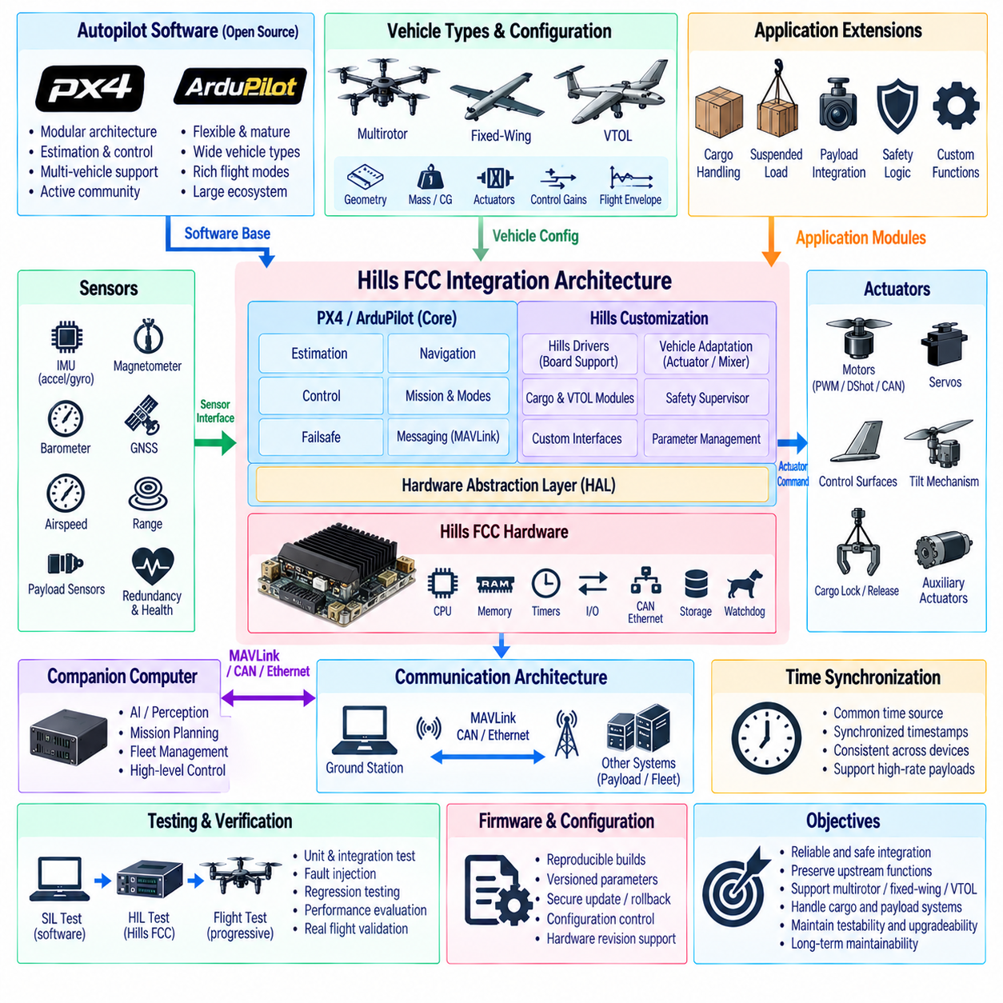
PX4 and ArduPilot provide mature open-source flight-control foundations that can accelerate development of multirotor, fixed-wing, and VTOL UAV platforms. For a proprietary flight-control computer such as the Hills FCC, integration should preserve validated upstream functions while introducing hardware-specific drivers, vehicle configuration, safety logic, communication interfaces, and application-level extensions through clearly defined architectural boundaries.
The first integration decision concerns the relationship between the autopilot software and the Hills FCC hardware. The FCC should expose processor, memory, timers, communication buses, sensor interfaces, actuator outputs, storage, and watchdog functions through a hardware abstraction layer. This allows higher-level estimation, navigation, and control modules to remain largely independent of board-level implementation details and simplifies migration between FCC hardware revisions.
Board-support customization establishes the lowest software layer. Startup code, clock configuration, memory layout, interrupt handling, GPIO, SPI, I2C, UART, CAN, Ethernet, PWM, and other peripheral functions must be mapped to the FCC architecture. Bootloader behavior, firmware update mechanisms, persistent parameter storage, debugging interfaces, and recovery procedures should also be defined before higher-level flight functions are integrated.
Sensor integration requires more than connecting device drivers. IMUs, magnetometers, barometers, GNSS receivers, airspeed sensors, range sensors, and payload-related sensors must provide correct units, coordinate frames, timestamps, calibration parameters, and health information. Multiple IMUs or redundant sensors require consistent device identification and priority management so that estimator switching and fault detection behave predictably.
Actuator integration should define a deterministic path from control allocation to physical outputs. Depending on the UAV configuration, the Hills FCC may command motors, servos, control surfaces, tilt mechanisms, cargo locks, or auxiliary actuators through PWM, DShot, CAN, or another interface. Output mapping, update rates, arming behavior, failsafe states, saturation limits, and actuator feedback should be configuration-controlled rather than embedded as scattered application logic.
PX4 customization can retain its modular publish-subscribe architecture while introducing Hills-specific modules at explicit interfaces. Hardware drivers can provide sensor data to standard topics, while custom monitoring, payload, or supervisory functions exchange information through defined messages. Modifications to core estimator and controller modules should be minimized unless a vehicle requirement cannot be satisfied through parameters, configuration, or an external extension module.
ArduPilot integration follows a similar principle but uses its own hardware abstraction and vehicle-specific software organization. Hills FCC support should be implemented through the appropriate board and hardware abstraction definitions, allowing established attitude estimation, navigation, controllers, mission management, and failsafe functions to operate above the hardware layer. Platform-specific additions should remain isolated wherever practical to reduce maintenance effort.
Maintaining a clean boundary from upstream source code is important for long-term product development. Direct modifications distributed throughout PX4 or ArduPilot can make future version upgrades difficult and introduce hidden dependencies. Hills-specific drivers, parameters, message definitions, payload functions, safety monitors, and vehicle adaptations should therefore be organized as identifiable components with documented interfaces and controlled patches when upstream modification is unavoidable.
Vehicle configuration separates common flight software from individual aircraft characteristics. Airframe geometry, rotor direction, control-surface arrangement, actuator limits, sensor orientation, mass properties, control gains, and flight-envelope parameters should be represented through configuration data whenever possible. Multirotor, fixed-wing, VTOL, and cargo variants can then share a common software baseline while retaining configuration-specific behavior.
Control allocation is a major integration point for nonstandard Hills UAV configurations. Conventional airframes may use existing mixer or allocation definitions, while cargo or VTOL platforms can require custom effectiveness matrices involving lift motors, cruise propulsion, tilting units, aerodynamic surfaces, or redundant actuators. The allocation layer should remain separated from attitude and trajectory controllers so that vehicle geometry can evolve without redesigning the complete control stack.
Cargo functions should also be separated from fundamental stabilization logic. Payload weight sensing, center-of-gravity estimation, cargo lock status, release commands, suspended-load monitoring, and payload health can be handled by dedicated application modules. These modules may provide mass estimates, constraints, or mode requests to the flight-control system, but the validated attitude and rate loops should remain responsible for basic vehicle stabilization.
A supervisory safety layer can provide Hills-specific protection above the standard autopilot failsafe mechanisms. It may monitor FCC health, redundant sensors, propulsion status, payload state, communication links, power conditions, flight-envelope limits, and mission-level constraints. Safety actions should be coordinated with PX4 or ArduPilot mode management so that independent protection mechanisms do not issue contradictory recovery commands.
Communication architecture determines how the FCC interacts with companion computers, ground stations, payload controllers, and fleet infrastructure. MAVLink can provide mission, telemetry, parameter, and command interfaces, while CAN or Ethernet may support high-rate devices and proprietary subsystems. Message ownership, update rates, time synchronization, command authorization, and failure behavior should be defined explicitly for each interface.
A companion computer should not replace the deterministic stabilization responsibilities of the flight controller. High-level perception, AI inference, route planning, fleet coordination, or mission optimization can execute on Jetson-class or other compute platforms, while the Hills FCC maintains attitude stabilization, navigation safety, actuator control, and failsafe behavior. A defined command interface prevents failures in autonomy software from directly destabilizing the aircraft.
Time synchronization becomes important when flight data are shared among the FCC, companion computer, payload sensors, and ground systems. Sensor fusion and post-flight analysis depend on consistent timestamps, while high-rate perception or inspection payloads may require tighter synchronization. The architecture should define a common time source or synchronization mechanism and preserve timestamps across communication gateways rather than replacing them arbitrarily.
Parameter management should distinguish development tuning from released aircraft configuration. Controller gains, estimator settings, actuator mappings, safety limits, payload parameters, and communication settings should be versioned with the corresponding hardware and software release. Parameter validation during startup can prevent incompatible configuration files from being applied to the wrong FCC revision or aircraft type.
Firmware lifecycle management should support reproducible builds and controlled deployment. Each released image should be traceable to source revisions, build options, board definitions, parameter sets, and verification results. Secure or authenticated update mechanisms may be added according to product requirements, while rollback and recovery paths should ensure that an interrupted or invalid update does not permanently disable the flight computer.
Testing should begin below the complete vehicle level. Board-support functions, drivers, communication interfaces, parameter handling, and actuator outputs can be verified independently before integrating estimation and control. Software-in-the-loop testing then validates vehicle behavior without FCC hardware, while hardware-in-the-loop testing executes production firmware on the Hills FCC against a real-time aircraft simulation.
Automated regression testing is particularly valuable when maintaining customized PX4 or ArduPilot branches. Changes from upstream updates or Hills-specific development can be exercised against standard scenarios covering arming, takeoff, navigation, VTOL transition, cargo variation, actuator saturation, sensor failures, communication loss, and landing. Results should be linked to software revisions so that integration defects can be identified before flight testing.
Flight-test integration should proceed from basic hardware validation to progressively more complex autonomous behavior. Initial tests can verify sensor orientation, actuator direction, manual stabilization, and failsafe responses before introducing navigation, payload adaptation, VTOL transition, or advanced autonomy. Logged estimator states, control outputs, timing information, safety events, and FCC resource utilization provide evidence for tuning and verification.
Long-term maintainability requires an explicit strategy for tracking upstream PX4 and ArduPilot development. Product branches should record which upstream release they are based on, which Hills modifications have been applied, and which interfaces are expected to remain stable. Periodic integration should be supported by automated builds and regression tests so that security fixes and useful upstream improvements can be adopted without uncontrolled software divergence.
A robust Hills FCC integration architecture therefore combines a stable PX4 or ArduPilot flight-control baseline with a hardware abstraction layer, board support, standardized sensor and actuator interfaces, configuration-driven vehicle adaptation, cargo and VTOL extensions, safety supervision, and controlled communication with external computing systems. Clear separation of upstream, platform-specific, and application software enables reliable UAV control while preserving testability, upgradeability, and product-level configuration control.

