Volume 04 Robot Control Software

05. Motion Control Software

05.01 Motion Profile Generation: Trapezoidal / S-Curve [w/Code]
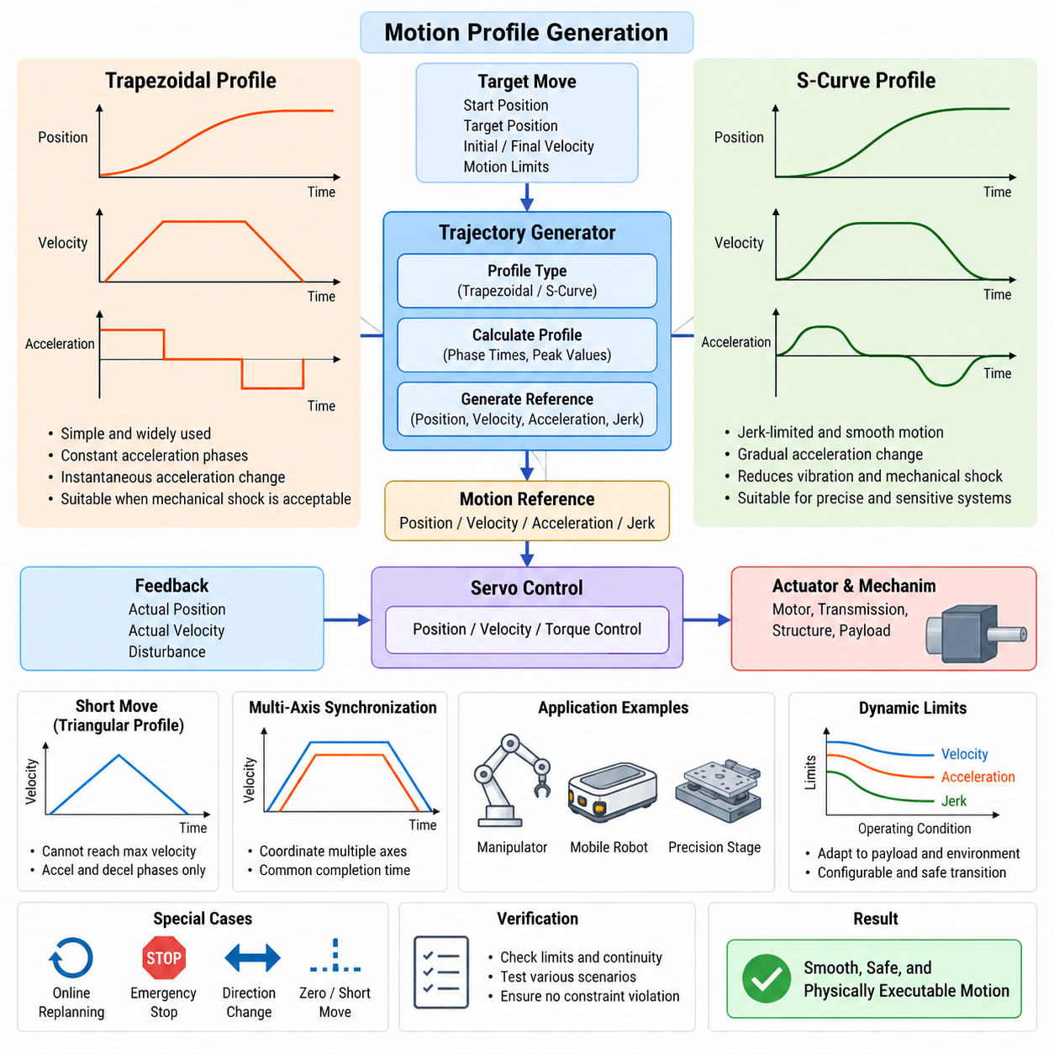
Motion profile generation converts a desired displacement into time-dependent position, velocity, acceleration, and sometimes jerk references that can be executed by a robot controller. Instead of commanding a joint or mobile axis to move instantly toward a target, the trajectory generator limits dynamic quantities so that motors, transmissions, structures, and payloads remain within their physical operating boundaries.
A trapezoidal velocity profile is one of the most widely used motion profiles because of its simplicity and deterministic execution. The motion is divided into acceleration, constant-velocity, and deceleration phases. During acceleration, velocity increases linearly under a constant acceleration command. After reaching the specified maximum velocity, the axis travels at constant speed until it must decelerate toward the final position.
The resulting velocity curve has a trapezoidal shape when the commanded displacement is sufficiently long. Position remains continuous and follows a piecewise quadratic or linear relationship with time, while acceleration changes between positive acceleration, zero acceleration, and negative acceleration. This structure makes the profile computationally inexpensive and suitable for embedded motor controllers that must generate references at high update rates.
Not every commanded displacement allows the axis to reach its configured maximum velocity. When the travel distance is short, the acceleration and deceleration portions intersect before the constant-velocity phase can occur. The resulting velocity trajectory becomes triangular rather than trapezoidal. A practical motion generator therefore calculates the required acceleration distance before deciding whether trapezoidal or triangular operation is physically feasible.
Although trapezoidal profiles provide bounded velocity and acceleration, their acceleration changes instantaneously at phase boundaries. These discontinuities correspond theoretically to very large jerk, where jerk represents the time derivative of acceleration. Real mechanical systems cannot reproduce instantaneous acceleration transitions, so such commands can excite structural vibration, transmission elasticity, wheel slip, payload oscillation, or audible mechanical shock.
S-curve motion profiles address this limitation by explicitly controlling jerk. Instead of switching acceleration immediately between fixed values, acceleration is gradually increased and decreased through finite-jerk segments. Velocity therefore changes smoothly, and the position trajectory acquires higher-order continuity. This approach reduces excitation of flexible structures and is particularly valuable for manipulators, precision stages, mobile robots, and systems carrying sensitive payloads.
A complete jerk-limited S-curve can contain several sequential phases: increasing acceleration, constant acceleration, decreasing acceleration, constant velocity, increasing deceleration, constant deceleration, and decreasing deceleration. Depending on travel distance and configured limits, some phases may disappear. The trajectory generator must therefore handle multiple profile configurations while preserving the requested displacement and final boundary conditions.
The fundamental constraints of profile generation are maximum velocity, maximum acceleration, and maximum jerk. These limits are normally derived from actuator capability, gear ratios, mechanical strength, traction conditions, payload characteristics, and control bandwidth. Software should treat them as coordinated constraints rather than independent parameters because changing one limit can alter the duration and feasibility of every subsequent trajectory segment.
For a single axis, the generator receives an initial position and target position together with initial and final velocity conditions. It calculates direction, displacement, phase durations, and peak dynamic values before producing references for the servo loop. At every control cycle, the trajectory state can be evaluated from analytical equations using elapsed time, avoiding the accumulation errors that can occur when references are generated only through repeated numerical integration.
Motion profile generation normally operates above the low-level position, velocity, or torque control loops. The profile generator determines what motion should occur over time, while the servo controller attempts to track that reference despite friction, disturbances, load variation, and modeling errors. Separating these responsibilities allows trajectory constraints and feedback-control parameters to be tuned independently while maintaining a clean software architecture.
In multi-axis manipulators, independently generated joint profiles can produce different completion times if each joint simply moves according to its own limits. Coordinated motion therefore requires synchronization. A common strategy calculates the minimum feasible duration for every participating axis, selects an appropriate common completion time, and scales individual profiles so that all joints reach their targets simultaneously without violating velocity, acceleration, or jerk constraints.
Synchronization becomes especially important when joint-space motion corresponds to an end-effector path. Poorly coordinated joint profiles can cause the Cartesian trajectory to deviate significantly from the intended geometry even though every individual joint reaches its final position correctly. For path-sensitive operations, motion profiling must therefore cooperate with trajectory interpolation, inverse kinematics, and Cartesian constraint management rather than operating as an isolated module.
Mobile robot applications use similar principles for longitudinal velocity and steering-related motion. Sudden changes in commanded speed can generate wheel slip, drivetrain shock, unstable payload behavior, or excessive current demand. Jerk-limited acceleration references improve traction and mechanical stability, particularly for heavy autonomous mobile robots, outdoor platforms, and robots operating on low-friction or irregular surfaces.
Motion limits may also need to change dynamically according to operating conditions. A manipulator can require lower acceleration while carrying a heavy payload, while an outdoor robot may reduce jerk and speed on slopes or rough terrain. The trajectory generator should therefore support configurable constraint sets and safe transitions between them instead of assuming that one fixed motion envelope is appropriate for every operating state.
Real-time implementation requires deterministic computation and predictable numerical behavior. Profile generation may occur once when a command is accepted, while profile evaluation occurs cyclically at the servo or motion-control rate. The software must correctly handle zero-distance commands, extremely short movements, reversed directions, nonzero initial velocity, command interruption, floating-point tolerances, and transitions near profile boundaries without producing discontinuous references.
Online replanning introduces additional complexity because a new target may arrive while the robot is already moving. Simply restarting a trajectory from zero velocity creates an artificial discontinuity. A robust generator instead uses the current commanded or measured motion state as the new initial condition and computes a dynamically feasible transition toward the updated target while respecting velocity, acceleration, and jerk limits.
Emergency stopping requires a different objective from normal trajectory generation. The priority becomes reducing kinetic energy and reaching a safe state within allowable mechanical and safety constraints. The motion software may therefore maintain separate controlled-stop and emergency-stop profiles, with different deceleration and jerk limits. These functions must coordinate with drive-level safety mechanisms rather than replacing certified hardware safety functions.
Profile quality should be evaluated using more than final positioning accuracy. Important software verification quantities include maximum velocity, acceleration, jerk, travel distance, completion time, continuity at segment boundaries, synchronization error, and constraint violations. Automated tests should cover long moves, short triangular profiles, direction reversals, interrupted commands, near-zero displacement, and parameter combinations close to physical limits.
Trapezoidal and S-curve profiles represent different engineering tradeoffs rather than universally superior and inferior solutions. Trapezoidal profiles provide simple equations, low computational cost, and fast responses when mechanical shock is acceptable. S-curves require additional calculations and potentially longer motion time but provide smoother force and torque transitions. The appropriate profile therefore depends on machine dynamics, precision requirements, payload sensitivity, and cycle-time objectives.
A well-designed motion-control software stack can expose both profile types through a common trajectory-generation interface. Higher-level planners specify target states and motion constraints, while the profile module selects or configures the required mathematical representation. The resulting position, velocity, acceleration, and jerk references are then delivered through a deterministic interface to the downstream control layer.
This abstraction also supports future extensions such as asymmetric acceleration and deceleration limits, velocity blending, waypoint transitions, time-optimal parameterization, Cartesian constraints, and model-based dynamic limits. The essential principle remains unchanged: geometric commands must be converted into physically executable time histories before they are sent to actuators. Motion profile generation therefore forms a critical bridge between planning and real-time robot control.

05.02 Position, Velocity, Acceleration Control Layer Design
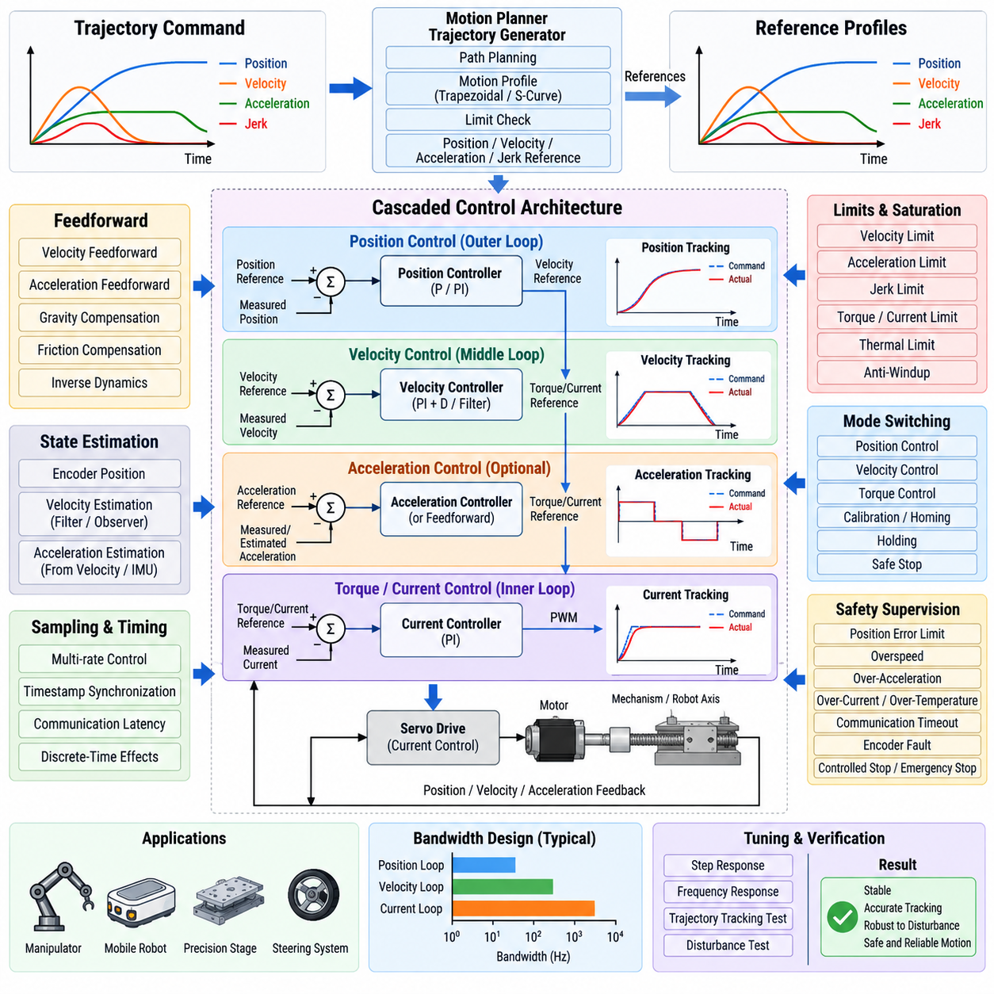
Position, velocity, and acceleration control form a layered motion-control architecture that converts high-level trajectory commands into stable actuator behavior. Each layer operates on a different representation of motion and normally at a different control bandwidth. The design objective is to separate trajectory tracking, dynamic response, and actuator regulation while maintaining predictable information flow between the layers.
The position-control layer determines how accurately a robot axis follows a commanded position trajectory. It compares the desired position with the measured position and converts the resulting position error into a velocity or dynamic correction command. Because position represents the outermost motion state, this loop generally operates with lower bandwidth than the inner velocity and current or torque loops.
A proportional position controller is sufficient for many servo systems when the inner velocity loop provides strong damping and disturbance rejection. Increasing position gain reduces tracking error and improves responsiveness, but excessive gain can amplify mechanical resonance, encoder noise, communication delay, or structural flexibility. Position-loop tuning must therefore consider the dynamics of the complete actuator and mechanism rather than only the mathematical error.
The velocity-control layer receives a velocity reference from the position controller, trajectory generator, or direct velocity command. It compares this reference with measured or estimated velocity and generates a torque, current, or acceleration-related command. Since velocity control directly influences damping and disturbance rejection, its bandwidth is normally higher than that of the position loop and lower than the electrical current-control loop.
Velocity feedback may be obtained directly from a sensor or estimated from position measurements. Numerical differentiation of encoder position is simple but can significantly amplify quantization and measurement noise. Practical implementations therefore use filtering, observer-based estimation, or drive-provided velocity estimates. Filtering must be selected carefully because excessive smoothing introduces phase delay and can reduce the stability margin of the closed-loop system.
Acceleration control provides an additional dynamic layer when direct regulation of acceleration is useful. Acceleration may be measured using an inertial sensor, estimated from velocity, or predicted using a dynamic model. In many industrial servo systems acceleration is primarily used as a feedforward quantity rather than as an independent feedback loop, while advanced robotic systems can combine acceleration feedback with force, torque, or disturbance estimation.
Feedforward control is important because feedback alone reacts only after tracking error has developed. Velocity feedforward can compensate for motion-dependent behavior, while acceleration feedforward can generate torque proportional to the inertia required to execute a trajectory. When an adequate dynamic model is available, gravity, friction, Coriolis, and payload-dependent terms can also be added before the inner control loop.
A typical cascaded architecture therefore contains an outer position loop, an intermediate velocity loop, and an inner torque or current loop. The position controller produces a velocity reference, the velocity controller produces a torque or current reference, and the drive regulates motor current. Each inner loop should respond significantly faster than its outer loop so that the outer controller can treat the inner dynamics as approximately settled.
Bandwidth separation is a fundamental design principle for cascaded control. If neighboring loops operate at nearly identical bandwidths, their dynamic interactions can create oscillation, overshoot, or difficult tuning behavior. A practical design assigns the electrical current loop the highest bandwidth, the velocity loop an intermediate bandwidth, and the position loop a lower bandwidth while accounting for sampling frequency and mechanical resonances.
Acceleration commands generated by a trajectory planner should not bypass physical constraints simply because they are mathematically valid. Before reaching the actuator, commands must be checked against velocity, acceleration, torque, current, power, and thermal limits. Saturation management is especially important because an outer controller can continue accumulating error while an inner actuator is already operating at its physical limit.
Integral action is frequently used in velocity or position control to remove steady-state error caused by friction, constant disturbances, or load imbalance. However, actuator saturation can cause the integral state to accumulate excessively, producing windup and large overshoot after saturation ends. Anti-windup logic limits, freezes, or back-calculates the integrator so that recovery remains controlled and predictable.
Derivative action can improve damping but is sensitive to measurement noise. In practical robot controllers, derivative behavior is often implemented through filtered velocity feedback rather than direct differentiation of position error. This avoids severe amplification of encoder quantization and high-frequency disturbances. Controller structure should therefore be selected according to available sensors and signal quality rather than by applying a textbook PID equation unchanged.
Reference limiting should be clearly separated from feedback regulation. The trajectory generator defines feasible position, velocity, acceleration, and jerk references, while the control layers minimize tracking error relative to those references. Allowing feedback controllers to generate unrestricted commands can undermine trajectory constraints, so software interfaces should explicitly define saturation, rate limits, and authority boundaries between planning and control.
Sampling rates must be selected according to the dynamics of each layer. A high-speed motor current loop may execute inside the servo drive, while velocity and position control can execute at progressively slower rates in a motion controller or robot computer. Multi-rate architecture reduces computational load but requires careful synchronization, timestamp management, interpolation, and deterministic communication between components.
Discrete-time implementation introduces effects that do not appear in ideal continuous-time controller equations. Sampling delay, computation time, communication latency, quantization, and zero-order hold behavior all consume phase margin. A controller that appears stable in continuous simulation can therefore oscillate on actual hardware. Digital implementation should be evaluated using realistic update rates and measured end-to-end latency.
Command and feedback timing must also remain consistent. If a controller compares a newly generated reference with an old sensor measurement, the apparent tracking error contains timing error in addition to physical error. Timestamped data, synchronized clocks, bounded communication latency, and deterministic scheduling become increasingly important as control bandwidth increases or multiple distributed controllers cooperate over a network.
In a multi-axis robot, each joint may contain its own cascaded control structure, but the joints are dynamically coupled through the mechanism. Independent joint controllers can perform well at moderate speeds, while high-speed manipulators or heavy payload systems may require model-based compensation for coupling effects. Feedforward inverse dynamics can reduce the burden on individual feedback loops while preserving the modular joint-control architecture.
Mobile robots apply the same layered concept differently. A wheel position or velocity loop may run at the actuator level, while a chassis controller generates wheel references from desired linear and angular motion. Acceleration limiting above the wheel controller prevents abrupt traction demand. For steering systems, position control regulates steering angle while velocity and torque layers provide fast and stable actuator response.
Mode switching is another important software-design issue. Robots may transition among position control, velocity control, torque control, calibration, holding, and safe-stop modes. A direct switch between controllers with inconsistent internal states can create command discontinuities. Bumpless transfer techniques initialize references, integrators, filters, and controller states so that the transition occurs without an unintended mechanical impulse.
Safety supervision should remain distinct from normal motion regulation. Control layers manage tracking performance, whereas safety logic monitors limits such as excessive position error, overspeed, excessive acceleration, motor current, thermal state, communication timeout, and encoder faults. When a violation occurs, the supervisory layer can request controlled deceleration or escalate to drive-level safety functions according to system requirements.
The software architecture should make controller interfaces explicit. Each control layer should define its input reference, feedback signal, output command, execution period, units, coordinate frame, valid range, saturation behavior, and fault response. Such contracts prevent ambiguity when controllers are distributed across servo drives, embedded processors, real-time computers, or ROS-based higher-level software.
Controller tuning should proceed from the innermost loop outward. The torque or current loop is stabilized first, followed by the velocity loop and then the position loop. This sequence preserves the assumption that each inner loop behaves predictably when an outer loop is tuned. Frequency-response analysis, step responses, trajectory tracking tests, and disturbance tests can then be used to validate stability and performance.
Verification should examine both nominal and boundary conditions. Important cases include slow and high-speed trajectories, sudden load changes, command saturation, sensor noise, communication delay, direction reversal, zero-speed holding, and emergency deceleration. Logged position, velocity, acceleration, torque, tracking error, saturation state, and timing information provide evidence for identifying interactions that cannot be observed from final position accuracy alone.
A robust layered controller combines trajectory feasibility, feedforward prediction, feedback correction, saturation management, timing integrity, and safety supervision into one coherent motion-control pipeline. Position, velocity, and acceleration should not be treated as isolated variables; they are connected states of the same physical motion. Their software layers must therefore cooperate while preserving clear bandwidth, authority, and interface boundaries.
This layered architecture provides a scalable foundation for different robot platforms. The same principles can support individual motor axes, multi-joint manipulators, autonomous mobile robots, steering actuators, precision stages, and whole-body robotic systems. By separating motion generation from progressively faster control layers, the software can achieve accurate tracking, stable dynamic response, reusable interfaces, and physically consistent actuator commands.

05.03 Linear and Circular Interpolation Algorithm [w/Code]
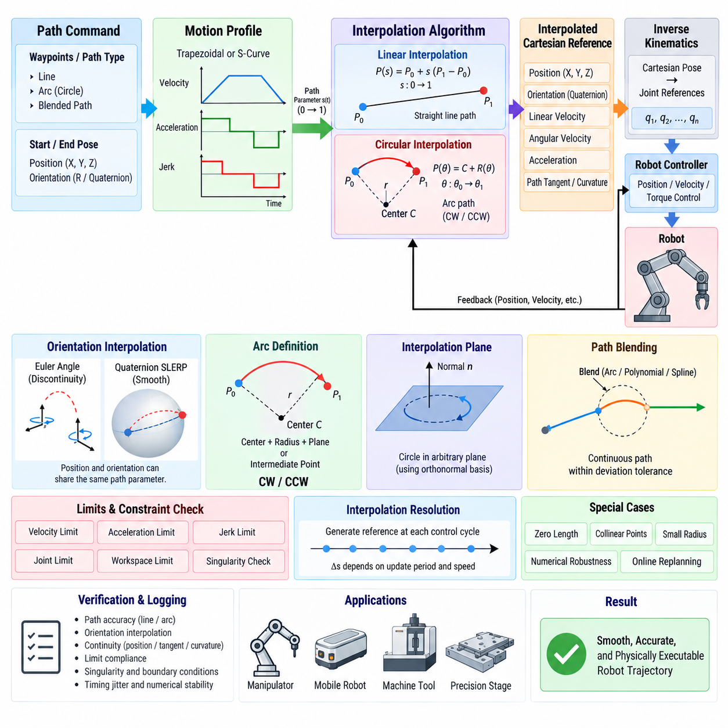
Linear and circular interpolation algorithms convert geometric path definitions into continuously updated reference points that a robot or motion controller can execute. While motion profiles determine how fast motion progresses with time, interpolation determines where the commanded point should lie along the geometric path. Separating these functions allows path geometry and temporal motion constraints to be designed and controlled independently.
Linear interpolation generates a straight-line path between a start point and an end point. A normalized path parameter, commonly ranging from zero to one, represents progress along the segment. Each intermediate position is calculated from the start position plus the scaled displacement vector toward the target. This simple formulation provides deterministic computation and guarantees that all generated points remain on the commanded line.
The interpolation parameter does not necessarily advance at a constant rate. It can be driven by a trapezoidal or S-curve motion profile so that path velocity, acceleration, and jerk satisfy physical constraints. When the scalar path parameter is combined with the geometric interpolation equation, the controller obtains a time-parameterized trajectory that preserves the straight-line geometry while providing smooth acceleration and deceleration.
For Cartesian robot motion, linear interpolation is usually performed on the end-effector position rather than independently on each joint. The interpolated Cartesian pose is converted into joint references using inverse kinematics. This approach preserves the desired tool path in workspace, whereas direct joint interpolation can cause the end effector to follow a curved and potentially unexpected Cartesian trajectory between the same start and target poses.
Orientation requires separate treatment because rotational coordinates cannot always be interpolated safely as ordinary linear values. Euler-angle interpolation can suffer from representation discontinuities and singularities. Quaternion-based interpolation, particularly spherical linear interpolation, provides a more consistent method for generating smooth orientation changes while preserving unit rotation representation throughout the commanded motion.
A complete Cartesian linear-motion command can therefore combine linear position interpolation with rotational interpolation. Position and orientation may share the same normalized progress parameter so that translation and rotation begin and end together. Alternatively, their constraints can be evaluated separately and synchronized to a common completion time, preventing either translational or rotational limits from being exceeded.
Circular interpolation generates points along an arc rather than a straight segment. The geometric definition normally requires a start point, an end point, and additional information describing the circle. This may be provided as a center point, radius and plane, or an intermediate point located on the desired arc. The controller uses these constraints to determine the circle center, radius, plane normal, and direction of travel.
Once the circle geometry is known, the motion can be parameterized using an angular variable. The commanded position is calculated by rotating a radius vector around the circle center as the angular parameter advances. As with linear interpolation, the angular or arc-length progress does not need to change uniformly with time. A motion profile can control progression while respecting velocity, acceleration, and jerk constraints.
Arc-length parameterization is especially useful because translational speed along a circular path is directly related to radius and angular velocity. For a circle of radius r, tangential velocity is proportional to r times angular velocity. This relationship allows Cartesian speed limits to be converted into appropriate angular limits and prevents the interpolation layer from generating path motion that exceeds the robot’s dynamic capability.
Circular interpolation requires careful definition of the interpolation plane. In three-dimensional space, a circle exists within a plane characterized by its normal vector. The algorithm typically constructs an orthonormal basis within this plane and expresses the rotating radius vector using the basis vectors. This avoids restricting circular motion to predefined XY, YZ, or ZX planes and supports arbitrary spatial arc trajectories.
Direction selection must also be unambiguous. Depending on the application, the command may specify clockwise or counterclockwise travel relative to the interpolation plane, or the direction may be inferred from an intermediate point. Without a clear convention, the same start and end points can describe two possible arcs. Software interfaces should explicitly define coordinate frames, normal direction, and arc-selection rules.
Degenerate geometry must be detected before interpolation begins. Linear interpolation should handle nearly identical start and end points without division by a near-zero path length. Circular interpolation must reject or specially process collinear points, extremely small radii, inconsistent center definitions, and numerically unstable configurations. Geometry validation prevents invalid references from propagating into downstream control loops.
Interpolation resolution is determined primarily by the controller update period rather than by manually selecting a fixed number of geometric points. At every interpolation cycle, the current path parameter is evaluated and a new reference is generated. This online evaluation avoids storing large point arrays and provides consistent timing, while sufficiently high update rates ensure that the discretized trajectory approximates the continuous path accurately.
However, interpolation period and robot velocity jointly determine the spatial distance between consecutive references. At high speed, a slow update rate creates large position increments that can reduce tracking quality or excite the servo system. The interpolation frequency must therefore be selected according to maximum path speed, required geometric accuracy, controller bandwidth, communication timing, and the mechanical characteristics of the robot.
Interpolation and inverse kinematics must be coordinated carefully. A geometrically valid Cartesian point may correspond to an unreachable joint configuration or require joint velocities beyond their limits. The software should evaluate workspace boundaries, joint limits, singularity proximity, and joint-rate feasibility before or during execution. Cartesian path validity alone does not guarantee that the robot can physically follow the trajectory.
Near a kinematic singularity, small Cartesian movements can require extremely large joint velocities. A linear or circular interpolator may continue producing perfectly smooth Cartesian references while the joint controller becomes unable to track them. Singularity monitoring, velocity scaling, alternative inverse-kinematics solutions, or path modification may therefore be required to maintain feasible and stable robot motion.
Path blending extends interpolation beyond isolated line and arc segments. If a robot stops at every waypoint, cycle time increases and acceleration repeatedly returns to zero. Blending replaces sharp transitions with continuous connecting regions so that velocity can be maintained across neighboring segments. The blend must remain within an allowed path-deviation tolerance while respecting velocity, acceleration, and jerk constraints.
A common blending strategy shortens the original segments near a waypoint and inserts a smooth transition curve. Depending on system requirements, this transition may use circular arcs, polynomial curves, splines, or higher-order geometric constructions. The interpolation layer must coordinate the blend geometry with the motion-profile generator so that geometric continuity and dynamic continuity are satisfied simultaneously.
Continuous-path applications require particular attention to continuity order. Position continuity prevents geometric jumps, tangent continuity prevents abrupt direction changes, and curvature continuity reduces discontinuities in normal acceleration. For high-speed manipulators, machine tools, inspection robots, and precision stages, higher geometric continuity can significantly reduce vibration and tracking error compared with merely connecting segments at identical positions.
Real-time interpolation software should maintain a clear internal state containing the active segment, path parameter, elapsed time, geometric coefficients, motion direction, and completion status. Precomputing constant geometric terms when a command begins reduces cyclic computational load. The real-time update function can then evaluate only the equations required for the current control period, improving determinism and execution efficiency.
Online command modification introduces additional requirements. When a target or waypoint changes during motion, abruptly replacing the current segment can create discontinuities in position, velocity, or acceleration. A robust system uses the current trajectory state as the initial condition for replanning and constructs a feasible transition toward the new path. The geometry and motion profile must therefore be regenerated together rather than independently reset.
Numerical robustness is essential because interpolation algorithms execute repeatedly and small errors can accumulate or appear near geometric boundaries. Vector normalization, angle wrapping, floating-point tolerances, quaternion normalization, and stable trigonometric calculations should be handled consistently. Values close to zero or to geometric limits require explicit treatment instead of relying on exact floating-point comparisons.
Multi-axis synchronization is naturally integrated with interpolation through a common path parameter. Rather than advancing every Cartesian coordinate or joint independently, a single scalar progression variable can define the state of the entire path. All position and orientation components are evaluated from this shared parameter, ensuring synchronized completion while the motion-profile layer determines the maximum dynamically feasible progression rate.
The interpolation layer should expose clearly defined outputs to downstream control software. These can include commanded position, orientation, linear velocity, angular velocity, acceleration, path tangent, curvature, and completion status. Providing derivative information directly can improve feedforward control and avoid reconstructing velocity or acceleration by numerically differentiating discrete position commands in lower-level controllers.
Verification should compare generated trajectories against both geometric and dynamic requirements. Linear paths can be checked for deviation from the commanded line, while circular paths can be checked for radius and plane errors. Tests should also examine endpoint accuracy, direction, orientation interpolation, continuity, velocity and acceleration limits, degenerate inputs, singularity conditions, timing jitter, and numerical stability.
Visualization and logging are valuable during validation even when they are not part of the real-time control algorithm. Recorded reference and measured trajectories can reveal chord errors, path deviation, discontinuities, excessive curvature, or synchronization problems. Comparing Cartesian and joint-space data helps determine whether an observed error originates in interpolation, inverse kinematics, servo tracking, communication timing, or mechanical behavior.
Linear and circular interpolation therefore form a fundamental geometric layer between high-level path commands and low-level robot control. Combined with motion profiling, inverse kinematics, dynamic constraint checking, blending, and synchronized real-time execution, these algorithms transform abstract geometric instructions into continuous and physically executable robot trajectories suitable for manipulators, mobile systems, precision machines, and other automated platforms.

05.04 Joint Space and Cartesian Space Motion Switching
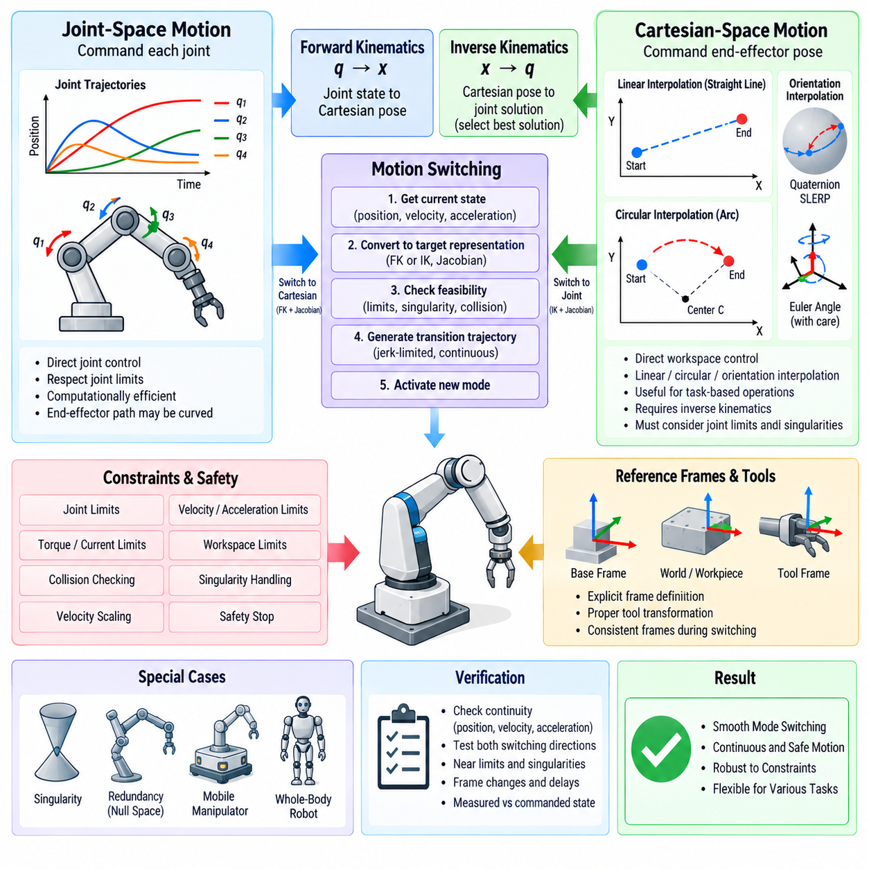
Joint-space and Cartesian-space motion represent two fundamental ways of commanding robotic systems. Joint-space motion describes the trajectory directly through individual joint coordinates, while Cartesian-space motion describes the desired position and orientation of an end effector or body frame. Motion switching allows a controller to transition between these representations while maintaining continuity, feasibility, and predictable robot behavior.
In joint space, each actuator or articulated joint is assigned a target position, velocity, or acceleration. A trajectory generator synchronizes the participating joints and produces time-dependent references within their individual limits. This representation maps naturally to servo controllers because the final commands are already expressed in actuator-related coordinates, reducing the amount of kinematic computation required during trajectory execution.
Joint-space motion is computationally efficient and usually provides straightforward enforcement of joint position, velocity, acceleration, and torque limits. However, synchronized joint trajectories do not generally produce a straight Cartesian path. Even when every joint moves smoothly from its initial value to its target, the end effector can follow a curved path whose geometry depends on robot kinematics and the selected joint-space interpolation strategy.
Cartesian-space motion instead specifies the desired motion of a tool center point, end effector, sensor frame, mobile manipulator base, or another task-related coordinate frame. Position is typically represented by three-dimensional translation, while orientation can be represented using rotation matrices, Euler angles, or quaternions. The commanded Cartesian trajectory must ultimately be converted into joint references before actuator-level execution.
This conversion is performed through inverse kinematics. For every Cartesian reference pose, the inverse-kinematics solver determines one or more joint configurations capable of realizing the desired pose. Because redundant robots can have multiple valid solutions, the solver may additionally optimize joint distance, manipulability, collision clearance, posture preference, energy consumption, or distance from joint limits when selecting the configuration.
Cartesian interpolation provides direct control over workspace geometry. Linear interpolation can maintain a straight tool path, circular interpolation can follow an arc, and orientation interpolation can independently control tool rotation. Such motion is essential for welding, machining, inspection, assembly, dispensing, grasping, and other tasks in which the path taken between two poses is as important as the final destination.
Switching between joint and Cartesian motion requires more than changing the active trajectory generator. Both representations describe the same physical robot state but use different coordinates and constraints. At the switching instant, the new controller must begin from a state consistent with the trajectory currently being executed. Otherwise, discontinuities can appear in commanded position, velocity, acceleration, or torque.
A basic switching procedure captures the current commanded or measured joint state and converts it into the representation required by the new mode. When switching from joint space to Cartesian space, forward kinematics computes the current end-effector pose. Joint velocities can be mapped into Cartesian linear and angular velocities using the robot Jacobian, providing initial conditions for a new Cartesian trajectory.
When switching from Cartesian space to joint space, the currently commanded Cartesian pose is converted into a valid joint configuration using inverse kinematics. The selected joint solution should remain close to the existing robot configuration to prevent sudden posture changes. If several inverse-kinematics branches are available, continuity with the current branch should normally be preserved unless an intentional configuration change has been planned.
Velocity consistency is especially important during motion switching. The Jacobian maps joint velocity into Cartesian velocity, while an inverse or pseudoinverse Jacobian can map Cartesian velocity into joint velocity. Simply matching position at the transition point while resetting velocity to zero can create an abrupt deceleration. Maintaining compatible velocity states enables smoother transitions without unnecessary stopping.
Acceleration continuity is more difficult because the relationship between Cartesian and joint acceleration includes both Jacobian and Jacobian-rate terms. At higher speeds, ignoring these terms can produce significant command discontinuities or unexpected torque demand. Smooth switching should therefore preserve position and velocity at minimum and, where dynamic performance requires it, construct a transition that also maintains acceleration and jerk continuity.
A practical system may use a dedicated transition trajectory rather than switching modes instantaneously. The transition generator starts from the current position, velocity, and acceleration state and gradually converges toward the reference required by the destination mode. Jerk-limited blending can reduce mechanical shock and prevent sudden changes in motor torque, particularly for heavy manipulators or systems carrying sensitive payloads.
Reference frames must remain explicit throughout Cartesian operation and switching. A pose may be expressed relative to the robot base, world frame, workpiece, mobile platform, or tool frame. Switching modes with inconsistent frame assumptions can create large unintended movements even when numerical coordinates appear reasonable. Frame identifiers, transforms, timestamps, and calibration validity should therefore be part of the motion-command interface.
Tool transformations introduce another consideration. The Cartesian pose controlled by the robot may represent the flange, tool center point, gripper, camera, or another attached device. Changing tools or active control frames changes the relationship between joint coordinates and task-space motion. The switching software should use the currently active kinematic chain and tool transform rather than assuming a fixed end-effector geometry.
Constraint handling differs between the two spaces. Joint-space control directly exposes joint limits and actuator capabilities, while Cartesian motion emphasizes workspace velocity, acceleration, orientation rate, and geometric path constraints. A Cartesian command that appears moderate can require excessive motion from one joint because of the robot configuration. Both Cartesian and joint constraints must therefore be checked during trajectory generation.
Kinematic singularities are a major concern during Cartesian motion. Near a singularity, a small Cartesian velocity can require very large joint velocities. A controller switching from a stable joint-space trajectory into Cartesian control must evaluate the Jacobian condition before enabling the new motion. Velocity scaling, damped pseudoinverse methods, path modification, or rejection of the command may be necessary when feasibility is insufficient.
Redundancy adds both flexibility and complexity. A robot with more degrees of freedom than required for a Cartesian task can move internally while maintaining the same end-effector pose. Null-space control can exploit this freedom to avoid joint limits, obstacles, or unfavorable configurations. During mode switching, however, the null-space objective must be initialized carefully to prevent sudden secondary joint motion.
Collision constraints must remain active regardless of the selected motion representation. Joint-space interpolation can create an unexpected Cartesian sweep, while Cartesian interpolation can require joint motions that bring links near obstacles. Self-collision checking, environment collision checking, joint-limit monitoring, and workspace restrictions should therefore supervise both modes rather than being associated with only one trajectory representation.
Mobile manipulators extend the switching problem because Cartesian motion can involve both the manipulator and the mobile base. A task command may initially use base motion for large displacement and later switch to arm-dominant Cartesian control for precise positioning. Coordinated control must determine which degrees of freedom participate in the task while preserving continuity when control authority is redistributed between subsystems.
Whole-body robots use an even more generalized version of this architecture. Joint-space commands remain useful for posture generation, initialization, and recovery, while Cartesian task commands regulate hands, feet, torso, head, or center of mass. A task-priority controller can combine multiple Cartesian objectives with joint-space posture objectives, allowing the system to move between representations without treating them as completely separate controllers.
Mode ownership should be explicitly defined in software. Only one component should have authority to generate the primary reference for a controlled degree of freedom at a given time unless a formally designed arbitration scheme is used. Without ownership management, simultaneous joint-space and Cartesian commands can conflict. A motion manager can validate requests, control transitions, and expose the currently active mode to higher-level planners.
The switching state machine typically includes request, validation, synchronization, transition, active, and fault states. Before accepting a switch, the system can verify kinematic feasibility, frame validity, controller readiness, safety conditions, and command limits. The transition becomes active only after the new reference has been initialized consistently with the current robot state, reducing the possibility of unintended motion.
Online switching must also consider whether measured or commanded state should define the transition point. Using the commanded trajectory preserves mathematical continuity, but the physical robot may have tracking error. Using measured state reflects actual configuration but can introduce a jump relative to the planned trajectory. Robust systems select the state source according to operating mode, tracking quality, safety requirements, and replanning strategy.
Fault handling should define behavior when the requested destination mode cannot be activated. An inverse-kinematics solution may not exist, a frame transform may be unavailable, or the target may violate limits. Instead of partially switching control authority, the motion manager should retain a known valid mode, request a controlled stop, or transition to a defined safe state according to the severity of the failure.
Real-time implementation requires deterministic transformations, kinematic calculations, and controller handover. Forward kinematics, Jacobian evaluation, inverse kinematics, constraint checking, and trajectory initialization must complete within bounded execution time. Expensive optimization-based calculations may operate at a slower planning rate, while high-frequency control loops consume already validated references through deterministic interfaces.
Verification should test stationary and moving transitions in both directions. Important cases include switching at zero velocity, switching during acceleration, high-speed motion, operation near joint limits, singularity proximity, multiple inverse-kinematics solutions, frame changes, communication delays, and interrupted commands. Logged joint and Cartesian states should be inspected for discontinuities in position, velocity, acceleration, and control effort.
The primary objective of joint-space and Cartesian-space motion switching is not merely to support multiple command types, but to provide one coherent motion-control system in which representation can change without violating physical continuity. Kinematic transformations, synchronized state initialization, constraint supervision, transition trajectories, frame management, and control ownership together make switching predictable and safe.
A well-designed switching architecture allows high-level planners to select the representation most appropriate for each phase of a task. Joint-space motion can provide efficient configuration changes, while Cartesian-space motion provides direct geometric control of task execution. Seamless transitions between them enable manipulators, mobile manipulators, and whole-body robots to combine efficient posture motion with precise workspace behavior within a unified software framework.

05.05 Motion Control Collision Detection and Safe Stop [w/Code]
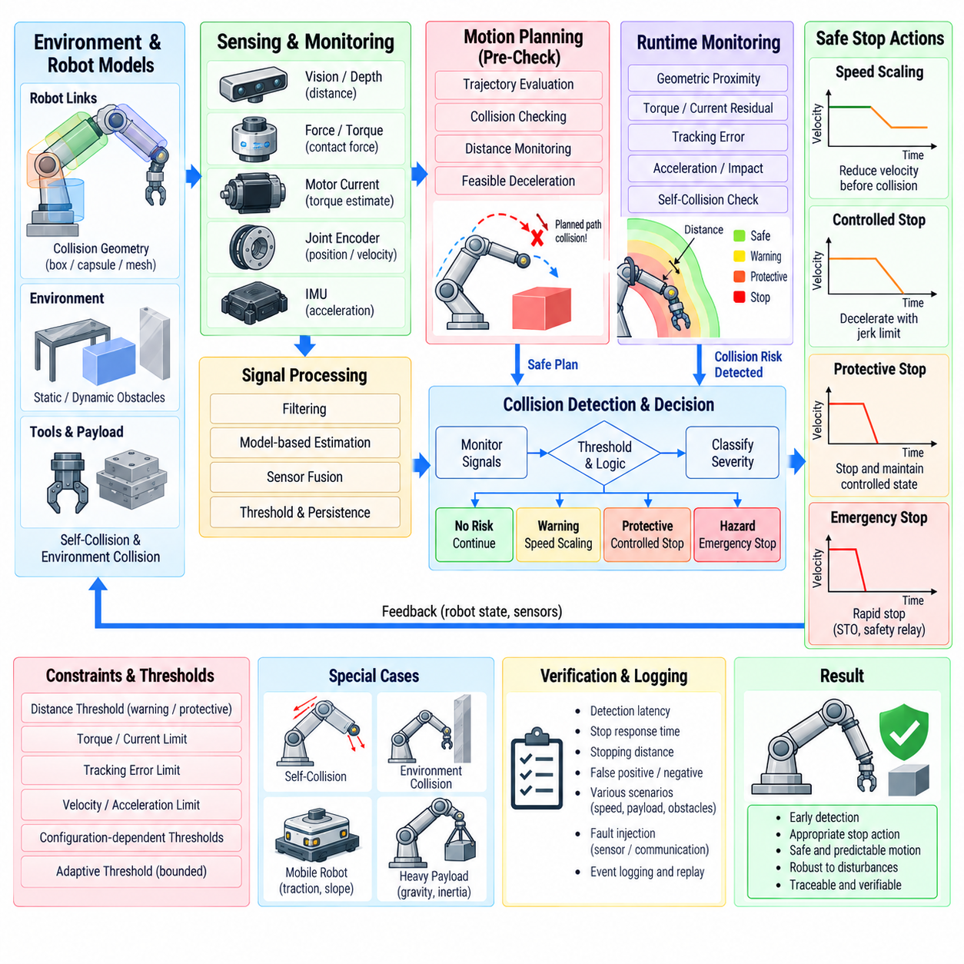
Motion-control collision detection and safe stopping provide a protective layer between trajectory execution and physical interaction. The objective is to identify conditions that indicate an unexpected obstacle, contact, mechanical interference, or unsafe motion, then transition the robot toward an appropriate safe state. This function combines sensing, model-based monitoring, control supervision, and deterministic stop behavior.
Collision detection can occur before physical contact or after contact has begun. Pre-collision detection uses environmental sensing and geometric prediction to determine whether the planned or currently commanded trajectory approaches an obstacle. Contact-based detection instead observes changes in force, torque, motor current, acceleration, velocity, or tracking error that indicate the robot has encountered resistance inconsistent with expected motion.
Geometric collision checking uses models of the robot, payload, tools, and surrounding environment. Robot links are represented by collision geometries such as boxes, capsules, convex meshes, or simplified bounding volumes. During planning and execution, the software evaluates distances between these models to detect self-collision, contact with static structures, or intersection with dynamically updated obstacles.
A useful collision-monitoring architecture separates planning-time prediction from runtime supervision. The motion planner evaluates candidate trajectories before execution, while the runtime monitor continuously verifies that the actual and commanded robot states remain within a safe envelope. This layered approach prevents known collisions before motion begins while retaining the ability to respond to unexpected events during execution.
Distance-based monitoring can provide an early warning before physical collision occurs. When the minimum distance between the robot and an obstacle falls below configurable thresholds, the controller can progressively reduce velocity or acceleration. A warning zone can initiate speed scaling, a protective zone can request controlled stopping, and an immediate hazard condition can escalate to a faster safety response.
Self-collision detection is particularly important for articulated and whole-body robots because different links can enter the same region of space. The collision model should account for joint configuration, attached tools, payload dimensions, and configuration-dependent geometry. Adjacent links that are expected to remain close can be excluded selectively, while relevant link pairs are monitored throughout trajectory execution.
Model-based contact detection estimates the torque or force expected during normal motion and compares it with measured or estimated actuator behavior. Differences between predicted and observed values can be interpreted as external disturbance. A residual exceeding an appropriate threshold may indicate collision, unexpected contact, payload change, excessive friction, or another abnormal mechanical condition requiring supervisory evaluation.
Motor current provides a practical indicator of mechanical loading because motor torque is related to current. An unexpected current increase can therefore contribute to collision detection when direct force or torque sensors are unavailable. However, current alone is not a reliable collision signal because acceleration, gravity, friction, drivetrain efficiency, and payload changes also affect current demand. Context-aware thresholds or model compensation are required.
Force and torque sensors can provide more direct evidence of physical interaction, particularly at robot wrists, joints, or contact interfaces. Their signals can detect contact magnitude and direction, but sensor noise, bias, structural vibration, and intended task forces must be distinguished from hazardous collisions. Filtering and threshold logic should therefore consider the expected interaction characteristics of the current operating mode.
Tracking error is another important supervisory signal. If commanded position continues advancing while measured position stops or deviates substantially, the robot may be blocked by an obstacle or mechanical fault. Position and velocity error thresholds can detect this behavior, but thresholds must account for controller bandwidth, normal transient error, flexible structures, and high-acceleration motion to avoid unnecessary stop events.
Acceleration and inertial sensing can detect impacts that appear as rapid dynamic changes. An IMU mounted on a robot body or payload can identify shocks that may not immediately produce large position errors. Combining inertial measurements with joint torque, current, and trajectory information can improve detection robustness because multiple independent signals provide stronger evidence than any single measurement.
Sensor fusion allows collision confidence to be constructed from several indicators. Geometric proximity, joint torque residuals, motor current, force sensing, tracking error, and acceleration can contribute to a common supervisory decision. The system does not necessarily need a complex machine-learning model; deterministic logic with well-characterized thresholds and persistence conditions can provide transparent and verifiable behavior.
Threshold design is critical because overly sensitive detection produces false stops, while insensitive thresholds delay response to real collisions. Thresholds may depend on robot speed, payload, joint configuration, operating mode, expected contact forces, and environmental conditions. Adaptive thresholds can improve performance, but their allowed ranges and update logic should remain bounded so that protection cannot silently degrade.
Temporal persistence helps distinguish genuine abnormal behavior from short measurement spikes. A threshold may need to remain exceeded for a defined number of control cycles before a collision state is declared. Conversely, severe signals can bypass persistence and trigger an immediate response. This combination allows the software to reject transient noise while retaining rapid reaction to high-confidence hazardous events.
Collision response should be graded according to severity rather than treating every event identically. A distant obstacle may require only velocity scaling, while an unexpected contact can require controlled deceleration. A severe fault or safety-system request may require rapid removal of drive torque through an independent safety function. The response architecture should explicitly map detected conditions to defined stop categories.
A controlled stop attempts to reduce velocity while maintaining trajectory and actuator control. The motion generator creates a feasible deceleration profile from the current velocity and acceleration state, preferably with bounded jerk. This approach limits mechanical shock and helps maintain robot stability, which is especially important for heavy manipulators, mobile robots, high-inertia axes, and systems carrying unstable payloads.
A protective stop generally brings the robot to a monitored stationary condition while preserving the possibility of controlled recovery. Depending on system architecture and applicable safety design, motor power or torque capability may remain available under defined conditions. The distinction between normal controlled stopping, protective stopping, and emergency stopping should be explicit in software rather than represented by one generic stop command.
Emergency stopping serves a different purpose and may require safety-rated hardware independent of normal motion software. Standard control software can coordinate deceleration or request the stop, but it should not be assumed to replace certified safety functions where functional-safety requirements apply. Safety relays, safe drive functions, redundant channels, or dedicated safety controllers may ultimately enforce the required machine state.
Safe Torque Off, commonly abbreviated STO, disables torque-producing capability in a drive and is frequently used as a final safety action. STO does not inherently perform controlled deceleration; if activated while the robot is moving, motion can continue through inertia or gravity. For this reason, systems may first use a controlled or safety-monitored deceleration function before applying STO when the risk assessment permits.
Stopping distance depends strongly on current velocity, available deceleration, control delay, communication latency, mechanical response, and payload inertia. Collision monitoring should therefore consider not only present obstacle distance but also whether sufficient distance remains to stop safely. A dynamic protective envelope can expand as speed increases and contract during slow operation, improving both safety and operational efficiency.
Mobile robots additionally require consideration of traction and terrain. Commanding excessive deceleration on a low-friction surface can cause wheel slip and increase rather than reduce stopping uncertainty. Safe-stop generation should account for achievable tire-ground force, slope, vehicle mass, payload distribution, steering state, and braking capability when estimating a feasible deceleration profile.
Manipulators present different challenges because gravity and multi-link dynamics influence stopping behavior. Abruptly disabling actuator torque can allow a heavy arm or payload to move under gravity unless mechanical brakes or safety mechanisms intervene. Controlled stopping should therefore coordinate joint deceleration while respecting torque limits and maintaining a configuration that does not introduce additional instability or collision risk.
Once a collision or protective stop has occurred, automatic motion restart should generally require explicit recovery logic. The software should record the trigger source, robot state, active trajectory, relevant sensor values, and stop category. Recovery can then verify that the hazardous condition has cleared, controllers are synchronized, references are reinitialized, and the planned path remains valid before motion resumes.
False-positive and false-negative behavior must be evaluated systematically. False positives reduce availability and can encourage operators to weaken thresholds, while false negatives undermine protection. Validation should therefore use representative payloads, speeds, trajectories, contact directions, obstacle materials, environmental conditions, and sensor disturbances to characterize detection performance across the intended operating envelope.
Real-time implementation requires bounded detection and response latency. Collision-related signals should be sampled, processed, evaluated, and communicated within known timing limits. Timestamp synchronization becomes important when geometric sensors, joint controllers, force sensors, and supervisory computers operate at different rates. Stale measurements can cause the monitor to evaluate a robot configuration that no longer corresponds to the observed environment.
Software architecture should separate normal motion control, collision monitoring, and safety enforcement while defining clear interfaces among them. The motion controller provides commanded and measured states, the collision monitor evaluates risk, and the safety supervisor determines the required response. Independent safety-rated hardware can then enforce functions that must remain effective even if the main robot computer or application software fails.
Verification should include obstacle approach, self-collision, unexpected contact, actuator blockage, excessive tracking error, sensor failure, communication timeout, and high-speed stop scenarios. Tests should measure detection latency, stop-command latency, stopping time, stopping distance, peak acceleration, residual motion, and final state. Fault injection can further verify that unavailable or inconsistent sensors are handled predictably.
Logging and event reconstruction are essential for debugging and validation. A synchronized event record should capture commanded and measured position, velocity, acceleration, torque or current, collision residuals, proximity distances, threshold states, controller mode, stop request, and safety response. These records make it possible to determine whether an event originated from the environment, trajectory, controller, sensor, communication system, or mechanical hardware.
A robust collision-detection and safe-stop design therefore combines prediction, runtime observation, multi-signal detection, graded response, dynamically feasible deceleration, and independent safety enforcement. The objective is not simply to stop the robot whenever an anomaly appears, but to detect meaningful hazards early and transition the physical system into an appropriate state with controlled, predictable, and verifiable behavior.

05.06 Motion Control Sequencer Design [w/Code]
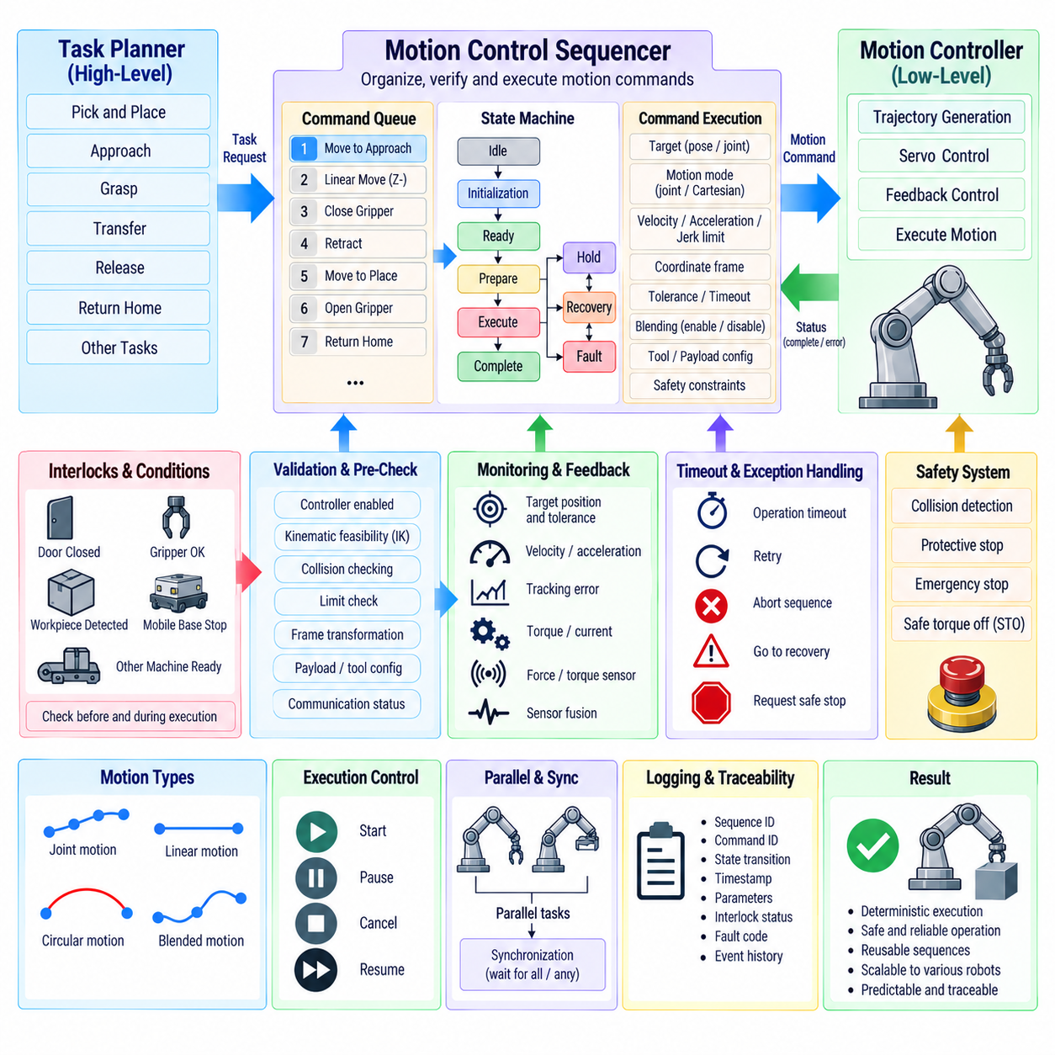
A motion-control sequencer coordinates individual motion commands into an ordered and deterministic execution flow. While trajectory generators calculate position, velocity, and acceleration references, the sequencer determines which motion should execute, when it may start, what conditions must be satisfied, and how the system should proceed after completion, interruption, or failure.
The sequencer operates between high-level task planning and low-level motion generation. A task planner may request actions such as move to approach pose, descend, grasp, retract, and return home. The sequencer converts these requests into controlled execution stages and activates the appropriate motion functions while monitoring completion conditions, interlocks, controller status, and safety permissions.
A state-machine architecture is commonly used because robot motion naturally consists of discrete operational phases. Typical states include idle, initialization, ready, motion preparation, execution, completion, hold, recovery, and fault. Each state defines permitted actions and transition conditions, allowing the sequence logic to remain explicit rather than being distributed across unrelated software callbacks or control loops.
State transitions should depend on verified conditions rather than elapsed time alone. A movement should normally advance to the next stage only after target position, velocity, settling tolerance, controller status, and required external conditions have been confirmed. Fixed delays may still be useful for specific physical processes, but they should not substitute for feedback when measurable completion information is available.
Each motion step can be represented as a structured command containing the target, motion mode, coordinate frame, velocity limit, acceleration limit, jerk limit, tolerance, timeout, and completion behavior. Additional fields can identify tool configuration, payload information, blending parameters, or safety constraints. A standardized command structure allows different motion types to use the same sequencing framework.
Before a motion step becomes active, the sequencer should validate its prerequisites. The controller must be enabled, the robot state must be appropriate, required coordinate transforms must be valid, and the target must satisfy configured limits. Depending on the system, inverse kinematics, collision checking, trajectory feasibility, payload configuration, and communication status may also be verified before execution begins.
The sequencer should distinguish command acceptance from command execution. A command can be syntactically valid yet temporarily unable to run because another motion owns the controller or an interlock is not satisfied. Separating accepted, queued, armed, executing, completed, rejected, and aborted conditions makes command behavior observable and prevents ambiguous interpretation by higher-level software.
A motion queue allows several commands to be prepared before execution. Commands can be processed sequentially while the next trajectory is validated or partially prepared in advance. This reduces gaps between motions and supports continuous operation. Queue management should define capacity, ordering, cancellation behavior, priority rules, and what happens to pending commands when an active motion fails.
Continuous-path applications require the sequencer to support blending between neighboring commands. Instead of waiting for one segment to reach zero velocity before starting the next, the sequencer can authorize transition through a blending region. This requires advance knowledge of the following command so that the trajectory generator can maintain position, velocity, acceleration, and preferably jerk continuity across the boundary.
Not every command can be blended safely. Changes in control mode, tool state, coordinate frame, payload configuration, or safety condition may require an explicit stop before the next step. The sequencer should therefore classify boundaries as blendable or non-blendable and prevent higher-level programs from accidentally creating continuous motion across transitions that require synchronization or physical confirmation.
Interlocks provide conditional permission for motion. Examples include a door being closed, a gripper reporting a valid state, a mobile base being stationary, a workpiece being detected, or another machine completing its operation. The sequencer should evaluate interlocks before motion begins and, where necessary, continuously during execution so that loss of permission produces a defined response.
Interlocks should be separated from general task conditions according to their importance. A missing process condition may simply pause the sequence, while a safety-related condition can require immediate protective action through a safety system. Keeping these concepts distinct prevents ordinary application logic from being mistaken for safety-rated protection and supports clearer verification of system behavior.
Timeout handling prevents the sequence from remaining indefinitely in a state that cannot complete. Every external wait or motion operation should have a defined timeout where appropriate. When the timeout expires, the sequencer can retry, enter recovery, abort the current sequence, or request a controlled stop. The selected behavior should depend on the operation and the consequences of incomplete execution.
Pause and resume functions require preservation of execution context. When a sequence is paused, the system should record the active command, progress state, controller mode, trajectory status, and relevant process conditions. Resuming cannot always mean continuing from the original command parameter because the physical robot may have stopped at an intermediate position requiring trajectory regeneration from its actual state.
Command cancellation is similarly different from emergency stopping. Cancellation is normally an application-level request to terminate or replace a motion in a controlled manner. The sequencer can request a feasible deceleration, wait for confirmed standstill, invalidate the remaining trajectory, and update the command state. Emergency stopping belongs to a separate safety path and may override normal sequencing immediately.
Recovery logic determines how the system returns from an interrupted or failed sequence to a known operational condition. Some faults allow continuation from the current state, while others require retracting the robot, returning to a reference pose, reinitializing an actuator, or requesting operator intervention. Recovery should therefore be represented as explicit sequence logic rather than improvised after a failure occurs.
Idempotent sequence design can improve recovery reliability. Where practical, repeating a command or initialization step should produce the same safe state rather than causing additional unintended motion or process action. This is particularly useful when communication interruptions make it uncertain whether a previous command was received, executed, or acknowledged by another subsystem.
Synchronization becomes important when multiple axes, manipulators, mobile platforms, or peripheral devices participate in one operation. The sequencer may need to wait until several components reach defined states before continuing. Barrier-style synchronization can ensure that all participants complete their assigned actions before the next coordinated phase begins, preventing one subsystem from advancing prematurely.
Parallel execution may also be required. For example, a manipulator can move while a vision system processes data or while a peripheral mechanism prepares for the next operation. The sequencer should represent parallel branches explicitly and define how they join. Completion may require all branches, any one branch, or a specific condition, depending on the intended task behavior.
Resource ownership prevents conflicting commands from controlling the same hardware simultaneously. A motion resource such as an arm, mobile base, lift, or gripper can be reserved by the active sequence. Requests from other tasks are queued, rejected, or arbitrated according to defined policies. Explicit ownership becomes increasingly important when autonomous planners and operator interfaces can issue commands concurrently.
Hierarchical sequencing improves scalability for complex robots. A high-level sequence can represent an operation such as pick-and-place, while lower-level subsequences handle approach, grasp, transfer, and release. Each subsequence exposes clear start, completion, failure, and cancellation semantics. This decomposition allows reusable motion procedures to be combined without placing the entire robot workflow inside one large state machine.
Parameterization further increases reuse. A generic transfer sequence can accept source pose, destination pose, speed class, payload, tool, and approach distance as parameters instead of embedding fixed values. The same sequencing logic can then support different workpieces or robot configurations while the motion-control layer continues to enforce platform-specific dynamic and geometric limits.
Deterministic execution is essential when the sequencer interacts with real-time motion control. High-level sequence decisions do not necessarily need to execute at servo-loop frequency, but command handover and state transitions must occur predictably. The real-time controller should continue generating valid references even if the higher-level sequencer experiences temporary scheduling jitter or communication delay.
The interface between the sequencer and motion controller should use explicit handshake semantics. A typical interaction includes command request, validation result, accepted state, execution start, progress, completion, and final acknowledgment. Sequence logic should not infer completion merely because a command message was transmitted. Positive confirmation from the responsible controller prevents race conditions and synchronization errors.
Sequence identifiers and command identifiers improve traceability. Every motion request can carry a unique identifier that remains associated with status updates, faults, logs, and completion events. When commands are retried or replaced, identifiers allow software to distinguish new requests from delayed messages related to previous execution, which is particularly important in distributed robot architectures.
Fault propagation should preserve both local detail and system-level meaning. A servo drive may report following error, a trajectory generator may report infeasible motion, and a collision monitor may report protective stop. The sequencer translates these subsystem events into defined sequence outcomes without discarding their original diagnostic information, allowing higher-level task management to choose an appropriate recovery strategy.
Logging should capture state transitions as well as continuous motion data. Important records include sequence identifier, command identifier, previous and next states, transition reason, timestamps, active motion parameters, interlock status, timeout events, controller responses, and fault codes. This event-oriented history makes complex execution failures much easier to reconstruct than motion traces alone.
Simulation provides an effective method for verifying sequence logic before hardware operation. A simulated controller can generate completion, timeout, rejection, collision, communication-loss, and recovery events while the sequencer executes realistic workflows. Fault injection is especially useful for confirming that every state has a defined exit path and that unexpected events cannot leave the robot in an ambiguous execution state.
Hardware verification should include normal sequences, blended transitions, pauses, resumes, cancellations, interlock changes, communication delays, actuator faults, collision stops, and recovery procedures. Testing should verify not only whether the final task succeeds but also whether every transition preserves valid controller ownership, motion continuity, command status, and safe behavior under abnormal conditions.
A robust motion-control sequencer therefore acts as the execution coordinator of the motion software architecture. It does not replace trajectory generation, servo control, collision detection, or functional safety. Instead, it organizes these capabilities into a deterministic operational flow by managing states, commands, interlocks, queues, synchronization, recovery, and communication with higher-level task software.
Well-designed sequencing allows complex robot behavior to be constructed from smaller and verifiable motion primitives. By clearly separating task intent, sequence execution, trajectory generation, and actuator control, the architecture remains scalable from a single-axis machine to manipulators, autonomous mobile robots, mobile manipulators, and whole-body systems while providing predictable execution and traceable recovery behavior.

05.07 Real-Time Motion Streaming: Command Queue Management [w/Code]
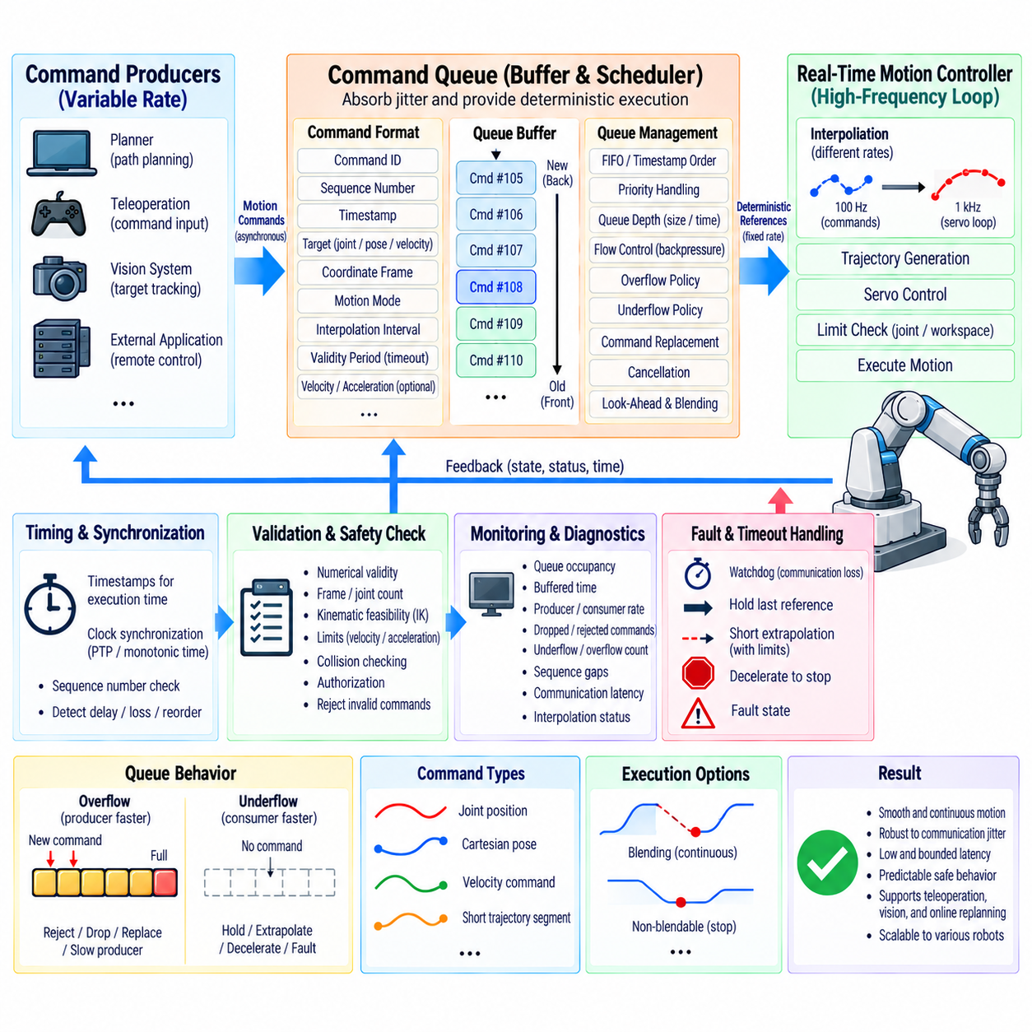
Real-time motion streaming allows a robot controller to receive continuously updated motion references rather than executing only complete trajectories prepared in advance. Commands may contain joint positions, Cartesian poses, velocities, accelerations, or short trajectory segments. Queue management provides the buffering and scheduling required to convert this asynchronous command stream into deterministic references for the real-time control loop.
The architecture normally separates the command producer from the real-time consumer. A planner, teleoperation interface, vision system, or external application generates motion commands at its own update rate, while the servo controller executes at a fixed high-frequency cycle. A bounded command queue between these components absorbs timing variation without allowing communication jitter to directly disturb actuator control.
Each streaming command should contain sufficient information for deterministic interpretation. Typical fields include command identifier, sequence number, timestamp, target state, coordinate frame, motion mode, interpolation interval, validity period, and optional velocity or acceleration information. Explicit metadata allows the receiver to detect delayed, duplicated, reordered, expired, or incompatible commands before they reach the trajectory execution stage.
A queue can be implemented as a first-in-first-out buffer when every command must preserve arrival order. More advanced systems may use timestamp ordering, priority classes, or separate queues for different command categories. Regardless of implementation, ordering semantics must be defined precisely so that the same input stream produces predictable execution and old commands cannot unexpectedly overwrite newer robot intentions.
Queue depth represents a fundamental tradeoff between robustness and latency. A deeper queue can tolerate larger communication jitter or temporary delays because several future references are already available. However, excessive buffering increases the time between command generation and physical execution. Teleoperation and reactive control usually favor low latency, while remotely generated trajectories may benefit from a larger look-ahead buffer.
The queue should therefore be sized using command frequency, expected jitter, network delay, computation time, and required reaction time. Buffer duration is often more meaningful than the number of entries because command rates can vary between applications. Monitoring both queue occupancy and estimated buffered execution time gives the controller a clearer indication of how much future motion is currently available.
A producer-consumer model provides a useful abstraction. The producer inserts commands into the queue while the real-time consumer removes references at deterministic intervals. These operations should avoid unpredictable blocking inside the servo thread. Lock-free queues, ring buffers, preallocated memory, or carefully bounded synchronization mechanisms are commonly used to reduce scheduling uncertainty and dynamic memory activity.
Memory allocation should generally be minimized during real-time execution. Repeated heap allocation, object construction, or container resizing can introduce nondeterministic delays. A fixed-capacity ring buffer allows command storage to be allocated during initialization and reused throughout operation. When the capacity is reached, the overflow policy must already be defined rather than relying on uncontrolled memory expansion.
Queue overflow occurs when commands arrive faster than they can be consumed. Possible responses include rejecting new commands, dropping selected obsolete commands, replacing future references, slowing the producer, or entering a controlled hold state. The appropriate policy depends on command semantics. Silently discarding arbitrary trajectory points can create discontinuities and should not be treated as a general solution.
Queue underflow occurs when the real-time consumer requires a new reference but none is available. This can result from network interruption, planner delay, computation overload, or producer failure. The controller should never respond by consuming uninitialized data. Instead, it should apply a predefined behavior such as holding the last valid reference, extrapolating briefly within limits, decelerating to a stop, or entering a fault state.
Holding the last reference can be appropriate for position commands when the robot can safely remain at the current target. It is less appropriate for streaming velocity commands because maintaining the last velocity after communication loss may continue robot motion indefinitely. Command type must therefore influence the underflow policy, with velocity or force-related streaming typically requiring explicit watchdog and timeout behavior.
A watchdog monitors whether valid commands continue arriving within the required interval. The watchdog should use a monotonic time source so that system-clock corrections do not corrupt timeout calculations. If the stream becomes stale, the controller can first stop accepting extrapolated motion and then initiate a controlled deceleration according to the configured communication-loss response.
Timestamps allow commands to be associated with intended execution times rather than simple arrival times. This is particularly important when commands travel across networks or originate from multiple computing nodes. The controller can buffer references and release them according to synchronized time, reducing the influence of variable packet arrival delay while maintaining a consistent temporal relationship between trajectory points.
Clock synchronization becomes important when timestamps originate outside the real-time controller. Precision Time Protocol, synchronized monotonic clocks, or another bounded synchronization mechanism can establish a common time reference. The required accuracy depends on command period and motion dynamics. Timestamp synchronization should be monitored because a clock offset can appear to the controller as trajectory delay or premature execution.
Sequence numbers complement timestamps by detecting missing or reordered commands. If the receiver expects sequence 125 but receives 127, it can recognize that at least one command was lost even if timestamps appear plausible. The response can depend on whether the missing information is recoverable through interpolation or whether trajectory integrity requires the stream to be rejected and safely stopped.
Streaming references often require interpolation because the producer and servo controller operate at different frequencies. A planner may send commands at 100 Hz while a servo loop runs at 1 kHz. The motion layer can interpolate between buffered samples to produce references at every servo cycle. Position, velocity, acceleration, and orientation interpolation should preserve the continuity required by the downstream controller.
Interpolation should not be confused with unrestricted prediction. Interpolation operates between known buffered samples, while extrapolation estimates motion beyond the newest available command. Short bounded extrapolation may improve tolerance to minor communication jitter, but long extrapolation can move the robot according to increasingly uncertain intent. Maximum extrapolation duration and dynamic limits should therefore be explicitly constrained.
Look-ahead processing allows future commands to be inspected before execution. The controller can evaluate velocity, acceleration, jerk, joint limits, workspace limits, collision risk, or discontinuities between adjacent samples. Invalid commands can then be rejected before they become active. Look-ahead also supports blending and smoother transitions because the controller knows the direction of upcoming motion.
Incoming commands should pass through a validation stage before entering the executable queue. Validation can check numerical validity, coordinate frame, joint count, timestamp range, sequence consistency, motion mode, limits, and authorization. Cartesian commands may additionally require inverse-kinematics and workspace checks. Separating reception from validation prevents malformed network data from becoming real-time control references.
Command replacement is useful for reactive planning. A perception system may generate a new trajectory because an obstacle appears or a target moves. Replacing queued motion must define exactly which commands remain valid. Common strategies retain the currently executing segment and replace only future segments, or generate a transition from the current predicted state into the newly supplied trajectory to preserve continuity.
Cancellation similarly requires deterministic semantics. A cancel request can identify one command, a sequence, or all queued motion. Removing future commands is straightforward, but canceling the active command requires a controlled transition. The motion layer should capture the current reference state and generate an appropriate deceleration or replacement trajectory instead of abruptly deleting the reference currently driving the robot.
Priority handling may be required when multiple producers submit commands. Normal trajectory updates, operator requests, recovery actions, and supervisory commands can have different precedence. Priority should not permit arbitrary discontinuous takeover of actuator references. A higher-priority request should acquire motion ownership through a defined arbitration and transition mechanism before its trajectory becomes active.
Flow control prevents a fast producer from continuously overflowing the receiver. The controller can expose queue capacity, accepted sequence number, buffered duration, or recommended transmission rate to the producer. Backpressure allows upstream software to regulate command generation according to actual consumption rather than assuming that every transmitted packet can be stored and executed immediately.
Distributed streaming also requires careful network behavior. Reliable transports can retransmit lost data but may increase latency when old packets block newer information. Low-latency transports can deliver recent data quickly but may lose or reorder packets. Motion protocols should therefore define freshness, sequence, timeout, and recovery behavior independently of assumptions about the underlying communication transport.
Real-time execution should isolate network communication from the servo loop. A communication thread receives and validates messages, a queue transfers accepted references, and the deterministic control thread consumes prepared data. This separation prevents packet parsing, operating-system scheduling, network retransmission, or serialization overhead from directly delaying high-frequency actuator control.
Monitoring should expose queue health as part of robot diagnostics. Useful values include queue occupancy, buffered duration, producer rate, consumer rate, oldest and newest timestamps, dropped commands, rejected commands, underflow count, overflow count, sequence gaps, communication latency, and interpolation status. Trends in these metrics can reveal problems before they become visible as motion instability.
Logging should preserve enough information to reconstruct streaming behavior. Command identifiers, sequence numbers, source timestamps, receive timestamps, execution timestamps, queue depth, validation results, and controller states can be correlated with measured robot motion. This makes it possible to distinguish trajectory-generation errors from network delay, queue-management problems, or servo tracking limitations.
Testing should intentionally introduce jitter, packet loss, duplication, reordering, delayed commands, burst traffic, producer stalls, clock offsets, queue overflow, and queue underflow. Verification should confirm that motion remains continuous where expected and that unsafe or stale streams lead to the defined hold, deceleration, cancellation, or fault behavior without unbounded execution latency.
A robust real-time streaming architecture therefore treats the command queue as an active control boundary rather than a simple message container. Timestamp management, bounded buffering, interpolation, validation, flow control, watchdogs, ownership, and deterministic failure handling collectively protect the servo loop from asynchronous computation and communication behavior.
When these mechanisms are integrated correctly, high-level planners and external systems can continuously modify robot motion while the low-level controller retains deterministic execution. The result is a scalable interface for teleoperation, visual servoing, autonomous navigation, manipulation, coordinated robotics, and online replanning that combines responsiveness with continuity, bounded latency, and predictable safe behavior.

05.08 Motion Control SW HIL Test Automation
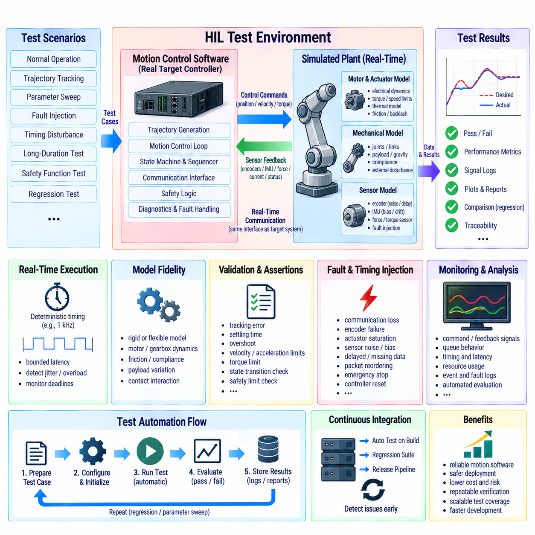
Hardware-in-the-loop (HIL) testing provides a controlled environment for validating motion-control software against realistic hardware interfaces without requiring the complete physical robot for every test. The motion controller executes its actual software while simulated motors, sensors, mechanical dynamics, loads, and environmental conditions provide the surrounding system behavior. This allows control algorithms, communication interfaces, fault handling, and timing behavior to be evaluated before full-system deployment.
A typical HIL architecture places the motion-control software on the target controller or an equivalent embedded computer while a real-time simulation platform models the plant. The plant model can represent motors, gearboxes, joints, links, payloads, friction, gravity, backlash, compliance, and external disturbances. Sensor models generate encoder, IMU, force, current, and other feedback signals, while actuator models receive the actual control outputs generated by the motion software.
The central advantage of HIL testing is that the software interacts with simulated hardware through interfaces that closely resemble the final system. Position commands, velocity commands, torque requests, sensor measurements, timestamps, diagnostic signals, and safety states can therefore pass through the same communication paths used during physical operation. This exposes integration problems that purely mathematical simulation may not reveal while avoiding the cost and risk of repeatedly operating the complete robot.
Real-time execution is essential because the simulated plant must respond within the timing constraints expected by the controller. If the motion-control loop operates at 1 kHz, the HIL environment must provide corresponding plant and sensor updates with sufficiently bounded latency. Computational overload, scheduling jitter, delayed sensor data, or missed simulation deadlines should be detected explicitly because timing behavior can be as important as numerical control accuracy.
The plant model should provide an appropriate balance between physical fidelity and real-time computational cost. A simple rigid-body model may be sufficient for basic trajectory and controller verification, while high-performance applications may require motor electrical dynamics, gearbox elasticity, joint friction, structural compliance, payload variation, and contact interaction. Model complexity should be increased when test objectives require it rather than reproducing every physical phenomenon unnecessarily.
Motor and actuator models are particularly important because the controller normally assumes a relationship between its commands and resulting mechanical motion. The HIL model can represent torque constants, current limits, voltage saturation, speed limits, thermal constraints, inertia, friction, transmission ratios, and actuator delays. Fault conditions such as saturation, encoder failure, excessive current, stalled motion, or reduced actuator capability can then be introduced systematically.
Sensor simulation should reproduce both nominal measurements and realistic imperfections. Encoder quantization, bias, noise, delay, sampling-rate differences, dropped samples, saturation, and intermittent faults can be injected into the feedback path. For inertial sensors, the model can include bias drift, noise, axis misalignment, vibration, and dynamic acceleration. This enables the motion software to be evaluated under conditions that are difficult to reproduce consistently with physical hardware.
Automated test scenarios can be defined as executable test cases containing initial robot state, target commands, payload parameters, environmental conditions, expected responses, timing limits, and pass or fail criteria. The test runner initializes the simulation, loads the required configuration, starts the target controller, injects the command sequence, records relevant signals, and evaluates the results automatically. This transforms HIL from an interactive debugging tool into a repeatable verification platform.
Assertions should evaluate both final results and dynamic behavior during execution. A trajectory may reach its final target while violating velocity, acceleration, torque, tracking-error, or safety limits along the way. Automated assertions can therefore monitor maximum position error, settling time, overshoot, control effort, jerk, actuator saturation, queue behavior, state transitions, collision responses, and fault-recovery timing. Continuous criteria provide much stronger verification than checking only the final position.
Regression testing becomes especially valuable as motion-control software evolves. Every change to trajectory generation, interpolation, controller gains, sequencing, communication, collision detection, or fault handling can potentially affect existing behavior. A stored HIL test suite can automatically execute previously validated scenarios and compare current results against defined acceptance limits. Changes that produce unexpected deviations can then be identified before integration with physical robots.
Parameter-sweep testing extends regression testing by evaluating many operating conditions automatically. The same motion sequence can be executed with different payload masses, joint configurations, friction coefficients, command velocities, acceleration limits, communication delays, and sensor noise levels. Instead of testing only one nominal operating point, the automation framework can characterize the region in which the controller remains stable and compliant with its specified performance requirements.
Fault injection is a major capability of automated HIL testing. Communication loss, encoder dropout, actuator saturation, excessive tracking error, stale commands, queue underflow, sensor bias, emergency-stop requests, collision signals, and controller resets can be introduced at controlled times. The expected response can then be verified against the defined safety and recovery architecture. Because the fault is repeatable, the same condition can be tested across multiple software versions.
Timing faults should also be treated as explicit test conditions. A controller may behave correctly with accurate sensor data but become unstable when measurements arrive late or when the control loop experiences excessive jitter. HIL automation can introduce controlled delays, timestamp offsets, packet reordering, computation load, and missed cycles. The resulting behavior can be compared with defined latency budgets and timeout policies to verify that the system fails in a predictable manner.
The HIL framework should maintain a synchronized signal-acquisition system. Commanded positions, measured positions, velocities, accelerations, torques, currents, sensor values, controller states, sequence identifiers, timestamps, and fault events should be recorded using a common or traceable time base. Synchronization allows engineers to correlate a control response with the exact simulated physical event that caused it, which is essential when investigating transient failures.
Automated pass and fail evaluation should use quantitative acceptance criteria. Examples include maximum tracking error, final position tolerance, settling time, maximum actuator torque, velocity limit compliance, absence of unexpected state transitions, correct fault detection latency, and safe-stop distance. Criteria should be derived from system requirements rather than arbitrary values. Where a requirement defines a range, the automation system should report both the measured result and the applicable limit.
Test results should be stored as structured artifacts rather than only screenshots or manually written observations. Each result can contain software version, controller configuration, plant-model version, test identifier, input parameters, environmental conditions, execution timestamps, pass or fail status, and diagnostic summaries. This creates traceability between a software build and the exact HIL evidence used to validate it.
Continuous integration can connect HIL automation with the software development workflow. When a new motion-control build is generated, selected HIL tests can execute automatically before the software is accepted for further integration. Fast tests can run on every change, while longer dynamic, fault-injection, and parameter-sweep tests can run on scheduled or release-oriented pipelines. This allows verification to become part of the normal development process rather than a final manual activity.
Not every HIL test needs the same execution frequency. Smoke tests can verify basic controller startup, command acceptance, state transitions, and simple motion within a short execution time. More comprehensive suites can evaluate trajectory continuity, multiple operating points, fault recovery, collision response, and long-duration stability. Organizing tests into levels helps control computational cost while maintaining broad automated coverage.
Long-duration testing is useful for identifying problems that do not appear during short trajectories. Memory growth, queue accumulation, numerical drift, timing degradation, repeated state transitions, and gradual estimator errors may become visible only after thousands or millions of control cycles. Automated endurance tests can execute repetitive motion patterns and monitor resource usage, timing statistics, numerical states, and controller health throughout the run.
Coverage should be considered at several levels. Software coverage evaluates which implementation paths have executed, while functional coverage evaluates whether important motion behaviors and requirements have been exercised. State-machine coverage can verify that every relevant state and transition has been tested, while fault coverage evaluates whether defined failure modes have produced the expected responses. Combining these measures provides stronger evidence than relying on source-code coverage alone.
HIL automation should also support reproducibility. Random disturbances can be useful for robustness testing, but each test should retain the random seed and configuration required to reproduce a failure. Deterministic initialization, fixed model versions, controlled timing, and recorded input parameters allow an intermittent failure to be converted into a repeatable debugging case. Reproducibility is particularly important for diagnosing rare timing and numerical problems.
The HIL environment should distinguish model faults from software faults. An intentionally injected sensor failure should be marked differently from an unexpected numerical exception in the controller. Test infrastructure must therefore record both the events it intentionally introduced and the responses generated by the target software. This separation prevents a correctly handled injected fault from being incorrectly classified as a controller failure.
Safety-related behavior requires additional attention because HIL testing alone does not replace certification or physical validation of safety mechanisms. HIL can verify logical responses such as protective-stop requests, watchdog activation, fault-state transitions, and command inhibition. However, hardware safety paths, actual braking performance, Safe Torque Off behavior, mechanical stopping characteristics, and other physical properties must ultimately be validated on the intended hardware according to the applicable safety process.
The final purpose of automated HIL testing is to establish a repeatable bridge between software development and physical robot validation. By combining realistic plant simulation, actual control software, deterministic timing, automated scenarios, fault injection, quantitative assertions, regression testing, and traceable results, the system can detect many motion-control problems before they reach expensive hardware trials. HIL therefore becomes an important verification layer for reliable and maintainable robot motion software.

05.09 Motion Control Diagnostics and Logging [w/Code]
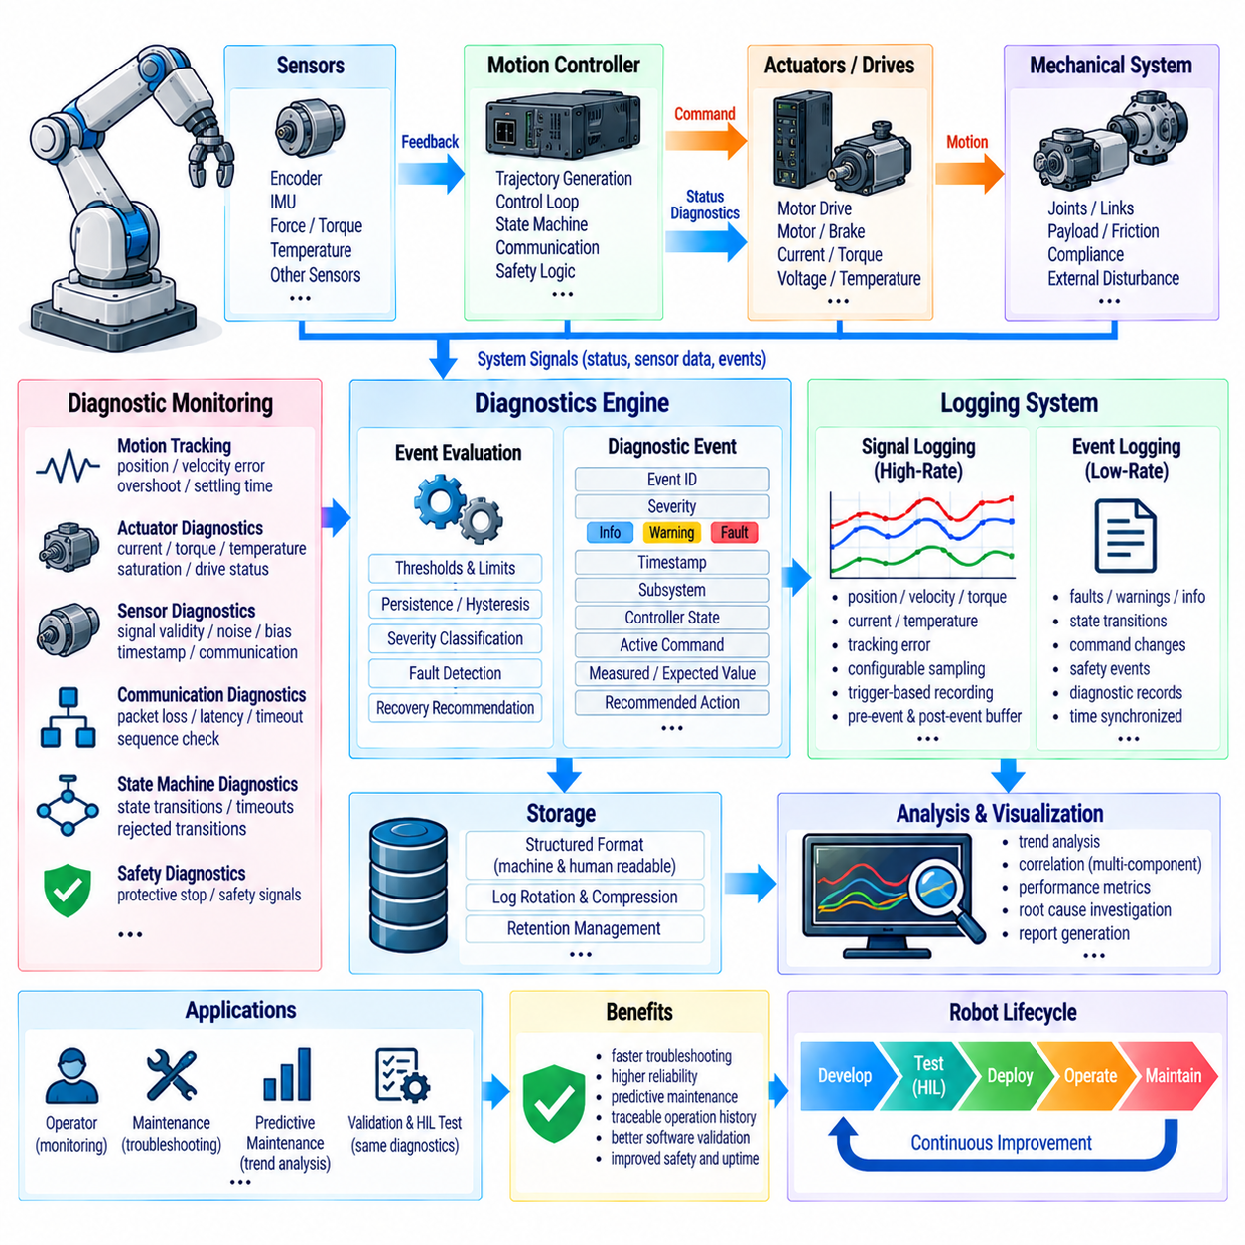
Motion-control diagnostics and logging provide the observability layer required to understand how a robot control system behaves during normal operation, degraded operation, and failure conditions. Diagnostics identify abnormal states, classify their severity, and provide information for corrective action, while logging preserves the time-ordered evidence required for analysis. Together, they connect controller behavior, robot motion, sensor feedback, actuator status, and software events into a traceable operational record.
A diagnostic architecture should operate across multiple levels of the motion-control stack. Low-level diagnostics can monitor motor current, encoder feedback, temperature, communication status, and servo errors. The motion-control layer can evaluate trajectory tracking, controller saturation, kinematic validity, and state-machine conditions. Higher-level diagnostics can interpret these signals as motion faults, subsystem faults, or system-level conditions and provide a consistent status to supervisory software.
Diagnostic information should distinguish normal status from warnings and faults. A normal status indicates that the controller is operating within expected conditions, while a warning identifies a condition that may require attention but does not yet prevent operation. A fault indicates that continued operation is unsafe, invalid, or technically unreliable. Severity levels should be explicitly defined so that software and operators can respond consistently instead of interpreting arbitrary diagnostic messages differently.
Each diagnostic event should contain sufficient context to explain what occurred. Typical information includes a diagnostic identifier, severity, subsystem, timestamp, controller state, active motion command, measured state, expected state, relevant sensor values, and recovery recommendation. The event should also indicate whether the condition is active, cleared, acknowledged, or latched. Structured diagnostic records are more useful for automated analysis than free-form text messages alone.
Real-time diagnostics must be designed so that monitoring does not interfere with the control loop. High-frequency control calculations should remain deterministic, while diagnostic processing that does not require servo-cycle execution can operate in a lower-priority task. Critical limits may be evaluated directly inside the real-time loop, but detailed formatting, storage, and transmission should normally be separated from time-critical control operations.
Motion tracking diagnostics are particularly important because a controller can remain numerically active while the physical robot fails to follow the intended trajectory. Position error, velocity error, acceleration deviation, following error, settling time, overshoot, and oscillation can be monitored continuously. Persistent or rapidly increasing errors can indicate actuator limitations, incorrect gains, mechanical resistance, communication delay, or an invalid trajectory.
Actuator diagnostics provide information about the physical drive system. Motor current, estimated torque, command saturation, temperature, voltage, encoder state, brake status, and drive communication can be monitored. A persistent difference between commanded and achieved actuator behavior may indicate mechanical loading, friction changes, transmission problems, sensor faults, or drive degradation. These signals should be correlated with motion state before a final fault classification is made.
Sensor diagnostics verify that feedback used by the controller remains trustworthy. Encoder continuity, sensor range, update rate, timestamp freshness, bias, noise level, and communication integrity can be checked continuously. A sensor that remains within its numerical range may still be invalid if its timestamp is stale or its value does not respond to expected motion. Diagnostic logic should therefore evaluate both signal validity and behavioral consistency.
Communication diagnostics are increasingly important in distributed robot architectures. Motion controllers may exchange data with motor drives, sensor nodes, perception computers, planning systems, safety controllers, and fleet-management software. Packet loss, sequence gaps, communication latency, timeout events, synchronization errors, and unexpected message rates should be monitored. Communication failures should be associated with defined fallback behavior rather than being treated as generic software errors.
State-machine diagnostics provide visibility into the operational logic of the motion controller. The system should record state transitions, transition causes, rejected transitions, unexpected states, timeout events, and recovery actions. This is especially useful when a robot appears to stop without an obvious hardware fault. The diagnostic history can reveal whether the controller intentionally entered a hold, protective stop, recovery, or fault state because a required condition was not satisfied.
Diagnostic thresholds should be carefully designed to avoid both excessive false alarms and delayed fault detection. A single transient measurement spike may not justify a fault, while a slowly increasing deviation may indicate an emerging mechanical problem. Persistence timers, hysteresis, rate-of-change limits, and operating-mode-dependent thresholds can improve diagnostic quality. However, threshold adaptation should remain bounded and traceable so that important protection limits cannot silently weaken.
Event logging should use a consistent time base across the motion-control system. Command timestamps, sensor timestamps, controller timestamps, actuator responses, and diagnostic events should be synchronized or at least traceably related. Accurate timing makes it possible to determine whether a fault was caused by a sensor event, delayed command, controller response, mechanical reaction, or communication problem. Monotonic timing should be used for duration measurements and timeout calculations.
A useful logging system separates high-rate signal recording from event logging. Continuous signals such as position, velocity, torque, current, and tracking error may require substantial storage and can be sampled according to the analysis objective. Discrete events such as faults, state transitions, command changes, and safety actions should be recorded with precise timestamps and contextual information. Keeping these two categories separate allows detailed analysis without unnecessarily increasing storage requirements.
Trigger-based logging can capture high-resolution information around important events without continuously storing every high-frequency signal at maximum resolution. The system can maintain a rolling pre-event buffer and preserve it when a fault or significant diagnostic condition occurs, together with a post-event recording period. This provides information about what happened immediately before and after the event, which is often more useful than a large undifferentiated log.
Diagnostic logging should also support correlation across multiple software components. A single motion event may involve the planner, sequencer, trajectory generator, controller, actuator driver, communication layer, collision monitor, and safety supervisor. Common command identifiers, sequence numbers, timestamps, and correlation identifiers allow records from these components to be associated with the same physical operation. This is particularly important for distributed or multi-controller robot architectures.
Log storage should be structured to support both human investigation and automated processing. Machine-readable formats can contain timestamps, identifiers, numerical values, states, severity levels, and diagnostic codes, while human-readable summaries can provide concise descriptions of significant events. Log rotation, compression, retention periods, and storage limits should be defined so that long-duration operation does not exhaust available storage or unexpectedly remove important evidence.
Diagnostics should support fault lifecycle management rather than only fault detection. A fault can progress through detected, confirmed, active, acknowledged, cleared, and recovered states. Some faults should remain latched until an explicit reset, while others can clear automatically when the abnormal condition disappears. The lifecycle rules should be deterministic so that the same physical condition produces consistent software behavior across repeated operations.
Recovery information is an important part of diagnostic design. When a fault occurs, the system should indicate whether the motion can continue, whether a controlled stop is required, whether the current command must be canceled, or whether operator intervention is necessary. Recovery actions should be linked to the fault classification rather than implemented as generic responses. This prevents minor warnings from unnecessarily stopping the robot while ensuring serious conditions receive an appropriate response.
Diagnostic data can also support predictive maintenance when collected over long operating periods. Trends in motor temperature, current, tracking error, vibration, communication errors, and settling time may reveal gradual degradation before a hard failure occurs. Statistical analysis can identify changes from established operating baselines, while maintenance systems can associate these trends with operating hours, payload conditions, motion patterns, and specific hardware components.
Automated diagnostic evaluation can continuously compare measured behavior against configured limits and expected operating envelopes. The system can calculate maximum tracking error, average error, settling time, actuator utilization, fault frequency, communication latency, queue health, and controller execution time. These metrics provide objective evidence for software validation, commissioning, maintenance, and performance improvement rather than relying only on subjective operator observations.
Logging and diagnostics should be integrated with simulation and HIL testing. The same diagnostic identifiers, event structures, timestamps, and severity definitions used during physical operation should be available in automated test environments. This allows injected faults and abnormal conditions to produce records comparable to those generated by real hardware. Test automation can then verify not only the physical control response but also whether the correct diagnostic event was generated and cleared.
Security and access control may also be relevant when diagnostic data is transmitted over networks. Diagnostic interfaces should prevent unauthorized modification of controller parameters, fault states, or stored evidence. Read-only monitoring, engineering access, and service-level control can be separated according to system requirements. Important diagnostic records should preserve their integrity so that later analysis can distinguish original operational evidence from manually modified information.
A robust motion-control diagnostic and logging architecture therefore provides continuous visibility into controller state, motion quality, actuator health, sensor integrity, communication behavior, safety responses, and software execution. Diagnostics determine what is happening and how serious the condition is, while logging preserves the evidence required to understand why it happened. When these capabilities are designed together, robot motion software becomes easier to validate, debug, maintain, and improve throughout its operational lifecycle.

05.10 Multi-Robot Synchronized Motion Control Case
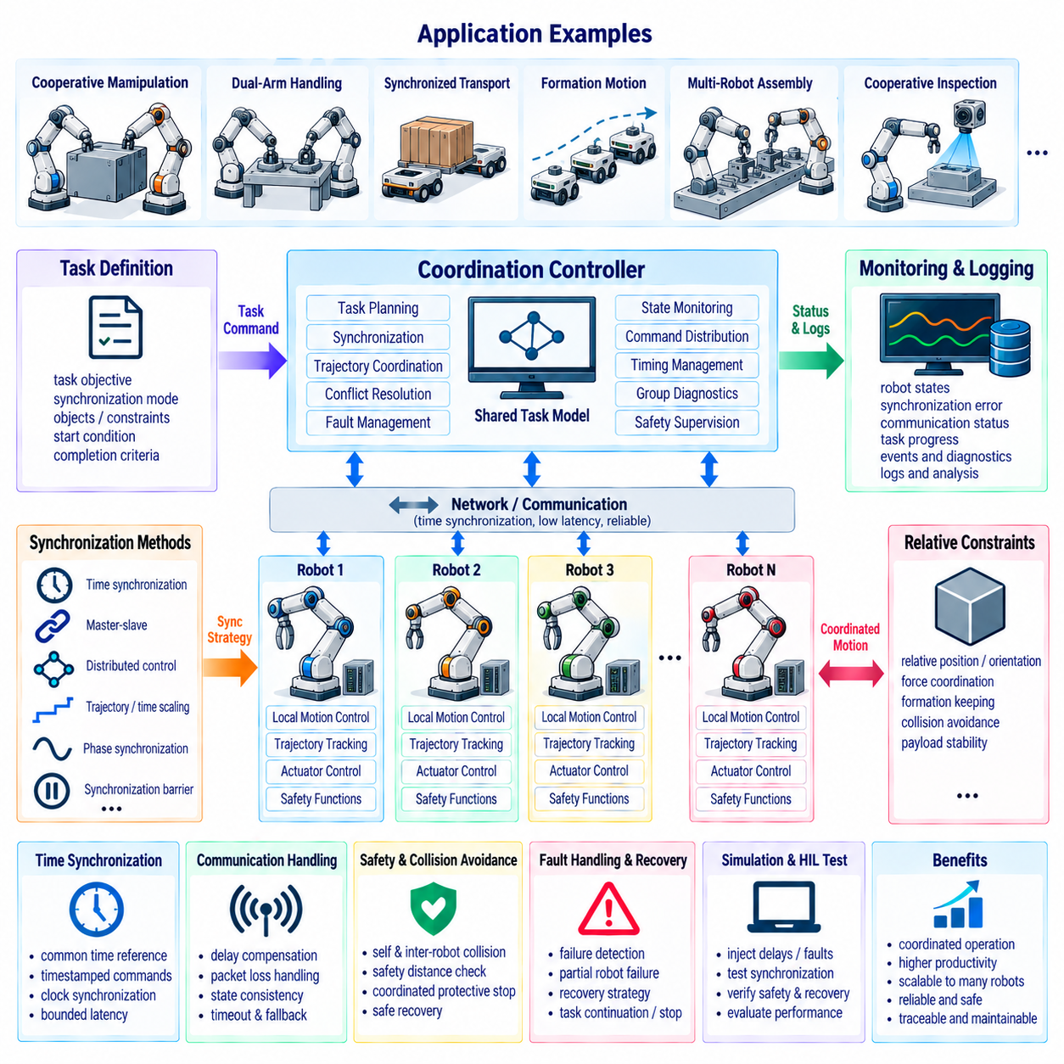
Multi-robot synchronized motion control coordinates the movement of multiple robots so that their individual actions satisfy a shared temporal, spatial, and task-level objective. Each robot may have its own controller, trajectory generator, sensors, and communication interface, but coordinated operation requires them to behave as one distributed motion system. Typical applications include cooperative manipulation, dual-arm handling, mobile manipulation, synchronized transport, formation motion, and multi-robot assembly.
The fundamental architecture separates local motion control from coordination control. Each robot retains a local real-time controller responsible for its own actuator dynamics, trajectory tracking, limits, and safety functions. A coordination layer exchanges state information and generates shared references, synchronization conditions, or task constraints. This separation allows individual robots to maintain deterministic local control while the coordination layer manages relationships between robots.
Synchronization can be defined in several ways depending on the task. Robots may need to reach their targets at the same time, maintain a fixed relative pose, follow a common velocity profile, preserve a geometric formation, or coordinate forces applied to a shared object. The synchronization objective should therefore be expressed explicitly rather than assuming that identical command timing automatically produces coordinated physical behavior.
A common method is master-slave synchronization, in which one robot or controller provides the primary motion reference and other robots follow it with defined offsets. This structure is relatively simple and can work well when one robot naturally determines the task progression. However, the master can become a single point of dependency, so communication loss, master failure, and transition to another coordination mode should be considered in the system architecture.
A distributed synchronization architecture allows every robot to exchange state information with neighboring robots and calculate its own coordinated command. Relative position, velocity, acceleration, orientation, and task progress can be compared continuously. Distributed control can improve scalability and fault tolerance, but it requires carefully defined communication timing, state consistency, ownership rules, and convergence behavior to prevent individual robots from making incompatible decisions.
For cooperative manipulation, synchronization is often defined in object space rather than only in individual joint space. Two or more robots may grasp the same payload and jointly move it along a Cartesian trajectory. Each robot converts the shared object motion into its own joint trajectory according to its kinematic configuration. The coordination system must ensure that the resulting individual motions remain compatible with the object's desired position, orientation, and dynamic constraints.
Relative motion constraints are important when robots carry or manipulate a common object. The relative transformation between end effectors should remain within specified position and orientation tolerances. If one robot moves faster than another, the resulting relative error can generate unwanted forces on the payload. Therefore, synchronization monitoring should evaluate both absolute trajectory error and relative error between participating robots.
Time synchronization is equally important. Distributed robots may generate commands on separate computing nodes with different clocks and communication delays. A common time reference allows trajectory samples and state measurements to be interpreted consistently. Timestamped commands, synchronized clocks, and bounded communication latency help ensure that a robot does not respond to information that represents an outdated state of another robot.
Communication delay must be treated as part of the control problem rather than simply as a networking issue. If one robot receives another robot's state late, direct feedback using that information may produce phase lag or unstable coordination. Prediction, buffered trajectories, time-stamped state estimates, or bounded synchronization windows can compensate for moderate delay. The system should also define safe behavior when communication quality falls outside the validated operating range.
A coordination cycle typically collects robot states, evaluates synchronization conditions, calculates coordinated references, and distributes updated commands. The update frequency does not necessarily have to equal the local servo frequency. A local controller may execute at a high deterministic rate while the coordination layer operates more slowly, provided that interpolation, prediction, buffering, and timeout behavior maintain smooth local execution between coordination updates.
Trajectory synchronization can use a common normalized progress variable. Instead of comparing only absolute time, each robot can report progress from zero to one through its assigned trajectory. The coordinator can then determine whether robots are ahead or behind the desired shared progress. This approach is useful when individual trajectories have different lengths or dynamic characteristics but must complete a common task phase together.
Time scaling provides another method for maintaining synchronization. Individual trajectories can be generated separately and then adjusted so that their execution durations match a common task duration. Velocity and acceleration limits must be considered when changing the time scale because simply increasing or decreasing execution speed can violate actuator constraints. Feasible time scaling therefore requires dynamic validation before synchronized execution begins.
Phase synchronization is useful for repetitive or continuous motion. Instead of requiring identical positions, robots maintain a defined phase relationship within a periodic motion pattern. This can support synchronized inspection, coordinated wheel or conveyor motion, repetitive manipulation, or formation movement. Phase error can be measured continuously and corrected through bounded adjustments to velocity or trajectory progress.
A synchronization barrier can coordinate discrete task stages. For example, several robots may move independently toward their assigned positions and then wait until all participants report readiness before starting a shared lifting operation. The barrier prevents one robot from entering the next phase prematurely. Timeouts and failure handling must be defined because one robot that never reaches the barrier should not leave the entire system waiting indefinitely.
Shared-object manipulation requires additional dynamic coordination. When multiple robots exert forces on the same payload, small trajectory differences can create internal forces even when the payload appears stationary. Force or torque sensing can therefore complement position synchronization. The controller can regulate relative force distribution while maintaining the desired object trajectory, subject to actuator, contact, and payload constraints.
Collision avoidance must operate at both individual and group levels. Each robot should perform local self-collision and environment collision checking, while the coordination layer evaluates potential collisions between robots. Predicted future positions can be compared using time-aware safety distances. If the predicted separation becomes insufficient, the system can reduce speed, modify trajectories, introduce waiting conditions, or initiate a coordinated protective stop.
A coordinated protective stop should consider the state of all participating robots. Stopping only one robot may create additional forces or collisions if the robots are physically coupled through a payload. The coordination system should therefore define whether all robots stop simultaneously, whether specific robots maintain support forces, or whether a controlled release sequence is required. Safety-rated functions must remain independent where required by the applicable safety architecture.
Robot ownership and command arbitration become important when multiple tasks compete for the same robot. A coordination controller may require temporary control authority over several robots while an operator interface or another autonomous task is also requesting motion. Explicit ownership, priority, reservation, and handover rules prevent two independent controllers from simultaneously generating incompatible commands.
A synchronized motion command should include more than a target position. It may contain a group identifier, robot identifier, synchronization mode, common start time, trajectory identifier, phase information, relative constraints, velocity and acceleration limits, and expiration time. These fields allow each robot to determine whether a command belongs to the current coordination session and whether it remains valid for execution.
The system should distinguish synchronization failure from ordinary motion error. A robot may accurately follow its own trajectory while still violating the group relationship because another robot has deviated. Diagnostic logic should therefore monitor local tracking error, relative position error, relative velocity, synchronization phase error, communication latency, and group-level task progress. This provides enough information to determine whether the problem originates locally or from coordination.
Recovery behavior should be predefined for partial robot failure. If one robot becomes unavailable, the remaining robots may need to stop, hold position, release a payload, retreat, or switch to a reduced-participant strategy. Automatic continuation should only occur when the task remains physically and logically valid. Recovery decisions should account for payload stability, contact conditions, remaining actuator capability, and the safety state of the complete group.
Simulation and HIL testing are particularly valuable for synchronized motion because many failures depend on timing relationships that are difficult to reproduce manually. Communication delays, packet loss, clock offsets, asynchronous updates, trajectory mismatch, actuator saturation, and robot dropout can be introduced systematically. The test system can then verify synchronization error, recovery timing, collision margins, and final task accuracy across many operating conditions.
Logging should preserve both individual and group-level information. Each robot should record its local state, commanded trajectory, measured motion, controller status, and diagnostic events, while the coordination layer records group commands, synchronization errors, communication timing, barrier states, and coordination decisions. Common timestamps, robot identifiers, sequence numbers, and group identifiers allow distributed records to be reconstructed as one physical event.
A robust multi-robot synchronization architecture therefore combines local deterministic control with coordinated trajectory management, common timing, communication monitoring, relative-state feedback, collision avoidance, task barriers, and defined recovery behavior. The objective is not to make every robot execute identical commands, but to ensure that independent robots maintain the spatial, temporal, and dynamic relationships required by the shared task.
When these principles are integrated, multi-robot systems can perform coordinated manipulation, synchronized transport, formation movement, cooperative inspection, and other complex operations while preserving local controller autonomy. Clear interfaces between coordination, motion control, diagnostics, communication, and safety functions make the system scalable from two cooperating robots to larger distributed robotic teams while maintaining predictable motion and traceable fault recovery.

