Volume 05 Robot Middleware and ROS2

09. ROS2 for AMR

09.01 AMR ROS2 Software Stack Configuration Overview
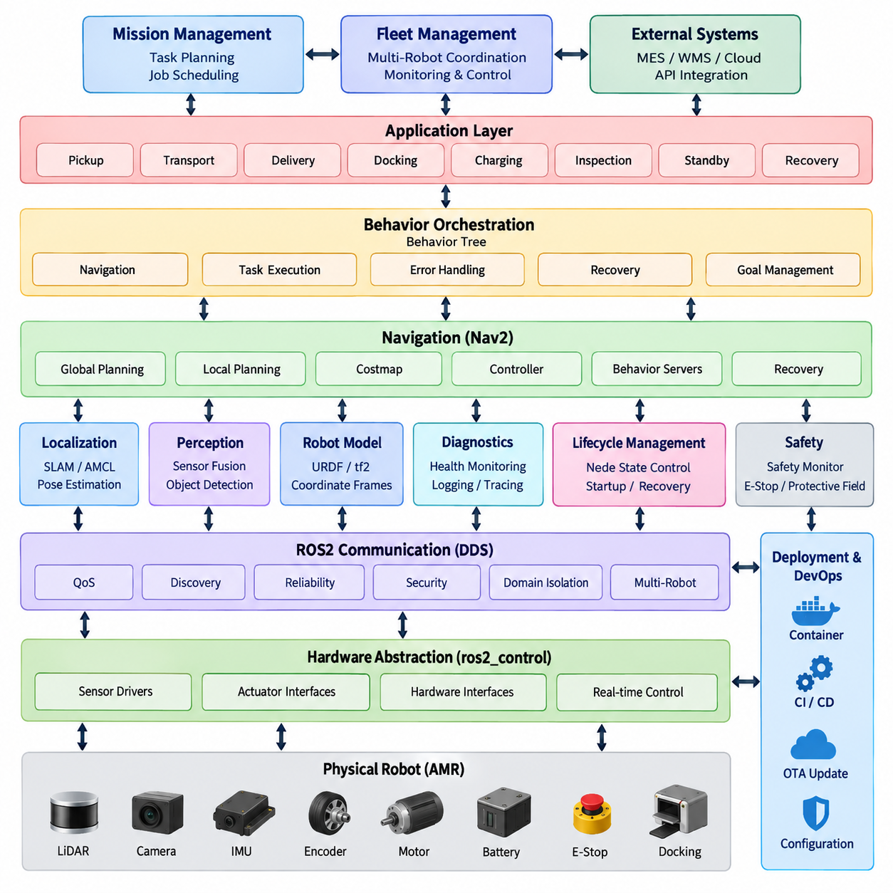
An Autonomous Mobile Robot (AMR) built on ROS2 is best organized as a layered software stack in which hardware access, sensing, localization, navigation, motion control, safety, diagnostics, and fleet interaction remain functionally separated while communicating through standardized ROS2 interfaces. This organization allows individual components to evolve independently and establishes a reusable platform for different AMR products.
At the lowest layer, the hardware abstraction and device interface components connect ROS2 to motors, encoders, brakes, batteries, LiDARs, cameras, IMUs, safety devices, and auxiliary I/O. Sensor drivers convert vendor-specific protocols into standard ROS2 messages, while drive interfaces expose velocity, wheel state, and actuator commands. ros2_control can provide a structured boundary between higher-level motion software and physical drivetrain hardware.
The robot model provides the common geometric reference required by the entire AMR stack. URDF or related descriptions define the chassis, wheels, sensors, coordinate frames, and physical relationships among components. tf2 then maintains transformations such as map, odom, base_link, laser, camera, and IMU frames. Correct frame conventions and timestamps are essential because localization, obstacle detection, planning, visualization, and control all depend on consistent spatial information.
The perception layer transforms raw sensor streams into information that can be consumed by localization and navigation. LiDAR scans, depth images, point clouds, wheel odometry, and inertial measurements may be filtered, synchronized, transformed, and fused before reaching higher-level components. ROS2 QoS policies should be selected according to the characteristics of each stream so that high-rate sensor traffic does not unnecessarily delay control or operational messages.
Localization determines the AMR pose relative to its operating environment. During map creation, SLAM software combines motion estimates and environmental observations to construct a persistent representation of the workspace. During normal operation, localization nodes estimate the robot pose against an existing map while odometry supplies continuous local motion information. The resulting map-to-odom-to-base_link relationship becomes a fundamental spatial backbone for autonomous navigation.
Navigation2, commonly referred to as Nav2, forms the principal autonomous navigation framework in a ROS2 AMR configuration. It combines global and local planning, costmaps, behavior execution, recovery mechanisms, controller interfaces, and lifecycle-managed servers. Rather than treating navigation as one monolithic algorithm, Nav2 organizes navigation as cooperating components whose plugins and parameters can be selected according to vehicle kinematics, environment structure, and operational requirements.
Global planning determines a feasible route from the current pose toward a mission goal using map and cost information, while local planning or trajectory control continuously converts that intent into executable motion. Local costmaps incorporate nearby obstacles and updated sensor observations, allowing the robot to react to dynamic conditions. Velocity commands eventually reach the drivetrain interface, closing the software path from mission request through navigation decision to physical AMR movement.
Behavior Trees provide an orchestration mechanism above individual Nav2 functions. A navigation mission can include path computation, path following, replanning, waiting, recovery, obstacle handling, and goal validation without embedding every operational decision inside a single controller. Higher-level AMR applications can extend this concept with mission states such as pickup, transport, delivery, docking, charging, inspection, standby, and fault recovery.
Lifecycle management is particularly important for production AMRs because software components cannot simply be assumed to start successfully at power-on. Sensor drivers, localization, navigation, control, and application nodes may have explicit dependencies and initialization conditions. ROS2 lifecycle nodes allow components to move through controlled configuration, activation, deactivation, cleanup, and shutdown states, enabling deterministic startup sequences and more systematic recovery from runtime failures.
Safety functions should remain architecturally distinct from ordinary autonomous navigation. Navigation software may avoid obstacles and optimize motion, but safety-rated functions can require independent scanners, controllers, emergency-stop circuits, protective fields, or certified communication paths. ROS2 can distribute safety status and coordinate safe operational responses, while the final safety authority should remain consistent with the hardware architecture and applicable functional-safety requirements.
Diagnostics and observability form another cross-cutting layer of the AMR stack. Nodes should expose health information for sensors, localization quality, navigation status, controller state, battery condition, communication quality, CPU and memory utilization, temperature, and software faults. Logging, ros2_diagnostics, tracing, metrics collection, and operational dashboards allow engineers to distinguish algorithmic failures from hardware, timing, networking, or configuration problems.
A production AMR also requires interfaces beyond the autonomous navigation stack. Docking software coordinates localization, alignment, charger communication, and final low-speed motion. Mission-management components translate warehouse or facility tasks into robot behaviors, while fleet interfaces exchange robot state, task status, traffic information, and commands with external management systems. Multi-robot deployments additionally require disciplined namespaces, domain configuration, and communication policies.
DDS provides the distributed communication foundation beneath ROS2 and makes communication configuration part of AMR system architecture rather than merely a networking detail. Reliability, durability, history depth, deadlines, discovery behavior, multicast configuration, and domain isolation influence how sensor, command, status, and fleet information moves through the robot. Appropriate QoS profiles should therefore be defined according to the semantic and timing requirements of each data path.
The complete stack should also separate time-critical control from computationally intensive autonomy. Motor regulation and safety-critical loops may execute in dedicated controllers, MCUs, or real-time environments, while ROS2 handles supervisory control, navigation, perception, mission execution, and system coordination. PREEMPT_RT, executor configuration, memory management, callback-group design, and carefully controlled communication can improve determinism where ROS2 participates in latency-sensitive processing.
Deployment configuration converts these software components into an operational robot product. Launch files, parameter sets, lifecycle orchestration, containers, environment variables, device permissions, network configuration, security policies, and hardware-specific profiles should be version controlled together. CI/CD and OTA mechanisms can then reproduce validated configurations across development robots and production fleets while retaining rollback capability when a new software release produces unexpected behavior.
An AMR ROS2 stack should therefore be understood as an integrated runtime architecture rather than simply a collection of ROS2 packages. Hardware interfaces provide physical connectivity; perception interprets sensors; localization establishes robot pose; Nav2 produces autonomous movement; lifecycle and diagnostics maintain operational integrity; safety constrains behavior; and mission and fleet layers connect individual robots to larger logistics or service processes. This layered organization is consistent with the broader robotics software structure in which middleware, navigation, fleet intelligence, perception, control, and deployment remain coordinated but modular concerns.

09.02 Navigation2 (Nav2) Architecture Deep Dive [w/Code]
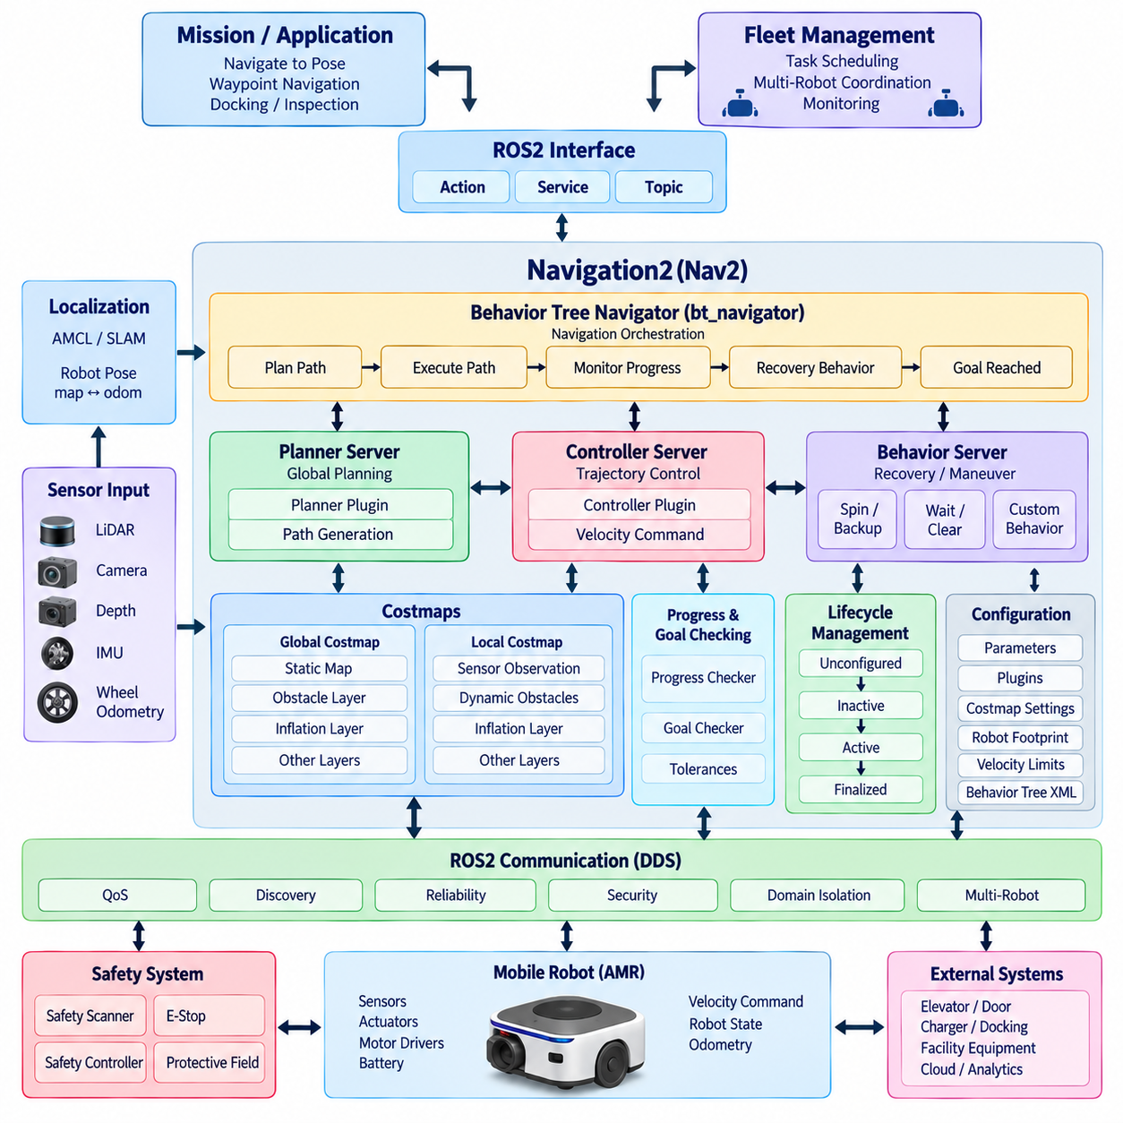
Navigation2, commonly called Nav2, is the ROS2 navigation framework that coordinates localization, environmental representation, path planning, trajectory control, behavior execution, and recovery for autonomous mobile robots. Rather than implementing navigation as a single process, Nav2 distributes these responsibilities among lifecycle-managed servers connected through ROS2 topics, services, and actions. This modular structure allows navigation functions to be configured or replaced without redesigning the complete AMR software stack.
The central architectural principle of Nav2 is server-oriented decomposition. Major capabilities such as planning, control, behaviors, waypoint execution, and navigation orchestration operate as independent ROS2 components. Each server exposes well-defined interfaces and typically supports dynamically loadable plugins. Consequently, an AMR developer can select algorithms according to vehicle kinematics, sensor configuration, operating environment, computational resources, and required navigation performance while preserving the surrounding system architecture.
The Behavior Tree Navigator, commonly implemented through the bt_navigator component, coordinates the overall navigation process. A navigation request such as NavigateToPose is translated into a sequence of operations that may compute a path, execute that path, monitor progress, detect failures, invoke recovery behaviors, and retry navigation. Behavior Trees separate mission-level navigation logic from individual planning and control algorithms, making complex navigation workflows easier to modify and inspect.
The Planner Server provides global path-planning functionality. It receives the robot pose, destination, map information, and global costmap context and invokes a configured planner plugin to generate a collision-aware path toward the goal. Different planning algorithms can be selected for different robot geometries and operating conditions. The resulting path represents a geometric navigation intention rather than direct actuator commands and is subsequently consumed by the control stage.
The Controller Server transforms the planned path into executable robot motion. Controller plugins continuously evaluate the robot pose, local environmental conditions, kinematic constraints, and reference path to generate velocity commands. Because this process operates repeatedly while the robot moves, controller performance directly affects path tracking, obstacle response, smoothness, and stability. Controller configuration must therefore reflect the AMR drivetrain, acceleration limits, maximum velocity, footprint, and expected operating environment.
Costmaps provide the spatial representation used by planning and control. The global costmap typically represents a wider operating area and supports route generation, while the local costmap maintains a continuously updated representation around the moving robot. Costmap layers can incorporate static maps, obstacle observations, inflation regions, voxel information, or application-specific data. This layered architecture separates environmental information sources while combining them into a common navigation representation.
Sensor observations enter costmaps through configured ROS2 data sources. LiDAR scans, point clouds, depth-derived obstacles, and other perception results can update occupied or cleared regions around the AMR. Accurate timestamps and tf2 transformations are critical because observations must be transformed into the correct navigation frame before they can influence planning. Sensor latency, update frequency, observation persistence, and clearing behavior consequently become important parameters in practical Nav2 deployments.
The map, odom, and base_link coordinate frames form the principal spatial relationship underlying Nav2. The map frame provides a globally consistent navigation reference, odom represents locally continuous motion, and base_link represents the robot body. Localization or SLAM normally establishes the map-to-odom transform, while wheel odometry or state estimation supports odom-to-base_link. Errors or discontinuities in this transform chain can propagate directly into planning, costmap alignment, and controller behavior.
Localization is therefore closely coupled with Nav2 even though it remains a distinct subsystem. An AMR may use AMCL with a previously generated map, SLAM Toolbox during mapping or localization workflows, or another localization system that provides the required pose and transforms. Nav2 primarily depends on receiving a sufficiently accurate and timely robot pose. This separation allows localization technology to evolve independently while maintaining stable navigation interfaces.
The Behavior Server supplies reusable navigation behaviors that can be invoked when ordinary path execution is insufficient or unsuccessful. Operations such as spinning, backing up, waiting, or other controlled maneuvers can help the robot escape temporary navigation failures. These behaviors are not merely emergency actions; they form part of a structured fault-handling strategy in which the Behavior Tree determines when a behavior should execute and whether navigation should subsequently be retried.
Progress checking and goal checking add explicit execution criteria to the navigation process. A progress checker determines whether the robot is making sufficient movement toward its objective, helping identify situations in which it is physically blocked or unable to follow the requested path. A goal checker determines whether position and orientation tolerances have been satisfied. Separating these criteria from the controller allows completion and failure conditions to be adapted independently for different AMR missions.
Waypoint and route-oriented functions extend navigation beyond a single destination. An AMR can receive sequences of poses representing inspection locations, logistics stations, intermediate route points, or operational checkpoints. Higher-level mission software can combine these navigation functions with actions such as loading, unloading, waiting, scanning, docking, or interacting with equipment. Nav2 therefore serves as the mobility execution layer beneath broader AMR mission and fleet-management systems.
Lifecycle management is deeply integrated into the Nav2 architecture. Core servers can transition through unconfigured, inactive, active, and finalized states, allowing startup to occur only after required parameters, plugins, maps, transforms, and dependencies are available. A lifecycle manager coordinates these transitions and can supervise participating nodes. This mechanism is particularly valuable for production AMRs because navigation should not become active before localization, sensors, control interfaces, and required environmental information are operational.
ROS2 actions are especially suitable for Nav2 because navigation commands are long-running asynchronous operations. Actions allow a client to issue a navigation goal, receive continuous feedback, obtain a final result, or cancel the operation while it is executing. Topics carry continuously changing information such as sensor observations and velocity commands, while services support shorter request-response interactions. Together these communication patterns provide clear boundaries among navigation components and external AMR applications.
Nav2 configuration is largely parameter-driven. Planner and controller plugins, costmap dimensions, robot footprint, obstacle layers, inflation parameters, velocity limits, transform tolerances, update frequencies, progress conditions, and Behavior Tree definitions collectively determine system behavior. Configuration should therefore be treated as part of the robot software baseline rather than as incidental tuning data. Parameter files should be version controlled and validated for each drivetrain, sensor configuration, and deployment environment.
Performance depends on the interaction of the complete navigation pipeline rather than on any single algorithm. Excessive sensor latency may create stale obstacles, inaccurate localization may distort path tracking, inappropriate costmap inflation may prevent passage through valid spaces, and aggressive controller parameters may produce unstable motion. Effective Nav2 engineering consequently requires synchronized evaluation of sensing, transforms, localization, costmaps, planning, control, ROS2 communication, and physical vehicle dynamics.
For production AMRs, navigation must also coexist with independent safety mechanisms. Nav2 can detect obstacles, generate collision-aware paths, regulate motion, and trigger behavioral responses, but ordinary navigation functions should not automatically be treated as safety-rated protection. Emergency stops, certified scanners, protective fields, safety controllers, and drivetrain safety functions may independently override navigation commands. The ROS2 architecture should expose their operational state while preserving the authority of the dedicated safety path.
Within the broader ROS2 AMR architecture, Nav2 occupies the critical layer between spatial intelligence and physical movement. Localization and perception provide knowledge about robot state and surroundings; costmaps transform that knowledge into navigation constraints; planners determine where to move; controllers determine how to move; behaviors handle exceptional conditions; and Behavior Trees coordinate the complete process. This decomposition makes Nav2 a configurable navigation framework capable of supporting both individual AMRs and larger multi-robot operational systems.

09.03 SLAM Toolbox Integration: Map Generation [w/Code]
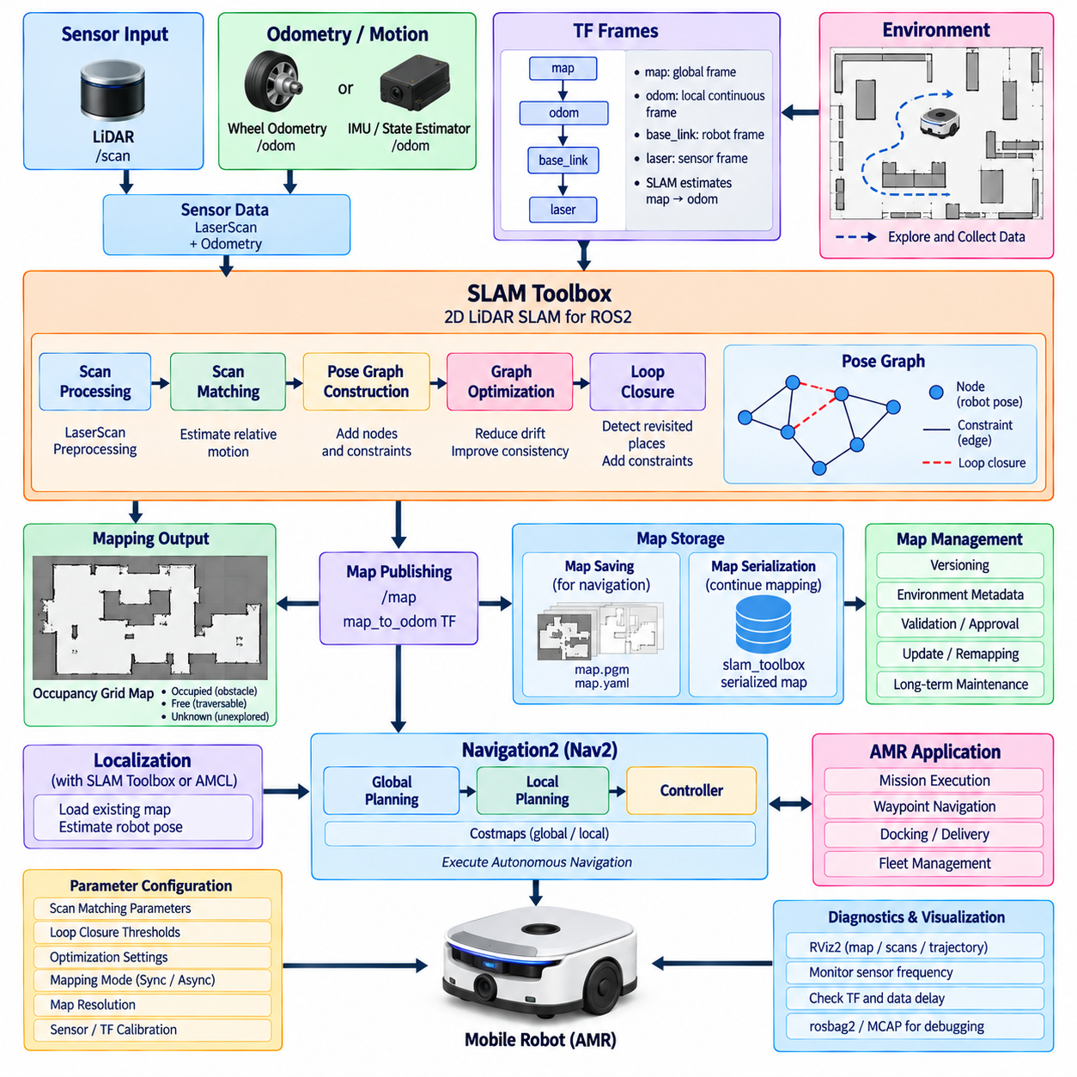
SLAM Toolbox is a ROS2-native simultaneous localization and mapping framework designed primarily for two-dimensional LiDAR-based robots. Within an AMR software stack, it converts laser observations, odometry, and coordinate transformations into a persistent occupancy-grid map while estimating the robot trajectory. Its integration provides the mapping foundation required by localization, Navigation2, visualization, map management, and later autonomous operation.
The mapping pipeline begins with reliable sensor and motion inputs. A laser scanner normally publishes sensor_msgs/LaserScan data, while wheel odometry or a fused state estimator provides continuous local motion information. tf2 connects the sensor frame to base_link and maintains the relationship between base_link and odom. SLAM Toolbox combines these inputs to estimate successive robot poses and align new laser observations with the evolving representation of the environment.
Coordinate-frame consistency is fundamental to successful map generation. The odom frame provides locally continuous motion but may accumulate drift, whereas the map frame represents the globally corrected reference established by SLAM. SLAM Toolbox estimates the map-to-odom transformation while the robot platform supplies odom-to-base_link. Sensor transforms then connect base_link to laser or other observation frames, creating the complete spatial chain required for scan matching.
During online mapping, incoming laser scans are associated with estimated robot poses and incorporated into a pose graph. Selected poses become graph nodes, while spatial constraints between observations form graph edges. Scan matching estimates relationships among these nodes, and graph optimization adjusts the accumulated trajectory when better constraints become available. This process reduces accumulated odometric error and improves consistency between different portions of the generated map.
Loop closure is particularly important when an AMR returns to a previously observed location. The system attempts to recognize correspondence between current sensor observations and earlier mapped regions and introduces additional constraints into the pose graph. Successful loop closure can correct drift accumulated over a long trajectory. Poor sensor geometry, repetitive environments, moving objects, or inaccurate odometry can make this process more difficult and must therefore be considered during mapping.
SLAM Toolbox supports synchronous and asynchronous mapping modes that represent different processing strategies. Synchronous processing handles observations in sequence and can be useful when deterministic scan handling is important. Asynchronous operation can process incoming data with greater flexibility when sensor rates and available computing resources differ. The appropriate mode should be selected according to AMR speed, LiDAR frequency, processor capacity, map complexity, and required mapping responsiveness.
Map quality depends strongly on the physical robot configuration and data quality rather than solely on the SLAM algorithm. Incorrect LiDAR mounting transforms, wheel slip, poor encoder calibration, vibration, insufficient environmental geometry, or timestamp errors can create duplicated walls, distorted corridors, or inconsistent loops. Before tuning advanced SLAM parameters, engineers should therefore verify sensor calibration, odometry scale, coordinate frames, timestamp consistency, and the mechanical stability of the sensor installation.
Mapping parameters determine how frequently scans are processed and how strongly candidate constraints are accepted. Scan matching thresholds, search dimensions, minimum travel distance, minimum heading change, loop-closure criteria, correlation parameters, and optimization settings influence both computational cost and map consistency. Excessively permissive settings can introduce incorrect constraints, while overly restrictive settings may prevent useful corrections. Parameter tuning should therefore be validated against representative AMR operating environments.
The occupancy-grid representation generated from SLAM can be consumed directly by ROS2 navigation tools and visualized using RViz2. Occupied cells represent structures or obstacles detected by the mapping process, free cells indicate observed traversable regions, and unknown cells identify areas that have not been sufficiently observed. Map resolution determines the spatial granularity of this representation and creates a tradeoff among geometric detail, memory consumption, computational cost, and navigation requirements.
Map generation should be treated as an operational procedure rather than simply driving the robot around an environment. The AMR should cover important corridors, intersections, docking areas, narrow passages, and operational zones while maintaining sufficient overlap between observations. Smooth motion and repeated observation of structurally informative areas generally provide better constraints than abrupt acceleration or unnecessary rotation. Dynamic obstacles should also be minimized when producing a reference map intended for long-term operation.
A major capability of SLAM Toolbox is serialization of the underlying mapping state. Saving only an occupancy-grid image preserves the final map representation, but serialization can retain information associated with the pose graph and mapping session. This enables later continuation or modification of an existing map instead of always beginning from an empty environment. Persistent map workflows are especially useful for industrial AMRs operating in facilities that gradually change over time.
Map saving and map serialization should consequently be distinguished in system design. A conventional map can be exported for use by map_server and localization components, while a serialized SLAM state supports continued mapping or pose-graph-based workflows. Production systems should manage these artifacts with explicit identifiers, versions, creation dates, environment metadata, and robot configuration information so that an outdated or incompatible map is not accidentally deployed.
SLAM Toolbox can also participate in localization workflows after map creation. Instead of continuously constructing a completely new environment representation, the system can use an existing serialized map and estimate the robot pose relative to it. This provides an alternative to localization approaches such as AMCL for some system architectures. The selection should depend on map-management strategy, environmental change, localization behavior, computational resources, and the operational requirements of the AMR.
Integration with Navigation2 requires a clear transition between mapping and autonomous navigation. During mapping, SLAM Toolbox may provide the map and map-to-odom transform while the robot explores or is manually driven. During production navigation, the saved map is loaded and an appropriate localization method provides the robot pose. Nav2 then uses this spatial information to construct costmaps, calculate paths, control motion, and execute higher-level navigation behaviors.
Lifecycle and startup sequencing should prevent navigation components from operating before their required spatial information becomes available. Sensor drivers, odometry, tf2 transforms, SLAM or localization, map services, costmaps, and Nav2 servers have logical dependencies that should be reflected in launch and lifecycle configuration. Automated checks can verify that laser data is arriving, transforms are valid, localization has converged, and the expected map has loaded before autonomous motion is enabled.
Diagnostics should monitor both the input conditions and output quality of the mapping subsystem. Engineers can observe LiDAR frequency, odometry continuity, transform delays, dropped messages, CPU load, scan-matching behavior, pose corrections, and map consistency. RViz2 is valuable for visually comparing laser observations with the generated map and robot trajectory. rosbag2 or MCAP recordings can preserve sensor and transform data for offline reproduction when mapping failures occur in the field.
Multi-session and long-term map management become increasingly important as AMRs move from laboratory demonstrations to production facilities. Warehouses and factories change because racks, machines, walls, doors, and operational zones may be modified. A robust architecture should distinguish temporary obstacles from structural changes and provide controlled procedures for remapping, updating, validating, approving, and deploying maps without unintentionally corrupting a known-good navigation reference.
Within the complete ROS2 AMR stack, SLAM Toolbox connects physical sensing with persistent spatial knowledge. LiDAR and odometry describe immediate observations and motion; tf2 establishes their geometric relationships; scan matching and pose-graph optimization construct a consistent trajectory; occupancy mapping converts that trajectory into a navigation representation; and map persistence enables later localization and Nav2 operation. This integration transforms raw robot movement into a reusable spatial foundation for autonomous AMR deployment.

09.04 AMR Sensor Driver ROS2 Package Config [w/Code]
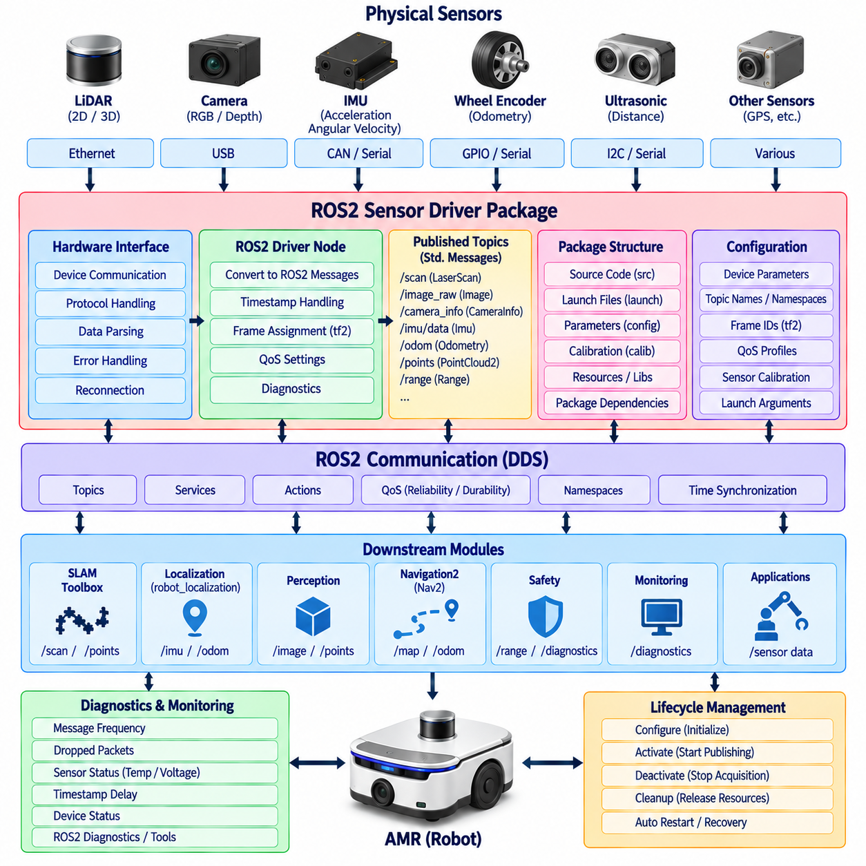
An AMR sensor-driver layer provides the software boundary between physical sensing devices and the ROS2 autonomy stack. Its primary responsibility is to convert vendor-specific interfaces, protocols, timestamps, coordinate conventions, and measurement formats into stable ROS2 interfaces. LiDARs, cameras, depth sensors, IMUs, wheel encoders, ultrasonic sensors, and other devices can therefore be consumed consistently by localization, perception, mapping, navigation, diagnostics, and safety-related supervisory software.
A production sensor package should separate hardware communication from ROS2-facing data publication. The hardware layer manages Ethernet, CAN, USB, serial, or other device-specific transport mechanisms, while the ROS2 node converts received measurements into standardized messages. This separation reduces dependency on individual vendors and makes it easier to replace a sensor without modifying every downstream AMR component that consumes its data.
ROS2 package organization should clearly separate source code, launch configuration, parameters, calibration information, and device-specific resources. A sensor package may contain the driver node, reusable communication libraries, launch files, YAML parameter files, diagnostic configuration, and supporting scripts. Package dependencies should explicitly describe required ROS2 interfaces and external libraries so that builds remain reproducible across development computers, robot computers, containers, and CI/CD environments.
Standard ROS2 message types should be preferred whenever they accurately represent the sensor output. A two-dimensional LiDAR commonly publishes sensor_msgs/LaserScan, a three-dimensional LiDAR may use sensor_msgs/PointCloud2, cameras publish sensor_msgs/Image and CameraInfo, and IMUs normally use sensor_msgs/Imu. Wheel encoder information may contribute to nav_msgs/Odometry or joint-state interfaces depending on the drivetrain and state-estimation architecture.
Topic naming should follow a predictable robot-wide convention. Names such as scan, camera/image_raw, camera/camera_info, imu/data, points, and odom allow downstream components to be configured consistently, while namespaces distinguish robots or multiple instances of similar sensors. Remapping should be used when external packages expect different topic names, avoiding unnecessary modifications to driver source code and preserving portability across AMR configurations.
Coordinate-frame configuration is equally important because sensor measurements become useful only when their physical relationship to the robot is known. Each device should have a clearly defined frame such as laser_frame, camera_link, imu_link, or lidar_link connected to base_link through tf2. Fixed mounting relationships can be published as static transforms, while dynamic transforms should originate from the component responsible for estimating the corresponding physical motion.
Sensor calibration parameters should remain separate from ordinary application logic. Camera intrinsics, LiDAR mounting positions, IMU orientation offsets, encoder scale factors, and other calibration values describe the actual physical robot and may differ between individual units. Treating these values as managed configuration data enables per-robot calibration while keeping the same driver software package reusable across a production fleet.
Timestamp integrity is critical for AMRs because localization and sensor fusion combine measurements originating from different devices. Ideally, a driver should preserve a hardware-generated acquisition timestamp when the sensor provides one instead of assigning a timestamp only after data reaches the ROS2 process. Clock synchronization, communication delay, buffering, and timestamp provenance should therefore be considered explicitly when configuring sensors for tightly synchronized perception and localization pipelines.
Quality of Service settings determine how sensor messages behave under varying computational and network conditions. High-rate measurements often favor low-latency delivery and may tolerate occasional sample loss, whereas some state or configuration information may require reliable transmission. Reliability, durability, history depth, queue size, and deadline settings should reflect the semantics of each sensor stream rather than applying one identical QoS profile to every device.
LiDAR configuration typically includes communication addresses, scan frequency, angular limits, range limits, frame identifiers, filtering options, and output topic names. For an AMR using LiDAR for SLAM and obstacle detection, the driver must provide stable scan timing and valid geometric information. Downstream SLAM Toolbox and Nav2 components depend on the correspondence among LaserScan data, odometry, and tf2, so driver-level timing or frame errors can propagate directly into mapping and navigation behavior.
Camera and depth-sensor drivers introduce additional bandwidth and synchronization requirements. Image resolution, pixel format, frame rate, compression, exposure, depth alignment, and camera calibration influence both computational load and perception quality. When RGB and depth streams are combined, their timestamps and optical frames must be correctly related. High-resolution data should be published only when downstream perception actually requires it, particularly on resource-constrained edge computers.
IMU integration requires careful treatment of coordinate orientation, units, covariance, bias, and measurement validity. Angular velocity and linear acceleration may feed robot_localization or another state estimator together with wheel odometry and other motion measurements. Incorrect axis conventions or covariance values can degrade the fused pose even when the raw measurements appear reasonable. Driver validation should therefore include stationary tests, controlled motion tests, and comparison with expected robot-frame behavior.
Wheel encoder and drivetrain sensing provide another essential input to AMR state estimation. Encoder counts must be converted according to wheel radius, gear ratio, encoder resolution, and drivetrain geometry before reliable odometry can be produced. Differential-drive, omnidirectional, and steering-based platforms require different kinematic interpretations. When ros2_control is used, hardware interfaces and controllers can provide a standardized path between encoder feedback, joint states, odometry generation, and commanded motion.
Launch files integrate individual sensor packages into a complete AMR configuration. A top-level robot launch process can start multiple drivers, load parameter files, establish static transforms, configure namespaces, and activate supporting filters or state estimators. Hardware variants should preferably be represented through launch arguments and configuration profiles instead of duplicated source trees, allowing one ROS2 software baseline to support several sensor combinations or robot models.
Lifecycle management can improve sensor startup and recovery behavior. A lifecycle-aware driver may configure hardware resources before activation, begin publication only after successful initialization, stop acquisition during deactivation, and release resources during cleanup. Higher-level orchestration can then ensure that localization and navigation are activated only after required sensors are healthy. Failed devices can also be restarted in a controlled manner without unnecessarily restarting the complete AMR software stack.
Diagnostics should expose more than whether a driver process is running. Useful health information includes message frequency, communication errors, dropped packets, sensor temperature, voltage, timestamp delay, invalid measurements, reconnect attempts, and device status codes. These diagnostics can be aggregated through ROS2 monitoring infrastructure so operators can distinguish a navigation problem from a degraded sensor, network interruption, calibration issue, or driver malfunction.
Driver robustness should include predictable behavior during disconnection and recovery. Ethernet cables can fail, USB devices can reset, serial links can become corrupted, and sensors may temporarily stop transmitting. A production driver should detect these conditions, report them through diagnostics, avoid publishing misleading stale data, and follow an explicit reconnection policy. Recovery behavior must also coordinate with lifecycle, navigation, and safety supervision when the missing sensor is operationally critical.
Sensor configuration should ultimately be validated as an integrated pipeline rather than as isolated device functionality. Engineers should verify topic rates, timestamps, QoS compatibility, tf2 relationships, calibration, CPU usage, network bandwidth, and downstream behavior in SLAM Toolbox, localization, perception, and Nav2. ros2 topic tools, tf2 utilities, RViz2, diagnostics, rosbag2, and tracing provide complementary mechanisms for detecting integration problems before deployment.
Within the overall AMR architecture, ROS2 sensor-driver packages transform heterogeneous physical devices into a coherent sensing infrastructure. Standard messages establish semantic compatibility, tf2 establishes geometric consistency, timestamps establish temporal consistency, QoS controls communication behavior, lifecycle management governs operational state, and diagnostics expose health. Together these mechanisms create a stable sensor boundary upon which mapping, localization, perception, navigation, and higher-level autonomous behavior can reliably operate.

09.05 ros2.control-Based AMR Drive Interface [w/Code]
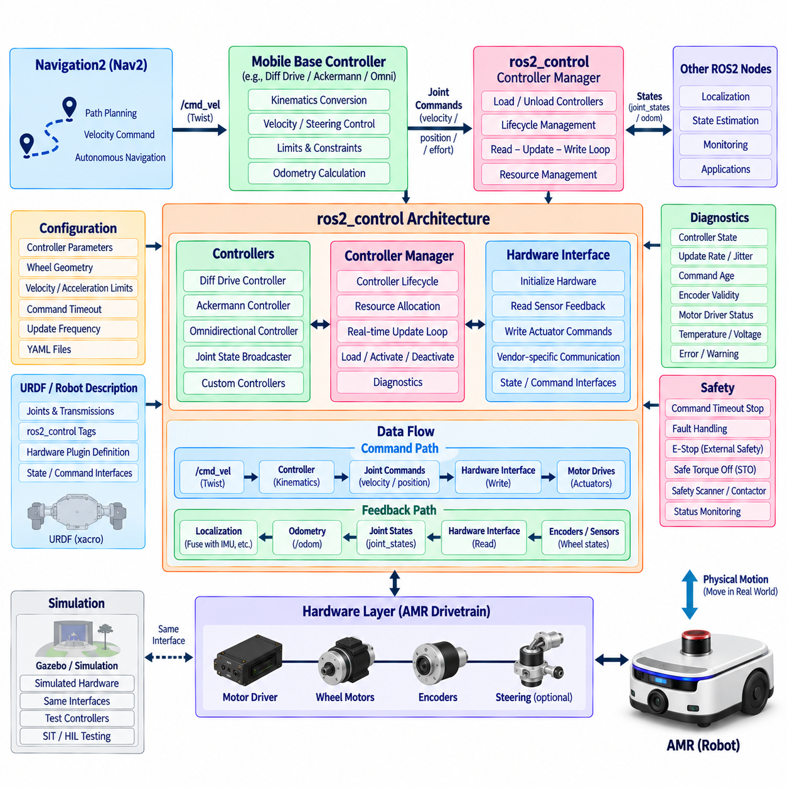
ros2_control provides a standardized control framework for connecting ROS2 autonomy software to the physical drivetrain of an Autonomous Mobile Robot (AMR). Instead of allowing navigation components to communicate directly with motor drivers, ros2_control introduces hardware interfaces, controllers, and a controller manager between high-level motion commands and actuators. This separation improves portability, testability, hardware replacement, and integration across different AMR platforms.
The central component of the architecture is the Controller Manager, which coordinates hardware resources and controller execution. It loads configured hardware components, activates appropriate controllers, manages their lifecycle, and executes the periodic read-update-write control cycle. From the perspective of higher-level ROS2 software, the Controller Manager creates a consistent runtime environment regardless of whether the physical drivetrain communicates through CAN, EtherCAT, Ethernet, serial communication, or another industrial interface.
The hardware interface represents the boundary between ros2_control and the physical drive system. A custom AMR hardware plugin typically initializes motor controllers, exposes command and state interfaces, reads encoder or drive feedback, and writes requested actuator commands. Vendor-specific communication is therefore isolated inside the hardware implementation instead of being propagated into navigation or application software. Replacing a motor controller can consequently require changes mainly within this interface layer.
State interfaces expose measured drivetrain information to the control framework. Typical wheel-based AMRs provide wheel position and velocity derived from encoders, although additional state information such as steering angle or actuator status may also be available. Command interfaces represent quantities that controllers are permitted to request, such as wheel velocity, steering position, or actuator effort. Clearly defining these interfaces establishes an explicit software contract between controllers and hardware.
For a differential-drive AMR, the differential drive controller converts robot-level linear and angular velocity commands into individual left- and right-wheel commands. Wheel separation, wheel radius, velocity limits, acceleration constraints, and odometry parameters determine this conversion. Encoder feedback is then used to estimate vehicle motion and publish odometry-related information, creating a structured connection between commanded chassis motion, physical wheel movement, and the ROS2 navigation stack.
Other AMR drivetrain configurations require different controller strategies. An omnidirectional platform may independently control several wheels, while an Ackermann or steering-based vehicle must coordinate steering angle and wheel velocity according to vehicle geometry. ros2_control does not require all mobile robots to share one kinematic model; instead, its hardware and controller abstractions allow appropriate control implementations to be selected while maintaining a common system-management architecture.
The command path normally begins with an autonomy component such as Navigation2. Nav2 generates a velocity command representing desired chassis motion, and the configured mobile-base controller converts this command into actuator-level references. The Controller Manager then executes the controller and passes commands through the hardware interface to the motor drives. This creates a clear sequence from navigation intent through kinematic conversion and hardware abstraction to physical motion.
The feedback path operates in the opposite direction. Encoders and motor drives report measured wheel states through the hardware interface, which exposes them to ros2_control. Controllers and state broadcasters can publish joint states, odometry, or related information for other ROS2 components. Localization and state-estimation software can subsequently combine this motion estimate with IMU, LiDAR, GNSS, or other sensor measurements to obtain a more robust estimate of the AMR state.
URDF-based robot descriptions can define the ros2_control hardware structure together with joints and interfaces. Each controlled joint identifies the state and command interfaces supported by the physical system, while plugin definitions associate the robot model with the corresponding hardware implementation. This approach connects the mechanical representation of the AMR to its runtime control architecture and helps maintain consistency among simulation, visualization, control configuration, and actual hardware deployment.
Controller parameters are generally maintained separately from application source code. YAML configuration can specify controller types, wheel joint names, wheel geometry, command timeout, publication rates, velocity limits, acceleration limits, covariance values, and other runtime settings. Separating these values allows the same software implementation to support different AMR dimensions or drivetrain variants while preserving configuration history through version control and deployment management.
Command timeout handling is essential because an AMR must not continue indefinitely using an outdated velocity request. If commands stop arriving because navigation fails, a process crashes, or communication is interrupted, the drive controller should transition toward a defined stopped condition according to its configuration. This mechanism provides an important operational safeguard, although it should not be confused with an independently engineered functional-safety stop or emergency-stop function.
Real-time behavior becomes important around the ros2_control update loop. The sequence of reading hardware state, updating controllers, and writing actuator commands should execute with sufficiently stable timing for the drivetrain dynamics. Excessive scheduling jitter, memory allocation, blocking communication, or slow callbacks can degrade motion quality. PREEMPT_RT, thread priorities, CPU affinity, pre-allocation, and carefully designed hardware communication may therefore be applied when stronger timing determinism is required.
The update frequency should be selected according to drivetrain response, motor-controller behavior, encoder resolution, communication latency, and the dynamic requirements of the AMR. Running the loop unnecessarily fast increases CPU and communication load, whereas an excessively slow loop reduces responsiveness and can degrade trajectory tracking. Performance evaluation should therefore measure actual loop period, jitter, command latency, feedback age, and physical motion rather than relying only on a configured nominal frequency.
Lifecycle and startup sequencing are also important for a production drive interface. Hardware should be initialized and verified before motion controllers become active, and controllers should not accept operational commands until required interfaces are available. During shutdown or fault recovery, command generation should be disabled before hardware resources are released. Coordinating ros2_control with the broader ROS2 lifecycle architecture helps produce deterministic power-on, restart, maintenance, and power-off behavior.
Diagnostics should expose the health of both software and drivetrain hardware. Useful information includes controller state, update frequency, command age, encoder validity, communication errors, motor-driver faults, temperatures, currents, voltages, and emergency conditions reported by the drive system. Monitoring these values allows operators to distinguish navigation failures from mechanical problems, communication faults, controller misconfiguration, or degraded actuator performance.
Safety architecture must remain distinct from ordinary ros2_control motion control. ros2_control can stop publishing motion commands or command zero velocity when a fault occurs, but safety-rated emergency stopping may require independent safety controllers, safe torque off, safety scanners, contactors, or certified fieldbus functions. The normal ROS2 control path can exchange status with these systems, but software motion control should not unintentionally become the sole authority for hazardous-motion prevention.
Simulation can use the same control-oriented architecture before physical hardware is available. A simulated hardware component can expose equivalent state and command interfaces while a simulator models wheel motion and robot dynamics. Controllers and higher-level Nav2 software can therefore operate through interfaces similar to those used on the real AMR. Maintaining this interface consistency reduces differences among software-in-the-loop, simulation, hardware-in-the-loop, and physical-robot testing.
Integration testing should verify the complete command and feedback chain rather than testing only individual controllers. Tests should confirm velocity-command reception, wheel-command conversion, encoder feedback, odometry direction, coordinate conventions, timeout behavior, controller activation, communication-loss handling, and recovery. Low-speed tests should precede full-performance operation so that incorrect wheel signs, geometry parameters, scaling factors, or frame conventions can be detected safely.
Within the complete AMR ROS2 stack, ros2_control forms the structured bridge between autonomous navigation and drivetrain hardware. Nav2 expresses desired robot motion, controllers translate that motion into drivetrain commands, hardware interfaces communicate with actuators and sensors, and feedback returns through state interfaces to odometry and localization. This architecture separates navigation intelligence from hardware-specific control while providing a reusable foundation for simulation, testing, deployment, diagnostics, and production AMR operation.

09.06 AMR Fleet Namespace: Multi-Robot Architecture [w/Code]
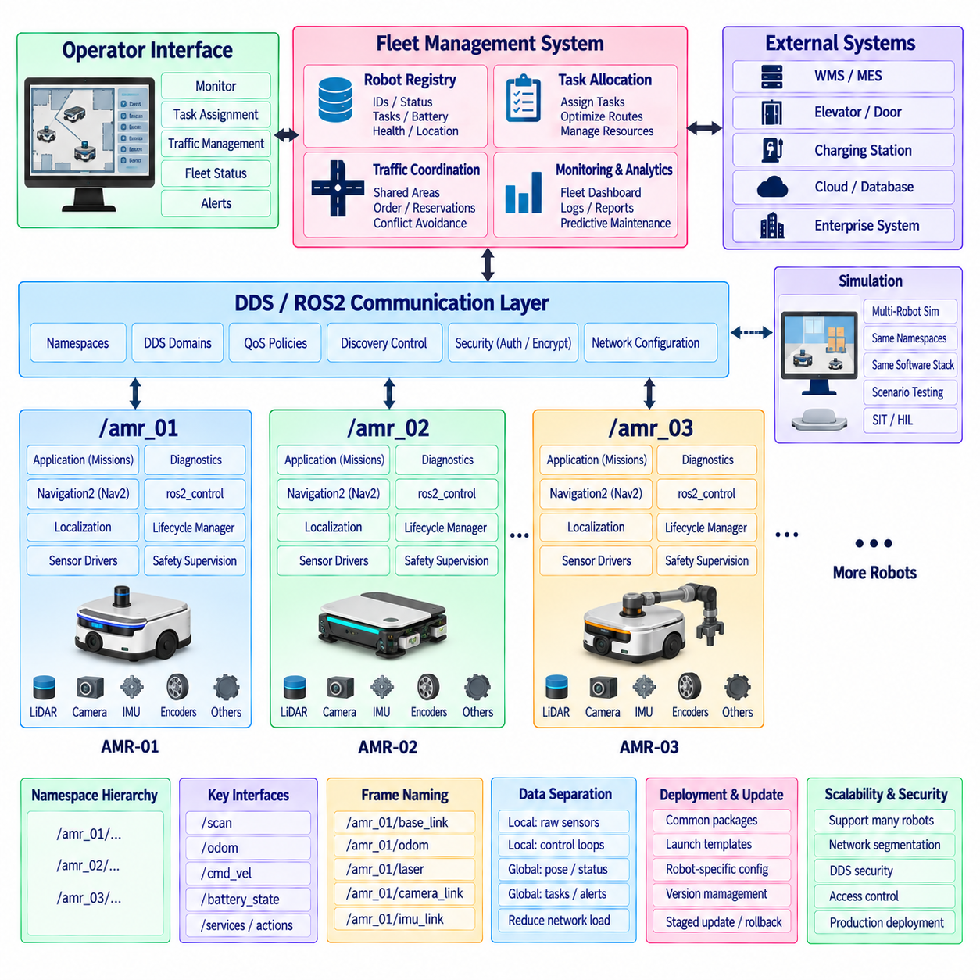
A multi-robot AMR system requires a communication architecture that allows many robots to run equivalent ROS2 software without creating collisions among topics, services, actions, coordinate frames, parameters, or lifecycle interfaces. ROS2 namespaces provide the primary logical isolation mechanism. Each AMR receives a unique namespace while retaining a common internal software structure, enabling one validated robot software baseline to be replicated across an entire fleet.
A typical namespace hierarchy assigns identifiers such as /amr_01, /amr_02, and /amr_03 to individual robots. Topics that would otherwise appear globally as /scan, /odom, /cmd_vel, or /battery_state become robot-specific interfaces such as /amr_01/scan and /amr_01/odom. The same principle applies to services and actions, allowing identical node names and software packages to operate simultaneously without ambiguous communication endpoints.
Namespace design should be established at the system architecture level rather than added after individual packages have already been developed. Sensor drivers, ros2_control components, localization nodes, Nav2 servers, diagnostics, docking modules, and mission applications should all support namespace-aware deployment. Hard-coded absolute topic names should be minimized because they bypass namespace composition and make the same package more difficult to reuse across robots, simulation environments, and fleet configurations.
Launch architecture provides the practical mechanism for creating multiple robot instances. A reusable robot launch description can accept arguments such as robot_id, namespace, parameter profile, map assignment, network configuration, and hardware variant. The fleet-level launch process can then instantiate the same software structure repeatedly with different identifiers. This reduces duplicated configuration while preserving controlled differences among AMRs with different sensors, drivetrains, or operational roles.
Coordinate-frame naming requires special attention in multi-robot systems. Each AMR needs an unambiguous transform tree containing frames such as base_link, odom, laser, camera_link, and imu_link. Frame prefixes or robot-specific frame naming can prevent tf2 ambiguity when information from multiple robots is visible within the same ROS2 environment. Global map conventions must also be deliberately designed when robots share facility-level spatial information.
Navigation2 instances should normally remain logically associated with their corresponding robots. Each AMR can operate its own planner, controller, costmaps, behavior server, lifecycle manager, and Behavior Tree Navigator within its namespace. Local navigation therefore continues even if fleet-level communication is temporarily degraded. Fleet software provides missions and coordination constraints, while each robot retains responsibility for executing safe and responsive local navigation using its own sensor and control loops.
The fleet-management layer operates above individual navigation stacks. It maintains information such as robot identity, operational state, current task, pose, battery level, availability, fault condition, and mission progress. Based on these inputs, a fleet manager can assign transportation or service tasks to appropriate robots. The resulting mission is transferred to the selected AMR, where robot-local software converts the fleet-level request into navigation and application behaviors.
Task allocation should remain distinct from low-level motion control. A fleet system may decide that AMR-07 should transport material from station A to station B, but it should not normally generate individual wheel commands for that robot. The local Nav2 and ros2_control stack should perform path execution and drivetrain control. This separation reduces network dependence and maintains clear responsibility boundaries between collective coordination and real-time physical control.
Multi-robot traffic management becomes necessary when several AMRs share corridors, intersections, elevators, doors, charging stations, or narrow passages. Fleet coordination can reserve shared resources, sequence robot access, or provide route constraints that reduce conflicts before they occur. Local Nav2 obstacle avoidance remains important, but reactive avoidance alone does not provide efficient fleet-level traffic coordination when many robots compete for the same constrained infrastructure.
DDS configuration determines how ROS2 communication behaves beneath the namespace architecture. Namespaces provide logical separation but do not by themselves control network discovery, bandwidth consumption, or security boundaries. DDS domains, discovery configuration, multicast behavior, QoS policies, and network interfaces should therefore be designed according to fleet size and deployment topology. Larger installations may require explicit strategies to prevent unnecessary robot-to-robot discovery traffic.
Quality of Service policies should reflect the semantics of fleet communication. High-rate sensor streams such as LiDAR and camera data normally remain local to the robot unless remote consumption is required, while fleet-level status may be transmitted at substantially lower rates. Mission commands, task results, alarms, and operational states may require stronger reliability than continuously updated telemetry. Restricting unnecessary high-bandwidth traffic is essential for maintaining scalable multi-robot communication.
A scalable architecture should distinguish robot-local data from fleet-global data. Raw images, point clouds, control-loop states, and detailed perception outputs usually belong within the local AMR domain. Robot pose, mission status, battery state, health summary, availability, and selected diagnostics are more appropriate for fleet-level exchange. This data-boundary design reduces network load and prevents centralized systems from becoming unnecessarily dependent on internal implementation details of individual robots.
Lifecycle management should operate at both robot and fleet levels. Within each AMR, lifecycle managers coordinate sensor, localization, Nav2, and application startup. At the fleet level, robot availability should reflect whether the required local components are operational. An AMR undergoing maintenance, initialization, localization recovery, charging, or fault handling should not be treated as available for ordinary mission assignment until its operational state satisfies defined readiness criteria.
Diagnostics require hierarchical aggregation in a fleet deployment. Individual nodes produce detailed component health information, each robot aggregates these signals into a robot-level health state, and the fleet layer receives selected summaries and alarms. Operators can then identify which AMR requires attention without continuously transmitting every internal diagnostic message. Detailed robot-local information can be retrieved when deeper troubleshooting is necessary.
Robot identity must remain stable across software, networking, configuration, and fleet databases. A unique robot identifier should map consistently to its ROS2 namespace, configuration profile, calibration data, hardware inventory, operational records, and fleet-management identity. Relying only on transient network addresses can create ambiguity when hardware is replaced or network assignments change. Stable identity also improves logging, telemetry correlation, maintenance history, and software deployment traceability.
Security boundaries become increasingly important as the fleet grows. ROS2 communication may use DDS security capabilities for authentication, encryption, and access control, while network segmentation can further separate robot, infrastructure, maintenance, and enterprise systems. A robot should receive only the permissions required for its operational role. Namespace conventions help organize communication but should not be treated as an authorization mechanism because naming alone does not provide security isolation.
Simulation should reproduce the same namespace and multi-robot conventions used by physical AMRs. Multiple simulated robots can be instantiated with unique namespaces, transform trees, Nav2 instances, sensor topics, and control interfaces. Fleet-management software can then interact with simulated robots through the same logical contracts expected in deployment. This enables testing of task allocation, traffic coordination, robot failures, communication interruptions, and scaling behavior before operating a large physical fleet.
Deployment and update mechanisms should preserve fleet consistency while supporting controlled robot-specific variation. Common ROS2 packages, launch templates, container images, and parameter schemas can form a shared software baseline, while robot-specific configuration stores calibration and hardware differences. Version information should be visible at the fleet level so operators can identify incompatible software combinations and perform staged updates, validation, rollback, and maintenance.
The resulting architecture forms a hierarchy of autonomy rather than a single centralized robot controller. Each AMR contains its own sensing, localization, Nav2, ros2_control, safety supervision, and diagnostics, while the fleet layer coordinates tasks, traffic, shared resources, and operational status. Namespaces establish logical identity, DDS provides distributed communication, and carefully defined local-global data boundaries preserve scalability. Together these mechanisms allow a common ROS2 AMR architecture to expand from one robot to a coordinated multi-robot fleet.

09.07 AMR Auto Docking and Charging ROS2 [w/Code]
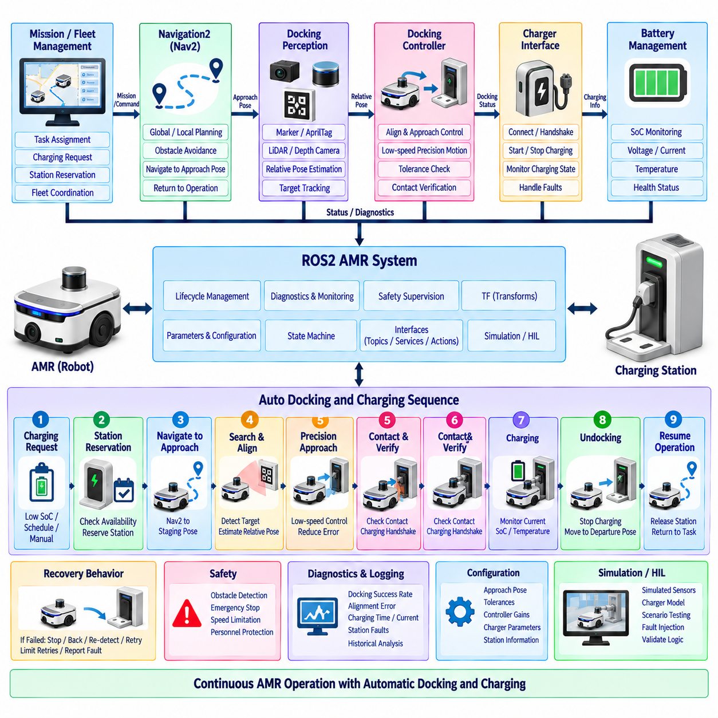
Automatic docking and charging allows an Autonomous Mobile Robot (AMR) to restore energy without manual intervention and is therefore essential for continuous fleet operation. In a ROS2 architecture, docking should be treated as a coordinated robot behavior rather than a single navigation goal. Navigation, localization, docking perception, precision motion control, charger communication, battery monitoring, safety supervision, and mission management must cooperate through clearly defined interfaces and operational states.
The docking process normally begins when mission management or a fleet-management system determines that charging is required. This decision may be triggered by battery State of Charge (SoC), predicted mission energy consumption, scheduled charging, idle time, or operator command. The charging request should consider whether sufficient energy remains to reach the selected station safely, preventing the AMR from accepting another mission that could leave it unable to reach a charger.
A charging station should be represented as a managed operational resource rather than only as a map coordinate. Its configuration can include a station identifier, approach pose, final docking pose, docking direction, compatible robot type, charging interface, and occupancy state. In multi-robot environments, the fleet layer may reserve charging stations and prevent multiple AMRs from attempting to enter the same docking area simultaneously.
The first phase is coarse navigation toward a predefined staging or approach pose near the charger. Navigation2 (Nav2) can perform this movement using the normal map, localization, global planner, local controller, and obstacle avoidance mechanisms. The approach pose should leave sufficient space and orientation for the subsequent precision docking maneuver. At this stage, centimeter-level charger alignment is normally unnecessary because standard autonomous navigation remains responsible for reaching the docking region.
After reaching the approach area, control transitions from general navigation to precision docking. This handover should be explicit so that Nav2 and the docking controller do not simultaneously issue conflicting velocity commands. A docking manager or behavior state machine can arbitrate motion authority, stop normal path following, validate the docking sensor inputs, and then activate the low-speed alignment controller responsible for final approach.
Precision docking usually requires a relative pose measurement between the AMR and docking station. Depending on the platform, this information may come from AprilTag or fiducial detection, LiDAR geometry, reflective markers, depth cameras, infrared sensors, magnetic guidance, mechanical alignment features, or combinations of these methods. The perception component should estimate relative distance, lateral displacement, and angular error with sufficient stability for closed-loop final positioning.
Coordinate transforms are critical during the precision phase. The detected docking target may initially be expressed in a camera, LiDAR, or dedicated docking-sensor frame and must be transformed into a robot-relative frame through tf2. Calibration errors between the sensor and base_link directly become docking alignment errors. Sensor mounting, frame conventions, timestamps, and target geometry should therefore be validated together rather than tuning the docking controller around incorrect transforms.
The final approach controller converts relative docking error into low-speed linear and angular velocity commands. Control gains and velocity limits should prioritize stability and repeatability rather than navigation speed. As the AMR approaches the station, allowable velocity can progressively decrease so that small perception errors do not produce aggressive motion. Maximum approach distance, lateral tolerance, angular tolerance, and final contact velocity should be explicit configuration parameters.
A robust docking sequence should continuously verify progress instead of assuming that commanded motion produces the expected physical result. The system can monitor whether distance and orientation errors are decreasing, whether wheel motion corresponds to odometry, and whether the target remains observable. If progress stalls or the target is lost, the AMR should stop and enter a defined recovery procedure instead of continuing to move using stale perception data.
Docking completion should not be declared solely because the estimated robot pose falls inside a geometric tolerance. Physical confirmation may be obtained from charger contact signals, docking switches, charging voltage, charging current, communication handshakes, or station status. Combining geometric alignment with electrical or mechanical confirmation prevents the software from reporting successful docking when the robot is physically close to the station but charging contact has not actually been established.
Once contact is confirmed, the system transitions from docking to charging. The drivetrain should enter an appropriate stationary state, and the charging interface can negotiate or enable energy transfer according to the hardware design. Battery-management information such as pack voltage, charging current, temperature, SoC, charger state, and fault indicators should be monitored throughout the charging session and exposed to ROS2 diagnostics and higher-level mission software.
Charging communication may occur through physical contacts, CAN, serial communication, Ethernet, wireless communication, or a charger-specific protocol. A ROS2 charger interface should isolate these hardware-specific details from mission software. Higher layers should interact through semantic states such as available, docking, connected, charging, completed, and fault rather than directly depending on vendor-specific register addresses or low-level communication packets.
The complete procedure can be represented as an explicit docking state machine. Typical states include request, station reservation, navigate to approach pose, search for target, align, approach, contact verification, charging, completion, and undocking. Fault and recovery transitions should be available from appropriate states. Explicit state representation improves diagnostics and makes it possible for operators and fleet systems to understand exactly where a docking operation has stopped.
Recovery behavior is particularly important because docking takes place in a constrained physical region. If alignment exceeds tolerance, the AMR may stop, reverse to a safe recovery pose, reacquire the docking target, and attempt another approach. Retries should be bounded by configurable limits. Repeated failure should produce a clear fault state and release or retain the station reservation according to the operational policy rather than creating an indefinite retry loop.
Undocking is also a controlled autonomous operation. After the required SoC or charging condition has been reached, the charging interface should terminate energy transfer appropriately before the AMR begins moving. The robot can then disengage from the station, move to a defined departure pose, verify that the docking area has been cleared, and return motion authority to Nav2. Fleet management can subsequently release the charging resource and assign another mission.
Lifecycle management helps coordinate the software components involved in docking. Docking perception, charger communication, precision control, and supporting sensor nodes can be configured and activated only when their dependencies are ready. During faults or maintenance, individual components can be deactivated and restarted in a controlled manner. The docking subsystem should also expose readiness information so mission software does not request autonomous charging when required hardware is unavailable.
Safety supervision must remain active throughout approach, contact, charging, and departure. Precision docking may intentionally move the AMR close to fixed infrastructure, but this does not remove requirements for obstacle detection, emergency stopping, speed limitation, or personnel protection. Safety-rated devices and independent safety logic should retain authority over motion, while the ROS2 docking application coordinates operational behavior within the permitted safety envelope.
Diagnostics should capture both individual docking attempts and long-term performance. Useful information includes target-detection quality, alignment error, approach duration, retry count, contact confirmation time, charging current, charging duration, station faults, and final SoC. Historical data can reveal deteriorating charger contacts, sensor contamination, calibration drift, mechanical wear, or stations that systematically require more docking attempts than expected.
Simulation and hardware-in-the-loop testing can validate the docking logic before extensive physical trials. The same ROS2 state machine, interfaces, and controller structure can be connected to simulated sensors, robot motion, battery state, and charger responses. Fault injection can test target loss, occupied stations, communication failures, unsuccessful contact, low battery conditions, and emergency stops, allowing recovery logic to be exercised systematically.
Within the complete ROS2 AMR architecture, automatic docking and charging forms a closed operational cycle connecting energy management with autonomous mobility. Fleet or mission logic initiates charging, Nav2 reaches the station area, docking perception establishes relative geometry, precision control completes alignment, charger interfaces verify energy transfer, and diagnostics supervise the process. Successful undocking returns the AMR to autonomous service, enabling repeatable long-duration operation with minimal human intervention.

09.08 VDA 5050 Fleet Manager Integration [w/Code]
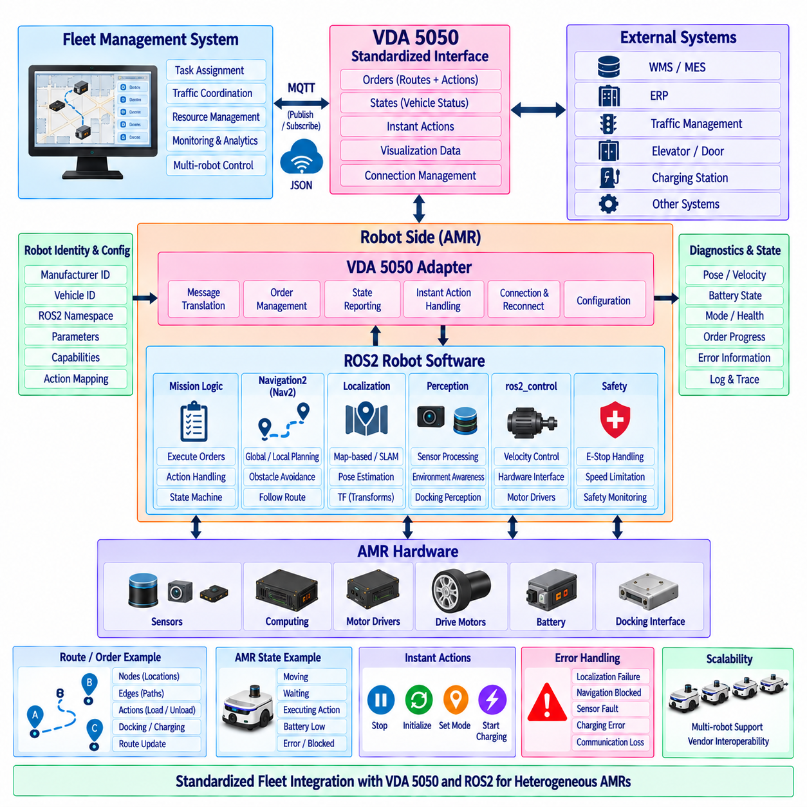
VDA 5050 provides a standardized communication interface between fleet management systems and automated guided vehicles or autonomous mobile robots from different manufacturers. In a ROS2-based AMR architecture, VDA 5050 should be positioned above robot-local navigation and motion control. It defines how an external fleet manager exchanges orders, states, actions, and operational information with each vehicle without directly controlling its low-level drivetrain or internal navigation algorithms.
The fundamental integration principle is separation between fleet-level orchestration and robot-level autonomy. A fleet manager determines which AMR should execute a transport or service mission and expresses that mission through VDA 5050-compatible messages. The robot-side integration layer interprets the request and translates it into ROS2 operations. Nav2, localization, perception, ros2_control, and safety functions remain responsible for executing physical movement within the robot.
A VDA 5050 adapter therefore forms the architectural bridge between the external fleet communication domain and the internal ROS2 software domain. On one side, it communicates using the message structures and transport conventions expected by the fleet manager. On the other side, it interacts with ROS2 topics, services, actions, lifecycle components, and mission software. This adapter prevents VDA 5050-specific communication details from spreading throughout the complete AMR software stack.
The communication model is based on asynchronous exchange of operational messages between vehicles and fleet management. Orders describe intended vehicle movement and associated operations, while state messages report the robot's current execution status. Additional communication can represent visualization information, instant actions, connection status, and other coordination data. The integration layer must maintain consistent identifiers, timestamps, sequence information, and execution state across these message flows.
An order normally represents a structured route rather than a continuous stream of velocity commands. It can describe nodes representing relevant locations and edges representing permitted transitions between those locations. Actions may be associated with appropriate elements of the order to represent operations such as waiting, loading, unloading, docking, charging, or interacting with equipment. The AMR converts this semantic mission representation into executable robot-local behaviors.
The relationship between a VDA 5050 route and Nav2 requires an explicit translation layer. Fleet-level nodes and edges may correspond to facility coordinates, predefined stations, route segments, or operational zones, while Nav2 operates using robot poses, maps, costmaps, planners, and controllers. The integration component converts the assigned route into navigation goals or route-following operations while preserving the constraints and action semantics defined by the fleet-level order.
Order execution should be managed through a deterministic mission state machine. After receiving and validating an order, the AMR can accept appropriate route segments, initiate navigation, monitor progress, execute associated actions, and report state transitions to the fleet manager. Internal ROS2 events should be mapped consistently to externally visible VDA 5050 states so that the fleet system can determine whether the robot is waiting, moving, executing an action, blocked, completed, or experiencing an error.
Order updates require careful handling because fleet coordination may change while the robot is already executing a mission. New route information should be validated against the currently active order and the robot's execution progress before being accepted. The adapter must prevent inconsistent updates from corrupting the active mission. Robot-local motion should remain predictable while fleet-level route extensions or modifications are incorporated according to clearly defined transition rules.
Instant actions provide a mechanism for requesting operations outside the ordinary progression of an order. Depending on the supported implementation and operational policy, these requests can trigger functions such as stopping, initializing, changing operating conditions, or other immediate behaviors. The ROS2 adapter should map each supported instant action to an explicit internal operation and return a meaningful result rather than exposing unrestricted access to arbitrary robot functions.
State reporting is essential because the fleet manager requires an accurate representation of each AMR. The VDA 5050 integration layer can collect robot pose, velocity, battery condition, order progress, node and edge status, action state, operating mode, safety-related state, and error information from ROS2 components. These internal signals are normalized into the external state representation so that heterogeneous robots can be supervised through a common fleet-management interface.
Robot identity must remain consistent across VDA 5050, ROS2 namespaces, network configuration, fleet databases, and deployment records. A manufacturer identity and vehicle-specific identifier should map deterministically to the corresponding ROS2 robot namespace and configuration profile. Stable identity prevents fleet commands from being associated with the wrong AMR and improves traceability across mission logs, diagnostics, maintenance records, software versions, and operational analytics.
MQTT is commonly used as the communication transport for VDA 5050 deployments. The robot-side adapter manages broker connectivity, message publication and subscription, reconnection behavior, and communication health while keeping these mechanisms separate from the ROS2 navigation path. Loss of fleet communication should produce a defined operational response rather than unpredictable behavior, with the appropriate response determined by mission policy, local autonomy, and system safety requirements.
Network interruption does not necessarily imply that low-level robot control must immediately disappear. The AMR may still contain local localization, Nav2, ros2_control, obstacle detection, and safety supervision. The architecture should explicitly define whether an active mission can continue, pause, or terminate when fleet connectivity is lost. This policy should depend on the operational environment and risk assessment rather than being an accidental consequence of communication failure.
Traffic coordination remains primarily a fleet-management responsibility when multiple AMRs share constrained infrastructure. The fleet manager can coordinate routes through intersections, narrow aisles, doors, elevators, and other shared resources, while VDA 5050 communicates the resulting route intent to each vehicle. Robot-local Nav2 continues to respond to immediate environmental conditions, but local obstacle avoidance should not independently override fleet-level traffic assumptions without a defined coordination strategy.
Error handling requires translation between detailed ROS2 diagnostics and the information useful to fleet management. A robot may internally detect localization degradation, blocked navigation, sensor failure, controller faults, charging problems, or communication errors. The adapter should classify and expose appropriate error information without unnecessarily transmitting every low-level diagnostic detail. Operators can then identify affected vehicles while detailed troubleshooting remains available within the robot-local diagnostic system.
Safety information should be integrated without making VDA 5050 the functional-safety control path. The fleet manager may need to know that an emergency stop is active or that the robot is operating under a restricted condition, but safety-rated stopping remains the responsibility of dedicated safety hardware and logic where required. Fleet communication can coordinate operational consequences, while independent safety mechanisms retain final authority over hazardous physical motion.
Lifecycle management improves robustness of the VDA 5050 adapter and its dependent ROS2 components. The adapter should become operational only after identity, communication configuration, mission interfaces, and required robot-state sources are available. During shutdown, maintenance, or faults, message exchange should transition predictably. Readiness information can prevent the fleet manager from assigning normal work to an AMR whose navigation or mission-execution components are unavailable.
Configuration should separate VDA 5050 protocol parameters from robot-specific navigation implementation. Broker information, vehicle identity, supported actions, interface settings, topic conventions, and protocol-related options can be managed independently from Nav2 parameters, sensor calibration, or drivetrain configuration. This separation allows the same VDA 5050 integration software to be reused across multiple AMR variants while each robot preserves its own physical and navigation characteristics.
Testing should cover both protocol compliance and end-to-end robotic behavior. Message validation alone cannot confirm that a fleet order is executed correctly on the physical AMR. Integration tests should exercise order reception, route translation, Nav2 execution, action handling, state reporting, order updates, communication loss, errors, recovery, cancellation, and mission completion. Simulation can reproduce multiple VDA 5050-controlled robots before the same interfaces are deployed on physical vehicles.
Within the complete ROS2 AMR architecture, VDA 5050 provides a standardized fleet-facing contract while ROS2 provides the robot-facing execution environment. The fleet manager coordinates tasks and traffic, the VDA 5050 adapter translates orders and states, mission logic coordinates robot behaviors, Nav2 executes mobility, and ros2_control connects movement to the drivetrain. This layered separation enables heterogeneous AMRs to participate in a common fleet while preserving modular robot-local autonomy.

09.09 AMR Diagnostic Dashboard ROS2 Integration [w/Code]
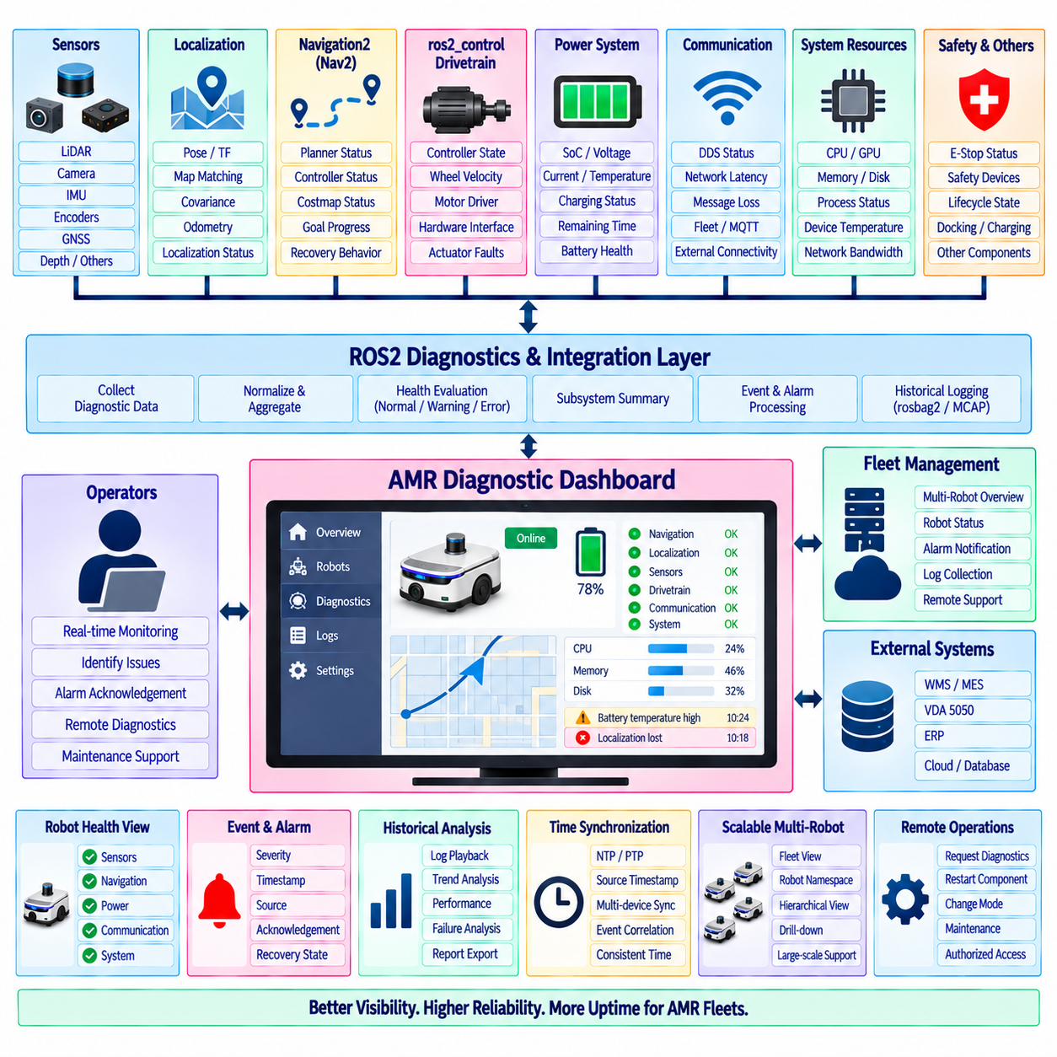
An AMR diagnostic dashboard provides a unified operational view of robot health, software state, navigation performance, communication quality, and hardware conditions. In a ROS2 architecture, the dashboard should not become another control subsystem. Its primary role is to collect, aggregate, interpret, and visualize information produced by distributed robot components so operators can rapidly understand current conditions and identify abnormal behavior.
ROS2 naturally distributes diagnostic information across many nodes and interfaces. Sensor drivers may report device temperature and communication errors, localization nodes provide pose quality, Nav2 exposes navigation states, ros2_control reports controller and hardware conditions, and battery systems publish energy information. A diagnostic integration layer combines these heterogeneous signals into a coherent robot-level health model rather than requiring operators to inspect individual topics manually.
The ROS2 diagnostics framework provides a useful foundation for standardized health reporting. Components can publish diagnostic status containing a component name, health level, descriptive message, and key-value information. These reports can be aggregated hierarchically so detailed device conditions are transformed into subsystem summaries such as sensing, localization, navigation, drivetrain, power, communication, and safety-related operational status.
A practical dashboard should distinguish raw telemetry from interpreted health. Wheel velocity, CPU utilization, battery voltage, localization covariance, network latency, and sensor frequency are measurements, while Normal, Warning, Error, Offline, or Degraded represent interpreted conditions. Keeping these concepts separate allows thresholds and health rules to evolve without changing the underlying data acquisition interfaces and helps operators understand why a particular warning was generated.
Sensor monitoring should verify more than whether a ROS2 topic exists. A LiDAR topic can remain visible even when data frequency becomes unstable, timestamps become stale, or measurements contain abnormal values. Camera, IMU, encoder, GNSS, depth, and other sensor interfaces should therefore be monitored using message frequency, timestamp age, communication status, data validity, calibration state, and device-specific indicators where available.
Navigation diagnostics should represent the complete mobility pipeline. Useful information includes localization status, current pose, active navigation goal, global and local planning state, controller activity, costmap status, recovery behavior, goal progress, obstacle conditions, and navigation failures. The dashboard should make it possible to distinguish a robot that is intentionally waiting from one that has stopped because localization, planning, or control has degraded.
Localization health requires interpretation rather than simply displaying coordinates. The monitoring layer can observe transform availability, pose update frequency, covariance, map association, odometry continuity, and localization mode. Sudden pose jumps, missing map-to-odom transforms, excessive uncertainty, or stale localization data should produce explicit diagnostic conditions because apparently valid numerical coordinates may still represent unreliable localization.
ros2_control and drivetrain diagnostics provide visibility into the physical motion chain. Controller state, command frequency, encoder feedback, wheel velocity, motor-driver communication, hardware-interface state, command timeout, and actuator faults can be monitored together. Comparing commanded and measured motion can help identify conditions such as stalled wheels, disconnected encoders, drivetrain faults, or commands that are not reaching the physical hardware correctly.
Power-system monitoring is particularly important for autonomous fleet operation. Battery State of Charge (SoC), pack voltage, current, temperature, charging state, estimated remaining operating time, and battery-management faults can be presented together. Docking and charging status should also be integrated so operators can distinguish normal charging, waiting for a charger, unsuccessful docking, interrupted charging, and battery conditions requiring maintenance.
Communication diagnostics should cover both internal ROS2 communication and external connectivity. DDS discovery state, selected topic rates, message loss indicators, network interface status, latency measurements, fleet-manager connectivity, VDA 5050 or MQTT connection state, and remote service availability may all contribute to operational health. The dashboard should distinguish robot-local failures from infrastructure or fleet-network failures whenever possible.
System-resource monitoring provides another important diagnostic dimension. CPU load, GPU utilization, memory consumption, disk usage, process status, device temperature, and network bandwidth can reveal performance degradation before robot behavior visibly fails. Resource information becomes especially useful when correlated with ROS2 events, for example when perception latency increases simultaneously with GPU saturation or logging failures appear as storage capacity approaches its limit.
Lifecycle state should be visible for components that use ROS2 managed-node behavior. Operators should be able to determine whether important nodes are unconfigured, inactive, active, finalizing, or unavailable according to the implemented lifecycle model. Unexpected lifecycle transitions can then be correlated with startup failures or recovery operations. Dashboard visualization should expose lifecycle information without assuming that every ROS2 node necessarily implements lifecycle management.
A robot-level health aggregator can reduce hundreds of detailed measurements into a manageable operational summary. Individual component states are evaluated and grouped into subsystem health, and subsystem health contributes to an overall AMR condition. Aggregation rules should preserve the original fault source so an overall Error indication can be expanded into the sensor, navigation, drivetrain, power, or communication component responsible for the condition.
Event and alarm management should prevent operators from being overwhelmed by rapidly repeating messages. Diagnostic events can include severity, source, timestamp, duration, acknowledgement state, and recovery state. Repeated occurrences may be grouped while significant state transitions are retained. Warning thresholds should also use appropriate hysteresis or persistence rules so small fluctuations around a threshold do not continuously alternate the dashboard between normal and warning conditions.
Historical logging transforms the dashboard from a real-time display into an engineering and maintenance tool. ROS2 data, diagnostic events, system metrics, mission information, and selected sensor streams can be recorded using appropriate logging mechanisms such as rosbag2 or MCAP-based workflows. Time-correlated records allow engineers to reconstruct what occurred before and after a navigation failure, docking problem, communication interruption, or unexpected robot stop.
Time synchronization is essential when diagnostic information originates from many computing devices and sensors. Consistent timestamps allow navigation events, hardware faults, network conditions, sensor measurements, and fleet commands to be correlated correctly. Depending on system requirements, NTP, PTP, hardware timestamps, or other synchronization mechanisms may be used. The dashboard should preserve source timestamps rather than replacing every event with only its display arrival time.
Multi-robot dashboards require hierarchical organization to remain usable as the fleet expands. A fleet view can show robot identity, availability, mission state, pose, battery level, and summarized health for every AMR. Selecting one robot can reveal subsystem status, and further drill-down can expose node or device details. This layered structure prevents a large fleet from producing an unreadable screen filled with every topic and diagnostic value from every robot.
ROS2 namespaces provide the natural mechanism for separating diagnostic information among robots. Data under /amr_01, /amr_02, and other namespaces can be associated with stable fleet identities and aggregated independently. Only selected summaries need to leave the robot continuously, while detailed high-rate telemetry can remain local until requested. This architecture reduces network traffic and supports scalable monitoring across increasingly large AMR deployments.
The dashboard can support remote operational commands, but monitoring and control should remain architecturally separated. Functions such as requesting diagnostics, restarting a non-safety application component, changing an operational mode, or initiating maintenance procedures should use authenticated and explicitly authorized interfaces. Safety functions, emergency stopping, and safety-rated motion control must remain under their designated safety architecture rather than depending on the dashboard.
Testing should verify diagnostic behavior by intentionally creating representative faults. Sensor disconnection, stale timestamps, localization loss, blocked navigation, motor communication failure, low battery, charger failure, network interruption, excessive CPU load, and ROS2 node termination can be injected in simulation or controlled test environments. The expected diagnostic state, alarm, logging record, recovery indication, and fleet-level summary should then be verified end to end.
Within the complete ROS2 AMR stack, the diagnostic dashboard becomes the observability layer connecting distributed software and hardware conditions to human operators and fleet supervision. Sensors, localization, Nav2, ros2_control, power, networking, lifecycle, and system resources produce evidence of robot behavior; aggregation converts that evidence into health states; logging preserves history; and visualization presents actionable context. This structure enables efficient troubleshooting, preventive maintenance, fleet-scale monitoring, and more reliable long-term AMR operation.

09.10 Indoor AMR Full ROS2 Stack Integration Case
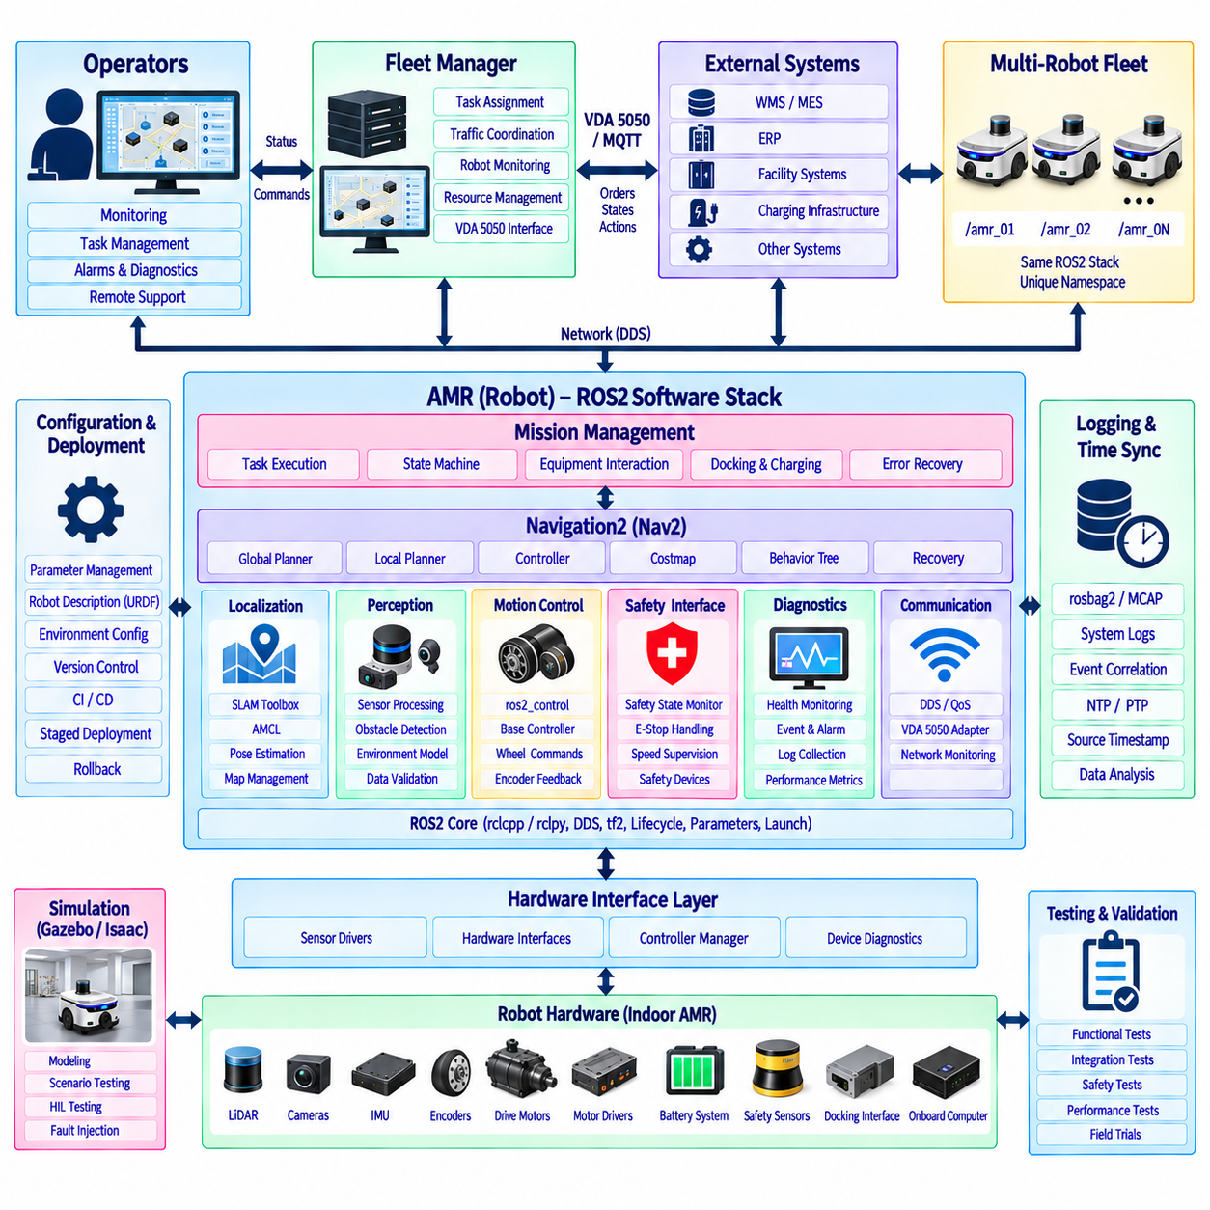
An indoor AMR full ROS2 stack integrates sensing, localization, navigation, motion control, safety supervision, mission execution, fleet communication, diagnostics, and deployment into one coordinated runtime architecture. The objective is not simply to connect independent ROS2 packages, but to define clear interfaces, ownership boundaries, startup dependencies, timing behavior, and failure responses so the complete robot operates as a coherent autonomous system.
At the physical layer, the AMR contains drive motors, motor drivers, wheel encoders, LiDAR, cameras, IMU, safety sensors, battery systems, docking interfaces, and onboard computing. ROS2 hardware-facing packages isolate these devices from higher-level autonomy software. Sensor drivers publish standardized measurements, while ros2_control provides structured state and command interfaces between the mobile-base controller and the physical drivetrain.
The robot description establishes the common geometric reference for the complete stack. URDF or equivalent robot-model information defines links, joints, sensor mounting positions, wheel geometry, and relevant physical relationships. tf2 maintains transformations among frames such as map, odom, base_link, laser, camera_link, and imu_link. Accurate calibration and consistent frame conventions are essential because errors propagate directly into localization, perception, navigation, and docking.
The perception and sensing layer transforms physical measurements into information usable by autonomous functions. LiDAR provides obstacle geometry and mapping observations, cameras or depth sensors contribute environmental perception, IMU measurements support motion estimation, and wheel encoders provide odometry. Each data source must be validated for message frequency, timestamps, coordinate frames, calibration, and Quality of Service before higher-level components depend on it.
Localization establishes the AMR pose within the operational map. During initial deployment, SLAM Toolbox can create a two-dimensional occupancy map and preserve appropriate mapping information for later use. During normal operation, a localization component combines map information with LiDAR observations and odometry to estimate robot pose. The resulting map-to-odom transform connects facility-level coordinates with the continuously evolving local motion estimate.
Navigation2 (Nav2) provides the main autonomous mobility layer. A mission request is converted into a navigation goal, after which the planner determines a global route and the controller produces local motion commands while costmaps represent obstacles and traversability. Behavior Tree orchestration coordinates navigation actions and recovery behaviors. Nav2 remains responsible for robot-local navigation rather than fleet-wide task allocation or safety-rated motion stopping.
The velocity command generated by the navigation layer passes through the mobile-base control architecture toward ros2_control. The selected controller converts body-level velocity commands into drivetrain-specific wheel commands, while the hardware interface exchanges commands and feedback with motor drivers. Encoder measurements return through the same control structure and contribute to odometry, creating a closed information loop between commanded movement and measured physical motion.
Functional safety remains architecturally separated from ordinary ROS2 autonomy. Emergency stops, safety scanners, protective fields, speed supervision, or safety-rated drive functions should retain independent authority where required by the system safety design. ROS2 can observe safety states and coordinate operational responses, but Nav2, mission software, dashboards, or ordinary DDS communication should not be treated as substitutes for required safety-rated hardware and logic.
Mission management sits above the navigation stack and converts operational tasks into sequences of robot behaviors. A transport mission may contain navigation to a pickup station, waiting for equipment, confirming load transfer, navigating to a destination, unloading, and reporting completion. Explicit mission states allow the robot to distinguish normal waiting, active navigation, equipment interaction, recovery, cancellation, charging, and fault handling.
In a fleet deployment, every AMR can run the same internal ROS2 architecture under a unique namespace such as /amr_01 or /amr_02. Robot-local sensor streams, Nav2 instances, controllers, diagnostics, and lifecycle components remain logically isolated. Fleet-level software exchanges only information required for coordination, including identity, pose, battery condition, availability, mission progress, health summaries, and selected operational events.
A fleet manager operates above individual robot autonomy by assigning tasks and coordinating shared resources. VDA 5050 can provide a standardized fleet-facing interface where required, with a robot-side adapter translating orders, states, actions, and communication events into internal ROS2 operations. This preserves a clear boundary: the fleet layer coordinates missions and traffic, while the local ROS2 stack executes perception, navigation, control, docking, and physical behavior.
Automatic docking and charging completes the autonomous operating cycle. When battery conditions or mission policy require charging, the AMR receives or generates a charging request, reserves an available station, and uses Nav2 to reach an approach pose. Docking perception then estimates the relative charger geometry, a precision controller performs low-speed alignment, and physical or electrical confirmation verifies successful contact before charging begins.
Lifecycle management coordinates startup and shutdown dependencies across the integrated stack. Hardware interfaces and sensors should become ready before localization depends on their data; localization should provide valid transforms before autonomous navigation begins; and mission execution should not accept ordinary work until required subsystems report readiness. Controlled activation also improves recovery by allowing failed components to be restarted or reconfigured without arbitrarily restarting the complete robot.
ROS2 communication must be engineered according to data semantics rather than using identical settings for every interface. High-rate sensor data, reliable mission commands, navigation actions, diagnostics, and transient configuration information have different communication requirements. DDS discovery, namespaces, Quality of Service policies, network interfaces, and bandwidth allocation should therefore be configured as part of the integrated system architecture rather than as isolated package defaults.
The diagnostic layer observes every major subsystem and converts distributed measurements into an understandable AMR health state. Sensor availability, localization quality, Nav2 status, controller state, drivetrain feedback, battery information, docking condition, network connectivity, CPU and GPU utilization, lifecycle state, and software faults can be aggregated. Operators receive concise summaries while detailed evidence remains available for engineering analysis.
Logging and time synchronization make failures reproducible rather than anecdotal. rosbag2 or MCAP-based recording can preserve selected ROS2 traffic, while system logs record process and hardware events. Consistent source timestamps allow sensor anomalies, localization changes, navigation failures, motor faults, fleet commands, and safety events to be correlated. NTP, PTP, or hardware timestamping can be selected according to required temporal accuracy.
Configuration management is critical because the full stack contains many interacting parameters. Robot geometry, sensor calibration, Nav2 settings, controller parameters, docking tolerances, network configuration, fleet identity, and diagnostic thresholds should be separated into controlled configuration domains. Common software packages can remain identical across a fleet while robot-specific profiles preserve hardware variations and calibration values without creating separate software branches.
Deployment should use a reproducible software baseline with explicit package, container, firmware, parameter, and interface versions. Continuous integration can build and test the ROS2 workspace, while staged deployment introduces validated releases to selected robots before fleet-wide rollout. Version visibility and rollback capability are important because an AMR failure can result from an incompatible combination of software, configuration, firmware, maps, or external interfaces.
Simulation provides the first environment for validating the integrated architecture before extensive physical testing. The same namespaces, robot descriptions, Nav2 configuration, mission interfaces, fleet contracts, and docking logic can be exercised with simulated AMRs. Hardware-in-the-loop testing can progressively introduce real controllers, computing hardware, sensors, or communication interfaces while preserving repeatable scenarios and fault injection.
System integration testing must verify complete operational flows rather than only individual ROS2 nodes. Representative cases include startup, localization initialization, autonomous navigation, obstacle response, mission execution, docking, charging, undocking, fleet task assignment, communication loss, sensor failure, localization degradation, blocked navigation, low battery, emergency stopping, software restart, and recovery. Each case should define observable success and failure criteria.
The completed indoor AMR architecture therefore forms a hierarchy from physical hardware to fleet-level orchestration. Sensors and actuators connect through ROS2 drivers and ros2_control; localization and perception establish environmental understanding; Nav2 produces autonomous mobility; mission logic coordinates work; docking sustains energy; fleet interfaces coordinate multiple robots; and diagnostics, lifecycle, security, logging, and deployment support reliable operation. The value of the full ROS2 stack emerges from these components operating through disciplined interfaces as one integrated autonomous system.

