Volume 05 Robot Middleware and ROS2

01. ROS2 Fundamentals

01.01 ROS1 vs ROS2: Architecture Changes and Migration Drivers
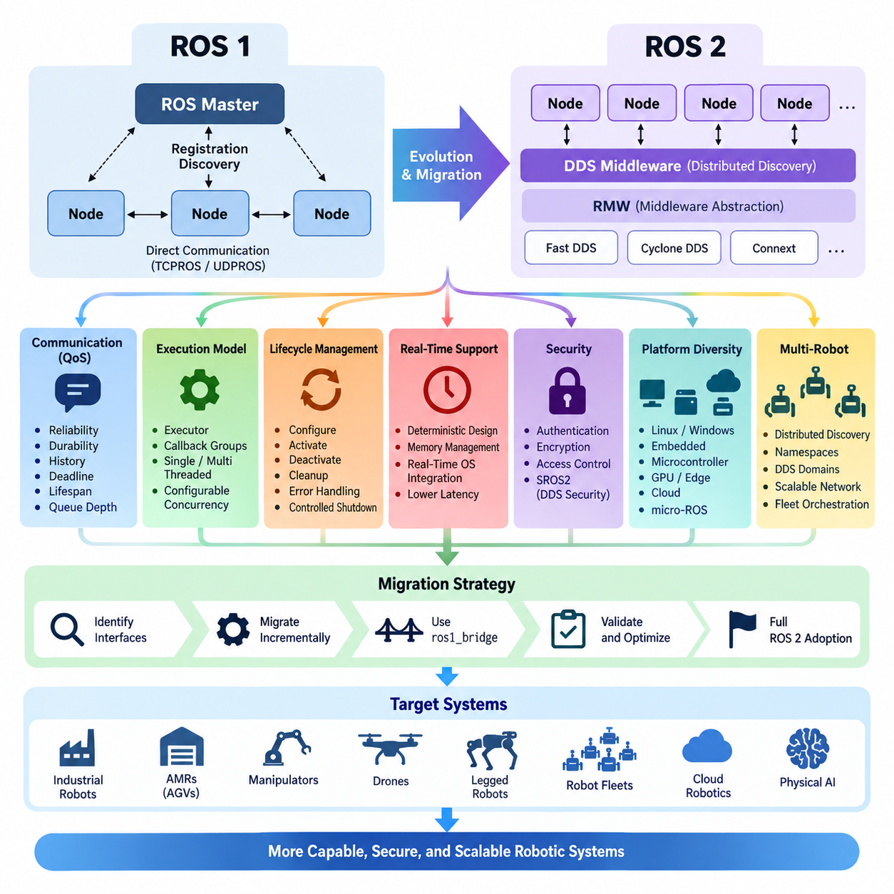
The transition from ROS 1 to ROS 2 was not simply a version upgrade but a fundamental redesign of the middleware architecture for production-grade distributed robotics. ROS 1 established an influential ecosystem for modular robot software, yet its architecture was primarily optimized for research environments, relatively trusted networks, and single-robot systems. ROS 2 retained familiar concepts such as nodes, topics, services, packages, and message interfaces while rebuilding the underlying communication and execution infrastructure.
A central architectural characteristic of ROS 1 is the ROS Master, which provides name registration and discovery information so that nodes can locate publishers, subscribers, and services. Although actual topic data normally flows directly between communicating nodes rather than through the Master, the Master remains an important coordination dependency. This design is straightforward and convenient, but it becomes less attractive when robots must operate across complex networks, recover from failures, or participate in dynamically changing distributed systems.
ROS 2 replaces this master-centered discovery model with a distributed communication architecture built around the Data Distribution Service, or DDS, abstraction. Nodes can discover communication peers through middleware mechanisms without depending on a single ROS Master. ROS 2 additionally introduces the ROS Middleware interface, known as RMW, which separates the ROS client libraries from the underlying middleware implementation. This abstraction allows different DDS implementations and compatible middleware technologies to support the same ROS 2 application model.
Communication semantics represent another major migration driver. ROS 1 provides useful TCPROS and UDPROS mechanisms, but applications have relatively limited control over communication behavior. ROS 2 exposes Quality of Service policies that allow developers to specify reliability, durability, message history, queue depth, deadlines, lifespan, and related delivery characteristics. Sensor streams can therefore favor low latency and tolerate losses, while commands, state transitions, or important events can use stronger delivery guarantees according to system requirements.
The execution model was also redesigned because modern robots execute many asynchronous activities simultaneously. ROS 1 commonly relies on callback queues and spinner-based processing, whereas ROS 2 formalizes executors, callback groups, and configurable concurrency. Single-threaded and multi-threaded execution can be selected according to application requirements, and callbacks can be organized to control mutual exclusion or parallel execution. These mechanisms provide a stronger architectural basis for coordinating perception, planning, communication, diagnostics, and control workloads.
ROS 2 also expands the concept of node state management through managed lifecycle nodes. A conventional node can start and immediately begin operating, but production robots frequently require deterministic initialization and shutdown sequences. Sensors may need calibration before localization starts, localization may need valid state before navigation activates, and actuators should remain disabled until safety conditions are satisfied. Lifecycle states and transitions provide an explicit framework for configuration, activation, deactivation, cleanup, error handling, and controlled shutdown.
Real-time behavior was another important reason for redesigning ROS. ROS 1 was not originally constructed around deterministic execution requirements, making it difficult to use directly in latency-sensitive control paths without additional engineering. ROS 2 was designed with greater consideration for real-time operation, including improved middleware control, executor design, memory-management strategies, and integration with real-time operating environments. This does not make every ROS 2 application automatically real-time, but it provides mechanisms from which more deterministic systems can be engineered.
Security illustrates an equally significant architectural change. ROS 1 generally assumes a trusted environment and does not provide a comprehensive built-in security architecture for authentication, encryption, and fine-grained access control. ROS 2 can use DDS Security capabilities through SROS2 to establish identities, protect communication, and define permissions governing node interactions. These capabilities are increasingly important when robots communicate over enterprise networks, wireless infrastructure, industrial facilities, remote fleet systems, or other environments where implicit trust is unacceptable.
ROS 2 was also designed for broader platform diversity. Modern robotic products may combine Linux computers, Windows workstations, embedded processors, microcontrollers, GPU edge systems, and cloud or fleet infrastructure. The architecture therefore emphasizes portable client libraries, standardized interfaces, middleware abstraction, and support for heterogeneous computing environments. Technologies such as micro-ROS extend ROS 2 concepts toward resource-constrained microcontrollers, helping connect embedded sensing and actuation components with higher-level distributed robot software.
Multi-robot operation further exposes the limitations that motivated the architectural transition. A research robot may contain only dozens of processes on one machine, whereas an industrial fleet can contain many robots, computers, sensors, gateways, and management services. Distributed discovery, namespaces, DDS domains, configurable QoS, and network-aware middleware behavior give ROS 2 stronger foundations for these systems. Nevertheless, large fleets still require deliberate network segmentation, discovery configuration, bandwidth engineering, observability, and higher-level fleet orchestration.
Migration from ROS 1 therefore requires more than mechanically translating source code. Packages must be reconsidered in terms of dependencies, build systems, interfaces, parameter handling, launch architecture, node execution, QoS assumptions, and lifecycle behavior. ROS 1 catkin-based projects typically move toward ament and colcon workflows, while communication code moves to ROS 2 client libraries such as rclcpp or rclpy. Existing topics and services must also be examined because ROS 2 communication policies may need to reflect the actual semantics of each data flow.
A practical migration strategy can preserve operational ROS 1 components while introducing ROS 2 incrementally. Interfaces between subsystems should first be identified, followed by migration of components that benefit most from ROS 2 capabilities. During transitional periods, ros1_bridge can exchange compatible messages between ROS 1 and ROS 2 domains, reducing the need for a single disruptive conversion. However, bridging should normally be treated as a migration mechanism rather than as a permanent substitute for a coherent ROS 2 architecture.
The architectural significance of ROS 2 ultimately lies in its shift from a research-oriented robotics framework toward middleware suitable for distributed robotic products. DDS-based communication, decentralized discovery, QoS control, lifecycle management, improved security, configurable execution, and stronger real-time foundations address requirements that become increasingly important as robots move from laboratories into factories, warehouses, outdoor environments, fleets, and Physical AI systems. Within the attached volume structure, these foundations naturally lead into dedicated treatment of DDS, node architecture, communication, real-time operation, security, lifecycle management, deployment, AMRs, Physical AI, and legged robots.

01.02 ROS2 Design Philosophy: DDS-Based Distributed System
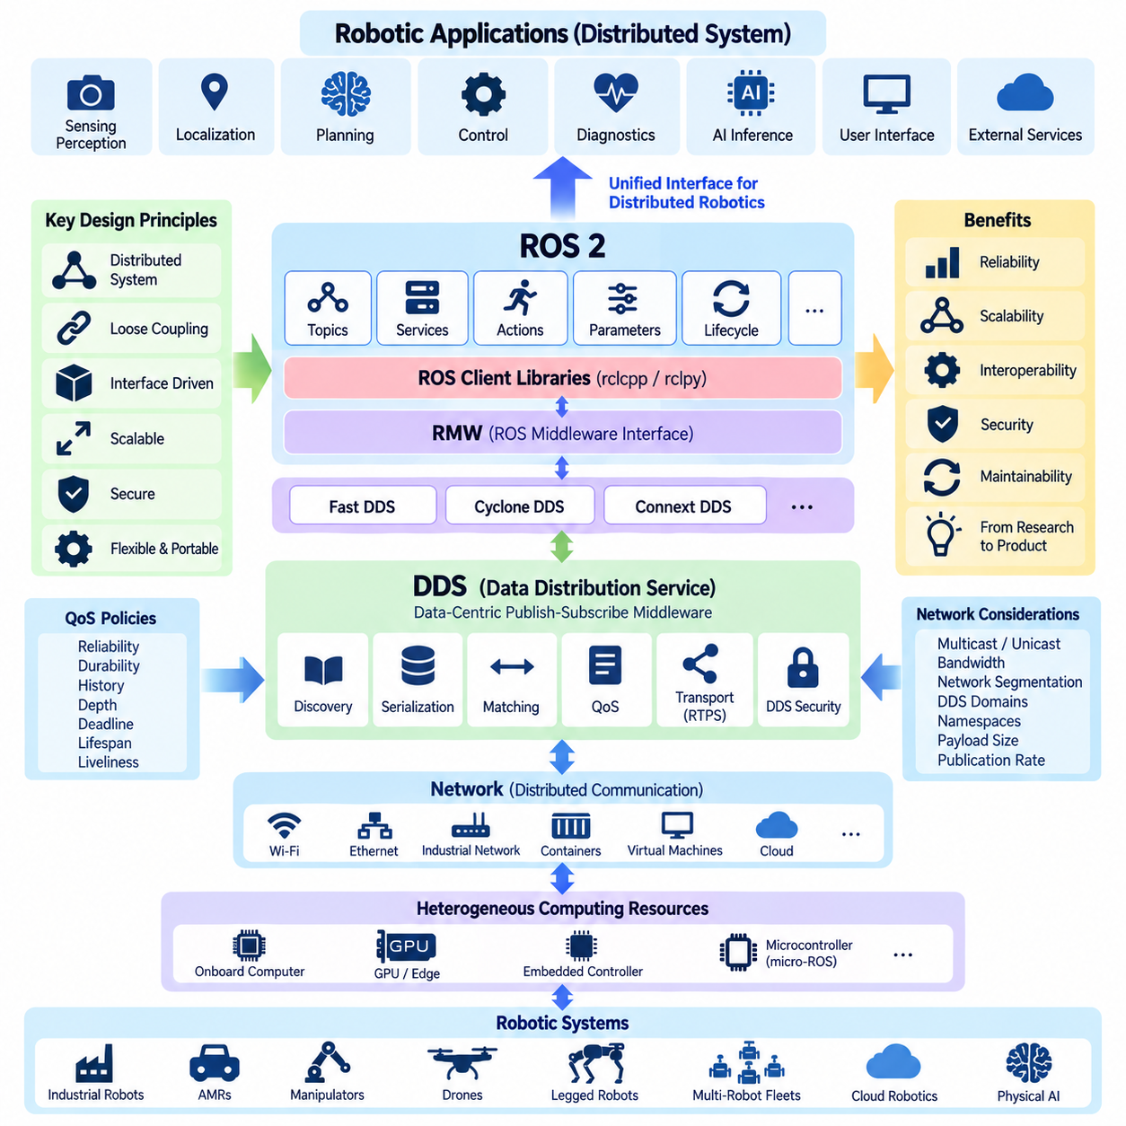
ROS 2 was designed around the principle that a robot is fundamentally a distributed computing system rather than a single application executing on one computer. Modern robots integrate sensors, perception pipelines, localization, planning, control, diagnostics, AI inference, user interfaces, and external services across heterogeneous processors. ROS 2 therefore treats communication, discovery, execution, reliability, and interoperability as fundamental architectural concerns rather than secondary networking features.
At the center of this philosophy is the Data Distribution Service (DDS), an industry-standard data-centric middleware specification for distributed systems. Instead of requiring applications to explicitly manage connections between individual processes, DDS organizes communication around typed data exchanged between publishers and subscribers. ROS 2 maps its topic-oriented communication model onto this data-centric publish-subscribe architecture, allowing nodes to communicate while remaining loosely coupled in location, implementation, execution timing, and deployment configuration.
This distributed philosophy differs fundamentally from architectures that depend on a centralized broker or master for communication discovery. DDS participants can discover one another dynamically and establish communication relationships according to compatible data types and policies. Consequently, ROS 2 nodes do not require a ROS Master to maintain the communication graph. This decentralized structure improves architectural flexibility when processes start, stop, migrate between computers, or operate across multiple computing devices within a robot.
ROS 2 does not expose DDS directly as the only programming interface. Applications normally use client libraries such as rclcpp for C++ or rclpy for Python, while the ROS client library layer communicates through the ROS Middleware interface (RMW). The RMW abstraction separates ROS 2 APIs from specific middleware implementations. As a result, implementations such as Fast DDS, Cyclone DDS, or Connext DDS can provide the underlying transport and discovery mechanisms without requiring application-level ROS interfaces to be redesigned.
The resulting architecture can be understood as several cooperating abstraction layers. Application nodes use ROS 2 concepts such as topics, services, actions, parameters, and lifecycle mechanisms. Client libraries translate these operations into lower-level ROS interfaces, while RMW provides a standardized middleware boundary. Beneath RMW, the selected DDS implementation performs discovery, serialization, transport, matching, and Quality of Service enforcement. This layered structure reduces middleware dependency while preserving a consistent application programming model.
Quality of Service (QoS) is particularly important to the ROS 2 design philosophy because robotic data flows do not share identical communication requirements. A high-rate camera or LiDAR stream may prioritize freshness and low latency over retransmission of every sample, while configuration data or critical state information may require reliable delivery. DDS QoS policies allow ROS 2 systems to express these differences through reliability, durability, history, depth, deadline, lifespan, liveliness, and related communication characteristics.
The DDS-based architecture also introduces the concept of compatibility between communicating endpoints. A publisher and subscriber must not only use compatible message types but must also have QoS configurations that permit communication. This makes communication behavior part of the system architecture rather than an implicit property of the transport. Engineers must therefore design QoS profiles according to the semantics of each data path, considering sensor frequency, network bandwidth, acceptable loss, latency constraints, recovery behavior, and the operational importance of the information.
Decentralized discovery supports dynamic robotic systems in which components may appear or disappear during operation. DDS discovery mechanisms identify participants and their communication endpoints, allowing publishers and subscribers to establish relationships without manually configuring every connection. This capability is valuable when software components are distributed across an onboard computer, GPU edge processor, embedded controller, operator station, or other networked computing resources. The ROS 2 graph can consequently evolve as the deployed system changes.
Data-centric communication also encourages interface-oriented software architecture. A perception node does not need detailed knowledge of the internal implementation of a localization or planning node; it primarily needs to understand the data interface and communication contract. Components can therefore be developed, tested, replaced, and deployed with greater independence when interfaces are carefully designed. This loose coupling becomes increasingly important as robotic software grows from experimental prototypes into long-lived products maintained by multiple engineering teams.
DDS also provides transport mechanisms appropriate for distributed communication, commonly using the Real-Time Publish-Subscribe (RTPS) interoperability protocol. Depending on the middleware configuration and network environment, communication can employ multicast or unicast discovery and data exchange mechanisms. ROS 2 developers therefore need to consider the underlying network as part of system design, especially when deploying across Wi-Fi, Ethernet, segmented industrial networks, containers, virtual machines, or multi-robot infrastructures.
The ROS 2 distributed model does not imply that every software function should communicate over an external network. Components executing in the same process can use composition and intra-process communication to reduce unnecessary serialization and data copying. Components on different processes or computers can communicate through middleware transports. This allows designers to select deployment boundaries according to fault isolation, performance, maintainability, computational load, and hardware topology while retaining a common ROS 2 communication model.
Scalability is another reason for adopting this architecture, but DDS alone does not automatically guarantee unlimited scaling. As the number of nodes, topics, sensors, computers, and robots increases, discovery traffic and high-bandwidth data streams can place substantial load on the network. Engineers must manage DDS domains, namespaces, discovery behavior, QoS policies, publication rates, payload sizes, and network segmentation. Large robot fleets may additionally require gateways or higher-level fleet communication architectures rather than placing every endpoint within one unrestricted discovery domain.
The distributed architecture also influences fault tolerance. Eliminating the ROS Master removes one centralized coordination dependency, but individual nodes, middleware participants, networks, and hardware components can still fail. Robust ROS 2 systems therefore combine decentralized communication with lifecycle management, diagnostics, health monitoring, restart mechanisms, redundant components, and safe-state strategies. Distribution provides architectural flexibility, while system-level reliability must still be deliberately engineered according to the consequences of each component failure.
Security becomes inseparable from distribution because dynamically discovered nodes may communicate across network boundaries. DDS Security provides mechanisms for authentication, encryption, integrity protection, and access control, which ROS 2 can integrate through SROS2. Rather than assuming that every process on a robot network is trustworthy, production architectures can establish identities and communication permissions. This is particularly important for industrial robots, autonomous mobile robots, remote operation, multi-robot fleets, and cloud-connected robotic systems.
The DDS-based philosophy ultimately enables ROS 2 to function as a common communication fabric across heterogeneous robotic computing resources. Sensors and embedded devices can feed perception pipelines, GPU systems can execute AI inference, planning nodes can generate decisions, and control components can consume resulting commands while remaining separated by well-defined interfaces. Technologies such as micro-ROS extend this architectural concept toward resource-constrained microcontrollers, further connecting embedded devices with the broader ROS 2 computational graph.
For Physical AI and increasingly autonomous robots, this distributed foundation becomes especially significant because intelligence is no longer located in a single software module. Perception, world modeling, semantic reasoning, planning, learned policies, motion generation, safety supervision, and fleet intelligence may execute on different processors or computing tiers. ROS 2 provides the communication and integration layer connecting these capabilities, while DDS supplies the distributed data infrastructure needed to exchange information according to explicit performance and reliability requirements.
ROS 2 should therefore be understood not merely as a collection of robotics libraries but as a distributed systems architecture specialized for robotic integration. DDS, RMW abstraction, decentralized discovery, configurable QoS, heterogeneous deployment, security, and interface-driven modularity form interconnected design principles. Together they establish the foundation upon which later ROS 2 topics—including node architecture, communication patterns, real-time operation, lifecycle management, AMR integration, Physical AI, and multi-robot systems—can be systematically constructed.

01.03 ROS2 Installation / Dev Environment: Humble, Iron, Jazzy [w/Code]
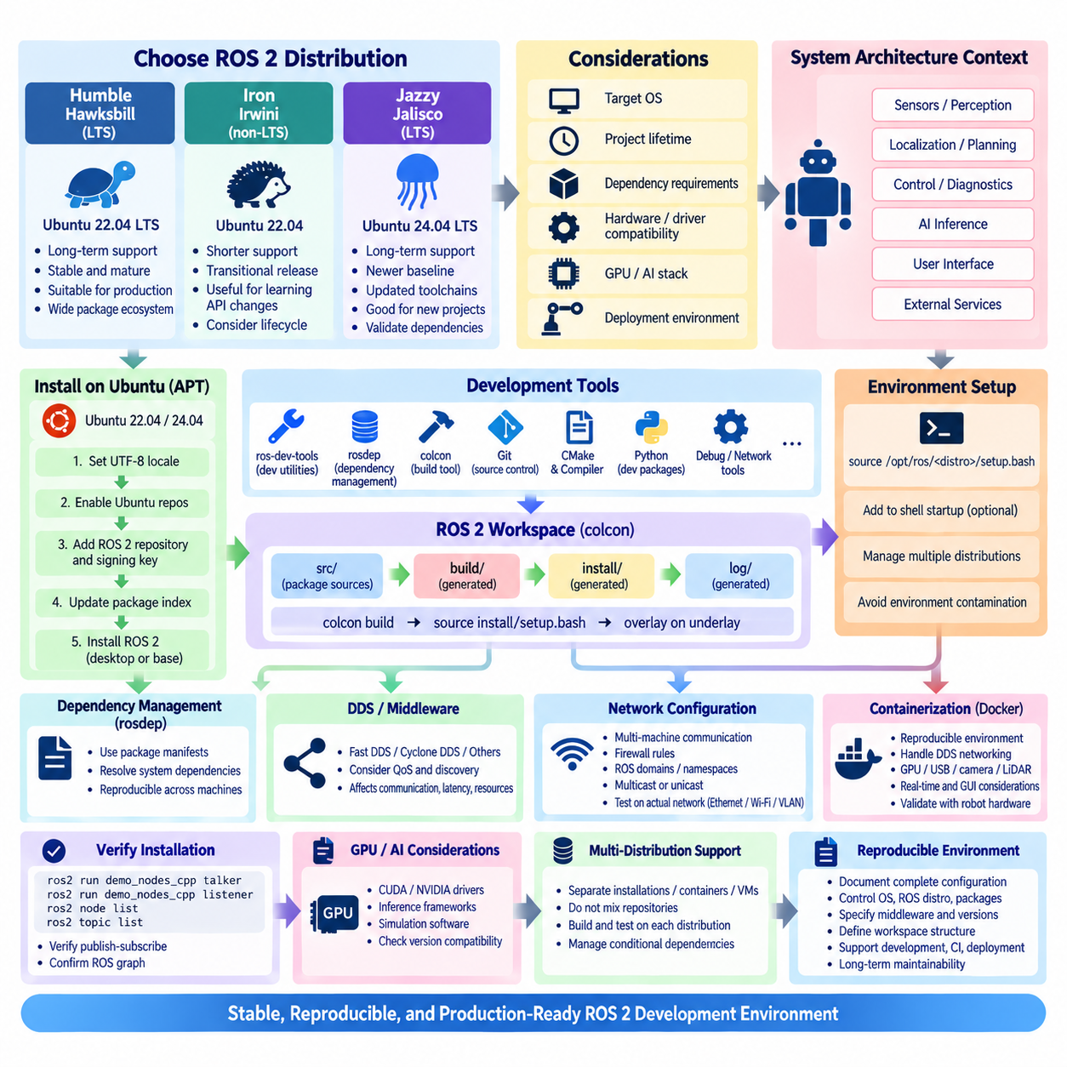
Installing ROS 2 is not merely a matter of placing middleware packages on a computer; it establishes a complete development environment in which operating-system versions, ROS distributions, compilers, Python packages, build tools, middleware implementations, and workspace configuration must remain compatible. Humble, Iron, and Jazzy represent successive ROS 2 generations, and selecting among them should begin with the target operating system, project lifetime, dependency requirements, and expected deployment environment.
ROS 2 Humble Hawksbill is a Long Term Support release associated primarily with Ubuntu 22.04 LTS and remains important for robotic products requiring a stable software baseline. Its long support period and mature package ecosystem make it suitable for production platforms where frequent operating-system migration is undesirable. Existing AMRs, manipulators, autonomous systems, and industrial robot applications may therefore continue using Humble even when newer ROS 2 distributions become available.
ROS 2 Iron Irwini represents an intermediate generation between Humble and Jazzy and is commonly associated with Ubuntu 22.04. Unlike Humble and Jazzy, Iron is not an LTS ROS 2 distribution, so its official support period is considerably shorter. Iron is useful for understanding API and package evolution between major long-term releases, but new long-lived production projects should carefully consider lifecycle requirements before selecting a distribution whose official maintenance period has already ended.
ROS 2 Jazzy Jalisco is a Long Term Support distribution primarily associated with Ubuntu 24.04 LTS. Jazzy provides a newer baseline for ROS 2 development and benefits from updated compilers, Python versions, middleware packages, and operating-system components. For projects beginning on Ubuntu 24.04 and intended to remain active for several years, Jazzy provides a natural development foundation, provided that required robot drivers, simulation packages, AI integrations, and third-party dependencies have been validated.
Distribution selection should therefore be treated as a system architecture decision rather than an isolated developer preference. A project already standardized on Ubuntu 22.04 with verified hardware drivers may obtain greater operational value from Humble, while a new Ubuntu 24.04 platform may favor Jazzy. The newest distribution is not automatically the best choice when a robot depends on proprietary sensor SDKs, GPU software, fieldbus drivers, vendor packages, or simulation tools with specific operating-system compatibility requirements.
On Ubuntu, binary package installation through the Advanced Package Tool (APT) is generally the most convenient development approach. The system locale should support UTF-8, the appropriate Ubuntu repositories must be enabled, and the official ROS package repository and signing key must be configured. After the package index is updated, developers can install either a desktop-oriented ROS environment containing common development and visualization tools or a smaller ROS base environment suitable for minimal systems and deployment targets.
The development environment also requires supporting tools beyond the ROS runtime itself. ros-dev-tools provides commonly required development utilities, while rosdep manages system dependencies declared by ROS packages. colcon serves as the standard workspace build tool, and Git remains essential for source management. Depending on the project, additional compiler tools, CMake, Python development packages, debugging utilities, networking tools, and middleware-specific configuration packages may also become part of the standardized development workstation.
After installation, the ROS 2 environment must be sourced before ROS commands and packages become available in the active shell. A distribution installed under /opt/ros typically provides a setup script that initializes environment variables and package search paths. Developers often add the appropriate source command to their shell startup configuration, but machines containing multiple ROS distributions require additional discipline because automatically sourcing one environment can unintentionally contaminate builds or tests intended for another distribution.
A ROS 2 development workspace normally separates source code from generated build artifacts. The workspace contains a src directory for package sources, while colcon creates build, install, and log directories during compilation. Developers place or clone packages under src, resolve dependencies with rosdep, execute colcon build from the workspace root, and then source the generated install/setup script. This overlay mechanism allows locally developed packages to extend or override packages supplied by the underlying ROS installation.
Environment layering is one of the most important concepts in ROS 2 development. The installed ROS distribution acts as an underlay, while a locally built workspace becomes an overlay. Additional workspaces can be layered above it when necessary. Although this mechanism enables modular development, excessive or inconsistent overlays can cause difficult dependency and package-resolution problems. Production teams should therefore define reproducible workspace structures and clearly specify which underlay and overlay combinations are supported.
Dependency management through rosdep is essential when source packages are shared across development machines or continuous integration systems. Package manifests describe dependencies using ROS package conventions, and rosdep maps these declarations to platform-specific system packages. Rather than manually installing libraries until compilation succeeds, developers can use dependency metadata to reconstruct the required environment. This approach improves reproducibility and reduces configuration differences among workstations, build servers, simulation computers, and robot targets.
A basic installation should always be validated before a large robot software stack is introduced. ROS 2 provides demonstration publisher and subscriber nodes that can confirm whether the client libraries, DDS middleware, discovery process, and topic communication are functioning correctly. Running a talker in one terminal and a listener in another verifies the fundamental publish-subscribe path. Command-line tools such as ros2 node list and ros2 topic list can then confirm that the expected ROS graph is visible.
DDS behavior must also be considered when establishing the development environment. ROS 2 communicates through an RMW implementation backed by middleware such as Fast DDS, Cyclone DDS, or another supported implementation. The default middleware may be sufficient for initial development, but production projects should explicitly document the selected implementation and configuration. Changing middleware can affect discovery behavior, network traffic, QoS compatibility, latency, resource consumption, and communication across multiple computers.
Network configuration becomes particularly important when ROS 2 nodes operate on different machines. Hosts must have compatible network connectivity, firewall rules must permit required middleware traffic, and ROS domain configuration should prevent unintended interaction with unrelated systems. Multicast availability can influence automatic discovery depending on middleware configuration. Development teams should therefore test communication on the actual Ethernet, Wi-Fi, VLAN, container, or industrial network topology intended for deployment rather than assuming localhost behavior represents field operation.
Containerization can provide another method for maintaining reproducible ROS 2 environments. Docker images can preserve a specific Ubuntu version, ROS distribution, package set, and build configuration while isolating projects from host-system changes. However, containers introduce additional considerations for DDS discovery, multicast networking, GPU access, USB devices, cameras, LiDAR interfaces, real-time scheduling, and graphical applications. Container adoption should therefore be validated against the robot's hardware and network requirements rather than treated only as a software packaging decision.
Development environments for GPU-accelerated robotics require additional compatibility planning. CUDA, NVIDIA drivers, inference frameworks, simulation software, and ROS packages may each impose version constraints. A ROS distribution that works correctly at the middleware level may still be unsuitable if the required perception or simulation stack does not support its Ubuntu baseline. GPU driver and CUDA compatibility should therefore be validated together with ROS, sensor SDKs, AI frameworks, and deployment hardware before the platform baseline is frozen.
Teams supporting Humble, Iron, and Jazzy simultaneously should avoid mixing package repositories or shell environments. Separate native installations, containers, virtual machines, or clearly controlled build environments can reduce accidental cross-version dependencies. Source code intended to support multiple distributions should be continuously compiled and tested against each supported target. Conditional dependencies or API differences should be explicitly managed rather than relying on a developer workstation that happens to contain compatible packages.
A production-quality ROS 2 environment should ultimately be reproducible from documented configuration rather than from the history of one engineer's workstation. The Ubuntu release, ROS distribution, package repositories, middleware implementation, dependency versions, compiler environment, workspace layout, environment variables, container definitions, and hardware SDKs should all be controlled. This transforms ROS 2 installation from a one-time setup procedure into a maintainable engineering baseline supporting development, simulation, continuous integration, deployment, debugging, and long-term robot software maintenance.

01.04 ROS2 Package Structure and CMake Build System [w/Code]
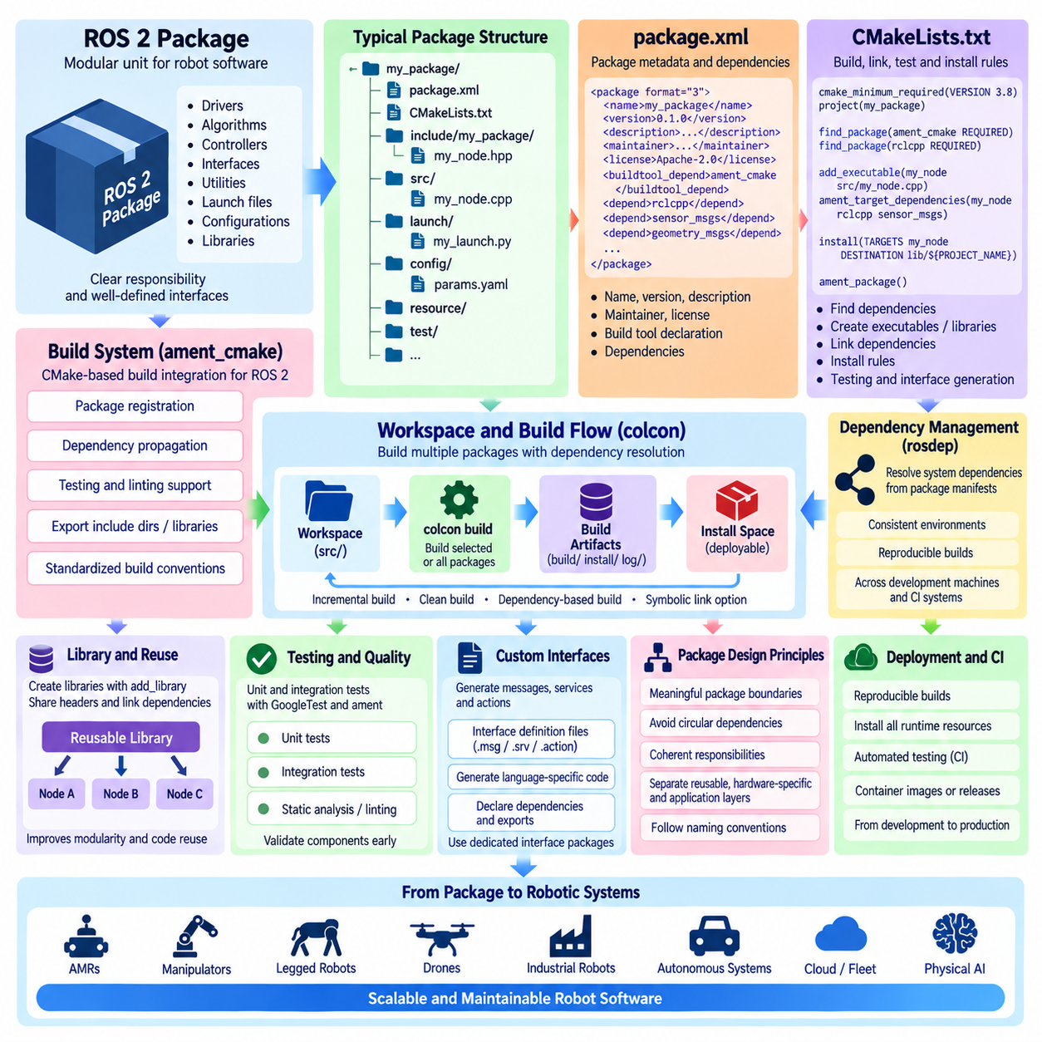
A ROS 2 package is the fundamental unit for organizing, building, distributing, and maintaining robot software. Rather than placing an entire robotic application inside one large project, ROS 2 encourages developers to divide functionality into packages with clearly defined responsibilities and interfaces. A package may contain sensor drivers, perception algorithms, controllers, communication interfaces, utilities, configuration files, launch definitions, or reusable libraries, allowing complex robot systems to evolve as modular software components.
A typical C++ ROS 2 package follows a recognizable directory structure centered on package.xml and CMakeLists.txt. Source files are normally stored under src, public C++ headers under include/<package_name>, while launch, config, resource, test, and other directories can be added according to package requirements. This convention makes package contents predictable to developers and build tools while separating source code, public interfaces, runtime configuration, testing assets, and installation resources.
The package.xml file defines package-level metadata and dependencies. It normally contains the package name, version, description, maintainer information, license, build tool declaration, and dependency specifications required by the package. Dependencies such as rclcpp, sensor_msgs, geometry_msgs, or other ROS 2 packages are declared here so that tools including rosdep and the ROS package infrastructure can understand what must be available before the software is successfully built and executed.
CMakeLists.txt defines how a C++ package is configured, compiled, linked, tested, and installed. ROS 2 commonly uses ament_cmake as the CMake-based build system integration layer. The file begins by establishing the minimum CMake version and project name, then locates required packages with find_package. Executables and libraries are created from source files, dependencies are attached to targets, installation destinations are defined, and package-specific testing or interface-generation rules can be added when required.
The relationship between package.xml and CMakeLists.txt is important because they serve different but complementary purposes. package.xml describes the package to the ROS ecosystem and dependency-management tools, whereas CMakeLists.txt describes how the package's build targets are produced. Declaring a dependency in only one location can result in builds that work on one developer machine but fail elsewhere. Production projects should therefore maintain consistent dependency information across package metadata and build configuration.
A simple ROS 2 C++ executable typically consists of a source file containing a node implementation and corresponding CMake instructions. add_executable creates the executable target, while ament_target_dependencies associates ROS dependencies with that target. The install command places the resulting executable in the package installation space where ROS 2 tools can locate it. This explicit target-oriented structure becomes increasingly valuable as packages contain multiple nodes, reusable libraries, tests, and generated interfaces.
Reusable C++ functionality should generally be separated into libraries rather than duplicated across executable nodes. A package can create libraries with add_library, expose public headers through the include directory, link required dependencies, and install both the compiled library and its headers. Other packages can then consume the library through well-defined interfaces. This approach improves modularity, testability, code reuse, and architectural separation between algorithmic functionality and ROS-specific executable wrappers.
Installation rules are a critical part of ROS 2 package design because a successful local compilation does not automatically mean that a package can be executed after installation. Executables, libraries, headers, launch files, configuration files, URDF resources, plugins, and other runtime assets must be installed into appropriate destinations. Correct installation rules allow the generated install space to represent the deployable package rather than depending on files that happen to remain inside the source directory.
ROS 2 workspaces organize multiple packages into a common development environment. Package sources are normally placed beneath the workspace src directory, while colcon analyzes dependencies and invokes the appropriate build system for each package. Generated artifacts are separated into build, install, and log directories. This separation keeps source trees clean and allows developers to inspect compilation artifacts, installed resources, and diagnostic logs independently when troubleshooting complex builds.
colcon can build an entire workspace or selected packages according to development needs. During iterative development, rebuilding only a target package and the packages affected by its dependencies can reduce turnaround time compared with rebuilding everything. Options such as symbolic linking can also simplify development of non-compiled resources by reducing repeated copying. Nevertheless, clean builds remain important when diagnosing dependency, installation, or environment problems that may be hidden by stale generated artifacts.
The ament build ecosystem extends beyond compilation by providing conventions for package registration, testing, linting, environment setup, and dependency propagation. Calling ament_package near the end of a CMake-based package finalizes important package information for the build and installation process. Additional ament mechanisms can export include directories, libraries, dependencies, and targets when a package is intended to provide reusable components to downstream packages.
Testing should be integrated into the package structure rather than treated as an external activity performed only after integration. C++ packages can include unit tests and integration-oriented tests using frameworks such as GoogleTest together with ament testing support. Static analysis and linting can also be incorporated into the build process. Keeping tests close to package interfaces allows developers to validate individual components before they become dependencies of navigation, perception, control, or complete robot applications.
Packages that define custom ROS interfaces require additional build configuration. Message, service, and action definitions are transformed into language-specific code and middleware type support during the build process. Their package metadata and CMake configuration must therefore declare the appropriate interface-generation dependencies and runtime exports. Separating interface definitions into dedicated packages can reduce coupling when many perception, planning, control, or fleet packages need to share the same communication contracts.
Package boundaries should reflect software architecture rather than arbitrary file counts. A package that contains unrelated drivers, planning algorithms, UI components, and robot-specific configuration becomes difficult to test, reuse, version, and maintain. Conversely, excessive fragmentation creates dependency complexity. Effective ROS 2 design normally groups components that share a coherent responsibility while separating stable interfaces, reusable libraries, hardware-specific implementations, and application-level orchestration where architectural independence provides practical value.
Naming and dependency direction are equally important in large robot software stacks. Lower-level interface and utility packages should generally avoid depending on higher-level application packages, because circular or inverted dependencies make builds and reuse difficult. Hardware interfaces, perception modules, navigation components, AI inference nodes, and fleet adapters can then depend on shared definitions without creating unnecessary knowledge of each other's internal implementations. The package graph consequently becomes an explicit representation of software architecture.
For production robotics, package design must also support deployment and continuous integration. Every package should build reproducibly from declared dependencies, install all required runtime resources, expose only necessary interfaces, and execute tests automatically. CI systems can build changed packages, run unit and integration tests, perform static checks, and generate deployable artifacts. Container images or robot software releases can then consume the workspace installation output rather than relying directly on an engineer's development source tree.
ROS 2 package structure and the CMake-based build system therefore provide more than a mechanism for compiling C++ source files. Together with package.xml, ament_cmake, colcon, rosdep, installation rules, interface generation, testing, and workspace overlays, they establish a disciplined software organization model. When package boundaries and dependency relationships are designed carefully, the same structure can scale from a single experimental node to production AMRs, manipulators, legged robots, autonomous systems, and large Physical AI software platforms.

01.05 ROS2 Interface: msg, srv, action Definition [w/Code]
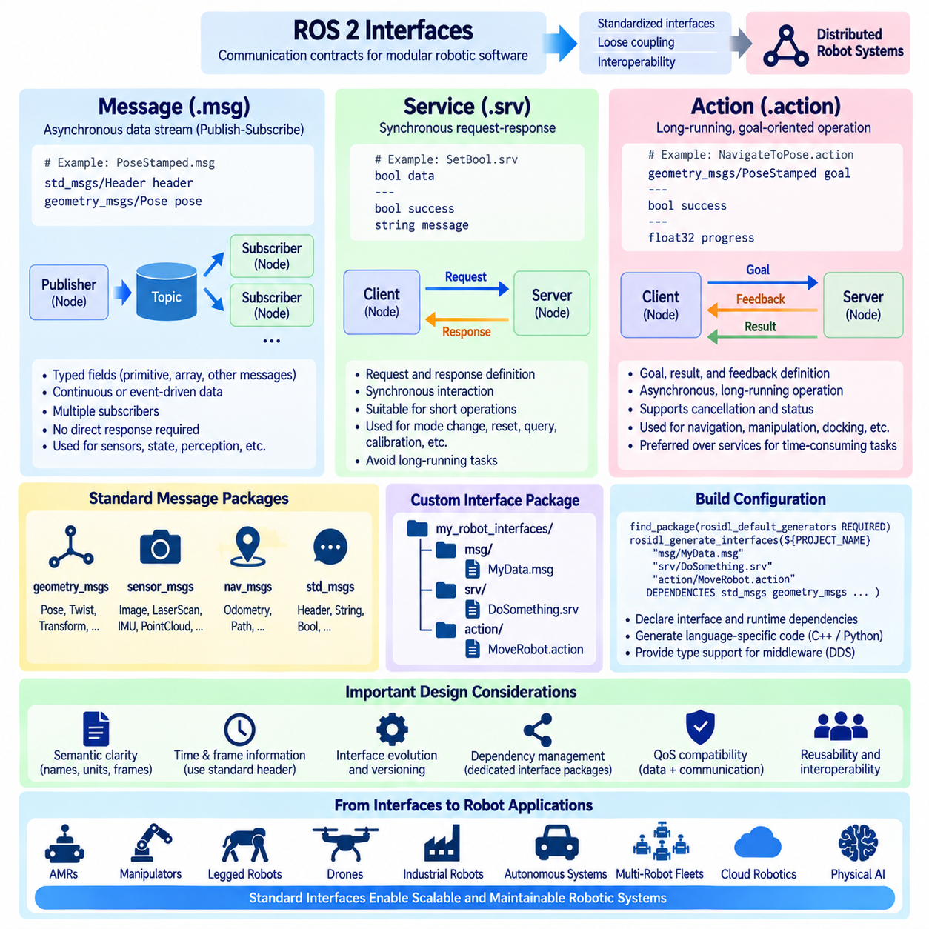
ROS 2 interfaces define the communication contracts that allow independently developed software components to exchange structured information. Instead of coupling nodes through implementation-specific function calls, ROS 2 describes data and interaction semantics through standardized interface definitions. The three fundamental interface forms are messages (.msg), services (.srv), and actions (.action), each corresponding to a different communication pattern and providing a foundation for modular distributed robotic software.
A message definition describes the structured data exchanged through ROS 2 topics using the publish-subscribe model. A .msg file contains typed fields that represent the information carried by each message instance. Fields may use primitive types such as integers, floating-point values, strings, and booleans, as well as arrays, bounded sequences, and other ROS message types. The interface definition therefore acts as a language-independent data contract between publishers and subscribers.
Messages are particularly appropriate for continuous or event-driven data streams where a publisher does not require a direct response from each receiver. Cameras, LiDARs, IMUs, joint-state sensors, localization systems, diagnostic modules, and perception algorithms commonly publish messages at their own rates. Multiple subscribers can independently consume the same topic, allowing visualization, logging, planning, monitoring, and control components to use identical information without creating direct dependencies between their implementations.
Standard message packages provide reusable interfaces for common robotic concepts. geometry_msgs defines structures for positions, orientations, poses, twists, transforms, and related geometric quantities, while sensor_msgs represents data from cameras, laser scanners, IMUs, point clouds, batteries, and other sensors. nav_msgs provides navigation-oriented information such as odometry and paths. Reusing standardized interfaces improves interoperability because different packages can exchange information without inventing incompatible representations for common data.
A service definition represents a synchronous request-response interaction. A .srv file contains a request section and a response section separated by three hyphens. The client sends a request containing input parameters, and the service server processes it and returns the defined response. This pattern is suitable when one component needs a specific operation to be performed and expects a corresponding result, rather than continuously receiving a stream of data through a topic.
Services are commonly used for operations such as resetting a subsystem, querying a state, changing a mode, triggering calibration, clearing stored data, or requesting a short computation. Because the client normally waits for completion or handles the returned future asynchronously, service callbacks should generally perform bounded operations rather than extremely long tasks. A long-running operation implemented as a service can complicate cancellation, progress reporting, timeout management, and system responsiveness.
Actions address this limitation by defining communication for long-running, goal-oriented operations. An .action interface consists of goal, result, and feedback sections separated by three hyphens. An action client sends a goal to an action server, which can accept or reject it and then execute the requested behavior. During execution, the server can publish feedback describing progress, and after completion it returns a result representing the final outcome of the operation.
Action communication is particularly useful for robotic behaviors whose execution takes meaningful time. Navigation to a target pose, following a trajectory, manipulating an object, docking an AMR, performing an inspection sequence, or executing a complex autonomous task may require seconds or minutes. During this period, the application may need progress feedback, goal status, cancellation, or replacement of the active goal. Actions provide these semantics directly instead of requiring developers to construct them manually from unrelated topics and services.
The distinction among messages, services, and actions should therefore be based on interaction semantics rather than convenience. Topics are suitable for asynchronous streams and state distribution, services for relatively short request-response operations, and actions for longer goal-oriented activities requiring feedback and cancellation. Selecting the wrong communication mechanism can create unnecessary coupling or timing problems. Interface design should begin by asking how information behaves over time and how participating components need to interact.
Custom interfaces are required when standard ROS 2 packages cannot adequately represent application-specific information. Developers typically place message definitions under msg, service definitions under srv, and action definitions under action directories. These definitions are processed during the build to generate language-specific interfaces and middleware type support. C++ and Python nodes can consequently exchange the same custom data even though their application implementations use different programming languages.
Custom interface generation requires explicit package configuration. The package metadata must declare the required interface-generation and runtime dependencies, while CMakeLists.txt configures rosidl_default_generators and invokes rosidl_generate_interfaces for the interface files. Dependencies on message packages referenced inside custom definitions must also be declared. Correct configuration ensures that generated code, type support, and runtime interface information become available to packages that depend on the custom interface package.
For larger systems, placing shared interface definitions in dedicated interface packages is often preferable to embedding them inside algorithm or hardware packages. A package such as robot_interfaces can define stable communication contracts that are consumed by perception, planning, control, fleet, and user-interface components. This prevents higher-level software from depending on an implementation package merely to obtain message definitions and helps preserve a clean dependency direction throughout the software architecture.
Interface definitions should be designed for semantic clarity rather than simply mirroring internal C++ structures. Field names, units, coordinate frames, timestamps, valid ranges, identifiers, and state meanings should be explicit and consistent. For example, a velocity field is ambiguous unless its units and reference frame are understood. Standard ROS conventions and existing message types should be reused whenever possible because semantic consistency is essential when independently developed nodes exchange data across a distributed system.
Time and coordinate-frame information are particularly important in robotic interfaces. Sensor observations and robot states often need timestamps so that perception, localization, transformation, and control algorithms can correlate data correctly. Spatial data may also require an associated coordinate frame. Standard header structures are therefore frequently included in ROS messages to carry timing and frame information. Omitting these semantics can make otherwise syntactically valid messages difficult to integrate reliably.
Interface evolution must be managed carefully because changing a message, service, or action definition affects every package that generates or consumes the corresponding type. Renaming fields, changing types, removing information, or altering semantic meaning can break source compatibility or communication assumptions. Stable interfaces should therefore be treated similarly to public APIs. Significant changes may require coordinated package updates, explicit versioning strategies, conversion components, or temporary compatibility mechanisms during migration.
The generated interface code connects application-level definitions to the ROS 2 middleware architecture. ROS Interface Definition Language mechanisms transform .msg, .srv, and .action specifications into language-specific representations and type-support structures. The selected RMW and DDS implementation can then serialize and transport the resulting data between endpoints. Developers normally work with familiar C++ or Python objects while the generated infrastructure handles the lower-level representation required for distributed communication.
Quality of Service remains relevant even when the message type itself is correctly defined. A topic interface determines the structure and meaning of the exchanged data, while QoS determines important delivery behavior such as reliability, durability, history, and queue depth. Two nodes can therefore agree completely on a message definition yet fail to communicate as intended if their QoS policies are incompatible. Data semantics and communication semantics must both be considered when defining a robust ROS 2 interface contract.
At the system level, messages, services, and actions form complementary communication primitives. Sensor and state information can flow continuously through topics, configuration and short commands can be handled through services, and navigation or manipulation objectives can execute through actions. Together, these interfaces allow perception, localization, planning, control, diagnostics, hardware drivers, fleet management, and AI components to remain modular while participating in coordinated robot behavior.
Well-designed ROS 2 interfaces ultimately become architectural boundaries between software components, teams, computing devices, and even different generations of a robotic product. Their value extends beyond serialization syntax: they define what information is shared, what operations are available, and how long-running behaviors are controlled. Careful use of .msg, .srv, and .action definitions therefore provides a stable communication foundation for AMRs, manipulators, legged robots, autonomous systems, multi-robot fleets, and increasingly complex Physical AI platforms.

01.06 colcon Build and Workspace Management [w/Code]
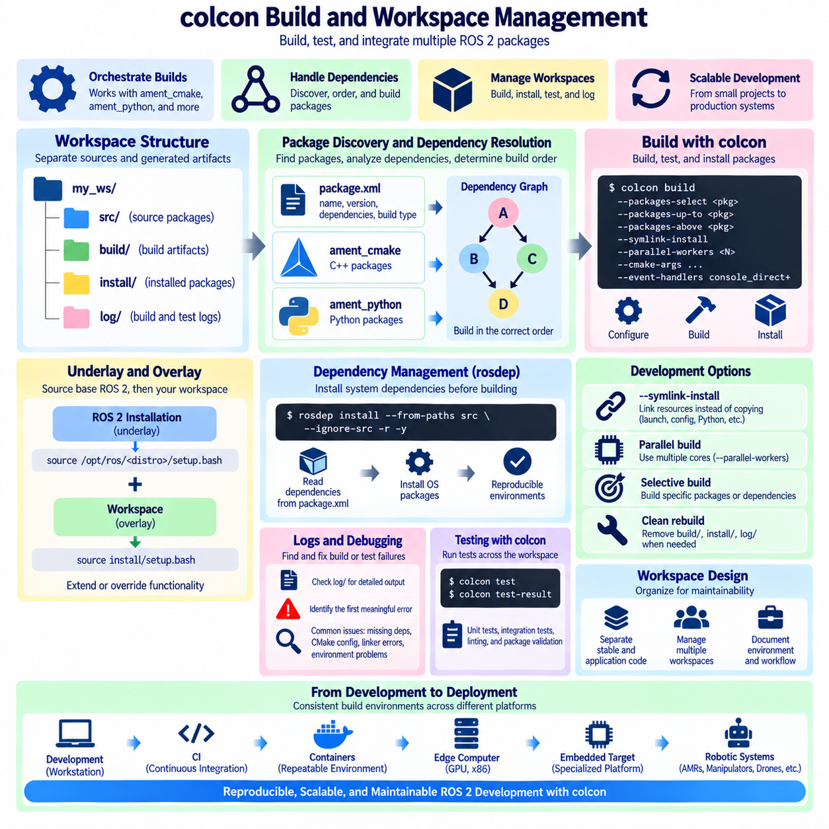
colcon is the primary command-line build tool used to coordinate the compilation of ROS 2 workspaces containing multiple packages. Unlike a package-specific compiler or build system, colcon operates above individual build technologies and determines how packages should be discovered, ordered, built, tested, and installed. In a ROS 2 C++ environment, it commonly orchestrates packages based on ament_cmake while maintaining dependency relationships across the complete workspace.
A conventional ROS 2 workspace separates package sources from generated artifacts. The workspace root normally contains a src directory where source packages are stored. After a build, colcon creates build, install, and log directories alongside src. The build directory contains intermediate compilation artifacts, install contains the usable outputs of successfully built packages, and log records detailed information that can be examined when compilation, configuration, or testing fails.
Package discovery begins when colcon examines the workspace and identifies packages from their metadata and supported build types. ROS 2 packages commonly declare ament_cmake or ament_python as their build type, although colcon itself can coordinate a broader range of package technologies. Once packages have been discovered, their declared dependencies are analyzed so that prerequisite packages are processed before downstream packages that depend on their headers, libraries, interfaces, or exported configuration.
The basic `colcon build` command builds the packages available in the workspace according to this dependency graph. Each package is configured and processed using its declared build system, and successful results are installed into the workspace installation space. This means colcon does not replace CMake, ament_cmake, or Python packaging mechanisms. Instead, it acts as an orchestration layer that coordinates those mechanisms across a potentially large collection of interdependent software components.
Before building a workspace, developers normally source the required ROS 2 installation so that its packages become the workspace underlay. After compilation completes, the generated install setup file is sourced to make newly built packages available in the current shell. The workspace then acts as an overlay above the underlying ROS distribution. This underlay-overlay relationship is fundamental to ROS 2 development because locally developed packages can extend or override functionality supplied by the base installation.
Overlay management requires discipline because the environment from which a workspace is built affects package discovery and dependency resolution. Building a workspace while an unintended overlay is already sourced can introduce hidden dependencies on another development environment. The resulting software may compile successfully on one machine but fail in a clean environment. Reproducible projects therefore define exactly which ROS distribution and prerequisite workspaces must be sourced before each build.
colcon provides package-selection mechanisms that make iterative development more efficient. Developers can build only a specific package, select several packages, or include packages required by or dependent on a target package. This becomes important in large workspaces where rebuilding every driver, interface, perception module, controller, and application after a small modification would waste significant time. Selective builds reduce development latency while preserving dependency-aware execution.
One commonly useful development option is `--symlink-install`. Instead of copying certain installed resources into the install space, symbolic links can be created where supported. This is especially convenient for Python files, launch descriptions, configuration resources, and other content that does not require recompilation after every edit. Developers must nevertheless understand which artifacts still require rebuilding, particularly compiled C++ code, generated interfaces, and build-system changes.
Build parallelism is another important colcon capability. Independent packages can be processed concurrently when their dependency relationships permit it, reducing total build time on multicore development computers. However, unrestricted parallel compilation can consume substantial CPU capacity and memory, particularly when large C++ packages or generated interfaces are involved. Build concurrency should therefore be adjusted according to workstation resources and the size of the software stack rather than simply maximized.
Workspace dependency installation is typically handled with rosdep before compilation. rosdep examines dependency declarations from package metadata and maps them to required system packages for the current platform. This separates operating-system dependency installation from source compilation. A newly prepared workstation, continuous integration runner, or robot build environment can therefore reconstruct dependencies systematically instead of relying on libraries that were manually installed during previous development.
When builds fail, the build and log directories provide essential diagnostic information. Failures may originate from missing dependencies, incorrect CMake configuration, incompatible APIs, absent headers, linker errors, generated-interface problems, or environment contamination. Developers should identify the first meaningful failure rather than focusing only on later packages that were aborted because their dependencies failed. Dependency-aware diagnosis is especially important when many packages are built together.
Clean rebuilding is sometimes necessary because generated artifacts can preserve obsolete configuration from previous builds. Removing build, install, and log directories forces colcon and the underlying build systems to reconstruct the workspace state. However, deleting all generated directories after every minor problem is inefficient and can hide the actual cause of environment errors. Selective cleaning or rebuilding should be preferred when the affected package and dependency relationship are understood.
The install space represents an important boundary between development sources and executable software. ROS 2 tools normally locate installed executables, libraries, interfaces, launch files, configuration data, and other resources after the workspace setup file has been sourced. Packages should therefore install every runtime dependency they own correctly rather than accessing resources through hard-coded paths into src. A package that works only from its source tree is not yet properly prepared for deployment.
Multiple workspaces can be layered when a system needs to separate stable platform software from frequently changing application code. For example, a lower workspace may contain hardware drivers and common interfaces, while an upper workspace contains robot-specific perception, planning, or application packages. This can accelerate development and clarify ownership boundaries, but each additional overlay increases environment complexity. Teams should use layering deliberately and document the required sourcing order.
Workspace organization should reflect software architecture and lifecycle. Stable interface packages, shared libraries, hardware abstraction components, application packages, and experimental modules may have different release and testing requirements. They do not necessarily need to reside in one enormous workspace. Separating repositories or workspaces can improve modularity, but excessive fragmentation can make dependency synchronization difficult. The correct structure balances independent development with manageable integration.
colcon also integrates with testing workflows. After packages have been built, tests can be executed across the workspace and their results summarized through colcon commands. Unit tests, integration tests, linting, and package-specific validation can therefore become part of a consistent developer and continuous integration workflow. A successful compilation should not be considered sufficient evidence of software correctness, particularly for components used in perception, navigation, control, or safety-related robot functions.
Continuous integration systems can reproduce the same workspace procedure used by developers: prepare the ROS underlay, obtain package sources, install declared dependencies, build with colcon, execute tests, and preserve logs or artifacts. Automating these steps exposes undeclared dependencies and environment assumptions early. A package that builds only on one engineer's workstation but fails in a clean CI environment usually indicates that the workspace or package dependency model is incomplete.
Large robotic projects benefit from controlling not only source revisions but also the complete build context. The ROS distribution, operating-system version, compiler, dependency repositories, middleware implementation, environment variables, package versions, and build options can all influence the result. Containers and scripted setup procedures can complement colcon by creating repeatable environments. colcon then provides the consistent orchestration mechanism inside those controlled development and deployment contexts.
For heterogeneous robotic systems, separate workspaces may also target different computing platforms. An x86 workstation can host simulation and visualization packages, an NVIDIA edge computer can build GPU-accelerated perception software, and embedded targets may use specialized ROS 2 integrations. Although their package sets and toolchains differ, common interface packages can preserve communication compatibility. Workspace management consequently becomes part of system-level deployment architecture rather than merely a developer convenience.
Effective colcon usage ultimately depends on treating the workspace as a reproducible software integration environment. Package discovery, dependency ordering, underlays, overlays, selective builds, installation, testing, logging, and environment sourcing all contribute to predictable behavior. When these practices are standardized, colcon can scale from building a few educational ROS 2 nodes to coordinating the software foundations of AMRs, manipulators, autonomous robots, multi-computer systems, and complex Physical AI platforms.

01.07 ros2 CLI Tools: topic, service, param [w/Code]
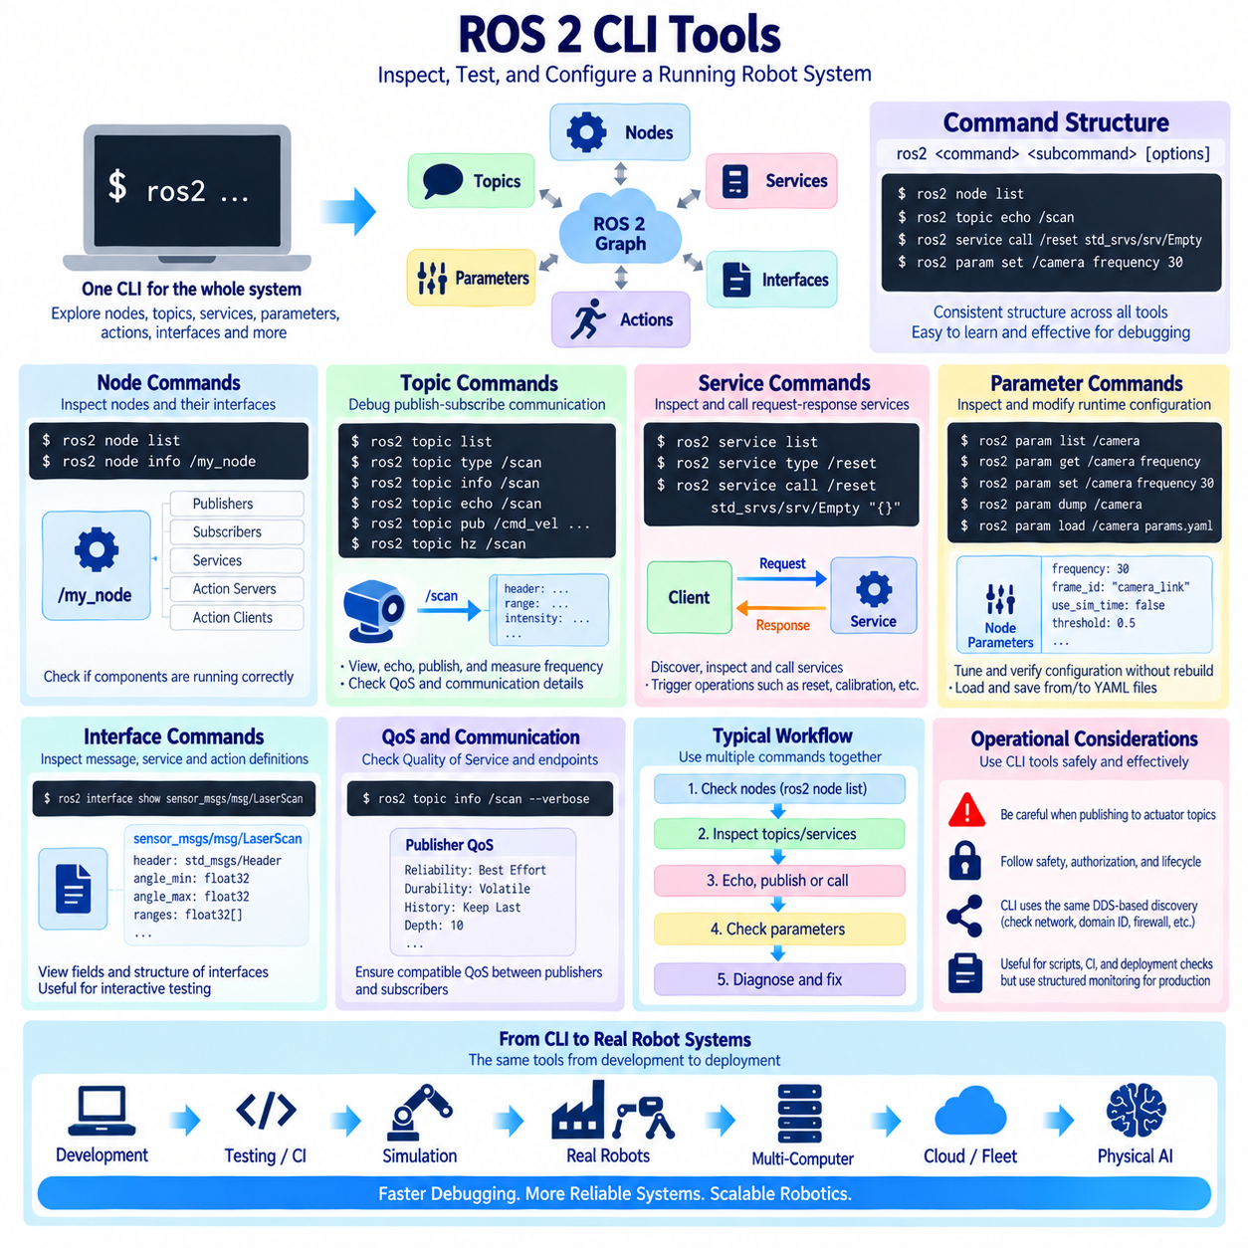
The `ros2` command-line interface (CLI) is one of the most important tools for interacting with a running ROS 2 system. It provides a unified entry point for inspecting nodes, topics, services, parameters, actions, interfaces, packages, and other elements of the ROS graph. Instead of writing diagnostic programs for routine tasks, developers can use CLI commands directly from a terminal to observe communication, test interfaces, modify configuration, and investigate system behavior.
The CLI follows a hierarchical command structure beginning with `ros2`, followed by a functional command group and a specific operation. Commands such as `ros2 node`, `ros2 topic`, `ros2 service`, and `ros2 param` expose different portions of the running system. Most groups provide subcommands such as `list`, `info`, `echo`, `get`, or `set`. This consistent structure makes the CLI useful both during initial development and when diagnosing complex distributed robot systems.
Node inspection provides a basic view of the ROS 2 computational graph. The `ros2 node list` command displays currently discovered nodes, while `ros2 node info <node_name>` reports communication interfaces associated with a selected node. Developers can inspect publishers, subscribers, services, action servers, and action clients to determine whether a component has started correctly and whether its expected interfaces are visible to other participants.
Topic commands are central to debugging publish-subscribe communication. `ros2 topic list` displays discovered topics, and the type associated with a topic can be examined using `ros2 topic type`. More detailed endpoint information can be obtained with `ros2 topic info`. These commands allow engineers to verify whether sensor streams, robot states, localization outputs, perception results, or control commands exist in the ROS graph before investigating higher-level application behavior.
The `ros2 topic echo` command subscribes to a selected topic and prints received messages to the terminal. It is particularly useful when checking whether a sensor or algorithm is producing meaningful data. Developers can observe fields such as timestamps, positions, velocities, identifiers, or status values without creating a dedicated subscriber. For high-rate or large messages, however, unrestricted terminal output can become expensive and should be used carefully during performance-sensitive operation.
ROS 2 CLI tools can also publish messages manually. `ros2 topic pub` creates a publisher from the terminal and sends data using a specified message type and YAML-style field representation. This allows developers to stimulate subscribers, test controllers, inject simple commands, or validate state transitions without implementing a temporary test node. Publication can be performed once or repeatedly depending on the selected options and the behavior being tested.
Topic frequency and bandwidth are important diagnostic characteristics for robotic data streams. Commands such as `ros2 topic hz` can estimate the observed message publication rate, while bandwidth-related inspection can help identify unexpectedly expensive communication paths where supported. A camera, LiDAR, IMU, odometry source, or controller that operates at an incorrect rate may produce downstream timing problems even though its topic remains visible and syntactically valid.
Quality of Service (QoS) must also be considered during topic inspection. A publisher and subscriber may use the same message type and topic name but still fail to exchange data if their QoS policies are incompatible. Detailed topic information can expose endpoint QoS characteristics such as reliability and durability. This is particularly valuable when diagnosing sensor drivers or distributed applications where one component uses best-effort communication while another expects reliable delivery.
Service CLI commands provide tools for inspecting request-response interfaces. `ros2 service list` displays currently available services, while `ros2 service type` identifies the interface associated with a selected service. Developers can then inspect the corresponding service definition and determine the fields required in its request and response. This workflow is useful when exploring an unfamiliar node or validating whether a service server has been correctly registered.
The `ros2 service call` command allows a service request to be issued directly from the terminal. The developer specifies the service name, service type, and request values using the expected field structure. This capability is useful for triggering calibration, resetting state, enabling functionality, changing operating modes, or testing short command-response operations. The returned response can immediately reveal whether the server accepted and processed the request as expected.
Interface inspection complements topic and service commands because developers frequently need to determine the exact structure of exchanged data. `ros2 interface show` displays the fields of a message, service, or action definition. Other interface-related commands can list available definitions and package interfaces. This removes the need to search manually through source directories whenever the required field names or nested message types are unknown during interactive testing.
Parameters provide runtime configuration associated with ROS 2 nodes. Unlike topics, which primarily exchange continuously changing data, parameters generally represent configuration values such as thresholds, frame names, algorithm options, update frequencies, or feature switches. A node declares the parameters it supports and can read or react to their values. The CLI provides a direct mechanism for discovering and manipulating these settings while the system is operating.
The `ros2 param list` command identifies parameters associated with discovered nodes, while `ros2 param get` retrieves the current value of a selected parameter. `ros2 param set` requests a runtime change when the node permits modification. These operations are useful when tuning algorithms or verifying configuration without rebuilding software. However, whether a parameter change is accepted and whether it immediately affects behavior depend on how the node implements parameter handling.
Parameter values can also be stored in YAML configuration files and loaded as part of a reproducible deployment. CLI commands remain useful for inspecting whether the values actually applied to a running node match the intended configuration. Parameters can also be dumped and loaded through appropriate ROS 2 parameter commands. This provides a bridge between interactive experimentation and controlled configuration management for larger robot applications.
The CLI is especially effective when several command groups are used together. A developer can first use `ros2 node list` to confirm that a component exists, inspect it with `ros2 node info`, identify its topics or services, examine their types, and then use `echo`, `pub`, or `service call` to test communication. Parameters can subsequently be inspected to determine whether incorrect configuration explains unexpected behavior. This creates a systematic diagnostic path through the ROS graph.
Command-line discovery depends on the same DDS-based distributed mechanisms used by application nodes. Therefore, a CLI command that cannot see a remote node may indicate a network or middleware problem rather than an application failure. ROS domain identifiers, middleware selection, multicast behavior, firewall configuration, container networking, and QoS settings can all influence what becomes visible. CLI tools consequently provide a practical way to diagnose both application-level and distributed communication problems.
CLI inspection should nevertheless be used with operational awareness. Publishing commands to actuator-related topics, calling state-changing services, or modifying parameters can directly alter robot behavior. On physical systems, especially mobile robots and manipulators, engineers should distinguish passive inspection commands from active commands that inject data or modify state. Diagnostic convenience must not bypass motion-control, authorization, lifecycle, or safety procedures established by the system architecture.
For automated workflows, many ROS 2 CLI operations can also be incorporated into shell scripts, deployment checks, integration tests, and commissioning procedures. Scripts can verify that expected nodes and interfaces are present, inspect configuration, or exercise selected services after startup. However, robust production monitoring should not depend solely on parsing human-oriented terminal output; dedicated diagnostics, lifecycle supervision, health interfaces, and structured telemetry are more appropriate for persistent runtime observability.
The ROS 2 CLI therefore acts as an interactive window into the distributed robotic system. Topic commands reveal asynchronous data flow, service commands exercise request-response operations, parameter commands expose runtime configuration, and node and interface commands provide the surrounding structural context. Used systematically, these tools shorten the path from observing an unexpected robot behavior to identifying whether the underlying cause lies in node execution, communication, configuration, QoS, interfaces, or the network.
ALL contents must be merged into only ONE image only.

01.08 ROS2 Logging System and Level Management [w/Code]
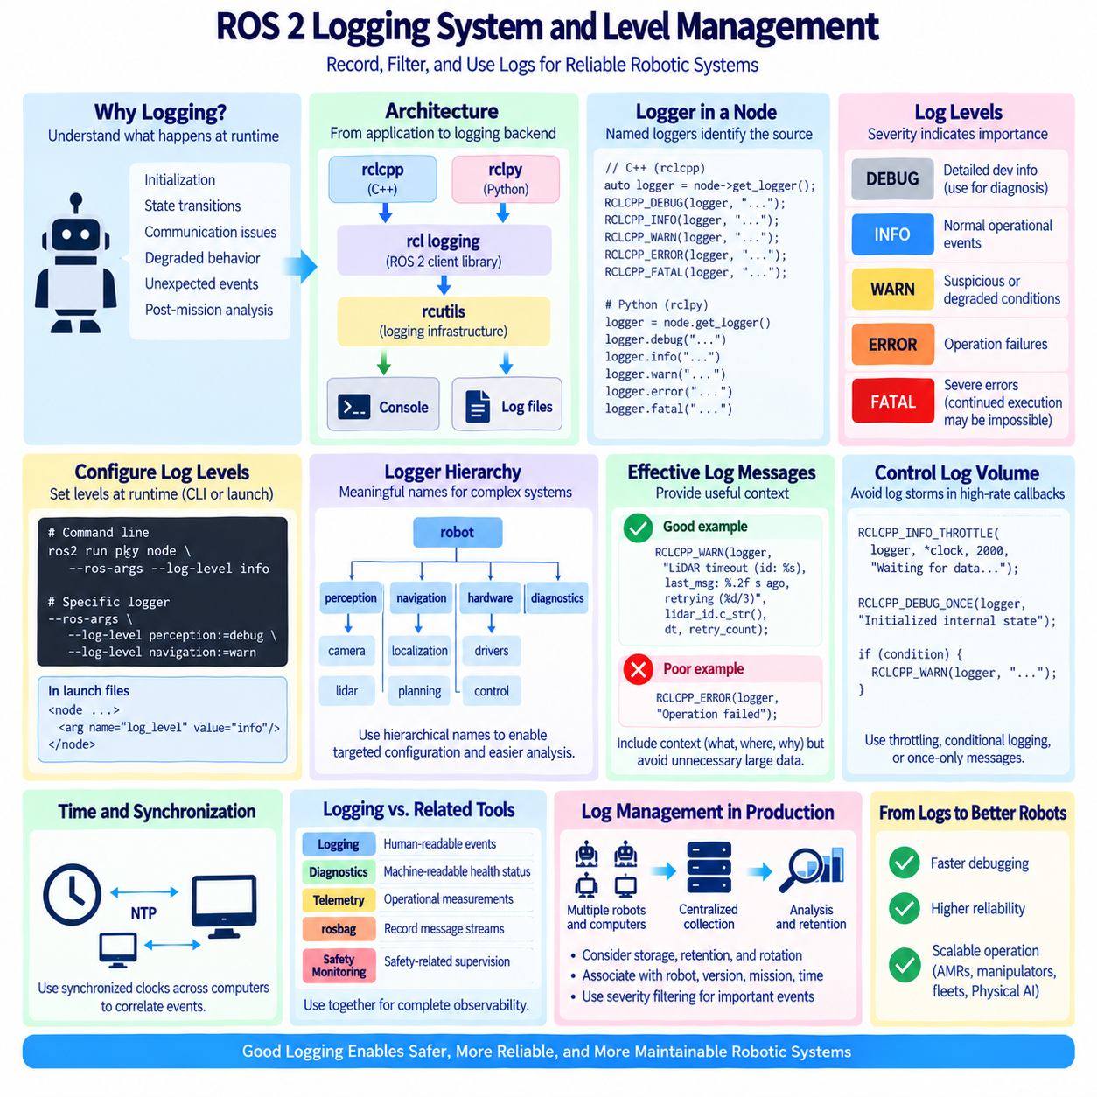
ROS 2 provides a structured logging system for recording runtime information from nodes, libraries, and distributed robotic applications. Logging is more than printing text to a terminal because each record can carry severity, logger identity, timestamp, and execution context. A well-designed logging strategy allows developers and operators to understand initialization, state transitions, communication failures, degraded behavior, and unexpected events without attaching a debugger to every running component.
The ROS 2 logging architecture is exposed to application code through client libraries such as rclcpp and rclpy. These libraries connect application-level logging calls to the underlying ROS logging infrastructure, commonly referred to through rcutils and rcl logging components. This layered design allows C++ and Python nodes to use consistent logging concepts while the lower layers manage formatting, output destinations, severity filtering, and integration with the broader ROS 2 runtime environment.
A logger is normally associated with a node or a named software component. In C++, a node can obtain its logger and use macros such as `RCLCPP_DEBUG`, `RCLCPP_INFO`, `RCLCPP_WARN`, `RCLCPP_ERROR`, and `RCLCPP_FATAL`. Python provides corresponding logger methods through rclpy. Named loggers make it possible to identify which subsystem generated a message, which becomes essential when dozens or hundreds of ROS 2 nodes execute simultaneously across several computers.
ROS 2 organizes log messages into severity levels that indicate the importance of an event. DEBUG is intended for detailed development information, INFO describes normal operational events, WARN indicates suspicious or degraded conditions, ERROR represents failures that prevent some operation from completing correctly, and FATAL identifies severe conditions that may prevent continued execution. Consistent interpretation of these levels is necessary if logs are to remain useful across a large software organization.
DEBUG messages should contain detailed information useful for diagnosing algorithms, data flow, state machines, or communication behavior. They may report intermediate values, decision paths, callback execution, or internal state that would be excessive during normal robot operation. Because high-volume DEBUG output can increase CPU, storage, and terminal overhead, production systems commonly suppress it by default and enable it selectively when investigating a particular component or failure.
INFO should describe meaningful normal behavior rather than every iteration of a control or sensor loop. Appropriate examples include successful initialization, connection establishment, lifecycle transitions, configuration loading, mission start, mode changes, or orderly shutdown. Excessive INFO logging at high frequency makes important events difficult to locate and can generate unnecessarily large files. Good logging therefore emphasizes operational significance rather than simply recording that code is executing.
WARN is appropriate when the system can continue operating but encounters a condition requiring attention. Examples include delayed sensor data, temporary communication loss, fallback operation, repeated retries, reduced localization quality, or approaching resource limits. A warning should communicate enough context to explain the degraded condition and, when possible, indicate whether automatic recovery is occurring. Repeated warnings should be controlled so that one persistent problem does not overwhelm the logging system.
ERROR should be used when an operation fails or an important function cannot produce its expected result. Examples include failure to initialize a required device, invalid configuration that blocks an algorithm, unsuccessful service execution, corrupted input, or loss of a critical dependency. An error message should identify what failed and provide useful context for diagnosis. It should not automatically imply complete process termination, because a node may isolate the failure or enter a recovery state.
FATAL represents the highest severity and should be reserved for conditions where continued execution is impossible, unsafe, or fundamentally invalid for the affected process. Examples may include failure of an indispensable initialization step or detection of an unrecoverable internal state. FATAL logging itself does not substitute for explicit shutdown, lifecycle transition, emergency handling, or safety mechanisms. Software must still implement the required response after reporting the condition.
Logger severity thresholds determine which records are emitted. If a logger is configured at INFO, DEBUG messages are normally filtered while INFO and more severe records remain visible. Raising the threshold to WARN reduces routine output, whereas lowering it to DEBUG exposes detailed diagnostic information. This mechanism allows the same software binary to support quiet production operation and detailed troubleshooting without inserting or removing temporary print statements throughout the source code.
Logging levels can be configured when ROS 2 nodes are launched or executed. Command-line ROS arguments can specify logger levels, including settings for particular named loggers where supported. Launch configurations can also establish verbosity appropriate to a deployment or diagnostic session. This is especially useful in distributed systems because engineers can increase logging for a problematic perception, navigation, or hardware component without enabling verbose output for every node in the robot.
Logger hierarchy and naming should follow the software architecture. A complex node may use child or component-specific logger names for subsystems such as localization, planning, hardware communication, or diagnostics. Meaningful naming enables targeted severity configuration and makes large log collections easier to search. Poorly chosen or inconsistent logger names reduce this advantage because operators cannot reliably associate messages with the software component, robot function, or failure domain that produced them.
ROS 2 logs can be presented through console output and may also be written to log files depending on runtime configuration. Console logs are convenient during interactive development, while persistent files are important when failures must be analyzed after a robot has completed a mission or restarted. File-based logging should consider storage capacity, retention periods, rotation, collection, and transfer policies because autonomous systems can generate substantial volumes of diagnostic data during continuous operation.
Time information is critical when logs from multiple nodes must be correlated. Events such as sensor loss, localization degradation, planner failure, controller response, and safety intervention may occur within milliseconds of one another. Reliable timestamps allow engineers to reconstruct the sequence of events across distributed processes. In multi-computer robots, system clock synchronization therefore becomes an important companion to logging because inconsistent clocks can make otherwise correct records difficult to correlate.
Logging statements should provide actionable context while avoiding unnecessary data. Messages such as “operation failed” are usually insufficient because they do not identify the operation, relevant resource, state, or reason. More useful records include identifiers, expected and observed states, retry counts, device names, or error codes. At the same time, high-rate sensor payloads and large binary data should not be copied indiscriminately into textual logs; dedicated recording mechanisms are more appropriate for such data.
Repeated logging inside high-frequency callbacks requires special attention. A controller operating at hundreds of hertz or a sensor callback processing many frames per second can produce thousands of identical messages within a short interval. ROS 2 logging facilities and application logic can use throttling, conditional logging, or once-only reporting patterns to limit repetition. These techniques preserve evidence of abnormal behavior while preventing log storms from consuming CPU, disk bandwidth, storage, or network resources.
Logging should be distinguished from diagnostics, telemetry, rosbag recording, and safety monitoring. Logs primarily explain software events for humans and post-event analysis, whereas structured diagnostics communicate machine-readable health states, telemetry reports operational measurements, and rosbag captures ROS message streams for replay and analysis. Mature robotic systems use these mechanisms together instead of attempting to encode every operational requirement as textual log messages.
In production robots, log management becomes a system-level architectural function. Logs from navigation, perception, control, hardware drivers, mission management, and infrastructure may need to be collected from several computers and associated with a specific robot, software version, mission, and time interval. Centralized collection and retention policies make fleet-level investigation possible, while severity filtering prevents routine information from obscuring failures that require engineering or operational attention.
A disciplined ROS 2 logging strategy therefore combines meaningful severity levels, consistent logger naming, runtime level control, useful contextual information, rate management, persistent storage, and synchronized timestamps. When these practices are integrated with diagnostics and telemetry, logging evolves from simple debugging output into an observability foundation for AMRs, manipulators, autonomous vehicles, multi-robot fleets, and complex Physical AI systems operating across distributed computing platforms.

01.09 ROS2 Community Ecosystem: Standard Packages / REP
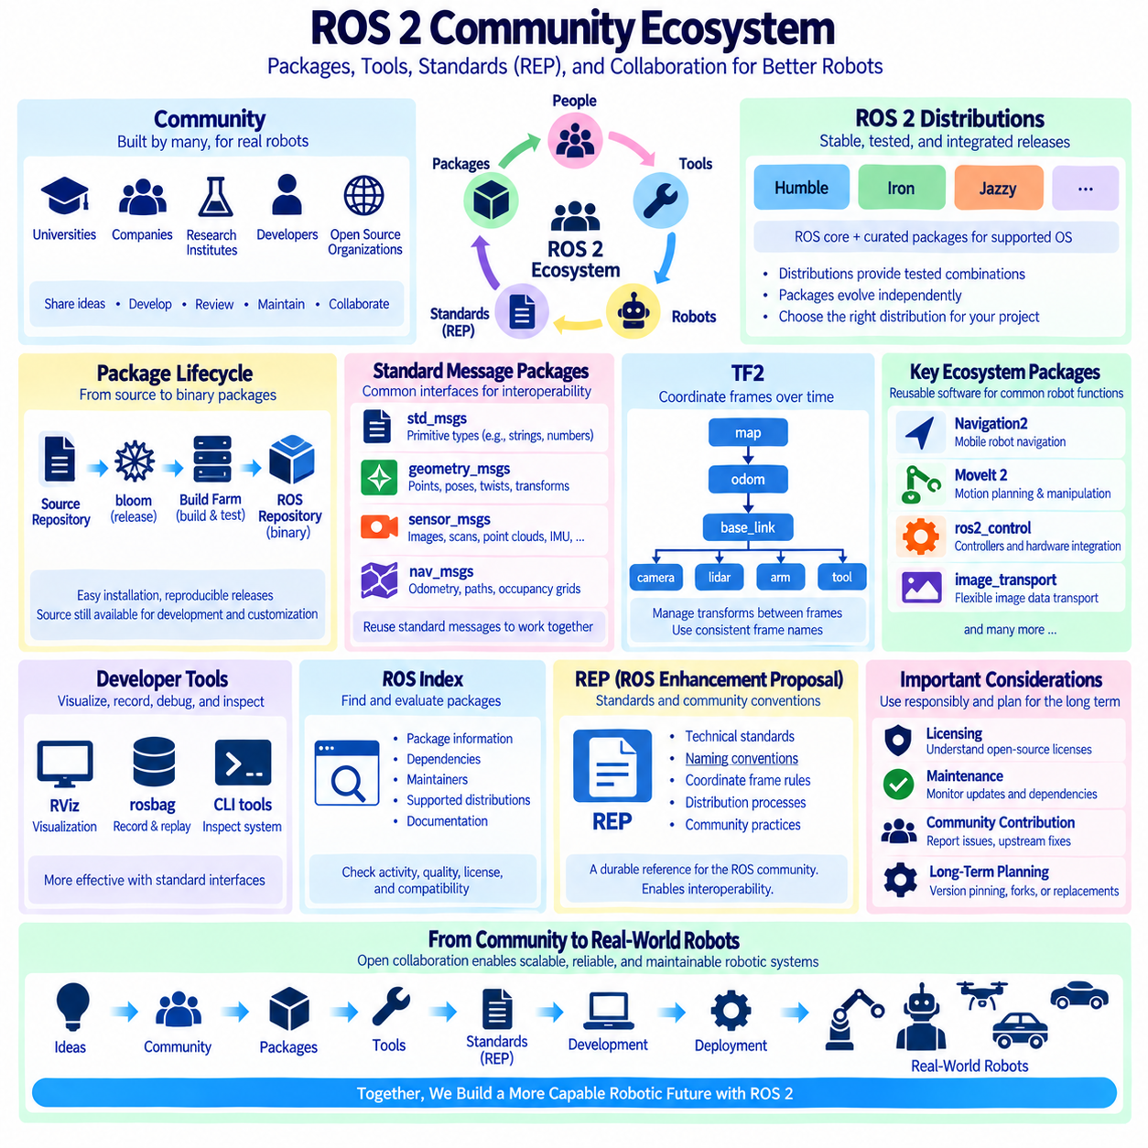
The ROS 2 ecosystem extends far beyond the core middleware and client libraries. It includes community-maintained packages, reusable robot software, development tools, interface definitions, hardware integrations, documentation, and design standards. This ecosystem allows developers to construct sophisticated robotic systems by combining established components rather than implementing every capability independently, while still preserving the modular and distributed architecture of ROS 2.
The ROS community plays a central role in developing, reviewing, maintaining, and distributing this software. Contributions come from universities, robotics companies, research institutes, independent developers, and open-source organizations. Because packages originate from many different groups, ROS 2 combines decentralized innovation with common conventions for package structure, interfaces, coordinate frames, quality practices, and distribution, enabling independently developed components to work together more effectively.
ROS 2 distributions provide stable integration points for the ecosystem. A distribution such as Humble, Iron, or Jazzy contains a coordinated collection of ROS 2 core software and released packages that have been built and tested for supported operating systems. Developers should distinguish the ROS distribution from individual package versions because packages evolve independently while distribution repositories provide a tested combination intended to reduce compatibility problems during installation and deployment.
Package distribution commonly follows a source-to-binary release process. Developers maintain source repositories, while release infrastructure converts approved package versions into artifacts that can be built and distributed through ROS repositories. Tools such as bloom and the ROS build farm support this process. Binary packages make installation convenient for users, while source repositories remain available when modification, debugging, platform adaptation, or development against unreleased functionality is required.
The ROS Index and package documentation help developers discover reusable components and understand their status, dependencies, maintainers, repositories, and supported distributions. Package discovery should not be based only on whether a repository exists. For production robotics, teams should also consider maintenance activity, documentation quality, release history, compatibility, test coverage, licensing, and dependency stability before adopting an external package as a long-term architectural dependency.
Standard message packages form an important interoperability layer. Packages such as `std_msgs`, `geometry_msgs`, `sensor_msgs`, and `nav_msgs` define commonly understood data structures for primitive values, geometric quantities, sensor measurements, and navigation information. Reusing standard interfaces reduces unnecessary custom message definitions and allows visualization, recording, navigation, perception, and diagnostic tools to consume data from different robots with fewer adaptations.
`geometry_msgs` provides widely used representations for points, vectors, poses, twists, transforms, and related geometric information. These interfaces appear throughout mobile robotics, manipulation, localization, and control. Their usefulness depends not only on field types but also on correct interpretation of coordinate frames and units. A valid message containing a pose or velocity can still be semantically incorrect if the producer and consumer assume different reference frames or conventions.
`sensor_msgs` defines interfaces for common sensing modalities such as images, camera information, laser scans, point clouds, joint states, IMU measurements, and satellite navigation data. Hardware drivers that publish standard sensor interfaces can connect more easily to perception, localization, visualization, and recording packages. This separation between hardware-specific implementation and standardized data representation is one of the mechanisms that enables ROS 2 systems to replace sensors without redesigning every downstream component.
`nav_msgs` provides data structures frequently used by navigation systems, including odometry, paths, and occupancy grids. These messages allow localization, mapping, planning, control, and visualization components to exchange navigation-related information using shared conventions. Standard interfaces do not eliminate the need for architectural design; developers must still define frame relationships, timestamps, covariance interpretation, update rates, and QoS behavior so that information remains meaningful across the complete navigation pipeline.
The TF2 ecosystem provides another fundamental standard mechanism by maintaining spatial relationships between coordinate frames over time. Robots often contain frames associated with maps, odometry, bases, sensors, manipulators, and tools. TF2 allows components to query transformations instead of embedding coordinate conversion logic independently. Consistent frame naming and transform ownership are therefore architectural concerns, because duplicated or contradictory transforms can make otherwise correct perception and navigation data unusable.
Higher-level ROS 2 ecosystems build upon these foundations. Navigation2 provides reusable components for mobile robot navigation, while MoveIt 2 supports motion planning and manipulation workflows. ros2_control provides a framework for integrating controllers with robot hardware, and image_transport supports flexible transport of image data. These frameworks demonstrate how standardized messages, plugins, lifecycle concepts, parameters, actions, and TF relationships can be composed into larger reusable robotic capabilities.
Visualization and debugging tools are also part of the ecosystem. RViz allows developers to inspect sensor data, transforms, robot models, maps, trajectories, and planning results in a spatial context. rosbag-related tools record and replay ROS data streams, while command-line utilities expose the runtime graph. These tools become significantly more valuable when application packages follow standard interfaces and conventions because generic tools can then interpret system data without robot-specific modifications.
ROS Enhancement Proposals, commonly called REPs, document important conventions, recommendations, processes, and architectural decisions used throughout the ROS community. A REP may define technical practices, standard representations, naming conventions, distribution procedures, or other ecosystem-wide agreements. REPs provide a durable reference for decisions that should not depend on informal discussion alone and help independent teams implement software according to shared expectations.
REPs should be understood as different from ordinary tutorials or package documentation. Package documentation explains how a particular component is used, while a REP addresses a convention or process intended to have broader significance within ROS. Some REPs describe established standards, while others document development or community processes. Engineers should therefore examine the scope and status of a relevant REP rather than assuming that every proposal represents an identical level of normative requirement.
REP conventions influence practical interoperability. Coordinate-frame conventions, package metadata expectations, platform targets, interface practices, and distribution policies can affect whether software developed by different organizations integrates cleanly. Following established conventions reduces the number of undocumented assumptions that must be resolved during system integration. When a project intentionally deviates from a convention, the reason and resulting interface implications should be explicitly documented.
Open-source reuse also introduces software lifecycle responsibilities. A package that works during an early prototype may later become unmaintained, incompatible with a newer ROS distribution, or dependent on obsolete libraries. Robotics teams should therefore maintain an inventory of important external dependencies and monitor upstream changes. Critical packages may require version pinning, internal validation, maintained forks, or replacement strategies so that the product roadmap is not controlled entirely by external repository activity.
Licensing must also be considered when incorporating community packages into commercial or research systems. ROS 2 packages may use different open-source licenses, and dependencies can impose different obligations for redistribution, modification, notices, or source availability. Technical suitability alone is therefore insufficient for package adoption. Organizations should record package origins and licenses as part of software configuration management and review them before software is incorporated into deliverable products.
Community participation can reduce long-term maintenance cost. When organizations report reproducible issues, contribute fixes, improve documentation, or upstream generally useful functionality, they reduce the need to maintain private patches indefinitely. Upstream contribution also exposes changes to broader review and testing. However, product-specific behavior, proprietary algorithms, and deployment customizations may appropriately remain internal while interoperating with community components through stable ROS 2 interfaces.
A mature ROS 2 architecture therefore treats the ecosystem as a managed engineering resource rather than an unlimited collection of packages. Standard interfaces should be reused where their semantics match the application, external packages should be evaluated before becoming dependencies, REPs should guide applicable conventions, and distribution compatibility should be planned across the product lifecycle. This approach enables AMRs, manipulators, autonomous platforms, fleets, and Physical AI systems to benefit from open collaboration without sacrificing architectural control.

01.10 Robotics ROS2-Based Architecture Design Principles
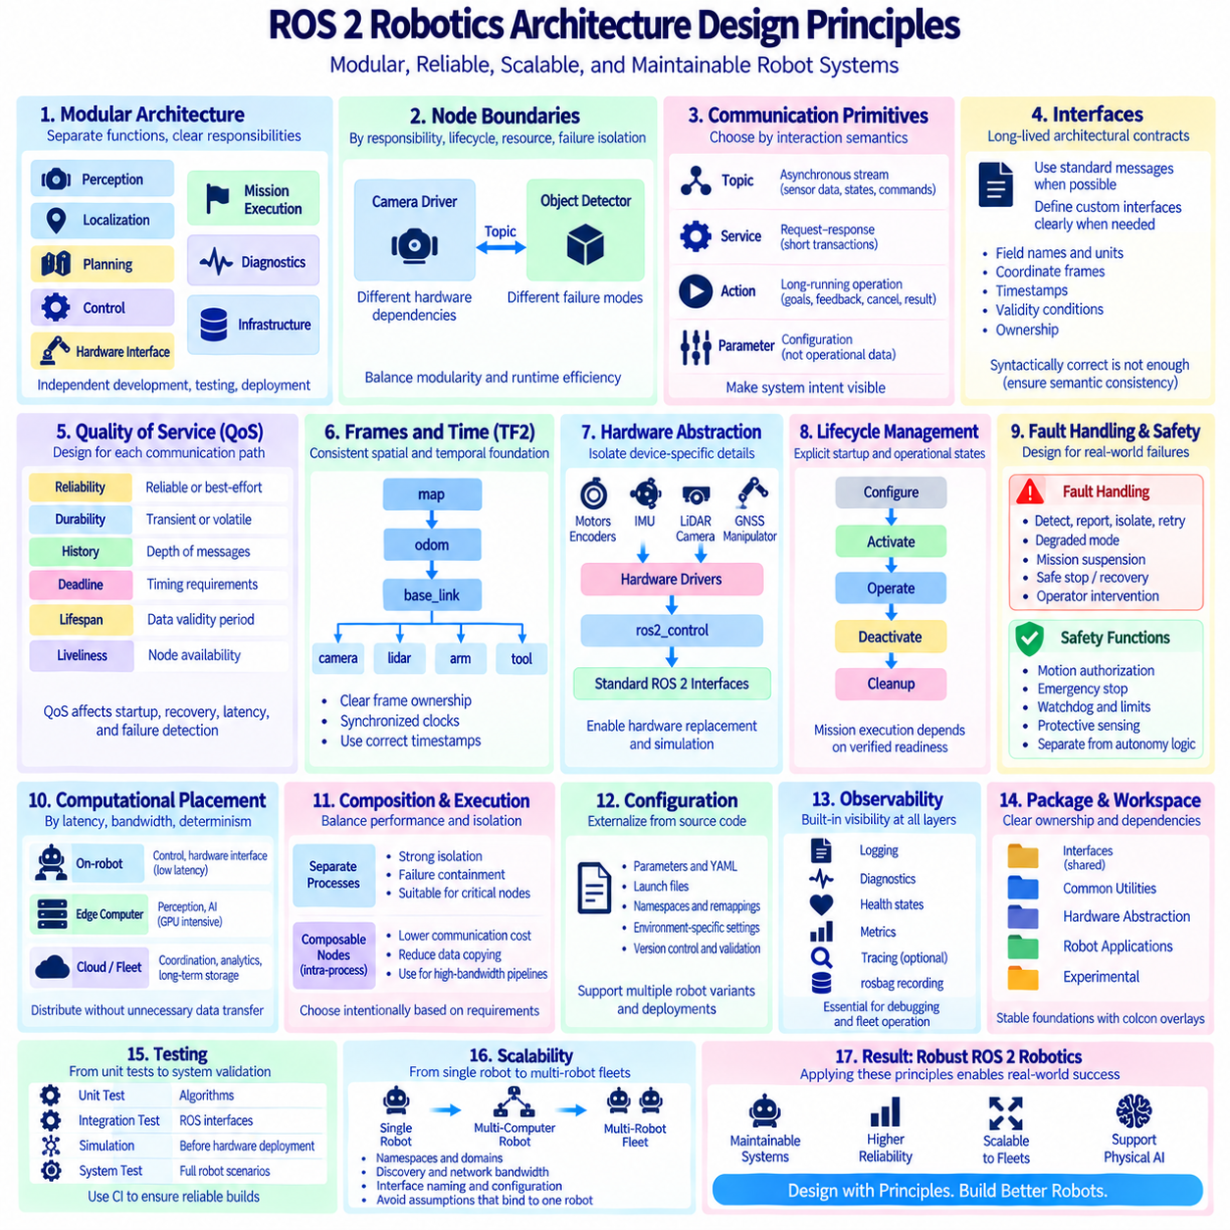
A ROS 2-based robotics architecture should begin by separating robot capabilities into components with clear responsibilities and explicit communication boundaries. Perception, localization, planning, control, hardware interfaces, mission execution, diagnostics, and infrastructure should not become one monolithic process. The objective is not to maximize the number of nodes, but to create modules that can evolve, fail, restart, test, and deploy independently while preserving predictable system behavior.
Node boundaries should follow functional responsibility, lifecycle, computational demand, and failure isolation. A camera driver and object detector may exchange closely related data, yet they have different hardware dependencies and failure modes and therefore often deserve separate architectural boundaries. Conversely, dividing a tightly coupled algorithm into many small nodes can introduce unnecessary serialization, scheduling, and communication overhead. Decomposition should balance modularity against runtime efficiency.
Communication primitives should be selected according to interaction semantics rather than developer convenience. Topics are appropriate for asynchronous streams such as sensor measurements, localization states, and commands. Services suit short request-response transactions, while actions support long-running operations requiring goals, feedback, cancellation, and results. Parameters represent configuration rather than operational data. Correct primitive selection makes system intent visible and reduces ambiguous dependencies between components.
Interfaces should be treated as long-lived architectural contracts. Standard ROS 2 messages should be reused when their semantics match the application, while custom interfaces should describe domain-specific information clearly. Field names, units, coordinate frames, timestamps, validity conditions, and ownership must be defined consistently. A syntactically correct message is insufficient if different nodes interpret its meaning differently, because semantic inconsistency becomes a distributed software defect.
Quality of Service should be designed for each communication path according to data characteristics and operational requirements. High-rate sensor streams may favor best-effort delivery and shallow histories, while critical state information may require reliable communication. Durability, deadline, lifespan, liveliness, and history policies can affect startup, recovery, latency, and failure detection. QoS should therefore be part of interface design rather than an implementation detail selected after integration problems appear.
Coordinate frames and time form shared foundations across perception, localization, navigation, and control. TF2 should maintain explicit spatial relationships among map, odometry, robot base, sensors, manipulators, and tools. Frame ownership must be unambiguous so that multiple components do not publish contradictory transforms. Timestamps should represent the actual measurement or state time whenever possible, and distributed computers should maintain synchronized clocks for reliable temporal correlation.
Hardware abstraction should isolate device-specific details from robot-level behavior. Motor controllers, encoders, IMUs, LiDARs, cameras, GNSS receivers, manipulators, and other devices may use different buses, protocols, and vendor APIs, but upper software layers should interact through stable ROS 2 interfaces. Frameworks such as ros2_control can reinforce this separation for actuators and controllers, making hardware replacement or simulation substitution possible without redesigning the complete application.
Lifecycle management should be explicit for components whose startup order and operational state matter. Hardware drivers, localization systems, planners, and safety-related support processes may require configuration, activation, deactivation, cleanup, and controlled restart. Lifecycle-aware architecture prevents a robot from assuming that every discovered node is automatically ready for operation. Mission execution should depend on verified component readiness rather than only on process existence.
Fault handling should be designed as part of normal system behavior. Distributed robots inevitably encounter missing sensor data, communication interruption, hardware faults, invalid localization, resource exhaustion, and process crashes. Components should define how failures are detected, reported, isolated, retried, or escalated. Restarting a node is only one recovery mechanism; the architecture may also require degraded modes, mission suspension, safe stopping, hardware reset, or operator intervention.
Safety functions should remain distinguishable from ordinary autonomy logic. ROS 2 can transport status information and commands related to safety, but software communication alone should not be assumed to replace independent safety mechanisms required by the robot or application. Motion authorization, emergency stopping, watchdogs, speed limits, protective sensing, and fault responses should be assigned explicit ownership. Autonomous decisions must operate inside these defined safety constraints.
Computational placement should reflect latency, bandwidth, determinism, hardware acceleration, and failure containment. Fast control and hardware interaction should remain close to the physical platform, while GPU-intensive perception or AI components may execute on dedicated edge computers. Fleet coordination, analytics, and long-term storage may reside on external infrastructure. ROS 2 communication boundaries should support this distribution without forcing every function onto one computer or unnecessarily moving high-bandwidth data across networks.
Composition and intra-process communication can be used when modular software boundaries are desirable but inter-process overhead is excessive. Multiple ROS 2 components may execute within a shared process to reduce copying and communication cost, especially for high-bandwidth perception pipelines. However, composition also reduces process-level fault isolation. Architects should therefore decide deliberately which components share an execution context and which remain independent processes based on performance and reliability requirements.
Executors, callbacks, and concurrency require architectural attention because ROS 2 nodes do not execute communication logic in isolation. Long-running callbacks can delay other work, and uncontrolled multithreading can create race conditions or unpredictable timing. Callback groups, executor selection, thread ownership, and synchronization should reflect the timing characteristics of sensing, planning, control, and service operations. Real-time-sensitive functions should avoid unnecessary blocking, allocation, and contention.
Configuration should be externalized from source code wherever practical. Parameters, YAML files, launch descriptions, namespaces, remappings, and environment-specific settings allow the same software components to support different robot variants and deployment environments. Configuration must nevertheless be version-controlled and validated because uncontrolled parameter changes can alter system behavior as significantly as source-code changes. Robot identity, calibration, hardware variants, and mission settings should have clearly separated ownership.
Observability should be built into every architectural layer. Structured logging, diagnostics, health states, metrics, traces where appropriate, and rosbag recording should provide complementary views of system behavior. A fleet robot may fail far from the developer who implemented its software, making post-event evidence essential. Logs should explain events, diagnostics should expose machine-readable health, and recorded data should support reconstruction of sensor and communication behavior without relying on terminal access.
Package and workspace organization should reflect architectural ownership. Shared interfaces, common utilities, hardware abstraction, robot-specific applications, and experimental software should have understandable dependency directions. Lower-level packages should not depend arbitrarily on high-level mission applications. Stable interfaces can be placed in dedicated packages so that multiple repositories or workspaces can share them. colcon overlays can then separate stable platform foundations from frequently changing application development.
Testing should occur at multiple architectural boundaries. Individual algorithms require unit tests, ROS interfaces require component and integration tests, and complete robots require scenario and system-level validation. Simulation can verify many interactions before hardware deployment, while recorded datasets and rosbag playback can reproduce difficult conditions. Continuous integration should build clean workspaces and expose undeclared dependencies so that software reliability does not depend on one developer's workstation configuration.
Scalability should be considered from a single robot to multi-computer robots and eventually multi-robot fleets. Namespaces, domain organization, discovery behavior, network bandwidth, interface naming, configuration distribution, and robot identity become increasingly important as the system grows. A design that functions with one robot on a laboratory network may not remain manageable with dozens of robots. Architecture should therefore avoid assumptions that unnecessarily bind software to one machine, one sensor, or one robot instance.
A mature ROS 2 robotics architecture ultimately combines modular decomposition, semantic interfaces, intentional QoS, explicit lifecycle management, hardware abstraction, controlled concurrency, fault handling, observability, testing, and disciplined deployment. ROS 2 supplies mechanisms for implementing these principles, but the mechanisms do not automatically create a good architecture. Their value emerges when they are applied consistently to build maintainable AMRs, manipulators, autonomous platforms, distributed robot fleets, and increasingly complex Physical AI systems.

