Volume 06 Robot Communication and APIs

01. REST API

01.01 REST Architecture Principles: Stateless, Resource, Uniform
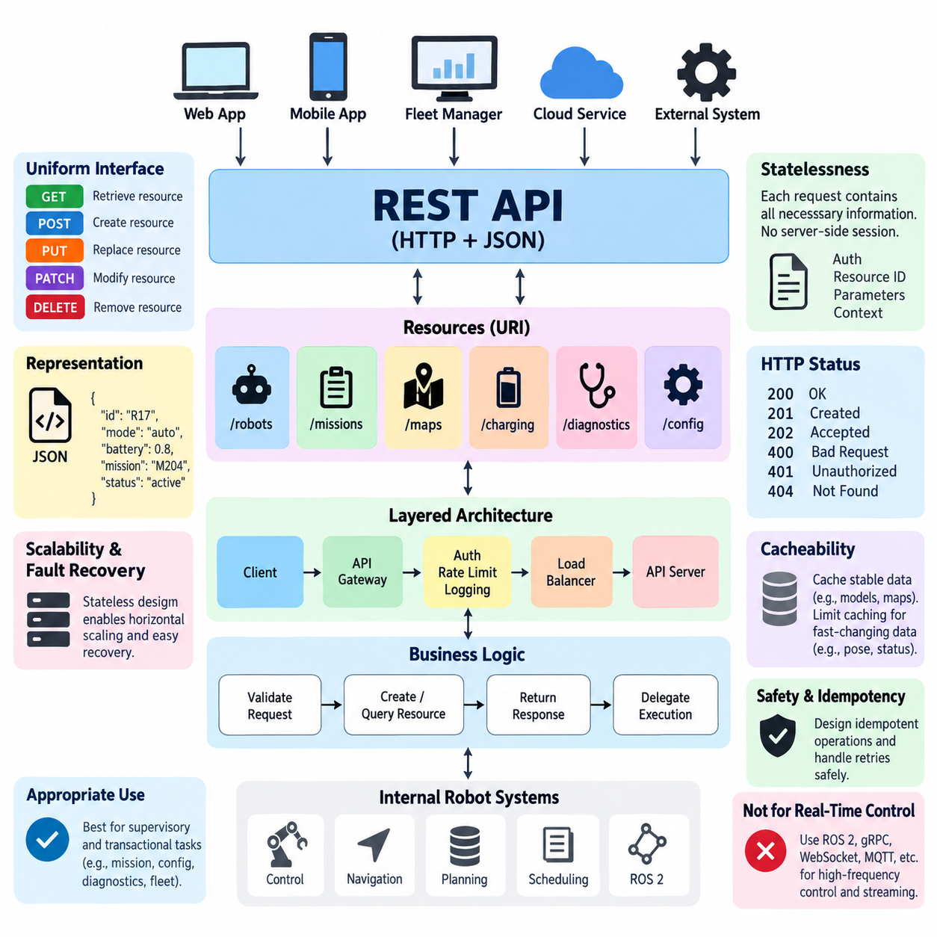
Representational State Transfer (REST) is an architectural style for distributed systems in which network-accessible functionality is organized around resources rather than remote procedures. In a robot software environment, resources may represent robots, missions, maps, charging stations, diagnostics, configurations, or fleet states. REST provides a consistent interaction model that allows clients and services to evolve independently while communicating through standardized web mechanisms.
A resource is the central abstraction of REST architecture. Instead of exposing implementation-specific functions such as startRobotMotor() or executeNavigationTask(), a REST interface identifies conceptual entities through resource identifiers. A robot might therefore be represented as /robots/{robot_id}, while its missions could appear beneath /robots/{robot_id}/missions. This resource-oriented approach separates the external API contract from internal software components and algorithms.
Resources are normally identified through Uniform Resource Identifiers (URIs), while their current state is exchanged through representations such as JSON. The URI identifies what the client is interacting with, whereas the representation describes the resource at a particular moment. A robot resource may contain operational mode, battery state, localization quality, mission status, or connectivity information without exposing the internal ROS 2 nodes, control loops, device drivers, or database structures that produce those values.
REST relies strongly on the uniform interface constraint. Clients interact with resources through a small and standardized set of HTTP methods rather than application-specific network commands. GET retrieves a representation, POST commonly creates a subordinate resource or initiates processing, PUT replaces a resource representation, PATCH modifies selected fields, and DELETE removes a resource where deletion is meaningful. Their consistent semantics reduce coupling between robot applications and external systems.
Uniform interfaces are especially valuable when heterogeneous systems must communicate with a robot platform. A warehouse management system, fleet manager, maintenance dashboard, cloud service, and mobile application can use the same fundamental interaction conventions even when they are implemented with different programming languages and frameworks. The API therefore becomes an architectural boundary through which robot capabilities can be exposed without requiring every external application to understand the internal robotics middleware.
Statelessness is another fundamental REST constraint. Every client request should contain the information required by the server to understand and process that request, without depending on conversational session state stored from previous requests. Authentication credentials, resource identifiers, request parameters, and required context must therefore accompany the appropriate request. The server may maintain persistent application state, such as mission records, but it should not require hidden client-session history to interpret subsequent interactions.
The distinction between stateless communication and persistent resource state is important in robotics. A mission server can permanently store that robot R17 is executing mission M204, while the REST interaction used to query that mission remains stateless. A GET request for the mission can be processed independently because the request identifies the required resource. Statelessness therefore does not imply that the robot forgets its operational state; it means that request processing does not depend on an implicit communication session.
This property improves scalability and fault recovery because any compatible service instance can potentially process an incoming request when shared application state is managed appropriately. Load balancers can distribute requests across multiple API servers without preserving a dedicated client-to-server session. For fleet systems containing tens, hundreds, or thousands of robots, this characteristic supports horizontal scaling of management services and simplifies replacement or restart of failed API instances.
REST also distinguishes resource manipulation from the physical execution mechanisms behind those resources. Creating a mission resource does not mean that an HTTP request directly controls wheel velocity or closes a motor-control loop. Instead, the API can validate the request, create a mission object, return its identifier, and delegate execution to navigation, planning, scheduling, or ROS 2 subsystems. This separation is particularly important because robot motion frequently requires deterministic or high-frequency communication unsuitable for ordinary REST transactions.
REST APIs are therefore most appropriate for supervisory and transactional robot interactions rather than hard real-time control. Mission creation, configuration management, map selection, diagnostics retrieval, fleet queries, maintenance records, and historical data access naturally fit resource-oriented HTTP interfaces. High-frequency sensor streams, low-latency control commands, and continuous telemetry may instead use ROS 2 DDS, gRPC streaming, WebSocket, MQTT, or specialized real-time communication mechanisms elsewhere in the communication architecture.
HTTP response semantics provide another element of the uniform interface. Successful retrieval can return 200 OK, resource creation can return 201 Created, asynchronous acceptance may use 202 Accepted, malformed input can return 400 Bad Request, unauthorized access can produce 401 Unauthorized, and a missing resource can return 404 Not Found. Consistent status semantics allow robot clients to interpret outcomes without learning a different proprietary error protocol for every service.
REST interactions should also consider safety and idempotency when commands affect physical systems. Repeating a GET request should not change robot state, while operations such as PUT are normally designed with idempotent semantics. For mission commands, designers must carefully handle retries caused by network failures so that a duplicated request does not unintentionally create two missions or execute the same physical operation twice. Resource identifiers, request identifiers, and explicit command state can support reliable retry behavior.
Another REST constraint is cacheability. Responses should indicate whether they may be reused by clients or intermediary systems. Relatively stable resources such as robot models, map metadata, software configuration schemas, or capability descriptions may benefit from caching, reducing network traffic and server workload. Rapidly changing resources such as robot pose, obstacle information, mission progress, or safety state generally require restrictive cache policies because stale representations could produce incorrect operational decisions.
REST architecture can also employ layered systems. A client does not need to know whether it communicates directly with the robot, an edge gateway, an API gateway, a fleet server, or an intermediary proxy. Authentication, routing, rate limiting, logging, caching, and protocol adaptation can therefore be introduced as intermediate layers without fundamentally changing the resource interface presented to the client. This becomes valuable in cloud-edge robot architectures where communication paths evolve as deployments scale.
A well-designed robot REST API consequently exposes stable domain abstractions rather than mirroring internal software implementation. Robots, missions, maps, alerts, diagnostics, and configurations form meaningful resources, while internal ROS 2 topics, processes, memory structures, and hardware-specific interfaces remain encapsulated. This abstraction permits internal algorithms or middleware components to change while preserving compatibility for external applications that depend on the API contract.
REST should ultimately be viewed as one component of a broader robot communication architecture rather than a universal protocol for every data flow. Its strengths are resource abstraction, stateless interaction, uniform semantics, interoperability, scalability, and compatibility with established web infrastructure. Combined with streaming and real-time protocols for workloads that REST does not naturally serve, it provides a practical control and integration plane connecting individual robots, edge computers, fleet services, enterprise systems, and cloud applications.

01.02 HTTP1.1 vs HTTP2 vs HTTP3: Robot API Perspective
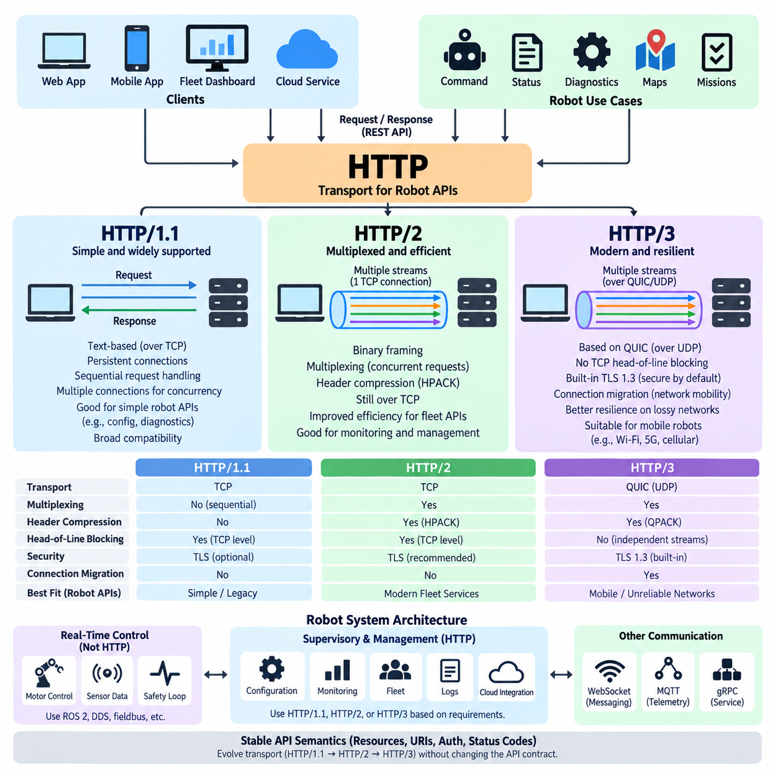
HTTP is the transport foundation for most REST APIs, but its three major generations—HTTP/1.1, HTTP/2, and HTTP/3—provide substantially different communication behavior. For robot APIs, these differences become important because robots continuously exchange commands, status information, diagnostics, configuration data, maps, and mission information across networks whose latency and reliability may vary significantly.
HTTP/1.1 remains widely supported and conceptually straightforward. It normally operates over TCP and represents each request and response as textual HTTP messages. Persistent connections allow multiple transactions to reuse an established TCP connection, avoiding repeated connection setup. This simplicity makes HTTP/1.1 practical for robot configuration, diagnostics, maintenance interfaces, and moderate-frequency REST transactions where extreme communication efficiency is unnecessary.
A major limitation of HTTP/1.1 appears when many requests must be processed concurrently. Although persistent connections improve efficiency, requests associated with a connection have historically faced ordering and concurrency limitations, encouraging clients to open several parallel TCP connections. A robot dashboard requesting status, battery information, mission state, diagnostics, maps, and configuration simultaneously can therefore generate unnecessary connection overhead and inefficient network utilization.
HTTP/2 changes this communication model by introducing binary framing and multiplexing while retaining familiar HTTP semantics such as methods, status codes, URIs, and headers. Multiple independent request and response streams can share a single TCP connection. Consequently, a fleet application can request information about many robot resources concurrently without requiring a separate TCP connection for every transaction, improving connection efficiency and application-level concurrency.
Multiplexing is particularly useful for robot monitoring and fleet-management applications. A supervisory interface may simultaneously request robot health, mission progress, localization state, charging information, alarms, and configuration metadata. HTTP/2 assigns these exchanges to separate streams carried through the same connection. This reduces the connection-management burden and enables responses to progress independently at the HTTP layer rather than forcing strictly sequential application transactions.
HTTP/2 also introduces header compression through HPACK. REST requests frequently repeat headers containing content types, authorization information, user-agent data, caching directives, and other metadata. When hundreds of robots repeatedly communicate with edge or fleet servers, repeated HTTP headers can consume meaningful bandwidth. Header compression reduces this redundancy and can improve efficiency, particularly for frequent API calls containing relatively small payloads.
However, HTTP/2 still relies on TCP. TCP guarantees reliable and ordered byte delivery, which is beneficial for API correctness but creates transport-level head-of-line blocking. If a TCP packet is lost, later data belonging to otherwise independent HTTP/2 streams may wait until the missing data is retransmitted. On stable wired networks this effect may be limited, but wireless robot networks can experience interference, handovers, congestion, and packet loss that make the limitation more visible.
HTTP/3 addresses this transport limitation by moving HTTP semantics from TCP to QUIC, which normally operates over UDP. QUIC integrates secure transport, stream multiplexing, congestion control, and connection management. Independent QUIC streams avoid the TCP-level head-of-line blocking behavior affecting HTTP/2, so packet loss associated with one stream does not necessarily prevent unrelated streams from continuing their progress.
This characteristic is attractive for mobile robots operating across Wi-Fi, private 5G, public cellular, or other changing network environments. An AMR moving between access points may encounter temporary packet loss or changes in network path characteristics. HTTP/3 can provide better resilience to such conditions because QUIC was designed for modern network mobility and independent stream handling rather than relying entirely on the traditional TCP connection model.
QUIC also incorporates TLS 1.3 into its transport architecture, making encrypted communication fundamental to HTTP/3. Connection establishment can require fewer round trips than conventional combinations of TCP and TLS, especially when communication is resumed between previously connected endpoints. For robot-cloud and fleet-edge APIs, reduced connection-establishment latency can be useful when robots frequently reconnect because of mobility, temporary wireless interruption, service migration, or changing network availability.
Connection migration is another relevant QUIC capability. Traditional TCP connections are closely associated with network endpoint information, so changes in a device's network path can disrupt an existing connection. QUIC uses connection identifiers that can help preserve logical connections when network addressing changes. This can benefit mobile robot platforms moving between wireless networks, although actual behavior still depends on infrastructure, security policy, NAT behavior, and implementation support.
The progression from HTTP/1.1 to HTTP/2 and HTTP/3 should not be interpreted simply as three levels of raw speed. Performance depends on payload size, request frequency, connection lifetime, packet loss, network latency, server implementation, proxy infrastructure, and security configuration. A simple robot maintenance API on a reliable industrial Ethernet network may obtain little operational benefit from HTTP/3, while a cloud-connected mobile fleet may benefit considerably from QUIC characteristics.
Compatibility also influences protocol selection. HTTP/1.1 has extremely broad support across embedded devices, proxies, gateways, debugging tools, and legacy enterprise systems. HTTP/2 is mature across modern web infrastructure and provides an effective balance between compatibility and multiplexed performance. HTTP/3 adoption continues to expand, but robot developers must verify support across API gateways, load balancers, firewalls, observability tools, embedded clients, and industrial network infrastructure.
From a robot API perspective, protocol selection should therefore follow communication requirements rather than technology novelty. HTTP/1.1 remains suitable for simple administrative APIs and legacy integration. HTTP/2 is well suited to modern REST services requiring concurrent requests and efficient connection reuse. HTTP/3 becomes especially interesting where robots communicate through variable-latency or lossy networks and where connection establishment, mobility, and transport-level blocking materially affect service quality.
None of these HTTP generations should automatically be treated as a replacement for deterministic robot communication. Motor control, safety loops, high-rate sensor transport, and tightly synchronized control generally require communication mechanisms designed for their timing and reliability constraints. REST over HTTP is more naturally positioned at supervisory, management, configuration, diagnostics, mission, fleet, edge, and cloud integration layers within the broader robot communication architecture.
A practical robot system can therefore use multiple communication technologies simultaneously. ROS 2 and DDS may handle internal distributed robot communication, specialized real-time networks may support deterministic control, WebSocket or MQTT may carry continuous events and telemetry, gRPC may provide efficient service communication, and REST may expose interoperable resource-oriented APIs. HTTP/1.1, HTTP/2, or HTTP/3 can then be selected according to the network environment and API workload.
For large robot fleets, the most important architectural principle is to separate API semantics from transport evolution. Resource models, URI structures, authentication policies, status codes, and application contracts should remain stable wherever possible even when the underlying HTTP generation changes. This separation allows a robot platform to migrate from HTTP/1.1 toward HTTP/2 or HTTP/3 without redesigning its entire external API, preserving interoperability while progressively improving communication efficiency.

01.03 RESTful Endpoint Design: Resource Modeling / URI [w/Code]
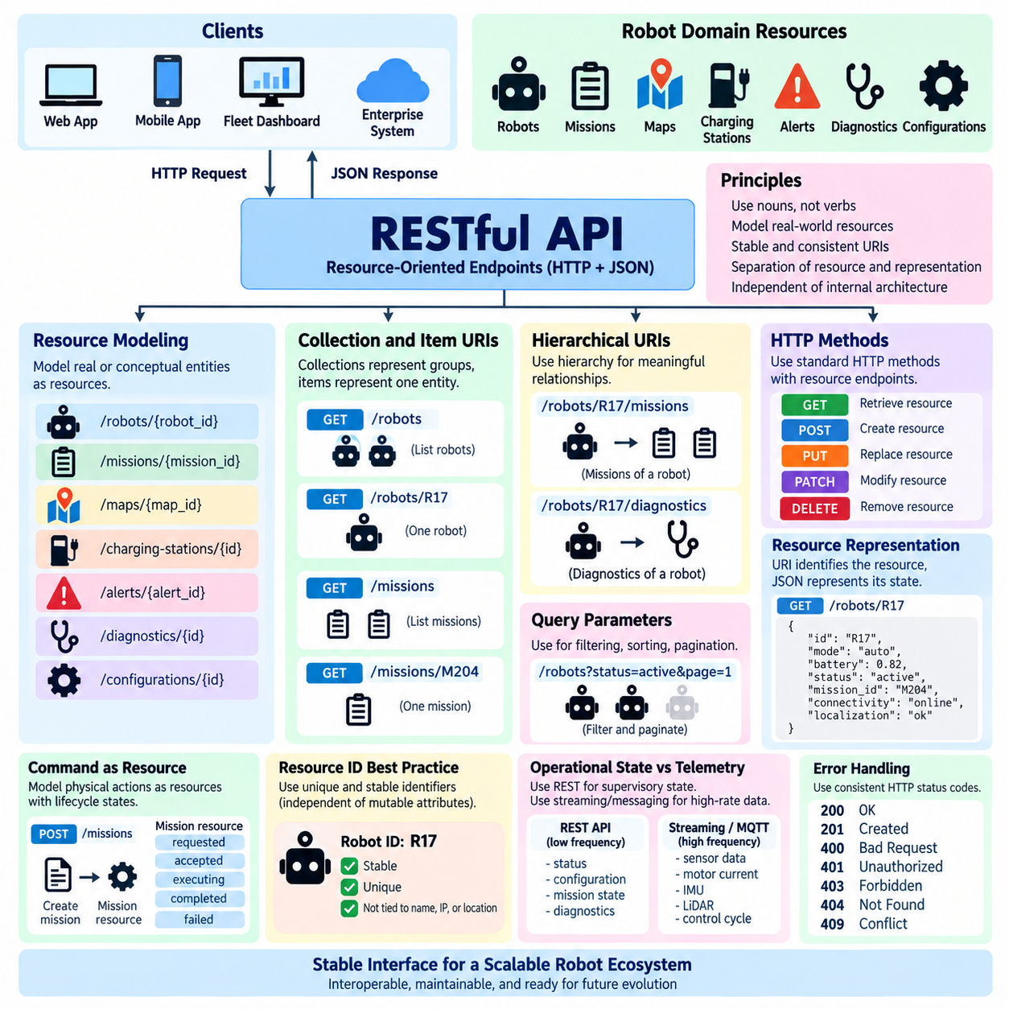
RESTful endpoint design begins with identifying the domain resources that external clients need to observe or manipulate. In a robot platform, these resources may include robots, missions, maps, charging stations, alerts, diagnostics, configurations, and fleet information. The endpoint structure should describe these domain concepts rather than expose internal functions, software modules, ROS 2 nodes, or database implementation details.
A resource model defines how real or conceptual entities in the robot system are represented through the API. A robot can be modeled as a primary resource identified by `/robots/{robot_id}`, while `/missions/{mission_id}` can identify an individual mission. Resource modeling establishes stable abstractions that allow clients to interact with the robot system even when navigation algorithms, middleware components, hardware, or internal data structures change.
Resource names should normally use nouns because REST endpoints represent entities rather than operations. An endpoint such as `/robots/R17` clearly identifies a robot resource, whereas `/getRobot/R17` unnecessarily embeds an action into the URI. The HTTP method already expresses the operation being performed. GET can retrieve the robot, PATCH can modify selected properties, and DELETE can remove the resource when deletion is meaningful within the application domain.
Collection resources represent groups of related entities. `/robots` can represent the available robot collection, while `/robots/R17` identifies one member of that collection. Similarly, `/missions` represents missions and `/missions/M204` represents a specific mission. This collection-and-item structure creates predictable URI patterns and makes the API easier for developers, fleet applications, dashboards, and enterprise systems to understand without extensive endpoint-specific knowledge.
Hierarchical URIs are useful when a resource has a meaningful relationship with another resource. For example, `/robots/R17/missions` can represent missions associated with robot R17, while `/robots/R17/diagnostics` can expose its diagnostic information. Such nesting communicates resource ownership or context clearly. However, excessive nesting should be avoided because deeply hierarchical URIs increase coupling and make endpoint structures difficult to maintain as relationships evolve.
URI design should remain stable and independent of the internal deployment architecture. A URI such as `/robots/R17/status` should not change merely because status processing moves from an onboard computer to an edge server or cloud service. Clients should interact with the logical resource model rather than know where the corresponding computation occurs. This abstraction supports migration between robot, edge, on-premise, and cloud architectures without unnecessarily changing external API contracts.
Resource representations carry the actual state exchanged between client and server. A GET request to `/robots/R17` might return JSON containing an identifier, operational mode, battery level, connectivity state, localization status, and active mission identifier. The URI identifies the resource, while the JSON document represents its current state. Separating resource identity from representation allows the same conceptual resource to evolve while preserving a stable addressing structure.
HTTP methods should be combined consistently with resource-oriented endpoints. `GET /robots/R17` retrieves the robot representation, while `POST /missions` may create a new mission. `PUT /robots/R17/configuration` can replace a complete configuration resource, and `PATCH /robots/R17/configuration` can update selected configuration fields. `DELETE /missions/M204` may remove a mission when application rules permit it. Consistent semantics reduce ambiguity for API consumers.
Robot commands require additional care because many commands represent physical actions rather than conventional data manipulation. Instead of creating arbitrary verb-based endpoints for every action, important operations can often be modeled as resources. A mission request can become a mission resource, a charging request can become a charging task, and an operational command can become a command resource whose lifecycle includes requested, accepted, executing, completed, rejected, or failed states.
This resource-oriented command model is valuable for asynchronous robot operations. Navigation to a destination may require several minutes, so an HTTP connection should not remain open until physical execution finishes. A client can create a mission using `POST /missions`, receive the newly created mission identifier, and subsequently retrieve `/missions/{mission_id}` to observe progress. The API therefore separates request acceptance from long-running physical execution.
Query parameters should be used primarily for filtering, sorting, pagination, and optional views rather than for defining fundamental resource identity. A fleet server might support `/robots?status=active` to select active robots or `/missions?robot_id=R17` to retrieve missions associated with one robot. Large collections may use pagination parameters to prevent clients from retrieving thousands of resources in a single response and consuming excessive server or network capacity.
Resource identifiers should be unique, stable, and independent of mutable attributes whenever possible. A robot's display name, network address, current location, or assigned work area may change during its operational lifetime, making these values poor permanent identifiers. A stable robot ID allows URI references, audit records, mission histories, maintenance systems, and fleet databases to continue referring to the same logical robot despite changes in its configuration or network environment.
Endpoint naming conventions should be consistent across the complete robot API. Developers should establish conventions for plural resource names, capitalization, separators, identifier formats, nesting depth, query parameters, and versioning. Consistency is more important than creating individually clever endpoint names. When `/robots`, `/missions`, `/maps`, `/alerts`, and `/diagnostics` follow the same structural rules, developers can often predict API behavior before reading detailed documentation.
The resource model should also distinguish operational state from high-frequency telemetry. A REST endpoint such as `/robots/R17/status` may provide a supervisory snapshot of battery level, mission state, connectivity, and localization health. It should not necessarily expose every motor current, IMU sample, LiDAR packet, or control-cycle value through repeated HTTP requests. High-rate information is generally better handled by streaming or messaging technologies designed for continuous communication.
Error behavior should remain consistent with the resource model. Requesting an unknown robot can return 404 Not Found, malformed resource data can produce 400 Bad Request, and attempts to perform an operation without appropriate authorization can return 401 Unauthorized or 403 Forbidden depending on the situation. Conflict conditions may use 409 Conflict, such as when a requested resource transition cannot be performed because the robot or mission is already in an incompatible state.
Well-designed RESTful endpoints ultimately form a stable semantic boundary around the robot platform. External systems interact with understandable resources and predictable URI structures while internal control, navigation, perception, scheduling, ROS 2 communication, databases, and hardware interfaces remain encapsulated. This resource-centered architecture supports interoperability and long-term evolution across robot, fleet, edge, and cloud systems while preparing the API structure for later schema, security, versioning, and performance design.

01.04 JSON Serialization and Schema Definition: OpenAPI 3.0 [w/Code]
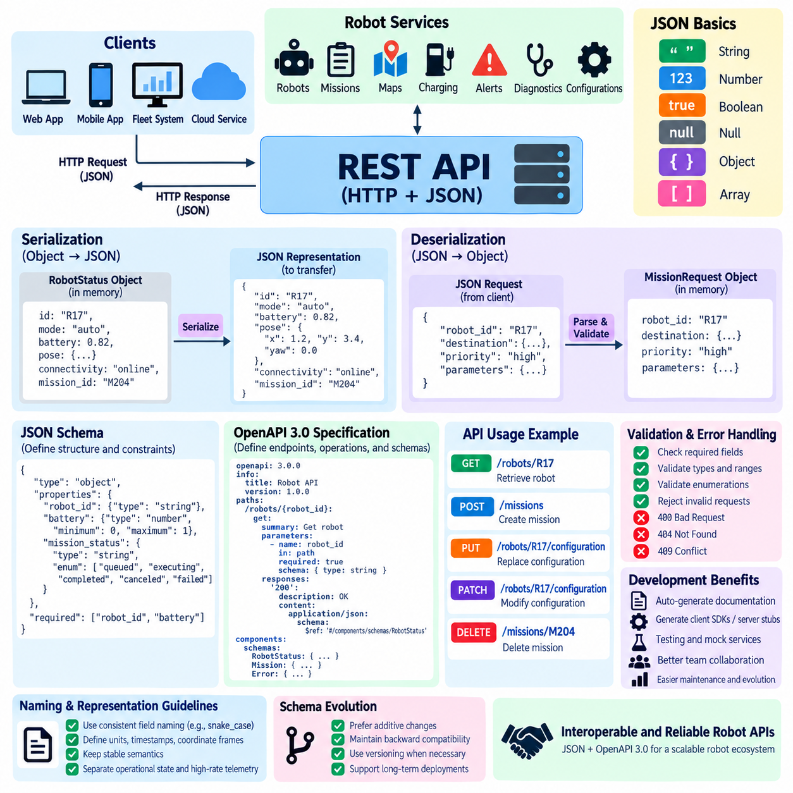
JSON is the dominant representation format for REST APIs because it provides a compact, human-readable, and language-independent way to exchange structured information. In robot systems, JSON can represent robot status, missions, configurations, diagnostics, maps, alerts, and fleet information. Its object and array structures map naturally to application data models and are supported by nearly every modern programming environment.
Serialization is the process of converting an in-memory software object into a transferable representation such as JSON. A robot application may maintain a status object containing a robot identifier, operating mode, battery level, pose, connectivity state, and active mission. Before transmitting this object through a REST API, the server serializes its fields into JSON text that can be transported inside an HTTP response body.
Deserialization performs the reverse operation. When a client submits a JSON request, the server parses the received representation and converts it into internal data structures that application logic can process. A mission request may contain a robot identifier, destination, priority, and execution parameters. Reliable deserialization must verify expected data types and required fields before the request is accepted by mission-management or robot-control subsystems.
JSON supports several fundamental value types, including strings, numbers, Boolean values, null values, objects, and arrays. These simple primitives can be combined into complex robot representations. A pose can be represented as a nested object containing position and orientation, while a mission route can contain an array of waypoints. The resulting hierarchy allows complex robotic information to remain logically organized without exposing internal memory structures.
A consistent JSON naming convention is important for long-term API maintainability. Field names such as `robot_id`, `battery_level`, `mission_status`, and `localization_quality` should follow one convention across the complete interface. Mixing styles such as snake_case, camelCase, and inconsistent abbreviations increases client complexity. Stable field semantics are equally important because changing the meaning of an existing field can break consumers even when its name remains unchanged.
Serialization also requires careful treatment of units, timestamps, enumerations, and coordinate systems. A field named `velocity` is ambiguous unless clients know whether it represents meters per second, kilometers per hour, or another unit. Robot APIs should therefore define these semantics explicitly. Timestamps should use an agreed representation, while pose and orientation fields should identify their reference frame when interpretation depends on a coordinate system.
A JSON document alone does not guarantee that clients and servers interpret data consistently. Schema definition addresses this problem by formally describing the expected structure of a representation. A schema can specify that `robot_id` is a required string, `battery_level` is a numeric value within an expected range, and `mission_status` must belong to an allowed set such as queued, executing, completed, canceled, or failed.
Schema validation creates a protective boundary between external API traffic and internal robot software. Incoming data can be checked before it reaches navigation, scheduling, configuration, or control components. Missing required fields, invalid enumerations, incorrect types, or values outside defined constraints can be rejected early. This reduces ambiguity and prevents malformed external requests from propagating deeply into the robot software architecture.
OpenAPI 3.0 provides a machine-readable specification for describing HTTP APIs, including endpoints, operations, parameters, request bodies, responses, authentication mechanisms, and reusable schemas. Instead of maintaining API behavior only in prose documentation, developers can create an OpenAPI document that formally defines the contract between robot services and their clients. YAML or JSON can be used to represent the specification itself.
The `paths` section of an OpenAPI document describes available API endpoints and their HTTP operations. A path such as `/robots/{robot_id}` can define a GET operation that retrieves a robot representation, including the required path parameter and possible responses. Another path such as `/missions` can define POST behavior for mission creation. This connects resource-oriented URI design directly with a machine-readable API contract.
Reusable data models are commonly placed in the OpenAPI `components/schemas` section. A `RobotStatus` schema might define robot identification, mode, battery state, connectivity, localization, and active mission information. A `Mission` schema can describe destination, priority, lifecycle state, and timestamps. Reusing these schemas prevents duplicated definitions and helps maintain consistent representations across multiple endpoints and responses.
OpenAPI can describe request and response media types through `content`, commonly using `application/json` for REST APIs. A mission-creation endpoint can reference a mission request schema for its request body and a mission response schema for the successful response. Error responses can similarly reference a standardized error schema containing fields such as error code, message, timestamp, resource identifier, and optional diagnostic context.
Validation constraints can express more than basic data types. Schemas may define required properties, minimum and maximum numeric values, string formats, array sizes, enumerations, and nested object structures. In robotics, these constraints can detect invalid configuration values or malformed mission requests at the API boundary. However, schema validation complements rather than replaces domain-level and physical safety validation performed by robot software.
OpenAPI specifications can also support automated development workflows. Tooling can generate interactive API documentation, client SDKs, server stubs, validation components, test cases, and mock services from the formal contract. This is particularly valuable when robot APIs must be consumed by web applications, fleet-management systems, cloud services, factory software, and external partners implemented in different programming languages.
A machine-readable API contract also improves collaboration between robot software teams. Navigation developers, fleet developers, cloud engineers, frontend developers, system integrators, and validation teams can work against the same endpoint and schema definitions. Changes to fields or operations become visible as contract changes rather than informal implementation details, making interface review, compatibility testing, and release management more systematic.
Schema evolution must nevertheless be controlled carefully. Adding an optional JSON property is usually easier for existing clients to tolerate than removing a field, changing its type, or redefining its meaning. Robot APIs that operate for many years may have clients running different software versions simultaneously. Stable schemas, explicit compatibility policies, and controlled API versioning therefore become essential for long-lived industrial deployments.
JSON serialization and OpenAPI schema definition together establish a structured information boundary around the robot platform. JSON provides the transferable representation, schemas define the expected structure and constraints, and OpenAPI 3.0 connects those representations with REST endpoints and HTTP behavior. This combination creates APIs that are easier to validate, document, test, integrate, and evolve across robot, edge, fleet, enterprise, and cloud systems.

01.05 REST API Authentication: JWT / OAuth 2.0 [w/Code]
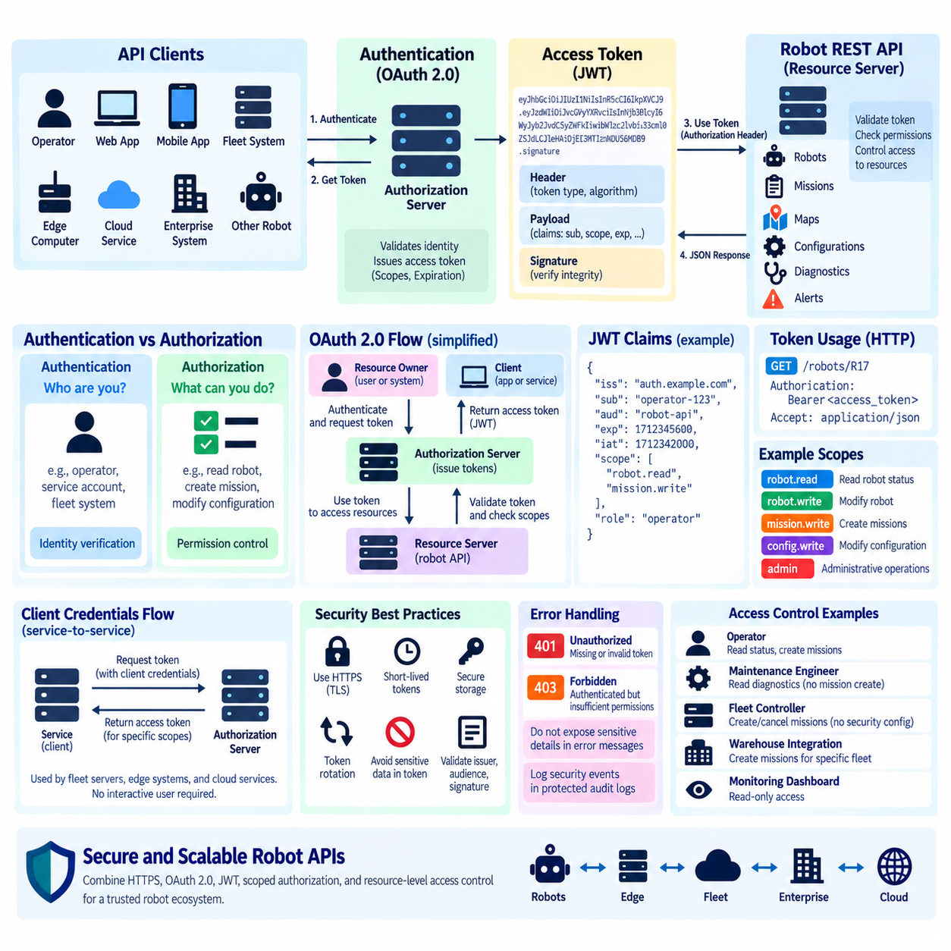
Authentication is a fundamental security function of a REST API because it establishes the identity of the client requesting access to robot resources. In robotic systems, API clients may include operators, fleet-management applications, edge computers, cloud services, enterprise systems, and other robots. Authentication ensures that commands, configuration changes, mission requests, and sensitive operational information are accessible only through recognized identities.
Authentication should be distinguished from authorization. Authentication answers the question of who or what is making a request, while authorization determines which resources and operations that authenticated identity is permitted to access. A maintenance engineer may be allowed to retrieve diagnostics but not create missions, while a fleet controller may create and cancel missions without being permitted to modify security configuration.
Basic credentials or static API keys can provide simple authentication, but they become difficult to manage securely across large robot fleets. Long-lived secrets may be copied, leaked, or remain active after a device or user should no longer have access. Modern robot API architectures therefore commonly rely on token-based mechanisms that support expiration, scoped permissions, centralized identity management, and controlled credential lifecycle management.
JSON Web Token (JWT) is a compact token format frequently used to carry authenticated identity and authorization information between systems. A JWT consists conceptually of a header, payload, and signature. The header describes token-related metadata, the payload contains claims, and the signature allows a receiving service to verify that the token has not been modified and was issued according to the expected trust relationship.
JWT claims can describe information such as the token issuer, intended audience, subject identity, expiration time, issue time, and application-specific permissions. In a robot platform, the subject might represent an operator, service account, fleet controller, or robot identity. Claims can also support roles or scopes that determine whether the requester may read robot status, create missions, modify configuration, or perform administrative operations.
A signed JWT provides integrity and authenticity but does not automatically provide confidentiality. The payload is typically encoded rather than encrypted, meaning sensitive secrets should not simply be placed inside token claims. REST APIs should normally transmit bearer tokens through encrypted HTTPS connections using TLS. This protects tokens from network interception while the token signature protects them against unauthorized modification.
Token expiration is important because bearer tokens effectively grant access to whoever possesses them. Short-lived access tokens reduce the period during which a stolen token can be abused. When an access token expires, a client may obtain another token through an approved authentication process rather than relying indefinitely on one credential. Robot systems should also validate expiration, issuer, audience, signature, and relevant authorization claims on protected requests.
OAuth 2.0 provides an authorization framework for obtaining and using access tokens without requiring every API service to directly manage user passwords. Its architecture separates responsibilities among the resource owner, client, authorization server, and resource server. In a robot ecosystem, the resource server may be a fleet or robot API, while a centralized authorization service issues tokens according to authenticated identities and approved permissions.
An OAuth 2.0 access token can be presented to a REST API using the HTTP Authorization header, commonly with the Bearer scheme. The receiving API validates the token and evaluates whether its scopes or permissions allow the requested operation. A token with `robot.read` authority might retrieve robot status, while `mission.write` could permit mission creation. More sensitive administrative operations can require separate, narrowly defined permissions.
OAuth 2.0 supports different authorization flows for different client types. Human-facing applications can use flows designed for interactive authorization, while machine-to-machine communication can use the Client Credentials flow when an application acts on its own behalf. This distinction is particularly relevant in robotics because a fleet server, edge gateway, cloud service, and human operator represent different security principals and should not necessarily share the same authentication mechanism.
The Client Credentials flow is useful for service-to-service communication where no interactive user is involved. An authorized fleet service can authenticate itself to an authorization server using protected client credentials and receive an access token for specific scopes. The service then presents that token to robot or fleet APIs. Credentials should be securely provisioned and protected rather than embedded casually in application source code or deployment images.
JWT and OAuth 2.0 are related but should not be treated as identical technologies. OAuth 2.0 defines authorization processes and token usage, whereas JWT defines a token representation format that may be used for access tokens. An OAuth deployment can issue JWT-formatted access tokens, but OAuth does not require every token to be a JWT. Keeping these concepts separate helps architects choose appropriate identity, token, and validation mechanisms.
Authorization policies should follow the principle of least privilege. A monitoring dashboard may require read-only access to robot status and diagnostics but should not automatically receive mission-control privileges. A warehouse integration service may create missions for a particular fleet without receiving access to firmware or security settings. Narrow roles and scopes reduce the consequences of compromised credentials and simplify security auditing.
Robot APIs must also consider authorization at the individual resource level. Permission to call `/robots` does not necessarily imply permission to control every robot returned by that collection. A multi-site fleet platform may restrict a client to specific robots, facilities, tenants, or operational zones. The server must therefore evaluate both the requested API operation and the particular resource being accessed rather than trusting endpoint-level permissions alone.
Authentication failures should produce consistent HTTP behavior without revealing unnecessary security information. Missing or invalid authentication commonly results in 401 Unauthorized, while an authenticated client that lacks permission for an operation may receive 403 Forbidden. Detailed internal reasons, signing information, credentials, or sensitive policy data should not be exposed through public error messages, although appropriate events should be recorded in protected audit logs.
Token security depends on the complete credential lifecycle rather than only the authentication endpoint. Secure provisioning, protected storage, rotation, expiration, revocation strategy, TLS, clock synchronization, audit logging, and key management all influence the effectiveness of the system. In industrial robot fleets, compromised credentials can potentially affect physical operations, making identity management part of the broader robot cybersecurity and safety architecture.
A scalable robot REST API can therefore combine HTTPS, OAuth 2.0, appropriately designed JWT access tokens, scoped authorization, and resource-level access control into a layered security model. The API gateway or service validates identity and token properties before requests reach mission, fleet, configuration, or diagnostic services. This approach provides a consistent trust boundary across robots, edge infrastructure, fleet servers, enterprise applications, and cloud services.

01.06 REST API Versioning Strategy
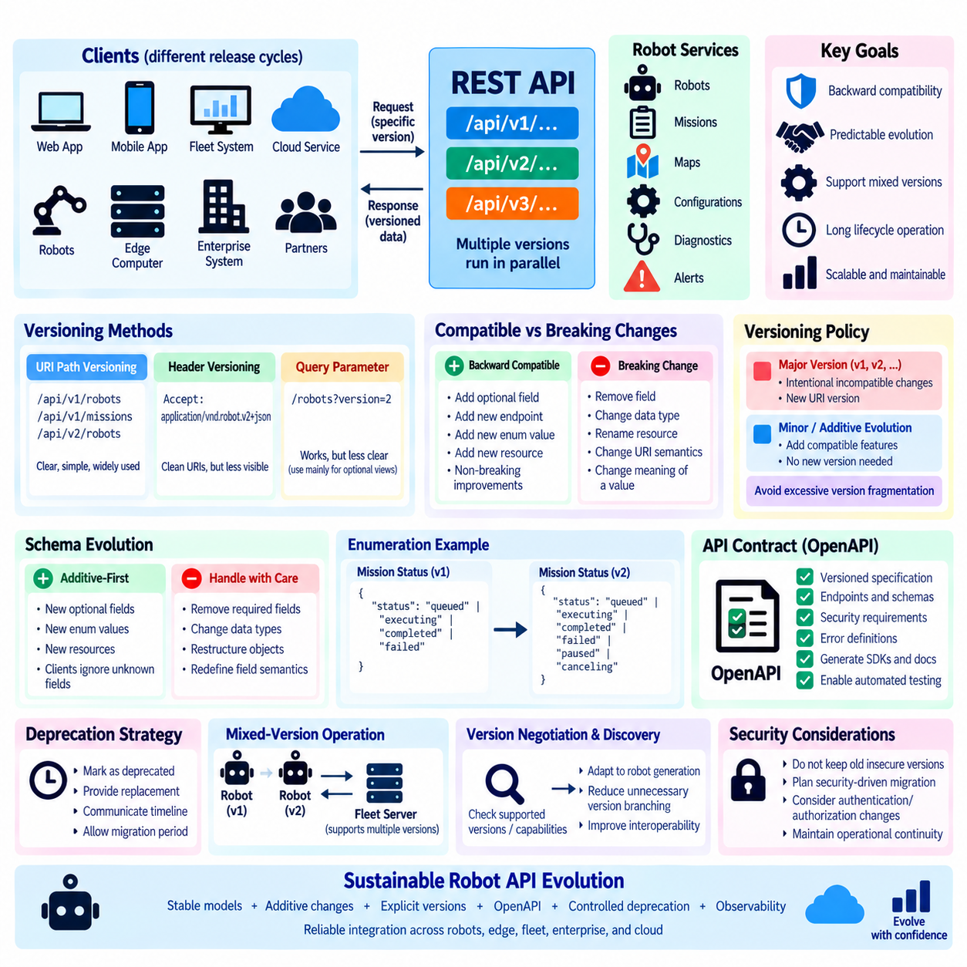
REST API versioning is the practice of evolving an API while preserving predictable behavior for existing clients. This is particularly important in robotics because robots, fleet servers, edge computers, cloud services, mobile applications, and enterprise systems may operate with different software release cycles. A versioning strategy provides a controlled boundary between API evolution and deployed systems that cannot all be upgraded simultaneously.
API changes can generally be considered backward-compatible or breaking. Adding a new optional response field is usually compatible because existing clients can ignore information they do not recognize. Removing a field, changing its data type, renaming a resource, altering URI semantics, or changing the meaning of an existing status value can break clients. Versioning becomes necessary when compatibility cannot reasonably be preserved through additive evolution.
Robot systems make backward compatibility especially important because deployed equipment may remain operational for many years. A warehouse may contain robots purchased at different times, running different firmware and application versions. The fleet-management system may evolve faster than onboard software, while WMS, MES, ERP, or external partner applications may follow separate upgrade schedules. API contracts must therefore tolerate controlled periods of mixed-version operation.
URI path versioning is one of the clearest strategies for REST APIs. Endpoints can include a major version such as `/api/v1/robots`, `/api/v1/missions`, or `/api/v2/robots`. Clients explicitly select the contract they expect, while servers can operate multiple major versions during migration. This approach is easy to understand, route, document, test, and observe, making it practical for industrial robot platforms and external integrations.
Version information can alternatively be communicated through HTTP headers or media types. Header-based versioning keeps resource URIs cleaner and can separate resource identity from representation evolution. However, it is less immediately visible when inspecting URLs, logs, browser requests, or simple debugging tools. For robot APIs used by many integration partners, operational clarity may be more valuable than strict URI purity, so the choice should reflect deployment requirements.
Query-parameter versioning, such as `/robots?version=2`, is another possible approach, but it can blur the distinction between resource selection and API contract selection. Query parameters are normally more appropriate for filtering, sorting, pagination, and optional views. Although technically workable, using them as the primary versioning mechanism may create less predictable routing, caching, documentation, and monitoring behavior in large API environments.
A practical versioning policy commonly distinguishes major changes from minor additive evolution. Major versions represent intentionally incompatible contracts, while compatible capabilities can often be added without creating a new URI version. This prevents excessive fragmentation. Creating a new API version whenever a field is added would force unnecessary migrations and leave fleet platforms maintaining many nearly identical interfaces.
Schema evolution should follow an additive-first philosophy whenever possible. New optional fields, new resources, additional endpoints, and new enumeration capabilities can often be introduced without breaking existing clients if consumers are designed to tolerate unknown fields. By contrast, removing required properties, changing numeric values to strings, restructuring nested objects, or redefining existing field semantics should be treated carefully because these changes can invalidate deployed software assumptions.
Enumerations require particular attention in robot APIs. A mission status may initially support `queued`, `executing`, `completed`, and `failed`, but future systems might introduce `paused` or `canceling`. Clients that assume the original set is permanently closed may fail when new states appear. API contracts and client implementations should therefore define whether enumeration extension is permitted and specify safe behavior when an unfamiliar value is received.
Versioning should apply to the complete API contract rather than only endpoint names. JSON schemas, required fields, validation rules, HTTP status behavior, authentication requirements, authorization scopes, error representations, units, coordinate conventions, and asynchronous operation semantics all form part of the contract. A URI that remains unchanged can still introduce a breaking change if the representation or behavioral expectations change incompatibly.
OpenAPI specifications can serve as formal versioned contracts for this process. Each supported API version can have a corresponding OpenAPI document describing endpoints, request schemas, response schemas, security requirements, and error behavior. Contract differences can then be reviewed systematically, while automated tests can verify that implementations continue to satisfy the expected interface. Generated SDKs and documentation can also be aligned with specific API versions.
Deprecation is the controlled process of retiring an older API capability without removing it immediately. When an endpoint, field, or API version becomes obsolete, clients should receive clear information about its deprecated status, recommended replacement, and planned support period. A fleet operator should have enough time to identify dependent robots and applications, validate replacements, schedule upgrades, and migrate safely before the old contract becomes unavailable.
A deprecation policy is particularly important for physical systems because software migration may require operational coordination. Updating a web application can take minutes, while upgrading hundreds of production robots may require staged deployment, maintenance windows, validation, rollback preparation, and site-specific approval. API retirement schedules should therefore reflect the operational realities of deployed robotic systems rather than assume that every client can upgrade immediately.
Mixed-version operation should be treated as a normal migration state rather than an exceptional failure condition. A fleet server may temporarily communicate with robots using both v1 and v2 interfaces while an upgrade proceeds. Gateways or adapter services can translate between contracts where appropriate. Telemetry and observability should record API version usage so operators can identify remaining dependencies before retiring an older interface.
Version negotiation and capability discovery can further improve interoperability in heterogeneous fleets. Instead of assuming that every robot supports the newest contract, a fleet system can determine supported API versions or capabilities before issuing operations. This is valuable when different robot generations provide different features. Capability-based behavior can sometimes reduce unnecessary version branching by allowing clients to adapt to explicitly advertised functionality.
Security must evolve alongside API versions. Older versions should not remain available indefinitely if they depend on obsolete authentication mechanisms, weak cryptography, or authorization models that no longer satisfy security requirements. At the same time, security-driven migrations must be planned carefully so that disabling an old interface does not unexpectedly disconnect operational robots. Compatibility, cybersecurity, and operational continuity must therefore be managed together.
A sustainable robot REST API versioning strategy combines stable resource modeling, additive schema evolution, explicit major versions for genuine incompatibility, formal OpenAPI contracts, controlled deprecation, compatibility testing, and observable migration. The objective is not to prevent change but to make change predictable. This allows robot, fleet, edge, enterprise, and cloud software to evolve at different rates while preserving reliable integration throughout long industrial deployment lifecycles.

01.07 REST API Rate Limiting and Throttling [w/Code]
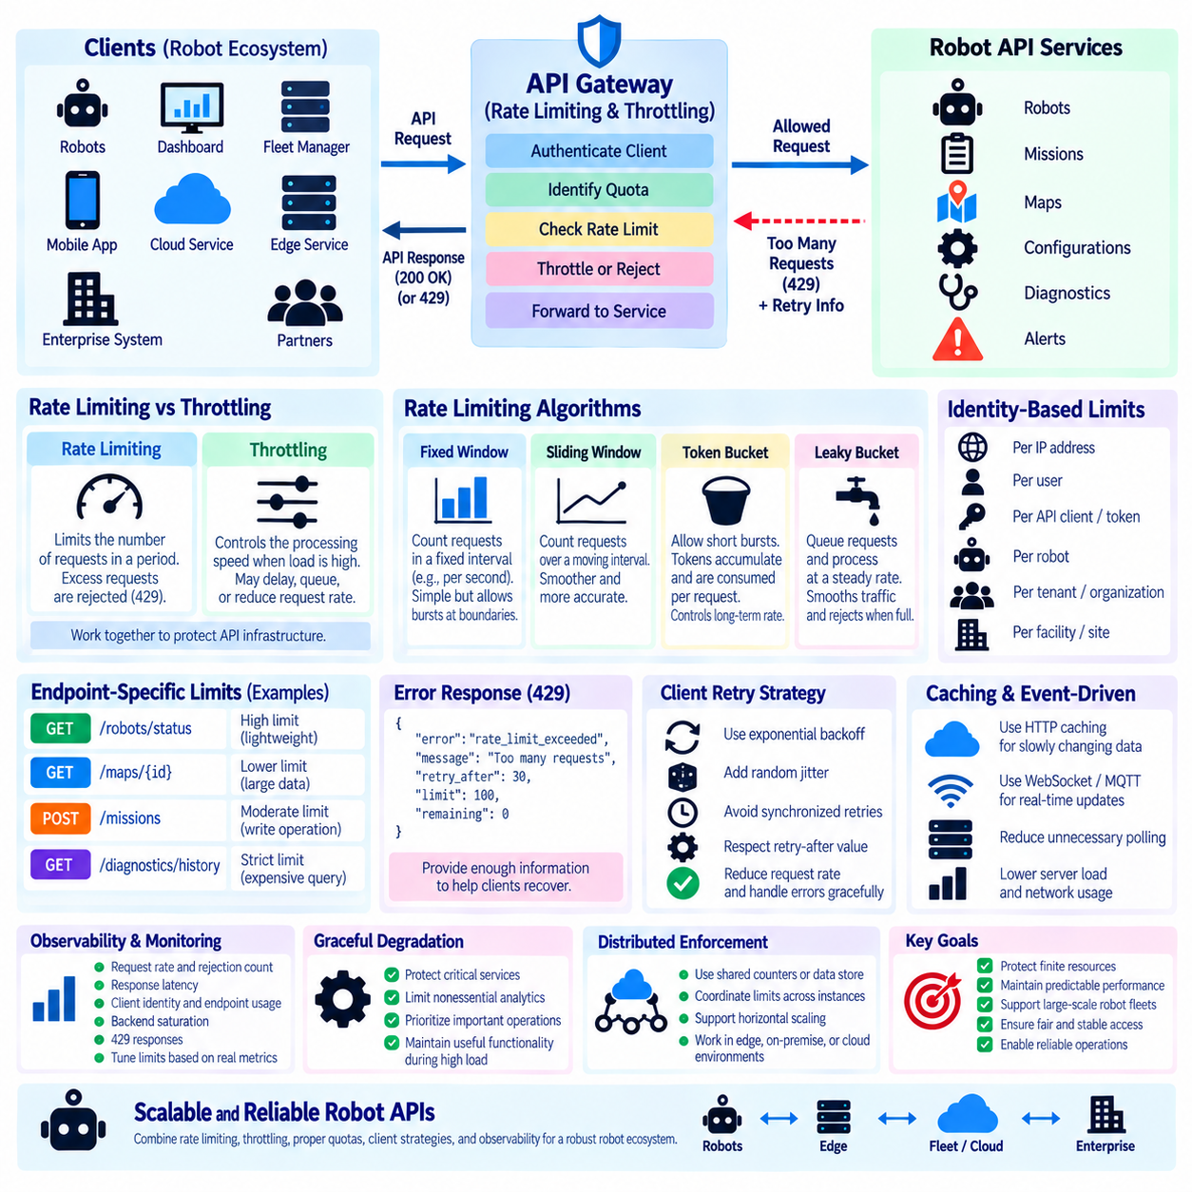
Rate limiting is a REST API protection mechanism that controls how many requests a client may submit during a defined period. In robot systems, clients may include individual robots, fleet managers, dashboards, edge services, enterprise applications, and cloud platforms. Without limits, excessive requests can consume CPU, memory, database connections, network bandwidth, or downstream service capacity and degrade the entire robot communication environment.
Throttling is closely related to rate limiting but emphasizes controlling the speed at which requests are processed when demand approaches or exceeds available capacity. A rate limiter may reject requests beyond an established quota, while throttling may delay, shape, queue, or reduce request processing. Together, these mechanisms protect robot API infrastructure from accidental overload, software faults, traffic bursts, and abusive behavior.
The need for rate control becomes more significant as robot fleets scale. A single dashboard polling robot status every second may create little load, but hundreds of robots combined with multiple monitoring applications can generate thousands of requests within short intervals. If every client simultaneously retrieves status, diagnostics, mission information, maps, and configuration data, an otherwise healthy API service can experience resource exhaustion or increased response latency.
Rate limits should therefore reflect the purpose and cost of each API operation rather than applying one arbitrary threshold to every endpoint. Retrieving lightweight robot status may permit a relatively high request frequency, while generating a large map, executing an expensive database query, or requesting historical diagnostics may require tighter limits. The API architecture should consider computational cost, payload size, backend dependencies, and expected operational frequency.
Several algorithms can implement rate limiting. A fixed-window counter measures requests within discrete intervals such as requests per second or minute. This approach is simple but may allow bursts near window boundaries. A sliding-window mechanism provides smoother enforcement by considering activity over a moving interval. Selection depends on implementation complexity, required fairness, traffic patterns, and the operational characteristics of the robot API.
The token bucket algorithm is particularly useful when an API should tolerate short bursts while controlling long-term request rates. Tokens accumulate in a bucket up to a configured capacity, and each request consumes one or more tokens. A client can temporarily send requests rapidly while tokens remain available, but sustained traffic is constrained by the token refill rate. This behavior fits many robot monitoring and supervisory workloads with occasional bursts.
A leaky bucket model provides another form of traffic shaping. Incoming requests conceptually enter a queue and are processed at a controlled output rate. Sudden bursts can therefore be smoothed before reaching downstream services. If the queue becomes full, additional requests may be rejected. This model can be useful where backend robot services require relatively predictable traffic rather than highly variable bursts of API activity.
Rate limits can be applied at several identity levels. A service may enforce limits per IP address, authenticated user, API client, access token, robot identifier, tenant, facility, or organization. Per-client controls prevent one application from consuming all available capacity, while fleet-level or tenant-level quotas can protect shared infrastructure. In multi-tenant robot platforms, combining several limit dimensions often provides stronger isolation than relying on a single global counter.
Authentication and rate limiting should work together. Once a REST API identifies a client through OAuth 2.0, JWT, service credentials, or another trusted mechanism, limits can be associated with that identity and its authorization scope. A fleet-control service may receive a different quota from a read-only dashboard. Anonymous or weakly trusted requests can be assigned more restrictive limits because their operational purpose and accountability are less certain.
When a client exceeds an allowed request rate, HTTP 429 Too Many Requests provides the standard response for indicating that too many requests have been submitted. The response should provide enough information for the client to determine how to recover without exposing unnecessary internal implementation details. Where appropriate, retry guidance can indicate when another request may be attempted, allowing well-designed clients to reduce pressure automatically.
Clients should implement retry behavior carefully because uncontrolled retries can make overload substantially worse. If thousands of robots receive an error and retry immediately at the same interval, they may create a synchronized retry storm. Exponential backoff increases the delay between repeated attempts, while randomized jitter distributes retries over time. These techniques reduce synchronization and help overloaded API services recover progressively rather than receiving another concentrated burst.
Rate limiting should also distinguish between ordinary management traffic and operationally important requests. A low-priority historical analytics query should not prevent a fleet controller from reporting a critical mission state. Systems can establish separate quotas, queues, priorities, or resource pools for different traffic classes. However, REST rate limiting should never be treated as the primary safety mechanism for deterministic emergency or safety-critical robot control.
Caching and event-driven communication can reduce the need for aggressive polling. If many dashboards repeatedly request information that changes slowly, appropriate HTTP caching can reduce server processing and bandwidth. For rapidly changing state, WebSocket, MQTT, or other event-driven mechanisms may be more efficient than frequent REST GET requests. Rate limiting therefore works best when combined with an architecture that uses the appropriate communication pattern for each workload.
Observability is essential for tuning rate limits. API gateways and services should record request rates, rejection counts, response latency, client identities, endpoint utilization, backend saturation, and 429 responses. These metrics allow engineers to determine whether limits are protecting infrastructure appropriately or unnecessarily restricting legitimate robot operations. Thresholds should be based on measured system capacity and expected workload rather than arbitrary values.
Distributed API deployments introduce additional implementation challenges because requests may be processed by multiple gateway or service instances. A rate limit maintained only in local memory can become inaccurate when traffic is distributed across several servers. Shared counters, distributed data stores, gateway-level enforcement, or coordinated limiting mechanisms may therefore be required when a fleet platform scales horizontally across edge, on-premise, or cloud infrastructure.
Graceful degradation should accompany overload protection. When demand exceeds capacity, the system may reduce access to expensive analytics, historical information, or nonessential diagnostic operations while preserving important supervisory services. This requires clear classification of API workloads and dependencies. The objective is not merely to reject traffic but to preserve useful robot and fleet functionality when infrastructure is under abnormal load.
A sustainable robot REST API rate-control strategy combines appropriate quotas, burst handling, identity-aware limits, HTTP 429 behavior, exponential backoff, jitter, caching, observability, and distributed enforcement. Rate limiting protects finite resources, while throttling shapes traffic to manageable levels. Together they help maintain predictable API performance as communication expands from individual robots to large edge, fleet, enterprise, and cloud deployments.

01.08 Robot Command / Status REST API Design Example [w/Code]
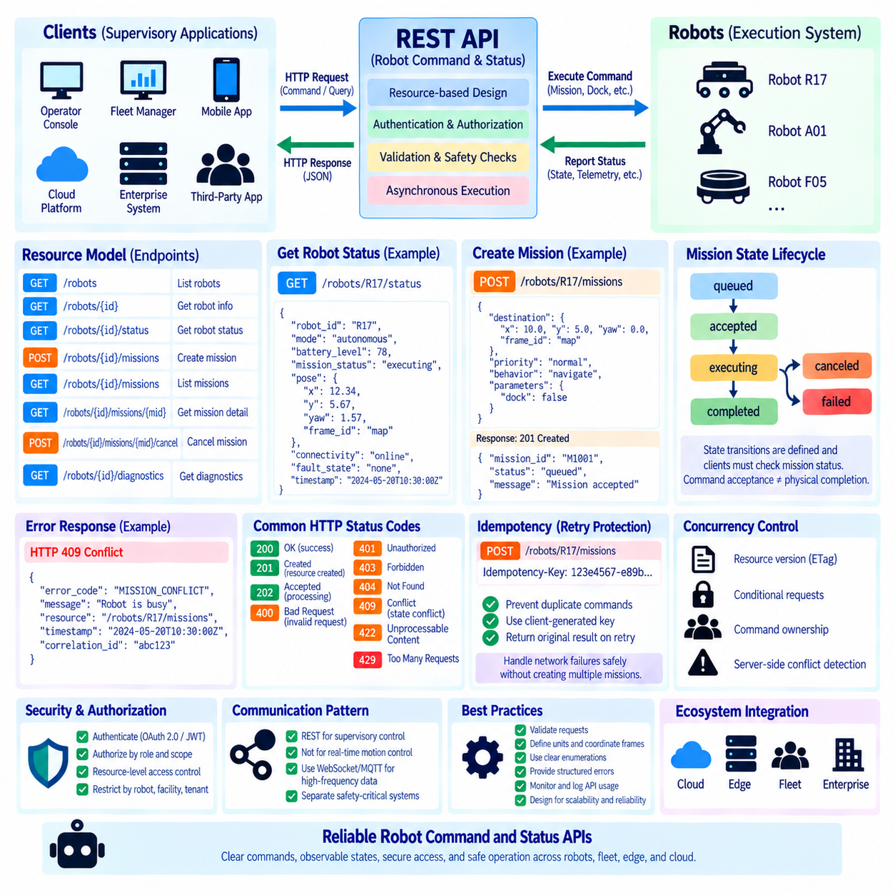
A robot command and status REST API provides a structured interface between supervisory applications and robot execution systems. The API should separate command intent from continuously changing robot state, because these represent different responsibilities. Commands request actions such as creating a mission, navigating to a destination, docking, or canceling work, while status resources describe what the robot is currently doing and its operational condition.
A practical resource model can begin with stable robot identifiers. A collection such as `/robots` represents registered robots, while `/robots/R17` identifies one robot. Related resources can expose `/robots/R17/status`, `/robots/R17/missions`, or `/robots/R17/diagnostics`. Stable identifiers allow fleet applications to address robots consistently even when network addresses, physical locations, software versions, or temporary operating conditions change.
Robot status should be represented as a resource that clients retrieve rather than as a command-like operation. A request such as `GET /robots/R17/status` can return information including operating mode, mission state, battery level, connectivity, localization quality, current pose, fault state, and timestamp. The response represents an observation of robot state at a specific time and should clearly define units, coordinate frames, enumerations, and timestamp conventions.
A status response might contain fields such as `robot_id`, `mode`, `battery_level`, `mission_status`, `pose`, and `timestamp`. Nested objects can represent structured values such as position and orientation. For example, a pose may contain `x`, `y`, and `yaw`, together with a `frame_id` that identifies the coordinate reference. Explicit metadata prevents clients from incorrectly interpreting values originating from different maps or coordinate systems.
Robot commands should normally be modeled according to their lifecycle rather than simply exposing remote procedure names through REST. Instead of an endpoint such as `/robot/startMissionNow`, a client can create a mission resource with `POST /robots/R17/missions`. The request body describes the desired operation, while the server creates a mission identifier and returns a representation that clients can subsequently inspect, cancel, or correlate with robot status.
For example, a mission creation request can specify a destination, priority, requested behavior, and optional parameters. The API validates the request before accepting it into the execution system. Validation should include JSON structure, required fields, value ranges, coordinate references, authorization, robot capability, and relevant operational constraints. A syntactically valid request does not automatically mean that the requested physical action is safe or currently executable.
Asynchronous behavior is essential because physical robot commands rarely complete within the duration of one HTTP transaction. A successful `POST` should therefore indicate that the command or mission has been accepted, not necessarily completed. The server can return `201 Created` with a newly created mission resource or `202 Accepted` when processing has begun asynchronously. The client then observes the mission lifecycle through subsequent status requests or event-based communication.
A mission resource can progress through states such as `queued`, `accepted`, `executing`, `completed`, `failed`, or `canceled`. These states create a clear contract between supervisory software and robot execution. The API should define valid transitions and the meaning of each state. Clients should not infer completion merely because the initial command request returned successfully; physical execution must be confirmed through the mission or robot state.
Cancellation can also be represented through resource-oriented semantics. Depending on the API design, a client may update a mission state, create a cancellation request, or use a dedicated subresource. The important principle is that cancellation is itself an operational request whose acceptance and physical completion may occur at different times. The API should distinguish a request to cancel from confirmation that robot motion or task execution has actually stopped.
Idempotency becomes important when command requests may be retransmitted because of network failures or uncertain responses. If a client sends a mission request and loses the HTTP response, blindly repeating the request could create two missions. An idempotency key or client-generated request identifier allows the server to recognize retries and return the result of the original operation instead of executing the same physical command twice.
HTTP status codes should communicate API-level outcomes consistently. `200 OK` can represent successful retrieval or update, `201 Created` can identify a newly created command resource, and `202 Accepted` can represent asynchronous acceptance. `400 Bad Request`, `401 Unauthorized`, `403 Forbidden`, `404 Not Found`, `409 Conflict`, `422 Unprocessable Content`, and `429 Too Many Requests` can communicate different classes of client or operational problems.
Error responses should provide structured information that applications can process automatically. A response may contain an error code, human-readable message, affected resource, timestamp, and correlation identifier. Robot-specific conditions such as `ROBOT_NOT_READY`, `LOCALIZATION_UNAVAILABLE`, `MISSION_CONFLICT`, or `DOCK_NOT_AVAILABLE` can supplement HTTP status codes. Internal implementation details and sensitive security information should not be exposed unnecessarily.
Concurrency must be considered when several clients can modify the same robot or mission resources. A fleet controller, operator console, and enterprise application might issue overlapping requests. Resource versions, entity tags, conditional requests, command ownership, or server-side conflict detection can prevent one client from unknowingly overwriting another client’s decision. A `409 Conflict` response can indicate that the requested operation conflicts with the current resource state.
Authentication and authorization should protect every command path according to operational risk. A monitoring application may retrieve `/robots/R17/status` but have no authority to create or cancel missions. A fleet controller may receive `mission.write`, while configuration changes require a separate privilege. Resource-level authorization is also necessary when clients are restricted to particular robots, facilities, fleets, or tenants.
REST should remain primarily a supervisory interface rather than a deterministic motion-control channel. Commands such as mission creation, docking requests, configuration changes, and status retrieval fit REST well because their timing is measured at supervisory timescales. High-frequency velocity commands, motor loops, emergency-stop chains, or tightly synchronized sensor-control interactions require communication mechanisms designed for real-time behavior and safety requirements.
A complete robot command and status design therefore separates desired actions, execution lifecycle, and observed state. REST provides stable resources and HTTP semantics, JSON defines interoperable representations, authentication controls access, idempotency protects command retries, and structured status resources expose execution progress. This architecture allows robots, fleet systems, edge services, enterprise applications, and cloud platforms to interact without confusing API request success with physical task completion.

01.09 REST API Documentation Automation: Swagger UI [w/Code]
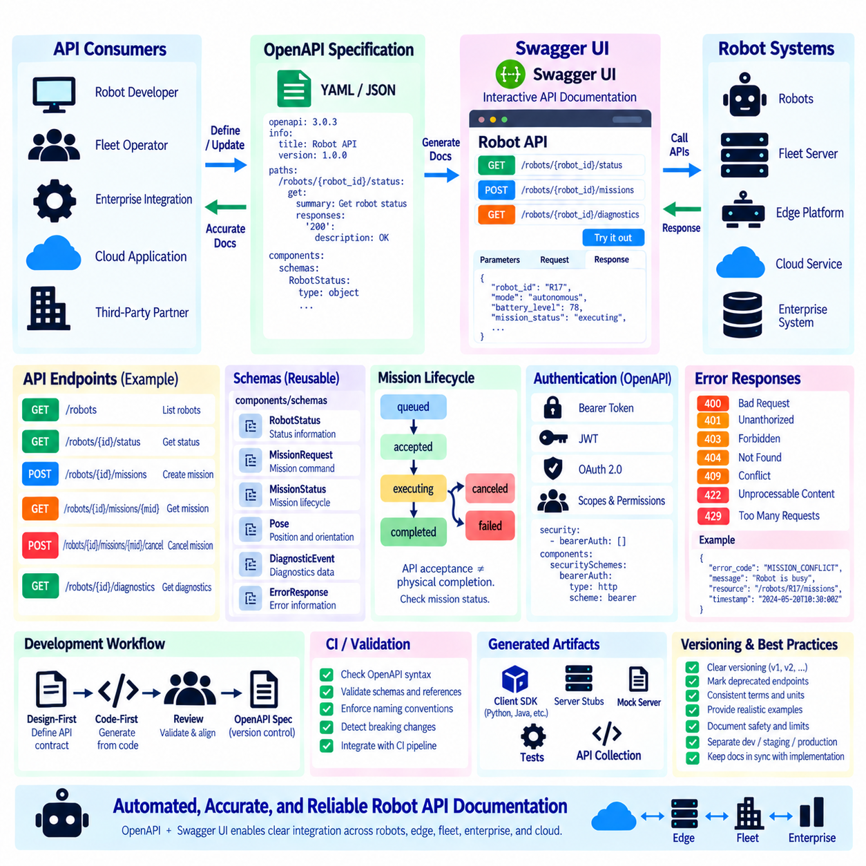
REST API documentation automation is the practice of generating and maintaining API documentation directly from a machine-readable interface definition rather than relying entirely on manually written reference documents. In robot systems, this reduces inconsistencies between implementation and documentation as APIs evolve across robots, fleet servers, edge platforms, cloud services, and enterprise applications.
OpenAPI provides a standardized description format for HTTP APIs and forms the foundation of many documentation automation workflows. An OpenAPI document can describe server addresses, resource paths, HTTP methods, parameters, request bodies, response structures, authentication requirements, and reusable schemas. The specification can be stored as YAML or JSON and managed as a version-controlled engineering artifact.
The `paths` section describes the REST resources and operations exposed by the robot platform. For example, `/robots/{robot_id}/status` may define a GET operation for retrieving robot state, while `/robots/{robot_id}/missions` may support POST for mission creation. Each operation can specify parameters, request schemas, response codes, media types, security requirements, summaries, and descriptions that documentation tools can interpret automatically.
Reusable data structures are normally defined under `components/schemas`. Robot-oriented schemas might include `RobotStatus`, `MissionRequest`, `MissionStatus`, `Pose`, `DiagnosticEvent`, and `ErrorResponse`. Instead of redefining these objects for every endpoint, operations can reference common definitions. This improves consistency and makes changes to shared representations easier to review, validate, document, and maintain.
Swagger UI transforms an OpenAPI specification into interactive browser-based API documentation. Developers can navigate endpoints, inspect request parameters, examine JSON schemas, review response definitions, and understand authentication requirements from a structured interface. When enabled appropriately, the Try It Out capability can also construct and send requests directly from the documentation interface to an API server.
Interactive documentation is particularly useful during robot system integration. A fleet developer can inspect the expected mission request without searching through source code, while a robot engineer can examine the documented status response expected by upstream applications. Enterprise integration teams can independently study endpoints and schemas, reducing repeated communication and shortening the time required to connect WMS, MES, ERP, cloud, or monitoring systems.
The documentation should clearly distinguish API request acceptance from physical robot execution. A documented `POST /robots/{robot_id}/missions` operation may return `201 Created` or `202 Accepted`, but this does not imply that the robot has completed the requested mission. Swagger UI descriptions and response schemas should explain asynchronous lifecycle states such as `queued`, `accepted`, `executing`, `completed`, `failed`, and `canceled`.
Example payloads improve documentation by showing how abstract schemas appear in realistic robot communication. A `RobotStatus` example can include robot identity, operating mode, battery level, pose, localization state, mission state, and timestamp. A `MissionRequest` example can demonstrate destination coordinates, reference frame, priority, and behavioral parameters. Examples should remain consistent with the formal schema rather than becoming independent specifications.
Authentication can also be represented directly in OpenAPI. Security schemes can describe bearer authentication, JWT-based access tokens, OAuth 2.0 flows, or other mechanisms used by the robot platform. Operations can then reference the required security scheme and authorization scopes. Swagger UI can expose an authorization interface so developers can test protected endpoints using credentials appropriate to the configured development or integration environment.
Interactive API execution must be deployed carefully because robot APIs can trigger physical actions. A documentation page connected to a production system should not casually allow users to create missions, modify configuration, cancel operations, or issue other commands merely for experimentation. Development, simulation, staging, and production environments should be clearly separated, and authentication and authorization policies must remain enforced regardless of Swagger UI availability.
Documentation automation is most effective when the OpenAPI specification participates directly in the software development lifecycle. In a design-first workflow, teams define or review the API contract before implementing services. In a code-first workflow, framework metadata can contribute to specification generation. Either approach should include systematic review so that generated documentation reflects intentional API behavior rather than merely exposing accidental implementation details.
Continuous integration can validate the API specification whenever software changes. Automated checks can verify OpenAPI syntax, schema references, required properties, naming conventions, and compatibility rules. A pipeline can compare the new specification with the previous release to identify potentially breaking changes. This turns documentation from a static deliverable into a testable interface contract associated with software quality and release management.
The same OpenAPI contract can support artifacts beyond Swagger UI. Toolchains can generate client SDKs, server interfaces, validation logic, mock servers, automated tests, and API collections from the specification. Robot, fleet, and enterprise teams can therefore share a common contract while using different programming languages and deployment platforms. Automation reduces repetitive integration work and lowers the risk of manually implementing incompatible request or response structures.
Versioning should be reflected explicitly in documentation. If `/api/v1` and `/api/v2` are supported simultaneously, developers must be able to determine which resources, schemas, security requirements, and behaviors belong to each version. Deprecated endpoints or properties should be clearly marked together with replacement guidance. Archived specifications can remain available when older deployed robots or integration systems still depend on previous API contracts.
Operational documentation should also describe failure behavior rather than presenting only successful examples. Responses such as `400 Bad Request`, `401 Unauthorized`, `403 Forbidden`, `404 Not Found`, `409 Conflict`, `422 Unprocessable Content`, and `429 Too Many Requests` should have structured schemas and meaningful descriptions. Robot-specific error codes can explain conditions such as mission conflicts, unavailable localization, invalid robot state, or unsupported capabilities.
Documentation quality depends on terminology and semantic consistency. Resource names, field names, units, coordinate frames, timestamps, enumeration values, and lifecycle definitions should use the same conventions throughout the specification. Descriptions should explain behavior that cannot be inferred from JSON types alone, especially when physical operations, asynchronous processing, retries, idempotency, or safety-related restrictions affect how clients should interpret an API response.
A mature robot REST API documentation architecture therefore treats OpenAPI as a shared, version-controlled contract and Swagger UI as one interactive representation of that contract. Automated validation, examples, security definitions, lifecycle descriptions, version tracking, and generated development artifacts keep documentation synchronized with implementation. This provides a reliable integration reference across robots, edge systems, fleet platforms, enterprise applications, and cloud services.

01.10 REST API Performance Optimization and Caching
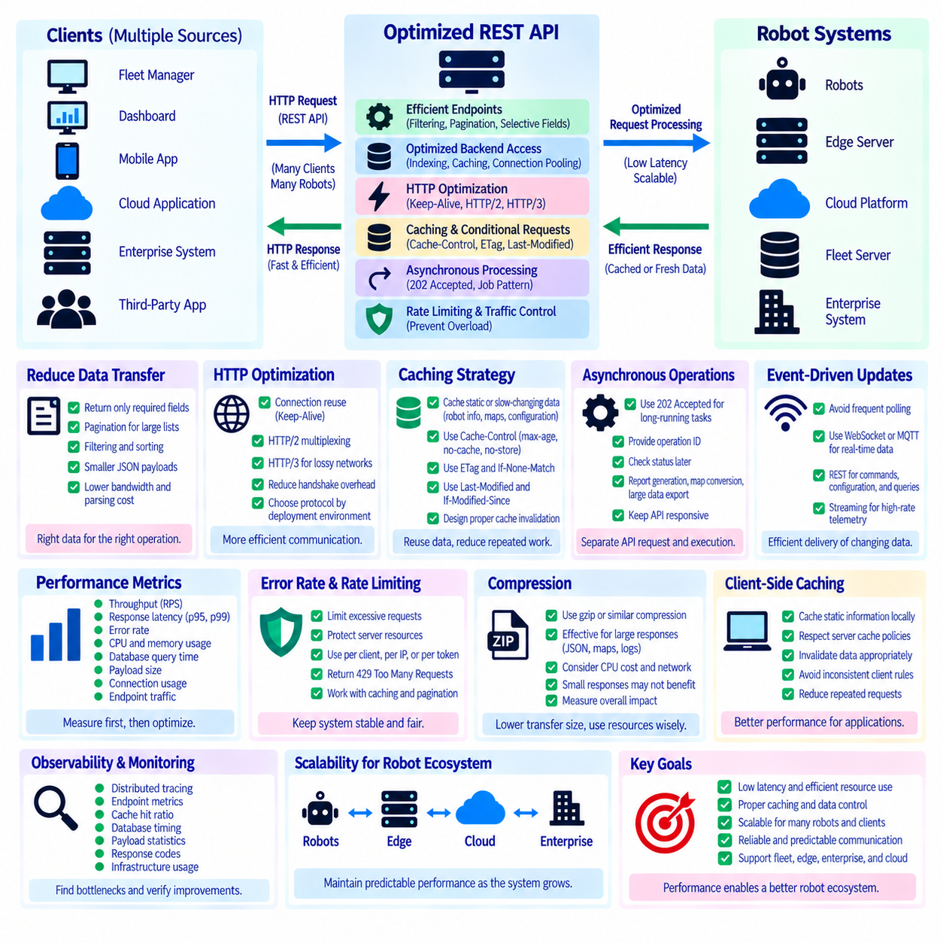
REST API performance optimization aims to reduce response latency, resource consumption, and unnecessary network traffic while maintaining predictable behavior as the number of robots and connected applications increases. In a robotic system, requests may originate from fleet managers, dashboards, edge services, enterprise platforms, and cloud applications. Efficient API design prevents supervisory communication from becoming a bottleneck as the deployment scales.
Performance optimization should begin with measurement rather than arbitrary tuning. Important metrics include request throughput, response latency, error rate, CPU and memory utilization, database query time, payload size, connection usage, and endpoint-specific traffic. Percentile measurements such as p95 and p99 latency are especially useful because average response time can hide occasional delays that significantly affect fleet-management applications.
The API should minimize unnecessary data transfer by returning representations appropriate to the requested operation. A robot list may require only identifiers, operating states, battery levels, and current missions rather than complete diagnostic histories. Large resources can support pagination, filtering, sorting, and selective fields. Reducing JSON payload size lowers serialization cost, network bandwidth consumption, client parsing overhead, and memory pressure.
Database and backend access frequently dominate REST API response time. Repeated queries for robot metadata, mission history, maps, or configuration can become expensive as fleet size grows. Appropriate indexing, efficient queries, connection pooling, batching, and avoidance of unnecessary backend calls can significantly improve performance. API optimization should therefore examine the complete request path rather than focusing only on HTTP processing.
HTTP connection reuse reduces the overhead associated with repeatedly establishing network connections. Persistent connections in HTTP/1.1 and multiplexed streams in HTTP/2 can improve efficiency when clients communicate frequently with fleet or edge APIs. HTTP/3 can provide additional benefits in network environments affected by loss or mobility. The appropriate protocol should be selected according to deployment conditions rather than assuming that protocol upgrades alone solve application-level inefficiencies.
Caching is one of the most effective techniques for reducing repeated computation and data transfer. When a resource does not change for every request, the server or an intermediate cache can reuse a previously generated representation. Robot metadata, map information, capability descriptions, software version information, and relatively static configuration are stronger caching candidates than rapidly changing pose, velocity, fault, or mission-execution data.
HTTP caching uses response metadata to communicate how representations may be reused. `Cache-Control` can specify whether a response is cacheable and how long it may remain fresh. A `max-age` value defines a freshness period, while directives such as `no-cache` or `no-store` express different reuse restrictions. Cache policy should reflect the operational meaning and sensitivity of each robot resource rather than applying one policy globally.
Validators such as ETag enable conditional requests that reduce unnecessary payload transfer. The server can associate an entity tag with a representation, and a client can later send `If-None-Match` with the previously received value. If the resource has not changed, the server can respond with `304 Not Modified` without transmitting the complete representation again. This is useful for configuration, metadata, maps, and other resources that are repeatedly checked but change infrequently.
Time-based validation can similarly use `Last-Modified` and `If-Modified-Since`. However, entity tags can provide more precise representation-level validation when timestamps are insufficient or difficult to manage consistently. The important principle is that clients should avoid repeatedly downloading identical data. Conditional requests preserve REST semantics while reducing bandwidth and serialization work across robot, edge, and fleet communication paths.
Cache invalidation requires careful design because stale information can produce incorrect operational decisions. A cached robot model description may remain valid for hours, while battery level or mission state may become obsolete within seconds. Each resource therefore requires an explicit freshness strategy. Safety-relevant or rapidly changing operational state should not be cached merely to improve performance when stale data could mislead supervisory applications.
Server-side caching can reduce repeated database queries or expensive computations. Frequently requested reference information may be stored in memory or a distributed cache, allowing API services to answer requests without repeatedly accessing slower backend systems. In horizontally scaled deployments, shared caching may improve consistency across instances, although cache coordination, expiration, invalidation, memory capacity, and failure behavior must be considered.
Client-side caching can also reduce traffic when applications repeatedly use the same information. A fleet dashboard does not need to retrieve a robot capability description on every screen refresh if that description rarely changes. Clients should nevertheless respect server-defined cache policies and invalidate local information appropriately. Independent caching rules implemented by clients without a shared contract can create inconsistent behavior and difficult-to-diagnose integration problems.
Compression can reduce network transfer for larger JSON responses, maps, logs, and diagnostic data, although compression itself consumes processing resources. The benefit depends on payload size, network bandwidth, CPU availability, and request frequency. Small responses may gain little from compression. Performance engineering should therefore measure the complete cost rather than enabling expensive processing indiscriminately for every response.
Asynchronous processing prevents long-running operations from occupying synchronous HTTP transactions. Expensive report generation, map conversion, large diagnostic exports, or fleet-wide operations can be represented as jobs or resources. The API may return `202 Accepted` together with an operation identifier, allowing the client to inspect progress later. This keeps request handling responsive while separating API interaction from lengthy backend execution.
Repeated polling should be reduced when information changes frequently. A dashboard requesting `/robots/R17/status` several times per second may create unnecessary API traffic, especially across hundreds of robots. WebSocket, MQTT, or another event-driven communication mechanism can deliver rapidly changing telemetry more efficiently. REST can remain responsible for resource retrieval, configuration, commands, and supervisory queries while streaming mechanisms handle high-rate updates.
Rate limiting and caching complement performance optimization. Caching reduces legitimate repeated work, while rate limiting prevents individual clients or traffic bursts from consuming excessive resources. Together with pagination, efficient schemas, connection reuse, asynchronous operations, and event-driven telemetry, these mechanisms allow the platform to allocate computing and network capacity according to the operational value of different API workloads.
Observability closes the optimization loop. Distributed tracing, endpoint metrics, cache hit ratios, database timing, payload statistics, response codes, and infrastructure utilization can reveal where latency is introduced. Engineers can then optimize measured bottlenecks and verify whether changes actually improve performance. Capacity tests should include realistic mixed workloads involving status queries, mission operations, diagnostics, configuration, and multiple concurrent clients.
A scalable robot REST API therefore combines efficient resource representations, optimized backend access, connection reuse, carefully designed HTTP caching, conditional requests, asynchronous processing, traffic control, and continuous measurement. The objective is not simply to maximize requests per second, but to preserve predictable supervisory communication as the system expands from individual robots to large edge, fleet, enterprise, and cloud deployments.

