Volume 06 Robot Communication and APIs

03. WebSocket

03.01 WebSocket Protocol: Handshake / Frame Structure
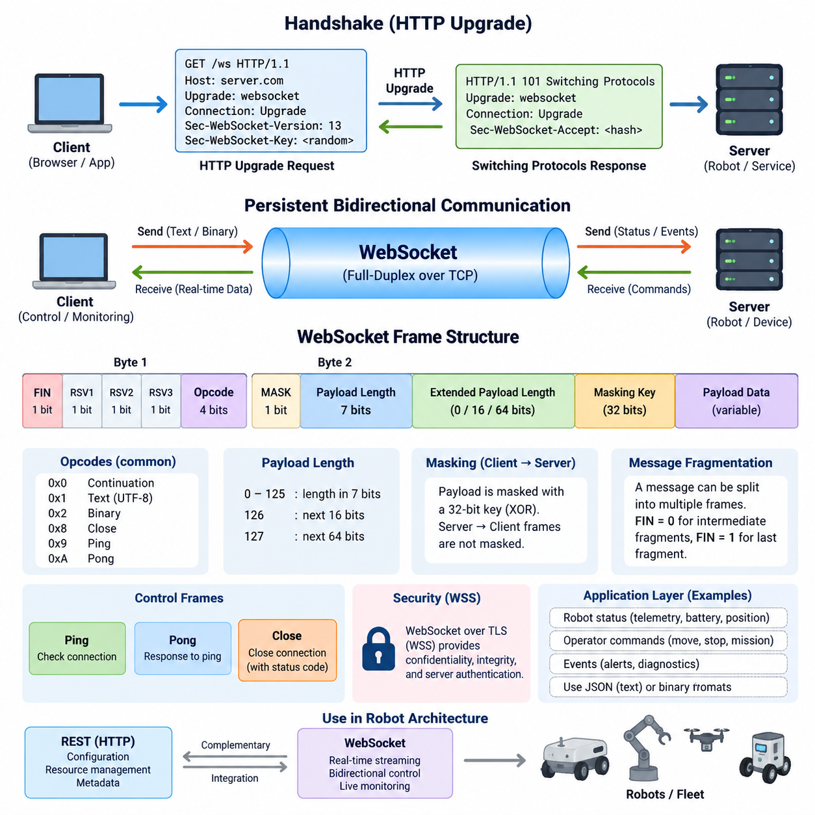
WebSocket is a persistent, full-duplex communication protocol designed to support continuous bidirectional data exchange between a client and a server over a single connection. Within the communication architecture of a robot system, it complements REST and gRPC by providing an efficient channel for rapidly changing information such as robot status, telemetry, alarms, mission progress, and operator commands.
Unlike conventional HTTP request-response communication, WebSocket allows either endpoint to transmit data whenever necessary after the connection has been established. The server therefore does not need to wait for a new client request before delivering updated information. This property is especially useful for robot monitoring interfaces where position, velocity, battery state, navigation progress, sensor summaries, and operational events may change continuously.
A WebSocket connection begins with an HTTP-based opening handshake. The client initially sends an HTTP GET request containing an Upgrade header that requests a protocol transition from HTTP to WebSocket. The request normally includes Connection: Upgrade, Sec-WebSocket-Version, and Sec-WebSocket-Key fields. This design allows WebSocket connections to begin through infrastructure that already understands HTTP before switching to persistent bidirectional communication.
The Sec-WebSocket-Key is a randomly generated Base64-encoded value supplied by the client during the handshake. The server combines this value with the WebSocket protocol's defined GUID, computes a SHA-1 hash, and Base64-encodes the result to produce Sec-WebSocket-Accept. The client verifies this response to confirm that the server understood the WebSocket upgrade rather than returning an unrelated HTTP response.
When the server accepts the upgrade, it returns an HTTP 101 Switching Protocols response with appropriate Upgrade and Connection headers. At this point, the HTTP transaction has completed and the underlying TCP connection becomes a WebSocket communication channel. Subsequent application data is no longer represented as ordinary HTTP requests and responses but is exchanged using the WebSocket framing mechanism.
WebSocket framing provides boundaries around individual units of transmitted information. Each frame begins with a compact header containing control information followed by optional extended payload length information, a masking key when required, and the payload itself. This framing model enables multiple messages to travel efficiently over the same persistent TCP connection without repeatedly transmitting HTTP headers for every application-level update.
The first frame-header byte contains several important fields. FIN indicates whether the frame completes a message, while RSV1, RSV2, and RSV3 are reserved primarily for negotiated protocol extensions. The four-bit opcode identifies the meaning of the frame. Common opcodes distinguish continuation frames, UTF-8 text data, binary data, connection-close requests, Ping messages, and Pong responses used for connection management.
The second header byte contains the MASK bit and the initial seven-bit payload-length field. Payload lengths from 0 through 125 can be represented directly. A value of 126 indicates that the actual length is stored in the following 16 bits, while 127 indicates an additional 64-bit length field. This variable representation keeps small robot status messages compact while still permitting substantially larger application payloads.
Client-to-server WebSocket frames are masked using a 32-bit masking key, and the receiver reconstructs the original payload by applying the defined XOR operation. Server-to-client frames are normally not masked. Masking is a protocol requirement intended to prevent WebSocket traffic generated by clients from being interpreted as predictable byte sequences by vulnerable network intermediaries; it is not a substitute for encryption or authentication.
WebSocket supports both text and binary application data. Text messages must contain valid UTF-8 data and are frequently used with JSON because browser applications and robot dashboards can process them conveniently. Binary frames can carry compact serialized structures, encoded sensor information, or application-specific formats where bandwidth and serialization overhead are important. The protocol itself does not prescribe the semantic structure of these payloads.
A WebSocket message does not necessarily correspond to exactly one frame. Large messages may be fragmented into an initial text or binary frame followed by one or more continuation frames. FIN remains clear while additional fragments are expected and is set on the final fragment. Fragmentation allows implementations to transmit data progressively and provides opportunities for intermediaries or endpoints to process messages without buffering an entire large payload.
Control frames perform protocol-level connection management independently of application messages. Ping frames can be transmitted to verify that the remote endpoint remains responsive, and Pong frames provide the corresponding response mechanism. These frames are particularly important in long-running robot connections because network interruption, device failure, wireless roaming, or idle connection termination may otherwise leave applications with stale connection state.
The Close control frame provides an orderly mechanism for terminating a WebSocket session. An endpoint sending a Close frame may include a status code and a short reason, after which the peer normally responds with its own Close frame before the TCP connection is terminated. Applications should distinguish intentional closure from unexpected network loss because robot dashboards and fleet systems may need different reconnection, alarm, and state-recovery behavior.
Because WebSocket runs over TCP, it inherits reliable, ordered byte delivery from the transport layer. This simplifies many robot monitoring applications because messages are not arbitrarily reordered or silently discarded by the transport. However, TCP reliability does not guarantee application-level timeliness. Congestion, retransmission, slow consumers, oversized queues, and network interruptions can still cause old telemetry to arrive after it has lost operational value.
For secure deployments, WebSocket is commonly transported using WSS, which places the WebSocket connection over TLS. TLS protects confidentiality and integrity while authenticating the server through certificates and, where required, supporting stronger identity architectures. Authentication and authorization remain application responsibilities, so robot systems must still determine which users, services, or fleet components may observe telemetry or issue operational commands.
WebSocket should therefore be understood as a transport mechanism for persistent application interaction rather than a complete robot communication architecture. Message schemas, timestamps, robot identifiers, sequence numbers, command acknowledgments, authorization rules, error semantics, timeout policies, and reconnection behavior must be defined above the protocol. These contracts determine whether a WebSocket interface remains predictable as the robot fleet and application ecosystem grow.
In a practical robot architecture, an HTTP or REST interface can perform configuration and resource-oriented operations while WebSocket maintains the live operational channel. A dashboard might retrieve robot metadata through REST and then subscribe to position, battery, navigation, diagnostics, and mission events through WebSocket. Operator commands can travel in the opposite direction over the same connection when the application contract permits bidirectional control.
The handshake and frame structure together explain the principal efficiency advantage of WebSocket. HTTP compatibility is retained during connection establishment, while repeated request-response overhead is avoided after the upgrade. Compact frames then support continuous bidirectional exchange through one connection, making WebSocket particularly suitable for interactive robot dashboards, edge interfaces, remote monitoring, fleet visualization, and event-oriented operational applications.

03.02 WebSocket Server Implementation: Python asyncio [w/Code]
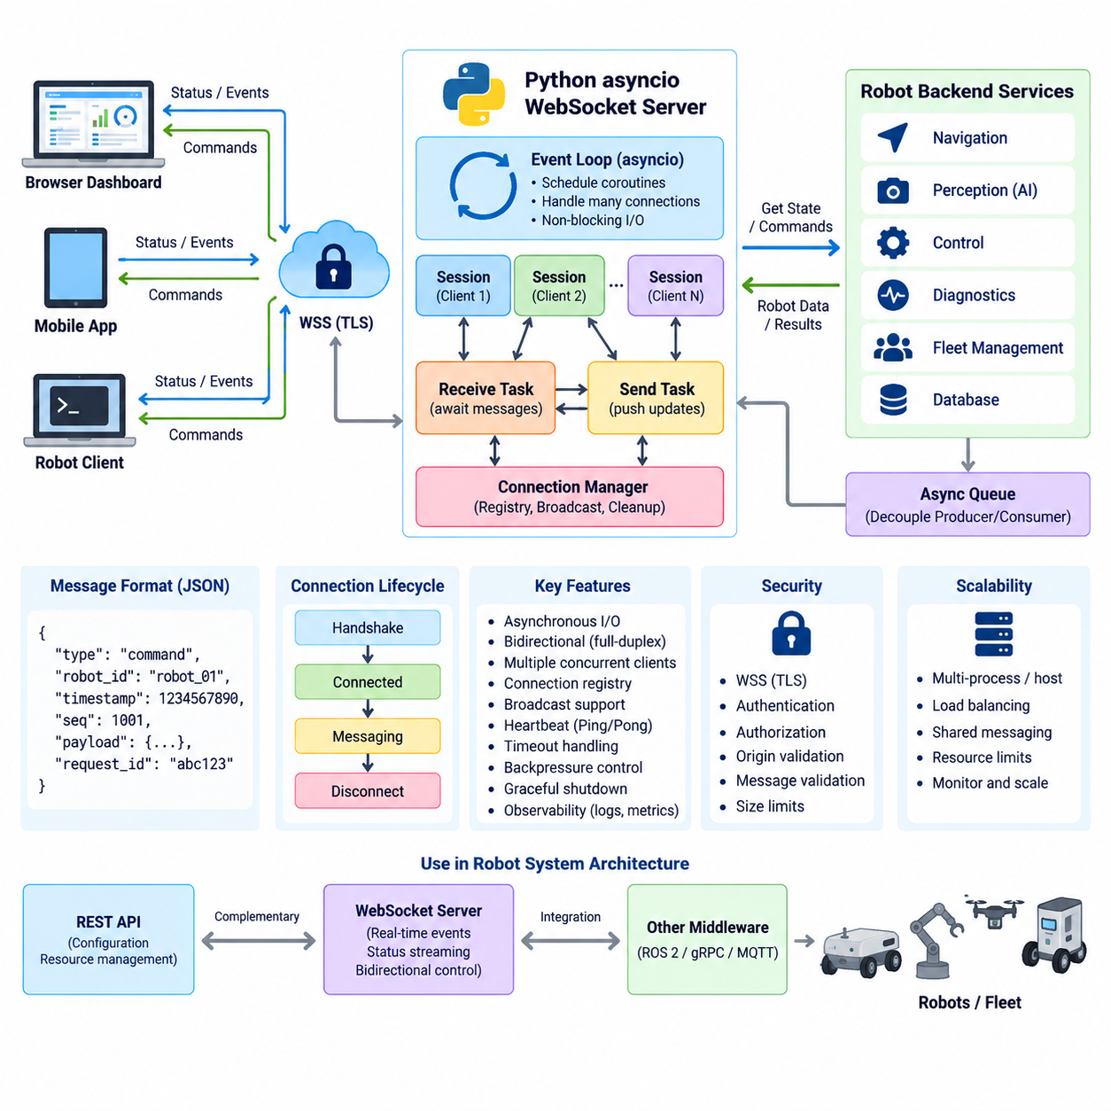
Python provides a natural environment for implementing WebSocket servers because its asynchronous programming model can manage many long-lived network connections without assigning a dedicated operating-system thread to every client. In robotics, this is valuable for dashboards, edge services, fleet interfaces, and monitoring systems that must maintain simultaneous connections while continuously exchanging status, telemetry, events, and commands.
The asyncio framework is Python’s standard foundation for asynchronous I/O. It organizes execution around an event loop that schedules coroutines and resumes them when asynchronous operations become ready. Instead of blocking a thread while waiting for network data, a coroutine can yield control with await. The event loop can then process another WebSocket connection, timer, queue, or application task until the original operation can continue.
A WebSocket server built with asyncio normally exposes an asynchronous connection handler. When a client completes the WebSocket handshake, the server creates a logical session and invokes this handler for the connection. The handler can receive messages, process application commands, generate responses, and observe connection termination. Because each session is represented by asynchronous work, many connected robot clients or browser dashboards can coexist within one event-driven server process.
The server implementation should separate connection management from robot application logic. The WebSocket layer is responsible for accepting connections, receiving frames, sending messages, handling closure, and detecting communication failures. Robot-specific services interpret commands, retrieve telemetry, validate operational state, and interact with navigation or fleet components. This separation prevents transport details from becoming tightly coupled with control and mission behavior.
An asynchronous receive loop typically waits for incoming WebSocket messages using await. While one client has no data available, the coroutine remains suspended rather than occupying the processor with repeated polling. When a message arrives, the event loop resumes the appropriate handler. This behavior makes asyncio particularly effective when a server manages numerous mostly idle connections interrupted by relatively short bursts of robot status updates or operator activity.
Outgoing communication can follow a similar asynchronous pattern. A robot monitoring server may periodically publish position, battery level, navigation state, diagnostic information, or mission progress without waiting for the client to request each update. The application can maintain a producer task that obtains new state and asynchronously sends it through the WebSocket connection, allowing reception and transmission to proceed logically at the same time.
For bidirectional applications, receive and transmit responsibilities are often implemented as independent coroutines. One coroutine processes incoming operator requests while another publishes robot events or telemetry. asyncio tasks allow these activities to execute concurrently within the same event loop. This structure reflects the full-duplex nature of WebSocket and avoids designing the server as a rigid sequence in which every transmitted message requires a preceding received message.
JSON is commonly used as an application message format because it is easy to generate in Python and directly consumable by browser-based clients. A message can contain fields such as message type, robot identifier, timestamp, sequence number, payload, and request identifier. However, the WebSocket protocol does not define these semantics. A production robot server should establish an explicit message contract so clients can reliably distinguish commands, state updates, events, acknowledgments, and errors.
Message processing should avoid long synchronous operations inside the event loop. CPU-intensive AI inference, image processing, blocking database operations, or synchronous hardware access can prevent other WebSocket connections from being serviced promptly. Such workloads should be delegated to suitable worker threads, processes, asynchronous services, or separate computation components. The event loop should remain responsive enough to handle network traffic and connection lifecycle events predictably.
Shared robot state introduces another design consideration. Multiple WebSocket clients may observe or modify information associated with the same robot or fleet. Even though asyncio commonly executes coroutines cooperatively in one thread, state changes can still be interleaved around await points. Server logic should therefore define clear ownership, synchronization, queues, or immutable message flows rather than assuming asynchronous execution automatically eliminates concurrency problems.
Connection registries are useful when the server must broadcast information to multiple clients. A registry can associate active WebSocket sessions with robot identifiers, users, subscriptions, or operational groups. When a robot generates a new event, the server can determine which sessions should receive it. The registry must also remove disconnected clients reliably so that stale connection objects do not accumulate and consume memory or generate repeated transmission errors.
Queues provide an effective boundary between robot data producers and WebSocket consumers. Navigation, diagnostics, perception, or fleet services can place events into asynchronous queues while WebSocket tasks consume and transmit them independently. This decouples the rate at which robot information is generated from immediate network operations. Queue limits are important because an indefinitely growing backlog can exhaust memory when clients become slow or network bandwidth decreases.
Backpressure must therefore be treated as an architectural concern rather than merely a networking detail. If telemetry is produced faster than a client can consume it, the server must decide whether to buffer, discard, aggregate, or replace older information. For rapidly changing robot pose or velocity, transmitting the newest state may be more valuable than preserving every historical update, while alarms and mission transitions may require reliable application-level processing.
Connection failures are normal in mobile and distributed robot environments. Wireless roaming, temporary network loss, browser suspension, service restart, and edge-device failure can interrupt otherwise valid sessions. The asynchronous handler should catch expected connection-closure conditions, release session resources, cancel associated tasks, and update the connection registry. Cleanup should execute consistently whether the connection closes normally or fails unexpectedly.
Ping and Pong mechanisms can help detect connections that remain technically allocated but no longer provide useful communication. WebSocket libraries may provide configurable heartbeat behavior, while applications can also maintain their own liveness semantics when necessary. Robot systems should distinguish transport-level connectivity from application health because a successful WebSocket heartbeat proves that endpoints can communicate but does not prove that navigation, perception, control, or mission services are functioning correctly.
Timeouts are important for preventing asynchronous tasks from waiting indefinitely. A server may impose limits on authentication, command processing, acknowledgments, or application heartbeat intervals. asyncio provides mechanisms for applying time constraints around awaited operations. Timeout behavior should be defined according to message semantics, because losing a telemetry update has different consequences from failing to acknowledge a safety-related operational request or mission command.
Security should be integrated into the server architecture from the beginning. Production WebSocket services normally use WSS so that communication is protected by TLS. The server should authenticate clients, validate authorization before exposing robot information or accepting commands, restrict message sizes, validate message schemas, and reject malformed input. Browser-facing deployments should additionally consider origin validation and secure handling of credentials or authentication tokens.
Graceful shutdown is another important asynchronous server behavior. When the service is intentionally stopped, it should stop accepting new clients, notify or close existing sessions where appropriate, cancel background tasks, flush critical state, and release network resources. Abruptly terminating an event loop can leave clients uncertain about server state and may complicate reconnection behavior in fleet monitoring systems or persistent robot user interfaces.
Observability should cover both networking and application behavior. Useful measurements include active connections, connection duration, message rates, transmitted and received bytes, queue depth, dropped updates, processing latency, exceptions, reconnect frequency, and authentication failures. Structured logs containing robot and session identifiers make it easier to trace communication problems across WebSocket servers, edge services, robot software, and fleet-management infrastructure.
Scalability eventually extends beyond the efficiency of asyncio itself. A single event loop can manage many I/O-bound connections, but CPU capacity, memory, serialization cost, TLS processing, telemetry frequency, and downstream services impose practical limits. Larger deployments may distribute WebSocket connections across multiple server processes or hosts and use shared messaging infrastructure so that robot events can reach clients regardless of which server instance owns their connection.
Within the broader robot communication architecture, a Python asyncio WebSocket server is most effective as a responsive real-time gateway rather than as the location for every robot function. REST can handle configuration and resource-oriented operations, while WebSocket maintains continuous event and status channels. Internal ROS 2, gRPC, MQTT, or other communication components can feed the gateway, allowing browser and external applications to interact with robots through a controlled asynchronous interface.

03.03 WebSocket Client Implementation: JS / Python [w/Code]
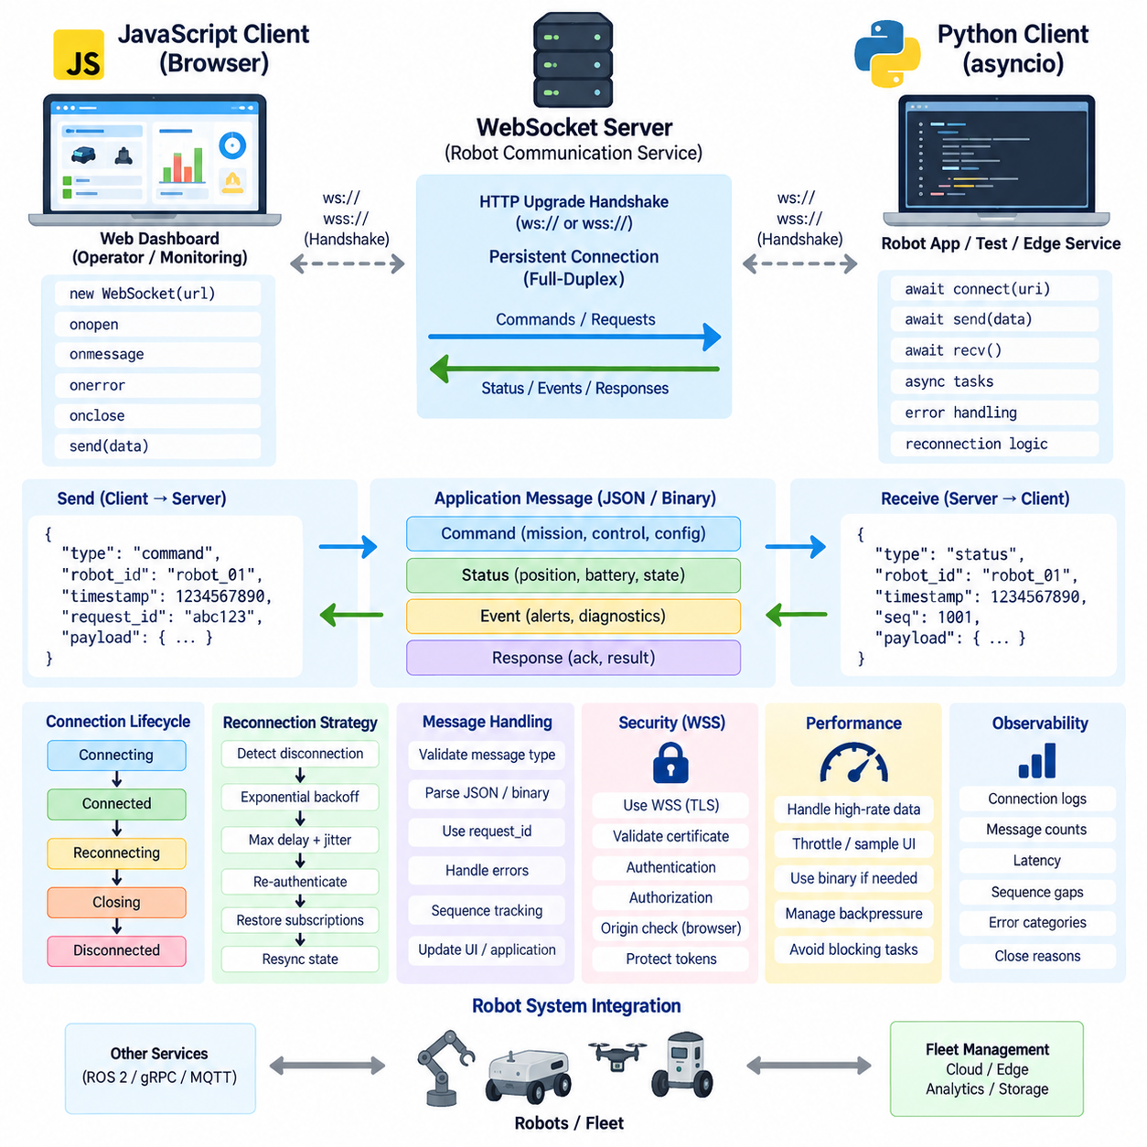
A WebSocket client is the endpoint that initiates a persistent connection to a WebSocket server and participates in bidirectional communication after the HTTP upgrade handshake succeeds. In robot systems, clients may include browser dashboards, operator consoles, edge applications, fleet-management software, diagnostic tools, or robot-side processes that continuously exchange commands, telemetry, mission status, alarms, and operational events.
JavaScript provides native WebSocket support in modern web browsers, making it particularly suitable for real-time robot dashboards. A browser application creates a WebSocket object with a ws:// or secure wss:// endpoint and then reacts to connection lifecycle events. The API is event-driven, so the application does not repeatedly poll the server. Instead, callbacks process connection establishment, incoming messages, errors, and connection closure as they occur.
The JavaScript client normally begins its application-level communication after the open event confirms that the WebSocket handshake has completed. Sending data before the connection reaches the OPEN state can cause errors or lost application operations. Once connected, the send() operation can transmit text or binary data, allowing operator commands, configuration requests, acknowledgments, subscription messages, or other application-defined information to reach the robot communication service.
Incoming data is handled through the message event. A browser dashboard can decode JSON payloads and immediately update robot position, battery status, navigation state, mission progress, diagnostics, or alerts. Because the server can push information without waiting for another HTTP request, the interface can represent changing robot conditions with substantially less application-level polling logic. The client must nevertheless validate received message types and payload fields before using them.
Python WebSocket clients serve a different but complementary role. They are useful for robot-side applications, automated test programs, fleet services, edge gateways, data collectors, simulation tools, and command-line diagnostics. Python implementations can use asynchronous libraries so that network communication cooperates with other tasks rather than blocking program execution while waiting for messages from the server.
An asynchronous Python client commonly creates a connection within an asyncio event loop and awaits send and receive operations. While the client is waiting for network data, the event loop can execute timers, process queues, interact with other asynchronous services, or manage additional WebSocket connections. This architecture is useful when one edge application communicates with several robots or when a test system simultaneously observes multiple communication endpoints.
Both JavaScript and Python clients benefit from a well-defined application message model. JSON messages can contain fields such as type, robot_id, timestamp, sequence, request_id, and payload. A command message might request a mission operation, while a status message reports current robot state. Explicit message types allow the same WebSocket connection to carry multiple logical interactions without confusing commands, responses, events, acknowledgments, and errors.
Request identifiers are particularly useful because WebSocket does not inherently associate a transmitted application message with a later response. When a client sends a command, it can attach a unique request_id, and the server can return that identifier in the corresponding acknowledgment or result. Sequence numbers can additionally help detect duplicated, missing, delayed, or reordered application-level information when reconnecting or processing streams across distributed robot services.
A robust client should treat connection state as an explicit part of its architecture. Typical states include connecting, connected, reconnecting, closing, and disconnected. User interfaces should avoid presenting stale connectivity as healthy operation, while robot-side software should prevent commands from being silently accepted into an unusable communication path. State transitions should therefore be exposed to application logic rather than hidden entirely inside the networking component.
Disconnection handling is essential because WebSocket connections may be interrupted by Wi-Fi roaming, mobile network changes, server restart, proxy timeout, browser suspension, or robot power transitions. A client can detect the close event or a connection exception and initiate reconnection when appropriate. Reconnection logic should avoid extremely rapid retries because many clients repeatedly reconnecting at once can overload a recovering server or network infrastructure.
Exponential backoff is commonly used to control repeated reconnection attempts. The client initially waits for a short interval and progressively increases the delay after successive failures, normally applying a maximum delay and sometimes randomized jitter. After a successful connection, the retry state can be reset. In robot fleets, this approach reduces synchronized reconnection storms when a shared server, access point, or network service temporarily becomes unavailable.
Reconnection alone does not restore application state. After establishing a new WebSocket session, the client may need to authenticate again, restore subscriptions, identify its robot or user context, retrieve the latest state, and reconcile commands that were pending when the previous connection failed. Applications should explicitly determine whether unsent commands are discarded, retried, or confirmed through another mechanism because blindly repeating robot commands can create unsafe or unintended behavior.
Heartbeat mechanisms help clients determine whether a connection remains operational. Protocol-level Ping and Pong frames may be handled by WebSocket libraries, while applications can also exchange their own heartbeat or status messages. A live TCP or WebSocket connection indicates communication availability but does not prove that the robot application is healthy. Clients should therefore distinguish network connectivity from navigation, control, perception, mission, and safety-service health.
Message frequency can become important when a dashboard receives high-rate robot telemetry. Updating the browser interface for every incoming pose or sensor message may consume unnecessary CPU resources even when the network can carry the traffic. The client can aggregate, sample, or throttle visual updates while retaining important alarms and state transitions. This separates the rate of communication from the rate at which information must actually be rendered or processed.
Binary WebSocket messages are useful when JSON serialization becomes inefficient. Python and JavaScript clients can process binary payloads representing compact telemetry structures or other application-specific data. Binary communication can reduce message size and parsing overhead, but it requires a clearly specified schema and versioning strategy. Human-readable JSON is often preferable during early development, diagnostics, and integration when maximum transmission efficiency is not required.
Security considerations differ slightly between browser and non-browser clients but share the same foundation. Production communication should normally use WSS so TLS protects data confidentiality and integrity. Clients must validate the server certificate appropriately and participate in the application authentication scheme. Authentication tokens should be handled carefully, and authorization must still be enforced by the server rather than trusting commands merely because they arrived through an encrypted connection.
Browser clients introduce origin and credential constraints that must be considered during interface design. JavaScript applications operate within browser security rules, and WebSocket authentication cannot always be structured exactly like a conventional REST request. Systems may establish authenticated sessions through HTTPS, use appropriately designed tokens, or apply other controlled mechanisms. Credentials should not be exposed unnecessarily in URLs, logs, browser history, or client-side diagnostic output.
Python clients often operate as trusted service components, but they should not automatically be treated as secure simply because they run on robot or edge computers. Certificates, tokens, and robot identities should be protected, communication endpoints should be verified, and message permissions should follow least-privilege principles. A diagnostic client may require read-only telemetry access, whereas an authorized control application may be permitted to transmit mission commands.
Error handling should separate transport failures from application errors. A broken connection, TLS failure, timeout, malformed frame, invalid JSON document, rejected command, and robot execution failure represent different conditions and should not be collapsed into one generic error. Clear error categories allow JavaScript interfaces to present meaningful operator feedback and allow Python clients to decide whether to reconnect, retry, report, or terminate an operation.
Client-side observability is valuable when diagnosing distributed robot communication. Connection timestamps, reconnect attempts, message counts, latency measurements, sequence gaps, parsing failures, command acknowledgments, and close reasons can reveal problems that server logs alone cannot explain. Correlation identifiers shared between client and server make it easier to trace one command from an operator interface through the communication gateway to downstream robot services.
JavaScript and Python WebSocket clients ultimately provide two complementary access patterns to the same real-time communication architecture. JavaScript enables interactive browser-based visualization and control, while Python supports automation, edge integration, testing, and robot-side services. When combined with explicit message contracts, secure WSS transport, controlled reconnection, state recovery, validation, and observability, both can form reliable client interfaces for real-time robot and fleet systems.

03.04 Robot Real-Time Status Streaming: WebSocket [w/Code]
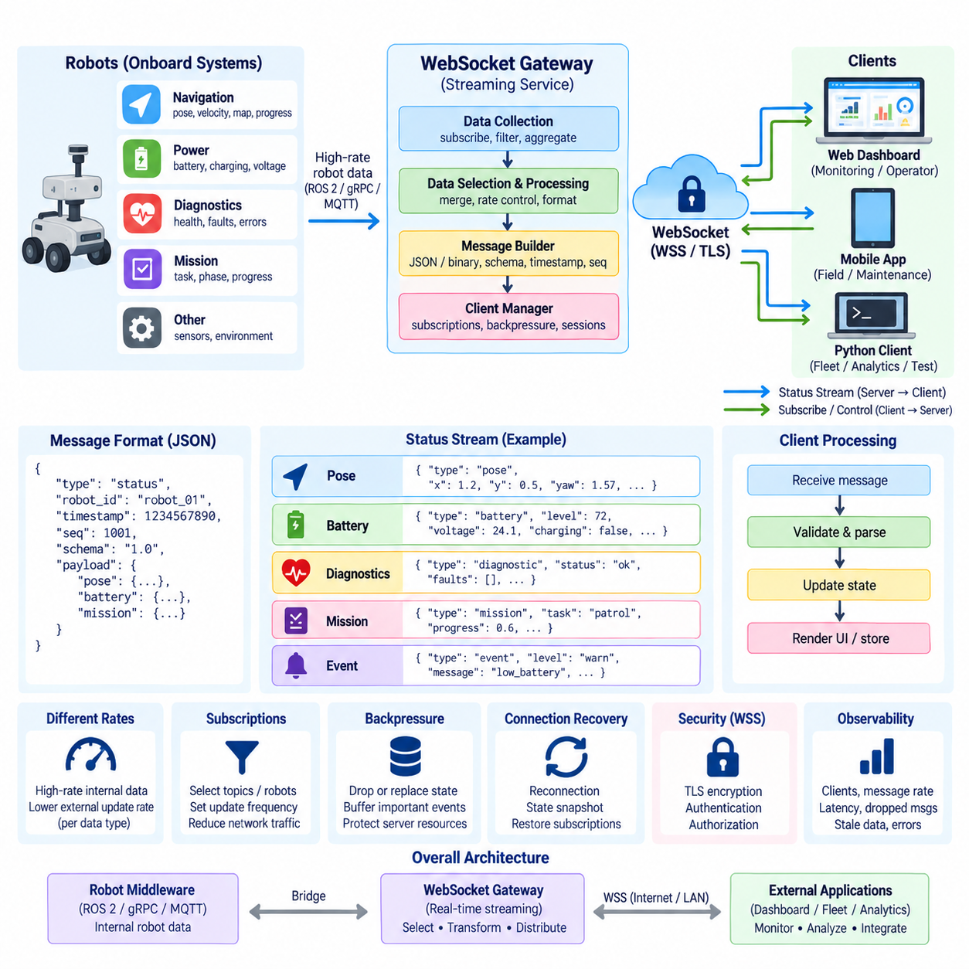
Real-time robot status streaming is a communication pattern in which continuously changing operational information is delivered from a robot or fleet service to connected applications as soon as new state becomes available. WebSocket is well suited to this pattern because a persistent full-duplex connection allows servers to push updates without requiring clients to repeatedly issue HTTP requests. This reduces polling overhead and improves responsiveness for monitoring interfaces.
A robot status stream typically combines information generated by several subsystems. Navigation may provide pose, velocity, localization confidence, and route progress, while power management supplies battery level, charging state, voltage, and estimated remaining runtime. Diagnostics can contribute health indicators and fault codes, and mission management can publish current task, execution phase, completion percentage, and operational transitions.
The streaming architecture should separate internal robot data rates from external WebSocket update rates. Sensors and control loops may operate at tens, hundreds, or thousands of hertz, but remote dashboards rarely require every internal sample. A streaming gateway can therefore collect high-rate state, select relevant fields, aggregate information, and publish a lower-rate representation appropriate for operators, fleet services, or external applications.
An event-driven architecture is particularly effective for this purpose. Robot components publish state changes or events to an internal communication layer, and a WebSocket gateway consumes the information required by external clients. The gateway then transforms internal representations into stable application messages. This prevents browser interfaces from depending directly on ROS 2 topics, hardware-specific structures, or implementation details that may change during robot development.
Status messages should use an explicit schema rather than an arbitrary collection of values. A typical envelope can contain message type, robot identifier, timestamp, sequence number, schema version, and payload. The payload then carries domain-specific information such as pose, battery, navigation, diagnostics, or mission state. A consistent envelope simplifies routing, validation, logging, version management, and processing across different robot models.
Timestamps are essential because real-time status has value only when its age is understood. A message should indicate when the underlying state was measured or generated rather than relying solely on the time at which a dashboard received it. In distributed robot systems, synchronized clocks improve interpretation of events across sensors, edge computers, fleet servers, and monitoring applications, especially when diagnosing latency or reconstructing operational sequences.
Sequence numbers complement timestamps by exposing continuity in a status stream. A client that receives sequence numbers 510, 511, and 514 can recognize that intermediate updates were not observed. This does not necessarily mean that the robot entered an unsafe condition, because some high-rate status updates may intentionally be dropped or replaced. However, sequence tracking provides useful evidence for detecting congestion, reconnection gaps, or overloaded consumers.
Different status categories require different delivery policies. Robot pose and velocity are rapidly changing values for which the newest state is generally more useful than an old backlog. Battery state can usually be transmitted less frequently, while faults, safety events, mission transitions, and emergency conditions should be delivered promptly and handled as discrete events. A single fixed streaming rate is therefore rarely optimal for every type of robot information.
Subscription mechanisms can reduce unnecessary network traffic. Instead of sending every available status field to every connected client, the WebSocket application can allow clients to request selected channels, robot identifiers, or update frequencies. A fleet overview may require compact status from hundreds of robots, while a diagnostic interface examining one robot may request detailed navigation, power, and fault information at a higher frequency.
The server should maintain subscription state for each active WebSocket session. When new robot information arrives, it determines which clients are interested in that data and produces the appropriate outgoing messages. This model allows browser dashboards, maintenance tools, fleet applications, and analytics services to share the same WebSocket infrastructure while receiving different views of the underlying robot state according to their operational needs.
Backpressure becomes important when the server produces updates faster than a client can receive or process them. An unlimited outgoing queue can consume increasing amounts of memory and eventually destabilize the streaming service. For replaceable state such as pose, the server can retain only the newest value. For important events such as faults or mission transitions, bounded buffering, acknowledgments, persistence, or a separate reliable event mechanism may be required.
The distinction between state and event data is fundamental. State describes the latest condition of the robot and can often replace an older value, while an event represents something that happened and may need to be preserved. A battery percentage update from 71 percent to 70 percent is normally replaceable state, whereas a localization failure, emergency stop, mission completion, or safety transition represents an event whose occurrence may remain important after newer data arrives.
Client applications should also control their rendering rate. A WebSocket connection might receive robot pose updates at 20 Hz, while a browser map may only need to redraw the visual representation at 10 Hz. Decoupling message reception from user-interface rendering reduces CPU and graphics workload. Critical alarms can still bypass this throttling and appear immediately, preserving responsiveness where operational significance is greater than visual smoothness.
Connection interruptions require explicit state recovery. After reconnecting, a client should not assume that the next incremental update provides a complete representation of the robot. The server can send a state snapshot after connection establishment or subscription restoration, followed by incremental updates. This snapshot-plus-stream pattern enables the client to reconstruct a coherent current view without depending on messages that may have been lost while disconnected.
A status snapshot should contain sufficient information to establish the current operational context, including relevant robot mode, mission state, navigation condition, power state, and active faults. Subsequent messages can contain only changed fields when bandwidth efficiency is important. Whether full-state or delta updates are used, the protocol should make the distinction explicit so that clients do not incorrectly interpret partial data as a complete robot state.
Heartbeat and freshness monitoring help identify stale status. Even when the WebSocket transport remains connected, an internal robot service may stop producing data because of a software fault or subsystem failure. The gateway or client can track the age of important fields and mark them stale when expected updates stop arriving. This is more informative than treating the WebSocket connection itself as proof that every robot subsystem is healthy.
Real-time streaming latency should be measured end to end rather than only at the network layer. Relevant stages include robot state generation, internal middleware transport, gateway processing, serialization, network transmission, client parsing, and user-interface rendering. Timestamping important boundaries allows developers to determine whether excessive delay originates inside the robot, at the WebSocket gateway, across the network, or within the monitoring application.
JSON is convenient for status streaming because it supports rapid development, readable diagnostics, and direct browser integration. For high-rate or bandwidth-sensitive applications, binary serialization can reduce payload size and processing overhead. The choice should reflect actual system requirements rather than assuming that binary encoding is always necessary. Stable schemas and predictable semantics are generally more important than premature optimization of message representation.
Security is particularly important because real-time robot status can reveal operational location, mission activity, faults, and infrastructure information. Production systems should normally use WSS with TLS, authenticate clients, and authorize subscriptions according to identity and role. A monitoring user may be permitted to receive status without receiving command privileges, while service components may have access only to specific robots or data categories.
Observability should measure the streaming pipeline itself. Useful metrics include connected clients, active subscriptions, messages per second, bytes transmitted, queue depth, dropped or replaced updates, serialization time, end-to-end latency, stale-data occurrences, reconnect frequency, and errors. These measurements allow operators to distinguish robot faults from communication congestion and help engineers determine when the WebSocket infrastructure requires scaling.
In a fleet architecture, WebSocket status streaming forms a real-time presentation and integration layer rather than replacing internal robot middleware. ROS 2, gRPC, MQTT, or other services can carry data among robot and edge components, while a gateway exposes selected information through a stable external WebSocket contract. This architecture allows dashboards and fleet applications to observe many heterogeneous robots without becoming dependent on their internal software structures.
A well-designed WebSocket status service therefore combines persistent communication with data selection, explicit schemas, timestamps, sequence tracking, subscriptions, backpressure control, state recovery, security, and observability. The objective is not simply to transmit robot data as quickly as possible, but to deliver sufficiently fresh, meaningful, and trustworthy operational information so that users and higher-level systems can understand the current state of robots and fleets.

03.05 WebSocket Security: WSS, Origin Validation, Token [w/Code]
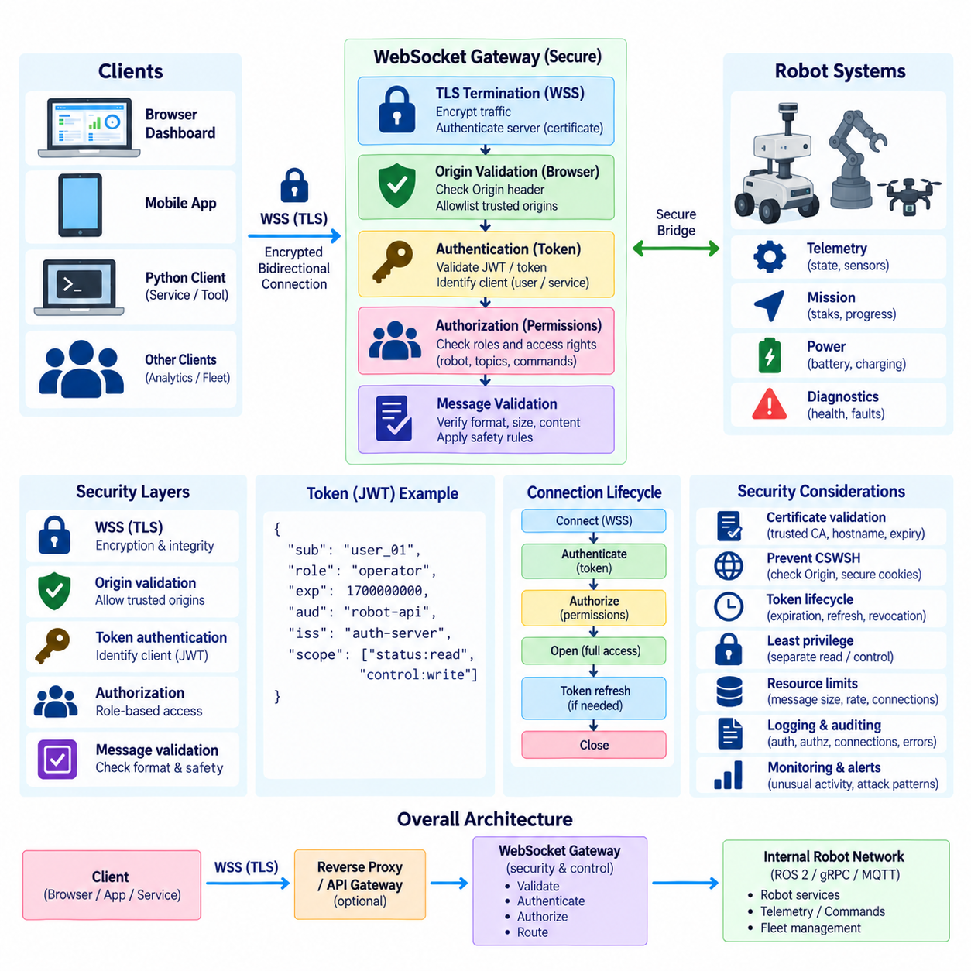
WebSocket security must protect a communication channel that can remain open for long periods and carry continuous bidirectional traffic. In robot systems, the same connection may expose telemetry, diagnostics, mission information, and operational commands. Security therefore cannot stop at the initial handshake. Confidentiality, endpoint authentication, client identity, authorization, message validation, and connection lifecycle controls must remain effective throughout the session.
The secure form of WebSocket is WSS, which transports WebSocket communication over TLS. A client connecting to a wss:// endpoint first establishes a protected TLS session before completing the WebSocket upgrade. TLS encrypts traffic traveling between endpoints and provides integrity protection against unauthorized modification. It also allows the client to authenticate the server through its digital certificate, reducing the risk of connecting to an impersonated robot or gateway.
Certificate validation is fundamental to WSS security. A client should verify that the server certificate is issued by a trusted certificate authority, remains within its validity period, and corresponds to the expected hostname. Disabling certificate verification may appear convenient during development but removes an important authentication property. Production robot systems should establish controlled certificate issuance, renewal, revocation, and trust-store management across robots, edge computers, gateways, and fleet services.
TLS protects the communication path but does not determine whether an application user is allowed to access a robot. WebSocket authentication must therefore establish the identity of the connecting client independently of transport encryption. Depending on the architecture, identity may represent a human operator, browser session, robot, edge service, fleet controller, maintenance application, or automated service account. Authentication should occur before privileged WebSocket operations become available.
Browser-based WebSocket clients introduce an important security consideration through the Origin header. During the opening handshake, browsers normally include an Origin value indicating the origin that initiated the connection. A server can validate this value against an explicit allowlist of trusted application origins. This helps prevent an attacker-controlled website from using a victim's browser and existing credentials to establish unauthorized WebSocket interactions with a robot service.
Origin validation should not be confused with user authentication. An allowed origin identifies the expected web application context but does not prove the identity or permissions of the individual user. Likewise, a valid user credential does not automatically mean that every originating website should be trusted. Secure browser deployments should therefore combine origin checking with authentication and authorization rather than treating any one of these mechanisms as sufficient protection.
Cross-Site WebSocket Hijacking can become possible when a WebSocket endpoint relies on browser cookies or existing authenticated sessions but fails to validate the requesting origin appropriately. A malicious web page may attempt to create a connection from the user's browser and exploit credentials that the browser supplies automatically. Explicit origin policies, appropriate cookie controls, session protection, and server-side authorization reduce exposure to this class of attack.
Token-based authentication is commonly used when WebSocket communication must integrate with modern API security architectures. A client first obtains an authentication token through an approved login or identity process and then presents evidence of that identity when establishing or initializing the WebSocket session. Tokens can represent users or services and can carry or reference information required by the server to determine which operations and robot resources are permitted.
JSON Web Tokens, or JWTs, are frequently used because they can contain signed claims such as subject, issuer, audience, expiration time, roles, and other authorization context. A WebSocket server receiving a JWT must verify its signature and validate relevant claims rather than merely decoding the token. Expired tokens, unexpected issuers, incorrect audiences, invalid signatures, and tokens that are not yet valid should be rejected according to the system's authentication policy.
Token transport requires careful design, particularly in browser environments. The browser WebSocket API does not provide the same arbitrary request-header control available to many non-browser HTTP clients. Systems may therefore use authenticated HTTPS sessions, secure cookies, protocol-specific negotiation, or an application-level authentication message after connection establishment. Long-lived credentials should not be placed casually in URLs because URLs can appear in logs, monitoring systems, or diagnostic records.
When authentication occurs after the WebSocket handshake, the connection should initially remain in an unauthenticated state with very limited capabilities. The server can require an authentication message within a short timeout and close the connection if valid credentials are not supplied. Robot telemetry subscriptions and command interfaces should remain inaccessible until identity verification succeeds, preventing an unauthenticated connection from becoming an unintended path to operational information.
Authentication answers who the client is, while authorization determines what that identity may do. A fleet administrator, maintenance engineer, monitoring dashboard, robot, and external analytics service should not automatically receive identical privileges. Authorization rules can restrict access according to robot identifier, fleet, message category, command type, operational role, or environment. This allows status observation to be separated from potentially higher-risk control permissions.
Least privilege is particularly important for robot WebSocket interfaces because bidirectional communication can combine monitoring and command functionality on the same connection. A read-only dashboard may need battery, pose, and diagnostic information without permission to start or cancel missions. A maintenance application may require diagnostic commands but not navigation control. The server should enforce these distinctions for every protected operation instead of relying on the client interface to hide unavailable functions.
Message validation remains necessary even after a client has been authenticated and authorized. Every received application message should be checked for expected structure, field types, acceptable values, identifiers, and size. Command messages should additionally be validated against current robot state and application safety rules. Authentication establishes trust in identity, not trust in every byte or command produced by that identity's software.
Resource limits protect the server from accidental or malicious exhaustion. WebSocket endpoints can impose maximum message sizes, connection limits, message-rate limits, queue bounds, authentication timeouts, and idle-session policies. Without such controls, oversized messages, excessive connections, or high-rate traffic can consume memory, CPU, bandwidth, or file descriptors. Robot communication services should define limits according to expected operational behavior and monitor when those limits are approached.
Long-lived WebSocket sessions create token lifecycle challenges because an authentication credential may expire while the underlying connection remains active. The system must define whether authorization remains valid until disconnection, whether tokens are refreshed, or whether periodic reauthentication is required. Security-sensitive robot environments should avoid assuming that successful authentication at connection time grants indefinite access regardless of later account, role, or credential changes.
Revocation is related but distinct from expiration. An operator account may be disabled, a robot credential may be compromised, or a service permission may be withdrawn while WebSocket sessions remain established. Architectures requiring rapid security response should provide a mechanism for reevaluating authorization or terminating affected sessions. Otherwise, revoking credentials for future connections may leave existing persistent connections operational longer than intended.
Connection identifiers and security context should be associated throughout the session. The server should know which authenticated identity owns each connection, which roles or permissions apply, which robots are accessible, and which subscriptions have been authorized. When authorization changes or a session closes, the corresponding connection registry and subscription state must be updated consistently so that stale permissions do not remain attached to reusable application objects.
Logging and auditing are essential for security investigations and operational accountability. Relevant records include successful and failed authentication, rejected origins, authorization failures, connection and disconnection events, unusual message rates, invalid message formats, privileged commands, and security-related closure reasons. Logs should include useful correlation identifiers while avoiding unnecessary exposure of passwords, access tokens, private keys, or other secrets.
Security monitoring should look beyond individual failures and identify patterns. Repeated authentication attempts, connections from unexpected origins, abnormal command rates, sudden increases in rejected messages, or many connections associated with one identity can indicate misconfiguration or hostile activity. Metrics and alerts can complement application logs, allowing fleet operators to detect changes in communication behavior before they develop into broader operational problems.
Network architecture can provide another layer of protection. WebSocket gateways may be placed behind reverse proxies, API gateways, firewalls, or segmented industrial networks. External clients do not necessarily need direct access to robot computers or internal ROS 2 communication. A controlled gateway can terminate TLS, enforce connection policies, authenticate clients, filter traffic, and expose only the application functions required outside the robot or trusted edge environment.
WSS, origin validation, and token authentication therefore solve different parts of the WebSocket security problem. WSS protects communication in transit and authenticates the server, origin validation constrains browser connection contexts, and tokens establish application identities that can be mapped to permissions. Combined with authorization, validation, resource controls, credential lifecycle management, auditing, and network segmentation, they form a layered security architecture suitable for persistent robot communication.

03.06 WebSocket Connection Management: Reconnect / Ping.Pong [w/Code]
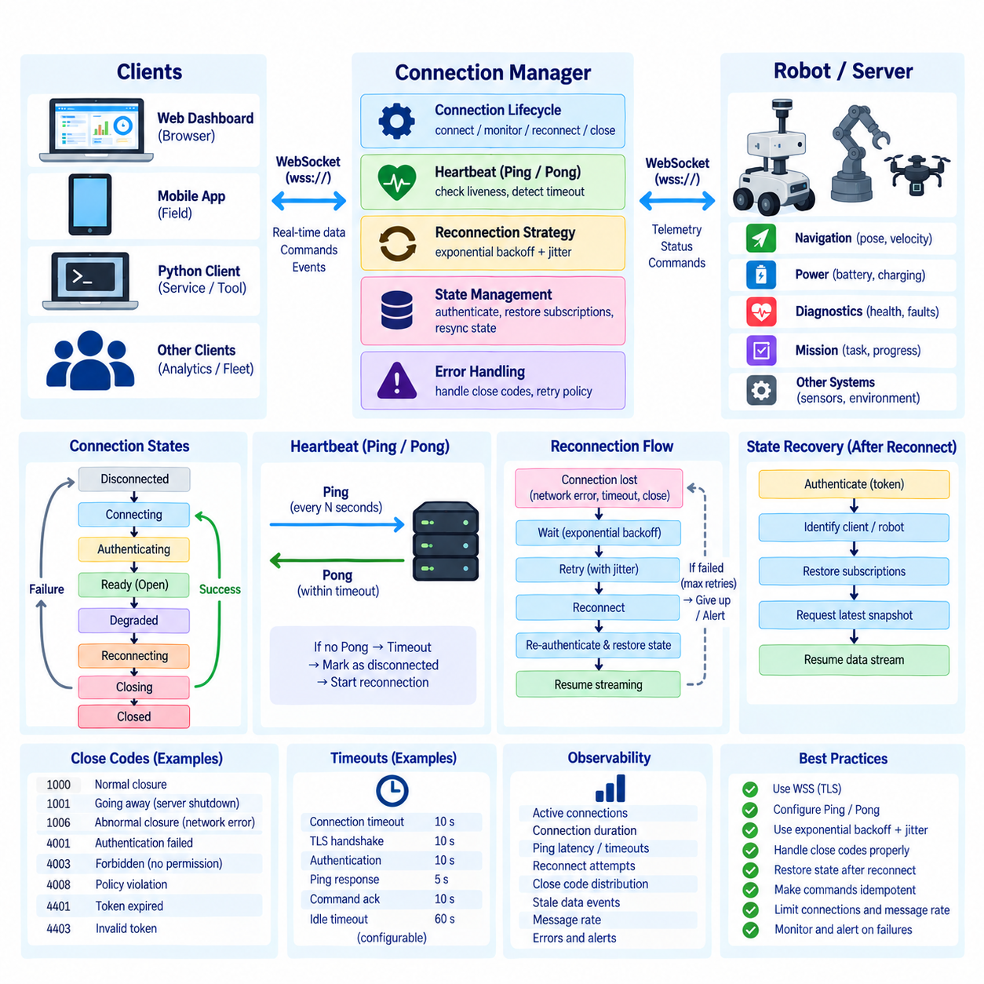
WebSocket connection management is responsible for keeping a persistent communication channel usable throughout changing network and application conditions. In robot systems, a connection may remain active for hours while carrying telemetry, mission events, diagnostics, and commands. Reliable operation therefore requires more than opening a socket; the system must detect failures, verify liveness, reconnect safely, restore state, and close connections predictably.
A WebSocket connection normally progresses through several logical states, including connecting, open, closing, and closed. Robot applications often extend this model with application states such as authenticating, ready, degraded, disconnected, and reconnecting. Making these states explicit allows dashboards and robot services to distinguish a fully operational communication channel from one that is technically connected but not yet authenticated, synchronized, or ready for normal traffic.
Connection establishment begins with the HTTP upgrade handshake and, for secure deployments, a preceding TLS negotiation. After the protocol connection opens, the application may still need to authenticate the client, establish permissions, register robot identifiers, and restore subscriptions. The connection should not be considered operational until these initialization steps succeed. This prevents application messages from entering a session whose security or state context is incomplete.
Persistent connections inevitably encounter interruptions. Wi-Fi roaming, access-point transitions, temporary packet loss, server restart, proxy timeout, edge-computer reboot, browser suspension, and network reconfiguration can all terminate or invalidate a WebSocket session. Robot software should treat such failures as expected distributed-system events rather than exceptional situations that require a complete application restart.
A client should detect disconnection through WebSocket close events, network exceptions, failed transmissions, heartbeat timeout, or application-level freshness checks. These mechanisms identify different failure conditions. A clean Close frame indicates an orderly shutdown, while a missing heartbeat may indicate an unreachable peer or broken path. Distinguishing these cases helps the application determine whether to reconnect immediately, wait, report an error, or require operator intervention.
Automatic reconnection is useful when temporary network failures are common, but reconnection should be controlled. Repeatedly attempting a connection with no delay can overload a recovering server, wireless network, or authentication service. A reconnect manager should schedule attempts according to an explicit policy and maintain information such as attempt count, elapsed disconnected time, previous close reason, and whether reconnection is currently permitted by the application.
Exponential backoff is widely used for reconnection scheduling. After the first failure, the client waits for a short interval, then progressively increases the delay after subsequent failures until reaching a configured maximum. Randomized jitter can be added so that hundreds of robots or dashboards do not reconnect simultaneously after a shared service outage. Once a stable connection is restored, the retry counter and backoff interval can normally be reset.
Not every disconnection should trigger automatic reconnection. Authentication rejection, revoked credentials, incompatible protocol versions, explicit administrative shutdown, or a permanently invalid endpoint may require different handling. Reconnecting indefinitely in these situations wastes resources and can hide configuration problems. Close codes and application error information should therefore be interpreted as part of the reconnection decision rather than treating every closure identically.
WebSocket Ping and Pong control frames provide a protocol-level mechanism for testing connection liveness. One endpoint sends a Ping frame and the peer responds with a Pong frame. Many WebSocket libraries implement this behavior automatically and allow applications to configure ping intervals and response timeouts. Regular heartbeat traffic helps detect connections that remain allocated locally even though the remote endpoint or network path is no longer reachable.
The heartbeat interval should reflect network characteristics and operational requirements. Very frequent Ping messages increase unnecessary traffic and processing, particularly when thousands of clients are connected. Very long intervals delay failure detection. A robot monitoring system requiring rapid awareness of communication loss may use shorter intervals than a low-priority analytics service. Timeout values should also tolerate realistic wireless delay and transient congestion.
Ping and Pong confirm transport-level responsiveness but do not prove that the robot application is healthy. A WebSocket process may respond correctly while navigation, perception, mission management, or hardware interfaces have stopped functioning. For this reason, robot systems often complement protocol heartbeats with application-level health messages containing service status, timestamps, robot mode, or freshness indicators. Transport liveness and robot operational health should remain separate concepts.
Application-level heartbeat messages can also verify that data is progressing through the complete software path. A gateway may be connected to a dashboard while its internal ROS 2 or robot service connection has failed. If the dashboard only observes WebSocket Ping and Pong, it may incorrectly assume that robot data is healthy. Tracking the age of telemetry and subsystem updates allows the client to identify stale data even when the WebSocket transport remains active.
Timeout management should cover several stages of the connection lifecycle. Systems may define limits for initial connection, TLS negotiation, authentication, subscription restoration, Ping response, command acknowledgment, and idle operation. A timeout should produce a meaningful state transition and cleanup action rather than leaving an asynchronous task waiting indefinitely. Different operations require different limits according to their expected latency and operational importance.
Reconnection must be followed by state restoration. A newly established WebSocket session does not automatically recover subscriptions, authentication context, pending requests, or the latest robot state from the previous connection. The client may need to authenticate again, identify itself, restore selected status channels, request a current snapshot, and resume streaming. This sequence should be deterministic so that both endpoints agree when the recovered session becomes ready.
Pending commands require especially careful treatment during reconnection. If a client transmitted a mission command immediately before the connection failed, it may not know whether the server received or executed it. Blindly resending the command can create duplicate or unintended robot actions. Request identifiers, acknowledgments, idempotent operations, command-status queries, or transaction records can help determine whether an uncertain operation should be retried.
State streams and event streams may use different recovery strategies. Replaceable state such as robot pose, velocity, or battery level can normally be recovered by requesting the newest snapshot. Events such as alarms, mission transitions, or safety notifications may require sequence tracking or persistent history to determine what occurred during disconnection. The reconnection protocol should therefore reflect the semantics of each data category rather than applying one universal recovery rule.
Server-side connection management is equally important. The server should maintain a registry of active sessions and associate each connection with authenticated identity, robot access permissions, subscriptions, timestamps, and health information. When a connection closes, the server must remove the corresponding session and release queues, background tasks, subscriptions, and other resources. Incomplete cleanup can gradually produce memory leaks and stale communication state.
Duplicate connections require an explicit policy when one robot or client identity establishes multiple sessions. Some applications permit several simultaneous dashboards, while a robot control channel may require a single authoritative connection. The server may allow, reject, replace, or prioritize connections according to identity and role. Such behavior should be defined deliberately because accidental duplicate control sessions can create ambiguous ownership of robot operations.
Graceful closure allows endpoints to terminate a session in a controlled manner. A WebSocket Close frame can communicate a status code and optional reason before the underlying TCP connection is released. During planned shutdown, the application can stop accepting new work, complete or cancel pending operations, notify the peer, close the WebSocket session, and release resources. This provides clearer behavior than abruptly terminating the network process.
Observability is essential for evaluating connection reliability. Useful metrics include active connections, connection duration, successful and failed handshakes, heartbeat latency, Ping timeouts, close codes, reconnect attempts, reconnect duration, stale-data events, restored subscriptions, and abnormal termination rates. Correlating these measurements with robot identifiers and network locations can reveal whether instability originates from clients, wireless infrastructure, gateways, or server services.
Connection management should also protect system capacity. Maximum connection counts, per-client queue limits, idle timeouts, heartbeat policies, message-rate limits, and authentication deadlines prevent abandoned or malicious sessions from consuming resources indefinitely. Large robot fleets should test reconnection behavior under shared outages because thousands of simultaneous retries can create more disruption than the original network failure if backoff and jitter are not applied.
A robust WebSocket connection manager therefore combines lifecycle states, controlled reconnection, exponential backoff, Ping/Pong heartbeats, application health monitoring, timeout policies, deterministic state restoration, safe command recovery, cleanup, and observability. In robot communication systems, these mechanisms transform WebSocket from a persistent transport connection into a manageable real-time channel capable of surviving the routine failures and transitions of distributed physical systems.

03.07 Robot Remote Monitoring Dashboard: WebSocket [w/Code]
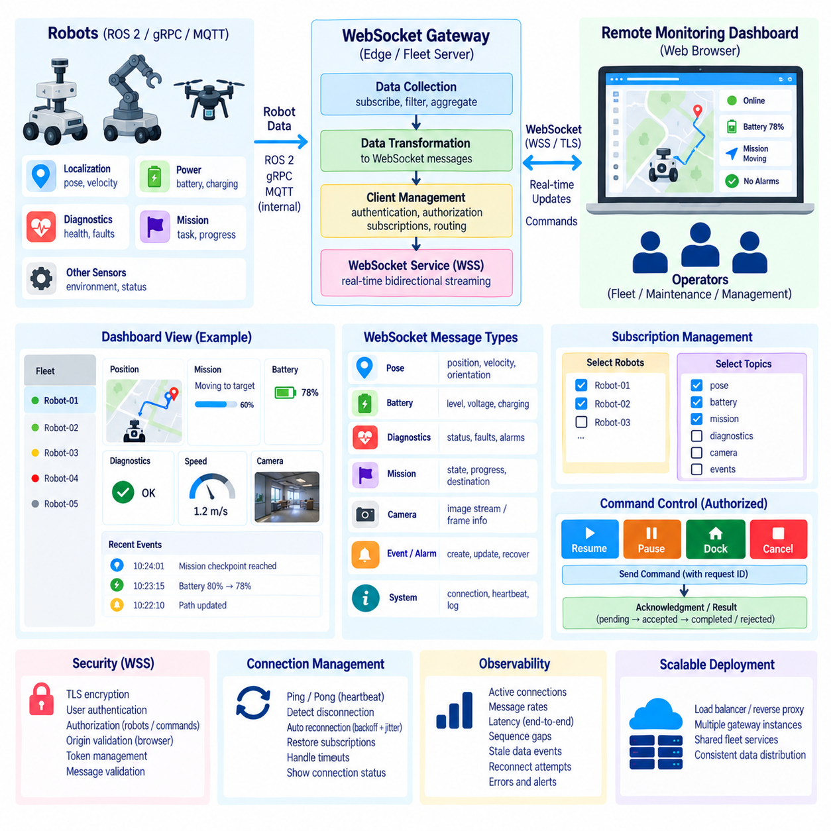
A robot remote monitoring dashboard provides operators with a continuously updated view of robot and fleet conditions without requiring direct access to onboard software. WebSocket is well suited to this interface because the server can push telemetry, mission changes, alarms, and diagnostics immediately over a persistent connection. The dashboard therefore becomes a real-time operational surface rather than a collection of periodically refreshed web pages.
The dashboard architecture typically separates the browser user interface from robot communication infrastructure. Robots publish internal information through ROS 2, gRPC, MQTT, or platform-specific services, while an edge or fleet gateway selects information intended for remote users. The gateway converts these internal representations into stable WebSocket messages and distributes them to authenticated dashboard sessions according to robot identity and subscription settings.
A remote dashboard should present operational information rather than simply expose every available sensor value. Important views commonly include robot connectivity, operating mode, position, velocity, battery condition, mission status, navigation progress, active faults, safety state, and subsystem health. The objective is to transform distributed machine data into a concise representation that allows an operator to understand what each robot is doing and whether intervention may be required.
WebSocket enables the dashboard to receive changes as events occur. Instead of repeatedly polling an HTTP endpoint for the latest robot status, the browser establishes one connection and listens for incoming messages. This reduces repetitive request overhead and can shorten the delay between a robot state change and its appearance on the screen. Conventional REST APIs can still complement WebSocket for configuration, historical queries, reports, or other request-oriented operations.
A consistent message envelope simplifies dashboard processing. Messages can include a type, robot identifier, timestamp, sequence number, schema version, and payload. The type may identify pose, battery, mission, diagnostic, alert, or connection information. The browser can route each message to the corresponding state model and visual component instead of implementing separate network logic for every widget displayed on the dashboard.
Robot position is often one of the most frequently updated dashboard values. A WebSocket stream can deliver pose and velocity data to a map component, allowing the interface to display robot movement, orientation, route progress, and current destination. The visualization rate should not necessarily equal the robot localization rate. High-frequency internal localization data can be sampled or aggregated before transmission, and browser rendering can be throttled independently.
Mission information provides the operational context required to interpret movement. A dashboard can show whether a robot is idle, assigned, navigating, waiting, charging, paused, completing a task, or reporting a mission failure. Progress values, task identifiers, destination information, and timestamps can be streamed as the mission changes. This allows an operator to correlate physical robot motion with the higher-level task being executed.
Power monitoring is particularly important for autonomous mobile robots operating over long periods. Battery percentage, voltage, charging condition, estimated remaining runtime, and charging-station status can be delivered at a lower rate than position data because these values usually change more slowly. The dashboard can update power indicators when new messages arrive while generating prominent warnings when thresholds or charging abnormalities require attention.
Diagnostics and alarms should be visually and logically separated from ordinary telemetry. Routine status can often replace older values, whereas an alarm represents an occurrence that may require acknowledgment or investigation. WebSocket messages can immediately deliver fault creation, severity changes, recovery events, emergency conditions, or subsystem failures. The dashboard should preserve sufficient event context even after subsequent status updates have arrived.
Fleet dashboards must scale beyond the detailed view of one robot. An overview may display dozens or hundreds of robots using compact indicators for connectivity, mission, battery, location, and fault state. Selecting a robot can activate a more detailed subscription containing higher-rate or subsystem-specific data. This hierarchical approach reduces unnecessary traffic and rendering work while still allowing operators to investigate individual machines when required.
Subscription management allows the dashboard to request only the information relevant to the current view. A fleet overview may subscribe to low-rate summary channels for all robots, while a diagnostic page subscribes to detailed data from one selected robot. When the user changes pages or selections, the client can modify its subscriptions. The server should validate every subscription against the authenticated user's access permissions before sending protected information.
The browser should maintain a local state model rather than allowing individual interface components to interpret raw WebSocket messages independently. Incoming messages are validated, parsed, and applied to a centralized representation of current robot state. Maps, gauges, tables, status cards, and alarm panels then render from that model. This separation makes the interface easier to maintain and prevents inconsistent interpretations of the same robot information across different components.
Rendering performance becomes important when many high-rate streams are displayed simultaneously. Updating the Document Object Model or graphics layer for every incoming telemetry message can overload the browser even when the network connection remains healthy. The client can receive data continuously while updating visual components at controlled intervals. Latest-value buffering, sampling, aggregation, and selective rendering help maintain a responsive interface during high message rates.
The dashboard must clearly represent communication freshness. A robot should not continue to appear healthy simply because its last received status looked normal. Each important state can carry a timestamp, allowing the browser to calculate how old the information is. When updates stop arriving beyond an expected interval, the interface can mark the robot or subsystem as stale, disconnected, or unknown rather than continuing to display outdated information as current.
WebSocket Ping/Pong provides transport-level connection monitoring, while application-level timestamps provide robot-data freshness. These mechanisms should be treated separately. A dashboard may still have a healthy WebSocket connection to the fleet gateway while the gateway has lost communication with a robot. Displaying gateway connectivity and robot connectivity as distinct states prevents operators from interpreting a functioning browser connection as evidence that the physical robot is reachable.
Reconnection handling is necessary because browser networks, wireless links, gateways, and backend services can temporarily fail. When a WebSocket session closes unexpectedly, the dashboard can reconnect using exponential backoff and jitter. After reconnection, it should authenticate again when necessary, restore subscriptions, and request a current state snapshot. The interface should indicate that information is being recovered instead of silently presenting old values during this process.
Remote control functions require stricter treatment than monitoring. A dashboard may provide actions such as pause mission, resume operation, request docking, or acknowledge an alarm, but these actions should be authorized independently from read access. Command controls should communicate their pending, accepted, rejected, and completed states. The interface must not imply successful robot execution merely because a command was transmitted through the WebSocket connection.
Command correlation can be implemented with unique request identifiers. When the dashboard sends an operation request, the server returns acknowledgments or results containing the corresponding identifier. This allows the interface to associate asynchronous responses with the correct user action. If the connection fails before confirmation arrives, the client should determine command status after reconnection rather than automatically repeating potentially non-idempotent robot operations.
Security should be integrated into the dashboard architecture from the beginning. Production connections should normally use WSS with TLS, while the server authenticates the user or service and authorizes access to robots, subscriptions, and commands. Browser Origin validation, secure credential handling, session expiration, token lifecycle management, message validation, and resource limits provide additional protection for an interface that may expose operationally sensitive robot information.
Observability should cover both the dashboard and the communication service. Useful measurements include active WebSocket sessions, subscribed robots, incoming and outgoing message rates, end-to-end latency, sequence gaps, stale-data occurrences, reconnect attempts, rendering delay, command acknowledgment time, and error rates. These metrics help determine whether a poor operator experience originates from the robot, network, gateway, backend, or browser.
A scalable deployment can place the WebSocket gateway behind a reverse proxy or load-balancing layer and connect it to shared fleet services or messaging infrastructure. When multiple gateway instances are used, robot status must be distributed consistently so that clients receive the required data regardless of which instance accepts their connection. Session, subscription, authentication, and message-routing strategies therefore become part of the overall fleet architecture.
A well-designed remote monitoring dashboard combines WebSocket streaming with structured robot state, selective subscriptions, controlled rendering, freshness detection, reconnection, secure access, command correlation, and operational observability. In this role, WebSocket becomes the real-time bridge between robot intelligence and human supervision, enabling a browser-based interface to present current fleet conditions while remaining decoupled from the detailed internal architecture of each robot.

03.08 WebSocket vs SSE (Server-Sent Events) Comparison
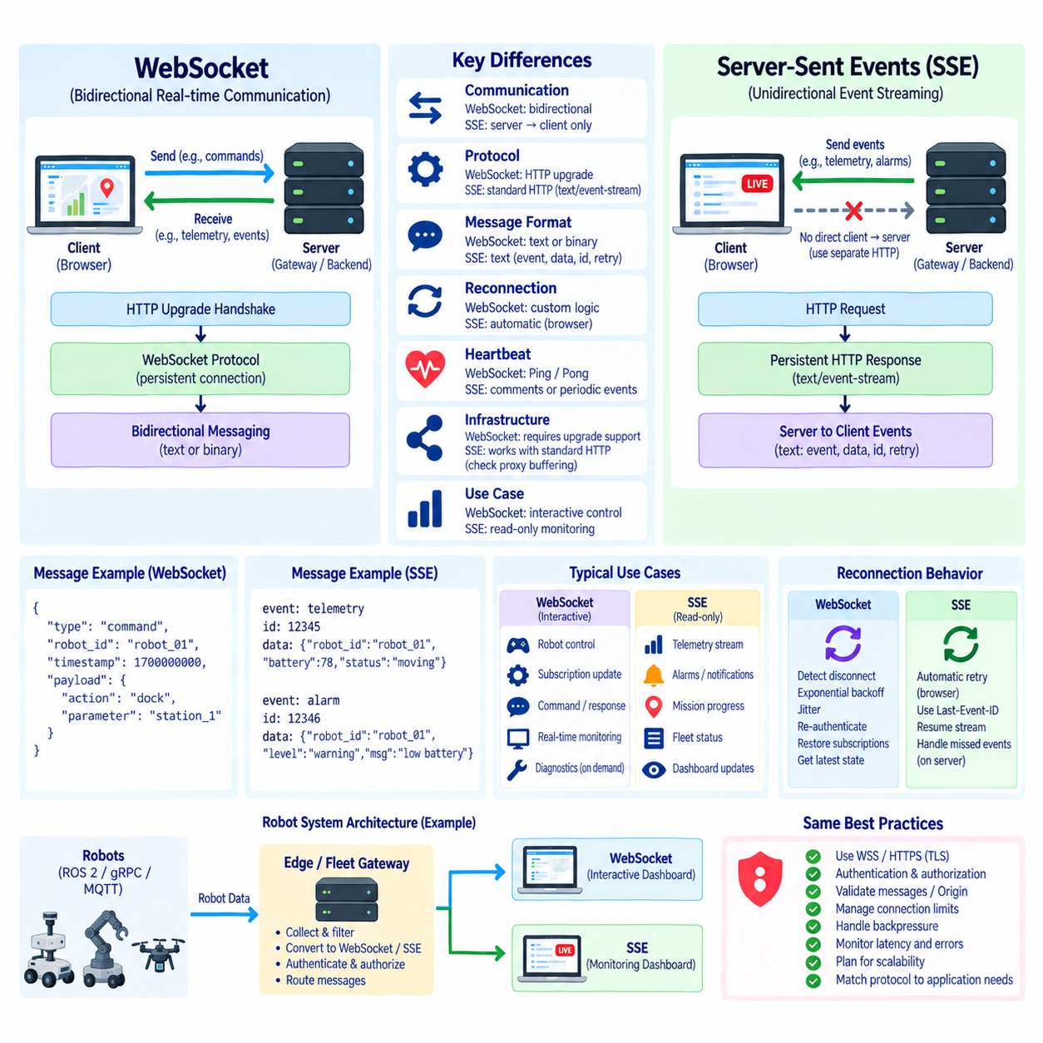
Server-Sent Events, commonly abbreviated as SSE, and WebSocket both support real-time communication between networked applications, but they are designed around different communication models. WebSocket establishes a persistent bidirectional channel in which either endpoint can transmit application messages at any time. SSE establishes a persistent HTTP response primarily intended for continuous server-to-client event delivery, making its communication direction fundamentally simpler.
A WebSocket session begins with an HTTP upgrade handshake and then transitions from HTTP semantics to the WebSocket protocol. After the upgrade succeeds, the client and server exchange WebSocket frames over the persistent connection. SSE remains within the HTTP model. A client issues an HTTP request and the server keeps the response open while transmitting a sequence of text events using the text/event-stream media type.
The most important architectural difference is communication direction. WebSocket provides full-duplex communication, allowing a robot dashboard to receive telemetry while also sending commands, subscription changes, acknowledgments, or other messages through the same connection. SSE is unidirectional from server to client. When an SSE application needs to send information back to the server, it normally uses a separate HTTP request or another communication mechanism.
This distinction strongly influences robot-system design. A remote monitoring page that only receives robot status, alarms, mission progress, or fleet notifications can fit naturally into the SSE model. An interactive robot-control dashboard that continuously exchanges status, commands, subscription updates, and responses is generally aligned with WebSocket. The correct protocol therefore depends more on interaction semantics than on whether an application is simply described as real time.
SSE provides a straightforward browser programming model through the EventSource interface. The browser opens an event stream and processes messages as they arrive. Because SSE is based on ordinary HTTP behavior, it can integrate naturally with many existing web infrastructures. The server formats each event according to the SSE stream structure, while the browser handles the persistent response as a continuous sequence of application events.
WebSocket requires a somewhat richer connection lifecycle. Applications commonly manage open, message, error, and close events as well as authentication, heartbeat behavior, reconnection, subscriptions, and application state restoration. This additional complexity supports a more flexible communication channel. In robotics, that flexibility becomes valuable when one connection must support both continuous observation and interactive operational behavior.
SSE events are text-oriented and can contain fields such as event, data, id, and retry. The data field may contain JSON text when structured robot information is required. The event field can distinguish categories such as status, battery, mission, diagnostic, or alarm. An event identifier can help the client and server reason about stream continuity, while retry information can influence reconnection behavior supported by the browser.
WebSocket supports both text and binary messages. JSON is commonly used for readable robot telemetry and command messages, while binary representations can be selected when message size, serialization overhead, or higher-rate data makes them beneficial. SSE is primarily designed for UTF-8 text streams. Binary information must therefore be transformed into a text-compatible representation or delivered through another mechanism, which can introduce additional overhead.
Reconnection behavior is another significant difference. Browser EventSource implementations provide built-in reconnection behavior when an SSE connection is interrupted. An application can also use event identifiers to assist continuation of the stream. WebSocket clients generally require more explicit reconnection logic, commonly including disconnect detection, exponential backoff, jitter, reauthentication, subscription restoration, and retrieval of the latest application state.
Automatic SSE reconnection can simplify applications that primarily consume notifications or changing state. However, reconnection alone does not guarantee complete application recovery. The server and client must still define what happens to events generated while the connection was unavailable. Robot systems should distinguish replaceable state, such as current battery level, from significant events, such as a safety alarm or mission transition, that may require history or persistence.
WebSocket faces the same semantic recovery problem but usually exposes it more directly to application design. After reconnection, a robot dashboard may authenticate again, restore subscriptions, request a state snapshot, and then resume incremental streaming. Pending commands require additional handling because the client may not know whether a command transmitted before disconnection was executed. SSE normally avoids this particular ambiguity because commands are not sent through the event stream itself.
Heartbeat and liveness management also differ. WebSocket defines Ping and Pong control frames that can be used to verify transport responsiveness, although browser APIs may hide some protocol-level details from application code. SSE servers can periodically send comments or lightweight events to keep a stream active and help prevent intermediaries from considering the connection idle. Application-level freshness monitoring remains important with either technology.
Network intermediaries can influence both protocols. Reverse proxies, gateways, firewalls, load balancers, and idle-timeout policies must be configured for long-lived connections. SSE uses conventional HTTP streaming and can fit naturally into HTTP-oriented infrastructure, but proxy buffering must not delay events that should be delivered immediately. WebSocket requires infrastructure that correctly supports protocol upgrades and persistent WebSocket connections.
Scalability depends on application behavior rather than protocol labels alone. Thousands of mostly idle SSE clients receiving occasional notifications may be efficient, while thousands of WebSocket clients exchanging frequent bidirectional messages create different CPU, memory, and bandwidth demands. Connection count, message frequency, payload size, fan-out patterns, buffering, authentication, and backend distribution must therefore be evaluated together when designing a large robot fleet service.
Backpressure requires careful consideration in either architecture. A server may generate robot updates faster than a browser can process them. WebSocket applications can implement bounded queues, latest-value replacement, rate control, or explicit application acknowledgments. SSE applications can similarly reduce update rates, aggregate state, or avoid building large queues. Real-time robot monitoring usually benefits from prioritizing the newest state rather than transmitting an obsolete backlog.
Security principles are largely shared. Production communication should use encrypted transport, meaning WSS for WebSocket and HTTPS for SSE. Both architectures require authentication, authorization, input validation for client-originated requests, credential lifecycle management, resource limits, logging, and network protection. WebSocket additionally requires careful authorization of messages sent through its bidirectional channel because monitoring and control may coexist within one persistent session.
Browser security behavior also affects implementation choices. WebSocket connections provide an Origin header that servers can validate, while SSE operates through the browser's HTTP security environment and may involve cross-origin resource sharing policies depending on deployment. Neither transport mechanism should be treated as an authorization system. Server-side access control must still determine which users or services may observe particular robots, fleets, events, or operational information.
A hybrid architecture can use both protocols instead of forcing every communication requirement into one mechanism. SSE can distribute server-generated fleet notifications, alarms, progress updates, or read-only status to simple browser clients. REST can handle configuration and discrete commands, while WebSocket can support highly interactive dashboards requiring bidirectional real-time exchange. Protocol selection can therefore be performed independently for different application interfaces.
For example, a fleet overview that displays robot availability, battery state, mission progress, and alarms may require only server-to-browser updates and can be implemented effectively with SSE. A maintenance console that changes subscriptions dynamically, requests diagnostics, sends operational commands, and receives asynchronous acknowledgments may benefit from WebSocket. Both applications can still consume the same underlying robot and fleet services through different gateway interfaces.
Latency differences between WebSocket and SSE should not be judged only from protocol structure. Both can deliver events quickly over persistent connections when correctly implemented. End-to-end latency is also affected by robot middleware, gateway processing, serialization, network conditions, proxy configuration, browser scheduling, and rendering. Measurements under realistic workload conditions are more useful than assuming that one protocol is universally faster.
Operational observability should therefore use comparable metrics for both approaches. Connection count, connection duration, event or message rate, bytes transferred, queue depth, dropped updates, reconnect frequency, stale-data occurrences, end-to-end latency, authentication failures, and server resource consumption provide evidence for architecture decisions. Testing should reproduce expected robot counts, update frequencies, network interruptions, and client behavior.
The central comparison is consequently not that WebSocket is an advanced replacement for SSE or that SSE is merely a simplified WebSocket. They represent different communication abstractions. WebSocket provides a general persistent bidirectional message channel, while SSE provides a focused server-to-client event stream built on HTTP. Understanding this distinction allows robot software architects to select the simplest mechanism that still satisfies the required interaction pattern.
In robot communication architectures, SSE is especially appropriate for read-oriented monitoring, notifications, alarms, progress information, and other server-pushed events, while WebSocket is appropriate when real-time interaction must flow in both directions. Combining either approach with REST, ROS 2, gRPC, MQTT, or fleet middleware allows external interfaces to remain decoupled from robot internals while matching each application to an appropriate communication model.

03.09 ROS2 WebSocket Bridge: rosbridge.suite [w/Code]
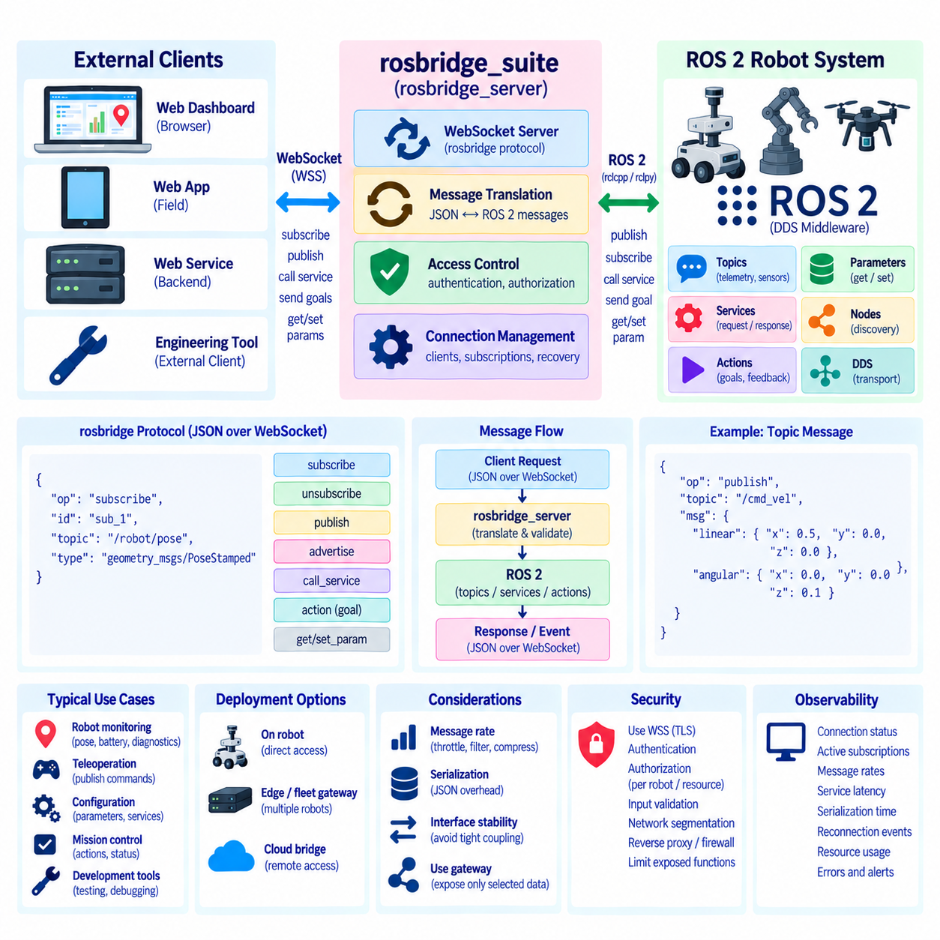
rosbridge_suite provides a bridge between ROS 2 communication and applications that do not run as native ROS 2 nodes. Its best-known component, rosbridge_server, exposes ROS capabilities through a WebSocket-based interface using the rosbridge protocol. This allows browser applications, remote dashboards, web services, and lightweight external clients to interact with selected ROS 2 resources without directly implementing DDS or the ROS 2 client libraries.
The bridge occupies an integration boundary rather than replacing ROS 2 middleware. Inside the robot, ROS 2 nodes continue to communicate through topics, services, actions, parameters, and DDS-based discovery and transport. At the external boundary, rosbridge translates WebSocket messages into ROS operations and converts ROS messages back into a representation that remote applications can process. This separation preserves the internal ROS architecture while enabling web-oriented access.
A typical deployment runs rosbridge_server on a robot computer, edge computer, or gateway that has access to the required ROS 2 graph. The server listens for WebSocket connections from external clients and interprets rosbridge protocol messages. A browser dashboard can therefore connect to a WebSocket endpoint, subscribe to robot topics, publish selected messages, call services, or perform other supported operations without installing a complete ROS 2 environment in the browser.
The rosbridge protocol defines application-level operations exchanged over the WebSocket connection. Messages are commonly represented using JSON objects containing an operation field and additional parameters. An operation can request a topic subscription, remove a subscription, publish data, advertise a topic, call a service, or manage other supported ROS interactions. The bridge interprets these messages and maps them to corresponding ROS 2 communication behavior.
Topic subscription is one of the most useful capabilities for robot monitoring. A browser can request a subscription to a ROS 2 topic containing localization, battery, diagnostics, mission, or sensor information. rosbridge then receives ROS messages from that topic and forwards them through the WebSocket connection. The web application processes the resulting data and updates maps, status panels, charts, alarms, or other user-interface elements.
Publishing works in the opposite direction. An authorized external application can send a rosbridge publish operation containing a topic name and message data. The bridge converts the received representation into the corresponding ROS message and publishes it into the ROS 2 graph. This capability can support user-interface interactions, configuration requests, or selected operational commands, but it also creates a security-sensitive path into the robot.
ROS services can also be exposed through the bridge. A client sends a service request describing the target service and required arguments, and rosbridge performs the corresponding ROS operation before returning the result. This request-response behavior is useful for operations that do not naturally fit continuous topic streaming, such as requesting information, triggering a defined function, or retrieving a particular system state.
ROS 2 actions require richer semantics because they represent longer-running operations with goals, feedback, status, and results. Depending on the rosbridge and client capabilities used in a deployment, action-related interaction can be represented through the available bridge interfaces or through application-specific gateway logic. For robot applications, long-running mission commands should preserve clear identifiers and execution states rather than being treated as simple fire-and-forget messages.
JavaScript applications frequently use roslibjs with rosbridge. roslibjs provides browser-oriented abstractions for establishing a ROS connection and interacting with topics, services, parameters, and other ROS concepts supported by the library and bridge. This allows web developers to work with familiar JavaScript objects and callbacks while rosbridge performs the translation between browser WebSocket communication and the underlying ROS environment.
For a remote robot dashboard, this architecture can significantly reduce development effort. Localization data can feed a map, battery information can update gauges, diagnostics can populate fault panels, and mission information can drive task displays. The browser remains independent of DDS implementation details and native ROS 2 libraries. The WebSocket connection effectively becomes an accessible presentation interface to selected portions of the ROS graph.
However, exposing the ROS graph directly to remote clients should be approached carefully. Internal topic names, message structures, service interfaces, and node organization are implementation details that may evolve during robot development. If a production dashboard depends directly on many internal ROS resources, changes to the robot software can force corresponding changes in every external application. The bridge can therefore create architectural coupling if it is used without an interface boundary.
An application-specific gateway can reduce this coupling. Instead of exposing the entire ROS graph, the gateway subscribes to internal ROS 2 data, converts it into stable external schemas, and publishes only the information required by remote clients. Commands arriving through WebSocket are validated and translated into controlled ROS operations. rosbridge can still be valuable for development, diagnostics, engineering tools, or carefully constrained interfaces while production APIs remain deliberately designed.
Message rates must also be considered. Camera streams, point clouds, high-frequency localization, and dense sensor topics can generate substantially more data than a browser or network connection should receive. Forwarding every ROS message directly through WebSocket may create excessive serialization, bandwidth, memory, and rendering load. Topic throttling, compression, filtering, aggregation, or lower-rate derived data can make the external interface more appropriate for remote monitoring.
Serialization introduces another boundary between ROS and web applications. ROS messages have strongly defined types, while browser clients commonly consume JSON-compatible representations. Translation makes the information accessible but can increase payload size and CPU overhead compared with native binary middleware. For high-rate data, architects should evaluate whether rosbridge is the appropriate path or whether dedicated streaming, binary transport, or specialized media protocols are more suitable.
Connection management remains important because the bridge operates over persistent WebSocket sessions. Clients should detect disconnection, reconnect using controlled backoff, restore required subscriptions, and determine whether displayed robot information remains fresh. A restored WebSocket connection does not automatically mean that every previously observed ROS state is still current. Applications may need to wait for new messages or request a current state snapshot.
Security is a major architectural consideration. A rosbridge endpoint can potentially provide access to powerful ROS capabilities, including publication and service invocation, depending on its configuration and surrounding system. Production deployments should avoid treating network reachability as authorization. WSS, authentication, authorization, network segmentation, reverse proxies, firewalls, and carefully restricted exposed functionality should be considered when the bridge is reachable beyond a trusted development network.
Authorization should operate at a meaningful application level. A monitoring user may need permission to subscribe to battery, pose, and diagnostic information without permission to publish navigation commands. Maintenance tools may require specific service calls but not unrestricted topic publication. Restricting access according to identity, robot, resource, and operation reduces the risk associated with exposing a general bridge between external applications and the ROS 2 graph.
Input validation is equally important. Even an authenticated client can send malformed, oversized, unexpected, or semantically invalid messages. External commands should therefore be checked before they influence robot behavior. For safety-related operations, application logic must validate current robot mode, command parameters, permissions, and operational constraints. rosbridge provides communication integration, but it should not be interpreted as a substitute for robot safety control.
A fleet environment introduces additional architectural choices. Running a bridge independently on every robot can provide direct access but may increase connection management, security exposure, and network complexity. An edge or fleet gateway can instead aggregate selected ROS information from multiple robots and expose a consolidated external interface. The appropriate arrangement depends on network topology, robot autonomy, diagnostic requirements, latency, and trust boundaries.
Observability should cover both sides of the bridge. Useful information includes WebSocket connection state, active subscriptions, message rates, serialization time, ROS topic freshness, service-call latency, rejected requests, reconnect events, and resource consumption. Monitoring these values helps determine whether a problem originates in the browser, WebSocket transport, rosbridge process, ROS 2 graph, DDS communication, or an individual robot subsystem.
rosbridge_suite is therefore most valuable when treated as an interoperability layer between ROS 2 and web-oriented software rather than as a replacement for a deliberately designed robot API. It provides a practical path from WebSocket clients to ROS topics, services, and related capabilities, enabling rapid dashboards and engineering tools. Its flexibility should be balanced with interface stability, traffic control, security, validation, and clear architectural boundaries.
Within a complete robot communication architecture, ROS 2 can remain responsible for internal distributed robotics communication while rosbridge connects selected capabilities to browsers and external applications. A carefully designed deployment combines ROS 2 semantics, WebSocket accessibility, controlled exposure, connection management, and security. This creates a useful bridge from the robot software graph to human-facing and web-based systems without requiring those systems to become native ROS 2 participants.

03.10 WebSocket Performance Limits and Large-Scale Management
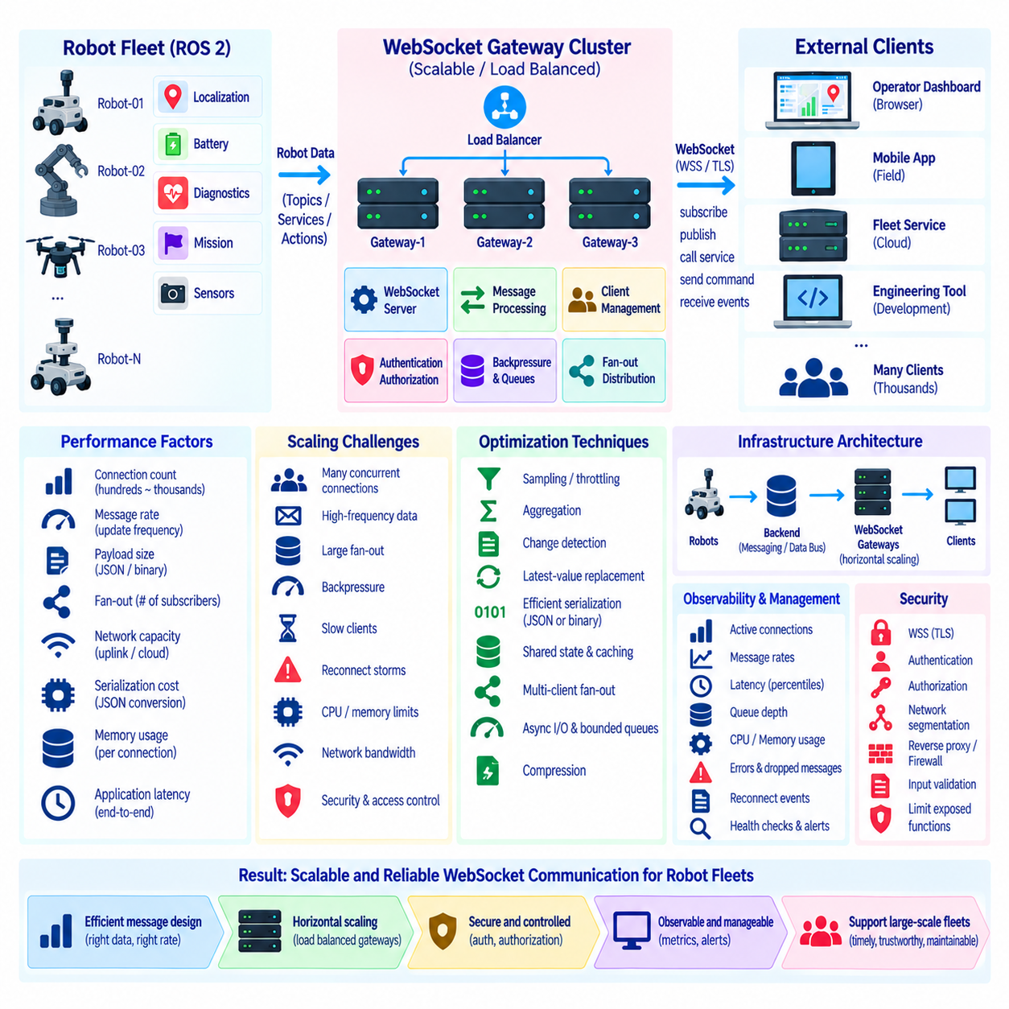
Large-scale WebSocket operation requires more than measuring how quickly a single client can exchange messages with a server. A production robot platform may maintain hundreds or thousands of persistent sessions while continuously delivering telemetry, alarms, mission events, and control responses. Performance therefore depends on connection count, message frequency, payload size, fan-out behavior, network capacity, serialization cost, memory usage, and application processing latency.
A persistent WebSocket connection consumes resources even when little application data is transmitted. The operating system maintains socket state and buffers, while the server maintains connection objects, authentication context, subscriptions, queues, timers, and application metadata. Individually these costs may be small, but they become significant when multiplied across a large fleet. Capacity planning must therefore consider both active traffic and the baseline cost of every connected client.
Connection count is not determined only by the number of robots. Each robot may have connections from operator dashboards, maintenance tools, fleet services, mobile applications, engineering consoles, and automated monitoring systems. A fleet of several hundred robots can consequently create thousands of concurrent sessions. Architects should model expected, peak, and abnormal connection counts rather than assuming a simple one-to-one relationship between robots and WebSocket connections.
Message rate is often a more important scaling factor than connection count. A thousand mostly idle connections may require fewer resources than one hundred connections carrying high-frequency telemetry. Robot pose, velocity, diagnostics, battery data, mission events, and sensor summaries have different update characteristics. Each data category should therefore have an intentional publication rate based on operational value instead of forwarding every internal robot update directly to remote clients.
High-frequency robot middleware can easily generate more data than remote interfaces require. Localization may run at tens or hundreds of updates per second, while a browser map may need only several visual updates per second. Sending every internal update wastes bandwidth, serialization capacity, and browser processing time. Sampling, throttling, aggregation, change detection, and latest-value replacement can substantially reduce WebSocket load without reducing useful operator awareness.
Payload size also influences scalability. JSON is convenient because it is readable and widely supported, but repeated field names and textual number representations increase message size. Binary formats can reduce bandwidth and serialization overhead for high-rate or structured data, although they introduce additional schema and debugging complexity. The appropriate representation should be selected according to message frequency, data size, interoperability requirements, and operational maintainability.
Serialization and deserialization consume CPU on both server and client. A gateway that receives ROS 2 messages, converts them into application objects, serializes them to JSON, and distributes them to hundreds of clients may perform the same transformation repeatedly. Where practical, shared serialization, reusable encoded messages, efficient schemas, and carefully designed fan-out paths can reduce duplicated work. Performance measurements should include conversion costs rather than measuring network transmission alone.
Fan-out becomes a central issue in fleet monitoring. One robot status update may need to reach many dashboards or services simultaneously. If every connection independently requests and transforms identical data, backend work can grow rapidly. A scalable architecture can separate robot-data ingestion from client distribution, maintain shared state, and distribute one processed update to multiple authorized subscribers. This reduces repeated access to robot-side services and improves consistency among clients.
Backpressure occurs when messages are produced faster than a connection can transmit or a client can consume them. Without explicit control, outgoing queues can continue growing, increasing memory usage and delivering increasingly obsolete robot states. Bounded queues prevent unlimited accumulation. For replaceable telemetry such as pose or battery state, replacing older queued values with the newest value is often more useful than preserving every intermediate update.
Events and commands require different queue semantics from replaceable telemetry. A sequence of safety alarms, mission transitions, or command acknowledgments may need reliable ordering and should not simply be overwritten by newer information. Large-scale WebSocket systems should therefore classify data according to delivery semantics. Latest-state channels, important event streams, command responses, and bulk data may require different buffering, persistence, retry, and loss-handling policies.
Slow clients must not degrade service for healthy clients. A browser on a congested wireless network may consume messages much more slowly than other connected systems. If server processing waits synchronously for that client, one connection can delay broader distribution. Asynchronous I/O, independent connection queues, bounded buffers, timeout policies, and slow-consumer detection allow the server to isolate problematic sessions and preserve overall service responsiveness.
Memory limits should be considered together with queue policies. Per-connection buffers that appear harmless at small scale can consume large amounts of memory when thousands of sessions are active. Maximum message size, queue depth, subscription count, and pending request count should therefore be explicitly constrained. Capacity tests should observe not only average memory consumption but also behavior during network slowdown, reconnect storms, and sudden bursts of fleet events.
CPU saturation can emerge from encryption, authentication, JSON processing, compression, logging, routing, and application logic rather than from WebSocket framing itself. Performance analysis should identify where processing time is actually spent. Excessive logging or repeated schema conversion can become a bottleneck even when network bandwidth remains available. Profiling under representative fleet workloads provides more useful evidence than isolated protocol benchmarks.
TLS adds computational work but is normally required for production WebSocket deployments through WSS. Connection establishment can be more expensive than steady-state encrypted traffic, making reconnect storms particularly important. When many clients reconnect after a gateway restart or network outage, TLS negotiation, authentication, subscription restoration, and state synchronization may occur simultaneously. Backoff and jitter help distribute this recovery load over time.
Heartbeat configuration also affects large deployments. Ping/Pong traffic from thousands of connections can create a measurable background workload if intervals are unnecessarily short. However, excessively long intervals delay detection of dead connections and allow abandoned resources to remain allocated. Heartbeat intervals and timeouts should reflect operational requirements, intermediary timeout behavior, expected network quality, and fleet scale rather than being copied unchanged from small development systems.
Horizontal scaling allows WebSocket capacity to be distributed across multiple server instances. A load balancer or reverse proxy can route new connections to available gateways, while each gateway maintains its own persistent sessions. Because a WebSocket connection remains associated with the server that accepted it, backend architecture must ensure that required robot information can reach that instance throughout the session.
Shared messaging infrastructure can decouple robot-data ingestion from WebSocket gateways. Robot or fleet services publish updates to a common backend, and gateway instances consume the information required by their connected clients. This architecture allows connection handling and robot communication to scale independently. It also avoids requiring every WebSocket server to maintain direct communication with every robot in a large deployment.
Session and subscription state require deliberate management in a distributed gateway architecture. Some information can remain local to the gateway that owns the connection, while authentication, fleet permissions, robot state, or event history may need access to shared services. Architects should avoid unnecessary centralized state while ensuring that another instance can support reconnection and state recovery when a client is routed to a different gateway.
Load balancing policies must support long-lived connections and WebSocket protocol upgrades. Connection distribution should consider not only the number of sessions but also traffic intensity because two servers with equal connection counts may have very different workloads. Health checks should identify instances that are alive but overloaded or unable to reach required backend services. Planned draining allows existing sessions to close or migrate through reconnection before an instance is removed.
Large-scale reconnection behavior should be tested as a system-level failure scenario. If thousands of robots and dashboards lose connectivity simultaneously, immediate retries can create a thundering-herd effect. Exponential backoff, randomized jitter, retry limits, staged recovery, and server-side admission controls reduce this risk. Recovery testing should measure how quickly useful fleet visibility returns without overwhelming authentication, gateways, databases, or robot services.
Network bandwidth must be evaluated end to end. A gateway may have sufficient local capacity while a site uplink, VPN, cellular connection, or cloud ingress path becomes the actual bottleneck. Multiplying message size by update rate and subscriber count provides a useful first estimate, but real measurements should include protocol overhead, encryption, retransmission, bursts, and duplicated fan-out traffic. Bandwidth planning should also reserve capacity for critical operational events.
Observability is essential for managing performance limits. Useful metrics include active connections, connection establishment rate, messages and bytes per second, queue depth, dropped or replaced updates, serialization latency, event-loop delay, CPU and memory utilization, network throughput, heartbeat timeout rate, reconnect frequency, and end-to-end message latency. Percentile measurements are especially useful because averages can hide a smaller group of severely delayed clients.
Performance limits should be established through progressive load testing rather than discovered during fleet deployment. Tests can increase connections, subscriptions, message frequency, payload size, and fan-out while monitoring latency and resource consumption. Failure tests should introduce slow clients, network interruptions, backend delays, gateway restarts, and reconnect storms. The objective is to identify safe operating envelopes and degradation behavior before the system reaches uncontrolled saturation.
A large-scale WebSocket architecture therefore combines efficient message design, controlled update rates, backpressure, bounded resources, asynchronous processing, horizontal scaling, shared backend distribution, secure connection management, and detailed observability. For robot fleets, scalability is not simply the maximum number of sockets a server can open. It is the ability to preserve timely, trustworthy, and manageable communication as robots, users, data rates, and failure conditions grow together.

