Volume 06 Robot Communication and APIs

04. MQTT

04.01 MQTT Protocol Deep Dive: Broker, QoS, Retain
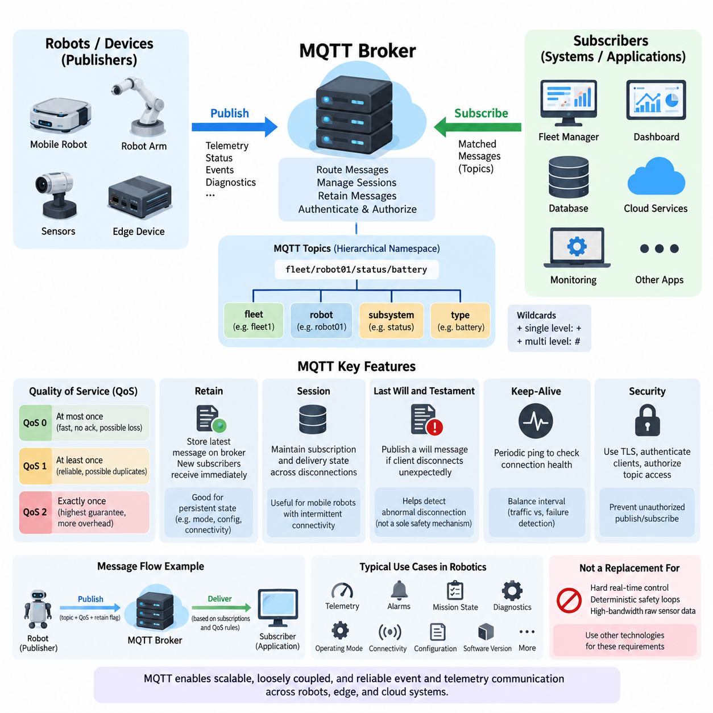
MQTT is a lightweight publish/subscribe messaging protocol designed for efficient communication across networks where bandwidth, processing power, connection stability, or energy may be constrained. In robotics, it is particularly useful for telemetry, fleet events, device status, diagnostics, and edge-to-cloud communication. Instead of establishing direct application-to-application dependencies, MQTT introduces a broker that mediates message delivery between publishers and subscribers.
The publish/subscribe model separates message producers from message consumers in space, time, and implementation. A robot may publish battery state, localization quality, mission progress, or diagnostic events without knowing which systems consume them. Fleet managers, dashboards, databases, cloud services, and monitoring applications independently subscribe to relevant topics. This decoupling allows communication architectures to evolve without continuously modifying every robot application.
The MQTT broker is the central routing component of the protocol. Clients establish connections to the broker and may act as publishers, subscribers, or both simultaneously. When a publisher sends a message, the broker examines its topic and distributes the message to clients whose subscriptions match that topic. The broker can additionally manage sessions, retained messages, authentication, authorization, delivery state, and other communication metadata required by the MQTT deployment.
MQTT topics provide a hierarchical namespace for organizing messages. A robotics system might conceptually separate information according to fleet, robot, subsystem, and data type, allowing subscribers to consume narrowly selected information or broader groups of related events. Topic filters support single-level and multi-level wildcards, enabling scalable subscription patterns. Careful topic architecture becomes increasingly important as deployments grow from individual robots to heterogeneous fleets and distributed infrastructure.
Quality of Service, or QoS, defines the delivery guarantees applied to MQTT messages. QoS 0 provides an at-most-once delivery model and does not require acknowledgment of each published message. It minimizes protocol overhead and latency but allows messages to disappear when packets are lost or connections fail. High-frequency robot telemetry such as rapidly refreshed sensor summaries may tolerate this behavior when the newest sample is substantially more important than recovering an older one.
QoS 1 provides at-least-once delivery. The sender retains responsibility for the message until receiving the corresponding acknowledgment, and retransmission may occur when confirmation is unavailable. This improves reliability but means that duplicate delivery is possible. Applications consuming QoS 1 data should therefore tolerate duplicates or implement idempotent processing. Robot alarms, mission-state changes, and operational events often require this stronger reliability model.
QoS 2 provides the highest MQTT delivery guarantee and is intended to achieve exactly-once delivery through a multi-step exchange between communication peers. Additional protocol packets and stored state make it more expensive than QoS 0 or QoS 1. It should therefore not automatically be selected merely because it offers the strongest guarantee. Robotics architects must balance delivery semantics against latency, bandwidth, broker load, client resources, and the consequences of duplicate processing.
The effective QoS of message delivery depends on both publication and subscription behavior. A publisher can request a particular QoS when transmitting a message, while subscribers establish maximum QoS requirements through their subscriptions. The broker applies MQTT delivery rules when forwarding the publication. Consequently, QoS should be designed as part of the end-to-end message contract rather than treated as a simple global reliability switch applied uniformly to every topic.
Retained messages solve a different problem from QoS. When a publication is marked as retained, the broker stores the latest retained message for that topic. A new matching subscriber can therefore receive the most recently retained value immediately rather than waiting for the publisher to transmit again. This behavior is valuable for relatively persistent robot information such as operating mode, connectivity state, configuration summaries, software version, or the latest known availability state.
Retained messages must be distinguished from historical storage. A broker normally retains the latest retained publication associated with a topic rather than functioning as a complete telemetry database. Continuous localization trajectories, sensor histories, maintenance records, or long-term performance measurements should therefore be transferred into suitable persistent storage or streaming infrastructure. MQTT provides communication semantics, while databases and data platforms provide historical information management.
MQTT also supports session-oriented communication. Depending on protocol version and session configuration, a client may preserve subscription and delivery-related state across temporary disconnections. This is important for mobile robots that move between wireless coverage regions or experience intermittent connectivity. Combined with appropriate QoS policies, persistent session behavior can reduce information loss while avoiding the assumption that every robot maintains an uninterrupted connection to the communication infrastructure.
Another important mechanism is the Last Will and Testament. A client can register a will message with the broker when establishing its MQTT connection. If the connection later terminates unexpectedly under conditions defined by the protocol, the broker publishes that message on the client's behalf. Fleet infrastructure can use this mechanism as one input for detecting abnormal robot disconnection, although safety-critical availability decisions should not depend solely on network messaging or broker observations.
MQTT control packets keep the protocol comparatively compact. Connection establishment, publication, subscription management, acknowledgment, keep-alive operation, and disconnection are represented through defined packet types with relatively small protocol overhead. The compact design makes MQTT suitable for embedded and edge devices, but application payload efficiency still matters. Excessively large JSON documents or unnecessarily frequent publications can eliminate much of the bandwidth advantage provided by the underlying protocol.
Keep-alive behavior helps the broker and client recognize communication failures. During otherwise idle periods, MQTT can use lightweight control exchanges to demonstrate that the connection remains operational. The appropriate interval depends on network characteristics and application requirements. Very aggressive intervals increase traffic and processing, whereas excessively long intervals delay failure detection. Robot fleet systems therefore coordinate keep-alive settings with application-level heartbeat and health-monitoring policies.
MQTT's broker-centric architecture provides strong decoupling but also creates infrastructure responsibilities. Broker availability, capacity, security, persistence behavior, and network placement can directly influence fleet communication. Production systems therefore require monitoring of connection counts, message rates, queue growth, dropped messages, subscription behavior, resource consumption, and end-to-end latency. High-availability broker architectures become particularly relevant when communication serves many robots or multiple operational sites.
Security must surround the protocol architecture rather than being assumed from MQTT itself. Production robot systems commonly protect broker connections with TLS, authenticate clients using suitable credentials or certificates, and restrict publish and subscribe operations through authorization policies. Robot identity should be mapped carefully to permitted topic namespaces so that a compromised or misconfigured device cannot publish commands or consume information outside its intended scope.
For robotic systems, MQTT is best viewed as an asynchronous event and telemetry transport rather than a replacement for every communication mechanism. Hard real-time motor control, deterministic safety loops, and high-bandwidth raw sensor transport generally require other technologies. MQTT instead fits naturally between robots, edge computers, fleet services, dashboards, and cloud systems where scalable distribution, loose coupling, intermittent-network tolerance, and configurable delivery reliability are more important than deterministic microsecond-level timing.

04.02 Eclipse Mosquitto Broker Install and Security [w/Code]
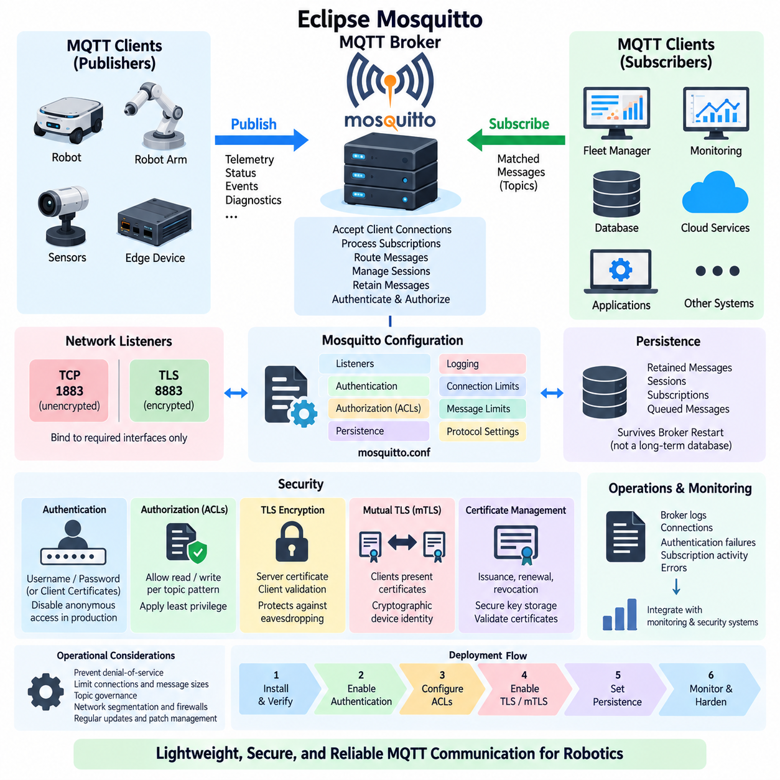
Eclipse Mosquitto is a lightweight open-source MQTT broker designed to implement the publish/subscribe communication model with relatively low computing and memory requirements. Within the robot communication architecture, it can operate between robots, edge computers, fleet services, monitoring systems, and cloud applications. Its compact implementation makes it suitable for development computers, embedded gateways, industrial edge servers, and production fleet infrastructure.
A Mosquitto installation normally consists of the broker service, configuration files, persistence storage when enabled, logging facilities, and MQTT client utilities. The broker accepts client connections, processes subscriptions, receives published messages, and routes those messages to matching subscribers. Command-line tools such as mosquitto_pub and mosquitto_sub are particularly useful during installation because they allow communication behavior to be verified before robot applications are connected.
On Linux systems, Mosquitto can typically operate as a system service after installation, allowing the broker to start automatically with the operating system and run independently of interactive user sessions. Administrators should verify the service state, listening interfaces, ports, configuration path, and log output before integrating robots. A minimal local configuration is useful for initial testing, but production deployment requires explicit network and security settings.
Listener configuration determines where and how clients can reach the broker. Standard MQTT commonly uses TCP port 1883 for unencrypted communication, while MQTT protected by TLS commonly uses port 8883. A broker may expose multiple listeners with different security requirements, but every exposed interface increases the attack surface. Production robot networks should therefore bind only to required interfaces and avoid unnecessarily exposing MQTT services to external networks.
Mosquitto configuration should be treated as part of the robot communication infrastructure rather than as a collection of temporary development settings. Important parameters include listeners, authentication methods, authorization rules, persistence, logging, connection limits, message limits, and protocol behavior. Configuration files should be version controlled where appropriate, reviewed during deployment, and separated between development, testing, and production environments to prevent insecure laboratory settings from reaching operational systems.
Anonymous access is convenient during isolated development because clients can connect without presenting an identity, but it is generally inappropriate for operational robot systems. When anonymous access is disabled, clients must authenticate before using the broker. A straightforward Mosquitto deployment can use username and password credentials maintained through a password file. Passwords should never be stored as plain text in robot source code, configuration repositories, container images, or deployment scripts.
Authentication answers the question of who a client is, while authorization determines what that authenticated client is permitted to do. Mosquitto can enforce topic-level access control so that a robot identity publishes and subscribes only within approved namespaces. For example, a telemetry producer should not automatically receive permission to publish mission commands. Separating read and write privileges limits the consequences of software defects, credential leakage, and compromised devices.
Access Control Lists, commonly called ACLs, provide a practical mechanism for implementing MQTT authorization. Rules can associate users or identities with permitted topic patterns and specify whether they may read, write, or perform both operations. In a fleet architecture, ACL design should reflect robot identity, fleet membership, subsystem responsibility, and application role. Broad wildcard permissions should be minimized because they can unintentionally provide access to unrelated robots or operational services.
Transport Layer Security, or TLS, protects MQTT traffic against passive observation and network manipulation by providing encryption and server authentication. The broker is configured with a server certificate and corresponding private key, while clients validate the certificate against an appropriate trusted Certificate Authority. This is especially important when MQTT traffic crosses shared Wi-Fi, industrial Ethernet segments, remote access networks, or edge-to-cloud communication paths.
Certificate validation is only useful when clients correctly verify the broker identity. Disabling certificate verification may simplify temporary experiments, but it defeats an important security property of TLS and should not become a production configuration. Certificates also require lifecycle management, including secure private-key storage, controlled issuance, renewal before expiration, revocation procedures, and replacement when credentials or devices are suspected of compromise.
Mutual TLS, or mTLS, extends TLS by requiring clients to present their own certificates in addition to validating the broker certificate. This enables cryptographic device identity and can be valuable for robot fleets where each robot or edge computer requires independently managed credentials. Compared with shared passwords, individual certificates can improve isolation and revocation control, although they introduce additional Public Key Infrastructure and certificate lifecycle responsibilities.
Broker persistence determines whether selected MQTT state can survive broker restarts. Depending on configuration and protocol behavior, persistence can protect information associated with retained messages, sessions, subscriptions, and queued delivery state. This is useful for fleet infrastructure that must tolerate maintenance or unexpected service interruption. Persistence should nevertheless be distinguished from application databases because an MQTT broker is not intended to replace long-term telemetry or event storage.
Logging is essential for both operations and security. Mosquitto logs can provide evidence about broker startup, client connections, disconnections, authentication failures, subscription behavior, and communication errors. During development, detailed logging simplifies troubleshooting, while production systems should balance diagnostic value against storage volume and exposure of sensitive information. Broker logs can also feed centralized observability and security-monitoring systems for fleet-wide analysis.
Security configuration should follow a defense-in-depth approach. TLS protects communication channels, authentication establishes client identity, and ACLs restrict operations after authentication. Network segmentation, firewalls, operating-system permissions, secure certificate storage, patch management, monitoring, and service hardening provide additional layers. No single mechanism is sufficient because a secure MQTT deployment depends on the combined behavior of the broker, host system, network, credentials, and client applications.
Robot deployments must also consider denial-of-service and resource exhaustion. Excessive connections, rapidly repeated subscriptions, oversized payloads, uncontrolled retained messages, or abnormal publication rates can consume broker memory, CPU, bandwidth, and storage. Appropriate connection policies, message-size constraints, topic governance, monitoring, and network-level controls help prevent individual malfunctioning or compromised clients from degrading communication for the entire robot fleet.
A practical deployment process progresses from local broker verification to authenticated communication, topic authorization, encrypted transport, persistence, monitoring, and operational hardening. Each stage should be tested independently so that failures can be attributed to networking, authentication, authorization, certificates, or MQTT behavior. Robot applications should also be tested for reconnection, certificate expiration, broker restart, credential rejection, network interruption, and restoration of normal service.
In production robotics, Mosquitto is most effective when the broker is treated as managed infrastructure with explicitly defined trust boundaries. Robots should receive unique identities where practical, topic permissions should follow least-privilege principles, external connections should use protected channels, and configuration changes should be auditable. These practices allow MQTT to remain lightweight while providing a communication foundation suitable for secure robot telemetry, events, diagnostics, fleet coordination, and edge-to-cloud integration.

04.03 MQTT Client Implementation: paho.mqtt Python [w/Code]
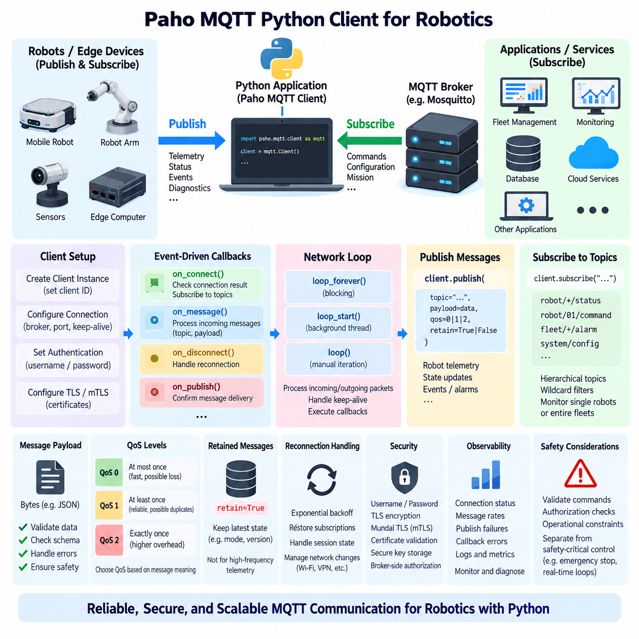
The Paho MQTT Python client provides a practical interface for implementing MQTT communication in robot software without requiring applications to handle MQTT packet encoding, socket management, acknowledgments, and protocol state directly. A Python process can operate as a publisher, subscriber, or both, allowing robots and edge applications to exchange telemetry, status, events, diagnostics, and commands through an MQTT broker.
A typical implementation begins by importing the Paho MQTT client library and creating a client instance representing the application within the MQTT environment. The client should have an identity appropriate for the deployment, particularly when persistent sessions or broker-side access policies are used. In robot fleets, client identities should normally correspond to individual robots, gateways, services, or application roles rather than being reused indiscriminately across unrelated devices.
The client connects to a configured MQTT broker using a hostname or IP address and a listener port. Connection parameters also include keep-alive behavior and may include authentication or TLS settings. Development systems may initially connect to a broker on the local network, while operational deployments commonly communicate with an edge, on-premise, or cloud broker. Connection establishment should be treated as a managed application state rather than assumed to succeed permanently.
Paho MQTT follows an event-driven programming model in which callback functions process important communication events. A connection callback can determine whether broker access succeeded and initiate subscriptions after successful connection. A message callback processes incoming publications, while additional callbacks can report disconnection or publication completion. This structure separates application logic from asynchronous network activity and is well suited to continuously operating robot processes.
Subscription logic associates the client with one or more MQTT topic filters. A robot monitoring application might subscribe to status, alarm, or mission topics, while a robot itself may subscribe to command or configuration topics intended for its identity. Hierarchical topic structures and wildcard filters make one client capable of monitoring individual devices, selected subsystems, or entire fleets without establishing separate network connections for every data source.
When a subscribed publication arrives, the message callback receives information including the topic and payload. MQTT payloads are fundamentally byte sequences, so the application must interpret them according to an agreed data contract. Text, JSON, binary structures, or serialized application messages may be transported. Robot applications should validate incoming data before using it because successful MQTT delivery does not guarantee that the payload contains semantically valid or safe information.
Publishing uses the client interface to associate application data with a destination topic and selected Quality of Service. Robot telemetry may be generated periodically from localization, battery, temperature, or health information, while events may be published only when state changes occur. Applications should avoid publishing every internal variable at uncontrolled rates because unnecessary traffic increases wireless bandwidth consumption, broker workload, processing overhead, and downstream storage requirements.
QoS selection should reflect the meaning of each message. Frequently refreshed telemetry may use QoS 0 when occasional loss is acceptable, while alarms or important state transitions may justify QoS 1. QoS 2 introduces additional protocol exchanges and should be reserved for cases where its delivery semantics are actually required. Paho manages the corresponding MQTT acknowledgment flows, but the application still determines which reliability level is appropriate for each topic.
The retained flag can be specified when publishing information that should remain immediately available to future subscribers. A robot can retain selected state such as operating mode, availability, software version, or current configuration summary. Retention should not be enabled indiscriminately for high-frequency telemetry because retained publications represent the latest broker-held state of a topic rather than a historical stream. Topic semantics should clearly indicate whether retained behavior is expected.
Network processing is essential because MQTT communication is asynchronous. Paho provides network-loop mechanisms that process incoming packets, outgoing packets, acknowledgments, keep-alive traffic, and callback execution. The loop can operate continuously in the foreground, in a background thread, or through application-controlled iterations depending on the software architecture. Robot developers must ensure that lengthy computation does not unintentionally prevent MQTT network processing.
Background network-loop operation is convenient when MQTT communication is only one component of a larger robot application. Sensor processing, AI inference, mission execution, database operations, and MQTT messaging may then proceed concurrently. However, shared application state accessed from callbacks and other threads must be designed carefully. Message callbacks should generally remain short and transfer expensive processing to queues, workers, or other application components rather than blocking network handling.
Reliable robot clients must handle disconnections as normal operational events. Wireless roaming, broker restart, access-point failure, cable interruption, VPN changes, and edge-server maintenance can all temporarily break an MQTT connection. Reconnection logic should use controlled retry behavior rather than an aggressive tight loop. After reconnection, the application must also understand whether subscriptions, queued messages, and session state were preserved or need to be reconstructed.
Authentication can be configured before establishing the broker connection, commonly using a username and password or deployment-specific security mechanisms. Credentials should be supplied through protected configuration or secret-management mechanisms rather than embedded directly in Python source files. Authentication alone does not protect network traffic, so production clients communicating over untrusted or shared networks should normally combine identity verification with encrypted transport and broker-side authorization.
TLS configuration enables the Python client to establish encrypted MQTT communication and verify the broker certificate against a trusted Certificate Authority. Mutual TLS can additionally provide a client certificate and private key so that the broker verifies the robot or edge-device identity cryptographically. Certificate verification should remain enabled in production, and private keys require protection because possession of a valid client key may allow another system to impersonate the corresponding robot.
Application-level message handling should include validation, error management, and observability. JSON payloads, for example, should be checked for required fields, expected data types, valid ranges, timestamps, robot identifiers, and supported schema versions before affecting application state. Parsing failures and unexpected topics should be logged without crashing the communication process. Metrics for connection state, publish failures, message rates, callback errors, and reconnection attempts improve operational diagnosis.
MQTT communication should also be separated from safety-critical control paths. Receiving a syntactically valid command through Paho does not mean that the command is safe to execute. Robot software should pass remote requests through authorization, state validation, operational constraints, and appropriate safety-control mechanisms. Emergency stopping, deterministic motor loops, and other hard real-time functions should remain independent of ordinary broker-based messaging.
A well-designed Paho MQTT client therefore combines protocol communication with disciplined application architecture. Client identity, topic structure, QoS, retained state, callbacks, network loops, reconnection, authentication, TLS, validation, and monitoring should be designed together. With these mechanisms properly integrated, Python-based robot applications can use MQTT as a lightweight and scalable communication layer connecting individual robots with edge computers, fleet management systems, monitoring services, and cloud infrastructure.

04.04 MQTT Topic Design Principles: Robot Fleet Hierarchy [w/Code]
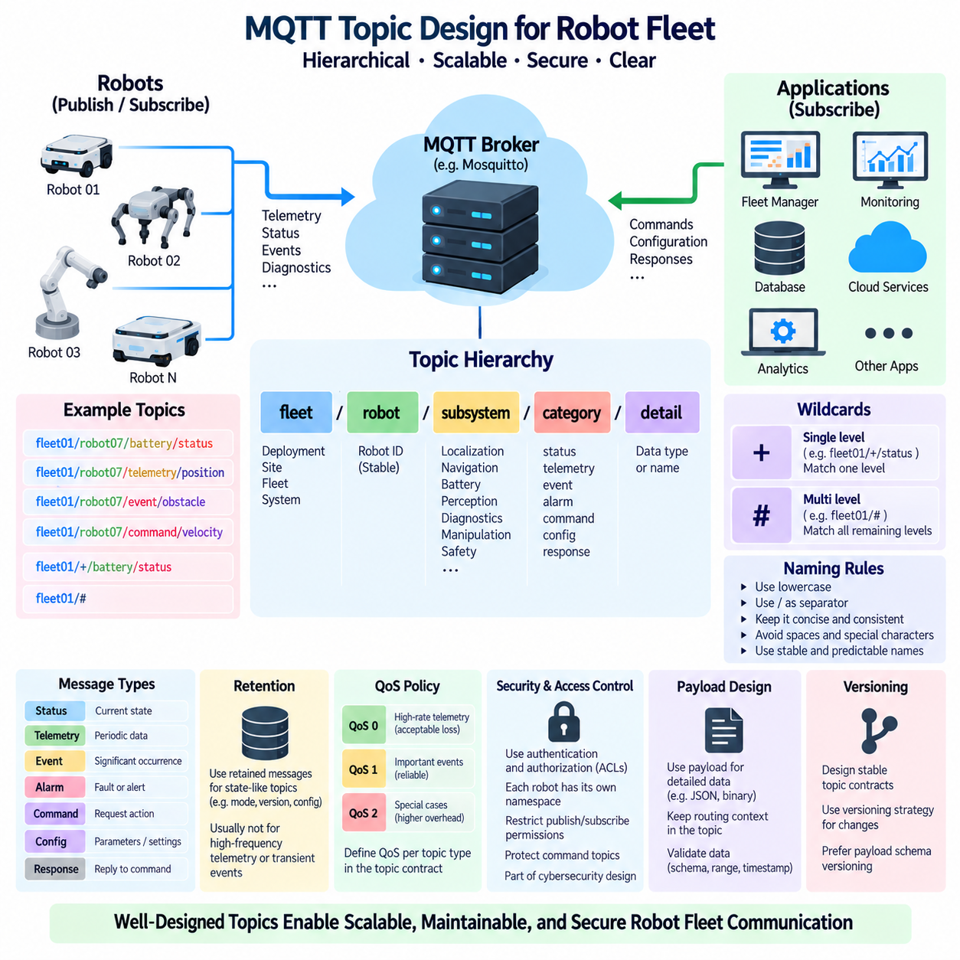
MQTT topic design defines the logical information structure through which publishers and subscribers communicate inside a robot fleet. A topic is not merely an address for transporting messages; it represents operational context such as fleet identity, robot identity, subsystem, message category, and data type. A disciplined hierarchy allows communication to remain understandable as a deployment expands from several robots to hundreds or thousands of distributed devices.
MQTT topics are hierarchical strings composed of multiple levels separated by forward slashes. A fleet-oriented structure may follow a pattern such as `fleet/robot/subsystem/message`, where each level progressively narrows the communication context. For example, `fleet01/robot07/battery/status` identifies both the physical robot and the meaning of the publication. Consistent hierarchy enables applications to determine message purpose without relying entirely on payload inspection.
The highest topic levels should represent stable organizational boundaries rather than rapidly changing operational values. Deployment, site, fleet, or system identifiers can provide useful roots when one broker supports multiple environments. Lower levels can identify robots, devices, subsystems, and message categories. Designing from broad context toward specific information creates predictable navigation through the namespace and simplifies subscriptions, access control, monitoring, and troubleshooting.
Robot identity is one of the most important hierarchy elements. Every independently addressable robot should have a stable identifier that does not change when its mission, location, network address, or temporary operational role changes. Embedding IP addresses or transient state into topic identities creates unnecessary coupling between messaging and network configuration. Stable robot identifiers allow fleet services to maintain subscriptions even when robots reconnect through different networks.
Subsystem levels organize communication according to functional components such as localization, navigation, battery management, perception, diagnostics, manipulation, or safety supervision. This separation prevents unrelated data from accumulating under ambiguous generic topics. It also enables subsystem-specific applications to subscribe only to information they require, reducing message processing overhead and making communication responsibilities easier to understand during system integration.
Message categories should distinguish different semantic roles instead of treating every publication as generic data. Status, telemetry, events, alarms, commands, configuration, and responses have different operational meanings and often require different QoS, retention, security, and processing policies. Explicitly representing these meanings in the hierarchy allows brokers and applications to apply appropriate communication behavior without repeatedly interpreting complex payload structures.
Topic names should remain concise, predictable, and machine friendly. Consistent lowercase naming and stable separators reduce ambiguity across software written in Python, C++, JavaScript, embedded environments, and cloud services. Spaces, unnecessary punctuation, inconsistent capitalization, and dynamically constructed names should generally be avoided. A naming convention becomes especially valuable when MQTT interfaces are shared among robot vendors, fleet systems, edge services, and external applications.
Single-level wildcards allow subscribers to match one topic level without knowing its exact value. The `+` wildcard can therefore be used to observe the same information across multiple robots. A monitoring service subscribing to a pattern conceptually similar to `fleet01/+/battery/status` can receive battery status from every matching robot in the fleet. This mechanism provides scalable aggregation while preserving individual robot identities in the actual topics.
The multi-level wildcard `#` matches all remaining levels below a selected hierarchy point. It can be useful for diagnostic tools, data collectors, or temporary system analysis because one subscription can observe an entire subtree. However, broad subscriptions may generate substantial traffic and processing load in large fleets. Production applications should therefore subscribe to the narrowest topic scope that satisfies their functional requirements rather than routinely consuming complete namespaces.
Topic design directly influences broker-side authorization. If each robot owns a clearly defined namespace, Access Control Lists can restrict that robot to publishing its own telemetry and subscribing only to approved command or configuration topics. Fleet managers may receive broader permissions, while monitoring applications can be granted read-only access. A well-designed hierarchy therefore becomes part of the cybersecurity architecture rather than merely an organizational convenience.
Command topics require particularly careful design because they can cause physical actions. A robot should not accept commands from arbitrary general-purpose topics, and command namespaces should be protected through authentication and authorization. Commands should include sufficient application-level context to support validation, correlation, expiration, and rejection when inappropriate. MQTT topic delivery alone must never be interpreted as authorization to perform a physical action.
Telemetry and event topics should also be distinguished. Telemetry normally represents continuously or periodically refreshed measurements such as battery percentage, temperature, position summaries, CPU load, or communication quality. Events represent meaningful occurrences such as mission completion, obstacle detection, charging start, fault activation, or mode transition. Separating these concepts allows downstream consumers to process continuous measurements differently from discrete operational changes.
Retained-message behavior should be aligned with topic semantics. State-like topics representing current mode, availability, software version, or configuration may benefit from retained publication because new subscribers immediately obtain the latest known value. Transient events and continuously changing measurements usually require different treatment. A topic convention should make retained-state expectations clear so that subscribers understand whether an initial message represents current state or a newly occurring event.
QoS policy can similarly be associated with topic categories. High-rate telemetry may tolerate QoS 0, important operational events may use QoS 1, and exceptional workflows may justify stronger delivery semantics. Defining expected QoS behavior as part of the topic contract prevents individual applications from choosing inconsistent reliability settings. Topic name, payload schema, QoS, retention, authorization, and publication rate together form the complete messaging interface.
Payload design should complement rather than duplicate the topic hierarchy. Information needed for efficient routing and subscription belongs naturally in the topic, while detailed measurements and structured application data normally belong in the payload. Placing every field into topic levels creates excessively deep namespaces, whereas placing all routing context inside JSON forces subscribers to receive and decode irrelevant messages. Effective MQTT architecture balances these two responsibilities.
Versioning must also be considered when topic structures become external or long-lived interfaces. Changing a hierarchy used by deployed robots, fleet servers, dashboards, databases, and cloud applications can break multiple systems simultaneously. Stable topic contracts should therefore evolve deliberately, with compatibility strategies when structural changes are unavoidable. Payload schema versioning can often absorb data evolution without requiring frequent changes to the fundamental topic namespace.
Large robot fleets benefit from documenting the MQTT namespace as an explicit communication contract. Documentation should define hierarchy patterns, identifier rules, publishers, subscribers, payload schemas, expected rates, QoS, retained behavior, and access permissions. Automated validation can further prevent applications from publishing malformed or unauthorized topic structures. This transforms topic design from an informal naming practice into a governed interface shared across the robotics platform.
A scalable robot fleet hierarchy ultimately connects communication architecture with operational organization. Site and fleet levels establish deployment scope, robot identifiers isolate individual machines, subsystem levels separate functional domains, and message categories describe communication intent. When these principles are applied consistently, MQTT topics provide a structured foundation for telemetry, events, commands, diagnostics, monitoring, fleet orchestration, and secure edge-to-cloud integration.

04.05 MQTT 5.0 New Features: Properties / Shared Sub [w/Code]
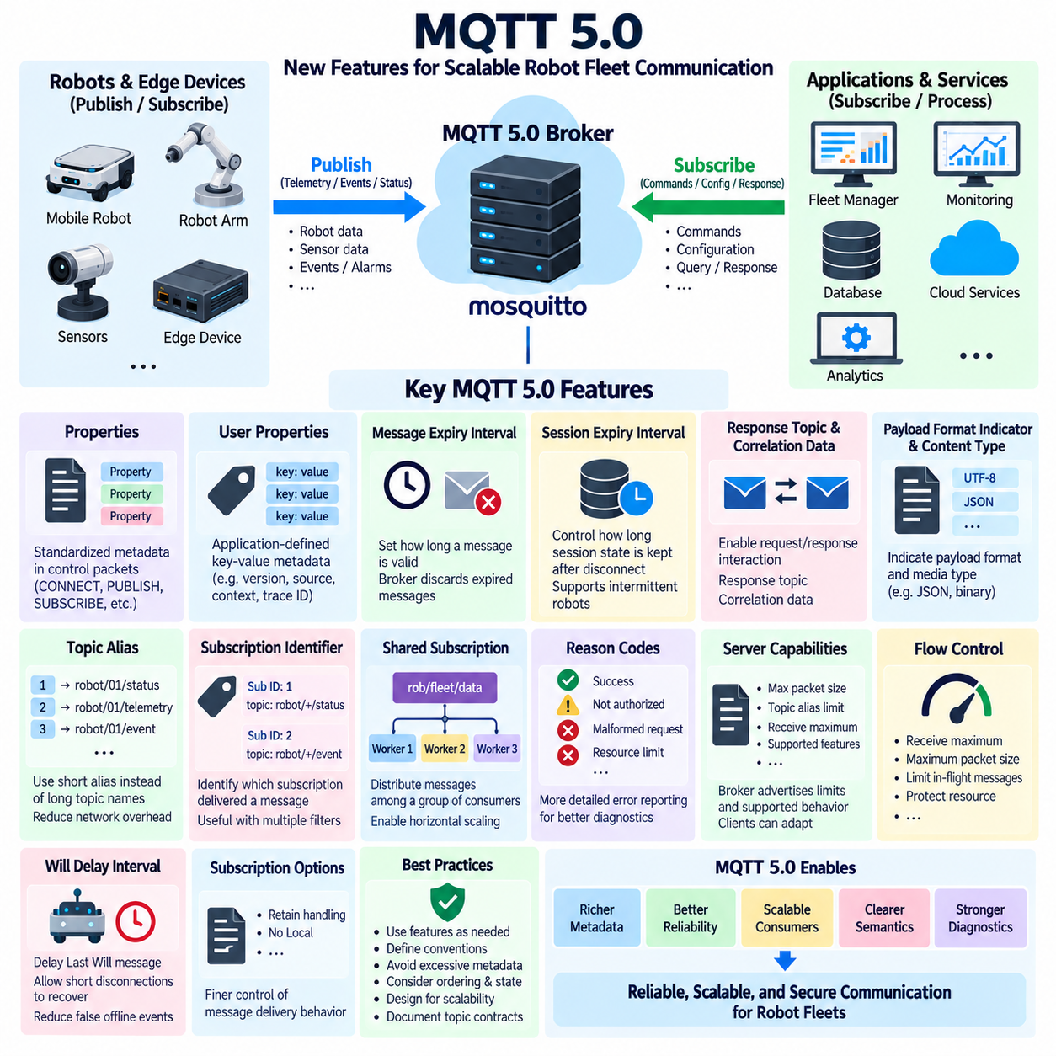
MQTT 5.0 extends the lightweight publish/subscribe model of earlier MQTT versions with richer metadata, improved error reporting, better session control, scalable subscription mechanisms, and more explicit communication semantics. These additions are particularly useful for robot fleets where many robots, edge computers, fleet services, and cloud applications must exchange messages while preserving the protocol’s relatively small communication overhead.
One of the most important MQTT 5.0 additions is the property mechanism. Properties attach standardized metadata to MQTT control packets without forcing applications to place all communication information inside the payload. Connection, publication, subscription, acknowledgment, and disconnection operations can therefore carry additional context. This makes MQTT behavior more expressive while allowing application payloads to remain focused on robot-specific data.
User Properties provide application-defined key-value metadata associated with MQTT packets. A robotics platform can use them to carry information such as application version, data source, processing stage, deployment context, or tracing identifiers without modifying the primary payload schema. Because User Properties are metadata rather than unrestricted application storage, their use should follow a documented convention to avoid unnecessary packet growth and inconsistent interpretation.
Message Expiry Interval allows a publisher to specify how long a message remains useful. This is highly relevant to robotics because many messages lose operational value quickly. A navigation update, temporary command, or short-lived alert may become dangerous or meaningless if delivered long after publication. Expiry information enables the broker to discard obsolete messages instead of delivering stale data after network interruptions or delayed client reconnections.
Session Expiry Interval provides more explicit control over how long broker-side session state should remain after a client disconnects. A mobile robot experiencing temporary wireless loss may benefit from preserving subscriptions and appropriate delivery state, while an ephemeral monitoring process may require no persistent session. Separating session lifetime from connection lifetime makes MQTT 5.0 better suited to intermittently connected robots and dynamically deployed edge applications.
MQTT 5.0 improves request/response interaction through Response Topic and Correlation Data properties. A requester can publish a message that identifies where the corresponding response should be sent, while correlation information allows the response to be associated with the original request. This does not transform MQTT into a synchronous RPC protocol, but it provides a standardized mechanism for command acknowledgments, configuration queries, diagnostic requests, and service interactions.
Payload Format Indicator and Content Type provide additional information about message representation. A publisher can indicate whether a payload should be interpreted as UTF-8 encoded text and can describe its media or application type. Robot systems exchanging JSON, binary telemetry, serialized structures, or other representations can use this metadata to reduce ambiguity. Consumers must still validate schemas and data semantics before using received information.
Topic Alias can reduce repeated transmission of long topic names. After an alias relationship is established for a connection, subsequent publications may reference a compact numeric alias rather than repeatedly transmitting the complete topic string. This can reduce communication overhead when robots publish frequently to long hierarchical topic names, which is useful on constrained wireless links or high-rate telemetry paths where repeated topic bytes accumulate significantly.
Subscription Identifiers allow subscriptions to carry identifiers that can later accompany matching publications. A client with multiple overlapping subscriptions can therefore determine which subscription caused a message to be delivered. This capability is useful for fleet gateways, monitoring systems, and routing services that maintain many topic filters. It reduces the need to reproduce complex subscription-matching logic entirely within the receiving application.
Shared Subscriptions address horizontal scaling of MQTT consumers. Instead of every subscriber in a group receiving every matching publication, clients join a shared subscription group and the broker distributes matching messages among members of that group. Multiple processing workers can therefore consume a workload collectively. This is valuable for fleet telemetry processing, event analysis, logging pipelines, AI preprocessing, and other services that need scalable parallel consumption.
A shared subscription conceptually uses a shared group together with an ordinary topic filter. Several backend workers subscribing through the same group can process different messages from the matching stream rather than duplicating all processing. Adding workers increases available consumer capacity without changing robot publishers. However, applications must consider ordering, state ownership, failure recovery, and idempotency because successive messages may be processed by different members of the shared group.
MQTT 5.0 introduces more informative Reason Codes across many protocol operations. Earlier implementations could provide limited information about why a connection, subscription, publication, or other operation failed. MQTT 5.0 enables brokers and clients to communicate more specific outcomes. Robot software can therefore distinguish conditions such as authorization failure, unsupported behavior, malformed requests, or resource limitations and respond with more appropriate diagnostics and recovery strategies.
Server capabilities can also be communicated more explicitly. MQTT 5.0 allows the broker to advertise limits and supported behavior such as maximum packet size, topic alias limits, receive constraints, and other operational properties. Clients can adapt to these capabilities instead of assuming every broker has identical resources or configuration. This is useful when the same robot software operates across development brokers, industrial edge infrastructure, and cloud environments.
Flow control is improved through mechanisms such as Receive Maximum and Maximum Packet Size. These properties help limit the number of QoS messages in flight and constrain packet sizes that communication peers are prepared to handle. Robot gateways and embedded systems can use these controls to protect limited memory and processing resources. They also reduce the risk that a fast producer overwhelms a slower receiver through excessive outstanding traffic.
Will messages also gain richer control in MQTT 5.0. Will Delay Interval can postpone publication of a Last Will message after an unexpected disconnection, allowing short communication interruptions to recover without immediately declaring a robot unavailable. Combined with session behavior and appropriate fleet-level heartbeat logic, this can reduce false offline events caused by brief wireless disturbances. Safety-critical decisions, however, should still rely on dedicated safety mechanisms.
MQTT 5.0 provides enhanced subscription options, including controls related to retained-message delivery and local publication behavior. A subscriber can influence whether retained messages are delivered under specific subscription conditions, while No Local can prevent a client from receiving publications that it originally sent when applicable. These mechanisms help applications avoid unnecessary processing and provide finer control over message behavior in complex gateways and multi-role clients.
The richer protocol features introduce additional design responsibility. Properties, aliases, shared subscriptions, expiry intervals, and advanced session behavior should not be enabled simply because they are available. Each mechanism should correspond to a documented operational requirement. Excessive metadata increases packet size, poorly selected expiry values can discard useful information, and inappropriate shared-subscription design can introduce unexpected ordering or state-management problems.
For robot fleet architectures, MQTT 5.0 is therefore an evolution from simple lightweight messaging toward a more controllable distributed communication framework. Properties provide metadata, expiry mechanisms control stale information, request/response properties improve asynchronous interactions, aliases reduce repeated overhead, shared subscriptions support scalable consumers, and reason codes improve diagnostics. Together these capabilities strengthen MQTT for large edge, fleet, and cloud-connected robotic systems.

04.06 MQTT TLS/SSL Security Configuration [w/Code]
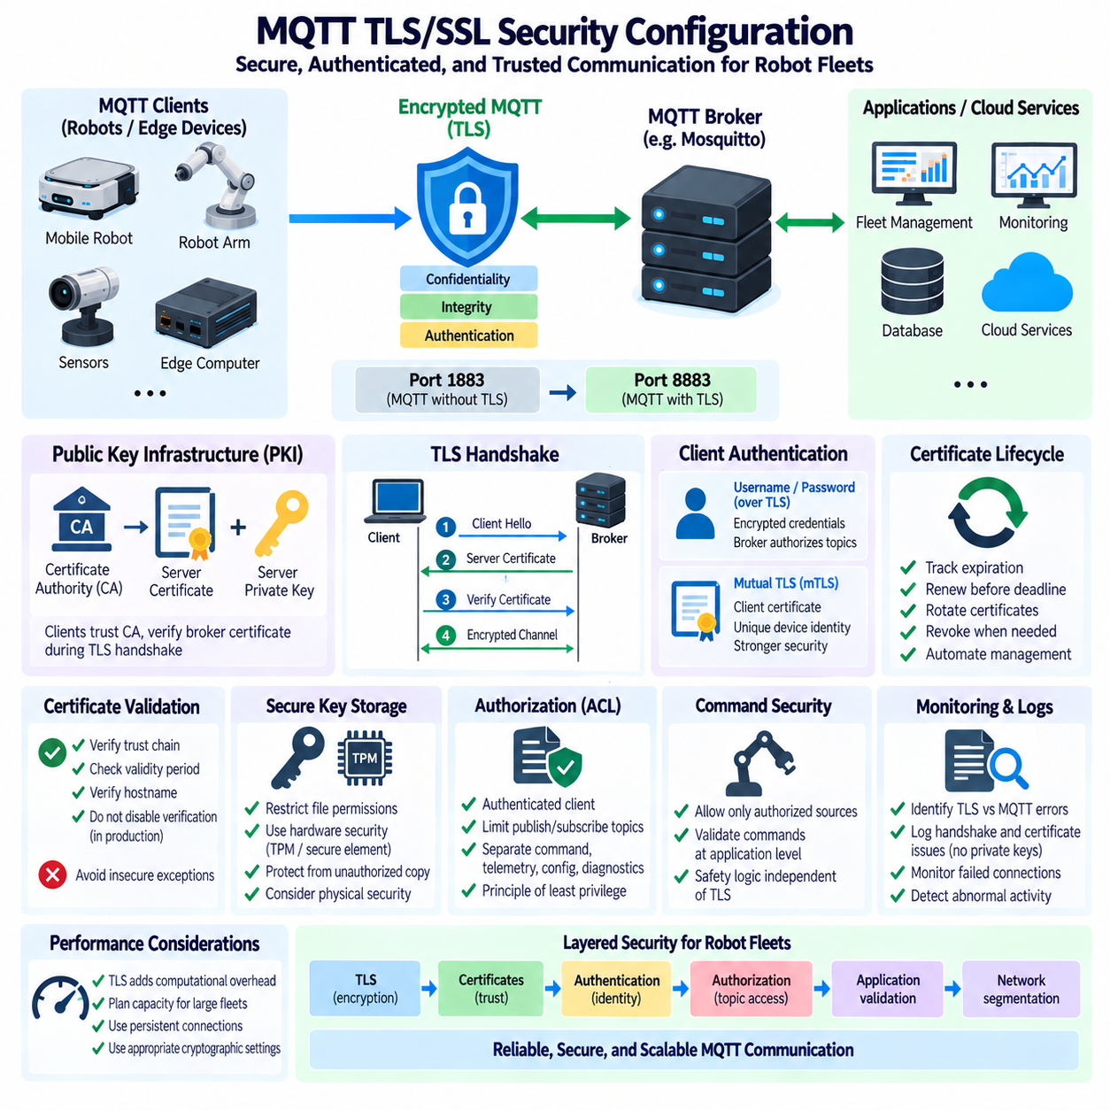
Transport Layer Security, or TLS, provides the primary cryptographic protection for MQTT communication when messages travel across networks that cannot be assumed to be trusted. Although the term SSL is still commonly used in configuration discussions, modern deployments should use TLS rather than obsolete SSL protocols. In robotics, TLS protects telemetry, commands, diagnostics, configuration data, and fleet events exchanged among robots, brokers, edge systems, and cloud services.
Without TLS, standard MQTT traffic transported over TCP can potentially be observed or modified by an attacker who gains access to the communication path. Usernames, passwords, topic names, payloads, and operational information may otherwise be exposed depending on the authentication mechanism and network configuration. TLS establishes an encrypted channel that provides confidentiality, integrity protection, and authenticated communication between MQTT clients and the broker.
MQTT commonly uses TCP port 1883 for communication without TLS and port 8883 for MQTT protected by TLS, although deployments may configure different ports. The port number itself does not provide security; protection depends on the listener configuration and successful TLS negotiation. Production brokers should expose only the listeners required by the system architecture, while firewalls and network segmentation should restrict unnecessary access to MQTT services.
A TLS deployment normally relies on a Public Key Infrastructure, or PKI, containing a Certificate Authority, server certificate, and corresponding private key. The Certificate Authority establishes the trust relationship used by clients to validate the broker certificate. The broker presents its certificate during the TLS handshake, and the client verifies that the certificate chains to a trusted authority and represents the server it intended to contact.
The server private key is one of the most sensitive assets in the broker environment because it proves possession of the broker identity associated with the certificate. It should be readable only by the required broker process or tightly controlled administrative accounts. Private keys should never be copied into source repositories, ordinary shared directories, application logs, or unprotected deployment packages. File permissions and secret-management procedures should therefore be included in broker hardening.
Certificate validation must include more than checking whether a certificate file exists. MQTT clients should verify the trust chain, validity period, and expected broker identity according to the TLS configuration. Disabling hostname or certificate verification may make laboratory troubleshooting easier, but it removes important protection against impersonation and man-in-the-middle attacks. Such insecure exceptions should not become permanent production settings.
A Mosquitto broker can configure a TLS-enabled listener with references to the trusted CA certificate, server certificate, and server private key. Once the secure listener is active, MQTT clients must establish TLS before normal MQTT protocol communication proceeds. Configuration should be tested carefully because incorrect certificate paths, permissions, certificate chains, names, or cryptographic parameters can prevent clients from establishing connections even when ordinary network connectivity is functioning correctly.
Server-authenticated TLS verifies the broker to the client but does not necessarily provide cryptographic client identity. Client authentication may still use MQTT usernames and passwords over the encrypted TLS channel. This combination is substantially stronger than sending credentials over an unencrypted connection because TLS protects the authentication exchange from passive network observation. Broker authorization rules should then determine which topics each authenticated identity may access.
Mutual TLS, or mTLS, extends the trust model by requiring the client to present a certificate that the broker can validate. Each robot, edge computer, gateway, or service can therefore receive a unique cryptographic identity. The broker validates the client certificate against an approved trust chain before accepting the connection. This approach is valuable for managed robot fleets because individual device credentials can be controlled independently rather than sharing one password across many machines.
Unique client certificates improve isolation and credential revocation. If one robot is decommissioned or its credentials are suspected of compromise, its certificate can be replaced or invalidated without necessarily changing credentials for the entire fleet. However, mTLS introduces operational complexity because certificates and private keys must be provisioned, stored, renewed, rotated, and eventually revoked across potentially hundreds or thousands of devices.
Certificate lifecycle management is therefore as important as the initial TLS configuration. Every certificate has a validity period, and an expired certificate can interrupt robot communication even when all application software is functioning correctly. Fleet operations should track certificate expiration, renew credentials before deadlines, and support controlled rotation. Automated certificate management becomes increasingly valuable as deployments scale and manual replacement becomes operationally impractical.
Private keys stored on robots require protection appropriate to the threat model. File permissions provide a basic software-level defense, while stronger deployments may use hardware-backed key storage, Trusted Platform Modules, secure elements, or platform-specific credential protection. The objective is to prevent another process or attacker from copying a robot identity and using it elsewhere. Security architecture should consider both network attacks and physical access to deployed machines.
TLS protects messages while they are transported, but it does not replace MQTT authorization. A client with a valid encrypted connection should not automatically receive permission to publish or subscribe to every topic. Authentication establishes identity, while Access Control Lists or equivalent authorization policies restrict permitted operations. Combining TLS, client identity, and topic-level authorization creates a stronger trust boundary around command, telemetry, configuration, and diagnostic namespaces.
Command channels deserve stricter protection because compromised commands may produce physical consequences. A robot should verify that commands originate through an authorized communication path and should apply application-level validation after MQTT delivery. TLS can protect the channel from interception and modification, but it cannot determine whether a requested velocity, mission, or actuator action is safe in the robot's current physical state. Safety logic must remain independent.
TLS also introduces computational and communication overhead. Certificate validation, key exchange, encryption, and integrity processing consume CPU resources and increase connection establishment cost. For modern edge computers this overhead is usually manageable, but constrained embedded clients and large fleets reconnecting simultaneously require careful capacity planning. Persistent connections, controlled reconnection backoff, and appropriate cryptographic configurations can reduce unnecessary repeated handshake load.
Operational monitoring should distinguish TLS failures from MQTT protocol failures. Certificate expiration, unknown Certificate Authorities, hostname mismatch, unsupported cryptographic parameters, invalid client certificates, and inaccessible private keys can all prevent a secure connection before MQTT authentication or subscription begins. Broker and client logs should therefore preserve enough diagnostic information to identify the security layer at which communication failed without exposing private credentials.
A production security test should verify both successful and intentionally rejected connections. Valid clients should connect through the expected secure listener, while unknown certificates, invalid credentials, unauthorized topics, expired certificates, and incorrect trust chains should be rejected as designed. Testing negative cases demonstrates that security controls are actually enforced rather than merely configured. Reconnection and certificate rotation scenarios should also be validated before deployment.
For robot fleets, MQTT TLS security is best implemented as a layered architecture rather than a single encryption option. TLS secures the transport channel, certificates establish cryptographic trust, authentication identifies communication participants, authorization limits topic access, and application validation controls how received information affects robot behavior. Together with secure key storage, lifecycle management, logging, network segmentation, and safety separation, these mechanisms provide a practical security foundation for MQTT-based robotic communication.

04.07 MQTT Authentication: Client Cert / JWT [w/Code]
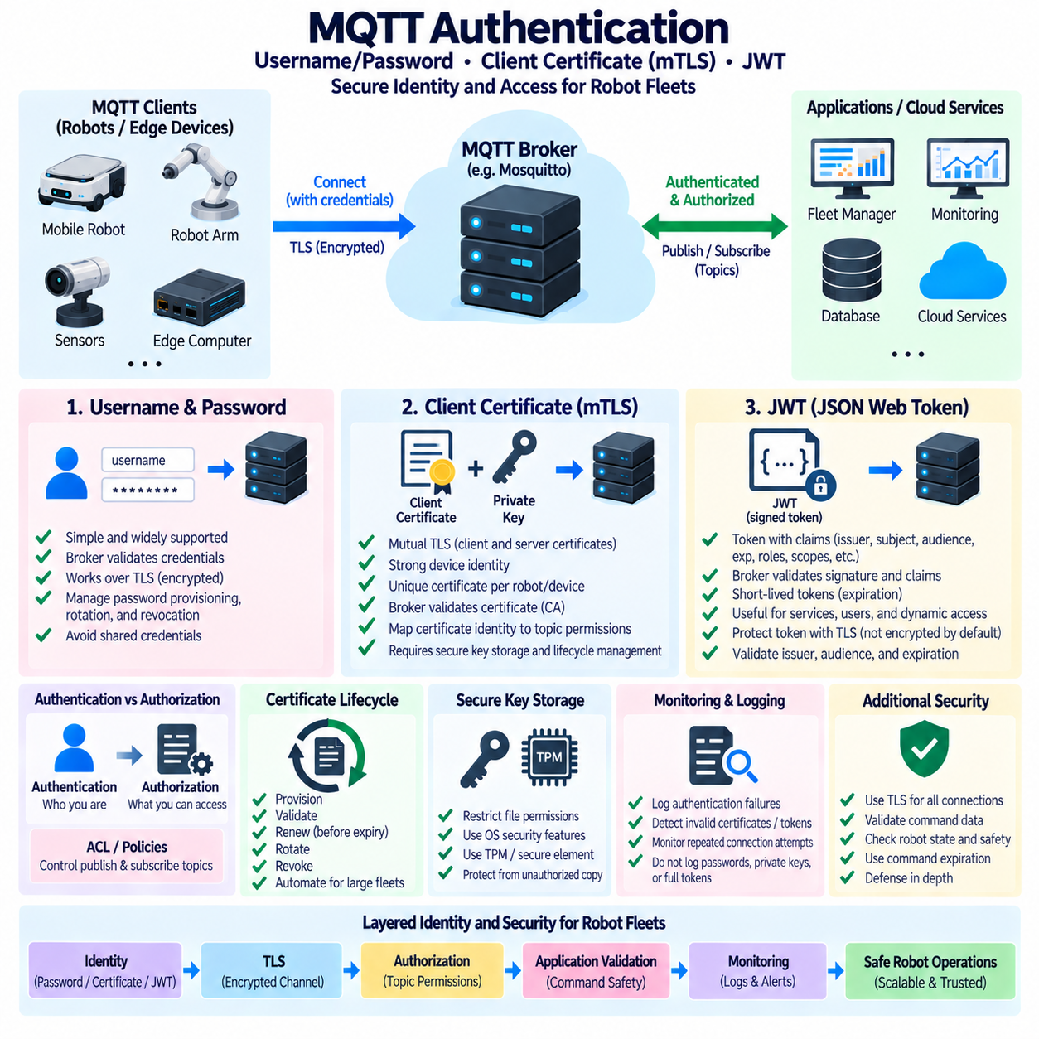
MQTT authentication establishes the identity of clients before they are allowed to participate in broker-mediated communication. In robot fleets, authenticated clients may include mobile robots, manipulators, sensors, edge computers, fleet managers, monitoring services, and cloud applications. Authentication must therefore scale beyond simple connectivity and provide reliable identity management across heterogeneous devices, networks, and operational environments.
The simplest MQTT authentication model uses a username and password presented by the client during connection establishment. The broker validates these credentials before accepting the session and can associate the authenticated identity with authorization rules. This approach is practical for development and smaller deployments, but passwords require secure provisioning, storage, rotation, and revocation. Shared credentials across many robots should generally be avoided because compromise of one device can affect the entire fleet.
Authentication and authorization must remain conceptually separate. Authentication determines who the client is, while authorization determines which MQTT resources that identity may access. After successful authentication, broker policies or Access Control Lists can restrict publication and subscription permissions. A robot may publish its own telemetry while subscribing to approved command topics, whereas monitoring services may receive read-only access to fleet-wide status information.
Client certificate authentication provides stronger cryptographic device identity through mutual TLS. In this model, the broker presents its server certificate and the MQTT client also presents a client certificate during the TLS handshake. The broker validates the client certificate against a trusted Certificate Authority. Successful validation demonstrates possession of the private key associated with an approved certificate, allowing the certificate identity to participate in MQTT access decisions.
Unique client certificates are particularly useful for robot fleets because each robot, gateway, or service can receive an independently managed identity. If one device is compromised, retired, replaced, or transferred to another operational domain, its credential can be revoked or replaced without changing credentials for unrelated systems. This provides better isolation than a fleet-wide shared secret and creates a stronger foundation for device-level auditing and accountability.
Certificate identity can be mapped to MQTT authorization policies using certificate attributes or broker-specific authentication mechanisms. The authenticated certificate identity may determine which topic hierarchy a robot is permitted to access. For example, a robot identity can be restricted to publishing telemetry under its own namespace while receiving commands only from explicitly authorized topics. This connects Public Key Infrastructure directly with MQTT topic-level security.
Private-key protection is critical because the security of certificate authentication depends on exclusive possession of the corresponding key. Robot private keys should not be embedded in source code, copied into public software images, or stored in broadly accessible directories. Depending on platform capability, keys can be protected through restricted file permissions, operating-system credential facilities, Trusted Platform Modules, secure elements, or other hardware-backed security mechanisms.
Certificate authentication introduces a lifecycle that must be managed throughout the operational life of the robot. Certificates must be provisioned during manufacturing or deployment, validated during operation, renewed before expiration, rotated when security policies require it, and revoked when devices are compromised or decommissioned. Large fleets benefit from automated certificate management because manually maintaining credentials across hundreds or thousands of robots quickly becomes impractical.
JSON Web Tokens, or JWTs, provide a different authentication model based on signed tokens containing structured claims. A token commonly identifies a subject and may include issuer, audience, issue time, expiration time, and application-specific claims. The MQTT broker or an integrated authentication service validates the token signature and relevant claims before accepting the client identity. JWTs are especially useful when MQTT participates in a broader identity and service architecture.
A JWT consists conceptually of a header, payload, and cryptographic signature. The payload contains claims describing the authenticated context, while the signature allows the receiver to verify that the token was issued by a trusted authority and was not modified. JWT contents are encoded rather than inherently encrypted, so sensitive information should not be placed in token claims unless additional protection is provided. TLS should still protect the communication channel carrying the token.
Token expiration is an important security property of JWT-based authentication. Unlike long-lived static passwords, access tokens can be configured with relatively short validity periods, limiting the useful lifetime of a stolen credential. Robot and edge applications must therefore support token acquisition or renewal before expiration. Token refresh behavior should tolerate temporary network failures without encouraging excessively long-lived credentials that weaken the intended security model.
JWT validation must verify more than the cryptographic signature. The receiving system should validate the expected issuer, intended audience, expiration time, and other required claims before trusting the token. A correctly signed token intended for another service should not automatically authorize access to an MQTT broker. Claim validation therefore establishes the security context in which the signed identity is accepted and prevents overly broad reuse of valid tokens.
JWT claims can also contribute to authorization decisions. A token may contain roles, device identifiers, tenant information, or approved scopes that an authentication layer maps to MQTT permissions. This enables dynamic authorization models in which access rights are derived from centrally managed identity services rather than static broker accounts alone. However, token claims and broker ACL rules must be designed consistently so that dynamic identity does not unintentionally grant excessive topic access.
Client certificates and JWTs solve related but different identity-management problems. Certificates are well suited to durable device identity and cryptographic authentication of robots or gateways, while JWTs are effective for temporary application sessions, services, users, or dynamically issued permissions. A production architecture may combine them rather than selecting only one mechanism. A robot can establish trusted device identity through mTLS while an application service uses short-lived tokens for service-level access.
Layered authentication can also connect device identity with application identity. An edge gateway may authenticate itself to the broker using a client certificate while obtaining JWTs for individual software services operating behind that gateway. This allows infrastructure trust and application authorization to be managed independently. Such separation becomes increasingly useful when robots host containers, AI services, diagnostic agents, and fleet applications with different communication privileges.
Credential rotation must be designed so that security maintenance does not unnecessarily interrupt robot operations. Certificate replacement may require overlapping validity periods, while JWT systems require reliable token renewal and clock synchronization. Robots with intermittent connectivity need strategies for handling credential expiration during network outages. At the same time, excessively permissive fallback behavior should be avoided because it can undermine revocation and expiration controls.
Authentication failures should be observable without exposing secrets. Broker and client logs can record rejected identities, certificate validation failures, expired tokens, invalid issuers, authorization failures, and repeated connection attempts. Security monitoring systems can correlate these events across a fleet to identify configuration problems or suspicious behavior. Passwords, private keys, complete tokens, and other reusable credentials should never be written into ordinary diagnostic logs.
No authentication mechanism alone guarantees safe robot behavior. A successfully authenticated client may still send an inappropriate command because of software failure, compromised credentials, or incorrect application logic. MQTT commands should therefore pass through topic authorization, schema validation, state checks, command expiration, operational constraints, and independent safety mechanisms before affecting actuators. Identity establishes trust boundaries but does not replace physical safety controls.
A scalable MQTT security architecture combines authentication methods according to the identities being protected. Passwords may remain useful for controlled environments, client certificates provide durable device identity, and JWTs support dynamic service and application authentication. When integrated with TLS, secure key storage, credential lifecycle management, topic-level authorization, logging, and application validation, these mechanisms provide a flexible identity foundation for secure robot fleet communication.

04.08 MQTT.SN: Lightweight Sensor Node Protocol
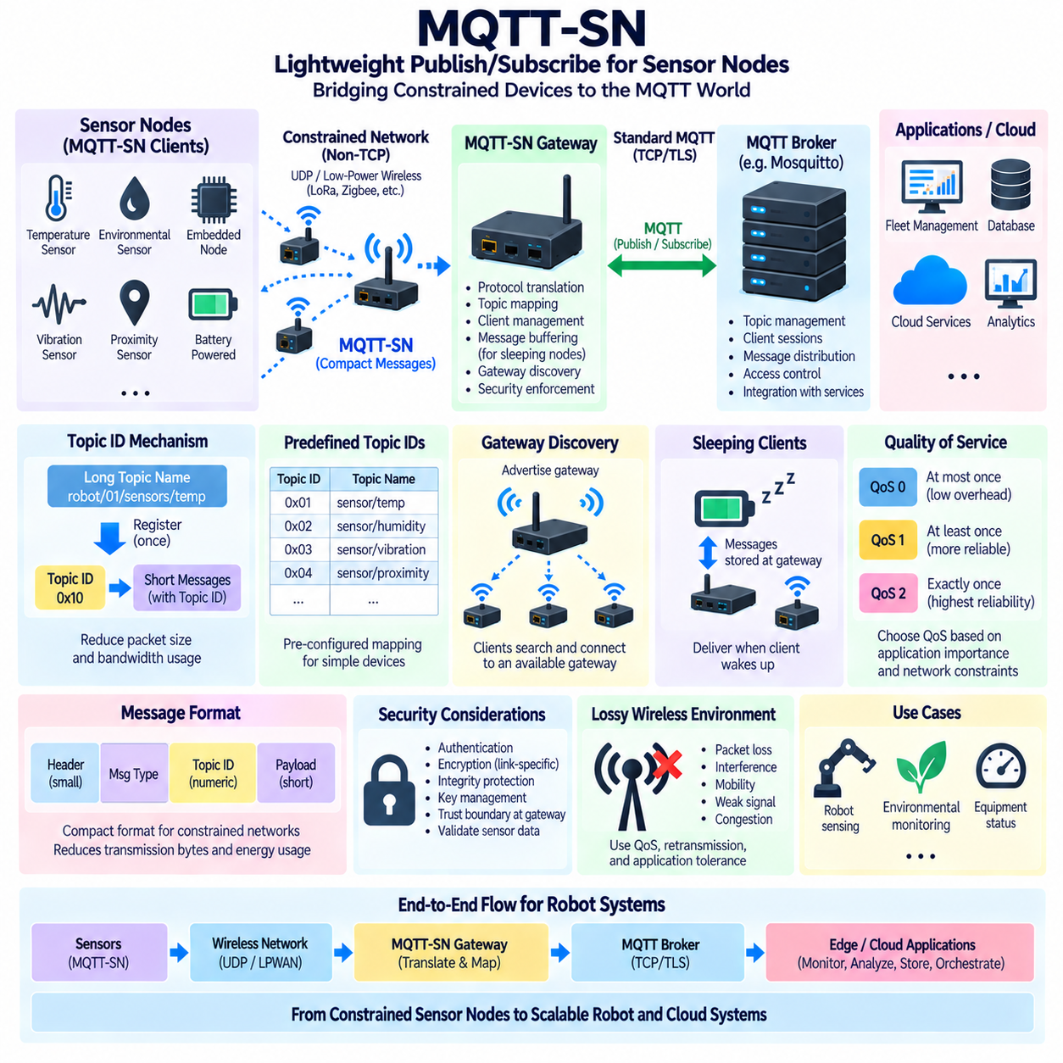
MQTT-SN, originally named MQTT for Sensor Networks, adapts the MQTT publish/subscribe communication model for constrained sensor nodes and networks where conventional TCP-based MQTT may introduce excessive overhead. It is designed for devices with limited memory, processing capability, energy, and communication bandwidth. In robotics, it can connect lightweight sensors and embedded nodes to broader MQTT-based robot, edge, and fleet infrastructures.
Unlike conventional MQTT, which normally operates over TCP/IP, MQTT-SN is designed to work over connectionless or lightweight transports and non-TCP networks. This allows implementations to use technologies such as UDP or specialized low-power wireless links. Removing the dependency on a persistent TCP connection can reduce protocol overhead and energy consumption, making MQTT-SN suitable for battery-powered or deeply embedded sensing devices.
The MQTT-SN architecture introduces a gateway between constrained MQTT-SN clients and the conventional MQTT infrastructure. Sensor nodes communicate using MQTT-SN, while the gateway translates or maps their communication toward an MQTT broker. This gateway allows low-resource devices to participate in publish/subscribe systems without requiring every sensor node to implement a complete TCP/IP and standard MQTT communication stack.
An MQTT-SN gateway performs more than simple packet forwarding. It manages protocol differences between MQTT-SN clients and MQTT brokers, maintains client-related state, processes topic mappings, and supports message delivery across different network technologies. Depending on the deployment, a gateway may be integrated into an edge computer, robot controller, embedded gateway, or dedicated communication device positioned between sensor networks and the main robot communication infrastructure.
Gateway discovery is an important MQTT-SN capability because constrained nodes may not always be configured with a fixed gateway address. Gateways can advertise their availability, and clients can search for an accessible gateway before establishing communication. This behavior is useful in wireless sensor environments where nodes may be deployed dynamically or where multiple gateways provide access to the wider messaging infrastructure.
MQTT-SN reduces topic-name overhead through Topic IDs. Standard MQTT publications normally carry topic names as strings, and repeatedly transmitting long hierarchical names can consume significant bandwidth on constrained links. MQTT-SN allows a topic name to be registered and associated with a compact numeric identifier. Subsequent messages can use the shorter Topic ID, reducing packet size and transmission cost for frequently published sensor information.
Topic registration creates a mapping between the application-level topic name and the compact Topic ID used across the constrained network. Once the client and gateway understand this mapping, sensor publications can avoid repeatedly transmitting the full topic string. For robot systems with numerous low-rate environmental, proximity, temperature, vibration, or equipment-monitoring sensors, this mechanism can improve communication efficiency while preserving integration with the MQTT topic hierarchy.
MQTT-SN also supports predefined topic identifiers. In this approach, topic mappings can be configured in advance so that a device does not need to perform dynamic topic registration before communication begins. This is useful for highly constrained embedded nodes with fixed functions and predictable data interfaces. A simple sensor can therefore publish measurements using a known numeric identifier with minimal runtime negotiation and message overhead.
The protocol retains the familiar publish/subscribe concept of MQTT. A sensor node can publish measurements without directly knowing which applications consume them, while monitoring systems and services subscribe through the MQTT infrastructure. This decoupling is valuable in robotics because sensing devices can remain simple while edge computers, fleet services, databases, analytics pipelines, or cloud applications independently process the resulting information.
Quality of Service remains relevant in MQTT-SN, but constrained networks require careful selection of reliability levels. Higher delivery guarantees may increase acknowledgments, retransmissions, radio activity, and energy consumption. Frequently refreshed sensor measurements may tolerate lower delivery guarantees, whereas significant alarms or state transitions may justify additional reliability. QoS policy should therefore reflect both application importance and the physical limitations of the sensor network.
One distinctive MQTT-SN feature is support for sleeping clients. Battery-powered sensor nodes may enter a low-power sleep state instead of maintaining continuous network activity. The gateway can retain appropriate messages while the client sleeps and provide them when the device becomes active again. This behavior allows MQTT-style messaging to support devices whose energy budget makes permanent connectivity impractical.
Sleeping-node operation requires coordination between communication behavior and application timing. A sensor that sleeps for long periods cannot be treated like an always-connected robot controller. Commands, configuration updates, or queued information may be delayed until the node wakes. Designers must therefore distinguish between data that can tolerate delayed delivery and functions requiring immediate response. Safety-critical control should not depend on a sleeping MQTT-SN node.
MQTT-SN message formats are designed to remain compact. Small headers, numeric topic identifiers, and reduced dependence on verbose network mechanisms help minimize transmitted bytes. This matters because radio transmission can consume substantial energy compared with local computation on small embedded devices. Reducing communication size can therefore improve battery life, decrease channel occupancy, and support larger numbers of sensing nodes within the same constrained network.
Lossy wireless environments introduce additional design challenges. Packets may be dropped because of interference, mobility, weak signal strength, congestion, or temporary gateway unavailability. MQTT-SN implementations must combine appropriate QoS behavior, retransmission policies, gateway discovery, and application-level tolerance for missing or delayed information. Robot applications should avoid assuming that every sensor measurement will arrive at precise and deterministic intervals.
Security must be designed according to the underlying transport and deployment environment because MQTT-SN does not automatically inherit the TCP/TLS security model commonly associated with conventional MQTT deployments. Authentication, encryption, integrity protection, key management, and device authorization may depend on lower-layer network security or implementation-specific mechanisms. The gateway should also enforce a clear trust boundary between constrained sensor networks and the broader MQTT infrastructure.
The MQTT-SN gateway is therefore a security-sensitive component. A compromised gateway may affect many sensor nodes or introduce false information into the robot messaging system. Gateway access should be restricted, software should be maintained and monitored, and mappings between sensor identities and MQTT topics should follow least-privilege principles. Data received from constrained nodes should still undergo validation before influencing robot decisions or operational services.
MQTT-SN is especially appropriate when a robot or industrial site contains many lightweight sensing nodes that do not justify full MQTT over TCP. Environmental sensors, distributed condition-monitoring devices, low-power wireless detectors, simple equipment-status nodes, and remote battery-powered sensors can communicate through MQTT-SN gateways. More capable robot computers can continue using conventional MQTT, allowing both communication models to coexist within one layered architecture.
A practical robot architecture can therefore place MQTT-SN at the sensor-network edge and conventional MQTT above the gateway. Lightweight nodes generate physical-world measurements, the MQTT-SN gateway performs protocol adaptation and topic mapping, the MQTT broker distributes information, and edge or fleet applications perform monitoring, analytics, storage, and orchestration. This layered approach extends publish/subscribe communication from highly constrained sensor nodes to scalable robot and cloud systems.

04.09 MQTT Broker HA Cluster: EMQX / HiveMQ [w/Code]
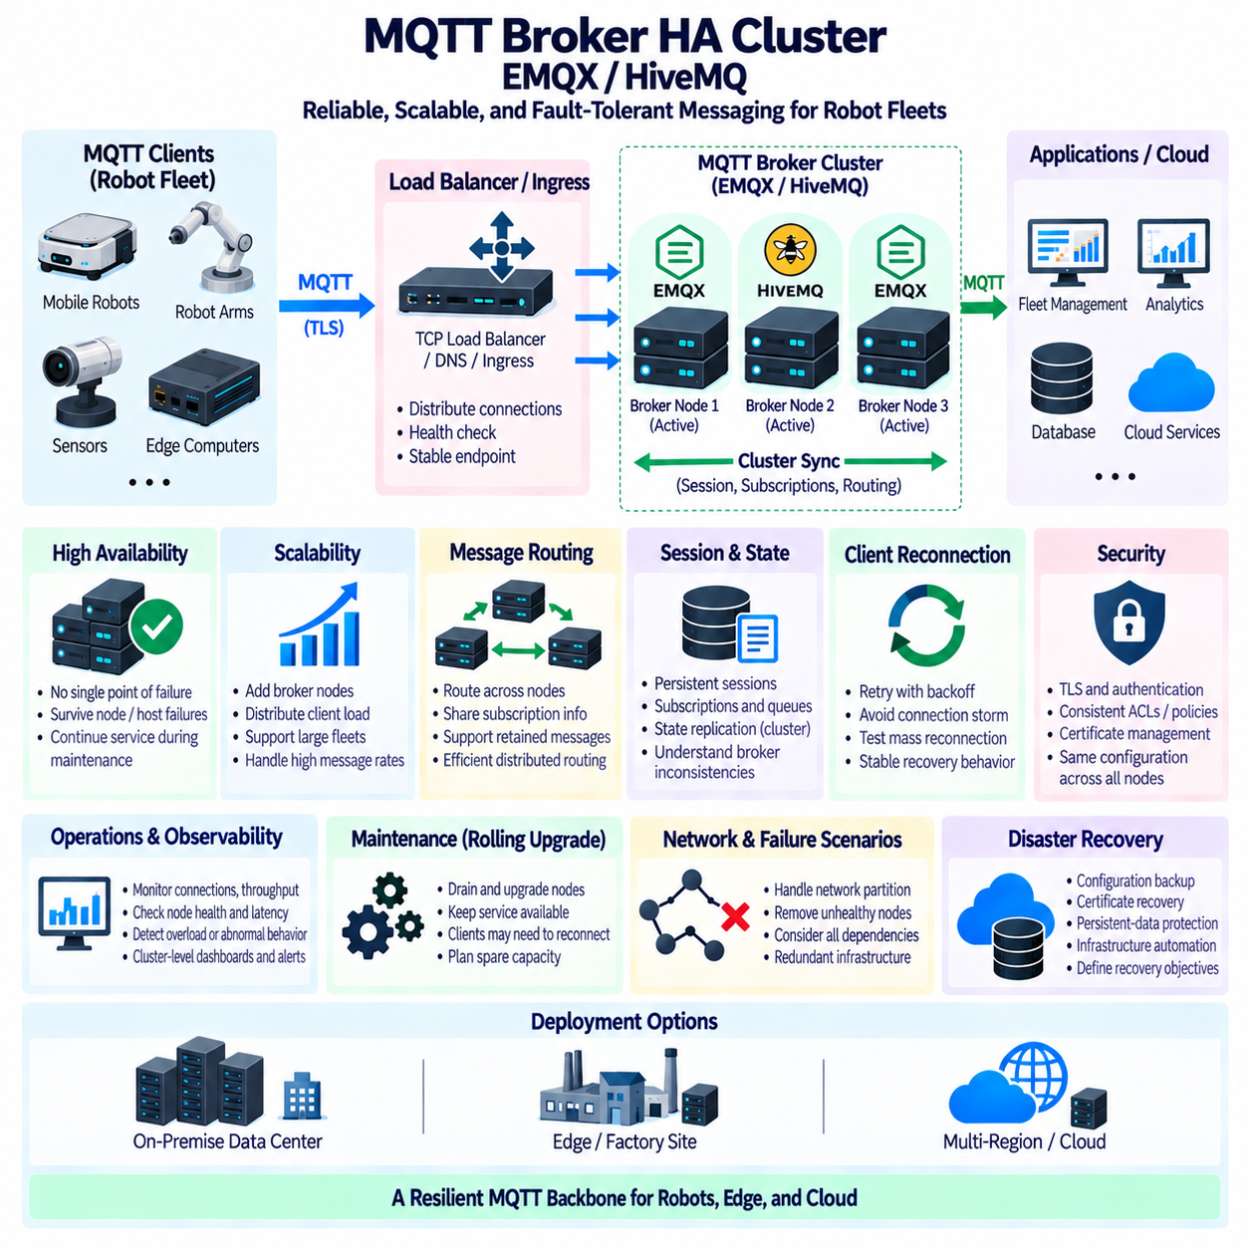
MQTT broker high availability is an architectural approach that prevents a single broker failure from interrupting communication across a robot fleet. Instead of relying on one broker process or server, multiple broker nodes cooperate as a cluster or distributed service. Platforms such as EMQX and HiveMQ provide clustering mechanisms designed for large numbers of MQTT clients, enabling robots, edge computers, fleet services, and cloud applications to maintain communication during failures or maintenance.
A single MQTT broker creates a potential single point of failure. If the broker process crashes, the operating system fails, the host loses power, or network connectivity is interrupted, connected robots and applications may lose their messaging path simultaneously. High availability reduces this dependency by distributing broker functionality across multiple nodes. Clients can reconnect to another healthy endpoint while the overall MQTT service continues operating.
A broker cluster consists of multiple MQTT broker nodes that cooperate to provide a logically unified messaging service. Each node can accept client connections, process subscriptions, receive publications, and participate in message routing. Depending on the broker implementation, cluster members exchange information required to locate subscribers and maintain distributed state. Applications interact with the cluster as a service rather than treating individual broker machines as independent messaging islands.
Load balancing is normally placed in front of the broker cluster to distribute incoming MQTT connections among available nodes. A TCP load balancer, network load balancer, DNS mechanism, or platform-specific ingress layer can provide a stable endpoint for clients. The load-balancing strategy should consider long-lived MQTT connections because MQTT traffic differs from short HTTP transactions. Once established, a client connection may remain attached to one broker node for hours or days.
Health checking allows the infrastructure to determine whether individual broker nodes are available to accept new connections. A failed or unhealthy node should be removed from the active load-balancing pool so that new clients are directed toward healthy nodes. Existing clients connected to a failed node must reconnect through their configured recovery mechanism. High availability therefore depends on both cluster infrastructure and correctly implemented MQTT client reconnection behavior.
Client reconnection should use controlled retry and backoff policies rather than aggressive continuous connection attempts. When hundreds or thousands of robots lose access to one broker simultaneously, immediate reconnection attempts can create a connection storm that overloads the remaining nodes. Randomized or exponential backoff distributes reconnection traffic over time. Fleet systems should test mass-reconnection scenarios because recovery behavior can create more load than normal steady-state operation.
Session state is an important consideration in clustered MQTT deployments. MQTT clients may depend on persistent sessions, subscriptions, queued QoS messages, and other protocol state that must remain meaningful after reconnecting through another node. Cluster implementations differ in how distributed state is represented and replicated. Architects should therefore understand which MQTT states survive node failure and which states depend on broker configuration, session settings, persistence, or external storage.
Message routing across nodes allows a publication received by one broker to reach a subscriber connected to another broker. The cluster must know enough about distributed subscriptions to forward messages toward the appropriate destination. Efficient routing becomes increasingly important as the number of clients, topics, subscriptions, and publication rates grow. Poorly designed topic structures or extremely broad wildcard subscriptions can increase routing and processing pressure across the cluster.
EMQX is an MQTT platform designed around distributed broker operation and large-scale client connectivity. Its clustering capabilities allow multiple nodes to participate in one MQTT service while supporting message routing and operational management across the deployment. In robot fleet architectures, EMQX can be positioned at an on-premise data center, industrial edge layer, or cloud environment where many robots and applications require a common messaging backbone.
HiveMQ also provides MQTT infrastructure intended for scalable and highly available deployments. Clustered HiveMQ nodes can serve large client populations while presenting a common MQTT service to applications. Its architecture is suited to enterprise and industrial systems where availability, operational management, security integration, and horizontal scalability are important. Robot fleets can use such a broker layer to decouple individual machines from backend services and analytics systems.
Horizontal scaling adds broker nodes to increase connection and processing capacity rather than relying only on a larger single server. As a robot fleet grows, additional nodes can distribute client connections and messaging workloads. Scaling decisions should consider not only the number of connected robots but also messages per second, payload size, subscription patterns, QoS levels, retained messages, persistent sessions, TLS processing, and integration workloads.
High availability and scalability are related but not identical. A cluster may contain enough nodes to survive failures without necessarily having sufficient capacity for major traffic growth. Conversely, a large cluster can provide high throughput while still containing architectural dependencies that reduce availability. Capacity planning should therefore include normal utilization, peak traffic, failure conditions, maintenance states, and the additional load that remaining nodes must absorb when one or more nodes become unavailable.
The cluster itself should not become the only reliability boundary. Load balancers, DNS services, authentication systems, certificate services, storage, network switches, and external databases may each introduce additional failure points. A production MQTT architecture should identify these dependencies and determine whether redundancy is required. Providing three broker nodes offers limited value if all of them depend on one nonredundant network path or authentication service.
Network partitioning creates a more difficult failure scenario than a simple node shutdown. Cluster members may remain operational but temporarily lose communication with one another. Distributed systems must determine how routing, state, and client connections behave during such conditions. The expected behavior should be understood from the selected broker architecture and tested under realistic network failures rather than assuming that clustering automatically guarantees uninterrupted or perfectly consistent operation.
Security policies must remain consistent across all broker nodes. Authentication methods, TLS certificates, trusted Certificate Authorities, Access Control Lists, authorization rules, plugins, and topic policies should be deployed through controlled configuration management. A client should not gain different permissions simply because a load balancer directs it to another cluster member. Configuration drift between nodes can create both operational failures and serious security vulnerabilities.
Observability is essential for operating a broker cluster. Administrators should monitor active connections, connection rates, subscriptions, message throughput, dropped messages, queue depth, latency, CPU utilization, memory usage, network traffic, authentication failures, and node health. Cluster-level dashboards should distinguish normal workload variation from conditions indicating overloaded nodes, network problems, reconnection storms, or abnormal client behavior.
Maintenance should be designed around rolling operations whenever the broker platform and deployment architecture support them. Individual nodes can be drained, upgraded, restarted, or replaced while other nodes continue serving MQTT clients. Clients connected to the affected node may still need to reconnect, so maintenance is not automatically invisible. Controlled connection migration, sufficient spare capacity, and tested reconnection behavior reduce the operational impact of rolling upgrades.
Geographic redundancy extends availability beyond a single server room or site. Robot deployments distributed across factories, campuses, cities, or regions may use local broker services combined with higher-level messaging or replication mechanisms. The architecture must account for wide-area network latency and intermittent connectivity. Local edge brokers can preserve site-level operation while selected information is forwarded to central fleet or cloud services.
Disaster recovery addresses failures that exceed the normal tolerance of an active cluster. Configuration backups, certificate recovery, persistent-data protection, infrastructure automation, and documented restoration procedures are necessary when an entire cluster or site becomes unavailable. Recovery objectives should define which MQTT state must be restored and which information can be reconstructed from robot clients, databases, or downstream event storage.
For robot fleets, an MQTT HA architecture therefore combines clustered brokers, load balancing, health checking, controlled client reconnection, distributed message routing, security consistency, observability, and capacity planning. EMQX and HiveMQ represent broker platforms capable of supporting such clustered deployments. The objective is not simply to keep broker processes running, but to preserve a dependable messaging backbone connecting robots, edge infrastructure, fleet intelligence, and cloud services during failures, scaling, and maintenance.

04.10 Robot Telemetry MQTT Pipeline Design Case [w/Code]
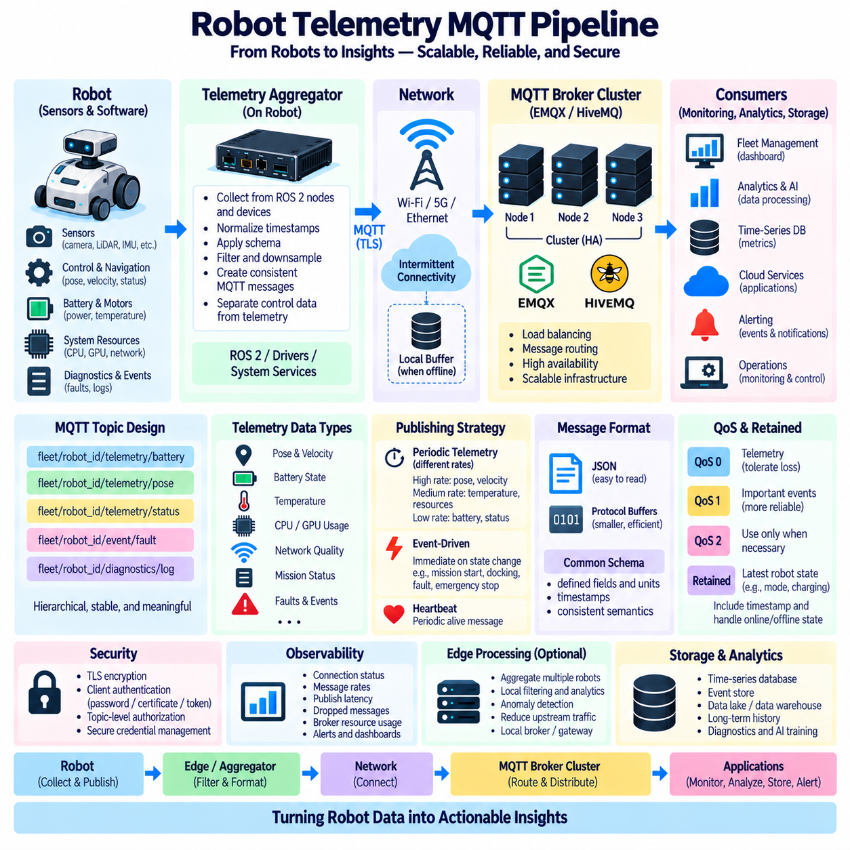
Robot telemetry is the continuous flow of operational information from robots to monitoring, analytics, fleet-management, and storage systems. An MQTT telemetry pipeline provides a publish/subscribe architecture that separates robot-side data producers from backend consumers. This separation allows sensors, controllers, edge computers, fleet services, databases, and cloud applications to evolve independently while exchanging information through a common messaging layer.
A practical telemetry pipeline begins inside the robot with data generated by sensors, control software, diagnostics, navigation modules, and computing resources. Typical telemetry includes pose, velocity, battery state, motor temperature, CPU and GPU utilization, network quality, localization confidence, mission status, and fault information. These signals have different rates and priorities, so they should not automatically be transmitted using identical policies.
Robot-side telemetry collection should separate real-time control data from information intended for remote observation. High-frequency control loops for motors, steering, stabilization, or collision avoidance should remain within deterministic local communication paths. MQTT is better suited to asynchronous telemetry, events, diagnostics, commands, and fleet-level information. This separation prevents cloud or network conditions from becoming dependencies of safety-critical robot control.
A telemetry aggregator can collect information from ROS 2 nodes, device drivers, system services, and application processes before publishing it through MQTT. Instead of allowing every component to independently manage external connections, the aggregator can normalize timestamps, apply schemas, filter unnecessary fields, reduce update rates, and organize data into consistent messages. This creates a controlled boundary between internal robot communication and external fleet communication.
Topic design should represent stable information semantics rather than temporary software implementation details. A hierarchy such as `fleet/robot_id/telemetry/battery`, `fleet/robot_id/telemetry/pose`, and `fleet/robot_id/event/fault` allows consumers to subscribe at different levels. Stable robot identifiers and predictable namespaces simplify fleet-wide monitoring, authorization, logging, debugging, and integration with downstream systems.
Telemetry frequency should be selected according to the operational value of each signal. Robot pose may require updates several times per second for fleet visualization, while battery health may change slowly enough for lower-frequency publication. Temperature, resource utilization, and network metrics can use moderate rates, whereas faults and safety-related events should normally be transmitted immediately when state changes occur. Rate control prevents unnecessary bandwidth and broker load.
Event-driven publishing complements periodic telemetry. Continuously sending an unchanged fault state or operating mode wastes bandwidth and processing resources. State transitions such as mission start, docking completion, localization loss, emergency stop activation, sensor failure, or low-battery warning can instead generate immediate event messages. Periodic heartbeat information can then confirm that the robot remains alive even when no significant event occurs.
Payload design should balance readability, bandwidth, and processing efficiency. JSON is convenient for development, debugging, and heterogeneous integrations because messages can be inspected easily. Binary formats such as Protocol Buffers may reduce message size and improve structured serialization for larger deployments. Regardless of encoding, each payload should have a defined schema so that producers and consumers interpret units, fields, timestamps, and status values consistently.
Timestamps are essential when telemetry passes through networks, brokers, queues, and storage systems. A message should normally contain the time associated with the original measurement or event rather than relying only on the time at which a backend service receives it. Clock synchronization across robots and infrastructure improves correlation between sensor observations, mission events, logs, and faults, particularly when multiple robots participate in coordinated operations.
Quality of Service should be assigned according to message semantics rather than applying the highest level to every topic. Frequently refreshed pose or resource telemetry may tolerate occasional loss and can often use QoS 0. Important alarms, mission transitions, or diagnostic events may justify QoS 1. QoS 2 introduces additional protocol exchanges and should be reserved for situations where its exactly-once delivery semantics provide sufficient value to justify the added overhead.
Retained messages can provide the latest known value for selected robot states. A newly connected dashboard may need the current operating mode, charging state, or availability without waiting for the next periodic update. Retention should be used carefully because stale state can become misleading after a robot disconnects. Timestamp information, Last Will messages, heartbeat monitoring, and explicit online/offline state handling help consumers interpret retained telemetry correctly.
Connectivity loss must be treated as a normal operating condition for mobile robots. Wireless coverage can degrade as robots move between access points, buildings, outdoor areas, or network zones. The telemetry pipeline should define which data can be discarded, which events should be buffered locally, and how much history should be retained during disconnection. After reconnection, backlog transmission should be rate-limited so that stored data does not overwhelm the broker or network.
An edge computer can provide an intermediate telemetry-processing layer between robots and centralized infrastructure. Edge services can aggregate multiple robot streams, perform local filtering, detect anomalies, compress information, and preserve selected data during WAN outages. This reduces unnecessary upstream traffic and allows site-level monitoring to continue even when cloud connectivity is unavailable. The edge layer can also provide a local MQTT broker or gateway when required.
The MQTT broker forms the distribution backbone of the telemetry pipeline. It receives publications from robots or edge gateways and routes them to authorized subscribers such as fleet managers, dashboards, alerting services, databases, analytics pipelines, and cloud applications. High-availability broker clusters can reduce single points of failure, while load balancing and capacity planning allow the messaging infrastructure to scale as robot count and telemetry volume increase.
Telemetry storage should distinguish between operational state and long-term historical data. MQTT brokers are messaging infrastructure rather than general-purpose historical databases. Subscriber services can transform MQTT messages into time-series databases, event stores, data lakes, or relational systems according to analytical requirements. This allows live dashboards to consume current information while engineering and AI pipelines retain selected history for diagnostics, optimization, and model development.
Security should be applied throughout the pipeline. TLS protects MQTT traffic in transit, while passwords, client certificates, or token-based authentication establish client identity. Topic-level authorization should ensure that each robot publishes only within approved namespaces and that applications subscribe only to required information. Credentials, private keys, and tokens require secure storage and lifecycle management, particularly when the fleet contains large numbers of independently deployed robots.
Observability should include both robot health and the telemetry infrastructure itself. Operators need visibility into connection status, message rates, publish latency, dropped messages, queue depth, reconnect frequency, broker resource utilization, and authentication failures. Monitoring these indicators makes it possible to distinguish an actual robot malfunction from a wireless problem, overloaded broker, storage delay, malformed payload, or backend service failure.
A representative pipeline can therefore flow from robot sensors and software through a telemetry aggregator, MQTT client, network, broker cluster, and multiple backend consumers. Local filtering controls data volume, topic namespaces organize information, QoS and retention express delivery behavior, security protects communication, and observability measures pipeline health. Edge processing and local buffering provide additional resilience when connectivity is intermittent.
The resulting architecture transforms raw robot signals into a scalable operational information stream. Robots remain responsible for immediate control and safety, while MQTT transports telemetry and events toward fleet-level intelligence. By combining structured topics, controlled publication rates, timestamps, schemas, buffering, broker high availability, secure identity, storage integration, and monitoring, the telemetry pipeline can support both individual robot diagnostics and large-scale fleet operations.

