Volume 06 Robot Communication and APIs

10. API Security

10.01 Robot API Threat Model: OWASP API Top 10
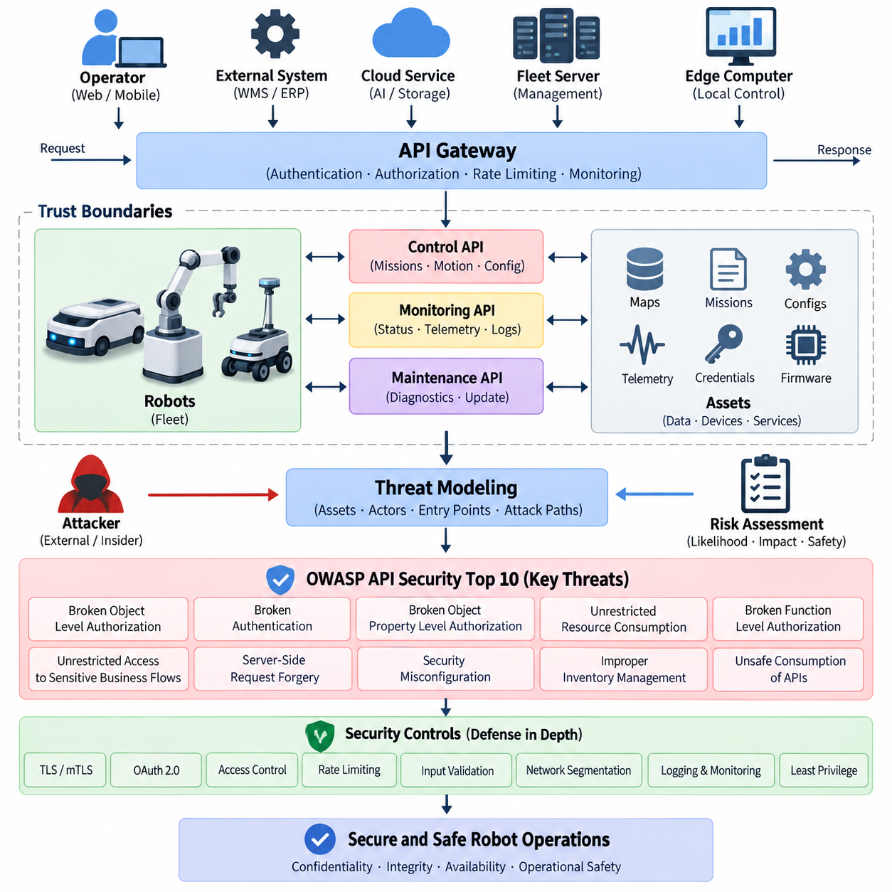
Robot APIs form a security boundary between digital services and physical machines. Unlike conventional web APIs, a compromised robot interface can affect motion, navigation, manipulators, charging, sensors, or safety-related operations. Threat modeling must therefore examine not only confidentiality and data integrity but also whether an attacker could translate an API weakness into an unsafe physical action or loss of operational control.
A useful threat model begins by identifying assets, trust boundaries, actors, entry points, and possible attack paths. Robot identities, mission commands, maps, localization data, telemetry, credentials, firmware information, and fleet configurations are important assets. Trust boundaries commonly exist between robots, edge computers, fleet servers, cloud platforms, operator consoles, mobile applications, and external WMS or ERP systems.
The OWASP API Security Top 10 provides a practical framework for analyzing many of these attack paths. It should not be treated as a complete robot cybersecurity standard, but as a structured checklist for API-layer weaknesses. Robotics adds physical consequences to traditional API risks, so every identified vulnerability should be evaluated in terms of cyber impact, operational impact, and potential influence on robot behavior.
Broken Object Level Authorization becomes especially important when API resources represent individual robots, missions, maps, charging stations, or payloads. An endpoint such as `/robots/{robot_id}/missions` must verify that the authenticated principal is authorized to access the specified robot rather than merely checking that a valid token exists. Otherwise, changing an identifier could expose or modify another robot's resources.
Broken Authentication can allow an attacker to impersonate an operator, robot, fleet controller, or service. Weak passwords, improperly validated tokens, long-lived credentials, insecure API keys, or insufficient certificate validation can undermine the entire control architecture. Robot systems should establish strong identities for both human and machine clients and apply credential expiration, rotation, revocation, and secure storage throughout their lifecycle.
Broken Object Property Level Authorization occurs when clients can read or modify fields that should not be available to their role. A maintenance interface, for example, might legitimately expose diagnostic parameters while a normal fleet operator should see only operational status. Explicit request and response schemas, field-level authorization, input allowlists, and separation of administrative properties reduce accidental exposure and unauthorized modification.
Unrestricted Resource Consumption can become both a cybersecurity and availability problem. Repeated requests for camera frames, maps, AI inference, route calculation, logs, or high-frequency telemetry may exhaust CPU, GPU, memory, network bandwidth, storage, or battery resources. Rate limits should therefore consider robot-specific resources rather than request counts alone, with quotas and concurrency controls adapted to the computational cost of each operation.
Broken Function Level Authorization appears when users or services can invoke privileged functions simply because an endpoint is reachable. APIs for emergency state changes, remote driving, mission cancellation, map replacement, configuration, diagnostics, or software updates require stronger authorization than ordinary status queries. Roles and permissions should be enforced server-side, and high-impact commands may require additional policy or operational-state checks.
Unrestricted Access to Sensitive Business Flows concerns legitimate API functions that can be abused at scale or in an unintended sequence. In robotics, examples include repeatedly creating missions, reserving chargers, requesting expensive AI inference, dispatching robots, or triggering automated workflows. Protection requires understanding the business and operational meaning of API calls, not merely validating their syntax and authentication credentials.
Server-Side Request Forgery becomes relevant when robot or fleet services retrieve URLs supplied directly or indirectly by clients. Map downloads, firmware packages, diagnostic resources, webhook callbacks, AI models, and cloud storage objects may create such paths. Without destination restrictions, an attacker could attempt to reach internal services or protected network resources. URL validation, destination allowlists, network segmentation, and restricted egress reduce this exposure.
Security Misconfiguration includes unnecessary endpoints, default credentials, permissive cross-origin settings, verbose error messages, exposed debugging interfaces, weak TLS configurations, and incorrectly configured gateways. Robot deployments are particularly vulnerable to configuration drift because software may exist simultaneously on robots, edge devices, fleet servers, and cloud services. Secure baselines and automated configuration verification should therefore accompany deployment.
Improper Inventory Management emerges when organizations lose visibility of API versions, endpoints, test interfaces, deprecated services, or robot software generations. Long-lived fleets may contain different firmware and API versions operating simultaneously. An accurate inventory should connect every exposed interface with its owner, version, deployment location, authentication mechanism, supported robot generation, lifecycle status, and planned retirement date.
Unsafe Consumption of APIs addresses the assumption that data received from another API is trustworthy. Robots increasingly depend on cloud AI, mapping, traffic management, identity, warehouse, building, and third-party fleet services. Responses from these systems must still be authenticated, validated, bounded, and handled safely. A trusted provider does not eliminate risks caused by compromised accounts, malformed responses, integration errors, or upstream failures.
Robot threat modeling should extend these categories across the complete command path. A fleet instruction may travel from an operator application through an API gateway, cloud service, message broker, edge server, robot middleware, and finally a motion controller. Authentication at the first interface alone is insufficient. Identity, authorization, message integrity, freshness, command semantics, and trust transitions must be evaluated at each boundary.
Replay and command-manipulation threats deserve particular attention because apparently valid messages may still be dangerous. Command identifiers, timestamps, expiration periods, sequence numbers, nonces, or equivalent freshness mechanisms can help reject duplicated or stale requests. Idempotency rules are also important for mission and actuator-related operations, because network retries must not unintentionally cause the same physical action to be executed multiple times.
The threat model should distinguish monitoring APIs from control APIs. Telemetry disclosure can reveal maps, robot positions, operational schedules, facility layouts, or production activity, while compromise of a control interface may directly alter movement or missions. Separating read, command, configuration, maintenance, and software-update privileges enables more precise authorization and reduces the consequences of compromised credentials.
Defense in depth is essential because no single security mechanism can protect a distributed robotic system. TLS or mTLS can protect communication channels, OAuth 2.0 or comparable identity mechanisms can control access, and API gateways can enforce policies such as rate limiting and request validation. These controls should be complemented by network segmentation, least privilege, secure credential storage, audit logging, anomaly detection, and controlled key rotation.
Risk assessment should combine conventional cybersecurity criteria with physical and operational consequences. A vulnerability affecting a low-value telemetry field may have limited impact, whereas unauthorized modification of navigation constraints or safety-related parameters can create significant hazards. Threats should therefore be evaluated according to likelihood, technical impact, operational disruption, safety implications, recoverability, and the number of robots potentially affected.
A robot API threat model is not a one-time design document. New endpoints, cloud integrations, AI services, fleet functions, firmware releases, and third-party systems continuously modify the attack surface. Threat models should be revisited during architecture changes and supported by automated security testing, API schema validation, fuzzing, penetration testing, dependency monitoring, audit-log analysis, and periodic review of identities and privileges.
Ultimately, secure robot APIs require the OWASP API threat categories to be interpreted through the realities of physical systems. The objective is not simply to prevent unauthorized access to software resources, but to maintain trustworthy control from application to robot. A mature design assumes that components can fail or be compromised and ensures that authentication, authorization, validation, isolation, monitoring, and safety constraints limit the resulting consequences.

10.02 TLS 1.3 Configuration and Cert Management Auto [w/Code]
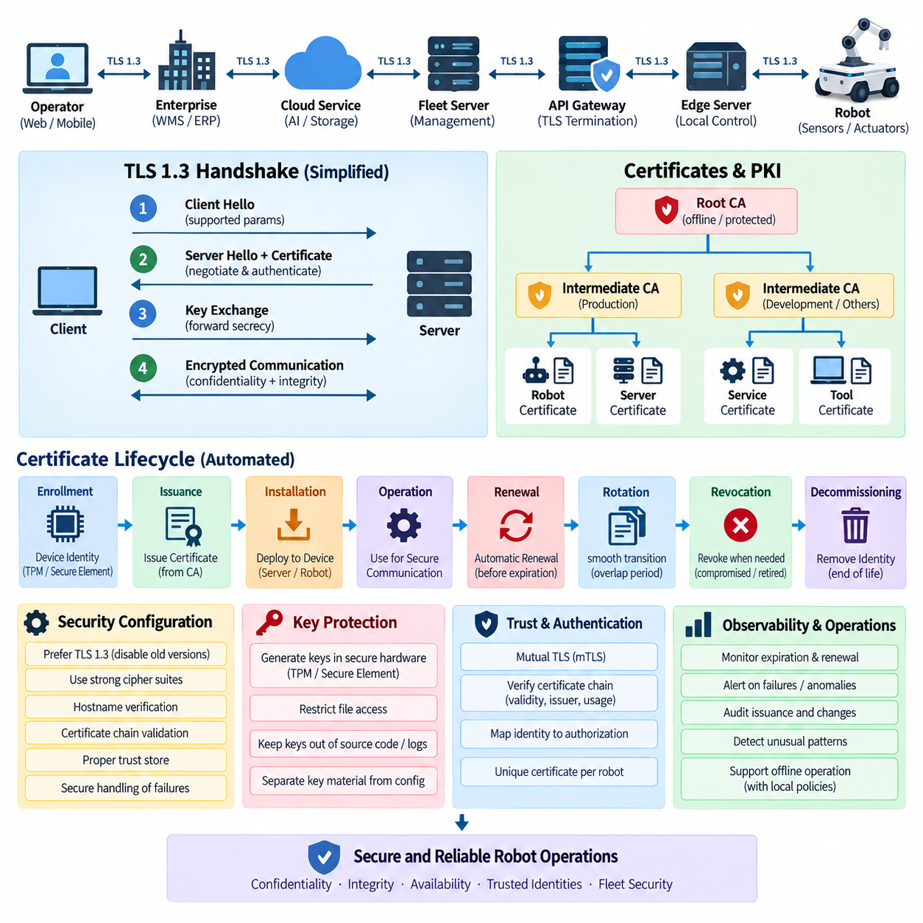
TLS 1.3 provides the transport-security foundation for robot APIs that exchange commands, telemetry, diagnostics, configuration data, and software-management information across untrusted or shared networks. Compared with earlier TLS generations, it simplifies protocol negotiation, removes obsolete cryptographic mechanisms, and reduces handshake overhead. In robotic systems, these properties help protect confidentiality and integrity without unnecessarily increasing communication latency.
A typical robot deployment contains multiple encrypted communication paths rather than a single TLS connection. Robots may communicate with edge servers, fleet-management systems, API gateways, cloud services, message brokers, maintenance tools, and external enterprise applications. Each connection crosses a different trust boundary and may require a different certificate policy. TLS configuration should therefore be designed as part of the overall robot communication architecture rather than added independently to individual APIs.
TLS 1.3 begins with a handshake in which the client and server negotiate supported parameters, establish shared cryptographic secrets, and authenticate the server through its certificate. Modern key-exchange mechanisms provide forward secrecy, meaning that later compromise of a long-term private key should not automatically expose previously captured sessions. After the handshake, application traffic is protected using authenticated encryption, providing both confidentiality and integrity for transmitted API messages.
Secure configuration should explicitly prefer TLS 1.3 while controlling compatibility with older clients according to deployment requirements. Obsolete SSL and early TLS versions should not remain enabled simply for convenience. Cipher configuration should follow the implementations supported by the selected TLS library and platform, while unnecessary legacy algorithms should be removed. Configuration must also include hostname verification, certificate-chain validation, appropriate trust stores, and secure handling of negotiation failures.
Certificates bind cryptographic identities to robots, servers, gateways, or services. In a large fleet, every robot should normally possess a unique machine identity instead of sharing one certificate and private key across all units. Unique identities enable individual authorization, auditing, certificate expiration, and revocation. If one robot is compromised, its credential can be disabled without forcing the organization to replace the credentials of every other robot in the fleet.
A public key infrastructure, or PKI, provides the trust framework required to issue and manage these certificates. A common architecture uses an offline or strongly protected root certificate authority and one or more intermediate certificate authorities for operational issuance. Separate intermediates may be assigned to production robots, development systems, backend services, or manufacturing environments, reducing the impact of a compromised issuing authority and supporting clearer lifecycle policies.
Certificate provisioning begins before a robot enters normal operation. During manufacturing, commissioning, or secure enrollment, the device establishes an initial identity and receives the credentials required to join the operational environment. Private keys should preferably be generated and retained inside protected hardware such as a TPM, secure element, or equivalent trusted key storage when available. Exportable private-key files should be minimized because copying them effectively duplicates the device identity.
Manual certificate management becomes impractical once a fleet grows beyond a small number of robots. Automated certificate management should therefore cover enrollment, issuance, installation, renewal, validation, rotation, revocation, and retirement. The automation service must maintain an authoritative relationship between certificate identity and robot identity so that a certificate cannot accidentally be issued to the wrong device or remain active after the corresponding robot has been decommissioned.
Automatic renewal reduces the operational risk created by expired certificates. Robots should begin renewal sufficiently before expiration and use retry mechanisms that tolerate temporary network outages or unavailable certificate services. Renewal schedules should avoid causing the entire fleet to request certificates simultaneously. Randomized renewal windows, staged operations, and local retry queues can prevent a certificate-management service from becoming overloaded when thousands of devices approach expiration.
Short-lived certificates can reduce the period during which stolen credentials remain useful, but certificate lifetime must reflect operational realities. Robots may remain offline for extended periods, operate on isolated industrial networks, or lose cloud connectivity while continuing local missions. Certificate policy must therefore balance security with availability. Edge-based enrollment services, local certificate authorities, or controlled grace strategies may be required for environments where continuous external connectivity cannot be assumed.
Mutual TLS, or mTLS, extends TLS by requiring both sides of a connection to authenticate with certificates. This is particularly useful for robot-to-server, edge-to-cloud, and service-to-service communication because the server can verify the identity of the connecting robot while the robot verifies the server. The authenticated certificate identity can then be mapped to authorization policies that define which APIs, robot groups, missions, or resources each machine is permitted to access.
Certificate validation must go beyond checking whether a certificate file exists. The receiving system should verify the certificate chain, validity period, expected issuer, identity attributes, intended usage, and revocation status where applicable. Server clients must also verify that the certificate corresponds to the expected service identity. Disabling certificate verification during development may simplify testing, but such exceptions must never silently migrate into production robot configurations.
Revocation is required when a private key is suspected of compromise, a robot is stolen, a service is retired, or an identity should no longer be trusted. Certificate revocation lists and online status mechanisms can support this process, although their suitability depends on network architecture and availability requirements. Short certificate lifetimes can complement revocation by limiting credential exposure, but they do not eliminate the need for an emergency mechanism to distrust a compromised identity.
Private-key protection is as important as certificate validation. Keys stored as ordinary files can be exposed through filesystem access, backups, diagnostic packages, container images, or incorrectly configured deployment scripts. Access permissions should be restrictive, secrets should not appear in source repositories or logs, and key material should be separated from application configuration. Hardware-backed storage further reduces the possibility of extracting a robot's long-term identity.
Certificate rotation should be designed so that communication remains available during credential transitions. Systems may temporarily accept both the current and replacement trust chains while certificates are updated across robots, gateways, and servers. This overlap must be controlled and time-bounded. Abrupt replacement of a certificate authority without coordinated trust-store updates can disconnect an entire fleet even when every individual component is functioning correctly.
Robots operating in offline-first architectures require special certificate-management logic. A robot should not immediately become unsafe or unusable merely because a remote certificate authority cannot be reached. Existing valid sessions and credentials can support continued local operation according to policy, while renewal requests are queued until connectivity returns. However, offline resilience must not become unlimited acceptance of expired or unverified credentials, especially for remote-control interfaces.
TLS termination must also be carefully located. An API gateway or reverse proxy may terminate an external TLS connection and establish another protected connection toward an internal service. If traffic becomes unencrypted after termination, the internal network becomes an implicit trust zone that attackers may exploit. Sensitive robot command paths should preserve encryption and authenticated identities across internal service boundaries, particularly between gateways, fleet servers, edge nodes, and robots.
Observability is necessary for reliable certificate automation. Monitoring systems should track certificate expiration, renewal failures, unknown issuers, handshake errors, rejected identities, unusual authentication patterns, and changes to trust stores. Alerts should be generated well before expiration becomes operationally critical. Audit records should identify which certificate was issued to which robot, when it was renewed or revoked, and which authority performed the operation.
Automation itself becomes a high-value security component because compromise of the certificate-management service could allow an attacker to create trusted identities. Enrollment services, certificate authorities, signing keys, automation credentials, and administrative interfaces therefore require strict access control and segmentation. High-value signing keys should receive stronger protection than ordinary application credentials, and certificate issuance events should be independently logged and monitored.
Testing should include more than confirming that HTTPS or another TLS-protected protocol successfully connects. Robot API validation should test expired certificates, unknown certificate authorities, incorrect service identities, revoked credentials, damaged certificate chains, clock errors, failed renewals, network interruptions, and certificate rotation. Fleet-scale testing should additionally verify that simultaneous or staged renewal operations do not overload gateways, enrollment services, or network infrastructure.
A mature TLS 1.3 architecture combines secure protocol configuration with automated identity lifecycle management. Encryption protects data in transit, certificates establish machine identities, PKI defines trust relationships, and automation keeps those relationships operational throughout deployment. For robotic systems, the objective is not merely to display a secure connection indicator, but to maintain authenticated and encrypted communication from robot commissioning through operation, maintenance, certificate rotation, and final decommissioning.

10.03 API Key Management and Secret Vault Integration [w/Code]
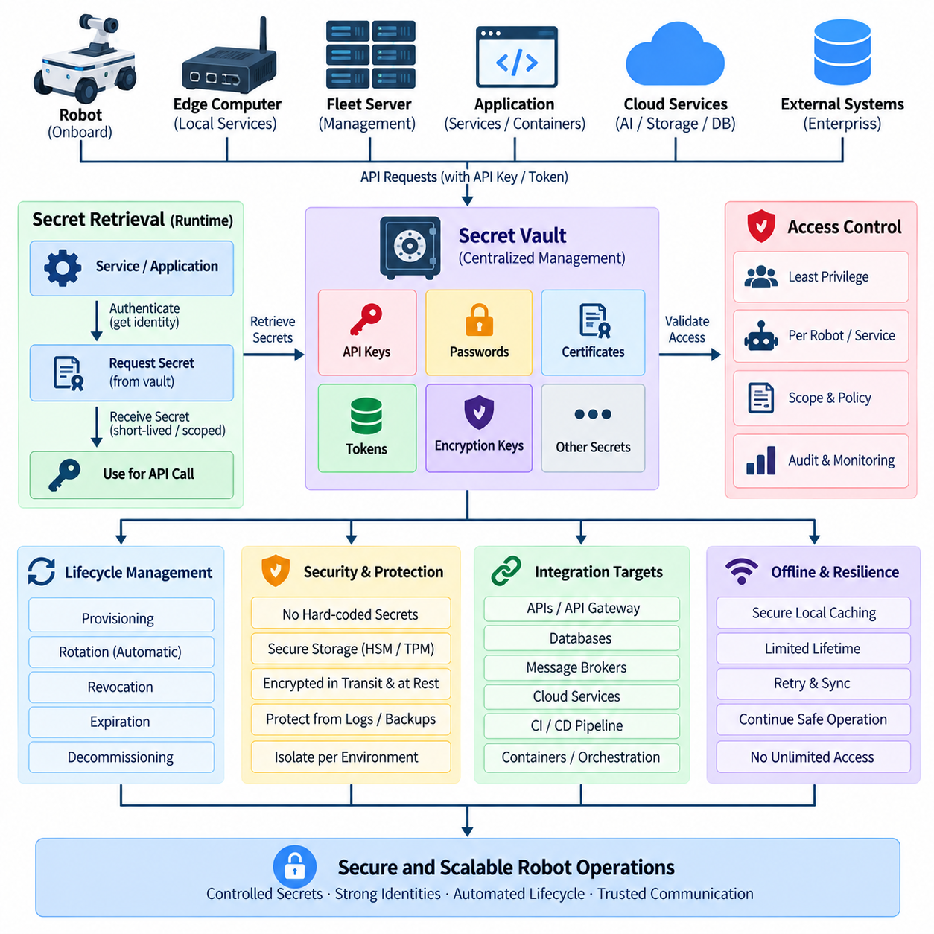
API keys and secrets are fundamental credentials in robot communication architectures because they allow software components to authenticate when accessing APIs, cloud services, databases, message brokers, AI platforms, storage systems, and enterprise applications. In a distributed robot environment, these credentials may exist across robots, edge computers, fleet servers, API gateways, containers, and cloud workloads, making centralized lifecycle management essential.
An API key is typically a machine-readable credential associated with an application, service, robot, or integration rather than a human user. Although API keys are simple to implement, possession of a valid key may be sufficient to access protected resources. They should therefore be treated as sensitive secrets rather than ordinary configuration values, with explicit ownership, scope, expiration, rotation, revocation, and auditing policies throughout their operational lifecycle.
Robot systems should avoid sharing a single API key across an entire fleet. If hundreds of robots use the same credential, compromise of one device can expose every system using that key and make individual revocation difficult. Assigning credentials to specific robots, services, workloads, or deployment groups creates smaller security domains. This approach also improves traceability because API activity can be associated with a particular machine identity or software component.
Secrets should never be embedded directly in application source code, configuration templates, container images, firmware repositories, or deployment scripts. Hard-coded credentials can remain in version-control history even after the visible value has been removed. They may also propagate through backups, development machines, CI/CD artifacts, and copied software packages. Applications should instead obtain secrets dynamically from an authorized secret-management mechanism at runtime.
Environment variables are commonly used to separate secrets from source code, but they should not automatically be considered a complete secret-management solution. Environment values may become visible through debugging tools, process inspection, crash reports, container metadata, or incorrectly configured logs. They can provide a convenient delivery mechanism, but the authoritative secret should remain inside a controlled vault and be exposed to the application only when required.
A secret vault provides centralized storage and controlled distribution for API keys, passwords, database credentials, encryption keys, certificates, tokens, and other sensitive values. Instead of allowing each robot service to maintain independent credential files, applications authenticate to the vault and request only the secrets they are authorized to use. This architecture separates secret ownership from application configuration and enables consistent security policies across heterogeneous robot software.
Vault integration begins with the bootstrap identity used by an application to authenticate to the vault itself. Storing a permanent vault password beside the application simply moves the original problem to another location. Strong designs use machine identities, workload identities, certificates, hardware-backed credentials, or platform-provided identity mechanisms. The initial identity should provide only enough privilege to obtain the specific runtime credentials required by the workload.
Access control within the vault should follow the principle of least privilege. A navigation service requiring a map API credential should not automatically receive database administrator passwords or firmware-signing secrets. Policies should define which identity can read, create, update, rotate, or revoke each secret. Separating secrets by application, robot group, environment, and operational purpose limits lateral movement if one service or credential becomes compromised.
Dynamic secrets provide stronger protection than long-lived static credentials when supported by the target service. Instead of retrieving a permanent database password, an application may request a temporary credential created specifically for that session or workload. The vault can assign a short time-to-live, automatically revoke the credential after expiration, and generate a new one when required. This reduces the useful lifetime of credentials captured by an attacker.
Secret rotation is essential because credentials should not remain valid indefinitely. Rotation replaces an existing secret with a new value according to a scheduled policy or in response to a suspected compromise. Robot fleets require carefully coordinated rotation because devices may be temporarily offline. Systems should support controlled overlap, versioned secrets, retry logic, and staged deployment so that credential changes do not unexpectedly disconnect large numbers of robots.
Automatic rotation should distinguish between changing a value inside the vault and changing the actual credential accepted by the target system. Updating only the stored copy is insufficient if the old API key remains valid at the external service. A complete rotation workflow generates or activates the replacement credential, updates authorized consumers, verifies successful operation, and then disables the previous credential after an appropriate transition period.
Revocation provides an immediate response when a credential is exposed, a robot is stolen, an employee or service no longer requires access, or an integration is retired. Security teams should be able to identify all systems associated with the compromised secret and invalidate access without waiting for normal expiration. Unique credentials and centralized inventories make this process substantially easier than environments where keys have been manually copied between devices.
Robots operating with intermittent connectivity require an offline-aware secret strategy. A robot cannot depend on contacting a remote vault before every API operation if communication may disappear during a mission. Short-term caching may therefore be necessary, but cached secrets should be encrypted, access-controlled, and retained only for the required period. Security policy should distinguish functions that may continue offline from sensitive remote operations that require fresh authorization.
Hardware-backed security can strengthen secret protection on robots and edge devices. A trusted platform module, secure element, hardware security module, or equivalent protected execution capability can safeguard bootstrap keys and cryptographic identities. The application can use the protected key for authentication without directly exposing its raw value. This reduces the risk that filesystem compromise or copied storage media will reveal credentials that can be reused elsewhere.
Containerized robot services introduce additional secret-management concerns. Secrets should not be included in container images or image build arguments that may persist in build history. Orchestration platforms can inject secrets through controlled runtime mechanisms, while external vault integrations can provide short-lived credentials to individual workloads. Access should be based on workload identity rather than assuming that every container running on the same robot deserves identical privileges.
CI/CD pipelines also require vault integration because build, test, signing, deployment, and infrastructure automation frequently access sensitive credentials. Pipeline secrets should be retrieved only by authorized jobs and should not appear in command output, logs, test reports, or generated artifacts. Production credentials should be isolated from development and testing environments so that compromise of a developer account or test pipeline does not automatically provide production access.
Logging requires special attention because secrets can accidentally appear in HTTP headers, query parameters, exception traces, diagnostic dumps, or debug messages. API gateways and applications should redact sensitive fields before storing logs. Observability systems should record credential identifiers, access decisions, and relevant metadata without recording the secret value itself. This preserves forensic visibility while avoiding creation of a secondary repository containing exposed credentials.
Vault availability becomes an architectural concern because centralized secret management can create a dependency shared by many services. High availability, replication, secure backup, disaster recovery, and controlled local caching should therefore be considered. However, availability mechanisms must not weaken security by distributing unprotected master keys or creating uncontrolled replicas. Recovery procedures should be tested so that loss of a vault node does not permanently prevent fleet operation.
Auditability is one of the major advantages of centralized secret management. The organization should be able to determine which identity requested a secret, which resource was accessed, when the request occurred, and whether access was allowed. Repeated failures, unusual access locations, unexpected secret retrieval, or sudden increases in credential usage can indicate compromise and should feed security monitoring and anomaly-detection systems.
Secret inventory should cover the entire lifecycle from creation to retirement. Every production secret should have an owner, purpose, associated system, permitted consumers, creation time, expiration policy, rotation schedule, and revocation procedure. Unknown or ownerless credentials should be treated as security debt. Automated discovery and policy enforcement can help identify long-lived keys, duplicated secrets, excessive permissions, and credentials that remain active after services have been decommissioned.
A mature robot API security architecture combines unique identities, least-privilege authorization, centralized vault storage, dynamic credentials, automated rotation, rapid revocation, secure runtime delivery, and comprehensive auditing. The objective is to eliminate unmanaged secrets scattered throughout robots and infrastructure. When credential management becomes an automated lifecycle service, compromise can be contained to smaller trust domains while secure robot, edge, fleet, cloud, and enterprise communication remains maintainable at scale.

10.04 OAuth 2.0 / OIDC-Based Robot API Auth [w/Code]
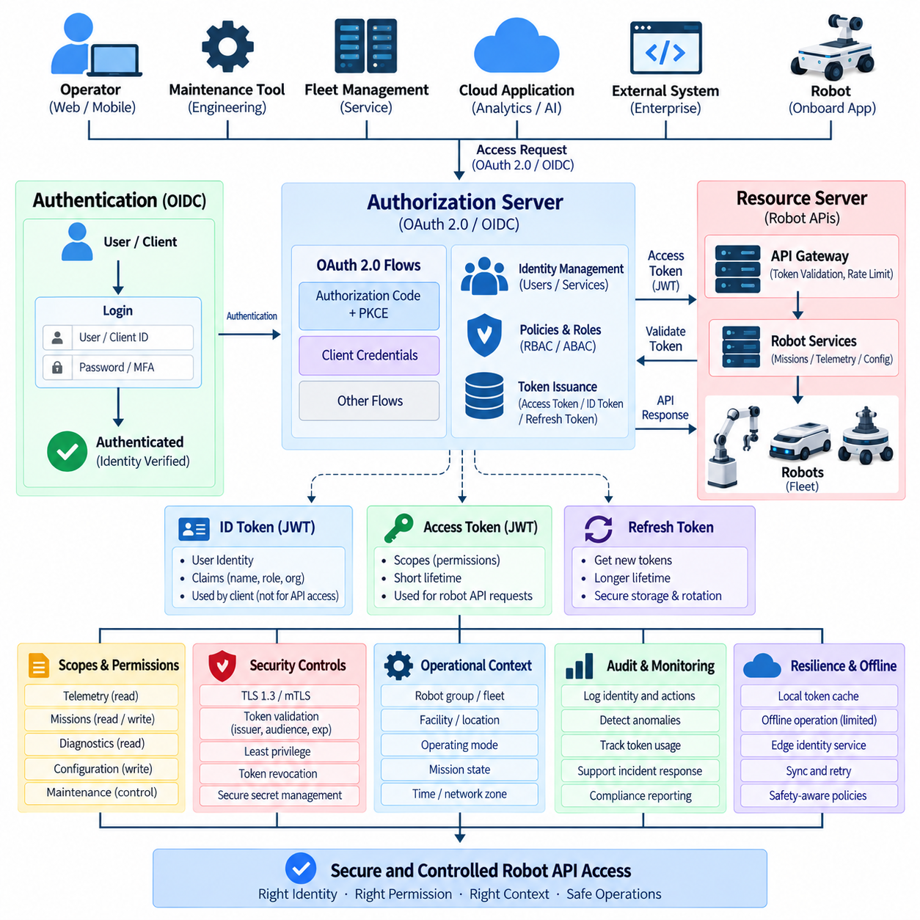
OAuth 2.0 provides an authorization framework for controlling access to robot APIs without requiring applications to repeatedly exchange user passwords or permanent credentials. In robotic systems, it can govern access from operator consoles, mobile applications, fleet-management services, cloud platforms, maintenance tools, and external enterprise systems. Access is represented by limited tokens rather than unrestricted credentials, enabling more precise control over robot resources and operations.
OpenID Connect, commonly called OIDC, adds an identity layer on top of OAuth 2.0. OAuth primarily answers whether a client is authorized to access a resource, while OIDC provides information about the authenticated user's identity. Together they allow a robot platform to authenticate operators and applications, issue tokens through a trusted identity provider, and authorize API requests according to identity, role, scope, organization, robot group, and operational context.
A typical architecture separates the authorization server from the robot API resource server. The authorization server authenticates users or client applications and issues tokens, while the resource server protects robot APIs and validates the presented access token. This separation prevents every robot service from implementing its own login mechanism and establishes a common trust framework across fleet servers, API gateways, edge systems, and cloud services.
OAuth defines different authorization flows for different client types. Interactive operator applications commonly use the Authorization Code flow with Proof Key for Code Exchange, or PKCE, while machine-to-machine services can use the Client Credentials flow when no human user is involved. Selecting the correct flow is important because a browser application, backend fleet service, robot workload, and maintenance tool have different security characteristics and credential-protection capabilities.
In an Authorization Code with PKCE flow, the operator authenticates through the identity provider rather than directly supplying credentials to the robot application. The client creates a temporary code verifier and corresponding challenge, receives an authorization code after authentication, and exchanges the code together with the verifier for tokens. PKCE reduces the usefulness of intercepted authorization codes and is particularly important for public clients that cannot safely maintain a permanent client secret.
The Client Credentials flow is appropriate for trusted service-to-service communication where a workload acts on its own behalf. A fleet optimizer, cloud analytics service, or backend integration may authenticate using its assigned client identity and obtain an access token with restricted permissions. This flow should not be used to imitate a human operator, and each service should receive a unique identity so that permissions, auditing, rotation, and revocation can be managed independently.
Access tokens represent authorization granted to a client. They should have limited lifetimes and narrowly defined privileges so that theft does not provide indefinite access to robot functions. A token intended only to read telemetry should not authorize mission creation, remote driving, configuration changes, or software updates. Token design therefore connects authentication with the principle of least privilege and with the operational safety requirements of each robot API.
Scopes provide a practical mechanism for expressing API permissions. A robot platform might distinguish permissions conceptually as telemetry read, mission read, mission write, diagnostics read, configuration write, or maintenance control. Scopes should represent meaningful capabilities rather than broad unrestricted access. High-impact operations can additionally require roles, policies, robot-group restrictions, or contextual checks instead of relying on a single general-purpose scope.
OIDC introduces the ID token, which communicates authenticated identity information to the client. An ID token is different from an OAuth access token and should not automatically be used as a substitute for API authorization. The application uses identity claims to understand the authenticated subject, while protected robot APIs should validate the access token intended for them. Maintaining this distinction prevents identity information from being incorrectly treated as permission to execute robot commands.
JWT is frequently used as a format for access and ID tokens. A resource server can validate a signed JWT locally by checking its cryptographic signature and relevant claims. Important checks include the issuer, audience, expiration time, validity timing, token type, and authorized scopes. Accepting a correctly formatted JWT without verifying these properties can allow a token issued for another service or purpose to be incorrectly accepted by a robot API.
The issuer identifies the trusted authorization or identity system that created the token, while the audience identifies the service for which the token is intended. Robot APIs should reject tokens issued by unknown authorities or intended for different resources. This is particularly important when an organization operates multiple cloud applications, development environments, fleet systems, and external integrations that may use the same identity infrastructure but require different authorization boundaries.
Token expiration limits the period during which a stolen access token can be abused. Short-lived access tokens are generally preferable for sensitive robot operations, while refresh mechanisms can obtain new tokens without forcing repeated interactive authentication. Refresh tokens require stronger protection because they may enable longer-term access. Their use should be limited to appropriate client types and supported by rotation, expiration, revocation, and secure storage policies.
Robot APIs should distinguish human identities from machine identities. An operator may receive permissions based on organizational role and assigned fleet responsibilities, while a robot or backend service operates using a workload identity. Combining all activity under shared service accounts reduces accountability. Explicit identities allow audit systems to determine whether a command originated from a human operator, fleet controller, automated scheduler, maintenance application, or another robot service.
Role-based access control can complement OAuth scopes by grouping permissions according to operational responsibilities. A monitoring operator may view status and telemetry, a dispatcher may create or cancel missions, and an authorized maintenance engineer may access diagnostic or configuration functions. Role definitions should remain aligned with actual operational duties, while sensitive capabilities should be separated to prevent ordinary accounts from acquiring unnecessary control over physical robot behavior.
Attribute- and policy-based authorization can provide finer control when roles alone are insufficient. Authorization decisions may consider robot identity, fleet membership, facility, operating mode, mission state, network zone, time, or other trusted attributes. For example, possession of a valid maintenance scope does not necessarily mean that configuration changes should be permitted while a robot is executing a safety-critical mission. Authentication establishes identity, but operational policy determines whether an action is acceptable now.
API gateways are useful enforcement points for OAuth and OIDC because they can validate tokens before requests reach internal robot services. The gateway can verify issuer, audience, signature, expiration, scopes, and other claims, then apply rate limits and routing policies. Internal services should nevertheless preserve appropriate authorization checks, especially for high-impact commands, because relying entirely on a perimeter gateway creates a single security boundary around many sensitive components.
Distributed robot architectures must also address connectivity failures. Cloud-based identity services may become temporarily unreachable while robots and edge systems continue operating locally. Previously issued valid credentials may support limited operation according to policy, but offline behavior must be explicitly designed. Local authorization caches or edge identity services can improve resilience, while remote control and highly privileged actions may require stronger freshness guarantees than routine local telemetry processing.
Revocation becomes necessary when an account is compromised, a device is lost, a service is retired, or privileges must be removed immediately. Short token lifetimes reduce exposure but do not solve every revocation requirement. Systems may combine token expiration, refresh-token revocation, session termination, credential disabling, and centralized policy changes. The response mechanism should reflect how quickly a compromised identity could influence physical robot operations.
Transport security remains mandatory even when OAuth tokens are used. Access tokens are bearer credentials in many deployments, meaning that an attacker who obtains a token may be able to use it until expiration. TLS 1.3 protects tokens and API messages during transmission, while mTLS or sender-constrained mechanisms can provide stronger binding between credentials and communicating machines. OAuth authorization and transport-layer security therefore address complementary parts of the security architecture.
Audit logging should connect identity, authorization, and physical actions. Records should capture the authenticated subject, client application, requested robot, API operation, relevant scope or role, authorization result, timestamp, and resulting command status without unnecessarily exposing token contents. This enables incident investigation and anomaly detection, such as identifying an account that suddenly issues commands to unfamiliar robots or invokes maintenance functions outside its normal pattern.
A mature OAuth 2.0 and OIDC architecture establishes centralized identity while maintaining distributed enforcement close to robot resources. Operators authenticate through trusted identity providers, services receive dedicated machine identities, access tokens carry constrained authorization, and robot APIs validate both token legitimacy and operational permission. Combined with TLS, secure secret management, least privilege, auditing, and safety-aware policy enforcement, this creates scalable authentication and authorization for robot, edge, fleet, cloud, and enterprise APIs.

10.05 API Gateway Security: Rate Limit / WAF
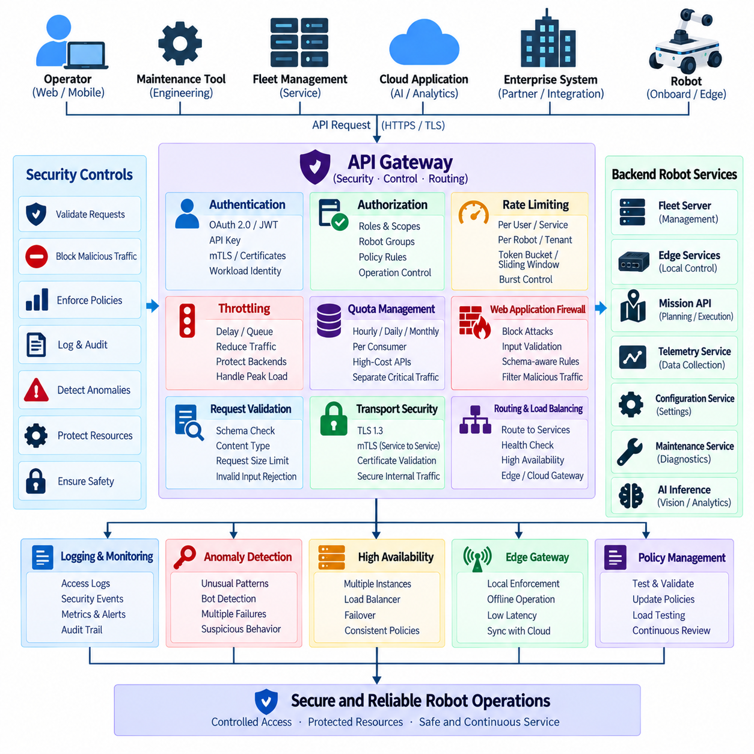
An API gateway provides a controlled entry point between API clients and distributed robot services. Instead of exposing fleet servers, edge services, telemetry endpoints, mission APIs, and maintenance interfaces directly, requests pass through a centralized enforcement layer. The gateway can authenticate clients, validate requests, apply traffic policies, route calls, and record security events before communication reaches operational robot resources.
In a robot architecture, API gateway security has consequences beyond protecting conventional web services. Excessive or malicious requests may consume edge CPU, network bandwidth, database capacity, AI inference resources, or communication channels required for robot operation. Requests targeting mission, navigation, configuration, or remote-control functions can also influence physical behavior. Gateway policies should therefore consider both cybersecurity risk and operational safety.
The gateway should authenticate every protected request before forwarding it to backend services. Depending on the architecture, authentication may use OAuth 2.0 access tokens, JWTs, API keys, mTLS certificates, or workload identities. Authentication verifies who is communicating, while authorization determines what that identity may perform. Invalid, expired, incorrectly signed, or improperly scoped credentials should be rejected before they enter the internal robot network.
Authorization policies should distinguish API operations according to their operational impact. Reading telemetry is fundamentally different from creating missions, changing navigation parameters, initiating maintenance functions, or commanding motion. The gateway can evaluate roles, scopes, robot groups, service identities, and other attributes before routing a request. Sensitive operations may require additional authorization checks inside the destination service to maintain defense in depth.
Rate limiting controls how frequently a client can invoke an API during a defined period. A simple policy may restrict requests per second or minute, but robot systems often require more contextual rules. Telemetry queries, map downloads, route calculations, AI inference requests, and motion-related commands have different resource costs and timing requirements. Limits should therefore be defined according to API function, client identity, robot group, and system capacity.
Several rate-limiting algorithms can support these policies. Fixed-window counters are simple but can create bursts around window boundaries, while sliding-window approaches provide smoother enforcement. Token-bucket algorithms allow controlled bursts while maintaining a long-term average rate, and leaky-bucket mechanisms can regulate traffic into a more consistent flow. The appropriate algorithm depends on whether the API prioritizes responsiveness, fairness, predictability, or protection of constrained resources.
Rate limits should normally be associated with authenticated identities rather than only source IP addresses. Multiple robots or users may legitimately share an address behind network address translation, while attackers can distribute requests across many addresses. Per-user, per-service, per-robot, per-token, or per-tenant limits provide more meaningful control. IP-based controls can remain useful as an additional signal, particularly for anonymous or suspicious traffic.
Throttling differs slightly from outright rejection because it controls the pace at which requests are processed. A gateway may delay, queue, or reduce traffic when a service approaches its capacity. This can protect fleet-management systems during temporary demand spikes. However, robot command APIs require careful treatment because delaying an old command may be more dangerous than rejecting it. Time-sensitive requests should include expiration or freshness semantics so stale commands are not executed later.
Quota management extends rate limiting across longer periods. External integrations, cloud applications, or third-party services may receive hourly, daily, or monthly usage allocations. Quotas can prevent one consumer from exhausting shared resources and can also control expensive operations such as cloud AI inference or high-volume data export. Internal safety-critical communication should be separated from lower-priority workloads so business traffic cannot starve essential robot services.
A Web Application Firewall, or WAF, examines HTTP traffic for suspicious patterns before requests reach protected APIs. It can detect or block classes of attacks such as injection attempts, malformed requests, protocol abuse, suspicious payloads, and known malicious signatures. In a robot API architecture, a WAF is most effective as one layer of defense rather than a replacement for secure API design, authentication, authorization, and application-level input validation.
WAF policies must be tuned to the actual robot API schema. Generic rules may identify common web attacks, but robot APIs contain domain-specific structures such as coordinates, velocities, mission identifiers, map references, robot IDs, configuration values, and diagnostic parameters. Schema-aware validation can reject unexpected fields, invalid content types, oversized payloads, malformed JSON, and values outside defined structural constraints before they consume backend resources.
Input validation should remain enforced by backend services even when a gateway or WAF validates requests. A gateway can verify syntax and general schema requirements, while the robot service understands operational semantics. For example, a request may contain syntactically valid velocity or destination values but still violate the robot's operational limits. Security validation and robot safety validation therefore operate at different layers and should reinforce each other.
Request-size limits protect gateways and backend services from oversized payloads that consume memory, processing time, or bandwidth. Different endpoints may require different limits because a small command API and a map-upload API have fundamentally different data characteristics. Header size, body size, multipart uploads, decompressed content, and nested JSON structures should be bounded according to legitimate operational requirements rather than accepting arbitrary input sizes.
API gateways can also enforce protocol and transport security. External connections should use TLS, while sensitive machine-to-machine communication may use mTLS to authenticate both endpoints. The gateway should reject insecure protocol versions and improperly validated certificates according to policy. If TLS terminates at the gateway, communication toward internal fleet and edge services should remain protected where the network cannot be assumed inherently trustworthy.
Bot detection and anomaly-based traffic controls can complement static WAF rules. Repeated authentication failures, rapidly changing robot identifiers, unusual request sequences, excessive mission creation, abnormal scanning behavior, or access from unexpected environments may indicate automated abuse. Detection systems can combine gateway logs, identity information, request patterns, and historical behavior to identify activity that individual requests would not reveal by themselves.
Responses to suspicious traffic should be proportional to risk. A gateway may reject a request, reduce its allowed rate, temporarily block a client, require stronger authentication, or generate a security alert. Automatic blocking should be designed carefully in industrial environments because false positives could interrupt legitimate robot operations. Policies should distinguish administrative, monitoring, business, and safety-related traffic so defensive actions do not unintentionally create operational hazards.
High availability is essential because a centralized API gateway can become both a security enforcement point and a potential single point of failure. Production robot systems may deploy multiple gateway instances behind load balancers with health checks and redundant network paths. Security policy and rate-limit state should remain sufficiently consistent across instances so clients cannot bypass controls simply by reaching another gateway node.
Distributed and edge robot deployments may use hierarchical gateways. A cloud gateway can protect external enterprise and Internet-facing APIs, while an edge gateway enforces local policies near robots. This architecture reduces latency and allows selected operations to continue when cloud connectivity is unavailable. Policies must clearly define which commands may be authorized locally and which require centralized identity, fresh authorization, or cloud-level approval.
Logging and observability allow gateway security controls to become part of continuous monitoring rather than static configuration. Useful records include client identity, endpoint, robot identifier, authorization result, request rate, WAF decision, response status, latency, and policy rule triggered. Sensitive credentials and confidential payloads should be redacted. Metrics can reveal increasing rejection rates, unusual traffic bursts, authentication failures, or attacks concentrated on particular APIs.
Security policies should be tested before deployment and continuously after changes. Testing should include excessive request rates, burst traffic, malformed payloads, invalid tokens, oversized requests, unsupported methods, injection patterns, expired certificates, unauthorized robot identifiers, and gateway failover. Load testing is especially important because aggressive security inspection can itself become a performance bottleneck when a large fleet simultaneously reports telemetry or reconnects after an outage.
A mature API gateway architecture combines authentication, authorization, rate limiting, throttling, quotas, WAF inspection, schema validation, transport security, monitoring, and high availability. The gateway reduces the exposed attack surface and provides consistent controls across robot, edge, fleet, cloud, and enterprise interfaces. Its purpose is not merely to block malicious web traffic, but to preserve predictable and trustworthy access to robot services while protecting computational resources and physical operations.

10.06 JWT Token Validation and Expiry Handling [w/Code]
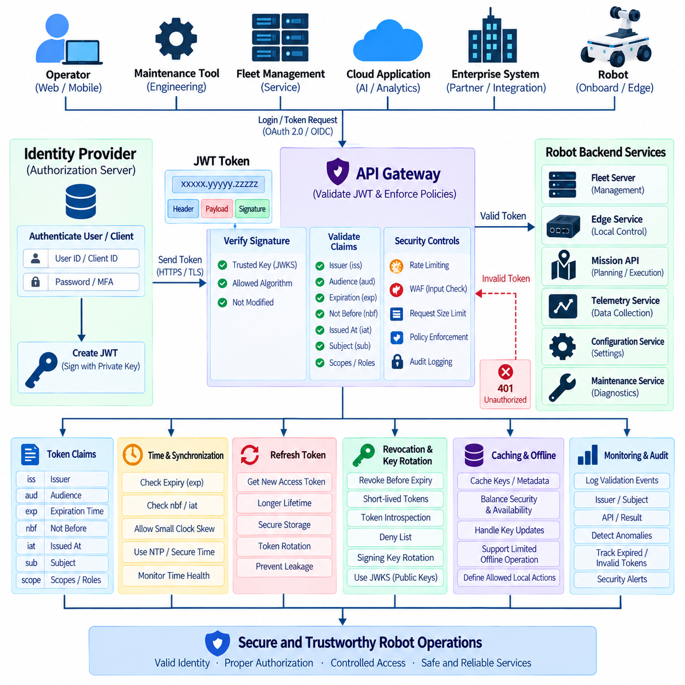
JWTs are widely used as compact security tokens for robot APIs because they allow authorization information to travel between identity systems, API gateways, fleet services, edge platforms, and protected robot applications. A JWT can contain claims describing the subject, issuer, audience, permissions, and validity period. However, receiving a syntactically correct token is not sufficient; every protected service must verify that the token is authentic, intended for that service, and currently valid.
A JWT consists of a header, payload, and cryptographic signature. The header normally identifies the token type and signing algorithm, while the payload contains claims describing identity and authorization context. The signature protects the header and payload from unauthorized modification. JWT contents are typically encoded rather than encrypted, so applications must not place passwords, private keys, or unnecessary confidential information inside ordinary token claims.
Token validation begins with cryptographic signature verification. The receiving API must verify the signature using a trusted key associated with the expected issuer and must never accept an unsigned token or an algorithm selected without policy control. The permitted signing algorithms should be explicitly configured. Successful signature verification demonstrates that the signed content has not been modified and that it was produced by an entity possessing the corresponding signing key.
Public-key-based signing is particularly useful in distributed robot architectures because authorization servers can retain private signing keys while gateways and robot services validate tokens using public keys. Public keys may be distributed through a controlled key set such as JWKS. Validators should obtain keys only from trusted locations, cache them appropriately, and handle key rotation without automatically trusting arbitrary key references supplied by an untrusted token.
The issuer claim, commonly represented as `iss`, identifies the authority that created the token. A robot API should accept tokens only from explicitly trusted issuers. Signature verification alone is insufficient if several systems use valid cryptographic keys for different environments or purposes. Development, testing, production, partner, and external identity domains should have clearly defined trust relationships so that a token from one environment cannot silently gain access to another.
The audience claim, represented as `aud`, defines the service or resource for which the token was issued. A fleet API should reject a token intended for an unrelated cloud application even when both systems trust the same identity provider. Audience validation prevents a legitimate token from being reused against a different service. Robot platforms should therefore define distinct resource identifiers for APIs with different security and operational responsibilities.
Expiration is normally represented by the `exp` claim and defines the time after which a token must no longer be accepted. Every protected robot API should validate expiration before executing the requested operation. Short-lived access tokens reduce the period during which stolen credentials remain useful. Highly privileged functions such as remote control, configuration modification, maintenance commands, or software deployment may justify shorter validity periods than ordinary monitoring operations.
The `nbf`, or not-before claim, specifies the earliest time at which a token may be accepted, while `iat` records when it was issued. These claims help services detect tokens used outside their intended temporal context. Validation should tolerate only a small, explicitly configured clock skew because robot, edge, gateway, and cloud clocks may differ slightly. Large tolerances weaken expiration controls and can unintentionally extend the usable lifetime of credentials.
Accurate time synchronization is therefore an important dependency of JWT validation. Robots and edge computers may use NTP, secure enterprise time services, GNSS-derived time, or another trusted synchronization mechanism depending on the architecture. A clock that is significantly incorrect can reject valid tokens or accept expired ones. Time-health monitoring should be considered part of security observability, particularly for disconnected robots that may operate for long periods without normal network synchronization.
Authorization claims must be validated after token authenticity and timing have been established. Scopes, roles, groups, or other claims can describe what the authenticated identity is permitted to perform. A valid token does not imply unrestricted API access. Telemetry reading, mission creation, configuration updates, diagnostics, maintenance, and remote motion control should be mapped to explicit permissions and checked against the requested endpoint and operation.
Token validation should also consider the identity represented by the subject claim, commonly `sub`, and the client responsible for obtaining the token. Human operators, backend services, robots, and automated schedulers should remain distinguishable whenever possible. This separation improves accountability and enables different authorization policies. A maintenance engineer and an autonomous fleet scheduler may both possess valid tokens while being permitted to perform fundamentally different actions.
Access tokens should normally be validated at the API gateway and again where necessary by sensitive backend services. Gateway validation provides centralized rejection of obviously invalid traffic, while service-level validation protects against internal routing mistakes or compromised infrastructure. High-impact robot commands should not depend exclusively on the assumption that every request arriving from an internal network has already been safely authorized elsewhere.
Expired access tokens should be rejected predictably rather than silently extended. The API can return an authentication-related error that allows an authorized client to obtain a replacement token through the appropriate mechanism. Backend services should not modify expiration values or create local exceptions simply to keep a session functioning. Consistent expiry behavior ensures that token lifetime remains a meaningful security boundary across gateway, cloud, edge, and robot components.
Refresh tokens can allow eligible clients to obtain new access tokens without requiring the user to authenticate again. Because refresh tokens may remain valid significantly longer than access tokens, they require stronger storage and lifecycle protection. They should be transmitted only to appropriate clients, protected from logs and application leakage, and subject to expiration, rotation, and revocation policies. Robot resource APIs generally consume access tokens rather than receiving refresh tokens directly.
Refresh-token rotation can reduce the impact of credential theft by issuing a replacement refresh token whenever the previous one is used. The authorization system can invalidate the older token and detect suspicious reuse. If a previously rotated token appears again, the event may indicate that credentials have been copied. Depending on policy, the associated session or token family can then be revoked and a new authentication process required.
Token revocation complements expiration when access must be removed before the normal lifetime ends. An operator account may be disabled, a robot may be stolen, a service identity may be compromised, or permissions may change during an active session. Short-lived access tokens reduce the revocation window, while centralized session controls, token introspection, deny lists, or other mechanisms can provide faster invalidation where the risk justifies the additional infrastructure.
Signing-key rotation must be handled without interrupting valid API traffic. During a controlled transition, validators may need to recognize both the retiring public key and the new public key while newly issued tokens use the replacement signing key. Token headers commonly contain a key identifier that helps select the appropriate validation key. Unknown identifiers should trigger controlled key refresh or rejection rather than causing the validator to trust an arbitrary external key source.
Caching improves JWT validation performance because gateways and services do not need to contact the authorization server for every API request. Public signing keys, discovery metadata, and selected authorization information may be cached according to policy. Cache lifetime must balance availability and security: excessively long caching can delay key or policy changes, while excessive remote validation creates latency and dependencies that may affect large robot fleets during connectivity problems.
Offline robot operation requires explicit expiry-handling rules. A robot that temporarily loses cloud connectivity may continue selected local functions using previously validated authorization state, but unlimited acceptance of expired tokens would defeat their security purpose. Systems should define which local operations may continue, for how long, and under which cached identity conditions. Privileged remote commands can require fresh credentials even when routine autonomous functions remain available.
Error handling should avoid revealing unnecessary security details. A client may need to know that authentication failed or that a new token is required, but external responses should not expose signing keys, internal policy structures, or sensitive validation logic. Detailed failure reasons can be retained in protected audit logs. Consistent error responses also make client behavior predictable when tokens are malformed, expired, incorrectly scoped, or issued for the wrong audience.
Monitoring should record token-validation events without storing complete bearer tokens. Useful information includes issuer, subject or pseudonymous identifier, client identity, audience, requested API, authorization result, expiration condition, key identifier, and validation failure category. Repeated expired tokens, unknown issuers, invalid signatures, unusual audiences, or excessive refresh activity can indicate configuration errors, attacks, or credential compromise and should feed anomaly-detection workflows.
A mature JWT architecture treats validation and expiry handling as a complete security lifecycle rather than a single signature check. Signature, issuer, audience, timing, identity, scope, key rotation, refresh, revocation, caching, logging, and offline behavior must work together consistently. For robot APIs, this ensures that only authentic, correctly targeted, sufficiently privileged, and currently valid credentials can reach functions capable of affecting fleet data, system configuration, missions, or physical robot behavior.

10.07 mTLS Mutual Auth: Robot.Server Communication [w/Code]
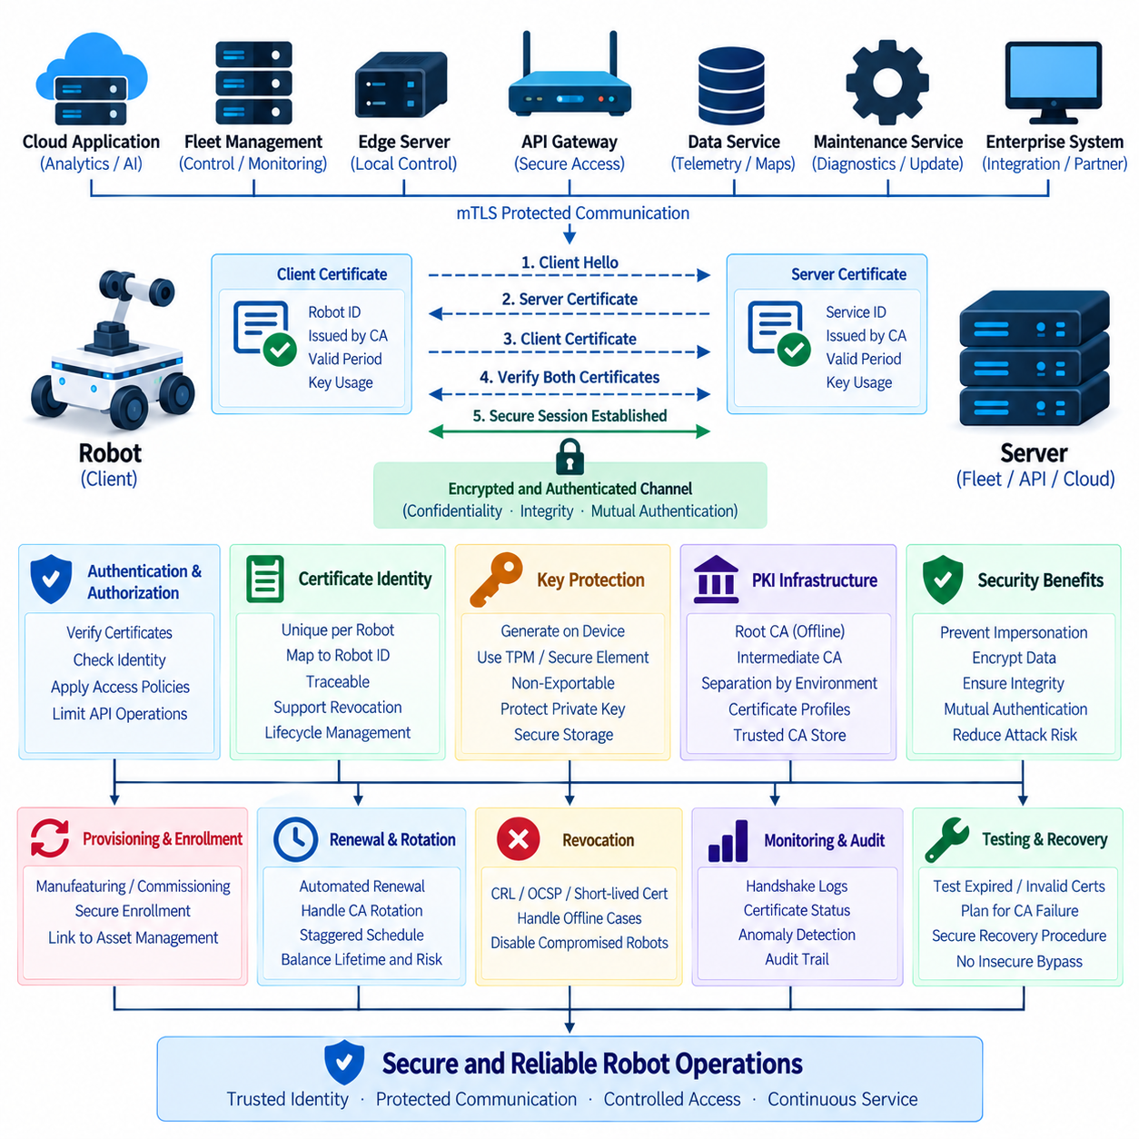
Mutual TLS, commonly called mTLS, extends standard Transport Layer Security by requiring both communication endpoints to authenticate with digital certificates. In conventional TLS, the client normally verifies the server certificate while the server may authenticate the client through another mechanism. With mTLS, the robot and server each present a certificate and verify the identity of the opposite endpoint before protected application communication is established. This creates a bidirectional cryptographic trust relationship suitable for machine-to-machine robot communication.
Robot systems benefit from mutual authentication because communication increasingly occurs across distributed and partially untrusted infrastructure. A robot may communicate with fleet-management servers, edge computers, API gateways, telemetry services, mission planners, maintenance platforms, and cloud applications through Ethernet, Wi-Fi, private 5G, or public networks. Network connectivity alone should not imply trust. mTLS allows each connection to establish whether both endpoints possess identities issued by an approved trust infrastructure.
A typical robot-to-server mTLS connection begins when the robot opens a TLS session with a protected service. The server sends its certificate chain and proves possession of the corresponding private key. The robot validates the certificate against its trusted certificate authorities, checks the certificate lifetime and expected service identity, and confirms that the certificate is appropriate for server authentication. The server then requests a client certificate so that the robot must provide equivalent cryptographic evidence of its own identity.
After receiving the robot certificate, the server validates its chain, issuer, validity period, intended usage, and identity information. The robot also proves possession of the private key corresponding to the certificate rather than merely transmitting a copied public certificate. When both authentication procedures succeed, the TLS handshake derives shared session keys used to protect subsequent traffic. Application messages can then be exchanged through an encrypted and authenticated communication channel.
The security value of mTLS comes from combining confidentiality, integrity, and mutual identity verification. Encryption prevents observers from directly reading telemetry, commands, configuration data, diagnostic information, or credentials transmitted between the robot and server. Integrity protection detects unauthorized modification during transmission. Mutual certificate authentication reduces the possibility that a robot connects to an impersonated server or that an unauthorized device successfully presents itself as a legitimate production robot.
Each production robot should normally receive a unique certificate identity rather than sharing one certificate across the entire fleet. Shared certificates weaken traceability and make selective revocation difficult because compromise of one robot can expose credentials used by many others. Unique certificates allow the backend to identify individual robots, associate policies with specific devices, record their activities, revoke compromised identities, and maintain independent certificate lifecycles without replacing credentials across the complete fleet.
The certificate identity should map cleanly to the robot identity maintained by fleet-management and asset-management systems. A certificate may contain or reference a stable robot identifier, device identity, service identity, or other controlled naming scheme. The exact representation depends on the Public Key Infrastructure, or PKI, design. What matters is that the server can reliably translate the authenticated certificate identity into an application identity used for authorization, auditing, inventory, and lifecycle management.
Authentication and authorization must remain separate concepts. A valid robot certificate proves that the connecting device possesses an approved identity, but it does not automatically mean that the device should access every API or service. After mTLS authentication, the server should apply authorization policies that determine which telemetry topics, mission interfaces, configuration functions, software repositories, or maintenance operations the authenticated robot may access. The same principle applies when servers initiate communication toward robots.
PKI provides the trust foundation for mTLS. A root Certificate Authority establishes the highest trust anchor, while intermediate Certificate Authorities can issue operational certificates for robots, servers, gateways, and services. Keeping the root CA offline or strongly protected reduces exposure of the most important signing key. Intermediate CAs can separate production robots, development systems, backend infrastructure, manufacturing environments, geographic regions, or other trust domains according to organizational requirements.
Certificate profiles should clearly distinguish their intended purposes. A robot certificate intended for client authentication should contain the appropriate usage constraints, while server certificates should support server authentication and identify the expected service. Some systems may use certificates for both roles, but unrestricted certificate usage can make trust relationships unnecessarily broad. Explicit profiles help prevent a credential created for one component or environment from being accepted for an unrelated role.
Certificate provisioning begins before the robot performs normal production communication. During manufacturing, commissioning, or secure enrollment, the robot must establish an initial trusted identity and obtain an operational certificate. The bootstrap mechanism is security-sensitive because an attacker who can fraudulently enroll a device may obtain a certificate that appears legitimate. Enrollment therefore requires a trustworthy relationship among the physical robot, manufacturing records, fleet inventory, enrollment service, and certificate authority.
Private keys should preferably be generated directly on the robot and remain non-exportable whenever the hardware supports this approach. A Trusted Platform Module, secure element, Hardware Security Module, or equivalent protected key store can generate and use private keys without exposing their raw values to ordinary application software. The certificate contains the corresponding public key, while authentication operations prove possession of the protected private key. This reduces the risk of cloning a robot identity by copying files.
Software-only key storage may still be required on some robot platforms, but it should be protected carefully. Private-key files require restrictive permissions, encrypted storage where appropriate, controlled backup policies, and isolation from ordinary logs and diagnostic packages. Container images, source repositories, firmware packages, and deployment scripts must not contain production private keys. Copying a complete robot filesystem should not automatically provide a reusable production identity to another device.
Trust stores determine which certificate authorities an endpoint accepts. Robots should maintain a deliberately controlled set of trusted CAs rather than relying blindly on every public certificate authority available in a general-purpose operating system. Private robot infrastructure often benefits from a dedicated organizational PKI. Limiting the trust store reduces the number of authorities capable of creating identities that the robot or server would accept and makes the intended trust boundary easier to understand and audit.
Server identity verification remains essential even though the robot also authenticates itself. The robot should verify the complete server certificate chain and confirm that the certificate represents the service it intended to reach. Accepting any certificate signed by a trusted CA without checking the expected service identity can enable incorrect or malicious routing. DNS names, URI-based identities, service identifiers, or other controlled naming mechanisms can be used according to the deployment architecture.
Certificate expiration limits how long a credential remains usable without renewal. Shorter certificate lifetimes reduce the period during which stolen credentials can remain valid, but very short lifetimes create operational dependencies on enrollment and renewal infrastructure. Robot fleets may operate through intermittent networks or remain disconnected for extended periods. Certificate lifetime should therefore balance credential exposure, fleet connectivity, maintenance intervals, renewal reliability, and the consequences of authentication failure.
Automated certificate renewal becomes increasingly important as fleet size grows. Manually replacing certificates on hundreds or thousands of robots creates operational risk and can result in unexpected outages when certificates expire. Robots should begin renewal before expiration, retry safely after temporary failures, and distribute renewal activity across time. Randomized renewal windows prevent large numbers of robots commissioned on the same day from overwhelming enrollment services when their certificates approach expiration simultaneously.
Certificate rotation should support a controlled transition from an existing credential to a replacement credential. The new certificate can be installed and validated before the old certificate is retired. For CA rotation, endpoints may temporarily trust both the previous and replacement trust chains while the fleet migrates. This overlap must be carefully bounded. Removing an old CA too early can disconnect robots that have not yet migrated, while retaining obsolete trust indefinitely unnecessarily enlarges the security boundary.
Revocation is required when a robot identity should no longer be trusted before certificate expiration. A device may be stolen, decommissioned, compromised, transferred to another environment, or suspected of private-key exposure. The infrastructure must be able to associate the affected robot with its certificate and prevent continued authentication. Certificate Revocation Lists, online certificate-status mechanisms, short-lived certificates, gateway policy, or combinations of these techniques may be used depending on connectivity and operational requirements.
Revocation behavior is especially important for intermittently connected robot environments. A robot or edge server may not always be able to contact a central status service during authentication. A strict dependency on online revocation checking can reduce availability, while ignoring revocation can allow compromised identities to remain active. The architecture should explicitly define how recently revocation information must be refreshed, how cached information is handled, and which operations are permitted when certificate status cannot be confirmed.
mTLS can be terminated at an API gateway, load balancer, service mesh proxy, or directly at the destination robot service. Gateway termination simplifies centralized certificate validation and policy enforcement, but it creates a new trust boundary behind the gateway. If traffic becomes unauthenticated or unencrypted after termination, internal services may lose the original machine identity or become vulnerable to internal network attacks. Sensitive robot architectures should preserve authenticated identity across downstream service boundaries.
End-to-end mTLS can provide stronger isolation when robot commands or sensitive data cross multiple network segments. A robot may establish mTLS directly with a fleet service, or separate mutually authenticated channels may protect robot-to-edge, edge-to-gateway, and gateway-to-cloud communication. The appropriate design depends on routing, latency, service ownership, observability, and failure requirements. The essential principle is that crossing an internal network boundary should not automatically convert authenticated communication into implicit trust.
mTLS also complements OAuth 2.0, OIDC, JWT, and API-key mechanisms rather than necessarily replacing them. A certificate can establish the machine identity and protect the transport channel, while an OAuth access token can represent delegated application authorization. A server may therefore verify both the TLS client certificate and an access token before allowing a sensitive operation. This provides stronger separation between the identity of the communicating device and the permission associated with a particular application request.
Certificate-bound or sender-constrained access mechanisms can further reduce the risk of stolen bearer tokens. If an access token is cryptographically associated with the mTLS client identity, possession of the token alone is insufficient for successful use from another machine. An attacker would also require access to the corresponding private key. This approach can be valuable for high-impact robot APIs where remote motion commands, software deployment, configuration changes, or maintenance functions require stronger protection.
Robot communication patterns can include long-lived sessions, persistent streaming, WebSocket connections, message brokers, and continuous telemetry channels. Certificate expiration and rotation behavior must therefore consider connections that remain active for long periods. Policies should define whether an existing authenticated session can continue until normal reconnection, whether reauthentication is required periodically, and how replacement credentials are introduced without causing large-scale simultaneous disconnections.
Edge computing introduces another trust layer. An edge server may communicate with dozens or hundreds of local robots while maintaining separate secure connections to cloud or enterprise infrastructure. mTLS can authenticate each robot individually to the edge server and authenticate the edge platform toward central services. The edge system should not collapse all robot identities into one indistinguishable credential if backend authorization, incident investigation, or audit requirements depend on knowing which robot originated an action or message.
Service meshes can automate mTLS for containerized backend services by issuing workload identities, distributing certificates, and establishing encrypted service-to-service channels. This can reduce the amount of TLS logic implemented directly by each microservice. However, robot device identity and backend workload identity remain conceptually different. The architecture should preserve the relationship between the physical robot, gateway identity, service workload, and application authorization rather than treating every certificate as equivalent.
Performance must also be considered, particularly when thousands of robots reconnect after a network interruption. TLS handshakes require cryptographic computation and can create bursts of load on gateways, certificate-validation infrastructure, and backend services. Persistent connections, session resumption, connection pooling, distributed gateways, and staged reconnection strategies can reduce this load. Performance optimization must not disable certificate verification or weaken identity checks simply to increase connection throughput.
Failure handling should default to secure behavior while considering physical operational requirements. An invalid, expired, revoked, or untrusted certificate should normally cause the protected connection to fail. Applications should not silently fall back to plaintext communication or certificate verification bypass. At the same time, loss of a cloud mTLS connection should not necessarily stop every autonomous robot function. Local safety and mission policies should define what the robot may continue doing independently.
Observability is essential for managing mTLS at fleet scale. Security monitoring should capture successful and failed handshakes, certificate expiration status, unknown issuers, rejected identities, protocol versions, validation errors, renewal failures, and unusual authentication patterns. Logs should identify the relevant robot or service without exposing private keys or unnecessary sensitive certificate material. Alerts should be generated well before expiration and immediately for suspicious certificate failures or unexpected trust relationships.
Audit records should connect certificate identity with application activity. When a robot authenticates successfully and subsequently uploads telemetry, requests a map, downloads configuration, or receives a mission, the platform should be able to determine which certificate identity participated in the communication. This relationship improves forensic investigation and allows security teams to distinguish network connectivity from authenticated activity. Certificate issuance, renewal, rotation, revocation, and retirement should also be recorded.
Testing should cover much more than successful TLS connections. Robot-server communication should be evaluated with expired certificates, unknown CAs, incorrect service identities, revoked credentials, missing client certificates, damaged certificate chains, unsupported algorithms, clock errors, and interrupted renewal processes. Tests should also examine CA rotation, gateway failover, large-scale reconnection, intermittent networks, and certificate replacement while robots are operating. Negative testing verifies that invalid identities fail safely and predictably.
Operational recovery procedures are equally important. If a CA, enrollment service, or fleet-wide certificate policy is misconfigured, thousands of robots could lose connectivity simultaneously. Recovery mechanisms should be designed before such incidents occur and should avoid insecure emergency shortcuts such as globally disabling certificate verification. Controlled fallback trust bundles, secure local maintenance procedures, staged recovery, and independently protected administrative channels can provide safer methods for restoring communication.
Decommissioning completes the certificate lifecycle. When a robot leaves service, its identity should be disabled, relevant certificates revoked or allowed to expire according to policy, backend authorization removed, and private-key material securely erased where possible. Asset-management records should reflect the retirement so that the same identity cannot accidentally return to production. Similar procedures apply when an edge server, gateway, or backend service is permanently removed or repurposed.
A mature mTLS architecture therefore treats mutual authentication as an identity lifecycle rather than merely enabling a TLS configuration option. Unique robot certificates, protected private keys, controlled trust stores, PKI governance, automated enrollment and renewal, rotation, revocation, authorization, monitoring, testing, and decommissioning must operate together. The result is a communication architecture in which robots and servers establish explicit cryptographic trust before exchanging operational information.
For robot platforms, the ultimate purpose of mTLS is to ensure that network reachability never becomes equivalent to permission or trust. A device must prove that it is an authorized robot, and a robot must prove that it is communicating with an authorized service. When this mutual identity is combined with encrypted transport, fine-grained authorization, secure API gateways, token-based access control, and safety-aware application policies, robot-to-server communication can remain trustworthy across edge, fleet, cloud, and enterprise environments.

10.08 API Security Testing: Fuzzing / Penetration Test
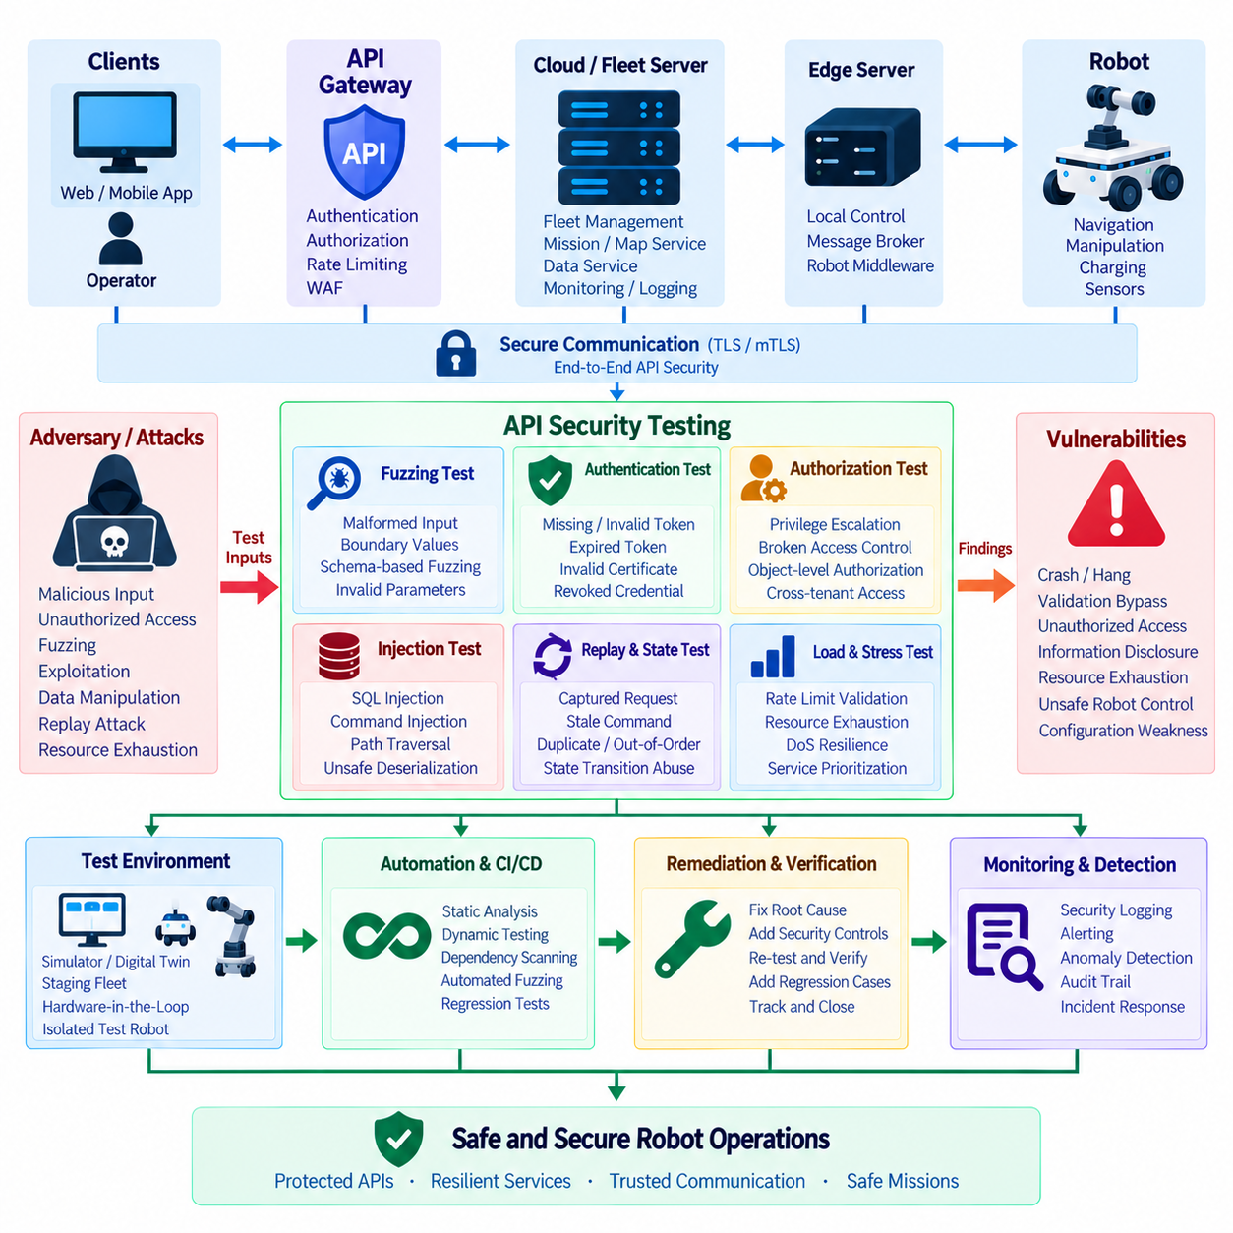
API security testing for robotic systems verifies whether communication interfaces remain secure when they receive unexpected, malformed, unauthorized, or intentionally malicious inputs. Unlike conventional business APIs, robot APIs may control missions, navigation, motion, charging, payloads, configuration, diagnostics, and software updates. A security defect can therefore affect not only confidentiality or service availability but also physical equipment, operational continuity, and human safety.
A comprehensive testing strategy should cover the complete API communication path rather than examining individual endpoints in isolation. Requests may travel from operator applications through API gateways, cloud services, fleet servers, message brokers, edge computers, and robot middleware before reaching hardware control functions. Each transition creates a trust boundary where authentication, authorization, validation, encryption, and error handling should be independently verified.
Security testing should begin with an accurate API inventory. Testers need to understand exposed endpoints, HTTP methods, message topics, authentication mechanisms, authorization scopes, data schemas, network locations, software versions, and dependencies. Undocumented or obsolete APIs are especially important because they may remain reachable after normal applications stop using them. An incomplete inventory creates blind spots that automated scanners and penetration testers may never examine.
The test environment should resemble the production architecture while remaining sufficiently isolated to prevent unsafe physical behavior. A staging fleet, digital twin, simulator, hardware-in-the-loop environment, or dedicated test robot can reproduce realistic communication paths without placing production missions at unnecessary risk. Tests that may generate excessive traffic, malformed commands, resource exhaustion, or unexpected motion should not be executed directly against operational robots without explicit safeguards.
Automated API security testing can be integrated into development and CI/CD pipelines. Static analysis can identify insecure coding patterns, exposed credentials, weak cryptographic configurations, and unsafe dependency usage before software runs. Dynamic testing examines running services by sending requests and observing behavior. Software composition analysis can identify vulnerable third-party libraries, while configuration scanning can detect insecure gateway, container, cloud, or network settings.
Fuzz testing, or fuzzing, systematically sends unexpected or mutated inputs to an API to discover behavior that developers did not anticipate. A fuzzer may alter field types, lengths, encodings, numerical ranges, nesting depth, delimiters, headers, message order, or protocol structures. The objective is not simply to produce errors but to identify crashes, hangs, memory problems, validation failures, inconsistent state transitions, excessive resource consumption, or security controls that can be bypassed.
Schema-aware fuzzing is particularly effective for structured robot APIs. OpenAPI specifications, JSON Schema, Protocol Buffers, ROS interface definitions, or other machine-readable contracts can guide generation of both valid and deliberately invalid messages. The fuzzer can preserve enough structure to reach deeper application logic while selectively violating constraints. This approach is often more productive than sending completely random bytes to strongly structured interfaces.
Robot-specific fuzzing should test physical and operational parameters as well as conventional software inputs. Coordinates outside permitted maps, negative distances, impossible velocities, extreme acceleration values, invalid orientation data, duplicated mission identifiers, oversized trajectories, nonexistent robot IDs, contradictory states, or malformed safety parameters can expose weaknesses. A request may be syntactically valid while remaining physically impossible or operationally unsafe.
Boundary-value testing is important because many API defects occur near numerical or structural limits. Values such as zero, negative numbers, maximum integers, floating-point extremes, NaN, infinity, extremely long strings, empty arrays, deeply nested objects, and oversized payloads should be evaluated where applicable. Robot control services should reject or safely normalize values outside defined operating envelopes instead of forwarding them blindly toward motion or hardware layers.
Stateful fuzzing examines sequences of operations rather than individual messages. Robot APIs frequently implement workflows such as create mission, assign robot, start mission, pause, resume, cancel, and complete. Individually valid requests may create unsafe or inconsistent behavior when delivered in unexpected order. Tests should therefore attempt duplicated commands, repeated cancellation, rapid state transitions, delayed messages, stale commands, replayed requests, and conflicting operations from multiple clients.
Authentication testing verifies that protected APIs cannot be reached without valid credentials. Tests should include missing tokens, malformed JWTs, expired tokens, invalid signatures, unknown issuers, incorrect audiences, revoked credentials, invalid API keys, missing client certificates, untrusted certificate authorities, and certificates belonging to the wrong device. Services should fail securely and should never fall back to anonymous or weaker authentication simply because the preferred mechanism fails.
Authorization testing determines whether an authenticated identity can perform only the operations it has been granted. Testers should attempt horizontal privilege violations by accessing another robot, mission, map, tenant, or device using a valid identity. Vertical privilege tests attempt administrative or maintenance operations using ordinary user or robot permissions. Object identifiers should be changed systematically to identify broken object-level authorization or insecure direct access patterns.
Robot APIs require especially careful authorization testing because different operations have very different physical consequences. An account permitted to view telemetry should not automatically be able to cancel missions, modify speed limits, change navigation parameters, disable sensors, install software, or initiate remote motion. Tests should verify permissions at the API gateway and at sensitive backend services so that internal routing does not bypass application-level authorization.
Rate limiting and resource-consumption controls should also be tested under realistic load. Testers can generate bursts of telemetry queries, authentication attempts, map downloads, mission requests, AI inference calls, or repeated connection establishment to determine whether one client can exhaust shared resources. Testing should observe CPU, GPU, memory, database connections, message queues, network bandwidth, storage, and robot-side processing to identify denial-of-service conditions.
The goal of load-related security testing is not merely to determine maximum throughput. It should verify that essential robot services remain available when lower-priority APIs are abused or overloaded. Monitoring traffic, analytics requests, large data exports, or external integrations should not prevent safety-related control or critical fleet communication. Rate limits, quotas, backpressure, prioritization, and graceful degradation should therefore be evaluated together.
Web Application Firewall and API gateway policies should be tested rather than assumed to work because they are enabled. Test cases can include injection patterns, malformed JSON, unsupported HTTP methods, abnormal content types, oversized headers, suspicious encodings, path manipulation, unexpected parameters, and known malicious payload structures. The objective is to confirm that gateway controls reject dangerous traffic while allowing legitimate robot communication without excessive false positives.
Transport-security testing should verify TLS and mTLS configuration across robot, edge, gateway, and cloud connections. Tests should attempt obsolete protocol versions, weak cipher configurations where applicable, invalid certificate chains, expired certificates, incorrect host identities, unknown certificate authorities, missing client certificates, and revoked credentials. Applications must not bypass certificate validation or silently downgrade to insecure communication when secure negotiation fails.
Replay testing is especially important for robot commands. A captured request that was legitimate at one point should not necessarily remain executable indefinitely. Testers should resend mission commands, maintenance actions, configuration changes, and other sensitive requests to verify timestamp, nonce, sequence-number, token-expiry, or idempotency protections. Repeated delivery should not create duplicate missions or cause an old motion command to execute after its intended context has disappeared.
Injection testing should consider every interface that ultimately interacts with databases, operating systems, message brokers, scripts, file systems, or interpreters. Conventional SQL injection remains relevant, but command injection, path traversal, template injection, header injection, unsafe deserialization, and message manipulation may also appear in robotic platforms. Inputs received through trusted internal services should not automatically bypass validation because upstream components can also be compromised.
File-handling APIs require dedicated tests when robots upload logs, images, maps, diagnostic packages, or receive firmware and configuration files. Testers should examine file names, paths, extensions, archive structures, compressed sizes, signatures, metadata, and content validation. Archive bombs, path traversal, oversized files, malicious packages, or incorrectly signed software should be rejected before they can consume excessive resources or modify protected system areas.
Penetration testing combines automated discovery with human reasoning to simulate realistic attack paths. A penetration tester may begin with an exposed gateway, obtain limited credentials, enumerate APIs, identify authorization weaknesses, pivot toward fleet services, and determine whether access can reach sensitive robot operations. The objective is to understand how several individually modest weaknesses can be chained into a significant compromise rather than treating every vulnerability as an isolated defect.
Robot penetration tests should define clear rules of engagement before testing begins. Scope should identify permitted systems, network segments, robot models, APIs, credentials, test times, prohibited actions, and emergency stop procedures. Safety observers may be necessary when physical robots participate. Destructive techniques should be replaced with simulations or controlled demonstrations whenever possible, particularly where unexpected movement could damage equipment or create hazards.
Network segmentation should be evaluated during penetration testing. Compromise of a monitoring workstation, enterprise application, guest network, or external integration should not automatically provide unrestricted access to robot control networks. Testers can examine whether gateways, firewalls, service identities, mTLS policies, and access-control rules prevent lateral movement. Segmentation should be verified through actual connection attempts rather than inferred solely from architecture diagrams.
Secret management is another important testing area. Source repositories, container images, environment variables, configuration files, logs, crash dumps, diagnostic bundles, CI/CD pipelines, and robot storage should be inspected for exposed API keys, passwords, private keys, or tokens. Discovered credentials should be evaluated carefully to determine their scope and lifetime. A leaked secret becomes significantly more dangerous when it is shared across an entire robot fleet or never expires.
Error handling can unintentionally reveal useful information to attackers. Tests should intentionally trigger authentication failures, invalid parameters, missing objects, internal exceptions, and unsupported operations. External responses should provide enough information for legitimate clients without exposing stack traces, database structures, filesystem paths, cryptographic details, internal hostnames, or sensitive configuration. Detailed diagnostic information should remain in protected operational logs.
Logging and detection capabilities should be evaluated as part of the security test rather than after vulnerabilities are found. Testers should determine whether suspicious authentication failures, privilege violations, scanning behavior, fuzzing traffic, abnormal request rates, certificate failures, and repeated rejected commands generate useful records and alerts. A technically blocked attack that produces no observable evidence can still leave operators unable to recognize persistent hostile activity.
Testing should also verify that security logs do not create a secondary vulnerability. Bearer tokens, passwords, API keys, private keys, complete sensitive payloads, or personal information should not be copied unnecessarily into logs. Log injection and manipulation should be tested so that attacker-controlled strings cannot corrupt audit records. Time synchronization and stable robot identifiers are important because incident investigation depends on correlating events across gateways, servers, edge devices, and robots.
Vulnerability findings should be evaluated according to both cybersecurity severity and robot operational impact. A weakness that appears moderate in a conventional web application may become critical if it enables unauthorized motion, disables safety functions, changes navigation constraints, or interrupts an entire fleet. Risk assessment should therefore consider exploitability, required privileges, affected assets, fleet scale, physical consequences, recoverability, and the availability of compensating controls.
Remediation should address the underlying cause rather than only the specific test payload that exposed the problem. If fuzzing discovers that an oversized array crashes a mission service, simply blocking one array size at the gateway may leave similar defects elsewhere. Developers should improve schema validation, memory handling, resource limits, error recovery, and service architecture as appropriate. Security regression tests should then preserve the discovered case so that future releases cannot silently reintroduce it.
API security tests should become repeatable engineering assets. Test cases for authentication, authorization, malformed messages, rate limits, certificate validation, replay protection, and previously discovered vulnerabilities can run automatically during CI/CD. More intrusive fuzzing and penetration testing can occur in dedicated environments at defined milestones. This combination provides continuous coverage while reserving higher-risk techniques for controlled systems.
Release gates can connect security test results with deployment decisions. Critical authentication or authorization failures, exploitable command injection, unsafe certificate validation, or uncontrolled access to physical robot functions should prevent production release until corrected. Lower-risk findings can be tracked through formal remediation processes with owners and deadlines. Exceptions should be documented explicitly rather than becoming permanent undocumented weaknesses.
Testing must continue after deployment because robot APIs evolve with new missions, sensors, integrations, cloud services, and fleet-management features. New endpoints can introduce unexpected trust boundaries, while configuration changes may weaken previously validated protections. Periodic penetration tests, continuous vulnerability scanning, dependency monitoring, gateway policy review, certificate testing, and analysis of operational security events help ensure that protection remains effective throughout the product lifecycle.
A mature robot API security program combines automated scanning, schema-aware fuzzing, stateful fuzzing, authentication and authorization testing, resource-exhaustion testing, transport-security verification, penetration testing, monitoring validation, and regression testing. These activities should be connected to threat models and real operational consequences rather than performed only for compliance or checklist completion.
The ultimate objective is to demonstrate that robot APIs fail safely under hostile and abnormal conditions. Invalid identities should be rejected, unauthorized operations should remain inaccessible, malformed data should not destabilize services, excessive traffic should not starve critical functions, and compromised network positions should not automatically provide robot control. Through continuous fuzzing, penetration testing, monitoring, remediation, and regression verification, API security becomes an engineering discipline supporting trustworthy and safe robot operations.

10.09 API Security Audit Logs and Anomaly Detection
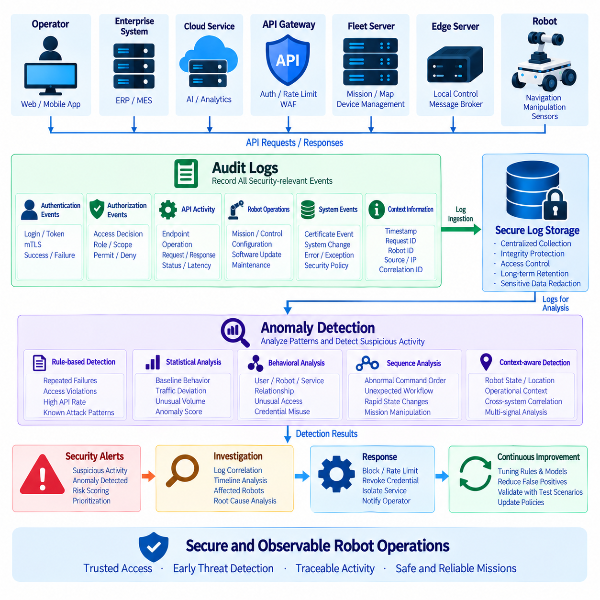
API security audit logs provide a structured record of who accessed robot services, what operation was requested, which resource was targeted, when the activity occurred, and whether the request succeeded or failed. In robotic platforms, these records are especially important because API activity can influence missions, navigation, configuration, software deployment, maintenance, and physical motion. Logs therefore support both cybersecurity investigation and operational accountability.
Audit logging should cover the complete communication path rather than only the public API gateway. Relevant events may originate from operator applications, enterprise systems, cloud services, fleet servers, message brokers, edge computers, robot middleware, and individual robots. Correlating these distributed records allows investigators to reconstruct how a request moved through the architecture and determine which identity, service, and device participated in an operation.
Each security-relevant event should contain enough context to support investigation without unnecessarily exposing sensitive information. Useful fields include timestamp, request identifier, authenticated identity, robot identifier, endpoint, operation, source, authorization decision, response status, latency, and security policy result. For sensitive operations, mission identifiers, configuration categories, or affected resources may also be recorded while confidential payload contents remain protected.
Consistent timestamps are essential because robotic systems generate events across many distributed computers. API gateways, fleet servers, edge devices, robots, databases, and security platforms should maintain synchronized clocks using controlled time services. Without reliable time synchronization, investigators may struggle to determine whether authentication failures occurred before a configuration change, whether a command preceded robot motion, or whether several suspicious events formed a coordinated attack sequence.
Correlation identifiers help connect events belonging to the same transaction. A request identifier generated at the gateway can be propagated through cloud services, fleet management, message brokers, edge software, and robot services. Distributed tracing identifiers can provide additional visibility when requests cross microservices. This creates an end-to-end evidence chain that is more useful than isolated log entries generated independently by each component.
Authentication events should record successful and failed login or machine-authentication attempts. OAuth token validation failures, invalid JWT signatures, expired tokens, unknown issuers, incorrect audiences, rejected API keys, failed mTLS handshakes, untrusted certificates, and revoked identities are valuable security signals. Repeated failures from one identity, device, network location, or service may indicate misconfiguration, expired credentials, automated scanning, or an active attack.
Authorization decisions are equally important. Logs should show when authenticated identities attempt operations outside their permitted roles, scopes, robot groups, tenants, or resources. Repeated attempts to access different robot identifiers can indicate object-level authorization probing, while attempts to invoke administrative or maintenance functions may indicate privilege escalation. Successful high-impact authorization decisions should also be retained for accountability and later investigation.
Robot APIs require special attention to commands that can influence physical behavior. Mission creation, cancellation, route changes, speed configuration, remote-control requests, safety-related configuration, software deployment, sensor disabling, and maintenance actions should generate auditable records. The log should identify the authenticated requester, target robot, requested operation, authorization result, and execution outcome so that digital activity can later be related to observed robot behavior.
Audit logs must avoid becoming a secondary source of credential leakage. Passwords, private keys, complete bearer tokens, API keys, refresh tokens, session secrets, and unnecessary confidential payloads should never be written directly into logs. Token identifiers or carefully selected hashes may be used when correlation is necessary. Logging frameworks should include centralized redaction rules so that sensitive values are removed consistently across services.
Log integrity is essential because attackers may attempt to erase or modify evidence after compromising a system. Security records should be transferred to protected storage with access controls that prevent ordinary robot applications from rewriting historical events. Append-oriented storage, cryptographic integrity mechanisms, restricted administrative permissions, and centralized security logging can make unauthorized modification more difficult and improve confidence in forensic evidence.
Retention policies should reflect operational, security, regulatory, and storage requirements. High-frequency telemetry is different from security audit information and should not automatically use the same retention period. Authentication events, administrative changes, software deployment records, certificate lifecycle events, and high-impact robot commands may require longer retention because they provide evidence during investigations that occur weeks or months after an incident.
Centralized log collection allows events from large fleets to be analyzed together. Gateways, servers, edge systems, robots, identity services, certificate infrastructure, and network security components can forward selected security events to a central analytics platform or Security Information and Event Management system. Local buffering is necessary when robots or edge sites temporarily lose connectivity so that important events can be uploaded after communication is restored.
Anomaly detection extends audit logging from historical evidence into active security monitoring. Instead of examining only individual events, detection systems analyze patterns over time and identify behavior that differs from expected operation. A single API request may appear legitimate, while hundreds of similar requests across multiple robots, unusual access times, abnormal command sequences, or rapid identity changes may reveal suspicious activity.
Rule-based detection is useful when dangerous behavior can be described explicitly. Examples include repeated authentication failures, excessive authorization denials, requests from revoked certificates, unusually high API rates, repeated access to nonexistent robot IDs, or administrative commands from unexpected services. Rules are understandable and easy to audit, but they may miss novel attacks that do not match predefined signatures or thresholds.
Statistical anomaly detection establishes baselines for normal API behavior and identifies significant deviations. A robot may normally communicate with a small set of services at predictable rates and times. Sudden increases in request frequency, new destination services, unusual payload sizes, unexpected command types, or abnormal failure ratios can generate anomaly scores. Baselines should account for legitimate changes such as software releases, maintenance periods, or fleet expansion.
Behavioral analysis can model relationships among users, robots, services, and operations. An operator may normally manage one facility, a robot may usually receive missions from one fleet server, and an edge service may access only specific API groups. A request that is technically authenticated but violates these established relationships can be suspicious. This approach can identify credential misuse that conventional authentication controls may not detect.
Sequence-based anomaly detection is particularly relevant to robot systems because commands usually follow expected operational workflows. Mission creation may normally precede assignment and execution, while maintenance mode may be required before certain configuration changes. Unexpected command ordering, repeated state transitions, rapid cancellation and recreation, or remote-control actions outside normal workflows may indicate software faults, automation errors, or malicious manipulation.
Rate and volume anomalies can reveal resource-exhaustion attacks or compromised clients. Sudden bursts of map downloads, telemetry queries, authentication attempts, file uploads, AI inference calls, or mission creation requests may consume shared resources. Detection should consider identity, robot, tenant, endpoint, and service context because normal traffic levels differ substantially between monitoring APIs, control interfaces, data transfer services, and fleet-wide operations.
Physical context can improve anomaly detection beyond conventional IT monitoring. API events may be correlated with robot mode, location, mission state, charging status, maintenance condition, or safety state. A remote-motion command sent to a robot expected to remain charging, or a configuration change during an active mission, may deserve additional scrutiny even if the request is authenticated and structurally valid.
Anomaly detection should combine multiple signals rather than depend on one metric. Identity information, API endpoint, request rate, authorization result, robot state, network origin, certificate status, historical behavior, and command sequence can collectively provide stronger evidence. Multi-signal correlation reduces reliance on simple thresholds and helps distinguish malicious activity from legitimate operational changes that would otherwise produce false alarms.
False positives require careful management because excessive alerts can overwhelm security and operations teams. Thresholds should be tuned using realistic fleet behavior, and alerts should include sufficient context for rapid interpretation. Detection models should distinguish development, staging, maintenance, and production environments where normal behavior differs. Feedback from investigated alerts can improve rules and models over time.
Security alerts should be prioritized according to both cyber risk and possible physical consequence. A failed request to a low-impact telemetry endpoint is different from repeated attempts to modify speed limits, disable safety-related functions, or issue unauthorized motion commands. Alert severity can consider target API, requester privilege, robot state, number of affected devices, persistence, confidence, and potential operational impact.
Automated response can reduce reaction time but must be applied cautiously in robotic environments. The platform may temporarily block credentials, reduce API rates, isolate a service, revoke a certificate, require reauthentication, or notify operators. However, automatically disconnecting robots or blocking critical control traffic could create operational hazards. Response policies should therefore distinguish suspicious activity from actions required to maintain safe robot operation.
Audit and anomaly systems should integrate with incident response processes. When an alert is raised, investigators need access to correlated authentication, authorization, gateway, server, edge, robot, and network records. The system should support reconstruction of the timeline, identification of affected identities and robots, containment actions, credential rotation, configuration recovery, and verification that the threat has been removed.
Testing is necessary to verify that monitoring works before a real incident occurs. Security teams should generate controlled authentication failures, authorization violations, fuzzing traffic, replay attempts, certificate errors, unusual request bursts, and suspicious command sequences. They should confirm that the expected logs are created, sensitive information is redacted, correlation works correctly, alerts are generated, and response procedures reach the appropriate personnel.
Observability should also monitor the logging infrastructure itself. Missing events, delayed uploads, storage exhaustion, broken collectors, clock drift, parsing errors, and disabled agents can create monitoring blind spots. Robots or services that suddenly stop producing expected security records may themselves represent an anomaly. Health metrics for collectors, pipelines, storage, analytics services, and detection engines are therefore part of the security architecture.
A mature architecture combines distributed audit generation with centralized correlation and context-aware anomaly detection. Gateways enforce and record access decisions, identity systems provide authentication context, fleet servers contribute mission information, edge systems provide local activity, and robots contribute operational state. Together these sources create a security view that connects digital API behavior with actual robotic operations.
The ultimate objective is not to collect the largest possible quantity of logs, but to create trustworthy evidence and actionable detection. Security teams should be able to determine who performed an operation, which robot was affected, whether the action was authorized, what happened afterward, and whether similar activity is occurring elsewhere. Well-designed audit logging and anomaly detection transform robot API security from passive record keeping into continuous operational defense.

10.10 IEC 62443 Compliant Robot API Security Architecture
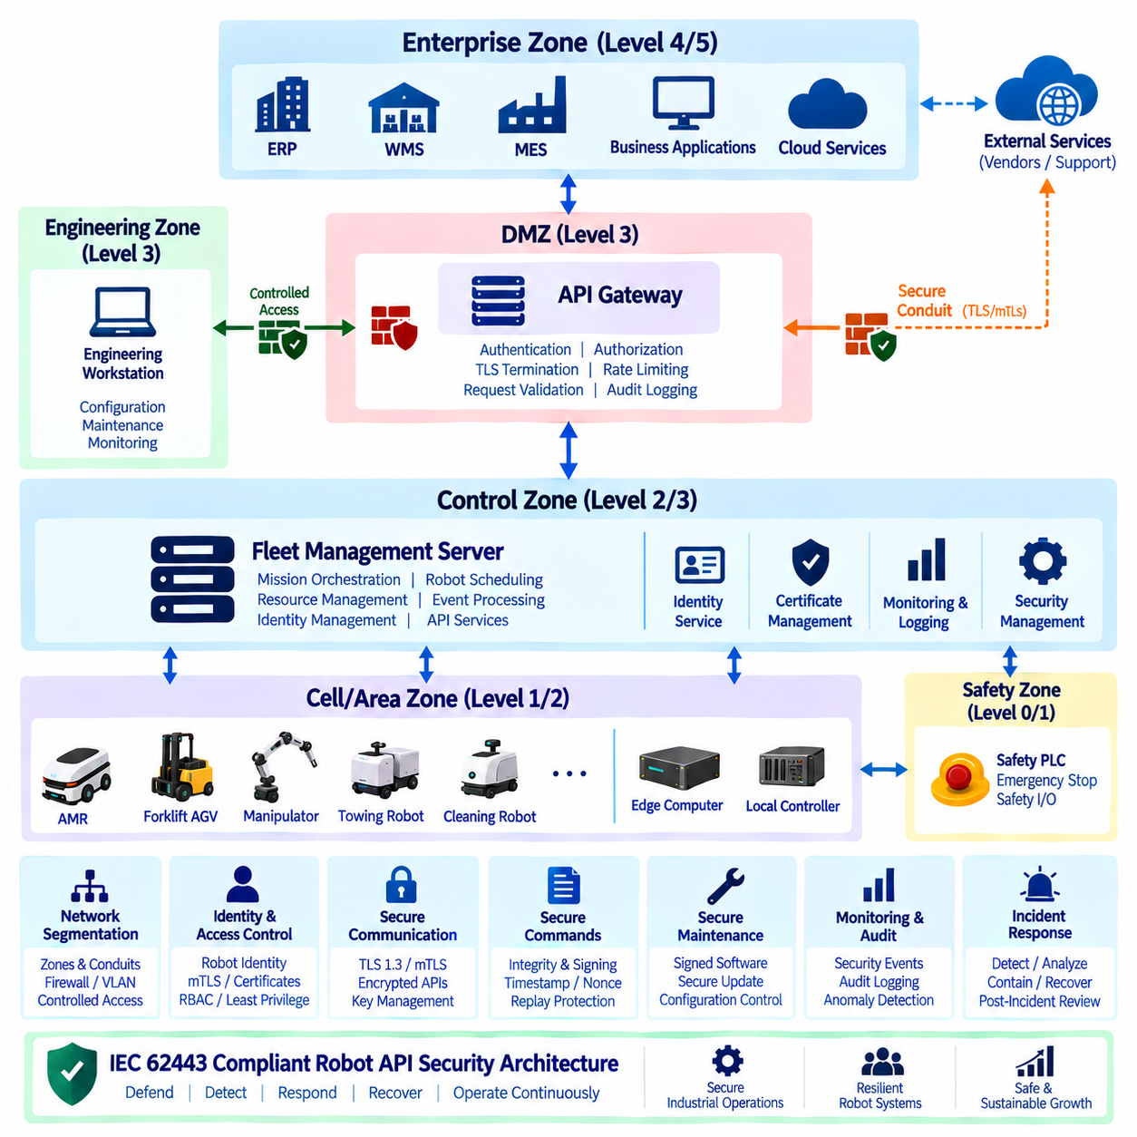
The provided structure places this topic at the end of Chapter 10, following robot API threat modeling, TLS 1.3 and certificate management, API key and secret management, OAuth 2.0 and OIDC, API gateway security, JWT validation, mTLS, security testing, and audit logging. This sequence supports treating IEC 62443 as an architectural security framework that integrates these controls into a coherent industrial robot API security design.
An IEC 62443-oriented robot API architecture should begin with a clear separation of operational responsibilities and security boundaries. Robot controllers, edge computers, Fleet Management Servers, API gateways, enterprise applications, engineering workstations, and external services should not automatically share the same trust level. The architecture should define which components communicate, what information crosses each boundary, and which security controls protect every communication path.
Network segmentation is a fundamental architectural concept for industrial environments. Robot devices and their control services can be organized into appropriate security zones according to their function and risk. Fleet services, enterprise systems, engineering interfaces, and external connections can be separated so that compromise of one environment does not automatically provide unrestricted access to another. Communication between zones should pass through controlled conduits with explicitly defined protocols and security policies.
The API gateway can serve as an important security enforcement point between external applications and internal robot services. It can provide TLS termination where appropriate, authentication, authorization, request validation, rate limiting, logging, and routing. However, gateway protection should not become the only security layer. Internal services should continue to verify service identity and authorization because an attacker who reaches an internal network should not automatically become a trusted API client.
Robot identity should provide a stable relationship between a physical asset and its digital API identity. Each robot can have a unique identifier and associated cryptographic credentials, certificates, or hardware-protected keys. Identity provisioning, renewal, suspension, replacement, and revocation should be managed throughout the robot lifecycle. A network address, hostname, or temporary session should not be treated as the fundamental identity of the robot.
Authentication and authorization should remain separate controls. Authentication establishes whether a robot, service, operator, or application is genuinely the identity it claims to be. Authorization determines which resources and operations that identity is allowed to access. A telemetry service may be allowed to read robot status without being allowed to issue motion commands, while a fleet scheduler may create missions without being allowed to modify security configuration.
Command interfaces require stronger protection than ordinary informational APIs because they can influence physical behavior. A robot command should be authenticated, authorized, validated, and protected against tampering and replay. Command identifiers, timestamps, sequence numbers, expiration information, and appropriate integrity mechanisms can help ensure that an old or modified command cannot be accepted as a current authorized instruction.
TLS and mutual TLS can protect communication between robot services, fleet servers, adapters, and other trusted components. TLS provides encrypted communication and server authentication, while mTLS can additionally authenticate the connecting client. Certificate management must include controlled issuance, validation, renewal, rotation, and revocation. Private keys should receive appropriate protection, preferably through hardware-backed or otherwise protected storage when supported by the platform.
API credentials and secrets should not be embedded directly into robot application source code or unmanaged configuration files. Centralized secret-management mechanisms can control storage, access, rotation, and auditing of sensitive credentials. API keys should have limited scope and lifetime where practical, while service identities should follow least-privilege principles. Credential compromise should be containable without requiring an uncontrolled replacement of every robot identity in the environment.
IEC 62443-oriented security should also address system integrity and secure maintenance. Robot software, API services, configurations, certificates, and security policies should have controlled change processes. Signed software packages, secure update mechanisms, configuration baselines, access control, and audit trails can help establish confidence that authorized software and configuration are running. Maintenance interfaces should be restricted because engineering access can provide powerful control over operational systems.
Security monitoring and audit logging provide visibility after preventive controls are deployed. Security-relevant events can include authentication failures, certificate changes, authorization denials, command-signature failures, unusual API request rates, configuration changes, privileged operations, and repeated connection attempts. Logs should preserve sufficient context to correlate a user, service, robot, command, timestamp, and result while protecting credentials and other sensitive information.
The architecture should also define how security controls behave during failures. Loss of an authentication service, certificate authority, authorization service, or network connection should not automatically result in unrestricted access. Critical robot commands should fail safely when authenticity or authorization cannot be established. At the same time, noncritical monitoring functions may use controlled degraded operation where appropriate. Security availability and operational availability must therefore be designed together.
Finally, IEC 62443 alignment should be treated as an architectural and lifecycle activity rather than as a label applied to an API after implementation. Threat modeling, security zones and conduits, identity management, access control, encrypted communication, secure command handling, vulnerability testing, logging, incident response, recovery, and controlled maintenance should form one consistent security model. The resulting Robot API architecture can then provide a defensible industrial security boundary between enterprise software, fleet orchestration, robot platforms, and physical operations.

