Volume 06 Robot Communication and APIs

11. VDA 5050 and Fleet Interoperability

11.01 VDA 5050 Standard Background and Goals
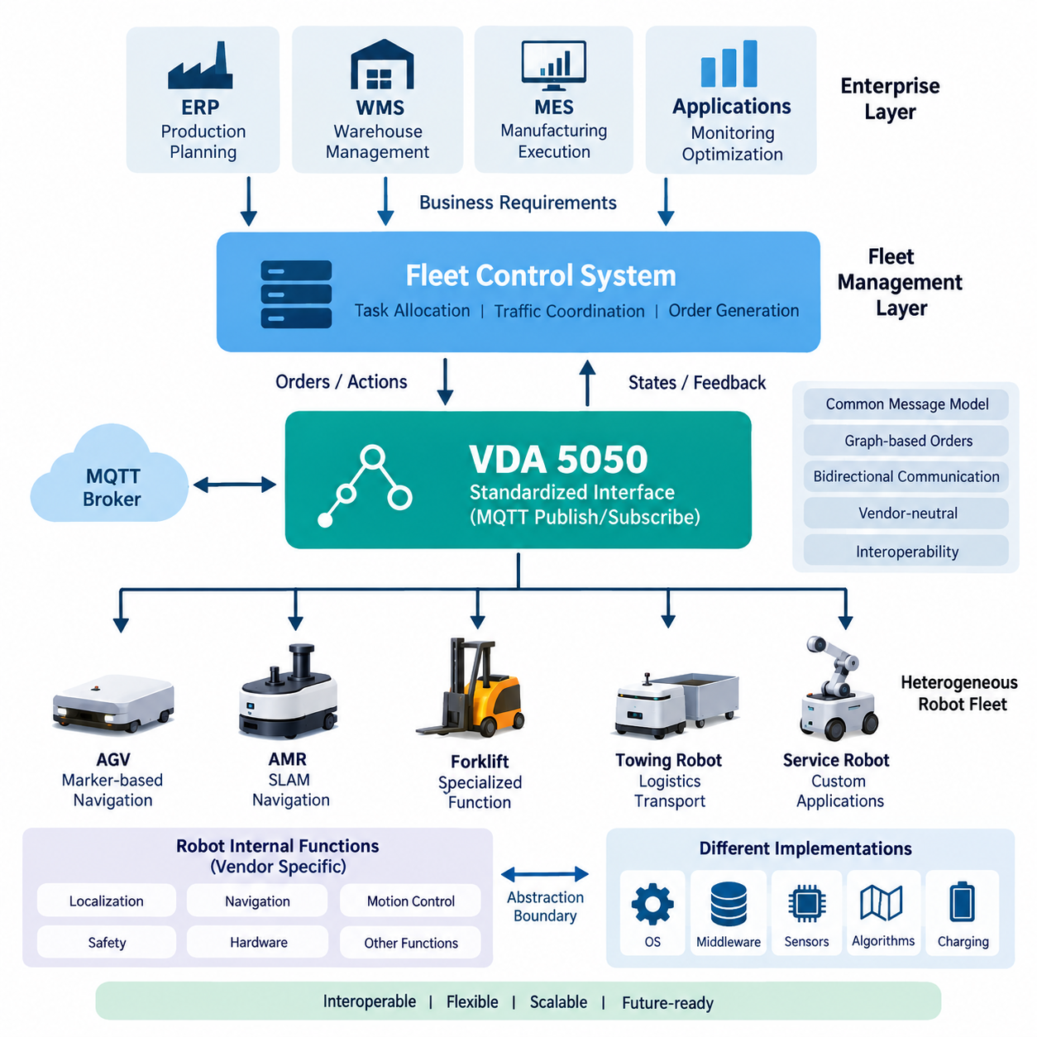
VDA 5050 emerged from a practical interoperability problem in industrial logistics: factories and warehouses increasingly operate automated guided vehicles and autonomous mobile robots from multiple manufacturers, yet each vendor traditionally supplies its own proprietary fleet control interface. This creates isolated automation islands in which higher-level production and logistics systems must integrate separately with every robot platform. VDA 5050 addresses this fragmentation by defining a common communication interface between mobile robots and a central fleet or master control system.
The specification was initiated in the German automotive and material-handling ecosystem, where large manufacturing sites frequently deploy transport systems from several suppliers over long equipment lifecycles. The German Association of the Automotive Industry, VDA, and the VDMA Materials Handling and Intralogistics Association cooperated with manufacturers, users, and technology providers to establish a vendor-neutral interface. The objective was not to standardize the internal construction of robots, but to make heterogeneous mobile transport systems accessible through a shared communication model.
This distinction is fundamental to understanding VDA 5050. A compliant interface does not require every robot to use the same navigation algorithm, localization technology, operating system, middleware, safety controller, or motion-control architecture. One vehicle may navigate using LiDAR SLAM, another may use reflectors or infrastructure-based localization, and another may combine cameras and multiple sensors. VDA 5050 creates an abstraction boundary above these implementation differences so that fleet-level software can exchange operational information using standardized concepts.
The primary goal is interoperability between a master control system and mobile robots supplied by different manufacturers. Instead of implementing a unique protocol for every vehicle type, the master control system can communicate through a standardized message structure. Orders, vehicle states, connection information, visualization data, and operational actions can therefore be represented consistently. This approach reduces the number of proprietary integration paths that must be developed and maintained as a heterogeneous robot fleet expands over time.
VDA 5050 is closely associated with MQTT-based publish/subscribe communication. Rather than requiring a persistent point-to-point command connection between every controller and robot, information is exchanged through defined topics and structured messages. This architecture fits distributed fleet environments because producers and consumers can be logically decoupled. A robot can publish its current state while the master control system publishes orders and actions, with an MQTT broker providing the messaging infrastructure between the participating systems.
The communication model also separates strategic fleet coordination from local vehicle execution. A master control system may decide which robot should perform a transport mission, coordinate traffic among vehicles, and generate an appropriate route through the shared environment. The individual robot remains responsible for safely executing the received instructions according to its own controller and capabilities. Consequently, VDA 5050 should be understood as a fleet interoperability interface rather than as a replacement for navigation, motion control, obstacle avoidance, functional safety, or embedded control software.
Orders are expressed through graph-oriented concepts that describe nodes and edges. Nodes represent relevant positions or operational points, while edges describe connections and movement between them. Actions can be associated with appropriate elements of the order to represent operations such as loading, unloading, docking, or other vehicle-specific functions. This representation provides enough structure for fleet coordination while avoiding unnecessary dependence on the internal trajectory-generation and actuator-control implementation of a particular robot manufacturer.
Bidirectional communication is equally important. Fleet interoperability cannot be achieved by sending commands alone; the master control system must understand whether a vehicle has accepted an order, where it is within the execution sequence, what actions are active, and whether errors or exceptional conditions have occurred. Standardized state information therefore provides a common operational vocabulary. This enables supervisory software to coordinate robots based on observable execution status instead of relying on proprietary status codes and vendor-specific telemetry semantics.
Another important goal is lifecycle flexibility. Industrial mobile robots may remain in operation for many years, while fleet management software, warehouse systems, manufacturing execution systems, and individual robot models evolve at different rates. A standardized interface reduces direct coupling between these lifecycles. Organizations can introduce new vehicle suppliers or upgrade fleet-level software without necessarily redesigning every surrounding integration, provided that compatibility, supported features, and implementation-specific constraints are carefully managed.
Interoperability, however, does not mean that every compliant robot automatically possesses identical capabilities. Robots can differ significantly in dimensions, payload, kinematics, charging behavior, supported actions, navigation constraints, and operating environments. A useful fleet architecture must therefore distinguish communication compatibility from functional compatibility. VDA 5050 provides a common language for interaction, while system integrators must still determine whether a particular vehicle can physically and functionally perform the requested mission within the intended facility.
This principle becomes particularly important when fleets include conventional AGVs, freely navigating AMRs, towing platforms, forklifts, service robots, or other specialized mobile systems. Modern interoperability must accommodate vehicles whose motion is not always adequately described by rigid infrastructure assumptions. The evolution of VDA 5050 therefore reflects a broader transition from relatively homogeneous automated transport installations toward heterogeneous and increasingly autonomous mobile robot ecosystems in which shared fleet coordination must coexist with diverse local autonomy.
VDA 5050 also provides an architectural bridge to enterprise logistics. Warehouse management systems, manufacturing execution systems, enterprise resource planning platforms, and production applications generally operate at a higher abstraction level than individual robots. A fleet controller can translate business-level transport requirements into coordinated robot assignments and VDA 5050 orders. The standard thus occupies an important interface layer between operational logistics orchestration and the vendor-specific software responsible for executing physical movement.
This layered role complements the broader API architecture of a robotic system. REST or gRPC interfaces may connect enterprise applications and fleet services, WebSocket interfaces may support dashboards, and internal ROS 2 or proprietary middleware may connect software components inside a robot. VDA 5050 addresses a different boundary: standardized fleet-to-vehicle communication across heterogeneous mobile robot platforms. It should therefore be integrated with these technologies rather than treated as a universal replacement for all robot communication mechanisms.
Standardization can also reduce long-term integration risk. Without a common interface, adding a new robot supplier may require new adapters, data models, error mappings, monitoring logic, and operational procedures. Each additional proprietary integration increases testing and maintenance complexity. A shared protocol establishes a more stable contract between fleet orchestration and vehicle implementations, allowing integration effort to focus on capabilities and operational behavior rather than repeatedly rebuilding the fundamental communication layer.
Nevertheless, conformance to message formats alone is insufficient for successful deployment. Real interoperability requires consistent interpretation of order updates, sequence identifiers, state transitions, action behavior, error conditions, connection recovery, and vehicle capabilities. Network reliability, MQTT broker configuration, cybersecurity, timing behavior, and failure handling also affect actual operation. For this reason, VDA 5050 implementation should be treated as a system-integration discipline involving protocol conformance, behavioral validation, and realistic multi-vendor testing.
The standard also supports an important architectural objective: preventing the fleet management layer from becoming tightly dependent on a single robot manufacturer. A well-designed system can place vendor-specific functions behind adapters or capability abstractions while preserving a common operational interface toward the master control layer. This separation improves replaceability and supports incremental fleet expansion, although proprietary extensions may still be necessary when specialized robot functions cannot be represented completely by the common interoperability model.
From a software architecture perspective, VDA 5050 is therefore best understood as a contract at the boundary between fleet intelligence and physical robot execution. Above the boundary are task allocation, traffic coordination, production scheduling, warehouse integration, monitoring, and fleet optimization. Below it are localization, perception, navigation, trajectory generation, safety functions, motor control, and hardware interfaces. The standard enables these layers to evolve with greater independence while maintaining a defined operational relationship.
The long-term significance of VDA 5050 extends beyond protocol standardization. As industrial sites deploy larger numbers of heterogeneous autonomous systems, interoperability becomes an architectural prerequisite for scalable automation. A common fleet interface allows robots to become replaceable and composable resources within a larger cyber-physical logistics system. This creates a foundation for multi-vendor orchestration, flexible manufacturing, fleet-level optimization, and future Physical AI environments in which increasingly intelligent robots must cooperate without requiring a single proprietary technology stack.

11.02 VDA 5050 Channel Structure: connection, order, state, viz [w/Code]
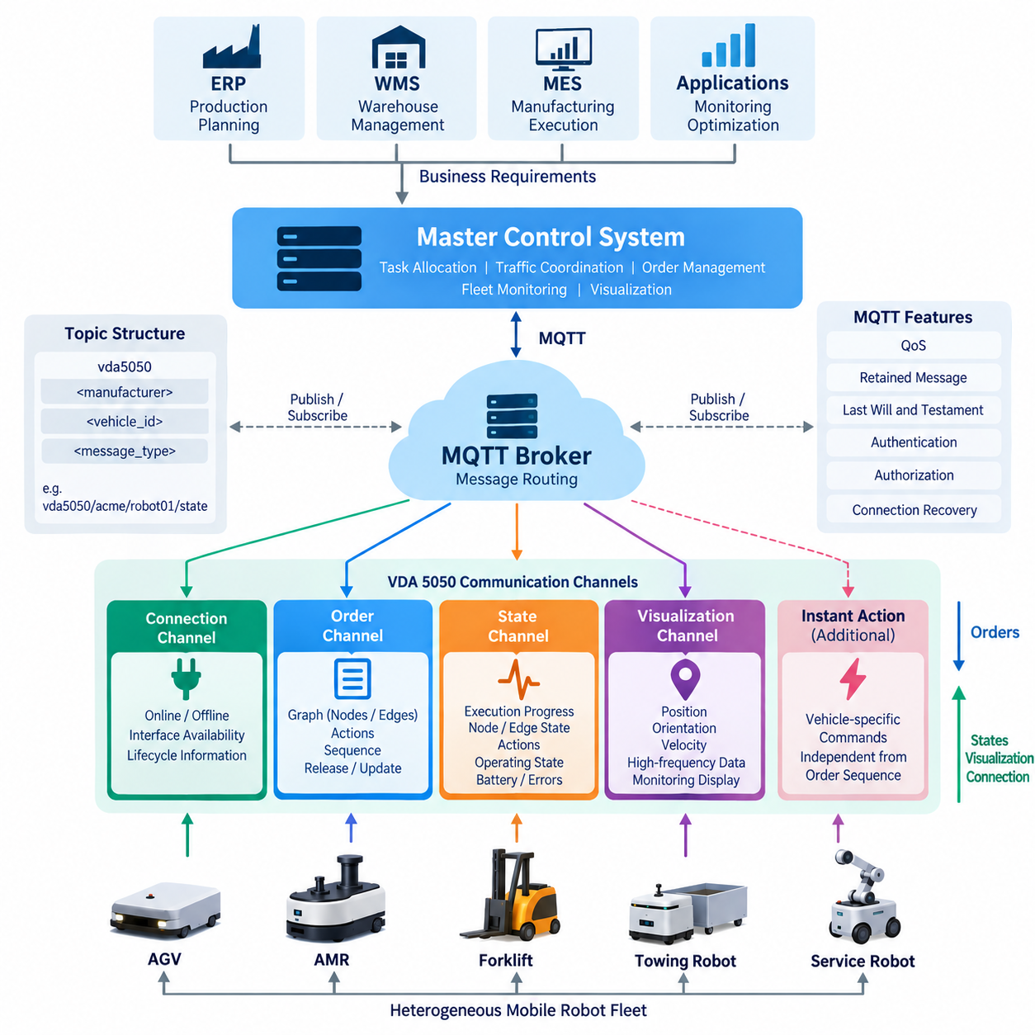
VDA 5050 organizes communication between a master control system and mobile robots through a defined set of MQTT topics, often described as communication channels. Each channel has a distinct operational purpose and message schema, allowing commands, execution feedback, connectivity information, and visualization data to remain logically separated. The core structure centers on connection, order, state, and visualization communication, with additional channels supporting actions and vehicle-specific capabilities.
The topic hierarchy provides the addressing mechanism that allows an MQTT broker to route messages to the correct participants. A typical topic identifies the VDA 5050 interface context, manufacturer, vehicle identity, and message type. This organization becomes especially important in installations containing many robots from several vendors. The master control system can communicate with a specific vehicle while monitoring state information from the entire fleet through predictable subscription patterns.
The connection channel communicates whether a vehicle is logically connected to the messaging infrastructure and available from the perspective of the communication interface. It supports lifecycle awareness rather than mission execution itself. A master control system needs this information because the absence of state messages alone may not clearly distinguish temporary network delay, application shutdown, broker disconnection, or another communication failure affecting a robot.
MQTT mechanisms such as retained information and Last Will and Testament can support connection monitoring. When a robot establishes communication, it can publish information indicating its online status, while an unexpected loss of the MQTT session can cause the broker to publish a predefined offline indication. This allows other components to detect communication loss even when the robot application cannot explicitly transmit a final message because power, network connectivity, or software execution has failed unexpectedly.
The order channel carries mission execution information from the master control system toward a mobile robot. An order describes a graph composed primarily of nodes and edges, together with associated actions and sequence information. Nodes represent positions or operational points, while edges define movement between them. The vehicle interprets this graph according to its own navigation and motion-control architecture rather than receiving low-level actuator commands through VDA 5050.
Order communication is designed to support controlled modification as execution progresses. A master control system does not necessarily need to transmit an entire long mission as one immutable command. Instead, portions of a route can be released and subsequently extended or updated while maintaining identifiers and sequence consistency. This enables fleet-level traffic coordination to remain dynamic while the robot retains sufficient authorized route information for predictable local execution.
The distinction between released and unreleased portions of an order is particularly significant for coordinated traffic management. A released section represents the part that the robot is authorized to execute, whereas subsequent graph elements may describe a planned continuation that has not yet been released. The master control system can therefore regulate entry into shared areas, intersections, narrow passages, or other contested resources without continuously controlling the vehicle's individual motion commands.
Order identity and update information are essential because MQTT communication is asynchronous and messages can be delayed, duplicated, or observed after newer information has already been processed. The robot must determine whether an incoming order represents a new mission, a valid extension or modification, or information that should not replace its current execution context. Consistent handling of identifiers and sequence numbers therefore protects the logical integrity of distributed mission execution.
The state channel provides the primary feedback path from the vehicle to the master control system. While the order channel describes what the robot should execute, the state message describes what the robot currently understands and what has actually happened. It can report order progress, node and edge status, active or completed actions, operating mode, driving state, battery information, errors, safety-related conditions, and other operational information required for fleet supervision.
This feedback creates a closed communication loop between fleet planning and physical execution. The master control system sends an order, the robot validates and executes it, and state messages reveal the resulting progress. The controller can then determine whether additional route sections should be released, another task should be scheduled, traffic coordination should change, or an exception requires intervention. VDA 5050 therefore uses state synchronization rather than assuming that command transmission implies successful physical execution.
State information is also essential for heterogeneous fleet abstraction. Different manufacturers may use different internal state machines, diagnostic frameworks, battery management systems, and navigation software. The VDA 5050 state representation exposes selected operational information through a common external model. A fleet controller can consequently reason about multiple vehicle types without directly understanding every vendor's internal software architecture, although manufacturer-specific interpretation may still be required for specialized functions.
The visualization channel serves a different purpose from authoritative order and state communication. It provides frequently updated information useful for displaying the robot's movement and orientation in monitoring applications. Position, orientation, velocity, and related visualization information can be published so that a fleet dashboard or engineering tool can present the vehicle dynamically. This channel should not be confused with the control information required to determine mission execution or safety behavior.
Separating visualization traffic is architecturally useful because display data and operational state often have different timing and bandwidth requirements. A graphical interface may benefit from frequent position updates to produce smooth motion, while the master control system does not necessarily require every visualization sample for mission logic. Independent channels allow communication frequency and processing behavior to be selected according to purpose instead of forcing all information into one large telemetry message.
The direction of information flow clarifies the responsibilities of each component. Orders generally travel from the master control system to the vehicle, while state and visualization information travel primarily from the vehicle toward subscribed consumers. Connection information communicates interface availability, and additional command mechanisms can support immediate actions that are not naturally represented as part of the normal node-and-edge order sequence. Together, these channels form a structured bidirectional communication model.
Instant actions complement normal order execution by allowing commands whose relevance is not limited to a particular position in the planned graph. Depending on supported capabilities and specification behavior, such actions can address operational needs that must be initiated independently of the ordinary mission sequence. Keeping these mechanisms distinct from graph-based orders helps preserve clear semantics between planned transport execution and commands that modify or influence the current operational context.
In a practical deployment, the MQTT broker becomes the communication hub connecting one or more fleet-control services with many vehicles. Robots publish their state, visualization, and connection-related messages to appropriate topics, while subscribing to the topics through which they receive orders and other supported commands. The broker routes messages but does not make fleet decisions, calculate robot trajectories, or interpret mission semantics; these responsibilities remain with the communicating applications.
MQTT Quality of Service, retained-message behavior, session configuration, authentication, authorization, and connection recovery must be engineered carefully around this channel model. A technically correct message schema does not guarantee reliable fleet operation if stale commands can be mistaken for current ones or unauthorized clients can publish control messages. Topic-level access control should therefore restrict which components can publish or subscribe to operational channels according to their defined responsibilities.
The channel structure also improves observability and troubleshooting. Because orders, states, connection information, and visualization traffic are logically separated, engineers can inspect each communication flow independently. When a vehicle stops progressing, for example, diagnostics can determine whether the order was published, whether the robot remains connected, whether state messages report an error, and whether visualization data indicates physical movement. This separation provides a systematic basis for identifying integration failures.
At fleet scale, predictable topic naming and channel semantics allow one master control architecture to manage many heterogeneous vehicles without creating an individual communication design for each robot. Manufacturer and vehicle identifiers provide routing boundaries, while standardized message categories establish common behavior. Fleet software can subscribe selectively, aggregate states across vehicles, monitor connectivity, issue targeted orders, and feed visualization services through the same messaging infrastructure.
The connection, order, state, and visualization channels should therefore be viewed as complementary parts of one distributed control contract. Connection establishes communication awareness, order expresses intended mission execution, state reports authoritative operational progress, and visualization supplies high-frequency information for observation. Their separation reduces ambiguity while their coordinated use closes the loop between fleet-level planning, message transport, local autonomous execution, and supervisory monitoring.
This architecture illustrates why VDA 5050 is more than a collection of JSON messages transported over MQTT. The channel model defines information ownership, communication direction, operational semantics, and responsibility boundaries between fleet software and mobile robots. When implemented consistently, it provides a scalable communication foundation on which multi-vendor fleets can coordinate missions while allowing each robot manufacturer to retain independent navigation, control, safety, and hardware implementations.

11.03 VDA 5050 Order Message Design: Nodes and Edges [w/Code]
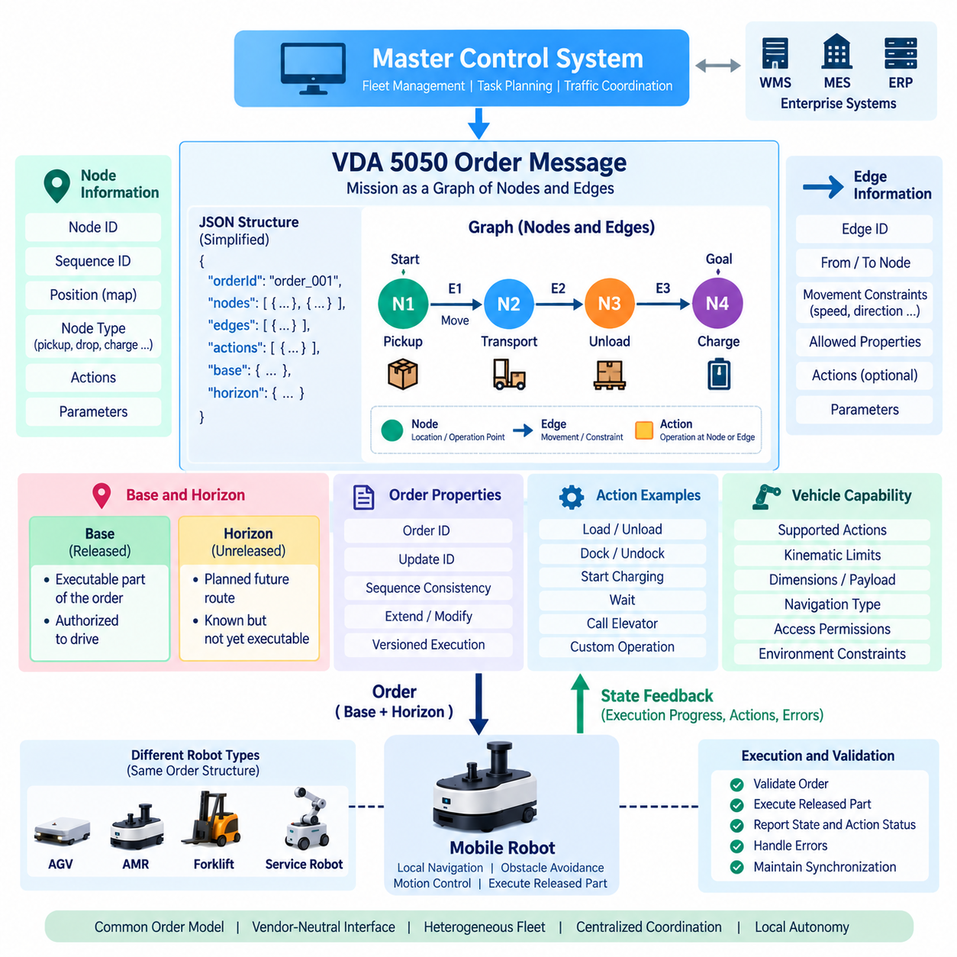
The VDA 5050 order message is the primary structure through which a master control system describes an intended transport mission to a mobile robot. Instead of transmitting low-level steering, velocity, or motor commands, the order represents the mission as an ordered graph of nodes and edges. This abstraction allows heterogeneous vehicles to receive a common mission description while retaining their own localization, navigation, trajectory generation, obstacle avoidance, and motion-control implementations.
A node represents a significant position or operational point within the environment. Depending on the application, it may correspond to a workstation, loading station, unloading location, charging point, waiting position, intersection, docking area, or intermediate route point. Nodes provide the discrete spatial references around which an order is constructed, but the vehicle remains responsible for converting these references into locally executable navigation and control behavior.
Each node requires information that allows the robot and master control system to identify its role within the order. A node identifier distinguishes the physical or logical location, while a sequence identifier establishes its position in the ordered graph. Position-related information can describe where the node is located in the relevant map or coordinate system. Additional parameters and actions may define what the vehicle is expected to do when it reaches that location.
Edges connect consecutive nodes and represent the movement that the robot should perform between them. If nodes answer the question of where important mission points are located, edges describe how those points are connected within the planned order. An edge can contain information relevant to route execution, including permitted movement characteristics or other constraints that the vehicle can interpret according to its capabilities and local navigation implementation.
Nodes and edges form an alternating sequence. A simplified mission may begin at Node A, continue through Edge A-B to Node B, and then proceed through Edge B-C to Node C. Sequence identifiers provide an explicit ordering relationship among these elements. This prevents the graph from being interpreted merely as an unordered collection of locations and connections and gives both communicating systems a shared representation of mission progression.
Sequence consistency is particularly important because order execution occurs across a distributed asynchronous system. MQTT messages may experience network delay, reconnection, retransmission, or different processing times at individual components. The vehicle must therefore determine whether received graph elements belong to the expected mission progression. Identifiers and sequence information provide the logical references needed to reject inconsistent updates and maintain synchronization with the master control system.
The order identifier distinguishes one order context from another, while an order update mechanism allows an existing order to be extended or modified according to the protocol rules. This distinction enables a master control system to continue an active mission without unnecessarily replacing the entire execution context. The robot can compare the received order identity and update information with its current state before accepting new graph elements for execution.
A central concept in VDA 5050 order design is the distinction between the base and the horizon. The base contains graph elements that have been released for execution, while the horizon represents planned elements that are known but not yet released. This allows the master control system to communicate future route intent without immediately authorizing the robot to traverse every part of the planned path.
This separation is useful for fleet traffic coordination. Consider two robots whose planned routes pass through the same narrow corridor. The master control system may provide both robots with information about their future routes while releasing the contested section to only one vehicle. The other vehicle can retain its planned continuation in the horizon but must not execute that unreleased section until the master control system updates the order and grants further progression.
The base-and-horizon mechanism therefore creates a boundary between executable authorization and future planning information. It enables the fleet controller to coordinate intersections, narrow passages, shared work cells, doors, elevators, and other constrained resources without directly controlling wheel motion. The robot autonomously executes released graph elements, while the master control system determines when additional parts of the planned mission become available for execution.
Actions extend the graph beyond pure movement. A node can contain actions associated with reaching or operating at a particular location, such as loading cargo, unloading material, docking, initiating charging, waiting, interacting with equipment, or performing another supported operation. By attaching an action to the graph, the order can describe both spatial movement and operational work as parts of the same mission execution context.
Actions can also be associated with edges when an operation is meaningful during movement between nodes. The precise supported action set depends on the vehicle and integration environment, because not every robot provides the same mechanical or application capabilities. A transport AMR, autonomous forklift, towing robot, and service robot may therefore share the VDA 5050 order model while exposing substantially different executable actions.
Action semantics require careful integration because a standardized communication mechanism does not make all vehicle functions identical. The master control system must understand which actions a particular vehicle supports, which parameters are required, and how those actions interact with movement. An unsupported or incorrectly parameterized action should not be treated as executable merely because its representation can be transmitted through the common order structure.
Order design must also consider the relationship between graph execution and action execution. Some operations can occur while the robot is moving, whereas others may require movement to stop before they begin. Loading, docking, or interaction with stationary equipment may impose different execution conditions from signaling or other nonblocking behavior. Correct integration therefore depends on interpreting the operational behavior associated with actions, not merely parsing their message fields.
The master control system should generate orders that reflect the physical and functional capabilities of the assigned vehicle. Graph connectivity alone does not guarantee feasibility. A route may be unsuitable because of robot dimensions, turning radius, kinematic constraints, payload, floor conditions, charging requirements, access permissions, or supported actions. Fleet interoperability consequently requires capability-aware order generation in addition to standardized message serialization.
The vehicle performs its own validation when an order is received. It must determine whether the order and its updates are logically consistent, whether referenced graph elements can be interpreted, and whether requested operations are supported. Once accepted, the released portion becomes part of the vehicle's executable mission context. Execution progress is then communicated back to the master control system through state messages, closing the control loop between planned order and physical behavior.
As the vehicle traverses an edge and reaches a node, its state reflects progress through the graph. Completed elements can be distinguished from elements still awaiting execution, and action states provide information about operational work. The master control system uses this feedback to decide whether the mission is progressing normally and whether additional horizon elements should be released as new base elements.
Order updates therefore form an incremental coordination process rather than a simple command-and-forget transaction. The master control system can initially release only the portion of the graph that is currently safe to execute, observe vehicle progress, evaluate traffic conditions, and subsequently extend the executable route. This architecture combines centralized fleet coordination with decentralized vehicle autonomy and avoids the need for the fleet controller to continuously generate low-level trajectories.
Error handling is inseparable from order processing. A vehicle may be unable to accept an order because of invalid graph relationships, inconsistent identifiers, unsupported actions, unavailable operating conditions, or other integration problems. During execution, physical obstacles or subsystem failures may also prevent completion. State and error information must therefore remain correlated with the active order so that the master control system can distinguish communication, planning, capability, and execution failures.
A robust implementation should treat an order as a versioned execution contract rather than merely as a JSON document. The master control system owns the fleet-level mission intent and route release decisions, while the vehicle owns local execution within the authorized graph. Order identifiers, update information, node and edge sequences, release states, and actions together establish the shared context required to maintain that contract across asynchronous communication.
This model scales naturally to heterogeneous fleets because the common graph representation does not prescribe how each vehicle physically follows an edge or reaches a node. An AGV may follow infrastructure-defined guidance, while an AMR may generate a local path using SLAM and obstacle avoidance. An autonomous forklift may additionally manage forks and pallet operations. Their internal implementations differ, yet each can interpret a fleet-level mission through the same node-and-edge abstraction.
The VDA 5050 order message therefore separates mission intent from robot implementation. Nodes define meaningful destinations, edges establish ordered connectivity, actions describe operational work, sequence information preserves graph consistency, and the base-and-horizon concept controls execution authorization. Together these mechanisms provide the structural foundation for coordinated multi-vendor fleet operation while preserving local autonomy inside each mobile robot.

11.04 VDA 5050 Instant Actions and Exception Handling [w/Code]
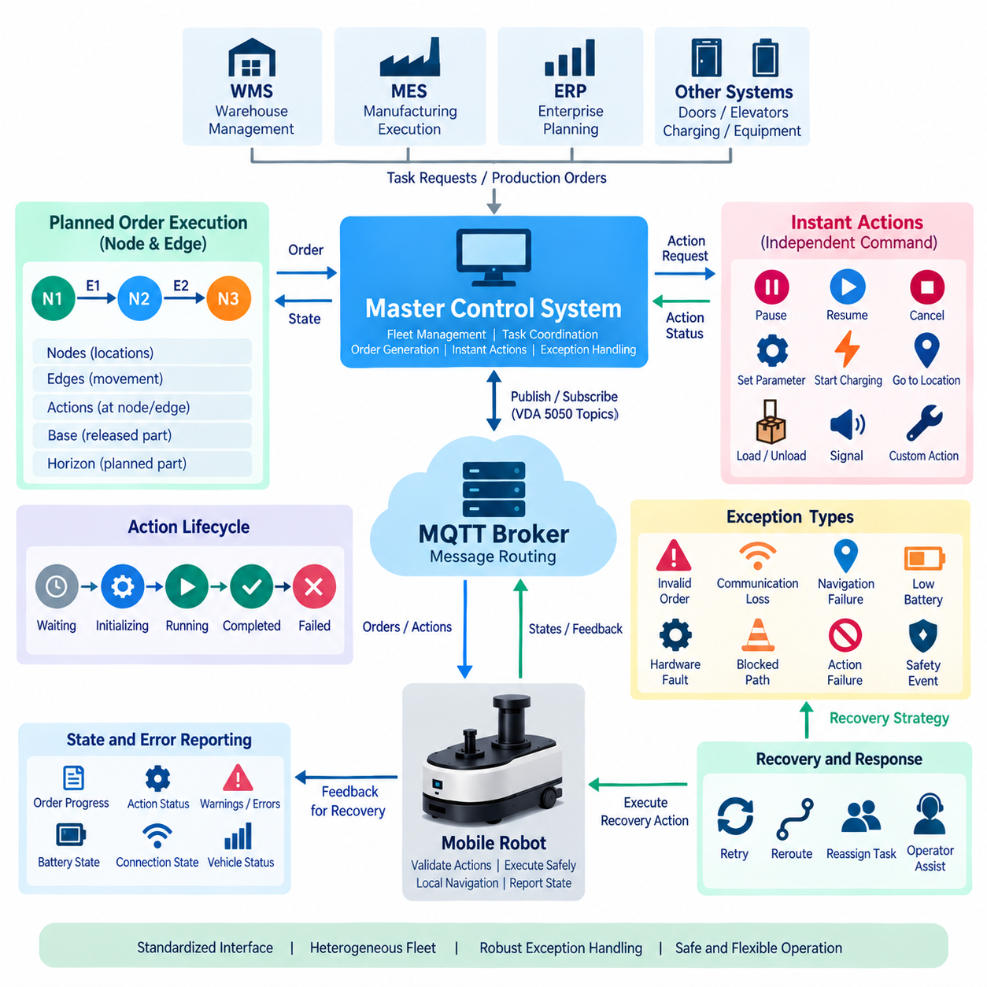
VDA 5050 separates planned mission execution from commands that may need to influence a vehicle independently of its normal node-and-edge sequence. Instant actions provide this second control path. While ordinary actions are associated with nodes or edges inside an order, an instant action can be transmitted independently of the current route structure. This allows the master control system to request operational behavior without rebuilding the active transport order.
This distinction is important because fleet operations frequently encounter situations that cannot be predicted when an order is initially generated. A robot may need to pause, resume, cancel an operation, modify a supported operating function, or respond to another supervisory request while executing an existing mission. Instant actions provide a standardized mechanism for expressing such requests while preserving the identity and execution context of the underlying order.
An instant action should not be interpreted as an unrestricted remote-control command. It remains a high-level request that the vehicle must validate and execute according to its supported capabilities, internal state, safety logic, and current operational conditions. VDA 5050 therefore preserves the same architectural boundary used for normal orders: the master control system expresses intent, while the vehicle determines how that intent can be safely realized through its local software and hardware.
Each action requires an identity so that its lifecycle can be tracked across asynchronous communication. The action definition describes the requested behavior and may include parameters needed for execution. When the vehicle receives the request, it evaluates whether the action type is supported, whether the supplied parameters are valid, and whether execution is permitted in the current state. Acceptance of the message does not automatically mean successful completion of the physical operation.
Action status provides the feedback needed to follow this lifecycle. An action can progress through states that indicate whether it is waiting, being initialized, running, completed, or failed according to the applicable protocol semantics. The master control system observes these transitions through vehicle state information. This creates an explicit relationship between the original request and its actual execution rather than forcing supervisory software to infer success from unrelated telemetry.
Instant actions can interact with an active order, so their semantics must be designed carefully. A request that changes vehicle behavior may affect movement, actions already in progress, or the continuation of the current route. The implementation must define how the robot resolves these interactions without creating contradictory execution states. The master control system must likewise understand that an instant action can influence the context in which subsequent order elements are executed.
The difference between operational interruption and emergency safety behavior is especially important. Fleet-level commands can request that normal mission execution be paused or otherwise changed, but functional safety must not depend exclusively on VDA 5050 messaging. Emergency stop circuits, certified safety controllers, protective sensors, safe motion functions, and other safety mechanisms remain within the vehicle or facility safety architecture and operate according to their applicable safety requirements.
Exception handling begins when actual execution diverges from the expected mission flow. Exceptions may originate from communication problems, invalid orders, unsupported actions, localization issues, blocked paths, battery conditions, hardware faults, safety events, or interactions with external equipment. A robust VDA 5050 integration must transform these conditions into understandable operational information so that the master control system can determine an appropriate fleet-level response.
Errors should provide more than a generic indication that something went wrong. Useful error reporting identifies the nature of the problem and supplies references that help correlate it with the relevant order, action, node, edge, or vehicle subsystem when applicable. Additional descriptive information can support diagnostics and operator interpretation. Structured errors allow fleet software to distinguish conditions that require automatic recovery from those that require human intervention.
Not every abnormal condition should produce the same system response. Some conditions are transient and may disappear without changing the mission, while others prevent the current route or action from continuing. The fleet architecture should therefore consider severity, persistence, operational impact, and recoverability. A temporary obstruction, for example, is fundamentally different from a localization failure or an actuator fault that makes continued autonomous movement impossible.
Warnings and errors should also be treated differently when the implementation exposes such distinctions. A warning may indicate degraded performance or a condition requiring observation while still allowing execution to continue. An error can indicate a condition that prevents expected operation or requires corrective action. Clear semantics are important because excessive undifferentiated alarms can overwhelm operators and make automated fleet recovery logic unreliable.
Communication failure is a particularly important exception because VDA 5050 operates across a distributed MQTT infrastructure. A robot may temporarily lose connectivity to the broker or master control system while remaining physically operational. Connection-state mechanisms, session behavior, and application-level timeout logic must therefore work together to identify loss of communication and determine what the vehicle should do according to the site's operational and safety policy.
Recovery after reconnection requires synchronization rather than simply continuing as though no interruption occurred. The master control system must understand the vehicle's current order context, execution progress, active actions, and errors before issuing further instructions. The vehicle must also avoid executing stale information that may have been retained or delayed during the communication interruption. Order identifiers, update information, action identities, and state feedback provide the references needed to restore a consistent shared context.
Order-related exceptions can occur before execution begins. A robot may reject an order because its graph is inconsistent, an update does not match the expected order context, required information is invalid, or requested functionality is unsupported. Such rejection should be visible to the master control system so that it can revise the mission, select another vehicle, correct the route, or escalate the problem rather than assuming that the transport task is progressing normally.
Exceptions can also emerge during physical execution. A released edge may become blocked, a docking operation may fail, a load-handling action may not complete, or the robot may enter a state that prevents further movement. In these cases, state and error reporting provide the fleet controller with evidence of the divergence. Recovery may involve waiting, retrying, rerouting, cancelling part of the mission, assigning another robot, or requesting operator assistance.
The master control system should implement exception handling as a stateful orchestration process rather than a collection of isolated error callbacks. It must correlate the vehicle identity, active order, graph position, action status, error information, and communication state before choosing the next valid operation. This contextual approach prevents recovery commands from being issued based on outdated assumptions about where the robot is or what it is currently executing.
Idempotency and duplicate handling are also relevant because distributed messaging can cause commands or updates to be observed more than once. An implementation should use identifiers and protocol state to determine whether a received request represents new work or information that has already been processed. Repeating a physical action merely because a message was retransmitted could produce serious operational consequences, particularly for loading, unloading, docking, or equipment interaction.
Timeouts require similar care. A master control system may expect an action or movement to complete within a certain operational window, but exceeding that expectation does not necessarily prove that execution has failed. Network delay, congestion, temporary obstacles, or slow external equipment can extend completion time. Timeout policies should therefore trigger controlled evaluation and recovery logic rather than automatically assuming that a physical operation can safely be repeated.
Exception handling becomes more complex in heterogeneous fleets because identical high-level failures may originate from very different internal implementations. One AMR may report navigation failure after its local planner cannot find a path, while another vehicle may encounter an infrastructure-guidance problem. VDA 5050 provides a common communication framework, but fleet software must preserve enough diagnostic context to support meaningful recovery without assuming identical internal causes.
Operational logging is essential for understanding these interactions. Orders, instant actions, action-state transitions, connection changes, errors, and recovery decisions should be recorded with consistent timestamps and correlation information. These records support troubleshooting, conformance testing, fleet performance analysis, and incident reconstruction. They also make it possible to determine whether a failure originated in mission planning, communication, vehicle execution, or external infrastructure.
A resilient architecture combines instant actions and exception handling with explicit responsibility boundaries. The master control system manages fleet-level intent, coordination, and recovery strategy, while the vehicle protects its local execution constraints and safety conditions. The MQTT infrastructure transports messages but does not resolve operational conflicts. External systems such as WMS, MES, doors, elevators, and charging equipment may contribute additional state that the fleet controller must consider.
Instant actions and exception handling therefore form the dynamic control layer around normal VDA 5050 order execution. Orders define planned movement and work through nodes, edges, and actions, while instant actions allow supervisory intervention outside that normal sequence. State, error, and connection information reveal what actually occurs. Together, these mechanisms enable a heterogeneous fleet to respond predictably to changing conditions without sacrificing local autonomy or safety responsibility.

11.05 VDA 5050 State Machine Implementation [w/Code]
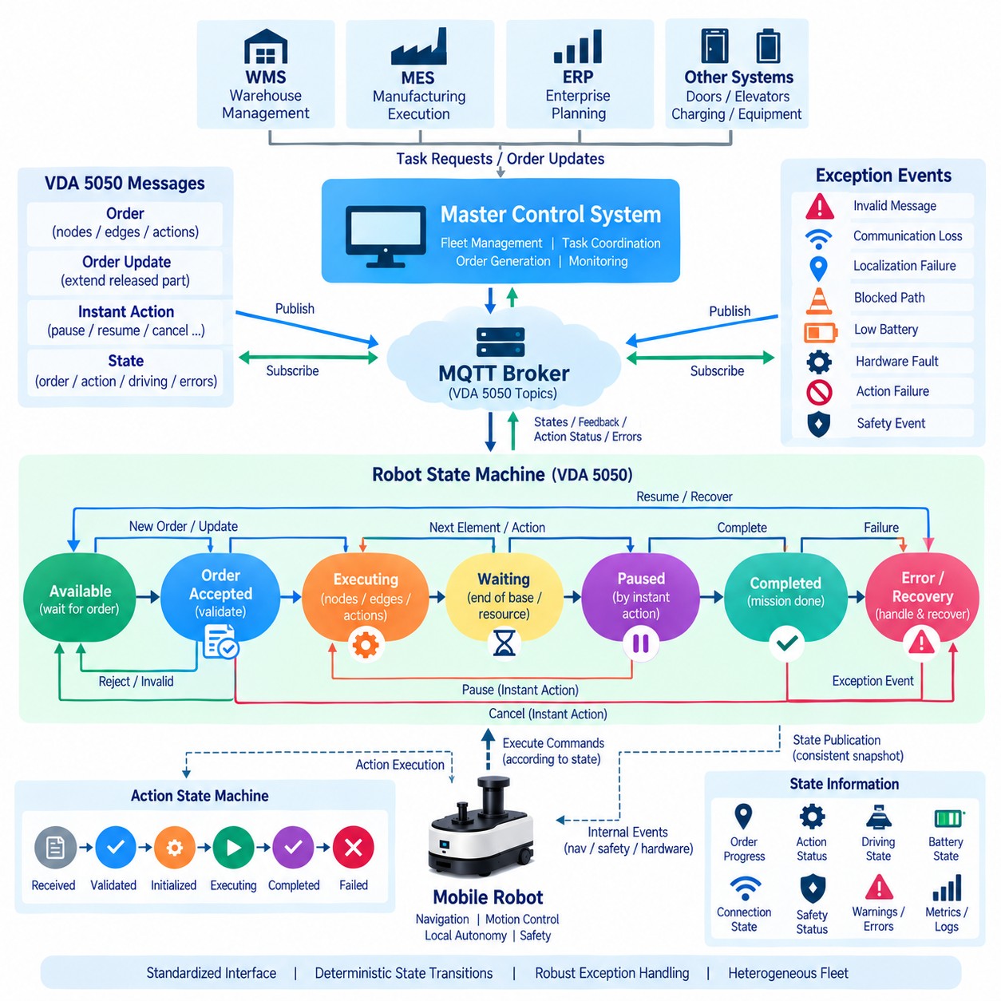
A VDA 5050 state machine translates asynchronous fleet messages into deterministic vehicle behavior. The robot cannot treat every received order, action, or connection event as an isolated command because each request is meaningful only within the current execution context. A state-machine architecture provides explicit rules for accepting orders, executing released graph elements, processing actions, reporting progress, handling exceptions, and returning to a stable operational condition.
The implementation normally separates protocol state from the robot's low-level motion-control state. VDA 5050 determines whether an order is accepted, which node or edge is active, which actions may execute, and what information must be reported. Local navigation software independently manages path planning, localization, obstacle avoidance, velocity control, and actuators. This separation prevents communication logic from becoming tightly coupled to a particular robot hardware or navigation stack.
At the highest level, a vehicle can be considered to move through conditions such as available, order accepted, executing, waiting, paused, completed, and error or recovery. These conceptual states do not need to replace every internal controller state. Instead, they form an orchestration layer that maps VDA 5050 events onto existing robot functions and converts internal execution results back into standardized state information for the master control system.
The available condition represents a robot that can evaluate new work. When an order arrives, the implementation first validates identifiers, update information, node and edge sequences, release flags, required actions, and relevant capabilities. Validation should occur before physical execution begins. If the order is inconsistent or unsupported, the state machine preserves a safe execution context and reports appropriate information rather than partially starting an invalid mission.
After acceptance, the state machine identifies the first executable element within the released base of the order. If a node action must execute before movement, the action scheduler activates it according to its defined behavior. Otherwise, the navigation interface can begin processing the next released edge. The VDA 5050 layer supervises progression through these elements without replacing the navigation stack responsible for physically moving the vehicle.
Edge execution provides a clear example of hierarchical state-machine design. The protocol layer may consider an edge active while the navigation subsystem transitions through planning, path following, obstacle avoidance, and arrival detection. The VDA 5050 implementation does not need to expose all these internal navigation states. It only needs enough information to determine whether the edge is progressing, completed, temporarily blocked, cancelled, or failed.
When the robot reaches the next node, the state machine updates its graph position and evaluates actions associated with that node. Depending on action semantics, movement may remain blocked until required work is completed. Once the node and its required actions satisfy their completion conditions, the state machine determines whether another released edge is available. If so, execution continues; otherwise, the robot waits for an order update or mission completion.
The distinction between base and horizon directly influences state transitions. Released base elements are executable, whereas horizon elements represent future route information that cannot yet be executed. A robot reaching the end of its released base must therefore avoid automatically entering an unreleased edge. It remains in a controlled waiting condition until the master control system extends the released portion through a valid order update.
Order updates are events processed against the current state rather than replacements applied without context. The implementation verifies that the update belongs to the active order and that its sequencing is compatible with the graph already accepted or executed. Valid extensions can add newly released elements and allow execution to continue. Invalid or stale updates must not corrupt the current mission state, even if they are syntactically valid messages.
Action execution benefits from its own nested state machine. An action can be received, validated, prepared, initialized, executed, completed, or failed according to the supported semantics. The vehicle reports corresponding action status so that the master control system can correlate requested work with actual progress. Separating action state from overall order state is important because several actions and movement conditions may interact during one transport mission.
Action blocking behavior determines how actions interact with other execution activities. Some actions may allow movement or other actions to continue, while others require partial or complete serialization. The state-machine implementation must enforce these relationships consistently. A docking or load-transfer operation, for example, may require the robot to remain stationary, whereas another supported action may execute concurrently without preventing route progression.
Instant actions introduce asynchronous events that can arrive while an order or action is already active. The state machine must validate the request against the current context and determine whether it can execute immediately, must modify ongoing behavior, or must be rejected. Pause, resume, cancellation, or other supported supervisory operations therefore become controlled state transitions rather than arbitrary interruptions of the navigation or actuator software.
A pause operation illustrates this principle. The state machine records that execution has been suspended and coordinates with the appropriate local subsystem to stop or hold normal mission progression according to the implementation. The active order context should remain identifiable so that a valid resume operation can continue from a consistent state. Pausing should not be confused with an emergency stop, which belongs to the independent functional-safety architecture.
Cancellation requires similarly explicit semantics. Cancelling a mission may involve stopping progression, terminating or completing selected actions according to their behavior, clearing future graph elements, and reporting the resulting state. The implementation should avoid simply deleting the active order data before dependent operations have reached a known condition. Deterministic cancellation is especially important when the robot is interacting with loads, doors, chargers, elevators, or other equipment.
Exception events can originate from the VDA 5050 layer or from internal robot subsystems. Invalid messages, communication loss, localization failures, blocked navigation, actuator faults, low battery conditions, or action failures may all affect execution. The state machine maps these events to defined operational responses while preserving enough context to report what was being executed when the problem occurred.
Recoverable conditions should not necessarily destroy the active mission. A temporary obstacle may cause navigation to wait while the order and current edge remain valid. When the obstacle disappears, execution may continue from the same logical context. More serious faults may require the mission to stop and the master control system to issue a recovery decision. The state machine distinguishes these cases through explicit transition rules rather than ad hoc callbacks.
Communication loss requires special treatment because the robot's physical state can continue changing while the distributed control connection is unavailable. The implementation should retain sufficient local context to know the active order, current graph position, action states, and relevant errors. After reconnection, this information can be published so that the master control system reconstructs the shared execution context before further coordination occurs.
State publication is therefore an output of the state machine, not merely a periodic collection of unrelated telemetry fields. The reported order identity, node and edge information, action states, operating mode, driving condition, battery status, safety information, and errors should describe a logically consistent snapshot of vehicle execution. This consistency is essential because fleet decisions are made from the state reported by multiple robots.
Concurrency must be controlled carefully in software implementation. MQTT callbacks, navigation events, action completions, timers, safety notifications, and order updates may occur from different threads or asynchronous tasks. If these events directly modify shared execution data, race conditions can produce impossible states. A robust design serializes state-machine events through an event queue or equivalent synchronization mechanism before applying transitions.
Persistence can further improve resilience. Important execution context such as active order identifiers, accepted graph elements, completed sequence positions, and action progress can be stored when appropriate. After a software restart, the system can use persisted information together with current physical state to determine whether controlled recovery is possible. Persistence must be designed carefully because blindly restoring obsolete commands could itself create unsafe behavior.
State transitions should also generate structured logs and metrics. Recording the previous state, triggering event, resulting state, order identifier, sequence information, action identifier, and error context makes behavior reproducible during debugging. Metrics such as order execution time, waiting duration, recovery frequency, rejected updates, and action failures can reveal fleet integration problems that may not be visible from individual robot logs.
Testing should focus on transition behavior rather than only message parsing. Normal execution, incremental order updates, base-to-horizon waiting, duplicate messages, unsupported actions, pause and resume, cancellation, communication loss, reconnection, navigation failure, and recovery should all be exercised. Simulation and mock fleet controllers are particularly valuable because rare asynchronous event combinations can be reproduced without placing physical robots at unnecessary operational risk.
A well-designed VDA 5050 state machine ultimately acts as an adapter between standardized fleet intent and vendor-specific robot autonomy. The master control system observes predictable order and action progress, while the robot retains control of navigation, motion, hardware, and safety. Explicit states, validated transitions, synchronized events, persistent context, and structured feedback transform asynchronous MQTT messages into deterministic and maintainable fleet behavior.

11.06 VDA 5050 MQTT Broker Configuration [w/Code]
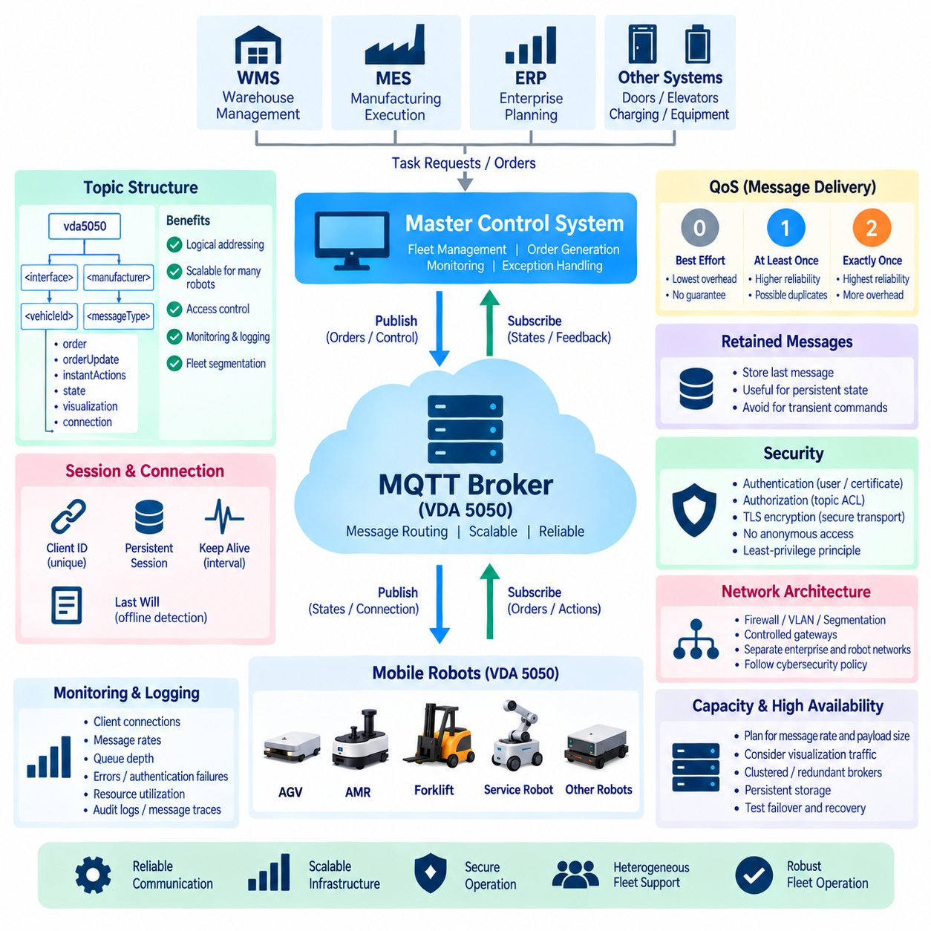
The MQTT broker is the messaging backbone of a VDA 5050 deployment, connecting the master control system with heterogeneous mobile robots through publish/subscribe communication. The broker does not decide routes, allocate missions, or control robot motion. Its responsibility is to receive messages from authorized publishers and distribute them to subscribed clients according to the configured topic structure, delivery policy, session behavior, and security rules.
A production configuration should begin with a clear separation between the broker and the applications using it. The master control system publishes orders and supported control messages while subscribing to robot state and connection information. Each vehicle performs the complementary communication functions required by the interface. This separation keeps fleet intelligence inside the control applications while allowing the MQTT infrastructure to remain a scalable and reusable message transport layer.
Topic configuration is fundamental because topics establish the logical addressing structure of the fleet. VDA 5050 communication identifies information according to interface context, manufacturer, vehicle identity, and message category. A consistent topic hierarchy allows the broker to route messages for many robots without requiring a dedicated network connection for every vehicle. It also provides a natural boundary for access control, monitoring, logging, and fleet segmentation.
Topic names should be generated systematically rather than assembled independently throughout application code. A shared configuration module can define the interface version, manufacturer identifier, serial number or vehicle identifier, and supported message channels. Centralized topic construction reduces typographical errors and prevents subtle incompatibilities between publishers and subscribers. It also simplifies migration when topic conventions or interface versions change.
Subscriptions should follow the principle of minimum necessary scope. A robot generally needs to receive messages intended for its own identity rather than commands for the entire fleet. A master control system may use broader subscription patterns to collect states from many vehicles, but wildcard subscriptions should be designed carefully. Excessively broad subscriptions increase processing load and can unintentionally expose information between systems that should remain isolated.
MQTT Quality of Service, or QoS, determines how message delivery is handled between a client and the broker. QoS 0 provides best-effort delivery, QoS 1 provides at-least-once delivery, and QoS 2 provides exactly-once delivery at the MQTT protocol level. Selecting a QoS level requires balancing reliability, network traffic, latency, broker workload, and the application semantics of each VDA 5050 message category.
Higher QoS does not eliminate the need for application-level consistency. At-least-once delivery can produce duplicate messages, while reconnection and queued traffic can expose information after its original transmission time. VDA 5050 implementations must therefore use order identifiers, update identifiers, sequence information, action identifiers, timestamps, and current state to determine whether a received message represents valid new work or information that has already been processed.
Retained messages require similar caution. MQTT can store the most recent retained publication for a topic and deliver it immediately to a new subscriber. This behavior is useful for information representing a persistent current condition, but it can be dangerous for transient control requests if an old command is interpreted as new. Retention policy should therefore be selected according to the semantics and lifecycle of each communication channel rather than applied uniformly.
The MQTT Last Will and Testament mechanism is especially useful for connection-state management. When a vehicle establishes its broker session, it can configure a predefined message that the broker publishes if the connection disappears unexpectedly. Combined with explicit online or connection messages, this mechanism allows the fleet infrastructure to distinguish normal availability from abrupt communication loss without requiring the disconnected robot to send a final message.
Keep-alive configuration determines how quickly inactive or failed connections can be detected. Very long intervals can delay detection of disconnected robots, while excessively short intervals create unnecessary network and broker traffic and may cause false disconnects on unstable networks. Appropriate values depend on fleet size, wireless network characteristics, expected mobility, operational response time, and the behavior required when communication becomes temporarily unavailable.
Client identifiers must be unique and stable enough for reliable session management. If two robots connect using the same MQTT client identifier, one connection may replace the other depending on broker behavior and protocol configuration. A fleet-wide naming strategy should therefore map each physical or logical communication endpoint to a unique identity. Client identity should also align with authentication and authorization policies so that devices cannot impersonate other vehicles.
Session configuration determines what happens to subscriptions and queued information when a client disconnects and later reconnects. Persistent sessions can improve continuity during temporary wireless interruptions, but queued messages must still be evaluated for freshness and operational relevance. A robot reconnecting after several minutes should not blindly execute accumulated control information without comparing it with its current physical state and active order context.
Broker authentication establishes who is allowed to connect. Depending on the deployment, this may use usernames and passwords, client certificates, or integration with an external identity service. Production fleets should avoid anonymous access because the MQTT infrastructure transports operational commands and detailed vehicle states. Each robot, fleet service, monitoring component, and administrative tool should have an identifiable and manageable security identity.
Authorization determines what an authenticated client is allowed to publish or subscribe to. Topic-level access-control lists can prevent a robot from publishing orders, prevent one vehicle from receiving another vehicle's control traffic, and restrict monitoring clients to read-only access. The master control system can receive broader permissions appropriate to its fleet role. Least-privilege authorization limits the operational impact of compromised credentials or incorrectly configured applications.
Transport security should protect MQTT traffic when it crosses networks that cannot be assumed to be trusted. TLS can provide encryption, server authentication, and, when mutual TLS is used, client authentication. Certificate lifecycle management then becomes part of fleet operations, including provisioning, renewal, revocation, and replacement. Security configuration must be planned for hundreds or thousands of devices rather than handled manually for each robot.
Network architecture should avoid treating the broker as an unrestricted bridge between every enterprise and robot network. Firewalls, network segmentation, dedicated VLANs, routing policies, and controlled gateway paths can limit communication to the services actually required. A robot fleet may span production networks, edge infrastructure, on-premise servers, and monitoring systems, but connectivity between these zones should follow explicit architectural and cybersecurity policies.
Broker capacity planning must account for more than the number of robots. Message frequency, payload size, visualization update rate, retained data, subscription fan-out, QoS level, persistent sessions, logging, and reconnect storms can all affect performance. Visualization traffic can be particularly frequent compared with order traffic. Load testing should therefore reproduce realistic fleet behavior instead of estimating capacity solely from the number of connected MQTT clients.
High availability becomes important when fleet operation depends on continuous broker communication. A single broker process or host can become a critical point of failure even when every robot and fleet application is redundant. Depending on operational requirements, deployments can use clustered brokers, redundant nodes, controlled failover, persistent storage, and health monitoring. The chosen architecture should be tested under actual disconnection and recovery scenarios.
Monitoring should expose broker health and communication behavior before failures become visible as stopped robots. Useful indicators include active client count, connection failures, message rates, subscription counts, queue depth, dropped messages, network throughput, authentication failures, and resource utilization. These metrics can be correlated with robot state and fleet events to distinguish broker problems from wireless, application, or vehicle-level failures.
Logging should provide enough information for operational investigation without unnecessarily storing sensitive or extremely high-frequency payloads. Connection and disconnection events, authentication failures, authorization violations, unusual publish rates, broker restarts, and configuration changes are particularly valuable. Message-level traces may be enabled selectively during integration testing or troubleshooting, but production logging should consider storage volume, privacy, security, and performance.
Configuration management should treat broker settings as controlled infrastructure rather than manual server adjustments. Version-controlled configuration files, documented topic permissions, reproducible deployment procedures, certificate policies, and automated validation reduce configuration drift between development, test, and production environments. Changes to QoS, access rules, persistence, limits, or security settings should be reviewed because they can directly alter fleet communication behavior.
Testing should include failure conditions as well as normal message exchange. Engineers should disconnect robots unexpectedly, restart brokers, interrupt wireless networks, duplicate messages, introduce delayed traffic, expire credentials, and test authorization violations. The objective is to verify not only that orders and states are exchanged during ideal operation, but that the entire fleet returns to a synchronized and controlled condition after realistic infrastructure failures.
A well-configured MQTT broker therefore provides far more than basic message forwarding. Topic design establishes addressing, QoS and session policies shape delivery behavior, retained messages and Last Will support lifecycle management, security controls protect operational channels, and monitoring reveals infrastructure health. Together these mechanisms create a reliable messaging foundation on which VDA 5050 can coordinate scalable, secure, and heterogeneous mobile robot fleets.

11.07 VDA 5050 Fleet Controller (FMC) Implementation [w/Code]
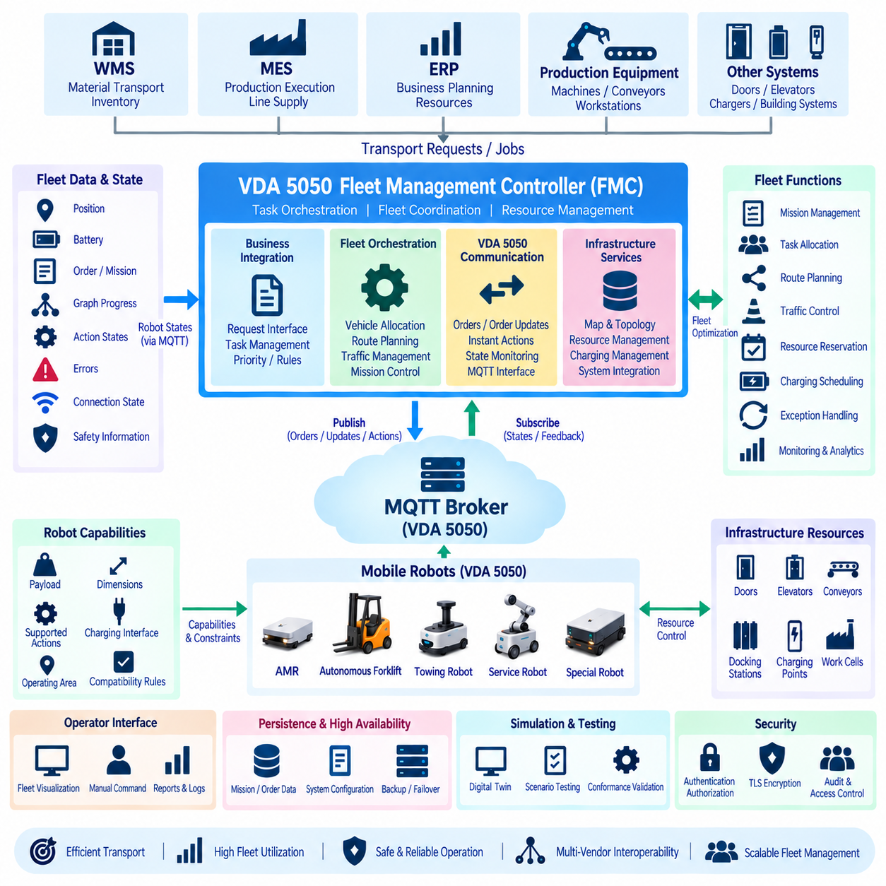
A VDA 5050 Fleet Management Controller (FMC) is the orchestration layer that converts business-level transport requirements into coordinated missions for heterogeneous mobile robots. It sits between systems such as WMS, MES, ERP, production equipment, and the robot fleet. Rather than directly controlling motors or generating local trajectories, the FMC determines which vehicle should perform a task, which route should be assigned, and when each part of that route may be released for execution.
The FMC architecture should separate business integration, fleet orchestration, VDA 5050 communication, and infrastructure services. Business interfaces receive transport requests such as moving a pallet from one workstation to another or delivering material to a production line. The orchestration layer converts these requests into executable missions, while the VDA 5050 adapter translates mission decisions into orders, instant actions, and other standardized messages exchanged with individual vehicles.
A fundamental FMC responsibility is maintaining a consistent digital representation of the fleet. For every connected vehicle, the controller tracks identity, current position, operating state, active order, graph progress, action states, battery information, errors, safety-related information, and communication availability. This representation should be continuously synchronized from VDA 5050 state and connection messages rather than inferred only from commands previously transmitted by the controller.
Vehicle capability modeling is necessary because VDA 5050 interoperability does not mean that every robot is functionally identical. An AMR, autonomous forklift, towing vehicle, and service robot can expose the same communication framework while differing in payload, dimensions, kinematics, supported actions, docking mechanisms, charging interfaces, and environmental restrictions. The FMC therefore requires a capability registry describing what each vehicle can physically and operationally perform.
When a new transport request arrives, the FMC first converts it into a mission model independent of any specific robot. The mission may define pickup and delivery locations, required actions, payload characteristics, timing constraints, priorities, resource dependencies, and completion conditions. This separation allows task requirements to remain stable even when the vehicle selected for execution changes because of availability, failure, charging requirements, or traffic conditions.
Task allocation determines which eligible vehicle should execute a mission. The controller filters the fleet according to capabilities and operating conditions before comparing candidate vehicles. Relevant factors can include current location, travel distance, active workload, battery level, payload compatibility, robot dimensions, charging requirements, expected completion time, and access permissions. Allocation should therefore be treated as a constrained scheduling problem rather than simply assigning the nearest robot.
A practical FMC often combines rule-based filtering with optimization. Hard constraints first eliminate vehicles that cannot perform the task, such as a robot without the required load-handling action or one too large for the destination area. Remaining candidates can then be evaluated according to configurable operational objectives. This layered approach makes allocation behavior easier to explain and maintain while still allowing optimization algorithms to improve fleet utilization.
Route planning transforms the assigned mission into a sequence of navigable fleet-level nodes and edges. The FMC does not normally calculate every wheel-level trajectory. Instead, it reasons over a map or topology representing stations, intersections, corridors, elevators, doors, charging areas, and other operational resources. The selected route is then represented through VDA 5050 graph elements that the robot interprets using its local navigation system.
The fleet map should contain more than geometric connectivity. Edges and nodes may require attributes describing directionality, vehicle restrictions, maximum dimensions, access rules, speed policies, resource identifiers, or supported operations. A route that is geometrically short may be operationally invalid for a particular vehicle. Capability-aware graph search therefore prevents the controller from producing orders that are structurally valid but physically impossible to execute.
Traffic management is one of the most important reasons for implementing a centralized FMC. Multiple robots can request access to the same narrow corridor, intersection, doorway, elevator, docking station, or loading area. Without coordination, locally autonomous robots may block one another even though each individual navigation system behaves correctly. The controller therefore manages shared resources at a fleet level and determines which vehicle may enter contested regions.
The VDA 5050 base-and-horizon concept provides a useful mechanism for implementing this coordination. The FMC can communicate a planned route while releasing only the portion that the robot is currently authorized to execute. Future nodes and edges remain in the horizon until relevant resources become available. When traffic conditions permit further movement, the controller sends a valid order update that extends the released base.
This release strategy allows centralized traffic control without converting the FMC into a real-time motion controller. The vehicle retains responsibility for localization, obstacle avoidance, trajectory generation, velocity control, and safe physical movement. The FMC manages authorization at the route and resource level. This separation preserves robot autonomy while preventing several vehicles from being intentionally routed into the same controlled resource at incompatible times.
Resource management should be implemented independently from individual route objects. A resource manager can represent corridors, intersections, doors, elevators, work cells, docking stations, and charging points as reservable entities. Each reservation records the owning vehicle, requested interval, current status, and dependencies. The route planner and order-release logic then consult this resource state before allowing additional graph elements to become executable.
Deadlock prevention requires reasoning beyond simple collision avoidance. Two or more robots may reserve resources in an order that causes each vehicle to wait indefinitely for another. The FMC should therefore establish consistent reservation policies, detect circular waiting dependencies, and maintain escape or waiting locations where appropriate. Preventing deadlock before releasing route segments is generally more reliable than attempting recovery after several physical robots have blocked one another.
The order manager converts approved mission and route information into VDA 5050 order messages. It maintains order identifiers, update identifiers, node and edge sequence numbers, release flags, actions, and other required execution context. Once an order has been transmitted, the controller must retain its logical history because future state messages and order updates are interpreted relative to the previously accepted execution context.
Order generation should be deterministic. Given the same mission state, route, vehicle capability, and reservation state, the controller should produce a predictable order representation. Deterministic behavior simplifies debugging and prevents subtle inconsistencies between the controller's internal mission model and the graph understood by the vehicle. It also improves reproducibility during simulation, integration testing, and incident investigation.
The FMC must not assume that publishing an order means that the mission has started successfully. Vehicle state messages provide authoritative feedback about what the robot has accepted and how execution is progressing. The controller therefore correlates order identity, graph sequence information, node and edge states, action states, errors, and driving information with its internal mission record. This creates a closed feedback loop between fleet planning and physical execution.
Mission state can be modeled separately from protocol state. A business-level transport task may transition through states such as created, scheduled, assigned, dispatched, executing, waiting, completed, failed, or cancelled. The associated VDA 5050 order has its own identifiers and graph progression. Separating these two models prevents protocol details from leaking unnecessarily into WMS or MES integration while preserving precise execution information inside the fleet controller.
Action orchestration is another core FMC function. Loading, unloading, docking, charging, waiting, equipment interaction, or other supported operations may be associated with nodes or edges. The controller must verify that the assigned vehicle supports the requested action and generate appropriate parameters. It must then observe the reported action state before deciding whether dependent mission stages or additional route elements may proceed.
Instant actions provide a separate supervisory mechanism for operations that are not naturally represented as part of the normal node-and-edge sequence. The FMC may use supported instant actions to influence an active execution context, but these requests must be coordinated with the current mission state. The controller should track each instant action by identity and monitor its lifecycle rather than assuming that successful MQTT transmission means successful vehicle execution.
Exception handling should be integrated into the mission state machine. A blocked route, rejected order, failed action, communication loss, localization problem, low battery condition, infrastructure failure, or robot fault can require different recovery behavior. The FMC first determines whether the condition is temporary, locally recoverable, mission blocking, or fleet critical. It can then select an appropriate response without discarding valuable execution context.
For temporary conditions, the best response may simply be to wait while preserving the current order and resource reservations. Other situations may require releasing reservations, calculating an alternative route, updating the order, cancelling the mission, or assigning the remaining task to another vehicle. Recovery logic should be stateful because the correct response depends on where the robot is physically located and which actions or resource interactions are already in progress.
Communication management is typically implemented through a dedicated VDA 5050 gateway or adapter connected to the MQTT broker. This component handles topic construction, serialization, schema validation, subscriptions, publishing, connection monitoring, and protocol-specific message processing. Keeping this responsibility separate from task scheduling and routing allows the fleet algorithms to operate on internal domain objects instead of directly manipulating MQTT payloads.
Incoming MQTT events should be processed through controlled event pipelines. State messages, connection changes, errors, and action updates may arrive concurrently from many robots. Directly modifying shared mission data from MQTT callback threads can create race conditions and inconsistent fleet state. A robust FMC places incoming events into queues or streams and processes them through synchronized state transitions or transactional domain services.
Persistence is essential because fleet operation can continue for hours or days and controller processes may restart. The FMC should preserve business missions, vehicle assignments, active order identities, graph progress, resource reservations, action context, and relevant recovery information. Persistent information must be reconciled with live robot state after restart because the physical fleet may have changed while the controller was unavailable.
Startup recovery should therefore begin with synchronization rather than immediate command transmission. The controller reconstructs its persisted state, reconnects to the MQTT infrastructure, receives current vehicle information, and compares the reported execution context with its own records. Only after inconsistencies have been resolved should normal scheduling and order release resume. This prevents obsolete controller state from generating commands that conflict with the actual fleet.
Infrastructure integration is often required for doors, elevators, conveyors, chargers, automated storage systems, and production equipment. These systems may not communicate through VDA 5050 and therefore require separate adapters or service interfaces. The FMC coordinates their states with robot missions so that, for example, an elevator is available before a robot is authorized to enter or a workstation is ready before a delivery action begins.
Charging management should be treated as part of fleet scheduling rather than as an isolated battery alarm response. The controller monitors battery information, predicts operational demand, identifies available charging resources, and schedules charging without unnecessarily reducing fleet capacity. Different vehicle types may require different chargers or charging procedures, so energy management must also use the vehicle capability and infrastructure models.
Scalability requires careful separation of services and data ownership. A small fleet may operate with a single controller process, but larger deployments can separate task scheduling, vehicle registry, route planning, traffic management, VDA 5050 communication, infrastructure integration, monitoring, and persistence. Service boundaries should follow operational responsibilities rather than being divided arbitrarily, because excessive distribution can create unnecessary synchronization complexity.
High availability should be designed around ownership of active fleet decisions. Running multiple controller instances is not sufficient if two instances can simultaneously release conflicting routes or assign the same task. Leader election, distributed locking, transactional resource ownership, or another consistency mechanism may be required. Failover behavior should guarantee that a replacement controller reconstructs current fleet state before taking authority over mission execution.
Observability is essential for understanding why the FMC made a particular decision. Logs should correlate transport request identifiers, mission identifiers, vehicle identities, VDA 5050 order identifiers, graph sequences, actions, reservations, and errors. Metrics can measure allocation latency, mission duration, robot utilization, waiting time, blocked resources, charging time, order rejection, communication loss, and recovery frequency.
A fleet visualization interface can expose this internal state to operators without becoming the source of control truth. The interface may show robot positions, active missions, planned routes, released route segments, reserved resources, battery conditions, errors, and infrastructure status. Operator commands should pass through the same controlled orchestration logic as automated decisions so that manual intervention cannot bypass mission consistency or resource ownership rules.
Simulation is particularly valuable for FMC development because many fleet problems emerge only when several vehicles interact. A digital environment can reproduce congestion, simultaneous task requests, resource competition, communication delay, robot failure, blocked routes, and charging demand. The same VDA 5050 interfaces used with physical robots can be connected to simulated vehicles, allowing controller logic to be tested before deployment.
Conformance testing should be combined with scenario-based fleet testing. Message schemas may be correct while the overall system still behaves incorrectly during order updates, base-and-horizon transitions, duplicate messages, reconnection, action failure, or resource contention. Tests should therefore verify complete mission lifecycles and recovery sequences rather than checking only whether individual JSON messages conform to the interface definition.
Cybersecurity must be incorporated into FMC implementation because the controller has authority over fleet-level operations. Authentication identifies robots and external systems, authorization restricts permitted operations, and TLS protects MQTT and service communication where appropriate. Credentials, certificates, configuration changes, operator actions, and administrative interfaces require controlled lifecycle management and auditing.
The FMC should also maintain a clear boundary with functional safety. Fleet coordination can reduce traffic conflicts and prevent logically incompatible route releases, but it does not replace certified vehicle safety functions. Emergency stopping, protective field monitoring, safe speed control, collision protection, and other safety mechanisms remain responsibilities of the robot and facility safety architecture according to applicable requirements.
A mature FMC architecture therefore combines task orchestration, capability-aware allocation, route planning, traffic coordination, resource reservation, order management, action supervision, exception recovery, infrastructure integration, persistence, and observability. VDA 5050 provides the standardized communication contract connecting these fleet-level functions to heterogeneous mobile robots, while internal domain models provide the intelligence needed to operate the fleet.
The central implementation principle is to keep responsibility boundaries explicit. Enterprise systems define business demand, the FMC determines fleet-level execution intent, VDA 5050 communicates that intent and returns execution state, and each robot performs local autonomous movement within its authorized context. This layered architecture allows multi-vendor fleets to scale without forcing every robot to share the same navigation software, hardware platform, or internal control architecture.
When these elements are implemented consistently, the FMC becomes more than a message dispatcher. It acts as the operational coordinator of the robotic system, continuously reconciling business requests, robot capabilities, route availability, shared resources, infrastructure state, and physical execution feedback. The result is a fleet architecture in which standardized VDA 5050 communication supports coordinated, observable, recoverable, and scalable operation across heterogeneous autonomous mobile robots.

11.08 VDA 5050 Conformance Test Execution
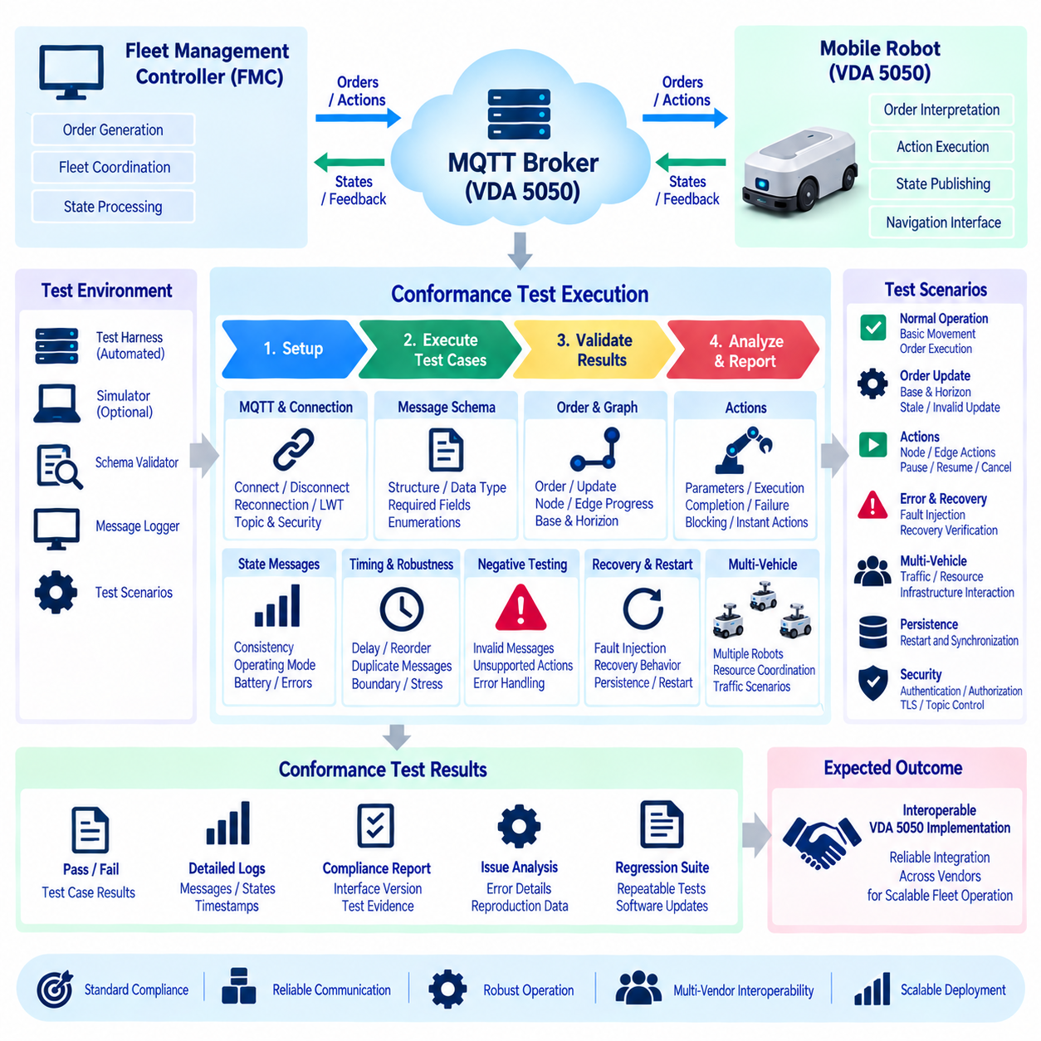
VDA 5050 conformance test execution is the systematic process of verifying that independently developed mobile robots, fleet management controllers, and communication adapters exchange information and coordinate behavior according to the same interface contract. The objective extends beyond checking whether MQTT messages can be transmitted. Testing must confirm that message structures, topics, orders, states, actions, identifiers, connection behavior, and exception handling remain mutually consistent throughout operation.
A conformance program should first define the System Under Test, or SUT, and establish its responsibility boundary. On the robot side, the SUT may include the VDA 5050 communication adapter, order interpreter, action manager, state publisher, and interfaces to navigation software. On the controller side, it may include order generation, state processing, MQTT communication, and fleet coordination. Clear boundaries prevent unrelated hardware or navigation defects from being incorrectly classified as protocol failures.
The test environment should reproduce the essential architecture of a real VDA 5050 deployment while remaining controllable and repeatable. A typical environment contains an MQTT broker, the SUT, a reference or simulated peer, message recording facilities, schema validators, and an automated test harness. Physical robots can be introduced for integration testing, while simulation is especially useful for reproducing abnormal communication, invalid commands, timing variations, and failure conditions without operational risk.
Before executing mission scenarios, the communication environment must be verified. The test should confirm that clients establish MQTT connections using expected identities and authentication mechanisms, subscribe to permitted topics, publish only where authorized, and respond correctly to disconnection. Topic construction is particularly important because a syntactically correct VDA 5050 payload delivered through the wrong topic hierarchy cannot provide reliable interoperability.
Message schema validation establishes the structural foundation of conformance testing. Every supported message category should be checked for required properties, correct data types, valid enumerations, nested object structures, arrays, identifiers, and other defined constraints. Automated validation can identify malformed messages efficiently, but schema validity alone is insufficient because a structurally valid message may still contradict the current order, action, or vehicle state.
Semantic validation therefore examines whether message content makes sense within the active execution context. An order update may be perfectly valid JSON but refer to an incorrect order, incompatible sequence, or obsolete execution state. Similarly, an action may use a valid structure while requesting behavior unsupported by the vehicle. Conformance execution must evaluate both structural correctness and contextual consistency to determine whether systems can safely interpret each other's information.
Header and identity behavior should be verified consistently across message categories. Vehicle identity, manufacturer information, message sequencing, timestamps, and other contextual information allow distributed components to associate messages with the correct source and execution context. Tests should introduce repeated, delayed, or reordered information to ensure that historical messages are not incorrectly interpreted as the newest state or as authorization for new physical activity.
Connection-state testing verifies whether the distributed system maintains an accurate understanding of vehicle availability. Scenarios should include normal connection establishment, intentional shutdown, unexpected network loss, broker interruption, client restart, and reconnection. Where MQTT Last Will and Testament and keep-alive mechanisms are configured, their behavior should also be observed to confirm that communication loss can be recognized without depending on a final message from the disconnected client.
Reconnection testing must go beyond proving that the MQTT session can be restored. During an interruption, the robot may continue local processing or remain physically at a different execution point than the controller expects. After communication returns, current order identity, graph position, action states, errors, and other relevant information should be synchronized before the controller makes new assumptions about mission progress.
Order conformance testing normally begins with a minimal valid graph and gradually introduces more complex combinations of nodes, edges, actions, and release states. The controller transmits an order and observes whether the vehicle validates it, accepts executable elements, begins execution, and publishes corresponding state changes. This verifies the complete relationship between command representation and reported physical progress rather than testing order parsing in isolation.
Node and edge progression should be evaluated throughout the mission lifecycle. When the vehicle traverses an edge and reaches a node, the controller must be able to determine which graph elements have been completed and which remain relevant. Tests should include several consecutive nodes and edges, waiting positions, action-bearing nodes, and realistic movement sequences so that graph progression is verified under representative operational conditions.
The base-and-horizon mechanism requires dedicated scenarios because it provides an important boundary between route planning and execution authorization. A test can send released base elements followed by unreleased horizon elements and verify that the robot executes only the released portion. The vehicle should not proceed into an unreleased graph segment simply because information describing that future segment is already available.
The controller can subsequently transmit an order update that extends the released base. Testing then verifies whether the vehicle correlates the update with the active order, accepts the newly released graph elements, and continues from the correct execution point. This scenario demonstrates whether planning information and execution authority remain correctly separated during incremental fleet coordination.
Order update testing should also deliberately introduce invalid or stale information. Updates may reference an incorrect order identity, incompatible update identifier, unexpected sequence relationship, or graph content inconsistent with previously accepted information. The implementation should respond predictably without corrupting the active graph, restarting completed work, or entering an ambiguous mission state.
Duplicate message handling is another important interoperability requirement. Network recovery, QoS behavior, application retries, or software restarts may cause logically identical information to appear more than once. Repeating an order, order update, or action-related message should not cause duplicate physical execution. The receiving system should use identifiers and execution context to distinguish new information from previously processed information.
Action conformance testing should cover every action that the robot declares or is configured to support. Parameter validation, initialization, execution, completion, and failure behavior should be observed. Actions attached to nodes or edges should be executed within their intended context, and the corresponding action state should provide sufficient information for the controller to determine whether dependent mission execution can continue.
Blocking behavior requires special attention because actions can influence movement and other concurrent activities. A blocking action should prevent the relevant execution progression until its required condition is satisfied, while a supported nonblocking action should not unnecessarily stop unrelated activity. Multiple simultaneous or sequential actions should also be tested because concurrency defects often appear only when several execution contexts overlap.
Instant actions should be introduced while normal order execution is active. Supported supervisory operations such as pause, resume, cancellation, or other implementation-specific capabilities can be transmitted and their effects observed. The receiving system should validate each request against its current context, associate it with the appropriate action identity, and report execution progress rather than treating successful message reception as successful completion.
Pause and resume scenarios should verify that mission context survives temporary suspension. The active order, graph position, unfinished actions, and relevant execution information should remain coherent while paused. When execution resumes, already completed work should not be repeated and unfinished work should not be skipped. Tests should inject pause requests at different execution points because behavior may differ during movement, actions, or waiting.
Cancellation scenarios should similarly be exercised at several mission stages. Cancellation before movement, during edge traversal, while executing an action, or shortly before completion may create different internal transitions. The resulting state should remain understandable to the controller, and graph elements that are no longer authorized should not continue executing after cancellation has become effective.
State-message conformance testing should evaluate the complete reported snapshot rather than validating fields independently. Order information, graph progress, action states, driving information, operating mode, battery data, safety-related information, and errors collectively describe the vehicle. Individually valid values can still form an inconsistent state combination, and such contradictions can lead the fleet controller to make incorrect operational decisions.
Error testing uses controlled fault injection to determine whether abnormal conditions are represented consistently. Scenarios may introduce unsupported actions, invalid orders, blocked navigation, localization problems, actuator failures, low battery conditions, communication loss, or infrastructure problems. The test should verify not only the presence of an error indication but also whether the surrounding mission, order, and action context remains interpretable.
Recovery testing should follow fault injection whenever the implementation supports continued operation. A blocked path may become available again, a communication link may recover, or an external resource may return to service. Testing should determine whether execution resumes from the correct context, remains waiting for controller intervention, or requires a revised order according to the intended system behavior.
Visualization communication should be evaluated separately from authoritative execution state. Visualization data can be published at a higher frequency to support operator displays and fleet monitoring, but it should not silently become the sole basis for determining mission completion. Tests should verify valid formatting and publication behavior while confirming that temporary visualization loss does not invalidate otherwise available execution-state information.
Asynchronous timing is a major source of integration defects and should be intentionally varied during testing. Messages may arrive later than expected, callbacks may be processed concurrently, and state transitions may occur while an order update or action request is being handled. Controlled delays, duplicates, connection interruptions, and event timing variations reveal race conditions that may remain hidden during ideal sequential demonstrations.
Negative testing deliberately provides information that a conforming implementation should reject or report as invalid. Examples include malformed payloads, missing mandatory content, unsupported actions, invalid identifiers, inconsistent graph sequences, unauthorized publications, and messages that conflict with the active execution state. The system should handle these conditions without crashing, corrupting persistent context, or initiating unintended robot movement.
Boundary and stress-oriented scenarios complement normal conformance cases. Large orders, extended graph sequences, numerous actions, frequent updates, rapid state publications, and high visualization rates can expose implementation limits. The purpose is not necessarily to perform a complete performance benchmark, but to verify that valid interface usage near expected operational boundaries does not cause incorrect protocol behavior.
Security-related conformance tests should confirm that communication controls support the intended operational architecture. Unauthorized clients should not be able to publish commands or access protected state information. Authentication failures, invalid credentials, topic authorization violations, and TLS-related configuration problems can be introduced systematically to verify that rejected communication does not alter the fleet execution context.
Multi-vehicle scenarios are essential when testing a Fleet Management Controller. Several simulated or physical robots can establish independent identities, publish state simultaneously, execute different orders, and experience connection changes at overlapping times. The controller must preserve strict separation between vehicle contexts so that a message from one robot cannot modify another robot's order, action, reservation, or recovery state.
Traffic coordination can extend testing from basic protocol conformance into fleet-level interoperability. Multiple robots may approach shared corridors, intersections, docking stations, elevators, or other constrained resources. The controller can use staged graph release and order updates while the test verifies that each vehicle receives a consistent executable route and that resource decisions remain aligned with reported vehicle progress.
Infrastructure interaction should be included whenever external systems participate in the deployed mission. Doors, elevators, conveyors, charging equipment, storage systems, and workstations may use protocols other than VDA 5050, yet their state can directly influence VDA 5050 orders and actions. End-to-end scenarios should verify that delays or failures in these systems result in understandable fleet and vehicle states.
Restart and persistence testing evaluates whether execution context survives software or infrastructure interruption. The robot adapter, fleet controller, broker, or supporting service can be restarted while a mission is active. After recovery, persisted information should be reconciled with current vehicle state before commands continue, preventing completed graph elements or actions from being repeated because a process lost volatile memory.
An automated test harness greatly improves repeatability. It can establish MQTT sessions, publish predefined orders and actions, subscribe to responses, validate schemas, evaluate state transitions, inject communication failures, introduce timing variations, and collect evidence. Each scenario should define preconditions, input events, expected observations, timeout criteria, and cleanup behavior so that results can be reproduced consistently.
Test automation should support deterministic replay wherever practical. When a failure occurs, engineers should be able to reproduce the same order, message sequence, timing pattern, and fault condition. This is especially important for asynchronous integration problems because an issue observed once in a large physical fleet may otherwise be difficult to recreate during debugging.
Traceability connects requirements, test scenarios, execution evidence, and results. A conformance report should identify the interface and software versions used, broker configuration, system under test, supported capabilities, scenario identifier, transmitted messages, observed responses, timestamps, state transitions, errors, and final result. Recording this evidence makes a pass or failure technically explainable rather than dependent on an operator's visual judgment.
Test results should distinguish mandatory conformance behavior from optional or implementation-specific capability. Different robots may support different actions and operational features while remaining interoperable within the common interface. The test plan should therefore identify which capabilities are declared by the implementation and verify those capabilities without incorrectly requiring every vehicle to provide identical mechanical or application functions.
Conformance testing must also remain separate from functional-safety validation. VDA 5050 testing can verify communication and observable execution behavior, but it does not certify emergency stopping, protective fields, safe speed monitoring, braking performance, or other safety functions. Test scenarios involving faults or interruptions should respect the robot's independent safety architecture rather than attempting to override it through fleet communication.
Similarly, successful conformance does not prove complete product quality. Navigation accuracy, localization performance, mechanical durability, wireless coverage, cybersecurity of every subsystem, and facility-specific operational suitability require additional verification processes. VDA 5050 conformance provides evidence that the standardized fleet interface behaves consistently within the scope actually tested.
Regression testing converts conformance from a one-time integration activity into an ongoing engineering discipline. Changes to navigation software, action implementations, MQTT libraries, fleet algorithms, security settings, or configuration can unintentionally alter interface behavior. A stable automated suite should therefore be executed repeatedly during development, system integration, and release preparation.
Previously discovered interoperability defects should become permanent regression scenarios whenever practical. If a duplicate order once caused repeated execution, or reconnection once produced an inconsistent graph state, the exact condition should be represented in the automated suite. This allows accumulated operational experience to improve the reliability of every later software release.
A mature test process can progress from schema validation to component testing, simulated integration, multi-vehicle scenarios, infrastructure interaction, physical robot validation, and regression execution. Each stage increases realism while retaining evidence from the previous level. This layered strategy reduces the cost of discovering simple protocol defects while still exposing complex problems that appear only in complete fleet operation.
The ultimate purpose of VDA 5050 conformance test execution is predictable interoperability between systems developed by different vendors or engineering teams. A robot should interpret valid fleet intent consistently and provide understandable execution feedback, while the fleet controller should generate coherent orders and correctly interpret the states returned by each vehicle.
When MQTT behavior, message schemas, identity, orders, graph progression, base and horizon, actions, state consistency, exceptions, recovery, security, persistence, timing, and multi-vehicle interaction are verified together, conformance testing becomes an end-to-end validation discipline. It transforms interoperability from a design assumption into repeatable engineering evidence that can support scalable heterogeneous robot fleet integration.

11.09 MassRobotics Interoperability vs VDA 5050 Comparison
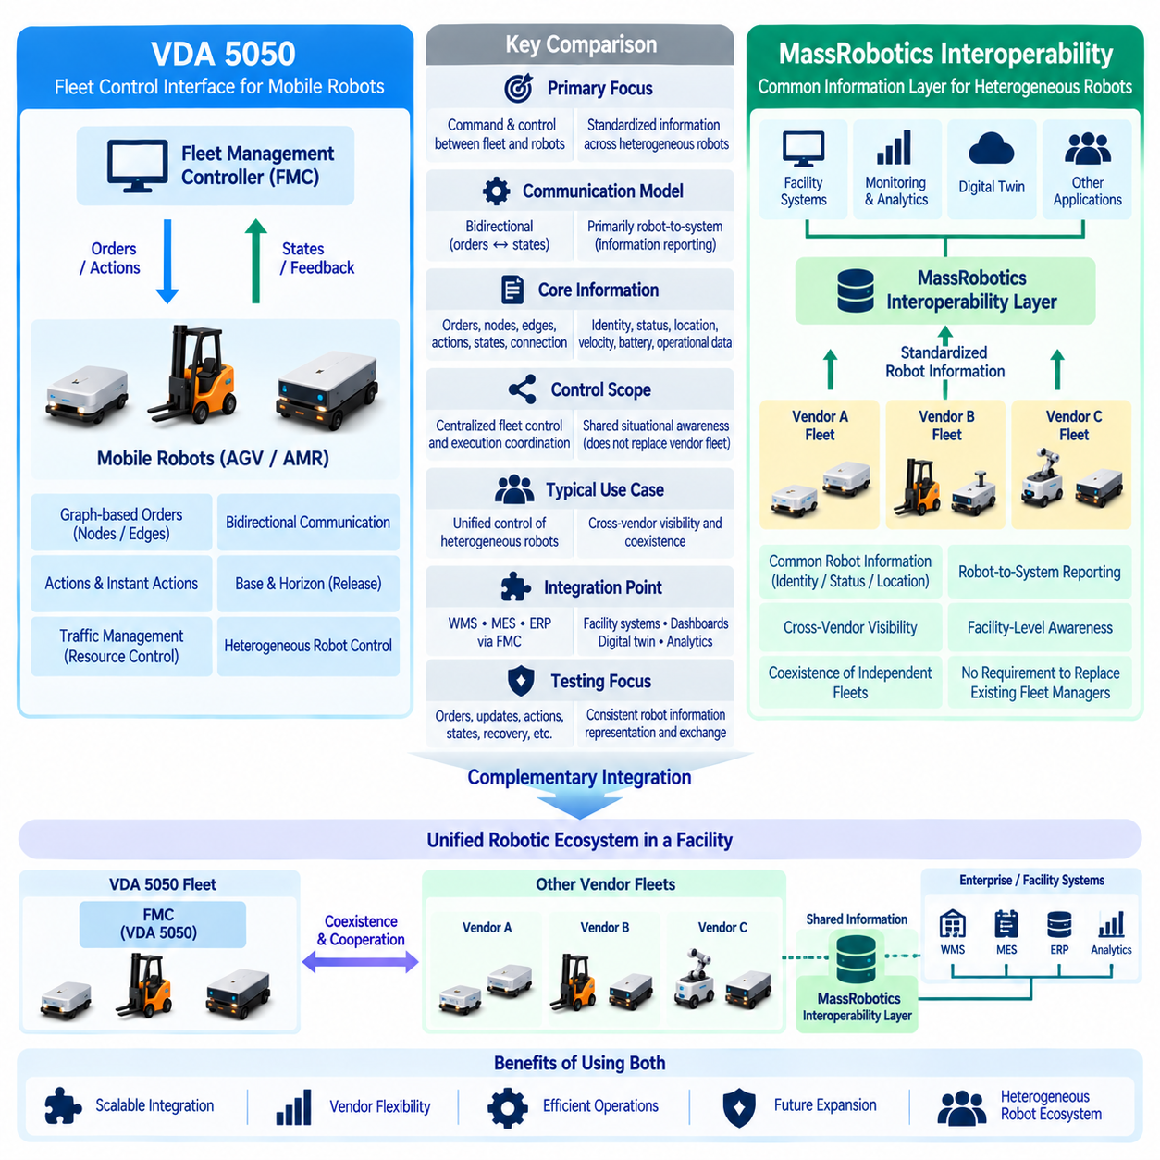
MassRobotics Interoperability and VDA 5050 address the common challenge of integrating heterogeneous mobile robots, but they approach interoperability from different operational perspectives. Both reduce dependence on proprietary interfaces and make information exchange between systems more predictable. Their scopes, communication models, and intended relationships between robots and external systems, however, are fundamentally different.
VDA 5050 primarily defines communication between mobile robots and a fleet or master control system. Its architecture assumes that a higher-level controller coordinates missions and communicates execution intent to vehicles. Orders, nodes, edges, actions, state information, and connection information therefore form an operational control interface capable of supporting coordinated execution across heterogeneous vehicles.
MassRobotics Interoperability focuses more strongly on enabling robots from different vendors to expose standardized information to shared systems. The interoperability model emphasizes common robot information such as identity, status, location, velocity, battery condition, and operational data. This allows infrastructure and monitoring systems to obtain a consistent view of heterogeneous robots without requiring every vendor-specific interface to be understood.
This distinction creates an important architectural difference. VDA 5050 is closely associated with command-and-state interaction between a fleet controller and mobile robots, whereas MassRobotics interoperability is oriented toward shared situational awareness and information exchange. A system receiving MassRobotics-compatible data can understand important aspects of a robot's presence and condition without necessarily becoming the controller responsible for its navigation or mission execution.
The difference can also be understood through the direction of information flow. In VDA 5050, communication is strongly bidirectional. The master control system sends orders and actions toward the vehicle, while the vehicle continuously returns state, connection, error, and execution information. This feedback loop allows the controller to coordinate tasks, routes, shared resources, and mission progression across the fleet.
MassRobotics interoperability places greater emphasis on robot-to-system reporting. Robots publish standardized operational information that can be consumed by facility platforms, dashboards, traffic-awareness services, or other participating systems. The architecture is therefore useful when multiple independently controlled robot fleets must coexist and external systems need a common representation of their presence and operating conditions.
The representation of robot movement is another major difference. VDA 5050 models mission execution through graph-based orders composed of nodes and edges. Nodes represent significant positions or operational points, while edges describe movement relationships between them. Release information, including the base-and-horizon concept, allows a controller to progressively authorize route execution while retaining centralized traffic coordination.
MassRobotics interoperability does not center its architecture on this graph-order execution model. Location and motion information can describe where robots are and how they are moving, but the interoperability layer is not intended to replace each vendor's fleet manager with a universal graph-based order controller. Consequently, it is well suited to environments where several existing fleet systems continue to manage their own robots independently.
Action handling further illustrates the difference in control scope. VDA 5050 can associate actions with nodes and edges and can provide instant actions for supported supervisory operations. The controller can therefore coordinate movement with activities such as loading, unloading, docking, waiting, charging, or other vehicle-specific functions, provided that the robot declares and implements the required capability.
MassRobotics interoperability is less focused on standardizing detailed mission-action execution between a central controller and every robot. Its primary value lies in creating a common information layer across otherwise independent robotic systems. Vendor-specific fleet managers can continue handling detailed actions while standardized interoperability information is shared with higher-level facility or coordination applications.
Traffic management also reflects these architectural differences. A VDA 5050 Fleet Management Controller can calculate routes, reserve shared resources, control the release of graph segments, and coordinate multiple vehicles through order updates. The interface therefore supports a control architecture in which fleet-level traffic decisions can directly influence what portions of a route a vehicle is authorized to execute.
With MassRobotics interoperability, traffic coordination is more naturally based on shared awareness of robot position, motion, destination-related information, or other exposed operational states. A higher-level system may use this information to identify interactions between independently managed fleets, but detailed control can remain with the original vendor fleet systems. This supports coexistence without requiring immediate replacement of established fleet controllers.
The two approaches consequently address different forms of heterogeneity. VDA 5050 is especially relevant when heterogeneous AGVs and AMRs need to operate under a common fleet-control framework. The controller can reason about vehicle capabilities while using a standardized order and state interface. Differences in local navigation software remain hidden behind the vehicle-side VDA 5050 implementation.
MassRobotics interoperability is particularly relevant when heterogeneity also exists at the fleet-manager level. A facility may already contain robots from several vendors, each operating through its own fleet management software. Instead of migrating every vehicle into one controller, a common interoperability layer can expose standardized information across those fleets and support broader facility-level awareness.
Neither approach requires robots to share identical internal navigation technology. Localization, obstacle avoidance, trajectory generation, motor control, and functional safety can remain inside the robot or its native system. Interoperability operates above these low-level functions. This separation is essential because standardizing communication does not mean standardizing every algorithm, sensor, controller, or safety architecture inside a mobile robot.
The integration point with enterprise and facility software can also differ. A VDA 5050 deployment may connect WMS, MES, ERP, or production systems to an FMC, which converts business transport requests into robot orders. The FMC then manages assignment, routing, traffic, actions, and execution feedback while enterprise applications remain separated from vehicle-specific communication details.
A MassRobotics-based environment can provide facility applications with a standardized view across multiple robotic systems. This information can support dashboards, digital twins, operational analytics, facility coordination, and cross-vendor awareness. The shared layer becomes particularly valuable when the objective is to understand the complete robotic environment rather than directly control every robot through one fleet controller.
These architectures should therefore not automatically be treated as competing alternatives. In a sufficiently large facility, they can operate at different layers. VDA 5050 may coordinate robots belonging to a centrally managed fleet, while a MassRobotics interoperability layer provides broader visibility across that fleet and other independently managed robots. The architectural boundary depends on where control authority and information ownership are placed.
A hybrid architecture can preserve existing fleet systems while gradually increasing interoperability. Individual vendors may continue using their native controllers, selected fleets may adopt VDA 5050 for standardized fleet execution, and a broader interoperability service may aggregate common robot information across the facility. This reduces the need for an immediate all-or-nothing migration of operational robot systems.
Protocol selection should therefore begin with the interoperability problem rather than with the standard name. If the primary requirement is standardized order execution, action coordination, graph-based routing, and controller-to-vehicle interaction, the VDA 5050 model directly addresses those needs. If the requirement is cross-vendor visibility among independently controlled robots, the MassRobotics approach addresses a different integration boundary.
The choice also affects system ownership. A VDA 5050 architecture places significant orchestration responsibility in the master or fleet controller, which must understand missions, vehicle capabilities, route topology, resource conflicts, and execution feedback. A MassRobotics interoperability layer can leave more operational ownership inside each vendor's existing fleet system while standardizing the information exposed externally.
Testing requirements follow the same distinction. VDA 5050 integration must verify orders, updates, nodes, edges, actions, state transitions, connection behavior, base-and-horizon processing, and recovery. MassRobotics interoperability testing emphasizes whether standardized robot information is represented and exchanged consistently so that independent consumers interpret identity, location, status, and related operational data correctly.
Scalability must be considered at both the communication and organizational levels. Centralized fleet coordination can provide strong control over shared resources, but it also requires the controller to maintain detailed execution context for participating vehicles. Information-oriented interoperability can reduce coupling between fleets, although additional coordination services may still be required when robots from independent systems physically compete for the same facility resources.
Security is important in both approaches but the risk profile differs with control authority. A communication path capable of issuing orders or actions requires strict authentication, authorization, encryption, and operational governance because unauthorized messages may influence physical execution. Information-sharing interfaces also require protection, particularly when location, status, facility topology, or operational data could expose sensitive system information.
For system architects, the most useful comparison is therefore based on control scope, information scope, and deployment objective. VDA 5050 provides a standardized framework for coordinated fleet execution between a master controller and mobile robots. MassRobotics interoperability provides a framework for establishing common visibility and information exchange among heterogeneous robotic systems that may retain independent control structures.
In large multi-vendor facilities, the strongest architecture may use these concepts as complementary layers rather than forcing one interface to solve every integration problem. Fleet-level control, cross-fleet awareness, enterprise integration, infrastructure coordination, and robot-local autonomy can each remain separate architectural responsibilities while standardized interfaces connect the layers where interoperability is required.
The broader engineering principle is that interoperability should not be confused with centralized control. Some environments require a common controller capable of coordinating orders and route execution, while others primarily require independent fleets to understand one another's presence and operational state. VDA 5050 and MassRobotics interoperability illustrate these two different but potentially complementary strategies for building scalable heterogeneous robot ecosystems.

11.10 Heterogeneous Robot Fleet VDA 5050 Integration Case
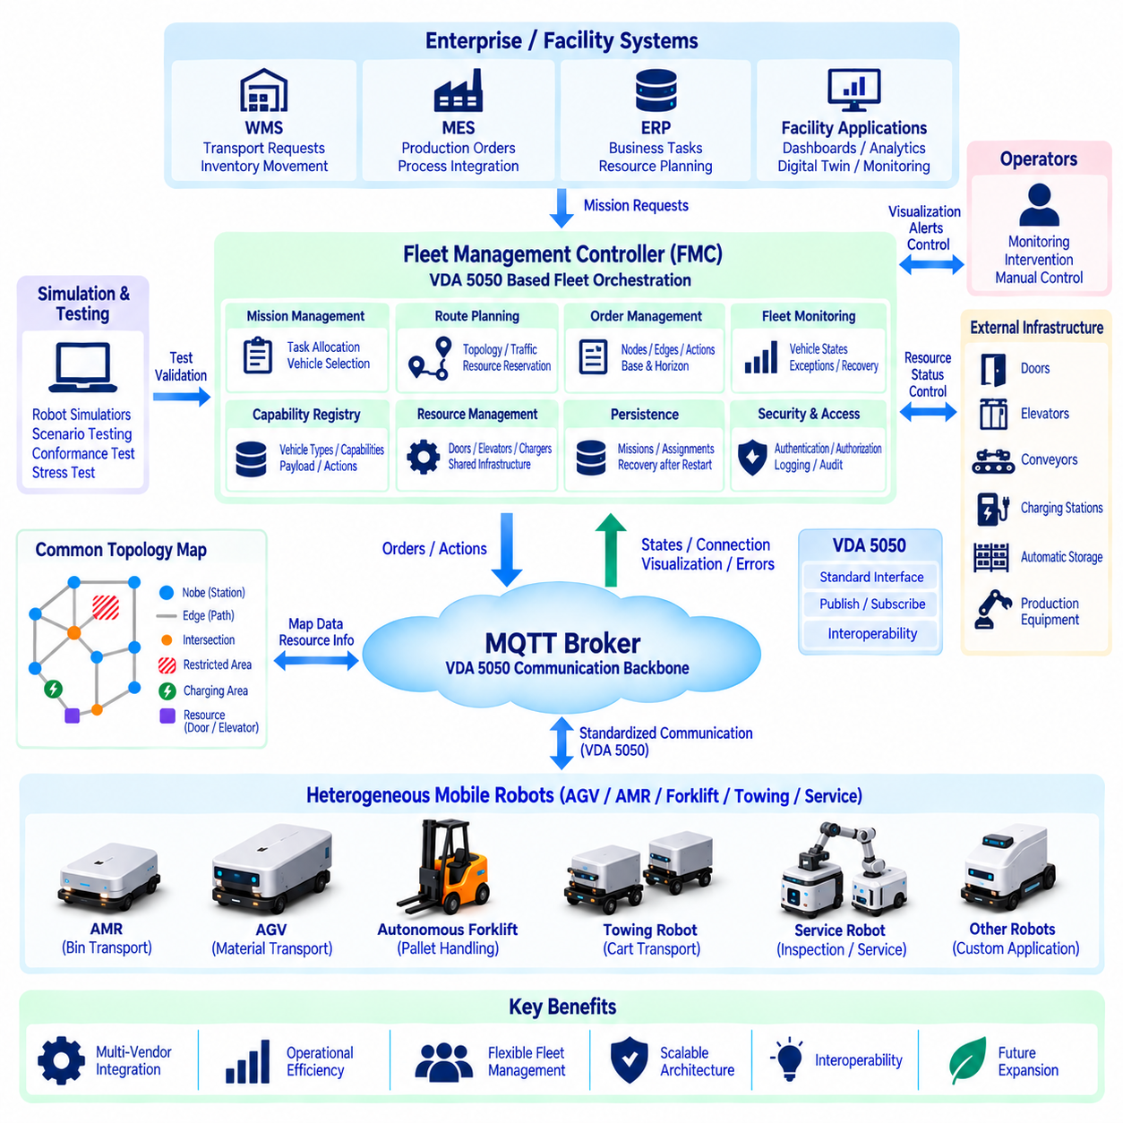
A heterogeneous robot fleet integration case begins with a facility in which several types of mobile robots must operate as one coordinated transportation system. The fleet may contain AMRs, conventional AGVs, autonomous forklifts, towing robots, and specialized service vehicles from different vendors. VDA 5050 provides a common communication boundary between these vehicles and a Fleet Management Controller while preserving each robot's internal technology.
The integration architecture separates enterprise requests, fleet orchestration, standardized communication, and vehicle-local control. WMS, MES, ERP, or production applications generate transport requirements without addressing individual robot APIs. The Fleet Management Controller converts these requirements into missions, selects suitable vehicles, plans routes, manages traffic, and communicates executable orders through the VDA 5050 interface.
An MQTT broker forms the communication backbone between the Fleet Management Controller and participating vehicles. Orders and actions flow toward robots, while state, connection, visualization, error, and execution information returns to the controller. This publish-subscribe architecture reduces direct coupling between components and allows multiple robot types to participate without requiring point-to-point connections for every vehicle.
The first practical challenge is capability normalization. An AMR may carry bins, an autonomous forklift may handle pallets, and a towing robot may move carts, while their dimensions, payload limits, turning characteristics, charging interfaces, and supported actions differ. The controller therefore requires a capability registry that represents these differences in a common form before task allocation can be performed reliably.
Mission requests should remain independent of specific robot models whenever possible. A business system can request movement of a pallet from storage to a production station without specifying which autonomous forklift must perform it. The Fleet Management Controller evaluates payload type, capacity, location, availability, battery level, operating area, required actions, and other constraints before assigning an appropriate vehicle.
A shared topological map provides the coordination layer for heterogeneous navigation. The map represents important nodes, edges, intersections, corridors, stations, charging areas, doors, elevators, and other operational resources. Individual robots may continue using their own detailed metric maps internally, while the fleet controller uses the common topology to describe mission-level movement and coordinate shared traffic.
Map integration requires a consistent relationship between fleet-level topology and robot-local coordinates. A station known to the controller must correspond to a meaningful destination in each participating robot system. Vendor adapters may therefore translate common node identifiers into local navigation targets while maintaining a stable VDA 5050 representation toward the Fleet Management Controller.
Route planning must account for vehicle-specific constraints. A narrow AMR may use corridors that an autonomous forklift cannot enter, while a towing robot may require larger turning space or prohibit certain reverse maneuvers. Edge attributes and vehicle capabilities can be evaluated together so that the controller selects only graph segments compatible with the assigned robot rather than assuming every vehicle can use every route.
Traffic management becomes the central coordination function when heterogeneous vehicles share physical space. Intersections, narrow corridors, doors, elevators, docking stations, and transfer points can become constrained resources. The controller tracks vehicle progress and resource reservations so that incompatible movements are not simultaneously authorized through the same critical area.
VDA 5050 base-and-horizon behavior supports staged route execution in this environment. The controller can provide information about a planned route while releasing only the graph elements that are currently safe to execute. When downstream resources become available, an order update extends the released base. This allows traffic decisions to evolve without forcing the robot to receive an entirely new mission for every route adjustment.
The order manager converts the planned mission into VDA 5050 nodes, edges, release states, and actions. Order identifiers, update identifiers, and sequence relationships must remain deterministic because the controller continuously compares issued commands with reported vehicle state. A clear order lifecycle prevents delayed or duplicate communication from being interpreted as authorization for repeated physical work.
Actions connect transportation with physical process operations. A forklift may pick or place a pallet, an AMR may dock at a workstation, and a towing robot may couple or release carts. The controller represents supported activities through the action capabilities available for each vehicle and coordinates them with node or edge execution instead of assuming that all robot types expose identical operational functions.
Instant actions provide supervisory control during active missions. Pause, resume, cancellation, or other supported operations can be issued without rebuilding the complete route order. Their use should remain coordinated with the robot's current execution state, and they must never replace local functional-safety mechanisms. Emergency protective behavior remains the responsibility of the vehicle's certified safety architecture.
State feedback closes the fleet-control loop. Each robot reports enough information for the controller to understand its active order, graph progress, actions, operating condition, battery state, errors, and communication status. The controller maintains a digital representation of every vehicle and continuously reconciles planned fleet behavior with the execution information received from the physical system.
Exception handling is essential because heterogeneous fleets fail in different ways. A forklift may lose access to a pallet station, an AMR may encounter a blocked corridor, or a towing robot may report a coupling failure. The Fleet Management Controller interprets these conditions in mission context and decides whether to wait, retry, reroute, reassign the task, or request operator intervention.
Reassignment should consider the physical state of the transported material as well as robot availability. A task cannot always be transferred simply because another robot is idle. If a payload is already attached to a specific vehicle, the controller must determine whether recovery, unloading, or human intervention is required before a replacement vehicle can safely continue the business mission.
Infrastructure integration extends fleet coordination beyond robots. Doors, elevators, conveyors, chargers, automatic storage systems, and production equipment may use protocols unrelated to VDA 5050. The Fleet Management Controller or an infrastructure service coordinates these resources with robot orders so that a vehicle does not enter an elevator, docking area, or transfer station before the external system is ready.
Charging management is also part of heterogeneous fleet orchestration. Different vehicle classes may have different battery capacities, charging rates, connectors, and operational thresholds. The controller combines reported battery state with mission demand, charger compatibility, travel distance, and predicted availability to schedule charging without treating every robot as an identical energy resource.
Vendor-specific adapters are useful when existing robots do not expose the required interface natively. An adapter can translate VDA 5050 orders into the vendor's internal mission API and convert proprietary status information back into standardized state messages. The adapter should isolate protocol differences rather than moving fleet-level routing, traffic, or business logic into a vendor-specific integration component.
Persistence is necessary because the fleet state cannot exist only in volatile memory. Active missions, orders, vehicle assignments, resource reservations, and relevant execution context should survive service restart. After recovery, the controller reconciles persisted information with live robot states before continuing operation, reducing the risk of repeating completed actions or issuing commands based on obsolete assumptions.
Scalability requires clear service boundaries as the number of vehicles increases. Mission management, vehicle state processing, route planning, traffic coordination, resource management, VDA 5050 communication, persistence, and monitoring can be separated logically or physically. The objective is to prevent increasing message traffic or optimization workload from turning a single software component into a fleet-wide bottleneck.
Observability provides the operational evidence required to manage a mixed fleet. Dashboards can display robot positions, mission status, traffic congestion, battery levels, errors, resource utilization, MQTT connection health, and task throughput. Logs and metrics should preserve robot identity and order context so that an operator can trace a business request from assignment through execution and completion.
Testing should begin with simulated vehicles before the complete physical fleet is connected. Simulators can represent different capabilities, dimensions, speeds, actions, battery conditions, and failure modes. Order processing, base-and-horizon behavior, traffic conflicts, reconnects, exceptions, and resource reservations can then be validated repeatedly without occupying production equipment or creating unnecessary collision risk.
Physical integration can proceed incrementally by robot class or vendor. A limited operating zone and small number of vehicles provide a controlled environment for verifying coordinate mapping, action behavior, MQTT configuration, state synchronization, and traffic rules. Additional robot types and shared resources can be introduced after the preceding integration layer demonstrates stable behavior.
Conformance testing verifies that each VDA 5050 interface behaves consistently, while system-level scenario testing verifies that the complete fleet solves operational missions correctly. Both are required. A robot can exchange conforming messages yet still be incorrectly mapped to a station, assigned an incompatible task, or integrated with an infrastructure resource using an invalid operational sequence.
Cybersecurity must protect the common communication architecture because standardized connectivity increases the number of systems sharing operational information. Authentication, authorization, encrypted communication, certificate management, network segmentation, and audit logging should protect MQTT and supporting services. Access privileges should follow operational roles rather than allowing every connected client to issue fleet commands.
The resulting architecture preserves local robot autonomy while centralizing the coordination that genuinely requires fleet-wide knowledge. Each vehicle remains responsible for localization, obstacle avoidance, trajectory execution, motor control, and local safety. The Fleet Management Controller concentrates on missions, assignments, topology, traffic, resources, actions, and standardized execution supervision across the heterogeneous fleet.
The principal value of the integration is therefore not that different robots become technically identical. Their mechanical designs, navigation stacks, payload mechanisms, sensors, and local control software can remain different. VDA 5050 creates a standardized operational boundary through which these differences can be managed without requiring enterprise applications and fleet algorithms to understand every proprietary robot interface.
A successful heterogeneous fleet integration ultimately combines capability modeling, common topology, task allocation, graph-based orders, traffic coordination, actions, infrastructure resources, state synchronization, recovery, security, and testing into one operational architecture. VDA 5050 acts as the interoperability layer that allows multi-vendor robots to participate in coordinated missions while retaining the specialized capabilities that make each vehicle useful.

