Volume 06 Robot Communication and APIs

08. Edge APIs

08.01 Edge API Design Principles: Low Latency / Offline First
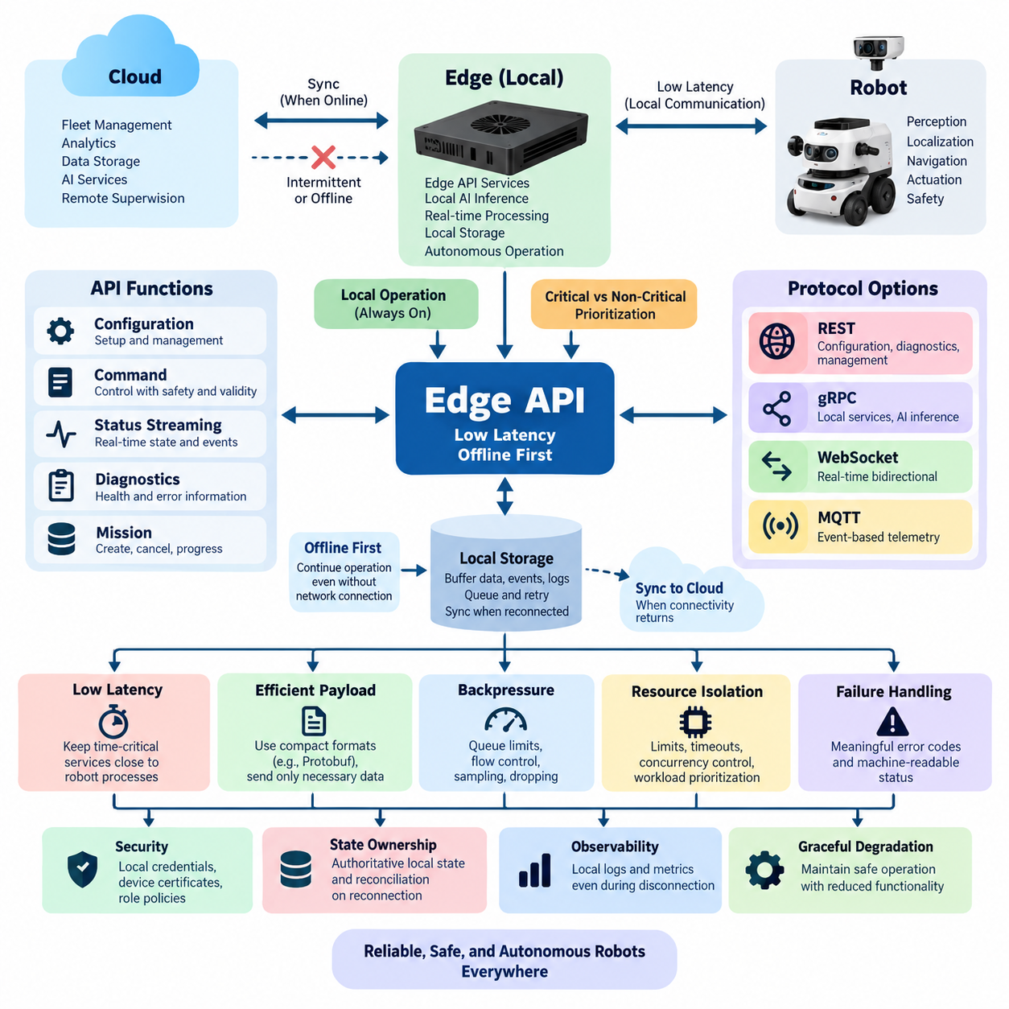
Edge APIs in robotics are designed around a fundamentally different operating assumption from conventional cloud APIs: the robot must continue to function safely and predictably even when external connectivity is slow, intermittent, or completely unavailable. The API therefore becomes part of the robot’s local operational infrastructure rather than merely an interface to a remote service. Low latency, deterministic behavior, bounded resource consumption, and offline autonomy become primary architectural requirements.
Low-latency design begins by placing time-critical API services physically and logically close to the processes that consume them. Perception results, localization estimates, navigation commands, actuator requests, safety states, and local AI inference should normally remain inside the robot or nearby edge computer. Sending these interactions through a remote cloud introduces network delay, jitter, packet loss, and dependency on external infrastructure that cannot be assumed to remain available during physical operation.
An edge API should distinguish hard operational paths from supervisory and informational paths. A command affecting motion or immediate robot behavior may require millisecond-scale processing, while mission history, diagnostics, analytics, or configuration synchronization can tolerate substantially greater delay. Treating all API traffic identically wastes resources and can allow noncritical workloads to interfere with control-related communication. Priority separation therefore becomes an architectural property rather than simply a network optimization.
Offline-first design assumes disconnection before it assumes connectivity. Instead of considering network failure an exceptional state, the system treats cloud access as an intermittently available capability. Essential robot functions, including local navigation, safety supervision, mission execution, state estimation, and selected inference services, should continue without cloud APIs. This principle aligns edge communication with the broader cloud-edge architecture while clearly separating local operational authority from remote services.
Local persistence is essential to this model. When an edge application produces telemetry, events, diagnostic records, mission updates, or inspection results while disconnected, the information should be written to durable local storage rather than discarded. A synchronization component can later forward the buffered information when connectivity returns. The API architecture therefore requires explicit policies for queues, storage limits, expiration, retry intervals, ordering, deduplication, and recovery from partially completed transfers.
Commands require more careful treatment than telemetry because replaying an old command can create physical consequences. Edge APIs should attach identifiers, timestamps, validity intervals, sequence information, and execution state to operational requests. Idempotent operations should be preferred wherever practical so that retransmission does not unintentionally repeat an action. Commands that are no longer valid after reconnection must expire locally rather than being executed merely because they eventually reached the robot.
State ownership must also be explicit. The edge should maintain an authoritative representation of operational state required for immediate robot behavior, while cloud and fleet systems may maintain synchronized representations for supervision and coordination. During disconnection these representations naturally diverge. Reconnection therefore requires reconciliation rules based on version numbers, timestamps, sequence counters, state-machine transitions, or domain-specific conflict policies rather than assuming that the newest network message is automatically correct.
Protocol selection should reflect the communication pattern rather than enforce one technology everywhere. REST is convenient for configuration, diagnostics, management, and resource-oriented operations. gRPC provides compact strongly typed communication suitable for local services and AI inference interfaces. WebSocket supports continuous bidirectional status exchange, while MQTT is effective for event-oriented telemetry and asynchronous messaging. A practical edge platform can expose several protocols behind a consistent domain model instead of forcing one protocol onto every workload.
Serialization and payload design directly influence latency on constrained edge computers. Large JSON structures, repeated metadata, unnecessary image encoding, and excessive object conversion increase CPU load, memory allocation, bandwidth consumption, and tail latency. Binary formats such as Protocol Buffers can reduce overhead for high-frequency internal interfaces, while human-readable JSON remains useful for administration and debugging. Payloads should carry only information required by the consumer and should avoid repeatedly transmitting unchanged state.
Edge APIs must incorporate backpressure because sensors and AI pipelines can generate information faster than consumers can process it. Camera detections, LiDAR-derived objects, localization updates, and diagnostic events may arrive at very different rates. Without bounded queues and flow control, temporary overload can evolve into memory exhaustion and system instability. APIs should define queue capacities, sampling policies, message dropping rules, aggregation behavior, and consumer acknowledgement according to the operational importance of each data stream.
Resource isolation is equally important because an edge computer commonly executes perception, localization, planning, inference, logging, networking, and API services simultaneously. An API request should not be allowed to consume unlimited CPU time, GPU memory, RAM, threads, file descriptors, or storage bandwidth. Timeouts, concurrency limits, request-size limits, process isolation, and workload prioritization help ensure that management traffic or an expensive inference request cannot degrade navigation or safety-critical functions.
Failure handling should expose meaningful operational semantics instead of returning only generic communication errors. Clients need to distinguish unavailable hardware, stale sensor information, overloaded inference services, rejected commands, expired requests, degraded localization, disconnected cloud services, and safety-related inhibition. Structured error codes and machine-readable status information allow local applications to choose appropriate recovery behavior without depending on fragile interpretation of textual error messages.
Security must remain effective without permanent access to a remote identity provider. Edge systems may therefore require locally verifiable credentials, cached authorization information, device certificates, protected keys, and local role policies. Authentication failure must not force unsafe behavior, but disconnection must also not silently disable authorization. Security design should establish which operations remain available offline, which require stronger credentials, and which must wait until trusted infrastructure becomes reachable again.
Observability should also operate locally. Request latency, timeout frequency, queue depth, dropped messages, synchronization backlog, CPU and memory pressure, storage consumption, service health, and connectivity state should be measurable even during a network outage. Local logs and metrics can later be synchronized to fleet or cloud platforms, preserving evidence about events that occurred while the robot was isolated and enabling reconstruction of failures after connectivity is restored.
Graceful degradation connects these principles into an operational strategy. Loss of cloud connectivity should first remove cloud-dependent enhancements rather than immediately stopping the robot. Loss of a nonessential edge service may reduce perception quality or analytics capability while preserving safe motion. Failure of a service required for safe operation, however, should trigger a defined degraded or safe state. The API contract must communicate these capability transitions clearly to every dependent component.
The resulting edge API architecture is therefore not simply a smaller cloud API deployed on a robot. It is a local autonomy boundary designed around physical consequences, uncertain networks, constrained computation, persistent state, and predictable recovery. Low latency determines where computation and communication occur, while offline-first design determines how state and services survive disconnection. Together they allow the robot to remain operational locally while still participating in cloud, fleet, and enterprise systems whenever connectivity is available.

08.02 Edge REST API Server: FastAPI on Jetson [w/Code]
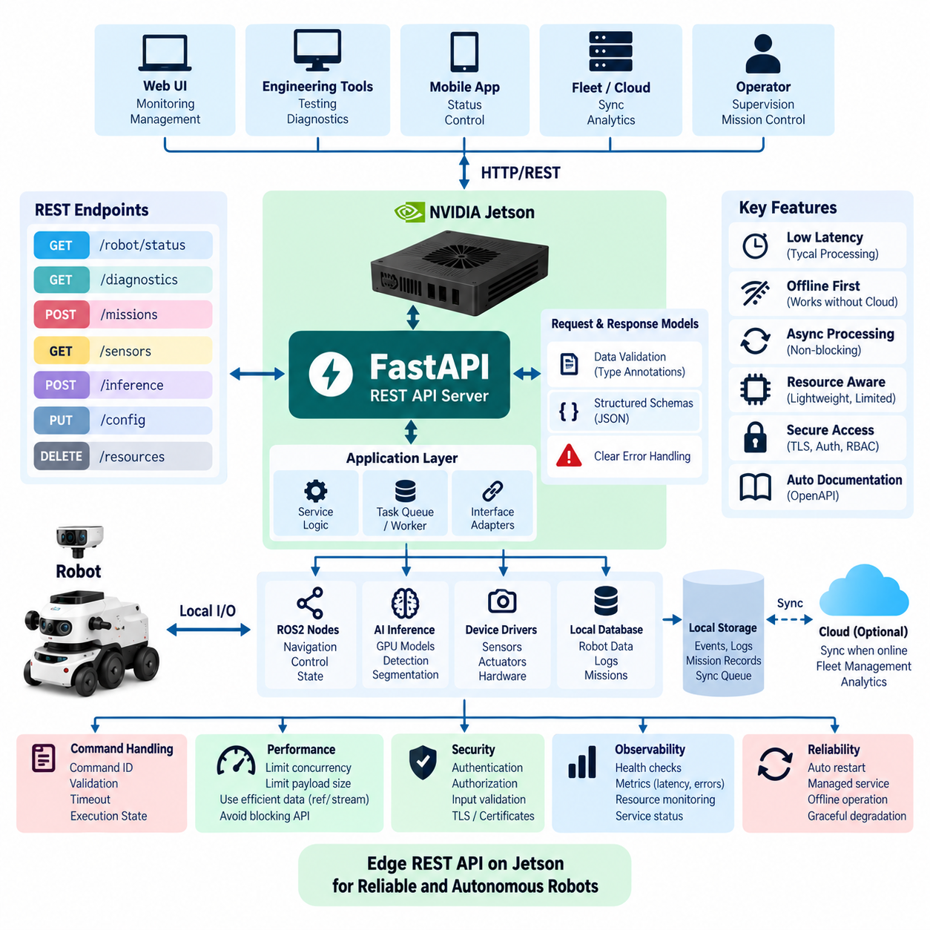
FastAPI provides a practical framework for implementing REST API services directly on NVIDIA Jetson edge computers. In a robotics system, the Jetson commonly hosts perception, AI inference, navigation support, diagnostics, and device-management processes while operating close to sensors and actuators. A FastAPI server can expose these capabilities through structured HTTP endpoints, allowing local applications, robot controllers, engineering tools, and supervisory systems to interact with edge services through a consistent interface.
The primary architectural advantage of running the REST server on the Jetson is locality. Requests for robot status, configuration, diagnostics, sensor metadata, or AI inference can be processed without traversing a cloud network. This reduces communication latency and allows the API to remain available when external connectivity is degraded or unavailable. The design therefore extends the low-latency and offline-first principles of edge APIs by placing the service endpoint inside the robot’s local computing environment.
A typical architecture separates the FastAPI layer from the underlying robotics functions. HTTP endpoints should not directly contain complex perception, control, or inference logic. Instead, the API layer validates requests, invokes application services, and converts internal results into stable response models. The application layer can communicate with ROS2 nodes, inference engines, local databases, device drivers, or dedicated processes while FastAPI remains responsible for external API semantics and HTTP communication.
FastAPI uses Python type annotations and data models to define request and response structures explicitly. Robot commands can therefore specify parameters such as command identifiers, target devices, requested actions, timestamps, and optional execution constraints. Status responses can represent operating modes, battery state, localization status, sensor availability, and service health. Explicit schemas reduce ambiguity between clients and edge services and make malformed requests easier to reject before they reach operational robot components.
Endpoint design should reflect robot resources and operations rather than expose implementation details. Paths such as `/robot/status`, `/diagnostics`, `/missions`, `/sensors`, or `/inference` provide meaningful resource boundaries. Read operations can use GET, creation or execution requests can use POST, modifications can use PUT or PATCH where appropriate, and DELETE can represent removal of suitable resources. Physical commands, however, require stronger semantics than ordinary web resources because retries or duplicated requests may cause real-world actions.
Command endpoints should consequently incorporate command identity, validation, timeout, and execution-state tracking. A request accepted by the FastAPI server does not necessarily mean that the physical action has completed. The server may return an accepted state and provide a separate status resource through which the client observes queued, running, completed, rejected, expired, or failed execution. Idempotency mechanisms are particularly valuable when clients may retry requests after temporary network interruptions without knowing whether the original command was received.
Asynchronous processing is useful because many edge operations involve waiting for other services rather than continuously executing Python code. FastAPI supports asynchronous endpoint handlers that can efficiently manage network communication, database access, message exchange, and other I/O-oriented tasks. However, computationally intensive AI inference, image processing, or numerical operations should not block the API event loop. Such workloads are better delegated to worker processes, inference services, ROS2 components, or GPU execution pipelines.
Jetson systems require explicit resource awareness because CPU cores, GPU capacity, memory, storage bandwidth, and thermal headroom are shared among multiple robotics workloads. The API server should remain lightweight relative to perception and control processes. Request concurrency, payload sizes, connection counts, timeouts, and worker configuration should therefore be bounded. Large camera frames or point clouds should not automatically be transferred through ordinary REST responses when references, compressed representations, streaming interfaces, or dedicated data channels can provide more efficient alternatives.
AI inference is a common edge API use case. A FastAPI endpoint may receive an image reference, region of interest, model identifier, or inference parameters and then invoke a local GPU-backed inference service. The response can return detected objects, classifications, poses, confidence values, segmentation metadata, or task-specific results. Separating the REST interface from the inference engine allows models and acceleration frameworks to evolve without forcing external clients to change whenever the internal implementation is modified.
REST is especially appropriate for management-oriented interactions, but it should not replace every communication mechanism inside the robot. High-frequency sensor streams and continuous control loops are generally better handled through ROS2, shared memory, gRPC streaming, WebSocket, or other real-time-oriented channels. FastAPI can instead expose configuration, snapshots, health information, mission operations, inference requests, and administrative functions. This division prevents convenient HTTP interfaces from becoming bottlenecks in time-critical data paths.
Local persistence supports reliable operation when the Jetson becomes disconnected from fleet or cloud infrastructure. API-generated events, mission records, diagnostic information, and synchronization metadata can be written to a local database or durable queue. When connectivity returns, a synchronization process can forward selected records upstream. The FastAPI server can expose synchronization state without making local robot functionality dependent on successful cloud communication, preserving the offline-first behavior expected from an edge architecture.
Error handling should distinguish HTTP transport semantics from robot operational semantics. Invalid input may produce an appropriate client error, while unavailable internal services, overloaded inference engines, missing sensors, expired commands, or unsafe robot states should be represented with structured application-level error information. Responses should include stable error identifiers and enough machine-readable context for clients to decide whether to retry, wait, request diagnostics, or stop an operation rather than relying only on human-readable messages.
Security remains necessary even when the REST API is intended primarily for a local network. The server should authenticate clients, authorize operations according to roles or capabilities, validate all external input, and protect sensitive endpoints. TLS can protect communication, while certificates, tokens, or locally managed credentials can establish identity. Particularly sensitive operations such as motion commands, configuration changes, software updates, or safety-related actions should receive stronger authorization controls than read-only telemetry and health queries.
FastAPI also supports automatic API documentation derived from declared routes and schemas, which is valuable during robot integration and testing. Developers can inspect available endpoints, understand request formats, and exercise selected operations without maintaining an entirely separate description of the interface. In production systems, however, documentation exposure and interactive testing capabilities should be controlled according to deployment policy so that engineering convenience does not unintentionally increase the accessible attack surface.
Deployment on Jetson should treat the API as a managed service rather than an manually launched development process. The FastAPI application can run behind an ASGI server and be supervised by the operating system, a container runtime, or another service manager. Startup dependencies, restart policies, health checks, logs, environment configuration, and model or device availability should be defined explicitly. The service should recover predictably after reboot or failure without requiring manual intervention from an operator.
Health and observability endpoints provide visibility into both the API and the services behind it. A basic liveness check can indicate whether the server process is running, while readiness checks can verify dependencies such as ROS2 interfaces, local databases, sensors, or inference services. Metrics for request latency, error rates, active connections, queue depth, CPU and memory consumption, and inference duration help determine whether the Jetson is approaching resource limits or experiencing degraded operation.
The resulting FastAPI-on-Jetson architecture creates a clean boundary between local robot capabilities and applications that need to access them. FastAPI supplies structured REST semantics, schema validation, asynchronous request handling, and API documentation, while the Jetson provides proximity to sensors, robot software, and accelerated AI computation. When combined with bounded resources, local persistence, secure access, explicit failure handling, and separation of time-critical communication paths, this approach provides a practical foundation for maintainable edge robot services.

08.03 Edge gRPC Service: Local AI Inference API [w/Code]
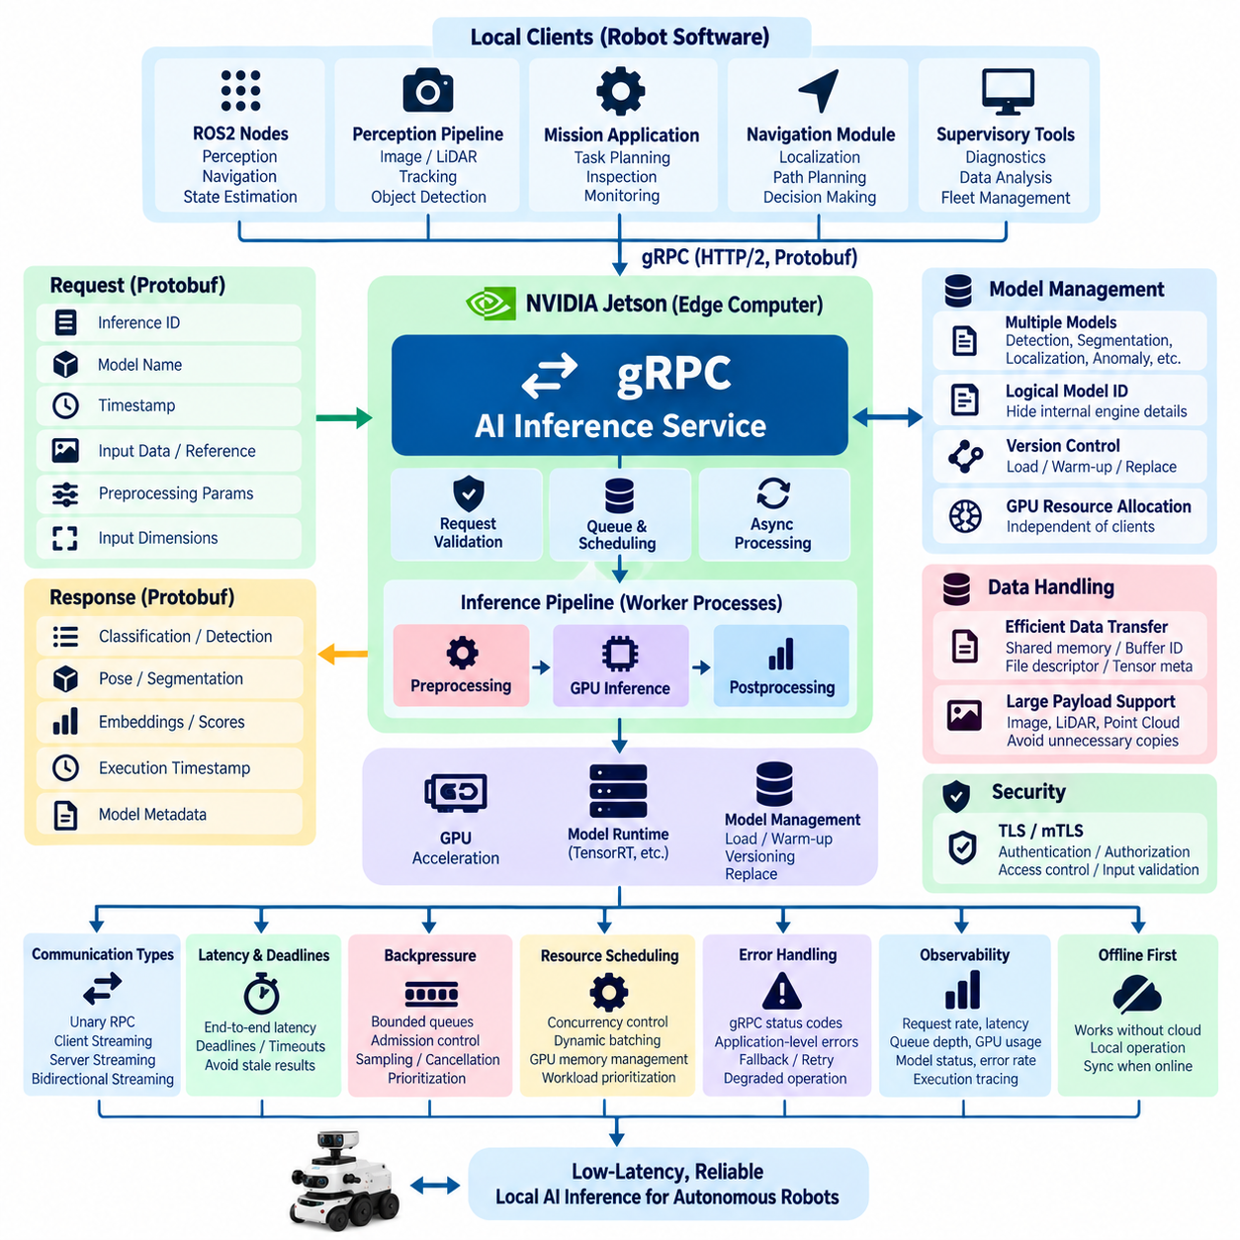
gRPC is well suited to local AI inference services on edge robots because it provides strongly typed interfaces, compact Protocol Buffers serialization, HTTP/2 transport, and efficient request-response or streaming communication. Instead of embedding every AI model directly inside perception, navigation, or application processes, an edge computer can expose inference as an independent local service. Robot software then accesses GPU-accelerated intelligence through a stable API contract while model implementation remains isolated behind the service boundary.
A typical architecture places the gRPC inference server on the robot’s Jetson or another GPU-equipped edge computer. Local clients may include ROS2 nodes, perception pipelines, mission applications, navigation components, or supervisory processes. These clients submit structured inference requests over the local network or loopback interface, and the server executes models using the available accelerator. Keeping this communication local avoids cloud round trips and supports predictable operation when external connectivity is unavailable.
The service contract is normally defined using Protocol Buffers. A request message can contain an inference identifier, model name, timestamp, input dimensions, preprocessing parameters, and either embedded data or a reference to locally accessible data. Response messages can represent classifications, detected objects, poses, segmentation results, embeddings, confidence scores, execution timestamps, and model metadata. Explicit schemas establish a language-independent interface between AI services and robot applications.
Unary RPC is appropriate when one request produces one inference result, such as object classification, image detection, pose estimation, or semantic analysis of a single frame. The client sends a request and receives one response after processing completes. This simple interaction model works particularly well for event-triggered inference, inspection tasks, diagnostic analysis, and application-level AI operations where requests occur independently rather than as a continuous high-frequency stream.
Streaming RPC becomes useful when inference operates continuously. A client-streaming interface can deliver successive inputs to a persistent inference service, while server streaming can return a sequence of results or intermediate updates. Bidirectional streaming allows inputs and inference outputs to flow concurrently over a long-lived connection. This avoids repeatedly establishing request context and can reduce communication overhead for camera perception, tracking, multimodal processing, or continuously updated robot intelligence.
Large sensor payloads require careful design even when Protocol Buffers are efficient. Continuously copying full-resolution camera frames, LiDAR point clouds, or multidimensional tensors through serialized RPC messages can consume substantial CPU time and memory bandwidth. For processes located on the same edge computer, the gRPC message may instead carry shared-memory references, buffer identifiers, file descriptors, tensor metadata, or other handles while the large underlying data follows an optimized local transport path.
AI inference should be separated from the gRPC communication thread so that expensive GPU execution does not block unrelated requests. The server can validate incoming messages, place accepted work into bounded queues, schedule inference according to model and priority, and return results asynchronously. Worker processes or dedicated inference runtimes can perform preprocessing, GPU execution, and postprocessing. This architecture keeps communication responsive even when individual models require substantial computational resources.
Model lifecycle management is an important part of the inference API. Edge systems may host several models for detection, segmentation, localization assistance, anomaly recognition, manipulation, or other Physical AI workloads. Requests should identify the required model or logical capability without forcing clients to know internal engine details. The service can map logical model identifiers to optimized implementations and manage loading, warm-up, version selection, GPU allocation, and controlled replacement independently of client applications.
Latency should be measured across the complete inference path rather than only GPU execution. Relevant stages include request serialization, transport, queue waiting, preprocessing, host-to-device transfer, inference, device-to-host transfer, postprocessing, response serialization, and return transport. A model that executes rapidly on the GPU can still produce poor API latency when queue contention or data movement dominates. Edge optimization therefore requires end-to-end measurements, including percentile and tail latency rather than averages alone.
Deadlines and timeouts are essential because inference results often have limited operational value. A detection result required for immediate navigation may become stale before a heavily loaded server finishes processing it. gRPC clients can provide deadlines, and the service should avoid spending scarce GPU resources on requests whose useful lifetime has already expired. Application-specific validity windows can complement transport deadlines so robot software can distinguish technically successful responses from results that arrived too late for operational use.
Backpressure prevents inference demand from overwhelming the edge computer. Camera pipelines may generate frames faster than a GPU can process them, especially when multiple models share the accelerator. The service should use bounded queues, admission control, sampling, request cancellation, and workload prioritization rather than accumulating unlimited pending work. For real-time perception, processing the most recent useful observation may be preferable to completing every historical request after it has become stale.
Resource scheduling becomes increasingly important when several clients share one inference service. Navigation perception may require higher priority than background inspection analytics, while safety-related detection may require protected compute capacity. The server can control concurrency, batching, model residency, GPU memory allocation, and request priority according to workload classes. Dynamic batching may improve throughput, but batch formation must remain bounded because waiting for additional inputs can increase latency for time-sensitive robot functions.
Failure semantics should clearly distinguish communication failures from AI execution failures. A gRPC status may indicate unavailable services, invalid requests, exceeded deadlines, resource exhaustion, or internal errors, while application-level response fields can describe unsupported models, invalid tensors, preprocessing failures, low-confidence results, or unavailable accelerators. Stable machine-readable error information allows robot clients to retry, select fallback models, reduce request rates, or enter degraded operation according to defined policies.
Security remains relevant even for local gRPC communication because edge computers may contain multiple applications, containers, network interfaces, and remotely managed services. TLS or mutual TLS can establish protected channels and service identities where required. Authentication and authorization policies should restrict access to expensive models or operationally sensitive inference capabilities. Request validation must also enforce message sizes, tensor dimensions, model identifiers, and other constraints before untrusted inputs reach inference runtimes.
Observability should expose both RPC behavior and AI execution behavior. Useful metrics include request rate, active streams, queue depth, deadline violations, serialization time, preprocessing latency, inference duration, GPU utilization, GPU memory consumption, model loading state, error rate, and response latency. Correlating request identifiers with model execution traces allows developers to determine whether degraded performance originates from communication, queueing, data preparation, GPU execution, or downstream processing.
The inference service should continue operating independently of cloud connectivity whenever required models and resources are available locally. Cloud systems may distribute models, collect metrics, aggregate inference results, or provide fleet-level management, but the local robot should not require a cloud round trip for immediate perception or decision-support inference. Model versions and configuration can be synchronized when connectivity exists while the active local service maintains the offline-first behavior expected from an edge architecture.
A local gRPC AI inference API ultimately creates a stable abstraction between robot applications and rapidly evolving AI implementations. ROS2 nodes and other clients interact with typed service contracts rather than directly managing GPU frameworks, model files, preprocessing pipelines, or accelerator resources. Combined with streaming, deadlines, bounded queues, optimized data transfer, resource scheduling, security, and observability, this architecture provides an efficient foundation for low-latency AI services within edge and Physical AI robot systems.

08.04 Edge WebSocket Real-Time Feed [w/Code]
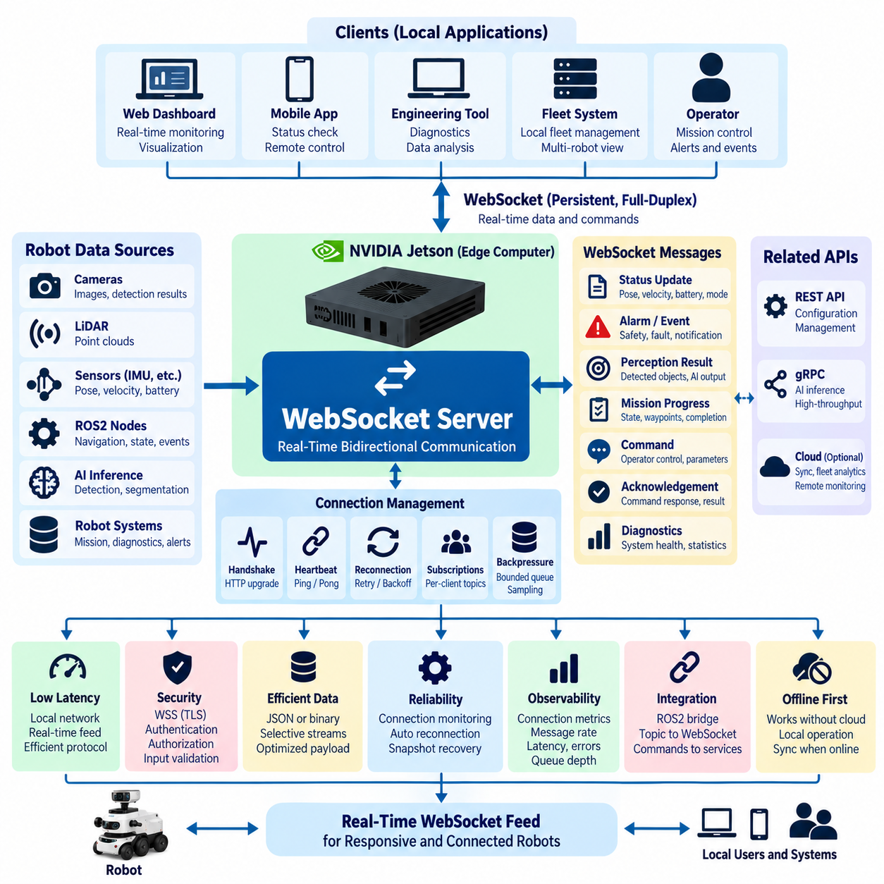
WebSocket provides a persistent, full-duplex communication channel that is particularly useful for real-time data feeds between edge robots and local applications. Unlike conventional REST interactions that repeatedly create independent request-response exchanges, a WebSocket connection remains open after the initial handshake. Robot status, events, alerts, perception summaries, mission progress, and operator commands can therefore move continuously in both directions with relatively low communication overhead.
In an edge robotics architecture, the WebSocket server is commonly deployed on a Jetson, industrial PC, or robot controller close to ROS2 nodes and local services. Browser dashboards, mobile applications, engineering tools, or nearby fleet systems connect directly to this endpoint. Because messages remain within the local network, real-time monitoring does not depend on a cloud round trip, reducing latency and allowing operational interfaces to remain functional when Internet connectivity is unavailable.
The WebSocket connection begins as an HTTP request and is upgraded through the WebSocket handshake. After the upgrade succeeds, the client and server exchange frames over the same persistent connection without repeating normal HTTP headers for every interaction. This persistent channel is advantageous when robot state changes frequently because connection establishment and protocol overhead are amortized across many messages rather than repeated for every status update.
Real-time feeds should expose meaningful robot information instead of indiscriminately forwarding every internal message. Useful streams may include robot pose, velocity, battery state, navigation mode, mission progress, safety status, active alarms, sensor health, detected objects, and selected AI inference results. The edge service acts as an abstraction boundary that converts internal ROS2 or application data into stable external messages appropriate for monitoring and operational applications.
A clear message envelope helps clients interpret heterogeneous data arriving over one connection. Each message can include a message type, schema version, robot identifier, timestamp, sequence number, payload, and optional correlation identifier. Status updates, alarms, mission events, commands, acknowledgements, and diagnostic messages can then share a common transport while retaining distinct semantics. Explicit versioning also allows the message format to evolve without immediately breaking existing clients.
WebSocket communication can use text or binary frames depending on workload requirements. JSON is convenient for dashboards, debugging, and moderate-rate status feeds because developers can inspect messages easily. Binary serialization can reduce payload size and processing overhead when update rates or message volumes become large. Large camera images, point clouds, and raw sensor streams should generally use dedicated transport mechanisms unless there is a specific reason to carry them through the WebSocket channel.
Publishing frequency should be designed according to the operational value of each signal. Robot pose may require frequent updates for smooth visualization, while battery information may change slowly and need far fewer transmissions. Alarm events should normally be delivered immediately rather than waiting for a periodic status cycle. Separating periodic state, event-driven notifications, and high-priority alerts reduces unnecessary traffic and allows clients to respond appropriately to different information classes.
Subscription mechanisms can prevent every connected client from receiving every available stream. A dashboard may request pose, battery, and mission progress, while an engineering application may additionally subscribe to diagnostics and inference statistics. The edge server can maintain per-client subscriptions and publish only relevant messages. This reduces bandwidth, serialization work, browser processing, and memory consumption, particularly when several applications simultaneously monitor the same robot.
Backpressure is essential when producers generate messages faster than a client can consume them. A slow browser, unstable Wi-Fi connection, or overloaded application should not cause an unlimited server-side queue to accumulate. Bounded buffers, message coalescing, sampling, priority queues, and selective dropping can maintain stability. For rapidly changing state such as robot pose, replacing an old unsent value with the newest value is often more useful than preserving every historical update.
Connection health must be actively monitored because a TCP connection can appear established even after the remote endpoint has become unreachable. WebSocket ping and pong frames provide a mechanism for detecting inactive or broken connections. The server can track heartbeat intervals and close connections that exceed defined thresholds. Clients should similarly detect missing heartbeats or prolonged silence and initiate controlled reconnection rather than assuming that an apparently open socket remains operational.
Reconnection logic should account for temporary wireless interruptions that commonly occur in mobile robotics. Clients can use bounded retry intervals and exponential backoff to avoid generating excessive connection attempts. After reconnection, the application may require a fresh state snapshot because events or updates could have been missed while disconnected. The server can combine snapshot recovery with sequence numbers or event identifiers so clients can determine whether their local representation remains synchronized.
Commands transmitted through WebSocket require stronger safeguards than ordinary visualization data because they can affect physical robot behavior. Command messages should include identifiers, timestamps, validity periods, and acknowledgement semantics. The server should validate authorization, robot state, parameters, and command freshness before forwarding requests to operational components. Duplicate or delayed commands should not be executed simply because the persistent connection eventually delivered them.
The WebSocket layer should remain separated from hard real-time robot control. Motor control loops, safety interlocks, localization fusion, and other deterministic internal functions should continue through ROS2, real-time middleware, shared memory, fieldbus, or dedicated control interfaces. WebSocket is better suited to human-machine interfaces, monitoring, mission interaction, notifications, and supervisory commands where low latency is valuable but strict deterministic timing is not required.
Integration with ROS2 commonly involves an adapter or gateway that subscribes to selected ROS2 topics and converts them into WebSocket messages. Incoming WebSocket commands can similarly be validated and translated into ROS2 services, actions, or application-level requests. This gateway prevents external clients from depending directly on the complete internal ROS2 graph and allows the robot software architecture to evolve while preserving a stable external communication interface.
Security should be applied even when the WebSocket endpoint primarily serves local applications. Secure WebSocket communication using WSS protects data in transit, while authentication establishes client identity and authorization determines which feeds or commands each client may access. Origin validation, token expiration, connection limits, payload-size restrictions, schema validation, and rate limiting further reduce exposure to unauthorized or malformed traffic.
Observability should cover both connection behavior and application-level messaging. Useful measurements include active connection count, connection duration, reconnect frequency, message rate, outgoing queue depth, dropped updates, heartbeat failures, serialization latency, transmission latency, and command acknowledgement time. These metrics help engineers distinguish robot application problems from network congestion, slow clients, excessive publishing rates, or WebSocket service overload.
Offline-first operation is naturally supported when the WebSocket service resides on the robot or local edge computer. Local dashboards and engineering tools can continue communicating with the robot even when the cloud connection disappears, provided the local network remains available. Cloud synchronization, fleet analytics, and remote monitoring can resume later without interrupting essential local status feeds, diagnostics, mission supervision, or permitted control interactions.
A well-designed edge WebSocket service therefore becomes the real-time presentation and interaction layer between robot software and local operational applications. Persistent bidirectional communication provides efficient state updates and event delivery, while subscriptions, bounded queues, heartbeat monitoring, reconnection, security, and observability make the service resilient. Combined with REST for management and gRPC or ROS2 for specialized internal communication, WebSocket forms an effective real-time component of a broader edge robot API architecture.

08.05 Local Robot Web UI and Edge API Integration [w/Code]
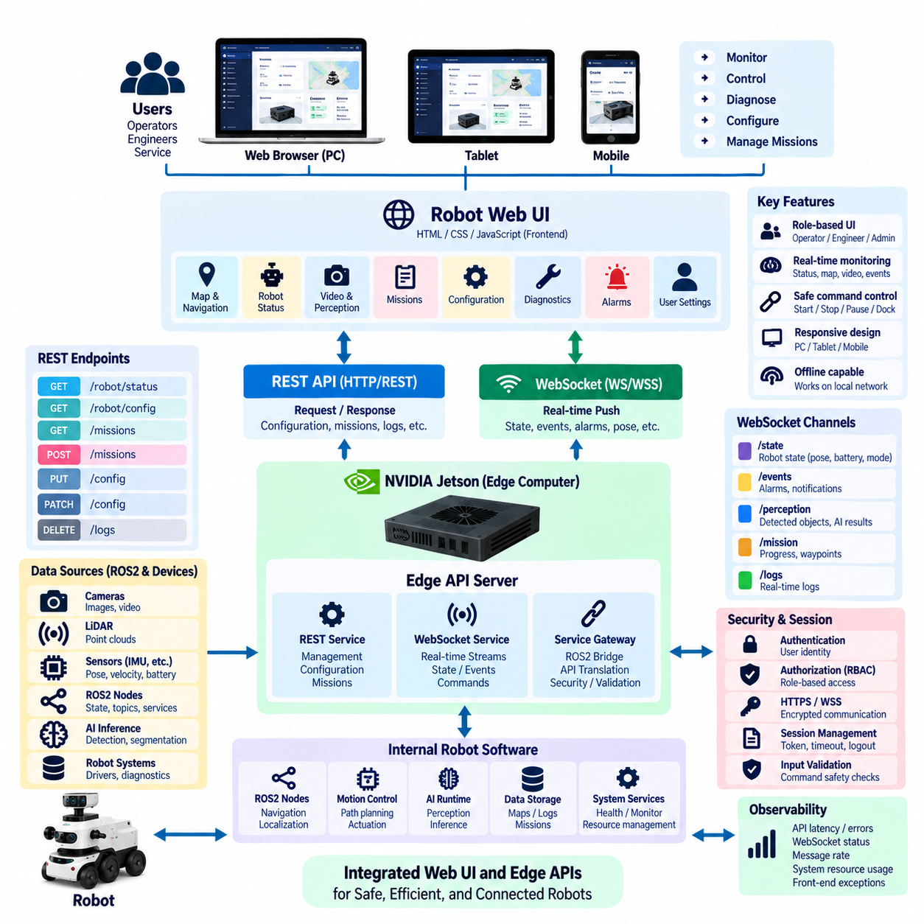
A local robot Web UI provides operators, engineers, and service personnel with direct access to robot functions through a browser without requiring a dedicated desktop application or permanent cloud connection. When the interface is hosted on the robot or its edge computer, users connected to the local network can inspect status, diagnostics, missions, sensors, and configuration through standard web technologies. The Web UI therefore becomes a practical human-facing layer above the Edge API architecture.
The architecture should separate presentation from robot functionality. HTML, CSS, and JavaScript or a modern frontend framework implement visualization and user interaction, while Edge APIs expose stable interfaces to robot services. The browser should not communicate directly with device drivers, ROS2 nodes, or AI runtimes. Instead, REST, WebSocket, and specialized service gateways create controlled boundaries between the user interface and internal robot software.
REST APIs are appropriate for operations that follow a request-response pattern. The Web UI can retrieve robot configuration, diagnostic summaries, mission information, sensor metadata, software versions, or historical records through GET requests. POST, PUT, or PATCH operations can submit missions, modify permitted configuration, acknowledge alarms, or initiate maintenance procedures. Stable resource-oriented endpoints allow the frontend to evolve independently from internal robot implementations.
WebSocket complements REST by delivering continuously changing information without requiring the browser to poll the server repeatedly. Robot pose, velocity, battery level, mission progress, active alarms, navigation state, and selected perception results can be pushed to the interface as soon as they change. A persistent connection reduces repeated HTTP overhead and provides the responsive behavior expected from dashboards used to supervise moving robots in real time.
A useful integration pattern combines an initial REST snapshot with subsequent WebSocket updates. When a dashboard opens, REST requests retrieve the current robot configuration and complete operational state. The browser then subscribes to relevant WebSocket channels and applies incremental changes to its local state. If the WebSocket connection is interrupted, the client can reconnect and obtain another authoritative snapshot before resuming real-time updates, preventing long-term divergence.
The UI should organize information according to operational tasks rather than mirror the internal software architecture. Operators may need a mission view, map, robot state, alarms, and basic controls, while maintenance engineers may require sensor diagnostics, network status, CPU or GPU utilization, logs, and service health. Role-oriented screens reduce unnecessary complexity and prevent users from depending on implementation-specific concepts that may change as robot software evolves.
Command controls require deliberate safety design because a browser action can produce physical motion. Start, stop, pause, resume, docking, mission cancellation, or manual movement requests should pass through validated Edge API endpoints rather than directly triggering actuators. The server should verify authentication, authorization, robot mode, command parameters, timestamps, and safety conditions before accepting a request. High-impact actions may additionally require explicit confirmation or appropriate operating modes.
The interface must distinguish between a command being submitted and the physical operation being completed. After a user requests an action, the API can return a command or mission identifier and the Web UI can display its execution state. Queued, accepted, running, completed, rejected, cancelled, expired, and failed states provide clearer feedback than assuming that an HTTP success response means the robot has already completed the requested physical behavior.
Map-based visualization is especially valuable for mobile robots. The Web UI can display robot position, orientation, planned path, mission waypoints, restricted areas, charging stations, and selected detected obstacles using information supplied by Edge APIs. High-rate raw localization or sensor data should generally remain within ROS2 or specialized pipelines, while the browser receives downsampled or application-oriented representations suitable for visualization without consuming excessive network and rendering resources.
Camera and perception information also require bandwidth-aware integration. A dashboard may display compressed snapshots, selected video feeds, bounding boxes, segmentation overlays, or detected-object metadata rather than transferring every raw image used by the perception pipeline. AI inference can remain inside the Jetson or edge computer, while the Web UI receives only results needed for supervision. This separation reduces browser workload and protects GPU and network resources required by autonomous operation.
Frontend state management becomes important as information arrives from multiple APIs. Configuration may originate from REST, live state from WebSocket, and long-running operations from mission or command services. The browser should maintain a coherent local state model and associate updates with timestamps, sequence numbers, or resource versions. Stale messages should not overwrite newer information, particularly after temporary connection failures or when several UI components observe the same robot resource.
Connection status should always be visible to the user. A dashboard that displays old data as though it were current can create operational risk. The interface should recognize WebSocket disconnection, REST timeout, missing heartbeat, and stale timestamps and clearly represent degraded connectivity. When communication returns, the UI should resynchronize with authoritative edge state instead of simply continuing from its previous local representation.
Offline-first design allows the Web UI to remain useful when Internet access or fleet-cloud connectivity disappears. Static frontend assets can be hosted directly on the edge computer, while REST and WebSocket endpoints remain reachable through the local robot network. Essential monitoring, diagnostics, mission supervision, and permitted maintenance functions can therefore continue locally. Cloud-dependent analytics or remote services can be marked unavailable without disabling the entire user interface.
Security should treat the browser as an external client even when it operates on a trusted local network. Authentication establishes user identity, while role-based access control limits functions according to operator, engineer, administrator, or service responsibilities. HTTPS and secure WebSocket connections protect traffic, and the server should validate every command independently of frontend controls. Hiding a button in the browser is never a substitute for server-side authorization.
Session management must account for unattended terminals and mobile engineering devices. Authentication tokens should have controlled lifetimes, sensitive operations may require renewed authorization, and logout should invalidate or remove appropriate session state. Cross-origin policies, request validation, content security controls, rate limiting, and protection against common web attacks remain relevant because the robot Web UI combines conventional web technologies with access to physically consequential systems.
The edge computer must prioritize autonomous robot workloads over user-interface convenience. Complex dashboards, excessive polling, high-resolution video, large log downloads, or many simultaneous browser sessions can consume CPU, memory, storage bandwidth, and network capacity. API rate limits, WebSocket subscription controls, compressed assets, bounded data feeds, caching, and resource monitoring help prevent the Web UI from interfering with perception, localization, planning, control, or AI inference.
Observability should extend across both frontend and backend components. The system can monitor REST latency, WebSocket connection state, message rates, API errors, authentication failures, frontend exceptions, stale-data events, and edge resource utilization. Correlation identifiers can connect a browser action to an API request and subsequent robot event, allowing engineers to trace a mission command from the user interaction through Edge API processing to its final execution state.
A well-integrated local Robot Web UI ultimately acts as the human-machine interface of the Edge API platform rather than as an independent control system. REST supplies structured management and transactional operations, WebSocket delivers real-time state and events, while ROS2 and specialized internal services continue handling time-critical robot functions. This layered approach creates a responsive, secure, offline-capable interface without exposing internal robot complexity directly to browser clients.

08.06 Edge API Cache and Offline Sync Design [w/Code]
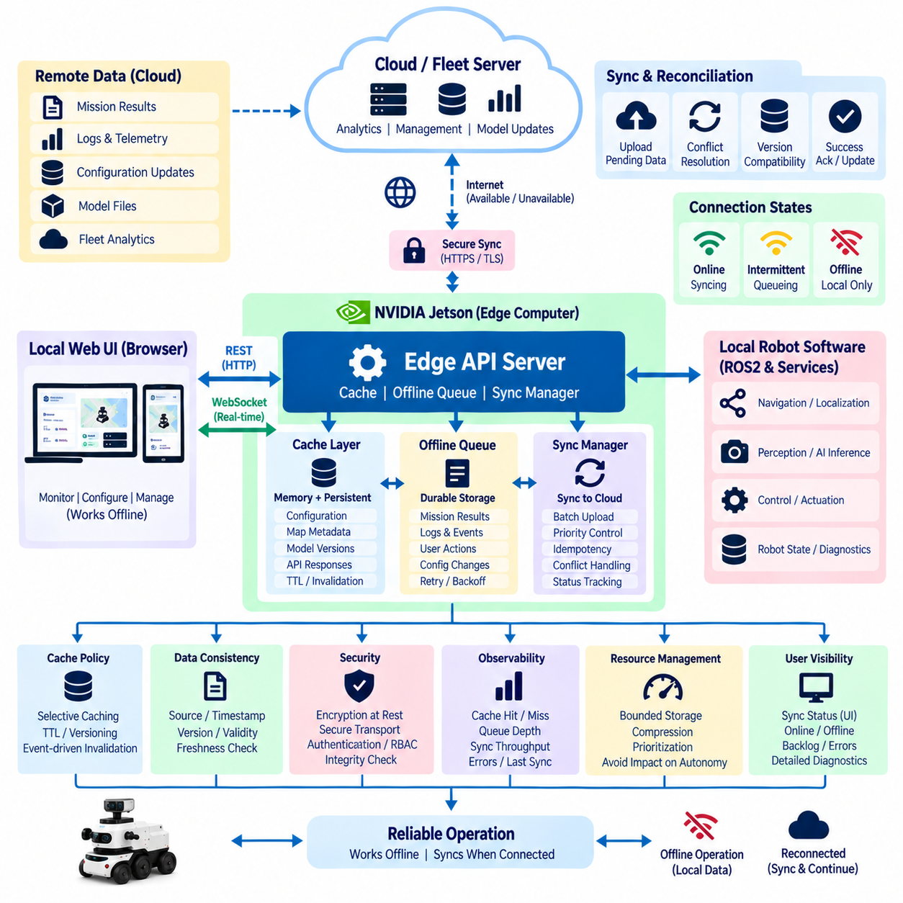
Edge API cache and offline synchronization design enables a robot to continue operating when cloud or enterprise connectivity becomes slow, intermittent, or unavailable. Instead of treating remote services as permanently reachable, the edge system maintains locally accessible copies of important configuration, operational data, mission information, and selected service responses. This local data layer reduces dependency on network availability and supports predictable robot behavior during disconnected operation.
Caching should be applied selectively because not every API resource has the same consistency or freshness requirements. Relatively stable information such as robot configuration, map metadata, device capabilities, model versions, and permitted mission templates can often remain cached for longer periods. Rapidly changing information such as robot pose, safety state, active alarms, or current command execution requires stricter freshness rules and should normally originate from authoritative local runtime services.
The architecture should distinguish cache data from authoritative operational state. A cached value is a reusable representation of previously obtained information, whereas authoritative state represents the current value owned by the responsible local service. Confusing these concepts can cause stale information to influence robot behavior. The API layer should therefore identify the source, timestamp, version, freshness, and validity of cached records so clients can determine whether information is suitable for their intended operation.
Cache placement depends on data access patterns and persistence requirements. Frequently accessed temporary values can reside in memory for minimal latency, while configuration, mission records, synchronization metadata, and important API responses may require persistent local storage. Embedded databases, key-value stores, files, or durable queues can support different workloads. A layered approach can combine memory caching for speed with persistent storage for recovery after process restart or robot reboot.
Cache keys should uniquely represent the resource and context associated with stored data. A key may include robot identity, resource type, version, model identifier, mission identifier, or relevant request parameters. Poorly designed keys can return data generated for a different configuration or operating context. Cache entries should also contain metadata such as creation time, expiration time, source version, synchronization status, and integrity information to support reliable lifecycle management.
Expiration policies determine how long cached information can be trusted. Time-to-live rules are useful for data whose acceptable freshness can be expressed as a duration, while version-based invalidation is more appropriate when configuration or resources change explicitly. Event-driven invalidation can remove or refresh entries when ROS2 services, local applications, or remote systems report updates. Critical robot data should never depend only on arbitrary expiration intervals when a stronger validity signal is available.
Offline writes require a different mechanism from ordinary read caching. When a robot generates mission results, inspection records, telemetry summaries, diagnostic events, user actions, or configuration changes while disconnected, these records should be written to durable local storage. Each pending operation can be represented as a synchronization item containing a unique identifier, timestamp, operation type, target resource, payload, version information, retry state, and synchronization status.
A durable synchronization queue protects data against application crashes, power cycles, and extended network outages. Queue entries should remain available until they are successfully synchronized, explicitly discarded according to policy, or moved into an error state requiring intervention. Storage capacity must be bounded, however, because robots may remain disconnected for long periods. Retention, compression, aggregation, prioritization, and deletion policies are therefore necessary to prevent offline data from exhausting local storage.
Connectivity recovery should trigger controlled synchronization rather than immediately transmitting every queued record. A synchronization manager can verify network availability, authenticate with the remote service, evaluate queue priority, and send data in manageable batches. Safety events, mission completion records, and important diagnostics may receive higher priority than routine telemetry. Rate limiting prevents synchronization traffic from consuming bandwidth needed for active robot operations after the network becomes available again.
Retry logic must distinguish temporary failures from permanent failures. Network timeouts, temporary service unavailability, and server overload may justify retries using exponential backoff and bounded intervals. Invalid payloads, rejected authorization, incompatible schema versions, or permanently removed resources may require a different error path. Repeatedly retrying an unrecoverable operation wastes network, CPU, storage, and power resources while potentially blocking newer synchronization work.
Idempotency is fundamental because connectivity can disappear after the remote server processes a request but before the robot receives the acknowledgement. The edge system may therefore resend an operation without knowing whether it was already completed. Unique operation identifiers and idempotency keys allow the remote service to recognize duplicates and return the previous result instead of creating duplicate mission records, events, configuration changes, or other side effects.
Ordering requirements should be defined according to data semantics. Some telemetry events can be synchronized independently, while configuration updates or mission state transitions may require strict sequence preservation. Sequence numbers, logical clocks, resource versions, or dependency identifiers can express ordering relationships. The synchronization engine should avoid imposing expensive global ordering on all data when only selected resource types require ordered delivery.
Conflict resolution becomes necessary when both edge and remote systems can modify the same resource during disconnection. Simply selecting the most recently received value may be unsafe because timestamps can differ and the latest update may not represent the correct operational authority. Policies can use resource ownership, version vectors, revision numbers, server authority, edge authority, or domain-specific merge rules. Safety-critical configuration should normally require explicit and conservative conflict handling.
Data synchronization should preserve schema compatibility across software versions. A robot may remain offline while cloud APIs, fleet services, or data models are upgraded. Synchronization records should therefore include schema or API version information, and migration logic may be required before old queued data can be uploaded. Version-aware synchronization prevents a long-disconnected robot from blindly submitting outdated payload structures to a newer remote service.
Security applies to both cached information and synchronization queues. Sensitive configuration, credentials, mission information, diagnostic records, or operational data may require encryption at rest and controlled access. Integrity checks can detect corrupted records, while authentication and secure transport protect synchronization with remote systems. Credentials required for reconnection should be stored securely and should not depend on unrestricted plaintext configuration files.
Observability is essential because offline synchronization problems may remain hidden for long periods. Useful metrics include cache hit and miss rates, entry age, storage utilization, pending queue depth, oldest unsynchronized record, synchronization throughput, retry count, conflict count, discarded records, and last successful synchronization time. These measurements allow operators to determine whether the robot is operating normally offline or accumulating a backlog that requires attention.
The local Web UI and Edge APIs should expose synchronization state without overwhelming users with implementation details. Operators may need simple indicators such as online, offline, synchronizing, backlog present, or synchronization error. Engineers can access more detailed diagnostics showing queue depth, storage pressure, failed records, and remote-service status. This layered visibility allows the same synchronization architecture to support operational simplicity and engineering-level troubleshooting.
Cache and offline synchronization should remain subordinate to local robot autonomy. Navigation, safety, immediate perception, control, and other time-sensitive functions should rely on authoritative local services rather than waiting for cloud consistency. Remote synchronization supports fleet coordination, analytics, reporting, model distribution, and enterprise integration, but temporary disagreement between local and remote representations must not prevent the robot from performing permitted local operations safely.
A robust Edge API cache and offline synchronization architecture therefore combines selective caching, durable queues, explicit freshness, versioning, idempotency, ordered delivery, conflict policies, retries, security, and observability. The edge system remains responsive using locally available information while disconnected data is preserved for later exchange. When connectivity returns, controlled reconciliation restores coordination with cloud and fleet services without making network availability a prerequisite for continuous robot operation.

08.07 Edge API Authentication: Local PKI [w/Code]
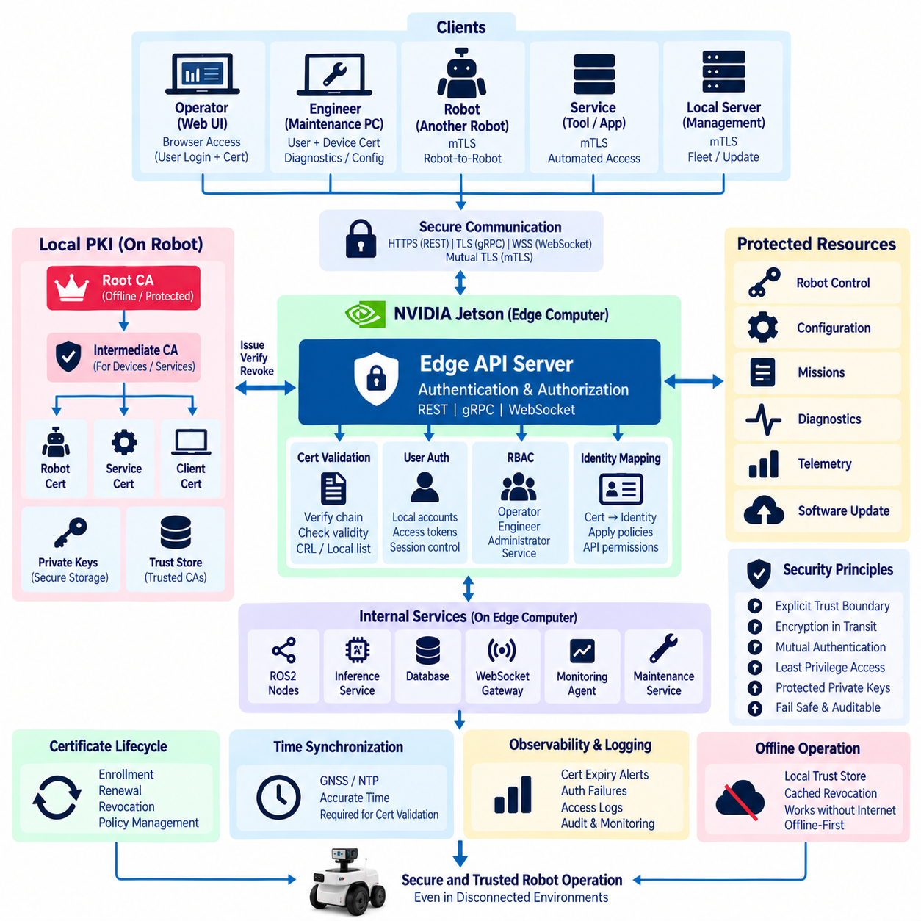
Edge API authentication establishes trusted identities for users, robots, services, and engineering tools that communicate with a robot through local network interfaces. A Local Public Key Infrastructure, or Local PKI, provides a practical foundation for this trust by issuing and validating digital certificates within the robot environment. Authentication can therefore continue even when the robot has no Internet or cloud connection, supporting the offline-first principles required by autonomous edge systems.
The fundamental purpose of Local PKI is to replace implicit network trust with cryptographically verifiable identity. A device should not be considered trustworthy simply because it is connected to the robot LAN, maintenance Wi-Fi, or internal Ethernet network. Instead, clients and services present certificates whose signatures can be verified against trusted certificate authorities. This approach establishes an explicit trust boundary around Edge APIs and reduces dependence on network location as a security mechanism.
A typical Local PKI contains a root Certificate Authority, one or more intermediate Certificate Authorities, device and service certificates, private keys, trust stores, and certificate lifecycle policies. The root CA represents the highest trust anchor and should normally be protected from routine operational use. Intermediate CAs can issue certificates for robots, edge computers, maintenance devices, API services, or specific deployment environments without exposing the root signing key during daily operations.
Each robot can receive a unique cryptographic identity during manufacturing, provisioning, commissioning, or deployment. The certificate may identify the robot, edge computer, API server, fleet, product family, or deployment domain according to the organization’s certificate policy. Private keys should be generated and stored securely so that copying configuration files alone cannot duplicate a robot identity. Hardware-backed key storage can provide stronger protection when supported by the edge platform.
Edge API services can use Transport Layer Security to protect REST, gRPC, and WebSocket communications. HTTPS secures REST endpoints, TLS protects gRPC channels, and WSS provides encrypted WebSocket sessions. Server certificates allow clients to verify that they are communicating with the intended Edge API service rather than an unauthorized endpoint. Encryption also protects credentials, commands, telemetry, configuration data, and diagnostic information from passive network observation.
Mutual TLS extends this model by authenticating both sides of a connection. The Edge API server presents its certificate to the client, while the client also presents a certificate that the server validates. This is especially useful for robot-to-robot, robot-to-edge, engineering-tool-to-robot, and edge-to-local-server communication. Mutual authentication reduces reliance on shared passwords and provides strong machine identity for automated service connections.
Human authentication should remain distinct from machine authentication. A certificate may prove that a trusted maintenance laptop is connecting to the robot, but it does not necessarily prove which engineer is currently using that laptop. Local Web UI access can therefore combine secure device identity with user credentials, short-lived access tokens, or another user authentication mechanism. Separating device trust from user identity allows authorization decisions to reflect both the endpoint and the individual operator.
Authentication and authorization should also remain separate concepts. Authentication determines who or what is making the request, while authorization determines which operations that identity may perform. After certificate or user validation, the Edge API can apply Role-Based Access Control to distinguish operators, maintenance engineers, administrators, automated services, and diagnostic clients. A successfully authenticated identity should not automatically receive unrestricted access to every robot function.
Certificate issuance requires a controlled enrollment process. During provisioning, a robot or device can generate a key pair and create a Certificate Signing Request containing its identity information and public key. An authorized registration process verifies the requesting device before a CA signs the certificate. Automated enrollment can simplify large robot fleets, but the initial bootstrap identity must itself be protected so that an unauthorized device cannot obtain a legitimate certificate by pretending to be a new robot.
Certificate renewal is necessary because certificates should have limited validity periods. Long-lived certificates reduce operational maintenance but increase exposure if a private key is compromised, while very short-lived certificates require reliable renewal mechanisms. Edge systems should therefore select validity periods according to deployment risk and connectivity conditions. Renewal should preferably occur before expiration and should tolerate temporary cloud disconnection without unexpectedly disabling essential local robot interfaces.
Offline operation makes certificate validation more challenging because remote revocation services may be unavailable. The robot should maintain sufficient local trust information to validate certificates without continuously contacting an external authority. Locally cached revocation information, certificate validity periods, managed trust lists, and deployment-specific policies can support disconnected operation. The design must balance revocation responsiveness with the requirement that legitimate robots continue operating during network outages.
Certificate revocation is required when a private key is suspected of compromise, a maintenance device is lost, an employee’s access changes, or a robot is removed from service. A Local PKI design should define how revoked identities are distributed to robots and edge systems. When connectivity is available, updated revocation information can be synchronized from fleet management. Local administrative procedures may also be required for isolated environments where central distribution cannot be reached.
Trust-store management is as important as certificate issuance. Edge devices should maintain an explicit set of trusted root and intermediate authorities rather than accepting arbitrary certificates. Trust anchors must be protected against unauthorized modification because adding a malicious CA could allow fraudulent certificates to appear legitimate. Updates to trust stores should therefore be authenticated, versioned, auditable, and recoverable if a deployment introduces an incorrect certificate chain.
Private-key protection is a critical security requirement. Keys stored as unrestricted plaintext files can be copied and reused by an attacker who gains filesystem access. Where available, Trusted Platform Modules, secure elements, hardware security modules, or protected operating-system key stores can make extraction more difficult. File permissions, encrypted storage, process isolation, and least-privilege access remain important even when dedicated security hardware is unavailable.
Certificate identity should map cleanly into API authorization policies. A certificate subject, Subject Alternative Name, device identifier, or other validated attribute can be translated into an internal service identity. The authorization layer can then determine whether that identity may read diagnostics, publish telemetry, modify configuration, upload software, submit missions, or invoke maintenance operations. This mapping should be explicit and centrally manageable rather than scattered across individual API handlers.
Local PKI must also support service-to-service communication inside the edge computer. A robot may run REST servers, gRPC inference services, WebSocket gateways, databases, monitoring agents, ROS2 bridges, and maintenance services as separate processes or containers. Internal network placement alone should not imply unlimited trust. Service certificates and workload identities can establish authenticated communication boundaries and reduce the impact of one compromised component on the rest of the edge software stack.
Certificate and authentication failures should fail safely and produce understandable diagnostics. Expired certificates, unknown issuers, hostname mismatches, invalid signatures, rejected client certificates, and authorization failures should be distinguishable in logs and monitoring. However, diagnostic messages returned to untrusted clients should avoid exposing unnecessary security details. Operators need actionable information, while attackers should not receive detailed clues about internal trust configuration.
Observability should include certificate expiration dates, renewal status, authentication failures, rejected identities, trust-store versions, TLS negotiation errors, and unusual connection patterns. Alerts can be generated before certificates expire so maintenance can occur without service interruption. Authentication events should include timestamps and correlation identifiers that allow security activity to be associated with API requests, configuration changes, mission commands, and other operational events.
Time synchronization deserves special consideration because certificate validity depends on time. A robot with an incorrect system clock may reject valid certificates as not yet valid or expired, or incorrectly accept credentials outside their intended validity interval. GNSS time, secure network time, hardware clocks, or controlled local time sources can support reliable validation. Systems should define safe behavior when trusted time is temporarily unavailable rather than silently bypassing certificate checks.
A robust Edge API authentication architecture therefore combines Local PKI, TLS, mutual authentication, protected private keys, certificate lifecycle management, explicit trust stores, user authentication, and role-based authorization. The objective is not merely encrypted communication but verifiable identity across local robot interfaces. By maintaining these trust mechanisms at the edge, robots can securely expose REST, gRPC, WebSocket, and internal services while preserving essential authentication capabilities during disconnected and offline operation.

08.08 Edge.Cloud API Gateway Pattern
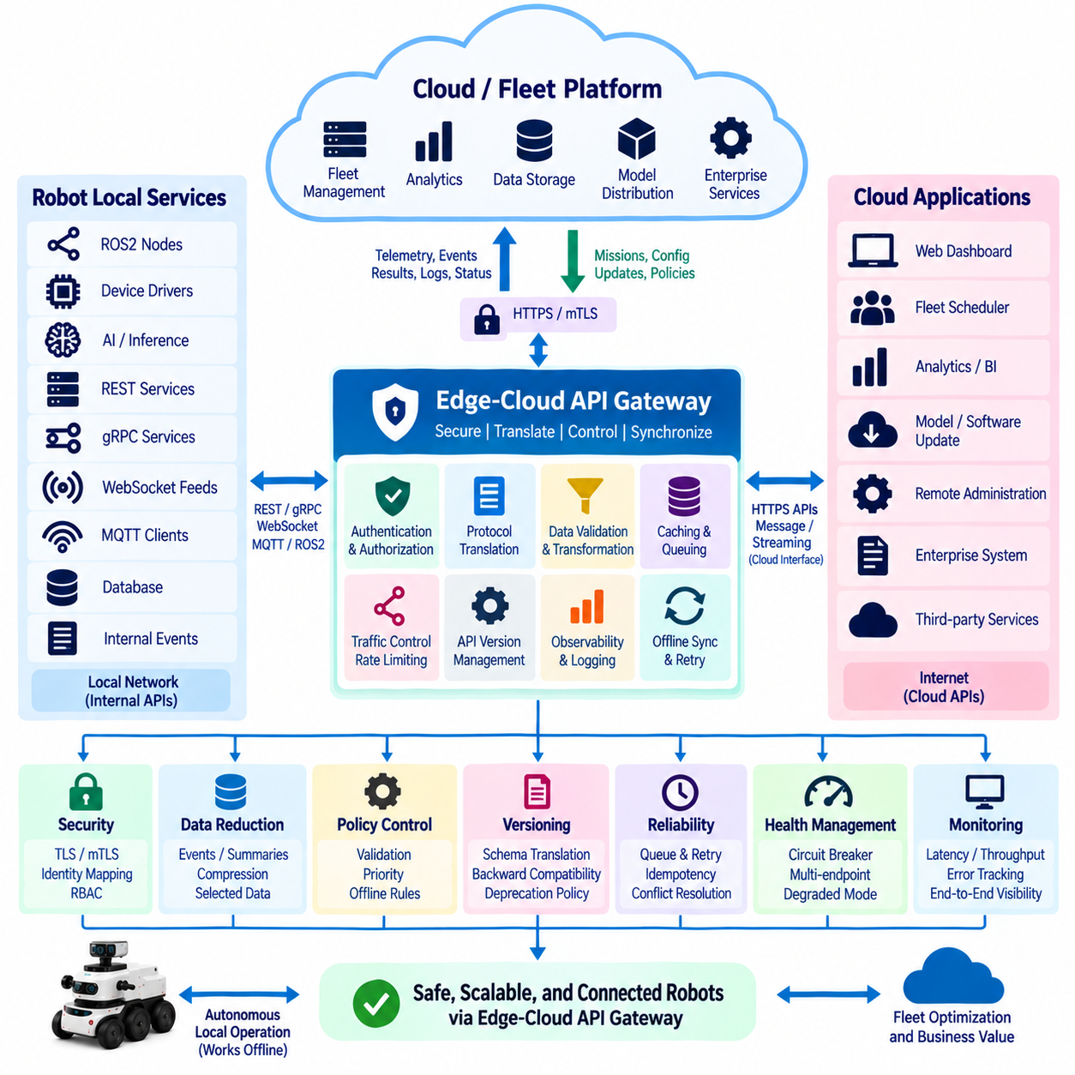
An Edge-Cloud API Gateway provides a controlled boundary between robot-local services and remote cloud or fleet platforms. Instead of allowing cloud applications to communicate directly with ROS2 nodes, device drivers, AI runtimes, or internal databases, the gateway exposes a stable set of external interfaces. This separation protects robot implementation details while allowing telemetry, missions, diagnostics, configuration, software management, and enterprise services to cross the edge-cloud boundary in a governed manner.
The gateway should be treated as an architectural boundary rather than merely as a network proxy. It can translate protocols, validate messages, authenticate identities, enforce authorization, control traffic rates, transform data, manage API versions, and observe communication health. Robot software can therefore evolve independently from cloud applications as long as the gateway maintains compatible contracts. This reduces tight coupling between rapidly changing robot internals and longer-lived fleet or enterprise systems.
A practical architecture separates local-facing and cloud-facing interfaces. On the robot side, the gateway may communicate with REST services, gRPC inference components, WebSocket feeds, MQTT clients, ROS2 bridges, databases, and internal event services. On the cloud side, it may expose HTTPS APIs, secure messaging, streaming connections, or managed IoT interfaces. Translation between these domains prevents every internal robot component from requiring its own cloud connectivity and security implementation.
Communication direction should reflect the semantics of each workload. Robot-to-cloud traffic commonly includes telemetry summaries, diagnostic events, mission results, health information, logs, selected perception metadata, and synchronization records. Cloud-to-robot traffic may contain mission assignments, approved configuration changes, software or model update instructions, fleet policies, and administrative requests. The gateway can classify these flows and apply different validation, priority, persistence, and security policies to each category.
The gateway should not place cloud connectivity in the critical control loop. Navigation, collision avoidance, localization, actuator control, safety monitoring, and immediate AI perception must continue through authoritative local services when the Internet is unavailable. Cloud APIs are better suited to supervisory functions such as fleet coordination, analytics, reporting, long-term storage, model distribution, and remote administration. This boundary preserves deterministic local autonomy while still enabling centralized management.
Asynchronous communication is particularly useful across unreliable edge-cloud networks. Instead of requiring a robot to keep a synchronous HTTP transaction open while a remote service processes information, the gateway can accept local events and place them into a durable outbound queue. When connectivity is available, queued messages are transmitted according to priority and policy. Temporary network failure therefore delays synchronization without forcing the originating robot application to fail or block.
Inbound cloud commands require equally careful handling. A remote mission request should not be translated directly into actuator commands. The gateway first authenticates the source, validates the schema, verifies authorization, checks freshness and replay protection, and forwards the request to an appropriate local mission or command service. The local robot system then evaluates current mode, safety conditions, resource availability, and operational constraints before accepting execution. Cloud authority therefore remains bounded by local safety authority.
Protocol translation allows each environment to use communication mechanisms appropriate to its characteristics. Internal gRPC may provide efficient typed service calls, ROS2 may support distributed robotic data flows, WebSocket may deliver local real-time status, and MQTT may support asynchronous event messaging. The gateway can expose a simpler cloud-facing contract without requiring remote applications to understand every robot-native protocol. Protocol conversion should preserve semantic meaning, identifiers, timestamps, and error states.
Data reduction is another important gateway responsibility because raw robot data can exceed practical network capacity. High-rate camera images, LiDAR point clouds, audio streams, and detailed inference outputs usually should not be continuously transmitted to the cloud. Edge processing can convert these sources into events, compressed summaries, selected snapshots, features, health metrics, or exception records. The gateway then transfers information that provides operational value while protecting bandwidth, storage, and cloud processing resources.
API version management prevents cloud and robot software releases from becoming tightly synchronized. A gateway can maintain versioned external contracts while adapting them to newer or older internal service representations. Schema transformation and compatibility logic allow mixed robot generations to participate in the same fleet platform. Deprecation policies should define how long older interfaces remain supported and provide a controlled migration path rather than abruptly breaking deployed robots after a cloud update.
Identity should be established independently on both sides of the gateway. Local services can use Local PKI, service certificates, workload identities, or protected credentials, while cloud communication can use device certificates, mutual TLS, signed tokens, or platform-specific identities. The gateway maps authenticated external identities into permitted local operations. This prevents a valid cloud connection from automatically becoming unrestricted access to every internal robot service.
Authorization policies should operate at resource and operation level. A fleet scheduler may be allowed to submit missions but not modify security settings, while a maintenance service may access diagnostics and approved configuration without controlling normal production missions. Software update services may require separate privileges and stronger approval policies. Centralizing these rules in the gateway and supporting local enforcement produces a clearer security boundary than distributing cloud permissions across many robot processes.
Traffic management protects the robot from excessive remote activity. Rate limiting, quotas, request-size limits, connection limits, backpressure, priority queues, and circuit breakers can prevent cloud clients or malfunctioning services from consuming edge resources. During CPU, GPU, memory, storage, or network pressure, low-priority uploads can be delayed while safety-related events and essential management traffic retain access. Gateway resource control should always prioritize autonomous robot workloads over remote convenience.
The gateway also provides a natural location for offline synchronization. Outbound data can be persisted when connectivity is unavailable, while inbound operations can be accepted only according to defined offline policies. After reconnection, synchronization should occur in controlled batches using idempotency keys, sequence information, version metadata, retry policies, and conflict-resolution rules. This integrates the gateway with the Edge API cache and offline synchronization architecture rather than creating an independent reliability mechanism.
Remote operations require protection against replay and stale commands. Gateway messages can include unique request identifiers, timestamps, expiration periods, sequence numbers, or cryptographic signatures. A command received long after its intended execution window should not automatically become valid simply because network connectivity has returned. Freshness validation is particularly important for motion-related missions, emergency actions, temporary permissions, and configuration operations whose context may have changed during disconnection.
Observability should cover the complete edge-cloud communication path. Useful measurements include connection status, request latency, message throughput, queue depth, retry rate, rejected requests, authentication failures, synchronization delay, dropped data, protocol translation errors, and cloud-service availability. Correlation identifiers can follow a request from the fleet platform through the gateway into a local service and back to the cloud, making distributed failures significantly easier to diagnose.
Health management should distinguish between gateway failure and external service failure. If the cloud is unavailable but the gateway and local services remain healthy, the robot should report a disconnected or degraded state rather than a complete system failure. Circuit breakers can temporarily stop requests to an unhealthy remote endpoint, while retry and backoff mechanisms avoid creating a continuous failure storm. Multiple cloud endpoints may also be supported where deployment requirements justify redundancy.
Deployment isolation can further protect robot workloads. The gateway may run as a dedicated process, container, or managed service with explicit CPU, memory, storage, and network limits. Internal interfaces should expose only the services required by the gateway, following least-privilege principles. Separating the gateway from perception, planning, control, and AI processes reduces the probability that malformed remote traffic or gateway resource exhaustion will directly destabilize autonomous functions.
The Edge-Cloud API Gateway ultimately acts as a policy-controlled bridge between two environments with different timing, reliability, security, and scalability characteristics. The robot side emphasizes local autonomy, bounded latency, safety, and offline operation, while the cloud side emphasizes fleet-scale coordination, analytics, storage, and centralized services. By combining protocol mediation, security, queuing, synchronization, data reduction, versioning, traffic control, and observability, the gateway allows both environments to cooperate without making either one structurally dependent on the other.

08.09 Edge API Performance Optimization: Compute Offloading
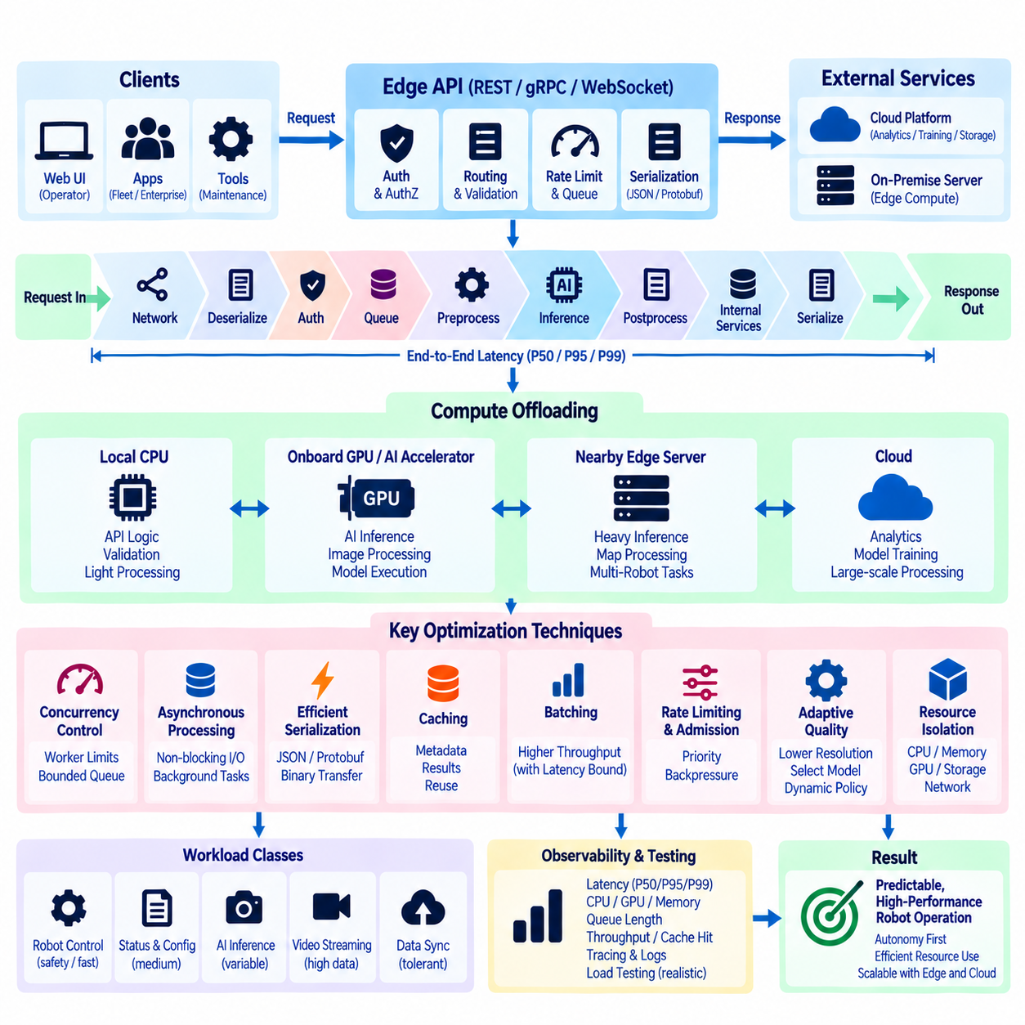
Edge API performance optimization begins with understanding that API latency is only one part of the robot’s complete execution path. A request may pass through network transport, serialization, authentication, middleware, application logic, ROS2 communication, AI inference, storage access, and response generation before reaching the client. Optimizing only the HTTP or gRPC server can therefore produce little practical improvement if the dominant delay exists in inference, queueing, memory transfer, or downstream robot services.
Performance requirements should be defined according to workload classes rather than applying one latency target to every API. Robot status queries, mission commands, configuration requests, diagnostic downloads, AI inference, video feeds, and cloud synchronization have very different timing characteristics. Safety-related and operational requests require predictable response behavior, while analytics uploads can tolerate longer delays. Classifying workloads allows the edge platform to allocate compute, memory, storage, and network resources according to operational importance.
End-to-end latency should be decomposed into measurable stages. Useful timing points include request arrival, authentication completion, queue entry, worker dispatch, preprocessing, accelerator submission, inference completion, postprocessing, internal service response, serialization, and final transmission. Percentile measurements such as P50, P95, and P99 reveal latency variation that averages can hide. This is particularly important because occasional long delays may be more disruptive to robot operation than a slightly higher but stable average latency.
Concurrency must be controlled because increasing the number of workers does not always increase performance. Too many API processes or asynchronous tasks can compete with localization, planning, perception, and control for CPU time, memory bandwidth, and I/O. Worker counts should therefore reflect available CPU cores, workload characteristics, and downstream capacity. Bounded queues and explicit concurrency limits prevent bursts of external requests from creating uncontrolled scheduling pressure inside the edge computer.
Asynchronous processing is useful when API operations involve network communication, database access, file operations, or other waiting periods. An asynchronous server can continue serving lightweight requests while slower operations are waiting, but asynchronous programming does not make CPU-intensive work free. Image processing, compression, large serialization jobs, and inference preparation may still consume substantial compute resources. Such workloads may require dedicated worker processes, thread pools, or accelerator-oriented execution services.
Compute offloading moves selected workloads away from the API process to the resource best suited to execute them. Lightweight validation and routing can remain on CPU, while neural inference can execute on GPU or dedicated AI accelerators. Image preprocessing may use GPU kernels when transfer overhead is justified, and long-running analytics may be moved to another local computer or cloud service. Offloading should reduce contention around the API layer rather than simply relocating the same bottleneck to another component.
The decision to offload should consider total execution cost rather than accelerator speed alone. Moving data to a GPU, another process, another edge computer, or the cloud introduces serialization, memory copying, communication, scheduling, and synchronization overhead. A computation that requires only a few milliseconds on the CPU may become slower after offloading. Engineers should therefore compare complete request latency and resource utilization before deciding where a workload should execute.
GPU inference services benefit from separation between API handling and model execution. REST or gRPC endpoints can validate requests and submit inference jobs to a dedicated inference service that owns model memory and accelerator resources. This avoids repeatedly loading models and prevents multiple API workers from independently consuming GPU memory. A centralized inference scheduler can manage priorities, concurrency, model selection, and admission control while presenting stable inference interfaces to other robot applications.
Batching can improve accelerator throughput when multiple compatible inference requests are available, but it introduces queueing delay while waiting for a batch to form. Dynamic batching can balance these effects by limiting both batch size and maximum waiting time. High-priority perception requests may bypass batching or use very short batching windows, while noncritical analytics can tolerate larger batches. Throughput optimization should never increase latency beyond the operational deadline of the consuming robot function.
Memory movement is often a hidden performance cost in edge AI pipelines. Camera frames may be copied from device drivers into ROS2 messages, then into API buffers, preprocessing arrays, GPU memory, and response structures. Repeated copying increases latency and memory bandwidth consumption. Shared memory, zero-copy transport, pinned memory, reusable buffers, and direct references to locally stored data can reduce unnecessary transfers when supported by the software and hardware architecture.
Serialization format also influences performance. JSON is convenient for configuration, management, and human-readable diagnostics but can become inefficient for large numerical arrays or high-frequency messages. Protocol Buffers and other binary representations reduce payload size and parsing overhead for structured machine-to-machine communication. Large images, point clouds, and model artifacts should often be transferred through dedicated binary channels or referenced by identifiers rather than embedded repeatedly inside general API messages.
Caching can remove repeated computation from frequently requested operations. Static robot capabilities, model metadata, map information, configuration summaries, and previously generated representations may be cached when their validity can be clearly determined. Expensive derived information can also be reused when input versions have not changed. Cache invalidation must remain explicit because returning a fast but outdated response can be more harmful than performing a slower authoritative computation.
Rate limiting and admission control protect finite edge resources. Requests can be assigned priorities according to identity, endpoint, workload type, robot mode, or current system pressure. When resources are constrained, the server may reject, defer, downsample, or queue low-priority work instead of allowing every request to compete equally. This preserves capacity for mission supervision, safety-related communication, essential diagnostics, and autonomous robot processes during periods of high external demand.
Adaptive quality can reduce compute requirements without completely disabling a service. Video feeds may lower resolution or frame rate, telemetry may reduce publication frequency, AI services may select a lighter model, and diagnostic collection may reduce sampling frequency when system utilization rises. Such degradation should follow explicit policies and remain observable. Adaptive behavior allows the platform to preserve essential functionality while protecting critical workloads from resource exhaustion.
Cloud offloading is appropriate primarily for workloads that tolerate network latency and temporary disconnection. Fleet analytics, large-scale historical analysis, model training, report generation, global optimization, and archival processing can often execute remotely. Immediate collision avoidance, local planning, safety decisions, and time-critical perception should remain on the robot. Hybrid applications can perform fast preliminary analysis at the edge and send selected results to the cloud for deeper processing.
Another edge computer can provide an intermediate offloading tier between the robot and cloud. A nearby on-premise server may execute heavier inference, map processing, multi-robot optimization, or data aggregation while maintaining lower latency and greater availability than a remote cloud service. The robot should still define fallback behavior if that server becomes unavailable. Compute placement therefore becomes a hierarchy spanning onboard CPU, onboard GPU, local edge server, on-premise infrastructure, and cloud resources.
Resource isolation prevents optimization of one API workload from degrading the rest of the robot. Containers, process priorities, CPU affinity, memory limits, GPU scheduling policies, storage quotas, and network shaping can establish resource boundaries. API gateways, Web UIs, log downloads, and synchronization processes should operate within controlled budgets. Localization, control, perception, and safety services should retain sufficient resources even when remote users generate unusually heavy API traffic.
Performance optimization should be driven by observability rather than assumptions. Metrics should include request latency, queue waiting time, active workers, CPU and GPU utilization, memory consumption, accelerator memory, network throughput, cache hit rate, serialization time, inference duration, batch size, rejected requests, and offloading success. Distributed tracing and correlation identifiers can connect an external API request with internal ROS2 calls, inference jobs, database operations, and downstream responses.
Load testing should reproduce realistic robot conditions instead of benchmarking the API on an otherwise idle computer. Tests should run while perception, localization, navigation, recording, Web UI monitoring, and other normal workloads are active. Burst traffic, multiple clients, degraded networks, storage pressure, and accelerator saturation should also be evaluated. This reveals whether an optimization improves isolated throughput while unintentionally reducing the stability of the complete robotic system.
A well-designed Edge API performance architecture therefore combines workload classification, bounded concurrency, asynchronous execution, caching, efficient serialization, controlled batching, resource isolation, and intelligent compute offloading. The objective is not simply to maximize requests per second but to preserve predictable robot behavior under changing workloads. CPU, GPU, nearby edge servers, and cloud resources should be treated as a coordinated compute hierarchy in which each task executes where latency, safety, availability, and resource cost are most appropriate.

08.10 Edge API Monitoring and Self-Healing Design
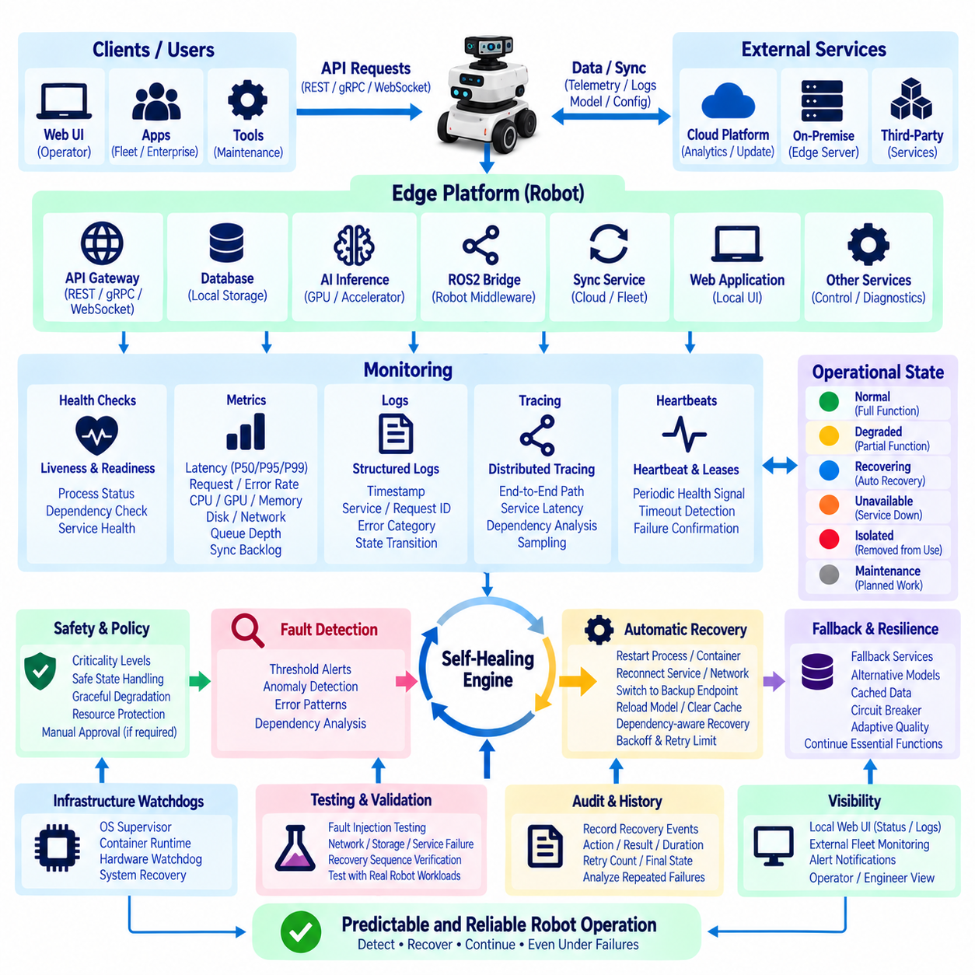
Edge API monitoring and self-healing design enables a robot to detect communication and service degradation, determine whether recovery is possible, and restore functionality without unnecessary human intervention. Because an edge platform may host REST, gRPC, WebSocket, databases, AI inference, ROS2 bridges, synchronization services, and local Web applications simultaneously, monitoring must observe both individual components and the complete service path. The objective is not merely uptime, but predictable robot operation under faults.
Monitoring should begin with explicit health models for every important Edge API component. A service can expose lightweight liveness and readiness information indicating whether its process is running and whether it can actually accept useful work. Liveness answers whether the component is alive, while readiness evaluates dependencies such as databases, ROS2 services, model runtimes, storage, network interfaces, or security credentials. Separating these states prevents a running but unusable service from being incorrectly reported as healthy.
Health should be represented using meaningful operational states rather than a simple healthy-or-failed flag. Normal, degraded, recovering, unavailable, isolated, and maintenance states can communicate different levels of capability. A WebSocket gateway may remain operational while cloud synchronization is unavailable, or an inference service may continue using a fallback model after its preferred GPU path fails. Such state models allow the robot to preserve available functions instead of declaring complete failure whenever one dependency becomes impaired.
Metrics provide continuous quantitative evidence of system behavior. Important measurements include API request latency, P50/P95/P99 response time, request rate, error rate, timeout count, active connections, queue depth, retry count, cache performance, synchronization backlog, CPU and GPU utilization, memory pressure, disk usage, network throughput, and accelerator temperature. Thresholds should reflect operational requirements and hardware limits rather than arbitrary values copied from generic server environments.
Logs complement metrics by preserving detailed information about events and failures. Edge services should generate structured logs containing timestamps, severity, service identity, request or mission identifiers, error categories, and relevant state transitions. Correlation identifiers can connect a REST request with a gRPC inference call, ROS2 command, database operation, and final response. This makes it possible to reconstruct failures that span several processes instead of examining isolated log files independently.
Distributed tracing becomes useful when an API request crosses multiple internal services. A trace can record time spent in authentication, routing, queueing, preprocessing, inference, storage access, ROS2 interaction, and response generation. This reveals whether an apparent API slowdown originates in the gateway, network, AI service, database, or robot middleware. Sampling policies are important because recording every trace on a resource-constrained edge computer may itself consume excessive storage and processing capacity.
Heartbeat mechanisms can detect missing or unresponsive components. Services may periodically publish health signals or update local leases that expire when communication stops. The monitoring supervisor can distinguish a delayed heartbeat from a confirmed process failure by considering timing tolerance and system load. Heartbeats should not be so aggressive that temporary CPU scheduling delays trigger unnecessary recovery, but they must detect failures early enough to preserve required service availability.
Self-healing begins only after reliable fault detection. Automatic recovery actions may include restarting a process, recreating a container, reconnecting a network session, reopening a database, clearing a bounded temporary cache, reinitializing an API worker, switching to a backup endpoint, or reloading an AI service. Recovery should follow predefined policies rather than arbitrary scripts, because an incorrect automated action can convert a limited service fault into a wider robot-system failure.
Restart policies should include limits and backoff behavior. A service that crashes immediately after every restart should not enter an unlimited restart loop that consumes CPU, fills logs, or repeatedly accesses failing hardware. The supervisor can use exponential backoff, maximum retry counts, and recovery windows before escalating the fault. Repeated failure may transition the component from recovering to unavailable or isolated, allowing the rest of the robot to continue operating without continuous recovery pressure.
Dependency-aware recovery prevents unnecessary cascading restarts. If an API server fails because its database is unavailable, repeatedly restarting the API process may provide no benefit. The monitoring system should identify dependency relationships and recover the underlying service first when possible. Recovery graphs can represent dependencies among gateways, databases, inference engines, ROS2 bridges, local storage, network interfaces, and cloud connections, enabling more intelligent sequencing of recovery actions.
Circuit breakers provide another form of self-protection. When repeated calls to an unhealthy service fail, the caller can temporarily stop sending requests and return a controlled degraded response instead. After a defined interval, limited probe requests determine whether the dependency has recovered. This prevents failure storms in which many API workers repeatedly call the same unavailable service, increasing latency and resource consumption across the entire edge platform.
Fallback services allow useful operation to continue when preferred resources are unavailable. An AI API may switch from a high-performance GPU model to a smaller local model, a cloud-dependent function may use cached information, or a remote endpoint may be replaced by a local service. Telemetry can be buffered when connectivity disappears. Fallback behavior should be explicitly designed and tested so that degraded operation remains predictable rather than becoming an improvised response to failure.
Graceful degradation is especially important for robotic systems because not all functions have equal importance. High-resolution video streaming, historical log downloads, cloud analytics, or secondary dashboards can be reduced or disabled before navigation, safety monitoring, localization, mission control, or essential diagnostics are affected. Resource pressure policies can progressively restrict lower-priority API workloads as CPU, memory, storage, GPU, thermal, or network conditions approach critical limits.
Self-healing must respect safety boundaries. Restarting a Web UI or telemetry service may be relatively low risk, while restarting localization, motion-control interfaces, or safety-related components can affect physical behavior. Recovery policies should therefore classify services by operational criticality and define which actions may occur automatically. Safety-critical recovery may require transition to a safe state, stopping motion, preserving actuator constraints, or requesting operator confirmation before normal operation resumes.
Persistent state must survive recovery when required. Restarting an API process should not erase mission identifiers, pending synchronization records, security state, configuration revisions, or important diagnostic evidence. Durable databases and queues can separate service lifecycle from operational data lifecycle. Before destructive recovery actions, the system should determine whether state must be flushed, checkpointed, preserved, or reconstructed from an authoritative source.
Watchdog design can extend monitoring below application services. Operating-system supervisors, container runtimes, hardware watchdog timers, and external controllers can observe different failure layers. An application supervisor may restart a failed API worker, while a system service can restart the application supervisor itself. A hardware watchdog can reset the edge computer when the operating system becomes completely unresponsive. Layered watchdogs reduce dependence on a single recovery mechanism.
Network self-healing should distinguish local, on-premise, and cloud connectivity failures. A robot may lose Internet access while local REST, gRPC, ROS2, and WebSocket services remain fully functional. The system should preserve local autonomy, queue outbound data, and periodically attempt controlled reconnection rather than treating cloud loss as total failure. Alternative interfaces or endpoints may be tried when available, but recovery traffic should remain bounded to avoid network storms.
Monitoring information should remain available through both machine and human interfaces. Local Web UIs can display service state, resource pressure, synchronization backlog, recent recovery actions, and unresolved faults. External fleet systems can receive summarized health events when connectivity permits. Engineers may require deeper diagnostic endpoints, while operators should see concise operational states. This layered visibility supports troubleshooting without exposing unnecessary implementation complexity during normal operation.
Recovery events should be auditable. Each automated action should record the detected fault, triggering condition, affected component, recovery policy, action performed, result, duration, retry count, and final state. This history allows engineers to determine whether self-healing actually improves availability or merely hides recurring defects. Frequent successful restarts are still evidence of an underlying reliability problem and should not be interpreted as normal system behavior.
Testing should intentionally inject realistic faults. Processes can be terminated, network links interrupted, storage filled, services delayed, certificates expired, GPU resources exhausted, databases disconnected, and cloud endpoints made unavailable. Fault-injection testing verifies detection thresholds, recovery sequencing, fallback behavior, state preservation, and operator visibility. Testing under simultaneous robot workloads is necessary because recovery behavior observed on an idle development computer may differ significantly from behavior during navigation and AI inference.
A robust Edge API monitoring and self-healing architecture therefore combines health models, metrics, logs, traces, heartbeats, watchdogs, dependency awareness, bounded restart policies, circuit breakers, fallback services, graceful degradation, and auditable recovery. Automation should restore recoverable functions while protecting local autonomy and safety, not blindly restart everything. The result is an edge platform that can recognize degradation, contain faults, recover appropriate services, and continue delivering predictable robot capabilities even when individual software, hardware, network, or cloud components fail.

