Volume 06 Robot Communication and APIs

12. API Case Studies

12.01 Hills Indoor AMR: REST / WebSocket API Architecture
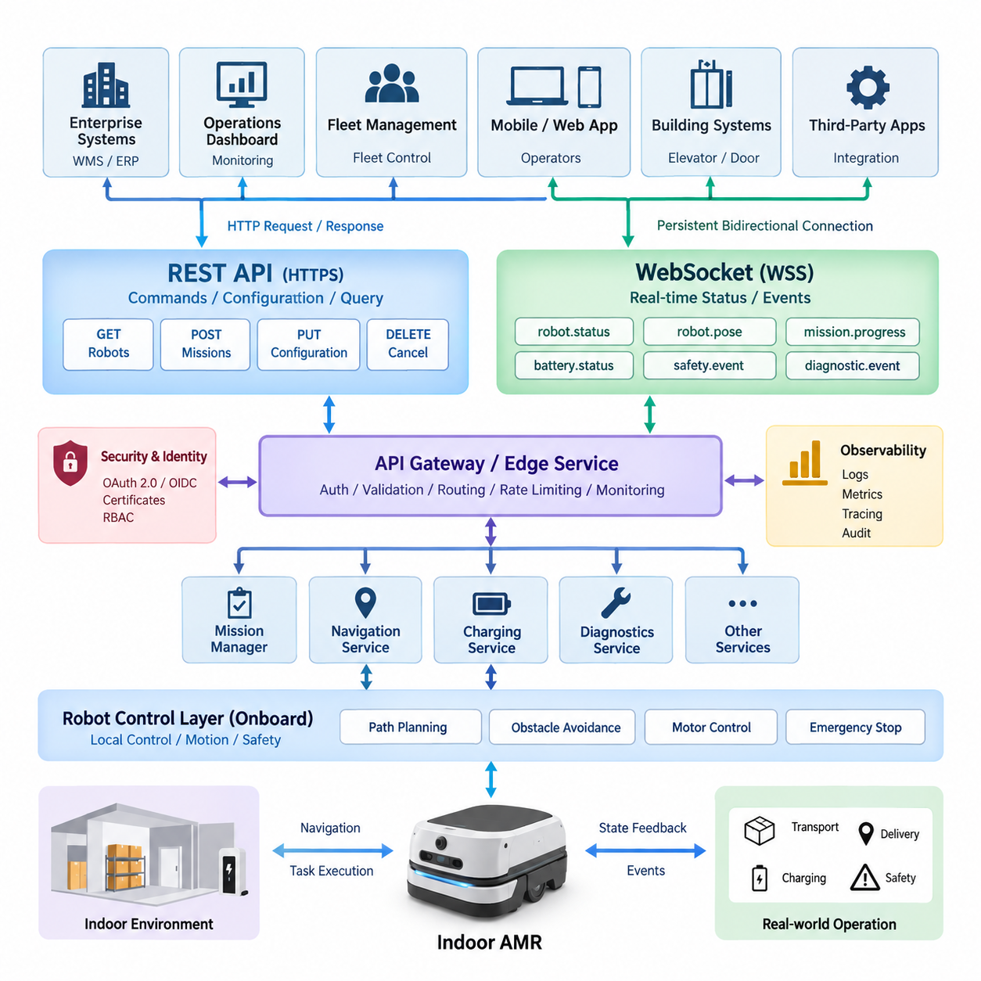
Indoor autonomous mobile robots operate in environments where navigation, task execution, human interaction, and fleet supervision must be coordinated through interfaces that remain understandable to enterprise software. A practical architecture therefore separates transactional operations from continuously changing robot information. REST APIs provide a stable resource-oriented interface for commands and configuration, while WebSocket channels provide persistent bidirectional connections for real-time operational data.
The REST layer represents each AMR as a collection of resources such as robots, missions, maps, charging stations, tasks, diagnostics, and configuration profiles. Enterprise applications can retrieve robot information through GET requests, create missions through POST operations, modify permitted configuration through PUT or PATCH, and cancel appropriate resources through defined control endpoints. This resource abstraction prevents external systems from depending directly on internal ROS 2 nodes or hardware-specific interfaces.
A typical indoor AMR exposes identification, operational mode, localization state, battery status, current mission, fault information, and capability metadata through a robot resource. Mission resources contain destinations, waypoints, priorities, payload requirements, execution constraints, and lifecycle information. Separating robot resources from mission resources allows the API to preserve a clear distinction between the physical platform and the work assigned to that platform.
Mission creation is particularly suitable for REST because it represents a discrete transaction with a persistent result. A client may submit a transport request containing pickup and delivery locations, priority, payload information, and optional scheduling constraints. The server validates the request, creates a mission identifier, and returns an accepted or created response. The client can subsequently retrieve the mission resource without maintaining a continuous connection to the robot.
REST alone becomes inefficient when dashboards or fleet applications require rapidly changing information. Repeated polling for position, velocity, battery level, navigation state, obstacle conditions, and mission progress generates unnecessary HTTP transactions and introduces latency between an event and its observation. WebSocket complements REST by establishing a persistent communication channel through which the AMR or fleet server can publish operational changes immediately.
The WebSocket data model should use explicit event categories rather than transmitting arbitrary internal messages. Typical categories include robot.status, robot.pose, mission.progress, battery.status, navigation.state, safety.event, diagnostic.event, and connection.state. Every message should contain a robot identifier, timestamp, event type, schema version, and payload. This envelope structure makes real-time streams easier to validate, route, record, and evolve independently of individual robot implementations.
REST and WebSocket should share a common domain model. A mission created through REST must use the same mission identifier that appears in WebSocket progress events, while robot identifiers and state definitions must remain consistent across both interfaces. This avoids the architectural mistake of building separate command and monitoring models. The client can create a mission through REST, receive its identifier, subscribe to relevant WebSocket events, and track execution using the same semantic objects.
Inside the robot, an API gateway or edge service isolates external communication from the real-time control domain. REST requests are translated into validated high-level commands and delivered to mission management, navigation, charging, or diagnostic services. WebSocket publishers collect selected state changes from these services and transform them into external event schemas. Low-level motor commands, raw control loops, and safety-critical actuation remain outside the public API boundary.
This separation is essential because an enterprise API must never become the timing mechanism for motion control. HTTP and WebSocket communication can experience network delay, congestion, reconnection, or client failure. Navigation controllers, obstacle avoidance, emergency stopping, and motor control therefore continue locally with deterministic or bounded behavior. External APIs request intentions such as “execute mission” or “go to station,” while onboard controllers determine how those intentions are safely executed.
Command semantics require explicit lifecycle management. After accepting a command, the system should distinguish states such as accepted, queued, executing, completed, canceled, rejected, and failed. Long-running operations should not keep an HTTP request open until physical completion. Instead, REST returns an operation or mission identifier immediately, and subsequent state transitions are available through resource queries and WebSocket events. This pattern scales better and provides clearer failure handling.
Idempotency is equally important because wireless communication can fail after a client sends a command but before it receives the response. Repeating a mission-creation request without protection could generate duplicate robot jobs. An idempotency key or client-generated request identifier allows the server to recognize retries and return the original result. Cancellation and configuration operations should similarly define whether repeated requests are harmless, rejected, or interpreted according to current state.
Indoor AMRs frequently move between wireless access points, enter elevators, pass through areas with weak coverage, or temporarily lose communication with the fleet server. WebSocket clients must therefore implement heartbeat monitoring, ping-pong mechanisms, timeout detection, exponential reconnection, and session recovery. Critical robot functions continue locally during interruption, while buffered operational events can be synchronized after connectivity returns according to retention and priority policies.
After reconnection, clients should not assume that every missed WebSocket event can be replayed. A robust design treats REST resources as authoritative snapshots and WebSocket messages as notifications of change. The client reconnects, retrieves the latest robot and mission states through REST, and then resumes event subscriptions. Sequence numbers or event offsets can additionally identify gaps when ordered event recovery is required for auditing or operational analysis.
Security must protect both interfaces consistently. REST endpoints should use HTTPS, while real-time connections use WSS. Authentication can be based on OAuth 2.0, OpenID Connect, signed tokens, certificates, or enterprise identity infrastructure according to deployment requirements. Authorization should distinguish monitoring, mission creation, mission cancellation, configuration, maintenance, and administrative privileges rather than granting every authenticated application unrestricted robot control.
Robot identity deserves separate treatment from human identity. Each AMR can possess a unique device credential or certificate, while operators and enterprise applications receive identities associated with defined roles. This allows the system to determine whether a message originated from a specific robot, fleet service, maintenance tool, WMS, or authenticated operator. Audit records can consequently associate important commands with their authenticated origin and execution result.
Safety-related events should receive higher semantic priority than ordinary telemetry. Emergency-stop activation, localization loss, blocked motion, protective-field activation, collision risk, hardware faults, and mission failures should be represented as structured events containing severity, source, timestamp, acknowledgement requirements, and recovery information. WebSocket delivery improves operational awareness, but reception of these messages must never replace the robot's local safety mechanisms.
Bandwidth management becomes important as fleet size grows. Publishing every pose update from every robot to every connected dashboard wastes network and server resources. Clients should be able to subscribe by robot, event class, fleet, or operational area, while the server applies appropriate update rates and change thresholds. High-frequency visualization data can be reduced independently from critical alarms, allowing one communication architecture to support both detailed diagnostics and large fleet supervision.
The architecture also provides a clean integration boundary for warehouse management systems, hospital logistics applications, building systems, elevators, automatic doors, and fleet management software. These systems interact with standardized mission and robot resources rather than directly controlling ROS 2 topics or vendor-specific navigation components. This abstraction supports replacement or upgrading of internal software while preserving stable interfaces for external applications.
Observability should cover both communication paths as one operational system. Useful measurements include REST request latency, response codes, authentication failures, mission submission rates, WebSocket connection counts, event throughput, reconnect frequency, dropped messages, queue depth, and end-to-end event latency. Correlating API requests with mission identifiers and robot identifiers allows engineers to trace a transaction from enterprise request through robot execution and final completion.
Version management should protect deployed integrations over the long service life of industrial robots. REST resources may use explicit API versions, while WebSocket event envelopes carry schema versions that allow consumers to interpret evolving payloads. Additive changes are preferable when possible, and deprecated fields should remain available during defined transition periods. Contract testing can verify that WMS, RMS, dashboards, and robot software remain compatible before deployment.
The combined REST-WebSocket pattern therefore creates a practical boundary between enterprise transactions and real-time robot observation. REST provides durable resources, explicit command semantics, configuration access, and recovery snapshots, while WebSocket provides efficient asynchronous status and event delivery. Together they form an API architecture suited to indoor AMRs without exposing safety-critical control loops or tightly coupling external applications to internal middleware.
In a production deployment, the most important architectural principle is not simply choosing two communication technologies, but assigning each technology the correct responsibility. REST governs stable resources and transactional intent; WebSocket distributes time-sensitive state changes; onboard software preserves autonomous and safe operation; and the API gateway enforces identity, policy, validation, and observability. This division creates an extensible foundation for individual AMRs, multi-robot fleets, and enterprise-scale robotic services.

12.02 Outdoor AMR gRPC-Based Real-Time Control API
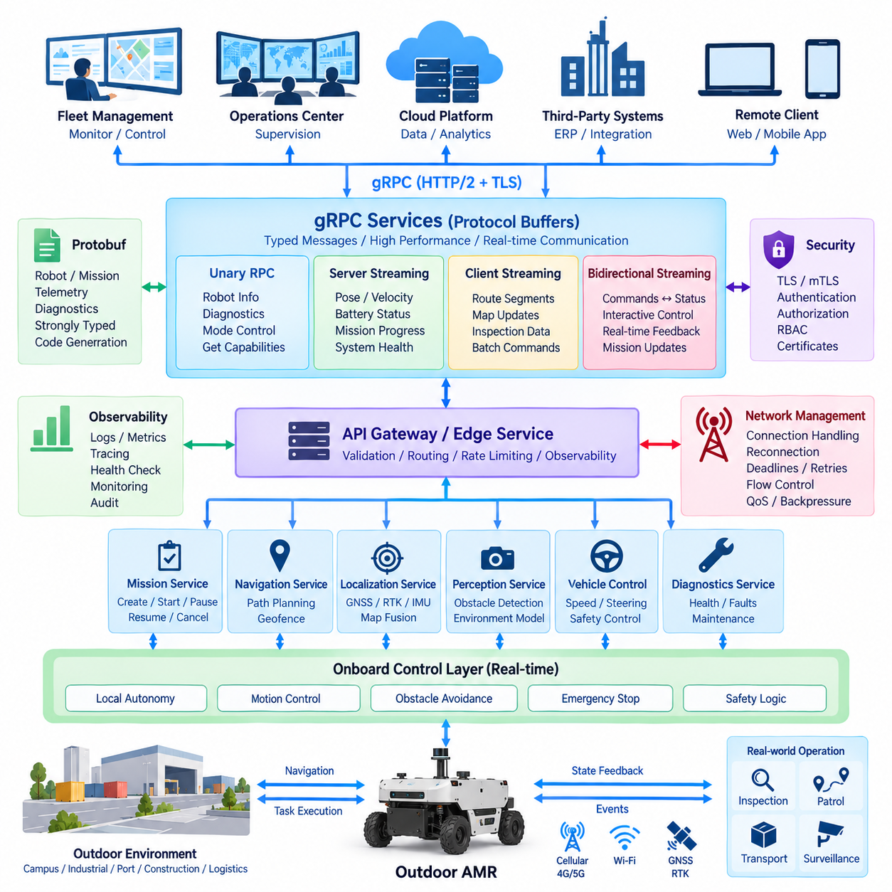
Outdoor autonomous mobile robots operate across campuses, industrial yards, ports, construction sites, logistics facilities, and infrastructure corridors where communication latency and network quality can vary significantly. For these systems, gRPC provides a strongly typed, high-performance API layer based on Protocol Buffers and HTTP/2. It is particularly suitable for structured command exchange, continuous telemetry, mission coordination, and service-to-service communication between outdoor AMRs, edge servers, and fleet controllers.
The architecture should separate external mission-level communication from safety-critical onboard control. A remote fleet controller may request navigation toward a destination, initiate an inspection route, modify mission parameters, or retrieve diagnostic information through gRPC services. However, steering, traction control, obstacle avoidance, emergency braking, and other deterministic functions remain within the robot. The API communicates operational intent rather than directly closing real-time motor-control loops over an unreliable external network.
Protocol Buffers define the communication contract shared by the robot and external systems. Messages can describe robot identity, pose, velocity, localization quality, battery state, mission information, detected obstacles, system health, and command results using explicit field types. Compared with loosely structured payloads, this schema-driven approach reduces interpretation ambiguity and supports automatic client and server code generation for languages commonly used in robotic systems, including C++, Python, Java, and Go.
Unary remote procedure calls are appropriate for operations that naturally follow a request-response pattern. Examples include retrieving robot information, requesting current diagnostics, loading mission parameters, changing an operating mode, or querying supported capabilities. The client sends one structured request and receives one structured response. Deadlines should be defined for each call so that communication failure or an unavailable robot cannot leave a remote application waiting indefinitely for a response.
Server streaming becomes valuable when the fleet controller requires continuous information from an outdoor AMR. After establishing a subscription, the robot can stream pose, velocity, battery level, localization confidence, mission progress, safety state, and diagnostic information over a persistent HTTP/2 connection. This eliminates repeated polling and enables the receiver to process state changes as they arrive while preserving a clearly defined protobuf schema for every transmitted message.
Client streaming can support cases in which an edge or fleet system needs to transmit a sequence of related data to the robot service. Route segments, map updates, inspection parameters, or batches of operational information may be delivered as a stream and acknowledged after processing. This model should be used selectively because unrestricted continuous command transmission can create unnecessary coupling between remote infrastructure and the robot's autonomous execution layer.
Bidirectional streaming provides the most flexible gRPC communication model for interactive robot operations. The robot and supervisory system can exchange messages independently over the same logical connection, allowing commands, acknowledgements, state transitions, and operational feedback to coexist. A fleet controller can issue high-level updates while the AMR continuously returns execution status, but message semantics must remain explicit so that streaming convenience does not blur the boundary between supervision and safety-critical control.
A mission-oriented gRPC service can represent operations such as CreateMission, StartMission, PauseMission, ResumeMission, CancelMission, and GetMissionStatus. Mission messages may include mission identifiers, destinations, route constraints, priorities, payload information, operating zones, and execution policies. Long-running missions should return an acknowledgement or mission handle quickly rather than keeping a unary request active until physical completion. Progress is then reported through streaming status messages.
Outdoor localization requires richer state representation than a simple two-dimensional position. A telemetry schema may include GNSS coordinates, map-frame pose, heading, linear and angular velocity, localization source, covariance, GNSS RTK state, IMU status, and timestamp information. The API should identify coordinate frames and measurement units explicitly because ambiguity between geographic coordinates, local map coordinates, and robot-relative coordinates can cause serious integration errors in autonomous navigation systems.
Real-time communication also requires consistent time semantics. Each message should contain timestamps generated from a defined clock source, while sequence numbers can identify ordering and missing messages. Systems using GNSS, PTP, or other synchronization mechanisms can correlate robot telemetry with sensor data and server-side events more accurately. The API contract should distinguish measurement time from transmission or reception time so that network delay is not mistakenly interpreted as robot state delay.
Command processing should incorporate identifiers, deadlines, acknowledgements, and lifecycle states. A remote command may transition through received, validated, accepted, executing, completed, rejected, canceled, or failed states. The command identifier allows responses and telemetry to be correlated with the originating request. When a client retries after communication loss, the server should detect duplicate identifiers where appropriate rather than executing the same physical operation multiple times.
gRPC deadlines are especially important for outdoor robots because mobile networks can introduce unpredictable delays. Clients should specify how long a request remains meaningful, and servers should stop unnecessary processing when that deadline expires. Retry policies must consider command semantics carefully. Automatically retrying a read-only status query is generally safe, whereas automatically retrying a movement or mission command without idempotency protection could create duplicate physical actions.
The architecture must assume temporary network disconnection rather than treating connectivity as permanently available. Outdoor AMRs may move through radio shadows, transition between Wi-Fi and cellular networks, or experience congestion and packet loss. When connectivity disappears, the robot should continue executing locally permitted behavior according to mission and safety policies. Remote control services should detect connection loss, expose communication state, and reconcile mission status after connectivity is restored.
Flow control and backpressure are necessary when telemetry production exceeds the receiver's processing capacity. High-frequency pose, perception, or diagnostic streams should not consume unlimited memory or delay safety-relevant information. Telemetry services can define different update frequencies, subscription classes, or data priorities. High-bandwidth sensor information such as camera images and raw LiDAR data should generally use dedicated data paths rather than being mixed indiscriminately with essential command and state messages.
The gRPC API gateway or edge service forms a controlled boundary between external networks and internal robot middleware. It validates requests, authenticates clients, applies authorization policies, translates external protobuf messages into internal service commands, and exposes selected robot states. ROS 2, DDS, CAN, Ethernet-based controllers, or proprietary interfaces can remain behind this boundary, allowing external systems to use a stable API without becoming dependent on internal implementation details.
Security should use transport encryption and authenticated identities throughout the communication path. TLS protects gRPC traffic, while mutual TLS can authenticate both robot and server when stronger device identity is required. Certificates, tokens, or enterprise identity mechanisms can be combined with role-based authorization so that monitoring applications, fleet controllers, maintenance tools, and administrative services receive only the operations required for their responsibilities.
Remote motion-related commands require particularly strict authorization and validation. The server should verify operating mode, mission state, permitted geographic area, speed constraints, command freshness, and safety conditions before accepting an instruction. Even after validation, onboard safety logic retains final authority over physical motion. A valid API request therefore represents permission to attempt an operation, not an unconditional instruction that overrides obstacle detection, emergency stopping, or local safety constraints.
Health and diagnostic services can expose processor utilization, memory usage, network quality, battery condition, motor-controller state, localization health, sensor availability, thermal conditions, and active fault codes. Structured diagnostic messages allow fleet software to distinguish warnings from critical failures and identify whether degraded operation is still permitted. Streaming diagnostics can additionally support remote maintenance and predictive analysis without exposing unrestricted access to internal robot processes.
Observability should trace communication from the client request to robot execution. Useful measurements include RPC latency, deadline expiration, error status, active stream count, message throughput, reconnect frequency, authentication failure, command acceptance rate, and telemetry delay. Correlation identifiers can connect a fleet-level mission to individual RPC calls and onboard events, enabling engineers to determine whether an operational problem originated in networking, API processing, navigation, hardware, or mission logic.
The protobuf contract must also evolve without unnecessarily breaking deployed robots and fleet applications. Existing field numbers should remain stable, removed fields should be reserved, and compatible additive changes should be preferred. New capabilities can be introduced through optional fields or new RPC methods while older clients continue using the subset they understand. Automated compatibility and contract tests should verify communication between multiple robot software and fleet-server versions before field deployment.
Large outdoor fleets can place gRPC services behind redundant edge or fleet infrastructure, but connection ownership must be designed carefully because streaming sessions are long-lived. Service discovery, load balancing, health checking, and failover mechanisms should preserve robot identity and mission continuity. The system should distinguish temporary server migration from robot failure and prevent multiple controllers from simultaneously assuming authority over the same physical robot without an explicit coordination mechanism.
In a production outdoor AMR system, gRPC is therefore best positioned between high-level fleet supervision and autonomous onboard execution. Unary RPC supports discrete operations, server streaming delivers continuous telemetry, and bidirectional streaming enables interactive supervision when necessary. Protocol Buffers provide a stable typed contract, while deadlines, identity, security, observability, reconnection, and lifecycle semantics make the communication layer suitable for real operational environments.
The resulting architecture does not attempt to transform an external network into a deterministic robot control bus. Instead, it uses gRPC to create an efficient, strongly defined communication boundary around an autonomous machine. The fleet system communicates goals and policies, the robot reports state and execution results, and onboard controllers retain responsibility for immediate motion and safety. This separation enables outdoor AMRs to combine responsive remote integration with resilient local autonomy as deployments expand from individual robots to large heterogeneous fleets.

12.03 Mobile Manipulator Mission API Design Case
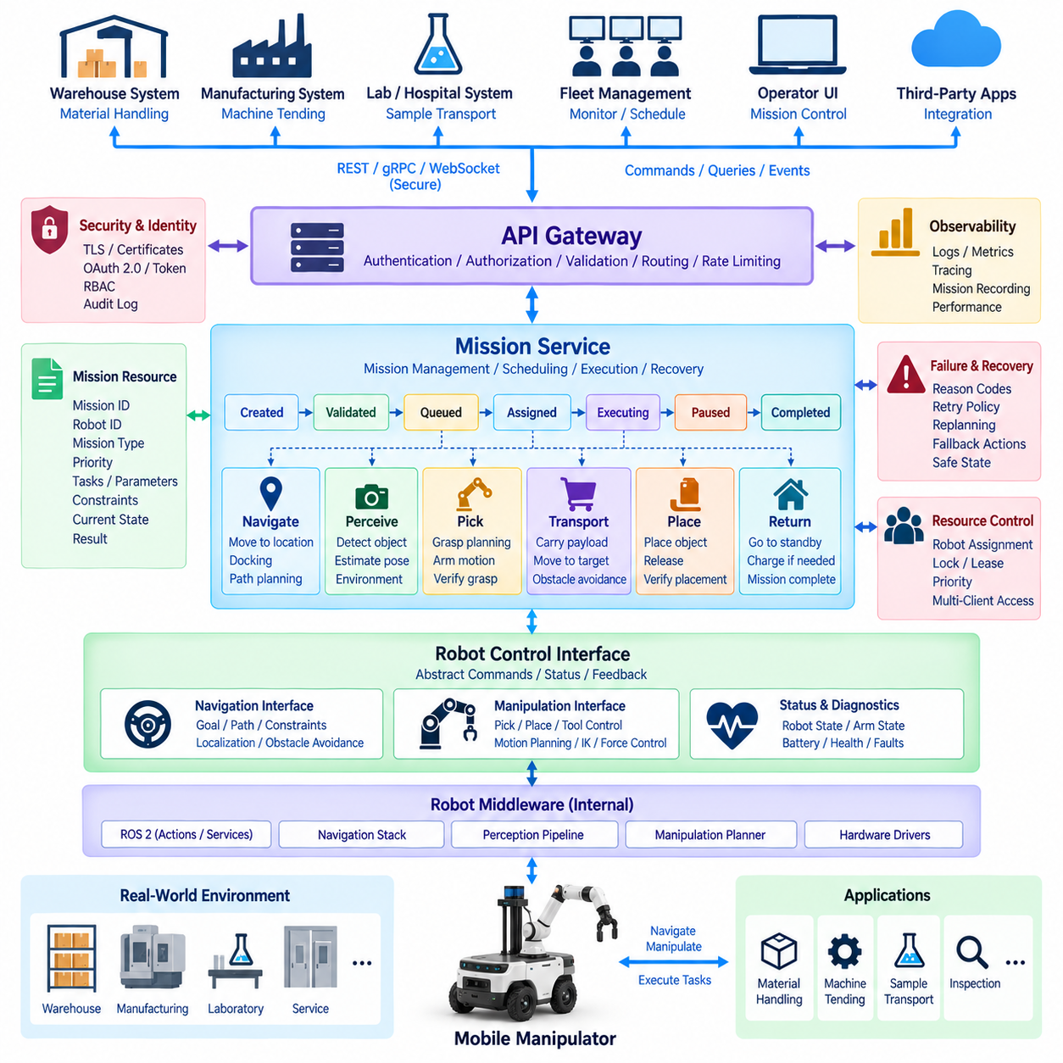
A mobile manipulator combines autonomous mobility with robotic manipulation, creating mission workflows that are more complex than those of a conventional AMR. A single mission may require navigation, localization, docking, object detection, grasp planning, arm motion, force-controlled interaction, transport, and placement. The mission API must therefore coordinate multiple robot capabilities through a unified abstraction without exposing every internal navigation or manipulator command to external applications.
The central design principle is to represent a mission as an ordered or conditionally connected collection of high-level actions. External applications should request goals such as move to workstation, identify target object, pick object, transport payload, place object, or return to standby. Internal motion planners and controllers determine the trajectories required to execute these goals, preserving a clear separation between enterprise-level mission intent and low-level physical control.
A mission resource should contain a unique mission identifier, robot identifier, mission type, priority, creation time, execution constraints, task sequence, current state, and result information. Additional metadata can describe payload properties, target locations, object identifiers, manipulation requirements, or environmental constraints. This structure allows the same API model to represent warehouse picking, machine tending, laboratory transport, inspection, and service operations without redesigning the entire interface.
Mission execution can be modeled through lifecycle states such as created, validated, queued, assigned, executing, paused, completed, canceled, and failed. Individual actions require their own states because a mission may remain active while one navigation or manipulation step is being executed. Maintaining both mission-level and action-level state enables external software to understand overall progress without requiring knowledge of internal controller states.
Navigation actions describe where the mobile base must move rather than how wheel velocities should be generated. A destination may be represented by a named station, map pose, docking point, or semantic location. Optional constraints can specify allowed zones, approach direction, speed restrictions, or required positioning accuracy. The navigation subsystem translates these requirements into global paths, local trajectories, and obstacle-avoidance behavior.
Manipulation actions require a similarly abstract interface. A pick request may specify an object identifier, expected pose, grasp constraints, tool requirements, or target container, while a place request describes the destination and placement conditions. The API should avoid requiring external clients to calculate joint trajectories. Manipulator planning, collision checking, inverse kinematics, trajectory generation, and actuator control remain internal robot responsibilities.
Perception forms an important bridge between mission intent and physical manipulation. An object referenced by an enterprise application may initially be represented by a logical identifier rather than an exact six-degree-of-freedom pose. The mission executor can request object detection or pose estimation, associate the perceived object with the mission target, and pass the resulting spatial information to the manipulation planner. This preserves abstraction while allowing execution to adapt to real environments.
Composite actions are useful when several internal operations always belong to one meaningful task. A PickObject operation, for example, may internally include object localization, base alignment, manipulator pre-positioning, grasp planning, collision checking, approach, gripper closure, grasp verification, and retreat. Exposing the composite operation simplifies external integration while detailed sub-action states remain available for diagnostics and engineering tools.
Mission dependencies must account for physical preconditions. Manipulation may require the mobile base to be stationary, localization confidence to exceed a threshold, the robot to be correctly docked, the manipulator workspace to be clear, and the required end effector to be available. The mission API should express these conditions through validation and execution policies rather than assuming every requested action can immediately begin.
Asynchronous execution is essential because physical missions may take seconds or minutes. A mission submission API should validate the request, assign a mission identifier, and return promptly. Clients can then retrieve mission status or subscribe to progress events. Holding a synchronous API call open throughout navigation and manipulation would tightly couple network availability to physical execution and make recovery from communication interruptions unnecessarily difficult.
Progress events should provide meaningful semantic information such as navigating_to_pickup, aligning_with_station, detecting_object, planning_grasp, grasping, verifying_grasp, transporting, placing, and completed. Each event can include the mission identifier, action identifier, robot identifier, timestamp, progress state, and optional diagnostic information. Such events provide useful operational visibility without exposing raw internal controller messages.
Failure handling becomes more complex when mobility and manipulation are combined. Navigation may fail because a path is blocked, while manipulation may fail because an object cannot be detected, a grasp is unstable, or a target location is occupied. The API should represent failure domains and reason codes clearly so that a fleet system can distinguish recoverable operational conditions from hardware failures or safety-related faults.
Recovery policies can be associated with missions or individual actions. A failed object detection step might permit another perception attempt, while an unsuccessful grasp could trigger repositioning and replanning. A blocked route might allow navigation replanning or waiting for a defined interval. The mission layer coordinates these policies, but retry limits and safety constraints prevent uncontrolled repetition of physical actions.
Cancellation requires explicit semantics because stopping a physical robot is different from deleting a software transaction. A cancellation request may arrive while the robot is driving, holding an object, approaching a machine, or executing an arm trajectory. The mission executor must transition toward a defined safe state before reporting cancellation as complete. Immediate emergency stopping remains a separate safety mechanism and should not be confused with normal mission cancellation.
Pause and resume operations require similar consideration. Pausing during navigation may allow the robot to stop at a safe location, while pausing during manipulation may require completing or reversing a critical motion before suspension. The API therefore communicates the requested mission state, while onboard execution logic determines the physically safe transition. Resume operations should verify that environmental and robot conditions remain valid before continuing.
Resource ownership is important when multiple applications can request missions. A fleet manager, warehouse system, operator interface, and maintenance tool should not independently issue conflicting commands to the same mobile manipulator. The mission service can implement assignment, locking, leases, priorities, or authority rules so that only the appropriate controller owns mission execution at a given time.
Idempotency prevents duplicate physical operations when clients retry requests after network failure. Mission creation should support a client request identifier or idempotency key so that repeated submissions do not cause the robot to pick or deliver the same object twice. Similar protection is necessary for actions that produce irreversible physical effects. Query operations, by contrast, can normally be repeated without such risk.
Safety must remain below the mission API boundary. Collision avoidance, joint limits, force limits, protective stops, emergency stops, speed restrictions, and other safety functions are enforced locally even when a mission request is valid. The mission API grants an intention to perform work but never guarantees that the requested physical action will execute when onboard safety conditions prohibit it.
Authentication and authorization should distinguish mission submission, manipulation control, status monitoring, maintenance, configuration, and administrative privileges. Robot and application identities can be authenticated through certificates, tokens, or enterprise identity mechanisms. Audit records should associate important mission operations with authenticated identities, timestamps, mission identifiers, and execution results, providing traceability for industrial deployments.
The API gateway separates external clients from internal robotics middleware. REST, gRPC, WebSocket, or event-based interfaces may be exposed externally while the gateway translates requests into internal mission services. Behind this boundary, ROS 2 actions, services, topics, manipulation planners, navigation components, perception pipelines, and hardware drivers can evolve without forcing enterprise applications to understand their implementation details.
Observability should correlate the complete mission chain from submission to physical completion. Logs and metrics can record mission queue time, navigation duration, perception latency, grasp-planning time, manipulation success, retry count, cancellation behavior, and failure reasons. Correlation identifiers connecting mission, action, robot, object, and workstation information make it possible to reconstruct complex operations during troubleshooting and performance analysis.
A well-designed mobile manipulator mission API therefore acts as an orchestration contract between business-level objectives and embodied robotic execution. It expresses what work should be performed, monitors meaningful progress, manages lifecycle and recovery, and reports results while leaving navigation, perception, manipulation, and safety decisions within appropriate onboard services. This separation reduces coupling and supports long-term evolution of both robot software and external systems.
The resulting architecture enables mobile manipulators to participate in larger robotic ecosystems as reusable service providers rather than isolated machines. Warehouse systems can request material handling, manufacturing software can request machine tending, and laboratory applications can request sample transport without controlling joints or wheels directly. A stable mission abstraction consequently becomes the foundation for scalable deployment of increasingly capable mobile manipulation systems.

12.04 Fleet VDA 5050 / WMS Integration Case
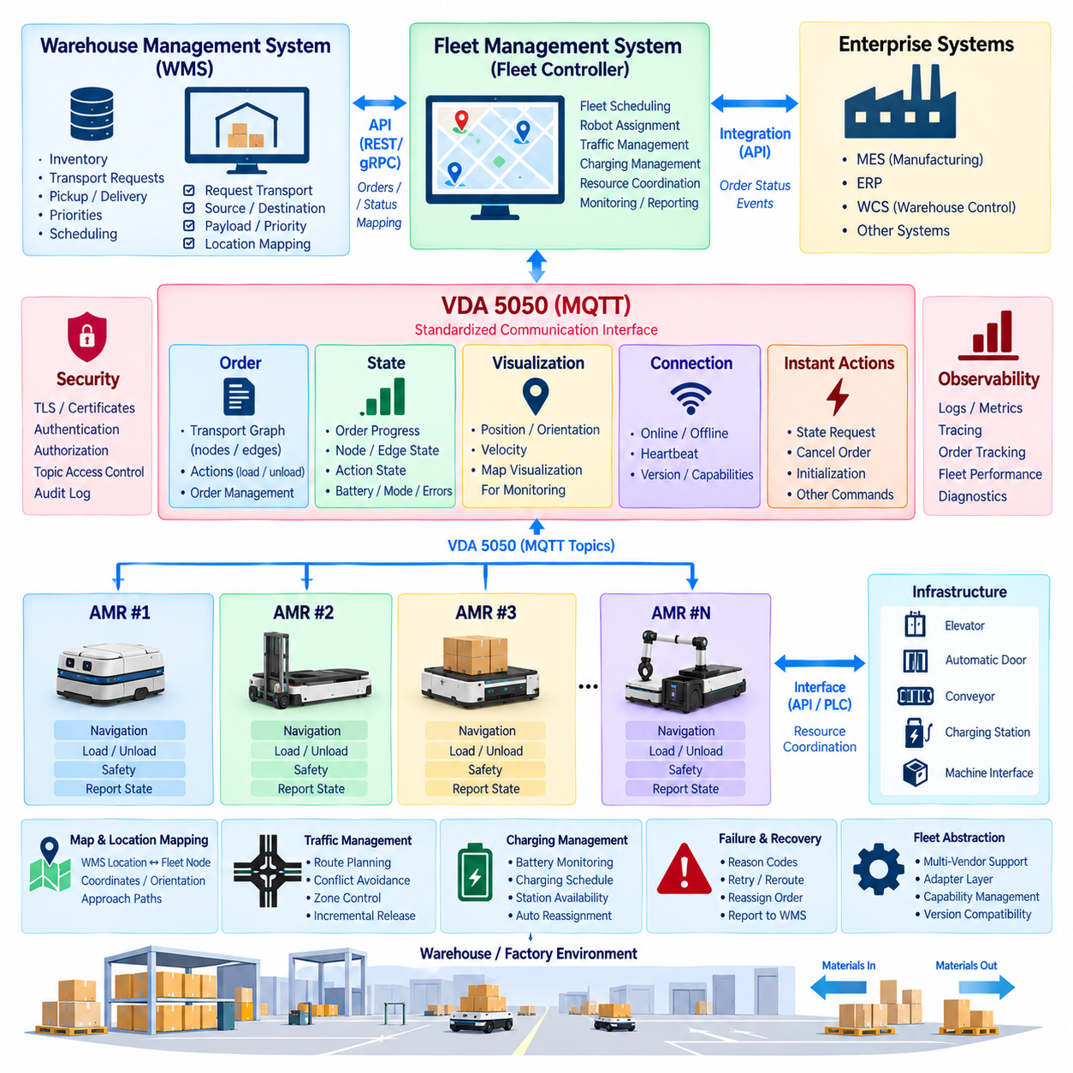
A fleet integration architecture based on VDA 5050 provides a standardized communication boundary between warehouse management systems, fleet controllers, and autonomous mobile robots. The Warehouse Management System, or WMS, determines logistics requirements such as material movement, pickup, delivery, priority, and scheduling, while the fleet controller translates these business-level requests into executable robot orders and coordinates multiple vehicles across the facility.
The integration should maintain a clear separation of responsibilities. The WMS manages inventory and logistics workflows but should not directly control robot motion. The fleet controller understands robot capabilities, traffic conditions, charging requirements, and resource availability. Individual AMRs remain responsible for local navigation, obstacle avoidance, motion control, and safety. VDA 5050 connects these layers through standardized order, state, visualization, connection, and action-related messages.
A typical workflow begins when the WMS creates a transport request describing a source location, destination, payload, priority, and optional timing constraints. This request enters the fleet management system through an enterprise API or integration adapter. The fleet controller evaluates available robots, current assignments, battery state, position, capabilities, and operational restrictions before selecting an appropriate AMR and converting the logistics request into a VDA 5050-compatible order.
VDA 5050 represents a transport mission primarily as a graph composed of nodes and edges. Nodes describe significant locations or operational points, while edges represent traversable connections between them. Actions may be attached to nodes or edges to describe operations such as loading, unloading, docking, waiting, or interacting with equipment. This representation allows the fleet controller to describe intended movement without transmitting low-level steering or velocity commands.
Each order requires identifiers and update semantics that allow the master control system and vehicle to determine whether information is new, repeated, or superseded. The fleet controller manages the relationship between the WMS transport request and the corresponding robot order identifiers. Maintaining this correlation is essential because enterprise applications normally reference logistics jobs, while AMRs execute VDA 5050 orders with their own lifecycle and state information.
MQTT commonly provides the messaging transport for VDA 5050 communication. The fleet controller publishes order-related information through defined topic structures, while robots publish state, connection, and visualization information. This publish-subscribe model decouples communicating components and allows multiple systems to observe selected information without establishing dedicated point-to-point connections between every fleet component.
The state channel provides the fleet controller with the operational information required to supervise execution. Robot state can communicate current order information, node and edge progress, action states, battery information, operating mode, errors, safety-related information, and other vehicle conditions. The fleet controller converts these detailed robot states into logistics-level progress that the WMS can understand, such as assigned, moving to pickup, loading, transporting, unloading, completed, or failed.
Visualization information serves a different purpose from authoritative execution state. Position, orientation, velocity, and related data can support dashboards and operational monitoring, but the WMS should not depend on high-frequency visualization messages to determine whether a logistics transaction has completed. Business process transitions should instead be derived from validated mission and action states managed by the fleet controller.
Instant actions provide a mechanism for operations that are not simply part of the normal node-and-edge sequence. Depending on vehicle capabilities and system policy, these may support operations such as state requests, cancellation-related behavior, initialization, or other immediate commands. The fleet controller should validate such actions carefully because asynchronous operations can interact with an already executing transport order and create conflicting robot behavior if authority is not controlled.
Heterogeneous fleets require an abstraction layer above individual robot implementations. Robots from different manufacturers may use different navigation stacks, coordinate representations, charging strategies, docking mechanisms, or internal state machines. A VDA 5050 adapter can translate the standardized external order and state model into vendor-specific interfaces, allowing the fleet controller to coordinate diverse vehicles without embedding every proprietary robot protocol directly into the WMS.
Map and coordinate consistency is critical for fleet integration. The WMS may identify locations using warehouse-oriented names such as receiving station, storage zone, or production cell, while VDA 5050 orders require locations that correspond to the navigation topology understood by the fleet system and robot. A mapping service therefore associates enterprise location identifiers with fleet nodes, coordinates, orientations, and allowable approach paths.
Traffic management remains primarily a fleet-level responsibility. The WMS should request transportation rather than determining which robot traverses a particular corridor. The fleet controller evaluates route conflicts, shared intersections, narrow passages, elevators, automatic doors, and restricted areas before releasing appropriate route segments. Individual robots continue to perform local obstacle avoidance, but fleet coordination prevents systematic conflicts that cannot be solved efficiently by independent local planning.
Order execution should be incremental when infrastructure or traffic conditions require controlled route release. The fleet controller can authorize an executable portion of the route while retaining later segments until conditions are appropriate. This allows centralized traffic coordination without requiring the robot to stop autonomous local navigation. The distinction between released and unreleased route elements is therefore important for coordinating multiple AMRs in shared spaces.
External infrastructure can be integrated through the fleet layer rather than independently controlled by every robot. Elevators, automatic doors, conveyors, machine interfaces, and charging stations may expose separate APIs or programmable logic controller interfaces. The fleet controller coordinates these resources with VDA 5050 mission execution, ensuring that infrastructure reservations and robot actions occur in the correct sequence while keeping infrastructure-specific protocols outside the standardized robot interface.
Failure handling must translate technical robot conditions into meaningful logistics outcomes. A robot may report localization problems, blocked motion, action failures, low battery, hardware faults, or safety events. The fleet controller interprets these conditions according to operational policy and determines whether to wait, reroute, retry an action, reassign the transport request, or report failure to the WMS. This prevents enterprise software from requiring detailed knowledge of robot-specific fault mechanisms.
Communication loss must also be treated as a defined operational state. MQTT connection monitoring and VDA 5050 connection information allow the fleet controller to recognize whether a robot remains reachable. The system should distinguish a temporary network interruption from a confirmed robot failure. During disconnection, the robot follows locally defined safety and execution policies, while the fleet controller avoids issuing conflicting assignments until communication and authoritative state are restored.
Charging illustrates the difference between logistics objectives and fleet execution. The WMS normally cares that required material movements are completed, whereas the fleet controller must maintain sufficient energy across the fleet. Battery information reported by each AMR can be combined with mission demand, charging-station availability, and expected workload. The controller may schedule charging or select another robot without requiring the WMS to manage battery behavior directly.
Security should protect the integration from the enterprise layer to individual vehicles. MQTT communication can use TLS, client certificates, authentication, and topic-level access control. WMS-facing APIs require their own authentication and authorization policies. Robot identities should be distinguishable from user and application identities, while audit logs record order creation, assignment, modification, cancellation, important state transitions, and administrative actions.
Reliability requires duplicate detection and clear ownership of commands. Network reconnection or application retries must not unintentionally create duplicate logistics missions or repeated physical actions. Correlation identifiers can link the WMS request, fleet mission, VDA 5050 order, robot assignment, and execution result. These identifiers also provide the traceability required to investigate why a particular pallet, container, or material transfer did not reach its expected destination.
Observability should span the complete WMS-to-robot workflow. Useful metrics include transport request rate, assignment latency, robot utilization, order completion time, queue duration, route waiting time, action failures, communication interruptions, charging time, and fleet throughput. Logs should preserve the relationship between enterprise requests and VDA 5050 messages so engineers can reconstruct execution without manually correlating independent systems.
Version and capability management become important when fleets contain vehicles with different software revisions or supported features. The fleet controller should maintain capability information and avoid assigning actions that a particular robot cannot execute. VDA 5050 interface evolution should be managed through controlled compatibility policies, adapter testing, schema validation, and staged deployment rather than assuming every vehicle and enterprise application can be upgraded simultaneously.
The resulting architecture creates a layered integration model in which the WMS defines what logistics work is required, the fleet controller determines which robot should perform it and how fleet resources should be coordinated, and VDA 5050 standardizes communication with participating vehicles. The robot then executes the authorized mission using its onboard navigation and safety functions while continuously reporting state back through the fleet layer.
This separation allows warehouse and manufacturing applications to remain independent from robot-specific implementations while enabling heterogeneous AMRs to participate in a coordinated fleet. VDA 5050 does not replace the WMS, fleet scheduler, traffic manager, or onboard autonomy; instead, it provides a common communication contract between these domains. The integration consequently supports scalable robot deployment while preserving clear boundaries among logistics orchestration, fleet coordination, and physical robot execution.

12.05 Cargo UAV UTM API Integration Case
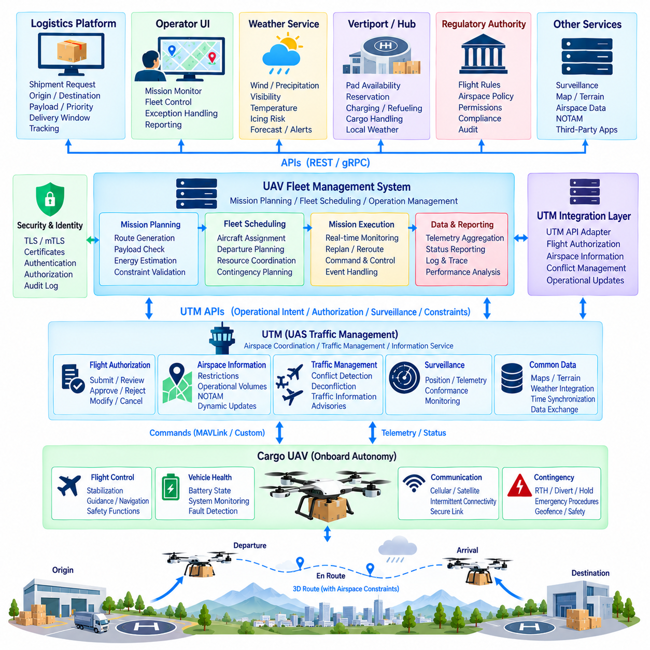
Cargo unmanned aerial vehicles require an API architecture that connects mission management, aircraft autonomy, ground infrastructure, and unmanned aircraft system traffic management, or UTM. Unlike conventional ground robots, cargo UAVs operate within shared three-dimensional airspace where flight authorization, route constraints, dynamic restrictions, weather, surveillance, and contingency management affect mission execution. The integration API must therefore coordinate logistics objectives with aviation operational requirements.
The architecture should separate cargo business logic from airspace management and onboard flight control. A logistics platform determines what cargo must move, its origin, destination, payload, priority, and delivery window. A UAV fleet management system converts this demand into an aircraft mission, while the UTM interface manages airspace-related information and operational coordination. The aircraft remains responsible for flight stabilization, guidance, navigation, vehicle health, and immediate safety functions.
A cargo mission resource can contain a mission identifier, aircraft identifier, origin, destination, payload characteristics, planned departure time, expected arrival time, route reference, altitude constraints, and operational status. Additional fields may represent landing-site requirements, energy reserves, cargo handling conditions, and contingency policies. The API should maintain correlation between the logistics shipment identifier and the aviation mission throughout planning, execution, and completion.
Before departure, the fleet system creates an intended flight trajectory based on aircraft performance, payload, available energy, weather, terrain, airspace constraints, and destination requirements. The route is represented as a structured operational plan rather than a sequence of direct actuator commands. Depending on the UTM environment, this plan can be submitted through an authorization or operational-intent interface and updated when mission conditions change.
The UTM integration layer acts as an adapter between the UAV fleet platform and external airspace services. It translates internal mission information into the schemas required by the applicable UTM ecosystem and converts external responses into normalized fleet events. This boundary prevents aircraft software and logistics applications from becoming tightly coupled to a particular UTM implementation, regional service provider, or regulatory interface.
Flight authorization should be modeled as a lifecycle rather than a single Boolean result. A requested operation may move through states such as drafted, submitted, under review, accepted, activated, modified, completed, rejected, or canceled according to the external service model. The fleet platform maps these states into its internal mission workflow and prevents departure when the required operational authorization or prerequisite information has not been obtained.
UTM information can include airspace constraints, temporary restrictions, operational volumes, route conflicts, traffic information, and other relevant operational data. The fleet system evaluates these inputs together with aircraft capabilities and mission requirements. Changes received after mission creation may require route modification, delayed departure, altitude adjustment, holding, diversion, or mission cancellation depending on the authority of the information and the operational policy.
Real-time flight monitoring requires the aircraft to report position, altitude, ground speed, heading, vertical speed, navigation quality, energy state, flight mode, communication status, and mission progress. The fleet platform can aggregate this telemetry and expose only the information required by external UTM or surveillance services. High-frequency internal flight-controller data should remain separated from external API traffic unless explicitly required for a defined integration purpose.
Coordinate and altitude semantics require strict definition. Geographic latitude and longitude must use an agreed geodetic reference, while altitude data must identify whether it represents ellipsoidal height, mean-sea-level altitude, or another reference. Route volumes should also include temporal information because airspace occupancy depends on both position and time. Ambiguous coordinate, altitude, or timestamp interpretation can produce serious errors in automated airspace integration.
Time synchronization is therefore fundamental. Flight plans, surveillance observations, authorization windows, dynamic restrictions, and aircraft telemetry must be correlated using consistent timestamps. GNSS-derived timing or other synchronized clock mechanisms can support onboard data alignment, while APIs should distinguish event time, measurement time, transmission time, and reception time where necessary. Sequence information can additionally identify delayed or missing telemetry.
Communication architecture must assume intermittent connectivity. Cargo UAVs may operate across cellular, private wireless, satellite, or other communication networks whose availability changes during flight. Loss of the UTM or fleet connection must not directly destabilize the aircraft. The onboard autonomy system continues according to predefined communication-loss procedures while the fleet platform detects the interruption and updates mission supervision according to established contingency policies.
Contingency management is a core part of the API design. Events such as navigation degradation, propulsion anomalies, low energy, communication loss, severe weather, destination unavailability, or unexpected airspace restrictions may require predefined responses. The API should communicate structured contingency states and reason codes rather than relying on unstructured text, allowing fleet systems, operators, and external services to interpret abnormal conditions consistently.
A contingency may trigger actions such as holding, rerouting, returning to origin, diverting to an alternate landing site, or executing another predefined safe procedure. The external API can request or coordinate the operational objective, but immediate aircraft safety remains under onboard flight-control and autonomy logic. Network-delivered instructions must never bypass flight-envelope protection, vehicle limitations, or other safety mechanisms implemented within the aircraft.
Weather integration is particularly important for cargo UAVs because wind, precipitation, visibility, temperature, icing risk, and severe weather can affect route feasibility and energy consumption. Weather services can be connected through separate APIs and normalized within the mission-planning layer. The resulting information can influence departure approval, route selection, cruise profile, reserve-energy calculations, and contingency-site selection without exposing weather-provider details to the flight controller.
Vertiports, logistics hubs, and landing sites form another integration domain. Their APIs may provide pad availability, reservation windows, charging or refueling status, cargo-handling readiness, local weather, and ground-resource information. The fleet platform coordinates these resources with flight planning so that an aircraft is not dispatched toward a destination that cannot safely receive it during the expected arrival interval.
For larger cargo UAVs, payload and aircraft performance must be closely connected to mission planning. Payload mass and distribution influence energy demand, range, takeoff performance, landing requirements, and potentially route feasibility. The mission API should therefore treat payload information as operational data rather than simple business metadata. Validation occurs before flight authorization and again when relevant mission or aircraft conditions change.
Security must protect communication among aircraft, fleet services, logistics platforms, and UTM interfaces. TLS or mutually authenticated TLS can protect service connections, while certificates, signed tokens, and role-based authorization establish trusted identities. Aircraft identities should remain distinct from operator and application identities. Sensitive operations such as mission activation, route modification, diversion, or cancellation require stronger authorization and comprehensive audit records.
API commands should incorporate freshness and replay protection because delayed or duplicated commands can have physical consequences. Mission identifiers, command identifiers, timestamps, sequence numbers, expiration times, and idempotency mechanisms help determine whether a request is valid and current. Repeated network requests should not unintentionally create duplicate flights, repeated route changes, or conflicting contingency actions.
Observability should connect the complete logistics-to-flight workflow. Logs and metrics can correlate shipment creation, aircraft assignment, route planning, UTM submission, authorization, departure, flight progress, landing, cargo delivery, and mission closure. Additional measurements such as API latency, telemetry delay, communication availability, route modification frequency, authorization response time, and contingency events help identify operational bottlenecks.
The architecture should also preserve evidence needed for post-flight analysis. Mission plans, authorization changes, aircraft state transitions, relevant telemetry, operator actions, external service responses, and contingency events can be associated with common correlation identifiers. This creates an auditable record of how a cargo mission progressed from a logistics request through airspace coordination to physical delivery without requiring every subsystem to maintain identical internal data models.
Interface versioning becomes increasingly important when cargo UAV fleets operate across different regions or interact with multiple service providers. The integration layer should isolate regional schemas and maintain adapters for supported interface versions. Contract validation, schema testing, backward compatibility policies, and staged deployment reduce the risk that changes to an external UTM API unexpectedly prevent operational aircraft from communicating with fleet infrastructure.
Scalability requires the fleet platform to manage many simultaneous aircraft without turning the UTM interface into a centralized flight-control loop. Mission planning, authorization, surveillance exchange, and operational updates can be processed centrally or regionally, while immediate flight behavior remains distributed onboard. Event-driven processing and asynchronous APIs allow large numbers of missions to progress independently without requiring persistent synchronous transactions for entire flights.
A well-designed cargo UAV UTM integration therefore forms a layered chain from logistics management to fleet orchestration, airspace coordination, and autonomous flight execution. The logistics system defines the transportation requirement, the fleet platform selects an aircraft and constructs the mission, the UTM integration coordinates applicable airspace information, and the aircraft executes the authorized operation while continuously maintaining onboard safety and reporting operational state.
This separation becomes increasingly important as cargo UAV capacity and mission range grow. Larger aircraft, longer routes, multiple logistics hubs, and shared airspace increase the consequences of tightly coupled interfaces. A standardized and adaptable API boundary allows logistics applications, UTM services, fleet intelligence, and aircraft autonomy to evolve independently while remaining operationally coordinated, providing the software foundation for scalable autonomous aerial cargo networks.

12.06 Robot API Security Breach Case and Lessons
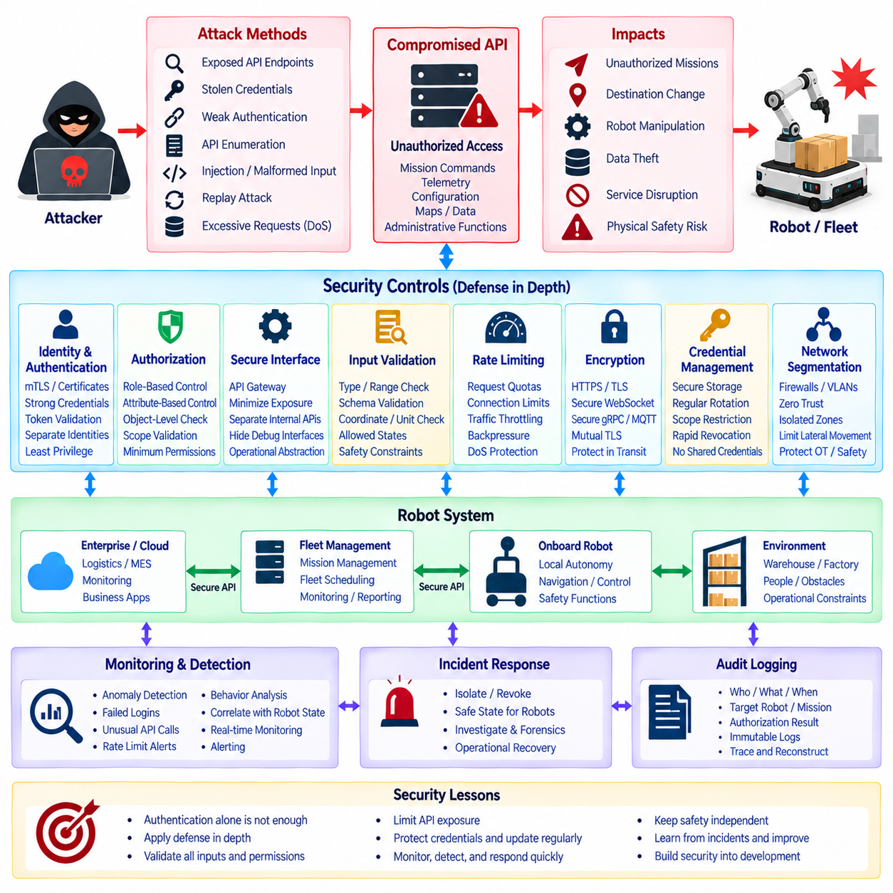
Robot APIs create a bridge between digital services and physical machines, so a security breach can produce consequences beyond conventional information loss. An attacker who compromises an exposed robot interface may gain access to mission commands, telemetry, configuration, credentials, maps, or operational data. In severe cases, unauthorized API access can influence physical behavior, making robot cybersecurity a combined problem of information security, operational technology security, and functional safety.
A representative breach scenario begins with an externally reachable robot or fleet API that was deployed with insufficient access control. During development, engineers may expose diagnostic endpoints, temporary credentials, test tokens, or administrative functions for convenience. If these interfaces remain accessible in production, an attacker can discover endpoints, identify API behavior, and attempt unauthorized requests without initially compromising the robot's low-level controller.
Weak authentication is often the first architectural failure. Shared passwords, long-lived API keys, hard-coded credentials, improperly validated tokens, or missing client authentication can allow unauthorized systems to impersonate legitimate applications. Robot and fleet architectures should therefore treat every API request as untrusted until identity is verified. Device identities, user identities, and service identities must be managed separately so that compromise of one credential does not automatically expose the entire robotic environment.
Broken authorization can be even more dangerous than weak authentication. A user may be legitimately authenticated but still gain access to operations outside the intended role. For example, a monitoring application should not automatically receive permission to create missions, modify navigation parameters, disable services, or access administrative functions. Fine-grained role-based or attribute-based authorization should therefore be enforced at the API gateway and service boundaries.
Another breach path occurs when APIs accept identifiers without validating ownership or scope. An attacker who changes a robot identifier, mission identifier, or fleet identifier in a request may retrieve or modify resources belonging to another robot or operational domain. Object-level authorization must verify not only whether the caller is authenticated, but also whether that identity is permitted to access the specific resource referenced by each request.
Excessive API exposure increases the attack surface. Internal ROS 2 services, debugging interfaces, actuator commands, raw configuration endpoints, database administration functions, and maintenance operations should not automatically become public APIs. External clients normally require mission-level and operational abstractions rather than direct access to internal middleware. An API gateway can expose a controlled subset of capabilities while keeping safety-critical and implementation-specific interfaces inside trusted boundaries.
Input validation is another critical defense. Robot APIs may receive coordinates, velocities, mission priorities, map identifiers, payload values, configuration parameters, or action names. Malformed or intentionally extreme values can cause application errors or unsafe operational requests if they pass directly into downstream components. Validation should enforce data types, ranges, units, coordinate frames, allowed states, schema versions, and operational constraints before requests reach robot execution services.
Rate-limit failures can transform otherwise valid APIs into denial-of-service vectors. An attacker or malfunctioning client may generate large numbers of mission requests, telemetry queries, authentication attempts, or WebSocket connections. This can exhaust gateway resources, overload fleet services, increase message queues, or reduce availability for legitimate operators. Rate limiting, quotas, connection limits, request prioritization, and backpressure should therefore be designed as part of normal robot API operation.
Replay attacks are particularly important when API requests trigger physical actions. An attacker who captures a valid command may attempt to transmit it again later, potentially repeating a mission, opening equipment, moving a robot, or changing an operational state. Command identifiers, timestamps, expiration periods, sequence numbers, nonces, and idempotency mechanisms help determine whether a message is fresh and whether an apparently valid request has already been executed.
Transport encryption protects commands and telemetry while they cross untrusted networks. HTTPS, secure WebSocket connections, and TLS-protected gRPC or MQTT channels reduce the risk of interception and modification. Mutual TLS can additionally authenticate both communicating endpoints. Encryption alone, however, does not provide authorization or application-level validation, so it must operate together with identity management, access control, command validation, and secure credential storage.
Credential leakage can expand a local incident into a fleet-wide compromise. API keys or certificates stored in source repositories, container images, configuration files, logs, or robot file systems may be extracted and reused against other services. Secrets should therefore be stored using protected mechanisms, rotated regularly, scoped to the minimum required privileges, and revoked rapidly after suspected compromise. Fleet-wide shared credentials should be avoided whenever individual device identity is practical.
Network segmentation limits the blast radius after an intrusion. Enterprise IT systems, cloud services, fleet servers, engineering workstations, robot networks, safety controllers, and maintenance interfaces should not exist within one unrestricted trust zone. Firewalls, gateways, VLANs, service policies, and zero-trust principles can constrain communication paths. A compromised dashboard should not automatically provide direct network access to motor controllers or safety-critical onboard components.
The breach scenario becomes more serious when an attacker obtains mission-control privileges. Unauthorized requests could attempt to change destinations, cancel missions, generate conflicting assignments, or alter operating parameters. The robot must therefore enforce local operational constraints even when a request originates from an authenticated API. Valid network credentials must never be interpreted as permission to bypass obstacle avoidance, speed limits, geofencing, protective stops, or emergency-stop functions.
Safety architecture provides an essential final boundary. Motion safety, emergency stopping, collision protection, actuator limits, and other critical functions should remain locally enforceable and independent from cloud or enterprise API availability. If the fleet server is compromised or communication becomes suspicious, the robot should be capable of entering a defined degraded or safe state. Cybersecurity controls reduce attack probability, while safety controls limit physical consequences when prevention fails.
Detection is as important as prevention because not every attack can be blocked immediately. API gateways and fleet services should monitor authentication failures, unusual request rates, unexpected administrative calls, repeated authorization errors, abnormal robot identifiers, geographic anomalies, and sudden changes in mission behavior. Security monitoring becomes more effective when network events are correlated with robot operational state rather than analyzed only as conventional web traffic.
Comprehensive audit logging enables incident reconstruction. Important records include authenticated identity, source service, requested operation, target robot, mission identifier, timestamp, authorization decision, configuration change, command result, and security event. Logs should be protected against unauthorized modification and synchronized across gateways, fleet services, and robots. Correlation identifiers allow investigators to reconstruct how an API request propagated through the robotic system.
Incident response for robots must consider physical operations as well as digital containment. Revoking credentials or isolating a server may interrupt active missions, charging operations, elevator coordination, or material transport. Response procedures should therefore define how affected robots transition to safe states, how control authority is transferred, how communications are isolated, and how operations resume after verification. Cyber recovery and operational recovery must be planned together.
A breach investigation should identify the initial access path, affected credentials, exposed services, unauthorized API calls, impacted robots, configuration changes, and possible persistence mechanisms. Teams should also determine whether the attacker reached only enterprise services or crossed into fleet and onboard domains. This distinction is important because restoring a web service is insufficient if robot credentials, software images, certificates, or internal configuration can no longer be trusted.
Recovery should rebuild trust rather than simply restore connectivity. Compromised credentials are revoked, certificates and tokens are rotated, vulnerable endpoints are disabled or patched, affected systems are verified, and robot configurations are compared with trusted baselines. Where integrity cannot be demonstrated, software or firmware may need to be redeployed from trusted sources. Services should return gradually while monitoring confirms that abnormal behavior has ceased.
Post-incident analysis should convert technical findings into architectural improvements. A breach caused by an exposed maintenance endpoint indicates a need for stronger interface separation. Stolen credentials indicate weaknesses in secret management and identity scope. Excessive permissions reveal authorization design problems, while delayed detection exposes observability gaps. The objective is not only to repair the exploited vulnerability but also to eliminate the architectural conditions that made the breach effective.
Secure development practices reduce these weaknesses before deployment. API schemas, authentication flows, authorization policies, threat models, dependency management, secret handling, and security tests should be reviewed throughout development. Automated testing can check malformed inputs, unauthorized resource access, expired tokens, excessive request rates, replay attempts, and incompatible protocol versions. Security becomes part of API engineering rather than a final gateway configuration task.
Version and patch management are equally important because robotic systems often remain deployed for many years. API gateways, operating systems, middleware, cryptographic libraries, containers, and robot applications may accumulate vulnerabilities over time. A controlled update process should maintain asset inventories, dependency versions, vulnerability status, compatibility testing, rollback procedures, and deployment records while minimizing disruption to operational fleets.
The principal lesson from a robot API breach is that authentication alone is not a sufficient security architecture. Effective protection requires layered controls across identity, authorization, transport security, input validation, rate limiting, segmentation, monitoring, auditability, credential management, software integrity, and local safety enforcement. Each layer assumes that another layer may eventually fail and limits the consequences of that failure.
A secure robot API architecture therefore follows defense in depth from enterprise applications to the physical machine. External systems communicate through controlled gateways, services receive only necessary privileges, commands are validated before execution, networks restrict lateral movement, monitoring detects abnormal behavior, and onboard safety retains final authority over physical actions. This approach transforms breach lessons into architectural requirements for resilient robotic systems.

12.07 API Version Upgrade: Backward Compatibility Case
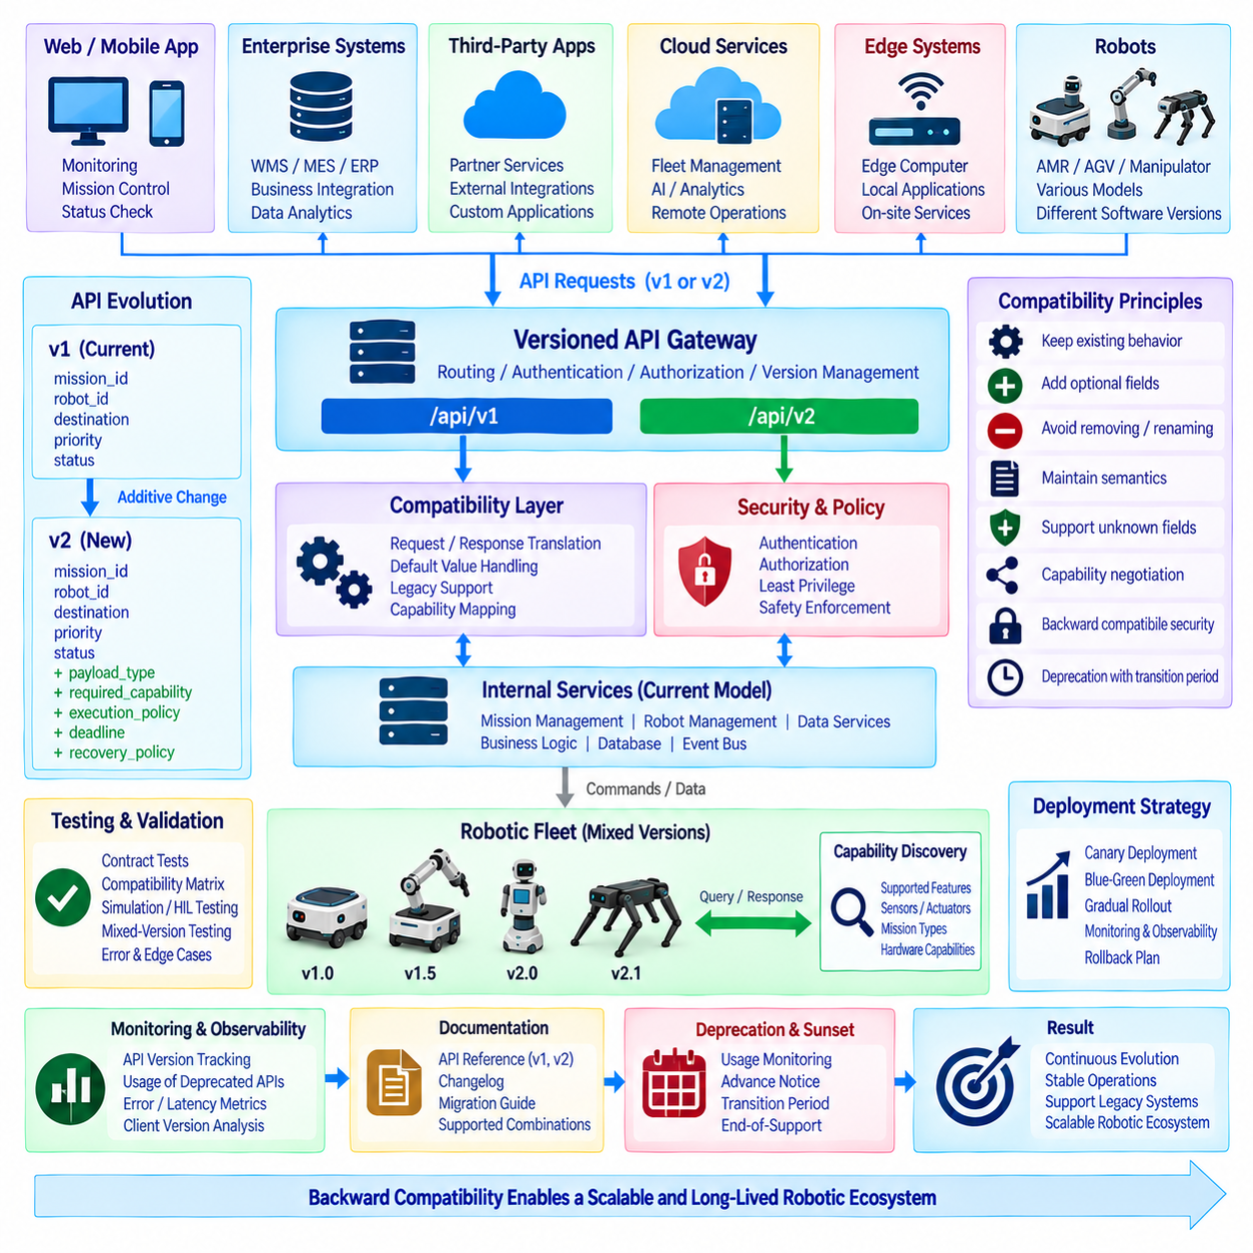
API version upgrades in robotic systems are more complex than ordinary software interface changes because APIs connect fleet platforms, edge computers, autonomous robots, enterprise applications, mobile applications, cloud services, and external infrastructure that may operate on different release cycles. A new API version may introduce improved mission models, telemetry fields, security mechanisms, or robot capabilities, while older deployed systems must continue operating. Backward compatibility therefore becomes an architectural requirement rather than a temporary migration convenience.
A representative upgrade case begins with a fleet platform operating API version 1 while hundreds of robots, warehouse applications, monitoring dashboards, and third-party integrations depend on the existing contract. Development of version 2 may introduce richer mission definitions, new robot states, improved error structures, or additional security metadata. Replacing version 1 immediately would require every connected component to upgrade simultaneously, which is rarely practical in operational robotic environments.
The fundamental compatibility principle is that an API contract should evolve without unexpectedly changing the meaning of previously valid requests and responses. Existing clients should continue to perform the operations they already understand, even when the server supports newer capabilities. New clients may use additional functionality when communicating with upgraded services, but they should detect whether the target system actually supports those features before depending on them.
Compatibility must be considered separately for syntax, schema, semantics, behavior, and operational expectations. A response can remain syntactically valid while changing the meaning of a field in a way that breaks an existing robot or application. Similarly, changing default values, timing behavior, error handling, ordering guarantees, or retry semantics may create incompatibility even if the JSON, protobuf, or message schema itself remains structurally unchanged.
An additive evolution strategy is generally safer than modifying or removing existing elements. New optional fields can be introduced while preserving existing fields and their original meanings. New endpoints or RPC methods can extend functionality without redefining established operations. Existing enumeration values should remain valid, and clients should be designed to tolerate unknown fields or future values whenever the serialization technology and application semantics permit it.
Consider a mission API in which version 1 defines mission_id, robot_id, destination, priority, and status. Version 2 may add payload_type, required_capability, execution_policy, deadline, and recovery_policy. If these new fields are optional or have well-defined defaults, a version 1 client can continue submitting its original mission representation while a version 2 server enriches processing internally. This allows capability growth without forcing immediate client replacement.
Removing or renaming fields creates significantly greater migration risk. If a field must eventually disappear, it should first be marked as deprecated while remaining operational for a defined transition period. Documentation should explain the replacement field, behavioral differences, migration path, and planned retirement policy. Deprecation is therefore not simply a documentation label; it is a managed lifecycle between supported usage and eventual removal.
Semantic changes require particular caution. Suppose a robot status field originally uses READY to mean that the robot is connected and available for mission assignment. If a later version redefines READY to mean only that communication is active, older fleet software may assign work to a robot that is not operationally prepared. A safer design introduces a new state or field while preserving the established interpretation of the original contract.
Version identifiers can be represented through URL paths, headers, content negotiation, service names, protobuf packages, message versions, or negotiated capability metadata. REST systems commonly expose paths such as /api/v1 and /api/v2, while gRPC systems may use versioned packages or service definitions. Event-driven systems require message schema versions because producers and consumers may not be upgraded together. The mechanism should be explicit, consistent, and observable.
Versioning should distinguish major compatibility boundaries from normal additive evolution. A major version change is appropriate when the contract intentionally introduces behavior that cannot remain compatible with existing clients. Minor extensions should normally preserve existing behavior. Excessive creation of major versions increases operational complexity because gateways, services, documentation, tests, monitoring, and support procedures must maintain several contracts simultaneously.
A compatibility layer can reduce the impact of major upgrades. When a version 1 client sends an older mission request to a version 2 platform, an adapter can translate the request into the current internal model. Responses can then be transformed back into the representation expected by the older client. This approach allows the internal architecture to evolve while keeping legacy integrations operational during a controlled migration period.
The adapter should not hide incompatible semantics that cannot be translated reliably. If version 2 requires information that version 1 never supplied, the system needs a defined default, derived value, compatibility policy, or explicit rejection condition. Silently inventing critical mission or safety parameters can produce unpredictable physical behavior. Compatibility translation should therefore be deterministic and documented rather than based on ambiguous assumptions.
Robotic systems also require capability negotiation because API version alone does not fully describe what a particular robot can perform. Two robots may both support version 2 while only one has a manipulator, precision docking capability, thermal camera, elevator interface, or outdoor navigation module. A fleet controller should therefore query or maintain capability information independently from protocol version and assign missions according to both interface compatibility and physical functionality.
A capability response may describe supported mission types, actions, sensors, payload limits, localization modes, charging methods, optional API extensions, and protocol features. Before sending an advanced request, the client verifies that the target supports the required capability. This prevents the incorrect assumption that every device implementing the same API version provides an identical set of physical functions.
Telemetry compatibility introduces another challenge because telemetry consumers frequently include dashboards, databases, analytics pipelines, monitoring systems, and machine-learning services. Adding fields is usually manageable when consumers ignore unknown data, but changing field names, units, coordinate frames, timestamp definitions, or sampling semantics can corrupt downstream analysis without causing an obvious communication failure. Telemetry contracts therefore require semantic version control as well as schema validation.
Units and coordinate systems should never change implicitly between versions. A velocity field expressed in meters per second must not later represent kilometers per hour under the same name. A pose referenced to a local map frame should not silently change to a global geographic frame. If the representation must change, a new field or message type should identify the new semantics explicitly while the legacy representation remains available during migration.
Event-driven APIs require special compatibility discipline because publishers often do not know every active subscriber. A new fleet service may publish an expanded mission event while an older warehouse application continues consuming the previous schema. Schema registries, compatibility validation, versioned topics, or event envelopes can help control evolution. Consumers should process the fields they understand while safely handling optional extensions and unknown information.
Protocol Buffers provide useful mechanisms for compatible evolution when used correctly. New fields can generally be added with new field numbers without breaking older clients, because unknown fields can be ignored by implementations that do not understand them. Existing field numbers should not be reused for different meanings. When a field is removed, its number and name should be reserved where appropriate to prevent accidental reuse and dangerous interpretation by mixed-version systems.
Enumeration evolution also requires care. A newer server may return a state value that an older client has never seen. Clients should avoid assuming that all future values are already known unless the protocol explicitly guarantees a closed set. Where appropriate, an UNKNOWN or UNSPECIFIED handling strategy allows older components to fail safely or degrade gracefully rather than crashing or interpreting a new operational state incorrectly.
REST APIs face similar challenges with JSON payloads. Clients should normally avoid rejecting responses merely because additional optional fields appear. Servers should validate required request fields while tolerating compatible extensions according to the contract. Strict validation remains important for safety-relevant parameters, but unnecessary rejection of harmless unknown response data can make otherwise additive upgrades operationally disruptive.
Backward compatibility also applies to authentication and security mechanisms. An upgrade may introduce stronger token formats, mutual TLS, certificate rotation, additional authorization scopes, or new identity claims. Security improvements should be deployed through a transition plan that avoids unexpectedly disconnecting operational robots. Temporary support for old and new mechanisms may be required, but the compatibility window should be controlled so that legacy security does not remain indefinitely.
Authorization changes can create subtle compatibility problems. A new API may divide one broad permission into several narrower scopes to improve least-privilege enforcement. Existing applications using the previous scope may suddenly lose functionality unless permissions are mapped during migration. The upgrade plan should therefore address not only API payload compatibility but also identity, roles, certificates, secrets, and policy changes across every participating system.
Database and internal data-model evolution should remain separated from the public API contract. A fleet platform may redesign its mission database, split services, rename internal objects, or move from a monolithic application to microservices without forcing external clients to change. Stable external resource identifiers and translation layers protect integrations from unnecessary exposure to internal implementation changes.
Testing is the primary mechanism for proving compatibility rather than merely assuming it. Contract tests should verify that version 1 clients can still communicate correctly with upgraded servers and that version 2 clients receive expected behavior from supported deployments. Tests should cover normal requests, optional fields, missing fields, unknown values, error responses, authentication, retries, timeouts, cancellation, and asynchronous state transitions.
A compatibility test matrix becomes important when several robot and server versions coexist. The organization may need to validate combinations such as old robot with old fleet server, old robot with new server, new robot with old server where supported, and new robot with new server. Not every combination must necessarily be supported, but the supported combinations should be explicitly defined and verified before deployment.
Simulation and hardware-in-the-loop testing can extend contract verification into physical behavior. A message may pass schema validation but still cause unexpected navigation, manipulation, docking, or charging behavior because semantics changed. Testing mission execution with representative robot software and simulated or real hardware provides stronger evidence that compatibility exists at the operational level rather than only at the communication level.
Deployment should normally proceed gradually instead of upgrading an entire fleet simultaneously. A canary deployment can update a small number of robots or fleet services first while monitoring API errors, mission completion, latency, telemetry consistency, and unexpected state transitions. If results remain acceptable, deployment expands through additional groups. This staged strategy limits the operational impact of compatibility defects that escaped laboratory testing.
Blue-green deployment can be useful for fleet or cloud services when two API environments can operate in parallel. Existing traffic remains on the stable environment while selected clients are directed to the new version. After validation, traffic is progressively shifted. If a serious issue appears, routing can return to the previous environment without immediately requiring every robot or enterprise client to be modified.
Rollback must be designed before deployment because reverting software does not automatically revert data or protocol state. A new version may have created mission records, configuration fields, certificates, database migrations, or events that the previous version cannot understand. The upgrade process should therefore define which changes are reversible, how data compatibility is preserved, and what conditions trigger rollback rather than attempting improvisation during an incident.
Observability is essential during mixed-version operation. Logs and metrics should identify the API version, client version, robot software version, schema version, requested operation, response status, translation path, and compatibility warning where appropriate. Engineers should be able to determine whether an error results from network failure, application logic, unsupported capability, version mismatch, deprecated behavior, or adapter translation.
Deprecation telemetry can reveal whether legacy interfaces are still actively used. Instead of removing version 1 based only on an expected migration date, operators can measure which clients continue calling deprecated endpoints, which robots still publish older schemas, and which enterprise systems depend on legacy fields. This evidence supports a safer retirement decision and identifies systems that require additional migration work.
Documentation should describe compatibility as an operational contract. Each version should clearly identify supported endpoints, schemas, fields, capabilities, authentication requirements, deprecated elements, known limitations, and migration guidance. Changelogs should distinguish compatible additions from breaking changes. Machine-readable API specifications can further support automated client generation, contract validation, and regression testing.
A sunset process is required when legacy versions can no longer be maintained. Retirement should include advance notice, migration documentation, usage monitoring, compatibility testing, and a clearly defined end-of-support point. Critical robotic operations should not discover API retirement through unexpected production failures. The objective is to move clients deliberately rather than allowing old versions to remain permanently because nobody knows whether they are still required.
Long-lived robots make this especially important. A physical robot may remain operational for ten years or more while cloud platforms and enterprise applications evolve much faster. Hardware limitations may also prevent older robots from adopting every new software stack. Gateway adapters, edge compatibility services, or long-term support branches can preserve interoperability while preventing legacy constraints from freezing the entire fleet architecture.
Multi-vendor fleets introduce an additional dimension because manufacturers may implement upgrades on different schedules. A fleet platform cannot assume that every vendor will support the newest API simultaneously. Standard interfaces, capability discovery, conformance testing, vendor adapters, and explicit compatibility profiles allow mixed-generation robots to operate together while the fleet gradually transitions toward newer contracts.
The same principle applies to external systems such as WMS, MES, ERP, cloud analytics, building infrastructure, and mobile applications. Their release schedules may be controlled by different organizations. The robot API architecture should therefore minimize coordinated upgrade requirements and favor asynchronous migration. Stable contracts reduce organizational coupling as effectively as they reduce software coupling.
From an architectural perspective, the preferred flow is external client to versioned API gateway, compatibility and policy layer, current internal service model, and robot execution services. Older requests are normalized before reaching core business logic, while responses are transformed according to the client's supported contract. This prevents every internal service from independently implementing multiple generations of legacy behavior.
Security and safety constraints must remain authoritative during compatibility translation. An older client must not gain access to operations that newer authorization policies prohibit simply because a legacy endpoint previously allowed them. Similarly, an adapter must not translate an incomplete legacy command into a physical operation when required safety information is unavailable. Compatibility preserves supported behavior, but it should not preserve obsolete security weaknesses.
The principal lesson from API version upgrades is that backward compatibility is a lifecycle management discipline involving contracts, semantics, capabilities, security, testing, deployment, monitoring, documentation, and retirement. Version numbers alone cannot provide compatibility. The organization must understand which behaviors are guaranteed, which extensions are optional, which combinations are supported, and how legacy dependencies will eventually be removed.
A robust robot API architecture therefore evolves through additive change whenever possible, explicit major versions when necessary, controlled adapters during transition, capability negotiation for heterogeneous robots, and extensive contract and operational testing. Gradual deployment, observability, rollback preparation, and measured deprecation reduce upgrade risk while allowing the platform to continue evolving.
When these principles are applied consistently, API evolution no longer requires synchronized replacement of every robot and connected application. Older robots can continue executing established missions, newer robots can expose advanced capabilities, enterprise systems can migrate according to their own schedules, and fleet infrastructure can progressively adopt improved services. Backward compatibility thus becomes a foundation for scalable, long-lived, and continuously evolving robotic ecosystems.

12.08 Cloud.Edge Hybrid API Operation Case
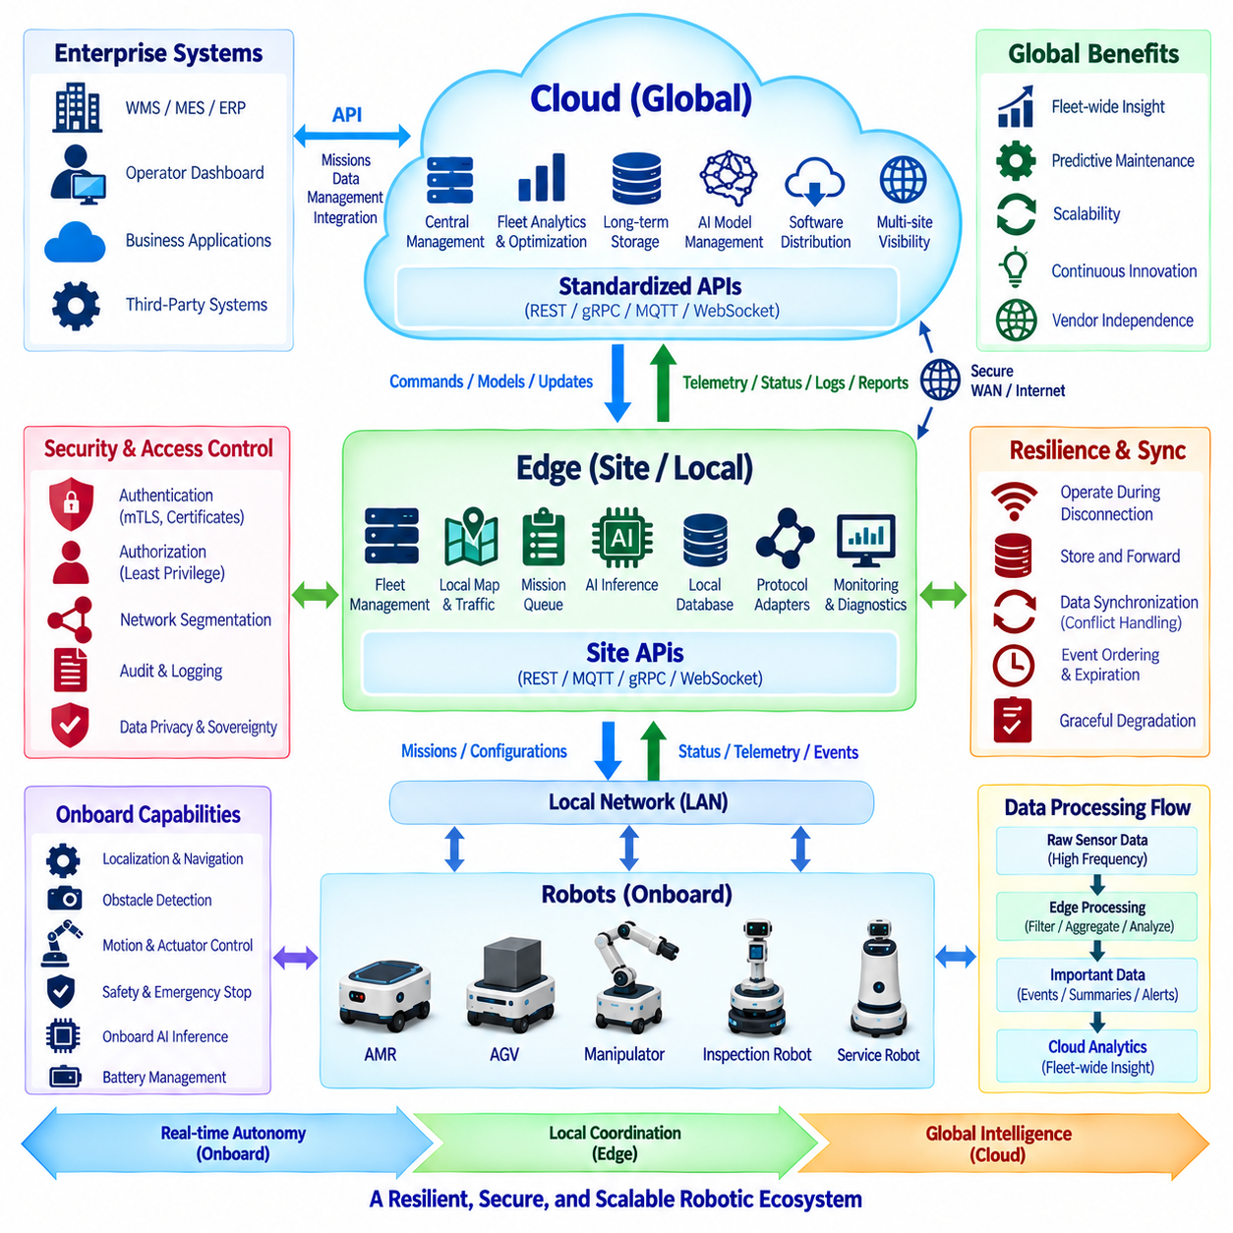
A cloud-edge hybrid API architecture allows robotic systems to divide intelligence and operational responsibility between cloud infrastructure and computing resources located close to the robots. The objective is not simply to connect robots to a remote server, but to place each function where latency, connectivity, computational demand, data volume, security, and operational continuity can be handled most effectively. APIs provide the controlled boundaries that allow cloud, edge, fleet, and onboard services to cooperate without becoming tightly coupled.
In a typical deployment, autonomous mobile robots communicate first with an edge platform located inside a factory, hospital, warehouse, campus, or logistics facility. The edge environment may host fleet management, map services, mission coordination, local databases, AI inference, video processing, and protocol gateways. Cloud services provide broader functions such as multi-site analytics, centralized administration, long-term storage, model management, software distribution, business integration, and global fleet visibility.
The robot itself remains responsible for functions that require deterministic or near-real-time behavior. Localization, obstacle avoidance, trajectory tracking, actuator control, emergency response, and immediate safety decisions should not depend on a cloud round trip. These functions operate through onboard controllers and local autonomy software, while APIs expose higher-level capabilities such as mission execution, status reporting, configuration, diagnostics, and controlled operational commands.
The edge layer forms the operational bridge between robots and cloud services. It can translate robot-specific protocols into standardized APIs, aggregate telemetry, coordinate multiple robots, cache maps and missions, and maintain local services when the external network becomes unavailable. This architecture prevents every robot from requiring a permanent direct connection to the cloud and reduces the amount of raw operational traffic transmitted through wide-area networks.
A mission may originate from a warehouse management system, hospital logistics application, manufacturing execution system, or cloud orchestration service. The request normally describes the operational objective rather than low-level motion commands. The edge fleet manager converts this objective into robot assignments, routes, tasks, and local execution policies according to robot availability, capabilities, battery state, traffic conditions, and site-specific constraints.
REST APIs are useful for configuration, mission creation, historical queries, administrative operations, and other request-response interactions. WebSocket, MQTT, gRPC streaming, or similar mechanisms can support asynchronous events and continuous operational data. The hybrid architecture does not require one protocol for every interface. Instead, each API style is selected according to communication pattern, latency requirement, reliability, message volume, and integration environment.
Telemetry demonstrates why hybrid processing is valuable. A robot can generate localization data, motor status, battery measurements, sensor information, diagnostic events, images, and other high-frequency streams. Sending every raw sample directly to the cloud increases bandwidth requirements and storage costs. The edge layer can filter, aggregate, compress, classify, or summarize this data before forwarding operationally meaningful information to centralized services.
For example, high-frequency motor current and vibration measurements may remain at the edge while statistical summaries and detected anomalies are transmitted to the cloud. Raw data surrounding a fault can be preserved for detailed analysis when required. This selective data movement allows cloud analytics to maintain fleet-wide visibility without turning the external network into a transport channel for every internal sensor sample.
Cloud services become particularly valuable when information from multiple facilities must be combined. A centralized platform can compare utilization, mission completion, energy consumption, failure patterns, software versions, and maintenance indicators across many sites. These results can support fleet optimization, predictive maintenance, capacity planning, operational benchmarking, and product improvement while local edge systems continue controlling individual facilities.
AI workloads can also be divided across onboard, edge, and cloud resources. A robot may perform immediate perception and obstacle detection onboard, while the edge server executes computationally heavier site-level inference using data from several robots or fixed cameras. The cloud may perform large-scale training, model evaluation, dataset management, and cross-site analysis. APIs and model registries coordinate how models and inference results move between these layers.
Model deployment should follow a controlled lifecycle. A cloud model-management service can register a validated model, its version, supported hardware, input schema, performance characteristics, and deployment policy. The edge platform downloads the approved artifact, verifies its integrity, tests compatibility, and distributes it to selected robots. Deployment status and inference health are then reported back through management APIs.
An edge system should not automatically activate every model received from the cloud. Hardware capability, GPU memory, runtime version, sensor configuration, model dependencies, and safety implications must be checked before activation. Canary deployment can introduce a new model to a small subset of robots first. If operational metrics remain within acceptable limits, the deployment can gradually expand across the local or global fleet.
Connectivity loss is one of the most important design conditions for cloud-edge operation. A robot fleet must not become unusable simply because the internet connection to the cloud is interrupted. The edge platform should retain the maps, active missions, robot registrations, credentials, policies, and operational data required for local continuity. Robots should continue executing authorized work according to predefined degraded-mode policies.
During cloud disconnection, new operations that require centralized authorization or unavailable business information may be restricted, while already authorized local missions can continue where appropriate. The edge system records events and state changes locally until connectivity returns. This behavior should be explicitly designed rather than assuming that network availability will remain continuous throughout robotic operation.
Store-and-forward mechanisms support this disconnected operation. Telemetry, mission histories, logs, and other cloud-bound events can be placed in durable local queues. Each event should contain identifiers, timestamps, sequence information, and schema metadata that allow later synchronization. When connectivity is restored, the edge platform transmits pending information without losing operational history or unnecessarily duplicating previously delivered events.
Synchronization introduces consistency challenges because both cloud and edge systems may change data while disconnected. Not every object should therefore support unrestricted bidirectional modification. Ownership rules should define which system is authoritative for robot configuration, mission state, maps, user policies, software versions, and business data. Clear authority boundaries reduce conflict when disconnected systems reconnect.
Some data can follow eventual consistency, while safety-critical or transactional operations may require stronger rules. Historical telemetry can normally arrive late without affecting immediate robot behavior. In contrast, a command to cancel a mission or modify a restricted operating zone may require freshness validation and explicit acknowledgement. The consistency model should therefore reflect the operational meaning of each resource rather than applying one synchronization policy to all data.
API requests transmitted across cloud-edge boundaries should include sufficient context to determine whether they remain valid after delay. Request identifiers, timestamps, expiration times, sequence numbers, idempotency keys, and version information can prevent stale or duplicated operations. A command created before a network interruption should not automatically execute hours later if its operational context is no longer valid.
Security boundaries are particularly important because the hybrid architecture connects public or enterprise cloud environments with operational robot networks. Cloud services should not receive unrestricted direct network access to onboard controllers. API gateways, edge proxies, firewalls, network segmentation, and service authentication establish controlled paths between security zones while preventing unnecessary lateral access.
Mutual TLS can authenticate cloud and edge services, while certificates or workload identities can distinguish individual sites and service instances. Authorization policies should restrict each API to the minimum required scope. A cloud analytics service may read aggregated telemetry without receiving permission to command robots, while a deployment service may distribute approved software without accessing unrelated operational or business information.
Credential management must also support intermittent connectivity and long-lived deployments. Certificates, tokens, and device identities require expiration, renewal, revocation, and rotation mechanisms that do not unexpectedly disable an entire facility. Edge platforms can maintain protected local credentials while synchronizing trust information with centralized identity services whenever connectivity permits.
Data sovereignty and privacy requirements can influence which information is allowed to leave the site. Video, audio, medical information, facility maps, production data, or personally identifiable information may require local processing or controlled retention. The edge layer can perform anonymization, feature extraction, event detection, or data reduction so that cloud APIs receive only the information permitted by organizational or regulatory policy.
Observability must span all layers of the architecture. Engineers should be able to trace a business request from the cloud or enterprise system through the API gateway, edge fleet manager, robot mission service, and onboard execution state. Correlation identifiers make it possible to connect distributed logs and determine where a mission was delayed, rejected, transformed, or interrupted.
Monitoring should distinguish cloud health, edge health, robot health, and network health. Metrics can include API latency, message backlog, synchronization delay, edge CPU and GPU utilization, robot connectivity, mission completion, telemetry loss, model inference performance, storage capacity, and external network availability. A single dashboard can summarize these layers without assuming that every component has the same operational importance.
Failure handling should isolate problems rather than propagate them through the architecture. If a cloud analytics service fails, local robot execution should continue. If an edge AI service becomes unavailable, the fleet may fall back to onboard capabilities or disable only the dependent feature. If one robot disconnects, the fleet manager can reassign appropriate work without treating the entire site as unavailable.
The architecture should define degraded modes for each major dependency. Loss of cloud connectivity, edge database failure, message broker overload, GPU service failure, identity-service interruption, or map-service unavailability may require different responses. Explicit degradation policies allow the system to preserve essential operations while suspending functions whose prerequisites are no longer trustworthy.
Software updates provide another important hybrid API use case. The cloud can manage software catalogs, release policies, signatures, compatibility information, and rollout schedules. Edge services download approved packages once and distribute them locally, reducing repeated wide-area transfers. Robots verify package integrity and compatibility before installation and report installation status through the edge to centralized management.
Update orchestration should account for fleet availability. Upgrading every robot simultaneously may interrupt facility operations, so the edge fleet manager can coordinate rolling updates according to workload and charging state. A small group is updated first, operational behavior is observed, and subsequent groups follow. Rollback artifacts should remain available when a new release produces unexpected API or robot behavior.
Version compatibility is especially important because cloud, edge, and robot software rarely upgrade simultaneously. A cloud platform may support a newer API while an edge site still operates an earlier release and some robots use older firmware. Versioned APIs, schema compatibility, adapters, capability negotiation, and explicit support matrices allow mixed-version components to communicate during staged migration.
The edge gateway is a useful location for compatibility translation. Legacy robot messages can be normalized into the current internal fleet model, while newer cloud requests can be translated into operations supported by older robots where semantics remain valid. Translation must not invent missing safety information or bypass new authorization rules merely to preserve compatibility.
Multi-site deployments benefit from a hierarchical architecture. Each facility can maintain an independent edge domain containing local robots, maps, traffic management, and operational services. The cloud sees each site through a standardized management interface rather than communicating individually with every robot. This reduces global complexity and allows site-specific robot technologies to remain hidden behind common API contracts.
A hospital, warehouse, airport, factory, and outdoor logistics campus may therefore use different robot models while presenting similar cloud-level resources such as sites, fleets, robots, missions, alerts, software versions, and performance metrics. Local adapters translate these standardized concepts into vendor-specific interfaces, allowing the central platform to manage heterogeneous deployments without embedding every robot protocol into cloud applications.
Scalability improves because high-frequency control traffic remains local. If thousands of robots continuously depended on a centralized cloud service for navigation decisions, network latency and service load would become operational bottlenecks. Keeping immediate autonomy onboard and fleet coordination at the edge allows cloud services to scale primarily with management, analytics, synchronization, and business transactions rather than control-loop frequency.
Disaster recovery should also respect the layered architecture. Cloud services may replicate data across regions, while edge systems maintain local backups of maps, configurations, certificates, and operational databases. Robot controllers retain the information necessary for safe behavior. Recovery procedures should define how each layer is restored and how synchronization resumes without overwriting newer or authoritative state.
Audit records should capture commands and configuration changes crossing trust boundaries. Important information includes the requesting identity, originating cloud or edge service, target site, target robot, API version, operation, authorization result, timestamp, and execution outcome. These records support cybersecurity investigation, operational troubleshooting, regulatory evidence, and accountability across distributed robotic infrastructure.
A cloud-edge hybrid design also improves vendor independence. The cloud platform can operate against stable site-level APIs while edge adapters isolate differences among robot manufacturers, message brokers, middleware versions, and facility systems. Replacing one robot type therefore does not necessarily require redesigning global applications, provided the edge layer continues exposing the established operational contract.
The most important architectural principle is placement by responsibility. Physical safety and immediate control belong onboard. Site-level coordination, low-latency integration, data reduction, and disconnected operation belong primarily at the edge. Cross-site intelligence, large-scale storage, global administration, model lifecycle management, and enterprise integration are natural cloud responsibilities. APIs define and protect the boundaries between these domains.
A well-designed hybrid system therefore does not treat cloud and edge as competing alternatives. They form complementary layers with different timing, reliability, computational, and governance characteristics. The robot continues operating safely, the edge maintains local operational continuity, and the cloud provides global intelligence and lifecycle management. Each layer remains useful even when another layer is temporarily unavailable.
The resulting architecture provides a scalable foundation for large robotic deployments. Robots can maintain real-time autonomy, facilities can continue operating during external network disruptions, high-volume data can be processed close to its source, and centralized services can coordinate multiple sites without entering safety-critical control loops. Cloud-edge hybrid APIs thus connect local autonomy with global intelligence while preserving resilience, security, interoperability, and long-term system evolution.

12.09 Open Source Robot API Standard Contribution Case
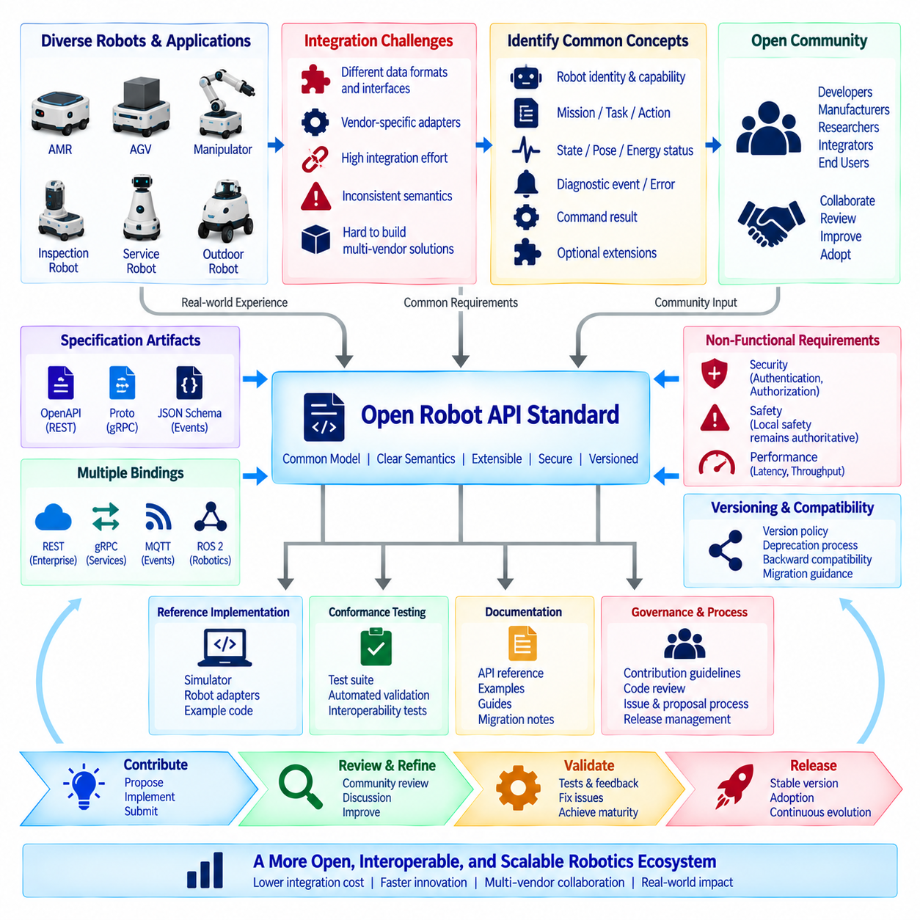
Open-source robot API standard contribution is the process of transforming practical interfaces developed for individual robots, fleets, or applications into reusable specifications that can be implemented by a broader robotics community. The objective is not merely to publish source code, but to define stable concepts, message structures, behaviors, compatibility rules, and implementation guidance that reduce integration effort across heterogeneous robotic systems.
A contribution case often begins with repeated integration problems observed in real deployments. Different mobile robots may represent missions, poses, battery states, errors, capabilities, and operational modes using incompatible schemas. Fleet software then requires vendor-specific adapters for every platform. When these differences represent common robotics concepts rather than true product distinctions, they become candidates for standardization through an open interface.
The first contribution step is identifying the smallest useful common model. A proposed standard should not attempt to expose every internal variable of every robot. Instead, it should define interoperable abstractions such as robot identity, capability, mission, task, action, state, pose, energy status, diagnostic event, and command result. Vendor-specific details can remain behind adapters or optional extensions without contaminating the common contract.
Real operational experience is particularly valuable when designing these abstractions. A mission schema tested only in a laboratory may overlook cancellation, partial completion, communication loss, charging interruption, blocked routes, localization degradation, or manual intervention. Field deployments reveal the state transitions and failure conditions that an API must represent if it is to become a practical interoperability standard rather than an idealized data format.
The proposed specification should separate normative requirements from implementation examples. Normative definitions describe what an implementation must or should provide, including field meanings, units, state transitions, error behavior, security expectations, and compatibility rules. Reference implementations demonstrate one possible realization using technologies such as REST, gRPC, MQTT, WebSocket, ROS 2, or another transport without unnecessarily restricting the standard to one software stack.
Schema design requires precise semantics. A field named position is insufficient unless the coordinate frame, units, orientation convention, timestamp, and validity conditions are defined. Battery percentage requires clarification of range and unavailable values. Mission status requires explicit state meanings and permitted transitions. Open standards become interoperable only when independent implementations interpret the same data in substantially the same way.
The contribution should therefore include machine-readable definitions where appropriate. OpenAPI documents can describe REST resources, Protocol Buffers can define gRPC messages, and JSON Schema or similar mechanisms can describe event payloads. These artifacts allow developers to generate clients, validate messages, automate testing, and detect incompatible changes while the human-readable specification explains operational meaning that cannot be captured completely by syntax alone.
Versioning policy must be established early because an open API will evolve after adoption. Compatible additions should normally preserve existing behavior, while breaking changes require explicit version boundaries and migration guidance. Fields that are no longer recommended should pass through a documented deprecation period. Implementations should tolerate compatible extensions so that different software generations can coexist during gradual fleet upgrades.
Extension mechanisms are necessary because robots vary significantly in physical capability. A basic mobile robot, manipulator, inspection robot, hospital service robot, and outdoor autonomous platform cannot expose identical functions. The standard can define a stable core while allowing namespaced or capability-specific extensions. Successful extensions that become widely useful can later be proposed for inclusion in the common specification.
Capability discovery helps prevent extensions from becoming assumptions. A client should be able to determine which mission types, actions, sensors, payload operations, docking methods, localization modes, or optional protocol features a robot supports. This allows generic software to adapt dynamically instead of identifying capabilities only through manufacturer names or hard-coded model tables.
Security must be part of the proposed standard rather than left entirely to each implementation. The specification can define expectations for authenticated communication, authorization boundaries, secure transport, credential handling, command freshness, audit information, and sensitive operations. It should also distinguish interoperability requirements from deployment-specific security mechanisms so that organizations can apply stronger controls without breaking the common API contract.
Safety boundaries require equally careful treatment. An interoperable API should normally communicate operational intent rather than bypassing onboard safety functions. A mission command can request navigation to a destination, but local collision avoidance, actuator limits, emergency stopping, and other safety mechanisms remain authoritative. The standard should clearly state that successful authentication does not grant permission to override safety constraints.
Before submitting a contribution, maintainers should provide a reference implementation that demonstrates the specification in realistic conditions. A simulator can represent several robot types and execute missions through the proposed API. An adapter can connect an existing robot platform to the standard interface. These implementations expose ambiguities that may remain invisible when reviewing specification documents alone.
Conformance testing converts the specification into measurable behavior. Test suites can verify required fields, units, state transitions, error responses, unknown values, optional capabilities, authentication behavior, timeout handling, and version compatibility. A vendor can run the same tests against its implementation, making interoperability claims more meaningful than simply stating that a product supports the standard.
Interoperability testing should involve implementations developed independently whenever possible. If two systems created by the same engineering team communicate successfully, they may share undocumented assumptions. Testing robots, fleet controllers, simulators, and adapters from different organizations reveals ambiguous definitions and hidden dependencies. Multi-vendor test events can therefore provide valuable evidence before a proposed interface is considered mature.
An open-source contribution also requires clear repository governance. The project should define contribution guidelines, code-review procedures, issue templates, release processes, maintainership responsibilities, and decision-making rules. API changes affect many downstream systems, so accepting a pull request solely because the code works locally is insufficient. Changes must be evaluated for semantics, compatibility, security, documentation, and ecosystem impact.
Design discussions should remain traceable. Significant changes can be proposed through issues, request-for-comment documents, design proposals, or enhancement processes before implementation is merged. The proposal should explain the problem, existing behavior, suggested interface, alternatives, compatibility impact, migration requirements, and unresolved questions. This record allows future maintainers to understand why the standard evolved in a particular direction.
Community review is especially important for terminology. Words such as mission, task, action, order, state, fault, pause, cancel, abort, and complete may have different meanings across robotics domains. A useful standard defines these concepts explicitly rather than assuming universal interpretation. Review from mobile robotics, manipulation, industrial automation, logistics, and service robotics communities can reveal domain-specific assumptions.
Backward compatibility should be evaluated before every release. Automated contract tests can compare new schemas with previously published versions and detect removed fields, changed types, reused identifiers, or incompatible required properties. Semantic review is still necessary because automated tools cannot always detect a change in operational meaning. Compatibility is therefore both a machine-verifiable and engineering-review responsibility.
Documentation should serve both implementers and integrators. The specification needs concise resource definitions, message examples, state diagrams described in text where necessary, error models, authentication expectations, extension rules, and migration notes. A quick-start implementation can help developers begin testing, while detailed reference material supports production integration and troubleshooting.
Licensing must be explicit for both code and specification artifacts. Contributors need to understand how implementations, examples, schemas, and documentation may be reused. The project should also establish a clear contribution policy so that intellectual-property expectations are understood before organizations submit substantial work. Ambiguous licensing can prevent industrial adoption even when the technical interface is strong.
A practical contribution strategy is to publish technology-neutral concepts together with several bindings. The same mission and robot-state model may be represented through REST for enterprise applications, gRPC for service communication, MQTT for event distribution, and ROS 2 adapters for robotic middleware. Shared semantics across bindings are more important than forcing every environment to adopt an identical transport protocol.
Performance requirements should be validated rather than assumed. Reference benchmarks can measure request latency, event throughput, message size, connection recovery, and resource consumption on representative edge computers and robots. The standard does not necessarily need to prescribe one performance target for every deployment, but implementers should understand the operational cost of required behaviors and message structures.
The project should also define how experimental features mature. New capabilities can begin in an experimental namespace or extension package, allowing implementations to gain field experience without destabilizing the core API. After sufficient adoption, interoperability testing, and semantic review, successful extensions can move into the stable specification. Unsuccessful experiments can be removed without creating permanent legacy obligations.
Contribution does not end when the first specification is merged. Issue reports from deployments, interoperability failures, security findings, implementation questions, and requests for new capabilities create a continuous feedback loop. Maintainers must distinguish genuine common requirements from product-specific requests so that the standard expands without becoming an uncontrolled collection of vendor features.
A successful open robot API standard therefore emerges from repeated interaction between implementation and specification. Field experience identifies common problems, the specification defines shared semantics, reference software demonstrates feasibility, conformance tests verify behavior, independent implementations expose ambiguity, and community governance controls evolution. Each cycle improves both the technical interface and the confidence of adopters.
For a robotics company, contributing an interface developed internally can also reduce long-term integration burden. If customers, partners, fleet platforms, and other robot manufacturers adopt compatible contracts, fewer custom adapters are required. The company can continue differentiating through hardware, autonomy, AI, performance, and application capability while using common interfaces for functions that provide little competitive value when implemented differently.
The broader lesson is that open-source API standardization is not simply code publication. It combines domain modeling, precise semantics, machine-readable schemas, reference implementations, security and safety boundaries, version governance, conformance testing, documentation, licensing, and community collaboration. The quality of the ecosystem depends on how consistently these elements are maintained after initial release.
A mature contribution creates a stable interoperability layer between heterogeneous robots and the software systems that coordinate them. Robots from different generations and vendors can expose common operational concepts, while specialized capabilities remain available through controlled extensions. This balance between a stable core and extensibility allows the standard to grow without forcing every robot into an identical architecture.
When maintained through transparent governance and real deployment feedback, an open robot API can evolve from a company-specific interface into shared infrastructure for the robotics ecosystem. The result is lower integration cost, more portable fleet software, clearer compatibility expectations, faster development of multi-vendor applications, and a stronger foundation for scalable robotic systems that must operate across organizations, technologies, and product generations.

12.10 Future Robot API Standardization and Strategy
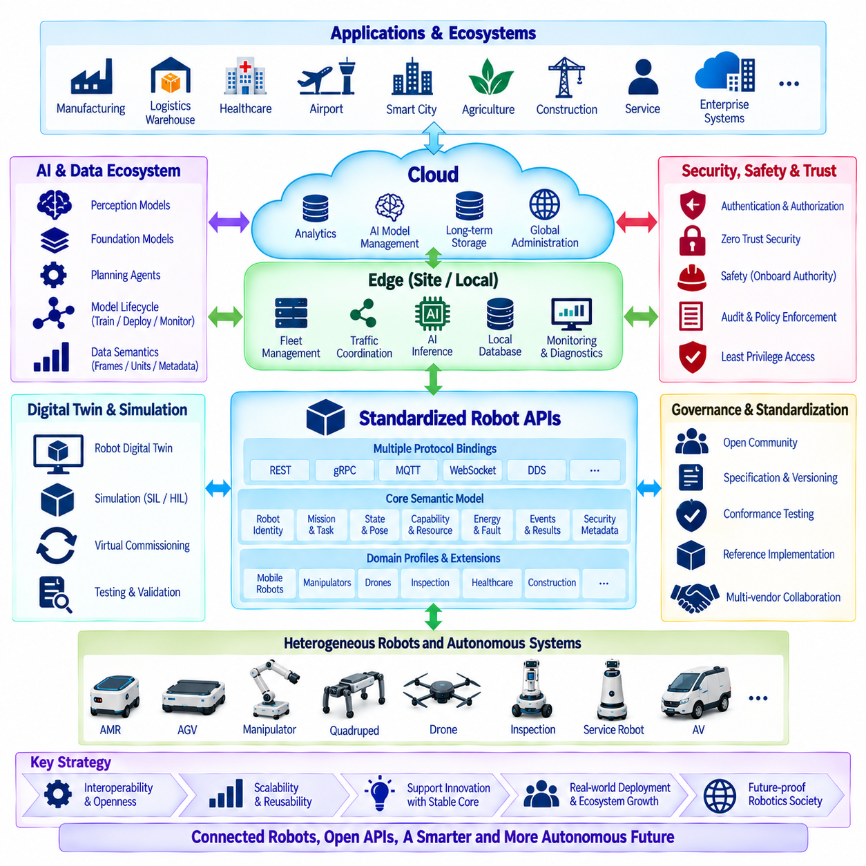
Future robot API standardization must evolve from simple message interoperability toward a shared operational architecture for heterogeneous autonomous systems. Robots are increasingly connected to fleet managers, AI services, digital twins, enterprise platforms, smart infrastructure, and cloud-edge environments. Future standards must therefore describe not only how data is exchanged, but also how capabilities, missions, states, policies, security, and lifecycle information are interpreted consistently across systems.
A central strategy is to separate stable semantic models from rapidly changing communication technologies. REST, gRPC, MQTT, WebSocket, DDS, and future protocols may coexist or change over time, while concepts such as robot identity, mission, task, action, pose, capability, energy state, fault, and execution result should remain comparatively stable. Standardization should focus first on shared meaning and then provide multiple protocol bindings for different deployment environments.
The future API model should adopt a layered structure rather than attempting to create one universal interface for every robotic function. A stable core can define common robot resources, mission lifecycle, state reporting, diagnostics, capabilities, and security metadata. Domain profiles can extend this foundation for mobile robots, manipulators, drones, inspection systems, healthcare robots, construction equipment, and other specialized platforms without fragmenting the common ecosystem.
Capability-driven interaction will become increasingly important as fleets become heterogeneous. Applications should not assume functionality from a manufacturer name or robot model. A robot should advertise supported actions, payload limits, sensors, mobility modes, docking interfaces, manipulation functions, localization technologies, AI services, and optional extensions through machine-readable capability descriptions. Clients can then construct missions according to actual available functions.
Mission APIs will also need to evolve from simple destination commands toward composable task models. Future missions may combine navigation, manipulation, perception, inspection, human interaction, charging, waiting, data collection, and conditional execution. Standard task primitives can provide interoperability, while vendors retain freedom to implement planning, control, optimization, and autonomy internally. This preserves innovation beneath a stable operational contract.
The boundary between robot APIs and fleet APIs should remain explicit. A robot interface describes the capabilities and state of an individual machine, while a fleet interface manages assignment, traffic, scheduling, shared resources, and coordination among many robots. Standardization should define how these layers interact without forcing every manufacturer to expose internal planning algorithms or adopt an identical fleet architecture.
Multi-vendor fleet interoperability will remain a major strategic requirement. Warehouses, hospitals, factories, airports, campuses, and smart cities may operate robots from several suppliers over long service periods. Common mission semantics, capability discovery, state models, traffic coordination interfaces, and conformance profiles can reduce dependence on proprietary integrations and allow fleet systems to coordinate heterogeneous machines more predictably.
Cloud-edge hybrid operation should become a first-class part of API standards. Real-time safety and motion remain onboard, site-level coordination and low-latency services operate at the edge, while cloud systems provide cross-site analytics, model management, long-term storage, and global administration. Standard APIs should define how missions, telemetry, events, configurations, software, and AI models move across these boundaries while preserving local operation during network disruption.
Offline and degraded operation therefore require standardized semantics. APIs should distinguish unavailable, disconnected, degraded, paused, failed, and safely operating states rather than representing every communication problem as a generic error. Store-and-forward behavior, command expiration, synchronization, conflict resolution, and data ownership should be defined so that distributed robotic systems can reconnect without creating ambiguous operational states.
Event-driven architectures will become increasingly important as robotic ecosystems scale. Instead of relying entirely on synchronous requests, robots and infrastructure can publish mission transitions, faults, safety events, capability changes, maintenance indicators, and environmental observations. Standard event envelopes should include identifiers, timestamps, source information, schema versions, correlation data, and event types so that independent consumers can process streams consistently.
Data semantics require stronger standardization as AI and analytics become integrated with robotics. Position values require coordinate frames, measurements require units, timestamps require clock definitions, and sensor observations require validity metadata. Without these definitions, syntactically compatible APIs can still produce incorrect analytics or unsafe decisions. Future standards should treat semantic metadata as part of the contract rather than optional documentation.
Artificial intelligence introduces another standardization layer. Robots will increasingly expose perception models, foundation-model services, world models, planning agents, and learned policies. APIs should describe AI capability, model identity, version, required inputs, output confidence, hardware requirements, and operational limitations without requiring every vendor to expose proprietary model internals. This allows AI functions to become discoverable services while preserving intellectual property.
AI model lifecycle APIs can connect cloud training infrastructure with edge and onboard deployment. A standardized workflow can describe model registration, validation, approval, distribution, activation, monitoring, rollback, and retirement. Model artifacts should be associated with compatible hardware, runtime environments, sensor configurations, and safety constraints so that an orchestration system does not deploy technically valid but operationally inappropriate models.
Future robot APIs will increasingly interact with digital twins. A digital representation may include robot configuration, geometry, software version, capability, maintenance state, battery condition, mission history, and environmental context. Standard identifiers and synchronization interfaces can connect physical robots with simulation, monitoring, predictive maintenance, and virtual commissioning systems without requiring separate integration models for each application.
Simulation should become part of API standardization strategy rather than merely a development tool. The same mission and state interfaces used by physical robots can be implemented by simulators, allowing applications to operate against virtual and real assets through comparable contracts. This supports regression testing, virtual commissioning, interoperability validation, training, and large-scale evaluation before software is deployed to physical fleets.
Security must evolve toward zero-trust principles across robot, edge, cloud, and enterprise boundaries. Every service and device should have a verifiable identity, communication should be authenticated and encrypted, and authorization should be based on explicit permissions rather than network location. API standards should define security metadata and behavioral expectations while allowing deployments to choose technologies appropriate to their risk environment.
Machine-to-machine authorization will become more granular as autonomous systems gain greater capabilities. Permission to read telemetry should not imply permission to command motion, modify maps, deploy software, change safety-related configuration, or activate AI models. Future standards should define resource and action boundaries that allow least-privilege authorization policies to be applied consistently across heterogeneous systems.
Safety and cybersecurity must remain separate but coordinated concerns. A valid authenticated command may still be physically unsafe, while a safe motion request may originate from an unauthorized source. APIs should preserve onboard safety authority while providing sufficient information for authentication, authorization, command validation, audit, and policy enforcement. Standardization should never create interfaces that bypass certified or authoritative safety mechanisms.
Lifecycle management will become increasingly important because robots may remain operational for ten years or longer while cloud software evolves rapidly. Standards must support mixed-version environments, backward-compatible schema evolution, capability negotiation, long-term-support profiles, controlled deprecation, and migration procedures. Compatibility should be treated as an operational property rather than merely a version number.
Machine-readable specifications and automated conformance testing will be essential for scaling adoption. OpenAPI, Protocol Buffers, JSON Schema, interface definitions, test vectors, and reference datasets can allow vendors to validate implementations continuously. Certification or conformance programs can test required behavior, optional profiles, error handling, security expectations, and version compatibility rather than relying only on documentation claims.
Standardization should also include observable behavior. Common metrics for API availability, mission latency, command rejection, synchronization delay, event backlog, robot connectivity, and software version can improve monitoring across multi-vendor fleets. Standard diagnostic and audit interfaces allow operators to investigate failures without learning a completely different observability model for every robot platform.
Open-source reference implementations can accelerate this strategy. A specification accompanied by simulators, robot adapters, fleet connectors, test suites, and example applications is easier to evaluate than a document alone. Open implementations also reveal ambiguous semantics early and allow universities, startups, manufacturers, integrators, and customers to participate in interoperability testing before committing to commercial deployments.
Governance will determine whether future standards remain useful. Stable specifications require transparent proposal processes, technical review, release policies, compatibility rules, security response procedures, and clearly defined maintainership. No single vendor should be able to redefine shared semantics solely for its own product advantage. At the same time, governance must remain efficient enough that standards can respond to rapid developments in robotics and AI.
A practical strategy is to standardize mature common behavior while allowing experimental innovation through controlled extensions. New AI agents, manipulation capabilities, sensor types, or mission primitives can first appear in namespaced extensions. Once multiple implementations demonstrate common requirements and interoperable behavior, the extension can be considered for promotion into a stable profile or core specification.
Regional regulations and data-governance requirements will also influence API architecture. Different markets may impose requirements concerning cybersecurity, privacy, data localization, AI governance, radio systems, or critical infrastructure. A global standard should define common technical semantics while allowing policy profiles and deployment configurations to satisfy regional requirements without creating completely incompatible API families.
Organizations developing robot platforms should therefore treat standardization as a product and ecosystem strategy rather than a final documentation activity. Internal APIs should be designed with explicit semantics, versioning, capability discovery, security boundaries, testing, and extensibility from the beginning. Interfaces that repeatedly prove useful across projects can then become candidates for external publication, industry collaboration, or open-standard contribution.
The strategic value of standard APIs is not the elimination of differentiation. Robot manufacturers can continue competing through mechanical design, reliability, autonomy, perception, AI, energy efficiency, safety, cost, and application expertise. Standardization is most valuable where proprietary differences create integration expense without creating meaningful customer value, such as basic mission submission, status reporting, diagnostics, and capability description.
Future ecosystems are likely to contain robots, autonomous vehicles, manipulators, drones, smart infrastructure, AI agents, digital twins, and enterprise systems operating together. The API layer must therefore evolve from a collection of device interfaces into a common machine ecosystem language. Shared semantics will allow higher-level orchestration systems to reason about capabilities and missions without requiring detailed knowledge of every underlying machine.
The long-term architecture should support composability. A business workflow may request material movement, inspection, manipulation, verification, and reporting without specifying which individual machines perform every step. An orchestration platform can discover available capabilities and compose services from multiple robots. Standard APIs provide the descriptions, state information, and execution contracts required for this transition from device integration toward capability orchestration.
This direction also prepares robotics for increasingly autonomous software agents. An AI planner may generate missions or coordinate resources, but it should interact through the same governed interfaces as other clients. Identity, authorization, validation, safety boundaries, observability, and auditability remain necessary regardless of whether a command originates from a human operator, enterprise application, optimization algorithm, or autonomous AI agent.
The future standardization strategy should therefore combine stable semantics, layered profiles, capability discovery, composable missions, cloud-edge operation, event-driven communication, AI lifecycle integration, digital twins, security, safety, version compatibility, automated conformance, open-source reference implementations, and transparent governance. These elements collectively provide a foundation that can evolve without repeatedly rebuilding integration interfaces.
The ultimate objective is not to create one API that controls every robot identically. It is to establish a durable interoperability framework in which different machines can communicate common operational concepts while preserving specialized capabilities and internal innovation. Such a framework can reduce integration cost, extend software reuse, support multi-vendor fleets, and make robotic systems easier to deploy and maintain over long product lifecycles.
As robotics expands from isolated automation toward connected physical AI ecosystems, API standardization becomes infrastructure rather than convenience. A well-designed strategy allows robots, software platforms, AI services, and enterprise systems to evolve independently while remaining interoperable. This combination of stable contracts and controlled extensibility provides the foundation for secure, scalable, and continuously evolving robotic ecosystems.

