Volume 07 Robot Data Architecture

03. Telemetry Architecture

03.01 Robot Telemetry Architecture: Collect, Transfer, Store, Analyze
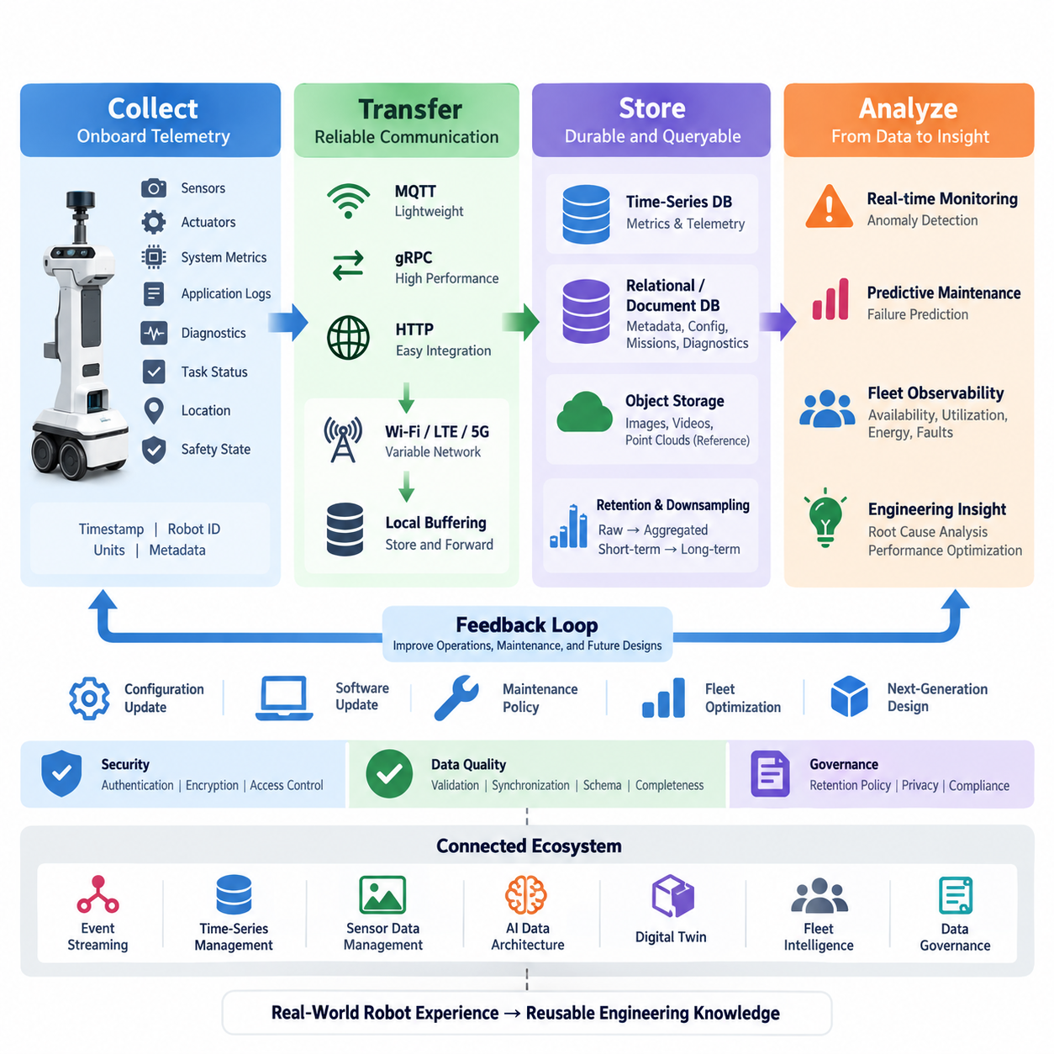
A robot telemetry architecture provides the continuous data foundation required to understand what a robot is doing, how its hardware and software are behaving, and whether the system is operating safely and efficiently. Within the Robot Data Architecture, telemetry forms a dedicated layer between onboard data generation and higher-level operational intelligence, following a recurring lifecycle of collect, transfer, store, and analyze.
The collect stage begins inside the robot, where telemetry originates from heterogeneous physical and software sources. Typical signals include battery voltage and current, motor temperature, wheel speed, CPU and GPU utilization, memory usage, network quality, localization confidence, task status, diagnostic codes, and safety states. Collection should preserve timestamps, robot identity, signal definitions, units, and quality metadata so downstream systems can interpret each observation consistently.
Telemetry collection should be separated from the robot's safety-critical control loops. A lightweight onboard telemetry agent can subscribe to selected ROS 2 topics, operating-system metrics, controller interfaces, application logs, and diagnostic channels without disturbing deterministic control behavior. Sampling frequency should reflect operational value: rapidly changing control-related measurements may require high rates, while configuration or health summaries can be collected much less frequently.
Raw robot data should not automatically be treated as telemetry that must leave the robot. Cameras, LiDAR point clouds, audio, and other high-bandwidth sensor streams can overwhelm communication and storage resources if continuously transmitted. The collection architecture therefore applies filtering, aggregation, event triggering, compression, and selective recording so that operational telemetry remains lightweight while important raw sensor evidence can be retained separately when required.
The transfer stage moves selected telemetry from onboard systems toward edge servers, on-premise infrastructure, fleet platforms, or cloud services. MQTT is suitable for lightweight publish-subscribe telemetry, while gRPC can support structured high-performance service communication and HTTP-based interfaces can simplify integration with conventional applications. The architecture should select transport mechanisms according to latency, bandwidth, reliability, interoperability, and deployment constraints.
Connectivity cannot be assumed to remain stable for mobile robots. Indoor AMRs may move through Wi-Fi coverage gaps, while outdoor robots can experience variable LTE or 5G quality. An effective telemetry architecture therefore uses local buffering and store-and-forward behavior. Messages that cannot be transmitted immediately are temporarily persisted, assigned sequence information, and retransmitted when connectivity returns, reducing gaps in the operational history.
Telemetry transport also requires explicit delivery and prioritization policies. Emergency stops, safety faults, critical temperatures, localization failures, and mission-blocking errors should receive higher priority than routine performance measurements. Systems may combine periodic transmission for normal metrics with event-driven transmission for abnormal conditions, allowing communication resources to focus on information that has immediate operational significance while still maintaining historical visibility.
The store stage converts incoming telemetry streams into durable and queryable operational records. Time-series databases are well suited to timestamped measurements such as temperatures, currents, velocities, resource utilization, and battery state, while relational or document-oriented stores can maintain robot metadata, configurations, missions, and diagnostic context. Large sensor artifacts can be referenced from object storage rather than inserted directly into telemetry databases.
Storage architecture should preserve relationships among robot ID, fleet ID, mission ID, timestamp, software version, hardware configuration, location, and operating state. These dimensions make telemetry useful beyond simple monitoring because engineers can compare behavior across robots, deployments, firmware releases, environments, and missions. Schema versioning is especially important when robot generations or software updates introduce new signals or change the interpretation of existing measurements.
Not all telemetry needs to remain at its original resolution forever. High-frequency data can be retained for a short diagnostic window and subsequently downsampled into minute, hourly, or daily summaries. Retention policies can distinguish operational monitoring data, failure evidence, engineering datasets, and long-term fleet statistics. This reduces storage cost while preserving the information required for trend analysis, reliability engineering, and lifecycle evaluation.
The analyze stage transforms stored and streaming telemetry into operational knowledge. Real-time rules can identify threshold violations, missing heartbeats, communication degradation, abnormal power consumption, excessive temperatures, or localization instability. More advanced analytics can combine multiple signals to recognize patterns that would not be visible from a single measurement, providing earlier indications of component degradation or system-level anomalies.
Historical telemetry enables predictive maintenance by revealing how equipment condition changes over time. Motor current, vibration, temperature, battery impedance, charging behavior, actuator load, and fault frequency can become features for statistical or machine-learning models. Rather than waiting for a component to fail, maintenance systems can estimate degradation trends, identify unusual behavior relative to comparable robots, and schedule inspection based on evidence accumulated during actual operation.
Telemetry also provides the foundation for fleet-level observability. Individual robot measurements can be aggregated into dashboards showing availability, utilization, mission completion, energy consumption, fault distribution, network health, and subsystem performance. Operators can move from fleet-wide indicators to a specific robot, mission, or time interval, while engineering teams can correlate operational symptoms with software versions, configuration changes, and environmental conditions.
The complete architecture should therefore be understood as a closed operational data loop rather than a one-way upload pipeline. Robots collect physical and software state, communication layers transfer selected information, storage systems maintain current and historical records, and analytical services convert those records into alerts, diagnostics, maintenance decisions, fleet optimization, and engineering feedback. The resulting knowledge can then influence configuration, software updates, maintenance policies, and future robot designs.
A mature implementation also treats telemetry quality as an architectural requirement. Missing timestamps, inconsistent units, duplicated messages, clock drift, invalid values, and schema mismatches can produce misleading analysis even when communication itself succeeds. Validation should therefore occur throughout the lifecycle, with synchronization, schema contracts, sequence tracking, range checks, completeness metrics, and provenance information supporting trustworthy interpretation of robot behavior.
Security and governance must span every stage of the telemetry lifecycle. Robot identities should be authenticated, communication channels protected, access controlled according to operational roles, and sensitive information separated from ordinary engineering metrics. Retention and deletion policies should reflect the type of data being collected, particularly when robot telemetry can be associated with images, locations, people, facilities, or customer operations.
The Collect–Transfer–Store–Analyze model ultimately creates a common data backbone connecting robot operation with observability, diagnostics, predictive maintenance, digital twins, fleet intelligence, and AI development. In the broader software architecture, this telemetry layer complements event streaming, time-series management, sensor-data management, AI data architecture, digital-twin data, and governance, allowing operational experience from deployed robots to become reusable engineering knowledge.

03.02 Telemetry Collection Agent Design: Onboard Lightweight [w/Code]
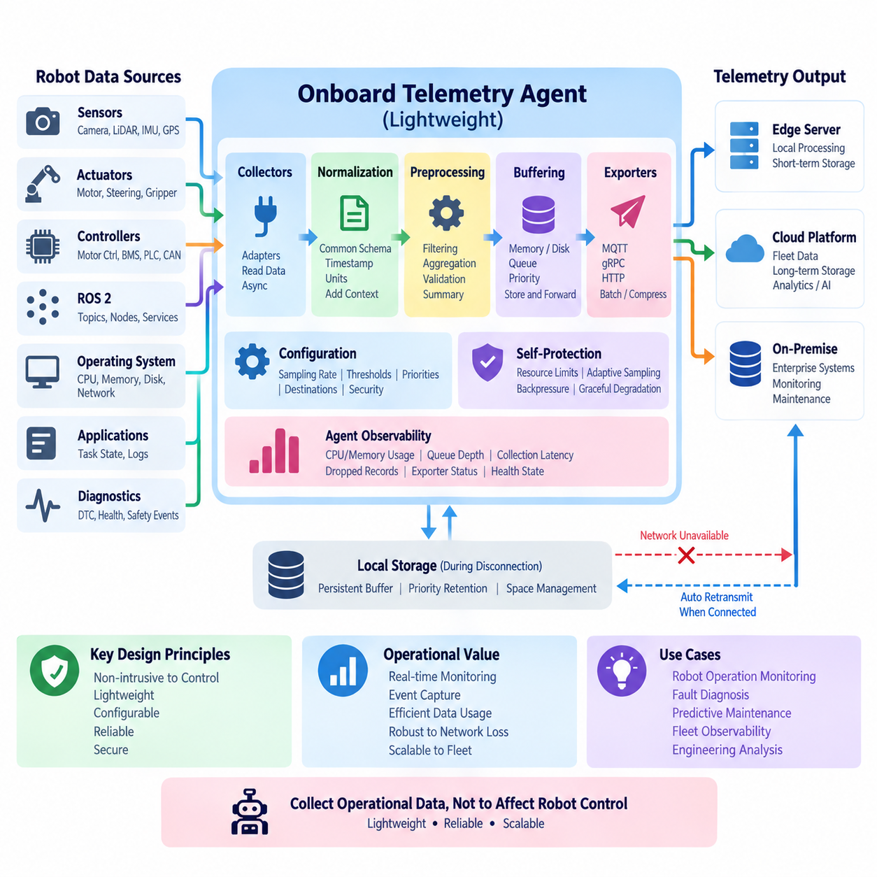
An onboard telemetry collection agent is a lightweight software component responsible for observing the operational state of a robot and converting selected measurements into structured telemetry without interfering with the robot’s primary control functions. Within the telemetry architecture, it forms the first software layer of the collection stage, connecting sensors, controllers, ROS 2 nodes, operating-system resources, diagnostics, and application services to downstream telemetry pipelines.
The most important design principle is isolation from safety-critical and real-time control paths. Motor control, steering, localization, obstacle avoidance, and emergency functions must continue operating even if the telemetry agent crashes, becomes overloaded, or loses network connectivity. The agent should therefore observe existing interfaces asynchronously whenever possible rather than becoming a mandatory intermediary through which control commands or safety signals must pass.
A lightweight design begins by defining exactly which signals provide operational value. Typical sources include battery voltage, current and state of charge, motor temperature and current, wheel velocity, localization status, CPU and GPU utilization, memory consumption, disk capacity, network quality, task state, diagnostic codes, software health, and safety events. Collecting every available signal at maximum frequency creates unnecessary computational, network, and storage overhead.
The agent should support multiple data adapters so heterogeneous robot subsystems can be observed through a common collection framework. ROS 2 topic subscribers can acquire middleware-level information, while operating-system collectors obtain processor, memory, storage, process, and network metrics. Hardware adapters can communicate with motor controllers, battery management systems, PLCs, CAN interfaces, serial devices, or dedicated diagnostic services without forcing these sources to adopt one internal implementation.
After acquisition, measurements should be normalized into a consistent telemetry representation. Each record should contain a timestamp, robot identifier, signal or metric name, value, engineering unit, source, and relevant quality information. Additional context such as mission ID, software version, operating mode, subsystem identifier, or location reference may be attached when necessary. This normalization prevents downstream applications from depending directly on device-specific data formats.
Time handling is especially important because robot telemetry originates from components operating at different frequencies and sometimes using different clocks. The collection agent should preserve the original measurement timestamp whenever available and distinguish it from collection or transmission time. Clock synchronization mechanisms such as NTP, PTP, or hardware-assisted synchronization can improve correlation among telemetry, sensor recordings, diagnostic events, and control behavior.
Sampling policies should be configurable by signal class rather than fixed globally. CPU temperature may only require periodic sampling, while motor current or vibration can require substantially higher rates for condition monitoring. Configuration parameters can define collection frequency, aggregation interval, threshold conditions, priority, retention behavior, and transmission policy, allowing the same telemetry agent architecture to support different robot platforms and operational environments.
Adaptive collection can further reduce resource consumption. During normal operation, a signal may be collected or transmitted at a relatively low rate, but an abnormal condition can temporarily increase sampling frequency. For example, rising motor temperature or repeated localization errors may trigger higher-resolution collection of related signals. This approach preserves detailed evidence around important events without continuously generating high-volume telemetry.
The telemetry agent should distinguish periodic metrics from event-driven information. Resource utilization and battery measurements naturally fit periodic sampling, whereas emergency stops, controller faults, mission transitions, charging events, localization failures, and safety alarms should be captured immediately as events. Supporting both patterns allows the collection layer to represent slowly changing operational conditions and sudden state transitions through the same overall architecture.
Local preprocessing can significantly reduce unnecessary data transmission. The agent may perform filtering, aggregation, unit conversion, basic validation, duplicate suppression, or calculation of summary statistics before data leaves the robot. High-frequency measurements can be represented by minimum, maximum, mean, variance, or selected samples over a defined interval when full-resolution transmission is unnecessary. Raw values can still be retained temporarily when diagnostic detail is required.
Resource limits must be explicit because the agent shares onboard computing resources with navigation, perception, planning, AI inference, and control software. CPU utilization, memory allocation, disk I/O, network bandwidth, and thread activity should therefore remain bounded. Queues should have defined limits, collection operations should avoid uncontrolled blocking, and expensive processing should be excluded from the agent whenever it can be performed more efficiently at an edge server or backend system.
A robust internal architecture commonly separates acquisition, normalization, buffering, and transmission responsibilities. Collectors read data from individual sources, a normalization layer converts measurements into common schemas, a local queue or buffer absorbs short-term differences between collection and transmission rates, and exporters deliver telemetry through configured protocols. This separation allows individual adapters or transport mechanisms to change without redesigning the complete agent.
Local buffering becomes essential when communication is intermittent. The agent should continue collecting important telemetry even when Wi-Fi, LTE, 5G, or an upstream server becomes temporarily unavailable. Buffered records can be stored in memory for short disruptions and moved to persistent local storage when outages continue. Once connectivity returns, retransmission can resume while preserving timestamps and sequence information so the backend can reconstruct the operational timeline.
Buffer management requires clear policies because onboard storage is finite. Critical faults and safety-related events may receive stronger persistence guarantees than routine metrics, while old low-priority records may be downsampled or removed when storage pressure increases. Priority-aware queues, maximum retention periods, disk quotas, and backpressure mechanisms prevent telemetry collection from exhausting storage resources needed by navigation, logging, or other robot applications.
Transmission should be decoupled from acquisition so network latency does not directly affect collectors. MQTT can support lightweight publish-subscribe telemetry, gRPC can provide efficient structured communication, and HTTP-based exporters can integrate with conventional backend services. The agent may batch multiple records, compress payloads, or adjust transmission intervals according to network conditions while maintaining a stable internal telemetry schema independent of the transport protocol.
Reliability also requires protection against duplicate or missing records. Sequence numbers, unique message identifiers, timestamps, acknowledgement policies, and retry logic can help downstream systems determine whether telemetry has been delivered completely. Depending on the operational requirement, the system may accept occasional loss for low-priority metrics while applying stronger delivery guarantees to diagnostic, safety, or maintenance-related information.
The collection agent itself must be observable. It should expose its own CPU and memory usage, queue depth, collection latency, dropped-record count, buffer utilization, transmission failures, reconnect attempts, and exporter status. A telemetry system that cannot report the health of its collection mechanism can create dangerous blind spots because missing data may otherwise be incorrectly interpreted as normal robot behavior rather than failure of the monitoring infrastructure.
Self-protection mechanisms can keep the agent lightweight during abnormal conditions. If CPU load becomes excessive, network bandwidth decreases, or local storage approaches capacity, the agent can reduce low-priority sampling, increase aggregation, delay bulk transmission, or discard expendable records according to predefined policies. Safety and critical diagnostic telemetry should remain protected from such degradation whenever system resources permit.
Configuration should be externalized rather than embedded throughout source code. Robot-specific configuration can define enabled collectors, topic names, device interfaces, sampling frequencies, thresholds, priorities, buffer sizes, destinations, and security parameters. Version-controlled configuration also makes deployments reproducible and allows fleet operators to compare telemetry behavior across robot models, software releases, customer sites, and operational profiles.
Security begins with minimizing the agent’s privileges. It should receive only the permissions required to read designated telemetry sources and write to approved local buffers or communication endpoints. Credentials and certificates should not be hard-coded, while encrypted transport and authenticated endpoints should protect telemetry leaving the robot. Access to sensitive sensor, location, diagnostic, or customer-related information should follow the broader data-governance policy.
Deployment and lifecycle management are equally important for fleet-scale operation. The telemetry agent should start automatically with the robot software environment, recover after failure, expose clear health states, and support controlled configuration and software updates. Containerized deployment may simplify dependency management on capable onboard computers, while smaller embedded platforms may require a native service optimized for minimal memory and startup overhead.
Testing should verify not only whether the agent collects correct values but also whether it remains harmless under failure conditions. Engineers should evaluate disconnected networks, unavailable topics, malformed measurements, full disks, slow backend services, clock changes, process restarts, excessive message rates, and corrupted configuration. The central requirement is graceful degradation: telemetry failures must not propagate into failures of navigation, control, perception, or safety functions.
When designed correctly, the lightweight onboard telemetry collection agent becomes a standardized boundary between robot execution and the broader data platform. It converts heterogeneous runtime information into consistent, timestamped, quality-aware records while controlling resource consumption and tolerating unreliable communication. This creates a dependable input for later compression, transport, buffering, aggregation, anomaly detection, predictive maintenance, unified observability, and fleet dashboards defined throughout the telemetry architecture.

03.03 Telemetry Data Compression and Encoding [w/Code]
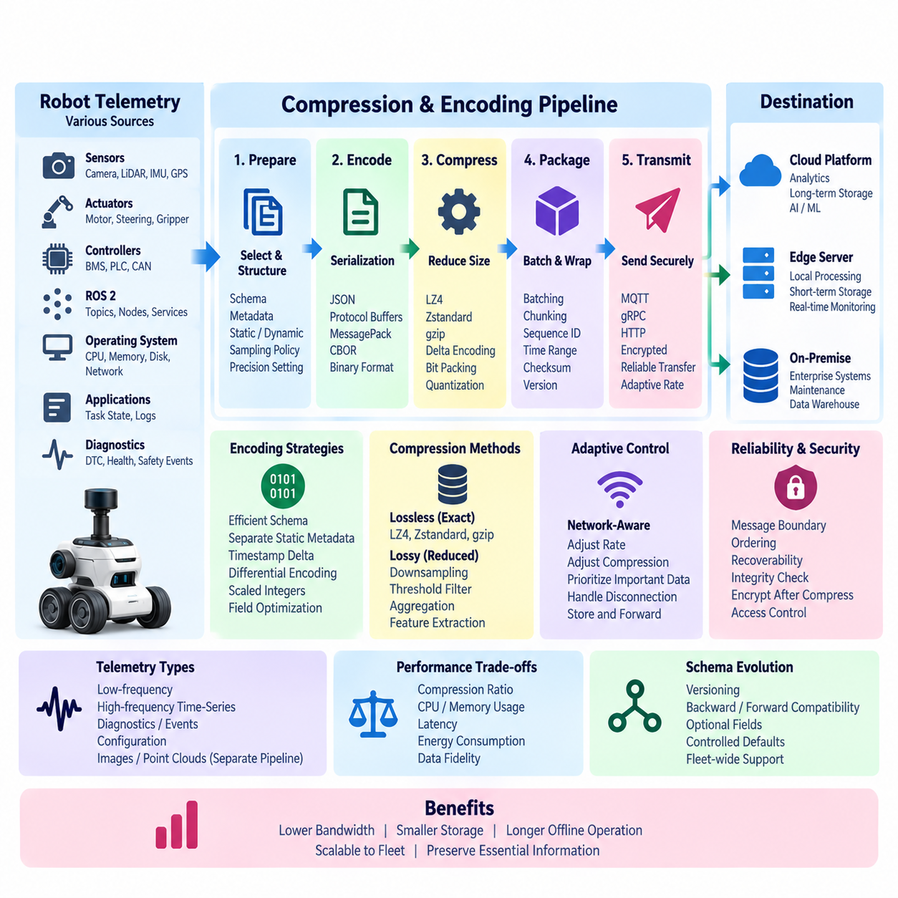
Telemetry compression and encoding are essential mechanisms for reducing the communication, storage, and processing cost of continuously generated robot data while preserving the information required for monitoring, diagnostics, predictive maintenance, and fleet analysis. In mobile robots, telemetry must often traverse bandwidth-constrained Wi-Fi, LTE, or 5G links, making efficient representation a fundamental part of the telemetry architecture rather than an optional optimization.
Compression and encoding address related but different problems. Encoding defines how telemetry values, timestamps, identifiers, status fields, and metadata are represented in a transferable binary or textual format. Compression reduces the size of that encoded representation by removing redundancy. A well-designed pipeline therefore defines a structured schema first, serializes the telemetry efficiently, and then applies compression when the expected reduction justifies its computational cost.
Human-readable formats such as JSON are convenient during development, debugging, and integration because engineers can inspect messages directly and many software systems support them natively. However, repeated field names, textual numbers, delimiters, and metadata can produce significant overhead when thousands of measurements are transmitted continuously. JSON can remain useful at external APIs while compact binary encoding is used internally for high-rate robot telemetry.
Binary serialization formats such as Protocol Buffers, MessagePack, CBOR, or similar schema-oriented representations can substantially reduce payload size compared with verbose textual formats. Numeric values are stored using compact binary representations, while schemas allow sender and receiver to interpret fields consistently. Protocol Buffers are particularly useful when telemetry interfaces require strongly defined message contracts and controlled schema evolution across robot and backend software versions.
The encoding schema should reflect the characteristics of telemetry rather than treating every measurement as an independent generic object. Robot ID, subsystem identity, units, software version, and other slowly changing metadata do not need to be repeated with every sample when they can be represented once at the session, batch, or stream level. Separating static metadata from rapidly changing values reduces redundancy before any general-purpose compression algorithm is applied.
Timestamps deserve special treatment because they appear in nearly every telemetry record and frequently increase by predictable intervals. Instead of repeatedly transmitting full absolute timestamps, a stream can encode an initial timestamp followed by time deltas. When sampling intervals are stable, delta-of-delta techniques can represent changes using very small values. Similar approaches can be applied to monotonically increasing counters, sequence numbers, odometry values, and other correlated measurements.
Numeric telemetry often changes gradually between adjacent samples, creating opportunities for differential encoding. Rather than storing every temperature, voltage, position, or speed as a complete value, the system can encode the difference from a previous sample or reference value. Small differences generally require fewer bits than full values, particularly when combined with variable-length integer encoding, bit packing, or specialized time-series compression techniques.
Floating-point measurements require careful treatment because unnecessary precision increases data volume. A temperature sensor may not provide meaningful information at six decimal places, and battery state or CPU utilization may tolerate bounded quantization. Converting suitable measurements to scaled integers can reduce payload size significantly. The acceptable precision must be defined per signal so compression never removes information required for control analysis, diagnostics, safety investigation, or engineering validation.
Lossless compression preserves the exact encoded telemetry and is generally appropriate for diagnostic records, safety events, configuration information, fault codes, and measurements whose original values may be required later. Algorithms such as LZ4, Zstandard, gzip, or platform-specific alternatives offer different trade-offs among compression ratio, CPU usage, memory consumption, and latency. The best choice depends on onboard resources, network conditions, message size, and backend compatibility.
Fast algorithms with moderate compression can be preferable onboard because telemetry processing shares CPU and memory resources with perception, localization, navigation, planning, and AI inference. Achieving the smallest possible file is not necessarily the correct objective if compression consumes excessive processor time or introduces transmission latency. The architecture should optimize total system cost by balancing payload reduction against compute utilization, energy consumption, and real-time operational requirements.
Lossy reduction can be appropriate for selected high-frequency signals when exact reconstruction is unnecessary. Downsampling, quantization, threshold-based suppression, deadband filtering, and statistical aggregation can reduce telemetry volume before serialization and compression. For example, a stable temperature may only need transmission when it changes beyond a defined threshold, while high-rate vibration measurements may be summarized by statistical or spectral features for routine monitoring.
Lossy methods must be signal-aware because telemetry classes have different engineering significance. Emergency events, diagnostic trouble codes, safety transitions, calibration values, and critical state changes should normally remain exact. In contrast, routine utilization metrics or slowly changing environmental measurements may tolerate controlled reduction. Compression policy should therefore be defined through telemetry metadata and configuration rather than applied uniformly to every stream.
Batching can improve compression efficiency by combining multiple telemetry records before encoding or transmission. Repeated patterns across adjacent records become easier for compression algorithms to exploit, and protocol overhead is amortized across many measurements. However, larger batches increase buffering requirements and delivery latency. Safety-related or urgent events should bypass long batching intervals even when routine telemetry is transmitted in larger compressed blocks.
Compression should be integrated with the onboard buffering architecture. Data stored during temporary network outages can be encoded and compressed before being written to persistent storage, extending the amount of telemetry that can survive prolonged disconnection. When connectivity returns, compressed batches can be retransmitted without repeating expensive transformations, provided the format contains sufficient version, ordering, timestamp, and integrity information for reliable reconstruction.
Network-aware compression can dynamically adjust behavior according to communication conditions. When bandwidth is abundant, the robot may transmit telemetry at higher resolution with minimal compression to reduce CPU cost. When LTE or 5G quality deteriorates, the system can increase aggregation, use stronger compression, reduce low-priority sampling, or delay noncritical data. Such adaptation allows telemetry quality and resource consumption to respond to real operating conditions.
Compression and encoding must preserve message boundaries, ordering, and recoverability. A corrupted compressed block should not make an excessive period of telemetry unusable. Chunking streams into independently decodable segments limits the impact of corruption and simplifies retry operations. Each chunk can include sequence information, schema version, time range, record count, compression method, and checksum so receivers can validate completeness before accepting the reconstructed data.
Schema evolution is particularly important for long-lived robot fleets. New software versions may introduce additional telemetry fields, modify optional metadata, or deprecate older measurements while older robots remain deployed. Encoding formats should therefore support backward and forward compatibility where practical. Field identifiers, optional values, explicit schema versions, and controlled defaults allow telemetry producers and consumers to evolve without requiring simultaneous fleet-wide upgrades.
Compression must occur in the correct order relative to encryption. Structured telemetry is normally serialized and compressed before transport encryption because encrypted data has intentionally high entropy and compresses poorly. The pipeline can therefore follow normalization, encoding, batching, compression, integrity protection, and secure transmission. Security design must also prevent compression mechanisms from exposing sensitive information through inappropriate cross-context processing or metadata leakage.
The telemetry agent should measure whether compression is actually beneficial. Useful metrics include original payload size, compressed size, compression ratio, encoding latency, compression latency, CPU consumption, memory use, queue delay, and decompression failures. These measurements allow engineers to compare algorithms and policies under real workloads rather than selecting a compression method solely from theoretical benchmark results.
Different telemetry classes may ultimately use different encoding profiles. Low-frequency configuration and diagnostic information can prioritize readability and compatibility, routine operational metrics can use compact binary serialization, and high-rate time-series streams can employ delta encoding, batching, and specialized compression. Large camera images or point clouds should normally follow dedicated sensor-data compression pipelines rather than being forced into the general telemetry representation.
At fleet scale, even modest reductions in message size can produce substantial savings because telemetry is generated continuously across many robots. Reduced bandwidth lowers communication cost, smaller buffers extend offline operating time, and compact storage improves long-term retention efficiency. Efficient encoding also reduces backend ingestion and I/O load, allowing telemetry infrastructure to scale from individual prototypes to hundreds or thousands of deployed robots.
The overall design objective is therefore not maximum compression but efficient preservation of operational information. A successful telemetry compression and encoding architecture reduces redundant bytes while maintaining timestamps, ordering, precision, semantic meaning, reliability, and compatibility. Combined with collection agents, transport protocols, edge buffering, aggregation, anomaly detection, predictive maintenance, and observability, it creates an efficient data path from robot operation to fleet intelligence.

03.04 Telemetry Transport Protocol: MQTT, gRPC, HTTP
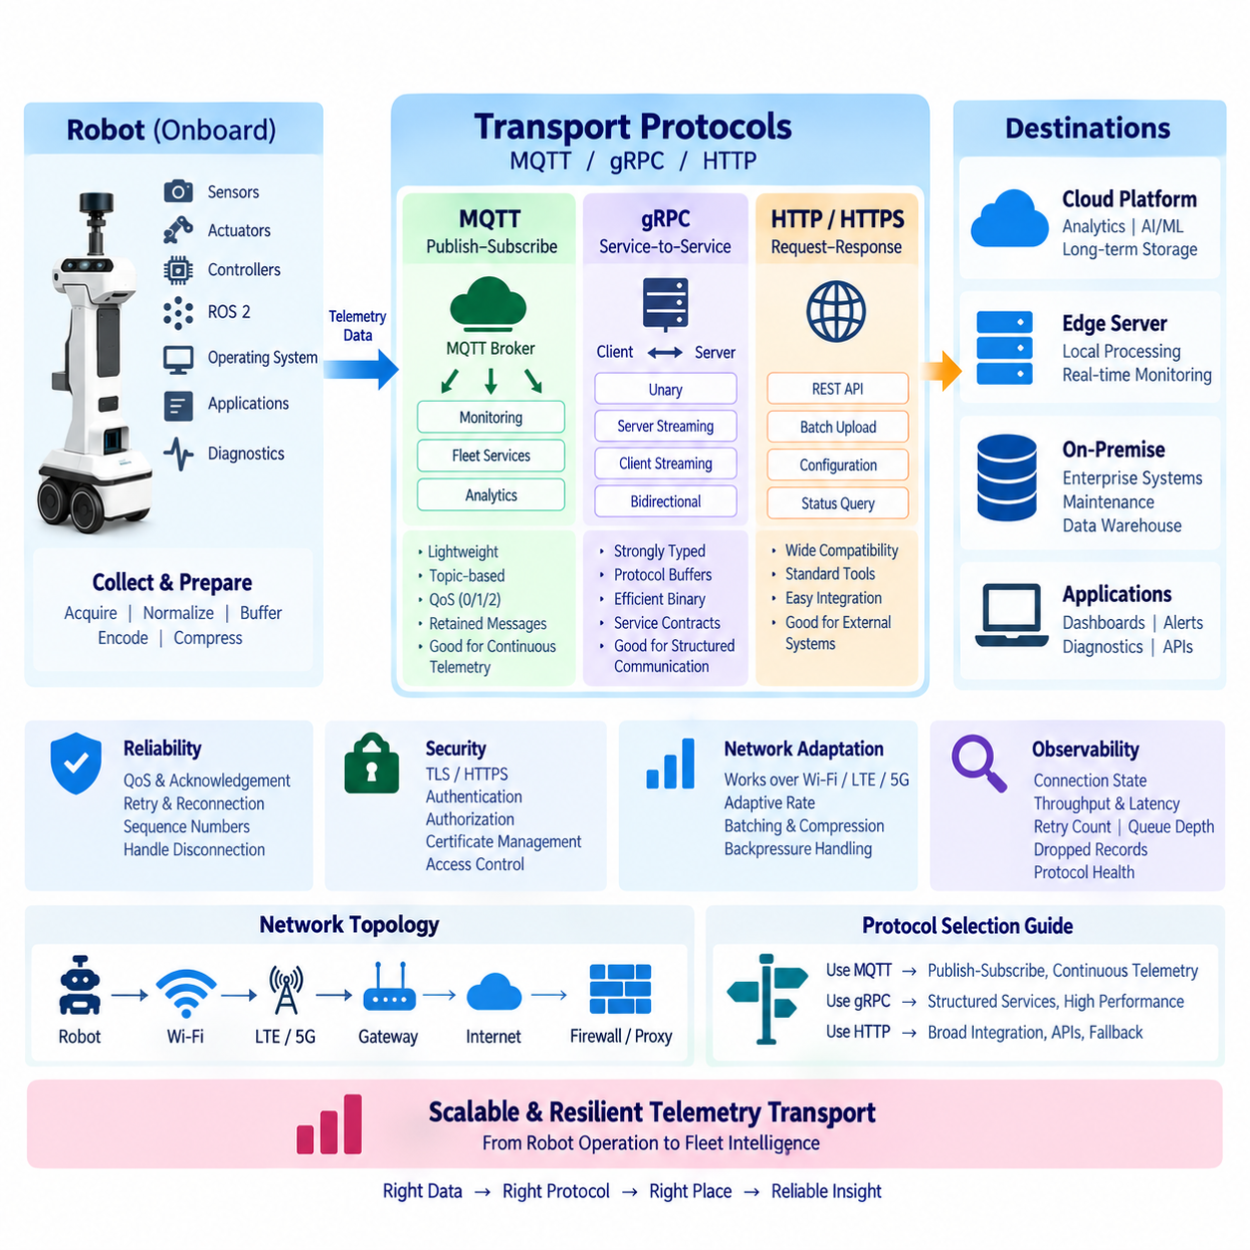
Robot telemetry transport protocols define how operational data moves from onboard collection agents to edge servers, fleet platforms, on-premise infrastructure, and cloud services. MQTT, gRPC, and HTTP represent three complementary communication approaches rather than interchangeable alternatives. Their suitability depends on telemetry frequency, message size, latency, connection stability, delivery requirements, integration environment, and available onboard computing resources.
The transport layer should remain separated from telemetry acquisition and internal data representation. Collectors acquire measurements, normalization creates consistent schemas, buffering protects data during communication interruptions, and transport adapters deliver prepared records through the selected protocol. This separation allows a robot to change from MQTT to gRPC or HTTP without redesigning sensor interfaces, diagnostic collectors, sampling policies, or the underlying telemetry data model.
MQTT is particularly suitable for lightweight, continuous telemetry from mobile robots because it follows a publish-subscribe model. A robot publishes messages to logical topics, while interested applications subscribe through an MQTT broker. The producer does not need direct knowledge of every consumer, allowing monitoring dashboards, fleet services, maintenance systems, and analytics applications to receive the same telemetry stream without tightly coupling themselves to the robot.
Topic design becomes an important architectural decision in MQTT deployments. Topics can represent fleet, robot, subsystem, and telemetry category, enabling consumers to subscribe at different levels of granularity. A fleet monitoring service may receive health information from every robot, while a diagnostic application subscribes only to a specific robot or subsystem. Topic structures should remain predictable and stable so routing logic does not become dependent on frequently changing application details.
MQTT provides Quality of Service levels that allow delivery behavior to be selected according to telemetry importance. Routine measurements may tolerate occasional loss and use lower-overhead delivery, while important diagnostic events can request stronger delivery guarantees. Higher reliability introduces additional acknowledgements, state management, and network traffic, so the highest delivery level should not automatically be applied to every message simply because it appears safer.
Persistent sessions, retained information, and broker-side capabilities can further improve MQTT-based robot operations, but they must be used intentionally. A newly connected monitoring application may need the latest robot state without waiting for the next periodic update, while historical telemetry should normally remain the responsibility of dedicated storage systems. The MQTT broker should primarily support communication and distribution rather than becoming an uncontrolled long-term telemetry database.
MQTT is also effective under variable wireless connectivity because its relatively small protocol overhead fits bandwidth-constrained Wi-Fi, LTE, and 5G environments. Combined with onboard buffering, a robot can temporarily retain messages while disconnected and resume transmission when communication returns. Nevertheless, application-level sequence numbers, timestamps, and deduplication logic remain valuable because transport-level delivery behavior alone does not guarantee a complete and perfectly ordered operational history.
gRPC provides a different communication model based on strongly defined remote procedure calls and service contracts. It commonly uses Protocol Buffers to define message structures and supports efficient binary serialization. For robotics systems that require structured interactions between robot, edge, and backend services, gRPC provides explicit interfaces, typed messages, generated client and server code, and efficient communication without the verbosity associated with many text-based API formats.
Unary gRPC calls resemble conventional request-response operations, while streaming modes support longer-lived communication. Server streaming can return a sequence of updates from one request, client streaming can send multiple telemetry records efficiently, and bidirectional streaming can maintain simultaneous data exchange between endpoints. These patterns make gRPC useful when telemetry transfer is closely integrated with configuration, diagnostics, command services, or edge processing workflows.
The strong interface definition of gRPC is valuable for large software systems because producers and consumers share explicit message contracts. Field identifiers, optional values, versioning practices, and compatibility rules can support controlled schema evolution as robot software changes. However, this strength also requires disciplined interface governance. Poorly managed service definitions can create dependencies between robot and backend releases, particularly when compatibility is not considered during API evolution.
gRPC is generally more appropriate when the communication relationship is service-oriented and relatively direct. A robot may connect to an edge ingestion service, a diagnostic client may request structured status information, or an edge application may stream processed telemetry to a central platform. Unlike MQTT's broker-mediated publish-subscribe model, gRPC naturally represents explicit client-server relationships, making the two protocols useful for different architectural interaction patterns.
HTTP remains highly relevant because it offers broad interoperability with enterprise systems, web services, cloud platforms, and existing IT infrastructure. REST-style HTTP APIs can accept telemetry batches, expose robot status, retrieve configuration, or integrate operational data with external business applications. Standard tooling, proxies, gateways, authentication mechanisms, and monitoring systems make HTTP particularly attractive when robotics data must cross organizational or application boundaries.
For continuous high-frequency telemetry, sending every individual measurement as a separate HTTP request can create excessive headers, connection overhead, and backend processing load. HTTP therefore becomes more efficient when records are aggregated into batches or when it is used for lower-frequency status updates, configuration exchanges, historical uploads, and integration APIs. Persistent connections and modern HTTP versions can reduce overhead, but message design remains important for resource-constrained robots.
HTTP is also valuable as a fallback or compatibility transport because network infrastructure commonly permits HTTPS traffic even when specialized ports or protocols are restricted. This can simplify deployment at customer sites with strict firewall and proxy policies. However, compatibility should not be confused with universal optimality. A protocol that passes easily through enterprise infrastructure may still be inefficient for high-rate telemetry if every measurement is wrapped in a large textual request.
The choice among MQTT, gRPC, and HTTP should therefore begin with communication semantics rather than protocol popularity. Publish-subscribe distribution naturally favors MQTT, strongly typed service-to-service communication favors gRPC, and broadly interoperable request-response integration favors HTTP. A mature robot architecture can use all three simultaneously, assigning each protocol to the communication pattern where its characteristics provide the greatest operational value.
For example, routine robot health and fleet telemetry can flow through MQTT, structured edge services can communicate through gRPC, and external enterprise applications can access selected information through HTTPS APIs. This hybrid transport architecture avoids forcing one protocol to solve every communication problem. The internal telemetry schema can remain consistent while transport adapters map the same logical information into different delivery mechanisms for different consumers.
Transport selection must also consider network topology. Indoor robots may communicate primarily through managed Wi-Fi to an on-premise broker or edge server, while outdoor robots may rely on LTE or 5G connections with changing latency and temporary disconnections. Direct cloud connectivity may be appropriate in some deployments, whereas regulated, private, or industrial environments may require all telemetry to terminate first at an on-premise gateway or local edge platform.
Latency requirements should be classified by operational purpose. Safety-critical control should generally remain onboard and should not depend on remote telemetry transport. Near-real-time monitoring may tolerate hundreds of milliseconds, while historical engineering data can tolerate substantially longer delays. By separating control, operational monitoring, diagnostic transfer, and bulk historical upload, the architecture can avoid imposing unnecessary real-time requirements on every telemetry message.
Reliability must similarly be designed according to data importance. Routine utilization metrics may tolerate occasional loss, whereas fault events, maintenance evidence, and safety-related state changes may require acknowledgement, persistent buffering, retransmission, or application-level confirmation. Sequence numbers and timestamps allow receivers to detect missing or duplicated information regardless of whether MQTT, gRPC, or HTTP is used as the underlying transport mechanism.
Backpressure is necessary when telemetry is generated faster than the network or receiver can process it. MQTT publishers may encounter broker or connection limitations, gRPC streams can experience slow consumers, and HTTP upload endpoints may respond slowly or become temporarily unavailable. The robot should respond by buffering, batching, reducing low-priority sampling, or applying aggregation rather than allowing transport congestion to consume unlimited memory or interfere with navigation and control workloads.
Security requirements apply consistently across all transport options. MQTT connections can be protected with TLS and broker authentication, gRPC commonly operates over secure HTTP/2 channels, and HTTP telemetry should normally use HTTPS. Mutual authentication, certificate management, authorization, credential rotation, and endpoint identity should be designed as fleet-level capabilities rather than configured manually and independently on every deployed robot.
Transport security must also enforce authorization at the appropriate granularity. A telemetry consumer should receive only the robot fleets, topics, services, or API resources it is permitted to access. MQTT topic authorization, gRPC service authorization, and HTTP API access control can implement this principle through different mechanisms. Sensitive diagnostic, location, customer, or operational information may require stronger policies than ordinary performance metrics.
Observability of the transport layer is essential for diagnosing communication problems. Useful measurements include connection state, publish or request rate, transmitted bytes, acknowledgement latency, retry count, timeout count, queue depth, dropped records, reconnect frequency, throughput, and compression ratio. These metrics help engineers distinguish robot failures from network degradation, broker overload, backend congestion, or transport configuration problems.
Protocol adapters should expose a common health model so higher-level monitoring does not require completely different logic for MQTT, gRPC, and HTTP. States such as connected, degraded, disconnected, buffering, retransmitting, and failed can provide a consistent operational view. This abstraction becomes particularly valuable when a fleet contains different robot generations or customer deployments that use different communication technologies.
Testing should reproduce realistic failure conditions rather than validating only successful laboratory communication. Engineers should examine packet loss, high latency, limited bandwidth, broker restarts, expired certificates, DNS failures, server overload, interrupted gRPC streams, HTTP timeouts, duplicate delivery, and long offline periods. Recovery behavior is as important as normal throughput because mobile robots routinely operate in networks that are less predictable than data-center connections.
Performance evaluation should measure end-to-end behavior using representative telemetry workloads. Message rate, payload size, serialization cost, CPU and memory consumption, network utilization, latency distribution, reconnection time, and backend ingestion capacity should be evaluated together. A protocol that performs well with small synthetic messages may behave differently when hundreds of robots simultaneously reconnect and attempt to upload buffered telemetry after a network outage.
Ultimately, MQTT, gRPC, and HTTP should be viewed as complementary building blocks within the broader robot telemetry architecture. MQTT provides efficient asynchronous distribution, gRPC provides structured high-performance service communication, and HTTP provides universal integration with web and enterprise systems. Combined with lightweight collection, efficient encoding, compression, buffering, retransmission, aggregation, and security, they create a resilient transport layer capable of supporting individual robots and large heterogeneous fleets.

03.05 Edge Buffering and Retransmission Mechanism [w/Code]
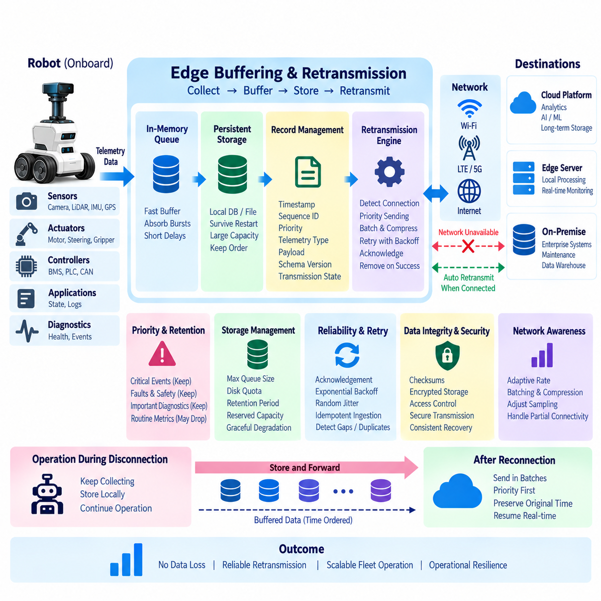
Edge buffering and retransmission provide the resilience required for robot telemetry when communication between the robot, edge infrastructure, and backend systems becomes unstable or temporarily unavailable. Mobile robots frequently operate across Wi-Fi, LTE, and 5G networks where coverage, bandwidth, and latency change continuously. The buffering layer therefore protects telemetry from transient connectivity failures while allowing robot operation to continue independently of remote infrastructure.
The fundamental principle is that telemetry generation and network transmission must be decoupled. Collection agents should continue acquiring important operational measurements even when an MQTT broker, gRPC service, HTTP endpoint, or network connection is unavailable. Instead of blocking collection or discarding data immediately, records are placed into a local buffer and transmitted asynchronously whenever communication resources become available.
A practical buffering architecture commonly uses multiple storage levels. A fast in-memory queue can absorb short transmission delays and temporary variations between collection and network throughput. When disconnection lasts longer or memory thresholds are reached, selected records can be transferred to persistent storage such as an embedded database, append-only file, or local disk queue. This prevents a process restart or power interruption from automatically destroying important buffered telemetry.
Each buffered record should preserve enough information to reconstruct the original operational sequence. A timestamp, robot identifier, message or sequence identifier, telemetry class, priority, payload, schema version, and transmission state can be maintained with the record. When data is retransmitted after an outage, the backend can distinguish when the measurement actually occurred from when it was eventually delivered, preventing delayed telemetry from being interpreted as current robot state.
Sequence numbers are especially useful for detecting gaps, duplicates, and ordering problems. A receiver can compare consecutive sequence values and determine whether telemetry is missing or has arrived more than once. Sequence tracking may operate globally, per robot, per subsystem, or per telemetry stream depending on scalability requirements. The selected scope should remain stable so that restart and reconnection behavior does not create ambiguous message histories.
Buffering policies should classify telemetry according to operational importance rather than treating every record equally. Emergency stops, safety faults, controller failures, critical battery conditions, and maintenance evidence may require persistent retention, while routine CPU utilization or repetitive environmental measurements may tolerate loss. Priority classes allow limited onboard storage to protect the information with the highest engineering and operational value.
When storage pressure increases, the system should degrade deliberately rather than fail unpredictably. Low-priority records can be downsampled, aggregated, expired, or removed before high-priority diagnostic information. Maximum queue sizes, disk quotas, retention periods, and reserved capacity for critical events should be defined explicitly. Such policies prevent telemetry buffering from consuming storage required by navigation maps, application software, sensor recordings, or other essential robot functions.
A store-and-forward mechanism extends buffering across longer communication outages. Telemetry is first stored locally with its original timing and ordering information and later forwarded when connectivity becomes available. This pattern is particularly important for outdoor robots that may leave cellular coverage and indoor AMRs that move through wireless dead zones. The robot remains operational while the data pipeline temporarily changes from real-time delivery to delayed delivery.
Connectivity recovery should not cause the entire buffered backlog to be transmitted without control. A robot reconnecting after a long outage may hold thousands or millions of records, and immediate full-rate retransmission can saturate the network or overload the backend. A controlled drain mechanism can limit retransmission bandwidth, send data in batches, and preserve capacity for newly generated real-time telemetry while historical records are gradually uploaded.
Priority-aware retransmission can ensure that important information arrives first after reconnection. Critical faults and safety events may be transmitted before routine historical metrics, even when they were generated later in the outage. At the same time, original timestamps and sequence information must remain intact so backend systems can reconstruct the true chronological history. Delivery priority and event chronology should therefore be treated as separate concepts.
Retransmission logic requires a clear acknowledgement model. A buffered record should not be permanently removed merely because transmission was attempted. Depending on the protocol, confirmation may come from an MQTT acknowledgement, successful gRPC response, HTTP success status, or application-level acknowledgement from the ingestion service. Records can remain in a pending state until the required confirmation is received and only then become eligible for deletion.
Retry behavior must avoid aggressive loops that waste network and computing resources. When a connection repeatedly fails, exponential backoff can progressively increase the delay between retry attempts, while random jitter prevents many robots from reconnecting simultaneously. Maximum retry intervals, connection timeouts, and recovery thresholds should be configurable according to the deployment environment and operational importance of the telemetry.
Exactly-once delivery is difficult to guarantee across distributed robot systems, particularly when acknowledgements can be lost even after the backend has successfully stored a message. A practical architecture often combines at-least-once transmission with idempotent ingestion. Unique message identifiers allow the backend to recognize repeated records and safely discard duplicates while preserving the stronger reliability provided by retransmission.
Data integrity must be protected throughout buffering and retransmission. Checksums, message authentication, database transactions, or append-only storage techniques can help detect corruption caused by incomplete writes, storage failures, or unexpected shutdowns. Persistent queues should recover into a known state after restart and identify records that were acknowledged, pending, partially written, or waiting for retransmission.
Compression and batching can extend buffer capacity and improve retransmission efficiency. Multiple telemetry records may be serialized into compact batches and compressed before being written to persistent storage or uploaded after reconnection. However, extremely large batches increase recovery cost when corruption or transmission failure occurs. Independently decodable chunks provide a practical compromise between compression efficiency, retransmission granularity, and fault isolation.
The buffering mechanism should cooperate with network-aware telemetry policies. When bandwidth decreases but connectivity remains available, the system may increase aggregation, compress more aggressively, reduce low-priority sampling, or postpone noncritical transfers before entering a fully disconnected state. This allows buffering to operate as part of a gradual adaptation strategy rather than only as an emergency response to complete network failure.
Fresh telemetry and historical backlog require separate handling because their operational meanings differ. Monitoring applications usually need the newest robot state with minimum delay, while engineering systems may require the complete historical record. A dual-queue or priority scheduling design can therefore reserve transport capacity for current telemetry while allocating remaining bandwidth to retransmission of buffered historical data.
Edge infrastructure can provide a second buffering tier beyond the robot itself. Robots may transmit telemetry reliably to a local edge gateway even when the site's connection to the cloud is unavailable. The gateway can aggregate data from multiple robots, maintain persistent queues, and forward records when upstream connectivity returns. This hierarchical buffering reduces onboard storage requirements and creates resilience across both robot-to-edge and edge-to-cloud communication paths.
In multi-robot deployments, edge buffering must prevent one robot from monopolizing shared resources. Per-robot quotas, stream priorities, fair scheduling, and maximum backlog limits can distribute storage and network capacity across the fleet. Critical events may still override ordinary fairness policies, but resource isolation prevents a malfunctioning or excessively verbose robot from exhausting the buffering infrastructure used by other robots.
Security must remain effective while telemetry is stored locally. Buffered records can contain diagnostic, location, operational, or customer-related information and should therefore be protected according to the same governance principles as transmitted telemetry. Access control, encrypted storage where appropriate, secure key management, and authenticated retransmission endpoints reduce the risk created by retaining operational data on robots or edge gateways.
Buffer lifecycle management should define when records are created, persisted, acknowledged, retransmitted, expired, and deleted. Retention cannot be based solely on available disk capacity because regulatory, engineering, and operational requirements may differ by telemetry category. Explicit lifecycle states also simplify recovery after software updates or unexpected shutdowns by allowing the system to determine which records still require delivery.
The buffering subsystem itself must be observable. Useful metrics include memory queue depth, persistent backlog size, oldest buffered record age, disk utilization, enqueue and dequeue rates, retry count, acknowledgement latency, retransmission throughput, dropped-record count, and current connectivity state. Alerts can be generated when backlog growth indicates that communication capacity is insufficient or when storage approaches configured safety thresholds.
Testing should reproduce realistic network failures rather than only verify normal operation. Important scenarios include short Wi-Fi interruptions, long cellular outages, repeated connection flapping, high latency, packet loss, backend overload, full disks, process restarts, power interruption, corrupted queue entries, and simultaneous fleet reconnection. Tests should confirm both successful data recovery and isolation of telemetry failures from navigation, perception, planning, and safety functions.
Recovery testing should also examine ordering and duplicate behavior. Engineers should verify that historical records retain their original timestamps, newly generated telemetry remains visible during backlog upload, acknowledged records are eventually removed, and repeated transmissions do not create duplicate operational events. Large outage backlogs should be tested to determine whether the system can recover without producing a second overload incident.
A mature edge buffering and retransmission mechanism therefore functions as a reliability boundary between robot operation and unreliable communication infrastructure. It combines memory queues, persistent storage, prioritization, acknowledgements, controlled retries, deduplication, compression, adaptive transmission, and lifecycle management to preserve important telemetry without allowing network failures to interfere with autonomous operation.
Within the broader telemetry architecture, this mechanism connects lightweight onboard collection, compression and encoding, MQTT/gRPC/HTTP transport, aggregation, time-series storage, anomaly detection, predictive maintenance, and unified observability. By preserving telemetry through temporary failures and delivering it safely after connectivity returns, edge buffering transforms intermittent mobile networks into a dependable operational data path from individual robots to fleet-level intelligence.

03.06 Telemetry Data Aggregation and Downsampling [w/Code]
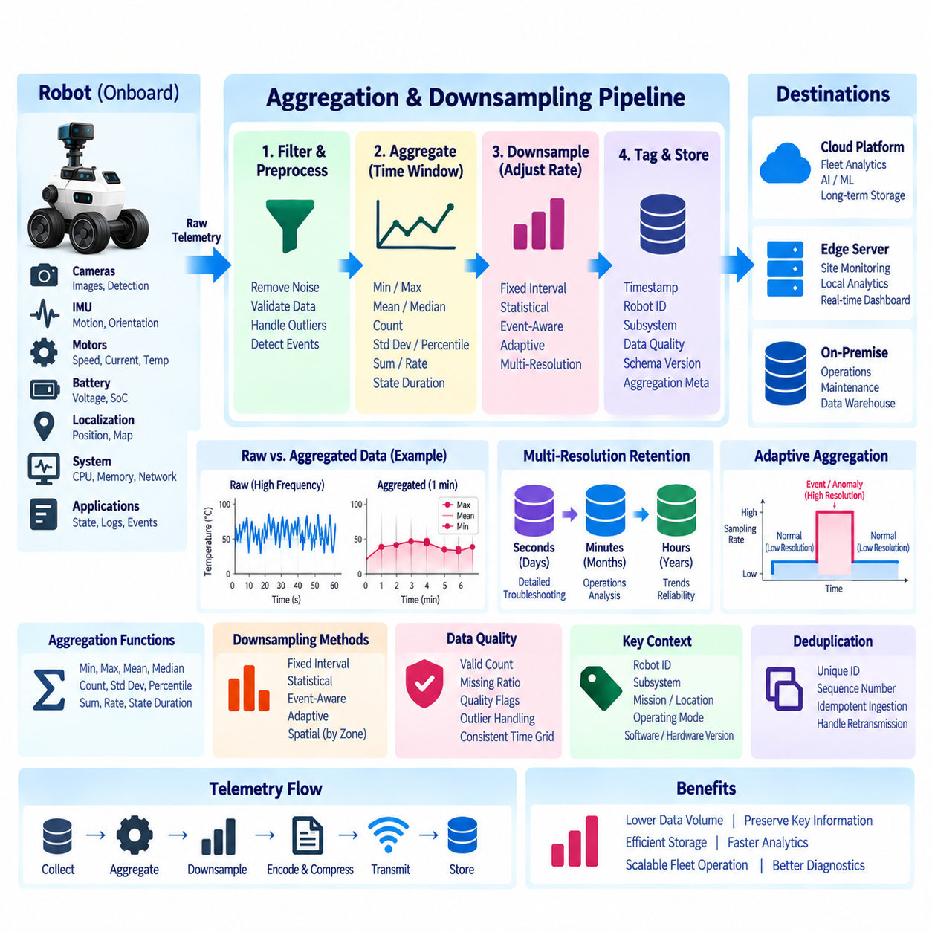
Telemetry data aggregation and downsampling reduce the volume of continuously generated robot measurements while preserving the information needed for operational monitoring, diagnostics, fleet analysis, and long-term engineering evaluation. High-frequency telemetry can rapidly create large datasets when hundreds of signals are collected across many robots. Aggregation converts detailed samples into meaningful summaries, while downsampling reduces temporal resolution according to analytical and retention requirements.
Aggregation and downsampling should be treated as controlled transformations rather than simple data deletion. The objective is to preserve operational meaning while reducing redundant information. Raw measurements may be required for short-term troubleshooting, whereas minute-level or hourly summaries can be sufficient for long-term trend analysis. A layered architecture can therefore maintain several resolutions of the same telemetry stream for different operational and engineering purposes.
Time-window aggregation is one of the most common approaches. Measurements collected during a defined interval can be summarized using minimum, maximum, mean, median, count, variance, standard deviation, percentile, or other statistical values. For example, hundreds of motor-temperature samples collected during one minute can be transformed into a compact record describing average temperature, peak temperature, variability, and the number of valid observations.
The appropriate aggregation function depends on the physical meaning of each signal. Average values can describe CPU utilization or temperature trends, while maximum values are more important for identifying thermal or electrical stress. Counters may require sums or rates, and categorical robot states may require duration or frequency calculations. Applying the same statistical function to every telemetry field can remove precisely the information that engineers need.
Downsampling reduces the number of temporal observations retained or transmitted. A high-rate stream collected at tens or hundreds of samples per second may be reduced to one representative record per second, minute, or hour. The downsampling interval should reflect how quickly the underlying phenomenon changes and how the resulting data will be used. Motor vibration, battery state, localization confidence, and CPU load naturally require different resolutions.
Simple interval sampling can select one observation from each time window, but this approach may miss important short-duration events. Statistical downsampling is generally safer because it preserves characteristics such as minimum, maximum, average, and variation within the interval. A temperature spike lasting only a few seconds could disappear from a simple one-minute sample, while a maximum-value field would preserve evidence that the abnormal condition occurred.
Event-aware downsampling provides additional protection for operationally significant information. Normal measurements can be aggressively reduced, while samples surrounding faults, warnings, emergency stops, localization failures, charging anomalies, or maintenance events are retained at higher resolution. This creates a variable-resolution telemetry history in which routine periods consume little storage but abnormal periods preserve detailed evidence for later diagnosis.
Adaptive aggregation can change resolution according to robot state. During normal operation, battery voltage or motor temperature may be summarized over relatively long intervals. When a threshold is approached, the aggregation window can become shorter and more detailed measurements can be retained. After conditions return to normal, the system can gradually resume its standard resolution. This approach aligns telemetry detail with operational risk.
Aggregation can occur at several locations in the telemetry pipeline. A lightweight onboard agent may perform basic filtering and short-window summaries before transmission. An edge gateway can aggregate data from multiple robots and create site-level metrics, while backend systems can generate longer-term hourly, daily, or monthly summaries. Distributing aggregation across these layers reduces network traffic while retaining centralized analytical capability.
Onboard aggregation must remain computationally lightweight because it shares resources with navigation, perception, planning, control, and AI inference. Simple rolling statistics, counters, thresholds, and fixed-window calculations are generally more appropriate than expensive analytical operations. More complex aggregation, correlation, and historical computation can be delegated to edge or backend infrastructure where processing and storage resources are less constrained.
Edge aggregation provides an intermediate layer between individual robots and centralized platforms. A local edge server can combine telemetry from multiple robots to calculate fleet availability, active mission count, charging utilization, network quality, or site-level fault statistics. This reduces the amount of detailed data that must leave the facility while still providing centralized systems with meaningful operational summaries.
Backend aggregation supports long-term analysis across larger fleets, sites, software versions, and robot generations. High-resolution telemetry may be retained temporarily, while derived datasets provide progressively lower resolutions for longer retention periods. For example, second-level records may be retained for several days, minute-level summaries for several months, and hourly or daily summaries for years, depending on engineering and business requirements.
This multi-resolution retention model allows recent failures to be investigated using detailed data while preserving historical trends without storing every original measurement indefinitely. Retention policies should specify which resolution exists at each age of the data. Automated lifecycle processing can progressively transform older telemetry into smaller representations before deleting raw records after their required diagnostic retention period has expired.
Aggregation must preserve important contextual dimensions. A summary should remain associated with robot ID, subsystem, mission, software version, hardware configuration, location or site, operating mode, and time interval where relevant. Combining measurements from incompatible contexts can produce misleading results. For example, energy consumption during charging should not automatically be aggregated with consumption during autonomous navigation without retaining the operational state.
Data quality information should also survive aggregation. A calculated average is unreliable if half of the expected samples were missing, delayed, or invalid. Aggregated records can therefore include expected sample count, received sample count, missing-data ratio, valid-data ratio, and quality flags. These fields allow downstream analytics to distinguish genuine physical trends from artifacts caused by sensor failures or communication interruptions.
Irregularly sampled telemetry requires special handling because a simple arithmetic average may overrepresent periods with more observations. Time-weighted aggregation can better represent signals that remain valid until the next measurement. Resampling onto a consistent time grid can also simplify comparison across robots, sensors, and missions. The selected method should reflect whether each signal represents an instantaneous measurement, accumulated quantity, or persistent state.
Counters and cumulative values require different processing from continuous measurements. Energy counters, traveled distance, operating hours, fault counts, and message totals may be aggregated using differences between interval boundaries rather than averages. Reset events and counter rollover must be detected so they are not interpreted as negative consumption or impossible operational changes. Signal semantics therefore need to be encoded in aggregation configuration.
Robot state information often requires duration-based aggregation. Instead of averaging values such as IDLE, RUNNING, CHARGING, or FAULT, the system can calculate how much time the robot spent in each state during a window. These summaries can support utilization analysis, mission efficiency, charging behavior, and reliability metrics. State-transition counts can additionally reveal unstable behavior such as repeated switching between operational modes.
Spatial aggregation can complement time-based aggregation for mobile robots. Telemetry may be grouped by map zone, facility area, route segment, or geographic grid to identify locations associated with communication degradation, repeated localization uncertainty, high energy consumption, or frequent obstacles. Spatial summaries become especially valuable when fleet operators need to distinguish robot-specific problems from environmental conditions affecting multiple robots.
Fleet-level aggregation transforms individual measurements into operational indicators. Robot availability, mission completion rate, average energy consumption, charging occupancy, fault frequency, network quality, and subsystem health can be summarized across groups of robots. Aggregation dimensions may include robot model, site, customer deployment, software release, mission type, or hardware revision, allowing engineers to compare behavior across the installed fleet.
Aggregation pipelines should avoid repeatedly calculating the same summaries when possible. Incremental aggregation can update existing windows as new telemetry arrives rather than rescanning large historical datasets. Streaming frameworks and time-series databases can maintain rolling windows, materialized summaries, or continuous aggregates. This reduces backend computation and allows dashboards to query precomputed metrics with predictable latency.
Late-arriving telemetry creates an additional challenge because buffered robot data may reach the backend after an aggregation window has apparently closed. Systems should distinguish event time from ingestion time and define how long a window remains open for delayed records. Depending on the application, historical aggregates may be corrected when late data arrives, or late records may be stored separately while finalized summaries remain unchanged.
Aggregation must also handle duplicated records produced by retransmission. If at-least-once delivery is used, the same measurement may arrive multiple times after connectivity recovery. Unique message identifiers, sequence numbers, or idempotent ingestion can prevent duplicates from inflating counts, averages, or fault frequencies. Deduplication should therefore occur before or as part of aggregation whenever retransmitted telemetry is expected.
Compression and aggregation address different forms of efficiency and work best together. Compression reduces the number of bytes required to represent data, while aggregation reduces the number of observations that must be represented at all. A telemetry pipeline may therefore filter unnecessary signals, aggregate high-rate measurements, encode the resulting records efficiently, compress batches, and then transmit or store them according to operational priority.
Aggregation policies should be configurable and versioned because analytical requirements change as robot systems evolve. Each signal can define its sampling rate, aggregation functions, window sizes, downsampling schedule, retention duration, quality rules, and exception conditions. Version-controlled policies allow engineers to understand how historical summaries were produced and prevent silent changes from making measurements across software releases incomparable.
The aggregation subsystem itself should expose operational metrics such as input record rate, output record rate, reduction ratio, processing latency, late-record count, invalid-record count, window completion delay, and storage savings. Monitoring these values helps determine whether downsampling is achieving the intended efficiency without creating excessive delay or information loss. Unexpected changes can also reveal upstream telemetry or configuration problems.
Validation should compare aggregated data against original high-resolution telemetry under representative operating scenarios. Engineers should verify that short anomalies remain detectable, averages and extrema are calculated correctly, missing data is represented honestly, and state durations match actual robot behavior. Fault injection and replay of recorded telemetry can help evaluate whether proposed downsampling policies preserve the evidence required for diagnostics and maintenance.
The overall objective is not simply to minimize telemetry volume, but to create the appropriate information resolution for each stage of the data lifecycle. Detailed recent data supports troubleshooting, medium-resolution data supports operational analysis, and compact long-term summaries support reliability studies, fleet optimization, predictive maintenance, and business intelligence. Aggregation and downsampling provide the mechanism for moving efficiently between these levels.
Within the broader telemetry architecture, aggregation and downsampling connect onboard collection, compression and encoding, MQTT/gRPC/HTTP transport, edge buffering, time-series storage, anomaly detection, predictive maintenance, and unified observability. By retaining high detail where it matters and reducing redundancy where it does not, the architecture can scale from individual robots to large fleets while preserving useful operational knowledge.

03.07 Telemetry Stream Real-Time Anomaly Detection [w/Code]
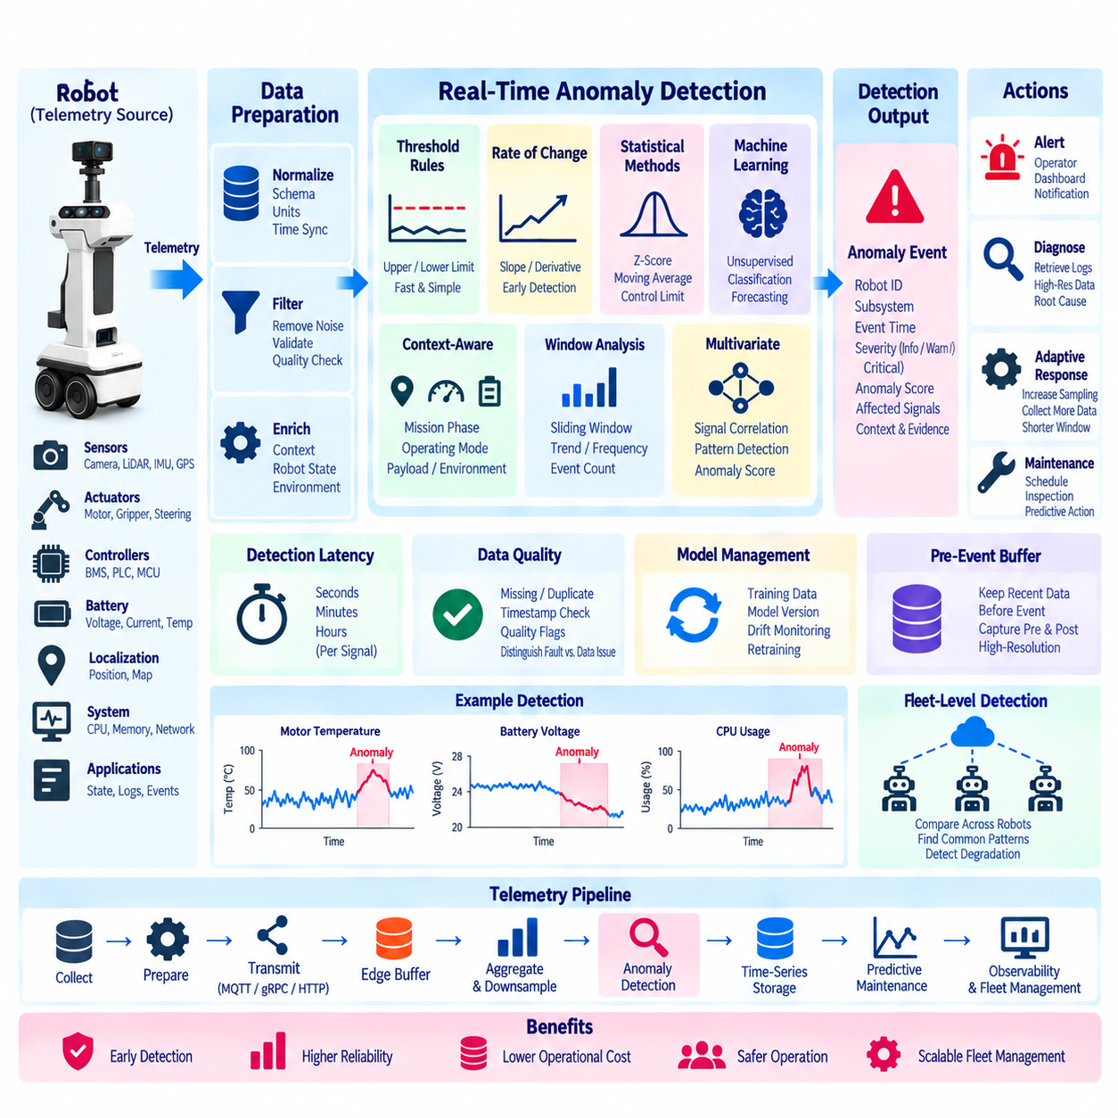
Real-time anomaly detection transforms continuous robot telemetry into an active operational intelligence layer capable of identifying abnormal behavior while the robot is still operating. Instead of waiting for engineers to inspect historical logs, telemetry streams from motors, batteries, localization, computing resources, networks, sensors, and applications can be evaluated continuously. The objective is early detection of conditions that may indicate degradation, failure, unsafe operation, or unexpected system behavior.
The anomaly-detection layer should operate downstream from telemetry collection and normalization so detection logic receives consistent, timestamped, quality-aware signals. Raw values from heterogeneous controllers and sensors should first be converted into common schemas, units, identifiers, and time references. This separation allows anomaly algorithms to focus on behavioral patterns rather than device-specific interfaces and makes the same detection framework reusable across different robot models and deployments.
Real-time detection does not mean that every telemetry signal requires microsecond-level processing. Detection latency should reflect the physical process and operational consequence of each signal. Motor overcurrent or rapid battery-temperature increase may require detection within seconds, while gradual storage degradation or long-term CPU utilization changes can tolerate longer windows. Defining appropriate latency classes prevents unnecessary computing load while preserving timely response to important conditions.
The simplest anomaly detectors are threshold-based rules. A measurement is considered abnormal when it exceeds a predefined upper or lower limit, such as excessive motor temperature, critically low battery voltage, high CPU temperature, or insufficient disk capacity. Threshold rules are computationally inexpensive, deterministic, and easy to explain, making them suitable for onboard or edge execution where predictable behavior and low processing overhead are important.
Static thresholds alone are insufficient when normal operating ranges depend on robot state. Motor current during acceleration differs naturally from current during idle operation, while battery voltage varies according to load and state of charge. Context-aware thresholds can therefore incorporate mission phase, velocity, payload, charging state, environmental condition, operating mode, or subsystem state. The same numerical value may be normal in one context and anomalous in another.
Rate-of-change detection can identify problems before an absolute threshold is crossed. A rapidly increasing motor temperature, sudden battery-voltage drop, escalating localization error, or accelerating memory consumption may indicate an emerging problem even though the current value remains within its nominal range. Monitoring derivatives, slopes, moving differences, and short-term trends enables earlier recognition of developing faults.
Statistical anomaly detection compares current telemetry with recent or historical behavior. Moving averages, standard deviations, z-scores, interquartile ranges, exponentially weighted statistics, and control limits can characterize expected variation. A measurement that deviates substantially from its recent distribution can then be flagged. These methods adapt better than fixed thresholds to signals whose normal values change gradually during operation.
Window-based analysis provides context across multiple observations rather than evaluating each sample independently. Sliding or tumbling windows can calculate average, maximum, variance, trend, frequency, or event count over a defined interval. Repeated localization resets, increasing communication retries, or intermittent current spikes may become obvious at the window level even when no individual measurement appears sufficiently abnormal.
Multivariate detection becomes important when failures are expressed through relationships among several signals. Motor current may appear normal by itself, but high current combined with low velocity and increasing temperature can indicate mechanical resistance. Likewise, rising CPU load combined with memory growth and processing latency may indicate software degradation. Multivariate models can identify abnormal relationships that independent single-signal thresholds cannot detect.
Machine-learning models can extend detection beyond manually defined rules when sufficient representative telemetry is available. Isolation Forest, one-class classification, clustering, autoencoders, forecasting models, and other techniques can learn patterns associated with normal operation and identify deviations. The appropriate model depends on available labels, signal dimensionality, computational resources, explainability requirements, and the expected characteristics of abnormal behavior.
Unsupervised and semi-supervised methods are particularly useful because robot fleets usually generate far more normal data than accurately labeled failure examples. A model can learn the distribution or representation of normal behavior and calculate an anomaly score for new observations. However, unusual behavior is not automatically a fault. Maintenance operations, unusual payloads, new routes, software updates, or environmental changes can legitimately create patterns that differ from historical data.
Anomaly scores should therefore be combined with context and persistence logic before generating operational alerts. A single unusual sample may represent noise, while repeated abnormal scores over several windows provide stronger evidence. Hysteresis, debounce intervals, minimum-duration rules, confidence thresholds, and multi-signal confirmation can reduce unnecessary alarms. This is important because excessive false alerts can cause operators to ignore the monitoring system.
Data quality must be evaluated before anomaly inference. Missing samples, duplicated records, delayed telemetry, corrupted measurements, clock errors, sensor disconnection, and communication outages can produce patterns that resemble equipment faults. Quality flags, expected sampling rates, sequence numbers, and timestamp checks should accompany detection logic so the system can distinguish an actual physical anomaly from a telemetry pipeline problem whenever possible.
Event time and ingestion time must also remain separate. Buffered telemetry may arrive after network recovery and should not be interpreted as a new real-time anomaly merely because it has just reached the backend. Detection systems should use the original measurement timestamp when reconstructing historical behavior. Current operational alerts should normally be generated from sufficiently fresh telemetry, while delayed records can still contribute to retrospective analysis.
The location of anomaly detection should reflect latency, computing cost, connectivity, and privacy requirements. Lightweight threshold and trend detectors can operate directly onboard for rapid local awareness. Edge servers can perform more complex multi-signal and multi-robot analysis with low network latency, while backend platforms can execute computationally intensive models and compare behavior across large fleets, sites, software versions, and long historical periods.
A hierarchical architecture can combine these levels effectively. The robot can detect immediate local abnormalities, the edge layer can correlate events across nearby robots, and the backend can identify fleet-wide patterns or slowly developing degradation. Detection results can move upward as compact events instead of requiring every high-frequency raw signal to be transmitted continuously, reducing bandwidth while retaining operational awareness.
Real-time anomaly detection should remain separated from safety-critical control unless the detector has been specifically engineered and validated as part of the safety function. A telemetry anomaly may trigger an alert, request additional data collection, initiate diagnostics, or recommend inspection, but it should not automatically replace certified protection mechanisms. Emergency stopping and fundamental safety behavior should remain governed by the robot's dedicated safety architecture.
An anomaly event should contain enough information for later interpretation. Useful fields include robot ID, subsystem, detection time, original event time, anomaly type, severity, affected signals, observed values, expected range, anomaly score, model or rule version, operating context, and supporting evidence. Structured events allow dashboards, maintenance systems, incident workflows, and historical analytics to process anomalies consistently.
Severity classification helps separate informational deviations from conditions requiring immediate attention. A minor anomaly may simply increase monitoring frequency, while a persistent warning may trigger maintenance review. A critical anomaly can be escalated rapidly to operators or diagnostic services. Severity should consider magnitude, duration, subsystem importance, confidence, and operational context rather than relying only on the numerical anomaly score.
Detection can dynamically modify telemetry collection. When an anomaly is identified, the system may temporarily increase sampling frequency, retain raw measurements, activate additional diagnostic signals, shorten aggregation windows, or preserve pre-event and post-event data. This event-driven high-resolution capture provides engineers with detailed evidence surrounding abnormal behavior without requiring maximum-resolution telemetry to be stored continuously.
Pre-event buffering is particularly valuable because the cause of a failure often begins before the alert threshold is reached. A rolling memory buffer can retain several seconds or minutes of recent high-resolution telemetry. When an anomaly occurs, the buffer is frozen or copied together with post-event data. Engineers can then examine the transition from normal operation to abnormal behavior instead of seeing only measurements collected after detection.
Anomaly detection can also support predictive maintenance by converting repeated weak deviations into degradation indicators. Gradual increases in motor current, vibration, thermal load, charging time, localization instability, or computation latency may not trigger immediate fault thresholds. Tracking anomaly frequency, duration, severity, and trend over longer periods can reveal deterioration that warrants inspection before functional failure occurs.
Fleet-level comparison provides another source of detection intelligence. Robots with similar hardware, software, missions, and operating environments can establish peer baselines. If one robot consistently consumes more energy, experiences more localization uncertainty, or operates at higher motor temperatures than comparable units, the deviation may indicate a developing issue. Peer comparison should control for payload, route, environment, configuration, and usage differences.
Model lifecycle management becomes necessary when machine-learning-based detection is deployed. Training datasets, feature definitions, thresholds, model versions, validation results, and deployment history should be traceable. Software updates, hardware revisions, seasonal changes, and new operating environments can alter normal telemetry distributions. Models therefore require monitoring for drift and controlled retraining rather than being treated as permanently valid after initial deployment.
Explainability is important for engineering acceptance. Operators need to understand why an alert was generated and which measurements contributed to it. Rule-based detectors are naturally interpretable, while statistical and machine-learning models should expose relevant features, deviations, confidence, or reconstruction errors where practical. An anomaly system that produces unexplained scores without supporting evidence is difficult to trust during maintenance and incident investigation.
The anomaly-detection subsystem itself must be observable. Useful metrics include processed record rate, detection latency, anomaly count, alert rate, false-positive feedback, missing-data rate, model inference time, queue depth, feature-generation latency, and detector availability. Monitoring these metrics helps determine whether the detection service is functioning correctly and whether changes in alert behavior originate from robots, data pipelines, or the detection system itself.
Validation should use historical replay, controlled fault injection, simulated degradation, and representative field data. Engineers should measure detection delay, false-positive rate, missed-event rate, precision, recall, and computational cost while examining whether important anomalies remain detectable after telemetry aggregation or downsampling. Testing should also include communication failures, delayed data, duplicated records, sensor faults, and software restarts.
The overall objective is to transform telemetry from passive monitoring data into an active mechanism for recognizing abnormal robot behavior early and consistently. Effective real-time anomaly detection combines deterministic rules, statistical analysis, contextual reasoning, multi-signal correlation, and machine learning according to the characteristics of each subsystem. The result is earlier awareness without imposing unnecessary computational or communication overhead.
Within the broader telemetry architecture, real-time anomaly detection connects collection agents, compression and encoding, MQTT/gRPC/HTTP transport, edge buffering, aggregation and downsampling, time-series storage, predictive maintenance, and unified observability. By continuously converting telemetry streams into contextual anomaly events, the architecture enables operators and engineering systems to move from simply observing robot status toward detecting, diagnosing, and managing emerging operational problems.

03.08 Telemetry-Based Predictive Maintenance (PdM) Design
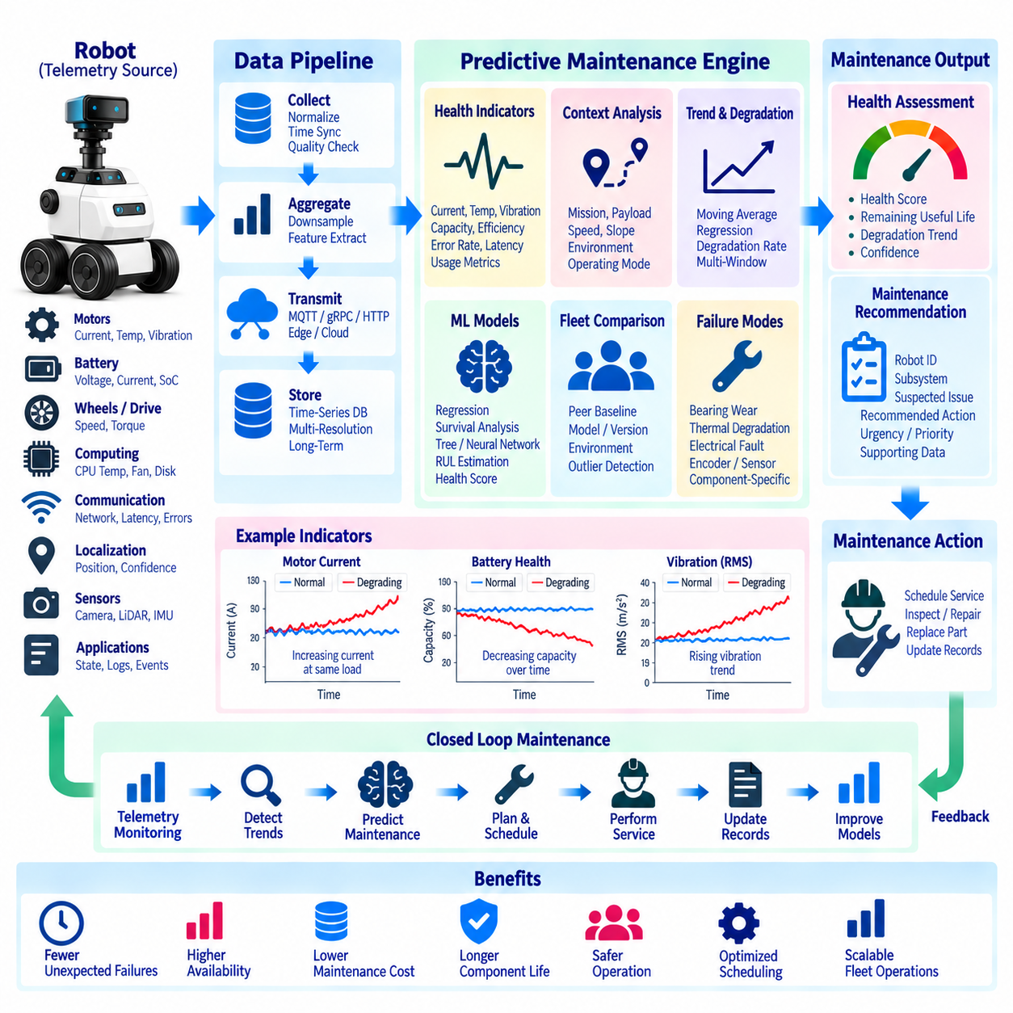
Telemetry-based predictive maintenance uses continuous operational data to estimate equipment degradation before functional failure occurs. Instead of servicing robots only at fixed intervals or after faults, predictive maintenance evaluates trends in motors, batteries, drives, wheels, sensors, computing hardware, communication systems, and other subsystems. The objective is to identify developing deterioration early enough to plan inspection, repair, or replacement without unnecessary downtime.
Predictive maintenance differs from conventional preventive maintenance because maintenance decisions are driven by observed equipment condition rather than primarily by calendar time or operating hours. Two identical robots may experience different degradation because of payload, route, temperature, floor condition, mission frequency, charging behavior, or operator environment. Telemetry provides the evidence needed to adapt maintenance decisions to the actual usage history of each robot.
A predictive-maintenance architecture begins with selecting telemetry signals that have a meaningful relationship with component health. Motor current, temperature, vibration, torque, wheel speed, battery voltage, current, state of charge, charging time, CPU temperature, fan speed, network errors, localization confidence, and controller faults may provide useful indicators. Collecting every available signal is less valuable than identifying measurements that can reveal specific degradation mechanisms.
Health indicators transform raw telemetry into interpretable measures of component condition. Increasing motor current at comparable speed and payload may indicate mechanical resistance, while rising vibration can suggest bearing or wheel degradation. Increasing battery internal resistance, reduced usable capacity, longer charging duration, or abnormal thermal behavior may indicate battery aging. Health indicators should therefore connect measurable telemetry patterns with plausible physical or software degradation processes.
Operating context must accompany health measurements because component behavior changes naturally with workload and environment. Motor temperature should be interpreted together with velocity, payload, slope, ambient temperature, and mission duration. Battery consumption depends on route, acceleration, payload, and auxiliary power usage. Context normalization prevents normal differences in operating conditions from being incorrectly interpreted as deterioration.
Trend analysis is fundamental to predictive maintenance because many failures develop gradually. Moving averages, exponentially weighted statistics, regression slopes, degradation rates, cumulative operating hours, and rolling distributions can reveal changes that are difficult to recognize from individual samples. The important question is often not whether a measurement is currently abnormal, but whether its baseline is moving consistently toward an undesirable condition.
Real-time anomaly detection and predictive maintenance should cooperate but serve different purposes. Anomaly detection identifies behavior that is unusual now, while predictive maintenance evaluates whether repeated anomalies or long-term trends indicate future maintenance needs. A short temperature spike may create an anomaly event without implying degradation, whereas a gradual increase in normal operating temperature across several weeks may provide stronger maintenance evidence.
Feature engineering converts telemetry into variables suitable for health assessment and prediction. Useful features can include mean, maximum, variance, rate of change, operating-state duration, event frequency, temperature rise relative to ambient conditions, energy consumed per distance, motor current per unit load, charging efficiency, or localization failure frequency. Features should be physically interpretable whenever possible so maintenance engineers can understand why health estimates are changing.
Time-window features can represent behavior over multiple temporal scales. Short windows capture immediate stress, while daily or weekly windows reveal gradual deterioration. A maintenance model may combine recent high-resolution features with longer-term historical summaries. Multi-resolution telemetry therefore allows predictive maintenance to preserve detailed evidence near abnormal events while using compact aggregated data for long-term degradation analysis.
Usage-based normalization is particularly important for mobile robots because accumulated calendar time alone does not describe mechanical stress. Distance traveled, number of missions, payload-distance, turning frequency, acceleration cycles, charging cycles, slope exposure, and operating hours can provide more meaningful usage measures. Component degradation can then be compared against actual workload rather than assuming that every robot ages at the same rate.
Fleet-level baselines improve health assessment by comparing similar robots under comparable conditions. Robots of the same model, hardware revision, software release, mission type, and operating environment can establish expected ranges for energy efficiency, temperature, vibration, fault frequency, and other indicators. A robot that gradually diverges from its peer group may require inspection even when no fixed threshold has yet been exceeded.
Predictive models can range from simple engineering rules to machine-learning algorithms. Threshold trends and linear degradation models are transparent and easy to validate, while regression, survival analysis, tree-based models, neural networks, and sequence models can capture more complex relationships. Model complexity should be justified by measurable improvement because maintenance decisions require reliability, traceability, and understandable evidence rather than prediction accuracy alone.
Remaining useful life estimation attempts to predict how much usable operating time remains before a component reaches a defined maintenance or failure condition. RUL can be expressed in operating hours, missions, distance, charging cycles, or calendar time depending on the component. The estimate should include uncertainty because degradation rates change with operating conditions and future workload cannot usually be known exactly.
Health scores provide a simpler alternative when precise remaining useful life cannot be estimated reliably. A subsystem can be represented by a normalized health index derived from several telemetry indicators. The score may describe states such as healthy, degrading, inspection recommended, or maintenance required. The underlying measurements and reasons for score changes should remain accessible so the health index does not become an unexplained maintenance decision.
Maintenance prediction should consider failure modes separately because a single component can degrade in multiple ways. A drive motor may experience bearing wear, thermal degradation, electrical problems, encoder faults, or mechanical loading issues, each producing different telemetry patterns. Failure-mode-oriented models make predictions easier to interpret and allow the system to recommend appropriate diagnostic procedures rather than generating only a generic health warning.
Data quality directly affects maintenance predictions. Missing telemetry, sensor drift, calibration errors, duplicated records, delayed uploads, software changes, or incorrect timestamps can appear as degradation trends. Predictive pipelines should therefore incorporate quality flags, completeness metrics, calibration information, and schema versions. Maintenance recommendations should be suppressed or marked with lower confidence when the supporting telemetry is unreliable.
Maintenance labels are often difficult to obtain because actual failures are relatively rare and service records may not precisely identify the failed component or root cause. Work orders, replacement records, technician findings, fault codes, inspection results, and warranty data should therefore be connected with telemetry whenever possible. These maintenance outcomes provide the ground truth needed to validate whether detected degradation patterns actually correspond to physical problems.
The feedback loop between maintenance activity and telemetry is essential. When a wheel, motor, battery, sensor, or computing module is repaired or replaced, the system should record the maintenance event and establish a new health baseline where appropriate. If telemetry returns to normal after service, that evidence can strengthen the relationship between the detected pattern and the diagnosed failure mode.
Predictive maintenance should produce actionable outputs rather than only analytical scores. A maintenance event can include robot ID, subsystem, suspected degradation mode, health score, trend, confidence, supporting signals, recommended inspection, urgency, and relevant telemetry history. These structured outputs can be integrated with fleet-management systems, maintenance dashboards, work-order systems, spare-parts planning, and technician workflows.
Maintenance priority should combine predicted condition with operational importance. A moderate degradation signal on a mission-critical robot may require earlier intervention than a similar condition on a redundant unit. Priority can consider health state, predicted failure horizon, mission schedule, robot availability, spare units, technician availability, parts inventory, and service location. Predictive maintenance therefore connects technical health assessment with operational planning.
Maintenance scheduling should balance failure risk against the cost of unnecessary intervention. Replacing components too early wastes useful life and increases service cost, while waiting too long increases the probability of breakdown and unplanned downtime. Condition-based thresholds and prediction confidence can support maintenance windows that align with planned charging periods, low-demand hours, scheduled inspections, or other opportunities to minimize operational disruption.
Edge processing can support predictive maintenance when immediate local health assessment is valuable or cloud connectivity is limited. Lightweight feature extraction and health rules can run onboard or on a local edge server, while more computationally intensive fleet comparisons and model training remain in backend infrastructure. This hierarchical approach reduces bandwidth requirements and allows basic health monitoring to continue during network interruptions.
Long-term storage is necessary because degradation may develop over weeks, months, or thousands of operating cycles. High-resolution raw telemetry does not need to be retained indefinitely if meaningful health features and aggregated summaries are preserved. A multi-resolution retention strategy can keep detailed recent data, event-centered diagnostic records, and compact long-term health histories while controlling storage cost.
Model lifecycle management is required when predictive models are deployed across evolving robot fleets. Hardware revisions, firmware updates, control-software changes, new battery suppliers, different tires, and modified missions can change telemetry distributions and degradation relationships. Training datasets, feature versions, model versions, thresholds, validation results, and deployment history should therefore remain traceable throughout the system lifecycle.
Prediction performance should be evaluated using maintenance-oriented metrics rather than generic machine-learning accuracy alone. Important measures include early-warning time, missed-failure rate, false-maintenance recommendation rate, RUL error, precision, recall, prediction stability, and operational downtime avoided. Evaluation should also determine whether the warning arrives early enough for technicians, spare parts, and maintenance windows to be arranged.
Validation should include historical failure replay, controlled degradation tests, fault injection where safe, accelerated lifecycle testing, and comparison with technician findings. Models should be evaluated across different robots, environments, payloads, routes, and software versions. A model that performs well on one deployment may not generalize to another if environmental and operational conditions differ substantially.
The predictive-maintenance subsystem itself should be observable. Useful metrics include feature-processing latency, health-score distribution, prediction frequency, model inference time, data completeness, number of active maintenance warnings, model drift indicators, recommendation acceptance, and maintenance outcomes. Monitoring these measures helps engineers determine whether changes originate from robot health, telemetry quality, model behavior, or maintenance processes.
A mature predictive-maintenance design ultimately creates a closed loop from telemetry to maintenance action and back to verified operational evidence. Robot data is collected, normalized, aggregated, analyzed for anomalies and degradation, converted into health assessments, and translated into maintenance decisions. Service results then return to the data platform, improving future rules, models, thresholds, and engineering understanding.
Within the broader telemetry architecture, predictive maintenance connects onboard collection, compression and encoding, MQTT/gRPC/HTTP transport, edge buffering, aggregation and downsampling, real-time anomaly detection, time-series storage, maintenance records, and unified observability. By converting long-term telemetry patterns into condition-based maintenance intelligence, the architecture can reduce unexpected failures, improve robot availability, optimize component life, and support scalable fleet operations.

03.09 OpenTelemetry-Based Unified Observability Architecture [w/Code]
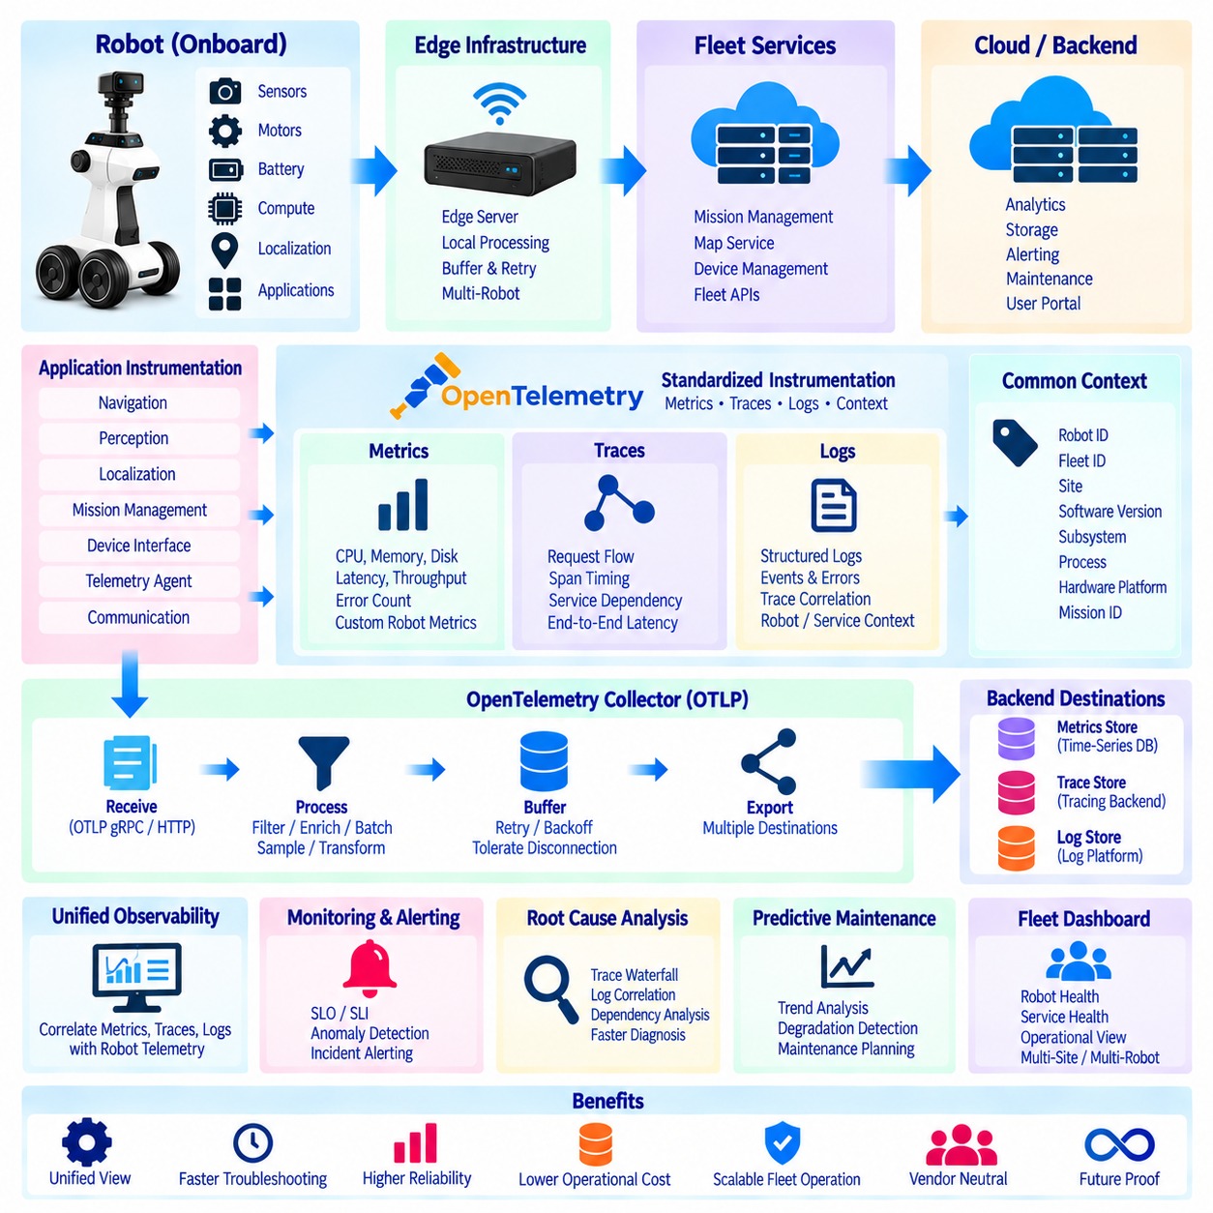
OpenTelemetry-based unified observability provides a common architecture for understanding robot software behavior across onboard computers, edge infrastructure, fleet services, and backend platforms. Instead of monitoring application logs, system metrics, communication traces, and robot events through separate mechanisms, OpenTelemetry provides standardized instrumentation and telemetry pipelines. This creates a consistent operational view across distributed robotic systems while reducing dependence on vendor-specific monitoring interfaces.
Unified observability should distinguish operational telemetry from observability telemetry while allowing them to complement each other. Robot telemetry describes physical and mission behavior such as battery state, motor temperature, localization quality, and velocity, whereas observability data describes software and infrastructure behavior. Metrics, logs, traces, and contextual events can therefore be correlated with robot state to explain not only what happened physically but also which software or service behavior contributed to it.
OpenTelemetry provides a vendor-neutral framework for generating, collecting, processing, and exporting observability data. Applications can use standardized APIs and software development kits to create metrics, traces, and logs without being tightly coupled to a specific backend. Export destinations can later change while much of the instrumentation remains unchanged. This separation is valuable for robot platforms expected to operate across different customers, cloud environments, and fleet-management infrastructures.
A unified architecture normally begins with instrumentation inside robot applications and services. Navigation, perception, localization, mission management, device interfaces, telemetry agents, and communication services can expose relevant measurements through OpenTelemetry instrumentation. Common resource attributes such as robot ID, fleet ID, site, software version, subsystem, process, and hardware platform provide the context needed to correlate observations originating from many distributed components.
Metrics represent numerical measurements that change over time. Useful observability metrics include CPU utilization, memory consumption, disk usage, queue depth, message rate, processing latency, dropped frames, inference time, network retries, RPC duration, and service error counts. Robot-domain metrics can also be exposed when appropriate, but naming and semantic conventions should clearly distinguish software infrastructure measurements from physical operational telemetry.
Distributed traces describe how requests or operations propagate through multiple components. A mission command may pass from a fleet server to an edge gateway, robot mission manager, navigation service, planner, and controller. Trace identifiers and span relationships allow engineers to reconstruct this execution path and measure latency at each stage. This becomes particularly useful when a delay appears at the robot level but the actual cause exists in an upstream service.
Spans should represent meaningful operations rather than every low-level function call. Examples include mission assignment, route calculation, map retrieval, localization initialization, AI inference, telemetry upload, charging request, or remote command execution. Each span can contain timing information, status, attributes, and related events. Excessive instrumentation creates overhead and large observability datasets, so span granularity should reflect diagnostic value.
Logs remain essential because they contain detailed descriptions of discrete software events. OpenTelemetry can associate structured logs with trace and resource context, allowing a log message to be connected with the robot, service, process, request, and software version that produced it. Structured fields are preferable to unstructured text because they enable reliable filtering, correlation, aggregation, and automated analysis across large robot fleets.
Correlation is the central value of unified observability. A localization failure can be examined together with CPU saturation, sensor-processing latency, network delay, application errors, and the trace of the active mission operation. Shared timestamps, robot identifiers, trace IDs, span IDs, and consistent metadata allow previously isolated signals to be analyzed as one operational timeline. This substantially reduces the effort required to reconstruct complex incidents.
The OpenTelemetry Collector can provide a common processing layer between instrumentation and observability backends. Collectors can receive telemetry using OpenTelemetry Protocol, process records, batch data, filter unnecessary attributes, enrich metadata, sample traces, and export data to one or more destinations. This architecture prevents every robot application from implementing separate integrations for each monitoring or analytics platform.
Collector deployment can follow a hierarchical model. A lightweight collector or agent may operate on the robot, while a more capable collector runs on an edge server or backend infrastructure. The robot-level component can perform local batching and filtering, the edge collector can aggregate site-level observability, and the backend collector can route information toward long-term storage and analytical systems. This hierarchy aligns well with distributed robot architectures.
The OpenTelemetry Protocol, commonly called OTLP, provides a standardized mechanism for transferring metrics, traces, and logs. OTLP can operate over gRPC or HTTP depending on deployment requirements. Standardized transport reduces custom integration effort and allows common collector infrastructure to receive observability data from heterogeneous robot applications. Network reliability and resource constraints should still be considered when configuring export intervals and batch sizes.
Observability pipelines must tolerate intermittent connectivity because mobile robots cannot assume continuous backend access. OpenTelemetry exporters and collectors should therefore cooperate with local buffering, retry, batching, and backoff mechanisms. Critical diagnostic information may require persistent retention, while low-value high-frequency metrics can tolerate controlled loss. Observability transport should never block navigation, perception, control, or safety-critical robot functions.
Sampling is particularly important for distributed traces because recording every operation across a large fleet can generate excessive data. Head-based sampling can decide whether to retain a trace when it begins, while tail-based sampling can make decisions after observing the completed trace. Tail sampling can preserve traces containing errors, excessive latency, or unusual conditions while discarding a portion of routine successful operations.
Metrics require careful control of label and attribute cardinality. Attributes such as robot model, software version, site, and subsystem are useful dimensions, but identifiers with extremely high variability can create excessive time-series counts. Mission IDs, request IDs, map coordinates, or arbitrary error strings should not automatically become metric labels. High-cardinality information is often better preserved in traces or structured logs.
Semantic conventions improve consistency across robot software teams. Standard names, units, attribute definitions, and resource conventions should be established for common concepts such as robot identity, subsystem, mission state, software version, site, device type, and communication interface. Domain-specific conventions can extend OpenTelemetry standards while maintaining compatibility with general infrastructure observability practices.
Time synchronization is fundamental when correlating data across robots, edge servers, and backend services. NTP, PTP, GNSS-derived timing, or other synchronization mechanisms can reduce timestamp inconsistencies. Accurate clocks allow engineers to align a physical telemetry anomaly with software logs and distributed traces. Systems should also record clock quality or synchronization status where timing accuracy is important for diagnosis.
Observability data should support multiple backend technologies rather than requiring one fixed platform. Metrics may be stored in a time-series monitoring system, traces in a distributed tracing backend, and logs in a searchable log platform. OpenTelemetry collectors can route the standardized data to appropriate destinations while dashboards and analytical tools provide a unified operational view above these specialized storage systems.
Service-level indicators can be derived from observability data to measure the reliability of robot software services. Mission-command latency, navigation-request success rate, telemetry delivery delay, map-service availability, inference latency, or fleet API error rate can become measurable indicators. Service-level objectives can then define acceptable operating targets and provide a systematic basis for detecting software reliability degradation.
Robot-level health and service-level health should be correlated rather than monitored independently. A robot may appear mechanically healthy while its mission service experiences repeated timeouts, or backend services may appear healthy while a particular robot suffers sensor-processing overload. Unified dashboards should therefore combine infrastructure metrics, software traces, application logs, anomaly events, and selected robot telemetry to provide operational context.
Observability can also support root-cause analysis by preserving relationships among symptoms. A mission delay may originate from network congestion, database latency, map-service slowdown, overloaded onboard computing, or planner instability. Trace waterfalls, correlated logs, metrics, and robot events allow engineers to follow the dependency chain instead of diagnosing each subsystem independently. This is especially important in distributed autonomous systems where failures propagate across boundaries.
Alerting should be based on meaningful operational conditions rather than every isolated metric deviation. Alerts can combine service errors, latency thresholds, resource saturation, anomaly events, and persistence rules. Correlated alerts reduce noise by grouping symptoms associated with the same incident. Severity and routing can then reflect whether the issue affects one process, one robot, one site, or the entire fleet.
Security and privacy requirements apply to observability data because logs and traces may contain customer identifiers, locations, commands, configuration values, or diagnostic details. Sensitive fields should be filtered or transformed before export where necessary. Authentication, encrypted transport, access control, retention policies, and audit mechanisms should protect observability pipelines without interfering with the real-time operation of robots.
Observability architecture must control resource overhead on the robot. Instrumentation consumes CPU, memory, network bandwidth, and storage, so collection frequency, trace sampling, log level, batch size, and export interval should be configurable. The monitoring system should never become a source of operational instability. Resource budgets can define maximum acceptable observability overhead for different robot computing platforms.
Dynamic configuration can adjust observability detail according to operational conditions. Normal operation may use moderate metric frequency and sampled traces, while an active incident can temporarily enable detailed logs, higher-frequency metrics, or additional traces. This adaptive observability approach preserves diagnostic depth when needed without continuously paying the computational and storage cost of maximum instrumentation.
Software versioning and deployment metadata should be included in observability context. When a new release causes increased CPU usage, navigation latency, or error frequency, engineers should be able to compare behavior across versions and deployment groups. Hardware revision, firmware version, model version, and configuration profile can provide additional dimensions for identifying regressions that affect only particular robot configurations.
The observability platform itself must also be observable. Collector queue depth, export failures, dropped records, processing latency, memory usage, sampling rate, backend availability, and ingestion throughput should be monitored. Otherwise, missing observability data may incorrectly appear to indicate healthy robot operation. Pipeline health metrics allow engineers to distinguish actual system silence from failures in the monitoring infrastructure.
Validation should include service failures, network interruptions, collector restarts, backend outages, clock drift, high-cardinality inputs, log bursts, trace overload, and robot reconnection. Engineers should verify that important diagnostic context survives failures, resource limits remain acceptable, and the observability pipeline recovers without disrupting autonomous operation. Cross-service traces should also be checked to confirm that context propagation remains intact.
A mature OpenTelemetry-based architecture creates a common diagnostic language across robot software, edge systems, and cloud services. Metrics describe system condition, traces reveal execution paths, logs provide detailed event evidence, and robot telemetry supplies physical context. Standardized identifiers and metadata connect these signals into a coherent operational model that can be queried from individual processes to fleet-wide services.
Within the broader telemetry architecture, unified observability connects onboard collection, MQTT/gRPC/HTTP communication, edge buffering, aggregation and downsampling, anomaly detection, predictive maintenance, time-series storage, logs, traces, metrics, and operational dashboards. OpenTelemetry provides the standardized instrumentation and transport foundation that allows these distributed signals to be correlated, enabling scalable monitoring, faster diagnosis, and consistent operational understanding across the complete robot fleet.

03.10 Fleet Telemetry Dashboard Configuration Case [w/Code]
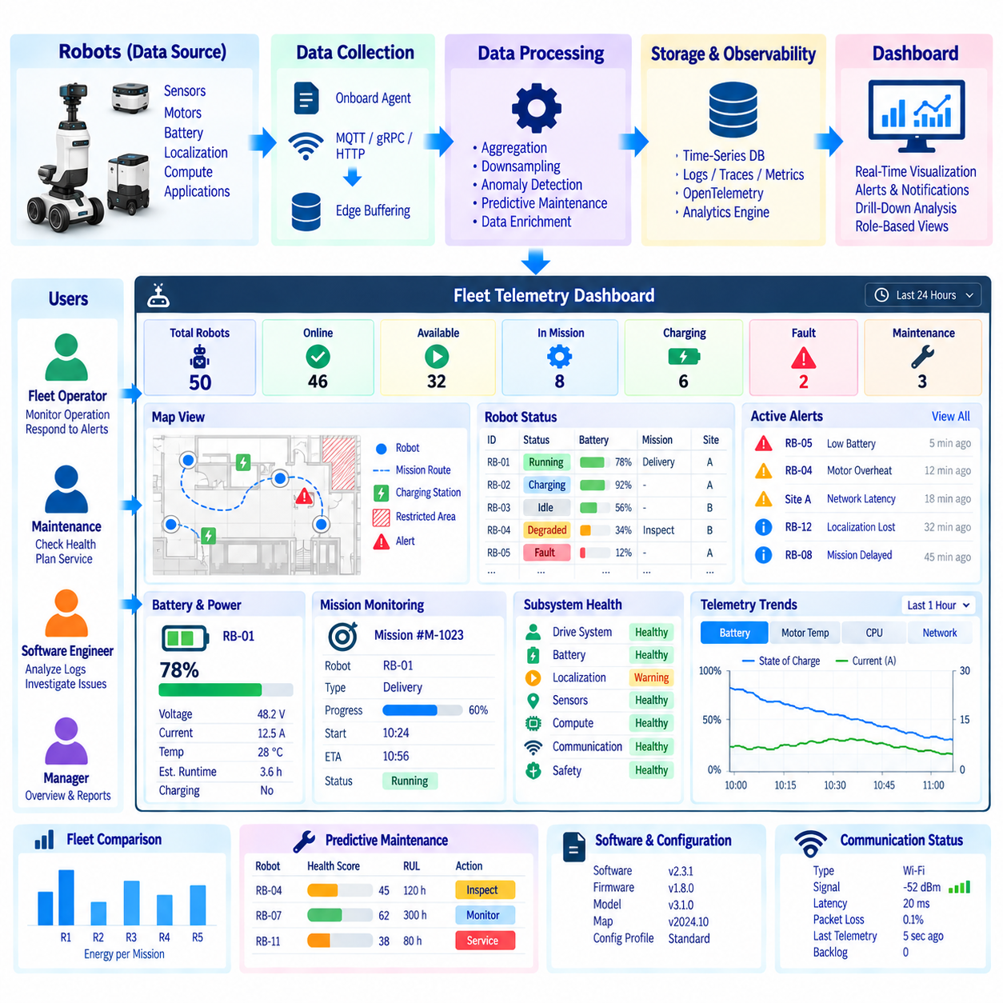
A fleet telemetry dashboard should convert continuous robot data into a concise operational view that allows operators, engineers, and maintenance teams to understand fleet condition without inspecting individual telemetry streams. The dashboard should emphasize actionable information such as robot availability, mission status, battery condition, subsystem health, communication quality, active anomalies, and maintenance warnings while preserving access to detailed data when deeper investigation is required.
A practical dashboard architecture begins by separating fleet-level awareness from robot-level diagnosis. The first view should answer whether the fleet is operating normally, how many robots are available, executing missions, charging, idle, degraded, or offline, and whether critical events require attention. Operators can then drill down from fleet summaries into a site, robot, subsystem, signal, or event without losing the operational context that triggered the investigation.
The dashboard data pipeline should consume normalized telemetry rather than directly processing heterogeneous raw device messages. Onboard collection agents acquire measurements, transport mechanisms deliver them through MQTT, gRPC, or HTTP, and edge buffering protects data during connectivity interruptions. Aggregation, downsampling, anomaly detection, and predictive-maintenance services then produce operational metrics that can be queried efficiently by visualization and alerting components.
A fleet overview should present a small number of key performance indicators that describe current operational condition. Useful indicators include total robots, online robots, available robots, active missions, mission completion rate, charging robots, faulted robots, active critical alerts, and robots requiring maintenance. These values should be calculated using clearly defined states so that different dashboards and backend services interpret fleet availability consistently.
Robot status should use a controlled state model rather than arbitrary application text. States such as RUNNING, IDLE, CHARGING, MAINTENANCE, DEGRADED, FAULT, and OFFLINE can provide a common operational vocabulary. State transitions should include timestamps and reasons where possible, allowing the dashboard to show both current condition and recent operational history. Ambiguous states should be avoided because they make fleet-level aggregation unreliable.
Site and map views are particularly useful for mobile robot fleets. Robot position, mission route, charging station, restricted area, communication quality, and active incident locations can be displayed on an indoor map or geographic view. Position information should be updated at a rate appropriate for human monitoring rather than at the full localization frequency, reducing network and visualization load without noticeably reducing operational usefulness.
Battery visualization should combine current charge state with operational context. State of charge, voltage, current, temperature, charging status, estimated remaining operating time, charging duration, and battery-health indicators can be displayed together. A low battery level is not necessarily abnormal when a robot is returning to charge, while unexpectedly rapid discharge during a normal mission may require investigation. Context prevents simple threshold displays from creating unnecessary alarms.
Mission monitoring should connect robot health with task execution. The dashboard can show mission identifier, assigned robot, mission type, current phase, start time, elapsed time, progress, destination, estimated completion, and failure state. Mission latency and repeated retries can reveal operational problems even when the robot itself remains online. Linking mission events with telemetry makes it easier to determine whether delays originate from planning, navigation, traffic, hardware, or infrastructure.
Subsystem panels provide a structured view of robot health. Drive systems, battery, localization, sensors, computing, communication, safety interfaces, and applications can each expose a summarized condition such as healthy, warning, degraded, or fault. Selecting a subsystem can reveal supporting measurements and recent events. This hierarchy prevents operators from being overwhelmed by hundreds of raw signals while retaining diagnostic depth for engineering users.
Time-series panels remain essential for detailed investigation. Motor current, temperature, battery voltage, CPU utilization, localization confidence, network latency, or other measurements can be plotted over selectable time windows. Operators should be able to compare related signals on synchronized timelines because relationships between measurements often provide more information than isolated charts. Event markers can indicate faults, software updates, mission transitions, or maintenance actions.
Aggregation and downsampling policies should match dashboard purpose. Fleet overview panels may require only minute-level summaries, while incident investigation may require second-level or higher-resolution telemetry. The visualization layer should request the appropriate resolution for the selected time range rather than retrieving maximum-resolution data for every query. This improves dashboard responsiveness and reduces unnecessary backend processing and network traffic.
Real-time anomaly events should appear as structured operational information rather than unexplained warning symbols. Each event can include robot ID, subsystem, detection time, severity, anomaly type, affected signal, observed value, expected range, and confidence. Selecting the event should expose supporting telemetry and related logs or traces where available. This allows operators to understand why the system generated the alert instead of treating anomaly detection as a black box.
Alert severity should be visually consistent across the dashboard. Informational, warning, major, and critical conditions can be represented through standardized status indicators, but color should not be the only method of communication. Text, icons, labels, and severity values improve accessibility and reduce ambiguity. Critical alerts should remain visible until acknowledged or resolved according to operational policy, while transient informational events can expire automatically.
Alert grouping is important in large fleets because one underlying failure can produce many secondary symptoms. A network outage may simultaneously make several robots appear offline, interrupt telemetry, delay missions, and trigger service errors. Correlation logic should group related symptoms into an incident where possible. The dashboard can then show the probable shared context rather than presenting dozens of independent alerts that overwhelm the operator.
Predictive-maintenance information should be integrated without dominating real-time operations. Health scores, degradation trends, remaining useful life estimates, repeated anomaly counts, and recommended inspections can be presented in a dedicated maintenance view. Robots approaching maintenance conditions can be ranked by urgency, while supporting trends remain accessible. Maintenance warnings should clearly distinguish predicted degradation from confirmed faults.
Communication status deserves dedicated visibility because fleet monitoring itself depends on connectivity. Wi-Fi, LTE, 5G, or Ethernet state, signal quality, latency, packet loss, retry count, last telemetry time, and buffered backlog can help distinguish robot failures from network problems. When a robot becomes temporarily disconnected, the dashboard should indicate the last known state and data freshness rather than presenting stale telemetry as if it were current.
Data freshness should be visible wherever current state is displayed. A timestamp or age indicator can show how recently each robot or panel was updated. Backend systems should define thresholds for fresh, delayed, stale, and offline data. This is particularly important when edge buffering and retransmission are used because historical records may arrive after reconnection and must not be mistaken for current operational status.
Fleet comparison views can reveal robots that behave differently from their peers. Energy consumption per mission, average motor temperature, localization failure frequency, mission duration, charging time, network quality, and anomaly rate can be compared across robots with similar configurations. Filtering by model, hardware revision, software version, site, mission type, or operating period prevents misleading comparisons between robots working under substantially different conditions.
Software and configuration information should be visible during diagnosis. Robot software version, firmware version, AI model version, hardware revision, map version, configuration profile, and recent deployment time can explain sudden behavioral changes. Fleet-level views can identify robots running outdated or inconsistent configurations, while incident analysis can determine whether a problem began shortly after a particular software deployment.
OpenTelemetry observability data can enrich the dashboard beyond physical robot telemetry. CPU and memory metrics, service error counts, distributed traces, structured logs, queue depths, and RPC latency can be correlated with mission and robot events. A navigation slowdown can therefore be investigated together with planner latency, onboard CPU saturation, communication delay, and related application logs from the same operational period.
Dashboard navigation should support progressive drill-down. An operator may begin with the complete fleet, select a site with abnormal conditions, identify an affected robot, open a subsystem, and finally inspect a specific telemetry signal or trace. Filters for time, site, robot model, status, software version, mission type, and severity should remain consistent across views so users can move between summaries and detailed diagnostics efficiently.
Role-based views can reduce unnecessary complexity. Fleet operators primarily need availability, missions, alerts, locations, and immediate actions, while maintenance personnel require degradation trends and service history. Software engineers may need logs, traces, processing latency, and resource utilization. A common data platform can support these different views without forcing every user to navigate the same highly technical dashboard.
Dashboard queries should be designed for scalability. Precomputed fleet metrics, continuous aggregates, time-series indexes, cached summaries, and appropriate retention tiers reduce the cost of repeatedly scanning high-resolution telemetry. Large time ranges should automatically use lower-resolution datasets, while recent incident windows can access detailed records. This allows dashboard performance to remain predictable as the number of robots and retained data grows.
Access control should reflect organizational responsibilities and deployment boundaries. Users may be authorized for particular customers, sites, fleets, robots, or maintenance functions. Sensitive location, operational, diagnostic, and customer information should only be displayed to permitted roles. Authentication, authorization, encrypted communication, audit records, and session controls should protect dashboard access without preventing operators from responding quickly to incidents.
Dashboard availability should not become a dependency for autonomous robot operation. Robots must continue navigation, mission execution, local safety behavior, and essential control even when visualization services are unavailable. The dashboard is an operational supervision and diagnostic interface rather than a fundamental control loop. Commands initiated from the dashboard should pass through authenticated, validated service interfaces rather than directly manipulating robot processes.
The dashboard itself should expose health metrics such as query latency, data-source availability, ingestion delay, rendering failures, alert-processing delay, and last successful update. If a backend data source becomes unavailable, the interface should communicate that limitation explicitly. Otherwise, an empty graph or missing robot may be incorrectly interpreted as evidence that no event occurred or that the robot is operating normally.
A representative fleet-dashboard case can combine a top-level fleet summary, robot status table, map view, active alert panel, mission monitor, battery and subsystem health panels, maintenance forecast, and synchronized telemetry trends. These components should share common filters and identifiers so selecting a robot or incident updates related views. The objective is one coherent operational workspace rather than a collection of unrelated charts.
Validation should use realistic fleet scenarios including robot faults, communication outages, charging events, delayed telemetry, retransmitted records, software deployments, maintenance warnings, site-level network failures, and simultaneous incidents. Operators should be able to identify the affected scope, determine data freshness, locate supporting evidence, and navigate to the appropriate diagnostic detail without requiring direct database or log access.
Dashboard effectiveness should be evaluated through operational outcomes rather than visual appearance alone. Useful measures include time to detect an incident, time to identify the affected robot, time to determine probable cause, alert acknowledgement time, dashboard query latency, false-alert burden, and operator navigation effort. Feedback from operators, maintenance engineers, and software teams should guide continuous refinement of views and information hierarchy.
A mature fleet telemetry dashboard therefore acts as the operational presentation layer above the complete robot data architecture. It converts telemetry, aggregated metrics, anomaly events, predictive-maintenance indicators, logs, traces, and fleet context into a unified view while preserving drill-down access to supporting evidence. The dashboard helps teams move efficiently from fleet awareness to incident detection, diagnosis, maintenance planning, and operational improvement.
Within the broader telemetry architecture, the fleet dashboard integrates onboard collection, compression and encoding, MQTT/gRPC/HTTP transport, edge buffering, aggregation and downsampling, real-time anomaly detection, predictive maintenance, time-series storage, and OpenTelemetry-based observability. By presenting these capabilities through a consistent operational interface, the dashboard transforms distributed robot data into actionable fleet intelligence for scalable monitoring and engineering.

