Volume 07 Robot Data Architecture

09. Data Governance

09.01 Robot Data Governance Framework Overview
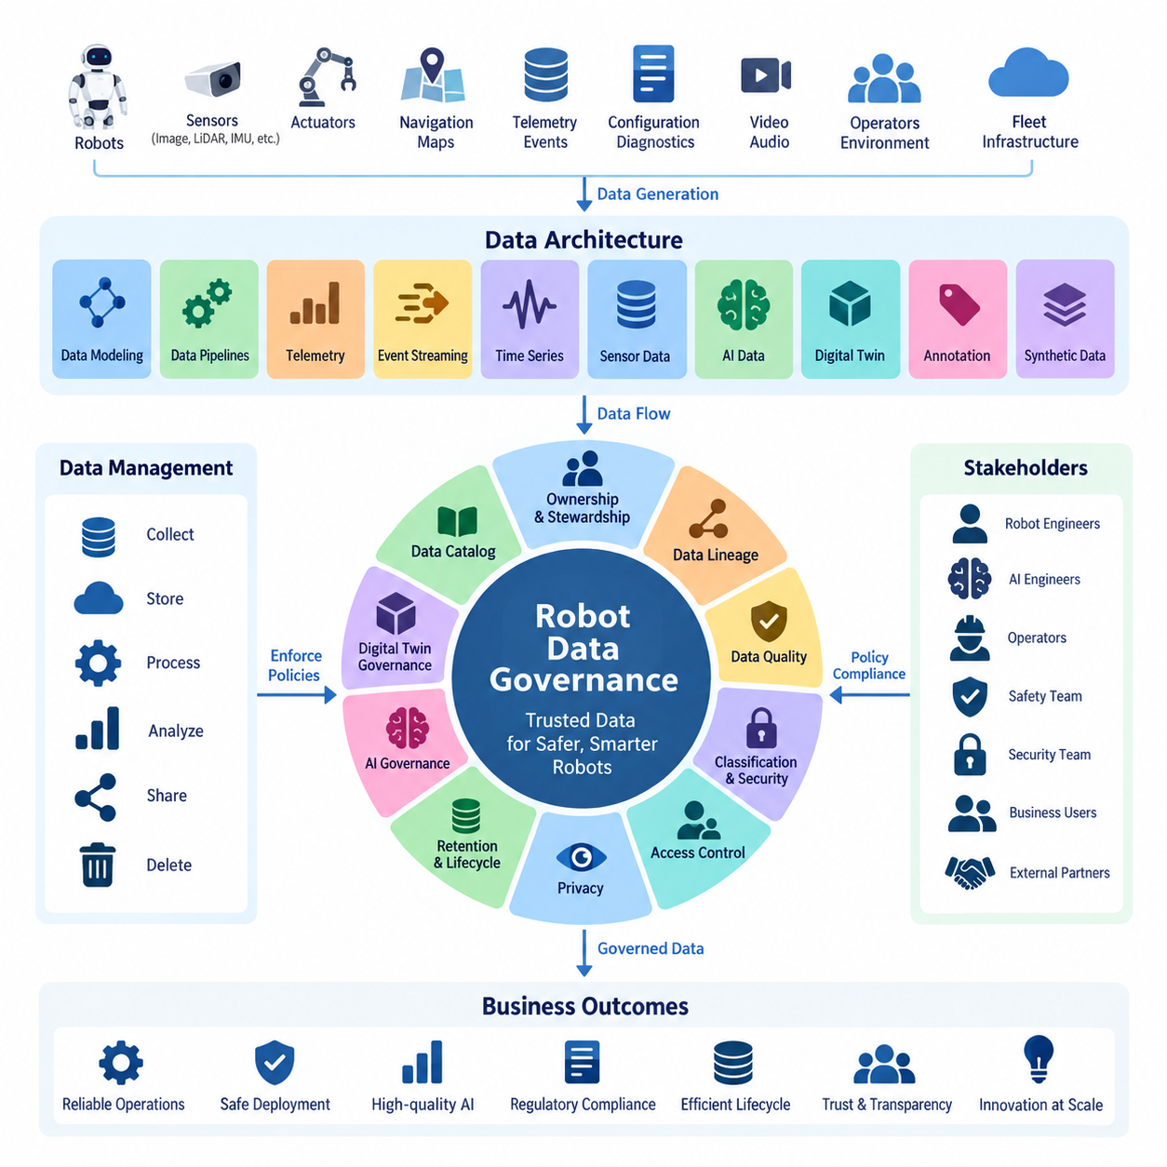
Robot data governance establishes the organizational, technical, and operational rules that determine how data generated by robots is identified, collected, classified, stored, accessed, transformed, shared, retained, and deleted throughout its lifecycle. Unlike conventional enterprise data, robot data continuously originates from physical interactions involving sensors, actuators, navigation systems, AI models, operators, environments, and fleet infrastructure. Governance therefore must connect information management with real-world robot operations.
A robot data governance framework should cover the complete data architecture rather than operate as an isolated administrative layer. The architecture described in this volume includes data modeling, pipelines, telemetry, event streaming, time-series information, sensor data, AI datasets, digital twins, annotation, synthetic data, and operational case studies. Governance provides common policies and accountability across these domains so that independently developed pipelines remain compatible, traceable, secure, and manageable.
The framework begins by defining clear ownership and stewardship. Data ownership identifies the organization or business function accountable for a dataset, while data stewardship assigns responsibility for maintaining its quality, metadata, classification, accessibility, and lifecycle rules. Technical custodians operate storage platforms and pipelines, while robot engineers, AI engineers, safety teams, security teams, and business users become producers or consumers governed by explicitly defined responsibilities.
Robot data should be treated as a collection of distinct data domains rather than as one homogeneous resource. Telemetry, images, video, point clouds, IMU measurements, localization information, maps, diagnostic events, configuration records, mission histories, AI annotations, digital-twin states, and synthetic datasets have different rates, sizes, sensitivity levels, retention requirements, and operational value. Governance policies therefore need domain-specific controls under a common enterprise framework.
A fundamental governance mechanism is a data catalog that provides a searchable inventory of available data assets. Catalog entries should describe dataset names, owners, schemas, source robots, sensor types, timestamps, physical units, storage locations, classifications, retention policies, and permitted uses. The chapter structure subsequently introduces Apache Atlas and DataHub as technologies for implementing such catalog capabilities, connecting governance concepts with practical metadata management infrastructure.
Metadata alone is insufficient when robot information passes through complex processing chains. Data lineage records how information moves from its original source through collection agents, message brokers, transformations, databases, feature pipelines, annotation systems, training datasets, and AI models. A lineage graph makes it possible to determine which robot, sensor, software version, transformation process, and dataset contributed to a particular analytical result or trained model, supporting reproducibility and root-cause investigation.
Data quality governance defines measurable expectations for whether robot information is trustworthy enough for its intended purpose. Important dimensions include completeness, validity, consistency, accuracy, timestamp integrity, synchronization, freshness, and uniqueness. Sensor pipelines may additionally monitor missing frames, corrupted packets, calibration status, outliers, and synchronization errors. These requirements can be expressed through data-quality service-level agreements and continuously evaluated as part of automated pipelines.
Governance must also distinguish data according to sensitivity and operational impact. Public documentation, ordinary operational telemetry, proprietary engineering information, personally identifiable information, safety-related records, credentials, maps of restricted facilities, and security-sensitive robot configurations should not receive identical protection. Classification policies establish protection levels and connect them to encryption, authentication, authorization, logging, network controls, sharing restrictions, and approved storage environments.
Access governance converts these classifications into enforceable permissions. Role-based access control can assign privileges according to functions such as robot operator, maintenance engineer, data engineer, AI researcher, fleet administrator, security administrator, or external partner. The objective is to provide sufficient access for legitimate work while limiting unnecessary exposure. Access decisions should be auditable, periodically reviewed, and consistently applied across onboard computers, edge infrastructure, on-premise systems, cloud platforms, and data repositories.
Privacy becomes particularly important because mobile robots may observe people and environments that were never created specifically as datasets. RGB cameras can capture faces and documents, microphones can record conversations, localization records may reveal movement patterns, and service robots can operate in hospitals, offices, factories, or public spaces. Governance therefore needs policies for collection purpose, minimization, masking, anonymization, permitted reuse, transfer, retention, and deletion, aligned with applicable privacy requirements.
Retention governance determines how long each category of robot information remains available and what happens when its useful or legally required lifetime ends. High-rate raw sensor streams may require short retention because of their storage cost, while selected incident records, aggregated telemetry, maintenance histories, validated training datasets, or safety evidence may need substantially longer preservation. Automated lifecycle rules can migrate information between storage tiers and ultimately trigger controlled deletion according to policy.
AI introduces an additional governance dimension because training data directly influences robot behavior. Training datasets should preserve provenance, annotation history, transformation records, version identifiers, quality results, licensing information, and relationships to trained models. Governance should also examine representativeness, inappropriate content, collection conditions, annotation bias, and authorized purposes. These records allow organizations to reconstruct why a particular model behaves differently across environments, robot types, or operating conditions.
Digital-twin data further expands the governance boundary by maintaining representations of physical robots and fleets. The preceding chapter includes robot digital-twin models, real-to-digital synchronization, time-series storage, simulation-to-real loops, predictive maintenance, and fleet aggregation. Governance must preserve the identity and temporal relationship between physical assets and their digital representations so that stale, simulated, estimated, and directly measured states are not accidentally treated as equivalent information.
Governance should be embedded into the data platform rather than implemented only through documents and manual approvals. Schema validation, catalog registration, lineage capture, quality checks, access enforcement, encryption, retention execution, deletion workflows, and audit logging can become automated controls inside ingestion and processing pipelines. This approach turns governance from a periodic compliance activity into continuous operational behavior that accompanies data from the robot through edge, server, cloud, analytics, and AI environments.
The governance framework ultimately operates as a control plane above the robot data lifecycle. Policies define what should happen; metadata identifies what data exists; ownership establishes accountability; lineage explains where information came from; quality controls determine whether it can be trusted; security and privacy controls determine who may use it; and lifecycle policies determine how long it remains available. Together, these mechanisms transform rapidly growing robot data from unmanaged files and streams into governed organizational assets.
Governance maturity develops progressively as robot deployments scale. Early systems may depend on naming conventions, manually maintained inventories, and basic access permissions. Larger fleets require automated catalogs, lineage, quality monitoring, policy enforcement, privacy controls, retention automation, and governance metrics. The volume therefore progresses from this framework overview toward cataloging, lineage, quality SLAs, privacy, RBAC, retention, AI ethics, security classification, and finally a governance maturity model and roadmap.

09.02 Data Catalog Build: Apache Atlas / DataHub [w/Code]
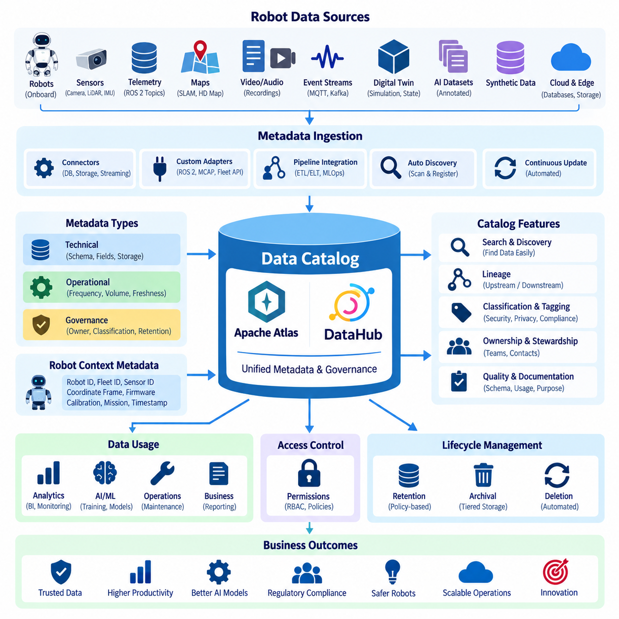
A data catalog provides a searchable and governed inventory of data assets distributed across a robot data architecture. In robotics, these assets may include telemetry streams, ROS 2 topics, sensor recordings, time-series tables, event streams, maps, digital-twin states, annotated datasets, synthetic data, and AI training datasets. The catalog creates a common metadata layer that allows engineers and automated systems to discover what data exists, where it is stored, who owns it, and how it may be used.
Robot organizations often accumulate data across onboard computers, edge servers, on-premise infrastructure, object storage, databases, message brokers, and cloud platforms. Without a catalog, knowledge about these assets tends to remain inside individual teams or application code. A catalog replaces fragmented knowledge with structured metadata describing datasets, schemas, storage locations, owners, classifications, quality information, lifecycle policies, and relationships between data assets.
Metadata collected by the catalog can be divided conceptually into technical, operational, and governance information. Technical metadata describes schemas, fields, data types, topics, tables, files, APIs, and storage systems. Operational metadata records properties such as update frequency, volume, freshness, or pipeline execution. Governance metadata identifies ownership, sensitivity classification, retention requirements, access policies, business descriptions, and approved purposes for using the data.
A robotics catalog should represent the physical origin of data as well as its digital location. Sensor information can therefore be associated with robot IDs, fleet IDs, camera or LiDAR identifiers, coordinate frames, firmware versions, calibration versions, collection missions, and timestamps. This context is important because two files with identical formats may represent substantially different physical conditions. Metadata allows downstream users to understand those conditions without manually reconstructing the original robot configuration.
Apache Atlas provides a metadata governance architecture centered on entities, classifications, relationships, and lineage. Data platforms can represent databases, tables, files, processes, datasets, and other resources as typed entities. Relationships connect these entities into a metadata graph, while classifications attach governance meaning such as confidential, personal, safety-related, or training-approved. This model can be extended with robot-specific entity types representing robots, sensors, missions, recordings, and AI datasets.
In an Apache Atlas-based design, ingestion connectors or custom integration services collect metadata from robot data platforms and register it with the catalog. A telemetry database might contribute tables and schemas, an object store might expose sensor dataset locations, and a processing pipeline might register input-output relationships. Atlas then provides a centralized metadata representation through which users can search assets and examine relationships between raw robot information and processed data products.
DataHub follows a metadata-platform approach designed around discovery, metadata ingestion, search, ownership, lineage, domains, tags, and related governance capabilities. Metadata from heterogeneous platforms can be ingested into a unified catalog and associated with organizational context. For a robot data architecture, DataHub can provide a searchable interface through which engineers locate telemetry datasets, sensor recordings, analytical tables, features, training datasets, or other assets without needing detailed knowledge of every underlying storage platform.
A practical DataHub deployment begins with metadata ingestion from databases, data lakes, warehouses, streaming platforms, orchestration systems, and other supported sources. Robot-specific systems can require additional adapters because ROS 2 bags, MCAP files, specialized sensor archives, fleet APIs, or robotics metadata may not correspond directly to conventional enterprise tables. Custom ingestion logic can transform these resources into catalog entities while preserving robot-specific metadata as properties, tags, domains, or relationships.
Catalog construction should follow the data lifecycle rather than simply scanning storage directories. When a robot creates sensor data, metadata can identify its source and collection context. When pipelines transform that data, the catalog can record derived datasets and lineage. Annotation adds label versions and quality information, while AI training associates datasets with experiments or models. This produces a connected metadata graph rather than a flat inventory of unrelated files and database objects.
Automation is essential because robot fleets can generate new data assets continuously. Manual catalog registration becomes impractical when thousands of sensor sessions, telemetry partitions, event topics, and training dataset versions are created. Metadata registration should therefore be integrated into ingestion pipelines, ETL or ELT workflows, streaming infrastructure, annotation pipelines, and MLOps processes. New assets can then appear in the catalog automatically as part of normal data processing.
A useful catalog entry should provide enough context for users to evaluate a dataset before accessing its underlying contents. Descriptions can explain the operational purpose, collection environment, robot platform, sensor configuration, schema, units, coordinate system, sampling rate, time range, owner, quality status, sensitivity classification, and retention policy. AI datasets may additionally record annotation schema, dataset version, train-validation-test partition, license, provenance, and approved model-development purposes.
Search and discovery convert metadata into operational value. Engineers should be able to search by robot type, sensor, mission, location category, data format, time period, owner, tag, domain, or intended use. Instead of browsing storage paths manually, an AI engineer could locate validated camera datasets suitable for perception training, while a reliability engineer could discover telemetry associated with a particular hardware revision or failure event.
Ownership and stewardship should be visible directly within catalog records. A sensor dataset might identify the robotics platform team as its owner and a data engineering group as its technical steward. AI training data may have separate owners responsible for annotations and model-development suitability. Exposing these responsibilities reduces uncertainty when users encounter incorrect schemas, missing metadata, quality problems, access restrictions, or questions concerning permitted data usage.
Classification and tagging connect the catalog with security, privacy, and compliance controls. Robot camera recordings containing people may receive privacy-sensitive classifications, while facility maps can be classified as security-sensitive. Safety logs, proprietary configuration data, and externally licensed datasets may receive different tags. These classifications can then support access-control decisions, retention rules, encryption requirements, review workflows, and auditing across the broader governance architecture.
The catalog also provides the foundation for data lineage. When metadata relationships identify that raw camera recordings were transformed into selected frames, annotated objects, training datasets, features, and eventually AI models, users can navigate both upstream and downstream dependencies. If a source dataset contains an error, lineage information helps determine which derived datasets and models may be affected, making catalog metadata important for reproducibility and operational incident analysis.
Apache Atlas and DataHub should not be viewed simply as competing user interfaces. Both represent approaches to building an enterprise metadata and governance layer, while implementation choices depend on existing infrastructure, integration requirements, governance processes, and operational expertise. A robotics organization can evaluate them according to metadata modeling flexibility, ingestion support, lineage capabilities, search experience, APIs, extensibility, deployment complexity, and compatibility with its data platform.
The resulting catalog becomes a shared metadata control point across robot data modeling, pipelines, telemetry, event streaming, sensor management, AI data architecture, and digital twins. It does not replace databases, object stores, message brokers, or dataset repositories; instead, it describes and connects them. By separating metadata management from physical data storage, organizations can maintain a unified view even when the underlying robot information remains distributed across multiple infrastructure layers.
A mature robot data catalog ultimately changes data discovery from personal knowledge into an organizational capability. Engineers can determine what information exists, understand its physical and technical context, identify responsible owners, inspect lineage, evaluate quality and classifications, and request appropriate access. Apache Atlas or DataHub can provide the metadata foundation for this capability, enabling subsequent governance functions such as lineage tracking, quality SLA monitoring, access control, retention automation, security classification, and AI data auditing.

09.03 Data Lineage Tracking System Design [w/Code]
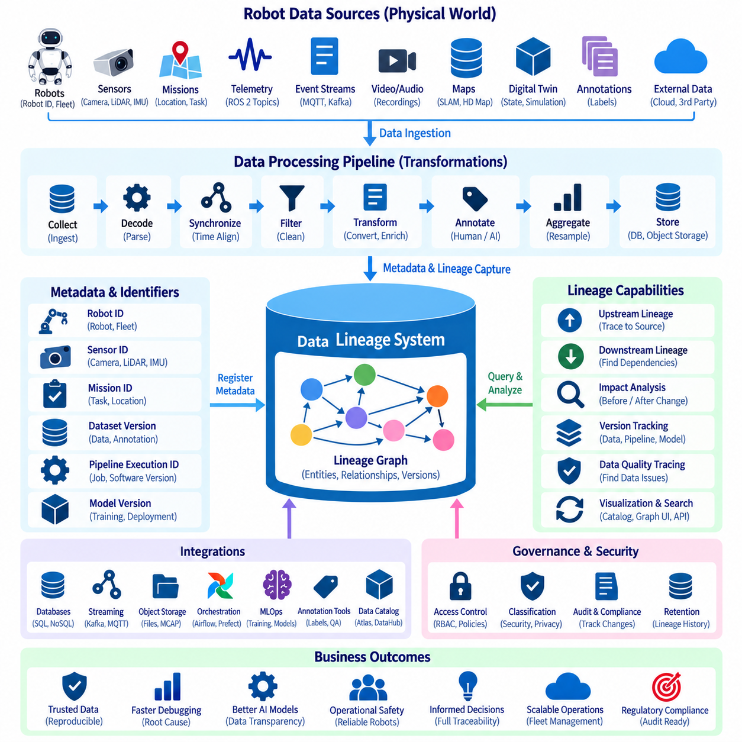
Data lineage describes the traceable history of data as it moves from its original source through collection, transformation, storage, analysis, and consumption. In robot systems, lineage must capture more than relationships between database tables. It should connect physical robots, sensors, ROS 2 topics, telemetry streams, event messages, files, processing pipelines, annotations, AI training datasets, digital twins, analytical products, and deployed models into a navigable dependency graph.
A lineage tracking system begins by assigning persistent identities to important data assets and processing activities. Robot ID, fleet ID, sensor ID, mission ID, dataset version, pipeline execution ID, software version, and model version can become references within the lineage graph. These identifiers prevent ambiguity when similar data is repeatedly generated by different robots, sensors, missions, or software configurations and allow historical relationships to remain traceable after systems evolve.
Source lineage records where information originally entered the data architecture. A camera frame may originate from a specific robot and camera during a particular mission, while telemetry may originate from motor controllers, batteries, localization modules, or navigation software. Recording timestamps, coordinate frames, calibration versions, firmware versions, and collection conditions provides the physical context needed to interpret downstream data correctly rather than treating every digital object as an isolated file.
Transformation lineage describes what happens after data enters a pipeline. Robot sensor information may be decoded, synchronized, filtered, compressed, resampled, aggregated, anonymized, converted, or enriched before reaching storage or analytical systems. Each transformation should identify its inputs, outputs, processing logic, software or container version, execution time, and relevant configuration so that engineers can understand how a derived data asset was produced.
Lineage should represent both upstream and downstream dependencies. Upstream navigation answers questions such as which sensor recordings and transformations produced a particular training dataset. Downstream navigation determines which analytical tables, dashboards, datasets, or models depend on a selected source. Bidirectional traversal is particularly important when corrupted sensor data, incorrect calibration, defective annotations, or pipeline errors are discovered after downstream products have already been created.
A practical architecture separates lineage capture from lineage storage and visualization. Capture components collect metadata from pipelines, databases, streaming platforms, orchestration systems, object stores, annotation workflows, and MLOps environments. A centralized lineage service converts these observations into standardized entities and relationships. The resulting dependency graph can then be queried through APIs or presented through a data catalog interface for engineers, governance teams, and automated systems.
Automated lineage capture is essential for robot platforms because manually documenting every data movement does not scale. Pipeline orchestration can emit lineage events whenever jobs execute, while ingestion services can register source and destination assets automatically. Streaming applications can describe relationships between input topics and output streams, and AI pipelines can register dataset-to-model dependencies during training. Automation makes lineage a normal consequence of data processing rather than a separate documentation task.
Batch and streaming lineage require different tracking strategies. Batch pipelines naturally produce relationships between input datasets, processing jobs, and output datasets at specific execution times. Event streaming systems continuously transform messages, making lineage potentially enormous if every event is represented individually. Streaming lineage therefore commonly focuses on relationships among topics, schemas, processors, windows, derived streams, and persistent sinks while retaining selected event-level identifiers where detailed traceability is operationally necessary.
Sensor data introduces additional lineage challenges because large binary objects may be separated from their metadata. Images, video, point clouds, ROS 2 bags, and MCAP recordings can reside in object or file storage while indexes and descriptive information exist elsewhere. The lineage system should connect physical files with metadata records, recording sessions, sensors, missions, timestamps, and processing outputs so that movement or archival of the underlying files does not destroy their provenance.
AI training creates one of the most important lineage chains in a Physical AI data architecture. Raw sensor recordings may pass through selection, privacy processing, annotation, quality validation, dataset assembly, augmentation, train-validation-test partitioning, feature generation, and model training. Lineage should connect these stages to the resulting model version, enabling teams to reconstruct which data and processing decisions contributed to a model that later controls or assists physical robot behavior.
Annotation lineage requires tracking both label origin and label evolution. A dataset may contain manually generated labels, AI-assisted labels, corrected annotations, or labels imported from previous versions. Recording annotation tool versions, schema versions, annotator or workflow identifiers, quality review results, and dataset revisions helps distinguish raw observations from human or machine interpretations. This separation becomes important when annotation defects are discovered during model evaluation.
Digital twin lineage connects measured physical states with derived or simulated representations. A digital-twin value may originate directly from a robot sensor, result from aggregation, be estimated by an analytical model, or be generated by simulation. These origins should remain distinguishable. Without lineage, users may incorrectly treat simulated, predicted, stale, and directly measured states as equivalent, reducing the reliability of maintenance analysis, operational monitoring, and simulation-to-real workflows.
Lineage also supports data quality management. When a quality rule identifies missing timestamps, abnormal values, synchronization failures, or corrupted records, the affected asset can be traced upstream to possible sources and downstream to dependent products. Instead of inspecting every dataset independently, engineers can use dependency relationships to determine the potential impact radius and prioritize validation, reprocessing, retraining, or rollback activities.
Integration with the data catalog allows lineage to become part of normal data discovery. A catalog entry can display an asset's owner, schema, classification, quality status, and retention policy together with its upstream and downstream relationships. Metadata platforms such as Apache Atlas or DataHub can therefore serve as interfaces for navigating lineage graphs while custom adapters register robot-specific entities such as robots, sensors, missions, ROS 2 recordings, datasets, and AI models.
Lineage records themselves require governance because they may reveal sensitive architectural information. Dependency graphs can expose storage locations, internal system names, data flows, security classifications, model relationships, or operational infrastructure. Access to lineage should therefore follow appropriate authorization policies, and metadata changes should be auditable. The lineage repository also needs reliable retention and versioning so historical dependencies are not lost when schemas, pipelines, or platforms change.
Version-aware lineage is especially important in rapidly evolving robot software. A logical pipeline name may remain unchanged while algorithms, configuration parameters, schemas, calibration files, or container images change. Recording only that a dataset passed through a pipeline is therefore insufficient. The lineage relationship should preserve the relevant execution and version context so that a previous result can be reproduced or compared with data generated after a software update.
A mature lineage system supports impact analysis before as well as after changes. If an engineer plans to modify a schema, remove a telemetry field, replace a sensor calibration, or deprecate a dataset, downstream dependencies can be inspected before deployment. Teams can identify affected dashboards, pipelines, AI datasets, models, or digital-twin processes and coordinate changes proactively, reducing hidden coupling across the robot data architecture.
Lineage ultimately provides the evidence chain connecting physical reality to digital decisions. It explains where robot data originated, how it changed, which systems consumed it, and what products or AI models were created from it. Combined with cataloging, quality management, access control, retention, and security classification, automated lineage tracking transforms distributed robot data pipelines into an observable and accountable architecture suitable for scalable fleet operations and Physical AI development.

09.04 Data Quality SLA Definition and Monitoring [w/Code]
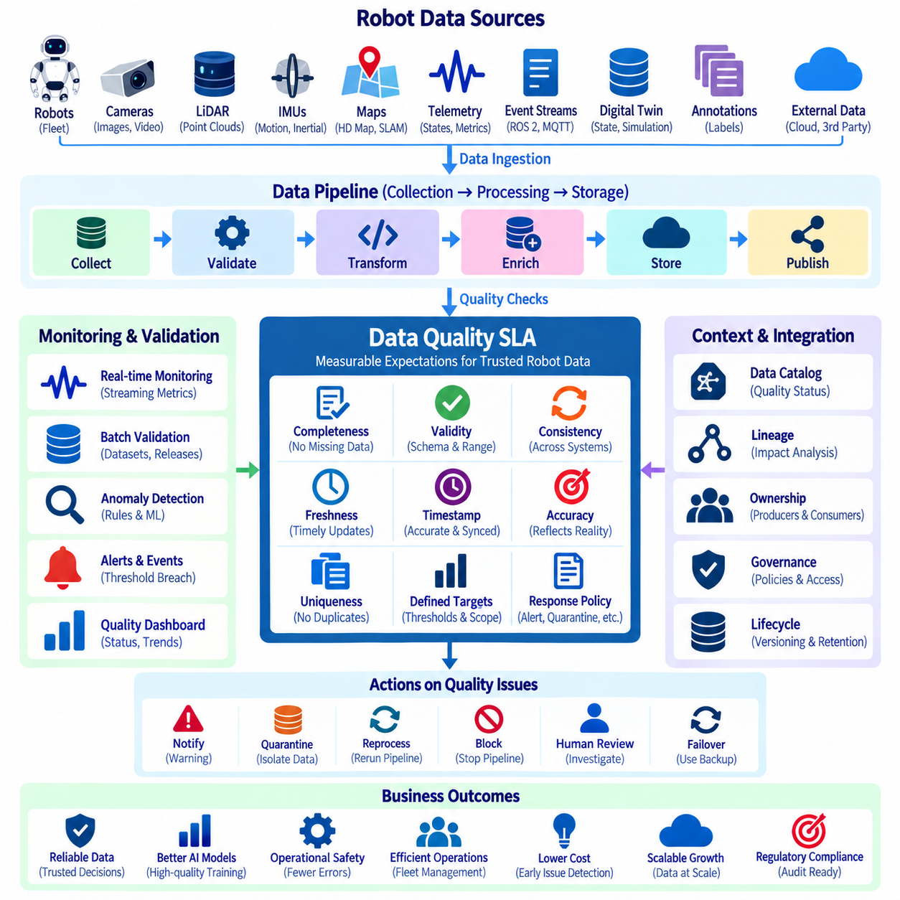
Data quality service-level agreements define measurable expectations for the reliability of data used throughout a robot data architecture. Unlike conventional SLAs that focus mainly on infrastructure availability or response time, a Data Quality SLA specifies whether data itself is sufficiently complete, valid, timely, consistent, synchronized, and accurate for an intended purpose. These agreements transform abstract expectations about trustworthy robot data into explicit operational metrics that can be continuously monitored.
Robot systems generate heterogeneous information with very different quality characteristics. Telemetry may arrive continuously at high frequency, cameras produce ordered image frames, LiDAR generates large point clouds, IMUs require precise timing, and event streams represent discrete state changes. Maps, annotations, AI datasets, and digital-twin states introduce additional requirements. A single universal quality threshold is therefore inappropriate; quality objectives should reflect each data domain and its operational purpose.
Completeness measures whether expected data actually exists. For telemetry, completeness may represent the percentage of expected measurements received during a time window. For camera or LiDAR recordings, it can indicate missing frames or incomplete sessions. Training datasets may require mandatory labels, metadata, and partition information. A completeness SLA converts these expectations into thresholds so missing information can be detected before it silently propagates into analytics or AI pipelines.
Validity determines whether data conforms to defined structural and semantic rules. Schema validation checks fields, types, required attributes, formats, and allowed values, while domain validation examines whether measurements fall within physically meaningful ranges. A battery state-of-charge value, robot velocity, temperature measurement, coordinate, or mission status should satisfy its expected constraints. Invalid records can then be rejected, quarantined, flagged, or routed for investigation according to policy.
Consistency measures whether related representations of the same information agree across systems and processing stages. Robot identifiers should remain consistent between telemetry, mission records, sensor archives, and fleet databases. Units, coordinate frames, status codes, and schema interpretations should not change unexpectedly between producers and consumers. Consistency checks are especially important when edge, on-premise, cloud, analytics, and AI platforms exchange independently maintained representations of robot state.
Freshness describes how recently data has been produced or updated relative to operational requirements. Fleet monitoring may require telemetry only seconds old, while maintenance reports may tolerate longer delays. AI training datasets can remain useful for much longer periods but may become unsuitable when hardware, environments, or software distributions change. Freshness SLAs should therefore define acceptable age or update latency according to how rapidly each consumer requires new information.
Timestamp integrity and synchronization are critical quality dimensions for robotics because perception and control frequently depend on multiple sensors representing the same physical moment. Camera, LiDAR, IMU, wheel odometry, GNSS, and actuator telemetry can become misleading when clocks drift or timestamps are missing, duplicated, reordered, or incorrectly generated. Quality monitoring should measure timestamp continuity, ordering, clock offsets, synchronization errors, and other timing anomalies where multimodal alignment matters.
Accuracy is more difficult to monitor automatically because a value may satisfy its schema while still incorrectly represent physical reality. Calibration results, reference measurements, redundant sensors, known landmarks, operational constraints, or statistical models can provide comparison points. Accuracy SLAs should therefore distinguish easily automated validation from measurements requiring external references, calibration procedures, or periodic engineering verification rather than claiming that every data value can be continuously proven correct.
Uniqueness and duplication checks prevent repeated records from distorting downstream analysis. Network retries, message replay, pipeline recovery, synchronization errors, or duplicated uploads can produce multiple copies of logically identical robot observations. Unique event identifiers, composite keys, sequence numbers, timestamps, or dataset object IDs can support duplicate detection. The acceptable duplication rate depends on whether downstream systems provide idempotent processing and how duplicated information affects their results.
A Data Quality SLA should associate each metric with a defined scope, target, measurement window, evaluation method, owner, and response policy. For example, a telemetry stream may require a completeness target evaluated every few minutes, while an AI dataset may be evaluated at dataset release time. Defining the measurement context is as important as defining the threshold because a percentage without a time window, population, or calculation method cannot be interpreted consistently.
Quality monitoring should be embedded directly into data pipelines. Validation can begin at robot-side collection, continue during edge ingestion and streaming, and execute again when data enters databases, lakehouses, annotation systems, or AI training workflows. Early checks prevent obviously defective data from traveling unnecessarily, while downstream checks detect errors introduced by transformations. Distributed validation therefore creates multiple quality gates across the robot data lifecycle rather than relying on one centralized inspection stage.
Real-time monitoring is particularly valuable for telemetry and event streams. Streaming quality processors can calculate missing-message rates, schema violations, latency, timestamp disorder, duplicate rates, or abnormal distributions over rolling windows. When measurements cross SLA thresholds, the system can generate alerts or quality events. These events should include the affected data asset, metric, observed value, threshold, evaluation period, and sufficient context for engineers to investigate the problem efficiently.
Batch quality monitoring complements streaming validation for datasets that are produced periodically or processed in large groups. Sensor archives, annotated datasets, historical telemetry, digital-twin snapshots, and AI training releases can undergo scheduled profiling and validation. Batch jobs can calculate completeness, null ratios, distribution changes, label statistics, duplicate records, schema conformity, and other metrics before a dataset is promoted to a trusted processing or training stage.
Quality status should be integrated with the data catalog and lineage system. Catalog entries can display quality scores, SLA status, recent validation results, owners, and known incidents alongside ordinary metadata. Lineage then identifies which upstream sources may have caused a quality failure and which downstream datasets, dashboards, digital twins, or AI models may be affected. This connection turns quality monitoring from an isolated dashboard into part of broader governance and impact analysis.
Not every quality failure should trigger the same response. A minor freshness delay in historical analytics may require only logging, while missing safety-related telemetry could demand immediate escalation. Policies can classify violations by severity and initiate actions such as warning, quarantine, pipeline suspension, reprocessing, failover, dataset rejection, or human review. Response procedures should reflect the operational consequences of the affected data rather than treating every SLA breach identically.
Quality monitoring also requires observability of the monitoring process itself. Validation jobs can fail, quality metrics can stop updating, and rules can become outdated after schema changes. Systems should therefore monitor whether checks are executing successfully, whether expected assets are covered, and whether rule versions correspond to current schemas. Otherwise, a green dashboard may indicate missing measurements rather than healthy data, creating a false sense of reliability.
Historical quality metrics provide evidence for identifying long-term trends. Organizations can examine whether a sensor type repeatedly experiences missing data, whether a software release increases schema violations, or whether a particular robot fleet produces synchronization problems. Combining quality history with robot IDs, hardware revisions, firmware versions, missions, and lineage information helps teams distinguish isolated incidents from systematic architectural or operational weaknesses.
AI data pipelines require particularly strict quality controls because defects can propagate into model behavior without producing obvious pipeline failures. Training data SLAs can cover annotation completeness, class distribution, duplicate samples, corrupted media, dataset partition integrity, provenance, and required metadata. Quality gates can prevent an unvalidated dataset version from entering training and preserve the validation results alongside the dataset version for reproducibility and later model investigation.
Data Quality SLAs ultimately create a contract between data producers, platform operators, and data consumers. Producers understand the expected characteristics of their outputs, platform teams can monitor whether pipelines preserve those characteristics, and consumers can determine whether data is suitable for a particular purpose. Combined with catalogs, lineage, ownership, access control, and lifecycle governance, continuous SLA monitoring turns data quality from an informal expectation into a measurable and accountable capability across scalable robot and Physical AI systems.

09.05 Privacy Protection: GDPR / PIPA for Robot Data
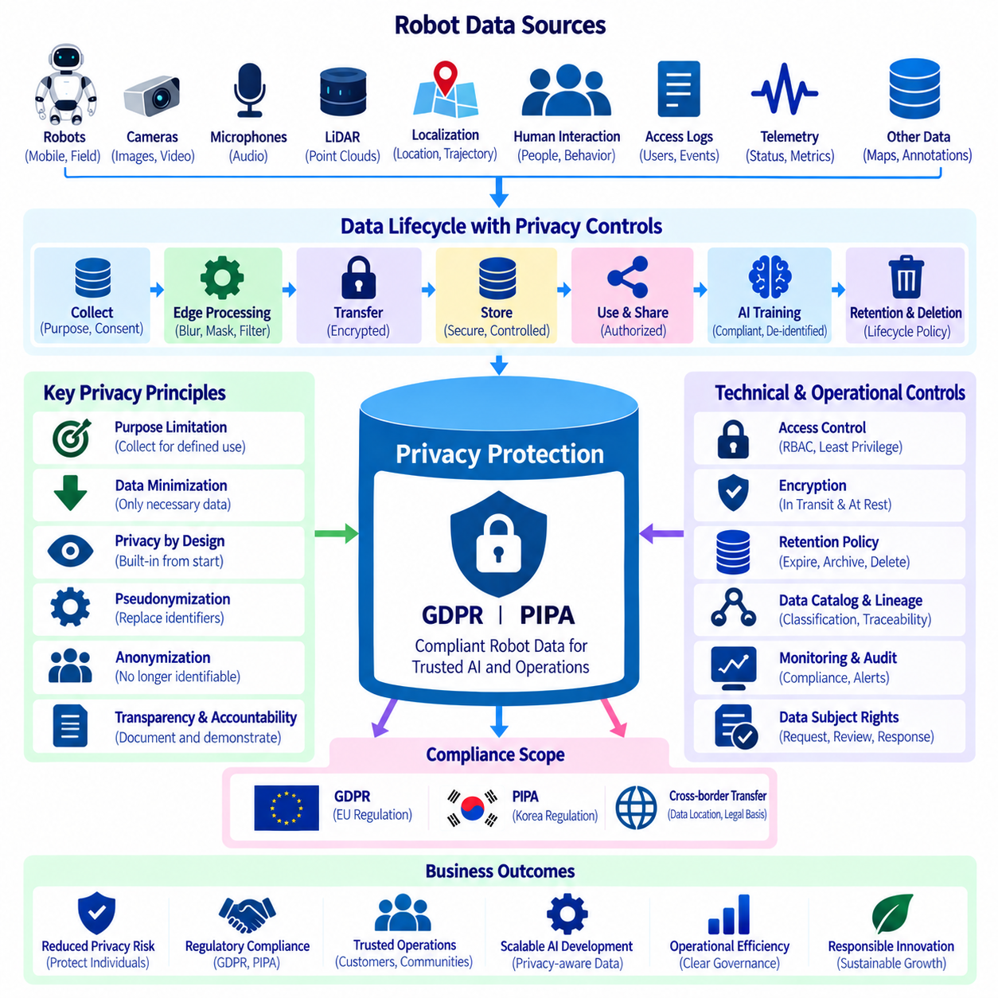
Privacy protection for robot data requires treating robots as mobile data-collection systems that continuously interact with people, objects, workplaces, homes, and public environments. Cameras, microphones, LiDAR, localization systems, access logs, telemetry, and human-robot interaction records can directly or indirectly contain information relating to identifiable individuals. Governance must therefore integrate privacy controls throughout collection, processing, storage, sharing, AI training, and deletion rather than addressing privacy only after data has been accumulated.
The European Union General Data Protection Regulation, commonly known as GDPR, provides a comprehensive framework for processing personal data, while Korea’s Personal Information Protection Act, or PIPA, establishes major privacy obligations within the Korean legal environment. Robot operators should determine which legal requirements apply according to jurisdiction, organizational role, processing context, and data flows. Technical architecture should support compliance without assuming that one universal configuration satisfies every deployment.
A fundamental requirement is determining whether robot-generated information constitutes personal data. A clearly visible face, recorded voice, employee identifier, vehicle identifier linked to a person, or account information may provide obvious examples, while other information can become personal when combined with additional datasets. Location histories, movement trajectories, interaction records, timestamps, or repeated observations may enable identification even when a person's name is not explicitly stored.
Privacy governance should begin with purpose specification. Before collecting information, an organization should identify why the robot requires the data and how it will be used. Navigation, obstacle avoidance, safety investigation, remote assistance, maintenance, analytics, and AI training represent different purposes and may require different treatment. Data originally collected for operational purposes should not automatically become unrestricted training data merely because it is technically available in storage.
Data minimization reduces privacy risk by limiting collection and retention to information that is necessary for a defined purpose. A robot that requires obstacle geometry may not always need to preserve identifiable RGB video, while an operational metric may be stored without retaining the complete raw sensor stream. Minimization can occur through sensor selection, reduced resolution, region filtering, selective recording, event-triggered capture, aggregation, or early deletion of unnecessary information.
Privacy by design integrates these controls into the robot data architecture before deployment. Collection agents can classify sensitive sources, edge processors can remove unnecessary information, pipelines can enforce masking, storage systems can apply retention rules, and catalogs can record privacy classifications. This approach is stronger than depending entirely on policies or manual review because privacy requirements become executable properties of the technical system.
Edge processing can reduce unnecessary exposure by transforming sensitive information before it leaves the robot or local environment. Face blurring, license-plate masking, audio filtering, cropping, feature extraction, and other privacy transformations can be performed close to the data source when technically appropriate. The architecture should preserve metadata indicating that a transformation occurred so downstream consumers can distinguish original, masked, anonymized, and derived data products.
Pseudonymization replaces directly identifying information with controlled identifiers while preserving some ability to associate records when legitimately required. Robot IDs, user IDs, operator identifiers, or interaction records can use pseudonymous references instead of direct personal identifiers. However, pseudonymized information may remain personal data when re-identification is possible, so it should not automatically be treated as equivalent to fully anonymous information.
Anonymization aims to transform data so individuals are no longer identifiable under the applicable standard, but achieving reliable anonymization can be difficult for rich robot datasets. Video, voice, trajectories, spatial context, behavioral patterns, and combinations of metadata may permit re-identification. Privacy engineering should therefore evaluate the complete information environment rather than assuming that removing names or faces alone makes a dataset anonymous.
Access control limits who can view or process privacy-sensitive robot data. Role-based access control can distinguish robot operators, maintenance engineers, AI researchers, data engineers, security teams, and external partners. Raw recordings may require more restrictive permissions than anonymized analytical outputs. Authentication, least-privilege authorization, periodic access review, and separation of administrative responsibilities help reduce inappropriate internal or external use.
Encryption protects personal information while it moves between robots, edge systems, on-premise infrastructure, cloud platforms, and storage services. Data should receive appropriate protection in transit and at rest, with encryption keys managed separately according to organizational security policy. Encryption does not replace minimization or access control, but it reduces exposure when storage devices, communication channels, backups, or infrastructure components are compromised.
Retention policies should connect the purpose of processing with the period for which information remains necessary. High-resolution recordings captured for temporary navigation support may require a different retention period from records retained for an authorized safety investigation. Automated lifecycle policies can expire, archive, anonymize, or delete information according to classification and purpose, reducing the risk created by indefinitely accumulating sensitive robot observations.
Deletion is more complex when robot information has propagated into replicated storage, backups, derived datasets, annotation systems, feature stores, or AI pipelines. Data lineage can help identify where a sensitive source has moved and what downstream assets were created from it. A privacy-aware architecture should therefore coordinate deletion and retention with catalog and lineage information rather than treating removal from one database or object-storage location as complete lifecycle deletion.
Data catalogs can expose privacy metadata without exposing the sensitive data itself. Catalog entries may record the responsible owner, collection purpose, sensitivity classification, applicable retention rule, access restrictions, processing status, and whether masking or pseudonymization has occurred. This allows governance teams and automated systems to discover privacy obligations before users access or transfer the underlying robot data.
AI training creates additional privacy challenges because large datasets can combine information collected across many robots, locations, and time periods. Dataset preparation should verify whether information is authorized for the intended training purpose and whether required privacy transformations have been applied. Training-data versions should preserve provenance, privacy status, transformation history, and approval information so that later model investigations can reconstruct how the dataset was assembled.
Synthetic data can reduce dependence on some sensitive real-world observations, but synthetic does not automatically mean privacy-free. Synthetic generation processes may use real data as input, and generated outputs may retain characteristics derived from source datasets. Governance should document how synthetic data was produced, what source information contributed to it, and whether privacy evaluation is required before the resulting dataset is broadly shared or reused.
Transparency and accountability require organizations to understand and document their robot data processing activities. Depending on the applicable legal framework and processing context, organizations may need mechanisms for notices, records of processing, handling individual rights, responding to incidents, evaluating high-risk processing, and demonstrating that privacy controls operate as intended. Governance records should therefore connect policies with actual systems, datasets, owners, and processing activities.
International or organizational data transfers require additional attention because robot fleets may operate in one jurisdiction while data platforms, cloud infrastructure, development teams, or AI training environments exist elsewhere. Before transferring privacy-sensitive information, organizations should determine applicable requirements and approved transfer mechanisms. Architectural controls can help by identifying storage regions, limiting replication, applying classifications, and recording authorized destinations.
Privacy monitoring should operate continuously rather than only during initial system approval. New sensors, software releases, AI features, data-sharing arrangements, and robot deployment environments can change privacy risk. Automated checks can identify unclassified datasets, excessive retention, missing masking steps, unexpected destinations, or unauthorized access patterns, while periodic governance reviews determine whether existing purposes and controls remain appropriate.
Effective GDPR- and PIPA-aware robot data governance ultimately combines legal requirements with technical architecture and operational accountability. Purpose limitation, minimization, privacy-aware processing, access control, encryption, retention, deletion, cataloging, lineage, auditing, and continuous review form complementary layers rather than independent controls. Together they allow organizations to develop scalable robot and Physical AI data systems while reducing unnecessary exposure of personal information and preserving traceability throughout the data lifecycle.

09.06 Data Access Control and RBAC
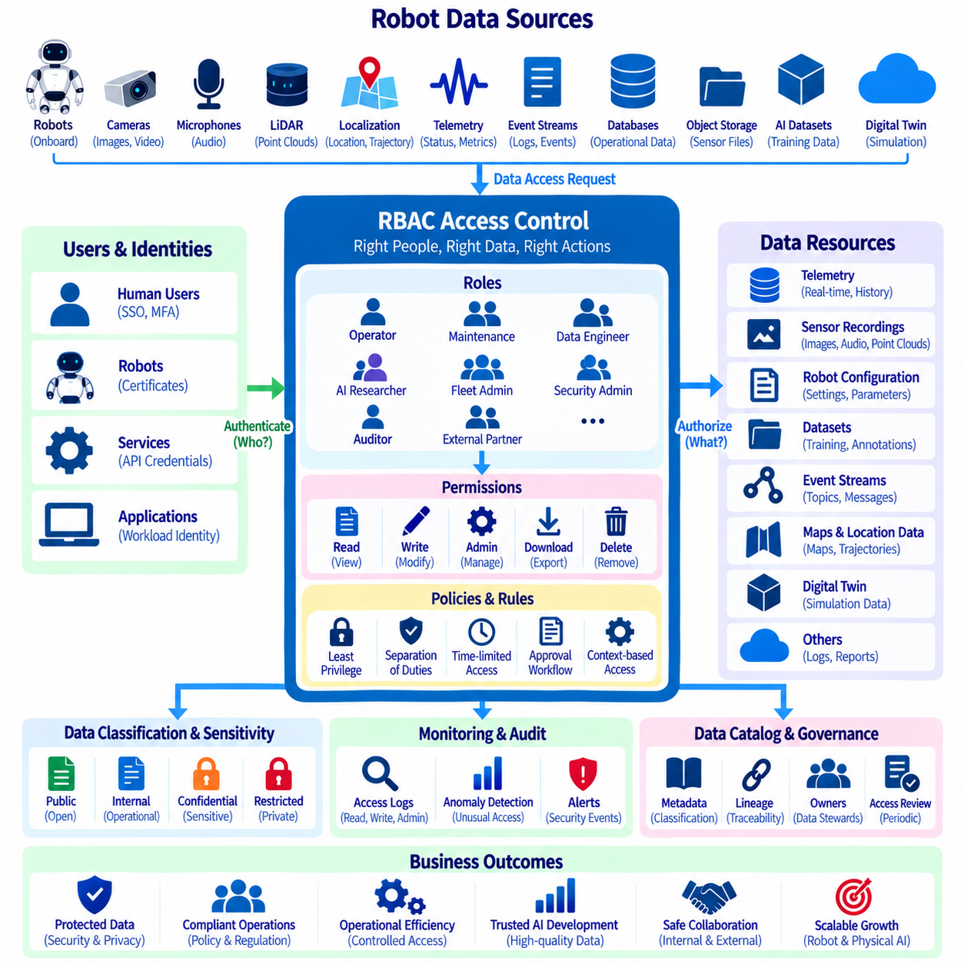
Data access control defines who or what may access robot data, which operations they may perform, and under what conditions those permissions remain valid. Robot data architectures span onboard computers, edge systems, on-premise servers, cloud platforms, databases, object stores, event streams, AI datasets, and digital twins. Access control must therefore operate consistently across distributed infrastructure while protecting information according to its sensitivity, operational importance, and intended use.
Role-Based Access Control, or RBAC, organizes permissions around defined organizational or system roles instead of assigning privileges independently to every user. A role represents a set of responsibilities such as robot operator, maintenance engineer, data engineer, AI researcher, fleet administrator, security administrator, auditor, or external partner. Users and services receive appropriate roles, and those roles determine which data resources and actions are available to them.
The fundamental RBAC relationship can be represented as users or service identities assigned to roles, roles associated with permissions, and permissions applied to protected resources. Permissions normally combine an action with a resource, such as reading telemetry, modifying configuration data, downloading sensor recordings, publishing events, administering datasets, or deleting archived information. This separation makes access policies easier to understand, review, and modify as robot fleets and organizations grow.
Authentication and authorization perform different functions within this architecture. Authentication verifies the identity of a human user, robot, application, service, or workload, while authorization determines what the authenticated identity is permitted to do. Human authentication may use enterprise identity systems and multi-factor authentication, whereas robots and services can use certificates, workload identities, API credentials, or other machine-oriented mechanisms appropriate to the deployment environment.
Robot data requires access policies at multiple levels of granularity. A user may be permitted to view aggregated fleet telemetry while being prohibited from downloading raw camera recordings. An AI engineer may access approved training datasets without receiving permission to modify operational robot configurations. A maintenance engineer may inspect diagnostic records for assigned robots but not access unrelated privacy-sensitive data collected by the fleet.
The principle of least privilege should guide role design. Each identity receives only the permissions required to perform its legitimate responsibilities and no unnecessary authority. Broad administrator privileges may simplify initial deployment but create significant risk as infrastructure expands. Separating read, write, modify, export, approve, administer, and delete permissions allows organizations to create roles that more closely correspond to actual operational duties.
Separation of duties provides an additional control for sensitive operations. The person who prepares a dataset does not necessarily need authority to approve its external release, and an engineer capable of modifying retention policies may not need permission to erase audit records. Critical workflows can require distinct roles for creation, review, approval, and execution, reducing the possibility that a single compromised or misused account can perform an entire high-impact operation.
Data classification should directly influence access-control policy. Public or low-sensitivity operational information may be available to broad internal groups, while proprietary engineering data, personal information, safety records, facility maps, credentials, and security-sensitive configurations require progressively stronger restrictions. Connecting classifications from the data catalog to authorization policies helps maintain consistent protection as datasets move between storage systems and processing pipelines.
Access control should protect both data and metadata. Data catalogs and lineage graphs may reveal dataset names, storage locations, system architecture, robot identities, processing relationships, security classifications, and model dependencies even when users cannot access the underlying files. Metadata permissions should therefore be designed deliberately rather than assuming that catalog information is harmless or universally visible.
Distributed robot architectures require enforcement at multiple control points. Onboard applications may restrict local files and ROS 2 resources, edge gateways can enforce service permissions, databases can control tables or views, object stores can protect buckets and objects, and streaming platforms can restrict topics. Cloud and on-premise systems may use different authorization technologies, but their policies should derive from a coherent governance model rather than independent conventions.
Machine-to-machine access is as important as human access in robotics. Collection agents, telemetry gateways, streaming processors, annotation services, digital-twin applications, training pipelines, and deployment systems continuously exchange information without direct human interaction. Each service should have its own identity and narrowly scoped permissions instead of sharing generic credentials, allowing compromised services to be isolated and access activity to be attributed correctly.
Temporary and contextual access can reduce the risks associated with permanently assigned privileges. Engineers investigating an incident may require elevated access only for a limited period, while external partners may need access to a specific dataset for a defined project. Time-limited authorization, approval workflows, scoped tokens, and automatic expiration can provide necessary access without converting exceptional requirements into permanent permissions.
Access policies must also consider privacy-sensitive robot information. Raw camera, audio, location, and human-interaction data may require stronger restrictions than anonymized or aggregated products derived from the same sources. RBAC can separate roles allowed to process raw information from roles allowed only to consume privacy-transformed outputs, complementing masking, pseudonymization, encryption, retention, and other privacy controls.
AI data pipelines introduce additional authorization boundaries. Training datasets, annotations, feature stores, experiment results, model artifacts, and deployment packages should not automatically share identical permissions. Researchers may require read access to approved datasets and permission to create experiments while production deployment remains restricted to designated engineering or operations roles. Such boundaries reduce accidental movement from experimentation into operational robot systems.
Audit logging records how access-control decisions are exercised in practice. Important events include successful and failed authentication, permission changes, sensitive reads, exports, administrative actions, policy modifications, and deletion requests. Audit records should identify the actor, resource, action, timestamp, result, and relevant context so security and governance teams can reconstruct activity during investigations or compliance reviews.
Access reviews ensure that permissions remain appropriate as people, projects, robots, and organizational structures change. Employees can move between teams, contractors can finish assignments, services can be retired, and datasets can receive new classifications. Periodic review should identify unused roles, excessive privileges, inactive identities, orphaned service accounts, and permissions that no longer correspond to current responsibilities.
The data catalog can become an important integration point for RBAC by connecting assets with owners, classifications, domains, and access requirements. A user discovering a restricted dataset can identify its owner and request appropriate access rather than bypassing governance through informal file transfers. Approval workflows can use catalog metadata to determine whether the requested role and intended purpose are consistent with organizational policy.
Access-control failures should generate observable security events. Repeated authorization failures, unusual bulk downloads, unexpected administrative operations, access from abnormal contexts, or attempts to reach restricted datasets can indicate configuration problems or security incidents. Monitoring systems can correlate these events with identities, roles, classifications, robot operations, and audit history to support investigation and automated response.
RBAC should evolve with the robot data architecture rather than becoming a static collection of roles. Early deployments may use a small number of broad roles, but growing fleets require more structured role hierarchies, automated provisioning, centralized identity integration, periodic certification, and policy-as-code approaches. Role design should remain understandable enough for governance teams to review while supporting the scale required by automated robot and AI infrastructure.
Effective data access control ultimately connects identity, organizational responsibility, data classification, and technical enforcement. RBAC provides a manageable foundation, while least privilege, separation of duties, service identities, temporary access, auditing, monitoring, and periodic reviews strengthen that foundation. Combined with catalogs, lineage, privacy controls, encryption, retention, and quality governance, access control ensures that robot data remains available to authorized consumers without becoming unnecessarily exposed across scalable Physical AI systems.

09.07 Data Retention and Deletion Policy Automation [w/Code]
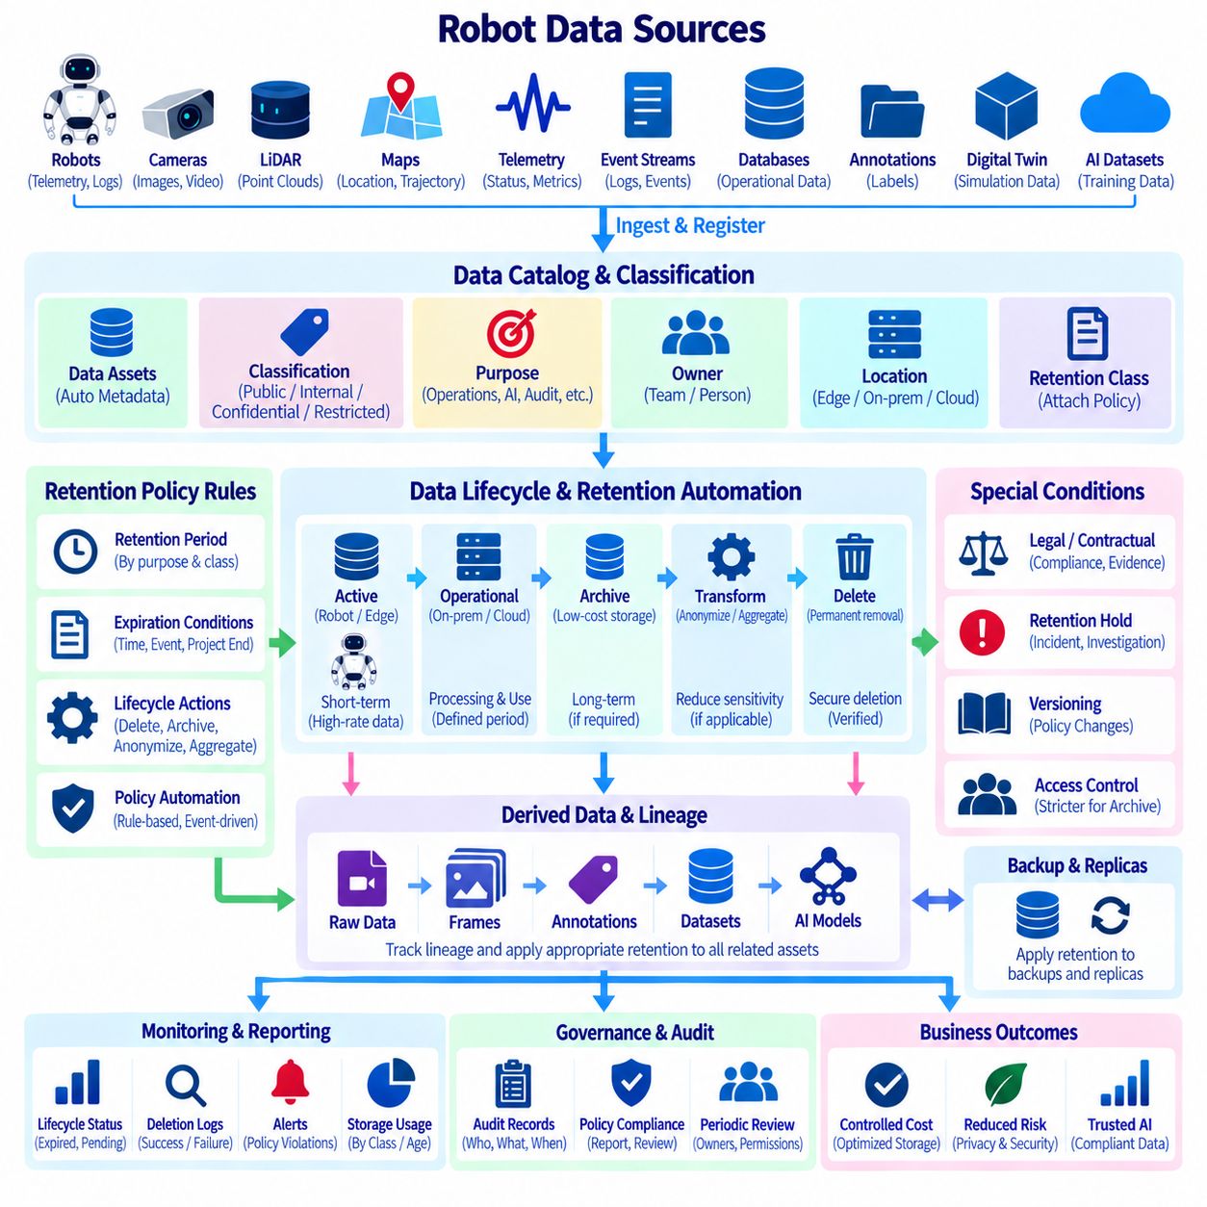
Data retention defines how long robot information should remain available, while deletion policy determines how that information is removed when its operational, legal, contractual, or analytical purpose has ended. Robot platforms continuously generate telemetry, images, video, point clouds, events, maps, logs, annotations, digital-twin states, and AI datasets. Without automated lifecycle controls, these assets can accumulate indefinitely across edge, on-premise, cloud, and archival infrastructure.
Retention requirements should be defined according to data purpose rather than applying one universal storage period. Real-time telemetry used for operational monitoring may require relatively short detailed retention, while aggregated statistics can remain useful for longer analysis. Safety incidents, maintenance histories, validated AI datasets, audit records, or contractual evidence may require different periods. Each data class therefore needs a documented lifecycle appropriate to its business and governance context.
A retention policy should connect the data asset with its owner, classification, purpose, storage location, retention period, expiration condition, and final disposition. Final disposition may include permanent deletion, anonymization, aggregation, archival, or transfer to another controlled storage tier. Explicitly defining these properties allows lifecycle decisions to become machine-readable rules rather than informal instructions interpreted differently by individual teams.
Data classification provides an important input to retention decisions. Public operational statistics, internal telemetry, confidential engineering records, privacy-sensitive sensor recordings, safety evidence, security logs, and externally licensed datasets can require different handling. Classification metadata from the data catalog can be combined with retention rules so that newly registered assets automatically inherit lifecycle policies appropriate to their sensitivity and intended use.
The robot data lifecycle commonly spans several storage tiers. High-rate sensor information may initially remain on the robot or an edge server, move to on-premise or cloud object storage for processing, and later migrate to lower-cost archival storage. Lifecycle automation can perform these transitions according to age, access frequency, project status, or classification. Tiering reduces storage cost while preserving information that still has legitimate long-term value.
Expiration should not always mean immediate physical deletion. Some information may first enter a restricted archive, undergo anonymization, or be converted into aggregated statistics before the original records are removed. Other datasets may require immediate destruction once their approved purpose expires. Policy engines should therefore support multiple lifecycle actions and clearly distinguish expiration of normal access from archival, transformation, and irreversible deletion.
Automated retention begins with reliable metadata. A system cannot consistently delete data when creation time, owner, classification, dataset version, purpose, or storage location is unknown. Data catalogs should therefore record lifecycle attributes when assets are created or registered. Pipelines can automatically attach timestamps, retention classes, project identifiers, privacy classifications, and ownership information, reducing dependence on manual metadata entry later.
Retention rules should be enforced as close as practical to the systems that physically store the information. Object storage can apply lifecycle rules to objects, databases can expire partitions or records, time-series platforms can enforce retention windows, and log systems can rotate or remove old data. A centralized governance layer can define common policy while storage-specific mechanisms execute the required actions within each infrastructure environment.
Deletion becomes more difficult when a source asset has produced multiple downstream copies and derived datasets. A camera recording may be copied into an archive, converted into frames, annotated, included in an AI dataset, and referenced by experiments. Removing only the original file does not address these descendants. Data lineage should therefore connect retention and deletion workflows with upstream and downstream relationships so affected assets can be discovered systematically.
Derived data does not necessarily inherit exactly the same retention rule as its source. An aggregated metric may contain substantially less sensitive information than the raw sensor stream from which it was calculated, while an annotated image can preserve nearly all privacy characteristics of the original image. Governance rules should evaluate the characteristics and purpose of each derived asset rather than assuming that transformation automatically removes lifecycle obligations.
AI datasets require version-aware retention because model development can create many snapshots, subsets, annotations, augmentations, and experimental copies. Dataset versions used to produce important models may need preservation for reproducibility, while temporary intermediate artifacts can be removed much earlier. Retention metadata should connect dataset versions with experiments and model versions so cleanup does not unintentionally destroy evidence required to reproduce deployed AI behavior.
Privacy requirements make deletion particularly important for camera, audio, location, interaction, and other potentially personal robot data. Data should not remain indefinitely simply because storage capacity is available. Privacy-aware lifecycle policies can associate collection purposes with expiration rules and trigger deletion, anonymization, or review when the approved retention period ends. This reduces unnecessary exposure while supporting accountable data processing.
Deletion workflows should include verification rather than assuming that a delete command completed the governance obligation. Systems can record which asset was targeted, which rule triggered the action, when deletion occurred, which storage systems were affected, and whether execution succeeded. Failed deletions should generate exceptions for investigation. Verification records provide evidence that automated lifecycle policies are operating as designed without preserving the deleted content itself.
Backups and replicas require special consideration because deleting primary data may leave additional copies elsewhere. Replicated databases, disaster-recovery environments, object-store replicas, offline backups, caches, and development copies can extend the effective lifetime of information. Retention architecture should define how these copies expire and how restoration procedures prevent previously deleted data from silently returning to active systems after recovery.
Legal, contractual, security, or investigative requirements can temporarily override ordinary deletion schedules. A dataset scheduled for expiration may need to be preserved because it is associated with an incident, audit, dispute, or other authorized hold. Automation should support controlled retention holds that suspend deletion for specifically identified assets, record the reason and authority, and resume the normal lifecycle when the hold is formally released.
Access control should become stricter as data moves toward long-term retention. Archived information may no longer require frequent operational access and can therefore be placed in restricted storage with fewer authorized roles. Encryption, immutable logging, approval workflows, and controlled restoration can protect retained evidence. Archival should not become an uncontrolled secondary data lake where expired operational information remains broadly accessible.
Policy automation benefits from event-driven execution. Asset creation can trigger assignment of a retention class, classification changes can recalculate lifecycle requirements, project completion can start expiration periods, and approved deletion requests can initiate workflows. Scheduled jobs can additionally scan for expired assets. Combining events with periodic reconciliation helps identify data that escaped normal lifecycle processing because of failures or legacy systems.
Monitoring should measure the effectiveness of retention automation. Useful operational indicators include assets without retention policies, expired assets awaiting action, deletion failures, active holds, storage consumed by expired information, and datasets approaching lifecycle deadlines. Dashboards and alerts can expose these conditions to data owners and governance teams, turning retention from a hidden storage configuration into an observable operational process.
Policy changes require versioning and auditability. Retention periods may change when business requirements, contracts, regulations, data classifications, or system purposes evolve. The governance platform should preserve which policy version applied to an asset and when changes became effective. Historical policy records allow organizations to explain why a dataset was retained, archived, anonymized, or deleted at a particular point in its lifecycle.
A mature retention architecture combines data catalogs, lineage, access control, privacy classification, storage lifecycle mechanisms, and audit records into one coordinated system. Catalogs identify what exists and which policy applies, lineage identifies dependent assets, storage systems execute lifecycle actions, and audit mechanisms record the outcome. Automation connects these components so policy decisions can be enforced consistently across distributed robot data infrastructure.
Retention and deletion automation ultimately prevents robot data platforms from becoming permanent collections of unmanaged information. By assigning explicit lifecycles when data is created, moving information through appropriate storage tiers, preserving justified evidence, and reliably removing unnecessary assets, organizations can control cost, reduce privacy and security exposure, and maintain accountable data operations. This lifecycle discipline becomes increasingly important as robot fleets and Physical AI systems generate data continuously at large scale.

09.08 AI Training Data Ethics Audit Framework
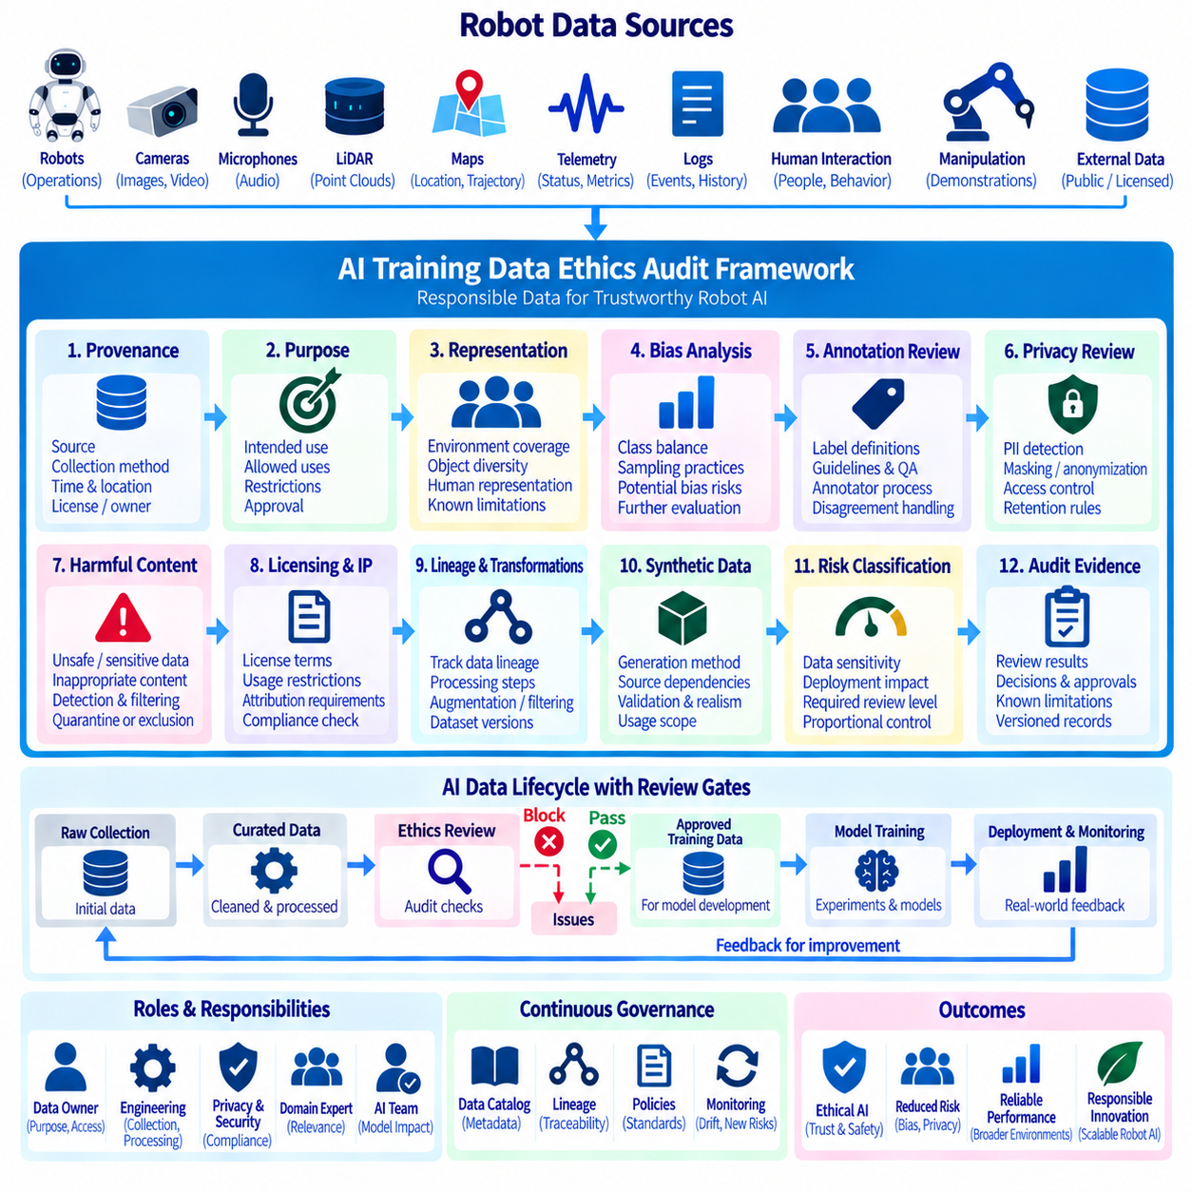
AI training data ethics auditing establishes a systematic process for examining whether datasets used to develop robot and Physical AI models are collected, selected, labeled, transformed, and governed responsibly. The audit extends beyond technical data quality by considering representation, privacy, provenance, consent or authorization, harmful content, usage restrictions, and potential downstream consequences. Its purpose is to create traceable evidence that training data has passed defined ethical and governance controls before model development.
Robot training datasets differ from conventional static datasets because they frequently represent people, physical environments, workplaces, vehicles, infrastructure, human behavior, and interactions between robots and humans. Images, video, audio, trajectories, telemetry, maps, manipulation demonstrations, and multimodal recordings may contain sensitive contextual information. Ethical review should therefore examine both individual data elements and the broader physical circumstances in which those observations were produced.
The audit framework should begin with dataset provenance. Every important dataset should identify its origin, collection method, acquisition period, responsible organization, applicable license or usage conditions, and major processing stages. Internally collected robot data should connect to robots, sensors, missions, and collection environments, while externally acquired datasets should retain source and licensing information. Unknown or poorly documented provenance should be treated as a governance risk rather than silently accepted into training.
Purpose assessment determines whether the intended AI training use is consistent with the reason data was originally collected or acquired. Operational robot recordings gathered for navigation, maintenance, or incident analysis should not automatically become unrestricted training material. The audit should record the proposed training purpose, permitted uses, restrictions, responsible owner, and approval status so that dataset availability is not incorrectly interpreted as authorization for every possible model-development activity.
Representation analysis examines whether the dataset adequately covers the environments, objects, operating conditions, and interactions relevant to the intended robot behavior. A model trained primarily in one facility, lighting condition, floor type, weather condition, or object distribution may perform differently elsewhere. Ethical auditing should therefore identify significant coverage limitations and document where training data may systematically underrepresent situations that matter to deployment.
Human representation requires additional attention when robot data contains people. Training records may vary across body characteristics, clothing, mobility patterns, workplace roles, environmental contexts, or interaction styles. The objective of an audit is not to assume that every dataset can represent every population equally, but to determine whether representation is appropriate for the intended use and whether known limitations could create uneven model behavior in deployment.
Bias auditing should distinguish dataset imbalance from demonstrated model behavior. Class frequency, sampling practices, annotation decisions, sensor placement, geographic concentration, and collection procedures can reveal potential sources of bias, but dataset statistics alone do not prove that a deployed model will behave unfairly. Audit reports should document observed imbalances, plausible risks, and required evaluation rather than converting incomplete evidence into unsupported conclusions about model outcomes.
Annotation ethics is important because labels encode human or machine interpretations of observed situations. Auditors should review annotation guidelines, label definitions, quality-control procedures, annotator instructions, automated labeling methods, disagreement handling, and correction histories. Ambiguous or subjective categories require particular attention because inconsistent definitions can become embedded in model behavior even when the underlying sensor observations are technically accurate.
Privacy review should determine whether training data contains personal or potentially identifying information such as faces, voices, locations, interaction histories, identifiers, or repeated behavioral observations. The audit should verify relevant classifications, authorized purposes, masking or pseudonymization processes, retention requirements, and access restrictions. Privacy-transformed datasets should retain metadata describing which protections were applied rather than losing the history of the original processing context.
Sensitive and harmful content requires controlled handling within dataset workflows. Robot recordings may unintentionally capture accidents, unsafe behavior, confidential documents, screens, private conversations, restricted facilities, or other material inappropriate for unrestricted training access. Detection procedures can flag such records for review, quarantine, exclusion, transformation, or specially controlled use according to organizational policy and the legitimate requirements of the intended application.
Dataset licensing and intellectual-property conditions should be audited before training begins. Public availability does not necessarily imply unrestricted permission for copying, modification, redistribution, commercial use, or model training. Dataset records should preserve licenses, contractual restrictions, attribution requirements, source terms, and internal approvals. When multiple sources are combined, the resulting training dataset should maintain traceability to the conditions associated with its components.
Data lineage provides the technical evidence chain required for repeatable ethics audits. Raw recordings can pass through filtering, privacy processing, annotation, augmentation, balancing, partitioning, and dataset assembly before reaching model training. Lineage should connect each dataset version with these transformations and ultimately with experiments and model versions, allowing auditors to reconstruct which source information contributed to a particular model and which controls were applied.
Synthetic data should also be included within the ethics framework. Simulation and generative processes can improve coverage of rare conditions and reduce dependence on some real-world recordings, but they can introduce unrealistic distributions, inherited source-data characteristics, or hidden assumptions from simulation design. Audits should document generation methods, source dependencies, scenario coverage, validation procedures, and the intended relationship between synthetic and real-world training data.
Dataset transformations can change ethical risk and should therefore be auditable. Cropping may remove contextual information, balancing can alter observed distributions, augmentation can create unrealistic examples, and filtering can systematically remove difficult cases. Transformation parameters, software versions, selection criteria, and resulting dataset statistics should be preserved so reviewers can determine how the final training distribution differs from the original collected information.
Ethics audits should establish explicit review gates within the AI data lifecycle. A dataset can move from raw collection to curated data, approved training data, validated release, and eventually archived or deprecated status. Advancement between stages can require completion of provenance, privacy, licensing, quality, representation, and documentation checks. Automated gates can block datasets with missing mandatory metadata while human review addresses issues that cannot be resolved reliably through rules alone.
Risk classification helps determine the depth of review required. A small internal dataset containing non-sensitive machine telemetry may require relatively lightweight controls, while large-scale video involving people or data supporting safety-related robot behavior may justify more extensive assessment. The audit process should therefore scale according to data sensitivity, deployment consequences, uncertainty, and organizational policy instead of imposing identical procedures on every dataset.
Audit evidence should be preserved with the dataset version rather than stored only in disconnected reports. Evidence can include provenance records, quality results, privacy status, license information, representation statistics, review decisions, known limitations, approvals, and unresolved issues. Version-specific evidence is essential because a dataset may change substantially after new sources, annotations, filtering rules, or transformations are introduced.
Responsibility should be distributed across clearly identified roles. Data owners can confirm purpose and provenance, engineering teams can explain collection and transformation processes, privacy and security teams can evaluate sensitive information, domain experts can assess operational relevance, and AI teams can examine representation and model implications. Defined ownership prevents ethics review from becoming an informal responsibility that everyone assumes another team has completed.
Post-training review connects dataset governance with observed model behavior. Evaluation results may reveal failure patterns associated with environments, objects, interaction scenarios, or data distributions that were not obvious during dataset inspection. These findings should feed back into the catalog, lineage, dataset documentation, and future collection plans. Ethics auditing therefore becomes an iterative lifecycle process rather than a one-time approval performed before the first training run.
Monitoring should continue after deployment because operational experience can expose new data limitations. Fleet incidents, edge cases, human feedback, performance drift, and newly encountered environments can indicate gaps in the original training distribution. When additional data is collected for retraining, the new material should pass the same provenance, privacy, representation, licensing, quality, and approval controls instead of bypassing governance because the model already exists.
A mature AI training data ethics audit framework ultimately combines data cataloging, lineage, quality governance, privacy protection, access control, retention, documentation, human review, and model feedback into a continuous evidence-based process. It does not guarantee that an AI system will be free from every ethical problem, but it makes assumptions, limitations, decisions, and responsibilities visible. This traceability supports more accountable development of scalable robot and Physical AI systems.

09.09 Robot Data Security Classification and Encryption
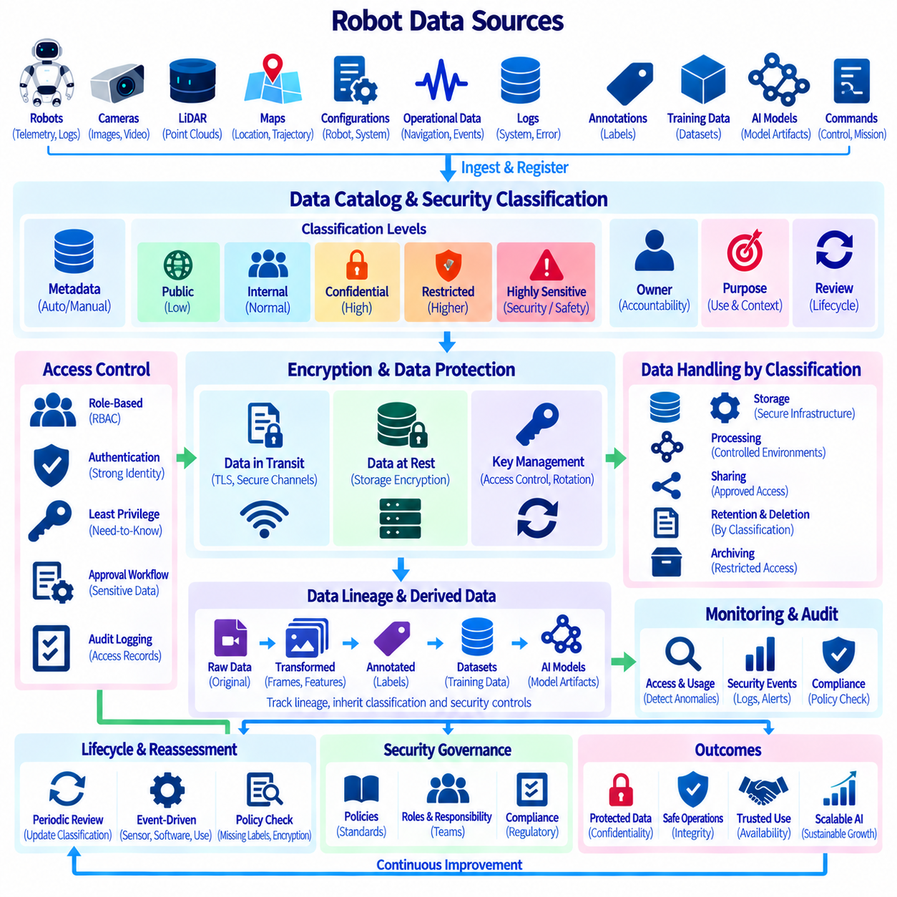
Robot data security classification establishes a structured method for determining how strongly different types of robot information should be protected. A Physical AI system can generate telemetry, camera images, LiDAR point clouds, maps, robot configurations, navigation records, logs, annotations, training datasets, model artifacts, and operational commands. These assets do not have identical security requirements. Classification therefore provides the foundation for applying appropriate access control, encryption, retention, monitoring, and handling policies throughout the data lifecycle.
Security classification should consider the sensitivity, operational importance, business value, privacy implications, and potential consequences of unauthorized disclosure or modification. A public operational statistic may require limited protection, while proprietary robot configurations, facility maps, raw sensor recordings, credentials, safety records, or AI training data may require stronger controls. Classification should describe the consequences associated with compromise rather than simply identifying where the data is stored or which application created it.
A practical classification model can distinguish categories such as Public, Internal, Confidential, Restricted, and highly sensitive security or safety information according to organizational policy. The exact labels should remain consistent across the data catalog, access-control system, storage platforms, and operational procedures. Classification should be assigned to datasets and important metadata at creation or registration time, then reviewed when purpose, content, ownership, processing method, or operational context changes.
Robot-specific context is important when determining security classification. A camera recording from an empty laboratory may have different sensitivity from a recording that captures people, confidential documents, production equipment, or restricted facilities. Similarly, a map may appear to be ordinary spatial data but become highly sensitive when it reveals protected infrastructure. Security classification should therefore consider both the information itself and the physical environment represented by that information.
Data classification should be connected to ownership and purpose. Each important data asset should identify a responsible owner who can determine why the information exists, who should use it, and what level of protection is required. Purpose information helps distinguish operational telemetry from safety evidence, research data, customer information, or AI training material. This connection prevents security labels from becoming static technical tags that no longer reflect how the data is actually used.
Access control should enforce classification decisions rather than maintaining classification as documentation only. A Restricted dataset may require stronger authentication, narrower roles, approval workflows, and more detailed audit logging than an Internal dataset. Role-Based Access Control can connect users and services with permissions derived from data classification, while least privilege limits access to only the information required for legitimate activities.
Encryption provides a technical protection layer for classified robot data. Data should be protected both at rest and in transit when the classification and threat model require it. Raw sensor recordings, confidential configurations, credentials, and sensitive datasets may require stronger encryption controls than low-risk operational statistics. Encryption keys should be managed separately from the protected data, with controlled access, rotation procedures, and auditable key-management operations.
Data moving between robots, edge devices, on-premise servers, cloud infrastructure, databases, object storage, and AI platforms should be protected according to its classification. Transport encryption can protect information while it crosses networks, while storage encryption protects persistent copies. Internal network location should not automatically be treated as sufficient protection because a compromised internal service or account may otherwise gain access to sensitive information.
Classification should also influence retention and deletion policies. Highly sensitive recordings may require shorter retention periods unless a documented operational, legal, safety, or analytical purpose justifies longer preservation. Archived data should not automatically retain the same broad accessibility it had during active processing. Lifecycle policies can combine classification with purpose and retention rules to archive, anonymize, or delete information when its approved use period ends.
Data lineage is important when classified information is transformed into derived products. A raw camera recording may produce selected frames, anonymized images, annotations, datasets, features, and AI models. The security properties of each derived asset should be evaluated rather than assuming that every transformation removes the original sensitivity. Lineage allows governance teams to identify where sensitive information originated, how it was transformed, and which downstream assets may require additional protection.
Security classification should extend to AI training datasets and model-development artifacts. Training datasets can contain proprietary operational information, personal data, sensitive environments, or licensed material, while model checkpoints and experiment outputs may indirectly preserve information from their training sources. Dataset versions, model artifacts, experiment records, and deployment packages should therefore receive classifications appropriate to their content, purpose, and potential consequences of unauthorized access.
Monitoring and auditing provide evidence that security controls are operating as intended. Important events include access to restricted data, permission changes, encryption-key operations, large exports, unexpected transfers, classification changes, and administrative actions. Audit records should identify the actor, resource, action, time, result, and relevant context. Monitoring can then detect unusual patterns and support investigation when sensitive robot information is accessed or transferred unexpectedly.
Security classification should be integrated with the data catalog so that governance information remains visible without unnecessarily exposing the underlying content. Catalog records can display classification, owner, purpose, retention requirements, access restrictions, encryption status, and approved handling procedures. This allows engineers and data users to understand the security conditions of a dataset before requesting or processing it and provides a common reference across distributed robot data infrastructure.
Classification must remain a lifecycle process rather than a one-time label assignment. New sensors, software releases, deployment environments, external data sources, AI applications, and business requirements can change the sensitivity of existing information. Periodic reviews and event-driven reassessment can identify assets whose classification is outdated. Automated policy checks can detect unclassified assets, inappropriate storage locations, missing encryption, excessive permissions, or transfers that conflict with the assigned security level.
A mature robot data security architecture combines classification, identity, access control, encryption, lineage, retention, monitoring, and auditing into a coordinated protection system. Classification determines the required level of protection, access control determines who may use the data, encryption protects information during storage and transmission, lineage tracks its propagation, and lifecycle policies control how long it remains available. Together, these mechanisms create a security framework that protects robot and Physical AI data while preserving the availability and traceability required for scalable engineering and operations.

09.10 Data Governance Maturity Model and Roadmap
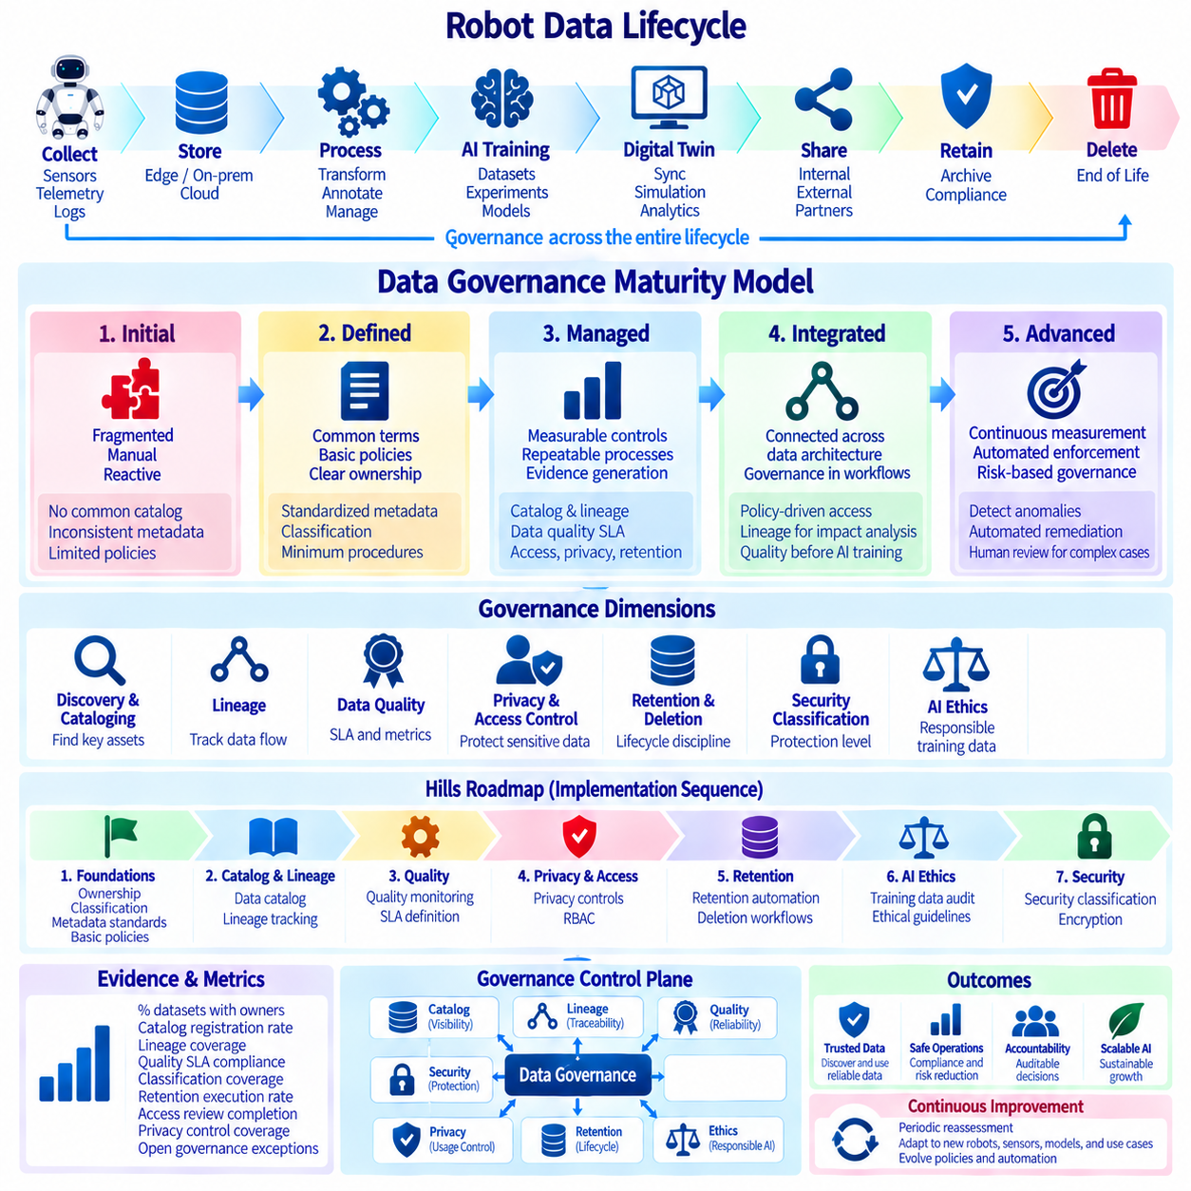
Data governance maturity for robot and Physical AI systems describes how an organization progresses from informal and fragmented data practices toward a coordinated, measurable, and continuously improving governance capability. The maturity model should connect governance with the complete robot data lifecycle, including collection, storage, processing, AI training, digital twins, sharing, retention, security, and deletion. In the Volume 07 structure, Data Governance follows data modeling, pipelines, telemetry, event streaming, time-series, sensor, AI, and digital-twin architecture, positioning governance as the control layer that coordinates these preceding data capabilities.
An initial maturity state is characterized by fragmented ownership and largely manual data management. Robot data may exist across onboard storage, edge computers, NAS systems, databases, cloud platforms, and development environments without consistent metadata or responsibility. Teams often know where their own data is located but lack a common catalog, lineage, classification, retention policy, or quality standard. Governance at this stage is primarily reactive, with problems discovered after data has already been reused, transferred, or incorporated into an AI workflow.
A defined governance stage establishes common terminology, ownership, policies, and minimum operating procedures. Data assets begin to receive standardized names, identifiers, classifications, owners, purposes, and lifecycle information. Basic policies can define how robot telemetry, sensor recordings, maps, annotations, training datasets, and operational records should be collected and handled. The objective is not to introduce maximum complexity immediately, but to create a consistent foundation that allows different engineering teams to manage data according to shared organizational rules.
A managed stage introduces measurable controls and repeatable governance processes. Data catalogs provide visibility into important assets, lineage records relationships between sources and derived products, and quality SLAs define measurable expectations for completeness, validity, freshness, consistency, and other quality dimensions. Access control, privacy protection, retention automation, and security classification become operational mechanisms rather than documentation alone. Governance begins to generate evidence that data policies are actually being applied across robot data pipelines.
An integrated stage connects governance controls across the complete data architecture. Catalog metadata can influence access policies, classification can determine encryption and retention requirements, lineage can support privacy deletion and impact analysis, and quality monitoring can identify unreliable datasets before they enter AI training or operational analytics. AI data governance can connect training-data versions with provenance, annotations, experiments, and model artifacts. Governance therefore becomes integrated with engineering workflows instead of operating as a separate administrative function.
An advanced maturity state introduces continuous measurement, automated policy enforcement, and risk-based governance. Systems can automatically detect unclassified assets, missing metadata, expired information, excessive permissions, quality violations, unexpected data transfers, and security anomalies. Governance dashboards provide visibility into compliance and operational status, while automated workflows initiate review, quarantine, remediation, archival, or deletion when defined conditions occur. Human review remains important for ambiguous or high-impact decisions that cannot be safely reduced to fixed rules.
The maturity model should evaluate governance across several connected dimensions rather than assigning a single maturity value to an entire organization. Data discovery and cataloging measure whether important assets are visible. Lineage measures whether data movement and transformation can be reconstructed. Quality measures whether data meets defined service expectations. Privacy and access control measure whether sensitive information is appropriately protected. Retention and deletion measure lifecycle discipline, while security classification and encryption measure protection against unauthorized disclosure or modification.
The Hills roadmap can use this maturity model to translate governance principles into an incremental implementation sequence. Early work should establish ownership, classification, metadata standards, and basic policies before attempting extensive automation. The next stage can prioritize catalog and lineage capabilities, followed by quality monitoring, privacy controls, RBAC, retention automation, ethical AI-data auditing, and security classification. This sequence allows governance capabilities to mature together with the underlying robot data architecture rather than creating isolated governance tools without operational integration.
For Hills, governance should be designed around the characteristics of Physical AI data rather than conventional enterprise datasets alone. Robot systems continuously generate multimodal sensor information, telemetry, spatial information, operational events, AI training data, digital-twin states, and derived model artifacts. These data products can move between robots, edge environments, on-premise infrastructure, cloud systems, AI training platforms, and external partners. The roadmap should therefore emphasize traceability across these boundaries and preserve clear relationships between source data, transformations, models, and operational use.
A practical Hills implementation can establish a governance control plane that connects the data catalog, lineage, quality, privacy, access control, retention, ethics, and security capabilities developed throughout Chapter 09. The catalog provides visibility, lineage provides traceability, quality provides measurable reliability, privacy and access control regulate use, retention manages lifecycle, ethics auditing governs AI training data, and security classification determines protection requirements. Together, these controls create a coordinated governance layer over the robot data architecture rather than a collection of independent compliance mechanisms.
Maturity should also be measured through evidence rather than the existence of documents or tools. Useful evidence includes the percentage of important datasets with identified owners, the proportion of assets registered in the catalog, lineage coverage, quality SLA compliance, classification coverage, successful retention execution, access-review completion, privacy-control coverage, and the number of unresolved governance exceptions. These indicators allow Hills to determine whether governance is becoming an operational capability and where additional engineering effort is required.
The roadmap should remain iterative because robot and Physical AI architectures will continue to change. New sensors, robot platforms, AI models, simulation environments, synthetic datasets, digital twins, and deployment patterns can introduce new governance requirements. The maturity model should therefore support periodic reassessment and event-driven updates rather than treating maturity as a permanent designation. Governance policies, technical controls, ownership models, and automation should evolve as the organization moves from individual robot projects toward multi-robot and scalable Physical AI operations.
The target state is not maximum governance complexity but governance that is proportional, automated, traceable, and useful to engineering operations. A mature Hills data governance capability should allow teams to discover trusted data, understand its origin and quality, determine who may use it, protect sensitive information, retain justified evidence, remove unnecessary data, and audit important decisions. This creates a foundation in which robot data can move safely through collection, processing, AI training, deployment, and continuous improvement while maintaining accountability across the entire Physical AI lifecycle.

