Volume 07 Robot Data Architecture

02. Data Pipelines

02.01 Data Pipeline Concepts: ETL vs ELT vs Streaming
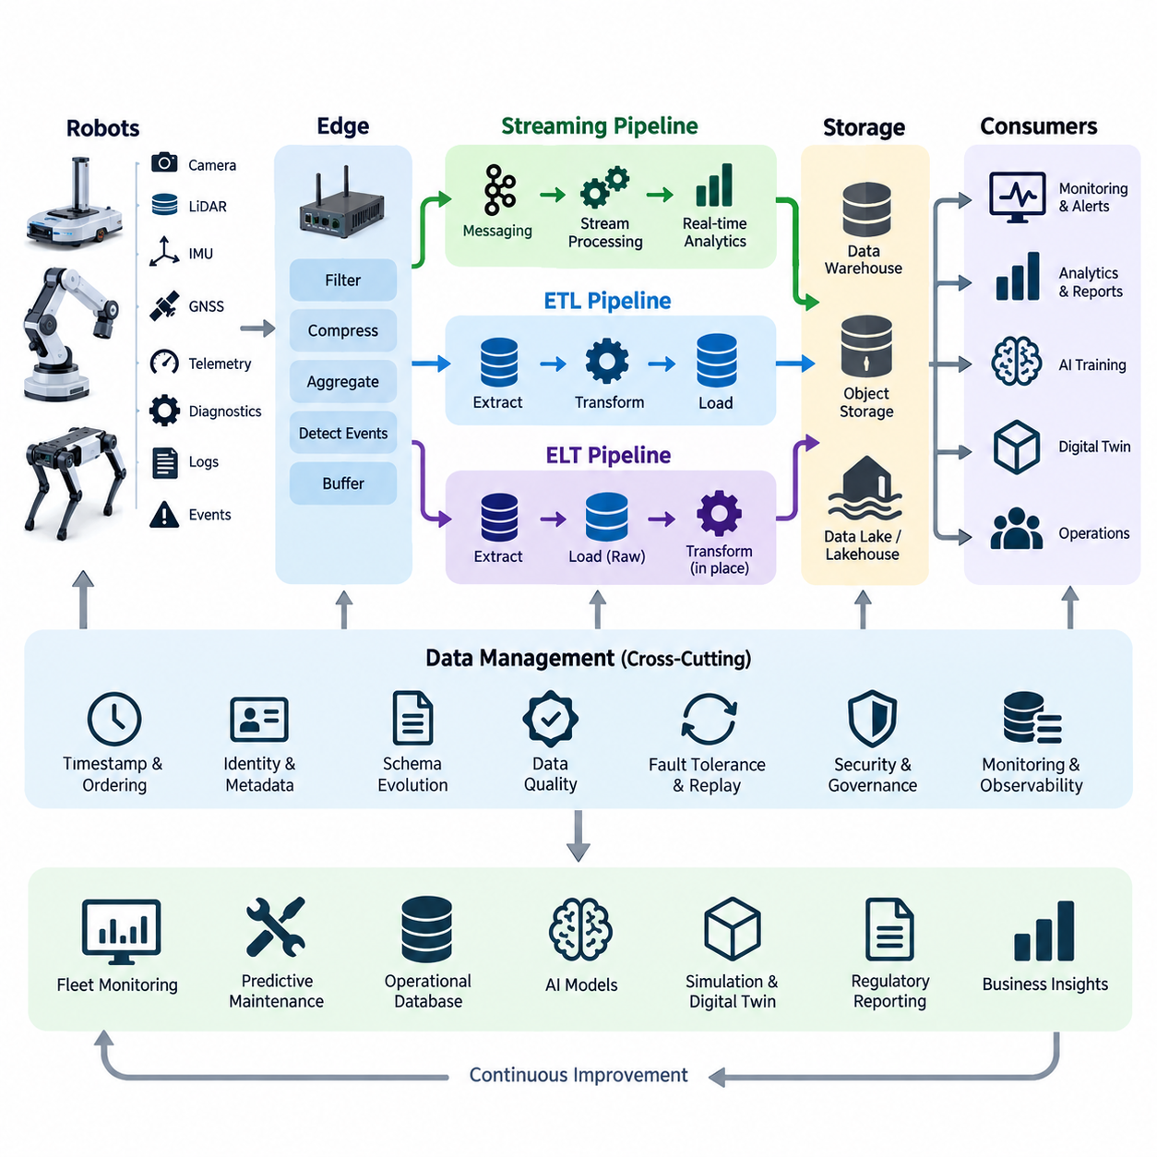
A robot data pipeline is the architectural path through which raw observations become reliable information for operations, analytics, artificial intelligence, and long-term knowledge. In the structure of Robot Data Architecture, data pipelines connect onboard collection, edge processing, cloud transfer, storage, validation, training, and governance. ETL, ELT, and streaming represent three fundamental processing models for organizing this movement.
ETL, or Extract, Transform, Load, follows a processing sequence in which data is first extracted from source systems, transformed into a predefined structure, and then loaded into a target repository. Transformation may include filtering invalid records, converting units, normalizing timestamps, joining metadata, removing duplicates, and mapping robot-specific messages into standardized schemas before permanent storage.
In robotics, ETL is particularly useful when the destination requires strongly controlled and predictable data. Telemetry collected from motor controllers, battery management systems, navigation modules, and diagnostic services can be extracted periodically and processed through validation rules before entering an operational database or analytical warehouse. This approach prevents malformed or incompatible records from contaminating downstream datasets.
The main advantage of ETL is that data quality and schema conformity can be enforced before information reaches the target system. This is valuable for regulatory reports, fleet KPI databases, maintenance histories, and carefully curated AI datasets. Its limitation is reduced flexibility because transformation logic must normally be designed before loading, while high-volume sensor data may require substantial intermediate processing resources.
ELT, or Extract, Load, Transform, reverses the last two stages. Raw or minimally processed information is extracted from robots and loaded directly into scalable storage before transformations are executed inside the destination environment. Modern object storage, data lakes, lakehouses, and distributed analytical platforms make this approach practical because they can retain large volumes of heterogeneous information economically.
For robot systems, ELT is well suited to camera images, LiDAR point clouds, ROS 2 recordings, diagnostic logs, localization histories, and multimodal datasets whose future analytical value may not yet be known. Instead of discarding information through early transformations, the architecture preserves original data and later derives specialized representations for perception training, failure analysis, simulation, or fleet analytics.
ELT therefore separates data preservation from data interpretation. A single raw dataset can generate multiple derived datasets without repeating collection from the physical robot. Engineers may produce cleaned telemetry for reliability analysis, synchronized sensor sequences for perception training, reduced-resolution data for visualization, and selected event windows for anomaly investigation while maintaining the original observations as a reproducible source.
Streaming addresses a different requirement: continuous processing while data is being generated. Rather than waiting for a complete batch, records or events move through the pipeline as an ongoing sequence. Robot position, velocity, battery state, temperatures, task status, obstacle detections, safety events, and system faults can therefore be processed within milliseconds or seconds of their occurrence.
A streaming pipeline commonly connects robot producers with transport or messaging infrastructure, stream processors, operational consumers, and persistent storage. Incoming events may be filtered, enriched, aggregated, correlated, or evaluated against rules and machine-learning models. The same stream can simultaneously support fleet dashboards, anomaly detection, alerts, digital twins, operational databases, and historical archives without forcing every consumer to communicate directly with each robot.
Streaming becomes especially important when data has immediate operational meaning. A rising motor temperature should not wait for a nightly ETL job if it indicates an approaching failure. A localization fault, emergency stop, unexpected obstacle, or rapidly falling battery state may require immediate fleet-level action. Streaming converts the data architecture from a passive recording mechanism into an active operational nervous system.
ETL, ELT, and streaming should therefore not be treated as mutually exclusive alternatives. They solve different temporal and architectural problems. ETL emphasizes controlled transformation before storage, ELT emphasizes preservation and flexible transformation after storage, and streaming emphasizes continuous low-latency processing. A mature robot platform typically combines all three according to data characteristics and business requirements.
Consider an outdoor autonomous mobile robot collecting LiDAR, camera, GNSS, IMU, battery, motor, and diagnostic information. Critical status values may enter a streaming pipeline for real-time monitoring, while large sensor recordings are uploaded through an ELT-oriented pipeline into object storage. Later, scheduled ETL jobs can extract selected operational records, apply quality rules, calculate fleet KPIs, and load validated results into structured analytical databases.
The distinction between batch and streaming processing is equally important. Batch pipelines process bounded collections accumulated over minutes, hours, or days, making them efficient for historical analytics, model training, reporting, and large transformations. Streaming pipelines process unbounded sequences continuously and prioritize latency, event ordering, fault recovery, and sustained throughput. Many robot architectures require both processing modes over the same underlying information.
Edge computing adds another dimension because transferring every raw observation to centralized infrastructure is often impractical. An onboard or nearby edge pipeline can filter redundant frames, compress sensor data, aggregate telemetry, detect important events, and maintain temporary buffers during network interruptions. Only selected or summarized information may be streamed continuously, while high-volume raw datasets are transferred later under appropriate network conditions.
Reliable pipeline design must also consider timestamps, ordering, identity, schemas, and metadata. Robot data is meaningful only when engineers can determine which robot generated it, which sensor produced it, when it was captured, which software and configuration were active, and how it was transformed. Pipeline stages should therefore preserve provenance and lineage instead of treating data movement as simple file transfer.
Fault tolerance is especially significant in physical systems because wireless communication is intermittent and robots continue operating even when cloud connectivity disappears. Pipelines should support buffering, retry, acknowledgment, deduplication, checkpointing, and replay. A temporarily disconnected robot can retain important records locally and transmit them after reconnection, while event identifiers and processing state prevent accidental duplication or loss.
Schema evolution must also be incorporated from the beginning. Robot software, sensors, AI models, and fleet services change throughout the product lifecycle, so data formats inevitably evolve. Versioned schemas and backward-compatible transformation rules allow old and new robots to coexist while downstream systems continue interpreting their information correctly. This becomes increasingly important as a deployment grows from prototypes to heterogeneous fleets.
Data quality controls should exist throughout the pipeline rather than at one final validation stage. Collection components can detect unavailable sensors, edge processors can identify impossible ranges, streaming systems can monitor missing events, and batch transformations can evaluate completeness and consistency. These controls provide the foundation for later pipeline monitoring, anomaly detection, replay, testing, and contract validation within the broader data architecture.
For AI and Physical AI systems, pipeline architecture directly influences model quality. Training data must preserve synchronization between perception, state, action, and environmental context. ELT can retain rich raw observations, ETL can create reproducible curated datasets, and streaming can identify valuable operational episodes as they occur. Together they establish a continuous path from physical experience to training data and from deployed models back to new observations.
The most effective robot data architecture consequently selects processing patterns according to latency, volume, reliability, cost, and future reuse rather than adopting one universal pipeline. Streaming supports immediate awareness, ELT preserves high-value raw experience, and ETL produces trusted structured information. Their coordinated use creates a scalable data foundation connecting individual robots, fleets, edge systems, cloud platforms, digital twins, analytics, and AI learning workflows.

02.02 Robot Onboard Data Collection Pipeline Design [w/Code]
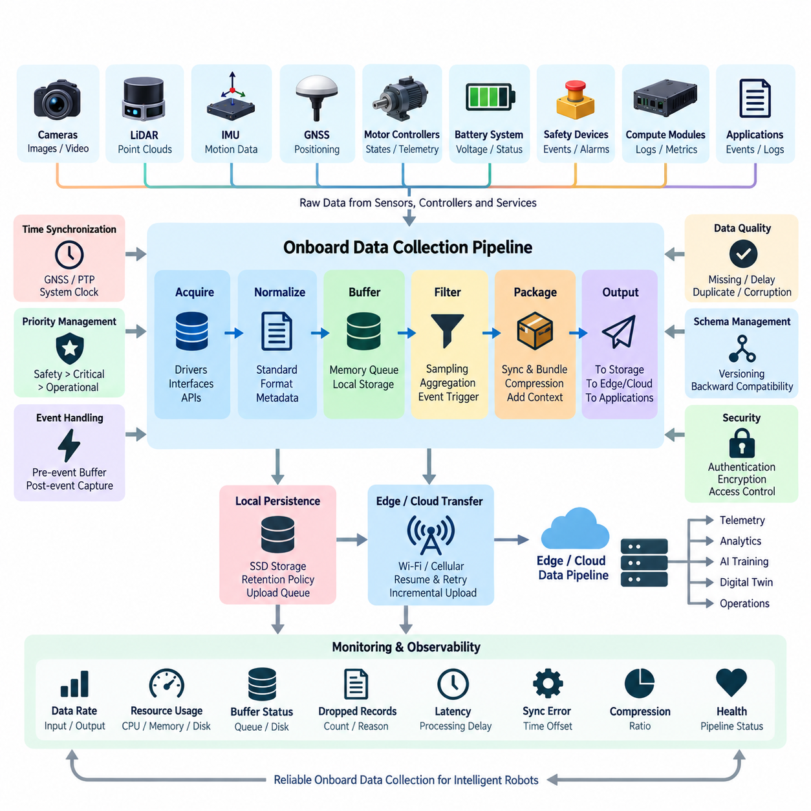
Robot onboard data collection is the first operational stage of the robot data pipeline, responsible for capturing information generated by sensors, controllers, computing modules, applications, and diagnostic services while the robot is operating. Within the broader Robot Data Architecture, this stage establishes the trusted interface between the physical robot and downstream edge, cloud, telemetry, analytics, and AI data systems.
An onboard collection pipeline must accommodate heterogeneous data sources with very different characteristics. Cameras generate high-bandwidth image streams, LiDAR produces structured point clouds, IMUs provide high-frequency motion measurements, GNSS receivers generate positioning information, while motor controllers, battery systems, safety devices, and software services continuously produce telemetry, states, events, diagnostics, and logs.
The collection architecture should separate data acquisition from application-specific processing. Sensor drivers and hardware interfaces acquire measurements from physical devices, while collection services convert these measurements into standardized internal representations. This separation prevents every navigation, perception, monitoring, or logging application from implementing its own hardware-specific acquisition logic and improves portability when sensors are replaced.
A common onboard architecture organizes collection into source, acquisition, normalization, buffering, filtering, packaging, and output stages. Raw measurements first enter through device drivers, ROS 2 topics, CAN interfaces, Ethernet devices, serial links, or internal software APIs. The pipeline then attaches timestamps, robot identifiers, sensor identifiers, sequence numbers, configuration references, and other metadata required for downstream interpretation.
Time synchronization is fundamental because robot intelligence depends on relationships among measurements rather than isolated samples. Camera frames, LiDAR scans, IMU measurements, wheel odometry, GNSS positions, and control commands may operate at different frequencies and clocks. The collection pipeline should preserve acquisition timestamps and, where appropriate, synchronized time references such as GNSS-based timing, PTP, or system clock synchronization.
Data rates must be considered independently for each source. A temperature sensor may produce only a few values per second, whereas multiple cameras and LiDAR sensors can generate hundreds of megabytes or more over short operating periods. Treating all sources identically wastes computing, storage, and network resources. Collection policies should therefore define sampling rates, priorities, retention periods, compression methods, and transmission behavior by data class.
Onboard filtering reduces unnecessary data before it consumes limited resources. Repeated status values may be transmitted only when they change, high-frequency telemetry can be aggregated over short windows, and sensor frames can be selectively retained according to mission conditions. Filtering should remain traceable, however, because aggressive reduction can remove information later required for failure investigation or AI model development.
Buffering protects the pipeline from temporary differences between data production and consumption rates. Producers such as cameras should not stop simply because storage or communication becomes momentarily slower. Memory queues can absorb short bursts, while local SSD storage can provide larger persistent buffers. Buffer size and overflow behavior should reflect the operational importance and recoverability of each data stream.
Priority management becomes essential when onboard resources are constrained. Safety events, emergency-stop states, localization failures, battery faults, and critical diagnostic information should normally receive higher collection and persistence priority than routine operational records. Large raw sensor streams may be reduced or temporarily suspended under resource pressure, while safety-critical records must remain available for operational response and later investigation.
The pipeline should distinguish continuous telemetry from event-triggered data. Continuous telemetry provides regular measurements such as battery voltage, motor temperature, velocity, CPU utilization, and localization status. Event-triggered collection captures detailed information around important occurrences such as collisions, emergency stops, perception anomalies, navigation failures, or abnormal vibration, allowing high-value context to be preserved without recording everything indefinitely.
Pre-event and post-event buffering is particularly useful for robot diagnostics. A circular buffer can continuously retain the most recent seconds or minutes of selected sensor and system data. When an important event occurs, the pipeline freezes the relevant historical window and continues recording for a defined period afterward. The resulting package provides engineers with context before, during, and after the failure.
Data packaging should preserve relationships among heterogeneous streams. Instead of treating images, point clouds, telemetry, and events as unrelated files, the pipeline should maintain metadata that identifies mission, robot, software version, sensor configuration, calibration version, and time range. Such contextual information enables downstream systems to reconstruct the operational situation and create reproducible datasets for engineering and AI workflows.
Compression can substantially reduce onboard storage and network demand, but the technique must match the data type and intended use. Images and video may use image or video compression, while structured telemetry can use compact serialization and batching. Point-cloud compression and selective recording can reduce LiDAR volume. Lossy compression should be applied carefully when retained data may later become training or validation evidence.
Local persistence provides resilience when connectivity is unavailable. Mobile robots frequently move through areas with weak Wi-Fi, cellular handovers, tunnels, elevators, industrial facilities, or outdoor coverage gaps. The onboard pipeline should continue collecting essential information locally, maintain upload state, and transfer buffered records when connectivity returns instead of assuming that cloud communication is continuously available.
Storage management must prevent local disks from filling indefinitely. Retention policies can divide data into critical, important, and replaceable classes and assign different deletion rules. Successfully uploaded low-priority data may be removed quickly, while unresolved fault records and selected AI training samples can be retained longer. Storage monitoring should trigger controlled cleanup before capacity exhaustion affects robot operation.
Reliable collection also requires explicit handling of missing, delayed, duplicated, and corrupted records. Sequence numbers can reveal dropped samples, checksums can identify damaged payloads, and timestamps can expose excessive delay or clock problems. Collection agents should report their own health so that downstream systems can distinguish a genuine environmental measurement from a failure of the data acquisition infrastructure itself.
Schema management becomes increasingly important as robot software evolves. New firmware may introduce additional diagnostic fields, sensors may be replaced, and AI modules may publish new inference outputs. Version identifiers should therefore accompany collected records so that downstream processing can interpret historical and current formats correctly without forcing every deployed robot to upgrade simultaneously.
Resource isolation prevents data collection from interfering with the robot's primary mission. CPU, GPU, memory, storage I/O, and network bandwidth used by collection services should be bounded so that navigation, perception, control, and safety functions retain the resources they require. When overload occurs, the pipeline should degrade intentionally according to priority rather than allowing uncontrolled competition among processes.
Security must begin at the point of collection. Robot identifiers and data-source identities should be trustworthy, sensitive information should be classified appropriately, and stored data should be protected against unauthorized access or modification. When data leaves the robot, authentication, integrity protection, and encryption can preserve trust across edge and cloud boundaries while supporting later governance requirements.
Observability should cover the collection pipeline itself. Useful operational measurements include input rate, output rate, queue depth, dropped records, buffer utilization, disk capacity, processing latency, compression ratio, synchronization error, and upload backlog. These measurements allow engineers to detect pipeline degradation before it results in substantial data loss or prevents important operational events from being captured.
For AI and Physical AI systems, onboard collection should preserve the connection between observation and action. Sensor inputs, robot state, perception outputs, planner decisions, control commands, mission context, and resulting physical behavior may later become training or evaluation data. Accurate timestamps and contextual metadata make it possible to reconstruct these sequences and convert field operation into reusable learning experience.
A well-designed onboard data collection pipeline therefore acts as more than a recorder. It is a controlled data acquisition layer that determines what physical experience is preserved, how accurately it can be reconstructed, and how efficiently it reaches downstream systems. Through synchronization, filtering, buffering, prioritization, persistence, metadata, quality control, security, and observability, it provides the reliable foundation required by the later edge-to-cloud, telemetry, event-streaming, and AI data pipelines defined in the Robot Data Architecture.

02.03 Edge.Cloud Data Transfer Pipeline [w/Code]
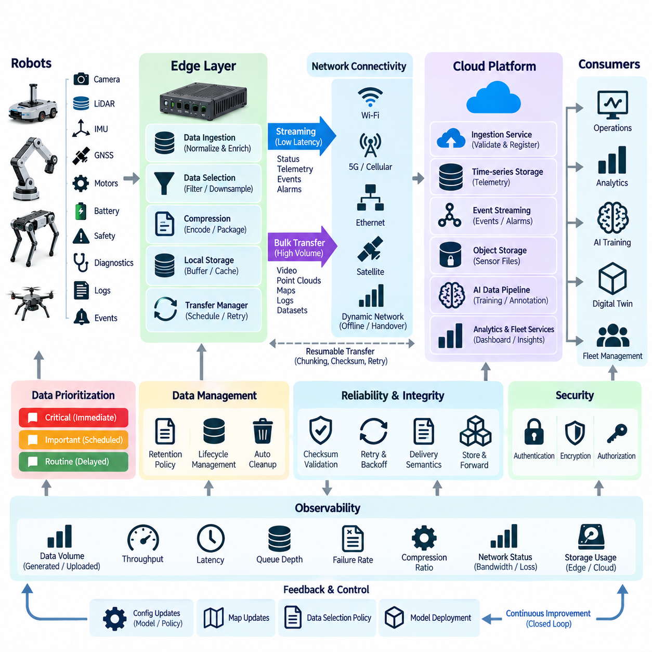
The edge-cloud data transfer pipeline connects robot-local data collection with centralized storage, analytics, fleet services, and AI infrastructure. Its purpose is not simply to upload every byte generated by a robot, but to determine which information should leave the robot, when it should be transmitted, how it should be protected, and how transfer can continue reliably despite changing network and operational conditions.
Robot workloads generate data with very different bandwidth and latency requirements. Emergency events, health telemetry, mission states, and fault codes may require immediate delivery, while camera recordings, LiDAR point clouds, ROS 2 bags, and diagnostic archives can tolerate delayed transfer. A practical pipeline therefore classifies traffic according to urgency, volume, persistence requirements, and downstream consumers before selecting a transfer strategy.
The edge layer acts as the bridge between onboard producers and cloud services. It can receive data from one robot or an entire local fleet, normalize metadata, aggregate telemetry, compress payloads, remove redundant information, and temporarily store records. By performing these functions close to the physical system, the architecture reduces unnecessary wide-area traffic while preserving information that has operational or analytical value.
Data selection is one of the most important edge functions because continuously transmitting all raw sensor information is rarely economical. High-frequency telemetry can be downsampled, repeated states can be suppressed, and large sensor streams can be uploaded selectively. Event-triggered policies can retain detailed data around collisions, perception failures, localization anomalies, emergency stops, or other situations that deserve deeper investigation.
The pipeline should support both streaming and bulk transfer. Streaming is appropriate for small, continuously generated records that require low latency, such as robot status, task progress, alarms, and selected telemetry. Bulk transfer is better suited to large files and bounded datasets such as recorded video, point clouds, maps, logs, and AI training samples. Combining both approaches prevents large uploads from delaying operational messages.
Transfer scheduling can further reduce network congestion and operating cost. Large noncritical datasets may remain in an edge buffer until sufficient bandwidth becomes available, the robot reaches a charging station, or a preferred network connection is established. Critical records can bypass normal scheduling rules and receive immediate transmission priority. This creates a policy-driven pipeline rather than a simple first-in-first-out upload mechanism.
Network conditions must be treated as dynamic rather than constant. Mobile robots may transition among Ethernet, Wi-Fi, private 5G, public cellular networks, or temporary offline states during a mission. The transfer service should observe connectivity, bandwidth, latency, packet loss, and link stability and adjust its behavior accordingly instead of assuming that the communication path available at startup will remain unchanged.
Store-and-forward operation provides resilience during disconnection. When the cloud cannot be reached, the edge system stores transferable records locally together with destination, priority, timestamp, retry state, and integrity information. Once connectivity returns, queued data can resume transmission without requiring the robot application to regenerate it. This decouples robot operation from temporary failures of external communication infrastructure.
Resumable transfer is especially important for large sensor files. Restarting a multi-gigabyte upload from the beginning after every interruption wastes bandwidth and energy. Chunking divides large objects into independently transferable units so completed portions remain valid. The receiver can acknowledge successfully stored chunks, while the sender retransmits only missing or corrupted sections and reconstructs the complete object after verification.
Retry mechanisms should avoid uncontrolled retransmission. Immediate repeated retries can overload a degraded network or remote service and increase congestion precisely when resources are limited. Exponential backoff, retry limits, jitter, and priority-aware scheduling can distribute retries over time. Persistent failure should move affected records into a recoverable error state rather than silently discarding potentially valuable robot data.
Delivery semantics determine how sender and receiver interpret retries and acknowledgments. At-most-once delivery minimizes duplicates but can lose records, while at-least-once delivery improves reliability at the cost of possible duplication. Exactly-once behavior is more difficult across distributed boundaries. Robot data pipelines commonly combine persistent identifiers, sequence numbers, acknowledgments, and idempotent consumers to achieve reliable practical behavior.
Data integrity should be verified across the entire transfer path. Checksums or cryptographic hashes can confirm that payloads received by the cloud match those produced at the edge. Metadata should identify robot, sensor, mission, time range, schema version, software version, and data type. This allows the cloud to reject incomplete or inconsistent objects and prevents corrupted data from silently entering analytical or AI datasets.
Compression reduces transfer volume but should be selected according to the data type. Structured telemetry can benefit from efficient binary serialization and batching, images and video from suitable codecs, and point clouds from specialized compression techniques. Compression decisions should balance bandwidth reduction against edge CPU or GPU consumption, transfer latency, reconstruction quality, and the possibility that raw information will later be required for AI training.
Security is required whenever robot information crosses trust boundaries. Edge and cloud endpoints should authenticate each other, transmitted information should be encrypted, and authorization should determine which robot or service may publish to each destination. Credentials and keys require secure lifecycle management. Integrity protection is equally important because altered telemetry or sensor records can undermine operational decisions and training data quality.
The cloud ingestion layer should separate communication from downstream processing. Once transferred data arrives, an ingestion service can validate metadata, verify integrity, register the object or event, and route it toward appropriate destinations. Telemetry may enter time-series storage, events may enter streaming infrastructure, sensor files may enter object storage, and selected datasets may enter AI data preparation workflows.
Backpressure becomes necessary when cloud ingestion cannot keep pace with incoming traffic. Without flow control, temporary congestion can propagate backward and exhaust robot or edge memory. Queue depth, storage availability, processing rate, and remote service health should influence sending speed. Lower-priority traffic can be delayed or throttled while safety-related and operationally critical messages continue through reserved capacity.
Edge storage requires explicit lifecycle management because buffering creates finite local storage obligations. Data can be assigned retention classes based on business and operational value. Successfully transferred disposable records may be deleted immediately, while critical incidents can remain until cloud verification is complete. High-value training samples may be preserved longer, and automatic cleanup should prevent transfer backlog from exhausting available disk capacity.
Metadata and data lineage should remain consistent across robot, edge, and cloud boundaries. A cloud dataset should be traceable back to its originating robot, sensor configuration, software build, calibration state, mission, and acquisition time. Transfer operations should add transport metadata without destroying original acquisition context, enabling engineers to reproduce failures and AI teams to determine exactly how training examples were created.
Observability should cover every stage of the transfer pipeline. Useful measurements include generated data volume, queued bytes, upload throughput, transfer latency, retry count, failure rate, compression ratio, network utilization, oldest pending object, available edge storage, and cloud acknowledgment delay. These metrics reveal whether a problem originates in the robot, edge node, network connection, ingestion service, or downstream platform.
A fleet architecture must also prevent synchronized upload behavior from overwhelming shared infrastructure. Hundreds of robots returning to charging stations simultaneously can generate large bursts of sensor data. Scheduling, bandwidth quotas, priority queues, randomized upload windows, and fleet-level admission control can distribute traffic over time while ensuring that critical operational information continues to receive preferential treatment.
For AI and Physical AI systems, edge-cloud transfer is the mechanism that converts field experience into reusable learning assets. Interesting sensor sequences, perception errors, difficult navigation situations, human interactions, and unusual environmental conditions can be selected at the edge and transferred with contextual metadata. Cloud systems can then curate these records for annotation, training, validation, simulation, or continual-learning workflows.
The reverse direction is also relevant because robot data architectures increasingly operate as closed loops. Cloud analytics can generate configuration updates, map revisions, data-selection policies, or model deployment decisions that influence future collection. Although these artifacts belong to broader deployment pipelines, coordinating them with data transfer creates a continuous cycle of field observation, cloud analysis, system improvement, and renewed operation.
A robust edge-cloud data transfer pipeline therefore combines intelligent selection, streaming, bulk upload, compression, buffering, resumable transfer, retry control, integrity verification, security, lifecycle management, and observability. Rather than treating connectivity as a transparent pipe, it manages communication as a constrained and failure-prone resource, providing the dependable bridge required between autonomous robots and scalable cloud data and AI platforms.

02.04 Apache Airflow Batch Data Pipeline [w/Code]
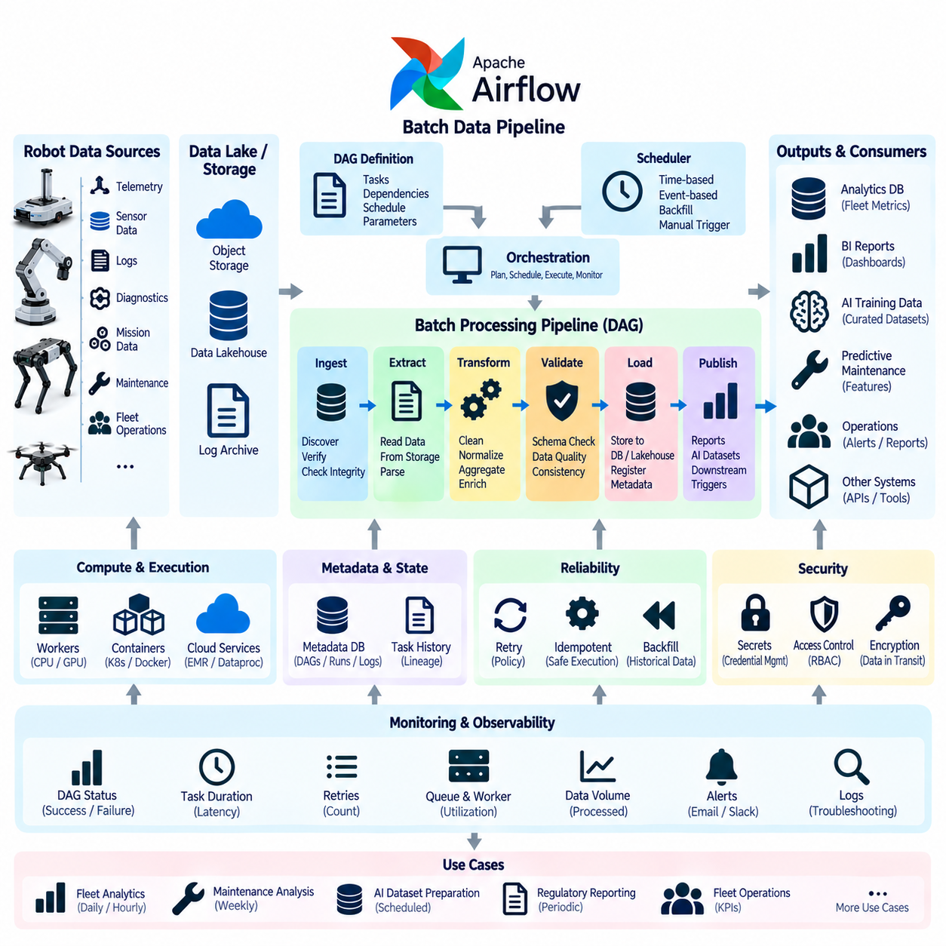
Apache Airflow is a workflow orchestration platform designed to define, schedule, execute, and monitor data-processing workflows. Within a robot data architecture, Airflow is particularly suitable for batch pipelines that operate on bounded datasets accumulated over time, such as telemetry archives, diagnostic logs, sensor recordings, maintenance histories, fleet operation records, and AI training datasets.
Unlike real-time streaming systems that continuously process events as they arrive, Airflow coordinates tasks that have explicit dependencies and execution boundaries. A robot fleet may upload operational data throughout the day, while an Airflow workflow processes the accumulated records every hour or night. This separation allows computationally intensive transformations to execute without affecting real-time robot operations.
The fundamental abstraction in Airflow is the Directed Acyclic Graph, commonly called a DAG. A DAG describes a workflow as interconnected tasks whose dependencies determine execution order. For example, a robot data workflow may first verify uploaded files, then extract telemetry, validate records, transform schemas, calculate operational metrics, store results, and finally generate reports or trigger downstream AI processing.
Each task represents a discrete unit of work and should ideally perform one clearly defined responsibility. Tasks may execute Python functions, shell commands, database queries, containerized applications, cloud operations, or external processing jobs. Breaking a robot data pipeline into small tasks improves maintainability because failed stages can be identified and retried without repeating the entire processing workflow.
The scheduler evaluates DAG definitions and determines when workflow instances should begin. Pipelines can run at fixed intervals, according to calendar schedules, or after defined operational periods. Daily fleet reports, hourly telemetry aggregation, weekly maintenance analysis, and periodic AI dataset preparation can therefore be represented as separate DAGs with schedules appropriate to their business and engineering requirements.
Airflow separates orchestration from the actual computational workload. The platform determines what task should execute, when it should execute, and which dependencies must be satisfied, while processing may occur on workers or external computing platforms. This distinction is important for robotics because image processing, point-cloud conversion, simulation, and AI preparation jobs may require resources very different from ordinary telemetry transformations.
A batch robot pipeline often begins with data discovery and ingestion verification. The workflow can identify newly uploaded objects, confirm that expected robot or mission files exist, inspect metadata, and verify checksums before processing begins. Incomplete uploads should not enter later stages because missing sensor files or corrupted records can invalidate fleet analysis, failure investigations, or AI training datasets.
After ingestion verification, extraction tasks read data from source repositories such as object storage, databases, NAS systems, log archives, or recorded robot datasets. The extracted information may include battery telemetry, motor temperatures, navigation states, diagnostic codes, task histories, images, or point clouds. Airflow coordinates these extraction activities while preserving dependencies among related processing stages.
Transformation tasks convert collected information into standardized analytical structures. They can normalize timestamps, convert engineering units, map robot-specific fields into common schemas, remove duplicates, calculate derived variables, or aggregate high-frequency measurements. These operations implement the batch transformation layer that turns heterogeneous field data into consistent information suitable for fleet-wide analysis.
Data validation should be integrated between transformation and loading rather than treated as an optional final check. Validation tasks can examine schema compatibility, missing values, timestamp continuity, value ranges, duplicate identifiers, expected record counts, and relationships between datasets. A failed validation can prevent unreliable data from being promoted into trusted analytical or AI repositories.
Loading tasks place validated outputs into their intended destinations. Structured fleet metrics may enter relational or time-series databases, transformed datasets may enter a lakehouse, and large sensor artifacts may remain in object storage with registered metadata. The pipeline can maintain separate raw, cleaned, and curated layers so downstream users understand the processing maturity of each dataset.
Task dependencies allow complex workflows to branch and converge. After a common validation stage, one branch may calculate fleet KPIs, another may generate maintenance features, and another may prepare AI training samples. Independent branches can execute in parallel and later converge at a final quality-control or publication task, reducing total processing time while preserving deterministic workflow relationships.
Parallel execution is valuable when processing data from many robots. Instead of handling every robot sequentially, a workflow can partition processing by robot, mission, date, site, or dataset. Multiple workers can process these partitions concurrently, provided storage and compute resources can support the load. This approach allows batch architecture to scale as fleet size and historical data volume increase.
Retries are essential because distributed data systems experience temporary failures. Database connections may time out, object storage may become temporarily unavailable, or worker processes may terminate unexpectedly. Airflow can retry failed tasks according to predefined policies, allowing transient problems to recover automatically without restarting successful upstream stages or requiring immediate operator intervention.
Retries should nevertheless be combined with idempotent task design. If a task executes more than once, it should not create inconsistent duplicate outputs or corrupt previously processed data. Deterministic identifiers, transactional database operations, overwrite-safe partitions, and explicit processing states can help ensure that repeated execution produces the same valid result rather than accumulating unintended side effects.
Backfilling enables historical data to be processed using the same workflow logic as current data. When a transformation algorithm changes, a new quality rule is introduced, or previously unavailable robot data becomes accessible, historical time intervals can be reprocessed. This capability is particularly valuable for fleet analytics and AI because consistent processing across historical and recent datasets improves comparability and reproducibility.
Pipeline state and metadata provide visibility into what has been processed. Engineers should be able to determine which DAG run handled a dataset, which tasks succeeded or failed, when execution occurred, and which workflow version was responsible. Combined with dataset lineage, this operational history supports troubleshooting, auditability, reproducible analytics, and controlled evolution of robot data processing.
Airflow monitoring provides information about workflow duration, task failures, retries, queue delays, worker utilization, and scheduling behavior. These operational metrics can reveal bottlenecks such as unusually slow transformations or overloaded workers. Alerts can notify operators when critical pipelines fail, when processing exceeds expected duration, or when important fleet datasets are not produced on schedule.
Resource management becomes important for pipelines containing heterogeneous workloads. Simple SQL aggregation may require little computation, while image preprocessing or point-cloud conversion can consume substantial CPU, memory, or GPU resources. Tasks can be routed toward appropriate execution environments so heavy AI or sensor-processing workloads do not block lightweight operational data transformations.
Security should protect workflow definitions, credentials, data access, and administrative functions. Pipeline tasks may require database passwords, object-storage credentials, API tokens, or encryption keys, but these secrets should not be embedded directly in workflow source code. Centralized secret management and role-based access control help restrict sensitive robot data and infrastructure operations to authorized identities.
Airflow is an orchestrator rather than a replacement for every data-processing technology. It can coordinate databases, distributed processing engines, object stores, container platforms, data-quality systems, and AI tools without performing all computation internally. In robot data architecture, this makes Airflow the control plane that connects specialized batch-processing components into a coherent and observable workflow.
For AI and Physical AI pipelines, Airflow can automate the transition from accumulated field data to training-ready datasets. A scheduled workflow may discover newly uploaded robot experience, validate metadata, extract selected episodes, synchronize sensor streams, perform quality checks, generate annotations or features, partition datasets, and register the resulting version for downstream model training.
Airflow can also connect batch analytics with operational decision processes. A nightly workflow may aggregate battery degradation, motor temperature, vibration, fault history, and mission utilization across the fleet. The resulting features can support predictive maintenance, reliability analysis, capacity planning, or engineering investigations, while reports and alerts can be generated automatically after successful processing.
A robust Airflow batch pipeline therefore combines explicit DAG dependencies, modular tasks, scheduling, validation, parallel processing, retries, idempotency, backfilling, lineage, monitoring, security, and controlled publication of results. Within Robot Data Architecture, it complements onboard collection, edge-cloud transfer, telemetry, and streaming systems by providing a reproducible orchestration layer for large-scale historical and scheduled data processing.

02.05 Apache Kafka Real-Time Streaming Pipeline [w/Code]
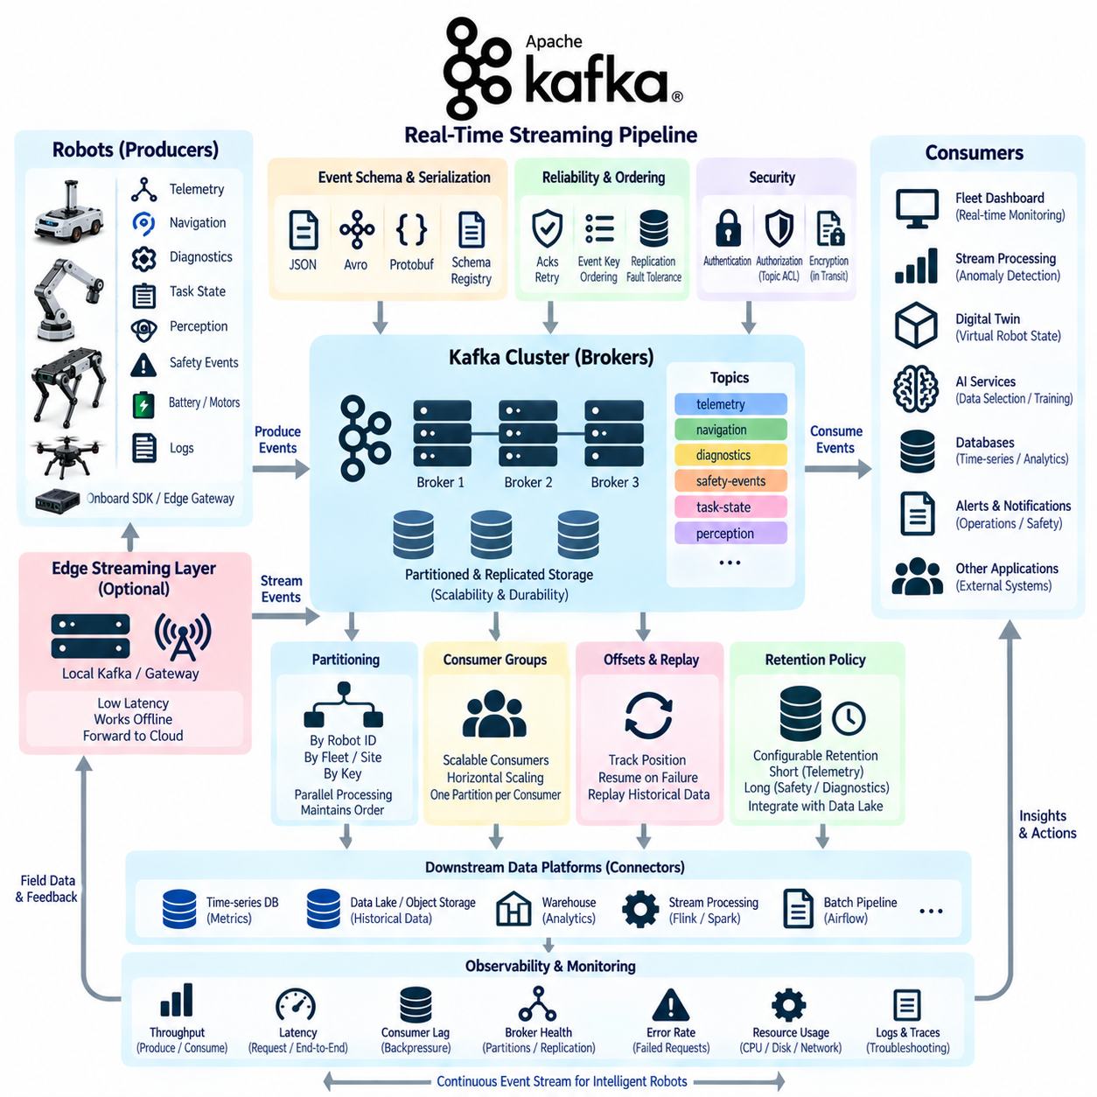
Apache Kafka is a distributed event-streaming platform designed to move, retain, and distribute continuous streams of data across scalable systems. Within Robot Data Architecture, Kafka provides the real-time backbone connecting robots, edge systems, fleet services, analytics, databases, digital twins, and AI applications. Unlike batch pipelines, it processes operational information continuously as events are generated.
A robot continuously produces events representing changes in the physical and computational world. Position updates, battery states, motor temperatures, navigation transitions, task progress, perception results, diagnostic faults, emergency stops, and safety alarms can all be represented as event records. Kafka allows these records to be published independently of the applications that eventually consume them.
The producer is the component that publishes events into Kafka. Robot onboard services, edge gateways, telemetry collectors, fleet managers, or cloud ingestion services can operate as producers. Each producer converts internal robot information into a defined event structure and sends it to an appropriate Kafka topic, allowing downstream applications to receive data without establishing direct connections to individual robots.
A Kafka topic represents a logical stream of related events. Robot data can be separated into topics such as telemetry, navigation, diagnostics, safety events, task states, perception events, or maintenance information. Topic design provides logical separation between data domains and enables different retention, security, partitioning, and processing policies to be applied according to the operational importance of each event category.
Topics are divided into partitions, which provide the fundamental mechanism for Kafka scalability. Events within one partition maintain an ordered sequence, while different partitions can be processed in parallel. Robot events may be partitioned by robot ID, fleet ID, site, or another stable key. Selecting the correct partition key is important because events requiring strict ordering should normally remain within the same partition.
Kafka brokers form the distributed cluster responsible for storing topic partitions and serving producer and consumer requests. Multiple brokers distribute storage and network workloads across machines, enabling the streaming infrastructure to scale beyond a single server. As robot fleets grow from a few units to hundreds or thousands, additional brokers and partitions can increase throughput without redesigning every producer and consumer.
Replication provides fault tolerance by maintaining copies of partitions across multiple brokers. If one broker becomes unavailable, another replica can continue serving the partition according to cluster leadership and replication state. This capability is important for robot operations because telemetry, safety events, and diagnostic records may remain valuable even when individual infrastructure components fail.
Consumers read events from Kafka and perform downstream processing. A fleet dashboard may consume robot status events, an anomaly detector may process motor and battery telemetry, a digital twin may update virtual robot states, and an AI data service may identify valuable sensor episodes. Because producers and consumers are decoupled, new applications can subscribe to existing event streams without modifying robot software.
Consumer groups enable scalable parallel processing. Multiple instances of the same application can belong to one consumer group, with Kafka distributing topic partitions among them. A large fleet telemetry service can therefore scale horizontally by adding consumer instances. Each partition is processed by one consumer within a group at a time, preserving ordered processing while distributing workload across available workers.
Offsets identify a consumer's position within each partition. Rather than deleting an event immediately after consumption, Kafka retains it according to configured retention policies, while consumers track how far they have processed. This allows a consumer to restart after failure, continue from a previous position, or deliberately reset its offset to replay historical events using updated processing logic.
Event replay is particularly valuable in robotics. If an anomaly-detection algorithm is improved, engineers can replay stored motor telemetry through the new algorithm without recollecting the original field data. Safety incidents, navigation failures, and unusual perception events can also be reprocessed to validate new logic, reconstruct operational sequences, or create improved AI training datasets.
Message keys help maintain relationships among events. Using robot ID as a key can ensure that events from the same robot are routed consistently to a partition, preserving their relative ordering. Other designs may use mission ID, asset ID, or site ID depending on processing requirements. Key selection therefore influences ordering, parallelism, data distribution, and the scalability of downstream applications.
Event schemas define how producers and consumers interpret event payloads. A robot telemetry event may contain robot ID, timestamp, sensor or subsystem ID, measurement values, sequence number, software version, and contextual metadata. Explicit schema management reduces ambiguity between services and supports controlled evolution as new robot models, sensors, diagnostic fields, and AI outputs are introduced.
Serialization converts structured events into efficient transferable representations. JSON is convenient for readability and integration, while binary formats can reduce message size and improve processing efficiency. Whatever representation is selected, producers and consumers should share consistent schema definitions so that changes to event structures do not unexpectedly break downstream applications.
Delivery reliability depends on producer acknowledgments, retries, replication, and consumer processing behavior. Producers can wait for appropriate broker acknowledgment before considering an event successfully published. Retries should be configured carefully to handle temporary failures without creating uncontrolled duplication. Consumers should also manage offset commits so events are not acknowledged before required processing has completed.
At-least-once processing is common because preserving events is often more important than eliminating every duplicate. Downstream services should therefore be designed to tolerate repeated records through event IDs, sequence numbers, deduplication, or idempotent updates. For example, receiving the same robot fault event twice should not create two independent maintenance incidents when both records represent the same physical occurrence.
Backpressure must be considered when event production exceeds processing capacity. Kafka can retain incoming events while consumers temporarily fall behind, preventing immediate loss of information. Consumer lag indicates the difference between newly available events and the consumer's processed position. Growing lag can reveal overloaded applications, insufficient partitions, slow external databases, or downstream failures requiring operational attention.
Retention policies determine how long events remain available. Routine high-frequency telemetry may be retained for a relatively short period before being transferred to long-term storage, while safety or diagnostic events may require longer retention. Kafka should not automatically replace data lakes or archival object storage; instead, it can provide a durable streaming layer that feeds systems optimized for long-term historical preservation.
Kafka can connect real-time streaming with persistent data platforms. Consumers or connector services may write telemetry into time-series databases, events into analytical stores, and selected records into object storage or lakehouse environments. This allows one event stream to support immediate operations while also contributing to historical analytics, predictive maintenance, regulatory evidence, and AI dataset construction.
Edge deployment can reduce latency and dependence on wide-area connectivity. A local Kafka-compatible streaming layer or gateway can collect events from robots within a factory, hospital, warehouse, or outdoor site and forward selected streams toward centralized infrastructure. This architecture allows local operational applications to continue consuming critical events even when external cloud connectivity becomes temporarily unavailable.
Security must protect producers, consumers, brokers, and administrative interfaces. Authentication establishes the identity of connected services, encryption protects events while they traverse networks, and authorization determines which identities can publish or consume specific topics. Topic-level permissions are especially useful when safety, operational, personal, or AI-related information requires different access policies.
Observability is essential because a streaming system may continue running while gradually falling behind. Important indicators include producer throughput, consumer throughput, request latency, broker health, partition distribution, replication status, failed requests, storage utilization, and consumer lag. Monitoring these metrics enables operators to distinguish healthy buffering from persistent congestion or infrastructure degradation.
For AI and Physical AI systems, Kafka creates a real-time bridge between physical experience and learning infrastructure. Perception anomalies, difficult navigation episodes, human interactions, unusual environmental states, and control failures can be emitted as events. These events can trigger preservation of related sensor data, initiate annotation workflows, or register valuable episodes for later training and validation.
Kafka also supports digital twin and fleet intelligence architectures because multiple consumers can independently react to the same event stream. A robot state update may simultaneously refresh a digital twin, update a fleet dashboard, enter an anomaly detector, contribute to operational metrics, and trigger maintenance logic. The producer publishes the event once while the architecture distributes its value across many services.
A robust Kafka real-time streaming pipeline therefore combines producers, topics, partitions, brokers, replication, consumer groups, offsets, schemas, retention, replay, security, and observability into a unified event architecture. Within Robot Data Architecture, it complements onboard collection, edge-cloud transfer, and Airflow batch processing by providing the continuous event backbone required for responsive fleet operations, digital twins, analytics, and Physical AI data loops.

02.06 Data Pipeline Monitoring and Anomaly Detection [w/Code]
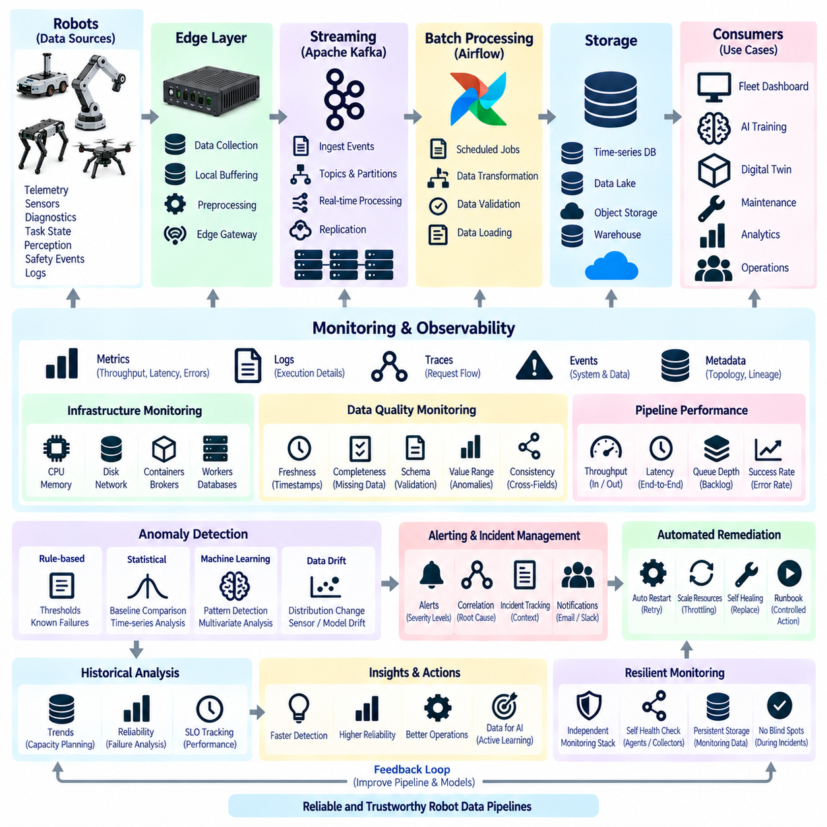
Data pipeline monitoring provides continuous visibility into whether robot data is being collected, transferred, processed, stored, and delivered as expected. In Robot Data Architecture, monitoring must cover the complete path from onboard acquisition and edge buffering to streaming, batch processing, cloud ingestion, storage, and downstream AI services. A healthy pipeline is defined not only by availability but also by data correctness and timeliness.
Pipeline observability is built from metrics, logs, traces, events, and metadata. Metrics summarize measurable behavior such as throughput, latency, queue depth, error rate, storage utilization, and processing duration. Logs provide detailed execution context, while distributed traces reveal how individual records or requests move across multiple services. Together, these signals allow engineers to reconstruct pipeline behavior and identify the location of failures.
Monitoring should distinguish infrastructure health from data health. A server may be running normally while the data flowing through it is incomplete, delayed, duplicated, or semantically incorrect. Infrastructure monitoring therefore examines CPU, memory, disk, network, containers, brokers, workers, and databases, while data monitoring evaluates volume, freshness, completeness, schema validity, value ranges, ordering, and consistency across related streams.
Throughput monitoring measures how much information enters and leaves each pipeline stage. Robot fleets can produce highly variable workloads depending on mission activity, sensor configuration, operating hours, and event frequency. Sudden throughput reduction may indicate failed sensors or disconnected robots, while unexpected growth may reveal duplicated messages, abnormal logging, configuration errors, or uncontrolled retry behavior.
Latency monitoring determines how long data takes to travel through the architecture. End-to-end latency can be decomposed into acquisition delay, edge buffering time, network transfer, broker delay, processing time, database write time, and downstream consumption delay. This decomposition is important because a delayed dashboard or alert may originate far upstream from the application where the problem becomes visible.
Queue depth and backlog provide early indicators that processing capacity is falling behind production. Growing Kafka consumer lag, Airflow task queues, edge upload backlogs, or database ingestion queues can reveal congestion before data is lost. Monitoring should evaluate both current backlog size and its growth rate because a stable temporary queue differs significantly from a continuously expanding one.
Freshness measures whether expected data has arrived within an acceptable time window. A robot may appear connected while its battery telemetry has not been updated for several minutes, or a nightly analytical dataset may exist but contain only yesterday's information. Freshness checks should therefore evaluate timestamps and expected update intervals rather than relying only on file existence or service availability.
Completeness monitoring determines whether all expected information is present. Sequence numbers can identify missing telemetry records, mission manifests can confirm required sensor files, and expected record counts can reveal incomplete batch processing. For multimodal robot datasets, completeness may also require confirming that camera, LiDAR, IMU, GNSS, control, and contextual records are available for the same operational interval.
Schema monitoring detects structural changes that may break downstream systems. Producers may add fields, change data types, rename attributes, or introduce new versions as robot software evolves. Compatible evolution can be accepted automatically, while unexpected changes should generate warnings or block publication. Schema validation therefore acts as an interface contract between producers, pipelines, storage systems, and consumers.
Value-level monitoring examines whether individual measurements remain within technically meaningful ranges. Battery voltage, motor temperature, velocity, localization confidence, CPU utilization, and sensor frequency can be checked against physical or operational boundaries. Range validation does not necessarily prove that a measurement is correct, but it can rapidly identify impossible values, corrupted records, unit conversion errors, and malfunctioning sensors.
Cross-field and cross-stream consistency checks provide deeper validation than simple thresholds. Robot velocity should be consistent with wheel odometry and localization changes, timestamps should progress logically, battery state should correspond with voltage trends, and mission identifiers should remain consistent across related datasets. Such relationships can expose subtle pipeline errors that individual field validation cannot detect.
Anomaly detection extends monitoring beyond fixed rules by identifying behavior that deviates from expected patterns. Statistical techniques can compare current throughput, latency, error rate, or data distributions with historical baselines. Machine-learning models can learn multidimensional normal behavior and detect unusual combinations of signals. This is useful when abnormal conditions cannot be represented reliably through a single predefined threshold.
Static thresholds remain valuable for conditions with clear operational boundaries. Disk utilization above a critical level, replication loss, unavailable brokers, failed scheduled jobs, excessive consumer lag, or missing safety events can require deterministic alerts. Dynamic anomaly detection should complement rather than replace these rules because known failure conditions are usually better handled through explicit and explainable limits.
Time-series baselines can account for normal operational variation. Robot data volume may increase during working hours and decrease overnight, while batch workloads may peak after fleet missions end. Comparing current measurements with the same hour, day, mission phase, or fleet operating state can reduce false alarms. Seasonal and contextual baselines therefore improve anomaly detection in environments with predictable workload cycles.
Data distribution monitoring is particularly important for AI pipelines. Even when records continue arriving successfully, the statistical properties of sensor or inference data may change. Camera brightness, LiDAR point density, localization confidence, object classes, environmental conditions, or model confidence distributions can drift over time. Detecting these changes can reveal sensor degradation, environmental shifts, configuration changes, or emerging AI data drift.
Monitoring systems should correlate technical anomalies with operational context. A sudden reduction in telemetry may be normal when robots enter charging mode, while the same reduction during an active mission may indicate failure. Mission state, robot mode, site, software version, network condition, and maintenance status can therefore enrich monitoring signals and help distinguish legitimate behavior from incidents requiring investigation.
Alert design should prioritize actionable information rather than generating notifications for every deviation. Alerts should identify the affected robot, service, topic, pipeline stage, dataset, or workflow and provide relevant measurements and timestamps. Severity levels can separate informational conditions from warnings and critical incidents. Poorly designed alerting creates alarm fatigue and reduces the probability that genuine failures receive timely attention.
Related alerts should be correlated into incidents whenever possible. A network outage may simultaneously create robot disconnections, upload backlog, Kafka lag, stale dashboards, and missing batch inputs. Treating each symptom as an independent incident overwhelms operators. Correlation based on time, topology, dependency relationships, and common infrastructure can help identify a likely shared cause and reduce duplicate operational responses.
Automated remediation can resolve well-understood failures without immediate human intervention. A failed collector may be restarted, a transient task may be retried, an unhealthy consumer may be replaced, or noncritical data may be throttled when storage pressure increases. Automation should use controlled policies and limits so recovery actions do not create restart loops, excessive retries, or additional instability.
Historical monitoring data supports capacity planning and reliability engineering. Long-term trends in throughput, latency, queue growth, storage consumption, failure frequency, and recovery time reveal whether infrastructure remains appropriately sized as fleet scale increases. Engineers can use these records to determine when additional brokers, workers, storage capacity, network bandwidth, or processing resources will be required.
Service-level objectives provide measurable expectations for pipeline behavior. Examples include maximum telemetry latency, minimum successful delivery rate, maximum acceptable data loss, freshness limits, or completion deadlines for scheduled datasets. Monitoring can compare actual performance with these objectives and calculate indicators that show whether the pipeline is meeting the reliability required by robot operations and downstream consumers.
Monitoring itself must remain resilient because losing observability during an incident makes diagnosis substantially harder. Metrics and logs should not depend entirely on the same components they are observing, and critical monitoring data may require independent storage or forwarding paths. Health checks should also verify monitoring agents and collectors so silence can be distinguished from genuinely normal pipeline behavior.
For AI and Physical AI systems, anomaly detection can connect data operations with learning operations. Unusual perception outputs, rare navigation conditions, unexpected control behavior, or abnormal sensor distributions can trigger preservation of surrounding raw data. These episodes can later enter annotation, simulation, validation, or model-training workflows, turning monitoring from a defensive mechanism into a source of valuable learning data.
A mature monitoring architecture therefore combines infrastructure metrics, data-quality checks, logs, traces, freshness, completeness, schema validation, statistical baselines, anomaly detection, alert correlation, automated remediation, and service-level objectives. Within Robot Data Architecture, these capabilities create the feedback layer that continuously verifies whether onboard, edge, Kafka, Airflow, storage, analytics, and AI pipelines remain trustworthy and operational.

02.07 AI Training Data Pipeline Automation [w/Code]
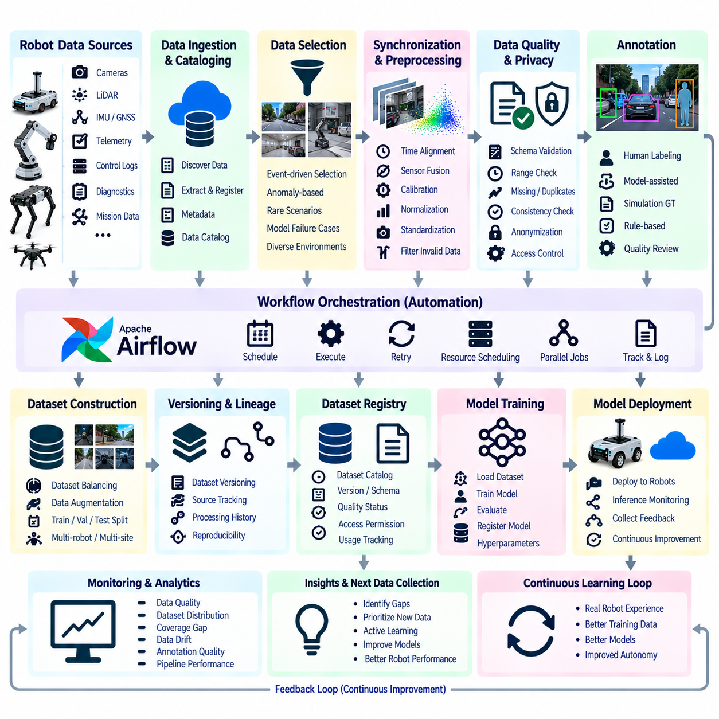
An automated AI training data pipeline transforms raw robot experience into controlled, traceable, and reusable datasets for model development. In Robot Data Architecture, this pipeline connects field data collection with selection, synchronization, filtering, annotation, validation, dataset construction, versioning, and training systems. Automation reduces repetitive manual work while ensuring that training data can be reproduced as robot fleets and data volumes grow.
The pipeline begins with data discovery across repositories containing robot telemetry, camera images, video, LiDAR point clouds, IMU measurements, GNSS positions, control commands, perception outputs, mission records, and diagnostic events. Instead of manually searching storage systems, automated cataloging identifies newly available data and registers metadata describing the robot, site, mission, sensors, software version, acquisition time, and operating conditions.
Not every collected record should become training data. Continuous robot operation can generate enormous volumes of repetitive or low-information observations. Data selection therefore identifies samples that provide useful learning value, including unusual environments, difficult navigation situations, perception failures, human interactions, safety events, rare object classes, and conditions in which deployed models produce low-confidence or incorrect predictions.
Event-driven selection can connect operational monitoring directly with AI data preparation. Kafka events, anomaly detectors, diagnostic systems, or fleet services can identify an important occurrence and preserve the surrounding sensor interval. A perception anomaly, localization failure, emergency stop, or unexpected control response can trigger extraction of pre-event and post-event data, creating focused episodes rather than retaining every raw stream indefinitely.
Multimodal synchronization is essential because Physical AI models often learn relationships among multiple sensor and action streams. Camera frames, LiDAR scans, IMU measurements, GNSS positions, odometry, robot states, perception results, planner decisions, and control commands may operate at different frequencies. The pipeline aligns these streams using timestamps and synchronization rules so that each training sample represents a coherent physical moment or sequence.
Preprocessing converts heterogeneous robot data into standardized representations suitable for subsequent processing. Images may be resized or normalized, point clouds may be transformed into common coordinate frames, telemetry units may be standardized, and invalid records may be removed. Calibration parameters and coordinate transformations must remain associated with the processed data so geometric relationships can be reproduced during training, validation, or later investigation.
Data quality gates prevent unsuitable information from entering trusted training datasets. Automated checks can detect missing sensor frames, corrupted files, timestamp discontinuities, invalid calibration references, impossible values, duplicated samples, incomplete missions, or inconsistent metadata. Samples that fail quality requirements can be quarantined for inspection rather than silently discarded, preserving evidence about recurring collection or pipeline problems.
Privacy and security processing should occur before datasets are broadly distributed. Depending on the robot environment, camera or audio data may contain faces, license plates, conversations, facility information, or other sensitive content. Automated pipelines can classify sensitive records, apply masking or anonymization where appropriate, enforce access policies, and record processing history so AI development does not bypass organizational data-governance requirements.
Annotation transforms selected observations into supervised learning information. Depending on the AI task, labels may describe objects, semantic regions, trajectories, poses, actions, anomalies, environmental states, navigation outcomes, or human-robot interactions. Annotation can combine human labeling, model-assisted labeling, simulation-generated ground truth, rule-based generation, and existing robot perception outputs, while preserving the origin of every label.
Model-assisted annotation can significantly reduce labeling effort when deployed carefully. An existing model generates initial predictions, and human reviewers verify or correct uncertain results rather than labeling every sample from the beginning. Confidence thresholds can route easy examples toward automated acceptance and difficult examples toward manual review, creating a human-in-the-loop process that concentrates expert effort where it provides the greatest value.
Active learning extends this approach by allowing model behavior to influence which data should be labeled next. Samples with high uncertainty, disagreement between models, unusual feature distributions, or poor performance can receive higher priority. Instead of randomly annotating large quantities of similar robot data, the pipeline directs labeling resources toward examples expected to improve model capability, robustness, or coverage.
Annotation quality must itself be measured because incorrect labels can degrade a model even when sensor data is valid. Automated validation can check label geometry, class definitions, temporal consistency, object identity, allowed values, and agreement between annotators. Selected samples may undergo secondary review, while disagreement can be routed to expert adjudication. Annotation guidelines and ontology versions should remain traceable to each dataset.
Dataset balancing prevents dominant operating conditions from overwhelming rare but important situations. A fleet may produce large amounts of ordinary corridor driving but relatively few near-collision events, difficult lighting conditions, unusual obstacles, or localization failures. Automated dataset construction can control class frequency, environment distribution, robot models, sites, weather, mission types, and difficulty levels to create more representative training populations.
Data augmentation can expand variability without requiring every condition to be physically recollected. Images may undergo controlled geometric or photometric transformations, while sensor data can receive carefully defined perturbations. Simulation and synthetic data can further introduce rare environments or hazardous scenarios. Augmented samples should retain provenance so developers can distinguish original field observations from transformed or synthetic training examples.
Dataset splitting must prevent information leakage between training, validation, and test populations. Random frame-level splitting may place nearly identical consecutive observations into different subsets and produce misleading performance estimates. Robot datasets are often better separated by mission, route, site, time interval, robot, environmental condition, or complete episode so evaluation measures generalization to genuinely independent operational situations.
Versioning converts a changing collection of files into a reproducible dataset artifact. Each dataset version should identify its source records, selection rules, preprocessing configuration, annotation version, filtering criteria, augmentation settings, and split definitions. A model trained months later should be traceable to the exact data version used, even if the underlying data lake has subsequently accumulated additional robot experience.
Data lineage connects the final training sample back through every transformation to its original physical observation. Engineers should be able to determine which robot generated a sample, which sensors were active, which software and calibration versions were installed, which pipeline processed the data, and which annotation procedure produced its labels. This lineage is essential for debugging unexpected model behavior and reproducing AI experiments.
Workflow orchestration automates dependencies among discovery, extraction, preprocessing, annotation, validation, dataset generation, and publication. Systems such as Apache Airflow can schedule recurring jobs, execute tasks in parallel, retry transient failures, and record processing states. Event-streaming infrastructure can trigger selected workflows immediately when valuable field events arrive, combining scheduled batch processing with event-driven AI data operations.
Resource scheduling becomes important when pipelines include image decoding, point-cloud processing, simulation, embedding generation, or model-assisted annotation. These tasks may require CPUs, GPUs, large memory, or high-throughput storage. Automated orchestration can route each workload toward suitable computing resources and limit concurrency so intensive preparation jobs do not overload shared infrastructure or interfere with operational robot services.
Once validated, a dataset should be published through a controlled registry or catalog rather than copied informally between developers. The registry can expose dataset identity, version, purpose, schema, size, supported tasks, quality status, lineage, access permissions, and associated model experiments. This creates a stable interface between data engineering and machine-learning teams and reduces ambiguity about which dataset is approved for training.
Training pipelines can consume registered datasets automatically. A model-development workflow may select an approved dataset version, load the required configuration, execute training, record hyperparameters, calculate evaluation metrics, and register resulting model artifacts. Connecting dataset and model registries establishes a traceable relationship among field observations, training data, experiments, model versions, and eventual robot deployments.
Monitoring should continue after dataset publication because training data quality changes as robot operations evolve. The pipeline can track class distributions, site coverage, sensor configurations, annotation quality, duplicate rates, environmental diversity, and dataset age. Comparing newly collected field data with existing training populations can reveal coverage gaps and data drift, indicating where additional collection or labeling should be prioritized.
Deployment results complete the automation loop. When a new model operates on robots, inference confidence, errors, anomalies, interventions, and difficult episodes can be captured through telemetry and event pipelines. These signals identify valuable new examples, which return to selection and annotation stages. The system therefore evolves from a one-way data preparation process into a continuous learning feedback loop driven by real-world robot experience.
A mature AI training data pipeline therefore combines automated discovery, event-driven selection, multimodal synchronization, preprocessing, quality control, privacy protection, annotation, active learning, balancing, augmentation, splitting, versioning, lineage, orchestration, monitoring, and dataset registration. Within Robot Data Architecture, this automation converts continuously generated Physical AI experience into reproducible training assets that support scalable model development and iterative improvement.

02.08 Data Pipeline Error Handling and Replay [w/Code]
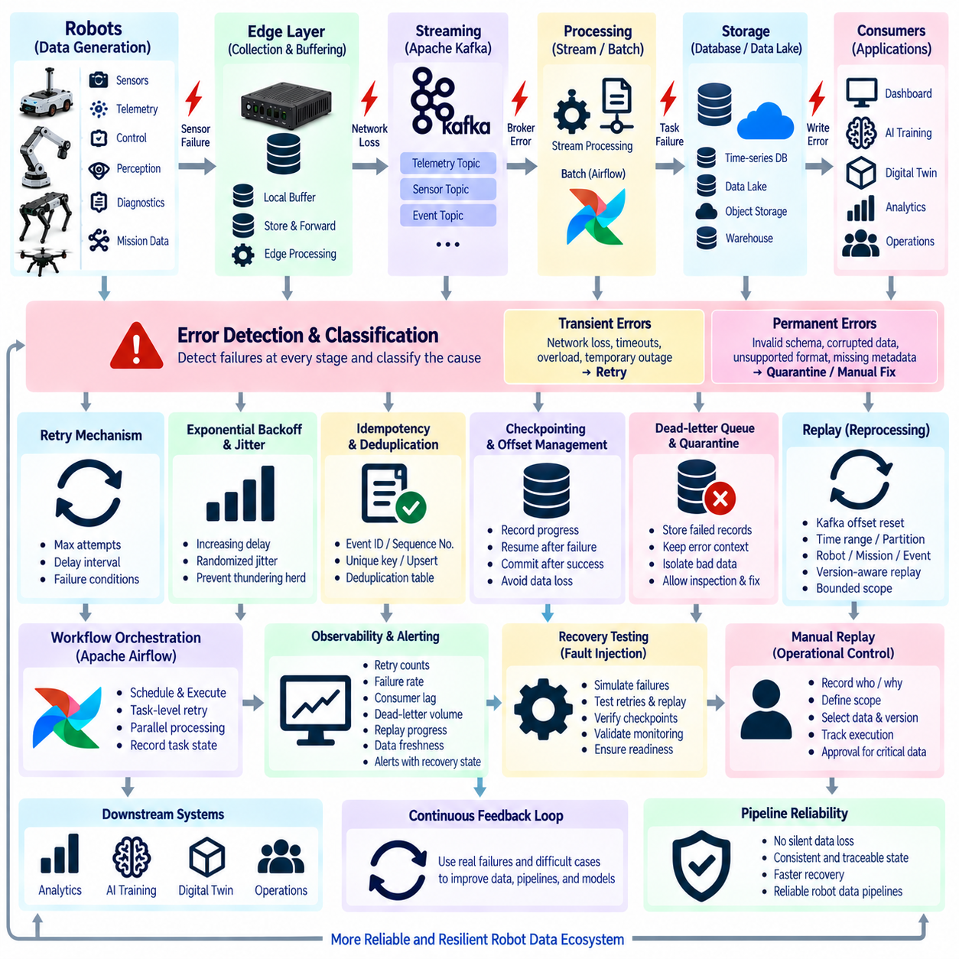
Error handling is a fundamental capability of a reliable robot data pipeline because failures can occur at every stage between physical data generation and final consumption. Sensors may disconnect, edge devices may lose power, networks may become unavailable, brokers may reject messages, processing tasks may fail, and storage systems may become temporarily inaccessible. The pipeline must detect these conditions while preserving recoverable data whenever possible.
Errors should first be classified according to their cause and expected recovery behavior. Transient errors include temporary network loss, service timeouts, overloaded brokers, or short database interruptions and can often be retried safely. Permanent errors include invalid schemas, corrupted files, unsupported formats, or missing required metadata. Separating these categories prevents endless retries of records that cannot succeed without intervention.
Retry mechanisms provide the first level of automated recovery for transient failures. A producer that cannot reach a broker, an edge uploader experiencing temporary connectivity loss, or a batch task encountering a short-lived database problem can retry the operation. Retry policies should define maximum attempts, delay intervals, and failure conditions so recovery remains controlled rather than creating continuous loops.
Exponential backoff increases the delay between successive retry attempts and reduces pressure on an already degraded service. Randomized jitter can be added so thousands of robots or workers do not retry simultaneously after a shared outage. This is especially important in large fleets because synchronized retries can create a second overload immediately after network, cloud, broker, or storage infrastructure begins recovering.
Idempotency allows an operation to be repeated without producing incorrect duplicate effects. A retried telemetry message should not create multiple maintenance incidents, and a repeated database write should not generate duplicated logical records. Event identifiers, sequence numbers, unique keys, upserts, and deduplication tables can help downstream services recognize that repeated delivery represents the same original operation.
Checkpointing records processing progress so a pipeline can resume from a known state after interruption. Streaming consumers commonly use offsets, while batch pipelines may record completed partitions, files, tasks, or processing stages. Without checkpoints, recovery may require restarting an entire workflow. Well-designed checkpoints reduce recovery time while ensuring that partially completed processing does not silently create inconsistent results.
Apache Kafka provides replay through durable event retention and consumer offsets. Consumers track their position independently from the stored events, allowing them to restart from the last committed offset after failure. Operators can also reset offsets to an earlier position when historical events must be processed again. This makes replay part of normal operational recovery rather than an exceptional reconstruction procedure.
Offset management must reflect the actual completion of downstream work. If a consumer commits an offset before a database update or analytical operation succeeds, failure can cause the event to be skipped after restart. If the offset is committed only after processing completes, the event may be delivered again after a crash. This favors reliable recovery but requires downstream processing to tolerate duplicates.
Dead-letter queues provide a controlled destination for records that repeatedly fail normal processing. Instead of blocking an entire stream because one malformed event cannot be interpreted, the pipeline can move the problematic record into a dead-letter topic or storage area. The record should retain the original payload, error reason, source, timestamp, retry history, schema version, and relevant processing context.
Quarantine is useful when a failure concerns data quality rather than execution availability. Corrupted sensor files, incomplete multimodal episodes, invalid calibration references, inconsistent timestamps, or unknown schemas can be isolated from trusted datasets. Quarantined data remains available for inspection and possible repair while preventing uncertain records from contaminating analytics, AI training datasets, or operational decisions.
Batch pipelines require task-level and dataset-level recovery strategies. In Apache Airflow, failed tasks can be retried according to configured policies while successful upstream tasks remain recorded. Tasks should be designed so they can execute again safely. Large datasets can also be partitioned by date, robot, mission, site, or file group, allowing only affected partitions to be reprocessed instead of repeating the complete batch workflow.
Partial failure requires special attention because some outputs may already have been written when processing stops. A transformation may generate several files before failing, or a database load may complete only part of a dataset. Temporary staging areas, atomic file replacement, transactional database operations, completion markers, and manifest validation can prevent incomplete outputs from being mistaken for successfully published data.
Replay should be bounded by a clearly defined scope. Reprocessing an entire fleet history because one hour of telemetry was affected wastes computing resources and may create unnecessary downstream changes. Replay boundaries can be defined using time ranges, Kafka offsets, robot IDs, missions, dataset partitions, event types, or workflow execution identifiers. Precise scope makes recovery faster and easier to audit.
Replay also requires version awareness. Historical data may have been produced with an older schema, calibration, preprocessing algorithm, or software release. Running it through current logic can produce results different from the original pipeline. Reproducible systems therefore retain schema versions, processing configurations, container or software versions, and transformation metadata so operators can choose between historical reproduction and intentional reprocessing.
Event ordering must be considered during retry and replay. Robotics applications may depend on the sequence of mission states, control commands, localization updates, or diagnostic transitions. Reprocessing events in the wrong order can reconstruct an impossible robot state. Partition keys, sequence numbers, timestamps, and ordering checks help preserve causal relationships when records are delivered again or recovered from storage.
Exactly-once behavior is desirable conceptually but can be difficult across heterogeneous robot systems, networks, databases, and external services. Many practical architectures therefore use at-least-once delivery combined with idempotent consumers and deduplication. This approach accepts that duplicate delivery can occur while ensuring repeated processing does not produce incorrect operational or analytical results.
Local buffering protects data when connectivity between robots, edge systems, and central infrastructure is interrupted. Events can be stored temporarily on onboard or edge storage and forwarded when connectivity returns. Buffer management should define storage limits, priorities, retention periods, and overflow behavior so critical safety and diagnostic information is preserved before lower-value high-volume telemetry.
Backpressure control prevents recovery activity from overwhelming downstream services. When a network connection returns after a long outage, many robots may attempt to upload accumulated data simultaneously. Rate limiting, priority queues, staged synchronization, adaptive concurrency, and bandwidth controls can gradually drain the backlog while allowing current operational events to continue flowing with acceptable latency.
Observability is essential for understanding whether recovery is succeeding. Monitoring should track retry counts, retry delays, failed records, dead-letter volume, quarantine volume, consumer lag, replay progress, backlog size, processing success rates, and recovery duration. Correlating these metrics with infrastructure and robot status helps distinguish isolated bad records from systemic failures affecting an entire site or fleet.
Alerts should communicate recovery state rather than reporting only the initial error. Operators need to know whether an issue is retrying automatically, waiting for connectivity, accumulating backlog, moving records to a dead-letter queue, or requiring manual intervention. Severity can escalate when retries are exhausted, data freshness exceeds limits, critical records remain undelivered, or recovery time violates a service-level objective.
Manual replay should be governed as an operational action because reprocessing historical information can affect databases, dashboards, AI datasets, maintenance records, and business logic. Replay requests should identify who initiated the operation, its reason, scope, source data, processing version, start time, completion status, and resulting outputs. Approval controls may be appropriate when replay can alter safety-related or regulated records.
Recovery testing verifies that mechanisms designed for failure actually work before a real incident occurs. Engineers can intentionally terminate consumers, disconnect networks, make storage temporarily unavailable, inject malformed events, or restart workers during processing. These fault-injection tests reveal whether retries, checkpoints, buffering, dead-letter handling, replay, and monitoring operate as expected under realistic failure conditions.
For AI and Physical AI pipelines, replay provides more than operational recovery. Historical perception failures, difficult navigation episodes, unusual sensor patterns, and safety interventions can be reprocessed using improved algorithms. The same preserved event and sensor history can therefore support debugging, regression testing, dataset regeneration, model evaluation, and comparison between previous and newly developed AI systems.
A mature error-handling architecture combines classification, retries, exponential backoff, idempotency, checkpoints, offsets, dead-letter handling, quarantine, local buffering, backpressure control, bounded replay, version tracking, observability, and recovery testing. Within Robot Data Architecture, these mechanisms ensure that failures become controlled and traceable events rather than causes of silent data loss, inconsistent state, or irreversible pipeline corruption.

02.09 Data Pipeline Performance Optimization: Parallel / Compress
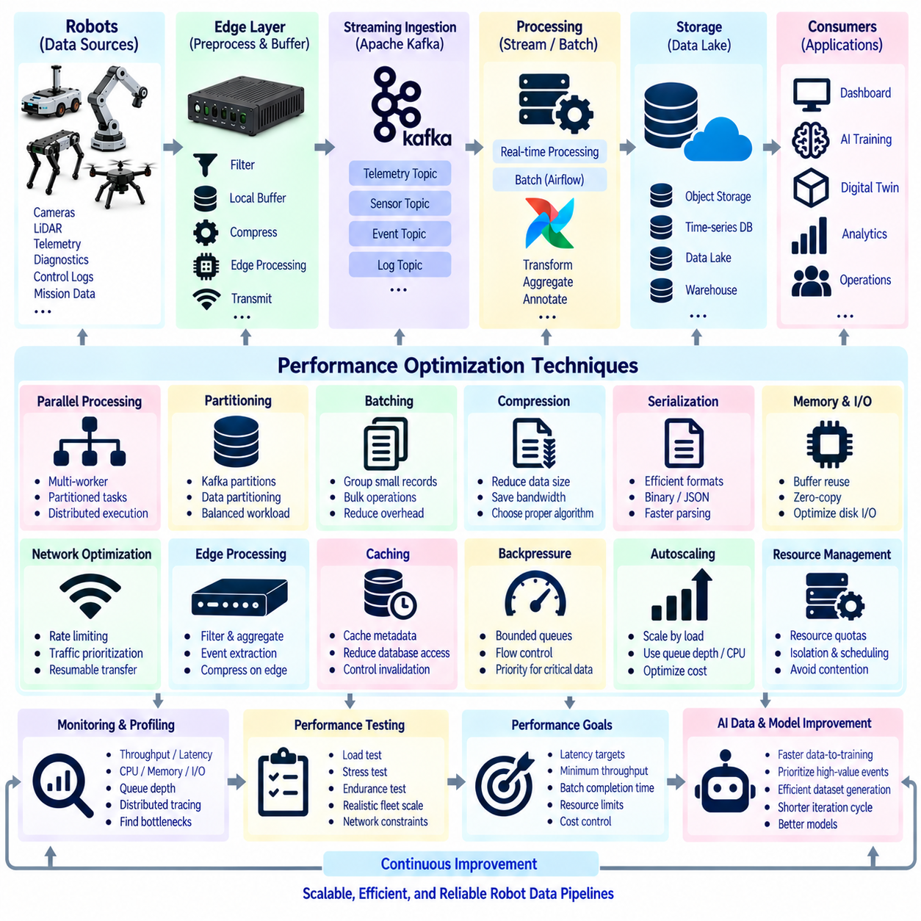
Performance optimization in robot data pipelines aims to move, process, and store increasing data volumes without allowing latency, resource consumption, or infrastructure cost to grow uncontrollably. Robot fleets continuously generate telemetry, images, point clouds, diagnostics, events, and logs with very different bandwidth requirements. Optimization therefore begins by measuring the complete pipeline and locating actual bottlenecks before changing architecture or computing resources.
A pipeline should be decomposed into acquisition, buffering, serialization, network transfer, ingestion, processing, storage, and consumption stages. Each stage has different performance constraints and may become the limiting factor as fleet size increases. Measuring throughput, latency, CPU utilization, memory pressure, disk I/O, network bandwidth, queue depth, and processing time provides the baseline required to determine where optimization will produce meaningful improvement.
Parallel processing increases throughput by dividing independent work among multiple execution units. Robot data can often be partitioned by robot ID, mission, time interval, sensor type, site, or dataset partition and processed concurrently. Instead of transforming thousands of sensor files sequentially, multiple workers can process independent partitions simultaneously, reducing overall completion time when sufficient CPU, memory, storage, and network resources are available.
Parallelism must match the structure of the workload. CPU-intensive transformations benefit from multiple processes or distributed workers, while I/O-intensive operations can use asynchronous execution or concurrent requests to overlap waiting time. GPU-based image, point-cloud, and AI preprocessing can batch operations across many samples. Selecting the correct execution model prevents additional concurrency from simply moving the bottleneck to another shared resource.
Partitioning is fundamental to scalable streaming architectures. Apache Kafka distributes topics across partitions so producers and consumer groups can operate in parallel. Increasing partition count can improve aggregate throughput, but excessive partitioning adds broker metadata, file handles, replication traffic, and operational complexity. Partition keys must also preserve ordering requirements while distributing robot workloads sufficiently evenly across available brokers and consumers.
Batch workflows can similarly exploit task-level and data-level parallelism. Apache Airflow can execute independent tasks concurrently and distribute workloads across multiple workers. Large robot datasets can be separated into mission, date, site, or robot partitions so transformations execute independently. Dependencies should remain explicit, ensuring downstream aggregation begins only after the required parallel processing stages have completed successfully.
Data compression reduces storage consumption and network bandwidth by representing information more efficiently. Compression is especially valuable when robot data must cross constrained wireless or wide-area networks or remain stored for long periods. However, compression consumes computing resources and may introduce additional latency. The appropriate strategy therefore depends on data type, available CPU or accelerator capacity, network limitations, and access frequency.
Compression algorithms should be selected according to workload characteristics rather than applying one method to every dataset. Fast algorithms can be appropriate for real-time telemetry and logs, where low encoding and decoding latency is important. Higher-compression methods may be suitable for archived datasets or batch transfers. Images, video, and point clouds require domain-specific approaches because they already contain structured redundancy or may use compressed sensor formats.
Compression level creates a direct tradeoff between data size and processing cost. Increasing compression may save network bandwidth and storage while consuming more CPU time and delaying transmission. On resource-constrained robot computers, aggressive compression can interfere with navigation, perception, or control workloads. Compression should therefore operate within resource budgets and give safety-critical robot functions priority over data-pipeline efficiency.
Batching reduces per-record overhead by combining multiple small records into larger transfer or processing units. Network protocols, message brokers, databases, and object storage systems generally operate more efficiently when requests contain useful payload sizes. Telemetry events can be grouped briefly before transmission, database writes can use bulk operations, and small files can be consolidated where appropriate. Excessive batching, however, increases latency and memory consumption.
Serialization format also affects pipeline performance. Human-readable formats such as JSON simplify debugging and interoperability but can require more bandwidth and parsing time than compact binary representations. Structured binary formats can reduce payload size and accelerate serialization for high-volume streams. Format selection should consider schema evolution, language compatibility, tooling, debugging requirements, and the actual performance benefit measured under realistic workloads.
Memory management becomes important when high-bandwidth sensors are processed continuously. Repeatedly copying camera frames, point clouds, or large tensors between processes and memory regions can consume significant bandwidth and increase latency. Buffer reuse, bounded queues, shared-memory techniques, streaming processing, and zero-copy mechanisms where supported can reduce unnecessary movement while preventing uncontrolled memory growth.
Disk and storage performance can dominate pipelines handling large sensor datasets. Writing thousands of tiny files creates metadata overhead, while large sequential files may improve throughput but complicate selective access. File organization, partition size, storage format, indexing, caching, and access patterns should be designed around expected workloads. Hot operational data and long-term archives may require different storage technologies and performance policies.
Network optimization requires understanding both bandwidth and transfer behavior. Large uploads can compete with robot command, monitoring, and safety traffic if they share the same connection. Rate limiting, traffic prioritization, resumable transfers, batching, compression, and scheduled synchronization can prevent bulk data movement from degrading operational communication. Edge filtering can further reduce traffic by transmitting only information that provides downstream value.
Edge processing is one of the most effective ways to reduce central pipeline load. Robots or edge gateways can filter repetitive telemetry, aggregate metrics, extract events, compress data, or select valuable sensor episodes before transmission. This reduces bandwidth and cloud processing requirements while preserving important operational information. The optimization must remain reversible where raw data is required for safety investigation, debugging, or AI training.
Caching improves performance when the same data or metadata is accessed repeatedly. Calibration parameters, robot configuration, schemas, maps, model metadata, or frequently requested dataset indexes can be cached near processing services. Effective caching reduces database and network requests, but cache invalidation must be controlled so outdated configuration or calibration information does not silently produce incorrect processing results.
Backpressure protects a pipeline when downstream processing becomes slower than incoming production. Bounded queues prevent unlimited memory growth, while producers or intermediate services can reduce rates, delay noncritical processing, or spill data to durable storage. In robotics, priority-aware backpressure is important because safety events and critical diagnostics should continue flowing even when high-volume perception or routine telemetry streams are temporarily constrained.
Autoscaling can adjust processing capacity as workload changes. Streaming consumers, batch workers, transformation services, and cloud processing nodes can scale according to queue depth, consumer lag, CPU utilization, or scheduled demand. Scaling policies should account for startup time and workload duration because adding workers after a short burst has already disappeared may increase cost without improving performance.
Performance optimization must consider resource contention. Data pipelines often share CPUs, GPUs, storage, and networks with perception, navigation, simulation, or AI training workloads. Increasing pipeline parallelism without resource governance can degrade more important applications. Resource quotas, execution priorities, concurrency limits, workload isolation, and scheduling policies ensure that optimization of one subsystem does not reduce overall robot-system performance.
Profiling identifies expensive operations that aggregate metrics alone may hide. Function-level CPU profiling, memory allocation analysis, I/O tracing, distributed tracing, and query profiling can reveal unnecessary serialization, repeated transformations, inefficient database access, excessive copying, or slow external dependencies. Optimization should target measured hotspots rather than relying on assumptions about where computation time is being spent.
Performance testing should reproduce realistic robot workloads instead of evaluating only small development datasets. Tests should include expected fleet scale, sensor rates, message sizes, burst traffic, network limitations, concurrent consumers, and storage behavior. Load tests determine sustainable throughput, stress tests expose failure boundaries, and endurance tests reveal memory leaks, queue accumulation, storage growth, or gradual degradation over long operating periods.
Optimization should be evaluated against explicit performance objectives. Examples include maximum end-to-end telemetry latency, minimum event throughput, batch completion deadlines, acceptable consumer lag, maximum CPU utilization, network bandwidth budgets, or storage cost limits. Improvements can then be assessed quantitatively, preventing local optimizations that increase speed in one stage while reducing reliability or efficiency elsewhere.
For AI and Physical AI pipelines, performance optimization determines how quickly field experience can become usable learning data. Parallel preprocessing, compressed transfer, efficient storage, distributed annotation preparation, and scalable dataset generation can shorten the cycle between robot operation and model improvement. High-value events can receive priority processing while routine data follows lower-cost batch paths, aligning computing resources with learning value.
A mature performance architecture therefore combines measurement, partitioning, parallel execution, batching, compression, efficient serialization, memory optimization, storage tuning, edge filtering, caching, backpressure, autoscaling, profiling, and realistic performance testing. Within Robot Data Architecture, these techniques allow onboard, edge, Kafka, Airflow, storage, analytics, and AI pipelines to scale while balancing throughput, latency, reliability, resource usage, and operational cost.

02.10 Data Pipeline Testing: Contract Test / Data Validation
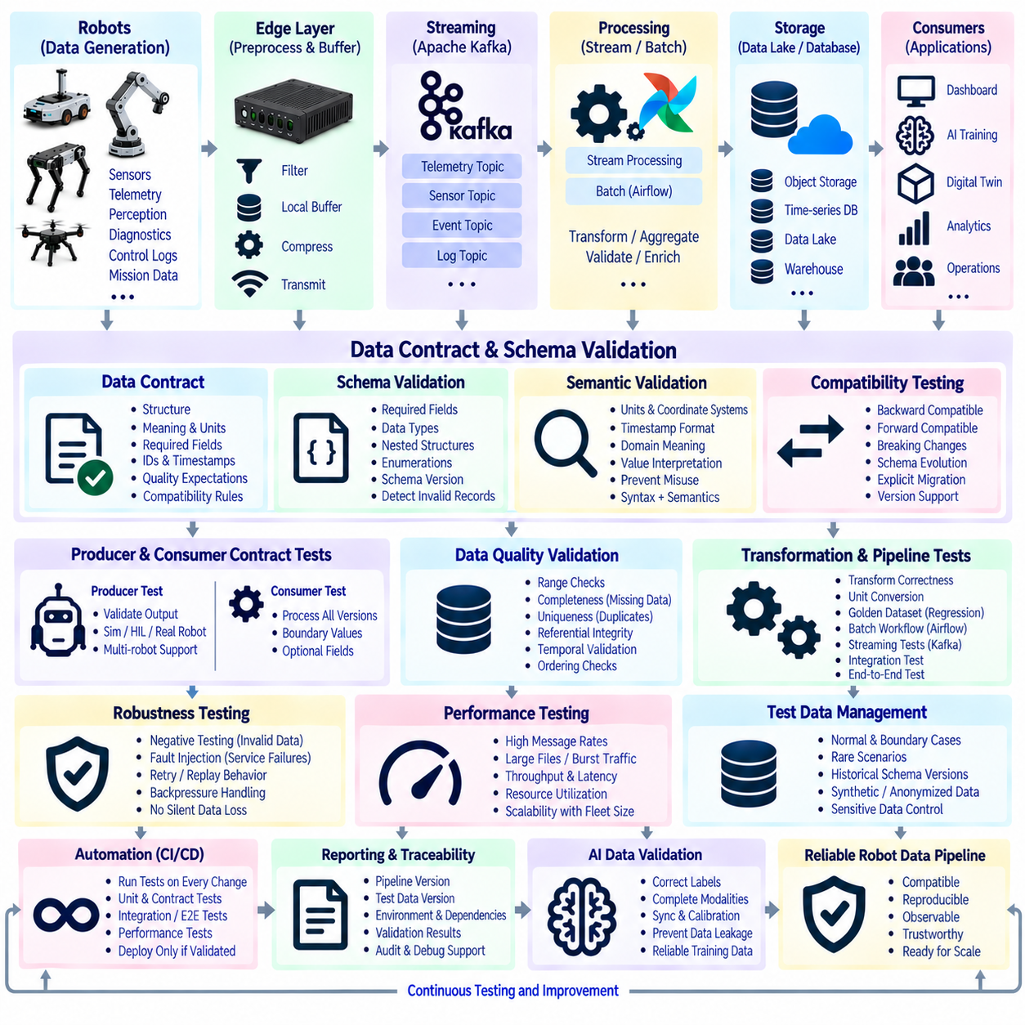
Data pipeline testing verifies that robot data moves through collection, streaming, processing, storage, and consumption stages without violating expected behavior. Unlike ordinary software tests, pipeline tests must evaluate both executable logic and the data itself. A service can remain operational while silently producing incomplete, duplicated, delayed, or structurally incorrect records, making systematic data validation essential to Robot Data Architecture.
Testing should begin with explicit contracts between producers and consumers. A data contract defines the structure, meaning, units, required fields, identifiers, timestamps, quality expectations, and compatibility rules associated with a dataset or event stream. Robot telemetry, perception results, diagnostic events, mission records, and AI outputs can each maintain independent contracts that define what downstream systems are allowed to assume.
Schema validation provides the structural foundation of contract testing. Incoming records can be checked for required fields, valid data types, nested structures, enumeration values, and supported schema versions. A battery telemetry event, for example, may require robot ID, timestamp, voltage, current, state of charge, and software version. Invalid structures should be detected before they propagate into storage, analytics, or AI pipelines.
Contract tests should also verify semantic meaning rather than only syntax. A field defined as velocity must use the agreed unit and coordinate convention, while timestamps must follow the specified clock and time representation. GNSS positions, battery percentages, temperatures, confidence scores, and mission states require clearly defined interpretation. Structurally valid data can still be operationally wrong when producers and consumers interpret the same field differently.
Compatibility testing determines whether pipeline components can evolve without breaking existing consumers. Schema changes may add optional fields, introduce new event types, modify enumerations, or deprecate old attributes. Automated tests can classify changes as backward compatible, forward compatible, or breaking. Breaking changes should require explicit migration procedures rather than being silently introduced into active robot fleets.
Producer contract testing confirms that each robot or upstream service actually generates records that satisfy the published specification. Tests can run against recorded samples, simulation outputs, hardware-in-the-loop systems, or live development robots. This is particularly important when multiple robot models or software versions share the same pipeline because implementation differences can otherwise create inconsistent event structures.
Consumer contract testing verifies that downstream applications correctly process all supported versions and valid variations of input data. Fleet dashboards, anomaly detectors, digital twins, databases, and AI preparation services should be tested against representative events, boundary values, optional fields, and expected schema evolution. Consumer tests reduce the risk that a technically valid producer update unexpectedly breaks downstream operations.
Data validation extends contract testing into the quality of actual values. Range checks can detect impossible battery voltage, invalid temperatures, negative dimensions, unrealistic velocities, or confidence values outside defined limits. Domain constraints should reflect physical and operational reality rather than arbitrary software limits, allowing validation rules to identify corrupted measurements, unit errors, and incorrectly configured sensors.
Completeness tests determine whether expected records are missing. Sequence numbers can expose gaps in telemetry streams, while mission manifests can confirm whether all required sensor files were produced. Multimodal datasets may require synchronized camera, LiDAR, IMU, GNSS, odometry, and control data for the same interval. A dataset should not be considered complete simply because its primary file exists.
Uniqueness testing detects duplicated events or records that may have been created by retries, replay, synchronization errors, or repeated ingestion. Event IDs, robot IDs, sequence numbers, timestamps, and composite keys can establish uniqueness expectations. Duplicate delivery may be acceptable in an at-least-once architecture, but the validation layer should identify it so downstream deduplication and idempotency mechanisms can be verified.
Referential integrity testing checks relationships between datasets and metadata. A sensor record may reference a robot configuration, calibration file, mission, map, model version, or annotation definition. Each reference should resolve to an existing and compatible object. Broken references can make otherwise valid data impossible to reproduce, interpret, transform, or use safely in AI training and analytical workflows.
Temporal validation is particularly important for robotics because many data relationships depend on time. Tests should detect timestamps that move backward unexpectedly, excessive gaps, duplicate timestamps, clock offsets, or synchronization errors between sensors. Camera frames, LiDAR scans, IMU measurements, localization outputs, and control commands should remain within defined temporal tolerances when combined into multimodal samples.
Ordering tests verify that events arrive or are processed in sequences required by downstream logic. Mission start should logically precede mission completion, and state transitions should follow permitted paths. Kafka partitioning, replay, retries, or parallel processing can change processing order if incorrectly configured. Sequence numbers and state-transition rules help detect ordering violations before they produce inconsistent robot states.
Transformation testing confirms that pipeline processing preserves intended information. Unit conversion, coordinate transformation, filtering, aggregation, compression, normalization, and feature extraction should produce deterministic results for known inputs. Golden datasets containing trusted input-output pairs can provide regression references, allowing engineers to detect unintended behavioral changes after pipeline code or configuration is modified.
Batch pipeline tests should verify task dependencies, partition handling, retry behavior, partial failures, and output publication. Apache Airflow workflows can be tested with small representative datasets before executing full production jobs. Tests should confirm that failed partitions can be rerun independently, successful tasks are not unnecessarily repeated, and incomplete outputs cannot be mistaken for successfully published datasets.
Streaming pipeline tests require continuous and failure-oriented scenarios. Kafka producers and consumers can be tested for message serialization, partition selection, offset management, duplicate delivery, consumer restart, broker interruption, and replay. Tests should verify that temporary failures do not silently lose critical events and that consumers resume from appropriate positions when services recover.
Integration testing evaluates how multiple pipeline components behave together. A test may generate synthetic robot telemetry, publish it through Kafka, process it with a streaming service, write results into a database, and verify the final record. These tests reveal interface problems that isolated unit tests cannot detect, including incompatible configurations, authentication failures, serialization differences, and incorrect assumptions between services.
End-to-end testing validates complete operational data journeys. A robot or simulator can generate a known event that passes through onboard collection, edge buffering, network transfer, ingestion, processing, storage, and application consumption. The final result is compared with expected behavior while latency, completeness, transformations, and metadata lineage are checked across the entire path.
Negative testing deliberately supplies invalid or unexpected data. Missing fields, unsupported schema versions, malformed messages, corrupted files, extreme values, duplicated records, and incorrect timestamps should not cause uncontrolled pipeline failure. Instead, the system should reject, quarantine, route, or report problematic information according to defined policies while continuing to process valid data whenever possible.
Fault-injection testing evaluates behavior when infrastructure fails rather than when data is incorrect. Networks can be disconnected, brokers restarted, databases made unavailable, workers terminated, disks filled, or services delayed. These tests confirm that retries, local buffering, checkpoints, dead-letter handling, backpressure, replay, and alerting mechanisms operate correctly under realistic failure conditions.
Performance testing verifies that correctness remains stable under expected fleet scale. High message rates, large sensor files, burst traffic, simultaneous robot uploads, parallel consumers, and batch workloads should be reproduced under controlled conditions. Testing should measure throughput, latency, queue growth, resource utilization, and error rates while confirming that increased load does not introduce data loss, ordering violations, or validation bypasses.
Test data management is necessary for repeatable validation. Test datasets should contain normal records, boundary conditions, rare scenarios, malformed inputs, historical schema versions, and known failure cases. Sensitive production data should not be copied casually into development environments. Synthetic, anonymized, or carefully controlled recorded data can provide reproducible coverage while maintaining security and privacy requirements.
Automated tests should be integrated into continuous integration and deployment workflows. Pipeline code, schema definitions, transformation logic, infrastructure configuration, and data contracts can trigger validation before deployment. Fast unit and contract tests may run on every change, while integration, replay, performance, and end-to-end suites can run at appropriate stages before software reaches production robot fleets.
Testing results should remain traceable to software, configuration, schema, and dataset versions. A successful test without knowing what was tested provides limited evidence. Reports should identify the pipeline version, test data version, environment, dependency versions, execution time, validation rules, and results. This traceability supports debugging, release decisions, regression analysis, and audits of safety- or quality-sensitive data systems.
For AI and Physical AI pipelines, data validation directly affects model reliability. Incorrect labels, missing sensor modalities, synchronization errors, duplicated episodes, calibration mismatches, or leakage between training and test datasets can create misleading model performance. Automated validation should therefore extend from operational data pipelines into dataset generation, annotation, splitting, model training, and evaluation workflows.
A mature testing architecture combines unit tests, contract tests, schema validation, semantic checks, completeness and uniqueness tests, temporal validation, integration tests, end-to-end tests, negative testing, fault injection, performance testing, and traceable test data. Within Robot Data Architecture, this layered approach ensures that data pipelines remain compatible, reproducible, observable, and trustworthy as robots, schemas, software, infrastructure, and AI workflows continuously evolve.

