Volume 07 Robot Data Architecture

05. Time Series Data

05.01 Time Series Data Characteristics: Timestamp / Monotonic
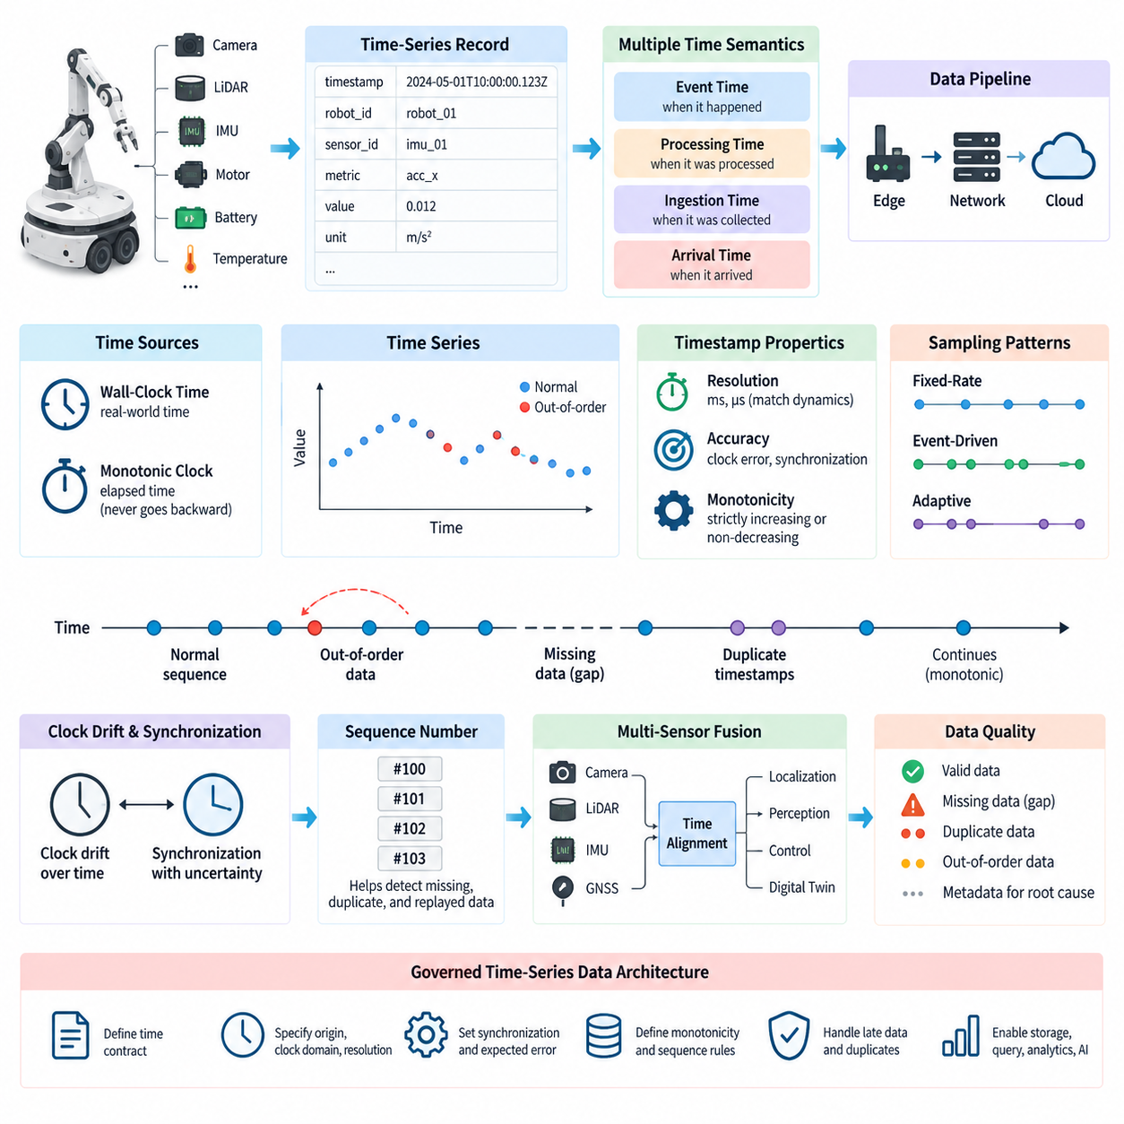
Time-series data is a fundamental representation for robot telemetry because most physical states evolve continuously and must be interpreted according to when they occurred. Motor current, battery voltage, wheel velocity, joint position, CPU temperature, localization confidence, vibration, and network latency are meaningful not only as individual values but also as ordered observations. The attached structure places this topic at the beginning of Chapter 05 before database-specific implementations.
A time-series record normally combines a timestamp with one or more measured values and contextual identifiers. A robot may generate records such as timestamp, robot ID, sensor ID, metric name, value, and unit. The timestamp establishes the temporal coordinate, while identifiers distinguish streams produced by different devices or subsystems. This organization allows applications to reconstruct robot behavior, compare measurements across time, calculate trends, and correlate events originating from multiple components.
Timestamp semantics must be explicitly defined because a single robot data pipeline can contain several notions of time. A sensor may record the instant at which a measurement was physically captured, a controller may attach the time at which the message was produced, and an edge gateway may record ingestion time. A cloud platform can add another timestamp when the record arrives. These timestamps describe different stages and should not be treated as interchangeable when precise temporal analysis is required.
Event time represents when an observation or event actually occurred in the physical system, whereas processing time represents when software processes that observation. In a low-latency system the difference may appear insignificant, but wireless delays, buffering, CPU scheduling, retransmission, or temporary network disconnection can increase it substantially. Robot analytics should therefore preserve event time whenever possible rather than assuming that arrival order accurately represents the physical sequence of events.
Timestamp resolution must match the dynamics of the measured phenomenon. Slowly changing information such as battery state of charge may require relatively modest resolution, while IMU measurements, motor-control signals, vibration data, and high-rate localization streams can require millisecond or microsecond precision. Selecting unnecessarily fine resolution increases storage and processing overhead, but insufficient resolution can collapse distinct observations onto the same timestamp and obscure causal relationships between rapidly occurring events.
Clock accuracy and timestamp resolution are different properties. A system may store timestamps with nanosecond fields while its physical clock is inaccurate by several milliseconds. Conversely, a well-synchronized clock can provide reliable ordering even when the stored resolution is coarser. Robot data architecture should therefore document clock source, synchronization mechanism, expected synchronization error, timestamp resolution, and measurement latency rather than using the timestamp data type alone as evidence of temporal precision.
Monotonicity describes whether timestamps or sequence coordinates move consistently forward as observations are generated. A strictly increasing series requires each new timestamp to be greater than the preceding timestamp, while a non-decreasing series permits equal timestamps. Monotonic ordering simplifies window calculations, interpolation, rate estimation, state reconstruction, and database ingestion because software can process records under the assumption that temporal position does not unexpectedly move backward.
Wall-clock time is necessary when robot observations must be associated with real-world dates and times, but it is not always suitable for measuring elapsed duration. Clock synchronization, administrator changes, or other corrections can alter wall-clock values. A monotonic clock instead advances according to elapsed time and is designed not to move backward because of civil-time adjustments. Robot software can therefore use wall-clock timestamps for global correlation and monotonic time for local duration and ordering measurements.
In distributed robot systems, global timestamp monotonicity is considerably harder to guarantee than monotonicity within a single process. Cameras, LiDARs, IMUs, motor controllers, edge computers, and cloud services may use different oscillators and synchronization mechanisms. Even small clock offsets or drift can cause observations from separate devices to appear in an incorrect order. Temporal architecture must consequently distinguish per-device ordering from globally synchronized time and quantify the uncertainty associated with cross-device comparisons.
Clock drift occurs because physical clocks do not advance at exactly identical rates. A small frequency difference can accumulate into a significant timestamp offset during long robot missions. Synchronization mechanisms periodically estimate and correct this difference, but synchronization itself introduces uncertainty caused by network asymmetry and variable delay. Systems requiring precise multi-sensor correlation should record synchronization status and, where appropriate, expose estimated offset or timing quality together with the sensor data.
Networked robots also produce out-of-order data even when every device maintains a correct clock. Messages can follow different network paths, remain in queues for different periods, or be retransmitted after temporary communication failures. A record arriving later may therefore contain an earlier event timestamp. Streaming systems must distinguish arrival order from event-time order and define policies for buffering, reordering, late-data acceptance, duplicate detection, and eventual correction of previously computed aggregates.
Missing timestamps create gaps rather than ordinary numeric null values. A gap may indicate sensor dropout, communication failure, selective sampling, storage loss, or an intentional change in acquisition frequency. These causes have very different operational meanings. Time-series processing should preserve enough metadata to distinguish expected silence from abnormal absence. Artificially filling every gap without retaining its provenance can hide failures and introduce false continuity into diagnostic, predictive-maintenance, or AI-training datasets.
Duplicate timestamps require similar care. Multiple measurements can legitimately share a timestamp when several channels are sampled simultaneously, but duplicates can also result from message replay or retry behavior. A robust schema therefore needs an identity strategy beyond timestamp alone, such as robot ID, source ID, metric identifier, sequence number, or event identifier. This prevents valid simultaneous measurements from being incorrectly removed while allowing true duplicate records to be recognized during ingestion.
Sampling interval determines the temporal density of a time series. Fixed-rate sampling produces observations at approximately regular intervals, while event-driven or adaptive acquisition creates irregular spacing. Many robot datasets contain both patterns simultaneously. Control signals may be periodic, diagnostic events asynchronous, and telemetry dynamically downsampled according to operating conditions. Analytics must therefore avoid assuming uniform spacing unless the acquisition contract explicitly guarantees it.
Sequence numbers complement timestamps when deterministic ordering is important. A timestamp answers when an observation occurred, whereas a sequence number identifies its position in a producer's output stream. Together they help detect missing records, duplicates, replayed messages, and ambiguous equal timestamps. Sequence numbers are especially useful across edge buffering and retransmission boundaries because transmission order can change while the original producer sequence remains available for reconstruction.
Temporal consistency becomes particularly important when multiple sensor modalities are fused. Camera frames, point clouds, IMU measurements, GNSS positions, wheel odometry, and actuator states may operate at different frequencies. Fusion algorithms need observations corresponding to approximately the same physical instant rather than simply the nearest database insertion time. Timestamp quality therefore becomes part of sensor-data quality and directly influences localization, perception, digital-twin synchronization, and Physical AI training.
A practical robot time-series architecture should consequently treat time as governed data rather than incidental metadata. Timestamp origin, clock domain, resolution, synchronization method, expected error, monotonic behavior, sequence semantics, late-arrival policy, and duplicate rules should be defined as part of the data contract. This foundation prepares Chapter 05 for the subsequent storage, query optimization, downsampling, anomaly detection, forecasting, visualization, and long-term retention topics defined in the volume structure.

05.02 InfluxDB Architecture and Robot Metrics Storage [w/Code]
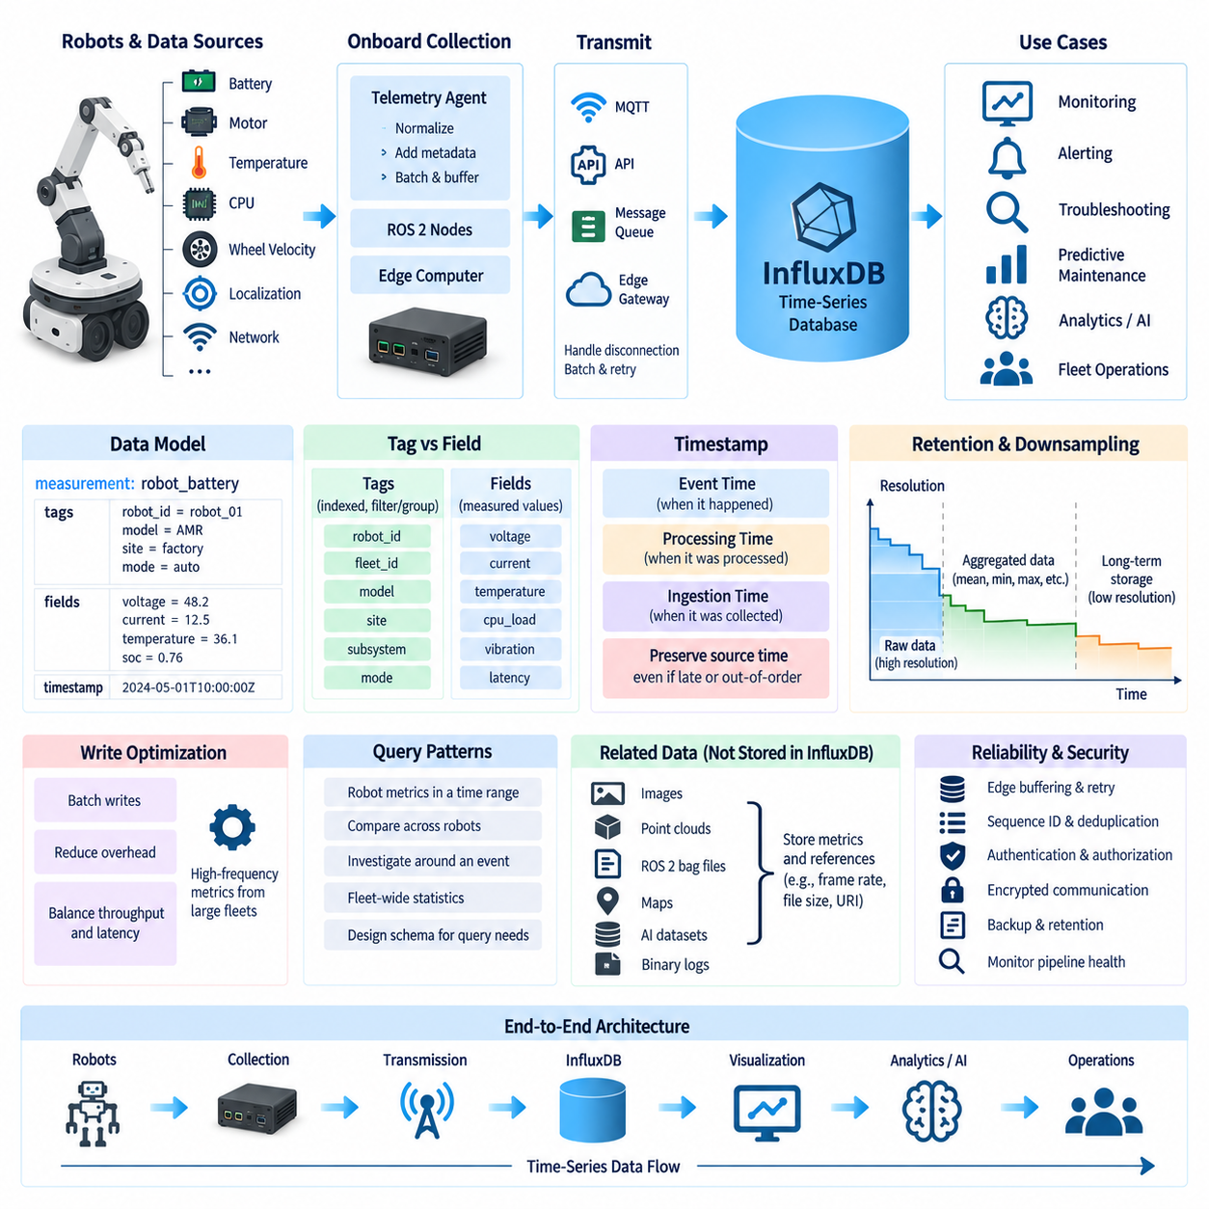
InfluxDB is a time-series database designed for workloads in which data is continuously generated, indexed by time, and analyzed over defined temporal ranges. In robotics, this model fits operational metrics such as battery voltage, motor current, CPU utilization, temperature, wheel velocity, localization quality, task duration, and network latency. Unlike general transactional storage, the architecture emphasizes efficient ingestion and retrieval of timestamped measurements.
Robot metrics typically arrive as continuous streams from onboard controllers, ROS 2 nodes, sensor-processing modules, edge computers, and fleet-management services. An InfluxDB-based architecture can collect these observations through telemetry agents or application interfaces and organize them into time-series records. Each record associates a measurement with its timestamp and contextual attributes, allowing operational behavior to be reconstructed across seconds, hours, missions, or the complete service life of a robot.
The logical data model should separate frequently queried dimensions from measured numerical values. A robot metric can include a measurement representing the monitored domain, tags describing robot identity or subsystem context, fields containing actual measured values, and a timestamp indicating when the observation occurred. For example, a battery measurement may identify the robot, battery pack, and operating mode while storing voltage, current, temperature, and state-of-charge values as fields.
Tags are particularly important because they provide indexed dimensions used to filter and group time-series data. Robot ID, fleet ID, model, site, subsystem, or operating mode can be useful tag candidates when they support common queries. However, values with extremely large or continuously increasing numbers of unique combinations should be selected carefully. Poor tag design can create excessive series cardinality and increase memory consumption, indexing overhead, and query complexity.
Fields store the actual metric values and generally represent quantities that change repeatedly over time. Motor current, joint temperature, CPU load, memory usage, battery voltage, localization error, vibration level, or communication latency are natural field values. Separating these values from descriptive tags enables the database to maintain efficient filtering dimensions while retaining high-frequency numerical observations required for monitoring, diagnostics, statistical analysis, and predictive-maintenance workflows.
Timestamp design remains central to the storage architecture. The timestamp should represent a clearly defined temporal event, preferably the physical measurement or source event time when that information is available. If edge buffering or network retransmission delays data delivery, database insertion time should not silently replace the original timestamp. Preserving source time enables correct reconstruction of robot behavior even when telemetry reaches the server late or arrives out of order.
A practical ingestion path may begin with robot sensors and control software, continue through an onboard telemetry collector, pass through an edge gateway or message infrastructure, and terminate in InfluxDB. The collector can normalize metric names, timestamps, units, robot identifiers, and quality metadata before transmission. Batching multiple records can reduce communication and write overhead, while buffering at the edge protects data continuity when cloud or on-premise connectivity is temporarily unavailable.
Write performance becomes important when a fleet generates large numbers of metrics at high frequency. Instead of issuing an independent database operation for every observation, telemetry services can accumulate records into appropriately sized batches and transmit them periodically. This approach reduces protocol and transaction overhead. Batch size and flush interval must nevertheless balance throughput against latency because excessively large batches can delay operational visibility or increase the amount of data affected by a failed transfer.
InfluxDB storage should reflect the different temporal requirements of robot data. High-frequency raw metrics may be valuable for recent troubleshooting but unnecessarily expensive to preserve indefinitely at full resolution. Older observations can often be represented by aggregated statistics such as mean, minimum, maximum, percentile, count, or standard deviation. Retention and downsampling strategies therefore allow detailed recent data and compact historical trends to coexist within the broader robot data architecture.
Robot metrics should also follow consistent naming and unit conventions. A fleet containing different robot generations can become difficult to analyze if one subsystem reports temperature in Celsius while another uses a different representation, or if equivalent signals use unrelated metric names. A metric contract should define measurement names, field names, units, timestamp semantics, tag conventions, valid ranges, and version information so that dashboards and analytics remain compatible as hardware and software evolve.
Query patterns should influence schema design from the beginning. Fleet operators commonly need to retrieve a robot's metrics during a mission, compare the same metric across several robots, investigate values surrounding a fault event, or calculate fleet-wide statistics over a selected interval. A schema optimized only for ingestion may perform poorly for these operational questions. Time range, robot identity, subsystem, and metric category should therefore align with expected filtering and aggregation patterns.
InfluxDB can serve as an operational telemetry store rather than a universal repository for every type of robot data. Large camera images, LiDAR point clouds, ROS 2 bag files, maps, AI datasets, and binary diagnostic artifacts are better handled by storage systems designed for large objects or specialized datasets. InfluxDB can instead store their associated metrics and references, such as frame rate, dropped-frame count, file size, recording status, sensor health, or a URI identifying an external artifact.
The database becomes particularly useful when connected to robot observability workflows. Dashboards can display battery discharge, motor temperature, compute utilization, communication quality, mission progress, or localization health as continuously updated time-series views. Alerting logic can evaluate recent windows and detect threshold violations or abnormal trends. Engineers can then correlate several measurements around the same timestamp to understand whether a fault originated from mechanical load, power, computation, sensing, or communication.
Predictive maintenance extends this architecture beyond simple monitoring. Long-term histories of motor current, vibration, temperature, charging behavior, actuator load, and fault frequency can reveal gradual degradation that may not trigger immediate alarms. Aggregated time-series features can be exported to statistical or machine-learning pipelines, while the original metrics remain available for traceability. The database therefore becomes an important bridge between real-time telemetry and maintenance-oriented AI analysis.
Reliability requires the ingestion layer to tolerate temporary communication failures without losing temporal meaning. Edge buffering can retain metrics locally and resend them when connectivity returns. Sequence identifiers, source timestamps, and duplicate-handling rules help ensure that replay does not create misleading records. Monitoring should also cover the telemetry pipeline itself, including ingestion rate, write failures, queue depth, storage consumption, delayed records, and database query latency.
Security and governance remain necessary even when the stored information appears to contain only technical metrics. Robot identifiers, site names, operating schedules, mission patterns, and diagnostic states can reveal operational information. Authentication, authorization, encrypted communication, controlled database access, backup policies, retention rules, and auditability should therefore be incorporated into deployment. Different engineering, operations, analytics, and service roles may require different levels of access to the same time-series environment.
Within the broader robot data architecture, InfluxDB provides a specialized layer for efficiently storing and querying timestamp-oriented operational measurements. Its value depends less on simply sending every signal into a time-series database than on establishing disciplined metric schemas, tag and field conventions, timestamp semantics, batching, retention, aggregation, and observability policies. These foundations prepare robot telemetry for subsequent query optimization, downsampling, anomaly detection, forecasting, visualization, and long-term retention workflows.

05.03 TimescaleDB: PostgreSQL-Based Time Series Extension [w/Code]
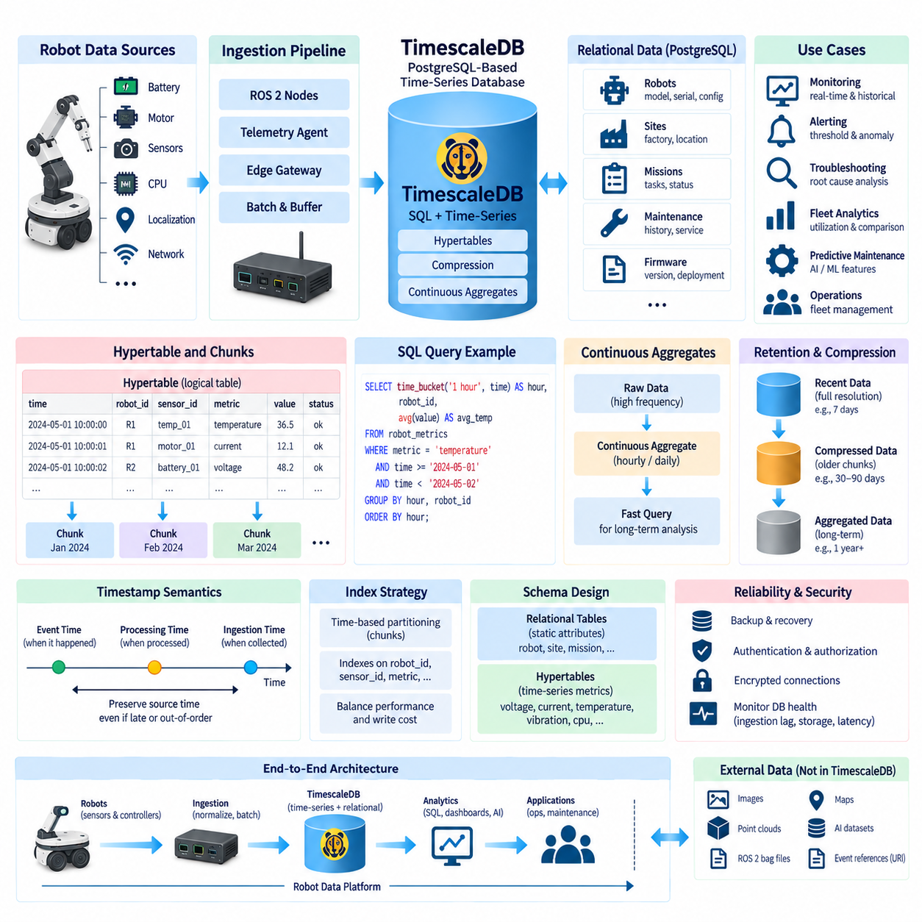
TimescaleDB extends PostgreSQL with capabilities specialized for time-series workloads while preserving the relational database model, SQL interface, transactions, indexes, and PostgreSQL ecosystem. For robot data architecture, this combination is valuable because operational telemetry often needs to be analyzed together with structured information such as robot identity, hardware configuration, missions, sites, maintenance records, and fleet metadata.
A conventional PostgreSQL table can store timestamped robot measurements, but very large time-series workloads create challenges as data volume and query ranges increase. TimescaleDB addresses this by organizing time-series data into hypertables, which provide a logical table abstraction while internally partitioning records into smaller physical units. Applications continue to interact with a familiar SQL table even though storage is managed according to temporal characteristics.
A hypertable is therefore the central abstraction of a TimescaleDB time-series architecture. Engineers define columns such as timestamp, robot identifier, sensor identifier, metric values, status, and other contextual attributes, and TimescaleDB distributes incoming records across chunks. This approach allows the database to limit many operations to relevant portions of the time range instead of treating an ever-growing telemetry table as one undivided storage structure.
Chunks are physical partitions representing subsets of hypertable data, commonly organized according to time intervals. When a query requests robot metrics from a specific period, the database can avoid scanning chunks that cannot contain matching records. Chunk interval selection should reflect ingestion rate, query patterns, retention requirements, memory resources, and the expected amount of data generated by the robot fleet rather than being chosen independently of workload characteristics.
The PostgreSQL relational model provides an important advantage when telemetry must be correlated with business and operational entities. A robot telemetry hypertable can reference relational tables containing robot models, deployed sites, customers, missions, maintenance history, firmware versions, or subsystem configuration. SQL joins can then connect a temperature anomaly with the affected robot, its hardware revision, current mission, or recent maintenance activity without requiring a separate integration layer for every analysis.
Schema design should distinguish stable relational attributes from rapidly changing time-series observations. Robot serial numbers, model definitions, installation sites, or hardware configurations generally belong in conventional relational tables, while battery voltage, motor current, temperature, vibration, CPU load, localization error, and communication latency belong in hypertables. This separation reduces unnecessary duplication while retaining the ability to query operational measurements together with their structured context.
Timestamp semantics remain critical even when PostgreSQL provides a rich data model. A telemetry row should preserve the time at which the source measurement or event occurred rather than relying exclusively on database insertion time. Edge buffering, intermittent connectivity, and retransmission can cause records to arrive later than they were generated. Accurate source timestamps allow engineers to reconstruct the original physical sequence and analyze delayed or out-of-order observations correctly.
Indexes complement time-based partitioning when queries frequently filter by additional dimensions. Robot ID, subsystem, sensor identifier, mission, or other selective attributes may participate in indexes depending on expected query patterns. However, excessive indexing increases write cost and storage consumption because every incoming telemetry record can require index maintenance. Index strategy should therefore be driven by measured query requirements rather than by indexing every available column.
TimescaleDB retains SQL as the primary analytical interface, allowing engineers to use filtering, grouping, joins, window functions, and aggregate calculations over robot time-series data. Queries can calculate average motor temperature, maximum current, battery discharge rate, mission duration, or fleet statistics over selected periods. This makes the platform accessible to engineers already familiar with PostgreSQL while supporting time-oriented analysis without introducing an entirely separate query language.
Continuous aggregates can be used to maintain summarized representations of high-volume time-series data. Instead of repeatedly scanning raw measurements to calculate hourly or daily statistics, the system can maintain aggregated results that support faster historical analysis. Robot fleets can preserve detailed recent telemetry while using summaries for long-term dashboards, reliability studies, utilization analysis, or maintenance trends where every individual high-frequency sample is no longer required.
Retention policies provide another mechanism for controlling the lifecycle of robot telemetry. High-frequency measurements can accumulate rapidly when dozens or hundreds of robots continuously report operational states. Raw data may be retained for a limited diagnostic period, while aggregated information is preserved for much longer periods. A lifecycle policy should be based on engineering traceability, service requirements, AI analysis needs, regulatory constraints, storage capacity, and the value of historical information.
Compression can further reduce the storage footprint of older time-series records. Robot telemetry frequently contains repeated identifiers and measurements with temporal locality, making historical data suitable for storage optimization after it is no longer actively modified. A practical architecture can maintain recent data in a form optimized for frequent writes and detailed troubleshooting while transitioning older chunks toward more storage-efficient representations for historical analysis.
Ingestion architecture should account for the continuous nature of robot metrics. ROS 2 nodes, controllers, telemetry agents, or edge services can normalize measurements before sending them through a gateway or data pipeline to TimescaleDB. Batch insertion can reduce communication and transaction overhead, while local buffering protects against temporary network failures. The original timestamp and identity information should remain intact throughout this path so that database arrival time does not redefine event history.
Transaction support becomes useful when time-series data must interact consistently with relational state. For example, a mission status update and related operational records may need controlled database behavior, or maintenance applications may combine telemetry analysis with service records. PostgreSQL's transactional foundation provides familiar mechanisms for maintaining data consistency, although high-rate telemetry ingestion should still be designed carefully to avoid unnecessary transaction overhead or contention.
TimescaleDB also fits architectures in which time-series storage is only one component of a larger robot data platform. Camera images, LiDAR point clouds, ROS 2 bag recordings, maps, and large AI datasets should generally remain in storage systems appropriate to their size and access patterns. The database can store timestamps, metadata, health metrics, event references, or object locations that connect structured telemetry analysis with these external artifacts.
Operational monitoring can use the database to examine both individual robots and fleet-wide behavior. Engineers can retrieve temperature, current, vibration, battery state, compute utilization, localization quality, and network performance for selected time windows. By joining these measurements with mission and configuration information, the same environment can support troubleshooting, performance comparison, fleet utilization analysis, reliability engineering, and predictive-maintenance feature generation.
The choice between a PostgreSQL-based time-series platform and a dedicated time-series system should depend on architectural requirements rather than on ingestion speed alone. TimescaleDB is particularly attractive when robot telemetry must coexist closely with relational information and when SQL compatibility is important. Systems focused almost exclusively on simple metric ingestion may emphasize different tradeoffs, while complex operational platforms often benefit from combining time-series and relational queries.
Reliability, backup, access control, and database operations remain part of the overall design because telemetry may become essential evidence for diagnosing field failures. Database health, ingestion lag, storage growth, query latency, failed writes, and chunk behavior should themselves be observable. Authentication, authorization, encrypted connections, role separation, backup procedures, and recovery strategies should be applied according to the operational importance and sensitivity of the stored robot information.
Within the robot data architecture, TimescaleDB provides a bridge between high-volume temporal measurements and PostgreSQL-based structured data management. Hypertables and chunks address time-oriented scale, while SQL, relational modeling, joins, indexes, aggregation, retention, and transactional capabilities preserve the strengths of PostgreSQL. This combination supports robot telemetry from recent troubleshooting through fleet analytics, long-term operational history, and data preparation for AI-driven maintenance workflows.

05.04 QuestDB: High-Performance Time Series Database [w/Code]
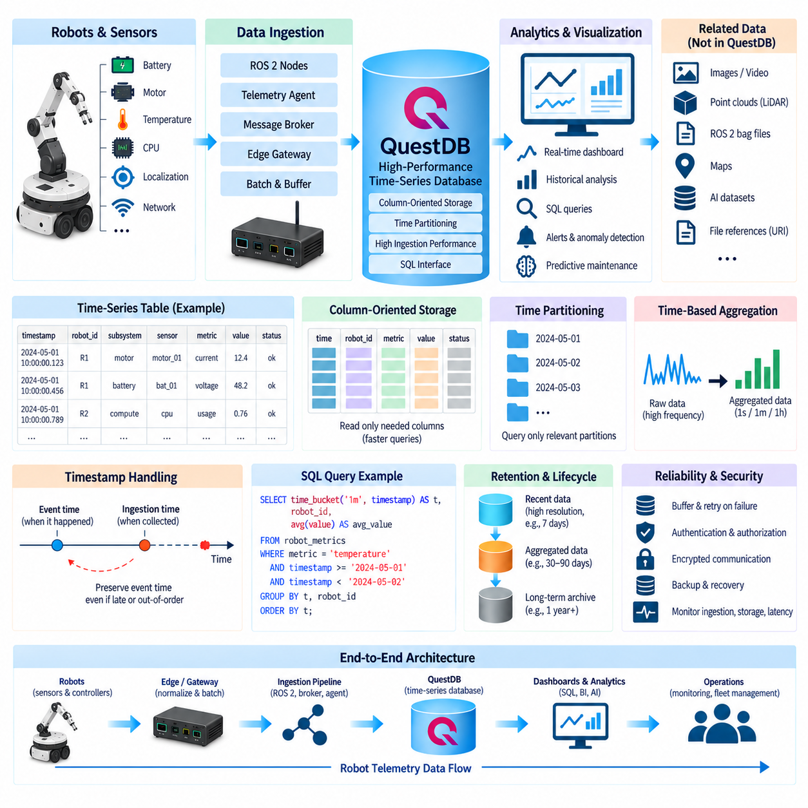
QuestDB is a high-performance time-series database designed for workloads that continuously ingest large volumes of timestamped records while requiring fast analytical queries. In robotics, these characteristics are relevant to telemetry streams such as motor current, battery voltage, joint state, temperature, vibration, localization quality, CPU utilization, network latency, and fleet operational metrics generated at high frequency by robots and edge systems.
The database architecture emphasizes efficient handling of append-oriented time-series data. Robot measurements normally arrive continuously and are rarely modified after their original event time has been established. QuestDB can exploit this pattern by organizing data around temporal access and column-oriented processing. This is particularly useful when engineers need to ingest millions of observations while simultaneously querying recent operating conditions or historical trends.
A robot telemetry table can contain a designated timestamp together with robot identifiers, subsystem information, sensor names, operating states, and measured values. The timestamp establishes the primary temporal dimension used for time-oriented operations. Measurements from motors, batteries, compute modules, localization systems, or communication interfaces can therefore share a consistent schema while remaining distinguishable through robot, subsystem, sensor, or metric attributes.
Column-oriented storage is well suited to analytical robot workloads because many queries access only a subset of the available attributes. A dashboard examining motor temperature may need timestamps, robot identifiers, and temperature values without reading unrelated columns such as battery voltage or network latency. Reading only relevant columns can reduce unnecessary data movement and improve analytical efficiency when telemetry tables contain many fields and very large numbers of records.
Partitioning further organizes time-series data according to temporal boundaries. Large robot telemetry tables can be divided into time-oriented partitions so queries targeting a specific period operate primarily on relevant data. The appropriate partitioning strategy depends on ingestion volume, fleet size, query ranges, retention requirements, and operational patterns. High-frequency fleets may require finer temporal organization than small systems producing relatively low telemetry volumes.
QuestDB supports SQL-oriented interaction, allowing engineers to use familiar relational concepts when exploring time-series information. Robot operators can filter measurements by time range, robot ID, subsystem, or operating state and calculate aggregates across selected intervals. SQL accessibility is valuable because telemetry can be incorporated into existing analytics workflows without requiring every engineering or operations application to adopt a completely specialized query model.
Time-series analysis frequently requires grouping raw observations into regular intervals. High-frequency motor or sensor measurements can be summarized into seconds, minutes, or hours for dashboards and long-term analysis. Time-based sampling enables engineers to calculate values such as average temperature, maximum current, minimum battery voltage, or communication latency statistics while reducing the number of individual observations that must be returned to visualization and analytical applications.
Robot data does not always arrive in perfect timestamp order. Wireless communication, edge buffering, temporary network outages, retransmission, or differences between device clocks can cause late or out-of-order observations. The storage architecture must therefore preserve the original event timestamp rather than assuming arrival order represents physical order. This allows reconstructed timelines to reflect what actually occurred on the robot even when transmission conditions distort ingestion sequence.
High ingestion performance is particularly important when a robot fleet produces many independent streams simultaneously. Cameras may generate health metrics, motor controllers may publish electrical and thermal measurements, navigation modules may report localization quality, and edge computers may expose resource utilization. Efficient ingestion allows these streams to be consolidated into a central operational store without forcing each subsystem to maintain a separate telemetry database.
Batching can improve ingestion efficiency by grouping multiple robot observations into fewer write operations. Telemetry collectors located on the robot or edge gateway can accumulate measurements for a short interval before transmitting them to the database. This reduces communication and per-request overhead while maintaining near-real-time visibility. Batch size and transmission interval should be selected according to acceptable latency, network conditions, failure recovery requirements, and data generation rate.
QuestDB can participate in architectures using standard telemetry and database interfaces rather than requiring direct coupling between every robot component and the database. ROS 2 nodes, embedded controllers, telemetry agents, message brokers, or edge services can normalize incoming signals and forward them through the ingestion layer. This separation allows robot software to remain focused on sensing and control while data infrastructure handles persistence, querying, retention, and operational analytics.
Schema design remains important even when the underlying database is optimized for speed. Stable naming conventions should identify robots, fleets, subsystems, sensors, metrics, and units consistently across different hardware generations. A temperature value without clear source, unit, or operating context has limited analytical value. Data contracts should therefore define timestamp semantics, identifiers, measurement units, valid ranges, quality indicators, and schema-version information before large-scale ingestion begins.
High-cardinality attributes also require careful consideration. Robot serial numbers and sensor identifiers may be essential for filtering, while continuously changing values should generally remain measurement data rather than becoming structural identifiers. Poor modeling can increase metadata complexity and reduce the benefits of an optimized time-series engine. Schema decisions should therefore reflect actual fleet queries, grouping requirements, and the expected number of unique values.
QuestDB is most appropriate for structured temporal measurements rather than every type of robot-generated information. Large camera images, video streams, LiDAR point clouds, maps, ROS 2 bag recordings, and AI training datasets normally belong in object storage, file systems, or specialized data platforms. The time-series database can instead store associated timestamps, health metrics, frame rates, dropped-frame counts, recording status, file references, and other searchable metadata.
Operational dashboards can use stored telemetry to display recent and historical behavior across individual robots or complete fleets. Battery discharge, motor temperature, actuator current, compute load, localization confidence, mission throughput, and communication latency can be compared over selected periods. Engineers can investigate changes surrounding a fault and determine whether several subsystems exhibited correlated abnormalities before or after the operational event.
Time-series data can also support anomaly detection and predictive maintenance. Long histories of vibration, temperature, current, charging behavior, or resource utilization can reveal gradual changes that are difficult to identify from individual samples. Analytical pipelines can derive rolling statistics, trends, or model features from database queries and provide them to external machine-learning systems while maintaining the original telemetry for traceability and engineering investigation.
Retention strategy should reflect the declining value of full-resolution telemetry over time. Recent high-frequency measurements may be essential for debugging, while older data may be useful primarily for reliability trends, fleet statistics, or AI feature generation. Raw data, aggregated data, and long-term archives can therefore follow different lifecycles. Storage policies should consider troubleshooting requirements, operational history, regulatory obligations, cost, and future analytical value.
Database performance should be evaluated as an end-to-end property rather than only as a headline ingestion benchmark. Network transport, telemetry normalization, batching, disk throughput, query concurrency, schema design, time ranges, and aggregation complexity all affect real deployments. A high-performance database cannot compensate for poorly designed timestamps, inconsistent metrics, uncontrolled cardinality, or an ingestion pipeline that loses data during intermittent robot connectivity.
Reliability and security must accompany performance in production robot deployments. Telemetry collectors should buffer data during communication failures and retry transmission without destroying source timestamps or creating uncontrolled duplicates. Database access should use authentication, authorization, encrypted communication, backup and recovery procedures, and operational monitoring. Ingestion rate, storage growth, query latency, failed writes, and system resource utilization should themselves be observable metrics.
Within the broader robot data architecture, QuestDB provides a high-performance option for storing and analyzing large streams of timestamped operational measurements. Its time-oriented storage, columnar analytical behavior, partitioning, SQL access, efficient ingestion, and temporal query capabilities align with demanding robot telemetry workloads. Used with disciplined schemas and lifecycle policies, it can connect real-time fleet monitoring with diagnostics, historical analytics, anomaly detection, and AI-driven maintenance.

05.05 Time Series Query Optimization: Indexes / Chunks
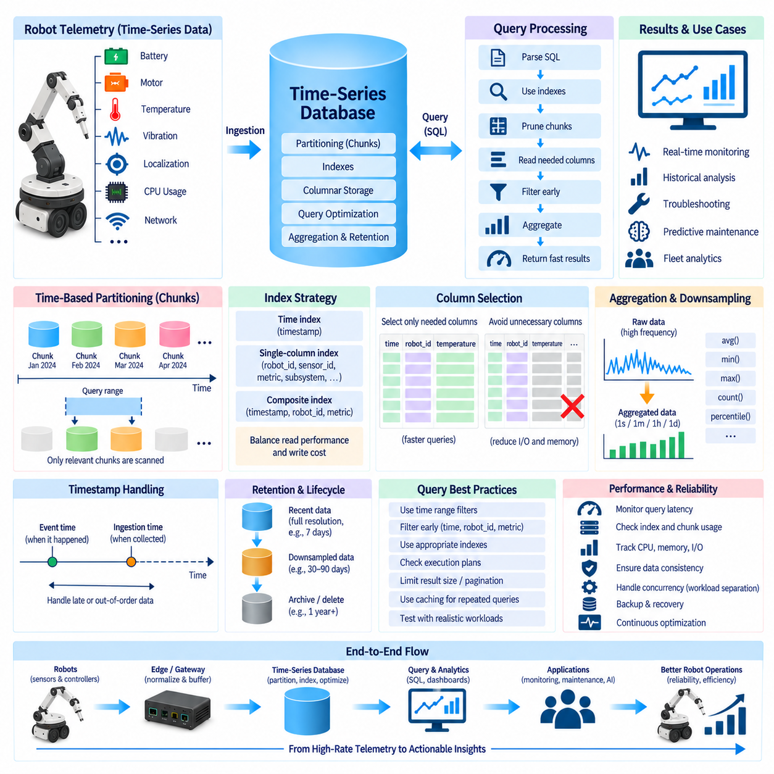
Time-series query optimization is essential in robot data platforms because telemetry tables grow continuously while operators still expect recent metrics, historical trends, and fault-related data to be retrieved quickly. Motor current, battery voltage, temperature, vibration, localization quality, and compute utilization can produce billions of records across a fleet. Efficient queries therefore depend on reducing how much data must be examined rather than simply increasing database hardware.
Time is normally the most important filtering dimension in a time-series query. Operational questions usually concern a bounded interval, such as the last five minutes, a specific mission, or the period surrounding a fault. Queries should therefore express explicit timestamp ranges whenever possible. A well-designed time-series engine can use these boundaries to eliminate irrelevant storage regions before evaluating robot identifiers, metrics, status values, or additional analytical conditions.
Time-based partitioning divides a continuously growing logical dataset into smaller physical regions. Depending on the database, these regions may be called chunks, partitions, or segments. Instead of searching an entire telemetry history, the query planner identifies only the temporal regions that can contain matching timestamps. This pruning mechanism becomes increasingly valuable as robot histories grow from days into months or years while most operational queries continue to examine relatively short periods.
Chunk size strongly influences performance. If chunks are excessively large, a query covering a short interval may still read a substantial amount of unrelated data. If chunks are too small, the database must manage large numbers of partitions and associated metadata, increasing planning and maintenance overhead. Appropriate chunk duration depends on ingestion rate, fleet size, typical query window, memory capacity, retention operations, compression strategy, and the amount of data generated during each interval.
Indexes provide another mechanism for avoiding unnecessary scans. A timestamp index can accelerate temporal access, while indexes involving robot ID, sensor ID, subsystem, mission, or metric may improve frequently executed filtering patterns. Composite indexes can be useful when queries repeatedly combine dimensions, such as retrieving one robot's motor temperature over a selected time range. The index column order should reflect real query predicates rather than theoretical possibilities.
More indexing does not automatically produce better performance. Every index consumes storage and must be maintained as new telemetry arrives, which can reduce ingestion throughput. High-frequency robot systems may insert thousands or millions of records within short periods, so unnecessary indexes can become expensive. Index design should balance read acceleration against write amplification, memory usage, storage consumption, maintenance cost, and the operational importance of the queries being optimized.
Cardinality affects both index efficiency and query planning. Attributes such as robot ID, fleet ID, subsystem, and sensor type often provide useful selective filters, while uncontrolled unique identifiers or rapidly changing values can create large indexing structures. Engineers should distinguish dimensions used repeatedly for search and grouping from values that are merely recorded. Schema design and indexing strategy must therefore be developed together rather than optimized independently.
Query planners use table statistics, indexes, partition metadata, and predicates to choose execution strategies. An apparently simple SQL statement can become expensive if statistics are outdated or conditions prevent efficient pruning. Engineers should inspect execution plans when important telemetry queries become slow and determine whether the database is scanning unexpected chunks, ignoring useful indexes, processing too many rows, or performing costly sorts and aggregations.
Filtering should occur as early as possible in the query path. A request for one robot's temperature during a ten-minute interval should constrain time, robot identity, and metric before performing expensive aggregation or joining additional tables. Reducing the working dataset early lowers CPU, memory, and I/O requirements. This principle is especially important for fleet analytics because an unconstrained intermediate result can combine measurements from hundreds of robots before later filtering removes most of them.
Selecting only required columns also reduces query cost. A dashboard displaying timestamp, motor temperature, and robot ID does not need every diagnostic attribute stored in the telemetry record. Column-oriented engines benefit directly from this pattern, but relational systems can also reduce transfer and processing overhead when applications avoid indiscriminate selection. Explicit column selection additionally makes data dependencies clearer and reduces unnecessary movement between databases and analytical clients.
Aggregation can dramatically reduce the number of records returned from high-frequency streams. A visualization covering several months rarely needs every millisecond-level sample. Queries can group observations into seconds, minutes, hours, or days and calculate average, minimum, maximum, count, percentile, or other statistical summaries. The aggregation interval should match the analytical purpose so that performance improves without removing temporal detail required to understand the underlying robot behavior.
Precomputed or continuous aggregates can accelerate repetitive dashboard and reporting workloads. Instead of repeatedly calculating hourly battery statistics from raw telemetry, the platform can maintain summarized results as new data arrives. Queries covering long historical periods can then use these smaller representations while recent troubleshooting continues to access full-resolution records. This creates a multi-resolution architecture in which query cost corresponds to the temporal detail actually required.
Downsampling and retention policies complement query optimization by controlling the amount of historical data that remains at full resolution. Recent telemetry can remain immediately accessible for detailed diagnostics, while older measurements are aggregated, compressed, archived, or removed according to lifecycle requirements. Smaller active datasets reduce storage pressure and can improve cache effectiveness, index size, maintenance operations, and long-range analytical performance.
Ordering operations require particular attention because sorting very large telemetry results can consume substantial memory and CPU resources. Time-series data is naturally queried in chronological order, but applications should avoid requesting global sorting over unnecessarily broad datasets. Time constraints, partition pruning, indexes, or native temporal ordering should reduce the number of records requiring explicit sorting. Pagination and bounded result sets can further protect interactive applications from excessive query workloads.
Joins can become expensive when high-frequency telemetry is combined with large relational tables or other time-series streams. Static robot metadata should generally be joined after temporal filtering has reduced the telemetry dataset. Time-aligned joins between different sensor streams require additional care because timestamps may not match exactly. Query strategies may use nearest-time relationships, bounded temporal windows, or pre-aligned datasets depending on the precision required for sensor correlation.
Caching can improve performance for frequently repeated queries whose underlying data changes slowly. Fleet dashboards often request similar historical ranges, configuration information, or aggregated statistics many times. Appropriate caching can reduce repeated database computation, although rapidly changing recent telemetry requires careful freshness policies. Cache design should distinguish live operational views from historical analytics so that improved performance does not introduce misleadingly stale robot states.
Query concurrency must also be considered because production platforms serve multiple workloads simultaneously. Dashboards, alerting systems, engineers, maintenance applications, and AI pipelines may all query telemetry while new data continues to arrive. A single expensive historical analysis should not prevent operational monitoring from retrieving recent safety or health metrics. Resource limits, workload separation, query timeouts, replicas, or dedicated analytical paths can be introduced when concurrency becomes significant.
Performance testing should use realistic robot workloads rather than isolated synthetic queries alone. Representative tests should include expected fleet size, metric frequency, retention duration, common time windows, concurrent users, aggregation patterns, and ingestion activity. Query latency should be evaluated together with CPU usage, memory consumption, disk I/O, cache behavior, scanned rows or partitions, and ingestion throughput to identify the actual bottleneck within the complete data path.
Observability of the database itself enables continuous optimization. Slow-query logs, execution plans, cache hit rates, index utilization, chunk statistics, query latency, storage growth, and resource consumption reveal how workload behavior changes as the robot fleet expands. Optimization should therefore be treated as an iterative process in which schema, chunk intervals, indexes, aggregation strategies, retention rules, and queries evolve according to measured production behavior.
Within the robot data architecture, effective time-series query optimization combines temporal partitioning, chunk pruning, selective indexes, disciplined schemas, early filtering, efficient aggregation, and lifecycle management. No single index or database setting can compensate for poorly bounded queries or uncontrolled data growth. When these mechanisms are designed together, the platform can preserve high-rate robot telemetry while supporting responsive dashboards, diagnostics, fleet analytics, predictive maintenance, and long-term operational analysis.

05.06 Time Series Downsampling and Retention Policy [w/Code]
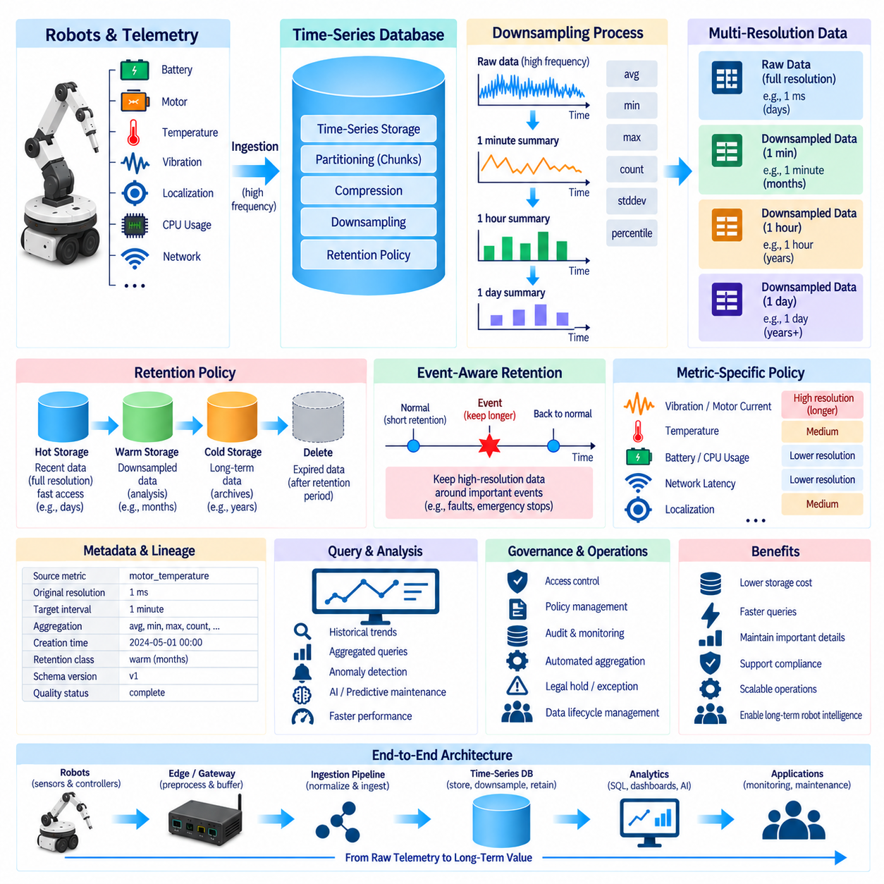
Downsampling is the process of reducing the temporal resolution of time-series data while preserving the statistical or operational information needed for later analysis. Robot systems can generate telemetry at millisecond or sub-second intervals, producing enormous datasets over months of operation. Keeping every raw measurement indefinitely is rarely economical, so data architecture must determine how detailed observations gradually become compact historical representations.
A robot may generate motor current, joint temperature, battery voltage, vibration, CPU utilization, localization quality, network latency, and other metrics continuously throughout a mission. Recent high-frequency samples are valuable for debugging and root-cause analysis, but older data is often used primarily to identify trends or compare operational periods. Downsampling exploits this difference by converting dense historical streams into lower-frequency summaries.
The simplest downsampling strategy divides time into fixed windows and calculates representative values for each interval. Measurements collected every few milliseconds may be summarized into one-second, one-minute, hourly, or daily windows. Each window can store statistics such as mean, minimum, maximum, count, sum, standard deviation, or percentiles. The selected statistics should preserve the characteristics required by monitoring, diagnostics, reliability analysis, and AI workflows.
Using only an average can hide important robot behavior. A motor may operate normally for most of a minute while briefly experiencing a dangerous current spike, yet the one-minute average may appear acceptable. Downsampled datasets should therefore preserve extrema or other distribution information when transient events matter. Minimum, maximum, percentile, variance, count, and anomaly indicators can complement averages and retain evidence of short-duration operational changes.
Sampling intervals should reflect the dynamics of each metric rather than applying one resolution to every data stream. CPU utilization or battery state may tolerate relatively coarse historical intervals, while vibration, actuator current, or control-related signals may require finer resolution to preserve meaningful patterns. Metric-specific policies can therefore produce better analytical value than a universal rule applied uniformly across all robot telemetry.
Multi-resolution storage provides a practical lifecycle for high-volume telemetry. Full-resolution data can be retained for a short diagnostic period, intermediate-resolution summaries can support recent operational analysis, and coarse aggregates can remain available for long-term trends. For example, a platform may maintain raw measurements for days, minute-level summaries for months, and hourly or daily statistics for years, although actual durations should follow operational requirements.
Retention policy defines how long each class and resolution of time-series data remains available. Retention is not simply a storage cleanup mechanism; it represents an explicit decision about the future value of information. Robot data needed for immediate debugging may have a different lifetime from data used for warranty investigation, fleet reliability analysis, predictive maintenance, AI training, regulatory evidence, or long-term product improvement.
Retention rules should consider data value, storage cost, operational risk, and reconstruction requirements together. Deleting raw telemetry too early can make rare field failures impossible to investigate, while retaining all high-frequency signals indefinitely can consume excessive storage and increase management complexity. The objective is to preserve sufficient evidence for expected engineering and business needs without treating every sample as permanently valuable.
A tiered retention architecture can separate hot, warm, and cold data according to access frequency and temporal detail. Hot storage contains recent full-resolution telemetry optimized for fast queries and troubleshooting. Warm storage can hold downsampled or compressed information used for periodic analysis. Cold storage or archives can preserve selected long-term summaries and important raw datasets at lower cost when immediate interactive access is no longer required.
Downsampling should normally occur before the corresponding raw data is deleted. The system first verifies that required aggregates have been generated successfully and that the resulting data satisfies completeness and quality requirements. Only then should the original high-resolution records become eligible for expiration. This ordering prevents lifecycle automation from destroying source data before the historical representation needed by dashboards, analytics, or maintenance systems has been created.
Continuous or scheduled aggregation can automate this transformation. A time-series platform may periodically process newly completed time windows and create lower-resolution representations. The process should account for late-arriving records because robot telemetry may be delayed by edge buffering, wireless outages, or retransmission. Aggregating a window permanently before delayed observations arrive can produce incomplete historical statistics unless refresh or correction mechanisms are available.
Event-aware retention can preserve exceptional periods at higher resolution than routine operation. A robot may normally retain raw telemetry for only a short period, but data surrounding motor faults, emergency stops, localization failures, collisions, abnormal vibration, or thermal events can be protected for longer investigation. This strategy combines economical storage with detailed evidence around operationally important events instead of applying identical retention to every time interval.
Mission context can also influence lifecycle decisions. Telemetry associated with commissioning, validation, unusual environments, new firmware versions, or experimental control algorithms may have greater future value than routine repetitive operation. Linking retention decisions with robot ID, mission ID, software version, site, subsystem, or event classification allows the data platform to preserve strategically important observations while reducing redundant historical data.
Downsampling must maintain temporal alignment when several metrics are analyzed together. If battery, motor, localization, and compute metrics are aggregated into incompatible windows, later correlation can become difficult or misleading. Standardized window boundaries and clearly documented aggregation semantics make cross-metric analysis more reliable. Time zone handling, event-time definitions, incomplete windows, and late-data behavior should also be consistent across the telemetry platform.
Metadata should describe how every downsampled dataset was produced. Useful information includes source measurement, original resolution, target interval, aggregation function, creation time, retention class, schema version, and quality status. This lineage allows engineers to distinguish raw observations from derived summaries and understand whether a historical value represents a mean, maximum, percentile, count, or another transformation when interpreting long-term robot behavior.
Retention policies should be applied at appropriate scopes rather than only at the database level. Different fleets, sites, robots, subsystems, or metric categories may require different lifetimes. Safety-related fault metrics may deserve longer retention than routine CPU utilization, while high-bandwidth experimental signals may require aggressive expiration. Policy granularity allows storage resources to follow operational value instead of forcing all time-series data into one lifecycle.
Storage compression complements downsampling but serves a different purpose. Compression reduces the physical size of retained records while preserving their logical values, whereas downsampling reduces the number of observations by creating lower-resolution representations. A platform can use both approaches together: compress relatively recent raw telemetry, downsample older periods, and archive or delete data after its defined retention lifetime expires.
Query performance can improve as lifecycle policies reduce the volume of active high-resolution data. Smaller hot datasets require fewer partitions, indexes, and cache resources, while historical dashboards can query compact aggregates rather than billions of raw samples. Retention and downsampling are therefore not merely storage-cost controls; they are also important mechanisms for maintaining predictable analytical performance as fleet size and operational history increase.
AI and predictive-maintenance requirements may justify preserving selected raw data longer than conventional dashboards require. Models detecting subtle vibration changes, actuator degradation, or unusual temporal patterns can depend on information that disappears during coarse aggregation. Data architects should identify which signals may become future training features and avoid irreversible downsampling until the organization has determined whether detailed temporal structure is still valuable.
Governance requirements should define who can change retention rules and how deletions are audited. Automated expiration can permanently remove engineering evidence, so policy modifications should be controlled, versioned, and observable. Legal holds, incident investigations, warranty cases, or important experiments may require temporary exceptions. Deletion status, aggregation completion, archival movement, and policy execution failures should therefore be monitored as part of data operations.
A mature robot time-series architecture treats downsampling and retention as a coordinated lifecycle pipeline rather than independent database settings. Data progresses from high-resolution operational telemetry through validated aggregates, compressed historical layers, archival storage, and eventual deletion according to defined value and policy. This approach balances diagnostic detail, query performance, storage efficiency, governance, predictive maintenance, and long-term fleet intelligence as robot data continuously grows.

05.07 Time Series Anomaly Detection: Z.Score / STL [w/Code]
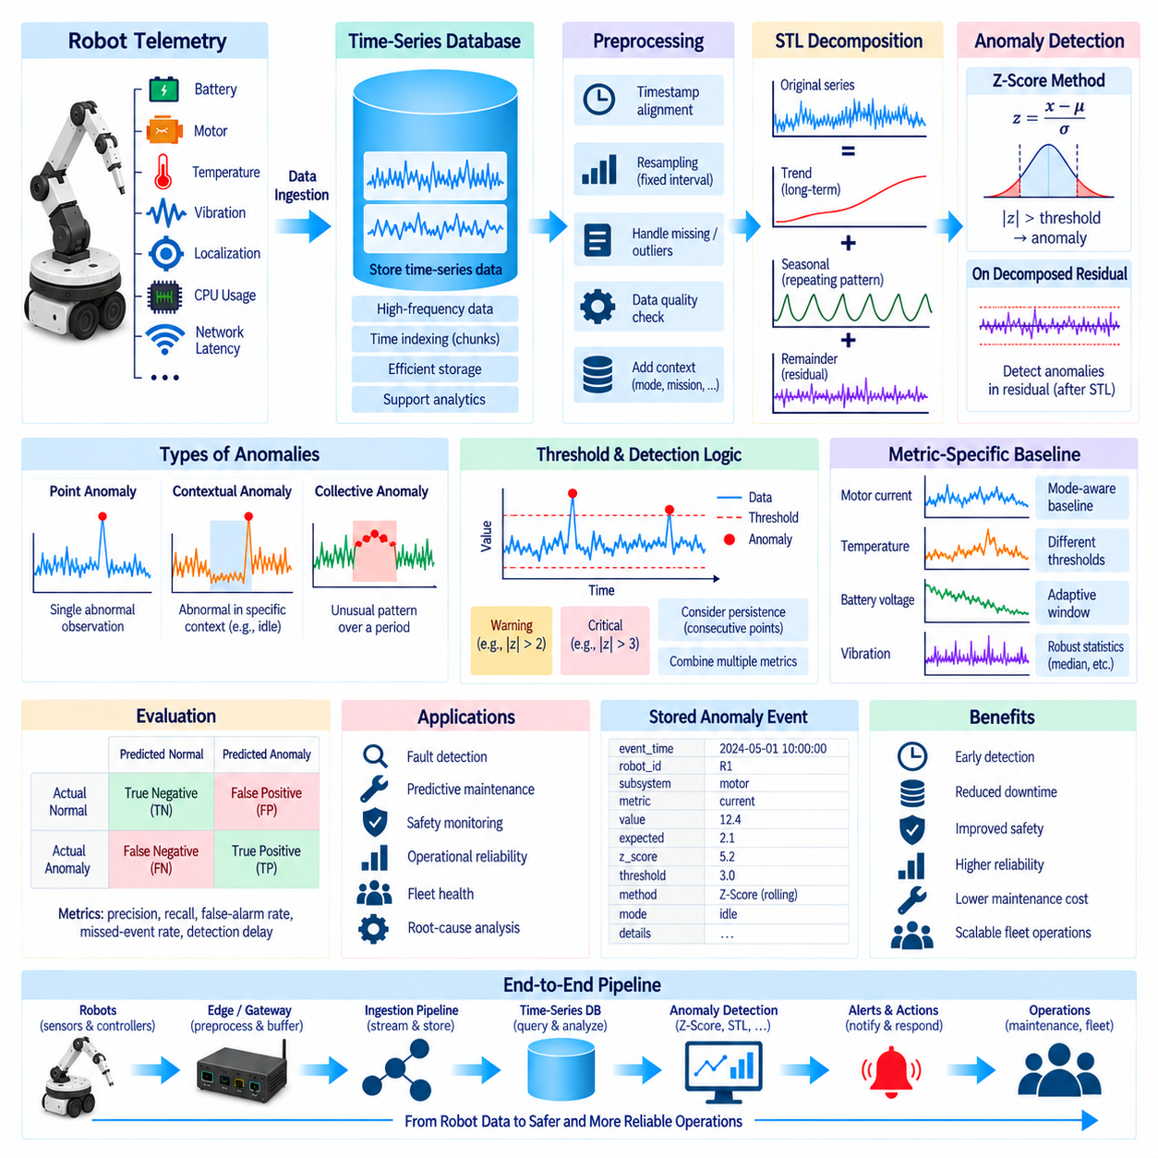
Time-series anomaly detection identifies observations or temporal patterns that deviate from expected robot behavior. In operational robotics, anomalies can appear in motor current, joint temperature, battery voltage, vibration, localization error, CPU utilization, communication latency, or mission duration. Detecting these deviations early supports fault diagnosis, predictive maintenance, safety monitoring, and fleet reliability before abnormal behavior develops into a larger operational failure.
An anomaly is not necessarily an extreme numerical value. A temperature of 60°C may be normal under heavy load but suspicious during idle operation, while a moderate vibration level may become abnormal if it persists much longer than expected. Time-series anomaly detection must therefore consider temporal context, operating mode, historical distribution, trends, and recurring patterns rather than treating every metric as a collection of independent measurements.
Point anomalies occur when individual observations differ significantly from surrounding or expected values. A sudden motor-current spike, abrupt battery-voltage drop, or isolated localization error can represent this type of anomaly. Contextual anomalies depend on circumstances, such as temperature being normal during motion but abnormal while stationary. Collective anomalies involve sequences whose combined pattern is unusual even though individual observations may remain within ordinary numerical ranges.
Z-score detection provides a simple statistical method for identifying observations that are unusually far from the mean. For a measurement x, the standardized score can be expressed as z = (x − μ) / σ, where μ represents the expected mean and σ represents standard deviation. A large absolute Z-score indicates that the observation lies far from the reference distribution and may therefore be classified as anomalous according to a selected threshold.
A common implementation calculates the mean and standard deviation from a historical baseline or recent moving window. Robot telemetry can then be standardized relative to that reference. If motor current normally remains near a stable operating range, a sudden deviation producing a high absolute Z-score can trigger investigation. The threshold should not be treated as universally fixed because acceptable sensitivity depends on metric behavior, operational risk, noise level, and the cost of false alarms.
Global Z-score detection assumes that a relatively stable distribution provides a meaningful reference across the analyzed period. This assumption can fail when robot metrics change naturally according to mission phase, payload, speed, terrain, battery state, or environmental conditions. A single global mean may combine several valid operating regimes and incorrectly classify normal behavior as abnormal. Context-specific baselines are therefore often more useful for heterogeneous robot operations.
Rolling Z-scores adapt the reference distribution to recent observations. A moving window calculates a local mean and standard deviation, allowing the detector to respond to changing operating conditions. This can improve detection for signals whose baseline gradually evolves, but window size becomes an important parameter. A short window adapts quickly but can become sensitive to noise, while a long window provides stability but may respond slowly to genuine behavioral changes.
Z-score methods also become unreliable when distributions are strongly skewed, contain frequent outliers, or have near-zero variance. A single extreme event can distort the mean and standard deviation used to detect subsequent anomalies. Robust alternatives can use median-based statistics or other resistant estimators when necessary. Statistical assumptions should therefore be validated for each robot metric rather than applying the same detection rule indiscriminately across every telemetry stream.
Many robot signals contain trends and seasonal or periodic behavior that simple threshold methods cannot represent effectively. Battery voltage may gradually decline during a mission, thermal measurements may increase after startup, and compute utilization may follow repeated task cycles. Seasonal-Trend decomposition using Loess, commonly called STL, separates a time series into trend, seasonal, and remainder components so that expected structure can be distinguished from unexplained variation.
Conceptually, an observed series can be represented as the combination of trend, seasonal structure, and remainder. The trend captures gradual long-term movement, while the seasonal component represents recurring patterns over a known or estimated period. The remainder contains variation not explained by those components. Anomaly detection can focus on the remainder because deviations that would be hidden by trend or periodic behavior become more visible after expected temporal structure has been removed.
For robot operations, STL can be useful when telemetry follows repeatable cycles. A warehouse robot may repeatedly accelerate, transport material, stop, unload, and return, producing periodic patterns in motor current or energy consumption. A simple global threshold may repeatedly flag these expected transitions. Decomposition can model recurring behavior and expose unusual residual patterns, such as an unexpectedly high current during a phase that historically exhibits lower electrical load.
Selecting an appropriate seasonal period is important for decomposition. Periodicity may correspond to control cycles, repeated manufacturing operations, charging schedules, shifts, missions, or other recurring processes. Incorrect periodic assumptions can move meaningful behavior into the wrong component and reduce anomaly-detection quality. Engineers should examine domain knowledge, autocorrelation, historical patterns, and mission structure when defining or validating the periodic characteristics of robot telemetry.
After decomposition, the remainder can be evaluated using statistical thresholds such as Z-scores or robust deviation measures. This creates a useful combination in which STL removes expected trend and seasonality while statistical detection identifies unusual residual behavior. A temperature increase caused by normal warm-up can remain part of the trend, while a sudden unexplained thermal excursion appears in the remainder and receives a higher anomaly score.
Anomaly detection should generally operate on event-time-aligned data with consistent sampling intervals. Missing observations, irregular sampling, duplicated timestamps, and out-of-order records can distort moving statistics and seasonal decomposition. Preprocessing may therefore include timestamp validation, resampling, gap identification, interpolation where justified, and quality labeling. Artificially filling long gaps without recording that transformation can create false patterns and should be avoided.
Multivariate context can improve interpretation even when detection begins with individual time series. A motor-current anomaly accompanied by increased vibration and temperature has different significance from an isolated current spike with no related changes. Robot systems can combine anomaly scores across electrical, mechanical, thermal, compute, localization, and network metrics to support richer diagnosis. Correlation does not prove causality, but synchronized evidence can narrow the investigation space.
Threshold design must balance false positives and false negatives. Excessively sensitive detection produces alarm fatigue and may cause operators to ignore warnings, while insensitive thresholds can miss early evidence of degradation. Thresholds can vary by robot model, subsystem, operating mode, mission phase, or severity level. Warning and critical levels may also be separated so that a moderate deviation triggers observation while a persistent or extreme anomaly initiates stronger operational responses.
Persistence is often as important as magnitude. A single high Z-score may result from sensor noise, whereas a sequence of moderately abnormal values may indicate genuine degradation. Detection logic can therefore incorporate consecutive violations, anomaly duration, accumulated score, or repeated occurrences within a defined window. This temporal reasoning helps distinguish transient measurement noise from developing mechanical, electrical, thermal, or communication problems.
Anomaly events should be stored with sufficient context for later investigation. Useful records include event time, robot ID, subsystem, metric, observed value, expected baseline, anomaly score, threshold, detection method, model or rule version, operating mode, and links to surrounding telemetry. Preserving this information enables engineers to reproduce why an alert was generated and compare detector behavior as algorithms and thresholds evolve.
Evaluation requires labeled incidents or carefully reviewed historical data whenever available. Precision, recall, false-alarm rate, missed-event rate, detection delay, and alert frequency can reveal different aspects of detector quality. In robot operations, detection latency may be particularly important because an algorithm that eventually identifies a fault may still provide little operational value if recognition occurs after the subsystem has already failed.
Z-score and STL methods provide interpretable foundations rather than complete solutions for every anomaly problem. Z-scores are efficient and understandable for relatively stable statistical behavior, while STL is useful when trend and periodicity must first be separated from residual variation. More complex robot systems may later require change-point detection, forecasting residuals, multivariate models, or machine-learning methods, but simpler techniques remain valuable as transparent baselines.
Within the robot data architecture, anomaly detection transforms stored time-series telemetry into operational signals that can support monitoring and maintenance decisions. A practical pipeline aligns timestamps, validates data quality, establishes contextual baselines, separates expected temporal structure when necessary, calculates anomaly scores, applies persistence and severity rules, and records detected events with traceable metadata. This connects raw robot metrics to explainable diagnostics, fleet reliability, and predictive-maintenance workflows.

05.08 Time Series Forecasting: ARIMA, Prophet, LSTM [w/Code]
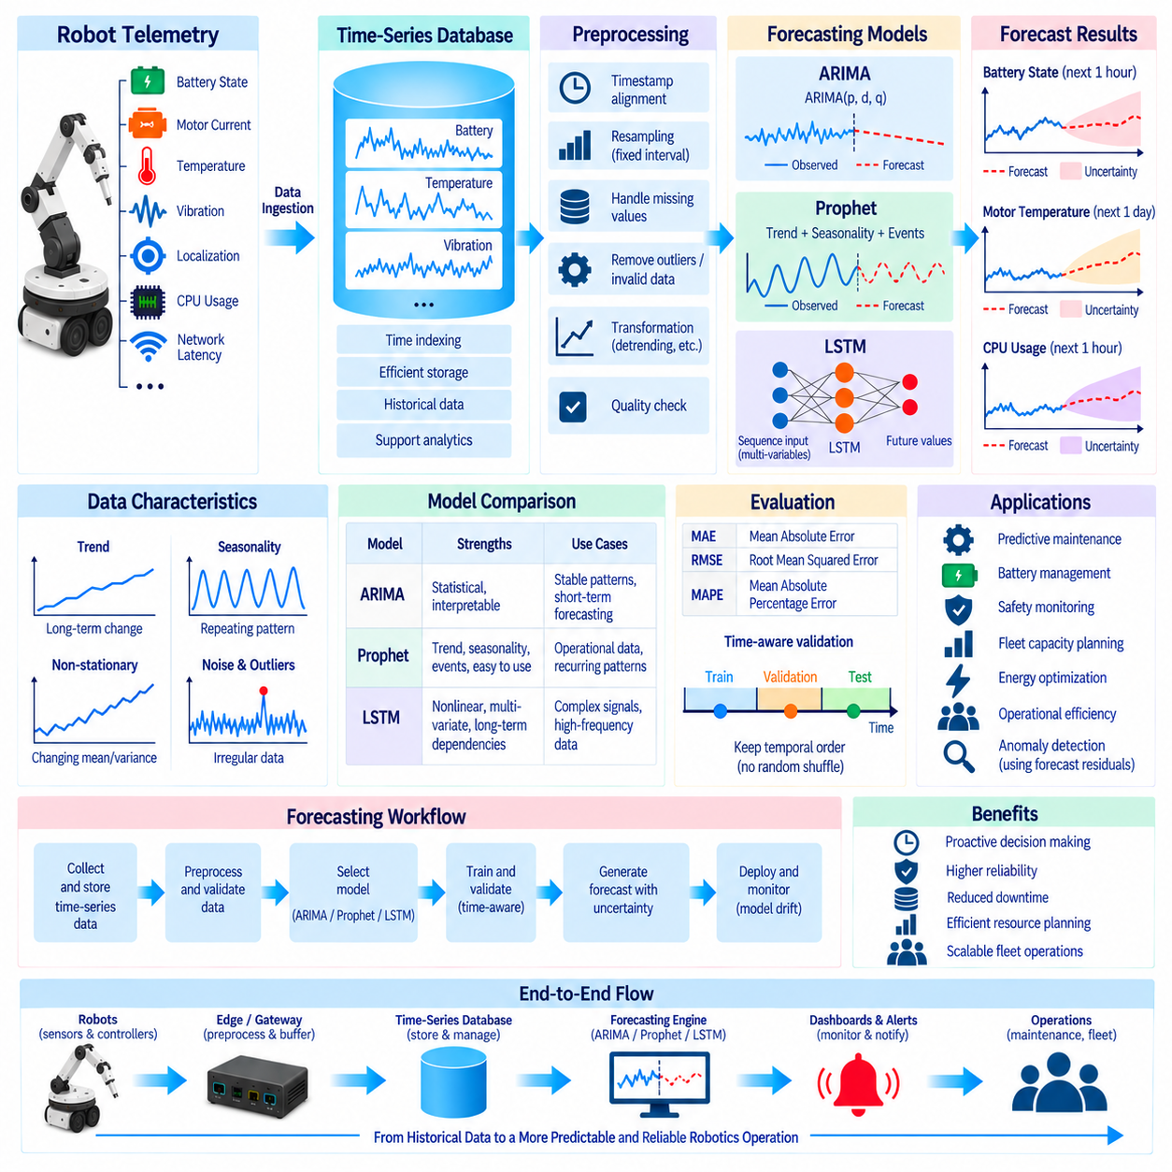
Time-series forecasting estimates future robot behavior from historical observations and temporal patterns. In robotics, forecasting can support battery management, thermal supervision, component maintenance, workload planning, energy optimization, and fleet operations. Instead of only identifying what has already happened, a forecasting system attempts to estimate what is likely to occur next and provides operators with additional time to prepare appropriate operational responses.
Robot telemetry contains many signals suitable for forecasting, including battery state, motor temperature, actuator current, vibration, CPU utilization, communication latency, localization quality, charging behavior, and mission duration. These signals differ greatly in dynamics and predictability. Some change gradually, others follow repeated cycles, and some respond strongly to external conditions. Forecasting methods must therefore be selected according to the temporal characteristics and operational purpose of each metric.
A forecasting problem begins by defining the target variable and forecast horizon. Predicting battery state ten minutes ahead serves a different purpose from estimating motor degradation several weeks ahead. Short-horizon forecasts may support immediate mission control, while long-horizon predictions can assist maintenance scheduling and fleet capacity planning. Sampling frequency, prediction interval, available history, and required accuracy should therefore be determined before selecting a forecasting algorithm.
Data quality is fundamental because forecasting models learn temporal relationships from historical records. Missing timestamps, duplicated observations, irregular sampling, sensor failures, clock drift, and out-of-order records can distort learned patterns. A preprocessing pipeline may align timestamps, resample measurements, identify gaps, handle missing values, remove invalid readings, and attach quality indicators. These transformations should remain traceable so later users understand how the training sequence was constructed.
Stationarity is particularly important for classical forecasting methods. A stationary series has statistical properties that remain relatively stable over time, while robot telemetry frequently contains trends, changing variance, operational transitions, or seasonal patterns. Differencing, transformations, detrending, or segmentation by operating mode can make some signals more suitable for statistical modeling. However, preprocessing should preserve operationally meaningful changes rather than automatically removing every long-term variation.
ARIMA, or AutoRegressive Integrated Moving Average, models a time series using autoregressive behavior, differencing, and moving-average relationships. The autoregressive component uses previous observations, the integrated component addresses non-stationary behavior through differencing, and the moving-average component represents relationships with previous forecast errors. ARIMA is useful when a robot metric exhibits structured temporal dependence that can be represented effectively with a relatively compact statistical model.
ARIMA is commonly expressed using parameters p, d, and q. The parameter p represents the number of autoregressive lags, d represents the degree of differencing, and q represents the moving-average order. Selecting these parameters requires analysis of the time series rather than arbitrary configuration. Autocorrelation, partial autocorrelation, information criteria, validation results, and domain knowledge can help determine a suitable model structure for a particular robot metric.
Seasonal behavior can require extensions such as seasonal ARIMA when repeated temporal patterns are important. Charging cycles, production schedules, warehouse missions, or periodic inspection routines may produce recurring behavior in energy consumption or subsystem load. Explicitly modeling these cycles can improve forecasts compared with a non-seasonal model. Nevertheless, abrupt mission changes or complex nonlinear interactions can limit the effectiveness of traditional statistical approaches.
Prophet provides a forecasting approach based on decomposing a time series into interpretable components such as trend, seasonality, and event-related effects. This structure is useful when data contains strong recurring patterns and gradual changes over time. Robot fleet metrics aggregated by hour or day, charging demand, mission counts, energy consumption, or utilization statistics can exhibit patterns that fit this style of forecasting better than extremely high-frequency control signals.
The trend component in Prophet represents longer-term growth or decline, while seasonal components capture repeated patterns over defined temporal cycles. Additional events or special periods can represent known operational changes when appropriate. For a robot fleet, maintenance schedules, shift structures, deployment cycles, or planned facility changes may affect observed workload. Explicitly representing such factors can make forecasts easier for engineers and operations teams to interpret.
Prophet is generally attractive when interpretability and practical forecasting of structured operational data are more important than modeling highly complex nonlinear dynamics. Engineers can examine trend and seasonal components separately and understand why the model produces a particular forecast. However, its assumptions should still be validated against actual telemetry. A convenient modeling interface does not guarantee accurate predictions when robot behavior changes rapidly or depends heavily on multivariate physical interactions.
Long Short-Term Memory, or LSTM, is a recurrent neural-network architecture designed to learn dependencies across sequences. LSTM networks use gating mechanisms to regulate how information is retained, updated, and forgotten across time steps. This capability can be useful for robot telemetry in which future behavior depends on complex nonlinear relationships extending across longer sequences that may be difficult to capture with conventional linear statistical models.
An LSTM forecasting model typically receives sequences of historical observations and predicts one or more future values. Input features can include the target metric together with contextual variables such as speed, payload, motor current, ambient temperature, battery state, mission phase, or CPU load. Multivariate input allows the model to learn relationships between several robot signals, potentially improving forecasts when the target cannot be explained adequately by its own history alone.
Sequence length is an important LSTM design parameter because it determines how much historical context is presented to the model. A short sequence may omit important dependencies, while an excessively long sequence increases computation and may introduce irrelevant information. The appropriate context window depends on the dynamics of the target signal, sampling frequency, mission structure, and forecast horizon. It should therefore be selected through validation rather than convenience.
LSTM models generally require more data, computation, tuning, and operational infrastructure than ARIMA or component-based forecasting methods. Training involves selecting network architecture, sequence length, features, loss functions, optimization parameters, and regularization strategies. Large models can overfit historical robot behavior and perform poorly when operating conditions change. Complexity should therefore be justified by measurable forecasting improvements rather than by the assumption that deep learning is inherently superior.
The three approaches represent different modeling tradeoffs rather than a simple progression from basic to advanced. ARIMA offers statistical transparency for structured temporal dependence, Prophet emphasizes interpretable trend and seasonal modeling, and LSTM can represent nonlinear sequential relationships with multivariate inputs. A robot data platform may use different models for different signals instead of selecting one forecasting method as a universal standard across every telemetry stream.
Model evaluation should preserve temporal ordering. Randomly shuffling time-series observations between training and testing can allow information from the future to influence model development and produce unrealistically optimistic results. Chronological train-validation-test splits or rolling-origin evaluation better represent real deployment. Models should always be evaluated by predicting periods that occur after the data used for training, reflecting how forecasting will actually operate in production.
Forecast quality can be measured using metrics such as mean absolute error, root mean squared error, or other domain-appropriate measures. Numerical accuracy alone, however, does not determine operational value. A battery forecast should be accurate enough to prevent mission interruption, while a thermal forecast should provide sufficient warning before a critical limit is reached. Evaluation should therefore connect prediction error with the consequences of operational decisions.
Prediction intervals or uncertainty estimates are valuable because forecasts are not exact future observations. A predicted motor temperature of a single value can create false confidence, while a forecast range communicates uncertainty and allows risk-aware decisions. Uncertainty can increase with forecast horizon, changing operating conditions, sparse historical data, or behavior not represented in training. Operational systems should distinguish expected values from confidence or uncertainty information.
Forecasting can also support anomaly detection by comparing predicted and observed behavior. When actual telemetry deviates substantially from a forecast and its expected uncertainty range, the residual can become an anomaly signal. This approach adapts expected behavior to trends and temporal patterns rather than relying exclusively on fixed thresholds. Persistent forecast errors can indicate sensor problems, component degradation, environmental changes, or a shift in operating regime.
Production forecasting requires continuous monitoring because robot behavior changes over time. New firmware, hardware replacement, battery aging, payload changes, environmental conditions, mission redesign, and fleet expansion can alter the relationship learned from historical data. Forecast errors should therefore be monitored for model drift, and retraining or recalibration should occur when performance degrades beyond defined operational limits.
Within the robot data architecture, forecasting transforms historical telemetry into forward-looking operational information. A practical pipeline validates and aligns time-series data, defines target and horizon, selects an appropriate statistical or neural model, performs time-aware validation, quantifies uncertainty, deploys forecasts, and monitors prediction error over time. ARIMA, Prophet, and LSTM provide complementary approaches for connecting robot data with predictive maintenance, resource planning, fleet intelligence, and proactive operations.

05.09 Grafana Time Series Visualization Dashboard [w/Code]
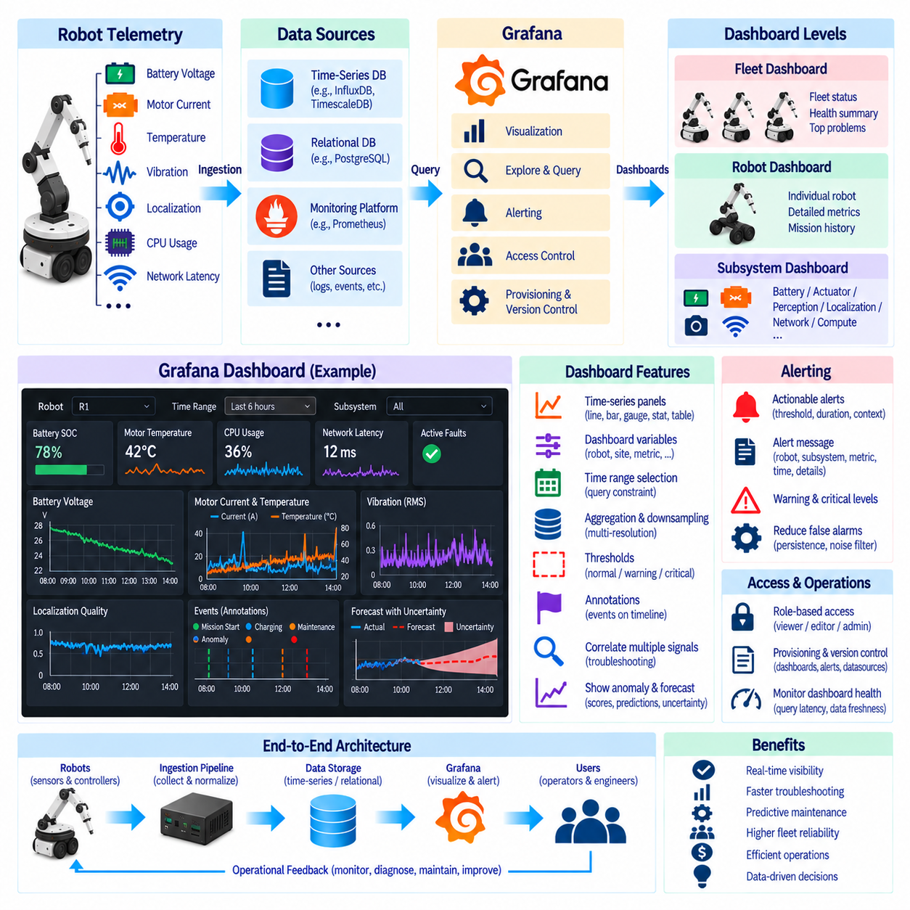
Grafana provides a visualization and observability layer for robot time-series data, allowing operators and engineers to transform continuous telemetry into dashboards that describe current system state and historical behavior. Instead of examining raw database records, users can monitor battery voltage, motor current, temperature, vibration, localization quality, compute utilization, and network performance through coordinated visual panels organized around operational questions.
A Grafana dashboard does not normally become the primary storage system for robot telemetry. It connects to underlying data sources such as time-series databases, relational databases, or monitoring platforms and executes queries against them. This separation allows the storage layer to focus on ingestion, retention, indexing, and aggregation while Grafana focuses on visualization, exploration, alert-oriented views, and interaction with operational data.
The dashboard architecture should reflect the hierarchy of the robot system. A fleet-level dashboard can summarize the condition of many robots, while robot-level dashboards expose the health of an individual platform. Additional subsystem dashboards can focus on batteries, actuators, perception, localization, networking, or compute resources. This hierarchy allows operators to move from a fleet-wide symptom toward increasingly detailed telemetry without placing every metric on one screen.
Time-series panels are fundamental because robot behavior is strongly dependent on temporal context. A line chart can show motor temperature rising during operation, battery voltage declining through a mission, or CPU utilization changing with perception workloads. Multiple related series can share a time axis so engineers can investigate whether events occurred together, although incompatible units or excessive series should be separated to avoid misleading visual comparisons.
Dashboard variables make one dashboard reusable across many robots and missions. Variables can represent robot ID, fleet, site, subsystem, sensor, metric, software version, or mission identifier and can be inserted into underlying queries. An engineer can therefore select another robot without creating a separate dashboard. Carefully designed variables reduce duplicated dashboards and create a consistent investigation workflow across large robot fleets.
The dashboard time range should be treated as an explicit query constraint rather than merely a visual preference. Selecting the last fifteen minutes, several hours, or a historical mission changes how much telemetry the database must scan. Queries should pass the selected time range to the data source so partition pruning, indexes, and time-series optimization can operate effectively. Unbounded queries can make dashboards slow as telemetry history grows.
Panel resolution should also influence query resolution. A screen containing a limited number of horizontal pixels does not benefit from retrieving millions of raw samples for a long historical period. Time bucketing and aggregation can return representative minimum, maximum, average, count, or percentile values at an interval appropriate to the selected range. This reduces database workload and network transfer while maintaining useful visual information.
Downsampled and continuously aggregated datasets are especially useful for long-range dashboards. Recent operational views may query full-resolution telemetry, while weekly, monthly, or yearly panels can use minute-, hour-, or day-level summaries. Grafana can therefore participate in a multi-resolution architecture in which the visualization selects an appropriate data representation rather than forcing every historical request to read high-frequency raw measurements.
Dashboard layout should prioritize operational interpretation instead of maximizing the number of panels. High-level state, active problems, and essential health indicators should appear prominently, while detailed diagnostic signals can be placed in lower sections or dedicated dashboards. A useful dashboard guides attention from overall status toward supporting evidence. Dense collections of unrelated graphs can increase cognitive load and make important changes more difficult to recognize.
Stat, gauge, and table-style panels can complement time-series graphs when the latest value or categorical state is more important than the full historical curve. Battery state of charge, robot availability, mission state, current software version, connectivity status, or number of active faults can be represented compactly. Historical plots can then provide temporal context when an operator needs to understand how the current state developed.
Thresholds can visually distinguish normal, warning, and critical operating regions. A motor-temperature panel, for example, may display engineering limits together with measured values so operators can see whether a signal is approaching an unsafe range. Threshold values should come from documented operational criteria whenever possible rather than arbitrary visual preferences. Different robot models or operating modes may require different thresholds.
Annotations add event context directly to time-series visualizations. Software deployments, mission starts, charging events, emergency stops, maintenance actions, detected anomalies, or configuration changes can be represented on the same timeline as telemetry. This makes it easier to determine whether a behavioral change coincided with a known operational event and reduces the need to manually compare independent logs and monitoring systems.
Correlating several signals is particularly valuable during troubleshooting. A motor fault investigation may compare current, temperature, vibration, command velocity, and battery voltage over the same interval. A localization investigation may compare pose uncertainty, sensor availability, CPU load, and network latency. Synchronizing panels by time allows engineers to visually explore relationships, although observed correlation should not automatically be interpreted as causation.
Grafana dashboards can also expose outputs from anomaly-detection and forecasting pipelines. An anomaly score can be plotted beside the original telemetry, while predicted values and uncertainty ranges can be compared with actual measurements. This connects descriptive monitoring with predictive analytics. Operators can see not only that a metric changed, but whether the change exceeded an expected statistical or model-based operating pattern.
Alerting should be designed around actionable conditions rather than every numerical deviation. A useful alert can combine threshold magnitude, duration, persistence, and contextual information so transient sensor noise does not repeatedly notify operators. Warning and critical conditions can represent different severity levels. Alert messages should identify the affected robot, subsystem, metric, time, observed condition, and enough context to begin investigation.
Fleet dashboards require careful control of cardinality. Displaying every metric from every robot simultaneously can generate expensive queries and visually unusable panels. Fleet-level views should aggregate or summarize information, then allow users to drill down into selected robots. Variables, filtering, grouping, and top-problem views help maintain usability while preventing visualization requirements from overwhelming the underlying time-series database.
Dashboard refresh intervals should match operational needs and data arrival rates. A panel displaying rapidly changing control-related telemetry may require frequent updates, while long-term maintenance statistics may change only occasionally. Refreshing every panel at the highest possible frequency wastes database, network, and browser resources. Different dashboards should therefore balance freshness requirements with query cost and infrastructure capacity.
Query inspection is important when dashboard performance degrades. Engineers should examine the time range, returned series count, aggregation interval, filters, database execution plan, scanned partitions, and response size rather than assuming the visualization platform itself is responsible. Slow dashboards often reveal inefficient queries, missing indexes, excessive cardinality, or attempts to retrieve unnecessarily detailed historical data.
Dashboard provisioning and version control improve consistency when monitoring becomes part of production robot operations. Dashboard definitions, data-source configurations, variables, and alert rules can be managed as controlled artifacts rather than relying exclusively on manual editing. Changes can then be reviewed, reproduced across environments, and associated with software releases. This is especially valuable when development, laboratory, staging, and deployed fleets require related monitoring views.
Access control should reflect the operational sensitivity of robot data. Operators may require monitoring access without permission to modify dashboards, while engineers may need exploration and editing capabilities. Administrative functions and data-source credentials should be more restricted. Separating viewing, editing, and administration reduces accidental configuration changes and supports a more controlled observability environment.
A production dashboard should itself be monitored as part of the data platform. Query latency, data-source errors, refresh failures, missing series, ingestion delay, and stale values can cause a dashboard to appear healthy while underlying telemetry is incomplete. Data freshness indicators and pipeline health metrics help users distinguish genuine robot stability from missing or delayed observations.
Within the robot data architecture, Grafana connects stored telemetry with human operational understanding. Robot sensors produce time-series data, ingestion pipelines normalize and store it, databases manage efficient temporal queries, and dashboards transform the results into fleet, robot, and subsystem views. When variables, aggregation, annotations, alerting, access control, and performance-aware queries are designed together, Grafana becomes an effective interface for monitoring, diagnostics, predictive maintenance, and long-term robot operations.

05.10 Long-Term Robot Sensor Time Series Retention Strategy
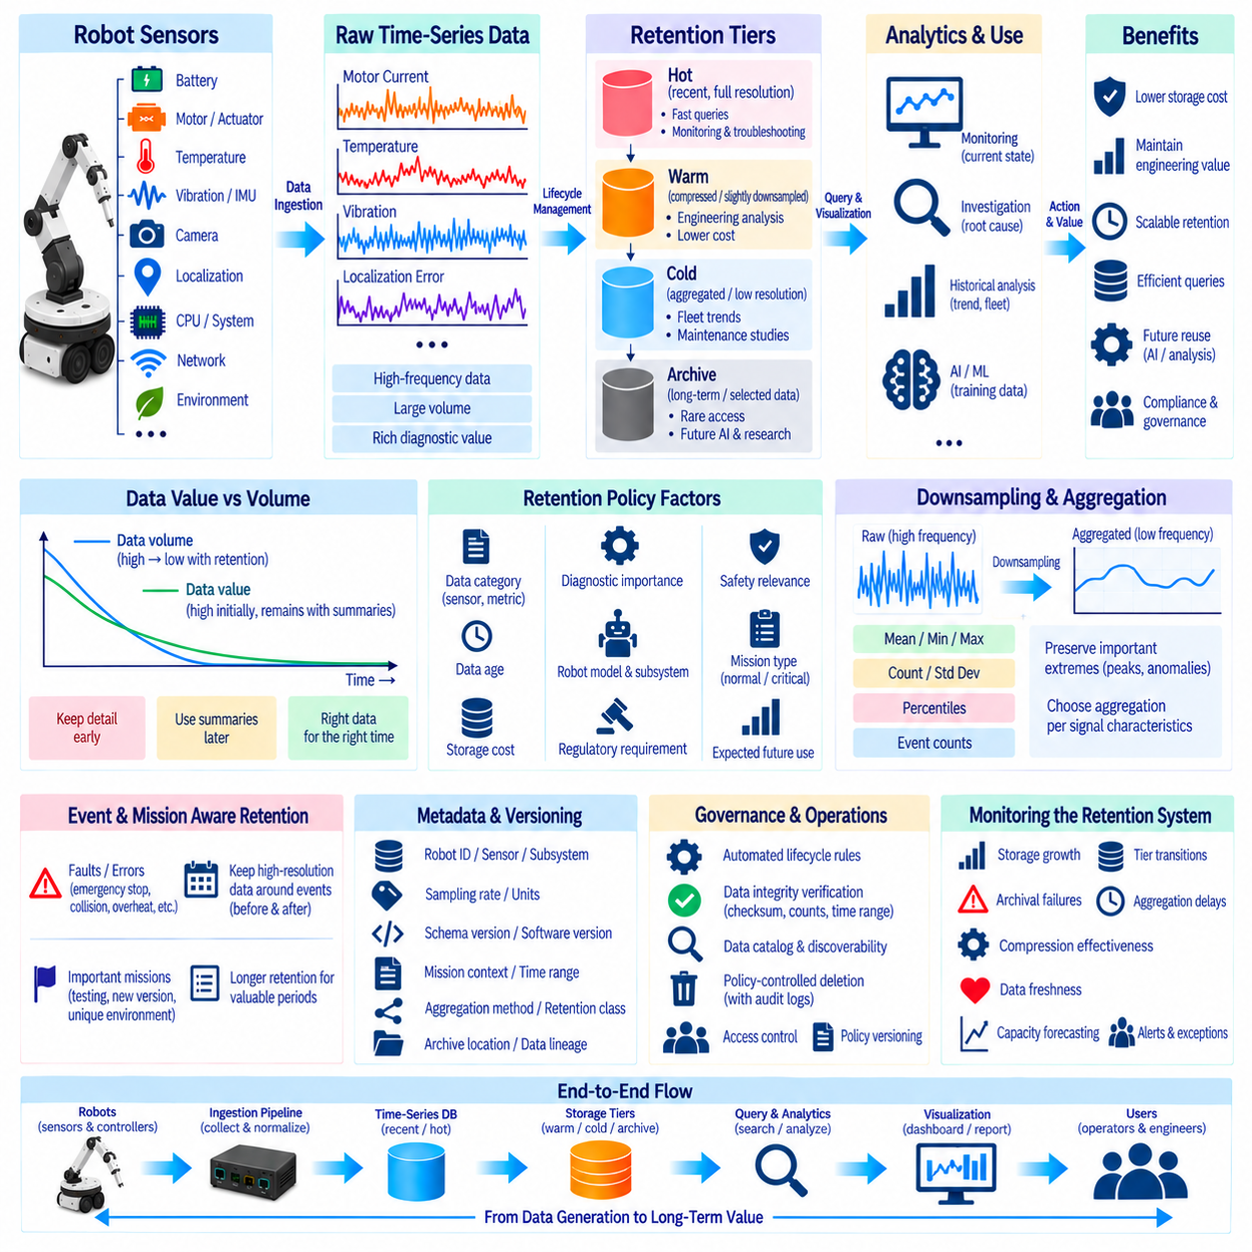
Long-term retention of robot sensor time-series data requires a strategy that balances engineering value, storage capacity, analytical performance, governance, and future reuse. Robots continuously produce measurements from actuators, batteries, cameras, localization systems, compute devices, environmental sensors, and communication interfaces. Without lifecycle planning, years of high-frequency telemetry can grow into an expensive archive that is difficult to search and maintain.
The first principle is to distinguish data value from data volume. High-frequency sensor measurements may be essential immediately after collection because engineers need detailed evidence for debugging, validation, and incident investigation. As the data becomes older, many operational questions can be answered using summaries rather than every original sample. A retention strategy should therefore allow temporal detail to decrease as information moves through its lifecycle.
Not every robot sensor requires the same retention period. Motor current, vibration, joint torque, and IMU measurements can generate high-rate streams whose raw history becomes extremely large, while battery state, mission status, thermal summaries, and maintenance events may require much less storage. Retention classes should reflect sampling frequency, diagnostic importance, reconstruction value, safety relevance, and expected future analytical use.
A practical architecture separates recent operational data from historical analytical data. Recent full-resolution telemetry can remain in a high-performance time-series database where engineers need fast interactive queries. Older information can transition into compressed, downsampled, or aggregated representations. Long-term historical datasets can then move into lower-cost object storage, a data lakehouse, or another archival platform optimized for capacity rather than millisecond query latency.
This lifecycle can be represented through hot, warm, cold, and archive tiers. Hot storage supports recent monitoring and troubleshooting with full temporal resolution. Warm storage retains compressed or moderately downsampled telemetry for engineering analysis. Cold storage preserves lower-resolution historical information for fleet trends and maintenance studies. Archive storage protects selected long-lived datasets that may be accessed rarely but remain valuable for future investigation or AI development.
Movement between storage tiers should be governed by explicit policies rather than manual decisions. Age, data category, robot model, subsystem, mission type, event severity, storage cost, or regulatory requirement can determine when data transitions to another tier. Automated lifecycle rules reduce operational burden and create predictable storage behavior, but transitions should be observable and validated so failures do not silently cause unexpected deletion or incomplete archives.
Downsampling is central to sustainable long-term retention because storing every raw sample indefinitely is rarely necessary. High-frequency telemetry can gradually become second-, minute-, hour-, or day-level summaries. Mean, minimum, maximum, count, standard deviation, percentiles, and other statistics can preserve useful historical behavior. The aggregation method should reflect the physical meaning of each signal rather than applying one universal summary function.
Long-term summaries must preserve important extremes. Averaging motor temperature, current, vibration, or network latency can hide short-duration peaks that indicate degradation or abnormal operation. Historical representations can therefore store minimum and maximum values together with averages and percentiles. For selected signals, anomaly counts, threshold violations, or duration-above-limit statistics can preserve evidence that would disappear during conventional downsampling.
Event-aware retention provides another important mechanism. Routine telemetry may follow standard expiration rules, while high-resolution data surrounding faults, emergency stops, collisions, localization failures, overheating, abnormal vibration, or safety events can be retained much longer. A defined time window before and after an important event can preserve the context required for root-cause analysis without forcing the entire fleet history to remain at full resolution.
Mission-aware retention can preserve strategically valuable operational periods. Commissioning runs, validation tests, unusual environments, new robot configurations, new firmware versions, hardware replacements, and experimental control algorithms may deserve longer retention than repetitive routine missions. Linking telemetry with mission metadata allows lifecycle policies to distinguish valuable engineering evidence from large volumes of redundant operational history.
Compression should complement rather than replace downsampling. Compression reduces physical storage while preserving individual values, whereas downsampling reduces the number of observations retained. Recent raw data can first be compressed, older data can later be converted into lower-resolution aggregates, and selected historical datasets can eventually move into archival storage. Combining these mechanisms provides a smoother tradeoff between fidelity, query performance, and cost.
Long-term retention should preserve metadata and data lineage even when the telemetry itself changes resolution or storage location. Records should identify robot ID, sensor or metric, subsystem, sampling characteristics, schema version, software version, mission context, original time range, aggregation method, retention class, and archival location. Without this information, an old dataset may physically exist but become difficult to interpret or safely reuse.
Schema evolution must also be considered because robot platforms change over years. Sensors can be replaced, units can change, message structures can evolve, and firmware can modify the meaning or frequency of measurements. Historical data should remain associated with the schema and configuration that were valid when it was collected. Explicit versioning prevents newer software from silently interpreting older telemetry using incompatible assumptions.
Time synchronization information remains important for long-term archives. Historical investigations often require correlation between sensors, robot events, software logs, and external systems. Event timestamps, clock sources, synchronization quality, and known timing corrections should therefore be retained where necessary. Preserving values without sufficient temporal context can significantly reduce their usefulness for later multi-sensor analysis or incident reconstruction.
AI development creates an additional reason to preserve selected high-quality raw telemetry. Future models for anomaly detection, predictive maintenance, perception, behavior analysis, or world modeling may require temporal detail that operational dashboards no longer need. However, retaining everything for unspecified future AI use is inefficient. Curated datasets with representative conditions, rare events, failures, environmental diversity, and reliable metadata generally provide greater value than uncontrolled accumulation.
Storage planning should estimate future growth before retention policies are deployed. Fleet size, number of metrics, sampling frequency, bytes per record, compression ratio, operating hours, replication, and retention duration determine long-term capacity requirements. Growth projections can be evaluated under different policies to understand how changes in raw retention periods or aggregation intervals affect annual storage consumption and infrastructure cost.
Query behavior should influence storage architecture as well. Recent operational telemetry is queried frequently and benefits from optimized time-series databases, while multi-year fleet analysis often scans larger periods with lower temporal resolution. Keeping all historical data in the most expensive operational database can degrade performance and increase cost. Separating operational and analytical workloads allows each storage technology to serve the access pattern for which it is best suited.
Archived data must remain discoverable. A catalog or registry should record what datasets exist, their time ranges, robots, missions, schemas, storage locations, retention states, and quality information. Engineers should not need to search storage buckets manually to determine whether historical telemetry is available. Data discovery becomes increasingly important as information moves away from active databases into long-term object storage and archives.
Data integrity should be verified during archival movement. File counts, record counts, checksums, object sizes, time coverage, or other validation mechanisms can confirm that data was transferred successfully before the source copy is removed. Critical datasets may require redundancy or geographically separated copies according to organizational requirements. Lifecycle automation should never assume that a successful transfer request guarantees a complete and recoverable archive.
Deletion is an explicit stage of the retention lifecycle rather than an accidental consequence of storage pressure. Expiration rules should identify which data is eligible for deletion, confirm that required aggregates or archives exist, respect legal or investigation holds, and record execution results. Policy-controlled deletion prevents uncontrolled storage growth while providing evidence that data was removed according to defined governance requirements.
Retention policies should be versioned because operational priorities change. A fleet may initially preserve raw motor telemetry for a short period and later extend that period after discovering its value for predictive maintenance. Policy versions make it possible to understand why different historical periods contain different resolutions or retention states. Changes should document their effective date, scope, responsible owner, and expected storage impact.
The retention system itself requires observability. Operators should monitor storage growth, tier transitions, archival failures, aggregation delays, compression effectiveness, deletion jobs, data freshness, and policy exceptions. Capacity forecasts should be compared with actual growth so unexpected ingestion changes can be identified early. Monitoring transforms retention from a passive storage rule into an actively managed data service.
A mature long-term strategy ultimately treats robot sensor history as a managed information asset rather than an unlimited collection of measurements. Full-resolution telemetry remains available where diagnostic value is highest, important events receive extended preservation, historical data becomes progressively compressed and summarized, and selected datasets move into durable archives. This lifecycle preserves engineering and AI value while maintaining scalable storage, efficient queries, traceability, and sustainable fleet-wide data operations.

