Volume 07 Robot Data Architecture

10. Data Annotation Pipeline

10.01 Annotation Pipeline Design: Quality, Speed, Cost
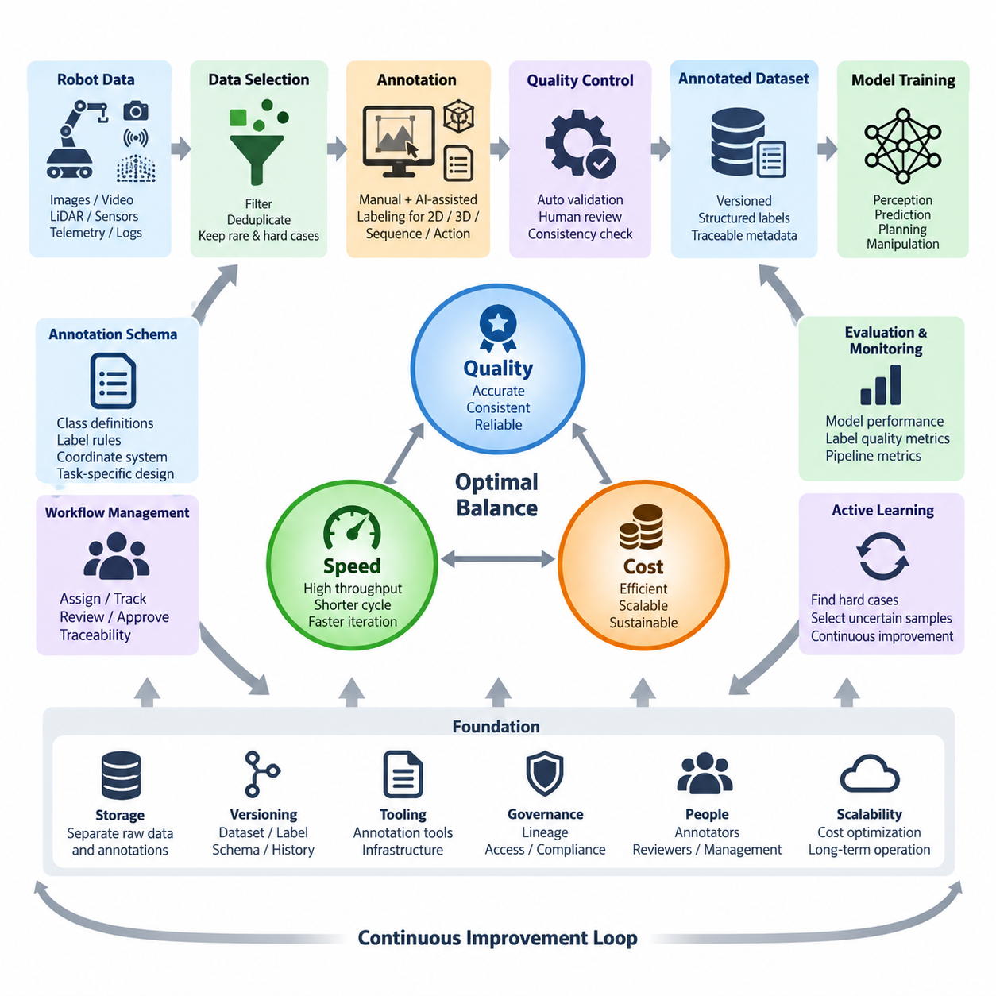
Annotation pipelines transform raw robot data into structured supervision that can be used reliably for perception, prediction, planning, manipulation, and Physical AI training. Within a robot data architecture, annotation should not be treated as an isolated manual labeling activity. It is an engineered data pipeline connecting sensor collection, dataset selection, task definition, labeling, validation, versioning, storage, and downstream model training.
The central design challenge is balancing annotation quality, processing speed, and operational cost. These objectives interact continuously rather than independently. Increasing review depth can improve label accuracy but reduces throughput and raises labor cost. Maximizing speed can shorten model development cycles but may introduce inconsistent or incomplete labels. A practical pipeline therefore defines measurable acceptance criteria for each dataset and annotation task.
Pipeline design begins with the intended machine-learning task. Object detection may require class labels and bounding boxes, semantic segmentation requires pixel-level regions, and 3D perception can require point-level classes, cuboids, tracks, or object poses. Manipulation datasets may additionally contain robot states, actions, trajectories, contact events, demonstrations, and task outcomes. The annotation schema must therefore be derived from the model objective rather than imposed uniformly on every sensor dataset.
Raw data should pass through a selection stage before expensive annotation begins. Robot fleets can generate enormous volumes of RGB images, depth maps, LiDAR point clouds, video, telemetry, and synchronized multimodal sequences, but much of this information may be repetitive. Dataset filtering can remove corrupted samples, long stationary periods, duplicate scenes, unusable sensor frames, and irrelevant operational intervals while preserving rare events and difficult environmental conditions.
A robust workflow separates annotation into explicit states such as candidate, assigned, in progress, completed, reviewed, accepted, and rejected. Each transition should be traceable so that operators can determine who produced a label, which annotation specification was applied, which tool version was used, and whether the sample passed quality control. This workflow converts labeling from an informal activity into a reproducible production process with observable throughput and failure points.
Quality starts with a precise annotation specification. Class definitions, object boundaries, occlusion rules, truncation rules, minimum object sizes, ambiguous cases, coordinate conventions, and temporal association policies must be documented before large-scale production. Without such rules, two competent annotators may interpret the same robot scene differently. These inconsistencies become label noise and can eventually limit model accuracy regardless of the quantity of collected data.
Quality control should combine automated validation with human review. Automated checks can detect invalid coordinates, missing mandatory fields, impossible class values, malformed polygons, duplicate identifiers, inconsistent timestamps, or annotations outside image boundaries. Human reviewers are more suitable for semantic ambiguity, incorrect object interpretation, difficult occlusions, and subtle scene relationships. The two mechanisms together provide stronger control than either approach alone.
Annotation speed depends heavily on how much work is performed manually. Fully manual labeling provides flexibility but becomes inefficient for large robot datasets, particularly video, segmentation, and 3D point clouds. AI-assisted labeling can generate initial bounding boxes, masks, classes, tracks, or 3D proposals that annotators verify and correct. As models improve, the pipeline can progressively shift human effort from drawing labels toward reviewing uncertain or difficult predictions.
Pre-annotation should not be interpreted as automatic ground truth. Model-generated labels inherit the strengths and weaknesses of the model that produced them, including systematic errors in rare classes, unusual viewpoints, poor illumination, crowded environments, or previously unseen objects. Confidence thresholds and uncertainty indicators can route easy samples toward rapid verification while sending ambiguous samples to experienced reviewers, allowing human attention to concentrate where it has the greatest value.
Cost should be measured beyond the price per labeled image or frame. The real annotation cost includes data preparation, tool infrastructure, storage, annotator time, reviewer time, rework, project management, quality audits, and delays caused by unclear specifications. A low-cost labeling process can become expensive when inaccurate labels require repeated correction or produce weak models that force additional data collection and retraining. Cost optimization must therefore consider the complete lifecycle.
Different annotation tasks justify different quality levels. Safety-critical pedestrian detection, obstacle perception, manipulation contact states, or autonomous navigation boundaries may require stricter review than exploratory datasets used for early experiments. A tiered quality policy can allocate stronger verification to high-risk or high-value samples while applying lighter controls to lower-risk data. This prevents the organization from spending identical annotation effort on data with very different consequences.
Throughput should be monitored using operational metrics such as samples completed per hour, annotation time per sample, review time, rejection rate, rework rate, backlog size, and end-to-end latency from data ingestion to training readiness. Quality metrics should be monitored alongside them. High throughput has little value if rejection and correction rates increase, while extremely high label precision may be economically inefficient if annotation latency prevents timely model iteration.
The pipeline should also support active learning and error-driven data selection. Instead of labeling every available sample uniformly, the training system can identify uncertain predictions, model failures, rare classes, domain shifts, and operational edge cases. These samples can receive higher annotation priority and then return to training. Annotation consequently becomes part of a closed learning loop in which model performance influences which robot data should be labeled next.
Multimodal robotics introduces additional synchronization requirements. RGB, depth, LiDAR, radar, IMU, robot pose, joint state, and control data may represent the same physical event from different perspectives and sampling rates. Annotation metadata must preserve timestamps, sensor identities, calibration versions, coordinate frames, and sequence relationships. Losing these associations can make individually correct labels unusable for sensor fusion, 3D perception, or embodied learning.
Dataset and annotation versioning are essential because labels evolve. Class taxonomies may change, incorrect annotations may be repaired, new object attributes may be introduced, and annotation guidelines may be refined. Each training run should therefore be traceable to a specific raw dataset version, annotation schema version, label version, and transformation history. This enables reproducibility and prevents silent changes in ground truth from invalidating model comparisons.
A scalable architecture should separate raw sensor assets from annotation metadata whenever practical. Large images, videos, and point clouds can remain in object storage or dataset repositories, while annotation records reference stable asset identifiers and contain labels, task metadata, workflow states, and provenance. This separation reduces unnecessary duplication and allows the same physical data to support multiple annotation projects, schemas, model generations, and experimental objectives.
The quality-speed-cost balance should ultimately be optimized at the system level. High-quality labels are valuable when they improve the model or reduce operational risk; speed is valuable when it shortens the data-to-model feedback cycle; and cost efficiency is valuable when it enables sustainable scaling. None should be maximized independently. The appropriate operating point depends on model maturity, application risk, dataset complexity, available automation, and deployment requirements.
For robot and Physical AI systems, the mature annotation pipeline becomes a continuous production loop: operational robots generate data, selection mechanisms identify valuable samples, annotation systems create structured supervision, quality controls validate the results, versioned datasets enter training, and deployed models generate new evidence about weaknesses and edge cases. This loop connects data operations directly with model improvement and prepares the foundation for the later tool, automation, quality, version-control, cost-optimization, and operational topics defined in the chapter structure.

10.02 Annotation Tool Comparison: CVAT, LabelStudio, ScaleAI [w/Code]
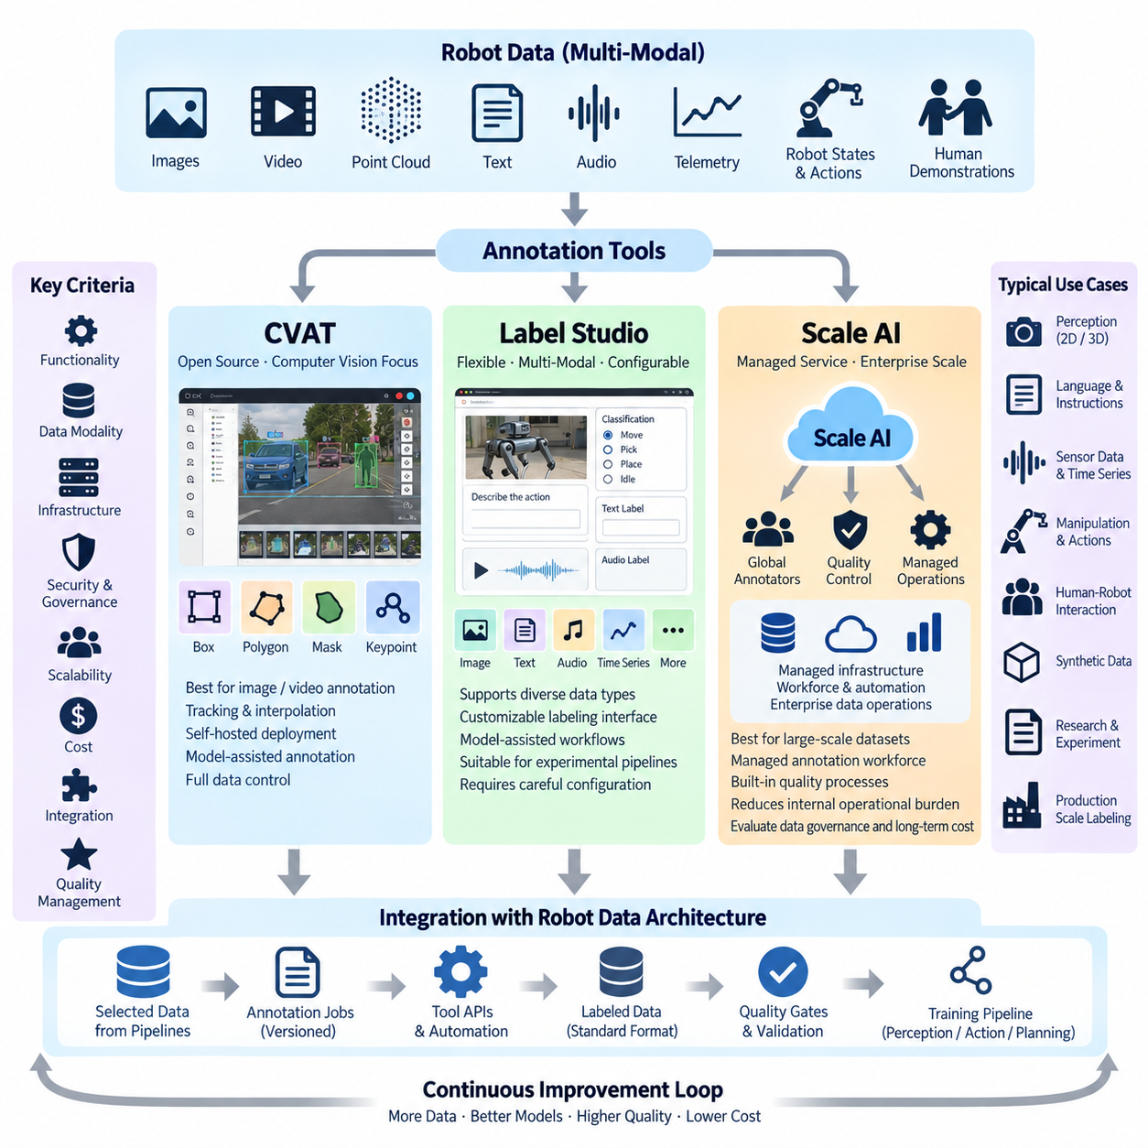
Annotation tools provide the operational environment in which raw images, video, point clouds, text, sensor sequences, and robot demonstrations are transformed into structured training labels. Within the annotation pipeline, tool selection directly affects labeling productivity, quality assurance, automation, collaboration, infrastructure control, and total operating cost. CVAT, Label Studio, and Scale AI represent three different approaches ranging from self-managed open-source platforms to managed enterprise data operations.
CVAT, originally developed for computer vision annotation, is particularly well suited to image and video labeling workflows. Its interface supports common computer vision tasks such as bounding boxes, polygons, polylines, points, masks, keypoints, tags, and object tracking. For robotics teams producing perception datasets from cameras or recorded video, this specialization provides an efficient environment for object detection, segmentation, tracking, and related vision-oriented annotation activities.
A major advantage of CVAT is its compatibility with self-hosted data infrastructure. Organizations can deploy the annotation environment within their own servers or controlled cloud environments and maintain direct authority over sensitive robot data. This is important when datasets contain factory interiors, logistics facilities, people, proprietary equipment, or operational information that should not leave organizational boundaries. Self-hosting, however, transfers deployment, upgrades, monitoring, backup, security, and scaling responsibilities to the operating team.
CVAT can also incorporate automated and semi-automated annotation into computer vision workflows. Existing models can generate candidate labels that human annotators subsequently verify or correct, reducing repetitive manual operations. Video interpolation and tracking functions are especially valuable when consecutive frames contain the same objects. Instead of independently labeling every frame, annotators can establish object states across selected frames and use tool-supported propagation to accelerate sequence annotation.
Label Studio takes a broader, configuration-oriented approach. Rather than focusing primarily on conventional computer vision, it supports diverse data modalities and customizable labeling interfaces. Projects can be configured for images, text, audio, time-series information, and other structured annotation tasks. This flexibility is useful in robotics because training datasets frequently combine visual perception with telemetry, language instructions, task states, actions, events, and human demonstrations rather than consisting only of independent images.
The configurable nature of Label Studio enables teams to define labeling interfaces that reflect the semantics of a particular learning problem. A project may require classification, object regions, text categories, sequence states, or combinations of several annotation concepts. This flexibility makes the platform suitable for experimental AI pipelines in which annotation requirements change as models and dataset schemas evolve. The tradeoff is that highly customized projects require careful configuration and stronger governance of annotation definitions.
Label Studio can participate in machine-learning-assisted workflows by connecting model predictions with human annotation. A model can provide initial predictions, and annotators can accept, modify, or reject them. This creates a practical human-in-the-loop architecture in which machine inference reduces repetitive work while people remain responsible for ambiguous cases. Such integration is especially useful when an annotation program evolves from small manually labeled seed datasets toward progressively automated production.
Scale AI represents a different operating model because it emphasizes managed data annotation and enterprise-scale data operations rather than only providing annotation software. Organizations can submit datasets and annotation requirements while relying on managed infrastructure, workforce processes, quality controls, and automation capabilities. This can reduce the internal operational burden associated with recruiting annotators, managing queues, maintaining annotation systems, and coordinating large labeling programs.
For robotics and autonomous-system projects, managed annotation can be attractive when dataset volume increases rapidly or when specialized labeling tasks require substantial workforce capacity. Large image collections, video sequences, sensor datasets, and complex perception tasks can create annotation backlogs that internal teams cannot process quickly. A managed service can convert part of this operational challenge into an external service relationship, although data governance, contractual controls, security requirements, and long-term cost must be evaluated carefully.
The three approaches therefore differ significantly in infrastructure ownership. CVAT provides strong control for computer-vision-centered self-hosted environments. Label Studio provides flexible annotation configuration across heterogeneous AI data types and can also fit controlled infrastructure strategies. Scale AI shifts more responsibility toward a managed platform and service model. The correct architectural choice depends not only on interface features but also on whether the organization wants to operate the annotation system itself.
Data modality is another important selection criterion. Camera-based robot perception projects naturally align with image and video annotation capabilities, making CVAT particularly relevant. Multimodal projects containing language, sensor states, classification tasks, or customized human-robot interaction data can benefit from Label Studio's flexible task configuration. Large production programs requiring extensive external annotation capacity may instead favor a managed approach such as Scale AI, especially when internal annotation operations would become a bottleneck.
Quality management should be evaluated separately from annotation convenience. A tool that allows labels to be produced quickly does not automatically guarantee reliable ground truth. Production pipelines require assignment management, review stages, acceptance criteria, annotator instructions, disagreement resolution, automated validation, and auditability. Regardless of platform, the annotation architecture should preserve who created or modified a label, which specification was used, and whether the result passed the required quality gates.
Integration with the wider robot data architecture is equally important. Annotation systems should receive selected assets from sensor-data and AI-data pipelines and return labels in controlled schemas that downstream training systems can consume. Stable dataset identifiers, timestamps, sequence relationships, calibration metadata, coordinate frames, and annotation versions should remain connected to the original sensor assets. The annotation tool is therefore one component of a larger data lifecycle rather than the authoritative repository for every piece of training information.
Export format and interoperability become critical when annotations move between tools, storage systems, model-training frameworks, and evaluation environments. Computer vision pipelines may use formats derived from COCO, YOLO, VOC, masks, tracking records, or project-specific schemas. Robotics applications may require additional transformations for synchronized sequences, 3D coordinates, actions, trajectories, and temporal events. A durable architecture should use conversion and validation layers so that long-term datasets are not unnecessarily locked to one annotation interface.
Automation should also influence tool selection. At small scale, annotators can manually create projects, upload data, and export labels, but these procedures become inefficient as datasets grow. Production environments benefit from APIs, programmatic task creation, automated data assignment, model-generated pre-labels, validation jobs, and controlled exports. Annotation should eventually operate as part of the broader AI data pipeline, where new candidate datasets can enter labeling and validated outputs can proceed toward training with minimal manual administration.
Cost comparison must include more than licensing or subscription fees. A self-hosted open-source tool may reduce software acquisition costs while requiring engineers, servers, storage, security management, upgrades, and internal annotation operations. A managed platform can reduce infrastructure and workforce administration but may introduce significant service costs as data volume and annotation complexity increase. The meaningful comparison is therefore total cost of ownership across infrastructure, labor, engineering, quality control, and operational management.
Hybrid architectures are often practical for robot organizations. Sensitive or experimental datasets can remain inside self-hosted CVAT or Label Studio environments, while selected high-volume projects can use managed annotation capacity when governance requirements permit. AI-assisted pre-labeling can further reduce the amount of manual work in both environments. This avoids treating annotation-platform selection as a permanent decision in which every dataset must pass through a single tool.
For Physical AI, annotation requirements increasingly extend beyond static visual objects. Training data can include robot actions, manipulation phases, contact states, success and failure outcomes, natural-language instructions, spatial relationships, trajectories, and synchronized multimodal observations. Consequently, annotation infrastructure should be evaluated for extensibility rather than only current perception requirements. The selected system must coexist with specialized pipelines for 3D point clouds, demonstrations, temporal sequences, and future embodied-learning datasets.
CVAT, Label Studio, and Scale AI should therefore be understood as different components or operating strategies within the broader annotation architecture rather than universally interchangeable products. CVAT emphasizes computer-vision productivity and infrastructure control, Label Studio emphasizes configurable multimodal labeling, and Scale AI emphasizes managed annotation operations at production scale. The appropriate combination depends on data modality, security, workforce strategy, automation maturity, throughput requirements, and lifecycle cost.
A mature robot annotation architecture can abstract these differences behind a common dataset workflow. Raw assets remain in governed storage, annotation jobs reference stable dataset versions, selected tools provide human and AI-assisted labeling, quality gates validate the results, and approved labels return to version-controlled training datasets. This approach allows annotation technology to evolve without breaking the underlying robot data architecture and prepares the pipeline for semi-automatic labeling, specialized 2D and 3D annotation, quality measurement, reproducibility, and cost optimization described in subsequent sections.

10.03 Semi-Auto Annotation: AI-Assisted Labeling [w/Code]
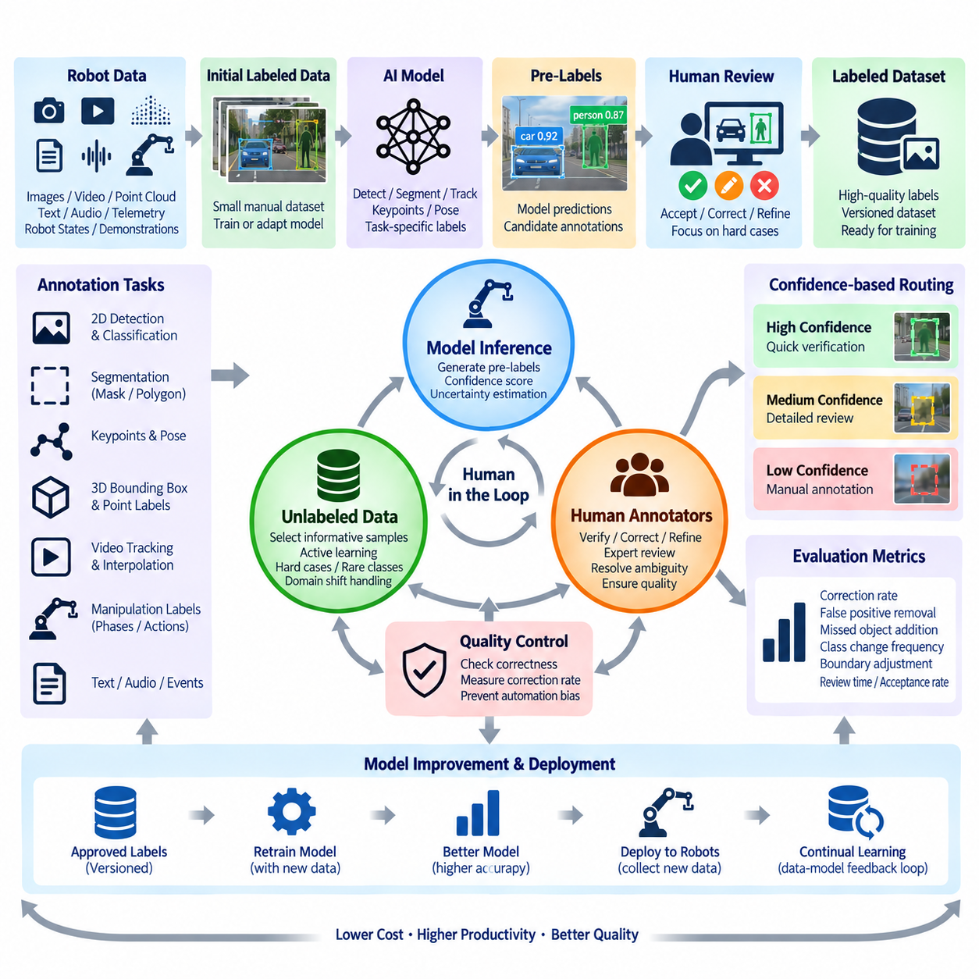
Semi-automatic annotation combines machine-generated predictions with human verification to reduce the labor required to create high-quality training datasets. Instead of asking annotators to construct every label from an empty frame, an AI model produces an initial annotation that can be accepted, corrected, refined, or rejected. This changes annotation from repetitive manual creation into a human-in-the-loop process focused increasingly on validation and difficult cases.
The basic workflow begins with a small set of manually annotated data used to train or adapt an initial model. That model processes a larger pool of unlabeled robot data and generates candidate bounding boxes, masks, classes, keypoints, tracks, poses, or other task-specific labels. These predictions are imported into the annotation environment as pre-labels, where human annotators inspect their accuracy and make corrections before the results are accepted as training data.
AI-assisted labeling is particularly effective when the model already performs reasonably well on common cases. If most objects are detected correctly, an annotator may only need to adjust boundaries, change incorrect classes, add missed objects, or remove false detections. The amount of manual interaction per sample can therefore decrease substantially. The objective is not to eliminate human participation immediately, but to use model inference to reduce low-value repetitive operations.
Confidence scores provide an important mechanism for controlling the workflow. Predictions above a carefully selected confidence threshold can be routed toward rapid verification, while medium-confidence results may require detailed inspection. Very uncertain samples can be assigned for full manual annotation or specialist review. Thresholds should not be interpreted as universal measures of correctness because confidence calibration varies across models, classes, environments, and operational conditions.
Uncertainty can be used more broadly than a single confidence value. Disagreement between multiple models, unstable predictions across neighboring video frames, inconsistent segmentation boundaries, unusual feature representations, or large changes under small input perturbations can indicate difficult samples. An annotation pipeline can use these signals to prioritize human attention, allowing scarce expert time to concentrate on examples where automated labeling is most likely to fail.
Active learning extends this concept by selecting which unlabeled samples should be annotated next. Rather than labeling robot data uniformly, the system identifies samples expected to provide high training value, such as uncertain predictions, rare classes, new environments, model failures, unusual viewpoints, or operational edge cases. Once annotated, these samples are added to the training dataset and used to improve the next model, creating an iterative data-model feedback loop.
Computer vision provides straightforward examples of semi-automatic annotation. An object detector can propose 2D bounding boxes and class labels, while a segmentation model can produce initial masks. Pose-estimation systems can propose keypoints, and tracking algorithms can propagate object identities through video sequences. Human operators then focus on correcting localization errors, missed objects, identity switches, inaccurate masks, and ambiguous categories rather than generating every annotation manually.
Video annotation can obtain additional efficiency from temporal continuity. Objects usually move gradually between neighboring frames, so labels from one frame can be propagated or interpolated into subsequent frames. Detection and tracking models can extend this process across longer sequences. Human review remains important because occlusion, rapid motion, camera movement, object entry or exit, and tracking failures can cause errors to accumulate if automatically propagated labels are accepted without inspection.
Three-dimensional robot data introduces additional challenges. AI models may propose 3D cuboids, semantic point labels, object instances, or poses from LiDAR and depth information, but errors can be difficult to identify from a single viewpoint. Annotation interfaces should allow multiple camera perspectives, projected sensor views, and 3D visualization when appropriate. Calibration and coordinate-frame consistency must also be preserved because geometrically incorrect labels can damage downstream sensor-fusion and perception training.
Robot manipulation data requires a broader interpretation of AI-assisted labeling. Models can help identify manipulation phases, grasp events, contact states, object interactions, action boundaries, success or failure outcomes, and relevant temporal segments within demonstrations. Automatic proposals can dramatically reduce the effort required to inspect long robot trajectories, but task semantics may remain difficult for models to infer reliably. Human expertise therefore remains important for ambiguous physical interactions.
The effectiveness of pre-labeling depends strongly on domain similarity. A model trained on outdoor driving images may perform poorly inside warehouses, while a warehouse model may fail on unusual lighting, new robot cameras, different lens characteristics, or previously unseen objects. Domain shift must therefore be monitored whenever annotation models are reused. Poor pre-labels can increase rather than decrease annotation time because workers must first discover and then repair systematic errors.
Automation bias is another important risk. When an AI system presents a plausible annotation, human reviewers may accept it without sufficiently examining the underlying data. Systematic model errors can consequently enter the training dataset and become reinforced during later training cycles. Annotation interfaces and quality procedures should encourage active verification, particularly for safety-critical classes, rare events, low-confidence predictions, and samples selected because previous models failed on them.
Quality control should compare AI-generated proposals with final human-approved annotations. Correction rate, false-positive removal rate, missed-object addition rate, class-change frequency, boundary adjustment magnitude, review time, and acceptance rate can reveal whether pre-labeling actually improves the workflow. These measurements can also identify classes or environments where the annotation model performs poorly and where automatic proposals should be disabled or subjected to stronger review.
The annotation model itself should be versioned like any other production model. Each generated pre-label should be traceable to the model version, inference configuration, confidence threshold, annotation schema, and source dataset. Without this provenance, teams may be unable to explain why annotation behavior changed between dataset releases. Versioning also enables objective comparison of annotation models by measuring how much human correction each model requires on equivalent data.
Semi-automatic pipelines benefit from integration through APIs and scheduled processing. Newly selected data can automatically enter a pre-labeling service, predictions can be written into annotation tasks, completed tasks can pass through validation, and accepted labels can return to version-controlled datasets. This architecture removes unnecessary manual file transfers and allows annotation to operate as a repeatable component of the broader robot AI data pipeline rather than as an isolated desktop activity.
Human roles evolve as automation improves. Early projects may require annotators to create most labels manually, while mature projects increasingly require reviewers to verify machine-generated annotations. Domain experts can then focus on complex edge cases, ontology decisions, disagreement resolution, and quality audits. This transition can improve productivity, but it also requires training workers to understand model failure patterns rather than simply teaching them how to draw labels.
Cost optimization should be evaluated using corrected annotation time rather than inference speed alone. Running an AI model has computational cost, but it is economically useful when the resulting predictions reduce total human effort while maintaining required quality. A sophisticated model that generates difficult-to-correct errors may be less valuable than a simpler model producing conservative, predictable proposals. The best annotation model is therefore the one that minimizes total validated-label cost at the required quality level.
For Physical AI systems, semi-automatic annotation can become part of continual learning. Deployed robots collect new operational data, automated systems identify informative or problematic samples, annotation models generate initial labels, humans validate difficult cases, and approved data enters subsequent training cycles. The newly trained models are redeployed and produce new evidence about remaining weaknesses, continuously connecting field operation, annotation, model development, and evaluation.
A mature AI-assisted annotation architecture therefore treats automation as adaptive collaboration between models and people rather than simple replacement of manual labor. Models handle repetitive and predictable labeling, humans resolve ambiguity and protect semantic quality, active learning determines where attention should be spent, and quality metrics verify whether automation is actually beneficial. This foundation naturally supports the specialized 2D, 3D, manipulation, quality-management, versioning, and cost-optimization pipelines developed in the subsequent annotation sections.

10.04 2D BBox / Segmentation Annotation Pipeline [w/Code]
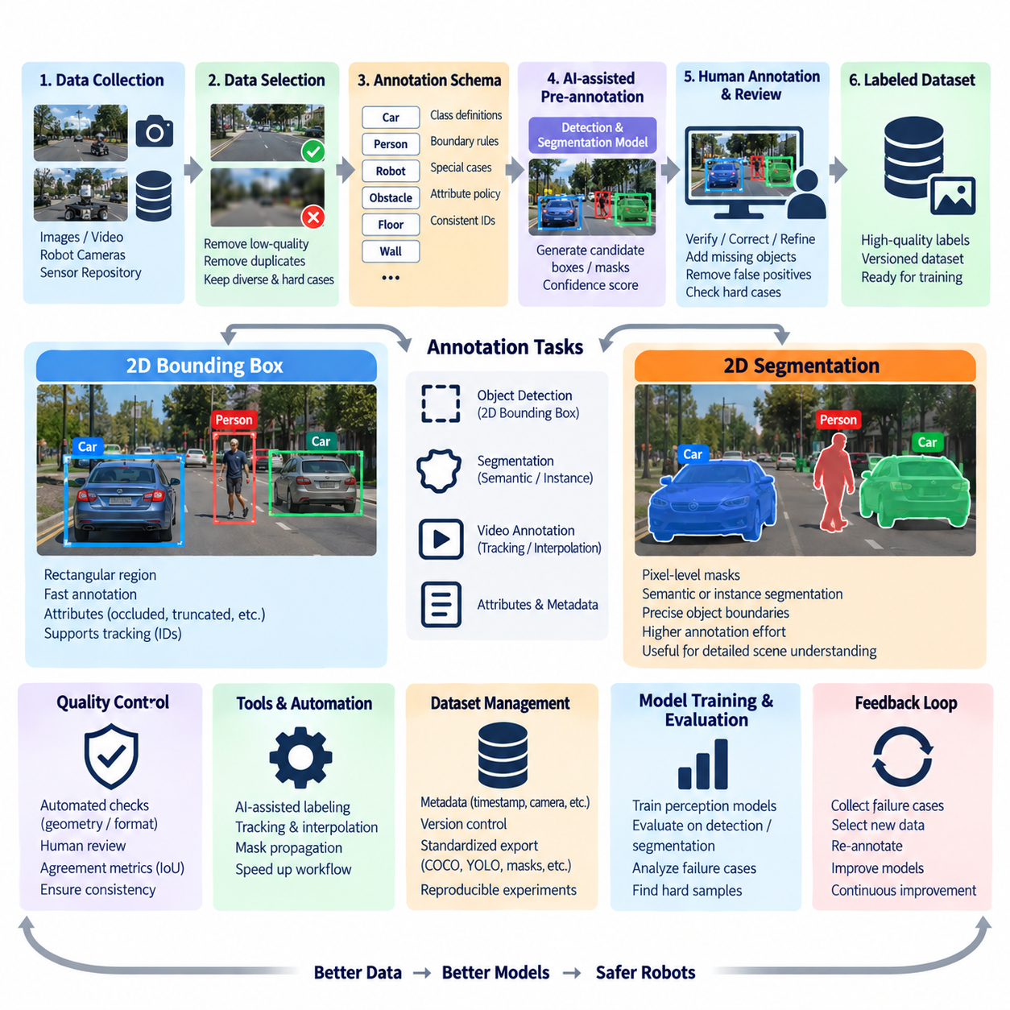
A 2D bounding box and segmentation annotation pipeline converts camera images and video frames into spatial labels that describe where objects appear and which pixels belong to them. Bounding boxes provide compact object localization, while segmentation masks represent more precise object or semantic boundaries. In robot perception, these annotations support object detection, scene understanding, obstacle recognition, manipulation perception, navigation, and other vision-based AI models.
The pipeline begins with image and video data selected from robot sensor repositories. Raw camera streams may contain millions of highly repetitive frames, so annotation should not start with indiscriminate labeling. Data selection removes corrupted images, blurred frames, duplicates, irrelevant stationary periods, and unusable exposures while preserving diverse environments, rare objects, difficult lighting, occlusion, unusual viewpoints, and operational edge cases that can improve model robustness.
Before labeling begins, the annotation schema defines the classes and geometric representation required by the model. Each class should have an explicit definition describing what constitutes an object, how partially visible objects are treated, when small objects should be ignored, and how ambiguous categories are resolved. Bounding-box and segmentation projects should share consistent class identifiers when they represent the same semantic entities, allowing datasets to remain interoperable across different perception tasks.
A 2D bounding box is commonly represented by coordinates describing the rectangular region containing an object. Depending on the dataset format, this may use minimum and maximum corner coordinates or an origin combined with width and height. Annotation guidelines must specify whether boxes should tightly follow visible pixels, include occluded portions, or approximate the full physical extent of an object. Consistent geometric rules are essential because systematic differences between annotators become noise during detector training.
Bounding-box annotation is relatively fast because the representation is geometrically simple. Annotators identify an object, assign its class, and draw a rectangle around the required region. Attributes such as occluded, truncated, moving, stationary, damaged, or uncertain can be added when they provide useful training information. Robot datasets may also preserve object identifiers across consecutive frames, enabling detection annotations to support tracking and temporal perception tasks.
Segmentation provides finer spatial supervision by describing object boundaries at pixel level. Semantic segmentation assigns each relevant pixel to a class, while instance segmentation distinguishes individual objects belonging to the same class. Depending on the annotation environment, masks may be created with polygons, brush tools, contour extraction, or AI-assisted segmentation. Segmentation generally requires more effort than bounding boxes but provides richer information for precise scene understanding.
For mobile robots, segmentation can represent floors, walls, doors, shelves, people, vehicles, obstacles, vegetation, traversable areas, and other environmental regions. Manipulation systems may require precise masks for objects that must be grasped or separated from clutter. Because segmentation captures shape rather than only approximate location, it is useful when downstream models must reason about free space, boundaries, contact regions, object geometry, or overlapping objects.
Annotation specifications must clearly define boundary behavior. Shadows, reflections, transparent surfaces, motion blur, holes inside objects, thin structures, and partially hidden regions can produce inconsistent masks if no policy exists. For example, annotators must know whether a visible gap inside an object should remain background and whether heavily occluded regions should be inferred. These decisions should reflect the intended model task rather than arbitrary visual preferences.
AI-assisted annotation can substantially accelerate both bounding-box and segmentation workflows. An object detector can generate initial boxes, while a segmentation model can propose masks from detected objects, points, prompts, or existing regions. Human annotators then verify and correct the predictions. When model accuracy is sufficiently high, this approach changes the task from drawing every label manually to correcting boundaries, adding missed objects, removing false positives, and resolving incorrect classes.
Video datasets provide additional opportunities for automation because neighboring frames are temporally related. Bounding boxes can be interpolated between manually selected keyframes, while tracking models can propagate object identities and locations. Segmentation masks can also be propagated across short sequences using tracking or video segmentation methods. These techniques reduce repetitive work, but propagated labels must be reviewed when objects become occluded, change shape, leave the scene, or interact with other objects.
Quality validation should begin with automated geometric checks. Bounding boxes with negative dimensions, coordinates outside image boundaries, missing class identifiers, duplicate records, or extremely unusual aspect ratios can be detected automatically. Segmentation masks can be checked for invalid polygons, empty regions, self-intersections, unsupported class values, or inconsistent image dimensions. Automated validation removes simple structural errors before expensive human review.
Human quality review focuses on semantic and geometric correctness. Reviewers verify whether all required objects are labeled, classes are correct, bounding boxes follow the specified policy, masks accurately represent boundaries, and difficult cases are handled consistently. Sampling-based review can be used for mature, stable datasets, while safety-critical classes, newly introduced categories, inexperienced annotators, or difficult environments may require stronger or complete verification.
Agreement metrics can quantify annotation consistency. Bounding boxes can be compared using Intersection over Union, which measures overlap between two rectangular regions or between a prediction and reference label. Segmentation masks can use IoU or related pixel-level overlap measures. Low agreement does not always mean that one annotator is careless; it can reveal ambiguous annotation rules, poorly defined classes, or inherently difficult visual boundaries that require specification refinement.
Annotation metadata should remain connected to the original camera data. Each label should reference a stable image or frame identifier and preserve relevant information such as dataset version, camera identity, timestamp, sequence identifier, annotation schema, tool version, annotator or process identity, and review status. For synchronized robotics datasets, links to depth, LiDAR, robot pose, calibration, or other sensor records may also need to remain intact even when the current task uses only 2D images.
Approved labels should be exported through standardized or controlled formats rather than becoming permanently dependent on one annotation tool. Object detection pipelines commonly require class identifiers and box coordinates, while segmentation pipelines require polygons, masks, or encoded pixel regions. Conversion layers can transform the canonical annotation representation into training-specific formats while validation ensures that class mappings, coordinates, image dimensions, and identifiers remain consistent.
Version control is essential because 2D labels change over time. Incorrect boxes may be corrected, segmentation boundaries refined, classes merged or divided, new attributes added, and annotation policies revised. Training datasets should therefore reference immutable or traceable annotation versions. A model experiment must be reproducible by identifying exactly which images, annotation schema, label revision, preprocessing configuration, and train-validation-test split were used.
The pipeline should also connect model evaluation back to data selection. Detection failures, segmentation errors, rare classes, low-confidence predictions, crowded scenes, and new operating environments can be collected from deployed robots and prioritized for annotation. These difficult samples enter the labeling workflow, receive human or AI-assisted annotations, pass quality control, and return to the training dataset. Annotation consequently becomes part of an iterative perception improvement loop.
Cost and throughput differ substantially between bounding boxes and segmentation. Bounding boxes are generally faster to create and appropriate when approximate localization provides sufficient supervision. Pixel-accurate segmentation requires more annotation effort and should be used when detailed geometry creates meaningful model value. A dataset architecture can combine both representations, applying inexpensive boxes broadly while reserving detailed masks for important classes, difficult scenes, or applications requiring precise boundaries.
For Physical AI, 2D annotation should remain connected to the physical context from which images were captured. Objects visible in a camera frame may correspond to robot interactions, navigation decisions, manipulation targets, safety events, or synchronized 3D observations. Preserving these relationships allows simple 2D labels to contribute to multimodal and embodied-learning datasets rather than existing only as isolated computer vision annotations.
A mature 2D annotation pipeline therefore integrates selective data ingestion, explicit schemas, bounding-box and segmentation labeling, AI-assisted pre-annotation, temporal propagation, automated validation, human review, versioning, standardized export, and model-driven feedback. This architecture produces traceable and reproducible visual training data while balancing geometric precision, annotation speed, and operational cost, and it provides a natural foundation for the 3D point-cloud annotation pipeline that follows in the chapter structure.

10.05 3D Point Cloud Annotation Pipeline [w/Code]
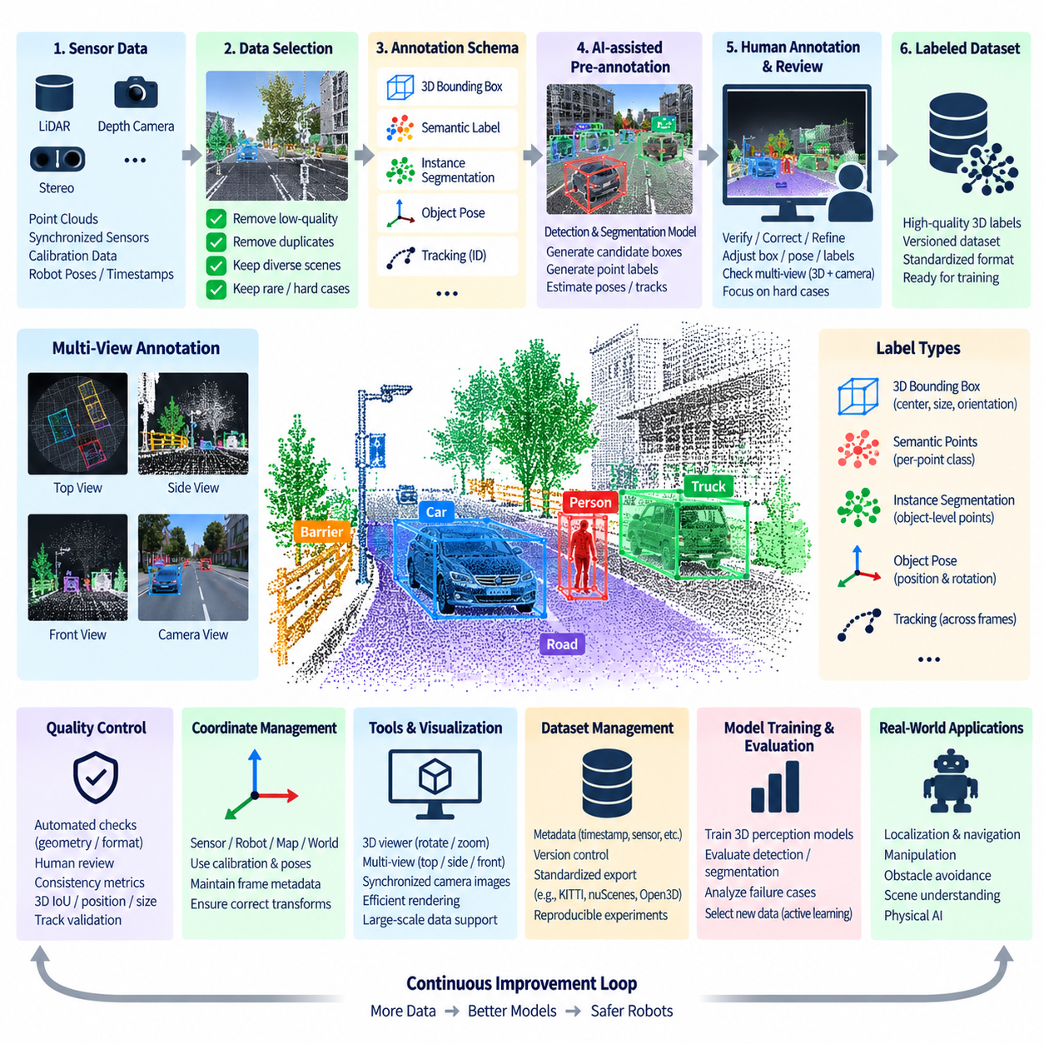
A 3D point cloud annotation pipeline transforms spatial sensor measurements into structured labels for three-dimensional perception and physical reasoning. LiDAR, depth cameras, stereo systems, and reconstructed 3D scenes produce geometric observations that describe objects and environments beyond the image plane. These annotations support 3D object detection, semantic understanding, localization, navigation, manipulation, sensor fusion, and Physical AI training.
Unlike 2D images, point clouds are sparse, irregular, and viewpoint dependent. The density of measured points changes with distance, surface reflectivity, sensor resolution, occlusion, and scanning geometry. A nearby object may contain thousands of points while a distant object is represented by only a small cluster. Annotation rules must therefore account for incomplete geometry rather than assuming that every physical object has a continuous visible surface.
The pipeline begins with synchronized and calibrated sensor data. A point cloud should retain its timestamp, sensor identity, coordinate frame, calibration parameters, sequence identifier, and relationships with associated camera images, robot poses, or other sensors. These metadata are essential because annotation may require projecting 3D points into camera views or transforming labels between LiDAR, robot, map, and world coordinate systems.
Data selection should occur before expensive 3D labeling begins. Robot fleets can generate enormous point-cloud sequences, many of which contain nearly identical environments or long periods with limited informational value. Selection mechanisms should preserve diverse scenes, dynamic objects, rare obstacles, difficult geometries, unusual terrain, close interactions, sensor degradation, and model failure cases while reducing redundant frames and corrupted measurements.
A 3D annotation schema defines the semantic classes and geometric label types required by downstream models. Common representations include 3D bounding boxes, semantic point labels, instance segmentation, object poses, tracks, and scene regions. Robotics datasets may additionally identify traversable surfaces, structural elements, manipulation objects, humans, vehicles, pallets, shelves, terrain classes, or safety zones depending on the operational domain.
Three-dimensional bounding boxes are commonly represented by a center position, dimensions, and orientation. Unlike 2D rectangles, they must describe an object's spatial extent along multiple axes and often include heading or rotation. Annotation guidelines should specify how boxes relate to visible points, whether occluded geometry should be estimated, how ground contact is handled, and how orientation is defined. Consistency is critical because small geometric errors can directly affect localization and planning models.
Semantic point-cloud annotation assigns class information to individual points or groups of points. This provides detailed supervision for distinguishing surfaces such as floor, wall, vegetation, vehicle, person, equipment, or obstacle. Instance-level annotation additionally separates individual objects belonging to the same class. Although point-level labels provide rich geometric information, they are substantially more expensive to create than coarse 3D boxes and therefore benefit strongly from automation.
Multi-view visualization is essential for reliable 3D labeling. A single perspective can make spatial relationships difficult to interpret, particularly when point density is low or objects overlap. Annotation environments can provide top, side, front, and freely rotatable 3D views together with synchronized camera images. Projecting points and 3D boxes onto image planes helps annotators use visual texture and color to resolve ambiguities that are difficult to understand from geometry alone.
Camera-LiDAR fusion can significantly improve annotation productivity. A 2D object visible clearly in an RGB image may correspond to an ambiguous cluster in the point cloud. When calibration is available, image detections, segmentation masks, or manually selected regions can be projected into 3D to generate candidate point labels or spatial regions. Conversely, 3D annotations can be projected into camera images to verify geometric alignment and identify calibration or labeling errors.
AI-assisted pre-annotation can generate candidate 3D boxes, semantic labels, object instances, or poses before human review. Existing perception models process incoming point clouds and populate annotation tasks with preliminary results. Annotators then adjust position, size, orientation, class, and point membership instead of creating every label from scratch. The benefit depends on model quality because systematically incorrect 3D proposals can require more effort to repair than manual annotation.
Temporal information provides another important source of efficiency. Mobile robots and autonomous systems collect point clouds as sequences rather than isolated frames. Once an object has been identified, tracking algorithms can propagate its identity and approximate 3D location through neighboring frames. Annotators can correct keyframes and interpolate intermediate states, reducing repetitive labeling while preserving trajectories useful for motion prediction and dynamic-scene understanding.
Coordinate-frame management must be explicit throughout the pipeline. Labels may initially be created in a sensor frame but later consumed in robot, odometry, map, or world coordinates. Transformations must use the correct calibration and pose information for each timestamp. A label that appears visually correct can become geometrically invalid if it is associated with the wrong transform. Frame identifiers and transformation provenance should therefore remain part of annotation metadata.
Automated validation can detect many structural errors before human review. Systems can identify invalid dimensions, impossible orientations, boxes containing too few points, duplicate object identifiers, labels outside expected spatial ranges, unsupported classes, missing timestamps, or inconsistent coordinate frames. Temporal validation can detect sudden object jumps, unrealistic dimension changes, or identity discontinuities across adjacent frames.
Human review focuses on semantic correctness and geometric accuracy. Reviewers should verify class assignment, object extent, orientation, point membership, occlusion handling, track continuity, and difficult boundary decisions. Safety-relevant objects such as people, vehicles, hazardous obstacles, or restricted regions may require stricter review policies. Difficult low-density objects may also require synchronized camera views or neighboring frames before a reliable decision can be made.
Quality metrics should reflect the type of 3D annotation being evaluated. Three-dimensional bounding boxes can be compared using 3D Intersection over Union, center-position error, dimension error, and orientation difference. Semantic point labels can be evaluated through class-level IoU and point agreement, while tracking labels can include identity consistency. These metrics help distinguish geometric inaccuracies from semantic disagreements and identify annotation guidelines that require refinement.
Point-cloud annotation is computationally demanding as well as labor intensive. Large scans may contain millions of points, and long sequences can require substantial memory, storage, rendering, and network bandwidth. Practical pipelines may use spatial partitioning, level-of-detail visualization, compressed representations, selective frame loading, or local caching. Annotation infrastructure should be designed so that visualization performance does not become a bottleneck for human productivity.
Approved annotations must remain linked to the original sensor assets and calibration state. Each label should reference a stable dataset and frame identifier together with annotation schema version, coordinate system, calibration version, tool configuration, model-generated pre-label version, annotator identity or process, and review status. This provenance is necessary for reproducible training and for diagnosing unexpected differences between dataset releases.
Export and transformation layers should separate the canonical annotation representation from individual training frameworks. Different 3D perception systems may require different box conventions, axis definitions, rotation formats, point-label encodings, or coordinate frames. Controlled conversion prevents each annotation project from becoming tied to a particular model implementation and allows the same validated spatial labels to support multiple perception and robotics pipelines.
Cost optimization requires matching annotation precision to model requirements. Not every point cloud needs full point-level segmentation. Large datasets can use relatively inexpensive 3D boxes for broad object supervision while reserving detailed semantic or instance labels for important environments, difficult objects, or models requiring precise geometry. AI-assisted labeling, temporal propagation, and active learning can further concentrate expensive human effort on samples with the highest expected training value.
For Physical AI, 3D annotations have value beyond conventional object detection because they describe the geometry in which actions occur. A labeled object can be connected to robot pose, grasp trajectory, navigation path, contact event, task state, or language instruction. Maintaining these relationships enables point-cloud data to participate in multimodal embodied datasets where perception, spatial reasoning, and physical action are learned together.
A mature 3D point-cloud annotation pipeline therefore integrates calibrated sensor ingestion, selective sampling, spatial schemas, multi-view visualization, camera-LiDAR fusion, AI-assisted labeling, temporal propagation, automated validation, human review, coordinate management, versioning, and standardized export. The result is traceable spatial supervision that balances geometric accuracy, annotation effort, computational efficiency, and cost while preparing the data architecture for manipulation demonstration annotation and subsequent quality-management stages.

10.06 Robot Manipulation Demo Data Annotation [w/Code]
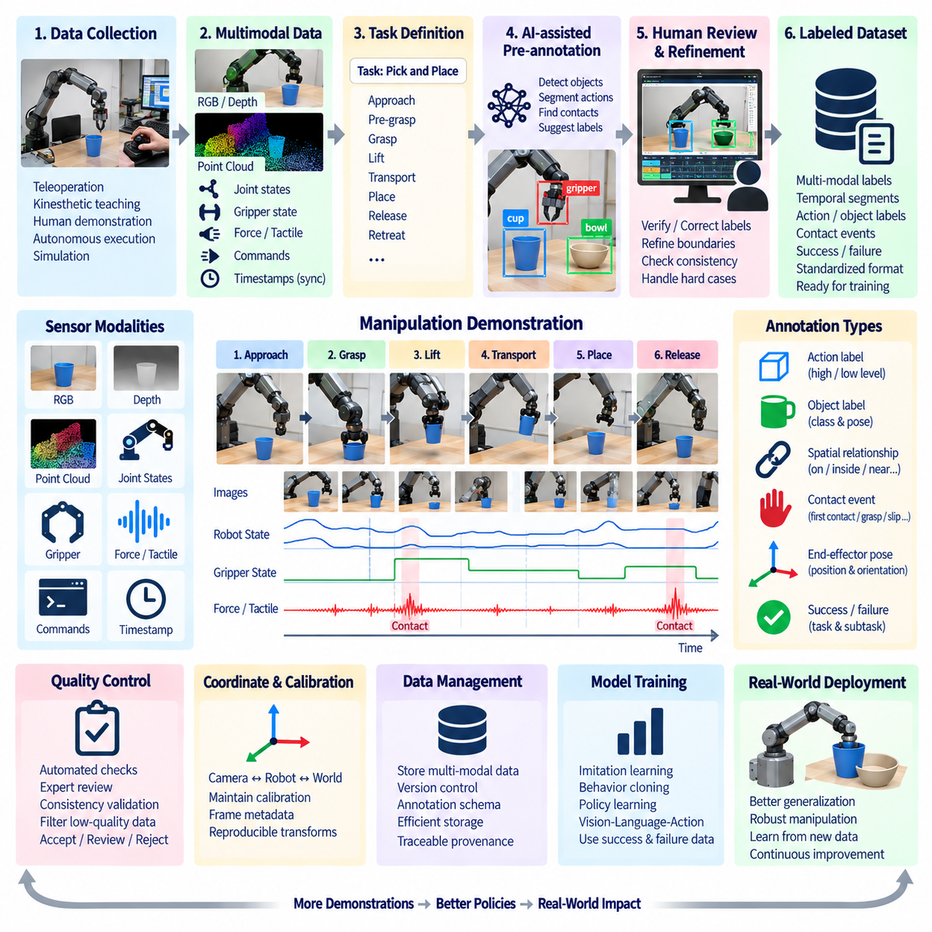
Robot manipulation demonstration data captures how a robot or human operator performs physical tasks over time and converts those experiences into training material for imitation learning, behavior cloning, policy learning, and Physical AI. Unlike conventional image annotation, manipulation annotation must describe not only what objects are visible but also how perception, robot state, actions, contacts, task phases, and outcomes evolve throughout an interaction.
A demonstration can originate from teleoperation, kinesthetic teaching, human motion capture, autonomous robot execution, simulation, or manually guided manipulation. Each recording may combine RGB and depth images, joint positions, joint velocities, end-effector poses, gripper states, force-torque measurements, tactile signals, commands, and environment states. Annotation must preserve synchronization among these modalities so that actions remain correctly associated with the physical observations that caused or resulted from them.
The annotation pipeline begins by defining the manipulation task and its semantic structure. A simple pick-and-place demonstration may contain approach, pre-grasp, grasp, lift, transport, place, release, and retreat phases. More complex tasks may contain repeated actions, conditional branches, tool use, bimanual coordination, recovery behaviors, or human-robot interaction. A task ontology should define these concepts before large-scale annotation begins so that demonstrations are interpreted consistently.
Temporal segmentation is one of the most important annotation operations. A long demonstration is divided into meaningful intervals representing skills, subskills, actions, or task states. Precise boundaries help learning systems understand when one behavior ends and another begins. Boundaries can be defined using timestamps, frame indices, robot states, or detected events, but the annotation policy must specify how transitions and ambiguous intermediate motions are treated.
Action labels describe what the robot is doing during each temporal segment. Depending on the learning objective, labels may represent high-level actions such as pick, place, open, insert, push, pull, or handover, or lower-level primitives such as approach object, close gripper, rotate wrist, or move to target pose. Hierarchical annotation can preserve both levels, enabling the same demonstration dataset to support task planning and low-level policy learning.
Object-centric annotation connects actions to the physical entities involved in the demonstration. A grasp action should identify the target object, relevant object pose, gripper relationship, and potentially the destination or supporting surface. Spatial relationships such as on, inside, near, aligned with, held by, or inserted into can provide additional semantic context. These relationships are valuable for models that must generalize actions across different objects and environments.
Contact events provide critical information because manipulation is fundamentally based on physical interaction. Annotation can identify first contact, stable grasp, slip, collision, release, insertion contact, support contact, or unexpected impact. Force-torque and tactile signals can help detect these transitions automatically. Connecting contact labels with visual observations and robot state allows models to learn not only motion patterns but also the physical consequences of actions.
Gripper and end-effector states should be represented consistently. Binary open and closed labels may be sufficient for simple parallel grippers, while dexterous hands may require finger joint configurations, grasp type, contact regions, or force information. End-effector pose can be stored as position and orientation relative to a defined coordinate frame. Frame conventions must remain explicit because identical numerical poses have different meanings when expressed relative to robot, object, or world coordinates.
Success and failure annotation is essential for learning from real robot demonstrations. A trajectory may complete the intended task successfully, partially succeed, fail during grasping, collide with the environment, drop an object, or require recovery. Outcome labels should therefore exist at both demonstration and subtask levels when appropriate. Failure data can be especially valuable because it teaches models which states and actions should be avoided or corrected.
Recovery behavior should not automatically be removed as noise. When a robot misses a grasp and attempts again, adjusts an object after poor placement, or changes trajectory after contact, the demonstration contains information about error recognition and corrective behavior. Annotation can explicitly distinguish nominal execution from recovery segments. Such data becomes increasingly important for robust policies that must operate outside carefully controlled laboratory conditions.
Demonstration quality should be evaluated before all recordings are admitted into a training dataset. Some demonstrations may contain operator hesitation, unnecessary motion, sensor dropouts, calibration errors, unsafe actions, or incomplete tasks. Quality metadata can classify demonstrations as accepted, review required, or rejected. Depending on the learning strategy, imperfect demonstrations may still be retained in separate categories rather than permanently discarded.
AI-assisted annotation can reduce the effort required to segment long manipulation sequences. Vision models can detect objects and hands, robot-state signals can identify gripper transitions, force sensors can suggest contact events, and trajectory analysis can detect pauses or motion changes. These signals can generate candidate task boundaries and action labels that human reviewers refine. Automation is most effective when multiple modalities provide consistent evidence for the same event.
Multimodal synchronization is particularly important for manipulation datasets. A camera frame showing contact must correspond to the correct robot pose, gripper state, force measurement, and action command. Even small timestamp offsets can distort the relationship between observation and action, especially during fast manipulation. Annotation systems should therefore preserve original timestamps, synchronization methods, clock domains, and any temporal corrections applied during preprocessing.
Coordinate systems and calibration metadata must also remain connected to annotations. Camera observations, object poses, end-effector trajectories, and force measurements may originate in different frames. Transformations between camera, robot base, tool, object, and world frames should be reproducible from stored calibration and pose information. This allows demonstrations to be transformed into common representations suitable for training across different robots or environments.
Human demonstrations introduce additional representation challenges. Human hands, arms, and tools do not directly correspond to robot joints or gripper commands. Annotation may therefore describe task intent, hand-object relationships, contact events, object trajectories, and action phases rather than attempting to reproduce every human motion. Retargeting systems can later convert relevant human behavior into robot-compatible representations while preserving the semantic structure of the task.
Quality control should combine automated consistency checks with expert review. Automated systems can detect missing timestamps, impossible joint values, discontinuous trajectories, invalid object identifiers, inconsistent task boundaries, or contradictory success labels. Human reviewers evaluate whether action semantics, object relationships, contact interpretation, and task outcomes correctly represent what occurred. Difficult physical interactions often require synchronized video and robot-state inspection.
Annotation provenance should identify the source demonstration, annotation schema, annotator or automated process, model version used for pre-labeling, review status, and revision history. When labels are corrected or task ontologies evolve, previous versions should remain traceable. This is essential for reproducible imitation-learning experiments because changes in temporal segmentation or action definitions can significantly alter the effective training data.
Storage architecture should separate large sensor streams from structured annotation records while maintaining stable references between them. Video, depth, tactile streams, and high-frequency robot states can remain in scalable storage, while annotations describe temporal intervals, events, actions, objects, relationships, and outcomes. This design avoids unnecessary duplication and allows one demonstration to support multiple annotation schemas or learning objectives.
For large datasets, active learning and model-driven selection can determine which demonstrations require additional annotation. Policy failures, uncertain action predictions, rare object interactions, unusual contact patterns, and new task configurations can receive higher priority. This creates a feedback loop in which deployed or evaluated manipulation models identify the demonstrations most valuable for future labeling and retraining.
Manipulation annotation increasingly supports generalist robot policies and Vision-Language-Action models. Demonstrations can connect visual observations and robot actions with natural-language instructions such as task goals, object references, or step descriptions. A sequence may therefore contain synchronized vision, language, proprioception, action, and outcome information. Consistent annotation across these modalities helps transform individual demonstrations into reusable embodied-learning episodes.
A mature robot manipulation demonstration annotation pipeline integrates synchronized multimodal recording, task ontology, temporal segmentation, action and object labels, contact events, coordinate information, success and failure outcomes, AI-assisted pre-labeling, quality review, versioning, and reproducible storage. The resulting dataset captures not merely what the robot observed, but what it attempted, how it interacted with the physical world, and whether its behavior achieved the intended goal, preparing the architecture for systematic annotation-quality measurement and management.

10.07 Annotation Quality Management: IOU / Kappa [w/Code]
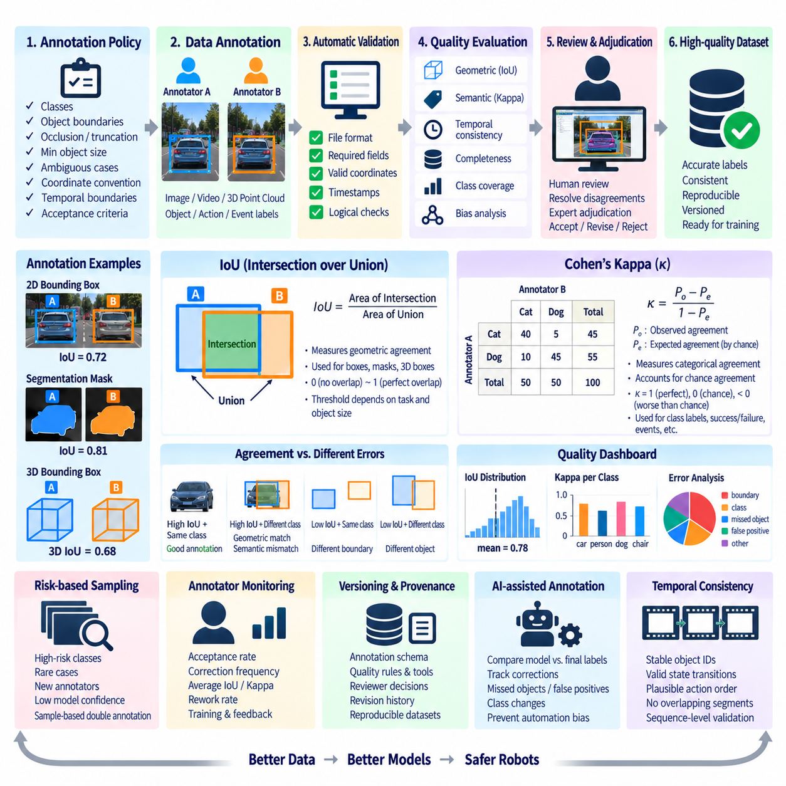
Annotation quality management ensures that labels used for robot and Physical AI training are accurate, consistent, reproducible, and appropriate for their intended learning task. Quality cannot be determined only by whether an annotation file is syntactically valid. It must also evaluate geometric precision, semantic correctness, agreement between annotators, completeness, temporal consistency, and compliance with the annotation specification across the complete dataset.
Quality management begins with a clearly defined annotation policy. Classes, object boundaries, occlusion handling, truncation rules, minimum object size, ambiguous cases, coordinate conventions, temporal boundaries, and acceptance criteria should be documented before production begins. Without a shared specification, differences between annotators may reflect different interpretations rather than actual mistakes, making numerical quality measurements difficult to interpret correctly.
Annotation quality can be considered at several levels. Structural quality verifies that files, identifiers, coordinates, timestamps, and required fields are valid. Geometric quality evaluates whether boxes, masks, points, or poses accurately represent spatial targets. Semantic quality determines whether labels correctly describe classes, actions, relationships, and events. Dataset-level quality additionally evaluates completeness, consistency, class coverage, and systematic annotation bias.
Intersection over Union, commonly abbreviated as IoU, is one of the most widely used measures for geometric agreement. It compares the overlapping region between two annotations with the total region covered by either annotation. Conceptually, IoU is calculated as the area of intersection divided by the area of union. A value near one indicates strong spatial agreement, while a value near zero indicates little or no overlap between the compared regions.
For 2D bounding boxes, IoU can compare an annotator's box with a reference annotation or compare labels produced independently by two annotators. High overlap suggests that both annotations describe approximately the same object extent. Lower IoU can indicate inaccurate localization, different interpretations of visible versus occluded regions, or inconsistent boundary policies. The acceptable threshold should depend on object size, task requirements, and annotation guidelines rather than being treated as universally fixed.
IoU is also applicable to segmentation masks. Instead of comparing rectangular regions, the intersection and union are calculated from the pixels assigned to the relevant class or object. This makes IoU useful for semantic and instance segmentation quality management. Boundary-sensitive objects, thin structures, small objects, and irregular shapes can produce lower IoU even when annotations appear visually similar, so quality interpretation should consider the characteristics of each class.
Three-dimensional annotations can extend the same principle through 3D IoU. Two 3D bounding boxes are compared according to their overlapping spatial volume relative to their combined volume. This provides a useful measure for LiDAR and point-cloud annotation, although additional metrics such as center-position error, orientation difference, and dimension error may be required. A single overlap value cannot fully describe every type of 3D geometric disagreement.
IoU primarily measures spatial agreement and does not adequately measure categorical agreement. Two annotators can draw identical boxes but assign different classes, producing perfect geometric overlap while disagreeing semantically. Conversely, two annotators may agree that an object is a pedestrian but draw slightly different boxes. Annotation quality systems should therefore separate geometric agreement from class agreement instead of combining all errors into a single metric.
Cohen's Kappa provides a method for measuring categorical agreement between two annotators while accounting for agreement that could occur by chance. The metric compares observed agreement with expected chance agreement. A higher Kappa generally indicates stronger agreement beyond chance, while values near zero indicate that observed agreement is close to what could be expected randomly. Negative values can indicate systematic disagreement below the expected chance level.
Kappa is useful for class labels, binary decisions, task states, quality categories, success and failure labels, and other discrete annotation decisions. For example, two reviewers may independently classify manipulation demonstrations as successful or failed, identify whether an object is occluded, or assign an action category. Kappa helps determine whether the annotation policy produces repeatable judgments rather than merely reporting the percentage of identical answers.
Kappa should nevertheless be interpreted carefully. Its value is affected by class prevalence and annotator decision distributions. When one category dominates a dataset, very high raw agreement can coexist with a less intuitive Kappa value. Rare classes can create similar interpretation problems. For this reason, Kappa should be reported together with raw agreement, class distributions, sample counts, and confusion information whenever those factors materially affect the quality assessment.
For projects involving more than two annotators or different annotation structures, additional agreement measures may be appropriate. The central principle is that the quality metric must match the annotation task. Spatial annotations require geometric measures, categorical decisions require agreement statistics, temporal segments require boundary or interval comparisons, and continuous quantities such as poses or coordinates require distance or error measures. No single metric is sufficient for every annotation type.
A practical quality-control pipeline can combine automated validation, sampled double annotation, expert review, and disagreement resolution. Automated checks first remove malformed or logically impossible annotations. A selected portion of the dataset can then be independently labeled by multiple annotators. IoU, Kappa, or task-specific metrics quantify agreement, while expert adjudication examines disagreements and establishes the accepted label when necessary.
Double annotation does not need to be applied uniformly to every sample. High-risk classes, new annotation tasks, difficult environments, newly trained annotators, or samples with low model confidence can receive higher rates of independent review. Mature and stable categories may use statistical sampling instead. This risk-based strategy concentrates quality-management resources where annotation errors would have the greatest effect while controlling overall cost and review latency.
Disagreement analysis is often more valuable than a single average quality score. Low IoU concentrated around small objects may indicate that minimum-size rules are unclear. Repeated class disagreement between similar objects may reveal an inadequate taxonomy. Low agreement around manipulation phase boundaries may indicate ambiguous temporal definitions. Quality metrics should therefore be used diagnostically to improve annotation specifications and workflows, not simply as pass-or-fail numbers.
Annotator-level monitoring can identify systematic patterns, but it should be designed carefully. Metrics such as acceptance rate, correction frequency, average IoU against reviewed references, categorical agreement, and rework rate can reveal training needs or confusing guidelines. However, differences may originate from task difficulty rather than annotator capability. Performance evaluation should therefore account for sample complexity and use quality measurements primarily to improve the production process.
Reference or gold-standard datasets can provide stable anchors for quality assessment. Expert-reviewed samples representing common, difficult, and safety-relevant cases can be periodically inserted into annotation workflows. Results can be compared with these references to detect drift in interpretation or declining consistency. Gold sets should themselves be versioned because annotation policies, class definitions, and domain requirements may evolve over time.
AI-assisted annotation introduces another quality dimension. Pre-labeling models may generate systematic errors that human reviewers unconsciously accept, creating automation bias. Quality management should compare machine proposals with final approved labels and track correction rates, missed-object additions, false-positive removals, class changes, and boundary adjustments. These measurements reveal whether automation is improving productivity without silently reducing label quality.
Temporal annotation requires consistency across sequences as well as individual frames. Object identifiers should remain stable during tracking, action labels should transition according to defined rules, and manipulation phases should follow plausible temporal order. Automated checks can detect identity switches, impossible state transitions, abrupt geometry changes, or overlapping task intervals. Sequence-level validation is therefore essential for robot demonstrations and video datasets.
Quality thresholds should reflect downstream risk and model sensitivity. Safety-related obstacle labels may require stricter geometric and semantic agreement than exploratory research labels. Precise manipulation or grasping tasks may require accurate poses and boundaries, while broad scene classification may tolerate larger spatial variation. A tiered quality policy allows organizations to apply stronger acceptance criteria where annotation errors have greater operational consequences.
Annotation quality must also be versioned and traceable. Each approved dataset should record the annotation schema, quality rules, validation software, metric configuration, reviewer decisions, and corrections applied. When a label changes, the previous state should remain recoverable. This provenance enables teams to reproduce training datasets, investigate model regressions, and determine whether performance differences originate from model changes or ground-truth revisions.
Quality dashboards can combine operational and statistical indicators. Annotation throughput, review backlog, rejection rate, correction rate, mean or distributional IoU, categorical agreement, Kappa, class-specific errors, and unresolved disagreements can be monitored together. Trends are often more informative than isolated values because gradual changes may reveal annotator drift, new domain conditions, tool problems, or degradation in AI-generated pre-labels.
For Physical AI, annotation quality ultimately concerns whether labels represent the physical world and robot behavior reliably enough for learning. Geometric accuracy, semantic agreement, temporal consistency, contact interpretation, action labeling, and success or failure judgments may all contribute to one training episode. Quality management must therefore operate across modalities rather than treating individual labels as isolated records.
A mature annotation quality-management system combines explicit specifications, automated validation, geometric metrics such as IoU, categorical agreement measures such as Kappa, independent review, expert adjudication, risk-based sampling, quality dashboards, and versioned provenance. The objective is not simply to maximize metric values, but to maintain trustworthy and reproducible supervision while balancing quality, annotation speed, and cost across the robot data lifecycle.

10.08 Annotation Data Version Control and Reproducibility [w/Code]
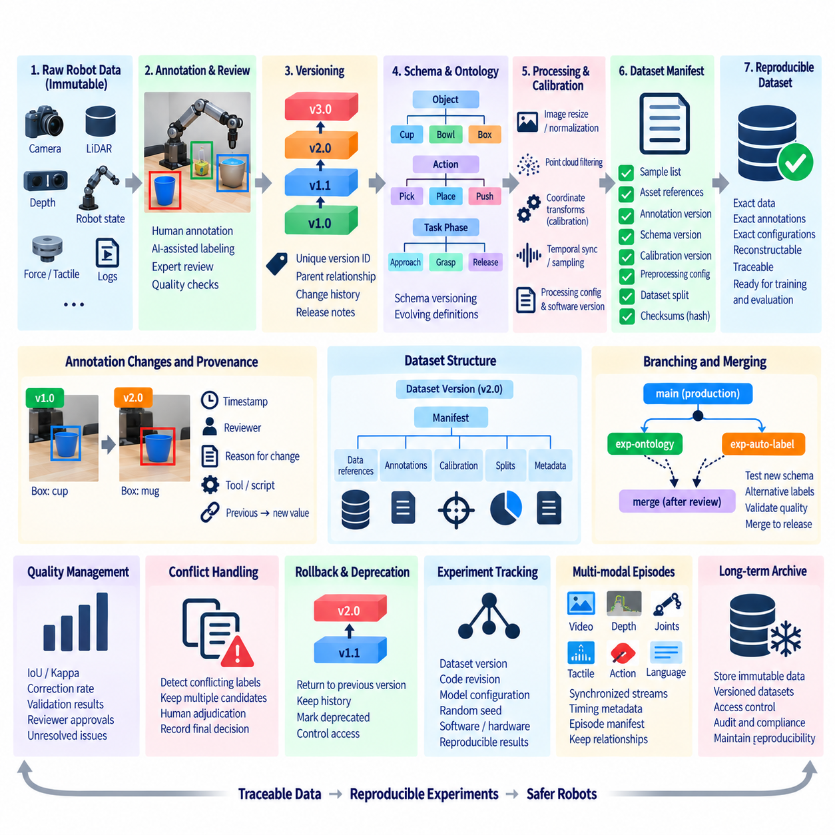
Annotation data version control is the discipline of preserving how labels, schemas, source data, review decisions, and processing rules change over time. In robotics and Physical AI, a dataset is rarely static after its first release. Labels are corrected, new classes are introduced, task definitions evolve, sensor sequences are added, and quality rules become stricter. Version control makes these changes explicit rather than silently overwriting previous ground truth.
Reproducibility means that a training, evaluation, or analysis dataset can be reconstructed later from recorded inputs and transformation rules. Reproducing a dataset requires more than keeping a copy of the final annotation files. The system must identify the exact raw data, annotation version, schema, preprocessing configuration, calibration information, filtering rules, software environment, and dataset split used to produce a particular experiment.
Raw robot data should normally be treated as immutable source material. Camera images, LiDAR scans, depth streams, robot states, force-torque measurements, tactile signals, and demonstration logs form the evidence from which derived datasets are created. Instead of modifying these assets during annotation, the architecture should maintain stable identifiers or content references and store annotations as separate versioned records associated with the original observations.
Annotation versions represent meaningful states of the labeled dataset. An initial release may contain manually generated labels, while later versions correct errors, add reviewed labels, introduce new attributes, or incorporate AI-assisted annotations. Each release should have a unique version identifier and documented parent relationship. This creates a dataset history in which teams can determine what changed, when it changed, and which experiments used each state.
Version identifiers can follow semantic or sequential conventions depending on organizational requirements. Major changes may represent incompatible schema modifications, while minor versions may add labels or improve quality without changing fundamental interpretation. Patch-level revisions can represent localized corrections. The exact naming convention is less important than ensuring that a version always refers to one immutable and recoverable dataset state.
Annotation schemas must be versioned independently from annotation instances. A class definition can change even when the underlying image or robot episode remains unchanged. For example, a generic container class may later be divided into cup, bowl, and box, or a manipulation ontology may add recovery and failure phases. Recording the schema version prevents older labels from being interpreted according to newer definitions that did not exist when they were created.
Changes between versions should be represented through explicit provenance. A correction may record the previous value, new value, reason for modification, reviewer, timestamp, and associated quality issue. Bulk transformations should additionally record the software or script that produced the change. This history supports auditing and allows teams to distinguish manual corrections, automated migrations, model-generated updates, and policy-driven relabeling.
Large robot datasets make full physical duplication for every version inefficient. Version-control architectures can instead combine immutable objects with manifests, metadata, hashes, and references. A dataset version may therefore be represented by a manifest describing exactly which sensor assets and annotation records belong to it. Unchanged data can be reused across versions while only new or modified annotation objects require additional storage.
Content hashes provide another mechanism for identifying immutable artifacts. A hash can verify whether an annotation file, calibration record, image, or manifest has changed since a dataset was created. Hash-based verification is especially valuable when datasets move between local storage, network-attached storage, object stores, training servers, or archives. It helps detect accidental modification and confirms that reconstructed experiments use the intended artifacts.
Dataset manifests act as reproducibility contracts. A manifest can contain sample identifiers, asset locations, annotation references, schema versions, checksums, calibration versions, preprocessing settings, and split assignments. Rather than asking which files happened to exist in a directory at training time, the training system reads an explicit manifest. This converts a loosely organized collection of files into a precisely defined dataset snapshot.
Training, validation, and test splits must also be version-controlled. Changing the split while retaining the same dataset name can make experimental comparisons misleading because performance differences may result from different evaluation samples. Split manifests should therefore be immutable for a given experiment version. If samples are added, removed, or reassigned, the system should create a new split version and record the relationship to the previous one.
Robot datasets frequently depend on calibration and coordinate transformations that are external to visible annotation files. Camera intrinsics, camera-to-robot transforms, LiDAR extrinsics, tool frames, map frames, and synchronization corrections can change after recalibration. Reproducibility therefore requires these parameters to be versioned alongside labels. A 3D annotation cannot be reliably reconstructed if the coordinate transformation used to create it has been lost.
Preprocessing is another part of dataset identity. Image resizing, cropping, normalization, point-cloud filtering, temporal sampling, coordinate conversion, sequence chunking, and data augmentation can substantially change the input presented to a model. The pipeline should record preprocessing configurations and software versions so that the same source data can be transformed consistently. Derived data should remain traceable to both its raw input and transformation recipe.
Annotation tools and AI-assisted models can influence the resulting labels. When pre-labeling is used, provenance should identify the model checkpoint, inference configuration, confidence threshold, and post-processing logic that generated candidate labels. Human review does not eliminate the need for this information because model suggestions may introduce systematic bias. Recording the annotation tool and model context makes later quality investigations more informative.
Reproducibility should connect datasets with model experiments. A training run should reference a specific dataset version rather than a mutable directory such as latest or current. The experiment record can link dataset manifest, code revision, model configuration, random seed, software dependencies, and hardware-relevant settings. This establishes a reproducibility chain from raw robot observations through annotations and preprocessing to the trained model artifact.
Branching can support annotation experiments without destabilizing production datasets. A team may test a new taxonomy, revised segmentation policy, alternative manipulation ontology, or automated relabeling model on a separate branch or candidate version. After validation, approved changes can be merged into a controlled release. The conceptual model resembles software version control, although large binary sensor assets usually require storage mechanisms designed specifically for datasets.
Conflicts occur when multiple annotators or processes modify the same logical label. Dataset version control should not resolve such conflicts by silently accepting the most recent write. Instead, conflicting annotations can remain as separate candidates until review or adjudication determines the approved result. The final version should preserve enough provenance to explain which alternative was selected and why, especially for safety-relevant or ambiguous robot data.
Rollback is an important operational capability. If a new annotation policy introduces errors or a bulk migration corrupts labels, teams should be able to return to the last validated dataset state without reconstructing it manually. Immutable versions and manifests make rollback predictable because a previous release remains unchanged. The faulty version can then be investigated while training and evaluation continue using a known stable dataset.
Reproducibility also requires controlled deletion and deprecation. Incorrect datasets should not necessarily disappear from history because previous experiments may depend on them. Instead, a version can be marked deprecated, invalid for new training, or superseded by another release while remaining available for audit. Access policies can distinguish active production datasets from historical snapshots, temporary candidates, and archived versions.
Quality-management results should be attached to dataset versions. IoU distributions, categorical agreement, Kappa values, correction rates, validation failures, reviewer approvals, and unresolved issues describe the quality state of a particular release. When annotations change, quality metrics may also change. Storing quality reports with the corresponding version prevents measurements from being incorrectly applied to a later dataset that contains different labels.
For multimodal robot episodes, versioning must preserve relationships among synchronized streams. A demonstration may reference video, depth, joint states, actions, tactile signals, language instructions, and outcome annotations. Replacing one stream or changing temporal alignment can alter the meaning of the entire episode. Episode manifests should therefore identify synchronized components and timing metadata as one reproducible logical unit rather than as unrelated files.
A mature annotation version-control architecture connects immutable raw assets, versioned schemas, annotation revisions, calibration records, preprocessing recipes, manifests, quality reports, dataset splits, and experiment metadata. Every model result can then be traced backward to the exact supervision that produced it, while every annotation change can be traced forward to affected datasets and experiments. This traceability transforms reproducibility from a manual documentation exercise into a property of the robot data architecture itself.

10.09 Annotation Pipeline Cost Optimization Strategy
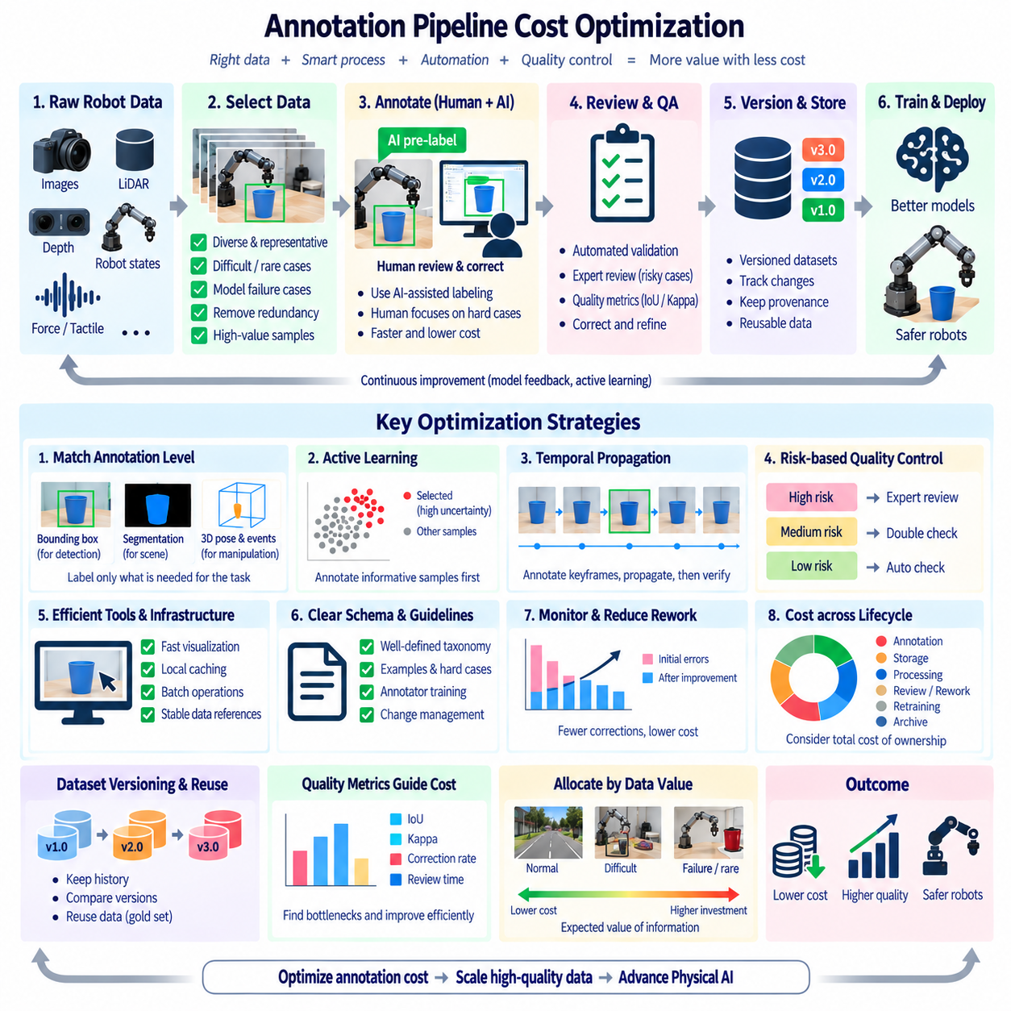
Annotation pipeline cost optimization focuses on reducing the total resources required to produce reliable training labels without sacrificing the quality needed for robotics and Physical AI. Annotation cost includes human labor, review effort, tool operation, storage, compute, data transfer, and rework caused by inconsistent labels. An effective strategy therefore treats annotation quality, production speed, automation, and dataset value as a connected system rather than optimizing labor cost alone.
The first optimization step is to define the required annotation level according to the learning objective. Not every dataset requires detailed pixel-level, point-level, or trajectory-level labels. Broad object detection may require only bounding boxes, while manipulation learning may require object poses, contact events, temporal phases, and action relationships. Matching annotation depth to model requirements prevents expensive labeling of information that provides little additional training value.
Dataset selection has a direct effect on annotation cost. Large robot datasets often contain many redundant frames or repeated observations of nearly identical scenes. Selecting representative samples before annotation reduces the number of records that require human processing while preserving environmental diversity. Difficult objects, rare situations, model failure cases, unusual interactions, and safety-relevant scenes should receive higher priority because their information value may be greater than that of repetitive normal samples.
Human labor should be concentrated on decisions that automated systems cannot reliably resolve. AI-assisted pre-labeling can generate candidate boxes, segmentation masks, object identities, action phases, or temporal boundaries. Human annotators then correct and approve these results instead of creating every label from the beginning. The economic benefit depends on correction effort, so automation should be evaluated by the amount of reliable human work it removes rather than by the number of predictions it generates.
Active learning can further reduce unnecessary annotation. A trained model can identify samples with high uncertainty, disagreement, unusual geometry, rare classes, or significant prediction errors. These samples can be prioritized for human labeling while low-information examples receive lower priority. The resulting feedback loop continuously directs annotation resources toward data that can improve model performance or robustness most effectively.
Temporal propagation is particularly valuable for robot video and manipulation demonstrations. Once an object, action phase, or trajectory has been correctly annotated in selected keyframes, tracking and interpolation methods can propagate the information through neighboring frames. Human reviewers then verify and correct the propagated labels. This approach can substantially reduce repetitive work while maintaining temporal continuity across long robot sequences.
A cost-efficient pipeline should use different quality levels rather than applying the strictest review procedure to every sample. Standard samples can follow automated validation and statistical sampling, while safety-critical objects, difficult manipulation events, new classes, and low-confidence AI labels receive additional expert review. Risk-based quality control reduces review expenditure while maintaining stronger protection around annotations that have greater downstream consequences.
Annotation tools and infrastructure also influence total cost. Slow visualization, repeated data downloads, inefficient file formats, excessive network transfers, or poorly designed interfaces increase the amount of time required for each labeling decision. Local caching, optimized point-cloud rendering, selective loading, batch operations, keyboard-driven workflows, and stable dataset references can reduce interaction overhead. These improvements may appear operational rather than algorithmic, but their cumulative effect becomes significant at large scale.
Rework is one of the most expensive hidden components of annotation. Labels created under unclear definitions may later require large-scale correction when the taxonomy or quality rules become more precise. A small investment in annotation guidelines, examples, difficult-case definitions, and annotator training can therefore prevent substantial downstream cost. Version-controlled schemas and explicit change management also reduce the risk that new policies silently invalidate previously produced labels.
Quality metrics should be connected to cost decisions. IoU, Kappa, correction rate, rejection rate, disagreement frequency, and review time can reveal where annotation resources are being consumed. If a particular class repeatedly generates low agreement and high correction effort, the problem may originate from ambiguous definitions rather than insufficient labor. Improving the schema or tool workflow may therefore produce greater savings than simply adding more annotators.
Dataset versioning allows optimization without losing historical information. Candidate annotations can be processed and evaluated before becoming part of a production release. Expensive high-quality labels can be preserved as reference or gold-standard samples, while broader datasets may use lower-cost annotation levels. This layered strategy allows organizations to maintain a small set of highly reliable supervision together with larger volumes of efficiently produced training data.
Cost should also be evaluated across the complete data lifecycle rather than only during initial labeling. Storage, preprocessing, synchronization, quality review, correction, export, retraining, and archival all contribute to the effective cost of a dataset. A cheap annotation process that creates unreliable labels may become expensive when repeated training experiments, debugging, and manual correction are considered. Total cost of ownership should therefore include both production and downstream rework.
For Physical AI, annotation resources should ultimately be allocated according to the expected value of information. High-value data may include rare manipulation failures, difficult contacts, unusual object configurations, safety-critical interactions, and environments where the current policy performs poorly. Routine and highly redundant observations can be processed with lighter annotation methods. This creates a data strategy in which annotation expenditure follows learning value rather than simply dataset size.
A mature annotation cost optimization strategy combines task-specific annotation depth, representative data selection, AI-assisted labeling, active learning, temporal propagation, risk-based review, efficient tools, clear schemas, quality monitoring, version control, and lifecycle cost analysis. The objective is not to minimize annotation expenditure at any cost, but to achieve the required level of trustworthy supervision with the least unnecessary human effort, computation, storage, and rework. This balance allows robot datasets to scale while preserving the reliability required for Physical AI training and evaluation.

10.10 Automated Annotation Pipeline Operation Case
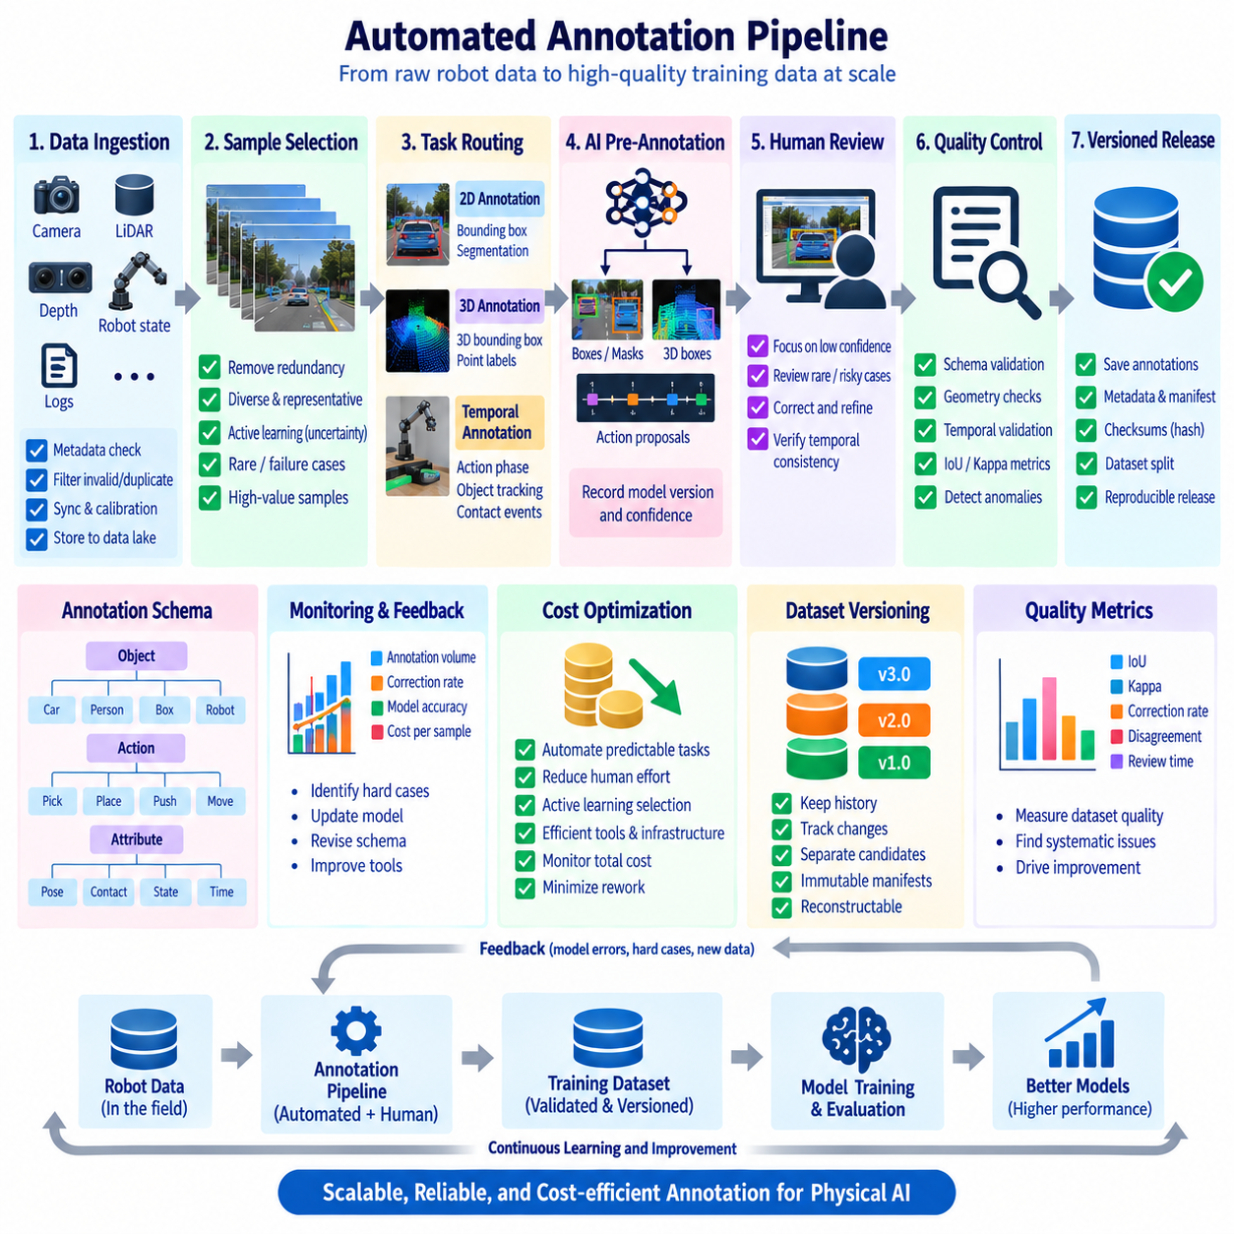
An automated annotation pipeline operationalizes the annotation methods developed throughout the data annotation workflow by connecting data selection, AI-assisted labeling, human verification, quality management, version control, and cost optimization into one repeatable production process. The objective is not to eliminate human participation, but to automate predictable operations while directing human attention toward ambiguous, high-risk, and high-value samples. In a robotics environment, the pipeline should operate continuously as new camera, LiDAR, depth, and robot demonstration data become available.
The operational process begins when newly collected robot data enters a controlled ingestion area. Metadata such as robot identity, sensor configuration, timestamp, sequence identifier, environment, task type, and calibration version are checked before annotation begins. Invalid, incomplete, duplicated, or corrupted records are filtered automatically. Representative samples are then selected according to data diversity, model uncertainty, rare events, and previously observed failure patterns. This prevents the annotation system from spending resources on large quantities of redundant observations.
After selection, the pipeline routes each sample to the appropriate annotation task. Camera images may be assigned to 2D bounding-box or segmentation workflows, point clouds to 3D annotation, and manipulation demonstrations to temporal action and contact annotation. The annotation schema determines which labels are required for each task. This routing layer allows one automated system to support different data modalities without forcing every sample through the same expensive annotation process.
AI-assisted pre-annotation is then applied according to the selected task. Detection models can generate bounding boxes, segmentation models can propose masks, 3D perception models can generate spatial boxes, and temporal models can suggest action phases or object tracks. The generated results are stored separately from approved labels so that machine predictions remain distinguishable from human-verified ground truth. Model version, confidence threshold, inference configuration, and preprocessing settings are recorded as part of annotation provenance.
Human review is introduced according to confidence and risk rather than applied uniformly. High-confidence predictions for stable classes may require rapid verification, while uncertain predictions, rare objects, safety-relevant cases, and unusual manipulation events receive detailed review. Annotators correct boundaries, classes, temporal phases, object relationships, or contact events as required. The system records both the original machine proposal and the final approved annotation, making it possible to measure how much correction was required.
Automated quality control runs before an annotation release is accepted. Structural validation checks identifiers, coordinates, timestamps, class values, geometry, and required fields. Geometric checks can evaluate bounding-box or 3D-box consistency, while segmentation validation checks masks and polygon integrity. Temporal validation can detect identity switches, impossible state transitions, or discontinuous trajectories. Statistical quality measures such as IoU, Kappa, correction rate, and disagreement frequency are then used to identify systematic problems.
When quality problems are detected, the pipeline should not simply reject the entire dataset. It can isolate problematic classes, environments, annotators, models, or task types and route them back for targeted correction. If a particular model repeatedly generates incorrect labels, its pre-annotation process can be suspended or replaced. If disagreement originates from an unclear class definition, the annotation schema can be revised and the affected samples reprocessed. This creates a controlled feedback mechanism rather than repeated manual rework.
Approved annotations are committed to a versioned dataset release. The release records the annotation schema, source data references, model versions, preprocessing configuration, quality results, calibration information, and dataset split. Immutable manifests and checksums allow the exact release to be reconstructed later. Candidate or experimental annotations can remain separate until they pass validation, preventing unfinished work from contaminating the production training dataset.
The pipeline can continuously learn from its own operational history. Samples that required extensive correction, produced model failures, or represented rare physical interactions can be added to an active-learning queue. Future annotation cycles prioritize these samples because they are likely to provide greater training value. As improved models generate better pre-labels, human correction effort can decrease, while new failure cases become the next source of targeted annotation.
Cost monitoring is integrated into operation rather than performed only after a project ends. The system can track annotation throughput, human review time, correction rates, model inference cost, storage consumption, rework volume, and quality results. These measurements reveal whether automation is actually reducing total cost. A model that produces many predictions but requires extensive correction may be less efficient than a simpler model that produces fewer but more reliable proposals.
A practical operational architecture therefore forms a closed loop from robot data ingestion to sample selection, AI pre-annotation, human verification, automated quality control, versioned release, model training, evaluation, and feedback-driven resampling. Each stage produces metadata that supports the next stage, while failures and corrections become structured information for improving future annotation cycles. This transforms annotation from a one-time labeling activity into a continuously operating data production system.
For Physical AI, the final objective is a trustworthy and scalable annotation operation in which data quality, automation, human expertise, cost, and reproducibility are managed together. Camera images, 3D sensor data, robot states, and manipulation demonstrations can enter the same controlled lifecycle while following task-specific annotation rules. The resulting system provides validated and traceable training data for perception, manipulation, navigation, and embodied AI, while creating the operational foundation for the broader robot data architecture. The chapter structure places this automated operation case after annotation design, tool selection, AI-assisted labeling, 2D and 3D annotation, manipulation demonstration annotation, quality management, version control, and cost optimization, making it the integrated operational stage of the annotation pipeline.

