Volume 07 Robot Data Architecture

04. Event Streaming

04.01 Event Streaming Basics: Event Definition, Schema, Serialization
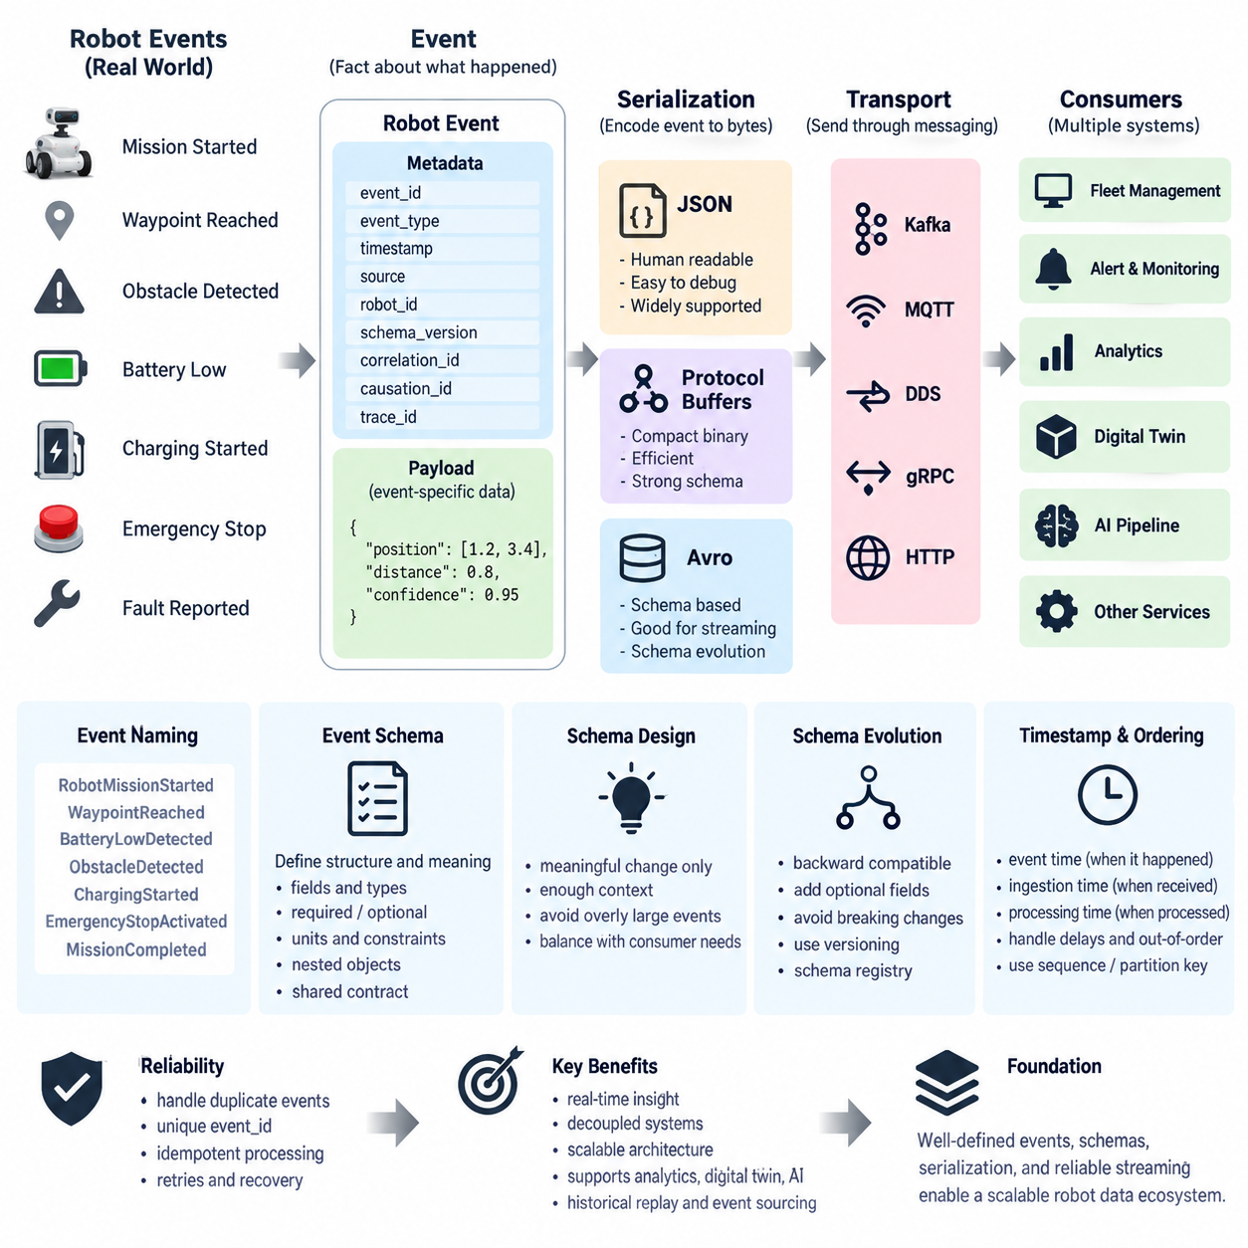
Event streaming is a data architecture approach in which meaningful changes in a robot or its surrounding system are represented as discrete events and continuously delivered to interested consumers. Unlike periodic database polling, an event stream communicates changes as they occur. A robot starting a mission, reaching a waypoint, detecting an obstacle, entering a charging station, or reporting a fault can therefore become an independently processed event.
An event represents a fact that has already occurred rather than a command requesting future behavior. A command such as “move to station A” expresses an intention, while an event such as “robot arrived at station A” records an observed result. This distinction is fundamental because event-driven systems use immutable facts to coordinate downstream services, maintain operational history, trigger workflows, and reconstruct how the robot system reached its current state.
A useful robot event normally contains more than the business fact itself. It requires an event identifier, event type, timestamp, source, robot or asset identifier, schema version, and payload describing the event-specific information. Correlation identifiers can associate multiple events with the same mission or transaction, while causation identifiers indicate which preceding command or event produced the current event. These fields make distributed robot behavior traceable across services.
Event names should describe domain facts clearly and consistently. Examples include RobotMissionStarted, WaypointReached, BatteryLowDetected, ObstacleDetected, ChargingStarted, EmergencyStopActivated, and MissionCompleted. Naming events in the past tense reinforces their role as historical facts. A well-defined vocabulary also prevents different robot teams, fleet services, analytics systems, and cloud applications from assigning incompatible meanings to the same operational occurrence.
The event schema defines the formal structure and meaning of an event. It specifies required and optional fields, data types, allowable values, nested objects, units, identifiers, and semantic constraints. In robotics, this is particularly important because data may cross embedded controllers, ROS 2 systems, edge computers, fleet management platforms, cloud services, databases, digital twins, and AI pipelines. A schema provides a shared contract between these heterogeneous producers and consumers.
A typical event can be separated conceptually into metadata and payload. Metadata describes the event itself through attributes such as event_id, event_type, timestamp, source, robot_id, schema_version, and trace_id. The payload contains domain-specific information. An ObstacleDetected event, for example, may contain position, distance, confidence, sensor source, obstacle class, and motion state, while a BatteryLowDetected event may contain state of charge, voltage, temperature, and estimated remaining runtime.
Schema design should avoid unnecessarily embedding the complete robot state into every event. Events are most useful when they describe a meaningful change with enough contextual information for consumers to understand that change. Excessively large messages increase bandwidth, serialization cost, storage requirements, and processing latency. Conversely, events that contain too little context force consumers to repeatedly query other services, reducing the autonomy and scalability of an event-driven architecture.
Serialization converts an in-memory event representation into a transferable byte or text format. JSON is widely used because it is human-readable, easy to debug, and supported by almost every programming environment. Its flexibility is valuable during development and integration, although textual representation increases message size and parsing overhead. For high-frequency robot telemetry and large fleets, these costs can become significant and motivate more compact binary serialization methods.
Protocol Buffers provide a strongly defined binary representation with compact messages and efficient serialization. Apache Avro also supports schema-based serialization and is commonly associated with data streaming environments where schema evolution and centralized schema management are important. The choice among JSON, Protocol Buffers, Avro, or another format should consider interoperability, bandwidth, processing performance, development convenience, schema governance, and long-term compatibility rather than message size alone.
Serialization and transport should remain conceptually separate. Serialization determines how an event is encoded, whereas transport determines how the encoded event moves between components. The same logical robot event could therefore be represented using JSON or Protocol Buffers and transported through Kafka, MQTT, DDS, or another messaging infrastructure. Maintaining this separation allows communication technologies to evolve without unnecessarily changing the underlying domain event model.
Schema evolution becomes critical once multiple robot software versions operate simultaneously. Producers and consumers cannot always be upgraded together, particularly in geographically distributed fleets. Adding optional fields is generally safer than removing existing fields or changing their meanings. Renaming fields, modifying units, or changing a numeric field into an incompatible type can silently break consumers. Schema compatibility must therefore be treated as part of the interface contract.
Version information should be explicit enough for consumers to determine how an event must be interpreted. Depending on the architecture, versioning can be managed through event metadata, topic organization, schema identifiers, or a schema registry. Compatibility rules can then be checked before a producer deploys a new schema. This reduces the risk that a robot software update introduces events that existing fleet, analytics, monitoring, or digital-twin services cannot process correctly.
Timestamp semantics require particular attention in robotic systems. An event may have a time at which the physical phenomenon occurred, another time when onboard software detected it, and another when the event reached the streaming platform. Network delays and temporary disconnections can make these values substantially different. Event-time processing should therefore distinguish the physical or logical occurrence time from ingestion or processing time when ordering and latency analysis matter.
Event ordering is not automatically guaranteed across an entire distributed system. A robot may generate several events rapidly, communication paths may have different delays, and disconnected robots may upload buffered events later. Sequence numbers, timestamps, partition keys, and robot identifiers can help preserve or reconstruct relevant ordering. Ordering requirements should normally be defined within meaningful boundaries such as a robot, mission, device, or operational entity rather than assuming one global sequence.
Reliable event processing must also consider duplicates. Network retries, broker delivery semantics, reconnection, and producer recovery can cause the same logical event to be delivered more than once. Globally or operationally unique event identifiers allow consumers to recognize duplicates. Idempotent processing is equally important: processing the same event repeatedly should not incorrectly create multiple missions, maintenance tickets, alerts, billing records, or state transitions.
Event streams create a temporal record that can serve many consumers simultaneously. A fleet-management service may update robot status, an alert service may detect faults, an analytics service may calculate reliability indicators, a digital twin may update its state, and an AI data pipeline may identify valuable training samples. Because consumers subscribe independently, new applications can often be introduced without modifying the robot-side producer, which reduces direct coupling between system components.
This architecture also establishes the foundation for more advanced stream processing. Once robot events have consistent definitions, governed schemas, timestamps, identifiers, and serialization rules, platforms can filter, aggregate, correlate, replay, and analyze them continuously. Later components can detect event patterns, maintain streaming state, reproduce historical sequences, and support event sourcing. The Event Streaming chapter therefore builds progressively from these basic event contracts toward Kafka, Flink, stateful processing, replay, monitoring, and security.
For robot data architecture, the most important principle is that an event is not merely a message transmitted through a broker. It is a durable semantic contract describing something meaningful that happened in the physical or digital robot domain. Clear event definitions, disciplined schemas, efficient serialization, explicit timestamps, stable identifiers, and controlled schema evolution allow heterogeneous robot, edge, fleet, cloud, digital-twin, and AI systems to exchange operational facts reliably at scale.

04.02 Robot Domain Event Classification System Design
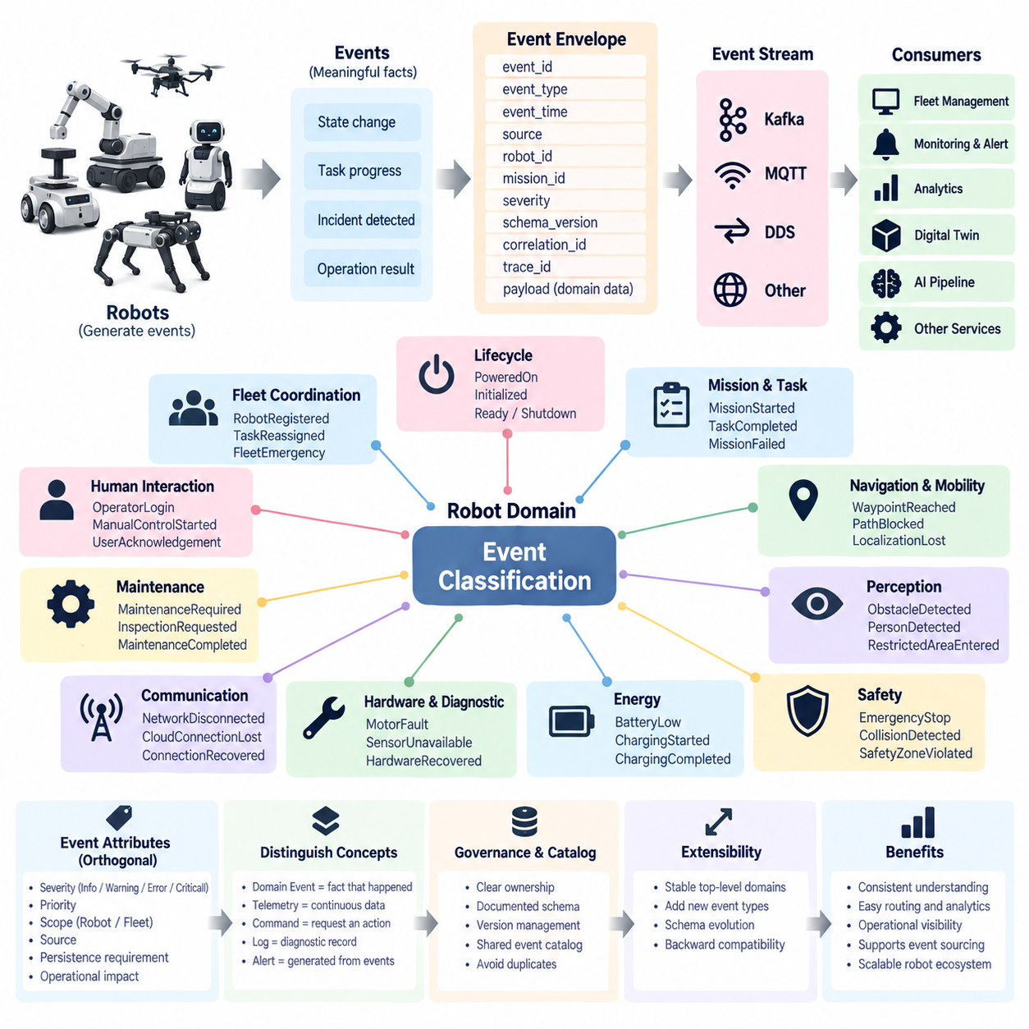
Robot domain event classification defines a systematic method for organizing the large number of events generated throughout robot operation. A robot does not produce only sensor data; it continuously generates facts related to missions, motion, navigation, hardware, safety, energy, communication, maintenance, and interaction with external systems. Classification provides a common semantic structure that allows these heterogeneous events to be understood consistently across the robot data architecture.
A domain event represents a meaningful occurrence within a specific robot operational context. Rather than treating every message, sensor sample, or state variable as an event, the classification system focuses on changes that have operational or business significance. A wheel encoder update may remain telemetry, while a localization failure, mission start, charging completion, emergency stop, or payload delivery can become a domain event because another component may need to react to it.
The classification model should begin with clearly defined robot domains. Typical domains include robot lifecycle, mission and task execution, navigation and mobility, perception, safety, energy, hardware health, communication, maintenance, human interaction, and fleet coordination. These domains provide stable semantic boundaries while allowing individual robot platforms to introduce specialized event types without destroying the consistency of the overall event architecture.
Robot lifecycle events describe transitions in the operational existence or availability of a robot. Examples include RobotPoweredOn, RobotInitialized, RobotReady, RobotPaused, RobotShutdown, and RobotOffline. These events are useful for fleet management, availability calculation, operational auditing, and digital-twin synchronization because they indicate whether the physical robot is capable of accepting tasks or participating in fleet operations.
Mission and task events represent the execution lifecycle of work assigned to a robot. MissionAssigned, MissionAccepted, MissionStarted, TaskStarted, TaskCompleted, MissionCompleted, MissionCancelled, and MissionFailed can describe the progression from assignment to termination. By maintaining a consistent task-event vocabulary, fleet software can reconstruct execution histories, measure mission duration, analyze failures, and coordinate workflows without depending on robot-specific internal state machines.
Navigation and mobility events describe meaningful changes associated with movement through the environment. RouteAssigned, NavigationStarted, WaypointReached, GoalReached, PathBlocked, LocalizationLost, ReplanningStarted, and RobotStuck are representative examples. These events should describe operational transitions rather than continuously publishing position samples, which are more appropriately handled as telemetry or time-series data within the broader robot data architecture.
Perception events represent significant interpretations produced from sensor processing rather than every raw sensor observation. ObstacleDetected, PersonDetected, RestrictedAreaEntered, FireDetected, FallDetected, or UnknownObjectDetected may trigger navigation, safety, monitoring, or AI workflows. Classification should distinguish the event from the underlying image, point cloud, radar frame, or inference tensor so that large sensor data can be referenced rather than embedded directly into every event.
Safety events require particularly clear classification because their operational meaning and response priority may differ substantially from ordinary events. EmergencyStopActivated, CollisionDetected, SafetyZoneViolated, ProtectiveStopActivated, and SafetySensorFault can belong to a dedicated safety domain. The event schema may additionally carry severity, safety source, affected subsystem, response state, and acknowledgement information without confusing classification with the detailed safety-control logic itself.
Energy events describe changes that influence robot availability and mission planning. BatteryLowDetected, CriticalBatteryDetected, ChargingRequested, ChargingStarted, ChargingCompleted, ChargingInterrupted, and BatteryFaultDetected are examples. These events allow fleet orchestration systems to coordinate charging resources, prevent mission assignment to unavailable robots, calculate energy-related utilization, and identify abnormal charging behavior without continuously processing every voltage or current measurement.
Hardware and diagnostic events capture meaningful changes in physical components and embedded subsystems. MotorFaultDetected, DriveControllerFault, SensorUnavailable, ComputeOverTemperature, BrakeFault, and HardwareRecovered can represent transitions requiring diagnosis or maintenance. Continuous temperatures, currents, vibration measurements, and controller values remain telemetry, while threshold crossings, diagnosed faults, degradation states, and recovery transitions become domain events.
Communication events describe connectivity changes that influence distributed robot operation. NetworkDisconnected, NetworkRestored, CloudConnectionLost, BrokerConnectionRecovered, or RemoteControlUnavailable may be classified separately from hardware faults. This separation is valuable because communication failures can occur while the robot itself remains mechanically healthy, and downstream systems may need different recovery, buffering, retransmission, or operator-notification procedures.
Maintenance events provide a semantic bridge between robot operation and service management. MaintenanceRequired, InspectionRequested, ComponentReplacementScheduled, MaintenanceStarted, MaintenanceCompleted, and FaultCleared can describe the maintenance lifecycle. When correlated with diagnostic and telemetry information, these events support reliability analysis, predictive maintenance, service history management, spare-parts planning, and calculation of operational metrics such as downtime and mean time to repair.
Human-robot interaction events describe meaningful interactions involving operators, workers, passengers, patients, or other authorized users. OperatorLogin, ManualControlStarted, AssistanceRequested, HumanOverrideActivated, DoorOpened, or UserAcknowledgementReceived may be appropriate depending on the robot application. Privacy and access-control requirements should be considered when such events contain identifiers or contextual information associated with individual users.
Fleet coordination events represent facts that are meaningful above the individual robot level. RobotRegistered, RobotAssignedToFleet, TrafficReservationGranted, TrafficConflictDetected, ChargingSlotAssigned, TaskReassigned, and FleetEmergencyDeclared can support multi-robot orchestration. Separating fleet-level events from robot-local events prevents individual robot implementations from becoming tightly coupled to every decision performed by the fleet-management system.
Classification should not depend only on functional domain. Events can also carry orthogonal attributes such as severity, priority, scope, source, persistence requirement, and operational impact. An event may belong to the navigation domain while simultaneously having warning severity and robot-local scope. Another navigation event may be critical and fleet-relevant. These attributes should complement the primary domain classification instead of creating many overlapping event categories.
Severity commonly expresses the operational importance of an event. Informational events describe normal progress, warnings indicate conditions requiring attention, errors represent failures affecting functionality, and critical events indicate situations requiring immediate response. Severity should not be inferred only from an event name because the same domain can contain normal and abnormal events. Explicit severity enables monitoring and alerting systems to apply consistent policies.
Event identity should remain stable across software components. A structured naming convention such as robot.navigation.localization_lost or robot.energy.charging_started can expose domain and event meaning while supporting filtering and routing. The naming convention should be understandable by developers and operators, independent of a specific transport technology, and governed centrally enough to prevent multiple teams from creating different names for the same operational fact.
Each classified event should use a common event envelope containing fields such as event_id, event_type, event_time, source, robot_id, fleet_id, mission_id, severity, schema_version, correlation_id, and trace_id where applicable. Domain-specific information belongs in the payload. This arrangement preserves consistency across domains while allowing navigation, safety, energy, perception, and maintenance events to contain specialized data appropriate to their individual purposes.
Relationships between events are as important as individual classifications. MissionStarted may cause NavigationStarted, which can be followed by WaypointReached and GoalReached before MissionCompleted. A PathBlocked event may cause ReplanningStarted, while BatteryLowDetected may cause ChargingRequested. Correlation and causation information allows these event chains to be reconstructed, supporting operational debugging, root-cause analysis, workflow automation, and event-sourcing scenarios.
The classification system should also distinguish domain events from telemetry, commands, logs, and alerts. Telemetry describes continuously measured state, commands request actions, logs provide implementation-oriented diagnostic records, and domain events describe meaningful facts that occurred. Alerts may be generated from one or more events according to operational policies. Keeping these concepts separate prevents an event platform from becoming an uncontrolled stream of every message produced inside the robot.
Extensibility is essential because robot capabilities evolve. New sensors, manipulators, AI functions, safety mechanisms, and fleet services will introduce new operational facts. The classification hierarchy should therefore provide stable top-level domains while permitting new event types and optional attributes to be added through controlled schema evolution. Existing consumers should continue processing known events even when newer robot software introduces event types they do not yet understand.
Governance completes the classification design. Event definitions should have documented ownership, descriptions, schemas, version rules, severity semantics, retention requirements, and intended consumers. Duplicate or ambiguous event definitions should be reviewed before deployment. A shared event catalog or schema registry can make the classification system discoverable and provide a controlled interface between robot software, edge platforms, fleet services, analytics, digital twins, and AI pipelines.
A well-designed robot domain event classification system ultimately becomes a semantic backbone for event streaming. It transforms diverse robot occurrences into organized operational facts that can be routed, stored, correlated, replayed, monitored, and analyzed consistently. This foundation prepares the architecture for Kafka-based robot event streams, stream processing, state management, event sourcing, monitoring, replication, and security covered by the subsequent Event Streaming topics.

04.03 Kafka-Based Robot Event Stream Design [w/Code]
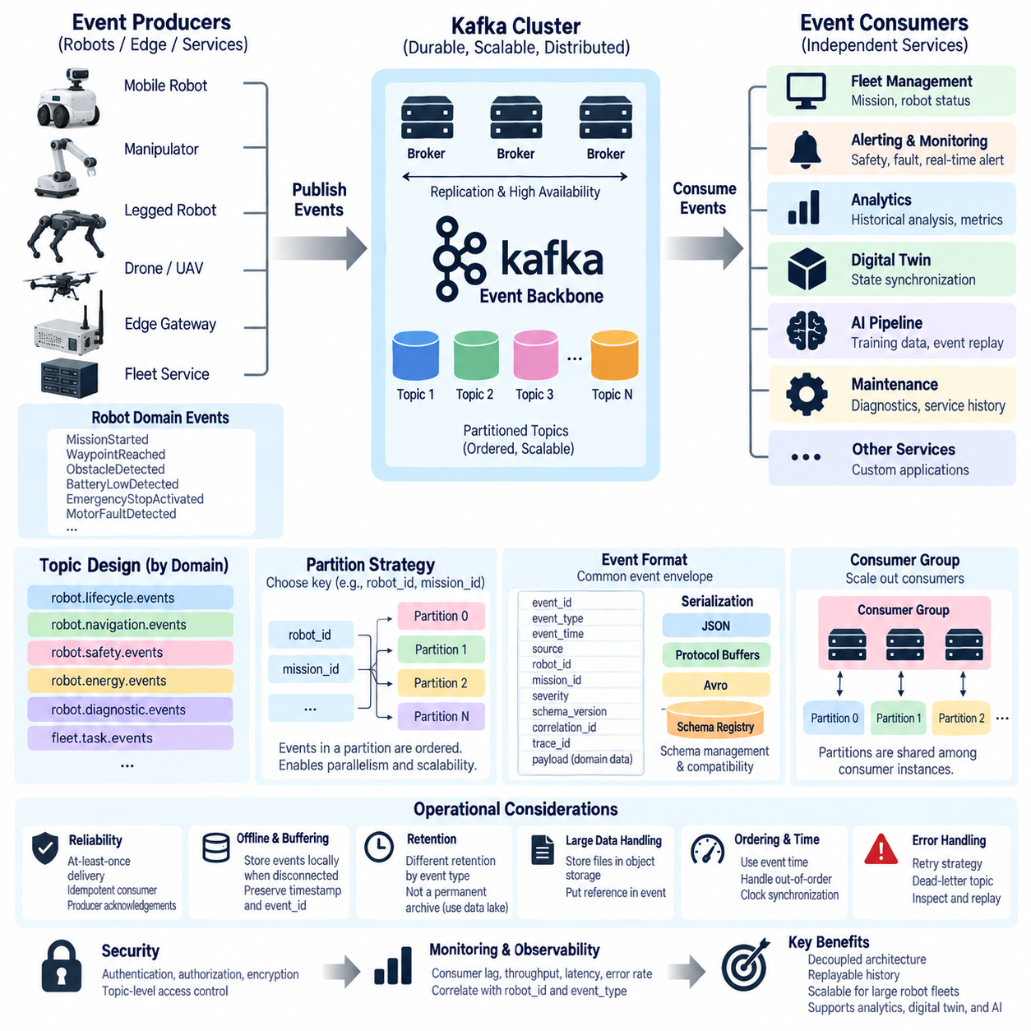
Apache Kafka provides a distributed event-streaming foundation for robot systems that must continuously exchange operational events across robots, edge computers, fleet platforms, cloud services, digital twins, and analytics applications. Instead of connecting every producer directly to every consumer, Kafka introduces a durable event backbone where robot events can be published once and independently consumed by multiple services.
In a Kafka-based robot architecture, producers generate domain events representing meaningful facts such as MissionStarted, WaypointReached, ObstacleDetected, BatteryLowDetected, EmergencyStopActivated, or MotorFaultDetected. Producers may run directly on robots, on edge gateways, or inside fleet services. Their responsibility is to construct valid events, serialize them according to the agreed schema, and publish them to appropriate Kafka topics.
Kafka topics provide logical channels for organizing robot events. Topic design should follow stable domain boundaries rather than creating arbitrary topics for every individual message. Examples might include robot.lifecycle.events, robot.navigation.events, robot.safety.events, robot.energy.events, and fleet.task.events. This organization allows consumers to subscribe to relevant event domains while preserving a consistent naming strategy across different robot models and operational environments.
A topic is divided into partitions, which provide Kafka with parallelism and scalability. Events within one partition maintain an ordered sequence, while ordering is not guaranteed globally across all partitions. Robot systems must therefore choose partition keys carefully. Using robot_id as the key keeps events from the same robot in the same partition, while mission_id may be appropriate when ordering must be maintained around a particular mission or workflow.
Partition strategy directly influences system scalability. If thousands of robots publish events through a small number of partitions, throughput can become constrained. Creating excessive partitions, however, increases broker and operational overhead. Partition counts should therefore consider expected fleet size, event rate, message size, consumer parallelism, retention requirements, and future expansion rather than being selected only from the current deployment scale.
Kafka brokers receive events from producers and store them as ordered records inside topic partitions. Multiple brokers can form a Kafka cluster, distributing partitions and replicas across servers. This architecture allows robot event streams to continue operating even when individual infrastructure components fail, provided replication and availability settings are appropriately configured. Broker placement can span edge data centers, on-premise infrastructure, or cloud environments depending on system requirements.
Consumers read events from Kafka topics independently of producers. A fleet management service may process mission events, an alerting service may subscribe to safety and diagnostic events, and an analytics pipeline may consume several domains simultaneously. Because each consumer maintains its own processing position, one slow analytics application does not necessarily prevent another real-time operational service from consuming the same event stream.
Consumer groups enable multiple instances of the same application to share event-processing workloads. Kafka assigns topic partitions among consumers within a group so that each partition is processed by one active consumer in that group at a time. Increasing consumer instances can therefore increase processing capacity when sufficient partitions exist. This mechanism is useful for scaling fleet monitoring, event enrichment, analytics, and AI data-processing services.
Kafka tracks the position of a consumer through an offset. The offset identifies where processing has progressed within a partition. If a service restarts, it can resume from its previously committed offset rather than requesting events again from each robot. Consumers may also reset offsets to earlier positions, enabling historical event replay for debugging, analytics, state reconstruction, testing, or recovery after application failures.
Event replay is especially valuable in robotics because operational incidents often require reconstruction after they occur. Engineers can replay navigation, mission, safety, diagnostic, and communication events around a failure without reproducing the physical situation. Digital twins can rebuild historical state, analytics systems can apply new algorithms to previous events, and AI pipelines can identify useful training samples from previously recorded robot operations.
Every Kafka event should preserve the common robot event envelope established by the domain model. Fields such as event_id, event_type, event_time, source, robot_id, mission_id, severity, schema_version, correlation_id, and trace_id provide consistent metadata. The payload contains domain-specific information. Keeping this structure independent from Kafka itself prevents the business meaning of an event from becoming tightly coupled to a particular streaming technology.
Serialization can use JSON during development or integration scenarios where readability is valuable, while Protocol Buffers or Avro may be preferable for compact, strongly structured production streams. A schema registry can centrally manage event schemas and compatibility rules. Producers can be prevented from publishing incompatible schema changes, while consumers can determine which schema version is required to deserialize and interpret an event correctly.
Delivery semantics must be selected according to operational requirements. At-most-once processing may lose an event but avoids duplicates, while at-least-once processing prioritizes delivery and may produce duplicate processing after failures or retries. Exactly-once capabilities can reduce duplicate effects within supported Kafka processing workflows, but application-level correctness still requires careful transaction boundaries, event identity, and downstream system design.
For many robot systems, at-least-once delivery combined with unique event identifiers and idempotent consumers provides a practical reliability model. If BatteryLowDetected or MissionCompleted is delivered twice, the receiving service should recognize the duplicate and avoid creating repeated charging requests, mission records, notifications, or maintenance actions. Reliability must therefore be designed across the complete producer-broker-consumer path.
Producer acknowledgement configuration determines how strongly Kafka confirms that an event has been stored. Higher durability settings can require acknowledgement from appropriate replicated broker state before a publish operation is considered successful. For critical safety, mission, or maintenance events, durability may be prioritized over minimum latency. Less critical informational events may permit different performance trade-offs depending on operational requirements.
Robots cannot always maintain continuous connectivity with Kafka infrastructure. Indoor wireless networks, outdoor cellular networks, tunnels, elevators, remote facilities, and temporary access-point transitions can interrupt communication. An onboard or edge buffering mechanism should temporarily persist important events and transmit them after connectivity returns. Original event timestamps and identifiers must be preserved so delayed events are not mistaken for newly generated events.
Backpressure must also be considered when event production exceeds downstream processing capacity. Kafka can absorb temporary differences between producer and consumer rates because events remain stored in partitions, but persistent consumer lag indicates that processing capacity is insufficient. Robot systems should monitor lag, event throughput, broker utilization, partition distribution, publish latency, error rates, and storage consumption as operational health indicators.
Retention policies determine how long Kafka keeps robot events independently of whether consumers have already processed them. Short retention may be sufficient for high-volume transient events, while mission, safety, diagnostic, or audit events may require longer retention. Kafka should not automatically be treated as the permanent archive for every robot dataset; long-term records may be transferred to databases, object storage, data lakes, or specialized analytical repositories.
Large sensor objects should generally not be inserted directly into ordinary Kafka domain events. Images, video segments, point clouds, maps, and large diagnostic files can quickly consume broker bandwidth and storage. A better pattern stores large data in object storage or another sensor-data repository and places a reference, object identifier, timestamp, checksum, or metadata record in the Kafka event that initiated or describes the data.
Event-time information must remain explicit because Kafka ingestion order does not always represent the actual physical sequence of robot behavior. Buffered events can arrive late, network paths can introduce different delays, and distributed producers may have clock differences. Consumers performing temporal correlation should distinguish event time from broker ingestion time and use synchronization, sequence information, and domain-specific ordering rules where required.
Correlation identifiers allow events belonging to one operational flow to be analyzed together. A MissionStarted event can be associated with NavigationStarted, WaypointReached, PathBlocked, ReplanningStarted, GoalReached, and MissionCompleted events through a common mission or correlation identifier. Trace information can extend this visibility across robot software, edge services, Kafka consumers, databases, APIs, and fleet applications.
Failure handling should include retry strategies and dead-letter processing. An event that cannot be deserialized, validated, enriched, or processed should not repeatedly block an entire consumer pipeline. After controlled retries, problematic events can be routed to a dead-letter topic together with failure metadata. Engineers can inspect, correct, replay, or quarantine these records without disrupting normal robot event processing.
Security must be integrated into the streaming architecture from the beginning. Robot producers and service consumers should authenticate before accessing Kafka, communication channels should be encrypted where required, and authorization policies should restrict which topics each identity can publish or consume. Safety events, operational records, human-interaction events, and fleet information may require different access permissions and retention controls.
Observability connects Kafka infrastructure health with robot operational health. Metrics from brokers, producers, consumers, and consumer groups should be correlated with robot identifiers, event types, and application traces where possible. A growing consumer lag, repeated serialization failures, abnormal partition imbalance, or sudden reduction in robot event throughput can reveal infrastructure problems before they become visible as fleet-level operational failures.
A Kafka-based robot event stream ultimately separates event production from event consumption while preserving durable, replayable operational history. Robots can publish meaningful facts without knowing every downstream application, while fleet management, monitoring, analytics, digital twins, maintenance systems, and AI pipelines can evolve independently. This decoupling provides a scalable foundation for the subsequent stream-processing, state-management, event-sourcing, replication, monitoring, and security layers of the robot data architecture.

04.04 Kafka Connect: Robot Data Source Connector [w/Code]
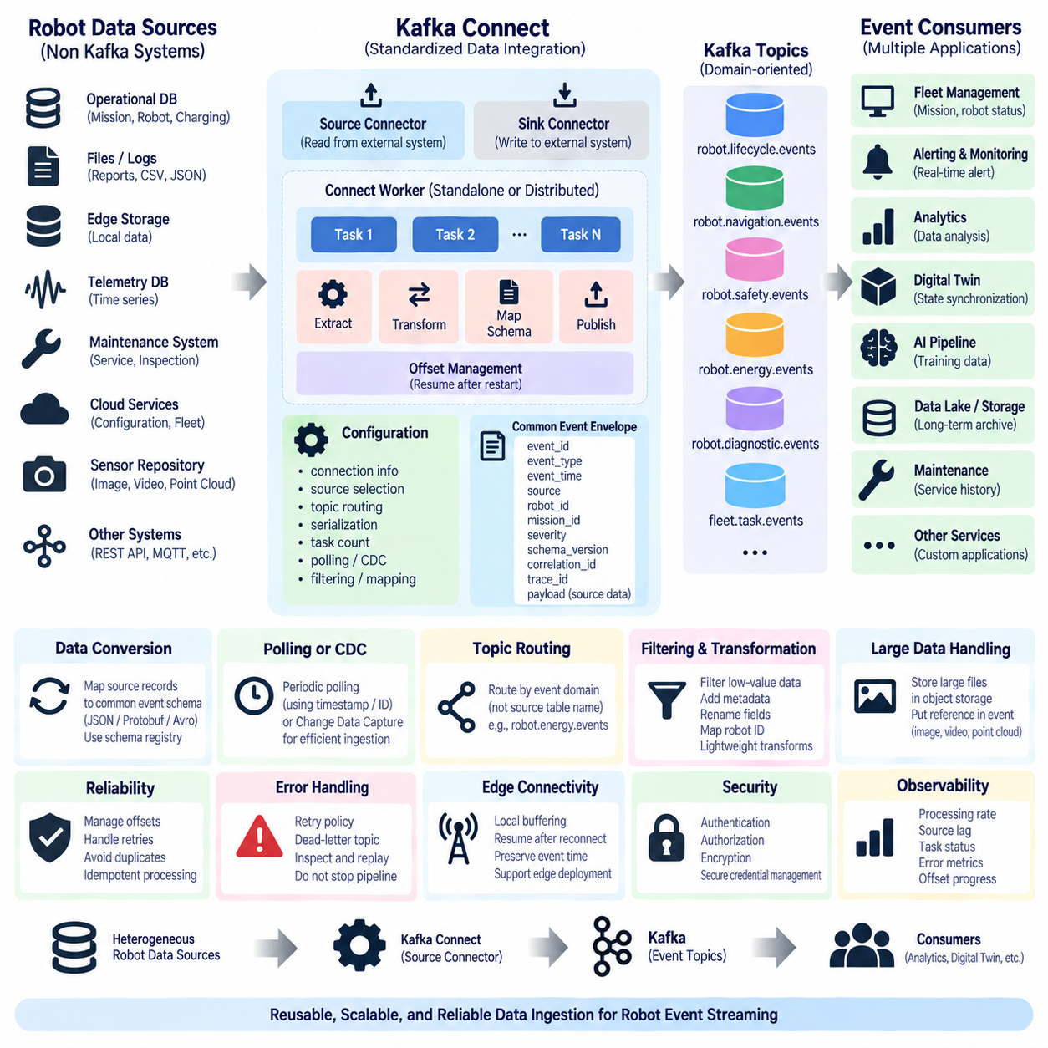
Kafka Connect provides a standardized integration layer for moving robot data between external systems and Apache Kafka without requiring every data transfer path to be implemented as a custom application. In a robot data architecture, it can connect operational databases, edge storage, files, telemetry repositories, maintenance systems, and other data sources to Kafka, allowing streaming pipelines to be constructed around reusable connector components.
Kafka Connect distinguishes between source connectors and sink connectors. A source connector reads data from an external system and publishes records into Kafka topics, while a sink connector consumes Kafka records and writes them to an external destination. For robot event streaming, source connectors are especially useful when operational information originates in systems that do not natively publish Kafka events.
A robot data source connector acts as an adapter between the source-specific data model and the event-streaming architecture. The source may contain robot status records, mission histories, diagnostic results, charging information, maintenance records, or telemetry summaries. The connector extracts relevant changes, transforms them into structured records, attaches required metadata, and publishes them into the appropriate Kafka topic.
Kafka Connect operates through workers that execute connector instances and their tasks. A connector defines how an external system is accessed and how work should be divided, while tasks perform the actual movement of data. This separation allows one logical connector to scale across multiple tasks when a source contains many robots, database partitions, files, devices, or independent data streams.
Workers can operate in standalone or distributed mode. Standalone mode is useful for development, local testing, or small edge deployments because configuration and execution remain relatively simple. Distributed mode allows multiple workers to cooperate as a cluster, providing workload distribution, configuration management, fault recovery, and scalability suitable for production robot fleets and enterprise data platforms.
A source connector configuration normally defines connection information, connector implementation, source selection rules, destination topics, serialization settings, task count, and source-specific parameters. Robot-oriented deployments may additionally define robot identifiers, fleet identifiers, event-domain mappings, polling intervals, timestamp rules, filtering policies, and mappings between source fields and the common robot event schema.
Topic routing should follow the domain-oriented event architecture rather than merely reproducing source-system table or file names. Data originating from different systems may represent the same operational domain. A database charging record and an edge-generated charging status, for example, may both need to enter robot.energy.events after normalization instead of creating unrelated topics based solely on their physical sources.
The connector should convert source records into the common event envelope whenever the source represents meaningful domain events. Fields such as event_id, event_type, event_time, source, robot_id, mission_id, severity, schema_version, correlation_id, and trace_id can provide consistent metadata. Source-specific attributes should remain inside the payload so downstream consumers receive a predictable structure independent of the original system.
Not every source record should automatically become a domain event. Continuous measurements such as motor current, temperature, position, or battery voltage may belong to telemetry streams, while a threshold transition such as ComputeOverTemperature or BatteryLowDetected can become a domain event. Connector design must therefore preserve the distinction between telemetry, events, logs, commands, and other robot data categories.
Serialization should be selected consistently with the surrounding Kafka architecture. JSON provides readability and straightforward debugging, while Protocol Buffers or Avro can provide compact representation and stronger schema control. When a schema registry is used, connector-produced records can reference governed schemas so that downstream consumers interpret robot events consistently even as connector implementations and source systems evolve.
Many robot data sources are not event-native and must be polled periodically. A connector can query a database using timestamps, incrementing identifiers, update markers, or other source-specific offsets to identify newly created or modified records. The polling interval represents a trade-off: shorter intervals reduce data latency but increase load on the source, while longer intervals reduce load at the cost of delayed event availability.
Change Data Capture, or CDC, can provide a more efficient approach for database-oriented robot systems. Instead of repeatedly querying complete tables, a CDC mechanism observes database changes and converts inserts, updates, and deletes into streaming records. This can be valuable for mission databases, fleet configuration repositories, maintenance systems, or operational applications where database changes must quickly propagate into Kafka.
Source offsets are essential for reliable ingestion. Kafka Connect records the position from which a source task has successfully processed data, allowing ingestion to continue after worker restarts or failures. Depending on the source, an offset might represent a database sequence, timestamp, file position, message identifier, or another progress marker. Correct offset management prevents unnecessary full reprocessing of robot data after recovery.
Nevertheless, failures and retries can still produce duplicate records, particularly when the source operation and Kafka publication cannot participate in one atomic transaction. Robot event consumers should therefore retain the reliability principles used throughout the event architecture: stable event identifiers, deterministic mapping where possible, duplicate detection, and idempotent downstream processing.
Transformation is often required because external robot systems rarely expose data in exactly the format required by the streaming architecture. Kafka Connect supports lightweight record transformations that can rename fields, add metadata, remove unnecessary attributes, route records, or modify keys. More complex domain interpretation should normally remain in dedicated stream-processing or application services rather than being hidden inside complicated connector logic.
Robot identity mapping deserves special attention. Different systems may identify the same robot using serial numbers, database keys, device IDs, hostnames, or fleet-specific identifiers. The connector layer should map these source identifiers to the canonical robot_id defined by the robot data architecture. Without consistent identity, downstream correlation across telemetry, missions, diagnostics, digital twins, and maintenance records becomes unreliable.
Timestamp handling requires similar normalization. A source may contain device time, database update time, server time, or ingestion time. The connector should preserve the timestamp representing when the operational fact actually occurred whenever that value is available, while separately retaining ingestion or processing timestamps when required. This prevents polling delay or temporary disconnection from changing the apparent sequence of robot behavior.
Edge connectivity creates additional design constraints. A robot or local gateway may temporarily lose access to the central Kafka cluster while continuing to generate data. Local persistence, buffering, or an edge Kafka-compatible layer can preserve important records until communication returns. After reconnection, the connector should resume from its stored offset and maintain original identifiers and event times rather than treating buffered records as new occurrences.
Large binary sensor data should not normally pass directly through a general-purpose Kafka Connect event connector. Images, video, point clouds, maps, ROS bag files, and large diagnostic artifacts are better stored in object storage or dedicated sensor-data repositories. The connector can publish metadata, storage references, checksums, robot identifiers, timestamps, and event relationships into Kafka without placing the complete binary object in the event stream.
Filtering reduces unnecessary traffic and downstream processing. A connector may exclude unchanged records, low-value fields, development-only diagnostics, or data outside the required robot population. Filtering rules should remain transparent and governed because overly aggressive filtering can remove information required for incident reconstruction, analytics, compliance, or AI data selection.
Error handling must prevent malformed source data from stopping the complete ingestion pipeline. Invalid schemas, conversion errors, missing identifiers, unsupported values, or serialization failures should be observable and handled according to defined policies. Depending on importance, a record may be retried, skipped with audit information, or routed to a dead-letter topic for inspection and controlled replay.
A dead-letter topic provides a separate path for records that cannot be processed normally. Failure metadata should explain the connector, source, timestamp, error category, and processing stage associated with the rejected record. Engineers can investigate and correct these records without stopping valid robot data ingestion, which becomes increasingly important as fleet size and source diversity grow.
Connector observability should cover both Kafka-side and source-side behavior. Useful indicators include records processed per second, polling latency, source lag, task status, restart frequency, serialization failures, error counts, Kafka publish latency, and offset progress. Monitoring these metrics helps distinguish whether missing robot events originate from the robot source, connector worker, network, Kafka cluster, or downstream consumer.
Security must protect both sides of the connector. Credentials used to access databases, file systems, cloud services, or edge gateways should not be embedded carelessly in configuration files. Kafka authentication, authorization, and encryption should be combined with secure secret management and minimum required privileges for the external source. Each connector should access only the sources and topics required for its assigned function.
Deployment architecture can place connectors centrally or near robot data sources. Centralized connectors simplify administration when systems are accessible through reliable enterprise networks. Edge-deployed connectors can reduce latency, tolerate intermittent wide-area connectivity, and avoid exposing local robot systems directly to cloud infrastructure. Hybrid architectures may combine edge ingestion with centralized Kafka processing and long-term data platforms.
Configuration and connector versions should be managed as controlled software artifacts. Changes to topic routing, schema mapping, filtering, credentials, polling behavior, or transformation logic can alter the meaning of production data. Version control, automated validation, staged deployment, rollback capability, and compatibility testing therefore belong to connector lifecycle management just as they do to robot application software.
Kafka Connect ultimately provides a reusable bridge between heterogeneous robot data sources and the Kafka event backbone. By standardizing source access, task execution, offset tracking, schema mapping, error handling, security, and operational monitoring, it reduces custom integration code while preserving the domain-oriented event model. This creates a reliable ingestion foundation for subsequent Flink processing, stateful streaming, event sourcing, replication, monitoring, and secure robot data operations.

04.05 Apache Flink Event Stream Processing [w/Code]
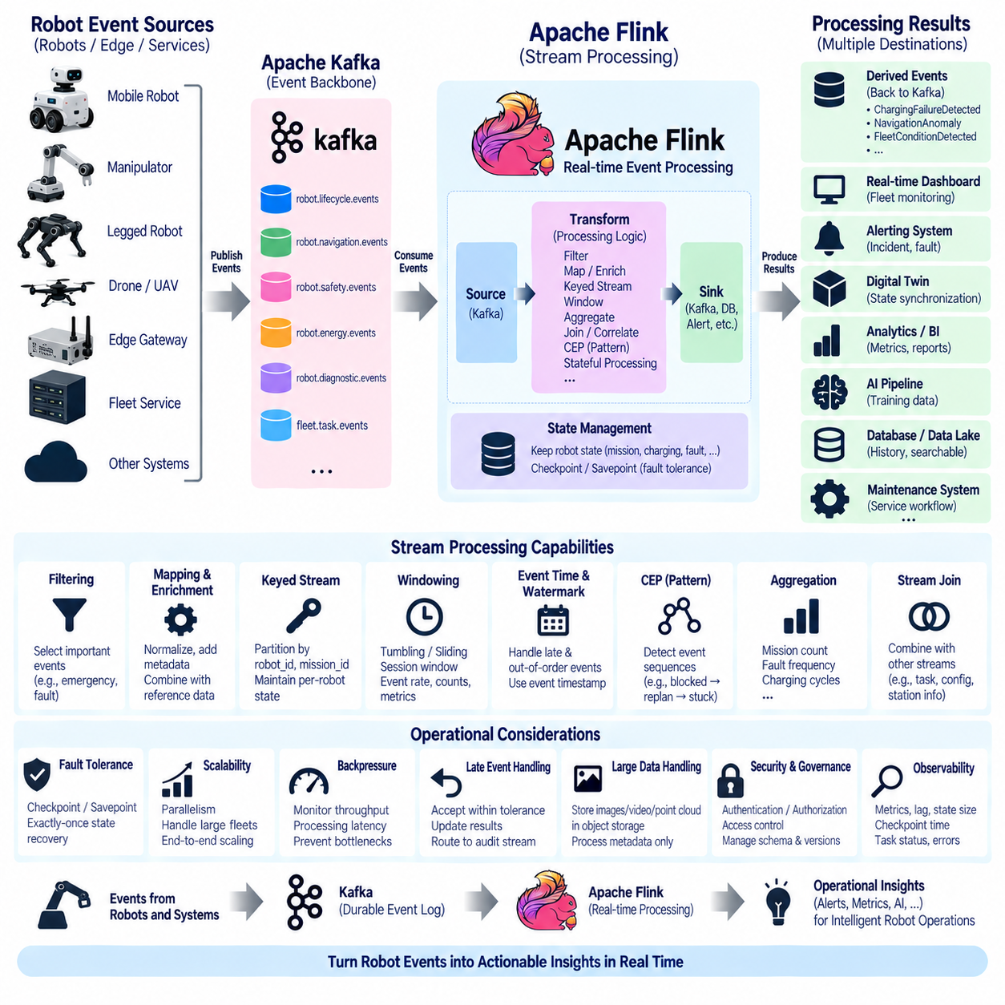
Apache Flink is a distributed stream-processing framework designed to perform continuous computation over unbounded data streams. Within robot data architecture, Flink can process events arriving from robots, edge gateways, Kafka topics, fleet services, and operational systems as they occur. Instead of waiting for a complete batch, it continuously evaluates incoming events and produces operational results with low processing latency.
A typical robot streaming pipeline places Flink downstream of an event backbone such as Apache Kafka. Robots and integration services publish navigation, mission, safety, energy, diagnostic, perception, and fleet events into Kafka topics. Flink consumes these streams, applies transformation and analysis logic, and publishes derived events or results to Kafka, databases, alerting systems, digital twins, dashboards, or AI data pipelines.
Flink applications are commonly expressed as dataflow graphs consisting of sources, transformations, and sinks. Sources ingest robot events from Kafka or other systems. Transformations filter, map, aggregate, correlate, enrich, or analyze those events. Sinks deliver processing results to external destinations. This model allows complex robot event-processing logic to be represented as a continuous flow rather than a sequence of periodic batch jobs.
Filtering is one of the simplest but most useful stream operations. A fleet may generate millions of normal operational events while only a subset requires immediate processing. Flink can select events such as EmergencyStopActivated, LocalizationLost, BatteryLowDetected, or MotorFaultDetected while allowing routine events to follow different paths. Filtering near the beginning of a pipeline reduces unnecessary downstream computation and communication.
Mapping and enrichment convert incoming robot events into structures required by downstream applications. A stream may normalize field names, derive operational attributes, attach fleet metadata, or combine robot events with reference information such as robot model, site, capability, or maintenance configuration. Enrichment should preserve event identity and timestamps so that transformed records remain traceable to their original operational facts.
Keyed streams allow processing to be organized around logical robot entities. Events can be partitioned by robot_id, mission_id, site_id, or another domain key before stateful operations are applied. Events with the same key are then processed within the same logical context. This enables Flink to maintain independent state for thousands of robots or missions while executing one distributed processing application across the complete fleet.
Window operations group events for computation over bounded portions of an otherwise continuous stream. Tumbling windows divide time into fixed non-overlapping intervals, sliding windows evaluate overlapping intervals, and session windows identify periods of activity separated by inactivity. Robot applications can use windows to calculate event rates, fault counts, mission throughput, charging frequency, or navigation anomalies over meaningful operational periods.
Time semantics are especially important because robot events may arrive later than the physical occurrences they represent. Flink distinguishes event time from processing time, allowing computation to follow the timestamp of the original event rather than only the moment when the processing engine receives it. This is valuable when wireless disconnection, edge buffering, network congestion, or distributed communication introduces variable delivery delays.
Watermarks provide a mechanism for estimating progress through event time. They allow Flink to determine when a time window can reasonably be evaluated even though some events may arrive late or out of order. Robot systems should configure watermark strategies according to expected communication delays. A warehouse Wi-Fi fleet and an outdoor cellular robot fleet may require substantially different assumptions about acceptable event lateness.
Late events must be handled according to their operational importance. A delayed mission event may still be useful for historical analytics, while a delayed emergency event may require different treatment because its real-time response opportunity has passed. Processing logic can accept late records within a defined tolerance, update previous results where appropriate, or route excessively late events to a separate stream for auditing and offline analysis.
Stateful processing is one of Flink's central capabilities. Instead of examining each event independently, an application can remember information from previous events and use it when processing subsequent ones. For each robot, the system might retain its last known mission state, charging status, fault condition, navigation mode, or recent event history. This enables detection of operational patterns that cannot be identified from isolated messages.
For example, BatteryLowDetected followed by ChargingRequested and ChargingStarted represents a normal operational sequence. If ChargingStarted does not appear within an expected period, Flink can identify a possible charging workflow failure. Similarly, repeated LocalizationLost events within a short interval may indicate an environmental or sensor problem even when each individual event alone would not justify a high-priority alert.
Event correlation allows streams from different domains to be analyzed together. A navigation fault can be correlated with communication loss, low battery state, sensor failure, or environmental perception events occurring around the same time. Such correlations provide richer operational context than single-domain monitoring and can support root-cause analysis, automated recovery decisions, maintenance prioritization, and fleet-level anomaly detection.
Complex Event Processing, commonly called CEP, extends this idea by identifying predefined sequences or patterns across event streams. A robot application might detect a sequence such as PathBlocked, ReplanningStarted, PathBlocked, and RobotStuck within a specified time interval. Another pattern could combine ComputeOverTemperature with repeated processing delays and SensorUnavailable to identify a developing onboard computing problem.
Aggregations transform many events into operational metrics or summaries. Flink can continuously calculate completed missions per robot, fault frequency per site, average charging cycles, emergency events per fleet, or navigation failures over a defined interval. These derived results can be written to monitoring systems or time-series databases without requiring every downstream application to repeatedly process the complete raw event history.
Flink also supports stream joins, allowing robot event streams to be combined with other dynamic or reference streams. Mission events can be joined with task assignments, diagnostic events with robot configuration, or charging events with station information. The join key and time relationship must be carefully designed because continuous streams do not naturally have the finite boundaries associated with traditional database tables.
Processing guarantees are important when stream results trigger operational actions. Flink can coordinate state and source progress through checkpointing so that applications can recover consistently after failures. When supported sources and sinks participate correctly, exactly-once state consistency can be maintained across processing. This reduces the risk that failures cause state updates to be lost or applied repeatedly during recovery.
Checkpoints periodically capture the processing state of a running application together with information required to resume stream consumption. If a worker fails, the application can restore a recent checkpoint and continue processing from a consistent position. For robot fleets, this means accumulated mission, fault, charging, or correlation state does not need to be rebuilt from the beginning after every infrastructure failure.
Savepoints provide a related mechanism intended for controlled operational changes rather than routine failure recovery. They can preserve application state before an upgrade, configuration change, scaling operation, or migration. A new version of a robot event-processing application can therefore resume from preserved state instead of discarding knowledge accumulated for active missions and fleet operations.
Parallelism enables Flink applications to scale as robot fleets and event volumes grow. Operators within the processing graph can execute across multiple task instances, and keyed data can be distributed among them. Scaling should consider Kafka partition counts, key distribution, state size, processing complexity, network transfer, checkpoint duration, and sink capacity because increasing parallelism in only one layer may simply move the bottleneck elsewhere.
Backpressure occurs when a downstream operator or sink processes records more slowly than upstream components produce them. Persistent backpressure can increase latency and eventually affect the responsiveness of real-time robot applications. Monitoring should therefore examine throughput, processing latency, busy time, backpressure, checkpoint duration, restart frequency, Kafka consumer lag, state size, and sink performance as related indicators.
Flink does not replace Kafka in this architecture. Kafka primarily provides durable event transport, buffering, partitioned storage, and replay, while Flink performs continuous computation over those event streams. Kafka retains operational facts so multiple applications can consume them independently, whereas Flink interprets, correlates, aggregates, and transforms those facts into higher-level information and derived events.
Large images, video, point clouds, maps, and ROS bag data should generally remain outside ordinary Flink event processing paths. Events can contain references to objects stored in dedicated sensor repositories or object storage. Flink can process their metadata, trigger workflows, correlate references with operational events, or decide which datasets should be retained for AI training without transferring the complete binary payload through every stream operator.
Stream-processing results should remain aligned with the robot domain event model. If Flink detects a charging failure, navigation anomaly, repeated localization problem, or fleet-level condition, it can publish a new derived domain event with its own event_id while retaining correlation identifiers that reference the source events. This maintains lineage between raw operational facts and higher-level conclusions generated by stream processing.
Security and governance remain necessary because Flink applications can consume events from multiple sensitive domains and produce operational decisions. Access to Kafka topics, state backends, checkpoints, configuration, and output systems should follow appropriate authentication and authorization policies. Processing logic, schemas, event definitions, and application versions should also be governed so derived events have clear and reproducible meanings.
Apache Flink therefore forms the real-time computation layer of a robot event-streaming architecture. Kafka and connectors collect and transport operational facts, while Flink converts continuous streams into correlated state, metrics, patterns, alerts, and derived events. This provides the processing foundation for stateful event management, event sourcing, monitoring, predictive maintenance, digital twins, and increasingly intelligent fleet operations.

04.06 Event Stream State Management: Stateful Processing [w/Code]
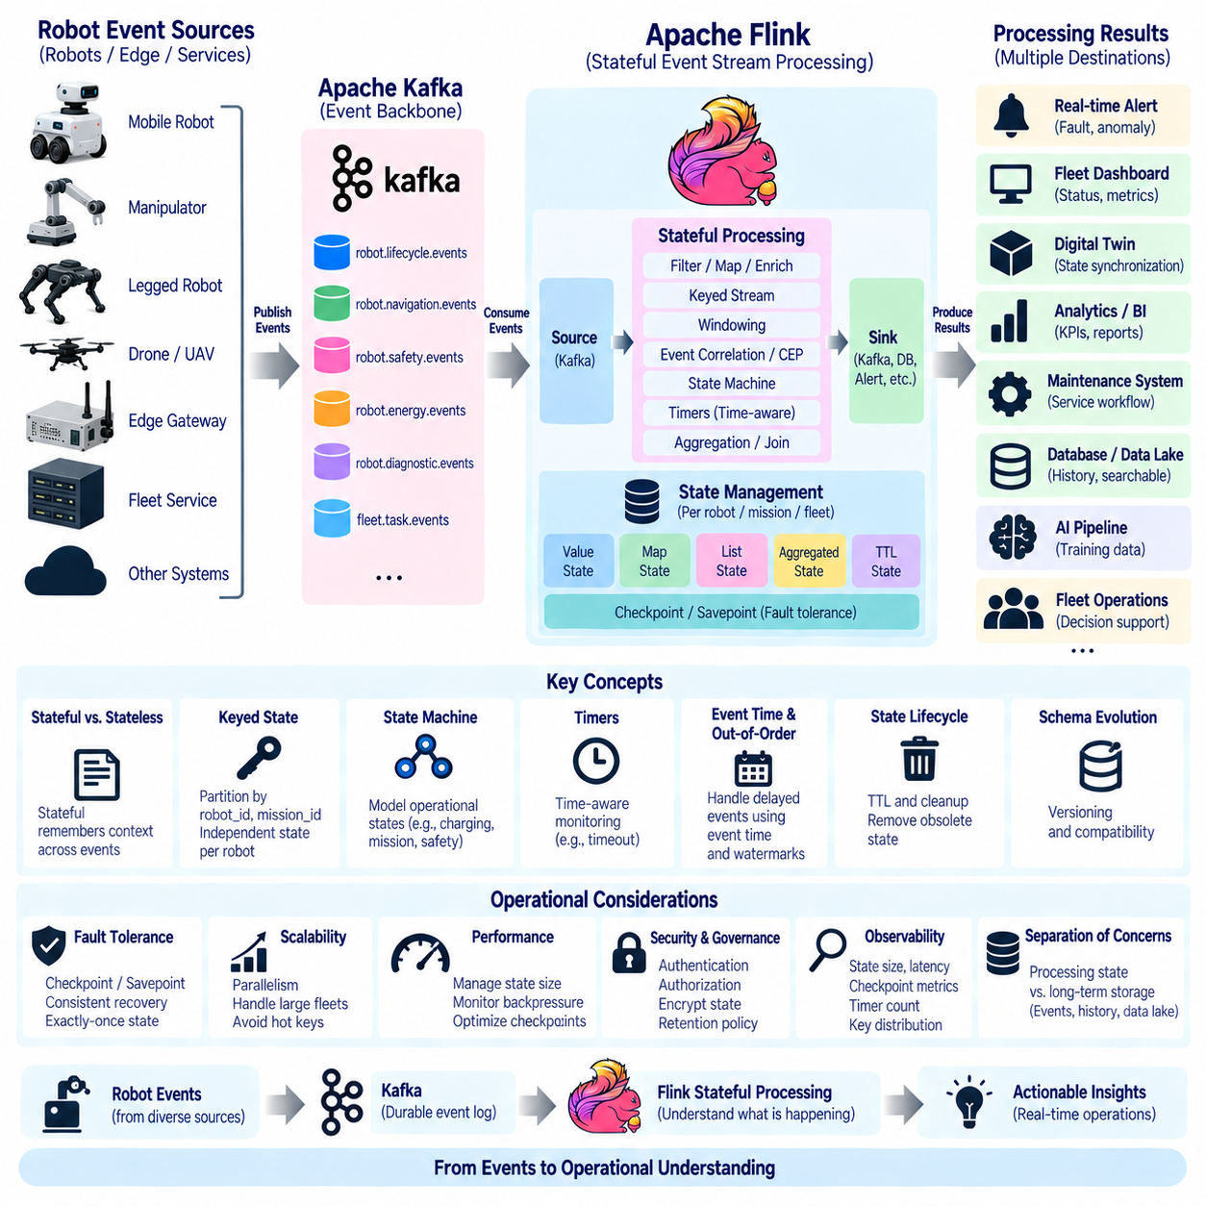
State management is the mechanism that allows an event-stream processing system to remember information from previously processed events and use that information when interpreting new events. In robot systems, this capability is essential because operational meaning often emerges from sequences and accumulated conditions rather than isolated messages. A robot’s current mission, navigation mode, battery condition, fault status, and connectivity state all depend on previous events.
Stateless processing evaluates each incoming event independently and produces an output without retaining information for future processing. Stateful processing, by contrast, preserves context across events. An individual BatteryLowDetected event provides useful information, but determining whether the robot requested charging, reached a charging station, and successfully started charging requires state maintained across multiple events and potentially several minutes of operation.
Robot event state should represent operational knowledge rather than duplicate every piece of raw telemetry. Useful state may include the current mission identifier, active task, navigation phase, charging mode, latest safety condition, communication status, maintenance state, and recent fault history. High-frequency measurements such as individual motor currents or camera frames normally remain in telemetry or sensor storage unless they are specifically required by a stateful processing algorithm.
A common approach is keyed state, where state is logically separated according to a domain identifier such as robot_id, mission_id, fleet_id, or charging_station_id. When events are keyed by robot_id, every robot can maintain an independent operational context even though thousands of robots are processed by the same distributed application. This structure enables horizontal scaling without mixing the state of unrelated robots.
For example, a robot-specific state may record MissionStarted followed by NavigationStarted and successive WaypointReached events. When GoalReached arrives, the processor can verify that the event belongs to the expected mission and navigation sequence. If MissionCompleted appears without the required preceding operational states, the system can detect an inconsistent transition and generate a diagnostic or derived event for further analysis.
State can be represented using simple values, collections, maps, or more specialized application structures. A value state may store the current battery mode, while a map state may maintain active faults indexed by fault code. List-like state can retain recent navigation anomalies, and aggregated state can continuously calculate counts or statistics. The state representation should remain as small and semantically focused as possible to control memory, storage, and recovery costs.
State machines provide a useful model for robot operational processing. A charging workflow, for example, may transition through Normal, LowBattery, ChargingRequested, NavigatingToCharger, Charging, and Charged states. Events trigger transitions between these states, while invalid or missing transitions can reveal operational problems. Similar state machines can represent missions, maintenance workflows, safety conditions, remote-control sessions, or robot lifecycle states.
Stateful processing becomes especially powerful when combined with timers. After ChargingRequested, a timer can be registered for an expected response interval. If ChargingStarted occurs before the timer expires, the timer can be cleared. If no charging event arrives within the allowed period, the processor can generate ChargingStartTimeout or another derived event. Timers therefore convert retained state into time-aware operational supervision.
Event time should be considered when timers and state transitions depend on when physical events actually occurred. Network delays, edge buffering, temporary disconnections, and retransmission can cause events to arrive later than their original occurrence. Processing only according to arrival time may incorrectly interpret delayed robot events. Event-time state processing preserves the relationship between operational state and the actual timeline of robot behavior.
Out-of-order events create another state-management challenge. A GoalReached event might arrive before an earlier WaypointReached event because of buffering or different communication paths. The processing system must define whether such late events can update existing state, whether results should be corrected, or whether the event should be routed for separate analysis. These policies should reflect the operational importance and timing characteristics of each event domain.
State has a lifecycle and should not remain indefinitely without purpose. A completed mission may no longer require detailed active-processing state after an appropriate retention period. Temporary fault correlation state can expire when the observation window closes, while long-lived robot configuration state may remain much longer. Time-to-live policies help remove obsolete state and prevent continuous growth as fleet operations accumulate.
Stateful processing should distinguish active computational state from permanent historical records. Processing state exists to support current stream computation and rapid recovery, while databases, event stores, or data lakes preserve long-term operational history. Treating stream-processing state as a permanent database can increase recovery time and operational complexity. Historical records should therefore be retained in systems designed specifically for durable long-term storage.
Checkpointing provides fault tolerance by periodically capturing a consistent representation of application state together with stream-processing progress. If a processing node fails, the application can restore a recent checkpoint and continue from a consistent position. For robot operations, this prevents active mission, charging, fault, or correlation context from disappearing whenever an infrastructure component restarts or becomes unavailable.
Checkpoint consistency is particularly important when state updates and event consumption occur together. Without coordinated recovery, an event might be processed twice or state might be restored to a position inconsistent with the input stream. Frameworks such as Apache Flink coordinate checkpoints with stream positions so state and event progress can be recovered consistently, supporting reliable stateful processing across distributed robot workloads.
Savepoints complement checkpoints by providing controlled snapshots for operational changes. Before upgrading a stream-processing application, changing parallelism, migrating infrastructure, or deploying revised state logic, operators can create a savepoint. The updated application can then restore the preserved state, allowing active robot and mission contexts to continue rather than forcing the complete state model to restart from an empty condition.
State schema evolution must be planned because processing applications change over time. A new software version may add a field to robot state, change a fault representation, or introduce a new mission phase. If existing state cannot be interpreted by the updated application, deployment becomes risky. State structures should therefore use controlled versioning, compatibility rules, migration procedures, and validation similar to event-schema governance.
State size directly influences processing performance and recovery behavior. Keeping extensive histories for every robot can increase memory consumption, checkpoint size, network traffic, and restoration time. Applications should retain only information required for current computation and move detailed historical data to external storage. Aggregation, expiration, compact representations, and bounded histories help maintain predictable performance as fleet size increases.
State backends determine where and how processing state is physically maintained. Small state may fit efficiently in memory, while large fleet-scale workloads may require embedded persistent storage or other managed state mechanisms. The choice should consider state volume, access frequency, checkpoint performance, recovery objectives, hardware resources, and the expected number of simultaneously active robots, missions, and event correlations.
Partitioning and state locality are closely related. Events associated with the same key should reach the processing task that owns the corresponding state. This minimizes remote access and enables efficient local state operations. When application parallelism changes, keyed state may need to be redistributed across processing tasks. The architecture should support this redistribution without losing state or mixing the contexts of different robots.
Hot keys can create imbalance even when overall event volume appears manageable. A highly active robot, site, fleet, or shared resource may generate significantly more events than other keys, concentrating computation and state on one processing task. Monitoring key distribution and workload skew is therefore important. Domain keys should be selected not only for semantic correctness but also with expected traffic patterns and scalability in mind.
Stateful event correlation can combine multiple operational domains. A robot experiencing LocalizationLost may also have SensorUnavailable, NetworkDisconnected, or ComputeOverTemperature events in its recent state. Rather than treating each event independently, the processor can correlate them within a defined time range and produce a higher-level condition. This supports richer diagnosis and reduces dependence on isolated threshold-based alerts.
State can also support fleet-level processing. Individual robot states may be aggregated into site or fleet state representing the number of available robots, charging demand, active faults, mission backlog, or traffic conditions. Such state must be designed carefully because fleet-wide aggregation can create centralized bottlenecks. Hierarchical aggregation can first summarize robot-level information before producing broader operational views.
Derived events should preserve lineage to the state and source events that produced them. If stateful processing determines that a robot has entered a repeated localization failure condition, the resulting event should receive its own event_id while retaining robot_id, correlation identifiers, relevant timestamps, and references to supporting events where appropriate. This enables downstream systems to understand how a higher-level operational conclusion was generated.
Exactly-once state consistency can be valuable when stateful results affect mission records, maintenance actions, billing, or other operations where duplicate effects are undesirable. However, processing guarantees must extend beyond internal state. External sinks and services must also support appropriate transactional or idempotent behavior. Exactly-once state inside a stream processor alone does not guarantee exactly-once business effects across the entire robot platform.
Observability should expose the health of both processing logic and retained state. Important indicators include state size, checkpoint duration, checkpoint failures, restoration time, timer counts, processing latency, backpressure, event-time delay, expired state, and state growth per key. These metrics help identify memory leaks, incorrect retention policies, overloaded partitions, or recovery configurations before they affect fleet operations.
Security and governance apply to state because it can contain mission context, operational history, robot identifiers, fault information, and potentially human-related data. Access to state backends, checkpoints, savepoints, and administrative interfaces should therefore be restricted. Retention policies, encryption requirements, state ownership, schema versions, and deletion procedures should be defined as part of the overall robot data governance model.
Stateful processing ultimately transforms an event stream from a sequence of independent messages into a continuously evolving representation of robot operation. By retaining mission context, detecting valid and invalid transitions, correlating events over time, using timers, recovering through checkpoints, and scaling keyed state across a fleet, the system can interpret what is happening rather than merely observe individual events.
Within the broader event-streaming architecture, Kafka provides durable event transport and replay, while a stateful processing engine such as Apache Flink maintains the computational context required to understand those events continuously. This combination establishes the foundation for event sourcing, real-time monitoring, anomaly detection, predictive maintenance, digital-twin synchronization, automated recovery, and intelligent fleet-level decision support.

04.07 Event Stream Replication and Disaster Recovery
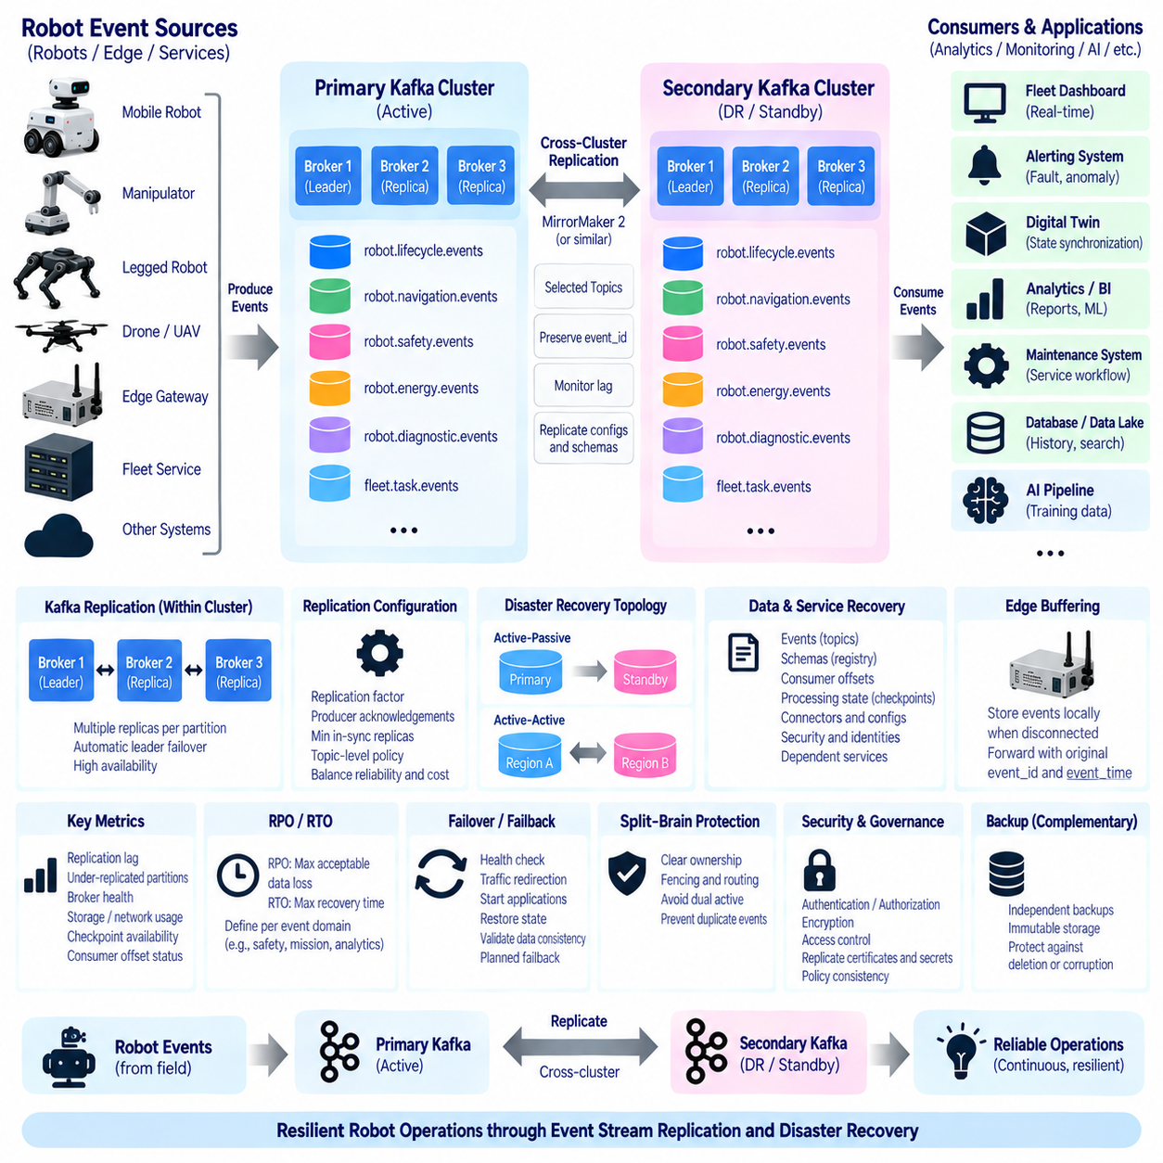
Event stream replication ensures that robot events remain available even when infrastructure components, data centers, or regional services fail. In a robot fleet, the event stream may contain mission transitions, safety incidents, navigation failures, charging activity, diagnostic conditions, and maintenance events. Losing these records can break operational continuity, historical reconstruction, analytics, and recovery processes.
Replication begins inside the Kafka cluster, where topic partitions can maintain multiple copies across different brokers. One replica acts as the leader for a partition while other replicas maintain synchronized copies. Producers and consumers normally interact through the leader, but if the leader broker becomes unavailable, an eligible replica can assume leadership and allow event processing to continue without reconstructing the complete event history.
The replication factor determines how many copies of each partition are maintained. A higher replication factor improves tolerance to broker failures but increases storage and network overhead. Robot event topics should therefore select replication policies according to operational importance. Safety, mission, and fault events may justify stronger redundancy than temporary or easily reconstructed streams.
Replication alone does not guarantee durability if producers consider a record successful before enough replicas have stored it. Producer acknowledgement settings and minimum in-sync replica requirements should therefore be coordinated with the replication strategy. Critical robot events should not be acknowledged under conditions that leave only a fragile single copy, particularly when the event may later be required for incident analysis or mission recovery.
Broker-level replication protects against individual server failures but does not fully address site-wide disasters. Power outages, network failures, storage corruption, natural disasters, configuration errors, or security incidents may affect an entire cluster. Disaster recovery therefore requires additional copies of important event streams in a separate failure domain such as another availability zone, data center, cloud region, or geographically separated site.
Cross-cluster replication transfers selected Kafka topics from a primary cluster to another cluster. The secondary cluster can serve as a disaster-recovery environment, regional replica, analytics platform, or migration target. Replication policies should define which robot event domains are copied, whether topic names are preserved or transformed, how frequently data is transferred, and how replication lag is measured.
Apache Kafka MirrorMaker 2 and comparable replication mechanisms can synchronize topic data between Kafka clusters. Such mechanisms should be treated as part of an overall recovery architecture rather than as simple copying utilities. Topic configuration, consumer progress, access policies, schema information, connector configuration, and application dependencies may also need protection before a secondary environment can assume production responsibilities.
Replication topology should reflect the operational structure of the robot platform. An active-passive design normally directs production traffic to a primary cluster while a secondary cluster receives replicated data and waits for failover. An active-active design allows multiple clusters to process traffic simultaneously, but requires more careful management of event ownership, duplicate records, topic naming, routing, and conflict avoidance.
Active-passive architectures are often easier to reason about for robot event systems because one environment remains authoritative during normal operation. If the primary environment becomes unavailable, services can be redirected to the recovery environment. The main design challenge is ensuring that replicated events, schemas, application state, security configuration, and dependent services are sufficiently current for controlled failover.
Active-active architectures may be appropriate for geographically distributed robot fleets where each site or region must continue operating independently. Events can be produced locally and replicated between regions for global visibility. A clear ownership model is essential so the same operational fact is not independently created in multiple clusters and interpreted as separate events after synchronization.
Globally unique event identifiers are important in replicated architectures. An event_id should remain unchanged when an event is copied to another cluster, allowing downstream consumers to recognize that the replicated record represents the same operational fact. Changing identifiers during replication can make duplicate detection, event lineage, incident reconstruction, and cross-region correlation significantly more difficult.
Replication lag measures how far the recovery copy is behind the primary event stream. Network congestion, cluster overload, large traffic bursts, unavailable links, or replication-service failures can increase this delay. Monitoring replication lag is essential because a secondary cluster that appears healthy but is several hours behind may not satisfy the actual recovery requirements of mission-critical robot operations.
Recovery Point Objective, or RPO, defines the maximum acceptable amount of data that may be lost when a failure occurs. An RPO close to zero requires very frequent or near-continuous replication. Less critical historical or analytical streams may tolerate a larger gap. Robot data architecture should define RPO according to event domain and business impact rather than applying one value indiscriminately to every topic.
Recovery Time Objective, or RTO, defines how quickly service must be restored after a disruption. Meeting a short RTO requires more than replicated event data. Kafka clusters, schema services, stream-processing applications, connectors, databases, authentication infrastructure, monitoring, networking, and routing may all need to be pre-provisioned or rapidly deployable in the recovery environment.
Disaster recovery should distinguish data recovery from service recovery. Successfully copying Kafka topics does not mean the robot platform can immediately resume operation. Consumers must reconnect, producers must discover the new cluster, processing applications must recover state, credentials must remain valid, and downstream systems must accept outputs. Recovery planning must therefore cover the complete event-processing dependency chain.
Schema registries and event definitions are part of this dependency chain. Replicated events may be unusable if the recovery environment lacks the schema versions required to deserialize them. Schema metadata, compatibility rules, and subject configuration should therefore be protected alongside the event stream. The same principle applies to configuration required by Kafka Connect, Flink applications, and other event-processing services.
Stateful stream processing introduces additional recovery requirements. Kafka may preserve the input event history, while Apache Flink or another processor maintains computational state representing active missions, fault correlations, timers, and fleet conditions. Checkpoints or savepoints should be stored in durable infrastructure that survives the failure of the primary processing environment and can be accessed during restoration.
Consumer offsets also influence recovery behavior because they indicate how far each consumer has processed a stream. If offset information is unavailable or inconsistent after failover, consumers may replay older events or skip records. Applications should be designed to tolerate controlled replay through stable event identifiers and idempotent processing rather than assuming recovery will always resume at exactly one perfect record boundary.
Edge buffering provides another layer of resilience when robots cannot reach either the primary or recovery cluster. Robots or edge gateways can temporarily persist important events locally while central connectivity is unavailable. Once communication is restored, buffered events can be forwarded using their original event_id and event_time, preserving the distinction between when the event occurred and when it finally reached central infrastructure.
Replication should be selective for large robot datasets. Event metadata, mission records, faults, and operational state transitions are generally suitable for continuous replication, while video, images, point clouds, maps, and ROS bag files may require separate object-storage replication policies. Kafka events can retain references and checksums so replicated event histories remain connected to large external data objects without carrying them directly.
Failover is the controlled transition from a failed or degraded primary environment to a recovery environment. It should include health verification, traffic redirection, application startup or activation, state restoration, producer and consumer reconnection, and validation of data consistency. Automatic failover may reduce recovery time, but poorly designed automation can redirect traffic during temporary network partitions and create conflicting active environments.
Failback returns operation to the original or replacement primary environment after the incident has been resolved. This process can be more complex than failover because events may have accumulated in the recovery cluster while it was authoritative. The architecture must define how those events are synchronized back, how duplicates are prevented, and when producers and consumers can safely return without losing operational continuity.
Split-brain conditions occur when multiple environments independently believe they are authoritative. In robot operations this can create duplicate commands, conflicting mission state, inconsistent event histories, or competing fleet decisions. Recovery architecture should therefore establish explicit authority, fencing, routing, and ownership mechanisms that prevent two disconnected clusters from simultaneously controlling the same operational scope.
Security policies must remain effective during disaster recovery. Emergency operation should not require disabling authentication, authorization, encryption, or topic-level access control. Certificates, secrets, service identities, access policies, and encryption keys must be available through protected recovery procedures. Replicated event data should receive equivalent protection in both primary and secondary environments.
Observability should continuously verify replication health rather than waiting for a disaster to reveal problems. Important indicators include replication lag, failed replication tasks, unavailable partitions, under-replicated partitions, broker health, storage capacity, network throughput, checkpoint availability, consumer offset status, and recovery-site readiness. Alerts should distinguish temporary degradation from conditions that threaten RPO or RTO objectives.
Backup and replication serve different purposes and should be used together where appropriate. Replication provides a rapidly accessible copy for continuity, but it can also propagate accidental deletion, corruption, or incorrect configuration. Independent backups or immutable historical storage can preserve earlier versions that remain available when an operational error has already been replicated to the secondary environment.
Disaster-recovery procedures must be tested regularly. A recovery plan that exists only as documentation may fail because credentials expired, routing changed, schemas were not synchronized, applications acquired new dependencies, or restoration procedures became outdated. Controlled exercises should verify event availability, state restoration, service startup, connectivity, failover timing, and the ability of robot applications to continue processing correctly.
Replication and disaster recovery ultimately extend event-stream reliability beyond individual brokers and applications. Broker replicas protect against local infrastructure failures, cross-cluster replication protects against larger failure domains, and recovery procedures restore the complete processing environment. Combined with durable state, edge buffering, backups, security, and monitoring, these mechanisms preserve robot operational continuity.
Within the broader robot event-streaming architecture, disaster recovery should therefore be designed as an end-to-end capability rather than a Kafka-only feature. Events, schemas, offsets, processing state, connectors, identities, routing, external data references, and dependent services must recover coherently. This allows the robot platform to resume trustworthy event processing after serious failures while minimizing data loss and operational interruption.

04.08 Event Sourcing Pattern in Robot Domain [w/Code]
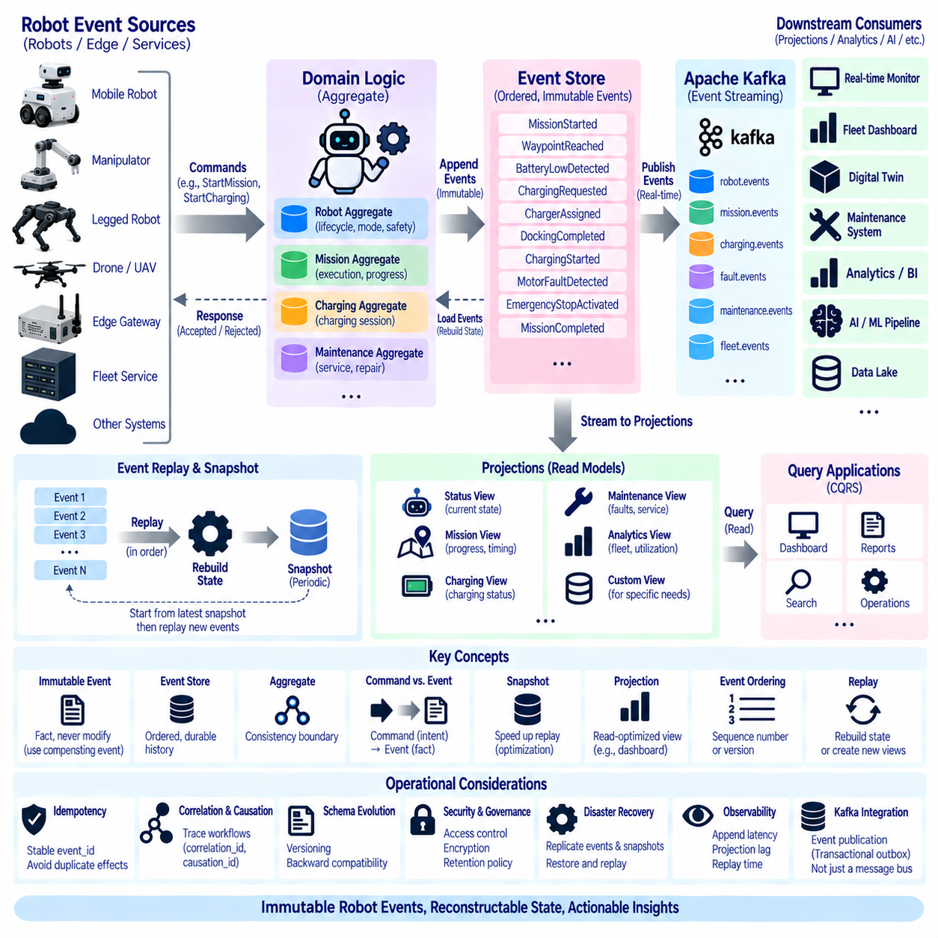
Event sourcing is an architectural pattern in which changes to a robot’s operational state are stored as an ordered sequence of immutable events rather than only as the latest state in a database. Instead of recording that a robot is currently charging, the system preserves events such as BatteryLowDetected, ChargingRequested, ChargerAssigned, DockingCompleted, and ChargingStarted. The present state can then be reconstructed from the events that produced it.
The central concept is that an event represents a fact that has already occurred and should not be modified after it is accepted into the event history. MissionStarted, WaypointReached, EmergencyStopActivated, MotorFaultDetected, and MissionCompleted describe historical facts. If information later proves incorrect, the preferred approach is to append a correcting or compensating event rather than silently rewriting the original event and losing historical context.
An event store is the authoritative persistence mechanism for an event-sourced domain. It stores events in a stable sequence together with identifiers, timestamps, event types, schema versions, and domain-specific payloads. Robot events may be organized into streams by robot_id, mission_id, charging session, maintenance case, or another aggregate identifier so that the history of a particular operational entity can be reconstructed efficiently.
An aggregate represents the consistency boundary whose state is derived from its event history. A robot aggregate may maintain lifecycle state, current mission, operating mode, or safety condition, while a mission aggregate may represent assignment, execution, navigation progress, completion, or cancellation. Aggregate boundaries should follow domain behavior rather than simply mirror database tables, services, or physical message sources.
Commands and events have different meanings in an event-sourced architecture. A command such as StartMission expresses an intention and may be rejected because of invalid state, authorization, or safety conditions. If accepted, domain logic can generate MissionStarted as an immutable fact. Maintaining this distinction prevents requested actions from being confused with actions that actually occurred in the robot system.
When a command arrives, the application loads or reconstructs the relevant aggregate state, validates domain rules, and determines whether new events should be produced. A StartCharging command might be accepted only when the robot is docked at an appropriate charger and no safety condition prevents charging. The resulting ChargingStarted event is appended to the event store and then used to update downstream representations.
Current state is obtained by replaying events in their original logical order. Starting from an initial state, each event applies a deterministic state transition until the latest state is reached. MissionStarted may create an active mission, WaypointReached may update progress, MissionPaused may change execution mode, and MissionCompleted may close the mission. The resulting state is therefore a projection of the stored event history.
Replay is one of the major advantages of event sourcing. If a new application requires a different representation of robot operations, historical events can be replayed to construct it without modifying the original records. A new maintenance model, fleet utilization dashboard, digital-twin state, anomaly detector, or AI feature dataset can therefore be generated from existing operational facts when the required information exists in the recorded events.
Repeatedly replaying a very long event history can become expensive. Snapshots can reduce this cost by periodically storing a derived representation of aggregate state at a known event position. Recovery begins from the latest valid snapshot and then applies only subsequent events. A snapshot is an optimization rather than the authoritative history; the event stream remains the primary source from which state meaning originates.
Event ordering is critical because different sequences can produce different states. Events associated with the same aggregate should have a stable ordering mechanism such as a monotonically increasing sequence number or aggregate version. Distributed timestamps alone may not provide sufficient ordering because robot clocks, edge gateways, and central systems can experience clock differences, communication delays, buffering, and retransmission.
Optimistic concurrency control can protect aggregate consistency when multiple actors attempt to update the same event stream. A command can specify the aggregate version on which its decision was based. If another event has already advanced that version, the append operation is rejected and the command can reload the newer state. This prevents concurrent decisions from silently overwriting each other.
Event sourcing naturally preserves an audit trail because every accepted state transition remains represented in the history. Engineers can determine how a robot entered a particular mission state, when a safety condition appeared, which fault preceded a shutdown, or how charging progressed. This historical trace is valuable for incident investigation, maintenance analysis, operational verification, and debugging distributed robot behavior.
Event sourcing should not mean storing every sensor sample as a domain event. Camera frames, point clouds, motor-current samples, IMU measurements, and high-frequency telemetry normally belong in specialized sensor or time-series storage. Domain events should capture meaningful operational facts and state transitions. When large data objects provide evidence for an event, the event can contain a durable reference, timestamp, checksum, or dataset identifier.
Projections transform event histories into representations optimized for specific queries. A fleet dashboard may require the latest status of every robot, while a maintenance application may need fault counts and service history. A mission view may require task progress and timing. Rather than querying the complete event stream for every request, dedicated projections can maintain these read-oriented views continuously as new events arrive.
This separation between event-based writes and query-oriented reads is often associated with Command Query Responsibility Segregation, or CQRS. Commands operate against domain rules and generate events, while query services read projections optimized for their particular access patterns. Event sourcing does not require CQRS in every implementation, but the two patterns complement each other when robot systems have complex write behavior and diverse read requirements.
Kafka can distribute events across robot services, but an event broker and an event store should not automatically be treated as identical concepts. Kafka provides durable streaming, partitioning, buffering, replay, and consumer independence. An event-sourced system additionally requires explicit rules for aggregate identity, authoritative event history, ordering, concurrency, retention, and long-term interpretability of the events used to reconstruct domain state.
Kafka can nevertheless participate strongly in the architecture. Events committed by the domain can be published to Kafka so monitoring, analytics, digital twins, maintenance systems, AI pipelines, and other consumers receive them asynchronously. Alternatively, carefully designed architectures may use a durable Kafka stream as part of the authoritative history, provided retention, ordering, governance, and recovery requirements are explicitly satisfied.
Reliable publication between an event store and Kafka requires attention to consistency. If an application successfully stores an event but fails before publishing it, downstream systems may never observe the change. Patterns such as a transactional outbox can record the domain event and publication intent within a consistent transaction, after which a separate publisher transfers the event to Kafka with retry and duplicate protection.
Idempotency remains important because retries, replay, replication, and recovery may cause an event to be observed more than once. Every domain event should have a stable event_id, and consumers should avoid applying the same business effect repeatedly. Aggregate identifiers, sequence numbers, correlation identifiers, and causation identifiers can further help systems distinguish event identity, ordering, workflow relationships, and processing history.
Correlation and causation metadata are particularly useful when reconstructing distributed robot workflows. MissionStarted may cause NavigationStarted, which can lead to PathBlocked, ReplanningStarted, and eventually GoalReached. correlation_id can associate the complete workflow, while causation_id can identify the event or command that directly caused another event. This creates a traceable graph of operational behavior across services.
Schema evolution becomes a long-term concern because historical events may remain stored for years. Software deployed in the future must still understand older event representations during replay. Event schemas should therefore be versioned and governed carefully. Compatibility techniques can include tolerant readers, schema migration, event transformation, or upcasting older representations into structures understood by newer application logic.
Historical events should generally preserve the meaning they had when originally recorded. Reinterpreting old events according to newly changed business rules can produce a state different from the state originally observed. Replay logic must therefore distinguish between evolution of technical representation and changes in domain meaning. Versioned event handlers or controlled migration may be required when robot behavior models change significantly.
Deletion and retention require careful governance because immutability does not mean data can legally or operationally remain forever. Robot events may contain identifiers, location context, human interaction information, or security-sensitive data. Retention policies should determine what must remain authoritative, what can be archived, anonymized, encrypted, or deleted, and how external references are handled without destroying required operational traceability.
Security controls should protect event stores because they contain detailed histories of robot and fleet operation. Authentication, authorization, encryption, integrity verification, backup protection, and administrative auditing should prevent unauthorized modification or disclosure. Append permissions should be restricted carefully, while direct alteration of historical events should be prevented or made strongly detectable.
Event sourcing also strengthens disaster recovery when authoritative events and snapshots are protected across failure domains. A robot aggregate or projection can be reconstructed by restoring its event history and replaying events from an appropriate position. However, recovery planning must also preserve schemas, aggregate versions, snapshots, security configuration, external data references, and the software capable of interpreting historical records.
Observability should cover both event storage and reconstruction behavior. Useful indicators include append latency, rejected concurrency operations, event-stream size, projection lag, replay duration, snapshot age, failed projections, duplicate detection, schema errors, and publication lag to Kafka. Monitoring these measures helps detect whether the authoritative history is healthy and whether downstream representations remain synchronized.
Event sourcing introduces additional architectural complexity and should therefore be applied where historical state transitions provide clear operational value. Simple reference data or disposable telemetry may not benefit from it. Mission execution, charging workflows, maintenance history, safety transitions, lifecycle management, and other domains requiring traceability, reconstruction, replay, or complex state reasoning are stronger candidates.
Within a robot data architecture, event sourcing converts operational history into a durable domain asset rather than treating events as temporary integration messages. Immutable events describe what happened, aggregates interpret those events, projections provide efficient operational views, and replay reconstructs state or creates new representations. Combined with Kafka and stateful stream processing, this pattern provides a foundation for traceable, recoverable, and continuously evolving robot operations.

04.09 Event Stream Monitoring: Lag, Throughput, Metrics [w/Code]
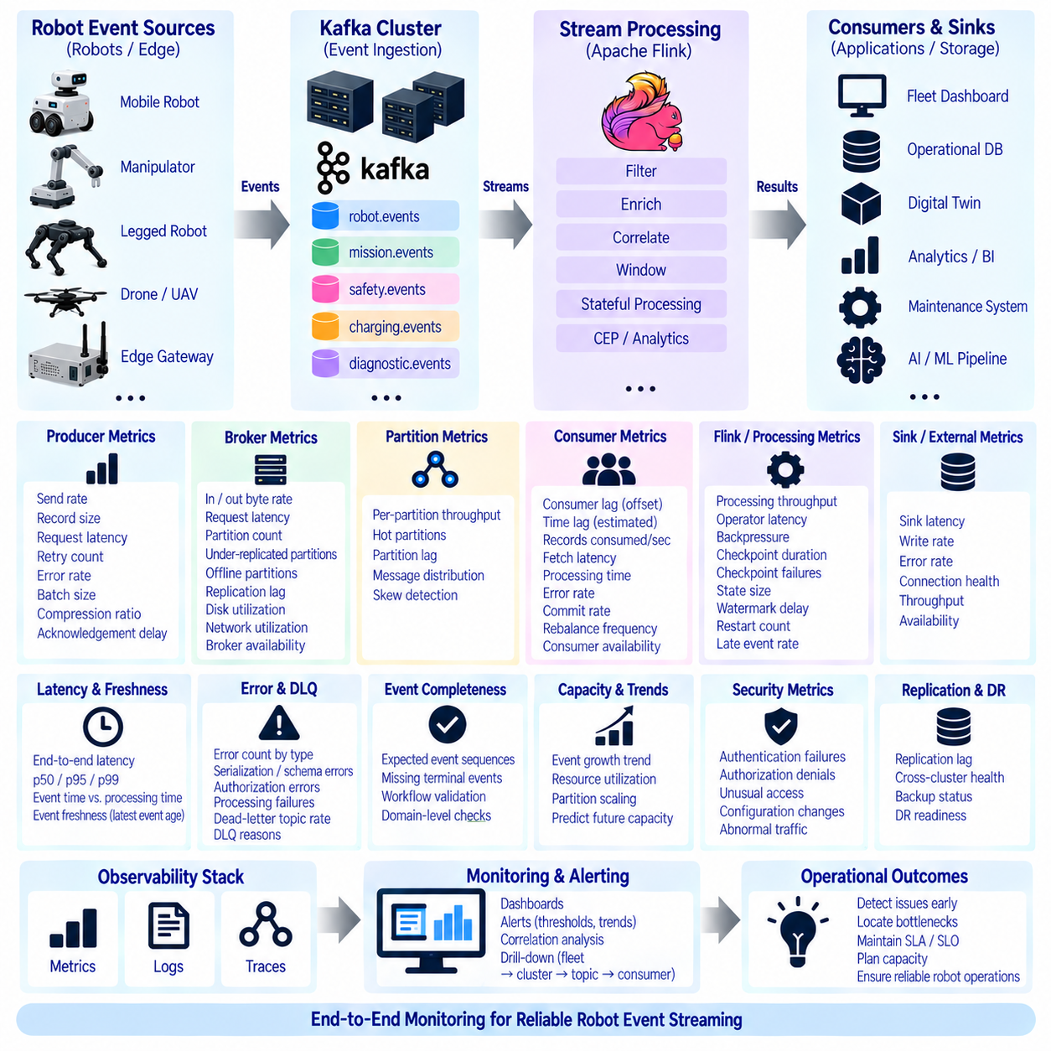
Event stream monitoring provides continuous visibility into whether robot events are being produced, transported, processed, and consumed within expected operational limits. A robot platform may depend on navigation, mission, safety, energy, diagnostic, and maintenance events for real-time decisions. Monitoring must therefore reveal not only whether infrastructure is running, but whether useful events are moving through the complete pipeline at the required speed.
Monitoring should cover the full path from robot and edge producers through Kafka brokers, stream processors, consumer groups, and downstream applications. A healthy broker does not guarantee a healthy robot data pipeline. Events may be delayed at an edge gateway, accumulated in Kafka, slowed by a Flink operator, or blocked at a database sink. End-to-end visibility is required to identify the actual location of degradation.
Consumer lag is one of the most important Kafka metrics. Lag represents the difference between the latest available offset in a partition and the offset already processed by a consumer group. A small and stable lag generally indicates that consumers are keeping pace with incoming robot events. Continuously increasing lag indicates that events are arriving faster than the consumer can process them or that consumption has partially stopped.
Lag should be interpreted together with time because an offset difference alone does not describe operational impact. Ten thousand delayed records may represent only seconds of high-frequency telemetry or several hours of rare safety events. Monitoring should therefore consider both record lag and estimated time lag, particularly for event domains where response deadlines are more important than raw message counts.
Throughput measures how much event data moves through the streaming architecture over time. It can be expressed as records per second, events per second, bytes per second, or domain-specific rates. Monitoring throughput at producers, brokers, processors, and consumers helps identify where capacity is constrained and whether changes in robot population, mission activity, or event frequency are affecting system load.
Expected throughput is not necessarily constant. Warehouse robots may produce more navigation and task events during operating hours, while charging events increase during shift transitions. Outdoor fleets may show traffic changes according to communication conditions or mission schedules. Monitoring should therefore compare observed throughput with contextual baselines rather than treating every deviation from a single fixed threshold as abnormal.
Producer metrics reveal whether robot events successfully enter the streaming backbone. Useful indicators include send rate, record size, request latency, retry count, error rate, batch size, compression ratio, and acknowledgement delay. A producer can remain technically connected while suffering repeated retries or long acknowledgement times, causing robot events to reach Kafka significantly later than expected.
Broker metrics describe the health and capacity of the Kafka infrastructure. Important measures include incoming and outgoing byte rates, request latency, partition count, under-replicated partitions, offline partitions, replication lag, disk utilization, network utilization, and broker availability. These metrics help determine whether event-processing problems originate from application behavior or from the underlying streaming infrastructure.
Partition-level monitoring is important because cluster-wide averages can hide localized problems. One partition may experience substantially higher traffic because its key maps a highly active robot, site, or mission to the same partition. Such hot partitions can increase latency and consumer lag even when total cluster utilization appears moderate. Monitoring should therefore expose workload distribution as well as aggregate capacity.
Consumer metrics complement lag by showing how applications process received events. Records consumed per second, fetch latency, processing duration, error rate, commit rate, rebalance frequency, and consumer availability provide insight into consumer behavior. A rapidly increasing lag combined with stable Kafka broker performance often indicates insufficient consumer capacity, slow processing logic, or a constrained downstream dependency.
Consumer-group rebalancing should also be observed. Rebalances occur when consumers join, leave, fail, or when partition assignments change. Occasional rebalancing is normal, but frequent rebalances can interrupt event consumption and increase lag. Unstable application instances, long processing pauses, incorrect timeout settings, or repeated deployments can therefore appear as stream-performance problems even when Kafka itself is healthy.
Stream-processing metrics become essential when Apache Flink or a similar engine transforms robot events. Processing throughput, operator latency, backpressure, busy time, idle time, checkpoint duration, checkpoint failures, state size, watermark delay, restart count, and late-event rate indicate whether stateful computations are keeping pace with the incoming event stream.
Backpressure deserves particular attention because it propagates through the processing graph. If a database sink cannot accept results quickly enough, an upstream Flink operator may slow down, which can eventually reduce Kafka consumption and increase consumer lag. Monitoring should correlate backpressure with sink latency and upstream lag rather than treating each metric as an independent infrastructure symptom.
End-to-end latency measures the time between an operational event occurring and the corresponding result becoming available to the intended consumer. For example, the interval from EmergencyStopActivated at the robot to its appearance in a monitoring service may be more meaningful than broker latency alone. Event time, ingestion time, processing time, and output time can be recorded to decompose total latency into individual stages.
Percentile latency is often more informative than average latency. An average of 100 milliseconds may appear acceptable even when a small but operationally important subset of events takes several seconds. Metrics such as p50, p95, p99, and maximum latency expose tail behavior. Safety and control-related event domains may require much stricter tail-latency objectives than analytical or maintenance streams.
Error metrics should classify failures rather than expose only a total error count. Serialization failures, schema incompatibilities, authorization errors, producer timeouts, consumer exceptions, processing failures, sink errors, and dead-letter records have different causes and remediation paths. Domain-specific error classification allows operators to determine whether the problem concerns event content, infrastructure, security, or application logic.
Dead-letter topic activity is itself an important monitoring signal. A sudden increase in rejected robot events may indicate a newly deployed incompatible schema, malformed source data, identity-mapping problems, or transformation defects. Dashboards should therefore show dead-letter event rates and reasons, while alerts should detect unusual growth before invalid records accumulate unnoticed.
Event completeness can be monitored through domain expectations. If MissionStarted normally leads to MissionCompleted or MissionFailed, missing terminal events may indicate lost data or an incomplete workflow. Similarly, ChargingRequested without ChargingStarted within an expected interval can indicate either an operational problem or a streaming problem. Semantic monitoring complements infrastructure metrics by examining whether expected event relationships remain intact.
Event freshness measures how old the latest successfully processed event is relative to the current time or its original event time. Freshness can reveal stalled streams even when message counts are low and lag metrics appear small. This is particularly valuable for low-frequency but critical topics where no large backlog develops when processing stops.
Availability metrics should describe whether each stage can perform its intended role. Producer connectivity, broker availability, consumer-group health, Flink job status, schema-registry availability, connector status, and sink accessibility can contribute to service-level indicators. However, infrastructure availability should be combined with event-delivery success because a technically running service may still fail to deliver useful robot information.
Service Level Indicators, or SLIs, translate raw metrics into measures directly related to expected service behavior. Examples include the percentage of safety events delivered within a defined latency, the percentage of mission events processed without error, or the fraction of time consumer lag remains below an acceptable threshold. These indicators can support explicit Service Level Objectives, or SLOs, for important robot event domains.
Alert thresholds should distinguish transient variation from sustained operational degradation. A short throughput spike or temporary lag increase may be harmless, while continuously growing lag requires attention. Alerts can combine threshold duration, rate of change, baseline deviation, and multiple correlated metrics to reduce unnecessary notifications while still detecting conditions that threaten event-processing objectives.
Dashboards should present metrics according to operational layers rather than displaying an unstructured collection of graphs. Fleet-level views can summarize event health across sites, while drill-down views expose clusters, topics, partitions, consumer groups, Flink jobs, connectors, and individual robot domains. This hierarchy allows operators to move from a visible service symptom toward the infrastructure or application component responsible for it.
Metrics should carry useful dimensions such as cluster, topic, partition, consumer group, site, robot class, event domain, application, and environment. However, using robot_id as a metric label for every robot can create excessive metric cardinality in large fleets. High-cardinality diagnostic information may instead be handled through logs, traces, or targeted event queries while metrics retain controlled aggregation dimensions.
Distributed tracing can complement metrics when events pass through multiple services. correlation_id, trace_id, event_id, and causation_id can connect producer activity, Kafka publication, stream processing, downstream service calls, and final outputs. Tracing is especially useful when overall latency increases but infrastructure metrics alone cannot reveal which application stage introduced the delay.
Logs provide detailed diagnostic context around monitoring signals. Broker errors, connector failures, Flink exceptions, schema validation messages, consumer crashes, and sink errors can explain why a metric changed. Metrics identify that a problem exists, traces show where an event traveled, and logs provide detailed evidence about what occurred inside individual components. These three observability mechanisms should be designed to complement each other.
Capacity monitoring should examine trends rather than wait for resource exhaustion. Event growth, partition utilization, disk consumption, network throughput, consumer processing capacity, state size, and checkpoint duration can reveal when additional resources will be required. Fleet expansion should therefore be reflected in capacity planning so event infrastructure scales before robot deployment causes sustained lag or processing instability.
Monitoring systems must themselves remain reliable during failures. If observability depends entirely on the same cluster, network, or storage system being monitored, a major incident can remove visibility precisely when it is most needed. Critical metrics and alerts may therefore require independent storage, external health checks, redundant collection paths, or disaster-recovery monitoring that remains accessible during primary-site failures.
Security monitoring should detect unusual authentication failures, authorization denials, unexpected topic access, configuration changes, and abnormal producer or consumer behavior. Event-stream monitoring is therefore not limited to performance. Combining operational and security telemetry can reveal whether unusual lag, traffic volume, or consumer activity originates from capacity problems, software defects, configuration mistakes, or unauthorized access.
Effective event-stream monitoring ultimately connects infrastructure metrics with robot-domain meaning. Lag, throughput, latency, errors, freshness, backpressure, availability, and replication health describe the technical pipeline, while workflow completeness and domain-specific SLIs describe whether robot operations receive the information they require. Together, these measures transform event streaming from an opaque transport layer into an observable operational system.
Within the robot data architecture, monitoring closes the feedback loop across Kafka, connectors, Flink processing, event sourcing, replication, and downstream consumers. By measuring event movement continuously and relating technical metrics to mission, safety, energy, navigation, and maintenance requirements, operators can detect degradation early, locate bottlenecks, plan capacity, verify recovery, and maintain trustworthy real-time robot operations.

04.10 Robot Event Streaming Security Design
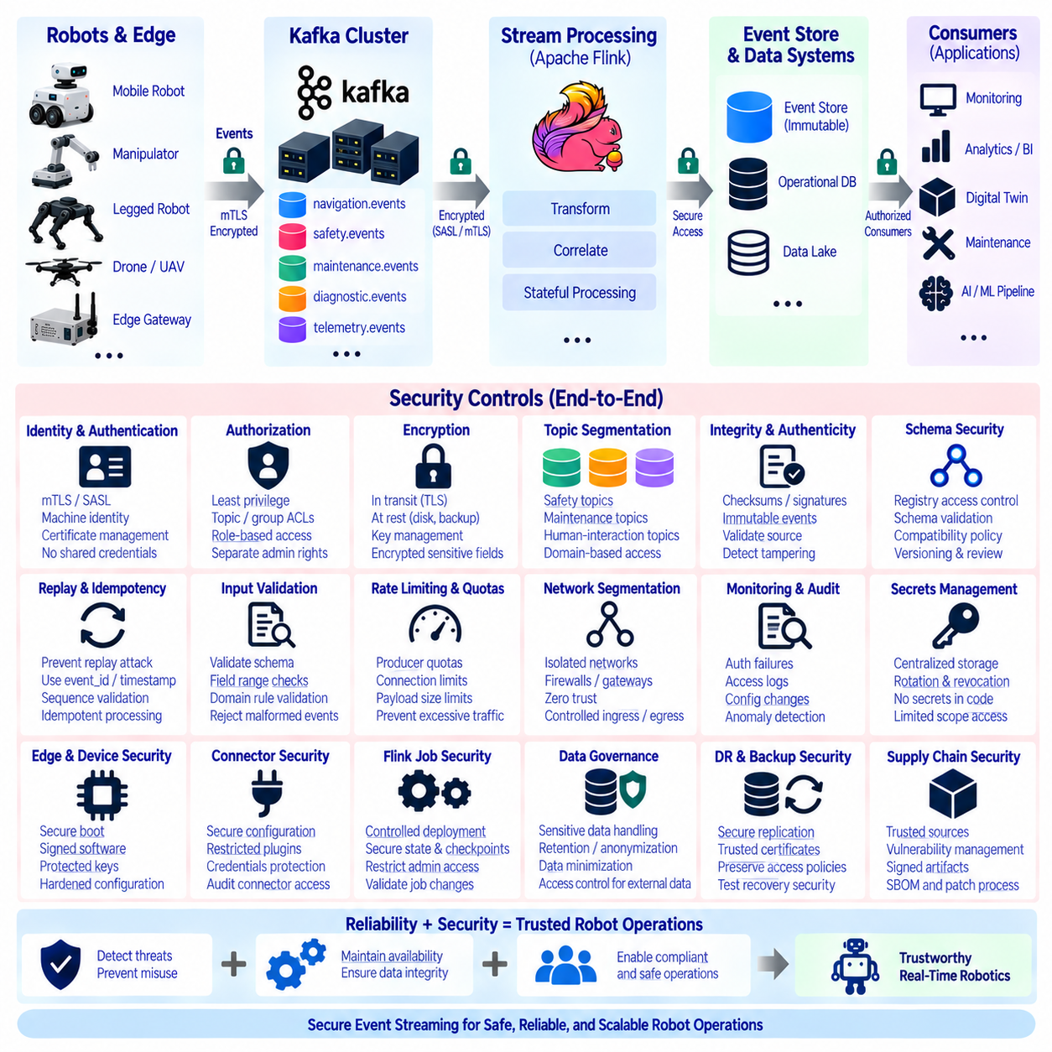
Robot event-streaming security must protect the complete path through which operational events are created, transmitted, processed, stored, replayed, and consumed. Mission, navigation, safety, energy, diagnostic, maintenance, and human-interaction events may directly influence robot operations. Security must therefore preserve confidentiality, integrity, availability, authenticity, and traceability without preventing the low-latency processing required by real-time systems.
The security boundary extends beyond Kafka brokers. Robots, onboard computers, edge gateways, Kafka Connect, schema registries, Apache Flink applications, event stores, databases, monitoring platforms, digital twins, and administrative systems all participate in the event pipeline. A weakness in any component can undermine the trustworthiness of the entire stream even when the central Kafka cluster itself is strongly protected.
Every producer and consumer should have a verifiable identity. Robots, gateways, services, connectors, and processing applications should authenticate before accessing the streaming infrastructure. Machine identities are preferable to shared credentials because individual components can be authorized, audited, rotated, and revoked independently. Compromise of one robot should not automatically provide access to the identities or privileges of other robots.
Mutual Transport Layer Security, or mTLS, can authenticate both sides of a connection while protecting network traffic with encryption. A robot or edge gateway can verify that it is communicating with an authorized service, while the server verifies the client certificate presented by the device. Certificate issuance, renewal, revocation, expiration monitoring, and secure private-key storage must therefore be treated as operational security functions.
Kafka also supports authentication mechanisms such as SASL-based approaches that can be integrated with organizational identity systems. The selected mechanism should reflect deployment constraints, device capabilities, credential lifecycle, and infrastructure architecture. Regardless of technology, credentials should not be embedded permanently in source code, container images, deployment scripts, or robot software packages where extraction would expose long-lived access.
Authentication establishes identity, while authorization determines what that identity may do. Kafka access-control policies should restrict producers and consumers to the topics, consumer groups, and operations they actually require. A navigation service may publish navigation events without receiving permission to modify safety topics, while an analytics consumer may read selected event domains without obtaining producer privileges.
The principle of least privilege should be applied throughout the event architecture. Kafka brokers, connectors, Flink jobs, schema services, event stores, monitoring systems, and administrative tools should receive only the minimum permissions necessary for their roles. Separating read, write, configuration, deployment, and administrative privileges limits the potential impact of compromised accounts, applications, or robot devices.
Topic design can support security segmentation. Safety events, maintenance events, human-interaction events, diagnostic information, and general operational telemetry may have different sensitivity and access requirements. Separating domains into controlled topics enables more precise authorization, retention, auditing, and monitoring policies than placing all robot events into a single unrestricted stream.
Encryption in transit protects events while they move between robots, gateways, brokers, processors, and downstream services. TLS should be applied to network paths carrying sensitive or operationally important events. Internal data-center traffic should not automatically be considered trusted because compromised hosts, configuration errors, lateral movement, or network interception can occur inside organizational boundaries.
Encryption at rest protects persisted event data on broker disks, event stores, checkpoints, backups, object storage, and disaster-recovery replicas. Storage-level encryption can protect physical media and infrastructure snapshots, while application-level encryption may be appropriate for particularly sensitive event fields. Encryption keys should be managed separately from protected data and governed through controlled key-management procedures.
Event integrity is critical because an altered event can lead downstream systems to construct an incorrect view of robot operation. TLS protects records while they are transported, but persistent integrity may require additional controls such as restricted append permissions, checksums, signatures, immutable storage, or tamper-evident audit records. Security requirements should reflect whether events are used only for analytics or also for safety, investigation, and operational decisions.
Event authenticity concerns whether a record genuinely originated from the claimed robot or service. Authentication of the transport connection provides an important foundation, but high-assurance applications may additionally bind device identity, event metadata, and cryptographic evidence. This becomes especially relevant when events cross gateways, are stored for long periods, or are later used as evidence during incident reconstruction.
Replay attacks must be distinguished from legitimate event replay. Kafka intentionally supports replay so consumers can rebuild state or reprocess history. An attacker, however, may attempt to inject an old operational event as though it were new. Stable event_id values, timestamps, aggregate sequence numbers, nonce or session information, and domain-specific validation can help consumers distinguish authorized historical replay from malicious duplication.
Idempotent processing also contributes to security resilience. If the same MissionCompleted, ChargingStarted, or maintenance event is received multiple times, consumers should avoid repeatedly applying irreversible business effects. Duplicate detection based on event_id and domain state protects against normal retries and recovery behavior while also reducing the impact of intentionally repeated event delivery.
Schema security is necessary because event interpretation depends on trusted schemas. Unauthorized schema modification could cause consumers to misinterpret fields, bypass validation, or fail during deserialization. Schema registry access should therefore require authentication and authorization, compatibility policies should be enforced, and changes to important robot-domain schemas should follow controlled review, versioning, and deployment procedures.
Input validation should occur even when producers are authenticated. A compromised or defective robot may still generate malformed values, impossible state transitions, oversized payloads, unexpected event types, or excessive traffic. Consumers and stream processors should validate schema, field ranges, identifiers, sequence relationships, payload sizes, and domain rules instead of assuming that authenticated sources always produce trustworthy data.
Rate limiting and quota management protect availability. A malfunctioning robot or compromised producer could generate excessive events and consume broker bandwidth, partition capacity, storage, or processing resources. Producer quotas, connection limits, payload restrictions, and domain-specific rate controls can prevent one source from degrading event services for the complete fleet while still allowing legitimate operational bursts.
Denial-of-service protection should consider the complete pipeline rather than only the Kafka entry point. Excessive events can overload connectors, Flink state, databases, alerting systems, or external APIs even if Kafka absorbs the traffic successfully. Backpressure monitoring, resource isolation, bounded queues, workload quotas, circuit breakers, and controlled degradation strategies help maintain critical event paths during abnormal load.
Network segmentation reduces unnecessary exposure between robot networks, edge systems, event infrastructure, and enterprise services. Brokers and administrative interfaces should not be reachable from every network zone by default. Firewalls, private networks, service gateways, controlled ingress and egress paths, and zero-trust principles can restrict communication to explicitly permitted relationships between authenticated components.
Edge security is particularly important because robots and gateways operate closer to physical environments and may be more exposed than central infrastructure. Device credentials and private keys should be protected using appropriate hardware or operating-system security mechanisms. Secure boot, signed software, controlled updates, local firewalling, and hardened service configurations can reduce the possibility that physical or software compromise becomes an entry point into the event platform.
Kafka Connect introduces another security boundary because connectors often possess credentials for both Kafka and external databases, storage systems, or APIs. Connector configurations may therefore contain sensitive connection information. Connector deployment, plugin installation, secret handling, REST interfaces, and configuration changes should be restricted and audited to prevent a compromised connector from becoming a bridge between otherwise separated systems.
Apache Flink applications require similar protection because they can consume multiple event domains, maintain state, and produce derived operational conclusions. Access to Flink administration, job deployment, state backends, checkpoints, and savepoints should be controlled. Unauthorized modification of processing logic could silently change event filtering, correlation, aggregation, or alert generation without altering the original Kafka records.
Event sourcing increases the importance of append security because the event history may become the authoritative record from which robot state is reconstructed. Historical events should not be silently modified or deleted outside governed procedures. Append permissions, optimistic concurrency controls, immutable storage mechanisms, integrity checks, and administrative auditing can help preserve the trustworthiness of long-lived event histories.
Monitoring and audit logging should record security-relevant activity across the streaming platform. Authentication failures, authorization denials, unusual topic access, schema changes, connector modifications, administrative actions, certificate failures, abnormal producer rates, consumer anomalies, and configuration changes should be observable. Security logs should themselves be protected against unauthorized alteration and inappropriate deletion.
Security monitoring becomes stronger when operational metrics and security signals are correlated. A sudden increase in consumer lag may indicate capacity problems, but when combined with abnormal producer traffic and authentication failures it may indicate malicious or compromised behavior. Similarly, unexpected access to safety topics combined with configuration changes deserves greater attention than either signal viewed independently.
Secrets management should centralize the lifecycle of passwords, tokens, certificates, private keys, and service credentials. Secrets should be issued with appropriate scope, rotated periodically, revoked when no longer required, and excluded from source repositories and ordinary logs. Automated rotation is especially valuable for large robot fleets where manually replacing credentials across hundreds or thousands of devices becomes operationally impractical.
Disaster recovery must preserve security controls rather than bypass them. Recovery clusters require trusted certificates, service identities, authorization policies, encryption keys, schema permissions, and protected secrets before they can assume production traffic. A recovery environment with weaker controls can become an attractive attack path and may expose replicated robot events even if the primary environment is strongly secured.
Data governance should define which event fields may contain sensitive information and how those fields are retained, shared, anonymized, or deleted. Human-interaction events, location information, operator identifiers, camera-derived metadata, and maintenance records may require stronger restrictions than ordinary machine-status events. Event minimization reduces both privacy exposure and the security impact of a data breach.
Security policies should also consider large external data objects referenced by events. Images, video, point clouds, maps, and ROS bag files may reside in object storage rather than Kafka. Authorization to read an event should not automatically imply unrestricted access to every referenced object. Signed references, separate storage permissions, expiration controls, checksums, and audit trails can maintain security across the event-to-object relationship.
Software supply-chain security affects the trustworthiness of the streaming platform. Kafka plugins, connector packages, Flink dependencies, container images, robot agents, and supporting libraries should originate from controlled sources and undergo vulnerability management. Signed artifacts, dependency inventories, software bills of materials, controlled build pipelines, and patch processes can reduce the risk of introducing compromised components.
Security testing should verify actual behavior rather than rely only on configuration reviews. Tests can confirm that unauthorized producers cannot publish events, consumers cannot access restricted topics, expired certificates are rejected, malformed events are isolated, excessive traffic is controlled, and disaster-recovery systems preserve access policies. Periodic exercises help identify differences between documented security architecture and deployed behavior.
A defense-in-depth model is appropriate because no single security mechanism can protect the complete robot event-streaming system. Device identity, network segmentation, encrypted transport, topic authorization, schema validation, rate control, secure processing, immutable history, monitoring, backup protection, and incident response provide overlapping safeguards. Failure of one layer should not immediately expose the entire event architecture.
Robot event-streaming security ultimately protects trust in operational facts. The objective is not merely to encrypt Kafka traffic, but to ensure that the platform can determine who produced an event, whether the producer was authorized, whether the event remained intact, whether consumers are permitted to use it, and whether abnormal behavior can be detected and investigated throughout the event lifecycle.
Within the broader robot data architecture, security should therefore be embedded across producers, Kafka, connectors, Flink processing, event stores, replication, monitoring, and downstream consumers. Combining strong identity, least privilege, encryption, integrity protection, validation, availability controls, auditability, secure recovery, and governance creates an event-streaming foundation capable of supporting trustworthy real-time robot and fleet operations.

