Volume 07 Robot Data Architecture

07. AI Data Architecture

07.01 AI Data Architecture Overview: Train, Val, Deploy Flow
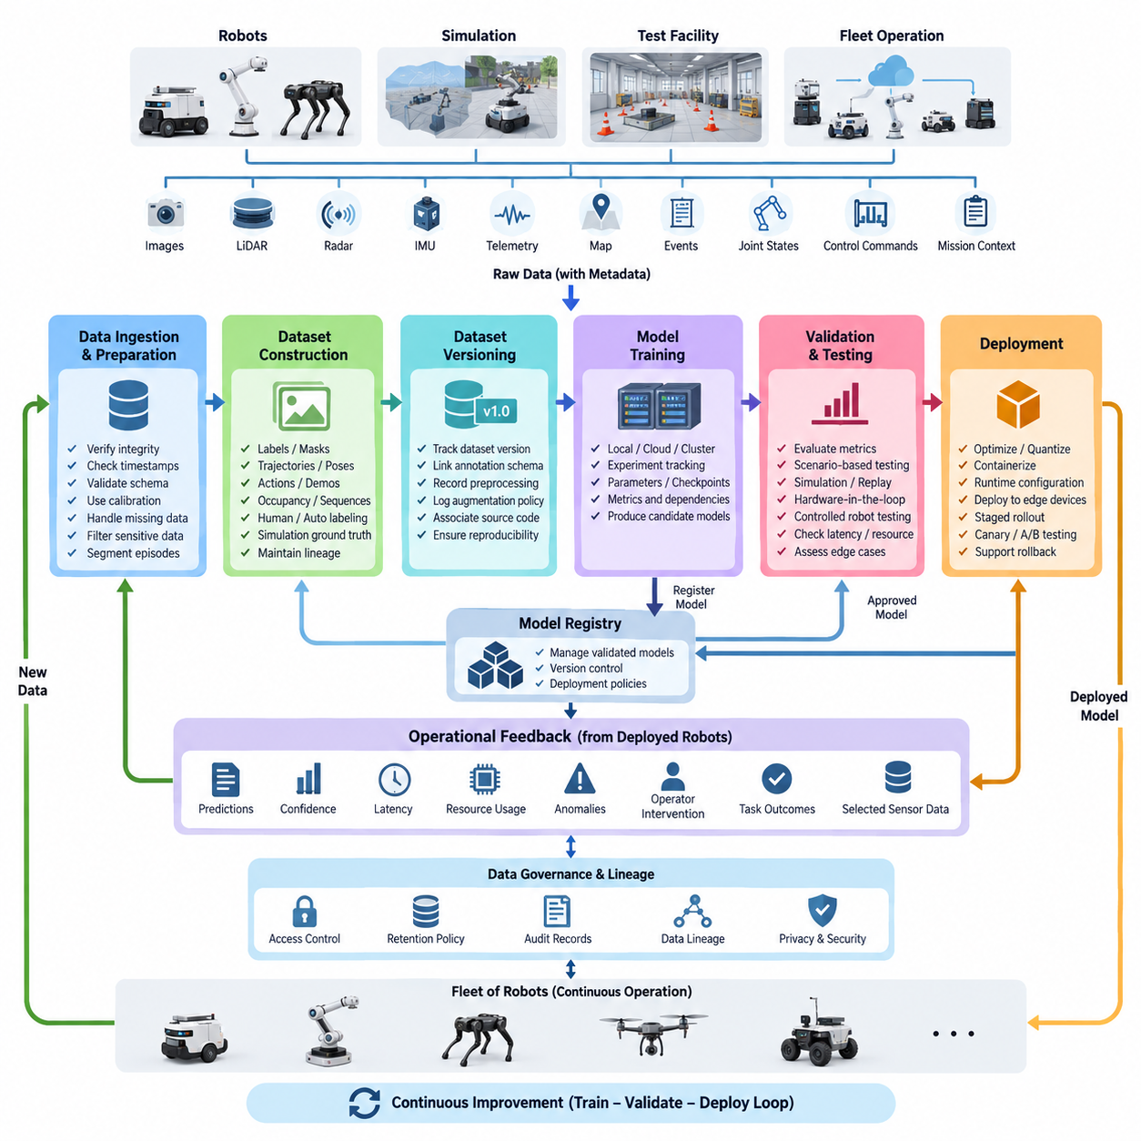
AI data architecture in robotics defines the controlled flow that transforms raw operational data into validated models deployed on physical machines. Unlike conventional analytics pipelines, robot AI must handle synchronized images, point clouds, IMU streams, telemetry, maps, events, and task context. The architecture therefore connects data collection, dataset preparation, training, validation, deployment, and operational feedback as one traceable lifecycle.
The lifecycle begins with data generated by robots, simulation environments, test facilities, and fleet operations. Camera frames, LiDAR scans, radar observations, joint states, localization results, control commands, and mission events are collected with timestamps and contextual metadata. Preserving robot identity, sensor configuration, software version, operating environment, and task state is essential because these attributes determine whether samples can later be interpreted and reproduced correctly.
Raw data should not move directly into model training. It first passes through ingestion and preparation stages that verify file integrity, timestamp consistency, schema compatibility, sensor calibration references, missing values, and metadata completeness. Large multimodal recordings may then be segmented into meaningful episodes or samples. Sensitive information can be filtered, and unusable observations are rejected or quarantined before entering curated AI datasets.
Dataset construction converts operational records into learning-ready representations. Depending on the task, this may include object labels, segmentation masks, trajectories, poses, actions, demonstrations, occupancy information, or temporal sequences. Annotation can combine human labeling, automated labeling, model-assisted labeling, and simulation-generated ground truth. Each resulting dataset should retain lineage linking derived samples to their original source data and transformation history.
Training, validation, and test partitions must represent distinct roles rather than merely random percentages of one dataset. Training data drives parameter optimization, validation data supports model selection and hyperparameter decisions, and test data provides an independent estimate of expected behavior. In robotics, splitting must also consider location, route, robot, operating session, weather, object instance, mission, and temporal correlation to prevent information leakage between partitions.
Dataset versioning makes the training process reproducible. A model artifact should be associated with a specific dataset version, annotation schema, preprocessing configuration, augmentation policy, source-code revision, model configuration, and training environment. When a model improves or degrades, engineers can then determine whether the change originated from new data, altered labels, modified preprocessing, different hyperparameters, or software changes rather than treating the model as an isolated binary artifact.
The training layer consumes approved dataset versions and produces candidate models together with experiment metadata. Training may occur on local GPU workstations, on-premise clusters, cloud infrastructure, or distributed accelerators depending on dataset size and computational requirements. Experiment tracking records parameters, checkpoints, metrics, execution environments, and dependencies so that important training runs can be reconstructed instead of becoming one-time experiments with unknown provenance.
Validation is a gate between model creation and operational deployment. Conventional metrics such as precision, recall, IoU, trajectory error, or success rate remain important, but robot AI also requires scenario-oriented evaluation. Models should be examined across lighting conditions, obstacle configurations, motion states, sensor degradation, environmental changes, and difficult edge cases. Performance must therefore be interpreted in relation to the operational domain in which the robot will act.
A candidate that satisfies offline validation can progress toward simulation, replay, hardware-in-the-loop, or controlled robot testing. Recorded sensor streams allow deterministic replay of known situations, while simulation can expose the model to rare or dangerous scenarios without placing hardware at unnecessary risk. Physical tests then determine whether latency, memory consumption, GPU utilization, thermal behavior, communication delays, and interaction with surrounding software remain acceptable on the target platform.
Deployment converts an approved model into a controlled operational artifact. The model may require optimization, quantization, compilation, container packaging, runtime configuration, or hardware-specific acceleration before installation on an edge computer. Deployment metadata should identify the model version, runtime dependencies, supported hardware, preprocessing requirements, configuration parameters, and rollback target so that every robot can be associated with an exact executable AI configuration.
Model rollout should normally be separated from model creation. A registry can hold validated artifacts while deployment policies determine which robots, sites, or fleet groups receive each release. Staged rollout, canary deployment, shadow inference, and controlled A/B evaluation reduce the consequences of unexpected behavior. If operational indicators violate predefined conditions, the system should support rapid rollback to a previously validated model without rebuilding the complete software environment.
Once deployed, the model becomes a new source of data. Predictions, confidence values, inference latency, resource consumption, detected anomalies, operator interventions, task outcomes, and selected sensor observations can be captured as operational feedback. This closes the Train–Validate–Deploy loop by connecting real-world behavior to the next dataset generation cycle rather than considering deployment the final stage of AI development.
Production feedback is especially valuable when it identifies situations poorly represented in the original training distribution. False detections, missed objects, unusual terrain, new equipment, changed lighting, localization failures, and human intervention can be converted into prioritized data candidates. Instead of storing every sensor byte indefinitely, the architecture can selectively retain high-information episodes based on events, uncertainty, novelty, failure conditions, or explicit engineering requests.
The feedback process enables continual improvement, but production data should not automatically become training data. Newly collected samples must pass through quality checks, privacy controls, annotation, review, versioning, and dataset approval before they influence another model. This separation prevents corrupted labels, sensor faults, anomalous operations, or unintended environmental bias from silently propagating through automated retraining pipelines.
Data lineage provides the connective tissue across the complete architecture. Engineers should be able to trace a deployed prediction backward from robot and model version to deployment package, validation results, training experiment, dataset version, annotation revision, preprocessing pipeline, and ultimately the originating sensor records. The same lineage should operate forward, allowing teams to identify which models or robots may be affected when problematic source data or labels are discovered.
Governance surrounds every stage of the Train–Validate–Deploy flow. Access control determines who can read sensitive sensor records, modify labels, approve datasets, register models, or authorize deployment. Retention policies determine how long raw recordings, intermediate datasets, checkpoints, and production feedback remain available. Audit records provide evidence of who changed critical artifacts and when, supporting reproducibility, operational accountability, security, and later investigation.
The architecture also separates data responsibilities from model responsibilities. Data pipelines manage acquisition, validation, transformation, storage, annotation, versioning, and lineage, while MLOps mechanisms manage experiments, model registration, deployment, monitoring, and rollback. These domains remain tightly connected through shared identifiers and metadata. This separation aligns AI data architecture with the broader robotics software stack while avoiding uncontrolled coupling between storage, training, and runtime systems.
At fleet scale, the loop operates continuously across many robots rather than around a single training workstation. Different robot types and deployment sites contribute observations with different sensors, environments, missions, and failure patterns. Centralized or federated data services can normalize these observations into governed datasets, while deployment services distribute approved model variants according to hardware capability, robot configuration, geographic region, or operational requirements.
A mature AI data architecture therefore treats Train–Validate–Deploy as a repeatable closed-loop system rather than a linear machine-learning project. Operational data becomes governed training evidence, training produces traceable candidate models, validation determines deployment eligibility, deployment produces measurable field behavior, and field behavior generates the next data priorities. This cycle establishes the data foundation required for increasingly adaptive, reliable, and scalable Physical AI systems.

07.02 Feature Store Design and Implementation: Feast / Tecton [w/Code]
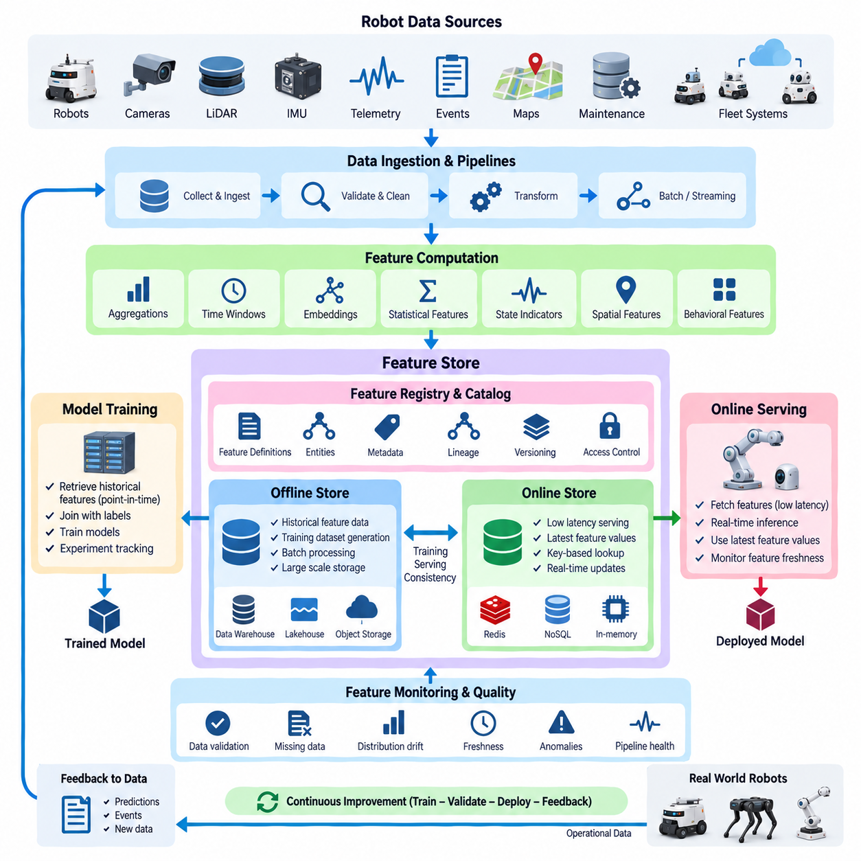
A feature store provides a managed data layer between raw robot data pipelines and machine-learning models. Its primary purpose is to define, compute, store, discover, and serve reusable features consistently across training and inference. Within robot AI architecture, it prevents individual teams from repeatedly rebuilding transformations for telemetry, perception, localization, fleet behavior, diagnostics, and operational context while maintaining a common definition of each feature.
Robot features are derived from heterogeneous sources such as sensor streams, time-series telemetry, event records, mission histories, maps, maintenance databases, and fleet-management systems. Raw measurements are rarely suitable for direct model consumption. They may be converted into rolling averages, statistical summaries, temporal windows, categorical states, embeddings, health indicators, spatial attributes, or historical behavior variables before being supplied to perception, prediction, anomaly-detection, or decision models.
A feature store separates feature definitions from the applications that consume them. Instead of embedding transformation logic independently inside every training script or inference service, feature definitions are registered as governed data assets. A definition can describe source fields, transformation logic, entity keys, timestamps, data types, ownership, and update policies. Multiple models can therefore reuse the same feature while preserving consistent semantics throughout the AI lifecycle.
Entities provide the keys that connect features to real-world objects. In robotics, typical entities include robot ID, fleet ID, mission ID, component ID, location, sensor ID, or operator-independent task identifiers. A feature such as battery temperature alone has limited meaning unless it is associated with a specific robot and observation time. Entity-aware organization allows feature values originating from different systems to be joined consistently for training and inference.
Time is particularly important because robot observations continuously change. Feature retrieval must reproduce what information was actually available at a particular historical moment rather than accidentally using future information. Point-in-time correct joins associate labels with feature values that existed before the prediction timestamp. This mechanism reduces training data leakage and is essential when constructing datasets for predictive maintenance, failure forecasting, mission-risk prediction, and other temporal robot applications.
Feature-store architecture commonly distinguishes an offline store from an online store. The offline store maintains large historical feature datasets used for model training, batch analysis, experimentation, and backtesting. It can rely on data warehouses, lakehouses, object storage, or analytical databases. Because training may consume months or years of robot history, the offline layer emphasizes scalable storage, historical retrieval, reproducibility, and efficient processing of large datasets.
The online store serves the latest feature values to deployed models with low latency. A robot inference service may need recent battery state, mission context, component health indicators, environmental conditions, or fleet statistics within milliseconds. Online storage therefore prioritizes fast key-based lookup and predictable response time. Only features required for operational inference normally need to be materialized online, reducing storage cost and synchronization complexity.
The relationship between offline and online stores is critical for training-serving consistency. A model trained using one feature calculation but served with a slightly different implementation can suffer from training-serving skew. A well-designed feature store allows common feature definitions and transformation logic to support both historical dataset generation and production inference. The goal is not merely faster retrieval but semantic consistency between what the model learned and what it receives after deployment.
Feature computation may operate in batch, streaming, or hybrid modes. Batch pipelines are appropriate for historical statistics, long-term maintenance indicators, aggregated fleet behavior, and slowly changing features. Streaming computation is useful for rapidly changing robot states such as recent velocity, fault-event frequency, short-term temperature trends, or mission activity. Hybrid architectures combine historical context with near-real-time updates to provide models with both long-term and immediate operational information.
Feature freshness defines how current a feature must be when it is consumed. Some attributes, such as robot hardware type, may change rarely, while motion state or battery measurements can become obsolete within seconds. Each feature should therefore have an explicit update frequency or freshness expectation. Monitoring feature freshness helps detect failed pipelines, delayed telemetry, disconnected robots, or stale online values before those conditions silently degrade deployed AI behavior.
Feature quality management extends conventional data validation into model-facing variables. Feature values can be checked for missing data, unexpected ranges, invalid categories, abnormal distributions, timestamp delays, duplicate records, and schema changes. Statistical monitoring can additionally identify feature drift between historical training data and production observations. These controls allow teams to distinguish model degradation caused by changing feature distributions from failures originating in software or model parameters.
Feast is an open-source feature store framework that organizes features around concepts such as entities, feature views, data sources, offline retrieval, and online serving. Feature definitions can be maintained alongside machine-learning code and connected to existing data infrastructure rather than requiring all robot data to be moved into a proprietary storage system. This makes Feast suitable when engineering teams want explicit control over storage technologies, pipelines, deployment environments, and feature definitions.
In a Feast-based workflow, engineers define entities and feature views that describe how feature data is associated with source systems. Historical retrieval creates training datasets using timestamp-aware joins, while materialization transfers selected feature values from offline sources into an online store for low-latency serving. Deployed inference applications can then retrieve feature vectors using entity keys, helping maintain a structured connection between training data generation and production model inputs.
Tecton represents a managed feature-platform approach in which feature engineering, orchestration, serving, monitoring, and governance are integrated into a broader operational service. Such an approach can reduce the amount of infrastructure that engineering teams must construct themselves, particularly when many models and teams share production features. The architectural decision between Feast and a managed platform therefore involves operational ownership, infrastructure control, integration requirements, scale, governance, and organizational resources.
For robotics, the feature store should not be interpreted as a replacement for raw sensor storage. High-bandwidth camera images, LiDAR point clouds, radar frames, ROS 2 bags, and other large multimodal records normally remain in dedicated object storage, data lakes, or sensor-data repositories. The feature store primarily manages derived variables and references needed by machine-learning models, while preserving lineage back to the datasets and sensor records from which those features were calculated.
Feature lineage connects every feature to its source data and transformation history. When a deployed model produces an unexpected result, engineers should be able to identify the feature values supplied to the model, their timestamps, transformation versions, originating datasets, and upstream pipelines. Conversely, when a source schema or transformation changes, lineage information helps identify which features, training datasets, models, and inference services may be affected by that change.
Feature versioning supports controlled evolution of machine-learning inputs. Changing a rolling window, normalization rule, aggregation function, coordinate transformation, or categorical encoding can alter model behavior even if the feature name remains unchanged. Significant semantic changes should therefore create identifiable feature versions. Training experiments can then reference exact versions, and production models can continue using validated definitions until a newer feature-model combination has completed validation.
Security and governance become increasingly important when feature stores are shared across fleets and AI teams. Access policies can restrict sensitive operational, location, customer, or human-related features while allowing broader reuse of non-sensitive variables. Ownership metadata identifies the team responsible for each feature, while documentation, tags, schemas, lineage, and audit records improve discovery and accountability. The feature catalog consequently becomes both an engineering interface and a governance mechanism.
In a fleet-scale robot AI system, reusable features can support predictive maintenance, energy estimation, task-duration prediction, anomaly detection, navigation-risk assessment, and fleet optimization simultaneously. A common robot entity may connect battery statistics, motor health, mission history, environmental context, and fault-event features. Models can consume different combinations without duplicating the complete upstream transformation pipeline, improving consistency while reducing repeated computation and engineering effort.
The feature store ultimately forms a bridge between robot data architecture and MLOps. Data pipelines transform operational observations into governed features, offline retrieval supplies reproducible training datasets, validation verifies model behavior, and online serving delivers corresponding features to deployed inference systems. Production observations then return through the data pipeline, allowing features and models to evolve together within the broader Train–Validate–Deploy feedback loop established by the AI data architecture.

07.03 Training Data Version Control: DVC / Delta Lake [w/Code]
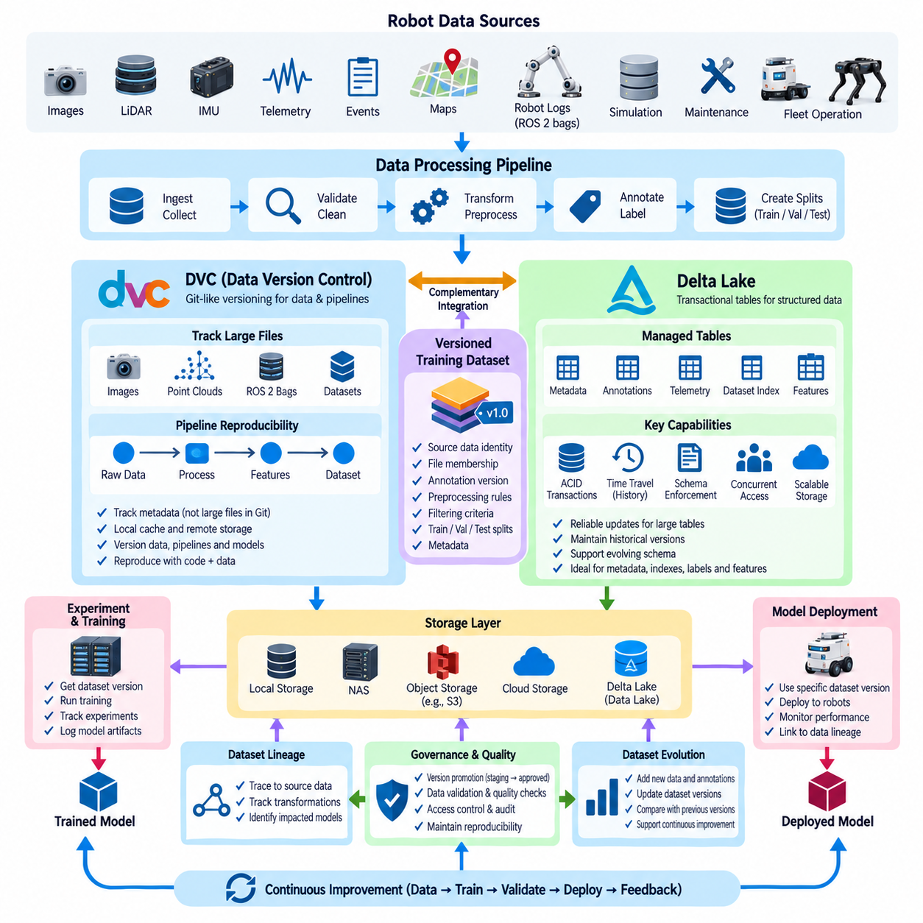
Training data version control is the discipline of preserving exactly which data was used to produce a particular AI model. In robotics, datasets evolve continuously as new sensor recordings, annotations, simulation results, operational failures, and edge cases are collected. Without explicit versioning, engineers may know the model code and parameters but still be unable to reconstruct the precise dataset that generated a deployed model.
Conventional source control systems such as Git are highly effective for code and small text files, but robot training datasets can contain millions of images, point clouds, trajectories, ROS 2 recordings, and large binary artifacts. Storing these objects directly in a Git repository is inefficient. Training data version control therefore separates lightweight metadata and references from the large data objects stored in remote or scalable storage systems.
A dataset version should represent more than a directory snapshot. It should capture source-data identity, file membership, annotation versions, preprocessing rules, filtering criteria, train-validation-test splits, and relevant metadata. When these elements are versioned together, a model experiment can reference a stable dataset state even while newer observations and annotations continue to enter the broader robot data platform.
DVC, or Data Version Control, applies Git-like versioning principles to datasets, machine-learning artifacts, and data pipelines. Instead of requiring large files to reside inside Git history, DVC tracks metadata describing those files while their contents can remain in local storage, NAS systems, object stores, or cloud storage. Git then versions the lightweight DVC metadata together with training code and configuration, connecting software revisions with corresponding dataset states.
A typical DVC workflow begins by placing raw or processed training data under DVC tracking. DVC calculates identifiers for the tracked content and records references that can be committed to Git. Large data objects are maintained separately in the DVC cache and optionally synchronized with remote storage. Another engineer can check out the required code revision and retrieve the corresponding data version, creating a reproducible relationship between source code and training data.
DVC remote storage enables teams and compute environments to share versioned datasets without copying every historical version into every Git repository. Depending on the infrastructure, a remote may be implemented using shared storage or object-storage services. Training workstations, GPU servers, CI pipelines, and other environments can retrieve required data versions when needed while maintaining lightweight source repositories and centralized control of large artifacts.
DVC can also describe reproducible data-processing stages rather than tracking only static files. A pipeline can express dependencies, parameters, commands, and outputs for operations such as filtering sensor records, resizing images, generating labels, extracting features, or constructing dataset splits. When an upstream dependency or parameter changes, affected stages can be identified and reproduced, linking dataset evolution to the transformations that created it.
This pipeline-oriented approach is important in robotics because one raw recording may generate many derived datasets. A ROS 2 bag or multimodal sensor session can produce synchronized frames, cropped images, point-cloud subsets, trajectories, annotations, and model-specific training samples. Versioning both source data and transformation definitions allows engineers to distinguish a change in original observations from a change introduced by preprocessing or dataset construction.
Delta Lake addresses a different but complementary version-control problem. It provides a transactional storage layer for large tabular datasets stored in a data lake, supporting reliable updates while preserving historical table states. Robot metadata, telemetry, annotation indexes, feature tables, training manifests, and structured sensor references can therefore evolve as managed tables rather than collections of loosely coordinated files.
A central Delta Lake capability is transaction management. Concurrent jobs may ingest robot data, update labels, calculate features, or construct training records at the same time. Transactional consistency helps ensure that readers observe a valid table state rather than a partially completed update. This becomes increasingly important when fleet-scale pipelines continuously modify datasets while training and analytical workloads access the same underlying information.
Delta Lake maintains a transaction log that records changes applied to a table. This history enables data changes to be tracked across successive table versions and supports access to previous states. For AI development, historical access means an experiment can be associated with a specific table version rather than simply referring to the latest contents of a constantly changing dataset.
Time travel allows previous table states to be queried when historical versions remain available under the configured retention policy. If an annotation update or preprocessing operation unexpectedly changes model performance, engineers can compare current data with the version used by an earlier experiment. Historical access therefore supports debugging, auditing, experiment reproduction, and investigation of regressions caused by changes in structured training data.
Schema enforcement and controlled schema evolution are also valuable for robotics AI datasets. Incoming records may change when sensors, software, annotation formats, or robot platforms evolve. Allowing arbitrary fields and incompatible types to enter training tables can silently damage downstream pipelines. Schema controls help reject or manage incompatible records, while intentional evolution mechanisms allow datasets to expand as legitimate requirements change.
DVC and Delta Lake operate at different architectural levels and can be used together rather than treated as direct substitutes. DVC is particularly useful for connecting code revisions, configurations, pipelines, and large file-based artifacts to identifiable versions. Delta Lake is suited to transactional management and historical versioning of large structured tables. A robot AI platform can therefore use DVC for dataset manifests and file-oriented artifacts while Delta Lake manages continuously evolving structured records.
For example, raw images, point clouds, simulation outputs, and model-specific dataset packages may reside in object storage or NAS and be referenced through DVC-managed metadata. Meanwhile, sample indexes, robot identifiers, timestamps, annotation states, quality flags, dataset membership, and feature metadata can be stored in Delta tables. A training release can then reference both a DVC revision and specific structured-table versions, creating a stronger reproducibility boundary.
Train-validation-test splits should themselves be treated as versioned data assets. Regenerating a split without recording the algorithm, random seed, grouping policy, or resulting sample membership can make two apparently identical experiments incomparable. In robotics, split definitions may additionally isolate locations, robots, missions, recording sessions, weather conditions, or object instances to prevent leakage. Preserving the exact split is therefore part of dataset reproducibility.
Annotation changes require equally careful version control. Corrections to bounding boxes, segmentation masks, object classes, trajectories, actions, or failure labels can alter model performance without any change to training code. Annotation releases should be associated with identifiable dataset versions, quality-review status, and transformation history so that teams can determine which label state was used by each experiment and deployed model.
Storage efficiency becomes important because naïvely duplicating complete robot datasets for every version is rarely practical. Version-control architectures should reuse unchanged objects where possible and record only the information needed to identify new or modified states. Large immutable sensor files can remain stable while metadata, manifests, labels, and table records evolve around them, reducing unnecessary duplication while preserving logical dataset history.
Dataset lineage extends version control beyond simple identifiers. A model should be traceable to its training dataset, which should in turn be traceable to preprocessing stages, annotation releases, source recordings, robot configurations, and collection conditions. When a defective sensor calibration, incorrect label set, or corrupted source recording is discovered, lineage allows engineers to identify the dataset versions, experiments, and models potentially affected by the problem.
Version promotion can introduce governance into the lifecycle. Newly collected data may first exist as an experimental or staging dataset and later become an approved training release after quality validation, annotation review, privacy checks, and split verification. Models intended for deployment can then be restricted to approved dataset versions, preventing uncontrolled intermediate data from becoming part of production AI without review.
At fleet scale, training data version control becomes the historical memory of the robot AI system. DVC-style artifact tracking and pipeline reproducibility can coexist with Delta Lake-style transactional tables and historical queries to connect large sensor assets, structured metadata, annotations, and experiments. Together they support a repeatable path from field observations to governed datasets, model training, validation, deployment, and future retraining within the broader robot data architecture.

07.04 Data Lakehouse Architecture: Bronze, Silver, Gold [w/Code]
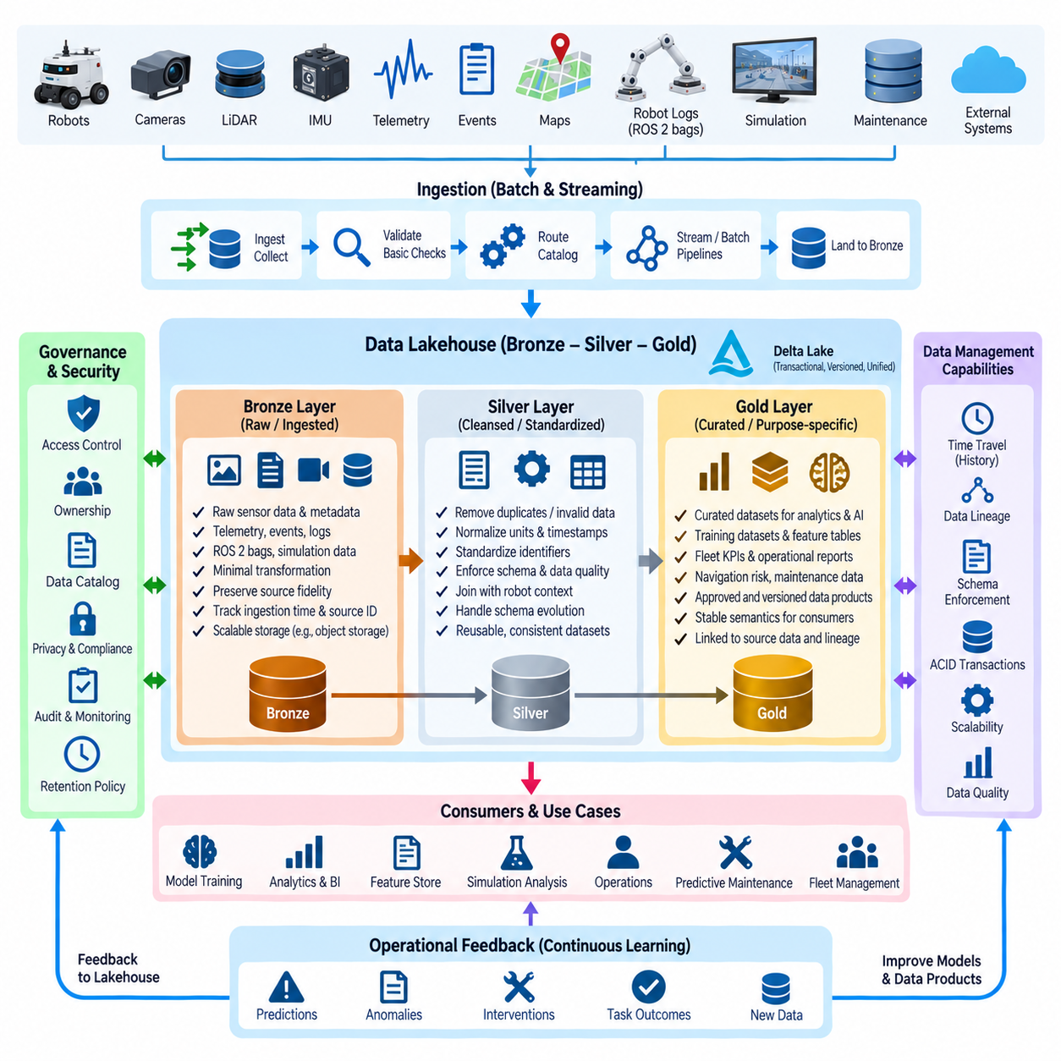
A data lakehouse combines the scalable storage characteristics of a data lake with the management, reliability, and query capabilities traditionally associated with a data warehouse. In robot AI systems, this architecture provides a common foundation for sensor metadata, telemetry, annotations, training records, simulation outputs, features, and operational events. It reduces fragmentation by allowing heterogeneous data to progress through controlled quality stages within a unified data platform.
The Bronze–Silver–Gold pattern organizes lakehouse data according to processing maturity rather than simply separating it by file type or application. Bronze represents data close to its original ingested form, Silver contains validated and standardized information, and Gold provides curated datasets optimized for specific consumers. This layered approach makes transformation boundaries explicit and allows engineers to understand how operational robot data becomes trusted AI and analytical data.
The Bronze layer is the primary landing zone for incoming information. Robot telemetry, event streams, sensor references, ROS 2 recording metadata, mission logs, annotation imports, simulation results, and external system records can enter this layer with minimal transformation. Preserving source identifiers, timestamps, ingestion times, robot IDs, software versions, and collection context ensures that downstream processing retains a traceable connection to the original observations.
Bronze data should preserve source fidelity even when incoming records contain imperfections. Missing fields, duplicated messages, inconsistent schemas, delayed telemetry, or unusual values may be retained rather than silently corrected during ingestion. The objective is to maintain an auditable representation of what was actually received. Validation results and ingestion status can accompany the records so that downstream stages can distinguish trustworthy observations from questionable or incomplete data.
Storage in the Bronze layer is commonly designed for scale and append-oriented ingestion. Large immutable sensor assets such as images, point clouds, video, or ROS 2 bags may remain in object storage while lakehouse tables maintain metadata and references to those objects. Structured and semi-structured operational records can be stored in transactional table formats, allowing the platform to ingest large volumes without requiring every data type to be physically represented in the same format.
The Silver layer transforms raw observations into consistent, reusable data products. Processing may remove duplicates, resolve invalid records, normalize units, align timestamps, standardize identifiers, enforce schemas, and join related robot context. Sensor metadata can be connected with robot configuration, mission information, calibration versions, or environmental conditions. The result is not yet necessarily a model-specific dataset, but a reliable representation suitable for reuse across multiple downstream workloads.
Schema management becomes particularly important in Silver because robot platforms evolve over time. New firmware may introduce telemetry fields, a sensor may be replaced, or an annotation schema may gain additional classes. Silver processing establishes canonical representations that isolate downstream applications from unnecessary source variation. Controlled schema evolution allows legitimate changes while preventing incompatible records from silently altering analytical or machine-learning behavior.
Data quality rules can be applied systematically as information moves from Bronze to Silver. Timestamp validity, required fields, numeric ranges, coordinate conventions, duplicate detection, referential integrity, calibration availability, and annotation consistency can be checked before records are promoted. Invalid data can remain traceable in quarantine or quality-status structures instead of being permanently discarded, preserving evidence for debugging and later correction.
The Gold layer contains curated information designed for specific business, analytical, or AI use cases. Examples include predictive-maintenance training tables, fleet reliability indicators, perception dataset manifests, navigation-risk features, robot utilization summaries, and approved model-training datasets. Gold data is normally more aggregated or purpose-specific than Silver data and should expose stable semantics that downstream users can consume without reconstructing complex transformation logic.
For machine learning, Gold can represent an explicit boundary between generally trusted platform data and model-ready datasets. Training samples can reference approved annotations, feature versions, source sensor objects, and reproducible train-validation-test membership. A Gold dataset should therefore identify not only the values consumed by a model but also the data version, transformation rules, quality state, and lineage required to reconstruct the training input later.
The Bronze–Silver–Gold architecture does not require all information to be copied physically at every layer. Large robot sensor files can remain immutable in object storage while metadata tables and manifests progress through increasingly refined states. This avoids duplicating terabytes of images or point clouds merely to represent quality transitions. Logical layering can therefore coexist with efficient physical storage, using references and metadata to connect curated records with original assets.
Transactional table technologies such as Delta Lake can strengthen the lakehouse by providing reliable updates, table versioning, schema enforcement, and historical access. Multiple pipelines may ingest fleet telemetry, modify annotations, generate features, and build training manifests concurrently. Transactional consistency helps ensure that consumers observe coherent table states, while historical versions make it possible to reproduce or investigate datasets that existed before later updates.
Batch and streaming workloads can share the same architectural foundation. Historical sensor archives and large annotation jobs may be processed through scheduled batch pipelines, while telemetry and operational events arrive continuously through streaming systems. Both flows can eventually populate standardized Silver structures and curated Gold products. This reduces the need to maintain completely separate architectures for historical analysis and near-real-time robot operations.
Data lineage should connect every Gold product backward through Silver transformations to Bronze source records and, where applicable, original sensor objects. If a training dataset contains an incorrect label or an operational dashboard shows suspicious statistics, engineers should be able to identify the upstream transformations and source observations involved. Forward lineage can likewise reveal which datasets, features, models, or reports may be affected by a discovered data problem.
Governance operates across all three layers rather than being confined to the final curated datasets. Bronze may contain sensitive or minimally processed information and therefore require restrictive access controls. Silver may expose standardized data to broader engineering teams, while Gold can provide approved products for specific AI or business purposes. Ownership, access policies, retention periods, privacy classifications, and audit records should follow data as it moves through these stages.
Retention policies can differ significantly by layer. High-volume Bronze data may be expensive to retain indefinitely, while selected source episodes associated with failures or model development may require long-term preservation. Silver data may retain normalized historical records for analysis, and Gold releases may need extended retention because deployed models depend on them. The policy should preserve reproducibility without assuming that every intermediate artifact must remain forever.
The lakehouse also provides an important connection to feature stores and training-data version control. Silver tables can provide standardized inputs for feature computation, while Gold tables or manifests can identify model-ready training releases. DVC-style artifact tracking can reference large file-based datasets, and Delta Lake-style table versions can identify structured records. Together these mechanisms connect storage architecture with reproducible AI experiments and model lineage.
A robot fleet increases the value of this architecture because data arrives from different hardware generations, software releases, environments, sites, and missions. Bronze preserves these heterogeneous observations, Silver normalizes them into common domain representations, and Gold reorganizes them around specific operational or AI objectives. This progression allows fleet-wide learning without requiring every robot to generate perfectly standardized data at the point of collection.
Operational feedback can continuously re-enter the lakehouse. Predictions, anomalies, interventions, failures, task outcomes, and selected sensor episodes from deployed robots become new Bronze inputs. After validation and contextual enrichment, valuable observations move into Silver and can eventually contribute to new Gold training releases. The architecture therefore supports continual learning while maintaining explicit quality gates rather than allowing production data to enter training automatically.
A mature Bronze–Silver–Gold lakehouse ultimately acts as the data backbone of the robot AI lifecycle. Bronze protects source fidelity, Silver establishes quality and common semantics, and Gold delivers trusted data products for training, validation, analytics, and operations. Combined with versioning, lineage, governance, and scalable storage, the architecture creates a repeatable path from physical robot observations to deployable AI and from field feedback back into the next learning cycle.

07.05 AI Data Quality Validation Pipeline [w/Code]
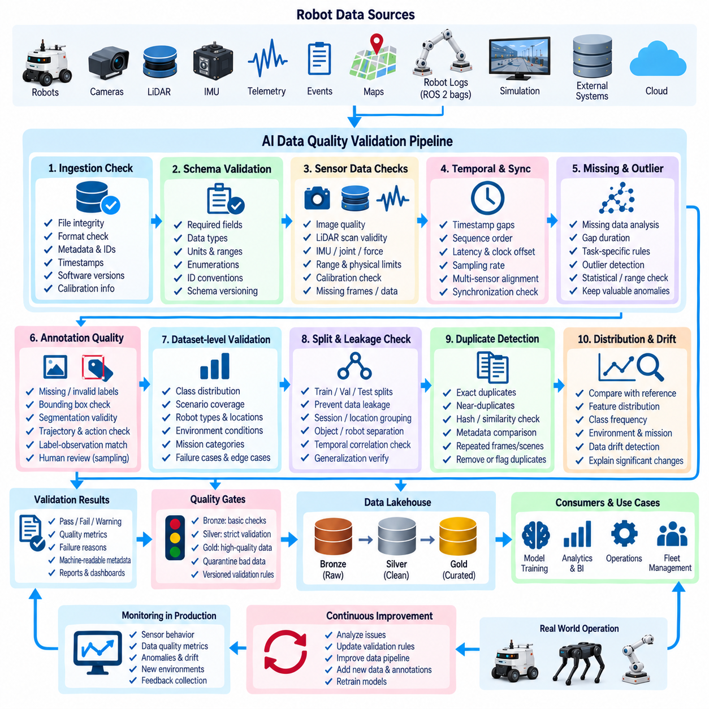
An AI data quality validation pipeline ensures that datasets entering robot model training are sufficiently complete, consistent, accurate, traceable, and representative for their intended task. Unlike conventional database validation, robotics AI validation must examine multimodal sensor observations, annotations, temporal relationships, spatial information, operational context, and dataset composition. Quality is therefore evaluated as a continuous pipeline rather than as a single inspection performed immediately before training.
Validation begins at data ingestion, where the system verifies whether expected files, records, metadata, and identifiers have arrived correctly. Checks can confirm file integrity, supported formats, schema compatibility, robot and sensor identifiers, collection timestamps, software versions, calibration references, and ingestion status. Detecting corruption or structural errors at this stage prevents invalid source data from propagating into expensive annotation, preprocessing, and model-training workflows.
Schema validation establishes whether each record conforms to the expected structure and data types. Required fields must exist, numerical values should use defined units, categorical values should belong to accepted domains, and identifiers should follow consistent conventions. As robot platforms evolve, schema versions must also be tracked so that legitimate changes can be distinguished from unexpected incompatibilities that could silently alter downstream processing or model inputs.
Sensor data requires domain-specific quality checks beyond ordinary schema validation. Camera streams can be examined for missing frames, unexpected resolution, corrupted images, exposure problems, or invalid calibration references. LiDAR data may be checked for empty scans, abnormal point counts, range violations, or coordinate-frame inconsistencies. IMU, joint, force, radar, and other signals require corresponding checks based on their physical ranges, sampling behavior, and expected operating characteristics.
Temporal quality is particularly important because robot AI frequently learns from synchronized sequences rather than independent records. Validation should detect timestamp gaps, non-monotonic sequences, duplicated timestamps, excessive latency, clock offsets, and unexpected sampling-rate changes. For multimodal datasets, the pipeline can verify whether camera, LiDAR, IMU, control, and telemetry observations are aligned within acceptable synchronization tolerances before samples are admitted into downstream datasets.
Missing data must be interpreted according to context rather than handled by one universal rule. A short telemetry gap may be recoverable through interpolation, while missing camera frames during a critical manipulation sequence may invalidate the episode. The validation pipeline should classify missingness, measure its duration and frequency, apply task-specific acceptance rules, and record any correction or exclusion so that downstream users know how the final dataset differs from the original observations.
Outlier detection identifies values that are statistically unusual or physically implausible. Simple range checks can reject impossible temperatures, velocities, joint angles, or coordinates, while statistical techniques can identify observations that deviate strongly from historical distributions. However, unusual robot events may represent valuable failures or rare edge cases rather than errors. The pipeline should therefore distinguish suspicious data from automatically invalid data and preserve potentially informative anomalies for review.
Annotation quality directly affects supervised and imitation-learning models. Validation can examine missing labels, invalid class identifiers, malformed bounding boxes, segmentation masks outside image boundaries, inconsistent trajectories, impossible actions, or temporal disagreement between labels and observations. Automated rules can identify obvious defects, while sampling-based human review remains useful for semantic errors that cannot be reliably detected through structural validation alone.
Agreement metrics can support annotation quality assessment when multiple annotators or automated labeling systems produce overlapping results. Bounding-box overlap, segmentation consistency, class agreement, trajectory deviation, or reviewer acceptance rates can reveal unstable labeling processes. Quality thresholds should reflect the downstream task because a small localization error may be insignificant for one application but unacceptable for precise manipulation or safety-related perception.
Dataset-level validation examines whether individually valid samples collectively form an appropriate training dataset. Class distribution, scenario coverage, robot types, locations, environmental conditions, mission categories, hardware versions, and failure cases should be measured. A dataset can contain technically correct records while still producing a weak model because important operational conditions are absent or severely underrepresented. Quality therefore includes coverage and representativeness as well as correctness.
Train-validation-test split validation is necessary to prevent information leakage. Samples from the same recording session, route, physical location, object instance, robot, or temporally adjacent sequence may be highly correlated. Random splitting can place nearly identical observations into multiple partitions and produce misleading evaluation results. Validation should inspect grouping rules and sample membership to ensure that evaluation data provides a meaningful test of generalization rather than memorization.
Duplicate and near-duplicate detection further protects dataset integrity. Exact duplicates can arise from repeated ingestion, file copying, pipeline retries, or annotation exports, while near-duplicates may occur when adjacent video frames or repeated simulation scenes contain almost identical information. Excessive duplication can distort class frequencies and evaluation metrics. Hashing, metadata comparison, similarity measures, or embedding-based methods can help identify redundant samples at different levels.
Distribution validation compares new data with established reference datasets or previous releases. Changes in feature distributions, class frequencies, sensor statistics, environment composition, or mission patterns can indicate data drift(Data Drift). Drift is not automatically an error because robot operations naturally evolve, but significant changes should be visible and explainable. This allows engineers to decide whether a new distribution requires additional review, dataset rebalancing, or model retraining.
Quality rules should be implemented as explicit, versioned validation contracts rather than informal assumptions embedded in individual scripts. Each dataset type can define required schemas, acceptable ranges, synchronization tolerances, completeness thresholds, annotation rules, and distribution expectations. Versioning these contracts is important because quality requirements evolve with robot hardware, software, AI tasks, and operational environments, and historical dataset releases must remain interpretable under the rules used when they were created.
Validation results should generate machine-readable quality metadata rather than only human-readable reports. Individual samples, episodes, partitions, or complete dataset releases can receive validation status, failure reasons, warning flags, quality metrics, and validator versions. These records allow downstream pipelines to automatically select approved data, quarantine problematic observations, prioritize human review, and reproduce the decision process that determined whether particular data entered model training.
Quality gates control promotion between stages of the AI data architecture. Raw data may enter a Bronze layer with minimal restrictions, while promotion into standardized Silver data can require schema, integrity, timestamp, and normalization checks. Promotion into Gold model-ready datasets can impose stricter requirements for annotations, coverage, split integrity, privacy, and task-specific quality. Failed data can remain traceable without being allowed to silently enter approved training releases.
Automation allows quality validation to become part of continuous data operations. Scheduled pipelines, event-driven workflows, or CI-style checks can execute validators whenever new data, annotations, schemas, or dataset versions are introduced. A failed validation can stop dataset promotion, generate an alert, or route samples into a review queue. Automated validation reduces dependence on manual inspection while preserving human review for ambiguous or semantically complex cases.
Data lineage connects every validation decision to the source and transformation history of the affected data. Engineers should be able to determine which robot, recording session, sensor configuration, preprocessing version, annotation release, and validation contract produced a particular dataset state. If a defective calibration or validation rule is later discovered, lineage can identify affected dataset versions, experiments, models, and deployed systems that may require reevaluation.
Monitoring continues after deployment because production observations reveal quality problems that may not have appeared in historical datasets. Changes in sensor behavior, missing telemetry, new environments, unexpected objects, annotation uncertainty, and feature drift can generate new quality signals. Selected production episodes can return through the validation pipeline before being incorporated into future training releases, maintaining a controlled boundary between operational feedback and continual learning.
A mature AI data quality validation pipeline therefore acts as a trust layer across the complete robot AI lifecycle. It combines structural validation, sensor checks, temporal consistency, annotation quality, distribution analysis, split verification, automated quality gates, lineage, and governance. By ensuring that data quality is measured and recorded from ingestion through training and production feedback, the architecture creates a reliable foundation for reproducible, scalable, and continuously improving Physical AI systems.

07.06 Data Augmentation Pipeline Automation [w/Code]
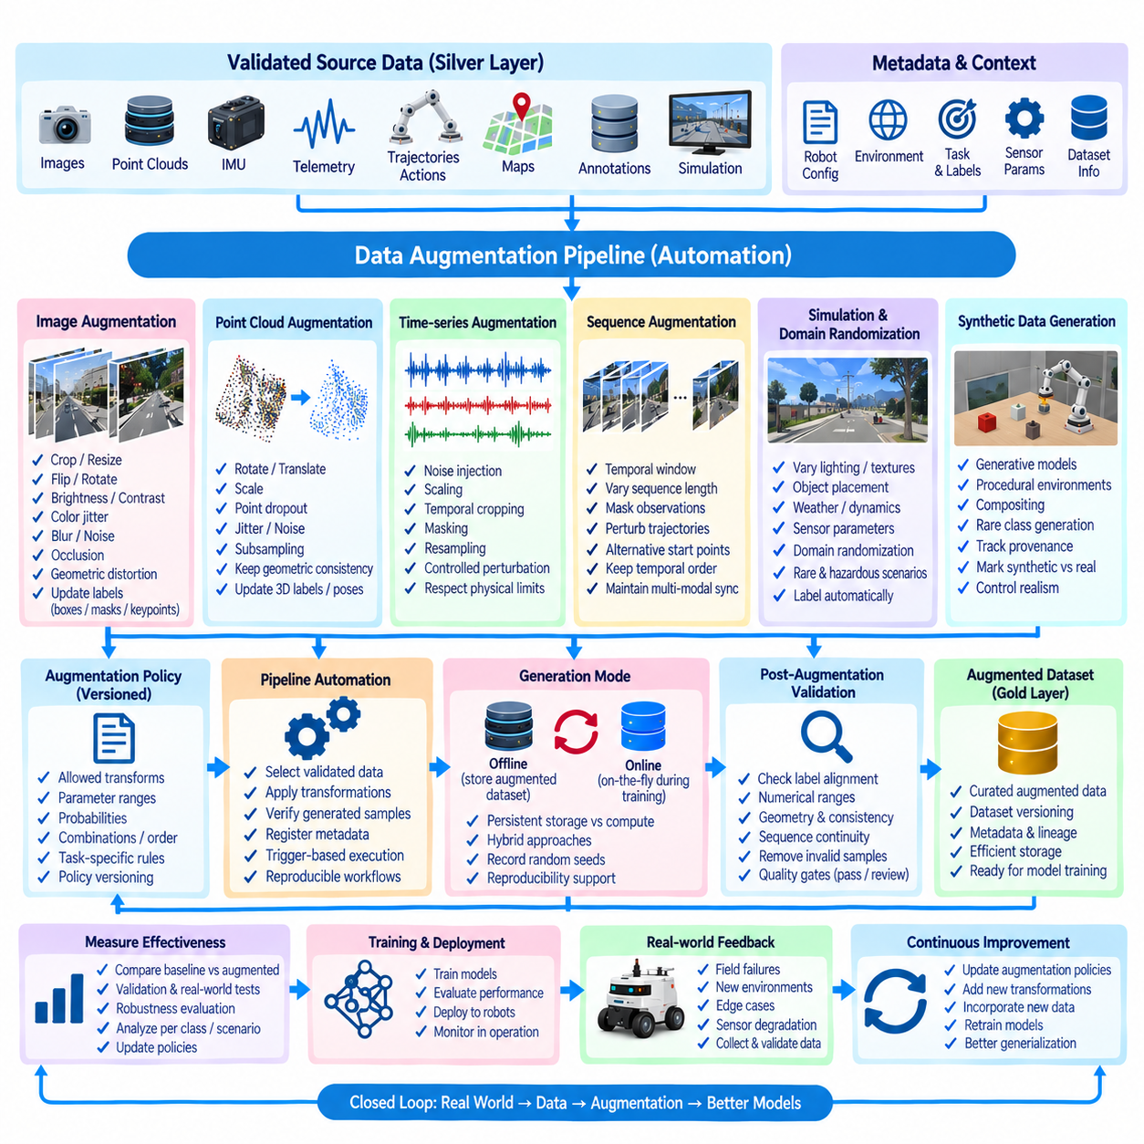
Data augmentation is the controlled process of expanding training diversity by transforming existing observations or generating additional variations while preserving task-relevant meaning. In robot AI, augmentation can be applied to images, point clouds, trajectories, actions, sensor signals, maps, and multimodal sequences. An automated pipeline makes these transformations reproducible, configurable, measurable, and directly connected to dataset versions and training experiments.
The augmentation pipeline begins with validated source data rather than arbitrary raw observations. Samples should first satisfy integrity, schema, synchronization, annotation, and quality requirements so that augmentation does not multiply existing defects. Dataset metadata identifies sensor types, robot configuration, environment, task, labels, and collection conditions, allowing the pipeline to select transformations that are appropriate for each modality and learning objective.
Image augmentation is widely used for robot perception because visual conditions can vary substantially between deployment environments. Transformations may include cropping, resizing, flipping, rotation, brightness and contrast adjustment, color variation, blur, noise, occlusion, and geometric distortion. Each transformation must preserve label validity; bounding boxes, segmentation masks, keypoints, depth maps, and other spatial annotations must be transformed consistently with the corresponding image.
Geometric augmentation requires particular care in robotics because spatial relationships often have physical meaning. Rotating or translating an image may require corresponding changes to object coordinates, poses, camera parameters, or reference frames. Transformations that are harmless for generic image classification can become invalid for localization, manipulation, or navigation. Augmentation policies should therefore be defined according to the semantics and physical constraints of the target task.
Point-cloud augmentation can increase robustness to changes in viewpoint, measurement noise, sensor sparsity, and environmental geometry. Common operations include rotation, translation, scaling, point dropout, jitter, subsampling, and controlled noise injection. For 3D detection or pose-estimation tasks, associated boxes, poses, coordinate frames, and labels must remain geometrically consistent. Sensor-specific characteristics should also be respected so that augmented samples remain plausible.
Time-series and telemetry augmentation requires different techniques from visual augmentation. Noise injection, scaling, temporal cropping, masking, resampling, or controlled perturbation can expose models to realistic variation in robot states and sensor measurements. However, arbitrary modification of velocity, temperature, battery, force, or joint signals can violate physical relationships. Constraints should therefore reflect robot dynamics, sensor limits, temporal continuity, and the operational meaning of each variable.
Sequence augmentation is useful for models that learn from trajectories, demonstrations, or multimodal episodes. Pipelines may select temporal windows, vary sequence lengths, mask observations, perturb trajectories, or generate alternative starting points. Transformations must preserve causal order and synchronization across modalities. Camera frames, actions, robot states, and labels belonging to one episode should remain temporally coherent after augmentation rather than being independently modified without context.
Simulation provides another augmentation mechanism by generating observations under controlled variations that may be difficult or expensive to collect physically. Lighting, textures, object placement, obstacles, weather, sensor parameters, robot poses, and task configurations can be varied systematically. Simulation-based augmentation can increase scenario coverage, particularly for rare failures or hazardous situations, while metadata should distinguish synthetic observations from physically collected data.
Domain randomization extends simulation augmentation by deliberately varying visual, physical, and environmental parameters across broad ranges. The objective is to prevent a model from depending excessively on narrow simulation characteristics and improve transfer to real environments. Randomization may affect appearance, illumination, friction, mass, object dimensions, sensor noise, or dynamics, but parameter ranges should remain connected to plausible deployment conditions whenever physical realism matters.
Synthetic data generation can complement conventional transformation-based augmentation. Generative models, procedural environments, simulation engines, or controlled compositing can produce additional examples for rare classes and difficult scenarios. Synthetic samples should carry provenance identifying the generation method, model or simulator version, parameters, and source assets. This allows synthetic data to be analyzed separately and prevents generated content from becoming indistinguishable from verified real-world observations.
Augmentation policies define which transformations are allowed, their parameter ranges, probabilities, combinations, and ordering. These policies should be versioned just like training code and datasets because changing augmentation can significantly alter model behavior. A training experiment should therefore reference an exact augmentation-policy version so that engineers can reconstruct not only the original dataset but also the transformations applied when samples were presented to the model.
Automation converts augmentation from ad hoc training-script logic into a repeatable data-processing capability. Workflow engines can select validated datasets, apply configured transformations, verify resulting samples, register metadata, and publish augmented datasets or dynamically generated training streams. Trigger-based execution can regenerate augmentation when source datasets, labels, transformation code, or policies change, reducing manual processing while preserving controlled dependencies.
Augmentation can be performed offline or online. Offline augmentation generates transformed samples before training and stores them as dataset artifacts, which simplifies inspection and reuse but can substantially increase storage requirements. Online augmentation applies transformations dynamically during training, reducing duplicated storage and producing greater variation across epochs. Hybrid approaches can precompute expensive transformations while generating lightweight stochastic variations at training time.
Determinism and randomness must be balanced carefully. Random augmentation increases sample diversity, but uncontrolled randomness makes experiments difficult to reproduce. Pipelines should record random seeds, policy versions, transformation parameters, and software dependencies when reproducibility is required. Deterministic replay allows an experiment or problematic sample to be reconstructed, while controlled stochastic execution still provides the diversity needed for robust model training.
Quality validation should follow augmentation as well as precede it. Generated samples can contain clipped objects, invalid masks, unrealistic geometry, corrupted sensor values, broken synchronization, or physically impossible states. Automated post-augmentation checks can verify annotation alignment, numerical ranges, geometry, sequence continuity, and modality consistency. Samples that violate defined contracts can be rejected or quarantined before entering approved training datasets.
Augmentation effectiveness should be measured rather than assumed. Experiments can compare baseline and augmented models across validation sets, operational scenarios, rare classes, environmental changes, and robustness tests. An augmentation that increases training diversity but reduces real-world accuracy should not be retained merely because it produces more data. Policies should therefore evolve according to measured generalization improvements and observed deployment requirements.
Class and scenario imbalance can guide augmentation priorities. If training data contains many normal navigation episodes but few obstacle encounters, failures, unusual lighting conditions, or rare object classes, targeted augmentation can increase exposure to underrepresented conditions. The goal is not necessarily to make every category numerically equal, but to improve coverage of conditions that are important for model reliability and operational performance.
Data lineage must connect augmented samples to their original observations and transformation history. Engineers should be able to trace a generated sample to its source dataset, source sample, augmentation policy, transformation parameters, software version, and resulting training release. This traceability is important when an augmentation defect is discovered because affected datasets, experiments, models, and deployed systems can then be identified systematically.
Augmentation also interacts with the Bronze–Silver–Gold data architecture. Raw observations can remain in Bronze, standardized and validated source data can reside in Silver, and approved augmented datasets or model-specific manifests can become Gold data products. Large derived assets do not always need permanent storage; reproducible policies and source references can regenerate some transformations when required, reducing storage while preserving logical reproducibility.
Production feedback can continuously improve augmentation policies. Field failures, unusual environments, new robot configurations, sensor degradation, and difficult edge cases reveal gaps that were not sufficiently represented during training. These observations can be validated, categorized, and used to design new transformations or simulation scenarios. Augmentation therefore becomes part of a closed learning loop connecting real-world operation with future dataset construction.
A mature automated data augmentation pipeline combines validated source data, modality-aware transformations, simulation, policy versioning, workflow automation, quality gates, lineage, and measurable model feedback. Rather than simply multiplying training samples, it systematically expands meaningful operational diversity while protecting physical and semantic consistency. This creates more reproducible training workflows and improves the ability of Physical AI models to generalize across changing robots, sensors, environments, and tasks.

07.07 Synthetic Data Generation and Integration Strategy
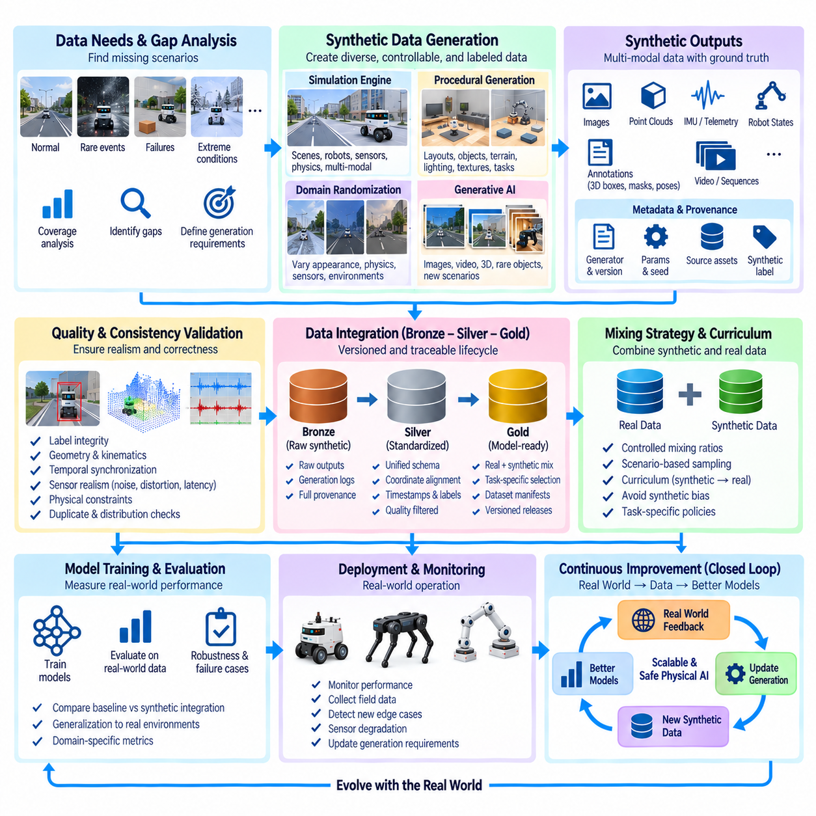
Synthetic data generation is the systematic creation of artificial observations that reproduce selected characteristics of real robot environments, sensors, objects, behaviors, and tasks. Within an AI data architecture, synthetic data complements physically collected datasets rather than simply replacing them. It expands scenario coverage, supplies rare conditions, supports controlled experimentation, and reduces dependence on costly or hazardous real-world data collection while maintaining explicit provenance.
A synthetic data strategy begins by identifying gaps in existing training data. Fleet observations may contain abundant normal navigation or manipulation examples but relatively few collisions, sensor failures, unusual objects, extreme lighting conditions, hazardous interactions, or uncommon task configurations. Coverage analysis can identify these deficiencies and translate them into generation requirements so that synthetic production is driven by measurable model and dataset needs rather than arbitrary volume targets.
Simulation engines provide a primary environment for generating robot data because they allow scenes, objects, robots, sensors, and physical parameters to be controlled systematically. Virtual cameras, LiDAR, depth sensors, IMUs, joint states, force sensors, and control signals can generate synchronized multimodal observations. Simulator configurations should record scene versions, robot models, sensor parameters, physics settings, and random seeds so that generated episodes can be reproduced.
Procedural generation can expand simulation beyond manually constructed scenarios. Object placement, room layouts, terrain, obstacles, routes, task goals, lighting, textures, and environmental conditions can be generated according to configurable rules. Parameterized generation enables thousands of related but distinct environments to be produced automatically, increasing diversity while preserving known constraints. The generation rules themselves should be treated as versioned data-production assets.
Domain randomization deliberately varies appearance, geometry, sensor characteristics, and physical properties to prevent models from overfitting to a narrow simulated world. Lighting intensity, textures, object colors, camera parameters, friction, mass, dimensions, noise, and dynamics may be sampled across defined ranges. Randomization should remain connected to the intended deployment domain because unrealistic variation can consume training capacity without improving real-world generalization.
Generative AI can provide another source of synthetic observations. Image, video, 3D, or multimodal generation models can create visual variations, rare objects, backgrounds, environmental conditions, and scenario concepts that are difficult to obtain through conventional collection. Generated content must retain metadata identifying the generator, model version, prompt or conditioning information, source assets, and generation parameters so that its origin remains distinguishable from physically observed data.
Synthetic generation can also support annotation production. Simulation environments often provide direct access to object identities, positions, poses, depth, segmentation, trajectories, contact states, and other ground-truth variables that are expensive to label manually in real data. These automatically generated labels can accelerate supervised learning, but their definitions and coordinate conventions must remain compatible with real-world annotation schemas before synthetic and physical datasets are combined.
Physical consistency is particularly important for robotics synthetic data. A visually convincing scene may still contain impossible robot poses, incorrect contact behavior, unrealistic dynamics, inconsistent shadows, invalid sensor geometry, or actions that violate actuator limits. Validation should therefore evaluate not only visual quality but also kinematic, dynamic, spatial, temporal, and sensor consistency according to the requirements of the target AI task.
Sensor modeling determines how closely synthetic observations reproduce the characteristics of deployed hardware. Ideal simulation outputs can differ substantially from real cameras, LiDAR, radar, depth sensors, and IMUs. Noise, distortion, resolution, field of view, latency, sampling frequency, missing measurements, motion effects, and calibration characteristics can be modeled to narrow this gap. Sensor profiles should be versioned and linked to corresponding physical robot configurations.
The difference between synthetic and real observations is commonly described as the simulation-to-reality gap, or sim-to-real gap. This gap can arise from appearance, physics, sensor behavior, object diversity, environmental complexity, or operational behavior. Reducing it may involve improved simulation fidelity, domain randomization, sensor modeling, calibration against real measurements, domain adaptation, or mixed training with both synthetic and physically collected datasets.
Integration strategy determines how synthetic data enters the broader training-data lifecycle. Synthetic outputs should pass through ingestion, metadata registration, schema validation, quality checks, version control, and lineage processes comparable to those used for real data. Explicit source-type fields can identify whether a sample is real, simulated, procedurally generated, or produced by a generative model, preventing synthetic observations from becoming indistinguishable from verified field data.
The Bronze–Silver–Gold architecture can provide a useful integration structure. Raw synthetic outputs and generation logs can enter Bronze while preserving complete provenance. Silver processing can standardize schemas, coordinate systems, timestamps, labels, and sensor representations so that synthetic and real observations share compatible interfaces. Gold datasets can then combine approved subsets according to task-specific mixing policies and release them as model-ready training products.
Mixing synthetic and real data requires deliberate control. Simply increasing the proportion of synthetic samples does not guarantee better performance and may bias the model toward artifacts of the generator or simulator. Dataset manifests should record synthetic-to-real ratios, scenario categories, source domains, and sampling policies. Experiments can then determine which mixtures improve validation and real-world performance for particular perception, navigation, manipulation, or prediction tasks.
Curriculum strategies can vary the synthetic-to-real mixture across the training process. Early training may use large volumes of diverse synthetic observations to establish broad representations, followed by increasing emphasis on high-quality real data for adaptation. Other tasks may interleave both sources continuously or use synthetic data only for underrepresented scenarios. The appropriate strategy should be determined empirically rather than assuming one universal mixing ratio.
Synthetic data is especially valuable for rare, dangerous, or expensive events. Collisions, near misses, equipment failures, hazardous obstacles, extreme weather, unusual object configurations, and recovery behaviors may be difficult to collect safely at useful scale. Simulation can generate controlled variations of these situations without exposing people, robots, or infrastructure to unnecessary risk, enabling models to encounter operational conditions that may otherwise be absent from training.
Quality validation should evaluate synthetic datasets before promotion into approved training releases. Checks can examine label integrity, geometry, temporal synchronization, physical constraints, sensor plausibility, duplication, distribution coverage, and generation failures. Statistical comparisons with representative real datasets can reveal major distribution differences. Failed or questionable samples should remain traceable and can be quarantined rather than silently mixed into trusted model-ready data.
Version control is necessary because synthetic datasets can change even when the scenario concept remains identical. Updates to a simulator, physics engine, robot model, generative model, asset library, sensor configuration, or generation policy may alter the resulting observations. Each synthetic release should therefore identify generation software, configuration versions, source assets, random seeds, validation rules, and dataset manifests required to reconstruct or explain the release.
Data lineage connects each synthetic sample to the process that produced it. Engineers should be able to trace a training sample back to its simulator or generator, environment, robot configuration, sensor profile, scenario definition, randomization policy, generation parameters, and validation results. This lineage becomes essential when a synthetic-data defect is discovered because affected experiments, datasets, models, and deployed systems can then be identified systematically.
Model evaluation must ultimately determine whether synthetic data contributes useful information. Performance should be measured on representative real-world validation and test data rather than only on synthetic benchmarks. Improvements in simulated accuracy may not transfer to physical operation. Evaluation should therefore examine generalization, robustness, rare-scenario performance, failure modes, and domain-specific metrics to determine whether synthetic integration actually improves deployed behavior.
Production feedback can guide future synthetic generation. Field failures, novel environments, sensor degradation, unexpected objects, and difficult robot interactions reveal gaps between training data and operational reality. These cases can be categorized and translated into new simulation scenarios, procedural rules, randomization ranges, or generative conditions. Synthetic production thereby becomes responsive to observed deployment weaknesses rather than remaining a disconnected offline process.
A mature synthetic data generation and integration strategy forms a closed loop between real-world operation, coverage analysis, generation, validation, training, deployment, and feedback. Synthetic data expands controllable diversity, while real data anchors the system to physical reality. By combining provenance, versioning, quality gates, real–synthetic mixing policies, lineage, and real-world evaluation, the architecture can use synthetic data as a governed component of scalable and continuously improving Physical AI development.

07.08 AI Data Governance: Lineage Tracking / Catalog
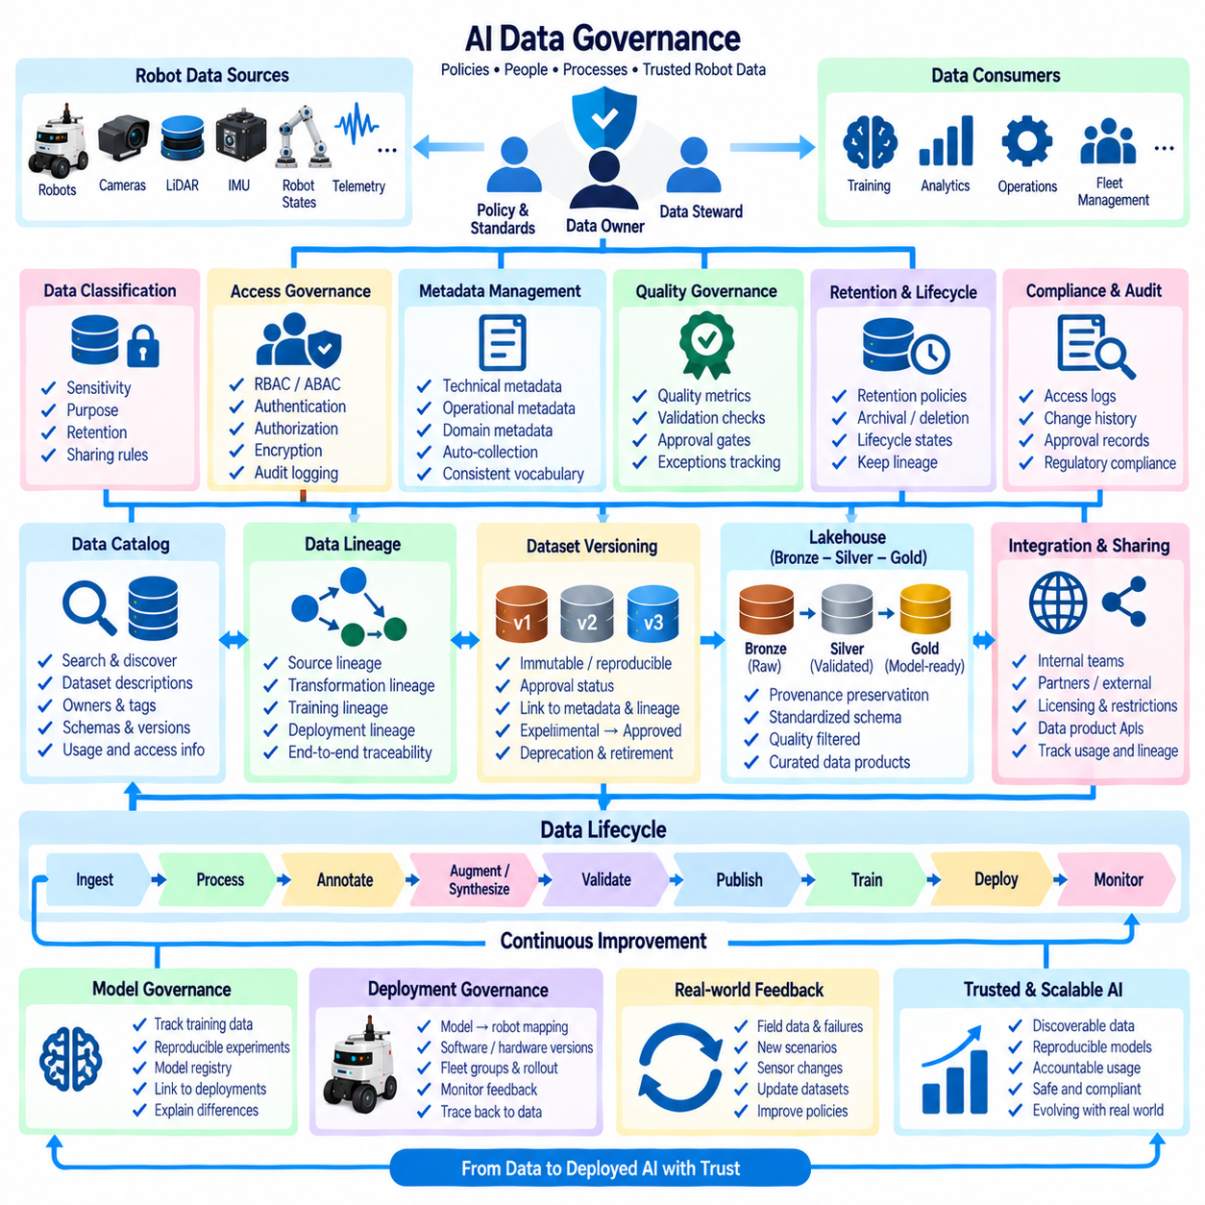
AI data governance establishes the policies, responsibilities, controls, and metadata required to manage data throughout the robot AI lifecycle. It determines who can create, access, modify, approve, share, retain, and retire datasets while ensuring that training and operational data remain trustworthy and traceable. In robotics, governance must cover heterogeneous sensor data, telemetry, annotations, features, synthetic data, training datasets, and production feedback across robots and fleets.
Governance begins with clear data ownership and stewardship. Every important dataset or data product should have an accountable owner responsible for its purpose, access rules, lifecycle, and approval status, while data stewards maintain definitions, quality requirements, metadata, and operational consistency. This prevents shared robot data platforms from becoming collections of files whose meaning, authority, and maintenance responsibilities are unclear.
Data classification provides a foundation for applying appropriate controls. Robot data can be categorized according to sensitivity, operational importance, source, intended use, retention requirement, and sharing restrictions. Images containing people, facility maps, customer environments, maintenance records, safety events, or proprietary process data may require different treatment from public simulation assets. Classification metadata allows policies to be applied consistently across storage and processing systems.
Access governance should follow explicit authorization policies rather than relying on storage location alone. Role-based or attribute-based access controls can determine which users, services, training jobs, and applications may read or modify particular datasets. Permissions can also distinguish raw data, standardized data, approved training releases, and sensitive operational records. Authentication, authorization, encryption, and audit logging together provide a controlled boundary around AI data assets.
A data catalog creates a searchable inventory of available AI and robotics data assets. Catalog entries can describe dataset names, owners, schemas, source systems, robot platforms, sensors, collection periods, locations, quality status, versions, classifications, and intended uses. Instead of searching storage directories manually, engineers can discover datasets through consistent metadata and understand whether a data product is appropriate for perception, navigation, manipulation, analytics, or another task.
The catalog should represent more than physical files. Tables, object-storage collections, ROS 2 bag archives, feature sets, annotation releases, synthetic datasets, training manifests, and Gold-layer data products can all be registered as governed assets. Logical catalog entries allow one dataset to reference multiple physical locations or formats while presenting a stable identity to users and downstream pipelines. This separates data discovery from underlying storage implementation.
Data lineage records how information moves and changes across the architecture. A lineage graph can connect raw robot observations to ingestion jobs, Bronze records, Silver transformations, annotations, augmented or synthetic samples, Gold datasets, features, training experiments, models, and deployments. This makes it possible to answer not only where data is stored, but also where it came from, which processes changed it, and which downstream systems depend on it.
Source lineage identifies the origin of each dataset. Relevant metadata may include robot ID, sensor ID, mission or episode, collection time, software version, calibration version, environment, simulator, external source, or generation method. Preserving these references is essential when multiple fleets and data-generation systems contribute to a shared platform because similar-looking records may have very different operational meaning, reliability, and usage restrictions.
Transformation lineage captures the processing steps between source and derived data. Filtering, synchronization, normalization, coordinate conversion, annotation, feature computation, augmentation, aggregation, and dataset splitting should be associated with identifiable pipeline versions and parameters. When a transformation changes, lineage enables engineers to determine which derived datasets were created with the old logic and whether they need to be regenerated or revalidated.
Training lineage extends traceability from datasets into machine-learning experiments. A model version should reference the exact training dataset release, validation dataset, feature definitions, augmentation policy, synthetic-data mixture, preprocessing configuration, code version, and relevant parameters. Connecting model artifacts to governed data versions makes experiment reproduction possible and provides evidence for explaining why two models trained for the same task may behave differently.
Deployment lineage continues the chain into production. Model registry entries can be connected to deployment packages, robot software versions, hardware configurations, fleet groups, rollout periods, and operational feedback. If a dataset defect or annotation problem is later discovered, the lineage graph can identify models trained from the affected data and the robots or applications receiving those models, enabling targeted investigation rather than fleet-wide uncertainty.
Metadata management supports governance and lineage by defining a consistent vocabulary for describing assets. Technical metadata includes schemas, formats, partitions, timestamps, storage locations, and processing dependencies. Operational metadata can include owners, approval states, quality scores, retention policies, and access classifications. Domain metadata describes robot tasks, sensors, environments, objects, behaviors, failures, and scenarios that give the data its physical and business meaning.
Metadata should be captured automatically whenever possible. Ingestion services can register source information, transformation pipelines can record inputs and outputs, validation jobs can publish quality results, and training systems can attach dataset and feature versions to experiments. Automatic metadata collection reduces incomplete documentation and ensures that governance information evolves with the data pipeline rather than depending entirely on engineers to update separate records manually.
Dataset versioning and governance must operate together. A catalog entry may represent a logical dataset across many releases, while each version identifies a specific immutable or reproducible state. Approval status, quality results, schema versions, lineage, and usage restrictions can be associated with each release independently. This allows an organization to distinguish experimental, validated, approved, deprecated, and retired data without losing historical traceability.
The Bronze–Silver–Gold architecture can express governance maturity as data moves through the lakehouse. Bronze preserves source fidelity and provenance with restricted access where necessary. Silver introduces standardized schemas, validated metadata, quality checks, and reusable identities. Gold contains curated data products approved for defined analytics or AI purposes. Promotion between layers can therefore function as a governed lifecycle rather than merely a technical transformation.
Quality governance connects validation results with data usability decisions. Quality metrics, failed checks, missing metadata, drift indicators, annotation confidence, and coverage measurements can be recorded in the catalog. Policies can prevent a dataset from becoming an approved training release until required thresholds are satisfied. Exceptions should also be documented so that downstream users can distinguish formally approved data from experimental data accepted under known limitations.
Retention and lifecycle management prevent unlimited accumulation of robot data. Policies can specify how long raw sensor recordings, derived datasets, intermediate artifacts, annotations, training releases, and audit records should be retained. Frequently used Gold datasets may remain readily accessible while replaceable intermediate outputs can be regenerated or archived. Retirement should preserve enough metadata and lineage to explain historical models even after large underlying assets are moved or removed.
Governance also controls data sharing across teams, partners, sites, and external environments. Catalog metadata can record licensing, contractual restrictions, permitted purposes, export constraints, or project-specific access boundaries. Derived datasets should inherit relevant restrictions from their sources unless an explicit governance process changes them. Lineage is therefore important not only for technical reproducibility but also for understanding whether downstream use remains consistent with source obligations.
Auditability requires recording important actions performed on governed data. Access events, permission changes, dataset approvals, schema modifications, quality overrides, release promotions, and retirement decisions can be logged with identities and timestamps. Audit records help reconstruct how a dataset reached its current state and provide operational evidence when investigating unexpected model behavior, security incidents, compliance questions, or errors in data-processing pipelines.
At fleet scale, governance must remain automated and federated enough to support many robots, sites, sensors, and teams without creating a central manual bottleneck. Common metadata standards, catalog APIs, policy engines, lineage collectors, and automated quality gates can provide shared controls while allowing domain teams to manage specialized datasets. The goal is consistent governance across distributed data production without eliminating the flexibility required by different robot applications.
A mature governance architecture connects the catalog, lineage graph, quality system, version control, feature store, lakehouse, experiment tracking, model registry, and deployment platform. Together they create an evidence chain from physical observation to deployed AI behavior. Engineers can discover what data exists, understand its meaning, verify its quality and permissions, reproduce how it was transformed, and determine which models and robots depend on it.
AI data governance therefore becomes an operational control plane for the complete Physical AI data lifecycle rather than a documentation activity performed after development. By combining ownership, classification, access control, cataloging, metadata, lineage, quality, versioning, retention, auditability, and deployment traceability, the architecture enables robot data to remain discoverable, reproducible, accountable, and safely reusable as datasets, models, and fleets continuously evolve.

07.09 Continual Learning Data Pipeline Design [w/Code]
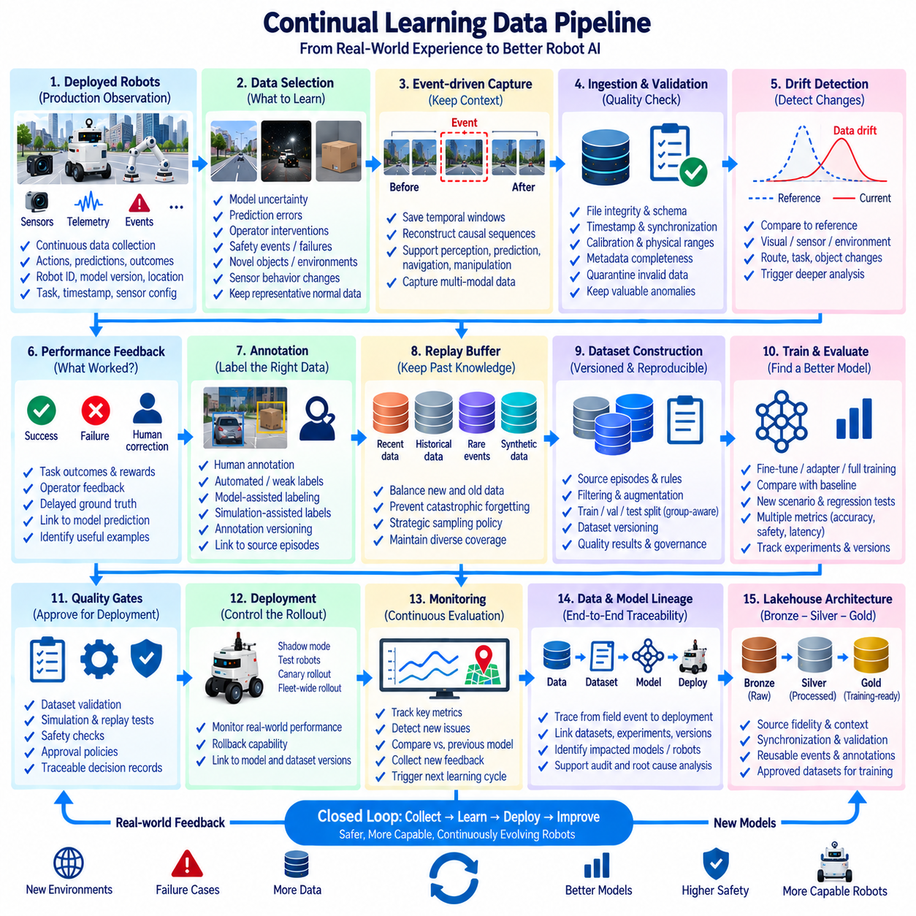
A continual learning data pipeline enables robot AI systems to improve after deployment by converting operational experience into controlled future training data. Unlike one-time model development, continual learning treats production data as part of an ongoing lifecycle connecting robots, data platforms, training systems, validation, and redeployment. The objective is not unrestricted automatic retraining, but governed adaptation that preserves reliability while incorporating meaningful changes from the real world.
The pipeline begins with production observation. Deployed robots continuously generate sensor streams, telemetry, events, predictions, actions, mission outcomes, system states, and diagnostic information. Storing every signal indefinitely is usually inefficient, so collection policies should determine which observations require preservation. Metadata such as robot ID, model version, software version, location context, task, timestamp, and sensor configuration provides the context required for later analysis.
Data selection is a central component because the most useful continual-learning samples are not necessarily the most frequent ones. Selection mechanisms can prioritize model uncertainty, prediction errors, operator interventions, safety events, task failures, novel objects, unusual environments, or changes in sensor behavior. Sampling normal successful operation remains important as a reference distribution, but targeted selection prevents large volumes of repetitive fleet data from overwhelming more informative examples.
Event-driven capture can preserve high-value context surrounding important incidents. When a robot detects a failure, intervention, anomaly, or low-confidence prediction, the pipeline can retain a temporal window before and after the event rather than saving only the triggering record. This contextual data helps reconstruct causal sequences and supports perception, prediction, navigation, manipulation, and behavior-learning tasks that depend on temporal relationships between observations and actions.
Selected production data must pass through ingestion and validation before becoming training material. File integrity, schemas, timestamps, sensor synchronization, calibration references, missing observations, physical ranges, and metadata completeness should be checked. Invalid data can be quarantined while potentially valuable anomalies remain available for review. Continual learning should not convert every unusual production observation directly into a trusted training sample without determining whether it represents reality or a data defect.
Data drift detection identifies changes between current production observations and established reference distributions. Changes may appear in visual features, object frequencies, routes, environments, sensor statistics, robot configurations, task patterns, or user behavior. Drift does not automatically indicate model failure, but it provides evidence that the operating domain is evolving. Drift metrics can therefore trigger deeper analysis, additional data collection, or candidate dataset construction.
Performance feedback provides another signal for deciding what should enter the learning cycle. Ground-truth outcomes, operator corrections, mission completion, collision avoidance, manipulation success, recovery behavior, and downstream system responses can reveal whether predictions were useful. Where immediate labels are unavailable, delayed outcomes or human review may provide supervision. Linking these outcomes to the exact model prediction and input context is essential for constructing meaningful feedback data.
Annotation can be integrated selectively rather than applied uniformly to all collected data. High-value samples may be routed to human annotation, automated labeling, weak supervision, simulation-assisted labeling, or model-assisted review. Existing models can propose labels to reduce effort, but uncertain or safety-relevant examples may require stronger verification. Annotation versions and reviewer decisions should remain linked to the source production episodes through data lineage.
A replay buffer or historical reference dataset helps prevent the learning process from focusing exclusively on recent observations. New data may represent emerging conditions, while older data preserves knowledge of established environments and behaviors. Training datasets can therefore combine recent samples, representative historical examples, rare events, and strategically selected synthetic data. Sampling policies control this balance and provide an important defense against catastrophic forgetting.
Catastrophic forgetting occurs when adaptation to new data degrades capabilities previously learned by the model. Continual-learning pipelines must therefore preserve representative historical coverage and evaluate both new and established scenarios. Replay data, balanced sampling, regularization techniques, frozen components, or selective fine-tuning can be used depending on the model architecture. Data design is fundamental because an adaptation dataset containing only recent conditions can itself create forgetting.
Candidate dataset construction should be reproducible and versioned. Each release can identify source episodes, selection rules, annotation versions, filtering logic, augmentation policies, synthetic-data contributions, train-validation-test partitions, and quality results. The dataset should be treated as a governed artifact rather than a temporary collection assembled inside a training script. This enables engineers to reconstruct why a particular model update received specific operational experiences.
Train-validation-test separation remains necessary in continual learning. Newly collected episodes can be highly correlated by robot, route, site, time, task, or object instance. Random sample splitting may therefore leak nearly identical observations into training and evaluation sets. Group-aware and time-aware partitioning helps ensure that updated models are evaluated against meaningful unseen conditions rather than simply demonstrating improved performance on variations of recently observed data.
Model retraining does not always require full training from the beginning. Depending on the change, the pipeline may perform fine-tuning, adapter updates, feature updates, partial retraining, or complete retraining. The selected method should be recorded with dataset and model versions. Continual learning is therefore closely connected to experiment tracking, because each candidate model must preserve the relationship between training data, configuration, code, checkpoints, and evaluation results.
Evaluation should compare candidate models against the currently deployed baseline across multiple dimensions. New scenarios that motivated the update must be tested, but established capabilities should also be protected through regression evaluation. Metrics can cover accuracy, task success, robustness, latency, resource consumption, safety-related behavior, and fleet-specific requirements. A candidate should advance only when evidence shows acceptable performance across both adaptation and retention objectives.
Quality gates separate model creation from model promotion. Passing training metrics alone should not automatically authorize deployment. Dataset validation, regression tests, simulation evaluation, replay tests, hardware-in-the-loop testing, safety checks, and approval policies can form staged release gates. Failed candidates remain traceable for analysis, while approved models enter the model registry with links to their datasets, experiments, evaluation evidence, and intended deployment scope.
Deployment should use controlled rollout rather than immediate fleet-wide replacement whenever operational risk requires caution. A candidate model can first run in shadow mode, simulation, a test robot, or a limited fleet group before broader promotion. Canary deployment and staged rollout provide opportunities to compare new and previous behavior under real conditions. Rollback capability should preserve the previous trusted model so that unexpected degradation can be contained quickly.
Model and data lineage must remain continuous through this entire cycle. Engineers should be able to trace a field event to the robot and deployed model, then to the selected production episode, annotation, dataset release, training experiment, candidate model, evaluation, and subsequent deployment. This end-to-end lineage allows an unexpected behavior to be investigated in both directions and identifies which models or fleet groups are affected by a defective dataset or processing rule.
The Bronze–Silver–Gold architecture can organize continual-learning data as it matures. Raw fleet observations and event captures enter Bronze with source fidelity and operational context. Silver processing performs synchronization, normalization, validation, annotation integration, and reusable event construction. Gold contains approved continual-learning datasets, evaluation sets, replay collections, or training manifests that satisfy defined quality and governance requirements for model development.
Automation coordinates the repeated cycle without removing necessary control. Workflow orchestration can detect new data, execute validation, calculate drift metrics, select samples, initiate annotation, construct datasets, launch training, run evaluations, and register candidate models. Policy-driven triggers determine whether a change merely produces an alert or proceeds toward retraining. Human approval can remain at critical gates where operational, safety, or business judgment is required.
Fleet-scale continual learning benefits from aggregation across many robots while retaining local context. A rare failure on one robot may provide useful training information for an entire fleet, while site-specific conditions may justify specialized models or datasets. Metadata and segmentation policies can distinguish global patterns from local variation. This enables shared learning without assuming that every observation from every robot should influence all deployments identically.
A mature continual learning data pipeline forms a governed closed loop from deployment to observation, selection, validation, dataset construction, training, evaluation, controlled rollout, and renewed monitoring. Real-world experience becomes a managed source of evidence rather than an uncontrolled stream of retraining data. By combining drift detection, replay data, lineage, versioning, quality gates, regression testing, and fleet feedback, Physical AI systems can evolve while preserving reproducibility, accountability, and previously acquired capabilities.

07.10 Robot Physical AI Training Data Architecture Case
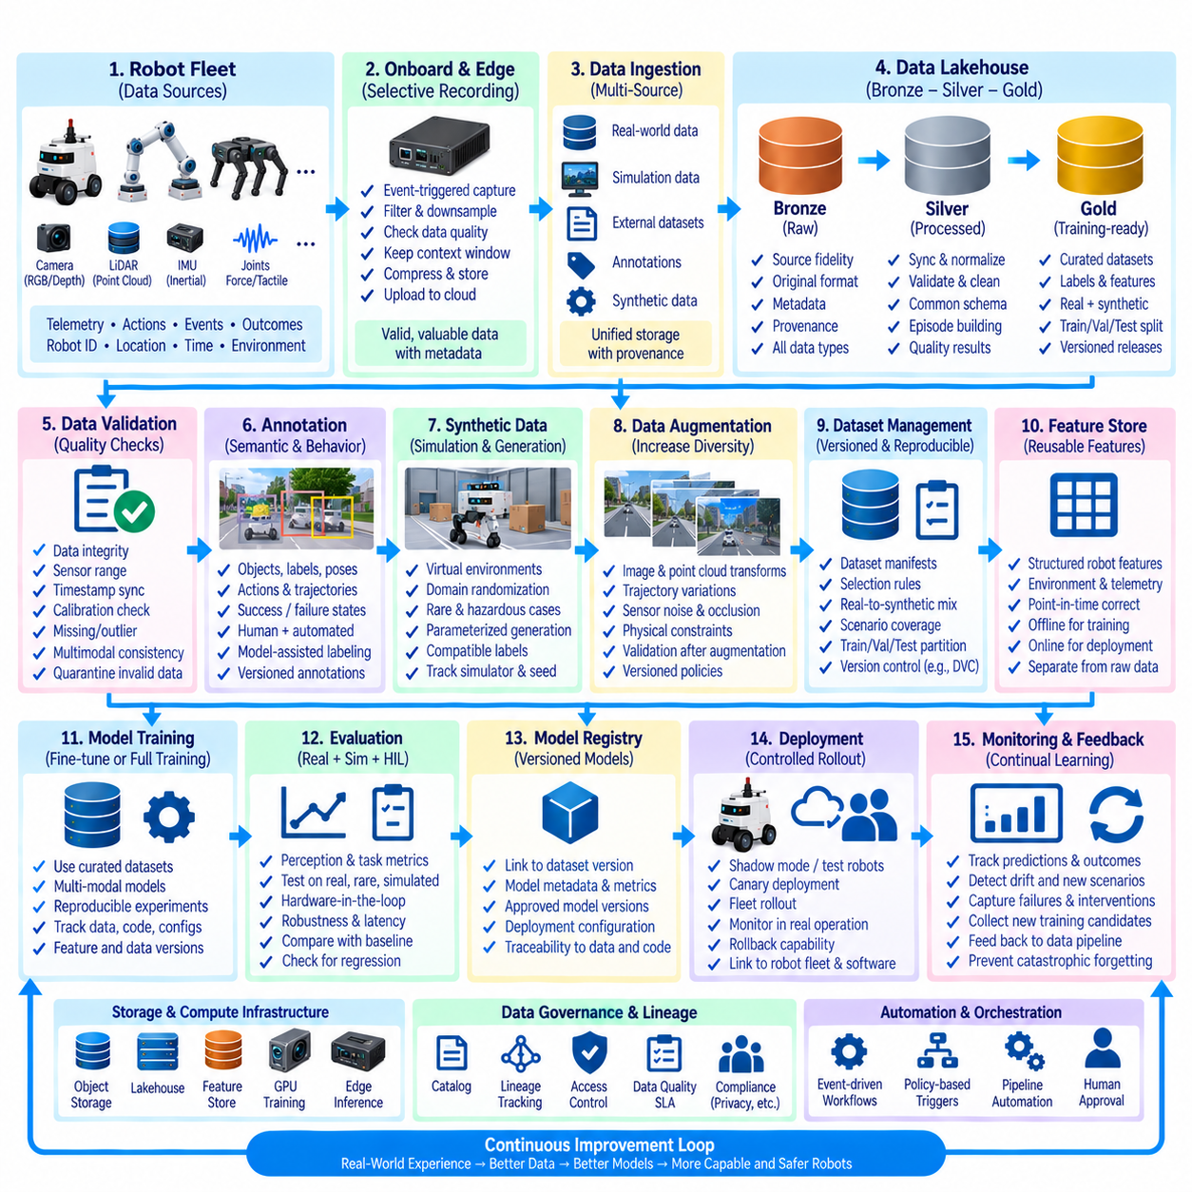
A Robot Physical AI training data architecture can be understood as an integrated case in which operational robot data, simulation data, annotations, features, and model feedback are transformed into governed training products. The architecture connects the earlier AI data components—lakehouse, quality validation, augmentation, synthetic data, lineage, and continual learning—into one lifecycle. Its purpose is to provide reproducible multimodal datasets that reflect physical interaction rather than isolated digital observations.
Consider a fleet containing mobile robots and manipulators operating across warehouses, laboratories, or industrial environments. Each robot may generate RGB and depth images, LiDAR point clouds, IMU measurements, joint states, force or tactile signals, localization estimates, commands, actions, telemetry, and task events. Physical AI training requires these streams to be interpreted together because useful learning examples often describe relationships between perception, robot state, action, environment, and resulting outcome.
Onboard collection should preserve operational context without attempting to upload every sensor stream continuously. Recording policies can capture routine samples, mission episodes, failures, operator interventions, uncertain predictions, collisions or near misses, and other high-value events. Each recording should carry robot ID, hardware configuration, software and model versions, calibration references, task information, timestamps, and environmental context so that later processing can reconstruct the conditions under which the experience occurred.
Edge processing can reduce unnecessary transfer while protecting the fidelity of important evidence. Lightweight validation may detect corrupted files, missing frames, timestamp problems, or incomplete recordings before data leaves the robot. Selection logic can retain event windows around failures or uncertain predictions while downsampling repetitive normal operation. Large camera, LiDAR, and ROS 2 bag assets may remain as immutable objects, with structured metadata describing their locations and relationships.
After transfer to the central data platform, raw operational data enters the Bronze layer of the lakehouse. Bronze preserves source fidelity, original identifiers, ingestion timestamps, robot configuration, calibration information, and provenance. Real-world recordings, simulation outputs, external datasets, annotation imports, and synthetic-generation logs can coexist at this level while retaining explicit source types. The objective is preservation and traceability rather than immediate model readiness.
Silver processing converts raw observations into standardized reusable data. Pipelines synchronize sensor streams, normalize units, resolve coordinate frames, validate schemas, associate mission context, remove invalid duplicates, and register quality results. Camera frames, point clouds, robot states, actions, and task outcomes can be organized into consistent episodes. This layer creates a common representation that allows data from different robots, sites, simulators, and collection periods to participate in shared downstream workflows.
Quality validation determines whether these episodes are trustworthy enough for AI use. Checks can examine image integrity, LiDAR density, sensor ranges, timestamp synchronization, calibration validity, missing observations, physical constraints, and multimodal consistency. Invalid records can be quarantined rather than silently deleted. Rare failures that appear statistically abnormal should remain available when they represent genuine robot behavior because Physical AI models often need precisely these difficult examples.
Annotation adds semantic and behavioral meaning to validated observations. Perception data may receive object classes, bounding boxes, segmentation masks, poses, or scene labels, while manipulation and navigation episodes can include actions, trajectories, contacts, success states, interventions, and task outcomes. Human annotation can be combined with automated or model-assisted labeling. Annotation versions remain connected to source episodes so that corrected labels can be propagated into future dataset releases.
Simulation and synthetic generation complement real-world collection where coverage is insufficient. Virtual environments can create unusual obstacles, object configurations, lighting conditions, sensor disturbances, failures, and hazardous interactions that are expensive or unsafe to reproduce physically. Procedural generation and domain randomization can expand diversity further. Synthetic samples should use compatible schemas and labels while retaining generator, simulator, configuration, random seed, and source information.
Data augmentation increases variation within approved observations without losing task semantics. Image transformations, point-cloud perturbations, temporal sampling, trajectory variations, sensor noise, or controlled occlusion can improve robustness when they respect physical constraints. Augmentation policies are versioned and associated with training experiments. Post-augmentation validation checks that transformed labels, geometry, temporal relationships, and multimodal alignment remain valid before the samples are accepted.
A Gold-layer training product is created after selection, validation, annotation, and transformation requirements are satisfied. Rather than copying every large sensor asset, the Gold release may consist of curated tables, manifests, references, labels, features, and approved object-storage locations. Each release defines its real-to-synthetic mixture, scenario coverage, augmentation policy, quality status, and train-validation-test membership, creating a stable contract between the data platform and model-training system.
Dataset partitioning must account for physical correlation. Frames recorded seconds apart, repeated routes, identical objects, the same robot, or multiple views of one manipulation episode should not be randomly distributed across training and evaluation sets when doing so creates leakage. Group-aware partitioning by episode, robot, site, route, object, or time period provides a more realistic measure of generalization to new physical conditions.
A feature store can complement the training dataset by managing reusable structured features derived from robot history, telemetry, environment state, maintenance information, or mission context. Offline feature retrieval supports training with point-in-time correct historical values, while online serving can provide equivalent features during deployment. Large raw images and point clouds remain in scalable storage rather than being forced into the feature store, preserving separation between heavy sensor assets and model-ready structured features.
Training data version control connects the Gold dataset to reproducible experiments. Dataset manifests, table versions, file references, annotation releases, feature definitions, preprocessing configurations, augmentation policies, and synthetic-data mixtures should be identifiable for every model run. A model registry can then reference the exact dataset release used to create each model, establishing a reproducible chain from physical observation through data preparation to trained artifact.
Evaluation combines conventional validation metrics with tests reflecting physical deployment. Candidate models can be assessed on held-out real episodes, rare events, simulation scenarios, replay collections, and hardware-in-the-loop environments. Perception accuracy alone may be insufficient when prediction errors influence navigation or manipulation. Evaluation should therefore consider task success, robustness, latency, resource requirements, failure behavior, and the consequences of model decisions within the robot system.
Deployment should preserve the connection between model and data. A registered model can be associated with robot hardware, software release, sensor configuration, fleet group, and rollout period. Shadow execution, test robots, or canary deployment can provide controlled exposure before fleet-wide adoption. Monitoring then records predictions, interventions, failures, task outcomes, and changing data distributions, providing evidence about whether the model behaves as expected under real physical conditions.
Operational feedback closes the Physical AI data loop. New failures, uncertain predictions, environmental changes, sensor degradation, and previously unseen objects can trigger selective capture and become candidates for future learning. Useful episodes return through ingestion, validation, annotation, dataset construction, training, and evaluation. Historical replay data remains part of the process so that adapting to new conditions does not unintentionally remove capabilities required in established operating environments.
Data governance and lineage span every stage of this architecture. Catalog records identify datasets, owners, schemas, classifications, quality status, and approved uses, while lineage connects robots and simulations to Bronze sources, Silver transformations, Gold releases, experiments, models, and deployments. If a calibration error, defective annotation, or transformation problem is discovered, affected datasets and deployed models can be identified without reconstructing relationships manually.
Storage and compute responsibilities can be separated according to workload. Object storage or scalable file systems hold large immutable sensor assets, lakehouse tables manage structured metadata and dataset state, feature stores serve reusable features, GPU infrastructure performs training, and edge computers execute deployed inference. Common identifiers and metadata contracts connect these systems so that scaling one component does not require collapsing the entire architecture into a single storage or processing technology.
Automation coordinates the architecture through event-driven and scheduled workflows. New recordings can trigger ingestion and validation; approved samples can enter annotation or dataset construction; dataset releases can initiate training and evaluation; accepted models can proceed through deployment gates. Automation reduces repetitive manual operations, but quality, safety, governance, and rollout policies determine whether an artifact is allowed to advance from one stage to another.
The resulting architecture treats Physical AI training data as a continuously evolving system rather than a static collection of files. Real robots provide grounded experience, simulation expands controlled coverage, augmentation increases useful diversity, validation protects trust, versioning preserves reproducibility, and lineage maintains accountability. By connecting these elements through Bronze–Silver–Gold data products and a governed continual-learning loop, robot fleets can convert physical experience into increasingly capable models while retaining traceability and control.

