Volume 07 Robot Data Architecture

08. Digital Twin Data

08.01 Digital Twin Data Architecture Overview
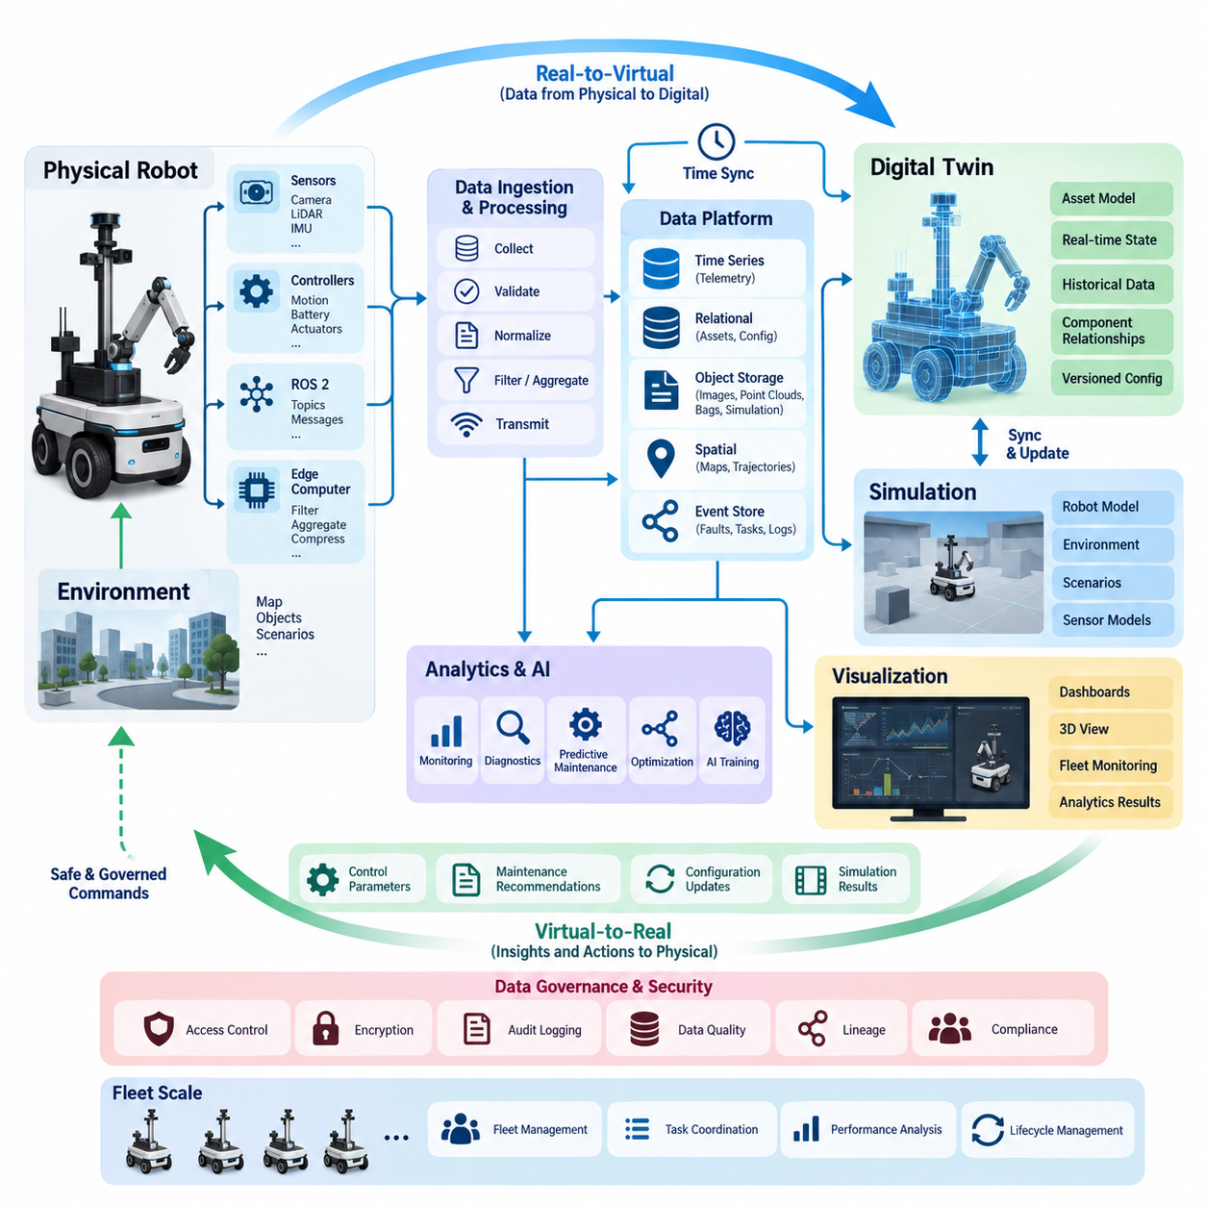
A digital twin data architecture provides the information foundation required to maintain a continuously evolving digital representation of a physical robot, its operating environment, and its mission context. Unlike a static simulation model, a digital twin combines engineering models with operational data so that the virtual representation reflects how the physical system is actually configured, behaving, and changing over time.
The architecture typically connects physical assets, onboard computing, communication infrastructure, data platforms, simulation environments, analytics services, and visualization applications. Robot sensors and controllers generate observations describing position, velocity, battery state, actuator behavior, temperature, vibration, perception results, faults, and mission progress. These observations become the continuously updated evidence from which the digital representation is maintained.
A fundamental architectural principle is separation between relatively static asset information and rapidly changing operational state. Robot geometry, component definitions, serial numbers, calibration parameters, software versions, sensor configurations, and mechanical constraints change comparatively slowly. Position, velocity, motor current, battery voltage, thermal state, localization confidence, and task status may change many times per second and therefore require different storage and processing strategies.
Digital twin information must also preserve relationships among components rather than treating telemetry as unrelated measurements. A mobile robot can be represented as an asset composed of drive modules, batteries, computers, sensors, communication devices, and payload systems. Measurements are associated with these components, while component relationships establish the context required to interpret values, diagnose abnormalities, and reproduce system configurations inside simulation environments.
Time is another central dimension of the architecture. A useful twin must distinguish the current state from historical state and maintain sufficiently accurate timestamps to reconstruct how the robot evolved during an operation. Sensor timestamps, controller clocks, edge-system time, server ingestion time, and simulation time may differ. Synchronization and explicit time semantics therefore become necessary for event reconstruction, debugging, predictive analysis, and physical-to-digital comparison.
The physical-to-digital data path normally begins with sensors, controllers, ROS 2 nodes, embedded systems, and edge computers. Raw signals are collected, timestamped, normalized, validated, and associated with robot and component identifiers. Edge processing can reduce unnecessary traffic through filtering, aggregation, compression, or event-based selection before relevant information is transmitted to an on-premise or cloud platform for persistent storage and higher-level analysis.
Different digital twin information classes require different storage technologies. High-frequency telemetry fits naturally into time-series storage, while configuration and asset metadata can use relational or document-oriented databases. Images, point clouds, ROS bags, simulation outputs, and large engineering files are commonly retained in object storage. Spatial databases may manage maps and trajectories, while event stores preserve faults, maintenance actions, task transitions, and other operational events.
The architecture should not be understood as a one-way telemetry pipeline. A mature digital twin establishes a bidirectional information loop between physical and virtual systems. Physical observations update the digital representation, while simulations and analytical models can generate predictions, optimized parameters, maintenance recommendations, or validated configuration changes. Any information flowing back toward the robot requires governance and safety controls appropriate to its operational impact.
State synchronization determines how faithfully the virtual system represents the physical asset. Not every variable requires identical update frequency or latency. Motion and safety-related states may demand near-real-time updates, while maintenance records or configuration metadata can tolerate much slower synchronization. Designing the architecture therefore requires explicit synchronization policies defining update rates, acceptable latency, consistency requirements, missing-data behavior, and recovery after communication interruptions.
Digital twins become particularly valuable when historical data is combined with analytical and simulation models. Current motor temperature alone provides limited information, but temperature history combined with load, velocity, ambient conditions, vibration, and maintenance records can reveal degradation patterns. The twin can use these relationships to estimate health indicators, compare actual behavior with expected behavior, and support predictive maintenance before a component reaches a critical failure condition.
Simulation introduces another important data domain. Robot geometry, physics parameters, sensor models, environmental assets, scenarios, and control configurations must be connected with operational information collected from real robots. Real-world observations can refine simulation assumptions, while simulated scenarios can produce synthetic data for testing and AI training. This creates a simulation-to-real and real-to-simulation feedback loop rather than maintaining separate engineering and operational data silos.
A digital twin architecture must also preserve version information. A robot operating today may differ substantially from the same robot several months earlier because firmware, AI models, calibration parameters, mechanical components, maps, or safety configurations have changed. Without versioned configurations and lineage, historical telemetry may be interpreted against the wrong system definition. Reproducibility therefore depends on linking operational records to the exact configuration active at that time.
At fleet scale, the architecture expands from individual asset twins to coordinated representations of many robots. Each robot maintains its own identity, configuration, state, health, and history, while fleet-level services aggregate task execution, traffic conditions, charging status, utilization, failures, and operational performance. This enables comparison among equivalent assets and provides the data foundation for fleet optimization, coordinated maintenance, and fleet-level digital twin applications.
Interoperability becomes increasingly important when twins span different robot types, simulation tools, engineering systems, and enterprise applications. Standardized identifiers, schemas, units, coordinate frames, metadata, and interfaces reduce dependence on proprietary representations. Asset Administration Shell and related industrial digitalization concepts can provide structured approaches for describing assets and their submodels, supporting more consistent information exchange across lifecycle systems.
Data quality directly determines digital twin credibility. Missing telemetry, duplicated events, incorrect timestamps, calibration drift, inconsistent units, and invalid coordinate transformations can cause the virtual representation to diverge from reality. Quality controls should therefore validate completeness, freshness, range, temporal consistency, schema compliance, and cross-sensor relationships. Quality status itself should be represented as data so applications can determine whether a twin state is trustworthy.
Security and governance must extend across the entire digital twin lifecycle because the architecture may contain detailed information about robot behavior, facility layouts, operational schedules, software configurations, maintenance history, and AI data. Authentication, authorization, encryption, audit logging, retention policies, data classification, and lineage tracking protect these assets while ensuring that engineers, operators, analytics services, and automated systems receive only the information they are permitted to access.
Ultimately, digital twin data architecture acts as a bridge between robotics data engineering and simulation-driven operation. It organizes heterogeneous robot information into a time-aware, version-aware, asset-centered representation that can support visualization, diagnosis, prediction, optimization, AI development, and lifecycle management. Its value comes not from creating a virtual model alone, but from maintaining a governed data loop connecting physical behavior, historical evidence, analytical intelligence, and virtual experimentation.

08.02 Robot Digital Twin Data Model Design
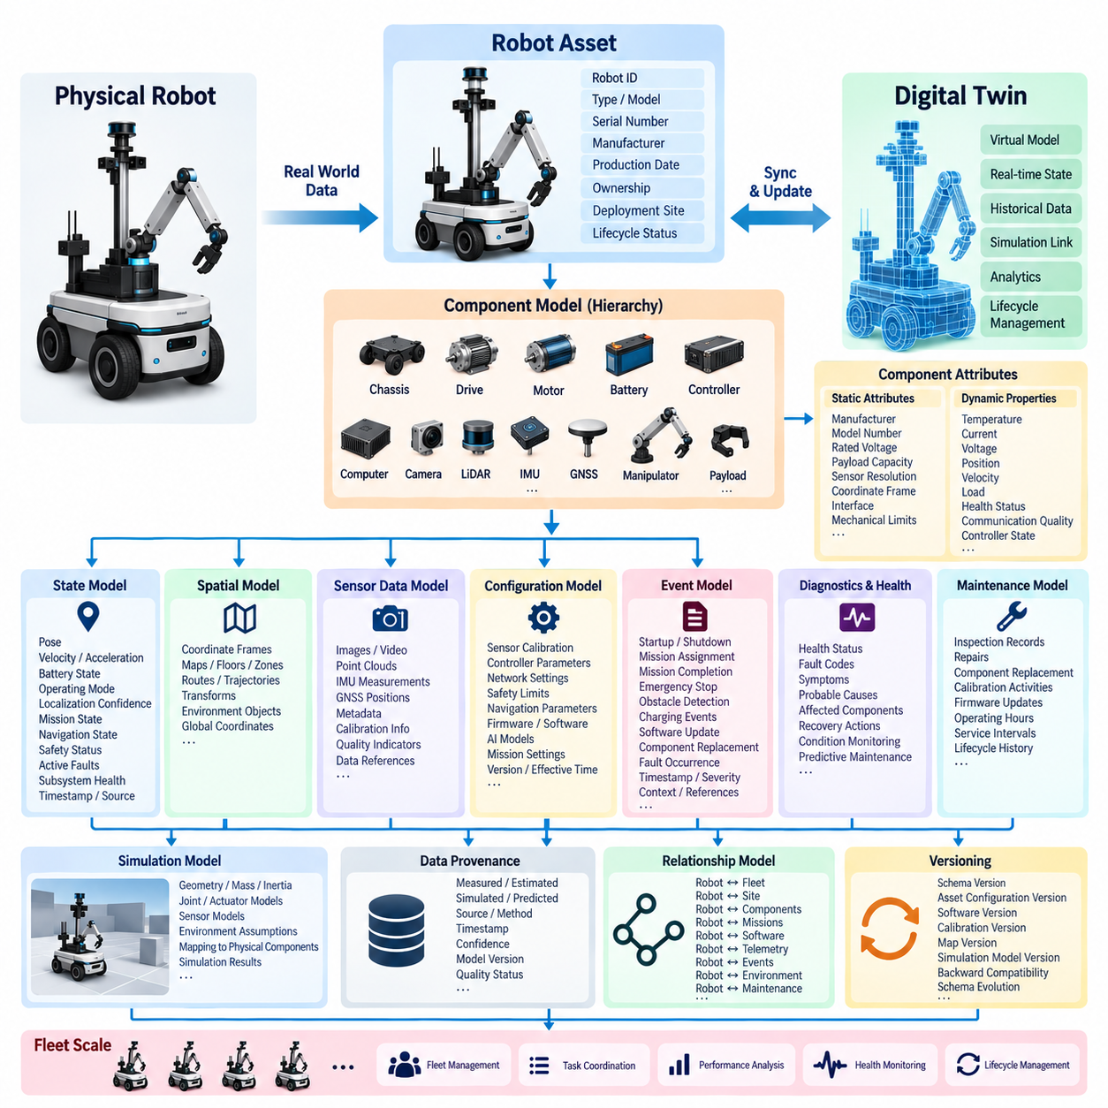
A robot digital twin data model defines how a physical robot is represented as structured, machine-readable information throughout its operational lifecycle. The model must describe not only the robot as a single asset but also its components, configuration, dynamic state, relationships, environment, operational history, and simulation counterparts. This structured representation becomes the semantic foundation that connects physical robot data with digital twin services.
The root entity of the model is normally the robot asset, identified by a globally unique robot ID and associated metadata. This entity can contain robot type, model, serial number, manufacturer, production date, hardware revision, software baseline, ownership, deployment site, and lifecycle status. Stable identity is essential because telemetry, maintenance records, configurations, simulations, and AI-generated information must remain associated with the correct physical asset over long periods.
A robot should then be decomposed into hierarchical component entities reflecting its actual physical and computational structure. Typical components include chassis, drive modules, motors, batteries, motor controllers, onboard computers, cameras, LiDARs, IMUs, GNSS receivers, communication modules, manipulators, and payload devices. Parent-child and dependency relationships allow applications to understand which measurements, faults, configurations, and maintenance activities belong to each subsystem.
Each component requires both static attributes and dynamic properties. Static attributes may describe manufacturer, model number, rated voltage, payload capacity, sensor resolution, coordinate frame, communication interface, or mechanical limits. Dynamic properties represent values that change during operation, including temperature, current, voltage, velocity, position, load, utilization, health status, communication quality, and controller state. Separating these categories improves storage efficiency and semantic clarity.
The dynamic state model represents the robot at a particular point in time. It may include pose, velocity, acceleration, battery state of charge, operating mode, localization confidence, current mission, navigation state, safety status, active faults, and subsystem health. Every state record should contain timestamps and source information so that applications can distinguish when a value was measured, which subsystem produced it, and whether it represents measured, estimated, or derived information.
Spatial information is especially important because robots operate within physical environments. Robot pose should therefore be associated with clearly defined coordinate frames, maps, floors, zones, routes, and reference systems. Transform relationships among robot base frames, sensors, manipulators, maps, and global coordinates must be represented consistently. This allows digital twin applications to combine localization, perception, trajectory, simulation, and environmental information without ambiguous spatial interpretation.
Sensor observations require dedicated data structures because different sensors produce fundamentally different information. Cameras generate images or video, LiDARs generate point clouds, IMUs produce high-frequency inertial measurements, and GNSS systems provide georeferenced positions. Rather than embedding large sensor payloads directly inside the twin state, the model can maintain metadata, timestamps, calibration information, quality indicators, and references to objects stored in specialized sensor or object storage.
Configuration data defines how the robot was intended to operate at a particular time. It includes sensor calibration, controller parameters, network settings, safety limits, navigation parameters, firmware versions, software packages, AI models, and mission-specific settings. Configuration records should be versioned and associated with effective time intervals, enabling engineers to reconstruct exactly which configuration was active when a particular behavior, fault, or performance result occurred.
Operational events complement continuous state information by recording meaningful transitions. Examples include robot startup, shutdown, mission assignment, mission completion, emergency stop, localization loss, obstacle detection, charging start, charging completion, software update, component replacement, and fault occurrence. Event records normally contain event type, timestamp, robot ID, component ID, severity, source, contextual parameters, and references to related telemetry or diagnostic information.
The model should explicitly represent robot health and diagnostic information. Components can expose health states such as normal, degraded, warning, critical, or unavailable, while diagnostic records describe fault codes, symptoms, probable causes, affected components, and recovery actions. Linking diagnostic events with historical telemetry enables the digital twin to support root-cause analysis, reliability engineering, condition monitoring, and predictive maintenance rather than functioning only as a visualization model.
Maintenance information extends the digital representation across the physical asset lifecycle. Inspection records, repairs, component replacements, calibration activities, firmware updates, operating hours, and service intervals should be connected to the affected robot and component entities. When a motor, battery, sensor, or computer is replaced, the model must preserve both the previous component history and the identity of the newly installed component instead of overwriting historical relationships.
A simulation representation must be linked to the corresponding physical entities. Robot geometry, mass, inertia, joint properties, actuator characteristics, sensor models, friction parameters, and environmental assumptions can be stored directly or referenced through simulation assets. Mapping between physical components and virtual components enables real-world measurements to update simulation parameters while simulation results can be compared with observed behavior to identify model discrepancies.
The digital twin data model should distinguish measured, estimated, simulated, and predicted values. A physical sensor temperature is fundamentally different from a simulated temperature or an AI-generated future estimate, even when all three use the same engineering unit. Each value therefore benefits from provenance metadata describing its source, generation method, timestamp, confidence, model version, and quality status. This prevents analytical systems from incorrectly treating heterogeneous information as equivalent observations.
Relationships are as important as individual entities. A robot belongs to a fleet, operates at a site, executes missions, contains components, uses software, produces telemetry, generates events, follows trajectories, interacts with environmental objects, and participates in maintenance activities. Explicit relationship modeling allows the digital twin to answer questions spanning multiple domains instead of forcing applications to reconstruct connections independently from disconnected databases.
Versioning must apply to both schema and asset data. As robots evolve, new sensors, fields, component types, AI models, and operational concepts will appear. The data model should permit controlled schema evolution while maintaining backward compatibility with historical records. Schema version, asset configuration version, software version, calibration version, map version, and simulation model version together provide the context required to reproduce previous system states and experimental results.
At fleet scale, the same model can be instantiated for hundreds or thousands of robots while retaining individual identities and histories. Fleet entities aggregate robot availability, mission state, charging status, utilization, health indicators, geographic distribution, and performance metrics. Common schemas make cross-robot comparison possible and allow fleet services to identify systematic component problems, operational bottlenecks, abnormal behavior, and maintenance requirements across heterogeneous robot populations.
The resulting robot digital twin data model should therefore be asset-centered, time-aware, spatially consistent, relationship-oriented, version-controlled, and provenance-aware. Its purpose is not simply to reproduce the robot visually, but to establish a persistent digital representation connecting engineering definitions, real-time state, historical evidence, simulation assets, diagnostics, maintenance, analytics, and fleet operations. This foundation enables reliable synchronization between physical robots and their evolving digital counterparts.

08.03 Real.Physical.Digital Sync: Real-Time State Mirror [w/Code]
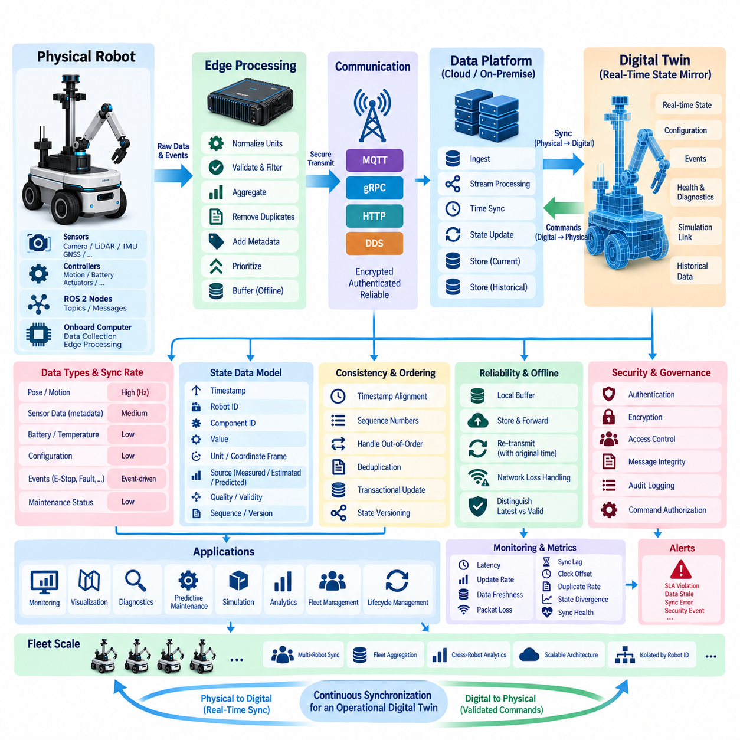
Real physical-digital synchronization is the mechanism that keeps a digital twin continuously aligned with the state of its corresponding physical robot. Instead of treating the twin as an independently updated database or visualization, synchronization establishes a controlled data relationship in which sensor observations, controller states, configuration changes, operational events, and derived information continuously update a time-aware digital representation of the robot.
A real-time state mirror represents the latest trusted operational state of the physical system inside the digital domain. Typical mirrored variables include pose, velocity, acceleration, battery state, motor current, actuator position, temperature, localization confidence, navigation mode, mission status, safety state, communication quality, and active faults. The mirror provides applications with a consistent state view without requiring each service to communicate directly with every robot subsystem.
The synchronization pipeline normally begins inside the robot with sensors, embedded controllers, ROS 2 nodes, and onboard computing services. Measurements and state transitions are collected together with timestamps, robot identifiers, component identifiers, coordinate-frame information, and quality metadata. Before transmission, edge software can normalize units, validate ranges, aggregate high-frequency signals, remove duplicates, and prioritize operationally significant information to reduce unnecessary network traffic.
Time synchronization is fundamental because a state mirror is meaningful only when the temporal relationships among observations are preserved. Sensor acquisition time, controller time, edge processing time, network transmission time, server ingestion time, and digital twin update time may all differ. The architecture should therefore preserve source timestamps and synchronization metadata so that delayed information can be distinguished from genuinely current physical state.
Different state variables require different synchronization frequencies. Robot pose and motion information may need updates many times per second, whereas battery health, component temperature, configuration information, or maintenance status may change much more slowly. A practical architecture assigns update policies according to the dynamics and operational importance of each data class rather than forcing every variable through the same fixed-rate synchronization mechanism.
State updates can use periodic, event-driven, or hybrid transmission strategies. Periodic synchronization is suitable for continuously varying telemetry, while event-driven updates are efficient for discrete transitions such as emergency stops, fault occurrences, mission changes, charging events, or software configuration changes. Hybrid synchronization combines both approaches, allowing regular state refreshes while immediately transmitting critical events that cannot wait for the next scheduled update interval.
A state mirror should distinguish the latest received value from the latest valid value. Network delays, packet loss, sensor failures, stale measurements, or invalid data can otherwise make the digital representation appear current when it is not. Each mirrored property can therefore include measurement time, reception time, validity, freshness, confidence, source, and quality indicators. Applications can then determine whether a value is reliable enough for visualization, analytics, diagnostics, or automated decisions.
Consistency management becomes important when multiple variables describe one physical condition. Position, velocity, navigation state, map version, and localization confidence may originate from different processes but must be interpreted together. The synchronization layer can group related updates using timestamps, sequence numbers, state versions, or transactional boundaries so that downstream applications do not accidentally combine values representing incompatible moments or system configurations.
Communication interruptions must be treated as normal operational conditions rather than exceptional cases. An edge buffer can temporarily retain state updates and events when connectivity to an on-premise or cloud platform is unavailable. After reconnection, buffered information can be retransmitted with original timestamps and sequence information, enabling the platform to reconstruct historical state while separately identifying the newest state required for the current real-time mirror.
The architecture should also manage out-of-order and duplicated messages. Wireless networks, retries, distributed brokers, and asynchronous processing can cause an older update to arrive after a newer one or the same event to arrive more than once. Sequence identifiers, event IDs, timestamps, idempotent processing, and version checks help prevent stale information from overwriting newer state and prevent duplicated events from corrupting the digital twin history.
Real-time synchronization does not mean that every raw sensor sample must be transmitted to the digital twin. High-bandwidth camera streams, LiDAR point clouds, and high-frequency IMU measurements can exceed practical communication and storage limits. The state mirror can retain compact derived information such as detected objects, localization results, health metrics, or data references, while selected raw data is stored separately and linked through timestamps and object identifiers.
Physical-to-digital synchronization is only one direction of the architecture. A mature digital twin can also support digital-to-physical information flows containing validated parameters, mission updates, maintenance recommendations, navigation constraints, or simulation-derived settings. These flows must be separated from ordinary state mirroring because information capable of changing robot behavior requires stronger authorization, validation, safety checking, version control, and auditability.
The synchronization service should maintain clear authority over each state variable. Physical sensors or controllers are normally authoritative for measured robot state, while enterprise systems may own mission definitions and engineering systems may own configuration baselines. Simulation and AI services can produce estimated or predicted states, but these should not silently replace measured values. Explicit source authority prevents conflicts among physical, simulated, predicted, and manually entered information.
Digital twin state can be organized into current-state and historical-state layers. The current-state layer is optimized for rapid access to the latest trusted representation, whereas historical storage preserves previous measurements, transitions, and events for analysis. Combining both allows an operator to inspect the robot now while engineers can reconstruct earlier conditions, compare behavior across missions, diagnose failures, and evaluate long-term degradation using the same underlying identity model.
Synchronization accuracy can be evaluated through operational metrics such as end-to-end latency, update frequency, data freshness, packet loss, synchronization lag, clock offset, duplicate rate, and state divergence. Monitoring these metrics is essential because a digital twin may remain technically connected while gradually becoming inconsistent with reality. Explicit synchronization health therefore becomes part of the twin state and can trigger warnings when defined service levels are violated.
At fleet scale, synchronization must support many robots operating concurrently without losing individual identity or temporal ordering. Each robot maintains its own state mirror while fleet services aggregate availability, position, mission progress, charging status, faults, and health indicators. Partitioning by robot ID, site, fleet, or data domain allows the architecture to scale while preserving isolation and enabling fleet-level monitoring, optimization, and coordinated operations.
Security is especially important because synchronization connects operational technology with digital platforms. Robot identity authentication, encrypted communication, access control, message integrity checking, certificate management, audit logging, and command authorization should protect the synchronization path. Critical state changes and digital-to-physical actions should remain traceable so that operators can determine what changed, when it changed, where the information originated, and which system accepted the update.
Ultimately, real physical-digital synchronization creates the continuously maintained connection that transforms a static robot model into an operational digital twin. By combining timestamped state acquisition, freshness management, buffering, event processing, consistency control, source authority, historical storage, and secure bidirectional communication, the architecture maintains a dependable real-time state mirror that supports monitoring, simulation, diagnostics, predictive maintenance, fleet intelligence, and lifecycle management.

08.04 Digital Twin Time Series Storage and Query [w/Code]
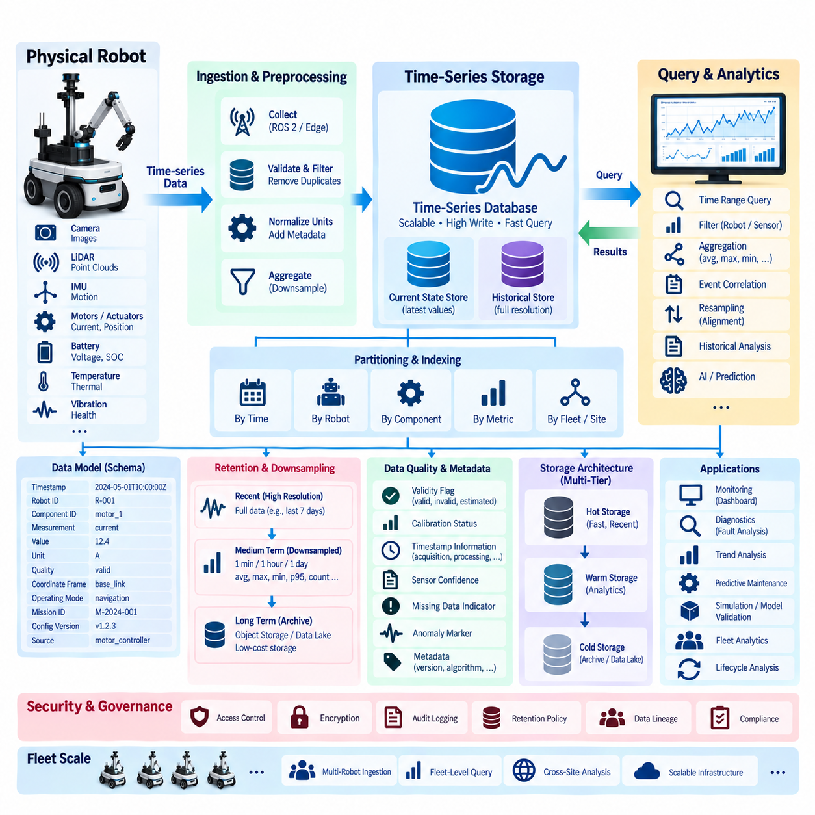
Time-series storage is a core element of digital twin data architecture because robot states continuously change over time. Position, velocity, motor current, battery voltage, temperature, vibration, localization confidence, actuator load, network quality, and health indicators can generate large streams of timestamped observations. A digital twin must preserve these values efficiently while supporting both rapid access to current conditions and analysis of historical behavior.
Unlike conventional business records, robot time-series data is primarily organized around time, asset identity, and measurement type. Each observation should contain a timestamp, robot ID, component or sensor ID, measurement name, value, engineering unit, and relevant quality information. Additional metadata such as coordinate frame, operating mode, mission ID, configuration version, and data source allows historical measurements to be interpreted within the correct operational context.
Timestamp design requires particular attention because several notions of time may exist within the same digital twin. Sensor acquisition time represents when a physical phenomenon was measured, while edge processing time, transmission time, and database ingestion time describe later stages of the pipeline. Preserving the original measurement timestamp alongside processing metadata allows engineers to analyze latency, reorder delayed observations, and reconstruct the actual sequence of physical events.
Time-series databases organize data differently from general-purpose transactional systems. Measurements are commonly grouped by robot, subsystem, sensor, or metric and partitioned into time ranges that can be searched efficiently. Indexes on time and selected dimensions allow applications to retrieve recent robot states, compare multiple sensors, examine a component before a failure, or analyze a specific mission without scanning the entire historical dataset.
The digital twin should normally separate current-state access from long-term historical storage. A current-state store maintains the latest trusted value for important properties and supports dashboards, monitoring, and operational applications with low latency. Historical time-series storage preserves previous observations for diagnostics, trend analysis, model validation, predictive maintenance, and lifecycle analysis. Both representations should remain linked through consistent identifiers and timestamps.
Data ingestion must accommodate high-frequency and heterogeneous robot signals. Some motion and control variables may arrive at tens or hundreds of samples per second, while temperature, battery health, mission state, and maintenance indicators change much more slowly. The ingestion architecture should support different sampling rates and avoid forcing low-frequency operational data and high-frequency control telemetry into an identical storage pattern.
Schema design determines whether stored telemetry remains understandable as systems evolve. A measurement schema can separate stable dimensions, such as robot ID and component ID, from changing numerical fields such as temperature or current. Schema version information should be retained when measurement definitions change. This prevents historical queries from silently combining values that were generated using different units, calibration rules, firmware versions, or processing algorithms.
High-frequency digital twin data can grow rapidly, making retention management essential. Recent information may be preserved at full resolution for detailed diagnosis, while older data can be downsampled into minute, hourly, or daily summaries. Minimum, maximum, average, percentile, count, variance, or domain-specific statistics can preserve useful trends while reducing storage consumption. Raw data required for safety investigations or AI development can follow separate retention policies.
Downsampling should be designed according to the physical meaning of each signal rather than applied uniformly. Averaging may work well for temperature but can hide short current spikes, vibration anomalies, emergency events, or transient localization failures. For these signals, maximum values, percentiles, event-triggered windows, or anomaly-preserving summaries may be more appropriate. Digital twin storage therefore requires data-aware aggregation policies instead of simple compression based only on age.
Query design should reflect the operational questions the digital twin must answer. Engineers may need the latest battery state of every robot, motor temperatures during a specific mission, sensor behavior during the minutes preceding a fault, or long-term degradation of a component across several months. Efficient query interfaces should support time ranges, robot and component filters, measurement types, event correlation, aggregation windows, and configuration versions.
Event correlation is particularly valuable because continuous telemetry becomes more meaningful when connected with discrete operational events. A fault event can define a time window used to retrieve motor current, temperature, vibration, velocity, and controller status before and after the failure. Similarly, mission start and completion events can divide continuous data into operational sessions, allowing performance and energy consumption to be compared across tasks and robots.
Digital twin queries frequently require resampling and temporal alignment because different sensors operate at different frequencies. Camera-derived perception results, LiDAR localization, IMU measurements, motor feedback, and battery telemetry may not share identical timestamps. Query processing can align observations into common time windows using interpolation, nearest-neighbor matching, aggregation, or domain-specific synchronization rules while preserving information about the original measurement times.
Missing values must be handled explicitly. A gap in telemetry may indicate communication loss, sensor failure, robot shutdown, filtering, or simply a signal that was not expected to update during that period. Automatically filling every missing interval can create false physical states. Queries should therefore distinguish observed values from interpolated, estimated, unavailable, and stale values so that analytics and visualization systems understand the reliability of reconstructed timelines.
Storage architecture can use multiple tiers according to access frequency and data value. Recent high-resolution telemetry can remain in fast time-series storage, medium-term information can move to lower-cost analytical storage, and long-term archives can be retained in object storage or a data lake. Metadata and catalog services should preserve references across these tiers so that older information remains discoverable even after it leaves the primary operational database.
Compression is important because many robot measurements contain temporal redundancy. Time-series engines can apply timestamp compression, delta encoding, columnar compression, or chunk-based storage to reduce capacity requirements. Compression strategy should balance storage efficiency against query latency and computational overhead. Frequently accessed operational data may favor faster decoding, whereas archival telemetry can tolerate more aggressive compression to reduce long-term infrastructure cost.
Data quality information should accompany time-series measurements rather than being managed separately. Validity flags, calibration status, synchronization quality, sensor confidence, missing-data indicators, and anomaly markers help applications determine whether a measurement should be trusted. This becomes particularly important when historical data is later reused for AI training, simulation calibration, predictive maintenance, or safety analysis where corrupted observations can produce misleading conclusions.
At fleet scale, time-series storage must support concurrent ingestion from many robots while maintaining isolation and query efficiency. Partitioning strategies can use time, robot ID, fleet, site, or measurement domain depending on workload characteristics. Fleet-level queries can then compare energy consumption, utilization, temperatures, faults, navigation performance, or component degradation across many assets while individual robot histories remain independently traceable.
Security and governance remain necessary throughout the time-series lifecycle. Access control can restrict sensitive operational data, encryption can protect stored and transmitted telemetry, and audit logs can record important queries or modifications. Retention and deletion policies should reflect operational, contractual, privacy, and regulatory requirements. Data lineage should also identify how derived metrics and aggregated series were produced from original measurements.
Ultimately, digital twin time-series storage is more than a repository for sensor values. It provides the temporal memory of the physical system by connecting current state, historical observations, events, configurations, component identities, and quality information. Well-designed storage and query mechanisms allow the digital twin to reconstruct past behavior, monitor present conditions, detect emerging degradation, support simulation and AI, and understand how a robot changes throughout its operational lifecycle.

08.05 Asset Administration Shell (AAS) Standard
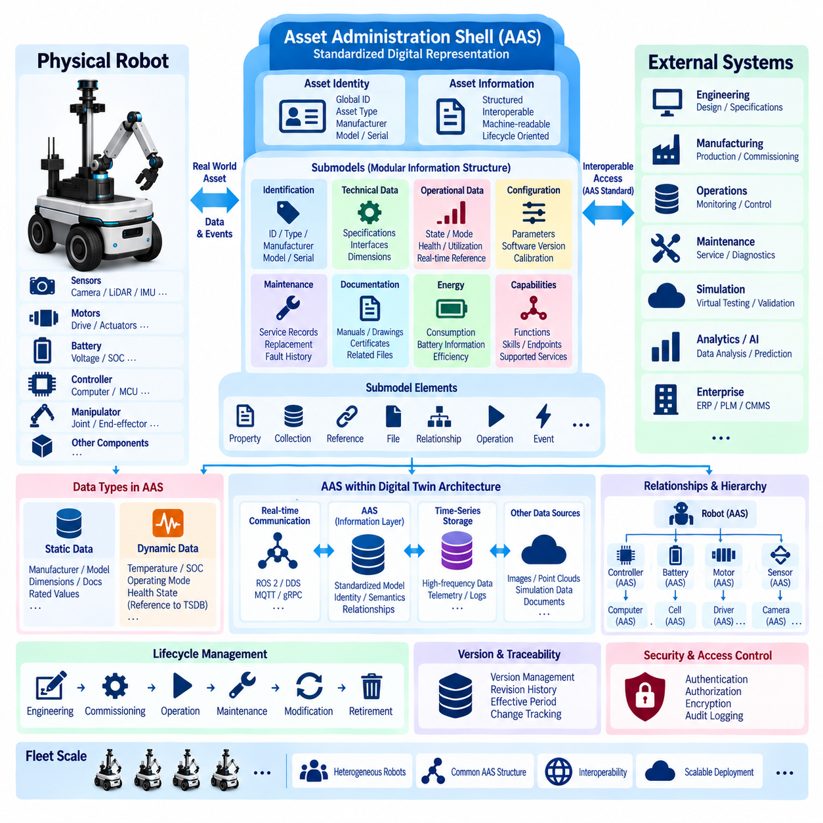
The Asset Administration Shell, commonly abbreviated as AAS, provides a standardized digital representation of an industrial asset and its information throughout the asset lifecycle. Within a robot digital twin architecture, an AAS can act as a structured interface between a physical robot and software systems that need to understand its identity, capabilities, configuration, operational state, documentation, and lifecycle information in a consistent machine-readable form.
An asset represented by an AAS can be a complete robot, a controller, battery, motor, sensor, manipulator, computing device, or another identifiable physical or logical element. The physical asset and its digital representation remain conceptually distinct: the asset exists in the operational world, while the Asset Administration Shell provides structured digital information about that asset. This separation supports consistent management of both individual components and complete robotic systems.
The AAS organizes asset information into modular information structures called submodels. Instead of placing every property of a robot into one large monolithic schema, information can be divided according to purpose or domain. A robot may therefore have submodels describing identification, technical specifications, operational data, documentation, maintenance, energy consumption, communication interfaces, capabilities, configuration, or other lifecycle-related information.
Each submodel contains submodel elements that represent individual pieces of information or functionality. These elements can express properties, collections, references, files, relationships, operations, events, and other structured concepts. For a robot battery, for example, submodel elements could represent rated capacity, manufacturer information, current state of charge, temperature, operating limits, maintenance information, and references to technical documentation.
Semantic identification is one of the most important concepts in AAS-based information modeling. A property name such as “temperature” may appear understandable to a human but can remain ambiguous between systems unless its meaning, unit, context, and definition are explicitly established. Semantic references allow information elements to point toward externally defined concepts, enabling different applications and organizations to interpret exchanged information more consistently.
Identifiers are equally important because digital twin systems must distinguish assets, shells, submodels, and information elements reliably. Persistent identifiers allow information from engineering systems, robot software, maintenance databases, simulation environments, and enterprise applications to refer to the same asset without depending on local database keys. This becomes especially valuable when robots and components move between sites, organizations, software platforms, or lifecycle phases.
AAS information can include both relatively static and dynamically changing data. Static information may describe manufacturer, model, dimensions, rated values, interfaces, documentation, or component specifications. Dynamic operational values such as temperature, battery status, operating mode, health state, or utilization can also be represented or referenced. High-frequency raw telemetry, however, is often better maintained in specialized time-series or sensor storage and linked from the AAS when appropriate.
This distinction allows the AAS to serve as a semantic and structural layer rather than requiring it to replace every database used by a digital twin. Large images, point clouds, ROS bags, historical telemetry, simulation datasets, and maintenance documents may remain in specialized storage systems. The AAS can provide identifiers, metadata, relationships, endpoints, or references that connect those distributed information resources to the correct robot or component.
Relationships between assets can also be represented so that the digital model reflects the structure of a physical robotic system. A robot may contain motors, sensors, batteries, controllers, computers, and manipulators, while those components may themselves contain additional subcomponents. Explicit relationships make it possible to navigate from the complete robot to individual components and associate specifications, operational states, documentation, diagnostics, and maintenance information with the appropriate asset.
For digital twin architectures, AAS can provide a standardized boundary between heterogeneous systems. Robot middleware, edge computers, databases, manufacturing systems, maintenance applications, simulation platforms, and enterprise software frequently use different internal data models. Mapping relevant information into standardized AAS structures reduces the need for every pair of applications to understand each other's proprietary representation and supports more reusable integration interfaces.
AAS-based architecture does not eliminate the need for robot-specific real-time communication. ROS 2, DDS, industrial networks, MQTT, gRPC, or other communication technologies may continue to transport operational data and commands according to system requirements. The AAS operates at a different architectural level by providing structured asset information and standardized access to digital representations, while real-time control paths can remain optimized for deterministic or low-latency behavior.
In a physical-to-digital synchronization pipeline, data collected from the robot can update relevant AAS information or external resources referenced by the shell. For example, a battery management system may provide current charge and health information, while a maintenance system updates service records and an engineering system manages technical specifications. The digital twin can combine these sources through the common identity and semantic structure associated with the asset.
AAS also supports lifecycle continuity because information can remain associated with an asset from engineering and commissioning through operation, maintenance, modification, and retirement. A robot may undergo component replacements, software updates, calibration changes, or configuration modifications during its service life. Maintaining structured lifecycle information makes it possible to understand not only the robot's current state but also how its technical and operational context has evolved.
Version and revision management become important when AAS structures or represented asset information changes. Digital twin applications should distinguish changes to the information model from changes to the physical asset or its configuration. Maintaining version metadata, effective periods, references, and historical records helps engineers determine which technical definition, software configuration, component arrangement, or documentation set applied to a robot at a particular time.
AAS becomes especially useful in fleet environments containing heterogeneous robot types. Different robots may use different controllers, sensors, middleware, databases, and vendor-specific APIs while still exposing selected information through common submodel structures. Fleet applications can then discover and interpret standardized properties or capabilities without requiring every robot to expose identical internal implementations, improving interoperability across mixed robotic assets.
Security and access control remain necessary because an AAS may expose valuable engineering and operational information. Identity management, authentication, authorization, encrypted communication, audit logging, and controlled access to sensitive submodels should be integrated with the surrounding digital twin security architecture. Different users or applications may receive access to public technical information, operational state, maintenance data, or configuration functions according to their assigned permissions.
For robotics, the greatest value of AAS is therefore not simply the creation of another digital database. Its purpose is to provide a standardized asset-oriented information structure that connects identity, semantics, properties, relationships, documentation, capabilities, lifecycle information, and external data resources. This structure can complement robot middleware, time-series databases, simulation systems, and enterprise platforms rather than attempting to replace them.
Within a broader robot digital twin architecture, the Asset Administration Shell can function as an interoperability layer connecting physical assets with their distributed digital information. By combining persistent identification, modular submodels, semantic definitions, relationships, standardized information access, and lifecycle context, AAS helps heterogeneous robotic and industrial systems exchange asset information more consistently while preserving the specialized systems required for real-time control, telemetry, simulation, analytics, and AI.

08.06 Simulation-to-Real Data Loop Design [w/Code]
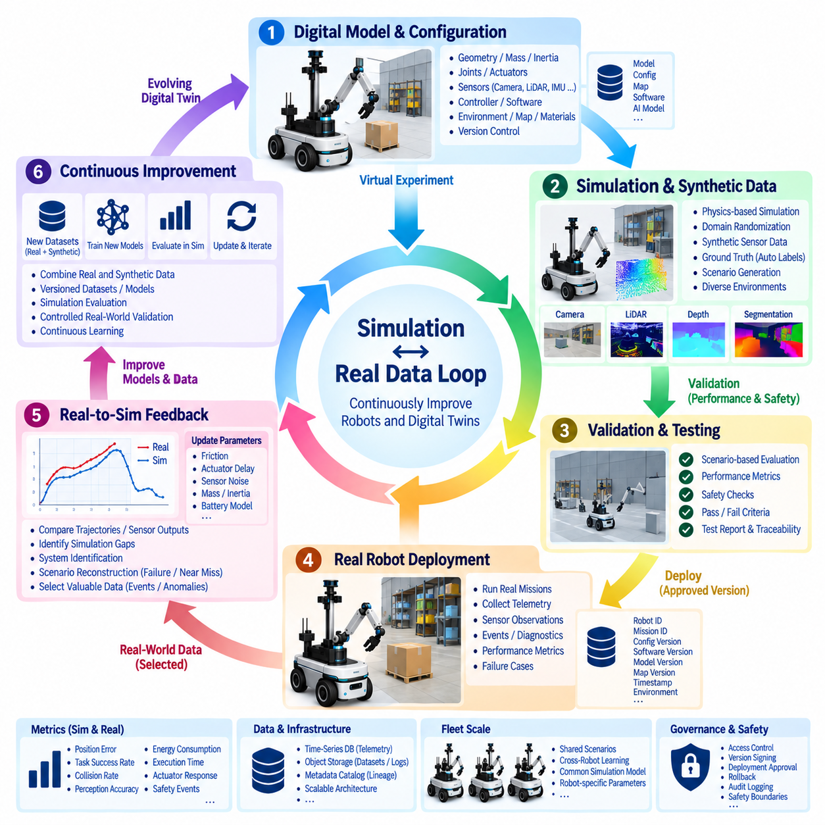
A Simulation-to-Real data loop connects virtual robot development with physical operation through a continuous exchange of data, models, parameters, and validation results. Instead of treating simulation as a separate engineering environment used only before deployment, the loop makes simulation part of the robot lifecycle. Virtual experiments generate knowledge for physical deployment, while observations from real robots continuously improve the fidelity and relevance of future simulations.
The loop begins with a digital representation of the robot and its environment. Robot geometry, mass, inertia, joints, actuators, sensors, controllers, maps, obstacles, materials, and environmental conditions must be represented with sufficient fidelity for the intended task. The objective is not to reproduce every physical detail, but to preserve the characteristics that materially influence perception, motion, interaction, safety, energy consumption, and task execution.
Simulation configuration should be connected to version-controlled engineering information. Robot models, controller parameters, sensor configurations, physics settings, maps, software versions, and AI models can change independently over time. Every simulation run should therefore reference the exact configuration used to generate its results. This enables engineers to reproduce experiments and determine whether performance changes resulted from software, hardware assumptions, environmental conditions, or model revisions.
Synthetic data generation is an important output of the simulation environment. Virtual cameras, LiDARs, depth sensors, IMUs, force sensors, and other simulated devices can generate observations together with automatically available ground truth. Object classes, segmentation masks, depth values, poses, trajectories, contact states, and environmental conditions can be recorded without the manual annotation effort normally required for real-world datasets.
Synthetic data should not be treated as automatically equivalent to real observations. Differences in lighting, textures, sensor noise, latency, friction, actuator behavior, object properties, and environmental complexity can create a simulation-to-real gap. The data architecture should preserve information identifying whether each sample is real, simulated, transformed, or derived, together with simulator version, scenario configuration, randomization parameters, and generation metadata.
Domain randomization can increase the diversity of simulated experience by varying parameters that are uncertain or difficult to reproduce precisely. Lighting, textures, camera characteristics, object placement, friction, mass, sensor noise, latency, and environmental conditions can be changed across simulation runs. Rather than relying on a single ideal virtual world, training and validation can use a distribution of conditions intended to improve robustness when the robot encounters physical variation.
The transition from simulation to physical deployment requires explicit validation gates. A controller, perception model, navigation policy, or manipulation strategy can first be evaluated against defined virtual scenarios and acceptance criteria. Only artifacts that satisfy the required performance and safety conditions should progress toward hardware testing. Simulation results, test configurations, metrics, model versions, and approval information should be preserved so deployment decisions remain traceable.
Deployment creates the next stage of the data loop. Validated software, AI models, calibration values, or configuration parameters are transferred to the physical robot under controlled version management. The robot then executes real missions while producing telemetry, sensor observations, events, diagnostics, trajectories, performance metrics, and failure information. These records provide evidence of how assumptions made in simulation behave under actual operating conditions.
Real-world data should be linked to the exact deployed configuration. A navigation failure is difficult to interpret if engineers cannot determine which map, localization model, controller parameters, firmware, AI model, or calibration values were active at the time. Robot ID, mission ID, configuration version, software version, model version, map version, timestamps, and environmental context create the lineage required to connect physical observations back to the corresponding simulation assumptions.
Real-to-Simulation feedback uses physical observations to identify where the virtual representation differs from reality. Measured trajectories can be compared with simulated trajectories, sensor outputs with virtual sensor outputs, and energy consumption with predicted consumption. Differences in acceleration, stopping distance, wheel slip, actuator response, perception confidence, thermal behavior, or task duration reveal parameters and models that may require recalibration.
System identification can convert these discrepancies into updated simulation parameters. Physical experiments may estimate friction coefficients, actuator delays, motor characteristics, payload effects, sensor noise distributions, or battery behavior. These estimated values can update the digital model so that subsequent simulations better represent the physical system. Parameter changes should remain versioned to preserve the history of how simulation fidelity evolved.
Scenario reconstruction provides another powerful feedback mechanism. When a robot experiences a failure, near miss, unusual obstacle, localization problem, or unexpected interaction, relevant telemetry and environmental information can be used to recreate the situation virtually. Engineers can repeatedly execute the reconstructed scenario, modify parameters, test alternative algorithms, and determine whether a proposed correction resolves the problem without immediately exposing physical hardware to repeated risk.
Data selection is important because transmitting every real-world observation back into simulation is rarely efficient. Event triggers, anomaly detection, uncertainty measures, performance thresholds, or sampling policies can identify valuable episodes. Normal operation may be summarized, while unusual failures, rare interactions, difficult perception cases, and unexpected environmental conditions are preserved at higher resolution for simulation replay, debugging, AI retraining, and validation.
The loop can also support continuous AI improvement. Real-world failure cases and difficult examples can be combined with synthetic variations to create updated training datasets. New models can be trained, evaluated in simulation, compared against previous versions, and then subjected to controlled physical validation. Dataset versions, training configurations, model artifacts, evaluation results, and deployment history should remain connected through data lineage to make the learning process reproducible.
Metrics provide the quantitative connection between virtual and physical behavior. Position error, trajectory deviation, task completion rate, collision frequency, perception accuracy, energy consumption, execution time, actuator response, and safety events can be measured in both domains. The objective is not necessarily perfect numerical equality, but a sufficiently accurate correspondence for the intended engineering decision, together with clear knowledge of where simulation remains unreliable.
A scalable architecture should separate heavy simulation artifacts from operational state while maintaining references between them. Large synthetic datasets, rendered images, point clouds, replay files, scenario packages, and simulation logs can reside in object storage or a data lake. Time-series databases can retain operational telemetry, while metadata catalogs connect simulation runs, physical missions, datasets, configurations, AI models, and validation results through persistent identifiers.
At fleet scale, physical experience from many robots can improve a shared simulation environment. Repeated failures, terrain characteristics, component degradation, perception difficulties, and mission patterns collected across the fleet can identify scenarios that deserve additional virtual testing. Updated simulation models and validated software can then benefit multiple robots, while robot-specific parameters remain separated when hardware condition, payload, calibration, or operating environment differs.
Governance and safety must control the entire loop, particularly when simulation outputs influence physical behavior. Access control, artifact approval, version signing, deployment authorization, rollback capability, audit logging, and validation records should prevent experimental configurations from silently reaching operational robots. Digital-to-physical changes should pass defined safety boundaries, while physical-to-digital observations should retain provenance and quality information.
Ultimately, Simulation-to-Real data loop design creates a closed learning cycle between virtual experimentation and physical evidence. Simulation generates synthetic experience, predictions, and candidate improvements; controlled deployment tests them in reality; physical observations reveal modeling gaps; and those observations refine future simulations, datasets, parameters, and AI models. The result is an evolving digital twin ecosystem in which virtual and physical systems improve each other throughout the robot lifecycle.

08.07 Digital Twin Data Visualization: 3D Viewer [w/Code]
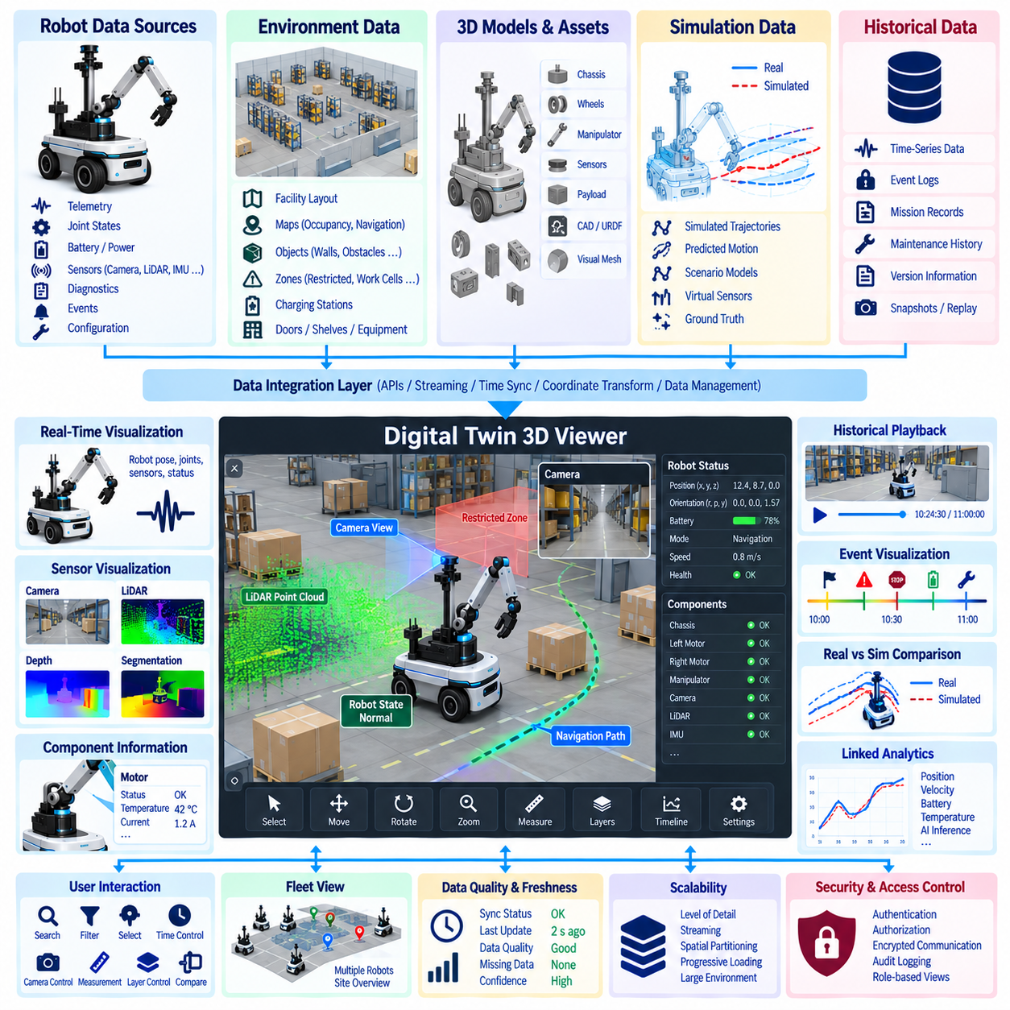
A digital twin 3D viewer transforms distributed robot data into an interactive spatial representation that operators and engineers can understand in context. Instead of displaying telemetry only as tables, charts, or isolated numerical values, the viewer associates information with the robot, its components, and the surrounding environment. This spatial approach allows users to observe where an event occurred, which component is affected, and how robot behavior relates to physical space.
The visualization architecture should separate the underlying digital twin data model from the rendering layer. Robot identity, configuration, telemetry, events, diagnostics, maps, and historical records remain managed by dedicated data services, while the 3D viewer consumes selected information through defined interfaces. This separation prevents visualization software from becoming the authoritative data source and allows multiple applications to use the same digital twin information consistently.
A robot representation usually begins with a structured 3D model containing the chassis, wheels, joints, manipulators, sensors, payloads, and other significant components. Geometry can originate from CAD models, URDF descriptions, simulation assets, or optimized visualization meshes. Each visual object should be mapped to a persistent robot or component identifier so that telemetry, configuration, diagnostics, and maintenance information can be associated with the correct graphical element.
Coordinate systems are fundamental to accurate visualization. Robot base frames, sensor frames, manipulator frames, map coordinates, facility coordinates, and global reference frames must be transformed consistently before data is rendered together. Incorrect frame relationships can make sensor observations, trajectories, or environmental objects appear displaced even when the original data is valid. The viewer should therefore use explicit frame definitions and timestamp-aware transformations.
Real-time visualization requires continuous synchronization between operational data and graphical state. Position, orientation, joint angle, actuator state, battery condition, mission progress, navigation mode, and health indicators can update the corresponding visual elements as new information arrives. The rendering rate does not necessarily need to match every sensor sampling rate; interpolation, throttling, aggregation, and prioritized updates can maintain smooth visualization without processing every raw measurement.
Environmental information provides the context required to understand robot operation. Facility layouts, occupancy maps, navigation graphs, restricted zones, charging stations, work cells, shelves, doors, obstacles, and other relevant objects can be represented within the same scene. When the robot is visualized together with its environment, users can evaluate route selection, spatial constraints, task progress, safety boundaries, and interactions that are difficult to understand from telemetry alone.
Sensor visualization can extend the viewer beyond the physical shape of the robot. Camera images, LiDAR point clouds, depth information, detected objects, segmentation results, localization uncertainty, and sensor fields of view can be overlaid on the 3D scene. Because these data types can be large and update rapidly, visualization pipelines should use selective loading, level-of-detail techniques, filtering, and rate control to balance analytical value with rendering performance.
Operational status should be communicated through visual encoding without overwhelming the user. Component states can be represented using labels, icons, highlighting, status panels, or carefully defined color mappings. A motor warning, battery degradation, localization uncertainty, or communication failure can be linked directly to the affected component. The interface should preserve access to exact values and timestamps so visual cues remain connected to measurable engineering information.
Historical playback is an important capability because many robot problems cannot be diagnosed from the current state alone. The viewer can retrieve time-series data and events for a selected interval and reconstruct the robot's trajectory, joint motion, sensor state, mission progress, and faults. A synchronized timeline allows users to move backward and forward through an operation and inspect the sequence of conditions that preceded a failure, safety event, or performance degradation.
Event visualization provides meaningful anchors within continuous telemetry. Mission start, obstacle detection, emergency stop, localization loss, charging, component warning, maintenance action, or software update can appear as markers on a timeline or within the spatial scene. Selecting an event can retrieve related telemetry and diagnostic information around that moment, helping users move from a high-level incident to detailed evidence without manually searching multiple databases.
The viewer can also support comparison between real and simulated states. A physical robot trajectory may be displayed alongside a simulated trajectory, or measured joint positions may be compared with predicted motion. Differences can be represented spatially or through linked charts and metrics. This capability supports Simulation-to-Real analysis by showing where virtual behavior diverges from physical observations and which environmental or component conditions may contribute to the discrepancy.
Three-dimensional visualization should be connected with analytical views rather than replacing them. Selecting a robot, sensor, motor, battery, or environmental object can open related time-series charts, diagnostic records, configuration information, maintenance history, or AI inference results. Conversely, selecting an anomaly in a chart can focus the 3D scene on the corresponding robot and time. Linked views create a common investigative workflow across spatial and numerical information.
Large digital twin environments require level-of-detail and streaming strategies. A facility may contain many robots, thousands of environmental objects, detailed CAD assets, maps, point clouds, and sensor overlays. Loading everything at maximum resolution would consume excessive network, memory, GPU, and CPU resources. Geometry simplification, spatial partitioning, progressive loading, visibility filtering, and distance-based detail control allow the viewer to remain responsive as scene complexity increases.
Fleet visualization extends the concept from one robot to coordinated monitoring of many assets. A site-level view can display robot locations, mission states, charging conditions, traffic congestion, warnings, and availability. Users can move from a fleet overview to a specific robot and then to an individual component while preserving context. This hierarchical navigation helps operations teams identify fleet-wide patterns while still supporting detailed engineering investigation.
Data freshness and quality must be visible because a convincing 3D scene can create false confidence when underlying information is stale or incomplete. The viewer should expose synchronization status, timestamp age, communication loss, estimated values, missing data, and confidence indicators where relevant. A robot whose state has not been updated should not appear indistinguishable from one providing verified real-time information, particularly in operational or safety-related applications.
User interaction should support engineering investigation rather than visualization alone. Search, filtering, component selection, time navigation, camera control, measurement tools, layer visibility, event selection, and comparison functions allow users to explore complex digital twin information. Role-specific views can simplify the interface for operators while providing deeper diagnostic, configuration, and historical capabilities to engineers, maintenance personnel, or simulation developers.
Security and access control should apply to visualization services in the same way they apply to the underlying data platform. Users may be permitted to view general robot status while being restricted from detailed facility maps, configuration parameters, maintenance records, or command functions. Authentication, authorization, encrypted communication, audit logging, and controlled access to data layers help prevent a convenient visualization interface from becoming an unintended path to sensitive operational information.
Ultimately, a digital twin 3D viewer acts as a spatial integration layer across robot geometry, real-time state, historical telemetry, events, diagnostics, environmental models, simulation results, and analytical information. Its value comes from connecting these data domains through shared identities, coordinates, timestamps, and relationships. When designed correctly, the viewer becomes an operational and engineering workspace for monitoring, investigation, validation, maintenance, simulation comparison, and fleet-level understanding.

08.08 Digital Twin Data-Based Predictive Maintenance
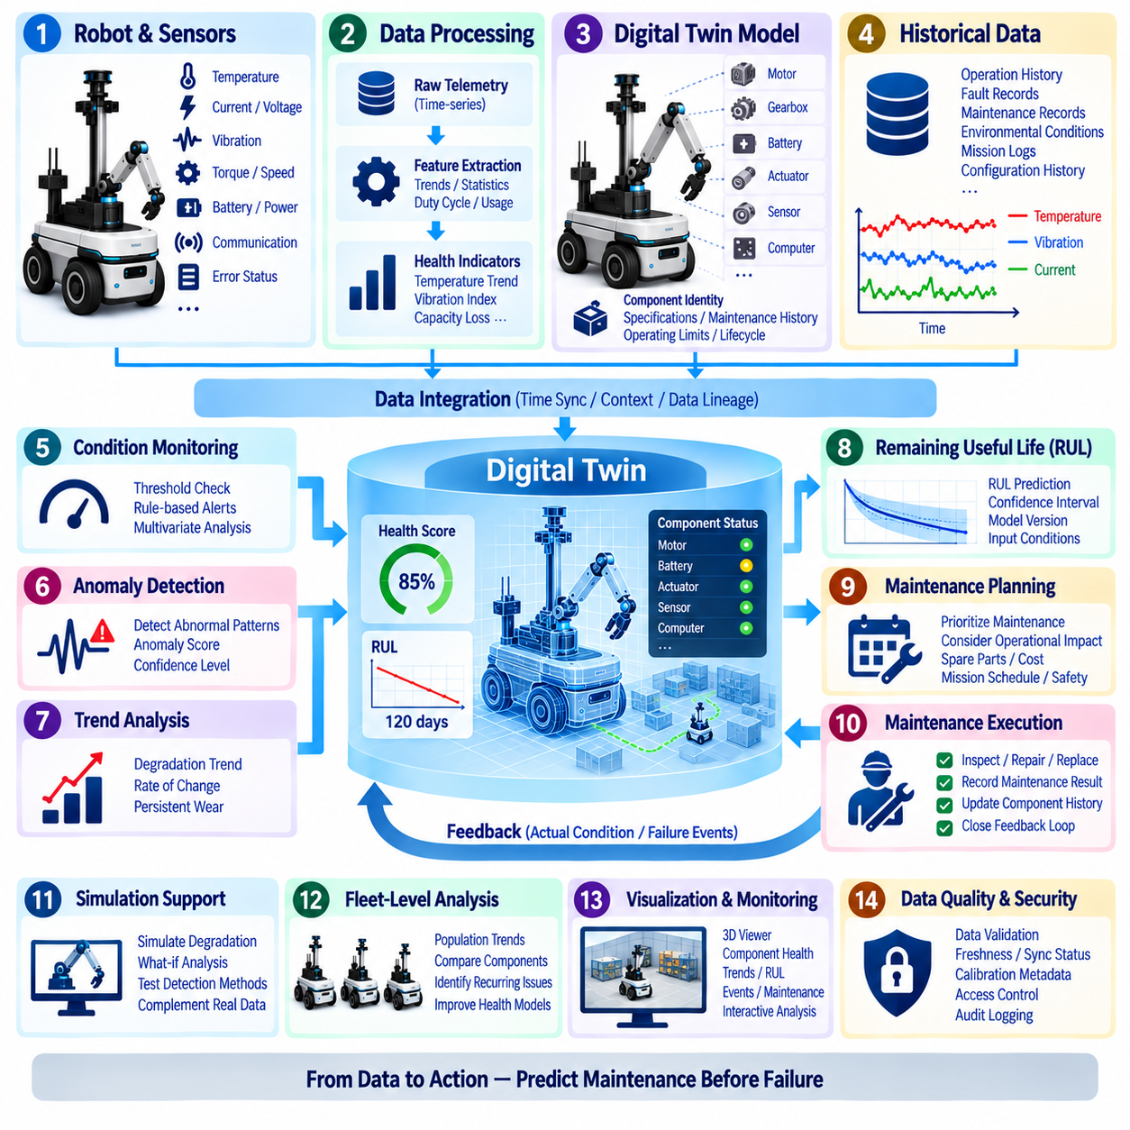
Predictive maintenance in a digital twin architecture uses operational data to identify equipment degradation before it develops into functional failure. Instead of relying only on fixed maintenance intervals or responding after a component fails, the digital twin continuously connects telemetry, component identity, operating conditions, fault history, maintenance records, and analytical models. This creates a data-driven representation of asset health that can support earlier and more targeted maintenance decisions.
The foundation of predictive maintenance is reliable condition data from the physical robot. Motors, gearboxes, batteries, actuators, joints, computing modules, cooling systems, and sensors can generate measurements such as temperature, current, voltage, vibration, torque, speed, load, power consumption, communication quality, and error status. These observations become more useful when they are associated with timestamps, robot IDs, component IDs, operating modes, missions, and environmental conditions.
Raw measurements alone rarely provide sufficient information about equipment health. Data processing pipelines can transform telemetry into health indicators such as temperature trends, vibration statistics, current variation, battery capacity loss, actuator response delay, duty cycle, accumulated operating hours, and fault frequency. These derived features provide compact descriptions of component behavior and can reveal gradual changes that are difficult to recognize from individual sensor readings.
Historical time-series data establishes the baseline required to distinguish normal behavior from degradation. A motor operating at high temperature may be normal under heavy payload conditions but abnormal during light operation. Predictive maintenance therefore requires contextual baselines that consider workload, robot speed, environmental temperature, mission type, component age, and configuration. Comparing current behavior with appropriate historical conditions reduces false alarms caused by legitimate operational variation.
Digital twin component models provide the structural context needed to organize maintenance information. Each physical component can be connected to its specifications, installation date, operating limits, maintenance history, replacement history, telemetry channels, and diagnostic records. When a component is replaced, the digital twin should preserve the history of the previous unit while establishing a new lifecycle record for the replacement component rather than treating both as the same physical asset.
Condition monitoring continuously evaluates whether measurements remain within expected operating ranges. Simple rules may detect excessive temperature, abnormal current, low battery capacity, or repeated communication errors. More advanced methods can examine multivariate patterns across several signals simultaneously. The purpose is not merely to detect threshold violations, but to recognize combinations and trends that indicate the physical condition of a component is changing over time.
Anomaly detection can identify behavior that differs from established normal operating patterns even when no explicit failure threshold has been crossed. Statistical models, machine learning algorithms, or representation-learning techniques can estimate whether current telemetry resembles previous healthy operation. An anomaly score can then become part of the digital twin health state, together with the contributing signals, confidence level, timestamp, and operational context.
Trend analysis focuses on gradual degradation rather than sudden anomalies. Increasing motor current, slowly rising bearing vibration, declining battery capacity, longer actuator response time, or increasing thermal recovery time may indicate progressive wear. By measuring the direction and rate of these changes, the digital twin can distinguish temporary fluctuations from persistent degradation and provide evidence that maintenance should be considered before performance becomes unacceptable.
Remaining Useful Life, commonly abbreviated as RUL, estimates how long a component may continue to perform its intended function under expected operating conditions. RUL models can combine historical failures, usage accumulation, degradation indicators, physical models, and machine learning predictions. Because the estimate contains uncertainty, the digital twin should preserve confidence intervals, model versions, input conditions, and prediction timestamps rather than representing RUL as an unquestionable single value.
Predictive models should remain connected to the data and configuration used to produce their outputs. A health prediction can depend on sensor calibration, feature definitions, software versions, model parameters, training datasets, and component specifications. Data lineage allows engineers to determine why a particular warning was generated and reproduce the analysis later. This traceability becomes essential when predictive maintenance results influence costly maintenance or operational decisions.
Maintenance events provide feedback that improves predictive models. When technicians inspect, repair, or replace a component, the actual physical condition can be compared with the predicted condition. Confirmed wear, unexpected damage, false alarms, and components that remained healthy despite warnings all provide valuable labels. Connecting these maintenance outcomes with preceding telemetry creates a closed feedback loop for improving thresholds, features, anomaly models, and RUL estimation.
Failure events should be analyzed together with the period that preceded them. The digital twin can retrieve telemetry windows before a motor shutdown, battery fault, communication failure, or actuator malfunction and compare them with normal operation. Repeated patterns across multiple incidents may reveal precursor signals that were previously unknown. These patterns can later become new health indicators or detection rules for other robots using similar components.
Simulation can complement historical data when real failure examples are limited. Digital models can explore overload, friction changes, sensor degradation, cooling problems, battery aging, or actuator faults under controlled conditions. Simulated degradation patterns should remain clearly distinguished from physical observations, but they can help engineers formulate hypotheses, evaluate detection methods, and identify measurements that may provide early evidence of developing faults.
Maintenance prioritization should consider operational impact as well as predicted component condition. A moderately degraded component on a mission-critical robot may require earlier attention than a similar component on an idle asset. Maintenance planning can therefore combine health score, predicted failure risk, RUL, mission schedule, spare-part availability, maintenance cost, safety relevance, and operational criticality to support practical scheduling decisions.
Fleet-level analysis significantly increases the value of predictive maintenance. Data from many robots using similar motors, batteries, sensors, or actuators can reveal population-level degradation patterns that may not be visible from one robot. Component age, usage intensity, environmental conditions, failure frequency, and maintenance outcomes can be compared across the fleet to identify recurring problems and improve health models using broader operational evidence.
Data quality directly affects maintenance predictions. Missing telemetry, incorrect timestamps, sensor drift, calibration errors, communication gaps, or configuration changes can resemble equipment degradation and generate misleading warnings. Predictive maintenance pipelines should therefore include validity checks, synchronization status, freshness indicators, calibration metadata, and confidence measures. Models should distinguish uncertain data from evidence of actual physical deterioration.
Visualization helps engineers interpret predictive results rather than receiving unexplained alerts. A digital twin interface can display component health, anomaly trends, historical measurements, predicted degradation, RUL estimates, and maintenance events alongside the robot's 3D representation. Selecting a component can reveal the signals and events that contributed to its current health assessment, allowing engineers to investigate evidence before scheduling maintenance.
Security and governance are necessary because predictive maintenance influences operational and economic decisions. Access to maintenance records, model outputs, component histories, and configuration information should be controlled and auditable. Model versions, prediction results, acknowledgements, maintenance actions, and overrides should be recorded so that organizations can reconstruct how a maintenance decision was reached and evaluate the performance of the predictive system over time.
Ultimately, digital twin data-based predictive maintenance transforms robot maintenance from a calendar-driven or failure-driven activity into a continuously informed lifecycle process. By combining telemetry, time-series history, component identity, contextual baselines, anomaly detection, degradation trends, RUL estimation, maintenance feedback, simulation, and fleet intelligence, the digital twin can provide an evolving view of asset health and support maintenance before emerging degradation becomes operational failure.

08.09 Fleet Digital Twin Data Aggregation Architecture
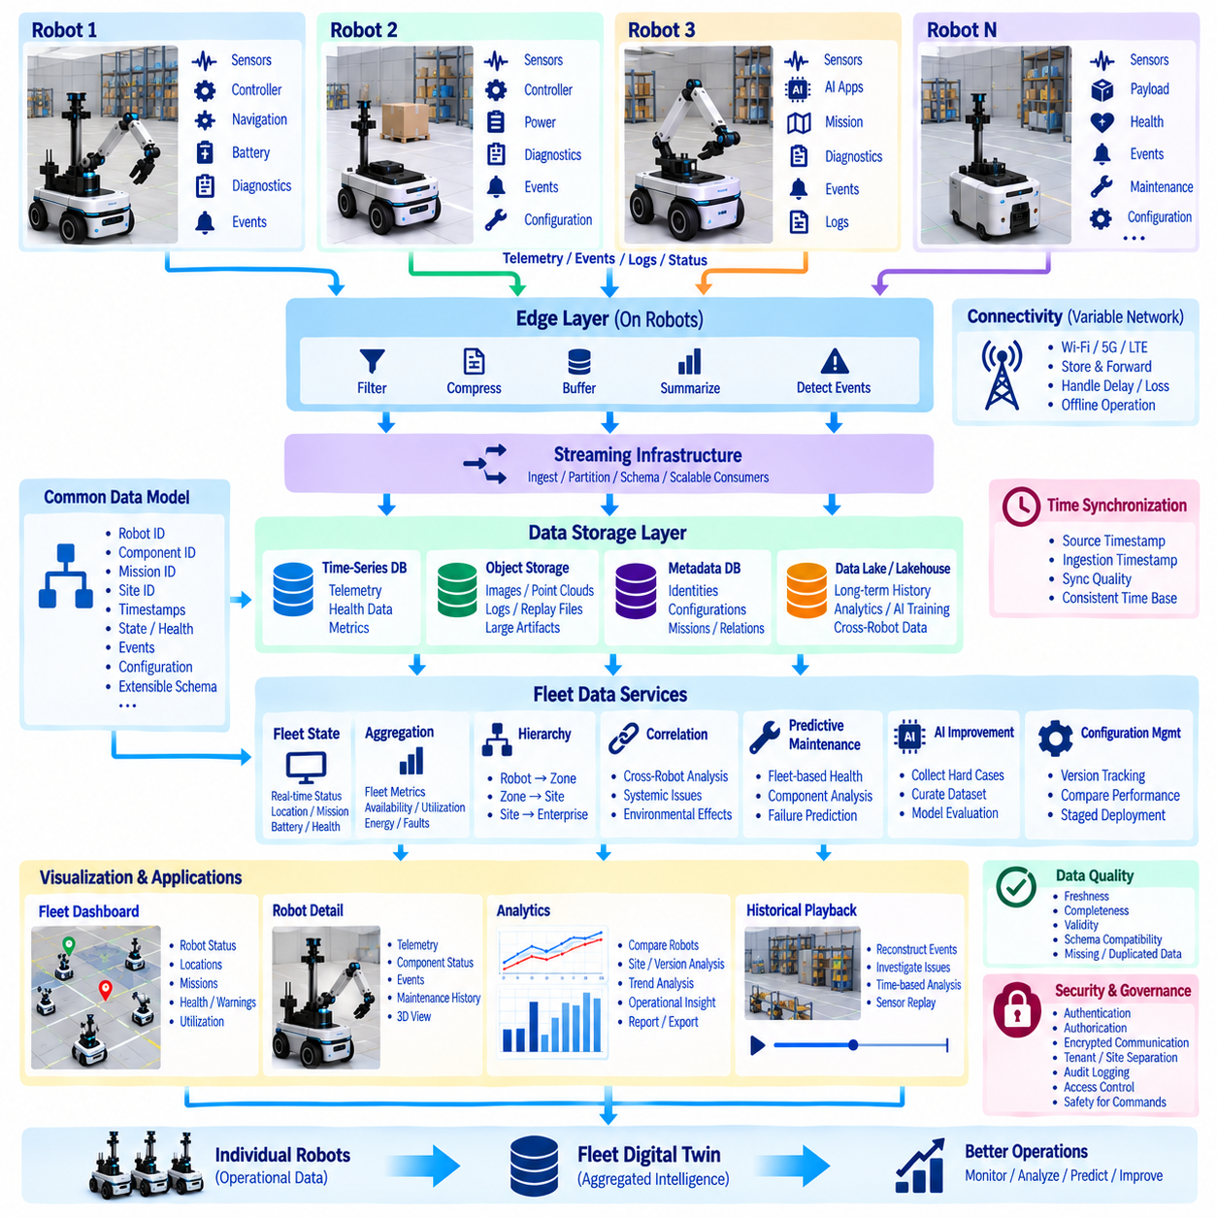
Fleet digital twin data aggregation architecture extends the digital twin concept from an individual robot to a coordinated population of physical assets. Each robot maintains its own identity, configuration, operational state, telemetry, events, diagnostics, and lifecycle history, while selected information is aggregated into a fleet-level representation. This architecture enables operators and engineers to understand both the condition of individual robots and patterns that emerge across the entire fleet.
The architecture should preserve the distinction between robot-level truth and fleet-level aggregation. A fleet digital twin is not simply one large merged dataset in which individual identities disappear. Robot ID, component ID, mission ID, site ID, configuration version, software version, and timestamps should remain attached to incoming records. Fleet services can then calculate aggregated metrics while maintaining the ability to trace every result back to the robots and observations that produced it.
Data collection begins at the robot or edge layer, where sensors, controllers, AI applications, navigation systems, power systems, and diagnostic services generate information at different rates. High-frequency motion and sensor streams may coexist with low-frequency health reports, mission events, configuration changes, and maintenance records. Local filtering, compression, buffering, summarization, and event detection can reduce unnecessary transmission while preserving information required for fleet analysis.
Connectivity between robots and fleet infrastructure cannot always be assumed to be continuous. Mobile robots may operate in warehouses, factories, outdoor areas, or remote environments where bandwidth and network quality vary. The aggregation architecture should therefore tolerate delayed, duplicated, reordered, or temporarily unavailable data. Local persistence and store-and-forward mechanisms allow robots to retain important records and synchronize them when connectivity becomes available again.
Time synchronization is essential when information from multiple robots is analyzed together. Sensor timestamps, mission events, charging activity, traffic interactions, and shared environmental observations must be interpreted against a consistent temporal reference. The architecture should preserve source timestamps as well as ingestion timestamps and synchronization quality. This enables engineers to distinguish an actual operational sequence from delays introduced by networks, gateways, or data-processing pipelines.
A common fleet data model allows heterogeneous robots to participate in the same aggregation architecture. Different robot models may expose different sensors, actuators, payloads, software stacks, and capabilities, but common concepts such as identity, pose, mission state, battery state, health, event, component, and configuration can be standardized. Model-specific information can remain available as extensions without forcing every robot to produce an identical physical data structure.
Streaming infrastructure supports the movement of operational information from many robots into fleet services. Telemetry and events can be organized by robot, site, data type, or operational domain, while schemas define the meaning and structure of messages. Partitioning and scalable consumers allow processing capacity to increase as the number of robots grows. Schema versioning is important because robot software and message formats can evolve independently across a deployed fleet.
Fleet aggregation normally requires several storage patterns rather than a single database. Time-series databases can retain operational telemetry and health measurements, object storage can hold images, point clouds, logs, replay files, and other large artifacts, while relational or metadata systems can manage identities, configurations, missions, and relationships. A data lake or lakehouse can preserve longer-term fleet history for analytics, model development, and cross-robot investigation.
A fleet state service can maintain a compact representation of the most recent known condition of every robot. Position, connectivity, mission state, battery level, health status, software version, current task, and last-update time can be continuously updated from incoming streams. This current-state layer supports operational dashboards and fleet supervision without requiring applications to repeatedly scan large historical datasets to determine the latest status.
Aggregation converts individual robot observations into fleet-level metrics. Robot availability, mission completion rate, utilization, charging demand, fault frequency, energy consumption, navigation delay, component health, and communication quality can be calculated across groups of robots. Results should retain dimensions such as robot type, site, software version, mission class, component model, and time period so that meaningful differences are not hidden inside fleet-wide averages.
Hierarchical aggregation is useful when fleets span multiple operational locations. Individual components belong to robots, robots can belong to work cells or zones, zones can belong to sites, and sites can belong to a regional or enterprise fleet. Metrics and events can be aggregated at each level while preserving drill-down capability. This allows management to observe enterprise-wide trends while engineers investigate a particular site, robot, component, or mission.
Fleet digital twins also require a shared representation of environmental and operational context. Robots operating within the same facility may use common maps, restricted zones, charging infrastructure, traffic rules, work areas, or semantic objects. Rather than duplicating every shared asset inside each robot twin, the architecture can maintain site-level digital entities and relationships. Robot-specific state can then reference these shared environmental objects through persistent identifiers.
Cross-robot correlation reveals patterns that cannot be identified from a single robot. Similar localization failures in one facility, repeated motor temperature increases on a particular hardware revision, or increased battery degradation after a software update may become visible only when records are compared across the fleet. Aggregation therefore provides an analytical foundation for identifying systemic problems, environmental effects, and configuration-dependent behavior.
Fleet data can support predictive maintenance by creating population-level evidence for component health. Operating hours, duty cycles, temperature exposure, vibration patterns, battery cycles, faults, repairs, and replacements can be compared across robots using similar components. Individual health assessments can then be interpreted against fleet distributions, helping engineers determine whether degradation is unique to one robot or part of a broader component or operating pattern.
The architecture can also support fleet-wide AI and software improvement. Difficult perception cases, navigation failures, unusual interactions, and high-uncertainty observations can be selected from many robots and added to curated datasets. Updated models can be evaluated against historical fleet cases and simulation scenarios before controlled deployment. Model version and deployment history should remain linked to robot performance so changes can be analyzed using operational evidence.
Configuration management is especially important because a fleet rarely operates one identical software and hardware state. Robots may run different firmware, AI models, maps, calibration values, controller parameters, or feature releases during staged deployment. The digital twin should record these differences explicitly. Fleet analytics can then compare performance by configuration and prevent observations from incompatible versions from being interpreted as if all robots were operating under identical conditions.
Data quality must be evaluated before fleet metrics are trusted. Missing robots, stale telemetry, duplicated messages, timestamp errors, sensor faults, and inconsistent schemas can distort aggregation results. Freshness, completeness, synchronization quality, source validity, and schema compatibility should therefore accompany important datasets and metrics. A fleet dashboard should distinguish between a healthy fleet and a fleet that merely appears healthy because several robots have stopped reporting data.
Visualization provides access to the aggregated architecture at multiple levels. A fleet view can show robot locations, connectivity, mission state, health, charging status, warnings, and utilization, while users can drill down into a single robot and its components. Historical views can reconstruct fleet activity over time, and analytical views can compare robots, sites, versions, or component populations. The same identities and timestamps should connect visual views to underlying evidence.
Security and governance become more important as data from many robots and sites is centralized. Authentication, authorization, encrypted communication, tenant or site separation, audit logging, retention policies, and controlled access to maps, telemetry, diagnostics, and configurations should be enforced throughout the architecture. Commands and configuration changes flowing from fleet services toward physical robots require particularly strong authorization, traceability, and safety boundaries.
Ultimately, fleet digital twin data aggregation architecture creates a scalable information layer connecting individual physical robots with fleet-wide operational intelligence. By preserving identity, time, configuration, context, lineage, and data quality while aggregating telemetry, events, health, missions, and lifecycle records, the architecture supports monitoring, analytics, predictive maintenance, AI improvement, and coordinated operations without losing the evidence associated with each physical robot.

08.10 Cargo UAV Digital Twin Data Management Case
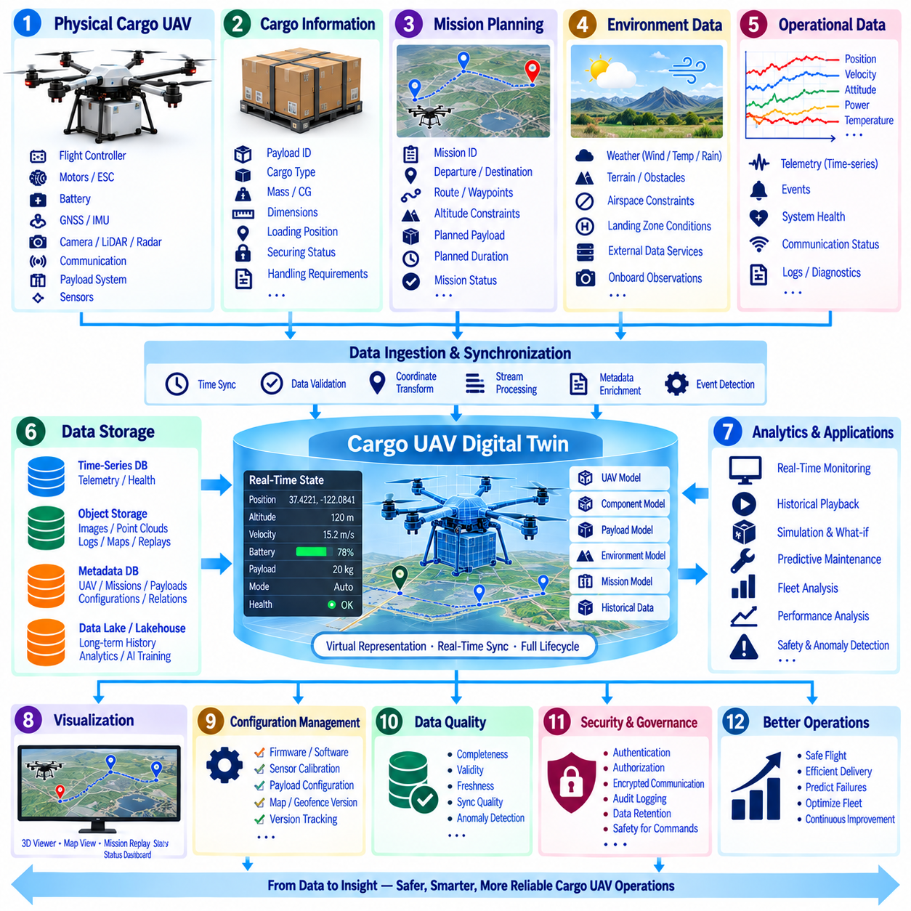
A Cargo UAV digital twin data management architecture connects the physical aircraft, its payload, mission environment, control systems, and operational history to a continuously updated digital representation. Unlike a static aircraft record, the digital twin changes throughout each mission as flight state, energy condition, navigation status, cargo information, environmental observations, and system health evolve. This provides a unified data foundation for monitoring, analysis, simulation, maintenance, and mission reconstruction.
The physical Cargo UAV produces heterogeneous data through flight controllers, GNSS receivers, inertial sensors, cameras, LiDAR, radar, motors, electronic speed controllers, batteries, communication modules, and payload systems. Position, velocity, attitude, acceleration, motor speed, current, voltage, temperature, vibration, communication quality, and fault status can be generated at different frequencies. Data management must preserve these measurements together with source identity, timestamp, unit, coordinate frame, and quality information.
Cargo information is an important part of the digital twin because payload characteristics directly influence aircraft behavior. Payload ID, cargo type, mass, center of gravity, dimensions, loading position, securing status, and handling requirements can be associated with each mission. The twin can therefore distinguish between an aircraft operating without cargo and the same aircraft carrying a heavy or asymmetrically positioned payload, allowing flight performance and energy consumption to be interpreted in the correct operational context.
Mission data provides the structure that connects individual observations into an operational record. Mission ID, UAV ID, operator or control system, departure point, destination, planned route, waypoints, altitude constraints, expected payload, planned duration, and mission status can be recorded before flight. During execution, the digital twin continuously associates telemetry and events with this mission context so that the complete flight can later be reconstructed without combining unrelated records manually.
Time synchronization is critical because flight control, navigation, perception, energy, and communication systems can operate at different sampling rates and clocks. Source timestamps should be preserved while a common time reference aligns observations for analysis. Synchronization quality and ingestion time can also be recorded. This makes it possible to determine whether a change in attitude occurred before or after a wind disturbance, motor anomaly, navigation correction, communication degradation, or payload-related event.
Spatial data requires equally careful management. GNSS coordinates, local navigation frames, body frames, sensor frames, map coordinates, and landing-zone references must be connected through explicit transformations. Position alone is insufficient when engineers need to interpret camera observations, obstacle detections, cargo orientation, or vehicle attitude. Coordinate-frame metadata allows flight trajectories and sensor observations to be reconstructed consistently in maps, simulations, and 3D digital twin viewers.
The digital twin can maintain a real-time state mirror of the aircraft during flight. Current position, altitude, heading, velocity, attitude, flight mode, waypoint progress, battery state, payload status, communication condition, and system health can be updated from incoming telemetry. A compact current-state representation supports operational monitoring, while high-frequency raw observations are stored separately for detailed analysis rather than forcing every application to process the entire telemetry history.
Energy management is especially important for Cargo UAV operation because payload, route, wind, temperature, maneuvering, and battery condition directly influence usable flight time. Voltage, current, power, state of charge, battery temperature, cell imbalance, accumulated cycles, and estimated remaining energy can be recorded alongside flight conditions. Historical missions can then provide baselines for comparing expected and actual consumption under different payload and environmental conditions.
Environmental context improves interpretation of flight behavior. Wind speed and direction, temperature, precipitation, visibility, terrain, obstacles, airspace constraints, landing-zone conditions, and other relevant information can be linked to the mission twin. Some information may come from onboard sensors, while other data can originate from external services or site infrastructure. Provenance should identify the source and time validity of environmental information rather than treating all context as equally reliable.
Event-driven records provide meaningful anchors within continuous telemetry. Takeoff, waypoint arrival, route deviation, obstacle avoidance, communication loss, GNSS degradation, low-battery warning, motor anomaly, emergency mode, cargo release, landing initiation, and mission completion can be represented as events. Each event can reference surrounding telemetry and system state, allowing engineers to move directly from an operational incident to the evidence required for investigation.
A scalable storage architecture separates data according to access pattern and volume. Time-series databases can store telemetry and health measurements, relational or metadata systems can maintain UAV identities, missions, payloads, configurations, and relationships, while object storage can preserve camera images, point clouds, flight logs, maps, replay files, and other large artifacts. A data lake or lakehouse can retain long-term mission history for fleet analytics and AI development.
Configuration lineage is necessary because aircraft behavior depends on the exact hardware and software configuration active during flight. Flight-controller firmware, navigation software, AI models, motor and propeller configuration, battery type, sensor calibration, payload configuration, geofence data, and map versions can all influence mission results. The digital twin should link every mission to these versions so abnormal behavior can be compared without assuming that all flights used identical configurations.
Historical playback enables complete mission reconstruction. Engineers can replay the UAV trajectory while synchronizing attitude, battery state, motor behavior, communication quality, sensor observations, events, and payload information along a common timeline. This capability is useful after route deviations, unexpected energy consumption, difficult landings, communication interruptions, or safety events because the sequence of conditions can be inspected rather than relying only on the final fault message.
Simulation can use digital twin records to reproduce physical missions and evaluate alternative conditions. A recorded route, payload, aircraft configuration, and environmental state can initialize a virtual mission, after which engineers can vary wind, payload mass, battery condition, control parameters, or avoidance behavior. Differences between simulated and actual trajectories, energy consumption, and system responses provide evidence for improving models and understanding Simulation-to-Real gaps.
Predictive maintenance can be integrated by connecting component health with flight history. Motor temperature, vibration, current consumption, battery cycles, thermal exposure, flight hours, payload stress, and fault events can be accumulated for each physical component. Health indicators and degradation trends can then be evaluated across missions. Maintenance actions and component replacements should update the digital twin while preserving the lifecycle history of the removed component.
Fleet-level aggregation extends the case from one Cargo UAV to multiple aircraft. Mission success, utilization, energy efficiency, battery degradation, motor health, route performance, communication quality, payload characteristics, and failure events can be compared across the fleet. Shared observations may reveal that a particular route, environment, component revision, payload class, or software version produces recurring operational problems that are difficult to identify from one aircraft alone.
Data quality controls are essential because incorrect flight data can lead to misleading analysis. Missing telemetry, GNSS jumps, sensor drift, duplicated messages, timestamp errors, communication gaps, incorrect payload records, or stale environmental information should be detected and represented explicitly. Validity, freshness, completeness, synchronization quality, calibration status, and confidence metadata help downstream applications distinguish verified measurements from uncertain or estimated information.
Security and governance must protect both operational data and the control boundary of the aircraft. Authentication, authorization, encrypted communication, audit logging, data retention, configuration approval, and role-based access should govern mission records and digital twin services. Commands, flight-plan changes, configuration updates, or AI model deployments moving from digital services toward the physical UAV require stronger authorization and safety controls than read-only monitoring data.
Ultimately, the Cargo UAV digital twin data management case demonstrates how identity, time, space, configuration, payload, telemetry, environment, events, health, and lifecycle information can be integrated around each physical aircraft and mission. The resulting digital twin supports real-time monitoring, historical reconstruction, simulation, predictive maintenance, fleet analytics, and continuous improvement while preserving traceability from aggregated intelligence back to the original UAV, mission, component, and observation.

