Volume 08 Robot Database and Storage

11. Geospatial Database

11.01 Spatial Data Overview: CRS, Projection, GeoJSON
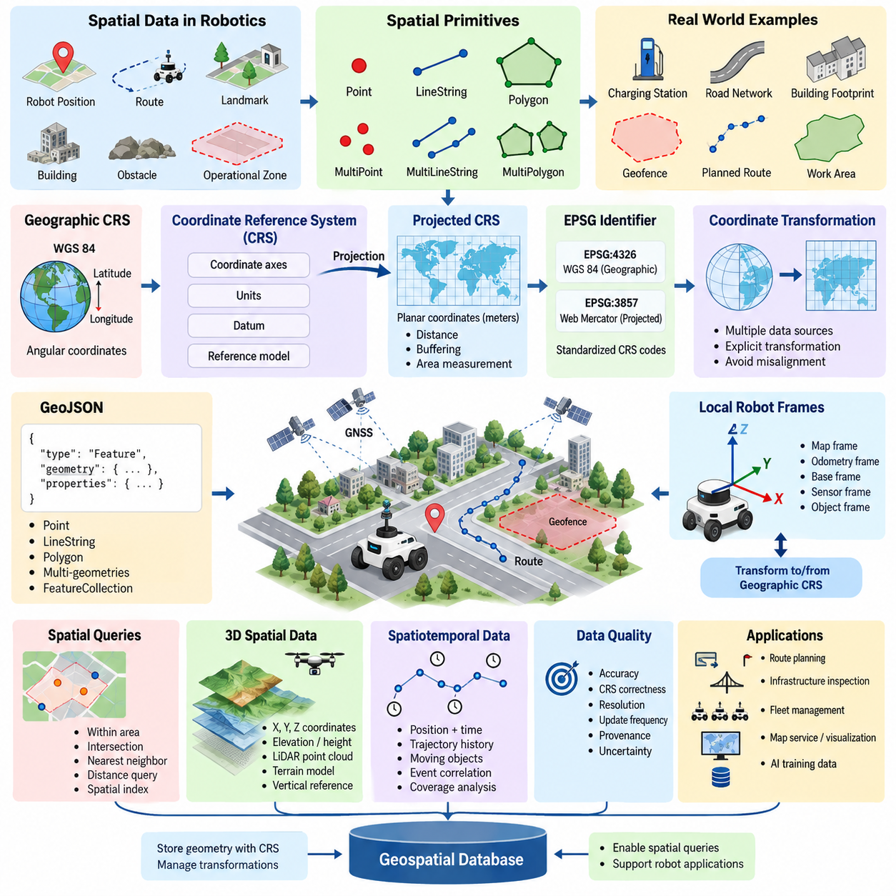
Spatial data represents objects, events, and environments whose meaning depends on location, shape, distance, or spatial relationships. Unlike conventional attributes such as names or identifiers, spatial information describes where something exists and how it relates geometrically to other entities. In robotics, spatial data may represent robot positions, navigation paths, landmarks, buildings, obstacles, operational zones, road networks, or geographic environments.
The most common spatial primitives are points, lines, and polygons. A point represents a discrete location such as a charging station, detected landmark, or GNSS waypoint. A line or LineString can represent a road centerline, planned route, or robot trajectory. A polygon describes an area such as a building footprint, restricted zone, work region, or geofence. More complex datasets combine these primitives into multi-geometries and collections.
Coordinates alone are insufficient to describe spatial information correctly because their numerical values require a reference system. A Coordinate Reference System, or CRS, defines how coordinates correspond to positions on or near the Earth. It specifies properties such as coordinate axes, units, datum, and mathematical reference models. Without CRS metadata, two datasets containing apparently similar coordinates may describe entirely different physical locations.
Geographic coordinate systems commonly express positions using angular coordinates such as latitude and longitude. WGS 84 is one of the most widely used geographic reference systems and forms the basis for many GNSS and web mapping applications. Longitude and latitude are convenient for representing global positions, but angular coordinates are not ideal for every spatial computation because degrees do not represent constant physical distances across the Earth's surface.
A projected coordinate system transforms locations from a curved geographic reference surface onto a two-dimensional plane. Projection makes coordinates practical for operations expressed in linear units such as meters, including distance calculation, buffering, area measurement, and local navigation analysis. Every projection introduces some distortion, so a projection must be selected according to the geographic extent and analytical requirements of the application.
Projection distortion can affect distance, direction, area, or shape. A coordinate system appropriate for global visualization may therefore be unsuitable for precise robot operations within a city or industrial site. Local or regional projected systems can provide more meaningful metric calculations for route planning, infrastructure inspection, outdoor AMR operation, and spatial database queries. The database should preserve the original CRS and explicitly control transformations between reference systems.
EPSG identifiers provide a standardized mechanism for identifying many coordinate reference systems. For example, EPSG:4326 is commonly associated with WGS 84 geographic coordinates, while EPSG:3857 is widely used for Web Mercator map visualization. Storing or transmitting an EPSG identifier allows GIS software, spatial databases, and robotic applications to interpret coordinate values consistently and perform controlled transformations when different systems must interact.
Coordinate transformation is especially important when robot data originates from multiple sources. GNSS measurements may use a global geographic CRS, a map provider may supply projected tiles, and a robot may internally operate within a local Cartesian map frame. Integrating these datasets requires explicit transformations rather than treating all coordinate values as interchangeable. Incorrect CRS assumptions can shift landmarks, distort routes, and produce invalid spatial relationships.
Robotic systems also use local coordinate frames that are conceptually different from global geospatial CRS definitions. A mobile robot may maintain map, odometry, base, sensor, and object frames while simultaneously associating its environment with geographic coordinates. A robust spatial architecture therefore maintains a clear boundary between local robot geometry and georeferenced spatial data, together with transformations that connect the two when global positioning is required.
GeoJSON provides a lightweight, human-readable format for exchanging geographic features using JSON structures. A GeoJSON Feature normally combines a geometry with descriptive properties, while a FeatureCollection groups multiple features into a single object. Supported geometry types include Point, MultiPoint, LineString, MultiLineString, Polygon, MultiPolygon, and GeometryCollection, making the format suitable for many map and robot-data exchange workflows.
A robot fleet application can use GeoJSON to exchange charging locations, navigation corridors, delivery destinations, operational boundaries, and restricted areas. A route may be represented as a LineString, while a geofence can be encoded as a Polygon with properties describing its identifier, access policy, or operational purpose. Because GeoJSON integrates naturally with web technologies, it is particularly useful at interfaces between spatial databases, APIs, dashboards, and visualization systems.
GeoJSON coordinates follow an ordered numeric representation, and applications must interpret this order correctly. For geographic positions, longitude appears before latitude, which can conflict with the familiar spoken convention of latitude followed by longitude. Accidentally reversing these values is a common source of spatial-data errors. Validation should therefore check coordinate ranges, geometry structure, expected CRS assumptions, and application-specific geographic boundaries before data is accepted.
Spatial data also carries topology and relationship information beyond raw coordinates. Applications frequently need to determine whether a robot is inside an operational zone, whether a route intersects a restricted region, which landmark is nearest to a vehicle, or which map objects fall within a specified distance. Spatial databases support these questions by combining geometry types, spatial reference information, geometric operations, and specialized indexes.
Three-dimensional robotics introduces additional considerations because elevation and local height may accompany horizontal coordinates. LiDAR maps, terrain models, aerial robots, and infrastructure inspection systems can require X, Y, and Z information, but the vertical reference must also be understood. A height measured relative to a robot's local map, an ellipsoid, or mean sea level cannot automatically be treated as equivalent without an appropriate transformation model.
Time further extends spatial information in autonomous systems. A robot position is usually meaningful not only because of where it occurred but also when it occurred. Fleet trajectories, moving obstacles, inspection records, and localization histories therefore combine spatial coordinates with timestamps and identifiers. This spatiotemporal structure allows databases to reconstruct movement, analyze coverage, detect operational patterns, and correlate robot behavior with environmental events.
Spatial-data quality depends on more than numeric precision. Accuracy, CRS correctness, resolution, update frequency, provenance, and uncertainty all influence whether a dataset is suitable for robotic operation. A coordinate recorded with many decimal places is not necessarily physically accurate. GNSS uncertainty, map age, sensor calibration, localization drift, and transformation errors should therefore be considered when spatial information is stored or used for automated decisions.
A practical geospatial database architecture treats CRS metadata and geometry semantics as part of the data model rather than external documentation. Geometry columns should have clearly defined spatial reference expectations, transformations should occur at controlled interfaces, and ingestion pipelines should reject incompatible or malformed geometries. This discipline becomes increasingly important when maps are shared among robots, edge computers, fleet servers, and cloud services.
Within robot database and storage architecture, spatial data forms the bridge between stored information and the physical world. CRS definitions establish the meaning of coordinates, projections make geographic information usable for specific measurements and maps, and GeoJSON provides a convenient interchange representation. Together, these concepts establish the foundation for later spatial indexing, PostGIS queries, route storage, map services, point-cloud management, and indoor or outdoor robot map databases.

11.02 PostGIS Install, Config, Basic Queries [w/Code]
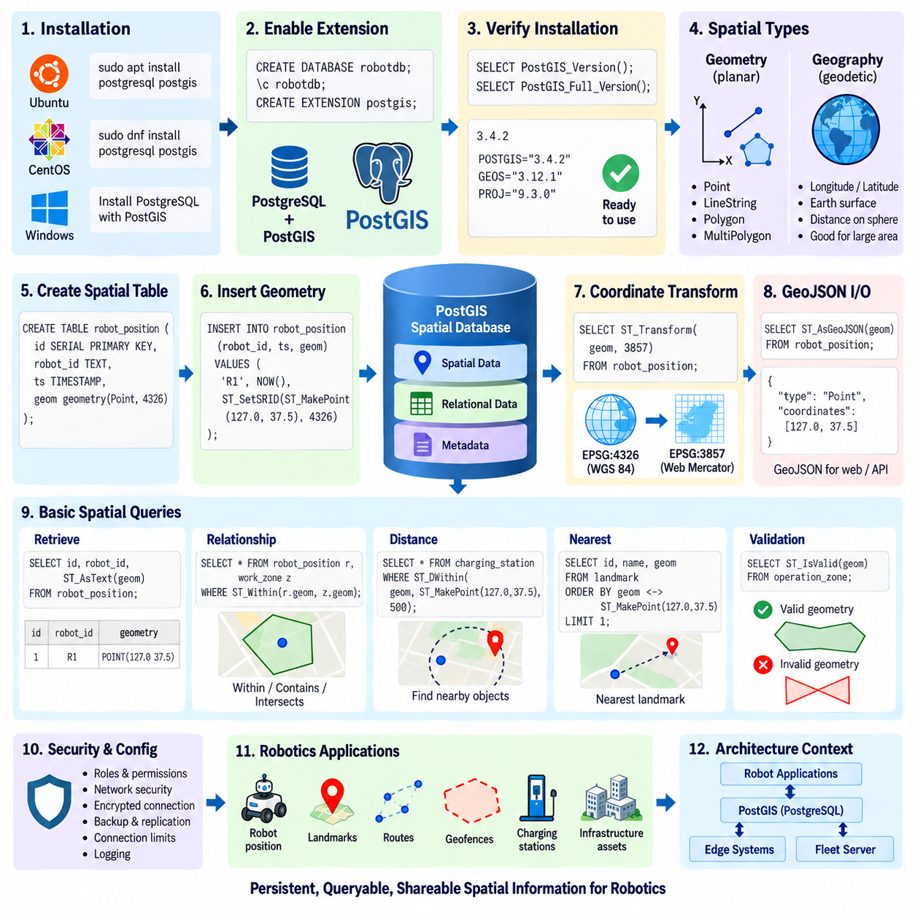
PostGIS is a spatial database extension for PostgreSQL that adds geometry and geography data types, spatial functions, coordinate reference system support, and spatial indexing capabilities. Within a robot database architecture, it allows ordinary relational information such as robot IDs, missions, timestamps, and status values to coexist with positions, routes, landmarks, operational zones, and map objects inside the same transactional database.
A typical PostGIS environment begins with a compatible PostgreSQL installation followed by installation of the PostGIS packages appropriate for the operating system and PostgreSQL version. PostGIS does not replace PostgreSQL; it extends an existing database server. This architecture preserves PostgreSQL capabilities such as ACID transactions, roles, backup mechanisms, replication, SQL processing, and JSONB while introducing specialized spatial operations required by mapping and robotics applications.
After the required software packages are installed, spatial functionality is enabled independently for each database. The commonly used SQL command `CREATE EXTENSION postgis;` loads the PostGIS extension and creates the spatial types, functions, operators, and supporting metadata required by the database. Additional extensions can be enabled when specialized functions are required, but the core PostGIS extension is sufficient for fundamental geometry storage and spatial queries.
Installation should be verified from inside PostgreSQL rather than assumed from package installation alone. Functions such as `PostGIS_Version()` or `PostGIS_Full_Version()` can report the active extension version and related library information. Administrators should also confirm the PostgreSQL server version, extension status, database encoding, permissions, and expected configuration before robot applications begin creating production spatial tables.
PostGIS primarily provides the `geometry` and `geography` spatial types. Geometry is generally used when coordinates are interpreted within a specified planar or projected coordinate reference system and is highly suitable for local maps and metric spatial processing. Geography is designed for geodetic coordinates on the Earth and performs calculations with the Earth's curved surface in mind, making it useful for longitude and latitude based distance operations over larger geographic areas.
A spatial column should define both its geometry type and Spatial Reference System Identifier, or SRID, whenever these properties are known. For example, a robot position table can use a column defined as `geometry(Point, 4326)` when storing WGS 84 positions. A route table may use `geometry(LineString, SRID)`, while operational boundaries can use Polygon or MultiPolygon types. Explicit definitions improve consistency and prevent incompatible geometries from being inserted unintentionally.
Spatial objects can be created from coordinate values or textual geometry representations. `ST_MakePoint()` constructs a point from numeric coordinates, while `ST_SetSRID()` assigns the intended spatial reference identifier. `ST_GeomFromText()` creates geometries from Well-Known Text, allowing values such as `POINT`, `LINESTRING`, and `POLYGON` to be converted into PostGIS objects. Assigning an SRID describes the coordinate system; it does not numerically transform coordinates.
Coordinate transformation is performed with `ST_Transform()` when spatial data must move between supported reference systems. This distinction is essential because changing an SRID label and transforming coordinates are different operations. GNSS data may arrive in EPSG:4326, while local route analysis may require an appropriate projected CRS expressed in meters. The application should therefore preserve source reference information and explicitly transform data for calculations that require another coordinate system.
Basic retrieval can combine standard SQL predicates with spatial information. A query can select a robot identifier, timestamp, and geometry from the same row, while functions such as `ST_AsText()` convert geometry into a human-readable Well-Known Text representation. `ST_X()` and `ST_Y()` can extract coordinate components from points, allowing developers to inspect stored values or expose coordinates through application interfaces without abandoning the underlying spatial type.
Spatial relationship queries determine how geometries interact. `ST_Intersects()` tests whether two geometries share any spatial portion, while `ST_Within()` determines whether one geometry lies within another. `ST_Contains()` expresses the complementary containment relationship from the container's perspective. These operations can answer practical questions such as whether a robot is inside an authorized work zone, whether a planned route crosses a restricted region, or whether a landmark belongs to a mapped facility area.
Distance-based queries are fundamental for robot applications. `ST_Distance()` calculates distance according to the spatial types and reference system involved, while `ST_DWithin()` determines whether two objects fall within a specified distance. The latter is particularly useful for finding charging stations, landmarks, robots, hazards, or mission targets near a given position. Correct units depend on the coordinate reference system and whether geometry or geography is being used.
Nearest-object searches can combine spatial operators, indexes, and ordering expressions to efficiently locate nearby features. A fleet service may need to find the closest charging station to a robot, the nearest inspection point to a route, or the closest known landmark to a localization estimate. Instead of transferring all coordinates to application code, these relationships can be evaluated directly within the spatial database, reducing data movement and centralizing geospatial logic.
GeoJSON can be integrated naturally with PostGIS-based services. `ST_AsGeoJSON()` converts stored geometries into GeoJSON representations suitable for web APIs, dashboards, and map visualization systems. Conversely, GeoJSON geometry can be converted into spatial database objects through supported PostGIS input functions. This makes PostGIS an effective persistence layer between robot applications that internally use database geometry and external services that exchange standardized JSON-based geographic information.
Spatial data should be validated before becoming operational map information. Functions such as `ST_IsValid()` can detect invalid polygonal geometry, while additional PostGIS functions can inspect or repair certain geometry problems when appropriate. Application-level validation should also verify SRIDs, expected geometry types, coordinate ranges, timestamps, identifiers, and operational boundaries because geometrically valid data can still be semantically incorrect for a particular robot system.
Spatial tables can retain normal relational constraints alongside geometry. Primary keys identify map entities, foreign keys connect spatial features with robots or missions, timestamps preserve observation history, and attributes describe semantic meaning. A landmark table, for example, can contain a relational identifier, landmark category, confidence value, creation time, and Point geometry. This hybrid model is one of the main advantages of using PostGIS within an existing PostgreSQL architecture.
Database configuration should follow the same security principles used for conventional PostgreSQL deployments. Robot applications should connect using dedicated roles with only the privileges required for their functions rather than administrator accounts. Network exposure, authentication, encrypted connections, backup policies, connection limits, and logging should be configured according to deployment requirements. Spatial functionality does not remove the need for conventional database security and operational controls.
For robotics, PostGIS becomes especially useful when spatial information must remain persistent, queryable, and shareable across multiple system components. Robot positions, charging stations, routes, geofences, infrastructure assets, and mission regions can be managed using consistent spatial types and SQL semantics. Edge systems can update operational information while fleet servers perform broader queries, historical analysis, visualization, or synchronization with other map services.
PostGIS should not be treated as a replacement for every robot mapping representation. High-frequency occupancy grids, raw LiDAR streams, dense point clouds, and temporary local planner states may require specialized memory structures, files, object storage, or dedicated processing systems. PostGIS is most effective when geometrically meaningful information must be persisted and queried together with structured metadata, transactional records, and relationships between operational entities.
A basic PostGIS workflow therefore progresses from PostgreSQL installation and extension activation to spatial column definition, SRID management, geometry insertion, coordinate transformation, and spatial querying. Once these foundations are established, the same database can evolve toward spatial indexing, route and landmark management, map services, point-cloud integration, indoor maps, and outdoor AMR HD map storage, providing a structured geospatial foundation for increasingly complex robot systems.

11.03 PostGIS Spatial Index: GiST / SP.GiST Design [w/Code]
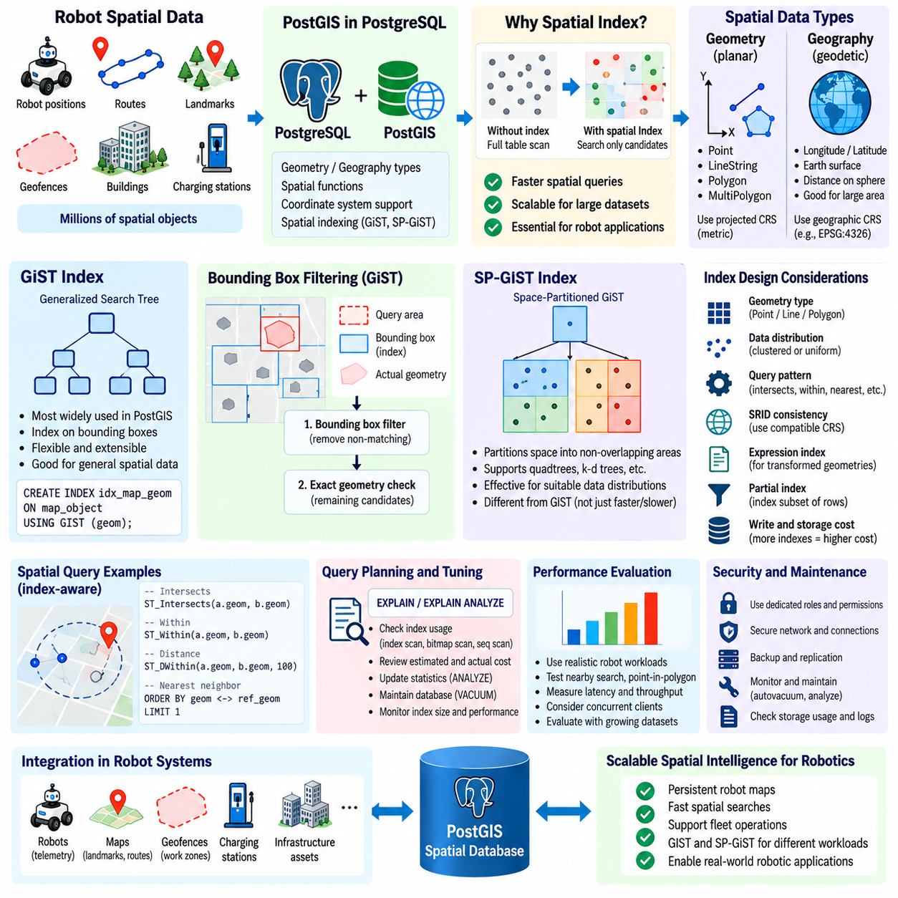
Spatial indexes are essential when a PostGIS database grows beyond small collections of geometries. Without an index, spatial predicates may require PostgreSQL to examine a large portion of a table and repeatedly evaluate geometric relationships. Robot fleets can generate millions of positions, landmarks, route segments, geofences, and infrastructure objects, making efficient spatial indexing a fundamental requirement for scalable geospatial database design.
Unlike conventional B-tree indexes, spatial indexes must organize multidimensional objects whose relationships cannot be represented efficiently by a simple scalar ordering. Points, lines, and polygons occupy regions in two-dimensional or higher-dimensional space. PostGIS therefore relies primarily on specialized PostgreSQL index access methods such as GiST and SP-GiST that can organize spatial objects according to geometric properties and rapidly eliminate irrelevant candidates.
GiST, or Generalized Search Tree, is the most widely used spatial indexing framework in PostGIS. GiST is not itself a single geometric tree algorithm; it provides an extensible infrastructure through which PostgreSQL data types can define search behavior. For PostGIS geometry, GiST commonly organizes bounding-box representations so that queries can quickly identify candidate geometries whose spatial envelopes may satisfy the requested relationship.
A GiST index on a geometry column is commonly created using a statement such as `CREATE INDEX idx_map_geom ON map_object USING GIST (geom);`. Once created, PostgreSQL's query planner can use the index for compatible spatial operators and functions. This becomes particularly valuable for tables containing robot positions, road segments, landmarks, work zones, building footprints, charging stations, or other large spatial datasets.
Bounding boxes are central to understanding many GiST-assisted PostGIS operations. A complex polygon may contain thousands of vertices, but comparing its complete geometry against every database object would be expensive. The index first compares simpler bounding regions and rejects objects that clearly cannot match. Exact geometry evaluation is then performed on the remaining candidates when required, creating an efficient filter-and-refine processing pattern.
Functions such as `ST_Intersects()`, `ST_Within()`, and `ST_DWithin()` can benefit from spatial indexes when queries and data are structured appropriately. A fleet server can rapidly identify robots located near a charging station, map objects intersecting a planned route, or operational features within a local search region. The database avoids scanning every spatial record and instead narrows the search to geometrically relevant candidates before performing more expensive calculations.
PostGIS also provides spatial operators that are useful for index-aware query design. Bounding-box operators can express overlap or relative spatial relationships, while the distance ordering operator `<->` is commonly used for nearest-neighbor searches. A query can order geometries according to their distance from a reference geometry and apply `LIMIT` to retrieve nearby landmarks or facilities efficiently, allowing the database index to participate directly in proximity search.
SP-GiST, or Space-Partitioned Generalized Search Tree, provides a different indexing framework based on partitioning the search space into non-overlapping regions. It can support structures conceptually related to quadtrees, k-d trees, radix trees, and other partition-based organizations depending on the operator class and data type. Instead of grouping overlapping bounding regions as GiST may do, SP-GiST recursively divides the search domain into partitions.
This distinction means that GiST and SP-GiST should not simply be viewed as faster and slower versions of the same index. Their effectiveness depends on geometry type, spatial distribution, operator class, query pattern, update behavior, and dataset characteristics. GiST remains the conventional general-purpose choice for many PostGIS workloads, while SP-GiST can be attractive for datasets and access patterns that benefit from explicit spatial partitioning.
Robot-position datasets illustrate why data distribution matters. A fleet operating across a large campus may produce dense clusters around charging stations, corridors, elevators, and work areas while leaving other regions nearly empty. Another system may distribute observations more uniformly across outdoor roads. Index structures respond differently to clustering, overlap, dimensionality, and geometry complexity, so representative operational data should be used when evaluating index alternatives.
Index design must also consider whether a table contains points, lines, polygons, or mixed geometries. Large polygons with overlapping bounding boxes can produce different search behavior from millions of discrete points. Route networks may contain many narrow LineStrings, while geofence tables may contain relatively few large polygons. Selecting an index only from total row count ignores the geometric structure that determines how effectively spatial candidates can be pruned.
Spatial Reference System Identifier consistency remains important even when indexes are available. An index cannot correct geometries that use incompatible coordinate reference systems or incorrectly assigned SRIDs. Queries should compare geometries in compatible reference systems, and transformations should be handled deliberately. Repeatedly applying `ST_Transform()` directly inside high-volume query paths may also influence optimization strategy, motivating carefully designed transformed columns or expression indexes where appropriate.
Expression indexes can be useful when applications repeatedly query a transformed or derived spatial representation. Instead of recalculating the same transformation for every search, an index can sometimes be constructed on the relevant expression. Such designs should match the actual query expression precisely and should be justified by measured workload requirements, because additional indexes consume storage and introduce maintenance work during inserts and updates.
Partial spatial indexes provide another optimization mechanism when only a subset of rows participates frequently in queries. A robot database might contain historical, inactive, and current map objects but operational queries may repeatedly access only active features. A partial index using an appropriate SQL predicate can reduce index size and maintenance overhead. The query conditions must correspond to the partial-index predicate for PostgreSQL to use it effectively.
Every spatial index introduces write and storage costs. Robot telemetry systems that continuously insert or update positions must maintain associated index structures as data changes. Creating multiple indexes without a defined query requirement can therefore reduce ingestion performance, increase disk usage, and lengthen maintenance operations. High-frequency transient localization data may require a different indexing strategy from relatively static landmarks, routes, or infrastructure maps.
PostgreSQL statistics and the query planner determine whether an available index is actually used. `EXPLAIN` and `EXPLAIN ANALYZE` are therefore essential tools for spatial database tuning. They reveal whether PostgreSQL chooses an index scan, bitmap scan, or sequential scan and provide information about estimated and actual execution behavior. Index existence alone does not guarantee improved performance, particularly for queries that return a large percentage of a table.
Database maintenance also affects spatial-query performance over time. `ANALYZE` updates statistics used by the planner, while `VACUUM` supports PostgreSQL storage maintenance and visibility management. Tables receiving frequent robot-position updates or map modifications should be monitored for growth, dead tuples, index size, and changing query behavior. Autovacuum settings and maintenance policies should reflect actual write rates and operational requirements rather than relying blindly on defaults.
Performance evaluation should reproduce realistic robot workloads instead of benchmarking isolated synthetic queries only. Useful tests include nearby-object searches, point-in-polygon checks, route intersection queries, geofence detection, nearest-landmark lookup, and map-window retrieval. Measurements should consider latency distributions, concurrent clients, cache state, dataset growth, insert rates, and query selectivity because an index that performs well in a small demonstration may behave differently in fleet-scale operation.
For many robot geospatial databases, a practical strategy is to begin with GiST as the general-purpose spatial index, verify execution plans and measured performance, and introduce SP-GiST or specialized designs only when workload evidence supports them. Index architecture should follow geometry characteristics and actual query patterns rather than theoretical preference. This measurement-driven approach keeps database design understandable while providing a clear path for optimization as spatial datasets grow.
A well-designed PostGIS spatial indexing layer ultimately connects persistent robot maps with responsive operational intelligence. GiST provides flexible multidimensional indexing for broad spatial workloads, while SP-GiST offers space-partitioned alternatives for suitable data distributions and operator classes. Combined with correct CRS management, query planning, maintenance, and workload testing, these indexes enable scalable searches across robot positions, routes, landmarks, geofences, and infrastructure data.

11.04 Robot Route / Landmark PostGIS Storage Queries [w/Code]
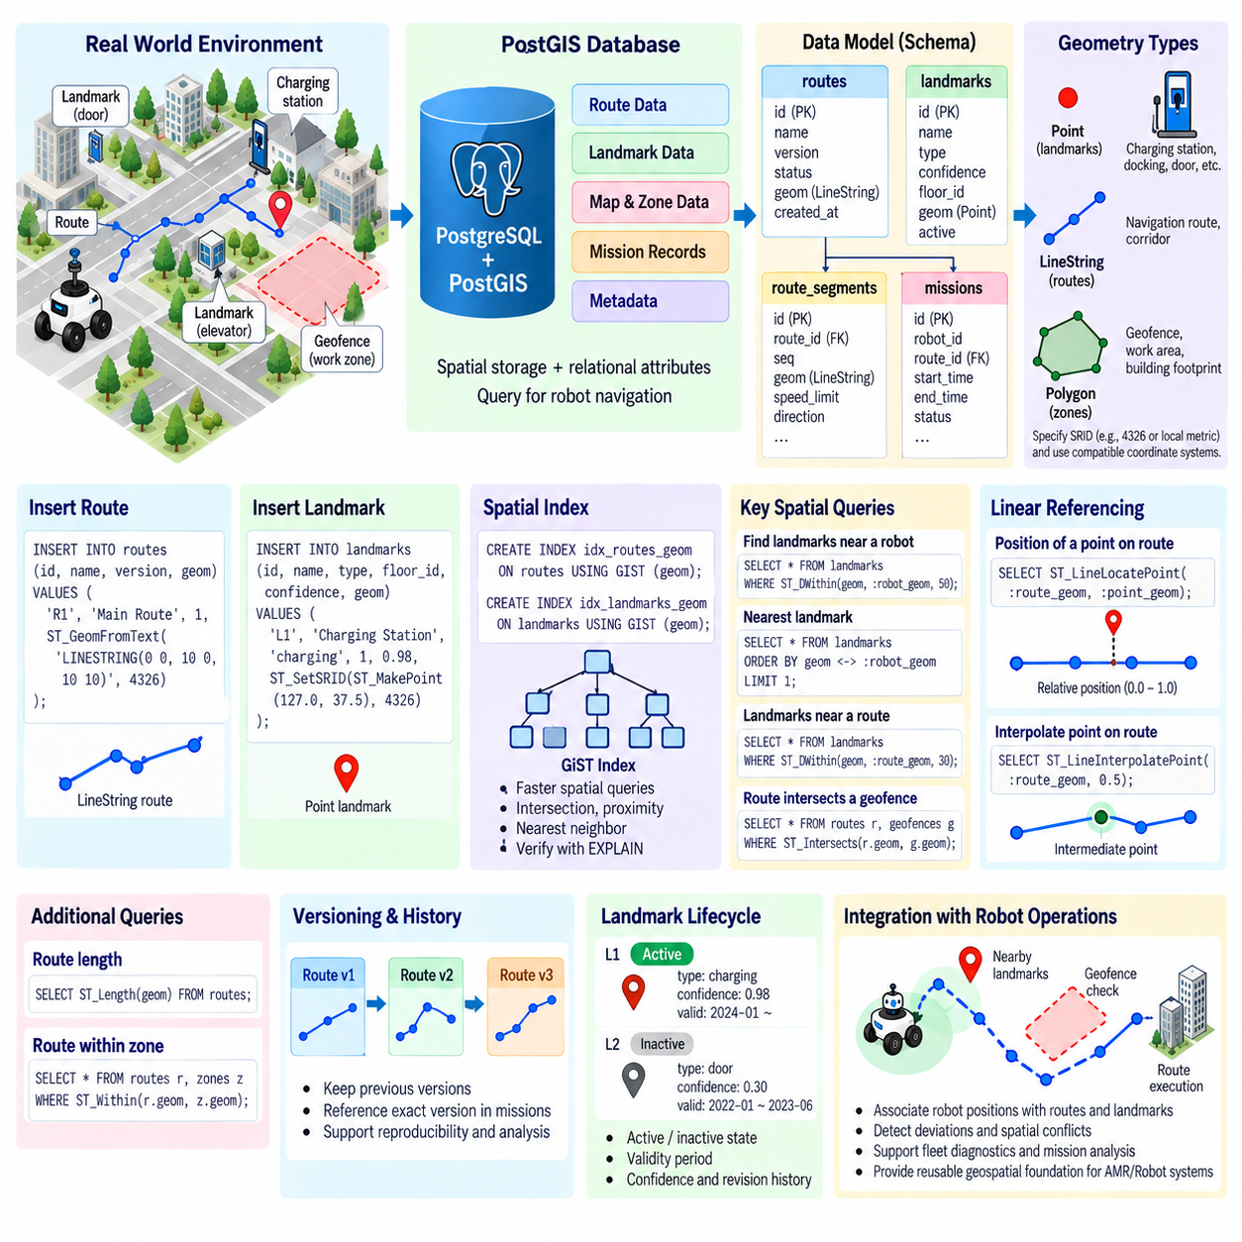
Robot routes and landmarks are two fundamental spatial entities in autonomous navigation databases. A route describes where a robot is expected or permitted to travel, while a landmark represents a spatially identifiable reference associated with localization, navigation, inspection, docking, or semantic understanding. PostGIS allows both entities to be stored as native geometries together with relational attributes, enabling spatial queries to become part of normal robot database operations.
A practical schema normally separates route definitions, route segments, landmarks, and related operational metadata. Routes can contain identifiers, names, versions, validity states, creation timestamps, and LineString or MultiLineString geometries. Landmarks can contain identifiers, semantic classes, confidence values, floor or zone information, timestamps, and Point geometries. This separation keeps spatial meaning explicit while allowing foreign keys to associate features with maps, missions, facilities, or robots.
A complete robot route can be represented as a `LineString` when its ordered coordinates form one continuous path. More complicated networks may use multiple route segments, with each segment stored separately and linked through relational identifiers. Segment-level storage is useful when speed limits, traversal direction, surface condition, accessibility, safety restrictions, or operational costs differ along the route and must be evaluated independently during navigation or mission planning.
Landmarks are commonly represented using `Point` geometries because many navigation references can be modeled as discrete positions. Examples include charging stations, docking locations, doors, elevators, inspection points, loading areas, traffic-control locations, and recognizable environmental references. When a landmark occupies a meaningful physical area rather than a single location, Polygon or other geometry types can be used instead of forcing every semantic object into a point representation.
Geometry columns should explicitly specify the Spatial Reference System Identifier, or SRID. Global outdoor data may originate from GNSS coordinates, while indoor facilities may use projected or locally referenced metric coordinates. Route and landmark geometries that participate in the same spatial operations should use compatible coordinate systems. Incorrect SRID assignment can cause routes, landmarks, and robot positions to appear spatially related in database records while representing incompatible physical locations.
Route geometry can be created from Well-Known Text using `ST_GeomFromText()` or constructed programmatically from points and lines. For example, a LineString can contain an ordered sequence of coordinates representing successive positions along a navigation corridor. Applications should preserve route direction when direction has operational meaning because reversing the coordinate order can change the interpretation of start and destination relationships even though the geometric path occupies the same physical space.
Landmark insertion can use `ST_MakePoint()` together with `ST_SetSRID()` when coordinates arrive as numeric values. Semantic information should remain in relational columns rather than being encoded unnecessarily inside geometry. A landmark record can therefore combine a Point with attributes such as `landmark_type`, `name`, `confidence`, `floor_id`, and `active`. This structure allows conventional SQL filtering to operate together with spatial predicates in a single query.
One common query is to retrieve landmarks located near a robot or route. `ST_DWithin()` can restrict the search to objects inside a specified distance, preventing unnecessary evaluation of distant landmarks. A navigation service can use this operation to identify docking stations within a local area, inspection points near the current trajectory, or localization landmarks expected to become observable as the robot approaches a particular section of its mission.
Nearest-neighbor search is useful when the system requires the closest landmark rather than every landmark inside a fixed radius. PostGIS can combine a spatial index with the `<->` distance-ordering operator and `LIMIT` to retrieve nearby candidates efficiently. This pattern can support selection of the closest charging station, reference marker, elevator, loading point, or recovery location without transferring the complete landmark table to the navigation application.
Route-to-landmark relationships can also be evaluated directly. `ST_DWithin()` can determine whether a landmark lies sufficiently close to a route, while distance functions can estimate its separation from the route geometry. This makes it possible to associate semantic objects with navigation corridors automatically. A map-management process can identify landmarks relevant to a route version and exclude objects that are spatially unrelated to the planned operating path.
PostGIS linear-referencing functions provide additional capabilities for route-oriented databases. `ST_LineLocatePoint()` can determine the relative position of a point along a LineString, producing a fractional location between the beginning and end of the route. A landmark can therefore be associated not only with geometric distance from a route but also with its progress position along that route, which is useful for ordered mission events and route-relative semantic information.
`ST_LineInterpolatePoint()` can derive a point at a specified fractional position along a route. This can support generation of intermediate checkpoints, visualization markers, sampling locations, or mission trigger positions. Combined with route length information, applications can translate between geometric progress and operational events. Such functions allow the route itself to become a spatial reference structure rather than merely a line displayed on a map.
Spatial relationship queries can determine whether routes intersect operational regions. `ST_Intersects()` can test whether a route crosses a geofence, restricted zone, work area, or mapped infrastructure feature. `ST_Within()` and `ST_Contains()` can evaluate containment relationships where appropriate. These queries allow map validation and mission preparation processes to detect spatial conflicts before a robot executes a route in the physical environment.
Route length is another useful database-derived property. `ST_Length()` can calculate the length of an appropriate geometry according to its coordinate system and spatial type. The resulting value may support route comparison, mission estimation, maintenance analysis, or navigation metadata generation. Correct CRS selection remains essential because calculations performed on unsuitable coordinate representations may not correspond to meaningful physical distances.
Spatial indexes should normally be created on route and landmark geometry columns when tables become operationally significant. GiST indexes provide a common general-purpose choice for PostGIS geometries and can accelerate intersection, proximity, containment, and nearest-neighbor operations. Index effectiveness should be verified using `EXPLAIN` or `EXPLAIN ANALYZE`, because the query planner determines whether an index is beneficial for a particular dataset and query selectivity.
Route data should also be versioned when maps or operational policies change. Replacing a geometry without preserving its previous state can make historical mission records difficult to interpret. A route identifier can represent the logical route while a separate version identifier distinguishes geometry revisions. Mission records can then reference the exact route version used during execution, supporting reproducibility, incident analysis, simulation replay, and comparison between map revisions.
Landmarks also require lifecycle management because physical environments change. Charging stations may move, doors may be reconfigured, temporary inspection points may disappear, and localization landmarks may become unreliable. Instead of immediately deleting every obsolete record, databases can maintain active states, validity periods, confidence information, or revision history. This preserves operational traceability while allowing current navigation queries to filter inactive spatial features.
Route and landmark information often interacts with robot-position history. A database can determine which route segment a robot was near, which landmarks were available around a recorded position, or whether the robot deviated from an expected corridor. Combining timestamps with spatial predicates enables reconstruction of mission context and supports fleet diagnostics, navigation-performance analysis, operational auditing, and generation of training data from real robot behavior.
PostGIS therefore provides more than simple storage for route coordinates and landmark positions. It creates a relational-spatial model in which geometry, semantic metadata, mission records, and spatial relationships can be queried together. With consistent CRS management, geometry validation, spatial indexing, version control, and carefully designed queries, route and landmark storage becomes a reusable geospatial foundation for indoor AMRs, outdoor autonomous robots, and fleet-scale navigation systems.

11.05 Map Tile Server: GeoServer / MapTiler [w/Code]
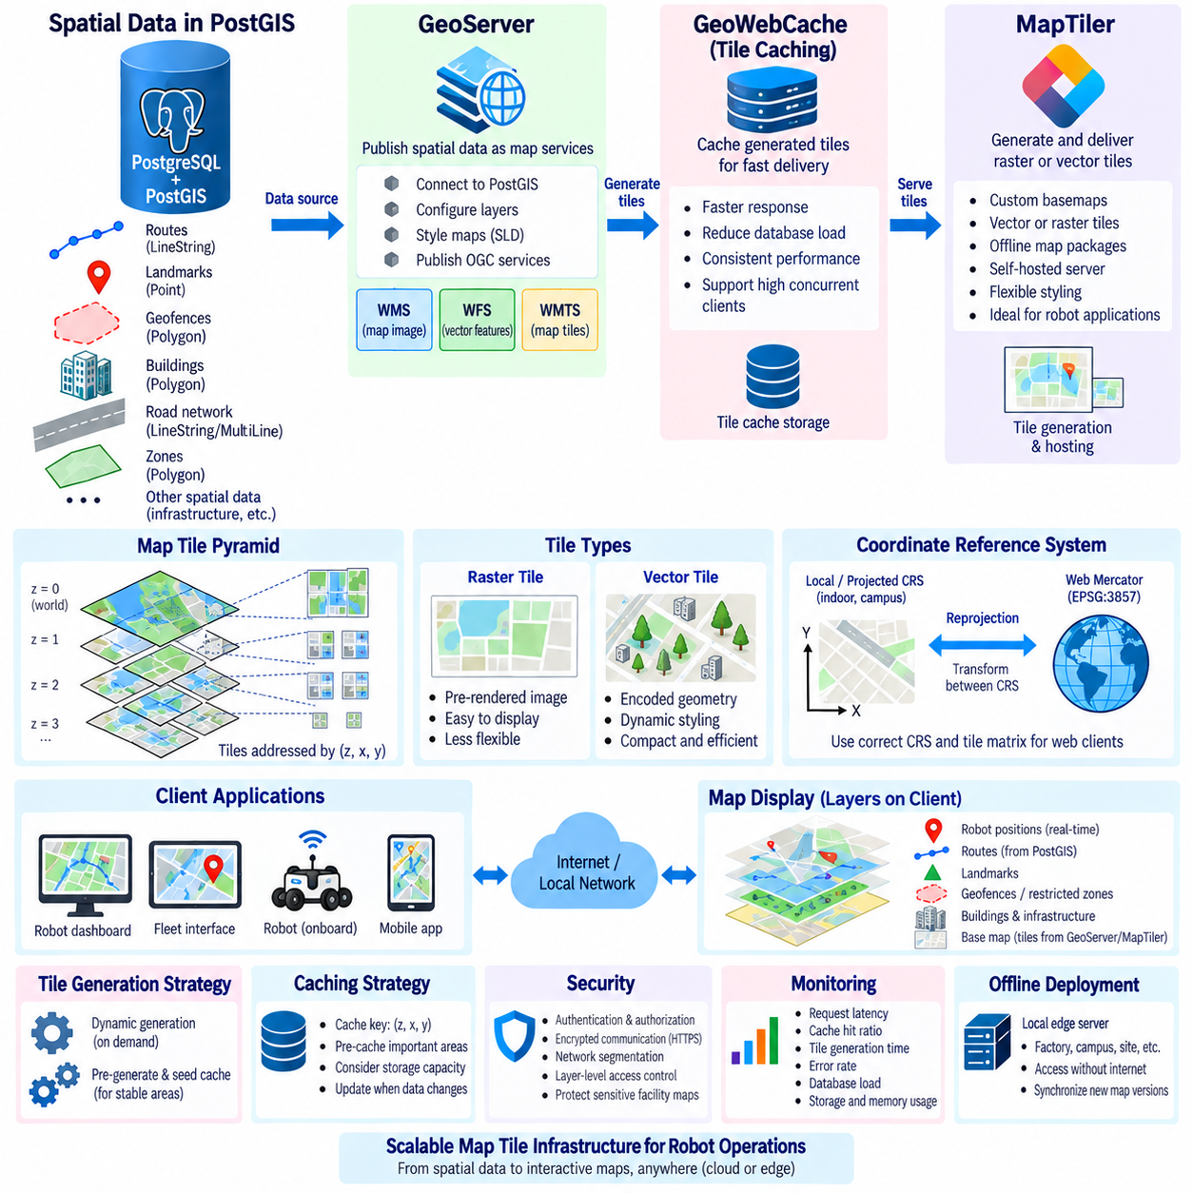
A map tile server transforms large geospatial datasets into map content that client applications can request efficiently by geographic region and zoom level. Instead of transferring an entire road network, facility map, or robot operating area, the server delivers only the tiles required for the current viewport. This architecture reduces network traffic and rendering workload while allowing robot dashboards, fleet interfaces, and operational map applications to display large spatial environments interactively.
Tile-based mapping divides a map into regularly addressable sections across multiple zoom levels. At low zoom levels, a small number of tiles represent large geographic areas, while higher zoom levels provide increasingly detailed local regions. Tile coordinates are commonly described by zoom, X, and Y values. A client determines which tiles intersect its current view and requests them independently, enabling efficient caching, parallel retrieval, and incremental map rendering.
Raster tiles contain pre-rendered map images, while vector tiles contain encoded geometric features and attributes that the client can style dynamically. Raster tiles are straightforward to display but provide limited flexibility after rendering. Vector tiles can represent roads, buildings, zones, landmarks, and infrastructure as compact geometry, allowing applications to change colors, labels, visibility, or emphasis according to robot state and operational context without regenerating the underlying map.
A typical robotics mapping architecture separates authoritative spatial storage from tile delivery. PostGIS can maintain routes, landmarks, geofences, buildings, road networks, and operational regions as structured spatial records, while a map server publishes selected information through standardized map services or tiles. Robot applications continue to query precise geometry from the spatial database when necessary, while visualization clients consume optimized map representations intended primarily for display and interaction.
GeoServer is an open-source geospatial server designed to publish data from sources such as PostGIS through established geospatial service standards. A PostGIS table or spatial view can be configured as a GeoServer layer, allowing stored routes, landmarks, operational zones, or infrastructure information to become available to map clients. This separation keeps database responsibilities focused on persistence and querying while GeoServer handles geospatial publication, styling, and service interfaces.
GeoServer commonly supports standards associated with the Open Geospatial Consortium, including Web Map Service, Web Feature Service, and Web Map Tile Service. WMS generally produces rendered map images, WFS provides geographic features that clients can inspect or process, and WMTS provides tiled map content through a predefined tile structure. Selecting among these interfaces depends on whether the application requires visualization, access to actual feature geometry, or efficient repeated map display.
GeoWebCache is closely associated with GeoServer and can cache generated map tiles so that identical requests do not require repeated rendering from source data. Tile caching is especially useful when many fleet operators repeatedly view the same facility, road network, or operating region. Frequently accessed tiles can be served directly from cache, reducing database access and rendering cost while improving response consistency for dashboards and monitoring stations.
MapTiler provides tooling and server-oriented workflows for generating, hosting, and delivering tiled maps from geospatial sources. It is particularly useful when applications require prepared raster or vector tile datasets, custom basemaps, offline map packages, or self-hosted map delivery. In robot systems, MapTiler-based infrastructure can provide the visual map foundation over which dynamic robot positions, routes, missions, alerts, and operational zones are displayed.
Vector tile workflows are particularly attractive for interactive fleet interfaces. Static or slowly changing infrastructure such as roads, building footprints, facility boundaries, and map landmarks can be encoded into vector tiles, while rapidly changing robot states remain separate dynamic layers. This separation prevents every robot position update from invalidating the underlying map tiles and allows the client to refresh telemetry independently from relatively stable geographic content.
Coordinate reference systems require careful handling throughout tile generation and publication. Source data may be stored in a local projected CRS or geographic CRS, while web mapping clients frequently expect a web-oriented projection and standardized tile matrix. The map server must therefore understand the source CRS and perform controlled reprojection where required. Incorrect CRS configuration can shift routes, buildings, landmarks, and robot overlays relative to the displayed basemap.
Layer design should reflect both semantic meaning and update frequency. Buildings, roads, terrain, restricted areas, charging stations, navigation landmarks, and route networks can be exposed as separate logical layers rather than merged into one undifferentiated map. This organization allows clients to enable or disable information according to mission needs and permits caching policies to differ between stable infrastructure and operational information that changes more frequently.
Styling determines how spatial information is translated into understandable map graphics. A route may be displayed differently according to availability or direction, while restricted zones can use distinct patterns and charging stations can use recognizable symbols. GeoServer supports server-side styling mechanisms, whereas vector tile clients can often apply styles on the client side. The appropriate approach depends on whether consistent centralized rendering or flexible application-specific visualization is more important.
Zoom-dependent visualization prevents excessive detail from overwhelming the map. At regional scale, only major operational areas and route networks may be necessary, while high zoom levels can reveal individual landmarks, doors, charging points, building details, or navigation corridors. Designing layers and styles around useful scale ranges improves readability and can reduce the amount of geometry that must be transmitted and rendered for each map view.
Tile generation can occur dynamically when requests arrive or be performed in advance through pre-generation and cache seeding. Dynamic generation adapts naturally to changing source data but can increase processing latency for uncached requests. Pre-generated tiles provide predictable retrieval performance for stable environments but must be regenerated when important map content changes. Robot deployments can combine both approaches according to the update frequency of each spatial layer.
Caching strategy should consider zoom level, geographic coverage, data-change frequency, storage capacity, and expected client behavior. Generating every possible tile at every zoom level can consume substantial storage even when many tiles are never requested. A more practical approach is to pre-cache important robot operating regions and frequently used zoom levels while allowing uncommon areas or resolutions to be generated on demand.
Offline operation is important for robots deployed where cloud connectivity is unreliable or unavailable. A local edge server can host required tiles for a factory, campus, construction site, logistics yard, or outdoor mission area. Robots or operator stations can then access maps over the local network without depending on an external service. Synchronization processes can update the local tile repository when new map versions become available from central infrastructure.
Security must be considered when map layers reveal sensitive operational information. Internal facility layouts, restricted zones, infrastructure locations, robot routes, or mission areas should not automatically be exposed through publicly reachable endpoints. Authentication, authorization, encrypted communication, network segmentation, reverse proxies, and layer-level access policies can be used to restrict map services according to system roles and deployment boundaries.
Monitoring should cover both the map server and its dependencies. Useful operational indicators include request latency, cache hit ratio, tile-generation time, error rate, database query load, storage consumption, concurrent clients, and memory utilization. Sudden increases in rendering time may indicate expensive source queries, ineffective caching, overly complex geometry, or excessive styling rules. Observability helps distinguish map-server problems from PostGIS, network, or client-side bottlenecks.
A robot fleet interface can combine multiple map-delivery mechanisms in a single application. A tiled basemap can provide geographic context, PostGIS-derived vector layers can represent infrastructure and operational zones, and real-time telemetry channels can continuously update robot positions. Mission routes and alerts can be rendered as separate overlays. This layered architecture prevents static cartographic content and high-frequency operational state from becoming unnecessarily coupled.
GeoServer and MapTiler therefore address complementary parts of geospatial delivery rather than simply representing interchangeable products. GeoServer is strongly oriented toward publishing spatial databases and interoperable geospatial services, while MapTiler workflows emphasize tiled map generation and delivery for web, local, and offline visualization. Either can participate in a robotics architecture depending on source data, client requirements, service standards, caching strategy, and deployment environment.
A well-designed map tile infrastructure converts persistent geospatial data into responsive visual context for robot operations. PostGIS can remain the authoritative spatial database, while GeoServer, tile caches, or MapTiler-based services deliver optimized representations to clients. By coordinating CRS management, layers, vector or raster formats, caching, security, offline deployment, and dynamic telemetry overlays, robot systems can provide scalable map visualization without compromising the precision of their underlying spatial data.

11.06 Point Cloud Spatial Index: pdal / PostgreSQL [w/Code]
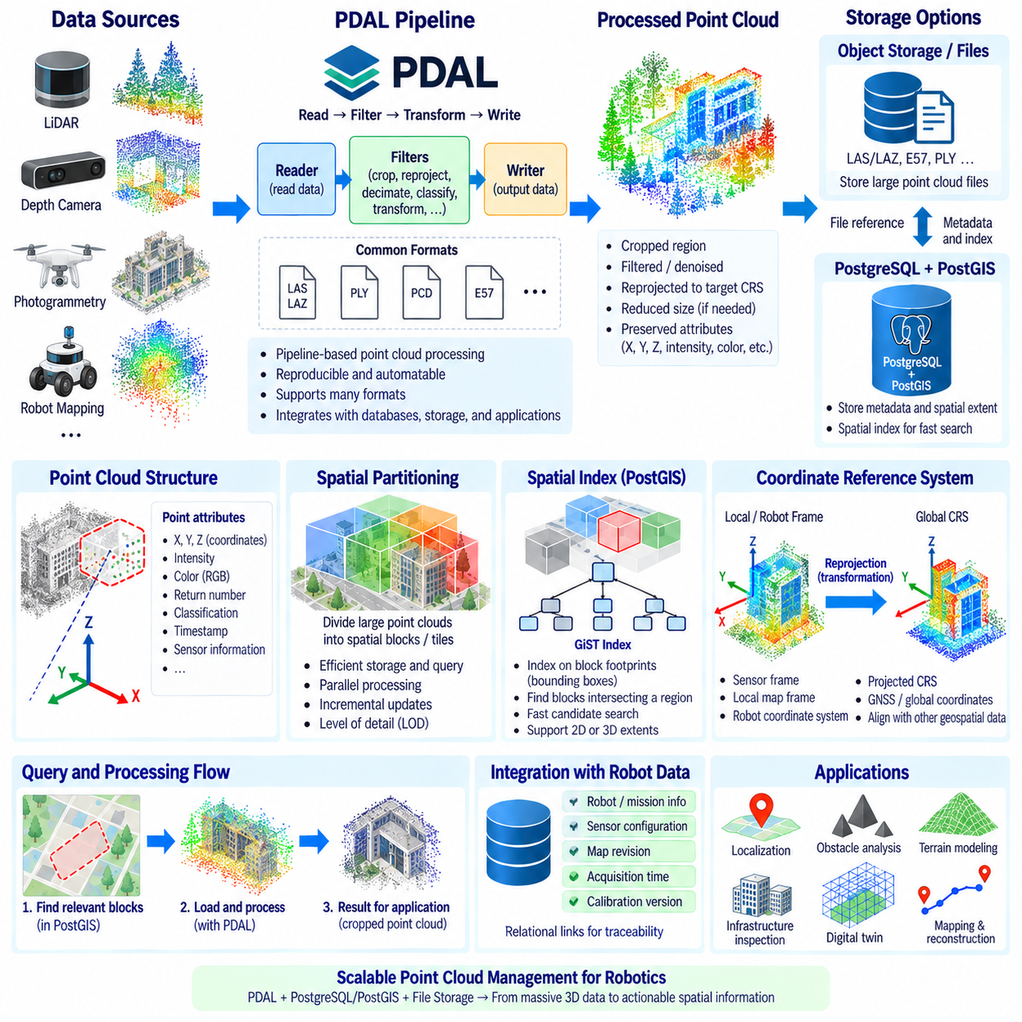
Point clouds represent three-dimensional environments as large collections of discrete points, usually containing X, Y, and Z coordinates together with attributes such as intensity, color, return number, classification, timestamp, or sensor information. In robotics, point clouds commonly originate from LiDAR, depth cameras, photogrammetry, or mapping systems and are used for localization, obstacle analysis, terrain modeling, infrastructure inspection, and reconstruction of physical environments.
Point-cloud datasets differ substantially from conventional two-dimensional spatial features. A single scan can contain hundreds of thousands or millions of points, while long-term mapping operations may accumulate billions of observations. Storing every point as an independent relational row is generally inefficient because row overhead, indexing cost, and query processing can become excessive. Practical architectures therefore organize points into blocks, patches, tiles, or external files that can be processed as spatial units.
PDAL, the Point Data Abstraction Library, provides a pipeline-oriented framework for reading, transforming, filtering, processing, and writing point-cloud data. It supports common formats and enables point-cloud operations to be assembled into reproducible processing pipelines. In a robotics data architecture, PDAL can operate between raw sensor archives, spatial databases, object storage, visualization systems, and analytical applications without requiring every component to implement its own point-cloud conversion logic.
A PDAL pipeline is typically composed of readers, filters, and writers. A reader imports point data from a supported source, filters perform operations such as cropping, reprojection, decimation, classification, transformation, or attribute manipulation, and a writer sends the processed result to a target format or storage system. Pipelines can be described declaratively, making processing steps easier to reproduce, automate, version, and integrate into robot mapping workflows.
Coordinate reference management is essential when point clouds are combined with geospatial databases. Outdoor LiDAR data may be referenced to a projected coordinate system, while robot-generated clouds may initially exist in local map or sensor frames. Before point data is integrated with roads, buildings, routes, or GNSS observations, the transformation between local robotic frames and geographic coordinates must be explicitly defined. Incorrect reference information can invalidate otherwise precise three-dimensional measurements.
Reprojection can be incorporated into PDAL processing when source and destination spatial reference systems are known. This allows point-cloud coordinates to be transformed before storage or analysis so that they align with other geospatial layers. Reprojection should not be confused with simply assigning a coordinate reference label. The source coordinate meaning must be correct before numerical transformation is performed, particularly when robot-local coordinates are connected to global map systems.
Spatial partitioning is one of the most important techniques for scalable point-cloud management. Instead of treating an entire environment as one enormous object, the cloud can be divided into spatially bounded regions. A query for a robot's nearby environment then accesses only blocks intersecting the requested region. Partitioning also supports parallel processing, incremental updates, selective transfer, and level-of-detail strategies for visualization or remote access.
Bounding boxes provide a compact representation of the spatial extent of point-cloud blocks. PostgreSQL with PostGIS can store these extents as geometries even when the complete point data remains elsewhere. A metadata table may contain a block identifier, source file, acquisition time, sensor, point count, coordinate reference information, and a 2D or 3D spatial extent. Spatial indexes can then identify relevant blocks before expensive point-cloud data is loaded.
GiST-based spatial indexes can accelerate searches over point-cloud block footprints or bounding geometries. For example, an application can find all cloud blocks intersecting a robot mission area, road segment, inspection region, or map viewport. The index does not need to examine every individual point to perform this first-stage search. Candidate blocks can be identified quickly and then passed to PDAL or another processing component for detailed three-dimensional analysis.
This two-stage pattern separates coarse spatial discovery from fine point processing. PostgreSQL and PostGIS are effective for transactional metadata, geometry relationships, timestamps, mission references, and indexed region searches, while PDAL is optimized for point-cloud transformation and filtering. Combining them prevents the relational database from being forced to perform every low-level point operation while still allowing point-cloud assets to participate in the broader geospatial information model.
Cropping is a common PDAL operation in robot applications. Once PostGIS identifies blocks overlapping an area of interest, PDAL can crop the actual point data to a polygon, bounding region, or other supported spatial constraint. A robot inspection workflow might therefore query a facility region in PostgreSQL, retrieve references to relevant cloud files, and process only the points surrounding a machine, corridor, road section, or infrastructure asset.
Filtering can reduce point-cloud size before storage or downstream processing. Depending on the application, PDAL pipelines may remove noise, select classifications, reduce density, retain specific returns, or restrict elevation ranges. The purpose is not simply to minimize data volume but to produce a representation appropriate for the intended task. Localization, terrain analysis, visualization, and structural inspection may require different subsets or resolutions of the same source cloud.
Point attributes should be preserved when they contribute to later analysis. LiDAR intensity, RGB values, classification labels, return information, acquisition time, or source identifiers can provide information that pure XYZ coordinates cannot represent. Metadata design should distinguish attributes stored for every point from information that applies to an entire block or acquisition session. Repeating session-level metadata for millions of individual points creates unnecessary storage overhead.
PostgreSQL can also maintain relationships between point-cloud datasets and other robot information. A cloud block can reference the robot, mission, sensor configuration, calibration version, map revision, or acquisition session that produced it. These relational links improve traceability and allow queries to combine spatial conditions with operational context. Engineers can retrieve point clouds associated with a specific mission, time interval, sensor configuration, or region without manually searching file directories.
Large point-cloud payloads are often better retained in specialized files or object storage while PostgreSQL stores searchable metadata and spatial footprints. Formats designed for efficient point-cloud access can preserve the dense data, while the database records where each asset resides and what region it covers. This hybrid architecture prevents database size from growing unnecessarily while preserving centralized discovery, governance, provenance, and integration with robot mission records.
For smaller datasets or tightly integrated applications, database-resident point-cloud representations may also be considered when supported by the selected PostgreSQL ecosystem. However, storage architecture should be chosen from measured requirements rather than assuming that database storage is always superior. Point count, update frequency, query granularity, network bandwidth, backup strategy, processing tools, and visualization requirements all influence the appropriate design.
Three-dimensional indexing introduces additional considerations because many traditional geospatial operations emphasize two-dimensional footprints. A building scan may overlap another dataset in X and Y while occupying a different elevation range. Applications requiring true volumetric discrimination should preserve Z extents and use processing structures appropriate for three-dimensional analysis. A 2D PostGIS footprint can remain valuable for initial discovery even when PDAL performs the detailed Z-aware filtering afterward.
Temporal organization is equally important for repeated mapping. Autonomous robots may scan the same facility or outdoor environment daily, producing multiple point-cloud versions for identical locations. Acquisition timestamps and map revisions allow the system to distinguish current geometry from historical observations. Spatial and temporal filtering together can support change detection, construction monitoring, infrastructure inspection, environment evolution analysis, and mission replay.
Data quality and provenance should accompany point-cloud storage. Sensor model, calibration state, coordinate frame, transformation history, acquisition time, processing pipeline version, and source file identifiers can determine whether a cloud is suitable for a particular analysis. A geometrically dense point cloud is not necessarily reliable if its localization or calibration is uncertain. Provenance metadata makes processing results reproducible and helps engineers trace errors back through the mapping pipeline.
Performance testing should reflect realistic point-cloud workloads rather than only file size. Important measurements include spatial lookup latency, number of blocks selected per query, bytes transferred, PDAL processing time, memory consumption, concurrent requests, and storage throughput. Block size and partition strategy should be evaluated together because extremely small blocks increase metadata overhead, while very large blocks cause unnecessary data to be read for localized queries.
A scalable robotics architecture therefore treats PostgreSQL, PostGIS, PDAL, and point-cloud storage as complementary components. PostgreSQL manages relational context, PostGIS provides indexed spatial discovery, PDAL performs point-level transformation and filtering, and files or object storage retain large dense payloads when appropriate. This separation of responsibilities creates a practical foundation for LiDAR maps, 3D inspection data, terrain models, digital twins, and autonomous robot world representations.

11.07 Indoor Map Standard: IndoorGML / IFC Data Storage
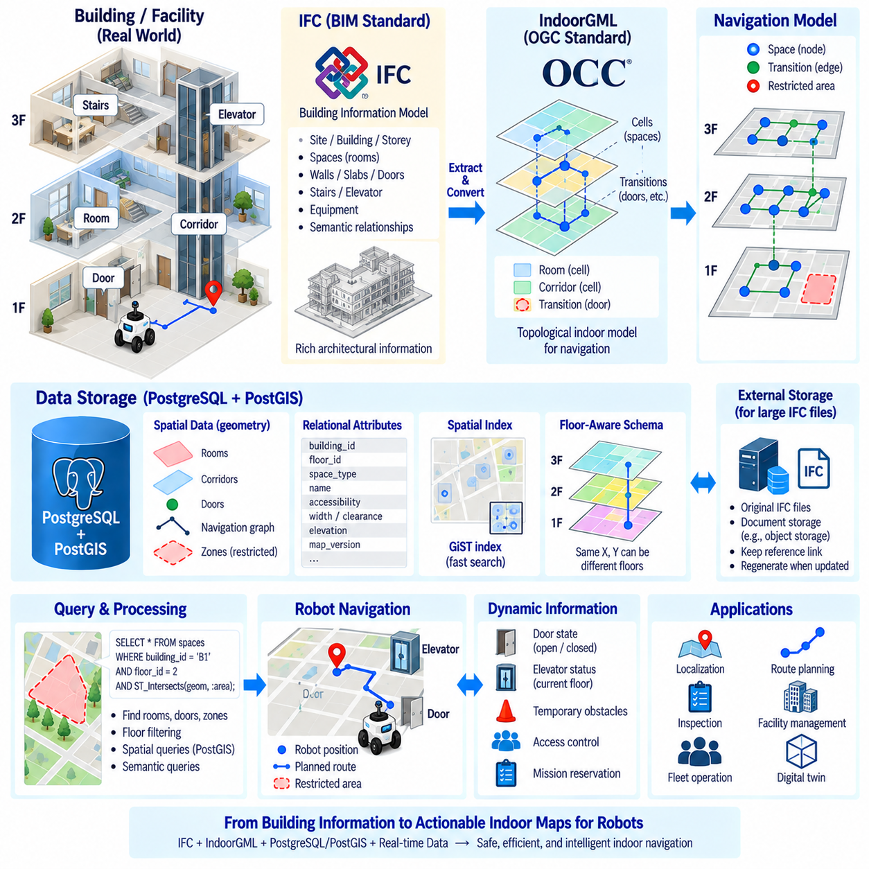
Indoor robot navigation requires map representations that describe more than geometric position. Robots operating inside factories, warehouses, hospitals, offices, and public facilities must understand rooms, corridors, doors, stairs, elevators, floors, restricted areas, and connections between spaces. Indoor mapping standards provide structured ways to represent these elements so navigation databases can connect physical geometry with semantic and topological information.
Indoor environments differ fundamentally from conventional outdoor geographic maps. GNSS signals are often unavailable or unreliable, multiple floors can occupy the same horizontal coordinates, and connectivity depends on specific transition points such as doors, elevators, ramps, and stairways. A useful indoor database must therefore represent not only where objects are located but also how spaces are connected and which transitions a robot can actually traverse.
IndoorGML is an Open Geospatial Consortium standard intended to model indoor spatial environments, particularly their cellular spaces and connectivity. Instead of treating a building only as a collection of geometric surfaces, IndoorGML can represent navigable spaces as cells and relationships between those cells as transitions. This structure is particularly relevant to robot navigation because route planning frequently depends more strongly on connectivity between spaces than on architectural geometry alone.
A simplified IndoorGML-oriented navigation model can represent rooms, corridors, halls, elevator areas, and other spaces as nodes within a topological network. Doors, passages, or other transitions establish connectivity between them. A robot planner can use this graph-like representation to determine that two geometrically nearby locations are not directly reachable, while two spaces separated by a doorway belong to a valid navigational sequence.
IndoorGML also supports the concept of multiple layers for representing different interpretations of the same indoor environment. One layer may describe physical connectivity, while another can represent accessibility or operational relationships. For robotics, this idea can be extended into navigation-oriented views that distinguish normal passages, robot-accessible routes, restricted areas, or transitions requiring specific capabilities without duplicating the complete building geometry.
IFC, or Industry Foundation Classes, provides a standardized data model widely used for Building Information Modeling. IFC describes buildings through structured objects such as sites, buildings, storeys, spaces, walls, slabs, doors, stairs, equipment, and their relationships. Compared with a navigation-centered indoor representation, IFC contains rich architectural and engineering information that can serve as an important source for constructing robot-oriented indoor maps.
IFC and IndoorGML therefore address different but complementary aspects of indoor spatial information. IFC primarily represents the building and its components from a BIM perspective, while IndoorGML emphasizes indoor spaces and connectivity useful for navigation and spatial analysis. A robotics system can extract relevant geometry and semantics from IFC and transform selected information into a navigation-oriented model rather than forcing the robot planner to interpret the complete BIM dataset directly.
IFC building elements must usually be filtered before they become useful robot-map information. Structural walls, doors, floors, ramps, stairs, elevators, columns, and spaces may be relevant, while many construction details may have little value for autonomous navigation. Conversion pipelines should therefore preserve identifiers and semantic relationships while selecting only the geometry and attributes required by localization, planning, collision checking, inspection, or facility interaction.
PostgreSQL and PostGIS can provide a practical persistence layer for processed indoor map information. Building identifiers, floor numbers, space classes, accessibility states, semantic attributes, and revision metadata can be stored relationally, while room boundaries, corridor regions, doors, landmarks, and navigation zones can be represented using spatial geometries. This enables conventional SQL filtering and spatial queries to operate within the same database.
A floor-aware schema is essential because identical X and Y coordinates can refer to different physical locations on separate storeys. Each indoor spatial entity should therefore be associated with an explicit building and floor or storey identifier. Elevation information may also be preserved where required. Queries can first constrain results by building and floor before performing detailed spatial operations, preventing accidental relationships between vertically separated spaces.
Connectivity should be stored explicitly rather than reconstructed repeatedly from geometry. A navigation graph can maintain nodes representing spaces or waypoints and edges representing valid transitions. Each edge can include properties such as direction, traversal cost, width, clearance, accessibility, or transition type. PostGIS geometries can describe physical locations while relational graph structures preserve the logical connectivity required by route-planning algorithms.
Doors are especially important because they connect architectural geometry with navigation topology. A door can have a spatial location and physical dimensions while also representing a transition between two spaces. Robot databases may additionally record operational properties such as open or closed state, minimum width, automatic operation, or access restrictions. Dynamic door status should remain separable from relatively static architectural information so it can be updated without rebuilding the entire map.
Elevators require an even richer model because they connect spaces vertically across multiple floors. An elevator can be represented as infrastructure with associated waiting areas, entrance locations, served floors, and transition relationships. Real-time elevator state may come from a building-management or robot integration interface, while the spatial database stores persistent topology. Route planning can then combine static connectivity with current operational availability.
Indoor robot accessibility cannot be inferred solely from human-oriented building connectivity. Stairs may connect two floors architecturally but be unusable for a wheeled AMR, while a ramp or elevator may provide the required alternative. Navigation databases should therefore distinguish physical connectivity from robot-specific traversability. Attributes such as minimum width, slope, clearance, floor condition, payload restrictions, and permitted robot class can influence whether a transition is valid.
Coordinate reference management remains necessary even inside buildings. BIM geometry may use a project-specific coordinate system, robot localization may operate in a local map frame, and facility information may also be connected to an external geographic reference system. Transformation relationships between these frames should be explicitly documented. A consistent reference strategy allows indoor robot maps to align with outdoor maps, site infrastructure, digital twins, and geospatial databases.
Map versioning is particularly important when indoor data originates from BIM models that continue to evolve. Walls can move, doors can be added, equipment layouts can change, and operational zones may be redefined after construction. The database should preserve map revision identifiers and effective periods so robot missions can reference the exact indoor-map version used during execution rather than automatically inheriting later building modifications.
Spatial indexes can accelerate indoor searches involving rooms, corridors, doors, landmarks, and operational zones. A GiST index on geometry columns can help identify features intersecting a robot's local region or planned route. However, floor constraints and semantic filters should accompany spatial predicates because a purely two-dimensional index may return geometries from multiple storeys occupying the same horizontal area.
Indoor map storage can also support semantic queries beyond navigation. A robot may need to locate all inspection points inside a mechanical room, identify charging stations on a particular floor, retrieve doors along a planned corridor, or find equipment belonging to a specific facility zone. Combining relational semantics with PostGIS spatial relationships allows these questions to be answered without maintaining separate disconnected map databases.
Large BIM files do not necessarily need to be stored directly inside the operational navigation database. Original IFC files can remain in document or object storage as authoritative engineering assets, while PostgreSQL stores extracted robot-relevant entities, identifiers, topology, and spatial geometry. Maintaining references back to source IFC objects preserves provenance and enables updated navigation maps to be regenerated when the underlying building model changes.
A useful processing architecture therefore separates source models, transformation, operational storage, and robot consumption. IFC supplies detailed building information, conversion processes extract navigation-relevant geometry and semantics, IndoorGML concepts organize indoor spaces and connectivity, and PostgreSQL/PostGIS stores optimized operational representations. Robot applications then consume the simplified model required for localization, routing, mission execution, and fleet management.
Validation should examine both geometry and topology. Room polygons should be geometrically valid, floor identifiers should be consistent, doors should connect expected spaces, and graph edges should correspond to physically possible transitions. Robot-specific validation should additionally verify clearance, accessibility, restricted areas, and required infrastructure. A geometrically correct building model can still produce an unusable robot map if connectivity or traversability is incorrectly represented.
Indoor map databases become especially powerful when combined with live robot information. Static spaces, doors, elevators, and navigation networks can be linked with robot positions, temporary obstacles, access-control states, mission reservations, and facility events. The persistent map provides structural context while dynamic operational layers describe current conditions, allowing route planning and fleet orchestration to respond to changes without modifying the underlying building model.
IndoorGML, IFC, PostgreSQL, and PostGIS can therefore form complementary layers of an indoor robotics data architecture. IFC preserves detailed building semantics, IndoorGML provides concepts for navigable spaces and connectivity, PostgreSQL manages structured relationships and metadata, and PostGIS supports spatial geometry and indexed queries. Together they provide a foundation for converting complex building information into persistent, floor-aware, semantically meaningful indoor maps for autonomous robots.

11.08 Outdoor AMR HD Map Database Design [w/Code]
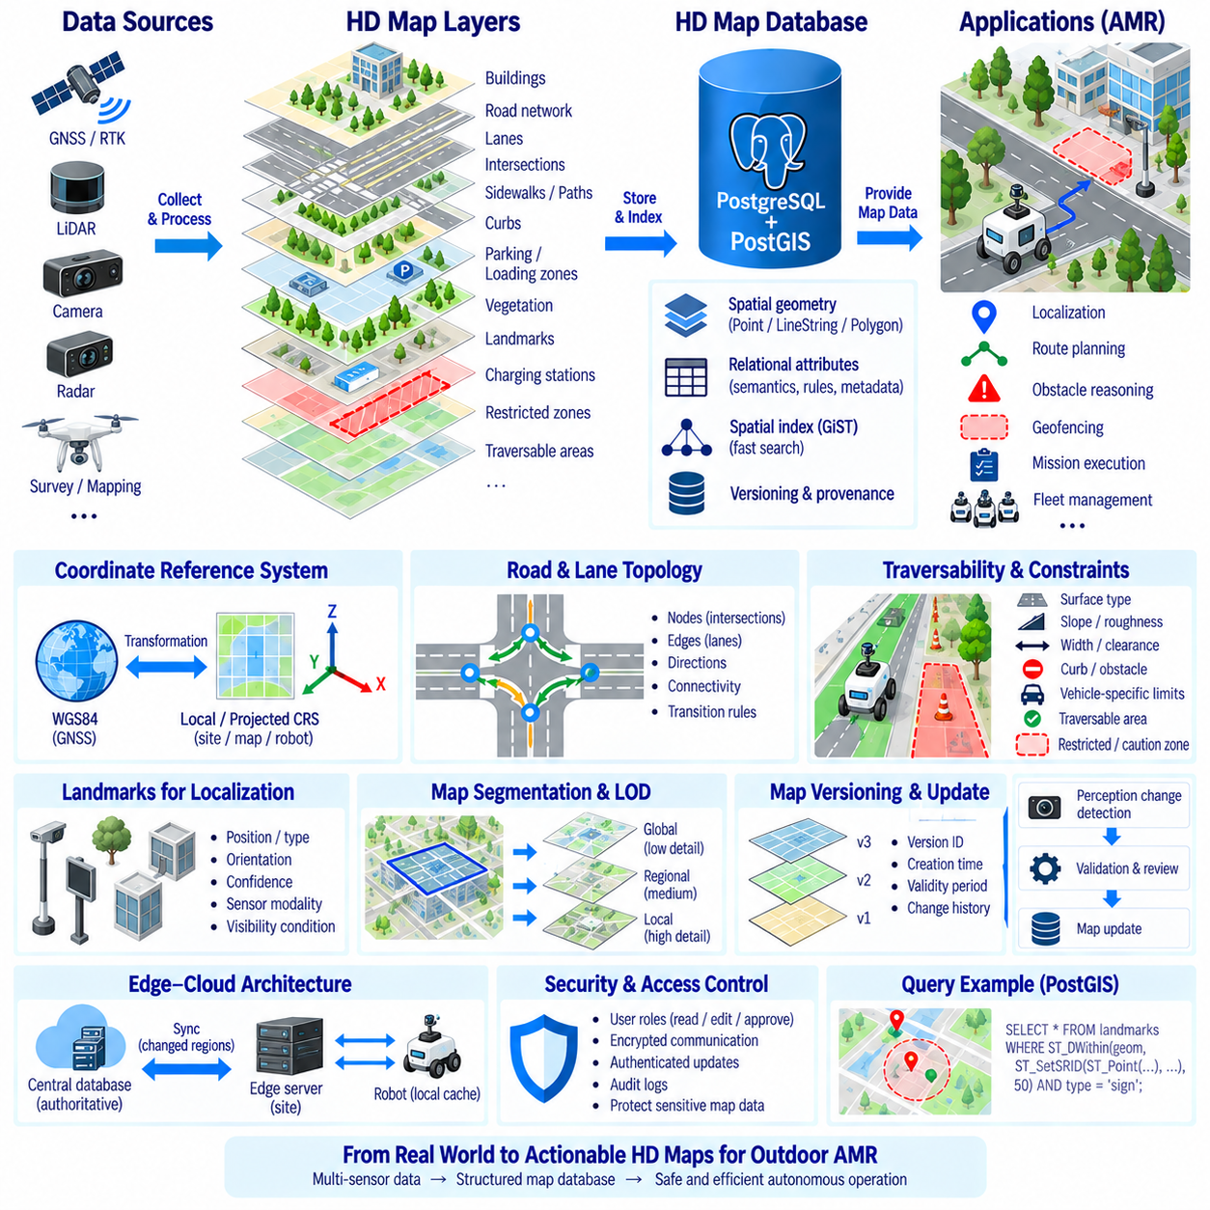
An Outdoor Autonomous Mobile Robot requires an HD map database that represents the environment with substantially more operational detail than a conventional digital map. The database must support localization, route planning, obstacle reasoning, geofencing, mission execution, and fleet management. Roads, lanes, boundaries, intersections, slopes, surfaces, landmarks, restricted zones, and traversable areas become machine-readable spatial entities rather than visual information intended primarily for human drivers.
The HD map should separate geometric representation from semantic and operational meaning. A road centerline describes geometry, while attributes can specify direction, width, surface type, speed limit, slope, payload restriction, or robot accessibility. This separation allows the same physical geometry to participate in localization, global planning, safety validation, and mission management without creating independent copies of the map for every robot function.
A practical database model can organize the outdoor environment into layers such as road networks, lanes, sidewalks, intersections, parking areas, loading zones, buildings, curbs, vegetation boundaries, landmarks, charging stations, and restricted regions. Each layer should have a clearly defined semantic role. Layer separation simplifies updates and enables applications to request only the information required for a particular navigation or visualization task.
PostgreSQL and PostGIS provide a useful foundation for persistent HD map storage because relational attributes and spatial geometry can be managed together. Points can represent landmarks and stations, LineStrings can describe road centerlines or lane boundaries, and Polygons can represent traversable surfaces, restricted areas, or operational zones. Spatial relationships can then be evaluated directly with indexed PostGIS queries.
Coordinate reference systems must be explicitly controlled in outdoor AMR databases. GNSS and RTK observations commonly originate in global geographic coordinates, while navigation algorithms often operate more effectively in a projected or local metric frame. The database should record the coordinate reference of every spatial dataset and preserve the transformations connecting global, site-level, map, and robot coordinate frames.
RTK-GNSS can provide high-accuracy outdoor positioning, but the HD map should not depend on GNSS alone. Buildings, trees, structures, tunnels, or radio conditions can degrade satellite positioning. LiDAR landmarks, visual features, road geometry, radar references, or other persistent environmental features can therefore be stored as localization references. The database becomes a shared spatial reference connecting multiple localization modalities.
Road and lane topology should be represented explicitly in addition to geometry. Two road segments may intersect geometrically without forming a valid robot transition, while separated geometries may be connected through a designated crossing or junction. A topological graph can represent nodes, edges, predecessor and successor relationships, permitted directions, and transition costs so that route planning does not repeatedly infer connectivity from raw geometry.
Traversability is a central distinction between conventional mapping and outdoor robot mapping. A geometrically open region is not necessarily safe or feasible for an AMR. Surface material, roughness, slope, curb height, road width, drainage structures, vegetation, clearance, and terrain condition may influence mobility. These properties can be stored as attributes or specialized layers and converted into planning costs or hard traversal constraints.
Vehicle-specific constraints should remain distinguishable from general map properties. A narrow path may be traversable by a small robot but unavailable to a larger platform, while a steep slope may be acceptable for one drivetrain and prohibited for another. The map can store measurable environmental properties, and robot profiles can define width, height, ground clearance, turning radius, slope capability, payload state, and other constraints used during route evaluation.
Geofences provide an operational mechanism for controlling where robots may travel. Polygon layers can represent prohibited regions, caution zones, mission boundaries, pedestrian-sensitive areas, construction sites, or temporary exclusion regions. PostGIS spatial predicates can determine whether a robot position or planned route enters these areas. Keeping geofence definitions in the database allows policies to be centrally managed across a fleet.
Landmarks should include both geometry and information describing their localization value. A landmark record may contain position, type, orientation, confidence, sensor modality, visibility conditions, creation time, and map version. Stable poles, building corners, signs, reflectors, road structures, or visually distinctive objects can become persistent references. Landmark quality should be monitored because environmental changes can invalidate previously reliable localization features.
Map segmentation improves scalability for large outdoor environments. A campus, industrial complex, logistics yard, or public-road network can be divided into spatial tiles or regions. Robots then retrieve only map segments near their current position or planned mission corridor. Spatial partitioning reduces network transfer, memory consumption, and query scope while supporting distributed edge caches and incremental map synchronization.
GiST spatial indexes can accelerate searches over map geometry, landmarks, routes, and operational zones. Queries such as finding nearby landmarks, road segments intersecting a mission region, or geofences overlapping a planned route should avoid sequentially scanning the entire map. Index effectiveness depends on geometry distribution and query patterns, so EXPLAIN ANALYZE and representative navigation workloads should be used to validate database performance.
HD map data should support multiple levels of detail. Global mission planning may require only road connectivity and major zones, whereas local navigation can require precise boundaries, curbs, surface information, and localization landmarks. Maintaining appropriate representations for different spatial scales prevents every robot from loading the most detailed map everywhere and allows bandwidth and memory to be allocated according to operational need.
Map versioning is essential because outdoor environments continuously change. Construction, parked structures, road repairs, vegetation growth, new buildings, or modified operating policies can alter navigation conditions. Each map release should have a version identifier, creation time, validity information, and change history. Robots executing a mission should know which map version they are using so that fleet behavior remains reproducible.
Updates should distinguish persistent map changes from temporary environmental events. A newly constructed curb may require an HD map revision, while a parked vehicle, temporary barrier, or short-term work zone belongs to a dynamic operational layer. Mixing both categories into the permanent map creates unnecessary revisions. Static HD map information and dynamic world-state information should therefore be maintained separately but spatially aligned.
Change detection can connect robot perception with map maintenance. Repeated LiDAR, camera, GNSS, or radar observations may reveal that stored geometry or landmarks no longer correspond to reality. Candidate changes should not automatically overwrite authoritative map data. Instead, observations can be recorded with confidence, time, and source information, reviewed or validated, and then promoted into a new map revision through a controlled update process.
Provenance is important for every high-value HD map element. The database should record where information originated, which sensor or survey produced it, when it was acquired, what processing pipeline generated it, and which validation process approved it. Provenance allows engineers to investigate localization failures or planning anomalies and determine whether the problem originated from sensing, transformation, extraction, or outdated map information.
An edge-cloud architecture can distribute HD maps efficiently across outdoor robot fleets. A central database can maintain authoritative map versions while site servers or robot computers cache operational subsets. Synchronization should transfer changed regions rather than repeatedly distributing the complete map. Robots can continue operating from validated local data during temporary network interruptions and synchronize newer revisions when connectivity returns.
Security and access control are necessary because HD maps can reveal detailed facility layouts, infrastructure locations, restricted areas, and robot operating policies. Database roles should limit who can read, modify, approve, or publish map information. Encrypted communication, authenticated update channels, audit logs, and revision controls reduce the risk that unauthorized or corrupted map data reaches autonomous navigation systems.
A complete outdoor AMR HD map database therefore combines precise geometry, topology, semantics, traversability, localization references, operational zones, versioning, and provenance. PostgreSQL/PostGIS can provide persistent spatial management, while perception pipelines and edge caches supply updates and local access. The resulting architecture transforms a conventional map into a machine-operational world representation supporting localization, planning, safety, mission execution, and scalable fleet autonomy.

11.09 Spatial Data Visualization: QGIS / Kepler.gl [w/Code]
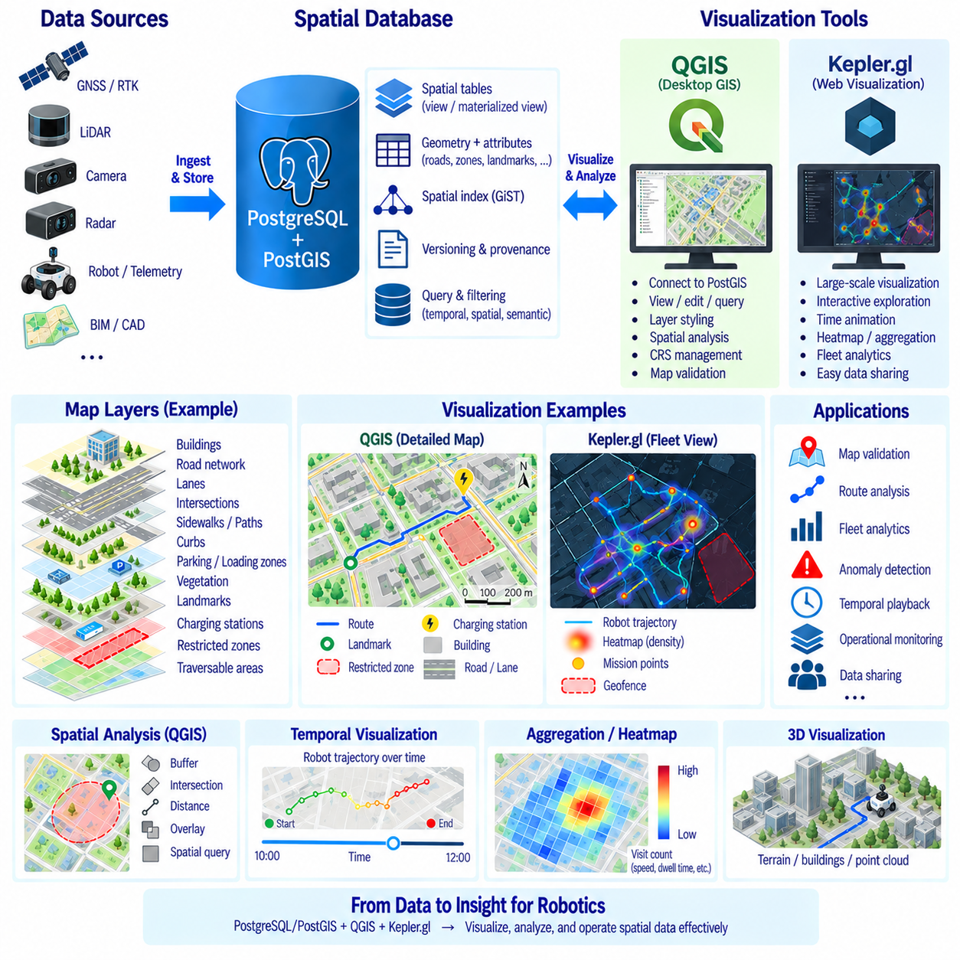
Spatial data visualization converts coordinates, geometries, attributes, and spatial relationships into visual representations that humans can inspect and interpret. In robotics, visualization is important for validating maps, examining robot trajectories, reviewing landmarks, checking geofences, analyzing sensor-derived features, and understanding fleet behavior. A spatial database may contain correct data while still hiding mapping errors that become immediately visible when displayed geographically.
QGIS is a desktop Geographic Information System that provides extensive tools for viewing, editing, querying, styling, and analyzing spatial data. It can connect directly to PostgreSQL/PostGIS, allowing engineers to inspect database layers without exporting every dataset into intermediate files. Robot routes, landmarks, operational zones, buildings, road networks, and navigation regions can therefore be visualized while remaining linked to their authoritative database records.
A PostGIS connection in QGIS exposes spatial tables and views as map layers. Geometry columns determine how features are rendered, while relational attributes can be inspected through attribute tables and filtering tools. Engineers can display a route LineString together with landmark Points and restricted-area Polygons, enabling geometric relationships stored in separate database tables to be examined within a common spatial context.
Coordinate Reference System management is essential during visualization. QGIS can display layers stored in different supported coordinate systems by transforming them for a common map view, but the source CRS must be correctly defined. Robot-local coordinates, projected site coordinates, GNSS-derived geographic coordinates, and external basemaps should therefore have explicit reference information so apparent alignment on the screen represents actual spatial consistency.
Layer styling transforms raw geometry into meaningful operational information. Road classes can use different line widths, geofences can be distinguished by fill patterns, landmarks can use symbols based on type, and robot trajectories can be colored according to mission, speed, or status. Effective styling should communicate semantics rather than simply decorate the map, allowing abnormal conditions or important spatial relationships to be recognized quickly.
QGIS filtering and rule-based visualization can focus attention on subsets of a large robotics dataset. An engineer may display only landmarks from a specific map version, routes associated with one robot, restricted areas active during a particular period, or features whose validation status requires review. Database-side filtering and QGIS expressions can be combined so unnecessary records do not need to dominate the visualization.
Temporal visualization is useful when robot spatial data changes over time. Position histories, mission trajectories, detected obstacles, map revisions, and environmental observations can include timestamps that allow movement or change to be examined chronologically. Instead of viewing thousands of historical positions simultaneously, time-aware visualization can reveal how a robot moved through an environment and when significant spatial events occurred.
QGIS also supports editing workflows, making it useful for controlled map maintenance. Operators can adjust geometries, inspect attributes, or create new spatial features when permissions allow. Direct editing of authoritative data should be governed carefully, however, because an accidental geometry modification can affect navigation or safety. Production systems should combine database permissions, validation rules, versioning, and review procedures with visual editing tools.
Spatial analysis tools extend QGIS beyond simple map display. Engineers can measure distances, inspect intersections, generate buffers, compare layers, and identify spatial inconsistencies. For example, a planned AMR route can be checked against restricted zones, landmarks can be examined relative to road geometry, and facility features can be compared with newly collected survey data. Visualization becomes part of map verification and debugging.
Kepler.gl provides a different visualization approach oriented toward interactive, high-volume geospatial exploration in a web-based environment. It is particularly useful when large collections of points, trajectories, arcs, grids, or other geographic records must be explored quickly. Robot position histories, fleet movement patterns, mission distributions, sensor observations, and outdoor mobility datasets can be transformed into interactive visual layers.
Kepler.gl commonly works with tabular or geospatial datasets containing coordinates and associated attributes. Point records can represent robot observations or events, while line and trip-oriented representations can show movement through time and space. Color, size, height, filtering, and temporal controls can encode additional attributes, enabling a large dataset to reveal density, movement patterns, operational concentrations, or unusual behavior.
The strengths of QGIS and Kepler.gl are therefore complementary rather than identical. QGIS is well suited to detailed GIS inspection, spatial editing, CRS management, PostGIS integration, and engineering analysis. Kepler.gl emphasizes rapid interactive exploration and visually rich presentation of large geospatial datasets. A robotics workflow may use QGIS for map engineering and validation while using Kepler.gl for fleet analytics or operational exploration.
Data preparation remains important before visualization in either tool. Geometry validity, coordinate references, attribute names, timestamps, identifiers, and units should be consistent. Large raw telemetry tables may need filtering or aggregation before they are displayed. Visualization performance can deteriorate when millions of unnecessary records are transferred to the client, even if the underlying database can store and query them efficiently.
PostGIS views and materialized views can provide visualization-oriented representations without changing authoritative source tables. A view may combine route geometry with robot or mission attributes, while a materialized view can precompute expensive aggregations for repeated analysis. This separation allows visualization schemas to evolve according to user needs while core operational tables remain optimized for reliable robot data management.
Spatial aggregation can reveal patterns that individual records obscure. Robot observations may be grouped into grid cells, zones, road segments, or operational regions to calculate visit counts, average speed, dwell time, event frequency, or mission density. Such summaries can then be represented using graduated symbols, heatmaps, grids, or other visual encodings, helping operators understand fleet-level behavior instead of examining one trajectory at a time.
Three-dimensional visualization can add value when elevation or height is operationally significant. Outdoor terrain, multilevel facilities, point-cloud-derived structures, and spatial density values may benefit from height-based representation. However, 3D visualization should be used when it communicates meaningful spatial information rather than merely adding visual complexity. The underlying Z coordinates and reference frames must remain correctly defined.
Visualization should distinguish static map information from dynamic operational data. Buildings, roads, lanes, and persistent geofences may change slowly, while robot positions, temporary obstacles, alerts, and mission states can update continuously. Separating these layers allows static information to be cached or reused while dynamic overlays are refreshed independently, reducing unnecessary data transfer and simplifying real-time interfaces.
Performance optimization becomes important as spatial datasets grow. Database-side spatial filtering, bounding-box queries, GiST indexes, geometry simplification, aggregation, and level-of-detail strategies can reduce the amount of information delivered to visualization clients. The objective is not to display every stored coordinate simultaneously, but to provide the appropriate spatial detail for the current analytical question and viewing scale.
Security must also be considered because visualized maps may expose facility layouts, robot routes, infrastructure, restricted zones, or mission history. Database accounts used by QGIS should receive only required permissions, and datasets exported for web visualization should exclude sensitive attributes that are not necessary for analysis. Sharing a visualization should not unintentionally become a mechanism for distributing unrestricted operational data.
A robust visualization workflow maintains traceability between what appears on the screen and the underlying source data. Map version, query conditions, time range, filtering rules, coordinate reference, and visualization configuration should be identifiable when results are used for engineering decisions. This makes screenshots and dashboards more than informal illustrations by connecting visual findings to reproducible database queries and datasets.
QGIS, Kepler.gl, and PostGIS can therefore form a complementary spatial visualization environment for robotics. PostGIS maintains structured and indexed spatial information, QGIS supports detailed map engineering and validation, and Kepler.gl enables interactive exploration of large operational datasets. Together they transform robot routes, landmarks, HD maps, telemetry, geofences, and spatial histories into interpretable views for development, verification, operations, and fleet analysis.

11.10 Robot Spatial Data Management Operation Case
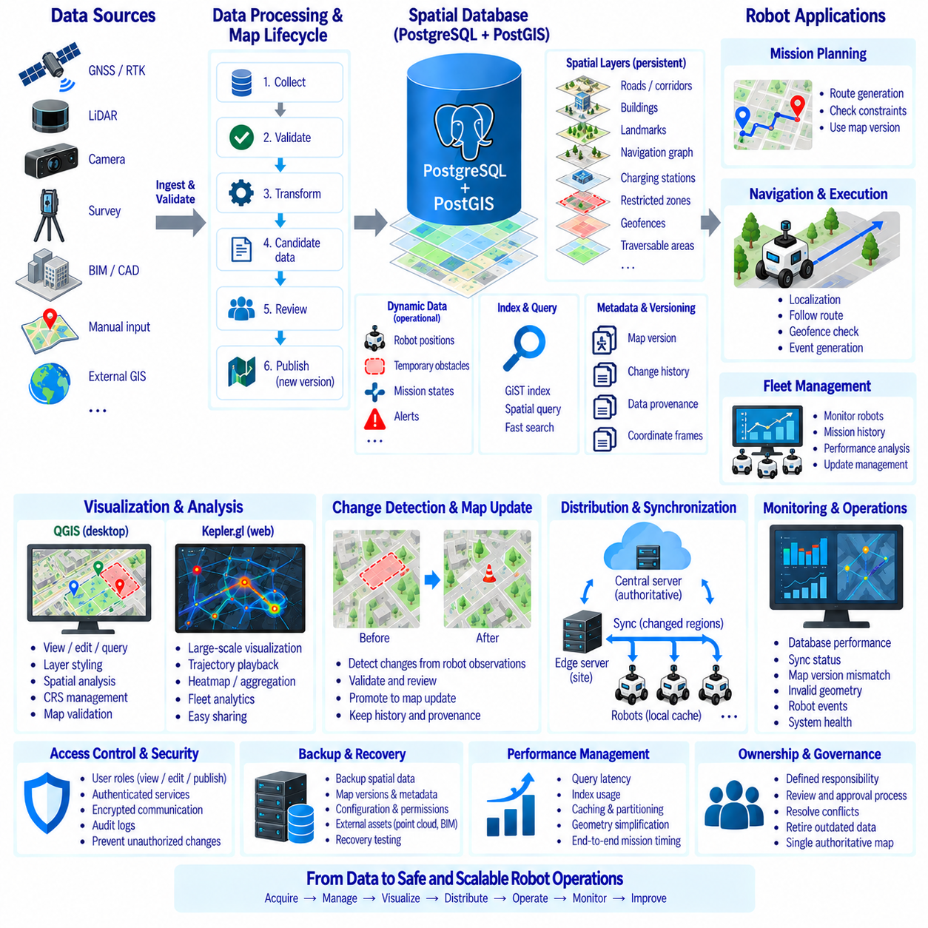
Robot spatial data management becomes an operational discipline when autonomous systems move from laboratory demonstrations to continuous fleet deployment. Maps, routes, landmarks, geofences, robot positions, mission histories, sensor observations, and environmental changes must remain consistent across robots and servers. The objective is not merely to store geographic information, but to maintain a trusted spatial representation that supports localization, planning, safety, monitoring, and maintenance.
A practical operating case begins with an authoritative spatial database that separates persistent map information from rapidly changing operational data. PostgreSQL and PostGIS can maintain roads, corridors, landmarks, charging stations, restricted zones, navigation graphs, and map metadata. Robot positions, temporary obstacles, mission states, and alerts can be handled as dynamic records or streams while retaining references to the persistent spatial entities that provide environmental context.
Spatial information usually enters the system from multiple sources. Survey data, BIM or CAD models, GNSS/RTK measurements, LiDAR mapping, cameras, manually defined operating zones, and existing geographic datasets may all contribute to the robot map. Each source can use different coordinates, accuracy levels, identifiers, and update cycles. An ingestion process should therefore validate coordinate references, geometry, timestamps, source identity, and required attributes before information enters operational storage.
Map data should pass through a controlled lifecycle rather than moving directly from collection to production. Newly acquired information can first be stored as candidate data, processed into standardized geometry and semantics, validated against existing map content, and reviewed before publication. Approved information becomes part of a defined map revision. This process prevents unverified sensor observations or accidental editing from immediately changing the environment used by autonomous robots.
The operational database can organize spatial entities according to their function. Base geometry describes roads, buildings, corridors, and traversable surfaces; localization layers contain stable landmarks; topology describes valid connectivity; policy layers define geofences and access rules; infrastructure layers represent charging or service points. Separating these concerns enables one physical environment to support several robot functions without duplicating the entire map.
Coordinate management must remain consistent throughout operation. Outdoor robots may combine WGS84 GNSS coordinates, projected site coordinates, local map frames, and robot-relative frames, while indoor systems may use building-specific coordinates. Transformation relationships should be explicitly maintained and validated. A coordinate error of only a few meters can make a technically valid route, landmark, or geofence operationally dangerous when interpreted in the wrong reference frame.
Spatial indexing becomes essential as the operational database grows. GiST indexes can accelerate searches for nearby landmarks, route segments, restricted areas, charging stations, or map regions surrounding a robot. Queries should restrict the search area whenever possible rather than repeatedly scanning complete datasets. Index performance should be verified with representative fleet workloads because real operational query patterns may differ significantly from development tests.
Mission planning provides a clear example of integrated spatial data use. A mission request identifies an origin, destination, robot, and operational constraints. The system retrieves relevant topology, traversability information, restricted regions, and robot-specific limits before producing a route. The resulting route can be stored with references to the map version and planning parameters so later analysis can reconstruct exactly what spatial information supported the decision.
During execution, the robot continuously produces position and state information that can be associated with the planned route and mission. Current position can be checked against geofences, expected corridors, or allowed operating areas. Significant deviations can generate events without modifying the underlying map. This separation allows dynamic behavior to be monitored against persistent spatial rules while preventing transient robot states from contaminating authoritative geographic information.
Temporary obstacles require a different lifecycle from permanent map features. A pallet, parked vehicle, closed passage, or construction barrier may block navigation for minutes or days but should not automatically become permanent map geometry. Dynamic obstacle records can include position, extent, detection time, confidence, source, and expiration policy. Persistent changes can later be promoted into a formal map update after verification.
Robot observations can also support map maintenance through change detection. Repeated disagreement between stored landmarks and sensor observations may indicate that an object moved or disappeared. Differences in road boundaries, structures, or traversable surfaces can generate candidate map-change events. Automated detection should identify potential discrepancies, while controlled validation determines whether the authoritative map should actually be revised.
Version management provides the foundation for safe map distribution. Each published map can have a unique version identifier, creation time, validity state, parent revision, and change description. Robots should report which map version they currently use. When a new version is released, fleet management can determine which robots require updates and whether the changes affect active missions or only regions outside their current operating areas.
Large environments benefit from region-based synchronization rather than complete map replacement. Spatial tiles or operational regions allow a central server to distribute only the areas required by each robot or site. Edge servers and robot computers can maintain validated local caches, enabling continued operation during network interruptions. When connectivity returns, changed regions and metadata can be synchronized without transferring the entire spatial database.
Operational monitoring should include the health of spatial data services themselves. Useful indicators include database query latency, spatial index usage, synchronization delay, failed map downloads, version mismatches, invalid geometry counts, cache status, and transformation errors. Monitoring these conditions is important because navigation problems may originate from map infrastructure even when robot sensors and planning software are functioning correctly.
Data provenance makes operational incidents traceable. Important map entities should record their source, acquisition time, processing method, responsible revision, and validation state. When a robot repeatedly fails to localize near a particular landmark or avoids a route unexpectedly, engineers can trace the relevant spatial information back to its origin. Provenance turns the map from an anonymous dataset into an auditable engineering asset.
Visualization tools provide an important operational interface for this data. QGIS can support detailed engineering inspection of PostGIS layers, geometry, attributes, and coordinate systems, while web-oriented visualization can display fleet trajectories, mission density, geofences, and temporal patterns. Operators should be able to distinguish authoritative map layers, candidate updates, dynamic obstacles, and live robot states through clearly separated visual representations.
Access control should reflect the consequences of spatial data modification. Many users may need permission to view maps, while fewer should be able to edit candidate information and only authorized roles should publish production revisions. Database roles, authenticated services, encrypted communication, audit logs, and approval workflows can prevent unauthorized changes from propagating to robots. Map publication should be treated as an operational configuration change.
Backup and recovery procedures should preserve both spatial content and its operational context. Recovering only geometry without map versions, topology, metadata, permissions, or provenance may leave the system unable to reproduce previous missions. Backups should therefore cover relational records, spatial tables, configuration, revision history, and references to external assets such as point clouds or BIM files according to the system's recovery requirements.
Performance management should focus on end-to-end operational behavior rather than database benchmarks alone. Engineers should measure how long robots require to obtain local map regions, retrieve landmarks, validate routes against geofences, synchronize revisions, and recover after disconnection. Database indexes, caching, partitioning, geometry simplification, and edge deployment can then be tuned according to measured mission requirements.
A mature operating process also establishes ownership for spatial information. Mapping systems may automatically collect observations, but responsibility is still required for validating changes, publishing revisions, resolving conflicts, and retiring outdated data. Clear ownership prevents multiple teams or robots from creating competing versions of the environment and supports a single authoritative spatial reference for fleet operations.
The complete operational case therefore forms a continuous spatial-data lifecycle: acquire, validate, transform, store, index, publish, distribute, use, monitor, detect change, review, and revise. PostgreSQL/PostGIS provides persistent spatial management, robots contribute observations and consume operational subsets, and visualization and monitoring tools support human oversight. This closed-loop architecture keeps spatial information synchronized with the physical environment while maintaining traceability, safety, and scalable autonomous operation.

