Volume 08 Robot Database and Storage

04. Redis

04.01 Redis Data Structures: String, Hash, List, Set, ZSet [w/Code]
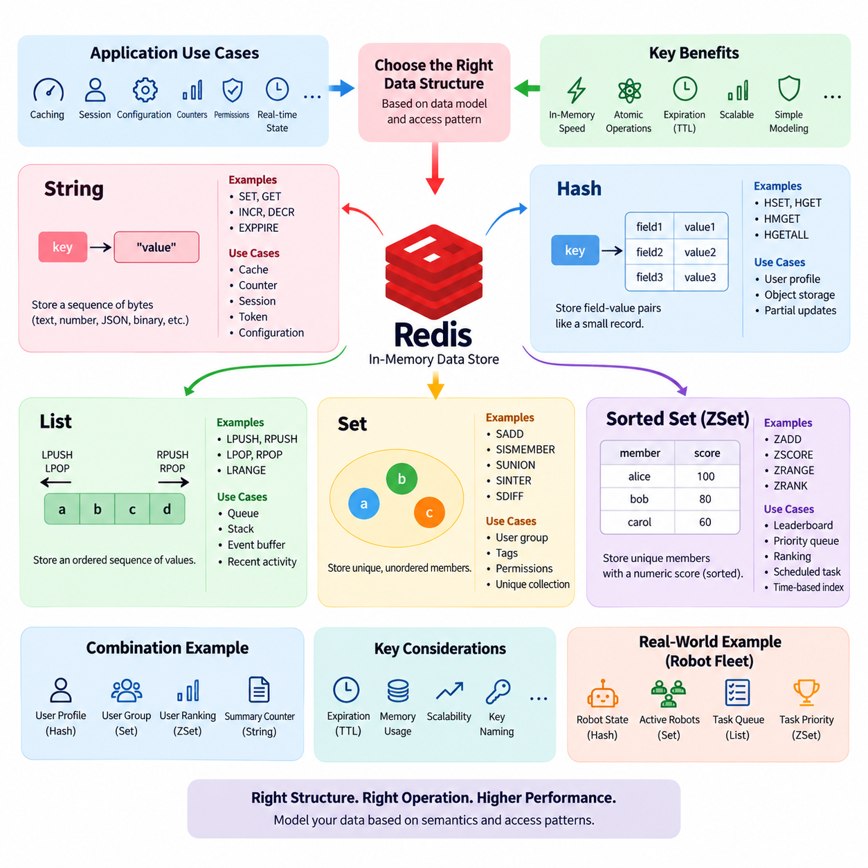
Redis provides several built-in data structures that allow applications to store and manipulate data efficiently in memory. The most important structures are String, Hash, List, Set, and Sorted Set, commonly called ZSet. Each structure is optimized for a different access pattern, so choosing the appropriate structure is an important part of Redis data modeling. Unlike a traditional relational database, Redis does not require every value to be represented as a row and column. Instead, an application can select a native structure that closely matches the logical shape of its data and the operations that will be performed most frequently.
The String is the simplest and most fundamental Redis data type. A String stores a sequence of bytes and can represent ordinary text, numbers, serialized objects, JSON documents, tokens, or binary data. Common operations include SET and GET, while INCR and DECR allow numeric values to be modified atomically. Strings are therefore useful for counters, flags, configuration values, cache entries, session identifiers, and temporary application state. Expiration can also be associated with a String key, making it particularly useful for short-lived data such as verification codes, authentication tokens, rate-limit counters, and cached results.
A Redis Hash represents a collection of field-value pairs under a single Redis key. It is conceptually similar to a small record or dictionary, where each field identifies one attribute of an object. For example, a user profile can be stored under a key such as user:1001 with fields representing name, email, status, and department. Commands such as HSET, HGET, HMGET, and HGETALL provide direct access to individual or multiple fields. Hashes are useful when an application frequently updates only selected attributes of an object because the entire object does not need to be replaced for every small modification.
Lists store ordered sequences of values and are particularly useful when the relative position of elements matters. Redis Lists support insertion and removal from both ends, making commands such as LPUSH, RPUSH, LPOP, and RPOP efficient for queue and stack patterns. A List can therefore implement a simple task queue, event buffer, recent-activity stream, or work-processing mechanism. Elements can also be retrieved by position or by a range. However, Lists should not automatically be treated as general-purpose relational tables. Their value comes from sequential access and controlled insertion or removal patterns rather than arbitrary querying across many attributes.
Redis Sets store unique, unordered members. When the same value is inserted more than once, Redis keeps only one copy, which makes Sets useful whenever uniqueness is part of the data model. Sets support efficient membership testing through commands such as SISMEMBER and can perform mathematical operations such as union, intersection, and difference. These properties make Sets suitable for representing user groups, tags, permissions, feature membership, active device identifiers, or collections of unique entities. For example, separate Sets can represent users belonging to different groups, while intersection can identify users who belong to both groups.
A Sorted Set, commonly called a ZSet, combines unique members with numeric scores. Every member has one associated score, and Redis maintains the collection according to score-based ordering. Commands such as ZADD, ZSCORE, ZRANGE, and ZRANK allow applications to insert members, inspect scores, retrieve ordered ranges, and determine relative positions. This makes ZSets particularly useful for leaderboards, priority queues, ranking systems, scheduled tasks, and time-based indexes. A timestamp can be used as a score to maintain an ordered collection of events, while a numerical performance value can represent the ranking criterion in a competition or recommendation system.
The distinction between these structures should be based primarily on access requirements rather than on the visual appearance of the data. A String is appropriate when the application treats the stored value as one logical object or scalar value. A Hash is appropriate when the value naturally consists of several named attributes that are independently accessed or updated. A List is appropriate when ordering and sequential insertion or removal are central to the workload. A Set is appropriate when uniqueness and membership operations are important. A ZSet is appropriate when uniqueness must be combined with numerical ordering or ranking. Selecting the structure according to these operations can simplify application logic and improve Redis performance.
The structures can also be combined to represent more sophisticated application models. For example, a user profile can be stored in a Hash, while a Set maintains the users belonging to a particular group and a ZSet maintains their ranking. A String can hold a frequently accessed summary or counter associated with the same user. This approach allows each part of an application's state to use the Redis structure that best matches its behavior. The resulting model is not necessarily normalized in the same way as a relational database, because the design is driven by application access patterns, latency requirements, and operational simplicity.
Redis data structures are also important because many operations are performed atomically by the Redis server. For example, incrementing a counter with INCR does not require an application to retrieve the current value, calculate a new value, and write it back through separate operations. Similarly, Set membership operations and Sorted Set score updates can be performed directly by Redis. This reduces the need for application-side synchronization in many common cases. Atomic commands are especially valuable in distributed applications where multiple processes or servers may simultaneously access the same logical state.
Expiration provides another important capability when these structures are used for temporary application data. Redis keys can be configured with a time-to-live, allowing cached values, sessions, temporary locks, verification tokens, and short-term state to disappear automatically. Expiration is applied at the key level, so the data model should consider whether related fields or members need to expire independently. When individual elements require different lifetimes, a single Hash or List may not provide the desired behavior without additional design. In such situations, separate keys or other Redis structures may be more appropriate.
Strings and Hashes are frequently used for caching and object-oriented application state, while Lists, Sets, and ZSets are particularly useful for collections with specialized access behavior. A List can represent a sequence, a Set can represent membership, and a ZSet can represent ordered membership. This distinction is valuable because many application requirements can be expressed directly through these structures without introducing additional indexing mechanisms. For example, finding whether a user has a permission can be modeled as Set membership, while retrieving the highest-ranked users can be modeled as a Sorted Set range operation.
From a data architecture perspective, Redis structures should be designed around the operations that the application must perform at low latency. A useful modeling process begins by identifying the entities involved, the relationships that must be represented, the most frequent reads and writes, and whether ordering or uniqueness is required. The next step is to map each access pattern to a Redis command and select the structure that supports that command naturally. This is often more effective than first designing a relational-style schema and then attempting to reproduce it inside Redis.
The five structures also have different implications for memory usage and scalability. Redis keeps active data in memory, so the number of keys, fields, members, and associated metadata can become significant at large scale. A model that is convenient for a small dataset may become inefficient when millions or billions of objects are stored. Developers therefore need to consider key naming, object granularity, duplication, serialization format, expiration policies, and the frequency of large retrieval operations. Commands that return an entire large collection should be used carefully because a single request can consume substantial server and network resources.
For Physical AI and robotics systems, these structures can represent rapidly changing operational state without replacing the primary data lake or long-term database. Strings can store current status values or counters, Hashes can represent robot state summaries, Lists can buffer short sequences of tasks or events, Sets can maintain active robot or device membership, and ZSets can maintain priorities, timestamps, or rankings. A robot fleet management service, for example, could use a Hash for each robot's current state, a Set for robots assigned to a site, and a ZSet for task priorities. Historical sensor data would normally remain in a more appropriate persistent storage system rather than being retained indefinitely in Redis.
The main principle is that Redis data structures should be selected according to semantics and access patterns. String provides simple value storage, Hash provides field-based object storage, List provides ordered sequential collections, Set provides unique unordered membership, and ZSet provides unique members with score-based ordering. Understanding these differences allows developers to design data models that are concise, efficient, and aligned with Redis's in-memory execution model. In practical systems, the best Redis schema is not necessarily the one that most closely resembles a traditional database schema, but the one that expresses the application's high-frequency operations directly and predictably.

04.02 Redis Cache Strategy: Cache.Aside / Write.Through [w/Code]
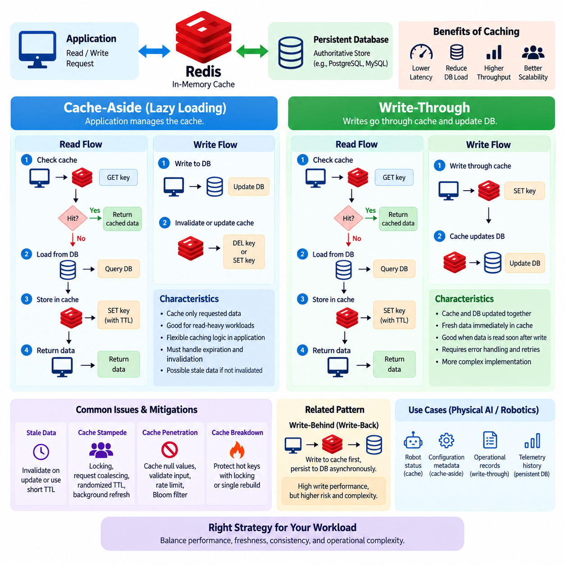
Redis is frequently used as a high-speed cache in front of a persistent database. The purpose of a cache is to reduce database access, lower application latency, and absorb repeated read requests. A cache strategy defines how application data moves between Redis and the primary data store, especially when data is read, created, updated, or deleted. Two commonly used patterns are Cache-Aside and Write-Through. They differ mainly in which component is responsible for updating the cache and how consistency between the cache and the persistent database is maintained.
Cache-Aside, also called Lazy Loading, is one of the most widely used Redis caching patterns. In this approach, the application is responsible for both reading from the cache and loading data into the cache when necessary. When a request arrives, the application first checks Redis. If the requested key exists, the cached value is returned immediately. This is called a cache hit. If the key does not exist, a cache miss occurs, and the application retrieves the data from the primary database, stores the result in Redis, and then returns the data to the requester.
The main advantage of Cache-Aside is that only data that is actually requested needs to be cached. This avoids filling Redis with large amounts of data that may never be accessed. It also allows the application to decide which objects should be cached, how long they should remain available, and under what conditions they should be invalidated. Cache-Aside is therefore particularly suitable for read-heavy applications where a relatively small portion of the persistent dataset receives a large proportion of the traffic. However, the application must explicitly implement cache population, expiration, invalidation, and error-handling logic.
A typical Cache-Aside read sequence begins with a request for a logical object such as a user profile, product record, or robot configuration. The application constructs a deterministic Redis key and performs a GET or equivalent lookup. If the key exists, Redis returns the cached representation without requiring a database query. If the key is missing, the application queries the persistent database and obtains the authoritative value. The application then writes that value into Redis, often with an expiration time, before returning it to the caller. Subsequent requests can therefore be served directly from memory until the cache entry expires or is explicitly invalidated.
Cache-Aside requires careful consideration of stale data. If the underlying database is updated while an old value remains in Redis, subsequent requests may receive the outdated cached value. A common solution is to invalidate the corresponding Redis key whenever the persistent value changes. Another approach is to use a relatively short time-to-live so that stale values eventually disappear automatically. The appropriate policy depends on the application's consistency requirements. Data such as product descriptions may tolerate a short period of staleness, while security permissions, financial balances, or safety-critical robot state may require stronger consistency guarantees.
Write-Through caching uses a different responsibility model. When the application changes data, the write operation is directed through the caching layer so that the cache and persistent database are updated as part of the same logical operation. Conceptually, the application writes the new value to the cache, and the cache layer ensures that the corresponding persistent store is also updated. The objective is to keep frequently accessed cached data synchronized with the authoritative storage system. Unlike Cache-Aside, the application does not wait for a later read miss to populate the cache after a write.
The main benefit of Write-Through is that successfully written data is immediately available in the cache. This can reduce the possibility that the application writes a new database value but leaves an old value in Redis. It is useful when the same data is likely to be read shortly after being modified and when maintaining cache freshness is important. However, Write-Through introduces additional complexity because a write may involve both Redis and the persistent database. The system must define what happens when one operation succeeds while the other fails, and it must provide appropriate retry or recovery mechanisms.
The difference between Cache-Aside and Write-Through becomes especially clear when considering the application's read and write paths. Cache-Aside places more responsibility on the application: reads check Redis first, misses load from the database, and writes normally update the database followed by cache invalidation or refresh. Write-Through places more responsibility on the caching mechanism: writes pass through the cache and are propagated to persistent storage, keeping the cached representation immediately available. Neither pattern is universally appropriate. The correct choice depends on read frequency, write frequency, consistency requirements, failure tolerance, and the relative cost of database access.
Cache expiration is an important component of both strategies. Redis can assign a TTL to cached keys so that entries are automatically removed after a defined period. Expiration prevents indefinitely stale data from remaining in memory and also helps control memory consumption. However, expiration alone should not be treated as a complete consistency mechanism. A long TTL may allow stale data to remain for too long, while a very short TTL may cause frequent cache misses and increase database traffic. A practical design therefore combines TTL with explicit invalidation or refresh behavior when the underlying data changes.
Cache stampede is another important concern. If a popular key expires while many requests arrive simultaneously, multiple application instances may detect the same cache miss and query the database at the same time. This can create a sudden burst of database traffic precisely when the cache was expected to protect the database. Common mitigation techniques include request coalescing, distributed locking, randomized expiration times, background refresh, and temporary stale-value serving. The appropriate technique depends on traffic volume and the cost of reconstructing the cached value.
Cache penetration occurs when requests repeatedly ask for data that does not exist in the persistent database. If every request misses Redis and then queries the database, attackers or malformed clients can generate unnecessary database load. Applications can mitigate this problem by caching negative results for a short period, validating request parameters, applying rate limits, or using Bloom filters where appropriate. The negative-cache TTL should generally be conservative because an object that does not exist today may be created later.
Cache breakdown refers to situations where an extremely popular data item becomes unavailable in the cache and many requests attempt to reconstruct it simultaneously. This is closely related to cache stampede but often focuses on a single high-value or highly popular key. Locking or request coalescing can ensure that only one process rebuilds the missing entry while other requests wait briefly or receive a controlled fallback response. For high-traffic services, protecting these hot keys can be more important than optimizing ordinary cache operations.
Write-Through can also introduce consistency and durability questions. If Redis is treated as the immediate write target but the persistent database update fails, the system must prevent the cache from becoming an apparently successful but non-durable source of truth. A robust implementation therefore defines transaction boundaries, retry behavior, failure states, and reconciliation procedures. In some architectures, a write-through cache is implemented through a dedicated caching component rather than by allowing application services to independently update Redis and the database. This centralized responsibility can reduce inconsistent implementation across services.
Another related pattern is Write-Behind, sometimes called Write-Back, in which changes are first written to the cache and persisted to the database asynchronously. This can provide very high write throughput because the application does not need to wait for the persistent database on every operation. However, it introduces a larger durability window and greater operational complexity. If Redis or the write queue fails before persistence occurs, recent changes may be lost. Write-Behind is therefore appropriate only when the system can tolerate asynchronous persistence and has reliable mechanisms for buffering, retrying, and recovering pending writes.
For Physical AI and robotics systems, cache strategy should be selected according to the distinction between operational state and authoritative historical data. Redis can provide fast access to current robot status, task assignments, configuration snapshots, fleet membership, or short-lived coordination state, while a persistent database or data lake retains durable records and historical sensor information. Cache-Aside can be useful for relatively stable robot configuration or metadata that is frequently read but infrequently changed. Write-Through may be appropriate for operational records where a successful update should immediately become visible to subsequent readers.
For example, a fleet management service could use Cache-Aside for robot metadata. When a robot's configuration is requested, the service checks Redis first and retrieves the persistent record only when the cache misses. After a configuration change, the service can update the database and invalidate the corresponding Redis key. For a frequently modified operational object where immediate cache visibility is important, a Write-Through design could update Redis and the persistent store as part of the same logical write operation. Historical telemetry should generally remain in durable storage rather than being treated as an indefinitely retained Redis cache.
A production Redis cache strategy should also consider key naming, serialization, TTL policy, memory limits, eviction behavior, observability, and failure recovery. Keys should follow predictable naming conventions so that related objects can be identified and invalidated consistently. Cached values should use a serialization format that balances size, compatibility, and processing cost. Redis memory policies should be selected according to the importance of cached data, and applications should monitor hit rate, miss rate, latency, memory usage, evictions, and database fallback traffic. These metrics reveal whether the cache is actually reducing the intended workload.
The fundamental principle is that Redis caching should be designed around the application's consistency and access requirements rather than simply adding Redis in front of a database. Cache-Aside provides flexible, demand-driven caching and is often straightforward for read-heavy workloads. Write-Through provides a more controlled relationship between writes, cached values, and persistent storage, but requires careful failure handling. TTL, invalidation, stampede protection, penetration protection, monitoring, and recovery mechanisms should be designed together. A well-designed Redis cache is therefore not merely a faster copy of database data; it is an explicit data-access layer with defined freshness, consistency, performance, and failure semantics.

04.03 Redis PubSub and Stream: Robot Event Bus [w/Code]
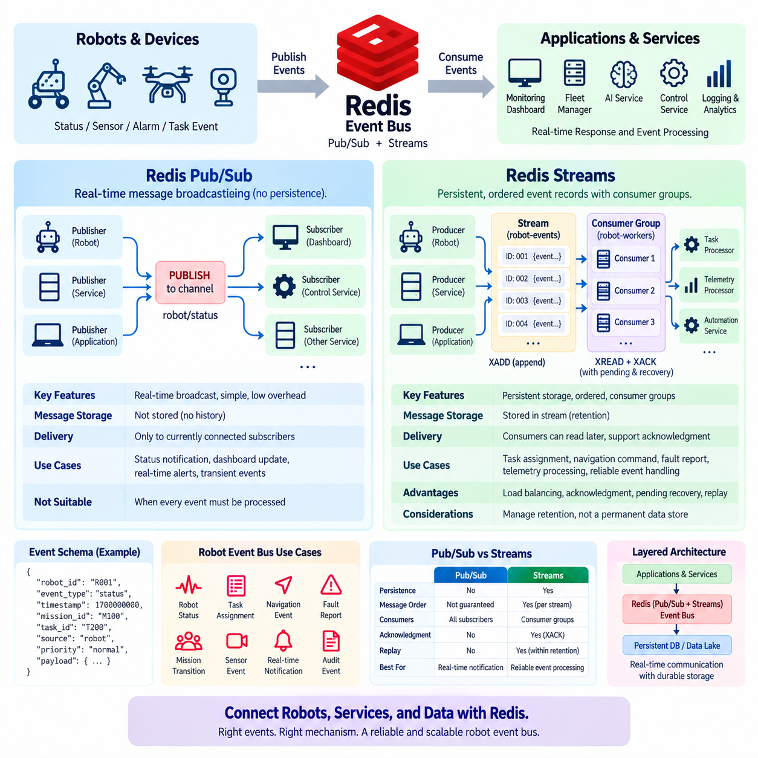
Redis provides two important mechanisms for event-driven communication: Pub/Sub and Streams. Both allow applications and services to exchange messages without requiring every component to communicate directly with every other component. However, their reliability and processing models are fundamentally different. Pub/Sub is designed for lightweight real-time message broadcasting, while Redis Streams provides persistent, ordered event records with consumer-oriented processing. Understanding this distinction is essential when Redis is used as an event bus for distributed applications and Physical AI or robotics systems.
Redis Pub/Sub follows a publisher-subscriber communication model. A publisher sends a message to a named channel, and every subscriber currently connected to that channel receives the message. The publisher does not need to know which applications are listening, which creates a loosely coupled communication relationship. Channels can represent logical topics such as robot/status, robot/alarm, task/update, or sensor/event. This simple model makes Pub/Sub attractive for real-time notifications, dashboards, control interfaces, and transient application events.
A key characteristic of Pub/Sub is that messages are not stored for later delivery. If a subscriber is disconnected when a message is published, that subscriber does not receive the missed message after reconnecting. Redis therefore does not provide a built-in historical event log for ordinary Pub/Sub channels. This behavior makes Pub/Sub unsuitable when every event must be processed reliably. Instead, it should be used when the latest notification matters more than historical completeness, such as refreshing a monitoring screen or notifying connected services that an operational state has changed.
Redis Streams addresses this limitation by storing messages as persistent stream entries. Each entry receives an ordered identifier, allowing consumers to process events according to their position in the stream. A producer can append events with XADD, while consumers can retrieve entries using commands such as XREAD. Unlike Pub/Sub, a Stream can retain events after they have been published, allowing consumers to reconnect and continue processing events that were generated while they were temporarily unavailable.
Streams also support consumer groups, which provide a mechanism for distributing event processing across multiple workers. A consumer group maintains a logical processing position and assigns stream entries to individual consumers within the group. This allows multiple robot-processing services to share a workload without every service receiving every message. For example, several workers can process navigation events from the same stream while Redis tracks which entries have been delivered to which consumers.
Consumer groups also introduce explicit acknowledgment and recovery behavior. After a consumer processes an event, it can acknowledge the entry using XACK. Redis maintains information about pending entries that have been delivered but not yet acknowledged. If a worker crashes before acknowledgment, another consumer can inspect or claim the pending event and continue processing it. This provides a stronger processing model than Pub/Sub and is particularly valuable for task execution, telemetry processing, event-driven automation, and distributed robotics workflows.
A robot event bus can use Pub/Sub and Streams for different purposes within the same architecture. Pub/Sub can distribute transient notifications such as “robot online,” “dashboard refresh,” or “status changed” to currently connected applications. Streams can store important operational events such as task assignments, navigation commands, fault reports, mission transitions, and selected sensor events that must be processed reliably. This separation prevents the system from treating every message as equally important and allows the communication mechanism to match the operational meaning of each event.
For example, a fleet management service could publish a robot status update through Pub/Sub whenever a robot changes from idle to moving. A monitoring dashboard subscribed to the corresponding channel can immediately update its display. At the same time, a mission assignment can be written to a Redis Stream because the assignment must not disappear simply because a worker temporarily loses its network connection. The event can remain available until the responsible processing service has successfully consumed and acknowledged it.
Redis Streams can also support event replay within the configured retention period. This is useful when a new service needs to reconstruct recent operational state or when a processing component needs to recover after an interruption. However, Streams should not automatically be considered a permanent historical data store. Stream retention must be deliberately managed using length limits, time-based policies, or explicit deletion. Long-term robot telemetry and high-volume sensor data generally belong in durable storage systems designed for large historical datasets.
Event ordering is another important consideration. A Stream provides ordered entries within a stream, but a distributed system may contain multiple streams, producers, robots, or partitions. Global ordering across all events should therefore not be assumed unless the architecture explicitly establishes such an ordering boundary. For robotics systems, ordering is often more meaningful within a robot, mission, or task stream. A robot-specific event sequence can preserve the relationship between task assignment, execution state, completion, and fault events without requiring a single global event stream.
Event schema design is equally important. Each event should contain enough information for downstream consumers to understand its meaning without excessive dependence on the producer's internal state. Typical fields may include robot_id, event_type, timestamp, mission_id, task_id, source, priority, and payload. A stable schema allows multiple services to consume the same event independently. Versioning should also be considered so that producers and consumers can evolve without breaking existing processing logic.
Reliability requirements should determine whether an event is sent through Pub/Sub or Streams. If losing an event is acceptable and the primary requirement is immediate notification, Pub/Sub provides a simple and low-overhead mechanism. If an event represents a command, task, fault, transaction, or other action that must be processed, Streams provide stronger guarantees through persistence, consumer groups, acknowledgment, and pending-entry recovery. This distinction should be established at the architecture level rather than decided inconsistently by individual developers.
Physical AI systems can benefit from this event-driven model because robots, edge devices, AI services, and operational applications often operate asynchronously. A robot may generate an event while an AI inference service, fleet manager, monitoring application, and logging system are processing different parts of the workflow. Redis can provide a low-latency communication layer between these components, while durable databases and data lakes retain authoritative configuration, historical telemetry, training data, and audit records.
A practical architecture can therefore position Redis as a real-time event coordination layer rather than as the complete data platform. Pub/Sub handles transient real-time notifications, Streams handle durable short-to-medium-term event processing, and persistent databases or data lakes handle long-term records. This layered approach keeps operational communication fast while preventing Redis from becoming overloaded with data that requires long-term retention, complex analytics, or large-scale historical storage.
The central design principle is to select the communication mechanism according to the meaning and reliability requirements of the event. Pub/Sub is appropriate for immediate broadcast where missed messages are acceptable. Streams are appropriate when events need ordering, retention, consumer coordination, acknowledgment, and recovery. In a robot event bus, combining both mechanisms allows real-time notifications and reliable task processing to coexist without forcing every message into the same processing model. Redis therefore becomes a flexible event coordination layer connecting robots, edge systems, AI services, and operational applications.

04.04 Redis Streams: Robot Command Queue [w/Code]
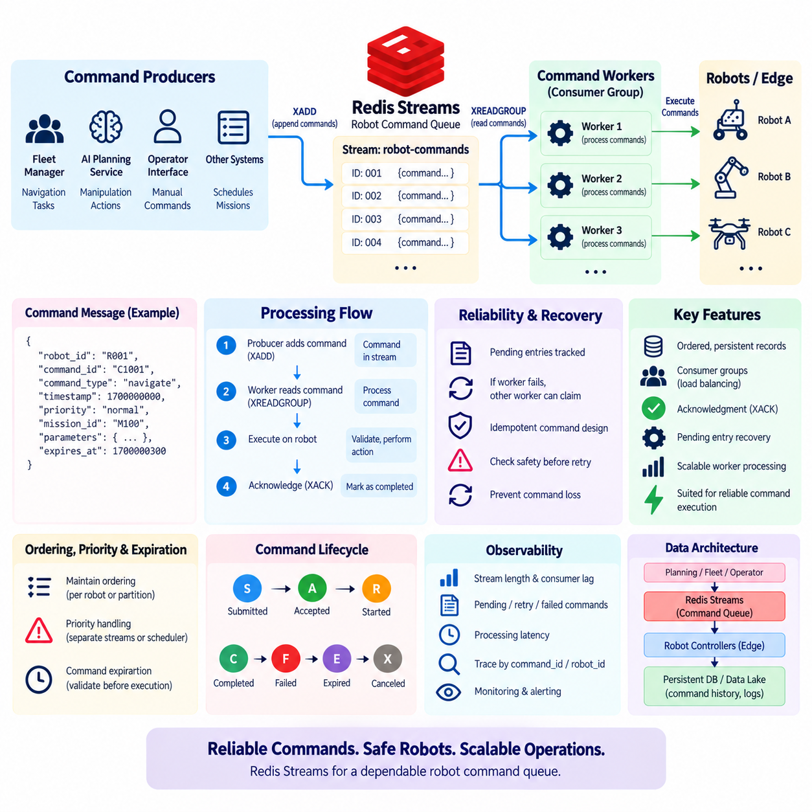
Redis Streams can be used to implement a reliable command queue for robots and autonomous systems. A robot command queue separates command production from command execution, allowing fleet managers, AI services, operator interfaces, and planning systems to submit commands without directly controlling the execution process. Redis Streams is well suited to this role because it provides ordered event records, consumer groups, acknowledgment, pending-entry tracking, and recovery mechanisms. Instead of treating a command as a temporary message, the system can represent it as a durable processing item with an identifiable lifecycle.
A robot command queue typically receives commands from multiple producers. A fleet management service may submit navigation tasks, an AI planning service may generate manipulation actions, and an operator interface may issue manual commands. These producers append command records to a Redis Stream using XADD. Each command can contain fields such as robot_id, command_id, command_type, timestamp, priority, mission_id, parameters, and expiration information. The command processor then reads these records through XREADGROUP and executes the appropriate action on the target robot.
Consumer groups are central to this architecture because they allow command-processing workloads to be distributed across multiple workers. A group such as robot-command-workers can contain several consumers, with each consumer responsible for processing a subset of commands. Redis tracks which entries have been delivered to each consumer. This prevents every worker from executing the same command and allows processing capacity to scale horizontally. Additional command workers can therefore be introduced as the number of robots or command requests increases, provided that the command semantics and ordering requirements are properly defined.
Command acknowledgment is an important part of reliable execution. After a worker receives a command, it should not immediately consider the command completed. The worker first validates the command, checks the target robot and required parameters, performs the requested operation, and then acknowledges the Stream entry using XACK when the required processing stage has been successfully completed. Until acknowledgment occurs, Redis maintains the entry in the pending entries list. This allows the system to distinguish between commands that have merely been delivered and commands that have actually completed their processing responsibility.
Worker failure can therefore be handled through pending-command recovery. If a command is delivered to a worker and that worker crashes before acknowledgment, the command remains pending. Another worker can inspect pending entries and claim work that has exceeded an appropriate processing interval. This mechanism is important for robotic systems because command loss can result in incomplete missions or inconsistent operational state. Recovery logic should nevertheless consider whether the command is safe to execute again. A navigation request may be retried under controlled conditions, while an irreversible physical action may require additional state verification before execution.
Command queues also require explicit treatment of ordering. Redis Streams maintains the order of entries within a stream, but consumer-group processing can distribute different commands to different workers. Consequently, application-level ordering must be defined according to the robot and command semantics. Commands for the same robot may need sequential execution, while commands for different robots can often execute concurrently. A practical architecture can use robot-specific streams, partitioning strategies, or application-level sequencing fields when strict ordering is required. The objective is to preserve the ordering that has operational meaning rather than unnecessarily enforcing global ordering.
Priority is another important consideration for robot command queues. Redis Streams naturally provides insertion order rather than arbitrary priority scheduling. If emergency commands must be processed ahead of ordinary commands, the application needs an explicit priority mechanism. This can be implemented by maintaining separate streams for emergency and normal commands, using multiple queues with defined scheduling rules, or introducing a priority layer before commands are written to the execution stream. The priority mechanism should ensure that safety-related commands cannot be delayed behind a large volume of routine navigation or telemetry-related work.
Command expiration is particularly important in robotics. A command may be valid only for a limited period because the physical environment can change after the command is created. For example, a navigation command generated thirty seconds ago may no longer be appropriate if another robot has occupied the target area. Each command can therefore contain a timestamp or expiration deadline, and the worker can validate this information before execution. An expired command should be rejected or redirected to a recovery workflow rather than blindly executed. Redis Stream retention and command validity are separate concepts: retaining an event does not mean that the command remains executable.
Idempotency is another fundamental requirement. A command may be delivered, partially executed, and then become pending because the worker fails before acknowledgment. If another worker subsequently processes the same command, the physical action could occur twice unless the command is designed to be idempotent or execution state is checked first. A unique command_id can be used as an execution identity, while a persistent command-state store can record whether the command has already been accepted, started, completed, or canceled. For physical operations, the worker should verify the robot's current state before repeating an operation that may already have taken effect.
Safety boundaries should also be separated from the command queue itself. Redis Streams can transport commands, but Redis should not automatically become the final authority for physical safety. A robot controller or safety subsystem should validate whether a command is physically permissible before execution. This can include emergency-stop state, collision constraints, operating-zone restrictions, actuator limits, battery conditions, and current robot mode. The command queue is therefore best understood as a coordination and delivery mechanism, while the robot's real-time controller and safety system retain authority over physical execution.
A useful command lifecycle can be represented as submitted, accepted, started, completed, failed, expired, or canceled. These states should not be inferred only from whether a Stream entry has been acknowledged. XACK indicates that a consumer has completed its responsibility for processing the Stream entry; it does not by itself represent the complete physical lifecycle of a robot command. A separate command-state record can maintain the authoritative business status, while the Stream provides the event and processing mechanism. This separation makes operational monitoring, troubleshooting, and audit analysis easier.
The command queue should also distinguish command events from high-volume sensor data. Redis Streams can transport selected telemetry or sensor events when low-latency processing is required, but a robot command queue should remain focused on actionable operational requests. Large camera frames, raw LiDAR scans, continuous IMU data, and other high-volume sensor streams should normally be stored in appropriate data systems rather than placed directly into the command queue. Commands can instead contain references to relevant data objects, model outputs, maps, or configuration records. This keeps command processing lightweight and predictable.
For a Physical AI fleet, the architecture can combine Redis Streams with persistent storage and edge execution systems. A planning service generates a command and writes it to the command Stream. A command worker consumes the entry, validates its schema and authorization, checks expiration and robot state, and sends the action to the robot's edge controller. The worker then records the resulting command state and acknowledges the Stream entry when its processing responsibility is complete. Persistent storage can retain the long-term command history, while Redis provides the low-latency coordination path required for active operations.
Observability is essential because a command queue can fail in ways that are not visible from application logs alone. Operators should be able to inspect stream length, consumer-group lag, pending entries, processing latency, retry counts, failed commands, expired commands, and commands that remain unacknowledged for unusually long periods. Correlation identifiers such as command_id, robot_id, mission_id, and trace identifiers should be propagated across the planning service, Redis, worker, edge controller, and persistent database. This creates a traceable execution path from the original command request to the physical robot outcome.
The fundamental principle is that Redis Streams should provide reliable command coordination without being treated as the complete robotics control system. Streams provide durable short-term command records, consumer-group distribution, acknowledgment, pending-entry recovery, and replay within the configured retention period. Application logic must provide priority, expiration, idempotency, authorization, lifecycle management, and command semantics, while the robot controller and safety layer retain authority over physical execution. With these boundaries clearly defined, Redis Streams can serve as a practical command queue connecting Physical AI planners, fleet management services, edge computers, and robot controllers with low latency and controlled reliability.

04.05 Redis Distributed Lock: Redlock Algorithm [w/Code]
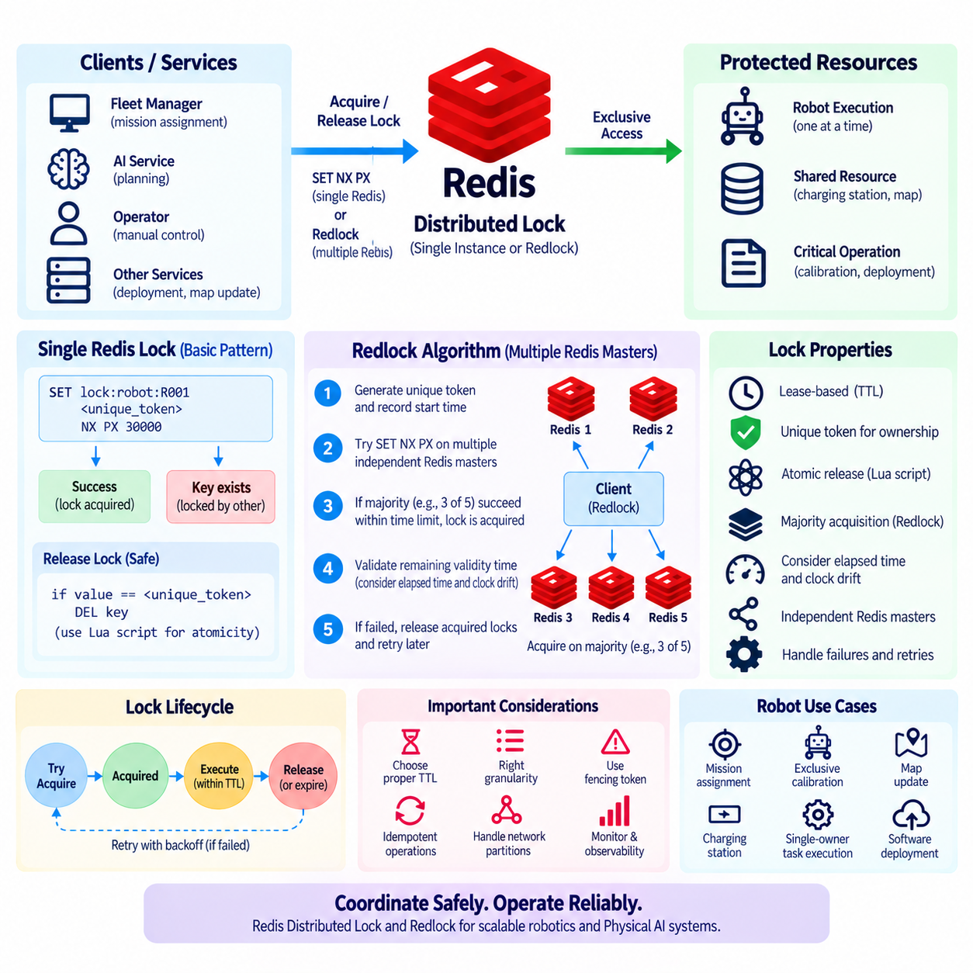
A distributed lock is a coordination mechanism that allows multiple processes, servers, or services to agree that only one participant should perform a particular operation at a given time. In distributed systems, ordinary in-process locks are insufficient because different application instances do not share the same memory space. Redis can be used as a coordination service for distributed locking because it provides fast key operations and atomic commands. A well-designed Redis lock can prevent duplicate job execution, conflicting resource updates, and simultaneous processing of the same operational task.
The simplest Redis locking pattern uses SET with the NX and PX options. The NX option ensures that the key is created only when it does not already exist, while PX assigns an expiration time. A unique random value should be stored as the lock value so that the process holding the lock can later verify ownership. Conceptually, a service attempts to create a key such as lock:robot:R001 with a unique token and a short TTL. If the operation succeeds, the service owns the lock for the specified period; if the key already exists, another process currently holds the lock.
The unique lock token is essential when releasing a lock. A process must not simply execute DEL on the lock key because its lease may have expired and another process may already have acquired the same key. In that situation, the original process could accidentally delete a lock belonging to another process. The safe release pattern therefore checks that the stored value still matches the process's unique token and removes the key only when ownership is confirmed. This check-and-delete operation should be performed atomically, commonly by using a Lua script or an equivalent Redis-side atomic mechanism.
A Redis lock is normally lease-based rather than permanent. The lock has a finite validity period, after which Redis can remove the key automatically even if the application crashes. This prevents a failed process from permanently blocking other workers. However, the TTL must be chosen carefully. If it is too short, a legitimate operation may continue after its lock has expired, allowing another process to acquire the same lock. If it is too long, recovery from a crashed process becomes slower. The lock duration therefore needs to reflect the expected execution time and the system's failure-recovery requirements.
The single-instance Redis lock pattern is often sufficient when the Redis deployment itself provides the required availability and the application can tolerate the associated failure model. However, a distributed environment may contain multiple independent Redis instances, and this creates a different design problem. Redlock was proposed as an algorithm for acquiring a distributed lock across multiple independent Redis masters. Its purpose is to reduce dependence on the availability of one Redis instance by requiring successful acquisition across a majority of independent nodes within a bounded time interval.
In the Redlock approach, the client obtains a unique lock value and records the start time before attempting to acquire the lock. It then attempts to create the same lock key with the same unique value on multiple independent Redis masters, using a short expiration time. The client measures how much time was consumed during the acquisition process. The lock is considered successfully acquired only when the client obtains the lock on a majority of the configured instances and the remaining validity time is still positive after accounting for the elapsed acquisition time and an appropriate clock-drift margin.
For example, a deployment may use five independent Redis masters. A client attempts to acquire the same logical lock on all five instances. If at least three instances accept the lock within the required acquisition window and sufficient validity time remains, the client can treat the lock as acquired. The other instances do not independently determine ownership; the algorithm relies on the majority condition. If the client cannot establish a valid majority within the required time, it should release any locks it successfully acquired and report that the distributed lock was not obtained.
The validity calculation is important because a distributed lock cannot safely be treated as valid simply because every individual Redis key has a TTL. Network latency, processing time, scheduling delays, and clock differences reduce the effective time available to perform the protected operation. Redlock therefore considers the elapsed acquisition time when determining the remaining validity period. An application should never assume that it has unlimited time merely because the Redis keys were initially created with the same expiration value.
Redlock also depends on assumptions about the independence and behavior of the Redis instances. The nodes used by the algorithm should not all fail together because they share a single underlying failure domain. If multiple Redis masters are simply replicas or processes controlled by the same infrastructure failure boundary, the apparent independence may be misleading. Network partitions, operating-system failures, virtualization failures, and correlated infrastructure outages can affect the practical safety characteristics of the design. Distributed locking is therefore partly a systems-architecture problem rather than merely a Redis command pattern.
Another important issue is that acquiring a lock does not automatically guarantee that the protected operation is safe. A process may acquire a lock, pause for an unexpectedly long period, and continue after its lease has expired. Another process may then acquire a new lock and begin performing the same logical operation. The original process could still attempt to modify the protected resource. For critical workflows, the system may therefore need an additional fencing mechanism, such as a monotonically increasing fencing token that downstream resources validate before accepting an operation.
Fencing tokens are particularly valuable when the lock protects an external resource that cannot itself understand Redis lock ownership. Consider two workers that sequentially acquire a lock but experience long pauses. Worker A obtains token 41 and begins an operation, then its lease expires. Worker B obtains token 42 and starts the newer operation. If the protected storage system accepts only operations carrying a token greater than the last accepted token, Worker A's delayed operation can be rejected. This prevents an old lock holder from overwriting work performed by the current owner.
Redlock should therefore be understood as a coordination algorithm with explicit assumptions rather than as a universal guarantee of distributed-system correctness. The design is useful when the application needs a distributed lease and the operational environment satisfies the assumptions required by the algorithm. However, distributed-systems literature has debated the exact safety guarantees of Redlock under certain failure and timing models. For operations where incorrect concurrent execution could cause severe consequences, engineers should consider whether a stronger coordination system or a resource-level fencing mechanism is more appropriate.
For Physical AI and robotics, distributed locks can coordinate shared resources such as mission assignment, exclusive robot calibration, map updates, shared charging stations, software deployment, or single-owner task execution. For example, a fleet management service may acquire a lock before assigning a particular robot to a mission. Another service attempting the same assignment sees that the lock is already held and must wait, retry, or select another task. The lock coordinates the software workflow, while the robot controller and safety system remain responsible for physical execution and safety authority.
Lock granularity is also important. A global lock such as lock:robot-system can unnecessarily serialize unrelated operations across an entire fleet. More specific keys such as lock:robot:R001 or lock:mission:M100 allow independent work to proceed concurrently. However, excessively fine-grained locks can increase coordination overhead and make deadlock-like application behavior more difficult to reason about. A practical design should therefore define the smallest resource boundary that must be protected while keeping ownership and recovery behavior understandable.
Retry behavior should also be controlled. When a lock cannot be acquired, an application should not immediately issue an unlimited stream of requests against Redis. Backoff, jitter, maximum retry duration, and failure handling should be defined according to the workload. Randomized delays can reduce synchronized retry bursts when many workers compete for the same lock. The system should also distinguish between temporary contention and an actual Redis infrastructure failure so that applications do not respond to every lock failure in the same way.
Observability is essential for production distributed locking. Services should record lock acquisition latency, acquisition failures, lease duration, renewal activity, release failures, contention frequency, and the identity of the protected resource. Correlation identifiers should connect lock operations with the corresponding mission, robot, task, or transaction. Long-held locks and repeated expiration events can reveal application problems such as unexpected execution delays, insufficient TTL values, or overloaded workers. Monitoring these conditions is important because a distributed lock can become a hidden source of latency and operational instability.
The fundamental principle is that Redis distributed locking should be used for coordination, not as a substitute for transaction design, database constraints, or physical safety mechanisms. A simple SET NX PX lock can be appropriate for many single-Redis coordination scenarios when ownership tokens and safe release are implemented correctly. Redlock extends the concept to multiple independent Redis masters by requiring majority acquisition and bounded validity. For critical operations, however, lease expiration, process pauses, network partitions, clock assumptions, and stale lock holders must be considered explicitly. In robotics and Physical AI systems, the safest architecture combines Redis-based coordination with idempotent operations, fencing where necessary, persistent state, and independent robot safety authority.

04.06 Redis Sentinel High Availability [w/Code]
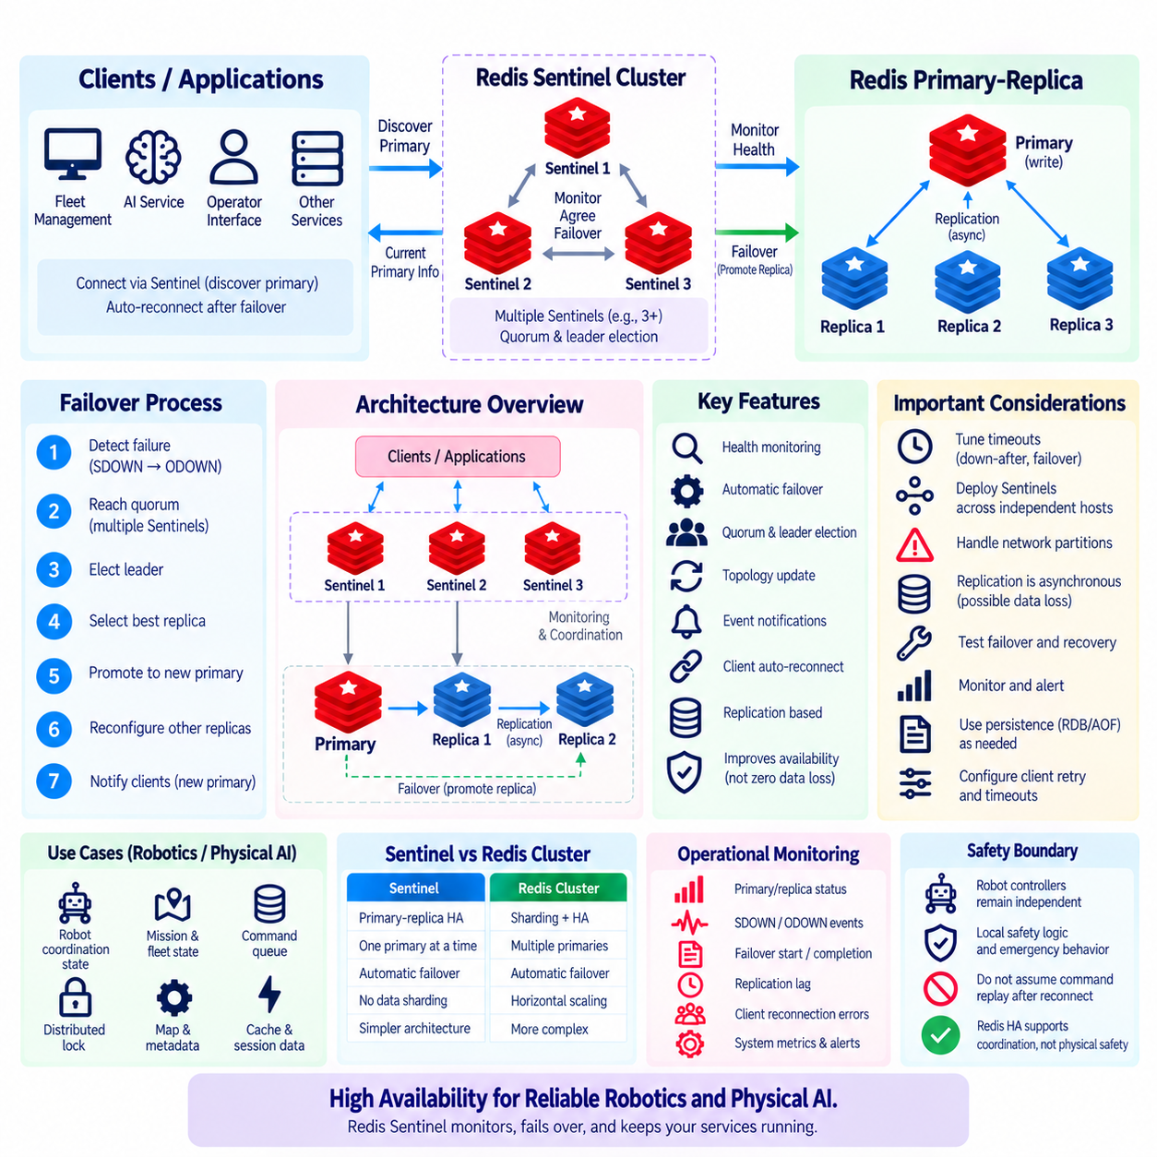
Redis Sentinel is a high-availability mechanism designed for Redis deployments that use a primary-replica architecture. A standalone Redis server can become a single point of failure because applications lose access to the service when that server becomes unavailable. Sentinel addresses this problem by continuously monitoring Redis instances, detecting failures, coordinating automatic failover, and informing clients about the current primary server. It provides availability management without requiring applications to manually select a replacement server after every primary failure.
A typical Sentinel deployment contains one Redis primary, one or more Redis replicas, and multiple Sentinel processes. The primary handles write operations and propagates data changes to its replicas through Redis replication. Replicas maintain copies of the primary dataset and can become candidates for promotion when the primary fails. Sentinel processes operate separately from the Redis data servers and monitor the health and topology of the deployment. Running multiple Sentinels reduces dependence on a single monitoring process and enables distributed agreement about failures and failover decisions.
Sentinel continuously checks whether monitored Redis servers are reachable and responsive. When a Sentinel cannot receive acceptable responses from a Redis instance within the configured timeout, it can mark that instance as subjectively down, commonly represented as SDOWN. This state reflects the observation of one Sentinel only. A temporary network delay, local connectivity problem, or overloaded server can therefore cause one Sentinel to suspect failure without immediately triggering a failover. This distinction helps prevent a single monitoring observation from controlling the entire availability decision.
When enough Sentinel processes independently agree that the primary is unavailable, the primary can be considered objectively down, or ODOWN. The required agreement is controlled by the configured quorum. Quorum is therefore an important part of Sentinel's failure-detection model because it requires multiple monitoring processes to confirm the problem. However, quorum for declaring ODOWN and the authorization needed to perform failover are related but distinct concepts. Sentinel also needs sufficient coordination among Sentinel processes to elect a leader that will conduct the failover.
During automatic failover, the elected Sentinel selects an appropriate replica and promotes it to become the new primary. Replica selection considers factors such as replica availability, replication status, configured priority, and replication offset. After promotion, the remaining replicas are reconfigured to replicate from the new primary. Sentinel also updates its internal view of the topology. Applications that support Sentinel-aware discovery can then obtain the address of the new primary and reconnect without requiring an administrator to manually modify a fixed server address.
Replication is therefore a fundamental dependency of Sentinel high availability. Redis replication is normally asynchronous, which means a replica may temporarily lag behind the primary. If the primary fails before the most recent writes have reached the replica that is promoted, some acknowledged data may be unavailable after failover. Sentinel improves service availability, but it does not convert asynchronous Redis replication into a fully synchronous durability mechanism. Applications must therefore distinguish high availability from guaranteed zero-data-loss persistence.
Sentinel-aware clients are an important part of the architecture. Instead of permanently connecting to a hard-coded Redis primary address, the application can contact Sentinel to discover which Redis instance is currently the primary for a named service. When failover occurs, the client library can rediscover the topology and establish a connection to the newly promoted primary. The exact reconnection behavior depends on the Redis client library, so timeout settings, retry policies, connection pools, and Sentinel support should be verified before production deployment.
A production Sentinel architecture normally uses multiple Sentinel processes located across independent hosts or failure domains. Three Sentinels are a common minimum topology because they allow majority-based coordination while tolerating the loss of one Sentinel under suitable conditions. Merely running three Sentinel processes on the same physical machine does not provide equivalent resilience because one host failure can remove all monitoring processes simultaneously. Placement should therefore reflect the infrastructure failures the system is intended to survive.
Network partitions require particular attention. A Sentinel may be able to communicate with some Redis nodes while another Sentinel observes a different network state. Quorum and majority-based failover coordination help reduce unsafe decisions, but network topology still influences availability. The system must be designed so that the group authorized to perform failover has the connectivity needed to reach the candidate replicas. Poor Sentinel placement or poorly understood network boundaries can create situations where healthy components cannot coordinate effectively.
Sentinel also provides monitoring and notification capabilities beyond automatic failover. It tracks primary and replica status, discovers topology changes, and can publish information about important events. Operations teams can integrate Sentinel events with monitoring and alerting systems to observe failovers, server availability changes, replica reconfiguration, and other topology transitions. These events should be correlated with application latency, connection failures, replication lag, and infrastructure metrics to understand whether a failover is an isolated Redis event or part of a broader system problem.
Failover timing should be configured carefully. If the down-after interval is too short, temporary latency or short network interruptions may cause unnecessary failure detection. If it is too long, applications may remain unable to write for an excessive period before failover begins. Similar considerations apply to failover timeout, client retry behavior, and connection timeouts. High availability is therefore not achieved simply by enabling Sentinel; detection, election, promotion, reconnection, and application recovery times must be considered as one end-to-end availability process.
Redis persistence settings remain important even when Sentinel is used. Replication and failover provide redundancy, while RDB snapshots and AOF persistence address different aspects of data recovery and durability. A deployment may combine replication, Sentinel, and persistence according to its recovery objectives. For cache-only workloads, limited persistence may be acceptable. For command state, coordination data, or other important operational information, persistence and external authoritative storage may be required. Sentinel does not eliminate the need for backup and recovery planning.
Sentinel should also be distinguished from Redis Cluster. Sentinel primarily provides high availability for a primary-replica Redis deployment while the dataset remains logically associated with one primary at a time. Redis Cluster introduces data sharding across multiple primary nodes in addition to high-availability mechanisms. Therefore, Sentinel is appropriate when the primary requirement is automatic failover without distributing the dataset across shards. Redis Cluster is considered when horizontal data partitioning and capacity scaling are also required.
In a Physical AI or robotics platform, Sentinel can protect Redis services that maintain caches, robot coordination state, event-processing metadata, command queues, distributed lock information, or short-lived fleet state. For example, an application may communicate with a Redis primary that supports fleet coordination while replicas continuously receive updates. If the primary server fails, Sentinel can promote a replica, and Sentinel-aware fleet services can reconnect to the new primary. This reduces service interruption without making Redis responsible for the robot's physical safety.
Safety-critical robot control should remain independent of Sentinel failover. A robot must not assume that loss of Redis connectivity means that a new command source is immediately trustworthy or that an interrupted command should automatically be repeated. Edge controllers should maintain local safety logic, command validation, emergency behavior, and bounded autonomous operation during infrastructure failures. Sentinel protects the availability of the Redis service layer, while robot controllers retain authority over real-time physical execution and safety constraints.
Operational testing is essential because a high-availability design that has never experienced controlled failure may behave differently from expectations. Teams should test primary shutdown, host failure, replica unavailability, Sentinel loss, network interruption, application reconnection, and recovery of the old primary. They should measure detection time, failover duration, client recovery time, replication lag, and potential data loss. Controlled failure testing exposes configuration and client-library problems before an actual production incident occurs.
Observability should cover both Redis and Sentinel. Important signals include primary availability, replica health, replication lag, Sentinel reachability, SDOWN and ODOWN events, leader election, failover start and completion, client reconnection errors, memory usage, persistence status, and command latency. Alerts should focus not only on individual server failures but also on whether the deployment still has enough healthy components to perform a safe failover. Monitoring the complete availability path is more useful than monitoring each Redis process in isolation.
The fundamental principle is that Redis Sentinel provides automated availability management around Redis replication rather than perfect fault tolerance. Sentinel monitors Redis nodes, reaches distributed agreement about primary failure, elects a failover leader, promotes an appropriate replica, reconfigures the remaining topology, and helps clients discover the new primary. Its effectiveness depends on replication health, Sentinel placement, quorum configuration, network design, client behavior, persistence strategy, and operational testing. For Physical AI systems, Sentinel can keep the Redis coordination layer available while durable databases, edge controllers, and independent safety mechanisms preserve long-term state and physical execution authority.

04.07 Redis Cluster Sharding Configuration [w/Code]
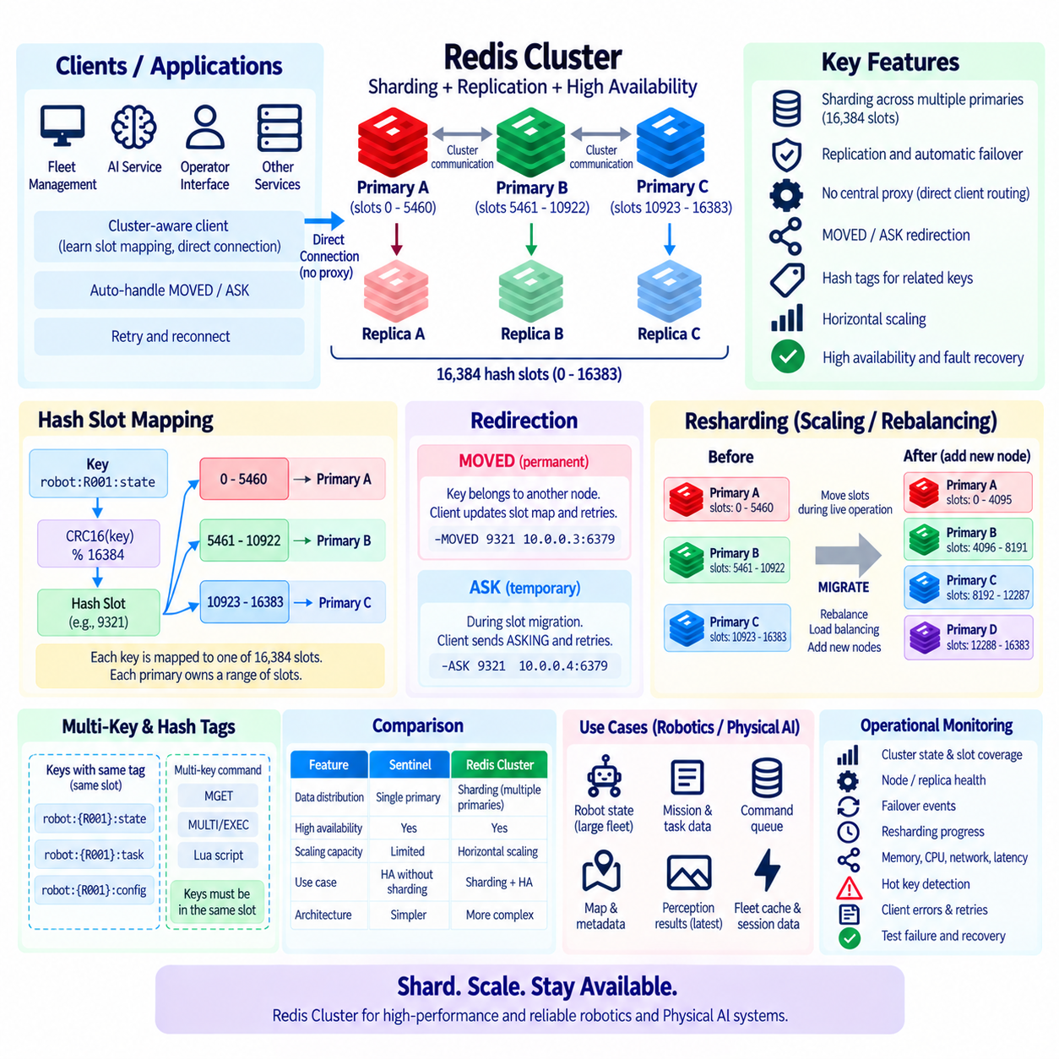
Redis Cluster is a distributed Redis architecture designed to divide a dataset across multiple Redis nodes while also supporting high availability. Unlike a primary-replica deployment in which one primary logically owns the entire dataset, Redis Cluster distributes keys among multiple primary nodes. This horizontal partitioning allows memory capacity and request processing to scale beyond a single server. Each primary can also have one or more replicas that provide redundancy and can be promoted when the corresponding primary becomes unavailable.
Redis Cluster partitions data through a fixed space of 16,384 hash slots. Every key is mapped to one of these slots using a deterministic hash calculation based on CRC16. The slot is obtained conceptually by calculating CRC16(key) modulo 16384. Primary nodes are assigned different ranges of hash slots, and each primary becomes responsible for the keys mapped to its assigned slots. This approach avoids requiring every individual key to be listed in a central routing table and provides a stable abstraction for distributing data across the cluster.
Consider a cluster with three primary nodes. The 16,384 slots may be divided so that Primary A owns approximately the first third, Primary B owns the middle range, and Primary C owns the remaining range. A key such as robot:R001:state is hashed to a particular slot, and the primary responsible for that slot stores and serves the key. Another robot key may hash to a different slot and therefore reside on another primary. Workload and memory usage can consequently be distributed across several servers.
Redis Cluster does not normally use a central proxy to route every command. Cluster-aware clients learn the relationship between hash slots and Redis nodes and can send commands directly to the node responsible for a key. If a client sends a command to the wrong node, Redis can return a MOVED redirection containing the correct destination. The client updates its slot mapping and retries the operation against the appropriate node. This distributed routing model reduces dependence on a single routing component and allows clients to communicate directly with cluster nodes.
An ASK redirection can occur during slot migration. When a hash slot is being moved from one primary to another, some keys may already exist on the destination while the migration is still in progress. Redis can temporarily direct a client to the destination node using ASK rather than permanently changing the client's slot map. The distinction between MOVED and ASK is important because MOVED indicates a stable slot ownership change, while ASK represents temporary routing behavior during migration or rebalancing.
Hash tags allow related keys to be intentionally mapped to the same hash slot. Text enclosed in braces is used as the hash input when a valid hash tag is present. For example, keys such as robot:{R001}:state, robot:{R001}:task, and robot:{R001}:config can be designed to map to the same slot because they share the tag {R001}. This is useful when an operation must access multiple related keys on the same cluster node. Hash tags should be used carefully because concentrating too many heavily accessed keys into one slot can create an uneven workload.
Multi-key commands and transactions require special consideration in Redis Cluster. Operations involving multiple keys generally need those keys to reside in the same hash slot when they must be processed atomically together. Keys distributed across different slots cannot simply participate in every command as if Redis Cluster were a single non-sharded instance. Application data models should therefore be designed around cluster routing boundaries. Hash tags can support related atomic operations, but excessive use can reduce the distribution benefits that sharding is intended to provide.
A production Redis Cluster commonly combines sharding with replication. For example, three primary nodes may each have one replica, producing a six-node topology. Each primary owns a subset of the hash slots, while its replica maintains a copy of the primary's data. If a primary fails and the cluster has sufficient connectivity and agreement, an appropriate replica can be promoted to take ownership of that primary's slots. This architecture provides both horizontal data distribution and failure recovery.
Redis Cluster nodes communicate with each other through a cluster communication mechanism used to exchange node state, slot ownership, failure information, and topology changes. Each node maintains knowledge about the cluster rather than relying on a single central coordinator. Failure detection and failover decisions therefore depend on communication among cluster members. Network design, node reachability, latency, and placement across failure domains directly influence the availability characteristics of the cluster.
Cluster availability depends not only on the number of running Redis processes but also on whether the required hash slots remain serviceable. If a primary fails and no suitable replica can take over its slots, the cluster may lose access to the affected portion of the keyspace. Depending on configuration and failure conditions, this can affect the cluster's ability to serve requests. Replicas should therefore be distributed across independent hosts or failure domains so that one infrastructure failure does not remove both a primary and its recovery candidate.
Sharding improves capacity but does not guarantee perfectly balanced workloads. Hash slots can be distributed evenly while actual memory consumption or request traffic remains uneven because different keys have different sizes and access frequencies. A small number of hot keys may generate disproportionate traffic on one primary. Large objects can similarly create memory imbalance. Operators should monitor per-node memory, CPU, network traffic, command latency, key distribution, and hot-key behavior rather than assuming that equal slot counts automatically produce equal load.
Redis Cluster supports resharding, allowing hash slots to move between primary nodes when capacity or workload requirements change. During expansion, new primary nodes can be added and selected slots migrated from existing nodes to the new nodes. During rebalancing, slots can be redistributed to improve resource utilization. Because migration occurs while the cluster may still be serving applications, clients must correctly handle temporary redirections. Operational planning should consider migration traffic, latency changes, and the additional load created by moving data.
Scaling out a cluster should therefore be treated as a controlled operational process rather than simply adding another server. The new node initially owns no useful portion of the dataset until slots are assigned or migrated to it. Administrators or cluster-management tools must determine how many slots should move and from which existing primaries. After migration, slot ownership and workload distribution should be verified. Capacity planning should leave enough spare memory and network bandwidth to perform rebalancing safely during normal operation.
Persistence remains relevant in Redis Cluster. Each node can use RDB snapshots, AOF persistence, or an appropriate combination depending on durability requirements. Replication and cluster failover provide redundancy, while persistence addresses recovery from other failure scenarios. Because Redis replication is generally asynchronous, acknowledged writes may still be vulnerable under particular failures. Applications that require stronger durability should retain authoritative data in an appropriate persistent system rather than assuming that clustering alone guarantees zero data loss.
Redis Cluster should be distinguished from Redis Sentinel. Sentinel provides monitoring and automatic failover for a primary-replica architecture where one primary logically owns the complete dataset. Redis Cluster distributes the dataset across multiple primaries using hash slots and also provides mechanisms for replica-based failover. Sentinel is therefore useful when high availability is required without sharding, while Cluster is designed for environments that also require horizontal memory capacity, distributed request processing, and partitioned key ownership.
Key design becomes especially important in clustered environments. Names should express resource identity while supporting the desired partitioning strategy. A robotics platform might use keys such as robot:{R001}:state, robot:{R001}:mission, fleet:{F01}:config, or station:{C03}:status. Hash tags can keep strongly related records together when necessary, while unrelated robots or resources can naturally distribute across different slots. The goal is to balance locality requirements against even distribution and avoid accidental concentration of high-volume workloads.
In a Physical AI platform, Redis Cluster can distribute real-time coordination data for large robot fleets across multiple Redis primaries. Robot state, mission metadata, temporary perception results, task status, cache entries, and short-lived operational information can be partitioned by robot, fleet, facility, or another logical resource. As the number of robots increases, additional Redis nodes can provide more memory and processing capacity. Cluster-aware fleet services can route requests to the appropriate nodes without treating one Redis server as the central bottleneck.
High-volume sensor streams require a different design decision. Camera frames, LiDAR point clouds, audio, and long-term telemetry are usually too large or too persistent to treat Redis Cluster as their primary historical storage system. Redis may instead store recent metadata, indexes, references, current state, or short-lived derived results while object storage, time-series systems, databases, or data lakes retain large historical datasets. Sharding Redis does not remove the need to separate real-time operational state from durable data architecture.
Operational monitoring should include cluster state, slot coverage, node membership, replica health, failover events, redirections, resharding progress, memory usage, CPU load, network throughput, latency, and hot-key patterns. Applications should also monitor client-side routing errors and retry behavior because cluster availability depends partly on correct client implementation. Controlled tests involving node failure, replica promotion, network interruption, slot migration, and client reconnection can reveal weaknesses before production failures occur.
The fundamental principle is that Redis Cluster scales Redis by partitioning key ownership rather than making every node contain the entire dataset. Its 16,384 hash slots provide the logical distribution layer, primary nodes own subsets of those slots, replicas provide redundancy, and cluster-aware clients route requests to the correct destinations. Effective deployment requires careful key design, hash-tag strategy, replica placement, resharding procedures, capacity planning, persistence, monitoring, and failure testing. In robotics and Physical AI systems, Redis Cluster can scale the real-time coordination layer while durable storage and independent robot safety systems remain responsible for historical data and physical execution authority.

04.08 Redis Memory Optimization: Compression / Eviction [w/Code]
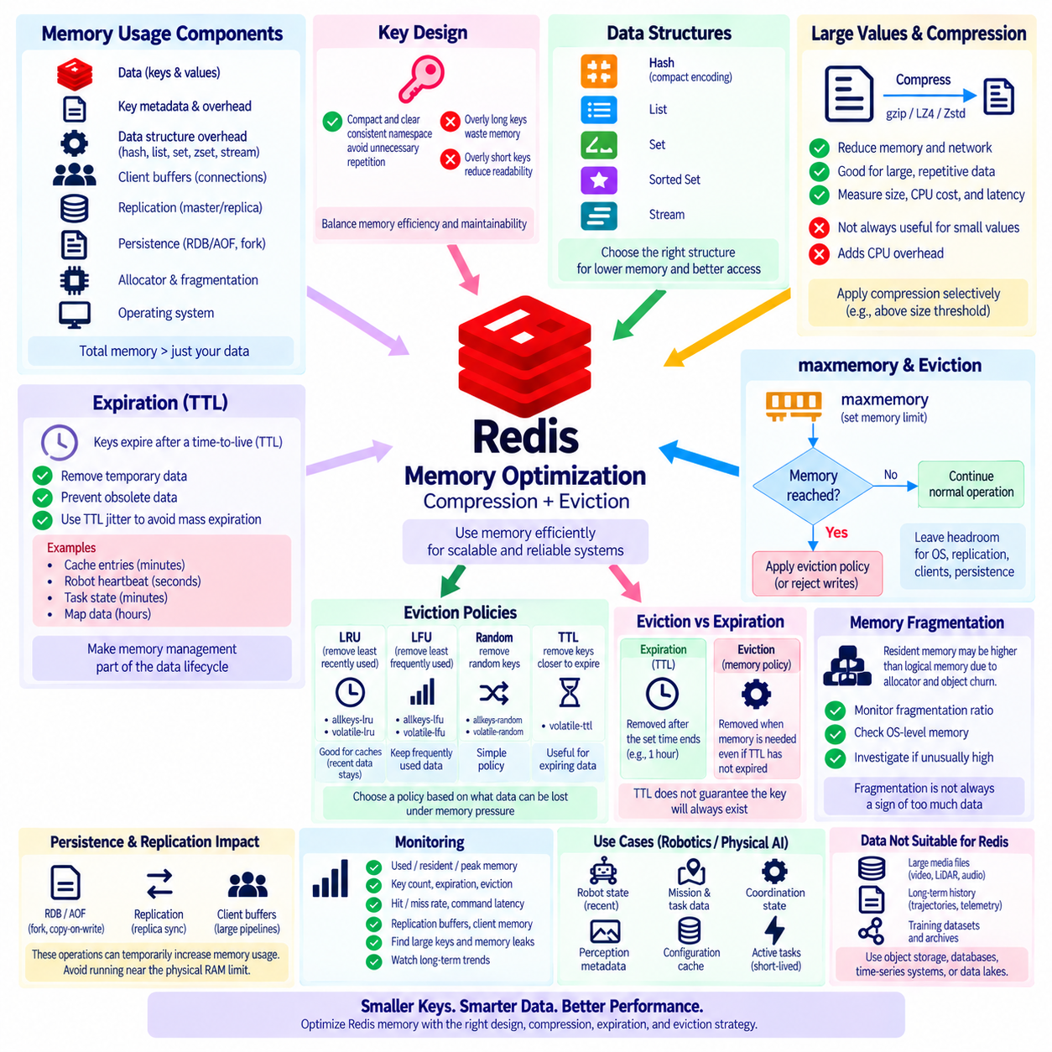
Redis is primarily an in-memory data platform, so memory efficiency directly affects capacity, latency, operating cost, and system stability. A Redis deployment can become constrained long before the server's physical memory is completely consumed because Redis itself, client buffers, replication, persistence operations, the allocator, and the operating system all require memory. Effective optimization therefore begins with understanding what occupies memory rather than simply increasing the server's RAM whenever usage grows.
Redis memory consumption includes more than the raw values stored by an application. Every key has metadata and internal object overhead, while data structures such as hashes, lists, sets, and sorted sets require their own representations. Small values stored under millions of separate keys can therefore consume substantially more memory than their payload size suggests. Key naming, value size, data structure selection, expiration policy, and object count should all be treated as parts of the memory model.
Key design is one of the simplest optimization opportunities. Long descriptive keys improve readability but can become expensive when repeated millions of times. Applications should use naming conventions that remain understandable without unnecessary repetition. However, excessively cryptic keys can damage maintainability and observability. The objective is not to minimize every key to a few characters, but to establish a compact and consistent namespace that balances memory efficiency with operational clarity.
Choosing the appropriate Redis data structure can significantly reduce memory consumption. Instead of representing every field of an object as an independent top-level key, related fields can often be grouped into a Hash. Redis can use compact internal encodings for sufficiently small aggregate structures, reducing per-key overhead. Lists, Sets, Sorted Sets, and Streams also have different memory characteristics. Data modeling should therefore consider both access semantics and the number and size of objects created.
Large values deserve special attention because a few oversized objects can dominate memory usage and increase network and command latency. Large JSON documents, serialized model metadata, maps, or configuration snapshots may contain repeated field names and redundant information. Applications can normalize or restructure these objects, store only frequently accessed fields in Redis, and move large historical content to persistent storage. Redis is usually most effective when it contains operational working data rather than complete archival datasets.
Application-level compression can reduce the memory required by large values. Text, JSON, repeated metadata, and some serialized structures may compress effectively with algorithms such as gzip, LZ4, or Zstandard. The application compresses data before writing it to Redis and decompresses it after reading. Compression introduces CPU cost and additional latency, so it is not automatically beneficial for every value. Very small objects may consume more processing time than the memory savings justify.
The decision to compress should therefore be based on measured workload characteristics. Large, repetitive values with moderate access frequency are stronger candidates than tiny values accessed thousands of times per second. Engineers should measure the original size, compressed size, compression and decompression latency, CPU utilization, and network savings. A useful policy may apply compression only above a size threshold or only to specific data classes rather than enabling it indiscriminately across all Redis values.
Expiration is another major memory-management mechanism. Redis allows keys to have a time-to-live, or TTL, after which they become eligible for removal. Temporary cache entries, sessions, intermediate AI results, robot heartbeat information, short-lived task state, and transient coordination metadata should generally not remain forever. Explicit TTL policies prevent obsolete data from accumulating silently and transform memory management from an emergency cleanup activity into part of the normal data lifecycle.
TTL values should reflect the semantics of the data rather than use one arbitrary duration for every key. A robot heartbeat may be useful for only seconds, a configuration cache for minutes, and a computed map reference for hours. Adding randomized variation, often called TTL jitter, can prevent a large population of related keys from expiring simultaneously. Without such variation, synchronized expiration can cause sudden cache misses and large bursts of traffic against downstream databases or services.
Redis can enforce a maximum memory limit through the maxmemory configuration. When memory usage reaches that boundary, Redis applies the configured eviction policy to determine whether and which keys should be removed. This provides a controlled response to memory pressure rather than allowing the instance to grow without an application-level limit. The maxmemory value should leave sufficient headroom for the operating system, replication buffers, client connections, persistence activity, and temporary memory requirements.
The noeviction policy prevents Redis from automatically removing keys when the memory limit is reached. Instead, commands that require additional memory can fail. This behavior may be appropriate when unexpected data removal is less acceptable than rejecting writes. However, applications must be prepared to handle the resulting errors. A noeviction configuration does not solve memory pressure; it changes the failure mode from automatic key removal to explicit write failure.
Eviction policies based on least recently used behavior, commonly represented by LRU, favor removal of keys that have not been accessed recently. allkeys-lru considers keys across the configured dataset, while volatile-lru considers only keys with expiration settings. LRU can be effective for caches where recently accessed objects are more likely to be needed again. Redis uses efficient approximations rather than maintaining a perfectly exact global ordering, providing practical eviction behavior without excessive tracking overhead.
Least frequently used policies, or LFU, estimate how often keys are accessed and prefer removing less frequently used data. allkeys-lfu can be useful when a relatively stable set of hot objects should remain in memory despite periods of inactivity. volatile-lfu restricts candidates to expiring keys. LFU and LRU represent different assumptions about future value: LRU emphasizes recency, while LFU emphasizes historical access frequency. Workload measurements should determine which assumption better matches the application.
Random eviction policies remove candidates without relying on recency or frequency estimates, while TTL-oriented policies can favor keys that are closer to expiration. These approaches may be appropriate for specialized workloads, but they should be selected deliberately. The critical question is which data the application can safely lose under memory pressure. An eviction policy should express business and operational semantics rather than being chosen solely because it appears to maximize cache hit rate.
Eviction is fundamentally different from expiration. Expiration removes a key because its predefined lifetime has ended, while eviction removes a key because Redis needs memory according to the configured memory policy. A key may therefore be evicted even though its TTL has not expired. Applications must not interpret the presence of a TTL as a guarantee that the key will remain available for that entire period when an eviction policy allows it to be removed earlier.
Memory fragmentation can cause the process's resident memory to differ from the logical memory Redis reports for stored data. Allocator behavior, object churn, deletion patterns, and changing value sizes can leave memory regions that are not immediately returned to the operating system. Operators should monitor both Redis memory statistics and operating-system-level resident memory. A high fragmentation ratio may indicate that workload patterns or allocator behavior require investigation rather than simply concluding that the dataset itself is too large.
Persistence and replication can temporarily increase memory pressure. Fork-based background operations, copy-on-write behavior, replica synchronization, client output buffers, and large command pipelines may require additional memory beyond the steady-state dataset. Capacity planning should therefore avoid operating Redis continuously near the physical RAM limit. A server that appears healthy during normal traffic may encounter memory exhaustion when persistence, replication recovery, and traffic spikes occur simultaneously.
Monitoring should include used memory, resident memory, peak memory, fragmentation, key count, expiration activity, eviction count, cache hit and miss rates, command latency, replication buffers, and client memory. Memory analysis tools and sampling can help identify large keys and unexpected data structures. Trends are often more informative than isolated measurements because gradual growth may reveal missing TTLs, oversized values, key leaks, or a workload whose assumptions have changed over time.
In Physical AI systems, Redis memory should be reserved for data that benefits from extremely fast access. Current robot state, recent mission status, short-lived perception metadata, active task assignments, distributed coordination information, and frequently accessed configuration values are appropriate examples. Raw camera video, LiDAR recordings, long-term trajectories, training datasets, and historical telemetry should normally be moved to object storage, databases, time-series systems, or data lakes instead of consuming expensive Redis memory.
A robotics platform can combine these techniques into a tiered memory strategy. Small active state may remain uncompressed for minimum latency, larger temporary metadata may be compressed when measurements justify the CPU cost, and every transient class may receive a meaningful TTL. Cache-oriented keys can use an LRU or LFU eviction policy, while critical coordination state may require a separate Redis instance or a noeviction policy. Separating workloads prevents expendable cache data and operationally important state from competing under one ambiguous memory policy.
The fundamental principle is that Redis memory optimization is a data-lifecycle and workload-design problem, not merely a server-sizing exercise. Efficient key structures reduce overhead, compression trades CPU for memory and network savings, TTLs remove obsolete information, maxmemory establishes a controlled boundary, and eviction policies determine what can be sacrificed under pressure. For robotics and Physical AI, the strongest architecture keeps only valuable real-time working data in Redis while durable and high-volume information flows to storage systems designed for long-term retention.

04.09 Redis Security Configuration: ACL / TLS [w/Code]
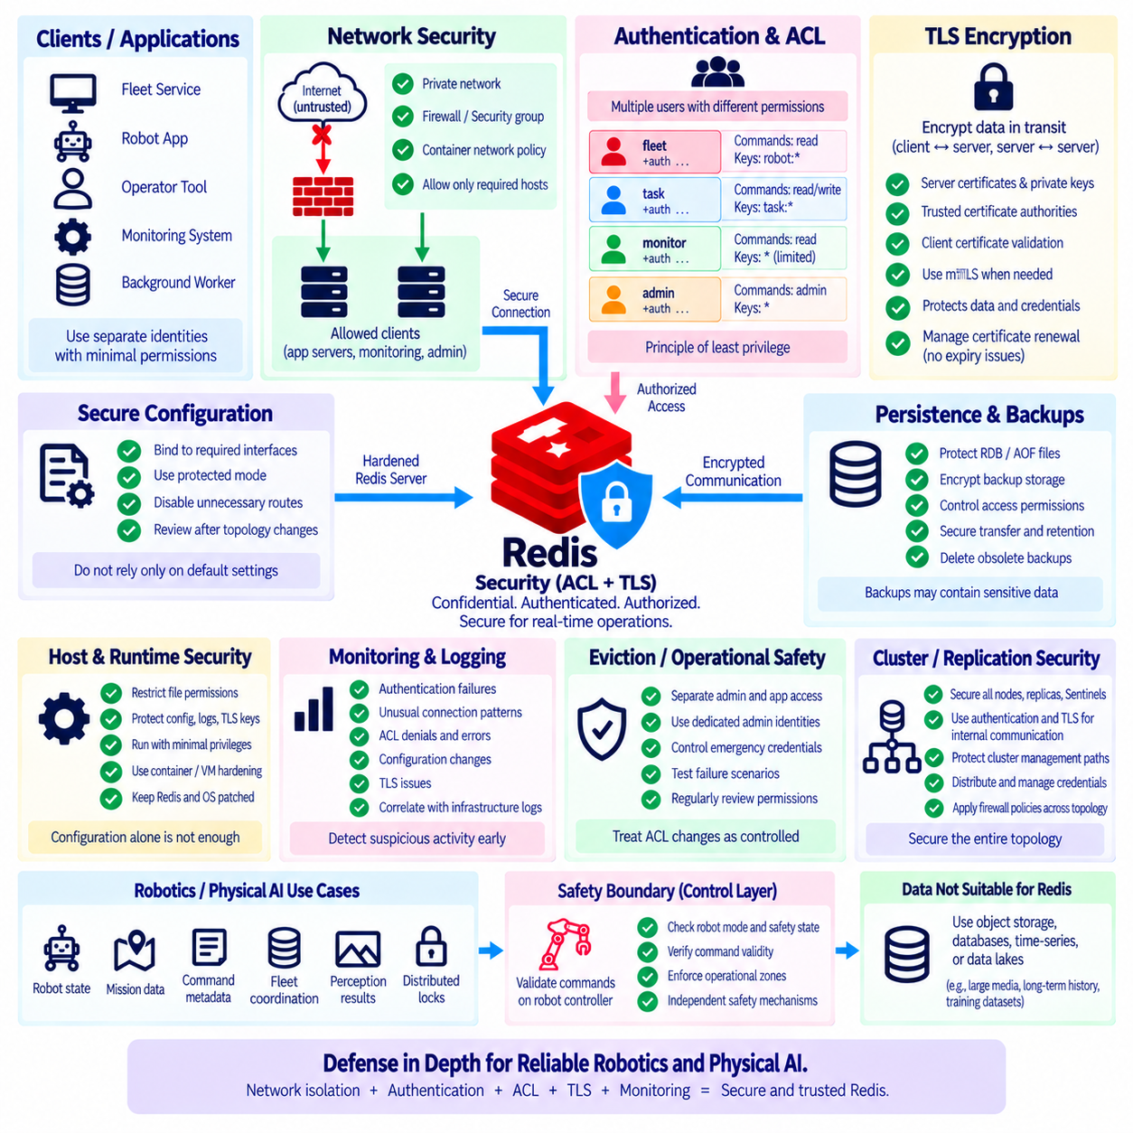
Redis security should be designed as a layered architecture rather than relying on one password or one network rule. Because Redis often contains caches, sessions, coordination state, command metadata, distributed locks, and other operational information, unauthorized access can affect both confidentiality and system behavior. A secure deployment combines network isolation, authentication, authorization, encrypted communication, protected credentials, safe configuration, monitoring, and disciplined operational procedures.
The first security boundary is network exposure. A Redis server should not normally be directly reachable from an untrusted public network. Deployment should restrict access through private networks, firewall rules, security groups, container network policies, or equivalent controls. Redis should listen only on interfaces required by the architecture, and unnecessary routes should be removed. Network isolation reduces the number of systems capable of reaching Redis before authentication and application-level controls are even evaluated.
Redis includes protective configuration mechanisms intended to reduce accidental exposure, but these should not replace deliberate network design. Binding Redis to appropriate interfaces and maintaining protected operating modes can help prevent unintended access. Production environments should explicitly define which application servers, management hosts, monitoring services, replicas, or cluster members are permitted to connect. Infrastructure configuration should be reviewed whenever topology changes because a secure Redis configuration can still become exposed through an incorrectly configured network.
Authentication verifies which identity is connecting to Redis, while authorization determines what that identity may do. Modern Redis deployments can use Access Control Lists, or ACLs, to define multiple users with different permissions. This is more flexible than giving every application the same unrestricted credential. A fleet service, monitoring system, administrative tool, and background worker can each use separate Redis identities, allowing permissions to reflect their actual responsibilities.
An ACL user can be configured with authentication credentials, allowed command categories, individual commands, and key-access patterns. For example, an application that only reads robot status may need GET or selected read commands but no permission to delete keys or modify server configuration. A task service may need access only to task-related namespaces. This supports the principle of least privilege, where each identity receives only the capabilities required to perform its intended function.
Key patterns provide another authorization boundary. If different applications use namespaces such as robot:*, mission:*, cache:*, and admin:*, ACL rules can restrict identities to the key regions they actually require. This makes key naming part of the security architecture as well as the data architecture. Namespace design should therefore be consistent and predictable. Poorly structured key names make it more difficult to create understandable access rules and increase the risk of granting unnecessarily broad permissions.
Command restrictions are especially important because not every Redis command has the same security impact. Normal application data operations differ significantly from administrative, configuration, scripting, debugging, or potentially destructive commands. Applications should not receive broad command access merely for convenience. ACL command categories and explicit command permissions can reduce the consequences of a compromised credential by preventing the affected identity from performing operations outside its normal role.
Credentials should be strong, unique, and managed outside application source code. Passwords or authentication secrets embedded in repositories, container images, scripts, or configuration files can be copied and reused long after the original deployment changes. Production systems should use an appropriate secret-management mechanism and limit which services and operators can retrieve credentials. Credential rotation procedures should also be defined so that compromised or outdated secrets can be replaced without causing unnecessary service interruption.
Authentication alone does not protect credentials or data while they travel across a network. Without transport encryption, network observers with sufficient access may be able to inspect sensitive traffic. Transport Layer Security, or TLS, provides encrypted communication between Redis clients and servers and can also be used for appropriate Redis-to-Redis communication depending on the deployment. TLS protects data in transit against passive observation and helps establish authenticated communication endpoints when certificates are properly validated.
A TLS configuration normally involves server certificates, private keys, trusted certificate authorities, protocol settings, and client-side certificate validation. Applications should verify the server identity rather than merely encrypting traffic without validation. Certificate expiration and renewal must also be operationally managed. A technically correct TLS deployment can still cause an outage if certificates expire unexpectedly or applications do not trust newly issued certificates after a rotation.
Mutual TLS, commonly called mTLS, can add client certificate authentication so that both sides authenticate each other at the transport layer. This can be useful in environments that require strong service identity in addition to Redis ACL authentication. TLS and ACLs solve different problems and can be used together: TLS protects and authenticates the communication channel, while ACLs control which Redis operations an authenticated Redis user may perform. One mechanism should not be treated as a replacement for the other.
Encryption introduces computational and operational overhead. TLS requires cryptographic processing, certificate management, connection establishment, and additional configuration. In many production environments this cost is justified by the security benefit, but performance should still be measured under realistic workloads. Connection pooling and persistent connections can reduce repeated handshake overhead. Security performance testing should focus on actual latency and throughput requirements rather than disabling encryption based on assumptions.
Administrative access should be separated from normal application access. Operators may require diagnostic or configuration capabilities that application services should never possess. Dedicated administrative identities, restricted management networks, controlled access paths, and audit procedures reduce the likelihood that an application compromise becomes full Redis administrative access. Emergency credentials should also be governed carefully and should not become permanent shared credentials used for routine operations.
Redis security also depends on the host and runtime environment. Operating-system permissions should restrict access to Redis configuration files, persistence files, logs, TLS private keys, and secret material. Containers or virtual machines should follow appropriate hardening practices, and Redis processes should run with only the privileges they require. Patching Redis, its operating system, client libraries, and surrounding infrastructure is part of the security lifecycle because configuration alone cannot compensate for known vulnerabilities indefinitely.
Persistence files and backups deserve the same protection as the live Redis service. RDB snapshots, AOF files, exported diagnostics, and backup archives may contain sensitive application information even when the Redis server itself is no longer accessible. Access permissions, storage encryption, backup retention, transfer security, and deletion procedures should therefore be defined. Protecting network traffic while leaving unprotected backups in broadly accessible storage creates an incomplete security boundary.
Logging and monitoring should detect both operational problems and suspicious activity. Teams should observe authentication failures, unusual connection patterns, unexpected command errors, ACL denials, configuration changes, connection sources, TLS problems, and changes in user definitions. Redis telemetry should be correlated with infrastructure and application logs where practical. Security monitoring is most useful when normal service behavior is understood well enough that deviations can be identified without generating excessive false alarms.
ACL changes should be treated as controlled configuration changes. Adding a user, expanding a key pattern, enabling a command category, or modifying authentication credentials can materially change the security boundary. Infrastructure-as-code or version-controlled configuration can improve consistency and reviewability when appropriate. Changes should be tested before production deployment, and organizations should periodically review whether identities and permissions are still required rather than allowing obsolete access to accumulate indefinitely.
In Redis Cluster, Sentinel, and replicated environments, security configuration must cover the complete topology rather than only the client-facing node. Redis nodes, replicas, Sentinel processes, cluster members, administrative tools, and monitoring systems may communicate across different paths. Authentication, TLS, certificate trust, firewall policy, and credential distribution should therefore be designed for all relevant communication flows. A secure front-end connection does not compensate for unprotected internal management or replication channels.
For Physical AI and robotics, Redis may contain robot state, mission assignments, command metadata, fleet coordination information, temporary perception results, or distributed lock state. These data can influence operational decisions even when Redis is not the final physical controller. A compromised identity capable of changing mission or command-related keys could disrupt fleet behavior. Robotics deployments should therefore separate read-only analytics, fleet coordination, command processing, monitoring, and administrative permissions wherever practical.
Redis authorization must not become the final safety boundary for physical actions. Even a correctly authenticated and authorized command should be validated by robot-side control and safety logic before actuators execute it. Edge controllers should enforce robot mode, command validity, operational zones, emergency-stop state, actuator constraints, and other physical safety requirements. Redis ACL and TLS protect the information and coordination layers, while independent robot safety mechanisms protect physical execution.
Security testing should verify expected failure behavior rather than only successful connections. Teams should confirm that unauthenticated clients are rejected, restricted users cannot access unauthorized keys or commands, invalid certificates fail validation, expired credentials are handled correctly, and network rules block prohibited paths. Credential rotation, certificate renewal, node replacement, failover, and disaster recovery should also be tested because security controls that work only during steady-state operation can fail during infrastructure changes.
The fundamental principle is defense in depth. Network isolation limits who can reach Redis, authentication establishes identity, ACLs enforce least-privilege authorization, TLS protects data in transit, secret management protects credentials, host controls protect Redis files and processes, and monitoring identifies abnormal behavior. In robotics and Physical AI systems, these controls should protect Redis as a real-time coordination service while durable storage, application validation, edge controllers, and independent safety mechanisms maintain their own security and authority boundaries.

04.10 Redis-Based Robot Real-Time State Cache Case [w/Code]
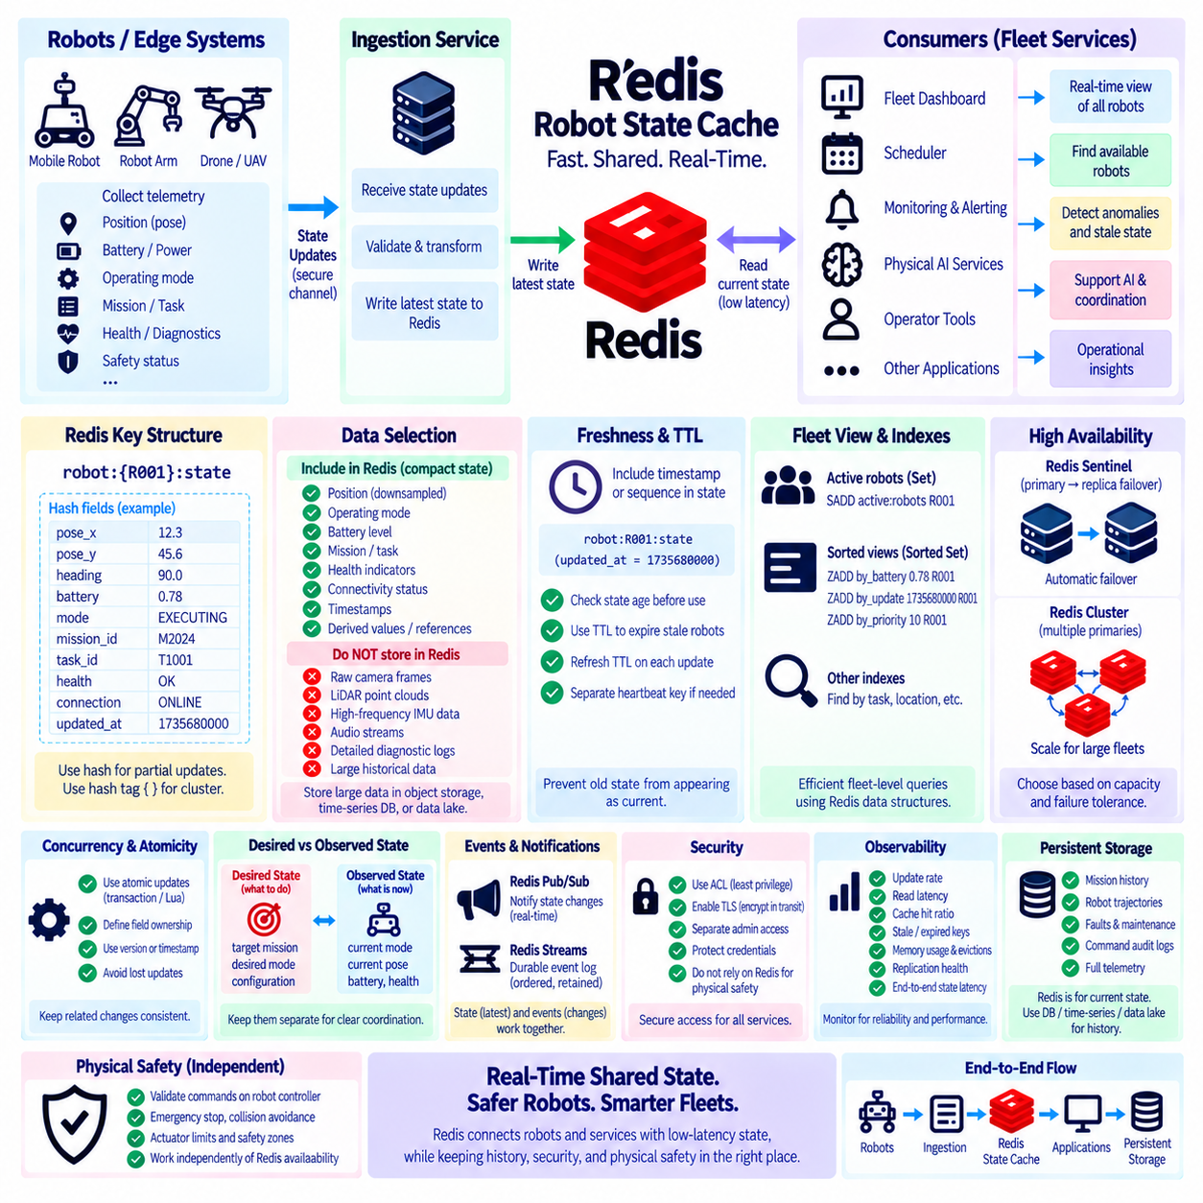
A Redis-based real-time robot state cache provides a fast shared representation of the most recent operational state of robots across a fleet. Instead of repeatedly querying a persistent database or processing complete telemetry histories, applications can read current state directly from Redis with very low latency. The cache can contain position, operating mode, battery level, connectivity, mission status, task assignment, health indicators, and timestamps required by fleet management, monitoring, and Physical AI services.
The architecture begins with robot or edge systems continuously producing state updates. An onboard controller or edge gateway collects selected telemetry from navigation, power, safety, mission, and diagnostic subsystems and converts it into a compact state message. The update is transmitted through the communication layer to an ingestion service, which validates the message and writes the latest state into Redis. Redis therefore becomes the fast operational state layer rather than the original source of every sensor measurement.
A practical key structure may use identifiers such as robot:R001 or robot:{R001} when Redis Cluster hash tags are required. The state can be represented as a Redis Hash containing fields such as pose_x, pose_y, heading, battery, mode, mission_id, task_id, health, connection, and updated_at. Using a Hash allows individual fields to be read or updated without rewriting a large serialized object. The exact structure should reflect the frequency and atomicity requirements of the application.
Not every sensor value should enter the real-time state cache. Raw camera frames, LiDAR point clouds, high-frequency IMU samples, audio, and detailed diagnostic streams can generate far more data than fleet applications need for current-state decisions. These streams should normally flow to specialized telemetry, object-storage, or data-lake systems. Redis should contain compact operational summaries, recent derived values, references, and state indicators that benefit directly from low-latency access.
Update frequency should be selected according to the semantics of each state field. Robot pose may change many times per second, battery percentage much more slowly, and mission assignment only when a scheduling event occurs. Writing every field at the fastest sensor frequency creates unnecessary network and Redis load. Edge aggregation, change detection, rate limiting, or field-specific update intervals can reduce traffic while preserving the freshness required by downstream services.
Freshness must be represented explicitly because a cached value can remain syntactically valid after the robot has disconnected. Every state record should therefore include a timestamp or sequence indicator that allows consumers to determine how recent the information is. A robot reported at position X ten minutes ago should not automatically be interpreted as currently occupying that position. Consumers should evaluate state age according to the operational meaning of the field before making decisions.
TTL provides an additional mechanism for detecting stale robot state. A robot state key can be refreshed whenever a valid heartbeat or state update arrives and allowed to expire when updates stop for longer than an expected interval. Expiration does not explain why communication stopped, but it prevents indefinitely retained state from appearing current. Separate heartbeat keys can also be used when the lifecycle of connectivity information differs from the lifecycle of other cached state.
A fleet application may combine state data with a Set containing currently active robot identifiers. When a robot begins reporting, its identifier can be added to the active fleet set, while heartbeat expiration or an offline-processing service can remove it when communication is lost. Sorted Sets can provide additional indexes, such as ordering robots by last-update time, battery level, task priority, or another numeric score. Redis data structures can therefore complement the primary robot-state Hash with efficient fleet-level views.
Atomic operations are important when several state fields represent one logical transition. For example, changing a robot from IDLE to EXECUTING while assigning a new task identifier may need to appear consistently to readers. Depending on the data model, a single Hash update, transaction, Lua script, or application-level version mechanism can ensure that related changes are applied coherently. Consumers should not observe combinations of fields that could never represent a valid robot state.
Concurrent writers require additional discipline. Navigation, mission management, charging, diagnostics, and operator services may all possess information related to the same robot. Allowing every service to overwrite the complete state object can create lost updates and ambiguous ownership. A stronger design defines which component owns each field or state domain. Version numbers, timestamps, conditional updates, or event-driven aggregation can be used when several producers contribute to one consolidated state representation.
A real-time cache should distinguish observed state from desired state. Observed state describes what the robot currently reports, such as its actual mode, pose, battery, and active task. Desired state represents what a fleet service wants the robot to do, such as a target mission, requested operating mode, or configuration version. Mixing both concepts into uncontrolled fields can create confusion during delays and failures. Separate namespaces or explicit field groups make reconciliation easier.
For example, a fleet scheduler may write a desired mission assignment while the robot continues reporting that it is currently idle. The difference between these states represents a transition that has not yet completed rather than an inconsistency that should be hidden. Once the robot accepts the mission and begins execution, its observed state changes accordingly. This pattern allows Redis to support coordination while preserving the distinction between software intent and physical reality.
Cache-aside behavior can be used when Redis does not contain a requested robot record. The application first checks Redis and, on a cache miss, retrieves an appropriate state snapshot from a persistent database before repopulating the cache. However, historical database state may already be stale relative to the physical robot. A recovered snapshot should therefore carry its original timestamp and should not automatically be treated as live state merely because it has just been inserted into Redis.
High availability becomes important when many fleet services depend on the cache. Redis Sentinel can provide automatic failover for a primary-replica deployment, while Redis Cluster can distribute state across multiple primary nodes when fleet size or workload exceeds a single server's capacity. Cluster key design can use robot identifiers as hash tags when related keys need slot locality. Availability architecture should be selected according to capacity, failure tolerance, and operational complexity rather than robot count alone.
Memory policies should protect the semantics of robot state. Short-lived cache entries can use meaningful TTL values, while maxmemory and eviction behavior must be chosen carefully. If active robot state is operationally important, it should not compete unpredictably with expendable application caches under one aggressive eviction policy. Separate Redis instances or logical workload boundaries can isolate critical coordination state from large disposable caches and provide clearer failure behavior.
Security is equally important because cached robot state can influence fleet decisions. Applications should use separate Redis ACL identities with least-privilege access to relevant namespaces and commands. TLS can protect state and credentials while they travel between edge gateways, services, and Redis infrastructure. Administrative access should remain separate from application access. Even with these controls, Redis authorization should not be treated as the final physical safety mechanism for robot actions.
A fleet dashboard is a representative consumer of the state cache. Instead of querying each robot individually, the dashboard can read the latest Redis state for many robots and display online status, battery, mission, position, and health. A scheduler can query the same state to identify robots that appear available for work. A monitoring service can detect stale timestamps or abnormal conditions. Multiple services can therefore share a consistent low-latency operational view without directly coupling themselves to every robot.
Redis Pub/Sub or Streams can complement the state cache when applications need notification of changes. The cache represents the latest known state, while an event mechanism communicates that something changed. A consumer that misses a transient notification can still query Redis for the current state. For workflows requiring durable event processing, Redis Streams can preserve ordered event records for a retention period. State and events should therefore be modeled as related but distinct concepts.
Persistent storage remains necessary because a current-state cache does not provide complete history. Robot trajectories, mission histories, faults, maintenance events, command audit records, and telemetry may need to be retained for analysis, compliance, debugging, or model training. Redis can provide the current operational snapshot while databases, time-series platforms, object storage, and data lakes maintain historical evidence. This separation prevents Redis memory from becoming an expensive long-term archive.
Observability should measure update rate, read latency, cache hit ratio, stale-state count, expired robot keys, memory consumption, evictions, connection failures, replication health, and Redis command latency. Application metrics should also track the time between a robot producing an update and consumers observing it. This end-to-end state propagation latency is often more meaningful than Redis command latency alone because network, ingestion, validation, and application processing all contribute to freshness.
Physical safety must remain outside the cache authority boundary. Redis may report that a robot is available, a mission is assigned, or a route is selected, but the robot controller must validate commands against its current local state before execution. Emergency stop, collision avoidance, actuator limits, safety zones, communication-loss behavior, and real-time control should continue operating independently of Redis availability. Cached state supports coordination and intelligence, not final physical authority.
The fundamental principle is to treat Redis as a real-time operational state layer between robots and higher-level services. Robots and edge systems produce validated updates, Redis maintains compact and fresh state, fleet applications consume low-latency views, event systems communicate transitions, and persistent platforms retain history. TTL, timestamps, ownership rules, atomic updates, high availability, security, memory isolation, and observability make the cache reliable. In Physical AI, this architecture creates a scalable shared state fabric while preserving robot-local control and safety authority.

