Volume 08 Robot Database and Storage

03. NoSQL Databases

03.01 NoSQL Type Classification: Document, KV, Column, Graph
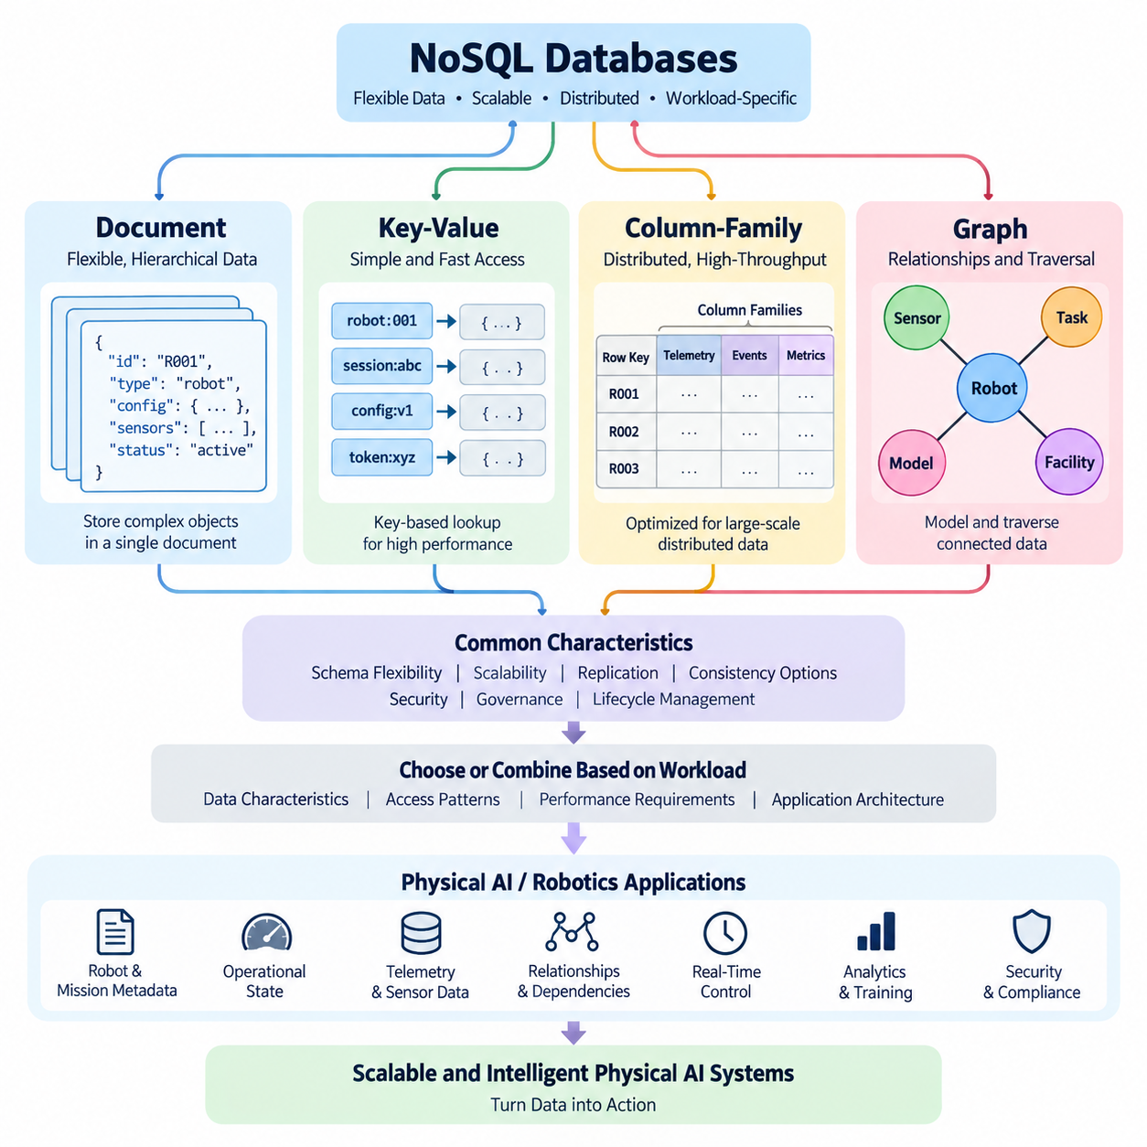
NoSQL databases are designed to manage data models that do not fit naturally into the fixed rows and columns of a traditional relational database. Rather than requiring every record to conform to a predefined schema, NoSQL systems generally emphasize flexible data structures, horizontal scalability, distributed operation, and workload-specific optimization. The term NoSQL does not mean that these databases cannot use query languages or structured data; instead, it commonly refers to approaches that move beyond the relational model to support large-scale, rapidly changing, or highly connected datasets.
Document databases organize information as self-contained documents, commonly represented using JSON-like structures. A document can contain nested objects, arrays, and different attributes from other documents, allowing applications to evolve their data model without repeatedly changing a centralized schema. This model is particularly suitable when application objects naturally correspond to stored records. For example, a robot mission document could contain mission metadata, sensor configurations, execution parameters, status information, and nested event records within a single logical unit.
Key-value databases use one of the simplest NoSQL models: each item is identified by a unique key and associated with a value. The database primarily focuses on retrieving or updating the value efficiently when the key is known. Because the model has very little structural overhead, key-value systems are widely used for caching, session management, configuration storage, distributed state, and high-throughput lookup operations. In a Physical AI environment, a robot identifier could serve as a key while the associated value stores its latest operational state, configuration, or temporary control information.
Column-family databases organize data around column families rather than conventional relational rows. Although the terminology can be confusing because relational databases also contain columns, the underlying storage and access model is substantially different. Column-family systems are designed for distributed workloads in which enormous datasets must be partitioned across many machines. They are particularly useful when applications repeatedly access related groups of attributes across very large datasets, such as telemetry records, event histories, machine observations, or large-scale analytical workloads generated by many robots.
Graph databases represent information through nodes, relationships, and properties. Instead of treating relationships as secondary connections that must be reconstructed through joins, the relationship itself becomes a first-class element of the data model. This makes graph databases appropriate for problems in which connectivity and traversal are central to the application. Examples include robot-to-sensor relationships, dependency networks, facility layouts, knowledge graphs, task dependencies, asset relationships, and multi-agent interaction structures.
The four major NoSQL categories therefore differ primarily in how they represent and retrieve information. Document databases emphasize flexible hierarchical records, key-value databases emphasize extremely efficient key-based access, column-family databases emphasize distributed storage and scalable access to large collections of related attributes, and graph databases emphasize relationships and traversal. These distinctions are not merely implementation details; they influence application architecture, query patterns, indexing strategies, consistency requirements, and the way developers design data around operational workloads.
Document databases are often a natural choice when the application frequently reads or writes an entire logical object. A document can preserve the relationship between closely related fields without requiring multiple tables and joins. This can simplify application development and reduce the number of database operations required to reconstruct an object. However, excessive document nesting or duplication can make updates difficult when the same information appears in many documents. Good document design therefore requires understanding access patterns rather than simply copying application objects directly into the database.
Key-value databases are particularly effective when predictable, low-latency access is more important than complex querying. Applications typically know the key before requesting the associated value, allowing the database to optimize the lookup path. This characteristic makes the model useful for robot session states, temporary inference results, authentication tokens, cache entries, and rapidly changing control metadata. Its simplicity is also a limitation: when applications need sophisticated filtering, relationships, or ad hoc queries across many attributes, a pure key-value model may require additional indexing or another data system.
Column-family databases become valuable when data volume and distributed throughput dominate the architectural requirements. A system can partition data across multiple machines and distribute storage and processing while maintaining an access model optimized for specific query patterns. This makes the approach useful for large-scale telemetry, historical sensor observations, event streams, and time-oriented operational records. However, column-family databases generally require careful planning of partition keys and query patterns because their performance depends heavily on how data is distributed and retrieved across the cluster.
Graph databases provide a different optimization target by making relationships explicit. In a relational design, discovering all connected entities may require multiple joins, while a graph model can traverse relationships directly. This is useful for applications where the question itself is relationship-oriented, such as identifying which sensors contribute to a perception pipeline, which robots depend on a particular edge service, or which components are connected through a physical or logical infrastructure. Graph modeling is especially powerful when relationships change frequently or when multi-hop exploration is a fundamental part of the workload.
The choice among these NoSQL types should therefore begin with the application's access patterns rather than with database popularity. If the application primarily stores flexible business or operational objects, a document model may be appropriate. If it requires extremely fast access through known identifiers, a key-value model may be more suitable. If it must process very large distributed datasets with predictable high-volume access patterns, a column-family architecture may be useful. If the dominant requirement is relationship traversal and network analysis, a graph database may provide a more natural representation.
NoSQL systems also differ in how they approach consistency, availability, partition tolerance, replication, and transactions. Some systems provide strong consistency for particular operations, while others prioritize availability and scalability across distributed environments. Modern NoSQL databases increasingly provide more sophisticated transaction and consistency capabilities than their early implementations, so it is inaccurate to assume that every NoSQL database follows the same consistency model. The architectural decision should instead examine the guarantees provided by the specific database and the consequences of those guarantees for the application.
Schema flexibility is another important characteristic of NoSQL databases, but flexibility should not be confused with the absence of structure. A production system still needs clearly defined data contracts, validation rules, versioning policies, naming conventions, retention rules, and ownership responsibilities. Without these controls, a flexible schema can gradually become inconsistent and difficult to maintain. For long-lived Physical AI systems, schema evolution should therefore be managed deliberately so that changes in robot firmware, sensor configurations, perception models, and operational metadata do not make historical data unusable.
NoSQL databases can also be combined rather than selected as mutually exclusive alternatives. A Physical AI platform may use a document database for robot and mission metadata, a key-value database for fast operational state, a column-family database for high-volume telemetry, and a graph database for relationships among robots, sensors, models, facilities, and tasks. This polyglot persistence approach can align each workload with a storage model optimized for its dominant access pattern. However, it also increases operational complexity, requiring consistent identity management, monitoring, backup policies, security controls, and data integration mechanisms.
In robotics and Physical AI, this classification becomes particularly important because data arrives at different speeds and serves different purposes. High-frequency sensor streams may require distributed time-oriented storage, while robot configuration is better represented as a structured document. Temporary inference state may require extremely fast key-based access, while relationships among robots, devices, tasks, and models may benefit from graph representation. Treating all of these workloads as one homogeneous database problem can create unnecessary compromises in performance, scalability, and maintainability.
A practical NoSQL architecture should therefore begin by separating data according to its semantic role and operational behavior. Data that changes rapidly, data that must remain historically traceable, data that requires relationship traversal, and data that must be retrieved with extremely low latency may require different storage strategies. The resulting architecture should then define clear interfaces between these systems rather than allowing every application component to access every database directly. This separation supports controlled evolution and makes it easier to replace or scale individual storage components.
Another consideration is the lifecycle of data. Robot systems continuously generate observations, events, configurations, model outputs, diagnostics, and operational histories. Some information is needed only for seconds or minutes, while other information may need to remain available for years for training, validation, compliance, or system analysis. NoSQL databases can support different lifecycle strategies through partitioning, replication, expiration policies, archival processes, and tiered storage. These mechanisms should be designed together with the data governance model rather than treated as database administration tasks alone.
Security and governance must also be incorporated into NoSQL architecture from the beginning. Flexible schemas can make it easier for sensitive or operationally important fields to appear unexpectedly in stored documents or event records. Access controls, encryption, authentication, audit logging, retention policies, and data classification should therefore apply at both the database and application layers. In distributed robotic environments, the architecture should additionally consider which data may remain on edge systems, which data may move to an on-premises platform, and which information may be transferred to centralized or cloud infrastructure.
Ultimately, the classification of NoSQL databases provides a framework for matching data characteristics with storage behavior. Document, key-value, column-family, and graph databases each represent different assumptions about how information is structured and accessed. The objective is not to identify one universal replacement for relational databases, but to select or combine models according to workload requirements. For Physical AI systems, this means designing storage around robot state, sensor data, operational events, knowledge relationships, and lifecycle requirements so that the data architecture can scale together with the intelligence and physical complexity of the system.

03.02 MongoDB Architecture and Robot Document Modeling [w/Code]
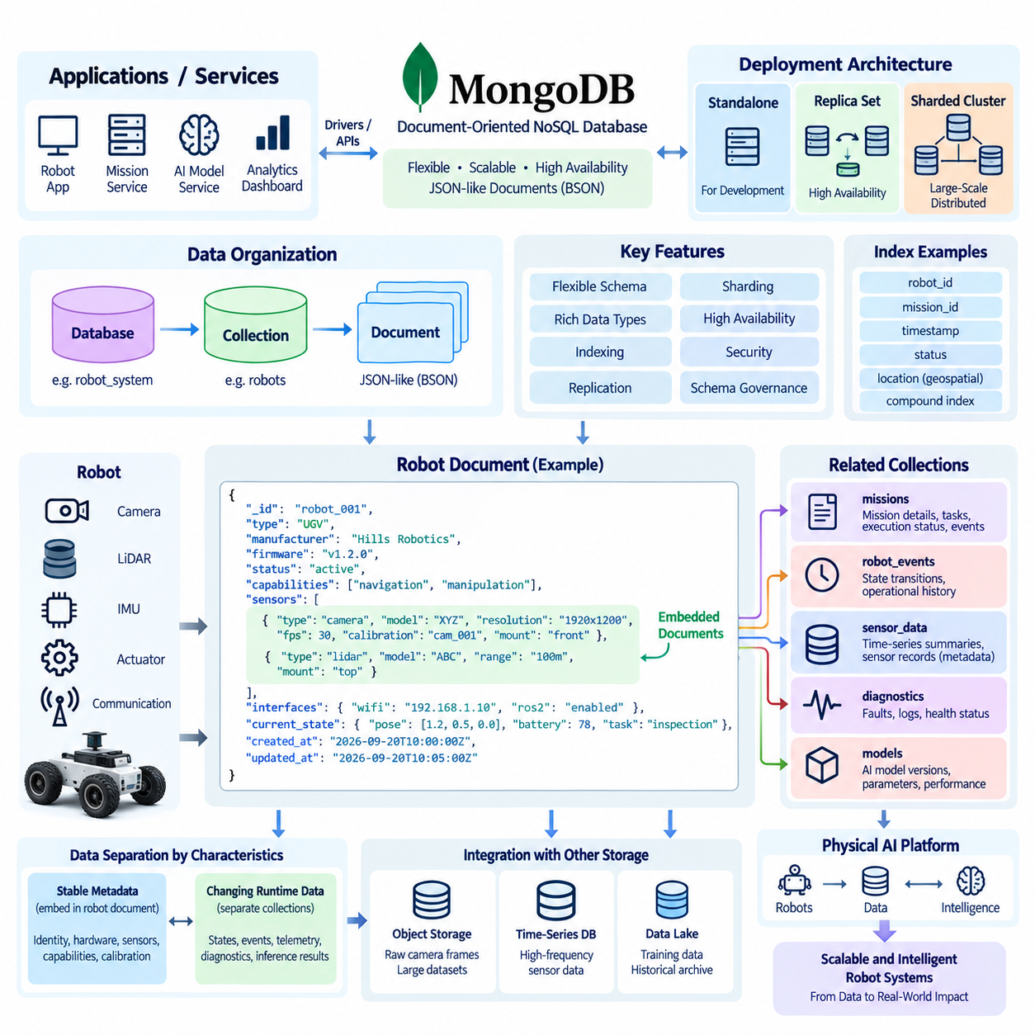
MongoDB is a document-oriented NoSQL database designed to store and process data as flexible, JSON-like documents rather than fixed relational rows. Internally, MongoDB uses BSON (Binary JSON) to represent documents, providing support for nested objects, arrays, timestamps, numeric types, and binary data. This model allows application data to remain close to its natural structure while supporting schema evolution. For robotics and Physical AI systems, this flexibility is useful because robot configurations, sensor descriptions, mission parameters, and operational states can change as hardware and software evolve.
A MongoDB architecture typically consists of applications or services communicating with database servers through drivers and APIs. A MongoDB deployment may operate as a standalone server for development, a replica set for high availability, or a sharded cluster for large-scale distributed workloads. Applications interact with collections containing related documents rather than directly managing physical storage structures. This separation allows developers to focus on logical data models while MongoDB manages indexing, storage, replication, and distributed database operations.
The basic organizational hierarchy is straightforward: a MongoDB deployment contains databases, databases contain collections, and collections contain documents. A collection is conceptually similar to a table but does not require every document to have exactly the same fields. Documents contain field-value pairs and may include embedded objects or arrays. This structure is particularly appropriate for robot data because one robot may have a different sensor configuration, software version, or capability set from another robot while still belonging to the same logical collection.
A robot document can represent a complete logical identity and operational description of a robot. Typical fields may include a robot identifier, platform type, manufacturer information, firmware version, capabilities, sensor configuration, communication interfaces, current status, and timestamps. Related information that is normally accessed together can be embedded within the same document. This approach reduces the need to reconstruct a robot object through multiple joins and allows an application to retrieve a meaningful operational representation through a single document query.
Embedded documents are especially useful when the relationship between data elements is strong and the embedded information is normally accessed together with its parent object. For example, a robot document can contain an array of cameras, LiDAR sensors, IMUs, and actuators, with each element containing its own configuration parameters. A camera entry could describe its model, resolution, frame rate, calibration reference, and mounting position. This design creates a self-contained representation of the robot configuration while preserving the hierarchical relationship between the robot and its components.
However, embedding everything into one document is not always appropriate. MongoDB document design should be based on access patterns, update frequency, document growth, and relationship characteristics. Information that changes independently, grows without a predictable upper bound, or is shared by many entities may be better represented as a separate collection. For example, a robot's current configuration may be embedded, while millions of historical sensor events should normally be stored separately. This distinction prevents individual robot documents from becoming excessively large and difficult to update.
Robot operational data can therefore be divided into relatively stable metadata and continuously changing runtime information. Stable metadata may include robot identity, hardware specifications, installed sensors, capabilities, and calibration references. Runtime information may include current pose, battery state, active task, connectivity status, fault conditions, and recent inference results. MongoDB can store these structures in separate but related collections when their update frequencies differ significantly. This separation supports efficient access while preserving a consistent logical relationship through identifiers and references.
MongoDB indexes are essential when robot collections become large or queries become frequent. An index can support searches by robot identifier, mission identifier, timestamp, status, location, or other commonly queried fields. Compound indexes can support queries involving multiple fields, while specialized indexes can be considered for geospatial or text-oriented workloads. Index design should follow actual query patterns because unnecessary indexes consume storage and can increase write overhead. In a Physical AI platform, indexes should therefore be selected according to operational queries rather than added indiscriminately.
MongoDB also supports replication through replica sets, allowing multiple database nodes to maintain copies of data and providing mechanisms for high availability. A primary node normally accepts writes while secondary nodes replicate the data. If the primary becomes unavailable, the replica set can elect another suitable member. This architecture is valuable for robotic systems where operational metadata and mission information may need to remain accessible despite infrastructure failures. Replication should nevertheless be designed together with recovery objectives, network conditions, and consistency requirements.
For larger deployments, MongoDB sharding can distribute data across multiple servers. Sharding becomes relevant when a single server cannot efficiently provide the required storage capacity, throughput, or scalability. A shard key determines how documents are distributed across the cluster, making its selection an important architectural decision. In robot fleets, candidate dimensions might include robot identifiers, geographic regions, organizations, or time-related partitioning strategies, depending on the dominant access pattern. A poorly selected shard key can create uneven distribution and reduce the benefits of horizontal scaling.
A practical robot document model should also support temporal information without confusing current state with historical evidence. The current robot state may be updated frequently, while historical states, telemetry summaries, mission events, and diagnostic records should generally remain immutable or append-oriented. MongoDB can support both patterns, but they should be modeled differently. For example, a robot document can contain the latest operational state, while a separate event collection stores timestamped state transitions. This distinction makes it easier to reconstruct operational history without constantly expanding the main robot document.
In Physical AI systems, MongoDB can serve as an operational data layer connecting robots, missions, sensors, models, and services. A mission document may reference a robot, task definition, model version, environment, execution status, and important events. A robot document can maintain its capabilities and configuration, while separate collections can retain mission histories, inference records, diagnostics, and selected sensor summaries. This structure creates a practical boundary between rapidly changing operational information and larger datasets that may be better managed by specialized storage systems.
MongoDB should not necessarily become the storage system for every type of robot data. High-frequency raw camera frames, LiDAR streams, large training datasets, and long-term time-series telemetry can quickly exceed the practical scope of an operational document database. These datasets may be stored in object storage, time-series systems, data lakes, or other specialized platforms, while MongoDB stores their metadata, identifiers, locations, processing states, and relationships. This architecture allows MongoDB to act as an operational coordination layer without forcing one database to handle every workload.
Schema governance remains important even though MongoDB permits flexible document structures. Production systems should define required fields, data types, naming conventions, validation rules, versioning mechanisms, and migration procedures. A robot document created by one software version should remain understandable to later versions of the system. Schema version fields can help applications interpret historical documents correctly. Controlled schema evolution is particularly important in robotics because hardware revisions, firmware updates, new sensors, and AI model changes can occur throughout the operational lifetime of a robot.
Security should also be incorporated into MongoDB architecture from the beginning. Authentication and authorization should restrict which applications, services, and users can access particular databases or collections. Encryption, network isolation, audit logging, backup protection, and credential management should be considered according to the operational environment. In a Physical AI architecture, edge robots may generate data locally while selected information is synchronized with an on-premises MongoDB cluster. The synchronization boundary should therefore be explicitly defined so that operational data remains controlled while required information becomes available to higher-level services.
The resulting MongoDB architecture can be understood as a document-centered operational model in which each robot is represented through structured yet adaptable information. Robot identity, configuration, capabilities, current state, missions, events, and relationships can be organized according to how applications actually use them. Embedding supports closely related information, references support independently managed entities, indexes support operational queries, replication supports availability, and sharding supports horizontal growth. Together, these mechanisms allow MongoDB to provide a flexible data foundation for robot fleets and Physical AI applications while remaining interoperable with specialized systems for large-scale sensor, training, and historical data.

03.03 MongoDB Index and Aggregation Pipeline Design [w/Code]
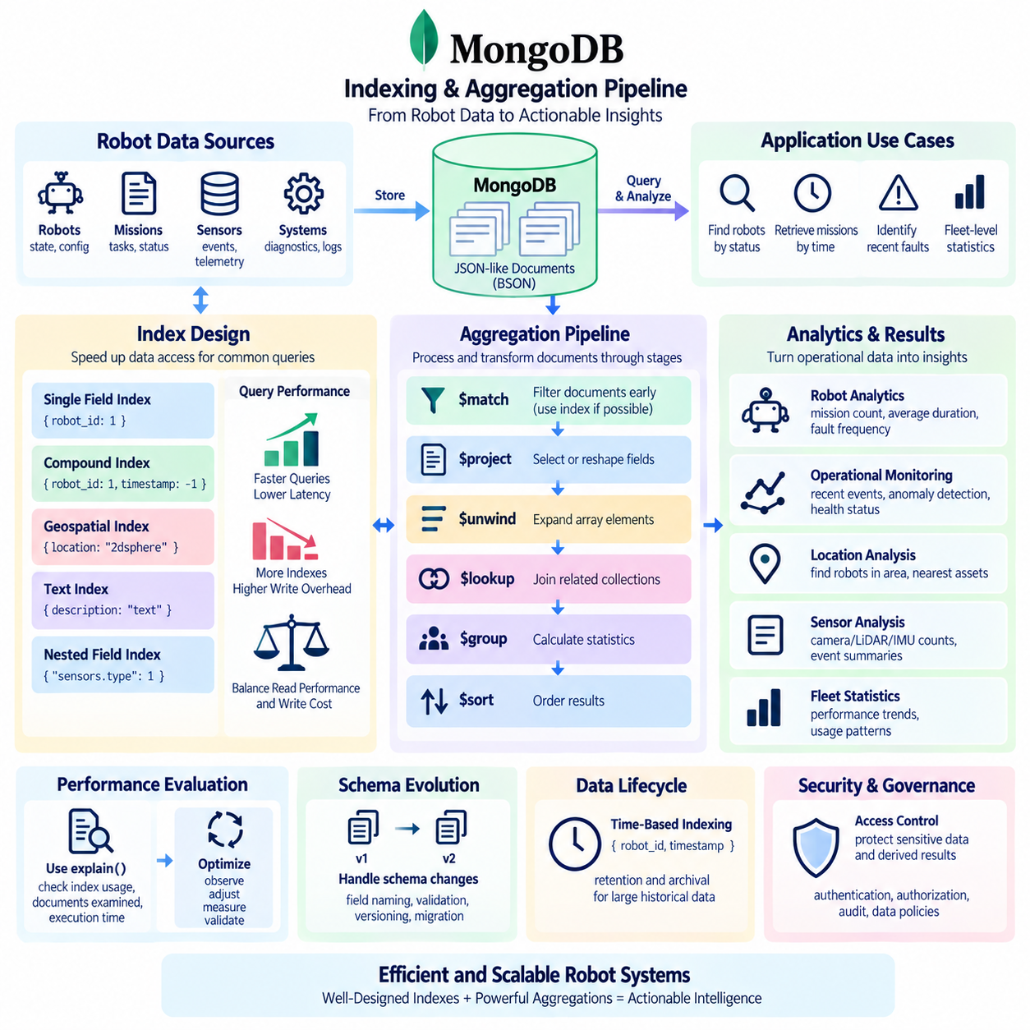
MongoDB indexing and aggregation pipeline design are essential for transforming a document database from a simple storage layer into an efficient operational data platform. In a robot or Physical AI system, applications may need to locate robots by status, retrieve missions by time, identify recent faults, summarize sensor events, or calculate fleet-level statistics. Indexes accelerate selective data access, while aggregation pipelines transform and summarize documents. Their design should therefore begin with actual application queries and operational workloads rather than with database structures alone.
An index provides MongoDB with an optimized access path for finding documents that satisfy common query conditions. Without an appropriate index, MongoDB may need to examine many or all documents in a collection, which becomes increasingly expensive as the robot fleet and historical records grow. A simple index on `robot_id`, for example, can efficiently locate a specific robot document. Indexes can also be created on fields such as `status`, `mission_id`, `timestamp`, `location`, or other attributes that appear frequently in operational queries.
Compound indexes are useful when queries commonly filter or sort using multiple fields. For example, a query that retrieves recent events for a particular robot may frequently use both `robot_id` and `timestamp`. A compound index such as `{robot_id: 1, timestamp: -1}` can support this access pattern efficiently. The order of fields in a compound index matters because MongoDB uses the index according to its defined field sequence. Index design should therefore reflect real query patterns rather than simply creating separate indexes for every field that appears in the database.
Index selection also requires balancing read performance against write overhead. Every additional index consumes storage and must be updated when documents are inserted, modified, or deleted. Excessive indexing can therefore increase write latency and resource consumption. In a robotics environment where operational state changes frequently, unnecessary indexes may become particularly costly. A practical strategy is to identify high-frequency and performance-sensitive queries first, measure their execution behavior, and then create indexes that directly support those workloads.
MongoDB also provides specialized indexing mechanisms for particular data types and access patterns. Geospatial indexes can support location-based queries, allowing applications to find robots or assets within a geographic area or near a specified position. Text-oriented indexes can support searches over appropriate textual fields, while indexes on nested fields can support queries inside embedded documents. These capabilities are valuable when robot information contains spatial configuration, mission descriptions, diagnostic information, or other structured attributes that require selective retrieval.
Aggregation pipelines provide a mechanism for processing documents through a sequence of transformation stages. Each stage receives documents from the previous stage, performs an operation, and passes the resulting documents to the next stage. Common stages include `$match` for filtering, `$project` for selecting or reshaping fields, `$group` for aggregation, `$sort` for ordering, `$unwind` for expanding arrays, and `$lookup` for combining information from related collections. This pipeline model allows complex analytical operations to be expressed as a controlled sequence of transformations.
A typical robot analytics pipeline may begin with `$match` to restrict processing to a specific robot fleet, time interval, or operational state. A subsequent `$project` stage can retain only the fields required for analysis, reducing unnecessary data movement. `$group` can then calculate metrics such as the number of missions, average execution duration, fault frequency, or sensor-event counts. Finally, `$sort` can arrange the results according to operational importance or time. This sequence separates filtering, transformation, calculation, and presentation into understandable processing stages.
The position of `$match` within an aggregation pipeline is particularly important. Filtering documents as early as possible can reduce the amount of data that subsequent stages need to process. When an appropriate index supports the initial filtering conditions, MongoDB may also use that index to avoid scanning the entire collection. For example, a pipeline analyzing only recent events for one robot should ideally begin with conditions on `robot_id` and `timestamp`. This approach can substantially reduce processing requirements when the underlying collection contains a large historical dataset.
Aggregation design should also consider the difference between operational queries and analytical workloads. Operational queries typically require a small number of documents with low latency, such as retrieving the current state of a robot. Analytical queries may process thousands or millions of documents to calculate fleet-level statistics. MongoDB aggregation can support many such workloads, but very large analytical datasets may eventually be better handled by dedicated analytical platforms, data warehouses, data lakes, or specialized time-series systems. MongoDB should therefore be positioned according to the actual workload rather than being forced to perform every type of analysis.
The `$lookup` stage can combine documents from different collections and is useful when information is intentionally modeled separately. For example, a mission document may reference a robot through `robot_id`, while another collection stores robot metadata. A pipeline can use `$lookup` to combine these datasets when producing an operational report. However, frequent and complex cross-collection operations may indicate that the data model or access pattern should be reconsidered. MongoDB encourages thoughtful document modeling, so embedding frequently accessed related data can sometimes be more efficient than repeatedly reconstructing relationships through aggregation.
Array processing is particularly relevant to robot documents because sensors, capabilities, tasks, and events are often represented as arrays. The `$unwind` stage can transform each array element into an individual pipeline document, allowing the application to analyze sensors or events separately. For example, a robot document containing multiple sensors can be unwound to calculate the number of cameras, LiDAR devices, or IMUs across a fleet. After processing, `$group` can recombine information into fleet-level statistics. This pattern provides a flexible way to analyze hierarchical robot configuration data.
Aggregation pipelines can also support operational monitoring and anomaly analysis. A pipeline can filter recent diagnostic events, group them by robot or fault type, calculate occurrence frequencies, and sort the results to identify recurring problems. Similar processing can summarize model inference outcomes, mission completion rates, battery behavior, or communication failures. These results can be stored, returned to dashboards, or passed to higher-level services. In a Physical AI architecture, such pipelines can therefore form an important bridge between raw operational records and actionable system intelligence.
Time-based indexing and aggregation are especially important for robotics because many operational events are naturally associated with timestamps. A compound index combining an entity identifier and time can support queries such as recent events for a specific robot. Aggregation pipelines can then group events by hour, day, mission, robot, or operational phase. This allows the system to calculate trends without requiring every historical record to remain in the active operational view. Retention and archival policies should also be considered so that increasingly large historical collections do not degrade routine operational performance.
Pipeline performance should be evaluated using actual execution statistics rather than assumptions. MongoDB provides tools such as `explain()` that can reveal whether a query uses an index, how many documents are examined, and how many results are returned. These measurements help identify collection scans, inefficient index usage, excessive sorting, and other bottlenecks. Performance optimization should therefore follow a cycle of query observation, index or pipeline adjustment, measurement, and validation. This approach is particularly important in Physical AI systems where workload characteristics may change as the number of robots and sensors increases.
Index and aggregation design should also account for schema evolution. Robot documents may gain new sensor types, model metadata, operational states, or mission attributes over time. Queries and pipelines should therefore be designed so that reasonable schema changes do not immediately break operational services. Explicit field naming, validation rules, schema versioning, and controlled migration procedures can make aggregation logic more maintainable. When different generations of robots produce slightly different document structures, pipelines may need to normalize those structures before performing fleet-level analysis.
Security and governance are also relevant to indexing and aggregation. Indexes can expose the existence of sensitive fields through operational behavior, while aggregation pipelines may combine information from multiple collections into outputs that have broader visibility than the original records. Access control should therefore be applied according to the sensitivity of both source data and derived results. In a Physical AI environment, operational location, mission information, diagnostics, and system configuration may require different access policies. Aggregation should be treated not only as a performance mechanism but also as a controlled data transformation process.
A well-designed MongoDB system ultimately connects document modeling, indexing, and aggregation into a single workload-oriented architecture. Document structures should reflect how robot information is naturally accessed, indexes should accelerate the most important query patterns, and aggregation pipelines should transform operational records into useful summaries and insights. The goal is not to maximize the number of indexes or create increasingly complex pipelines, but to establish predictable and measurable data access. For Physical AI systems, this enables robot fleets, missions, sensor metadata, diagnostics, and operational events to become efficiently searchable and analytically useful without sacrificing scalability or maintainability.

03.04 MongoDB ReplicaSet and Sharding Configuration [w/Code]
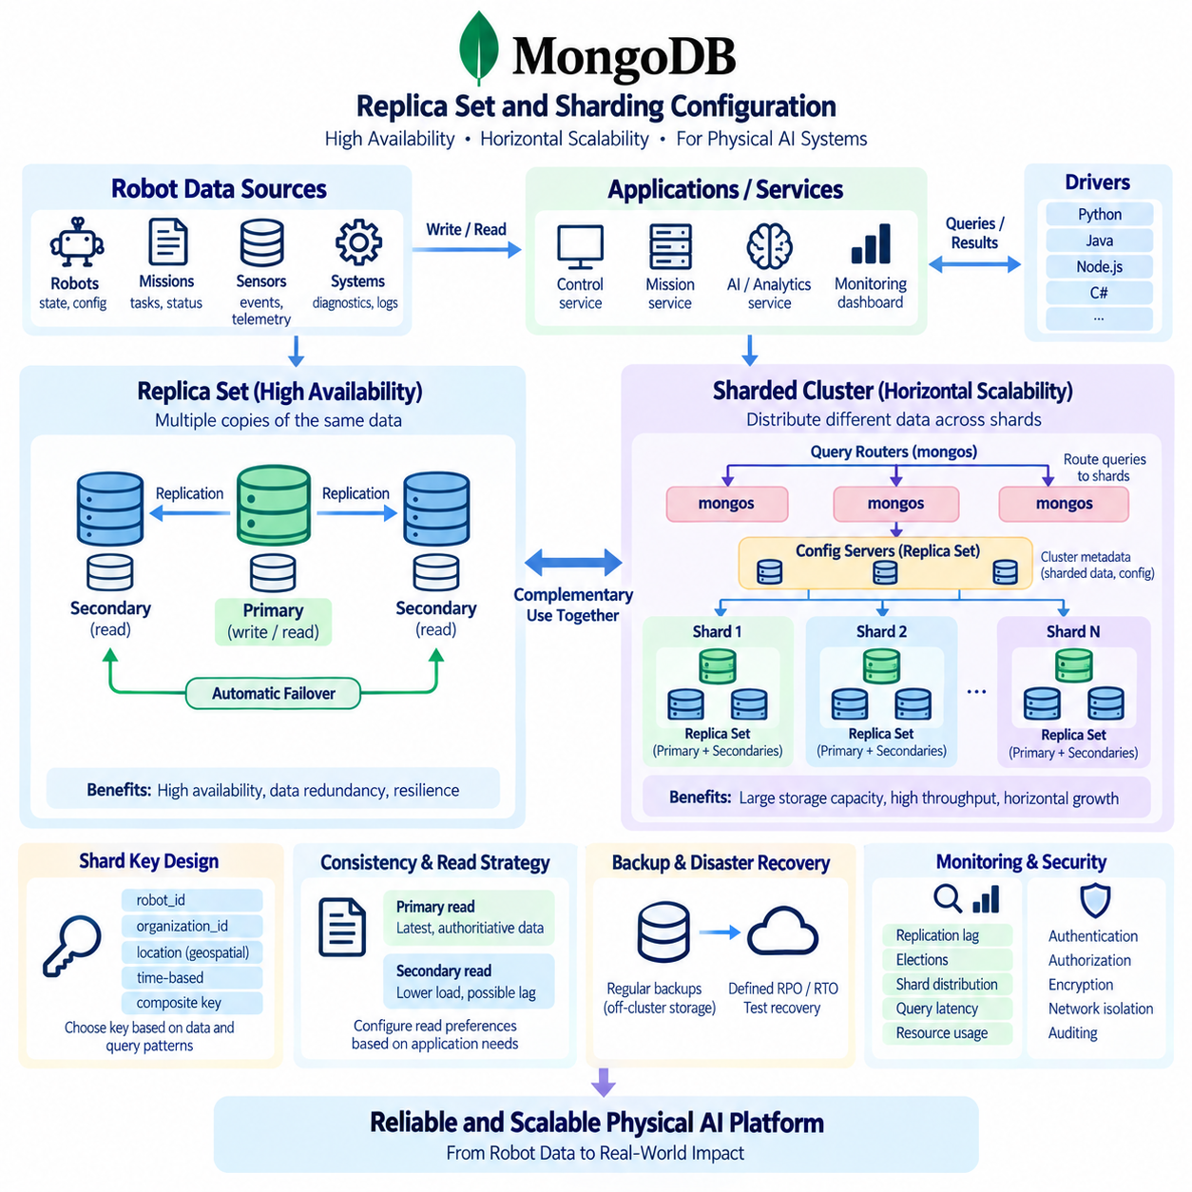
MongoDB Replica Set and sharding configurations provide two complementary mechanisms for building highly available and horizontally scalable database infrastructure. A replica set maintains multiple copies of the same data across different MongoDB nodes, primarily addressing availability and resilience. Sharding distributes different portions of a dataset across multiple shards, primarily addressing storage capacity and throughput at scale. In a Physical AI platform, these mechanisms can support reliable robot metadata, mission information, operational events, and fleet-scale workloads while reducing the impact of individual infrastructure failures.
A MongoDB replica set normally consists of multiple members that maintain synchronized copies of the same dataset. One member acts as the primary and normally receives write operations, while secondary members replicate changes from the primary. If the primary becomes unavailable, an eligible secondary can participate in an election and become the new primary. This automatic failover mechanism allows applications to continue operating with limited interruption. The exact number and configuration of members should be selected according to availability objectives, failure domains, network conditions, and operational requirements.
Replica sets are particularly valuable when robot systems must continue operating despite infrastructure failures. A Physical AI control platform may store robot identities, configurations, mission assignments, model versions, and operational states in MongoDB. If one database server fails, another replica can provide continued access to the replicated dataset. However, replication is not a substitute for backup. Replica members generally contain copies of the same logical data, so accidental deletion, corruption, or an incorrect application update can potentially propagate across members. Independent backup and recovery procedures therefore remain essential.
Network topology has an important influence on replica set reliability. MongoDB members should ideally be distributed across appropriate failure domains so that a single machine, rack, power source, or network failure does not eliminate the ability to maintain an operational majority. In an on-premises robotics environment, this may involve separating database nodes across physical servers or infrastructure zones. The design should also consider network latency because replication depends on communication among members. Excessive latency or unstable connectivity can affect replication behavior and application performance.
Replica set elections are based on the ability of members to communicate and establish an appropriate voting majority. A deployment therefore needs enough suitable voting members to tolerate the expected failure scenario. Configuration should avoid creating a topology in which a common infrastructure failure simultaneously removes too many voting members. For critical Physical AI services, the database architecture should be evaluated against realistic failure scenarios such as server loss, network segmentation, power interruption, storage failure, and maintenance activities rather than assuming that every failure will affect only one component.
Read operations can also be distributed in carefully designed MongoDB deployments. Applications may be configured to read from secondary members under appropriate read preferences, potentially reducing load on the primary. However, secondary reads can expose applications to replication lag, meaning that a recently written value may not immediately be visible on every secondary. For robot control and safety-sensitive operational decisions, the application should therefore distinguish between data that requires the latest authoritative state and data that can tolerate slightly delayed information.
Sharding addresses a different problem from replication. Instead of keeping complete copies of the same dataset on every shard, sharding distributes portions of a large collection across multiple shards. A sharded MongoDB cluster normally includes shard servers, configuration servers, and `mongos` query routers. Applications communicate through the routing layer, while MongoDB uses metadata about data distribution to direct operations to the appropriate shard or shards. This architecture allows storage and processing capacity to grow by adding additional infrastructure.
The shard key is one of the most important decisions in a sharded MongoDB architecture. MongoDB uses the shard key to determine how documents are distributed across the cluster. A good shard key should support balanced distribution while also aligning with important query patterns. For a robot fleet, possible attributes might include `robot_id`, organization identifiers, geographic regions, or carefully designed combinations of fields. The correct choice depends on how data is generated and queried. A poorly selected key can create hotspots where one shard receives a disproportionate amount of traffic.
High-cardinality fields can often provide more distribution opportunities than fields with only a few possible values. For example, a `status` field containing values such as `active`, `idle`, and `error` would generally provide limited distribution because many documents share the same values. A unique or highly varied identifier may provide more opportunities for distributing documents. However, high cardinality alone does not guarantee a good shard key. The key must also be evaluated against write patterns, query targeting, data growth, and the physical distribution of workload.
Robot data can exhibit strong temporal and spatial access patterns that influence sharding decisions. Telemetry or event records may arrive continuously from many robots, while applications may frequently request data for one robot during a specific time interval. A shard key combining an entity identifier with a time-related component may sometimes align better with these workloads than a single field. However, monotonically increasing keys can create write concentration under certain configurations. Sharding should therefore be validated using representative workload measurements rather than theoretical assumptions.
A major advantage of a properly designed sharded cluster is horizontal scalability. As the number of robots, missions, events, and operational records increases, additional shards can provide more storage and processing capacity. This can be important for Physical AI platforms that evolve from a small laboratory fleet to many robots operating simultaneously. Scaling should nevertheless be planned before capacity becomes critical because shard-key selection, data migration, monitoring, and operational procedures become more complex as the cluster grows.
Replica sets and sharding are not mutually exclusive architectures. In production MongoDB deployments, each shard can itself be implemented as a replica set. This creates two layers of resilience: sharding distributes the workload across multiple shards, while replication provides redundancy within each shard. Configuration servers can also use replication to protect cluster metadata. The resulting architecture can provide both horizontal scalability and high availability, but it requires careful capacity planning because additional replicas increase infrastructure, storage, network, and operational requirements.
The application layer should also be designed to understand the distributed nature of the database. MongoDB drivers can communicate with the deployment and provide mechanisms for handling topology changes, connection failures, and retryable operations. Applications should use appropriate connection settings, timeouts, retry behavior, and error handling rather than assuming that the database endpoint will always remain unchanged. In a robotics platform, services responsible for mission management, fleet monitoring, diagnostics, and AI orchestration should be tested against database failover and temporary connectivity loss.
Data consistency requirements should influence how replica sets and sharding are configured. Some robot information, such as historical telemetry summaries or analytical results, may tolerate eventual visibility across replicas. Other information, such as active mission ownership or authoritative robot state, may require stronger consistency guarantees. MongoDB provides configurable mechanisms for controlling read and write behavior, but these settings involve trade-offs among consistency, latency, availability, and throughput. The correct configuration should therefore be determined by the semantics of each workload.
Backup and disaster recovery must be designed independently from replication and sharding. A resilient database should have defined recovery point objectives and recovery time objectives, along with tested procedures for restoring data. Backups should be stored separately from the active database infrastructure so that a failure affecting the production cluster does not automatically destroy the recovery copies. For Physical AI systems, recovery planning should also consider the relationship between MongoDB metadata and external datasets such as raw sensor data, object storage, model artifacts, and historical archives.
Monitoring is essential once MongoDB operates as a distributed system. Administrators should observe replication lag, election events, connection counts, query latency, disk usage, memory consumption, cache behavior, shard distribution, chunk or data migration activity, and error rates. Monitoring should focus not only on whether individual servers are running but also on whether the overall data service is maintaining its expected performance and availability. Early detection of uneven shard utilization or growing replication lag can prevent operational problems from becoming fleet-level failures.
Security must apply consistently across replica sets and sharded clusters. Authentication, authorization, encryption in transit, encryption at rest where required, network segmentation, certificate management, auditing, and controlled administrative access should be incorporated into the deployment architecture. Database nodes should not be exposed unnecessarily to robot networks or general application networks. In an on-premises Physical AI environment, network boundaries can separate edge systems, application services, database infrastructure, and management interfaces while allowing only explicitly required communication paths.
A practical deployment strategy should therefore begin with the workload rather than immediately selecting a complex cluster topology. A small development environment may use a single MongoDB instance, while a production service requiring high availability may use a replica set. A large fleet with substantial data growth may eventually require sharding, with each shard protected through replication. The transition between these stages should be based on measurable capacity requirements, failure tolerance, query behavior, and operational maturity rather than adopting distributed infrastructure solely because it appears more sophisticated.
Ultimately, MongoDB Replica Sets and sharding solve different but complementary architectural problems. Replica sets provide data redundancy, automated failover, and improved resilience against infrastructure failures, while sharding distributes large datasets and workloads across multiple database resources. When combined carefully, they can provide a scalable foundation for Physical AI systems in which robot fleets, missions, operational events, diagnostics, and metadata continuously increase in volume. The central design principle is to match topology, shard keys, replication policies, and recovery mechanisms to real workload and reliability requirements so that the database remains predictable as the robotic system grows.

03.05 Apache Cassandra: High Availability Distributed Storage [w/Code]
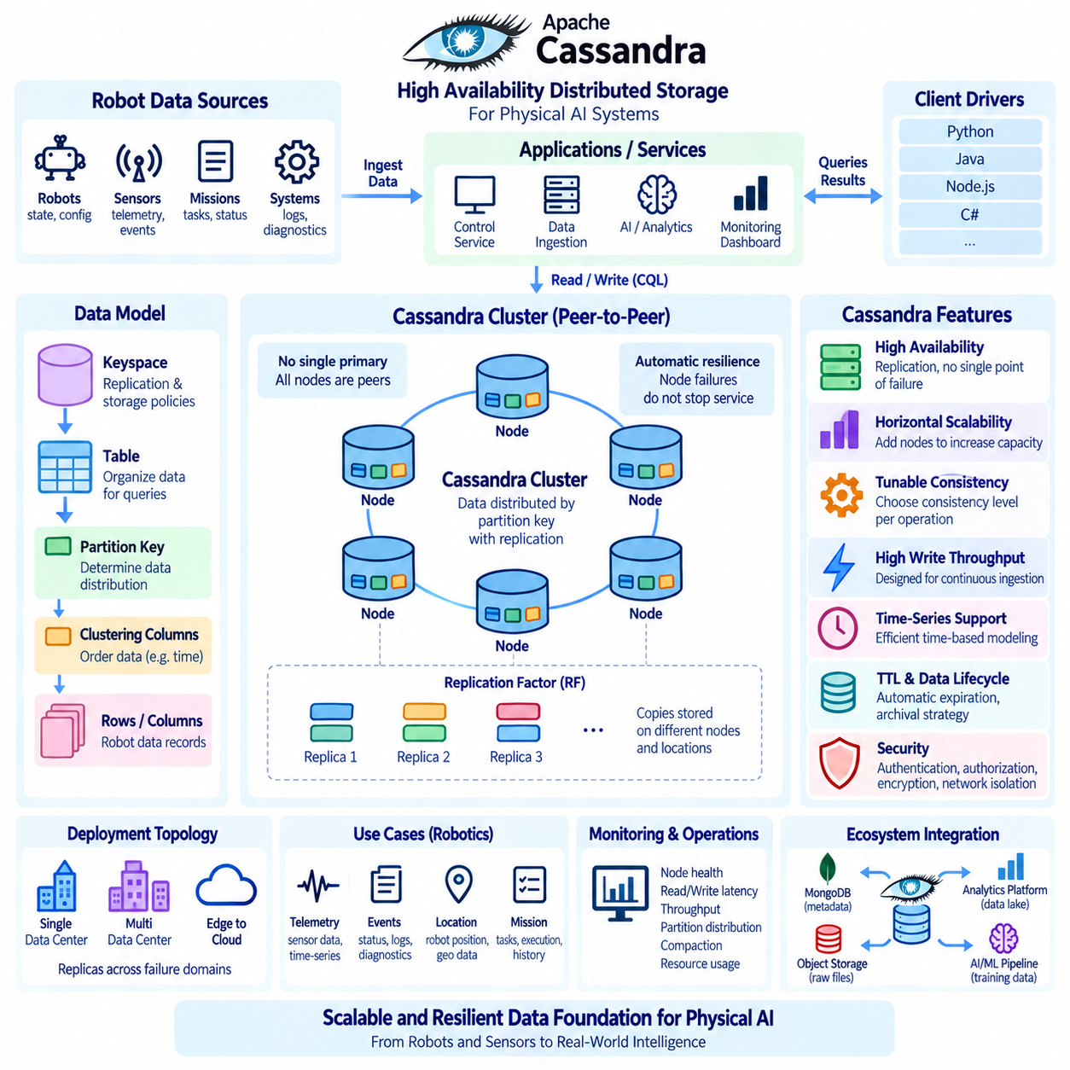
Apache Cassandra is a distributed wide-column database designed for high availability, horizontal scalability, and continuous operation across multiple machines and failure domains. Unlike a centralized database that depends heavily on a primary server, Cassandra distributes data across a cluster so that individual node failures do not necessarily interrupt service. Its architecture is particularly suitable for workloads that generate large volumes of continuously arriving data, such as robot telemetry, sensor events, operational logs, and machine-generated time-series records.
Cassandra uses a peer-to-peer architecture in which nodes have similar responsibilities rather than relying on a single permanent primary database server. Data is distributed across the cluster according to a partition key, and multiple copies can be maintained according to a configured replication factor. Because there is no single master responsible for all writes, the system can continue accepting operations even when some nodes become unavailable. This architecture makes Cassandra useful for distributed Physical AI environments where data producers may operate continuously across multiple robots and edge locations.
The basic Cassandra data model is based on keyspaces, tables, partitions, rows, and columns. A keyspace defines important replication and storage policies, while tables describe how application data is organized. The partition key determines where data is distributed within the cluster, making partition-key design one of the most important decisions in Cassandra architecture. Unlike a relational database model that often starts from normalized entities, Cassandra data modeling begins with the queries that the application must execute efficiently.
For robotics, a Cassandra table can be designed around an access pattern such as retrieving recent telemetry from a specific robot. A logical record may contain a robot identifier, event timestamp, sensor type, measurement values, operational state, and additional metadata. The partition key can identify the robot or another appropriate data domain, while clustering columns can organize records chronologically inside the partition. This design allows the database to efficiently retrieve a bounded time range without scanning unrelated robot data.
Cassandra achieves high availability through replication. When a record is written, Cassandra stores copies on multiple nodes according to the replication factor and replication strategy. If one node becomes unavailable, another replica may still contain the required data. This approach means that availability does not depend on maintaining a single database server. For a Physical AI platform, replicated operational records can remain accessible even when individual servers, racks, or infrastructure zones experience failures.
Replication strategy should reflect the physical and logical deployment environment. In a single data center, a simple topology may be sufficient, while a multi-data-center deployment can distribute replicas across separate locations. For robotics systems operating across edge sites, on-premises infrastructure, or multiple facilities, replicas can be positioned according to failure domains and data locality requirements. The objective is not simply to create more copies, but to place those copies where they can remain available when realistic infrastructure failures occur.
Cassandra also provides tunable consistency, allowing applications to choose consistency levels appropriate to individual operations. A write or read can require acknowledgment from a selected number of replicas before the operation is considered successful. Lower consistency requirements may provide lower latency and higher availability, while stronger consistency requirements may require more coordination among replicas. This flexibility is valuable in Physical AI because not every dataset requires the same guarantees. Historical telemetry may tolerate weaker consistency, while certain operational state transitions may require stronger coordination.
The relationship between consistency and availability should therefore be considered at the workload level. A robot telemetry pipeline may prioritize continuous ingestion because losing access to the data stream can be more damaging than temporarily observing a slightly delayed value. Conversely, an application controlling mission ownership or resource allocation may require stronger guarantees before accepting a state transition. Cassandra's consistency configuration should consequently be selected according to the meaning of the data rather than applying one global policy to every table.
Cassandra is particularly effective for write-intensive workloads. Large numbers of robots can continuously generate sensor observations, status events, diagnostics, and operational measurements without requiring every write to pass through a single central database node. Data can be distributed across the cluster and written to different nodes according to the partitioning scheme. This characteristic makes Cassandra attractive for large Physical AI systems in which the number of data-producing devices and the frequency of observations can increase significantly over time.
Time-series data requires careful partition design because an unlimited partition can eventually become too large and difficult to manage. A robot telemetry table might therefore use a combination of robot identifier and time bucket as part of its partitioning strategy. For example, data could be grouped by robot and day or by robot and hour depending on ingestion volume and query requirements. Clustering columns can then maintain records in timestamp order within each partition. The appropriate time bucket should be determined from expected data volume, query ranges, retention requirements, and operational experience.
Cassandra data modeling should avoid relying on expensive joins or flexible ad hoc queries as would be common in relational analytical systems. Instead, tables are often designed specifically for known application queries, and the same logical information may intentionally appear in more than one table. This denormalized approach can increase storage requirements but allows predictable query performance at scale. For robotics applications, separate tables may be created for recent robot state, historical telemetry, mission events, and diagnostic summaries because each workload has different access patterns.
Cassandra's distributed architecture also requires careful attention to partition-key quality. A poorly selected partition key can create uneven data distribution or concentrate too many writes on a small number of nodes. For example, using a low-cardinality attribute such as robot status as the primary partitioning dimension could cause a large number of records to concentrate within a limited set of partitions. A well-designed key should provide sufficient distribution while keeping data that is commonly queried together in an efficient locality. This balance is central to achieving predictable cluster performance.
Data lifecycle management is another important consideration for large Cassandra deployments. Robot systems can generate enormous quantities of telemetry and event data, but not all records need to remain in the active database indefinitely. Cassandra supports mechanisms such as TTL (Time To Live) for automatically expiring data that is no longer required. Older information can also be transferred to lower-cost storage or analytical platforms when operational access is no longer necessary. A lifecycle policy should distinguish between hot operational data, historical data, archival information, and datasets retained for model training or compliance.
Cassandra can therefore operate as one component within a broader Physical AI data architecture rather than serving as the only data platform. High-frequency telemetry and operational events can be stored in Cassandra, while robot configuration and mission metadata may be maintained in a document database such as MongoDB. Large raw sensor files can remain in object storage, and long-term analytical datasets can be managed through data lakes or specialized analytical systems. Metadata, identifiers, timestamps, and processing states can connect these systems without forcing every workload into a single database technology.
Monitoring is essential because Cassandra performance depends on the health and balance of the entire cluster. Administrators should observe node availability, disk utilization, read and write latency, throughput, partition distribution, compaction activity, garbage collection behavior, and replication health. Increasing latency or uneven resource utilization can indicate problems with data modeling, partition size, hardware capacity, or workload growth. Monitoring should therefore examine both individual nodes and cluster-wide behavior so that emerging bottlenecks can be identified before they affect robot operations.
Compaction and storage management also play important roles in Cassandra performance. Cassandra writes data efficiently using structures designed for high-throughput ingestion, but stored data may later require background compaction to organize and consolidate files. The compaction strategy should be selected according to the workload characteristics, particularly whether data is primarily time-series, frequently updated, or relatively immutable. Poorly matched storage settings can increase disk consumption or background processing overhead. Production configuration should therefore be validated using representative workloads rather than relying only on default settings.
Security should be integrated into Cassandra deployment from the beginning. Authentication and authorization should control which applications and operators can access keyspaces and tables. Encryption can protect communication between clients and database nodes as well as communication among cluster members. Network segmentation can isolate database infrastructure from general-purpose networks while permitting only required application and management connections. In a Physical AI environment, access to robot telemetry, location information, diagnostics, and operational events should be governed according to data sensitivity and system responsibilities.
Backup and recovery strategies remain necessary even though Cassandra provides replication and fault tolerance. Replication protects against individual node failures, but it does not protect against every form of data loss. Application errors, accidental deletion, incorrect schema changes, or malicious activity can affect replicated data. Independent snapshots, backup procedures, recovery testing, and defined recovery objectives are therefore required for important datasets. Recovery planning should also account for external data systems that contain related robot information, ensuring that identifiers and temporal relationships can be reconstructed when necessary.
Cassandra is especially appropriate when the dominant requirement is continuous, distributed ingestion combined with predictable query patterns and high availability. It is less suitable when applications require frequent relational joins, highly flexible ad hoc queries, or complex transactional relationships across many entities. Choosing Cassandra should therefore be based on workload characteristics rather than simply on the size of the dataset. A smaller system with complex relational requirements may be better served by another database, while a large fleet producing continuous telemetry may benefit significantly from Cassandra's distributed architecture.
For Physical AI systems, Cassandra can form a high-throughput data layer connecting large numbers of robots, sensors, and edge services to centralized operational and analytical infrastructure. Robot telemetry, sensor events, diagnostics, mission events, and time-oriented operational records can be distributed across a cluster while maintaining multiple replicas for resilience. When combined with appropriate partition keys, time bucketing, replication policies, consistency levels, retention mechanisms, and monitoring, Cassandra can provide predictable performance as data volume increases.
The overall design principle is to treat Cassandra as a workload-oriented distributed storage system rather than as a general replacement for every database. Its strengths come from peer-to-peer distribution, replication, high write throughput, horizontal scaling, and configurable consistency. These characteristics make it valuable for continuously generated robot data where availability and scalable ingestion are fundamental requirements. In a broader Physical AI architecture, Cassandra can work alongside document databases, object storage, time-series platforms, and analytical data lakes to create a resilient data foundation capable of supporting increasingly large and distributed robot fleets.

03.06 Elasticsearch: Robot Log / Event Search Infrastructure [w/Code]
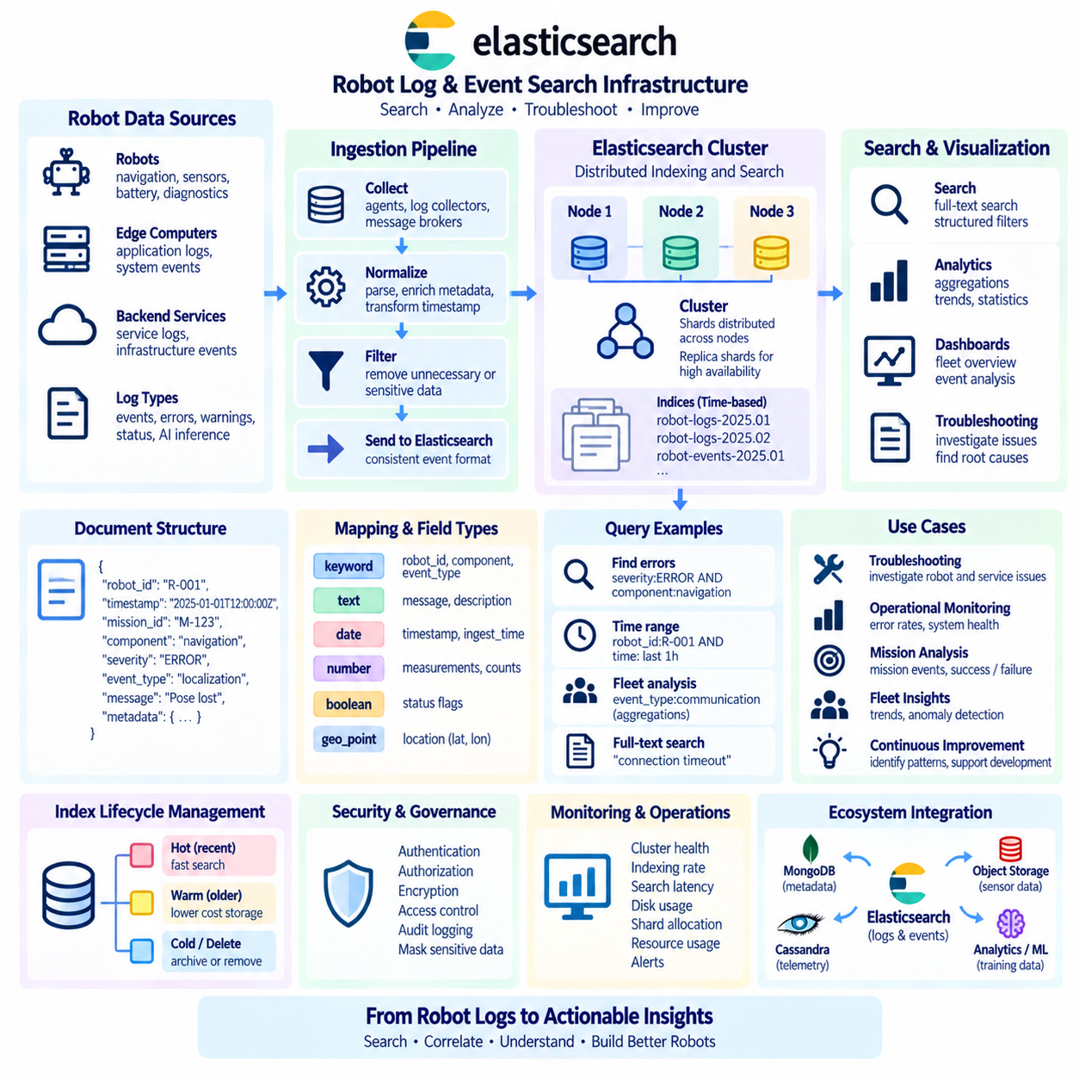
Elasticsearch is a distributed search and analytics engine designed to index large volumes of structured and unstructured information and make that information rapidly searchable. In robotics and Physical AI systems, it can provide a centralized search layer for robot logs, mission events, diagnostics, application messages, infrastructure records, and selected sensor-derived events. Instead of manually examining files on individual robots or servers, operators can search distributed operational records through a unified interface and quickly investigate system behavior.
Robot platforms continuously produce heterogeneous operational information. A mobile robot may generate navigation logs, localization warnings, battery events, sensor status messages, mission transitions, network errors, AI inference results, and hardware diagnostics. Edge computers and backend services generate additional application and infrastructure logs. Elasticsearch can index these records with timestamps, robot identifiers, severity levels, component names, mission identifiers, event categories, and message content so that related events can be discovered across the complete system.
Elasticsearch organizes information into indices containing documents composed of fields and values. A robot event document may contain `robot_id`, `timestamp`, `mission_id`, `component`, `severity`, `event_type`, `message`, and contextual metadata. Unlike storing logs as undifferentiated text files, structured documents allow applications to filter and aggregate records using meaningful attributes. Operators can therefore retrieve only localization errors from a particular robot, examine events from one mission, or search for a specific failure message across an entire fleet.
The mapping defines how document fields are interpreted and indexed. Fields may be represented as keywords, analyzed text, numbers, dates, Boolean values, geographic coordinates, or other supported types. Correct mapping design is important because robot identifiers and event categories generally require exact matching, while diagnostic messages may require full-text search. Timestamps should use appropriate date types, and numeric measurements should remain numeric so that range filtering and statistical analysis can be performed efficiently.
Elasticsearch full-text search is particularly useful for diagnostic messages and software logs. Text fields can be analyzed into searchable terms so that operators can locate records even when the complete original message is not known. Keyword fields, in contrast, preserve exact values and are useful for identifiers, categories, status codes, and component names. A well-designed robot log schema often uses both approaches, enabling exact filtering by structured metadata while retaining flexible text search across descriptive diagnostic content.
Robot logs normally reach Elasticsearch through a data ingestion pipeline rather than being written manually by applications directly into search indices. Log collectors, message brokers, ingestion services, or processing pipelines can receive events from robots and backend systems, normalize field names, attach metadata, transform timestamps, and remove unnecessary information before indexing. This separation prevents each robot application from implementing its own indexing logic and creates a consistent operational event format across heterogeneous robot platforms.
An ingestion pipeline should preserve the identity and temporal context of every event. Robot identifier, source component, event timestamp, ingestion timestamp, software version, mission identifier, and environment information can provide important context during troubleshooting. The original event time should remain distinguishable from the time at which Elasticsearch receives the event because edge connectivity may be intermittent. Without this distinction, delayed transmission could make historical events appear to have occurred later than they actually did.
Distributed indexing allows Elasticsearch to scale as log volume increases. An index can be divided into primary shards, and shard replicas can provide redundancy and additional read capacity. Shards are distributed across nodes in the Elasticsearch cluster so that storage and query workloads are not restricted to a single server. For growing Physical AI deployments, this architecture can support increasing numbers of robots and backend services, although shard counts and cluster topology should be planned carefully to avoid unnecessary operational overhead.
Replica shards contribute to availability by maintaining additional copies of indexed data. If a node becomes unavailable, another node containing a replica may continue serving requests. Replication therefore improves resilience against individual infrastructure failures, but it should not be confused with independent backup. Accidental deletion, incorrect lifecycle policies, or administrative mistakes can affect the cluster logically. Snapshot and recovery procedures should therefore remain part of the overall Elasticsearch operational architecture.
Time is a fundamental dimension of robot log infrastructure. Most operational investigations begin with a time range and then narrow results by robot, mission, component, or severity. Time-oriented indices or data streams can organize continuously generated event data while lifecycle mechanisms manage its progression through active and historical storage stages. Recent events may remain readily searchable, while older records can move to lower-cost storage or eventually be removed according to retention requirements.
Search queries can combine multiple dimensions of operational context. An engineer might search for `ERROR` events generated by the navigation component of a specific robot during a particular mission and time range. Another query might locate all robots reporting a repeated communication failure during the previous hour. Because structured filters and full-text search can be combined, Elasticsearch supports both targeted troubleshooting and broader fleet-level investigation without requiring operators to manually collect log files from each machine.
Aggregations extend Elasticsearch beyond individual event search by summarizing large groups of records. Events can be grouped by robot, severity, component, event type, mission, or time interval. Operators can calculate event counts, error rates, distributions, and trends to understand whether a problem is isolated or widespread. For example, a time-based aggregation may reveal a sudden increase in localization failures after a software deployment, providing a useful signal for engineering investigation without claiming the underlying cause automatically.
Dashboards and monitoring interfaces can use Elasticsearch query and aggregation results to provide operational visibility. A fleet dashboard may display active error counts, robots generating repeated warnings, event rates by subsystem, mission failure patterns, or trends over time. Search and visualization should complement rather than replace dedicated real-time safety and control systems. Elasticsearch is well suited to observability and investigation, but safety-critical robot decisions should remain within appropriately engineered control and assurance mechanisms.
Index design should reflect expected query patterns and data volume. Storing every possible field as searchable data can increase index size and processing requirements, while overly restrictive mappings can make useful investigations difficult. Fields that support common filtering, grouping, or search operations should be intentionally indexed. Large payloads, raw sensor frames, binary data, and information rarely used for search may be stored elsewhere, with Elasticsearch retaining identifiers, metadata, summaries, or references to those external objects.
Physical AI systems can generate extremely large log volumes, making lifecycle management essential. Not every debug message requires permanent retention. High-value fault events may need long retention periods, while verbose development logs may expire quickly. Index lifecycle policies can automate rollover, retention, and deletion according to operational requirements. A tiered strategy can preserve recent searchable information while moving long-term evidence to archival systems, helping control storage costs without abandoning traceability requirements.
Elasticsearch should therefore operate alongside other data platforms rather than replacing them. MongoDB may manage robot configuration and mission metadata, Cassandra or a time-series system may retain high-volume telemetry, and object storage may contain camera, LiDAR, and training datasets. Elasticsearch can specialize in searchable operational events, logs, diagnostics, and selected metadata. Shared robot identifiers, mission identifiers, timestamps, model versions, and dataset references can connect these systems into a coherent Physical AI data architecture.
Observability infrastructure should also consider correlation between robot events and backend services. A mission failure observed on a robot may correspond to messages from an edge AI service, network gateway, orchestration platform, or database. Consistent correlation identifiers can connect records generated by these different components. Searching by a mission or trace identifier can then reconstruct a distributed sequence of events, reducing the need to investigate each subsystem independently and improving end-to-end troubleshooting across the Physical AI platform.
Security and governance are essential because logs frequently contain operationally sensitive information. Robot locations, network addresses, software versions, mission details, user identifiers, and diagnostic payloads may appear in event records. Access control should restrict who can search particular data, while encryption, authentication, auditing, and network isolation should protect the infrastructure. Ingestion pipelines should also remove or mask unnecessary sensitive fields before indexing when they are not required for operational analysis.
Cluster monitoring is necessary to maintain reliable search performance. Administrators should observe node health, shard allocation, indexing rate, search latency, memory pressure, disk utilization, queue behavior, and rejected operations. Rapid increases in log volume can create resource pressure even when the number of robots remains unchanged, particularly during widespread faults that generate repeated messages. Capacity planning should therefore consider both normal event rates and burst conditions produced by abnormal system behavior.
Search performance should be validated using representative operational queries rather than assumptions. Engineers should test common combinations of robot identifiers, time ranges, severity levels, components, and message searches against realistic data volumes. Slow queries may indicate inefficient mappings, excessive shard counts, inappropriate aggregations, or insufficient infrastructure capacity. Performance tuning should follow an iterative process of observing actual queries, measuring resource usage, adjusting configuration, and validating the resulting behavior.
Ultimately, Elasticsearch can provide the searchable observability layer of a Physical AI data platform. Robot logs, mission events, diagnostics, AI service messages, and infrastructure records can be normalized, indexed, searched, correlated, aggregated, and visualized through a distributed architecture. When combined with appropriate mappings, ingestion pipelines, shard design, lifecycle policies, security controls, and external storage systems, Elasticsearch transforms fragmented operational records into accessible evidence for fleet monitoring, troubleshooting, engineering analysis, and continuous improvement of increasingly complex robotic systems.

03.07 Neo4j: Robot Knowledge Graph / Dependency Graph [w/Code]
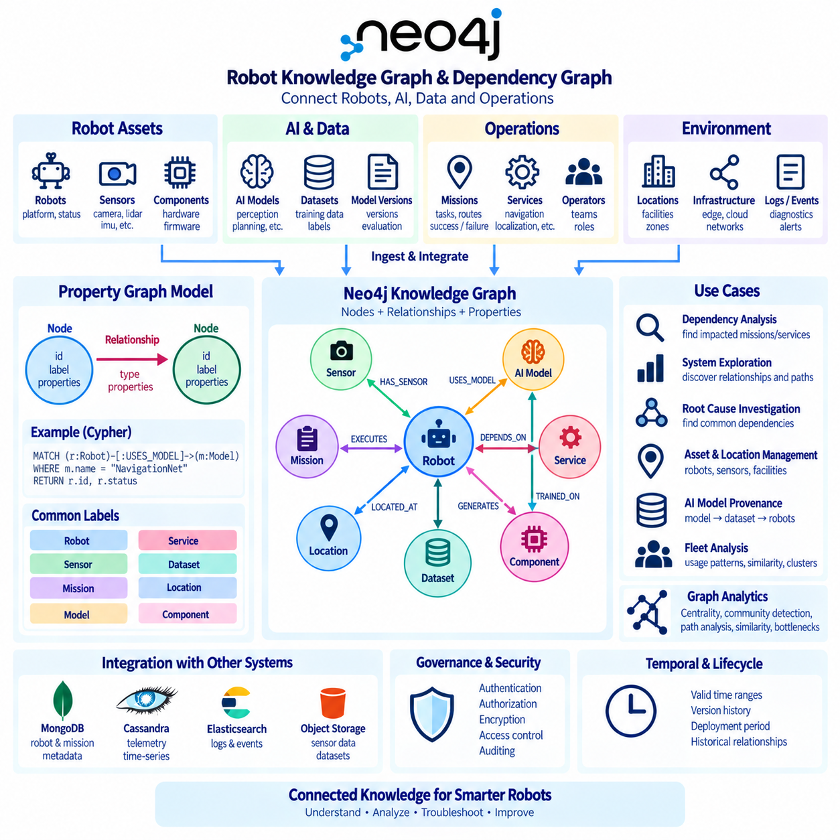
Neo4j is a graph database designed to represent information as nodes, relationships, and properties rather than primarily as rows or isolated documents. This structure is useful when relationships among entities are as important as the entities themselves. In robotics and Physical AI, robots, sensors, AI models, missions, facilities, services, datasets, and operators form interconnected systems. A graph database can preserve these connections directly and provide an intuitive foundation for knowledge representation, dependency analysis, and system-level reasoning.
The Neo4j property graph model represents entities as nodes and connections as typed relationships. Both nodes and relationships can contain properties that describe their characteristics. A robot node may contain an identifier, platform type, software version, and operational status, while a sensor node may contain its model, type, and configuration. A relationship such as `HAS_SENSOR` can connect the robot to the sensor, preserving the fact that the sensor belongs to or is installed on that particular robot.
Labels classify nodes according to their semantic roles. A Physical AI graph might contain labels such as `Robot`, `Sensor`, `Mission`, `Model`, `Service`, `Dataset`, `Location`, and `Component`. Relationships can express meaningful connections such as `HAS_SENSOR`, `USES_MODEL`, `EXECUTES`, `DEPENDS_ON`, `LOCATED_AT`, `GENERATES`, or `CONNECTED_TO`. This explicit representation creates a semantic structure that can be traversed directly instead of reconstructing relationships repeatedly through joins or application-side logic.
A robot knowledge graph can combine information that would otherwise remain fragmented across multiple systems. A robot may be connected to its hardware components, installed sensors, firmware, perception models, assigned missions, operating locations, generated datasets, and maintenance records. AI models can be connected to their training datasets, versions, deployment targets, and evaluation results. By connecting these entities through stable identifiers, Neo4j can provide a system-level view of how physical devices, software, data, and operational activities interact.
Dependency graphs are particularly valuable for complex robotic platforms. A mission may depend on a navigation service, localization model, map, camera, LiDAR sensor, communication link, and edge computer. Each of these components can have further dependencies. Representing these relationships as a graph allows engineers to traverse the dependency chain and determine which missions or services could be affected when a component becomes unavailable. This supports impact analysis without requiring every dependency path to be manually encoded in application logic.
Graph traversal is one of Neo4j's central strengths. Instead of asking only for records that match specific attributes, applications can ask questions about paths and neighborhoods. An engineer might identify all robots using a particular AI model, all missions depending on a specific service, or every sensor connected to systems operating in one facility. Multi-hop queries can continue across several relationship types, enabling analysis that becomes increasingly cumbersome when relationships are distributed across many relational tables or independent document collections.
Neo4j uses Cypher, a declarative graph query language designed around pattern matching. A query can describe the node labels, relationship types, directions, and property conditions that define a desired graph pattern. For example, an application can search for robots that `USES_MODEL` a particular model or missions that `DEPENDS_ON` a service affected by an infrastructure event. Cypher allows graph queries to resemble the conceptual relationships being investigated, making complex connectivity questions easier to express and maintain.
Knowledge graphs become more useful when relationships include semantic meaning rather than merely connecting identifiers. A robot may `USES_MODEL` an AI model, the model may `TRAINED_ON` a dataset, the dataset may `CAPTURED_AT` a location, and the robot may `EXECUTES` a mission in another environment. Traversing these relationships can reveal provenance and operational context. This structure can help engineers understand not only which model is deployed but also where its underlying data originated and how it relates to current deployment conditions.
Provenance is especially important for AI-enabled robotic systems because model behavior depends on training data, model versions, configuration, and deployment context. A graph can connect a deployed model to its training datasets, evaluation records, software package, hardware target, and robots currently using it. When a model is replaced or a dataset is found to contain a problem, graph traversal can identify potentially affected deployments. This creates a foundation for traceability across the AI lifecycle rather than treating model files as isolated artifacts.
Dependency analysis can also support maintenance and fault investigation. Suppose several robots report localization failures. A graph query may reveal that the affected robots share the same localization model, map version, sensor type, or edge service. This relationship does not by itself prove the cause of the failure, but it can identify common dependencies that deserve investigation. Graph analysis therefore complements logs and telemetry by exposing structural relationships that may not be obvious when events are examined independently.
Neo4j can represent spatial and organizational relationships in addition to technical dependencies. Robots may be assigned to facilities, zones, production lines, teams, customers, or operational domains. Locations can contain other locations, while assets can be connected to physical infrastructure. This allows applications to ask questions such as which robots operate in a particular zone, which sensors are associated with a production line, or which services support robots belonging to a particular organizational unit.
Graph modeling requires deliberate decisions about what should become a node, a relationship, or a property. An entity that needs its own identity, lifecycle, or connections is often appropriate as a node. A meaningful association between entities is naturally represented as a relationship, while descriptive attributes that do not require independent connections may remain properties. Over-modeling every value as a node can create unnecessary complexity, while hiding important relationships inside properties can reduce the advantages of graph traversal.
Constraints and indexes remain important even in a relationship-oriented database. Unique constraints can protect identifiers such as robot IDs, mission IDs, model IDs, or dataset IDs from accidental duplication. Indexes can accelerate the initial lookup of nodes based on frequently queried properties. Once relevant nodes are identified, graph traversal can efficiently follow relationships from those starting points. Good Neo4j performance therefore combines selective indexed lookup with appropriately bounded graph traversal rather than attempting unrestricted exploration of the entire graph.
A robot knowledge graph should not necessarily contain every high-frequency operational record. Raw camera frames, LiDAR measurements, telemetry streams, and verbose logs are generally better stored in systems designed for those workloads. Neo4j can instead maintain semantic metadata and references to external data. A dataset node may point to object storage, a telemetry source may reference Cassandra or a time-series platform, and an event record may link to Elasticsearch. The graph then acts as a connective semantic layer across specialized storage technologies.
This approach is especially useful in a heterogeneous Physical AI architecture. MongoDB may store robot and mission documents, Cassandra may handle high-volume telemetry, Elasticsearch may index logs and diagnostic events, and object storage may retain raw sensor datasets. Neo4j can connect these resources through shared identifiers and relationships. Rather than duplicating every piece of data, the graph can describe where information exists, what it represents, how entities depend on one another, and which operational processes use it.
Knowledge graph synchronization must be designed carefully because many authoritative facts originate outside Neo4j. Robot configuration may come from a fleet management service, model metadata from an AI registry, and mission state from an operational database. Integration pipelines can update the graph when these source systems change. The architecture should clearly define which system owns each fact so that Neo4j does not become an uncontrolled duplicate of operational data. The graph should represent trusted relationships while preserving links to authoritative sources.
Temporal information can further improve dependency and knowledge analysis. Relationships may include activation times, deployment periods, version intervals, or validity states. This allows the graph to represent not only what is connected now but also what was connected during a previous mission or failure. Historical dependency information is valuable when software, sensors, and AI models change frequently. Without temporal context, a current graph may incorrectly suggest that today's configuration was also present when an older event occurred.
Security and governance should reflect the sensitivity of connected information. A graph can make relationships visible that are difficult to discover in isolated databases, which increases its analytical value but may also expose operational structure. Access controls should therefore restrict sensitive information about robot locations, infrastructure dependencies, users, customers, or system architecture. Authentication, authorization, encryption, auditing, and controlled query interfaces should be incorporated according to the role of the graph within the broader Physical AI platform.
Graph analytics can extend the system beyond direct traversal. Connectivity, centrality, community structure, path analysis, and similarity techniques can help identify highly connected services, groups of related robots, dependency bottlenecks, or structurally similar configurations. Such metrics should be interpreted as analytical signals rather than automatic conclusions about operational importance or failure causality. Combined with domain knowledge, telemetry, and logs, graph analytics can help engineers prioritize areas for further investigation.
A practical Physical AI knowledge graph can therefore serve several roles simultaneously: system catalog, dependency map, provenance network, configuration relationship model, and operational context layer. It can answer questions about what exists, how components are connected, which resources a mission depends on, where a model came from, and what may share a common dependency. These capabilities become increasingly valuable as robot fleets grow and the relationships among hardware, software, AI models, data, and infrastructure become too complex to manage manually.
Ultimately, Neo4j provides a relationship-centered foundation for representing the interconnected structure of robotic systems. Nodes capture meaningful entities, relationships express dependencies and semantic connections, properties provide context, and Cypher queries traverse these structures to answer system-level questions. When integrated with document databases, telemetry stores, search infrastructure, object storage, and AI platforms, a Neo4j knowledge graph can become the semantic connective layer of Physical AI, supporting traceability, dependency analysis, troubleshooting, knowledge discovery, and more coherent management of increasingly complex robot ecosystems.

03.08 NoSQL Selection Matrix per Robot Data Type
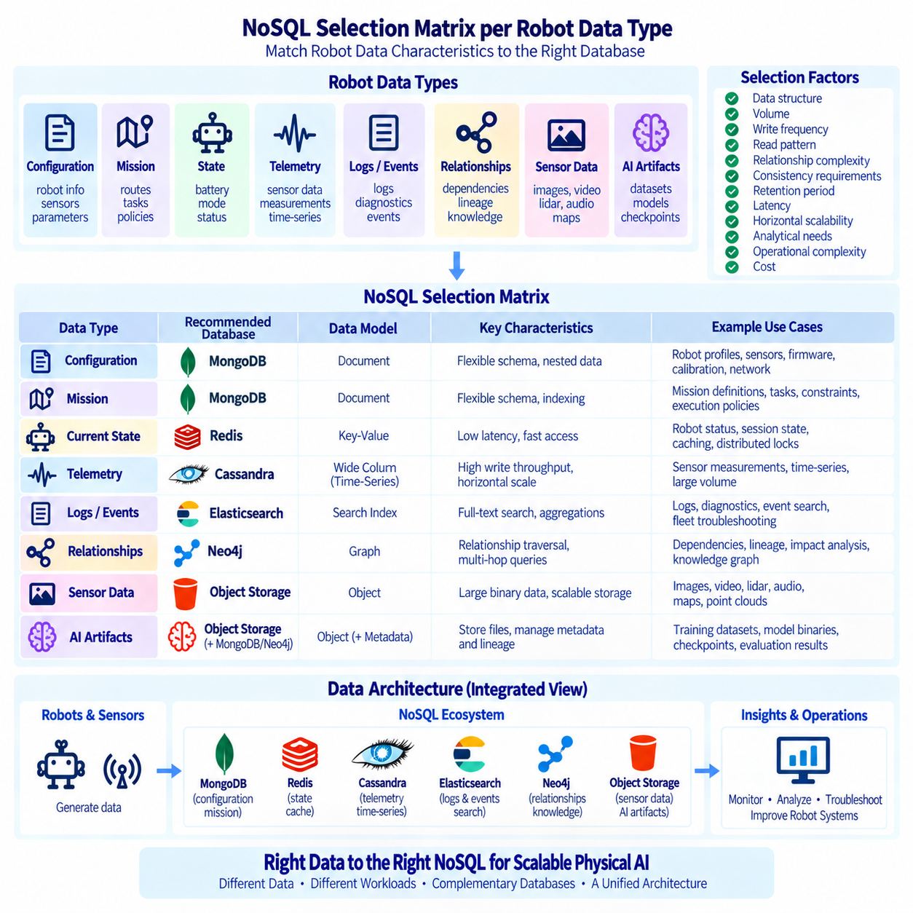
Selecting a NoSQL database for a robotic system should begin with the characteristics of the data and the operations performed on it rather than with a preferred database product. Physical AI platforms generate configuration documents, runtime states, telemetry, logs, events, knowledge relationships, sensor metadata, and AI artifacts. These workloads differ significantly in structure, update frequency, query patterns, retention, consistency, and scale, so a single database rarely provides the optimal storage model for every robot data type.
A practical selection matrix evaluates each robot data category against several dimensions. Important factors include data structure, expected volume, write frequency, read pattern, relationship complexity, consistency requirements, retention period, latency, horizontal scalability, and analytical needs. The purpose of the matrix is not to declare one NoSQL technology universally superior. Instead, it provides a repeatable method for matching storage characteristics with workload requirements while making architectural trade-offs visible to engineering teams.
Robot configuration and asset metadata are naturally document-oriented. A robot description may contain identifiers, platform information, firmware versions, capabilities, installed sensors, network interfaces, calibration parameters, and nested configuration objects. MongoDB is well suited to this type of information because related attributes can be represented within flexible BSON documents. Document-oriented modeling also accommodates differences between robot models without requiring every platform to share exactly the same set of fields.
Mission and operational documents often have similar requirements. Mission definitions may contain routes, task parameters, assigned robots, constraints, payload information, timestamps, and execution policies. These structures can evolve as applications become more sophisticated. MongoDB provides flexible schema management, indexing, and query capabilities for such operational records. References can connect missions to robots, users, or resources, while frequently accessed information can remain embedded when keeping related data together improves application performance.
Current robot state requires a different evaluation because values such as battery level, operating mode, connectivity, position summary, and current mission may change frequently. A document database can maintain a consolidated state document when applications frequently retrieve the robot as one logical object. A key-value database may be preferable when extremely fast lookup by robot identifier is the dominant requirement. The correct choice depends on whether the workload prioritizes rich structured queries or simple low-latency state access.
High-frequency telemetry presents a substantially different workload. Motors, batteries, IMUs, temperatures, localization systems, and other components can continuously generate measurements at large scale. Cassandra is suitable when sustained write throughput, horizontal scaling, availability, and time-oriented access are primary requirements. Telemetry tables can be designed around robot identifiers and time buckets, with timestamps used as clustering dimensions. This model supports continuous ingestion while avoiding the need to treat each measurement as a complex independent document.
Time-series requirements should be considered separately from the general concept of telemetry. Queries commonly retrieve measurements for one robot or sensor over a specific time interval, compare recent values, or generate aggregates over time. Partition design, retention, and write behavior therefore become central selection criteria. Cassandra can support these patterns at large distributed scale, while specialized time-series databases may be appropriate when advanced time-series functions, compression, downsampling, or domain-specific analytical capabilities dominate the workload.
Robot logs and diagnostic events are primarily search-oriented data. Operators need to search message text, filter by severity, robot, component, mission, or timestamp, and aggregate large numbers of events to identify patterns. Elasticsearch is a strong match for these requirements because it combines structured filtering, full-text search, distributed indexing, and aggregations. Logs can be normalized through ingestion pipelines before indexing, enabling fleet-wide troubleshooting without requiring engineers to inspect individual files on each robot.
Event data should still be differentiated by purpose. Searchable operational events belong naturally in Elasticsearch, but events that function as durable business or control records may require a different authoritative store. A mission completion record, for example, may need transactional integrity and long-term retention beyond its usefulness for search. The same event can therefore be represented in more than one system for different purposes, provided ownership is clearly defined and uncontrolled duplication is avoided.
Relationships and dependencies introduce another storage requirement. Robots depend on sensors, services, AI models, maps, networks, and infrastructure, while models depend on datasets, versions, and deployment environments. Neo4j is well suited to information where multi-hop relationships and graph traversal are central to the query. A knowledge graph can answer which missions depend on a failed service, which robots use a particular model, or which datasets contributed to models deployed on a specific group of robots.
Graph storage is less appropriate when relationships are simple and rarely queried. Creating graph nodes for every telemetry sample or routine log message would usually add complexity without meaningful benefit. Neo4j should focus on entities and relationships that have semantic value, identity, dependencies, or lifecycle significance. High-volume raw measurements can remain in telemetry stores, while the graph maintains references to data sources, components, models, missions, and other meaningful resources.
Key-value databases are useful when the dominant operation is direct access through a known key. Robot session state, distributed locks, short-lived coordination information, cached configuration, temporary mission context, and frequently accessed status values can fit this model. Redis is commonly used for such low-latency workloads. Its role should be distinguished from durable systems of record, especially when information must survive failures or satisfy long-term audit and historical requirements.
Raw sensor data requires another architectural decision because camera images, video, LiDAR point clouds, audio, maps, and large binary artifacts are generally inefficient to store directly inside operational NoSQL databases. Object storage is typically more appropriate for these large objects. Databases can retain metadata, timestamps, robot identifiers, labels, checksums, storage locations, and access references. This separation keeps operational databases efficient while preserving searchable connections to high-volume physical-world data.
AI datasets and model artifacts follow a similar pattern. Training images, large dataset archives, checkpoints, and model binaries belong naturally in object or artifact storage, while MongoDB may maintain descriptive metadata and Neo4j may represent lineage and dependency relationships. Elasticsearch can index searchable annotations or processing events, and telemetry platforms can preserve evaluation measurements. The storage architecture therefore separates the artifact itself from the operational, searchable, temporal, and relational information surrounding it.
Consistency requirements are another major dimension in the selection matrix. Configuration changes, authorization information, and mission assignments may require stronger guarantees than high-frequency environmental telemetry. Distributed databases often allow different trade-offs between consistency, availability, and latency. Engineers should define what happens when replicas temporarily disagree, networks become partitioned, or edge robots lose connectivity. Database selection should reflect the operational consequences of stale, missing, duplicated, or delayed information.
Availability requirements vary by data type as well. A temporary delay in historical analytics may be acceptable, while loss of access to current mission state could significantly affect operations. Cassandra emphasizes distributed availability, MongoDB replica sets provide failover for document workloads, Elasticsearch replicas improve search resilience, and Neo4j deployment architecture can provide graph service availability. The required level of redundancy should be determined by the operational role of each dataset rather than applied identically to every database.
Retention and lifecycle policies can significantly influence technology selection and cost. Current robot state may only require the latest value, detailed logs may be retained for weeks, telemetry may require several months of online access, and selected mission evidence may need years of archival retention. Lifecycle rules should define what remains searchable, what is summarized, what moves to lower-cost storage, and what is deleted. These decisions prevent high-volume robotic data from expanding indefinitely across expensive operational systems.
Query patterns should remain the primary design input. If applications retrieve complete robot objects by identifier and filter structured attributes, document storage is appropriate. If they continuously write measurements and read them by partition and time range, a wide-column or time-series model is preferable. If they search text and aggregate events, a search engine is appropriate. If they repeatedly traverse dependencies and provenance relationships, a graph database provides a more natural representation.
Operational complexity must also be included in the matrix. Every additional database introduces deployment, monitoring, backup, security, upgrade, integration, and engineering requirements. Polyglot persistence should therefore not mean adopting a different technology for every minor data variation. A new database should be introduced when its workload advantage justifies the operational cost. Smaller robotic platforms may begin with fewer technologies and separate workloads progressively as volume, reliability, or query complexity increases.
A practical Physical AI platform may therefore combine several complementary systems. MongoDB can manage robot, mission, and configuration documents; Redis can provide low-latency transient state and caching; Cassandra can handle high-volume telemetry; Elasticsearch can support logs and event search; and Neo4j can represent knowledge and dependency graphs. Object storage can retain large sensor files and AI artifacts. Shared identifiers and timestamps allow these systems to operate as parts of one coordinated data architecture.
The selection matrix should be treated as a living architectural tool rather than a one-time procurement decision. Robot fleets evolve, sensor rates increase, AI pipelines change, and operational questions become more sophisticated. Workloads should be periodically measured using actual data volume, latency, query frequency, storage growth, failure behavior, and maintenance cost. A database that was appropriate for an early prototype may require supplementation or redesign when the same platform expands to hundreds or thousands of robots.
Ultimately, effective NoSQL selection for robotics is based on matching each data type to the storage model that best represents its operational behavior. Documents favor flexible document databases, high-volume telemetry favors distributed write-oriented storage, searchable logs favor search engines, transient state favors key-value systems, and complex dependencies favor graph databases. Combined with object storage for large sensor and AI artifacts, this workload-driven matrix creates a scalable data foundation in which each technology has a clearly defined responsibility within the broader Physical AI ecosystem.

03.09 NoSQL Data Model Anti-Patterns and Solutions
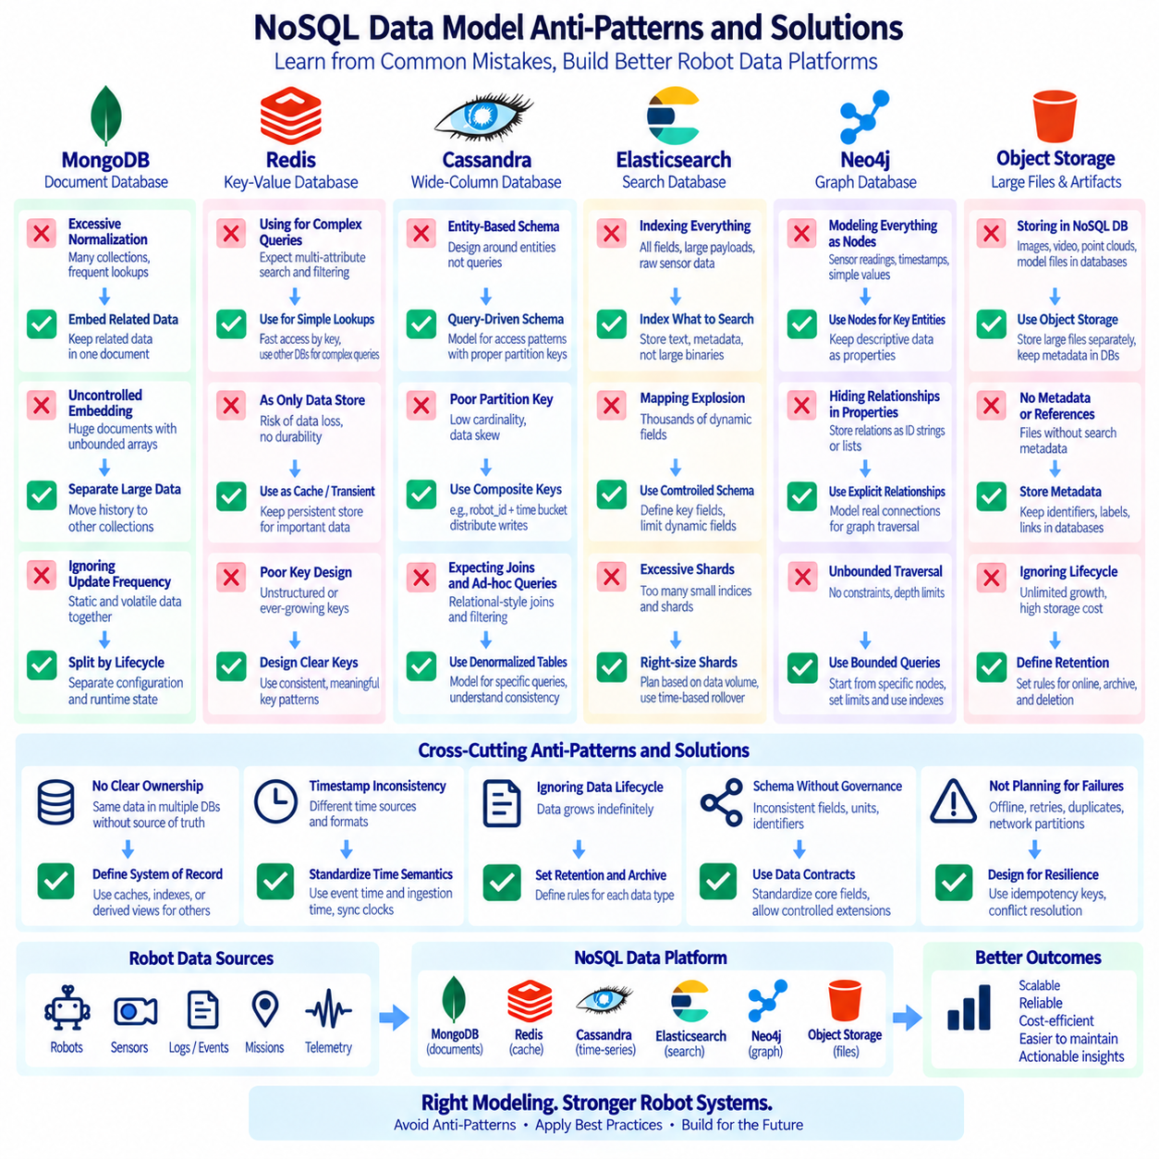
NoSQL data modeling requires a different mindset from traditional relational database design. A common anti-pattern is to transfer normalized relational schemas directly into document, key-value, wide-column, search, or graph databases without considering their access models. In Physical AI systems, this can create unnecessary network requests, expensive cross-record operations, poor scalability, and complicated application logic. Effective NoSQL modeling begins with workload behavior, expected queries, data volume, update patterns, and lifecycle requirements.
One frequent anti-pattern is excessive normalization in a document database such as MongoDB. Splitting robot configuration, sensors, capabilities, network interfaces, and frequently accessed metadata into many small collections may force applications to perform repeated lookups simply to reconstruct one robot. When related information is commonly read together and has a compatible lifecycle, embedding can reduce query complexity. References should be reserved for independently managed entities, shared resources, or relationships that would create excessive duplication.
The opposite problem is uncontrolled embedding. A robot document should not continuously accumulate telemetry samples, logs, mission history, images, and diagnostic events inside growing arrays. Such documents become increasingly expensive to update, transfer, and manage, while potentially approaching database size limits. Unbounded one-to-many relationships should normally be separated into dedicated collections or specialized stores. The parent document can preserve current summaries, counters, identifiers, or references without becoming an unlimited historical container.
Designing documents without considering update frequency is another common mistake. Static robot metadata and rapidly changing runtime state may technically fit within one document, but frequent updates to a large shared object can increase write overhead and contention. Separating stable configuration from volatile state allows each workload to evolve independently. Current status can remain compact and frequently updated, while configuration documents change only when hardware, firmware, calibration, or deployment settings are modified.
Using a key-value database for complex multidimensional queries is also an anti-pattern. Redis and similar systems are effective when applications know the key and require extremely fast access, but problems arise when developers later expect arbitrary filtering across many attributes and relationships. Creating numerous secondary structures manually can increase complexity and synchronization risk. If robot information requires rich document filtering, full-text search, time-series analysis, or relationship traversal, another specialized database should handle that responsibility.
Treating an in-memory key-value cache as the only authoritative data store can create durability and recovery problems when the workload requires permanent records. Robot session information or temporary coordination state may tolerate loss or reconstruction, while mission evidence, configuration history, or compliance records may not. The solution is to define explicitly whether each key represents cache, transient state, coordination data, or durable information and to maintain an appropriate persistent system of record when long-term correctness is required.
Wide-column databases such as Cassandra are frequently misused when schemas are designed around entities rather than queries. A relational mindset may produce generic tables that appear elegant but cannot efficiently answer actual application requests. Cassandra modeling should begin with the queries the system must support and then design partition and clustering keys accordingly. Denormalized tables for specific access patterns are expected, provided that ownership, synchronization, and consistency behavior are clearly understood.
Poor partition-key selection is one of the most damaging Cassandra anti-patterns. A low-cardinality key can concentrate large amounts of telemetry on a few partitions or nodes, while an ever-growing partition can become difficult to manage. Robot telemetry commonly benefits from composite partitioning based on robot or sensor identity combined with a time bucket. This distributes writes while keeping time-range queries efficient and prevents years of measurements from accumulating inside a single unbounded partition.
Monotonically increasing or highly concentrated access patterns can create hotspots in distributed databases. Even when total cluster capacity appears sufficient, one partition or node may receive a disproportionate share of writes. Physical AI systems should evaluate expected fleet behavior, including synchronized sensor uploads, mission starts, and fault bursts. Partition strategies should distribute traffic across available resources while preserving the ability to retrieve operationally meaningful groups of data without expensive scatter-gather queries.
Another anti-pattern is expecting Cassandra or similar distributed stores to behave like relational databases with frequent joins, unrestricted filtering, and ad hoc analytical queries. These systems achieve scale partly by constraining efficient access paths. If applications continuously require joins among robots, missions, users, and models, the data model should provide query-specific denormalized representations or another database should serve those queries. Technology selection should follow workload requirements rather than forcing every query into one storage engine.
Elasticsearch has its own modeling anti-patterns. Indexing every field by default, storing enormous payloads, or sending raw sensor binaries into a search cluster can waste storage and memory. Search infrastructure should contain information that benefits from filtering, full-text search, aggregation, or correlation. Large camera frames, LiDAR files, and model artifacts should normally remain in object storage, while Elasticsearch retains searchable metadata, diagnostic text, identifiers, timestamps, and references to external objects.
Mapping explosion is another Elasticsearch problem. Dynamically creating thousands of fields from arbitrary robot attributes, sensor names, or user-generated keys can increase cluster metadata and resource consumption. A controlled event schema should define important searchable fields and constrain highly variable content. Flexible payloads can be stored selectively when necessary, but not every nested attribute needs to become an independently indexed field. Schema governance is therefore important even in systems marketed as schema-flexible.
Excessive shard creation can also reduce Elasticsearch performance. Creating many tiny indices or assigning too many shards for small robot groups increases memory and cluster-management overhead. Shard strategy should reflect expected data volume, retention, query patterns, and node capacity. Time-based rollover can help manage continuously generated logs, but rollover thresholds should be based on measured index growth rather than arbitrary calendar boundaries. Search scalability depends on balanced shard sizing, not simply increasing shard count.
Neo4j anti-patterns often begin with modeling every value as a node. Sensor readings, timestamps, simple status strings, and other attributes do not automatically require independent graph identities. Excessive node creation can make the graph unnecessarily large and difficult to understand. Entities should generally become nodes when they have meaningful identity, relationships, or lifecycle significance. Descriptive values can remain properties, while high-frequency measurements should usually remain in telemetry or time-series systems.
The opposite graph anti-pattern is hiding meaningful relationships inside string properties or embedded lists. If a robot depends on a service, uses an AI model, operates at a location, or belongs to a mission, representing those connections only as identifiers inside properties prevents efficient graph traversal. Important semantic connections should become explicit relationships. This allows Cypher queries to explore dependency paths, provenance, shared resources, and impact propagation without repeatedly parsing application-specific property structures.
Unbounded graph traversal is another potential problem. Queries that search arbitrary paths across a large knowledge graph without relationship constraints, direction, labels, or depth limits can consume substantial resources and return results with little operational value. Queries should begin from selectively identified nodes and traverse relationships relevant to the question. Indexes and constraints can accelerate starting-node lookup, while bounded traversal patterns keep dependency and knowledge queries understandable and predictable.
A broader anti-pattern is storing the same authoritative information independently in multiple databases without defining ownership. Robot status may appear in MongoDB, Redis, Elasticsearch, Cassandra, and Neo4j, but those representations should not all claim to be the source of truth. Each data element needs a clearly defined system of record. Other systems may contain caches, indexes, historical copies, derived views, or semantic references, but synchronization rules and acceptable staleness must be explicit.
Timestamp inconsistency can make distributed robot data almost impossible to correlate. Logs may use server time, telemetry may use robot-local time, and mission events may use ingestion time without preserving the original event timestamp. Physical AI architectures should define common time semantics and retain both event time and ingestion time where appropriate. Clock synchronization, timezone conventions, timestamp precision, and delayed transmission behavior should be considered part of data modeling rather than treated only as infrastructure concerns.
Ignoring data lifecycle is another common design failure. Telemetry, debug logs, temporary states, and intermediate AI processing records can grow indefinitely if retention policies are not established early. Each data class should have explicit rules for online retention, summarization, archival, and deletion. Frequently accessed recent data can remain in operational stores, while older raw information moves to lower-cost object storage. Lifecycle policies reduce cost and prevent historical data from degrading production database performance.
Schema flexibility should not be interpreted as permission to abandon governance. Inconsistent field names, units, identifiers, coordinate systems, status values, and version conventions make data integration increasingly difficult as robot fleets grow. A shared data contract should define core identifiers and semantics while still allowing controlled extensions for different robot models. Versioned schemas and compatibility rules help ingestion pipelines and applications evolve without breaking historical records or downstream analytics.
Ignoring failure behavior is another architectural anti-pattern. A data model may work perfectly during normal connectivity but fail when robots operate offline, messages arrive late, retries create duplicates, or network partitions occur. Systems should define idempotency keys, retry semantics, conflict resolution, ordering assumptions, and acceptable consistency for each data type. Robot data architectures must be designed for intermittent connectivity because physical devices often operate under less predictable network conditions than centralized web services.
Finally, overusing polyglot persistence can become an anti-pattern itself. MongoDB, Redis, Cassandra, Elasticsearch, Neo4j, and object storage each provide valuable capabilities, but adopting all of them without sufficient workload justification increases operational burden. Every additional system requires monitoring, security, backup, upgrades, expertise, and integration. The solution is not to minimize technology at all costs, but to introduce specialized storage only when its benefits clearly exceed the complexity it adds.
Effective NoSQL modeling for Physical AI therefore depends on disciplined workload-driven design. Embed bounded data that is read together, separate unbounded histories, choose partition keys from real access patterns, index only searchable information, represent meaningful relationships explicitly, define authoritative ownership, standardize identifiers and time semantics, and plan lifecycle policies from the beginning. Avoiding these anti-patterns transforms multiple NoSQL technologies from disconnected databases into a coherent, scalable, and maintainable data foundation for robotic systems.

03.10 NoSQL Database Security and Authentication [w/Code]
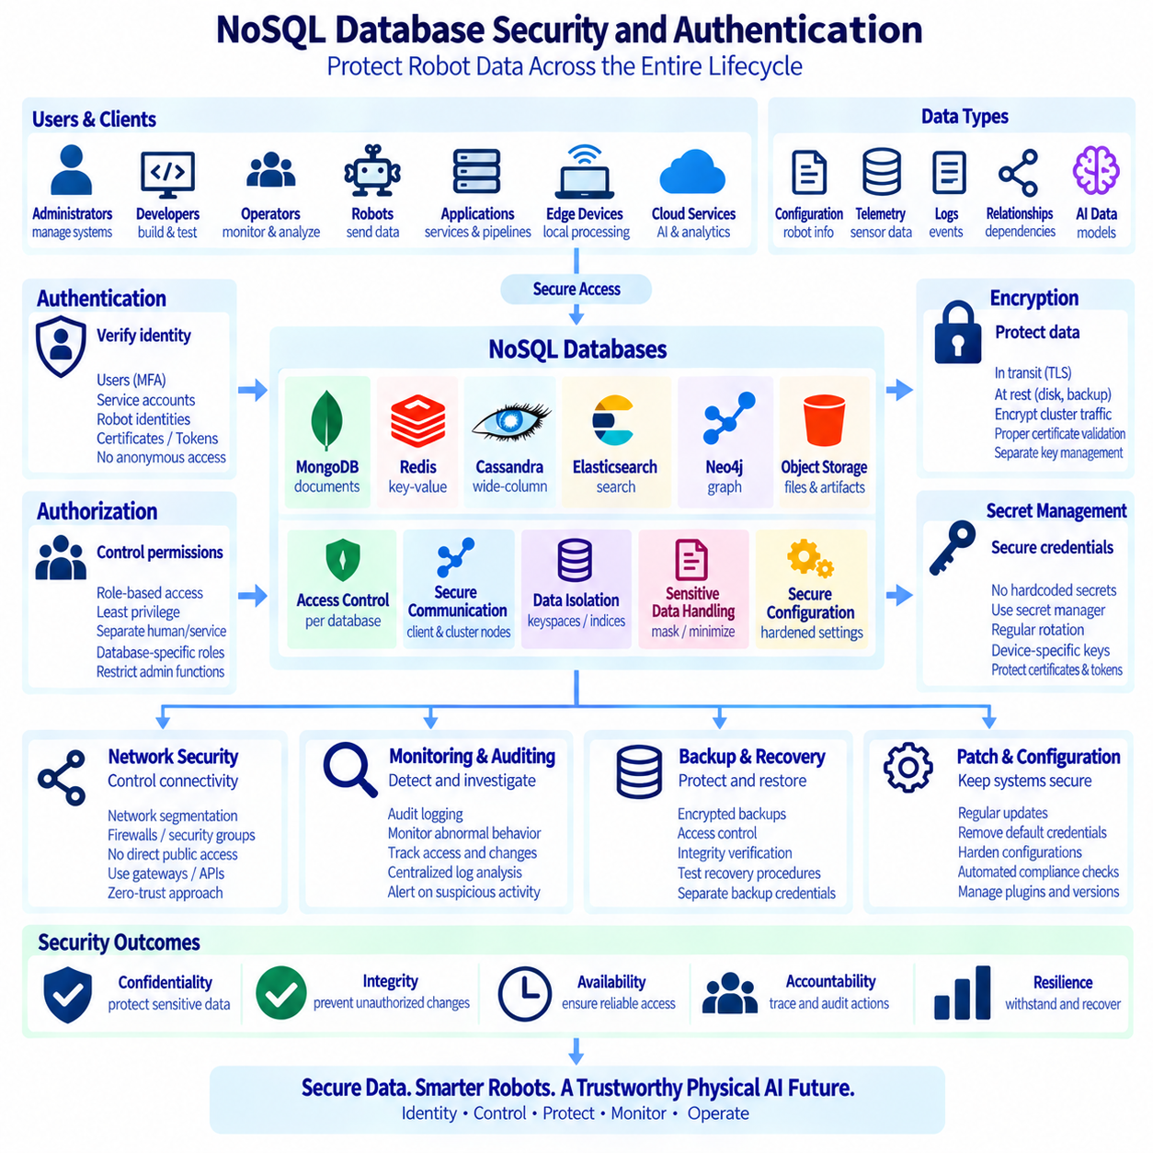
NoSQL database security in robotics must protect more than stored records. A Physical AI platform may contain robot identities, mission definitions, telemetry, logs, AI model metadata, facility information, and operational dependencies distributed across MongoDB, Redis, Cassandra, Elasticsearch, Neo4j, and other services. Security must therefore cover identity, authentication, authorization, encryption, network boundaries, auditing, secret management, backup protection, and operational monitoring throughout the complete data lifecycle.
Authentication establishes which user, application, robot, or service is requesting access. Every production database should require authenticated connections rather than relying on network location alone. Human administrators, backend services, edge computers, robots, and automation tools should use distinguishable identities whenever practical. Shared anonymous credentials make incident investigation difficult because actions cannot be reliably attributed to individual workloads, devices, or operators.
Authorization determines what an authenticated identity is permitted to do. Role-based access control can separate database administration, application read/write operations, monitoring, backup, analytics, and read-only investigation. The principle of least privilege should be applied so that each identity receives only the permissions required for its function. A robot telemetry uploader, for example, may require permission to write measurements but should not automatically receive authority to modify user accounts, delete historical data, or change cluster configuration.
Service identities should be separated from human accounts. Applications and robots operate continuously and require machine-oriented credentials, while administrators require interactive access that can be governed differently. Using one account for both purposes increases exposure and makes credential rotation difficult. Physical AI platforms should maintain clear identity boundaries among robots, edge services, cloud services, data pipelines, operators, developers, and administrators so that access policies can reflect their distinct responsibilities.
MongoDB security should begin with authentication and carefully designed roles. Application accounts can be restricted to specific databases and collections, while administrative functions remain available only to dedicated privileged identities. Replica set and sharded cluster members also require trusted communication between internal components. Authorization should be aligned with application responsibilities so that a robot management service can access operational documents without automatically obtaining unrestricted control over the entire MongoDB deployment.
Redis requires particular attention because it is frequently deployed as a low-latency internal service and may be incorrectly assumed to be safe simply because it resides inside a private network. Authentication and access control should still be enabled, and commands can be restricted according to application roles. A cache client rarely needs administrative commands. Network exposure should be tightly limited because unauthorized access to Redis may reveal session state, coordination information, cached credentials, or other operationally sensitive data.
Cassandra security must protect both client access and communication among distributed nodes. Authentication identifies clients, while authorization controls access to keyspaces, tables, and administrative operations. Node-to-node and client-to-node encryption can protect data as it moves through the distributed system. Because Cassandra clusters may span multiple servers or failure domains, security policies should remain consistent across the deployment rather than assuming that internal cluster traffic is inherently trustworthy.
Elasticsearch often contains highly revealing operational information, including software errors, robot identifiers, network details, mission activity, and infrastructure metadata. Authentication and role-based authorization should restrict access to indices and administrative APIs. Search users may need permission to investigate logs without being able to modify index lifecycle policies or cluster configuration. Ingestion services can receive write-oriented roles, while dashboards and analytical tools can operate with narrower read privileges.
Neo4j knowledge graphs may expose relationships that are more sensitive than individual records. A graph can reveal which robots depend on particular services, where systems are deployed, which models are used, and how infrastructure components are connected. Authentication and role-based privileges should therefore protect graph access according to operational need. Query access should also consider that seemingly harmless traversal can reveal broader system architecture when relationships are combined across multiple hops.
Encryption in transit protects database traffic against interception or manipulation while it crosses networks. TLS should be used for client-to-database communication and, where supported and appropriate, for communication among database cluster members. This is particularly important when robot data travels between edge devices, on-premise infrastructure, data centers, or cloud environments. Certificate validation should be configured correctly so that encrypted connections also authenticate the intended endpoint rather than merely hiding traffic.
Encryption at rest protects stored database files, snapshots, backups, and storage volumes when physical media or storage infrastructure is compromised. Depending on the architecture, encryption may be provided by the database, operating system, storage layer, cloud service, or a combination of these mechanisms. Encryption keys should be managed separately from protected data whenever possible. Storing encrypted backups beside exposed keys provides little protection against an attacker who can obtain both.
Secret management is essential because database passwords, API keys, certificates, and tokens should not be embedded permanently in source code, robot images, configuration repositories, or container definitions. A secret-management system can distribute credentials to authorized workloads and support controlled rotation. Robots and edge devices require special consideration because credentials may remain deployed for long periods. Device-specific or service-specific secrets reduce the impact of one compromised credential compared with fleet-wide shared passwords.
Credential rotation should be designed as an operational process rather than an emergency activity. Applications need mechanisms to receive new credentials without prolonged downtime, and databases may temporarily support overlapping credentials during controlled transitions. Certificate expiration, password rotation, token renewal, and device replacement should be incorporated into deployment procedures. Security mechanisms that cannot be rotated safely often become permanent technical debt and eventually encourage insecure exceptions.
Network segmentation provides another security boundary. Databases should generally not be exposed directly to networks that do not require access. Application services, management systems, analytics tools, and database clusters can be placed into controlled network zones with firewalls or equivalent policy enforcement between them. Edge robots should normally communicate through defined gateways, APIs, or ingestion endpoints rather than receiving unrestricted connectivity to every backend database in the Physical AI platform.
Zero-trust principles strengthen this architecture by avoiding the assumption that a request is trustworthy merely because it originates from an internal network. Identity, device context, encrypted communication, authorization, and policy enforcement can be evaluated for each connection. This is useful in distributed robotics because robots, edge computers, wireless networks, remote facilities, and cloud services create a broad and changing attack surface. Internal segmentation limits the potential movement of an attacker after one component is compromised.
Audit logging provides evidence of security-relevant activity. Important events may include successful and failed authentication attempts, privilege changes, administrative operations, schema modifications, sensitive reads, data deletion, backup actions, and security configuration changes. Audit records should contain appropriate identity and timestamp information and should be protected from unauthorized alteration. Centralized log analysis can correlate database audit events with operating system, application, network, and robot events during an investigation.
Security monitoring should detect abnormal behavior rather than merely store audit records. Unexpected authentication failures, unusual query volumes, access from unfamiliar systems, privilege changes, mass deletion, or sudden export activity may require investigation. Thresholds should reflect normal robotic workloads because fleet operations can naturally generate bursts of traffic. Monitoring systems should distinguish legitimate operational peaks from behavior that deviates meaningfully from established patterns.
Data classification helps determine which controls are necessary for each dataset. Robot configuration, public reference data, internal telemetry, facility maps, user information, mission records, and security logs may have different sensitivity levels. Classification can guide access restrictions, encryption requirements, retention periods, masking, and sharing policies. Applying identical controls to every byte may be inefficient, while treating all robot data as harmless can expose operational information that becomes sensitive when combined.
Sensitive information should be minimized before storage whenever possible. Logs should avoid unnecessary credentials, personal information, tokens, or complete request payloads. Diagnostic usefulness does not require recording every value available to an application. Ingestion pipelines can remove, mask, tokenize, or transform sensitive fields before data enters Elasticsearch or other analytical stores. Data minimization reduces both storage exposure and the amount of information that must later be protected, audited, retained, and deleted.
Backup security is part of database security rather than a separate concern. A strongly protected production cluster can still leak information if its snapshots are copied to weakly controlled storage. Backups should use appropriate encryption, access control, retention, integrity verification, and deletion policies. Recovery procedures should be tested because security incidents may require restoration to a known state. Backup credentials should also be separated from routine application permissions to reduce the impact of compromised service accounts.
Patch and configuration management are equally important. Secure authentication cannot compensate for outdated database software, unnecessary network exposure, default credentials, insecure plugins, or overly permissive roles. Database versions, operating systems, client libraries, and management tools should follow controlled update processes. Configuration baselines can define required authentication, encryption, logging, network, and access-control settings, while automated checks can identify deployments that drift from approved security configurations.
Security should also account for availability. Denial-of-service conditions, uncontrolled queries, resource exhaustion, or accidental administrative actions can make robot data unavailable even without data theft. Rate limits, query controls, resource quotas, replication, capacity monitoring, and tested recovery procedures can improve resilience. Security architecture should protect confidentiality, integrity, and availability together because a database that is confidential but unavailable during critical operations may still fail the needs of the robotic system.
A multi-database Physical AI platform needs consistent security governance across technologies. MongoDB, Redis, Cassandra, Elasticsearch, and Neo4j expose different authentication models, permission structures, and configuration mechanisms, but organizational policy should define common principles. Identity naming, privileged access, credential rotation, encryption, audit retention, incident response, and backup requirements should remain coherent even when their technical implementation differs among database products.
Ultimately, NoSQL security for robotic systems depends on defense in depth. Authentication verifies identities, authorization limits actions, encryption protects data, network segmentation restricts connectivity, secret management protects credentials, auditing preserves evidence, monitoring detects suspicious behavior, and lifecycle controls reduce unnecessary exposure. Applied consistently across document, key-value, wide-column, search, and graph databases, these controls create a trustworthy data foundation capable of supporting scalable Physical AI operations without treating security as an afterthought.

