Volume 08 Robot Database and Storage

07. NAS and Object Storage

07.01 NAS Architecture: NFS, SMB, iSCSI Comparison
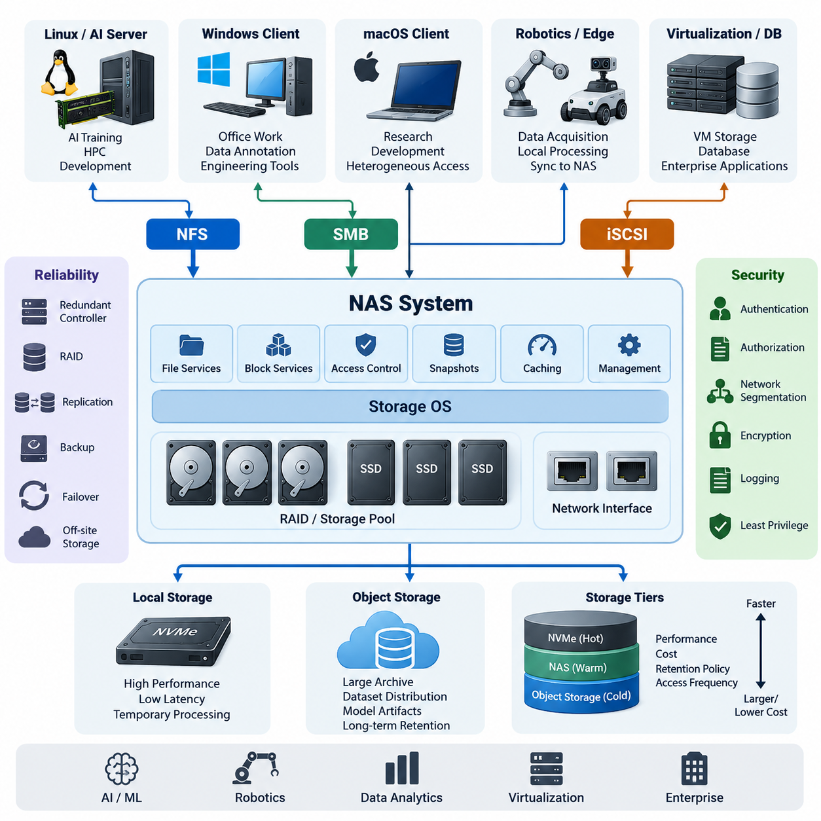
Network Attached Storage provides shared storage services over an IP network and is widely used in AI laboratories, robotics platforms, enterprise data centers, and distributed development environments. Instead of attaching disks directly to individual computers, a NAS system centralizes storage capacity and exposes data through network protocols. This architecture simplifies sharing, backup, access control, capacity expansion, and lifecycle management while allowing heterogeneous systems to work with common datasets.
A typical NAS architecture consists of physical storage devices, a storage operating system, network interfaces, protocol services, and client machines. Hard disk drives or SSDs are organized through RAID, storage pools, or similar redundancy mechanisms. Above this physical layer, the NAS operating system manages volumes, permissions, snapshots, caching, and network services. Clients access these resources through protocols such as NFS, SMB, while block-oriented environments may use iSCSI.
NFS, or Network File System, is a file-level protocol traditionally associated with Linux and UNIX environments. A server exports directories, and remote clients mount them into their local directory trees. Applications can therefore interact with remote files using familiar filesystem operations. This makes NFS particularly convenient for Linux-based AI servers, GPU workstations, robotics development machines, shared source repositories, and large scientific datasets.
Modern NFS implementations support stronger security, improved locking, parallel workloads, and more efficient communication than earlier versions. NFSv4 integrates features such as stateful operation and enhanced authentication mechanisms, while enterprise deployments can combine NFS with Kerberos and centralized identity services. Performance depends heavily on network bandwidth, latency, server caching, storage media, metadata activity, and the access patterns generated by applications.
SMB, or Server Message Block, is another file-level storage protocol and is deeply integrated with Windows environments. Users typically see SMB resources as shared folders or mapped network drives. Windows authentication, Active Directory integration, access control lists, file locking, and familiar administrative tools make SMB especially suitable for organizations where Windows desktops and application servers constitute a significant portion of the computing infrastructure.
SMB is not limited to Windows. Linux, macOS, NAS appliances, and many embedded platforms can access SMB shares, making it useful for heterogeneous environments. In robotics or AI organizations, researchers may use Linux GPU machines while administrative users and annotation teams use Windows workstations. A NAS can expose selected datasets through both NFS and SMB, allowing different clients to access centralized storage through protocols appropriate to their operating environments.
NFS and SMB operate primarily at the file level. The server maintains the filesystem and presents files and directories to clients. This architecture differs fundamentally from iSCSI, which provides block-level storage. With iSCSI, a storage server exposes logical block devices called LUNs across an IP network. The client sees the remote resource much like a locally attached disk and normally creates and manages its own filesystem on that device.
Because iSCSI operates below the filesystem layer, it is useful when an application or operating system expects direct block storage. Virtualization platforms, database servers, clustered infrastructure, backup systems, and specialized enterprise applications may use iSCSI volumes. The client has greater control over filesystem formatting and block organization, but this also introduces operational responsibilities that are different from ordinary shared-folder administration.
The distinction between file sharing and block storage becomes especially important when multiple computers need simultaneous access. NFS and SMB are explicitly designed around shared filesystem access and coordinate file operations through their protocol semantics. A conventional iSCSI LUN, however, should not simply be mounted read-write by several independent hosts using an ordinary filesystem. Multi-host block access generally requires a cluster-aware filesystem or another coordination mechanism.
Protocol selection should therefore begin with workload requirements rather than theoretical protocol performance. NFS is often a natural choice for Linux-centric compute clusters, AI training servers, container hosts, and robotics development systems. SMB is usually preferable when Windows integration, user-oriented file sharing, office workflows, or Active Directory permissions are important. iSCSI becomes attractive when software requires a disk-like block device instead of a network filesystem.
Performance comparisons must also consider the complete data path. A 10, 25, or 100 Gigabit Ethernet connection cannot deliver its theoretical throughput if the underlying disk array, NAS processor, filesystem, or client application becomes the bottleneck. Conversely, an all-flash array can remain underutilized when connected through a slow network. Queue depth, file size, metadata operations, concurrent users, caching behavior, and sequential versus random access can significantly alter observed performance.
Large AI datasets illustrate these differences clearly. Training workloads that continuously read large image, video, point-cloud, or tensor files may benefit from high-bandwidth NFS combined with local caching and fast network interfaces. Workloads containing millions of tiny files can become metadata-bound even when raw network bandwidth is abundant. Dataset packaging, sharding, prefetching, local NVMe caches, and parallel data loaders can therefore matter as much as the selected storage protocol.
Robotics systems introduce another dimension because data is generated continuously by cameras, LiDAR, radar, microphones, telemetry systems, and simulation environments. Edge computers may initially write data to local SSDs and later synchronize it with centralized NAS storage. NFS can serve Linux processing pipelines, while SMB can expose validated datasets to Windows-based annotation or engineering tools. This hybrid approach separates real-time acquisition requirements from centralized data management.
Reliability should be designed independently from protocol choice. RAID protects against certain disk failures but does not replace backup, and a NAS itself can remain a single point of failure unless redundancy is implemented. Production architectures may include redundant controllers, multiple network interfaces, link aggregation, failover paths, snapshots, replication, immutable backup copies, and off-site storage. Recovery objectives should determine how much redundancy and replication are economically justified.
Security must also extend beyond simple username and password protection. Storage networks should use appropriate segmentation, firewall policies, least-privilege permissions, identity management, encryption where required, logging, and administrative separation. NFS exports should be restricted to authorized clients and networks, SMB shares should apply carefully designed access control policies, and iSCSI environments should restrict initiators and targets while protecting the storage network from unauthorized access.
NAS architecture increasingly operates together with object storage rather than replacing it. NAS protocols provide familiar filesystem semantics, hierarchical directories, and compatibility with conventional applications. Object storage organizes data as objects inside logical namespaces or buckets and commonly exposes access through APIs. Large-scale AI repositories can therefore use NAS for active engineering workflows while object storage supports massive archives, dataset distribution, model artifacts, and long-term retention.
A practical architecture may consequently combine several storage tiers. Local NVMe storage handles latency-sensitive processing, centralized NFS or SMB storage supports collaborative datasets, iSCSI supplies block devices to specialized infrastructure, and object storage provides scalable repositories for less filesystem-dependent information. Data can migrate between these tiers according to performance requirements, project status, retention policy, cost, and frequency of access.
For Physical AI and robot fleet environments, this layered model becomes particularly valuable. Robots and edge computers generate operational data locally, on-premise servers aggregate and preprocess selected streams, NAS systems provide controlled shared workspaces, and object storage preserves large historical collections. Training systems can retrieve curated subsets without forcing every robot, workstation, and GPU server to interact with the same storage technology.
Ultimately, NFS, SMB, and iSCSI represent different storage abstractions rather than interchangeable network protocols. NFS emphasizes shared file access in Linux-oriented environments, SMB provides rich file-sharing integration across Windows and heterogeneous clients, and iSCSI delivers network-based block devices for workloads requiring disk semantics. Effective NAS design combines these technologies according to workload behavior, operating systems, security boundaries, scalability requirements, and the broader AI data lifecycle.

07.02 Robot Edge NAS Design: Sensor Data Local Storage
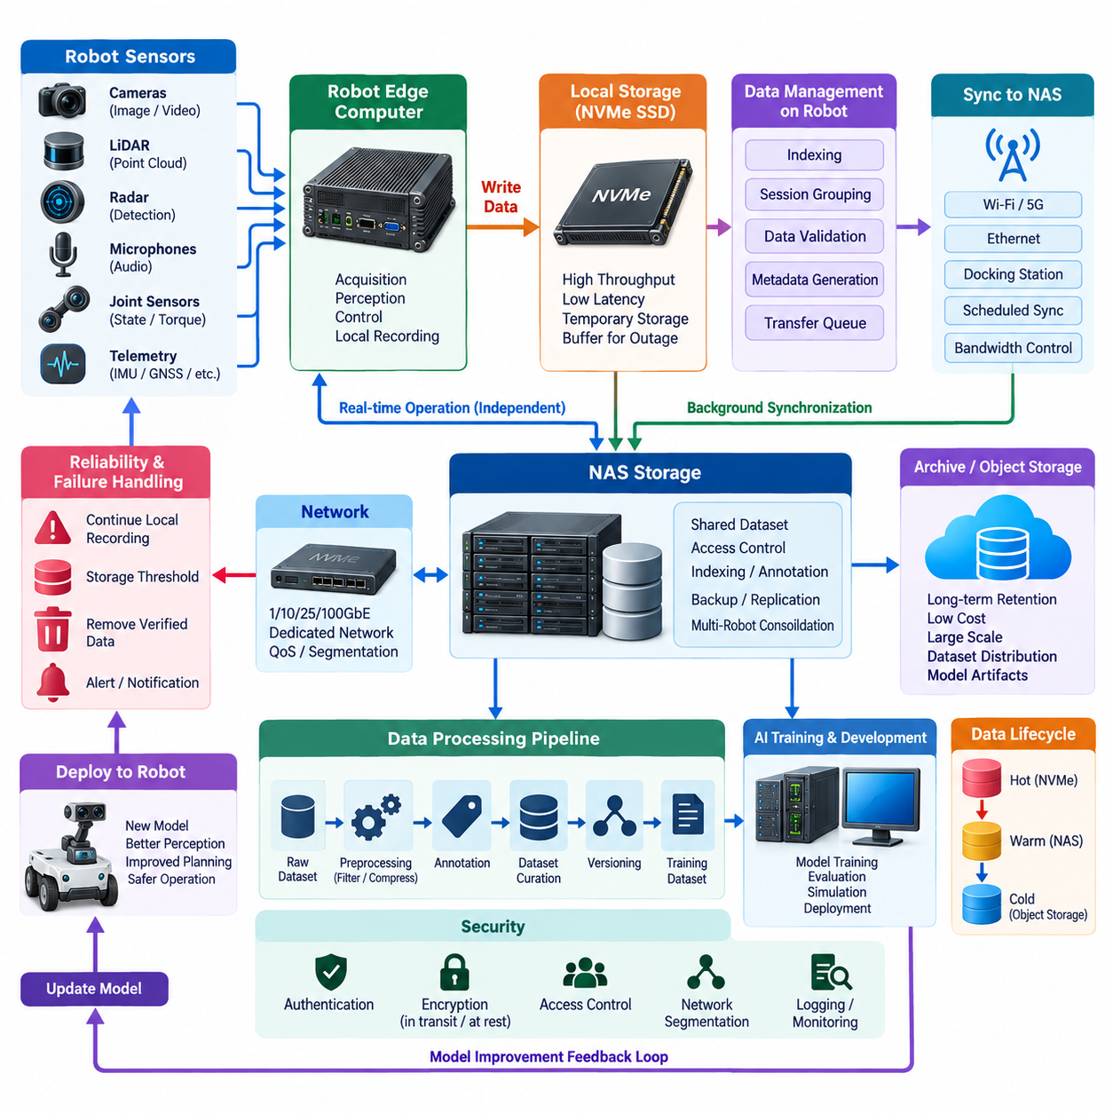
Robot edge storage architecture is designed around a fundamental constraint: sensor data is generated continuously at the physical edge, while network connectivity and centralized storage cannot always guarantee matching bandwidth, latency, or availability. Cameras, LiDAR, radar, microphones, joint sensors, force sensors, and telemetry streams therefore require local storage capable of absorbing data immediately before selected information is transferred to a NAS or other central repository.
A robot may generate multiple synchronized data streams with very different characteristics. High-resolution cameras produce large sequential image or video streams, LiDAR generates dense point clouds, and control systems create smaller but highly frequent state messages. These streams must often preserve timestamps and relationships between sensors. Storage design must therefore consider not only total capacity but also sustained write throughput, latency, metadata overhead, synchronization, and temporary traffic bursts.
Local NVMe SSDs are particularly useful as the first storage tier because they provide high throughput and low latency without depending on the network. During robot operation, sensor acquisition processes can write directly to local storage while perception and control applications continue executing independently. This prevents temporary network congestion or NAS unavailability from interrupting data collection and reduces the risk that real-time workloads compete with remote storage traffic.
The local storage layer should normally be treated as an operational buffer rather than the permanent system of record. Raw sensor streams can first be captured locally, validated, indexed, and grouped into sessions or missions. Once the robot reaches an appropriate synchronization point, selected data can be transferred to centralized NAS storage. This separation allows the acquisition pipeline to prioritize deterministic collection while centralized infrastructure handles collaboration, retention, and larger-scale processing.
Capacity planning begins with the aggregate data generation rate. If several cameras, LiDAR units, and other sensors collectively generate hundreds of megabytes per second, even a multi-terabyte SSD can fill quickly. Designers should estimate sustained and peak rates, expected mission duration, compression ratios, reserved free space, and synchronization delay. Storage sizing should include safety margin so that unexpected network outages do not immediately stop data acquisition.
Data reduction can significantly decrease storage pressure, but it must be applied according to the purpose of the dataset. Video compression, point-cloud filtering, frame sampling, region-of-interest extraction, and event-based recording can reduce volume. However, aggressively discarding raw information may prevent future model development or failure analysis. Important experiments may therefore preserve raw streams while routine fleet operations retain only events, features, or selected intervals.
A useful edge architecture separates hot operational data from data waiting for synchronization. Active sensor files are written into a temporary capture area, while completed and validated sessions move into a transfer queue. A synchronization service then copies queued data to the NAS according to available bandwidth and priority. Successfully transferred files can be verified through size checks, hashes, manifests, or other integrity mechanisms before local copies become eligible for deletion.
This staged workflow is important because file transfer completion does not automatically prove data integrity. Interrupted transfers, partial files, storage failures, or application crashes can create inconsistencies between the robot and NAS. Each dataset session should therefore contain metadata describing the robot, sensors, timestamps, software versions, calibration information, mission identifiers, and expected files. Checksums can confirm that centralized copies match the original edge data.
NAS storage acts as a shared consolidation layer for data collected from multiple robots and edge computers. Instead of allowing training servers or engineers to retrieve large datasets directly from individual robots, each robot synchronizes validated data into a controlled namespace. Central servers can then perform indexing, annotation, quality analysis, dataset construction, backup, and AI training without placing additional computational or network load on operational robots.
Directory and naming conventions become increasingly important as the fleet grows. A simple structure may organize data by robot identifier, date, mission, sensor, and recording session. More advanced systems can maintain a metadata catalog independently from the physical directory structure. The goal is to ensure that a dataset remains traceable even after files have moved from robot SSDs to NAS volumes, archives, object storage, or model-development environments.
Time synchronization is especially important for multimodal robotics datasets. Camera images, LiDAR scans, joint states, localization estimates, and control commands may need to be reconstructed as one physical event. Precision Time Protocol, hardware timestamps, synchronized clocks, or platform-specific timestamp mechanisms can establish temporal relationships. Storage must preserve these timestamps rather than relying only on filesystem creation or modification times.
Network architecture determines how quickly edge storage can be drained into the NAS. Gigabit Ethernet may be adequate for moderate datasets but can become a bottleneck when several robots upload large recordings simultaneously. Higher-speed Ethernet, dedicated data networks, Wi-Fi, or scheduled synchronization windows can be used depending on deployment conditions. Upload policies can also prioritize critical logs and metadata before transferring large raw sensor files.
Bandwidth-aware synchronization is particularly valuable for mobile robots. A robot may operate in areas with unstable wireless connectivity and later return to a docking station with reliable high-speed networking. During operation, only compact telemetry or important events may be transmitted immediately. Large camera and LiDAR recordings remain on local SSDs and are synchronized after docking, reducing dependence on continuous high-bandwidth wireless communication.
The edge system should also protect real-time robot functions from storage overload. Sensor recording, AI inference, localization, navigation, and control may share the same compute platform. If background synchronization consumes excessive CPU, memory, disk bandwidth, or network capacity, robot performance can degrade. Resource limits, transfer throttling, process priorities, separate storage devices, and scheduled synchronization can isolate data-management activity from mission-critical workloads.
Failure handling should be designed explicitly. If the NAS becomes unreachable, local recording should continue until a defined storage threshold is reached. If available capacity falls below a warning level, the system can prioritize important sessions, remove verified temporary data, reduce nonessential recording, or notify operators. Automatic deletion should never depend solely on file age when data has not yet been confirmed as safely transferred and retained elsewhere.
Security must follow the data across both edge and centralized storage. Robots should authenticate before writing to NAS destinations, and each device should receive only the permissions required for its assigned namespace. Sensitive datasets may require encryption at rest and in transit. Network segmentation can separate robot control traffic from bulk storage transfers, reducing the possibility that large synchronization workloads or unauthorized access affect operational communication.
A complete design should also distinguish NAS from backup and long-term archive storage. The NAS may contain active datasets used by engineers and training systems, but accidental deletion, ransomware, hardware failure, or administrative errors can still affect shared storage. Snapshots, replication, immutable backups, and object-storage archives provide additional protection. Data lifecycle policies can move older raw datasets away from expensive high-performance NAS capacity.
For AI development, the centralized dataset should not be treated as an uncontrolled collection of files. Raw robot recordings can pass through validation, preprocessing, annotation, curation, and versioning stages before becoming training datasets. A model should be traceable to the dataset version used for training, while the dataset should remain traceable to original robot sessions. This lineage supports reproducibility, debugging, safety analysis, and future model improvement.
A scalable fleet architecture therefore forms a continuous data path from sensor to edge storage, centralized NAS, and eventually archive or object storage. Local NVMe provides fast temporary absorption, NAS provides shared operational storage, and colder tiers provide economical long-term retention. Metadata, integrity verification, synchronization policies, and lifecycle rules connect these physical tiers into one manageable data system rather than a collection of independent disks.
In Physical AI systems, this architecture creates a feedback loop between physical operation and model development. Robots generate multimodal experience, edge computers preserve it reliably, NAS infrastructure consolidates and organizes it, and AI pipelines transform selected data into improved perception, planning, and control models. Updated models can then return to edge systems, producing new operational data and continuously expanding the organization's reusable physical-world knowledge.

07.03 MinIO Object Storage: Self-Hosted Setup [w/Code]
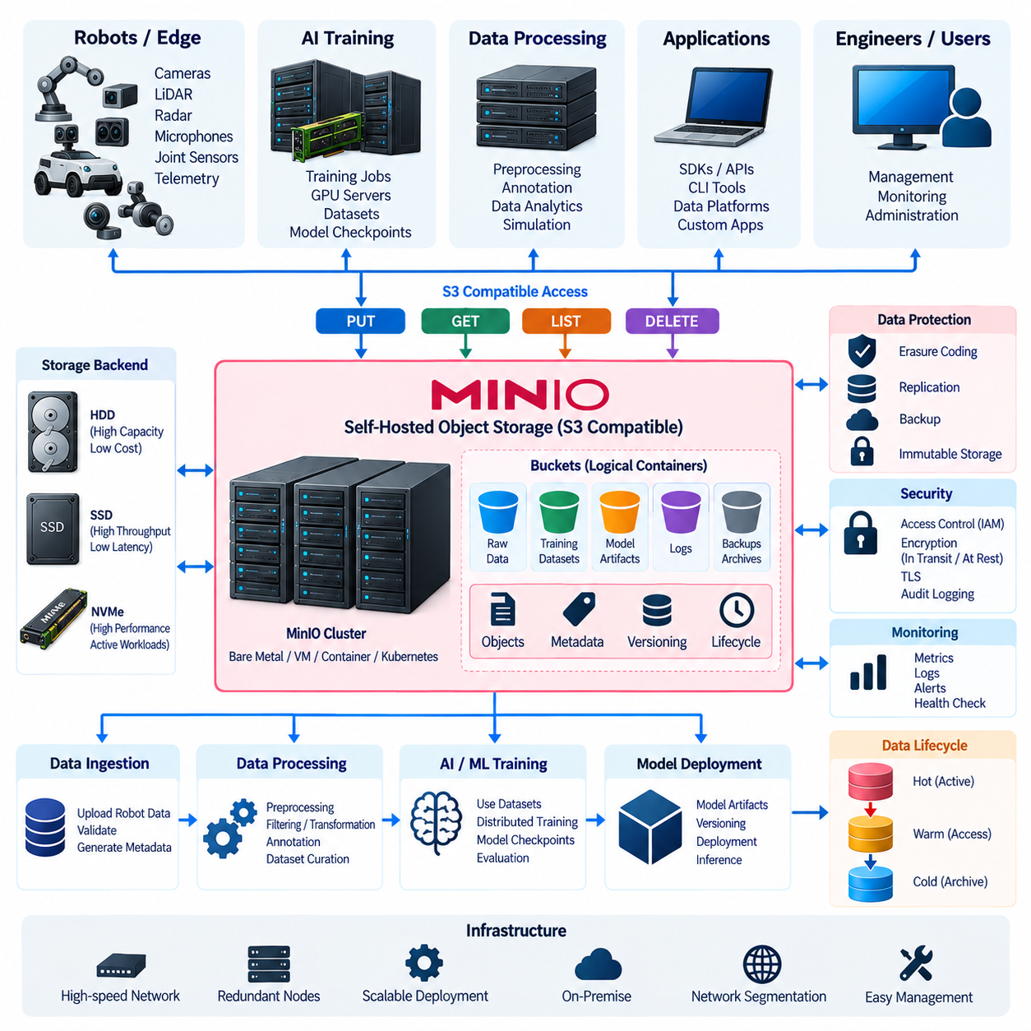
MinIO is a self-hosted object storage platform designed around an S3-compatible application programming interface. Unlike traditional NAS systems that expose hierarchical filesystems through NFS or SMB, MinIO stores data as objects inside buckets. Applications interact with those objects through APIs, SDKs, command-line tools, or compatible data platforms, making the architecture suitable for AI datasets, model artifacts, backups, logs, and large binary data collections.
Object storage organizes information differently from conventional filesystem storage. Each object contains data, an object name or key, and associated metadata, while buckets provide logical containers for groups of objects. Applications do not normally mount these objects as ordinary local directories. Instead, they perform operations such as PUT, GET, LIST, and DELETE through the S3-compatible interface, which separates application-level data access from the physical arrangement of disks.
A self-hosted MinIO deployment gives an organization direct control over storage hardware, network topology, access policies, and data location. It can run on dedicated servers, virtual machines, containers, or orchestrated infrastructure depending on operational requirements. For AI and robotics environments, this allows large datasets to remain inside an on-premise network while still providing an object-storage interface similar to that used by cloud-native applications.
The simplest deployment may use a single MinIO server with locally attached storage. This configuration is useful for development, experimentation, demonstrations, or workloads where service interruption is acceptable. The server exposes an S3-compatible endpoint and management interface, while applications access named buckets through configured credentials. Production systems, however, generally require stronger redundancy, monitoring, backup, and failure-management strategies.
Storage media should be selected according to workload characteristics rather than capacity alone. HDDs provide economical capacity for large archives and infrequently accessed datasets, while SSDs and NVMe devices provide higher throughput and lower latency for active workloads. AI repositories may combine high-capacity storage for raw datasets with faster storage for frequently accessed training subsets, checkpoints, embeddings, or intermediate processing results.
Distributed object storage can spread data across multiple drives or nodes, improving capacity and resilience. MinIO uses erasure coding techniques to protect data against certain drive or node failures by storing encoded information across available storage resources. This approach differs from simply maintaining one complete copy on every disk and allows storage efficiency and fault tolerance to be balanced according to the deployed topology.
Erasure coding should not be confused with backup. Redundancy can keep a service available when hardware components fail, but it does not automatically protect against accidental deletion, compromised credentials, software errors, or destructive administrative actions. A complete architecture therefore combines storage-level resilience with versioning, replication, immutable retention where appropriate, independent backups, and recovery procedures tested before an actual incident occurs.
Network design becomes critical when MinIO serves large AI or robotics datasets. A storage cluster may contain enough disks to deliver several gigabytes per second, but clients cannot use that performance if network links become the bottleneck. High-speed Ethernet, redundant interfaces, suitable switching infrastructure, balanced client connections, and careful separation of storage traffic from latency-sensitive robot-control networks can improve predictable system behavior.
Buckets should represent meaningful administrative or lifecycle boundaries rather than arbitrary folders. An organization might separate raw robot recordings, curated training datasets, synthetic data, model checkpoints, deployment artifacts, and long-term archives into different buckets. Object prefixes can provide additional logical organization inside each bucket, while metadata and tags can describe project identifiers, robot sources, dataset versions, retention classes, or processing status.
Access control is fundamental because object storage often consolidates valuable datasets from many projects. Administrative credentials should not be embedded in ordinary applications. Separate users, service accounts, access keys, and policies can restrict each workload to required buckets and operations. A training pipeline may receive read access to curated datasets and write access to model-output locations without receiving permission to delete original robot recordings.
Encryption can protect data both while stored and while moving across the network. Transport Layer Security should be used to protect S3-compatible API traffic, particularly when clients operate across shared or untrusted networks. Depending on infrastructure requirements, server-side encryption and external key-management mechanisms can provide additional protection for stored objects. Key lifecycle and recovery procedures must be designed together with encryption.
MinIO can become part of an AI data pipeline rather than functioning only as passive storage. Data ingestion services can upload robot sessions, preprocessing systems can retrieve raw objects and generate derived datasets, annotation pipelines can store labels, and training systems can consume versioned collections. Model checkpoints and final artifacts can then return to object storage, creating a common repository across multiple stages of model development.
This architecture is especially useful when datasets become too large or distributed for conventional workstation-oriented file sharing. Training jobs running on multiple GPU servers can access objects through standard APIs without requiring every system to share identical filesystem mount configurations. Containerized workloads can receive endpoint and credential information dynamically, while data-management software can interact with the same storage through compatible S3 libraries.
Object naming requires careful design because an object store should not be treated exactly like a conventional filesystem. Keys can appear hierarchical by using separators such as slashes, but this hierarchy is primarily logical. A consistent naming scheme can encode dataset family, acquisition date, robot identifier, mission, sensor, or version. However, important searchable attributes should also be maintained in metadata catalogs rather than relying entirely on long object names.
Large files can be transferred efficiently through multipart upload mechanisms. Instead of requiring an entire large dataset archive to be uploaded as one uninterrupted operation, multipart transfers divide an object into parts that can be transmitted and retried independently. This is valuable for large video recordings, simulation outputs, model checkpoints, and packaged datasets, particularly when network connections may occasionally experience interruptions or variable throughput.
Data integrity should be verified throughout ingestion and migration workflows. Applications can maintain checksums, manifests, object counts, expected sizes, and dataset-level metadata before deleting source copies. A successful API response alone should not be the only criterion for removing valuable robot data. Validation procedures should confirm that expected objects exist, their contents are intact, and required metadata has been preserved in the destination repository.
Versioning can provide protection and reproducibility when objects change over time. Instead of immediately replacing the only available copy of an object, version-enabled storage can retain previous versions according to configured policies. For AI development, dataset releases should ideally be immutable or explicitly versioned so that a training experiment can later identify the exact data collection, labels, preprocessing results, and model artifacts used during execution.
Lifecycle management helps prevent high-performance storage from becoming an unlimited accumulation point. Policies can expire temporary objects, retain important datasets, or move information toward colder storage according to age and operational value. Raw sensor recordings may initially remain in active object storage, curated subsets may stay readily accessible for repeated training, and older archives can migrate to lower-cost capacity designed primarily for retention.
Monitoring should cover both infrastructure health and application-level behavior. Administrators need visibility into disk utilization, capacity growth, network throughput, request latency, error rates, node availability, and failed operations. Alerts can identify conditions such as rapidly declining free capacity or unavailable storage components before they become service interruptions. Logs and audit information also support security investigation and operational troubleshooting.
MinIO and NAS storage can coexist within the same architecture because they solve different access problems. NAS provides filesystem semantics that are convenient for engineers, legacy applications, and interactive file workflows, while MinIO provides object APIs suited to scalable datasets, automation, cloud-native applications, and programmatic pipelines. Data can move between these systems according to lifecycle stage instead of forcing every workload onto a single storage abstraction.
In a Physical AI environment, robots may first capture high-rate sensor streams onto local NVMe storage and later synchronize validated sessions to NAS. Data-ingestion processes can subsequently package or transform selected datasets and place them into MinIO buckets for long-term management, distributed training, or model development. This separates real-time robot acquisition, collaborative engineering storage, and scalable object-oriented dataset management into appropriate layers.
A mature self-hosted MinIO architecture therefore extends beyond installing an object-storage server. It requires deliberate decisions about hardware, redundancy, networking, bucket organization, identities, encryption, versioning, lifecycle rules, observability, backup, and disaster recovery. When these elements are designed together, MinIO can provide an on-premise S3-compatible data foundation connecting robot-generated experience with AI training, model management, and long-term organizational knowledge.

07.04 Amazon S3 API Compatible Storage Client [w/Code]
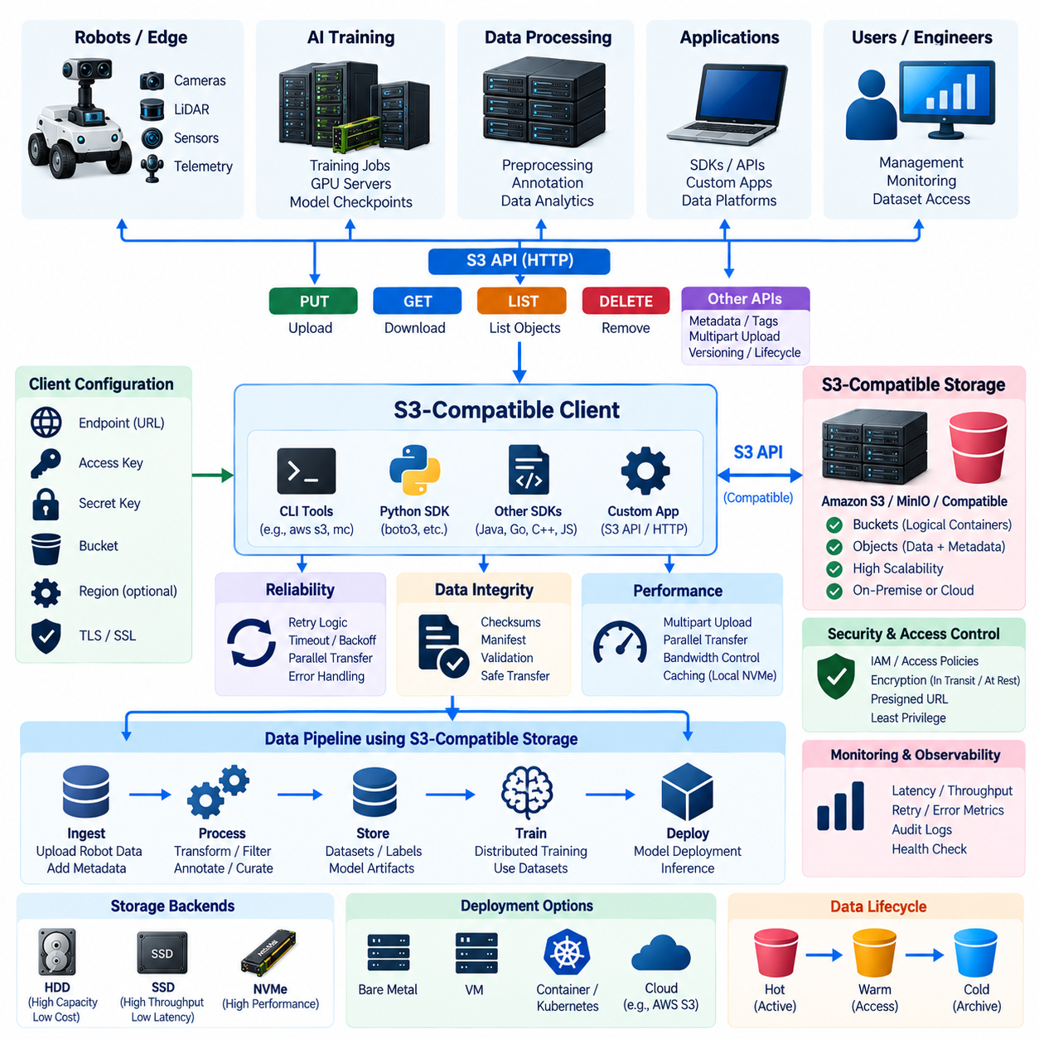
Amazon S3 API-compatible storage clients provide a standardized way for applications to communicate with object storage systems through interfaces modeled on Amazon Simple Storage Service. Instead of depending on a particular storage appliance or filesystem, software communicates with an endpoint using HTTP-based requests, credentials, bucket names, and object keys. This abstraction allows similar application logic to work with cloud S3 services and compatible self-hosted platforms.
The fundamental data model consists of buckets and objects. A bucket acts as a logical container, while each object contains data, an object key, and associated metadata. Unlike conventional filesystems, applications do not normally navigate physical directories or disk volumes. Keys may contain slash characters that create a directory-like appearance, but the client ultimately addresses objects through API operations against a storage endpoint.
The most common client operations correspond to creating, retrieving, listing, and deleting objects. PUT requests upload data, GET requests retrieve it, LIST operations discover objects or prefixes, and DELETE removes selected objects when permitted. Additional operations can manage metadata, object tags, multipart uploads, versions, lifecycle configurations, and access policies. These capabilities allow storage interaction to become part of automated data pipelines rather than manual file management.
An S3-compatible client requires several configuration elements before establishing a connection. These normally include the endpoint address, access key, secret key, target bucket, region information when required, and transport-security settings. Cloud services may use public endpoints, while an on-premise deployment may expose an internal hostname or IP-based endpoint. Applications should obtain these settings from secure configuration rather than embedding sensitive credentials directly in source code.
Authentication determines which identity is making a request, while authorization determines which operations that identity may perform. S3-compatible systems commonly use access-key credentials together with request-signing mechanisms. Policies can then restrict users or service accounts to specific buckets, prefixes, or operations. A robot ingestion service, for example, may be allowed to upload objects without receiving permission to delete historical training datasets.
Client software exists at several abstraction levels. Command-line clients are convenient for administrators and interactive testing, while software development kits allow applications written in Python, Java, C++, Go, JavaScript, and other languages to access object storage programmatically. Higher-level AI frameworks and data platforms may integrate S3-compatible access directly, enabling training pipelines to consume remote datasets without implementing low-level HTTP requests themselves.
Python-based AI workflows commonly use an S3 SDK or compatible library to create clients and perform object operations. Once configured, an application can upload sensor recordings, enumerate dataset objects, download selected samples, or write model checkpoints. The same application architecture can often target different compatible storage systems by changing endpoint and credential configuration, although implementation-specific differences should always be tested before assuming complete interchangeability.
S3 compatibility does not necessarily mean that every implementation supports every Amazon S3 feature identically. Core object operations are broadly interoperable, but behavior involving identity management, lifecycle policies, replication, event notifications, encryption, versioning, or specialized extensions can differ between platforms. Client applications should therefore identify the specific API features they depend on and validate those features against the selected storage implementation.
Large-object transfer requires more consideration than uploading small configuration files. Multipart upload divides a large object into independently transferred parts and later combines them into the final object. Failed parts can be retried without retransmitting the entire dataset. This improves resilience for large robot videos, point-cloud archives, simulation outputs, model checkpoints, and packaged AI datasets transferred across networks with variable throughput.
Parallel transfers can further increase throughput when storage, network, and client resources are capable of handling concurrent requests. However, increasing concurrency without limits can overload network links, storage nodes, CPU resources, or robot edge computers. Production clients should control worker counts, connection pools, timeouts, retry behavior, and bandwidth consumption according to workload priorities rather than simply maximizing the number of simultaneous transfers.
Retry logic is essential because distributed storage operations can fail temporarily. Network interruptions, overloaded services, transient server errors, and connection timeouts do not always indicate permanent failure. Well-designed clients distinguish retryable errors from authentication failures, invalid requests, or missing objects. Exponential backoff and bounded retry policies can improve reliability while preventing large fleets of clients from repeatedly overwhelming a recovering storage service.
Data integrity should be verified independently of application-level assumptions. Upload workflows can maintain object sizes, checksums, manifests, session identifiers, and expected object counts. After transfer, validation processes can confirm that all required objects exist and that the destination contains the expected data. Robot-side source files should remain protected until the system has sufficient evidence that centralized copies have been transferred and validated successfully.
Object metadata provides useful context without modifying the object payload itself. A robotics pipeline can associate attributes such as robot identifier, sensor type, acquisition time, mission identifier, calibration version, software release, or dataset status with uploaded objects. Tags can support lifecycle or administrative classification. For large repositories, important metadata should also be indexed in a dedicated catalog or database to enable efficient search and dataset discovery.
Object keys should follow a consistent naming convention. A key might logically represent a project, robot, date, mission, sensor, and filename, allowing humans and software to understand the object's origin. Nevertheless, object names should not become the only source of dataset semantics. Structured metadata, manifests, and catalogs provide stronger mechanisms for maintaining provenance when data is reorganized, transformed, copied, or incorporated into new dataset versions.
Security should protect both credentials and transferred data. Transport Layer Security encrypts communication between the client and storage endpoint, while server certificate validation helps prevent connections to unintended systems. Credentials should be stored in protected environment variables, secret-management systems, workload identities, or other controlled mechanisms. Logging should avoid exposing secret keys, authentication tokens, or other reusable security information.
Least-privilege access is especially important when many robots, users, and AI pipelines share the same object-storage infrastructure. Individual services should receive only the permissions needed for their functions. Data ingestion clients may write to designated raw-data locations, training systems may read approved datasets, and deployment pipelines may access model artifacts. Separating these permissions reduces the impact of compromised or incorrectly configured clients.
Presigned URLs provide another useful access mechanism. A trusted service can generate a time-limited URL that permits a specific object operation without distributing long-lived storage credentials to the recipient. This can support temporary downloads, uploads from controlled external processes, dataset exchange, or application workflows. Expiration periods and permitted operations should be limited according to the intended use and security requirements.
S3-compatible clients can bridge edge robotics infrastructure and centralized AI systems. A robot may first record high-rate data to local NVMe storage and later run an ingestion client when suitable connectivity becomes available. The client packages or selects completed sessions, attaches metadata, uploads objects, verifies successful transfer, and updates local state. Large transfers can be deferred until the robot reaches a high-bandwidth docking or maintenance network.
Centralized processing systems can use the same API model in the opposite direction. Preprocessing workers retrieve raw objects, produce transformed data, and upload new results. Annotation services store labels, training systems consume curated datasets, and model pipelines write checkpoints and deployment packages. Because each stage communicates through object APIs, compute resources can scale independently from the underlying storage infrastructure.
Caching can improve performance when the same remote objects are accessed repeatedly. GPU training nodes may copy frequently used shards to local NVMe storage while treating object storage as the authoritative repository. This reduces repeated network transfers and can improve accelerator utilization. Cache policies must still preserve dataset identity so that a locally cached object cannot silently substitute for a different or newer dataset version.
Versioning and immutable dataset practices improve reproducibility. Training code should identify the exact dataset release, manifest, preprocessing configuration, and model artifacts associated with an experiment. When storage supports object versioning, previous object states can be retained according to policy. Dataset-level manifests can additionally record expected keys and checksums, creating a stable reference even when the repository contains many evolving projects.
Observability should be incorporated into client design rather than added only after failures occur. Useful measurements include request latency, transfer throughput, uploaded and downloaded bytes, retry counts, failed operations, authentication errors, and queue depth. Combined with storage-side metrics and audit logs, these signals help administrators determine whether performance problems originate from clients, networks, storage services, or application behavior.
In a Physical AI architecture, the S3-compatible client becomes a portable data interface connecting robots, edge computers, NAS-based staging areas, object storage, GPU training systems, and model-management services. It decouples applications from specific physical disks while preserving controlled access to large datasets. Combined with metadata, integrity verification, security, versioning, and lifecycle policies, this interface supports a scalable path from physical-world data acquisition to AI training and model deployment.

07.05 Robot Log / Sensor Bag Object Storage Pipeline [w/Code]
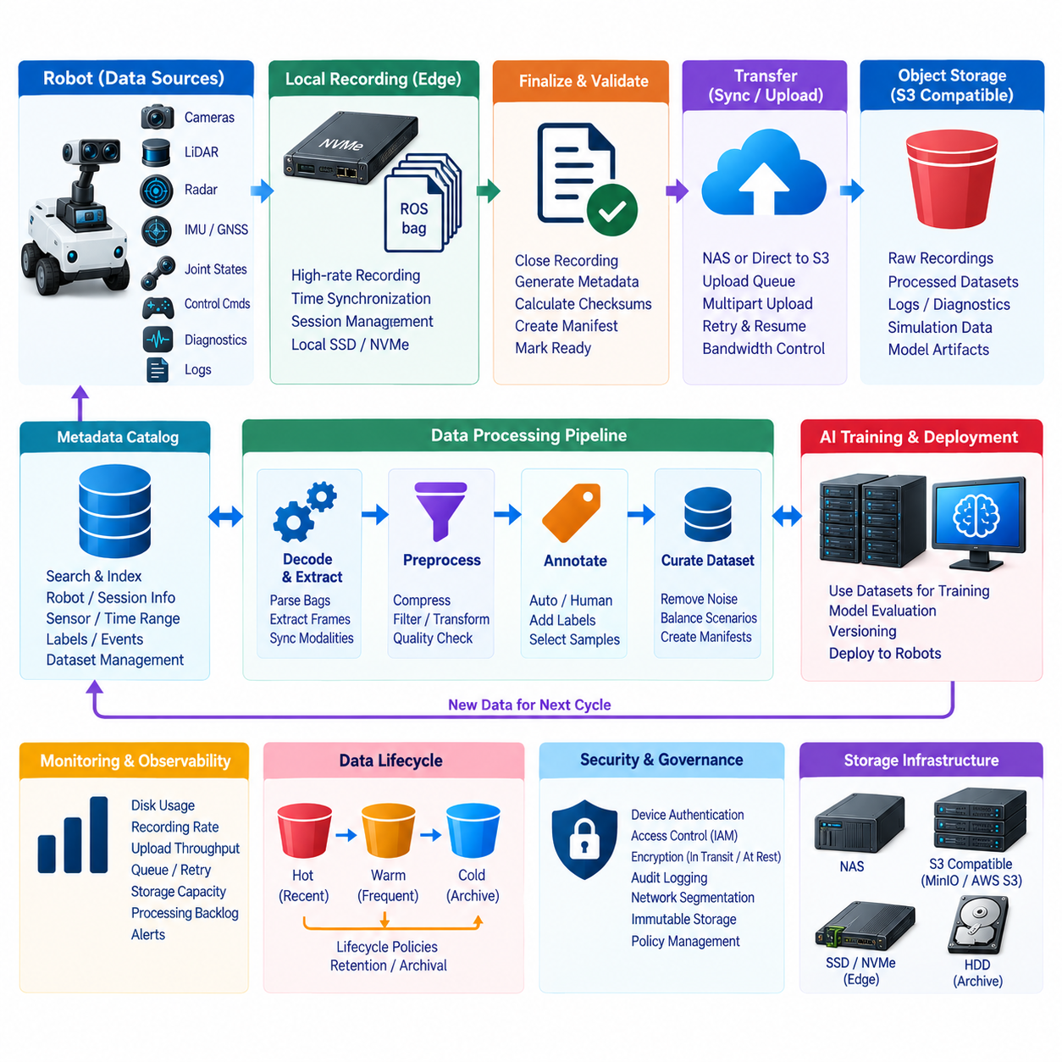
A robot log, sensor bag, and object storage pipeline provides a structured path for moving operational data from physical robots into reusable engineering and AI repositories. Robots continuously generate camera frames, LiDAR scans, radar measurements, IMU signals, GNSS data, joint states, control commands, diagnostics, and software logs. The pipeline must capture these heterogeneous streams reliably while preserving the context required to reconstruct what happened during operation.
Robot data is commonly recorded as sessions or bag-like containers rather than as unrelated individual files. ROS and similar middleware environments can serialize multiple topics with timestamps into recording structures that preserve temporal relationships between sensors and software components. A session may contain perception inputs, localization outputs, planner decisions, actuator commands, and diagnostic events, allowing engineers to replay an operational sequence later for debugging, validation, or model development.
The first stage of the pipeline is local acquisition on the robot or edge computer. High-rate sensor streams should normally be written to local SSD or NVMe storage rather than directly to remote object storage. Local recording isolates acquisition from wireless instability, network congestion, and temporary backend outages. Perception, localization, planning, and control processes can continue operating while the storage layer absorbs sequential sensor data with predictable latency.
Recording software should organize data around explicit session boundaries. A mission start, experiment identifier, route, operator command, or defined time interval can create a new recording session. Each session should have a unique identifier and associated metadata describing the robot, software version, sensor configuration, calibration, mission, location context where appropriate, and recording period. This information makes raw data understandable after it leaves the original robot.
Time synchronization is essential because multimodal data only becomes useful when measurements can be correlated accurately. Camera images, LiDAR point clouds, IMU samples, wheel odometry, GNSS measurements, joint states, and control commands may operate at different frequencies. Hardware timestamps, synchronized clocks, PTP, GNSS time, or middleware timestamps should therefore be preserved so that downstream systems can reconstruct the temporal sequence of physical events.
Active recording files should be separated from completed sessions. A file still being written should not be uploaded as though it were complete because the remote copy may represent an inconsistent state. When recording ends, the system can close the bag, finalize indexes, generate metadata, calculate file sizes and checksums, and mark the session as ready for transfer. This creates a clear transition from acquisition to data management.
Large recordings may be divided into chunks according to duration, size, topic group, or operational phase. Chunking prevents one damaged or interrupted transfer from affecting an entire multi-hour mission and allows downstream applications to retrieve only the required portion of a dataset. However, chunk boundaries should preserve enough metadata to reconstruct the original session and maintain relationships among synchronized streams.
A manifest can act as the authoritative description of a completed recording. It may contain the session identifier, expected files or objects, sizes, checksums, recording times, sensor topics, software versions, and processing status. The manifest allows automated systems to determine whether a session is complete without relying only on directory contents. It also becomes useful when the dataset later moves between NAS, object storage, archives, and training environments.
Before transfer, optional preprocessing can reduce storage volume or prepare data for downstream use. Video streams may be compressed, point clouds filtered, diagnostic logs normalized, or privacy-sensitive fields transformed according to policy. Raw data should not be discarded automatically simply because a smaller derived representation exists. Important experiments, incidents, and training sources may require the original measurements for future algorithms or forensic analysis.
The transfer stage moves validated recordings from robot storage into centralized infrastructure. A robot may first synchronize data to a nearby NAS or upload directly to S3-compatible object storage when sufficient connectivity exists. Mobile robots can postpone large transfers until they reach a docking station or maintenance network. Small diagnostic events and critical logs can be transmitted earlier while high-volume sensor bags remain queued locally.
An upload queue provides controlled synchronization between edge storage and the backend. Sessions can be prioritized by operational importance, available bandwidth, age, or storage pressure. The transfer service should support interruption recovery, bounded retries, timeouts, and bandwidth throttling. These controls prevent large uploads from consuming resources required by navigation, perception, teleoperation, or other mission-critical robot functions.
Multipart and parallel uploads can improve transfer efficiency for large bag files or archives. Multipart transfer allows failed portions to be retransmitted independently, while controlled parallelism can increase utilization of high-speed links. Concurrency should still be limited according to robot CPU load, storage bandwidth, network capacity, and backend performance. The objective is reliable ingestion rather than maximum transfer speed at the expense of robot operation.
Object storage provides a scalable destination because recorded sessions can be represented as immutable or versioned objects inside buckets. Separate buckets or logical prefixes may distinguish raw recordings, validated sessions, processed datasets, diagnostic logs, simulation data, and model artifacts. Object keys can encode project, robot, date, mission, and session identifiers while metadata records attributes that should remain searchable independently of naming conventions.
Integrity verification must occur before local recordings become eligible for deletion. The backend should confirm expected object counts, sizes, checksums, and manifest information after upload. A session can then move from states such as recording, finalized, queued, uploading, verifying, and archived. Explicit state management prevents a temporary network failure or incomplete upload from being mistaken for successful long-term preservation.
Centralized metadata services can provide capabilities that object storage alone does not efficiently provide. A database or catalog can index robot identifiers, time ranges, sensor combinations, software versions, labels, events, and dataset membership. Engineers can query the catalog to find relevant sessions and then retrieve the corresponding objects from storage. This separates large binary payloads from structured search and operational metadata.
Once centralized, robot recordings can enter processing pipelines. Workers retrieve selected objects, decode sensor bags, extract frames or point clouds, synchronize modalities, calculate quality metrics, and identify corrupted or incomplete sequences. Derived outputs can be stored as new objects rather than overwriting the original recordings. This preserves provenance and allows processing algorithms to evolve without destroying the source data.
Annotation and curation transform operational recordings into datasets suitable for machine learning. Interesting scenes can be selected based on rare objects, localization failures, planner interventions, environmental conditions, or model uncertainty. Human or automated annotation systems add labels, and curation processes remove unusable samples or balance scenario coverage. Dataset manifests then reference selected source objects and their derived annotations.
Versioning is critical because the same robot session may contribute to multiple dataset releases. Instead of physically duplicating every large sensor recording, dataset definitions can reference immutable source objects through manifests or catalogs. Each release can identify its source sessions, preprocessing configuration, annotations, filtering rules, and checksums. Training experiments can therefore reproduce the exact dataset composition used for a particular model.
Storage lifecycle policies should reflect the different value and access frequency of data. Newly recorded sessions may remain in high-performance storage while engineers validate them. Frequently used training data can stay in a warm tier, whereas older raw bags can migrate to lower-cost archival storage. Critical incident recordings, benchmark datasets, and model-validation evidence may require longer retention than ordinary operational telemetry.
Security and governance must remain consistent across the pipeline. Robots should authenticate to ingestion services using device-specific identities, and write permissions should be limited to designated destinations. Training jobs may receive read-only access to approved datasets, while deletion or retention-policy changes require stronger administrative privileges. Encryption, audit logging, network segmentation, and immutable retention can protect high-value operational data.
Observability helps operators understand both robot-side and backend conditions. Useful metrics include local disk utilization, recording rate, queue depth, upload throughput, retry counts, verification failures, object-storage capacity, and processing backlog. Alerts can identify a robot approaching storage exhaustion or a backend ingestion service falling behind before either condition causes data loss or interferes with normal robot operation.
The complete pipeline forms a data feedback loop for Physical AI. Robots generate experience, edge storage preserves it, synchronization services transfer validated sessions, object storage provides scalable retention, and processing systems convert recordings into searchable and trainable datasets. AI models trained from these datasets can be evaluated, versioned, and deployed back to robots, where they generate new experience that begins the next cycle of collection and improvement.

07.06 Object Storage Lifecycle Policy: Tiering / Deletion [w/Code]
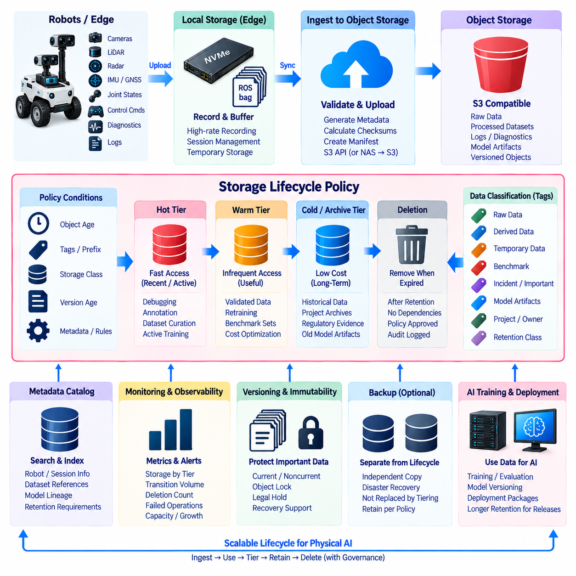
Object storage lifecycle management defines how data changes state as it ages, loses operational value, or reaches the end of its required retention period. Instead of keeping every object indefinitely on the same high-performance storage, lifecycle policies automate transitions between storage tiers and eventual deletion. This reduces cost and capacity pressure while preserving important datasets according to operational, legal, research, and AI-development requirements.
A lifecycle policy is generally evaluated from object attributes such as creation time, version age, prefix, tags, storage class, or other supported metadata. Rules determine what should happen when specified conditions are satisfied. An object may remain in an active tier for several weeks, move to a lower-cost tier after a defined period, enter archival storage later, and finally become eligible for deletion when its retention requirement expires.
Storage tiering separates data according to access frequency, latency requirements, and economic value. A hot tier provides rapid access for recently generated or frequently used information, while a warm tier accommodates data that remains useful but is accessed less often. A cold or archival tier prioritizes capacity efficiency and long-term retention over immediate retrieval performance. The exact implementation depends on the selected object-storage platform and infrastructure.
In robotics environments, newly collected sensor recordings typically begin as hot data because engineers may need to inspect them immediately. Recent missions can contain localization failures, perception anomalies, planner interventions, or valuable training examples. Keeping these objects in readily accessible storage supports debugging, annotation, dataset curation, and repeated processing during the period when their operational value is highest.
As robot recordings age, most sessions are accessed less frequently. Validated data that is no longer part of active engineering work can move to a warm tier while remaining available for occasional analysis or model retraining. This transition releases expensive high-performance capacity for newer workloads. Frequently reused benchmark datasets or important scenario collections can remain warm longer than ordinary operational recordings.
Cold storage is appropriate for data that must be retained but rarely accessed. Historical raw sensor bags, completed project datasets, regulatory evidence, old simulation results, or previous model artifacts may belong in this category. Retrieval can involve greater latency or operational overhead depending on the storage system, so applications should not assume that archived objects behave exactly like objects in an active high-performance tier.
Lifecycle policies should distinguish between raw data and derived data because their long-term value can differ substantially. A derived image, embedding, filtered point cloud, or temporary preprocessing result may be reproducible from an authoritative raw recording. Such derived objects may therefore have shorter retention periods. Conversely, unique physical-world sensor measurements may be impossible to reproduce and can justify substantially longer retention.
Temporary data deserves explicit lifecycle rules. Multipart upload remnants, intermediate processing files, caches, temporary exports, failed-job outputs, and staging objects can accumulate silently and consume significant capacity. Automated expiration policies can remove these objects after an appropriate period. However, deletion conditions should clearly distinguish disposable temporary data from incomplete but potentially valuable ingestion sessions.
Object tags and prefixes can provide practical mechanisms for assigning lifecycle behavior. Objects can be classified as raw, curated, temporary, benchmark, incident, model, or archive data. Additional tags may represent project ownership, retention class, sensitivity, or processing state. Lifecycle engines can then apply different transition and expiration policies without requiring every application to implement independent cleanup logic.
Deletion must be treated as a controlled lifecycle state rather than a simple storage optimization. Before an object expires, the system should determine whether retention obligations, dataset references, active experiments, legal holds, incident investigations, or model-reproducibility requirements still depend on it. Automatic deletion without dependency awareness can permanently break datasets or eliminate evidence needed to explain previously trained models.
Versioned object storage requires additional lifecycle planning because deleting the current object does not necessarily remove previous versions. Old versions can continue consuming substantial capacity even when users no longer see them through normal access patterns. Policies may separately manage current versions, noncurrent versions, and delete markers. Retention rules should preserve versions that support recovery while eventually expiring unnecessary historical copies.
Immutable storage and object locking introduce deliberate restrictions on deletion. Important datasets, audit records, safety evidence, or backup objects may be protected for a defined retention period during which modification or deletion is prohibited. This can protect information against ransomware, compromised credentials, or accidental administrative actions. Lifecycle expiration must therefore respect any active retention or immutability constraints.
Backup and lifecycle management solve different problems. Lifecycle policies control how primary stored objects move and expire, while backups provide independent recovery paths when primary data is lost or corrupted. Moving an object from hot to cold storage is not equivalent to creating a backup. Similarly, deleting an object from active storage should not automatically imply that every independent recovery copy must be removed unless policy explicitly requires it.
Dataset manifests and metadata catalogs help prevent lifecycle automation from losing semantic context. A catalog can record which robot sessions belong to a training dataset, which model was trained from that dataset, and which objects remain required for reproducibility. Before deleting source data, lifecycle services can evaluate references or apply retention classes assigned during dataset curation rather than relying only on object age.
AI model artifacts require their own lifecycle strategy. Temporary checkpoints generated during training may consume large amounts of storage but have limited long-term value. Selected checkpoints, final models, evaluation reports, deployment packages, and datasets associated with released models may need longer retention. Policies can remove redundant intermediate artifacts while preserving enough information to reproduce, audit, or roll back important model releases.
Lifecycle transitions should consider retrieval cost as well as storage cost. Moving large datasets to a cheaper archival tier can reduce monthly storage consumption, but repeatedly restoring those datasets may increase cost, delay experiments, and consume network resources. Access history and workload patterns can therefore inform tiering decisions. Data used regularly for retraining may be more economical to keep in a warmer tier.
Robotic fleet data often has uneven value distribution. Most routine missions may contain repetitive environments, while a small number of sessions capture rare failures, unusual obstacles, safety interventions, or previously unseen conditions. Retention policy should therefore incorporate data value rather than applying identical expiration periods to every recording. Automated event detection and human review can promote important sessions to longer retention classes.
Deletion workflows should include observable state transitions. Objects can move through states such as active, transition scheduled, archived, expiration candidate, deletion approved, and deleted. Logging these transitions creates an audit trail and helps administrators understand why data disappeared. For high-value repositories, deletion events may require additional validation or approval rather than relying entirely on unattended expiration rules.
Monitoring is essential because lifecycle automation can affect millions of objects without direct human interaction. Useful measurements include capacity by storage tier, transition volume, deletion counts, failed lifecycle operations, archive growth, restoration requests, and objects approaching expiration. Dashboards and alerts can reveal incorrect policies, unexpectedly rapid data growth, or archival tiers that are accumulating data faster than planned.
Lifecycle policies should be tested before they are applied broadly. A rule intended for temporary objects can cause severe data loss if its prefix, tag condition, or retention period is incorrect. Administrators can first evaluate policies against test buckets or representative object inventories and inspect the expected transition results. Policy changes should be version-controlled and reviewed like other important infrastructure configurations.
A scalable Physical AI storage architecture can combine local NVMe, NAS, active object storage, and archival object storage as complementary lifecycle stages. Robots initially preserve high-rate data locally, validated sessions move into centralized hot storage, selected datasets remain available for AI development, and older material transitions toward economical retention tiers. Lifecycle automation coordinates these movements according to defined organizational policy.
The complete lifecycle forms a controlled progression from creation to eventual disposal. Data is ingested, validated, classified, actively used, transitioned between tiers, retained according to value and obligation, and finally deleted when no valid dependency remains. When tiering, metadata, versioning, immutability, backup, monitoring, and deletion governance are designed together, object storage can scale without sacrificing traceability, reproducibility, security, or long-term data value.

07.07 Object Storage Versioning and Restoration [w/Code]
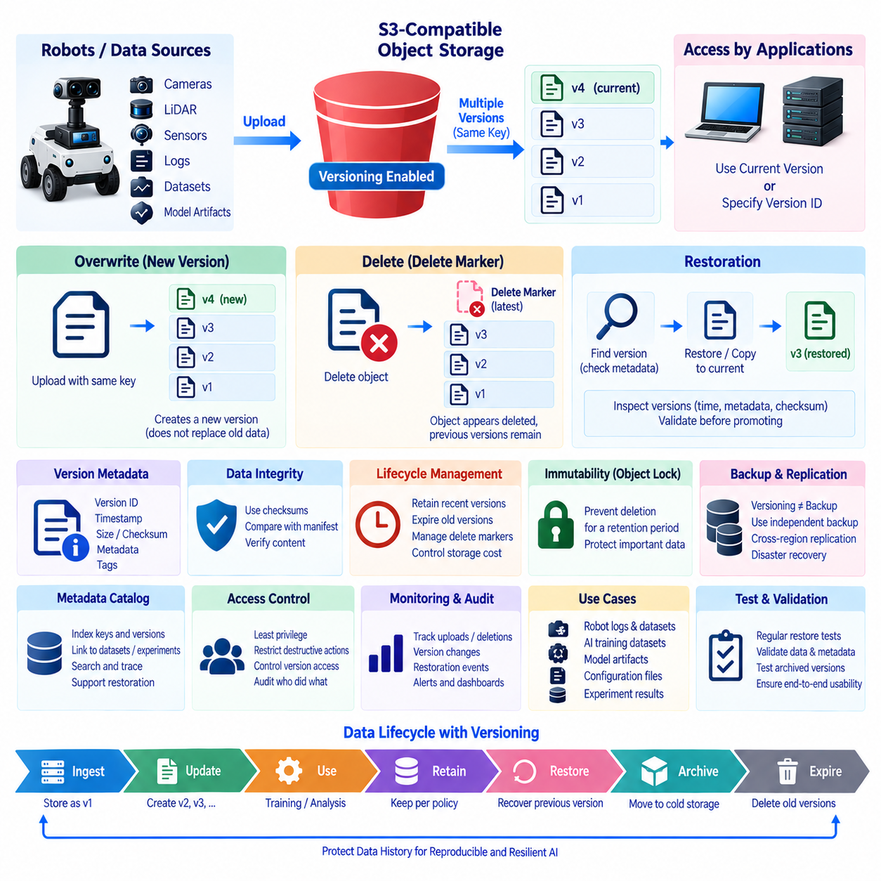
Object storage versioning preserves multiple states of an object under the same logical key, allowing earlier data to remain recoverable after updates or deletions. Instead of treating an overwrite as permanent replacement, the storage system assigns a distinct version identifier to each stored state. This capability is valuable for AI datasets, robot logs, model artifacts, configuration packages, and other information where accidental changes can have significant consequences.
When versioning is enabled for a bucket, uploading an object with an existing key normally creates a new version rather than physically replacing the previous data. Applications can continue retrieving the current version through the familiar object key, while older versions remain available through version-aware operations. This separates the logical identity of an object from its historical physical states and provides a foundation for restoration and auditing.
Version identifiers allow clients and management systems to address a specific historical object state. A dataset manifest can reference an exact version rather than relying only on a key that may later be overwritten. This is particularly important for reproducible AI experiments because the same logical filename can otherwise point to different content over time. Explicit version references preserve a stable relationship between experiments, datasets, and model outputs.
Object deletion behaves differently when versioning is active. A normal delete operation may create a delete marker instead of immediately destroying all historical object data. The object then appears deleted through ordinary access, while previous versions can still exist underneath the marker. Removing the delete marker can make an earlier version visible again, although exact behavior depends on the selected object-storage implementation and configured retention policies.
Delete markers should therefore be understood as logical state indicators rather than complete data erasure. They are useful for recovering from accidental deletion because historical versions can remain available. However, they also consume metadata and can complicate storage management when large repositories experience frequent object replacement and deletion. Lifecycle policies should explicitly manage obsolete versions and unnecessary delete markers where supported.
Restoration begins by identifying the object and the historical version that should become usable again. Administrators or automated recovery tools can inspect available versions, creation times, metadata, checksums, and related dataset manifests. Once the correct state is identified, the system can expose that version, copy it into a new current object, or remove an applicable delete marker. Recovery procedures should preserve evidence of what was restored and why.
A safe restoration workflow should avoid destroying the current state while recovering an older one. Instead of permanently replacing the current object immediately, an older version can be copied to a temporary location or restored as another version. Engineers can validate size, checksum, metadata, and application behavior before promoting it. This approach is especially useful when the reason for corruption or unintended modification is not yet fully understood.
Checksums and manifests provide important evidence during restoration. A historical version is useful only when the system can determine that it represents the expected data. Dataset manifests can record object keys, version identifiers, sizes, hashes, timestamps, and processing information. Recovery software can compare restored objects against these records, reducing the possibility of selecting an incorrect historical state merely because its timestamp appears appropriate.
Versioning is especially valuable for robot-generated datasets because raw physical-world measurements can be difficult or impossible to reproduce. A processing error might overwrite metadata, a synchronization workflow might upload an incorrect file, or an operator might accidentally delete a session. Historical object versions can provide a recovery path without requiring the robot to repeat the original mission, environment, or physical event.
AI training datasets also benefit from version-aware storage. Labels, preprocessing outputs, manifests, and dataset packages can change as annotation quality improves or processing algorithms evolve. Preserving previous states allows engineers to determine exactly what information was available during an earlier experiment. A model release can reference immutable dataset manifests containing explicit object versions, supporting reproducibility and later investigation.
Model artifacts require similar protection. Training pipelines can generate checkpoints, optimized models, quantized models, configuration files, evaluation results, and deployment packages. Accidentally overwriting a validated artifact with an experimental version can disrupt deployment or rollback operations. Versioned object storage provides historical states, while release processes can additionally use immutable naming and retention policies for production-approved models.
Versioning is not equivalent to backup. All versions may reside in the same storage system and can therefore share infrastructure risks, administrative boundaries, or account-level security exposure. A catastrophic storage failure, compromised privileged account, or destructive policy can potentially affect multiple versions. Independent backups, replication to separate failure domains, and immutable recovery copies remain necessary for stronger disaster-recovery protection.
Object locking and immutable retention can complement versioning by preventing selected versions from being modified or permanently deleted for a defined period. Important training datasets, safety records, released models, or incident evidence can receive stronger protection than ordinary working data. Versioning provides history, while immutability controls whether that history can be intentionally or accidentally destroyed before its retention period expires.
Lifecycle management is essential because versioning can substantially increase storage consumption. Every overwrite may preserve another full object version, and large sensor bags, videos, point-cloud archives, or model checkpoints can consume capacity rapidly. Policies can retain recent noncurrent versions for recovery while expiring older versions after an appropriate period. Critical objects can use longer retention classes than temporary or reproducible data.
Version retention should reflect data value rather than using one policy for every object. Raw robot recordings associated with rare incidents may justify long historical retention, while temporary preprocessing outputs may require only a short recovery window. Final model releases can retain multiple validated versions, whereas intermediate checkpoints may expire quickly. Tags, prefixes, bucket boundaries, or metadata can assign these different policies automatically.
Restoration from archival storage may involve an additional stage. A historical object version can exist but reside in a cold tier that does not support immediate access. The system may first need to request restoration into an accessible state and wait for the storage platform to make the data available. Recovery planning should therefore consider both whether a version exists and how quickly that version can actually be retrieved.
Recovery objectives help determine the required architecture. Recovery Point Objective describes how much recent data loss can be tolerated, while Recovery Time Objective describes how quickly service or data must become available again. Versioning can improve recovery from logical errors, but the complete RPO and RTO strategy may also require replication, snapshots, backups, redundant infrastructure, monitoring, and documented operational procedures.
Metadata catalogs can make version restoration more practical in large repositories. Instead of manually browsing millions of object versions, a catalog can associate robot sessions, dataset releases, model experiments, object keys, and version identifiers. Engineers can identify a failed experiment or corrupted dataset and trace it back to the precise object states required for recovery. This connects storage-level history with application-level meaning.
Audit logging should accompany versioning and restoration. Useful records include who uploaded a new version, when an object was deleted, which version became noncurrent, who initiated restoration, and whether permanent deletion occurred. These events help diagnose operational mistakes and security incidents. They also provide governance evidence when important datasets or model artifacts must be traced across their complete lifecycle.
Access control should distinguish ordinary object operations from destructive version-management operations. Many applications may need permission to read current objects, while fewer identities should be allowed to retrieve historical versions, remove delete markers, alter retention settings, or permanently delete specific versions. Least-privilege policies reduce the probability that compromised applications can erase both current and recoverable historical data.
Restoration procedures should be tested regularly rather than assumed to work because versioning is enabled. Test scenarios can include accidental overwrite, logical deletion, corrupted metadata, expired credentials, archived versions, and partial dataset recovery. Successful tests should verify object contents as well as application-level usability. A technically restored object is not sufficient if dependent manifests, metadata, permissions, or dataset relationships remain inconsistent.
In a Physical AI data architecture, versioning can protect the continuous flow from robot experience to AI models. Raw sensor sessions, curated datasets, labels, processing outputs, checkpoints, and deployment packages evolve at different rates, but each can retain recoverable historical states according to its value. This allows engineering teams to experiment and automate aggressively while maintaining controlled paths back to previously validated information.
A complete versioning and restoration strategy therefore combines historical object versions, explicit version identifiers, delete-marker handling, checksums, manifests, lifecycle policies, immutability, independent backups, metadata catalogs, access control, and audit records. Together these mechanisms transform object history from passive storage overhead into an operational recovery capability that supports reproducibility, resilience, traceability, and long-term management of Physical AI data.

07.08 NAS / Object Storage Replication and DR Design
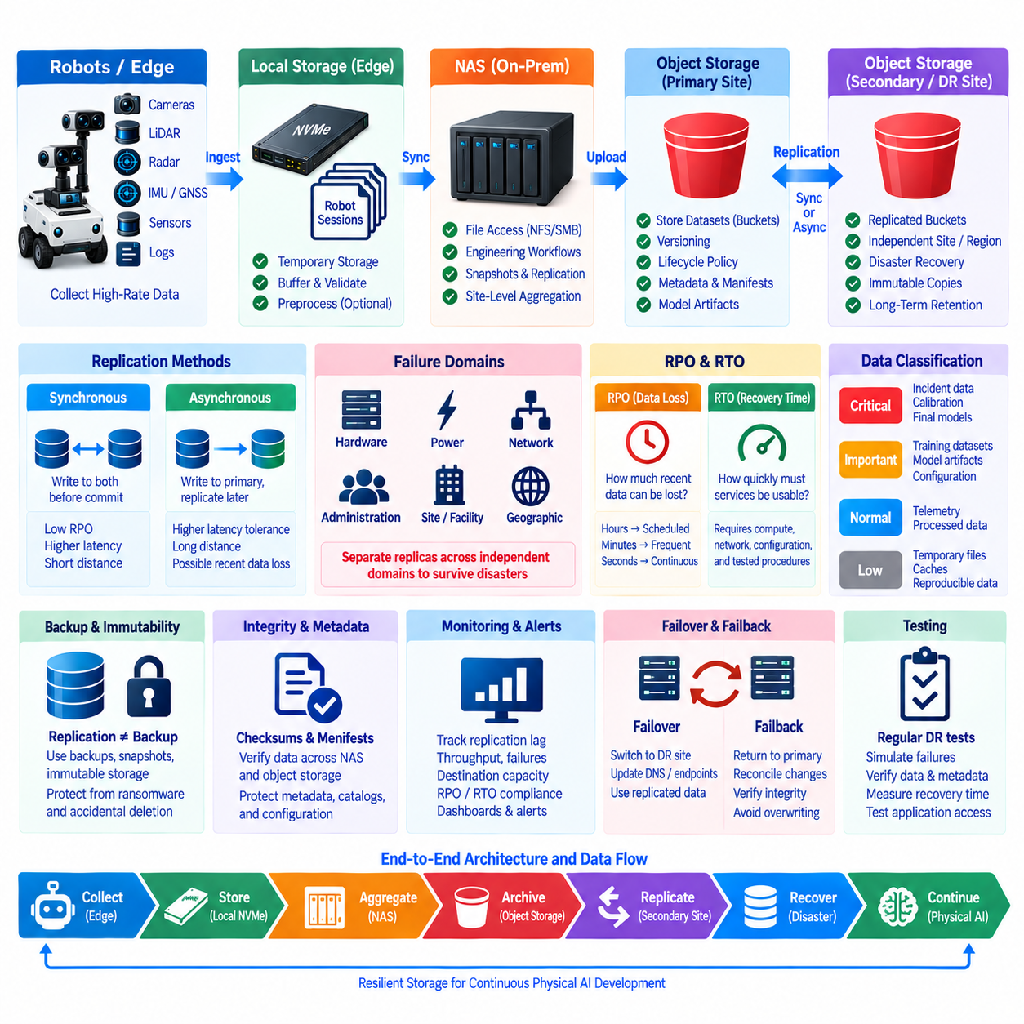
NAS and object storage replication provides a foundation for protecting robotics and AI data against hardware failure, storage corruption, site outages, operational mistakes, and larger disasters. NAS systems primarily expose file-oriented interfaces, while object storage organizes data as objects inside buckets. A disaster recovery design can combine both technologies so that operational files remain convenient to access while critical datasets are replicated into independent recovery locations.
Replication creates additional copies of data in another storage system or failure domain. A NAS may replicate directories, snapshots, or volumes to a secondary NAS, while object storage can replicate buckets or selected objects to another cluster, region, or site. The objective is not simply to duplicate capacity, but to ensure that important data remains available when the primary storage environment becomes unavailable or unusable.
Replication architecture should begin by defining failure domains. Two storage systems located in the same rack may protect against individual disk failure but provide little protection against fire, flooding, power loss, network failure, or administrative compromise affecting the entire facility. Stronger disaster recovery separates replicas across independent hardware, power, network, administrative, and preferably geographic boundaries according to the risks the organization intends to tolerate.
Synchronous replication writes data to multiple storage systems before acknowledging completion to the application. This can minimize data loss when the primary system fails, but it introduces additional latency and depends on reliable low-latency connectivity between replicas. It is therefore most practical across nearby infrastructure where network conditions are predictable and the application requires a very small recovery point.
Asynchronous replication allows the primary storage system to acknowledge writes before the secondary copy has been completed. Data is transferred afterward according to replication queues, schedules, or continuous background processes. This approach supports longer distances and reduces application latency, but a sudden failure can lose the most recent unreplicated changes. The acceptable replication delay should therefore be derived from business and engineering recovery requirements.
Recovery Point Objective, or RPO, describes how much recent data an organization can tolerate losing after a failure. An RPO of several hours permits periodic replication, while a much smaller RPO requires more frequent or continuous synchronization. Different robotics datasets can use different RPO values. Critical mission evidence may require aggressive replication, whereas reproducible intermediate processing outputs may tolerate a longer recovery window.
Recovery Time Objective, or RTO, defines how quickly storage services or datasets must become usable after an outage. Meeting RTO requires more than having a secondary copy. Recovery infrastructure must provide sufficient compute, storage performance, networking, credentials, configuration, and operational procedures to make the replicated data accessible. A replica that requires several days of manual reconstruction cannot satisfy a short RTO even if no data was lost.
NAS replication commonly operates at file, filesystem, snapshot, or block level depending on the platform. Snapshot-based replication can efficiently transfer changed data while preserving point-in-time states. File synchronization is flexible but may not preserve every filesystem property unless configured carefully. Block-level replication can provide strong consistency characteristics but may also reproduce logical corruption or accidental changes quickly to the secondary system.
Object storage replication typically operates at the object or bucket level. Newly created or modified objects can be copied to another object-storage destination while preserving selected metadata and, depending on the implementation, version information. Replication policies can target particular buckets, prefixes, tags, or object classes. This allows important robot recordings and released datasets to receive stronger protection than temporary processing objects or caches.
Replication and backup should not be treated as identical mechanisms. Replication improves availability by maintaining another usable copy, but destructive actions or corrupted data may also propagate to replicas. Backup preserves independent recovery points that can survive failures affecting the active storage environment. A resilient design therefore combines replication for continuity with versioning, snapshots, immutable copies, or backups for historical recovery.
Immutability provides additional protection against ransomware, compromised administrative accounts, and accidental deletion. Object locking, write-once retention, or protected snapshots can prevent selected recovery copies from being modified for a defined period. The disaster recovery copy should not rely entirely on the same credentials and administrative controls as production storage, because a compromised identity could otherwise damage both primary and secondary data.
A Physical AI environment often contains data with very different recovery priorities. Raw robot sensor bags may be irreplaceable because the original physical event cannot be reproduced. Curated training datasets are valuable because they represent substantial processing and annotation effort. Temporary caches, intermediate tensors, or reproducible preprocessing outputs can often receive lower replication priority because they can be regenerated from authoritative source data.
Data classification should therefore drive replication policy. Critical incident recordings, calibration information, dataset manifests, final model artifacts, deployment packages, and essential configuration can receive aggressive replication and longer retention. Ordinary telemetry may use scheduled replication, while disposable intermediate data may remain unreplicated. This prevents disaster recovery infrastructure from consuming capacity equally for data with very different business and engineering value.
A practical robotics architecture may use local NVMe for high-rate acquisition, NAS for site-level aggregation, and object storage for centralized retention. Completed robot sessions can move from edge storage to NAS, where engineers access them through familiar file protocols. Validated sessions can then be uploaded or synchronized into object storage, and selected buckets can replicate to a secondary site or cloud environment for disaster recovery.
NAS and object storage should not necessarily contain identical representations of every dataset. NAS may hold active working directories optimized for engineering workflows, while object storage maintains immutable session archives, manifests, processed datasets, and model artifacts. Replication design should identify the authoritative copy for each data class. Without clear ownership, multiple replicas can evolve independently and create uncertainty about which copy represents the valid state.
Checksums and manifests are important when data crosses different storage technologies. File-based NAS data may be transformed into objects, archives, or dataset shards before replication. A manifest can record expected filenames or object keys, sizes, hashes, timestamps, and dataset identifiers. Recovery processes can verify these records to confirm that replicated data remains complete and has not silently changed during transfer or storage.
Metadata must be protected alongside large binary data. Recovering terabytes of sensor recordings is insufficient if the system loses information describing robot identifiers, calibration versions, mission times, dataset membership, annotations, or model relationships. Metadata databases, catalogs, manifests, and configuration repositories therefore require their own backup and replication strategies. Their recovery order should be coordinated with the objects they describe.
Network design directly influences replication performance. Large video, LiDAR, simulation, and training datasets can consume substantial bandwidth, especially when multiple robots upload simultaneously. Replication services should support bandwidth limits, scheduling, queues, retries, and resumable transfers. Operational traffic for navigation, teleoperation, monitoring, or production systems should remain protected from bulk disaster recovery transfers through appropriate network separation and quality controls.
Replication lag should be continuously measured rather than assumed. Useful metrics include pending bytes, pending objects, oldest unreplicated object age, transfer throughput, failed replication operations, destination capacity, and verification errors. Alerts can identify when the secondary site is falling behind the required RPO. Without such observability, an organization may discover during a disaster that its supposedly protected data is significantly outdated.
Disaster recovery also requires a defined failover process. When primary storage becomes unavailable, applications must know how to locate and authenticate to the recovery environment. DNS changes, endpoint configuration, mounted shares, S3 endpoints, credentials, access policies, and application configuration may all need adjustment. Automating these dependencies reduces recovery time and limits mistakes during stressful operational incidents.
Failback is equally important. After the primary site has been repaired, data generated or modified in the recovery environment may need to return safely to the original infrastructure. Administrators must determine which system is authoritative, reconcile changes, verify integrity, and avoid overwriting newer recovery-site data with older primary-site copies. Failback procedures should therefore be designed and tested together with failover procedures.
Disaster recovery testing should simulate realistic failures rather than only confirming that replica files exist. Tests can include loss of the primary NAS, object-storage cluster failure, network isolation, accidental deletion, credential compromise, corrupted data, and complete site unavailability. Teams should measure actual recovery time, verify recovered checksums and metadata, and confirm that applications can consume the restored datasets correctly.
A secondary storage site is useful only if it can support the workload required during recovery. Capacity planning should consider current protected data, growth rate, version history, replication overhead, retention policies, and temporary restore space. Performance planning should also consider how quickly large datasets must be restored. A system with sufficient capacity but inadequate throughput may technically preserve data while still failing operational recovery requirements.
Geographic replication introduces additional considerations such as network latency, bandwidth cost, data sovereignty, security boundaries, and cloud egress charges. Organizations should determine which datasets genuinely require off-site or cross-region protection. Critical source data and released model assets may justify geographically separated copies, while large reproducible datasets may use less expensive protection strategies depending on their reconstruction cost and required recovery time.
The complete NAS and object storage disaster recovery design should combine failure-domain separation, replication, versioning, snapshots, immutable retention, independent backups, integrity verification, metadata protection, monitoring, and tested recovery procedures. No single mechanism protects against every failure. Layered protection ensures that hardware faults, logical corruption, human error, ransomware, and site-level disasters do not share one common path to permanent data loss.
In a Physical AI infrastructure, this layered architecture protects the continuous knowledge flow from robot experience to trained models. Edge devices capture unique physical-world observations, NAS systems support local engineering workflows, object storage provides scalable dataset retention, and independent replicas preserve recoverable copies. When RPO, RTO, data classification, replication, and recovery testing are designed together, the storage platform becomes a resilient foundation for long-term Physical AI development.

07.09 Object Storage Security: Bucket Policy / SSE
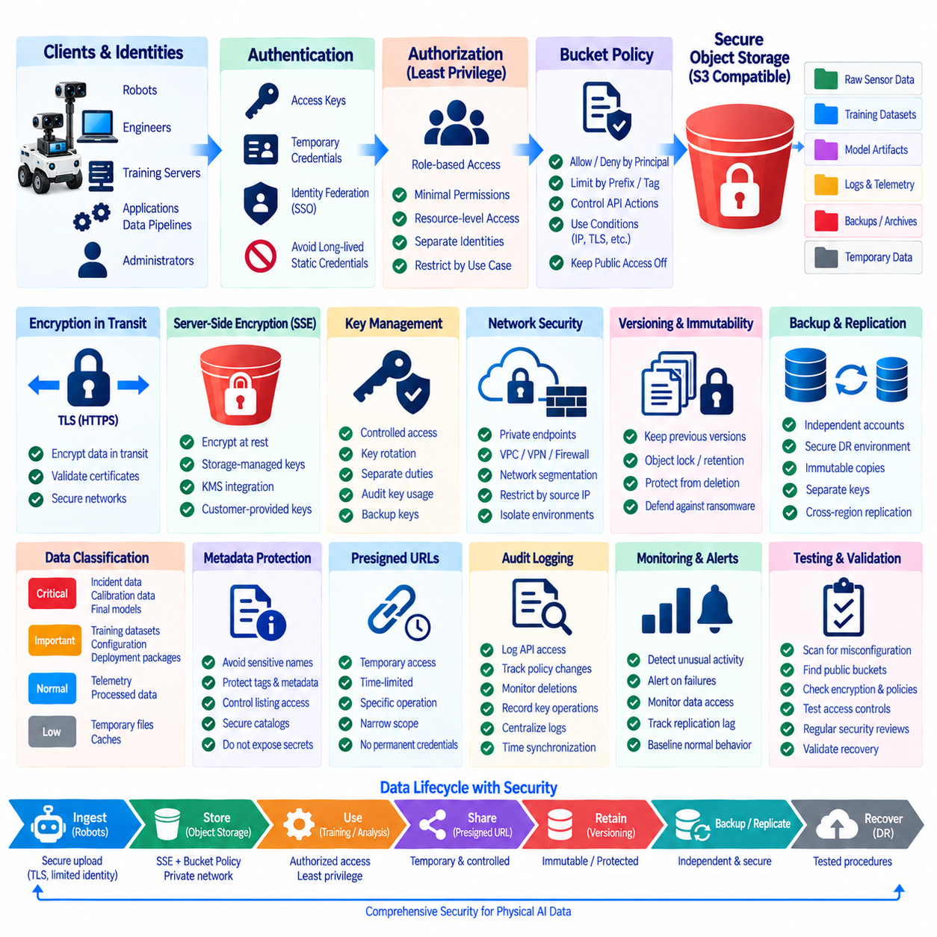
Object storage security protects data through multiple coordinated controls rather than relying on a single password or network boundary. A secure architecture combines identity management, authentication, authorization, bucket policies, encryption, network protection, audit logging, versioning, and operational monitoring. For robotics and Physical AI systems, these controls protect valuable sensor recordings, datasets, model artifacts, logs, and deployment packages throughout their lifecycle.
The first security boundary is identity. Human users, robots, applications, training servers, data pipelines, and administrative services should use distinguishable identities rather than sharing one credential. Separate identities make permissions easier to restrict and activities easier to audit. Service accounts or workload identities can represent automated systems, while centralized identity providers can manage engineers and administrators according to organizational roles.
Authentication verifies who or what is requesting access, while authorization determines which actions that identity may perform. S3-compatible systems commonly use access keys, signed requests, temporary credentials, or identity federation. Long-lived static credentials should be minimized where practical. Secrets should not be embedded directly in source code, container images, scripts, or robot software repositories because these locations can expose credentials unintentionally.
Least privilege is the central authorization principle. A robot responsible only for uploading sensor sessions does not normally need permission to delete historical datasets or modify model artifacts. A training service may need read access to curated datasets and write access to experiment outputs but no administrative privileges. Restricting each identity to required resources and operations reduces the impact of mistakes or compromised credentials.
Bucket policies provide resource-level authorization rules for object storage. A policy can specify which principals may access a bucket, which object prefixes they can use, which API actions are permitted, and under what conditions requests are accepted. Policies can separate raw sensor data, curated datasets, model artifacts, logs, backups, and temporary objects even when they are managed within the same object-storage infrastructure.
Policy conditions can enforce additional security context rather than relying only on identity. Access may be restricted according to network source, transport security, object tags, requested actions, or other attributes supported by the storage platform. For example, a sensitive dataset can require encrypted transport and approved identities, while a robot upload account can be restricted to a specific ingestion prefix without permission to read unrelated objects.
Public access should normally be disabled for internal robotics and AI repositories. Misconfigured anonymous access can expose large volumes of sensor data, intellectual property, models, logs, or operational information. Bucket-level public-access protections, explicit deny rules, configuration scanning, and periodic reviews can reduce this risk. External sharing should use controlled mechanisms rather than making an entire bucket publicly readable.
Presigned URLs provide a useful mechanism for temporary delegated access. A trusted service can generate a time-limited URL that permits a specific upload or download without distributing permanent storage credentials to the client. This can support external annotation tools, temporary dataset delivery, or robot upload workflows. Expiration times should remain short enough to limit exposure, and the permitted operation should be narrowly scoped.
Encryption in transit protects data while it moves between robots, NAS gateways, applications, and object-storage endpoints. TLS should be used for S3 API communication so credentials, metadata, and object contents are not exposed to network observers. Clients should validate server certificates rather than disabling verification for convenience. Internal storage networks also require encryption when traffic crosses security boundaries or untrusted infrastructure.
Server-side encryption, or SSE, protects objects at rest by encrypting data within the storage system. The client uploads data through the normal object API, and the storage service performs encryption before persistent storage. During authorized retrieval, the service decrypts the object transparently. SSE reduces the risk associated with lost drives, unauthorized physical access, storage-media reuse, or lower-level access to stored data.
Different SSE models provide different levels of key control. Storage-managed encryption allows the object-storage service to manage encryption keys automatically, simplifying operations. Key-management-service integration provides stronger centralized control, auditing, rotation, and separation of duties. Some systems also support customer-provided encryption keys, but these approaches require careful key handling because loss of the key can make otherwise intact data unrecoverable.
Key management is therefore as important as encryption itself. Encryption keys should have controlled access, defined rotation procedures, protected backups where appropriate, and audit records for sensitive operations. Storage administrators should not automatically receive unrestricted access to every key. Separating storage administration from key-management authority can reduce the consequences of one compromised administrative account.
Client-side encryption can provide another security layer when data must remain encrypted before reaching the storage service. The application encrypts content locally and uploads ciphertext rather than plaintext. This reduces trust placed in the storage infrastructure but transfers responsibility for encryption formats, key distribution, rotation, and recovery to the application environment. It should be adopted only when its operational complexity is justified.
Encryption does not replace authorization. An encrypted object that is automatically decrypted for an overprivileged account remains exposed to that identity. Similarly, strong bucket policies cannot protect plaintext transmitted through an insecure network. Effective object-storage security therefore combines identity, authorization, transport encryption, at-rest encryption, key management, and monitoring as complementary controls rather than interchangeable features.
Network architecture provides another defensive layer. Object-storage endpoints can be placed on private networks, segmented from public services, and accessed through controlled gateways, VPNs, private endpoints, or firewalls. Robotics networks may separate robot ingestion traffic, engineering access, AI training clusters, administrative interfaces, and replication traffic. Segmentation limits lateral movement when one system becomes compromised.
Versioning and object locking can reduce the damage caused by destructive actions. Versioning preserves previous object states after overwrites or logical deletion, while object locking or immutable retention can prevent selected data from being permanently deleted for a defined period. These controls are valuable against accidental deletion and ransomware, although they must be combined with independent backups because versioning alone is not complete disaster protection.
Sensitive data should be classified before security policies are assigned. Raw robot video may contain people, facilities, or operational details, while model artifacts may contain valuable intellectual property. Calibration data, credentials, incident recordings, and deployment packages can have different risk profiles. Classification allows encryption, retention, access control, replication, and auditing requirements to be matched to actual data sensitivity.
Metadata can also reveal sensitive information even when the object content is encrypted. Object keys, bucket names, tags, timestamps, robot identifiers, project names, and custom metadata may expose operational context. Naming conventions should therefore avoid unnecessary secrets or personally sensitive information. Access to object listings and metadata catalogs should be controlled with the same care applied to the underlying binary objects.
Audit logging provides evidence of security-relevant activity. Logs should capture authentication attempts, object reads and writes, policy changes, deletion operations, version access, administrative actions, and encryption-key events where supported. Centralizing logs outside the protected storage system can make them harder for an attacker to erase. Time synchronization is important so events from robots, storage services, identity systems, and security tools can be correlated.
Monitoring converts audit data into operational detection. Alerts can identify unusual download volumes, repeated authentication failures, unexpected deletion attempts, policy modifications, access from unusual networks, or abnormal key usage. Baselines for robots and automated pipelines are especially useful because their behavior is often predictable. Deviations from normal upload locations, object prefixes, or API patterns can indicate configuration errors or compromised credentials.
Credential rotation and revocation must be operationally practical. If a robot, server, or developer credential is compromised, administrators should be able to disable it without disrupting unrelated workloads. Short-lived credentials reduce the lifetime of stolen secrets, while automated rotation reduces dependence on manual processes. Inventory systems should record which identities and credentials belong to each robot, application, service, and environment.
Backup and replication environments require independent security controls. Replicating objects into a secondary site provides limited protection if the same compromised credentials can delete both primary and recovery copies. Recovery storage can use separate accounts, restricted administrative paths, immutable retention, and independent encryption keys. Security architecture should intentionally reduce common failure modes across production and disaster-recovery environments.
Security configuration should be continuously validated. Automated checks can detect public buckets, overly broad policies, unused credentials, disabled encryption, unexpected administrative privileges, expired certificates, or missing audit logging. Policy definitions should be version-controlled and reviewed before deployment. Infrastructure-as-code practices can make security settings reproducible and reduce configuration drift across development, production, and recovery systems.
A Physical AI architecture can apply these controls from edge to cloud. Robots authenticate with limited identities and upload encrypted data through TLS, object storage enforces bucket policies and SSE, metadata catalogs control discovery, AI training services receive dataset-specific permissions, and model repositories protect deployment artifacts. Audit logs, monitoring, immutable copies, and independent backups provide additional layers around the entire data pipeline.
A complete object-storage security model therefore combines identity, least privilege, bucket policies, private networking, TLS, server-side encryption, secure key management, versioning, immutability, logging, monitoring, credential lifecycle management, and independent recovery controls. Security becomes strongest when these mechanisms reinforce one another, protecting Physical AI data against unauthorized access, accidental modification, credential compromise, ransomware, and infrastructure failure.

07.10 AI Training Data Object Storage Performance Optimization
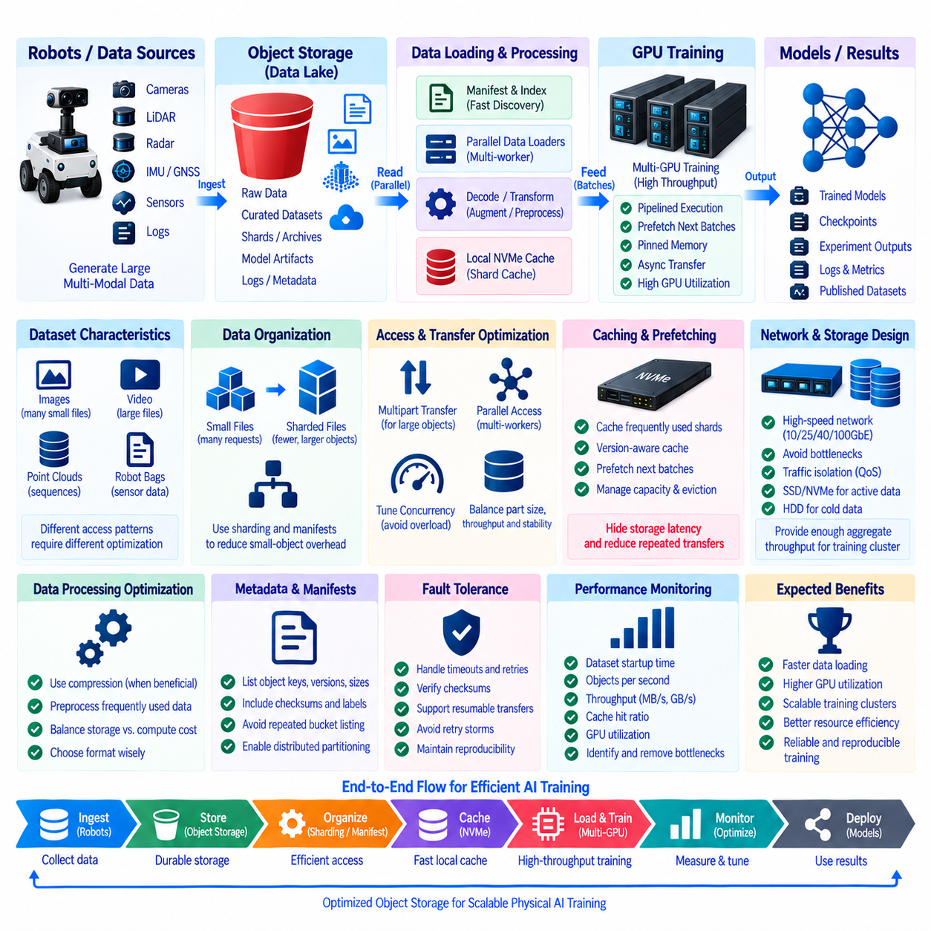
AI training workloads place unusual demands on object storage because GPUs can consume data much faster than conventional applications. Training performance depends not only on GPU compute but also on how quickly datasets can be discovered, transferred, decoded, transformed, and delivered to accelerators. Object-storage optimization therefore requires an end-to-end view of the path from storage media and network interfaces to CPU workers, local caches, host memory, and GPU pipelines.
The first optimization step is understanding the workload rather than maximizing a single storage benchmark. Large video files, image datasets, point-cloud sequences, robot sensor bags, embeddings, and millions of small samples produce very different access patterns. Sequential throughput may dominate large-object workloads, while request rate, metadata operations, and latency become critical when training repeatedly accesses many small objects.
Small-object overhead can significantly reduce effective training throughput. Each object may require request processing, authentication, metadata lookup, network transactions, and application-level handling before useful bytes reach the training process. Millions of tiny images or annotations can therefore create far more overhead than fewer large objects containing the same total data volume. Dataset packaging and sharding can reduce this inefficiency.
Sharding groups many individual samples into larger storage objects while preserving an index or manifest that identifies samples inside each shard. Formats and frameworks vary, but the architectural principle is consistent: reduce the number of remote storage operations while maintaining efficient sequential reading. Shard size should balance transfer efficiency, randomization requirements, parallel workers, recovery behavior, and the cost of downloading unnecessary data.
Parallelism is essential for saturating high-speed object storage. Multiple data-loader workers can request different objects or shards concurrently so that network and storage latency are hidden behind useful work. However, unlimited concurrency is not automatically beneficial. Excessive workers can overload CPUs, storage endpoints, network queues, or metadata services. Concurrency should be measured and tuned against the complete training system rather than selected arbitrarily.
Multipart transfer improves efficiency for very large objects by dividing them into multiple parts that can be transferred concurrently and retried independently. Large robot datasets, archives, checkpoints, and simulation outputs can benefit from multipart upload and download strategies where supported. Part size and concurrency should be chosen to balance throughput, memory consumption, request overhead, network stability, and recovery from interrupted transfers.
Local NVMe caching can substantially reduce repeated object-storage traffic. Frequently reused training shards can be downloaded once to fast local storage and consumed repeatedly across epochs. A cache manager can track available capacity, recently used data, dataset versions, and eviction priorities. This approach is particularly effective when GPU servers have high-speed NVMe but communicate with centralized object storage through a slower shared network.
Caching must remain version-aware. If an object is updated while an older local copy remains cached, training may silently consume stale data. Cache keys can therefore incorporate object versions, checksums, immutable dataset identifiers, or manifest versions. Before reuse, the system can verify that the cached representation corresponds to the requested dataset. Reproducibility is more important than saving a small amount of transfer time.
Prefetching hides storage latency by retrieving future training data before the GPU requires it. While the accelerator processes the current batch, CPU workers can fetch, decode, decompress, augment, and stage subsequent batches. Effective prefetch depth depends on memory capacity, transformation cost, network latency, and batch size. Too little prefetching starves the GPU, while excessive prefetching wastes memory and can increase storage contention.
The training pipeline should overlap storage I/O, CPU preprocessing, host-to-device transfer, and GPU computation whenever possible. A sequential design that waits for each stage to finish before starting the next leaves expensive resources idle. Pipelined execution allows object downloads, decoding, augmentation, memory staging, and accelerator computation to proceed concurrently. Performance analysis should therefore measure pipeline stalls rather than only raw storage bandwidth.
Pinned host memory and asynchronous device transfers can reduce the time required to move prepared batches from CPU memory to GPU memory. These techniques do not increase object-storage throughput directly, but they prevent downstream transfer inefficiencies from being incorrectly diagnosed as storage problems. End-to-end profiling should distinguish remote I/O wait, CPU decoding time, memory copies, GPU utilization, and synchronization delays.
Network capacity is a major design constraint for distributed training. A single GPU server may require substantial sustained throughput, while a multi-node cluster can multiply that demand. 10, 25, 40, 100 GbE or faster networking may be appropriate depending on dataset characteristics and cluster scale. Actual usable throughput depends on storage nodes, switches, NICs, protocol overhead, concurrency, and competing traffic rather than link speed alone.
Network topology should minimize unnecessary bottlenecks between storage and training nodes. Multiple storage servers connected through a constrained uplink can make aggregate disk performance irrelevant. Training traffic can also interfere with robot ingestion, backups, replication, and engineering access when they share the same links. Dedicated networks, traffic segmentation, scheduling, or quality-of-service controls can protect critical workloads and provide predictable training performance.
Object-storage servers must provide enough aggregate disk and network throughput to match training demand. HDD-based clusters can offer large economical capacity, but random small-object access may expose seek and metadata limitations. SSD or NVMe tiers can accelerate active datasets, indexes, and metadata-heavy workloads. Hybrid designs can keep frequently trained datasets on faster media while moving older or infrequently used data to capacity-oriented tiers.
Data compression can reduce storage capacity and network transfer requirements, but decompression consumes CPU resources. For highly compressible sensor or textual data, the network savings can outweigh the additional compute cost. For already compressed video or image formats, additional compression may provide little benefit. The correct decision depends on whether the current bottleneck is storage capacity, network bandwidth, CPU processing, or accelerator starvation.
Data preprocessing can similarly trade storage for compute. Resizing images, converting formats, generating point-cloud features, or preparing tokenized data ahead of training can reduce repeated CPU work during every epoch. However, excessive preprocessing creates additional derived datasets and storage requirements. Frequently reused transformations are strong candidates for precomputation, while experiment-specific augmentation is often better performed dynamically.
Dataset manifests help training systems avoid expensive directory-style discovery operations. Instead of repeatedly listing large buckets or prefixes, a manifest can describe the exact object keys, versions, sizes, checksums, labels, and shard assignments belonging to a dataset release. Workers can partition the manifest deterministically and access only required objects. This improves startup time, reproducibility, distributed coordination, and integrity validation.
Distributed training requires careful dataset partitioning. If many workers repeatedly request the same objects, storage hotspots and redundant network transfers can occur. Deterministic sharding can assign different portions of a dataset to ranks or nodes while preserving the required statistical sampling behavior. Node-local caches can further reduce duplicate downloads when multiple GPUs on the same server consume related training data.
Storage performance should be evaluated using application-level metrics. Useful measurements include dataset startup time, objects per second, effective MB/s or GB/s, cache hit ratio, request latency, CPU utilization, network utilization, data-loader wait time, batch preparation time, and GPU utilization. A storage system can report high aggregate bandwidth while GPUs remain underutilized because the actual bottleneck lies in small-object requests or preprocessing.
GPU starvation is one of the clearest symptoms of an inefficient input pipeline. If accelerator utilization repeatedly drops while training waits for the next batch, engineers should trace the delay backward through data loaders, CPU transformations, caches, network transfers, and object-storage requests. Increasing GPU count without fixing the input path can worsen the problem because more accelerators compete for the same constrained storage and network resources.
Benchmarking should reproduce realistic training behavior rather than relying only on sequential file-copy tests. Tests should use representative object sizes, worker counts, batch sizes, transformations, cache states, network paths, and concurrent training nodes. Both cold-cache and warm-cache behavior should be measured. Scaling tests can reveal the point where additional GPUs stop improving training throughput because storage or preprocessing becomes saturated.
Metadata and request scaling also require attention as datasets grow. Large numbers of workers can generate substantial LIST, HEAD, GET, authentication, and catalog traffic. Repeated object discovery should be minimized through manifests and cached metadata. Connection reuse, persistent client sessions, batching where supported, and sensible retry policies can reduce unnecessary overhead while avoiding synchronized retry storms during temporary service degradation.
Fault tolerance must remain part of performance optimization. Aggressive parallel transfers without bounded retries can amplify failures and overload a recovering service. Training pipelines should handle timeouts, partial downloads, corrupted cache entries, unavailable objects, and transient network errors. Checksums and manifests can verify downloaded data, while resumable transfers and controlled backoff prevent temporary failures from turning into large training interruptions.
A practical Physical AI training architecture can use object storage as the durable dataset repository and local NVMe as the high-performance working tier. Robot data flows from edge systems into centralized storage, where validation and curation create immutable dataset releases. GPU servers read manifests, prefetch selected shards into local caches, process batches through parallel loaders, and continuously feed accelerators while preserving dataset version information.
Performance optimization should therefore focus on balanced utilization across storage, network, CPU, memory, and GPUs. Sharding reduces request overhead, parallelism increases concurrency, caching removes repeated transfers, prefetching hides latency, preprocessing manages CPU cost, and manifests improve coordination. When these mechanisms are tuned together using realistic measurements, object storage can support scalable AI training without becoming the bottleneck of the Physical AI development pipeline.

