Volume 08 Robot Database and Storage

05. Vector Databases

05.01 Vector Database Concepts: Embeddings / ANN Search
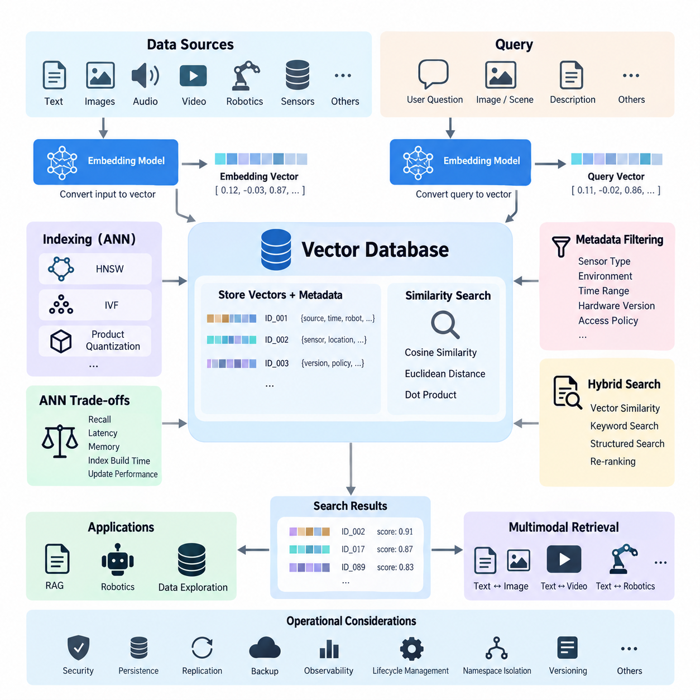
Vector databases are specialized data systems designed to store, index, and retrieve high-dimensional numerical representations called embeddings. Unlike relational databases that primarily search structured values through exact comparisons, vector databases compare mathematical representations of meaning, appearance, behavior, or context. This makes them particularly useful for AI systems that must retrieve information based on semantic similarity rather than exact keywords or identifiers.
An embedding is a dense numerical vector generated by a machine learning model from an input such as text, an image, audio, video, sensor observations, robot states, or multimodal data. The embedding model transforms important characteristics of the original input into coordinates within a high-dimensional vector space. Inputs with similar semantic or perceptual characteristics are generally positioned closer together, allowing mathematical distance to approximate meaningful similarity.
Embedding dimensionality depends on the model and application. A vector may contain hundreds or thousands of floating-point values, with each dimension contributing to the learned representation. Individual dimensions usually do not correspond to simple human-readable attributes. Instead, meaning is distributed across the vector. This distributed representation enables AI applications to compare complex objects even when their raw formats, wording, viewpoints, or sensor observations differ substantially.
Similarity between vectors is commonly measured using cosine similarity, Euclidean distance, or dot product. Cosine similarity evaluates the angle between vectors and is widely used for semantic embeddings, while Euclidean distance measures geometric separation in vector space. Dot-product search is frequently used when embedding models are trained around that metric. The database and embedding model must therefore use compatible similarity assumptions to produce meaningful retrieval results.
A basic vector retrieval pipeline begins when source data is processed by an embedding model. The resulting vector is stored together with an identifier and associated metadata, such as document source, timestamp, robot identifier, sensor type, location category, access policy, or dataset version. When a query arrives, the same or a compatible embedding model converts it into a query vector. The database then searches for stored vectors located near that query in the embedding space.
Performing an exact comparison against every stored vector is known as exact nearest-neighbor search. Although this approach can provide highly accurate results, its computational cost increases rapidly as the number and dimensionality of vectors grow. AI platforms may contain millions or billions of embeddings, making exhaustive comparison impractical for latency-sensitive applications. Vector databases therefore commonly employ Approximate Nearest Neighbor (ANN) search to obtain highly relevant candidates with much lower computational cost.
ANN algorithms deliberately trade a small amount of retrieval accuracy for substantial improvements in search speed, memory efficiency, and scalability. Instead of calculating the distance between a query and every vector, an ANN index organizes the vector space so that promising regions or candidates can be examined first. The system attempts to retrieve vectors that are extremely close to the true nearest neighbors without requiring a complete scan of the entire collection.
Hierarchical Navigable Small World (HNSW) graphs are among the most widely used ANN indexing approaches. HNSW represents vectors as nodes in a multilayer graph and connects nearby vectors through navigable links. Search begins in sparse upper layers and progressively moves toward denser lower layers, rapidly approaching relevant neighborhoods. HNSW often provides excellent recall and low query latency, although maintaining the graph can require significant memory and index construction resources.
Another important ANN family uses inverted-file indexing, commonly represented by IVF techniques. The vector space is partitioned into clusters, and vectors are assigned to representative regions. During retrieval, the query first identifies likely clusters and searches only selected portions of the index. IVF can significantly reduce the number of distance calculations and can be combined with vector compression techniques to support very large embedding collections.
Product Quantization (PQ) reduces vector storage and distance-computation costs by representing vectors with compact encoded approximations. High-dimensional vectors are divided into smaller subvectors, and each subvector is mapped to a learned codebook entry. Instead of storing and comparing every original floating-point component, the system can operate on compact codes. IVF and PQ are frequently combined when database scale makes memory consumption and search throughput critical architectural concerns.
ANN configuration involves balancing recall, latency, memory consumption, index construction time, and update performance. Increasing the number of explored graph nodes or searched clusters may improve recall but also increase query latency. More aggressive compression reduces storage requirements but can reduce retrieval precision. Consequently, there is no universally optimal vector index. Parameters should be benchmarked using representative workloads and realistic queries rather than selected solely from theoretical performance characteristics.
Metadata filtering is another essential capability of practical vector databases. Semantic similarity alone may return mathematically relevant vectors that violate application constraints. A robot application, for example, may require observations from a particular sensor family, environment type, hardware version, time interval, or operational condition. Combining ANN retrieval with metadata filters allows the system to narrow the candidate space while preserving semantic similarity as the primary retrieval mechanism.
Vector databases commonly support hybrid retrieval that combines vector similarity with lexical or structured search. Keyword matching remains valuable for exact product names, error codes, component identifiers, technical terminology, and uncommon proper nouns that embeddings may not represent precisely. Hybrid systems can merge semantic scores with lexical relevance and metadata constraints, producing retrieval pipelines that benefit from both learned representations and conventional information-retrieval techniques.
Retrieval quality depends heavily on embedding quality. A sophisticated ANN index cannot compensate for embeddings that fail to represent distinctions important to the application. Embedding models should therefore be evaluated against domain-specific queries, positive examples, difficult negatives, and operational edge cases. Changes to an embedding model may also alter the geometry of the vector space, potentially requiring stored data to be re-embedded and indexes to be rebuilt or migrated.
Vector databases are especially important in Retrieval-Augmented Generation (RAG). Documents are divided into suitable chunks, transformed into embeddings, and indexed. A user question is embedded and used to retrieve semantically related chunks, which are then supplied to a language model as contextual evidence. Retrieval quality, chunking strategy, metadata design, embedding selection, reranking, and access control collectively determine whether the generated response receives relevant and trustworthy supporting information.
In Physical AI and robotics, vector databases can extend beyond document retrieval. Images, trajectories, manipulation episodes, sensor sequences, maps, object observations, failure events, and robot experiences can be represented as embeddings. A robot or orchestration platform can retrieve similar historical situations and associate them with actions, outcomes, environmental conditions, or safety information. This creates a searchable experience layer connecting large-scale robot data with reasoning and decision-support systems.
Multimodal embeddings further expand this architecture by placing information from different modalities into compatible representation spaces. A textual query such as a description of an object or scene may retrieve relevant images, video segments, or robot observations when the embedding model supports cross-modal alignment. Such capabilities are valuable for dataset exploration, robot memory, incident analysis, training-data discovery, and semantic search across heterogeneous Physical AI data repositories.
Operationally, a vector database must be treated as more than an ANN algorithm. Production systems require persistence, replication, backup, authentication, authorization, encryption, observability, lifecycle management, namespace isolation, and controlled index updates. The original source data should normally remain authoritative because embeddings are derived representations. Maintaining references between vectors and source objects allows retrieval results to be traced, validated, refreshed, deleted, or regenerated when models change.
A robust architecture also separates embedding generation from vector storage and retrieval. Embedding services can evolve independently, while the database manages vector collections, indexes, metadata, and query execution. Version identifiers for embedding models, preprocessing pipelines, schemas, and datasets should accompany stored vectors. This prevents vectors generated under incompatible representation spaces from being silently mixed and supports controlled migration when models or preprocessing procedures are upgraded.
Ultimately, vector databases provide the retrieval infrastructure that connects machine-learned representations with scalable data systems. Embeddings convert complex information into searchable numerical spaces, while ANN methods make similarity search practical at large scale. Their effectiveness depends on the combined design of embedding models, distance metrics, indexes, metadata, filtering, hybrid retrieval, and operational governance, forming a foundational data layer for modern generative AI and Physical AI systems.

05.02 FAISS: Large-Scale Vector Search Library [w/Code]
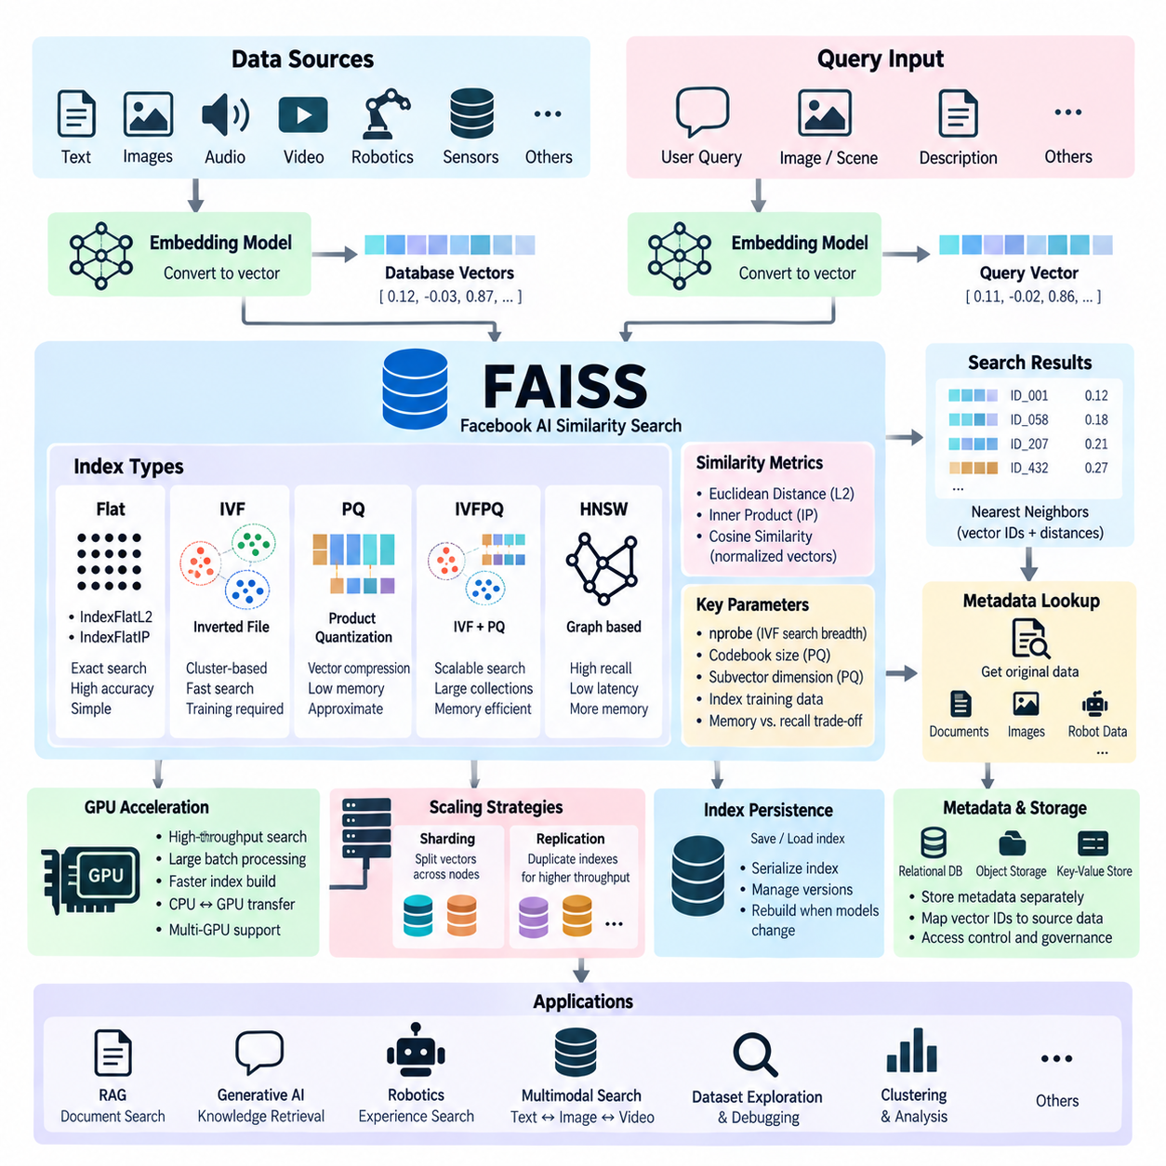
FAISS, or Facebook AI Similarity Search, is a software library designed for efficient similarity search and clustering of dense numerical vectors. It was developed to address the computational challenges that arise when AI systems must compare a query embedding against millions or billions of stored embeddings. Rather than functioning as a complete database, FAISS provides optimized algorithms and data structures that can serve as the high-performance vector-search engine inside a larger AI data architecture.
The fundamental FAISS workflow begins with a collection of fixed-dimensional vectors, usually produced by an embedding model. Text, images, audio, video, robot observations, trajectories, or other information can first be transformed into vectors and then added to a FAISS index. A query is transformed using a compatible embedding model, and FAISS searches the index for the nearest vectors according to a selected distance or similarity metric, returning identifiers and corresponding distance values.
FAISS commonly supports Euclidean distance and inner-product-based similarity calculations. Cosine similarity can also be implemented by normalizing vectors and performing inner-product search. Selecting the metric is not merely an implementation detail because the geometry assumed during embedding-model training affects how similarity should be interpreted. A search system should therefore preserve consistency among embedding generation, normalization procedures, FAISS index configuration, and application-level relevance evaluation.
One of the simplest FAISS structures is a flat index, such as IndexFlatL2 or IndexFlatIP. Flat indexes retain vectors without approximation and compare a query against all indexed vectors. They provide exact nearest-neighbor search and are useful as accuracy baselines, for relatively small datasets, or when maximum recall is more important than search cost. However, computation grows with collection size, making exhaustive flat search increasingly expensive for very large vector repositories.
FAISS provides multiple approximate nearest neighbor techniques for situations where exhaustive search is impractical. Inverted File Indexes, commonly called IVF indexes, divide the vector space into clusters represented by centroids. During a query, FAISS identifies the most promising clusters and searches vectors contained within only a selected number of them. This substantially reduces comparisons while allowing the operator to control the trade-off between query latency and retrieval recall.
An IVF index generally requires a training phase before vectors are added. Representative training vectors are used to learn the centroids that partition the embedding space. The quality and distribution of this training sample are important because poorly selected samples may create unbalanced or unrepresentative partitions. After training, database vectors are assigned to inverted lists associated with centroids, allowing queries to concentrate computation on regions likely to contain relevant nearest neighbors.
The nprobe parameter is especially important when using IVF. It determines how many inverted lists are examined for each query. A small nprobe value reduces computation and usually improves speed, but it may miss relevant vectors located in neighboring clusters. Increasing nprobe searches more regions and generally improves recall at the cost of additional latency. Production tuning therefore requires measuring recall and response time against representative queries rather than selecting parameters arbitrarily.
Product Quantization, or PQ, is another major FAISS capability for large-scale search. PQ compresses high-dimensional vectors by dividing them into subvectors and encoding each subvector using entries from learned codebooks. The resulting compact representation can dramatically reduce memory requirements compared with storing every component as a full floating-point value. Approximate distances can then be calculated efficiently from the encoded vectors, enabling much larger collections to remain searchable within available memory.
FAISS can combine inverted indexing and product quantization through structures such as IVFPQ. The IVF component limits search to selected portions of the vector space, while PQ reduces the storage and computational cost of vectors inside those regions. This combination is particularly useful when the vector collection becomes too large for straightforward in-memory exact search. The architectural trade-off is that compression and restricted probing introduce approximation that must be evaluated against application requirements.
Hierarchical Navigable Small World graph techniques are also available through FAISS indexes based on HNSW. These structures organize vectors as graph nodes connected to nearby neighbors, enabling search to navigate rapidly toward relevant regions. HNSW can provide strong recall and low query latency, particularly when enough memory is available. Compared with heavily compressed indexes, however, graph structures may consume more memory, making workload characteristics and infrastructure constraints important selection factors.
FAISS also provides GPU acceleration for supported index types and operations. Similarity calculations are highly parallel numerical workloads, making GPUs well suited for processing large batches of vector comparisons. CPU indexes can often be transferred to GPU resources, while multiple GPUs can be used to replicate or partition workloads depending on the architecture. GPU acceleration is particularly valuable for high-throughput retrieval, large batch queries, index construction, and AI pipelines that already use GPU-based embedding models.
Memory architecture becomes increasingly important as vector collections grow. A million vectors with hundreds or thousands of floating-point dimensions can already require substantial memory, while billion-scale collections demand careful compression, partitioning, or distributed strategies. FAISS provides mechanisms that help reduce this burden, but architects must still estimate vector count, dimensionality, representation size, index overhead, query concurrency, and available CPU or GPU memory before selecting an index configuration.
Large-scale FAISS systems may use sharding to divide vectors across multiple indexes, devices, or servers. Each shard searches a subset of the vector collection, after which candidate results are merged to obtain the global nearest neighbors. Replication can instead place equivalent indexes on multiple resources to increase query throughput. These approaches address different scaling requirements: sharding expands searchable capacity, whereas replication primarily improves concurrency and availability at the retrieval layer.
FAISS itself should not be confused with a full production vector database. It focuses primarily on vector indexing, similarity search, clustering, and related numerical operations. Features such as durable transactional storage, rich metadata management, authentication, authorization, replication policies, backup workflows, distributed coordination, and application APIs generally require additional infrastructure. Many vector database products and custom AI platforms therefore use FAISS-like indexing concepts while surrounding them with broader data-management capabilities.
Metadata is commonly managed outside the core FAISS index. FAISS search results usually provide vector identifiers and distances, which an application can map to documents, images, robot episodes, sensor records, or database rows stored elsewhere. This separation allows relational databases, object storage, key-value systems, or specialized metadata services to remain authoritative for original content. Careful identifier management is therefore essential for maintaining reliable relationships between vectors and their source objects.
Index persistence is another important operational consideration. A trained and populated FAISS index can be serialized to storage and loaded again rather than rebuilt every time an application starts. Nevertheless, the index should be treated as a derived artifact when vectors originate from external authoritative datasets. Keeping embedding-model versions, preprocessing configurations, index parameters, dataset manifests, and source identifiers makes it possible to reproduce or rebuild the index when data or models change.
Embedding-model migration requires particular attention because vectors produced by different models usually inhabit incompatible representation spaces. Adding vectors from a new embedding model directly into an existing index can make similarity results meaningless even when vector dimensions happen to match. A controlled migration typically creates a separate index, regenerates embeddings from authoritative source data, evaluates retrieval quality, and then switches applications to the new representation after validation.
FAISS is valuable in Retrieval-Augmented Generation systems where document chunks are embedded and indexed for semantic retrieval. A query embedding can rapidly identify candidate passages that are then filtered, reranked, and supplied to a language model. In this architecture, FAISS handles high-performance candidate generation, while surrounding services manage document ingestion, chunking, metadata, access permissions, reranking, source attribution, and lifecycle control.
Physical AI systems can apply the same architecture to robot and sensor data. Embeddings may represent camera observations, manipulation episodes, trajectories, environmental states, failure cases, object interactions, or learned robot experiences. FAISS can retrieve historical vectors similar to a current observation, allowing higher-level systems to locate related episodes, training samples, behaviors, or outcomes. The original high-volume data can remain in object or dataset storage while FAISS provides a compact semantic retrieval layer.
For multimodal robotics, separate or jointly trained embedding models can transform text, images, video segments, sensor sequences, and robot states into searchable representations. FAISS then provides efficient nearest-neighbor operations over these representations without needing to understand their original modality. When cross-modal embeddings share a compatible space, a textual description may retrieve relevant visual observations or robot experiences, supporting dataset exploration, robot memory, debugging, and training-data discovery.
Benchmarking is essential before deploying FAISS at scale. Evaluation should include recall at different values of k, query latency distributions, throughput, memory consumption, index construction time, update behavior, and CPU or GPU utilization. Tests should use realistic vector distributions and representative queries because synthetic random vectors may not reproduce the clustering characteristics of production embeddings. Exact flat search can serve as a reference for measuring the recall of approximate configurations.
Ultimately, FAISS provides a flexible computational foundation for large-scale vector similarity search rather than an all-in-one data platform. Its flat, IVF, PQ, IVFPQ, HNSW, CPU, and GPU capabilities allow engineers to select different balances of accuracy, latency, throughput, and memory efficiency. When integrated with embedding services, metadata systems, persistent storage, governance, and application logic, FAISS can form a powerful retrieval engine for generative AI, multimodal systems, and large-scale Physical AI data architectures.

05.03 Pinecone: Cloud Vector DB Usage [w/Code]
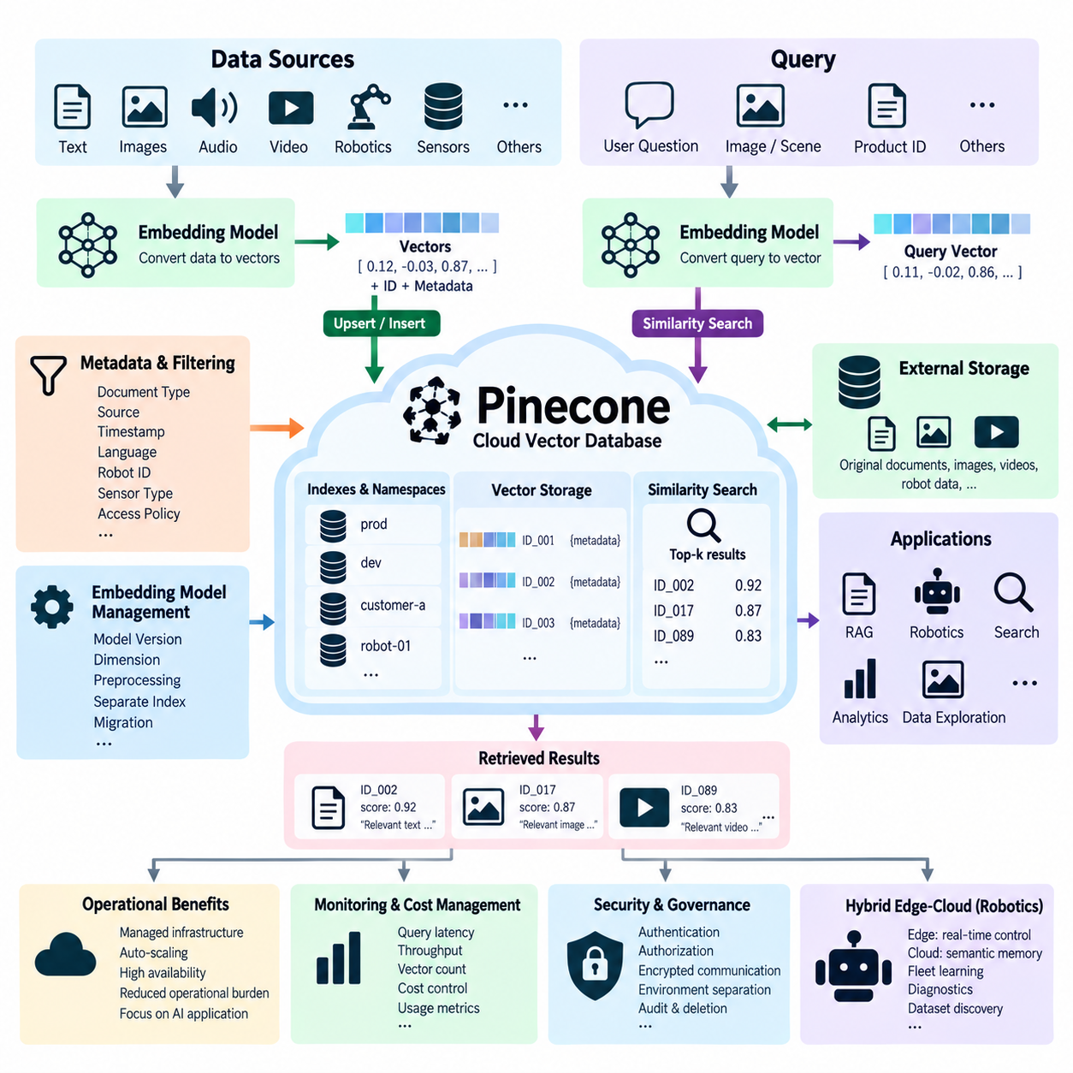
Pinecone is a managed cloud vector database designed to store, index, and retrieve high-dimensional vector representations for AI applications. Instead of requiring developers to build and operate their own vector-search infrastructure, it provides database services through cloud-accessible APIs and software development kits. This allows application teams to concentrate on embedding generation, retrieval logic, and AI workflows while the service manages much of the underlying vector infrastructure.
A typical Pinecone workflow begins by transforming source information into embeddings. Text passages, images, product records, sensor observations, robot experiences, or other data can be processed by an embedding model to produce numerical vectors. These vectors are inserted into Pinecone together with unique identifiers and metadata. When a new query arrives, it is represented in a compatible vector space and submitted for similarity search against the stored collection.
The relationship between the embedding model and the vector database is fundamental. Pinecone stores and searches vector representations, while an embedding model determines what those vectors mean. Vectors produced by incompatible models should not normally be mixed within the same searchable collection because their coordinates may represent completely different semantic spaces. Embedding-model identity, dimensionality, preprocessing rules, and version information should therefore be treated as part of the data architecture.
Pinecone organizes searchable vector data through logical structures that isolate and manage collections of embeddings. Applications can separate vectors according to projects, environments, customers, models, datasets, or other operational boundaries. Within these structures, each vector is associated with an identifier that allows applications to connect the embedding to its original content. Clear naming and lifecycle policies become increasingly important as multiple AI services begin sharing vector infrastructure.
Metadata provides contextual information that cannot be represented reliably through vector similarity alone. A vector may be associated with attributes such as document type, source, timestamp, language, robot identifier, sensor category, dataset version, security classification, or operational state. Metadata filtering can restrict a similarity search to records satisfying application-specific conditions, preventing semantically similar but operationally inappropriate information from being returned.
Similarity search begins when a query representation is compared with indexed vectors according to an appropriate similarity metric. The system returns the most relevant candidates together with information needed to interpret or retrieve the corresponding records. Applications commonly request the top-k nearest results rather than retrieving a single match. These candidates may then be filtered, reranked, combined with other retrieval methods, or supplied directly to downstream AI components.
Cloud-managed vector search reduces the operational burden associated with self-hosted indexing systems. A team using a low-level vector library must normally plan compute resources, memory, storage, deployment, scaling, monitoring, index persistence, recovery, and service availability. A managed vector database abstracts many of these responsibilities behind a service interface. The trade-off is greater dependence on provider architecture, pricing, network connectivity, supported features, and service-level constraints.
Network architecture is therefore an important consideration when Pinecone is used in production systems. Embeddings and queries may travel between application infrastructure and the managed vector service, creating latency, bandwidth, security, and data-governance considerations. Large source objects should not automatically be duplicated into a vector database. In many architectures, original documents, images, video, or robot datasets remain in authoritative storage while Pinecone contains embeddings, identifiers, and retrieval-oriented metadata.
This separation is especially useful for AI dataset architectures. Large binary objects can remain in object storage, NAS systems, data lakes, or specialized dataset repositories. Pinecone can operate as a semantic index over those assets, allowing applications to discover relevant information without scanning the original files directly. Search results can return identifiers that the application resolves against authoritative metadata or storage systems to obtain the complete source objects.
Pinecone is commonly associated with Retrieval-Augmented Generation, or RAG. Documents are divided into appropriately sized chunks, converted into embeddings, and stored with metadata identifying their source and context. A user question is converted into a compatible representation, and semantically related chunks are retrieved. The selected evidence is then provided to a language model, allowing generation to be grounded in information obtained from an external knowledge collection.
Effective RAG requires more than simply storing document embeddings. Chunk size, overlap, metadata structure, query formulation, retrieval depth, filtering, reranking, and context assembly all influence final response quality. Retrieving too few candidates may omit useful evidence, while retrieving too many can introduce irrelevant context and increase model cost. Pinecone therefore functions as one component in a broader retrieval pipeline rather than independently determining the quality of generated answers.
Hybrid search can be useful when semantic similarity alone is insufficient. Embeddings are effective at retrieving conceptually related information, but exact terms such as model numbers, technical codes, error identifiers, product names, or uncommon terminology may require lexical signals. Combining semantic and keyword-oriented retrieval can improve candidate discovery for technical applications. Reranking can subsequently evaluate the candidate set with a more computationally expensive relevance model.
Namespaces or equivalent logical isolation mechanisms can help applications separate subsets of vectors without deploying entirely independent retrieval systems. For example, development and production data, different organizations, individual robots, separate factories, or dataset generations may require isolation. The chosen structure should reflect security, lifecycle, query, and scaling requirements rather than simply mirroring arbitrary application folders.
Vector updates and deletion are essential for continuously changing knowledge bases. Documents may be revised, robot experiences may be invalidated, access policies may change, and obsolete datasets may need to be removed. Applications should maintain reliable source identifiers so that embeddings can be replaced or deleted when authoritative data changes. Without this relationship, a vector index can gradually accumulate stale representations that continue appearing in search results.
Embedding-model upgrades create another lifecycle challenge. A new model may improve semantic quality or support additional modalities, but its vectors generally should not be assumed to be compatible with an existing embedding space. Migration may require regenerating vectors from original source data, loading them into a separate collection, benchmarking retrieval quality, and switching applications after validation. Versioned indexing prevents uncontrolled mixing of old and new vector representations.
Observability should cover both database performance and retrieval quality. Operational measurements can include query latency, throughput, failure rates, vector counts, ingestion behavior, and application-level errors. Retrieval evaluation should additionally measure whether relevant items actually appear among the returned candidates. A technically fast vector service provides limited value if embedding or filtering choices consistently retrieve the wrong information.
Cost management is particularly important for cloud vector databases because architectural choices influence resource consumption. Vector dimensionality, number of stored vectors, query volume, metadata size, ingestion rate, and retrieval patterns can affect overall cost. Applications should avoid storing unnecessary duplicate embeddings and should evaluate whether all historical data requires immediate online searchability. Tiered data lifecycle strategies can keep frequently accessed semantic indexes online while retaining colder source data elsewhere.
Security architecture should treat embeddings and metadata as governed application data rather than assuming numerical vectors are inherently harmless. Metadata can expose sensitive contextual information, and embeddings may represent proprietary documents, operational records, or internal knowledge. Authentication, authorization, encrypted communication, environment separation, secrets management, deletion policies, and auditing should therefore be integrated with the surrounding application security model.
For Physical AI, Pinecone can provide a cloud semantic memory layer over distributed robot information. Robot observations, task descriptions, manipulation episodes, failure reports, maintenance records, or summarized trajectories can be embedded and indexed. A robot management system can search for experiences similar to a current event and retrieve references to relevant historical data, enabling knowledge discovery across fleets without placing all high-volume sensor data directly inside the vector database.
A hybrid edge-cloud architecture is often appropriate for robotics because real-time control should not depend on unpredictable cloud retrieval latency. Safety loops, motion control, collision avoidance, and other deterministic functions remain at the robot or edge layer, while cloud vector retrieval supports slower knowledge-oriented tasks. Pinecone can therefore participate in semantic memory, diagnostics, fleet learning, RAG, and dataset discovery without becoming part of the hard real-time control path.
Multimodal systems can extend this concept by indexing embeddings derived from text, images, video, audio, or robot observations. When compatible multimodal models map different data types into aligned representation spaces, a textual description may retrieve relevant visual or robotic experiences. Alternatively, modality-specific indexes can be maintained and their results combined at the application layer. The design depends on embedding-model capabilities and retrieval requirements.
Pinecone should ultimately be viewed as a managed semantic retrieval service within a larger data architecture. Authoritative source storage, embedding generation, metadata governance, access control, evaluation, and application logic remain essential responsibilities of the overall system. By separating large source assets from searchable vector representations, organizations can build scalable retrieval layers that connect cloud AI, RAG, multimodal data, and Physical AI knowledge systems while maintaining clear ownership of the original information.

05.04 Weaviate: Self-Hosted Vector DB [w/Code]
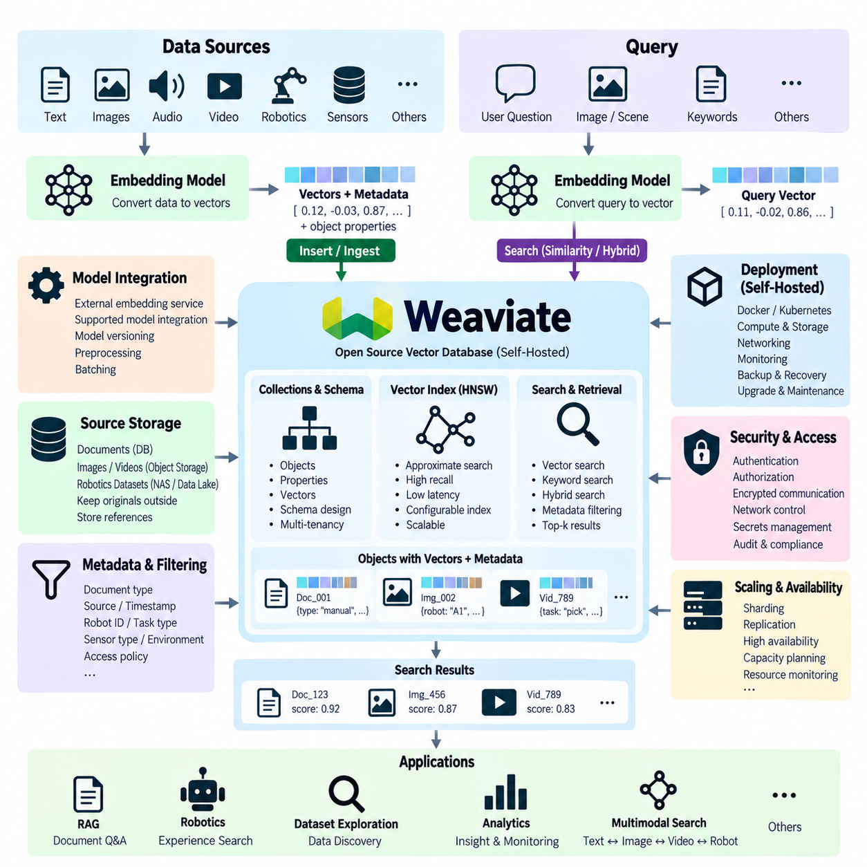
Weaviate is an open-source vector database designed to store objects together with high-dimensional vector representations and retrieve them through semantic similarity search. It can be deployed as self-hosted infrastructure, allowing organizations to control where vector data, metadata, and indexes reside. This makes it useful when AI applications require semantic retrieval while infrastructure ownership, data locality, customization, or integration with private systems is important.
A typical self-hosted Weaviate workflow begins with source information such as documents, images, product records, sensor observations, or robot experiences. An embedding model converts this information into numerical vectors that represent semantic or perceptual characteristics. The vectors are stored together with application objects and properties, creating a searchable relationship between machine-learned representations and the descriptive information needed by downstream applications.
Vectorization can be performed outside Weaviate by dedicated embedding services or integrated into an application pipeline using supported model integrations. External vectorization provides explicit control over model selection, preprocessing, batching, hardware, and model versions. Regardless of the approach, vectors stored within the same semantic search space should be generated using compatible models and preprocessing procedures so that distance calculations remain meaningful.
Weaviate organizes information into collections containing objects, properties, and associated vectors. A schema or collection design describes how application information is represented and which properties are important for filtering or retrieval. For example, a robotics collection could include robot identifiers, task categories, sensor types, timestamps, environment labels, dataset versions, and references to original sensor files while maintaining an embedding for semantic similarity search.
Similarity search compares a query vector with vectors stored in a collection and returns the nearest candidates. Depending on the vector configuration, distance functions such as cosine distance, dot product, or Euclidean distance can be used. The selected metric should correspond to the assumptions of the embedding model. Applications typically retrieve several candidates and use their distances, properties, or additional ranking logic to determine which results should be passed to downstream processing.
Approximate Nearest Neighbor search is essential when collections grow beyond the scale where exhaustive comparison is practical. Weaviate commonly uses graph-based vector indexing techniques such as Hierarchical Navigable Small World, or HNSW, to navigate efficiently through high-dimensional spaces. Instead of comparing every vector, the graph guides the search toward promising neighborhoods, providing low-latency retrieval while accepting a controlled approximation of exact nearest-neighbor results.
HNSW introduces trade-offs among search recall, query latency, memory consumption, index construction cost, and update behavior. Increasing search effort can improve the probability of finding true nearest neighbors but consumes additional computation. Dense graph connectivity can improve navigation while increasing memory requirements. Self-hosted deployments should therefore benchmark index settings using realistic embeddings and application queries instead of assuming that one configuration is optimal for every workload.
For workloads where memory efficiency or different operational characteristics are required, vector index design should be considered alongside dataset size, dimensionality, update frequency, and available infrastructure. The vector index is only one part of the system because object properties and persistent data also consume storage resources. Capacity planning should account for the complete database footprint rather than estimating requirements from raw embedding vectors alone.
Filtering is an important capability because semantic similarity by itself cannot express every application constraint. A search for a robot experience may need to consider only a particular robot model, factory, sensor configuration, task type, or time range. Weaviate can combine vector retrieval with property-based filters, enabling applications to constrain the candidate set according to structured information while still using semantic similarity to rank relevant objects.
Hybrid search combines semantic vector retrieval with keyword-oriented retrieval. This is useful when an application must understand both conceptual similarity and exact terminology. Technical documentation, for example, may contain component numbers, error codes, software package names, or uncommon engineering terms that benefit from lexical matching. Hybrid retrieval can combine these signals so that semantically related information and exact textual evidence contribute to the candidate ranking.
Self-hosting provides greater infrastructure control but also transfers operational responsibilities to the organization. Teams must plan deployment, compute capacity, persistent storage, networking, monitoring, upgrades, backup, recovery, security, and availability. Unlike a fully managed cloud service, a self-hosted installation requires administrators to understand both database behavior and the surrounding infrastructure. This additional responsibility is the principal trade-off for increased control and deployment flexibility.
Container-based deployment is a practical approach for development and smaller installations. Weaviate can be incorporated into a containerized application environment together with embedding services, APIs, relational databases, or object storage. Container orchestration can extend this architecture for larger environments, but production design should carefully address persistent volumes, resource limits, restart behavior, network policies, service discovery, health monitoring, and controlled software upgrades.
Persistent storage is essential because vector indexes and application objects must survive process or container restarts. Storage performance can influence ingestion, index construction, recovery, and database responsiveness. Production deployments should use reliable persistent volumes rather than temporary container filesystems. Backup procedures should also be tested through actual restoration exercises because a backup that has never been restored provides limited assurance of recoverability.
High availability and horizontal scaling require architecture beyond a single database process. Larger deployments may distribute data across multiple nodes through sharding and maintain replicas according to availability and throughput requirements. Sharding increases total storage and processing capacity by distributing data, while replication maintains additional copies that can improve resilience and read capacity. The appropriate topology depends on dataset size, query load, failure tolerance, and infrastructure cost.
Self-hosted security begins with controlling access to the database network. Authentication and authorization should be integrated with application security policies, while transport encryption should protect traffic where required. Database endpoints should not be exposed unnecessarily to public networks. Secrets, credentials, certificates, firewall rules, container permissions, operating-system updates, audit requirements, and backup access should all be included in the security architecture rather than treating the vector database as an isolated component.
Original source objects often remain outside Weaviate when they are large or already managed by another authoritative system. Documents may reside in document repositories, images and video in object storage, and robotics datasets in NAS or data-lake infrastructure. Weaviate can store vectors, searchable properties, and references to these assets. Retrieval results can then direct applications to the authoritative source instead of duplicating every large binary object inside the vector database.
This separation is particularly valuable for Retrieval-Augmented Generation. Documents can be divided into chunks, transformed into embeddings, and stored with properties describing source, section, version, permissions, and other contextual information. A user query retrieves semantically or lexically relevant chunks, which can then be reranked and supplied to a language model. Weaviate consequently serves as the retrieval layer while the broader RAG pipeline manages ingestion, context assembly, generation, and source presentation.
Retrieval quality must be evaluated independently from database availability. A healthy database may still produce poor application results if the embedding model, chunking strategy, metadata filters, or query formulation is inappropriate. Evaluation datasets should contain representative queries and expected relevant objects. Metrics such as recall, ranking quality, latency, and throughput can then be measured while index parameters and retrieval strategies are adjusted systematically.
Embedding-model upgrades require controlled lifecycle management. Vectors generated by different models generally represent different mathematical spaces and should not be mixed merely because they have identical dimensionality. A migration can create a new collection or vector configuration, regenerate embeddings from authoritative source data, evaluate the new retrieval behavior, and redirect applications after validation. Maintaining model and preprocessing version information makes this process reproducible.
Observability should include infrastructure and retrieval behavior. CPU, memory, disk usage, storage latency, network traffic, query latency, ingestion rate, object count, errors, and node health help administrators understand system operation. Application-level measurements should additionally track whether relevant information is actually being retrieved. Combining operational telemetry with retrieval-quality evaluation prevents infrastructure optimization from being mistaken for improvement in AI performance.
For Physical AI systems, a self-hosted vector database can provide a private semantic memory layer close to enterprise or robotic infrastructure. Embeddings can represent robot observations, task descriptions, failure events, manipulation episodes, maintenance knowledge, maps, or summarized trajectories. Weaviate can retrieve similar historical experiences while original high-volume camera, LiDAR, audio, and telemetry data remain in specialized storage systems.
An edge and on-premises architecture can be particularly useful when robotics data should remain inside a factory, laboratory, or organization. Real-time motion and safety functions should remain in deterministic robot or edge-control systems, while Weaviate handles asynchronous semantic retrieval, diagnostics, fleet knowledge, dataset discovery, and AI context generation. This separation prevents non-deterministic database queries from becoming dependencies of hard real-time control loops.
Multimodal Physical AI can extend the architecture by storing representations derived from text, images, video, sensor sequences, and robot states. Compatible multimodal embedding models can place different information types into aligned vector spaces, enabling cross-modal retrieval. Alternatively, separate vector spaces can be maintained for different modalities and combined at the application layer, preserving flexibility when one embedding model cannot adequately represent every type of robotic information.
Ultimately, self-hosted Weaviate combines vector retrieval, structured object properties, filtering, and hybrid search within infrastructure controlled by the organization. Its value extends beyond nearest-neighbor search because it connects semantic representations with application metadata and operational data management. When integrated with embedding services, authoritative storage, security, monitoring, backup, and AI applications, it can provide a practical private retrieval layer for RAG, multimodal AI, and Physical AI systems.

05.05 pgvector: PostgreSQL Vector Extension [w/Code]
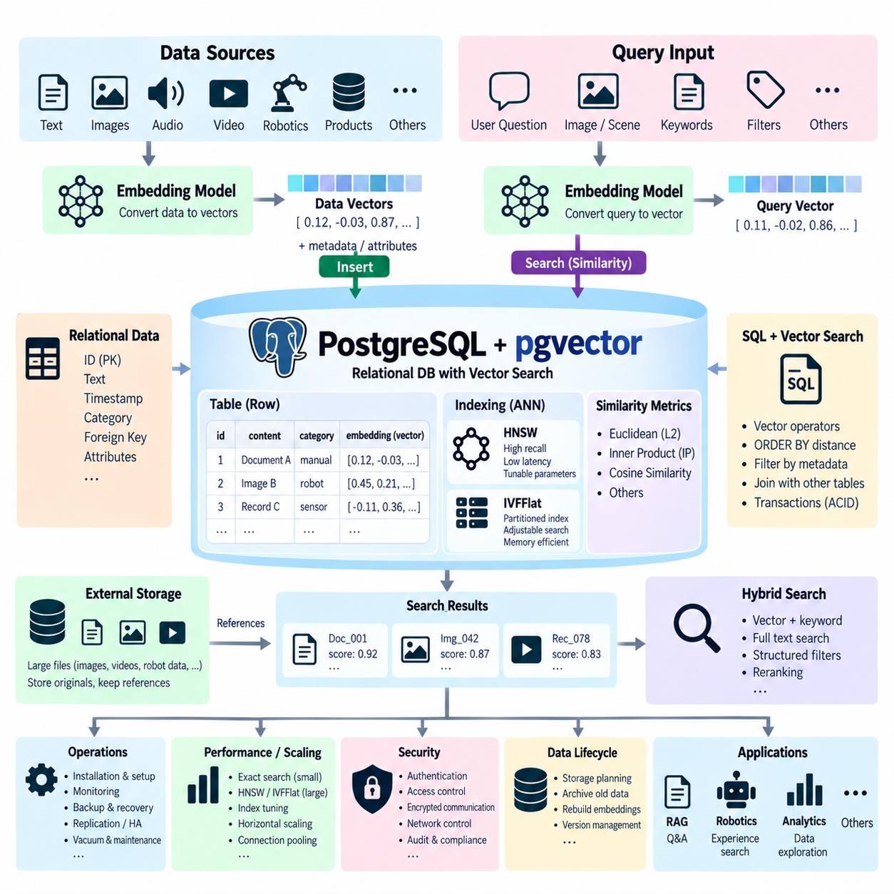
pgvector is an open-source PostgreSQL extension that adds vector data types and similarity-search capabilities to a relational database. Instead of operating a separate vector database, developers can store embeddings beside conventional application data in PostgreSQL. This approach is useful when an existing system already depends on relational schemas, SQL, transactions, joins, constraints, and PostgreSQL administration but also requires semantic retrieval for AI applications.
The basic architecture begins by enabling the vector extension in a PostgreSQL database and defining a vector column with a dimensionality compatible with the selected embedding model. A table can contain an ordinary primary key, text, timestamps, categories, foreign keys, operational attributes, and an embedding within the same row. This allows the numerical representation used for semantic search to remain directly associated with authoritative relational information.
Embedding generation normally occurs outside PostgreSQL. Text, images, robot observations, product descriptions, or other information is processed by an embedding model, and the resulting numerical vector is inserted into the vector column. Applications should record the embedding model and preprocessing version because vectors generated by incompatible models should not be treated as belonging to the same semantic space, even when their dimensionality happens to be identical.
A query follows a similar process. The application transforms a search request into a query embedding using the same or a compatible model and sends that vector to PostgreSQL. pgvector provides operators for comparing the query vector with stored embeddings according to supported distance measures. SQL can then order records by vector distance and return the nearest objects, enabling semantic retrieval through familiar relational query mechanisms.
Vector similarity can be evaluated using metrics such as Euclidean distance, inner product, and cosine distance, with additional distance functions available for suitable vector representations. The correct metric depends on how the embedding model was trained and how its output is normalized. Application designers should therefore treat distance configuration as part of the embedding contract rather than selecting a metric solely because it produces numerically convenient results.
Exact nearest-neighbor search can be performed without an approximate vector index. PostgreSQL evaluates distances against the candidate vectors and sorts them to identify the closest results. This approach provides an important correctness baseline and can be practical for smaller datasets or heavily filtered queries. As vector collections grow, however, scanning large numbers of high-dimensional embeddings increases CPU work and query latency.
Approximate indexing is therefore important for larger workloads. pgvector supports specialized vector indexes that reduce the number of candidate comparisons required during nearest-neighbor search. HNSW, or Hierarchical Navigable Small World, organizes vectors using a graph structure that can navigate rapidly toward relevant neighborhoods. It generally offers strong query performance and recall, although index construction and memory requirements can be significant.
HNSW configuration introduces trade-offs between index size, construction effort, query speed, and recall. More extensive graph connectivity can improve search quality while consuming additional memory and build resources. Query-time search effort can also be adjusted to examine more candidates when higher recall is required. These parameters should be benchmarked with production-like embeddings because realistic vector distributions may behave differently from synthetic test data.
pgvector also supports IVFFlat indexing, which partitions vectors into groups and limits queries to selected regions of the vector space. Before effective use, the index depends on an appropriate distribution of data so that partitions represent the stored vectors reasonably well. Search parameters determine how many regions are examined. Searching more partitions generally increases recall but also requires additional computation, producing the familiar ANN balance between speed and retrieval quality.
One of pgvector's strongest architectural characteristics is the ability to combine vector similarity with ordinary SQL conditions. A semantic query can simultaneously filter by customer, robot identifier, document type, time interval, access policy, product category, or operational status. PostgreSQL can also join vector-bearing rows with other relational tables. This enables semantic retrieval to participate directly in structured business and operational logic rather than existing as an isolated search service.
For example, a robotics application can search for observations semantically similar to a current situation while restricting candidates to a particular robot platform, factory, sensor configuration, or software version. The result can then be joined with task records, maintenance histories, or experiment metadata. Such queries demonstrate why relational and vector capabilities in the same database can simplify applications whose semantic information is tightly connected to structured operational data.
Transactions are another important advantage. Embeddings can be inserted, updated, or deleted together with related relational information under PostgreSQL transaction semantics. This reduces synchronization problems that may occur when metadata is stored in one database and vectors in an independent search system. Nevertheless, embedding generation itself may be asynchronous or computationally expensive, so application workflows still need clear strategies for pending, failed, or outdated embeddings.
pgvector inherits much of its operational environment from PostgreSQL. Authentication, role-based permissions, backup procedures, replication strategies, monitoring, connection management, and high-availability architectures can be applied within familiar PostgreSQL practices. Organizations with established PostgreSQL expertise can therefore introduce vector search without adopting an entirely separate database operating model, although vector workloads add new CPU, memory, storage, and indexing considerations.
Storage planning should account for vector dimensionality, row count, numeric representation, indexes, relational columns, and PostgreSQL overhead. High-dimensional embeddings multiplied by millions of rows can consume substantial storage even before approximate indexes are added. Keeping every historical embedding online may not always be necessary. Data lifecycle policies can archive obsolete source information or regenerate embeddings when appropriate rather than allowing vector tables to grow without control.
Large binary source objects should generally remain in storage systems suited to their characteristics. Images, video, LiDAR sequences, audio, or large robot datasets can reside in object storage, NAS, or a data lake, while PostgreSQL stores metadata, file references, relationships, and embeddings. pgvector then acts as a semantic access path to the source assets without forcing PostgreSQL to become the primary repository for every high-volume binary object.
Retrieval-Augmented Generation is a common use case. Document chunks can be stored as relational rows containing source identifiers, text, metadata, permissions, and embeddings. A query vector retrieves semantically related chunks, while SQL filters enforce application constraints. Retrieved records can then be reranked and supplied to a language model. This architecture combines semantic retrieval with PostgreSQL's mature structured-data capabilities and transactional consistency.
Hybrid retrieval can also combine vector similarity with PostgreSQL text-search capabilities and structured conditions. Semantic embeddings are effective for conceptual matches, while lexical search is valuable for exact identifiers, technical terms, product codes, or unusual names. Application logic can combine or rerank candidates produced by these methods, creating retrieval pipelines that exploit both semantic representation and conventional database search.
Index selection should reflect workload characteristics rather than assuming that approximate search is always preferable. Exact search may be adequate when collections are small or SQL predicates reduce candidates substantially. HNSW may be appropriate when low-latency, high-recall vector retrieval is important and sufficient memory is available. IVFFlat may offer a different balance of build behavior, memory, and search characteristics. Benchmarking should guide the final choice.
Database maintenance becomes important as vectors are inserted, updated, and deleted over time. PostgreSQL statistics, vacuum behavior, index maintenance, table growth, write amplification, and query planning remain relevant to vector workloads. A vector-enabled table is still part of a relational database and should be monitored accordingly. Performance investigations should consider both traditional SQL execution plans and the behavior of vector indexes.
Embedding-model migration requires explicit version management. When an organization changes embedding models, existing vectors normally cannot simply be compared with vectors produced by the new model. A practical migration can create a new vector column or table, regenerate embeddings from authoritative source data, construct new indexes, evaluate retrieval quality, and switch applications after validation. The previous representation can then be retired according to rollback and retention requirements.
Horizontal scaling remains an architectural consideration because pgvector operates within PostgreSQL rather than automatically transforming it into an unlimited distributed vector platform. Read replicas, partitioning, connection pooling, application-level distribution, or PostgreSQL-compatible distributed architectures may be considered as workloads grow. Scaling decisions should examine both relational traffic and vector-search traffic because the two workloads can compete for CPU, memory, I/O, and cache resources.
For Physical AI, pgvector can provide a practical semantic layer over structured robot operations. A database can store tasks, robots, sensor metadata, incidents, maintenance events, experiment results, and vector representations within related schemas. Applications can search for similar failures, observations, task descriptions, or manipulation experiences while using SQL to constrain results according to operational context and retrieve associated structured records.
In edge or on-premises robotics deployments, pgvector is particularly attractive when PostgreSQL is already part of the local infrastructure. Semantic retrieval can remain within a factory or laboratory network rather than requiring every query to reach an external cloud vector service. Hard real-time control should remain separate, but pgvector can support diagnostics, robot memory, dataset discovery, fleet analytics, RAG, and asynchronous decision-support workflows.
Ultimately, pgvector extends PostgreSQL from conventional relational storage into a combined structured and semantic retrieval platform. Its primary architectural advantage is not simply nearest-neighbor search, but the ability to integrate embeddings with SQL, transactions, joins, filtering, security, backup, and established PostgreSQL operations. For applications where vector data is closely tied to relational information, it can provide a compact and practical foundation for RAG, enterprise AI, multimodal retrieval, and Physical AI systems.

05.06 Milvus: Open Source Vector DB [w/Code]
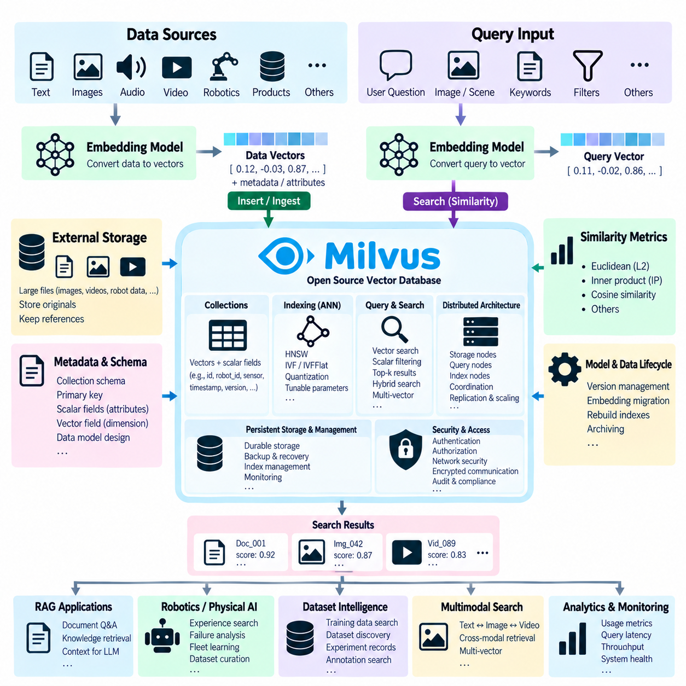
Milvus is an open-source vector database designed for storing, indexing, and searching large collections of high-dimensional embeddings. It is intended for AI workloads where semantic similarity must be evaluated across millions or potentially much larger numbers of vectors. Unlike a low-level similarity-search library, Milvus provides database-oriented capabilities around vector storage, indexing, filtering, distributed execution, persistence, and application access.
A typical Milvus workflow begins with source data such as text, images, audio, video, product records, sensor observations, or robot experiences. An embedding model converts each item into a numerical vector representing important semantic or perceptual characteristics. Applications insert these vectors into Milvus together with identifiers and scalar metadata, creating a searchable representation that can remain connected to the authoritative source data.
Milvus organizes data into collections that function as logical containers for vectors and related fields. A collection schema defines primary keys, vector fields, and scalar attributes required by the application. Robotics data, for example, might include an embedding together with robot ID, sensor type, task category, timestamp, environment, software version, and source reference. Proper schema design enables semantic retrieval to operate alongside structured operational constraints.
Embedding dimensionality and similarity metrics must remain consistent with the selected embedding model. A vector field is configured according to the representation generated by that model, while similarity can be evaluated using supported metrics appropriate to the data and index. Embeddings produced by incompatible models should normally be separated because identical dimensions do not imply a shared semantic space. Model and preprocessing versions should therefore be tracked explicitly.
When a query arrives, the application converts it into a compatible query vector and submits a nearest-neighbor search. Milvus compares the query representation against indexed vectors and returns the top-k candidates according to similarity or distance. The result typically includes identifiers, scores or distances, and requested scalar fields. Applications can then resolve these identifiers to documents, images, robot episodes, or other original information stored elsewhere.
Exact vector comparison becomes expensive as collections grow, so Milvus supports approximate nearest-neighbor indexing to reduce search cost. Different index strategies can be selected according to data scale, hardware resources, latency requirements, memory availability, and desired recall. This flexibility is important because no single vector index provides the best balance for every workload, and production systems frequently require explicit performance tuning.
Graph-based indexes such as HNSW organize vectors through neighborhood connections that allow a query to navigate rapidly toward promising regions of the embedding space. HNSW can provide strong recall and low search latency but may require significant memory for large collections. Parameters controlling graph construction and search effort affect memory, index build time, latency, and recall, making representative benchmarking essential before production deployment.
Inverted-file approaches partition the vector space into regions so that a query searches only selected candidate areas rather than the entire collection. IVF-style techniques can reduce distance calculations substantially at large scale. Search parameters determine how broadly the index is explored, producing a trade-off between speed and recall. Quantization techniques can further reduce vector memory requirements by representing high-dimensional vectors with more compact approximations.
Milvus supports scalar filtering in combination with vector similarity search. A query can restrict candidates according to fields such as category, timestamp, robot identifier, dataset version, environment, or access-related attributes. This is important because semantic similarity alone may retrieve mathematically close vectors that do not satisfy operational requirements. Filtering allows structured context to constrain the search while the vector index determines semantic relevance.
Hybrid and multi-vector retrieval architectures can extend this concept when applications need several representations of the same object. Different embeddings may represent text, images, sparse lexical features, or specialized semantic properties. Search results from multiple representations can be combined or reranked to improve relevance. This is useful for multimodal AI and technical retrieval where exact terminology and learned semantic similarity may both contribute valuable evidence.
Milvus separates computational responsibilities within its distributed architecture so that storage, coordination, indexing, and query processing can scale according to workload requirements. This separation is useful for large deployments because ingestion and search do not necessarily have identical resource demands. Components can be scaled to support growing data volume, higher query concurrency, or increased indexing workloads without treating the system as one indivisible database process.
Persistent data architecture is particularly important for distributed vector databases. Large vector collections and associated metadata must survive service restarts and node failures, while indexes may be reconstructed or managed as derived structures. Production deployments therefore require reliable persistent storage and clear recovery procedures. The database should be considered part of a broader data platform that includes storage durability, backup strategy, monitoring, and failure management.
Object storage can play an important role in large Milvus architectures, particularly when persistence and distributed operation are separated from query-serving resources. Original high-volume assets such as images, video, LiDAR sequences, audio, or complete robot datasets should generally remain in storage designed for large objects. Milvus can maintain vectors, searchable scalar information, and references that allow applications to locate these authoritative assets after semantic retrieval.
Self-hosted Milvus can be deployed in infrastructure controlled by an organization, providing flexibility over data location, compute resources, networking, security, and operational policies. Containerized environments can support development or smaller installations, while orchestrated distributed deployments can address larger workloads. The selected topology should reflect actual vector volume, ingestion rate, query concurrency, availability targets, and administrative capability.
Operating a distributed Milvus environment requires attention to more than search accuracy. Administrators must monitor CPU, memory, storage, network utilization, query latency, ingestion throughput, index construction, errors, and component health. Capacity planning should consider vector dimensions, collection size, index overhead, metadata, replicas, and growth rates. Performance problems can arise from infrastructure bottlenecks even when the selected ANN algorithm is theoretically appropriate.
High availability and scaling strategies should be designed around the failure characteristics and performance objectives of the complete deployment. Replication can improve resilience and read capacity, while distribution of data and workload enables larger collections and greater concurrency. Recovery procedures should be tested rather than assumed. Operational architecture must also account for software upgrades, schema evolution, index rebuilding, and changes in embedding pipelines.
Security should be incorporated into the deployment architecture from the beginning. Database access should be restricted to authorized applications and users, while credentials and secrets require controlled management. Network segmentation, encrypted communication where appropriate, authentication, authorization, audit practices, and infrastructure security should protect both vectors and metadata. Embeddings should not be assumed to be non-sensitive simply because they are numerical representations.
Retrieval-Augmented Generation is a common Milvus application. Document chunks can be transformed into embeddings and stored with source identifiers, permissions, timestamps, and other contextual metadata. A user question is embedded and searched against the collection, producing candidate passages that can be filtered or reranked before being supplied to a language model. Milvus therefore operates as the scalable retrieval layer within a larger RAG pipeline.
RAG quality depends on more than database speed. Chunking strategy, embedding quality, metadata design, search depth, filtering, reranking, and context construction determine whether useful evidence reaches the language model. Exact search on a smaller evaluation set can provide a baseline for measuring approximate-index recall. Representative evaluation queries should be maintained so that infrastructure tuning does not accidentally reduce semantic retrieval quality.
Embedding-model migration requires a controlled data lifecycle. Vectors generated by a new model normally occupy a different representation space and should not simply be mixed with existing embeddings. A migration may create a new collection or vector field, regenerate embeddings from authoritative sources, construct appropriate indexes, compare retrieval quality, and switch application traffic after validation. Version information allows rollback and reproducibility.
Milvus is particularly relevant when semantic search must operate over large AI datasets. Training examples, images, video segments, generated annotations, simulation episodes, and experiment records can be represented as vectors and searched according to similarity. Rather than scanning large data lakes directly, researchers can use the vector database as a semantic catalog that points toward relevant source assets, accelerating dataset discovery and curation.
For Physical AI, embeddings can represent robot observations, trajectories, manipulation episodes, task descriptions, failures, environmental states, or summarized sensor sequences. Milvus can search large experience repositories for situations resembling a current event and return references to relevant historical episodes. This creates a semantic memory layer over fleet and laboratory data while raw sensor streams remain in specialized storage infrastructure.
In robotics, cloud or database retrieval should remain separate from hard real-time control. Motion control, emergency behavior, collision avoidance, and deterministic safety functions belong on robot or edge computing systems. Milvus is better suited to asynchronous functions such as experience retrieval, fleet learning, diagnostics, RAG, dataset discovery, training-data selection, and knowledge services where millisecond-level deterministic control guarantees are not required.
Multimodal Physical AI can use separate or aligned embeddings for text, images, video, audio, sensor data, and robot states. When a multimodal model places several modalities into a compatible representation space, one type of query can retrieve information from another modality. Where a single shared space is inappropriate, multiple vector fields or collections can preserve modality-specific representations and combine their retrieval results at a higher application layer.
Ultimately, Milvus provides an open-source foundation for vector retrieval at scales that may exceed the practical range of simple embedded libraries or single-node solutions. Its value comes from combining vector indexing, structured filtering, persistent data management, and distributed scaling within a database-oriented architecture. Integrated with embedding services, object storage, security, monitoring, and AI pipelines, it can support large-scale RAG, multimodal retrieval, dataset intelligence, and Physical AI semantic memory.

05.07 Robot Scene Embedding Storage and Similarity Search [w/Code]
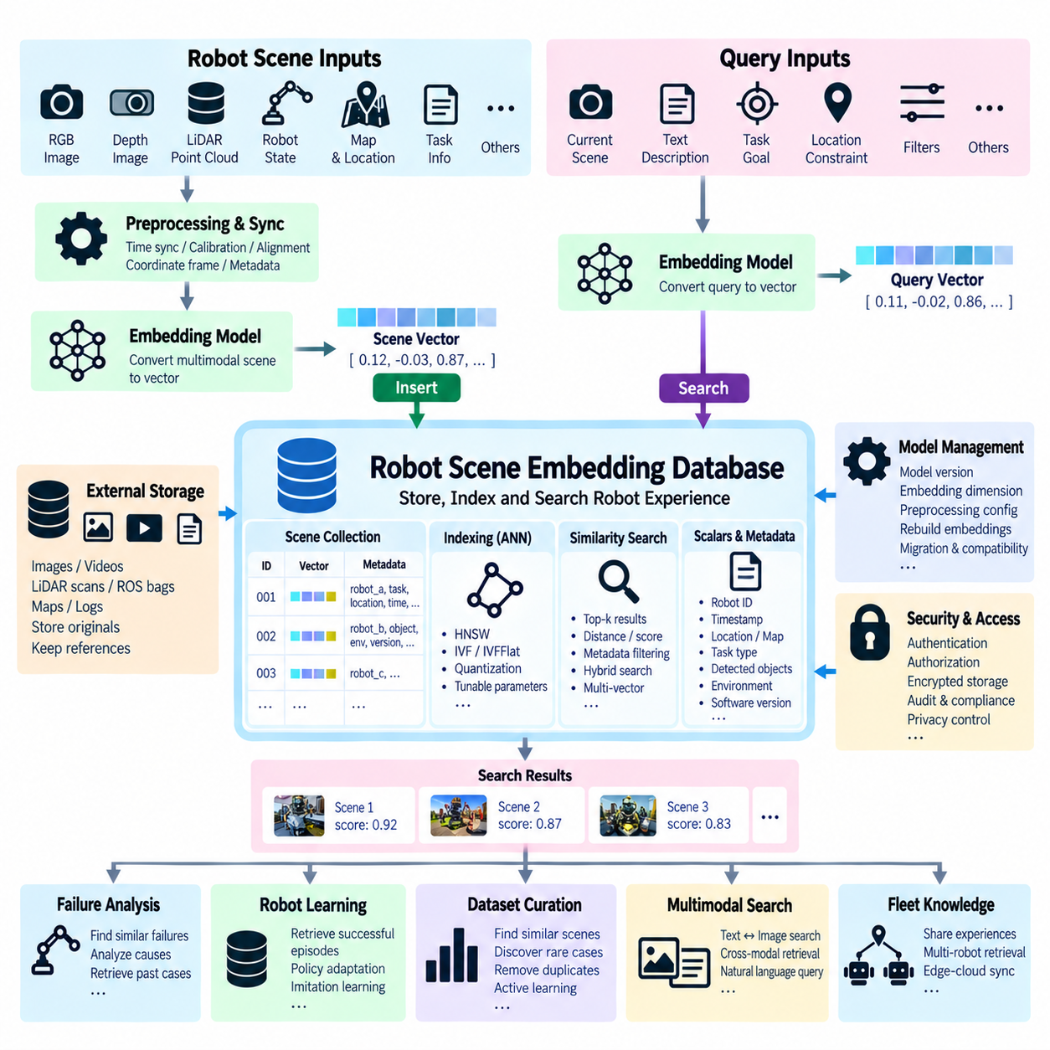
A robot scene is a structured observation of the environment captured at a particular moment or over a short temporal interval. It may contain RGB or depth images, LiDAR point clouds, object detections, robot poses, maps, language descriptions, task states, and interaction histories. Scene embedding converts this heterogeneous information into compact numerical representations that allow robot experiences to be stored, compared, and retrieved according to semantic or perceptual similarity.
The scene-embedding pipeline begins with synchronized sensor and state information. Cameras provide appearance and geometry, LiDAR contributes spatial structure, proprioceptive sensors describe robot motion, and task systems provide operational context. Before embedding generation, timestamps, coordinate frames, calibration parameters, robot identity, and mission information should be preserved so that the resulting vector remains traceable to the physical observation from which it originated.
Raw sensor data is normally too large and structurally complex to use directly for similarity search. A representation model therefore extracts meaningful features and encodes them into a fixed-dimensional vector. Depending on the application, embeddings may describe an entire scene, individual objects, local regions, trajectories, actions, or short temporal episodes. The representation level should correspond to the retrieval question the robot system is expected to answer.
Visual scene embeddings can be generated from RGB images using vision encoders that capture objects, appearance, spatial context, and semantic relationships. Depth images and point clouds can provide geometric representations describing surfaces, free space, obstacles, and three-dimensional arrangements. A robot operating in warehouses or factories may benefit from combining visual semantics with geometry because visually similar scenes can require different actions when their spatial layouts differ.
Multimodal scene embeddings integrate information from several sensor or semantic channels. Image features can be combined with depth, LiDAR, language, robot state, or task information to represent a richer scene context. Fusion can occur before embedding generation, within a learned multimodal model, or after independent modality-specific embeddings are produced. The appropriate strategy depends on model capabilities, available training data, and retrieval objectives.
Temporal information becomes important when a robot scene represents an event rather than a static observation. A sequence of frames can describe an approaching obstacle, failed manipulation, human interaction, navigation transition, or changing workspace. Temporal encoders can summarize these sequences into episode-level embeddings. Similarity search can then retrieve previous events with comparable dynamics rather than merely locating individual frames with similar visual appearance.
Scene embeddings should be stored together with structured metadata rather than as anonymous vectors. Useful metadata can include robot ID, mission ID, timestamp, location or map region, sensor configuration, software version, task type, detected objects, environmental conditions, and dataset version. Metadata enables a retrieval system to constrain vector search according to operational context and provides the provenance needed to interpret retrieved experiences.
Large source data should normally remain outside the vector database. High-resolution images, video sequences, LiDAR scans, ROS bags, maps, and telemetry archives can reside in object storage, NAS, or a data lake. The vector database stores embeddings, identifiers, searchable metadata, and references to these authoritative assets. This separation keeps similarity search efficient while preserving access to the complete evidence when a retrieved scene requires detailed analysis.
A query scene passes through an embedding pipeline compatible with the one used for stored scenes. The resulting query vector is compared with vectors in the scene database using an appropriate similarity metric. The database returns the top-k nearest candidates together with distances, scores, metadata, and source references. These results represent robot experiences that are mathematically close in the learned representation space and potentially relevant to the current situation.
Similarity does not automatically imply operational equivalence. Two warehouse scenes may contain similar shelves and pallets but differ in obstacle position, robot payload, floor condition, or mission state. For this reason, vector similarity should often be combined with metadata filtering and structured constraints. Retrieval can first restrict candidates to compatible robot platforms, tasks, environments, or software versions and then rank them according to embedding similarity.
Approximate Nearest Neighbor search becomes necessary when a robot fleet accumulates millions of scene embeddings. Indexes such as HNSW or IVF-based structures reduce the number of vector comparisons required for each query. Search parameters control the trade-off between latency and recall. Exact search on representative subsets can provide a baseline for measuring how much retrieval quality is lost when approximate indexing is introduced.
The quality of a scene retrieval system depends strongly on the embedding model. A useful representation should place operationally similar scenes near one another while separating scenes that require substantially different interpretations or actions. Generic vision embeddings may capture semantic appearance but overlook robotics-specific geometry or task state. Domain adaptation, multimodal training, or task-aware representations can therefore improve retrieval for specialized robot applications.
Robot scene retrieval can support failure analysis by searching historical experience for situations resembling a newly observed problem. If a manipulation attempt fails, the system can retrieve previous scenes containing similar objects, gripper configurations, environmental conditions, or failure patterns. Engineers or higher-level AI systems can examine associated actions and outcomes, accelerating diagnosis without manually searching large collections of sensor logs.
Experience retrieval can also support robot learning. Successful navigation, manipulation, inspection, or interaction episodes can be indexed as semantic memories. When a similar scene is encountered, the system can retrieve relevant examples and provide them to a planner, policy adaptation module, or reasoning model. Retrieved experiences should be treated as contextual evidence rather than direct control commands because similarity alone does not guarantee that a previous action is safe or optimal.
Scene embeddings are useful for dataset discovery and curation. Large robotics datasets frequently contain redundant frames, rare situations, repeated environments, and uneven task distributions. Vector search can identify clusters of similar scenes, retrieve examples around unusual events, discover near-duplicates, or locate scenes containing related semantic content. This helps researchers construct more balanced training and evaluation datasets without manually reviewing every recording.
Similarity search can contribute to active learning by identifying observations that are poorly represented in the existing dataset. A new scene that is distant from known clusters may represent a novel environment, unusual object arrangement, or rare failure case. Such observations can be prioritized for annotation or expert review. Conversely, highly redundant scenes may be sampled less aggressively, improving the efficiency of data labeling and training-data selection.
Cross-modal retrieval becomes possible when robot observations and language are represented in compatible embedding spaces. An engineer could search for scenes using a description such as a blocked aisle, misplaced pallet, failed grasp, or person approaching the robot. The system can return visual or multimodal experiences matching the description. Conversely, an observed scene may retrieve maintenance notes, task instructions, or textual reports associated with semantically related experiences.
A scene-memory architecture can integrate vector retrieval with a world model or higher-level reasoning system. The world model represents the current environment and predicts possible state transitions, while semantic memory retrieves relevant historical observations and episodes. A reasoning layer can compare current state, predicted outcomes, and retrieved experience. This creates a useful separation between perception, memory, prediction, reasoning, and real-time control.
For fleet robotics, scene embeddings can support collective experience across multiple robots. Individual robots generate observations locally, while selected embeddings and metadata are synchronized with an edge or central repository. Similarity search can then retrieve experiences captured by other robots operating in related environments. This allows knowledge discovered by one robot to become searchable evidence for the rest of the fleet without transferring every raw sensor stream continuously.
Edge-cloud partitioning should reflect latency, bandwidth, privacy, and safety requirements. Frequently needed embeddings or local indexes can remain on an edge computer for low-latency retrieval, while larger historical collections are maintained on-premises or in the cloud. Selected experiences can be synchronized asynchronously. Safety-critical motion control remains local and deterministic, whereas scene similarity search supports slower memory, analysis, learning, and reasoning functions.
Embedding lifecycle management is essential because perception models evolve. When an encoder is replaced, vectors produced by the new model may no longer be comparable with previously stored representations. Model identifier, embedding dimension, preprocessing configuration, and version should therefore accompany every vector collection. Migration can regenerate embeddings from authoritative scene data, build a new index, evaluate retrieval behavior, and switch applications after validation.
Evaluation should measure whether retrieved scenes are genuinely useful for robotics tasks rather than merely close according to vector distance. Test sets can contain query scenes with known relevant experiences, allowing recall, ranking quality, latency, and filtering accuracy to be measured. Human or task-level evaluation may also determine whether retrieved examples improve diagnosis, planning, dataset selection, or reasoning. Retrieval quality should be monitored as models and datasets change.
Security and governance apply to scene embeddings because robot observations can contain sensitive operational information. Metadata may reveal locations, equipment identities, production processes, or mission histories, while source images and sensor logs can contain additional restricted information. Access control, encryption, retention policies, auditability, and dataset provenance should therefore cover the vector index and the underlying source storage as one connected information system.
Ultimately, robot scene embedding transforms large collections of heterogeneous observations into searchable semantic memory. Vector databases provide efficient similarity retrieval, while metadata, authoritative storage, multimodal representations, temporal context, and lifecycle management preserve the operational meaning of each experience. Combined carefully, these components enable Physical AI systems to discover prior experience, analyze failures, curate datasets, share fleet knowledge, and connect perception with memory and higher-level reasoning.

05.08 VLA Model Knowledge Base and Vector DB Integration [w/Code]
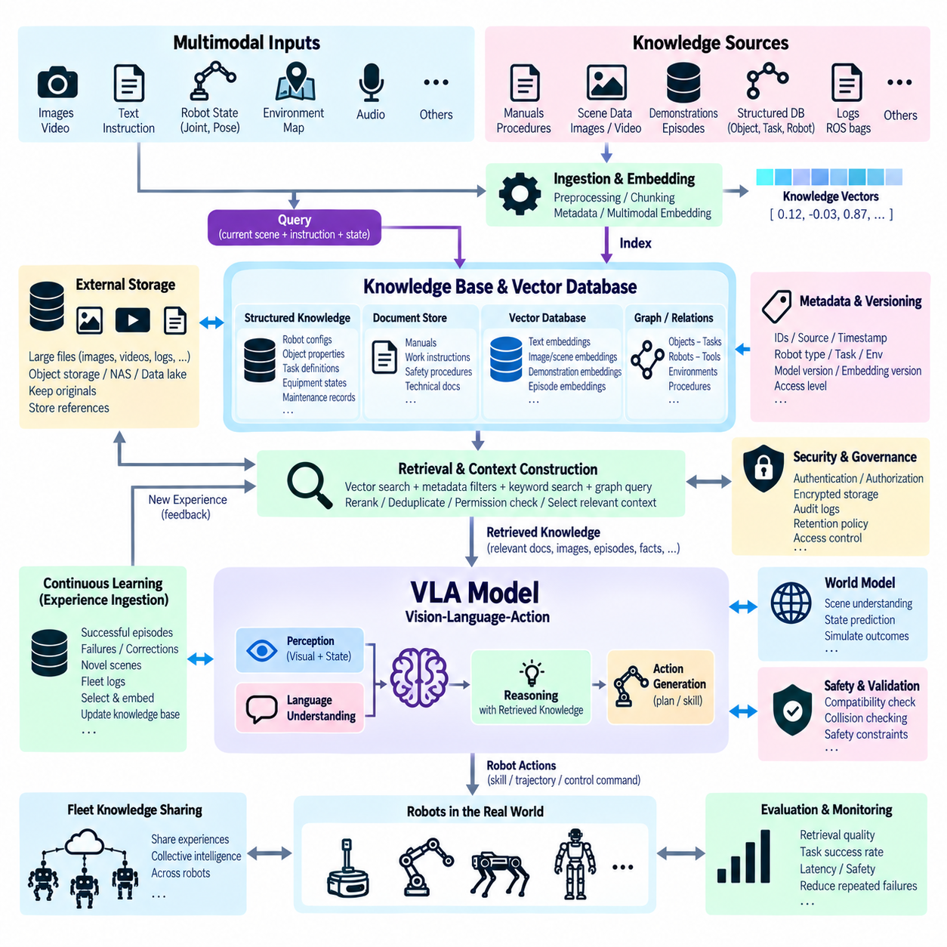
A Vision-Language-Action model connects visual perception, language understanding, and robot action generation within a unified Physical AI pipeline. The model receives observations such as camera images together with natural-language goals and robot state, interprets the current situation, and generates actions or action representations. A knowledge base and vector database can extend this capability by providing external memory that is searchable during reasoning and task execution.
The VLA model itself should not be treated as a complete repository of operational knowledge. Model parameters contain knowledge acquired during training, but factories, robots, objects, procedures, maps, failures, and task policies continue to change after deployment. External knowledge systems allow information to be updated independently of model retraining and provide explicit sources that can be retrieved, inspected, versioned, secured, and associated with real robot experience.
A VLA knowledge architecture can combine structured knowledge, unstructured documents, and semantic vector memory. Structured databases may contain robot configurations, object properties, task definitions, equipment states, and maintenance records. Document repositories may store manuals and procedures, while vector databases index embeddings of text, images, scenes, demonstrations, and episodes. Together they provide complementary forms of memory for robot reasoning.
The vector database acts as semantic memory rather than simply as long-term file storage. Documents, scene observations, manipulation demonstrations, failure episodes, and task descriptions are transformed into embeddings and indexed according to their semantic or perceptual characteristics. When the VLA system encounters a new situation, a compatible query embedding can retrieve related experiences even when the current observation does not exactly match previously stored text or metadata.
Knowledge ingestion begins with authoritative source information. Robot manuals, work instructions, object models, images, videos, ROS bags, sensor sequences, task demonstrations, and fleet logs can be processed into searchable units. Each unit receives identifiers, metadata, provenance, and an embedding generated by an appropriate encoder. Large original assets remain in object storage, NAS, or a data lake, while the vector database maintains compact semantic representations and source references.
Multimodal embeddings are particularly important for VLA systems because a robot operates through several information channels simultaneously. Text can describe an intended task, images represent the observed workspace, video captures temporal behavior, and robot states describe embodiment and execution context. Compatible multimodal representations allow language queries to retrieve visual experiences or current scenes to retrieve related instructions, demonstrations, and historical episodes.
A retrieval request can originate from the user's instruction, the current visual scene, robot state, planner context, or a combination of these inputs. A retrieval module converts the context into one or more query representations and searches the knowledge system. Metadata filters can restrict results according to robot type, end effector, workspace, task, object, software version, safety class, or time period before semantic similarity is used to rank candidates.
Retrieved information should normally pass through a context-construction layer before reaching the VLA reasoning process. This layer can remove duplicates, apply permissions, rerank candidates, verify source versions, and limit context size. It can also combine vector results with structured database queries or lexical search. The objective is not to provide the model with the largest possible amount of information, but to construct a compact set of relevant and traceable evidence.
Retrieval-Augmented Generation principles can therefore be extended from language models to Vision-Language-Action systems. Instead of retrieving only document passages for text generation, the system can retrieve task instructions, visual examples, object information, robot demonstrations, previous failures, and successful trajectories. The retrieved context can support task interpretation, planning, action selection, explanation, or recovery while the VLA model remains responsible for integrating current perception.
A robot asked to manipulate an unfamiliar object illustrates this architecture. The current image and language instruction can form a multimodal query that retrieves visually similar objects, handling instructions, successful grasp demonstrations, and previous failure cases. Structured metadata can restrict results to compatible grippers or robot platforms. The VLA reasoning layer then evaluates this evidence together with the current geometry and robot state before proposing an action.
Experience memory can continuously expand as robots execute tasks. Successful episodes, unusual observations, operator corrections, and selected failures can be summarized and embedded after execution. Metadata records the robot, task, environment, model version, action outcome, and source logs. New experiences become searchable by other tasks or robots, allowing the knowledge base to evolve from deployed operation instead of remaining fixed at the time of initial model training.
Not every observation should become permanent memory. Continuous cameras and sensors can generate enormous amounts of redundant data, so a memory-selection policy is necessary. Novel scenes, failures, successful demonstrations, operator interventions, rare events, or high-value task outcomes can be prioritized. Similarity search can identify near-duplicate experiences, while novelty detection and clustering can help determine which episodes provide new information worth retaining.
The architecture should distinguish semantic memory from episodic memory. Semantic memory represents generalized information such as object properties, task concepts, procedures, and relationships. Episodic memory represents specific experiences containing a time, environment, robot state, actions, and outcomes. Vector databases can index both, but metadata and storage schemas should preserve the distinction so that the reasoning system understands whether retrieved evidence is general knowledge or a particular historical event.
A structured knowledge base can complement vector retrieval by representing explicit relationships. A robot may need to know that a tool belongs to a certain equipment class, that a procedure requires a specific end effector, or that an object is located within a designated workcell. Relational databases or graph structures can answer these precise questions, while vector retrieval discovers semantically related information. Combining both avoids forcing every knowledge problem into embedding similarity.
Hybrid retrieval can integrate semantic vectors, keyword search, structured SQL filters, and graph relationships. Exact identifiers and safety procedure numbers may be better retrieved lexically, while ambiguous scene descriptions benefit from embeddings. Structured queries enforce compatibility constraints, and graph traversal can expose relationships between objects, tasks, and equipment. A retrieval orchestrator can combine these sources before presenting evidence to the VLA reasoning layer.
World models can add another layer by representing the current environment and predicting how it may change after an action. The knowledge base provides factual and procedural information, semantic memory retrieves related experiences, and the world model predicts possible state transitions. The VLA system can integrate perception, retrieved memory, predicted outcomes, and task objectives, creating a richer reasoning architecture than a purely reactive mapping from images and language to actions.
Retrieved experiences must not automatically become executable commands. A demonstration that succeeded on another robot, software version, payload, or environment may be unsafe in the current context. Compatibility checks should compare embodiment, workspace constraints, object state, tool configuration, and safety requirements. Retrieval supplies evidence and candidate strategies, while validation, planning, collision checking, and safety control determine whether an action can actually be executed.
This separation is especially important for hard real-time robotics. Vector search, knowledge retrieval, large-model reasoning, and cloud services may have variable latency and cannot replace deterministic motion control or emergency safety functions. Low-level control, collision protection, and safety interlocks remain local. VLA reasoning and memory retrieval operate at a higher level, producing goals or candidate actions that are validated before entering the real-time execution layer.
Edge, on-premises, and cloud resources can cooperate within the knowledge architecture. Frequently accessed task knowledge and recent scene embeddings can be cached near the robot, while large historical vector collections and training datasets remain in an on-premises data center or cloud environment. Retrieval can follow a hierarchical strategy that searches local memory first and expands outward when additional evidence is required, reducing latency and network traffic.
Fleet operation creates the possibility of collective intelligence. Each robot can contribute selected experiences to a shared knowledge repository, where embeddings make them searchable by other robots. A failure observed by one unit can later be retrieved when another encounters a similar scene. Central systems can cluster experiences across the fleet, identify recurring problems, curate valuable demonstrations, and distribute validated knowledge or updated indexes back toward edge systems.
Knowledge and embedding versioning are essential because VLA models, perception encoders, robot software, and operating procedures evolve independently. Every memory item should retain model identifiers, embedding versions, source versions, timestamps, and relevant robot configuration. When an embedding model changes, vectors may need regeneration and reindexing. Version-aware retrieval prevents incompatible representations or obsolete procedures from silently contaminating current reasoning.
Security and governance must cover the complete retrieval chain. Robot observations may reveal production environments, people, equipment, or confidential processes, while operational documents can contain restricted procedures. Authentication, authorization, encryption, audit logs, retention rules, source provenance, and access-aware filtering should apply to knowledge stores, vector databases, object storage, and retrieval services. Retrieved context should never bypass the permissions of its original source.
Evaluation should measure whether retrieval improves robot behavior rather than only vector-search accuracy. Useful metrics include retrieval recall, ranking quality, latency, source correctness, context relevance, task success, recovery success, and reduction of repeated failures. Controlled tests can compare VLA performance with and without external memory. Evaluation should also identify harmful retrieval, where irrelevant or outdated experiences cause poorer planning or inappropriate actions.
Ultimately, integrating a VLA model with a knowledge base and vector database creates a layered Physical AI memory architecture. Perception describes the current world, the knowledge base provides explicit facts and procedures, vector retrieval supplies semantically related experience, and the VLA model integrates this evidence into task reasoning. World models, planners, validation, and real-time control then convert high-level decisions into safe execution, enabling robots to learn from accumulated knowledge without placing every capability inside a single model.

05.09 Vector DB Index Comparison: HNSW, IVF, PQ
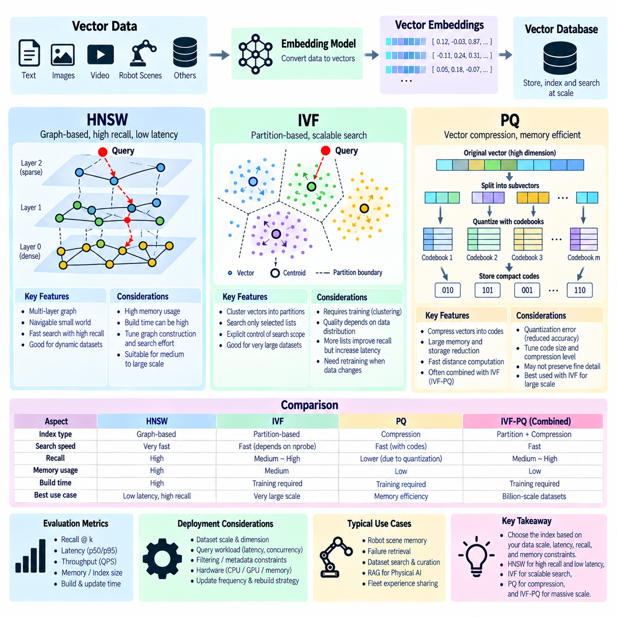
Vector database indexes reduce the computational cost of finding embeddings that are closest to a query vector. Exact nearest-neighbor search compares a query against every candidate and provides a useful accuracy baseline, but its cost grows with collection size and vector dimensionality. Approximate Nearest Neighbor indexing sacrifices some exactness to reduce latency, memory traffic, or storage requirements, making large-scale semantic retrieval practical.
HNSW, IVF, and PQ address different parts of the vector-search problem. HNSW organizes vectors as a navigable graph, IVF divides the vector space into partitions so that only selected regions need to be searched, and PQ compresses vectors into compact codes that make storage and distance computation cheaper. They should not be viewed simply as three interchangeable algorithms because their structures, resource requirements, and optimization objectives differ substantially.
Hierarchical Navigable Small World, or HNSW, builds a multi-layer graph whose nodes represent stored vectors. Connections link vectors to nearby neighbors, while upper layers provide longer-range paths across the vector space. During a query, search begins in sparse upper layers and progressively moves toward denser lower layers. This graph traversal allows the algorithm to reach promising neighborhoods without scanning every stored vector.
HNSW is widely used when low query latency and high recall are important. Its graph can preserve many useful neighborhood relationships, allowing search to find strong candidates with relatively few distance calculations. The principal cost is memory because the database must store vectors together with graph connections and supporting structures. Large HNSW indexes can therefore require substantial RAM, particularly when high-dimensional vectors and large collections are involved.
Two important HNSW tuning concepts are graph construction quality and query search effort. Increasing connectivity or construction effort can improve the quality of the graph but increases build time and memory usage. Increasing query-time exploration examines more candidate nodes and can improve recall at the expense of latency. The appropriate settings depend on vector distribution, collection size, update behavior, available memory, and service-level objectives.
HNSW can also be attractive for dynamic datasets because new vectors can be inserted into the graph without requiring a complete retraining stage comparable to clustering-based indexes. However, frequent updates, deletions, index growth, and database-specific maintenance behavior still require operational consideration. HNSW should therefore be benchmarked not only for static search speed but also for ingestion throughput, memory growth, rebuild procedures, and long-term maintenance.
Inverted File indexing, commonly represented by IVF, takes a partition-based approach. A clustering process divides the vector space into regions represented by centroids. Each stored vector is assigned to one or more corresponding partitions, often called inverted lists. At query time, the system identifies the nearest centroids and searches only selected lists rather than examining the complete vector collection.
The number of partitions and the number of partitions examined during a query strongly affect IVF behavior. Searching only a small number of lists reduces latency but may miss relevant vectors located in neighboring partitions. Searching more lists improves recall while increasing computation. This parameterized search scope makes IVF useful when operators want explicit control over the trade-off between search speed and retrieval quality.
IVF normally requires a training or clustering stage before the index can represent the dataset effectively. Training samples should reflect the actual vector distribution, because poor centroid placement can create unbalanced or semantically inappropriate partitions. Significant changes in data distribution may eventually reduce index quality. Consequently, IVF deployment should consider dataset evolution, retraining strategy, partition balance, and index reconstruction procedures.
Product Quantization, or PQ, focuses primarily on compact vector representation. A high-dimensional vector is divided into several subvectors, and each subvector is approximated using an entry from a learned codebook. Instead of storing every original floating-point component for search, the system stores compact code identifiers. Approximate distances can then be computed from these compressed representations using efficient lookup operations.
The major advantage of PQ is memory and storage reduction. When billions of vectors or very high-dimensional embeddings must be retained, storing full-precision vectors and large indexes can become prohibitively expensive. PQ can substantially reduce the footprint, allowing more vectors to remain in memory or reducing storage and data-transfer costs. The trade-off is quantization error because compressed representations do not preserve every detail of the original vector.
PQ configuration determines how aggressively vectors are compressed. More detailed codes generally preserve vector information better but consume more memory, while stronger compression reduces footprint at the cost of greater approximation error. The effect on retrieval quality depends on the embedding distribution and application. A configuration suitable for broad image retrieval may not preserve the distinctions required for fine-grained robot failure analysis or technical document search.
PQ is frequently combined with IVF rather than used as an entirely independent search architecture. IVF first narrows the search to selected partitions, while PQ reduces the memory and computation required to evaluate vectors inside those partitions. This combination, commonly referred to as IVF-PQ, is particularly useful for very large collections where both candidate reduction and vector compression are necessary to achieve acceptable resource consumption.
HNSW and IVF-PQ therefore represent different scaling philosophies. HNSW spends substantial memory to construct a navigable neighborhood graph and can provide strong recall with low latency. IVF-PQ reduces the candidate search space and compresses vector representations, making it attractive when memory efficiency and very large scale are dominant requirements. The better choice depends on actual workload constraints rather than a universal ranking of index technologies.
Dataset scale is one of the first selection factors. For moderate collections with sufficient RAM and demanding interactive latency, HNSW may provide a straightforward high-recall solution. As collections become extremely large, storing complete vectors and graph connections can become expensive, making partitioning and compression increasingly valuable. However, thresholds depend on embedding dimensions, hardware, implementation, query rate, and database architecture.
Query workload also affects index selection. Interactive applications may prioritize predictable low latency, while offline dataset exploration may tolerate slower searches in exchange for reduced infrastructure cost. High query concurrency can make CPU and memory bandwidth important, while ingestion-heavy systems must consider index update cost. Filter-heavy workloads may behave differently because metadata predicates can greatly reduce the effective candidate population before or during vector search.
Recall should always be measured against an appropriate exact-search baseline. ANN parameters can make an index appear extremely fast simply by examining too few candidates, but this speed has little value if relevant results disappear. Evaluation should use representative production queries and known relevant neighbors. Recall at k, latency percentiles, throughput, memory consumption, build time, index size, and update performance should be measured together.
Filtering introduces another practical consideration. A vector database may need to retrieve similar items only from a particular robot, customer, time interval, task, or security domain. Depending on the database implementation, filters may be applied before, during, or after ANN traversal. Highly selective filtering can alter index behavior substantially. Index benchmarks should therefore reproduce real metadata constraints rather than testing only unrestricted vector searches.
Vector dimensionality directly affects computational and storage costs. Higher-dimensional embeddings require more memory and more arithmetic for distance calculations. HNSW must maintain vectors plus graph structures, while PQ can reduce the representation footprint through compression. Dimensionality reduction or a smaller embedding model may sometimes provide greater system-level benefit than aggressive index tuning, provided semantic retrieval quality remains sufficient.
Hardware architecture also influences performance. Large-memory CPU servers may accommodate substantial HNSW indexes, while GPU-accelerated systems can make highly parallel distance calculations and IVF-style searches attractive. Storage bandwidth, cache behavior, network topology, NUMA characteristics, and accelerator memory can all become bottlenecks. An index should therefore be evaluated on the hardware architecture intended for production rather than selected solely from algorithmic descriptions.
Index construction time matters when embeddings change frequently or entire collections must be regenerated. HNSW graph construction can be computationally expensive, while IVF requires clustering and PQ requires codebook training. Embedding-model migration may force large portions of the index to be rebuilt regardless of algorithm. Organizations should include rebuild duration, temporary storage, dual-index operation, validation, and rollback in lifecycle planning.
For robot scene memory, HNSW can be effective when a facility maintains a moderate-to-large collection of scene embeddings and requires fast retrieval of similar experiences. A robot encountering a failure can query historical observations and receive high-recall candidates quickly. Metadata can restrict results to compatible platforms, tasks, or environments, while retrieved source references provide access to full sensor logs for diagnosis and reasoning.
IVF-PQ becomes attractive when a fleet accumulates extremely large experience repositories containing embeddings from many robots, sites, tasks, and years of operation. Partitioning reduces the candidate space while quantization controls memory growth. The resulting retrieval may be less exact than an expensive full-vector configuration, so critical subsets or recent experiences can remain in higher-fidelity indexes while older archives use stronger compression.
Tiered indexing can combine these approaches. Recent, frequently accessed, or safety-relevant experiences may use high-recall HNSW or even exact search for limited subsets, while large historical collections use IVF-PQ. A retrieval orchestrator can search local and high-value memory first, then expand toward compressed archival indexes when necessary. This architecture aligns retrieval fidelity and infrastructure cost with the operational value of the data.
No ANN index should be considered part of a hard real-time safety mechanism unless the complete system has been engineered and validated for that requirement. Approximate search latency and recall can vary with data, load, parameters, and infrastructure. In Physical AI, HNSW, IVF, and PQ are better suited to semantic memory, RAG, experience retrieval, dataset discovery, diagnostics, and planning support, while deterministic safety and motion control remain separate.
Ultimately, HNSW emphasizes graph-based navigation and high-recall low-latency retrieval, IVF emphasizes partition-based candidate reduction, and PQ emphasizes vector compression and resource efficiency. IVF and PQ can be combined for very large-scale search, while HNSW is often compelling when memory is available and retrieval quality is prioritized. Reliable selection requires workload-specific benchmarking across recall, latency, throughput, memory, index size, build cost, filtering, and lifecycle behavior.

05.10 Robot Semantic Map Vector Storage Case [w/Code]
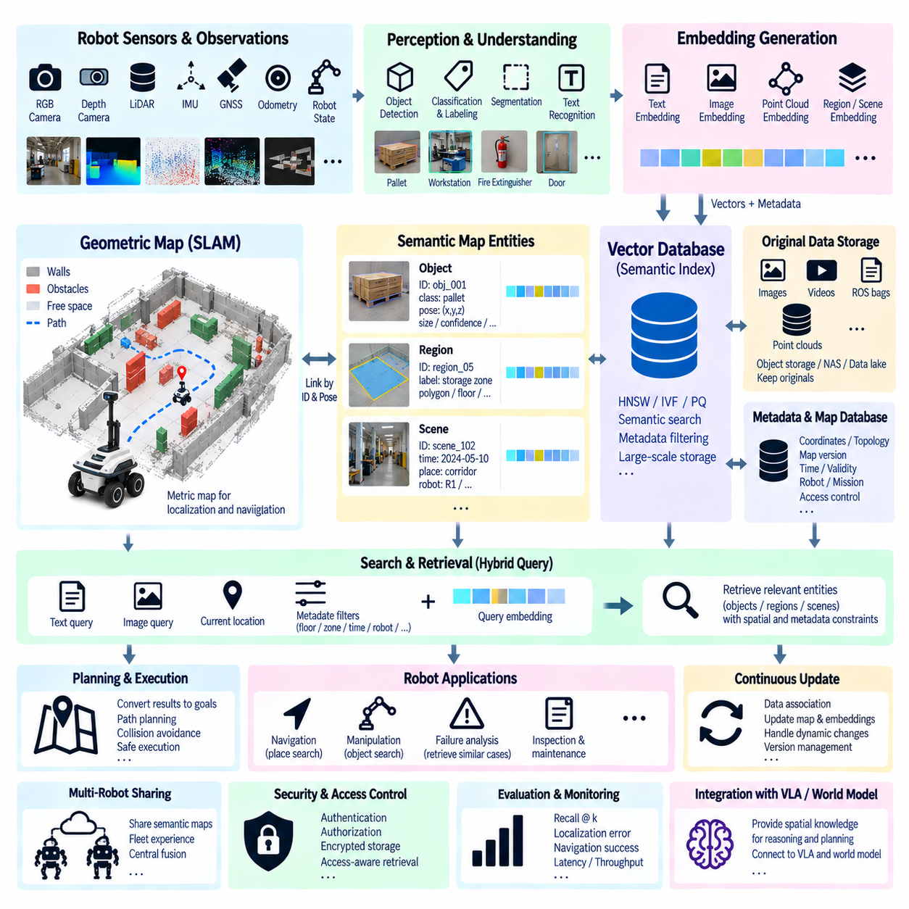
A robot semantic map extends a geometric map by attaching meaning to places, objects, structures, and observations. Traditional SLAM may describe walls, free space, obstacles, and robot poses, while a semantic map can represent concepts such as loading station, elevator, fire extinguisher, workstation, pallet, restricted zone, or damaged surface. Vector storage adds another layer by making these semantic entities searchable through learned embeddings.
The architecture begins with synchronized robot perception. RGB cameras, depth cameras, LiDAR, IMU, GNSS, odometry, and robot state can contribute observations associated with a position and time. Perception models detect objects, classify regions, segment surfaces, recognize text, or describe scenes. Every semantic observation should retain spatial coordinates, reference frames, timestamps, sensor provenance, and confidence so that meaning remains connected to physical space.
Geometric and semantic information should remain distinguishable even when they are tightly integrated. Occupancy grids, point clouds, meshes, and metric landmarks represent physical geometry, while semantic labels and embeddings describe meaning. A navigation controller may require precise geometry for collision avoidance, whereas a task planner may ask for a location semantically described as a charging area or a place containing a particular type of equipment.
An embedding model can transform map entities into vectors that encode semantic or perceptual characteristics. Text descriptions, cropped object images, scene images, map regions, point-cloud segments, or multimodal observations can each receive embeddings. A storage record then links the vector to a semantic entity identifier, map coordinates, object or region metadata, and references to the original sensor information.
The vector database should not replace the authoritative geometric map. Instead, it acts as a semantic retrieval layer connected to map data through stable identifiers. Large point clouds, images, video sequences, and ROS bags can remain in object storage, NAS, or a data lake. The vector database stores compact embeddings and metadata, while a spatial or mapping database maintains geometry, coordinates, topology, and other map-specific structures.
This separation supports efficient multimodal search. A user might ask the robot to find an area that looks like a maintenance workspace, while another robot may query using a camera observation rather than text. Both inputs can be converted into compatible embeddings and compared with stored semantic-map vectors. The retrieved records provide map entity identifiers and spatial references that connect semantic similarity back to physical locations.
Metadata filtering is essential because semantic similarity alone does not guarantee spatial or operational relevance. A query can first restrict candidates by building, floor, map version, robot type, zone, object class, timestamp, confidence, or mission. Vector similarity then ranks candidates inside the valid subset. Spatial predicates can further restrict results to entities within a radius, polygon, corridor, or designated operating area.
A hybrid query can therefore combine vector similarity with spatial and relational constraints. For example, a robot may search for an object visually similar to a reference image, located on the second floor, inside an authorized zone, and within ten meters of its current route. The vector database identifies semantic similarity, while geospatial and structured databases enforce location and operational constraints before results are used by planning.
Object-level semantic mapping represents each detected physical object as an entity with a persistent or probabilistic identity. The record can contain object class, position, orientation, dimensions, observation history, confidence, source frames, and an embedding. Multiple observations of the same object may be associated with one entity after data association, allowing the semantic map to accumulate richer descriptions without treating every detection as a new object.
Region-level embeddings provide a broader representation of the environment. A corridor, storage zone, laboratory, outdoor loading area, or intersection can be represented by an embedding derived from multiple observations. These vectors enable place recognition and semantic localization when exact visual details have changed. A robot can retrieve regions that resemble its current surroundings and use the candidates as contextual evidence for localization or task reasoning.
Scene-level storage can preserve snapshots of important environmental states. Instead of indexing every video frame, the system can select keyframes, unusual scenes, transitions, failures, or task-relevant observations. Each scene embedding is associated with pose, map region, time, robot identity, and source data. Similarity search can later retrieve historical scenes showing how the same place or a similar environment appeared under different conditions.
Temporal information becomes important when environments change. Pallets move, doors open and close, equipment is relocated, and temporary obstacles appear. A semantic map should therefore avoid assuming that every observation is permanently valid. Timestamps, validity intervals, observation frequency, confidence decay, and map versions can help distinguish persistent infrastructure from temporary state and prevent outdated vector records from dominating current decisions.
Semantic map updates require data association between new observations and existing entities. Geometry, object class, appearance embeddings, timestamps, and motion assumptions can contribute to determining whether a detection represents an existing object or a new one. Vector similarity is useful evidence, but it should not be the only criterion. Incorrect association can merge different physical objects and corrupt both semantic memory and spatial reasoning.
Approximate Nearest Neighbor indexes can support large semantic maps containing millions of object, region, and scene embeddings. HNSW can provide high-recall interactive retrieval when sufficient memory is available, while IVF or IVF-PQ can support much larger historical collections with lower memory requirements. Different semantic-map layers can use different indexes according to access frequency, required recall, and data scale.
A hierarchical storage strategy is particularly useful for mobile robots. Recent and locally relevant embeddings can remain on the robot or nearby edge computer for low-latency access. Facility-level semantic memory can reside on an on-premises server, while long-term fleet history may be stored centrally. Retrieval can search local memory first and progressively expand to facility or fleet collections when additional context is needed.
Semantic maps can improve natural-language robot interaction. An operator can request, “Go to the area where blue containers are stored,” even if no waypoint with that exact name exists. The language instruction is embedded and matched against object and region representations. Retrieved candidates are converted into spatial goals, but navigation still relies on the geometric map, localization, path planning, obstacle avoidance, and safety constraints.
The same architecture supports visual place retrieval. A robot can use its current camera image to search for previously observed regions with similar appearance. This can complement conventional localization, especially when semantic landmarks are more stable than low-level visual features. However, perceptual similarity does not prove geometric identity, so retrieved candidates should be verified using pose estimation, geometry, topology, or additional sensor evidence.
Failure analysis is another important application. When navigation or manipulation fails at a particular location, the associated scene, map region, robot state, and event description can be embedded and stored. Later failures can retrieve similar historical episodes, helping engineers identify recurring environmental patterns. The system can link semantic-map entities to logs, sensor recordings, maintenance records, and corrective actions for deeper diagnosis.
Fleet robots can contribute observations to a shared semantic map while maintaining provenance for each source. Multiple robots may observe the same corridor, machine, or outdoor region from different viewpoints and sensor configurations. Central fusion can consolidate stable knowledge while retaining individual observations. Vector search then allows one robot to benefit from experiences collected by others without copying every raw sensor file to the robot.
Map and embedding version management is critical because geometry, semantic models, and embedding models can evolve independently. Every vector should reference the map version and encoder version under which it was created. A remodeled facility may invalidate spatial relationships even when object descriptions remain semantically meaningful. Version-aware retrieval prevents vectors tied to obsolete maps or incompatible embedding spaces from being silently mixed with current data.
Security and access control can also have spatial meaning. Some map regions, images, or operational descriptions may be restricted according to user role, robot authorization, mission, or facility zone. Retrieval should apply permissions before protected information enters a reasoning model. Authentication, encryption, audit logging, source provenance, retention policies, and access-aware metadata filtering should extend across vector storage, map databases, and original sensor archives.
Evaluation must examine both semantic retrieval quality and spatial usefulness. Recall at k and ranking metrics can measure whether related entities are retrieved, while localization error, destination correctness, navigation success, task completion, and query latency measure operational value. Tests should include appearance changes, moved objects, duplicate objects, map updates, poor lighting, sensor differences, and ambiguous language to expose failure modes.
A Physical AI system can connect semantic maps with VLA models, world models, planners, and experience memory. The semantic map provides grounded knowledge about what exists and where it is located, vector retrieval discovers related entities and experiences, and the world model can represent current state or predicted changes. Higher-level reasoning can use this information to propose goals while deterministic navigation and safety remain separate execution layers.
Ultimately, vector storage transforms a robot semantic map from a collection of labeled coordinates into searchable spatial memory. Geometry answers where the robot can move, structured map data describes explicit entities and relationships, and embeddings provide flexible semantic similarity across language, images, scenes, and objects. Combining these layers allows robots to retrieve meaningful places and experiences while preserving the spatial grounding required for reliable real-world operation.

