Volume 08 Robot Database and Storage

01. SQL Databases

01.01 Relational DB Theory: Normalization / ACID
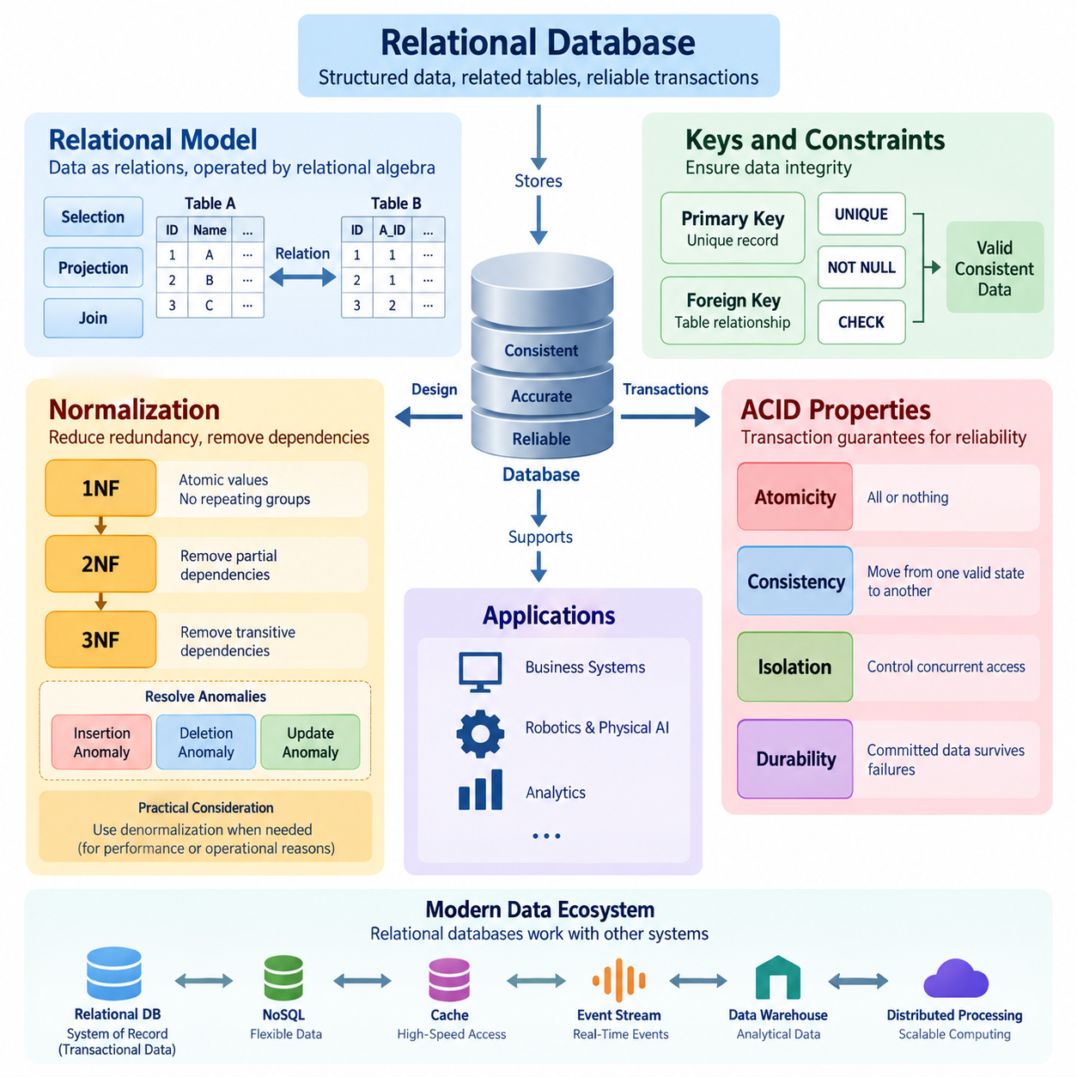
A relational database organizes information into structured tables composed of rows and columns, while relationships between tables are represented through keys. The theoretical foundation comes from the relational model, in which data is treated as relations and operations are defined through concepts such as selection, projection, and joining. A primary key uniquely identifies each record, while foreign keys establish logical relationships between tables. This structure allows applications to retrieve and manipulate complex information while maintaining consistency and reducing unnecessary duplication.
A central principle of relational database design is data integrity. Integrity means that stored information remains accurate, valid, and logically consistent as records are inserted, updated, and deleted. Primary key constraints prevent duplicate or unidentified records, while foreign key constraints prevent relationships from pointing to nonexistent entities. Additional constraints such as UNIQUE, NOT NULL, and CHECK can express business rules directly within the database. By enforcing these rules at the data layer, a relational database can protect information even when multiple applications or users access the same data.
Normalization is a systematic method for organizing relational data so that unnecessary redundancy and undesirable dependencies are reduced. Without normalization, the same fact may be stored repeatedly in many records, creating inconsistencies when one copy is changed but another is not. Normalization analyzes functional dependencies between attributes and decomposes large tables into smaller, logically related relations. The goal is not simply to create as many tables as possible, but to represent each important fact in an appropriate place while preserving the ability to reconstruct meaningful information through relationships.
The first normal form, or 1NF, requires each attribute to contain atomic values and each record to represent a distinct logical occurrence. Repeating groups and lists stored inside a single field are therefore separated into appropriate rows or related tables. Second normal form, or 2NF, builds on 1NF and removes partial dependencies in tables with composite keys, ensuring that non-key attributes depend on the complete key rather than only part of it. Third normal form, or 3NF, further removes transitive dependencies so that non-key attributes depend directly on the key. These principles improve maintainability and reduce update anomalies.
Normalization addresses several common anomalies that appear in poorly designed schemas. An insertion anomaly occurs when a new fact cannot be recorded without also supplying unrelated information. A deletion anomaly occurs when removing one record unintentionally removes the only stored representation of another important fact. An update anomaly occurs when the same fact appears in multiple rows and changes must be applied consistently to every copy. Proper decomposition reduces these risks by separating independent facts into related tables. However, normalization must remain practical because excessive decomposition can increase query complexity and require additional joins.
Functional dependency provides an important theoretical basis for normalization. If the value of one attribute or a group of attributes uniquely determines another attribute, a dependency exists between them. For example, a customer identifier may determine a customer's name and contact information, while a product identifier may determine a product's description and price. Understanding these dependencies helps designers identify candidate keys, determine whether attributes are stored at the correct level, and detect structural problems in a schema. Database normalization therefore connects logical modeling with precise rules about how facts depend on one another.
Although normalization improves logical integrity, production systems sometimes introduce controlled denormalization for performance or operational reasons. A frequently accessed value may be duplicated to reduce expensive joins, or summary information may be materialized to accelerate analytical queries. Such duplication should be deliberate and governed by clear consistency mechanisms. Denormalization is therefore not a replacement for sound relational modeling. A practical design usually begins with a normalized representation and introduces selective redundancy only when measured workload characteristics demonstrate a meaningful performance or operational benefit.
ACID properties describe the transaction guarantees that make relational databases reliable for concurrent and failure-prone workloads. Atomicity means that a transaction is treated as an indivisible unit: either all required changes are committed or the transaction is rolled back. Consistency means that a successful transaction moves the database from one valid state to another while respecting defined constraints and rules. Isolation controls how concurrent transactions interact so that intermediate states do not create incorrect results. Durability means that once a transaction has been committed, its effects survive system failures according to the database's durability guarantees.
Atomicity is particularly important when a logical operation requires multiple physical changes. Consider a transfer between two accounts: subtracting money from one account and adding it to another must be treated as one transaction. If the first operation succeeds but the second fails, the database must be able to roll back the partial change. Transaction logs, recovery mechanisms, and commit protocols support this behavior. Atomicity therefore prevents partially completed business operations from becoming permanent database states and provides a foundation for reliable application behavior.
Consistency operates at the intersection of database rules and application transactions. Constraints such as primary keys, foreign keys, uniqueness requirements, and validation conditions define states that the database considers valid. A transaction must preserve those conditions when it commits. Consistency does not mean that every database automatically understands every business rule; application-level requirements may also need explicit validation. The important principle is that transaction processing should not leave persistent data in a state that violates the integrity guarantees defined for the system.
Isolation becomes essential when many users or processes access the same database simultaneously. Without appropriate isolation, transactions can observe or interfere with changes made by other transactions, potentially producing phenomena such as dirty reads, non-repeatable reads, or phantom reads. Relational database systems provide different isolation levels that balance correctness, concurrency, and performance. Stronger isolation can reduce certain concurrency anomalies but may increase locking, waiting, or resource consumption. Database designers therefore select an isolation strategy according to the consistency requirements and workload characteristics of each application.
Durability ensures that committed information remains available after events such as process crashes, operating-system failures, or hardware interruptions. Relational database systems commonly use transaction logs, write-ahead logging, checkpoints, recovery procedures, and persistent storage mechanisms to support this guarantee. Durability does not mean that data can never be lost under every possible failure scenario; its practical strength depends on the storage architecture, replication strategy, backup policy, and recovery configuration. A complete reliability design therefore combines transaction durability with backup, replication, monitoring, and disaster-recovery mechanisms.
Relational theory, normalization, and ACID transactions address different but interconnected layers of database reliability. Relational modeling defines how facts and relationships should be represented, normalization reduces structural redundancy and dependency problems, and constraints protect the validity of stored information. ACID transactions then provide controlled state transitions when multiple operations must occur together under concurrent access. Together, these principles form a foundation for transactional data systems in which correctness is treated as an architectural property rather than something left entirely to application code.
In modern systems, relational databases remain important even when architectures also incorporate NoSQL stores, caches, event streams, data warehouses, and distributed processing platforms. Transactional relational databases often serve as the authoritative source for highly structured operational information, while other systems handle specialized workloads. Understanding normalization and ACID principles makes it easier to determine where transactional guarantees are necessary and where different storage models may be appropriate. For Physical AI and robotics systems, this distinction is particularly useful because configuration, identity, calibration metadata, task state, equipment records, and operational events may require different combinations of consistency, scalability, and access patterns.

01.02 Advanced SQL: Window Functions, CTE, Execution Plan [w/Code]
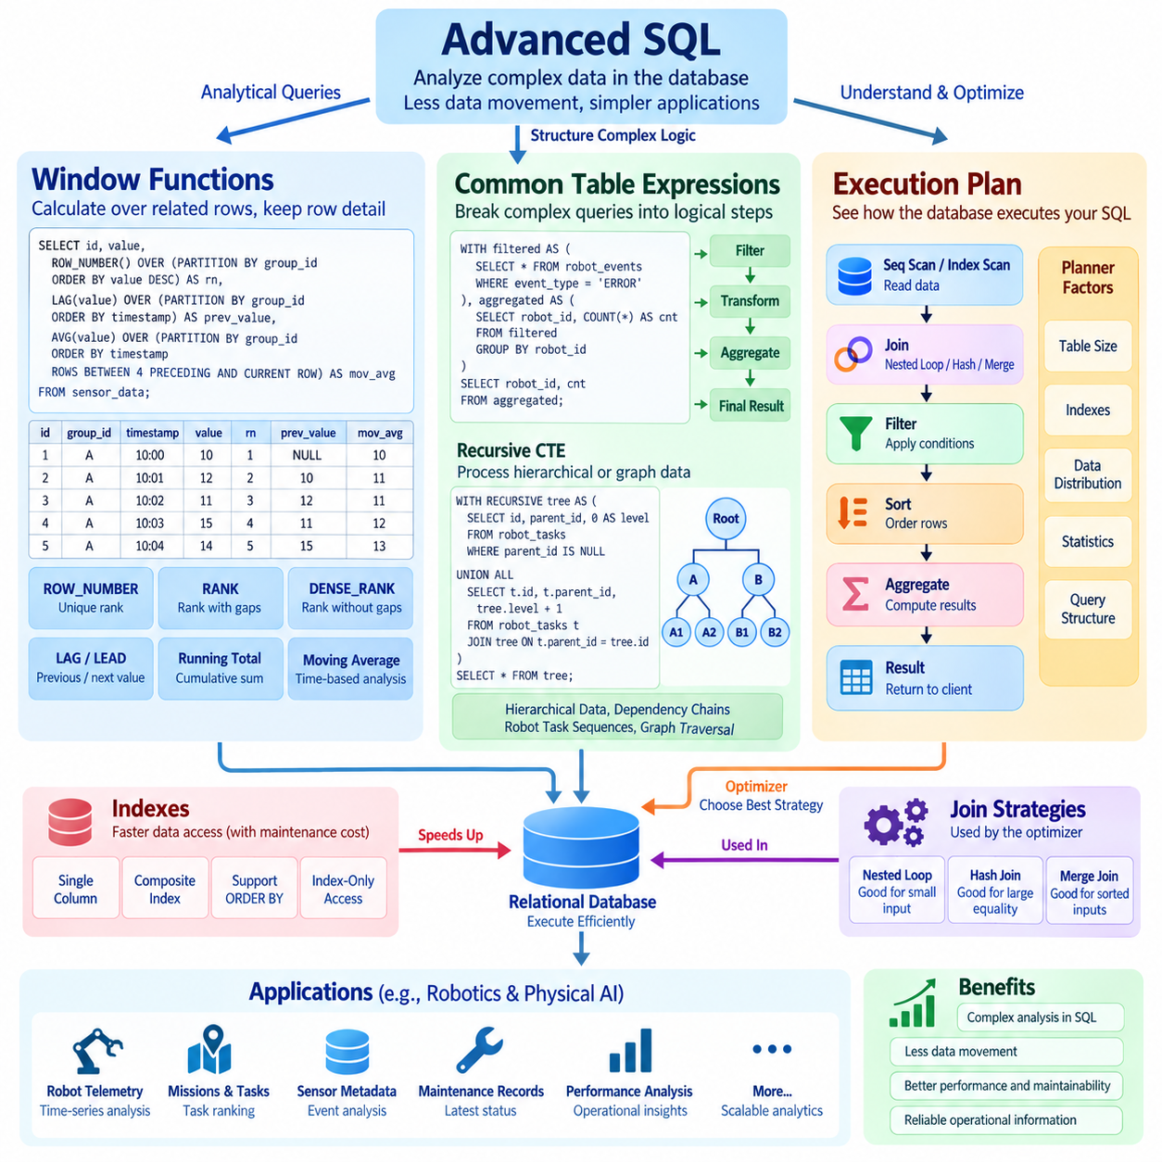
Advanced SQL extends the basic capabilities of relational databases by allowing complex analytical logic to be expressed directly within queries. Instead of retrieving raw records and performing all calculations in application code, SQL can perform ranking, aggregation, comparison, filtering, recursive traversal, and multi-stage transformations close to the data. This approach can reduce data movement and simplify application logic. However, advanced SQL also requires an understanding of how query structure, intermediate results, indexes, joins, and execution strategies affect both correctness and performance.
Window functions are one of the most important features for analytical SQL. Unlike traditional aggregate functions, which normally reduce multiple rows into a single result row, window functions calculate values across a defined set of related rows while preserving the original row structure. A window is specified using the OVER clause and can contain PARTITION BY and ORDER BY expressions. This allows a query to calculate rankings, running totals, moving averages, sequential differences, and other contextual metrics without collapsing individual records.
Ranking functions illustrate the practical value of window functions. Functions such as ROW_NUMBER, RANK, and DENSE_RANK assign positions to rows according to an ordering rule, but they behave differently when multiple rows have equal values. ROW_NUMBER assigns a unique sequential number, while RANK can leave gaps after ties and DENSE_RANK does not. Choosing the correct function depends on the intended business meaning. In robotics or operational data, these functions can be used to identify the highest-performing tasks, prioritize events, compare robot performance, or select the most recent record for each device.
Window functions can also perform calculations across time or sequence. LAG and LEAD access values from previous or subsequent rows within an ordered window, making them useful for calculating changes between observations. A sensor dataset, for example, may contain timestamped measurements for each robot, and LAG can compare the current measurement with the previous observation without requiring a self-join. Running totals and moving averages can similarly be expressed using aggregate functions combined with an appropriate window frame. This makes temporal and sequential analysis considerably more concise.
Common Table Expressions, or CTEs, provide a structured way to divide a complicated SQL statement into logical stages. A CTE is introduced with the WITH clause and can be referenced by the query that follows it. Instead of constructing one extremely long nested query, developers can separate filtering, joining, aggregation, and transformation into named intermediate steps. This can improve readability, testing, and maintenance. A CTE does not automatically guarantee better performance, because the database optimizer may inline or materialize it depending on the database system and execution strategy.
Recursive CTEs extend this concept to hierarchical and graph-like data. A recursive CTE contains an initial query, called the anchor member, followed by a recursive member that repeatedly derives additional rows from previously generated results. This structure is useful for organizational hierarchies, dependency chains, filesystem-like structures, robot task sequences, and graph traversal. Recursive queries must be designed carefully because an incorrect termination condition can generate excessive intermediate results or continue until a database-specific recursion limit is reached. The logical clarity of recursion should therefore be balanced with workload size and execution cost.
Advanced SQL often combines CTEs and window functions to construct multi-stage analytical pipelines. A query may first identify a relevant subset of records, then calculate metrics within each group, rank the results, and finally select the desired rows. For example, a system may partition robot telemetry by robot identifier, order observations by timestamp, calculate previous-state differences, aggregate abnormal events, and rank robots by operational impact. This approach allows complex analysis to remain within the database while preserving a logical sequence that can be inspected and validated.
The execution plan explains how a database intends to execute a SQL statement. Although SQL describes what result is required rather than explicitly specifying every physical operation, the database optimizer chooses an execution strategy involving operations such as sequential scans, index scans, joins, sorting, aggregation, filtering, and data access. An execution plan therefore provides a bridge between logical SQL and physical database behavior. Understanding the plan is essential when a query that appears simple becomes unexpectedly slow as the volume of data increases.
Join strategy is often a major factor in query performance. Relational database systems may use nested-loop joins, hash joins, merge joins, or other strategies depending on table size, available indexes, ordering, estimated cardinality, and optimizer statistics. A nested-loop join can be efficient when one input is small and the other can be accessed efficiently through an index, while hash joins can be effective for larger equality-based joins. Merge joins can be useful when both inputs are already appropriately ordered. The important principle is that the optimal strategy depends on the actual data distribution and workload rather than on a universally preferred join type.
Indexes can substantially improve query performance, but they also introduce storage and maintenance costs. An index can allow a database to locate relevant rows without scanning an entire table, particularly when filtering or joining on selective columns. Composite indexes can support queries involving multiple columns, but their effectiveness depends on column order and query predicates. Indexes may also help ORDER BY operations or support index-only access in some situations. Excessive indexing, however, can slow INSERT, UPDATE, and DELETE operations because index structures must also be maintained.
Execution plans should be interpreted together with actual workload measurements rather than treated as theoretical diagrams. Estimated row counts, actual row counts, execution time, memory consumption, sorting operations, and disk access can reveal where a query spends its resources. A significant difference between estimated and actual cardinality may indicate outdated or insufficient statistics, unusual data distribution, or a query pattern that is difficult for the optimizer to estimate accurately. Query optimization should therefore follow a measurement-driven process: identify the expensive operation, understand its cause, test a targeted change, and compare the resulting execution behavior.
Advanced SQL is particularly valuable when analytical processing must remain close to operational data. In Physical AI and robotics environments, relational databases may store robot identities, missions, task states, sensor metadata, calibration information, maintenance records, and event histories. Window functions can analyze temporal behavior, CTEs can organize multi-stage transformations, and execution plans can help maintain acceptable performance as operational records grow. Used together, these techniques provide a powerful foundation for transforming structured robot data into reliable operational information without unnecessarily transferring large datasets to external application layers.

01.03 Index Design Strategy: BTree, Hash, Composite [w/Code]
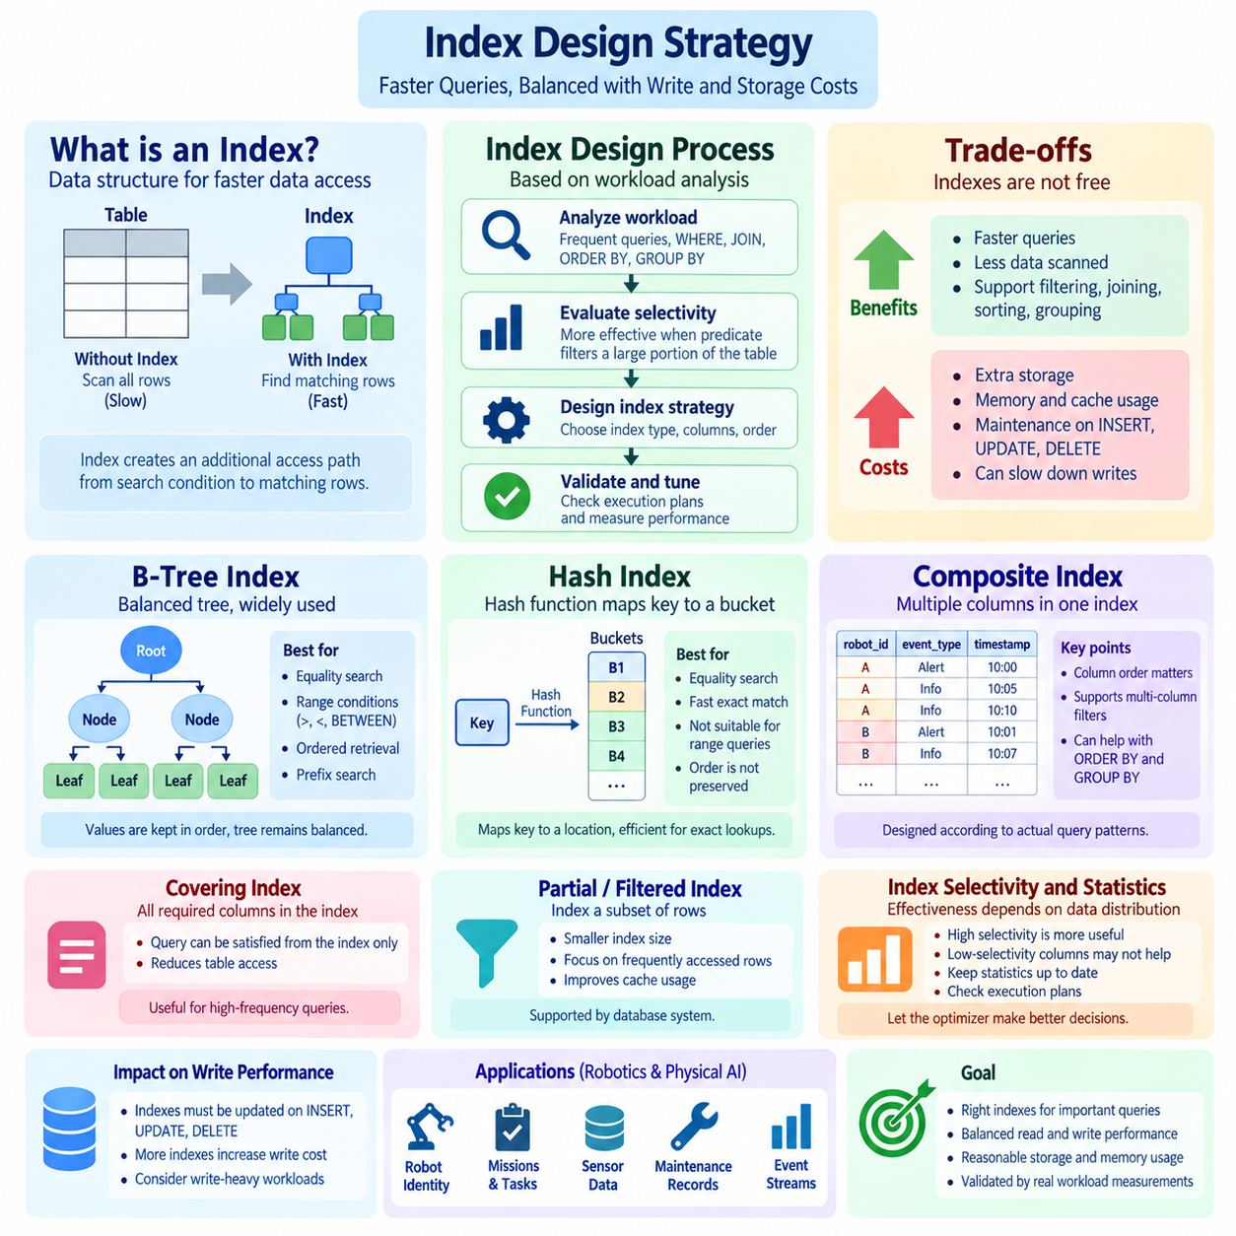
An index is a data structure that helps a relational database locate rows more efficiently without scanning every record in a table. Conceptually, an index creates an additional access path from a search condition to the physical or logical locations of matching rows. This can dramatically reduce the amount of data that must be examined, especially when a table contains millions or billions of records. However, an index is not free. It requires storage, consumes memory and cache capacity, and must be maintained whenever indexed data is inserted, updated, or deleted. Effective index design therefore requires balancing read performance against write and storage costs.
Index design should begin with workload analysis rather than with the assumption that every frequently accessed column needs an index. The important questions are which queries are executed frequently, which columns appear in WHERE conditions, which columns are used for JOIN operations, and which columns participate in ORDER BY or GROUP BY operations. Selectivity is also important because an index is generally more useful when a predicate eliminates a large proportion of the table. A column containing only a few distinct values may provide limited benefit for many queries, while a highly selective identifier can make an index extremely effective. Actual execution plans and workload measurements should guide final decisions.
The B-Tree, or balanced tree, is one of the most widely used index structures in relational database systems. A B-Tree organizes indexed values in a hierarchy of nodes so that searches can navigate from the root toward the relevant leaf entries. The tree remains approximately balanced as values are inserted and removed, keeping lookup depth relatively small even as the index grows. B-Tree indexes are particularly suitable for equality comparisons as well as range conditions such as greater-than, less-than, and BETWEEN. They can also support ordered retrieval efficiently because neighboring values are maintained in an ordered structure.
B-Tree indexes are especially valuable when a query needs both filtering and ordering. If an index matches the required column order, the database may be able to retrieve rows in the desired sequence without performing a separate large sort operation. This can reduce CPU usage, memory consumption, and temporary storage requirements. B-Trees can also support prefix-based searches in many database systems when the search condition is compatible with the index ordering. However, the usefulness of an index depends on the query predicate, data distribution, and optimizer decisions. Creating an index with the correct structure does not guarantee that the optimizer will always choose it.
Hash indexes use a different principle. Instead of maintaining values in sorted order, a hash function maps an indexed key to a location or bucket where matching entries can be found. This makes hash-based access naturally suited to equality searches such as finding a record where an identifier exactly matches a specified value. Because hash structures do not preserve the ordering of indexed values, they are generally unsuitable for range queries and operations that require ordered traversal. Their practical behavior also depends strongly on the database implementation, collision handling, memory architecture, and workload characteristics.
The distinction between B-Tree and Hash indexes should therefore be understood in terms of access patterns rather than simple claims about which structure is faster. A query that repeatedly searches for an exact identifier may benefit from hash-oriented access, while a workload that performs both equality and range searches can be better served by a B-Tree. B-Trees also provide a natural foundation for ordered retrieval and many forms of prefix access. In production systems, the database engine's supported index types and optimizer behavior must be considered because implementation details differ between database platforms.
Composite indexes contain multiple columns within a single index structure and are essential for workloads that frequently filter or sort using combinations of attributes. For example, a robotics event table might contain robot_id, event_type, and timestamp. A composite index on robot_id and timestamp can efficiently support queries that retrieve the events of one robot within a particular time interval. The order of columns in a composite index matters because the database generally benefits most from the leading columns of the index. Therefore, index column order should be designed according to actual query patterns rather than simply following the order in which columns appear in the table.
The leading-column principle is particularly important when designing composite indexes. Suppose an index is defined on customer_id, status, and created_at. Queries that filter by customer_id can potentially use the index efficiently, and queries that filter by customer_id and status can often use an even larger portion of the index. However, a query that filters only by status may receive little or no benefit from that index because status is not the leading column. This does not mean that every possible column order should receive its own index. Multiple overlapping indexes increase storage and write costs, so designers should identify a small set of index structures that efficiently support the most important query patterns.
Composite indexes can also support ORDER BY and GROUP BY operations when their column order is compatible with the required result ordering. For example, an index beginning with robot_id followed by timestamp can support queries that retrieve records for each robot in chronological order. This can reduce the need for expensive sorting operations and may allow the database to stop scanning once a required subset has been obtained. Nevertheless, the optimizer evaluates the complete query, including filters, estimated cardinality, table size, and available alternatives. Index design should therefore consider filtering, joining, ordering, and grouping together rather than optimizing only one SQL clause.
Covering indexes provide another important optimization strategy. An index is considered covering for a query when it contains all the columns required to satisfy that query, either for filtering, joining, or returning the requested values. In such a situation, the database may be able to obtain the result directly from the index without accessing the underlying table for every matching row. This can significantly reduce random data access for suitable workloads. However, adding many output columns to an index increases its size and maintenance cost. Covering indexes are therefore most appropriate for carefully selected high-frequency queries where the performance benefit justifies the additional storage and update overhead.
Partial or filtered indexing can reduce index size when only a subset of records is frequently accessed, depending on the capabilities of the database system. For example, an operational table may contain millions of historical events but only a small number of records representing active or unresolved events. An index focused on that subset can be substantially smaller than an index covering the entire table. This can improve cache utilization and reduce maintenance overhead. The exact syntax and behavior vary across database systems, so the strategy should be designed according to the capabilities of the selected database engine and validated with actual execution plans.
Index selectivity and data distribution must be evaluated carefully. An index on a column with highly repetitive values may not provide enough filtering power to justify an index scan, particularly when a large percentage of the table matches the condition. In contrast, an index on a unique or nearly unique identifier can reduce the candidate set dramatically. The optimizer estimates these characteristics using statistics and other metadata. If statistics are outdated or inaccurate, the optimizer may select an inefficient access path. Regular statistics maintenance and execution-plan analysis are therefore important parts of long-term index management.
Indexes also affect write performance because every modification to indexed columns may require changes to one or more index structures. INSERT operations may add new index entries, while UPDATE operations can require existing entries to be removed and recreated when indexed values change. DELETE operations must remove corresponding entries. A table with many indexes can therefore become significantly more expensive to modify than a table with only a few carefully selected indexes. This trade-off is especially important for high-frequency telemetry or event ingestion systems, where data may arrive continuously and write throughput can be as important as query latency.
Index design should also account for physical storage and memory behavior. Large indexes consume disk space and can occupy substantial portions of the database cache. When frequently accessed index pages remain in memory, queries may execute much faster than when the same pages must repeatedly be read from storage. Conversely, excessive indexes can compete with table data and other working sets for limited memory. Index size, page organization, storage characteristics, and cache behavior therefore influence real-world performance. A theoretically efficient index may provide little benefit if its working set is too large for the available infrastructure.
The effectiveness of an index should ultimately be validated through execution plans and measured workload performance. A useful process begins by identifying a slow or high-value query, examining its execution plan, and determining whether the database is scanning excessive data, performing an expensive sort, or selecting an inefficient join strategy. A candidate index can then be introduced and the same workload measured again. The comparison should consider execution time, logical reads, physical reads, CPU consumption, memory usage, and write overhead where relevant. Index tuning should be treated as an iterative engineering process rather than a one-time schema decision.
For Physical AI and robotics systems, index strategy becomes increasingly important as operational datasets grow. Robot identities, missions, task states, sensor measurements, calibration records, maintenance histories, and event streams can produce large volumes of structured data. An index on robot_id and timestamp may support rapid retrieval of a robot's recent telemetry, while another index on task status and updated_at may support operational monitoring. Unique indexes can protect identity constraints, and carefully designed composite indexes can accelerate queries combining robot, task, state, and time conditions. The appropriate design should follow actual access patterns rather than assuming that every sensor or metadata field requires its own index.
A mature index strategy therefore treats indexes as workload-specific infrastructure rather than as automatic performance improvements. B-Tree indexes provide flexible support for equality, range, ordering, and many composite access patterns, while Hash indexes can be appropriate for specific equality-oriented workloads where supported effectively by the database engine. Composite indexes extend these capabilities by aligning multiple query conditions within one access path, but their column order must reflect real usage. The final objective is not to maximize the number of indexes, but to create a controlled set of access paths that improves important queries while keeping storage, memory, maintenance, and write costs within acceptable operational limits.

01.04 Transaction Isolation Levels and Robot Data Consistency [w/Code]
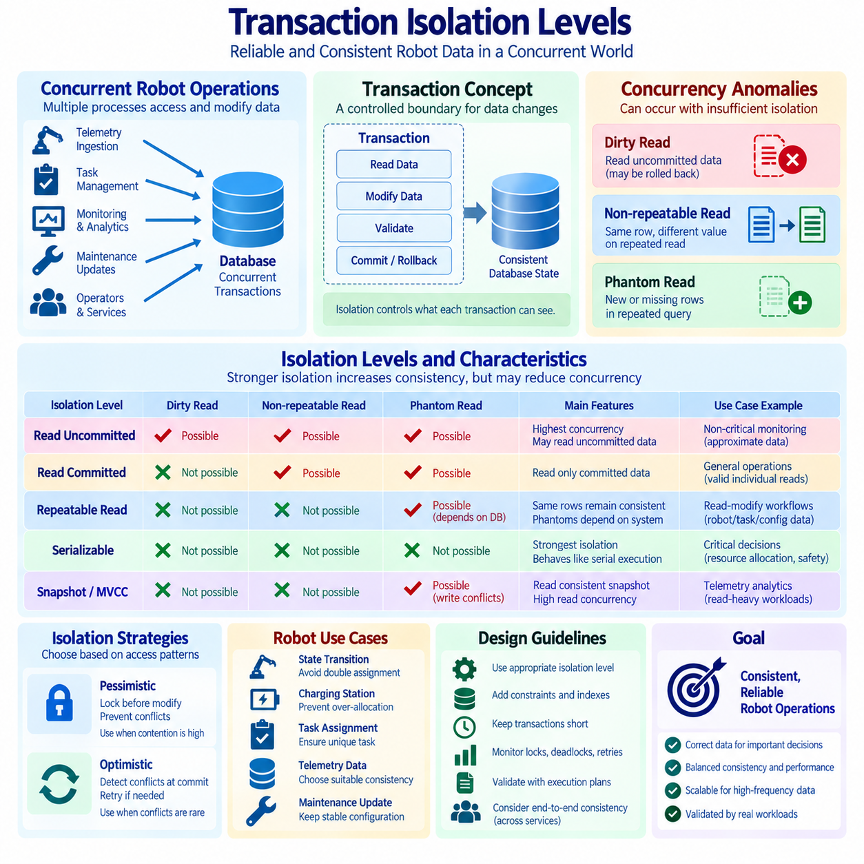
Transaction isolation defines how concurrent transactions interact when they read and modify shared data in a relational database. In a robotics system, multiple processes may simultaneously record telemetry, update robot states, create tasks, acknowledge events, and modify maintenance information. Without appropriate isolation, one transaction may observe another transaction's incomplete or changing results. Isolation therefore provides a controlled boundary between concurrent operations, helping the database maintain predictable behavior while allowing multiple robots, services, and operators to work at the same time.
Concurrency is necessary in modern robot data systems because information arrives continuously from many sources. A fleet management service may update mission status while robot controllers write telemetry and monitoring services read operational conditions. At the same time, maintenance software may modify equipment state or configuration metadata. These operations can target related records simultaneously. Transaction isolation determines which changes are visible to each transaction and when those changes become observable. The objective is not always maximum isolation, but an appropriate balance between data correctness, concurrency, latency, and system throughput.
Several anomalies can occur when concurrent transactions are insufficiently isolated. A dirty read occurs when one transaction reads data written by another transaction before that transaction commits. If the writer subsequently rolls back, the reader has observed information that never became permanent. A non-repeatable read occurs when the same row is read twice within one transaction and produces different values because another transaction committed an update between the reads. A phantom read occurs when repeating a range query returns additional or missing rows because another transaction inserted, deleted, or changed records within the queried range.
The weakest commonly discussed isolation level is Read Uncommitted. Under this model, a transaction may observe changes that another transaction has not yet committed, allowing dirty reads. The advantage is high concurrency with relatively little waiting or locking overhead, but the resulting data may not represent a stable database state. This level is therefore generally unsuitable for critical robot state decisions where an observed value could influence motion, task assignment, safety-related logic, or resource allocation. It may have limited usefulness for non-critical monitoring scenarios where approximate or transient information is acceptable.
Read Committed prevents a transaction from reading uncommitted changes. A query therefore observes only data that has already been committed at the time the relevant read occurs. However, two separate reads within the same transaction may still return different values if another transaction commits an update between those reads. This level is widely used because it provides a practical balance between consistency and concurrency. For many operational robot systems, it can be appropriate when individual reads must be valid but a transaction does not require a completely stable view of the database throughout its entire execution.
Repeatable Read provides stronger guarantees by ensuring that rows read by a transaction remain consistently visible during that transaction according to the database system's implementation. This reduces the possibility of non-repeatable reads, which is useful when a workflow reads the same robot, task, or configuration record multiple times before committing an update. However, the exact behavior concerning phantom rows differs between database systems and implementation models. Designers should therefore consult the selected database engine's transaction semantics rather than assuming that the isolation-level name guarantees identical behavior everywhere.
Serializable is generally the strongest standard isolation level. It aims to produce results equivalent to transactions being executed one after another in a serial order, even though the database may execute them concurrently. This can prevent a broad class of concurrency anomalies and is valuable when correctness depends on mutually exclusive decisions. For example, allocating a limited robot resource, assigning a unique task slot, or modifying inventory-like equipment state may require strong protection against competing transactions. The trade-off is potentially lower concurrency, increased waiting, locking, retries, or transaction aborts.
Some modern database systems also provide snapshot-based isolation mechanisms. Instead of forcing readers to wait for writers, a transaction can read a consistent version of data maintained through mechanisms such as multi-version concurrency control. Under MVCC, different transactions may see different committed versions of a row according to their snapshot boundaries. This can substantially improve read concurrency because readers and writers can often proceed with less direct blocking. However, snapshot-based mechanisms do not eliminate all concurrency problems automatically. Write conflicts, serialization failures, and application-level consistency requirements still need to be addressed.
The choice of isolation level should therefore be based on the semantics of the robot operation rather than applied uniformly to every query. A telemetry dashboard that displays recent sensor values may tolerate a relatively relaxed consistency requirement, while a task allocator deciding which robot receives a unique mission may require much stronger protection. Similarly, historical analytics may prioritize throughput, whereas a transaction that changes calibration metadata may require a stable and carefully validated state. Treating every operation as equally sensitive can unnecessarily reduce system performance, while treating every operation as weakly consistent can create correctness problems.
Robot state transitions provide a useful example of why isolation matters. Suppose a robot is currently marked as AVAILABLE, and two independent task schedulers simultaneously attempt to assign new missions to it. If both transactions read AVAILABLE before either transaction commits its update, both schedulers may believe they have successfully acquired the same resource. Without an appropriate concurrency-control mechanism, the database may contain a logically conflicting assignment even though every individual SQL statement appears valid. Stronger isolation, appropriate locking, unique constraints, or atomic conditional updates can prevent or detect this type of race condition.
A similar problem can occur with inventory, charging stations, docking resources, or limited computational capacity. Multiple robots may simultaneously request the same charging station, while a scheduling service updates station availability. A transaction that reads the current availability and then performs a separate update must protect the relationship between those operations. Otherwise, another transaction may change the state between the read and the write. Reliable designs often combine transaction isolation with explicit constraints and atomic update conditions so that correctness does not depend solely on application timing.
Isolation also interacts with transaction duration. A long-running transaction can retain locks, snapshots, or other resources for an extended period, increasing contention with other operations. In a high-frequency robot telemetry system, keeping a transaction open while processing a large amount of external data can unnecessarily delay unrelated operations. A better approach is generally to keep critical transactions short and focused on the minimum set of database operations required to establish a consistent state. Data processing that does not require transactional protection can often be performed outside the critical transaction boundary.
Consistency must also be distinguished from correctness at the application level. A database can guarantee that a transaction satisfies its declared constraints while the overall business operation is still logically incorrect. For example, two robot assignments may each satisfy a foreign-key constraint while violating the higher-level rule that a robot can have only one active mission. Such rules should be represented through appropriate database constraints, unique conditions, transactional logic, or carefully designed application workflows. Transaction isolation is therefore one component of a broader consistency architecture rather than a substitute for data modeling and business-rule enforcement.
Robot telemetry introduces another important consideration because sensor data is naturally sequential and time-dependent. Multiple ingestion processes may write observations for the same robot while analytical services query recent measurements. The system must determine whether readers require a stable snapshot, the latest committed value, or simply a rapidly available operational approximation. Timestamp ordering, event identifiers, sequence numbers, and transaction metadata can complement isolation controls by making the temporal relationship between observations explicit. This is particularly important when reconstructing robot behavior or correlating sensor events with task and control decisions.
Distributed robot systems can make consistency management more complex because data may be replicated across multiple services or storage systems. A relational database transaction normally provides atomicity and isolation within its defined transactional boundary, but it does not automatically make an external message broker, cache, object store, or separate database participate in the same transaction. Systems that combine operational databases with event streams may therefore require patterns such as transactional outbox processing, idempotent consumers, version checks, or reconciliation mechanisms. These patterns extend consistency management beyond the boundaries of a single database transaction.
Optimistic and pessimistic concurrency control provide two broad approaches to managing conflicting updates. Pessimistic approaches assume that conflicts are sufficiently likely to justify protecting data before modification, often through locks or equivalent mechanisms. Optimistic approaches allow transactions to proceed and detect conflicts when changes are committed, sometimes requiring a failed transaction to retry. For robot fleets, the appropriate choice depends on contention patterns. A highly contested resource may benefit from early protection, while a large telemetry dataset with relatively independent updates may be better suited to optimistic approaches with efficient conflict detection.
Observability is essential when transaction isolation affects production performance. Database monitoring should track transaction duration, lock waits, deadlocks, serialization failures, retry rates, query latency, and throughput. If stronger isolation causes excessive contention, the solution should not immediately be to weaken consistency. Engineers should first identify which transactions conflict, why they remain active, and whether the protected data scope can be reduced. Shortening transactions, improving indexes, changing access order, separating workloads, or redesigning a contention point may improve both consistency and performance.
For Physical AI and robotics systems, transaction isolation should ultimately be treated as part of the operational data architecture. Robot identity, task assignment, mission state, telemetry, maintenance status, configuration, and resource allocation have different consistency requirements. A practical architecture can therefore use different transactional strategies according to the consequences of inconsistency. Read-heavy telemetry analysis may favor concurrency and throughput, while resource allocation and critical state transitions may require stronger guarantees. The key principle is to align isolation with the meaning and risk of each operation rather than selecting one global level for every workload.
A robust robot data system combines transaction isolation with constraints, indexes, timestamps, versioning, retry mechanisms, and carefully defined transaction boundaries. Isolation determines what concurrent transactions can observe, constraints define which database states are valid, and application logic defines how operational rules are enforced. When these mechanisms are designed together, the system can support high-frequency robot activity without sacrificing essential consistency. The result is a database architecture in which concurrent operations remain predictable, conflicts are detected or prevented, and robot decisions are based on data whose consistency properties are explicitly understood.

01.05 Stored Procedures and Triggers Usage [w/Code]
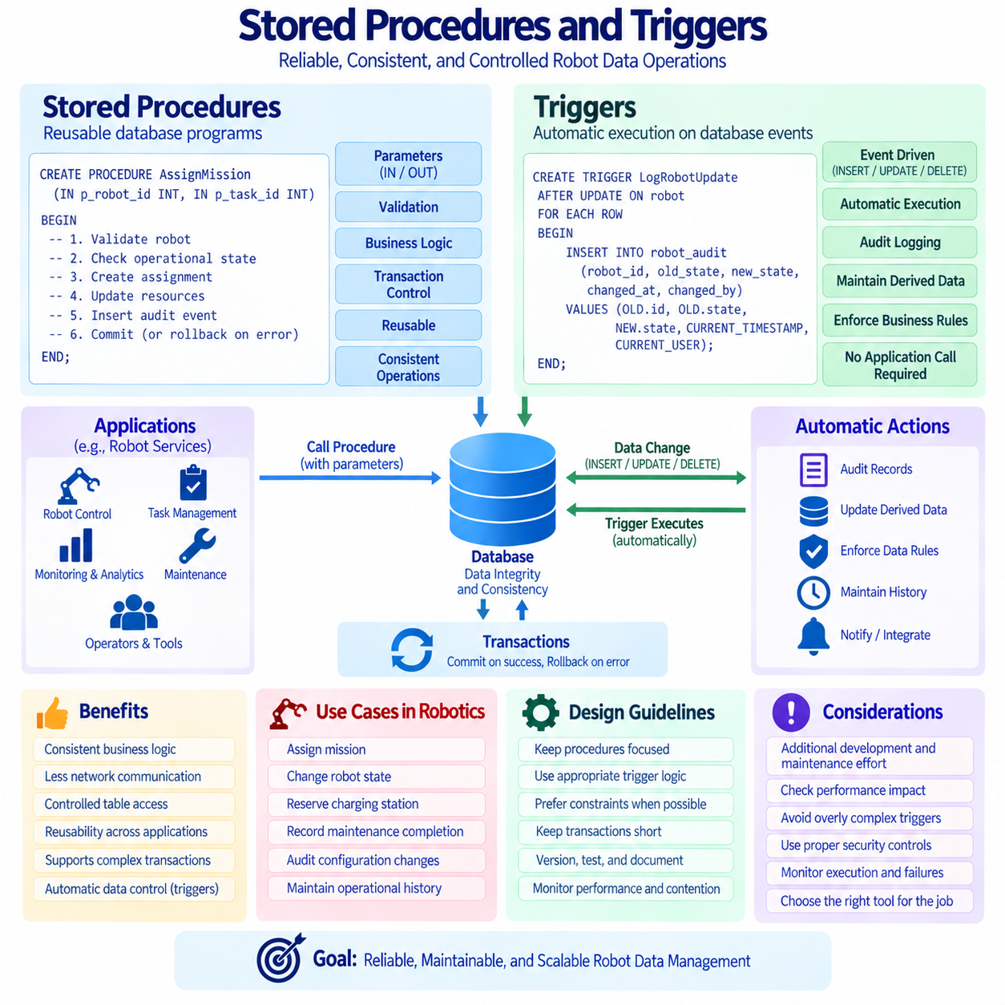
Stored procedures are database-side programs that encapsulate SQL statements and procedural logic into a reusable unit. Instead of sending many individual SQL statements from an application, a procedure can perform validation, data retrieval, updates, calculations, and transaction control within the database. This can reduce network communication and centralize frequently used operations. Stored procedures are particularly useful when multiple applications must execute the same business operation consistently, because the core database logic can be maintained in one controlled location rather than duplicated across application code.
A stored procedure can accept input parameters, produce output values, and execute conditional or iterative logic depending on the database platform. For example, a robot management system could provide a procedure that registers a new mission, validates the target robot, checks its operational state, creates the assignment, and records an audit event within one transactional workflow. Encapsulating these operations makes the intended sequence explicit and can reduce the possibility that different application services implement slightly different versions of the same database operation.
Stored procedures can also provide a useful transaction boundary for operations that require multiple related changes. A procedure may update a robot state, create a task record, modify resource availability, and insert an operational event before committing the complete transaction. If a validation failure or database error occurs, the transaction can be rolled back according to the procedure's transaction logic. This approach can strengthen consistency for tightly coupled operations, although transaction boundaries should remain reasonably short to avoid excessive locking, contention, or resource consumption.
Another advantage of stored procedures is controlled access to underlying tables. Applications can sometimes be granted permission to execute a procedure without receiving direct permission to modify every table involved in the operation. This can create a more controlled database interface and reduce the number of paths through which sensitive data can be changed. However, stored procedures should not be treated as a complete security architecture. Authentication, authorization, auditing, input validation, encryption, and application-level security controls remain necessary, especially when database operations are exposed to multiple services or external users.
Stored procedures also introduce maintenance considerations. Database-side code becomes part of the software system and therefore requires version control, testing, deployment procedures, documentation, and monitoring. A procedure that contains complex business logic can become difficult to understand if it grows into a large monolithic program. Database developers should therefore keep procedures focused on operations that benefit from database locality, transactional consistency, controlled access, or reuse. Logic that is better suited to application services, machine-learning pipelines, or external orchestration should not automatically be moved into the database.
Triggers provide a different mechanism because they execute automatically when specified database events occur. A trigger can respond to events such as INSERT, UPDATE, or DELETE and execute additional database logic without requiring the application to call it explicitly. This makes triggers useful for enforcing certain low-level data rules, maintaining audit records, updating derived metadata, or recording changes. The automatic nature of triggers is powerful, but it also means that database behavior can occur implicitly. Developers must therefore understand when triggers execute and what additional work they introduce.
An audit trigger is a common practical example. When a robot configuration record is updated, a trigger can automatically record the previous value, new value, timestamp, user or service identity, and affected record in an audit table. This provides a history of important changes without requiring every application service to remember to create its own audit record. The approach can be valuable for configuration management, maintenance history, and operational accountability. However, audit design should consider storage growth, retention policies, sensitive information, and the performance impact of recording large numbers of changes.
Triggers can also enforce certain data integrity rules that are difficult to guarantee through a single constraint. For example, a trigger might detect a particular state transition and create a related event record or update a controlled summary value. Nevertheless, many integrity requirements are better expressed using primary keys, foreign keys, UNIQUE constraints, CHECK constraints, or transactional application logic when those mechanisms are sufficient. Using triggers for rules that could be expressed more transparently through standard constraints can make the schema harder to understand and troubleshoot.
The implicit execution of triggers creates an important operational risk. An application may issue a simple UPDATE statement while the database performs several additional operations through triggers. When performance problems occur, developers who are unaware of these side effects may incorrectly attribute the cost to the original SQL statement. Trigger chains can also become difficult to reason about when one trigger modifies data that activates another trigger. Excessive trigger complexity can therefore create hidden dependencies, unexpected execution paths, and difficult debugging scenarios.
Stored procedures and triggers should also be evaluated differently from ordinary SQL queries. Their performance depends on the underlying statements they execute, the indexes available to those statements, transaction duration, locking behavior, data volume, and the database optimizer. A procedure may appear efficient during development but become expensive when called thousands of times per second. Similarly, a trigger attached to a frequently updated telemetry table can multiply the amount of database work performed for every incoming record. Performance testing should therefore use realistic data volumes and representative workloads.
For robot and Physical AI systems, stored procedures are particularly useful for operations that represent explicit business or operational commands. Examples include assigning a mission, changing a robot lifecycle state, reserving a charging station, registering maintenance completion, approving a configuration change, or closing an operational incident. Such procedures can provide consistent transactional workflows while keeping application services from repeatedly implementing the same sequence of database operations. The procedure interface can also act as a stable contract between operational applications and the underlying relational schema.
Triggers are more appropriate when an action should occur automatically as a consequence of a database change and should not depend on whether every application remembers to perform it. Audit logging, controlled history creation, certain derived metadata updates, and selected integrity-related actions are possible examples. For high-frequency sensor or telemetry ingestion, however, triggers should be used cautiously because even a small amount of additional processing can become significant at scale. In such workloads, asynchronous event processing or dedicated streaming mechanisms may be more appropriate when immediate transactional execution is not required.
A balanced architecture therefore uses stored procedures and triggers selectively rather than treating them as replacements for application services. Stored procedures are explicit interfaces that applications intentionally invoke, while triggers are implicit mechanisms activated by database events. Procedures are often suitable for well-defined transactional commands, whereas triggers are useful for automatic side effects that must remain closely coupled to a data change. Both should have clear ownership, documented behavior, controlled deployment, and appropriate testing. Their use should be justified by consistency, locality, security, auditability, or operational requirements rather than by the assumption that database-side code is always faster.
In a mature robot data architecture, stored procedures and triggers become part of a broader governance model for database behavior. Procedures should have defined inputs, outputs, transaction semantics, error handling, and authorization requirements. Triggers should have clearly documented activation conditions, side effects, dependencies, and performance implications. Monitoring should identify execution frequency, failures, latency, lock contention, and abnormal growth in audit or history tables. When these mechanisms are designed deliberately, they can provide reliable transactional interfaces and automatic data controls without turning the database into an opaque collection of hidden business logic.

01.06 Database Partitioning: Range, Hash, List [w/Code]
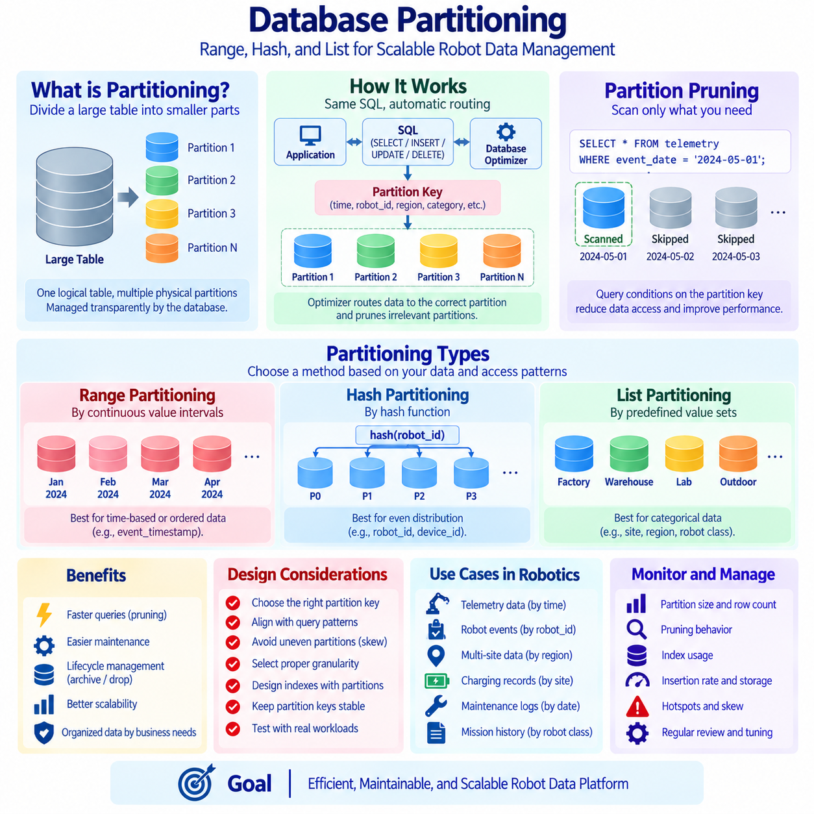
Database partitioning divides a logically large table or index into smaller physical segments while preserving a unified view for applications and SQL queries. Instead of storing every record in one monolithic structure, the database places rows into partitions according to a defined partition key and routing rule. Partitioning can improve manageability, maintenance, and query efficiency for very large datasets. It is especially valuable when data naturally separates by time, device, region, category, or another predictable dimension, although partitioning does not automatically make every query faster.
A partitioned table normally remains one logical object from the application's perspective. Applications can issue ordinary SELECT, INSERT, UPDATE, and DELETE statements while the database determines which physical partition should contain or provide the relevant rows. The partition key is therefore a critical design decision because it determines how data is distributed. A good partitioning strategy aligns the partition key with dominant access patterns, retention requirements, and maintenance operations. A poorly selected key can produce uneven partitions, excessive scanning, or unnecessary movement of records between partitions.
Partition pruning is one of the primary performance benefits of partitioning. When a query contains conditions that correspond to the partition key, the database optimizer may eliminate irrelevant partitions before executing the main data access operations. For example, if telemetry is partitioned by date and a query requests only one day of measurements, the database may scan only the partition containing that date rather than the entire historical dataset. Effective pruning can substantially reduce disk access and processing work, but its success depends on query predicates, database capabilities, statistics, and the exact partition definition.
Range partitioning distributes records according to continuous value intervals. Time is one of the most common range-partitioning keys because operational data frequently grows chronologically. A robot telemetry table could be divided into daily, weekly, or monthly partitions based on event_timestamp. Older partitions can then be archived or removed independently, while recent partitions remain actively queried and updated. Range partitioning is also suitable for numeric intervals, sequence ranges, or other naturally ordered values. The chosen partition interval should reflect data volume, query windows, and operational maintenance requirements.
The size of a range partition requires careful planning. If partitions cover excessively long periods, each partition may become too large and reduce the benefit of pruning and independent maintenance. If the interval is too short, the system may create thousands of small partitions, increasing metadata and planning overhead. A high-frequency robot fleet may generate enough telemetry to justify daily partitions, whereas lower-volume maintenance records may work efficiently with monthly or yearly partitions. Partition granularity should therefore be determined from actual ingestion rates, retention periods, query behavior, and database-specific limits.
Hash partitioning distributes rows by applying a hash function to the partition key and mapping the result across a predefined number of partitions. Unlike range partitioning, the objective is usually not to preserve natural ordering but to spread records relatively evenly. This can be useful when the workload accesses data primarily by an identifier such as robot_id, device_id, or tenant_id and there is no strong chronological partitioning requirement. Balanced distribution can prevent one physical partition from receiving a disproportionate share of the data, although real behavior still depends on key distribution and implementation.
Hash partitioning can support workloads where many robots continuously generate records and the system needs to distribute storage or processing pressure across partitions. If robot_id is hashed across several partitions, records from different robots can be distributed more evenly than they might be with a poorly chosen categorical scheme. However, hash partitioning is less intuitive for range-oriented operations. A query covering all robots during a specific time interval may still need to access many or all hash partitions unless additional partitioning or indexing strategies support the time condition.
List partitioning assigns rows to partitions according to explicitly defined sets of values. This approach is useful when data contains a manageable number of meaningful categories that should be physically separated. A robotics platform might partition records by site, operational zone, robot class, data source, or organization. For example, factory, warehouse, laboratory, and outdoor operations could be placed into different partitions when those categories have distinct access or retention patterns. List partitioning provides clear semantic control, but new or unexpected values require appropriate routing rules or a default partition where supported.
List partitioning should be used carefully when category distribution is highly uneven. If one site produces most of the records while other sites generate relatively little data, a single partition can become much larger and busier than the others. This creates a hotspot and can reduce the operational benefits of partitioning. Designers should therefore examine both the semantic meaning of categories and their expected data volumes. In some systems, a list partition can be combined with another partitioning method to provide more balanced distribution within a large category.
Multi-level or subpartitioning combines more than one partitioning dimension. A large robot telemetry table, for example, could first be range-partitioned by month and then hash-partitioned by robot_id within each monthly partition. This structure supports time-based retention and pruning while also distributing records among several subpartitions. Another architecture could partition first by site and then by date. Multi-level partitioning can provide substantial flexibility, but it also increases schema complexity, operational procedures, monitoring requirements, and the number of physical database objects that administrators must manage.
Partitioning can simplify data lifecycle management because partitions can often be managed as units. Historical partitions may be detached, archived, compressed, moved to different storage, or removed according to retention policies without processing individual rows one by one. For telemetry systems that continuously accumulate large volumes of time-series data, dropping an expired partition can be considerably more efficient than issuing a massive DELETE operation. The exact capabilities vary by database engine, so lifecycle procedures should be designed around supported partition operations and tested before being used on production-scale datasets.
Indexes and partitioning must be designed together. Individual partitions may have local indexes, while some database platforms also support index structures spanning multiple partitions. The appropriate strategy depends on query patterns, uniqueness requirements, maintenance operations, and database implementation. A partition key alone does not replace indexes on frequently searched attributes. For example, a telemetry table partitioned by month may still require an index on robot_id and timestamp inside relevant partitions. Query performance depends on both eliminating unnecessary partitions and efficiently locating rows within the selected partitions.
Partitioning also affects data modification operations. INSERT statements must route new records to the correct partition, while UPDATE operations that change a partition key may require a row to move from one partition to another. This can make updates to partition keys more expensive and operationally complex. Partition keys should therefore preferably represent stable attributes such as event time, immutable identifiers, or durable categories. Frequent changes to the partition key can undermine the simplicity and performance benefits that the partitioning strategy was intended to provide.
Partitioning should not be confused with database sharding. Partitioning commonly divides data within a database system while maintaining centralized database semantics, whereas sharding generally distributes data across multiple database instances or nodes. The concepts can overlap in distributed database implementations, but they address different architectural scales. Partitioning primarily organizes large tables for efficient access and management, while sharding is often used to scale storage and workload beyond the practical capacity of a single database instance. Understanding this distinction is important when planning long-term growth.
Operational monitoring is necessary because a partitioning strategy that works initially may become inefficient as the workload evolves. Administrators should observe partition sizes, row counts, query pruning behavior, index usage, insertion rates, storage consumption, planning time, and hotspots. Rapid growth in one partition can indicate skewed data distribution, while queries that repeatedly scan all partitions may indicate poor alignment between query predicates and the partition key. Partition design should therefore be periodically reviewed using actual workload measurements rather than assumed to remain optimal indefinitely.
For Physical AI and robotics systems, partitioning provides a practical mechanism for organizing continuously growing operational data. Sensor measurements can be range-partitioned by timestamp, robot events can be distributed using robot identifiers, and records from different factories or operational environments can be separated through list partitioning. A combined strategy can support both historical retention and active fleet analysis. The correct design depends on whether the dominant requirement is time-based retrieval, balanced robot distribution, semantic separation, lifecycle management, or a combination of these objectives.
A mature partitioning architecture aligns physical data organization with query behavior and operational policy. Range partitioning is effective for ordered intervals and time-based lifecycle management, Hash partitioning supports relatively balanced distribution based on keys, and List partitioning provides explicit control over meaningful categories. These approaches can also be combined when the scale justifies additional complexity. The goal is not simply to create smaller tables, but to reduce unnecessary data access, simplify large-scale maintenance, control data growth, and preserve predictable performance as robot datasets expand over time.

01.07 SQL Database Performance Tuning Methodology
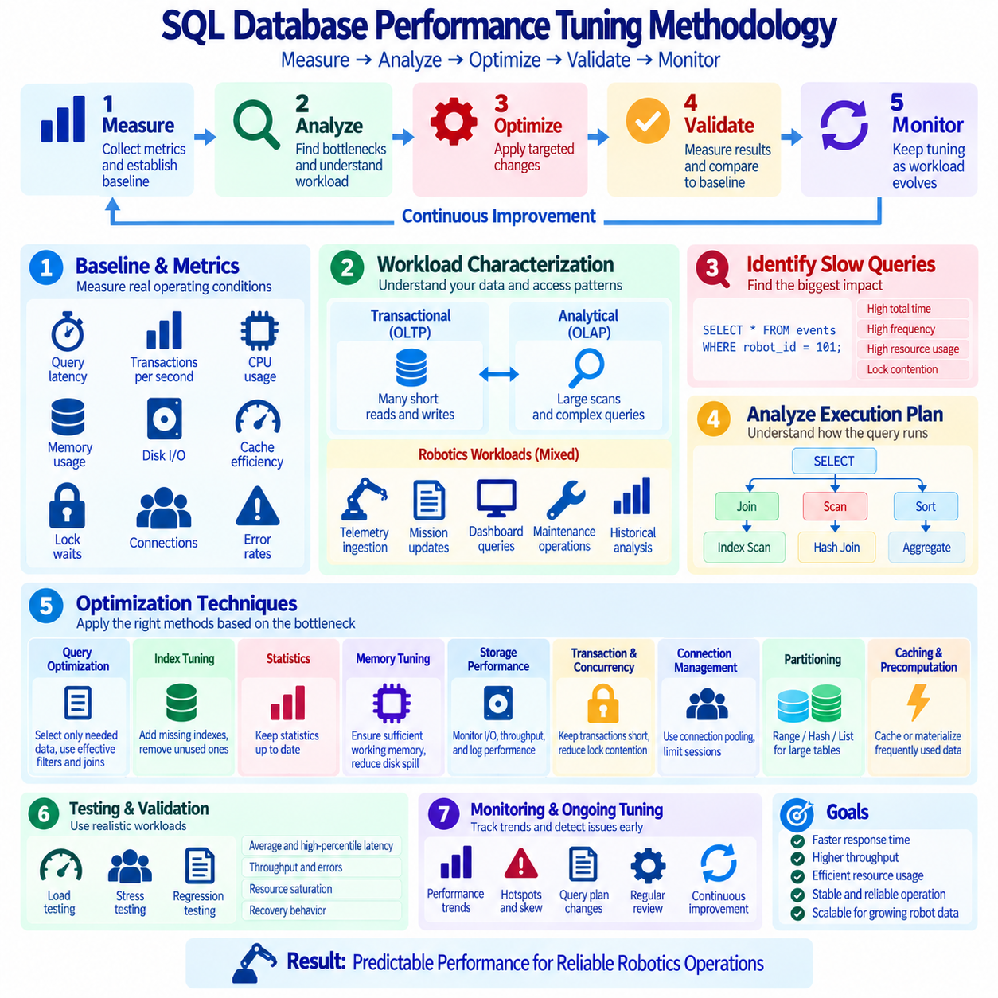
SQL database performance tuning is a systematic engineering process for improving response time, throughput, resource efficiency, and operational stability. Effective tuning does not begin by randomly adding indexes or rewriting every query. It begins by measuring the workload, identifying the actual bottleneck, forming a hypothesis, applying a controlled change, and measuring again. This evidence-driven cycle prevents unnecessary optimization and helps engineers distinguish database problems from limitations in applications, networks, storage systems, or infrastructure.
A performance baseline establishes the reference point for tuning. Important measurements include query latency, transactions per second, CPU utilization, memory consumption, disk input/output, cache efficiency, lock waits, connection counts, and error rates. Measurements should represent realistic operating conditions rather than isolated laboratory queries. In robot systems, the baseline may include normal telemetry ingestion, mission updates, dashboard queries, maintenance operations, and analytical workloads. Without a baseline, it is difficult to determine whether a tuning change actually improved the system.
Workload characterization is the next important step because different workloads create different database pressures. Online transaction processing workloads typically contain many short reads and writes, while analytical workloads may scan large datasets and perform complex aggregation. Robot platforms often combine both patterns: high-frequency sensor metadata and state updates coexist with historical analysis and operational reporting. Engineers should identify query frequency, concurrency, read-to-write ratio, data growth rate, peak periods, and service-level requirements before selecting optimization techniques.
Slow-query analysis helps locate SQL statements that consume disproportionate resources. A query can be problematic because it runs very slowly once, because it executes millions of times, or because it creates contention with other transactions. Database monitoring and query statistics can reveal total execution time, average latency, execution frequency, rows processed, logical reads, physical reads, and temporary storage usage. Tuning should prioritize queries according to their total operational impact rather than focusing only on the single query with the longest individual execution time.
Execution plans provide the primary connection between SQL syntax and physical database behavior. The optimizer may choose sequential scans, index scans, nested-loop joins, hash joins, merge joins, sorting, aggregation, or parallel operations to produce the requested result. Engineers should examine estimated and actual row counts, access paths, join order, expensive operators, sorting behavior, and memory usage. Large differences between estimated and actual cardinality can indicate inaccurate statistics, skewed data, or predicates that are difficult for the optimizer to estimate.
Query optimization should first eliminate unnecessary work. Applications should retrieve only the columns and rows they actually require instead of repeatedly requesting complete tables or using broad SELECT * patterns when only a small subset is needed. Filters should be applied effectively, joins should reflect correct relationships, and repeated calculations should be reviewed. Complex nested queries can sometimes be simplified or reorganized using appropriate joins, CTEs, or precomputed structures. The objective is not to make SQL shorter, but to reduce the amount of data the database must process.
Index tuning is one of the most powerful performance techniques, but it should follow workload analysis. Indexes can accelerate filtering, joins, ordering, grouping, and selective lookups, while composite or covering indexes can support important multi-column access patterns. However, every additional index consumes storage and increases the cost of INSERT, UPDATE, and DELETE operations. Engineers should identify missing indexes, redundant indexes, rarely used indexes, and overlapping structures. Index effectiveness should always be confirmed through execution plans and measured workload results.
Database statistics are essential because the optimizer relies on them to estimate how many rows different operations will process. If statistics are outdated or do not adequately represent the data distribution, the optimizer may choose an inefficient join order or access path. Rapidly changing tables, highly skewed values, and unusual correlations between columns can make estimation more difficult. Statistics maintenance should therefore be treated as part of performance management, particularly for operational databases whose data volume and distribution change continuously.
Memory tuning affects caching, sorting, hashing, connection management, and other database operations. When frequently accessed data and index pages remain in memory, storage access can be reduced significantly. Insufficient working memory may cause sorts or hash operations to spill to disk, increasing latency. Excessive memory allocation can also be harmful if concurrent queries collectively exceed available resources. Memory configuration should therefore be evaluated at both the individual-query and system-wide levels rather than maximizing every memory-related parameter independently.
Storage performance remains important even when substantial memory is available. Databases generate random reads, sequential scans, transaction log writes, checkpoints, temporary files, and background maintenance traffic. Engineers should monitor input/output latency, throughput, queue depth, storage utilization, and transaction-log behavior. Slow storage can make an otherwise well-designed query appear inefficient. Conversely, replacing storage hardware cannot compensate indefinitely for queries that repeatedly scan unnecessary data. SQL optimization and infrastructure tuning should therefore be treated as complementary activities.
Transaction and concurrency tuning focuses on the interaction between simultaneous database operations. Long-running transactions can hold locks or snapshots for extended periods and increase contention. Deadlocks, lock waits, serialization failures, and excessive retries may indicate that transactions access shared resources inefficiently. Keeping transactions short, using consistent access order, selecting appropriate isolation levels, and ensuring efficient indexes can reduce contention. Strong consistency requirements should not be weakened automatically when performance problems appear; the underlying conflict pattern should first be understood.
Connection management can become a performance issue when applications create excessive database sessions. Establishing connections consumes resources, while thousands of idle or rapidly created connections can place unnecessary pressure on the database server. Connection pooling allows applications to reuse established sessions and limit concurrent database activity to a manageable level. Pool size should be coordinated with database capacity, query latency, application concurrency, and infrastructure characteristics. More connections do not necessarily produce more throughput when CPU, storage, or locking resources are already saturated.
Partitioning can improve performance and manageability for very large tables when query conditions align with the partition key. Time-based telemetry, historical events, and audit records are common candidates because partition pruning can eliminate irrelevant data before detailed processing begins. Partitioning also supports lifecycle operations such as archiving or removing old data. However, poorly chosen partition keys or excessive numbers of partitions can increase planning overhead and complexity. Partitioning should therefore address demonstrated scale or maintenance problems rather than being applied automatically.
Caching and precomputation can reduce repeated database work for information that does not need to be recalculated for every request. Frequently requested reference data, summaries, or analytical results may be stored in application caches, materialized views, or precomputed tables where appropriate. These techniques exchange freshness and maintenance complexity for reduced query cost. Engineers must define how cached data is invalidated or refreshed and determine how much staleness is acceptable. Caching should complement efficient database design rather than hide fundamentally inefficient queries.
Physical AI and robotics platforms require performance tuning across mixed operational workloads. High-frequency telemetry ingestion may emphasize write throughput, while fleet dashboards require low-latency reads and historical analysis may perform large scans. Mission assignment and robot-state transitions may additionally require strong transactional consistency. Separating workload characteristics, selecting appropriate indexes and partitions, controlling transaction duration, and monitoring resource contention allow these different requirements to coexist without assuming that one optimization strategy fits every type of robot data.
Performance testing should reproduce realistic concurrency and data volume before changes are introduced into production. A query that performs well with ten thousand rows may behave differently with hundreds of millions of records, and a system that responds quickly for one user may degrade under hundreds of simultaneous requests. Load testing, stress testing, and regression testing can expose scalability limits and unintended side effects. Tests should evaluate not only average latency but also high-percentile latency, throughput, errors, resource saturation, and recovery behavior.
A mature tuning process is continuous because database workloads evolve as applications, robot fleets, and datasets grow. Monitoring should establish trends for latency, throughput, CPU, memory, storage, locks, query plans, table growth, and index usage. Significant changes should trigger investigation before users experience severe degradation. Performance tuning therefore becomes an operational feedback loop: observe the system, identify the dominant constraint, optimize the relevant layer, validate the result, document the change, and continue monitoring under real workloads.
The central principle of SQL performance tuning is measurement before modification. Query rewriting, indexing, statistics maintenance, memory configuration, partitioning, transaction design, caching, and infrastructure improvements are tools rather than isolated solutions. Each should address a verified bottleneck and be evaluated against measurable objectives. In a scalable robot data platform, this methodology creates predictable performance as telemetry, missions, events, and operational history expand, while preserving the consistency and reliability required for Physical AI systems.

01.08 SQL Database Security: Roles, Privileges, Audit [w/Code]
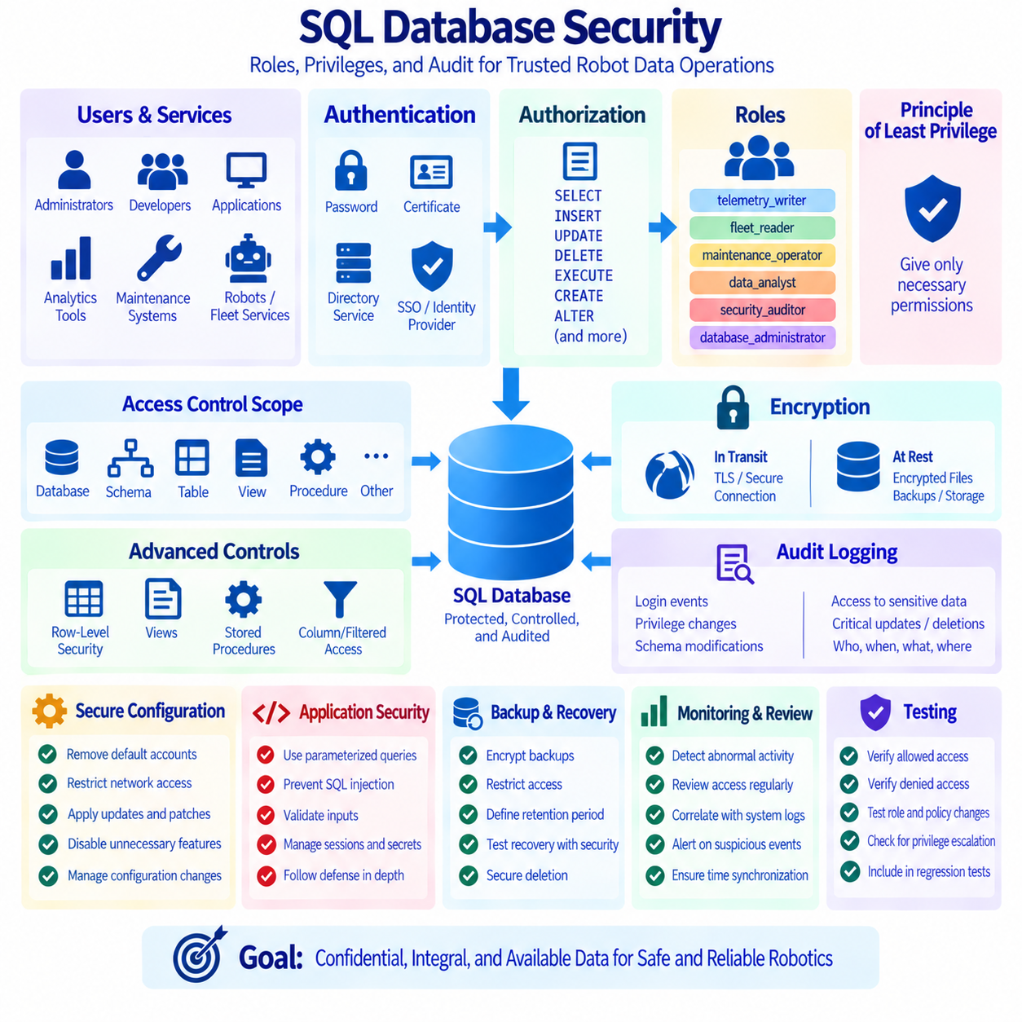
SQL database security protects data confidentiality, integrity, and availability while ensuring that legitimate users and services can perform required operations. Security should not depend on a single password or network boundary. A mature design combines authentication, authorization, roles, privileges, encryption, auditing, secure configuration, and operational monitoring. For robotics and Physical AI systems, these controls protect configuration, mission, maintenance, identity, calibration, and operational records that may directly influence physical behavior.
Authentication establishes who or what is attempting to connect to the database. Human administrators, application services, analytics tools, maintenance systems, and automated robot-management components should use identifiable credentials rather than sharing one universal account. Depending on the platform, authentication may use passwords, certificates, operating-system identities, directory services, or external identity providers. Credentials should be protected, rotated when appropriate, and stored using secure secret-management mechanisms instead of being embedded directly in source code or configuration files.
Authorization determines what an authenticated identity is permitted to do. SQL databases commonly control access through privileges such as SELECT, INSERT, UPDATE, DELETE, EXECUTE, CREATE, ALTER, and administrative permissions. These privileges may apply at database, schema, table, view, sequence, procedure, or other object levels. Authorization should reflect actual operational responsibilities. A monitoring service that only reads robot status does not normally require permission to modify mission assignments, while a maintenance application may need access to specific maintenance tables without receiving unrestricted administrative authority.
The principle of least privilege requires every user, service, and process to receive only the permissions necessary for its intended function. Excessive privileges increase the impact of programming mistakes, compromised credentials, malicious activity, and configuration errors. A telemetry ingestion service may require INSERT access to measurement tables but not DELETE access to historical data. An analytics service may require SELECT privileges without modification rights. Applying least privilege reduces the number of operations that can damage or expose critical data when one component fails or is compromised.
Roles provide a manageable way to organize permissions. Instead of granting dozens of privileges independently to every account, administrators can define roles representing operational responsibilities and assign users or services to those roles. Examples might include telemetry_writer, fleet_reader, maintenance_operator, data_analyst, security_auditor, and database_administrator. When responsibilities change, modifying role membership or the privileges associated with a role is generally safer and easier to audit than maintaining many unrelated grants for individual accounts.
Role design should reflect separation of duties, especially for sensitive administrative operations. A person who develops database changes does not necessarily need unrestricted authority to approve and deploy those changes in production. Similarly, security auditors may need access to logs and configuration information without permission to modify operational records. Separating development, operation, security, and audit responsibilities reduces the possibility that one identity can perform an entire high-risk process without independent oversight. The exact separation should match organizational scale and risk.
Privileges should be granted at the narrowest practical scope. If an application needs to read only selected columns or filtered records, a database view can sometimes expose the required data without providing direct access to the underlying table. Stored procedures can also provide controlled interfaces for specific transactional operations while restricting direct modification of base tables. These techniques help create stable security boundaries, although they should be combined with appropriate database permissions and application-level authorization rather than treated as substitutes for a complete access-control architecture.
Row-level security can provide finer-grained control when different users or services share the same tables but should access different subsets of rows. For example, a multi-site robotics platform may allow an operator from Factory A to access only robots and missions belonging to Factory A. The database can evaluate security policies when queries are executed and automatically restrict visible or modifiable rows. Row-level security can be powerful, but policies must be carefully tested because complex rules may affect query behavior, administration, troubleshooting, and performance.
Data encryption protects information from unauthorized disclosure at different stages. Encryption in transit protects database traffic between clients and servers, commonly through TLS or equivalent secure communication. Encryption at rest protects stored database files, backups, snapshots, or storage volumes if underlying media is exposed. Particularly sensitive fields may require additional application-level or column-level protection. Encryption does not replace authorization because an authenticated database process may still access decrypted information according to its privileges, but it provides an important additional defensive layer.
Audit logging records security-relevant and operationally important database activities. Useful audit events may include authentication successes and failures, privilege changes, role membership changes, schema modifications, administrative commands, access to sensitive data, and critical updates or deletions. For robot systems, changes to safety parameters, calibration records, mission configurations, or control-related metadata may deserve explicit auditing. Audit records should identify what occurred, when it occurred, which identity performed the action, and which database object or record was affected.
Audit design must balance visibility, storage, privacy, and performance. Recording every statement and every row change in a high-frequency telemetry database may create enormous log volumes and increase system overhead. Organizations should therefore classify events according to risk and compliance requirements and determine which activities require detailed auditing. Retention periods, access controls, log integrity, timestamp accuracy, and archival procedures should also be defined. Audit logs themselves contain sensitive operational information and must be protected from unauthorized modification or deletion.
Database auditing is most useful when logs are reviewed rather than merely stored. Monitoring systems can analyze repeated authentication failures, unexpected administrative activity, unusual data access, sudden privilege changes, or large destructive operations. Alerts can then direct operators to events requiring investigation. Correlating database audit records with application, operating-system, network, and identity logs provides stronger context for incident analysis. Accurate time synchronization is important because events from multiple systems must be placed on a consistent timeline during troubleshooting or security investigations.
Secure database configuration reduces unnecessary attack surfaces. Unused accounts, default credentials, obsolete extensions, unnecessary network exposure, and overly broad administrative interfaces should be removed or restricted. Database servers should accept connections only from authorized systems through controlled network paths where practical. Software updates and security patches should be managed through a tested maintenance process. Configuration changes should be versioned or documented so that administrators can identify deviations from approved security settings and restore known configurations when required.
Application security is closely connected to database security. Parameterized queries or prepared statements should be used to separate SQL structure from untrusted input and reduce SQL injection risk. Input validation, output handling, session management, API authorization, and secret protection remain application responsibilities even when strong database permissions are configured. An application account with broad privileges can still cause significant damage if the application is vulnerable. Database access should therefore be treated as one layer within a broader defense-in-depth architecture.
Backup and recovery security is sometimes overlooked because backups are not part of the active database service. However, a backup may contain the same sensitive robot, customer, configuration, and operational data as the production system. Backup files should therefore have controlled access, appropriate encryption, defined retention periods, and secure deletion procedures. Recovery processes should be tested so that security controls are restored together with the data. A technically successful recovery that exposes restored data through incorrect permissions can create a serious security incident.
Physical AI systems require particularly clear boundaries between observation and control. A service that reads telemetry for visualization should not automatically receive privileges to alter robot state, mission assignments, safety configuration, or calibration data. Control-related changes may require stronger authentication, narrowly scoped roles, transactional procedures, and detailed auditing. By separating read-only analytics, operational control, maintenance, and administration, the database can help prevent an error or compromised service in one functional area from directly affecting physical robot behavior.
Security governance should include periodic access reviews. Accounts may remain active after employees change responsibilities, services may retain privileges that are no longer required, and temporary permissions can become permanent if they are not reviewed. Administrators should examine active identities, role memberships, direct privilege grants, privileged accounts, authentication methods, and inactive credentials. Automated reports can assist this process, but ownership decisions still require organizational context. Removing unnecessary access is often as important as correctly granting new permissions.
Security testing should verify both intended access and intended denial. It is not enough to confirm that an application can read or update required data; tests should also demonstrate that it cannot access prohibited schemas, tables, rows, or administrative functions. Changes to roles, views, stored procedures, row-level policies, and application identities should be included in regression testing. Production-like testing can reveal accidental privilege escalation, missing grants, policy conflicts, and performance effects before a security configuration reaches operational systems.
A mature SQL security architecture treats identity, roles, privileges, encryption, audit, monitoring, secure configuration, and recovery as interconnected controls. Authentication establishes identity, authorization limits actions, roles simplify permission management, least privilege reduces exposure, and auditing creates accountability. Encryption and secure infrastructure protect data beyond logical access control. For robotics and Physical AI, the objective is to ensure that every important database action is performed by an identifiable entity, through an authorized path, with sufficient evidence for detection, investigation, and recovery.

01.09 SQL vs NoSQL Selection Criteria: Robot System
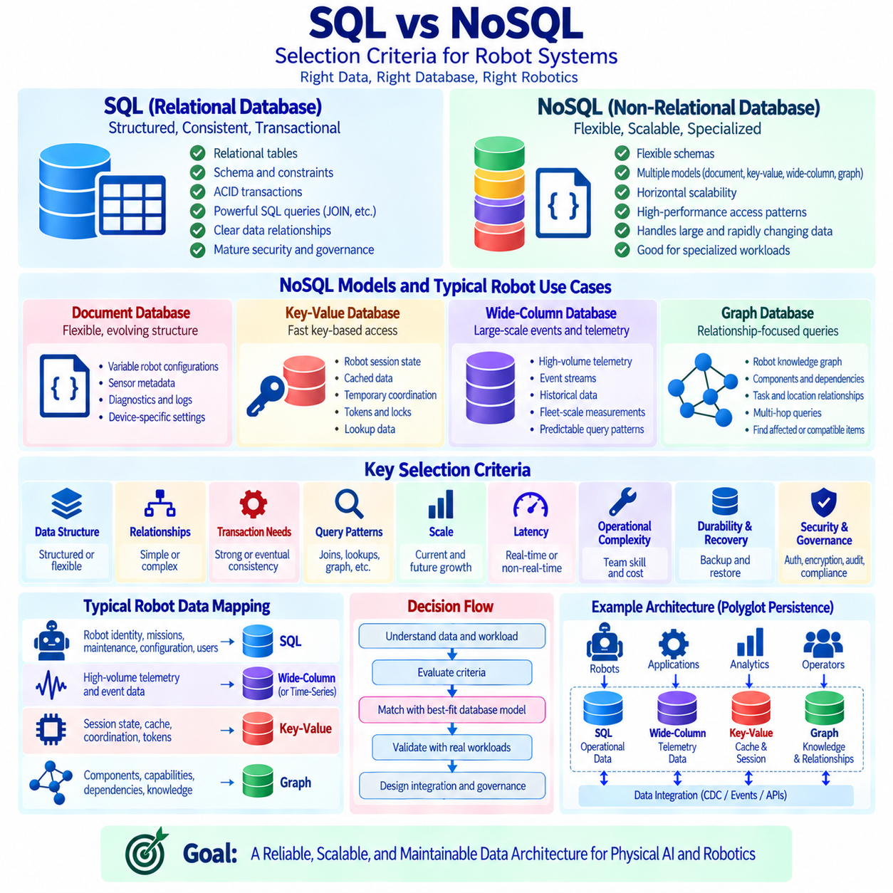
Selecting between SQL and NoSQL for a robot system is an architectural decision based on data structure, consistency requirements, query patterns, scale, latency, and operational complexity. Neither technology is universally superior. SQL databases are strong when relationships, transactions, constraints, and structured queries are central, while NoSQL systems provide alternative models for flexible schemas, large-scale distribution, specialized access patterns, or rapidly changing data. A practical architecture chooses the database according to the responsibility of each dataset rather than forcing every robot workload into one technology.
SQL databases organize information primarily through relational tables with defined columns, keys, constraints, and relationships. This model is well suited to robot identities, mission definitions, equipment records, maintenance history, user accounts, permissions, configuration metadata, and other structured information. Primary keys, foreign keys, UNIQUE constraints, CHECK constraints, and transactions allow the database to enforce important rules. When a robot, mission, charging station, operator, and maintenance record have meaningful relationships, relational modeling can provide a clear and auditable representation of those dependencies.
Transactional consistency is one of the strongest reasons to select SQL. Operations such as assigning one robot to a mission, reserving a charging station, changing an equipment state, or approving a configuration may require several related records to change atomically. ACID transactions allow these changes to commit together or roll back together when an error occurs. This behavior is especially valuable when partially completed updates could create contradictory operational states. Strong transactional semantics reduce the amount of consistency logic that application developers must recreate across multiple services.
SQL is also appropriate when the system requires flexible analytical queries across known relationships. JOIN, GROUP BY, window functions, CTEs, aggregation, and subqueries allow developers and analysts to investigate operational information without designing a dedicated access path for every future question. Fleet operations may need to combine robot metadata, missions, maintenance events, failures, and site information in changing ways. A relational schema can support these cross-domain queries effectively when the data model and indexes are designed around realistic workloads.
NoSQL is a broad category rather than a single database model. Document, key-value, wide-column, and graph databases solve different classes of problems and should not be evaluated as one identical technology. A document database stores flexible hierarchical records, a key-value store emphasizes rapid access by key, a wide-column database can support large distributed datasets with predefined access patterns, and a graph database represents highly connected entities and relationships. The selection process should therefore compare a specific NoSQL model with the actual robot data requirement rather than simply asking whether SQL or NoSQL is faster.
Document databases can be useful when records contain variable or evolving structures. Robot models may produce different sensor configurations, capability descriptions, diagnostics, perception metadata, or device-specific settings that do not fit comfortably into one rigid table structure. A document can keep related nested information together and allow fields to evolve as hardware generations change. However, schema flexibility does not eliminate the need for data governance. Applications still require validation, versioning, compatibility rules, indexing strategies, and clear ownership of document structures.
Key-value databases are appropriate when the dominant operation is retrieving a value through a known key with very low latency. Robot session state, temporary coordination data, cached configuration, short-lived tokens, distributed locks, or frequently requested lookup results may fit this model. The simplicity of key-based access can provide excellent performance, but complex relational queries are usually not the purpose of the system. If applications repeatedly need to search values by many attributes or combine several related entities, another database model may provide a more natural solution.
Wide-column databases are designed for workloads where very large datasets must be distributed across multiple machines while supporting predictable query patterns. High-volume event streams, telemetry summaries, historical sensor metadata, or fleet-scale operational measurements can be candidates when data volume exceeds the convenient operating range of a centralized relational design. Their data models are often shaped around the queries that must be served. This can produce high scalability, but it may require denormalization and additional application logic compared with relational databases that support general-purpose joins.
Graph databases become useful when relationships themselves are a primary part of the query. A robot knowledge graph may connect robots, components, sensors, capabilities, tasks, locations, failures, maintenance actions, dependencies, and semantic concepts. Queries such as finding dependency paths, compatible capabilities, affected components, or multi-hop relationships can be easier to express in a graph model than through many relational joins. Graph technology should be selected because graph traversal is an important workload, not merely because the system contains relationships, since relational databases also model relationships effectively.
Consistency requirements must be evaluated explicitly when considering distributed NoSQL systems. Some systems prioritize strong consistency, while others allow configurable or eventual consistency to improve availability, latency, or geographic distribution. Eventual consistency may be acceptable for cached dashboard information or replicated analytical data, but it may be inappropriate for safety-related configuration, resource reservation, or mission ownership. Database selection should therefore start from the business meaning of stale or conflicting data rather than from a general assumption that stronger or weaker consistency is always better.
Scalability is another important criterion, but the expected scale should be quantified. A relational database can support substantial workloads through efficient schema design, indexing, partitioning, caching, replication, and capable hardware. Introducing a distributed NoSQL platform for a dataset that does not require distributed scale can increase operational complexity without producing meaningful benefits. Conversely, a fleet producing extremely large event or telemetry volumes may justify distributed storage. Engineers should estimate data growth, ingestion rate, query concurrency, retention period, and geographic requirements before choosing a scaling model.
Query patterns should influence the database model more strongly than data format alone. JSON data does not automatically require a document database, and structured records do not automatically require SQL. Engineers should identify how information is inserted, retrieved, updated, aggregated, joined, traversed, and deleted. A workload dominated by relational joins and ad hoc analysis favors different technology from one dominated by key lookup or graph traversal. The best model minimizes unnecessary transformations while supporting the most important operations predictably and efficiently.
Latency requirements must also be considered in context. A real-time robot control loop should generally not depend on a remote general-purpose database for millisecond-level actuator decisions. Databases are more appropriate for persistent state, coordination, configuration, history, analytics, and management information. Low-latency caches or local data stores may support edge components while authoritative information remains elsewhere. Database selection should therefore consider where the database sits in the robot control architecture rather than treating database response time as equivalent to deterministic real-time control.
Operational complexity can outweigh theoretical scalability advantages. Every additional database technology introduces deployment procedures, backup strategies, monitoring, security configuration, upgrades, failure recovery, expertise requirements, and integration work. A polyglot architecture using several database types can be powerful when each system has a clear responsibility, but unnecessary technology diversity creates maintenance burden. Teams should select a new database model when its advantages materially improve an important workload and justify the additional lifecycle cost.
Data durability and recovery requirements should be evaluated for both SQL and NoSQL systems. Robot mission history, maintenance evidence, calibration records, security audits, and configuration changes may require reliable persistence and tested recovery procedures. Replication alone is not equivalent to backup because corrupted or accidentally deleted data can propagate to replicas. Engineers should examine backup support, point-in-time recovery, replication behavior, failure modes, consistency during recovery, and restoration testing rather than assuming that a distributed system automatically provides stronger durability.
Security and governance are equally important selection criteria. The chosen platform should support required authentication, authorization, encryption, auditing, data retention, and access-review practices. Mature relational platforms often provide extensive security controls, while NoSQL products vary significantly in their capabilities and operational models. Flexible schemas can accelerate development but may complicate governance if data structures evolve without control. Security requirements should be evaluated before adoption because adding missing governance mechanisms after a system contains sensitive operational data can be expensive.
Robot architectures frequently benefit from polyglot persistence, where different database technologies serve different data responsibilities. A relational database may store robot identities, missions, maintenance, configuration, and authorization data; a time-series or wide-column system may retain high-volume telemetry; a key-value store may provide caching and transient coordination; and a graph database may represent knowledge and dependencies. Integration should define which system is authoritative for each dataset and how changes move between systems so that multiple databases do not create ambiguous sources of truth.
Data movement between SQL and NoSQL systems requires explicit consistency boundaries. Change data capture, event streams, transactional outbox patterns, idempotent consumers, version identifiers, and reconciliation processes can help propagate information reliably. For example, mission data may be committed first in an authoritative SQL database and then published to analytical or operational stores. Downstream copies may temporarily lag without compromising the authoritative state. Clearly distinguishing systems of record from derived views reduces confusion when several technologies contain overlapping information.
A practical selection process evaluates each dataset against structure, relationships, transaction requirements, consistency, query patterns, scale, latency, retention, security, recovery, and team capability. SQL is often the default choice for strongly related transactional operational data, while specific NoSQL models become attractive when their specialized access or scaling characteristics solve a demonstrated problem. The decision should be validated with representative workloads and realistic data volumes instead of relying on technology trends or simplified SQL-versus-NoSQL comparisons.
For Physical AI, the final objective is not to choose one database family as the winner but to create a reliable data architecture around robot behavior and operational risk. Safety-sensitive state, mission ownership, configuration, and governance records may demand strong transactional controls, while massive telemetry, caches, semantic relationships, and rapidly evolving metadata may benefit from specialized stores. Assigning each workload to a database model that matches its semantics allows robot systems to scale while preserving consistency, observability, maintainability, and clear data ownership.

01.10 SQL Database Migration Strategy: Flyway / Liquibase [w/Code]
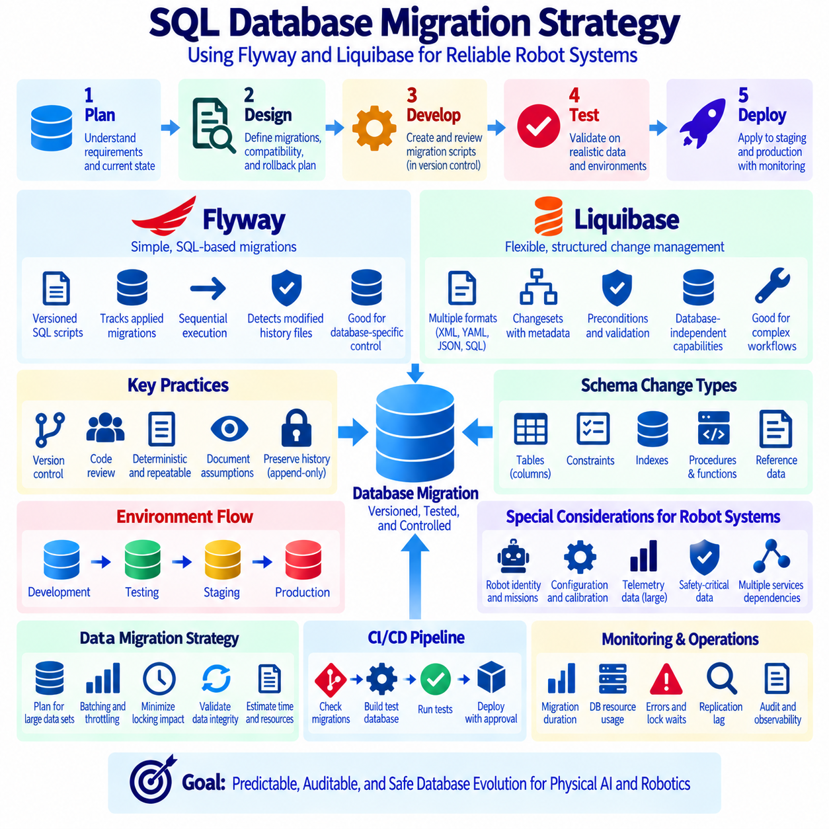
SQL database migration is the controlled process of changing database schemas, reference data, constraints, indexes, procedures, and related objects as an application evolves. Manual production changes become increasingly risky because environments can drift and administrators may apply modifications differently. A migration strategy treats database structure as versioned software. Every approved change is represented by a reproducible migration, stored in version control, tested before deployment, and applied consistently across development, testing, staging, and production environments.
Schema versioning establishes a historical sequence of database changes. Instead of maintaining only the latest CREATE TABLE definitions, teams preserve migrations that describe how the database moved from one version to another. A migration might create a table, add a column, introduce an index, modify a constraint, or populate required reference data. This history allows engineers to understand when structural changes occurred and align application releases with the database state expected by each software version.
A reliable migration should be deterministic and repeatable in its intended context. Applying the same ordered migration set to equivalent starting databases should produce equivalent schemas. Migration scripts should therefore avoid unnecessary dependence on manual actions, local machine settings, or undocumented assumptions. Each change should have a clear purpose and ownership. Database-specific behavior, required extensions, character encoding, time-zone assumptions, and privileges should be documented when they can affect migration results across environments.
Flyway provides a migration approach centered strongly on ordered migration files, commonly written as SQL scripts. Versioned migrations use naming conventions that identify sequence and description, while Flyway records executed migrations in a schema history table. During deployment, it compares available migrations with recorded history and applies migrations that have not yet been executed. This model is straightforward for teams that prefer explicit SQL and want database changes to remain close to the native syntax and capabilities of their chosen database engine.
Flyway checks migration history to detect unexpected changes to previously applied migration files. Once a versioned migration has been executed in shared or production environments, editing that file can create inconsistency between databases that applied the original version and databases that receive the modified version. A safer practice is generally to preserve the historical migration and create a new migration that corrects or extends it. This append-only mindset makes the evolution of the schema easier to trace and reduces ambiguity about the state of deployed environments.
Liquibase also manages database changes through version-controlled change definitions but provides several representation formats, including XML, YAML, JSON, and SQL. Changes are organized into changesets that contain identifiers, authorship information, and database modifications. Liquibase records executed changesets in tracking tables and determines which changes remain to be applied. Its abstraction features can be useful when organizations want structured change descriptions, database-independent capabilities, or additional metadata around complex migration workflows.
Liquibase supports concepts such as preconditions that can verify expected database conditions before a changeset executes. A migration can check whether a table, column, database type, or other condition satisfies the assumptions required by the change. This can prevent a migration from proceeding against an unexpected state. Preconditions should not become a substitute for controlled environments, but they provide useful safeguards when deployment conditions vary or when a migration requires explicit verification before potentially disruptive operations are performed.
Choosing between Flyway and Liquibase depends more on team workflow and migration requirements than on a universal feature ranking. Flyway is often attractive when teams want a simple, SQL-oriented, sequential migration model with direct control over database-specific syntax. Liquibase can be attractive when structured changesets, multiple definition formats, preconditions, or broader change-management abstractions are useful. Both tools can support disciplined migration practices when scripts are reviewed, tested, versioned, and integrated correctly into the software delivery process.
Migration files should be stored in the same version-control discipline as application code. A database change associated with a software feature should be reviewable alongside the code that depends on it. Pull requests or equivalent review processes can examine SQL correctness, locking risks, compatibility, indexing effects, rollback considerations, and data transformation requirements. This approach turns schema evolution into a visible engineering activity rather than an undocumented administrative action performed directly on production systems.
Backward and forward compatibility are critical when application instances and database migrations cannot be updated at exactly the same moment. A deployment may temporarily run old and new application versions against the same database. Additive changes, such as introducing a nullable column or a new table, are generally easier to deploy safely than immediately renaming or deleting an object used by existing code. Migration planning should therefore consider the deployment sequence of both application and database components rather than treating them as independent releases.
The expand-and-contract pattern is useful for potentially incompatible schema changes. During the expand phase, the database introduces new structures while retaining old ones so both application versions can operate. Applications are then updated to use the new structure, and required data is migrated or synchronized. After the old structure is no longer used, the contract phase removes obsolete columns, tables, or interfaces. Although this approach requires additional steps, it reduces downtime and deployment risk for systems that require continuous operation.
Data migrations require different planning from purely structural changes because transforming millions or billions of rows can consume substantial CPU, storage bandwidth, transaction-log capacity, and lock resources. A migration that adds a column may complete quickly, while populating that column for an entire telemetry history can take hours. Large transformations may need batching, throttling, checkpoints, background processing, or separate operational jobs. Engineers should estimate data volume and execution behavior before treating a data migration as a normal short schema change.
Indexes and constraints can also make migrations operationally expensive. Building a large index may consume CPU, memory, temporary storage, and I/O, while adding a constraint may require existing rows to be validated. Some database engines provide online or concurrent operations that reduce blocking, but capabilities and tradeoffs differ. Migration designers should understand how each DDL operation behaves on the target platform, particularly for tables receiving continuous robot telemetry or operational transactions that cannot tolerate extended blocking.
Rollback strategy should be defined according to the nature of each migration. Some changes can be reversed with a simple down migration, while destructive operations such as dropping data cannot necessarily be restored by reversing SQL. In many production systems, correcting a failed migration with a new forward migration can be safer than attempting an automatic rollback. Backups, snapshots, point-in-time recovery, and tested restoration procedures remain necessary because migration tooling does not itself guarantee recovery from every logical or operational failure.
Migration testing should begin on disposable databases and progress toward production-like environments. Automated pipelines can create a database from an earlier version, execute the complete migration sequence, start the application, and run integration tests. Teams should also test upgrades from realistic recent production states rather than only building an empty database from the beginning. Large tables and realistic data distributions are particularly important when evaluating migration duration, locking behavior, index creation, constraint validation, and storage requirements.
Continuous integration and continuous delivery pipelines can automate migration validation and controlled execution. A pipeline may verify migration naming, detect modified historical files, build test databases, execute migrations, run application tests, and package approved artifacts. Production execution should still include appropriate authorization, observability, and failure handling. Automation improves consistency, but an automated destructive migration is still destructive. Deployment gates should reflect the operational risk of the database changes being introduced.
Robot and Physical AI platforms require special attention because database migrations may affect continuously operating services. Changes to robot identity, mission state, configuration, calibration, maintenance, safety metadata, or telemetry schemas can influence multiple applications simultaneously. Migrations should identify dependent services and interfaces before deployment. Safety-sensitive or control-related data requires particularly conservative compatibility planning so that schema evolution cannot leave active software interpreting operational state incorrectly.
Observability should continue throughout the migration process. Teams should monitor migration duration, database CPU, memory, I/O, lock waits, replication lag, transaction-log growth, errors, application latency, and connection behavior. A technically successful DDL statement can still create unacceptable service degradation. Defined thresholds and stop conditions help operators determine when to pause or alter a deployment. Migration records should also identify which version ran, when it ran, who or what initiated it, and whether validation completed successfully.
A mature migration strategy separates schema evolution from uncontrolled manual administration. Flyway or Liquibase provides the mechanism for tracking and executing changes, while engineering discipline provides review, compatibility planning, testing, recovery, monitoring, and governance. The objective is not merely to automate ALTER TABLE commands. It is to make database evolution predictable, auditable, reproducible, and aligned with application releases so that growing Physical AI and robot systems can change their data structures without sacrificing operational reliability.

