Volume 08 Robot Database and Storage

02. PostgreSQL

02.01 PostgreSQL Architecture: Process Model / WAL
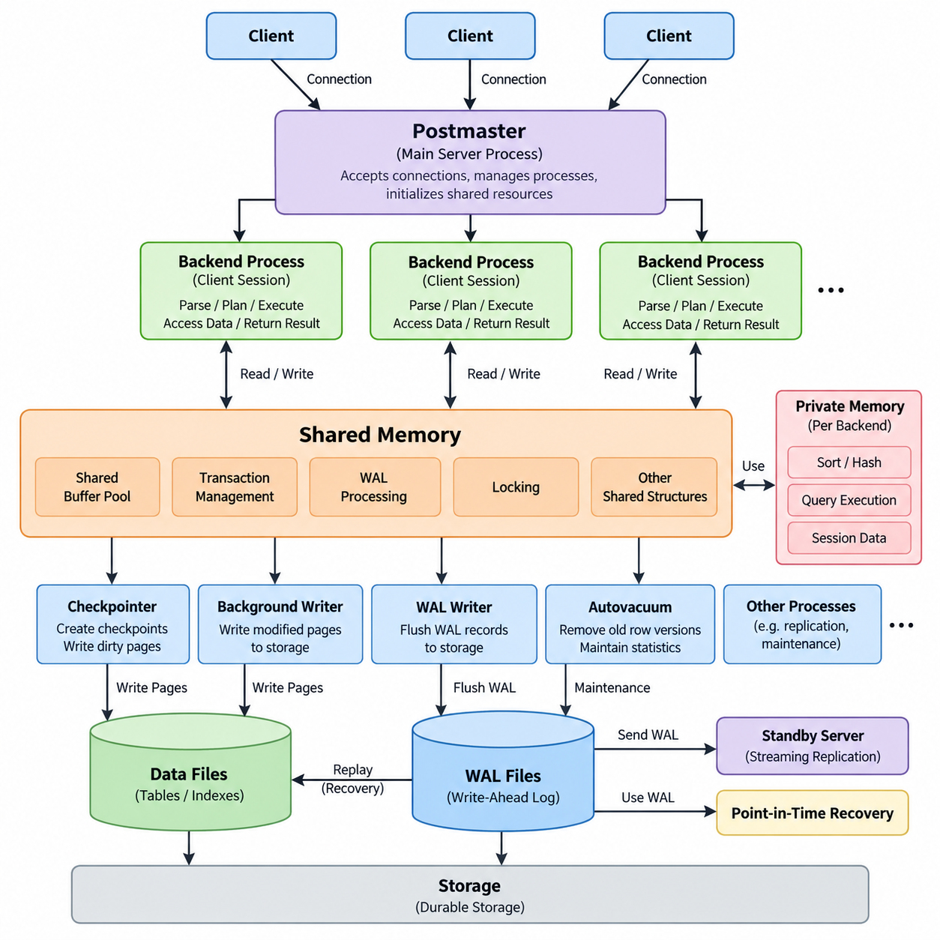
PostgreSQL is a client-server relational database management system designed around a multi-process architecture. Unlike a database engine that performs most work inside a single process, PostgreSQL creates a dedicated server process for each client connection while maintaining several background processes for shared database operations. The PostgreSQL server is started by the postmaster or main server process, which manages connections, initializes shared resources, and supervises the lifecycle of backend and background processes. This architecture provides process isolation, operational reliability, and a clear separation between client requests and system-level database management.
When a client connects to PostgreSQL, the server accepts the connection and creates a dedicated backend process for that client session. The backend process parses SQL statements, performs semantic analysis, generates or selects an execution plan, accesses shared buffers and storage, and returns results to the client. Each backend maintains session-specific information such as transaction state, temporary objects, prepared statements, and configuration parameters. Because client sessions are separated at the operating-system process level, a failure in one backend does not normally terminate all other client sessions or the entire database server.
PostgreSQL also relies on several background processes to coordinate database-wide activities. The checkpointer periodically creates checkpoints that establish a known recovery position in the database's write-ahead log. The background writer gradually writes modified data pages from shared buffers to storage, reducing the amount of work required during checkpoints. The WAL writer transfers WAL records from memory to persistent storage, while the autovacuum launcher schedules maintenance workers that remove obsolete row versions and maintain table statistics. These processes allow foreground client sessions to focus primarily on query execution rather than performing every maintenance operation themselves.
Shared memory is a critical component of the PostgreSQL architecture because multiple server processes must cooperate while remaining separate operating-system processes. The shared buffer pool caches database pages in memory so that frequently accessed data does not always require physical storage access. PostgreSQL also maintains shared structures for transaction management, WAL processing, locking, and other coordination mechanisms. Each backend additionally has private memory areas used for tasks such as sorting, hashing, query execution, and session-specific operations. Consequently, PostgreSQL performance depends on both shared memory configuration and the amount of private memory consumed by concurrent queries.
The process model is closely connected to PostgreSQL's transaction architecture. A transaction represents a logical unit of work that PostgreSQL must execute according to transactional consistency rules. When a transaction modifies data, PostgreSQL does not simply overwrite the previous row immediately. Instead, it creates a new row version and records transaction visibility information. This multi-version concurrency control, or MVCC, allows readers and writers to operate concurrently with reduced blocking. Each transaction observes a consistent database snapshot according to PostgreSQL's isolation rules, while obsolete row versions are eventually reclaimed through vacuum processing.
Write-Ahead Logging, commonly called WAL, is one of the most important mechanisms in PostgreSQL. The central rule is that changes to database pages must be recorded in the WAL before the corresponding modified pages are considered safely persistent. When a transaction changes data, PostgreSQL generates WAL records describing the required physical or logical changes. These records are initially held in shared memory and are eventually flushed to the WAL files on durable storage. The transaction can be considered committed only after the required WAL information has been durably written according to the configured synchronous commit behavior.
WAL separates logical transaction durability from the immediate writing of database data pages. A modified data page in the shared buffer does not necessarily have to be written to its table file at the exact moment a transaction commits. Instead, PostgreSQL can first make the corresponding WAL records durable and write the actual data pages later. During normal operation, this reduces random storage writes and allows PostgreSQL to combine or reorder data-page writes more efficiently. The WAL therefore acts as a durable record of database changes and provides the foundation for crash recovery, checkpoint processing, replication, and point-in-time recovery.
A checkpoint establishes a recovery boundary within the WAL stream. During checkpoint processing, PostgreSQL ensures that modified data pages associated with transactions before the checkpoint are written to durable storage and records checkpoint information in the WAL. After a system crash, PostgreSQL can start recovery from an appropriate checkpoint and replay subsequent WAL records to reconstruct changes that had been committed but whose data pages had not yet reached their final storage locations. This process is called WAL replay and allows PostgreSQL to restore database consistency without requiring every transaction to synchronously write all modified data pages.
The interaction among backend processes, shared buffers, WAL, and storage can therefore be viewed as a continuous data path. A client sends a SQL request to its backend process, the backend executes the required operations and modifies pages in shared memory, and PostgreSQL generates WAL records describing those changes. The WAL writer and commit process ensure that required WAL information reaches durable storage according to the transaction's durability requirements. The background writer and checkpoint process subsequently manage the persistence of modified data pages. This separation enables PostgreSQL to combine transactional correctness with efficient storage management.
WAL also provides the foundation for PostgreSQL replication technologies. A primary PostgreSQL server generates WAL as database changes occur, and standby servers can receive and replay those WAL records to reproduce the database state. Streaming replication can continuously transmit WAL from the primary toward one or more replicas, allowing replicas to maintain a relatively current copy of the primary database. Because replication is based on WAL rather than on independently copying every modified table page, PostgreSQL can efficiently propagate database changes while maintaining the same underlying recovery mechanism used after a local system failure.
For large-scale systems, understanding the relationship between PostgreSQL's process model and WAL is essential for capacity planning and operational management. Increasing the number of concurrent connections can increase the number of backend processes and therefore increase memory and operating-system overhead. Connection pooling is often used to control this pressure. At the same time, transaction volume, WAL generation rate, checkpoint frequency, storage latency, and replication traffic must be considered together. A database that has sufficient CPU capacity can still experience performance degradation if WAL storage, checkpoint I/O, memory pressure, or connection concurrency becomes a bottleneck.
From an operational perspective, PostgreSQL architecture is therefore not simply a collection of independent components. The backend process model controls how client work is executed, shared memory enables coordination and caching, MVCC controls transaction visibility, WAL protects durability and supports recovery, and background processes continuously maintain the database environment. These mechanisms form an integrated execution and persistence model. Understanding this relationship provides the foundation for diagnosing PostgreSQL performance problems, designing reliable database infrastructure, configuring replication, planning storage systems, and determining how database behavior changes as workload concurrency and transaction volume increase.

02.02 PostgreSQL Install, Config, Security Hardening [w/Code]
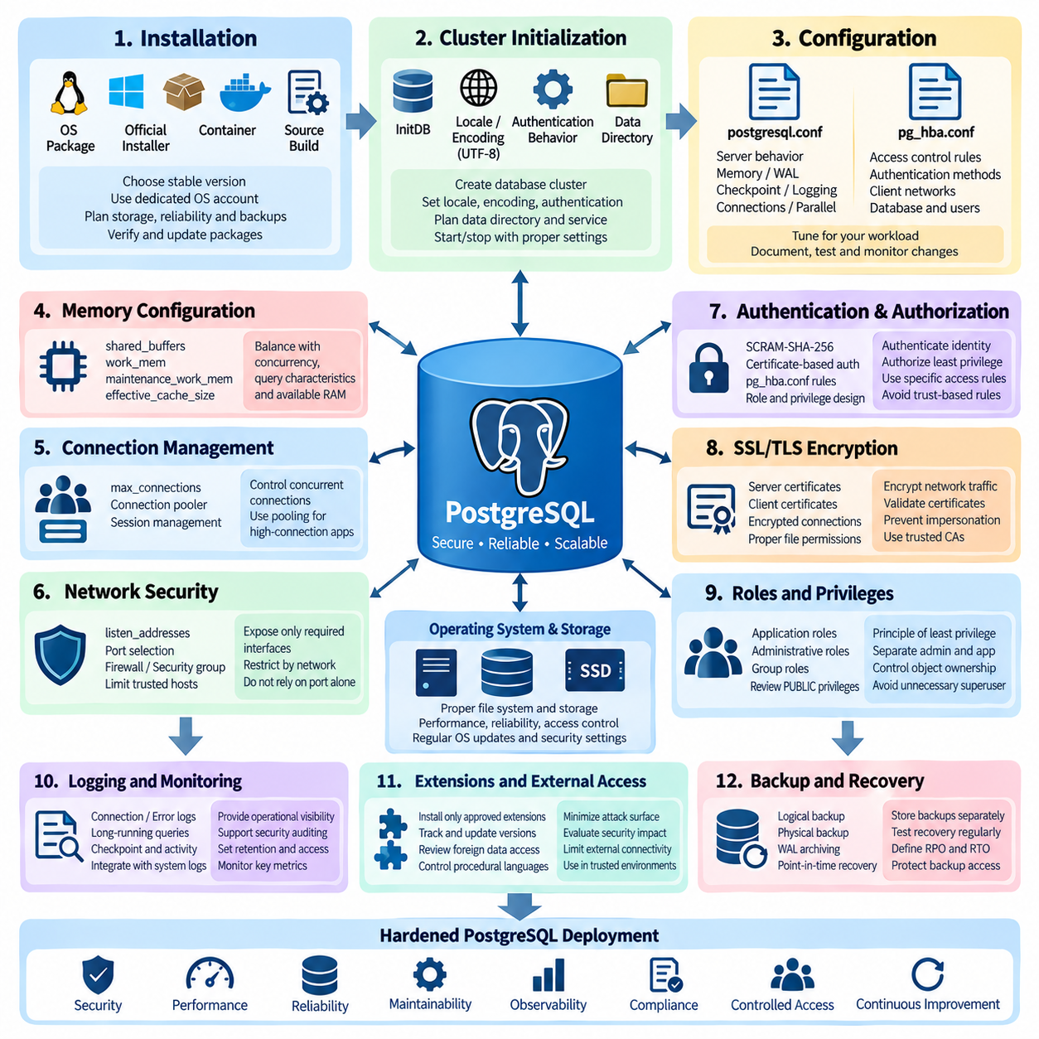
PostgreSQL installation begins with selecting an appropriate version, operating system package, storage layout, and deployment model for the intended workload. PostgreSQL can be installed through native operating-system packages, official installers, containers, or source compilation. For production environments, a supported stable release should be selected and the installation source should be controlled so that packages can be verified and updated consistently. The database server should run under a dedicated operating-system account rather than a privileged user, and database files should be placed on storage with appropriate performance, reliability, backup, and access-control characteristics.
After installation, PostgreSQL creates a database cluster that contains the system catalogs, configuration files, transaction metadata, and database storage managed by a particular server instance. The cluster should be initialized with deliberate choices for locale, encoding, authentication behavior, and data directory placement. UTF-8 is commonly appropriate for modern applications because it provides broad support for multilingual data. The operating-system service configuration should also be reviewed so that PostgreSQL starts and stops predictably, uses the intended cluster, and does not expose an unnecessary number of listening interfaces or network endpoints.
PostgreSQL configuration is primarily controlled through parameters in postgresql.conf and access rules in pg_hba.conf. The configuration file controls server behavior such as listening addresses, port selection, memory allocation, WAL behavior, checkpoint management, logging, parallel execution, and connection limits. Changes should be made according to the workload rather than copied blindly from generic tuning guides. A parameter that improves performance for a large analytical workload may be inappropriate for a transactional system with many concurrent connections. Configuration changes should therefore be documented, tested, and monitored after deployment.
Memory configuration requires particular attention because PostgreSQL uses both shared memory and memory allocated by individual backend processes. Parameters such as shared_buffers, work_mem, maintenance_work_mem, and effective_cache_size influence different aspects of database operation. Increasing work_mem, for example, can improve sorting and hashing operations but may multiply memory consumption when many operations execute concurrently. Similarly, increasing shared_buffers consumes memory that must be balanced against operating-system cache requirements. Safe configuration therefore requires considering concurrency, query characteristics, available RAM, and workload variability rather than optimizing individual parameters in isolation.
Connection management is another important part of PostgreSQL configuration. The max_connections parameter determines how many client connections the server can accept, but increasing this value can significantly increase memory and process-management overhead. High-connection applications should often use a connection pooler so that a controlled number of database sessions can serve a larger number of application requests. Connection pooling also reduces the cost of repeatedly establishing sessions and helps protect the database from sudden connection spikes. The appropriate configuration depends on application behavior, transaction duration, query complexity, and available server resources.
Network exposure should be minimized from the beginning. PostgreSQL does not need to listen on every network interface simply because remote access is technically possible. The listen_addresses parameter should expose only the interfaces required by the deployment, and network-level controls such as firewalls or security groups should restrict access to trusted application servers, administration hosts, or replication nodes. The default PostgreSQL port should not be treated as a security boundary by itself. Security comes from controlling which systems can connect and how those connections are authenticated and authorized.
Authentication and authorization should be designed separately. Authentication determines whether a client is allowed to establish an identity, while authorization determines what that identity is permitted to do after connection. PostgreSQL supports several authentication mechanisms through pg_hba.conf, including password-based methods and certificate-based approaches. Modern deployments should prefer secure password authentication such as SCRAM-SHA-256 rather than legacy password mechanisms. Access rules should be as specific as practical, limiting database, user, source network, and authentication method rather than relying on broad trust-based rules.
Database roles should follow the principle of least privilege. Applications should normally use dedicated roles with only the permissions required for their assigned functions instead of connecting with superuser accounts. Administrative roles should be separated from application roles, and ownership of critical database objects should be controlled carefully. Where appropriate, privileges can be granted through group roles so that permission management remains consistent as users and applications change. PUBLIC privileges should also be reviewed because permissions granted to PUBLIC may unintentionally provide access to every database role.
Sensitive database operations require additional restrictions. PostgreSQL superusers have extensive authority and can bypass many ordinary permission controls, so superuser credentials should be used only for administration and protected carefully. Application code should never require unrestricted superuser access merely to perform normal transactions. Functions, extensions, foreign data access, file-related capabilities, and administrative interfaces should be evaluated according to the trust level of the environment. Security hardening should focus not only on external attackers but also on limiting the impact of compromised application credentials or incorrectly configured database roles.
Transport security is essential when PostgreSQL connections cross untrusted or shared networks. SSL/TLS can encrypt database traffic and can also provide certificate-based client authentication when required. Server certificates, private keys, certificate authorities, and permissions on those files must be managed securely. The server should be configured to require encrypted connections for clients that communicate across networks where traffic could otherwise be intercepted. Certificate validation should be implemented correctly on clients rather than treating encryption alone as sufficient protection against impersonation or man-in-the-middle attacks.
Logging provides both operational visibility and security evidence. PostgreSQL can record connection events, disconnections, errors, long-running queries, checkpoints, and other activities through its logging configuration. The appropriate level of logging depends on the operational environment because excessive logging can create storage and performance overhead. Security-sensitive environments should establish retention and access policies for database logs and protect them from unauthorized modification. Logs should be correlated with operating-system, application, network, and identity-management events when investigating incidents or unusual database activity.
Security hardening also requires disciplined management of extensions and external functionality. PostgreSQL extensions can provide valuable capabilities, but every extension expands the database's functional surface and may introduce additional privileges, dependencies, or maintenance requirements. Only approved extensions should be installed in production environments, and their versions should be tracked and updated through controlled procedures. External connections, procedural languages, foreign data wrappers, and other features that can interact with systems outside the database should receive additional scrutiny because their security implications extend beyond ordinary SQL access.
Backups and recovery are fundamental parts of database security because confidentiality and integrity are not sufficient if data cannot be restored after corruption, accidental deletion, ransomware, or infrastructure failure. PostgreSQL supports logical backups, physical backups, WAL archiving, and point-in-time recovery. Backup storage should be separated from the primary database environment, protected with appropriate access controls, and tested through actual restoration procedures. A backup that has never been successfully restored should not be treated as a proven recovery mechanism. Recovery objectives should therefore be defined in terms of acceptable data loss and restoration time.
Operational hardening continues after installation and initial configuration. PostgreSQL should be kept on supported versions, security updates should be evaluated and applied through a controlled maintenance process, and configuration changes should be tracked. Database roles, privileges, extensions, authentication rules, network exposure, certificates, backups, and logs should be periodically reviewed. Monitoring should cover resource utilization, connection counts, transaction activity, WAL generation, replication status, storage capacity, query latency, and database errors. This ongoing process turns security hardening from a one-time installation activity into a continuous operational practice.
A properly hardened PostgreSQL deployment therefore combines secure installation, controlled network exposure, strong authentication, least-privilege authorization, encrypted communication, deliberate resource configuration, protected logging, controlled extensions, reliable backups, and continuous maintenance. Performance and security should not be treated as completely separate concerns because excessive connections, uncontrolled memory allocation, inefficient logging, or poorly designed backup procedures can affect both availability and security. The objective is to create a database environment in which application workloads can operate efficiently while administrative access, data exposure, recovery capabilities, and operational changes remain controlled and auditable.

02.03 JSONB Type: Robot Config / Event Data [w/Code]
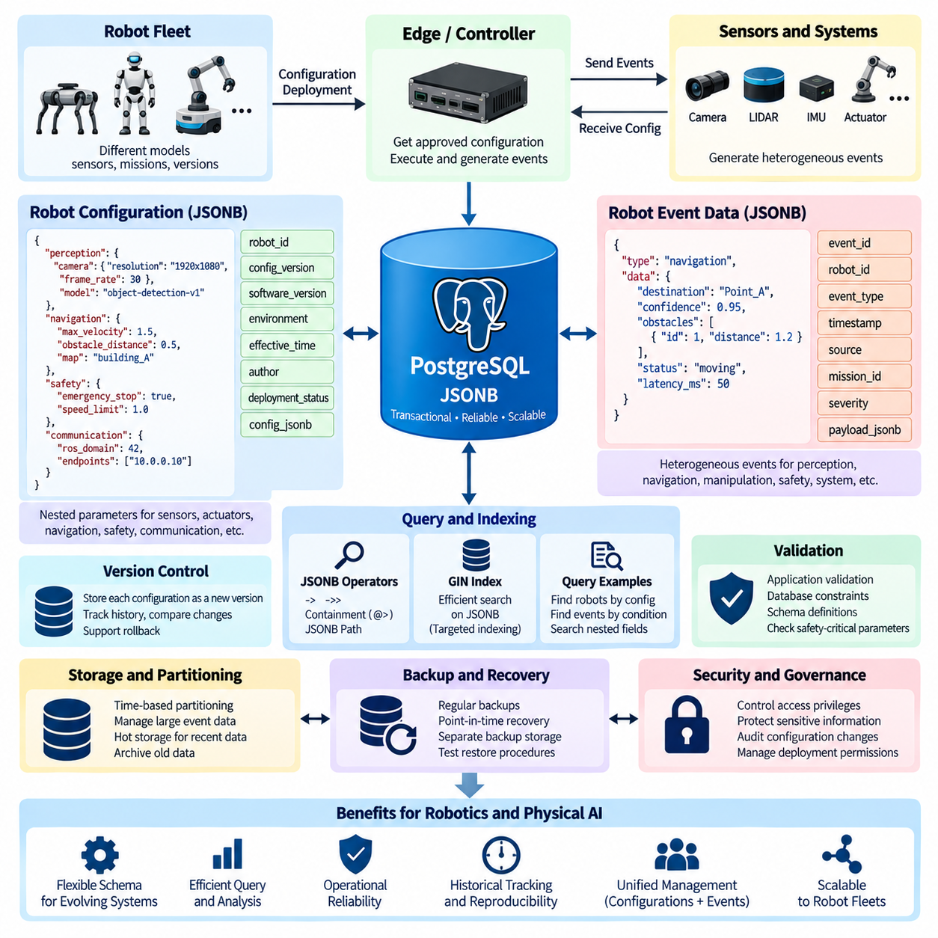
PostgreSQL JSONB is a binary JSON data type designed to store semi-structured information while retaining PostgreSQL's transactional, indexing, and query capabilities. For robotics systems, JSONB is particularly useful because robot configurations and event records often contain fields that vary between robot models, sensors, missions, and software versions. Instead of creating a rigid relational column for every possible attribute, a stable relational structure can be combined with flexible JSONB fields. This approach allows PostgreSQL to manage structured operational data while preserving the variability required by Physical AI and robotic applications.
Robot configuration data commonly contains nested parameters such as sensor settings, actuator limits, navigation parameters, perception models, safety thresholds, network endpoints, and software versions. These values may differ considerably between robot platforms. A JSONB document can represent such configuration as a hierarchical object while keeping related parameters together. PostgreSQL can store the complete configuration in a JSONB column while maintaining important identifiers such as robot_id, configuration_version, environment, and effective_time as conventional relational columns. This hybrid design provides both flexible configuration management and efficient relational filtering.
A typical robot configuration can contain objects for perception, navigation, manipulation, communication, and safety. For example, a perception section may contain camera resolution, frame rate, exposure settings, and detection thresholds, while navigation may contain maximum velocity, obstacle distance, localization parameters, and map references. Safety parameters may define emergency-stop behavior, operating boundaries, and permitted speed limits. JSONB is well suited to this structure because nested objects and arrays can be stored without requiring a separate table for every configuration category. The resulting document can closely represent the logical structure used by robot software.
Robot configurations should be treated as versioned data rather than mutable application settings. A configuration record can include robot identity, configuration version, software version, creation timestamp, author, deployment status, and the JSONB configuration itself. When a configuration changes, creating a new version is generally safer than silently overwriting the previous document. This enables operators to determine which parameters were active at a particular time and supports rollback when a new configuration causes unexpected behavior. Configuration history can therefore become an important part of robot reliability, reproducibility, and operational auditability.
JSONB is also useful for robot event data because robotic systems continuously generate heterogeneous events. A navigation event may contain a destination, localization confidence, obstacle information, and route status, while a perception event may contain detected objects, confidence values, camera identifiers, and processing latency. A safety event may contain a trigger condition, sensor source, severity, and response action. These event types do not necessarily share the same attributes, making a flexible JSONB payload practical. Stable metadata such as event_id, robot_id, event_type, timestamp, and source can remain relational columns while event-specific details are stored in JSONB.
Time is especially important for robot event data. Events should normally include precise timestamps and, when necessary, information about the clock source or synchronization state. PostgreSQL timestamp columns can provide efficient temporal filtering and ordering, while JSONB can contain event-specific temporal information such as sequence numbers, sensor timestamps, processing duration, or mission-relative time. In distributed Physical AI systems, timestamps should be designed carefully because events may originate from multiple robots, edge computers, sensors, and services. Consistent time semantics make it possible to reconstruct operational sequences and correlate events across systems.
The combination of relational columns and JSONB creates a useful separation between stable identity and variable payload. Columns such as robot_id, event_type, timestamp, mission_id, and severity are frequently queried and can be indexed using conventional PostgreSQL indexes. The JSONB payload contains attributes whose structure may evolve as robot capabilities change. This prevents the relational schema from becoming excessively wide while preserving the ability to query nested information. The design is particularly useful when the system must support multiple robot generations or sensor configurations without redesigning the entire database schema for every hardware revision.
PostgreSQL provides operators and functions for querying JSONB content directly. Operators such as -> and ->> can access nested values, while containment operators can identify documents containing specified structures or values. JSONB paths can also be used for more complex searches across nested documents. For example, a system can search for robots whose configuration specifies a particular camera mode or identify events whose payload indicates a specific safety condition. These capabilities allow application developers to query semi-structured robotic information using SQL rather than maintaining a separate document database solely for flexible fields.
Indexing strategy becomes important when JSONB data grows significantly. A generalized inverted index, or GIN index, can support efficient searches over JSONB structures and containment conditions. However, indexing every JSONB field indiscriminately can increase storage consumption and write overhead. Frequently queried attributes should be identified through actual workload analysis, and targeted expression indexes can be considered when a specific nested value is queried repeatedly. For high-volume robot event streams, indexes should therefore be designed around the application's most important access patterns rather than simply indexing the entire payload.
JSONB should not be used as a replacement for every relational table. Data that has a stable structure, strong relationships, frequent joins, strict constraints, or important referential integrity requirements is often better represented using conventional relational columns and tables. JSONB is most valuable where the structure is variable, evolving, or naturally hierarchical. A robot database may therefore use relational tables for robots, missions, deployments, users, and timestamps while using JSONB for configuration parameters and event-specific payloads. This hybrid model preserves relational integrity while providing schema flexibility where it provides genuine value.
Validation is another important consideration for robot configuration data. JSONB itself does not automatically guarantee that every document follows the configuration rules expected by the robot software. A robust system should therefore validate configuration documents before deployment. Application-level validation, database constraints for critical fields, schema definitions, or controlled configuration-generation tools can be used together. Safety-critical parameters should receive stronger validation than optional metadata. A configuration should not reach a physical robot merely because it is syntactically valid JSONB; it should also satisfy the semantic and operational requirements of the target robot platform.
Configuration deployment should be separated from configuration storage. PostgreSQL can act as the authoritative configuration repository, while an edge computer or robot controller retrieves an approved configuration and applies it locally. The database can record deployment status, target robot, software compatibility, activation time, and rollback information. This separation makes it possible to distinguish between a configuration that exists in the repository and one that has actually been deployed. For Physical AI systems, this distinction is important because the database may contain multiple candidate configurations while only one configuration is active on a specific robot.
Robot event data can similarly be used as an operational history rather than simply a collection of application logs. Events can describe mission transitions, sensor anomalies, perception results, navigation decisions, actuator states, safety triggers, and system failures. When event metadata is stored consistently, PostgreSQL can support temporal analysis across missions and robots. JSONB provides the flexibility required for event-specific information, while relational identifiers allow events to be associated with robots, missions, deployments, and operators. This creates a structured operational record that can support debugging, performance analysis, incident investigation, and model improvement.
For high-volume event ingestion, database design must consider write throughput, index overhead, partitioning, and retention. Robot fleets may generate large numbers of events from cameras, lidar, navigation systems, controllers, and edge services. Time-based partitioning can separate historical event data into manageable segments and make retention operations more predictable. Frequently accessed recent events can remain in fast storage while older data can be moved to lower-cost archival storage. JSONB remains useful within each partition, but the overall architecture should distinguish between operational event storage, analytical datasets, and long-term archives.
Security and governance are also important when JSONB contains configuration or operational information. Configuration documents may contain network addresses, credentials references, device identifiers, calibration parameters, or information about operational environments. Sensitive values should not be stored in plaintext merely because JSONB makes it convenient. Access privileges should distinguish between users who can inspect configurations, users who can modify them, and services that can deploy them. Audit records should capture significant configuration changes and deployment actions. This ensures that flexible data storage does not weaken control over robot behavior or operational information.
A well-designed PostgreSQL JSONB architecture for robotics therefore combines relational structure, flexible documents, version control, validation, indexing, temporal management, security, and deployment governance. Robot identity, timestamps, mission relationships, and lifecycle metadata remain stable relational information, while configuration parameters and event-specific payloads are represented as JSONB. This approach allows the database schema to evolve with new robot platforms and Physical AI capabilities without sacrificing transactional consistency or queryability. When combined with disciplined validation and lifecycle management, JSONB becomes a practical foundation for storing evolving robot configuration and event data in a unified PostgreSQL environment.

02.04 PostGIS Extension: Robot Map, Route, Spatial Query [w/Code]
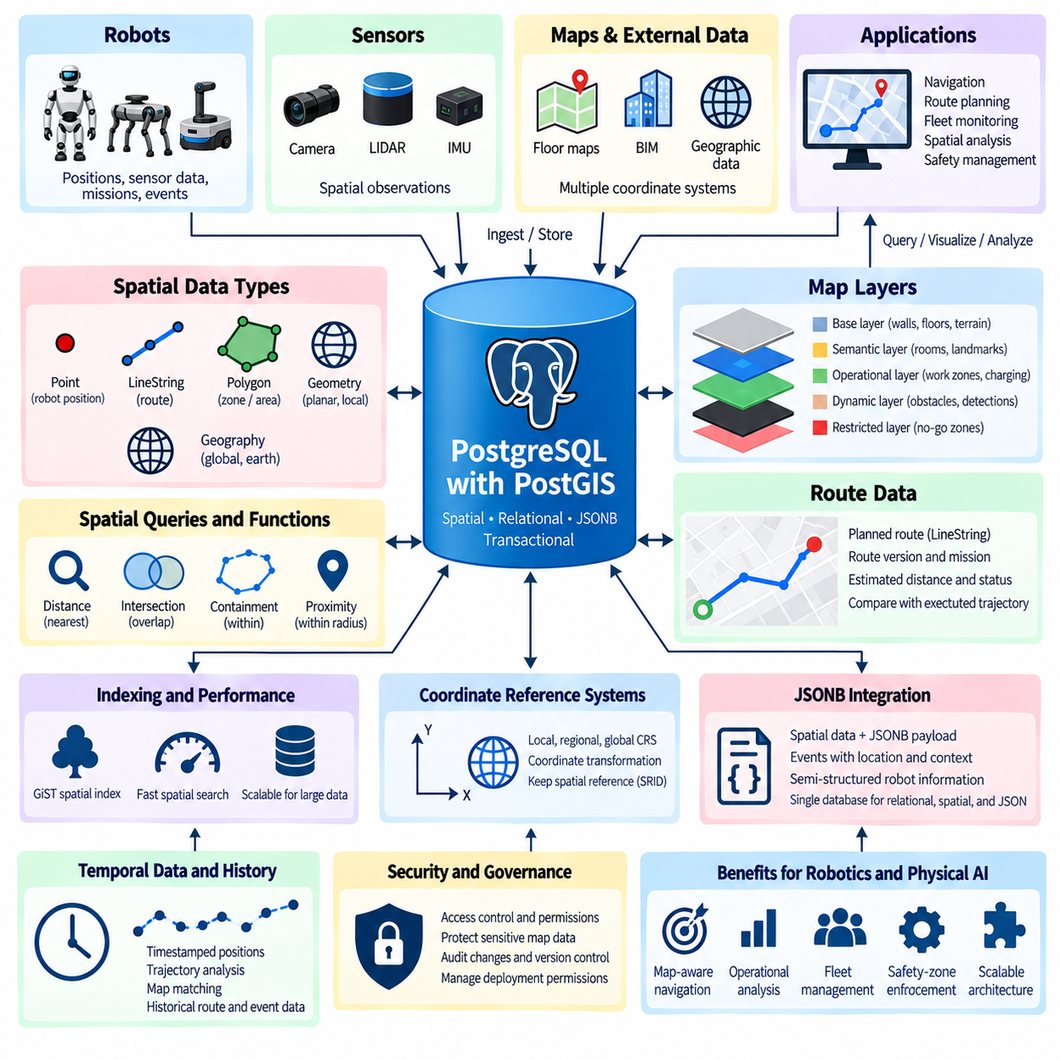
PostGIS is a PostgreSQL extension that adds geospatial data types, spatial indexes, coordinate reference systems, and spatial analysis functions to the relational database. For robotics, this allows PostgreSQL to store and query maps, robot positions, routes, obstacles, zones, landmarks, and other spatial information within the same transactional environment as ordinary operational data. Instead of maintaining a separate spatial database, a robot platform can combine relational metadata, JSONB configuration data, and geographic information in PostgreSQL. This unified architecture is useful for Physical AI systems where spatial state must be correlated with missions, events, sensor observations, and robot identity.
PostGIS provides spatial data types such as geometry and geography for representing points, lines, polygons, and more complex spatial structures. A robot position can be represented as a Point, while a planned route can be represented as a LineString and an operational area or restricted zone can be represented as a Polygon. Geometry is generally used when precise coordinate-system control and planar calculations are important, whereas geography is useful for geographic coordinates on the earth's surface and distance calculations over larger areas. The appropriate type should be selected according to whether the robotic environment is local, regional, or global.
For an indoor robot, a spatial database can represent the environment using a local coordinate reference system rather than latitude and longitude. A warehouse map, factory floor, hospital corridor, or laboratory can therefore be modeled using metric coordinates such as x and y positions. Robot locations, charging stations, work areas, safety zones, shelves, and navigation waypoints can all use the same coordinate system. This is particularly useful because navigation algorithms normally operate in metric space. The database can store the spatial reference identifier together with each dataset so that coordinates remain interpretable and transformations can be performed when information from different coordinate systems must be combined.
Robot map data can be divided into several logical layers. A base layer may describe walls, floors, corridors, roads, or terrain, while semantic layers can represent rooms, restricted areas, charging stations, work zones, delivery points, and landmarks. Dynamic layers can represent temporary obstacles, detected objects, congestion areas, or changing operational boundaries. PostGIS allows these layers to be stored as spatial objects while relational attributes describe their identity, type, status, source, and validity period. This creates a database representation that connects geometric structure with the semantic information required by robotic applications.
Route data can also be stored directly in PostGIS. A planned route may contain a LineString representing the sequence of spatial coordinates that a robot should follow. Additional relational attributes can identify the robot, mission, route version, planner, creation time, estimated distance, and operational status. Alternative routes can be stored without overwriting previous plans, allowing the system to compare planning results and maintain route history. When a route is actually executed, the planned geometry can be compared with the observed robot trajectory to determine deviations, delays, or unexpected movements. This creates a direct connection between planning, execution, and operational analysis.
Spatial queries are one of the primary advantages of PostGIS for robotics. Instead of retrieving every object and calculating distances in application code, the database can perform spatial filtering directly. A system can identify obstacles within a defined radius of a robot, determine which operational zone contains a robot position, find the nearest charging station, or determine whether a planned route intersects a restricted area. Functions such as distance calculations, intersection tests, containment operations, and nearest-neighbor searches allow spatial reasoning to become part of normal SQL-based data processing.
Spatial indexing is essential when the number of geographic objects becomes large. PostGIS commonly uses GiST-based indexes for geometry and geography data, allowing spatial searches to avoid scanning every object in a table. For example, a query searching for obstacles near a robot can first use the spatial index to identify candidate objects and then perform the precise geometric calculation on those candidates. This becomes increasingly important for robot fleets because thousands or millions of spatial observations may be accumulated over time. Proper indexing allows spatial queries to remain practical as the dataset grows.
A robot navigation system can combine spatial queries with ordinary relational conditions. For example, the database can search for charging stations within a certain distance of a robot while also requiring that the station is currently operational and compatible with the robot model. Similarly, a route query can identify paths that intersect a restricted zone while filtering the result by mission status or route version. This combination is valuable because real robotic decisions rarely depend on geometry alone. Spatial relationships must usually be evaluated together with time, robot identity, operational state, permissions, mission context, and other metadata.
PostGIS can also support map matching and trajectory analysis. A robot continuously generates position observations that can be stored as points associated with timestamps, robot identifiers, and mission identifiers. These observations can later be assembled into trajectories or compared with planned routes. Spatial operations can determine whether the robot remained inside an allowed corridor, entered a prohibited region, or deviated significantly from the planned path. Historical trajectories can also be analyzed to identify frequently used paths, recurring navigation problems, congestion patterns, or locations where robots repeatedly require intervention.
Coordinate transformations become important when data originates from different sensors, maps, or external geographic systems. A camera, LiDAR system, robot localization system, building information model, and geographic map may use different coordinate reference systems. PostGIS supports spatial reference identifiers and coordinate transformation functions that allow compatible datasets to be transformed into a common reference system. The transformation process should be explicitly managed rather than assuming that coordinates from different sources are directly comparable. Incorrect coordinate-system handling can produce spatial errors that may appear to be navigation or sensor problems.
Spatial data can also be connected with robot events and JSONB payloads. A navigation event may contain a robot position as a PostGIS point while JSONB stores additional planner information, sensor context, or decision metadata. A safety event can identify the spatial zone in which an event occurred while its JSONB payload records the triggering condition and response. This combination allows PostgreSQL to answer questions that require both spatial and semi-structured reasoning. For example, the system can identify all safety events that occurred within a particular restricted zone and then inspect the JSONB payload to determine the associated sensor or operational condition.
For fleet-scale robotics, spatial data management should also consider temporal behavior and data volume. Static map features such as walls and charging stations may change infrequently, while robot positions and detected obstacles can be generated continuously. These different data classes should not necessarily share identical retention and indexing policies. Historical trajectory data may be partitioned by time or mission, while relatively static map layers can remain in smaller, stable tables. Recent operational data can be optimized for fast queries, whereas older trajectories and observations can be moved to analytical or archival storage.
Security and data governance are important when spatial information represents real facilities or operational environments. Maps may reveal building layouts, restricted areas, infrastructure locations, or sensitive operational zones. Database permissions should therefore distinguish between users who can view spatial data, users who can modify maps, and services authorized to publish navigation information to robots. Changes to critical map layers and restricted zones should be auditable and version controlled. Spatial data should also be protected according to the sensitivity of the physical environment it represents rather than being treated as ordinary application data.
A practical PostGIS architecture for robotics therefore combines PostgreSQL transactions, PostGIS spatial objects, spatial indexes, relational metadata, JSONB payloads, temporal information, and controlled access. Robot positions, maps, routes, zones, obstacles, landmarks, and trajectories can remain connected to robot identities, missions, events, and configuration versions in one database environment. This enables applications to perform spatial queries close to the source data while maintaining transactional consistency and operational traceability. The resulting architecture provides a foundation for map-aware navigation, route planning, fleet monitoring, spatial event analysis, safety-zone enforcement, and Physical AI systems that must continuously reason about robots and their physical environment.

02.05 TimescaleDB Extension: Sensor Time Series Integration [w/Code]
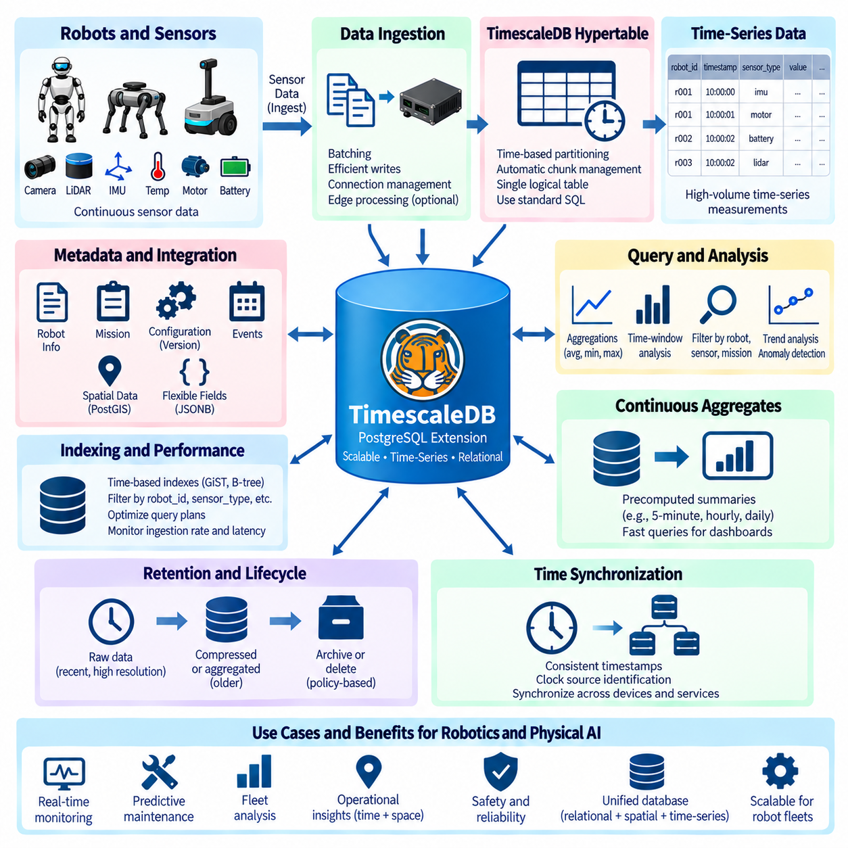
TimescaleDB is a PostgreSQL extension designed to manage time-series data while preserving PostgreSQL's relational database capabilities. For robotics, it is useful because sensors continuously generate timestamped observations such as temperature, vibration, motor current, battery voltage, IMU measurements, LiDAR statistics, localization states, and system health metrics. Instead of placing these measurements in a completely separate time-series database, a robotics platform can use PostgreSQL as a unified data environment and add TimescaleDB capabilities for high-volume temporal workloads. This approach allows sensor measurements to remain connected to robots, missions, configurations, events, and operational metadata.
A central concept in TimescaleDB is the hypertable, which provides a time-series abstraction over PostgreSQL tables. A hypertable automatically organizes incoming records into smaller time-based chunks while presenting them to applications as a single logical table. For example, a robot sensor table may contain robot_id, timestamp, sensor_type, measurement_value, and additional metadata. As measurements accumulate, TimescaleDB manages the underlying chunks according to the configured partitioning strategy. Applications can continue using ordinary SQL without needing to manually manage individual physical partitions for every time interval.
Time is the primary dimension in most robotic sensor workloads, but a second dimension such as robot_id can also be important. A fleet may contain hundreds or thousands of robots producing measurements simultaneously, so queries often need to filter by both time range and robot identity. TimescaleDB can organize time-series workloads around these access patterns while PostgreSQL indexes can support additional filtering. The database design should reflect how applications actually retrieve data, such as recent measurements for one robot, historical measurements for a fleet, or sensor behavior during a particular mission.
Robotic sensor data normally contains more than a single numeric value. An IMU record may contain acceleration and angular velocity across multiple axes, while a battery measurement may include voltage, current, temperature, state of charge, and diagnostic status. Some sensor outputs are highly structured, while others evolve as firmware and hardware versions change. A relational schema can store frequently queried measurements in explicit columns, while JSONB can hold variable metadata or device-specific fields. This combination allows TimescaleDB to manage the time-series portion while PostgreSQL provides flexible relational and semi-structured data management.
High-frequency sensor ingestion requires careful consideration of write throughput and transaction overhead. A robot may generate hundreds or thousands of measurements per second across multiple sensors, and a fleet can multiply this volume substantially. Data ingestion should therefore use efficient batching, appropriate transaction sizes, and connection management rather than creating an independent database transaction for every sensor sample. Application-side buffering or edge aggregation can also reduce database pressure when raw measurements do not all require immediate persistence. The appropriate ingestion strategy depends on sampling frequency, latency requirements, network reliability, and the importance of retaining every observation.
TimescaleDB becomes particularly valuable when sensor data must be analyzed across different time windows. SQL queries can calculate averages, minimum and maximum values, rates of change, standard deviations, and other statistical measures over recent or historical intervals. A robotics platform can therefore determine whether motor temperature is increasing during a mission, whether battery voltage is declining abnormally, or whether vibration levels have changed after a mechanical modification. Time-based analysis can be combined with robot identity, mission information, operating mode, and configuration version to transform raw measurements into operational knowledge.
Continuous aggregates provide a mechanism for maintaining precomputed summaries of time-series data. Instead of repeatedly scanning millions of raw sensor records to calculate hourly or daily statistics, a system can maintain summarized views over selected time intervals. For example, a fleet-management system can maintain five-minute summaries of CPU utilization, battery state, motor temperature, or communication latency. Applications can then query these summaries efficiently while retaining access to the original high-resolution measurements when detailed investigation is required. This creates a practical separation between high-resolution operational data and frequently accessed analytical summaries.
Retention and lifecycle management are especially important for robotic sensor data because continuous collection can rapidly consume storage. Not every measurement needs to remain at full resolution indefinitely. Recent data may be retained at high resolution for operational monitoring, while older measurements can be aggregated, compressed, archived, or deleted according to defined policies. For example, raw vibration data might be retained for a limited period, while daily statistical summaries remain available for a much longer period. Retention policies should be aligned with safety, maintenance, research, regulatory, and model-training requirements rather than being determined only by available storage capacity.
Sensor time-series data can also be connected directly with robot events and spatial information stored in PostgreSQL. A motor-temperature anomaly can be associated with a mission event, robot configuration version, geographic position, and maintenance record. Similarly, a navigation problem can be investigated by correlating localization uncertainty, IMU measurements, wheel velocities, battery state, and system events within the same time interval. When combined with PostGIS and JSONB, TimescaleDB enables a database architecture in which temporal, spatial, relational, and semi-structured information can be queried together rather than reconstructed from disconnected systems.
Time synchronization is a critical requirement for meaningful multi-sensor analysis. Measurements generated by cameras, IMUs, LiDAR systems, motor controllers, edge computers, and external services may originate from different clocks. If timestamps are inconsistent, events can appear to occur in the wrong order and correlations between sensors can become unreliable. A robust architecture should therefore define timestamp semantics clearly, identify the clock source when necessary, and maintain appropriate synchronization across devices. For distributed robotic systems, accurate time provides the foundation for reconstructing what happened, when it happened, and which sensor observations corresponded to the same physical event.
Performance also depends on appropriate indexing and query design. Queries should normally restrict the time range as early as possible because time is the dominant dimension of most sensor workloads. Additional indexes can support frequently used filters such as robot_id, sensor_type, mission_id, or operating mode, but excessive indexing increases storage consumption and write overhead. The goal is not to index every possible attribute but to optimize the access patterns that are important to operational applications. Query plans, ingestion rates, storage utilization, and latency should be monitored as the dataset grows and workload characteristics change.
For Physical AI systems, TimescaleDB can become part of a broader data architecture rather than simply a replacement for a traditional database. PostgreSQL can maintain robot identities, missions, configurations, events, spatial information, and transactional records, while TimescaleDB manages high-volume temporal measurements within the same environment. PostGIS can provide spatial relationships, JSONB can represent evolving sensor metadata, and conventional PostgreSQL tables can enforce relational integrity. This integrated model allows applications to investigate a robot's physical state over time while simultaneously considering where the robot was operating, which configuration was active, and what events occurred during the same period.
A practical TimescaleDB-based robotics architecture therefore combines efficient time-series ingestion, hypertable-based organization, temporal indexing, continuous aggregation, retention management, timestamp discipline, and integration with PostgreSQL capabilities. The resulting system can support real-time monitoring, historical diagnostics, predictive maintenance, fleet analysis, sensor-quality evaluation, and Physical AI model development. The key architectural principle is to preserve the complete context surrounding a measurement rather than treating sensor values as isolated numbers. When time-series observations remain connected to robot identity, mission state, spatial position, configuration, and events, PostgreSQL with TimescaleDB becomes a unified foundation for understanding the evolving physical state of robotic systems.

02.06 PostgreSQL Streaming Replication Setup [w/Code]
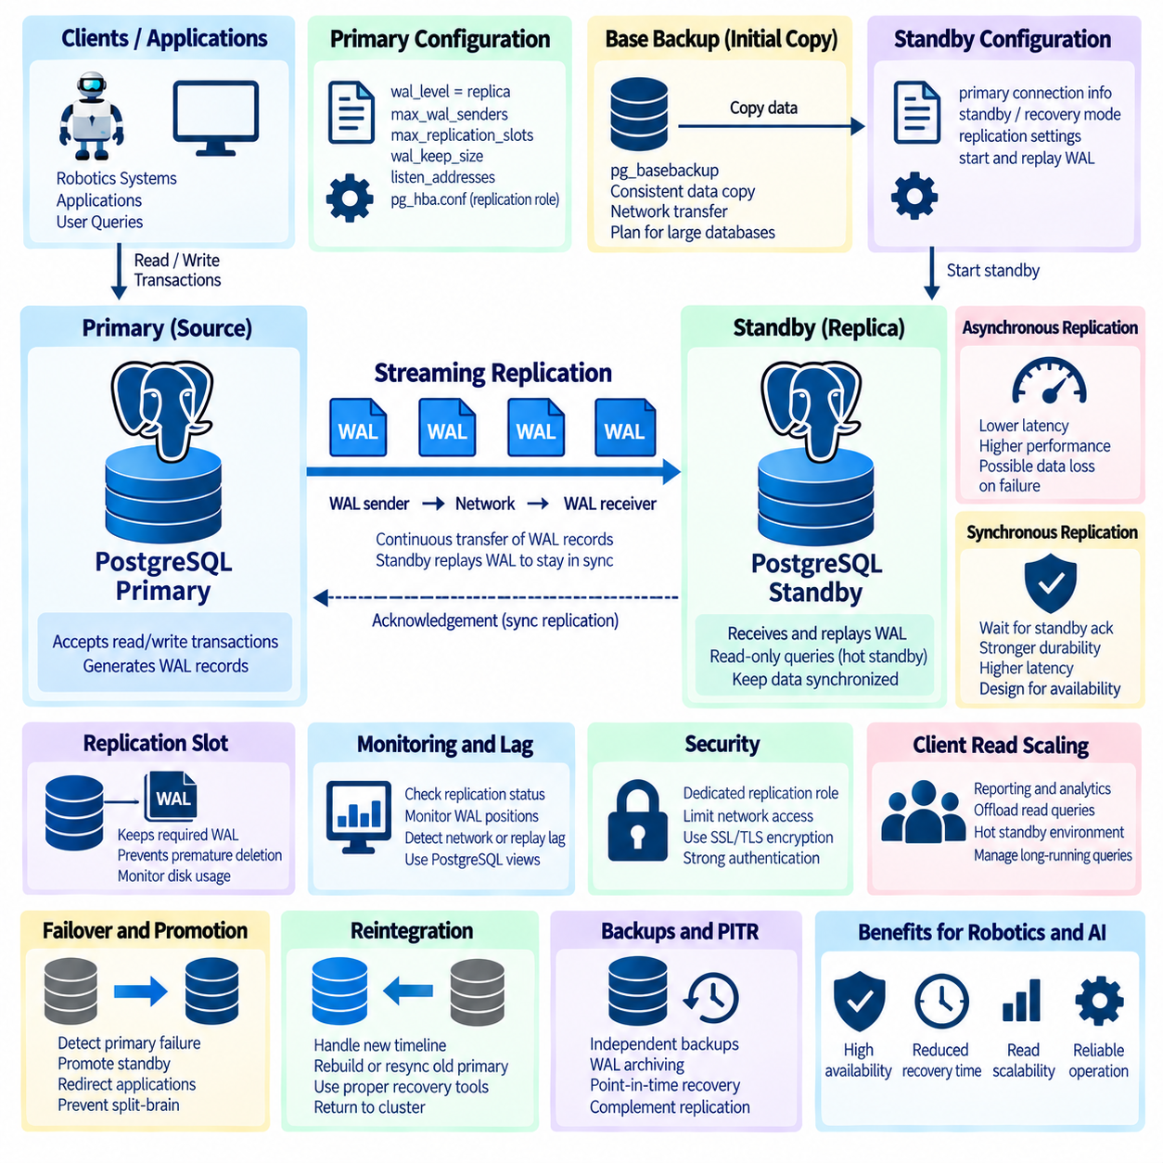
PostgreSQL streaming replication is a physical replication mechanism that continuously transfers Write-Ahead Log, or WAL, records from a primary server to one or more standby servers. The standby replays these records against a physical copy of the database cluster, allowing it to maintain a state close to the primary. Because replication operates from WAL changes rather than application-level SQL statements, the mechanism integrates directly with PostgreSQL durability and crash-recovery architecture. It is commonly used to improve availability, create read replicas, support disaster recovery, and reduce the recovery time required after a primary-server failure.
A streaming replication environment begins with a primary PostgreSQL server that accepts normal read and write transactions. As transactions modify database pages, PostgreSQL generates WAL records describing those changes. A WAL sender process on the primary transmits WAL data to a WAL receiver process running on the standby. The standby writes the received WAL to local storage and replays it against its database files. This continuous pipeline allows committed changes on the primary to propagate toward the standby without repeatedly copying complete database files.
Before replication is configured, the primary and standby environments should be prepared consistently. Compatible PostgreSQL major versions, suitable operating-system resources, sufficient storage capacity, reliable networking, and synchronized system clocks are important operational requirements. The standby should normally have enough CPU, memory, and storage performance to replay WAL at approximately the rate at which the primary generates it. If WAL generation consistently exceeds replay capacity, replication lag can grow even when the network itself is functioning correctly.
The primary server must be configured to generate and retain the WAL information required for replication. Parameters related to WAL level, WAL sender processes, replication slots, and WAL retention determine how the primary supports standby servers. The server must also listen on an appropriate network interface, and pg_hba.conf must permit the designated replication role to connect from approved standby addresses. Network access should remain narrowly restricted rather than exposing replication services broadly. Configuration choices should account for the expected number of replicas and the volume of WAL generated by the workload.
A dedicated replication role should normally be created instead of using a general application account or unrestricted superuser. The role requires the permissions needed to establish a replication connection but should not receive unrelated privileges. Strong authentication, preferably using modern PostgreSQL authentication mechanisms or appropriately managed certificates, should protect the replication channel. Where replication traffic crosses an untrusted or shared network, SSL/TLS should be used to protect WAL data and credentials from interception or manipulation.
The standby server requires an initial physical copy of the primary database cluster before continuous WAL streaming can begin. PostgreSQL's pg_basebackup utility is commonly used to create this base backup directly from the primary while maintaining the consistency required for replication. The resulting data directory contains the physical database files from which the standby can start. Base backup operations should be planned carefully for large databases because they consume network bandwidth, storage I/O, and capacity on both systems.
Modern PostgreSQL versions use standby configuration information to indicate that a server should operate in recovery mode and connect to the primary. Connection information identifies the primary host, port, replication identity, and other required parameters. Once started, the standby enters recovery, connects to the primary, receives WAL records, and continuously replays them. The startup process should be verified through PostgreSQL logs and replication monitoring views rather than assuming that the presence of a standby configuration automatically means replication is healthy.
Replication can operate asynchronously or synchronously. In asynchronous replication, the primary can confirm a transaction commit without waiting for the standby to acknowledge that WAL has reached a specified stage. This generally provides lower transaction latency but creates the possibility that recently committed transactions could be lost if the primary fails before their WAL reaches the standby. The amount of potential loss depends on workload behavior, network conditions, replication lag, and the timing of the failure.
Synchronous replication changes the durability relationship between the primary and standby. The primary can be configured to wait for acknowledgement from one or more synchronous standbys before confirming selected transaction commits. This can reduce the risk of losing committed transactions during primary failure, but it also places replication network latency and standby responsiveness on the transaction path. If the required synchronous standby becomes unavailable, transaction commits may wait according to the configured policy. Synchronous replication should therefore be designed according to explicit durability and availability requirements.
Replication slots can help ensure that WAL required by a standby is not removed from the primary before the standby receives it. A physical replication slot tracks the WAL position needed by its consumer, which can improve resilience when a standby is temporarily disconnected. However, a replication slot can also cause WAL files to accumulate if the associated standby remains unavailable for a long period. Storage utilization must therefore be monitored carefully. Replication slots improve WAL retention control but do not eliminate the need for operational monitoring and capacity management.
Replication lag is a key health indicator. Lag can occur during WAL transmission, local WAL writing, or replay on the standby. Administrators should therefore distinguish between network-related delay and replay-related delay rather than treating lag as a single metric. Heavy write workloads, slow standby storage, long-running queries, resource contention, or network problems can all contribute to delayed replication. PostgreSQL monitoring views expose information about sender and receiver state, WAL positions, replay progress, and replication connections that can be incorporated into operational monitoring systems.
A standby can also serve read-only queries, creating a hot standby environment. This allows reporting, monitoring, analytical queries, or selected application reads to be moved away from the primary. However, a standby is not an independent writable database because its physical state is derived from WAL replay. Long-running read queries can also interact with recovery because the standby must continue applying changes generated by the primary. Read workloads should therefore be managed carefully so that analytical activity does not create unacceptable conflicts or replication delay.
High availability requires more than streaming WAL to another server. A complete design must define how primary failure is detected, how a standby is selected, how promotion occurs, and how applications reconnect to the new primary. PostgreSQL provides mechanisms for promoting a standby, but automatic failover coordination is typically handled through additional cluster-management components or operational procedures. The system must prevent two servers from simultaneously accepting conflicting writes, a condition commonly associated with split-brain behavior.
After a standby is promoted, the former primary cannot simply resume its previous role without considering the new database timeline. The promoted server begins a new timeline, and any server that rejoins must be synchronized with the current authoritative database state. Depending on the situation, the old primary may be rebuilt from a new base backup or synchronized using appropriate PostgreSQL recovery tools. Failover procedures should therefore include both promotion and reintegration rather than focusing only on the moment when the standby becomes writable.
Backups and streaming replication solve different problems and should not be treated as substitutes for one another. Replication can quickly reproduce accidental deletion, incorrect updates, or application corruption because valid database changes are transmitted to the standby. Backups, WAL archiving, and point-in-time recovery provide the historical recovery capability required to return to an earlier database state. A resilient PostgreSQL architecture commonly combines streaming replication for availability with independent backups and archived WAL for disaster recovery and historical restoration.
A robust PostgreSQL streaming replication architecture therefore combines WAL generation, secure replication connections, consistent base backups, standby replay, lag monitoring, appropriate WAL retention, tested promotion procedures, and independent recovery mechanisms. The design should explicitly balance transaction latency, acceptable data-loss risk, recovery time, infrastructure cost, and operational complexity. When these elements are tested as a complete system rather than configured independently, streaming replication becomes a reliable foundation for highly available PostgreSQL services supporting robotics, Physical AI, and other continuously operating data platforms.

02.07 pgBouncer Connection Pooling Configuration [w/Code]
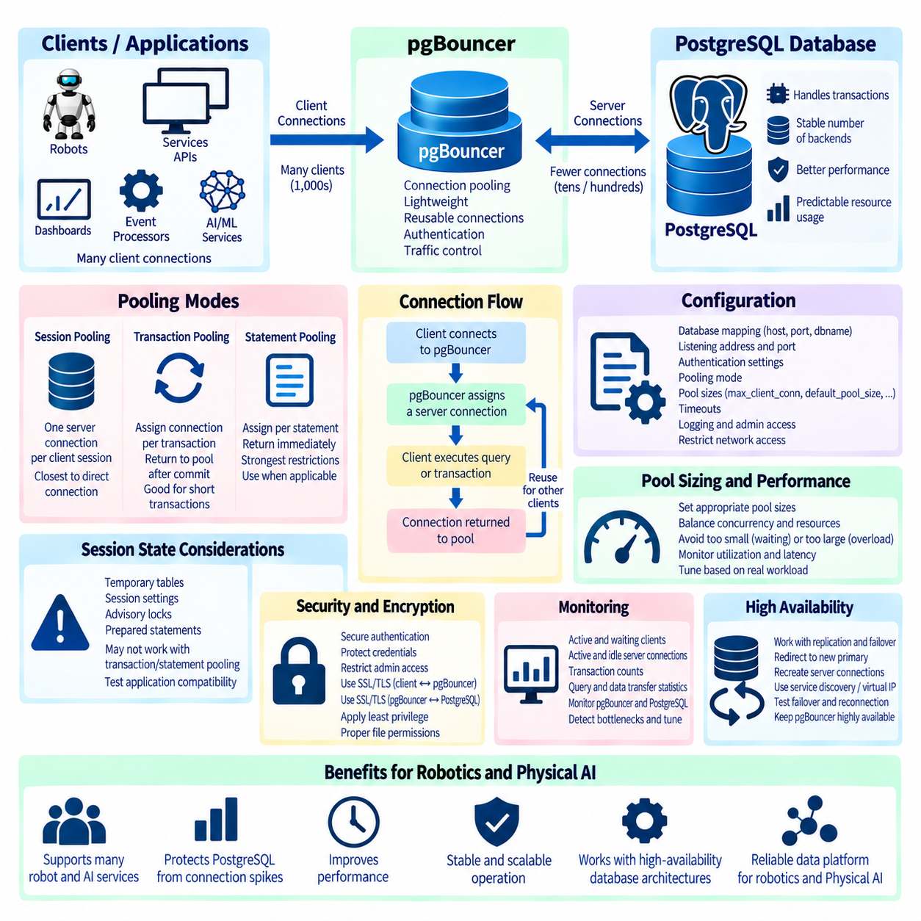
pgBouncer is a lightweight connection pooler designed to manage client connections to PostgreSQL more efficiently. PostgreSQL normally creates a dedicated backend process for each database connection, so a large number of simultaneous application connections can increase memory consumption, process-management overhead, and context switching. pgBouncer sits between clients and PostgreSQL and maintains a controlled pool of reusable server connections. Applications connect to pgBouncer rather than directly to the database, allowing many logical client sessions to share a smaller number of PostgreSQL backend connections.
The basic architecture separates client connections from server connections. A client establishes a session with pgBouncer, and pgBouncer assigns an available PostgreSQL connection according to the configured pooling mode. When the connection is no longer required for the current unit of work, it can be returned to the pool and reused by another client. This reduces repeated connection establishment and authentication overhead while protecting PostgreSQL from sudden connection spikes. The database can therefore operate with a more predictable number of backend processes even when application concurrency changes significantly.
pgBouncer supports session, transaction, and statement pooling modes. Session pooling assigns a PostgreSQL server connection to a client for the entire client session and provides behavior closest to a direct PostgreSQL connection. Transaction pooling assigns a server connection only for the duration of a transaction and returns it to the pool after the transaction completes. Statement pooling releases the connection after individual statements and imposes the strongest restrictions. Pooling mode should be selected according to application behavior rather than simply choosing the mode that produces the smallest connection count.
Transaction pooling is frequently attractive for web services, APIs, robot fleet services, and other workloads containing many short transactions. A client can remain connected to pgBouncer while different transactions are executed through different PostgreSQL backend connections. This enables a relatively small server pool to support a much larger number of logical clients. However, applications must not assume that session-level database state will remain attached to the same PostgreSQL backend between transactions. Compatibility with transaction pooling should therefore be evaluated before deployment.
Session-level features require particular attention when transaction pooling is used. Temporary tables, session-specific settings, advisory locks, prepared statements, and other features can depend on the lifetime or state of a PostgreSQL backend session. An application designed for persistent direct connections may therefore behave differently when its transactions are distributed across pooled server connections. Connection pooling should not be treated as completely transparent. Application behavior, database drivers, frameworks, and session-state assumptions should be tested under the intended pooling mode.
The pgBouncer configuration defines how client traffic maps to PostgreSQL databases and how connection pools are sized. Database entries identify target PostgreSQL servers, ports, database names, and optional connection parameters. General settings define listening addresses, listening ports, authentication behavior, pooling mode, connection limits, timeouts, logging, and administrative access. The configuration should expose only the interfaces required by applications and should use network controls to prevent unauthorized systems from reaching the pooling service.
Pool sizing is one of the most important configuration decisions. Parameters such as max_client_conn, default_pool_size, min_pool_size, and reserve_pool_size influence the relationship between logical clients and physical PostgreSQL connections. Increasing the client limit does not mean that PostgreSQL should receive the same number of server connections. The objective is to determine a server connection count that provides sufficient concurrency without overwhelming database CPU, memory, storage, or lock-management resources. Pool size should therefore be based on measured workload behavior rather than an arbitrary ratio.
A pool that is too small can create waiting queues and increase application latency, while a pool that is too large can remove the protection that pgBouncer is intended to provide. The optimal size depends on transaction duration, query complexity, CPU capacity, storage latency, lock contention, and the number of database instances or application services sharing the server. Monitoring should focus on both utilization and waiting behavior. A fully utilized pool is not automatically a problem if waiting remains low, while a large pool with high database contention may indicate excessive concurrency.
Timeout configuration helps prevent unhealthy connections from occupying pool capacity indefinitely. pgBouncer provides controls for client inactivity, server connection lifetime, idle server connections, connection attempts, query execution, and waiting clients. Appropriate values depend on the application and network environment. Timeouts should protect the service from abandoned or stalled sessions without terminating legitimate long-running operations unexpectedly. They should also be coordinated with application-driver, load-balancer, network, and PostgreSQL timeout settings to avoid conflicting behavior.
Authentication should be configured so that pgBouncer does not become a weaker security boundary than PostgreSQL itself. Client identities can be validated using supported authentication mechanisms and credential sources, while connections from pgBouncer to PostgreSQL should use appropriately protected credentials. Authentication files, configuration files, and administrative interfaces require restrictive operating-system permissions. In environments using centralized identity or dynamically managed database users, the authentication architecture should be designed carefully so that credential updates remain consistent and auditable.
Transport encryption should be considered separately for the client-to-pgBouncer connection and the pgBouncer-to-PostgreSQL connection. Depending on the deployment topology, SSL/TLS may be required on one or both segments. For example, pgBouncer located on the same trusted host as PostgreSQL has different network exposure from a pooler operating on a separate application gateway. Certificate verification and key management should follow the sensitivity of the environment. Pooling improves connection efficiency but does not replace network segmentation, authentication, encryption, or least-privilege database roles.
Monitoring pgBouncer is essential for understanding whether pooling actually improves the system. Administrative statistics can show active clients, waiting clients, active server connections, idle server connections, transaction counts, data transfer, and timing information. These metrics should be evaluated together with PostgreSQL statistics such as backend count, CPU utilization, query latency, lock waits, transaction rates, and storage activity. Observing only pgBouncer can hide a database bottleneck, while observing only PostgreSQL can hide application-side connection pressure.
Connection pooling becomes especially valuable in distributed robotics and Physical AI architectures. Robot services, fleet managers, dashboards, APIs, event processors, model services, and monitoring components may independently open database connections. Without pooling, a large deployment can create thousands of mostly idle connections even when the number of actively executing transactions is modest. pgBouncer can consolidate this connection demand and provide a stable interface between many edge or application services and a smaller number of PostgreSQL backend processes.
High-availability architectures require pgBouncer to be coordinated with PostgreSQL replication and failover mechanisms. A pooler connected to a failed primary must be redirected toward the newly promoted primary, and existing server connections may need to be recreated. pgBouncer itself does not determine which PostgreSQL node should become primary. Service discovery, virtual addresses, proxies, cluster managers, or operational automation can provide that function. Failover testing should verify not only database promotion but also application reconnection through the connection-pooling layer.
A resilient pgBouncer deployment therefore combines appropriate pooling mode, controlled pool size, coordinated timeouts, secure authentication, encrypted communication where required, continuous monitoring, and integration with PostgreSQL high availability. The objective is not simply to maximize the number of clients that can connect, but to regulate concurrency so PostgreSQL operates within a stable resource envelope. When application session behavior and database capacity are understood together, pgBouncer provides an effective connection-management layer for scalable PostgreSQL systems supporting robotics, Physical AI, sensor platforms, and other highly concurrent services.

02.08 PostgreSQL VACUUM, ANALYZE, autovacuum Optimization
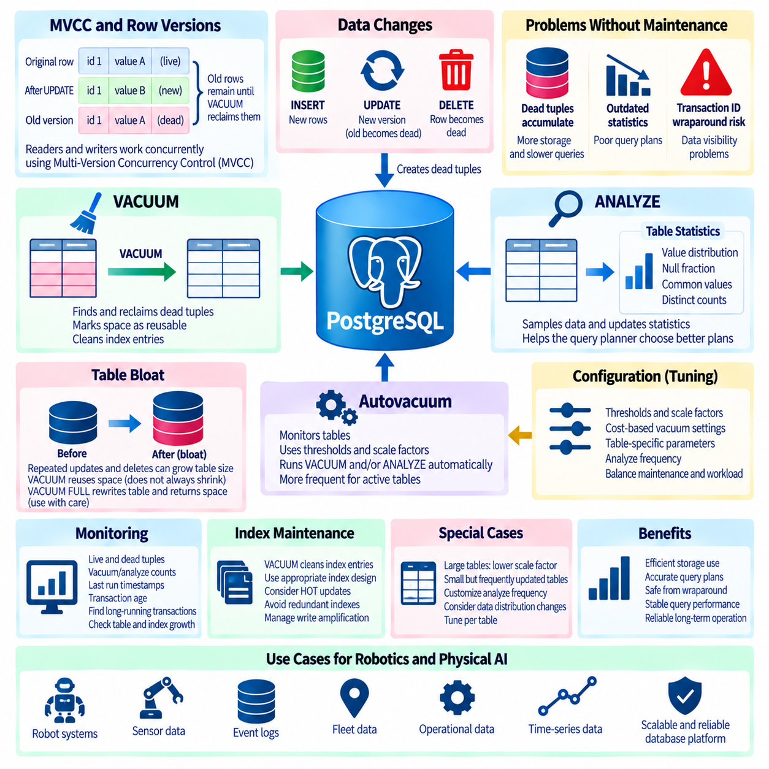
PostgreSQL uses Multi-Version Concurrency Control, or MVCC, to allow readers and writers to operate concurrently without unnecessarily blocking one another. When a row is updated or deleted, PostgreSQL normally does not immediately overwrite or physically remove the old row version. Instead, obsolete row versions remain in the table until they can safely be reclaimed. VACUUM, ANALYZE, and autovacuum are therefore fundamental maintenance mechanisms that preserve storage efficiency, transaction-ID safety, and predictable query performance in continuously operating PostgreSQL systems.
Under MVCC, an UPDATE usually creates a new tuple version while the previous version eventually becomes a dead tuple. DELETE operations also leave obsolete tuples behind until no active transaction can require them. These dead tuples consume table and index space and can increase the amount of data that queries must process. VACUUM identifies row versions that are no longer visible to any relevant transaction and marks their storage space as reusable. Normal VACUUM generally reuses space inside the table rather than immediately returning that space to the operating system.
VACUUM is also essential for protecting PostgreSQL against transaction ID wraparound. PostgreSQL uses transaction identifiers to determine row visibility, but these identifiers exist within a finite numeric space. If sufficiently old transaction information is not frozen, transaction IDs can eventually wrap around and create serious visibility problems. VACUUM freezes old tuple information before this becomes dangerous. This means vacuuming is not merely a performance optimization; it is part of the database's fundamental correctness and long-term operational safety mechanisms.
ANALYZE serves a different but complementary purpose. PostgreSQL's query planner estimates the cost of alternative execution plans using statistical information about table contents. ANALYZE samples table data and updates statistics such as value distributions, null fractions, common values, and approximate distinct-value counts. When these statistics accurately reflect current data, the planner can make better choices between sequential scans, index scans, joins, and other execution strategies. Outdated statistics can cause inefficient query plans even when tables and indexes themselves are correctly designed.
VACUUM and ANALYZE are frequently used together because data modification affects both physical storage and planner statistics. A table receiving many inserts, updates, and deletes may accumulate dead tuples while its data distribution also changes. Running VACUUM ANALYZE can reclaim reusable tuple space and refresh planner statistics within the same maintenance operation. However, production systems should not depend only on occasional manual execution. PostgreSQL provides autovacuum to perform these maintenance activities automatically according to table activity and configured thresholds.
Autovacuum continuously observes database tables and determines when vacuuming or analyzing should be initiated. Its decisions are based on configuration parameters that combine fixed thresholds with scale factors related to table size. As the number of changed or dead tuples crosses the configured trigger level, PostgreSQL schedules an autovacuum worker for the table. This adaptive approach allows active tables to receive maintenance more frequently than relatively static tables. Nevertheless, default settings may not be optimal for every workload, especially for very large or extremely write-intensive tables.
Large tables illustrate why scale-factor tuning can be important. If a table contains hundreds of millions of rows, a percentage-based threshold can require millions of changed tuples before maintenance begins. That delay may allow substantial dead-tuple accumulation, index inefficiency, or inaccurate planner statistics. For heavily updated large tables, lower table-specific autovacuum scale factors may trigger maintenance earlier. PostgreSQL allows storage parameters to be configured for individual tables, enabling maintenance behavior to reflect the characteristics of each workload instead of applying one global policy to every table.
Conversely, very small but frequently modified tables may require different settings. Configuration tables, robot-state tables, task queues, device registries, or current-status tables can experience repeated updates even though their total row count remains small. These tables may benefit from lower thresholds or more frequent analysis because their contents can change significantly in a short period. Autovacuum optimization should therefore consider modification frequency, table size, query importance, and acceptable maintenance overhead rather than treating database size as the only relevant factor.
Autovacuum workers consume CPU, memory, and storage I/O while scanning tables and cleaning obsolete tuples. If maintenance is too aggressive, it can compete with application queries and ingestion workloads. If it is too conservative, dead tuples and outdated statistics can accumulate faster than they are processed. PostgreSQL provides cost-based vacuum controls that can limit or regulate maintenance activity. Effective tuning seeks a sustainable maintenance rate that keeps up with database change while avoiding disruptive bursts of I/O or CPU consumption during critical operational periods.
Monitoring dead tuples is important for determining whether autovacuum is keeping pace with workload activity. PostgreSQL statistics views expose estimates of live tuples, dead tuples, modification counts, vacuum operations, analyze operations, and timestamps associated with maintenance. These values should be observed over time rather than interpreted from a single snapshot. A steadily increasing number of dead tuples can indicate that vacuuming is too infrequent, maintenance workers lack sufficient capacity, long-running transactions prevent cleanup, or write activity exceeds the maintenance system's ability to reclaim space.
Long-running transactions are particularly important because VACUUM cannot remove tuple versions that might still be visible to an older transaction snapshot. A transaction that remains open for an extended period can therefore prevent cleanup across heavily modified tables, even if autovacuum runs normally. Idle transactions left open by application bugs can create similar problems. Operational monitoring should track transaction age, idle-in-transaction sessions, replication-related retention, and other conditions that hold back cleanup. Vacuum tuning alone cannot solve dead-tuple accumulation when old snapshots remain active.
Table bloat occurs when physical table size grows significantly beyond the amount of currently useful data. Repeated updates and deletes can contribute to bloat when reusable space is not efficiently reused or maintenance is delayed. Ordinary VACUUM makes dead-tuple space available for future rows but usually does not shrink the physical table file. VACUUM FULL can rewrite a table and return unused space to the operating system, but it requires stronger locking and additional temporary disk capacity. It should therefore be treated as a deliberate maintenance operation rather than routine autovacuum behavior.
Indexes require maintenance consideration as well because updates and deletes can leave obsolete index entries associated with dead tuples. VACUUM participates in cleaning these entries, while appropriate index design and PostgreSQL features such as HOT updates can reduce unnecessary index modifications under suitable conditions. Excessive or redundant indexes increase write amplification because each data modification may require additional index work. Autovacuum optimization should therefore be considered together with schema design, fill factor, update patterns, and index strategy rather than as an isolated configuration exercise.
ANALYZE frequency can also be customized for tables whose data distributions change rapidly. A robot-event table, sensor metadata table, fleet-status table, or mission queue may receive new categories and changing values that influence query selectivity. If planner statistics lag behind these changes, PostgreSQL may choose inappropriate execution plans. Increasing statistics targets for important columns can provide more detailed information to the planner, although collecting and storing additional statistics has a cost. Tuning should focus on columns that materially influence filtering, joins, and query planning.
In robotics and Physical AI platforms, maintenance requirements can vary considerably across database components. Static robot definitions may change rarely, while configuration histories, event tables, mission states, spatial records, and sensor-related metadata can experience continuous modification. Timescale-oriented measurements may use different retention and partitioning strategies from ordinary transactional tables. PostgreSQL maintenance policies should reflect these differences so that high-frequency operational data receives sufficient cleanup without spending unnecessary resources on mostly static information.
A robust optimization process therefore begins with observation rather than arbitrary parameter changes. Administrators should monitor dead tuples, transaction age, table growth, autovacuum frequency, analyze activity, query plans, storage latency, CPU consumption, and maintenance duration. Table-specific settings can then be adjusted for workloads that clearly require different behavior. Changes should be evaluated over representative operating periods because an apparently successful short test may not reveal gradual bloat, wraparound risk, or maintenance backlog that develops during sustained production activity.
Effective PostgreSQL maintenance combines MVCC awareness, regular vacuuming, accurate planner statistics, responsive autovacuum settings, transaction monitoring, controlled resource usage, and workload-specific tuning. VACUUM preserves reusable storage and transaction visibility safety, ANALYZE provides the statistics required for efficient planning, and autovacuum automates both processes across continuously changing databases. When monitored and tuned as an integrated subsystem, these mechanisms help PostgreSQL maintain stable latency, efficient storage utilization, reliable query execution, and long-term operational health for robotics, Physical AI, and other data-intensive platforms.

02.09 PostgreSQL Backup Strategy: pg.dump, pg.basebackup, PITR [w/Code]
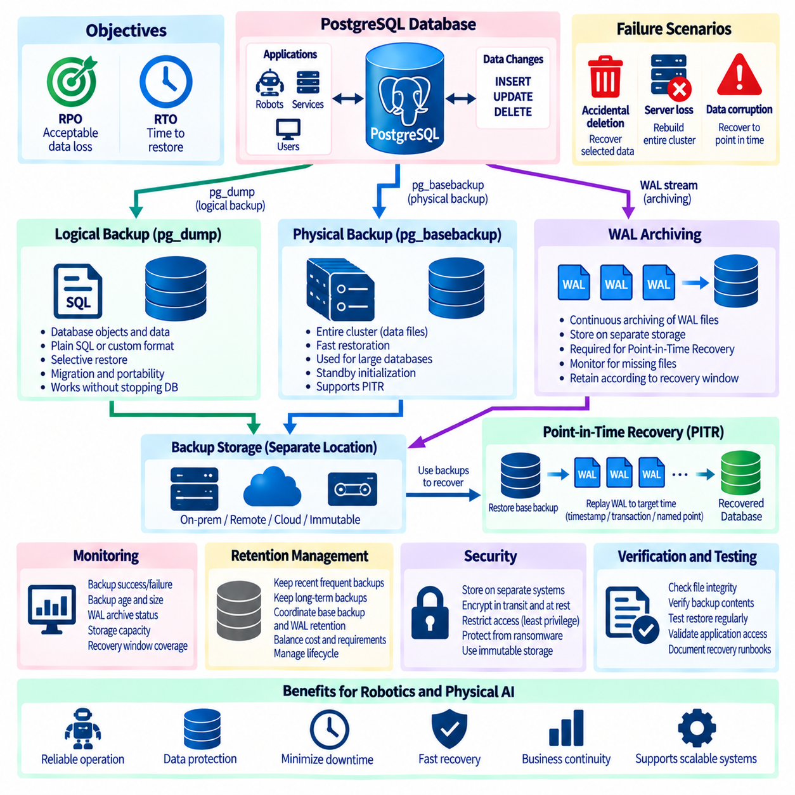
A PostgreSQL backup strategy should be designed around recovery requirements rather than around a single backup command. Different failures require different recovery mechanisms: accidental deletion may require restoration of selected objects, complete server loss may require rebuilding an entire cluster, and data corruption may require recovery to a point before the incident. PostgreSQL therefore provides complementary logical and physical backup methods. A resilient architecture combines pg_dump, pg_basebackup, WAL archiving, and Point-in-Time Recovery according to required Recovery Point Objective and Recovery Time Objective.
Recovery Point Objective, or RPO, defines how much recent data an organization can tolerate losing, while Recovery Time Objective, or RTO, defines how quickly service should be restored. These targets determine backup frequency, WAL retention, storage architecture, and restoration procedures. A system accepting several hours of data loss can use a simpler strategy than a mission-critical robot fleet platform requiring recovery within minutes. Backup design should therefore begin by classifying databases and workloads according to business and operational consequences rather than applying identical policies everywhere.
pg_dump creates a logical backup of a PostgreSQL database by extracting database objects and their data into a portable representation. It can produce plain SQL scripts or archive formats that work with pg_restore. Logical backups are useful when administrators need database-level portability, selective restoration, migration between compatible PostgreSQL environments, or recovery of individual schemas and tables. Because pg_dump reads database objects logically instead of copying raw database files, the resulting backup is independent of the physical storage layout of the source cluster.
A major advantage of pg_dump is restoration flexibility. Custom and directory archive formats allow pg_restore to inspect backup contents and selectively restore schemas, tables, functions, or other database objects. Restoration can also be parallelized in suitable situations to reduce recovery time. However, pg_dump is not intended to reproduce an entire PostgreSQL cluster exactly as it existed at the storage level. Cluster-wide objects such as roles and some global definitions require separate handling, commonly through pg_dumpall options or configuration-management procedures.
Logical backups have important performance characteristics. pg_dump creates a transactionally consistent view without requiring the database to stop accepting normal activity, but reading and exporting a large database can consume CPU, storage bandwidth, and I/O capacity. Restoration may take substantially longer because tables, indexes, constraints, and other structures must be recreated logically. For multi-terabyte operational databases, relying exclusively on pg_dump can therefore produce an unacceptable RTO even if the backup itself completes successfully.
pg_basebackup serves a different purpose by creating a physical base backup of an entire PostgreSQL cluster. It copies the files required to reconstruct a working PostgreSQL instance and integrates naturally with streaming replication and WAL-based recovery. Physical backups are particularly useful for large databases, standby initialization, disaster recovery, and PITR. Unlike pg_dump, pg_basebackup operates at the cluster level rather than selecting individual tables, so it provides faster reconstruction of the physical database environment but less object-level restoration flexibility.
A physical base backup alone does not provide arbitrary point-in-time recovery. PostgreSQL continuously records database changes in the Write-Ahead Log, or WAL. By preserving completed WAL segments in an archive separate from the primary database, administrators can replay changes that occurred after a base backup was created. The combination of a valid base backup and an uninterrupted WAL archive forms the foundation of PITR. WAL archiving must therefore be treated as a continuous data-protection pipeline rather than an optional supplement to periodic backups.
Point-in-Time Recovery allows PostgreSQL to restore a base backup and replay WAL records until a specified recovery target. The target can correspond to a timestamp, transaction, named recovery point, or another supported boundary. This capability is particularly valuable after accidental data modification, application errors, or corruption discovered after the event occurred. Instead of restoring only the latest backup and losing everything created afterward, administrators can reconstruct the database state immediately before the damaging operation when the required WAL history is available.
PITR depends on continuity. A missing WAL segment between the selected base backup and recovery target can prevent recovery from progressing beyond that gap. Archive storage should therefore be monitored for failed transfers, insufficient capacity, permission problems, and unexpected deletion. WAL files should normally be stored independently from the primary database so that failure of the main server does not destroy both production data and recovery history. Retention policies must preserve every WAL segment required by the oldest base backup that remains eligible for recovery.
Backup storage should follow failure-domain separation principles. Keeping backups on the same disk or server as the production database provides little protection against hardware failure, ransomware, administrative mistakes, or site-level incidents. Backup copies should be stored on independent systems, and important environments may use geographically separate or immutable storage. Encryption should protect sensitive backup data both in transit and at rest. Access to backup repositories should also follow least privilege because a database backup can contain nearly all information available in the production system.
Backup retention must balance recovery flexibility, storage cost, regulatory requirements, and operational complexity. Organizations may retain frequent recent backups for rapid recovery while preserving less frequent historical backups for longer periods. WAL retention should be coordinated with base-backup retention so that advertised recovery windows are actually achievable. Deleting a base backup without considering dependent WAL or deleting required WAL while retaining the base backup can create misleading recovery coverage. Backup lifecycle management should therefore understand dependencies between recovery components.
Verification is as important as backup creation. A successful command or uploaded archive does not prove that the database can actually be recovered. Backup systems should verify file integrity, expected sizes, checksums where applicable, archive continuity, and availability of required configuration information. More importantly, organizations should periodically restore backups into isolated environments and validate database startup, schema consistency, representative queries, application connectivity, and critical records. A backup that has never been restored is an unverified recovery assumption.
Recovery procedures should be documented and automated where practical. During an incident, administrators must know which base backup to select, which WAL archive to use, how recovery targets are specified, where configuration and credentials are obtained, and how the recovered instance is validated before serving applications. Manual improvisation increases RTO and the probability of secondary errors. Recovery runbooks should therefore include both technical restoration steps and operational decisions such as traffic isolation, validation gates, service reopening, and preservation of evidence from the failed environment.
Replication should not be confused with backup. Streaming replication can maintain a nearly current standby and provide rapid service restoration after primary-server failure, but logical mistakes or destructive transactions can be replicated immediately to the standby. Replication also may not preserve historical states required to recover from delayed discovery of corruption. High availability and backup solve related but different problems. A robust PostgreSQL architecture commonly combines replication for availability with independent logical or physical backups and WAL archives for recoverability.
Robotics and Physical AI systems often contain databases with different recovery priorities. Robot configuration, mission history, event metadata, fleet state, spatial information, user permissions, and model deployment records may require strong protection, while high-volume raw sensor data may be retained in specialized object or time-series storage. Backup policy should classify these datasets separately. Critical PostgreSQL metadata may require short RPO and RTO targets, whereas reproducible or externally archived data can use less aggressive database backup schedules.
An integrated strategy can use regular pg_dump archives for selective logical recovery, scheduled pg_basebackup operations for full-cluster reconstruction, and continuous WAL archiving for PITR between base backups. Streaming replicas can complement these mechanisms by reducing downtime during infrastructure failures. Monitoring should track backup age, duration, size, WAL archival success, storage capacity, restore-test results, and recovery-window coverage. Alerts should identify not only failed backup jobs but also conditions that silently make future recovery impossible.
The effectiveness of a PostgreSQL backup architecture is ultimately measured by successful recovery, not by the number of backup files created. pg_dump provides portable and selective logical protection, pg_basebackup supplies efficient physical cluster copies, and WAL archiving enables precise Point-in-Time Recovery. When these mechanisms are aligned with RPO, RTO, independent storage, security controls, retention policies, continuous monitoring, and tested restoration procedures, PostgreSQL can provide reliable recovery for robotics, Physical AI, and other continuously operating data platforms.

02.10 PostgreSQL HA: Patroni Cluster Configuration [w/Code]
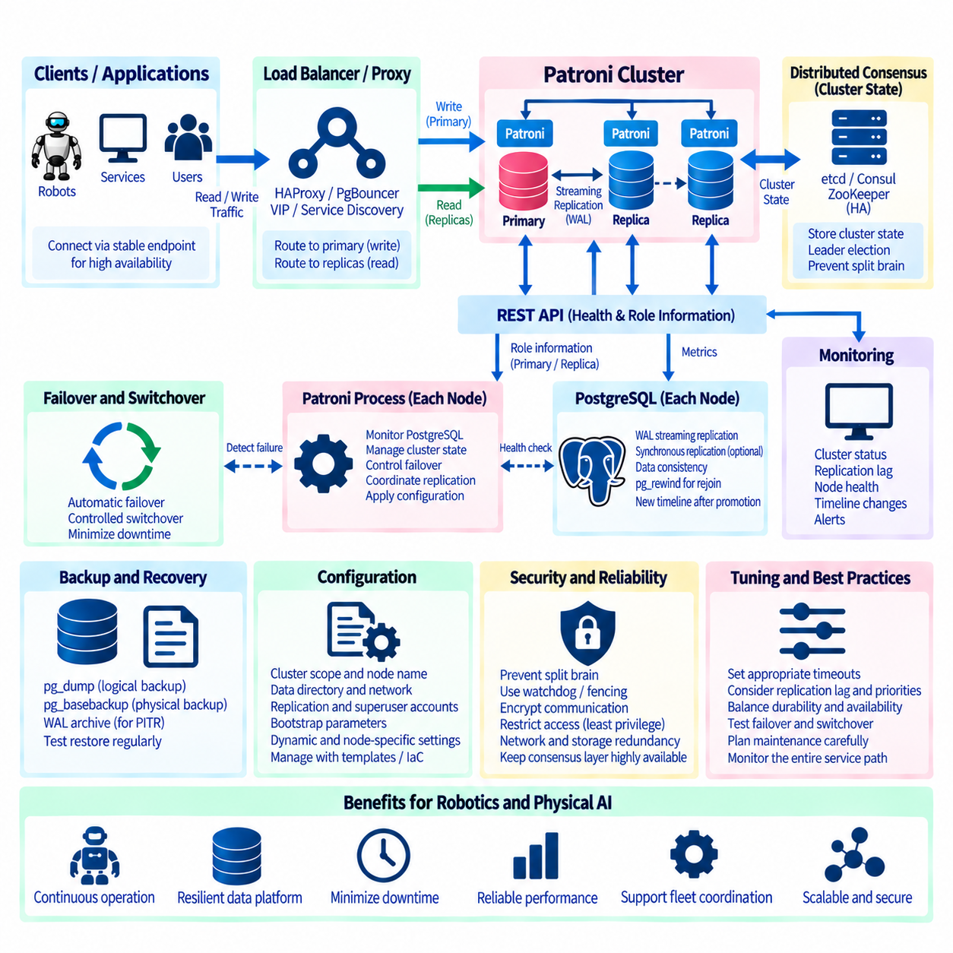
PostgreSQL high availability is designed to keep database services accessible when a server, process, network path, or infrastructure component fails. Native streaming replication provides the mechanism for maintaining standby copies, but replication alone does not coordinate leader election, promotion, or application redirection. Patroni adds an orchestration layer around PostgreSQL and automates many of these decisions. A Patroni cluster therefore combines PostgreSQL replication, distributed consensus, health monitoring, controlled failover, and service-routing mechanisms into an integrated high-availability architecture.
A typical Patroni deployment contains one PostgreSQL primary and one or more replicas, with Patroni running alongside PostgreSQL on every database node. Each Patroni instance continuously observes the local PostgreSQL process and communicates cluster state through a distributed configuration store or supported consensus mechanism. The current leader holds a time-limited leadership lock, while replicas monitor that state and continue receiving WAL through PostgreSQL streaming replication. This arrangement separates database replication from cluster coordination while allowing both mechanisms to operate as one HA system.
Distributed consensus is fundamental because cluster members need a shared source of truth about leadership. Depending on the Patroni architecture and supported deployment model, systems such as etcd, Consul, ZooKeeper, or other supported coordination approaches can provide this function. Patroni stores or exchanges cluster state through the coordination layer so that nodes do not independently promote themselves during ordinary failures. The consensus infrastructure must itself be highly available because unreliable coordination can prevent safe automated failover even when PostgreSQL replicas remain healthy.
Patroni configuration describes the identity and behavior of each cluster member. Common settings define the cluster scope, node name, REST API address, PostgreSQL data directory, listening addresses, replication credentials, superuser credentials, and bootstrap parameters. Cluster-wide dynamic settings can control PostgreSQL parameters and failover behavior, while node-specific configuration defines local network and filesystem details. Configuration should be managed consistently through templates, automation, or infrastructure-as-code so that differences between nodes are intentional and auditable.
Cluster initialization begins with one node bootstrapping the PostgreSQL cluster and publishing the initial state to the coordination layer. Additional nodes can then create replicas from the leader using configured replica-creation methods, commonly based on a physical base backup. After initialization, PostgreSQL streaming replication transfers WAL records from the primary to replicas. Patroni monitors replication state and node health but relies on PostgreSQL itself to maintain the physical database copies. Backup and replica creation procedures should therefore be designed consistently with the wider PostgreSQL recovery architecture.
The Patroni REST API provides health and role information that can be consumed by load balancers, proxies, monitoring systems, and operational automation. External components can determine whether a node is the current primary, a healthy replica, or unsuitable for traffic. This is important because Patroni manages database roles but applications still require a stable method of reaching the correct server. HAProxy, PgBouncer, virtual IP mechanisms, service discovery, Kubernetes services, or similar routing layers can be used to direct write traffic toward the leader and optional read traffic toward appropriate replicas.
Automatic failover begins when Patroni determines that the current leader can no longer safely provide service and the leadership lock expires or becomes unavailable according to cluster rules. Eligible replicas evaluate the shared cluster state, and an appropriate replica can acquire leadership and promote its PostgreSQL instance. Promotion changes the replica into a writable primary and creates a new database timeline. Routing infrastructure must then direct application connections toward the new leader. The entire sequence should minimize downtime while avoiding simultaneous writable primaries.
Replica selection during failover should consider data freshness and operational policy rather than simply choosing any reachable node. A replica with excessive replication lag may contain less recent data and can increase data loss when promoted. Patroni provides controls that can restrict promotion according to replication state, node tags, priorities, or other cluster conditions. Administrators should establish acceptable failover lag based on the required Recovery Point Objective. The most highly available configuration is not necessarily the safest if it promotes a severely outdated replica.
Synchronous replication can reduce the possibility of losing committed transactions during primary failure by requiring confirmation from one or more replicas before acknowledging selected commits. Patroni can coordinate PostgreSQL synchronous replication settings and, depending on configuration, enforce stronger consistency behavior. This improves durability but can reduce write availability when synchronous replicas become unreachable. The architecture must therefore balance transaction durability, latency, and availability according to application requirements rather than enabling synchronous operation without understanding its failure behavior.
Split-brain prevention is one of the most important responsibilities of an HA design. Split brain occurs when multiple database nodes believe they are primary and accept independent writes, creating divergent histories. Patroni uses the distributed leadership mechanism to coordinate promotion, but infrastructure and operational procedures must also prevent isolated former leaders from continuing to serve application traffic. Reliable routing, appropriate watchdog or fencing strategies where required, controlled network design, and careful failure testing help reduce the possibility that two writable database paths remain active simultaneously.
A failed former primary does not automatically become a valid replica after another node has been promoted. Once a new timeline exists, the returning node may require rewind or complete reinitialization before safely joining the cluster. PostgreSQL's pg_rewind can often synchronize a diverged former primary with the new leader when the required WAL history and configuration conditions are available. Otherwise, Patroni can rebuild the node from a fresh base backup. Reintegration procedures should be automated and tested because recovery from failover is part of normal HA lifecycle management.
Timeout parameters strongly influence Patroni failover behavior. Settings related to leadership time-to-live, loop intervals, retry behavior, and PostgreSQL operation timeouts determine how quickly the cluster detects problems and how aggressively it reacts. Extremely short values can cause unnecessary failovers during temporary network delays or storage stalls, while excessively long values increase service interruption during genuine failures. Timeout tuning should reflect network stability, storage characteristics, application tolerance, and the behavior of the distributed consensus system.
Monitoring should combine Patroni state, PostgreSQL replication metrics, operating-system health, and routing-layer information. Administrators should observe leader identity, replica availability, replication lag, WAL generation and replay, timeline changes, connection counts, transaction rates, disk capacity, CPU load, network conditions, and failover history. Alerts should distinguish a failed database process from coordination-layer failure or routing failure. High availability depends on the complete service path, so monitoring only whether PostgreSQL is running does not demonstrate that applications can successfully reach a writable database.
Planned maintenance should use controlled switchover rather than waiting for an unplanned failover. A switchover intentionally transfers leadership from a healthy primary to a selected replica, allowing administrators to perform operating-system updates, hardware maintenance, PostgreSQL upgrades, or infrastructure changes with reduced interruption. Before switching roles, replica health and replication lag should be verified. Controlled switchovers are also valuable operational exercises because they demonstrate whether routing, connection pooling, monitoring, and application reconnection behave correctly when leadership changes.
Patroni high availability does not replace backups or Point-in-Time Recovery. Replication rapidly copies both valid changes and destructive mistakes to replicas, while a Patroni failover primarily protects service availability after node failure. Independent pg_dump archives, physical base backups, WAL archives, and tested PITR procedures remain necessary for recovering historical states or rebuilding the environment after broader failures. HA, backup, and disaster recovery should therefore be treated as coordinated but distinct layers of PostgreSQL resilience.
In robotics and Physical AI systems, a Patroni cluster can provide a resilient database foundation for robot configuration, fleet coordination, mission state, event metadata, spatial information, user authorization, and operational services. Edge and application components can connect through a stable proxy or pooling layer rather than tracking individual database nodes. When PostgreSQL replication, Patroni coordination, distributed consensus, secure routing, monitoring, backups, and tested failover procedures are engineered together, the platform can continue operating through database-node failures while preserving controlled leadership and reliable data services.

