Volume 09 Cloud and Edge Robotics

04. AWS Robotics

04.01 AWS Robot Service Portfolio: IoT, RoboMaker, S3, EC2
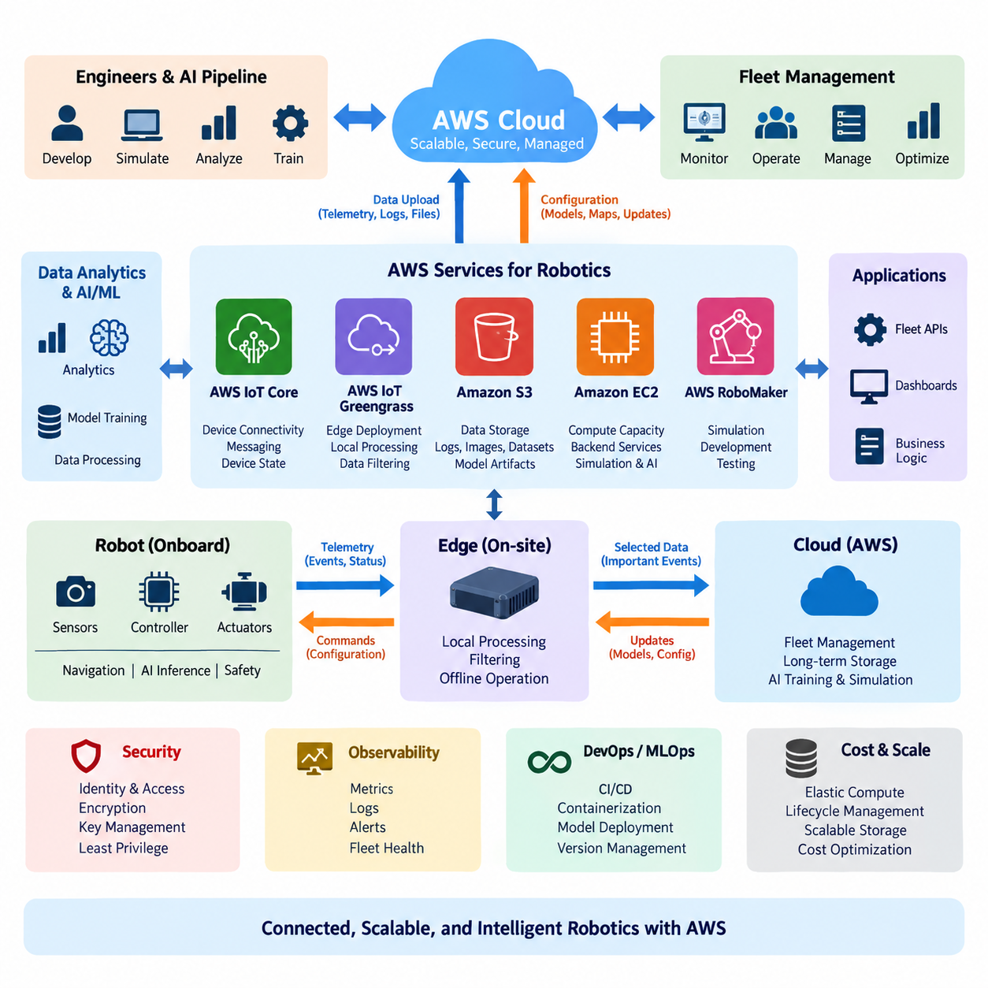
AWS provides a broad cloud and edge service portfolio that can support the full operational lifecycle of connected robots. Rather than relying on one robotics-specific service, practical architectures combine device connectivity, edge processing, compute, storage, analytics, security, and monitoring services. In the structure of a robotics cloud platform, AWS IoT services connect robots, Amazon S3 retains large-scale operational data, and Amazon EC2 supplies elastic computing resources for backend and engineering workloads.
A useful way to understand the AWS robotics portfolio is to divide the system into robot, edge, and cloud layers. The robot layer contains sensors, actuators, controllers, navigation software, and local AI inference. Edge components handle workloads that must remain close to the machine, while cloud services provide centralized fleet functions, historical storage, model training, simulation, analytics, and administrative applications. This separation prevents network latency from becoming part of safety-critical control loops.
AWS IoT Core provides a managed communication layer for connecting devices and cloud applications. Robots can publish telemetry such as battery level, pose, temperature, diagnostic status, mission progress, and fault events, while backend applications can distribute configuration or operational commands. MQTT is commonly suited to this communication model because its publish-subscribe mechanism allows robot software and cloud applications to exchange asynchronous messages without maintaining tightly coupled service relationships.
For robotics, cloud connectivity should complement rather than replace autonomous local operation. Motion control, emergency stopping, obstacle avoidance, localization, and other time-sensitive functions normally remain on the robot or nearby edge computer. AWS IoT connectivity is more appropriate for fleet status, configuration management, event reporting, remote supervision, and data synchronization. This distinction becomes particularly important when robots must continue operating safely during temporary network degradation or complete cloud disconnection.
Device state can also be represented independently of continuous connectivity. A cloud-side representation of desired and reported device state enables applications to reason about robot configuration even when a robot is temporarily offline. When connectivity returns, state synchronization can reconcile changes between the device and backend. In fleet environments, this pattern helps separate transient telemetry from persistent operational state such as assigned configuration, software version, operating mode, or selected mission parameters.
AWS IoT Greengrass extends cloud-oriented software patterns toward edge devices and local computers. It can support deployment and management of components that perform local processing, messaging, filtering, or integration with cloud services. In a robot fleet, this makes it possible to process high-frequency sensor information locally and transmit only selected events or summaries. Such filtering reduces bandwidth consumption while retaining cloud visibility into information that is operationally important.
Amazon S3 provides object storage for data that does not belong in high-frequency robot control paths. Camera images, LiDAR recordings, ROS bag files, diagnostic archives, maps, simulation outputs, AI datasets, model artifacts, and operational logs can be organized as objects and retained at large scale. Because robotics datasets often grow from gigabytes to terabytes or petabytes, object storage becomes a central component of long-term fleet data architecture rather than merely a backup location.
S3-based storage also supports separation between raw, processed, and curated robot data. Raw sensor captures may be preserved for reproducibility, while derived datasets contain filtered frames, annotations, features, or training samples. Lifecycle policies can move older information into lower-cost storage classes according to retention requirements. This approach allows engineering teams to preserve valuable historical evidence without keeping every robot-generated object in the most expensive storage tier indefinitely.
Amazon EC2 provides general-purpose virtual computing capacity for workloads requiring operating-system-level control or configurable CPU, memory, networking, and accelerator resources. Robotics teams can use EC2 instances for fleet backend applications, ROS-related development environments, simulation coordination, data preprocessing, build infrastructure, dashboards, and AI workloads. GPU-enabled instance families can additionally support machine learning training, accelerated inference, computer vision processing, and selected simulation workloads.
Elastic compute is especially valuable because robotics workloads are rarely uniform. Continuous fleet services may require predictable capacity, whereas simulation campaigns, dataset preprocessing, or model training can generate large temporary peaks. EC2 capacity can be provisioned according to workload characteristics instead of purchasing physical infrastructure for the maximum possible demand. However, real-time robot control should not be moved to remote virtual machines merely because scalable compute is available in the cloud.
AWS RoboMaker historically provided AWS-managed capabilities aimed specifically at robotics development and simulation, particularly around ROS-based workflows. In an architectural study, RoboMaker is useful for understanding how cloud resources can be connected to robot simulation, development, and testing processes. The broader lesson is that robotics workloads can consume scalable compute and storage resources while maintaining a software workflow linking simulation environments, robot applications, test scenarios, and operational data.
For a modern architecture, RoboMaker should be understood within the larger AWS service ecosystem rather than as the sole foundation of an AWS robotics platform. Robot systems can be assembled from general AWS infrastructure and IoT services according to their actual requirements. This service-composition approach also fits the structure of a broader cloud and edge robotics platform in which later layers address Greengrass, S3 analytics, AI training, Kubernetes deployment, monitoring, security, and fleet cost optimization separately.
A typical data flow begins when a robot generates telemetry and sensor information during operation. Small status messages and events can travel through IoT-oriented communication channels, while large files are uploaded asynchronously to object storage. Backend services running on EC2 or other compute platforms process operational information, expose fleet APIs, and coordinate business logic. Engineers and AI pipelines can later retrieve historical datasets from S3 for analysis, retraining, debugging, or simulation.
The reverse flow is equally important. Cloud applications may produce robot configurations, mission parameters, AI model versions, maps, or software deployment instructions. These artifacts should not be treated as unrestricted remote control commands. Instead, robot-side software validates received information, applies authorization and version checks, and activates changes according to controlled deployment procedures. This preserves a clear authority boundary between centralized management and local autonomous execution.
Security must span every layer of the portfolio. Individual robots require identities and credentials, communication channels require encryption, cloud applications need controlled permissions, and stored datasets may require encryption and retention policies. AWS Identity and Access Management can restrict cloud-side actions, while key-management mechanisms can protect sensitive data and credentials. A production design should grant each robot, service, operator, and engineering workflow only the permissions required for its intended function.
Observability is another essential part of the architecture because physical systems fail differently from ordinary web applications. A robot can remain connected while experiencing degraded localization, a damaged sensor, excessive motor temperature, or declining battery health. Cloud monitoring therefore needs both infrastructure metrics and robotics-specific operational signals. Logs, telemetry, alerts, and fleet-level aggregation should allow engineers to distinguish network failures, software defects, hardware faults, and abnormal mission behavior.
The resulting architecture is not simply a robot connected to a remote server. It is a distributed computing system in which responsibility is assigned according to latency, bandwidth, safety, availability, privacy, and cost. Robot and edge computers maintain immediate physical interaction, while AWS services provide scalable connectivity, storage, computation, analytics, and centralized fleet functions. This division is consistent with the volume's progression from cloud fundamentals and edge computing toward hybrid architectures and fleet operations.
The most effective AWS robotics design therefore treats IoT, edge, storage, and compute services as complementary building blocks. IoT services establish managed communication and device integration, edge software preserves local responsiveness, S3 creates a durable data foundation, and EC2 supplies configurable computing capacity. Together, these capabilities allow a robotics platform to grow from a small number of connected machines into a larger fleet without forcing every workload into either the robot or the cloud.
From a system-engineering perspective, the key design decision is workload placement. Millisecond-level control and safety functions remain local; near-real-time filtering and inference can execute at the edge; fleet coordination, historical analysis, large-scale training, and long-term storage can use cloud resources. When these boundaries are explicitly defined, AWS becomes an infrastructure layer supporting robotic autonomy rather than a dependency that autonomy requires for every physical action.
This portfolio view also establishes the foundation for more specialized AWS robotics topics. Device connectivity and state management lead naturally to AWS IoT Core, local execution leads to Greengrass, accumulated robot data leads to S3 and analytics, AI workloads lead to managed training and deployment services, and fleet applications lead to container orchestration, monitoring, identity, and cost management. The chapter structure reflects this progression from core services toward an integrated cloud-edge robot operating environment.

04.02 AWS IoT Core: Device Connect, Shadow, Rules [w/Code]
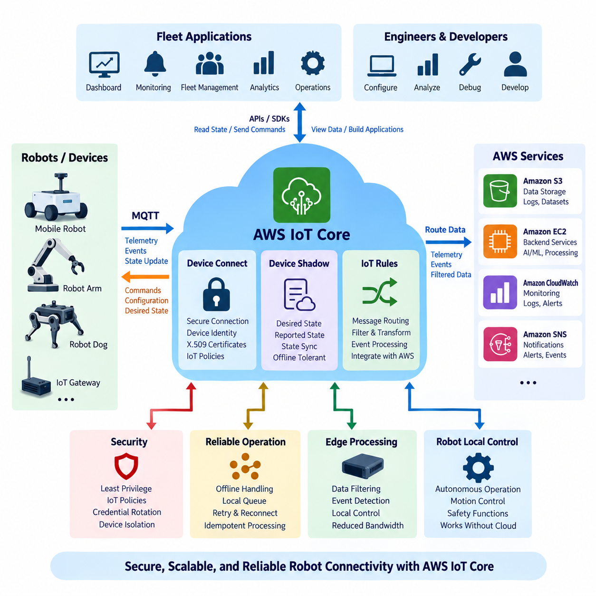
AWS IoT Core provides the managed connectivity layer that allows robots, sensors, gateways, and cloud applications to exchange information securely at scale. In a robotics architecture, it normally sits above the robot’s real-time control functions rather than replacing them. Robots maintain autonomous motion and safety locally while IoT Core carries telemetry, operational events, configuration information, and cloud-originated messages between distributed devices and backend services.
A robot typically establishes its identity before communicating with AWS IoT Core. Device authentication can use X.509 certificates associated with IoT policies that define which operations the device is permitted to perform. This creates a device-oriented security model in which each robot or gateway can have an independently managed identity. Compromise of one credential therefore does not inherently require every robot in the fleet to share the same security exposure.
MQTT is one of the principal communication protocols used with AWS IoT Core because its publish-subscribe model fits distributed robotic systems well. A robot publishes information to topics without needing to know which backend application consumes it. Fleet services subscribe to relevant topics and react independently. The same mechanism allows backend components to publish configuration or operational information that selected robots or robot groups receive through predefined topic structures.
Topic design becomes an important architectural decision as the number of robots increases. A structured namespace can distinguish fleet, site, robot, subsystem, and message type, allowing applications to subscribe at appropriate levels of granularity. Telemetry, faults, mission events, diagnostics, and configuration messages should be logically separated rather than placed into one generic channel. Clear topic organization improves authorization, routing, observability, debugging, and long-term fleet maintainability.
Robot telemetry commonly includes pose summaries, battery state, mission progress, operating mode, temperature, connectivity quality, subsystem health, and diagnostic events. High-bandwidth raw camera or LiDAR streams are generally unsuitable for continuous MQTT transmission. Such data can be filtered or stored locally and transferred through storage-oriented pipelines when necessary, while IoT messages communicate metadata, events, references, or upload completion notifications.
Device Shadow provides a persistent cloud representation of selected device state. Instead of requiring an application to communicate synchronously with a robot whenever it needs state information, the application can interact with a shadow document maintained by AWS IoT. This is particularly useful for mobile robots because connectivity may change as they move through buildings, outdoor environments, warehouses, factories, or private wireless networks.
A shadow distinguishes between desired state and reported state. The desired state represents what an application wants the device configuration to become, while the reported state represents what the robot currently reports about itself. When these values differ, the difference can be used to identify pending changes. The robot can receive the requested state, validate it locally, apply an appropriate configuration, and then update its reported state after the change succeeds.
This desired-reported pattern is valuable for configuration management because cloud software does not need to assume that every robot is continuously online. For example, a backend may request a different operating parameter while a robot is disconnected. The requested state remains represented in the cloud, and synchronization can occur after connectivity returns. This supports an offline-tolerant architecture while maintaining a consistent mechanism for managing fleet configuration.
Not every robot variable belongs in a Device Shadow. High-frequency sensor samples, rapidly changing localization values, image streams, and control-loop signals are better handled through telemetry or local processing. Shadow state is more appropriate for information whose current value has operational meaning, such as configuration mode, selected profile, software-related state, feature enablement, or other relatively persistent properties that cloud applications need to inspect or modify.
AWS IoT Rules provide a mechanism for routing and processing messages arriving through IoT Core. A rule can examine incoming MQTT messages, select relevant fields or events, and direct matching information toward other AWS services. This allows the messaging layer to become an entry point into broader cloud data pipelines without requiring every robot to understand the architecture of downstream storage, analytics, monitoring, or application systems.
For example, routine robot telemetry can be routed toward persistent storage or analytics pipelines, while fault events can trigger separate processing paths. A battery warning, navigation failure, sensor fault, or mission completion event may require different cloud-side actions even though all originated from robot messages. Rule-based routing separates device communication from backend processing logic and reduces direct dependencies between embedded robot software and individual cloud services.
Rules also support data reduction strategies when combined with appropriate robot and edge processing. The robot should avoid uploading every available measurement simply because cloud connectivity exists. Local software can aggregate high-rate information into summaries or detect significant events before publishing them. IoT Rules can then perform another stage of selection or routing, creating a hierarchy in which data becomes progressively more relevant as it moves from physical devices toward cloud applications.
A complete connection workflow therefore begins with device provisioning and identity. The robot obtains credentials, connects securely to an AWS IoT endpoint, and receives permissions according to its IoT policy. After connection, it publishes telemetry and subscribes to authorized command or configuration topics. Device Shadow interactions maintain selected persistent state, while Rules transform or route incoming messages into storage, monitoring, analytics, notification, or application workflows.
Security policies should follow the principle of least privilege. A robot that only needs to publish telemetry for its own identity should not automatically receive permission to publish arbitrary messages for every other robot. Topic structures and policies should therefore be designed together. Device identity, permitted actions, resource scope, certificate lifecycle, credential rotation, and revocation procedures become fundamental elements of fleet security rather than implementation details added after deployment.
Cloud-to-robot communication also requires a carefully defined authority boundary. Receiving an MQTT message or desired shadow state should not imply unconditional execution by the robot. Local software should validate message structure, authorization context, operating state, version compatibility, and safety constraints before applying a request. Safety-critical actions such as emergency braking, collision avoidance, and low-level actuator control should remain under deterministic local control.
Connectivity failures must be treated as normal operating conditions rather than exceptional cases. A mobile robot may temporarily lose Wi-Fi, private 5G, or Internet connectivity while continuing its mission. Local queues, retry policies, timestamped events, state reconciliation, and idempotent processing help prevent duplicated or lost operations after reconnection. Device Shadow can restore configuration context, while buffered telemetry can be uploaded according to bandwidth and operational priorities.
At fleet scale, the combination of MQTT topics, device identities, shadows, and rules creates a logical abstraction above individual network connections. Backend applications can reason about robots as managed entities with state, events, permissions, and data flows. This makes it possible to construct fleet dashboards, alert systems, maintenance workflows, mission services, and historical analytics without embedding all cloud-specific processing logic directly into each robot application.
The architecture also connects naturally with the broader AWS robotics service portfolio. IoT Core supplies device communication, Greengrass can extend processing toward edge computers, S3 can retain large robot datasets, and EC2 or other compute services can host backend processing. IoT Rules provide routing between incoming device information and these cloud resources, while Device Shadow maintains selected operational state across temporary disconnections and asynchronous application interactions.
For Physical AI and autonomous robots, the most important principle is that IoT Core forms a management and information plane rather than the innermost physical control loop. Perception, localization, planning, motion control, and safety functions must be placed according to their latency and reliability requirements. Cloud connectivity adds fleet-level visibility and coordination, but autonomous operation should degrade gracefully when communication with remote services becomes unavailable.
AWS IoT Core can therefore be viewed as the communication backbone connecting robot identity, messaging, persistent state, and event-driven cloud processing. Device Connect establishes secure communication, Device Shadow maintains synchronized operational state, and IoT Rules transform message streams into actionable cloud workflows. Together, these mechanisms provide a scalable foundation for connecting individual robots to larger cloud-edge fleet architectures while preserving local autonomy and clear system boundaries.

04.03 AWS IoT Greengrass V2: Edge Runtime Setup [w/Code]
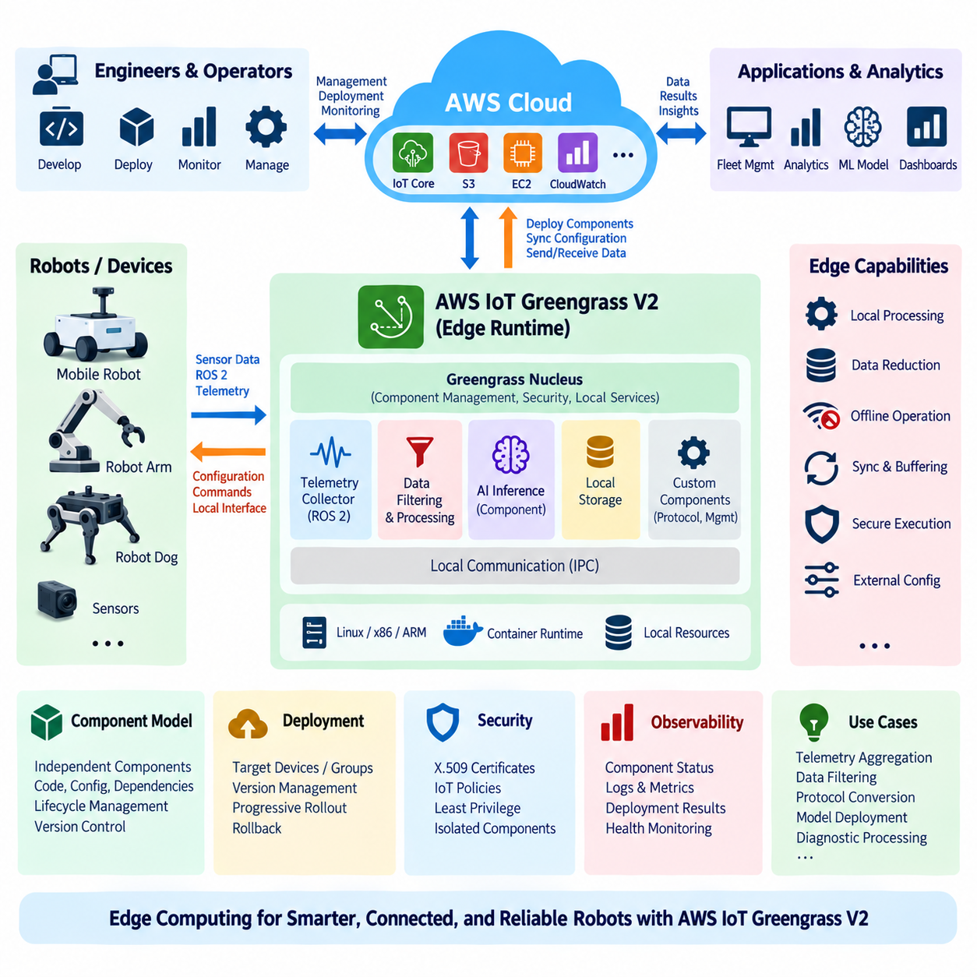
AWS IoT Greengrass V2 extends cloud-managed software capabilities to edge computers located close to robots, sensors, and industrial equipment. In a robotics architecture, Greengrass acts as an edge runtime between autonomous robot software and AWS cloud services. It allows selected applications, data-processing functions, communication services, and management logic to execute locally while maintaining controlled integration with centralized cloud infrastructure.
The main architectural reason for using Greengrass is that robotic workloads have different latency and connectivity requirements. Motion control, collision avoidance, and safety functions must remain local, while telemetry aggregation, data filtering, protocol conversion, model distribution, or diagnostic processing can operate as managed edge workloads. Greengrass provides a framework for deploying these functions without requiring every workload to execute remotely in the cloud.
Greengrass V2 uses a component-based software model. Instead of treating the edge system as one monolithic application, software capabilities can be packaged as independently deployable components. A component can contain application code, configuration, dependencies, lifecycle instructions, and artifacts required for execution. This modular structure allows robotics teams to separate telemetry collectors, monitoring agents, data filters, AI inference services, and cloud synchronization functions.
The Greengrass nucleus is the core runtime responsible for coordinating component execution and essential device-side services. It operates on the Greengrass core device and provides the foundation on which additional components are deployed. For a robot or industrial edge computer, the core device may be an embedded Linux computer, an x86 industrial PC, or another supported computing platform positioned between local robot software and AWS services.
Initial setup begins with preparing the edge operating environment and establishing an AWS IoT identity for the core device. The device requires appropriate credentials, certificates, permissions, and connectivity to relevant AWS endpoints. The runtime software is then installed and associated with the intended IoT thing and Greengrass configuration. Production provisioning should treat certificates and private keys as protected security assets rather than ordinary application files.
The host environment must also provide the runtime dependencies required by the selected Greengrass configuration and deployed components. Hardware capacity should be evaluated according to expected CPU utilization, memory consumption, storage, network traffic, and application dependencies. A small telemetry gateway has very different requirements from an edge computer simultaneously performing sensor processing, AI inference, local database operations, and synchronization for several robots.
After installation, component deployment becomes the primary mechanism for managing edge software. A deployment specifies which components and versions should operate on a target core device or group of devices. Greengrass resolves the required software and applies the deployment to the edge system. This allows a fleet operator to manage software configurations centrally while execution remains physically close to the robots and equipment generating the data.
Component lifecycle definitions determine how software is installed, started, stopped, and executed. This separation is useful in robotics because different edge services may require different runtimes or startup behavior. A telemetry service may continuously monitor ROS 2 data, while another component may periodically package diagnostic files. An AI component may load a model and remain active as a local inference service for applications that require low-latency responses.
Configuration should be externalized whenever possible rather than embedded permanently into component code. Parameters such as topic names, sampling intervals, file locations, endpoint settings, thresholds, and operational modes can then be modified without rebuilding an entire application. Controlled configuration management also makes it easier to maintain different settings for development robots, test fleets, production sites, or hardware variants while preserving common component implementations.
Interprocess communication is important when several Greengrass components cooperate on the same edge device. Components may need to exchange messages, request services, or share selected information without sending every interaction through the remote cloud. Local communication reduces unnecessary network traffic and allows edge workflows to continue during connectivity interruptions. Access between components should nevertheless be explicitly controlled rather than implicitly trusted.
A common robotics pattern is to connect Greengrass components with local robot middleware or application interfaces. A component can collect selected ROS 2 messages, transform them into compact operational records, and publish only meaningful events to cloud services. Another component may receive configuration information and expose it to robot applications through a controlled local interface. This creates a boundary between robot-native communication and cloud-oriented communication.
Local data filtering is one of the strongest reasons for introducing an edge runtime. Cameras, LiDARs, IMUs, motor controllers, and navigation software can generate data at rates far beyond what should continuously traverse an Internet connection. Edge components can aggregate measurements, detect anomalies, extract metadata, compress records, or select important events before transmission. Raw datasets can remain local until a policy determines that cloud upload is necessary.
Greengrass also supports architectures designed for intermittent connectivity. Edge applications should not assume that the AWS connection is continuously available. Local processing can continue while the network is unavailable, and data can be buffered or queued according to application requirements. After connectivity returns, synchronization logic can transmit pending information while considering timestamps, ordering, duplication, storage limits, and available network bandwidth.
Deployment strategy is especially important for robot fleets because a defective edge component can affect many physical machines. New component versions should therefore be validated on development systems and representative robots before broad deployment. Fleet segmentation allows different groups to receive different versions or configurations. Progressive rollout, health verification, rollback planning, and version traceability reduce the operational risk associated with centralized software distribution.
Security extends beyond initial device authentication. Components should execute with only the permissions they require, and access to local resources should be restricted according to function. Cloud-side IAM permissions, IoT policies, component permissions, operating-system accounts, file ownership, secrets, and network exposure collectively determine the security boundary. A compromised telemetry component should not automatically gain unrestricted access to robot control interfaces or sensitive credentials.
Observability should be designed into the edge runtime from the beginning. Operators need visibility into component status, startup failures, resource consumption, communication errors, deployment results, and application-specific health indicators. Logs generated by edge components can be retained locally and selectively forwarded to cloud monitoring systems. This allows engineers to distinguish failures in robot software, edge applications, network connectivity, cloud integration, or the Greengrass runtime itself.
Greengrass should not be treated as a replacement for the robot’s deterministic execution environment. High-frequency motor control, emergency stopping, hard real-time communication, and safety-certified logic should remain within the appropriate embedded controller or real-time computing domain. Greengrass is better positioned for supervisory processing, data management, integration, local AI services, application orchestration, and cloud synchronization where timing requirements permit a general-purpose edge runtime.
For AI-enabled robots, Greengrass components can participate in model deployment workflows. A cloud-side pipeline can prepare a validated model artifact, while an edge deployment distributes the appropriate version to selected devices. A local inference component can load the model and expose predictions to nearby applications. Model version, hardware compatibility, preprocessing configuration, rollback behavior, and resource consumption should be managed together rather than treating the model as an isolated file.
The resulting architecture forms a clear robot-edge-cloud continuum. Robot controllers execute immediate physical interaction, Greengrass core devices host managed edge applications, and AWS cloud services provide centralized deployment, storage, analytics, monitoring, and fleet functions. Data can be reduced near its source before cloud transmission, while configuration and software artifacts flow from centralized management toward selected edge systems under controlled deployment policies.
AWS IoT Greengrass V2 therefore provides an edge application platform rather than simply a communication client. Its component model, deployment mechanism, local processing capability, device identity integration, and cloud connectivity allow robotics systems to distribute software according to latency and operational requirements. When combined with AWS IoT Core, storage, compute, and monitoring services, it creates a practical foundation for scalable cloud-edge robot operations.
A robust setup ultimately depends less on installing the runtime than on defining correct architectural boundaries. Teams must determine which functions belong inside deterministic robot control, which can run as Greengrass edge components, and which should execute in the cloud. With these boundaries established, Greengrass can provide manageable edge software deployment while preserving local autonomy, reducing bandwidth consumption, supporting disconnected operation, and maintaining centralized fleet visibility.

04.04 AWS RoboMaker Simulation Environment Setup [w/Code]
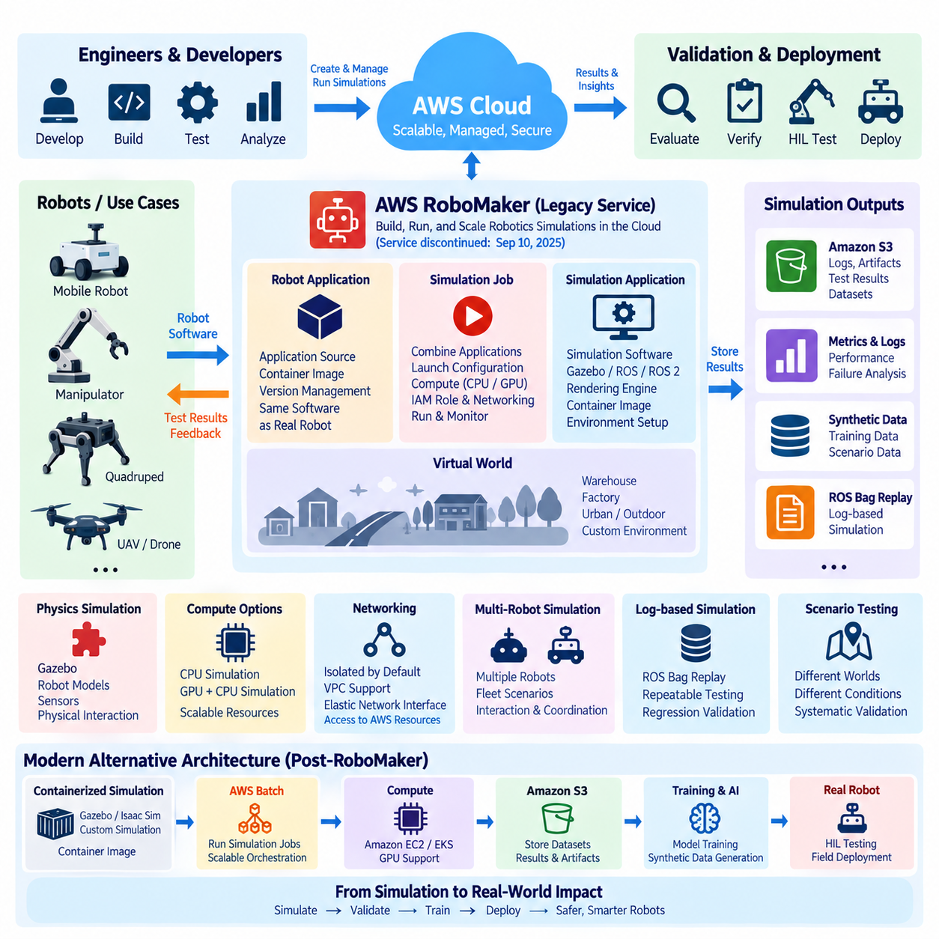
AWS RoboMaker was designed as a managed cloud service for building, running, scaling, and automating robotics simulations without requiring teams to manage the underlying simulation infrastructure. It supported robot applications, simulation applications, simulation jobs, and virtual worlds as managed resources. However, AWS discontinued RoboMaker support on September 10, 2025, so this material should now be understood as a legacy architecture and migration reference rather than a procedure for creating new RoboMaker resources.
The historical RoboMaker simulation architecture separated the robot application from the simulation application. The robot application represented the software that would eventually execute on the physical robot, while the simulation application provided the virtual environment and simulation-specific functions. A simulation job combined these applications with a selected world and runtime configuration, allowing developers to test robot behavior before transferring software to physical hardware.
Robot application packaging was an important part of the environment. RoboMaker supported application sources and container-based execution, allowing the software environment to be defined consistently across simulation jobs. Application versions provided identifiable revisions that could be referenced by simulation jobs. This approach established a useful engineering principle: simulation should execute a version-controlled representation of the same robot software architecture that will later be evaluated on physical hardware.
The simulation application defined the virtual execution environment used to evaluate the robot application. Historical RoboMaker APIs included support for simulation software suites such as Gazebo, robot software suites including ROS and ROS 2 variants, rendering engines, application sources, and container image URIs. These elements allowed developers to construct a reproducible simulation environment rather than manually configuring a separate simulation server for every experiment.
A simulation job was the execution unit that brought the robot application and simulation application together. The job configuration could specify the applications, launch configuration, maximum duration, IAM role, output location, failure behavior, networking, and computing resources. The robot and simulation applications could therefore be launched together as a controlled experiment, with the resulting execution status and outputs collected for later analysis.
The virtual world was another important element of the simulation environment. A world represents the physical context in which the robot operates, such as a warehouse, factory, roadway, or other structured environment. By changing the world while keeping the robot application consistent, developers can evaluate how navigation, perception, planning, and control software behaves under different environmental conditions. This separation supports systematic scenario-based validation.
Gazebo was historically important within the RoboMaker ecosystem because it provided a physics-based simulation environment for ROS-oriented robotics development. The simulator could represent robot models, sensors, environments, physical interactions, and motion. A cloud execution environment allowed teams to run such simulations without maintaining every simulation server locally. RoboMaker documentation and APIs also exposed simulation configurations for Gazebo and related simulation software.
Simulation computing could be configured according to the workload. RoboMaker historically supported CPU-based simulation and GPU-and-CPU simulation configurations. GPU-backed simulation was useful when applications required GPU-enabled sensor plugins, high-fidelity rendering, or workloads that benefited from accelerated computation. This distinction is important because simulation resource requirements can differ substantially between simple functional tests and visually or computationally intensive robotic scenarios.
Networking was another architectural consideration. RoboMaker simulation jobs were isolated by default, while VPC configuration could be provided when simulations needed to access resources inside an Amazon VPC. The service could establish elastic network interfaces for such connectivity, allowing a simulation job to interact with private AWS resources under controlled networking policies. This demonstrated how simulation workloads could be integrated into a broader cloud architecture rather than operating as completely isolated processes.
Simulation outputs could be directed to Amazon S3, making object storage an important companion to the simulation environment. Developers could retain logs, generated artifacts, test results, and other outputs for subsequent inspection or automated analysis. This creates a valuable simulation data loop in which a scenario is executed, results are stored, failures are analyzed, and modified software or parameters are tested again. For large robotics programs, this repeatable loop is more important than any single simulation run.
Log-based simulation was another significant concept demonstrated by RoboMaker. Instead of relying entirely on a virtual physics environment, prerecorded ROS bag data could be replayed as input to robot software. This approach enables repeatable regression testing because the same recorded inputs can be presented repeatedly to different software versions. It can be particularly useful when validating perception or decision-making behavior against previously captured real-world situations.
Multi-robot simulation was also an important use case. RoboMaker was designed to help developers execute simulations containing multiple robots and to scale simulation workloads for fleet-oriented scenarios. Such experiments can evaluate robot interaction, shared-space navigation, multi-robot coordination, task allocation, and algorithms that depend on information from other robots. This provides a bridge between single-robot validation and fleet-level behavior testing.
For a modern AWS robotics architecture, the key lesson is therefore not to reproduce the discontinued RoboMaker service itself. AWS currently documents alternative approaches in which containerized simulation workloads can be executed using services such as AWS Batch, while contemporary AWS guidance also demonstrates robotic simulation and training using NVIDIA Isaac Sim on Amazon EC2 or Amazon EKS. These approaches preserve the underlying architectural principle of scalable cloud simulation while replacing the former RoboMaker-managed execution layer.
A modern simulation environment should consequently treat the robot application, simulation environment, compute infrastructure, dataset storage, and experiment orchestration as separable components. Containers can package the software environment, AWS Batch can coordinate containerized batch workloads, EC2 or EKS can provide scalable compute, and S3 can retain datasets and experiment artifacts. This architecture is more general than the historical RoboMaker model and can accommodate Gazebo, Isaac Sim, or other supported simulation technologies according to project requirements.
The simulation workflow should also remain connected to the physical robot development lifecycle. A software revision can first be evaluated against deterministic regression scenarios, then subjected to varied environments and sensor conditions, followed by multi-robot or large-scale experiments. Successful candidates can proceed to hardware-in-the-loop testing and eventually controlled field testing. Simulation does not prove that a robot is safe in every physical condition, but it can substantially increase the number and repeatability of software tests performed before physical deployment.
For Physical AI systems, simulation becomes even more important because training and validation may require large numbers of interactions rather than a small collection of manually designed test cases. Parallel environments can generate diverse experiences for learning-based policies, while recorded real-world data can provide evaluation references. The cloud therefore becomes a scalable experimentation layer, while edge and robot hardware remain responsible for actual physical execution and real-time constraints.
The central architectural principle is that cloud simulation should reproduce the relevant software and physical interfaces without moving safety-critical execution requirements into an uncontrolled remote environment. Simulation provides scalable experimentation, automated regression testing, scenario variation, data generation, and software validation. Physical robots ultimately provide the evidence required for real-world performance. The historical RoboMaker architecture remains useful for understanding this separation, while current AWS designs should use supported services and contemporary simulation platforms rather than attempting to deploy new RoboMaker resources.

04.05 AWS S3 / Athena Robot Data Analytics Pipeline [w/Code]
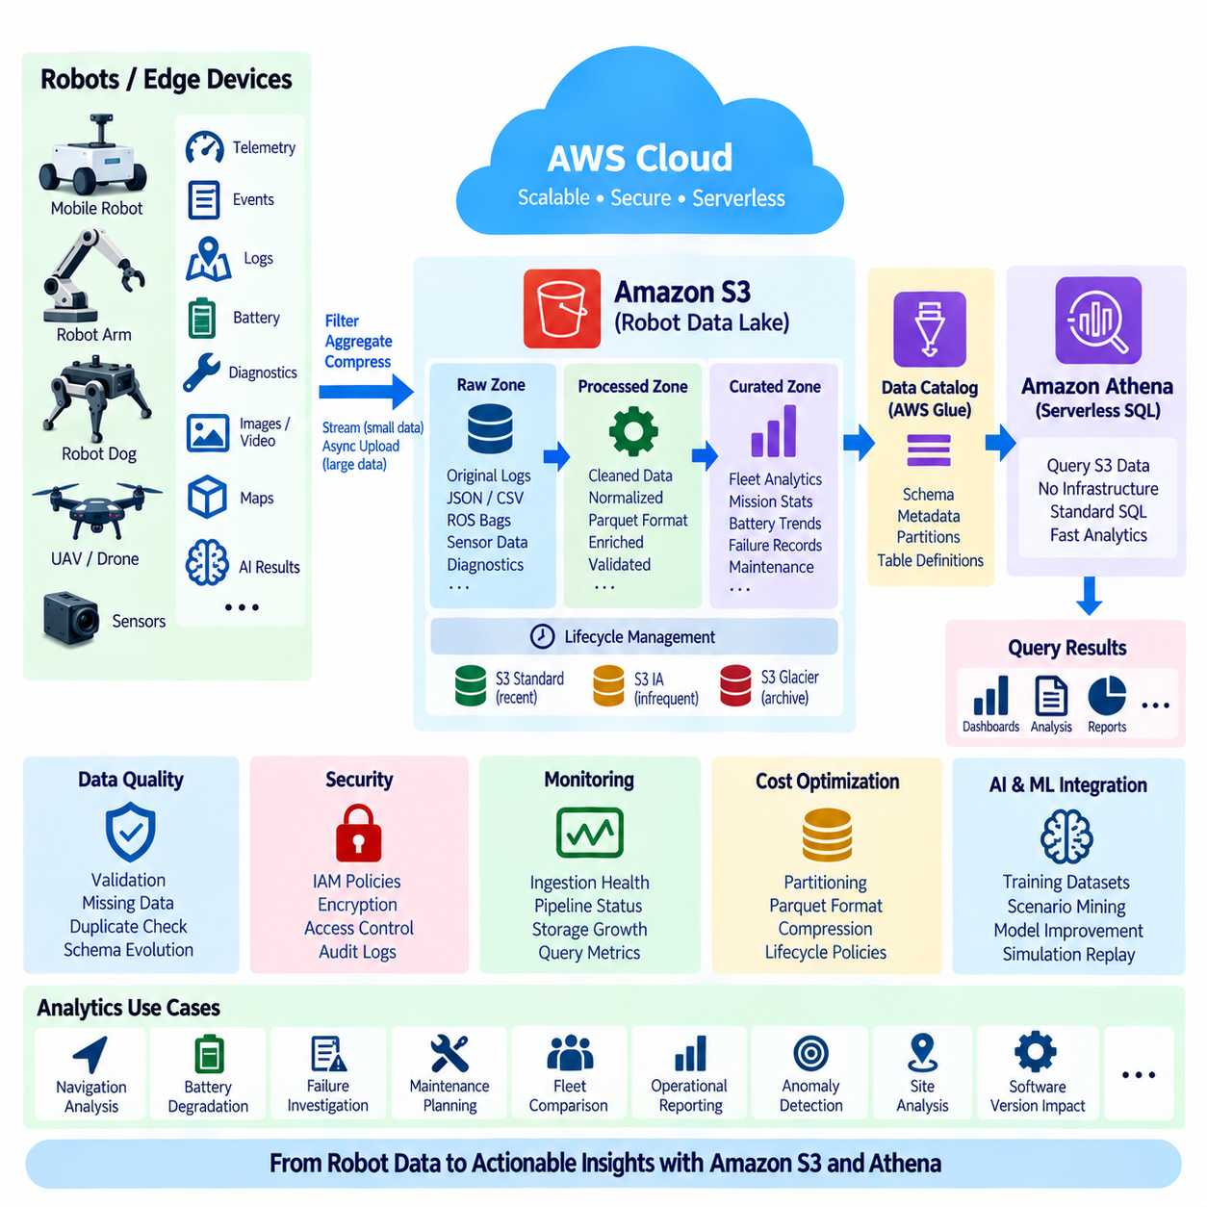
Robot fleets continuously generate heterogeneous data such as telemetry, mission events, navigation logs, battery histories, diagnostic records, sensor metadata, maps, and AI inference results. An AWS-based analytics pipeline can use Amazon S3 as the durable data foundation and Amazon Athena as a serverless SQL query layer. This combination allows robotics teams to retain large operational datasets while analyzing them without maintaining a dedicated database server for every historical workload.
The pipeline normally begins at the robot or edge layer rather than directly inside the cloud. High-frequency sensors can generate far more information than should be transmitted continuously, so robot and edge software should first classify, filter, aggregate, or compress data. Small telemetry records and events may flow continuously, while large camera, LiDAR, ROS bag, map, or diagnostic files can be uploaded asynchronously according to bandwidth, mission, and retention policies.
Amazon S3 functions as the central object storage layer for this architecture. Data can be organized by fleet, site, robot identifier, data type, and time period so that analytical workloads can efficiently locate relevant objects. A logical hierarchy might distinguish raw ingestion data from processed and curated datasets. Maintaining these layers preserves original evidence while allowing optimized representations to be created for repeated analytics and machine learning workflows.
Raw data should preserve information as close as practical to the original robot output. This layer may contain unmodified logs, JSON telemetry, CSV exports, ROS-related files, sensor captures, and diagnostic packages. Because raw data acts as a historical source of truth, transformation pipelines should generally create new processed objects rather than destructively modifying the original dataset. This supports reproducibility, debugging, auditing, and future reprocessing.
The processed layer converts operational data into formats and structures better suited to analytics. Timestamps can be normalized, identifiers validated, corrupted records removed, units standardized, and frequently queried fields extracted. Column-oriented formats such as Apache Parquet are particularly useful for analytical datasets because queries can read selected columns instead of repeatedly scanning complete text records, improving efficiency for large robot fleets and long operating histories.
A curated layer can provide higher-level datasets designed around specific engineering or operational questions. Examples include daily battery degradation summaries, navigation failure records, mission completion statistics, charging behavior, localization quality, component temperatures, and maintenance events. Curated datasets reduce repeated preprocessing and give engineers, operators, and AI teams a consistent analytical representation of fleet behavior across robots, sites, and software versions.
Metadata is essential because S3 stores objects but does not by itself provide the relational schema expected by SQL analytics. A data catalog can describe tables, columns, data types, partitions, and object locations associated with datasets stored in S3. Once these definitions are available, Athena can interpret the underlying objects as queryable tables, allowing users to analyze robot data through familiar SQL without loading the entire dataset into a traditional database.
Amazon Athena is a serverless interactive query service that can execute SQL queries directly against data stored in Amazon S3. Robotics teams can therefore investigate historical operations without provisioning and maintaining a permanent analytical database cluster. Engineers can query mission failures, compare robot performance, identify abnormal battery behavior, examine fault frequency, or correlate software versions with operational outcomes while leaving the underlying data in object storage.
Partitioning is one of the most important design decisions for an S3-Athena pipeline. Robot data is naturally partitionable by attributes such as year, month, day, site, fleet, robot, or data category. Proper partitioning allows queries to scan only the relevant subset of objects instead of examining the entire data lake. Poor partition design can increase query latency and cost even when the SQL statement itself appears simple.
File organization also affects analytical performance. Millions of extremely small objects create metadata and query overhead, while very large unstructured files can reduce flexibility. Edge or cloud processing stages can combine small records into appropriately sized analytical files before long-term storage. Compression and columnar formats further reduce the amount of data Athena must scan, making storage layout an important part of both performance engineering and cloud cost optimization.
A typical analytics flow begins when robots publish telemetry or upload operational files. Ingestion services or edge applications write the data into an S3 raw zone, after which processing jobs validate and transform it into structured analytical datasets. Catalog metadata describes the resulting objects, and Athena executes SQL queries against them. Query results can then support dashboards, engineering investigations, reports, maintenance analysis, or downstream AI workflows.
Athena is particularly useful for fleet-level analysis because SQL can aggregate information across many robots and long time ranges. An engineer can calculate mission success rates by software version, compare energy consumption across robot models, identify sites with unusually high navigation failures, or examine whether specific fault codes increase before maintenance events. These analyses transform isolated robot logs into fleet-level operational knowledge.
Time alignment requires special attention because robot datasets originate from distributed systems. Sensor timestamps, edge processing times, cloud ingestion times, and application event times may not represent the same moment. Analytics pipelines should preserve relevant timestamps and their provenance rather than replacing them with a single cloud arrival time. Accurate temporal information is essential when reconstructing incidents or correlating events across navigation, perception, control, and infrastructure systems.
Data quality should also be treated as an explicit pipeline concern. Missing fields, duplicate messages, inconsistent units, clock errors, corrupted files, and software-version-dependent schemas can produce misleading analytical results. Validation stages should identify or quarantine problematic records and preserve enough metadata to explain why data was rejected. Schema evolution should be managed so that historical data remains interpretable as robot software changes over time.
Security must protect both the S3 data lake and the analytical access path. IAM policies can restrict which users and services may read, write, transform, or query specific datasets. Encryption can protect stored objects and query results, while logging and auditing mechanisms provide visibility into access. Sensitive operational datasets should be separated according to business, privacy, customer, or security requirements rather than granting broad access to an entire robotics data lake.
Lifecycle management becomes increasingly important as fleet data accumulates. Frequently queried recent telemetry may remain in storage classes optimized for active access, while older raw sensor data can move to lower-cost archival tiers when operational requirements permit. Retention policies should reflect the future value of each dataset. A small fault event may remain analytically valuable for years, whereas redundant raw sensor streams may justify different retention strategies.
The S3-Athena pipeline can also support AI and Physical AI development. Historical mission data can be queried to identify difficult scenarios, rare failures, environmental conditions, or robots exhibiting unusual behavior. SQL-derived subsets can help define training and evaluation datasets, while associated sensor files remain in S3. This connects fleet operations with dataset curation, model improvement, simulation replay, and continuous learning workflows.
The architecture should nevertheless separate analytical processing from real-time robot control. Athena is designed for interactive analysis of stored data, not deterministic control loops or millisecond-level operational decisions. Immediate collision avoidance, motion control, safety functions, and time-critical anomaly responses belong on the robot or edge system. S3 and Athena operate at the historical and fleet intelligence layer, where scalability and analytical flexibility are more important than control latency.
Observability of the data pipeline itself is also necessary. Teams should monitor failed uploads, delayed ingestion, transformation errors, unexpected schema changes, partition gaps, abnormal storage growth, and query behavior. A pipeline that silently loses data can produce apparently valid but incomplete fleet statistics. Data completeness and processing health should therefore be treated as measurable system properties alongside robot availability and mission performance.
Cost optimization follows directly from good data architecture. S3 storage cost depends on retained volume and storage class, while Athena query cost is strongly influenced by the amount of data scanned. Partition pruning, compressed Parquet datasets, appropriate file sizes, lifecycle policies, and selective retention can substantially reduce unnecessary consumption. Efficient analytics is therefore achieved through data engineering decisions made before a SQL query is executed.
The resulting architecture transforms robot-generated information into a reusable organizational asset. Robots and edge systems generate and filter data, S3 provides scalable and durable storage, metadata services describe analytical structure, and Athena provides serverless SQL exploration. Processed results feed dashboards, engineering analysis, maintenance workflows, AI dataset construction, and operational decision support without forcing high-volume historical data into the robot’s real-time execution path.
An effective AWS S3-Athena robotics pipeline therefore depends on more than simply uploading files and running SQL. It requires deliberate decisions about edge filtering, data zones, schemas, partitioning, timestamps, file formats, security, lifecycle management, and query patterns. When these elements are designed together, the platform can scale from individual robot debugging to long-term fleet analytics while providing a data foundation for cloud robotics and Physical AI development.

04.06 AWS SageMaker: Robot AI Train / Deploy [w/Code]
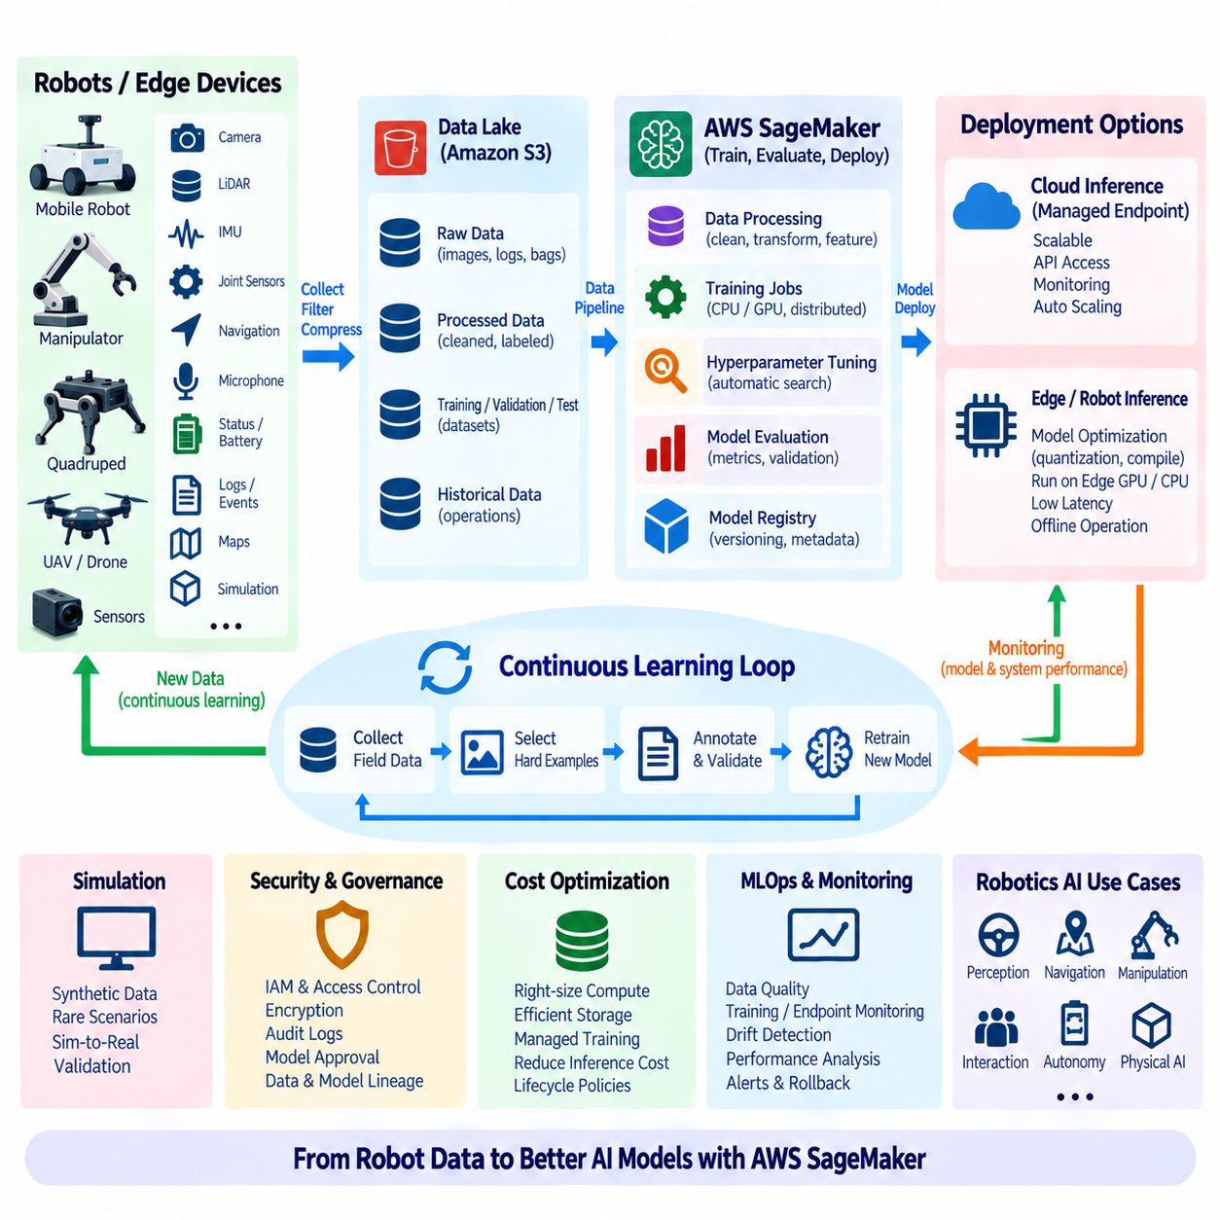
Amazon SageMaker provides managed capabilities for building, training, evaluating, and deploying machine learning models that can support robot AI development. In a robotics architecture, SageMaker is normally positioned in the cloud AI lifecycle rather than inside the robot’s deterministic control loop. Robot and edge systems collect operational data, cloud pipelines prepare datasets, SageMaker trains models, and validated model artifacts can later be deployed to suitable cloud or edge inference environments.
The workflow begins with robot-generated data. Cameras, LiDARs, depth sensors, IMUs, microphones, joint sensors, navigation systems, and application software can generate observations useful for AI development. Because raw robotics data can become extremely large, robots or edge computers may filter, compress, select, or annotate information before transfer. Amazon S3 can then provide a scalable storage foundation for training, validation, test, and historical operational datasets.
Dataset preparation is critical because model quality depends heavily on the consistency and relevance of training information. Raw robot data may contain corrupted frames, duplicated samples, timestamp errors, missing labels, inconsistent coordinate systems, or software-version differences. Processing pipelines can clean and transform these records, generate features, convert formats, and divide datasets into training, validation, and test subsets while preserving the provenance of the original observations.
SageMaker processing capabilities can support preprocessing and evaluation workloads that should be separated from the training algorithm itself. Robotics teams may resize images, normalize sensor values, convert annotations, calculate dataset statistics, or generate derived samples before training begins. Treating preprocessing as a reproducible pipeline stage makes it easier to repeat experiments when datasets, algorithms, preprocessing parameters, or robot software versions change.
A training job executes machine learning code using selected compute resources and input datasets. Depending on the workload, robotics teams may use CPU or GPU instances and choose computing capacity appropriate for model complexity and dataset size. Computer vision networks, multimodal models, perception systems, and large learning workloads can require substantial GPU resources, while smaller classification or regression models may require significantly less infrastructure.
Managed training separates model development from ownership of permanent training servers. Compute resources can be provisioned for a training job and released when the job finishes, which is useful when robotics workloads occur in campaigns rather than continuously. A team can perform intensive training after collecting new field data without maintaining the maximum required GPU capacity at all times. This elasticity becomes increasingly important as datasets and model complexity grow.
Experiment traceability should accompany training. A useful robot AI experiment records the dataset version, source code revision, preprocessing configuration, hyperparameters, training environment, model artifact, and evaluation results. Without this information, a model deployed months later may be difficult to reproduce or diagnose. Model development should therefore be treated as a controlled engineering process rather than simply storing whichever neural-network file produced the highest metric.
Hyperparameter optimization can automate repeated training experiments across different parameter combinations. Parameters such as learning rate, batch size, regularization, network configuration, or optimizer settings can materially affect model behavior. Automated searches can reduce manual experimentation, but optimization objectives must reflect meaningful robot performance. Improving a generic machine learning metric does not automatically guarantee better behavior when the model interacts with physical environments.
Model evaluation should use data that is appropriately separated from training data. For perception systems, evaluation may include precision, recall, detection quality, segmentation accuracy, latency, robustness, and failure analysis. Robot AI evaluation should also examine operationally meaningful conditions such as illumination changes, occlusion, motion blur, unusual objects, sensor degradation, environmental variation, and difficult scenarios collected from real deployments.
After evaluation, a model artifact can be stored and associated with metadata describing its origin and intended use. Model registration and version management help distinguish experimental models from candidates approved for deployment. A production robotics organization may maintain several versions simultaneously because different robot models, sensors, accelerators, sites, or software releases can require different AI artifacts even when they perform the same logical function.
Deployment does not necessarily mean hosting every robot model behind a cloud endpoint. Cloud inference can be useful for workloads that tolerate network latency and have reliable connectivity, but many robotic perception and decision functions require local execution. A camera-based obstacle detector or time-sensitive perception model may need to run directly on an edge GPU or robot computer. The deployment architecture must therefore follow latency, safety, bandwidth, availability, and hardware constraints.
For cloud inference, managed endpoints can expose trained models as scalable services that applications invoke through network APIs. This pattern can support centralized analysis, non-real-time classification, fleet-level services, or applications in which data is already located in the cloud. Endpoint monitoring, scaling, authentication, and version control are important because the inference service becomes part of the production application rather than merely an experimental machine learning resource.
For edge inference, the trained artifact must be converted into a form compatible with the target hardware and runtime. A robot may use an NVIDIA GPU, embedded accelerator, CPU, or specialized AI processor with different memory and numerical precision constraints. Model optimization can include graph transformation, quantization, compilation, or runtime-specific conversion. Validation must be repeated after optimization because deployment transformations can change numerical behavior or accuracy.
The edge deployment package should include more than the neural-network weights. Preprocessing logic, normalization parameters, label definitions, model metadata, runtime dependencies, postprocessing logic, and compatibility information may all be necessary to reproduce expected behavior. A mismatch between cloud training preprocessing and robot-side inference preprocessing can cause serious performance degradation even when the model file itself is technically correct.
A controlled model release process can connect SageMaker with broader AWS edge and device-management services. Validated model artifacts can be stored centrally, assigned versions, and distributed to selected devices through an appropriate deployment mechanism. Fleet segmentation is important because a new model should normally be evaluated on development systems or a limited robot group before broad deployment. Health checks and rollback mechanisms reduce the risk of fleet-wide AI regressions.
Continuous learning creates a feedback loop between deployed robots and cloud model development. Robots encounter environments that may not be represented adequately in the original training dataset. Difficult examples, false detections, uncertain predictions, rare events, or operator-confirmed failures can be selected and returned to the data platform. These observations can become new training or evaluation samples after appropriate validation, annotation, and governance processes.
This feedback loop should not imply uncontrolled automatic retraining and deployment. A newly trained model may improve one metric while degrading another operational condition. Training, evaluation, approval, deployment, and monitoring should remain distinct stages with explicit quality gates. For safety-relevant robotics applications, human review, simulation, controlled testing, and physical validation may be required before a new model is permitted to influence production robot behavior.
Monitoring continues after deployment because model performance can change as operating environments evolve. Data distributions may shift when lighting, floor conditions, objects, customers, sensors, robot hardware, or mission patterns change. Operational monitoring can identify changes in prediction confidence, error rates, inference latency, resource consumption, and failure patterns. Selected field data can then be returned to the training pipeline for investigation and improvement.
Simulation can complement real-world datasets during the SageMaker lifecycle. Synthetic images, simulated sensor observations, rare scenarios, and controlled environmental variations can expand training or evaluation coverage. However, simulated data should be treated with awareness of the simulation-to-reality gap. Real-world validation remains necessary because sensor noise, physical interactions, environmental complexity, and unexpected operating conditions may differ from the simulated environment.
Security and governance apply across the entire machine learning pipeline. Access to training datasets, processing jobs, model artifacts, endpoints, and deployment resources should follow least-privilege principles. Encryption, IAM permissions, logging, artifact integrity, and controlled model approval help protect the AI supply chain. Robotics organizations should also preserve enough lineage information to determine which data and software produced a model currently operating in a physical system.
Cost management requires matching resources to each lifecycle stage. Large GPU instances may be justified during intensive training but unnecessary for preprocessing or lightweight inference. Training jobs should release resources when complete, datasets should use appropriate storage policies, and repeated experiments should be designed to avoid unnecessary computation. Edge deployment can also reduce recurring cloud inference traffic when models can execute efficiently on hardware already installed in the robot.
The complete architecture therefore forms a robot-data-to-model-to-robot cycle. Robots and edge systems generate operational observations, S3 retains structured datasets, processing stages prepare training information, SageMaker executes training and evaluation, and approved model artifacts move toward cloud or edge deployment. Production results generate new observations that return to the data platform, creating an iterative engineering loop for improving robot intelligence.
For Physical AI, this lifecycle can extend beyond conventional image classification into multimodal perception, learned representations, policy components, world-model-related processing, and other data-driven robot functions. The underlying engineering principle remains consistent: scalable cloud resources perform computationally intensive development, while deployment targets are selected according to the physical system’s real-time, safety, connectivity, power, and compute constraints.
Amazon SageMaker can therefore serve as the managed machine learning layer within a broader AWS robotics architecture. It connects stored robot datasets with reproducible processing, scalable training, model evaluation, version management, deployment workflows, and operational feedback. When combined with S3, edge computing, IoT connectivity, simulation, and disciplined MLOps practices, it supports a continuous path from robot-generated data to validated AI models and controlled deployment back into robotic systems.

04.07 AWS EKS: Robot Backend Service Deployment [w/Code]
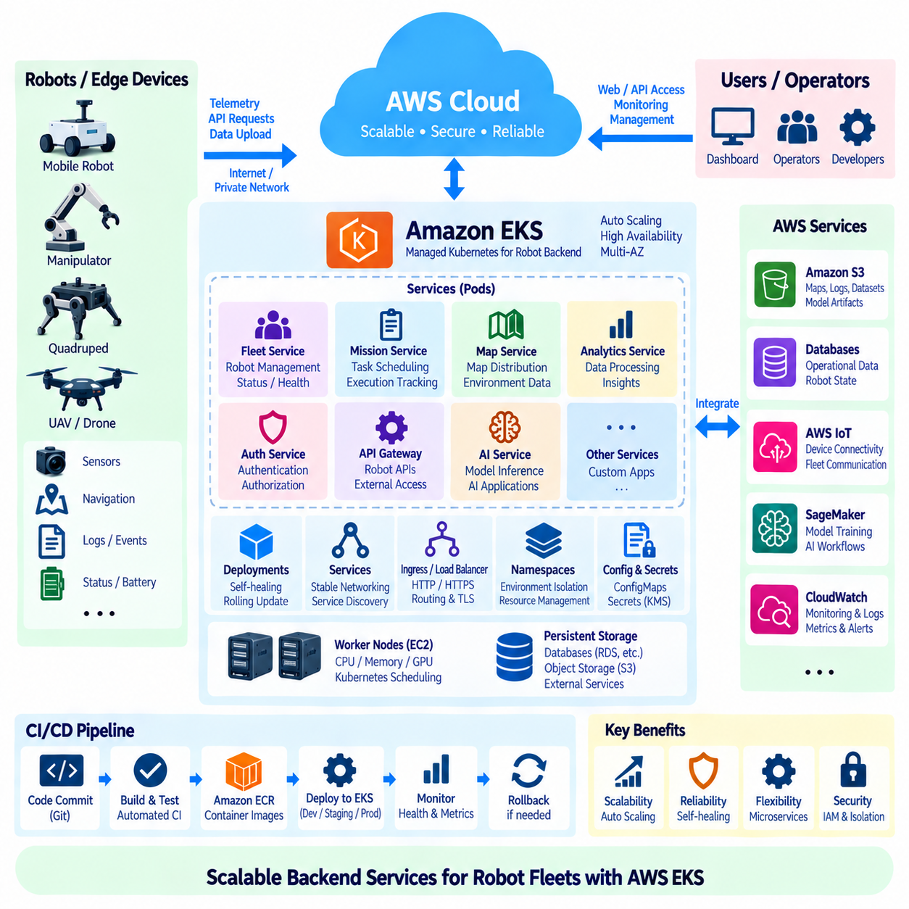
Amazon Elastic Kubernetes Service (Amazon EKS) provides a managed Kubernetes environment for deploying and operating containerized backend services used by robotic systems. In a cloud robotics architecture, EKS normally hosts fleet management, mission coordination, APIs, data services, authentication, monitoring, and AI-support applications rather than deterministic robot control. This separation allows cloud services to scale independently while real-time and safety-critical functions remain on robots or edge computers.
The architecture begins by decomposing the robot backend into services with clear responsibilities. A fleet service may track robot identity and status, a mission service may manage tasks, a map service may distribute environment information, and an analytics service may process operational events. Containerizing these functions makes their runtime dependencies explicit and allows each service to be developed, tested, deployed, scaled, and updated independently within the Kubernetes environment.
Container images provide the deployable software unit for EKS. Application code, libraries, runtime dependencies, and startup configuration are packaged into versioned images and stored in a container registry such as Amazon Elastic Container Registry (Amazon ECR). Immutable image versions improve traceability because a deployment can reference a specific artifact rather than an ambiguously changing software package. The same image can then move through development, staging, and production environments.
An EKS cluster provides the Kubernetes control environment while worker compute resources execute application Pods. Worker capacity can be supplied through EC2-based nodes or other supported compute approaches according to workload requirements. CPU-intensive backend services, memory-heavy analytics, and GPU-dependent AI services can require different resource profiles. Kubernetes scheduling enables workloads to be placed on suitable compute resources while maintaining a common orchestration framework.
Kubernetes Deployments describe how stateless backend applications should run. A Deployment specifies container images, replica counts, resource requirements, update behavior, and other execution settings. If a Pod fails, Kubernetes can create a replacement, while multiple replicas can provide additional capacity and availability. This self-healing behavior is valuable for fleet backend services that must continue operating even when individual application instances or compute nodes experience failures.
Kubernetes Services provide stable network access to groups of Pods whose individual addresses may change over time. Internal services can expose APIs only within the cluster, while externally reachable services can be connected to appropriate AWS load-balancing infrastructure. A robot fleet may communicate with public or private API endpoints depending on network architecture. Stable service discovery prevents robot-facing applications from depending on the temporary network identity of individual containers.
Ingress and load-balancing mechanisms can provide controlled entry points for HTTP or HTTPS traffic entering the backend. Requests can be routed to different services according to hostnames or paths, enabling fleet APIs, operator interfaces, and administrative functions to share managed infrastructure. Transport encryption, authentication, authorization, rate control, and API validation should be applied at appropriate layers because robot connectivity exposes operational systems to external networks.
Namespaces can logically separate Kubernetes resources belonging to different environments, teams, applications, or operational domains. Development, test, and production workloads should not be mixed without clear boundaries. Robotics deployments may also separate fleet services, analytics, monitoring, and AI workloads. Namespaces alone are not a complete security boundary, but they provide an organizational foundation for resource policies, access control, quotas, and operational management.
Configuration should remain separate from container images whenever practical. Kubernetes ConfigMaps can provide non-sensitive configuration, while secrets require protected handling through appropriate Kubernetes and AWS security mechanisms. Robot backend configuration may include service endpoints, feature settings, fleet identifiers, database parameters, and environment-specific values. Separating configuration from application images allows the same software artifact to operate consistently across multiple deployment environments.
Persistent state should also be separated from disposable application containers. Robot identities, mission histories, user information, maps, operational records, and analytical datasets generally belong in appropriate databases or storage services rather than inside Pod-local filesystems. Backend Pods can then be replaced or scaled without losing critical information. This stateless-service pattern improves resilience and simplifies rolling updates, horizontal scaling, and recovery.
Horizontal scaling is particularly important when the number of connected robots or backend requests changes over time. Kubernetes can increase or decrease application replicas according to workload indicators, while underlying compute capacity can also be adjusted when required. A fleet management service may experience higher traffic during shift changes, mass mission dispatch, software updates, or incident analysis. Elastic scaling helps the backend accommodate such variations without permanently provisioning peak capacity.
Resource requests and limits help Kubernetes understand the CPU and memory requirements of each workload. Without reasonable resource definitions, one service can consume excessive capacity and interfere with other backend functions. Robotics platforms often combine lightweight APIs with computationally expensive processing, so resource governance is essential. Workload profiling should determine suitable values rather than assigning arbitrary limits that may cause unnecessary throttling or instability.
Availability should be designed across multiple layers. Multiple Pod replicas reduce dependence on a single application instance, while worker nodes can be distributed to reduce node-level failure risk. AWS infrastructure can further support resilient deployment across Availability Zones where architecture and service requirements permit. High availability does not eliminate failures, so applications should also use retries, timeouts, idempotent operations, health checks, and graceful degradation where appropriate.
Kubernetes readiness and liveness mechanisms help distinguish whether an application is ready to receive traffic and whether it remains healthy. A newly started mission service should not receive production requests before its dependencies and internal state are ready. Likewise, an unhealthy process can be restarted when recovery is appropriate. Health checks should represent meaningful application conditions rather than merely confirming that a process exists.
Rolling deployment enables backend software to be updated gradually instead of stopping the entire service at once. New Pods can be introduced while older versions continue handling requests, allowing service availability to be maintained during routine updates. For higher-risk robotics changes, teams can use staged release patterns, limited traffic exposure, or separate environments before broad rollout. Rollback capability is important when a new backend version produces unexpected fleet behavior.
Continuous integration and continuous deployment (CI/CD) can automate the path from source code to container image and Kubernetes deployment. A typical pipeline performs code validation, automated tests, image construction, security checks, registry publication, manifest or package updates, and controlled deployment. Automation reduces manual inconsistency, but production release policies should still include explicit approval and validation gates when backend changes can influence physical robot operations.
Observability is essential because distributed backend failures can be difficult to diagnose from robot symptoms alone. Application logs, Kubernetes events, resource metrics, request latency, error rates, deployment status, and service health should be collected and correlated. Amazon CloudWatch and compatible observability tools can support monitoring and alerting. Robot identifiers, mission identifiers, timestamps, and software versions should be preserved to connect cloud events with field behavior.
Security operates at the AWS, Kubernetes, container, network, and application layers. IAM controls access to AWS resources, Kubernetes authorization controls cluster actions, and workload identities should receive only the permissions they require. Container images should be managed and inspected, sensitive information protected, network paths restricted, and administrative interfaces separated from robot-facing interfaces. Security should be treated as part of the deployment architecture rather than an additional feature added later.
Network design must recognize that robots may communicate over unreliable wireless or wide-area connections. A cloud backend should not assume permanent low-latency connectivity with every robot. APIs and messaging patterns should tolerate delayed requests, reconnection, duplicate delivery, and temporary offline operation where possible. Robots must retain enough local autonomy to enter a safe or useful operating state when cloud services or external networks become temporarily unavailable.
EKS is therefore most appropriate for supervisory and fleet-level services rather than hard real-time control. Mission assignment, fleet coordination, dashboards, user management, data APIs, software distribution, analytics, and cloud AI services are natural backend workloads. Motor control, emergency stopping, immediate obstacle avoidance, and other deterministic functions should remain on robot or edge systems where execution does not depend on Internet latency or cloud availability.
The backend can integrate with other AWS services instead of implementing every capability inside Kubernetes. Amazon S3 can store maps, logs, datasets, and artifacts; databases can maintain structured operational state; IoT services can provide device connectivity; SageMaker can support machine learning workflows; and CloudWatch can provide monitoring. EKS then acts as an orchestration layer for custom robot backend applications that connect these managed capabilities.
A complete deployment flow can begin when developers commit backend code, after which automated processes test the software and create a versioned container image. The image is stored in ECR and referenced by Kubernetes deployment configuration. EKS schedules the resulting Pods, Services expose required interfaces, monitoring verifies application health, and staged rollout mechanisms control production introduction. Operational telemetry then feeds back into debugging and future software revisions.
For large robot fleets, this architecture allows backend capacity and software organization to evolve independently from individual robot hardware. New cloud capabilities can be introduced as services, existing components can be scaled according to demand, and multiple robot generations can communicate through stable APIs. Clear interface contracts are essential so that backend upgrades do not unexpectedly break robots running older software versions in the field.
For Physical AI systems, EKS can also coordinate cloud-side services surrounding model training, world-model data processing, simulation, fleet intelligence, and policy management. These computational services may require different scaling and accelerator resources from conventional web APIs. Kubernetes provides a common orchestration model, but workload placement must still reflect latency, cost, GPU availability, data locality, and the safety boundary between cloud intelligence and physical execution.
An effective AWS EKS robotics backend therefore combines containerization, Kubernetes orchestration, elastic compute, stable networking, security, observability, persistent external storage, and automated deployment. The objective is not to move the entire robot into the cloud, but to provide a scalable service layer around autonomous machines. When cloud, edge, and robot responsibilities are clearly separated, EKS can support reliable fleet operations while preserving local autonomy and real-time physical control.

04.08 AWS CloudWatch: Robot Fleet Monitoring [w/Code]
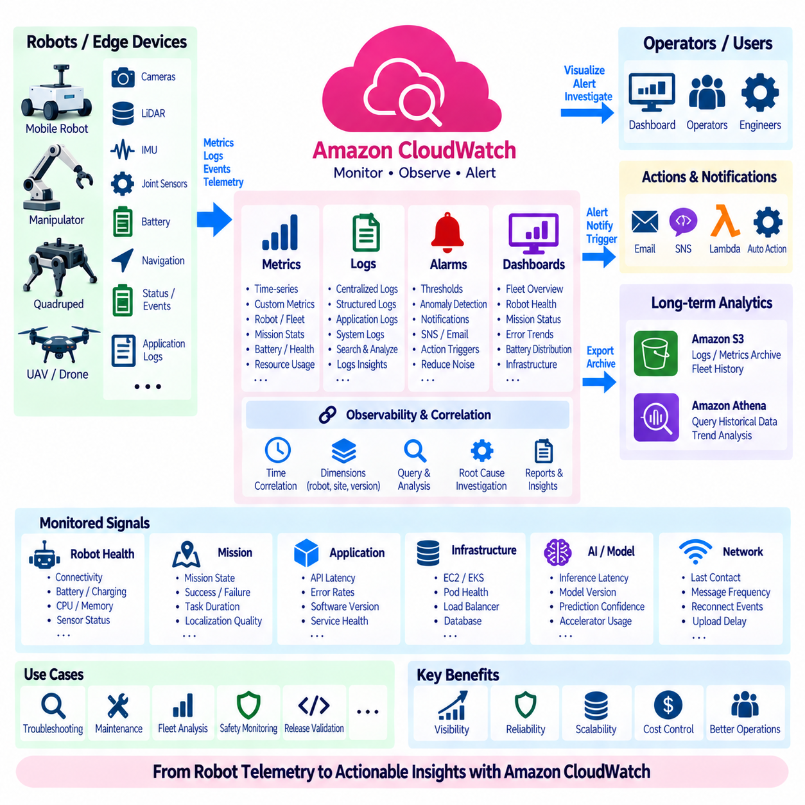
Amazon CloudWatch provides monitoring and observability capabilities for cloud applications and infrastructure supporting robot fleets. In an AWS robotics architecture, CloudWatch can collect metrics, logs, events, and operational signals from backend services, edge applications, and connected systems. It provides a centralized view of fleet health while the robot itself continues to execute real-time control, safety, perception, and motion functions locally.
Robot fleet monitoring begins by defining which operational signals are meaningful. Useful information can include robot connectivity, mission state, battery level, charging status, localization quality, navigation failures, CPU and memory utilization, sensor health, application errors, and software versions. Monitoring every available variable is rarely efficient, so telemetry should be selected according to operational, diagnostic, safety, and maintenance requirements.
CloudWatch Metrics represents numerical measurements as time-series data. Standard AWS services automatically publish many infrastructure metrics, while robotics applications can publish custom metrics describing fleet-specific behavior. Examples include active robot count, completed missions, mission failure rate, average task duration, battery state, localization recovery events, charging cycles, and backend API latency. These measurements provide quantitative visibility into system behavior over time.
Metric dimensions allow measurements to be separated according to operational context. A custom metric can include dimensions such as robot identifier, fleet, site, robot model, software version, or subsystem. This makes it possible to compare behavior across groups rather than viewing only a global average. Dimension design should remain controlled because excessive combinations can create unnecessary metric cardinality, operational complexity, and monitoring cost.
CloudWatch Logs provides centralized storage and analysis for application and infrastructure logs. Robot backend services running on EC2, EKS, Lambda, or other AWS environments can send execution logs to CloudWatch Logs, while selected robot or edge logs can also be forwarded through suitable ingestion mechanisms. Centralized logs allow engineers to investigate failures without manually retrieving every diagnostic file from individual robots.
Structured logging is particularly valuable for distributed robotic systems. Instead of storing only free-form text messages, log records can contain consistent fields such as timestamp, robot ID, mission ID, component, software version, severity, error code, and event type. These attributes make it easier to search and correlate events across cloud services and robots. Consistent identifiers are essential when reconstructing a failure that spans several distributed components.
CloudWatch Logs Insights can query and analyze log data interactively. Engineers can search for recurring error codes, identify robots generating abnormal exceptions, compare failures between software releases, or reconstruct events around a mission interruption. Log analysis becomes significantly more effective when applications use consistent timestamps and structured fields, because events from different services can then be correlated along a common operational timeline.
CloudWatch Alarms evaluate metrics against defined conditions and can change state when abnormal behavior is detected. A fleet operator might monitor high backend error rates, excessive CPU utilization, repeated mission failures, rapidly decreasing battery state, or loss of expected telemetry. Alarms should represent actionable conditions rather than every minor variation, because excessive alarms can create alert fatigue and reduce the operational value of the monitoring system.
Static thresholds are useful when acceptable operating ranges are clearly known, but not every robot metric behaves consistently across all environments. Mission duration, network latency, power consumption, and workload intensity may vary by site or robot type. Monitoring policies should therefore reflect operational context and distinguish expected variation from meaningful anomalies. Thresholds should be validated using actual fleet behavior rather than chosen without supporting evidence.
CloudWatch Dashboards can combine important metrics into operational views for engineers and fleet operators. A fleet dashboard may show connected robots, mission completion, error trends, battery distribution, backend latency, compute utilization, and site-level status. Separate dashboards can serve different audiences because an operations team requires a different level of information from a software engineer investigating a specific subsystem failure.
Fleet monitoring should follow a hierarchy from overall service health to individual robot diagnosis. A high-level view can reveal that mission success has declined at one site, after which operators can inspect affected robot groups, individual devices, missions, and component logs. This drill-down structure avoids overwhelming users with low-level telemetry while preserving access to detailed evidence when deeper investigation is required.
Time synchronization is fundamental to robot observability. A navigation event recorded on the robot, an API request observed in the cloud, and a backend exception may describe the same incident but contain different clocks or timestamps. Monitoring pipelines should preserve event time, ingestion time, and relevant timestamp provenance where necessary. Reliable time correlation makes it possible to reconstruct distributed failures and determine the sequence of events.
Connectivity itself should be treated as a monitored condition because mobile robots frequently depend on wireless networks. Monitoring can track last-contact time, message frequency, reconnect events, upload delays, or missing telemetry. However, loss of cloud connectivity should not automatically make a robot unsafe. Safety-critical responses must remain local, while cloud monitoring identifies communication problems and supports operators in diagnosing persistent or fleet-wide connectivity degradation.
CloudWatch can also monitor the AWS infrastructure supporting the robot fleet. EC2 instances, EKS workloads, load balancers, databases, APIs, storage pipelines, and other services can produce metrics and logs relevant to system health. Correlating robot symptoms with backend infrastructure conditions helps distinguish whether a failure originated on the robot, in the network, in a cloud service, or in an application dependency.
For Kubernetes-based robot backends, monitoring should include both infrastructure and application perspectives. Node resource utilization, Pod health, restart frequency, deployment status, request latency, and service errors can be observed alongside robot-oriented metrics. A robot may appear offline because its physical system failed, but similar symptoms can also occur when a backend service becomes unavailable. Cross-layer observability helps distinguish these cases.
Monitoring should also support software release management. Metrics and logs can be segmented by software version to determine whether a new robot or backend release changes failure frequency, resource consumption, latency, or mission performance. During staged deployment, teams can compare a limited release group with the existing fleet before expanding rollout. Observable degradation provides evidence for stopping deployment or initiating rollback.
AI-enabled robots introduce additional monitoring requirements. Useful signals can include inference latency, model version, prediction confidence distributions, accelerator utilization, preprocessing failures, and selected model errors. These signals do not by themselves prove model quality, but they can reveal operational changes or data drift that deserve investigation. Monitoring should connect model behavior with robot, environment, mission, and software context.
Operational monitoring and long-term analytics serve different purposes. CloudWatch is well suited to near-term observability, health monitoring, logs, alarms, and operational investigation, while large historical datasets may be retained in Amazon S3 and analyzed through services such as Athena. Important monitoring information can therefore flow into longer-term data platforms when organizations need fleet trend analysis, maintenance studies, or AI dataset construction.
Retention policies should reflect the value and volume of monitoring data. Detailed debug logs may be valuable during development but expensive and unnecessary to retain indefinitely across a large fleet. Critical fault records, mission summaries, and security events may require longer retention. Log levels and retention periods should therefore be defined intentionally so that observability remains useful without producing uncontrolled storage and ingestion costs.
Security is part of monitoring architecture because logs can contain operational details, identifiers, network information, and application state. IAM policies should restrict who can publish, read, query, or modify monitoring resources. Encryption, controlled log access, audit trails, and appropriate separation between development and production environments help prevent observability infrastructure from becoming an unintended source of sensitive information.
Monitoring cost should be engineered alongside monitoring coverage. High-frequency custom metrics, excessive dimensions, verbose logs, and unnecessary retention can increase cloud consumption significantly when multiplied across hundreds or thousands of robots. Edge aggregation, selective logging, appropriate metric periods, controlled dimensions, and retention policies can reduce cost while preserving the information required for reliable operations and diagnosis.
An effective alerting workflow should connect detection with operational response. An alarm is useful only when operators know what the condition means, which robots or services are affected, and what action should follow. Alerts can reference dashboards, logs, diagnostic procedures, or automated workflows. Severity levels can distinguish informational events from conditions requiring immediate investigation, helping teams focus attention on meaningful operational risks.
Observability can ultimately create a feedback loop for reliability improvement. Repeated failures identified through metrics and logs can become engineering issues, regression tests, maintenance rules, or new AI evaluation scenarios. Fleet monitoring therefore does more than display current status. It converts production behavior into evidence that can improve software, hardware, operating procedures, datasets, and future robot designs.
The complete monitoring architecture connects robots, edge systems, communication infrastructure, cloud backends, and operational applications through shared observability signals. CloudWatch provides metrics, logs, queries, dashboards, and alarms, while longer-term data services retain historical evidence. The robot remains responsible for immediate physical safety, whereas cloud monitoring provides fleet-wide awareness, diagnosis, trend detection, and operational coordination.
AWS CloudWatch can therefore function as the observability layer surrounding a cloud-connected robot fleet. When telemetry selection, structured logging, metrics, alarms, dashboards, time correlation, security, retention, and cost controls are designed together, operators gain a coherent view from fleet-level health down to individual failures. This visibility supports scalable operations without confusing cloud supervision with the robot’s local real-time control responsibilities.

04.09 AWS Security Hardening: IAM Roles / KMS
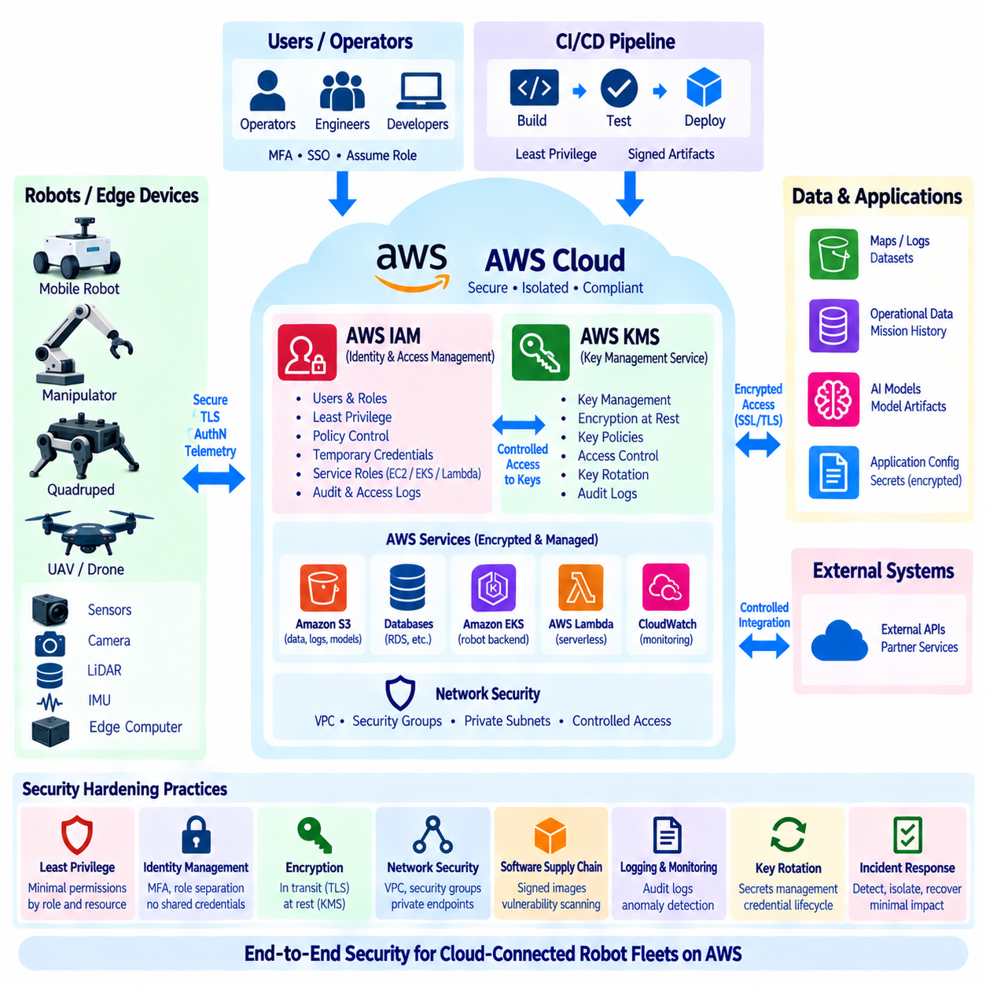
Security hardening for an AWS robotics platform begins with the assumption that robots, edge computers, cloud services, operators, and development systems form one distributed security boundary. A compromise in one layer can affect fleet operations or expose sensitive data. Security must therefore be designed across identity, authorization, encryption, networking, software deployment, monitoring, and operational procedures rather than added after the system is deployed.
AWS Identity and Access Management (IAM) provides the foundation for controlling access to AWS resources. IAM policies define which principals can perform specific actions on selected resources and under which conditions. In a robotics environment, developers, operators, CI/CD systems, backend workloads, analytics jobs, and device-management services should receive permissions appropriate to their responsibilities instead of sharing broad administrative credentials.
The principle of least privilege should guide IAM design. A fleet monitoring service that only reads telemetry does not need permission to modify deployment resources, while a model deployment service does not automatically require access to unrelated customer datasets. Permissions should be narrowed by action, resource, and condition wherever practical. This reduces the potential impact of compromised credentials, software defects, and unintended administrative operations.
IAM roles provide temporary AWS credentials to authorized users, applications, and services without requiring long-lived access keys to be embedded in software. EC2 instances, EKS workloads, Lambda functions, and other AWS services can assume roles designed for their specific responsibilities. For robot backend systems, this allows each service to obtain only the AWS permissions it needs while reducing dependence on manually distributed static credentials.
Role separation should follow system responsibilities. A telemetry ingestion role may write robot data to selected storage locations, an analytics role may read approved datasets, and a deployment role may update defined application resources. Administrative roles should remain separate from normal operational roles. Clear separation limits privilege propagation and makes audit records easier to interpret because actions can be associated with specific functional identities.
Human access should also be separated from machine access. Engineers and operators should authenticate through controlled identity mechanisms and assume roles appropriate to their tasks, while workloads should use service or workload identities. Shared user accounts and credentials make accountability difficult. Strong authentication, temporary sessions, and multi-factor authentication for privileged operations can reduce the risk associated with stolen passwords or persistent credentials.
Amazon EKS environments require coordination between AWS identity and Kubernetes authorization. AWS permissions determine access to AWS resources, while Kubernetes mechanisms govern operations within the cluster. Workloads should receive dedicated identities instead of inheriting broad node permissions whenever possible. A robot mission service, analytics component, and monitoring application may require different AWS access even when they execute within the same Kubernetes cluster.
Robot and edge identities require similar discipline. Each device should have a distinguishable identity so that credentials can be revoked or policies changed without affecting the entire fleet. Sharing one credential among many robots increases the blast radius of compromise. Device provisioning should establish identity securely, while lifecycle processes should support certificate or credential rotation, replacement, revocation, and decommissioning.
Encryption in transit protects information moving between robots, edge systems, cloud endpoints, and backend services. TLS should be used where supported so that telemetry, commands, API requests, software artifacts, and management traffic are protected against interception and modification. Encryption does not replace authentication or authorization; secure communication requires verification of identity and enforcement of permissions in addition to protecting network traffic.
Encryption at rest protects data stored in services such as Amazon S3, databases, logs, snapshots, and other persistent resources. Robot fleets can retain maps, sensor records, mission histories, diagnostic logs, AI datasets, and model artifacts that may contain sensitive operational information. Encryption policies should therefore be applied according to data classification, operational requirements, regulatory obligations, and recovery needs.
AWS Key Management Service (AWS KMS) provides centralized management of cryptographic keys used by supported AWS services and applications. KMS keys can be associated with encrypted S3 objects, database resources, storage volumes, logs, secrets, and other protected data. Central key management helps organizations define who may use particular keys, record key-related activity, and separate cryptographic control from ordinary application access.
KMS key policies and IAM policies must be designed together. Permission to access an encrypted object does not automatically mean that every principal should be allowed to use the key required to decrypt it. Separating data permissions from key permissions creates an additional control layer. Sensitive robotics datasets can therefore require both authorization to the storage resource and authorization to perform the necessary cryptographic operation.
Key separation can reflect data sensitivity and operational boundaries. Development datasets, production fleet information, customer-specific data, security logs, and model artifacts may use different keys when isolation requirements justify it. This makes it possible to control access, rotation, auditing, and incident response at a finer level. Excessive key fragmentation, however, can create operational complexity, so separation should follow meaningful security boundaries.
Secrets such as database passwords, API credentials, tokens, and private configuration values should not be embedded directly in source code, container images, deployment manifests, or robot application packages. Appropriate secret-management mechanisms should provide controlled retrieval at runtime. Access to secrets should be limited to the workloads that require them, and secret rotation should be planned so credentials can be replaced without rebuilding an entire robotics platform.
Network hardening reduces unnecessary exposure between components. Cloud services can be placed in appropriate public or private network segments, security groups can restrict traffic, and administrative interfaces can be separated from robot-facing endpoints. Backend databases generally should not become directly reachable simply because robot APIs require external connectivity. Network paths should expose only the protocols and destinations necessary for intended operation.
Robot-to-cloud communication should treat all externally received commands and configuration as untrusted until validated. Authentication confirms who sent a request, but application-level checks must still verify message format, authorization context, freshness, permitted operating range, and expected state. A valid cloud identity should never become an unrestricted path to actuators. Safety limits and immediate physical protection must remain enforced locally.
Software supply-chain security is another important hardening layer. Container images, robot packages, dependencies, AI models, and deployment artifacts should have identifiable versions and controlled sources. CI/CD pipelines should restrict who can publish production artifacts and preserve evidence linking deployed software to reviewed source and build processes. Vulnerability scanning and dependency management help identify known weaknesses before software reaches production systems.
Production and development environments should be separated to reduce accidental cross-environment access. Test credentials, experimental services, temporary datasets, and development containers should not automatically receive production permissions. Separate accounts, roles, namespaces, networks, or other boundaries can be used according to system scale. The objective is to prevent experimentation from becoming an unintended administrative path into operational robot infrastructure.
Logging and auditing are necessary because preventive controls cannot eliminate every security incident. AWS activity records, application logs, authentication events, deployment histories, and security-relevant robot events should provide enough evidence to determine what occurred. Monitoring can identify unusual access attempts, unexpected policy changes, repeated authentication failures, or abnormal resource activity and can trigger investigation before a problem expands.
Security monitoring should be connected to incident response procedures. When a robot credential, backend service, user account, or deployment artifact is suspected of compromise, operators should know how to isolate the affected identity, revoke access, rotate credentials, preserve evidence, and restore trusted operation. Fleet architecture should allow individual robots or services to be contained without unnecessarily disabling the entire robotic system.
Backup and recovery design must include security considerations. Encrypted backups are valuable only when the required keys and permissions remain recoverable under controlled conditions. Conversely, overly broad recovery access can bypass normal production protections. Organizations should test restoration procedures, key availability, identity recovery, and emergency administrative processes so that security controls remain effective during failures and disaster recovery operations.
Security hardening also requires continuous review because robot fleets evolve. New sensors, cloud services, APIs, software versions, AI models, sites, and external integrations can introduce additional trust relationships. IAM policies that were appropriate during a prototype may become overly broad in production. Periodic review should identify unused permissions, obsolete credentials, exposed endpoints, outdated software, and security assumptions that no longer match the deployed architecture.
For Physical AI systems, the security boundary extends from cloud data and AI pipelines to machines capable of physical action. Model artifacts, policies, configuration, maps, and mission commands can influence robot behavior even when they are not conventional control signals. Their integrity and provenance therefore matter. Security architecture should protect not only confidentiality but also the authenticity and integrity of information that can affect physical decisions.
A defense-in-depth architecture combines multiple controls so that failure of one mechanism does not automatically compromise the entire fleet. Device identity, IAM roles, least privilege, network segmentation, TLS, encryption at rest, KMS, secret protection, artifact control, monitoring, and local safety enforcement address different attack paths. No single AWS service provides complete robot security; protection emerges from coordinated controls across the complete robot-edge-cloud system.
Effective AWS security hardening therefore establishes explicit trust boundaries and minimizes unnecessary authority throughout the robotics platform. IAM and roles determine who or what may perform actions, KMS protects cryptographic control over sensitive data, network and application policies restrict communication, and monitoring provides evidence of system activity. Combined with secure robot-side execution, these controls create a scalable security foundation for cloud-connected robot fleets.

04.10 AWS-Based Robot Fleet Operation Cost Optimization
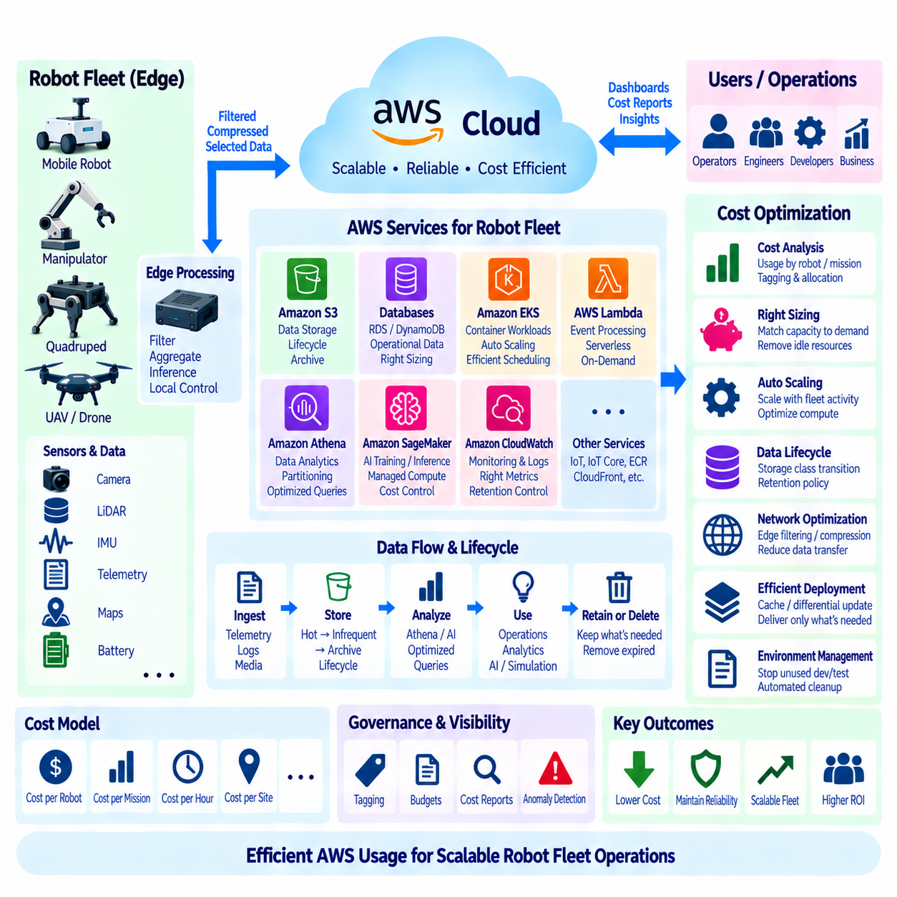
Operating a robot fleet on AWS requires cost optimization across the complete robot-edge-cloud architecture rather than simply reducing the price of individual cloud services. Compute, storage, networking, telemetry, databases, monitoring, AI training, and software deployment can all contribute to recurring expenditure. The objective is to match cloud resources to operational value while preserving fleet reliability, security, scalability, and robot autonomy.
Cost analysis should begin by identifying how robot activity creates cloud consumption. Each robot may generate telemetry, logs, images, maps, sensor records, mission events, API requests, and software update traffic. Backend applications consume compute and database resources, while analytics and AI pipelines add processing and storage demand. Mapping these flows makes it possible to understand which fleet behaviors are responsible for specific AWS costs.
A useful cost model separates fixed infrastructure from variable fleet consumption. Some backend services may require a minimum operating capacity regardless of robot count, while storage, messages, API calls, analytics, and data transfer can grow with fleet activity. Cost per robot, cost per mission, cost per operating hour, or cost per site can provide more meaningful indicators than a single monthly cloud bill because they connect spending directly with operational scale.
Workload placement is one of the most important cost decisions. Sending every camera frame, LiDAR scan, or high-frequency sensor measurement to the cloud can create substantial network, storage, and processing demand. Edge computers can filter, aggregate, compress, or summarize data before transmission. Local execution is especially appropriate when information is required for immediate robot control and does not provide enough long-term value to justify continuous cloud transfer.
Telemetry should therefore be designed according to information value. High-frequency internal control variables may remain local, while mission status, health indicators, exceptions, summaries, and selected diagnostic samples are transmitted to the cloud. During an incident, a robot can temporarily increase diagnostic detail when architecture permits. This adaptive approach can preserve operational visibility without maintaining maximum telemetry volume during normal fleet operation.
Amazon S3 can support cost-efficient storage when robot data is organized according to its access pattern and lifecycle. Recently collected operational data may require frequent access, while older logs, completed mission records, historical sensor datasets, and archived AI data may be accessed less often. Storage lifecycle policies can move appropriate objects to lower-cost storage classes or remove data after its required retention period has expired.
Retention policies should be defined by the purpose of each dataset rather than by an assumption that all robot data must be preserved indefinitely. Safety records, security events, AI training samples, debugging information, and routine telemetry may require different retention periods. Duplicate files and obsolete intermediate artifacts should also be controlled. Data classification and lifecycle management prevent long-running fleets from accumulating storage without corresponding operational value.
Data format also influences storage and analytics cost. Compact structured formats, compression, partitioning, and efficient object organization can reduce the amount of data scanned or transferred during analysis. Large collections of small files can create management and query inefficiencies, while poorly partitioned historical data can cause analytics jobs to process much more information than necessary. Data architecture should therefore consider both analytical usability and cloud consumption.
Amazon Athena enables serverless analysis of data stored in S3, but query design directly affects cost because unnecessary data scanning creates unnecessary consumption. Partitioning by dimensions such as date, site, fleet, robot, or data type can reduce the amount of information examined by a query. Column-oriented formats can further improve analytical efficiency when workloads need only selected fields from large robot datasets.
Compute resources should be matched to actual workload requirements. Robot backend services running on EC2 or EKS should not remain permanently oversized for rare peak conditions when scaling mechanisms can handle changing demand. CPU, memory, network, and accelerator utilization should be measured before selecting capacity. Rightsizing based on observed workloads can reduce waste while avoiding arbitrary resource reductions that damage application reliability.
Elastic scaling allows backend capacity to follow fleet demand. Mission services, APIs, analytics workers, and processing applications may experience predictable or temporary workload increases. Horizontal scaling can add application instances during high demand and reduce them when traffic falls. The underlying compute layer should also be designed so that unused capacity does not remain indefinitely after application demand has decreased.
Containerized workloads require resource governance because inefficient Kubernetes configurations can create hidden waste. Excessive CPU and memory requests may reserve capacity that applications never use, while limits that are too small can cause throttling or instability. EKS workloads should be profiled using operational measurements, and node capacity should be aligned with actual Pod requirements. Scheduling efficiency becomes increasingly important as the number of backend services grows.
Different purchasing and capacity models can be appropriate for different workloads. Predictable baseline services and interruptible batch processing do not necessarily require the same compute strategy. Training, simulation, offline analytics, and large preprocessing jobs may tolerate flexible execution patterns, while production fleet APIs may require stable availability. Cost optimization should therefore classify workloads by duration, interruption tolerance, performance needs, and operational criticality.
AI training can become a major cost center because GPU resources are expensive relative to general-purpose compute. Training jobs should provision accelerators only when needed and release them after completion. Dataset preparation and lightweight processing do not automatically require the same GPU resources as model training. Experiment tracking also helps teams avoid repeating expensive training runs simply because previous configurations or results were not recorded correctly.
Simulation workloads have similar elasticity opportunities. Large-scale robot simulations may require substantial compute for limited periods during development, validation, or release testing. Cloud resources can be provisioned for these campaigns and removed afterward instead of being maintained continuously. Simulation scenarios, output data, and artifacts should also have retention policies so temporary validation workloads do not create permanent storage growth.
Monitoring costs can increase rapidly when each robot publishes many high-frequency custom metrics and verbose logs. CloudWatch configurations should prioritize actionable metrics, appropriate collection periods, controlled dimensions, and useful log levels. Debug logging may be temporarily enabled during investigation rather than permanently across an entire fleet. Log retention should also reflect diagnostic and compliance requirements instead of using unlimited retention by default.
Network consumption should be included in architecture decisions because robot fleets can continuously move data among devices, sites, AWS services, and external systems. Video, point clouds, maps, model packages, and software updates are particularly important to control. Edge filtering, compression, caching, incremental updates, and scheduled transfer can reduce unnecessary traffic while still delivering the information required by fleet applications.
Software and model distribution should avoid repeatedly transferring identical large artifacts when more efficient mechanisms are available. Versioned packages, local caching, differential updates, and site-level distribution strategies can reduce redundant traffic. Deployment systems should identify which robots actually require a new artifact rather than broadcasting every package to the entire fleet. This becomes increasingly important when fleets operate across many facilities or wide-area networks.
Database cost depends on workload design as well as instance capacity. High-frequency writes, inefficient queries, excessive indexes, unnecessary replicas, and poorly defined retention can increase consumption. Operational state should be modeled according to access patterns, while large raw sensor datasets usually belong in object storage rather than transactional databases. Separating operational databases from historical data platforms helps each storage technology serve the workload for which it is suited.
High availability and disaster recovery introduce deliberate redundancy, so cost optimization should not remove resources that exist for reliability requirements without understanding their purpose. Multiple replicas, backup copies, additional Availability Zones, and recovery environments may appear underutilized during normal operation but provide resilience during failures. Optimization should distinguish waste from intentional redundancy and relate reliability expenditure to defined service objectives.
Development, test, staging, and demonstration environments should also be managed intentionally. Non-production resources can remain active long after engineers finish using them if shutdown and cleanup processes are not established. Temporary clusters, compute instances, test databases, simulation resources, and experimental storage should have ownership and lifecycle rules. Automated scheduling or environment teardown can reduce consumption that provides no value outside working or testing periods.
Cost allocation becomes more useful when resources are associated with meaningful organizational dimensions. Tags and account structures can help attribute spending to fleets, sites, projects, environments, applications, or teams. This enables engineers and managers to identify which systems create increasing consumption and whether that growth corresponds to operational expansion. Cost visibility should support engineering decisions rather than exist only as a financial reporting activity.
Budgets, cost reports, and anomaly detection can provide early warning when consumption differs significantly from expectations. A sudden increase may indicate a software defect, excessive logging, unexpected data transfer, a scaling configuration problem, or legitimate fleet growth. Cost monitoring should therefore be connected with technical observability. Engineers need enough context to determine whether a financial anomaly represents waste, failure, or expected operational activity.
The most effective optimization process is continuous because fleet behavior changes as robot count, missions, software, sensors, AI models, and sites evolve. Architecture decisions that are economical for ten robots may behave differently at hundreds or thousands of devices. Teams should periodically review unit costs, utilization, data growth, telemetry volume, storage retention, scaling behavior, and major service contributors instead of treating cost optimization as a one-time activity.
For Physical AI systems, cost optimization should preserve the architectural boundary between physical execution and cloud intelligence. Moving suitable filtering and inference to the edge can reduce network and cloud consumption while supporting low-latency operation, whereas centralized cloud resources remain valuable for fleet analytics, large-scale training, simulation, data management, and collective intelligence. The optimal design balances computation location with latency, data value, reliability, and cost.
An AWS-based robot fleet can therefore optimize cost through coordinated decisions across workload placement, telemetry, storage lifecycle, analytics, compute sizing, elastic scaling, AI training, simulation, monitoring, networking, databases, and deployment. The goal is not minimum cloud spending at any cost, but efficient consumption per unit of useful robot operation. A well-designed architecture allows cloud expenditure to grow predictably with fleet value while maintaining reliability, security, and scalable autonomy.

