Volume 09 Cloud and Edge Robotics

11. 5G and Private Network

11.01 5G NR Architecture: NSA, SA Mode, Slicing
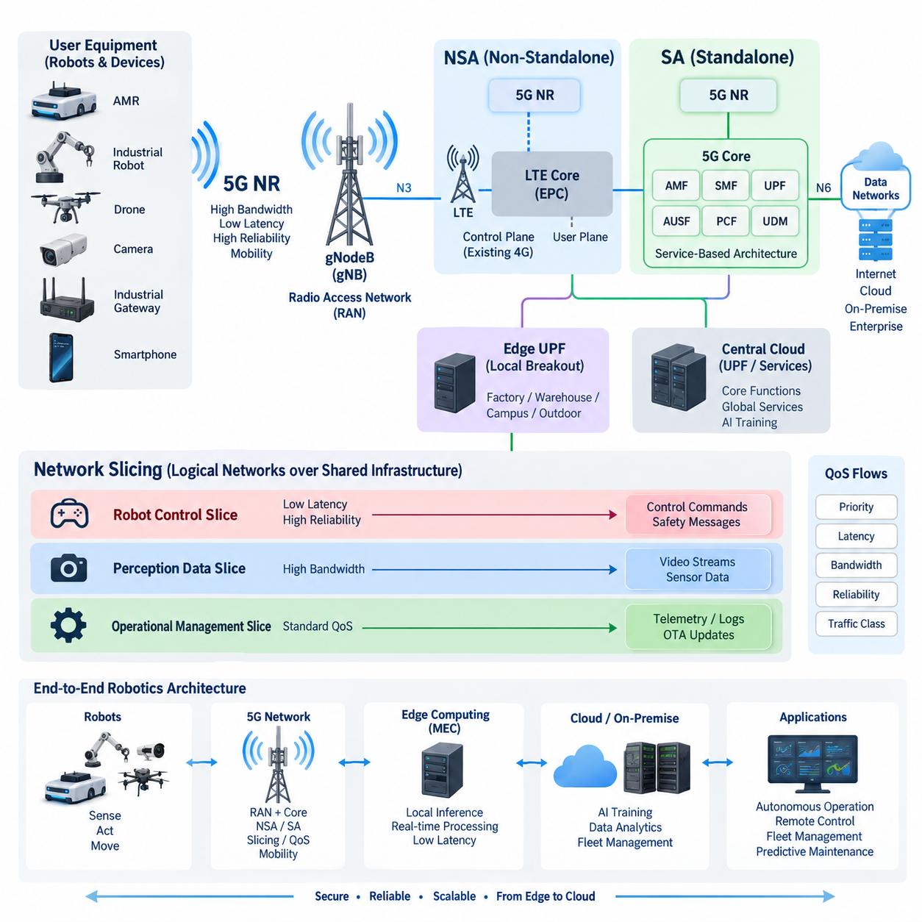
5G New Radio is the radio access technology defined for fifth-generation mobile systems. Its architecture separates the radio access network, transport infrastructure, and core network so that each layer can evolve independently while still providing an integrated communication service. For robotics, this separation is important because connectivity can be designed around latency, reliability, mobility, bandwidth, and security requirements rather than treating wireless access as a simple replacement for Wi-Fi or Ethernet.
A 5G system connects user equipment such as smartphones, industrial gateways, autonomous mobile robots, cameras, and embedded 5G modems to the radio access network through a 5G NR air interface. The principal radio node is the gNodeB, commonly abbreviated as gNB. It manages radio resources, scheduling, mobility procedures, and communication between devices and the core network. In robot systems, the gNB therefore becomes the wireless access point through which telemetry, commands, video, maps, and operational data enter the broader edge-cloud infrastructure.
5G deployment can broadly follow Non-Standalone and Standalone architectures. Non-Standalone, or NSA, was designed as an evolutionary path that allows operators to introduce 5G NR while continuing to use significant parts of an existing LTE infrastructure. In a typical NSA deployment, LTE provides important control-plane functions while NR adds high-capacity radio resources. This approach enables faster deployment because existing LTE networks, spectrum assets, operational systems, and core infrastructure can continue to be utilized during the transition toward full 5G.
NSA is particularly useful when an organization primarily needs increased wireless throughput without immediately replacing its complete mobile network architecture. Robots may obtain higher data rates through NR while established LTE infrastructure continues to support connectivity management. However, because NSA remains dependent on elements of the 4G architecture, it cannot expose the complete architectural capabilities associated with a native 5G core. This distinction becomes important when evaluating advanced industrial services such as network slicing, localized edge services, and highly differentiated traffic policies.
Standalone, or SA, architecture removes this dependency by connecting 5G NR directly to a 5G Core. The resulting system is designed around service-based network functions rather than simply extending the LTE architecture. Major 5G Core functions include the Access and Mobility Management Function, Session Management Function, User Plane Function, authentication functions, policy control, and network repository services. Together they manage device registration, mobility, sessions, traffic forwarding, authentication, policy enforcement, and access to data networks.
The separation between control-plane and user-plane functions is especially valuable for distributed robot systems. A User Plane Function can be positioned close to a factory, warehouse, logistics center, or outdoor robot operating area while higher-level control functions remain elsewhere. Robot traffic can therefore be routed toward a nearby edge application without unnecessarily traversing a distant central cloud. This local breakout architecture reduces transport distance and can improve latency consistency while limiting the amount of operational data that must leave the local environment.
SA architecture also provides a stronger foundation for private 5G networks. A manufacturing site can deploy dedicated radio infrastructure, core network functions, subscriber management, security policies, and edge computing resources according to its operational requirements. Robots can then communicate through an infrastructure designed specifically for industrial traffic instead of sharing all network behavior with general-purpose users. Such deployment does not automatically guarantee deterministic robot control, but it provides mechanisms through which traffic classes and operational policies can be engineered more systematically.
One of the major concepts enabled by the 5G architecture is network slicing. A network slice represents a logical network environment created over shared physical infrastructure. Different slices can be configured with different service characteristics, policies, resource behavior, and logical network functions. The objective is not merely to create another virtual LAN. Slicing extends across mobile network functions and can associate particular devices, sessions, and services with logically differentiated network behavior.
A robot fleet illustrates why this capability matters. Safety-related operational messages, fleet-management commands, high-resolution camera streams, diagnostic logs, software updates, and background telemetry have very different communication characteristics. Control traffic may require low latency and high reliability while camera streams require substantial bandwidth. OTA packages may transfer large amounts of data but tolerate scheduling delays. Placing every workload into the same undifferentiated communication path can cause resource contention and make service behavior difficult to control.
Network slicing allows these workloads to be separated logically. A robot-control slice can emphasize latency and reliability, a perception-data slice can emphasize throughput, and an operational-management slice can carry telemetry, diagnostics, and maintenance traffic. Slice selection can be combined with QoS policies so that traffic treatment reflects application requirements. The physical radio and transport infrastructure may still be shared, but the logical service architecture provides mechanisms for separating policies and allocating resources according to operational priorities.
QoS flows provide a finer level of traffic differentiation within 5G sessions. Instead of assuming that every packet associated with a robot requires identical treatment, the network can classify traffic according to characteristics such as priority, delay requirements, and packet handling behavior. A robot may therefore maintain communication for motion-related commands while simultaneously transmitting video, health information, and application logs. Correct QoS design prevents high-volume traffic from being treated as if it were equivalent to latency-sensitive operational traffic.
For cloud and edge robotics, the combination of SA, slicing, QoS, and local user-plane placement creates an important architectural bridge between robots and computing infrastructure. Perception workloads may execute locally on the robot, at a nearby Multi-access Edge Computing platform, on an on-premise GPU cluster, or in a cloud environment. The network architecture determines how these computing domains are connected and which traffic should remain local. Communication architecture consequently becomes part of workload-placement design rather than an independent networking concern.
Mobility is another important advantage of cellular architecture for autonomous systems. AMRs, outdoor robots, inspection platforms, and mobile machines continuously change their physical position while maintaining application sessions. The radio access and core networks coordinate mobility so that devices can move between coverage areas without requiring applications to rebuild connectivity from the beginning. Effective deployment nevertheless requires careful radio planning because handover behavior, interference, signal blockage, antenna placement, and coverage gaps can directly influence robot communication quality.
NSA and SA should therefore be understood as different architectural stages rather than simply two radio modes. NSA combines 5G NR with existing LTE and evolved packet core infrastructure, making it suitable for incremental migration and rapid introduction of higher radio capacity. SA uses NR together with the 5G Core and provides the native architectural foundation required for capabilities such as advanced slicing, flexible user-plane placement, and more sophisticated service differentiation.
For industrial robotics, the choice among NSA, public SA, and private SA should ultimately follow system requirements. Applications dominated by cloud telemetry or high-bandwidth data transfer may operate effectively without exploiting every native 5G capability. Applications involving large robot fleets, localized edge computing, differentiated QoS, security segmentation, or tightly managed operational traffic can benefit more strongly from SA and private-network architectures. The correct design begins with robot workloads and service requirements, then maps them to radio, core, edge, and cloud resources.
Within a cloud-and-edge robotics architecture, 5G NR should therefore be treated as programmable communication infrastructure rather than only as a faster wireless link. NSA provides a practical transition from LTE toward 5G radio capabilities, while SA establishes an end-to-end 5G architecture capable of supporting more flexible traffic engineering and network slicing. Combined with edge computing and robot fleet services, these mechanisms create a communication foundation for scalable industrial and Physical AI systems.

11.02 5G URLLC: Ultra-Low Latency for Robot Control
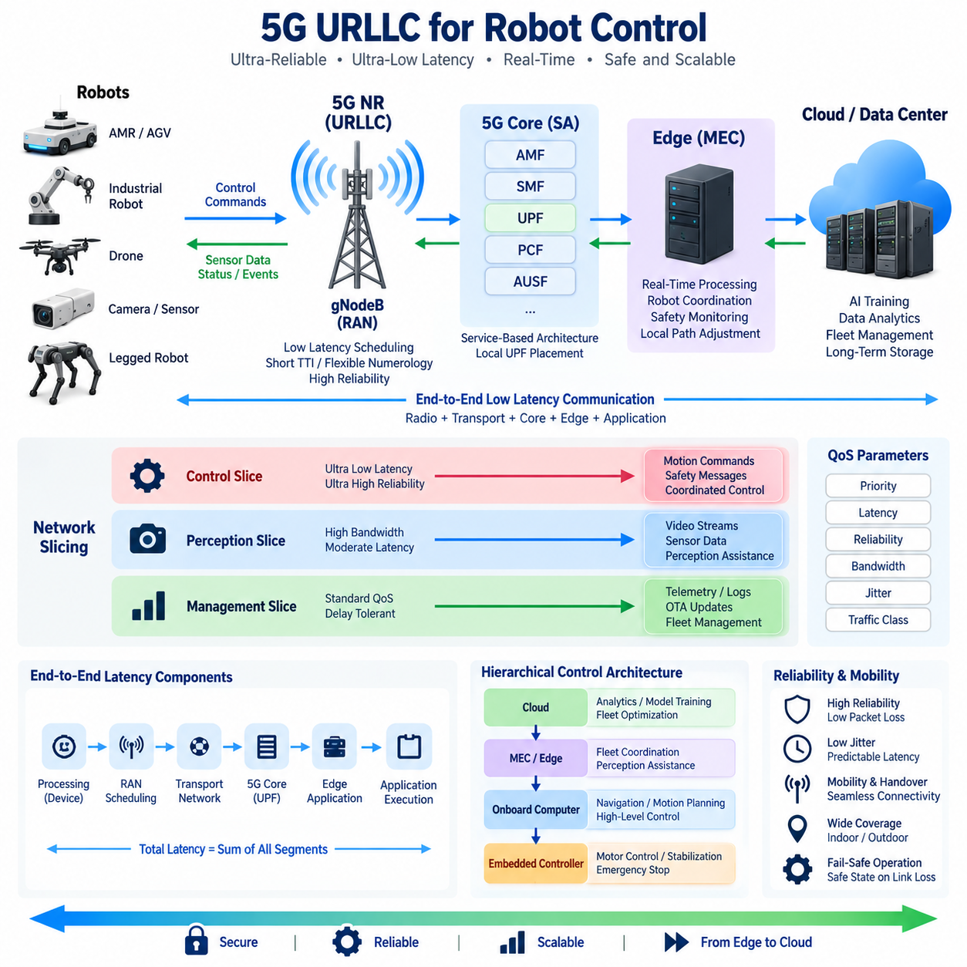
Ultra-Reliable Low-Latency Communication, commonly abbreviated as URLLC, is a 5G service capability designed for applications in which communication delay and delivery reliability are operationally critical. In robotics, URLLC is relevant to control commands, safety events, coordinated motion, and other time-sensitive exchanges where delayed or lost packets can directly affect robot behavior. Its purpose is therefore different from simply maximizing wireless throughput.
Robot communication latency must be considered as an end-to-end property rather than only the transmission time of the 5G radio link. A control message may travel from a robot controller through the radio access network, transport network, 5G Core, User Plane Function, and edge application before a response returns. Processing, queueing, scheduling, routing, and application execution all contribute to the total delay, so low radio latency alone cannot guarantee low control-loop latency.
5G NR supports low-latency operation through mechanisms that reduce the time required to schedule and transmit data. Shorter transmission intervals, flexible numerology, rapid scheduling, and appropriately configured radio resources can reduce waiting time before packets are transmitted. These mechanisms are particularly useful when control traffic consists of relatively small packets that must be delivered frequently rather than large continuous data streams such as high-resolution video.
Reliability is equally important because extremely fast communication has limited value if packets are frequently lost or require unpredictable retransmissions. URLLC therefore combines latency objectives with high delivery reliability. Radio configuration, interference management, packet duplication, retransmission strategies, diversity, coverage planning, and resource reservation can all contribute to dependable communication. The practical engineering objective is to minimize both communication delay and the probability of missing the required delivery deadline.
For robot control, average latency is often less informative than latency distribution and worst-case behavior. A system that normally delivers packets quickly but occasionally produces large delays may create unstable or unsafe operating conditions. Jitter, which represents variation in packet delay, is therefore an important design parameter. Control architectures should evaluate percentile latency, packet loss, deadline violations, and communication availability rather than relying only on a single average round-trip-time measurement.
Standalone 5G architecture provides a useful foundation for URLLC-oriented robot systems because the 5G Core allows flexible traffic management and user-plane placement. A User Plane Function can be deployed near the robot operating environment, allowing control traffic to reach a local application without traveling through a distant centralized cloud. Combined with local breakout, this architecture can shorten the communication path and reduce dependency on wide-area network conditions.
Multi-access Edge Computing, or MEC, extends this principle by placing computing resources close to the radio network. Instead of sending every sensor event or control request to a remote cloud region, latency-sensitive functions can execute on a nearby edge server. Robot coordination, local path adjustment, safety monitoring, perception assistance, and fleet-level traffic management are examples of workloads that may benefit from this architecture when their computational and communication requirements justify edge execution.
Quality of Service is essential because a robot normally generates several traffic classes simultaneously. Motion commands, emergency messages, localization information, camera streams, telemetry, diagnostic logs, and OTA packages should not automatically receive identical network treatment. QoS mechanisms can prioritize latency-sensitive traffic while allowing bandwidth-intensive or delay-tolerant workloads to use different service characteristics, reducing the risk that background transfers interfere with operational control messages.
Network slicing can provide another logical layer for separating robot communication services. A control-oriented slice can be designed around latency and reliability requirements, while a perception-data slice emphasizes bandwidth and an operational-management slice carries telemetry, logs, and maintenance traffic. Slicing does not eliminate the need for adequate physical capacity, radio coverage, or QoS engineering, but it provides a framework for associating different robot workloads with differentiated network behavior.
The robot itself must also be designed so that wireless communication is not the only mechanism preserving safe operation. High-frequency motor current control, actuator stabilization, emergency stopping logic, and other functions requiring tightly bounded response should generally remain on local controllers when appropriate. 5G can then support supervisory commands, coordinated behaviors, remote assistance, fleet interaction, or selected distributed control functions while local safety mechanisms continue operating if connectivity becomes degraded.
This distinction produces a hierarchical control architecture. Fast inner control loops can execute on embedded controllers inside the robot, higher-level motion and navigation functions can run on the onboard computer, and fleet coordination or computationally demanding services can operate at the MEC or local data center. Cloud systems can handle workloads such as analytics, model training, historical storage, and long-term optimization. Communication requirements become less stringent as functions move away from immediate physical control.
Mobility adds another challenge because autonomous robots move through changing radio environments. Signal strength, interference, obstacles, reflections, handovers, and cell loading can alter communication performance while the robot is operating. A URLLC-oriented deployment therefore requires radio planning that considers the actual robot routes and operating conditions. Measurements should be performed while robots are moving through representative areas rather than evaluating network performance only from stationary test locations.
Private 5G can be useful where an organization needs greater control over radio resources, network configuration, device access, traffic policies, and edge infrastructure. A factory or logistics site can engineer coverage around robot operating zones and connect the private core to local MEC resources. This provides greater architectural control than relying entirely on a general-purpose public network, although actual performance still depends on spectrum conditions, deployment density, configuration, hardware, and application design.
Robot applications should also be designed for communication failures even when the network has been engineered for high reliability. The robot can monitor link quality, latency, packet loss, and session state and change its operating mode when communication quality falls below defined thresholds. Depending on the application, degradation may trigger reduced speed, increased following distance, suspension of remote operations, execution of a locally stored mission, or transition to a controlled safe state.
Testing URLLC for robotics therefore requires more than measuring network throughput. Engineers should examine one-way and round-trip latency, jitter, packet delivery reliability, deadline violation rate, handover interruption, coverage consistency, and recovery behavior under congestion or partial failure. These measurements should be correlated with robot-level effects such as trajectory deviation, command response, stopping behavior, mission completion, and fleet coordination performance.
The most effective architecture treats URLLC as one component of an end-to-end real-time system. Radio technology, 5G Core configuration, QoS, network slicing, local UPF placement, MEC computing, robot software, control-loop design, and fail-safe behavior must work together. Optimizing only the wireless interface cannot compensate for excessive application processing time, overloaded edge servers, inefficient routing, or poorly designed robot control software.
For cloud and edge robotics, URLLC therefore provides a communication foundation for selected time-sensitive interactions rather than replacing onboard autonomy. Robots should retain sufficient local intelligence to remain stable and safe, while 5G enables low-latency exchange with nearby computing and coordination services. When combined with Standalone 5G, QoS, slicing, MEC, and resilient robot control, URLLC can support scalable architectures in which physical machines and distributed computing resources cooperate with tightly managed communication performance.

11.03 5G eMBB: High BW for Sensor Data Transmission
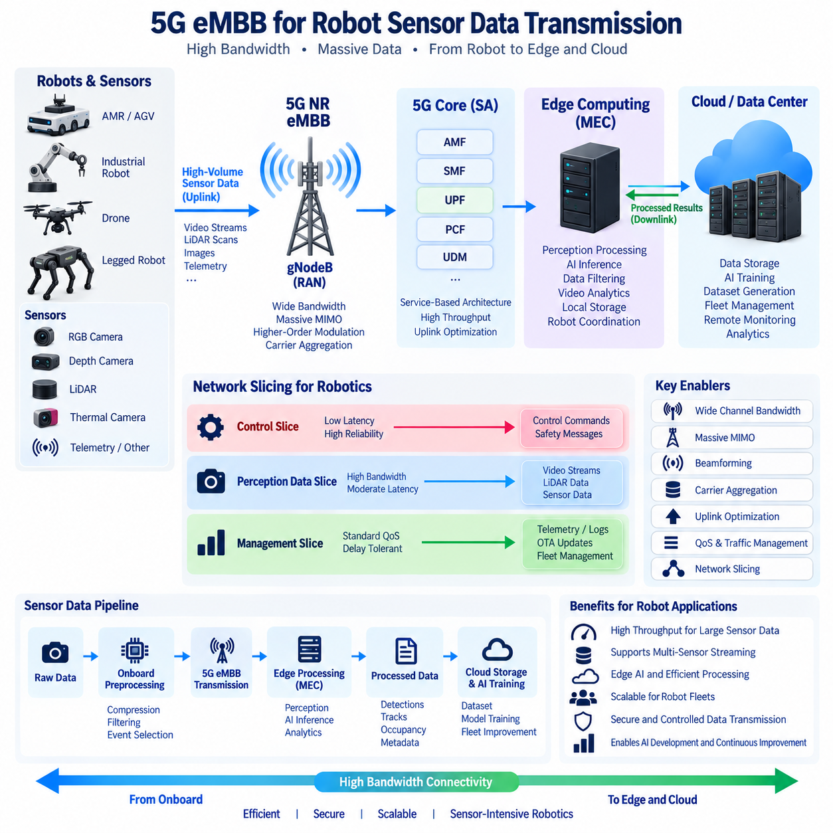
5G enhanced Mobile Broadband (eMBB) is a service capability designed to provide substantially higher data throughput and greater network capacity than earlier mobile communication systems. In robotics, eMBB is particularly relevant when robots generate large volumes of sensor data that cannot be efficiently transferred through low-bandwidth wireless links. High-resolution camera streams, LiDAR data, thermal imagery, and other perception information can therefore become important candidates for 5G-based transmission between robots, edge systems, and cloud infrastructure.
A robot may generate several sensor streams simultaneously, and the required bandwidth can increase rapidly as sensor resolution, frame rate, or the number of sensors increases. Multiple RGB cameras, depth cameras, thermal cameras, and LiDAR sensors may operate concurrently for perception and monitoring. Transmitting all raw data continuously is usually unnecessary, but selected data may need to be transferred for remote perception, recording, dataset generation, diagnostics, or AI processing. eMBB provides the network capacity needed for these high-volume communication patterns.
The key characteristic of eMBB is high data throughput rather than extremely low latency. This distinction is important when designing robotic communication architecture. A high-bandwidth camera stream may tolerate substantially more delay than an emergency stop command, while still requiring stable throughput for continuous transmission. Consequently, eMBB traffic should normally be separated from latency-critical control traffic through appropriate Quality of Service (QoS) policies, traffic classification, or network slicing.
5G NR achieves high throughput through the use of wider channel bandwidths, advanced antenna technologies, higher-order modulation, carrier aggregation, and efficient radio resource utilization. Massive Multiple-Input Multiple-Output (Massive MIMO) and beamforming can improve spectral efficiency and link performance under suitable deployment conditions. The actual throughput available to a robot, however, depends on spectrum, signal quality, network configuration, cell loading, device capability, and radio environment rather than on the theoretical peak rate of the 5G standard alone.
For a mobile robot, uplink performance can be particularly important because many robotics applications generate more data at the robot than they consume. A robot may capture multiple camera streams, LiDAR scans, thermal images, and operational telemetry and transmit selected information toward an edge server. This differs from typical smartphone usage patterns in which downstream traffic may dominate. Network planning for robotics should therefore examine uplink capacity, uplink scheduling, coverage, and sustained throughput instead of evaluating only advertised download performance.
Raw sensor transmission should nevertheless be treated carefully because continuous transmission of every sensor sample can consume significant network resources. A robot can perform preprocessing at the edge of the vehicle and transmit compressed, filtered, or event-selected information instead. For example, camera images can be encoded into appropriate video streams, LiDAR data can be filtered to relevant regions, and telemetry can be aggregated before transmission. This creates a hybrid architecture in which onboard computing reduces unnecessary network traffic while eMBB provides sufficient capacity for the information that genuinely needs to leave the robot.
eMBB is particularly valuable when robotics systems use edge computing for computationally demanding perception or AI inference. Instead of installing maximum computing capacity on every robot, selected workloads can be transferred to a nearby Multi-access Edge Computing (MEC) platform. Camera or sensor data can be transmitted through the 5G network, processed at the edge, and returned as perception results, classifications, object tracks, or other compact outputs. The benefit depends on the combined cost of wireless transmission, edge processing, and response time.
Network slicing and QoS can help integrate eMBB traffic with other robot services. A perception-data slice may be configured around high bandwidth, while a control slice emphasizes low latency and reliability and a management slice carries telemetry, logs, and software updates. These logical service categories allow a single physical 5G infrastructure to support workloads with different communication characteristics. Slicing does not create unlimited capacity, so sufficient radio and transport resources must still be available for the expected aggregate traffic.
A robot fleet creates an additional scaling challenge because the bandwidth requirement increases with the number of simultaneously active robots. If every robot transmits multiple high-resolution streams continuously, the aggregate uplink demand can become much larger than the requirement of an individual robot. Fleet architecture should therefore define which data is transmitted continuously, which is transmitted periodically, which is triggered by events, and which remains stored locally. Edge filtering, adaptive compression, and selective upload can substantially change the network capacity required by the overall fleet.
Outdoor autonomous robots introduce additional variability because wireless conditions change as the robot moves. Buildings, vegetation, terrain, vehicles, structures, and other obstacles can affect signal strength and throughput. Cell transitions and temporary interference can also change available bandwidth. Consequently, eMBB performance should be evaluated along actual robot operating routes rather than only at a single stationary measurement point. Sustained throughput and coverage continuity are often more meaningful for robot operations than a short-duration peak throughput measurement.
Private 5G can provide an organization with greater control over the communication environment used by robots. In a factory, warehouse, campus, or outdoor industrial site, the network can be designed around robot operating areas and connected directly to local edge infrastructure. This architecture can keep large sensor streams within the local environment while providing controlled access to cloud services when required. The resulting system can support local data processing, fleet management, remote monitoring, and selected cloud synchronization.
Security and data governance are also important when large volumes of sensor information are transmitted over wireless networks. Camera images, environmental observations, maps, and operational data may contain sensitive information depending on the application. Authentication, encryption, access control, device identity management, network segmentation, and appropriate data-retention policies should therefore be considered together with bandwidth planning. High-speed communication is useful only when the transmitted data can be handled securely and according to the operational requirements of the system.
The architecture should also distinguish between raw sensor data, processed perception data, and operational metadata. Raw camera or LiDAR data can require substantial bandwidth, whereas detected objects, tracks, occupancy information, or semantic observations can be much smaller. A robot may therefore transmit raw data selectively for recording or AI development while sending compact perception results during normal operation. This separation allows eMBB capacity to be allocated where it provides the greatest operational value.
For AI development and fleet improvement, eMBB can also support data collection from deployed robots. Selected sensor sequences can be uploaded to edge or cloud storage and later incorporated into annotation, dataset construction, model training, and evaluation pipelines. The network architecture should avoid treating every collected frame as equally valuable. Event-driven recording, representative sampling, compression, and local buffering can reduce unnecessary transmission while preserving the data needed for improving perception and Physical AI models.
An effective robotics communication architecture therefore combines eMBB with local computing and differentiated traffic management. High-volume perception data can use eMBB resources, latency-sensitive commands can use appropriate low-latency QoS treatment, and delay-tolerant logs or software packages can be scheduled separately. The robot can continuously adapt its transmission behavior according to available bandwidth, application priority, network condition, and mission state. This makes the communication system part of the overall robot resource-management architecture rather than an isolated connectivity function.
In cloud-and-edge robotics, 5G eMBB should consequently be viewed as a high-capacity transport layer for selected sensor and perception workloads. Its value is not simply the maximum theoretical bandwidth of the radio interface, but the ability to connect mobile robots with nearby edge computing, fleet infrastructure, and cloud services while managing large volumes of data. When combined with onboard preprocessing, MEC, QoS, network slicing, adaptive data transmission, and appropriate security controls, eMBB provides a practical communication foundation for sensor-intensive robot fleets and distributed Physical AI systems.

11.04 Private 5G Network Deployment: Spectrum / Base Station
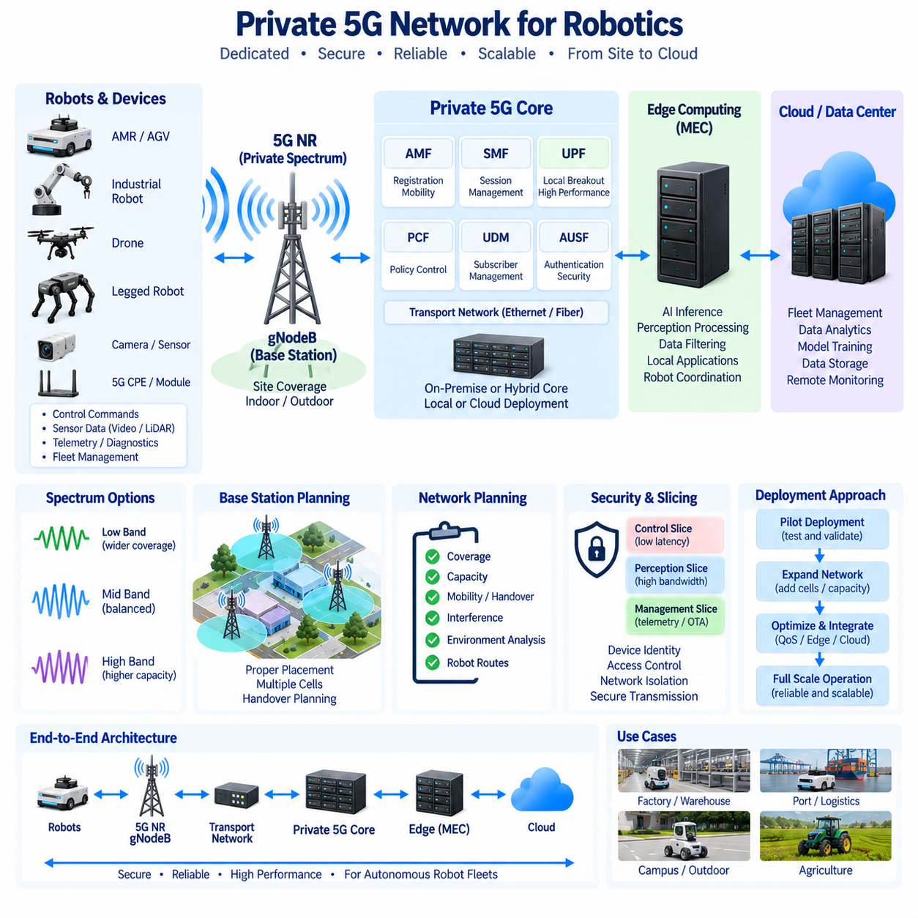
Private 5G is a locally managed cellular network designed to provide dedicated wireless connectivity for industrial facilities, campuses, warehouses, ports, factories, and outdoor robot operating areas. Unlike a general public mobile network, a private network can be designed around a specific physical site, device population, traffic profile, security policy, and edge-computing architecture. For robotics, this makes private 5G useful when many mobile robots must maintain controlled connectivity while exchanging commands, telemetry, sensor data, video, and fleet-management information.
A private 5G deployment normally consists of several interconnected domains, including the 5G New Radio (5G NR) radio access network, base stations, transport network, 5G Core, subscriber and device management, security functions, and edge or cloud computing resources. The base station provides radio coverage, while the core network manages registration, sessions, mobility, authentication, policy, and user-plane traffic. The architecture should be designed as an integrated system because radio coverage alone cannot guarantee the latency, reliability, security, or application performance required by autonomous robots.
Spectrum is one of the first considerations when designing a private 5G network. The available frequency range determines important characteristics such as coverage, propagation, channel bandwidth, penetration, antenna requirements, and achievable capacity. Lower-frequency spectrum can provide broader coverage and better propagation through obstacles, while higher-frequency spectrum can provide wider channels and higher capacity but generally requires denser infrastructure. The appropriate spectrum therefore depends on the physical environment, required coverage area, robot density, traffic volume, and regulatory conditions.
Spectrum planning must also consider the actual operating environment rather than relying only on theoretical propagation characteristics. Buildings, machinery, metal structures, walls, vegetation, terrain, and vehicles can create attenuation, reflection, shadowing, and interference. An indoor factory may require a different radio design from an outdoor logistics yard or a large agricultural site. Robot routes should therefore be included in the planning process so that coverage and communication quality are evaluated along the areas where robots actually move.
The base station, or gNodeB, is the principal radio infrastructure connecting robots and other 5G devices to the network. Its placement determines coverage, capacity, handover behavior, and radio quality. A single powerful base station is not necessarily the optimal solution because increasing transmission power does not eliminate physical obstructions or capacity limitations. Multiple appropriately positioned cells may provide more consistent coverage and better support for mobile robots, particularly when the site contains complex structures or large operating areas.
Capacity planning becomes increasingly important as the number of robots grows. Each robot may generate control traffic, telemetry, camera streams, LiDAR information, diagnostics, and other data simultaneously. A private 5G system must therefore consider both the number of connected devices and the traffic generated by each device. Peak traffic conditions should be evaluated together with normal operating conditions because a network that performs adequately with a small pilot fleet may require additional radio or transport resources when the fleet expands.
Mobility and handover should be included in base-station planning from the beginning. Autonomous robots can continuously move between radio coverage areas, and communication performance may temporarily change during cell transitions. Poorly positioned cells can create weak-coverage zones, unnecessary handovers, or unstable radio conditions along robot routes. A practical deployment should therefore use drive tests or robot-based measurements to evaluate received signal quality, throughput, latency, packet loss, and handover behavior under representative operating conditions.
The private 5G core should be positioned according to the application's latency, availability, security, and connectivity requirements. A local core can keep important network functions within the facility and can be combined with a local User Plane Function (UPF) for local traffic breakout. This architecture is particularly useful when robot traffic must reach local applications or Multi-access Edge Computing (MEC) resources without unnecessarily traversing an external network. Cloud connectivity can still be provided for fleet management, analytics, model training, storage, and other higher-level services.
Private 5G should also be designed together with the site's wired network and edge-computing infrastructure. Base stations require reliable transport connectivity to the core, while edge servers may require high-speed connections to both the core and local applications. A robot may send sensor information through 5G to an edge GPU server, receive processed perception results, and simultaneously exchange fleet-management information with a cloud service. The network architecture must therefore consider radio, Ethernet, routing, switching, edge computing, and cloud connectivity as one end-to-end system.
Security is another fundamental consideration in private 5G deployment. Robot devices should have managed identities and controlled access to network resources, while network functions and applications should be separated according to their security requirements. Control traffic, sensor data, management interfaces, and external cloud connections can be logically isolated using appropriate network policies, QoS mechanisms, and, where applicable, network slicing. The objective is to prevent a problem in one service or device group from unnecessarily affecting other robot operations.
A private 5G network should be deployed progressively rather than treating the complete production network as the first experiment. A pilot deployment can validate spectrum availability, base-station placement, robot device compatibility, coverage, throughput, latency, handover, core connectivity, and edge integration. After representative robots and workloads have been tested, the network can be expanded by adding cells, increasing capacity, refining QoS policies, and integrating additional edge or cloud services. This approach allows network assumptions to be validated against actual robot behavior before large-scale deployment.
For autonomous robot fleets, the final objective is not simply to build a private cellular network but to create a controlled communication infrastructure for robot operations. Spectrum planning determines the available radio resources, base-station placement establishes coverage and mobility behavior, the 5G Core manages connectivity and policy, and MEC or cloud systems provide computing services beyond the robot. When these components are designed together, private 5G can provide a scalable foundation for indoor and outdoor robot fleets, high-volume sensor transmission, low-latency services, fleet coordination, and distributed Physical AI workloads.

11.05 5G CPE Module Integration: Robot HW Interface
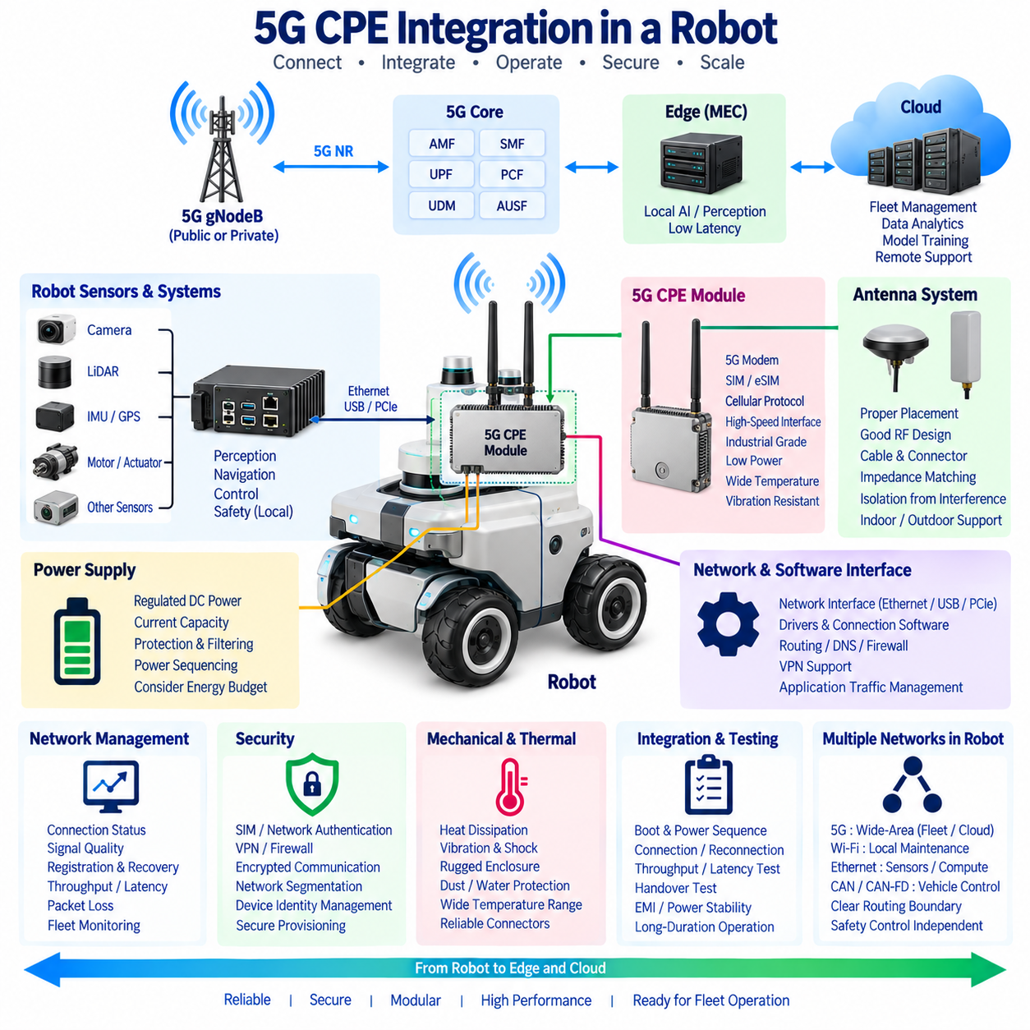
A 5G CPE (Customer Premises Equipment) module provides the physical communication interface between a robot and a 5G network. In a robotic system, the CPE is more than a conventional network adapter because it must operate as part of a mobile machine with strict constraints on power, space, thermal conditions, vibration, antenna placement, and system reliability. The integration therefore requires coordinated design between the 5G modem, robot computer, power system, network software, antennas, and mechanical enclosure.
The CPE module normally contains a 5G modem, cellular protocol processing, SIM or eSIM support, and interfaces for connecting the module to the robot's computing platform. Depending on the implementation, the connection between the CPE and robot computer may use Ethernet, USB, PCIe, or another supported high-speed interface. Ethernet is particularly convenient when the CPE operates as an independent network device, while USB or PCIe can be appropriate when a modem is integrated more directly into the onboard computing platform.
The interface architecture should begin by separating the communication functions that require 5G from functions that must remain local to the robot. Control software, perception pipelines, navigation, motor control, and safety functions normally execute on the robot's onboard computing system or embedded controllers. The CPE provides connectivity to external services such as fleet management, remote monitoring, cloud applications, edge computing, selected sensor-data transmission, and remote assistance. This separation prevents the wireless module from becoming an unnecessary dependency for basic robot operation.
Power design is an important part of CPE integration because the module operates continuously while the robot is active. The CPE may require a regulated DC supply and can experience changing power consumption according to radio activity, transmit power, network conditions, and data throughput. The robot power architecture should therefore provide appropriate voltage regulation, current capacity, protection, filtering, and power sequencing. The CPE should also be considered in the robot's overall energy budget because continuous wireless communication can affect battery endurance.
Antenna integration is equally important because the performance of a 5G module depends strongly on the radio-frequency environment around the antennas. A robot enclosure can contain metal structures, batteries, motors, cables, computers, and other electronic components that influence antenna performance. Antennas should therefore be positioned and oriented according to the CPE manufacturer's requirements while maintaining appropriate separation from major interference sources. Cable length, connector quality, impedance matching, antenna gain, and environmental exposure should also be considered as part of the complete RF design.
The CPE should provide a suitable network interface to the robot's operating system and software stack. When an Ethernet-based CPE is used, the robot can treat the 5G connection as another network interface and manage routing, DNS, firewall rules, VPN connectivity, and application traffic through the operating system. A directly integrated modem can instead expose modem-management interfaces and require appropriate drivers and cellular connection software. The choice affects installation complexity, software maintenance, troubleshooting, and the ability to replace the communication module independently from the main robot computer.
For a fleet robot, network management should be designed together with the CPE rather than added after hardware integration. The system may need to identify the active cellular connection, monitor signal quality, detect registration failures, recover from connection loss, and report communication status to the fleet-management system. Useful operational information can include connection state, signal indicators, assigned network information, throughput, packet loss, latency, and modem health. These measurements allow the robot and fleet platform to distinguish between an application failure and a wireless connectivity problem.
The CPE should also be integrated with the robot's security architecture. Cellular authentication can establish the device's relationship with the mobile network, while additional mechanisms are required to protect robot applications and operational data. VPN tunnels, firewall policies, certificate-based authentication, encrypted application protocols, and network segmentation can be used according to the system architecture. Device identity should be managed as part of robot provisioning so that replacing a CPE or moving a robot into a different fleet does not create uncontrolled network access.
Thermal and mechanical design are especially important for mobile robots because the CPE may operate continuously inside a relatively enclosed enclosure. Heat generated by the modem must be transferred to the surrounding structure or cooling system without creating excessive temperature around other sensitive components. The module and its connectors should also tolerate the vibration and shock expected during robot operation. For outdoor robots, protection against dust, moisture, temperature variation, and mechanical contamination may additionally be required. Mechanical integration should therefore be considered together with electrical and RF design.
A modular hardware architecture can simplify maintenance and fleet evolution. The CPE can be designed as a replaceable communication subsystem with standardized power, Ethernet, antenna, and management interfaces. This allows a robot platform to accommodate different cellular operators, regional network requirements, or future modem generations without redesigning the complete onboard computer. Such modularity is particularly useful for fleets deployed across different countries or environments where available spectrum, SIM provisioning, and private 5G infrastructure can differ.
The communication architecture should also distinguish between 5G data traffic and other robot networks. A robot may contain CAN or CAN-FD networks for vehicle and actuator control, Ethernet for sensors and onboard computing, Wi-Fi for local maintenance, and 5G for wide-area connectivity. These networks should have clearly defined responsibilities and routing boundaries. Safety-critical actuator communication should not depend on the 5G CPE, while selected supervisory, fleet, telemetry, sensor, and edge-computing traffic can be routed through the cellular interface according to application requirements.
Testing the CPE integration should cover the complete robot rather than only verifying that the modem can connect to a 5G network. Engineers should evaluate boot and power sequencing, connection establishment, reconnection after network loss, antenna performance, throughput, latency, packet loss, handover behavior, thermal conditions, vibration, and long-duration operation. Testing should also include simultaneous operation of the robot's cameras, LiDAR, GPU computers, motors, and other electronic systems because electromagnetic interference and power fluctuations can produce problems that are not visible during an isolated modem test.
In a private 5G environment, the CPE also becomes an important endpoint of the site's network architecture. The robot may connect through a gNodeB to a private 5G Core and then access local MEC services, fleet-management applications, or other enterprise systems. The CPE configuration must therefore be compatible with the selected spectrum, network authentication, addressing model, QoS policies, and security architecture. If network slicing is used, the robot's traffic may also need to be associated with the appropriate service or policy according to the private network design.
For autonomous robot fleets, the 5G CPE should ultimately be treated as a managed communication subsystem rather than a simple modem. Its hardware interface, power consumption, antenna system, thermal behavior, operating-system integration, security identity, network management, and application routing all influence the reliability of the complete robot. A well-designed integration allows the robot to use 5G for fleet connectivity, remote monitoring, edge computing, high-volume sensor transmission, and other distributed services while preserving local autonomy and safety when wireless communication is unavailable.

11.06 5G QoS Configuration: Robot Traffic Priority [w/Code]
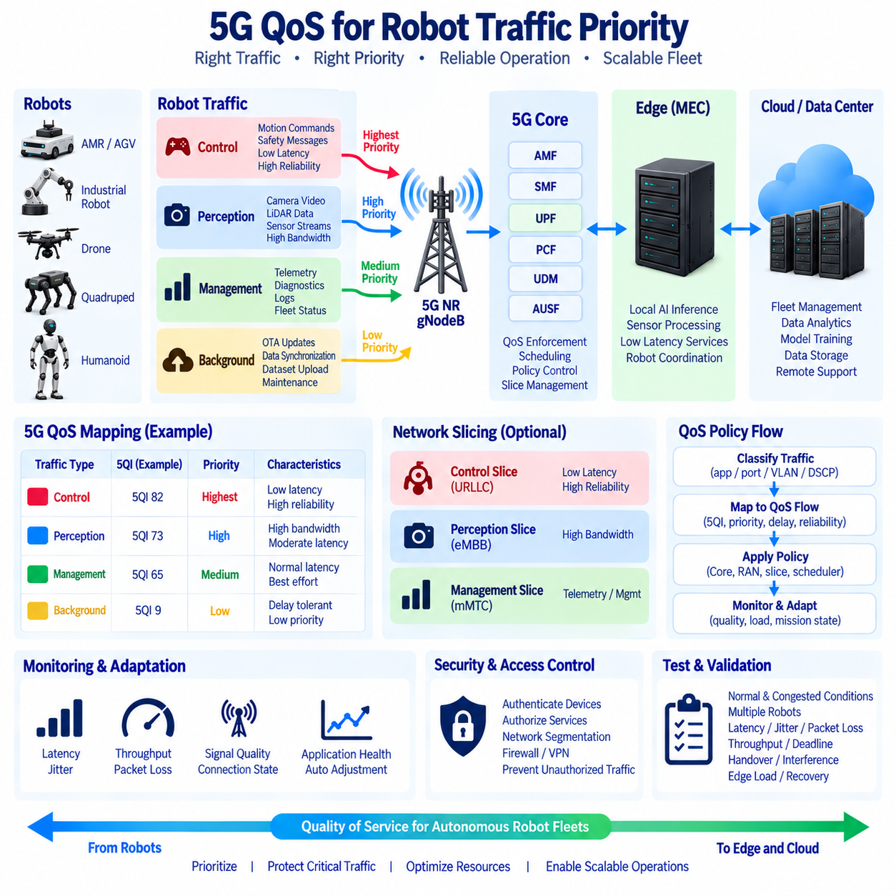
Quality of Service (QoS) in a 5G robot network defines how different traffic flows are treated according to their operational importance. A robot rarely carries only one type of data. Control commands, emergency messages, sensor streams, telemetry, diagnostics, video, and software updates may share the same cellular connection. QoS provides a framework for distinguishing these flows so that latency-sensitive and operationally important traffic can receive appropriate treatment when network resources become limited.
Robot traffic should therefore be classified according to application requirements rather than simply according to packet size or source device. Motion-related commands and safety messages may require low latency and high reliability, while camera and LiDAR streams primarily require sustained bandwidth. Telemetry and diagnostics can normally tolerate greater delay, and OTA software packages are generally delay tolerant. Establishing these traffic classes provides the foundation for assigning priorities and preventing high-volume background traffic from unnecessarily affecting critical robot communication.
In 5G, QoS is associated with PDU sessions and QoS flows that allow traffic to receive differentiated treatment within the network. Each flow can be associated with characteristics such as a QoS Identifier, priority level, packet delay requirements, and packet error expectations. The exact configuration depends on the 5G Core, radio network, device capabilities, and service architecture. For robotics, the important principle is that application requirements should be translated into network policies that can consistently distinguish control, perception, management, and background workloads.
A practical robot fleet can define several logical traffic classes. Control traffic can include velocity commands, navigation commands, coordination messages, and safety-related information. Perception traffic can include compressed camera streams, LiDAR data, depth information, and selected sensor recordings. Management traffic can include telemetry, health information, diagnostics, logs, and fleet status. Background traffic can include OTA packages, bulk data synchronization, dataset uploads, and maintenance transfers. These classes allow the network to prioritize traffic according to operational consequences rather than treating every packet equally.
Priority becomes particularly important when network capacity is temporarily reduced. A robot operating under normal conditions may have sufficient bandwidth for control, video, telemetry, and maintenance traffic simultaneously. During congestion, however, the network must determine which traffic should continue receiving resources. Critical control traffic should be protected from unnecessary congestion, while video quality or background transfer speed may be reduced when required. This principle allows the robot to preserve essential functions even when the communication environment is no longer operating at its nominal capacity.
Bandwidth-intensive perception traffic requires a different QoS strategy from control traffic. High-resolution camera streams and LiDAR data can consume substantial uplink capacity, especially when multiple robots operate simultaneously. Rather than assigning the highest priority to every sensor stream, the architecture can combine appropriate bandwidth allocation with application-level compression, filtering, event selection, and adaptive transmission. The objective is to maintain useful perception information without allowing sensor traffic to consume resources needed by more time-sensitive operational services.
Latency-sensitive control traffic should also be evaluated using end-to-end behavior rather than only radio-level measurements. A packet may experience delay in the robot computer, wireless scheduler, transport network, 5G Core, edge application, and return path. QoS can control network treatment, but it cannot compensate for inefficient application processing or an unnecessarily long network path. For this reason, robot QoS design should be considered together with local User Plane Function placement, edge computing, application architecture, and the control-loop requirements of the robot.
Network slicing can provide an additional layer of logical separation when a private 5G network supports multiple classes of robotic services. A control-oriented slice can be associated with low-latency and high-reliability requirements, while a perception-oriented slice can emphasize bandwidth and a management slice can carry telemetry and maintenance traffic. Slicing and QoS serve related but different purposes. QoS differentiates traffic treatment, while slicing can establish logically separated service environments with their own policies and network functions.
QoS configuration should also account for fleet-scale behavior. If one robot transmits a large amount of video data, the effect may be limited. If hundreds of robots transmit several high-resolution streams simultaneously, aggregate traffic can consume significant radio, transport, and edge capacity. Fleet-level policy should therefore define traffic limits, priorities, admission behavior, and transmission strategies across groups of robots. A fleet management system can also adjust data rates or disable nonessential uploads according to mission state and current network conditions.
A robust QoS architecture should include monitoring and feedback rather than relying on static configuration alone. The robot and fleet platform can monitor latency, packet loss, throughput, signal quality, connection state, and application-level communication health. When performance changes, the system can adapt video quality, reduce nonessential uploads, postpone large transfers, or change operational behavior. This creates a relationship between network condition and robot behavior in which communication resources become part of the overall fleet-management strategy.
Security and QoS should also be considered together because traffic classification must not become an uncontrolled mechanism for granting network access. Devices should be authenticated before receiving authorized services, and network policies should associate permitted traffic with known robot identities, applications, or service groups. Control interfaces, management services, sensor streams, and external cloud connections can be separated through appropriate routing, firewall, access-control, and network-segmentation policies. This approach helps prevent unauthorized traffic from receiving the same treatment as legitimate robot operations.
Testing should validate QoS under both normal and congested conditions. Engineers should generate representative control, perception, telemetry, diagnostic, and background traffic and then measure latency, jitter, packet loss, throughput, and deadline violations for each class. Tests should also examine multiple simultaneous robots because a configuration that works for one robot may behave differently when many devices compete for shared radio and transport resources. Handover, temporary interference, edge-server load, and network recovery should also be included in realistic validation scenarios.
For a cloud-and-edge robot fleet, 5G QoS should ultimately be treated as an operational policy connecting application importance with communication resources. Local safety and fast actuator control should remain independent of the cellular network where required, while supervisory commands, fleet coordination, perception data, telemetry, and cloud services can receive differentiated network treatment. A well-designed QoS architecture combines traffic classification, priority, bandwidth management, network slicing, edge placement, monitoring, and adaptive behavior so that limited communication resources are consistently allocated according to the operational requirements of the robot fleet.

11.07 5G MEC (Mobile Edge Computing): Robot AI Offloading
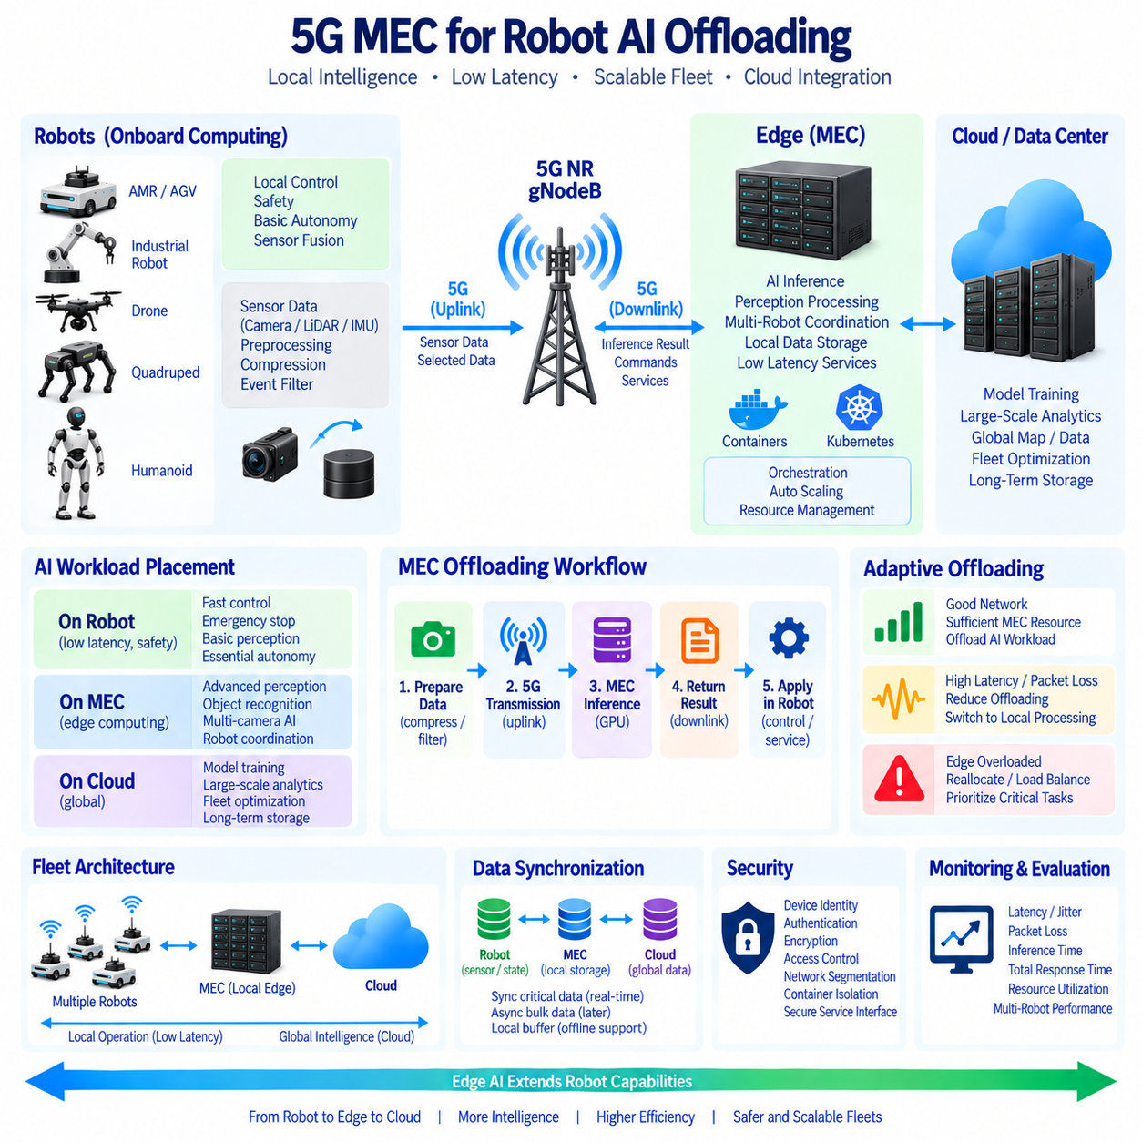
Multi-access Edge Computing (MEC) places computing resources close to the mobile access network so that data generated by robots can be processed without always traveling to a distant cloud. In a 5G robotics architecture, MEC provides an intermediate computing layer between the robot and centralized cloud infrastructure. This enables selected AI inference, perception processing, fleet coordination, and data services to execute near the robot while local onboard computing continues to handle functions that require immediate and deterministic responses.
Robot AI workloads can be divided according to their latency, computational, bandwidth, and reliability requirements. Fast actuator control, emergency stopping, basic obstacle avoidance, and essential sensor fusion normally remain on the robot. More computationally demanding workloads, such as advanced object recognition, multi-camera perception, scene understanding, or selected AI inference, can be moved to an MEC server when the communication path and computing resources provide sufficient performance. Long-term training, global analytics, and large-scale model optimization can remain in the cloud.
AI offloading means transferring part of a robot's computational workload from its onboard computer to an external computing resource. The decision is not simply based on whether the edge server has a faster GPU. The complete processing path must be considered, including sensor-data preparation on the robot, 5G transmission, network processing, MEC inference, result transmission, and application-level processing. Offloading becomes useful when the combined communication and edge-processing time is acceptable and the reduction in onboard computational load provides a meaningful system benefit.
The most practical architecture is therefore hierarchical rather than completely centralized. The robot performs time-critical control and essential autonomy locally, while the MEC layer provides additional computational capacity for workloads that can tolerate network interaction. The cloud provides large-scale storage, model training, historical analytics, fleet-wide optimization, and other services that do not require immediate physical interaction. This separation allows each computing layer to perform functions according to its latency and resource characteristics rather than forcing every workload into a single location.
5G provides an important communication foundation for MEC-based offloading because it can provide high bandwidth, controlled Quality of Service (QoS), and low-latency connectivity. Large camera or LiDAR data streams can be transmitted toward an edge server, processed by GPU or other accelerators, and returned as compact perception results. However, the network should not automatically transmit every raw sensor frame. Compression, filtering, region selection, event-triggered transmission, and local preprocessing can reduce the amount of data that must cross the wireless link.
Workload placement should also respond to the current operating condition of the robot. When the 5G connection is stable and the MEC server has sufficient capacity, selected AI workloads can be executed remotely. If latency increases, packet loss occurs, coverage becomes unreliable, or the edge server becomes overloaded, the system may need to reduce the offloaded workload or execute an alternative local pipeline. This makes workload placement a dynamic resource-management problem involving robot computing capacity, network condition, MEC availability, and application requirements.
MEC is particularly valuable for robot fleets because one edge infrastructure can serve multiple robots within the same operating area. Instead of equipping every robot with the maximum possible computing hardware, computationally intensive workloads can be shared through local edge resources. The fleet platform can manage workload distribution according to robot demand, available GPU capacity, network condition, and service priority. This architecture can support scalable perception and AI services while reducing the need to duplicate expensive computing resources across every robot.
Containerized deployment can further simplify MEC workload management. AI inference services, perception components, data-processing pipelines, and supporting applications can be packaged as containers and deployed on edge servers. An orchestration layer can manage service placement, restart failed workloads, allocate resources, and support horizontal scaling when demand increases. This approach is consistent with cloud-native robotics architectures using containers, Kubernetes, microservices, and centralized observability while adapting those technologies to the resource and connectivity constraints of edge environments.
MEC should also integrate with the Robot Management System (RMS) and Fleet Management System (FMS). The RMS can monitor robot health, software state, diagnostics, communication status, and lifecycle information, while the FMS coordinates missions, task allocation, routes, traffic, charging, and multi-robot operations. MEC services can provide computational support for these systems by processing local sensor information, coordinating robots within an operating zone, or supplying low-latency AI services. This creates a connected architecture spanning robot, edge, and cloud management layers.
Data synchronization is another important consideration. Sensor data, perception results, maps, robot states, AI models, configuration files, logs, and operational events may exist simultaneously on robots, MEC servers, and cloud systems. The architecture should therefore distinguish between data that requires immediate synchronization and data that can be transferred asynchronously. Local edge storage can temporarily buffer information when cloud connectivity is unavailable, while selected results can be synchronized later. This reduces dependence on continuous wide-area connectivity and supports more resilient operation.
Security must be maintained across the complete offloading path. A robot transmitting sensor data to an MEC server creates communication and processing relationships between the device, 5G network, edge infrastructure, and applications. Device identity, authentication, encryption, access control, network segmentation, container isolation, and secure service interfaces should therefore be considered together. Sensitive sensor information should only be exposed to services that are authorized to process it, and edge workloads should not automatically receive unrestricted access to the robot's internal control networks.
Performance evaluation should measure the complete offloading workflow rather than only the AI model's inference time. Relevant measurements include sensor preprocessing time, wireless uplink latency, packet loss, network jitter, MEC queueing time, inference time, downlink latency, total response time, and resource utilization. The system should also be evaluated under multiple simultaneous robots because contention for wireless, CPU, GPU, memory, and storage resources can significantly change performance. These measurements provide the basis for deciding which workloads should remain onboard and which can be executed at the edge.
For Physical AI and autonomous robot fleets, MEC can therefore be viewed as a distributed computing layer that extends the robot's capabilities without replacing local autonomy. The robot remains responsible for immediate physical interaction and safety, while MEC provides nearby computational resources for selected AI and coordination workloads, and the cloud provides global intelligence and long-term data services. Combined with 5G, QoS, workload orchestration, adaptive offloading, local buffering, and secure data management, this architecture creates a practical foundation for scalable edge AI and cloud-edge robotics.

11.08 5G Security: Auth, Encryption, Slice Isolation
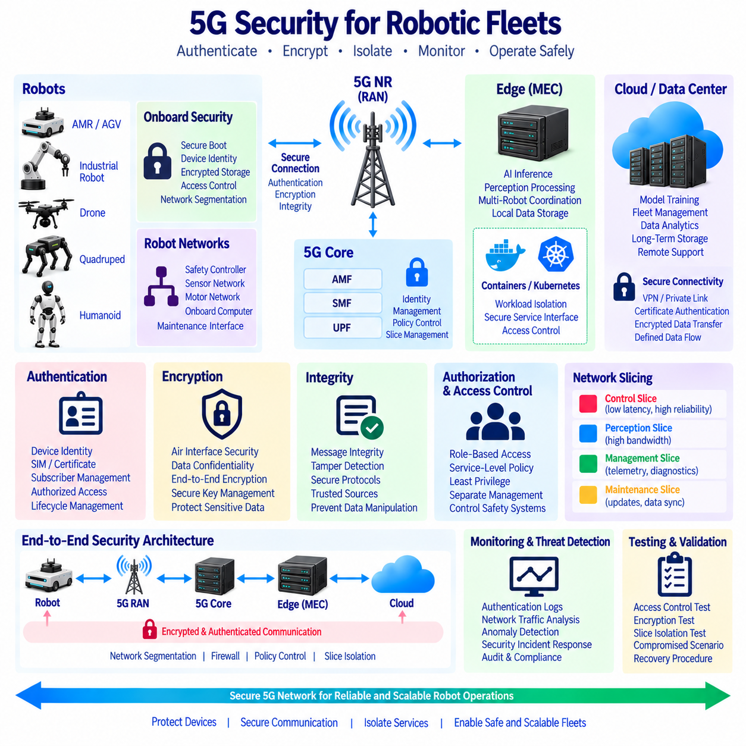
Security in a 5G robot network must protect the complete communication path from the robot device to the radio access network, 5G Core, edge infrastructure, and cloud services. Autonomous robots continuously exchange control information, telemetry, sensor data, video, diagnostics, and management commands, making communication security an integral part of robot safety and operational reliability. The security architecture should therefore address device identity, authentication, confidentiality, integrity, authorization, network segmentation, and secure lifecycle management as interconnected functions.
Authentication establishes whether a robot or network device is an authorized participant in the 5G system. 5G uses subscriber identity and authentication mechanisms to establish trust between the device and the mobile network. In a private 5G environment, device provisioning must be coordinated with subscriber management so that only registered robots can obtain network access. Robot identity should remain associated with fleet records, certificates, credentials, and configuration information so that device replacement or reassignment can be performed without creating uncontrolled access.
Encryption protects information while it travels across wireless and network infrastructure. 5G incorporates security mechanisms designed to protect the confidentiality and integrity of communications, while applications may require additional end-to-end encryption above the cellular layer. Robot telemetry, camera streams, maps, diagnostics, and management messages can contain operationally sensitive information, so encryption should be selected according to the sensitivity of the data and the complete application architecture rather than assuming that cellular connectivity alone provides sufficient protection.
Integrity is as important as confidentiality for autonomous robots because an attacker modifying a legitimate command can create a different operational risk from simply observing the communication. Secure protocols should therefore provide mechanisms for detecting unauthorized modification of messages or data. Application-layer authentication, message integrity protection, certificates, secure session establishment, and controlled key management can complement 5G security mechanisms. The objective is to ensure that commands, telemetry, configuration data, and software-related information originate from authorized sources and have not been altered during transmission.
Access control determines what an authenticated robot, user, service, or application is permitted to access. A robot that is authorized to connect to a private 5G network should not automatically receive unrestricted access to every enterprise service. Network policies can restrict access according to robot identity, role, application, service group, location, or other operational attributes. Management interfaces should be separated from operational traffic, and access to safety-related systems should be more tightly controlled than access to ordinary monitoring or reporting services.
Network segmentation provides another layer of protection by separating different communication domains. A robot may contain safety controllers, motor networks, sensor networks, onboard computing, maintenance interfaces, and external 5G connectivity. These domains should not automatically share unrestricted network access. VLANs, firewalls, routing policies, private network functions, and other segmentation mechanisms can establish controlled boundaries. The 5G connection should therefore be treated as a gateway into a defined service environment rather than as a direct extension of every internal robot network.
Network slicing can extend logical separation into the 5G infrastructure. Different robot services can be associated with different logical network environments according to their operational requirements. A control-oriented service may require strict latency and reliability policies, while perception data, telemetry, diagnostics, and software updates may have different requirements. Slice isolation can reduce unintended interaction between service classes, but it should not be treated as a complete security boundary by itself. Authentication, authorization, encryption, firewalling, and application-level security remain necessary.
Private 5G also requires secure management of the network infrastructure itself. Base stations, 5G Core functions, management servers, edge platforms, and network controllers are all potential security targets. Administrative access should use strong authentication and controlled privileges, while management interfaces should be isolated from ordinary robot traffic. Configuration changes, network policies, subscriber records, and security credentials should be protected and logged so that unauthorized modifications can be detected and investigated.
The edge computing layer introduces additional security considerations because robot data may be processed outside the physical robot. A MEC server can receive camera data, LiDAR information, telemetry, or other sensor information and execute AI inference or coordination services. The edge platform should therefore verify the identity of connected robots and applications before accepting data or providing services. Containers and workloads should also be isolated according to their trust relationships, and edge services should not receive unnecessary access to robot control networks or sensitive management interfaces.
Cloud connectivity creates another security boundary between the private operational environment and external infrastructure. Fleet management, analytics, model training, storage, remote support, and other cloud services may require data to leave the local network. Secure APIs, VPN or private connectivity, certificate-based authentication, encryption, access control, and carefully defined data flows can limit exposure. The architecture should distinguish information that must remain within the private environment from information that can be synchronized with cloud systems.
Security must also continue throughout the robot lifecycle. Initial provisioning, credential installation, software deployment, configuration changes, maintenance, replacement, decommissioning, and credential revocation should be managed as controlled processes. When a robot is removed from a fleet, its network credentials and service permissions should not remain active indefinitely. Similarly, replacement CPE modules, computers, or other communication components should be provisioned with controlled identities rather than inheriting undocumented credentials from previous equipment.
Security monitoring should provide visibility into abnormal network and device behavior. Useful events may include repeated authentication failures, unexpected device registrations, unusual traffic patterns, unauthorized configuration changes, abnormal service access, and communication with unexpected endpoints. Logs from robots, 5G infrastructure, edge servers, and cloud services should be correlated when appropriate so that an incident can be analyzed across the complete communication path. Monitoring should support detection and response rather than merely storing historical records.
For robot fleets, security controls should also be tested under realistic operating conditions. Testing can examine authentication failures, credential changes, unauthorized access attempts, network segmentation, encrypted communication, slice isolation, firewall policies, compromised service scenarios, and recovery procedures. Security testing should include multiple robots because fleet-scale operation introduces shared infrastructure and management dependencies. The goal is to verify that a problem affecting one device or service does not unnecessarily propagate to other robots or critical operational functions.
A secure 5G robotics architecture therefore combines authentication, encryption, integrity protection, authorization, network segmentation, slice isolation, secure edge computing, controlled cloud connectivity, lifecycle management, and continuous monitoring. No individual mechanism should be treated as sufficient protection for the complete system. The robot should maintain local safety and autonomy, while the 5G network provides controlled connectivity to authorized services. When these security mechanisms are integrated across robot, network, edge, and cloud layers, private 5G can become a managed communication foundation for reliable and scalable autonomous robot fleets.

11.09 5G Network Performance Measurement: SLA Management [w/Code]
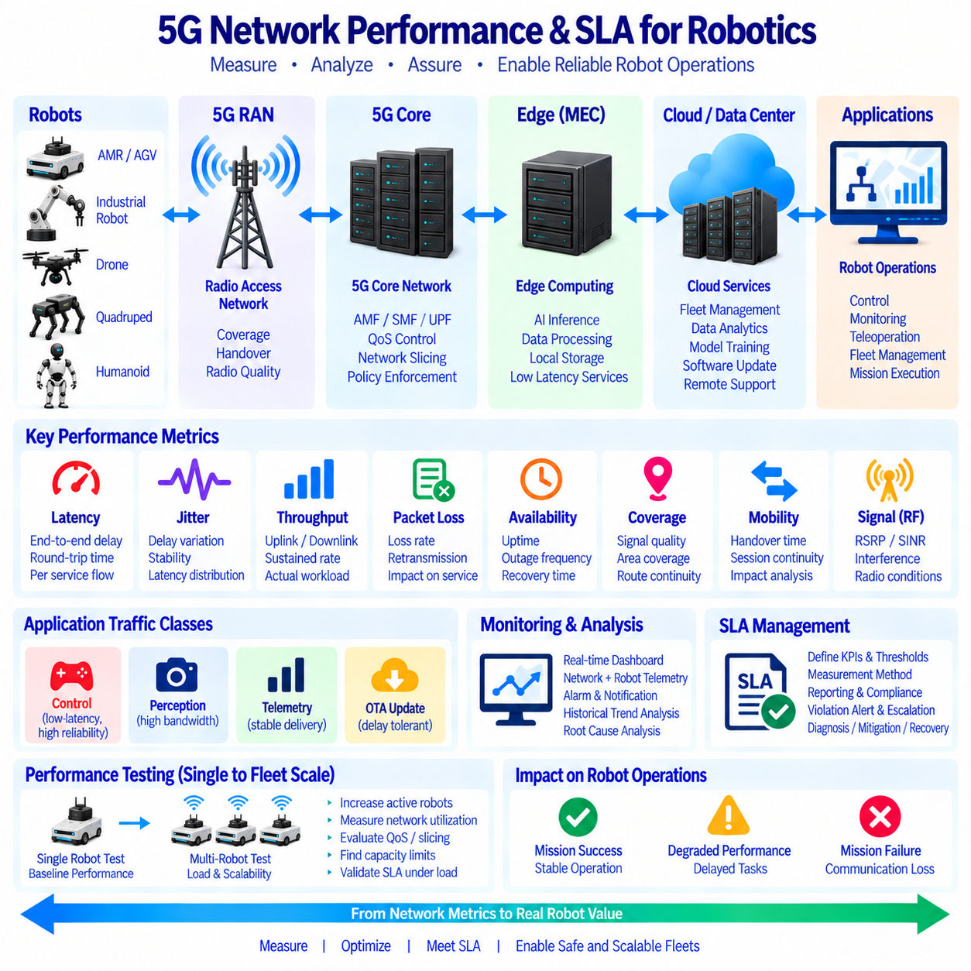
5G network performance measurement for robotic systems determines whether the communication infrastructure can consistently support the operational requirements of autonomous machines. Connectivity alone is not sufficient because robots depend on predictable latency, throughput, reliability, packet delivery, and mobility performance. Performance management therefore requires continuous measurement of both network-level indicators and application-level behavior so that communication quality can be related directly to robot operations and service requirements.
A Service Level Agreement (SLA) defines measurable expectations for communication services between the network provider and the robot application environment. In a private 5G deployment, an SLA can also operate as an internal engineering agreement between network, edge, cloud, and robotics teams. Rather than describing service quality only as general availability, the SLA should identify measurable parameters such as latency, throughput, packet loss, jitter, availability, coverage, recovery time, and other indicators relevant to robot workloads.
Latency measurement should consider the complete communication path rather than only the radio interface. A robot command or sensor message can experience delay inside the onboard computer, radio access network, transport network, 5G Core, MEC platform, application server, and return path. Round-trip time provides a useful general indicator, but individual application flows may require more detailed measurements. Control traffic, perception offloading, telemetry, and remote monitoring can each have different acceptable latency characteristics and should therefore be evaluated separately.
Jitter describes variation in packet delay and can be important even when average latency appears acceptable. A control or coordination application may tolerate a stable communication delay more effectively than unpredictable fluctuations around a lower average value. Excessive jitter can disturb streaming, remote operation, synchronized robot coordination, and distributed processing. Performance monitoring should therefore measure latency distributions and variation rather than reporting only a single average value that can hide temporary but operationally significant degradation.
Throughput measurements indicate how much useful data can be transferred through the network during a defined period. Robot applications can generate substantial uplink traffic from cameras, LiDAR, depth sensors, diagnostics, and dataset collection. Downlink traffic may include commands, maps, AI models, configuration data, and software updates. Because robot traffic is often uplink intensive, network evaluation should measure uplink and downlink performance independently and should consider sustained throughput rather than relying only on short peak-speed measurements.
Packet loss and communication reliability are particularly important for autonomous systems. Lost packets can reduce video quality, interrupt sensor-data delivery, delay application transactions, or require retransmission. The operational effect depends on the protocol and application, so packet-loss measurements should be correlated with robot behavior. A small amount of loss may be acceptable for some compressed video streams while the same network condition could be unacceptable for another service that depends on timely and complete message delivery.
Availability measures whether the required communication service is accessible when the robot needs it. A network can show high overall availability while still containing short outages that disrupt robot missions. SLA management should therefore consider outage frequency, outage duration, recovery time, and the location where failures occur. For mobile robots, availability should also include coverage continuity along actual operating routes rather than treating the network as a static service measured at a single fixed position.
Mobility performance requires specific measurement because robots move continuously between different radio conditions and potentially between cells. Handover events can temporarily influence latency, throughput, packet delivery, or application sessions. Measurements should identify where handovers occur, how long transitions take, and whether application traffic experiences disruption. Mapping these results to robot routes allows engineers to discover weak coverage zones, unstable cell boundaries, and locations where network behavior may affect mission execution.
Signal measurements provide important context for interpreting service performance. Radio indicators can help explain why throughput or latency changes at particular locations, but signal strength alone does not represent the complete user experience. Interference, congestion, scheduling, transport-network conditions, edge-server load, and application processing can influence performance even when radio reception appears strong. Network monitoring should therefore combine RF measurements with end-to-end service metrics and application observations.
Performance measurement should distinguish among robot traffic classes because different services have different requirements. Control and coordination traffic may emphasize latency, jitter, and reliability, while perception traffic emphasizes sustained bandwidth. Telemetry may prioritize consistent delivery with moderate bandwidth, and OTA updates can normally tolerate delay. QoS and network-slicing policies can then be evaluated against these traffic classes to determine whether the configured priorities actually produce the intended operational behavior under load.
Fleet-scale testing is necessary because network performance can change significantly when many robots operate simultaneously. A network that performs well with one robot may become congested when dozens or hundreds of devices transmit camera streams, telemetry, diagnostics, and AI data. Testing should therefore increase the number of active robots or representative traffic generators while measuring radio utilization, throughput, latency, packet loss, edge load, and application response. This reveals capacity limits before they become operational failures.
Monitoring systems should collect performance data continuously and present it in a form that supports both engineering analysis and operations. Dashboards can combine network metrics with robot identifiers, mission state, location, application status, and MEC resource utilization. Historical data can reveal recurring degradation patterns, while alerts can identify SLA violations in near real time. Correlating robot and network telemetry is particularly valuable because it allows operators to determine whether a problem originates from wireless connectivity, computing resources, software, or the robot itself.
SLA management requires defined thresholds, measurement intervals, reporting methods, and escalation procedures. A metric without an agreed measurement method can produce conflicting interpretations between teams or suppliers. The architecture should therefore define where measurements are collected, how timestamps are synchronized, how unavailable samples are handled, and how compliance is calculated. When an SLA violation occurs, operational procedures should identify the responsible subsystem and provide a structured path for diagnosis, mitigation, and recovery.
For autonomous robot fleets, 5G performance management should ultimately connect communication metrics with mission-level outcomes. Latency, jitter, throughput, packet loss, availability, coverage, and handover statistics become most useful when they can be related to delayed commands, interrupted AI offloading, degraded perception streams, failed uploads, or mission interruptions. Continuous measurement, fleet-scale testing, SLA monitoring, alerting, and historical analysis allow the network to become a measurable operational resource rather than an assumed communication service.

11.10 Private 5G-Based Robot Fleet Operation Case
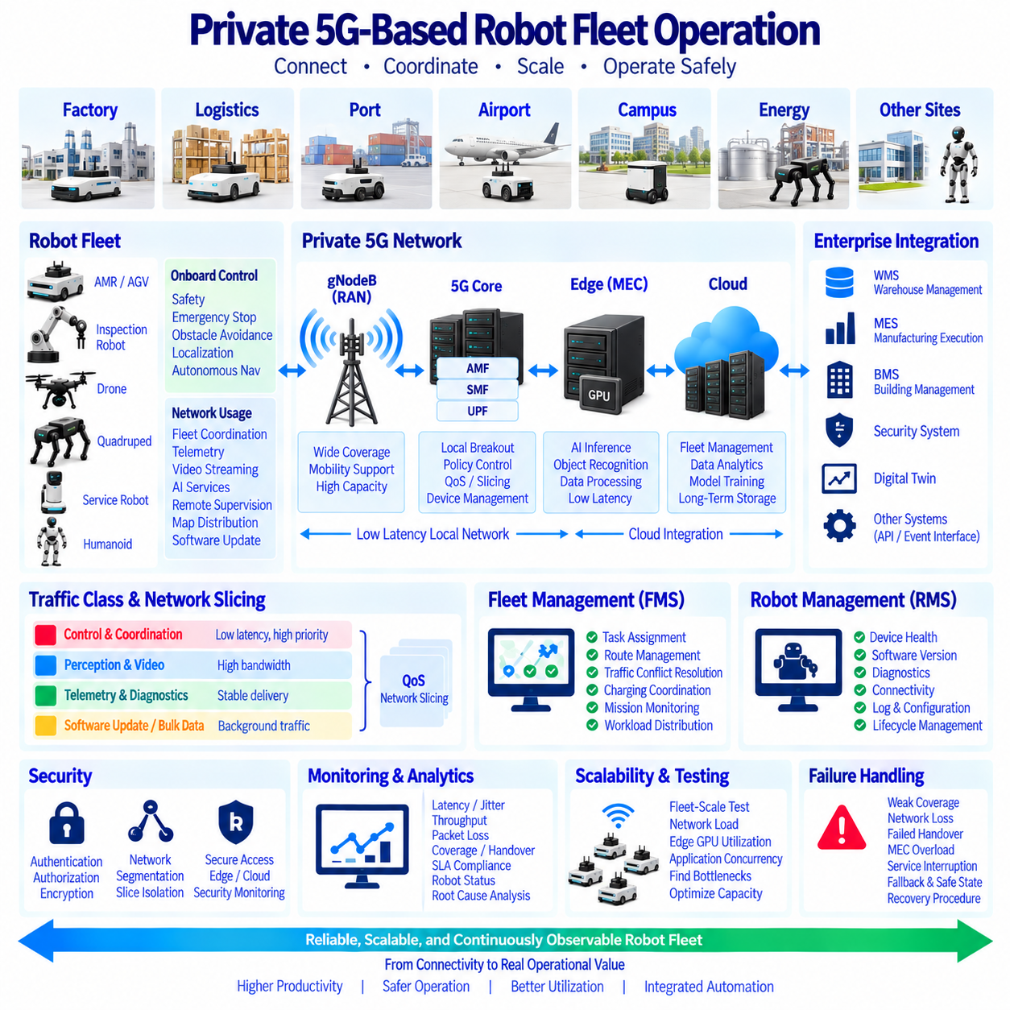
A private 5G-based robot fleet combines autonomous mobile robots, dedicated wireless infrastructure, edge computing, fleet management, and cloud services into one operational environment. Unlike a robot deployment that treats wireless connectivity as a generic network utility, this architecture designs communication around robot missions. Coverage, mobility, latency, bandwidth, security, and service availability are therefore managed as operational resources that directly influence fleet performance.
A representative deployment may operate across a factory, logistics center, port, airport, campus, energy facility, or other large industrial site. Multiple AMRs, inspection robots, quadrupeds, service robots, or specialized autonomous platforms can share the same private 5G infrastructure. Each robot maintains onboard control and safety functions while using the network for fleet coordination, telemetry, video, AI services, remote supervision, map distribution, software management, and operational data exchange.
The robot remains responsible for immediate physical safety even when private 5G provides highly reliable connectivity. Motor control, emergency stopping, basic obstacle avoidance, essential localization, and minimum autonomous navigation should continue without dependence on a remote server. Network services extend these capabilities rather than replacing them. This separation allows a robot to enter a degraded communication mode, complete a safe maneuver, stop safely, or continue limited operation when connectivity becomes temporarily unavailable.
Private 5G provides a controlled radio environment across the operating site. gNodeBs are positioned according to robot routes, obstacles, building structures, outdoor propagation conditions, traffic density, and required capacity. Coverage engineering should examine loading docks, elevators, corridors, production areas, storage zones, outdoor roads, and cell boundaries where connectivity may change rapidly. Handover behavior is particularly important because robots continuously move while maintaining application sessions and operational communication.
The 5G Core provides centralized communication control through functions for device registration, session management, user-plane connectivity, policy enforcement, and service differentiation. A local User Plane Function can keep robot traffic within the facility instead of routing every packet through a distant external network. Local breakout reduces unnecessary transport distance and allows robot applications to communicate efficiently with MEC servers, RMS platforms, FMS services, local databases, and other operational systems.
Traffic is separated according to application requirements rather than handled as one undifferentiated data stream. Mission commands and coordination messages can receive higher priority and predictable treatment, while camera streams and perception data require greater bandwidth. Telemetry and diagnostics require stable delivery but normally consume less capacity, while software updates and bulk data synchronization can use available background resources. QoS policies and network slicing can support these different service characteristics.
MEC extends the fleet with shared computing resources located near the private 5G network. Robots can selectively offload advanced object recognition, multi-camera processing, AI inference, scene understanding, or other computationally intensive workloads to edge GPUs. The offloading decision should depend on network quality, edge resource availability, application latency requirements, and onboard computing load. If edge services become unavailable, essential robot functions should continue through local processing and defined fallback behavior.
The Fleet Management System coordinates mission-level operation across multiple robots. It can assign tasks, manage routes, resolve traffic conflicts, coordinate charging, monitor mission progress, and distribute work according to robot availability. The Robot Management System complements this role by monitoring hardware health, software versions, diagnostics, connectivity, logs, configuration, and lifecycle status. Private 5G provides the communication fabric connecting these management layers to mobile robots throughout the operating area.
A practical fleet case also requires integration with enterprise and site systems. Robots may exchange information with warehouse management, manufacturing execution, building management, security, digital twin, or other operational platforms. APIs and event interfaces can connect robot missions with business processes so that a material request, inspection event, production condition, or safety incident automatically generates an appropriate robot task. The robot fleet therefore becomes part of the broader automation architecture rather than an isolated subsystem.
Security is applied across robot, network, edge, and cloud layers. Each robot should have a controlled identity and authenticated network access, while authorization policies restrict the services that the robot can reach. Encryption protects sensitive communication, network segmentation separates operational domains, and slice isolation can reduce interaction among different traffic classes. Edge workloads, management interfaces, remote access, software deployment, and cloud synchronization also require their own access controls and security monitoring.
Fleet operations require continuous monitoring of both robots and communication infrastructure. Network dashboards can track latency, jitter, throughput, packet loss, radio quality, coverage, handovers, availability, and SLA compliance while robot systems report location, mission state, battery level, faults, compute utilization, and application status. Correlating these datasets allows operators to determine whether degraded behavior originates from the robot, radio network, 5G Core, MEC platform, application service, or external system.
Scaling from a small pilot to a large fleet requires capacity testing rather than simply adding robots. Increasing robot count changes uplink demand, radio scheduling, edge GPU utilization, application concurrency, database traffic, and management workload. Fleet-scale tests should reproduce simultaneous video transmission, telemetry, mission traffic, AI offloading, handovers, and software operations. The resulting measurements reveal bottlenecks and provide evidence for adjusting cell capacity, QoS policies, edge resources, and application architecture.
Failure scenarios should be included in normal fleet design. Robots need defined responses to weak coverage, temporary network loss, failed handovers, overloaded MEC servers, unavailable fleet services, or interrupted cloud connectivity. Local autonomy, cached maps, local mission information, edge buffering, retry policies, redundant services, and safe-state behavior can prevent a communication problem from immediately becoming a physical operational failure. Recovery procedures should restore synchronized fleet operation when the affected service becomes available again.
A private 5G robot fleet should ultimately be evaluated through operational outcomes rather than network performance alone. Useful measures include mission completion, task delay, robot utilization, communication-related interruption, AI service response, recovery time, fleet throughput, and service availability. When private 5G, onboard autonomy, QoS, MEC, RMS, FMS, security, monitoring, and cloud integration are engineered as one system, the network becomes a managed foundation for reliable, scalable, and continuously observable multi-robot operations.

