Volume 09 Cloud and Edge Robotics

02. Edge Computing

02.01 Edge Computing Concepts: Edge, Fog, Cloud Continuum
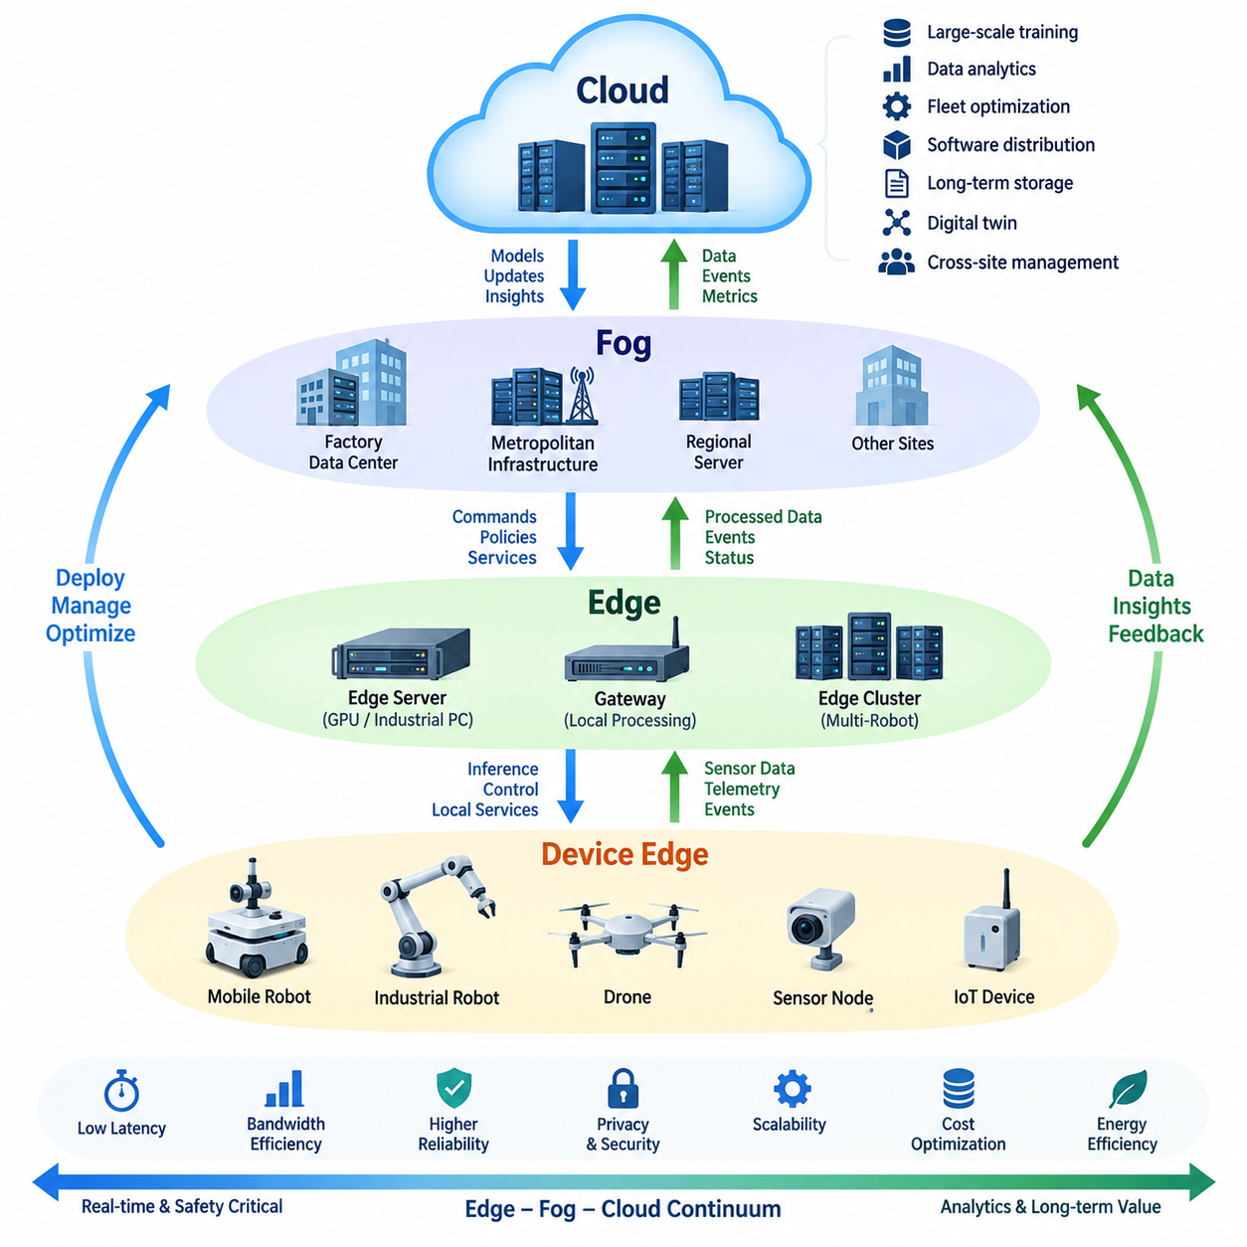
Edge computing extends computation, storage, and intelligent decision-making from centralized cloud data centers toward locations physically closer to robots, sensors, machines, and users. In robotics, this placement is especially important because perception, navigation, manipulation, and safety functions often require responses within milliseconds. Processing data near its source reduces dependence on distant networks while allowing robots to continue operating when cloud connectivity becomes slow, unstable, or temporarily unavailable.
The term edge does not describe one specific computer or device. It represents a distributed computing layer positioned between physical devices and centralized infrastructure. An edge node may be an embedded AI computer inside a robot, an industrial PC connected to several machines, a gateway serving a production cell, or a local server supporting an entire facility. The appropriate location depends on latency requirements, computational demand, network capacity, power constraints, security policies, and operational responsibility.
Device edge represents computation performed directly on or immediately beside the physical system generating data. A mobile robot may execute localization, obstacle detection, trajectory generation, motor coordination, and emergency reactions using its onboard processors. Camera streams and LiDAR point clouds can therefore be interpreted locally instead of continuously transmitted to remote servers. This minimizes communication latency and bandwidth consumption while preserving autonomous operation during temporary network interruptions.
Edge servers provide greater computing capacity while remaining geographically and logically close to robots. Multiple robots can share a local GPU server, inference accelerator, map service, database cache, or fleet coordination component without communicating with a distant cloud region. This architecture is useful when individual robots cannot carry sufficient computing hardware or when several machines need access to common information. Edge servers consequently form an intermediate intelligence layer between onboard autonomy and centralized services.
Fog computing broadens the edge concept by distributing services across multiple intermediate computing layers. Instead of dividing a system simply into devices and cloud servers, fog architecture may include robot computers, gateways, local servers, factory data centers, metropolitan infrastructure, and cloud platforms. Each layer can perform different processing tasks according to latency, bandwidth, security, and resource requirements. Fog therefore emphasizes coordinated hierarchical computing rather than computation at one fixed edge location.
Cloud computing remains essential because centralized infrastructure provides resources that are difficult or inefficient to place on every robot. Large-scale model training, historical analytics, fleet-wide optimization, software distribution, long-term data storage, digital twin processing, and cross-site management can consume substantial compute and storage capacity without requiring millisecond responses. The cloud can aggregate information from many edge systems and generate models, policies, updates, or operational insights that are subsequently distributed back toward robots.
The edge–fog–cloud continuum describes these resources as a connected spectrum rather than isolated architectural categories. Workloads can be placed dynamically at different points according to operational conditions. Immediate collision avoidance may execute onboard, semantic perception may run on a nearby GPU edge server, fleet scheduling may operate in a local facility cluster, and long-term learning may occur in the cloud. The continuum therefore allows each workload to execute where its technical and operational requirements can be satisfied most effectively.
Latency is one of the primary factors determining workload placement. A control loop that must respond within a few milliseconds cannot safely depend on a remote service whose network delay varies unpredictably. Conversely, a daily fleet utilization report does not require onboard execution. Designers must distinguish hard or near-real-time functions from interactive services and delay-tolerant workloads. This classification prevents inappropriate cloud dependency while avoiding unnecessary duplication of expensive computing resources at every device.
Bandwidth provides another important reason for processing data at the edge. Modern robots can generate large volumes of camera images, depth maps, LiDAR scans, audio, telemetry, and diagnostic information. Continuously transmitting all raw data to the cloud may overload wireless networks and create significant storage and communication costs. Edge processing can filter, compress, summarize, or interpret sensor streams locally, forwarding only meaningful events, selected samples, metadata, anomalies, or data required for later analysis and model improvement.
Reliability changes fundamentally when computation is distributed across the continuum. A cloud-dependent robot may lose important capabilities whenever external connectivity fails, whereas an edge-oriented robot can preserve essential autonomy using local services and cached information. Cloud synchronization can resume after connectivity returns. This offline-capable behavior is particularly valuable in factories, warehouses, construction sites, underground facilities, outdoor environments, and mobile operations where communication quality cannot be assumed to remain constant throughout a mission.
Privacy and data sovereignty also influence where workloads execute. Sensor streams may contain images of workers, production information, facility layouts, customer data, or proprietary operational knowledge. Processing sensitive information locally can reduce the amount of raw data leaving a controlled environment. Edge systems can extract required features or statistics before transmitting selected information upward. However, local processing does not automatically guarantee security; edge nodes still require authentication, encryption, access control, secure boot, patching, monitoring, and physical protection.
Artificial intelligence strengthens the importance of the edge–cloud continuum because AI workloads have widely different computational characteristics. Compact perception models may execute continuously on embedded accelerators, while larger multimodal or foundation models may require nearby GPU servers or centralized clusters. Training normally benefits from large-scale infrastructure, whereas inference frequently benefits from proximity to the physical process. A practical architecture therefore separates model training, optimization, deployment, inference, monitoring, and retraining across appropriate computing layers.
For robotics, workload placement should ultimately follow the physical consequences of delay and failure. Functions directly responsible for safe motion should remain close enough to the machine to operate predictably without external connectivity. Higher-level reasoning, coordination, analytics, and learning can progressively move toward facility edge, fog, on-premise, or cloud resources. The resulting architecture is not simply edge versus cloud; it is a distributed intelligence system in which computation follows the timing, data, safety, privacy, and resource requirements of each robotic function.

02.02 Edge Platform Comparison: Jetson, x86 Mini, ARM SBC
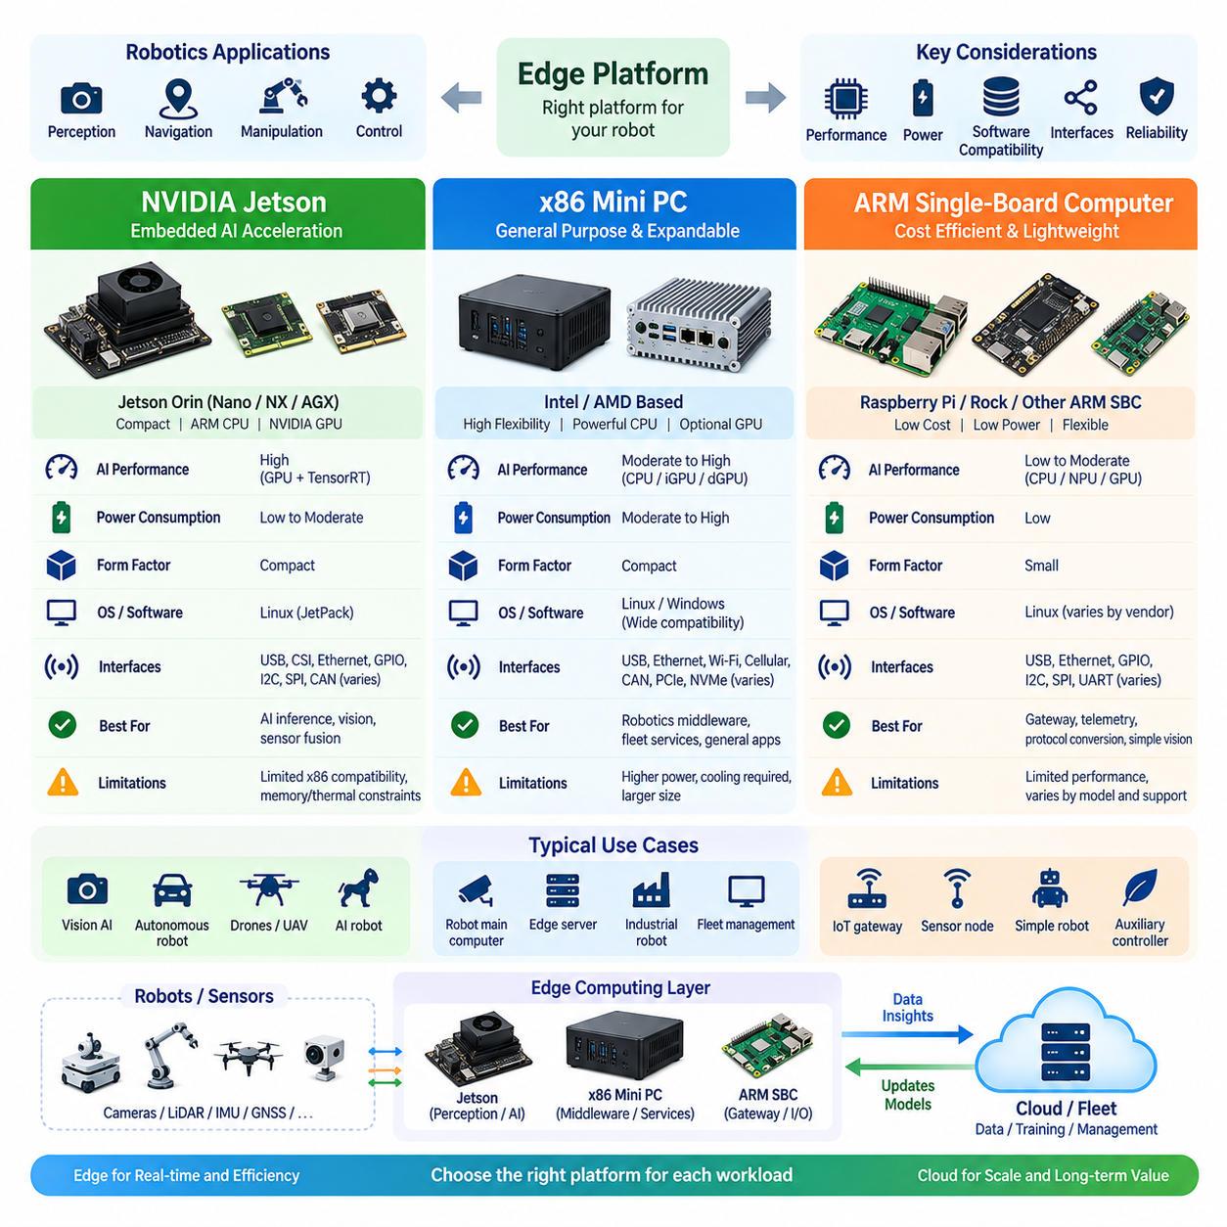
Edge platform selection is a fundamental architectural decision in robotics because the computing platform determines available AI performance, real-time capability, power consumption, software compatibility, sensor connectivity, and deployment flexibility. NVIDIA Jetson systems, x86 mini PCs, and ARM single-board computers represent different design points rather than interchangeable alternatives. Selecting among them requires matching computational resources to perception, control, networking, storage, environmental, and energy requirements.
NVIDIA Jetson platforms are designed for embedded accelerated computing and are particularly suitable for robots that execute AI inference close to sensors. Their combination of ARM CPUs and NVIDIA GPU acceleration enables camera perception, object detection, segmentation, depth processing, sensor fusion, and learned navigation within a compact power envelope. CUDA, TensorRT, and the broader NVIDIA software ecosystem also provide a direct path from trained neural networks to optimized edge inference.
Jetson modules span multiple performance and power classes, allowing developers to select hardware according to robot size and workload complexity. Smaller configurations can support lightweight perception and sensor-processing applications, while higher-performance platforms can execute several neural networks and high-bandwidth sensor pipelines concurrently. Because CPU, GPU, memory, and hardware accelerators share a tightly integrated architecture, Jetson is particularly effective when AI inference density per unit of size and electrical power is a primary requirement.
The principal limitation of Jetson is that it does not provide the same general-purpose compatibility as conventional x86 computers. Applications dependent on x86-only binaries, specialized PCIe hardware, legacy industrial software, or particular enterprise tools may require adaptation. GPU workloads must also be designed within the available memory and thermal envelope. Consequently, peak accelerator performance alone should not determine selection; sustained performance under realistic robot temperature, power, and concurrent workload conditions is more important.
An x86 mini PC provides a familiar general-purpose computing environment in a relatively compact form factor. Intel- or AMD-based systems can run standard Linux and Windows software stacks with broad compatibility across development tools, databases, middleware, industrial applications, and peripheral drivers. This makes x86 attractive when an edge computer must combine robot middleware, fleet services, databases, visualization, networking, and conventional application software rather than concentrating primarily on embedded AI inference.
Expansion capability is another major advantage of x86 systems. Depending on the platform, developers can integrate NVMe storage, multiple Ethernet interfaces, Wi-Fi, cellular communication, CAN adapters, frame grabbers, additional accelerators, or discrete GPUs. Industrial x86 computers may also provide ruggedized enclosures, wide-voltage inputs, extended temperature operation, and richer I/O. These characteristics make them suitable as robot main computers, vehicle computers, local gateways, or facility-level edge servers.
The disadvantages of x86 platforms generally appear in power, thermal management, size, and system complexity. A high-performance CPU combined with a discrete GPU can require substantially more electrical and cooling capacity than an integrated embedded platform. This matters for battery-powered mobile robots because computing power directly affects operating time and thermal design. The x86 architecture is therefore especially attractive when software compatibility, expansion, and general-purpose performance outweigh strict size and energy constraints.
ARM single-board computers, or ARM SBCs, occupy another important part of the edge platform spectrum. Systems such as compact Linux boards can provide low-cost computing for gateways, telemetry collection, protocol conversion, simple vision, device management, and lightweight robotics applications. Their small physical dimensions and modest power requirements make them easy to integrate into distributed sensor nodes or auxiliary controllers where deploying a larger computer would be unnecessary.
ARM SBC performance varies widely, so the term SBC should not be interpreted as a single capability class. Some boards provide only modest CPU resources, while others include multicore processors, neural processing units, GPUs, high-speed networking, and substantial memory. Software support also varies considerably between vendors. Kernel quality, device drivers, accelerator runtimes, operating-system images, and long-term update policies can be as important as processor specifications when evaluating an SBC for production robotics.
For AI workloads, accelerator architecture strongly influences practical platform performance. Jetson systems benefit from tightly integrated NVIDIA GPU acceleration, while x86 computers can use CPU inference, integrated accelerators, or discrete GPUs depending on configuration. ARM SBCs may rely on NPUs, GPUs, or external accelerators with vendor-specific toolchains. Consequently, TOPS or similar headline metrics should not be compared in isolation because model compatibility, precision support, memory bandwidth, runtime optimization, and sustained utilization determine actual inference performance.
Memory architecture is equally important for robotics. Camera frames, point clouds, occupancy maps, neural-network tensors, localization states, and middleware buffers can consume significant memory bandwidth and capacity. Integrated systems may reduce data movement between CPU and accelerator, whereas discrete architectures can provide greater total capacity and upgradeability. Platform evaluation should therefore consider not only installed memory size but also bandwidth, sharing architecture, copying overhead, and behavior when multiple perception workloads execute simultaneously.
Sensor and communication interfaces often determine whether a theoretically powerful platform is practical. Robots may require USB3 cameras, Gigabit or multi-Gigabit Ethernet, CAN, serial interfaces, GPIO, hardware synchronization, GNSS, IMU, LiDAR, radar, and storage interfaces. The platform must provide sufficient physical ports and bus bandwidth while supporting reliable drivers. For multi-sensor robots, timestamp synchronization and deterministic data acquisition can become more important than incremental improvements in processor benchmark performance.
Power budgeting must be evaluated at the complete system level. Compute modules, storage devices, network adapters, cooling fans, communication modems, and external accelerators all consume energy. A platform that performs inference faster may finish workloads sooner, but high sustained power can reduce battery endurance and increase cooling requirements. Mobile robot design should therefore evaluate performance per watt together with mission duration, battery capacity, ambient temperature, enclosure airflow, and expected computational duty cycle.
Software ecosystem and lifecycle support become critical when edge systems move from prototypes to fleets. Robotics platforms may remain deployed for many years, requiring reproducible operating-system images, security updates, driver availability, container support, remote diagnostics, and controlled software deployment. A platform with excellent benchmark performance but unstable software dependencies can increase lifecycle cost. Hardware availability, vendor support, replacement strategy, and compatibility across future revisions should therefore be included in the architecture decision.
A heterogeneous architecture is often more effective than forcing every workload onto one platform. An ARM controller can manage low-level interfaces, a Jetson can execute perception and AI inference, and an x86 computer can host higher-level middleware, databases, planning services, or legacy applications. Facility edge servers can then aggregate data and coordinate multiple robots. This separation allows each computing class to perform the workloads that best match its performance, power, compatibility, and reliability characteristics.
The appropriate platform should ultimately be selected from workload requirements rather than processor branding. Jetson is naturally aligned with compact GPU-accelerated robotics, x86 mini PCs emphasize compatibility and extensibility, and ARM SBCs provide efficient lightweight distributed computing. Real deployments should compare sustained inference throughput, CPU utilization, memory pressure, interface bandwidth, thermal behavior, power consumption, software maintainability, and failure recovery under representative workloads before the final hardware architecture is fixed.

02.03 Edge Container Runtime: Docker / containerd on ARM [w/Code]
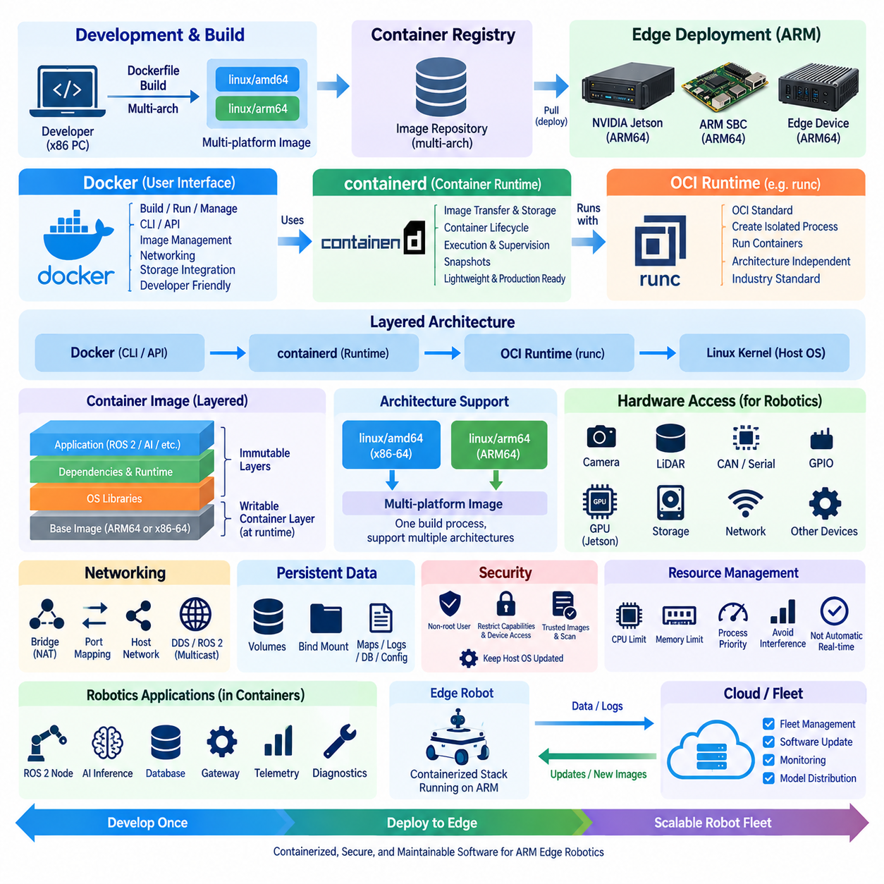
Container technology provides a practical software deployment model for edge robotics because it packages applications together with their runtime libraries, dependencies, and configuration while sharing the host operating-system kernel. Compared with traditional virtual machines, containers generally require less storage and memory and start more quickly. These characteristics are valuable on ARM-based edge computers, where CPU capacity, memory, storage, power, and thermal resources are often more constrained than in cloud servers.
Docker provides a widely used developer-facing environment for building, packaging, distributing, and running containerized applications. Developers define application environments with container images and can reproduce nearly identical software stacks across development computers, CI/CD systems, edge devices, and robot fleets. In ARM robotics, Docker simplifies deployment of ROS 2 nodes, AI inference services, telemetry agents, databases, gateways, and diagnostic tools without manually reproducing every dependency on each physical device.
A container image consists of immutable filesystem layers containing the application and its required software components. A running container adds a writable runtime layer while the original image remains unchanged. This layered architecture allows common components to be reused across multiple images and can reduce distribution overhead. For edge fleets, carefully designed images also support version control, rollback, staged deployment, and reproducible recovery when software failures occur in remotely deployed robots.
Docker itself represents more than the low-level mechanism that executes containers. Its architecture includes command-line tools, APIs, image management, networking, storage integration, and a daemon responsible for coordinating container operations. Modern Docker deployments rely on lower-level components beneath this interface. This separation is important because developers may interact with Docker during development while production orchestration platforms communicate more directly with container runtimes through standardized interfaces.
containerd is a container runtime designed to manage the complete container lifecycle, including image transfer and storage, container execution, supervision, snapshots, and related runtime operations. It operates below higher-level platforms such as Docker or Kubernetes-oriented systems and provides a smaller operational layer for production infrastructure. On resource-constrained edge systems, using containerd directly or through lightweight orchestration can reduce unnecessary management components while retaining standardized container execution.
At an even lower level, container execution commonly relies on Open Container Initiative specifications and OCI-compatible runtimes such as runc. The OCI model standardizes image formats and runtime behavior so that container artifacts are not tied exclusively to one high-level product. Conceptually, an application image is delivered through a container management layer, containerd manages its lifecycle, and an OCI runtime creates the isolated Linux process environment that actually executes the application.
ARM introduces an important architectural consideration because container images contain architecture-specific executable binaries. An image built only for x86-64 cannot normally execute natively on an ARM64 robot computer. Production pipelines must therefore build images for the intended architecture or create multi-platform images containing variants for architectures such as linux/amd64 and linux/arm64. A container registry can then provide the appropriate image variant according to the architecture of the target edge device.
Multi-platform container builds are particularly useful when development and deployment machines use different processors. Engineers may develop software on x86 workstations while production robots use ARM64 Jetson or other ARM platforms. Build systems can generate architecture-specific images from a common source tree, provided that application dependencies are available for each target. This approach reduces divergence between software branches and enables one release process to support heterogeneous edge hardware.
Cross-architecture emulation can assist development and automated builds, but it should not be confused with native execution performance. Emulation may allow ARM binaries to be built or tested on x86 hosts, yet computationally intensive workloads can execute much more slowly. Robotics applications should therefore undergo final integration and performance testing on representative ARM hardware, particularly when evaluating perception latency, memory consumption, hardware acceleration, sensor throughput, and thermal behavior.
Hardware access requires special consideration because robotic containers interact with physical devices rather than operating as isolated cloud services. Cameras, LiDARs, serial ports, CAN interfaces, GPIO, GPUs, and other accelerators may need to be exposed from the host into a container. Device permissions, Linux groups, mounts, runtime configuration, and vendor-specific drivers must be configured deliberately. Excessive privileged access simplifies prototypes but increases security risk and should generally be replaced by narrowly defined device permissions.
GPU-enabled ARM systems introduce another layer between containers and hardware. AI applications may depend on host GPU drivers, accelerator libraries, container runtime integration, and compatible user-space libraries. On NVIDIA Jetson systems, the software environment must align with the supported JetPack and associated acceleration stack. Containerization can isolate application dependencies, but it cannot completely abstract incompatible kernel drivers or hardware-specific runtime components supplied by the underlying platform.
Networking architecture also affects containerized robot applications. Containers may use isolated virtual networks, explicit port mappings, or host networking depending on communication requirements. ROS 2 and DDS-based applications can be sensitive to multicast discovery, interface selection, firewall configuration, and network namespaces. A networking configuration that works for ordinary web services may therefore behave differently for distributed robotic middleware, requiring validation across actual robot, edge-server, and fleet network environments.
Persistent data should normally be separated from disposable container layers. Robot maps, calibration parameters, logs, databases, mission state, learned configuration, and diagnostic records may need to survive container replacement or software upgrades. Bind mounts, managed volumes, or dedicated host storage can preserve these assets independently of application images. This separation also simplifies rollback because software can return to an earlier image version without automatically discarding operational data required by the robot.
Container security on ARM edge devices follows the same fundamental principles as other Linux environments but must account for physical deployment and remote operation. Images should use minimal dependencies, non-root execution where practical, restricted capabilities, controlled device access, trusted registries, vulnerability management, and cryptographic verification. The host operating system and kernel remain part of the security boundary because containers share the host kernel rather than providing the stronger isolation boundary associated with separate virtual machines.
Resource management becomes important when several containers compete for limited edge hardware. CPU quotas, memory limits, process priorities, storage consumption, and accelerator access should be controlled so that a noncritical service cannot starve navigation or perception workloads. Container isolation improves software organization, but it does not automatically provide deterministic real-time behavior. Safety-critical and timing-sensitive components still require appropriate scheduling, operating-system configuration, workload prioritization, and system-level validation.
For production robot fleets, Docker and containerd should be viewed as complementary layers rather than simple competitors. Docker offers a productive workflow for developers and image creation, while containerd provides a focused runtime foundation suitable for automated deployment and orchestration. ARM-compatible images, controlled hardware access, persistent storage, resource limits, security policies, and architecture-aware CI/CD together transform containers from a development convenience into a maintainable edge deployment mechanism.
A robust ARM edge container strategy therefore begins with reproducible multi-architecture builds and continues through registry management, deployment, execution, monitoring, rollback, and lifecycle maintenance. The objective is not merely to place robot software inside containers, but to create a predictable software unit that can move from development to heterogeneous edge hardware with controlled dependencies. When combined with hardware-aware validation, containers provide a scalable foundation for maintaining software across individual robots and large distributed fleets.

02.04 Edge Orchestration: K3s Lightweight Kubernetes [w/Code]
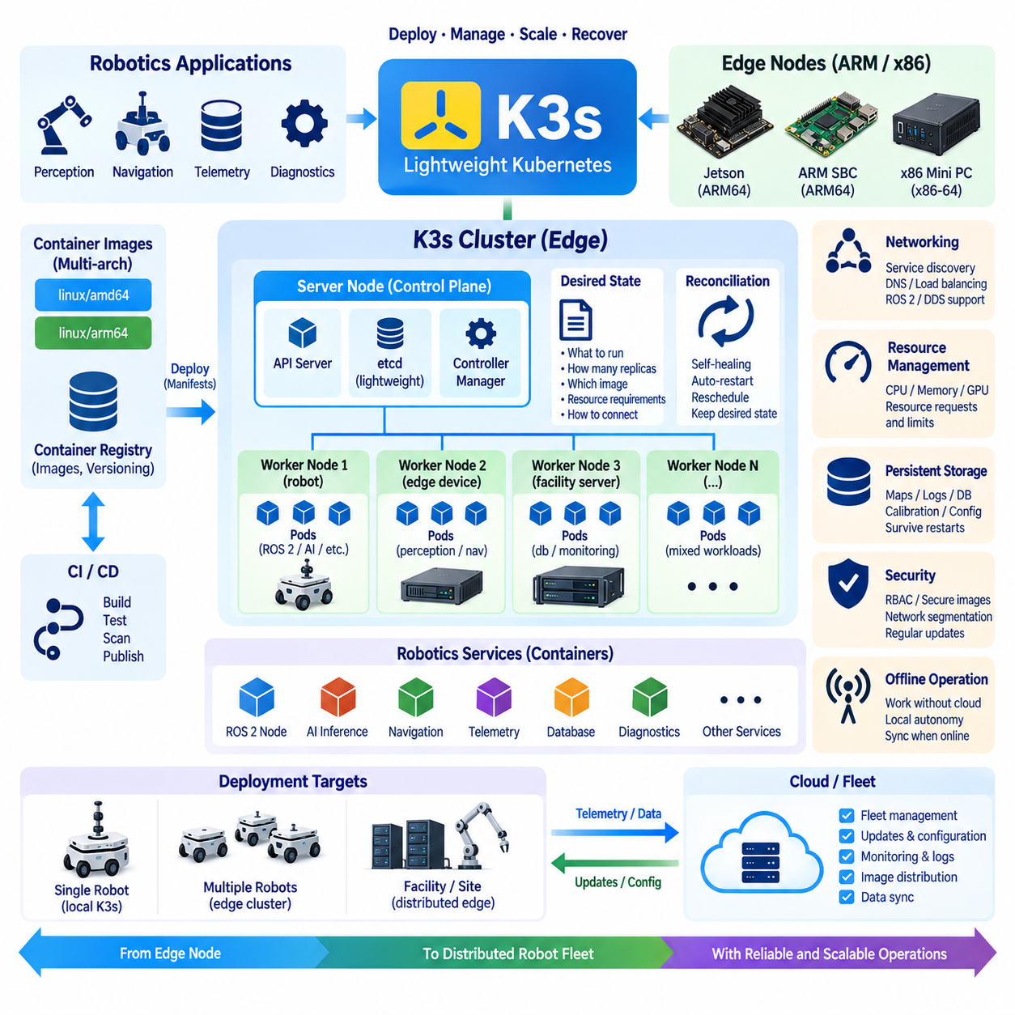
Edge orchestration is the process of managing multiple containerized services across distributed edge computers so that applications can be deployed, started, monitored, updated, and recovered in a consistent manner. In robotics, orchestration becomes important when a single robot or facility contains several independent services such as ROS 2 nodes, AI inference, navigation, telemetry, databases, device management, and diagnostics. Rather than manually controlling each container, an orchestration layer maintains the intended operating state of the system.
K3s is a lightweight Kubernetes distribution designed to provide Kubernetes capabilities with reduced operational overhead. Its smaller footprint makes it appropriate for edge environments where computing resources, storage, memory, and power are more constrained than in conventional cloud clusters. K3s retains core Kubernetes concepts such as workloads, services, networking, configuration, and declarative management while simplifying deployment for smaller installations. This makes it useful for robotic edge nodes and compact local clusters.
The central architectural concept is the desired state. Instead of issuing individual commands to start or restart every application, an operator describes which workloads should exist, how many instances should run, which images they should use, what resources they require, and how they should communicate. The orchestration system continuously compares the desired state with the actual state and attempts to reconcile differences. If a container crashes or a node becomes unavailable, Kubernetes mechanisms can restart or reschedule workloads according to the defined configuration.
K3s can be deployed on ARM64 as well as x86-64 hardware, which is particularly relevant to heterogeneous robotics environments. A robot may use an ARM-based edge computer while a nearby industrial PC or server uses x86-64. Architecture-aware container images allow the same application definition to be deployed across different processor platforms when the required software and hardware interfaces are supported. This provides a consistent management model while still allowing each robot or edge node to use hardware appropriate to its workload.
In a robotic system, a K3s node can host several functional containers. A perception container may process camera or LiDAR data, a navigation container may calculate motion commands, another service may manage telemetry, and additional containers may provide diagnostics or local databases. These services can be described as separate workloads while remaining part of one operational system. The orchestration layer provides a common mechanism for deployment and lifecycle management without requiring every service to be installed directly into the host operating system.
Networking is a critical part of edge orchestration because robotic applications frequently communicate continuously. Kubernetes provides service discovery and networking abstractions that allow applications to communicate using logical service identities rather than depending entirely on fixed container addresses. However, robotics workloads can have requirements that ordinary web applications do not, particularly with ROS 2 and DDS communication, multicast discovery, network interfaces, and timing-sensitive sensor streams. These characteristics must be validated carefully rather than assuming that a default Kubernetes network configuration is sufficient.
Resource management is equally important on an edge robot because the available CPU, memory, storage, and accelerator resources are finite. Kubernetes allows workloads to express resource requests and limits so that the scheduler can make placement decisions and prevent unrestricted resource consumption. This is particularly useful when AI inference, perception, navigation, logging, and monitoring compete for the same hardware. Resource limits, however, should not be interpreted as providing deterministic real-time behavior; safety-critical and hard real-time functions may require dedicated execution environments outside ordinary orchestration mechanisms.
GPU and accelerator access introduces additional complexity. An AI workload running on a Jetson or another accelerator-equipped edge platform may require access to GPU devices and vendor-specific runtime components. The orchestration layer must therefore be configured so that the appropriate hardware can be exposed to the container while maintaining security and resource control. GPU scheduling becomes increasingly important when multiple AI services share an edge server, but accelerator support must be tested against the exact hardware, driver, runtime, and container-image combination used in the deployment.
Storage should be designed separately from disposable application containers. Robot maps, calibration information, logs, databases, configuration files, and operational state may need to survive container restarts, image replacement, or node maintenance. Persistent volumes and suitable host storage can separate application lifecycle from operational data lifecycle. This is especially important for robots because replacing a failed software component should not unintentionally erase information required for localization, diagnostics, mission execution, or recovery.
Edge orchestration must also account for intermittent connectivity. A robot may temporarily lose communication with a fleet server or cloud service while continuing to operate locally. The local K3s environment should therefore retain the workloads required for autonomous operation instead of assuming continuous access to external control infrastructure. Updates and configuration synchronization can occur when connectivity is available. This approach supports an offline-capable architecture in which local services continue operating while higher-level management and synchronization are temporarily disconnected.
Security becomes more significant as orchestration introduces a management plane capable of controlling many applications. Access to the Kubernetes API, credentials, container images, network services, and node resources must be controlled carefully. Images should originate from trusted registries and should be scanned and versioned as part of the software supply chain. Nodes should use secure operating-system configurations, controlled privileges, appropriate network segmentation, and regular security updates. The orchestration platform should therefore be treated as part of the robot's operational security boundary.
For a robot fleet, K3s can extend beyond a single robot and provide lightweight cluster management for groups of edge computers. A local facility may contain several industrial PCs, GPU servers, gateways, and robot nodes, with workloads distributed according to available resources and operational requirements. This enables common deployment definitions, centralized configuration, service discovery, monitoring integration, and controlled updates. However, fleet-scale management should distinguish between robot-level autonomy and facility-level orchestration so that a failure in the management layer does not unnecessarily compromise essential local functions.
The practical objective of K3s in robotics is not to introduce Kubernetes simply because Kubernetes is widely used, but to provide repeatable lifecycle management for distributed software. When the number of services and edge nodes grows beyond what can be maintained reliably with manual scripts, orchestration provides a structured mechanism for deployment, recovery, scaling, configuration, and software consistency. For small systems, direct container management may remain sufficient; as robotic systems become more distributed and heterogeneous, lightweight Kubernetes can provide an intermediate management layer between individual containers and full-scale cloud orchestration.

02.05 Edge AI Inference Optimization: TensorRT / OpenVINO [w/Code]
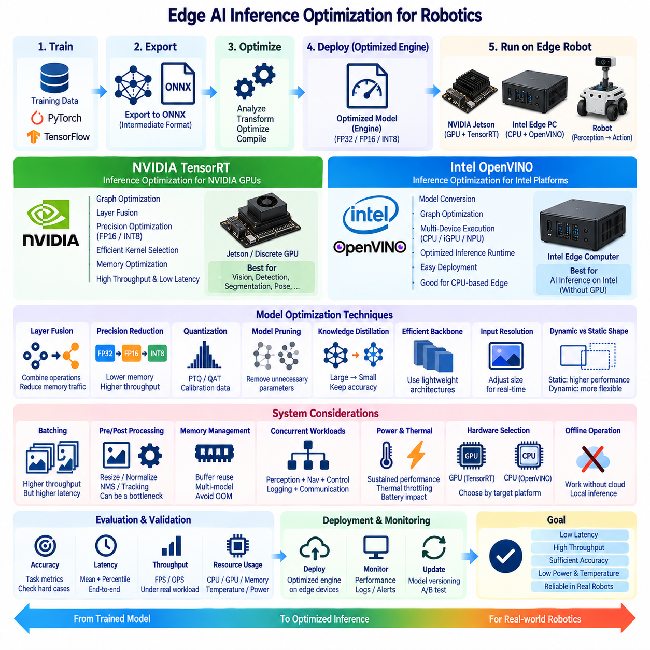
Edge AI inference optimization is the process of transforming a trained neural network into an execution form that delivers useful accuracy with lower latency, higher throughput, reduced memory consumption, and controlled power usage. In robotics, optimization is especially important because perception must often operate continuously while sharing limited compute resources with localization, planning, control, communication, and logging. The objective is therefore sustained system-level performance rather than maximum benchmark speed alone.
A typical inference workflow begins with a model trained in frameworks such as PyTorch or TensorFlow and converts it into a representation suitable for deployment. ONNX is frequently used as an intermediate model format because it separates the training framework from the target inference engine. The exported model can then be analyzed, transformed, compiled, and optimized for the selected edge hardware. Successful deployment requires verifying that operators, tensor shapes, precision modes, and preprocessing behavior remain compatible throughout this conversion process.
TensorRT is NVIDIA's inference optimization and runtime technology for NVIDIA GPUs and related edge platforms. It analyzes a trained network and generates an optimized execution engine for the target GPU environment. TensorRT can combine compatible operations, select efficient kernels, optimize tensor memory usage, and exploit reduced numerical precision. These capabilities make it particularly relevant to Jetson-based robots and GPU-equipped edge computers running vision, detection, segmentation, pose estimation, and other neural inference workloads.
Layer and operation fusion reduces unnecessary intermediate processing by combining compatible operations into more efficient execution sequences. Instead of repeatedly writing intermediate tensors to memory and reading them again, an optimized engine can reduce memory traffic and kernel-launch overhead. This is important on edge systems because inference performance is determined not only by arithmetic capability but also by memory bandwidth, data movement, synchronization, and the efficiency with which hardware resources remain occupied.
Precision reduction is another major optimization technique. Models originally trained using FP32 can often execute inference using FP16 or INT8, depending on hardware support and acceptable accuracy loss. Lower precision reduces tensor storage and memory bandwidth requirements while enabling specialized accelerator units to process more operations efficiently. However, numerical precision should be selected through measurement because different network architectures and application tasks can respond differently to quantization and reduced-precision arithmetic.
INT8 inference generally requires additional attention because floating-point values must be represented using a limited integer range. Post-training quantization may use representative calibration data to determine suitable scaling parameters, while quantization-aware training can expose the model to quantization effects during training. For robotic perception, calibration data should represent realistic operating conditions, including relevant lighting, objects, environments, and sensor characteristics, because inappropriate calibration can degrade accuracy even when inference speed improves substantially.
OpenVINO provides an inference optimization and deployment environment particularly relevant to Intel-based edge systems. It supports model conversion, graph optimization, and execution across supported Intel compute devices such as CPUs, integrated graphics, and dedicated AI acceleration hardware where available. This allows an x86 edge computer to execute neural inference without requiring a discrete NVIDIA GPU and can be useful when robotics middleware, conventional CPU workloads, and AI inference must coexist within the same Intel-oriented platform.
TensorRT and OpenVINO should therefore be understood primarily as hardware-oriented inference ecosystems rather than universally interchangeable acceleration libraries. TensorRT is closely aligned with NVIDIA GPU execution, while OpenVINO emphasizes optimized inference across supported Intel hardware. The correct choice follows the deployed computing architecture. A heterogeneous robot fleet may consequently use different optimized inference engines while retaining common training models, model registries, validation procedures, and deployment policies.
Dynamic and static tensor shapes also influence optimization. Fixed input dimensions allow an inference engine to make stronger assumptions about memory allocation and execution planning, while dynamic shapes provide flexibility for applications that process different resolutions or sequence lengths. Robotics developers should avoid enabling unnecessary dynamism because flexibility can introduce optimization complexity. Camera resolution, batch size, point-cloud dimensions, and model input structure should therefore be defined according to realistic operational requirements.
Batching is highly effective in cloud inference but requires more careful treatment at the robotic edge. Increasing batch size can improve accelerator utilization and throughput, yet waiting to accumulate multiple inputs can increase end-to-end latency. A robot reacting to a newly detected obstacle may value immediate processing more than maximum images per second. Edge optimization should therefore distinguish throughput-oriented workloads from latency-sensitive perception and control pipelines rather than automatically maximizing batch size.
Preprocessing and postprocessing must also be included in performance analysis. Image resizing, color conversion, normalization, tensor formatting, non-maximum suppression, coordinate transformation, tracking, and message serialization can consume significant CPU and memory resources. Accelerating only the neural network may produce limited system improvement if surrounding operations remain inefficient. End-to-end profiling should measure the complete path from sensor acquisition through inference to the final output consumed by the robot.
Memory optimization becomes critical when several AI models execute concurrently. Detection, segmentation, depth estimation, pose recognition, and multimodal processing may compete for the same GPU or system memory. Efficient buffer reuse, controlled model loading, appropriate tensor precision, and minimized host-device copying can prevent memory exhaustion and reduce latency. Unified-memory or integrated architectures can simplify some data movement, but actual behavior should still be profiled under realistic concurrent workloads.
Model optimization can also involve architectural changes rather than runtime compilation alone. Pruning, knowledge distillation, efficient backbone selection, input-resolution reduction, and model redesign can decrease computational demand before deployment. A smaller model that preserves sufficient task accuracy may outperform a heavily optimized large model in latency, power consumption, and thermal stability. Edge AI engineering therefore connects model design with hardware deployment instead of treating inference optimization as a final conversion step.
Benchmarking should measure latency distributions rather than only average inference time. Mean latency can hide occasional long delays that affect robot behavior. Percentile latency, throughput, memory consumption, CPU and accelerator utilization, temperature, clock behavior, and power consumption provide a more realistic picture of sustained performance. Measurements should also include simultaneous robotics workloads because an inference engine tested in isolation may behave differently when navigation, sensor processing, recording, and networking are active.
Accuracy validation must accompany every optimization stage. Converting from the training framework to ONNX, changing operators, enabling FP16, applying INT8 quantization, or modifying preprocessing can alter numerical outputs. Validation should therefore compare optimized models against an accepted reference using representative datasets and task-specific metrics. For safety-relevant perception, developers should examine difficult cases and operational scenarios rather than accepting optimization solely because aggregate benchmark accuracy appears similar.
Thermal and power constraints finally determine whether optimized inference can be sustained on a physical robot. A model may achieve excellent short-duration performance while the processor is cool but slow after prolonged operation because of thermal throttling or shared power limits. Evaluation should therefore run long enough to expose steady-state behavior inside the intended enclosure and environmental conditions. Cooling design, power modes, workload concurrency, and battery impact are part of inference engineering.
A robust edge AI pipeline consequently connects training, model export, optimization, validation, deployment, monitoring, and later model updates. TensorRT can provide highly optimized execution on NVIDIA platforms, while OpenVINO can optimize inference across supported Intel edge hardware. The engineering goal is not simply the highest TOPS utilization or FPS value, but predictable end-to-end latency, sufficient task accuracy, sustainable power and thermal behavior, and reliable integration with the complete robotic software stack.

02.06 Edge Data Local Processing: Stream, Filter, Anomaly [w/Code]
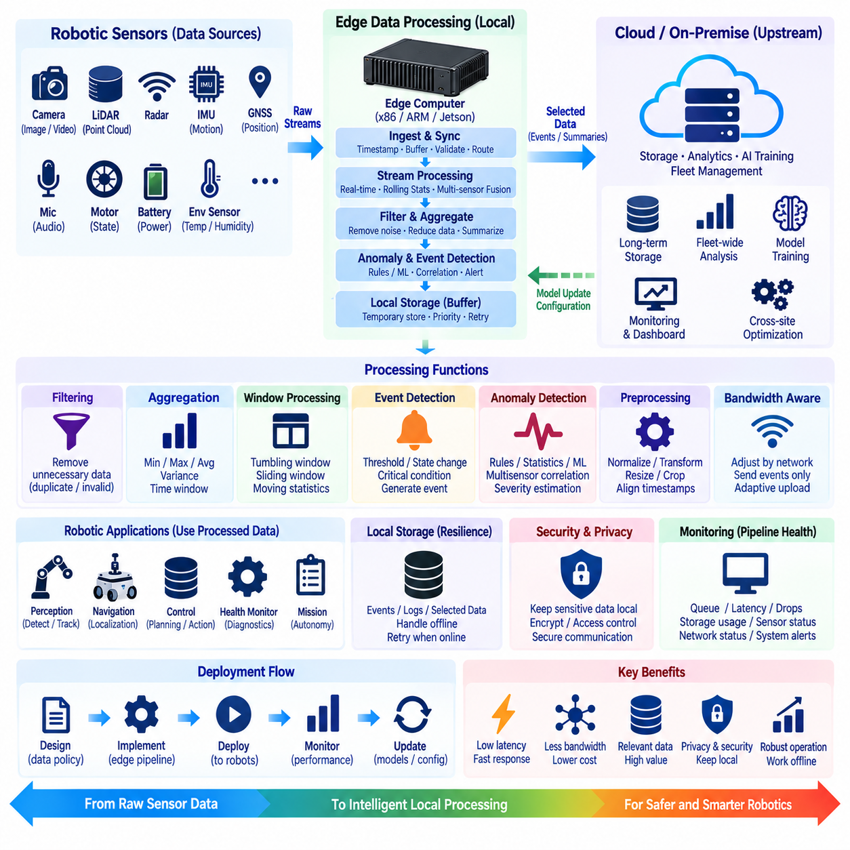
Edge data processing moves selected computation from centralized cloud infrastructure to locations close to robots, sensors, machines, and physical processes. Instead of continuously transmitting every raw camera frame, LiDAR scan, telemetry message, or equipment signal, an edge node can process incoming data locally and determine what requires immediate action, temporary storage, or upstream transmission. This reduces communication load while improving responsiveness and operational independence.
A robotic edge data pipeline normally begins with continuous streams generated by cameras, LiDAR, radar, IMU, GNSS, microphones, motor controllers, batteries, and environmental sensors. These sources differ significantly in frequency, data volume, timing requirements, and reliability. Local processing therefore requires a structured ingestion layer that timestamps, buffers, validates, and routes incoming streams while preserving enough temporal information to support synchronization and later interpretation.
Stream processing treats data as a continuously arriving sequence rather than waiting for large datasets to be stored before analysis. Sensor messages can be evaluated as they arrive, allowing the edge system to calculate rolling statistics, detect state transitions, combine multiple signals, or trigger robot actions within short time intervals. This processing model is particularly suitable for robotics because the value of sensor information often decreases rapidly when decisions must respond to changing physical conditions.
Filtering removes data that does not need further processing or transmission. A camera pipeline may discard unusable frames, telemetry processing may suppress repeated values, and vibration monitoring may ignore measurements inside an accepted operating range. Filtering can also reduce sampling frequency or select specific regions and channels. The objective is not simply to delete data, but to preserve information relevant to control, diagnostics, learning, and operational evidence while reducing unnecessary computation and communication.
Aggregation converts high-frequency observations into compact summaries that are easier to store and transmit. Hundreds of temperature, current, vibration, or motion measurements can be represented using minimum, maximum, average, variance, count, or time-window statistics. Robot telemetry can similarly be summarized by mission, route segment, operating mode, or time interval. Aggregation preserves useful trends while preventing low-value repetitive measurements from consuming network bandwidth and centralized storage.
Window-based processing provides a practical mechanism for interpreting continuous streams. Tumbling windows divide data into fixed non-overlapping intervals, while sliding windows repeatedly evaluate overlapping recent observations. Time windows can support moving averages, vibration analysis, communication-quality monitoring, battery trends, or localization confidence. The window duration should match the physical phenomenon because an interval that is too short may amplify noise while one that is too long may hide rapid changes.
Event detection converts continuous sensor streams into meaningful operational signals. Instead of uploading all measurements, the edge system can report events such as excessive motor current, rapid battery voltage decline, unexpected vibration, obstacle appearance, localization degradation, or communication loss. Events may contain timestamps, severity, relevant sensor values, robot state, and selected contextual data. This event-oriented approach allows upstream systems to focus on conditions that require attention rather than processing every observation equally.
Anomaly detection extends event processing by identifying behavior that differs from expected operating patterns. Simple approaches may use thresholds, ranges, rate-of-change limits, or statistical deviations, while more advanced systems can use machine-learning models trained on normal and abnormal behavior. The appropriate method depends on the application and available evidence. For safety-related functions, interpretable rules may remain important even when learned anomaly detectors are used as additional diagnostic mechanisms.
Multisensor anomaly detection can provide stronger evidence than monitoring individual signals independently. Increased motor current alone may result from normal load variation, but increased current combined with abnormal vibration, reduced wheel speed, and rising temperature can indicate a more significant mechanical problem. Edge processing can correlate these observations using synchronized timestamps and operational context. This enables local diagnosis without transmitting every raw sensor stream to a remote analytics platform.
Local preprocessing also improves the quality of data used by downstream AI systems. Sensor values can be normalized, invalid samples removed, coordinate systems transformed, timestamps aligned, and missing data marked before information enters perception or learning pipelines. Images can be resized or cropped, point clouds can be filtered, and telemetry can be converted into consistent units. Performing these operations near the data source reduces repeated preprocessing and creates more predictable inputs for subsequent computation.
Robotic vision generates particularly large data volumes, making selective local processing valuable. Rather than continuously storing or uploading complete video streams, an edge computer can perform object detection, segmentation, tracking, or scene classification and retain only selected frames or metadata. An unusual event can trigger temporary recording of frames before and after the event. This converts continuous high-bandwidth sensing into compact evidence while preserving important context for diagnostics or later model improvement.
Local buffering provides resilience when network connectivity is intermittent. Processed events, telemetry, logs, and selected sensor samples can be stored temporarily on the edge device and forwarded after communication is restored. Buffers should have defined capacity, retention, prioritization, and overflow policies because storage is finite. Critical diagnostic or safety evidence may receive higher retention priority than routine telemetry, allowing the system to degrade gracefully during prolonged communication outages.
Bandwidth-aware processing can dynamically adjust what information is transmitted according to network conditions. When connectivity is strong, the robot may upload richer telemetry or selected sensor samples, while constrained communication may permit only events, health summaries, and critical status messages. Local intelligence can therefore act as a data reduction layer between physical sensors and centralized systems. This is particularly useful for mobile robots operating across Wi-Fi, cellular, private wireless, or unreliable outdoor networks.
Edge data processing also supports privacy and security by reducing unnecessary movement of raw information. Camera images, facility layouts, production details, and operational records can remain within the local environment while derived metadata or approved events are transmitted upstream. However, local storage and processing introduce their own security responsibilities. Data at rest, communication channels, credentials, access permissions, logs, and software components must be protected according to the sensitivity of the robotic application.
Processing priorities should reflect the operational value of data. Safety and control information requires immediate handling, health monitoring may tolerate short delays, and historical analytics can often be deferred. Separating fast-path and slow-path processing prevents large logging or upload workloads from interfering with time-sensitive robot functions. Edge architecture should therefore classify streams according to latency, criticality, retention, bandwidth, and computational requirements before assigning processing resources.
Monitoring is necessary because the data pipeline itself can fail. Queue depth, dropped messages, processing latency, storage utilization, timestamp quality, sensor availability, network status, and anomaly-detector behavior should be observable. Without pipeline monitoring, missing data may incorrectly appear to represent normal operation. Edge systems should distinguish between a genuine absence of abnormal events and an inability to observe the underlying sensor stream because of communication, hardware, or software failures.
A complete edge data strategy connects local stream processing with cloud or on-premise analytics rather than replacing centralized infrastructure. The edge performs immediate filtering, aggregation, anomaly detection, event generation, and temporary buffering, while higher-level systems provide long-term storage, fleet-wide analysis, model training, historical comparison, and cross-site optimization. Only information with sufficient operational or learning value needs to move upward through this hierarchy.
The resulting architecture transforms raw robotic data into progressively higher-value information close to where it is generated. Sensors produce continuous streams, edge processing filters and contextualizes them, anomaly logic identifies important deviations, and selected events or summaries are forwarded for broader analysis. By combining local responsiveness with centralized learning and fleet intelligence, edge data processing reduces bandwidth and storage demand while improving resilience, observability, and timely decision-making across distributed robotic systems.

02.07 Edge Network Design: Local Breakout / SD.WAN
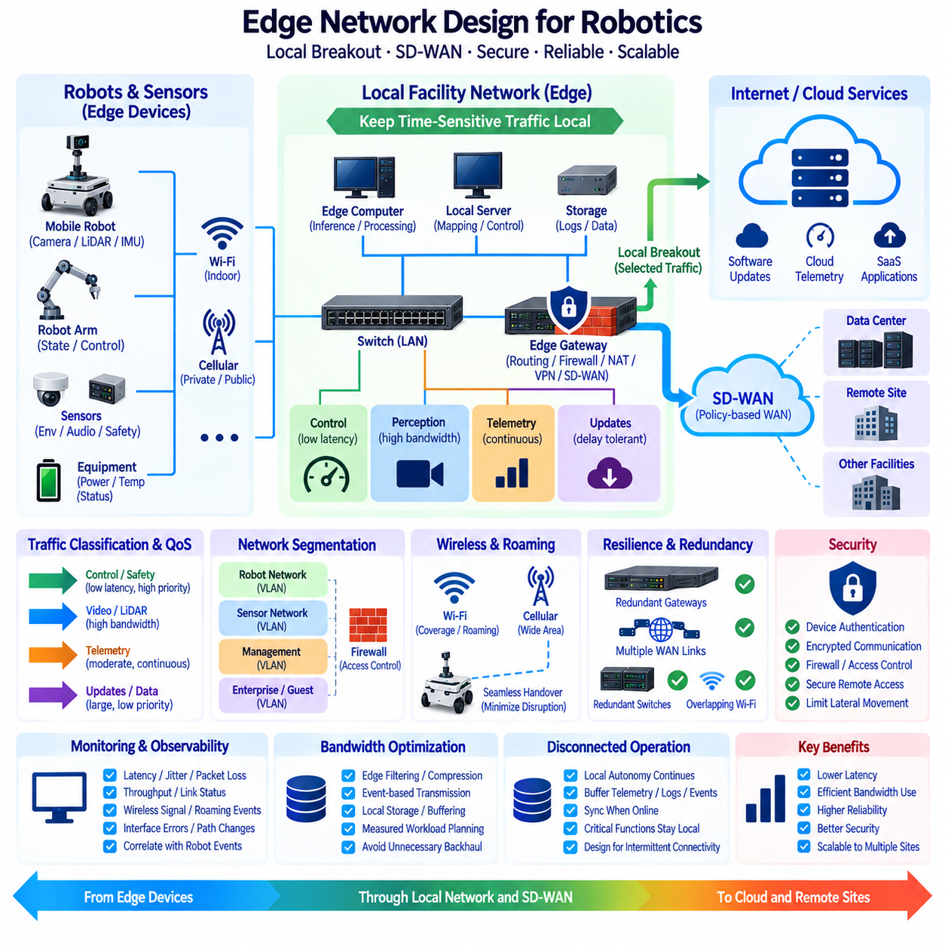
Edge network design determines how robots, local compute nodes, facility infrastructure, remote sites, and cloud services exchange data while preserving latency, reliability, security, and operational continuity. Unlike conventional enterprise endpoints, robots continuously generate sensor streams and depend on communication for fleet coordination, telemetry, software updates, and remote management. The network must therefore distinguish traffic that must remain local from traffic that can safely traverse wide-area or cloud connections.
A fundamental design principle is to keep time-sensitive robotic communication as close to the physical system as possible. Sensor data, localization messages, navigation commands, safety-related status, and local coordination may require predictable communication even when external connectivity is degraded. Sending such traffic through a remote cloud region introduces unnecessary latency and dependency. Local switching, routing, and edge computing allow essential robot functions to continue within the facility or operational site.
Local breakout provides a mechanism for sending selected traffic directly toward its destination instead of backhauling everything through a centralized data center. Internet-bound software updates, cloud telemetry, or SaaS traffic can leave through a local gateway, while internal robot communication remains inside the local network. This reduces unnecessary WAN traversal and can improve latency, bandwidth efficiency, and resilience. Breakout policies should nevertheless preserve security inspection and organizational access-control requirements.
Traffic classification is essential because robotic data has different operational characteristics. Control and safety messages may be small but highly latency-sensitive, camera or LiDAR streams can consume substantial bandwidth, telemetry is generally moderate and continuous, while software images and dataset transfers can be large but delay-tolerant. Network architecture should classify these flows according to latency, jitter, loss tolerance, bandwidth, criticality, and destination rather than treating every packet with equal operational priority.
Quality of Service(QoS) can prioritize important traffic when network resources become constrained. Critical control or coordination messages can receive preferential treatment over background uploads, logs, backups, or software downloads. QoS cannot create bandwidth that does not exist, but it can determine which workloads experience degradation first during congestion. Effective policies therefore require realistic measurements of robot traffic and should avoid assigning high priority to so many flows that prioritization becomes meaningless.
Network segmentation separates systems according to function, trust level, or operational responsibility. Robots, sensors, engineering workstations, management services, guest devices, and general enterprise systems should not necessarily share one unrestricted broadcast domain. VLANs, routing policies, firewalls, and access controls can limit unnecessary communication paths. Segmentation reduces fault propagation and security exposure while making it easier to define which services are allowed to communicate across robotic and enterprise network boundaries.
Wireless connectivity requires special attention because mobile robots cannot depend entirely on fixed Ethernet links. Wi-Fi may provide high local bandwidth, while private cellular or public mobile networks can extend coverage across larger areas. Actual performance depends on interference, obstacles, roaming behavior, access-point placement, channel utilization, and radio conditions. Robot networking should therefore be evaluated through movement across the real operating environment rather than through stationary throughput measurements alone.
Roaming behavior can directly affect autonomous operation when a robot moves between wireless coverage zones. Handover delays, packet loss, reassociation, or address changes may temporarily interrupt telemetry or distributed services. Applications should tolerate short communication disruptions, and critical local autonomy should not depend on uninterrupted remote connectivity. Wireless design, application recovery behavior, buffering, and edge processing must consequently be engineered together instead of being treated as independent subsystems.
Software-defined wide-area networking(SD-WAN) provides policy-based control over connectivity between facilities, edge sites, data centers, and cloud environments. Instead of relying on one fixed WAN path, SD-WAN can use multiple available transports and select paths according to application policies and observed network conditions. This can be valuable for geographically distributed robot fleets because operational sites may use combinations of broadband, dedicated links, cellular connections, or other network services.
SD-WAN policies can steer different application classes according to business and technical requirements. Fleet management traffic may use one preferred path, cloud telemetry another, while large software or dataset transfers can use lower-priority connectivity. When a preferred WAN path becomes unavailable, policies can redirect eligible traffic through another connection. The effectiveness of this approach depends on actual transport diversity, application behavior, security design, and the capabilities of the selected SD-WAN implementation.
Local breakout and SD-WAN address related but different architectural problems. Local breakout determines where selected traffic exits a site instead of forcing it through centralized infrastructure, while SD-WAN manages how traffic traverses available wide-area connections according to policy. Used together, they can keep robot-local communication near the edge, provide efficient access to cloud services, and dynamically manage inter-site connectivity without requiring every packet to follow the same centralized route.
Edge gateways form an important boundary between robot networks and external infrastructure. A gateway may provide routing, firewall functions, VPN connectivity, protocol mediation, traffic inspection, local DNS, network address translation, or SD-WAN functions. In smaller deployments several functions may share one appliance, while larger facilities may separate them for performance and resilience. Gateway failure must be considered explicitly because concentrating many network functions into one device can create a critical dependency.
Redundancy should be designed according to the consequence of communication failure. Critical sites may use multiple gateways, independent WAN links, redundant switches, overlapping wireless coverage, or alternative cellular connectivity. However, redundancy is effective only when failure domains are genuinely independent. Two logical paths using the same physical cable, power source, access point, or upstream provider may still fail simultaneously. Network resilience therefore requires analysis of the complete physical and logical communication path.
Security must be integrated into routing and connectivity decisions rather than added after the network topology is complete. Device authentication, encrypted communication, firewall rules, network segmentation, certificate management, secure remote access, and monitoring can reduce unauthorized access to robotic systems. Remote maintenance should provide controlled access to required services without exposing entire robot networks. Security policies should also account for compromised edge nodes and limit their ability to move laterally across the infrastructure.
Observability is required to understand whether network behavior is affecting robot performance. Useful measurements include latency, jitter, packet loss, throughput, retransmissions, wireless signal quality, roaming events, interface errors, path changes, and WAN availability. These metrics should be correlated with robot timestamps and operational events. A navigation or perception failure that appears to be a software problem may otherwise originate from delayed, reordered, or missing network data.
Bandwidth planning should use measured workloads rather than nominal interface speeds. Multiple cameras, LiDAR sensors, map transfers, remote visualization, logs, and software updates can generate bursts that exceed average traffic levels. Designers should evaluate both normal and worst-case concurrent operation. Edge filtering, compression, event-based transmission, and local storage can substantially reduce WAN demand by preventing high-volume raw data from leaving the site unless it has clear operational or learning value.
Disconnected operation should be treated as a normal design condition for mobile and distributed robots rather than only as an exceptional failure. Local navigation, safety, mission execution, and essential coordination should continue whenever technically appropriate without cloud connectivity. Telemetry, logs, and events can be buffered locally and synchronized when connectivity returns. This separates robot autonomy from WAN availability while still allowing centralized fleet management and analytics when communication is available.
A scalable architecture therefore combines local robot networking, segmented facility infrastructure, edge gateways, local breakout, and policy-controlled WAN connectivity. Immediate physical operations remain close to the robot, facility services coordinate local resources, and SD-WAN can connect distributed sites to data centers or cloud environments. Each layer handles traffic according to latency, bandwidth, security, availability, and operational importance instead of using one communication strategy for every workload.
The final objective of edge network design is not simply maximum network speed, but predictable communication that supports physical autonomy. Local breakout reduces unnecessary backhaul, SD-WAN provides policy-based wide-area path management, segmentation limits security exposure, and edge processing reduces transmitted data volume. Combined with redundancy, observability, and offline-capable robot software, these mechanisms create a network foundation capable of supporting reliable distributed robotic operations across local facilities and remote sites.

02.08 Edge Security Hardening: Immutable OS / Secure Boot
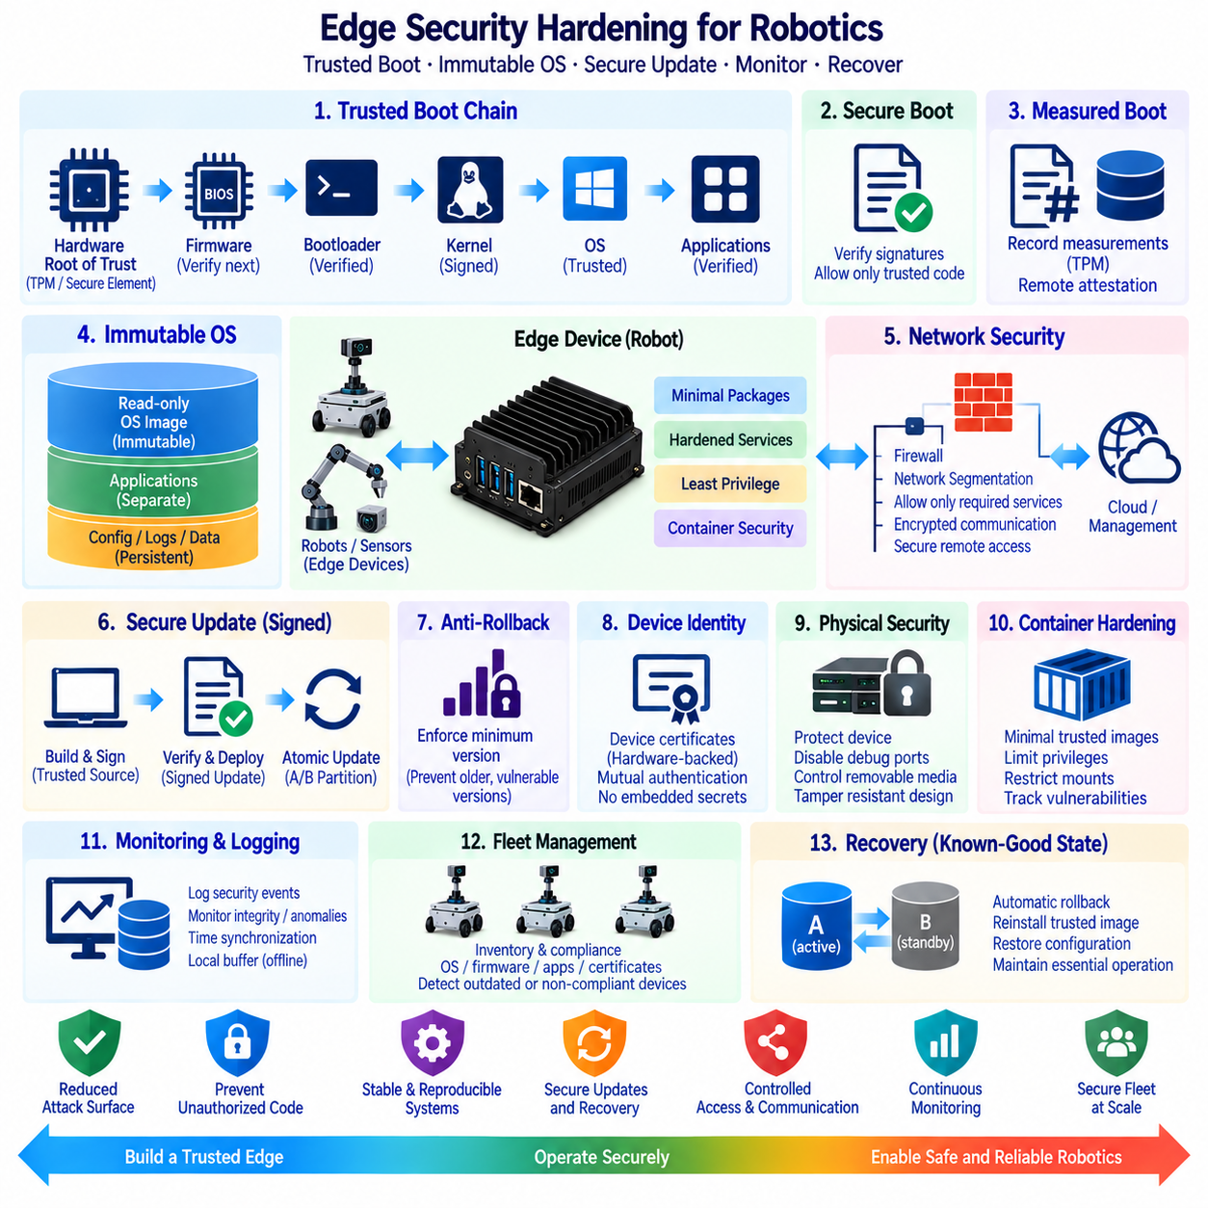
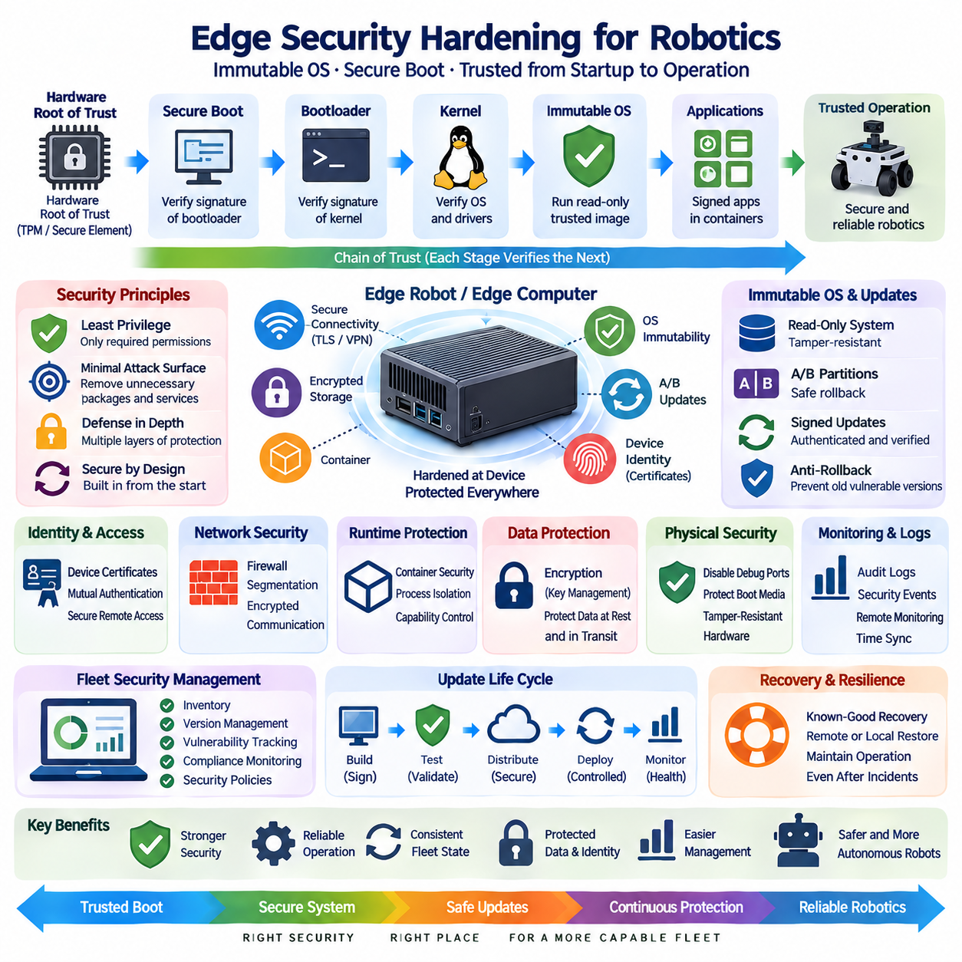
Edge security hardening protects robotic and industrial edge systems by reducing the number of components, privileges, interfaces, and software states that attackers can manipulate. Unlike centralized servers located in controlled facilities, edge computers may operate inside robots, production areas, warehouses, outdoor environments, or remote sites where physical access is possible. Security must therefore protect the complete platform from initial boot through operating-system execution, application deployment, communication, update, and recovery.
A hardened edge architecture begins with a hardware-rooted chain of trust. The processor or platform firmware establishes the first trusted execution stage and verifies the integrity and authenticity of subsequent boot components before allowing them to execute. Each trusted stage verifies the next stage, creating a chain from firmware to bootloader, kernel, and operating-system components. If unauthorized code is introduced into this sequence, verification should prevent normal execution or direct the device toward a controlled recovery mechanism.
Secure Boot provides an important mechanism for enforcing this trusted startup process. Cryptographic signatures are used to determine whether boot components originate from authorized sources and remain acceptable according to the platform security policy. Secure Boot is most effective when signing keys, firmware configuration, bootloader policies, and recovery procedures are managed as part of one lifecycle. Enabling the feature without controlling keys and update processes provides less protection than a fully governed trust architecture.
Measured Boot complements Secure Boot by recording cryptographic measurements of important startup components rather than relying only on execution blocking. These measurements can be stored or protected using hardware security capabilities such as a Trusted Platform Module. A management system can compare measurements against known acceptable values and determine whether a device started with an expected software configuration. This provides evidence that can support device health assessment, remote attestation, incident investigation, and fleet security monitoring.
An immutable operating system reduces uncontrolled changes to the software platform after deployment. Core system partitions or operating-system images are treated as read-only or replaced atomically rather than modified continuously through manual package installation. Applications, configuration, logs, and persistent operational data can be separated from the protected system image. This reduces configuration drift across robot fleets and makes the deployed state easier to reproduce, validate, update, and restore after failures.
Immutability does not mean that the robot can never change. Instead, changes are introduced through controlled image versions rather than arbitrary modifications to individual files. A new operating-system image can be built, tested, signed, distributed, and activated as one known software state. This approach creates a clearer relationship between source configuration and deployed devices. If a problem appears after an update, the platform can return to a previously validated image instead of attempting to reconstruct an unknown combination of modified packages.
A/B system partitions are frequently useful for robust edge updates. One partition runs the current validated operating system while another partition receives the next software image. After verification, the device can boot into the updated partition and perform health checks. If startup or validation fails, the system can return to the previous partition. This mechanism reduces the risk that interrupted downloads, power failures, corrupted images, or incompatible software will permanently disable remotely deployed robots.
The operating system itself should follow the principle of minimal attack surface. Unnecessary packages, services, shells, network listeners, development tools, and default accounts should be removed or disabled in production deployments. Every additional component can introduce vulnerabilities, maintenance requirements, or unexpected communication paths. A minimal platform also simplifies vulnerability management because fewer software packages must be inventoried, monitored, patched, and validated throughout the operational lifetime of the robot.
Least privilege should govern applications and system services. Robot software should execute with only the permissions required for its function rather than running everything as root. Linux capabilities, user and group permissions, filesystem controls, device permissions, mandatory access-control mechanisms, container restrictions, and service isolation can reduce the consequences of a compromised process. Access to cameras, CAN interfaces, serial devices, GPUs, storage, and network configuration should be granted deliberately rather than exposing the entire host environment.
Containerized workloads require hardening at both container and host levels. Containers should use minimal trusted images, avoid unnecessary privileged execution, restrict mounted host paths, limit Linux capabilities, and separate persistent data from application layers. Image provenance and vulnerability status should be tracked before deployment. Because containers share the host kernel, container isolation cannot replace operating-system security. A compromised kernel or excessively privileged container can undermine boundaries that appear strong at the application level.
Cryptographic identity allows each edge device to prove which device it is when connecting to management systems or other trusted infrastructure. Device certificates, protected private keys, and controlled credential provisioning can support mutual authentication and encrypted communication. Credentials should not be embedded as reusable secrets inside application images. When practical, sensitive keys should be protected using hardware-backed mechanisms so that extracting storage media or copying a filesystem does not automatically reveal the device identity.
Network hardening limits the communication paths available to an attacker. Edge nodes should expose only required services, while firewalls and network segmentation restrict inbound, outbound, and lateral communication. Robot networks, management networks, sensor networks, and enterprise systems can be separated according to trust and operational requirements. Remote administration should use authenticated and encrypted channels with controlled authorization instead of exposing general-purpose management interfaces directly to untrusted networks.
Software updates represent both a security requirement and a security risk. Edge devices must receive vulnerability fixes and application improvements, but accepting unauthorized updates could give an attacker control of the system. Update packages should therefore be authenticated, integrity checked, version controlled, and distributed through trusted mechanisms. Rollback policies must also consider security because returning to an older image can restore availability while potentially reintroducing a known vulnerability that had already been corrected.
Anti-rollback protection can prevent a device from accepting software versions below an approved security level. This is particularly relevant when an attacker has physical access and attempts to install an older but legitimately signed image containing exploitable vulnerabilities. Version counters, trusted metadata, or hardware-supported mechanisms can enforce minimum accepted versions. Recovery procedures must nevertheless be designed carefully so that security controls do not make legitimate maintenance or disaster recovery impossible.
Physical security remains important because edge computers may be accessible outside controlled data centers. Attackers with direct access may attempt to remove storage, connect debugging interfaces, replace boot media, reset firmware settings, or access exposed ports. Production devices should disable unnecessary debug interfaces, protect boot configuration, control removable media, and use tamper-resistant mechanical design where appropriate. Encryption can further reduce the value of storage devices removed from the robot.
Logging and security monitoring provide evidence when preventive controls are insufficient. Authentication failures, privilege changes, update attempts, boot measurements, service crashes, configuration changes, network anomalies, and integrity violations should be recorded according to operational requirements. Important logs may need protected local buffering when connectivity is unavailable and later forwarding to centralized monitoring infrastructure. Time synchronization is essential because incident analysis depends on correlating events across robots, gateways, servers, and network systems.
Fleet security requires maintaining an inventory of hardware, firmware, operating-system versions, application images, certificates, and security status across all deployed devices. A robot that is no longer receiving updates or uses an expired certificate can become a weak point even if its original configuration was secure. Central management should identify outdated or noncompliant nodes while allowing essential local functions to continue safely during temporary disconnection. Security therefore becomes a continuous lifecycle process rather than a one-time deployment activity.
Recovery must be treated as part of security hardening rather than only as an availability function. A compromised or corrupted device should have a defined method for returning to a trusted state using validated images, protected credentials, known configuration, and preserved operational data where appropriate. Immutable images and verified boot mechanisms simplify this process because the recovery target can be explicitly defined. The objective is to restore a known-good state rather than manually repairing an uncertain software environment.
A robust edge security architecture therefore connects hardware trust, Secure Boot, measured startup, immutable operating-system images, controlled updates, least privilege, network segmentation, device identity, monitoring, and trusted recovery. No single mechanism provides complete protection. Together, these controls reduce unauthorized software execution, configuration drift, credential exposure, lateral movement, and persistent compromise while making robot software states easier to verify and reproduce.
For distributed robotic systems, the final goal is a verifiable edge platform whose identity, boot state, operating system, applications, communication paths, and update history can be managed throughout the device lifecycle. Secure Boot establishes confidence at startup, immutable operating systems preserve predictable software states, and signed atomic updates provide controlled evolution. Combined with monitoring and recovery, these mechanisms create a security foundation suitable for autonomous robots operating beyond continuously supervised computing environments.

02.09 Edge Device Monitoring and Remote Management [w/Code]
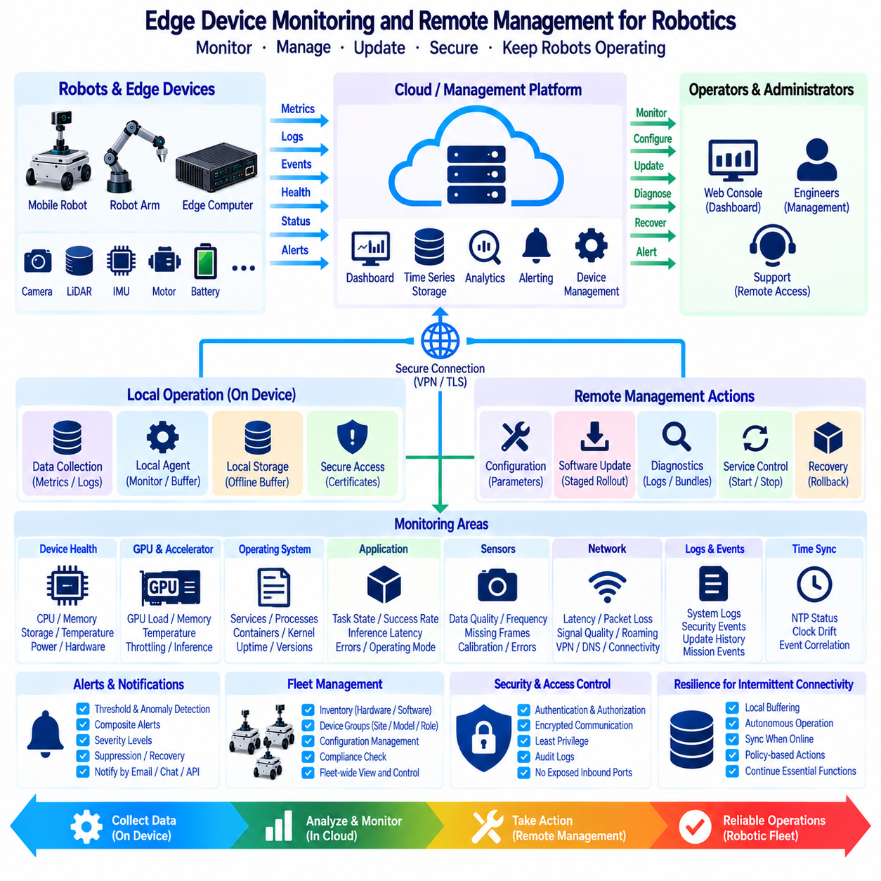
Edge device monitoring and remote management provide the operational visibility and control required to maintain robots and distributed computing nodes after deployment. A robot may operate for months or years outside direct engineering supervision, making manual inspection impractical at fleet scale. Monitoring therefore collects evidence about hardware, operating systems, applications, networks, sensors, storage, and mission execution, while remote management provides controlled mechanisms for diagnosis, configuration, maintenance, and recovery.
Effective monitoring begins with device health telemetry. Edge computers should report processor utilization, memory consumption, storage capacity, filesystem state, temperature, power conditions, accelerator utilization, and important hardware errors. GPU-equipped robots may additionally track GPU load, memory usage, temperature, throttling, and inference workload behavior. These measurements help distinguish application problems from resource exhaustion, thermal limitations, storage failures, or underlying hardware degradation.
Operating-system monitoring provides another layer of visibility. Services, processes, containers, kernel events, boot status, system uptime, resource limits, and package or image versions can indicate whether the software platform remains in its intended state. Repeated process restarts, unexpected service termination, filesystem errors, or abnormal resource growth may reveal problems before complete system failure occurs. Monitoring should therefore focus on trends and state transitions as well as instantaneous measurements.
Application-level telemetry is especially important for robotic systems because a healthy computer does not necessarily mean a healthy robot. Perception pipelines can report inference latency, frame rate, dropped frames, detection confidence, and processing queues. Localization can expose pose uncertainty or tracking quality, while planners can report planning latency, failed routes, or recovery events. Mission software can publish task state, completion rate, exception codes, and operational mode to provide meaningful context beyond generic infrastructure metrics.
Sensor monitoring should verify both availability and data quality. A camera process may remain active while images are frozen, a LiDAR interface may be connected while packet loss increases, and an IMU may publish data with abnormal timing or values. Useful monitoring therefore includes message frequency, timestamps, stale-data detection, missing frames, communication errors, calibration status, and selected statistical checks. This allows the system to distinguish a functioning interface from a trustworthy sensor stream.
Network observability is necessary because remote management itself depends on connectivity. Robots can record latency, packet loss, interface state, wireless signal quality, roaming events, throughput, DNS failures, VPN status, and communication interruptions. These measurements should be correlated with application and mission events. A temporary navigation or fleet-coordination problem may otherwise be diagnosed as a software defect when its actual cause is degraded wireless coverage or an unstable upstream connection.
Logs provide detailed evidence that complements numerical metrics. System logs, application logs, security events, container output, update histories, and mission events can be collected locally and selectively forwarded to centralized infrastructure. Because robots may lose connectivity, logging should support local buffering and delayed synchronization. Retention policies are necessary because unrestricted logging can consume storage rapidly, especially when verbose diagnostics, sensor metadata, or repeated faults generate large amounts of data.
Time synchronization is fundamental to distributed monitoring. Events from robots, edge gateways, local servers, cloud services, and network infrastructure must share sufficiently consistent timestamps to reconstruct what occurred during an incident. Without reliable time, a communication failure, application restart, sensor anomaly, and mission interruption may appear in the wrong sequence. Monitoring architecture should therefore treat timestamp quality and synchronization status as observable system properties rather than assuming that device clocks are always correct.
Centralized dashboards transform distributed telemetry into an operational view of the fleet. Operators can examine device availability, software versions, resource utilization, connectivity, mission status, active alarms, and historical trends without directly logging into every robot. Fleet-level aggregation can reveal patterns that are difficult to detect from one device, such as a software release causing higher memory usage across many robots or a specific facility producing repeated communication failures.
Alerting should focus on actionable conditions rather than generating notifications for every unusual measurement. Thresholds may detect high temperature or low storage, while rate-of-change rules can identify rapidly deteriorating conditions. Composite alerts can combine several signals, such as increasing GPU temperature together with throttling and rising inference latency. Appropriate severity levels, persistence requirements, suppression rules, and recovery notifications help prevent alert fatigue while preserving visibility into conditions that require intervention.
Remote management extends observability into controlled operational action. Authorized personnel may need to inspect configuration, restart services, collect diagnostic bundles, change approved parameters, rotate credentials, deploy software, or initiate recovery procedures. These capabilities should be exposed through managed interfaces rather than unrestricted remote shells whenever possible. Standardized actions are easier to audit, automate, validate, and restrict than arbitrary administrative access to each robot.
Remote access must be designed according to least privilege and strong authentication. Operators, automated services, and support personnel should receive only the permissions required for their responsibilities. Device certificates, identity-based authorization, encrypted channels, short-lived credentials, and audited administrative sessions can reduce the risks associated with remote maintenance. Robots should not require permanently exposed inbound management ports when secure outbound management connections or controlled gateways can provide the required functionality.
Configuration management helps keep large fleets consistent. Parameters such as service settings, network configuration, logging levels, application policies, and operational profiles should have identifiable versions and controlled deployment procedures. The management system should be able to determine the intended configuration and compare it with the observed device state. Detecting configuration drift is important because manually modified robots can behave differently even when they nominally run the same application software.
Software and firmware inventory should be integrated with remote management. Operators need to know which operating-system image, container version, application release, driver, firmware, and security configuration is running on each device. Fleet queries can identify outdated devices or incompatible combinations before maintenance begins. Inventory information also supports staged deployment because updates can first be applied to selected devices and expanded only after health indicators confirm acceptable operation.
Remote updates should use controlled rollout strategies rather than changing the entire fleet simultaneously. A small group of devices can receive a new version first, followed by progressively larger groups after validation. Health checks can examine boot success, application status, resource consumption, connectivity, and mission behavior. If predefined conditions fail, deployment can stop or trigger rollback. This limits the operational impact of defective software and connects update decisions directly to observed device health.
Intermittent connectivity requires the edge device to remain manageable even when centralized services are temporarily unreachable. Monitoring agents can buffer metrics and logs locally, while management policies can define which actions may execute autonomously and which require confirmed remote authorization. When connectivity returns, stored information can be synchronized and pending operations reconciled. The robot should continue essential local functions rather than treating loss of the management channel as a reason to stop normal autonomy.
Remote diagnostics should collect enough evidence to investigate failures without routinely transferring massive raw datasets. A diagnostic bundle can contain selected logs, system information, configuration versions, recent alerts, resource histories, network statistics, and application status. For perception or sensor failures, short event-centered recordings may be captured around the incident. This event-driven approach reduces bandwidth while preserving the information most likely to explain operational problems.
Monitoring infrastructure itself must be monitored. Agents can fail, queues can overflow, local storage can become full, timestamps can drift, and telemetry links can silently stop transmitting. A missing metric should not automatically be interpreted as a healthy condition. Heartbeats, freshness checks, collection error counters, queue depth, and last-contact timestamps allow operators to distinguish normal operation from loss of observability. This principle is critical when automated decisions depend on monitoring data.
Fleet-scale management benefits from organizing devices by site, hardware type, robot model, software channel, mission role, or operational status. Policies and updates can then target appropriate groups instead of relying on individual device administration. The same structure supports staged releases, compliance checks, maintenance windows, and incident isolation. As fleet size grows, declarative policies and automated reconciliation become more reliable than manual procedures performed independently on each robot.
A complete edge management architecture therefore connects local telemetry collection, logs, health evaluation, secure remote actions, configuration control, software inventory, staged updates, diagnostics, and centralized fleet visibility. Local agents preserve operation during network interruptions, while upstream systems provide historical analysis and fleet-wide coordination. The objective is not continuous remote control of every robot, but continuous knowledge of operational state combined with safe mechanisms for intervention when required.
For autonomous robotic fleets, monitoring and remote management ultimately convert geographically distributed machines into manageable operational infrastructure. Detailed telemetry makes failures observable, centralized analysis reveals fleet-wide patterns, secure management enables maintenance without physical access, and controlled updates keep software consistent over time. Combined with local autonomy and offline buffering, these capabilities allow robots to remain independently functional while still participating in a centrally governed and continuously maintainable fleet.

02.10 Edge Computing Power Budget for Battery Robots
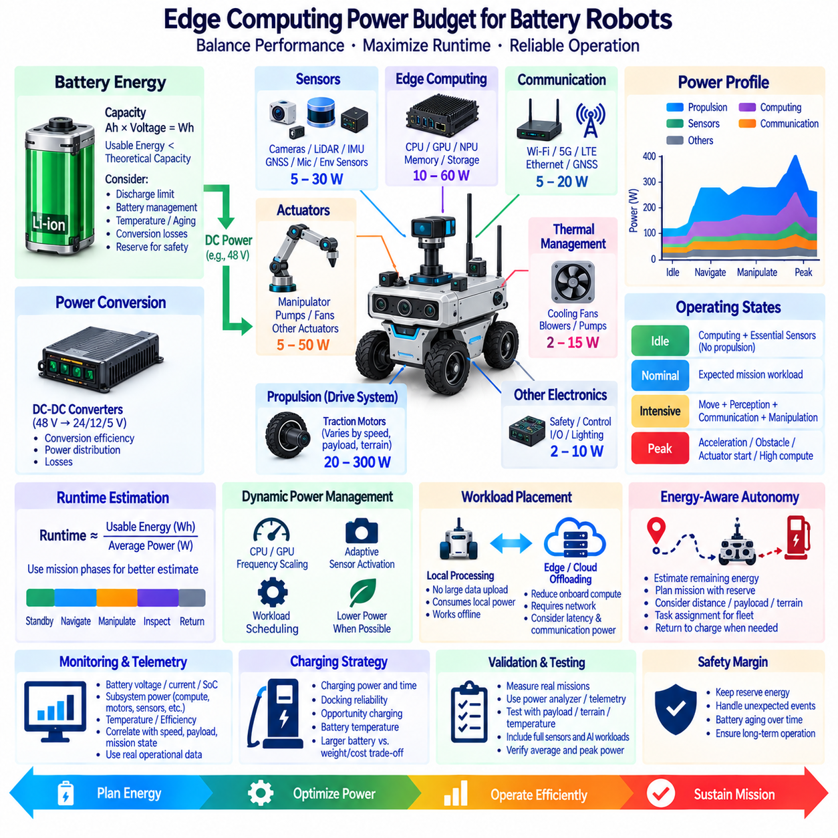
Power budgeting for battery-powered robots determines how electrical energy is distributed among propulsion, computing, sensors, communication, actuators, and supporting electronics while preserving the required operating time. Edge computing can consume a significant and continuously changing portion of this energy. A realistic design must therefore evaluate computing power together with the complete robot energy system rather than selecting processors only from peak AI performance specifications.
The starting point is the battery energy capacity, normally expressed in watt-hours. A battery rated in ampere-hours must be interpreted together with its nominal voltage to estimate available energy. Theoretical capacity, however, is not identical to usable energy because discharge limits, battery-management policies, temperature, aging, conversion losses, and required reserve capacity reduce what can safely be consumed during operation. Runtime calculations should therefore use a realistic usable-energy assumption.
Robot power demand consists of both relatively continuous loads and highly variable loads. Computers, networking equipment, and many sensors may draw power throughout the mission, while traction motors, manipulators, pumps, heaters, or other actuators can create large temporary peaks. Average power determines much of the achievable operating duration, whereas peak power determines whether the electrical system can support demanding events without excessive voltage drop, protection trips, or system instability.
Propulsion frequently dominates total energy consumption for mobile robots, but its demand varies strongly with speed, payload, acceleration, slope, terrain, wheel resistance, and control strategy. A robot operating on smooth indoor floors may have a very different energy profile from the same platform carrying a heavy payload outdoors. Computing power should consequently be evaluated as part of a mission-specific energy budget instead of assuming that the motor subsystem always consumes a fixed percentage of battery capacity.
Edge computers introduce a load that can remain active even when the robot is stationary. CPUs, GPUs, NPUs, memory, storage, cooling fans, and interface devices contribute to the total compute demand. A high-performance AI computer may improve perception and planning, but unused computing capacity still carries power and thermal costs. Platform selection should therefore compare sustained workload performance per watt rather than relying only on maximum TOPS, GPU throughput, or processor thermal design power.
AI inference workloads can produce substantial variation in computing power. Camera detection, segmentation, multi-object tracking, LiDAR processing, localization, mapping, and planning may execute simultaneously, creating a higher sustained load than isolated benchmark tests suggest. Designers should measure representative concurrent workloads because the power consumed by the complete perception and autonomy stack can differ considerably from measurements obtained while running only one neural network.
Sensors must also be included explicitly in the power budget. Multiple cameras, 2D or 3D LiDAR units, radar, GNSS receivers, IMUs, microphones, depth sensors, and environmental sensors may operate continuously. Individual devices can appear small compared with propulsion, but their combined load becomes significant when several sensors are installed. Sensor heaters, illumination, active depth emitters, and high-speed interfaces can further increase consumption under particular operating conditions.
Communication systems create another persistent load. Wi-Fi, Ethernet switches, cellular modems, private 5G equipment, GNSS correction links, and edge gateways consume energy even when application traffic is moderate. Wireless transmit power and modem behavior may vary with coverage quality and network conditions. Robots that continuously upload telemetry, video, maps, or diagnostic information should therefore consider both communication-device power and the additional computing required for encoding, encryption, buffering, and protocol processing.
Power conversion efficiency influences how much battery energy actually reaches computing electronics. A robot may use a 48 V traction battery while edge computers and sensors require 24 V, 12 V, 5 V, or other regulated supplies. DC-DC converters introduce losses that depend on converter design and operating load. The power budget should account for conversion efficiency along each electrical path rather than simply adding the nominal input ratings of downstream devices.
Thermal management and electrical power are closely connected. Higher computing loads generate additional heat, which may require fans, blowers, pumps, or other cooling mechanisms that consume more energy. High internal temperature can also cause processor throttling, reducing performance despite continued power consumption. Measurements should therefore include sustained operation in realistic ambient conditions, especially for sealed enclosures, outdoor robots, and platforms operating under direct sunlight or high-temperature environments.
A practical power budget should distinguish idle, nominal, intensive, and peak operating states. Idle operation may include computers and essential sensors while propulsion is inactive. Nominal operation represents the expected mission workload, while intensive operation may combine movement, perception, communication, and manipulation. Peak conditions include acceleration, obstacle traversal, actuator startup, or simultaneous high-load computation. These states provide more useful engineering information than one single power number.
Runtime can be estimated by comparing usable battery energy with average mission power, but a robot mission rarely maintains one constant load. A more realistic model divides the mission into operating phases such as standby, navigation, manipulation, inspection, communication, and charging approach. The energy consumed in each phase can be estimated from its average power and duration. Summing these phase energies provides a mission-level estimate that can later be validated against measurements from the physical robot.
Safety margin is necessary because calculated runtime should not consume the battery to its absolute limit. Energy must remain available for localization recovery, obstacle avoidance, communication delays, route changes, docking attempts, and return-to-charge behavior. Battery aging also reduces capacity over time. A robot that satisfies its mission requirement only with a new battery under ideal conditions has insufficient operational margin for long-term deployment.
Dynamic power management can reduce unnecessary edge-computing consumption. CPU and GPU frequency scaling, accelerator power modes, selective sensor activation, adaptive frame rates, reduced inference frequency, and workload scheduling can lower power when full performance is unnecessary. For example, a stationary robot may not require the same perception rate as a robot navigating at maximum speed. Power optimization should nevertheless preserve safety, control stability, and required perception coverage.
Workload placement also affects the energy budget. Processing sensor data locally avoids continuous transmission of high-volume raw streams but consumes local compute power. Offloading selected workloads to an edge server or cloud can reduce onboard computation, yet wireless communication, latency, connectivity, and remote infrastructure become additional dependencies. The most energy-efficient architecture therefore depends on data volume, computation intensity, network conditions, mission requirements, and required autonomy during disconnection.
Power telemetry should be integrated with robot monitoring rather than treated only as a design-time measurement. Battery voltage, current, state of charge, estimated remaining energy, compute power, temperature, converter status, and major subsystem loads can be recorded during missions. Correlating these measurements with robot speed, terrain, payload, AI workload, and mission state reveals where energy is actually consumed and allows engineering assumptions to be replaced by operational evidence.
Energy-aware autonomy can use this information during mission planning. A robot can estimate whether sufficient energy remains to complete a task and still reach a charging location with an appropriate reserve. Mission scheduling may consider travel distance, payload, terrain, expected computation, and charging opportunities. For fleets, energy state can influence task assignment so that missions are allocated to robots capable of completing them without unnecessary interruption or emergency charging.
Charging strategy is part of the power architecture because usable robot availability depends on both discharge and recharge behavior. Charging power, charging duration, docking reliability, battery temperature, and opportunity-charging policies affect how much productive time the robot can provide. Increasing battery capacity can extend runtime but also increases mass, charging time, cost, and potentially propulsion energy, so battery enlargement is not always the most efficient solution.
Validation should be performed using physical measurements across representative missions rather than relying exclusively on component datasheets. Power analyzers, battery-management telemetry, onboard current sensors, and subsystem measurements can identify actual average and peak demand. Testing should include representative payloads, terrain, temperatures, sensor configurations, communication conditions, and AI workloads because laboratory idle measurements rarely represent the energy profile of an autonomous robot in operation.
A robust battery-robot architecture therefore treats propulsion, edge computing, sensors, communication, power conversion, thermal management, mission behavior, and charging as one integrated energy system. The objective is not simply to minimize computer power, but to allocate limited battery energy where it creates the greatest operational value. Measured workloads, realistic mission profiles, adequate reserve margins, and adaptive power management together enable sustained AI capability without sacrificing mobility, safety, or mission completion.

