Volume 09 Cloud and Edge Robotics

03. Hybrid Cloud.Edge Architecture

03.01 Hybrid Architecture Principles: Latency, BW, Privacy
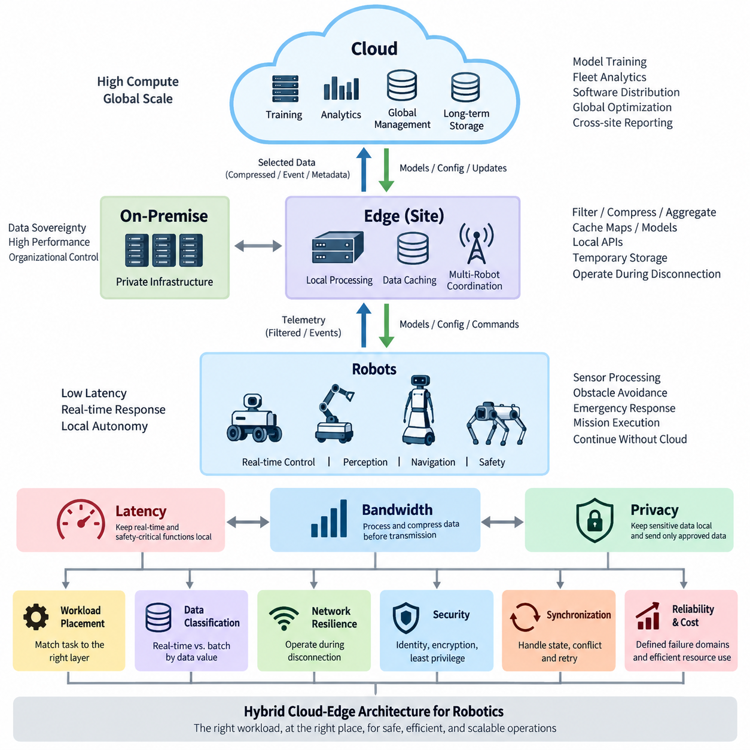
A hybrid cloud-edge architecture for robotics distributes computation across robot-local processors, nearby edge infrastructure, on-premise systems, and remote cloud platforms according to operational requirements. The objective is not simply to divide software between edge and cloud, but to place each workload where its latency, bandwidth, availability, security, privacy, and computational characteristics can be satisfied most effectively.
Latency is one of the strongest factors determining workload placement. Robot functions such as motor control, obstacle avoidance, emergency response, localization updates, and safety monitoring often operate within strict timing constraints. Sending these operations through a wide-area network introduces variable delay and jitter, so safety-critical and real-time decisions should normally remain on the robot or a deterministic local edge platform.
Cloud systems are better suited to workloads whose value comes from computational scale rather than immediate response. Large-scale model training, historical fleet analytics, long-term data storage, global optimization, software distribution, and cross-site reporting can tolerate greater communication delay. Hybrid architecture therefore separates the robot's immediate operational loop from higher-level intelligence and management processes that can execute asynchronously.
Bandwidth provides a second major architectural constraint. Modern robots may continuously generate camera images, LiDAR point clouds, audio, telemetry, maps, diagnostic logs, and intermediate AI features. Uploading all raw sensor streams to the cloud is inefficient and may overwhelm wireless links. Edge processing reduces this demand by filtering, compressing, aggregating, transforming, or selectively retaining information before transmission.
This principle creates a hierarchy of data value. High-frequency raw sensor information may remain temporarily at the edge, while detected events, summarized telemetry, compressed observations, metadata, or selected training samples are transmitted upstream. Cloud storage can then preserve information with long-term operational or learning value without requiring every byte produced by every robot to cross the network continuously.
Privacy and data sovereignty provide another reason to distribute processing. Camera streams, human interaction records, facility maps, production information, customer data, or operational logs may contain sensitive information. Processing such data locally allows the system to extract necessary features or decisions without transmitting complete raw records. Cloud communication can therefore be restricted to approved, minimized, encrypted, or anonymized information.
Hybrid architecture should consequently be designed around explicit data classification rather than a simple rule that edge is fast and cloud is powerful. Each data type and workload should be evaluated according to latency sensitivity, bandwidth consumption, privacy classification, retention period, computational demand, synchronization requirements, and failure consequences. These attributes determine where processing and storage should occur throughout the architecture.
Network availability is equally important because mobile robots cannot assume permanent cloud connectivity. Wireless coverage may deteriorate because of obstacles, interference, handovers, infrastructure failures, or operation in remote environments. A robust hybrid system therefore preserves essential autonomy when cloud communication disappears. Navigation, safety functions, local perception, basic mission execution, and essential state management should continue without external connectivity.
The edge environment acts as an operational bridge between individual robots and centralized infrastructure. A site-level edge server can aggregate telemetry, cache maps and models, coordinate multiple robots, provide local APIs, and temporarily store data during network outages. This reduces dependence on distant cloud services while providing more compute and storage capacity than may be practical inside battery-powered robots.
Cloud infrastructure provides the global coordination layer. It can maintain fleet-wide configuration, model repositories, long-term databases, analytics pipelines, identity services, OTA deployment systems, and aggregated monitoring. When multiple factories, warehouses, hospitals, or outdoor sites operate independently at the edge, the cloud provides a common management plane through which policies and software versions can be governed across the entire fleet.
A useful design principle is to distinguish control-plane traffic from data-plane traffic. High-rate sensor processing and time-sensitive robot behavior belong primarily to local data paths, while configuration, policy, deployment, fleet metadata, and lifecycle management can use slower centralized paths. Separating these responsibilities prevents temporary cloud or WAN problems from directly destabilizing the robot's real-time operational behavior.
Workload placement should also consider computational efficiency. AI inference may execute on embedded GPUs or edge accelerators when immediate perception is required, while training and large-scale optimization can use cloud or on-premise GPU clusters. Some models may even be partitioned across tiers, with lightweight preprocessing and inference occurring locally and computationally expensive analysis performed only when selected events require escalation.
The architecture must define synchronization boundaries because distributed components inevitably hold partially different states. Robots may maintain local mission state, edge servers may maintain site-level operational state, and cloud services may maintain fleet-wide state. Synchronization should therefore include timestamps, version identifiers, conflict policies, retry mechanisms, idempotent operations, and durable queues so that temporary disconnection does not corrupt system state.
Security should follow the same distributed model. Robots and edge devices must not automatically become trusted simply because they operate inside a local network. Device identity, mutual authentication, encrypted communication, least-privilege authorization, certificate management, secure boot, signed software, and auditable access should protect communication between robot, edge, on-premise, and cloud layers. Trust must be established explicitly across every boundary.
Reliability emerges when each architectural layer has a clearly defined failure domain. A robot should know what happens when its edge server fails, an edge system should know how to operate when the cloud becomes unreachable, and cloud services should tolerate individual site failures. Local fallback behavior, cached configuration, persistent queues, health monitoring, reconnection procedures, and controlled state reconciliation transform network failure into a manageable operating condition.
Latency, bandwidth, and privacy are therefore interconnected rather than independent optimization variables. Keeping perception close to the robot reduces latency and network traffic while also limiting exposure of raw sensor data. Moving large-scale learning to centralized infrastructure provides greater computational capacity but requires deliberate data selection and secure transfer. Effective hybrid design balances these competing requirements instead of maximizing any single characteristic.
For robotics, the resulting architecture is best understood as a continuum rather than a binary choice between edge and cloud. Robot-local computing protects immediate physical interaction, site edge infrastructure supports low-latency coordination and resilience, on-premise infrastructure provides controlled organizational computing, and cloud platforms provide elastic global services. Workloads can move or synchronize across this continuum according to their operational characteristics.
A well-designed hybrid system ultimately ensures that physical operation does not depend on unpredictable remote connectivity while still benefiting from centralized intelligence and scale. The robot remains capable of safe local action, the edge maintains site-level continuity, and cloud or on-premise platforms provide fleet-wide learning, governance, storage, and optimization. This layered responsibility becomes the foundation for later offline-first, synchronization, hybrid AI, monitoring, and recovery patterns.

03.02 Edge.Cloud Data Classification: Real-Time vs Batch
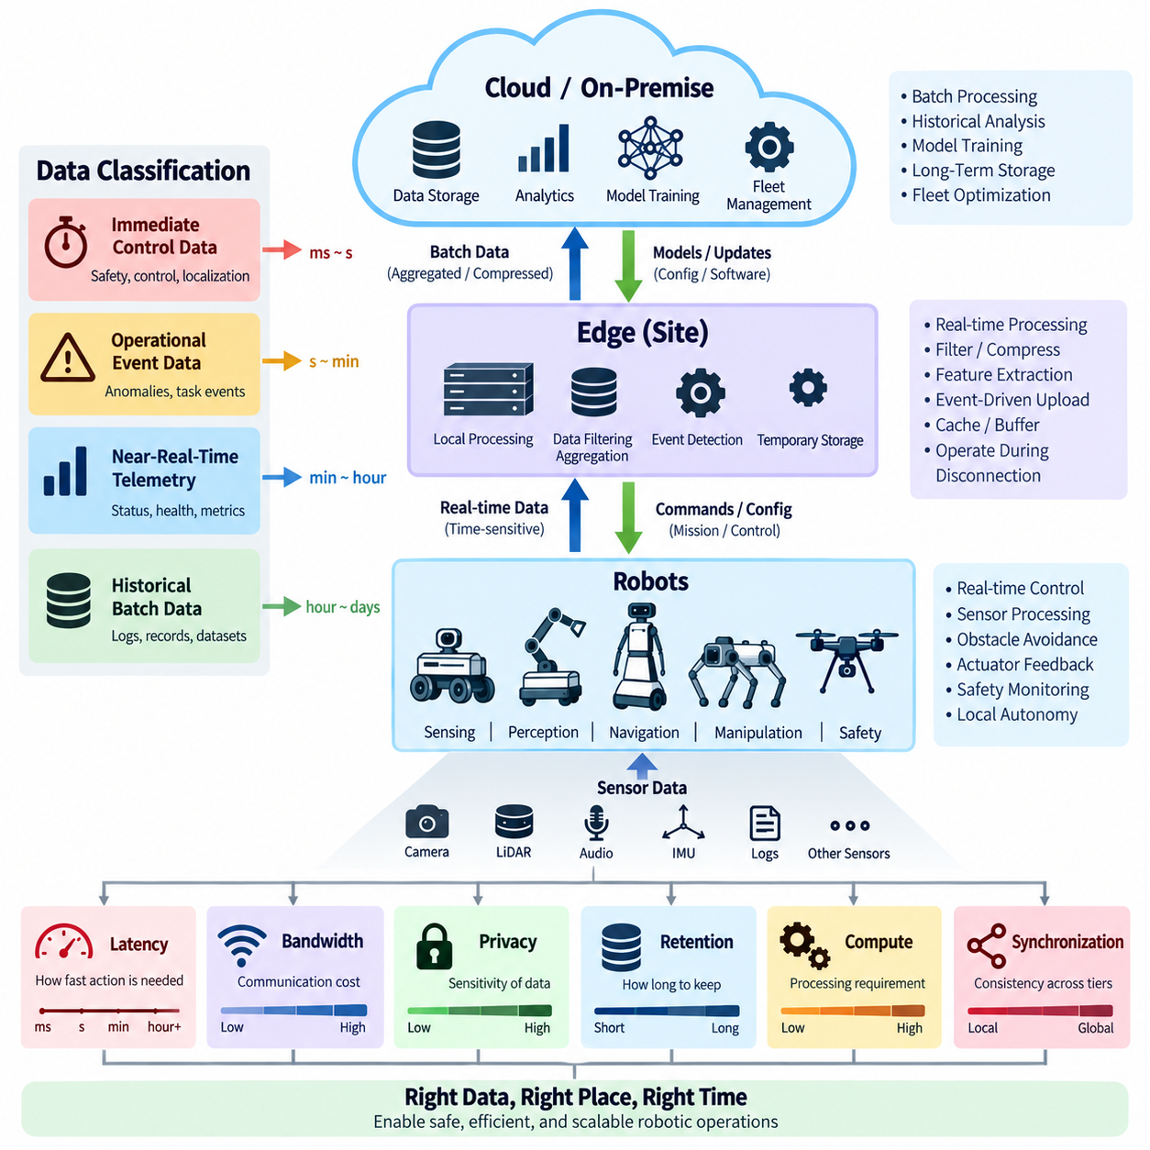
Edge-cloud data classification determines where robotic information should be processed, stored, transmitted, and retained according to its operational urgency and value. The fundamental distinction is between real-time data that directly influences physical behavior and batch data that can be accumulated and processed later. This classification prevents every sensor stream and event from being treated with the same latency, bandwidth, and infrastructure requirements.
Real-time data belongs primarily to the operational path of the robot. Examples include obstacle detections, localization updates, velocity estimates, safety states, actuator feedback, collision warnings, and mission-critical sensor observations. These data streams often lose their operational value within milliseconds or seconds. Processing them close to the robot minimizes network dependency and allows autonomous behavior to continue even when communication with remote infrastructure becomes unstable.
Batch data has a different temporal characteristic. Historical telemetry, diagnostic logs, completed mission records, selected images, accumulated point clouds, maintenance statistics, and training datasets usually do not require immediate processing. They can be buffered locally, aggregated over time, compressed, and transferred when network capacity is available. Cloud or on-premise infrastructure can then process these datasets using scalable compute and storage resources.
The distinction between real-time and batch processing should not be interpreted as a rigid separation between edge and cloud. Some information begins as a real-time stream at the robot but becomes batch data after its immediate operational purpose has been satisfied. A camera frame may support obstacle detection locally, while only a detected anomaly, compressed image, or selected training sample is later transferred to centralized storage for analysis.
Data classification therefore requires multiple attributes beyond timing alone. Latency tolerance describes how quickly information must produce an action, while bandwidth cost represents the communication resources required for transmission. Data volume, privacy sensitivity, computational demand, retention period, operational criticality, and synchronization requirements provide additional dimensions. Together, these attributes determine the appropriate processing and storage location.
A practical hybrid architecture can classify information into immediate control data, operational event data, near-real-time telemetry, and historical batch data. Immediate control data remains local because delayed delivery may affect physical safety or stability. Operational events can be transmitted rapidly but do not necessarily require deterministic timing. Telemetry can tolerate buffering, while historical datasets can be uploaded asynchronously according to network and storage policies.
Sensor data illustrates why this classification is important. Cameras and LiDARs may generate substantially more information than simple status messages or robot poses. Continuously forwarding every raw frame or point cloud consumes network capacity without necessarily increasing operational value. Edge systems can instead perform perception, filtering, feature extraction, event detection, downsampling, or compression and transmit only information required by higher-level services.
Event-driven transmission provides an effective bridge between real-time and batch processing. Rather than continuously uploading high-bandwidth raw information, the robot or edge system can detect meaningful conditions such as localization degradation, unexpected obstacles, abnormal vibration, task failure, or safety intervention. The event can trigger temporary retention of surrounding sensor data and selective upload of the relevant time window for later diagnosis.
Buffering is essential when data does not require immediate delivery. A robot can maintain local queues or persistent storage for telemetry, logs, and selected sensor records and synchronize them when connectivity improves. The buffering policy should define storage limits, priorities, expiration rules, retry behavior, and overflow handling. Critical records should not be discarded merely because lower-value high-volume data has consumed local capacity.
Priority must also be reflected in network scheduling. Safety events, robot health information, and mission-state changes may require immediate transmission, while large log archives or training datasets can wait for available bandwidth. Quality-of-service mechanisms, separate queues, rate limits, and upload schedules can prevent background transfers from interfering with operational traffic. Network capacity is therefore allocated according to information value rather than simple arrival order.
Privacy introduces another classification dimension. Raw video, audio, facility maps, human interaction records, or production information may require stricter handling than ordinary machine telemetry. Sensitive data can remain on the robot or within a controlled edge environment, where algorithms extract approved features or events. Only minimized or transformed information then crosses organizational or cloud boundaries, reducing unnecessary exposure of raw operational data.
Retention policies should differ according to data purpose. High-frequency sensor streams may require only short local retention unless an event occurs, whereas maintenance records, mission histories, software deployment records, or selected AI training samples may require long-term storage. Explicit retention rules reduce unnecessary storage growth while ensuring that information required for debugging, auditing, learning, and fleet optimization remains available.
Synchronization between edge and cloud must account for the fact that batch transfers may arrive late, out of order, or after temporary disconnection. Records should therefore carry timestamps, robot identifiers, sequence information, schema versions, and relevant context. Idempotent ingestion and duplicate detection help prevent repeated synchronization attempts from creating inconsistent datasets, while persistent queues allow interrupted transfers to resume safely.
Data classification also influences AI architecture. Time-sensitive inference such as object detection, traversability estimation, or safety monitoring is generally executed close to the physical system. Computationally expensive training, fleet-wide learning, model evaluation, and historical analysis can operate centrally. Edge systems may collect difficult cases or representative samples, allowing centralized training pipelines to learn from fleet experience without continuously uploading every observation.
Fleet-scale systems make classification increasingly important because data volume grows with the number of deployed robots. A design that works for one robot may become inefficient when hundreds or thousands of devices continuously transmit raw information. Local filtering and hierarchical aggregation reduce this growth by converting large sensor streams into smaller operational summaries, events, metrics, and carefully selected datasets before they reach centralized infrastructure.
Real-time processing should also be separated from remote monitoring. A cloud dashboard may display robot position, health, battery state, and mission progress with small delays without affecting autonomous operation. The robot itself, however, cannot depend on the same communication path for collision avoidance or motion control. This distinction allows centralized visibility while preserving a local control loop that remains independent of variable network conditions.
The resulting data architecture is a lifecycle rather than a fixed routing rule. Information is generated by sensors and software, evaluated according to urgency and sensitivity, processed locally when necessary, filtered or aggregated at the edge, buffered when transmission can wait, and transferred to centralized infrastructure when broader analysis or long-term retention provides value. Different representations of the same event may therefore exist across multiple architectural layers.
Effective edge-cloud classification ultimately places each piece of information on an appropriate time scale. Millisecond-level physical decisions remain near the robot, operational events move through the edge with low delay, telemetry is aggregated according to monitoring needs, and large historical datasets are processed asynchronously. This separation protects real-time autonomy while allowing cloud and on-premise resources to provide fleet-wide analytics, learning, governance, and long-term intelligence.

03.03 Offline-First Design Pattern [w/Code]
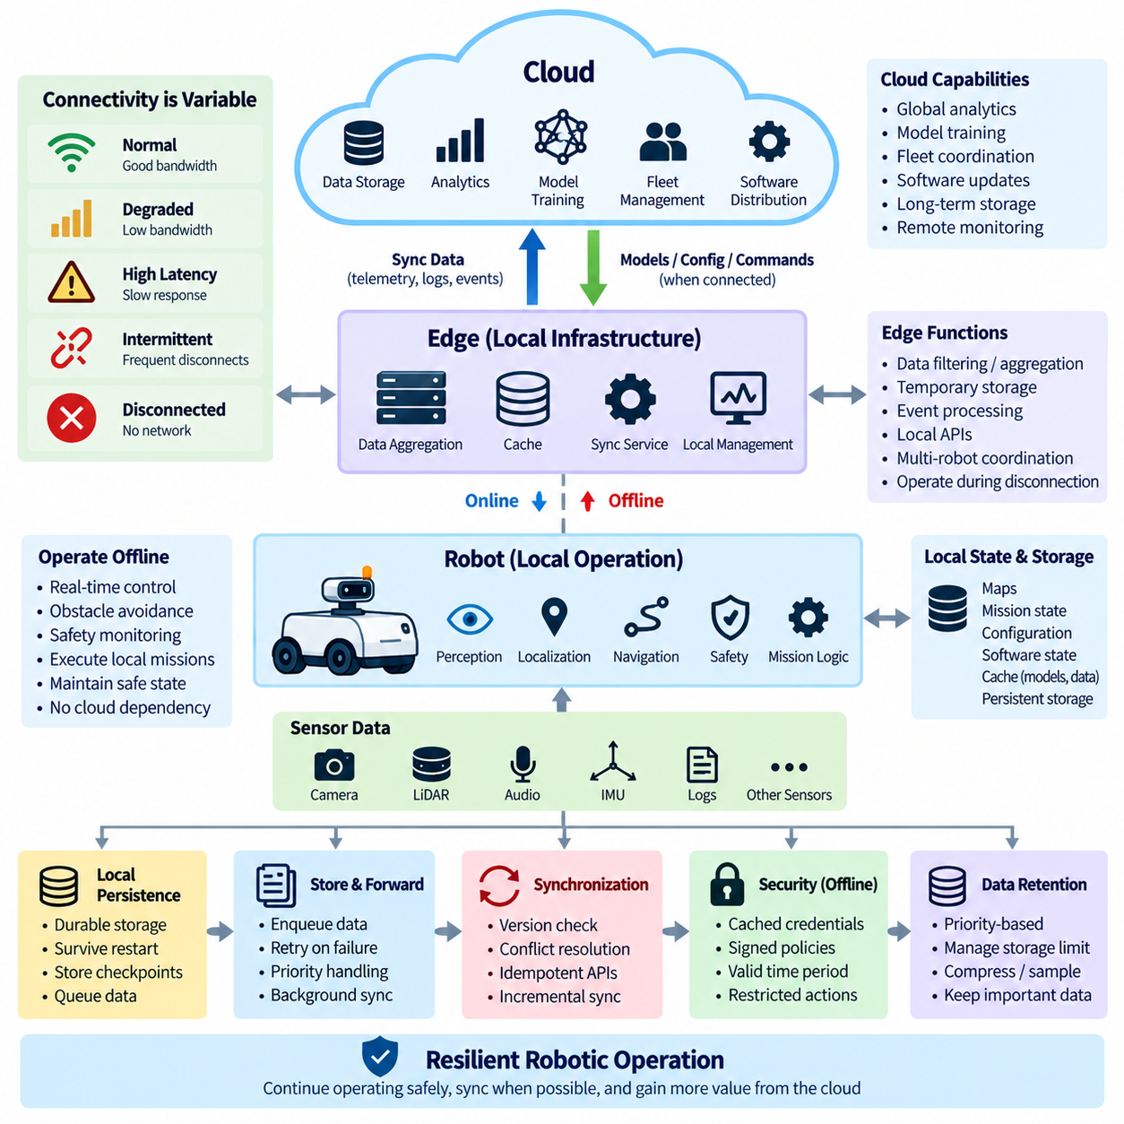
An offline-first design pattern assumes that network connectivity is temporary, variable, or unavailable rather than permanently reliable. For robotic systems, this principle means that essential operation must continue without continuous access to cloud services. The robot and local edge environment become the primary execution domain, while cloud connectivity enhances capability through synchronization, analytics, model distribution, and fleet-wide management when communication is available.
This approach is particularly important for mobile robots operating in warehouses, factories, hospitals, construction sites, outdoor environments, and remote facilities. Wireless networks may experience interference, dead zones, access-point handovers, congestion, gateway failures, or complete WAN outages. If navigation, safety, mission execution, or state management depends directly on a remote service, even a short communication interruption can become an operational failure.
Offline-first architecture therefore places operational authority close to the physical system. Perception, localization, obstacle avoidance, motion planning, safety monitoring, and essential mission logic should execute on the robot or trusted local infrastructure. Cloud services may provide optimization and coordination, but loss of cloud connectivity should not immediately prevent the robot from maintaining a safe state or completing locally authorized operations.
Local state is a fundamental element of this pattern. A robot should maintain the information required to understand its current mission, configuration, map, operational mode, software state, and recent events without querying a remote database. Frequently required information can be stored in local databases, caches, files, or persistent key-value stores so that application behavior remains predictable during disconnected operation.
Local persistence must survive process restarts and temporary power interruptions whenever operational continuity requires it. Mission checkpoints, pending events, telemetry records, diagnostic information, synchronization metadata, and critical state transitions should not exist only in volatile memory. Durable storage allows the system to reconstruct its state after restart and prevents temporary infrastructure problems from causing unnecessary loss of operational history.
The offline-first pattern also requires a local command policy. Commands already authorized before disconnection may continue according to defined rules, while actions requiring new external authorization can be delayed or rejected. Safety-sensitive commands should include validity periods, sequence information, and execution conditions so that an old command does not become valid again simply because connectivity is restored after a long interruption.
Data generated while offline should normally enter a store-and-forward pipeline. Telemetry, logs, events, selected sensor observations, and mission records are first written to local durable storage rather than being discarded when transmission fails. A synchronization service can later forward these records to edge or cloud infrastructure. This separates data production from network availability and allows robot applications to operate without blocking on remote communication.
Queues are particularly useful for implementing this behavior. Each record can contain a unique identifier, timestamp, priority, retry state, destination, and synchronization status. High-priority safety or fault events can be transmitted immediately when connectivity returns, while large diagnostic files or historical datasets can wait. Persistent queues also allow interrupted transfers to resume without forcing application components to recreate the original data.
Connectivity should be treated as an observable system state rather than a simple binary assumption. The architecture can distinguish normal connectivity, degraded bandwidth, high latency, intermittent communication, and complete disconnection. Applications can then adapt their behavior accordingly. For example, a robot may reduce telemetry frequency during degraded communication while retaining full local navigation and safety capability.
Synchronization after reconnection is more complex than simply uploading everything that accumulated offline. Local and remote states may both have changed during the disconnected period. The system must determine which records are append-only, which configuration has authority, whether commands have expired, and how conflicting modifications should be resolved. Explicit synchronization semantics are therefore essential for predictable recovery.
Version information helps establish these semantics. Configuration objects, maps, models, missions, and policies can carry revision numbers, timestamps, hashes, or immutable identifiers. When communication returns, the robot and server compare their known versions before applying updates. This prevents a stale local copy from silently overwriting a newer cloud state and prevents an outdated remote instruction from replacing a valid local operational state.
Idempotency is another important principle. Network failures can occur after a message has reached the server but before the robot receives confirmation, causing the same operation to be transmitted again. Cloud and edge APIs should therefore tolerate duplicate requests whenever possible. Unique operation identifiers and deduplication logic allow repeated synchronization attempts to produce the same final state instead of duplicate missions, records, or actions.
Conflict resolution should follow explicit ownership rules rather than relying only on timestamps. The robot may be authoritative for locally observed physical state, while the fleet system may be authoritative for organization-wide configuration or scheduling policy. Some conflicts can use latest-version rules, while others require merging, rejection, or operator review. Defining ownership for each data category makes reconnection behavior easier to verify and test.
Caching extends offline operation beyond state storage. Maps, navigation parameters, AI models, certificates, mission templates, software dependencies, and frequently used reference data can be cached before they are required. The cache should include version and expiration information so the robot knows whether a resource remains acceptable for operation. Critical resources should not disappear merely because a remote repository becomes temporarily unreachable.
Security must remain effective during disconnected operation. Offline capability must not mean bypassing authentication or authorization whenever the network disappears. Robots can retain validated credentials, certificates, trusted public keys, signed policies, and authorization information within defined validity periods. Locally cached security material should be protected, and privileged operations may require stronger restrictions when centralized verification is unavailable.
Resource management becomes important during long disconnections because local storage is finite. The system should define retention priorities and maximum queue sizes before storage becomes exhausted. Low-value high-frequency telemetry may be aggregated, downsampled, or removed first, while safety events, mission histories, fault records, and audit information receive stronger retention. Storage pressure should become a managed operating condition rather than an unexpected failure.
Reconnection should occur progressively instead of producing an uncontrolled synchronization burst. Critical state and safety events can synchronize first, followed by operational telemetry, diagnostics, and large historical files. Rate limiting and priority scheduling prevent accumulated uploads from consuming all available bandwidth. The robot should continue normal local operation while synchronization proceeds in the background.
Offline-first behavior also changes monitoring strategy. A cloud dashboard cannot interpret temporary silence as immediate robot failure because communication may simply be unavailable. The system should distinguish the last known robot state from confirmed current state and record connectivity timestamps explicitly. After reconnection, locally collected health and event history can reconstruct what occurred during the period when centralized monitoring had no direct visibility.
Testing must intentionally include disconnection scenarios. Engineers should interrupt Wi-Fi, WAN connectivity, DNS, authentication services, message brokers, and cloud APIs while robots are operating. Tests should verify local autonomy, queue persistence, storage limits, command expiration, restart recovery, reconnection, duplicate handling, conflict resolution, and synchronization ordering. Offline capability becomes trustworthy only when failure conditions are treated as normal validation cases.
An offline-first architecture ultimately changes the relationship between robots and cloud infrastructure. The cloud becomes a powerful coordination, learning, storage, and management layer rather than a mandatory participant in every physical action. Robots preserve local autonomy and operational continuity, edge systems provide nearby coordination and buffering, and centralized infrastructure receives and distributes information whenever connectivity permits. This separation creates a resilient foundation for hybrid cloud-edge robotics.

03.04 Edge.Cloud Sync Protocol Design [w/Code]
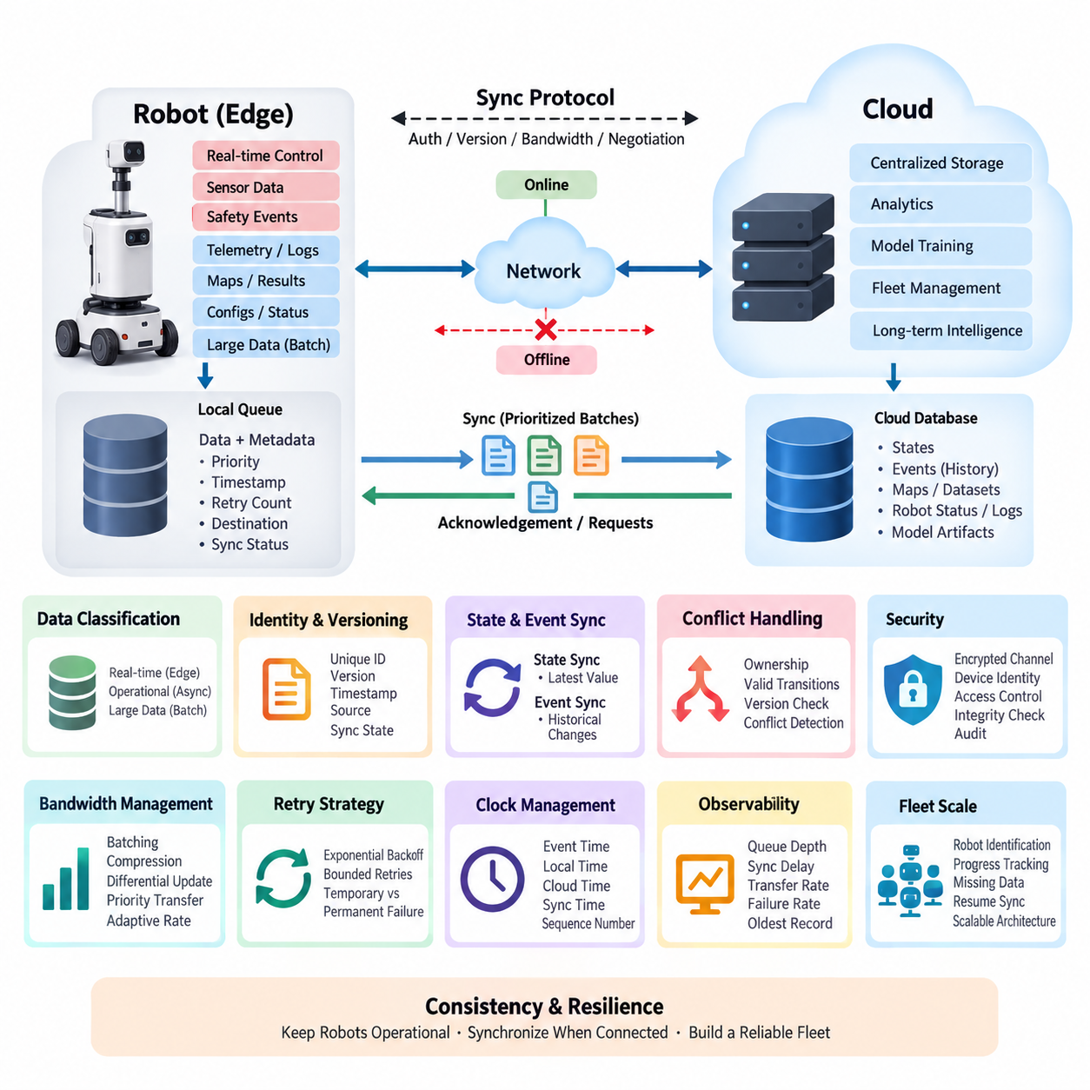
Edge-cloud synchronization for robotics is the communication mechanism that keeps robot-side data and cloud-side data consistent while recognizing that the two environments have different latency, connectivity, computing, and reliability characteristics. A practical synchronization protocol should not assume that a robot is continuously connected to the cloud. Instead, it should allow the Edge system to continue operating locally, preserve important state and events, and synchronize accumulated changes when communication becomes available again. This approach connects directly with the hybrid architecture and offline-first design described for this chapter.
The protocol should begin by classifying data according to its operational importance and synchronization requirements. Real-time control data, emergency events, safety states, and short-term sensor information generally remain at the Edge because transferring them through the cloud can introduce unacceptable latency or dependency on network availability. Operational telemetry, task results, logs, maps, selected sensor records, and robot status can be synchronized asynchronously. Large datasets such as raw camera or LiDAR streams should normally use controlled batch transfer rather than continuous synchronization.
A robust synchronization protocol requires every transferable object to have a clear identity, version, timestamp, source, and synchronization state. A robot may generate the same type of event repeatedly while disconnected, and the cloud may receive delayed or duplicated messages after reconnection. Unique event identifiers and sequence information allow the receiving system to determine whether a message is new, duplicated, or already processed. This makes synchronization idempotent, meaning that retransmitting the same operation does not unintentionally create multiple logical records.
Synchronization should also distinguish between state synchronization and event synchronization. State synchronization transfers the latest known condition of an object, such as robot configuration, task status, battery state, or map version. Event synchronization transfers historical changes, such as task completion, fault occurrence, operator commands, or system alarms. State synchronization is useful when only the latest value matters, while event synchronization preserves operational history. A hybrid protocol can use both mechanisms according to the semantics of each data type.
When the network connection is interrupted, the Edge system should continue collecting synchronization candidates in a durable local queue. The queue should survive process restarts and preferably system reboots so that temporary failures do not cause silent data loss. Each item can maintain metadata such as creation time, priority, retry count, payload size, destination, and synchronization status. High-priority safety or operational events can be transmitted before lower-priority telemetry, while large historical datasets can remain queued until sufficient bandwidth becomes available.
Network recovery should not simply trigger unrestricted transmission of everything accumulated during the outage. A synchronization session should negotiate connectivity status, authentication, protocol version, available bandwidth, and the amount of pending data before transferring large payloads. The Edge system can then send prioritized batches and receive explicit acknowledgements from the cloud. After successful acknowledgement, the corresponding local records can be marked as synchronized according to the retention policy. Failed transfers should remain recoverable rather than being immediately deleted.
Conflict handling becomes important when both Edge and cloud systems can modify the same logical state. A simple last-write-wins rule may be appropriate for some non-critical configuration values, but it is not universally safe for robotics. For operational commands, task assignments, safety states, or mission data, the protocol should define authoritative ownership and valid state transitions. Version numbers, revision identifiers, timestamps, and source identifiers can be combined to detect conflicting updates before they overwrite valid operational information.
Clock management is another important consideration because timestamps are frequently used to order events and diagnose synchronization behavior. Robot systems may operate with imperfect clocks, particularly during disconnected operation. The protocol should therefore distinguish between event creation time, local receipt time, cloud receipt time, and synchronization time. Where available, synchronized time sources can improve correlation, but the protocol should not assume that timestamps alone are sufficient to establish causality. Sequence numbers and event identifiers provide additional ordering information.
Data integrity and security should be applied throughout the synchronization path. Communication between Edge and cloud should use authenticated and encrypted channels, while individual synchronization records should be protected against accidental corruption and unauthorized modification. Device identity, credential management, certificate validation, access control, and audit information should be integrated with the hybrid authentication architecture. The synchronization service should also validate payload structure and protocol versions before accepting data so that malformed or incompatible messages cannot propagate into operational databases.
Bandwidth management is particularly important for mobile robots because wireless connectivity can fluctuate significantly during operation. The protocol can use batching, compression, differential updates, payload prioritization, and adaptive transfer rates to reduce unnecessary traffic. For example, a robot may synchronize critical events immediately, operational summaries periodically, and large sensor datasets only when the network is stable. This allows the Edge system to preserve local autonomy while using cloud resources efficiently rather than treating every data item as an equally urgent transmission.
A synchronization protocol should provide observable states that make failures understandable to operators and developers. Typical states include pending, transmitting, acknowledged, failed, retrying, expired, and permanently rejected. Metrics such as queue depth, synchronization delay, transfer rate, retry count, failure rate, and oldest pending record can reveal whether an individual robot or the entire fleet is experiencing connectivity or cloud-side problems. These measurements also provide a foundation for the hybrid monitoring architecture in which detailed Edge metrics are aggregated into cloud-level operational views.
Retry behavior should be carefully controlled because repeated transmission failures can consume network resources and create unnecessary load on both Edge and cloud systems. Exponential backoff with bounded retry intervals can prevent synchronized retry storms when many robots reconnect simultaneously. The system should distinguish temporary failures, such as network loss or service unavailability, from permanent failures, such as invalid authentication or incompatible payload schemas. Permanent failures should be isolated for investigation rather than repeatedly retransmitted indefinitely.
For fleet-scale robotics, synchronization should operate as a controlled distributed system rather than as a collection of independent file transfers. The cloud should be able to recognize each robot, track synchronization progress, identify missing or delayed data, and request specific ranges or versions when necessary. The Edge system should retain enough local history to recover from interrupted sessions and should be able to resume transmission without restarting an entire dataset. This becomes increasingly important as the number of robots, sensor streams, operational events, and AI-related data products grows.
The overall design should therefore treat Edge-cloud synchronization as a consistency and resilience layer rather than merely a networking function. The Edge remains responsible for immediate robotic operation and local continuity, while the cloud provides centralized storage, analytics, fleet-level coordination, model-related processing, and long-term operational intelligence. The synchronization protocol connects these two domains through explicit data ownership, durable queues, versioning, acknowledgement, conflict handling, prioritization, security, and recovery mechanisms. This architecture allows robots to remain operational during disconnection while progressively restoring a consistent system state after connectivity returns.

03.05 AI Model Hybrid Deploy: Edge Infer / Cloud Train [w/Code]
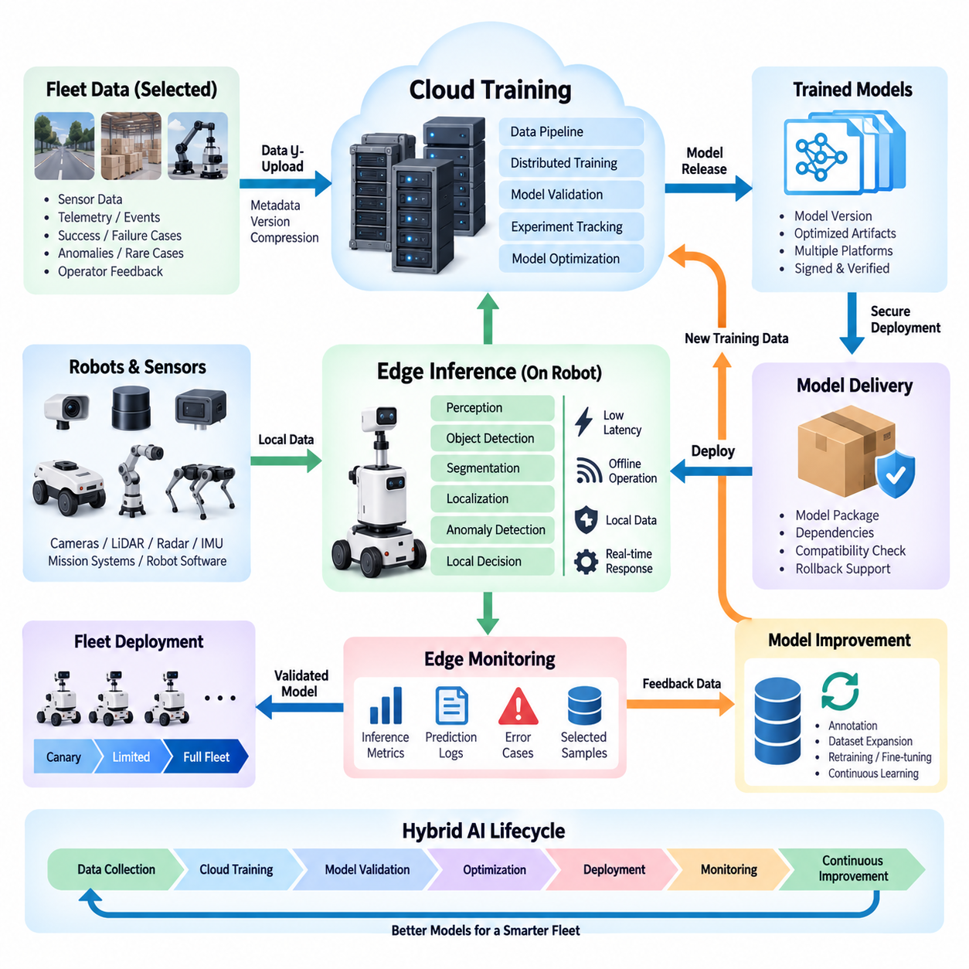
Hybrid AI deployment separates model training and model inference according to their computational and operational characteristics. Cloud or on-premise GPU infrastructure performs data-intensive training, large-scale validation, and model optimization, while Edge devices execute trained models close to robots and sensors. This separation allows robotic systems to obtain high-performance AI development capabilities without making real-time operation dependent on continuous cloud connectivity.
The Edge inference layer is responsible for AI functions that require low latency, predictable response, local data access, and operational continuity. Perception, object detection, semantic segmentation, anomaly detection, localization assistance, human recognition, and local decision support are typical examples. Keeping these workloads near the robot reduces network round-trip delay and enables the robot to continue executing essential AI functions when external communication becomes unavailable.
Cloud training addresses the opposite computational requirement. Training foundation models, perception networks, reinforcement learning policies, or multimodal models can require large datasets and substantial GPU resources that are impractical to install on every robot. Centralized GPU servers or cloud accelerators can aggregate selected fleet data, execute distributed training, evaluate candidate models, maintain experiment histories, and generate optimized model artifacts for later deployment to heterogeneous Edge platforms.
The complete lifecycle begins with data generation at the robot. Cameras, LiDAR, radar, IMU, operational software, mission systems, and AI inference components continuously produce sensor observations, telemetry, events, predictions, and diagnostic information. The Edge should filter this information before transmission because transferring every raw data stream to the cloud can consume excessive bandwidth and storage. Relevant samples can instead be selected according to operational value, uncertainty, anomalies, failures, or training requirements.
Selected data is transferred through the Edge-cloud synchronization architecture. Metadata should identify the robot, sensor, software version, model version, timestamp, mission context, and data quality so that cloud-side training pipelines can reconstruct the conditions under which each sample was generated. When connectivity is unavailable, training candidates can remain in durable local storage and be uploaded later. This offline-first behavior prevents AI data collection from becoming dependent on uninterrupted wireless connectivity.
Once synchronized, cloud-side data pipelines can validate, normalize, organize, label, and version incoming datasets. Training data should remain traceable to its source because model performance problems may originate from particular sensors, robot configurations, environments, or software versions. Dataset versioning also makes experiments reproducible by connecting each trained model with the exact data, preprocessing configuration, training code, hyperparameters, and evaluation procedure used to create it.
Training infrastructure can then execute computationally expensive workloads using scalable GPU resources. Multiple GPUs or GPU nodes may be allocated when dataset size or model complexity requires distributed computation. The training environment should remain logically separated from operational robots so that training failures or resource-intensive experiments cannot interfere with robot control. The resulting candidate models proceed through validation rather than being transferred directly to production robots.
Model validation should examine both conventional AI accuracy and robot-specific operational behavior. A candidate model may achieve strong offline metrics while producing excessive latency, memory consumption, GPU utilization, thermal load, or power demand on an Edge device. Therefore, cloud-side evaluation should be complemented by hardware-aware testing using representative Edge platforms. The deployment decision should consider accuracy, inference latency, throughput, memory footprint, compatibility, and operational robustness together.
After validation, models can be optimized for the target Edge hardware. Techniques such as quantization, graph optimization, operator fusion, pruning, reduced precision, or hardware-specific compilation can reduce inference cost. Different robot platforms may require different artifacts derived from the same trained model. A model registry should therefore distinguish the logical model version from deployment artifacts optimized for specific GPU, accelerator, runtime, operating system, or robot configuration.
A controlled model delivery pipeline transfers approved artifacts from the cloud to Edge devices. Each package should contain sufficient metadata to verify model identity, version, target platform, dependencies, integrity, and compatibility. Cryptographic signing and secure transport can protect the deployment chain. The Edge deployment agent should verify the artifact before activation and retain a known-good model so that an unsuccessful deployment can be rolled back without leaving the robot without functional AI capability.
Fleet deployment should normally be progressive rather than simultaneous. A new model can first be deployed to development robots or a limited canary group, where inference latency, error rates, resource utilization, and operational behavior are observed. If the model remains stable, deployment can expand to larger groups. This staged approach reduces the operational impact of model defects and provides real-world evidence before the model becomes the standard version across an entire fleet.
The Edge runtime should monitor model behavior after deployment because production environments inevitably differ from training datasets. Confidence distributions, prediction failures, unusual inputs, latency changes, resource pressure, and operator interventions can provide signals of model degradation or data drift. Instead of uploading every inference input, the Edge can selectively preserve informative cases such as low-confidence predictions, novel environments, false detections, safety-relevant events, or explicitly requested samples.
These field observations close the learning loop between Edge inference and cloud training. Difficult or novel samples collected from deployed robots can become candidates for annotation, dataset expansion, retraining, fine-tuning, or evaluation. A new model is then produced, validated, optimized, registered, and progressively redeployed. The architecture therefore forms a continuous cycle of Edge operation, selective data collection, cloud learning, controlled deployment, and field feedback rather than a one-time model installation process.
Model and software versions must remain coordinated throughout this cycle. A model may depend on a particular preprocessing pipeline, sensor calibration, inference runtime, CUDA or accelerator library, ROS 2 interface, or application API. Deploying only the model file without checking these dependencies can create subtle incompatibilities. The hybrid architecture should consequently treat a deployed AI capability as a versioned configuration consisting of the model, runtime, preprocessing logic, interfaces, and hardware assumptions.
Security and governance should cover both directions of the lifecycle. Robot-generated training data may contain sensitive environmental or operational information, while model artifacts represent executable intelligence that can affect physical behavior. Authentication, encryption, access control, artifact signing, audit logs, dataset provenance, and model lineage should therefore connect Edge data collection with cloud training and deployment. These controls make it possible to determine what data produced a model and which robots received it.
The fundamental architectural principle is that cloud intelligence should improve the robot without becoming a mandatory dependency for immediate robotic behavior. Edge inference provides local autonomy, deterministic response, privacy advantages, and resilience during disconnection, while cloud or centralized GPU infrastructure provides scalable training, fleet-wide learning, model management, and computational elasticity. Together they establish a hybrid AI lifecycle in which robots execute intelligence locally while continuously contributing experience to a larger learning system.

03.06 Hybrid Auth: PKI-Based Edge Identity Management [w/Code]
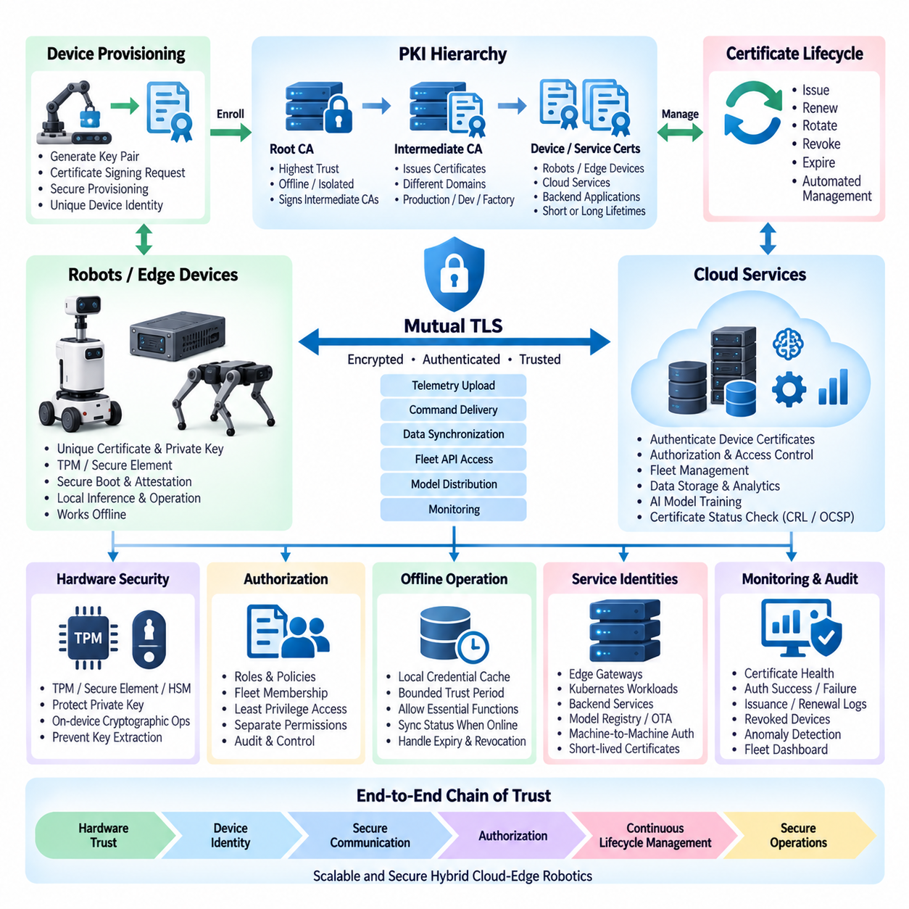
Hybrid authentication in cloud-edge robotics establishes a trusted identity relationship among robots, Edge computers, cloud services, operators, and backend applications. A Public Key Infrastructure (PKI) provides this trust through cryptographic identities rather than relying only on passwords or shared secrets. Each authorized device receives a unique certificate and private key, allowing services to verify which physical or virtual component is requesting communication before exchanging operational data or commands.
Device identity should be created as early as possible in the robot lifecycle. During manufacturing, commissioning, or secure provisioning, an Edge device can generate its own asymmetric key pair and submit a certificate signing request to an approved Certificate Authority (CA). The private key should remain protected on the device, while the issued certificate represents its verifiable identity. This creates a scalable mechanism for distinguishing individual robots even when thousands of devices connect to the same cloud infrastructure.
A hierarchical PKI structure is useful for separating organizational and operational trust domains. A protected Root CA can establish the highest trust anchor, while intermediate CAs issue certificates for production robots, development systems, factories, customer fleets, or cloud services. Keeping the Root CA offline or strongly isolated reduces exposure of the most important signing key. Intermediate authorities can then perform routine certificate operations without requiring direct access to the root credential.
Hardware-backed key protection strengthens Edge identity because a certificate alone is insufficient if its private key can be copied. Trusted Platform Modules (TPM), secure elements, hardware security modules, or platform-specific secure key stores can generate and retain private keys without exposing them directly to normal application software. When authentication is required, cryptographic operations can occur inside the protected hardware. This makes cloning a robot identity considerably more difficult even if parts of the operating system are compromised.
Mutual Transport Layer Security (mTLS) can use these device certificates to authenticate both sides of an Edge-cloud connection. The robot verifies that it is communicating with an authorized cloud endpoint, while the cloud verifies the certificate presented by the robot. After successful authentication, an encrypted communication channel is established. This model can protect telemetry upload, command delivery, synchronization, fleet APIs, monitoring traffic, and AI model distribution through a common certificate-based trust mechanism.
Authentication determines identity, but authorization determines what that identity is permitted to do. After validating a robot certificate, the cloud should map the authenticated identity to explicit roles, policies, fleet membership, customer ownership, or service permissions. A robot responsible for telemetry upload should not automatically receive administrative privileges, and a monitoring service should not automatically obtain authority to issue motion commands. Least-privilege authorization limits the impact of compromised credentials.
Certificate lifecycle management is therefore a continuous operational function rather than a one-time provisioning task. Certificates have defined validity periods and must be renewed before expiration. Devices may also require certificate rotation when ownership changes, security policies are updated, cryptographic algorithms evolve, or compromise is suspected. Automated renewal reduces fleet maintenance effort, but renewal procedures must authenticate the existing device securely so that an attacker cannot obtain a replacement identity.
Revocation provides a mechanism for removing trust from devices that should no longer communicate with the system. A robot may be retired, stolen, transferred, compromised, or removed from a fleet, making its previous certificate invalid for future access. Certificate Revocation Lists (CRLs), Online Certificate Status Protocol (OCSP), short-lived certificates, or platform-specific revocation mechanisms can communicate this change. Cloud gateways should reject revoked identities even if the certificate has not yet reached its normal expiration date.
Robotics introduces an additional challenge because Edge devices frequently operate with intermittent connectivity. A robot cannot always contact a remote certificate service whenever authentication occurs. The architecture should therefore define what credentials and trust information can be cached locally, how long offline validation remains acceptable, and what operations are permitted while cloud verification is unavailable. Safety-critical local robot functions should not stop merely because an external identity service cannot be reached.
Offline operation also requires careful treatment of certificate expiration and revocation information. If a robot remains disconnected for an extended period, its locally cached trust state can become stale. The system should define bounded offline trust periods and require synchronization of certificate status when connectivity returns. Sensitive cloud operations can demand fresh authentication, while local functions may continue under previously established device trust according to explicitly defined policies.
Secure boot and measured platform integrity can complement PKI-based identity. A valid certificate proves possession of a trusted private key, but it does not necessarily prove that the device is running approved software. Hardware roots of trust can verify bootloaders, kernels, firmware, or operating system components before execution. More advanced architectures can combine device identity with attestation so that cloud services evaluate both who the device is and whether its software environment satisfies defined integrity requirements.
Service identities are equally important because hybrid architectures contain more than physical robots. Edge gateways, Kubernetes workloads, synchronization services, model registries, OTA servers, fleet-management backends, and cloud APIs may communicate with one another. Assigning cryptographic identities to these services allows authentication to extend across machine-to-machine communication. Workload certificates can also be shorter-lived than device certificates, reducing the exposure period if temporary service credentials are compromised.
Identity namespaces should remain globally unambiguous across large fleets. Certificate subjects, Subject Alternative Names, device identifiers, fleet identifiers, and backend registry records should follow a consistent naming strategy. Identity should not depend only on mutable properties such as IP addresses or hostnames because robots can move between networks. A persistent device identity can instead remain stable while network location, assigned mission, customer site, and operational role change independently.
Provisioning must also prevent unauthorized devices from entering the trust domain. A newly installed robot should not receive production credentials merely because it can reach a provisioning server. Bootstrap authentication can use manufacturing credentials, one-time enrollment tokens, hardware-bound identities, administrator approval, or controlled registration workflows. After successful enrollment, temporary bootstrap credentials should be replaced or restricted so that they cannot later be reused to create unauthorized duplicate devices.
PKI operations require strong auditing and observability. Certificate issuance, renewal, expiration, revocation, failed authentication, unusual enrollment attempts, and authorization denials should generate traceable security events. Fleet dashboards can expose certificate health, approaching expiration dates, revoked devices, authentication failure rates, and identity anomalies. This allows identity management to become part of normal fleet operations rather than an invisible security subsystem that receives attention only after a connection failure.
The overall architecture should establish a chain of trust from hardware and device identity through encrypted communication to cloud authorization. PKI supplies verifiable identities, protected private keys preserve identity ownership, mTLS establishes authenticated channels, authorization policies restrict permitted actions, and lifecycle management maintains trust over years of robot operation. Combined with offline-aware policies and platform integrity mechanisms, this creates a scalable identity foundation for secure hybrid cloud-edge robotics.

03.07 Hybrid Monitoring: Edge Metrics / Cloud Aggregation [w/Code]
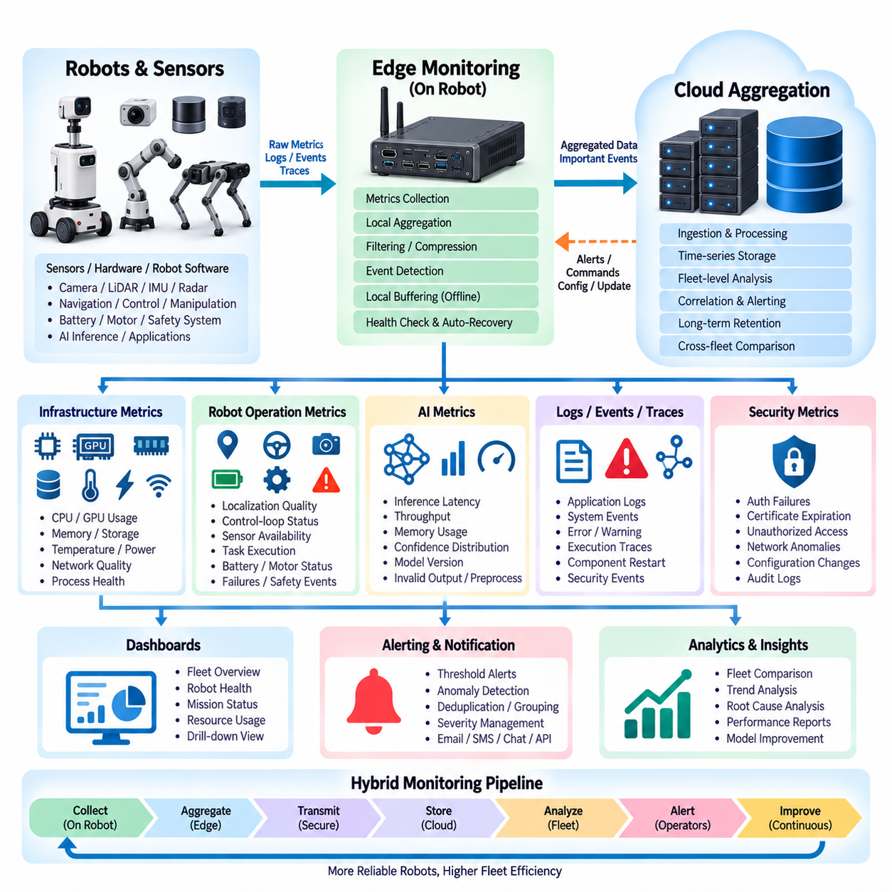
Hybrid monitoring in robotics combines local Edge observability with centralized cloud aggregation so that each robot can be monitored independently while the entire fleet can be understood as one operational system. The Edge collects high-frequency metrics close to hardware and robot software, while the cloud receives selected and summarized information for long-term analysis, fleet comparison, alert management, and operational dashboards. This separation preserves local responsiveness without losing fleet-wide visibility.
The Edge monitoring layer should observe the physical computing platform as well as the robot software stack. CPU utilization, GPU utilization, memory consumption, storage capacity, temperature, power consumption, network quality, and process health provide basic infrastructure visibility. Robotics-specific measurements can include localization quality, control-loop status, sensor availability, navigation failures, task execution state, battery condition, motor faults, inference latency, and safety-system events.
Not every metric should be transmitted to the cloud at its original sampling frequency. High-rate measurements may be necessary locally for diagnosis or protection but can generate excessive bandwidth and storage requirements when multiplied across hundreds or thousands of robots. Edge monitoring agents can therefore aggregate measurements over short windows and calculate statistics such as minimum, maximum, average, percentile, count, or rate before transmission. Important events can still bypass normal aggregation and be reported immediately.
Metrics, logs, events, and traces represent different forms of observability information and should be handled according to their characteristics. Metrics provide efficient numerical representations of system behavior over time, while logs preserve detailed application and diagnostic messages. Events describe significant state changes such as task failures or component restarts, and traces can reveal execution paths across distributed services. Correlating these sources gives operators a more complete explanation of why a robot or cloud service behaved unexpectedly.
Local buffering is essential because mobile robots cannot assume continuous network connectivity. Monitoring data should be stored temporarily when the cloud is unreachable and synchronized after communication is restored. The buffering policy should distinguish critical alarms from routine telemetry because storage capacity on an Edge computer is finite. Safety events, severe faults, and important diagnostic records may require longer retention, while repetitive low-value metrics can be downsampled, summarized, or discarded according to predefined policies.
Cloud aggregation transforms individual robot measurements into fleet-level operational information. Incoming metrics should include contextual labels such as robot identity, fleet, site, software version, model version, hardware type, mission, and environment where appropriate. These dimensions allow operators to compare similar robots, identify whether a problem affects a single unit or an entire deployment, and determine whether failures correlate with a particular software release, hardware configuration, or operating location.
Time-series storage is well suited to monitoring data because most robot metrics are timestamped measurements that change continuously. Cloud monitoring platforms can retain recent high-resolution data while progressively reducing resolution for older records. This tiered retention strategy balances diagnostic value against storage cost. Long-term summaries can reveal degradation trends such as increasing temperature, declining battery performance, growing inference latency, or gradually increasing navigation failure rates across the fleet.
Dashboards should organize information according to operational responsibility rather than simply displaying every available metric. A fleet-level dashboard may emphasize robot availability, active missions, connectivity, battery status, critical alarms, and overall service health. A robot-level view can expose CPU and GPU behavior, sensor status, localization quality, AI inference performance, network condition, and recent faults. Engineers should be able to move from fleet symptoms to detailed device evidence without losing operational context.
Alerting converts monitoring data into actionable operational signals. Threshold alerts can detect conditions such as excessive temperature, low storage capacity, high CPU load, or prolonged communication loss. More advanced rules can combine multiple signals, detect rates of change, or identify deviations from normal behavior. Alert severity should reflect operational impact so that a minor performance variation does not receive the same response as a safety-related failure or complete robot outage.
Alert systems also need mechanisms to prevent excessive notification. A single hardware failure can generate many secondary symptoms, producing multiple alarms that all originate from the same root cause. Deduplication, grouping, suppression, hysteresis, and cooldown periods can reduce alert storms. Fleet-level correlation can further determine whether simultaneous alarms represent independent robot failures or a shared infrastructure problem such as a network outage, cloud service failure, or problematic software deployment.
Monitoring should remain functional even when the cloud is unavailable. Local health checks can supervise essential robot processes and restart recoverable components according to defined policies. Critical conditions can trigger local safe-state behavior without waiting for a remote monitoring decision. This preserves the architectural principle that cloud monitoring improves visibility and fleet management but does not become a mandatory dependency for immediate robot safety or basic autonomous operation.
AI workloads introduce additional monitoring requirements because model behavior cannot be represented only by CPU or GPU utilization. Edge systems can record inference latency, throughput, memory usage, confidence distributions, invalid outputs, model version, preprocessing failures, and selected prediction statistics. These measurements help distinguish infrastructure problems from model problems and can identify cases where a model remains technically operational but its behavior is degrading in a changed environment.
Cloud aggregation enables comparisons that are difficult to perform on individual robots. Operators can compare model performance across sites, hardware platforms, software versions, environmental conditions, or robot generations. A sudden increase in inference latency after a deployment may indicate a runtime compatibility issue, while similar failures across multiple robots may indicate a systemic problem. Fleet-wide monitoring therefore becomes an important feedback source for AI model management and continuous improvement.
Monitoring architecture should also include security observability. Authentication failures, certificate expiration, unexpected service connections, repeated authorization denials, unusual network traffic, and changes to protected configurations can be collected alongside operational metrics. Security events should retain sufficient device and time context to support investigation. Combining security and operational monitoring helps determine whether abnormal robot behavior results from hardware failure, software defects, network problems, or unauthorized activity.
Observability data itself requires governance because unrestricted collection can create significant cost and privacy concerns. Metric cardinality, log volume, trace sampling, retention duration, compression, and cloud ingestion frequency should be controlled explicitly. Sensitive sensor information or operational details should not automatically become monitoring data simply because they are available. Edge-side filtering provides an important boundary where unnecessary or sensitive information can be removed before cloud transmission.
The complete architecture therefore forms a hierarchical monitoring pipeline from robot components to Edge aggregation and then to cloud-level fleet intelligence. Local monitoring provides high-resolution visibility, immediate health evaluation, buffering, and autonomous response, while cloud aggregation provides scalable storage, correlation, dashboards, alerts, historical analysis, and cross-fleet comparison. Together they create an observability system that remains useful during disconnection while providing centralized operational understanding whenever connectivity is available.

03.08 Network Disconnection Scenario Design and Recovery [w/Code]
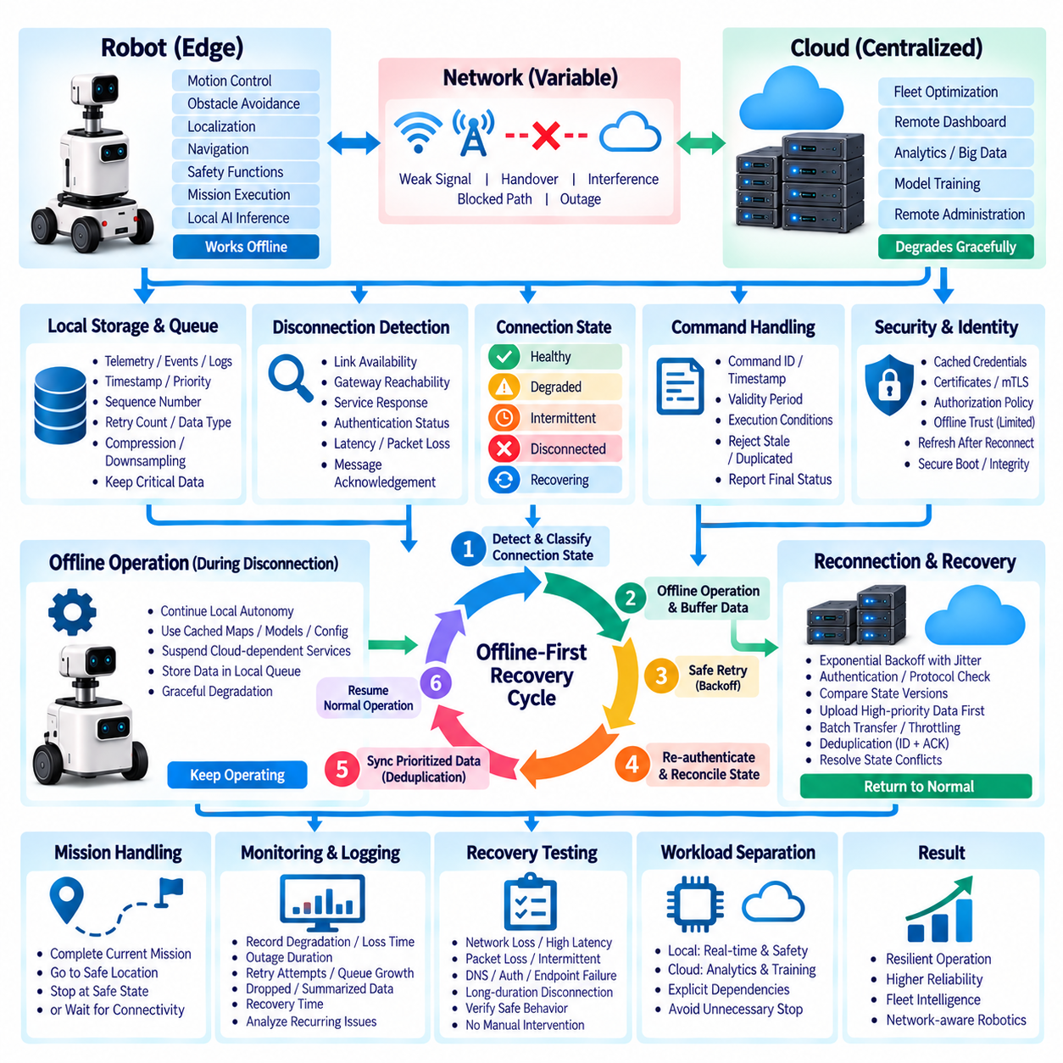
Network disconnection must be treated as a normal operating condition in hybrid cloud-edge robotics rather than as an exceptional failure. Mobile robots frequently move through areas with weak Wi-Fi, private 5G handover zones, interference, blocked radio paths, or temporary infrastructure outages. The architecture should therefore preserve essential autonomous functions at the Edge while cloud-dependent services degrade in a controlled manner until communication becomes available again.
The first design step is to identify which robot functions can continue locally and which functions require external connectivity. Motion control, obstacle avoidance, localization, emergency stopping, basic navigation, and safety supervision should normally remain available without cloud access. Fleet-wide optimization, remote dashboards, centralized analytics, large-scale data upload, cloud training, and remote administration can tolerate temporary interruption. Explicitly separating these dependencies prevents a network outage from unnecessarily stopping the entire robot.
Disconnection detection should use more than a simple network interface status. A robot may remain connected to a wireless access point while the cloud service, DNS, VPN, gateway, or application endpoint is unreachable. Health checks can therefore evaluate multiple layers, including link availability, gateway reachability, service response, authentication status, round-trip latency, packet loss, and message acknowledgement. Combining these signals provides a more accurate view of whether the communication path is actually usable.
Connectivity should be represented as operational states rather than only connected or disconnected. A system can distinguish healthy, degraded, intermittent, disconnected, and recovering conditions. A degraded state may indicate high latency or packet loss while communication is still possible, whereas an intermittent state may show repeated short outages. State-based handling allows the robot to reduce nonessential traffic or change synchronization behavior before complete communication loss occurs.
When disconnection is detected, the Edge should enter a predefined offline operating mode. Cloud-dependent requests can be suspended, while local services continue using cached configuration, maps, credentials, models, and mission information. New telemetry, events, logs, and synchronization records should be written to durable local storage. The objective is graceful degradation: functions that genuinely require the cloud become temporarily unavailable, while independent local capabilities continue without unnecessary interruption.
Local storage must be managed carefully because the duration of a network outage cannot always be predicted. A durable queue can retain unsynchronized messages with metadata such as timestamp, priority, sequence number, retry count, and data type. Critical alarms and mission results should receive higher retention priority than repetitive telemetry. If storage approaches its limit, policies can downsample low-value metrics, compress records, remove expired information, or preserve only representative sensor samples.
Commands require special treatment during disconnection because delayed execution can be dangerous. A cloud command issued before or during an outage should not automatically execute after reconnection if its operational context has expired. Commands should therefore contain identifiers, timestamps, validity periods, sequence information, and execution conditions. The Edge can reject stale or duplicated commands and report their final status after reconnection, preventing outdated instructions from changing current robot behavior.
Mission handling should define what happens when communication disappears during task execution. Depending on the application, a robot may complete its current mission, proceed to a predefined safe location, stop after reaching a safe state, or wait for connectivity while maintaining local safety functions. This behavior should be determined by mission policy rather than improvised after failure. Safety-critical decisions must remain local when the remote controller cannot be reliably reached.
Repeated reconnection attempts should use controlled retry behavior. Immediate continuous retries can consume power, wireless bandwidth, CPU resources, and cloud capacity, especially when many robots lose connectivity simultaneously. Exponential backoff with bounded intervals and randomized timing can distribute retry traffic over time. Critical communication paths may use more aggressive recovery policies than low-priority telemetry, allowing the system to allocate limited network resources according to operational importance.
Reconnection is not equivalent to full recovery. When communication returns, the Edge and cloud may contain different versions of configuration, task state, telemetry history, model information, or synchronization records. A recovery handshake should first re-establish authentication, verify protocol compatibility, determine the last confirmed synchronization point, and compare relevant state versions. Only after this reconciliation should normal bidirectional communication resume.
Buffered data should be uploaded according to priority rather than strictly according to volume or creation order. Safety events, fault reports, mission outcomes, and important state transitions can be transmitted first, followed by operational telemetry, logs, and large sensor datasets. Batch transfer, compression, and bandwidth throttling can prevent recovery traffic from overwhelming a recently restored connection. New real-time traffic should retain sufficient capacity while historical backlog is being synchronized.
Duplicate prevention is essential because the Edge may not know whether a message reached the cloud immediately before the connection failed. Unique message identifiers, sequence numbers, acknowledgements, and idempotent processing allow retransmission without creating duplicate logical events. The cloud can recognize previously processed records and acknowledge them again, while the Edge removes records from its pending queue only after receiving reliable confirmation that they have been accepted.
State conflicts can occur when both cloud and Edge components continue changing information during a disconnection. Configuration, mission assignments, robot status, and software or model versions may diverge. Recovery logic should therefore define authoritative ownership for each type of state and establish conflict-resolution rules. Safety and actual robot execution state should not be overwritten simply because a cloud record has a newer timestamp; semantic validity and ownership must be considered.
Authentication and certificate handling must also support disconnected operation. The robot may need locally cached trust information and credentials to continue internal communication while remote identity services are unavailable. However, offline trust should have defined limits because certificate status or authorization policies may change during a long outage. After reconnection, the robot should refresh relevant credentials, certificate status, authorization information, and security policies before performing sensitive cloud operations.
Monitoring should record the entire disconnection lifecycle. Useful information includes the time connectivity degraded, the time of complete loss, outage duration, retry attempts, queue growth, dropped or summarized data, recovery time, synchronization duration, and unresolved errors. Cloud aggregation of these records enables operators to identify recurring coverage gaps, unstable network infrastructure, problematic sites, or robot configurations that experience unusually frequent communication failures.
Recovery testing should intentionally reproduce communication failures before deployment. Test scenarios can include complete network loss, high latency, packet loss, intermittent connectivity, DNS failure, authentication service failure, cloud endpoint outage, and long-duration disconnection. Engineers should verify that robots maintain required local functions, avoid unsafe delayed commands, preserve important data, and recover without manual intervention. Such testing turns network resilience from an assumed property into a validated system behavior.
The resulting architecture follows an offline-first recovery cycle: detect communication degradation, classify the connection state, preserve essential Edge operation, buffer important information, retry communication safely, authenticate after reconnection, reconcile distributed state, synchronize prioritized data, and return to normal operation. This approach allows cloud services to enhance fleet intelligence and management while ensuring that temporary network failure does not become an uncontrolled failure of the physical robot system.

03.09 Hybrid Cost Optimization: Workload Distribution
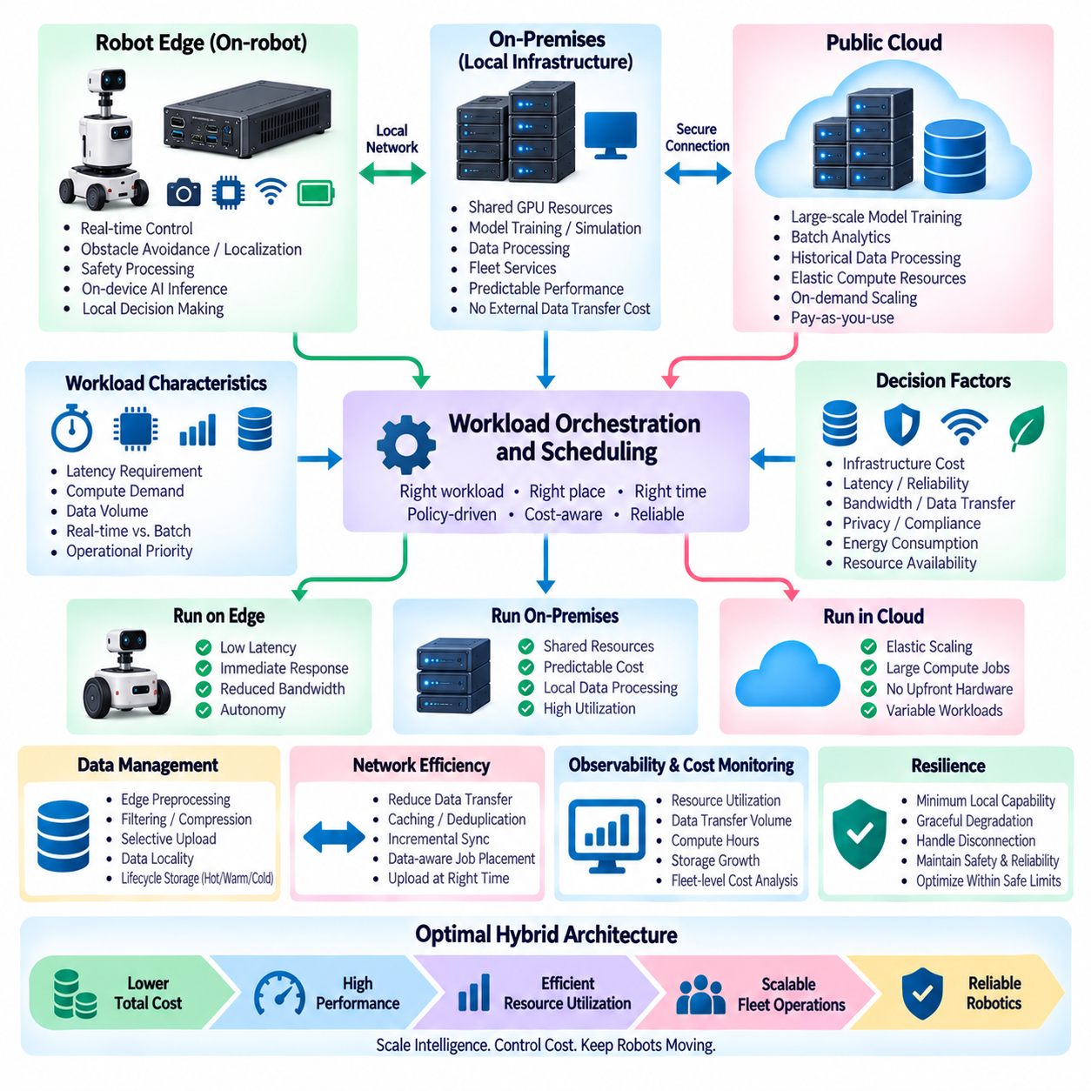
Hybrid cost optimization in robotics determines where workloads should execute across robot Edge computers, on-premise infrastructure, and public cloud resources. The objective is not simply to minimize cloud spending, but to balance cost with latency, reliability, privacy, bandwidth, energy consumption, and computational demand. A well-designed hybrid architecture assigns each workload to the environment that satisfies its operational requirements while avoiding unnecessary infrastructure and data-transfer expenses.
Workload distribution begins by identifying the characteristics of each robotic function. Real-time control, obstacle avoidance, localization, safety processing, and latency-sensitive AI inference normally belong at the Edge because they require immediate access to sensor data and predictable response. Large-scale model training, fleet analytics, historical processing, and computationally intensive optimization are better suited to centralized GPU infrastructure where resources can be shared and scaled efficiently.
Latency is one of the strongest constraints on workload placement. Sending sensor information to a remote cloud service and waiting for a response introduces network delay and variability that may be unacceptable for physical control. Edge execution removes much of this dependency, although it requires dedicated computing hardware on each robot. Cost optimization therefore cannot move a workload to the cloud merely because centralized computing appears cheaper; the workload must first satisfy its latency and availability requirements.
Bandwidth cost becomes significant when robots generate large volumes of camera, LiDAR, radar, audio, and telemetry data. Continuously uploading raw sensor streams can consume network capacity and increase cloud ingestion and storage costs. Edge preprocessing can reduce this burden through filtering, compression, feature extraction, event detection, aggregation, and selective sampling. Only information with operational, analytical, or training value then needs to cross the Edge-cloud boundary.
Data locality also affects economic decisions. Some information may need to remain within a factory, customer site, vehicle, or robot because of privacy, security, contractual, or operational requirements. Processing such data locally can reduce external transfer while improving response time. Cloud services can receive derived metrics, selected events, anonymized information, or approved datasets rather than complete raw streams, allowing centralized intelligence without requiring unrestricted data movement.
On-premise infrastructure provides an intermediate option between per-robot Edge computing and public cloud resources. Organizations with continuous GPU workloads may operate shared local servers for model training, simulation, data processing, or fleet services. These systems require capital expenditure, power, cooling, networking, maintenance, and capacity planning, but they can provide predictable performance and avoid recurring external data-transfer costs for workloads that remain consistently utilized.
Public cloud infrastructure is particularly useful when workload demand is variable or temporarily exceeds local capacity. Large training jobs, simulation campaigns, batch analytics, or periodic dataset processing can use elastic resources without permanently installing equivalent hardware. The economic advantage depends on actual utilization, instance pricing, storage, network transfer, managed-service charges, and operational overhead. Cloud elasticity is most valuable when resources can be released after the workload is completed.
GPU workloads require separate consideration because accelerator resources can dominate AI infrastructure cost. Edge GPUs should primarily support operational inference and other functions that must remain close to the robot. Centralized GPUs can be shared among training, evaluation, simulation, and model optimization tasks. Scheduling workloads onto available accelerators, selecting suitable precision, batching inference or training operations, and shutting down idle cloud GPU instances can substantially improve resource utilization.
Workload scheduling should consider time as well as location. Non-urgent jobs such as log processing, dataset conversion, report generation, map consolidation, model evaluation, and large data synchronization can be delayed until network conditions or compute prices are favorable. Robots can also postpone large uploads until they reach reliable Wi-Fi or local infrastructure. This temporal flexibility prevents low-priority processing from competing with mission-critical workloads for expensive or constrained resources.
Storage architecture contributes significantly to total cost because robotic systems accumulate large datasets over long periods. High-value recent data may remain in fast storage, while older logs, sensor archives, training datasets, and historical artifacts can move to lower-cost storage tiers. Retention policies should define what must remain immediately accessible, what can be archived, and what can be deleted. Without explicit lifecycle management, storage consumption can continue growing even when much of the retained data no longer provides operational value.
Data transfer should be treated as a measurable resource rather than an invisible part of the architecture. Repeatedly moving the same datasets between Edge, on-premise systems, cloud storage, and GPU environments can create unnecessary network load and cost. Caching, incremental synchronization, deduplication, compression, local dataset staging, and data-aware job placement can reduce movement. In many AI workflows, moving computation closer to a large dataset can be more efficient than repeatedly transferring the dataset to computation.
Fleet scale changes the economics of small architectural decisions. A telemetry message, log stream, or cloud API call may appear inexpensive for one robot but become significant when multiplied by hundreds or thousands of devices operating continuously. Monitoring frequency, metric cardinality, log verbosity, synchronization intervals, API requests, storage retention, and model-download behavior should therefore be evaluated at fleet scale. Cost models should represent both per-robot consumption and aggregate fleet demand.
Dynamic workload placement can adapt to changing operating conditions. When network quality is poor, more processing can remain at the Edge. When local GPU resources are heavily utilized, non-critical workloads can move to on-premise or cloud systems. When cloud resources become expensive or unnecessary, batch processing can be postponed or redirected. This policy-driven approach allows placement decisions to respond to latency, resource availability, connectivity, workload priority, and economic constraints rather than relying on a fixed architecture.
Cost optimization should not compromise resilience. Removing local computing resources may reduce hardware cost but can make robots dependent on network availability, while excessive Edge capacity can increase device cost, power consumption, thermal requirements, and maintenance complexity. Similarly, minimizing redundant cloud services may reduce operating expenses while weakening availability. The architecture should therefore establish minimum operational capabilities first and optimize cost only within those reliability and safety boundaries.
Observability provides the measurements required to make these decisions objectively. CPU and GPU utilization, memory use, storage growth, network traffic, cloud compute hours, data-transfer volume, inference demand, queue depth, job duration, and service utilization can reveal where resources are underused or overloaded. Combining technical metrics with infrastructure cost information makes it possible to identify workloads whose current execution location is economically inefficient.
A practical hybrid strategy therefore distributes workloads according to their operational value and resource characteristics. Real-time and safety-related processing remains near the robot, shared low-latency services can use local or on-premise infrastructure, and elastic large-scale computation can use cloud resources when appropriate. Data is filtered before transfer, compute is scaled according to demand, storage follows lifecycle policies, and workload placement is continuously reviewed using measured utilization rather than static assumptions.
The resulting architecture treats cost optimization as continuous workload orchestration across Edge, on-premise, and cloud environments. Each layer contributes a different economic and technical advantage: Edge provides autonomy and low latency, on-premise systems provide shared predictable capacity, and cloud platforms provide elasticity and large-scale services. Coordinating these resources allows a robotics fleet to expand without requiring infrastructure cost to increase unnecessarily in direct proportion to data volume, computational demand, or fleet size.

03.10 Hills Robotics Hybrid Cloud.Edge Reference Architecture
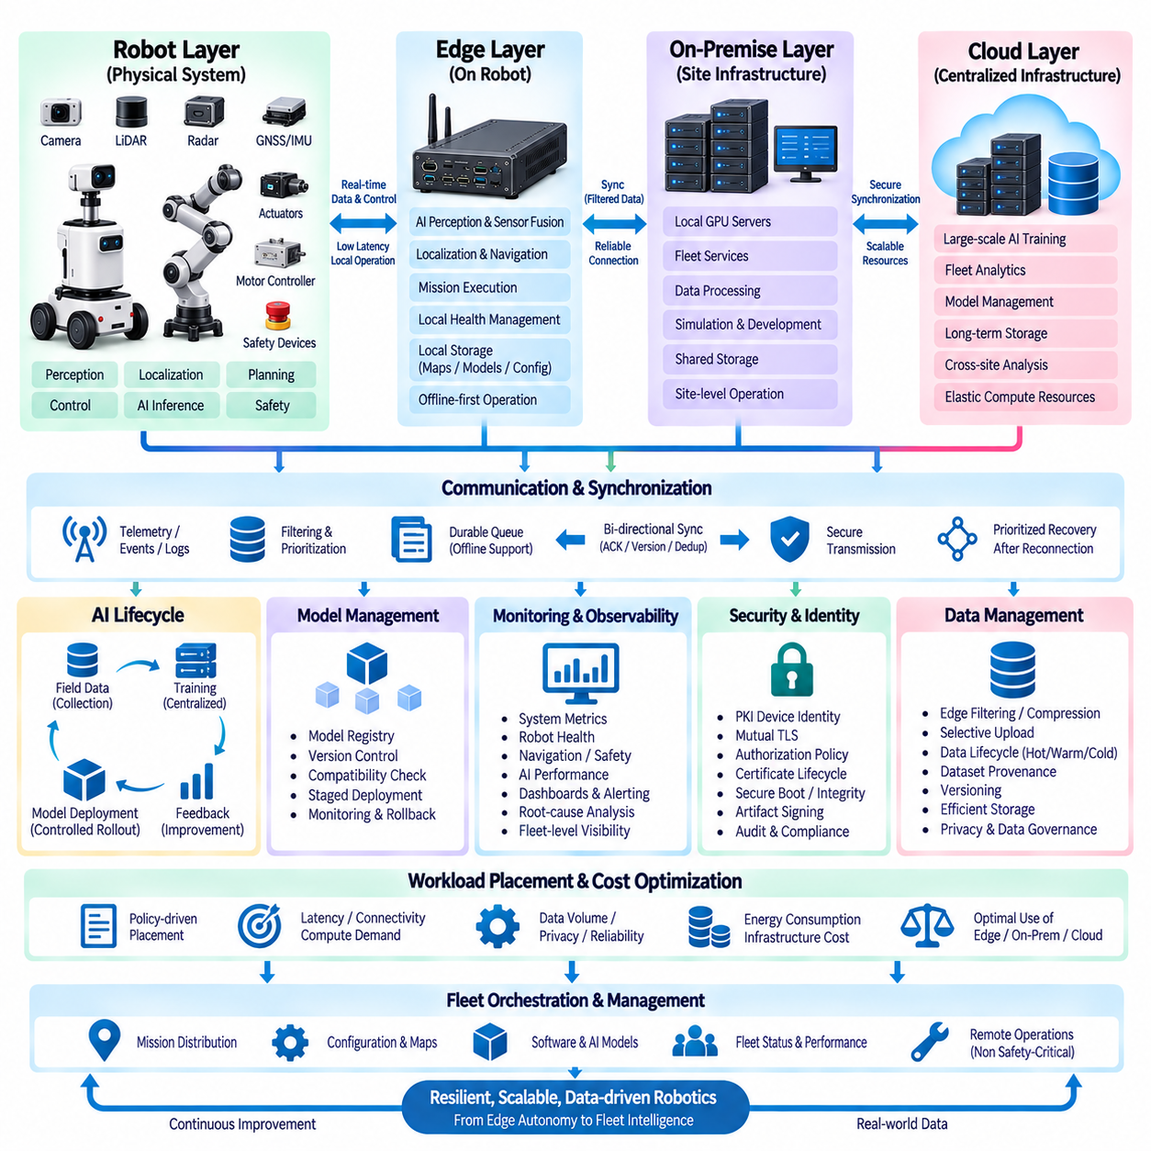
Hills Robotics’ Hybrid Cloud-Edge Reference Architecture is designed to combine autonomous robot operation at the Edge with scalable computing, data management, and fleet intelligence in centralized infrastructure. The architecture assumes that robots must continue essential missions even when external connectivity is degraded or unavailable. Cloud resources therefore enhance learning, coordination, analytics, and management without becoming a mandatory dependency for immediate physical operation.
At the robot layer, sensors, actuators, controllers, and Edge computing platforms form the operational foundation. Cameras, LiDAR, radar, GNSS, IMU, motor controllers, and safety devices continuously interact with perception, localization, planning, control, and AI inference software. Time-sensitive processing remains close to the physical system so that sensing-to-action loops can operate with predictable latency. This layer provides the minimum autonomous capability required for safe robot operation.
The Edge computing layer executes workloads that require low latency, local data access, and resilience against network disruption. AI perception, sensor fusion, localization, obstacle detection, navigation, mission execution, and local health management can operate independently of cloud availability. Local storage preserves maps, models, configuration, credentials, mission information, and temporary operational data. This offline-first design allows each robot to remain a functional autonomous system rather than becoming a remote terminal of the cloud.
An Edge communication and synchronization layer connects robot autonomy with centralized services. Telemetry, operational events, logs, selected sensor records, mission results, and AI training candidates are filtered and prioritized before transmission. Durable queues preserve unsynchronized information during communication loss, while acknowledgements, sequence numbers, version identifiers, and idempotent processing prevent data duplication. When connectivity returns, prioritized synchronization progressively restores consistency between distributed systems.
On-premise infrastructure can provide a shared computing layer between individual robots and external cloud services. Local GPU servers, storage systems, fleet services, development environments, and simulation platforms can support workloads that require more resources than a robot can provide but benefit from remaining close to operational data. This layer can reduce external bandwidth requirements, provide predictable computational capacity, and support site-level operation when access to public cloud infrastructure is limited.
The cloud layer provides elastic resources for workloads that do not require immediate physical response. Large-scale AI training, fleet analytics, historical data processing, centralized monitoring, model management, long-term storage, and cross-site analysis can operate in this environment. Cloud services aggregate information from multiple robots and sites to produce fleet-level intelligence. Resources can expand when computational demand increases and be released when intensive training, simulation, or batch-processing workloads are completed.
AI operation follows a hybrid learning lifecycle in which inference remains near the robot while computationally intensive learning is centralized. Edge devices execute validated models and selectively collect informative field data such as unusual environments, low-confidence predictions, failures, or operational anomalies. Centralized GPU infrastructure uses these samples for dataset expansion, training, evaluation, and optimization. Approved models are then packaged, versioned, and progressively redistributed to compatible Edge platforms.
Model deployment should be managed as a controlled fleet process rather than as simple file distribution. A model registry maintains logical model versions and hardware-specific deployment artifacts, while compatibility metadata identifies required runtime, preprocessing, software, and accelerator configurations. New models can first be deployed to limited robot groups and monitored before wider rollout. Known-good versions remain available for rollback when a new artifact produces unacceptable latency, resource consumption, or operational behavior.
Hybrid identity and security establish trust across robots, Edge systems, on-premise services, and cloud infrastructure. PKI-based device identities, protected private keys, certificates, and mutual TLS can authenticate machine-to-machine communication. Authorization policies restrict each identity to required operations, while certificate lifecycle management supports renewal and revocation. Secure boot, platform integrity mechanisms, encrypted communication, artifact signing, and audit records extend trust from device startup through data exchange and software deployment.
Monitoring follows the same hierarchical structure as computation. High-frequency CPU, GPU, memory, storage, temperature, network, sensor, navigation, safety, and AI inference metrics are collected locally. Edge agents filter and aggregate these measurements before cloud transmission, while critical events can be reported immediately. Centralized monitoring correlates information across robots, sites, software versions, and model versions to support dashboards, alerting, trend analysis, root-cause investigation, and fleet-wide operational improvement.
Network resilience is treated as an architectural requirement rather than an exception mechanism. Connectivity can be classified as healthy, degraded, intermittent, disconnected, or recovering, allowing the robot to adapt its communication behavior. During an outage, local autonomy continues while telemetry and synchronization records are buffered. After reconnection, authentication and state reconciliation occur before normal communication resumes. Stale commands are rejected, important events are synchronized first, and historical data follows according to available bandwidth.
Data management spans the entire architecture because robotic systems continuously generate large volumes of heterogeneous information. Raw sensor data should not automatically move to centralized storage. Edge filtering, compression, feature extraction, event selection, and aggregation reduce unnecessary transfer. Recent high-value information can remain in fast storage, while historical datasets move through appropriate retention and archival tiers. Dataset provenance and versioning preserve traceability between field observations, training data, experiments, and deployed AI models.
Workload placement is determined by operational requirements rather than by a fixed Edge-versus-cloud rule. Safety-critical and real-time workloads remain on the robot, shared low-latency processing can use on-premise resources, and elastic computational workloads can move to the cloud. Placement decisions consider latency, connectivity, compute demand, data volume, privacy, reliability, energy consumption, and infrastructure cost. This creates a policy-driven continuum across robot Edge, local infrastructure, and centralized computing resources.
The architecture also supports fleet-level orchestration without transferring immediate physical control away from the robot. Centralized services can distribute missions, configurations, maps, software, AI models, and operational policies while collecting fleet status and performance information. Each robot retains authority over immediate safety and local execution. This separation allows centralized intelligence to coordinate many autonomous systems while preserving deterministic local behavior when communication delays, failures, or infrastructure disruptions occur.
Observability, security, synchronization, AI lifecycle management, and cost optimization should operate as shared architectural services rather than independent additions. Monitoring data informs workload placement and capacity planning, identity controls protect synchronization and deployment, synchronization supplies field data for AI learning, and model telemetry provides feedback for subsequent training. Integrating these mechanisms creates a closed operational loop in which infrastructure decisions and robot intelligence continuously improve using measured fleet behavior.
The resulting Hills Robotics reference architecture establishes a layered hybrid system extending from sensors and physical control through Edge intelligence, site-level infrastructure, and centralized cloud services. Edge autonomy keeps robots operational, on-premise resources provide shared predictable capacity, and cloud infrastructure supplies scalable learning and fleet intelligence. Secure synchronization connects these layers while preserving local independence, creating a foundation for resilient, scalable, data-driven robotic fleets and future Physical AI services.

