Volume 09 Cloud and Edge Robotics

07. GPU Clusters

07.01 GPU Cluster Architecture: Scheduling / Connectivity
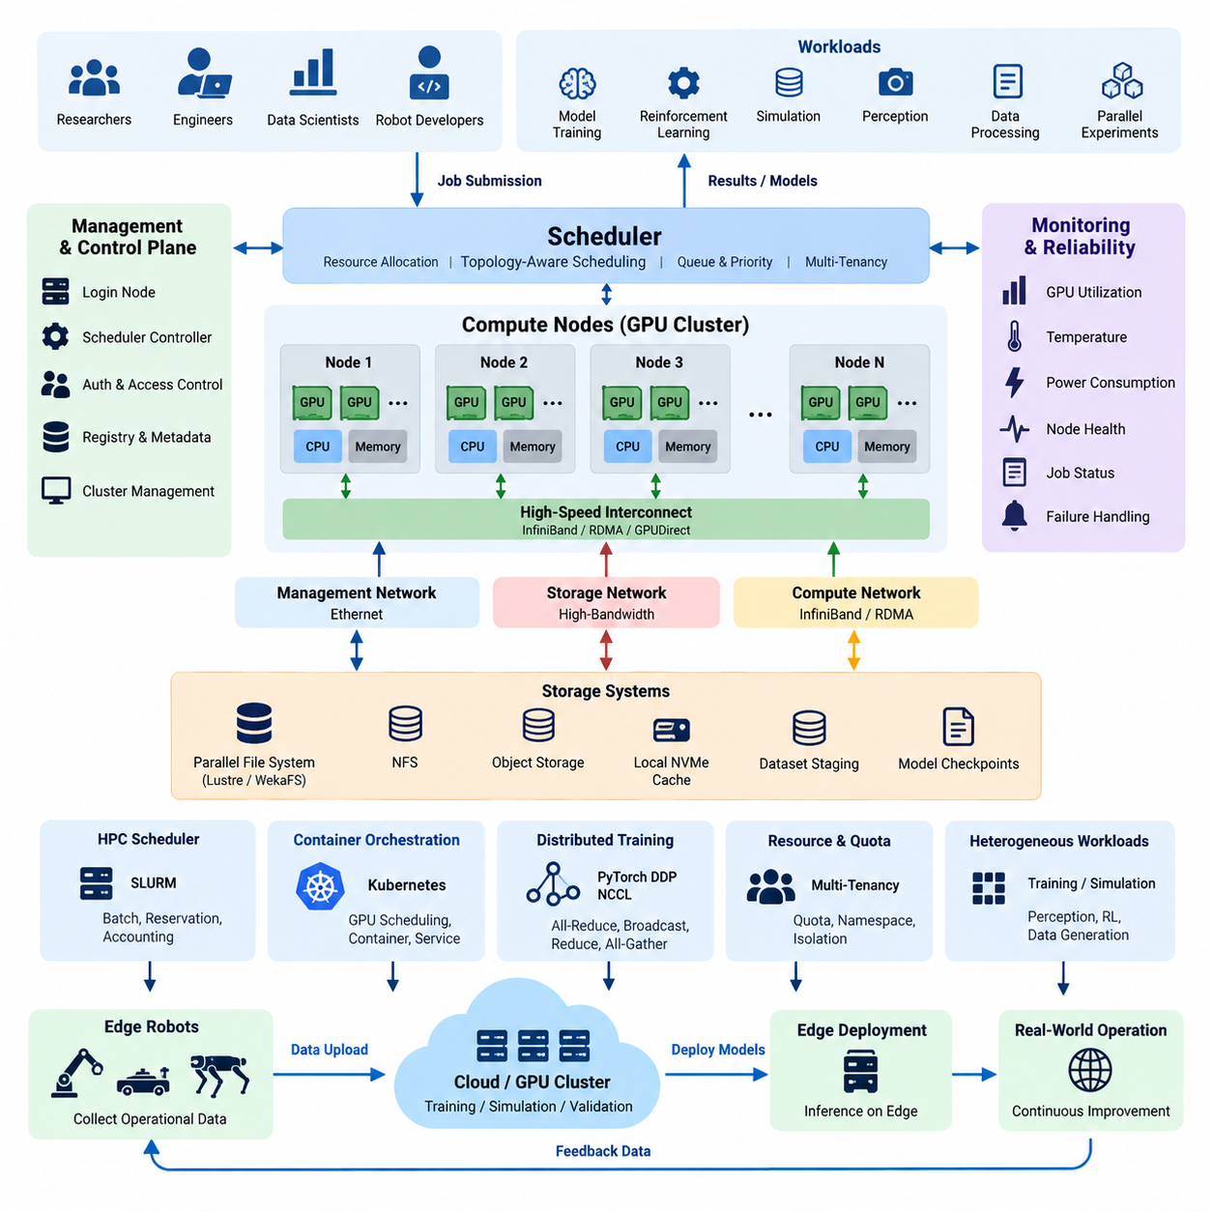
A GPU cluster is a computing environment in which multiple graphics processing units are organized as a shared infrastructure rather than operated as isolated accelerators. In robotics and Physical AI, this architecture supports workloads that exceed the memory, computation, or throughput available from a single GPU, including foundation-model training, reinforcement learning, large-scale simulation, perception training, and parallel experiment execution.
The fundamental architecture normally consists of GPU compute nodes, a management or control layer, high-speed networking, shared storage, and workload scheduling services. Each compute node may contain one or several GPUs connected to CPUs and system memory through PCI Express, while high-performance systems can provide faster GPU-to-GPU communication inside a node. The cluster architecture combines these individual nodes into a coordinated computing resource.
GPU topology strongly influences application performance. Communication between GPUs located within the same server can be substantially different from communication between GPUs located in separate servers. Distributed software must therefore understand whether data transfers occur through local GPU interconnects, PCIe, host memory, or the external network. Efficient topology-aware placement reduces unnecessary communication and helps distributed jobs scale as additional GPUs are allocated.
The cluster network can be divided conceptually into management traffic, storage traffic, and high-performance computation traffic. Ethernet is commonly suitable for administration and general services, while demanding distributed training can require high-bandwidth, low-latency fabrics. Technologies such as InfiniBand and RDMA reduce communication overhead between nodes, while GPUDirect technologies can shorten data paths between GPUs, network adapters, and storage devices.
Connectivity becomes particularly important during synchronous distributed training. Each GPU calculates part of a model workload, but gradients or other intermediate information must frequently be exchanged among participating processes. Collective communication operations such as all-reduce, broadcast, reduce, and all-gather can therefore become major performance factors. As computation becomes faster, an insufficient interconnect can leave expensive GPUs waiting for communication rather than executing useful operations.
A scheduler transforms the physical cluster into a manageable shared computing platform. Instead of manually assigning individual GPUs to users, the scheduler receives workload requirements and maps jobs to appropriate resources. Requests may specify the number of GPUs, CPU cores, system memory, execution time, node characteristics, or accelerator type. The scheduling layer then determines where and when each workload should execute while preventing conflicting resource allocation.
Scheduling is more complex than simply locating an unused GPU. A distributed job requesting eight GPUs may perform very differently when those GPUs are concentrated in one server, distributed across two closely connected nodes, or scattered throughout the cluster. Topology-aware scheduling attempts to place related processes near one another, preserve communication locality, and allocate contiguous resources when practical. This becomes increasingly important as clusters grow in size and hardware diversity.
Batch-oriented GPU clusters commonly use HPC schedulers such as SLURM, while cloud-native environments often use Kubernetes and GPU-aware device management. These approaches serve overlapping but different operational models. HPC scheduling emphasizes queued jobs, reservations, resource accounting, and tightly coupled parallel computation, whereas Kubernetes emphasizes containers, services, declarative deployment, orchestration, and integration with modern application platforms.
Resource utilization is another major architectural objective because GPU capacity is expensive and idle accelerators provide no computational value. The scheduler can improve utilization by maintaining job queues, applying priorities, supporting preemption policies, and matching workloads to suitable devices. Smaller experiments may use individual GPUs, while large training jobs may reserve complete multi-GPU nodes to obtain predictable communication performance and avoid interference from unrelated workloads.
GPU memory must also be treated as a first-class scheduling constraint. Two GPUs with similar computational capability may not support the same workload if their available memory differs. Large neural networks, high-resolution perception models, world models, and large training batches can require substantial accelerator memory. Cluster resource descriptions should therefore represent GPU type, memory capacity, compute capability, interconnect characteristics, and other hardware properties rather than treating every GPU as interchangeable.
Storage architecture directly interacts with GPU scheduling and connectivity. Training jobs can consume enormous collections of images, video, LiDAR data, robot trajectories, simulation outputs, and model checkpoints. If shared storage cannot deliver data at the rate required by the accelerators, GPUs remain underutilized regardless of their theoretical performance. High-speed NFS, parallel file systems, object storage, local NVMe caching, and dataset staging can be combined according to workload characteristics.
Data locality can further improve cluster efficiency. Frequently accessed datasets may be copied from central storage to node-local NVMe devices before training begins, reducing repeated traffic across the shared storage network. Checkpoints and final artifacts can subsequently be returned to durable centralized storage. This separation between persistent storage and high-speed temporary working data helps balance reliability, capacity, bandwidth, and infrastructure cost.
Distributed AI frameworks depend on the cluster architecture beneath them. PyTorch Distributed Data Parallel, for example, can launch processes across multiple GPUs while communication libraries coordinate tensor exchange. NCCL is commonly used for optimized GPU collective communication and can select communication paths according to available hardware. The effective training speed therefore emerges from the interaction among application parallelism, GPU topology, network bandwidth, communication libraries, and scheduling decisions.
Physical AI introduces especially diverse cluster workloads. One cluster may simultaneously execute perception-model training, reinforcement-learning experiments, synthetic-data generation, robot simulation, world-model learning, and validation pipelines. These workloads have different GPU, CPU, memory, network, and storage requirements. A practical architecture must consequently support heterogeneous resource profiles instead of assuming that every AI job has the same computational behavior.
Massive parallel simulation creates another scheduling pattern. Rather than running one extremely large training process, hundreds or thousands of simulation environments may execute concurrently and generate experience for learning algorithms. The cluster must coordinate simulation workers, training processes, data buffers, and experiment metadata. Efficient placement becomes important because excessive communication between simulation and learning components can reduce the advantage obtained from large-scale parallel execution.
Multi-tenancy requires the scheduler to balance utilization with isolation. Different researchers, projects, or robot programs may share the same infrastructure while requiring independent quotas, priorities, namespaces, containers, and access permissions. Resource accounting makes GPU consumption visible and allows capacity to be assigned according to organizational policy. Isolation also reduces the possibility that one experiment consumes all available accelerators or disrupts another critical workload.
Reliability must be considered because the probability of component failure increases as cluster size and job duration grow. Long-running distributed training should therefore support checkpointing and restart mechanisms. Monitoring systems should observe GPU temperature, memory utilization, power consumption, interconnect activity, node health, and job status. Failed GPUs or nodes can then be removed from scheduling until maintenance restores them to a reliable operating state.
The control plane should remain logically separated from intensive AI computation. Login nodes, scheduler controllers, monitoring services, registries, metadata systems, and authentication services should not compete with training jobs for the same critical resources. This separation improves operational stability and makes it easier to maintain the infrastructure while computational workloads continue to execute across worker nodes.
Cluster scalability should be evaluated as an end-to-end property rather than by counting GPUs. Adding accelerators increases theoretical compute capacity, but actual performance depends on communication efficiency, storage throughput, CPU preparation, scheduling quality, and software scalability. A cluster containing twice as many GPUs does not automatically complete a distributed workload twice as fast if another subsystem becomes the limiting factor.
For robotics organizations, the GPU cluster ultimately functions as a shared intelligence-production infrastructure connecting datasets, simulation, training, evaluation, and deployment pipelines. Edge robots can collect operational data, while centralized GPU resources perform computationally intensive learning and validation. Approved models can then return to edge systems for inference, creating a continuous relationship between robot operation and centralized AI computation within the broader cloud-edge architecture.

07.02 SLURM HPC Cluster Configuration [w/Code]
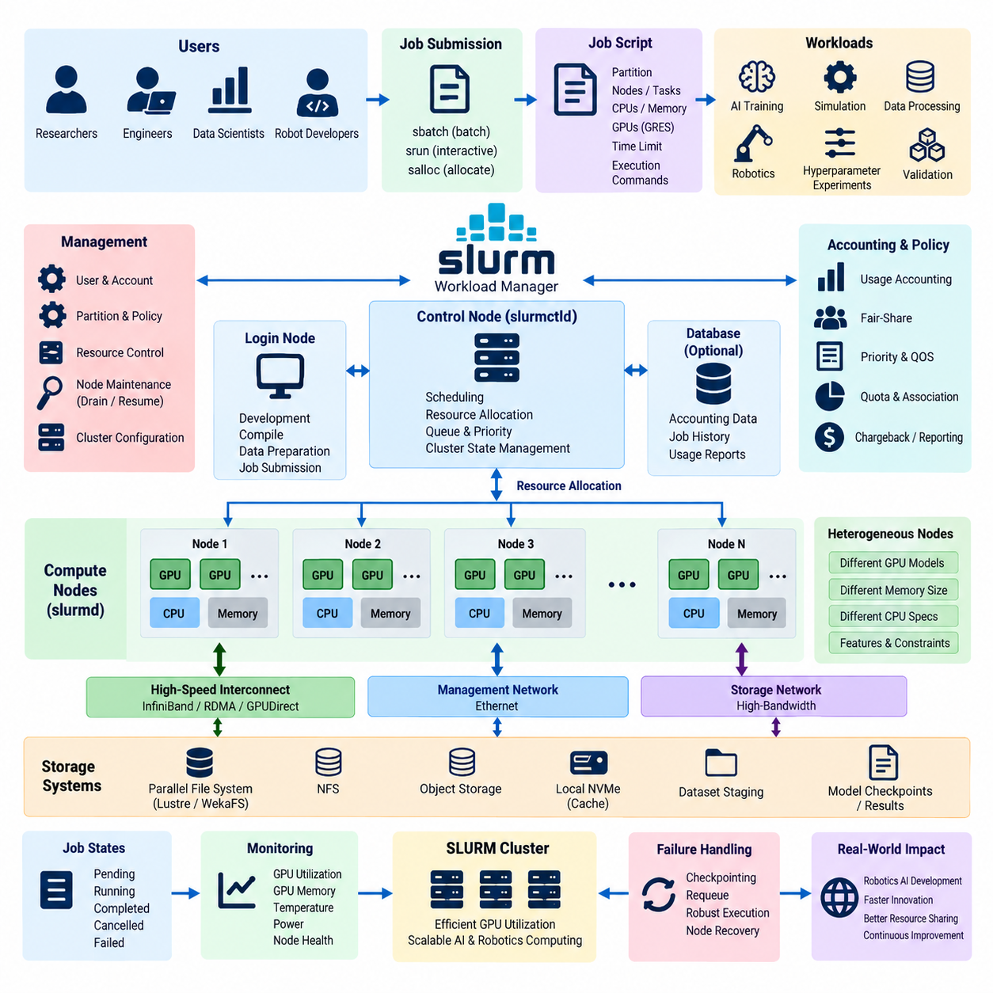
SLURM is a workload management and job scheduling system widely used in high-performance computing environments, including GPU clusters for artificial intelligence and robotics. Instead of allowing users to manually select compute servers and GPUs, SLURM presents cluster resources through a centralized scheduling environment. Jobs request resources, enter queues, receive allocations, execute on selected nodes, and release those resources when processing finishes.
A basic SLURM cluster separates management functions from computation. The control node runs the central scheduler and maintains information about available nodes, partitions, jobs, and resource states. Compute nodes execute user workloads and report their status to the controller. Login nodes can provide separate environments for source management, job preparation, compilation, dataset inspection, and job submission without placing interactive user activity directly on compute servers.
The SLURM controller is primarily managed through the slurmctld daemon, while each compute node normally runs slurmd. The controller receives job requests, evaluates scheduling policies and available resources, and assigns suitable nodes. Compute-node daemons launch tasks and communicate their status back to the controller. In production environments, controller reliability is important because scheduling decisions and cluster state management depend on this control-plane service.
Cluster configuration begins by describing the hardware resources that SLURM is expected to manage. Compute nodes can be defined with CPU counts, memory capacity, topology information, and other characteristics. GPU resources are represented as generic resources, commonly called GRES. This allows a node to advertise the number and type of installed GPUs so that users can explicitly request accelerator resources instead of treating GPUs as invisible hardware attached to servers.
Partitions provide logical groupings of compute resources. A GPU cluster can separate nodes according to hardware generation, workload purpose, execution policy, or service level. For example, short experiments, long-running training, high-memory GPU workloads, and production validation may use different partitions. Partitions can define scheduling limits and access policies while still allowing the underlying physical infrastructure to remain part of one centrally managed cluster.
Job submission is normally performed with sbatch for non-interactive batch workloads. A job script contains execution commands together with resource requirements such as partition, node count, task count, CPU allocation, memory, execution time, and GPU quantity. After submission, SLURM assigns a job identifier and places the workload into the scheduling system. The user does not need to determine manually which specific server should execute the workload.
Interactive execution can be supported through commands such as srun or resource allocations created with salloc. This is useful when developers need to debug training code, inspect GPU behavior, test distributed communication, or verify an environment before launching a long batch job. Interactive sessions should still pass through resource allocation so that experimental processes do not occupy GPUs that have already been assigned to another workload.
GPU scheduling requires the relationship between physical accelerators and SLURM resources to be configured correctly. A node containing multiple GPUs can expose those devices through GRES definitions, and jobs can request one or several GPUs. SLURM then limits the job to its allocated resources and provides the execution environment required for GPU-aware applications. Accurate configuration prevents multiple independent jobs from unintentionally competing for the same accelerator.
Hardware heterogeneity introduces additional scheduling requirements. A cluster may contain different GPU models, GPU memory capacities, CPU architectures, or node configurations. Features and constraints can describe these differences so that workloads requiring a particular accelerator class are placed on compatible nodes. This is important for AI workloads because model size, numerical precision, software compatibility, and performance requirements can differ substantially between GPU generations.
Distributed training requires coordinated allocation across multiple GPUs and sometimes multiple nodes. SLURM can reserve the complete set of required resources before execution, avoiding a situation where only part of a distributed job can start. Frameworks such as PyTorch Distributed Data Parallel can then launch cooperating processes within the allocation, while NCCL handles GPU collective communication such as all-reduce across the available interconnect infrastructure.
Task placement should reflect the physical topology of the cluster. Processes communicating intensively with each other should preferably use GPUs and nodes connected through efficient communication paths. Within a server, GPU communication may use PCIe or dedicated GPU interconnects, while communication between servers can use Ethernet, InfiniBand, RDMA, or GPUDirect-capable infrastructure. Poor placement can cause communication overhead to dominate otherwise powerful GPU computation.
SLURM scheduling policies determine how competing workloads share limited resources. Jobs may be ordered according to priority, waiting time, resource requirements, account information, or organizational policies. Backfill scheduling can improve utilization by executing smaller jobs when they do not delay previously scheduled higher-priority workloads. This reduces unused gaps in the schedule and can substantially improve the effective utilization of expensive GPU infrastructure.
Fair-share mechanisms can prevent one user or project from continuously consuming most of the cluster. Usage history, accounts, associations, and priority policies can be combined to distribute resources according to organizational objectives. Research teams can receive defined access without permanently assigning physical GPUs to individual users. This enables infrastructure to operate as a common resource pool while retaining accountability for computational consumption.
Resource accounting is essential when the cluster supports multiple projects. SLURM accounting can record submitted jobs, allocated resources, execution duration, job states, and related usage information. Administrators can use these records to understand GPU demand, identify persistent queues, evaluate utilization, and support capacity planning. Accounting information can also help organizations associate infrastructure consumption with research programs, customers, or internal development activities.
Job states provide visibility into cluster operation. A workload may be pending because resources are unavailable, running after allocation, completed successfully, cancelled, or failed because of software or hardware problems. Commands such as squeue allow users and administrators to inspect queued and active jobs, while node-oriented commands expose available, allocated, drained, or unavailable compute resources. This operational visibility is important when many experiments execute concurrently.
Node maintenance requires controlled removal of resources from scheduling. Administrators can drain a compute node when a GPU, network adapter, storage path, driver, or other component requires investigation. New workloads are prevented from being assigned to that node while maintenance is performed. After validation, the node can be returned to service. This approach avoids shutting down the entire cluster because of a problem affecting one server.
Software environments should be reproducible across compute nodes. AI clusters commonly combine SLURM with environment modules, containers, or standardized software images so that jobs obtain consistent CUDA libraries, frameworks, communication libraries, and dependencies. Containers are particularly useful for separating project-specific software stacks from the host operating system while still exposing allocated GPUs and high-performance networking to applications.
Storage must be accessible consistently from scheduled compute nodes. Users may keep source code, datasets, checkpoints, experiment outputs, and logs on shared storage, while high-throughput workloads can stage frequently accessed data to local NVMe devices. The job workflow can copy data before execution and return checkpoints afterward. This reduces pressure on shared storage while preserving centralized data management and reproducibility.
Failure handling becomes increasingly important for long-running Physical AI training. A multi-day job can lose substantial computation if a node fails before model state is saved. Training applications should therefore create periodic checkpoints and maintain restartable execution procedures. SLURM can resubmit or requeue suitable workloads according to configured policies, but application-level checkpointing remains necessary because the scheduler cannot reconstruct lost neural-network training state by itself.
Monitoring should combine scheduler information with GPU telemetry. SLURM explains which job owns each resource, while GPU monitoring systems can report utilization, memory consumption, temperature, power, and hardware health. Combining these views helps administrators determine whether allocated GPUs are actually performing useful work. Persistent low utilization may indicate inefficient code, data-loading bottlenecks, communication limitations, oversized allocations, or inappropriate scheduling policies.
For robotics and Physical AI, SLURM can coordinate a heterogeneous workload portfolio rather than only conventional HPC computation. Perception training, reinforcement learning, world-model training, simulation, synthetic-data generation, hyperparameter experiments, and validation can coexist within the same infrastructure. Different partitions, resource constraints, priorities, and quotas allow these workloads to share GPU capacity while preserving operational control.
A well-configured SLURM environment therefore acts as the resource-management layer between expensive GPU hardware and AI development workflows. Compute nodes supply acceleration, high-speed networks support distributed communication, storage provides datasets and checkpoints, and SLURM determines when and where workloads execute. This architecture transforms independent GPU servers into a coordinated HPC platform capable of supporting scalable robotics and Physical AI development.

07.03 Kubernetes GPU Scheduler: nvidia.device.plugin [w/Code]
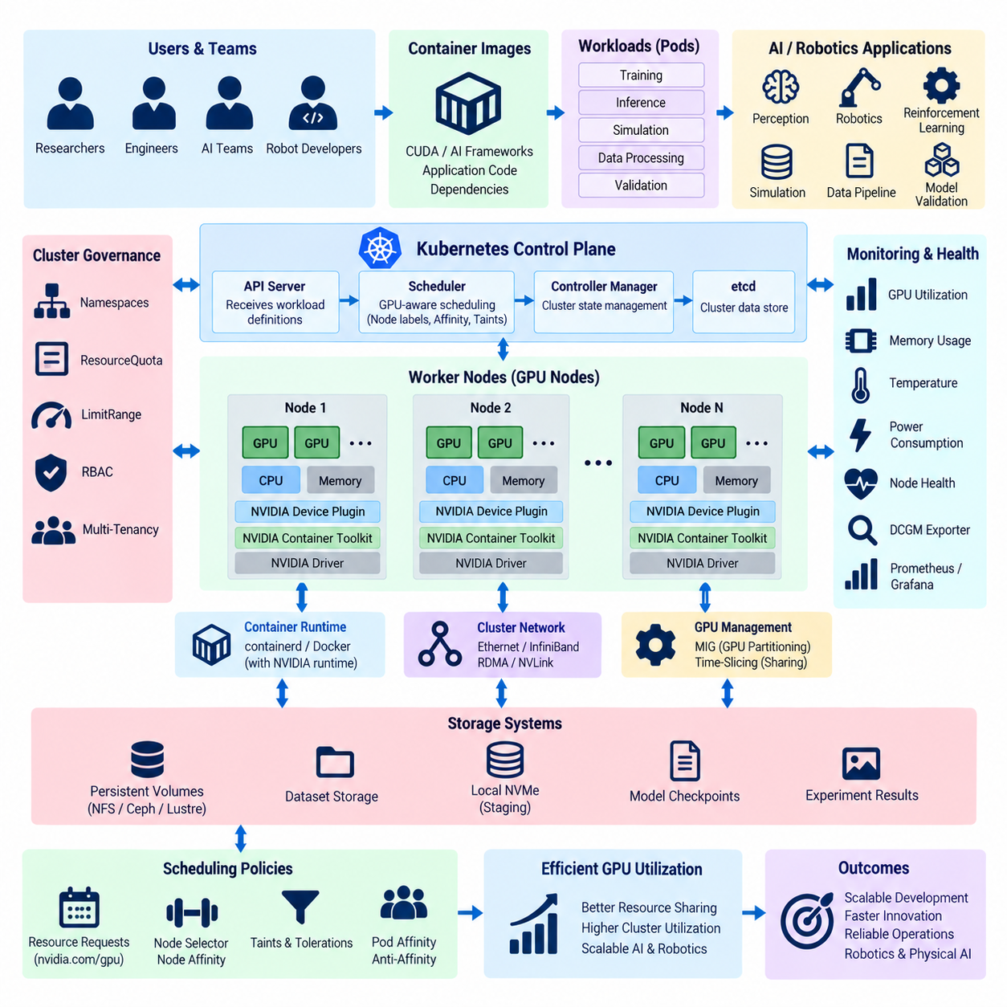
Kubernetes provides a cloud-native orchestration environment for running GPU-accelerated workloads as containerized applications. In a GPU cluster, Kubernetes does not normally manage accelerator hardware directly through the standard CPU and memory resource model. Instead, NVIDIA GPUs are exposed to Kubernetes through supporting components such as the NVIDIA device plugin, allowing Pods to request GPUs as schedulable resources alongside conventional compute resources.
The NVIDIA device plugin operates between Kubernetes resource management and the GPU devices installed on worker nodes. It discovers compatible NVIDIA accelerators and advertises them to the kubelet as extended resources, typically represented as nvidia.com/gpu. Once these resources are registered, the Kubernetes scheduler can recognize how many GPUs are available on each node and can place GPU-requesting Pods only where sufficient accelerator capacity exists.
Each GPU worker node requires an appropriate NVIDIA software stack before accelerator workloads can execute reliably. The host operating system must provide compatible NVIDIA drivers, while the container runtime must be configured so containers can access assigned GPU devices. NVIDIA Container Toolkit is commonly used to connect container execution with the host GPU environment, allowing CUDA-based applications inside containers to use physical accelerators without embedding kernel-level GPU drivers into each image.
The device plugin is commonly deployed as a DaemonSet so that one plugin instance runs on every eligible GPU node. This deployment model automatically follows changes in cluster membership: when a GPU worker joins the cluster, Kubernetes can start the plugin on that node, while removal of the node also removes its plugin instance. The DaemonSet approach therefore provides a scalable mechanism for maintaining GPU discovery across many worker nodes.
GPU resources are requested in a Pod specification rather than manually assigning a physical accelerator to a container. A workload can declare a GPU limit using the nvidia.com/gpu extended resource, and the scheduler searches for a node capable of satisfying that request. After placement, the device plugin participates in exposing the allocated accelerator to the container, creating a separation between application-level resource requests and low-level device assignment.
Unlike CPU resources, conventional GPU resources are generally treated as integer devices. A Pod requesting one GPU receives access to an allocated accelerator rather than an arbitrary fractional amount of standard nvidia.com/gpu capacity. This affects cluster utilization because small inference or experimental workloads may not consume the full computational capability of a GPU. More advanced sharing mechanisms can be introduced when workloads require finer-grained accelerator utilization.
Scheduling depends not only on GPU quantity but also on workload compatibility. A heterogeneous cluster may contain GPUs with different architectures, memory capacities, performance levels, or intended purposes. Kubernetes node labels can describe these hardware characteristics, while node selectors, node affinity, and related placement rules allow workloads to target suitable nodes. This prevents a memory-intensive training workload from being scheduled merely because an incompatible GPU happens to be available.
Node affinity provides more flexible placement logic than a simple node selector. Workloads can express required or preferred characteristics so that scheduling reflects accelerator type, node generation, networking capability, or operational role. Taints and tolerations can additionally reserve GPU nodes for appropriate workloads by preventing ordinary CPU-only Pods from consuming valuable resources on accelerator servers unless those Pods have explicit permission to run there.
Kubernetes scheduling can also consider Pod affinity and anti-affinity when multiple components form one AI pipeline. Closely cooperating services may benefit from placement near each other, while replicas requiring fault isolation may be distributed across nodes. For distributed GPU training, placement decisions should additionally consider network topology because communication-intensive workers can lose significant performance when scheduled across nodes connected through inefficient network paths.
The default Kubernetes scheduler focuses primarily on satisfying declared resources and scheduling constraints rather than understanding every detail of GPU interconnect topology. Large distributed training environments may therefore require additional scheduling policies, topology information, operators, or specialized schedulers. The objective is to align Pod placement with NVLink, PCIe, InfiniBand, RDMA, and other connectivity characteristics that influence collective communication performance.
Distributed training commonly runs multiple coordinated worker processes across several GPUs or nodes. Frameworks such as PyTorch Distributed Data Parallel can operate inside Kubernetes Pods, while NCCL provides GPU collective communication. Kubernetes supplies lifecycle management and resource placement, whereas the training framework coordinates computation. High-performance networking becomes essential because slow inter-node communication can reduce the scaling benefits obtained from adding more GPUs.
The Kubernetes control plane maintains the desired cluster state while GPU computation occurs on worker nodes. The API server receives workload definitions, the scheduler selects appropriate nodes, and kubelets manage Pod execution on those nodes. This separation allows GPU workloads to use the same declarative deployment model as other Kubernetes applications while preserving specialized accelerator handling through the NVIDIA device plugin and supporting runtime components.
Namespaces and resource governance become important when multiple robotics or AI teams share the cluster. Kubernetes namespaces can logically separate projects, while ResourceQuota and LimitRange policies can restrict resource consumption. GPU quotas can help prevent one team from submitting enough workloads to consume all accelerators. Combined with role-based access control, this creates a multi-tenant environment in which shared GPU infrastructure can be governed according to organizational policies.
GPU sharing can improve utilization for workloads that do not require an entire accelerator. Depending on the GPU platform and software configuration, approaches can include time-slicing or hardware-supported partitioning technologies such as Multi-Instance GPU. These mechanisms represent different isolation and performance characteristics. Cluster designers must therefore distinguish between sharing execution time on a device and dividing supported GPUs into more strongly isolated hardware-backed GPU instances.
Multi-Instance GPU, commonly known as MIG, allows supported NVIDIA GPUs to be divided into multiple isolated GPU instances with defined compute and memory resources. Kubernetes environments can expose these instances according to the configured device-management strategy. MIG can be useful when multiple inference services, development experiments, or moderate workloads need predictable accelerator partitions without dedicating an entire physical GPU to each individual Pod.
Time-slicing addresses a different utilization problem by allowing multiple workloads to share access to GPU execution over time. It can increase effective occupancy for lightweight workloads but does not provide the same hardware isolation characteristics as MIG. Consequently, scheduling policy should reflect workload behavior. Large training jobs may require dedicated GPUs, while development, testing, or relatively small inference tasks may be appropriate candidates for controlled sharing.
Operational visibility requires more than knowing whether a GPU has been allocated. Kubernetes can report Pod placement and resource requests, but administrators also need accelerator-level information such as utilization, memory usage, temperature, power consumption, and hardware health. NVIDIA DCGM-based monitoring can complement Kubernetes metrics, and telemetry can be exported to monitoring platforms so that scheduler decisions can be compared with actual GPU behavior.
Health management is particularly important because an allocated GPU may exist from the scheduler's perspective while experiencing hardware, driver, or communication problems. Monitoring systems should detect abnormal accelerator conditions, and unhealthy nodes can be cordoned or drained to prevent new workloads from being placed there. Kubernetes can then reschedule suitable workloads elsewhere, although stateful AI jobs still require application-level checkpointing to recover computational progress.
Containerization improves reproducibility across GPU nodes by packaging frameworks, libraries, application code, and user-space dependencies into versioned images. Teams can maintain separate environments for CUDA applications, perception training, reinforcement learning, simulation, and model validation without repeatedly modifying host systems. Container registries provide controlled distribution of these images, while Kubernetes ensures that declared versions are launched consistently across the cluster.
Persistent and high-performance storage remains essential because GPU scheduling alone cannot guarantee efficient AI execution. Training Pods may read large image, video, LiDAR, trajectory, or simulation datasets and continuously write checkpoints and experiment outputs. Persistent volumes provide managed storage access, while local NVMe staging can accelerate data-intensive workloads. Poor storage throughput can leave correctly scheduled GPUs idle while applications wait for data.
For robotics and Physical AI, Kubernetes GPU scheduling enables one cluster to host diverse containerized workloads such as perception training, reinforcement learning, world-model development, simulation, synthetic-data generation, validation, and inference services. GPU worker nodes can coexist with ordinary CPU nodes, while scheduling rules direct each workload toward appropriate hardware. This creates a flexible platform connecting AI development with broader cloud-native robotics infrastructure.
The NVIDIA device plugin therefore serves as a critical bridge between Kubernetes and physical GPU resources. Kubernetes provides declarative orchestration, scheduling, isolation, lifecycle management, and multi-tenant governance, while NVIDIA components expose and enable accelerator devices. Combined with suitable networking, storage, monitoring, and sharing policies, this architecture transforms GPU servers into a scalable cloud-native computing platform for robotics and Physical AI.

07.04 Distributed Training Infrastructure: NCCL, RDMA, GPUDirect [w/Code]
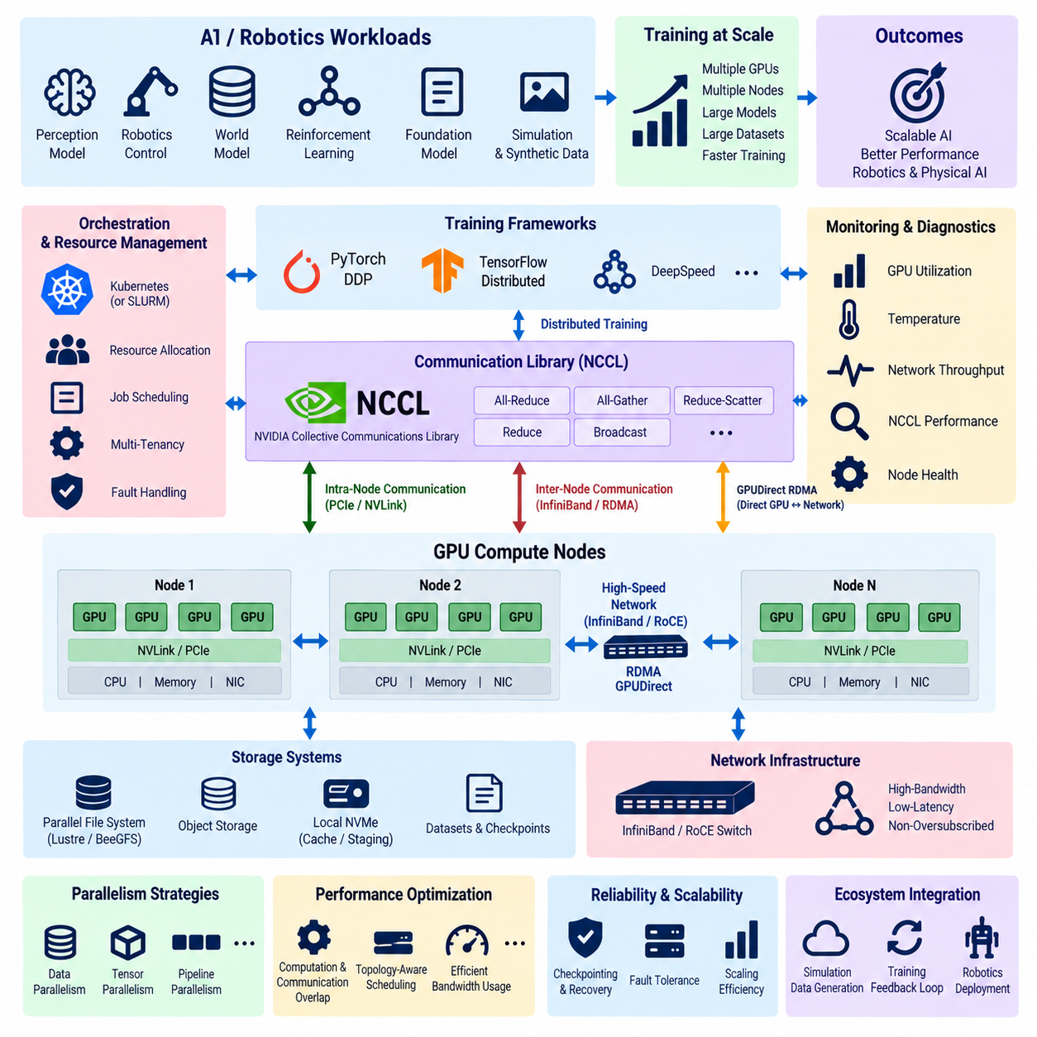
Distributed training infrastructure enables AI models to use multiple GPUs and multiple compute nodes as a coordinated computing system. This capability is essential when model size, dataset scale, simulation throughput, or training time exceeds the practical limits of a single accelerator. In robotics and Physical AI, distributed training supports perception models, world models, reinforcement learning, foundation models, and large-scale multimodal learning.
The basic architecture consists of GPU compute nodes, high-speed interconnects, distributed training frameworks, communication libraries, and shared or distributed storage. Each node typically contains several GPUs connected through PCIe or high-bandwidth GPU interconnects, while nodes communicate through Ethernet or InfiniBand. Efficient training requires these components to operate as one coordinated data path rather than as independent infrastructure elements.
Distributed data parallelism is one of the most common scaling strategies. Each GPU maintains a copy of the model and processes a different subset of the training batch. After forward and backward computation, gradients calculated by individual workers must be synchronized before model parameters are updated. As GPU count increases, the efficiency of this synchronization becomes a major factor determining whether additional accelerators actually reduce training time.
NCCL, the NVIDIA Collective Communications Library, provides optimized communication primitives for multi-GPU and multi-node applications. It supports operations such as all-reduce, all-gather, reduce-scatter, reduce, and broadcast. Deep-learning frameworks can use these operations without implementing low-level GPU communication mechanisms themselves, allowing the training framework to concentrate on model execution while NCCL manages efficient data movement among accelerators.
All-reduce is especially important in synchronous data-parallel training because gradients generated by multiple workers must be combined and distributed back to all participants. A poorly implemented synchronization stage can cause GPUs to spend substantial time waiting instead of calculating. NCCL selects communication strategies according to available GPU topology and networking capabilities, helping reduce the communication overhead associated with large distributed training jobs.
Communication within one compute node differs from communication between nodes. GPUs in the same server may exchange data through PCIe or technologies such as NVLink, while multi-node communication must cross network interfaces and switches. Distributed training performance therefore depends on both intra-node and inter-node bandwidth. A cluster with powerful GPUs can still scale poorly when its external network cannot sustain the required collective communication traffic.
Remote Direct Memory Access, or RDMA, allows data to move between the memory spaces of networked systems with reduced CPU involvement compared with conventional network communication paths. By avoiding unnecessary copying and portions of the traditional operating-system networking stack, RDMA can reduce latency and CPU overhead. This makes it valuable for distributed AI workloads that repeatedly exchange large tensors between compute nodes.
InfiniBand is commonly associated with high-performance RDMA environments because it provides high bandwidth, low latency, and features designed for intensive cluster communication. RDMA can also be implemented over appropriately configured Ethernet environments through technologies such as RoCE. The choice between these approaches depends on performance targets, existing infrastructure, operational expertise, network design, and the scale of distributed workloads.
GPUDirect extends the objective of reducing unnecessary data movement by enabling more direct communication paths involving GPUs. Conventional transfers may require GPU data to pass through host memory before reaching a network interface or another subsystem. GPUDirect technologies are designed to reduce these intermediate transfers where supported, decreasing CPU intervention and allowing accelerator data to move through more efficient paths.
GPUDirect RDMA is particularly important for multi-node GPU training because compatible network adapters can access GPU memory through a more direct data path. Instead of repeatedly staging communication buffers through CPU system memory, supported configurations can transfer data between GPU memory and the network interface with reduced intermediate copying. This can lower latency, reduce CPU load, and improve effective communication throughput.
The complete communication path therefore involves several cooperating layers. The deep-learning framework generates tensors and distributed operations, NCCL determines how collective communication should be performed, CUDA provides the GPU execution environment, and the networking stack transports data between nodes. RDMA and GPUDirect can optimize lower-level transfers, while physical network adapters and switches provide the actual connectivity required by the cluster.
Topology awareness is critical because not every GPU has an equivalent path to every other GPU or network adapter. PCIe hierarchy, NUMA placement, GPU interconnects, network-interface location, and switch topology can affect transfer performance. Distributed training infrastructure should therefore consider which GPU communicates through which network interface and how processes are mapped to hardware. Poor topology alignment can create avoidable bottlenecks.
Network interface bandwidth must be evaluated against aggregate GPU communication demand rather than against the requirements of one accelerator. A multi-GPU server can generate communication traffic from several workers simultaneously. If all GPUs depend on a network interface whose bandwidth is insufficient for their combined traffic, the network becomes the bottleneck. High-performance designs may therefore use multiple network adapters or carefully balanced communication paths.
Switch architecture also affects scaling. Training traffic can involve many simultaneous flows created by collective operations across numerous compute nodes. Oversubscribed network designs may work well for ordinary enterprise traffic but can limit distributed AI workloads. Cluster networks intended for large-scale training should provide sufficient fabric bandwidth and predictable latency so that collective communication remains efficient as the number of participating nodes increases.
Distributed training frameworks must coordinate process identity and membership across the cluster. Each worker typically requires information such as global rank, local rank, world size, and the address of coordination services. The global rank identifies a process across the complete distributed job, while the local rank identifies its GPU assignment within a node. Correct process initialization is necessary before NCCL communication groups can operate consistently.
PyTorch Distributed Data Parallel commonly uses one training process per GPU. Each process performs computation on its assigned accelerator while gradient synchronization occurs through the distributed backend. This structure maps naturally to multi-GPU clusters because process placement can follow the physical GPU topology. Cluster schedulers such as SLURM or Kubernetes can allocate nodes and accelerators before the distributed framework launches the cooperating training processes.
Communication and computation should overlap whenever possible. If training waits for every gradient calculation to finish before beginning all communication, accelerators can remain idle during synchronization. Modern distributed frameworks can organize gradient communication into buckets and begin transferring completed gradients while backward computation continues for other layers. Effective overlap reduces exposed communication time and improves scaling efficiency.
Model size can require parallelism beyond conventional data parallelism. Tensor parallelism divides mathematical operations across accelerators, while pipeline parallelism places different model stages on different devices. Large models may combine data, tensor, and pipeline parallelism. These strategies increase communication complexity, making high-bandwidth interconnects, NCCL operations, topology-aware placement, and predictable network performance even more important.
Storage performance remains connected to distributed training efficiency even though NCCL and RDMA primarily address communication. Hundreds of GPU workers cannot remain productive if datasets arrive too slowly. Shared parallel storage, object storage, dataset staging, and node-local NVMe caches can be combined to supply training data efficiently. Checkpoint writes must also be designed so that large synchronized outputs do not overload shared storage infrastructure.
Fault tolerance becomes more important as the number of participating nodes increases. A failure in one GPU, network adapter, node, or communication process can interrupt an entire synchronous training job. Periodic checkpointing therefore protects training progress, while monitoring should track GPU health, network errors, communication performance, and node availability. Schedulers can replace failed resources, but the training framework must restore model and optimizer state.
Performance analysis should distinguish computation bottlenecks from communication bottlenecks. GPU utilization, NCCL communication time, network throughput, latency, CPU activity, and storage throughput should be observed together. If GPU utilization decreases as more nodes are added, communication may be limiting scaling. Measuring end-to-end training throughput is therefore more meaningful than evaluating theoretical GPU performance or network bandwidth independently.
For Physical AI, distributed infrastructure can connect massive simulation with large-scale learning. Thousands of simulated robot environments may generate trajectories, sensor observations, actions, rewards, or synthetic data while GPU training nodes update policies and world models. High-speed communication allows these components to exchange information efficiently, making the cluster a coordinated learning platform rather than merely a collection of independent GPU servers.
NCCL, RDMA, and GPUDirect consequently address different but complementary layers of distributed training. NCCL provides GPU-oriented collective communication, RDMA reduces overhead in networked memory transfer, and GPUDirect enables more efficient paths between GPUs and compatible devices. Combined with high-speed networking, topology-aware scheduling, fast storage, and distributed AI frameworks, they form the communication foundation for scalable robotics and Physical AI training.

07.05 GPU Cluster Storage: High-Speed NFS, Lustre, WekaFS
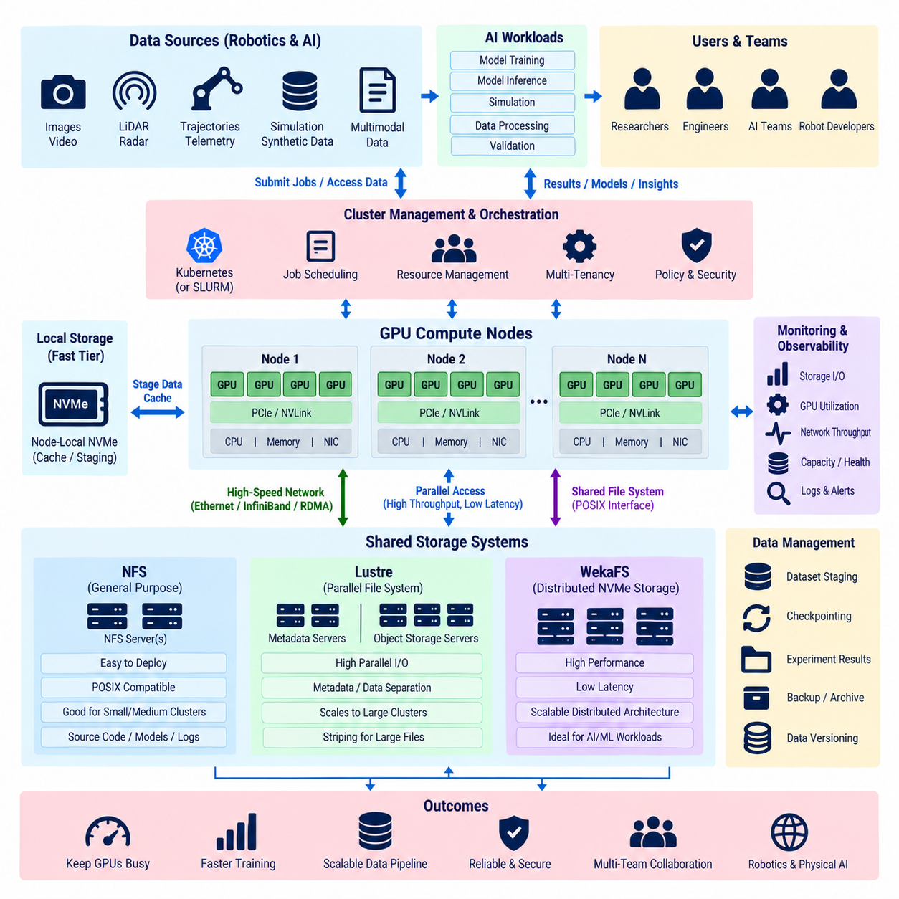
GPU cluster storage is a critical part of AI infrastructure because accelerators can only remain productive when data is supplied at sufficient speed. Large training workloads continuously read datasets, write checkpoints, store experiment outputs, and exchange intermediate artifacts. In robotics and Physical AI, these datasets may include images, video, LiDAR point clouds, trajectories, simulation results, synthetic data, and multimodal sensor records.
Storage performance must therefore be evaluated together with GPU compute and network performance rather than as an independent capacity problem. A cluster containing many high-performance GPUs can remain underutilized when storage cannot deliver training samples fast enough. Effective architecture balances aggregate throughput, metadata performance, latency, concurrency, capacity, reliability, and cost according to the characteristics of the workloads executed across the cluster.
A typical GPU cluster separates persistent shared storage from high-speed temporary storage. Shared storage provides centralized datasets, source artifacts, model checkpoints, and experiment results, while node-local NVMe devices can cache or stage frequently accessed data. Training jobs may copy selected datasets to local storage before execution and return important outputs afterward, reducing repeated traffic against centralized storage during computationally intensive phases.
Network File System, or NFS, provides a familiar shared file interface that can be mounted by multiple compute nodes. It is relatively straightforward to deploy and integrates naturally with Linux applications expecting POSIX-style file access. For small and medium GPU clusters, NFS can provide practical centralized storage for source code, model files, moderate datasets, logs, and checkpoints without introducing the operational complexity of a parallel file system.
High-speed NFS configurations can improve performance through fast storage media, high-bandwidth Ethernet or InfiniBand connectivity, suitable server sizing, and multiple network paths. However, conventional NFS architectures can concentrate traffic on a limited number of storage servers. As the number of GPU workers increases, concurrent access from many nodes can create bottlenecks in server processing, network bandwidth, metadata operations, or underlying disks.
NFS is therefore most effective when workload concurrency and aggregate throughput remain within the capability of the storage server architecture. It can also coexist with local NVMe caching so that large datasets are not repeatedly read from the NFS server during every training epoch. This hybrid approach preserves simple centralized management while allowing individual compute nodes to obtain higher local read performance during sustained training workloads.
Parallel file systems address larger-scale workloads by distributing storage operations across multiple servers and storage targets. Instead of relying on one primary data path, they allow many clients to access data concurrently through parallel infrastructure. This architecture is particularly useful for GPU clusters where dozens or hundreds of accelerators can generate substantial simultaneous read and write traffic during training, simulation, preprocessing, and checkpoint operations.
Lustre is a parallel file system widely associated with high-performance computing environments. Its architecture separates metadata management from bulk object storage and distributes file data across multiple storage targets. Compute clients can therefore access different portions of data in parallel, enabling aggregate throughput to scale beyond what a conventional single-server file service can normally provide when the underlying infrastructure is appropriately designed.
In Lustre, metadata servers manage information such as filenames, directory structures, permissions, and file layout, while object storage servers handle actual file data. This separation allows metadata operations and bulk I/O to be optimized independently. Large files can be striped across multiple object storage targets so that several storage devices and servers participate simultaneously when compute nodes read or write training data.
Striping is particularly important for large AI datasets, checkpoints, and simulation outputs. By distributing file blocks across several storage targets, Lustre can increase aggregate bandwidth for sequential or parallel I/O. The optimal stripe configuration depends on file size, access pattern, number of clients, and available storage targets. Excessive striping can introduce unnecessary overhead, so storage policies should reflect actual workload characteristics rather than applying one configuration universally.
AI workloads also create metadata-intensive access patterns. A dataset containing millions of small images or sensor files may stress metadata services even when total data bandwidth is moderate. Dataset formats that combine many samples into larger containers can reduce the number of filesystem operations. Storage architecture should therefore consider not only terabytes per second or gigabytes per second of throughput but also file counts, directory operations, and metadata request rates.
WekaFS, commonly associated with the WEKA data platform, represents another approach to high-performance shared storage for data-intensive computing. It is designed around distributed software-defined storage and can use NVMe-based infrastructure to provide high throughput and low latency across multiple clients. Such architectures are attractive for GPU environments where training, inference, preprocessing, and checkpoint workloads require concurrent access to large datasets.
A distributed high-performance storage platform can aggregate resources from multiple storage nodes instead of depending on a single storage controller. Data and metadata operations are distributed across the system, allowing performance to scale as suitable resources are added. For AI infrastructure, this model can reduce centralized bottlenecks and provide a shared namespace while supporting the parallel access patterns produced by many GPU workers.
The choice among NFS, Lustre, and WekaFS should be driven by workload scale rather than by technology preference alone. NFS can provide simplicity for modest environments, Lustre is well suited to large HPC-style parallel workloads, and distributed NVMe-oriented platforms can address demanding AI data pipelines requiring high concurrency and low latency. Operational complexity, hardware requirements, licensing, expertise, and expected growth must also be considered.
Storage networking is equally important because a fast filesystem cannot deliver its potential performance through an inadequate network. GPU clusters may use high-bandwidth Ethernet, InfiniBand, or RDMA-capable networks between compute and storage systems. Separate storage and compute communication fabrics can prevent dataset traffic from competing directly with NCCL collective communication, particularly during large distributed training jobs that already generate substantial inter-node network traffic.
RDMA-capable storage paths can reduce CPU overhead and improve data-transfer efficiency when supported by the complete infrastructure. The benefit depends on the storage system, network adapters, switches, protocols, and software configuration operating together correctly. Storage design should therefore treat the path from storage media through servers, network fabric, compute node, system memory, and accelerator as an integrated pipeline rather than optimizing one component in isolation.
Local NVMe storage provides another performance tier close to GPU computation. Frequently reused datasets can be staged from shared storage to node-local NVMe before a training job begins. Training processes then perform repeated reads locally instead of generating identical traffic across the cluster network. After execution, important checkpoints and experiment artifacts can be synchronized back to persistent shared storage for retention and later analysis.
Dataset staging is especially useful when training repeatedly accesses a relatively stable dataset. The scheduler or workflow system can prepare data before GPU allocation begins or integrate staging into job initialization. Cache management must still address capacity, consistency, eviction, and dataset versioning. Otherwise, local storage can accumulate obsolete copies or allow experiments to unknowingly train against different dataset revisions.
Checkpoint workloads have different characteristics from dataset reads. Large distributed models may periodically write substantial amounts of state, including model parameters, optimizer state, scheduler information, and training metadata. If many workers write checkpoints simultaneously, storage can experience sudden bursts of traffic. Checkpoint frequency, parallel write strategy, temporary local buffering, and asynchronous persistence should therefore be designed to avoid repeatedly stalling GPU computation.
Reliability and data protection remain essential even when performance is the primary design objective. Training datasets may be reproducible from original sources, but curated annotations, expensive simulation outputs, experiment records, and trained model checkpoints can be difficult to recreate. High-performance storage should therefore be integrated with backup, replication, snapshots, object storage, or archival tiers according to the value and recoverability of each data category.
Monitoring should observe storage throughput, IOPS, latency, metadata load, network utilization, cache effectiveness, capacity, and client behavior together with GPU utilization. Low GPU utilization may originate from storage even when no filesystem has completely failed. Correlating storage metrics with training throughput helps distinguish data starvation from GPU computation or communication bottlenecks and supports evidence-based capacity planning.
Physical AI creates particularly demanding storage pipelines because robot development combines real-world sensor data with simulation and generated datasets. Camera streams, LiDAR, radar, audio, telemetry, maps, trajectories, labels, world-model data, and synthetic environments can produce large heterogeneous collections. Storage must support ingestion, preprocessing, training, validation, checkpointing, and long-term retention while serving multiple AI teams concurrently.
An effective GPU cluster therefore uses storage tiers rather than expecting one filesystem to satisfy every requirement. NFS can support straightforward shared access, Lustre can provide large-scale parallel I/O, distributed high-performance platforms such as WekaFS can serve demanding AI workloads, and local NVMe can accelerate repeated access through staging and caching. Together with high-speed networking and appropriate data-management policies, these layers keep expensive GPUs supplied with data and enable scalable robotics and Physical AI training.

07.06 GPU Utilization Monitoring: DCGM Exporter / Grafana [w/Code]
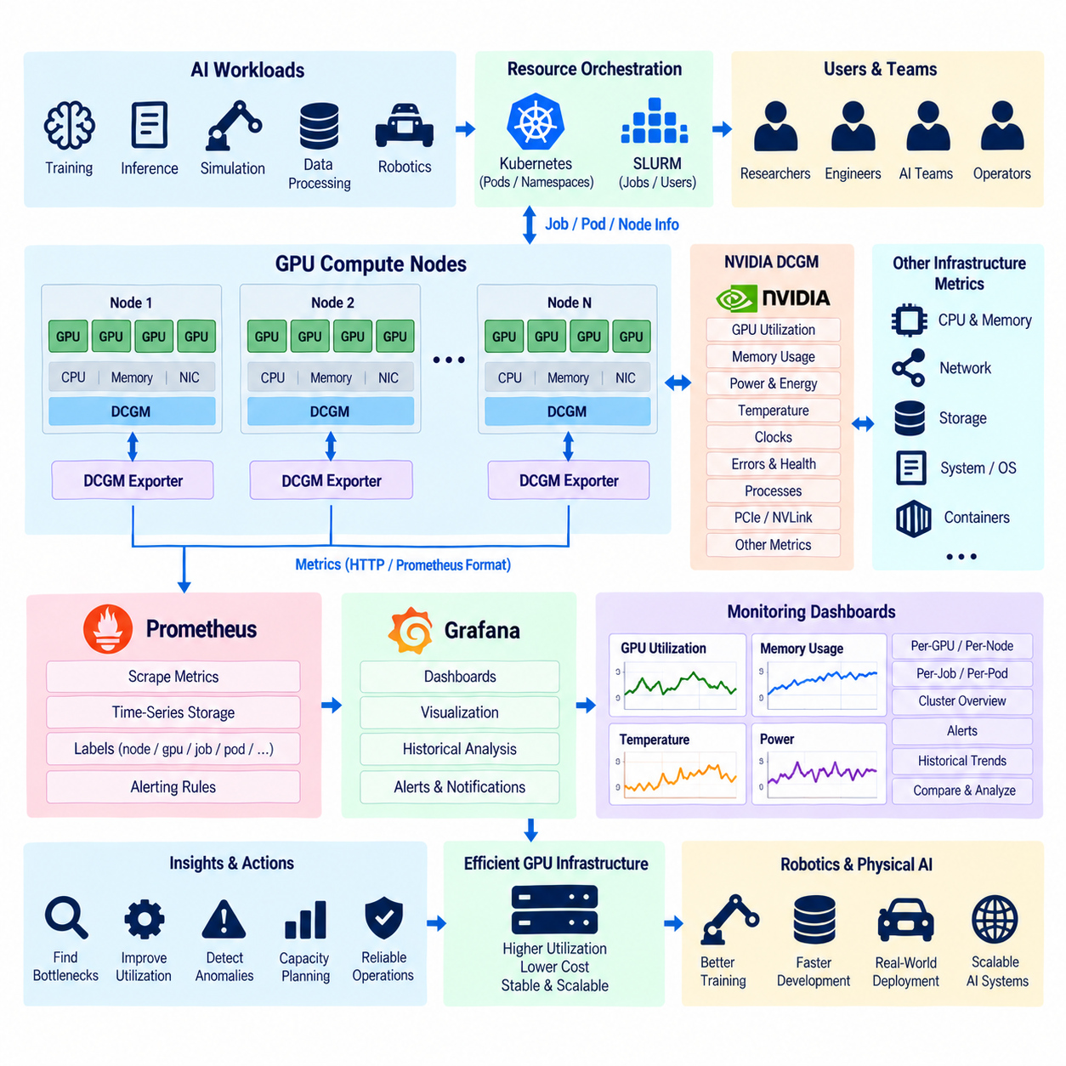
GPU utilization monitoring is essential for operating an efficient AI cluster because accelerator allocation alone does not indicate whether GPUs are performing useful computation. A GPU may be assigned to a training job while remaining partially idle because of slow data loading, communication delays, CPU bottlenecks, memory limitations, or inefficient application code. Monitoring converts these hidden conditions into measurable operational information.
A complete monitoring architecture observes GPU compute activity together with memory, power, temperature, interconnect, process, network, storage, and job-level information. These measurements should be correlated rather than evaluated independently. High GPU allocation with low compute utilization, for example, may indicate resource waste, while high memory occupancy combined with low utilization can indicate that a model occupies accelerator memory but spends significant time waiting for another subsystem.
NVIDIA Data Center GPU Manager, commonly called DCGM, provides management and telemetry capabilities for NVIDIA GPUs in data-center environments. It can expose information about GPU utilization, framebuffer memory, power consumption, temperature, clocks, errors, and other device conditions. In GPU clusters, DCGM provides a standardized layer for collecting accelerator health and performance information instead of requiring every application to implement independent hardware monitoring.
DCGM can operate close to the physical GPU layer and provide telemetry that infrastructure administrators can use for both performance monitoring and hardware health management. This distinction is important because low application performance does not always originate from software. Thermal limitations, hardware errors, abnormal power behavior, memory conditions, or communication problems can also affect accelerator performance and should be visible through the monitoring architecture.
DCGM Exporter connects GPU telemetry with the Prometheus monitoring ecosystem. It collects supported DCGM metrics and exposes them through an HTTP endpoint in a format that Prometheus can scrape. This transforms GPU-specific telemetry into time-series metrics that can be stored, queried, aggregated, and correlated with information from other infrastructure components such as compute nodes, containers, networks, storage systems, and schedulers.
In Kubernetes GPU clusters, DCGM Exporter is commonly deployed across GPU worker nodes so that telemetry follows the physical accelerator infrastructure. Each exporter instance observes GPUs available on its node, while Prometheus periodically collects the exposed metrics. This distributed collection architecture scales naturally as GPU nodes are added and provides centralized visibility without requiring users to manually inspect each server using command-line tools.
Prometheus acts as the time-series collection and query layer of the monitoring stack. It periodically scrapes configured metric endpoints and stores measurements with timestamps and labels. Labels are particularly useful in GPU environments because telemetry can be associated with nodes, GPU identifiers, workloads, namespaces, Pods, or other infrastructure dimensions. Administrators can therefore move from cluster-wide trends to individual accelerator behavior during troubleshooting.
Grafana provides the visualization layer above the collected time-series data. Dashboards can present GPU utilization, memory usage, temperature, power, clock behavior, and other measurements over time. Instead of checking current values only, operators can observe historical patterns and compare periods before and after configuration changes. This makes Grafana useful for both real-time operations and longer-term performance analysis.
GPU utilization is one of the most visible metrics but should not be interpreted in isolation. High utilization generally indicates that the accelerator is actively executing workloads, but it does not automatically mean that the complete training pipeline is efficient. A workload may maintain high compute activity while suffering from excessive communication, inappropriate batch sizes, poor scaling, or unnecessarily long execution. Utilization must therefore be interpreted together with throughput and workload objectives.
GPU memory monitoring provides another important dimension. Metrics describing used and available framebuffer memory help identify workloads approaching accelerator capacity or jobs reserving substantially more memory than necessary. Memory pressure can cause out-of-memory failures, while consistently low memory consumption may indicate that a workload could use a smaller GPU class or share resources, depending on its compute and isolation requirements.
Power consumption and temperature provide insight into both performance and infrastructure health. GPUs executing sustained training workloads can operate near their configured power limits, while thermal conditions may influence clock behavior and performance stability. Monitoring these metrics helps administrators identify abnormal nodes, cooling problems, power constraints, or differences between apparently identical servers that could otherwise be difficult to diagnose.
GPU clock information can help explain unexpected performance variation. Two accelerators assigned similar workloads may deliver different throughput when their effective clocks differ because of power, temperature, configuration, or hardware conditions. Correlating clocks with utilization, temperature, and power makes it possible to distinguish software inefficiency from device-level operating constraints and provides a stronger basis for troubleshooting performance anomalies.
Error and health telemetry should be integrated into the same monitoring environment used for performance analysis. Hardware faults, memory-related errors, communication problems, or other accelerator events can affect training reliability before a node completely fails. Persistent abnormal conditions can trigger investigation, maintenance, or removal of a node from scheduling so that new workloads are not repeatedly assigned to unreliable hardware.
Monitoring becomes more valuable when GPU telemetry is correlated with scheduler information. SLURM can identify the job and user associated with an allocated GPU, while Kubernetes can associate resources with Pods, namespaces, and workloads. Combining scheduling metadata with DCGM metrics makes it possible to determine not only whether a GPU is busy, but also which workload is responsible and whether the assigned resources are being used effectively.
This correlation supports cluster-level utilization analysis. Administrators can distinguish allocated GPUs from actively utilized GPUs and identify resources that remain reserved but perform little computation. A cluster can appear fully occupied from the scheduler perspective while actual accelerator utilization remains low. Measuring both allocation and activity therefore provides a more accurate representation of infrastructure efficiency than either measurement alone.
Prometheus alerting rules can convert telemetry into operational responses. Alerts can be defined for sustained high temperatures, unusual memory behavior, prolonged low utilization, exporter failures, unavailable nodes, or other measurable conditions. Alert thresholds should reflect hardware characteristics and workload behavior rather than relying on arbitrary universal values. The purpose is to identify actionable abnormalities without generating excessive notifications from normal workload variation.
Grafana dashboards should be organized according to operational questions rather than displaying every available metric simultaneously. A cluster overview can show total GPU capacity, active accelerators, utilization distribution, memory usage, power, and unhealthy devices. Node-level views can expose individual GPU behavior, while workload-oriented dashboards can connect accelerator telemetry with jobs, Pods, training throughput, network activity, and storage performance.
Distributed training requires particular attention to utilization differences between GPUs. In synchronous training, one slow worker can cause other workers to wait at collective synchronization points. A dashboard showing individual GPU utilization across all workers can reveal imbalance that disappears in cluster-wide averages. NCCL communication metrics, network throughput, and training-step duration can provide additional evidence when diagnosing distributed scaling problems.
Storage monitoring should also be correlated with GPU telemetry. If GPU utilization repeatedly drops while storage latency or throughput reaches a limiting condition, the training pipeline may be suffering from data starvation. Similar patterns can occur when CPU preprocessing cannot generate batches fast enough. Observing GPU, CPU, network, and storage metrics on the same timeline allows operators to identify relationships that would be difficult to recognize from separate monitoring systems.
Monitoring local NVMe caches can further improve analysis of data-intensive workloads. Cache hit rates, local read throughput, staging duration, and capacity usage can indicate whether dataset staging is reducing shared-storage traffic as intended. When local caches are ineffective, GPUs may continue waiting on centralized storage despite substantial NVMe capacity being available within compute nodes.
Long-term telemetry provides information for capacity planning as well as immediate troubleshooting. Historical GPU utilization can reveal peak demand, idle periods, workload growth, and differences among teams or projects. Memory usage distributions can help determine which accelerator capacities are actually required, while network and storage measurements can indicate whether future GPU expansion would create bottlenecks elsewhere in the infrastructure.
Physical AI environments benefit from this historical view because workload characteristics can vary significantly across perception training, reinforcement learning, world-model development, simulation, synthetic-data generation, and validation. Some workloads are compute intensive, while others are limited by memory, storage, CPU preprocessing, or communication. Monitoring provides evidence for assigning each workload to appropriate infrastructure instead of treating every GPU task identically.
Monitoring data should also support reproducibility and experiment analysis. Important training runs can retain references to GPU type, utilization patterns, memory behavior, software environment, and infrastructure conditions alongside model metrics. When two experiments produce unexpectedly different training times or results, infrastructure telemetry can help determine whether the difference originated from model configuration or from the execution environment.
The overall monitoring pipeline therefore connects NVIDIA GPU telemetry, DCGM, DCGM Exporter, Prometheus, and Grafana into an operational feedback loop. DCGM observes accelerator behavior, the exporter exposes metrics, Prometheus collects and stores them, and Grafana converts the resulting time series into dashboards and operational insight. Scheduler, network, storage, and application metrics can be added to provide end-to-end visibility.
For robotics and Physical AI, the objective is not simply to display GPU percentages but to understand whether expensive computing resources are producing useful AI work efficiently and reliably. A well-designed DCGM Exporter and Grafana monitoring architecture makes resource waste, hardware problems, communication delays, memory pressure, and data bottlenecks visible, enabling GPU clusters to evolve from collections of accelerators into measurable and manageable AI computing infrastructure.

07.07 GPU Cluster Multi-Tenancy: Quota, NS, Isolation [w/Code]
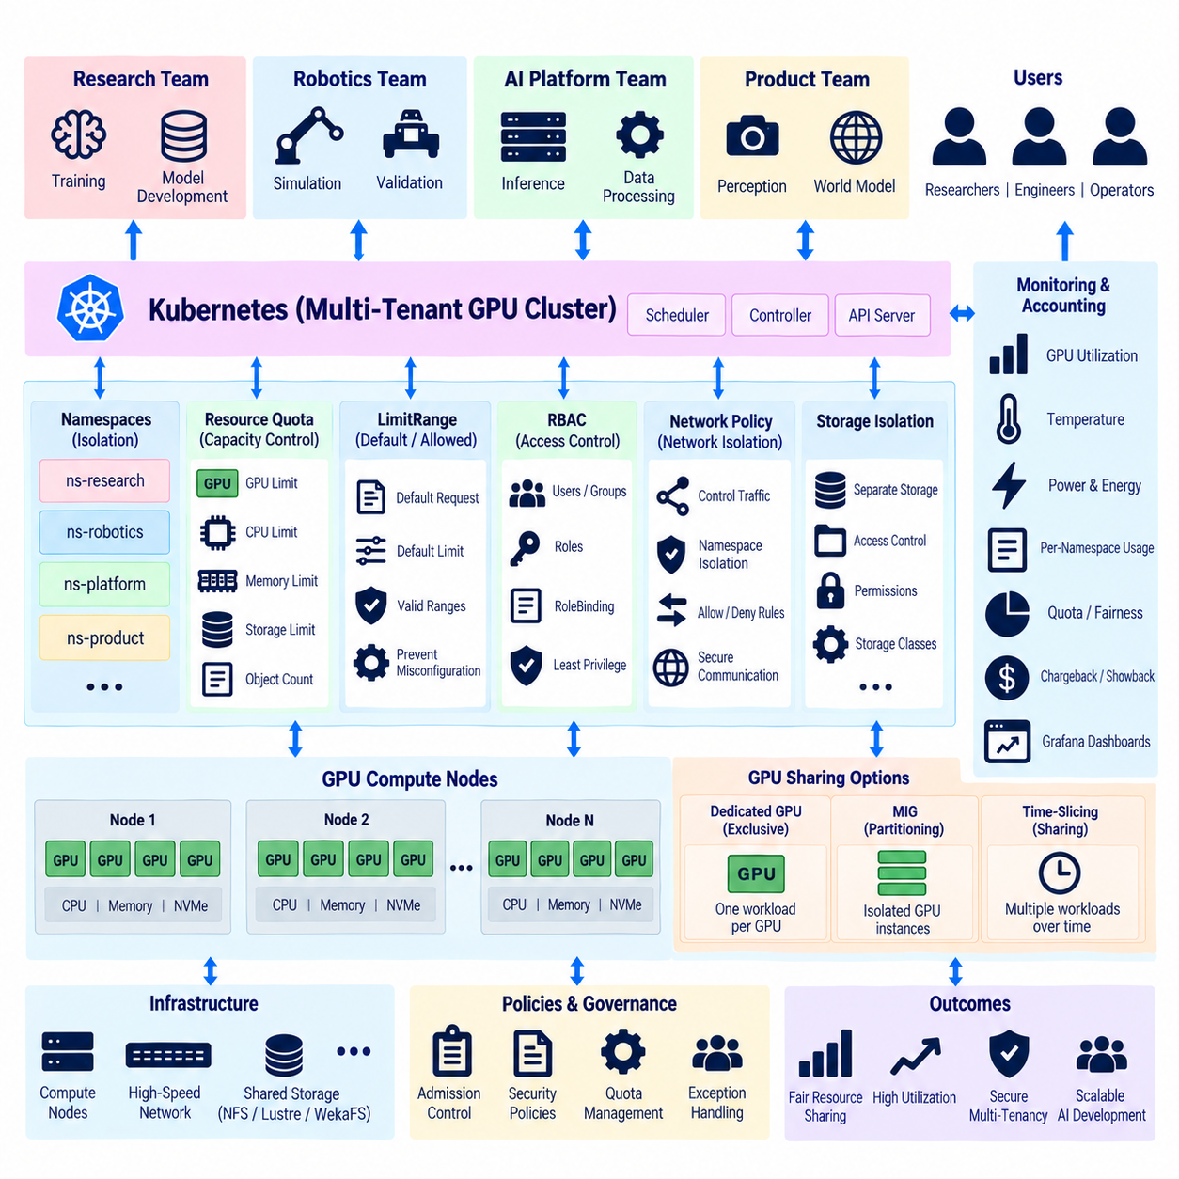
Multi-tenancy allows a GPU cluster to serve multiple teams, projects, applications, and users while maintaining controlled access to shared computing infrastructure. In robotics and Physical AI environments, perception training, reinforcement learning, simulation, world-model development, inference, and data processing may compete for the same accelerators. A multi-tenant architecture prevents one workload from consuming resources needed by every other user.
The main challenge is that GPU resources are expensive, limited, and less flexible than ordinary CPU resources. A user requesting several GPUs can occupy a significant portion of a cluster for hours or days. Effective multi-tenancy therefore requires mechanisms for resource allocation, quotas, scheduling, isolation, access control, monitoring, and accounting so that shared infrastructure remains predictable as the number of workloads increases.
Kubernetes namespaces provide a logical boundary for organizing workloads inside a shared cluster. Separate namespaces can represent teams, projects, development environments, production services, or research programs. Pods, Services, ConfigMaps, Secrets, and other Kubernetes objects can be grouped within these boundaries, making administration easier and allowing policies to be applied to specific tenant groups without requiring a separate physical cluster for every organization.
Namespaces provide logical separation but should not be treated as complete security isolation by themselves. Additional mechanisms such as role-based access control, network policies, admission policies, resource quotas, workload security controls, and appropriately configured storage permissions are required. Multi-tenancy is therefore created by combining several Kubernetes capabilities rather than relying on namespace boundaries as a single protection mechanism.
ResourceQuota controls how much infrastructure a namespace can consume. Administrators can define limits for CPU, memory, storage, object counts, and extended resources such as GPUs when supported by the resource model. A team can therefore receive a defined GPU budget instead of competing without limits against every other tenant. Quotas transform cluster capacity into administratively controlled resource pools.
GPU quotas are particularly useful because scheduler allocation alone does not enforce organizational fairness over long periods. Without quotas, a single namespace may continuously submit jobs that occupy most available accelerators whenever capacity becomes free. Namespace-level limits place an upper boundary on simultaneous GPU consumption and help preserve capacity for other teams, although they do not replace scheduling priority or fair-share mechanisms.
LimitRange complements ResourceQuota by defining default or permitted resource requests and limits for individual workloads within a namespace. While GPU resources have different allocation characteristics from CPU and memory, consistent workload specifications remain important. Requiring appropriate requests prevents poorly defined Pods from entering the cluster and improves the scheduler's ability to make predictable placement decisions across shared compute nodes.
Role-Based Access Control, or RBAC, determines which users and service accounts can perform operations on Kubernetes resources. Permissions can be scoped so that researchers manage workloads inside their own namespaces without gaining administrative control over the complete cluster. Platform administrators can retain authority over nodes, GPU device configuration, networking, storage, and security policies while delegating normal experiment operations to individual teams.
Authentication and authorization should be connected to organizational identity management where practical. Users should operate through identifiable accounts rather than shared administrator credentials. Service accounts should receive only the permissions required by their applications. This least-privilege model reduces accidental configuration changes and limits the effect of compromised credentials while creating clearer audit records for operations performed in a shared GPU environment.
Network isolation is another component of multi-tenancy. Workloads belonging to different namespaces may not need unrestricted communication with each other. Kubernetes NetworkPolicy can restrict permitted traffic between Pods and services when supported by the deployed networking implementation. This is important when training services, experiment APIs, model endpoints, databases, or internal tools from multiple projects operate on the same cluster network.
Storage requires equivalent isolation. Shared filesystems may contain datasets, checkpoints, models, logs, or proprietary project information belonging to different teams. Namespace separation does not automatically guarantee filesystem separation, so persistent volume configuration, storage classes, access modes, directory permissions, credentials, and external storage policies must be designed deliberately. Data isolation should remain consistent with compute and network isolation.
GPU hardware introduces additional isolation considerations because multiple workloads may share the same physical accelerator under some configurations. The simplest model assigns an entire GPU exclusively to one workload, providing strong resource separation but potentially leaving unused capacity. Smaller workloads can waste substantial accelerator resources when they require only a fraction of GPU memory or compute capability.
NVIDIA Multi-Instance GPU, or MIG, can partition supported GPUs into hardware-isolated GPU instances with defined compute and memory resources. Kubernetes can expose these instances as schedulable resources when the supporting software stack is configured appropriately. MIG can improve utilization for workloads that do not require an entire accelerator while providing stronger resource separation than software-only sharing approaches.
Time-slicing represents a different sharing model in which multiple workloads receive access to the same GPU over time rather than receiving dedicated hardware partitions. It can increase apparent resource availability for development, experimentation, or relatively light workloads, but tenants still compete for the underlying physical accelerator. Time-slicing should therefore be distinguished from MIG because the performance and isolation characteristics are fundamentally different.
Multi-tenant scheduling must also consider priority. Production inference, critical validation, scheduled training, exploratory research, and batch preprocessing may have different business importance. Kubernetes PriorityClass and scheduler policies can influence which workloads receive resources first, while preemption can allow higher-priority workloads to displace lower-priority ones under configured conditions. Such policies should be transparent to users to avoid unpredictable cluster behavior.
Quota and priority solve different problems. Quota defines how much capacity a tenant may consume, whereas priority influences which workloads obtain scarce resources when demand exceeds supply. A namespace may remain within its GPU quota yet still wait because higher-priority workloads occupy available devices. Effective governance therefore combines capacity boundaries with scheduling policies rather than expecting one mechanism to provide complete fairness.
Node labels, selectors, affinity rules, taints, and tolerations can separate tenants or workload classes across different hardware pools. A cluster containing several GPU models may reserve specific accelerators for large-model training, simulation, inference, or specialized research. Sensitive or production workloads can also be directed toward dedicated nodes when logical isolation is insufficient for operational, security, or performance requirements.
Multi-tenancy should avoid excessive fragmentation of GPU capacity. If every team receives permanently dedicated nodes, one group may have idle GPUs while another waits for resources. Shared scheduling improves overall utilization by allowing capacity to move between workloads according to demand. Dedicated pools remain useful where isolation is essential, but the balance between shared and reserved resources should reflect measurable workload requirements.
Monitoring provides evidence that quota and isolation policies are working as intended. GPU utilization, memory consumption, allocated accelerators, namespace usage, job duration, queue time, and failure rates can be aggregated by tenant. DCGM Exporter, Prometheus, Grafana, and scheduler metadata can provide a unified view showing both assigned GPU capacity and actual computational activity across teams and projects.
Chargeback or showback can be built from the same accounting information. Organizations do not necessarily need to bill internal teams directly, but reporting GPU-hours, storage consumption, network usage, and workload efficiency makes infrastructure cost visible. A team occupying many accelerators with consistently low utilization can then investigate data pipelines, model configuration, scheduling behavior, or resource requests instead of simply requesting additional hardware.
Admission control provides another policy enforcement point before workloads are accepted into the cluster. Policies can require approved container registries, mandatory resource requests, permitted GPU types, security settings, labels, or other configuration rules. Preventing invalid or unsafe workloads at admission time is generally more effective than detecting configuration problems only after Pods have already consumed shared cluster resources.
Container isolation also contributes to tenant separation, but containers share the underlying host kernel and should not automatically be considered equivalent to separate physical machines. Security contexts, restricted privileges, controlled device access, trusted images, runtime policies, and host protection remain important. Higher-risk workloads may require stronger isolation boundaries or dedicated nodes depending on organizational security requirements.
Operational governance should define what happens when tenants exceed quotas, submit unusually large workloads, require temporary capacity increases, or need privileged access. Exceptions should be explicit rather than implemented through permanent administrative privileges. Clear processes for quota adjustment, priority changes, maintenance, and incident response make shared infrastructure easier to operate as the number of users and projects grows.
Physical AI clusters particularly benefit from flexible multi-tenancy because their workloads are highly heterogeneous. A simulation team may temporarily require many GPUs, a perception team may perform continuous training, a robotics team may run smaller validation jobs, and a world-model project may require large-memory accelerators. Namespace and quota policies allow these activities to share infrastructure while preserving organizational boundaries.
A mature architecture therefore combines namespaces for logical organization, ResourceQuota and LimitRange for capacity governance, RBAC for authorization, NetworkPolicy and storage controls for isolation, and GPU-specific mechanisms such as dedicated allocation, MIG, or time-slicing. Scheduler priority, topology policies, monitoring, and accounting extend these controls into a complete operational model.
The objective of GPU cluster multi-tenancy is not simply to divide hardware equally. It is to provide controlled, secure, observable, and efficient access to expensive accelerators while allowing different teams to work independently. When quotas, namespace isolation, scheduling, GPU partitioning, security, and monitoring operate together, a shared cluster can support scalable robotics and Physical AI development without sacrificing resource efficiency or operational control.

07.08 Robot Physical AI Massive Parallel Training Infra
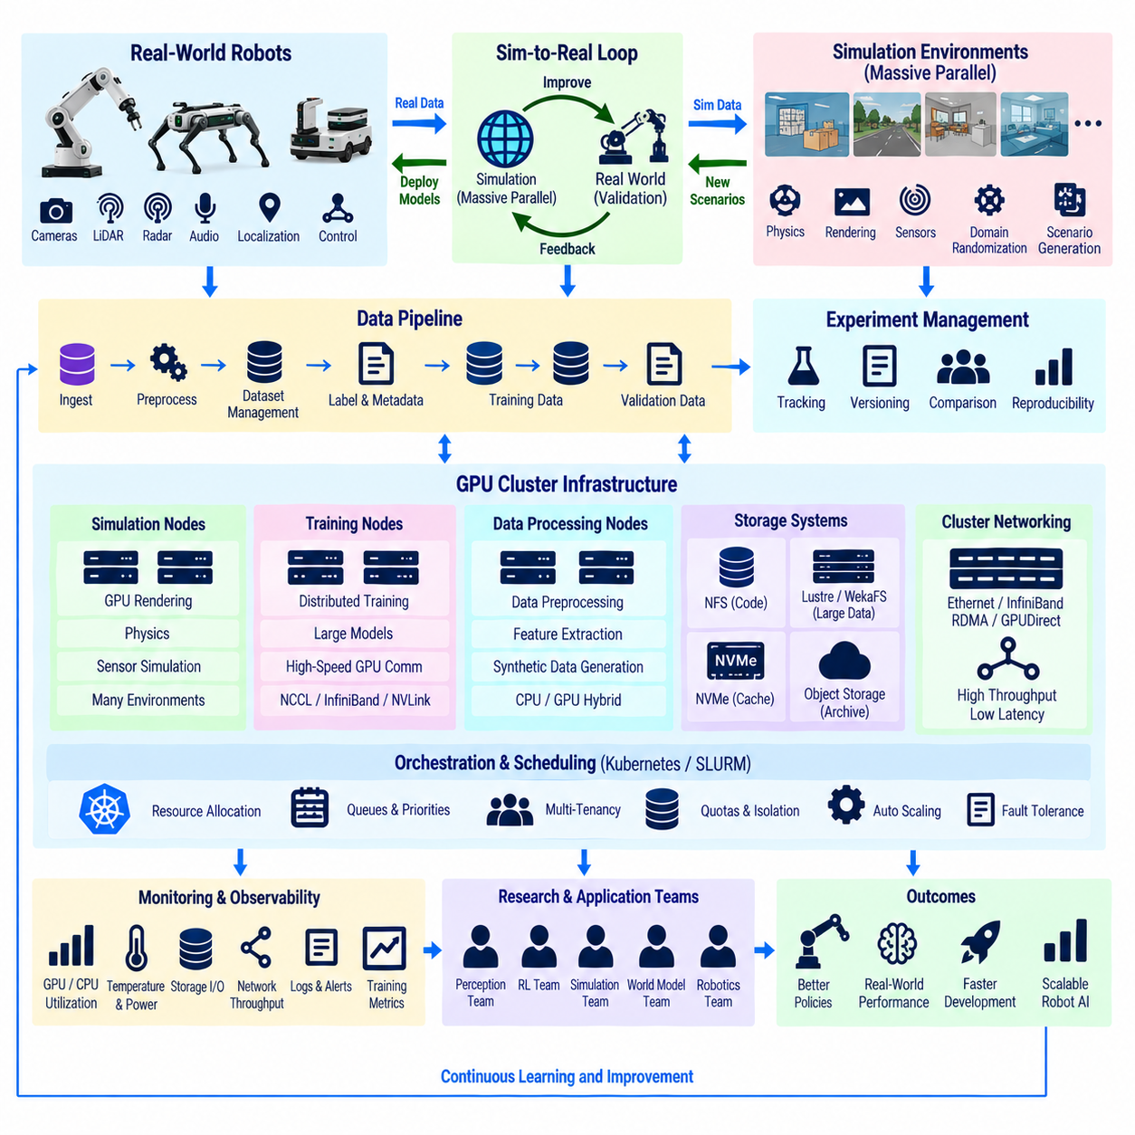
Massive parallel training infrastructure for Robot Physical AI is designed to execute large numbers of simulations, learning processes, data pipelines, and validation workloads simultaneously. Unlike conventional AI training that mainly scales model computation across GPUs, Physical AI must also scale environments, robot instances, sensor generation, physics simulation, reinforcement learning, and multimodal data processing as parts of one coordinated infrastructure.
The central objective is to transform limited real-world robot experience into a much larger learning process. Physical robots can collect valuable camera, LiDAR, radar, audio, localization, control, and interaction data, but real-world acquisition is relatively slow and expensive. Massive simulation complements this data by generating many virtual robot experiences in parallel, allowing policies and models to encounter diverse environments and operating conditions before deployment.
A typical architecture contains simulation nodes, GPU training nodes, data-processing nodes, high-speed storage, cluster networking, orchestration, and experiment management. Simulation nodes generate environments and trajectories, while training nodes update perception models, policies, or world models. Storage preserves datasets and checkpoints, and the scheduler coordinates resource allocation so that thousands of concurrent tasks can operate without becoming disconnected computational islands.
Parallel simulation is one of the defining characteristics of Physical AI infrastructure. Instead of executing one robot simulation sequentially, the system can run hundreds or thousands of environment instances with different maps, objects, robot states, sensor conditions, and task configurations. Each environment produces observations, actions, rewards, failures, or trajectories that can be consumed by reinforcement learning and other data-driven training processes.
GPU-accelerated simulation increases the number of environments that can be processed within a given time. Physics calculations, rendering, sensor synthesis, collision processing, and parts of environment logic can be executed in parallel where the simulation platform supports GPU acceleration. The resulting throughput allows robot learning algorithms to experience far more interactions than would be practical using only physical robots.
Reinforcement learning particularly benefits from this architecture because policy improvement can require enormous numbers of environment interactions. Multiple simulation workers execute the current policy, generate experience, and send trajectories or transition data to training processes. Learners update policy parameters using the accumulated experience and distribute updated models back to workers, forming a repeated simulation-training feedback loop.
The relationship between simulation throughput and learner throughput must be balanced carefully. If simulation workers generate experience faster than training nodes can consume it, queues and storage requirements grow. If learners are faster than simulation, expensive GPUs may wait for new experience. Infrastructure design therefore considers environment steps per second, training batch consumption, communication overhead, and synchronization behavior as parts of one performance model.
Physical AI training also extends beyond reinforcement learning. Perception models can train on large combinations of real and synthetic images, depth maps, point clouds, segmentation labels, and robot states. World models can learn temporal relationships from trajectories and multimodal observations, while vision-language-action and related models may combine visual information, language instructions, robot actions, and environmental feedback within much larger distributed training pipelines.
Synthetic data generation can operate as a parallel workload alongside model training. Simulation environments can vary lighting, textures, object placement, sensor noise, camera position, weather, terrain, and physical parameters to create diverse training samples. Domain randomization and controlled scenario generation increase data diversity and can help models avoid excessive dependence on a narrow set of simulated conditions.
Large-scale scenario generation also supports safety and validation. Rare collisions, unusual obstacles, localization failures, sensor degradation, difficult terrain, or unexpected interactions may be difficult or dangerous to reproduce repeatedly with physical robots. Parallel simulation can execute large numbers of such scenarios and record failures systematically, creating datasets that can be used for model improvement and regression testing.
Compute infrastructure should separate workloads according to their resource characteristics. Simulation may require GPU rendering and substantial CPU processing, distributed training may require high-end GPUs and fast interconnects, and preprocessing may be CPU-, storage-, or memory-intensive. Using identical nodes for every task can waste resources. Heterogeneous clusters allow each workload class to run on hardware that better matches its computational behavior.
Schedulers such as Kubernetes or SLURM can manage these heterogeneous resources through node labels, partitions, queues, priorities, quotas, and accelerator requests. Simulation workers may occupy one resource pool while distributed training uses another. Scheduling policies can also reserve high-memory GPUs for large models, allocate ordinary GPUs to rendering or inference, and prevent low-priority experiments from blocking critical validation or production workloads.
Distributed model training relies on high-speed GPU communication when many accelerators participate in one job. NCCL, InfiniBand, RDMA, GPUDirect, NVLink, and appropriate topology-aware placement can reduce synchronization overhead. These technologies are particularly important for large world models or multimodal models where communication between accelerators can become a significant portion of total training time.
Simulation-to-training traffic has different requirements from gradient synchronization. Experience buffers, trajectories, images, point clouds, and synthetic sensor streams may produce very large data volumes. Some pipelines transmit data directly between processes, while others use shared memory, queues, object storage, or high-performance filesystems. The architecture should avoid writing every temporary simulation artifact to persistent storage when direct streaming is more efficient.
Storage therefore requires multiple tiers. Shared NFS may support code and smaller project assets, parallel or distributed storage such as Lustre or WekaFS can serve large datasets, and node-local NVMe can cache frequently accessed samples or temporary simulation output. Long-term object or archival storage can retain valuable real-world datasets, validated synthetic datasets, experiment results, and model checkpoints without occupying the fastest storage tier.
Data pipelines must preserve relationships between observations and robot actions. A training sample may contain synchronized camera frames, LiDAR scans, robot pose, velocity, actuator commands, task state, reward, and environmental metadata. Losing timing or scenario context can reduce the usefulness of collected experience. Physical AI infrastructure therefore requires dataset schemas, timestamps, episode identifiers, scenario metadata, and version information alongside raw sensor data.
Experiment reproducibility becomes increasingly difficult as parallelism grows. Each training run may depend on model code, container images, simulation versions, environment parameters, datasets, random seeds, hyperparameters, and cluster configuration. Experiment tracking should associate these elements with checkpoints and evaluation results so that successful or failed behaviors can be reproduced instead of becoming untraceable outcomes of a large distributed system.
Monitoring must cover both infrastructure and learning performance. GPU utilization, memory, temperature, CPU load, storage throughput, network traffic, simulation rate, environment steps per second, training throughput, queue depth, reward trends, loss, and validation metrics provide complementary views. DCGM, Prometheus, Grafana, scheduler telemetry, and application metrics can be integrated to expose bottlenecks across the complete training pipeline.
Failure handling is essential because large parallel systems experience component failures more frequently than small systems. Individual simulation workers should be replaceable without terminating an entire experiment whenever possible. Distributed learners require checkpointing and recovery, while workflow systems should detect failed tasks and reschedule them. Designing workloads to tolerate partial failure improves cluster productivity during long-running Physical AI training campaigns.
Multi-tenancy allows perception, simulation, reinforcement learning, world-model, and robotics teams to use the same infrastructure. Namespaces, quotas, priorities, RBAC, storage isolation, and GPU allocation policies prevent one experiment from monopolizing the cluster. At the same time, shared scheduling allows unused capacity to move between projects instead of leaving expensive accelerators permanently assigned to inactive teams.
A critical element is the sim-to-real loop. Models trained in simulation must eventually be evaluated on physical robots, where real sensors, actuators, timing, friction, terrain, communication delays, and environmental uncertainty reveal differences from virtual environments. Real-world results are returned to the data platform, used to identify simulation gaps, and incorporated into subsequent training and scenario generation.
This creates a continuous Physical AI learning cycle in which real robots generate evidence, simulation expands experience, GPU clusters train models, validation measures performance, and deployment returns improved models to robots. Failures discovered in the field become new scenarios, while successful behaviors provide reference data for further optimization. Infrastructure therefore supports not only training but an iterative engineering feedback system.
Massive parallel training also changes how robot development is measured. The important metric is not simply the number of installed GPUs, but useful learning throughput produced by the complete system. Simulation steps, training samples, model updates, validation scenarios, GPU efficiency, experiment completion time, and real-world performance should be evaluated together when determining whether additional infrastructure creates meaningful improvement.
The resulting architecture combines physical robots, simulation farms, heterogeneous GPU clusters, distributed training, high-speed networking, tiered storage, scheduling, monitoring, and experiment management into one learning platform. By scaling experience generation and model optimization together, massive parallel infrastructure enables robotics and Physical AI systems to learn from far more scenarios than physical testing alone can provide while maintaining a controlled path back to real-world validation.

07.09 GPU Cluster Energy Efficiency Optimization
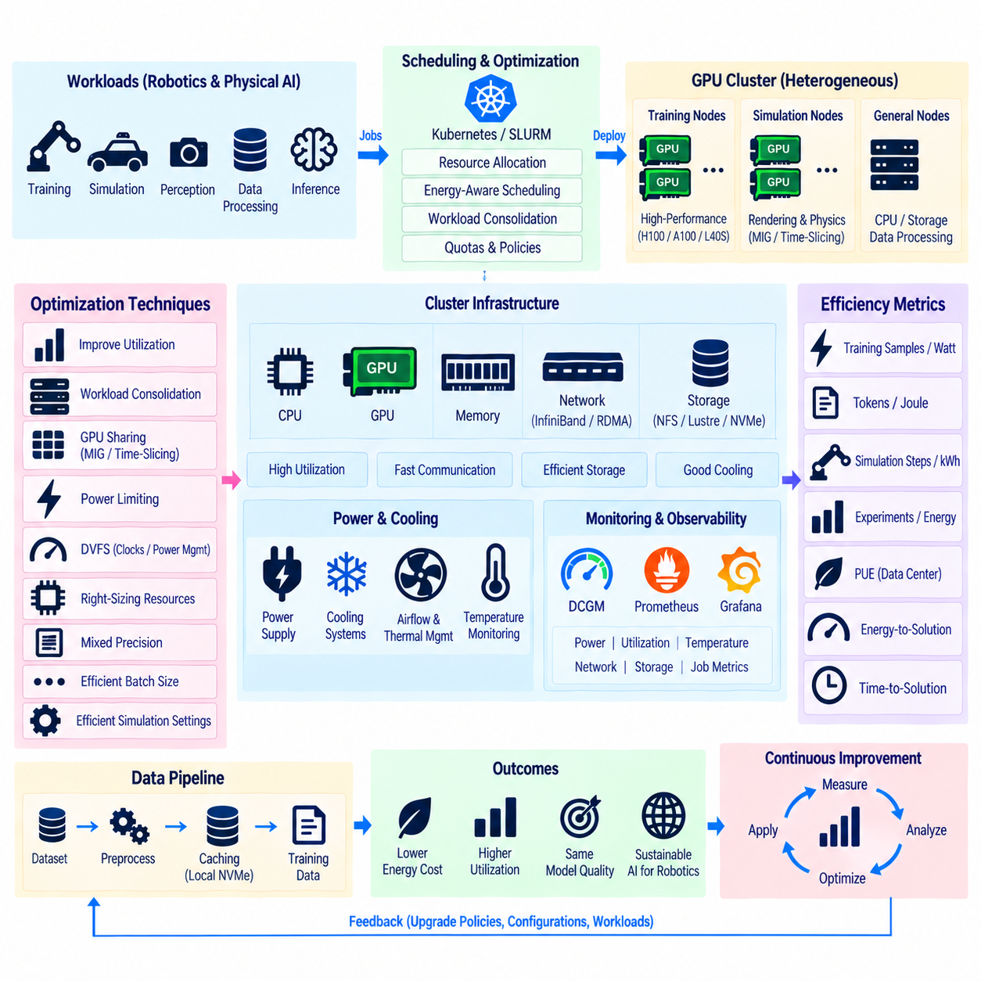
Energy efficiency optimization in a GPU cluster aims to maximize useful AI computation for every unit of electrical energy consumed. Modern accelerators can require substantial power, and large clusters multiply this demand across GPUs, CPUs, memory, networking, storage, and cooling systems. For robotics and Physical AI, energy efficiency therefore becomes an infrastructure design objective rather than merely a hardware operating parameter.
The most useful efficiency metric is not simply total power consumption. A cluster consuming less electricity can still be inefficient if training jobs take significantly longer or accelerators remain idle. Metrics such as training samples per watt, tokens per joule, simulation steps per kilowatt-hour, or completed experiments per unit of energy connect electrical consumption with useful computational output and provide a better basis for optimization.
GPU utilization strongly influences energy efficiency because an allocated accelerator continues consuming power even when application activity is low. Data-loading delays, synchronization waits, CPU bottlenecks, slow storage, and insufficient network bandwidth can leave GPUs underutilized while the cluster still draws significant power. Improving the complete data and communication pipeline can therefore reduce energy per training task without changing the GPU hardware itself.
Workload consolidation can improve efficiency by reducing the number of lightly loaded servers. Instead of distributing small workloads across many nodes, schedulers can place compatible jobs on fewer systems while allowing unused nodes to enter lower-power states or become available for shutdown. Consolidation must still respect GPU memory, performance isolation, thermal limits, topology, and communication requirements so that energy savings do not create new computational bottlenecks.
GPU sharing technologies can increase useful work performed by each active accelerator. Dedicated GPUs remain appropriate for large or performance-sensitive workloads, while NVIDIA Multi-Instance GPU, or MIG, can partition supported accelerators for smaller isolated workloads. Time-slicing may also improve utilization for development or lightweight tasks. The appropriate mechanism depends on performance predictability, isolation, memory requirements, and workload behavior.
Power limiting provides another optimization mechanism. GPUs do not always achieve proportionally higher application throughput when operated at their maximum permitted power. For some workloads, a moderate reduction in GPU power limit can reduce electrical consumption substantially while causing only a smaller decrease in training throughput. The optimal setting is workload-dependent and should be determined through measurement rather than applying one universal power limit across the cluster.
Dynamic Voltage and Frequency Scaling, commonly represented through operating clock and power-management mechanisms, can influence accelerator and CPU efficiency. Maximum frequency is not always necessary for workloads limited by memory, storage, communication, or preprocessing. Matching operating performance to actual workload demand can reduce unnecessary power consumption, although aggressive frequency reduction can increase execution time and offset the intended energy savings.
CPU efficiency should be considered together with GPU efficiency. Physical AI pipelines frequently use CPUs for simulation logic, data decoding, augmentation, sensor preprocessing, orchestration, and storage operations. Excessive CPU allocation can waste energy, while insufficient CPU capacity can starve GPUs. Profiling the relationship between CPU utilization and GPU throughput helps determine an appropriate balance instead of maximizing either resource independently.
Memory configuration also affects cluster energy and performance. Large system-memory capacity may be necessary for dataset preprocessing, simulation, caching, or large models, but unused memory still contributes to platform power consumption and hardware cost. GPU memory capacity should similarly match workload requirements. Selecting accelerators solely for maximum memory can be inefficient when most workloads use only a small fraction of available capacity.
Network efficiency becomes important in distributed training because communication can determine how long many GPUs remain active. Slow or oversubscribed networks extend synchronization periods and increase total job duration. High-speed interconnects such as NVLink and InfiniBand, combined with NCCL, RDMA, GPUDirect, and topology-aware placement, can shorten communication time and reduce the energy required to complete a distributed training workload.
Topology-aware scheduling contributes to energy efficiency by placing cooperating processes close to the resources they communicate with. Training jobs distributed unnecessarily across distant nodes or network paths may consume additional communication time and keep more infrastructure active. Placing GPUs within suitable nodes, NUMA domains, network fabrics, and storage paths can improve both performance and energy efficiency without reducing computational capability.
Storage architecture has a similar effect. GPUs waiting for datasets from overloaded shared storage continue consuming energy without producing useful training progress. High-performance shared storage, parallel filesystems, node-local NVMe caching, and dataset staging can reduce data stalls. Frequently reused datasets can be copied closer to compute nodes so that repeated training epochs do not continuously consume shared-network and storage resources.
Checkpoint strategies should also consider energy efficiency. Very frequent synchronized checkpoint writes can interrupt computation, create storage bursts, and extend total training duration. Local buffering, asynchronous persistence, incremental techniques where appropriate, and workload-specific checkpoint intervals can reduce unnecessary I/O. Reliability requirements must remain the priority, so optimization should balance recovery cost against checkpoint overhead.
Schedulers can incorporate energy-related policies in addition to conventional CPU and GPU availability. Workloads may be placed on newer or more efficient GPU generations when compatible, consolidated onto active nodes, or delayed within permitted operational windows to improve infrastructure utilization. Energy-aware scheduling should remain subordinate to service-level objectives, deadlines, hardware constraints, and workload priorities rather than optimizing electricity consumption in isolation.
Heterogeneous clusters create opportunities for workload-to-hardware matching. Large distributed models may require high-memory accelerators and high-speed interconnects, while inference, preprocessing, simulation, or smaller training tasks may operate efficiently on less powerful devices. Assigning every workload to the highest-performance GPU can waste both energy and capacity. Scheduler policies can direct jobs toward hardware classes appropriate to their measured requirements.
Simulation workloads require special attention in Physical AI clusters. GPU rendering, physics calculation, synthetic sensor generation, and reinforcement-learning environments can consume large amounts of compute even when maximum visual fidelity is unnecessary. Simulation resolution, sensor frequency, environment complexity, rendering quality, and number of parallel environments should match the learning objective so that computational effort is not spent generating information that does not improve the model.
Batch size can affect both GPU utilization and energy efficiency. Larger batches may improve accelerator occupancy and reduce overhead, but excessively large batches can increase memory pressure or alter training behavior. Gradient accumulation can provide an alternative when memory capacity limits batch size. The objective is to achieve high useful throughput while preserving the numerical and optimization characteristics required by the model.
Mixed-precision computation can significantly improve efficiency when models and hardware support it. Lower-precision formats reduce memory traffic and can increase tensor-processing throughput compared with full-precision execution. Modern training pipelines commonly combine lower-precision computation with techniques that preserve numerical stability. Faster completion can reduce energy per training run even when instantaneous GPU power remains relatively high.
Monitoring is necessary because energy optimization cannot be managed reliably from theoretical specifications alone. DCGM can expose GPU utilization, power, temperature, clocks, memory behavior, and health information, while Prometheus and Grafana can retain and visualize these measurements. CPU, network, storage, cooling, scheduler, and application metrics should be correlated with GPU telemetry to identify where energy is consumed without corresponding useful work.
Power Usage Effectiveness, or PUE, provides a facility-level perspective by comparing total data-center energy with energy delivered to computing equipment. GPU optimization addresses only part of the complete energy system because cooling, power conversion, fans, networking, and storage also consume electricity. Improvements in airflow, cooling efficiency, rack layout, and power distribution can therefore complement software and scheduler optimization at the cluster level.
Thermal management and energy efficiency are closely connected. Poor airflow or excessive rack density can increase cooling demand and may force hardware to operate under thermal constraints. Monitoring inlet temperature, GPU temperature, fan behavior, and rack power density helps identify infrastructure conditions that reduce efficiency. Efficient cooling should maintain safe operating conditions without consuming more facility energy than necessary.
Historical telemetry enables energy-aware capacity planning. Administrators can compare GPU models, workloads, teams, and training configurations using both performance and power data. A faster accelerator may consume more instantaneous power but complete a workload sufficiently sooner to use less total energy. Decisions should therefore compare energy-to-solution and time-to-solution rather than relying only on device thermal design power or peak consumption.
Physical AI requires this system-level perspective because its workloads combine simulation, multimodal training, distributed communication, synthetic-data generation, validation, and real-world data processing. Each stage has different compute and energy characteristics. Optimizing only GPU power can shift bottlenecks elsewhere, while coordinated optimization of compute, network, storage, scheduling, and simulation settings improves efficiency across the complete learning pipeline.
The ultimate objective is to maximize useful learning per unit of energy while maintaining reliability, model quality, deadlines, and operational requirements. Efficient GPU clusters combine high utilization, workload-aware power settings, suitable hardware selection, fast communication, optimized storage, intelligent scheduling, monitoring, and effective cooling. For robotics and Physical AI, these techniques reduce infrastructure cost and energy demand while increasing the amount of productive training and simulation that available computing resources can deliver.

07.10 GPU Cluster Deployment TCO Analysis
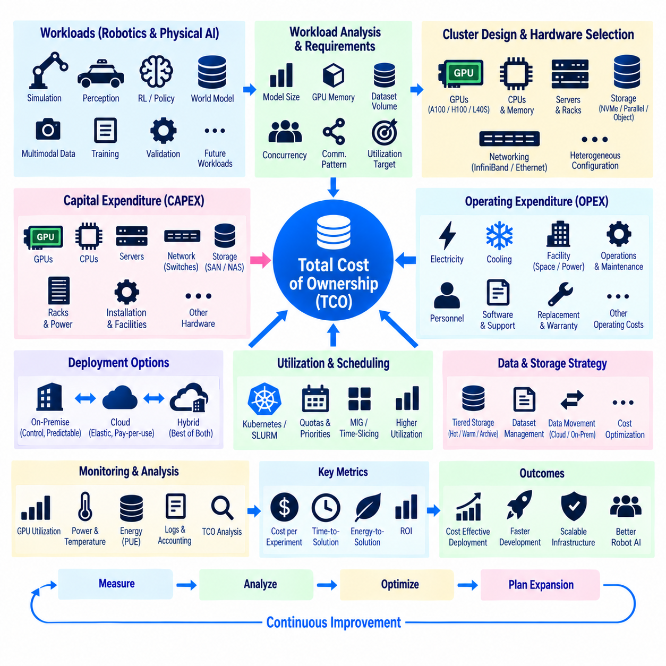
Deploying a GPU cluster requires evaluating much more than the purchase price of accelerators and servers. Total Cost of Ownership, or TCO, includes acquisition, networking, storage, power, cooling, facilities, software, operations, maintenance, and hardware lifecycle costs. For robotics and Physical AI, deployment planning must also consider simulation, distributed training, multimodal datasets, validation, and rapidly changing compute requirements.
The first stage of TCO analysis is workload characterization. Infrastructure should be sized according to expected training models, GPU memory requirements, simulation concurrency, dataset volume, distributed communication patterns, and utilization targets. Purchasing hardware before understanding these workloads can produce either an undersized cluster that limits development or an oversized system whose expensive accelerators remain idle for substantial periods.
Capital expenditure includes GPUs, CPUs, system memory, server chassis, local NVMe storage, network adapters, switches, racks, power-distribution equipment, and shared storage. High-performance clusters may also require InfiniBand or comparable low-latency networking. These supporting components can represent a significant portion of deployment cost, particularly when many GPU nodes must communicate continuously during distributed training.
GPU selection should consider workload suitability rather than peak performance alone. Large world models may require accelerators with substantial memory and high-speed GPU interconnects, while simulation, inference, preprocessing, or smaller perception models may operate efficiently on less expensive hardware. A heterogeneous cluster can reduce TCO by matching different workloads to appropriate accelerator classes instead of using premium GPUs for every task.
Storage architecture is another major cost factor. Physical AI pipelines can generate large volumes of camera images, point clouds, simulation trajectories, synthetic datasets, checkpoints, and experiment logs. High-performance storage is expensive, so placing all information on the fastest tier is rarely economical. Shared storage, parallel filesystems, local NVMe caches, object storage, and archival tiers can be combined according to performance and retention requirements.
Network design directly affects both acquisition cost and cluster productivity. Distributed training may require high-bandwidth, low-latency communication using technologies such as InfiniBand, RDMA, GPUDirect, and NCCL. A cheaper network can reduce initial expenditure but increase training duration if communication becomes a bottleneck. TCO analysis should therefore evaluate network cost together with its effect on GPU utilization and time-to-solution.
Facility readiness can substantially change deployment cost. GPU servers may require high rack power density, redundant electrical distribution, sufficient cooling, appropriate airflow, and physical space. Existing server rooms designed for conventional CPU workloads may not support dense GPU systems without upgrades. Electrical capacity, UPS systems, cooling equipment, rack layout, fire protection, and installation work should therefore be evaluated before hardware procurement.
Operational expenditure includes electricity consumed by computing equipment and the infrastructure required to support it. GPUs account for a major portion of power demand, but CPUs, memory, storage, switches, fans, cooling, and power conversion also contribute. Power Usage Effectiveness, or PUE, helps connect IT equipment consumption with total facility energy and provides a broader basis for estimating long-term operating cost.
Utilization is one of the strongest factors affecting effective TCO. An expensive GPU cluster operating at high productive utilization may provide better economics than a smaller system with poor scheduling and frequent idle periods. GPU allocation, actual compute utilization, queue time, job completion rate, and workload throughput should be monitored together because hardware ownership only creates value when installed resources perform useful work.
Schedulers such as Kubernetes or SLURM improve infrastructure economics by sharing accelerators among projects and assigning workloads according to demand. Quotas, priorities, heterogeneous node pools, MIG, time-slicing, and workload consolidation can increase utilization while preserving operational control. Effective scheduling can delay the need for additional hardware by extracting more useful computation from existing cluster capacity.
Personnel costs should be included in deployment planning. GPU clusters require expertise in Linux administration, networking, storage, container platforms, GPU drivers, schedulers, monitoring, security, and AI frameworks. Large environments may also require dedicated platform engineering or MLOps personnel. Infrastructure that appears inexpensive from a hardware perspective can become costly if it requires substantial manual administration and frequent troubleshooting.
Software and support costs can vary significantly depending on the architecture. Open-source components may reduce license expenditure but still require engineering effort for integration and maintenance. Commercial storage platforms, cluster-management software, enterprise Kubernetes distributions, monitoring tools, vendor support, and specialized AI software may introduce recurring fees. These costs should be evaluated over the planned infrastructure lifetime rather than only during initial deployment.
Maintenance and replacement costs are also part of TCO. GPU failures, storage-device replacement, switch failures, fan and power-supply maintenance, warranty extensions, and spare hardware can affect operating budgets. Large clusters should include strategies for node isolation, workload rescheduling, checkpoint recovery, and component replacement so that individual hardware failures do not cause disproportionately expensive interruptions.
Hardware depreciation and technology refresh require particular attention because GPU technology evolves rapidly. A cluster may remain functional for many years while becoming less competitive in performance per watt or memory capacity compared with newer systems. TCO analysis should therefore consider the expected useful life of accelerators, potential resale or secondary use, upgrade paths, and whether older GPUs can continue serving inference, simulation, testing, or smaller training workloads.
Deployment can follow on-premise, cloud, or hybrid models. On-premise infrastructure requires significant upfront investment but can provide predictable capacity, direct control, and favorable economics when utilization remains consistently high. Cloud GPU services reduce initial capital requirements and provide rapid elasticity, but long-running intensive workloads can accumulate substantial operating costs. Neither model is universally cheaper because economics depend on workload duration and utilization.
Hybrid infrastructure can combine persistent local capacity with cloud resources used for temporary peaks, specialized accelerators, or short-term experiments. Core workloads with predictable demand can remain on-premise, while burst workloads use external capacity when necessary. This approach can reduce the need to size the local cluster for rare maximum demand, although data transfer, security, software compatibility, and operational complexity must be included in the analysis.
Data movement can become a hidden cost in hybrid and cloud deployments. Physical AI datasets can reach very large sizes, making repeated transfers slow and potentially expensive. Training infrastructure should therefore consider where data is generated, stored, processed, and archived. Moving compute closer to large datasets may be more economical than repeatedly moving datasets toward available GPUs, especially for iterative training and validation workflows.
TCO should be analyzed together with time-to-solution. A lower-cost cluster that requires twice as long to train critical models may delay experiments, robot validation, product releases, or research milestones. Faster infrastructure can sometimes justify higher acquisition cost when it increases experiment throughput and shortens development cycles. Cost per completed experiment or cost per validated model can therefore be more meaningful than hardware price alone.
Energy-to-solution provides another useful economic perspective. A newer accelerator may consume more instantaneous power but complete training sufficiently faster to use less total energy. Similarly, high-speed networking and storage may increase infrastructure power while reducing GPU idle time and total execution duration. Deployment decisions should compare complete workload energy and completion time instead of evaluating component power ratings independently.
Capacity planning should include expected growth but avoid purchasing excessive unused capacity too early. GPU demand may increase as model size, simulation scale, dataset volume, and engineering teams grow. Modular deployment allows organizations to add compute nodes, storage, and network capacity in stages. However, the initial architecture should provide sufficient rack, power, cooling, and network scalability so that later expansion does not require complete infrastructure redesign.
Monitoring is essential for validating the assumptions used in TCO models. DCGM, Prometheus, Grafana, scheduler accounting, storage telemetry, and power monitoring can reveal actual GPU utilization, energy consumption, queue behavior, memory requirements, and workload distribution. Real operational data can then replace initial estimates and guide decisions about expansion, consolidation, hardware refresh, or changes in scheduling policy.
For Physical AI, cluster economics should be evaluated across the complete learning pipeline. Simulation farms, synthetic-data generation, perception training, reinforcement learning, world-model development, validation, and real-world dataset processing have different hardware requirements. Separating these workload classes and measuring their resource consumption allows infrastructure investments to be directed toward the components that actually constrain development throughput.
A practical TCO model therefore combines capital expenditure, operating expenditure, utilization, energy, personnel, software, maintenance, facilities, depreciation, and expansion requirements. These costs should be related to measurable outputs such as GPU-hours delivered, experiments completed, simulation steps generated, models trained, and validation cycles finished. This converts TCO from a simple accounting calculation into an engineering decision framework.
The objective of GPU cluster deployment is not to build the largest possible infrastructure at the lowest apparent hardware price. It is to create a computing platform that delivers sufficient performance, availability, scalability, and operational control at a sustainable lifecycle cost. For robotics and Physical AI, a well-designed TCO analysis connects infrastructure investment directly with productive learning throughput and the speed at which improved intelligence can be deployed to physical robots.

