Volume 09 Cloud and Edge Robotics

01. Cloud Computing Fundamentals

01.01 Cloud Service Models: IaaS, PaaS, SaaS, RaaS
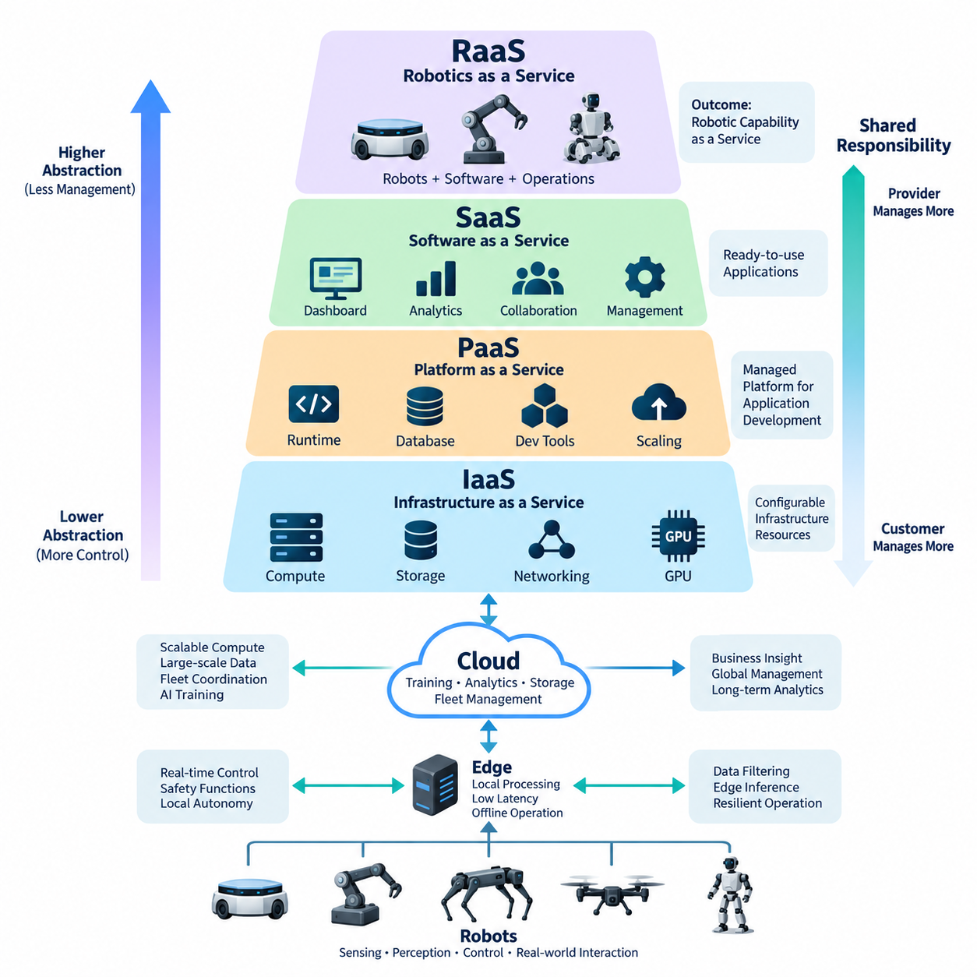
Cloud computing organizes computing resources into service models that define how responsibility is divided between a provider and a customer. In robotics, this distinction is especially important because applications combine remote computing infrastructure with physical machines operating in real environments. The service model determines who manages servers, operating systems, runtime environments, applications, data, security controls, and operational availability.
Infrastructure as a Service (IaaS) provides fundamental computing resources such as virtual machines, networking, storage, load balancers, and accelerator-equipped instances. The cloud provider operates physical data centers and virtualization infrastructure, while the robotics developer normally manages operating systems, middleware, databases, containers, AI frameworks, and application software running on the allocated resources.
IaaS is useful when robotics teams require extensive control over their software environment. A fleet-management backend, simulation server, map-processing cluster, or AI training system can be deployed on virtual machines configured with specific CPU, GPU, memory, storage, and network characteristics. This flexibility resembles operating conventional servers without requiring the organization to purchase and maintain the underlying physical data-center hardware.
The flexibility of IaaS also introduces operational responsibility. Teams must configure operating-system updates, access control, network security, monitoring, backup policies, application deployment, and capacity management. Infrastructure automation tools and container platforms are therefore commonly combined with IaaS. For robotics workloads that change significantly over time, infrastructure can be expanded during intensive simulation or training and reduced when demand decreases.
Platform as a Service (PaaS) moves additional infrastructure responsibilities to the cloud provider. Instead of maintaining individual operating systems and runtime environments, developers deploy applications onto a managed platform. The provider typically handles server provisioning, operating-system maintenance, runtime availability, scaling mechanisms, and parts of monitoring, allowing development teams to concentrate more directly on application logic and robot-related services.
A robotics PaaS workload might include telemetry processing, fleet APIs, device registration services, mission databases, dashboards, or AI application backends. Developers can build services that receive robot status messages, process operational events, store structured information, and expose results to fleet-management applications without manually configuring every underlying server. This reduces infrastructure administration but also limits low-level control compared with IaaS.
Software as a Service (SaaS) provides complete applications that users access through web interfaces, APIs, or client software. The provider manages infrastructure, operating systems, runtime environments, application deployment, updates, and most platform maintenance. Customers primarily configure the service, manage their users and data, and integrate the application into their operational processes rather than developing and operating the complete software stack themselves.
Within a robotics organization, SaaS can support collaboration, monitoring, analytics, project management, visualization, or other operational functions. A cloud-hosted fleet dashboard, for example, may present robot locations, battery states, alarms, mission histories, and maintenance information through a managed application. SaaS can accelerate deployment because organizations avoid building equivalent platforms internally, although customization and infrastructure control are generally more constrained.
Robotics as a Service (RaaS) extends the service concept from software and computing infrastructure to operational robotic capability. Instead of purchasing robots and independently constructing all supporting systems, a customer consumes a defined robotic function as an ongoing service. The service may combine robots, software, fleet management, cloud infrastructure, maintenance, monitoring, updates, technical support, and operational analytics within a unified commercial and technical model.
RaaS is fundamentally different from ordinary SaaS because its service boundary includes physical assets interacting with the real world. A warehouse AMR service, for example, must manage not only software availability but also robot charging, navigation reliability, mechanical maintenance, sensor health, site connectivity, replacement procedures, and safe operation. Service quality therefore depends on coordinated management of physical robots, edge computing, networks, and cloud services.
The four service models can be understood as progressively changing the ownership of technical responsibilities. IaaS provides configurable infrastructure, PaaS provides managed application platforms, SaaS provides finished software functions, and RaaS provides robotic operational capability. These models are not mutually exclusive. A RaaS platform may internally use SaaS applications, PaaS databases, container services, and IaaS GPU resources while presenting customers with one integrated robotics service.
This layered relationship is particularly important for cloud and edge robotics because robot workloads cannot simply be transferred entirely to remote data centers. Motion control, emergency handling, obstacle avoidance, and other latency-sensitive or safety-related functions normally require local execution. Cloud resources are more appropriate for fleet-wide coordination, historical analytics, large-scale data storage, AI training, reporting, and computational workloads that tolerate network latency or temporary disconnection.
Consequently, service-model selection should consider latency, bandwidth, connectivity, data sensitivity, scalability, operational control, engineering resources, and lifecycle cost rather than cloud convenience alone. IaaS offers substantial flexibility but requires greater operational expertise. PaaS reduces infrastructure management, SaaS minimizes application ownership, and RaaS can shift a much larger portion of technology and operational responsibility toward the robotics service provider.
Security responsibility also changes across these models rather than disappearing as more services become managed. In IaaS, customers retain significant responsibility for operating systems and applications. PaaS transfers more platform management to the provider, while customers remain responsible for application behavior, identities, configuration, and data. SaaS further reduces infrastructure responsibility, but organizations must still control accounts, permissions, integrations, information governance, and appropriate service usage.
RaaS introduces an even broader shared-responsibility boundary because cybersecurity must be coordinated with physical safety and operational continuity. Compromised credentials, unavailable connectivity, incorrect software updates, or cloud service failures can influence fleet operations. A robust RaaS architecture therefore requires explicit boundaries between cloud authority and local robot authority so that loss of remote services does not automatically eliminate essential local safety and operational functions.
Cost structures also differ among the models. IaaS costs are strongly related to consumed compute, storage, network traffic, accelerators, and operating duration. PaaS and SaaS increasingly incorporate managed-service or subscription pricing, while RaaS may associate cost with robots, operating hours, completed tasks, throughput, availability, or service levels. Evaluating these models requires consideration of engineering labor, maintenance, support, infrastructure utilization, and operational risk in addition to provider fees.
For robotics architects, the practical objective is therefore not to select one universal service model but to assign each responsibility to an appropriate layer. Low-level robot control can remain on the robot, site-wide processing can operate at the edge, scalable computing and storage can use IaaS or PaaS, business applications can consume SaaS, and customers can ultimately receive the complete robotic capability through RaaS. This layered approach establishes the foundation for later cloud-edge architecture design.

01.02 Cloud Provider Comparison: AWS, Azure, GCP, Naver
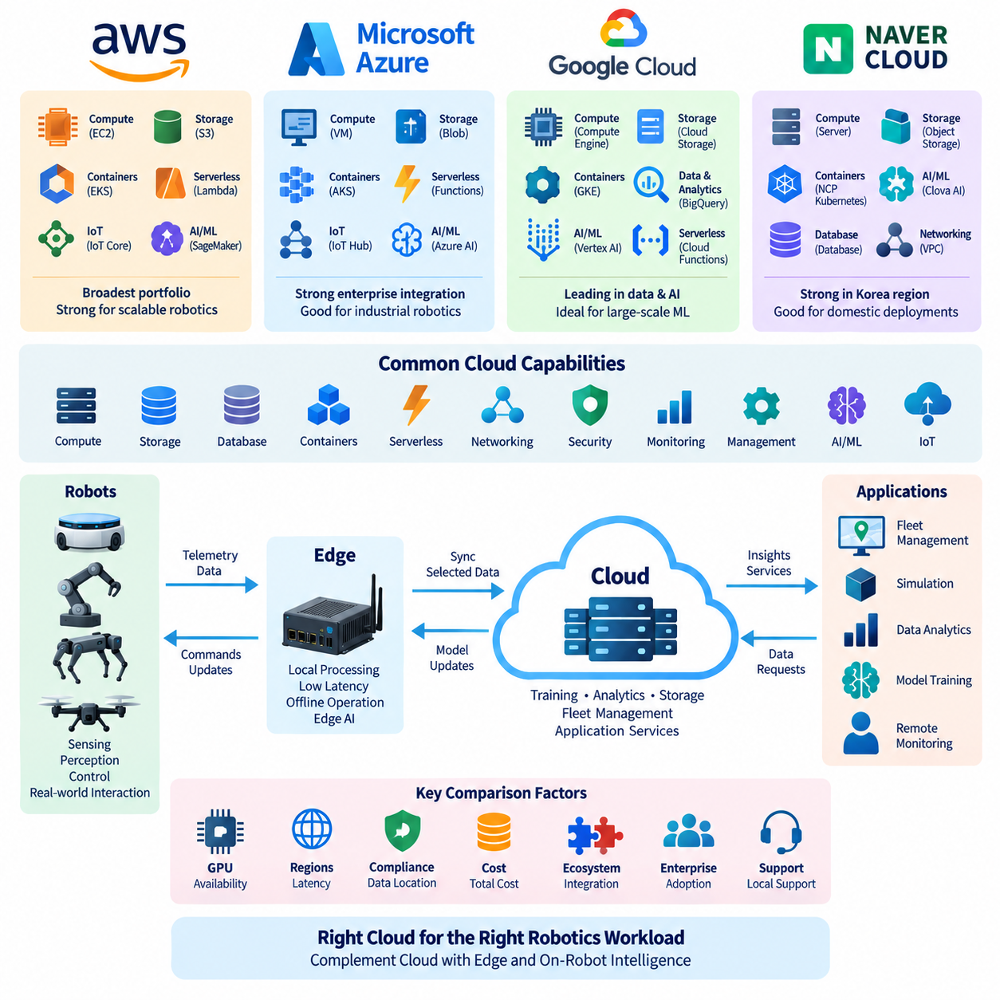
Amazon Web Services (AWS), Microsoft Azure, Google Cloud Platform (GCP), and Naver Cloud represent different cloud ecosystems that can support robotics applications from infrastructure hosting to AI training, data management, fleet services, and edge integration. Their basic capabilities overlap substantially, but differences in service portfolios, ecosystem integration, regional presence, operational tooling, and enterprise adoption can influence architecture decisions.
AWS provides a broad cloud portfolio covering compute, storage, networking, databases, analytics, containers, serverless computing, IoT, security, and machine learning. Its infrastructure services can support robot fleet backends, telemetry pipelines, simulation workloads, large-scale dataset storage, and AI training. EC2 supplies configurable virtual machines, while S3 provides object storage suitable for sensor logs, maps, images, models, and training datasets.
For containerized robotics backends, AWS provides services such as Elastic Container Service (ECS) and Elastic Kubernetes Service (EKS), allowing microservices and fleet-management components to operate on managed container infrastructure. AWS Lambda supports event-driven serverless processing, while messaging and IoT services can connect distributed devices with cloud applications. These capabilities enable architectures in which robots, edge computers, and centralized cloud services exchange operational information.
Microsoft Azure provides a similarly broad cloud environment but is particularly associated with integration across Microsoft enterprise technologies. Azure Virtual Machines, Blob Storage, managed databases, Azure Kubernetes Service (AKS), serverless functions, monitoring services, identity management, and AI platforms can be combined to construct robotics backends. This makes Azure applicable to organizations that already depend heavily on Microsoft-based IT environments and development ecosystems.
Azure's IoT-oriented architecture supports device connectivity, provisioning, telemetry ingestion, edge execution, and cloud-side management. These functions are relevant when a robotics fleet consists of many independently deployed machines that must maintain device identities, report health information, receive configuration updates, and exchange operational data. Azure services can therefore connect enterprise systems with factory equipment, mobile robots, sensors, and edge computers through a common cloud architecture.
Google Cloud Platform (GCP) combines general-purpose cloud infrastructure with strong capabilities in data processing, analytics, Kubernetes, and machine learning. Compute Engine provides virtual machines, Cloud Storage handles object data, and Google Kubernetes Engine (GKE) supplies managed Kubernetes environments. These services can host robot APIs, fleet applications, simulation pipelines, data-processing systems, and scalable backend components while reducing direct infrastructure administration.
GCP is especially relevant to robotics workloads that involve large datasets and AI development. Robot sensor logs can be transferred into cloud storage, transformed through data-processing pipelines, analyzed using managed analytical services, and connected to machine-learning environments. Kubernetes-based deployment also provides a consistent operational model for containerized software moving between development systems, cloud clusters, and appropriately configured edge environments.
Naver Cloud Platform provides cloud infrastructure and managed services with particular relevance to organizations operating within the Korean market. Its portfolio includes computing, storage, networking, databases, containers, AI-related services, security, and management capabilities. For domestic robotics deployments, local infrastructure availability and integration with Korean enterprise environments can become important considerations alongside raw computing capability.
Naver Cloud can support conventional robotics cloud workloads such as fleet backend servers, operational databases, object storage, monitoring systems, API services, and AI processing. A robotics company serving Korean factories, hospitals, logistics facilities, or public-sector environments may evaluate it when domestic service support, network connectivity, data-location requirements, procurement processes, or integration with locally used platforms influence deployment architecture.
The four providers can be compared through common infrastructure layers rather than only by individual product names. At the compute layer, each offers virtualized computing resources. At the storage layer, each provides scalable object and block storage. Managed databases, container orchestration, monitoring, identity management, networking, security, and AI services are also available in different forms. The architectural distinction therefore often lies in how these components integrate as an ecosystem.
For robotics, GPU availability and AI infrastructure are particularly important because cloud workloads may include perception-model training, reinforcement learning, foundation-model adaptation, simulation, synthetic-data generation, and large-scale inference. Cloud GPU resources allow temporary expansion beyond locally installed hardware, but architects must consider accelerator availability, regional capacity, storage throughput, network transfer costs, distributed-training support, and the expected duration of computational workloads.
IoT and edge integration form another important comparison dimension. Robots continuously generate telemetry, sensor information, diagnostics, events, and mission data, but many control functions cannot depend on permanent cloud connectivity. A suitable provider should therefore support architectures in which edge systems continue local operation during network interruptions while selected data is synchronized with cloud services for fleet coordination, analytics, model management, and long-term storage.
Regional architecture also affects provider selection. Cloud latency depends partly on the physical relationship between robots, edge sites, network infrastructure, and cloud regions. Data-governance requirements may additionally restrict where operational or customer information can be stored and processed. Consequently, a provider with technically similar services may be more appropriate for a particular deployment because of region availability, connectivity, compliance requirements, or organizational policy.
Security should be evaluated as an architectural system rather than as a list of individual cloud features. Identity and access management, encryption, key management, network segmentation, audit logging, secrets management, device authentication, and security monitoring must extend from cloud applications toward edge computers and robots. The selected cloud environment should allow these mechanisms to be incorporated consistently into fleet provisioning, operations, maintenance, and software deployment processes.
Cost comparison must also consider the complete robotics data lifecycle. Compute instance prices represent only one component. Object storage, database capacity, GPU usage, API requests, logging, monitoring, backups, inter-region communication, and outbound network traffic can all contribute to operating expenses. Sensor-rich robots may generate large data volumes, making data retention policies and cloud transfer strategies as important as the price of the primary compute resources.
Multi-cloud architecture can reduce dependence on a single ecosystem, but it also introduces additional complexity in identity, networking, observability, deployment automation, data synchronization, and engineering skills. Robotics organizations should therefore avoid adopting multiple providers simply because equivalent services exist. A multi-cloud strategy is most useful when business, regional, customer, regulatory, resilience, or technical requirements provide a clear reason for distributing workloads.
Cloud-provider selection for robotics should ultimately begin with workload requirements rather than provider branding. AWS, Azure, GCP, and Naver Cloud can all participate in cloud-edge robotics architectures, but the appropriate choice depends on application latency, AI workload scale, data volume, enterprise integration, regional deployment, security policy, operational expertise, and cost structure. The cloud should complement local robot and edge intelligence rather than replace functions that require deterministic or autonomous local execution.

01.03 Cloud Network Basics: VPC, Subnet, Security Group
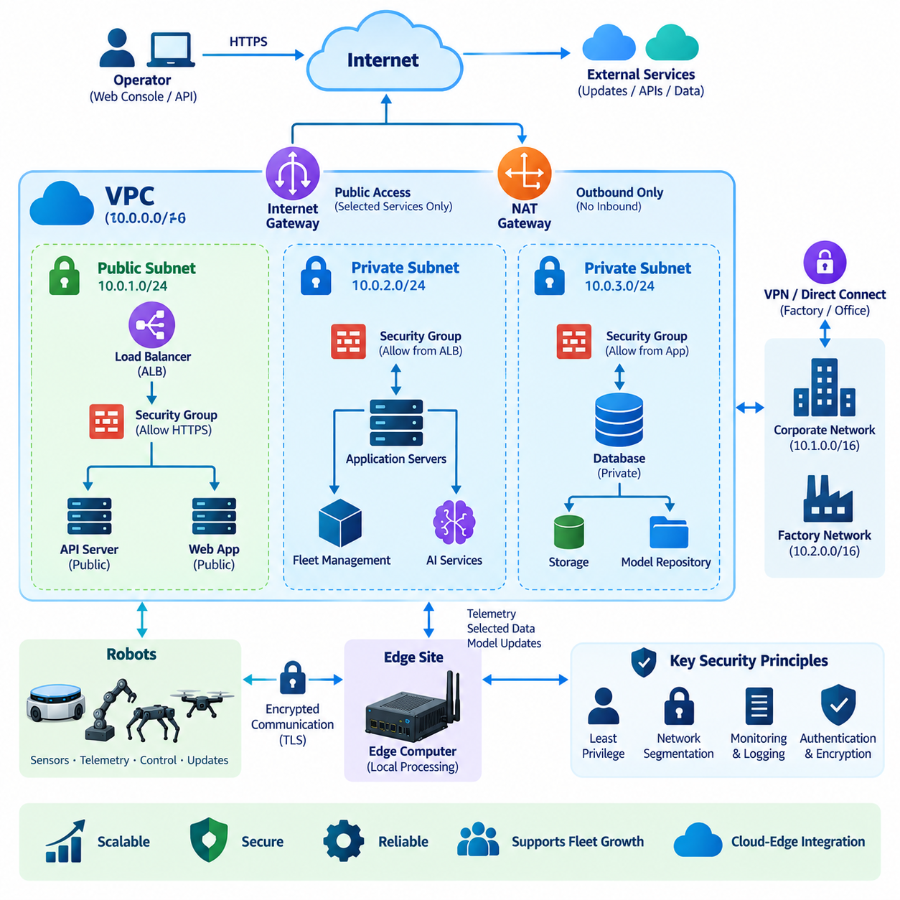
Cloud networking provides the communication foundation that connects cloud applications, databases, storage systems, edge computers, operators, and robots. Unlike a traditional physical network built mainly from switches and routers, cloud networks are largely software-defined. Resources can be created, segmented, connected, protected, and modified through configuration, APIs, or infrastructure automation, allowing network architecture to evolve together with robotic services.
A Virtual Private Cloud (VPC) is a logically isolated network environment created inside a cloud provider's infrastructure. It gives an organization control over address ranges, subnets, routing, connectivity, and security boundaries without requiring ownership of the underlying physical network. Robotics backend servers, databases, monitoring systems, fleet-management services, and AI applications can therefore operate inside a controlled virtual network separated from unrelated cloud customers.
VPC design normally begins by assigning a private IP address range using Classless Inter-Domain Routing (CIDR). The selected address space is subsequently divided into smaller subnet ranges. Address planning should consider current resources, expected fleet growth, additional sites, development environments, and possible connections with corporate or factory networks. Poor planning can create overlapping address ranges that complicate VPN, routing, and future hybrid-cloud integration.
A subnet is a logical subdivision of the VPC address space. Subnets allow resources with different roles and exposure requirements to be separated while remaining part of the same overall network architecture. A robotics system might place internet-facing API gateways or load balancers in externally reachable subnets while application servers, fleet databases, model repositories, and internal management components operate within more restricted subnets.
The terms public subnet and private subnet describe connectivity characteristics rather than fundamentally different network technologies. A public subnet generally has routing that allows designated resources to communicate with the Internet through an appropriate gateway, while a private subnet avoids direct inbound Internet exposure. Backend databases and internal robot-management services are commonly placed in private network segments and reached through controlled application or management paths.
Routing determines where network packets are forwarded between subnets, gateways, external networks, and other cloud environments. Route tables associate destination address ranges with appropriate next hops. In robotics deployments, routing may connect fleet services with Internet gateways, network address translation services, virtual private networks, corporate systems, factory networks, or other VPCs while maintaining intentional boundaries between different traffic classes.
An Internet Gateway provides connectivity between eligible VPC resources and the public Internet. Public connectivity is useful for selected interfaces such as customer APIs or web applications, but exposing every cloud resource directly increases the attack surface. Robotics architectures should therefore minimize public endpoints and place databases, internal services, administrative systems, and sensitive processing components behind controlled network boundaries whenever practical.
Network Address Translation (NAT) allows systems in private network segments to initiate communication toward external services without necessarily accepting unsolicited inbound connections from the Internet. A private application server may need to download software packages, contact an external API, or retrieve container artifacts while remaining inaccessible as a public server. This pattern separates outbound connectivity requirements from inbound exposure.
Security Groups provide virtual firewall controls associated with cloud resources or network interfaces. Rules typically specify permitted protocols, ports, and traffic sources or destinations. Instead of allowing broad network access, architects should define communication according to actual service relationships. For example, an application service may accept HTTPS traffic from a load balancer while a database accepts its database port only from the authorized application layer.
Security Group design should follow the principle of least privilege. A rule such as allowing all traffic from every Internet address may simplify initial testing but creates unnecessary exposure. Production robotics systems should identify which components communicate, which protocols they use, and which direction communication occurs. This produces smaller and more understandable trust boundaries and reduces the consequences of a compromised service.
Cloud platforms may also provide subnet-level network access controls in addition to resource-level Security Groups. These mechanisms operate at different layers and can provide defense in depth when carefully designed. Excessive overlapping rules, however, can make troubleshooting difficult. Network security architecture should therefore remain understandable, documented, and consistent with the actual data flows between robots, edge systems, backend services, and administrators.
A robotics cloud normally receives connections from geographically distributed robots or edge gateways. These devices should not automatically become trusted merely because they belong to the same fleet. Device identity, encrypted communication, authentication, and authorization must complement network segmentation. Compromise of one robot should not provide unrestricted access to databases, management interfaces, model repositories, or other robots connected to the platform.
Virtual Private Network (VPN) connections can securely connect a cloud VPC with factories, offices, laboratories, or other private networks across public infrastructure. This is useful when robot fleet services must exchange information with warehouse management systems, manufacturing execution systems, engineering servers, or on-premise databases. Dedicated private connectivity can also be considered when predictable bandwidth, latency, security, or enterprise networking requirements justify it.
Robotics network traffic has different operational characteristics. Small telemetry messages may be transmitted continuously, while cameras and LiDAR sensors can generate very large data streams. Software updates and AI models can also contain hundreds of megabytes or several gigabytes of data. Sending all raw sensor information directly to the cloud is therefore often inefficient, making edge filtering, compression, aggregation, and selective synchronization important parts of network architecture.
Real-time robot control requires additional caution because cloud network latency and availability cannot normally be treated as deterministic. Safety functions, motor control, immediate obstacle avoidance, and essential autonomy should remain executable locally when appropriate. The cloud network is better suited to fleet coordination, configuration, monitoring, historical data, model distribution, analytics, and other functions whose timing requirements tolerate network variability or temporary disconnection.
High availability can be improved by distributing cloud resources across multiple isolated infrastructure locations when supported by the provider. Application servers and load balancers can be distributed so that failure of one location does not necessarily stop the entire fleet backend. Network design must accompany this redundancy because routing, database connectivity, service discovery, monitoring, and failover paths determine whether replicated resources can actually maintain service continuity.
Network observability is essential for operating distributed robotic systems. Flow records, firewall logs, latency measurements, connection errors, bandwidth statistics, and application telemetry can help distinguish cloud failures from site-network problems or robot-side faults. Without this visibility, an operator may know that a robot is disconnected but cannot determine whether the cause is wireless coverage, an edge gateway, VPN connectivity, routing, security policy, or the backend application.
A practical robotics cloud network therefore combines VPC isolation, structured subnet design, controlled routing, limited Internet exposure, Security Groups, encrypted site connectivity, and continuous monitoring. These mechanisms create the communication boundary between cloud services and physical robots. Well-designed networking does not merely connect resources; it defines which components may communicate, how failures are contained, and how cloud-edge robotic operations remain secure and manageable as the fleet grows.

01.04 Cloud Storage Service Comparison and Selection
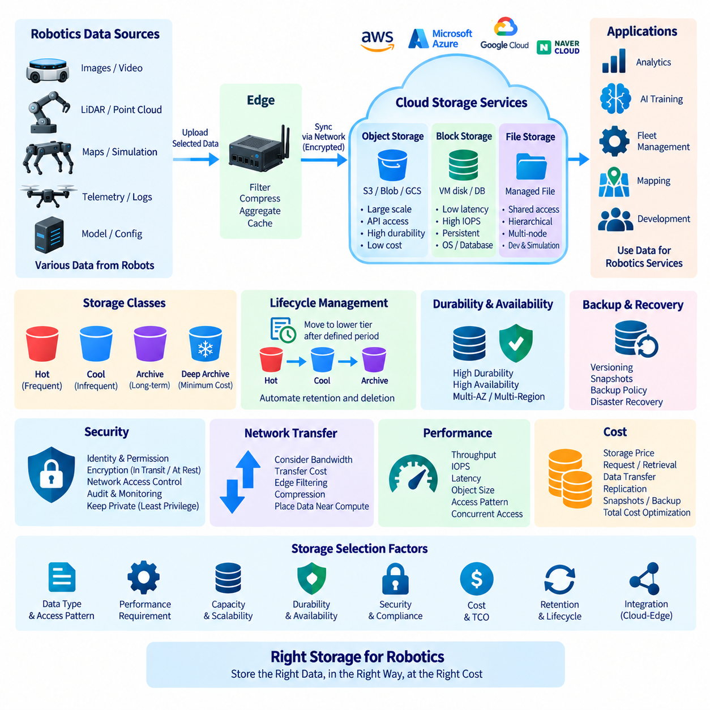
Cloud storage is a fundamental component of robotics infrastructure because robots generate heterogeneous data with very different performance, capacity, durability, and access requirements. Images, video, LiDAR point clouds, maps, telemetry, logs, AI datasets, model checkpoints, configuration files, and database volumes should not automatically use the same storage technology. Selecting storage therefore begins by understanding how each type of data is created, accessed, retained, transferred, and recovered.
Object storage organizes data as independent objects rather than conventional disk blocks or hierarchical file-system structures. Each object normally contains data, metadata, and a unique identifier and is accessed through APIs. Services such as Amazon S3, Azure Blob Storage, Google Cloud Storage, and comparable object-storage platforms are designed for very large numbers of objects and capacities that can expand without manually managing individual storage devices.
For robotics, object storage is particularly suitable for sensor archives, camera images, recorded video, LiDAR data, simulation outputs, AI datasets, trained models, software packages, and long-term operational logs. A robot or edge gateway can upload selected data after local preprocessing, while cloud applications later retrieve it for analytics or training. This model separates data capacity from individual compute servers and supports large-scale fleet data collection.
Block storage presents storage volumes that operating systems can use similarly to locally attached disks. Cloud virtual machines commonly use block storage for boot volumes, application data, database files, and workloads requiring predictable low-level disk access. Unlike object storage, applications can use normal file systems on top of block devices, making block storage appropriate when software expects conventional disk semantics rather than object-based API access.
Robotics backend databases and stateful applications frequently depend on block storage. A fleet-management database, mapping server, or application running on a virtual machine may require persistent storage that survives instance restart or replacement. Performance must be evaluated through capacity, throughput, input/output operations per second, and latency because storage behavior can directly affect database transactions, map loading, event processing, and service response time.
File storage provides shared hierarchical directories and files that can be mounted by multiple systems. Managed network file systems are useful when applications require familiar file semantics or when several compute nodes must access common files. Robotics development teams may use file storage for shared simulation assets, maps, engineering files, machine-learning datasets, experiment outputs, or software resources that existing tools expect to access through standard directories.
The choice between object, block, and file storage should follow application access patterns rather than simple capacity comparisons. Object storage is generally appropriate for large-scale durable datasets and API-based access, block storage for operating systems and performance-sensitive stateful workloads, and file storage for shared hierarchical access. A practical robotics architecture commonly uses all three because sensor archives, databases, and shared engineering assets have fundamentally different requirements.
Storage classes further distinguish frequently accessed data from information retained mainly for historical or recovery purposes. Hot storage prioritizes immediate access, while cooler or archival tiers reduce storage cost in exchange for retrieval conditions such as additional latency or access charges. Robot telemetry from the current week may require frequent analysis, whereas raw sensor recordings from completed deployments may be moved to lower-cost tiers after their operational value decreases.
Lifecycle management automates these transitions. Storage policies can move objects from frequently accessed classes into colder tiers after defined periods and eventually delete information according to retention requirements. This is especially valuable for large robot fleets because cameras, LiDARs, and other sensors can accumulate enormous data volumes. Without lifecycle rules, cloud storage may continue growing even when much of the stored information is rarely used.
Durability and availability describe different properties and should not be confused. Durability concerns the probability that stored information remains intact over time, while availability describes whether the storage service can be accessed when required. Robotics architects must determine whether data primarily requires long-term preservation, continuous operational access, or both. Critical configuration, maps, models, and fleet records may justify stronger protection than temporary intermediate processing files.
Replication improves resilience by maintaining data across multiple infrastructure locations or geographic regions, depending on the selected service and configuration. Regional replication can protect against localized failures, while cross-region strategies can support disaster recovery. However, additional copies increase cost and may introduce synchronization, consistency, regulatory, or data-location considerations. Replication policy should therefore reflect the business importance and recovery requirements of each dataset.
Backup is not identical to replication. Replication can reproduce accidental deletion, corruption, or unwanted modification across copies, whereas backups preserve recoverable historical states when properly configured. Versioning, snapshots, immutable retention, and backup policies can protect important robotics information from operational mistakes, software defects, ransomware, or failed updates. Recovery procedures should also be tested rather than assuming that stored backups are automatically usable.
Cloud storage security requires control over identities, permissions, encryption, network access, and auditability. Storage buckets, file systems, and volumes should not be exposed publicly unless there is a specific requirement. Access should follow least-privilege principles so that robots, applications, developers, and administrators receive only the permissions necessary for their roles. Encryption should protect sensitive information both during transmission and while stored.
Robotics data introduces additional security concerns because sensor recordings may reveal factory layouts, equipment, personnel activity, customer facilities, or operational processes. Maps and configuration files may also expose infrastructure details, while trained models and datasets can represent valuable intellectual property. Storage classification should therefore distinguish public, internal, confidential, operationally critical, and regulated information so that security controls correspond to actual data sensitivity.
Performance requirements depend strongly on data format and workflow. Uploading thousands of small telemetry objects creates a different access pattern from streaming multi-gigabyte sensor recordings or reading large datasets for distributed AI training. Architects should consider object size, request frequency, sequential versus random access, concurrency, throughput, latency, and metadata operations. The nominal capacity of a storage service alone provides little information about application-level performance.
Network transfer is closely connected to storage architecture. Moving raw camera and LiDAR data from robots to the cloud can consume substantial bandwidth, while repeatedly transferring large AI datasets between regions or environments can create both delays and costs. Edge systems can reduce unnecessary traffic by filtering, compressing, aggregating, or temporarily caching data before synchronization. Frequently used datasets may also be positioned closer to the compute resources that process them.
AI training introduces specialized storage demands because GPUs can remain underutilized if data cannot be supplied quickly enough. Large-scale robotics datasets may contain millions of images, video segments, point clouds, trajectories, and metadata records. Training infrastructure therefore requires coordinated design of storage throughput, caching, parallel data loading, dataset organization, and compute placement. Increasing GPU capacity without addressing the data pipeline can simply move the performance bottleneck into storage.
Cost evaluation must include more than the price per unit of stored capacity. Requests, retrieval operations, data transfer, replication, snapshots, backups, minimum retention periods, and high-performance storage options can all contribute to the total cost. A low storage price may become less attractive when data is accessed frequently or transferred extensively. Cost optimization therefore requires understanding the complete data lifecycle and expected access behavior.
A robust robotics storage architecture typically combines local robot storage, edge storage, and cloud storage. The robot retains information needed for immediate operation, the edge layer buffers and processes site-level data, and cloud storage preserves selected information for fleet analytics, AI training, long-term history, backup, and collaboration. Data should move between these layers according to latency, bandwidth, value, privacy, retention, and recovery requirements rather than being uploaded indiscriminately.
Cloud storage selection is therefore a workload-matching problem rather than a search for one universally superior service. Object, block, file, hot, archival, replicated, and backup storage each solve different problems. By classifying robotics data according to access pattern, performance, durability, security, retention, recovery, and cost requirements, architects can construct a storage hierarchy that scales from individual robots to large fleets while supporting cloud-edge operations efficiently.

01.05 Cloud Compute Services: VM, Container, Serverless
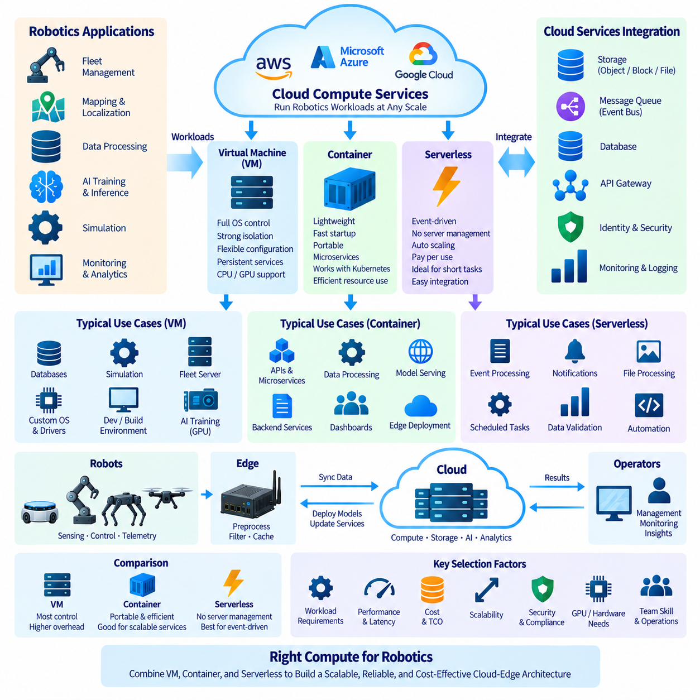
Cloud compute services provide the execution environment in which robotics backend applications, fleet-management systems, simulation workloads, AI pipelines, databases, APIs, and operational services run. Three major execution models are virtual machines, containers, and serverless computing. They provide different levels of infrastructure control, isolation, portability, scaling, startup speed, and operational responsibility, so robotics architectures commonly combine them rather than selecting only one model.
A virtual machine (VM) emulates a complete computer environment on top of physical cloud infrastructure. Each VM normally contains its own operating system, libraries, runtime, applications, and allocated CPU, memory, storage, and network resources. Cloud providers manage the underlying servers and virtualization layer, while users retain substantial control over the guest operating system and the software installed inside it.
VMs are appropriate when robotics software requires a specific operating system, custom drivers, specialized networking, persistent services, or extensive administrative control. Fleet-management servers, simulation environments, development systems, databases, build servers, and AI workloads can run on appropriately configured instances. GPU-equipped VMs are particularly useful for perception training, simulation, model optimization, and other computationally intensive robotics workloads.
The main advantage of VMs is flexibility. Engineers can configure operating-system packages, middleware, security tools, storage layouts, runtime libraries, and application dependencies almost as they would on physical servers. This flexibility also creates management overhead because operating-system patching, software configuration, monitoring, security hardening, capacity planning, and failure recovery remain important operational responsibilities.
Containers provide a lighter execution model by packaging applications together with their libraries and dependencies while sharing the host operating-system kernel. A container image defines a reproducible software environment that can be started on compatible container runtimes. Because containers do not normally require a complete guest operating system for every application instance, they can start faster and use infrastructure resources more efficiently than many VM-based deployments.
Containerization is particularly valuable in robotics because software systems consist of many interacting components. Fleet APIs, telemetry processors, map services, authentication services, dashboards, model servers, notification services, and data-processing workers can be packaged independently. Each component can use its own dependencies and release cycle while communicating through defined interfaces, reducing conflicts between software environments and simplifying deployment automation.
Container images also improve portability between development computers, on-premise servers, cloud environments, and appropriately configured edge computers. The same application package can move through development, testing, staging, and production with fewer environmental differences. However, portability is not absolute because CPU architecture, GPU runtime, device drivers, kernel capabilities, networking, storage, and hardware interfaces can still differ between cloud servers and robotic edge platforms.
As the number of containers increases, orchestration becomes necessary. Platforms such as Kubernetes can schedule containers across multiple compute nodes, restart failed workloads, distribute traffic, manage configuration, expose services, and scale application replicas. Managed Kubernetes services reduce some control-plane administration, making them suitable for scalable fleet-cloud platforms composed of many continuously operating backend microservices.
Containers do not eliminate infrastructure management. Worker nodes, networking, storage, security policies, image registries, observability, resource limits, and software supply chains must still be managed. Kubernetes can also introduce significant architectural complexity. Small robotics deployments should therefore avoid adopting orchestration merely because it is widely used and instead evaluate whether workload scale, availability, deployment frequency, and team capability justify it.
Serverless computing moves another portion of infrastructure responsibility to the cloud provider. Developers deploy functions or application components without directly managing persistent servers. The platform allocates execution resources when events or requests arrive and can automatically scale the number of concurrent executions. Billing is commonly associated with requests, execution duration, allocated resources, or related managed-service consumption rather than continuously running dedicated servers.
Serverless functions are well suited to short-lived, event-driven robotics workloads. A robot telemetry event might trigger validation and storage, an alarm could initiate a notification workflow, an uploaded log could start processing, or completion of a mission could generate a report. Serverless execution allows these tasks to run only when needed instead of maintaining continuously active application servers for infrequent events.
The event-driven nature of serverless computing integrates naturally with message queues, object storage, databases, API gateways, and event buses. A robot may upload a diagnostic file to cloud storage, which generates an event that invokes a function to inspect metadata, update a database, and notify an operator. Such loosely coupled workflows can simplify automation and allow individual processing stages to scale independently according to incoming event volume.
Serverless computing also has limitations. Functions may have restrictions on execution duration, memory, local storage, networking, runtime environments, and accelerator access. Startup delay, commonly discussed as cold-start latency, can affect applications that require immediate response. These characteristics make serverless unsuitable for many continuously running or timing-sensitive robotics functions, especially low-level control and safety-critical processing.
Real-time robot control should generally remain on the robot or appropriate edge system rather than depend on remote VM, container, or serverless execution. Steering, motor control, emergency stopping, immediate obstacle avoidance, and essential autonomy must tolerate cloud disconnection and variable network latency. Cloud compute is more appropriate for fleet coordination, analytics, AI training, historical processing, remote management, and other non-deterministic workloads.
Scaling behavior differs significantly among the three models. VM scaling typically creates or removes complete machine instances and can require substantial startup time. Containers are lighter and can often scale application replicas more rapidly when compute nodes are available. Serverless platforms can automatically create many concurrent executions in response to events, although service quotas, initialization delays, downstream capacity, and cost must still be considered.
State management is another important distinction. VMs can maintain local state, although relying on instance-local data can complicate replacement and recovery. Containers are commonly designed to be replaceable, with persistent information stored in external databases or storage systems. Serverless functions are normally treated as ephemeral and stateless between invocations. Separating compute from persistent state generally improves scalability and failure recovery across all three models.
Cost depends strongly on workload behavior. Continuously utilized services may operate efficiently on appropriately sized VMs or container clusters, while highly variable or infrequent event workloads may benefit from serverless execution. Idle resources, autoscaling behavior, GPU utilization, licensing, storage, networking, orchestration overhead, and engineering effort should all be included when comparing alternatives rather than considering compute price alone.
AI workloads introduce additional selection criteria. Large-scale training often requires GPU or accelerator instances with predictable access to memory, high-speed storage, and interconnects, favoring VM or container-based infrastructure. Model inference may run in containers for scalable serving, while lightweight event-driven AI processing can sometimes use managed or serverless inference services. The compute model should therefore match model size, latency, throughput, accelerator, and concurrency requirements.
A robotics cloud architecture can combine all three approaches. GPU VMs may perform model training and simulation, Kubernetes containers may operate fleet APIs and continuously running backend services, and serverless functions may process alerts, reports, file events, or asynchronous workflows. Edge containers can additionally package selected software for deployment closer to robots while local control processes remain independent of cloud availability.
Selecting between VMs, containers, and serverless computing is therefore a workload-placement decision rather than a competition between technologies. VMs maximize environmental control, containers emphasize portability and service-oriented deployment, and serverless computing emphasizes event-driven execution with reduced infrastructure management. Matching each robotics workload to its latency, duration, state, scaling, hardware, security, availability, and cost requirements creates a more efficient cloud-edge architecture.

01.06 Cloud Cost Structure and Optimization Principles
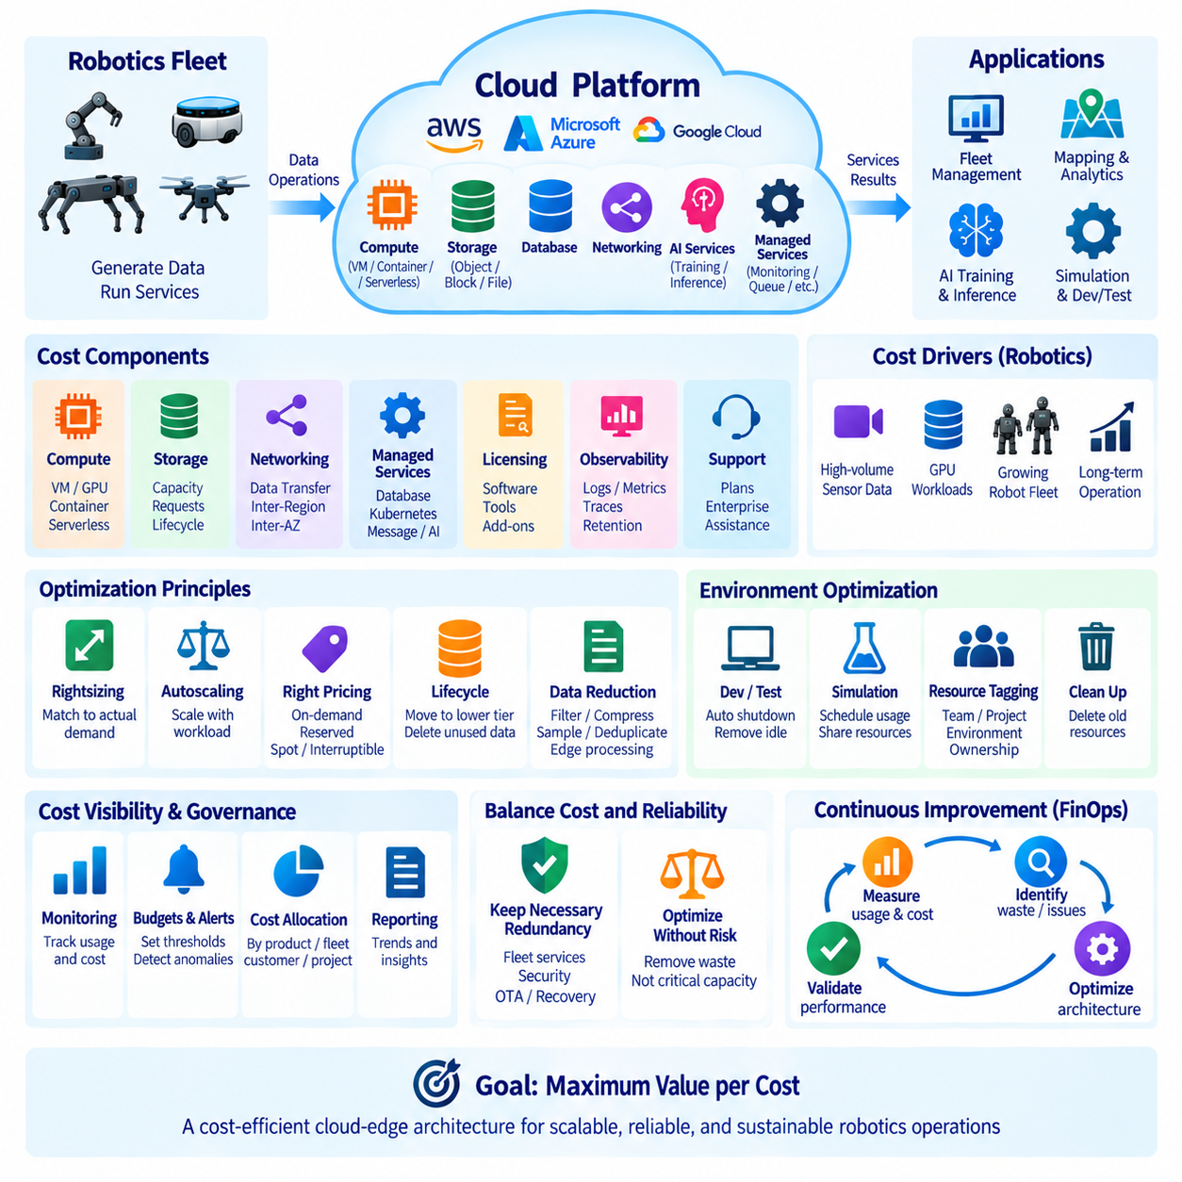
Cloud cost management is an architectural discipline rather than a simple accounting activity. Robotics cloud platforms combine compute, GPU resources, storage, databases, networking, monitoring, AI services, and fleet operations, each with different pricing mechanisms. Because robot fleets continuously generate data and may operate for years, small inefficiencies can accumulate into significant operating expenses as the number of robots, sites, models, and services increases.
Cloud expenditure can generally be understood through several interacting categories: compute consumption, storage capacity and operations, network transfer, managed services, software licensing, observability, and support. A robotics system may simultaneously pay for fleet servers, GPU training instances, object storage, database transactions, telemetry ingestion, log retention, model distribution, backups, and outbound traffic. Total cost therefore reflects the entire architecture rather than a single service price.
Compute cost depends on resource type, capacity, operating duration, and utilization. Virtual machines may be charged according to allocated CPU, memory, GPU, and runtime, while containers ultimately consume underlying compute resources. Serverless workloads are commonly associated with requests and execution consumption. The central optimization principle is to avoid paying continuously for resources that provide little useful work while maintaining sufficient capacity for operational requirements.
Rightsizing matches allocated resources to actual workload demand. An oversized fleet server may reserve CPU and memory that remain mostly idle, while an undersized system may create latency and reliability problems. Monitoring utilization over representative operating periods allows engineers to adjust instance sizes, container requests, memory limits, and database capacity. Rightsizing should therefore be continuous because robot populations, traffic patterns, and software behavior change over time.
Autoscaling adjusts compute capacity according to workload conditions. Fleet services may require additional instances when many robots reconnect simultaneously, telemetry volume increases, or operators access dashboards during peak periods. Capacity can later decrease when demand falls. Effective autoscaling requires meaningful metrics and safe limits because aggressive scaling may create instability, while overly conservative policies preserve unnecessary resources and reduce potential savings.
Pricing models can also influence cost. On-demand resources provide flexibility without long commitments, while commitment-based or reserved capacity can reduce unit cost for predictable workloads. Interruptible or spare-capacity instances may offer lower prices but can be terminated by the provider. Robotics architects should therefore match pricing models to workload tolerance: persistent production services require stability, while fault-tolerant simulation, batch analytics, or some AI training jobs can exploit flexible capacity.
GPU infrastructure requires particular attention because accelerators are significantly more expensive than general-purpose CPU resources and can remain idle when data pipelines, preprocessing, or scheduling are inefficient. GPU utilization should be measured rather than inferred from instance uptime. Training jobs can be scheduled, queued, consolidated, or terminated automatically after completion, while datasets and checkpoints should be positioned to prevent expensive accelerators from waiting for storage or network transfers.
Storage cost grows with both capacity and access behavior. Frequently accessed operational data may justify high-performance storage, while historical sensor recordings can move to lower-cost storage classes. Lifecycle policies can automatically transition objects as their operational value decreases. Retention rules should also delete data that no longer has technical, contractual, regulatory, or business value instead of treating unlimited retention as the default.
Robotics datasets make storage optimization especially important because cameras, LiDARs, simulation systems, and multimodal sensors can produce data much faster than conventional enterprise applications. Uploading everything indefinitely is rarely economical. Edge filtering, event-based recording, deduplication, compression, representative sampling, and metadata-driven selection can reduce cloud storage requirements while preserving information that remains useful for debugging, analytics, validation, and AI training.
Network cost is frequently underestimated. Data transferred into a cloud platform may have a different pricing structure from data transferred out, and inter-region or cross-zone communication can also generate charges. Large robot fleets distributing models, software packages, maps, video, and sensor datasets can therefore accumulate substantial network expenses. Architecture should minimize unnecessary movement and place computation close to frequently accessed data whenever practical.
Edge computing can reduce both bandwidth consumption and cloud processing costs. Instead of transmitting every sensor frame, an edge computer can perform filtering, compression, aggregation, inference, and anomaly detection locally. Only selected events, summaries, metadata, or training samples need to reach the cloud. The economic benefit must still be balanced against the cost of purchasing, powering, maintaining, and remotely managing edge infrastructure.
Managed services reduce engineering and operational effort but may cost more per unit than self-managed infrastructure. Managed databases, Kubernetes control planes, message services, monitoring platforms, and AI services can eliminate substantial maintenance work. Cost evaluation should therefore include engineering labor, operational risk, availability requirements, patching, backup, security, and incident response rather than assuming that the infrastructure with the lowest direct provider charge has the lowest total cost.
Observability itself can become a major cost category. Robots and distributed services may generate enormous volumes of logs, metrics, traces, and diagnostic events. Collecting every message at maximum resolution indefinitely can create unnecessary ingestion and retention expenses. Logging levels, metric frequency, trace sampling, retention periods, and diagnostic detail should be designed according to operational value while preserving enough information to investigate failures and safety-relevant events.
Development, testing, and simulation environments often contain substantial optimization opportunities because they do not always need to operate continuously. Automatic shutdown schedules can stop unused virtual machines, GPU instances, development clusters, and test databases outside required periods. Temporary environments should also be removed after projects or experiments finish. Resource tagging and ownership information help identify abandoned infrastructure that would otherwise continue generating charges unnoticed.
Cost allocation becomes increasingly important as a robotics platform expands. Resources should be associated with meaningful dimensions such as product, fleet, customer, site, development team, environment, or project. Tags, accounts, subscriptions, projects, or billing groups can provide this separation. Without allocation, a company may know total cloud expenditure but remain unable to determine which robot service, customer deployment, AI experiment, or engineering activity is responsible for growth.
Budgets and cost alerts provide early visibility before unexpected spending becomes a serious problem. Thresholds can be established for projects, services, environments, or teams, and unusual changes can trigger investigation. Cost anomaly detection is especially useful when automation is involved because configuration errors can rapidly create resources, increase logging, generate network traffic, or scale services far beyond expected levels without immediate human awareness.
Reliability and cost optimization must be balanced. Removing redundancy, reducing database capacity, or aggressively shutting down resources can lower expenditure while increasing operational risk. Fleet management, authentication, safety-related data services, and OTA infrastructure may require redundancy and recovery capability even when those resources appear underutilized. Optimization should remove waste without eliminating capacity that exists for justified resilience or recovery requirements.
Architecture decisions have greater long-term impact than isolated price reductions. A system that repeatedly transfers raw sensor data between regions, stores duplicate datasets indefinitely, or depends on permanently running oversized GPU servers will remain expensive despite minor discounts. Designing data locality, lifecycle policies, workload scheduling, autoscaling, caching, edge processing, and appropriate compute models into the architecture creates structural rather than temporary savings.
Cost optimization should therefore operate as a continuous feedback loop. Teams measure utilization and spending, attribute cost to workloads, identify waste or abnormal behavior, modify architecture or resource configuration, and verify the resulting effect on performance and reliability. As fleets grow, this process evolves into financial operations integrated with engineering, commonly associated with FinOps principles, where technical and business teams share visibility into cloud consumption.
For robotics, the objective is not simply to minimize the cloud bill but to maximize useful operational and engineering value per unit of expenditure. Compute, storage, networking, edge processing, managed services, and reliability mechanisms should be selected according to workload requirements. A cost-efficient cloud-edge architecture spends aggressively where performance or resilience creates value and systematically removes idle capacity, unnecessary data, excessive transfer, and unmanaged resource growth.

01.07 Cloud Security Basics: IAM, Encryption, Compliance
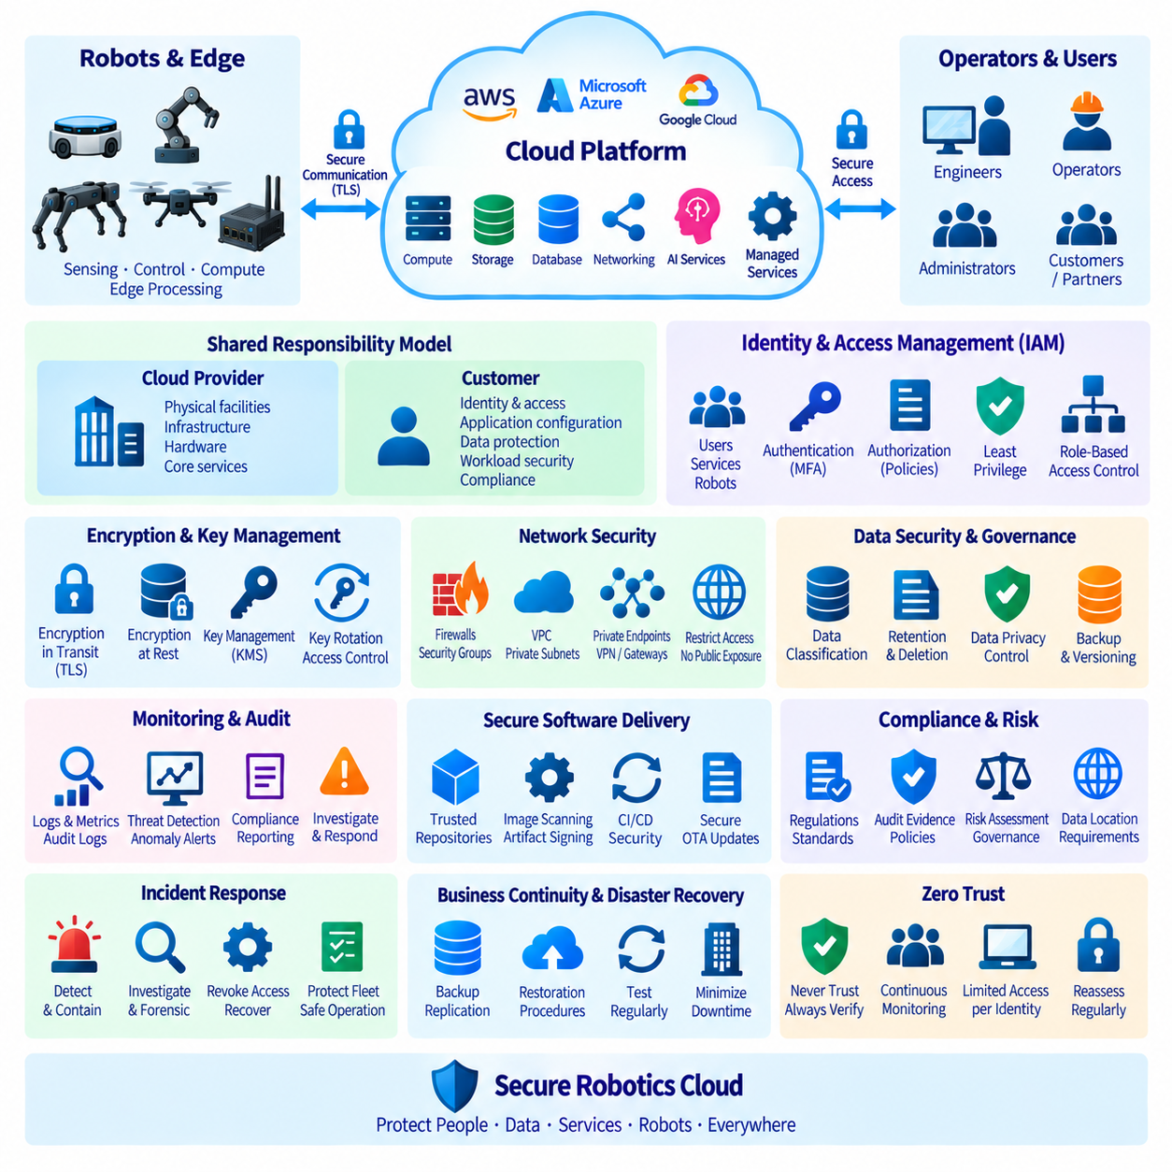
Cloud security establishes the controls required to protect robotics applications, data, infrastructure, users, and connected machines across distributed cloud-edge environments. A robotics platform extends beyond conventional cloud servers because physical robots, edge computers, operator interfaces, APIs, and external networks participate in the same operational system. Security must therefore protect both digital information and the services that can influence physical robot behavior.
Cloud security follows a shared responsibility model in which the cloud provider protects underlying facilities, physical infrastructure, and selected managed-service layers, while customers remain responsible for areas such as identities, permissions, application configuration, data, and workload security. The exact boundary changes between IaaS, PaaS, SaaS, and managed services, so engineering teams must understand which controls remain under their responsibility.
Identity and Access Management (IAM) determines who or what can access cloud resources and which actions are permitted. Identities may represent human users, applications, services, automated pipelines, robots, or edge gateways. Authentication verifies an identity, while authorization determines the permitted operations. Effective IAM creates explicit relationships between identities, roles, resources, and policies instead of relying on broadly shared accounts or credentials.
The principle of least privilege is fundamental to IAM design. Each identity should receive only the permissions necessary to perform its assigned function and only for the required resources. A telemetry service may need permission to write robot events but should not automatically receive authority to modify IAM policies or delete model repositories. Restricting permissions limits the potential impact of mistakes, compromised credentials, and vulnerable applications.
Role-based access control can simplify permission management by assigning privileges to defined operational roles instead of configuring every user individually. Developers, operators, security administrators, data engineers, and automated services may require different access patterns. Robotics organizations should also separate development, testing, and production privileges so that experimental activities cannot unintentionally modify operational fleet resources.
Strong authentication reduces the risk created by stolen passwords. Multi-factor authentication should protect privileged human accounts, while applications and machines should use appropriate service identities, temporary credentials, certificates, or workload identity mechanisms instead of embedding long-lived secrets in source code. Credential rotation and centralized secrets management further reduce exposure when passwords, tokens, API keys, or certificates must be maintained.
Robots and edge devices require machine identity because network location alone is not sufficient evidence of trust. Each deployed device should be distinguishable and authenticated before accessing fleet services. Device certificates or equivalent credentials can support this relationship, while authorization policies restrict the services and data available to each device. Compromise of one robot should not automatically grant access to the entire fleet.
Encryption protects information from unauthorized disclosure. Encryption in transit protects data moving between robots, edge systems, operators, APIs, and cloud services through secure communication protocols such as TLS. This is important for telemetry, commands, credentials, software updates, model distribution, and sensor information because these data may travel through networks that are not fully controlled by the robotics organization.
Encryption at rest protects information stored in databases, object storage, block volumes, file systems, snapshots, backups, and logs. Cloud platforms commonly provide encryption capabilities integrated with managed storage services. However, encryption is effective only when cryptographic keys are properly controlled. Key management should define who can use keys, how they are rotated, where they are stored, and how access to key operations is audited.
Key Management Services (KMS) centralize cryptographic key creation, protection, rotation, and access control. Highly sensitive workloads may require additional control through dedicated or hardware-backed key mechanisms. Separating key-management permissions from ordinary data-access permissions strengthens security because an identity that can access encrypted storage should not automatically receive unrestricted authority over the cryptographic keys protecting that data.
Network security complements IAM and encryption. VPC segmentation, private subnets, Security Groups, firewalls, private endpoints, VPNs, and controlled gateways can restrict communication paths between cloud services and external systems. Databases and internal management interfaces generally should not be publicly exposed when private connectivity is sufficient. Network controls reduce attack paths but should not replace application-level authentication and authorization.
Security monitoring provides visibility into authentication attempts, permission changes, API calls, network activity, configuration modifications, and suspicious behavior. Centralized audit logs allow security teams to reconstruct events and investigate incidents. Robotics environments should correlate cloud logs with edge and robot events when possible because an operational anomaly may involve several layers, from device identity and connectivity to backend services and operator actions.
Configuration management is a major security concern because cloud incidents frequently result from incorrect permissions or unintended exposure rather than sophisticated attacks. Infrastructure as Code can make network, IAM, encryption, and resource configurations reproducible and reviewable. Automated policy checks can identify public storage, excessive permissions, unencrypted resources, or insecure network rules before configurations are deployed into production environments.
Software supply-chain security is also important for robotics cloud systems. Container images, libraries, operating-system packages, firmware, AI models, and deployment artifacts may pass through multiple build and distribution stages. Trusted repositories, dependency management, image scanning, artifact signing, controlled CI/CD pipelines, and provenance records help reduce the possibility that unauthorized or vulnerable software reaches cloud services, edge computers, or robots.
Over-the-Air (OTA) software and firmware updates require particularly strong protection because an update mechanism can modify deployed physical machines. Update packages should be authenticated and integrity-protected, and deployment authority should be tightly controlled. Staged rollout, rollback capability, version tracking, and audit records can reduce operational risk when distributing new robot software or AI models across a fleet.
Data security begins with classification. Robotics data may include ordinary telemetry, customer information, facility maps, video, audio, production information, maintenance records, AI datasets, and proprietary models. These categories do not necessarily require identical controls. Classification helps determine appropriate permissions, encryption, retention periods, backup policies, geographic storage locations, monitoring requirements, and deletion procedures.
Compliance translates legal, contractual, industry, and organizational requirements into technical and operational controls. Depending on the deployment, a robotics cloud system may need to address privacy requirements, security frameworks, customer policies, data-location restrictions, audit obligations, or sector-specific rules. Compliance should not be treated as a one-time certification exercise because configurations, applications, data flows, providers, and regulatory expectations can change over time.
Compliance and security are related but not identical. A system may satisfy a required checklist while still containing unnecessary privileges, weak operational practices, or poorly protected interfaces. Conversely, strong technical controls require documentation and evidence if they must demonstrate compliance. Effective governance therefore combines architecture, policy, implementation, monitoring, audit evidence, risk assessment, and continuous improvement.
Incident response defines how an organization reacts when suspicious activity, credential compromise, data exposure, malware, or unauthorized access is detected. Cloud environments should support rapid credential revocation, account isolation, log preservation, workload containment, backup recovery, and forensic investigation. Robotics incident procedures must additionally consider whether affected cloud services can influence deployed machines and whether robots should enter a restricted or locally autonomous operating mode.
Business continuity and disaster recovery complement security by ensuring that essential services can recover from destructive incidents or major failures. Backups, versioning, replication, immutable recovery copies, infrastructure automation, and documented restoration procedures can reduce downtime. Recovery should be tested because the existence of backup data does not guarantee that fleet services, identities, configurations, databases, and application dependencies can be reconstructed successfully.
Zero Trust principles provide a useful direction for distributed robotics architectures: no user, service, robot, edge device, or network location should receive unlimited trust merely because it is inside a nominal organizational boundary. Access should be explicitly authenticated, authorized, limited, monitored, and periodically reassessed. This approach becomes increasingly important as fleets operate across factories, warehouses, hospitals, public spaces, laboratories, and remote sites.
A secure robotics cloud therefore combines IAM, least privilege, strong authentication, machine identity, encryption, key management, network segmentation, monitoring, secure software delivery, data governance, compliance, incident response, and recovery planning. Security is not a separate layer added after deployment; it is a continuous architectural property that must extend from cloud infrastructure through edge systems to physical robots throughout the complete system lifecycle.

01.08 Cloud SLA and Robot Availability Mapping
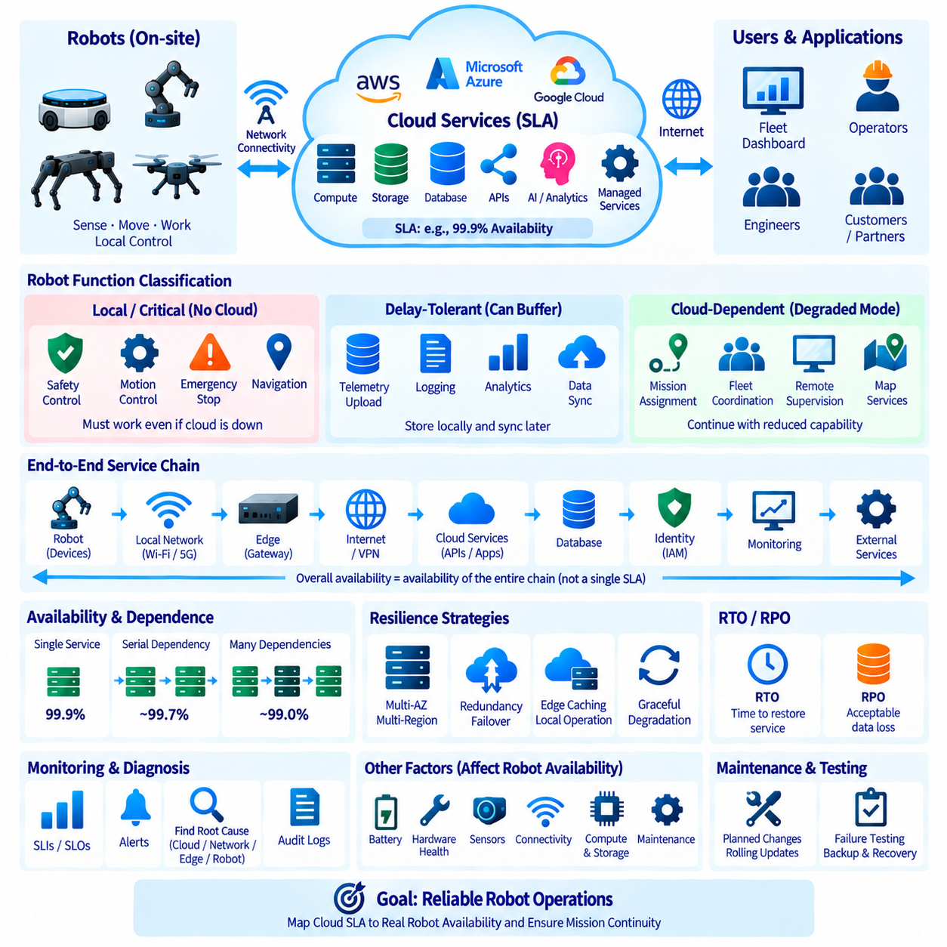
A Service Level Agreement (SLA) defines measurable commitments for the availability or performance of a cloud service over a specified period. In robotics, however, cloud SLA cannot be interpreted directly as robot availability. A robot depends on multiple layers including onboard computing, sensors, actuators, wireless networks, edge systems, cloud services, databases, APIs, and operational processes. End-to-end availability therefore requires mapping cloud commitments to the complete robotic service chain.
Cloud availability is commonly expressed as a percentage of service uptime during a measurement period. Small differences between availability percentages can represent significantly different amounts of potential downtime. Architects should therefore translate SLA values into operational meaning rather than treating percentages as abstract numbers. The relevant question is how a cloud-service interruption affects missions, fleet coordination, monitoring, updates, data access, and physical robot operation.
Robot availability describes whether a robot or robotic service can perform its required operational function when requested. This is broader than whether a cloud endpoint responds successfully. A robot may remain available for local navigation while a cloud analytics service is unavailable, or it may become operationally unavailable even when the cloud is healthy because of battery depletion, sensor failure, mechanical damage, wireless loss, or a local software fault.
The first architectural task is therefore to classify robot functions according to their dependency on cloud connectivity. Safety control, motor control, emergency stopping, immediate obstacle avoidance, and essential navigation should normally remain locally executable. These functions require deterministic or highly predictable behavior and should not become unavailable merely because a remote cloud service or wide-area network connection has failed.
Other functions can tolerate temporary cloud loss. Telemetry upload, historical logging, analytics, report generation, long-term data synchronization, and some model-management activities can often be delayed and resumed after connectivity returns. Edge buffering allows data to accumulate locally during an outage and synchronize later. Designing these functions as delay-tolerant prevents short cloud interruptions from unnecessarily stopping physical robot operations.
A third category includes cloud-dependent functions whose temporary loss can degrade fleet operation without immediately compromising local safety. Central mission assignment, cross-robot coordination, remote supervision, enterprise-system integration, or cloud-hosted map services may belong to this category depending on the architecture. Robots should have explicitly defined degraded modes that specify which missions can continue and which functions must pause when these services are unavailable.
Availability mapping connects each robotic function to the infrastructure components required to deliver it. A fleet dashboard may depend on an API gateway, application service, database, identity system, network path, and monitoring platform. Mission dispatch may additionally depend on site connectivity and edge gateways. Mapping these dependencies reveals that the availability of an end-to-end function is determined by the service chain rather than by one advertised cloud SLA.
Serial dependencies can reduce overall service availability because every required component must operate for the complete function to succeed. Even when individual services have high availability, combining many mandatory dependencies can produce lower end-to-end availability. Architects should therefore minimize unnecessary dependencies in critical paths and avoid requiring nonessential cloud services for basic robot operation.
Redundancy can improve availability when duplicate components do not share the same failure mode. Application instances may run across separate infrastructure zones, databases may use replication or failover, and multiple network paths may protect site connectivity. However, redundancy is effective only when failover mechanisms are correctly designed and tested. Two components that depend on the same network, credentials, configuration, or region may still fail together.
Availability Zones and geographic regions provide different levels of fault isolation in cloud architectures. Multi-zone deployment can protect against some localized infrastructure failures, while multi-region designs can address broader regional disruptions. Multi-region operation introduces additional complexity involving data replication, consistency, routing, identity, deployment, testing, and cost. It should therefore be applied according to recovery requirements rather than as an automatic design rule.
Robotics systems also require communication availability between the physical site and cloud infrastructure. A highly available cloud backend provides limited operational value if factory Wi-Fi, cellular connectivity, an Internet service provider, VPN gateway, or edge router fails. End-to-end availability analysis must therefore include local wireless networks, site gateways, external communication links, DNS, authentication, and other services located outside the cloud provider's direct SLA boundary.
Edge computing provides an important availability boundary between robots and cloud services. An edge server can maintain site-level mission queues, cache maps and models, buffer telemetry, provide local APIs, and coordinate robots when wide-area connectivity is unavailable. This does not eliminate cloud dependence but changes its operational impact. The system can continue essential local functions and synchronize with the cloud after connectivity is restored.
Graceful degradation is preferable to binary operation whenever safety and mission requirements allow it. Instead of treating the cloud as simply available or unavailable, a robot system can transition between normal, degraded, disconnected, recovery, and maintenance states. Each state should define permitted functions, data behavior, operator notifications, mission restrictions, and recovery conditions so that failures produce predictable operational behavior.
Recovery Time Objective (RTO) defines the targeted time within which a service should be restored after disruption, while Recovery Point Objective (RPO) defines the acceptable amount of data loss measured in time. These concepts complement availability SLAs. A fleet analytics service may tolerate a longer RTO, while mission databases or operational configuration may require faster recovery and a smaller RPO depending on their role in active robot operations.
Robot availability also depends on local reliability factors that cloud SLA cannot cover. Battery condition, charging infrastructure, wheel and actuator health, sensor contamination, compute temperature, storage failure, localization quality, and maintenance readiness can all determine whether a robot is operational. Availability mapping should therefore distinguish cloud availability, communication availability, edge availability, robot hardware availability, software availability, and mission-level availability.
Operational monitoring must observe these layers separately. A fleet platform should identify whether loss of service originates from the cloud application, database, identity service, network connection, edge gateway, robot computer, sensor subsystem, or physical mechanism. A single overall “offline” status provides insufficient diagnostic information. Layered health indicators allow operators to isolate failures and select appropriate recovery actions more rapidly.
Service Level Indicators (SLIs) provide measurable observations such as request success rate, API latency, mission-dispatch success, robot connectivity, telemetry delivery, or recovery time. Service Level Objectives (SLOs) define desired targets for those indicators, while SLAs may establish contractual commitments. Robotics teams can therefore define internal SLOs that reflect actual operational requirements even when cloud-provider SLAs use different measurements or boundaries.
Maintenance windows and planned changes must also be included in availability engineering. Software deployments, database migrations, certificate rotation, network changes, robot firmware updates, and infrastructure maintenance can interrupt services even without unexpected failures. Rolling updates, staged deployment, backward-compatible interfaces, redundant instances, and rollback procedures can reduce disruption while allowing the platform to evolve continuously.
Testing is essential because redundancy and recovery mechanisms that exist only in architecture diagrams do not guarantee actual availability. Teams should test loss of cloud connectivity, database failover, edge restart, network interruption, expired credentials, service overload, and restoration from backup. Controlled failure testing reveals hidden dependencies and verifies whether robots actually enter the intended degraded mode rather than stopping unpredictably.
Availability requirements should be assigned according to business and mission impact. A historical analytics dashboard does not necessarily require the same availability as active mission dispatch, authentication, or OTA recovery services. Higher availability generally requires additional infrastructure, engineering effort, testing, monitoring, and cost. Architecture should therefore invest in redundancy where interruption creates meaningful operational consequences rather than applying maximum availability uniformly.
Cloud SLA and robot availability mapping ultimately creates a traceable relationship between provider infrastructure and physical mission continuity. Each robot function is classified by criticality, mapped to its cloud, edge, network, and local dependencies, assigned degraded and recovery behavior, and monitored through meaningful indicators. This approach allows cloud services to enhance fleet capability without making physical robot availability unnecessarily dependent on remote infrastructure.

01.09 Cloud Migration Strategy: 6R Framework
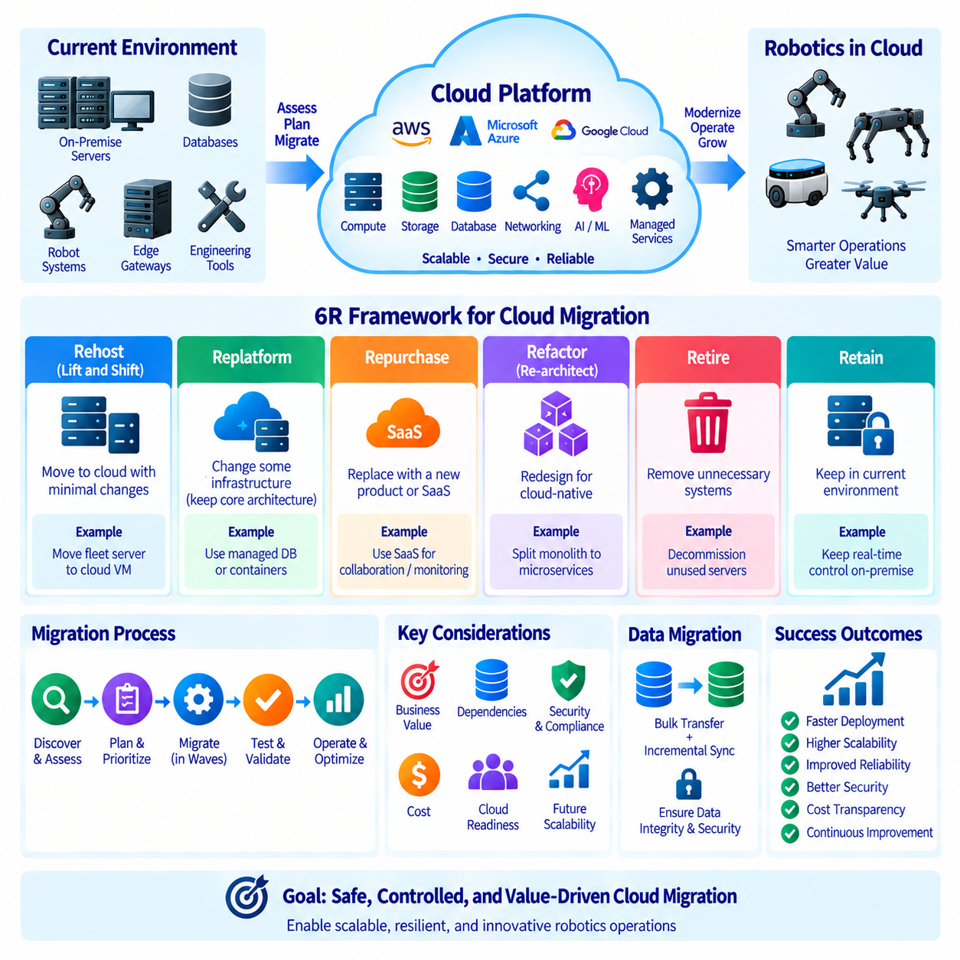
Cloud migration is the process of moving applications, data, infrastructure, and operational capabilities from existing environments into cloud-based platforms. For robotics organizations, migration can involve fleet-management servers, telemetry pipelines, databases, simulation environments, AI development systems, monitoring services, and engineering tools. Migration should therefore be treated as an architectural transformation rather than simply copying existing servers into a cloud data center.
The 6R Framework provides a structured method for deciding how individual applications and workloads should be handled during migration. Instead of applying one migration technique to every system, each workload is evaluated according to technical architecture, business value, operational risk, dependencies, cloud readiness, cost, and future requirements. The six commonly used strategies are Rehost, Replatform, Repurchase, Refactor, Retire, and Retain.
Rehost, often called lift-and-shift, moves an existing application to cloud infrastructure with minimal architectural modification. A physical or virtual server running a robotics backend application may be transferred to a cloud virtual machine while preserving most operating-system, middleware, and application configurations. This approach can reduce migration complexity and provide a relatively direct path away from existing data-center infrastructure.
Rehosting is useful when migration speed is more important than immediate architectural optimization. Legacy fleet-management services, engineering tools, internal applications, or databases may initially operate on cloud VMs with few software changes. However, simply moving an inefficient system into the cloud does not automatically make it scalable, resilient, secure, or cost-efficient. Rehosted workloads often require later optimization after operational stability has been established.
Replatform modifies selected infrastructure components while preserving the application's fundamental architecture. An organization might move an application from an on-premise server to a cloud VM while replacing a self-managed database with a managed database service, or package selected application components into containers. This approach introduces useful cloud capabilities without requiring the complete redesign associated with extensive application refactoring.
For robotics platforms, replatforming can provide a practical balance between migration effort and modernization. Fleet APIs may retain their existing logic while adopting managed load balancing, database services, object storage, monitoring, or container platforms. The application remains recognizable to the engineering team, but operational responsibilities such as database maintenance, backup, scaling, or infrastructure management can be reduced through managed cloud services.
Repurchase replaces an existing application with a different commercial product or Software as a Service (SaaS) solution. Instead of migrating the original software itself, the organization migrates users, workflows, configurations, and data to a new service. Generic business functions such as collaboration, issue tracking, customer management, monitoring, or enterprise applications may be better candidates for repurchase than specialized robot-control or autonomy software.
Repurchase can reduce responsibility for infrastructure and software maintenance, but it introduces dependency on the selected service provider. Migration planning must evaluate data portability, integration interfaces, security, subscription cost, customization limits, and vendor dependency. Robotics organizations should also determine whether the replacement service can integrate reliably with fleet platforms, engineering systems, identity services, and operational data flows.
Refactor, sometimes called re-architect, redesigns an application to take greater advantage of cloud-native architecture. A monolithic robotics backend might be decomposed into independently deployable services, event-driven processing, managed databases, message queues, containers, or serverless functions. Refactoring can improve scalability, resilience, deployment flexibility, and operational automation, but usually requires significantly more engineering effort than rehosting or replatforming.
Refactoring is most valuable when the existing architecture prevents important business or technical objectives. A fleet platform designed for dozens of robots may require redesign before supporting thousands of geographically distributed devices. Telemetry processing may move from tightly coupled application logic to asynchronous event pipelines, while model distribution and data ingestion can become independently scalable services. Migration then becomes an opportunity to remove architectural limitations.
Retire identifies applications, servers, databases, interfaces, or processes that are no longer required and removes them instead of migrating them. Legacy environments often contain duplicated tools, obsolete test systems, abandoned services, unused databases, and temporary infrastructure that continued operating long after its original purpose disappeared. Migrating these resources wastes time and reproduces unnecessary technical debt in the new cloud environment.
Retirement requires evidence that a workload is genuinely unnecessary. Dependencies should be identified before shutdown because an apparently unused service may still support another application, scheduled process, robot configuration, or reporting workflow. Usage logs, network flows, ownership records, application dependencies, and stakeholder confirmation can support retirement decisions. Data retention obligations should also be addressed before systems are permanently removed.
Retain means deliberately leaving a workload in its current environment for the time being. Some systems may depend on specialized hardware, local devices, deterministic networks, licensing constraints, regulatory requirements, or interfaces that make immediate cloud migration inappropriate. In robotics, real-time control systems, hardware-in-the-loop environments, factory interfaces, large local datasets, or specialized engineering equipment may remain on-premise or at the edge.
Retention should be a conscious architectural decision rather than migration avoidance. The organization should document why the workload remains local, which dependencies require retention, how it interacts with migrated cloud services, and when the decision should be reviewed again. Hybrid architecture is often a natural result, with real-time and hardware-dependent workloads remaining local while fleet coordination, analytics, storage, AI pipelines, and management services move toward the cloud.
Selecting a migration strategy requires workload discovery before execution. Teams should inventory applications, servers, databases, interfaces, data stores, network connections, users, owners, security requirements, and operational dependencies. Robotics systems additionally require mapping relationships among robots, edge gateways, fleet services, maps, OTA systems, telemetry pipelines, AI models, and external enterprise systems because migration of one component can affect physical operations elsewhere.
Dependency mapping is especially important because applications rarely operate independently. A fleet service may depend on authentication, databases, message brokers, object storage, DNS, certificates, monitoring, and external APIs. Moving only part of this chain can create latency, connectivity, security, or availability problems. Migration waves should therefore group strongly connected workloads when appropriate and explicitly manage interfaces that cross cloud, edge, and on-premise boundaries.
Data migration requires its own strategy because application migration and data movement do not necessarily occur at the same speed. Large robotics datasets containing images, video, LiDAR, maps, logs, and AI training records may require substantial transfer time. Initial bulk transfer can be followed by incremental synchronization until cutover. Data integrity, encryption, bandwidth, transfer cost, retention, backup, and rollback requirements should be defined before migration begins.
Migration should normally progress through controlled waves rather than moving the entire environment simultaneously. Lower-risk workloads can validate networking, identity, monitoring, security, backup, and operational procedures before mission-critical systems are transferred. Each wave provides evidence that can improve later migration decisions. Robotics deployments should also coordinate cloud changes with robot software versions, edge configurations, site connectivity, and operational schedules.
Testing must verify more than whether an application starts successfully in the cloud. Performance, latency, data integrity, security, failover, monitoring, backup recovery, cost behavior, and integration with robots and edge systems should be validated. A migrated fleet service may appear healthy from the cloud perspective while introducing unacceptable communication delays or failure behavior at physical sites, making end-to-end operational testing essential.
Rollback planning reduces risk during cutover. Teams should define conditions that trigger rollback, preserve required source environments until validation is complete, maintain recoverable data states, and document procedures for restoring previous service paths. For robotics systems, rollback may also require compatibility with deployed robot software and edge components because cloud and field versions can evolve at different rates during migration.
Migration success should be measured against intended outcomes rather than the number of servers moved. Relevant results may include improved deployment speed, scalability, resilience, security, observability, recovery capability, engineering productivity, or cost transparency. After migration, workloads should be reviewed because a rehosted application may later become a replatform or refactor candidate as operational knowledge and cloud maturity increase.
The 6R Framework ultimately provides a decision structure for transforming a mixed robotics infrastructure without assuming that everything belongs in the cloud. Rehost moves with minimal change, Replatform introduces selective modernization, Repurchase replaces applications, Refactor redesigns them, Retire removes unnecessary systems, and Retain preserves workloads where they currently fit best. Applying these choices workload by workload enables controlled migration while preserving robot safety, operational continuity, and long-term architectural flexibility.

01.10 Robot System Cloud Architecture Design Principles
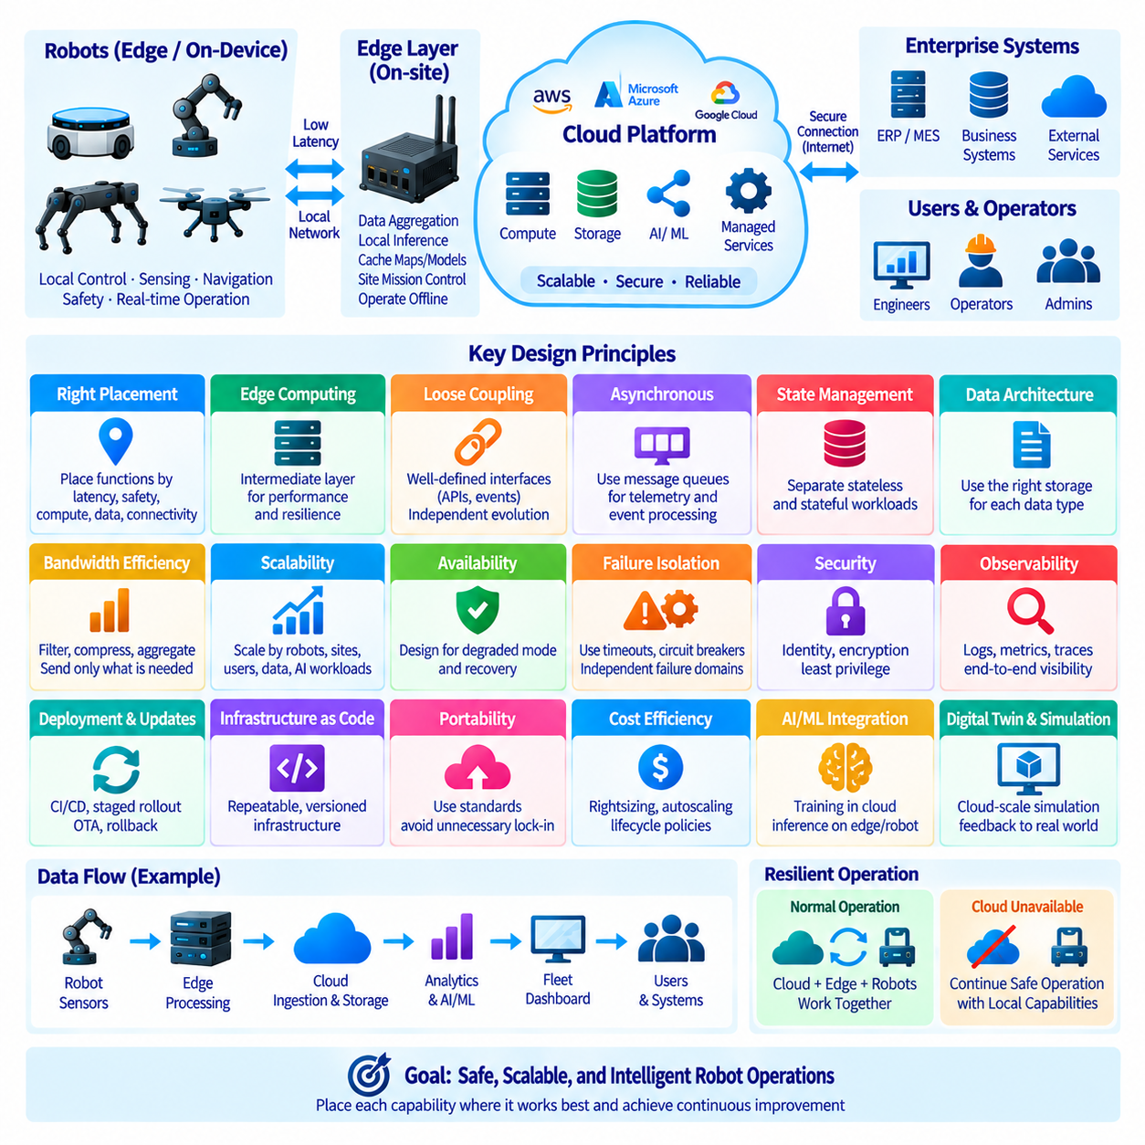
Robot system cloud architecture should be designed as a distributed computing system rather than as a conventional application hosted remotely. Physical robots, onboard computers, edge servers, communication networks, cloud platforms, enterprise systems, and human operators participate in one operational environment. The architecture must determine where each function executes, how components communicate, and how the system behaves when individual layers become unavailable.
The first design principle is to separate functions according to latency, safety, computational demand, data volume, and connectivity requirements. Motor control, emergency response, collision avoidance, and other time-critical functions should remain on the robot or nearby deterministic infrastructure. Cloud services are better suited to fleet coordination, long-term analytics, large-scale storage, model management, simulation, and computationally intensive processing that does not require immediate physical response.
Edge computing provides an intermediate layer between robots and centralized cloud services. Edge systems can aggregate telemetry, cache maps and models, perform local inference, manage site-level missions, and maintain temporary operation when Internet connectivity is unavailable. This reduces communication latency and bandwidth consumption while preventing every robot function from becoming directly dependent on remote infrastructure. The edge therefore acts as both a computing layer and an operational resilience boundary.
Loose coupling should be preferred between major system components. Robot applications, fleet services, analytics pipelines, AI services, databases, and enterprise integrations should communicate through clearly defined interfaces rather than hidden internal dependencies. APIs, message brokers, and event-driven mechanisms allow components to evolve independently. Loose coupling also limits the propagation of failures and makes individual services easier to replace, scale, test, or migrate.
Asynchronous communication is particularly useful for telemetry and event processing. Robots can publish status, sensor summaries, alarms, mission events, and diagnostic information without waiting for every downstream consumer to complete processing. Message queues or event streams can absorb temporary differences in processing speed and support multiple consumers. Synchronous communication should be reserved for interactions that genuinely require an immediate request and response.
The architecture should distinguish stateful and stateless workloads. Stateless application services can generally be replicated and scaled more easily because processing instances do not permanently own critical operational state. Persistent information such as robot identity, mission history, maps, configurations, user data, and fleet state requires carefully selected databases or storage services. Explicit state management improves scalability, failover behavior, backup, and recovery.
Data architecture should reflect the different characteristics of robotics information. High-frequency sensor streams, telemetry, images, video, LiDAR, maps, logs, AI datasets, and operational records have different requirements for latency, capacity, retention, and query patterns. A single storage technology is rarely optimal for every data type. Object storage, relational databases, time-series systems, caches, and local edge storage can be combined according to workload characteristics.
Bandwidth should be treated as an architectural resource rather than an unlimited connection. Continuously transferring raw camera or LiDAR data from every robot to the cloud can create substantial network and storage demands. Edge filtering, compression, sampling, aggregation, event-triggered recording, and selective upload can reduce unnecessary transfer. The cloud should receive the information required for its role rather than automatically receiving every byte produced by every sensor.
Scalability should be designed around the growth dimensions of the robotic system. Growth may occur through additional robots, sites, users, telemetry volume, AI workloads, stored data, or external integrations. Services should scale independently where possible so that increasing sensor ingestion does not require proportional expansion of unrelated management functions. Containers, autoscaling, queues, partitioning, caching, and managed services can support this separation.
Availability must be considered from the robot mission perspective rather than only from the cloud infrastructure perspective. A highly available cloud service does not guarantee an available robot if site connectivity, edge infrastructure, batteries, sensors, or local software fail. Critical functions should therefore have clearly defined local behavior, degraded modes, buffering strategies, retry mechanisms, and recovery procedures when cloud or network services become unavailable.
Failure isolation prevents a problem in one component from disabling the entire robotic system. Services should use bounded retries, timeouts, circuit-breaking behavior, queues, resource limits, and independent failure domains where appropriate. A malfunctioning analytics service should not stop navigation, and failure of one robot should not overload the complete fleet platform. Architecture should assume that components will eventually fail and define predictable responses in advance.
Security must be embedded throughout the architecture. Human users, applications, robots, and edge devices require explicit identities and appropriately limited permissions. Communication should be authenticated and encrypted, sensitive data protected at rest, secrets centrally managed, and network paths segmented. Secure boot, trusted software delivery, signed updates, logging, and audit mechanisms can extend the security model from cloud infrastructure to deployed physical machines.
Observability should be designed together with application architecture rather than added after deployment. Logs, metrics, traces, events, robot health, network status, resource utilization, and mission outcomes provide different views of system behavior. Correlation identifiers and synchronized timestamps help connect cloud events with edge and robot activity. Effective observability allows operators to determine not only that a failure occurred but where and why it occurred.
Deployment architecture should support controlled software evolution. Cloud applications, edge software, robot firmware, AI models, maps, and configuration files may change at different rates. Versioned interfaces and backward compatibility reduce conflicts between these layers. CI/CD pipelines, staged rollout, canary deployment, OTA mechanisms, health verification, and rollback procedures allow updates to be introduced gradually instead of changing an entire fleet simultaneously.
Infrastructure as Code (IaC) improves repeatability by expressing cloud networks, compute resources, permissions, databases, monitoring, and other infrastructure through version-controlled definitions. Development, testing, staging, and production environments can then be created from consistent configurations. Automated deployment and policy validation reduce manual configuration differences and provide an auditable history of infrastructure changes.
Cloud architecture should avoid unnecessary dependence on a single implementation when portability has meaningful value. Standard containers, documented APIs, portable data formats, and separated application logic can reduce migration difficulty. However, complete provider independence may increase complexity and prevent effective use of managed services. Portability should therefore be balanced against operational simplicity, performance, cost, and the strategic value of cloud-native capabilities.
Cost efficiency should be incorporated into architecture decisions from the beginning. Compute instances, GPUs, storage capacity, database requests, data transfer, logging, and managed services all contribute to operating cost. Rightsizing, autoscaling, storage lifecycle policies, scheduled shutdown, shared simulation infrastructure, and edge data reduction can improve efficiency. Cost should be monitored as an architectural signal alongside performance, reliability, and security.
AI workloads require particular attention because training and inference have different infrastructure characteristics. Large-scale training may use cloud GPU clusters and centralized datasets, while latency-sensitive inference may execute on robots or edge accelerators. Model registries, version management, evaluation pipelines, deployment controls, and telemetry feedback can connect these environments. The architecture should support a continuous path from data collection to training, validation, deployment, and monitoring.
Digital twins and simulation can be integrated as cloud-scale engineering capabilities rather than isolated development tools. Simulation environments can reproduce robot behavior, maps, traffic, sensors, and operational scenarios without occupying physical equipment. Scalable cloud compute can execute many experiments in parallel, while collected field data can improve scenarios and models. This creates a feedback loop between physical operation, simulation, AI development, and deployment.
Enterprise integration should remain separated from real-time robot control. Manufacturing systems, warehouse systems, ERP, MES, customer applications, and business analytics may exchange missions, inventory information, schedules, or operational results with the fleet platform. Well-defined integration APIs and event interfaces prevent external enterprise systems from becoming tightly coupled to robot control logic and allow both sides to evolve independently.
Architecture decisions should be documented together with assumptions, constraints, dependencies, and trade-offs. Choices involving cloud versus edge execution, database technologies, communication patterns, redundancy, security, or managed services rarely have universally correct answers. Recording the reasons behind important decisions helps future engineers understand the intended system behavior and prevents accidental removal of architectural safeguards during later development.
A well-designed robot cloud architecture ultimately combines robot autonomy, edge resilience, cloud scalability, secure communication, structured data management, observability, automation, and controlled integration. The objective is not to move every function into the cloud, but to place each capability where it can operate most effectively. This distributed design allows robots to remain safe and operational locally while using cloud resources to achieve fleet-scale intelligence, coordination, learning, and continuous improvement.

