Volume 09 Cloud and Edge Robotics

12. Cloud Case Studies

12.01 Indoor AMR: AWS IoT Core / Greengrass Operation Case
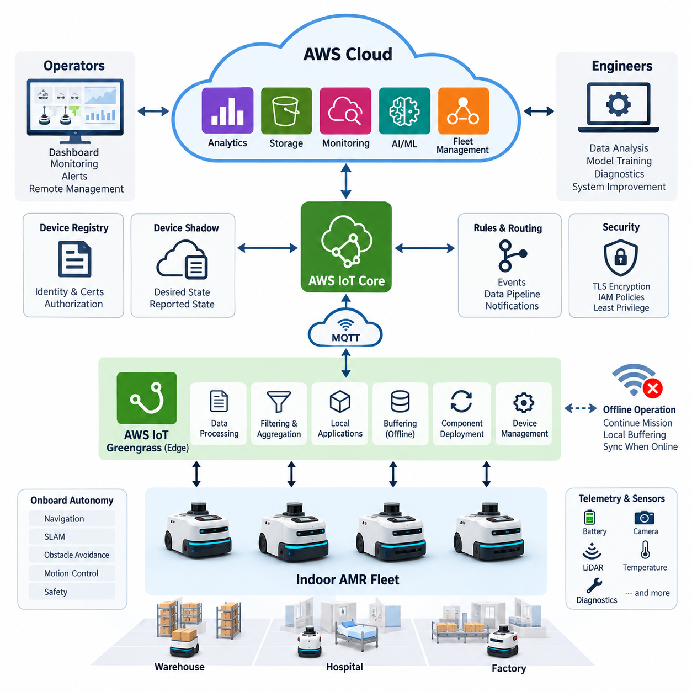
An indoor autonomous mobile robot fleet operating in warehouses, hospitals, or production facilities requires a cloud architecture that supports centralized visibility without making robot autonomy dependent on continuous network connectivity. In an AWS-based deployment, each AMR performs navigation, obstacle avoidance, localization, motion control, and safety processing locally, while AWS services provide fleet-level communication, monitoring, configuration, data collection, and lifecycle management. This separation preserves real-time behavior at the edge while enabling scalable fleet operations.
AWS IoT Core can serve as the primary communication layer between indoor AMRs and cloud applications. Each robot is registered as an individual IoT device with its own identity and credentials, allowing MQTT-based telemetry and command exchange through authenticated connections. Robot state such as operating mode, position, battery level, mission progress, fault codes, temperature, and connectivity status can be published through structured topics. Cloud applications subscribe only to the information required for monitoring, analytics, or fleet coordination.
AWS IoT Greengrass extends this architecture from the cloud into the robot or a nearby industrial edge computer. The Greengrass runtime hosts locally deployed software components that can process telemetry, perform filtering, execute application logic, manage communication, and interact with robot software without requiring every transaction to cross the Internet. This creates a practical edge execution layer between the AMR control stack and AWS cloud services, matching the broader edge and hybrid-cloud organization defined for this volume.
The operational boundary between local and cloud functions is especially important for indoor AMRs. Localization, SLAM, collision avoidance, emergency behavior, trajectory generation, and low-level control remain inside the robot because their latency and availability requirements cannot safely depend on remote infrastructure. Greengrass can handle less time-critical local services such as telemetry preprocessing, event classification, local buffering, configuration synchronization, and communication adapters, while IoT Core becomes the controlled interface to fleet-level cloud applications.
During normal operation, raw robot information is first generated by navigation, perception, battery management, motor controllers, and application software. Instead of transmitting every message directly to the cloud, a Greengrass component can transform high-frequency internal data into operational events and summarized telemetry. For example, localization data may be reduced to periodic fleet-position updates, while abnormal localization loss can immediately generate a higher-priority event. This approach decreases bandwidth consumption and prevents the cloud backend from being overwhelmed by unnecessary robot-level data.
The MQTT topic hierarchy should represent both fleet structure and operational purpose. A deployment may separate telemetry, status, events, commands, configuration, and diagnostics while also identifying a site, fleet, and robot. This allows cloud-side authorization policies and processing rules to distinguish routine battery reports from fault notifications or remote operational commands. Carefully designed topic structures also make it easier to add robots or facilities without redesigning the entire communication interface as the fleet grows.
Device Shadow functionality can represent selected desired and reported states independently of temporary connectivity loss. A cloud application may define a desired configuration, while the robot reports the configuration actually applied after reconnecting and validating the change. This mechanism is useful for parameters such as reporting intervals, application modes, feature flags, or non-safety operational settings. Safety-critical motion commands should remain outside this asynchronous pattern because delayed execution after reconnection could create undesirable robot behavior.
Network interruption must be treated as a normal operating condition rather than an exceptional cloud failure. When Wi-Fi connectivity disappears, the AMR continues its locally authorized mission according to its onboard autonomy and site safety rules. Greengrass components can buffer appropriate telemetry and events locally, maintain local application functions, and resume cloud synchronization when connectivity returns. The architecture therefore follows an offline-tolerant operating principle in which loss of cloud access reduces centralized visibility but does not automatically eliminate basic autonomous capability.
Fleet monitoring becomes more useful when telemetry is converted into operational information rather than stored as an uncontrolled stream. IoT Core rules or downstream AWS processing services can route selected messages toward monitoring, storage, analytics, or alerting pipelines. Routine status information may support dashboards and historical analysis, while critical events such as repeated localization failures, abnormal battery behavior, component faults, or unexpected mission termination can trigger faster notification paths. The resulting cloud layer becomes an operational observability system rather than a remote robot controller.
Greengrass components also provide a controlled mechanism for deploying and updating edge applications across multiple robots. A component can package telemetry adapters, diagnostic collectors, preprocessing logic, protocol gateways, or other supporting software together with version information and dependencies. Deployment can then target selected robot groups instead of requiring technicians to manually modify every AMR. Production operation should still use staged deployment policies so that new components are validated on a small subset of robots before wider fleet distribution.
Security begins with assigning a unique identity to every robot rather than sharing credentials across the fleet. Certificate-based authentication, restrictive IoT policies, encrypted communication, and controlled cloud permissions reduce the consequences of a compromised device. The robot should receive only the permissions required for its designated topics and services. Edge components should likewise operate with limited privileges, and sensitive credentials should not be embedded directly in application code or container images that may be copied between systems.
An indoor AMR deployment also benefits from separating operational telemetry from large sensor datasets. Continuous camera, LiDAR, depth, or diagnostic recordings can generate far more data than routine fleet monitoring requires. The robot or edge layer should therefore determine which information is summarized, retained locally, uploaded after an event, or transferred to cloud storage for engineering analysis. Event-driven collection is particularly useful because detailed sensor windows surrounding navigation failures can be preserved without continuously uploading the complete perception stream.
Consider a warehouse operating dozens of AMRs across several zones. Each robot independently performs navigation and obstacle avoidance, while Greengrass collects application status and converts internal robot messages into standardized fleet telemetry. IoT Core receives authenticated MQTT messages and distributes them to cloud-side monitoring and data services. Operators observe battery state, robot availability, mission progress, faults, and communication health from a centralized interface without inserting the cloud into the real-time motion-control loop.
If one robot begins reporting repeated localization degradation, its edge software can classify the condition and publish a diagnostic event containing the robot identifier, timestamp, map context, software version, and relevant health indicators. The cloud backend records the event and can associate it with similar failures from other robots. Engineers can then distinguish an isolated hardware problem from a site-wide map or environmental issue. Cloud connectivity adds fleet-wide correlation and historical visibility while the immediate safety response remains local to the AMR.
The same architecture can support operational scaling from a pilot fleet to multiple facilities. Site and fleet identifiers can partition communication, Greengrass deployments can target defined device groups, and cloud-side services can aggregate information at robot, zone, facility, or enterprise level. The architecture therefore scales logically before it scales computationally: consistent identities, message schemas, deployment groups, observability rules, and security policies become the foundation for adding hundreds or thousands of devices without creating individually managed robot-cloud integrations.
Operational reliability should be measured across both edge and cloud layers. Useful indicators include robot-to-cloud connection availability, message delivery failures, local queue growth, telemetry latency, Greengrass component health, deployment success rate, certificate status, and the time required to restore synchronization after an outage. These measurements reveal whether a problem originates in robot software, the wireless network, the edge runtime, authentication, message routing, or downstream cloud processing, reducing diagnostic ambiguity during fleet operation.
Cost control is closely related to data architecture. Publishing excessive high-frequency telemetry increases messaging, processing, storage, and analytics workloads while often providing little additional operational value. Edge aggregation should therefore reduce repetitive information and preserve detailed data primarily when engineering or incident analysis requires it. Reporting frequencies can also vary by robot state: an active AMR may publish more frequently, while an idle or charging robot can use lower-rate reporting unless an abnormal condition occurs.
A mature deployment treats AWS IoT Core and Greengrass as complementary layers rather than replacements for robot autonomy. IoT Core provides secure cloud connectivity and fleet-scale messaging, while Greengrass places manageable application logic near the physical system. The AMR itself retains deterministic navigation and safety responsibilities. This three-level separation—robot control, edge operation, and cloud fleet services—creates a resilient architecture in which each computational layer performs work appropriate to its latency, availability, bandwidth, and management characteristics.
The central lesson from this operating case is that successful cloud robotics does not mean moving the robot controller into the cloud. It means creating a disciplined distribution of responsibilities across autonomous robots, local edge software, and scalable cloud services. For indoor AMRs, AWS IoT Core and Greengrass can provide secure connectivity, edge processing, fleet observability, remote component management, and data integration while preserving local operation during network disruption. This architecture forms a practical foundation for progressively larger and more intelligent robot fleets.

12.02 Outdoor AMR: Azure IoT Edge Deployment Case
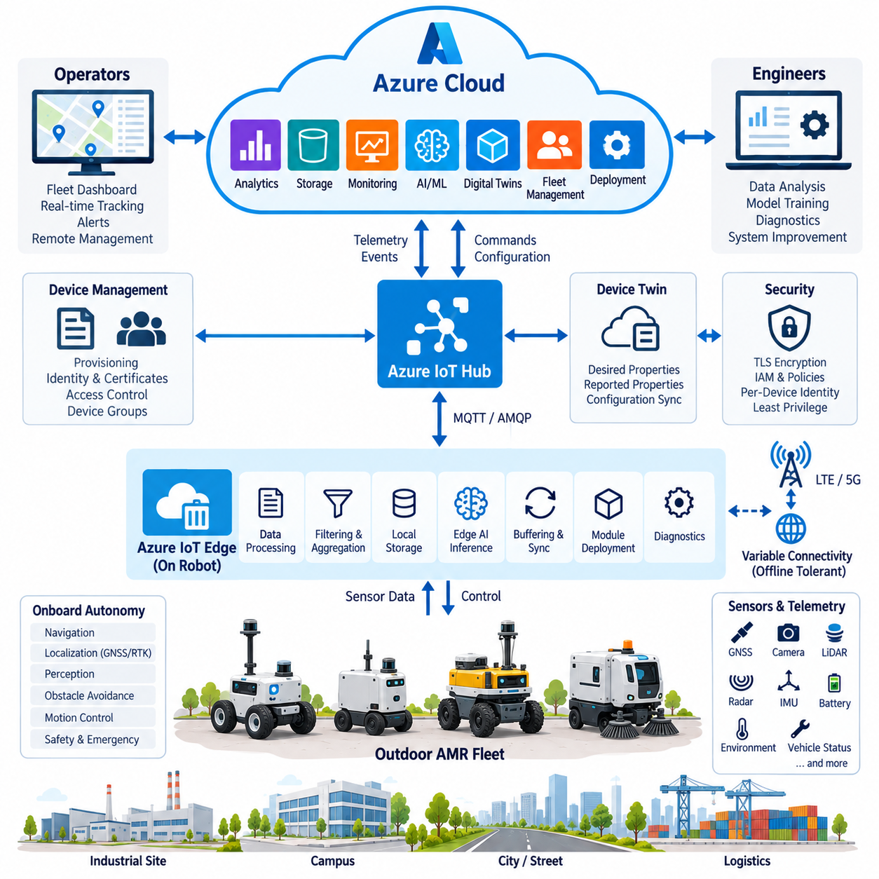
Outdoor autonomous mobile robots operate under conditions that are substantially less predictable than indoor AMRs. Uneven terrain, changing illumination, weather, GNSS availability, pedestrians, vehicles, and variable cellular connectivity make continuous cloud dependence impractical. An Azure-based outdoor AMR architecture therefore separates safety-critical autonomy from cloud services. Navigation, perception, obstacle avoidance, localization, motion control, and emergency responses remain onboard, while Azure provides fleet connectivity, monitoring, data management, deployment, and large-scale operational intelligence.
Azure IoT Hub can provide the primary cloud communication interface for an outdoor AMR fleet. Each robot receives an individual device identity and authenticated connection, allowing telemetry, events, configuration information, and cloud-to-device messages to be exchanged through controlled channels. Typical telemetry includes GNSS position, velocity, mission state, battery state of charge, localization quality, network status, sensor health, fault codes, and environmental information. Device-specific identities allow access policies and operational histories to remain separated even when hundreds of robots share the same backend.
Azure IoT Edge extends cloud-managed functionality onto the computing platform installed inside the robot. Edge modules can execute containerized applications for telemetry processing, protocol conversion, event detection, local storage, diagnostics, and selected AI inference. These modules operate alongside the robot autonomy stack without replacing its real-time control functions. The result is a layered architecture in which the vehicle control system manages physical behavior, IoT Edge provides manageable edge services, and Azure cloud resources provide fleet-scale coordination, storage, analytics, and lifecycle management.
Outdoor operation requires a strict boundary between functions that may depend on the network and functions that must remain available independently. Steering, braking, obstacle avoidance, trajectory tracking, emergency stopping, and immediate perception decisions cannot wait for cloud responses. These functions remain within onboard control and perception systems. Cloud services instead handle activities such as fleet monitoring, mission distribution, historical analysis, configuration management, software deployment, reporting, and long-term optimization where additional communication latency does not directly compromise vehicle safety.
Connectivity changes continuously as an outdoor AMR moves between buildings, streets, industrial facilities, tunnels, vegetation, and other radio environments. LTE or 5G service may temporarily degrade or disappear, so the robot must operate according to an offline-first principle. IoT Edge modules can retain important telemetry and events in local storage while communication is unavailable. When connectivity returns, buffered information can be synchronized with the cloud according to priority and retention policies rather than forcing the robot to stop simply because Azure services cannot temporarily be reached.
Data prioritization becomes essential when network bandwidth is variable. Low-volume operational information such as position, battery level, mission state, safety events, and fault notifications may receive higher transmission priority than large camera or LiDAR datasets. High-bandwidth sensor recordings can remain onboard until a suitable connection becomes available or can be uploaded only when an engineering event requires investigation. Edge preprocessing therefore converts continuous sensor streams into compact operational information while preserving selected raw data for diagnostics, AI development, or incident reconstruction.
An outdoor robot commonly combines GNSS RTK, IMU, LiDAR, cameras, radar, ultrasonic sensors, and vehicle-state information. These sensors produce data at different frequencies and volumes, and transmitting every measurement to Azure would be inefficient. Edge applications can aggregate localization confidence, obstacle statistics, environmental observations, and sensor-health indicators into structured telemetry. Significant conditions such as GNSS degradation, repeated localization resets, unexpected obstacles, excessive motor temperature, or emergency stops can immediately generate event messages with higher operational importance.
Device twins provide a cloud-side representation of selected robot properties and desired configuration states. Operators can use these representations to manage non-real-time parameters such as telemetry intervals, diagnostic modes, feature activation, or application configuration. The robot validates and applies appropriate changes before reporting the resulting state. Commands whose delayed execution could affect physical safety should not be modeled as ordinary asynchronous configuration updates. Outdoor robotics requires clear separation between configuration synchronization and immediate vehicle control.
IoT Edge modules also support controlled software distribution across geographically dispersed robots. Diagnostic collectors, telemetry adapters, data filters, AI inference services, or communication gateways can be packaged as independently managed modules. A deployment can target a test group before reaching a wider production fleet, reducing the risk of simultaneously introducing a defect across all robots. Version information and deployment status should remain visible to fleet operators so that software state can be correlated with field failures and performance changes.
Security is particularly important because outdoor robots communicate through networks that are less physically controlled than factory networks. Every robot should use a unique identity and authenticated communication rather than fleet-wide shared credentials. Transport encryption, restricted access policies, secure credential storage, controlled module permissions, and auditable cloud access reduce exposure. Compromise of one robot should not automatically provide access to other robots, fleet administration functions, or unrelated cloud resources. Security architecture therefore follows the same device-level isolation principle as operational architecture.
Consider an outdoor patrol AMR operating across a large industrial campus. The robot performs localization, path planning, pedestrian detection, obstacle avoidance, and vehicle control locally. IoT Edge processes operational telemetry and publishes selected information through IoT Hub. Fleet services receive position, battery state, mission progress, network quality, and diagnostic events, allowing operators to supervise the robot remotely. Large sensor recordings remain local unless an event, scheduled upload, or engineering request requires their transfer.
Suppose the robot enters an area where cellular communication becomes unavailable. Its onboard autonomy continues operating according to the current mission and safety policy, while edge services buffer cloud-bound telemetry. If operational rules permit autonomous continuation, the robot proceeds without waiting for cloud connectivity. If a mission requires remote authorization beyond a defined boundary, the robot can instead transition to a predefined safe state. The correct response to disconnection is therefore determined by mission policy and local safety logic rather than by the availability of the cloud itself.
When communication is restored, synchronization should not simply upload all accumulated information simultaneously. Critical events, fault records, and mission summaries can be transmitted first, followed by routine telemetry and selected diagnostic data. Large sensor files can be deferred until bandwidth conditions are suitable. This priority-based recovery prevents reconnection from creating a sudden bandwidth spike and enables operators to receive the most important operational information first. Edge buffering thus becomes part of both resilience and network-resource management.
Cloud-side monitoring can correlate information across many outdoor robots and operating sites. Repeated GNSS degradation in the same geographic area may indicate an environmental problem rather than a robot-specific fault. Similar thermal warnings across vehicles may reveal workload, weather, or hardware issues. Centralized historical data allows engineers to compare robot versions, operating environments, mission types, and failure patterns. Azure therefore adds value primarily through fleet-wide visibility and analysis that cannot be obtained from an isolated robot.
Fleet scalability depends on standardized identities, message schemas, module versions, deployment groups, and operational policies. A pilot system containing several outdoor AMRs may be manageable through manual procedures, but larger deployments require automated provisioning and configuration. Robots can be grouped by site, hardware generation, software release, application type, or operational role. Cloud and edge management can then target these logical groups while preserving device-level traceability, allowing the architecture to expand without treating every robot as a unique integration project.
Operational observability should cover the entire path from robot to cloud. Important measurements include cellular connection quality, message latency, synchronization backlog, local storage utilization, IoT Edge module health, device authentication status, software deployment results, GNSS quality, mission completion, and fault frequency. Combining communication and robot-health information makes it possible to distinguish network problems from autonomy failures. This distinction is essential in outdoor deployments where temporary communication degradation may be expected even while the robot itself remains fully functional.
Cloud cost and network cost can be controlled by determining which information genuinely requires centralized processing. High-frequency raw sensor streams are normally poor candidates for continuous cloud transmission, while summarized health metrics and operational events provide substantial value at much lower bandwidth. Edge filtering, adaptive telemetry rates, event-triggered recording, compression, and delayed bulk upload can reduce both communication and storage requirements. The robot can publish more information during abnormal operation while using reduced reporting rates during stable or idle periods.
The practical deployment model is therefore a three-layer system consisting of autonomous vehicle functions, Azure IoT Edge services, and Azure cloud services. The onboard autonomy layer controls the physical robot and maintains immediate safety. The edge layer processes data, buffers communication, runs manageable applications, and isolates robot software from cloud-specific interfaces. The cloud layer manages fleet visibility, historical data, deployment, analytics, and enterprise integration. Each layer assumes responsibility according to its latency, bandwidth, availability, and safety requirements.
This outdoor AMR case demonstrates that cloud-edge robotics should be designed around graceful degradation rather than permanent connectivity. Azure IoT Hub and IoT Edge can provide secure communication, remote management, telemetry processing, software deployment, and fleet-scale data integration while the robot preserves local autonomy during network disruption. By combining onboard intelligence with edge resilience and centralized cloud visibility, the architecture can support outdoor fleets that remain operational under changing network and environmental conditions while still benefiting from scalable cloud management.

12.03 Manipulator Fleet: On-Premise / Cloud Hybrid Case
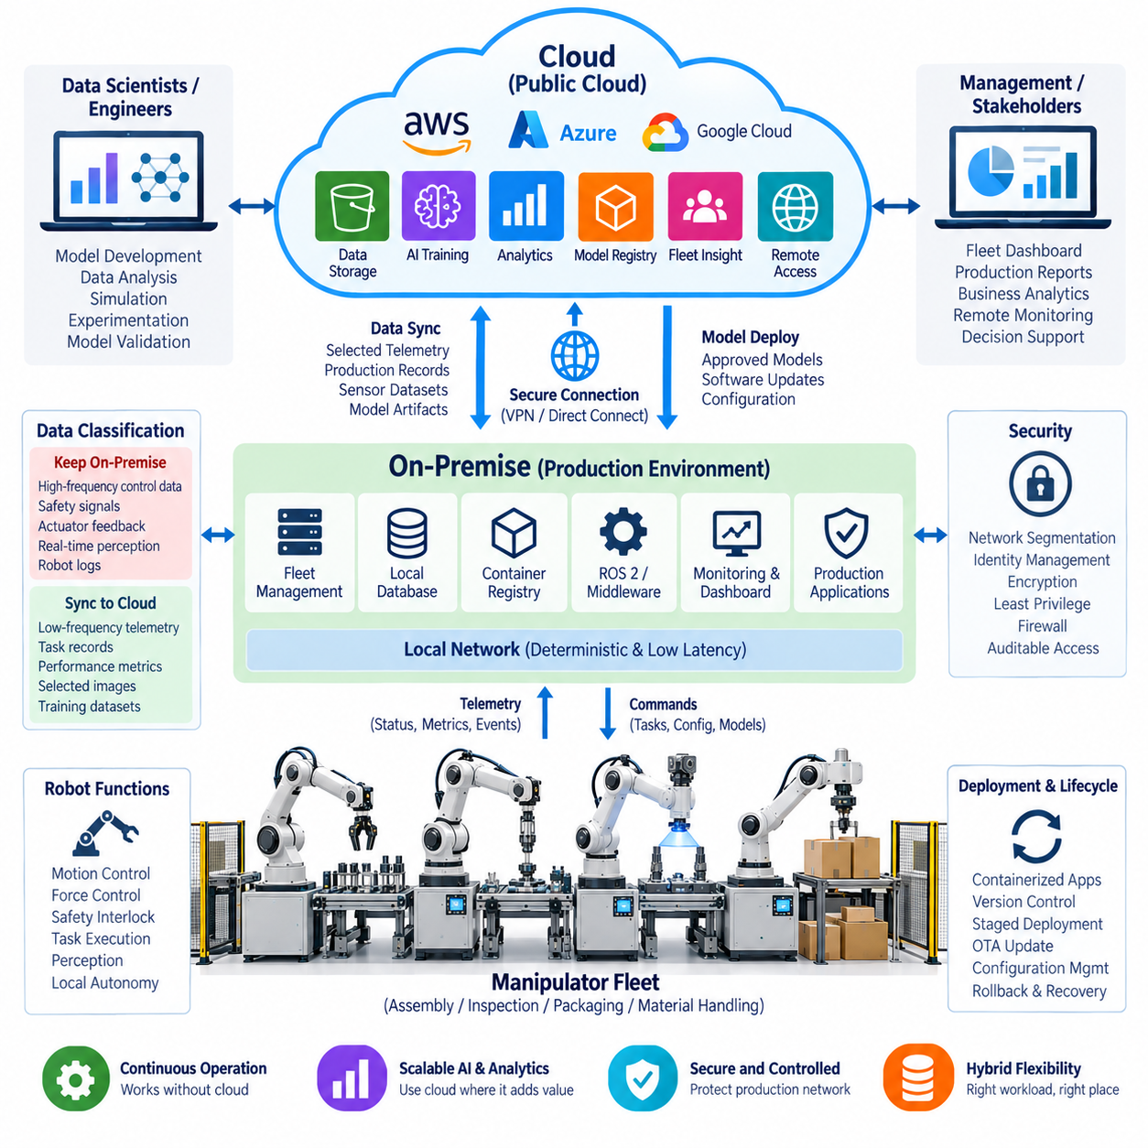
A manipulator fleet used in manufacturing or laboratory environments often requires a different cloud strategy from mobile robots because robot motion, force control, safety interlocks, and production processes can be highly sensitive to latency and network availability. A practical hybrid architecture therefore keeps real-time manipulation and safety functions on an on-premise infrastructure while using cloud resources for selected workloads such as long-term data analysis, model development, fleet-level reporting, and scalable storage. This approach combines local determinism with cloud scalability.
The on-premise environment can provide the primary operational platform for the manipulator fleet. Robot controllers, ROS 2 services, perception pipelines, motion planning, force-control interfaces, and production applications can operate within a controlled local network. Local servers can host databases, container registries, monitoring services, and selected AI workloads. Because these resources remain physically close to the robots, production operations can continue even when the external cloud connection is unavailable. The on-premise layer therefore becomes the operational core of the hybrid system.
Cloud resources are used for workloads that benefit from elastic computing and centralized accessibility. Historical robot telemetry, production records, selected sensor datasets, experiment results, and model-training data can be transferred from the on-premise environment to cloud storage. Cloud GPU resources can then be used for computationally intensive AI training or large-scale experimentation when local GPU capacity is insufficient. The hybrid design avoids forcing every workload into either the local infrastructure or the cloud and instead assigns each workload according to its technical requirements.
The first architectural decision is data classification. High-frequency control data, safety signals, actuator feedback, and short-latency perception information should normally remain inside the local environment. These data streams may be generated at rates that make continuous cloud transmission inefficient or unnecessary. In contrast, lower-frequency telemetry, completed task records, summarized performance metrics, selected images, and training datasets can be synchronized to cloud storage. This classification reduces network traffic while preserving the information required for analysis and AI development.
A fleet management layer can connect individual manipulators with the on-premise infrastructure. Each robot can publish standardized information such as robot state, joint status, controller health, task progress, cycle time, fault codes, and production statistics. Local services can aggregate these messages and provide dashboards for operators and engineers. The same information can be selectively forwarded to the cloud for long-term analysis. This creates a consistent operational data model without requiring every robot to communicate independently with external cloud services.
Containerization is useful for maintaining consistency across the manipulator fleet. Robot applications, perception services, diagnostics, data collectors, and supporting middleware can be packaged as versioned containers and deployed through an on-premise container registry. This allows software versions to be associated with individual robots or robot groups. When a production problem appears, engineers can compare software versions, configuration states, and operational history. Cloud-based development environments can subsequently use synchronized data to reproduce or investigate the problem without directly interfering with the production robots.
The hybrid architecture also supports a controlled AI development cycle. Manipulators generate operational data during production, and selected datasets can be transferred to cloud or dedicated training infrastructure. Engineers can use these datasets to train perception, grasping, anomaly-detection, or predictive-maintenance models. After validation, the resulting model can be packaged and returned to the on-premise environment for controlled deployment. This creates a closed loop in which production data supports model improvement while production inference remains close to the physical robot.
Network disconnection should be considered part of the normal operating model rather than an exceptional failure. If the external cloud becomes unavailable, the on-premise robot environment should continue providing the services required for production. Local databases can temporarily retain telemetry, while synchronization services maintain a queue of information waiting for cloud transmission. When connectivity is restored, the synchronization process can resume according to priority. Critical production records and fault events should normally be synchronized before large historical datasets.
Security requires a clear boundary between the production network and external cloud services. Robots should not receive unrestricted access to cloud resources, and cloud applications should not directly access safety-critical robot interfaces without controlled authorization. Firewalls, identity management, encrypted communication, network segmentation, least-privilege permissions, and auditable access policies can reduce the attack surface. The hybrid architecture should allow useful data to cross the boundary while preventing unnecessary exposure of the robot-control environment.
A representative deployment may contain multiple manipulators performing assembly, inspection, packaging, or material-handling operations. Each robot executes its motion and task logic locally while an on-premise fleet service collects operational information. Engineers can monitor cycle time, task completion, faults, and equipment health from a local dashboard. At scheduled intervals, selected information is transferred to cloud storage for historical analysis. If a particular task begins producing abnormal results, the system can preserve relevant sensor and execution data for later investigation.
Cloud and on-premise computing can also be divided according to computational scale. Routine inference and production workloads can run on local GPU or CPU resources where predictable latency is required. Large model training, hyperparameter experimentation, dataset processing, or temporary computational workloads can be moved to elastic cloud GPU infrastructure. This distribution allows the organization to use expensive high-performance resources when necessary without requiring the entire production environment to depend on them. Workload placement can therefore become an engineering decision based on latency, data sensitivity, compute requirements, and cost.
Operational observability should cover both sides of the hybrid boundary. Local monitoring should track robot controller health, CPU and GPU utilization, network status, ROS 2 node health, storage capacity, joint and actuator conditions, and production performance. Cloud monitoring should track synchronization status, data-transfer failures, training jobs, storage utilization, and model-management activities. Correlating these measurements makes it possible to determine whether a problem originated in the robot, the local infrastructure, the synchronization layer, or the cloud workload.
Backup and recovery are also important because the hybrid architecture creates multiple categories of operational data. Production-critical information should have local backup and an appropriate secondary copy, while cloud-based datasets may serve as an additional recovery source. Recovery procedures should define which services must be restored first and how robots behave while supporting infrastructure is being recovered. A robot should not require an unavailable cloud service simply to enter a safe operational state. Local recovery capability is therefore an important part of system availability.
The resulting architecture can be understood as a controlled continuum between the manipulator, on-premise infrastructure, and cloud resources. The robot handles physical interaction, motion, safety, and immediate perception. The on-premise layer provides deterministic production services, fleet management, local data processing, monitoring, and operational storage. The cloud layer provides elastic computing, long-term storage, large-scale analytics, AI training, and broader organizational access. Data and software move between these layers through explicitly controlled interfaces rather than through unrestricted connectivity.
This manipulator fleet case demonstrates why hybrid cloud architecture is often more practical than choosing either a completely local or completely cloud-based design. Real-time manipulation remains close to the robot, production systems remain operational inside the controlled local environment, and cloud resources are introduced where scalability or computational capacity provides meaningful value. By classifying workloads and data according to latency, availability, security, bandwidth, and computational requirements, a manipulator fleet can gain cloud-scale capabilities without making physical robot operation dependent on external infrastructure.

12.04 Quadruped GPU Cluster RL Training Infra Case
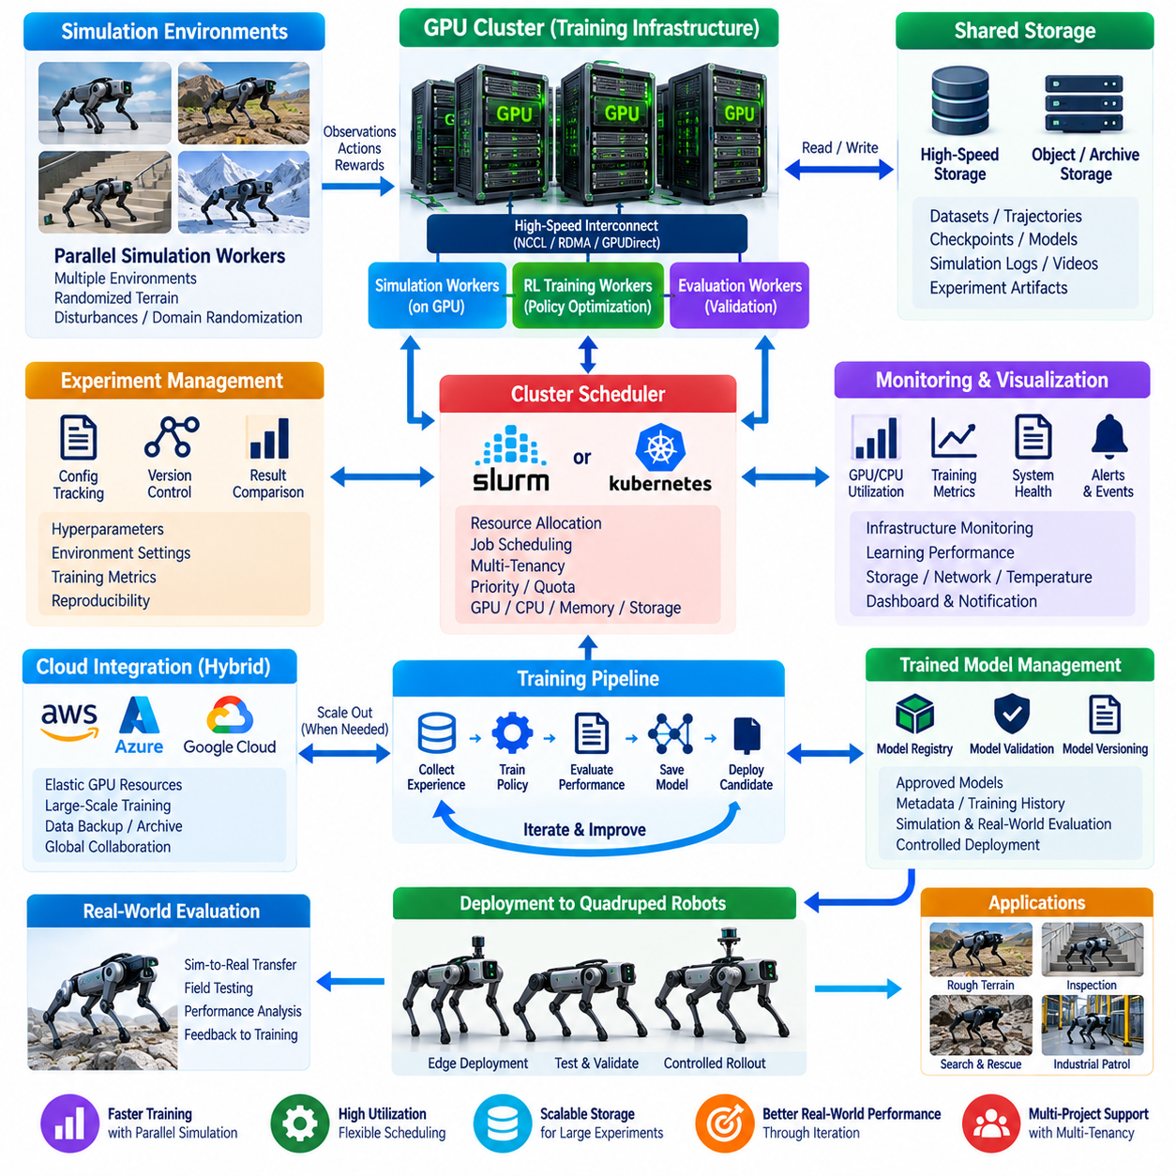
A quadruped robot reinforcement learning system requires substantially more computing capacity than a conventional robot software development environment because training depends on repeated interaction between a robot policy and many simulated environments. A GPU cluster can execute these environments in parallel, collect observations and rewards, update policy networks, and continuously generate new training data. In the cloud robotics architecture defined for this volume, the GPU cluster becomes a scalable training infrastructure that connects simulation, reinforcement learning, experiment management, model storage, and eventual robot deployment.
The training system can be organized into several functional layers consisting of simulation workers, GPU training workers, shared storage, experiment management, and monitoring. Simulation workers generate physical interactions for multiple quadruped environments, while training workers process trajectories and update the reinforcement learning policy. Shared storage maintains datasets, checkpoints, configuration files, and experiment results. This separation allows simulation and training capacity to scale independently and makes it possible to increase the number of parallel environments without redesigning the complete training system.
Parallel simulation is one of the most important characteristics of a quadruped reinforcement learning infrastructure. Instead of training a policy through a single robot instance, many simulated quadrupeds can interact with different terrain, disturbances, initial states, and task conditions simultaneously. Each environment produces observations, actions, rewards, and termination information. These parallel experiences are collected into batches and supplied to the learning algorithm, significantly increasing the amount of experience available during each training iteration.
GPU resources are particularly valuable because both simulation and neural-network computation can require substantial parallel processing. A cluster can assign GPU resources to simulation workers, policy training, evaluation jobs, or data-processing workloads according to current demand. The architecture should avoid assuming that every GPU must perform the same function permanently. Flexible scheduling allows available capacity to be allocated to the workload that currently limits training throughput, improving overall utilization and making cluster resources more useful for multiple robotics projects.
A cluster scheduler provides the mechanism for managing these GPU workloads. Depending on the infrastructure, a workload may be submitted through an HPC-oriented scheduler such as SLURM or through Kubernetes with NVIDIA GPU scheduling components. The scheduler determines where training or simulation jobs execute and manages resource allocation. GPU memory, CPU capacity, system memory, storage access, and job priority must be considered together because reinforcement learning throughput is often limited by the interaction between simulation, data movement, and neural-network training rather than by GPU compute alone.
Distributed reinforcement learning introduces an additional communication requirement. Multiple workers may generate experience while one or more learners update the policy. Model parameters, gradients, observations, and training batches therefore need to move between processes or machines. Technologies such as NCCL, RDMA, or GPUDirect can become important when communication overhead begins to limit scaling. The objective is not simply to connect more GPUs but to maintain an efficient ratio between computation and data movement so that additional hardware produces useful additional training throughput.
A practical training loop begins with an initial policy and a defined simulation environment. Simulation workers execute the policy, observe the resulting robot states, calculate rewards, and collect trajectories. The learner receives these experiences and performs policy optimization using an appropriate reinforcement learning algorithm. Updated policy parameters are then distributed back to simulation workers. This cycle repeats continuously. Over many iterations, the policy gradually learns behaviors such as stable locomotion, velocity tracking, turning, disturbance recovery, and terrain adaptation.
The simulation environment should expose enough variation to prevent the learned policy from becoming specialized to a single idealized condition. Terrain height, friction, slopes, external disturbances, robot mass properties, sensor noise, and command conditions can be varied during training. Randomization can be applied systematically so that the policy encounters a distribution of situations rather than repeatedly experiencing an identical environment. This becomes especially important when the final objective is transfer from simulation to a physical quadruped.
Training data and experiment artifacts require a storage architecture capable of handling large volumes of information. Checkpoints, configuration files, evaluation results, selected trajectories, simulation recordings, and model metadata should be organized so that an experiment can be reproduced later. High-speed shared storage can provide training workers with access to frequently used datasets, while longer-term object or archival storage can retain completed experiments. The GPU cluster therefore depends not only on compute resources but also on a storage system capable of supplying data at an appropriate rate.
Experiment management is essential because reinforcement learning experiments can differ through hundreds of configuration variables. Environment parameters, reward weights, network architectures, learning rates, batch sizes, random seeds, simulation settings, and curriculum schedules can all influence results. Each experiment should therefore retain its configuration together with checkpoints and evaluation results. This creates traceability between a trained model and the exact conditions under which it was produced, reducing the risk of selecting a model whose training history cannot be reconstructed.
Monitoring should cover both machine-level and learning-level behavior. GPU utilization, GPU memory consumption, CPU utilization, system memory, network traffic, storage throughput, and temperature reveal whether the infrastructure is being used effectively. At the same time, training metrics such as reward, episode length, policy loss, value loss, success rate, and evaluation performance indicate whether the learning process is progressing. A cluster can therefore appear highly utilized while producing poor learning results, making infrastructure monitoring and reinforcement learning evaluation complementary rather than interchangeable.
Multi-tenancy becomes relevant when the same GPU cluster supports several robotics projects or several research teams. Resource quotas and workload isolation prevent a single large experiment from consuming all available GPUs or storage bandwidth. Jobs can be assigned priorities or resource limits according to project requirements. Kubernetes namespaces or equivalent isolation mechanisms can separate workloads, while scheduler policies can control GPU allocation. These mechanisms transform a collection of GPU servers into a shared robotics training platform rather than a set of independently managed workstations.
A quadruped training farm can also connect simulation and physical robot development. Simulation generates large numbers of training experiences, while physical robots provide real-world evaluation data that can expose differences between simulation and reality. A selected policy can therefore move from simulation training to controlled physical testing, where locomotion stability, actuator behavior, sensor characteristics, and terrain interaction are evaluated. Observed discrepancies can then guide additional simulation conditions or training data, creating an iterative simulation-to-real development cycle.
Model deployment should remain separated from unrestricted training activity. Once a candidate policy reaches predefined evaluation criteria, the model can be stored with its version, configuration, training history, and evaluation results. The deployment system can then transfer an approved model to the robot's edge computer for controlled testing. This separation prevents an experimental checkpoint from being accidentally deployed to a physical robot and establishes a clear distinction between research models and validated deployment artifacts.
The same infrastructure can support curriculum-based reinforcement learning in which the difficulty of the simulation environment changes as the policy improves. Early training may emphasize basic balance and locomotion, while later stages introduce slopes, uneven terrain, disturbances, velocity commands, and more complex environmental conditions. A cluster allows many curriculum stages or parameter combinations to be evaluated in parallel. The resulting infrastructure therefore supports not only faster training but also systematic exploration of the conditions under which a quadruped policy succeeds or fails.
Cloud resources can be introduced when local GPU capacity becomes insufficient or when a temporary increase in training capacity is required. Instead of permanently purchasing enough hardware for the maximum expected workload, a robotics organization can combine an on-premise GPU cluster with elastic cloud GPU resources. Stable development and frequently used experiments can remain local, while large-scale training campaigns can temporarily expand into the cloud. This hybrid strategy follows the broader principle of distributing workloads according to computational demand, data requirements, latency, security, and cost.
Energy efficiency and cluster utilization should also be considered as part of infrastructure design. GPUs that remain allocated to inactive experiments represent wasted capacity, while excessive synchronization can cause expensive hardware to spend time waiting for data. Job scheduling, appropriate batch sizes, efficient simulation, resource quotas, and workload consolidation can improve utilization. Monitoring historical utilization also provides evidence for future capacity planning, helping determine whether additional GPUs, faster storage, or improved networking would address the actual bottleneck.
A representative quadruped reinforcement learning cluster therefore forms a continuous pipeline from simulation to training and evaluation. Simulation workers generate diverse physical experiences, GPU learners optimize policies, high-speed storage supplies datasets and checkpoints, schedulers distribute computational resources, monitoring systems observe infrastructure and learning behavior, and model management preserves validated artifacts. The resulting platform can support repeated experiments while maintaining reproducibility and resource control across multiple robotics workloads.
The central lesson of this case is that reinforcement learning infrastructure for quadruped robots should be designed as a complete computing system rather than simply as a collection of powerful GPUs. Parallel simulation, distributed training, high-speed communication, shared storage, scheduling, experiment management, monitoring, and controlled model deployment must work together. A properly organized GPU cluster can transform reinforcement learning from a slow individual-machine experiment into a scalable training process capable of producing and evaluating large numbers of robot experiences systematically.

12.05 Humanoid Physical AI Large-Scale Cloud Training Case
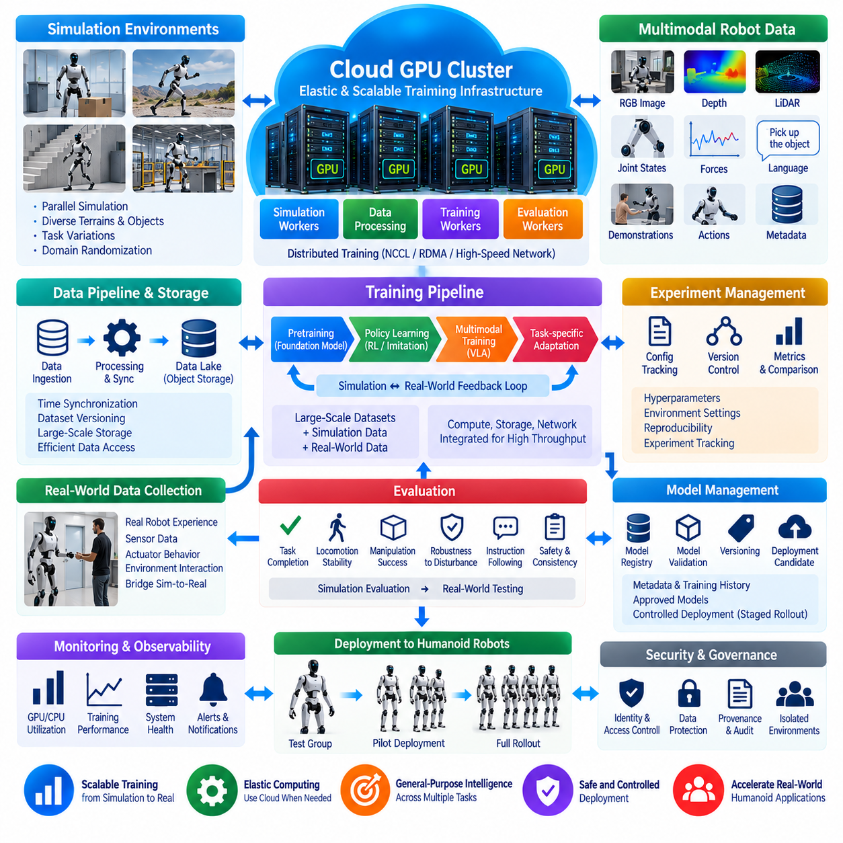
A humanoid Physical AI system requires a training infrastructure capable of combining large-scale simulation, multimodal robot data, foundation models, and distributed GPU computation. Unlike a conventional machine-learning workload, humanoid training must represent perception, language, body state, actions, contact dynamics, manipulation, locomotion, and interaction with complex environments. A cloud-based architecture provides elastic computing resources for these workloads while connecting simulation, data generation, model training, evaluation, experiment management, and controlled deployment into a continuous development pipeline.
Large-scale cloud training begins with parallel simulation environments that reproduce humanoid robots and their operating conditions. Thousands of simulated environments can generate different body configurations, terrain conditions, objects, tasks, disturbances, camera viewpoints, and interaction scenarios. Each environment produces observations, actions, rewards, demonstrations, or multimodal trajectories. Parallel simulation increases the amount of experience available to the training system and allows many variations of a task to be explored without requiring the same number of physical robots.
The training data should combine multiple modalities because Physical AI must connect what the robot perceives with what it does. Camera images, depth information, LiDAR observations, proprioceptive states, joint positions, forces, velocities, language instructions, demonstrations, and action sequences can be organized into synchronized training samples. Data pipelines must preserve timestamps, robot configuration, task context, environment information, and sensor metadata so that multimodal relationships remain available during training. This enables models to learn associations between visual and linguistic context, physical state, and robot action.
A scalable GPU cluster provides the computational foundation for model pretraining, policy learning, reinforcement learning, imitation learning, and multimodal training. GPU resources can be distributed among simulation workers, data-processing workers, training workers, and evaluation workers. Large training jobs can use multiple GPUs or multiple GPU nodes through distributed-training frameworks and high-speed communication. The objective is to scale useful training throughput rather than simply increase the number of GPUs, because communication, storage, simulation speed, and synchronization can become bottlenecks as the cluster grows.
Distributed training requires efficient movement of model parameters, gradients, and training batches between GPU processes. High-speed GPU communication technologies can reduce synchronization overhead when models or batch sizes become large. The infrastructure should also provide sufficient CPU, memory, storage, and network capacity around the GPUs. A training cluster that contains powerful accelerators but cannot supply data quickly enough may spend significant time waiting for input. Therefore, compute, networking, and storage must be designed as one integrated training system.
The cloud provides elasticity that is particularly valuable for humanoid Physical AI. A development team may require moderate resources for daily experimentation but significantly larger capacity for a major pretraining or simulation campaign. Cloud GPU resources can temporarily expand the training farm without requiring permanent ownership of the maximum required capacity. Completed experiments, checkpoints, datasets, and model artifacts can be retained in scalable storage. This creates a flexible infrastructure in which compute capacity can expand according to the current training workload.
Simulation and real-world data should form a feedback loop rather than independent datasets. Simulation can generate large quantities of controlled experience, while physical humanoid robots provide observations of real actuator behavior, contact dynamics, sensor noise, latency, and environmental uncertainty. Differences between simulated and real behavior can be analyzed and used to improve simulation parameters, randomization strategies, datasets, or training procedures. The resulting simulation-to-real process allows cloud training to benefit from physical-world evidence without requiring every training iteration to occur on hardware.
Foundation-model training introduces another layer of scale. A humanoid Physical AI model may combine vision, language, robot state, and action representations so that a common model can support multiple tasks. Large datasets can be used for pretraining before task-specific adaptation or policy optimization. Training infrastructure must therefore support both large general-purpose models and smaller specialized policies. Model checkpoints, datasets, tokenizer or action representations, configuration parameters, and evaluation results should remain traceable so that a deployed model can be associated with its training history.
A vision-language-action approach can connect high-level instructions with physical behavior. The system may receive visual observations and language instructions together with the current robot state, then generate an action representation or intermediate policy output. Training such systems requires synchronized multimodal data and careful separation between perception, reasoning, and action-learning components. Large-scale cloud infrastructure makes it possible to process diverse datasets and run many experiments while preserving a common model-development framework for different humanoid tasks.
Experiment management becomes increasingly important as the number of models, datasets, environments, and training configurations increases. Each training run should preserve its dataset version, simulation configuration, model architecture, hyperparameters, random seeds, software environment, checkpoints, and evaluation results. This provides reproducibility and makes comparisons meaningful. Without systematic experiment tracking, improvements in a humanoid policy can be difficult to attribute to a particular dataset, training method, environment configuration, or model change.
Evaluation must extend beyond conventional model metrics because Physical AI ultimately produces physical behavior. A humanoid model can be evaluated through task completion, locomotion stability, manipulation success, recovery from disturbances, instruction following, interaction quality, safety constraints, and consistency across environments. Simulation evaluation can screen large numbers of candidate models before selected policies are transferred to physical robots. Real-world testing then provides additional evidence about robustness and the gap between simulated and physical behavior.
Model management should establish a controlled path from experimental checkpoints to deployment candidates. Training artifacts can be stored in a model registry together with metadata describing their dataset, training configuration, evaluation results, and software dependencies. Only models that pass predefined validation procedures should move toward physical-robot deployment. Deployment can begin with a limited test group before broader rollout, allowing engineers to observe behavior and compare the deployed model against the validated reference.
Monitoring must cover both infrastructure and learning performance. GPU utilization, memory consumption, network throughput, storage performance, job status, and training duration reveal the condition of the cloud training environment. Learning metrics, task success, reward trends, validation results, and evaluation behavior reveal whether the model itself is improving. These two monitoring layers should be correlated because a reduction in training performance may originate from infrastructure bottlenecks rather than the learning algorithm, while high GPU utilization does not necessarily indicate useful model progress.
Security and data governance become important when large-scale humanoid datasets contain proprietary robot information, environmental recordings, or human interaction data. Access to datasets, training infrastructure, model registries, and deployment systems should be controlled through appropriate identities and permissions. Data should be protected during transfer and storage, while model artifacts should retain version information and provenance. Separating research workloads from deployment infrastructure also reduces the possibility that an experimental model or unvalidated configuration will reach a physical robot unintentionally.
A complete humanoid Physical AI cloud-training system therefore forms a continuous pipeline from data generation to simulation, distributed training, evaluation, model management, and physical deployment. Parallel simulation supplies scalable experience, multimodal datasets connect perception and action, GPU clusters provide computational capacity, cloud storage preserves training artifacts, experiment management provides reproducibility, and controlled deployment transfers validated intelligence to humanoid robots. The central principle is to treat cloud infrastructure not merely as remote computing, but as a scalable Physical AI training platform that connects simulation, data, models, and real-world robot experience into one iterative learning system.

12.06 Cargo UAV Fleet Cloud OTA Operation Case
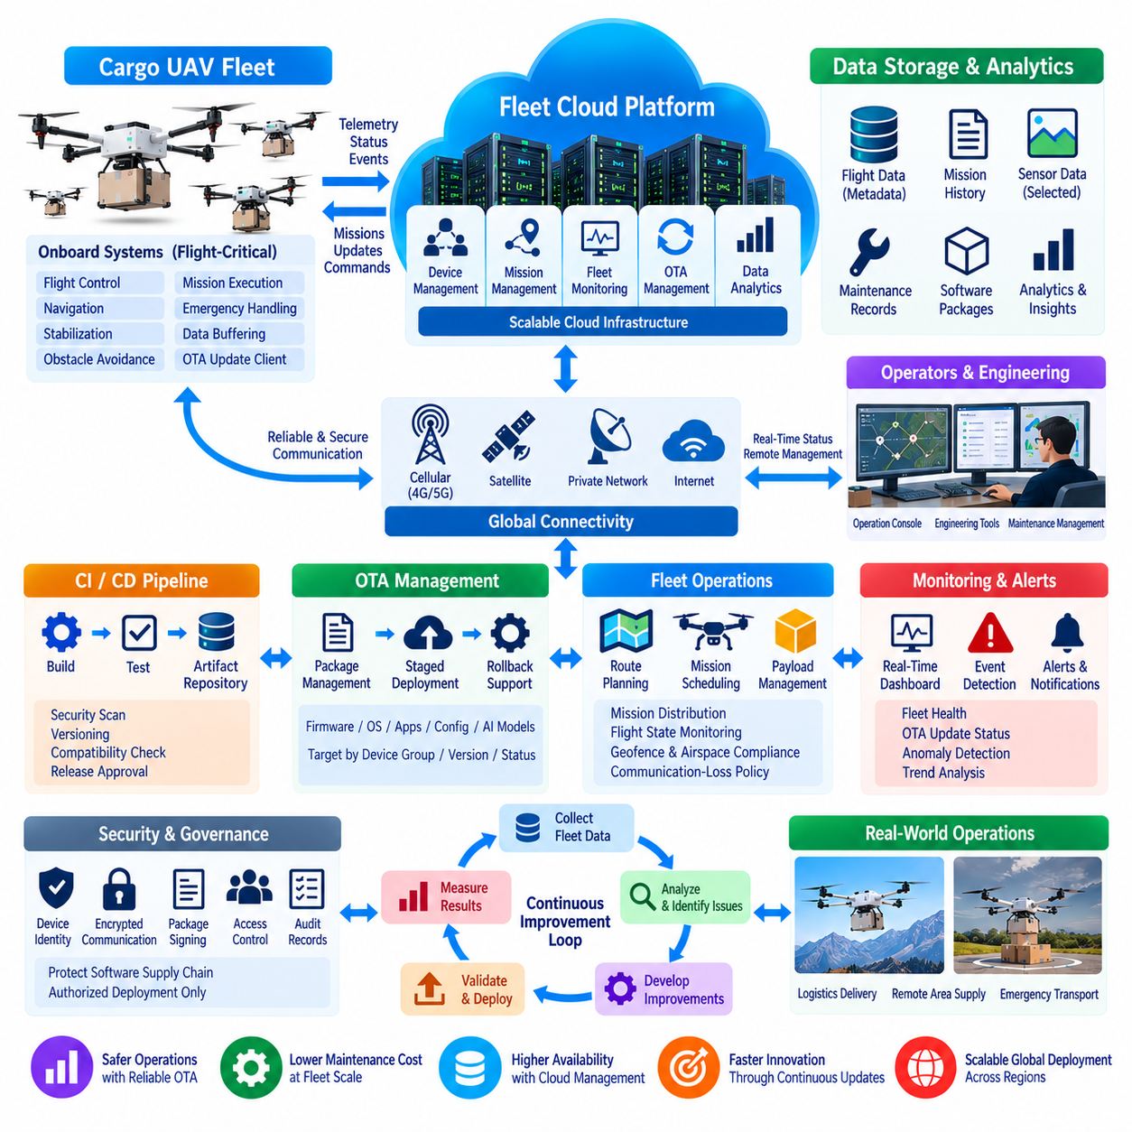
The cargo UAV fleet case can be designed as a cloud-connected operational system in which flight-critical functions remain onboard while the cloud provides fleet management, mission visibility, data services, software lifecycle management, and OTA operations. The architecture follows the broader cloud-edge principle of separating real-time control from centralized services. Flight control, navigation, stabilization, obstacle avoidance, and emergency behavior must remain available on the aircraft, while the cloud manages functions that benefit from centralized coordination and fleet-scale processing.
Each cargo UAV can be registered as an individual managed device with a unique identity, software version, hardware configuration, and operational history. The fleet cloud maintains information such as aircraft availability, mission status, position, battery condition, communication state, flight hours, fault events, and maintenance indicators. This device-level identity allows operators to distinguish individual aircraft while also managing groups according to fleet, route, mission type, hardware generation, or software release.
Mission management should be separated from direct flight control. A cloud-based fleet service can distribute approved missions, schedules, routes, payload information, and operational constraints to the aircraft. The onboard flight system validates the received mission against local safety conditions and executes the flight autonomously. If cloud connectivity is temporarily lost, the UAV should follow its predefined communication-loss policy rather than waiting indefinitely for a remote command. This separation prevents cloud latency from becoming a dependency for immediate flight safety.
Cargo UAV operations can generate multiple categories of data, including flight telemetry, GNSS position, attitude, velocity, battery information, propulsion status, payload status, sensor measurements, environmental conditions, and fault events. High-frequency flight-control data should normally remain within the aircraft or local edge system, while selected telemetry and events can be transmitted to the cloud. This classification reduces communication requirements while preserving the information required for fleet monitoring, maintenance, operational analysis, and post-flight investigation.
Cloud storage provides a centralized location for flight records, mission histories, maintenance information, software packages, configuration files, and selected sensor datasets. Data should be organized with aircraft identity, mission identity, timestamp, software version, and relevant environmental context. This allows engineers to correlate an observed problem with the exact aircraft configuration and software state. Historical fleet data can also support trend analysis, such as recurring propulsion faults, battery degradation, communication problems, or abnormal mission termination.
OTA operation becomes particularly important when a fleet contains many aircraft distributed across different locations. Instead of physically accessing every UAV, the cloud can maintain approved firmware, operating-system components, edge applications, configuration packages, and AI models. The OTA system should maintain explicit package versions and deployment states so that operators can determine which aircraft are running which software. This transforms software maintenance from an individual aircraft procedure into a controlled fleet lifecycle process.
OTA packages should pass through a validation process before they become eligible for production deployment. Build artifacts can be generated through a CI/CD pipeline and stored in a controlled package or artifact repository. Security-related metadata, package integrity information, version identifiers, and compatibility requirements should accompany each release. The deployment service can then identify eligible UAVs according to hardware generation, current software version, operational state, and other defined deployment conditions rather than sending every package indiscriminately to the entire fleet.
Large-scale deployment should use staged rollout rather than simultaneous fleet-wide updates. A small canary group can receive the new software first, followed by a larger pilot group after successful validation. Fleet monitoring can compare update success, communication stability, mission completion, fault frequency, and other operational indicators between updated and non-updated aircraft. If the release produces abnormal behavior, deployment can be paused and the affected aircraft can be returned to a previously validated version when the OTA architecture supports rollback.
OTA scheduling should also account for mission availability. Updating an aircraft during an active cargo mission can introduce unacceptable operational risk, so software deployment can be scheduled during maintenance periods, charging periods, or defined off-hours. The fleet system should understand whether an aircraft is flying, preparing for a mission, undergoing maintenance, or available for software updates. This allows OTA scheduling to become part of fleet operations rather than an independent software activity.
The aircraft should verify an OTA package before installation and maintain a reliable recovery mechanism. Package authenticity, integrity, compatibility, and sufficient local storage should be checked before the update begins. A robust update process should preserve a known-good software state so that an interrupted or failed installation does not leave the aircraft without a usable flight system. The exact rollback mechanism depends on the aircraft platform, but the operational principle is consistent: software failure must not eliminate the ability to recover the vehicle safely.
Cloud connectivity may use cellular, satellite, private network, or other available communication technologies depending on the operating environment and mission profile. Because cargo UAVs may operate beyond continuous terrestrial coverage, the system should tolerate intermittent connectivity. Telemetry can be buffered locally and synchronized after reconnection, while mission and safety logic continues to operate onboard. The fleet platform should therefore distinguish between temporary communication loss and actual aircraft malfunction rather than treating every connectivity interruption as a flight-system failure.
Fleet monitoring should provide both operational and maintenance perspectives. Operators need visibility into aircraft position, mission state, battery condition, communication status, payload state, and active alerts. Engineers require deeper information such as software versions, flight logs, fault histories, sensor status, propulsion behavior, and update results. A common cloud backend can support both views while applying role-based access control so that users receive only the information and management functions required for their responsibilities.
A large cargo UAV fleet also benefits from automated event processing. Important events such as failed OTA installation, repeated communication loss, abnormal battery behavior, propulsion warnings, navigation degradation, or unexpected mission termination can be converted into structured alerts. The cloud can correlate these events across aircraft and locations to identify recurring patterns. For example, the same fault appearing after a particular software release can provide an early indication that the release requires investigation, while geographically concentrated communication problems may point toward an operational environment issue.
The relationship between OTA management and fleet data creates a continuous operational feedback loop. Aircraft generate flight and health information, the cloud aggregates and analyzes this information, engineers identify software or configuration improvements, and validated updates are prepared for controlled deployment. After deployment, the same fleet monitoring system measures the resulting behavior. This makes OTA more than a mechanism for distributing software; it becomes part of a broader fleet lifecycle in which operational evidence supports controlled improvement.
Security must cover the complete software supply chain and the communication path between aircraft and cloud services. Individual device identities, authenticated connections, encrypted communication, restricted management permissions, package signing, integrity verification, audit records, and controlled deployment authorization can reduce the risk of unauthorized software entering the fleet. Production aircraft should not be able to install arbitrary software simply because a package is available in cloud storage. The OTA service must establish which packages are approved and which aircraft are authorized to receive them.
The overall cargo UAV architecture therefore connects onboard autonomy, communication services, fleet cloud management, data storage, OTA infrastructure, monitoring, and engineering workflows into one controlled system. The aircraft remains responsible for flight-critical operation, while the cloud provides fleet-scale visibility and lifecycle management. OTA enables validated software and configuration changes to move systematically from development to selected aircraft and eventually across the fleet. This architecture supports scalable cargo UAV operations while maintaining a clear separation between cloud-managed lifecycle functions and the real-time responsibilities of the aircraft.

12.07 Private 5G-Based Outdoor AMR Control Case
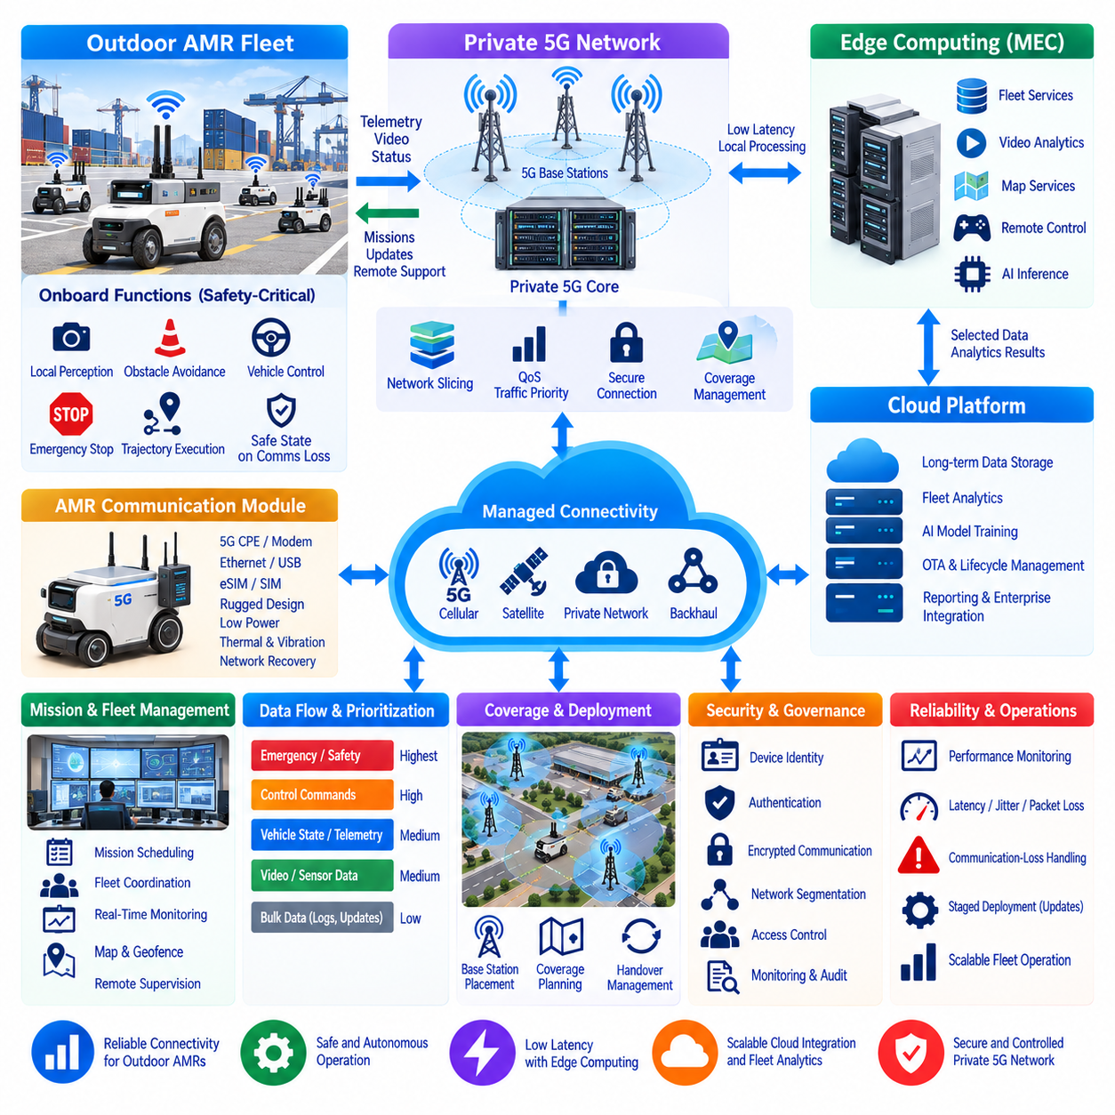
A private 5G-based outdoor AMR control system is designed to provide a managed wireless communication environment for robots operating across large industrial sites, ports, campuses, logistics yards, and other outdoor areas. Unlike a conventional public wireless connection, a private 5G network can be engineered around the operational requirements of the robot fleet, including predictable connectivity, traffic prioritization, device authentication, coverage management, and integration with edge computing. The architecture therefore combines outdoor AMR autonomy with private cellular infrastructure rather than treating 5G simply as an Internet access technology.
The outdoor AMR should retain direct responsibility for safety-critical functions such as emergency stopping, low-level vehicle control, obstacle avoidance, local perception, and immediate trajectory execution. Private 5G provides the communication path for fleet-level commands, telemetry, remote supervision, mission information, map updates, diagnostics, and selected sensor data. This separation is important because wireless communication can improve coordination and observability but should not become a single point of failure for physical safety. The robot must remain capable of entering a predefined safe state when communication quality becomes insufficient.
A private 5G network can include 5G radio access infrastructure, a private core network, edge computing resources, and connections to fleet management services. Outdoor AMRs use an integrated 5G CPE or modem as their network interface, while the network provides controlled access to operational applications. Depending on the deployment architecture, the user-plane traffic can be routed toward an on-site edge environment so that robot services do not need to traverse a distant public cloud for every interaction. This creates a communication path suitable for applications requiring controlled latency and local data processing.
Traffic classification is essential because an AMR generates multiple types of information with different operational importance. Emergency-related messages, vehicle state, control-related traffic, fleet coordination, telemetry, video, and bulk data should not necessarily receive identical network treatment. Quality of Service policies can assign different priorities and resource characteristics to these traffic classes. The objective is to protect operationally important traffic when network utilization increases rather than allowing high-bandwidth sensor streams to consume resources needed by control and safety-related communication.
5G network slicing can provide logical separation between different classes of services when supported by the selected private-network architecture. A robot-control-oriented service can be isolated from high-bandwidth video transmission or general enterprise traffic. The precise performance characteristics depend on the radio configuration, spectrum, network implementation, device capability, and application design, so slicing should be treated as a resource-management mechanism rather than an automatic guarantee of a particular latency. Proper engineering still requires measurement under realistic fleet and environmental conditions.
Coverage planning becomes especially important for outdoor AMRs because robots can travel across large areas with changing radio conditions. Buildings, containers, vehicles, vegetation, terrain, and other structures can influence propagation and create shadowed regions. Base-station placement, antenna configuration, frequency selection, handover behavior, and coverage overlap should therefore be evaluated against the intended robot routes. A coverage map should be considered together with robot operating zones and mission paths rather than being treated only as a telecommunications planning document.
The AMR communication module provides the physical interface between the robot computing system and the private 5G network. A 5G CPE or modem can connect to the robot computer through Ethernet, USB, or another appropriate interface, while the robot software treats the cellular connection as one managed network path. The integration should account for power consumption, thermal conditions, antenna placement, vibration, enclosure requirements, SIM or eSIM management, and recovery after network loss. Network integration is therefore both a communication-design issue and a robot hardware-integration issue.
A private 5G deployment can also support Mobile Edge Computing by placing selected services close to the robots. Fleet telemetry processing, video analytics, map services, remote-control gateways, and selected AI inference workloads can be deployed at an edge site instead of sending every data stream to a distant cloud region. This can reduce unnecessary wide-area traffic and provide a more direct path between robots and operational applications. Edge placement is particularly useful when an application requires frequent communication with robots but does not require global cloud accessibility for every transaction.
The cloud remains useful for functions that benefit from centralized scale. Long-term telemetry storage, fleet-wide analytics, model training, software lifecycle management, reporting, enterprise integration, and historical data processing can remain in cloud infrastructure. The private 5G network therefore does not replace cloud computing; it provides a controlled communication foundation between robots, local edge systems, and cloud services. The resulting architecture forms a continuum in which real-time robot functions remain onboard, operational services can run at the edge, and large-scale data and management functions can use the cloud.
Network security should be designed together with robot identity and application security. Each AMR should have an individually managed network identity rather than relying on shared credentials across the fleet. Authentication, encrypted communication, device authorization, network segmentation, access control, and monitoring can limit unauthorized access. Private 5G should also be integrated with the robot's broader cybersecurity architecture, including the operating system, ROS 2 or other middleware, application services, OTA mechanisms, and cloud APIs. Network isolation alone does not establish complete robot security.
A representative outdoor AMR deployment may operate dozens of robots across a logistics or industrial site. Each robot connects through the private 5G network and continuously reports selected state information to an edge fleet service. Mission assignments and operational updates travel in the opposite direction through controlled application interfaces. High-bandwidth camera streams can use an appropriate traffic class, while robot status and critical events receive higher operational priority. The fleet manager can therefore maintain centralized visibility while the robots continue to perform autonomous navigation locally.
When several robots operate simultaneously, network behavior must be evaluated at fleet scale rather than by testing a single robot. Concurrent video transmission, telemetry bursts, software updates, remote sessions, and mission traffic can create different load conditions. Capacity planning should therefore consider the number of connected devices, traffic profiles, radio coverage, edge-processing capacity, backhaul capacity, and expected peak utilization. Performance measurements should include latency, jitter, packet loss, throughput, handover behavior, connection availability, and application-level message delivery rather than relying on a single network metric.
Communication-loss handling should be explicitly integrated into the AMR operating policy. If the private 5G connection temporarily degrades, the robot can continue functions that are authorized for autonomous operation while locally buffering appropriate telemetry. If communication remains unavailable beyond a defined operational condition, the robot can slow down, stop, return to a designated location, or enter another predefined safe state depending on the mission. Recovery should also be controlled so that a large backlog of data or delayed commands does not create an unexpected operational condition immediately after reconnection.
The private 5G network can also become part of the fleet's operational observability system. Network measurements can be correlated with robot position, mission status, battery condition, sensor state, and application performance. If communication degradation repeatedly occurs in a particular geographic area, engineers can compare the network measurements with robot routes and environmental conditions. This allows the organization to distinguish radio-coverage problems from robot-software problems and provides evidence for improving antenna placement, network configuration, or operational routes.
The resulting architecture connects outdoor AMR autonomy, private 5G connectivity, QoS and traffic management, edge computing, fleet management, and cloud services into a controlled operational system. The robot remains responsible for immediate physical behavior and safety, while private 5G provides managed wireless connectivity for fleet communication and remote services. Edge infrastructure can process latency-sensitive operational workloads close to the robots, while cloud infrastructure provides scalable storage, analytics, AI training, and lifecycle management. This division creates a practical foundation for outdoor AMR fleets that require reliable connectivity without making autonomous operation dependent on the network.

12.08 Fleet Cloud Failure Response: DR Live Fire Case
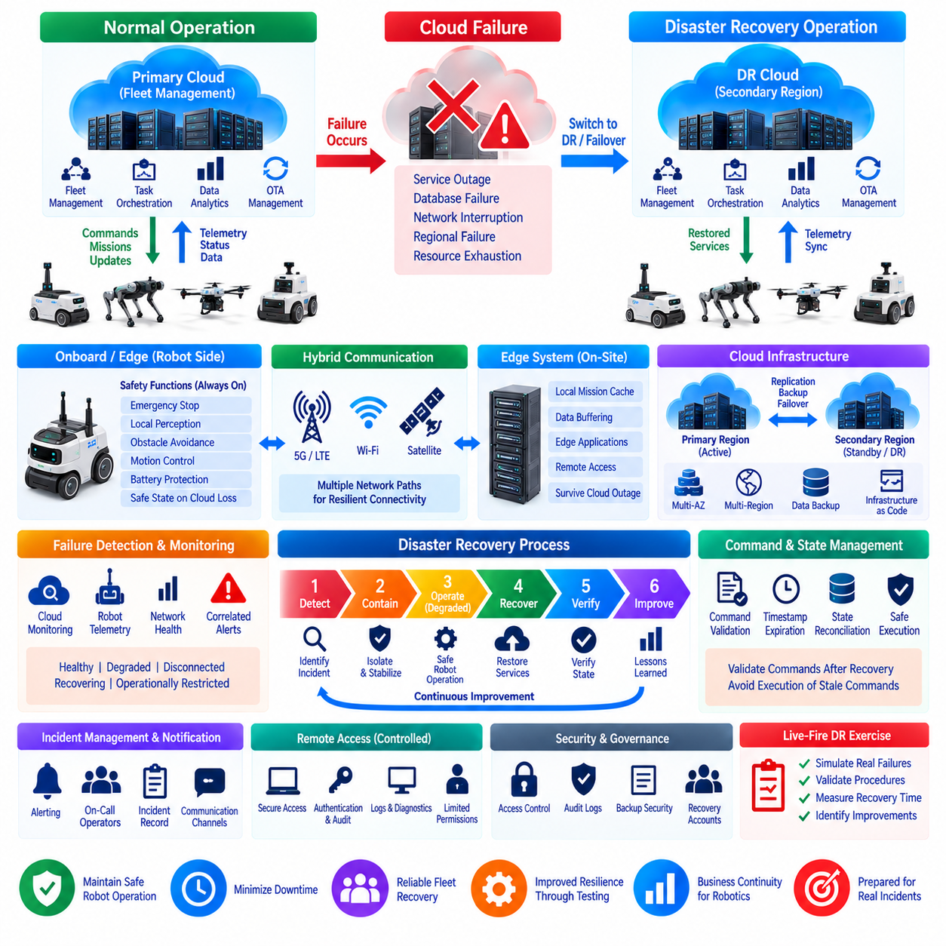
A fleet cloud failure-response system must be designed around the assumption that cloud services can become unavailable even when the physical robot fleet remains operational. The objective of disaster recovery is therefore not simply to restore servers, but to preserve safe robot behavior, maintain operational visibility, protect mission state, and recover fleet-management services in a controlled sequence. The architecture should separate robot-local safety functions from cloud-dependent management functions so that a cloud incident does not automatically become a physical robot safety incident.
The first principle is to define which functions must continue during a cloud outage. Emergency stop behavior, local obstacle avoidance, low-level motion control, battery protection, and other safety-critical functions should remain available on the robot or local edge system. Fleet scheduling, dashboards, historical analytics, remote access, and nonessential cloud services may become degraded or temporarily unavailable. This functional separation creates a clear degraded-operation mode in which robots can continue only the behaviors that have been explicitly authorized for operation without cloud connectivity.
Failure detection should combine infrastructure monitoring with robot-side observations. Cloud monitoring can identify unavailable services, database failures, network interruptions, excessive resource utilization, or regional service degradation, while the fleet layer can detect missing telemetry, disconnected robots, delayed commands, or abnormal communication patterns. An incident should therefore be identified through correlated signals rather than through a single alarm. Clear health states such as healthy, degraded, disconnected, recovering, and operationally restricted can help operators understand the current condition of the fleet.
A disaster-recovery architecture should maintain defined recovery priorities. Safety-related robot functions have the highest operational priority, followed by communication and fleet-state services required to understand the condition of the robots. Mission orchestration, operator dashboards, notification services, databases, analytics, and other supporting services can then be restored according to their operational dependencies. This ordering prevents engineers from attempting to recover every cloud component simultaneously and provides a controlled sequence for returning the fleet to normal operation.
High availability can be implemented by distributing critical cloud services across independent failure domains. Multi-Availability-Zone deployment can reduce the impact of a localized infrastructure failure, while multi-region architecture can provide an additional recovery path for larger incidents. The appropriate design depends on service criticality, recovery requirements, data consistency, and operational complexity. Redundancy should therefore be designed around actual failure scenarios rather than treating duplication of every component as automatically necessary.
Robot state must be protected during a cloud failure because fleet management depends on knowing what each robot was doing when the incident occurred. Important state information can include robot identity, operational mode, mission state, last known position, battery condition, software version, active faults, and communication status. Local buffering and durable synchronization mechanisms can preserve information generated during an outage. After recovery, the system should reconcile buffered state carefully rather than blindly replaying every delayed message or command.
Command handling requires particular attention during recovery. Commands generated before an outage may become invalid by the time connectivity returns. A delayed movement command, mission assignment, or configuration change should therefore not automatically execute merely because it remains in a message queue. Commands should carry appropriate timestamps, identifiers, expiration conditions, or state-validation requirements. The fleet service should verify that a command is still valid for the robot's current condition before allowing it to reach the operational layer.
A live-fire disaster-recovery exercise provides a practical way to validate these assumptions. Instead of reviewing recovery procedures only on paper, an organization can deliberately introduce controlled failures into a test environment or an appropriately isolated operational scenario. Examples include disabling a fleet-management service, interrupting database access, simulating network loss, forcing a regional service transition, or disconnecting selected robots. The purpose is to observe actual system behavior and determine whether recovery procedures work under realistic operational conditions.
During such an exercise, operators should record the sequence of events from initial failure detection through degraded operation, service recovery, state reconciliation, and return to normal fleet operation. Important observations include which alarms appeared, how quickly operators recognized the failure, whether robots entered the expected operating mode, whether telemetry was preserved, whether commands were safely handled, and whether recovery introduced unexpected behavior. The exercise should produce evidence about the actual system rather than relying only on assumptions contained in architecture documents.
Notification and incident-management services provide the operational coordination layer during a failure. Critical events should reach the appropriate operators through reliable notification channels, while repeated events should be correlated to avoid overwhelming personnel with duplicate alarms. The incident record should preserve timestamps, affected services, affected robots, detected symptoms, recovery actions, and final status. This information becomes valuable after the exercise because recurring failure patterns can be analyzed and the disaster-recovery procedure can be improved systematically.
Remote access should also be treated as a controlled recovery capability rather than an unrestricted emergency mechanism. Engineers may require access to edge computers, logs, diagnostic services, or selected robot interfaces when cloud services fail. Such access should use authenticated and auditable mechanisms with clearly defined permissions. Where possible, recovery procedures should avoid depending on a single remote-access path, because the same network or cloud failure that caused the incident may also prevent engineers from reaching the affected infrastructure.
Recovery should include verification, not simply service restart. After a cloud component becomes available again, the system should confirm database consistency, message-queue state, robot connectivity, mission state, telemetry synchronization, authentication status, and service dependencies. Robots that were disconnected should be reconciled individually or through controlled groups according to their current state. Fleet-wide operation should resume only after the recovered services provide a trustworthy representation of the physical fleet.
The recovery architecture should also support controlled rollback when a failure is caused by a software release or configuration change rather than infrastructure loss. Versioned application artifacts, configuration management, deployment history, and staged rollout mechanisms allow engineers to identify what changed immediately before the incident. If the previous version is known to be valid, the affected service can be returned to that version through a controlled procedure. The same principle applies to robot-side software when an OTA deployment is identified as the source of abnormal fleet behavior.
Security and disaster recovery must be considered together because emergency procedures can otherwise create uncontrolled access paths. Recovery accounts, privileged operations, backup systems, alternate regions, and emergency remote-access mechanisms should remain authenticated and auditable. Backup data should also be protected from accidental modification or unauthorized access. A disaster should not force the organization to abandon normal security controls; instead, emergency procedures should provide predefined, limited, and traceable ways to perform recovery operations.
A mature fleet cloud disaster-recovery system therefore operates as a continuous cycle of prevention, detection, containment, degraded operation, recovery, verification, and improvement. Architecture provides redundancy and isolation, robot software provides safe local behavior, monitoring identifies abnormal conditions, notification coordinates the response, backup and synchronization preserve state, and recovery procedures restore cloud services in a defined order. A live-fire exercise then validates whether these mechanisms actually work together under failure conditions and provides concrete evidence for improving the next version of the fleet platform.
The final objective is not to create a system that assumes failure will never occur, but to create a fleet that can respond predictably when cloud infrastructure becomes unavailable. Robots should remain within their authorized safe operating envelope, operators should retain sufficient visibility to make informed recovery decisions, and cloud services should return through a controlled and verifiable process. By combining high-availability architecture, offline-capable robot behavior, state synchronization, controlled command recovery, incident management, and repeated disaster-recovery exercises, a fleet cloud platform can transform failure response from an improvised emergency activity into an engineered operational capability.

12.09 Cloud Cost 50% Reduction Optimization Project
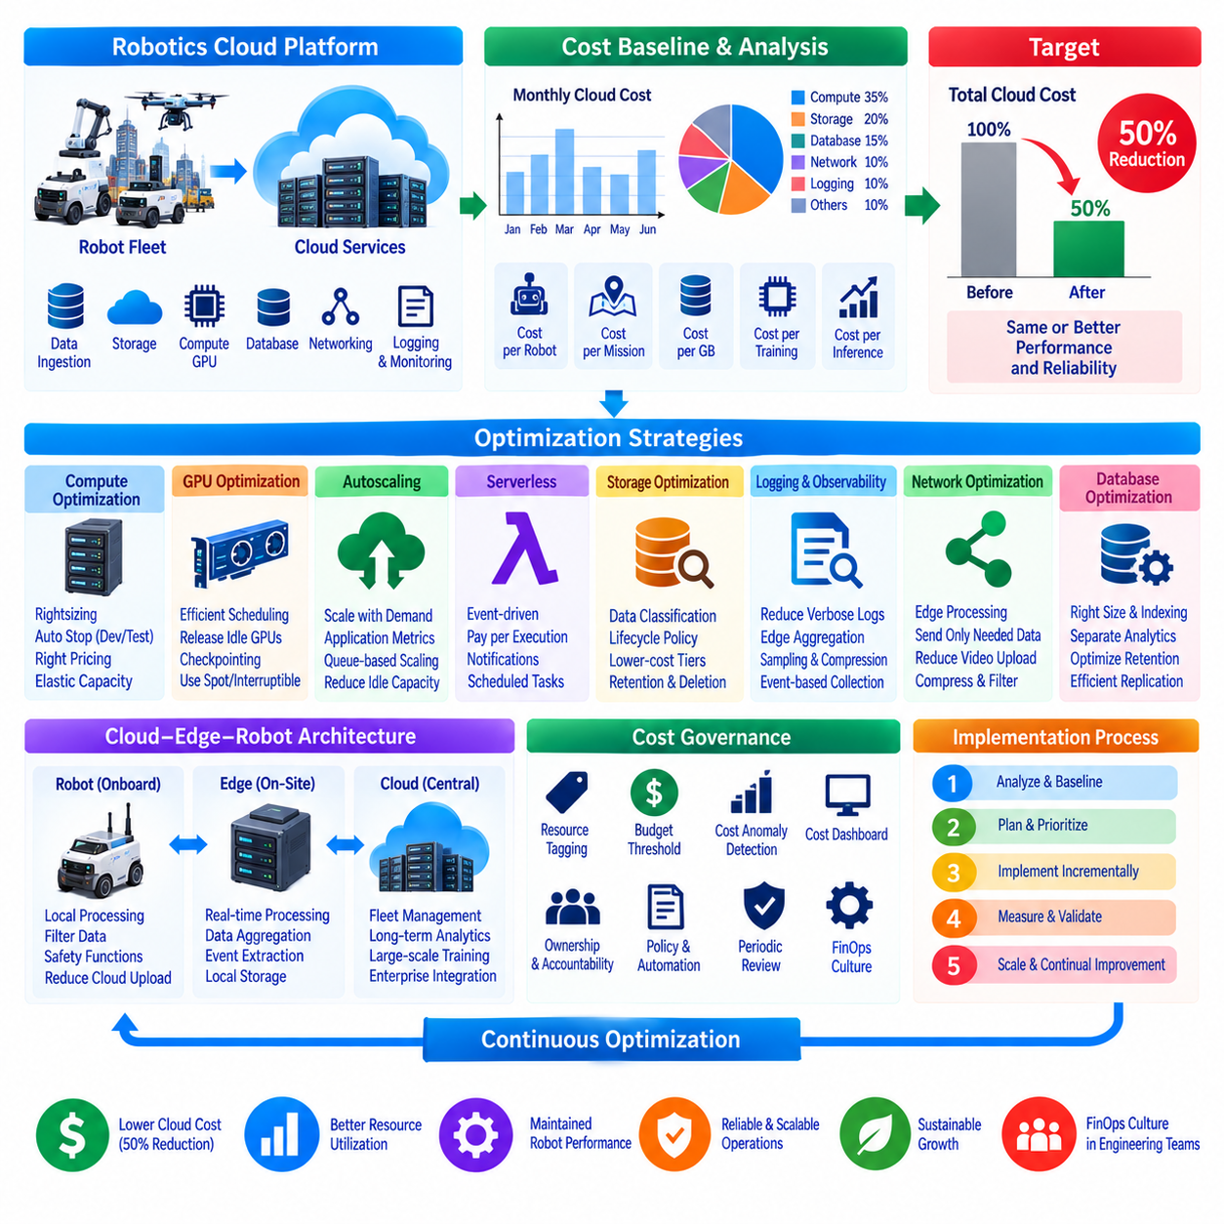
A cloud cost reduction project for a robotics platform should begin by treating cost as an architectural metric rather than only a billing problem. Robot fleets can generate expenses through compute instances, GPU training, databases, object storage, telemetry ingestion, video transfer, logging, backups, and network traffic. A 50 percent reduction target therefore requires systematic analysis of where resources are consumed, why they are required, and whether each workload belongs in the cloud, at the edge, or on the robot.
The first phase establishes a measurable cost baseline. Cloud billing data should be classified by service, application, environment, robot fleet, project, and workload whenever appropriate tagging or accounting information is available. Monthly cost alone is insufficient because fleet size and workload volume may change. Metrics such as cost per robot, cost per mission, cost per gigabyte, cost per training experiment, and cost per inference request provide a more useful view of efficiency and allow optimization results to be compared against operational growth.
Compute resources are often the first optimization target because continuously running instances can accumulate cost even when utilization is low. CPU, memory, GPU, and network utilization should be measured before resizing workloads. Overprovisioned virtual machines can be reduced to more appropriate instance types, while development environments can be automatically stopped outside active periods. Workloads with predictable utilization can use longer-term pricing commitments where appropriate, while variable workloads can retain elastic capacity rather than being permanently provisioned for peak demand.
GPU workloads require separate analysis because robotics simulation, reinforcement learning, foundation-model training, and computer-vision development can consume expensive accelerator resources. GPU jobs should be scheduled so that accelerators are released when experiments finish instead of remaining attached to idle instances. Training pipelines can use checkpointing to tolerate interruption where appropriate, while batch experiments can use lower-cost interruptible capacity when the workload permits. The optimization objective is to increase useful GPU-hours rather than merely reduce the number of GPUs.
Autoscaling can reduce cost for services whose demand changes with fleet activity. Telemetry processors, API services, event consumers, dashboards, and data-processing workers do not always require fixed maximum capacity. Horizontal scaling can increase the number of instances during high traffic and reduce them during quiet periods. Scaling policies should be based on application-level demand as well as CPU utilization because message backlog, request latency, queue depth, or connected robot count may represent workload demand more accurately than processor usage alone.
Serverless architecture can be useful for intermittent robotics workloads such as notifications, event transformation, scheduled reporting, lightweight telemetry processing, and maintenance automation. Instead of keeping a dedicated server active continuously, functions can execute when an event occurs and consume resources only during execution. Serverless design is not automatically cheaper for every workload, especially when processing is continuous or high-volume, so candidate services should be evaluated according to invocation frequency, execution duration, data transfer, and operational requirements.
Storage optimization begins by classifying data according to access frequency and retention requirements. Robotics systems can accumulate camera images, LiDAR recordings, simulation outputs, logs, telemetry, model checkpoints, and training datasets rapidly. Frequently accessed operational data may remain in high-performance storage, while older datasets can move to lower-cost storage tiers. Lifecycle policies can automate transitions and eventual deletion according to defined retention rules, preventing historical data from remaining indefinitely in expensive storage simply because nobody reviewed it.
Logging and observability can become significant cost sources when every robot publishes high-frequency diagnostic information continuously. Logs should be classified according to operational value, and unnecessary duplication or excessively verbose debug output should be removed from production environments. High-frequency metrics can be aggregated at the edge before transmission, while detailed logs can be retained temporarily around abnormal events. Sampling, retention policies, compression, and event-triggered collection can preserve diagnostic usefulness while reducing ingestion and storage volume.
Network cost is particularly important in robotics because raw sensor streams can be much larger than conventional application traffic. Continuously uploading camera video, depth images, point clouds, or other high-bandwidth data can create substantial transfer and storage requirements. Edge processing can extract events, metadata, embeddings, health indicators, or selected clips before cloud transmission. Raw data can remain locally unless required for incident analysis, model development, or scheduled synchronization. This reduces both network traffic and downstream cloud processing.
Database optimization should focus on workload characteristics rather than simply selecting a smaller database instance. Robot telemetry, fleet state, mission history, configuration, and analytical data have different access patterns and may not require the same storage technology. Retention, indexing, replication, query frequency, and provisioned throughput should be reviewed. Historical analytical data can be separated from operational state where appropriate, preventing the real-time fleet database from carrying unnecessary long-term data and reducing both capacity and performance overhead.
Development and test environments frequently contain hidden waste because resources remain active after experiments have finished. Temporary clusters, GPU instances, databases, test storage, public addresses, snapshots, and load balancers should have clear owners and expiration policies. Infrastructure-as-Code can make environments reproducible so that engineers do not need to preserve unused infrastructure simply because rebuilding it is difficult. Automated cleanup policies can remove abandoned resources while protected production assets remain governed by stricter lifecycle rules.
A hybrid cloud-edge architecture can produce larger savings than isolated resource resizing. Workloads that require immediate robot interaction or continuously process high-volume sensor data may be more efficient at the edge, while cloud infrastructure remains appropriate for centralized fleet management, historical analytics, large-scale AI training, and enterprise integration. Moving suitable preprocessing and filtering toward the robot reduces repeated network transfer and cloud ingestion. Cost optimization therefore becomes a workload-placement problem as well as a resource-pricing problem.
Cost governance is required to prevent savings from disappearing as the platform grows. Resource tagging, budget thresholds, anomaly detection, cost dashboards, ownership information, and periodic reviews can make spending visible to engineering teams. A sudden increase in storage, network transfer, GPU usage, or logging cost should be detected before it persists for several billing cycles. Engineering teams should understand the operational reason behind major cost categories so that cost becomes part of normal architecture and deployment decisions rather than a finance-only concern.
Optimization should be executed incrementally because aggressive cost reduction can damage reliability if resources are removed without understanding their function. Each change should record the original cost, expected saving, technical risk, observed performance, and resulting cost after implementation. Compute resizing, storage lifecycle policies, logging reduction, network filtering, autoscaling, and GPU scheduling can be introduced in controlled stages. This makes it possible to identify which changes produce real savings and which simply move cost from one service to another.
A 50 percent target should therefore be managed as the combined result of multiple optimization mechanisms rather than a single infrastructure change. Compute rightsizing reduces idle capacity, autoscaling aligns resources with demand, storage lifecycle management reduces long-term data cost, edge processing limits network traffic, GPU scheduling improves accelerator utilization, and governance prevents unnecessary resources from returning. The exact contribution of each mechanism depends on the original workload profile, so the target must be verified against measured billing and operational data rather than assumed in advance.
The final architecture treats cloud cost, robot performance, reliability, and scalability as connected engineering variables. The lowest-cost infrastructure is not useful if robots lose required services, while unlimited overprovisioning is difficult to sustain as a fleet expands. A successful optimization project establishes continuous measurement, assigns workloads to appropriate cloud or edge resources, removes idle capacity, controls data growth, and automates cost governance. The result is not merely a one-time 50 percent reduction project, but a repeatable FinOps-oriented operating model that keeps robotics cloud expenditure aligned with actual fleet value.

12.10 Robotics Cloud.Edge Evolution Roadmap
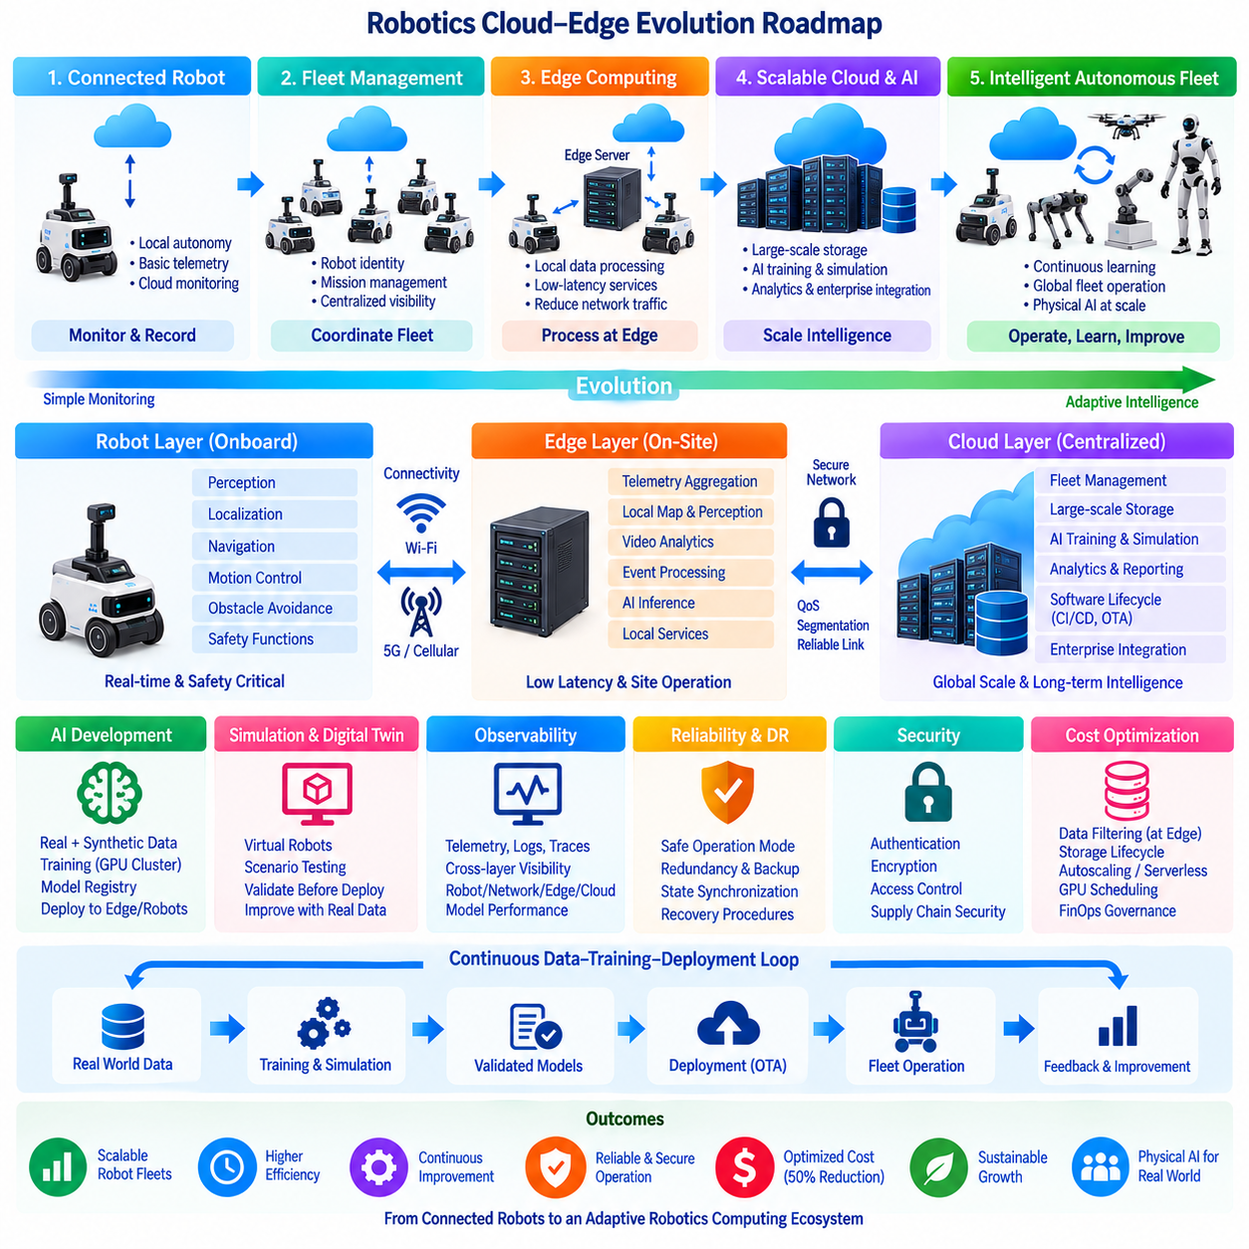
The evolution of robotics cloud-edge architecture can be understood as a gradual redistribution of intelligence across robots, local edge infrastructure, and centralized cloud platforms. Early connected robots primarily used the cloud for monitoring and remote data storage, while most autonomous functions remained onboard. As fleets grow and AI workloads become more demanding, the architecture evolves toward coordinated computing in which each layer performs the workloads best suited to its latency, bandwidth, reliability, security, and computational requirements.
The first stage of this evolution begins with the connected robot. Individual robots execute perception, localization, navigation, motion control, obstacle avoidance, and safety functions locally while sending basic telemetry to centralized servers. Cloud services provide dashboards, historical records, configuration management, and remote diagnostics. This architecture is relatively simple and preserves robot autonomy, but centralized services initially have limited influence over real-time fleet behavior or large-scale AI operations.
As the number of robots increases, centralized fleet management becomes necessary. The cloud begins managing robot identities, mission histories, software versions, operational states, alerts, and long-term telemetry. Fleet management systems coordinate mission assignment and provide operators with a unified view of distributed robots. At this stage, the cloud changes from a passive monitoring destination into an operational management layer, while immediate navigation and safety decisions continue to remain on the robot.
The next stage introduces edge computing between robots and centralized cloud services. Edge servers located inside factories, warehouses, campuses, ports, or logistics facilities can process data close to the fleet. High-frequency telemetry aggregation, local map services, video analytics, event processing, and selected AI inference can move to this layer. This reduces unnecessary wide-area network traffic and allows operational services to communicate with robots without requiring every interaction to traverse a distant cloud region.
Connectivity evolves together with edge computing. Wi-Fi, public cellular networks, private 5G, and other communication technologies can connect robots according to the operating environment. Managed connectivity becomes increasingly important as fleets expand across large facilities or outdoor areas. Quality of Service, traffic prioritization, coverage planning, network segmentation, and communication-loss handling become architectural concerns. The network is therefore transformed from a basic data transport mechanism into part of the robot fleet's operational infrastructure.
The cloud becomes increasingly important for workloads that benefit from centralized scale rather than immediate response. Long-term data storage, fleet-wide analytics, AI model training, simulation, experiment management, reporting, enterprise integration, and software lifecycle management can use elastic cloud resources. Compute-intensive workloads can expand temporarily when large training or simulation campaigns occur and contract afterward. This separates permanent robot hardware capacity from the much larger computational capacity occasionally required during AI development.
AI development drives another major architectural transition. Robot data collected from physical operations can be combined with synthetic data and large-scale simulation to train perception models, policies, world models, or multimodal Physical AI systems. GPU clusters can execute distributed training while cloud storage manages datasets and checkpoints. Validated models can then move through a controlled model registry and deployment pipeline before being delivered back to edge computers or robots, forming a continuous data-to-training-to-deployment loop.
Digital twins and simulation further strengthen the connection between physical robots and cloud infrastructure. Robot configurations, environments, missions, sensor characteristics, and operational conditions can be represented in simulation so that software and policies are evaluated before physical deployment. Large numbers of virtual robots can execute scenarios in parallel, generating data that would be expensive or dangerous to obtain exclusively from real hardware. Physical fleet observations can subsequently improve the simulation, creating an iterative relationship between virtual and real systems.
Software lifecycle management also becomes a fleet-scale capability. Instead of updating robots individually, firmware, applications, AI models, and configurations can move through CI/CD and OTA pipelines. Releases can be validated, signed, versioned, and deployed first to limited canary groups before wider rollout. Fleet monitoring measures the operational effect of each release, while rollback mechanisms provide a path back to previously validated software. Cloud-edge architecture therefore becomes closely integrated with Robot DevOps and MLOps practices.
Observability evolves from simple robot logging into an integrated view across robots, networks, edge systems, cloud services, and AI models. Telemetry, logs, traces, events, network measurements, hardware health, mission states, and model performance can be correlated across the platform. Operators can determine whether abnormal behavior originates from the robot, communication network, edge service, cloud infrastructure, or deployed AI model. This cross-layer visibility becomes increasingly important as system complexity and fleet size grow.
Reliability architecture must evolve at the same time. Robots should remain within a defined safe operating envelope when cloud or network services become unavailable. Edge systems can preserve selected operational functions during external connectivity failures, while cloud services can use redundancy, backup, state synchronization, and disaster-recovery mechanisms. Recovery procedures must reconcile robot state and reject expired commands rather than simply reconnecting every service. Resilience therefore becomes a property of the complete robot-edge-cloud system.
Security also expands from protecting individual robots to protecting an interconnected computing platform. Robot identities, device credentials, network access, APIs, cloud services, datasets, software artifacts, and OTA packages require coordinated protection. Authentication, encryption, access control, segmentation, package signing, audit records, and software supply-chain controls become part of the architecture. As robots become more dependent on shared infrastructure, cybersecurity must follow the complete path from development systems to deployed physical machines.
Cost optimization becomes increasingly important as cloud usage scales with robot count and data volume. Raw sensor streams should not automatically be uploaded when local processing can extract useful events or metadata. Storage lifecycle policies can move older information to lower-cost tiers, while autoscaling and serverless services can reduce idle compute capacity. GPU scheduling improves accelerator utilization, and FinOps practices make expenditure visible by fleet, workload, service, or project. Architectural efficiency therefore becomes directly connected to economic scalability.
The mature architecture develops into a cloud-edge-robot continuum rather than three isolated computing domains. Safety-critical control and immediate perception remain close to the physical machine. Edge infrastructure handles site-level coordination, low-latency processing, data aggregation, and local services. Cloud infrastructure provides global fleet management, large-scale storage, analytics, simulation, AI training, enterprise integration, and lifecycle management. Workloads can be assigned according to their actual operational characteristics instead of following a fixed cloud-first or edge-first rule.
Physical AI pushes this continuum further by requiring continuous interaction between real-world experience and large-scale learning infrastructure. Humanoids, quadrupeds, AMRs, manipulators, and autonomous vehicles can contribute operational data to shared training pipelines while receiving improved models in return. Simulation farms, GPU clusters, multimodal datasets, foundation models, reinforcement learning, and fleet evaluation become connected components of one learning system. The fleet itself gradually becomes a distributed source of experience for improving future robot intelligence.
The long-term roadmap therefore moves from connected robots toward intelligent, continuously improving fleets. Initial cloud connectivity enables monitoring, fleet platforms introduce centralized coordination, edge computing reduces latency and bandwidth requirements, scalable cloud infrastructure supports simulation and AI training, and DevOps/MLOps pipelines automate software and model evolution. Reliability, cybersecurity, networking, observability, and FinOps mature alongside these capabilities rather than being added only after deployment.
The final stage is an adaptive robotics computing ecosystem in which robot, edge, and cloud resources operate as coordinated layers of one platform. Intelligence is placed where it provides the best combination of response time, computational capacity, data access, reliability, and cost. Real robots generate experience, edge systems maintain local operational intelligence, and cloud platforms transform fleet-scale data into improved software and AI models. This evolution provides the architectural foundation for scalable Physical AI systems that can operate, learn, update, and improve continuously across increasingly large robot fleets.

