Volume 09 Cloud and Edge Robotics

06. On-Premise AI

06.01 On-Premise AI Infrastructure Design: Privacy, Latency, Cost
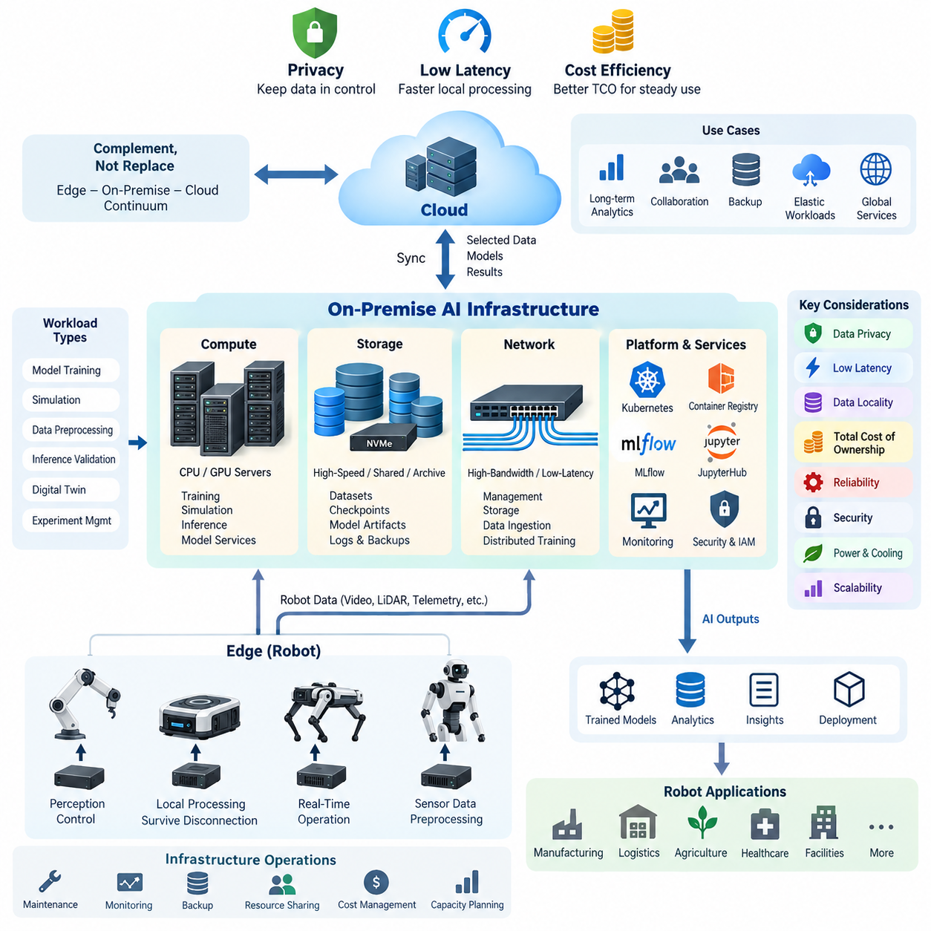
On-premise AI infrastructure places computing, storage, networking, and AI development resources inside an organization’s own facilities or dedicated data center rather than relying entirely on public cloud services. In robotics, this architecture is especially valuable because training datasets may contain sensitive factory layouts, camera streams, operational records, robot trajectories, and proprietary control knowledge that organizations prefer to retain within controlled infrastructure.
The design of an on-premise AI environment should begin with workload characterization rather than hardware selection. Robot AI workloads can include model training, simulation, dataset preprocessing, inference validation, digital-twin execution, and large-scale experiment management. Each workload produces different requirements for GPU memory, CPU capacity, storage throughput, network bandwidth, and execution time, so infrastructure should be sized around measurable computational and data flows.
Privacy is one of the strongest motivations for deploying AI infrastructure on premises. Industrial robots continuously generate information about production processes, facility geometry, equipment behavior, workers, inventory, and operational performance. Keeping raw datasets within organizational boundaries reduces unnecessary external data transfer and allows security policies, access controls, retention rules, encryption, and audit procedures to be applied directly under the organization’s governance framework.
Data locality also becomes important when robotics datasets grow from terabytes to petabytes. High-resolution video, LiDAR point clouds, depth images, simulation outputs, and multimodal training datasets can create substantial transfer overhead when repeatedly moved between a facility and a remote cloud. An on-premise architecture allows GPU servers to operate close to high-capacity storage, reducing dependence on wide-area network bandwidth and avoiding repeated movement of large datasets.
Latency is another major architectural consideration, although on-premise computing should not automatically be interpreted as hard real-time robot control. Safety-critical motor control and fast perception loops normally remain on robot controllers or edge computers. On-premise servers instead provide nearby computational capacity for workloads such as fleet analytics, map processing, model services, simulation, centralized perception assistance, and operational intelligence where local network latency can be advantageous.
A practical architecture therefore separates robot edge computing from centralized on-premise AI computing. Robots execute functions that must survive network interruption, while the local AI infrastructure performs computationally intensive or shared services. Cloud platforms can remain a third layer for long-term analytics, external collaboration, backup, elastic workloads, or globally distributed services. This creates an edge–on-premise–cloud continuum rather than treating the deployment choices as mutually exclusive alternatives.
Compute infrastructure usually combines CPU servers with one or more GPU systems. GPU selection should consider not only peak arithmetic performance but also GPU memory capacity, memory bandwidth, inter-GPU communication, power consumption, cooling requirements, software compatibility, and expected utilization. Small organizations may begin with GPU workstations, while larger installations can evolve toward rack-mounted multi-GPU servers and eventually clustered training infrastructure.
Storage architecture is equally important because expensive GPUs provide little value when they wait for data. Robot AI environments often require a combination of high-speed local NVMe storage for active workloads, shared storage for datasets and checkpoints, and larger-capacity storage for archives. Dataset versioning, metadata, experiment outputs, model artifacts, logs, and backup copies should be considered from the beginning because storage demand frequently grows faster than the initial compute configuration.
Network design connects these resources into a usable AI platform. Management traffic, user access, storage traffic, robot data ingestion, and distributed GPU communication can have very different performance and security requirements. Separating traffic logically or physically can improve predictability and fault isolation. As distributed training grows, network throughput and latency become increasingly important because communication between accelerators can limit scaling even when individual GPU servers are powerful.
Cost analysis for on-premise AI differs fundamentally from consumption-based cloud pricing. The organization must account for capital expenditure on servers, GPUs, storage, networking, racks, power systems, and cooling, together with operational expenses such as electricity, maintenance, administration, hardware replacement, and facility capacity. The relevant metric is therefore total cost of ownership over the expected service life rather than the purchase price of GPU hardware alone.
Cloud infrastructure has an advantage when workloads are highly variable because resources can be provisioned temporarily and released after use. On-premise infrastructure becomes economically attractive when expensive computing resources are used consistently and when large datasets remain local. However, low utilization can turn purchased accelerators into stranded capital. Capacity planning should consequently evaluate GPU utilization, queue time, storage growth, power consumption, and expected workload expansion before major investments are approved.
Cost and performance are also affected by resource sharing. A centralized GPU environment can serve multiple AI engineers, simulation jobs, training pipelines, and validation workloads rather than assigning one physical machine permanently to each developer. Containers and workload schedulers can improve repeatability and allocation efficiency, while quotas and priorities prevent individual experiments from monopolizing resources. This prepares the infrastructure for later Kubernetes or dedicated cluster scheduling architectures.
Reliability must be designed into the platform because centralized AI infrastructure can become a dependency for many engineering activities. Redundant storage, backup policies, monitoring, spare capacity, network redundancy, and recovery procedures should reflect the operational importance of each service. Training jobs may tolerate temporary interruption, whereas model repositories, authentication services, dataset catalogs, and operational robot services can require significantly stronger availability guarantees.
Security requires more than placing servers behind a corporate firewall. Administrative access should follow least-privilege principles, identities should be centrally managed, sensitive data should be encrypted, network segments should restrict unnecessary communication, and software images should be controlled and updated. Container registries, notebooks, model repositories, APIs, and GPU management interfaces all expand the attack surface and therefore need explicit authentication, authorization, logging, and vulnerability-management policies.
Power and cooling impose physical limits that are sometimes overlooked during AI infrastructure planning. Multi-GPU systems can concentrate substantial electrical and thermal loads within a small rack area. Facility design must therefore consider circuit capacity, power distribution, UPS requirements, cooling capability, airflow, rack density, and expansion margin. Installing additional accelerators without sufficient supporting infrastructure can reduce reliability or prevent the hardware from operating at sustained performance.
Scalability should be planned as an evolutionary process. An organization can begin with a single GPU workstation or server, add shared storage and centralized development services, introduce additional GPU nodes, and later adopt high-speed networking and distributed scheduling. Designing addressing, identity, storage namespaces, monitoring, and deployment standards early makes this progression easier and prevents every hardware expansion from becoming a complete infrastructure redesign.
The most effective robotics architecture ultimately assigns each workload to the environment that best satisfies its requirements. Immediate perception and control remain near the robot, sustained local AI workloads can execute on on-premise infrastructure, and elastic or geographically distributed workloads can use cloud resources. Privacy, latency, cost, availability, data volume, utilization, and operational responsibility should therefore be evaluated together rather than optimizing any single factor independently.
On-premise AI should consequently be understood as part of the broader cloud-and-edge robotics architecture rather than simply as a privately owned GPU server. It provides a controlled computational foundation connecting robot-generated data, AI development, simulation, model training, validation, and deployment. When privacy, latency, data locality, utilization, and total cost are balanced correctly, it can become the persistent intelligence infrastructure supporting increasingly capable robotic systems.

06.02 GPU Server Selection: NVIDIA DGX, HGX, Workstation
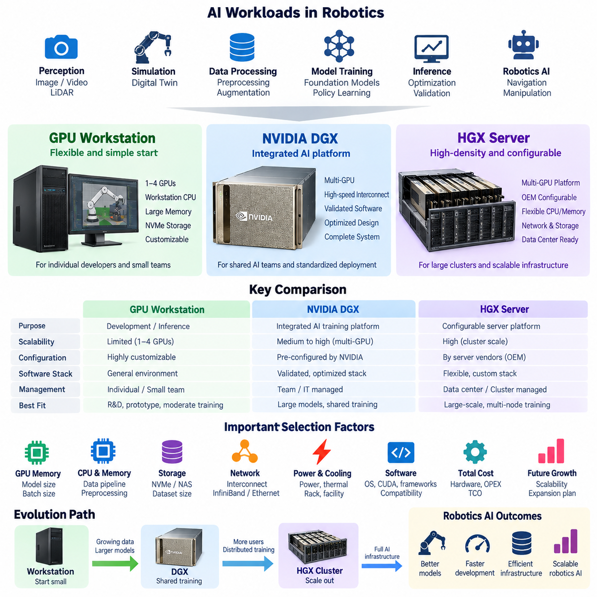
Selecting a GPU server for on-premise AI requires matching the computing platform to workload scale, model size, dataset volume, concurrency, and expected growth. NVIDIA DGX systems, HGX-based servers, and professional GPU workstations represent different infrastructure classes rather than simply different performance levels. The correct choice depends on whether the system serves an individual developer, a shared AI team, or a large distributed training environment.
A GPU workstation is generally the simplest entry point for robotics AI development. It combines one or several professional or data-center-class GPUs with conventional workstation CPUs, system memory, and local NVMe storage. This configuration is suitable for model development, inference optimization, dataset preprocessing, simulation, visualization, and moderate training workloads where engineers benefit from direct access to dedicated computing resources.
Workstations provide flexibility because GPU, memory, storage, and peripheral configurations can often be customized around specific engineering requirements. Robotics developers may need high-capacity NVMe drives for sensor datasets, large system memory for point-cloud processing, or additional PCIe devices for networking and data acquisition. However, workstation scalability is constrained by chassis space, PCIe topology, power delivery, cooling capacity, and the number of GPUs that can operate efficiently within one system.
NVIDIA DGX represents a more integrated approach to AI infrastructure. Rather than treating GPUs as independent accelerator cards installed in a general-purpose server, DGX systems are engineered as complete AI computing platforms in which GPUs, CPUs, high-speed interconnects, networking, storage interfaces, system software, power, and cooling are designed together. This reduces the integration effort required when deploying large multi-GPU AI workloads.
A major advantage of the DGX architecture is its emphasis on high-bandwidth communication between GPUs. Modern AI training increasingly involves models or batches that cannot be processed efficiently on a single accelerator. High-speed GPU interconnect technologies allow multiple GPUs to cooperate with substantially lower communication overhead than architectures that depend entirely on conventional PCIe transfers. This becomes important for distributed deep learning, foundation models, multimodal models, and large robotics policy training.
DGX systems also provide a standardized software environment around the hardware platform. NVIDIA's AI software ecosystem, GPU drivers, CUDA libraries, communication libraries, containerized frameworks, monitoring components, and validated configurations can reduce compatibility problems. For organizations that value predictable deployment and vendor-supported integration, this standardization can be more important than the cost difference between a DGX platform and a custom-built GPU server.
HGX occupies a different position because it is primarily a server platform architecture used by system manufacturers to build high-density GPU servers. An HGX platform integrates multiple data-center GPUs through high-speed GPU interconnect technologies and provides the foundation upon which OEM and server vendors add CPUs, memory, storage, networking, chassis design, cooling, management controllers, and other infrastructure components.
This distinction is important when comparing DGX and HGX. DGX is delivered as an NVIDIA-designed integrated AI system, whereas HGX enables server manufacturers and infrastructure providers to create systems around NVIDIA's multi-GPU computing platform. An organization selecting HGX-based servers can therefore obtain greater flexibility in server vendor, CPU configuration, storage architecture, network interfaces, rack integration, support contracts, and data-center deployment strategy.
HGX-based servers become particularly attractive when AI infrastructure is being designed as part of a larger cluster. In this environment, individual servers are nodes within a distributed computing system rather than isolated machines. High-speed Ethernet or InfiniBand networking, shared storage, workload schedulers, container orchestration, monitoring, authentication, and cluster management become as important as the GPU specification of each node.
The selection process should therefore begin with GPU memory requirements. Robotics AI models increasingly combine camera images, video, LiDAR, language, actions, maps, and simulation states, which can consume substantial accelerator memory. Training also requires memory for model parameters, gradients, optimizer states, activations, and temporary tensors. If workloads regularly exceed the capacity of a single GPU, multi-GPU communication and memory-distribution strategies become fundamental architectural requirements.
GPU quantity alone is not a reliable indicator of training performance. Two systems containing the same number of accelerators can behave differently because of GPU topology, PCIe bandwidth, GPU-to-GPU interconnects, CPU architecture, system memory, storage throughput, and network configuration. Server selection should therefore evaluate the complete data path from storage to CPU memory, GPU memory, neighboring GPUs, and other cluster nodes rather than comparing only theoretical GPU compute performance.
CPU and system memory must also be sized for the AI pipeline surrounding the GPUs. Image decoding, point-cloud transformation, simulation, data augmentation, dataset indexing, compression, and preprocessing can create substantial CPU workloads. Insufficient CPU resources can leave expensive GPUs underutilized. Similarly, inadequate system memory may limit large datasets, simulation environments, caching strategies, or parallel data-loader processes before GPU capacity becomes the actual bottleneck.
Local storage should support the active working set of AI experiments. High-speed NVMe storage can accelerate dataset caching, checkpoint operations, container loading, preprocessing, and repeated training iterations. Larger datasets can remain on shared NAS or high-performance cluster storage, while frequently accessed subsets are staged locally. The server architecture should provide enough PCIe connectivity to support GPUs, NVMe devices, and high-speed network adapters without creating hidden bandwidth bottlenecks.
Power and cooling requirements become progressively more significant when moving from workstations toward DGX or HGX-class systems. Dense multi-GPU servers can require substantial electrical capacity and generate concentrated thermal loads. Rack power distribution, UPS design, cooling capacity, airflow, equipment weight, acoustic constraints, and facility expansion should therefore be evaluated before procurement rather than after the servers arrive.
Software compatibility is another selection criterion. The server must support the operating system, GPU driver, CUDA environment, container runtime, AI frameworks, distributed training libraries, simulation software, and orchestration platform required by the organization. Standardizing these components across development workstations and shared servers simplifies model migration because experiments can move from individual development systems to larger infrastructure with fewer environmental differences.
Operational responsibility differs among the three approaches. Workstations can usually be managed directly by individual engineers or small teams. DGX systems provide a more standardized platform but still require infrastructure management for networking, storage, accounts, monitoring, backup, and scheduling. HGX-based clusters demand broader data-center and cluster engineering capabilities because hardware integration, node configuration, fabric design, resource scheduling, and lifecycle management become organization-level responsibilities.
Cost comparison should consequently use total cost of ownership rather than accelerator purchase price alone. Workstations may offer an economical starting point but become difficult to manage when many independent systems accumulate. DGX can reduce integration risk and engineering effort through standardization, while HGX-based systems can provide greater architectural flexibility for large deployments. Power, cooling, networking, storage, support, administrator effort, and utilization must all be included in the economic analysis.
For robotics organizations, these platforms can also form an evolutionary infrastructure path. Individual GPU workstations can support early perception, navigation, simulation, and Physical AI experiments. As datasets and models expand, centralized multi-GPU servers can provide shared training capacity. When workloads require many concurrent users or distributed training across multiple nodes, DGX or HGX-class infrastructure can become the foundation of a dedicated GPU cluster.
The final selection should therefore be based on workload architecture rather than product prestige. A workstation is appropriate when flexibility, local development, and moderate GPU scale dominate. DGX is suitable when an integrated and standardized multi-GPU AI platform is important, while HGX-based servers are especially relevant when organizations require configurable high-density GPU nodes within larger data-center or cluster architectures. These platforms can coexist as complementary layers of the same on-premise AI environment.

06.03 On-Premise AI Cluster Network: InfiniBand / NVLink
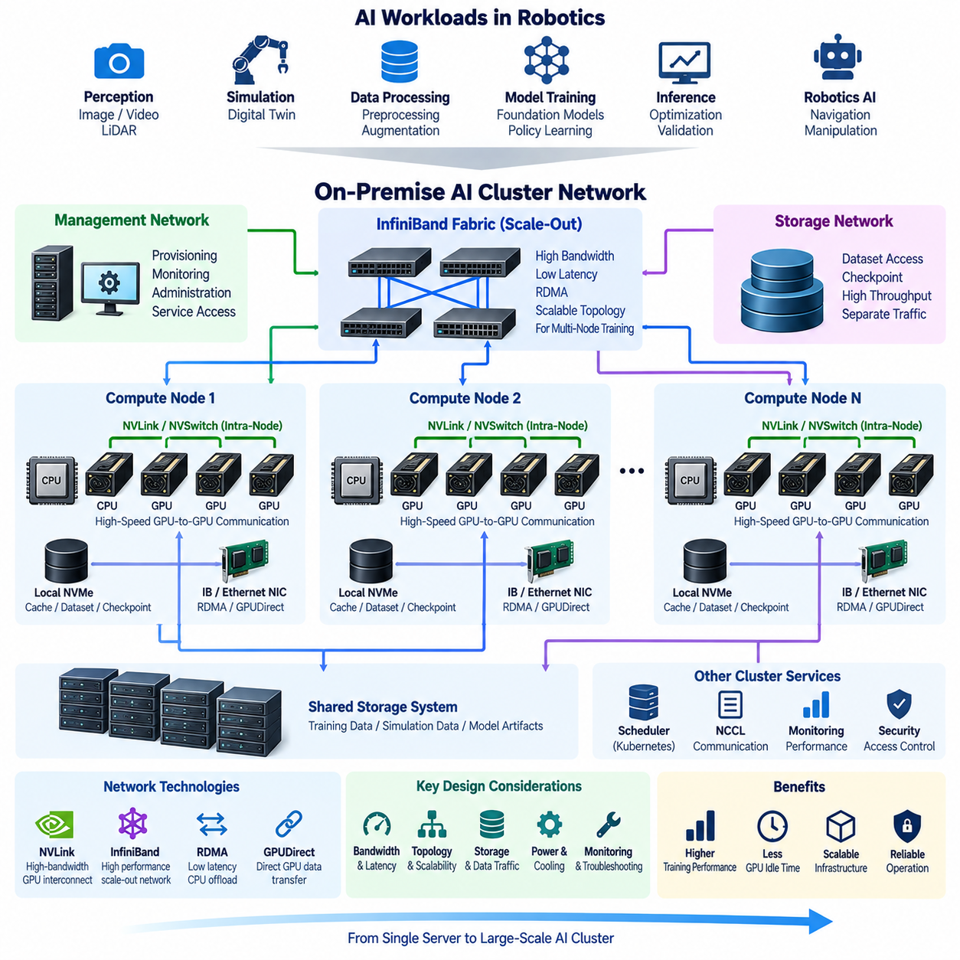
An on-premise AI cluster network must move data efficiently between GPUs, compute nodes, storage systems, and management services. As AI workloads expand from a single server to distributed training across multiple machines, network communication can become as important as GPU performance itself. InfiniBand and NVLink address different parts of this communication hierarchy and should be understood as complementary technologies rather than direct substitutes.
Distributed AI training repeatedly exchanges gradients, parameters, activations, and synchronization messages among accelerators. If communication cannot keep pace with GPU computation, accelerators spend increasing amounts of time waiting for data instead of executing useful operations. Network architecture must therefore be designed according to model size, communication pattern, number of GPUs, node count, storage traffic, and expected cluster expansion.
NVLink is a high-speed interconnect technology designed primarily for direct communication between NVIDIA GPUs and, in supported architectures, other tightly coupled processors. Compared with communication paths that rely only on conventional PCIe, NVLink can provide higher bandwidth for supported GPU-to-GPU transfers. This allows accelerators inside a multi-GPU system to exchange data more efficiently during parallel AI computation.
Within a server, GPU topology strongly influences performance. GPUs connected through high-bandwidth interconnects can communicate differently from devices whose traffic must traverse PCIe switches or CPU-controlled paths. Distributed training software should therefore understand the physical topology of the machine. Scheduling processes without considering GPU connectivity can produce inconsistent performance even when the same number and type of accelerators are allocated.
NVSwitch extends high-bandwidth GPU connectivity by providing switching infrastructure among multiple GPUs within supported systems. Instead of relying only on individual point-to-point connections, an NVSwitch-based architecture can provide more flexible communication paths across a dense group of accelerators. This is particularly valuable for large models that distribute computation or model state across several GPUs inside one server.
InfiniBand operates at another level of the cluster architecture. It provides high-performance networking for communication between servers, storage systems, and other cluster resources. Its combination of high bandwidth, low latency, and remote direct memory access capabilities makes it widely applicable to high-performance computing and distributed AI environments where many compute nodes must exchange data continuously.
Remote Direct Memory Access, or RDMA, reduces communication overhead by allowing data transfers to occur with less involvement from host CPUs and conventional operating-system networking paths. For distributed AI workloads, this can reduce latency and CPU consumption while increasing effective communication throughput. RDMA becomes increasingly valuable as collective communication operations span larger numbers of accelerators and servers.
GPUDirect RDMA further optimizes the data path by enabling supported network adapters and GPUs to exchange data without requiring every transfer to be staged through conventional host-memory paths. This reduces unnecessary copies and helps distributed training frameworks communicate GPU-resident data efficiently between nodes. The resulting benefit depends on compatible GPUs, network adapters, drivers, topology, and software configuration.
NCCL, the NVIDIA Collective Communications Library, provides communication primitives commonly used by distributed deep-learning frameworks. Operations such as all-reduce, all-gather, reduce-scatter, and broadcast are fundamental to data parallelism and other distributed training strategies. NCCL can select communication paths according to available GPU interconnects and network interfaces, making physical topology an important component of software-level performance.
A multi-node AI cluster therefore contains several communication layers. Inside an accelerator node, GPUs may communicate through NVLink and NVSwitch where supported, while PCIe continues to connect GPUs, CPUs, storage devices, and network adapters. Between nodes, InfiniBand or high-performance Ethernet transports distributed workloads. The overall training performance depends on how effectively these layers operate together rather than on any single interconnect technology.
High-performance Ethernet remains an important alternative to InfiniBand. Modern Ethernet networks can support RDMA technologies and integrate well with existing data-center infrastructure, operational tools, and networking expertise. Organizations should therefore avoid selecting InfiniBand solely because it is associated with high-performance AI. Existing infrastructure, cluster scale, target workload, operational capability, cost, and required performance should determine the network technology.
Network topology becomes increasingly important as clusters expand. A poorly designed switching hierarchy can create oversubscription, congestion, and uneven communication performance between nodes. Distributed training frequently generates synchronized traffic patterns in which many GPUs communicate simultaneously. Switch capacity, uplink bandwidth, path diversity, and oversubscription ratios should therefore be evaluated against expected collective communication behavior.
Storage traffic must also be considered separately from GPU synchronization traffic. Large robotics datasets can contain video, LiDAR point clouds, depth images, simulation outputs, maps, and multimodal training samples. Hundreds of workers reading these datasets simultaneously can generate substantial network load. Storage access competing with distributed training communication on the same constrained links can reduce GPU utilization and increase training time.
For this reason, cluster designs often separate management, storage, and high-performance compute traffic logically or physically. Management networks handle provisioning, monitoring, administration, and service access. Storage networks carry datasets and checkpoints, while the high-performance fabric supports latency-sensitive distributed computation. Separation improves traffic predictability, troubleshooting, security segmentation, and capacity planning even when some infrastructure is shared.
Latency and bandwidth must be evaluated together. Large sequential transfers benefit strongly from bandwidth, while synchronization-heavy workloads can also be sensitive to message latency. A network with impressive theoretical throughput may still perform poorly if topology, congestion, protocol overhead, or software configuration increases effective communication delay. Benchmarking should therefore reproduce actual AI communication patterns rather than relying only on interface specifications.
Cluster networking also requires careful physical infrastructure planning. High-speed network adapters and switches consume PCIe resources, electrical power, rack space, and cooling capacity. Cable type, cable length, transceiver selection, switch placement, redundant paths, and rack layout can influence both reliability and cost. Network design should consequently be coordinated with server, storage, power, and cooling architecture before hardware procurement.
Monitoring is essential because communication bottlenecks may appear as apparent GPU performance problems. GPU utilization, network throughput, packet errors, link state, retransmissions, congestion indicators, storage throughput, and collective communication performance should be observed together. Baseline measurements collected when the cluster is healthy make it easier to identify whether later degradation originates from GPUs, software, storage, or the network fabric.
Scalability should be designed before the first expansion. A small cluster may operate effectively with a simple switching configuration, but adding many GPU nodes can change bandwidth requirements and traffic patterns dramatically. Switch port availability, uplink capacity, addressing, fabric management, rack placement, and storage connectivity should include expansion margins so that growth does not require replacing the entire network architecture.
For robotics AI, the cluster network connects workloads such as perception training, simulation, world models, reinforcement learning, multimodal foundation models, and large-scale dataset processing. These workloads can differ substantially in communication intensity. Simulation may require large numbers of independent GPU tasks, whereas distributed foundation-model training can demand continuous accelerator synchronization. Network requirements should therefore be derived from workload behavior rather than GPU count alone.
The resulting architecture can be viewed as a communication hierarchy: high-speed GPU interconnects provide tightly coupled communication inside supported servers, PCIe integrates major local devices, and InfiniBand or high-performance Ethernet connects compute nodes and shared infrastructure across the cluster. RDMA, GPUDirect technologies, and communication libraries such as NCCL optimize movement across these layers.
A well-designed on-premise AI cluster network ultimately minimizes the time expensive accelerators spend waiting for communication. NVLink and NVSwitch strengthen intra-node GPU communication, while InfiniBand and comparable high-performance network technologies enable efficient scale-out across servers. When topology, RDMA, storage access, software libraries, monitoring, and future expansion are designed together, the network becomes an integral part of AI computing performance rather than a secondary infrastructure component.

06.04 Kubernetes GPU Cluster Configuration [w/Code]
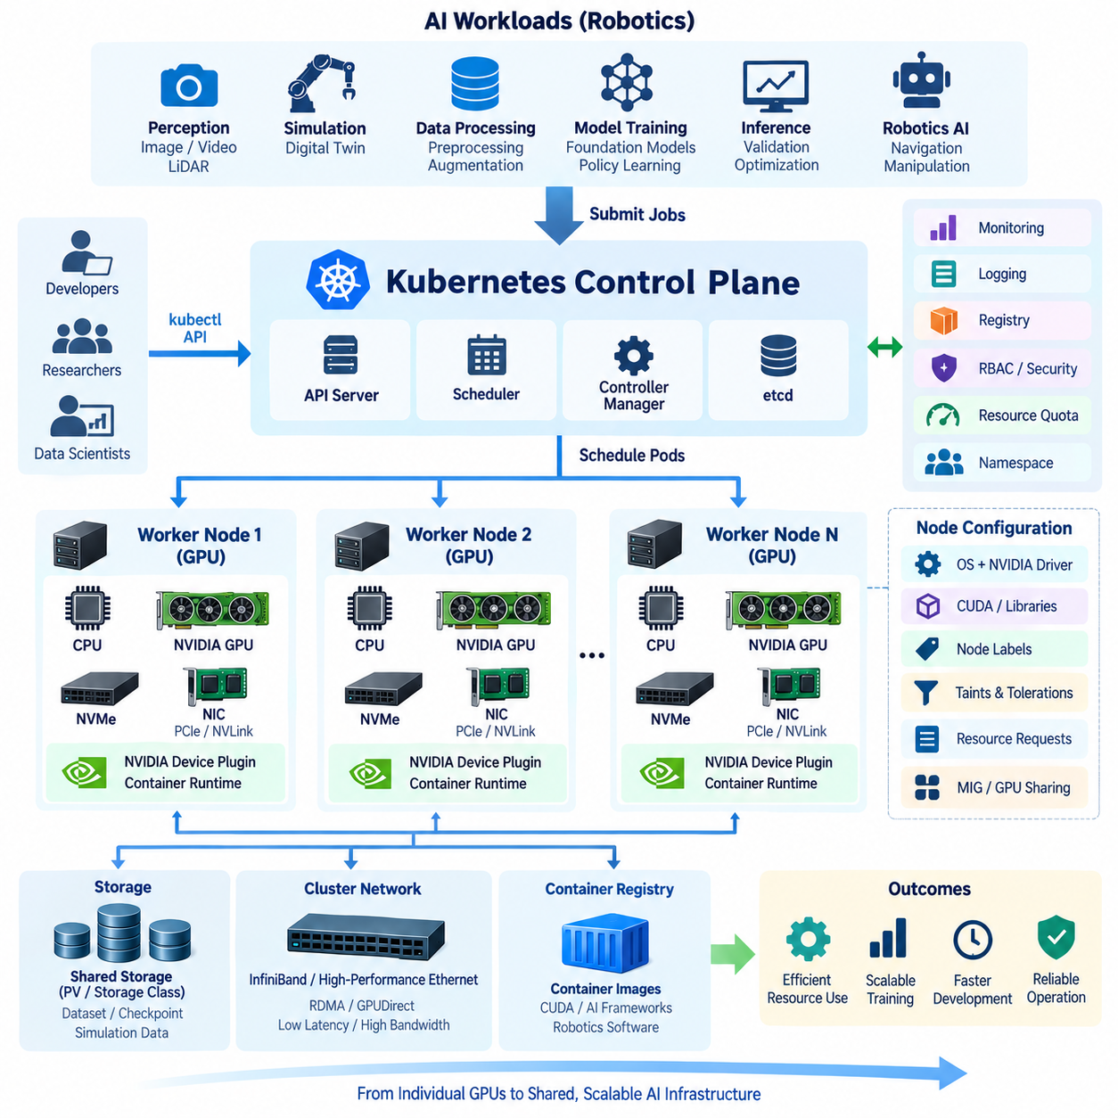
Kubernetes provides a container orchestration layer for operating shared GPU resources across an on-premise AI cluster. Instead of assigning physical GPU servers permanently to individual engineers, Kubernetes represents compute nodes as a common resource pool and schedules containerized AI workloads according to declared requirements. This model supports robotics training, simulation, inference validation, data processing, and other GPU-intensive workloads within a unified infrastructure.
A Kubernetes GPU cluster extends the conventional Kubernetes control-plane and worker-node architecture with GPU-aware components. The control plane manages desired state, scheduling, APIs, and cluster metadata, while GPU-equipped worker nodes execute containers. Each worker can contain CPUs, system memory, local NVMe storage, network adapters, and one or more NVIDIA GPUs connected through PCIe, NVLink, or other supported interconnects.
Before Kubernetes can schedule accelerators, each GPU node requires a compatible software stack. The host operating system, NVIDIA GPU driver, container runtime, Kubernetes components, and GPU container support must operate together correctly. AI containers should package frameworks and application dependencies while relying on the host driver interface for GPU access, reducing differences between developer environments and shared production infrastructure.
The NVIDIA Container Toolkit enables containers to access NVIDIA GPUs while preserving container isolation and reproducibility. Applications can therefore use CUDA and GPU-accelerated libraries without installing an independent kernel-level GPU driver inside every container image. This separation simplifies image maintenance and allows standardized AI environments to move between compatible GPU nodes while retaining access to underlying acceleration hardware.
Kubernetes itself does not automatically discover every specialized accelerator as a schedulable resource. NVIDIA Device Plugin is commonly deployed across GPU worker nodes to detect available devices and advertise them to Kubernetes. Once registered, GPUs appear as extended resources that Pods can request explicitly, allowing the scheduler to place workloads only on nodes with sufficient accelerator capacity.
A GPU workload is typically expressed through a Pod, Job, or higher-level workload controller containing resource requirements. Training jobs can request GPUs together with CPU and memory resources, while node labels and affinity rules can distinguish different accelerator classes. This becomes important when a cluster contains heterogeneous hardware because not every robotics workload requires the same GPU memory capacity, performance level, or interconnect topology.
Node labels provide a practical mechanism for describing infrastructure characteristics such as GPU family, memory class, network capability, or intended workload role. Node selectors and node affinity can then constrain placement according to these attributes. Taints and tolerations can reserve expensive GPU nodes for approved workloads, preventing ordinary CPU-only services from consuming resources on specialized AI servers unnecessarily.
Resource requests and limits are central to predictable cluster operation. CPU and memory can be allocated independently from GPUs, so an AI workload should describe the complete resource profile needed for execution. Allocating many GPUs without sufficient CPU preprocessing capacity or system memory can leave accelerators underutilized. Kubernetes configuration should therefore reflect the entire AI pipeline rather than treating the GPU as the only relevant resource.
For long-running AI services, Deployments can maintain a desired number of replicas and recover failed Pods automatically. Training and preprocessing workloads are often better represented as Jobs because they have defined completion states. More complex distributed training systems may use specialized operators or controllers that coordinate worker processes, ranks, replicas, restart behavior, and communication settings across multiple Pods and nodes.
Multi-GPU training inside a single node depends heavily on the physical GPU topology. Kubernetes may allocate the requested devices, but application performance still depends on communication paths among those GPUs. NVLink or NVSwitch connectivity, PCIe topology, CPU locality, and network-interface placement can affect throughput. GPU-aware scheduling should therefore evolve beyond simple device counting when large distributed workloads become important.
Multi-node training adds the cluster network to this scheduling problem. Pods running on separate servers must exchange gradients, parameters, or model states through InfiniBand or high-performance Ethernet. RDMA and GPUDirect technologies can reduce communication overhead when supported by the hardware and software stack. Kubernetes provides orchestration, but high-performance communication still requires correct network devices, drivers, plugins, topology, and distributed training libraries.
Storage must also be integrated into the cluster architecture. Robotics AI workloads may consume large datasets containing video, LiDAR, maps, simulation data, model checkpoints, and experiment artifacts. Kubernetes Persistent Volumes and storage classes can provide controlled access to shared storage, while local NVMe can cache frequently used datasets. Storage throughput must remain high enough to prevent data loading from becoming the bottleneck for expensive GPUs.
Namespaces provide a logical boundary for organizing users, projects, teams, or workload classes. ResourceQuota policies can limit the amount of CPU, memory, storage, and GPU capacity that a namespace consumes, while LimitRange policies can establish default or permitted resource configurations. These controls are especially useful in shared environments where multiple robotics projects compete for a finite pool of accelerator resources.
Scheduling policy should reflect organizational priorities as well as technical constraints. Interactive development, urgent validation, scheduled model training, simulation campaigns, and background preprocessing may require different service levels. Priority classes can influence which workloads receive resources first, while queue-oriented extensions or external scheduling systems can provide more sophisticated policies when demand consistently exceeds available GPU capacity.
GPU partitioning can improve utilization for workloads that do not require an entire accelerator. Depending on the GPU architecture and deployment model, technologies such as Multi-Instance GPU can divide supported GPUs into isolated hardware-backed instances. Other sharing mechanisms may allow multiple processes to use the same accelerator. The appropriate method depends on isolation requirements, memory demand, workload behavior, and supported hardware capabilities.
Container images should be managed through a controlled registry rather than assembled independently on each node. Versioned images can capture CUDA libraries, AI frameworks, robotics software, and application dependencies in reproducible environments. An on-premise registry also reduces repeated external downloads and supports environments with restricted internet access. Image signing, vulnerability scanning, and access control strengthen the software supply chain.
Observability must cover both Kubernetes and GPU-specific metrics. Standard cluster monitoring provides information about Pods, nodes, CPU, memory, storage, and network behavior, while NVIDIA GPU telemetry can expose utilization, memory consumption, temperature, power, and hardware health. Combining these signals makes it possible to determine whether low training performance originates from GPU saturation, CPU starvation, storage delays, networking, or scheduling inefficiency.
Failure handling is another advantage of orchestration, but AI jobs require careful recovery design. Kubernetes can restart failed containers or reschedule workloads after node failures, yet restarting a large training process from the beginning may waste substantial computation. Periodic checkpointing to persistent storage allows training to resume from a recent state, while application-level recovery logic should complement Kubernetes infrastructure-level restart mechanisms.
Security should follow least-privilege principles throughout the cluster. Role-Based Access Control can restrict Kubernetes API operations, namespaces can separate organizational workloads, and network policies can constrain service communication. Secrets, container registry credentials, storage access, service accounts, and administrative privileges require explicit management because a shared GPU cluster concentrates valuable datasets, models, computing resources, and infrastructure controls.
Capacity planning should examine utilization rather than simply counting installed GPUs. Administrators should track accelerator occupancy, GPU memory usage, job queue time, CPU-to-GPU balance, storage throughput, network traffic, and workload duration. These measurements reveal whether additional GPUs are actually required or whether performance is limited by preprocessing, communication, storage, scheduling policy, or inefficient resource allocation.
A practical deployment can evolve gradually. An organization may initially create a small Kubernetes cluster with several GPU worker nodes, shared storage, a container registry, and basic monitoring. As usage increases, the environment can add dedicated GPU pools, high-speed networking, distributed training operators, quotas, advanced scheduling, automated provisioning, and stronger observability without fundamentally changing the containerized workload model.
For robotics AI, Kubernetes therefore acts as the resource-management layer connecting developers, containerized software, GPU servers, storage, and cluster networking. It does not replace CUDA, NVLink, InfiniBand, NCCL, or AI frameworks; instead, it coordinates where and how workloads execute across the underlying infrastructure. A well-configured Kubernetes GPU cluster transforms independent accelerator servers into a shared, reproducible, scalable computing platform for robotics AI development and training.

06.05 MLflow On-Premise Install and Model Management [w/Code]
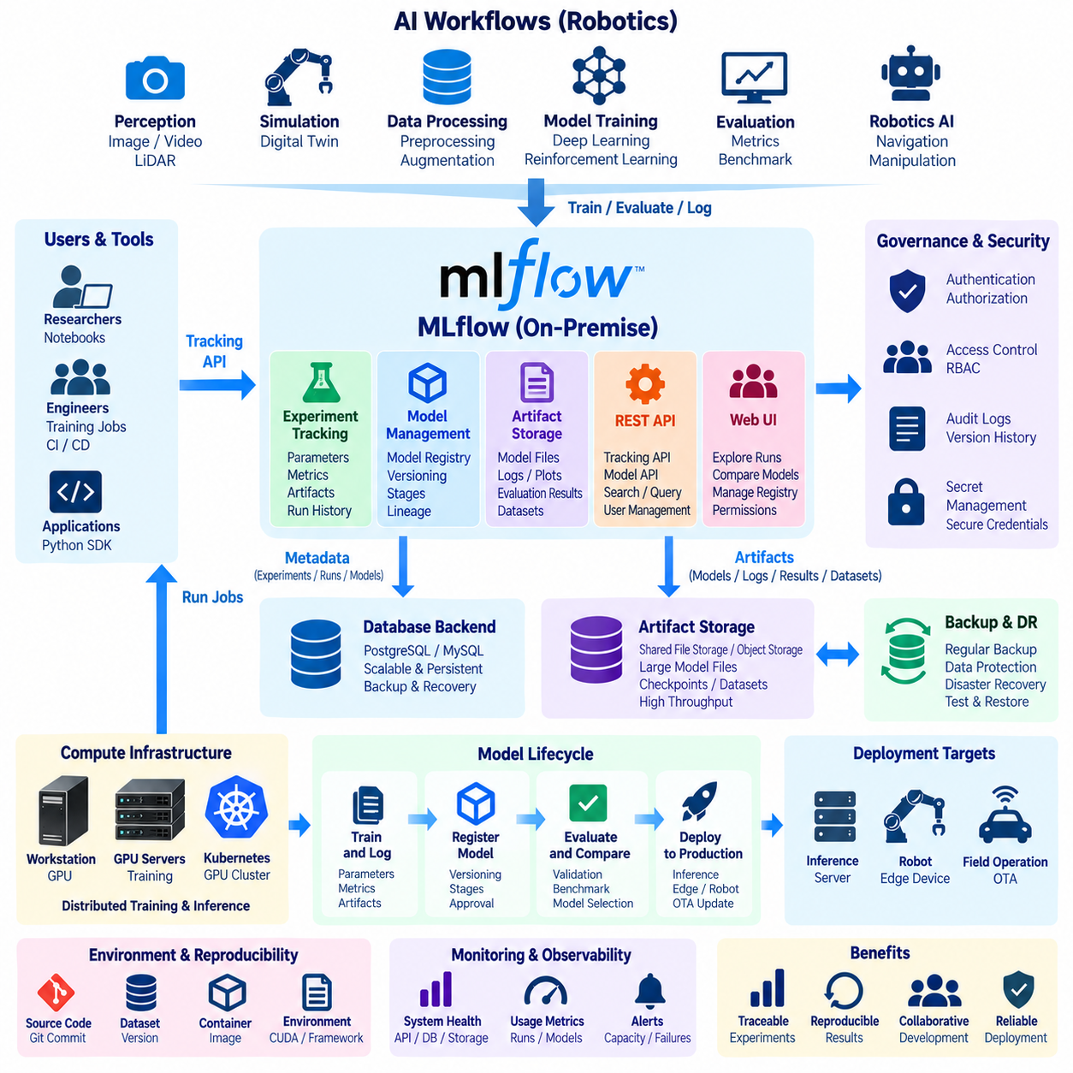
MLflow provides a platform for managing the machine-learning lifecycle by connecting experiment tracking, model artifacts, model registration, and deployment-oriented metadata within a common workflow. In an on-premise AI environment, MLflow allows robotics organizations to retain experiment information, trained models, parameters, metrics, and related artifacts inside infrastructure controlled by the organization rather than depending entirely on externally hosted services.
An on-premise MLflow deployment should be designed as a shared service rather than as a tool installed independently on every developer workstation. Researchers, training jobs, notebooks, CI pipelines, and Kubernetes workloads can communicate with a centralized MLflow Tracking Server. This architecture establishes a common system of record for AI experiments while allowing actual computation to remain distributed across GPU workstations, servers, and cluster nodes.
The MLflow Tracking Server acts as the primary interface between AI applications and the experiment-management infrastructure. Training code sends information such as parameters, metrics, tags, run status, and artifact references to the tracking service. By assigning experiments and runs systematically, engineers can compare training configurations and preserve the history of how a particular model result was produced instead of relying on manually named folders or disconnected spreadsheets.
A production-oriented installation normally separates metadata storage from artifact storage. Metadata describing experiments, runs, parameters, metrics, and model-management information can be maintained in a database backend, while larger files such as model checkpoints, evaluation outputs, plots, logs, and packaged models are stored in an artifact repository. This separation makes the system easier to scale and prevents large binary objects from overwhelming the metadata layer.
For an on-premise environment, artifact storage can be implemented using shared file storage or an internally operated object-storage service, depending on scale and operational requirements. Robotics projects can generate large model files, perception results, evaluation reports, and training outputs, so storage capacity and throughput should be planned alongside MLflow itself. Backup policies must protect both metadata and artifacts because losing either side can break experiment reproducibility.
Database selection should reflect the expected number of users, experiments, and concurrent training processes. A small development installation can begin with a simple backend, but a shared organizational service benefits from a dedicated database architecture that supports concurrent access, backup, monitoring, and recovery. The database should be treated as persistent infrastructure rather than temporary storage attached to a single MLflow process.
MLflow integrates naturally with Python-based AI training workflows. Training scripts can create or select experiments, start runs, log hyperparameters, record metrics during training, and save model artifacts at completion. This makes experiment tracking part of the execution pipeline rather than a separate reporting task. Robotics teams can record learning rates, dataset versions, sensor configurations, simulation conditions, evaluation scores, and other information needed to reproduce results.
Model management becomes increasingly important when many experiments produce similar model files. A useful model repository must distinguish experimental checkpoints from models that have been reviewed for downstream use. MLflow's model-management capabilities provide structured identities and versions for registered models, allowing teams to associate model artifacts with their experiment history and manage their progression through development and operational workflows.
Model versioning should be coordinated with dataset, source-code, and container versions. A trained model alone does not completely describe how an AI result was produced. Reproducibility may require the Git commit, dataset revision, preprocessing configuration, framework version, CUDA environment, container image, training parameters, and hardware context. These identifiers can be stored as tags, parameters, or related metadata so that a model can be traced back to its development environment.
This traceability is particularly valuable in robotics because model behavior can depend on sensor configuration and operating conditions. A perception model may have been trained using a particular camera resolution, LiDAR configuration, region of interest, annotation policy, or simulation environment. Recording these conditions alongside the training run reduces the risk of deploying a technically valid model into a robot configuration for which it was never evaluated.
MLflow can also support evaluation-oriented workflows. Training results can include validation metrics, confusion matrices, benchmark outputs, latency measurements, memory consumption, or robustness tests as artifacts and metadata. Teams can compare candidate models using common evaluation criteria before selecting models for deployment. The final acceptance decision can therefore be linked to recorded evidence rather than only to a model filename or informal developer judgment.
In a Kubernetes GPU cluster, MLflow can operate as a persistent platform service while training workloads execute as separate Pods or Jobs. GPU jobs communicate with the MLflow endpoint to record their results regardless of which worker node executes them. This separation is important because training containers may be temporary, while experiment history must remain persistent. Persistent databases and artifact storage therefore sit outside the lifecycle of individual training Pods.
Containerization simplifies deployment of the MLflow service itself. The tracking server and supporting components can be packaged into controlled container images and deployed through Docker or Kubernetes. Configuration such as database connections, artifact locations, service addresses, and credentials should be supplied externally rather than embedded permanently in images. This approach improves reproducibility and allows infrastructure configuration to change without rebuilding application software.
Networking should restrict MLflow access to authorized development and cluster environments. In a private AI infrastructure, the tracking endpoint may be exposed only through internal networks, VPN access, or controlled ingress services. Authentication and authorization should be added according to organizational requirements, while database and object-storage credentials should be protected through appropriate secret-management mechanisms rather than stored directly in training scripts.
Security also applies to the model artifacts themselves. Trained models can contain substantial intellectual property and may encode knowledge derived from proprietary datasets. Access policies should therefore distinguish users who can view experiments, upload artifacts, register models, or approve deployment candidates. Audit logs and version history become increasingly important when MLflow is used as part of a formal model-governance process rather than only as a research convenience.
Model deployment should remain separated from model registration. Registering or identifying a model as a candidate does not automatically mean that it is safe for robot operation. A deployment pipeline can retrieve an approved model version, perform additional validation, package it into an inference container or robot software release, and then distribute it through the organization's deployment or OTA infrastructure. This separation reduces accidental promotion of unvalidated models.
For edge robotics, the registered model may require optimization before deployment. A training artifact created with PyTorch or another framework can pass through export and optimization stages such as conversion to an inference representation or hardware-specific runtime format. MLflow can preserve references to the original model and derived deployment artifacts, helping engineers understand the relationship between the trained model and the version actually executed on the robot.
Monitoring should cover both MLflow infrastructure health and usage. Administrators should observe server availability, API response time, database performance, artifact-storage capacity, request volume, and backup status. Rapid growth in experiments or large checkpoints can consume storage unexpectedly. Capacity planning should therefore consider model size, run frequency, retention policy, number of users, and the expected growth of robotics AI programs.
Backup and disaster recovery must preserve consistency between the backend database and artifact repository. Database backups alone cannot recover model binaries that have been lost, while artifact backups without experiment metadata may leave files difficult to identify or reproduce. Recovery procedures should therefore include both layers and be tested periodically so that the experiment history and corresponding artifacts can be restored together after infrastructure failure.
A practical adoption strategy can begin with one centralized tracking service, persistent metadata storage, and a shared artifact repository. As usage grows, the organization can add database redundancy, scalable object storage, authentication, Kubernetes deployment, monitoring, backup automation, and integration with CI/CD and model deployment pipelines. The fundamental experiment and model identities can remain stable while the supporting infrastructure evolves.
For robotics AI, MLflow ultimately provides the management layer connecting experimentation with controlled model delivery. GPU clusters perform the computation, datasets provide training material, Git manages source code, container registries preserve software environments, and MLflow records how experiments and models relate to those resources. When these systems are integrated, model development becomes traceable, reproducible, and manageable across teams.
An on-premise MLflow environment should therefore be treated as part of the organization's AI infrastructure rather than merely as an experiment dashboard. Centralized tracking, persistent metadata, artifact management, model versioning, access control, evaluation records, and deployment integration create a continuous path from research experiments to validated robotics models. This foundation becomes increasingly important as AI teams, GPU resources, datasets, and deployed robot fleets grow in scale.

06.06 JupyterHub On-Premise AI Dev Environment [w/Code]
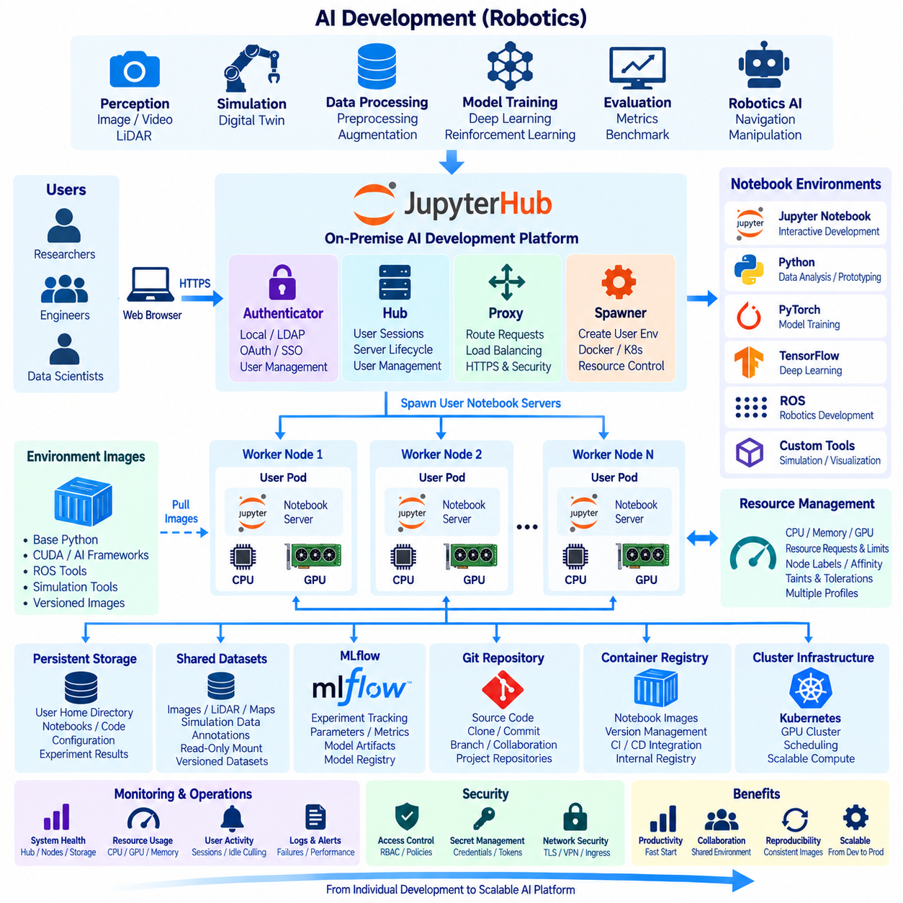
JupyterHub provides a centralized, multi-user development environment for on-premise AI infrastructure by allowing researchers and engineers to access individual Jupyter notebook sessions through a shared service. Instead of configuring independent Python environments on every workstation, an organization can provide controlled development environments connected directly to internal datasets, GPU resources, model repositories, and robotics software infrastructure.
The architecture separates user access from the actual notebook execution environment. A user connects through a web browser and authenticates with JupyterHub, after which the platform creates or connects the user to an isolated notebook server. The notebook environment can execute on a local server, container, virtual machine, or Kubernetes worker node depending on the deployment architecture and resource requirements of the organization.
JupyterHub itself coordinates authentication, user sessions, and notebook-server lifecycle management. Its Hub component maintains information about users and running servers, while a configurable proxy routes incoming requests to the correct notebook instance. A Spawner determines how each user environment is created. This separation allows the same user interface to support deployments ranging from a single shared server to a large Kubernetes-based GPU cluster.
Authentication should be integrated with the organization's identity-management strategy whenever possible. Local accounts may be sufficient for a small laboratory, while larger installations can connect JupyterHub to centralized authentication systems. The objective is to avoid unmanaged shared accounts and establish identifiable users whose permissions, resource consumption, notebook environments, and access to sensitive AI datasets can be controlled according to organizational policy.
User isolation is particularly important in a shared AI environment. Researchers may install libraries, execute experimental code, consume large amounts of memory, or accidentally create processes that continue running after interactive work has finished. Containers or other isolated execution environments can limit the impact of these activities. Each user can receive a separate filesystem workspace and computational environment while selected datasets and shared project resources remain centrally accessible.
Containerized notebook environments improve reproducibility by packaging Python, CUDA libraries, AI frameworks, ROS tools, simulation dependencies, and project-specific software into versioned images. Instead of manually reproducing development environments across multiple machines, administrators can publish standardized images for particular workloads. Researchers can then begin experiments from controlled software baselines while retaining separate workspaces for notebooks, code, and intermediate results.
GPU access is a central requirement for robotics AI development. JupyterHub can be integrated with GPU-equipped servers or a Kubernetes GPU cluster so notebook sessions request accelerator resources when required. CPU-only analysis can remain on ordinary nodes, while deep-learning training, perception experiments, simulation, or model optimization can be directed toward GPU workers. This separation improves utilization of expensive accelerator resources.
In a Kubernetes deployment, JupyterHub can create a dedicated Pod for each user session. Kubernetes then determines where the Pod runs according to CPU, memory, GPU, node labels, affinity rules, taints, and other scheduling policies. This model connects interactive notebook development with the same resource-management infrastructure used for batch training and other containerized AI workloads, reducing the need for separate computing environments.
Resource requests and limits should be defined carefully because interactive notebooks can otherwise consume cluster capacity unpredictably. A notebook profile can specify CPU, memory, storage, and GPU requirements for different development tasks. Lightweight data exploration may require no GPU, while perception training or simulation can request one or more accelerators. Administrators can provide several predefined profiles rather than allowing every user unrestricted resource allocation.
Persistent storage ensures that user work survives notebook restarts or Pod replacement. Home directories, notebooks, source code, configuration files, and selected experiment outputs can reside on persistent volumes, while large shared datasets remain on centralized storage. Temporary local NVMe storage can be used for high-speed caching or intermediate processing, but important results should be transferred to persistent infrastructure before temporary execution environments are removed.
Shared robotics datasets require a different access strategy from personal workspaces. Camera images, LiDAR point clouds, maps, simulation data, annotations, and training datasets may be too large to duplicate for every user. Read-only or controlled shared mounts can provide common dataset access while preventing accidental modification. Dataset versioning should remain independent from notebook storage so experiments can identify precisely which data revision was used.
JupyterHub should also integrate with source-control workflows rather than becoming the permanent location of project code. Developers can clone Git repositories into their notebook environments, create branches, test modifications, and commit validated changes back to the repository. This preserves Git as the authoritative source for software history while JupyterHub remains an interactive development environment for exploration, experimentation, debugging, visualization, and prototype implementation.
The relationship with MLflow is similarly complementary. JupyterHub provides the environment in which researchers interactively develop and execute experiments, while MLflow can record parameters, metrics, artifacts, model versions, and experiment history. A notebook can launch training code and log its results to the centralized MLflow service. This prevents important experimental knowledge from remaining only inside notebook cells or manually written notes.
Container registries provide another connection between JupyterHub and the broader AI platform. Standard notebook images can be built through controlled CI/CD processes, stored in an internal registry, and referenced by JupyterHub profiles. Updating an AI framework or robotics library then becomes an image-versioning process rather than a manual modification on every user's environment. Previous images can remain available when older experiments must be reproduced.
Network design should restrict notebook services to authorized users and trusted environments. JupyterHub may be accessible only through an internal network, VPN, or controlled ingress endpoint. TLS should protect browser communication, while access to databases, MLflow, storage systems, Git services, and cluster APIs should follow least-privilege principles. Notebook users should not automatically receive administrative access to the underlying Kubernetes or server infrastructure.
Secrets require particular care because notebooks encourage interactive experimentation. API keys, database passwords, storage credentials, and service tokens should not be written directly into notebooks or committed to Git repositories. Credentials can instead be injected through controlled environment variables, mounted secrets, or dedicated secret-management mechanisms. Access should be scoped so that compromise of one notebook session does not expose unrelated infrastructure.
Idle-resource management becomes important when GPU notebooks are shared by many users. Interactive sessions can remain open even when no computation is occurring, leaving valuable GPUs reserved but unused. Idle culling policies can stop inactive notebook servers after an appropriate period, while persistent storage preserves user work. Users can restart their environment later and request accelerator resources again when active computation is required.
Monitoring should combine JupyterHub service health with infrastructure utilization. Administrators should observe active users, notebook startup time, failed spawns, CPU and memory consumption, GPU utilization, storage usage, network activity, and idle sessions. These measurements help determine whether poor user experience results from insufficient cluster capacity, slow container startup, storage bottlenecks, scheduler congestion, or inefficient resource reservations.
JupyterHub can also support multiple development profiles for different stages of robotics AI engineering. A lightweight Python environment can serve data inspection, a CUDA-enabled profile can support deep-learning experiments, a ROS-oriented environment can provide robotics libraries, and a simulation profile can include specialized tools. Maintaining these environments as controlled images provides flexibility without forcing every notebook session to contain the complete software stack.
Interactive development and production execution should remain distinct. A notebook is useful for exploration, visualization, debugging, and prototype development, but validated training or deployment pipelines should eventually become reproducible scripts, containers, Jobs, or CI/CD workflows. This transition prevents critical AI processes from depending permanently on manual notebook execution and allows experiments to scale beyond an individual research session.
Backup policies should focus on persistent user data and platform configuration rather than temporary notebook containers. User workspaces, important notebooks, configuration, access policies, and required metadata should be recoverable after infrastructure failure. Source code committed to Git, experiments logged to MLflow, and model artifacts stored in dedicated repositories provide additional separation between interactive development and long-term engineering records.
A practical deployment can begin with a centralized JupyterHub server connected to shared storage and one or more GPU systems. As the organization grows, notebook execution can move into Kubernetes, standardized container images can be introduced, GPU profiles can be established, and authentication, monitoring, idle culling, quotas, and persistent storage can be strengthened. The user experience can remain largely consistent while the underlying infrastructure scales.
For robotics AI, JupyterHub ultimately becomes the interactive development gateway to the on-premise computing environment. It connects researchers with Python, GPU acceleration, robotics datasets, Git repositories, MLflow, container images, shared storage, and Kubernetes resources through controlled notebook sessions. This creates a common workspace where experimentation can begin quickly without sacrificing infrastructure governance or reproducibility.
A well-designed JupyterHub environment therefore complements rather than replaces the surrounding AI platform. Kubernetes manages shared compute resources, GPU infrastructure performs accelerated computation, storage systems preserve datasets, Git manages source code, MLflow tracks experiments and models, and JupyterHub provides the human-facing development interface connecting these components. Together they form a scalable and controlled on-premise AI development environment for robotics research and engineering.

06.07 On-Premise Container Registry: Harbor Setup [w/Code]
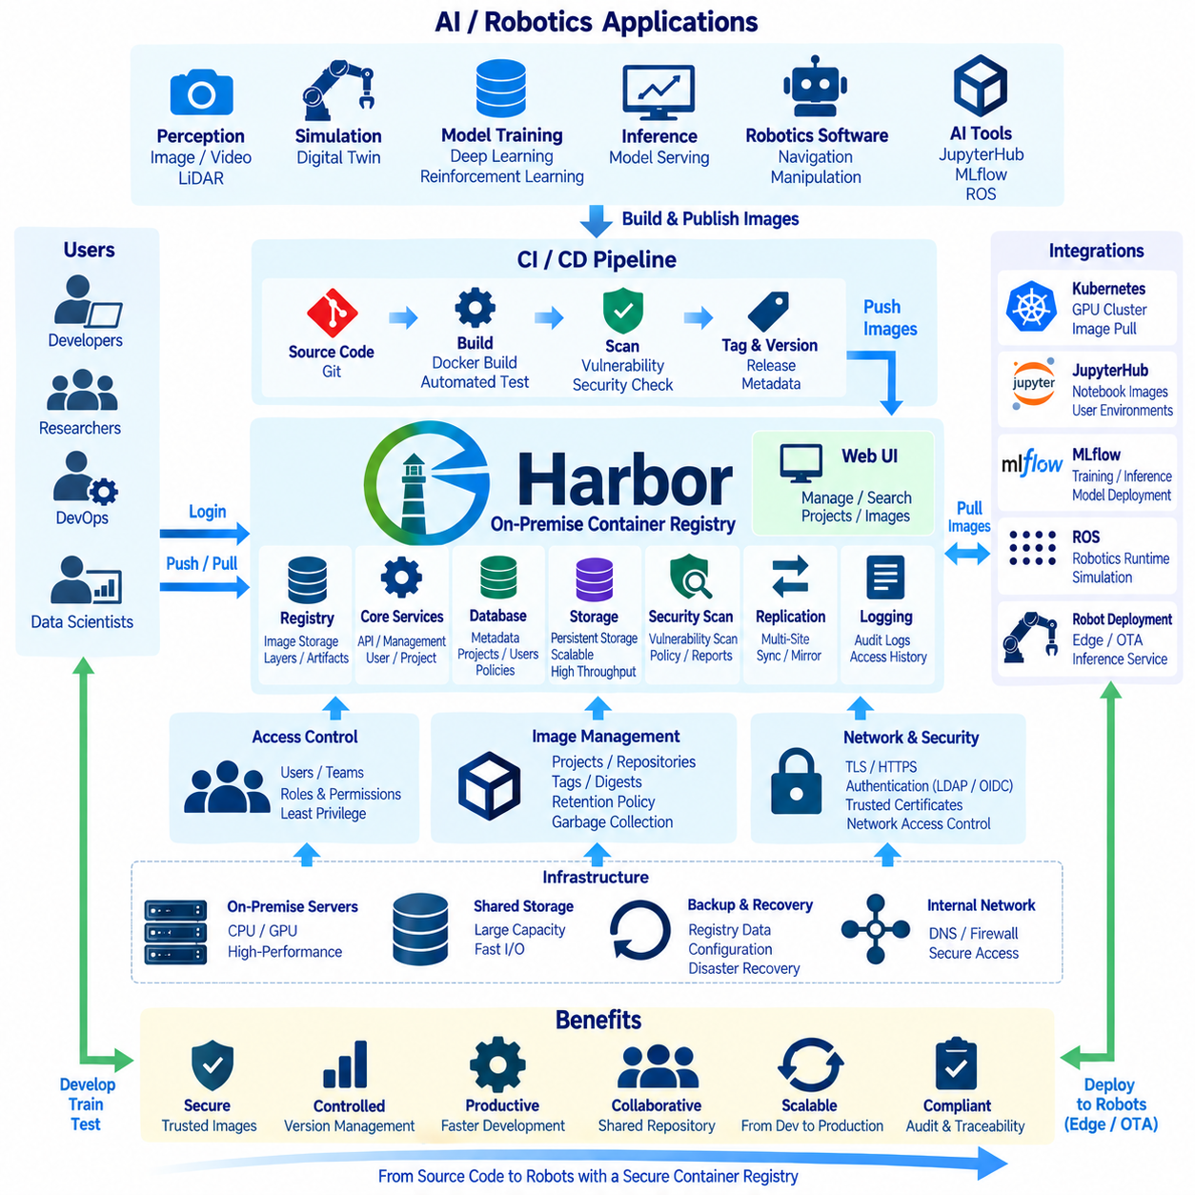
Harbor provides an enterprise-oriented container registry for storing, organizing, securing, and distributing container images inside an on-premise AI infrastructure. Instead of requiring GPU servers, Kubernetes nodes, and developer systems to repeatedly download images from external registries, Harbor creates an internally controlled repository where robotics software, AI frameworks, notebook environments, inference services, and infrastructure components can be maintained.
An on-premise registry becomes increasingly important as AI development shifts toward containerized workflows. A robotics organization may maintain different images for model training, JupyterHub notebooks, ROS development, simulation, perception services, MLflow components, and robot deployment. Harbor provides a common distribution point for these images so that developers and automated systems can reference controlled versions rather than independently assembling environments on each machine.
Harbor is built around projects that logically organize container images and related artifacts. Separate projects can represent development teams, robotics platforms, AI workloads, infrastructure services, or deployment environments. A project can define access permissions and repository policies independently, allowing the organization to separate experimental development images from validated production artifacts while continuing to operate them through the same registry infrastructure.
A typical Harbor deployment contains several cooperating services rather than only a directory containing image files. Registry services manage image content, Harbor services provide APIs and management functions, a database maintains metadata, and storage preserves image layers and artifacts. Additional components support authentication, security scanning, replication, logging, and web-based administration, forming a complete registry management platform.
Installation should begin with infrastructure planning rather than immediately starting containers. Administrators must determine the registry hostname, network location, storage capacity, TLS configuration, authentication method, backup strategy, and expected image volume. Because AI container images can include CUDA libraries, deep-learning frameworks, ROS packages, and simulation dependencies, individual images may become large and storage requirements can grow rapidly as versions accumulate.
A stable domain name should be assigned to Harbor so that developers, CI/CD systems, Kubernetes nodes, and other infrastructure can access the registry consistently. Changing registry addresses after images and deployment configurations have been widely distributed creates unnecessary operational work. Internal DNS should therefore resolve the Harbor hostname reliably from all authorized development, cluster, and administration networks.
TLS should be treated as a standard requirement rather than an optional production enhancement. Registry clients exchange credentials and software artifacts with Harbor, making authenticated and encrypted communication important. Organizations can use certificates issued by an internal certificate authority or another trusted mechanism appropriate to the environment. Docker, container runtimes, Kubernetes nodes, and developer machines must trust the certificate chain used by the registry.
Storage architecture directly influences registry reliability and performance. A small installation can use appropriately protected local or shared storage, while larger deployments may require scalable storage services. The design should account for container layer size, number of repositories, image versions, concurrent pulls, backup requirements, and future growth. High-throughput storage becomes particularly important when many GPU worker nodes simultaneously pull large AI images.
After Harbor is installed, administrators create projects and define repository organization. A practical naming strategy can distinguish platform, application, and version information without creating excessively complex paths. For example, separate repositories can represent training environments, robotics runtime components, notebook images, or infrastructure services. Consistent naming makes automated pipelines easier to understand and reduces ambiguity when multiple teams publish similar artifacts.
Image tags provide convenient human-readable references, but tags alone should not be treated as immutable identities. A tag such as development or latest can move between different image contents over time. Deployment systems that require strong reproducibility can reference immutable digests or enforce policies around protected release tags. This ensures that a previously validated robotics deployment does not silently receive different software under an unchanged reference.
Harbor access control should follow the principle of least privilege. Developers may need permission to pull and push images within selected projects, while production environments may require pull-only access. CI/CD service accounts can receive narrowly scoped credentials for automated publishing. Administrative privileges should remain restricted because registry administrators control software artifacts that may eventually execute across GPU clusters and deployed robot systems.
Authentication can be integrated with broader organizational identity management when required. Centralized authentication simplifies account lifecycle management and reduces unmanaged credentials across development infrastructure. Regardless of the authentication mechanism, shared personal accounts should be avoided. Individual users and automated services should have identifiable credentials so that repository operations can be attributed and access can be revoked without disrupting unrelated users.
Vulnerability scanning is one of Harbor's major security functions. Container images can contain operating-system packages, Python libraries, AI frameworks, utilities, and other dependencies with known vulnerabilities. Scanning allows teams to identify potential problems before an image progresses through the deployment pipeline. Scan results should support engineering decisions, but vulnerability severity, exploitability, runtime exposure, and application context should be evaluated together.
Image security should also address software provenance. Organizations need confidence that an image originated from an approved build process and has not been replaced or modified unexpectedly. Signing and verification mechanisms can become part of the container supply-chain strategy, while CI/CD pipelines can associate build metadata, source revisions, and release information with published artifacts. This strengthens traceability from source code to executable container.
Harbor integrates naturally with CI/CD pipelines. A source-code change can trigger automated testing and container building, after which the pipeline assigns an appropriate version and pushes the resulting image to Harbor. Subsequent validation stages can retrieve exactly that artifact for testing or deployment. This creates a controlled path from Git source code through build and verification stages to a container artifact that can be consumed by the AI infrastructure.
Kubernetes integration is especially important in an on-premise GPU cluster. Worker nodes can pull training, inference, JupyterHub, MLflow, monitoring, and robotics service images directly from Harbor. Private repositories require Kubernetes to receive appropriate image-pull credentials or service-account configuration. Once configured, workload definitions can reference internal registry locations consistently across development, validation, and production namespaces.
JupyterHub can use Harbor as the source of standardized notebook environments. Administrators can publish separate images containing Python, CUDA, PyTorch, ROS, simulation tools, or project-specific dependencies. JupyterHub profiles then reference these controlled images when creating user environments. Updating a development environment becomes a managed image-release process rather than a sequence of manual package installations on individual notebook sessions.
MLflow and Harbor serve different but complementary purposes. MLflow records experiments, metrics, model artifacts, and model-management information, while Harbor stores executable container environments. A validated model can be packaged with its inference runtime and dependencies into a container image, published to Harbor, and associated with the model version that produced it. This creates traceability between model development and the software environment used for deployment.
Robot deployment introduces another important use case. An inference or robotics application image validated in the central infrastructure can be stored in Harbor and then incorporated into an edge deployment or OTA pipeline. The registry should remain the authoritative source of approved container artifacts, while the deployment system controls when and where those artifacts are released. Registry publication alone should not automatically authorize deployment to operational robots.
Replication can support environments containing multiple sites or isolated infrastructure zones. Instead of forcing every location to retrieve large images through a single connection, registry artifacts can be synchronized according to defined policies. This can reduce external bandwidth consumption and improve availability for remote development or deployment environments. Replication policies should clearly define artifact ownership, direction, filtering, and conflict handling.
Retention policies are necessary because container registries can grow continuously. CI pipelines may generate new images for every branch, commit, experiment, or release, while large CUDA-based AI images can consume substantial storage. Harbor retention rules can preserve important releases while removing unnecessary intermediate artifacts according to organizational policy. Cleanup should be coordinated with deployment requirements so that still-required images are not removed.
Garbage collection complements retention management by reclaiming storage associated with artifacts that are no longer referenced. Deleting tags or repositories does not always translate immediately into recovered physical capacity because container layers may be shared. Registry maintenance should therefore include controlled cleanup procedures, storage monitoring, and sufficient free-space margins rather than waiting until the underlying filesystem becomes full.
Monitoring should cover service availability, storage consumption, request rates, authentication failures, image push and pull behavior, scanning status, and infrastructure health. Sudden increases in pull traffic may indicate large-scale deployment activity, while repeated failures can reveal certificate, credential, network, or storage problems. Harbor monitoring should be integrated with the broader observability environment used for the on-premise AI platform.
Backup and recovery must protect both registry data and Harbor configuration. Container artifacts, metadata databases, configuration files, certificates, and required credentials may all be necessary for complete restoration. A backup that preserves only image layers may not reproduce project configuration or access policies. Recovery procedures should therefore be documented and tested so that the registry can be restored without breaking dependent Kubernetes and AI services.
Harbor should ultimately be treated as the software artifact distribution layer of the on-premise AI platform. Git manages source code, CI/CD builds and validates software, Harbor stores controlled container artifacts, Kubernetes schedules those containers, JupyterHub provides interactive development environments, and MLflow manages experiments and models. Together these components create a traceable path from development source to reproducible execution.
A well-designed Harbor deployment therefore improves more than container storage. It provides centralized image management, controlled access, vulnerability visibility, reproducible versioning, internal distribution, and integration with automated development and deployment pipelines. For robotics AI organizations, this makes Harbor an important foundation for securely moving software from developer environments through GPU clusters and ultimately toward validated robot operation.

06.08 On-Premise Distributed Training: PyTorch DDP / Horovod [w/Code]
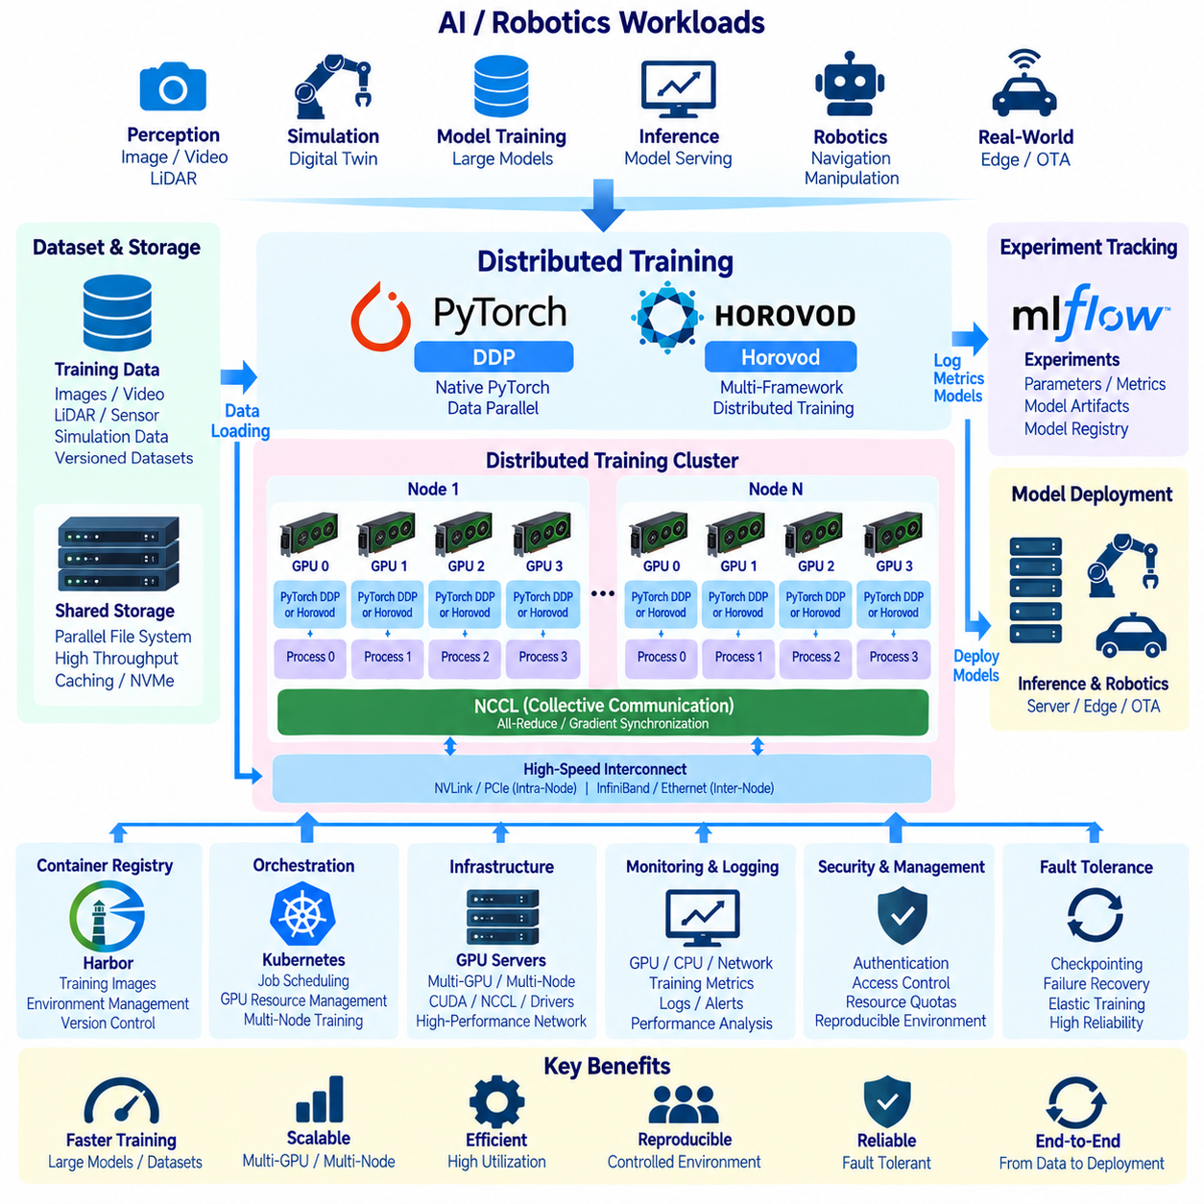
Distributed training allows an on-premise AI infrastructure to combine multiple GPUs and multiple servers so that large neural networks or large datasets can be processed faster than on a single accelerator. Instead of treating each GPU server as an isolated resource, frameworks such as PyTorch Distributed Data Parallel and Horovod coordinate training processes across the cluster while maintaining a consistent model state.
The basic principle is data parallelism. Each training process maintains a copy of the same model but processes a different portion of the training batch. After computing gradients locally, the processes exchange and aggregate those gradients before updating their model parameters. When synchronization is performed correctly, every process begins the next iteration with equivalent parameters while the computational workload is distributed across many GPUs.
PyTorch Distributed Data Parallel, commonly called DDP, is a native PyTorch mechanism for distributed data-parallel training. A typical configuration launches one training process for each GPU and associates that process with a specific accelerator. The model is wrapped by DDP, input data is partitioned among processes, and gradient synchronization occurs automatically during backward propagation, allowing existing PyTorch training code to be extended toward multi-GPU execution.
Each DDP process is identified by a rank within a distributed process group. The global rank identifies the process across the entire training job, while local rank commonly identifies the GPU used within one server. World size represents the total number of participating processes. Correct management of rank, world size, device assignment, and process initialization is essential because every participant must join the same distributed training operation consistently.
Distributed initialization requires the participating processes to discover one another and establish communication. A designated address and port can be used to coordinate process-group creation, while launch utilities or cluster orchestration systems provide rank and topology information. On a single server this configuration is relatively simple, but multi-node training additionally requires reliable network connectivity and consistent software environments across all participating machines.
For GPU-based PyTorch training, NCCL is commonly used as the communication backend because it is optimized for collective operations across NVIDIA GPUs. Operations such as all-reduce combine gradients produced by individual workers and distribute the aggregated result back to them. Communication performance therefore becomes part of training performance, especially when models contain large numbers of parameters or synchronization occurs frequently.
The physical communication path depends on the cluster architecture. GPUs within the same server may communicate through PCIe, NVLink, or NVSwitch, while communication between servers can use high-performance Ethernet or InfiniBand. RDMA and GPUDirect RDMA can reduce unnecessary CPU involvement and memory copies by enabling more direct data movement between accelerator resources and the network, improving distributed-training efficiency.
DDP overlaps portions of gradient communication with backward computation where possible. Rather than waiting until every gradient has been calculated before beginning synchronization, gradients can be grouped into communication buckets and reduced as they become available. The effectiveness of this overlap depends on model structure, communication bandwidth, latency, bucket configuration, and the relative amount of computation performed by each GPU.
Data loading must also be distributed correctly. If every worker processes the same samples during every iteration, additional GPUs may duplicate work rather than increase useful training throughput. Distributed samplers divide dataset indices among workers so that each process receives an appropriate subset. Epoch transitions must maintain coordinated shuffling behavior so that data diversity is preserved without unintentionally repeating the same workload across processes.
Global batch size changes as the number of workers increases. If each GPU processes a local batch of 32 samples, eight GPUs collectively process a global batch of 256 samples per synchronized step. Increasing global batch size can affect convergence and may require changes to learning rate, warm-up strategy, optimizer configuration, or training duration. Distributed scaling therefore requires validation of model quality as well as measurement of raw throughput.
Horovod provides another distributed-training approach originally designed to simplify scaling across multiple deep-learning frameworks. It uses collective communication concepts and can integrate with frameworks such as PyTorch while presenting a relatively compact distributed-training interface. Horovod became widely associated with ring-allreduce and MPI-style distributed execution, although its practical communication behavior can depend on the backend and environment used.
In Horovod-based training, each worker initializes the distributed environment and obtains information such as its rank, local rank, and total worker count. The local rank can determine GPU assignment, while distributed optimizer mechanisms coordinate gradient updates. Initial model parameters and relevant optimizer states must remain consistent across workers so that every process participates in a synchronized training procedure rather than developing independent model states.
DDP and Horovod should not be viewed simply as competing implementations of the same command. DDP is tightly integrated with the PyTorch ecosystem and is a natural choice when the training stack is standardized around PyTorch. Horovod can be useful when an organization has established Horovod-based workflows or requires a distributed abstraction across supported frameworks. Selection should reflect the software ecosystem, operational experience, orchestration method, and required compatibility.
Containerization is especially valuable for multi-node training because all workers should execute compatible versions of Python, PyTorch, CUDA, NCCL, drivers, libraries, and application dependencies. A controlled image stored in an internal registry such as Harbor can provide the common execution environment. Kubernetes or another scheduler can then start distributed workers from the same image, reducing failures caused by inconsistent software configurations between servers.
Kubernetes can provide the resource-management layer underneath distributed training. Training workers can run as Pods scheduled onto GPU nodes according to GPU requests, node labels, affinity rules, and other policies. Distributed training controllers or job definitions can coordinate groups of related workers. Kubernetes manages placement and lifecycle, while PyTorch DDP, Horovod, NCCL, and the underlying network handle the actual training communication.
Storage performance can become a bottleneck even when GPU communication is highly optimized. Large robotics datasets containing camera images, video, LiDAR point clouds, simulation sequences, or multimodal sensor records may require substantial read throughput. If all workers continuously request data from a slow shared filesystem, GPUs can remain idle while waiting for input. Parallel storage, caching, preprocessing, and local NVMe staging can reduce this problem.
Checkpointing is necessary because the cost of a failed distributed job increases with cluster size and training duration. Rather than independently writing identical checkpoints from every process, one designated rank can usually perform persistent checkpoint operations while other workers synchronize appropriately. The checkpoint should contain the model, optimizer state, training progress, and other information required to resume execution after node, process, or infrastructure failure.
Failure handling becomes more complex in multi-node training because loss of one worker can interrupt collective communication for the entire job. Infrastructure monitoring should detect GPU errors, process failures, network problems, and node unavailability quickly. Depending on the training architecture, the job may restart from the latest checkpoint or use elastic mechanisms capable of adapting to worker changes. Recovery behavior should be tested before long production-scale runs.
Performance evaluation should focus on scaling efficiency rather than only reporting that additional GPUs were used. If one GPU processes a certain number of samples per second, an eight-GPU configuration will rarely deliver exactly eight times that throughput because communication, synchronization, data loading, and framework overhead increase. Measuring throughput, GPU utilization, communication time, input waiting time, and iteration latency helps identify the actual scaling limitation.
Strong scaling and weak scaling describe different evaluation perspectives. Strong scaling keeps the overall workload approximately constant while increasing computing resources, measuring how much faster the same work completes. Weak scaling increases the workload as resources increase, examining whether each GPU can maintain similar productivity. Both measurements can help determine whether additional cluster investment will translate into useful training capacity.
Network topology should be considered when allocating distributed jobs. Placing communicating GPUs across poorly connected nodes can reduce performance even if the total number of accelerators is unchanged. GPU topology within servers, network interface placement, InfiniBand or Ethernet fabric design, and oversubscription can influence collective communication. Topology-aware scheduling can therefore become important as the on-premise cluster grows.
Distributed training should integrate with the surrounding AI lifecycle rather than operate as an isolated cluster function. Training jobs can obtain source code from Git-controlled workflows, use container images from Harbor, read versioned datasets from shared storage, and record parameters, metrics, checkpoints, and model results in MLflow. This creates traceability between distributed computation and the experiment that produced the final model.
Monitoring should combine application-level and infrastructure-level information. Training metrics such as loss and validation accuracy describe model behavior, while GPU utilization, GPU memory, temperature, network throughput, storage I/O, CPU usage, and synchronization time explain infrastructure efficiency. Correlating these measurements makes it easier to distinguish model-level problems from communication, storage, scheduling, or hardware bottlenecks.
A practical adoption path begins with single-node multi-GPU DDP before moving to multi-node training. Engineers can first validate process launching, data partitioning, gradient synchronization, checkpointing, and reproducibility within one server. Once these mechanisms are stable, the same training architecture can expand across the cluster, where network performance, distributed storage, orchestration, monitoring, and failure recovery become increasingly important.
For an on-premise robotics AI platform, distributed training connects GPU servers into a shared computational system capable of processing increasingly large models and datasets. PyTorch DDP provides a tightly integrated approach for PyTorch workloads, while Horovod offers another collective-training abstraction. Their effectiveness ultimately depends on the entire infrastructure path, including GPUs, interconnects, storage, containers, orchestration, and software configuration.
A successful distributed-training architecture therefore requires more than adding GPUs to a training job. Compute, communication, data delivery, synchronization, checkpointing, monitoring, and experiment management must operate as one coordinated system. When these layers are designed together, an on-premise AI cluster can scale robotics model development from individual GPU experiments to repeatable multi-node training while preserving performance, reliability, and reproducibility.

06.09 On-Premise AI Infrastructure Monitoring: Capacity Planning
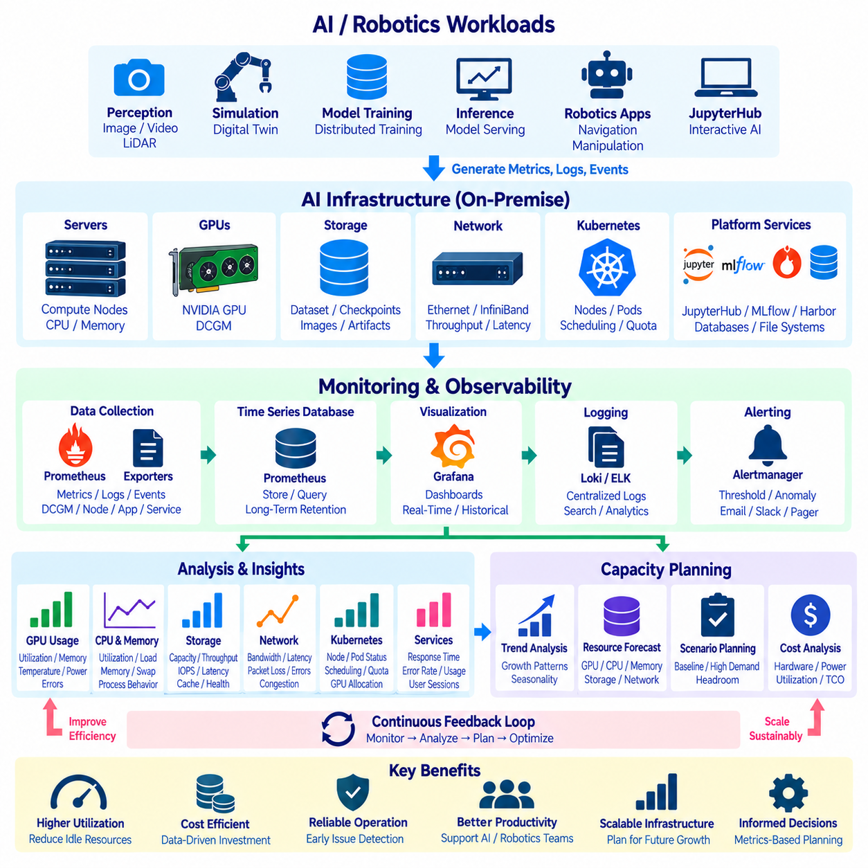
Monitoring an on-premise AI infrastructure requires visibility across compute, accelerators, memory, storage, networking, orchestration, and application services. A GPU cluster may appear operational while expensive accelerators remain underutilized because of slow data loading, network congestion, memory pressure, scheduling delays, or software failures. Monitoring therefore must reveal not only whether infrastructure is running, but also whether resources are being used efficiently.
Infrastructure monitoring should begin with a layered observability model. Physical servers, operating systems, GPU devices, storage systems, network fabrics, Kubernetes resources, and AI platform services generate different classes of operational information. Metrics, logs, events, and alerts from these layers should be collected into a common monitoring environment so administrators can correlate symptoms across the complete AI execution path.
GPU monitoring is particularly important because accelerators usually represent the most expensive computing resources in an AI cluster. Administrators should observe GPU utilization, memory consumption, temperature, power usage, clock behavior, and hardware errors. Low utilization does not automatically indicate insufficient demand; it may reveal that training processes are waiting for CPU preprocessing, storage reads, network communication, synchronization, or scheduler allocation.
NVIDIA Data Center GPU Manager, commonly known as DCGM, provides telemetry and management capabilities for NVIDIA GPU infrastructure. In clustered environments, DCGM metrics can be exported into monitoring systems to provide visibility into GPU utilization, memory, temperature, power, errors, and other operational indicators. Combined with node and workload metadata, these measurements help identify which jobs or services are consuming accelerator resources.
CPU and system-memory monitoring remains essential even in GPU-centered infrastructure. Data preprocessing, augmentation, decompression, simulation, container runtime operations, storage handling, and distributed-training coordination may consume substantial CPU resources. Memory pressure can trigger swapping, process termination, or degraded performance. Monitoring CPU utilization, load, memory availability, swap activity, and process behavior helps identify bottlenecks outside the GPU layer.
Storage monitoring should cover both capacity and performance. AI datasets, container images, model checkpoints, experiment artifacts, logs, and simulation outputs can grow rapidly. Administrators should track used and available capacity, read and write throughput, IOPS, latency, cache effectiveness, and filesystem health. A storage system with sufficient free space can still limit AI performance if concurrent training jobs exceed its available throughput.
Network observability becomes increasingly important as training expands from single-server workloads to distributed multi-node execution. Metrics should include interface utilization, throughput, latency, packet loss, errors, and congestion. High-performance Ethernet or InfiniBand fabrics may additionally require monitoring of specialized counters. Network telemetry helps distinguish communication bottlenecks from GPU, CPU, or storage limitations during distributed training.
Kubernetes introduces another monitoring layer because physical resource availability does not directly indicate whether workloads can actually obtain those resources. Administrators should observe node health, Pod status, scheduling delays, pending workloads, restarts, resource requests, limits, quotas, and GPU allocation. A cluster can contain idle GPUs while jobs remain pending because of affinity rules, taints, resource fragmentation, or incompatible scheduling constraints.
Monitoring should extend beyond infrastructure into platform services such as JupyterHub, MLflow, Harbor, databases, and internal storage services. Service availability, response time, error rate, active sessions, request volume, database performance, and storage consumption can reveal problems affecting developers even when the underlying servers remain healthy. User-facing AI productivity depends on the complete platform rather than only on GPU availability.
Prometheus can provide a centralized time-series monitoring layer by collecting metrics from servers, Kubernetes components, exporters, applications, and GPU monitoring services. Grafana can visualize these measurements through dashboards that combine infrastructure and workload information. A useful dashboard should allow operators to move from cluster-level health to individual nodes, GPUs, workloads, and services without requiring separate monitoring systems for every component.
Logs complement metrics by providing detailed information about events that numerical measurements cannot fully explain. Container logs, Kubernetes events, application errors, authentication records, storage messages, and system logs can help determine why a workload failed or degraded. Centralized log collection makes it possible to correlate a performance anomaly with application, infrastructure, or security events occurring during the same period.
Alerting should focus on conditions requiring action rather than generating notifications for every unusual measurement. Examples include GPU overheating, repeated hardware errors, critical storage capacity, failed nodes, unavailable services, persistent scheduling failures, or abnormal network behavior. Alert thresholds should consider duration and operational context because short utilization spikes or temporary resource saturation may be normal during intensive AI workloads.
Monitoring data becomes the foundation for capacity planning when it is collected over sufficiently long periods. Capacity planning should use observed workload behavior to determine whether existing GPU, CPU, memory, storage, and network resources can support future demand. Purchasing additional hardware based only on peak utilization can lead to overprovisioning, while planning from average utilization alone can underestimate periods of intense training activity.
GPU capacity planning should distinguish allocated capacity from effective utilization. A GPU can be reserved by a workload while performing little useful computation, meaning allocation statistics alone may overestimate actual demand. Conversely, consistently high utilization with long job queues can indicate insufficient accelerator capacity. Queue duration, job completion time, GPU utilization, memory requirements, and concurrency should therefore be evaluated together.
Workload classification improves capacity forecasts. Interactive JupyterHub sessions, distributed model training, inference services, simulation, preprocessing, and experimental jobs have different usage patterns. Interactive workloads may require fast startup but low average utilization, while distributed training can occupy many GPUs continuously for hours or days. Separating these workload classes helps determine whether dedicated resource pools or scheduling policies are appropriate.
Historical trends can reveal growth that short-term dashboards cannot show. Increasing dataset size, model complexity, research-team size, experiment frequency, and deployed services may gradually increase infrastructure demand. Monitoring systems should retain enough historical information to identify weekly, monthly, and project-based patterns. Trend analysis can provide evidence for expanding GPU capacity, storage, network bandwidth, or supporting infrastructure before saturation occurs.
Capacity planning must also account for headroom. Operating every component permanently near maximum utilization leaves little capacity for failures, workload bursts, maintenance, or urgent experiments. Some spare capacity allows jobs to migrate when nodes are unavailable and provides flexibility when several teams require resources simultaneously. The appropriate margin depends on workload criticality, procurement lead time, reliability requirements, and budget constraints.
Storage capacity requires lifecycle planning because AI data often grows faster than compute infrastructure. Raw robotics sensor data, processed datasets, simulation outputs, checkpoints, MLflow artifacts, Harbor images, and monitoring logs may have different retention requirements. Capacity planning should therefore combine growth forecasting with retention, archival, replication, backup, and deletion policies rather than assuming all generated data must remain permanently on high-performance storage.
Network capacity should be planned according to communication patterns rather than server count alone. Distributed training can generate heavy east-west traffic between GPU nodes, while dataset access produces traffic between compute and storage systems. Simultaneous container pulls or checkpoint operations can create additional bursts. Monitoring these flows helps determine whether network upgrades, topology changes, traffic separation, or higher-bandwidth interconnects are necessary.
Power and cooling should be included in AI capacity planning because adding GPU servers does not only increase computational capacity. High-density accelerators can significantly increase rack power, heat output, cooling requirements, and electrical infrastructure demand. Monitoring server power and thermal behavior provides data for determining whether a facility can support additional GPU nodes before procurement decisions are finalized.
Cost monitoring adds another dimension to capacity management. On-premise infrastructure has capital costs, power consumption, maintenance expenses, storage growth, networking requirements, and administrative overhead. Resource utilization data can help calculate whether expensive equipment is providing sufficient productive capacity. Underutilized GPUs may indicate scheduling or workflow problems that should be corrected before additional hardware is purchased.
Capacity forecasting should use scenarios rather than one fixed estimate. A baseline scenario can represent expected project growth, while higher-demand scenarios can model additional teams, larger models, increased simulation, or major training campaigns. Comparing these scenarios against current utilization and infrastructure limits provides a clearer view of when particular resources are likely to become constraints and where investment should be prioritized.
Monitoring and capacity planning should therefore form a continuous feedback loop. Infrastructure produces telemetry, monitoring systems convert telemetry into operational visibility, historical analysis identifies utilization patterns, and capacity planning converts those patterns into infrastructure decisions. After resources or policies are changed, monitoring verifies whether the expected improvement actually occurred and provides new data for the next planning cycle.
For robotics AI, this feedback loop should connect with Kubernetes, distributed training, JupyterHub, MLflow, Harbor, storage, and GPU infrastructure. Operators can observe how developers and training pipelines consume resources from interactive experimentation through model training and deployment. This end-to-end visibility allows technical teams to distinguish genuine hardware shortages from inefficient scheduling, software configuration, data pipelines, or resource allocation.
A mature on-premise AI platform therefore treats monitoring and capacity planning as core infrastructure functions rather than administrative tasks performed after problems occur. Continuous observability, historical analysis, workload classification, forecasting, and resource optimization allow the organization to increase AI computing capacity in a controlled manner while maintaining performance, reliability, cost efficiency, and room for future robotics workloads.

06.10 Cloud vs On-Premise AI Workload Distribution Strategy
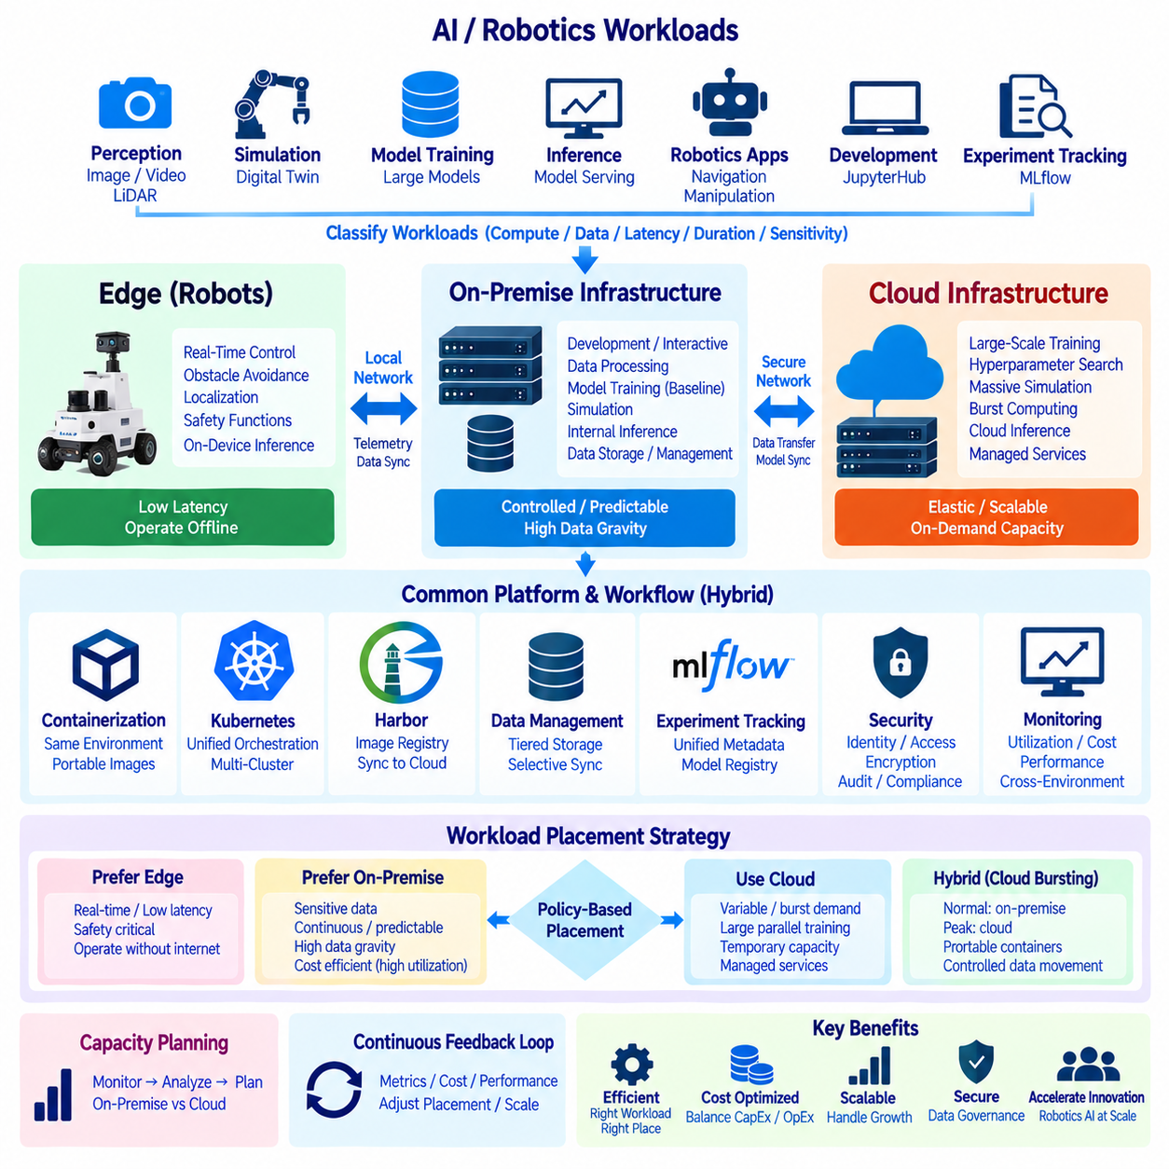
Cloud and on-premise AI should not be treated as mutually exclusive infrastructure choices. A robotics organization can distribute workloads between them according to latency, data sensitivity, computational demand, utilization pattern, cost, scalability, and operational requirements. The objective is to place each workload where it can execute most effectively while maintaining a consistent development, security, and model-management workflow.
Workload classification should precede infrastructure selection. AI activities such as interactive development, data preprocessing, model training, simulation, inference, experiment tracking, and long-term storage have different resource characteristics. Some require continuous access to internal robotics datasets, while others need temporary access to hundreds of GPUs. Classifying workloads by compute intensity, duration, data volume, and urgency provides the basis for placement decisions.
On-premise infrastructure is particularly suitable for workloads that operate continuously and predictably. Frequently used GPU servers can provide stable computing capacity without recurring cloud instance charges for every training hour. Internal clusters are also useful when large datasets already reside inside the organization, because training can occur near the data without repeatedly transferring camera images, LiDAR point clouds, simulation records, and model artifacts across external networks.
Data governance is another major reason to retain workloads on-premise. Robotics datasets may contain proprietary facility maps, customer environments, industrial processes, sensor recordings, or information subject to organizational security policies. Keeping sensitive datasets and selected models inside controlled infrastructure can simplify data-location policies and reduce unnecessary external transfer. Cloud usage can then be limited to workloads whose data and security requirements permit external processing.
Latency-sensitive workloads generally belong closer to the robot or local infrastructure. Motion control, obstacle avoidance, localization, safety functions, and other real-time operations should remain on the robot or Edge because network connectivity cannot be assumed continuously. Local on-premise servers can support nearby services requiring relatively fast response, while cloud services are better suited to functions that can tolerate wider and more variable communication latency.
Cloud infrastructure provides an important advantage when demand changes rapidly. A local GPU cluster has a fixed capacity determined by purchased hardware, whereas cloud resources can be provisioned temporarily for unusually large experiments, parallel hyperparameter searches, simulation campaigns, or short-term training peaks. This elasticity allows an organization to access additional computational capacity without permanently installing enough hardware for its maximum possible demand.
This leads to a cloud-bursting strategy in which normal workloads execute on-premise while temporary excess demand is moved to cloud resources. The approach can be useful when local GPU queues become long or a project requires substantially more accelerators for a limited period. Effective cloud bursting requires portable containers, compatible software environments, controlled data movement, and orchestration policies that determine which workloads are eligible to leave the internal infrastructure.
Cost comparison must consider workload behavior rather than only GPU hourly prices or hardware purchase prices. On-premise systems require capital investment, power, cooling, networking, maintenance, storage, and administration, but highly utilized equipment can provide economical long-term capacity. Cloud platforms avoid much of the initial infrastructure investment but introduce recurring compute, storage, managed-service, and data-transfer costs that increase with sustained usage.
Utilization is therefore central to the economic decision. An expensive local GPU cluster that remains mostly idle can be inefficient, while continuously running cloud GPU workloads can accumulate substantial operating costs. Predictable baseline demand is often easier to justify on dedicated infrastructure, whereas irregular or temporary demand can benefit from elastic cloud capacity. Monitoring historical utilization provides stronger evidence for this decision than theoretical peak requirements.
Data movement can become the hidden constraint in hybrid AI architectures. Large robotics datasets may reach terabyte or petabyte scale, making repeated transfers between on-premise storage and cloud environments slow and costly. Workload placement should therefore consider data gravity: computation is often most efficient when moved toward the location where the required data already resides. Only necessary datasets, subsets, features, or model artifacts should cross infrastructure boundaries.
A tiered data strategy can reduce unnecessary transfers. Raw sensor recordings may remain on-premise, while curated datasets approved for external processing can be synchronized to cloud storage when required. Training outputs can return as checkpoints, metrics, or validated model artifacts rather than transferring every intermediate file. Clear dataset identities and versions are necessary so that experiments remain reproducible regardless of where computation occurs.
Containerization provides an important portability layer between cloud and on-premise environments. Training and inference software can be packaged with framework versions, CUDA dependencies, robotics libraries, and application code into controlled container images. Harbor can serve as the internal authoritative registry, while approved images can be replicated or published to cloud-accessible registries when external execution is required.
Kubernetes can provide a common orchestration model across environments, although the underlying infrastructure may differ. On-premise clusters can manage internal GPU nodes while cloud Kubernetes services or separate cloud clusters provide elastic capacity. Consistent workload definitions, resource requests, namespaces, configuration practices, and container interfaces reduce the engineering effort required to move eligible workloads between environments.
JupyterHub can remain primarily connected to internal resources while providing controlled access to alternative execution backends when required. Interactive development and smaller experiments may use on-premise GPUs, while larger training tasks can be submitted to separate clusters. This prevents researchers from manually rebuilding development environments whenever computational demand exceeds local capacity and preserves a familiar development workflow.
MLflow can provide experiment continuity across distributed infrastructure. Whether a training job runs on an internal GPU server or approved cloud resources, it can record parameters, metrics, model artifacts, dataset references, and execution metadata through a common model-management workflow. Infrastructure location should itself be recorded as experiment metadata because hardware type, accelerator count, and execution environment may influence performance results.
Distributed training requires additional placement considerations because network topology strongly affects performance. Multi-GPU jobs with frequent gradient synchronization benefit from high-bandwidth, low-latency interconnects. An on-premise InfiniBand or NVLink-based environment may be effective for sustained distributed training, while cloud GPU clusters can provide temporary large-scale configurations. Performance should be evaluated using actual training throughput rather than accelerator count alone.
Simulation workloads are strong candidates for flexible distribution because many simulation tasks can be parallelized with limited communication between workers. Large scenario-generation campaigns can exceed local capacity even when normal development fits comfortably on-premise. Temporary cloud resources can execute additional simulations, while results needed for training or validation are returned to controlled storage according to the organization's data-management policy.
Inference placement should follow application latency and availability requirements. Real-time robot inference normally remains on the robot's Edge computer, while centralized on-premise inference can support fleet-level or facility-level services. Cloud inference can support applications where connectivity and latency are acceptable. The architecture should avoid making safety-critical robot behavior dependent on remote cloud availability unless the system is explicitly designed to tolerate communication loss.
Security policies must remain consistent even when workloads cross infrastructure boundaries. Identity management, encryption, secret handling, container provenance, access control, audit logging, and model permissions should follow defined organizational rules. Hybrid operation should not create an uncontrolled secondary environment in which datasets or credentials are copied manually. Infrastructure automation can enforce approved configurations more reliably than ad hoc migration procedures.
Monitoring should provide a unified view of workload behavior across both environments. GPU utilization, job duration, queue time, storage consumption, network transfer, failures, and cost information can be collected to determine whether current placement decisions remain appropriate. A workload initially assigned to cloud resources may become economical to move on-premise as usage increases, while an infrequent internal workload may become a better candidate for elastic execution.
Capacity planning should use cloud resources as one possible response to local capacity limits rather than automatically expanding physical infrastructure. When monitoring shows persistent GPU saturation and long queues, the organization can compare purchasing additional servers with using cloud capacity. If demand is temporary, cloud expansion may absorb the peak; if demand becomes stable and sustained, additional on-premise infrastructure may provide a more predictable long-term resource base.
Workload placement can therefore be expressed as a policy-driven decision process. Sensitive data, continuous utilization, low latency, and strong data gravity tend to favor on-premise or Edge execution. Highly variable demand, short-lived capacity peaks, large parallel experiments, and rapid scalability tend to favor cloud resources. Many robotics AI workflows contain both characteristics, making hybrid distribution more practical than applying one infrastructure model to every task.
The strategy should also consider failure and connectivity conditions. Internal development and robot operations should not become unusable simply because cloud connectivity is interrupted. Essential services, repositories, models, and operational functions can remain available locally, while cloud-dependent workloads pause or degrade gracefully. When connectivity returns, queued data transfers, experiment synchronization, or external jobs can resume according to defined recovery procedures.
A mature architecture forms a continuous placement feedback loop. Monitoring measures utilization, performance, cost, and data movement; capacity planning identifies emerging constraints; policies determine whether workloads remain local, burst to the cloud, or move permanently; and subsequent monitoring verifies the result. Placement decisions therefore evolve with model size, dataset growth, hardware utilization, project demand, and infrastructure economics.
For robotics AI, the resulting architecture is a continuum rather than a simple cloud-versus-on-premise choice. Robot Edge systems provide real-time autonomy, on-premise infrastructure supplies controlled and predictable AI development capacity, and cloud platforms provide elastic resources for appropriate workloads. Containers, Kubernetes, MLflow, registries, storage policies, security controls, and monitoring connect these environments into a coordinated operational model.
An effective workload distribution strategy ultimately places computation according to technical and operational requirements rather than infrastructure preference. By combining Edge execution, on-premise GPU clusters, and elastic cloud resources, robotics organizations can balance latency, privacy, performance, scalability, utilization, and cost. The result is a hybrid AI infrastructure capable of adapting as datasets, models, development teams, and deployed robot fleets increase in scale.

