Volume 09 Cloud and Edge Robotics

05. Azure Robotics

05.01 Azure IoT Service Portfolio Overview
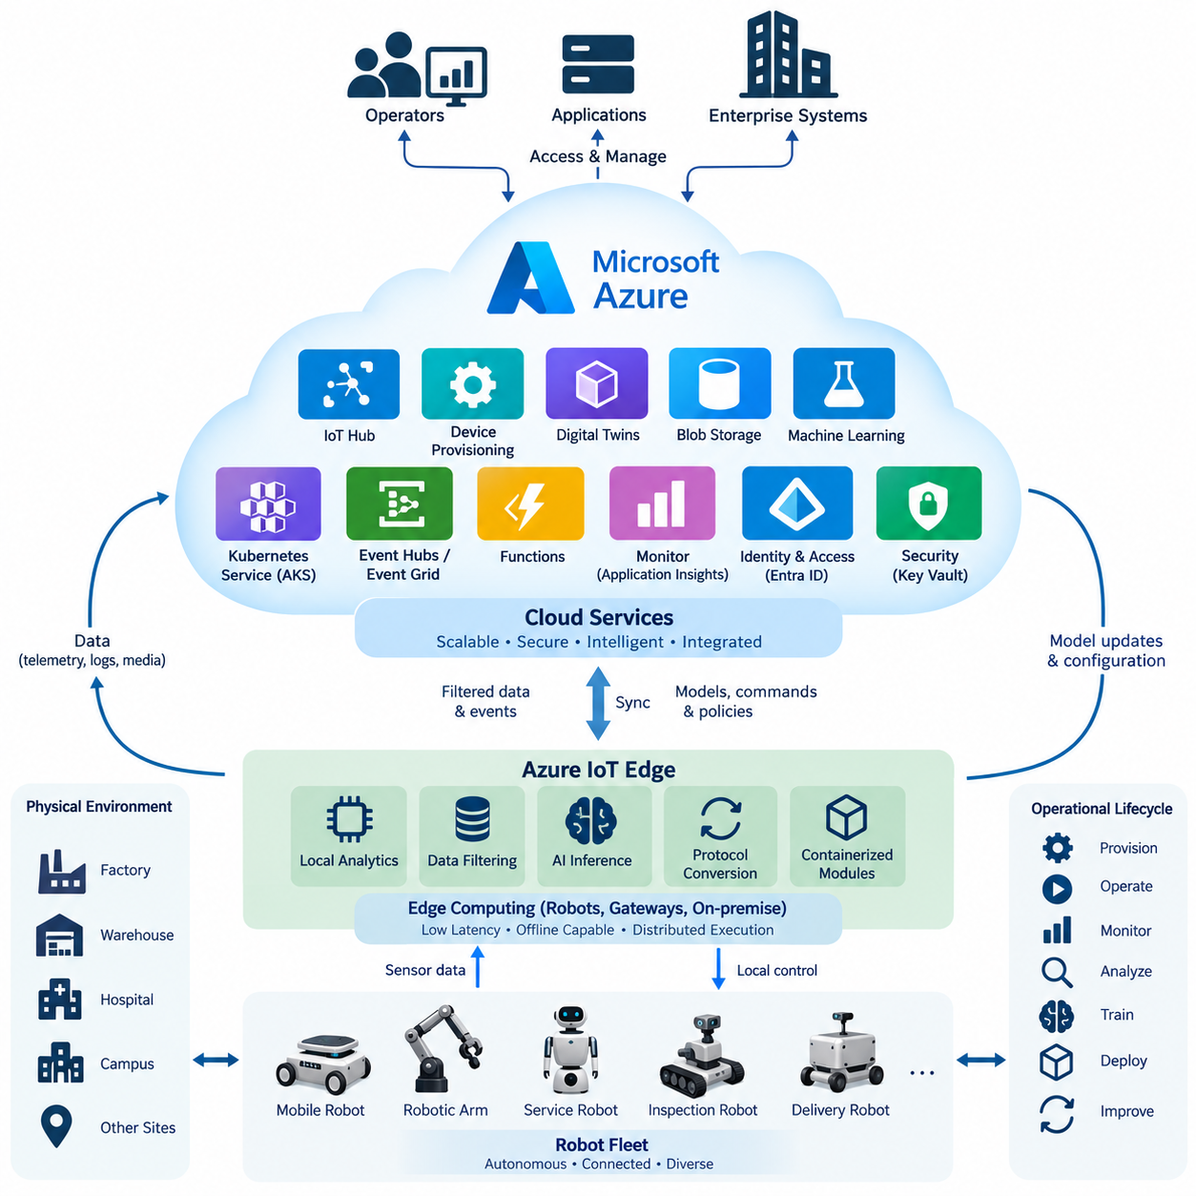
Microsoft Azure provides a broad portfolio of cloud and edge services that can be assembled into an end-to-end infrastructure for connected robots. Within the structure of Azure robotics, these services form the foundation for later functions such as device provisioning, edge execution, digital twins, data storage, AI training, Kubernetes deployment, monitoring, and authentication. Rather than treating the cloud as a remote robot controller, Azure is most effective when it provides scalable management and intelligence services around autonomous edge systems.
Azure IoT Hub is a central connectivity service for managing bidirectional communication between cloud applications and large populations of connected devices. A robot can be represented as an individually authenticated device and exchange telemetry, commands, state information, and operational events with backend systems. This architecture allows cloud applications to manage thousands of heterogeneous robots through standardized interfaces while keeping time-critical perception, planning, motion control, and safety functions on the robot itself.
Device identity is fundamental because a production robot fleet cannot safely rely on manually configured credentials. Azure IoT Hub Device Provisioning Service supports automated provisioning by associating devices with appropriate IoT hubs and enrollment policies. During manufacturing, commissioning, or field deployment, a robot can establish its identity and obtain the information required to connect to its assigned cloud environment. This mechanism becomes increasingly important as fleets expand across factories, warehouses, hospitals, campuses, and geographically distributed customer sites.
Azure IoT Edge extends cloud-oriented application management toward computers installed near or inside robots. Containerized modules can execute locally so that data filtering, protocol conversion, analytics, and selected AI workloads do not depend continuously on Internet connectivity. In a robotics architecture, this creates a practical separation between low-latency local execution and scalable cloud services. Edge processing can continue during temporary network interruptions while selected information is synchronized with the cloud when communication becomes available again.
Azure Digital Twins provides a modeling environment for representing physical environments, assets, and their relationships. In robotics, a digital representation may connect robots with facilities, work cells, charging stations, equipment, zones, and operational resources rather than merely storing a copy of individual robot telemetry. Such models can provide contextual information that raw sensor streams cannot express efficiently, allowing backend applications to reason about relationships between physical assets and operational states.
Robot fleets continuously generate logs, images, maps, diagnostic records, AI inference results, and other operational data. Azure Blob Storage can serve as scalable object storage for these large and heterogeneous datasets. Instead of transmitting every high-bandwidth sensor stream continuously, an edge system can select, compress, buffer, or aggregate information before uploading it. Cloud storage can then support historical analysis, failure investigation, dataset construction, model development, compliance retention, and fleet-wide optimization.
Azure Machine Learning provides infrastructure for developing, training, tracking, registering, and deploying machine-learning models. A robotics workflow can collect operational datasets from deployed machines, prepare training data in cloud or hybrid infrastructure, train improved models, register validated artifacts, and distribute selected versions back toward edge computers. This establishes a lifecycle in which cloud resources perform computationally intensive learning while robots perform latency-sensitive inference, producing a continuous cloud-edge AI improvement loop.
Azure Kubernetes Service, commonly called AKS, provides managed Kubernetes infrastructure for backend applications composed of containers and microservices. Robot fleet platforms often require independent services for telemetry ingestion, device management, task orchestration, maps, user interfaces, notifications, APIs, and AI services. AKS allows these components to scale independently and supports rolling deployment, service discovery, workload isolation, and automated recovery, making it suitable for backend systems that must grow with the number of deployed robots.
Event-driven services complement persistent robot connections. Azure Event Hubs can ingest high-volume streams, while Azure Event Grid can distribute events between loosely coupled applications. Azure Functions can execute short-lived processing logic in response to events without requiring permanently running application servers. For example, a robot fault event may trigger processing that updates an operational database, generates a notification, stores diagnostic metadata, and initiates another workflow without embedding all of these responsibilities inside the robot software.
Operational visibility is provided through Azure Monitor and related observability capabilities such as Application Insights. Robotics monitoring must cover more than cloud server health because failures may originate from applications, networks, edge computers, sensors, batteries, localization systems, or physical mechanisms. By aggregating metrics, logs, traces, and application information, operators can correlate robot-side events with backend behavior. Fleet dashboards and alerting systems can therefore provide a system-level view rather than forcing engineers to inspect each robot independently.
Identity and access management provide another architectural layer. Microsoft Entra ID, historically known as Azure Active Directory, can authenticate human operators and applications accessing robot services, while Azure role-based access control can restrict what authenticated identities are permitted to perform. Device identity, user identity, application identity, and authorization should remain conceptually separated. This prevents a cloud credential intended for a dashboard or backend service from becoming an unrestricted mechanism for controlling physical machines.
Security services should be integrated throughout the architecture rather than added only at the network boundary. Encryption, certificates, managed identities, secrets management, access policies, logging, and security monitoring contribute to a defense-in-depth model. Azure Key Vault can protect secrets, keys, and certificates used by cloud applications, while centralized identity policies reduce uncontrolled credential distribution. For robots operating in public or industrial environments, compromised cloud credentials must not automatically translate into unrestricted physical control authority.
The overall Azure robotics portfolio is therefore best understood as a set of cooperating layers rather than as one dedicated robotics product. IoT Hub and provisioning establish device connectivity and identity; IoT Edge supports distributed execution; Digital Twins adds physical context; Blob Storage preserves data; Azure Machine Learning manages AI workflows; AKS hosts scalable backend services; event services connect asynchronous processes; monitoring provides observability; and identity and security services establish controlled access across the system.
A practical robot architecture distributes responsibility according to latency, bandwidth, availability, safety, and computational requirements. Motor control, emergency handling, obstacle avoidance, localization, and other time-critical functions generally remain local. Fleet analytics, historical storage, model training, cross-site coordination, enterprise integration, and long-term optimization are natural cloud workloads. Intermediate edge computers can aggregate data and host services requiring local responsiveness without placing every workload directly on embedded robot controllers.
This separation also improves resilience. A robot should not immediately lose its essential autonomous capability simply because its cloud connection disappears. Local software can preserve safe operation, buffer important data, and enforce locally available policies while disconnected. Once connectivity returns, accumulated telemetry and state changes can be synchronized with cloud services. The cloud therefore enhances fleet intelligence, manageability, scalability, and lifecycle automation without becoming an unnecessary single point of failure for basic physical operation.
For large robot fleets, the value of Azure emerges from integration across the complete operational lifecycle. A device can be securely provisioned, connected, monitored, represented digitally, supplied with containerized software and AI models, and integrated with scalable enterprise applications. Data generated during operation can return to storage and machine-learning pipelines, producing new models and operational knowledge that can subsequently be redeployed. This closed cloud-edge lifecycle provides the architectural foundation for increasingly data-driven and continuously improving robotic systems.
The service portfolio also illustrates why cloud robotics should be designed as a distributed system rather than as simple remote computation. Robots interact with the physical world under strict timing and safety constraints, whereas cloud platforms provide elasticity, centralized coordination, persistent data, and large-scale computation. Combining these strengths creates an architecture in which autonomous robots remain operationally independent at the edge while Azure supplies the shared digital infrastructure required to manage, analyze, secure, and evolve an entire fleet.

05.02 Azure IoT Hub: Device Provisioning / Messaging [w/Code]
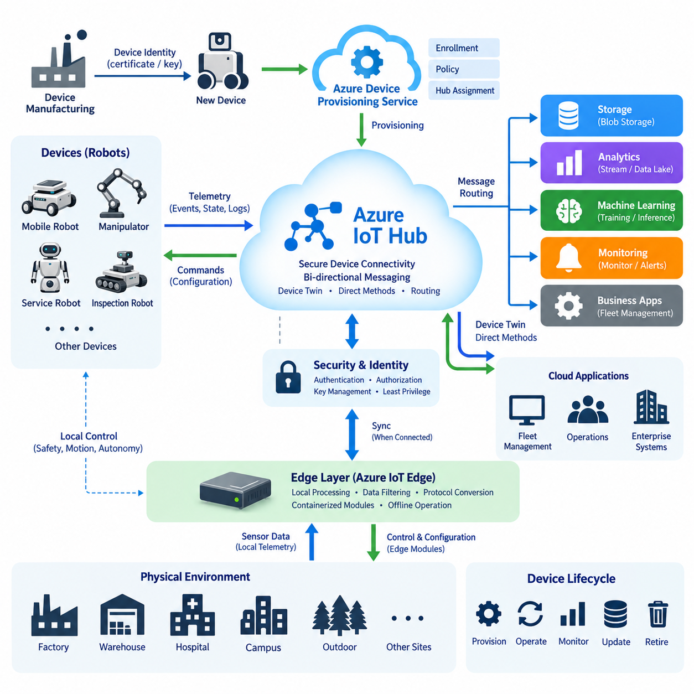
Azure IoT Hub provides the device communication layer that connects robots, gateways, sensors, and embedded controllers with Azure cloud applications. In a robotics architecture, each robot can maintain its own authenticated device identity while exchanging telemetry, operational state, commands, and events with backend services. This creates a controlled communication boundary between autonomous machines operating in the physical environment and scalable cloud services responsible for fleet-level management.
A production robot fleet may contain hundreds or thousands of devices deployed across different factories, warehouses, hospitals, campuses, and outdoor environments. Manually creating credentials and configuring cloud endpoints for every robot quickly becomes impractical. Azure IoT Hub Device Provisioning Service, commonly called DPS, addresses this problem by providing automated and scalable device enrollment and provisioning before a robot begins normal communication with its assigned IoT Hub.
The provisioning process separates device manufacturing identity from its final cloud assignment. A robot can leave production with an identity credential and later contact DPS during commissioning or first boot. DPS evaluates its enrollment information and determines the appropriate IoT Hub assignment according to the configured provisioning policy. The robot then receives the connection information required for normal operation, allowing deployment teams to commission devices without manually embedding site-specific IoT Hub configuration into every machine.
Device authentication can be based on mechanisms such as X.509 certificates or symmetric keys, depending on security requirements and device capabilities. For large robotics deployments, certificate-based identity provides a useful foundation for establishing individual trust relationships between physical devices and cloud infrastructure. Credentials should be protected using hardware-backed security where available, and the device identity lifecycle should include secure manufacturing, provisioning, rotation, revocation, replacement, and retirement rather than treating authentication as a one-time configuration task.
Azure IoT Hub supports device-to-cloud messaging for telemetry and operational information generated by robots. A robot may transmit battery state, localization quality, mission progress, temperatures, diagnostic events, subsystem health, utilization statistics, or selected perception results. These messages can be consumed by backend applications and routed toward storage, analytics, monitoring, or event-processing services. High-bandwidth raw sensor streams, however, normally require separate data strategies rather than indiscriminately sending all camera or LiDAR data through IoT messaging.
Cloud-to-device communication provides the reverse path for information originating from fleet or backend services. Applications can deliver commands or other operational messages to connected devices, while device twins provide synchronized representations of selected device state and configuration. In robotics, these mechanisms are useful for configuration changes, operating parameters, mission-related information, feature settings, and other non-hard-real-time interactions where reliable cloud coordination is required without placing deterministic motion control inside the cloud communication path.
Device twins maintain cloud-side information describing a device through desired properties, reported properties, and additional metadata. A fleet service can express a desired configuration while the robot reports the state it has actually applied. This distinction is valuable because a cloud request does not guarantee that a physical robot immediately reached the requested state. Temporary disconnection, software failures, safety constraints, or local operating conditions may delay or prevent configuration changes, so desired and reported states should be evaluated separately.
Direct methods provide another interaction pattern when a backend application needs request-response style communication with a connected device. They can be useful for management operations that require an immediate acknowledgement or result, but they should not be confused with deterministic real-time control. Network latency, cloud availability, and wireless connectivity remain variable. Emergency stopping, motor loops, collision avoidance, and other safety-critical functions therefore need local execution paths independent of Azure IoT Hub connectivity.
Message routing allows IoT Hub traffic to be directed toward different downstream services according to message properties, device information, or application-defined conditions. Instead of forcing every telemetry message through one monolithic backend, robot events can be separated into operational, diagnostic, analytics, and archival flows. For example, critical fault events can enter a rapid monitoring workflow while routine telemetry is stored for historical analysis and selected data is forwarded into analytics or machine-learning pipelines.
Robots frequently operate over wireless networks where connectivity can become intermittent. The device communication architecture must therefore assume temporary disconnection rather than treating it exclusively as an exceptional failure. Local applications can preserve autonomous behavior, maintain safety functions, buffer appropriate information, and reconnect when network service returns. After reconnection, synchronization mechanisms can restore relevant cloud state while the robot continues operating according to locally available policies and constraints.
Message design is as important as the communication service itself. Telemetry should include sufficient context to identify the robot, subsystem, timestamp, software or configuration state, and meaning of the measurement. Consistent schemas allow fleet services to process information from different robot generations without tightly coupling backend applications to individual firmware implementations. Versioned message contracts become especially important when hardware, embedded software, edge applications, and cloud services evolve independently throughout a long robot lifecycle.
Provisioning also needs to support fleet segmentation. Robots may belong to different customers, sites, development stages, geographic regions, or operational groups, and these distinctions can influence which cloud resources they should use. Automated allocation policies can reduce commissioning effort and support scalable deployment patterns. Device metadata established during enrollment can subsequently assist backend systems in applying appropriate configuration, monitoring, software deployment, and operational policies to different groups of robots.
Security requires more than simply authenticating the initial connection. Device permissions should follow least-privilege principles, credentials must be protected against extraction, and backend applications should use controlled identities when accessing IoT resources. Transport encryption protects communication channels, while certificate and key management policies determine whether device trust remains reliable over years of operation. Compromised or retired robots must be removable from the trusted fleet without disrupting unrelated devices.
IoT Hub should therefore be positioned above the robot's deterministic control architecture rather than inserted directly into low-level control loops. Motor control, actuator synchronization, safety monitoring, localization, obstacle avoidance, and other latency-sensitive functions remain on embedded or edge computers. IoT Hub handles communication that benefits from centralized visibility and fleet-scale coordination, including telemetry, configuration, diagnostics, remote management, and integration with enterprise or cloud applications.
A scalable implementation also separates IoT communication from higher-level fleet business logic. IoT Hub establishes secure device connectivity and messaging, while other backend components interpret telemetry, maintain fleet state, schedule missions, generate alerts, store historical information, or expose APIs to operators and enterprise systems. This separation prevents the messaging layer from becoming a monolithic fleet-management application and allows individual cloud services to evolve according to their own scalability and availability requirements.
The complete lifecycle can therefore begin with a robot carrying a trusted manufacturing identity, continue through automated DPS enrollment and IoT Hub assignment, and transition into authenticated operational messaging. During service, the robot sends telemetry and reported state while receiving desired configuration, management requests, and appropriate cloud-originated information. Monitoring and backend services consume these communication flows, while identity and provisioning policies maintain control over which physical machines are permitted to participate.
For robotics, the central architectural principle is that Azure IoT Hub and Device Provisioning Service provide secure fleet connectivity without replacing robot autonomy. Provisioning establishes trusted membership in the cloud-managed fleet, messaging connects physical operations with digital services, and device-state mechanisms coordinate configuration across distributed systems. When these capabilities are combined with local autonomous execution, the result is a cloud-edge architecture capable of scaling from a small deployment to large fleets while preserving operational resilience.

05.03 Azure IoT Edge: Runtime Module Deployment [w/Code]
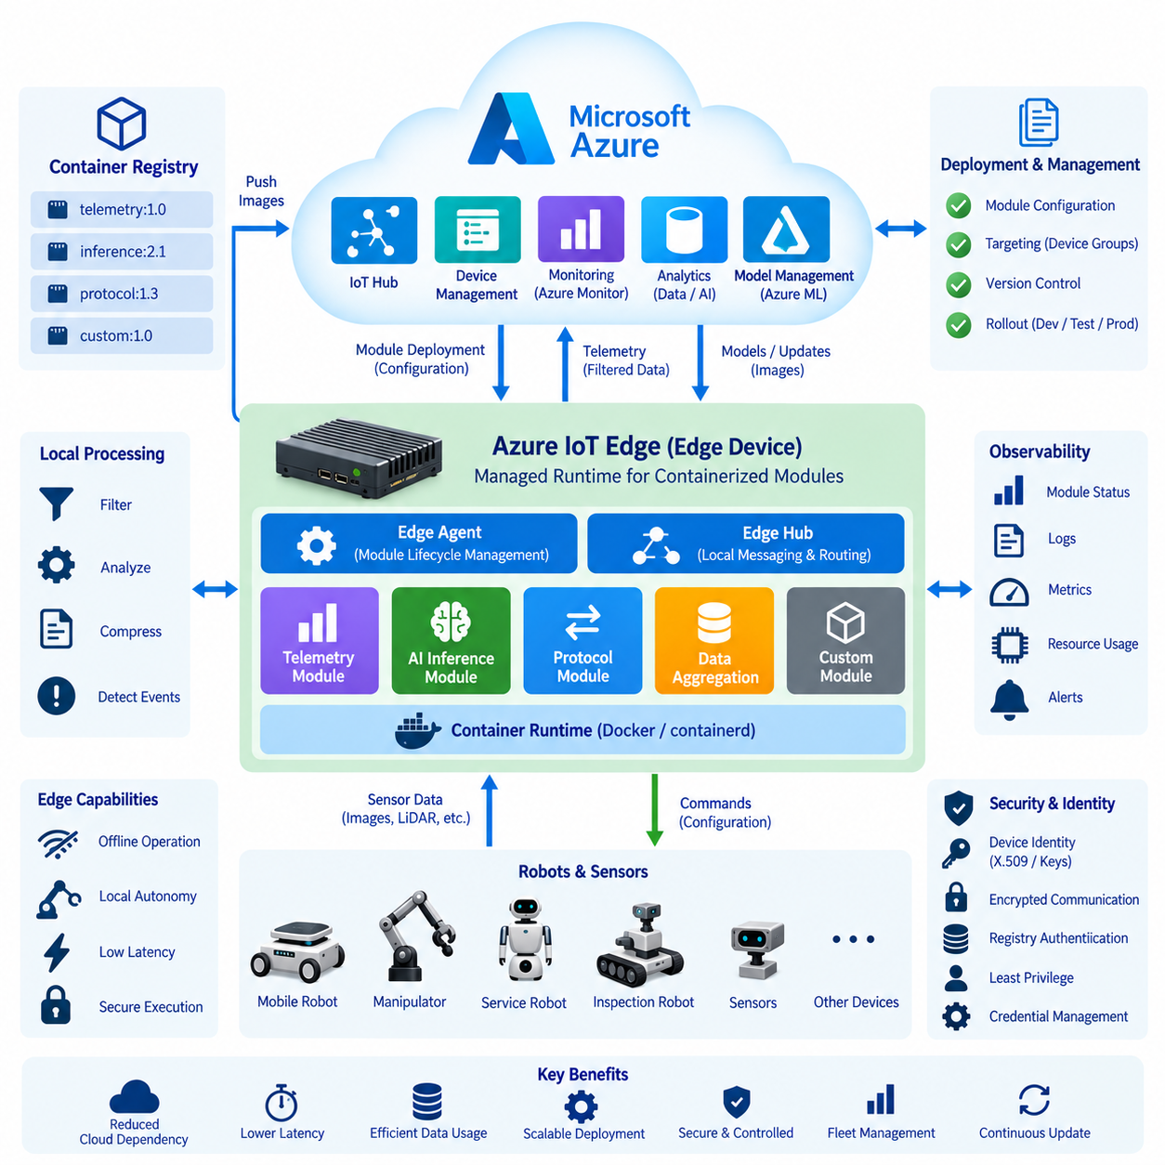
Azure IoT Edge extends Azure cloud capabilities to local computers installed on robots, gateways, or nearby industrial infrastructure. Its purpose is not to replace the robot’s embedded control software but to provide a managed execution environment for containerized applications close to physical operations. This architecture reduces dependency on continuous cloud connectivity while allowing selected cloud-managed workloads to execute with lower latency and controlled access to local robot data.
The IoT Edge runtime provides the software foundation that manages workloads deployed to an edge device. Instead of installing every application manually, software functionality can be packaged as independently deployable modules. These modules may perform telemetry preprocessing, protocol conversion, local analytics, AI inference, data aggregation, or communication with robot middleware. The runtime coordinates their execution while Azure services provide centralized configuration and deployment management.
An IoT Edge installation fundamentally separates workload management from workload implementation. Application developers build module functionality, package it into container images, and publish those images to an appropriate container registry. Deployment configuration then describes which modules should execute on a particular edge device and how they should operate. This separation enables the same physical edge computer to host multiple independently maintained services without combining all functionality into one monolithic robot application.
The runtime includes system components responsible for communication and module lifecycle management. The edge agent interprets deployment information and ensures that required modules are created, started, stopped, or restarted according to the specified configuration. The edge hub provides local messaging capabilities and mediates communication between modules, devices, and IoT Hub. Together, these components establish a managed local environment whose desired configuration can be coordinated from the cloud.
Module deployment begins with a container image containing the application and its required runtime dependencies. For robotics, one module might process telemetry, another could execute AI inference, while another translates between a local protocol and cloud messaging. Packaging these workloads separately reduces software dependency conflicts and permits individual components to be updated without rebuilding the entire edge software stack. Versioned images also provide an explicit relationship between deployed software and operational configuration.
Deployment manifests describe the desired state of the IoT Edge device. They identify modules, image locations, environment variables, restart behavior, routing relationships, and other execution parameters required by the deployment. When the desired configuration changes, the edge agent compares the requested state with the local state and performs the necessary lifecycle operations. This desired-state model allows fleet administrators to manage edge software declaratively rather than logging into each robot and manually modifying its installation.
Container registries provide the distribution point for module images. During deployment, an edge device obtains the specified image and creates the corresponding module according to its configuration. Registry authentication therefore becomes part of the deployment security architecture, particularly when proprietary robot software is distributed through private repositories. Image versions should be controlled explicitly so that fleet operators can determine which software artifact is running on each robot and avoid unintended changes caused by ambiguous image references.
IoT Edge message routing allows data to move between local modules and cloud endpoints without embedding every communication relationship directly inside application code. A sensor-processing module can publish filtered results to another module, while selected telemetry is forwarded toward IoT Hub. Routing rules therefore help separate application logic from communication topology. This is valuable when robot software evolves because data paths can be modified without requiring every participating module to implement its own cloud integration mechanism.
Edge processing is particularly important for robots because raw sensor information can be significantly larger than the operational information required by cloud applications. Camera images, LiDAR point clouds, audio streams, diagnostic logs, and other sources can generate substantial data volumes. Local modules can filter, summarize, compress, classify, or detect events before transmission. The cloud consequently receives information that is more appropriate for fleet monitoring, storage, analytics, and model improvement while unnecessary network traffic is reduced.
Offline operation must be treated as a normal design condition for mobile and field robots. When cloud connectivity becomes unavailable, locally deployed modules can continue executing because their runtime resides on the edge computer. Appropriate information can be buffered locally and synchronized after connectivity returns. This enables the cloud to manage software and collect fleet information without making essential robot behavior dependent on uninterrupted Internet connectivity, which is particularly important in warehouses, outdoor environments, and remote facilities.
The boundary between IoT Edge and real-time robot control must remain explicit. Safety loops, emergency stopping, motor control, actuator synchronization, obstacle avoidance, and other deterministic functions should remain in dedicated embedded or real-time software layers. IoT Edge is better suited to supervisory processing, data management, AI inference, integration, diagnostics, and cloud synchronization. Separating these responsibilities prevents variable container or network behavior from becoming part of a safety-critical control path.
AI inference represents an important IoT Edge workload for robotics. A trained model can be packaged together with its inference application and required libraries, then deployed as a versioned module. Sensor or preprocessed data can be passed to that module locally, allowing inference results to be generated without sending every input to the cloud. Updated models can subsequently be distributed through the managed deployment process, creating a practical connection between cloud-based model development and robot-side execution.
Fleet-scale deployment requires targeting mechanisms because not every robot should necessarily receive identical software at the same time. Devices may differ by hardware generation, customer site, operating environment, development stage, or application configuration. Deployment policies can associate desired module configurations with appropriate groups of devices. This allows organizations to separate development, validation, pilot, and production populations and provides the architectural basis for controlled software rollout across heterogeneous robot fleets.
Software updates should be treated as controlled lifecycle transitions rather than simple file replacement. A new module version must be retrieved, instantiated, configured, started, and observed before it can be considered operational. If an application fails repeatedly or becomes incompatible with surrounding components, deployment procedures need a defined recovery strategy. Maintaining versioned container images and deployment configurations improves traceability and makes it possible to identify the software state associated with a particular field event.
Observability is necessary because successful deployment does not guarantee correct application behavior. Operators need visibility into module status, restart behavior, resource consumption, application logs, communication failures, and edge-device health. Robot-specific metrics such as battery condition, sensor availability, localization quality, mission state, and AI inference performance can be combined with infrastructure information. This provides a more complete operational picture than monitoring either cloud services or container status alone.
Security must cover the complete path from cloud configuration to local module execution. Device identity establishes which edge computer is trusted, registry credentials control access to software images, encrypted communication protects data in transit, and application permissions should be restricted according to least-privilege principles. Secrets should not be embedded directly in container images. Production systems should also maintain control over image provenance, versioning, credential rotation, and removal of obsolete or compromised software.
Resource management is especially significant on battery-powered robots because edge computers have finite CPU, GPU, memory, storage, thermal, and electrical budgets. Deploying additional modules can increase computational load and power consumption even when individual applications operate correctly. Edge architecture therefore requires workload prioritization and capacity planning. AI inference, data processing, diagnostics, and communication workloads must coexist without starving autonomy software or exceeding the thermal and energy constraints of the robot platform.
In a complete cloud-edge robotics architecture, Azure IoT Edge becomes the managed application layer between low-level autonomous robot software and centralized Azure services. The robot retains local control and safety, edge modules provide adaptable processing and integration, and IoT Hub supplies fleet-scale connectivity and configuration. Cloud systems can distribute software and models while receiving selected operational information, producing a controlled feedback loop between deployed physical machines and centralized digital infrastructure.
The architectural value of IoT Edge therefore comes from combining local execution with centralized lifecycle management. Containerized modules provide software isolation and deployment flexibility, the runtime maintains desired application state, routing connects local and cloud data flows, and offline capability preserves operation during communication loss. When these mechanisms are designed around the real-time and safety boundaries of the robot, Azure IoT Edge can support scalable software deployment without sacrificing the autonomy and resilience required by physical robotic systems.

05.04 Azure Digital Twins: Robot Twin Modeling [w/Code]
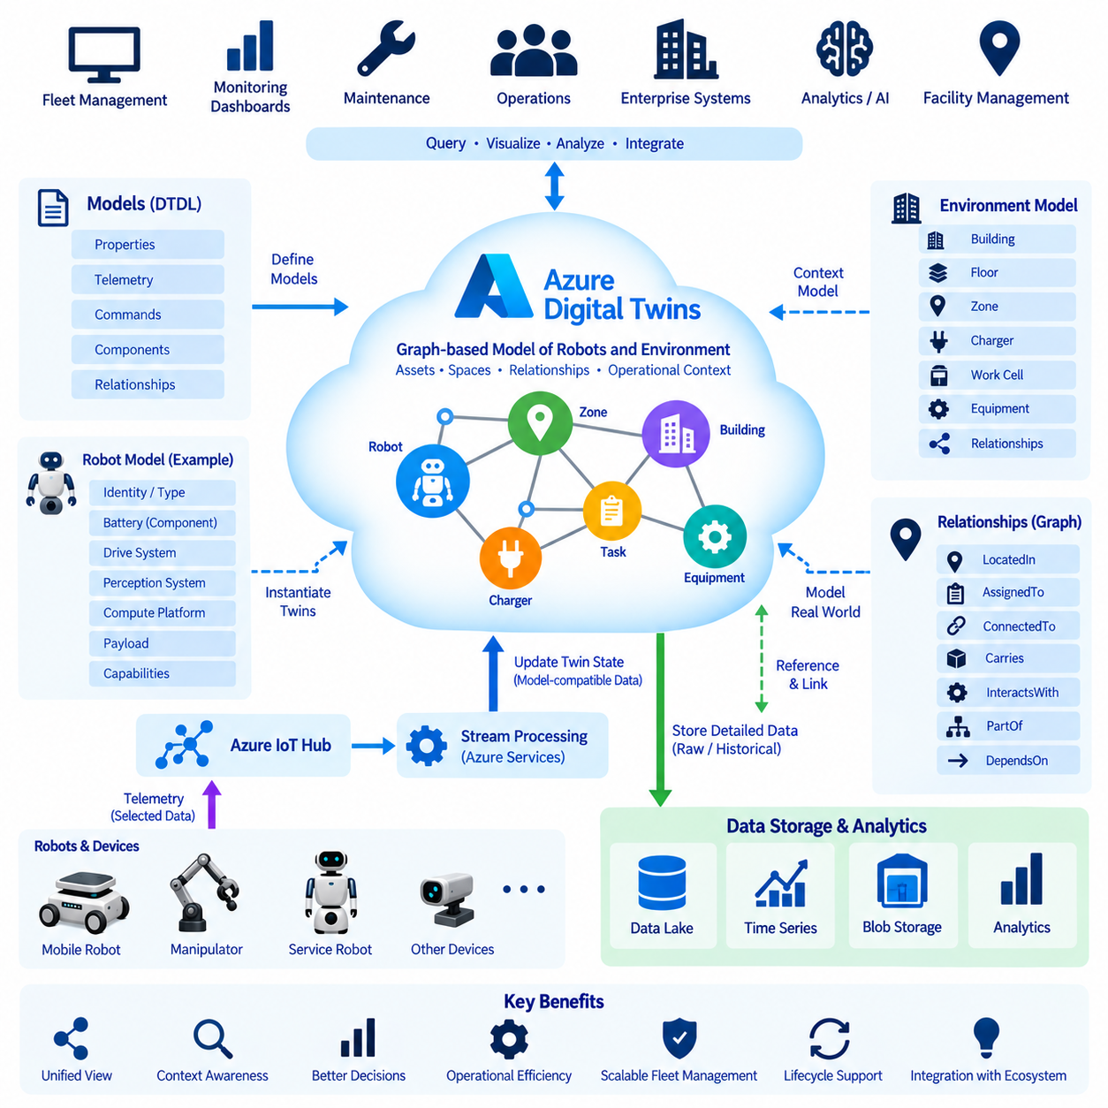
Azure Digital Twins provides a graph-based modeling environment for representing physical systems, assets, spaces, and their relationships in the cloud. In robotics, a digital twin should not be understood merely as a visual 3D copy of a robot. It is a structured digital representation that connects robot properties, operational state, environment, infrastructure, and relationships so applications can interpret the physical system within a meaningful operational context.
A robot twin can represent both relatively static characteristics and continuously changing operational information. Static information may include robot type, hardware configuration, payload class, sensor arrangement, software generation, and supported capabilities. Dynamic properties can describe battery state, operating mode, current mission, localization status, temperature, health indicators, or charging condition. Separating these concepts creates a consistent information model that can remain useful throughout the robot lifecycle.
Azure Digital Twins uses models to define the structure and semantics of digital entities. A model specifies properties, telemetry, commands, components, and relationships that describe a particular type of physical or logical object. Robot developers can therefore define reusable models for mobile robots, manipulators, charging stations, work cells, elevators, doors, inspection equipment, or facilities rather than creating an unrelated data structure for every deployed asset.
The Digital Twins Definition Language, commonly called DTDL, provides a standardized way to describe these models. DTDL interfaces can define the capabilities and data structures associated with a digital entity, while components allow complex systems to be decomposed into reusable submodels. A robot model could contain components representing its battery, drive system, perception subsystem, compute platform, or payload, enabling complex machines to be represented through modular and maintainable model structures.
Relationships are one of the most important characteristics of digital twin modeling. A robot rarely operates as an isolated object; it may be located in a warehouse zone, assigned to a mission, connected to a charging station, carrying a payload, or interacting with equipment. Azure Digital Twins can represent these connections as graph relationships, allowing applications to understand not only the state of individual objects but also how those objects are connected within the operational environment.
A fleet-level twin can therefore extend beyond individual robot models. The graph may represent robots, buildings, floors, zones, charging infrastructure, production equipment, storage areas, workstations, and other resources within one contextual model. A backend application can query this graph to determine which robot is located in a particular area, which charger belongs to that zone, or which operational resources are associated with a specific mission or facility.
Real robot data must be mapped into the digital twin model before the twin can represent current physical conditions. Telemetry originating from robot controllers, sensors, IoT devices, or edge applications can travel through IoT Hub and related processing services. Selected information is then transformed into model-compatible updates. This architecture prevents every raw sensor measurement from becoming a twin property and encourages the twin to contain operationally meaningful state rather than unrestricted high-volume data streams.
This distinction is important because Azure Digital Twins is not intended to replace time-series databases, object storage, or raw sensor repositories. Camera images, LiDAR point clouds, large diagnostic files, and high-frequency telemetry are better stored in services designed for those data types. The twin can instead maintain references, summarized states, latest values, or relationships that provide context for those datasets. The digital twin consequently becomes a semantic operational layer above underlying data platforms.
Robot twin modeling should also distinguish reported physical state from requested or planned state. A fleet system may assign a robot to a mission or charging station, while the robot reports its actual location and execution status independently. Treating these as separate concepts prevents software from assuming that a command has already changed physical reality. Digital twins can therefore help applications reason about differences between intended operations, current state, and observed execution results.
Events generated by changes in the twin graph can be integrated with other cloud services. A battery condition, robot fault, zone transition, or equipment-state change may trigger downstream processing, monitoring, notification, or workflow logic. This event-driven approach reduces the need for applications to continuously poll every asset. Instead, meaningful state transitions can propagate through cloud services and initiate appropriate actions while the underlying robot continues its autonomous local operation.
Historical analysis requires combining the contextual model with persistent operational data. The current twin graph may describe where a robot belongs, what equipment it interacts with, and its latest meaningful state, while historical telemetry is maintained in dedicated analytical or storage systems. By linking these layers, engineers can investigate failures or performance trends with contextual information such as location, mission, hardware configuration, software version, and environmental relationships.
Digital twin modeling becomes especially useful for fleet management because heterogeneous robots can be represented through common semantic structures. Different robot generations may use different sensors, embedded computers, or internal software, yet fleet applications still require consistent concepts such as availability, mission status, battery condition, location, and health. Well-designed base models and specialized extensions allow common fleet logic to coexist with platform-specific characteristics.
Model versioning is necessary as physical robots and software evolve. A robot may receive new sensors, compute hardware, payload modules, or capabilities during its service life. Changing a model without considering compatibility can break applications that depend on existing properties or relationships. Digital twin governance should therefore include model naming, version management, compatibility rules, validation, and migration strategies so that the semantic architecture can evolve without destabilizing operational systems.
Security and authorization remain important because a twin may expose detailed information about robot status, facility structure, equipment relationships, or operational activity. Applications updating twin state should use controlled identities and receive only the permissions required for their roles. The digital twin layer should not become an unrestricted path for controlling physical equipment. Safety-critical commands and deterministic control must remain within appropriately designed robot and industrial control systems.
A digital twin is also different from a physics simulation. Simulation systems calculate physical behavior using mathematical models, dynamics, collision models, sensor simulation, or virtual environments. A digital twin focuses on maintaining a structured representation connected to real operational entities and data. The two concepts can be integrated, however: twin information can configure simulations, while simulation results can support planning, predictive analysis, testing, or operational decision support.
For an autonomous mobile robot, a practical twin graph might connect the robot to its current facility, operating zone, assigned task, charging resource, payload, and software configuration. Components inside the robot twin can represent battery, navigation, perception, and compute subsystems. Cloud applications can then query these relationships to understand the operational context of a warning rather than receiving an isolated message containing only a robot identifier and error code.
At fleet scale, this contextual graph can support monitoring, asset management, maintenance, operational analytics, and integration with enterprise systems. A maintenance application can associate a fault with the affected subsystem and robot configuration, while a fleet service can relate robot availability to missions and charging resources. Facility applications can connect mobile robots with buildings and operational zones, producing a shared information model across robotics and surrounding infrastructure.
The architecture should nevertheless preserve clear responsibility boundaries. Robots and edge computers remain responsible for autonomous operation, local perception, motion planning, safety, and low-latency decisions. IoT communication transports selected information, while Azure Digital Twins organizes meaningful state and relationships for cloud applications. Storage and analytical platforms preserve detailed historical data, and higher-level services use these layers to support fleet-wide reasoning and operational management.
The central value of Azure Digital Twins for robotics is therefore semantic integration. It transforms disconnected device data into a graph describing what each entity represents, how entities relate, and what their current operational context means. When combined with IoT connectivity, edge processing, persistent data platforms, analytics, and fleet applications, robot twin modeling provides a scalable digital representation that connects individual autonomous machines with the larger physical and operational systems in which they work.

05.05 Azure Blob Storage: Robot Data Pipeline [w/Code]
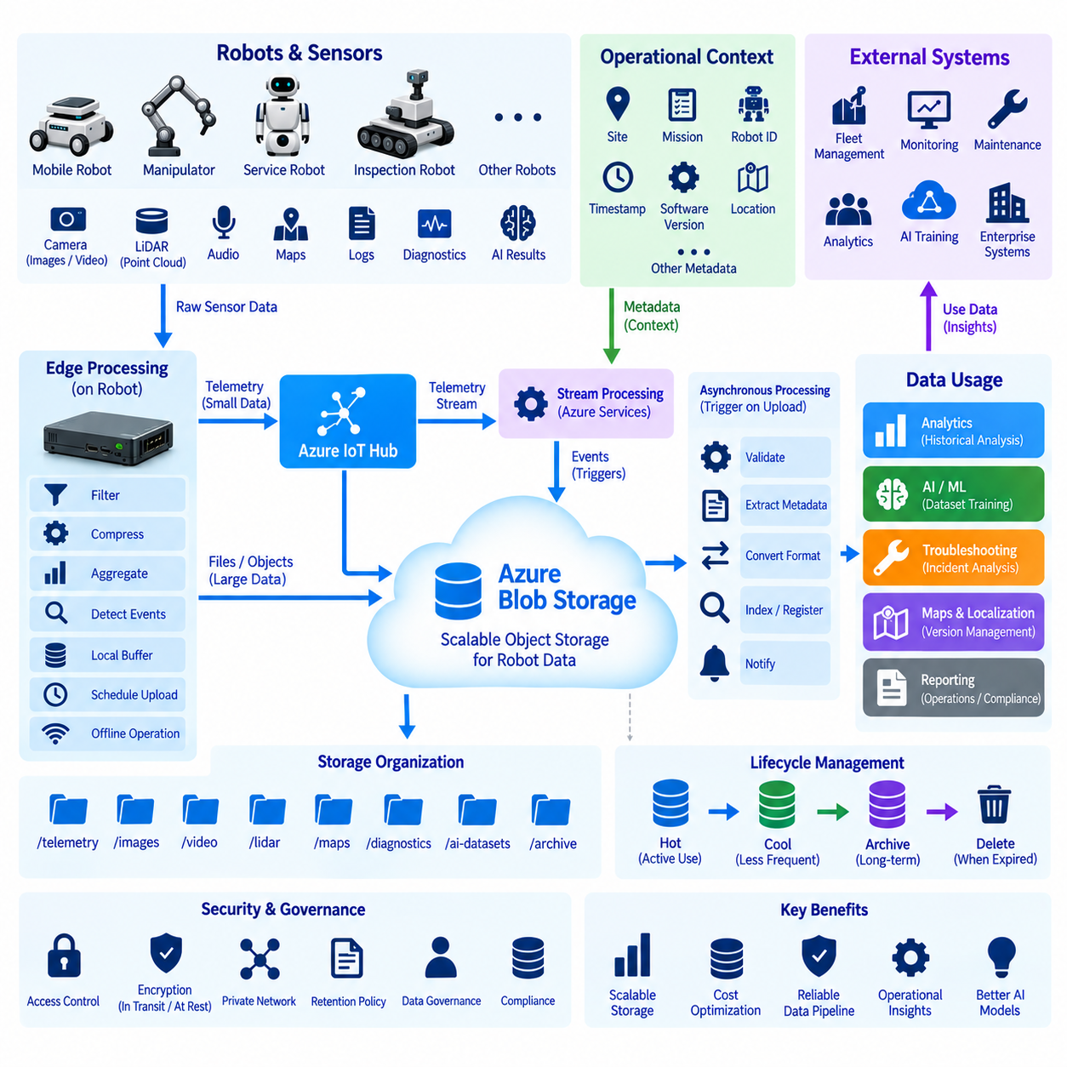
Azure Blob Storage provides scalable object storage for the large and heterogeneous datasets generated by robotic systems. Mobile robots, manipulators, inspection platforms, and service robots continuously produce telemetry, images, video, LiDAR data, maps, logs, diagnostic files, and AI results. Blob Storage provides a persistent cloud repository where these datasets can be organized independently from the transactional services responsible for real-time robot operation.
A robot data pipeline should not simply transmit every sensor sample directly to cloud storage. Cameras, LiDARs, microphones, and diagnostic systems can generate data at rates that exceed practical network bandwidth and storage budgets. Edge computers therefore perform filtering, compression, aggregation, event detection, and temporary buffering before upload. This edge-first approach reduces unnecessary traffic while preserving information that is valuable for operations, troubleshooting, analytics, and AI development.
Data can reach the storage pipeline through several paths depending on its characteristics. Small telemetry and event messages may pass through Azure IoT Hub and stream-processing services, while large files such as images, video segments, maps, point clouds, and diagnostic archives can be uploaded as objects. Separating message-oriented communication from bulk object transfer prevents large sensor files from overwhelming the IoT messaging path and produces a more scalable robotics data architecture.
Blob Storage organizes objects within storage accounts and containers, allowing robot datasets to be separated according to application requirements. A fleet may use containers or logical object paths for production telemetry, perception data, diagnostics, maps, AI datasets, and archived information. Object names can incorporate contextual identifiers such as robot ID, site, date, mission, sensor, or data type, making datasets easier to locate and process without requiring one enormous undifferentiated repository.
Metadata is essential because a sensor file without operational context has limited value. Robot data objects should be associated with information such as device identity, timestamp, sensor type, mission identifier, software version, calibration version, location, and event classification where appropriate. Consistent metadata conventions allow downstream systems to identify datasets generated under specific conditions and significantly improve failure analysis, dataset construction, model evaluation, and operational traceability.
Time synchronization becomes important when multiple robot sensors contribute to one analytical event. Images, LiDAR scans, localization estimates, IMU measurements, and system logs may need to be correlated after operation. Timestamps should therefore originate from a controlled time architecture rather than being interpreted only from upload time. Cloud storage records when an object was stored, but meaningful robotics analysis often depends on knowing when the physical observation actually occurred.
Local buffering protects the pipeline against intermittent connectivity. A mobile robot may temporarily lose Wi-Fi, cellular, or private-network access while continuing its mission. Instead of discarding data or blocking autonomous operation, the edge system can store selected files locally and maintain an upload queue. When connectivity returns, pending objects can be transferred according to priority, available bandwidth, retention rules, and operational importance without placing cloud availability inside the robot’s real-time control path.
Upload scheduling can further reduce interference between cloud transfer and robot operation. High-priority fault evidence may need immediate transmission, whereas routine logs or large perception datasets can wait until the robot reaches a charging station or high-bandwidth network. A data pipeline can therefore classify information according to urgency and value. This prevents background transfers from consuming communication resources required for fleet commands, monitoring, remote assistance, or other operational traffic.
Storage lifecycle management is necessary because robotics datasets can grow rapidly. Frequently accessed operational data may initially remain in a storage tier optimized for active use, while older information can move toward lower-cost tiers according to retention policies. Data that no longer has engineering, regulatory, analytical, or training value can eventually be deleted. Lifecycle policies transform storage from unlimited accumulation into a governed system whose cost reflects the continuing value of the data.
The data pipeline should distinguish raw, processed, and curated information. Raw data preserves selected original observations required for reproducibility or later reprocessing. Processed data may contain compressed sensor outputs, extracted features, detection results, or normalized records. Curated datasets contain information that has passed quality checks and is suitable for analytics, validation, or AI training. Maintaining these stages helps engineers understand data lineage and prevents transformed results from being mistaken for original measurements.
Azure services can process stored objects asynchronously after upload. New files can trigger event-driven workflows that perform validation, metadata extraction, format conversion, indexing, dataset registration, or notification. Large processing tasks do not need to execute inside the robot simply because the data originated there. This allows battery-powered edge computers to focus on autonomous operation while scalable cloud resources perform non-real-time processing and long-running analytical workloads.
Robot logs and diagnostic packages provide an important example of this architecture. When a navigation failure, sensor fault, thermal event, or unexpected stop occurs, the edge system can collect relevant logs and selected sensor evidence into an incident package. That package can be uploaded together with contextual metadata and analyzed centrally. Engineers can then compare incidents across multiple robots instead of manually retrieving files from each physical machine after a problem occurs.
Perception data stored in Blob Storage can also become part of an AI lifecycle. Selected images, point clouds, or sensor sequences can be collected from deployed robots, filtered according to data policies, and incorporated into dataset preparation workflows. After annotation and quality control, curated data can support model training and evaluation. Improved models may later be deployed back to edge systems, creating a feedback loop between field operation, cloud data collection, learning, and redeployment.
Maps and localization-related artifacts require careful version management because the meaning of robot behavior may depend on the map used during operation. Storage paths and metadata can associate map files with site, revision, creation time, and compatible robot software. Historical versions may need to remain available for incident reconstruction. A robot data platform should therefore treat maps and configuration artifacts as governed operational assets rather than ordinary files with arbitrary names.
Security must protect both data transfer and stored objects. Access to storage should be controlled through appropriate identities and authorization policies rather than broadly distributed credentials. Encryption protects information in transit and at rest, while private networking and restricted endpoints can reduce unnecessary exposure. Different applications should receive only the permissions required for their roles, preventing a monitoring service, for example, from automatically gaining unrestricted access to every stored robotics dataset.
Data governance becomes increasingly important when robot sensors observe people, facilities, customer assets, or sensitive industrial processes. Retention periods, access rules, geographic requirements, anonymization procedures, and deletion policies should be defined according to the nature of the collected information. The technical ability to store a dataset indefinitely does not mean that doing so is operationally or legally appropriate. Data collection should therefore be connected to an explicit purpose and lifecycle.
Observability should cover the pipeline itself as well as the robots generating the data. Operators need to know whether uploads are succeeding, queues are growing, local storage is approaching capacity, transfers are repeatedly failing, or cloud storage consumption is increasing unexpectedly. Monitoring these conditions prevents silent data loss and allows capacity planning across both edge and cloud infrastructure. Pipeline health becomes part of overall fleet observability rather than a separate storage concern.
At fleet scale, a consistent storage architecture allows data from heterogeneous robots to be processed through common cloud workflows. Different platforms may produce different sensor formats, but shared naming, metadata, lifecycle, security, and lineage conventions provide a common organizational layer. This makes it possible to compare operational behavior across robot generations, sites, and missions while preserving platform-specific datasets where they are technically necessary.
The overall Azure Blob Storage robot data pipeline therefore connects physical data generation with long-term digital value. Robots and edge systems select and prepare information, communication services transport operational messages, object storage preserves large datasets, and downstream services perform analysis, monitoring, and AI processing. By separating real-time autonomy from bulk data management, the architecture can scale data collection without making safe robot operation dependent on continuous cloud transfer.
The key design principle is selective, contextual, and governed data movement rather than indiscriminate uploading. Edge filtering controls bandwidth, structured metadata preserves meaning, object storage provides durable capacity, lifecycle policies control cost, and downstream processing transforms stored observations into engineering and operational knowledge. Together, these mechanisms create a robot data pipeline that supports fleet operations, failure investigation, historical analytics, and continuous AI improvement across the cloud-edge lifecycle.

05.06 Azure Machine Learning: Robot AI Training [w/Code]
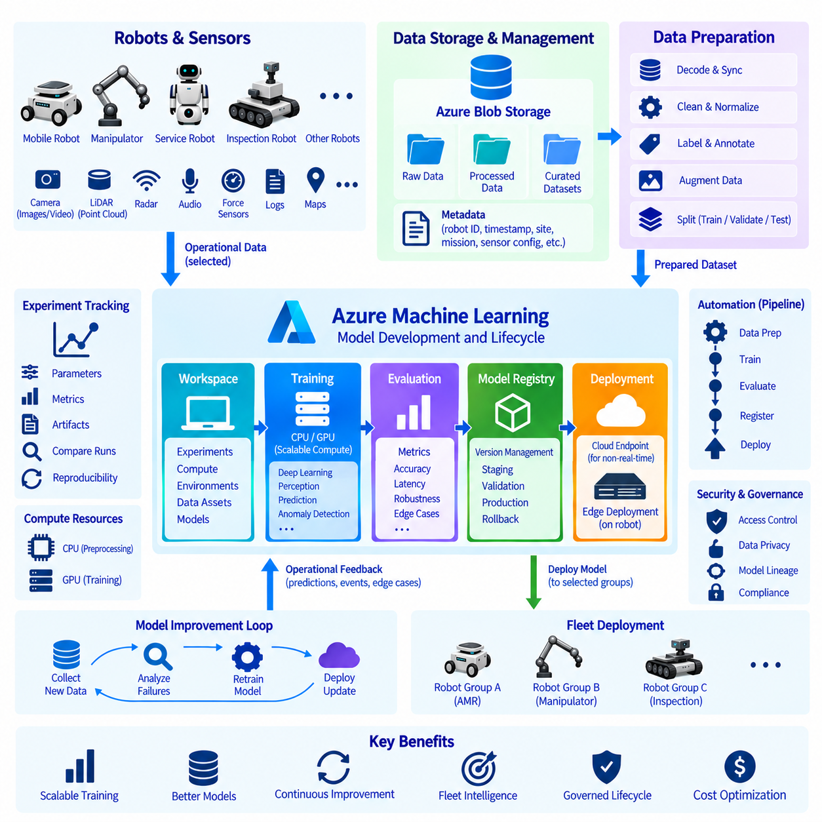
Azure Machine Learning provides a managed platform for developing, training, evaluating, registering, and deploying machine-learning models used by robotic systems. Within a cloud-edge robotics architecture, Azure ML primarily supplies scalable computation and lifecycle management rather than replacing onboard inference. Robots collect operational data in the physical world, while cloud infrastructure transforms selected datasets into improved perception, prediction, inspection, and decision-support models.
Robot AI development begins with data collected from cameras, LiDAR, radar, microphones, force sensors, diagnostic systems, and operational software. Because continuously deployed robots can generate enormous data volumes, the training pipeline should not automatically preserve every sensor sample. Edge filtering and event selection identify useful observations, while cloud storage retains datasets required for model development, failure analysis, validation, and future retraining.
Azure Blob Storage and related data services can provide the persistent data foundation for machine-learning workflows. Raw observations may be organized separately from processed and curated datasets so that transformations remain traceable. Metadata describing robot identity, sensor configuration, timestamp, site, mission, software version, and calibration state helps engineers understand how training samples were produced and prevents unrelated operating conditions from being mixed without appropriate context.
Dataset preparation converts operational robot data into representations suitable for learning. This process may include decoding sensor files, synchronizing multimodal observations, removing corrupted samples, normalizing values, generating labels, dividing training and validation subsets, and applying augmentation. For robotics, careful preparation is particularly important because changes in camera calibration, LiDAR configuration, environment, weather, lighting, payload, or robot motion can significantly affect the statistical characteristics of collected data.
An Azure Machine Learning workspace provides a logical environment for organizing machine-learning resources and development activities. Engineers can associate experiments, jobs, compute resources, data assets, environments, models, and other artifacts with a controlled project context. This organization becomes valuable when multiple developers and robot platforms share infrastructure because model results must be connected to the exact data, software environment, parameters, and training procedure that produced them.
Compute resources can be selected according to workload characteristics rather than permanently assigning one machine to every project. CPU resources may support preprocessing and conventional analytics, while GPU-enabled compute can accelerate deep-learning workloads such as object detection, semantic segmentation, multimodal perception, anomaly detection, and other neural-network models. Cloud elasticity allows larger training jobs to temporarily use additional resources without requiring equivalent compute capacity on every deployed robot.
Training environments should be reproducible because a model cannot be reliably maintained when its software dependencies are unknown. Framework versions, Python packages, CUDA-related dependencies, preprocessing code, and training configuration influence model behavior. Managed environments and containerized execution help capture these dependencies so that an experiment can be repeated or investigated later. Reproducibility is especially important when a model version becomes associated with field performance or a safety-related engineering investigation.
Experiment tracking connects training runs with parameters, metrics, artifacts, and outputs. Engineers can compare alternative architectures, learning rates, augmentation strategies, dataset versions, or preprocessing configurations without relying on manually maintained notes. For robot AI, useful metrics depend on the task and may include precision, recall, detection accuracy, localization error, inference latency, robustness, or other application-specific measurements. Cloud tracking provides a common history of how candidate models evolved.
Training at scale does not eliminate the need for representative robot data. Increasing GPU resources can accelerate optimization, but it cannot compensate for datasets that fail to represent the deployment environment. Indoor AMRs, outdoor inspection robots, hospital robots, and manipulators encounter fundamentally different operating conditions. Dataset composition should therefore reflect the intended operational domain, including difficult cases such as occlusion, lighting variation, unusual objects, sensor degradation, and environmental changes.
Model evaluation must extend beyond a single aggregate accuracy value. A candidate model should be tested against representative scenarios, edge cases, operational constraints, and hardware limitations. For an edge-deployed robot, inference latency, GPU memory consumption, thermal load, and power consumption may be as important as prediction quality. A model that performs well on cloud GPUs may require optimization, quantization, pruning, or another deployment-specific transformation before it becomes practical on embedded hardware.
Validated models can be registered as managed artifacts so that training results become identifiable deployment candidates rather than anonymous files. Model registration provides a controlled relationship between versions and associated metadata. A fleet organization can distinguish experimental, validation, pilot, and production models and preserve previous versions for comparison or rollback. This prevents uncontrolled copying of model files between developer computers, cloud storage, and individual robots.
The deployment path depends on where inference should occur. Cloud endpoints are appropriate for workloads that tolerate network latency and benefit from centralized computation, while robots usually require local inference for perception and other latency-sensitive functions. A trained model can therefore move from Azure Machine Learning into an edge deployment workflow where it is packaged with inference software and distributed through a managed mechanism such as containerized edge modules or another robot software deployment system.
Cloud training and edge inference create a practical division of computation. Large datasets and computationally expensive optimization remain in scalable cloud infrastructure, while deployed robots execute compact inference workloads close to sensors and actuators. Only selected data and model results need to cross the network. This reduces bandwidth requirements and allows the robot to preserve important AI functionality during temporary cloud disconnection while still benefiting from centrally trained models.
A mature robotics AI pipeline forms a continuous feedback loop. Robots execute models in the field and generate predictions, operational events, and selected sensor evidence. Difficult or unusual cases are returned to the data platform, reviewed, labeled when necessary, and incorporated into improved datasets. New models are trained and evaluated, approved versions are registered, and selected releases are deployed back to appropriate robot groups. Field operation therefore becomes a source of evidence for subsequent model improvement.
Automation can transform this sequence into a repeatable machine-learning pipeline. Data preparation, training, evaluation, model registration, and deployment validation can be connected into controlled workflows rather than executed manually in inconsistent ways. Automation does not remove engineering judgment; instead, it ensures that repeated technical steps follow known procedures. Approval gates can remain between stages when safety, performance, customer requirements, or operational risk require human review.
Fleet segmentation is important during model deployment because heterogeneous robots may not support identical AI artifacts. Different platforms can contain different cameras, GPUs, sensor positions, firmware, or application requirements. Model releases should therefore include compatibility information and target appropriate device groups. A model validated for one sensor configuration should not automatically be distributed across an entire fleet merely because the robots perform similar missions.
Monitoring continues after deployment because offline validation cannot represent every real operating condition. Production systems can observe inference statistics, confidence distributions, latency, resource usage, failure events, and selected examples that indicate possible model degradation. Changes in environments, sensors, objects, or operating procedures can produce data drift or performance drift. These signals can initiate investigation and eventually trigger dataset updates and retraining when justified by evidence.
Security and governance apply throughout the machine-learning lifecycle. Access to datasets, compute resources, experiments, registered models, and deployment mechanisms should be controlled according to user and service roles. Sensitive robot data requires appropriate retention and access policies, while production models require traceability from training data and code to deployment. This lineage helps organizations determine which model was operating on a particular robot when an incident or unexpected AI behavior occurred.
Cost management is also important because large-scale training can consume substantial GPU and storage resources. Compute should match the workload, inactive resources should not remain allocated unnecessarily, and repeated experiments should be designed to avoid wasteful duplication. Dataset lifecycle policies can reduce long-term storage costs, while smaller preliminary experiments can eliminate unsuitable approaches before expensive full-scale training begins. Cloud scalability is most valuable when accompanied by disciplined resource governance.
Azure Machine Learning therefore occupies the model-development and lifecycle layer of an Azure robotics architecture. Blob Storage and data pipelines supply training information, scalable compute performs optimization, experiment tracking preserves development history, model registration controls artifacts, and deployment workflows deliver validated models toward cloud or edge inference environments. Robots remain responsible for physical autonomy while cloud ML infrastructure provides the computational and organizational foundation for continuous AI improvement.
The central architectural principle is a closed cloud-edge learning lifecycle rather than one-time model training. Operational robots generate carefully selected evidence, cloud infrastructure converts that evidence into governed datasets and reproducible experiments, validated models become controlled artifacts, and edge systems execute appropriate versions close to the physical world. Repeating this cycle allows robot AI to improve systematically while preserving traceability, deployment control, scalability, and the operational independence required by autonomous machines.

05.07 Azure AKS: Robot Service Deployment [w/Code]
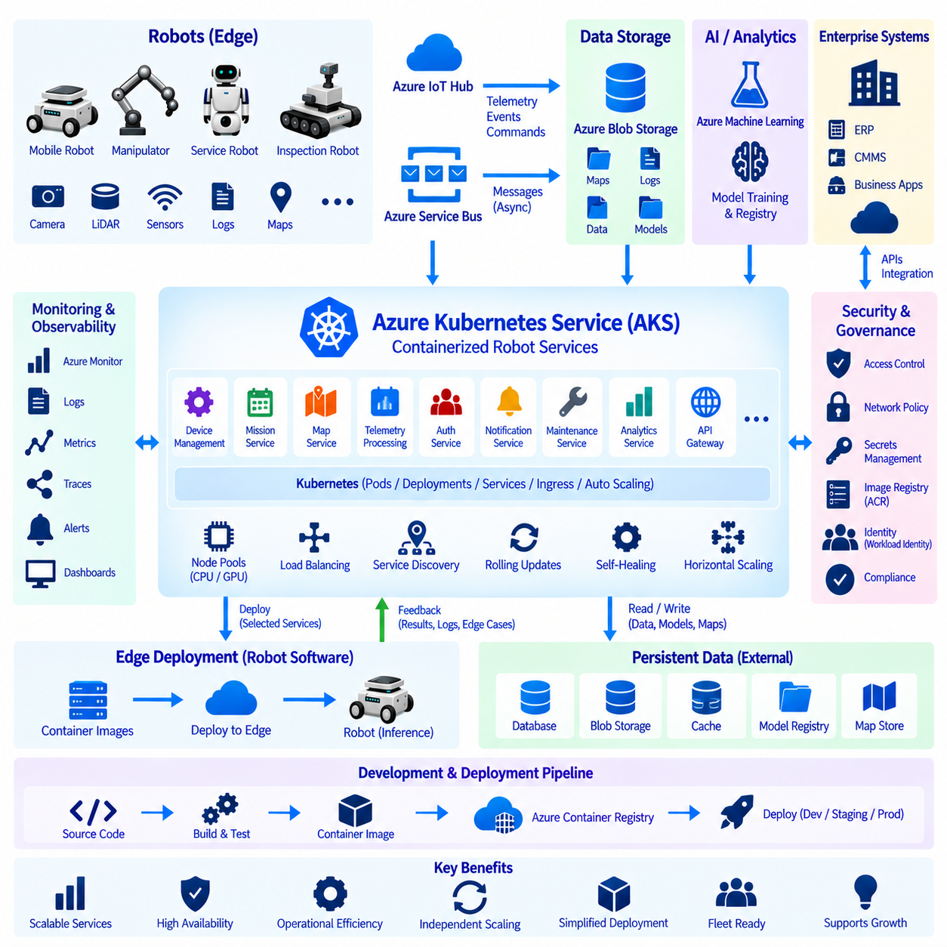
Azure Kubernetes Service, commonly called AKS, provides a managed Kubernetes environment for deploying and operating containerized backend services used by robotic systems. In a cloud-edge robotics architecture, AKS does not normally execute deterministic robot control loops. Instead, it hosts scalable services for fleet management, mission coordination, telemetry processing, APIs, dashboards, analytics, AI integration, and other workloads shared across many robots.
A robot cloud platform is naturally composed of multiple services with different responsibilities and scaling requirements. Device management, mission scheduling, map distribution, telemetry ingestion, user authentication, notifications, maintenance, and enterprise integration may evolve independently. Packaging these functions as containers and deploying them through Kubernetes allows each service to be developed, released, scaled, monitored, and recovered without rebuilding one monolithic fleet application.
Kubernetes organizes application containers into Pods, which represent the basic deployable execution units within a cluster. A Pod may contain one primary service container together with supporting containers when tightly coupled functionality is required. Deployments describe how application instances should run and maintain a desired number of replicas. If a Pod fails, Kubernetes can create a replacement, providing a foundation for resilient robot backend services that must operate continuously.
Kubernetes Services provide stable network access to groups of Pods whose individual addresses may change as workloads are restarted or rescheduled. This abstraction is useful for robotics microservices because a mission service should not need to know the physical location of every telemetry or map-processing container. Internal service discovery allows backend components to communicate through stable logical endpoints while Kubernetes manages the changing infrastructure underneath them.
Ingress and related networking mechanisms expose selected applications to external clients while keeping internal services separated. Robot operators may access dashboards, APIs, or fleet-management interfaces through controlled endpoints, while internal databases and processing services remain inaccessible from public networks. Network architecture should distinguish robot connectivity, operator access, service-to-service communication, and administrative traffic instead of placing every component behind one unrestricted endpoint.
AKS separates the Kubernetes control plane from worker nodes that execute application workloads. Node pools can be configured for different workload characteristics, allowing general backend services and compute-intensive processing to use appropriate resources. CPU-oriented services may run on standard nodes, while specialized workloads can use nodes equipped with accelerators when required. This separation supports more efficient resource allocation than provisioning every backend component with identical infrastructure.
Resource requests and limits are important because multiple robot services can share the same Kubernetes cluster. Each workload can declare expected CPU and memory requirements, allowing the scheduler to place Pods on suitable nodes. Limits can reduce the risk that one malfunctioning service consumes resources required by others. Capacity planning should nevertheless consider traffic peaks, fleet growth, software updates, and failure scenarios rather than assuming average utilization represents the maximum operational demand.
Horizontal scaling allows selected services to increase or decrease the number of running instances according to workload demand. Telemetry ingestion, API processing, event handling, or analytical services may experience increased traffic as the robot fleet grows or during operational peaks. Kubernetes can scale appropriate workloads independently instead of scaling the entire backend as one unit. This characteristic is particularly valuable when thousands of robots generate asynchronous communication and operational events.
High availability requires more than simply running applications inside Kubernetes. Critical services should use multiple replicas where appropriate and distribute workloads so that individual node failures do not remove the complete service. Health probes allow Kubernetes to identify containers that are running but unable to serve requests correctly. Readiness checks prevent unhealthy instances from receiving traffic, while liveness mechanisms can initiate recovery when an application becomes unresponsive.
Rolling updates support gradual replacement of application versions while maintaining service availability. When a fleet backend receives a new mission service or telemetry processor, Kubernetes can create new Pods and progressively retire previous instances. Deployment strategy should include compatibility with databases, APIs, message schemas, and robot software because backend availability alone does not guarantee system compatibility. Controlled rollout and rollback procedures reduce the operational risk of cloud software updates.
Configuration should be separated from container images whenever practical. Environment-specific parameters, endpoint information, feature settings, and other configuration values can be supplied at deployment time instead of rebuilding application images for every site. Sensitive information such as credentials, keys, and tokens requires stronger protection and should not be embedded directly in source code or container images. Identity-based access and dedicated secret-management mechanisms provide a more secure operational model.
Container images used by AKS should be versioned and stored in controlled registries such as Azure Container Registry. A reproducible deployment requires knowing exactly which software artifact is running rather than relying on ambiguous image references. Image build pipelines can produce immutable versions that move through development, validation, staging, and production environments. This establishes traceability between source code, container artifacts, deployment configuration, and the fleet services running in production.
AKS integrates naturally with continuous integration and continuous deployment workflows. Source-code changes can trigger automated building, testing, security checking, image publication, and deployment preparation. Production rollout can include approval gates and staged release policies when operational risk requires human review. For robotics, backend software and robot-side software may evolve at different rates, so API and message compatibility must be validated as part of the deployment process.
Observability is essential because a distributed robotics backend may contain dozens of interacting services. Metrics, logs, and distributed traces can reveal application failures, resource exhaustion, communication latency, unusual traffic, and dependency problems. Azure Monitor and related monitoring capabilities can aggregate infrastructure and application information. These cloud metrics can be correlated with robot telemetry to determine whether an operational problem originated in a physical robot, network connection, or backend service.
A robot fleet backend commonly depends on asynchronous messaging because robots do not continuously behave like traditional web clients. Telemetry, fault events, mission updates, and device-state changes can arrive independently from thousands of machines. AKS-hosted services can consume events from IoT and messaging infrastructure, process them, update fleet state, and trigger downstream workflows. Decoupling event producers from consumers prevents every robot connection from becoming tightly coupled to a specific backend application instance.
Persistent data should generally remain outside ephemeral application containers. Databases, object storage, telemetry repositories, model registries, and map stores require storage architectures designed for durability and backup. AKS applications can access these systems while remaining replaceable and largely stateless where practical. This design allows Pods to be restarted, moved, or scaled without treating an individual container filesystem as the authoritative source of robot fleet information.
Security should be applied across cluster, application, identity, and network layers. Role-based access control can restrict administrative actions, workload identities can reduce dependence on static credentials, and network policies can limit unnecessary service communication. Container images and dependencies should be governed throughout their lifecycle. Production robot infrastructure also benefits from separating development permissions from operational privileges so that access to software development does not automatically grant control over deployed fleet services.
Multi-environment deployment is useful for reducing operational risk. Development clusters can support rapid experimentation, staging environments can validate integration with representative robot interfaces, and production clusters can enforce stricter security and release policies. Configuration and infrastructure definitions should remain reproducible across these environments while preserving necessary differences. This enables backend changes to be evaluated before they become dependencies for actively operating robots.
AKS and robot edge systems perform complementary roles. Edge computers handle latency-sensitive processing, local autonomy, sensor interaction, and continued operation during network loss. AKS hosts centralized services that benefit from elastic compute, shared fleet state, enterprise integration, and coordinated management. The communication boundary between them should tolerate intermittent connectivity so that temporary loss of access to the Kubernetes backend does not immediately disable essential autonomous robot behavior.
At fleet scale, AKS can become the application platform connecting IoT communication, storage, digital twins, machine learning, monitoring, and enterprise services. Telemetry arriving through Azure IoT services can be consumed by containerized applications, operational data can be written to storage systems, digital representations can be updated, and AI-related workflows can interact with registered models. Kubernetes provides the orchestration layer that allows these backend components to evolve and scale independently.
The central architectural principle is to use AKS for scalable robot services rather than direct physical control. Kubernetes provides container orchestration, service discovery, scheduling, scaling, recovery, configuration management, and controlled deployment for cloud applications. Robots retain local autonomy and safety, while AKS coordinates the digital services surrounding the fleet. This separation produces a resilient cloud-edge architecture capable of supporting growing robot populations without making physical operation dependent on individual cloud containers.

05.08 Azure Monitor / Application Insights Integration [w/Code]
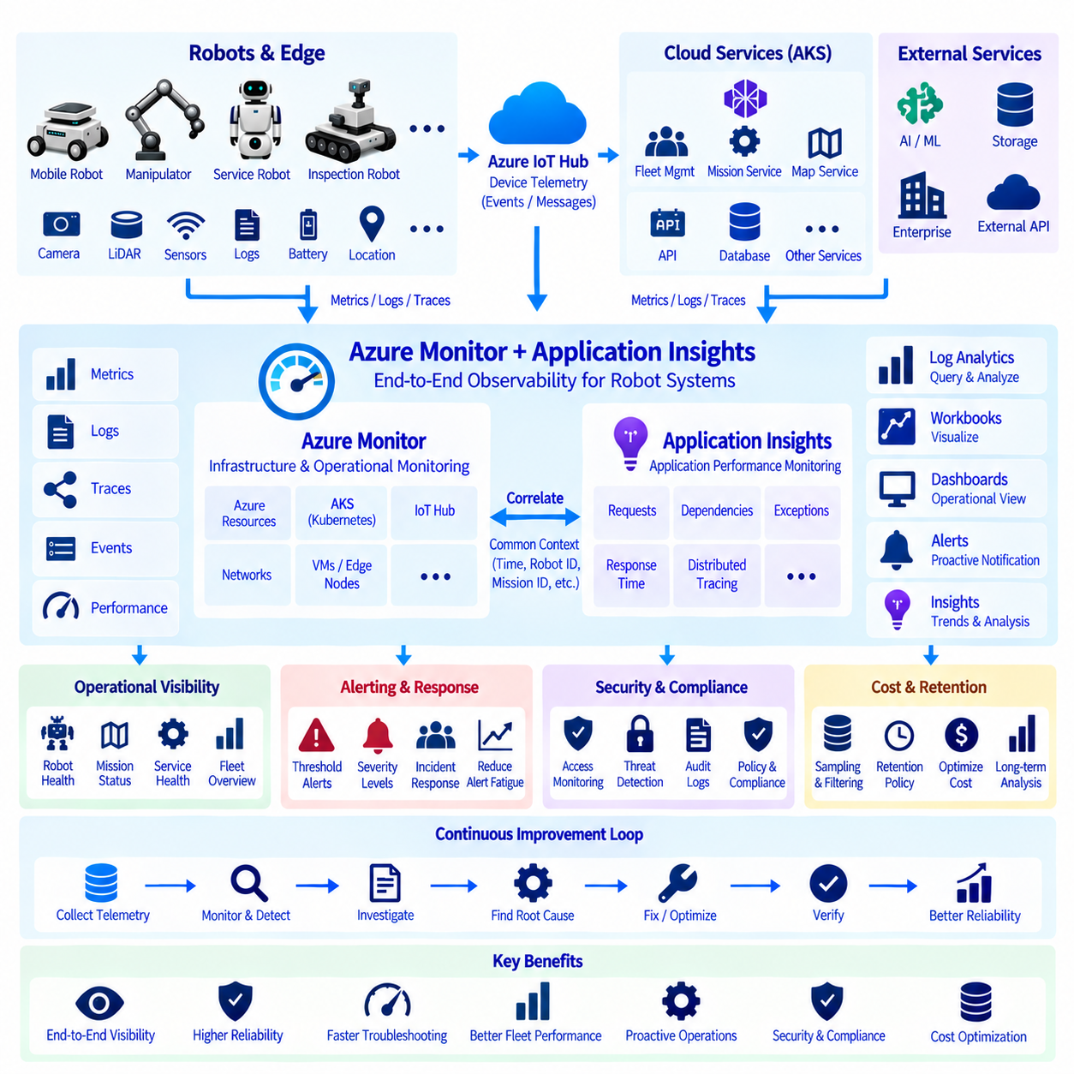
Azure Monitor provides the central observability layer for collecting, analyzing, visualizing, and responding to operational information generated by cloud, edge, and robotic systems. Application Insights extends this capability with application performance monitoring for distributed software services. Together, they help engineering teams understand whether robot fleet applications are available, responsive, correctly integrated, and operating within expected performance boundaries.
Robot observability requires information from several layers because a visible failure may originate far from the component where the symptom appears. A delayed mission can result from a robot, wireless network, IoT communication service, AKS application, database, or external API. Monitoring should therefore correlate robot telemetry with cloud infrastructure and application signals instead of treating each subsystem as an isolated monitoring domain.
Azure Monitor can collect metrics, logs, events, and other telemetry from Azure resources and connected applications. Metrics represent numerical measurements such as CPU utilization, memory consumption, request rate, queue depth, network throughput, or service latency. Logs provide richer contextual records that can describe application events, errors, device activity, deployment changes, and operational conditions over longer periods.
Application Insights focuses on application-level behavior and is particularly useful for robot fleet microservices running in environments such as Azure Kubernetes Service. It can observe requests, dependencies, exceptions, response times, and application transactions. This allows developers to investigate whether a fleet-management API, mission scheduler, telemetry processor, authentication service, or map service is behaving correctly under real operational workloads.
Distributed tracing becomes important when one robot event passes through multiple cloud services. A mission request may enter through an API, invoke authentication, query a database, publish a message, update fleet state, and eventually generate a command for a robot. Trace correlation connects these operations into a logical transaction, helping engineers identify which service introduced excessive latency or failure instead of examining unrelated logs manually.
Robot-side telemetry should contain enough context to connect physical operation with cloud observations. Useful attributes can include robot identity, mission identifier, software version, site, timestamp, operating mode, battery state, localization quality, communication status, and fault codes. Consistent identifiers allow cloud logs and robot events to be correlated when investigating incidents that span physical machines, networks, and backend applications.
Time synchronization is fundamental to meaningful correlation. If robot clocks, edge computers, cloud applications, and infrastructure logs use inconsistent time references, event sequences can become difficult to reconstruct. Robots should maintain reliable synchronized timestamps whenever practical, and monitoring pipelines should preserve event time separately from processing time when necessary. Accurate timing is especially valuable when diagnosing intermittent failures that occur across several distributed components.
Log Analytics provides a query-oriented environment for investigating collected operational data. Engineers can search and correlate records across applications and infrastructure to answer questions such as which robots experienced communication failures, whether errors increased after a software deployment, or which backend service produced abnormal latency. Structured logging makes these investigations more reliable than searching large volumes of unformatted text.
Dashboards and workbooks can transform raw monitoring information into operational views for different users. A fleet operator may need robot availability, mission status, communication health, and active alarms, while a cloud engineer may focus on request latency, service failures, container health, and resource utilization. Maintenance teams can emphasize recurring robot faults and diagnostic trends without requiring every stakeholder to inspect the same technical metrics.
Alerts convert monitoring data into actionable operational signals. Threshold-based alerts can identify conditions such as high CPU utilization, excessive API latency, abnormal error rates, or loss of robot communication. More complex rules can combine several measurements or evaluate log queries. Alert design should focus on conditions requiring action because excessive low-value notifications can create alert fatigue and make genuinely important events harder to recognize.
Severity classification helps distinguish informational events from operational incidents. A temporary telemetry delay may require observation, while widespread loss of fleet communication or failure of a mission-critical backend service may require immediate response. Severity should reflect operational impact rather than merely the technical source of an event. This allows response procedures to prioritize conditions that affect robot safety, mission continuity, or customer operations.
Monitoring AKS-based robot services requires visibility into both Kubernetes infrastructure and application behavior. Node utilization, Pod status, restart counts, resource pressure, and deployment state describe platform health, while Application Insights reveals request behavior and service dependencies. Combining these perspectives helps distinguish infrastructure failures from application defects and prevents engineers from assuming that a healthy Kubernetes cluster means every robot service is functioning correctly.
IoT communication should also be observed as a separate operational layer. Message rates, connection changes, delivery failures, throttling, and abnormal latency can reveal communication problems before they become visible as robot mission failures. Monitoring should distinguish between a robot that is physically unavailable, a robot that has lost network connectivity, and a cloud service that cannot process incoming messages because each condition requires a different response.
Application dependency monitoring is useful because robot backend services often rely on databases, storage systems, message brokers, identity services, machine-learning endpoints, and enterprise applications. A fleet service may remain operational while one dependency becomes slow or unavailable. Dependency telemetry exposes these relationships and allows engineers to determine whether degraded performance originates inside the application or from an external service it depends upon.
Custom metrics can represent robotics-specific operational conditions that generic cloud metrics cannot describe. Examples include mission completion rate, navigation failure count, localization confidence, emergency-stop events, charging failures, average task duration, intervention frequency, or robots currently offline. These measurements connect technical observability with actual fleet performance and make monitoring more meaningful to robot operators and service managers.
Software deployment information should be integrated with monitoring because operational changes frequently follow releases. Dashboards and logs can associate abnormal behavior with backend versions, container images, configuration changes, or robot software revisions. If error rates rise immediately after deployment, engineers can investigate the affected version and decide whether rollback is appropriate. Release annotations and version metadata therefore improve incident diagnosis.
Monitoring must remain useful during intermittent robot connectivity. Edge systems can preserve local diagnostic records while disconnected and upload selected information when communication returns. Cloud monitoring should avoid interpreting every short network interruption as a complete robot failure. Connection state, last-known status, local buffering, and delayed telemetry indicators help operators distinguish temporary communication gaps from persistent operational faults.
Data volume requires careful control because unrestricted logging from a large fleet can create unnecessary network, storage, and analysis costs. High-frequency sensor streams should not automatically become monitoring logs. Instead, systems can aggregate metrics, sample repetitive events, retain important exceptions, and route large raw sensor data to dedicated storage pipelines. Observability data should contain enough evidence for diagnosis without duplicating the complete robot dataset.
Security monitoring complements performance monitoring. Authentication failures, unusual access patterns, unauthorized configuration attempts, abnormal API activity, and unexpected administrative operations can be collected and correlated with infrastructure events. Access to monitoring data should itself be controlled because logs may contain operational details about robot locations, customers, software versions, or system architecture that should not be exposed indiscriminately.
Retention policies should reflect diagnostic, operational, regulatory, and cost requirements. Recent detailed logs may be valuable for rapid troubleshooting, while older information can be aggregated or retained selectively for trend analysis. Different telemetry classes do not necessarily require identical retention periods. Defining these policies prevents monitoring platforms from becoming uncontrolled long-term repositories while preserving evidence needed for engineering and operational analysis.
A mature monitoring architecture supports a closed operational improvement loop. Robots and cloud services generate telemetry, Azure Monitor and Application Insights collect and correlate signals, dashboards expose fleet health, alerts identify significant conditions, and engineers investigate root causes. Findings can lead to software fixes, configuration changes, infrastructure scaling, revised alert rules, or improved robot behavior, after which monitoring verifies whether the corrective action was effective.
The central principle is end-to-end observability across the complete cloud-edge robot system. Azure Monitor provides infrastructure and operational visibility, while Application Insights exposes application performance and distributed service behavior. When robot telemetry, IoT communication, AKS workloads, dependencies, deployments, and business-level fleet metrics share consistent context, operators can move from simply detecting failures toward understanding their causes and systematically improving fleet reliability.

05.09 Azure Active Directory: Robot API Auth
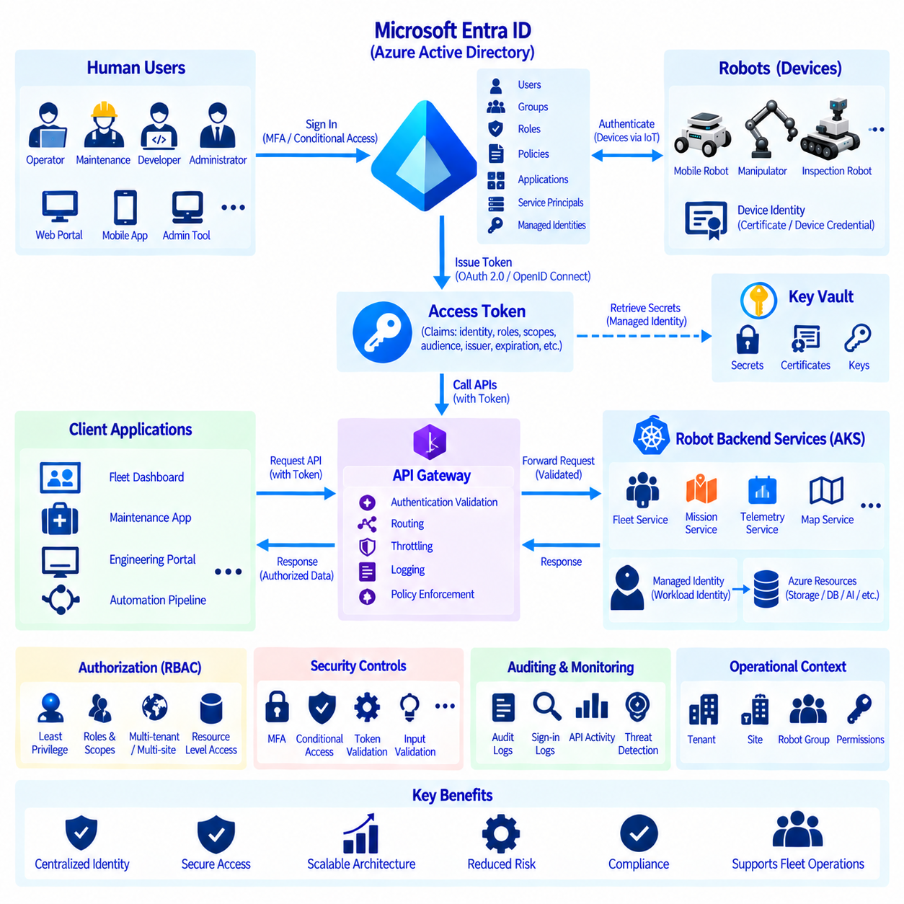
Microsoft Entra ID, formerly Azure Active Directory, provides the identity and access-management foundation for users, applications, services, and APIs within an Azure robotics environment. In a robot fleet architecture, authentication should not depend on every backend service maintaining its own user database or password mechanism. Centralized identity allows robot APIs, fleet applications, cloud services, and administrative tools to share consistent authentication and authorization policies.
Authentication and authorization represent different security functions. Authentication establishes who or what is requesting access, while authorization determines which operations that identity is permitted to perform. A successfully authenticated fleet operator should not automatically receive permission to modify robot configurations, deploy software, access diagnostic data, or issue mission commands. Robot platforms should therefore evaluate identity and permissions separately at protected service boundaries.
Human users can authenticate through Entra ID before accessing fleet dashboards, maintenance applications, engineering portals, or administrative APIs. The resulting identity can be associated with organizational accounts, groups, roles, and security policies. Centralized user identity simplifies account lifecycle management because access can be changed when an employee changes responsibilities or leaves the organization without manually updating credentials across every robot-related application.
Applications that expose robot APIs can be registered with the identity platform so that protected resources have explicit identities and permission definitions. A fleet-management API, mission service, telemetry service, map service, or maintenance interface can define which clients are allowed to access its functions. This creates a controlled trust relationship between API consumers and providers rather than assuming that any application inside the cloud network should be trusted automatically.
OAuth 2.0 provides an authorization framework commonly used for protected APIs, while OpenID Connect extends identity functionality for user authentication. A client obtains an access token from the identity platform and presents that token when calling a protected service. The receiving API validates the token and its relevant claims before processing the request. Credentials therefore do not need to be repeatedly transmitted to every backend application.
Access tokens can contain claims describing the authenticated identity, intended audience, issuer, expiration, scopes, roles, and other security context. Robot APIs should validate these properties rather than merely checking whether a token exists. Audience validation helps ensure that a token issued for one service is not reused against an unrelated API, while expiration and issuer validation reduce the risk of accepting inappropriate or outdated authentication information.
Scopes can represent delegated permissions granted to applications acting on behalf of users. For example, an operator application may receive permission to read fleet status while another authorized workflow can request mission-management capabilities. Roles can represent application or organizational responsibilities such as fleet operator, maintenance engineer, developer, or administrator. Permission design should reflect actual robot operations rather than relying on a single broad privileged role.
Role-based access control supports the principle of least privilege by granting identities only the permissions necessary for their responsibilities. A monitoring user may require read-only access to fleet status, while maintenance personnel may need diagnostic functions without software-deployment authority. Deployment engineers may require access to release services but not customer operational data. Separating these capabilities limits the impact of compromised accounts and accidental actions.
Machine-to-machine communication requires identities that do not depend on interactive human login. Backend services, automation pipelines, and other workloads may authenticate through application identities, service principals, or managed identities where supported. Managed identity is particularly useful for Azure-hosted workloads because applications can access permitted Azure resources without embedding long-lived credentials directly in source code, configuration files, or container images.
AKS-hosted robot services can use workload identity mechanisms to obtain access to Azure resources according to assigned permissions. A telemetry processor may require access to a storage account, while a mission service may need a different set of resources. Providing separate identities to workloads avoids using one shared credential across an entire cluster. Compromise of one microservice therefore does not automatically provide the same permissions held by unrelated services.
Robot identity should be distinguished from human and backend application identity. A physical robot connecting through Azure IoT services may use device-specific authentication mechanisms such as certificates or device credentials, while an operator calling a fleet API uses Entra ID. Mixing these identity domains can create unnecessary complexity. The cloud backend can correlate device identity with application identity without requiring physical robots to authenticate exactly like human users.
An API gateway can provide a controlled entry point for robot-related APIs. Authentication validation, routing, throttling, logging, and policy enforcement can occur before requests reach internal services. This reduces duplicated security logic across microservices and creates a consistent external interface. Internal services should still apply appropriate authorization because passing through a gateway should not automatically establish unlimited trust throughout the backend network.
Fine-grained authorization becomes important for multi-site or multi-customer robot fleets. A user may be authorized to operate robots at one facility but not another, or a maintenance organization may require access only to specific device groups. Authorization decisions can therefore combine identity roles with application-level context such as tenant, site, fleet, robot group, or resource ownership. This prevents broad organizational permissions from exposing unrelated operational assets.
Privileged operations require stronger protection than ordinary read requests. Commands that stop robots, modify safety-related configuration, deploy software, rotate credentials, or change access policies can have substantial operational consequences. These functions can require elevated roles, additional approval, stronger authentication, or detailed auditing. Authentication architecture should therefore consider the physical impact of API operations rather than treating every endpoint as equivalent.
Conditional access policies can strengthen human authentication according to organizational security requirements. Access decisions may consider factors such as authentication strength, user risk, device state, or access context where applicable. Multi-factor authentication can reduce dependence on passwords for sensitive administrative interfaces. Such controls are particularly important for remote fleet management because cloud credentials can indirectly influence physical machines operating at customer sites.
Secrets that remain necessary should be managed separately from application source code. API keys, certificates, signing materials, database credentials, and other sensitive values require controlled storage, access, rotation, and auditing. Azure Key Vault can provide centralized secret and certificate management for appropriate workloads. Applications should retrieve only the secrets they require and should avoid copying credentials into container images, repositories, logs, or deployment scripts.
Token and credential lifecycles should be designed for rotation and expiration. Long-lived static credentials increase exposure because leaked values can remain useful for extended periods. Short-lived tokens, managed identities, certificate renewal, and automated secret rotation reduce this risk. Robotics systems must also handle credential changes without unnecessarily interrupting fleet operations, particularly when backend services and edge devices are deployed across many sites.
API security includes more than identity verification. Rate limiting, input validation, encrypted transport, replay protection where necessary, request logging, and secure error handling complement authentication and authorization. A valid identity should not be able to overwhelm a mission service with excessive requests or exploit malformed input. Security therefore requires multiple controls surrounding the authenticated API rather than treating a valid token as complete protection.
Auditing connects identity decisions with operational accountability. Security logs can record who authenticated, which API was accessed, what privileged action was requested, and whether authorization succeeded or failed. When combined with robot and fleet logs, these records help reconstruct events such as configuration changes, mission modifications, or deployment actions. Consistent timestamps and correlation identifiers improve investigation across distributed cloud and robot systems.
Monitoring can detect suspicious identity and API behavior, including repeated authentication failures, unusual privileged operations, unexpected access patterns, or abnormal API traffic. Azure monitoring and security services can correlate these signals with application and infrastructure events. Detection should distinguish legitimate operational peaks from potentially malicious activity while preserving enough evidence for investigation when an incident occurs.
A mature robot API architecture establishes trust at every interaction rather than relying primarily on network location. Users authenticate through centralized identity, applications and workloads receive dedicated identities, APIs validate tokens and permissions, and physical robots maintain separate device identities. Authorization is applied according to the requested resource and operation. This approach aligns robot cloud services with a zero-trust security model in which access is explicitly verified.
The central principle is that robot API authentication must protect both digital resources and physical operations. Microsoft Entra ID provides centralized identity, token issuance, application registration, roles, and access policies, while API services enforce authorization according to operational context. Combined with managed identities, workload identity, secure secret management, auditing, and monitoring, this architecture creates scalable access control for robot fleets without distributing uncontrolled credentials throughout the system.

05.10 Azure-Based Robot Fleet Case Study
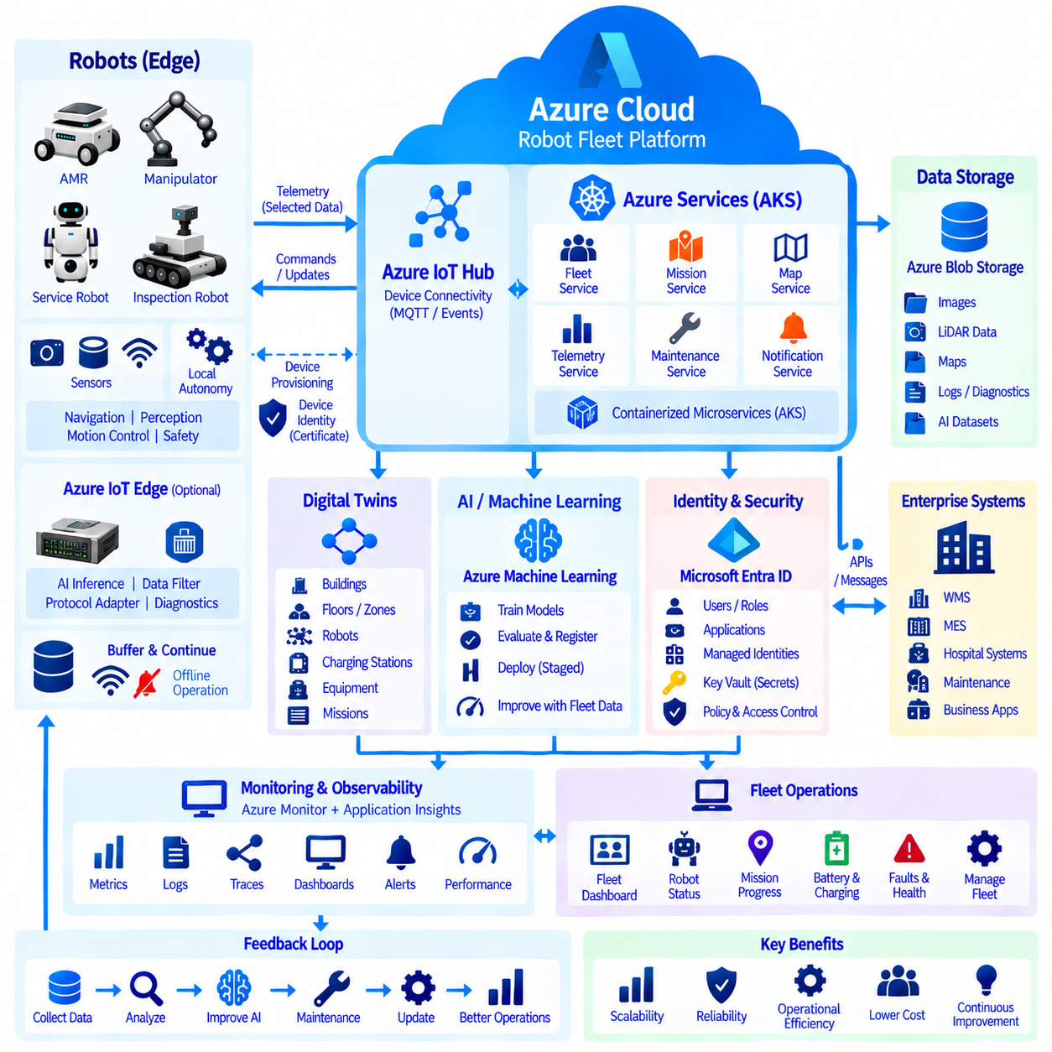
An Azure-based robot fleet can be designed as a distributed cloud-edge system in which physical robots preserve local autonomy while Azure provides centralized connectivity, fleet services, data management, AI lifecycle functions, monitoring, and security. A representative deployment may include indoor AMRs, inspection robots, manipulators, or service robots operating across warehouses, factories, hospitals, campuses, and other facilities while sharing a common cloud platform.
Each robot contains the computing, sensors, and control software required for safe local operation. Navigation, localization, obstacle avoidance, perception, motion control, and essential safety functions remain on the robot or nearby Edge computer because these functions cannot depend on unpredictable Internet latency. The Azure platform therefore supervises and coordinates the fleet without becoming part of the deterministic control loop required for immediate physical movement.
Robot onboarding begins with a unique device identity and controlled provisioning process. Azure IoT Hub provides the communication layer for device-to-cloud telemetry and cloud-to-device messages, while Device Provisioning Service can automate assignment of devices to the appropriate IoT environment. Certificates or other device credentials establish trust so that unauthorized machines cannot simply connect to the fleet infrastructure and begin publishing operational information.
During operation, robots transmit selected telemetry such as pose, mission state, battery level, health information, fault codes, software version, and communication status. High-volume sensor streams are normally processed locally instead of continuously uploaded. Edge software can filter events, compress diagnostic information, extract AI results, and buffer data during network interruption. This preserves bandwidth while maintaining the information required for fleet supervision and engineering analysis.
Azure IoT Edge can provide a managed execution layer when containerized workloads must operate close to the robot. Perception modules, protocol adapters, data filters, diagnostic functions, or AI inference components can run locally while their software lifecycle is coordinated from the cloud. The robot can continue essential operations during temporary disconnection, and buffered events can be synchronized after connectivity returns without requiring cloud availability for every local decision.
Cloud-side fleet services can run as containerized microservices on Azure Kubernetes Service. Separate services may manage missions, robot status, maps, telemetry, maintenance, notifications, users, and external APIs. Kubernetes allows these components to scale independently as the fleet grows. A sudden increase in telemetry processing does not require identical scaling of map or authentication services, while failed application instances can be restarted without rebuilding the entire fleet platform.
Mission coordination illustrates the cloud-edge division of responsibility. A central service may assign a delivery, inspection, or patrol task according to fleet availability and business priorities. The selected robot receives the mission objective and executes local path planning and obstacle avoidance using its onboard autonomy stack. Progress and exceptions are reported back to the cloud, allowing centralized coordination without requiring the cloud to generate every steering or velocity command.
Azure Blob Storage can retain large operational artifacts such as selected images, LiDAR data, maps, diagnostic packages, logs, and AI datasets. Metadata identifies the robot, timestamp, site, mission, sensor configuration, software version, and event context associated with each object. Raw, processed, and curated datasets can be separated so that troubleshooting, analytics, and machine-learning workflows use traceable information rather than uncontrolled collections of files.
Azure Digital Twins can represent the operational relationships surrounding the fleet. Robots can be associated with buildings, floors, zones, charging stations, equipment, and missions in a graph-based model. This semantic context allows applications to understand not only that a robot reported a state but also where it operates and which resources it interacts with. The twin graph complements telemetry and storage systems rather than replacing detailed time-series or raw sensor repositories.
Machine-learning development can use selected fleet data to improve perception, inspection, anomaly detection, or prediction models. Azure Machine Learning provides scalable training resources, experiment tracking, model evaluation, and model registration. Field failures and difficult examples can be incorporated into improved datasets, after which candidate models are trained and validated. Approved models can then enter a controlled deployment process targeting compatible robot groups.
Model deployment should consider hardware differences across the fleet. Robots may use different cameras, GPUs, sensor configurations, or software revisions, so one model should not automatically be distributed to every device. Compatibility metadata and staged rollout policies allow releases to target selected groups first. Operational monitoring can then verify latency, resource consumption, prediction behavior, and failure rates before broader deployment, with rollback available when necessary.
Azure Monitor and Application Insights provide end-to-end observability across cloud applications and fleet operations. Infrastructure metrics, application requests, dependencies, exceptions, logs, and distributed traces can be correlated with robot telemetry. If missions begin failing after a backend deployment, engineers can determine whether the cause is a robot problem, wireless interruption, IoT communication issue, AKS service failure, database dependency, or newly released application version.
Fleet dashboards transform this information into operational views. Operators can monitor robot availability, mission progress, battery state, active faults, communication health, and charging status, while engineering teams can examine service latency, container restarts, resource utilization, API failures, and software versions. Maintenance teams can focus on recurring diagnostic events and failure trends. Each group therefore receives information appropriate to its responsibilities from the same observability foundation.
Alerts can detect conditions requiring intervention, including persistent robot disconnection, repeated mission failure, charging problems, backend service degradation, abnormal error rates, or resource exhaustion. Alert severity should reflect operational impact instead of generating notifications for every temporary anomaly. Short wireless interruptions may be tolerated, while simultaneous communication loss across a large robot group may indicate infrastructure failure requiring immediate investigation.
Microsoft Entra ID provides centralized identity for operators, engineers, administrators, applications, and protected APIs. Role-based permissions can separate fleet operation, maintenance, development, and administrative responsibilities. API clients obtain tokens and protected services validate identity and authorization before executing requests. Physical robots retain separate device identities through the IoT layer, preventing human, application, and device authentication from becoming one uncontrolled credential domain.
Sensitive backend workloads can use managed identities or workload identities instead of embedding long-lived credentials in application images. Azure Key Vault can protect secrets, certificates, and keys that remain necessary. Privileged operations such as software deployment, credential changes, or sensitive configuration modification can require stronger permissions and auditing. This identity architecture reduces the possibility that compromise of one application automatically provides unrestricted control over the entire fleet.
Enterprise systems can integrate through controlled APIs and asynchronous messaging. Warehouse management, manufacturing execution, hospital systems, maintenance platforms, or business applications may request tasks or receive operational results without directly controlling robot actuators. The fleet platform translates enterprise objectives into robot missions and returns execution status. This boundary prevents business applications from becoming tightly coupled to individual robot hardware or navigation implementations.
The complete system operates as several interconnected feedback loops. Robot telemetry updates fleet services and dashboards, operational data feeds diagnostics and analytics, selected sensor evidence supports AI retraining, monitoring reveals infrastructure and software problems, and maintenance results improve operational policies. Cloud services therefore do more than remotely display robots; they create a common digital environment for coordinating physical machines, software, data, AI, and human operators.
Network disconnection is treated as a normal operating condition rather than an exceptional failure. Robots preserve localization, navigation, obstacle avoidance, and safety locally while cloud-dependent functions degrade in a controlled manner. Edge buffers retain important events until connectivity returns, and the backend distinguishes temporary communication loss from physical robot failure. This principle prevents a short wireless or Internet outage from unnecessarily stopping an otherwise capable autonomous robot.
As the fleet expands from a few robots to hundreds or thousands, scalability comes from separating responsibilities. IoT services manage device communication, AKS scales backend applications, Blob Storage handles large data objects, Digital Twins provides semantic context, Azure Machine Learning manages AI development, Azure Monitor supplies observability, and Entra ID controls access. Each layer can evolve independently while maintaining defined interfaces with the rest of the architecture.
The case study demonstrates that an Azure robot fleet should be designed as a resilient cloud-edge ecosystem rather than a collection of remotely controlled machines. Physical autonomy and safety remain close to the robot, while Azure coordinates fleet-level services, data, AI, security, and operations. This separation allows centralized management and continuous improvement without making robot movement dependent on continuous cloud connectivity, providing a scalable foundation for long-term multi-robot operation.

