Volume 09 Cloud and Edge Robotics

08. Fleet Cloud

08.01 Fleet Cloud Architecture: Scalability, Availability, Security
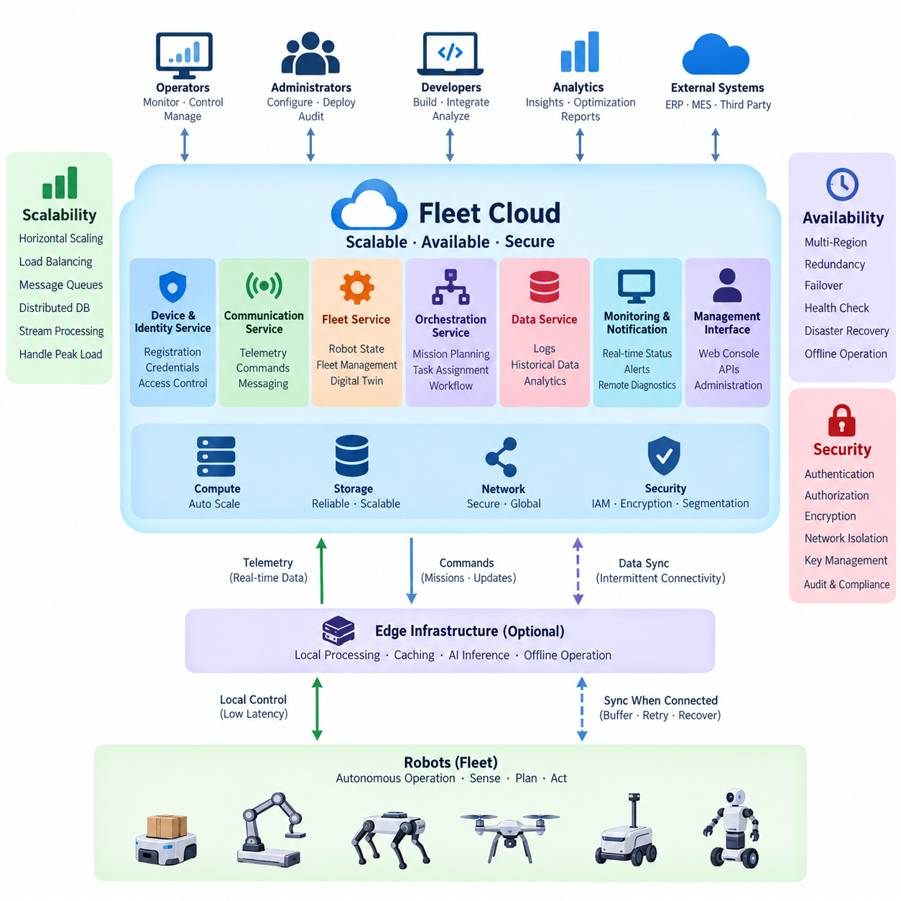
A fleet cloud provides the shared backend environment through which large populations of robots can be registered, monitored, coordinated, updated, and analyzed. Unlike a conventional application cloud, it must continuously interact with physical machines whose connectivity, battery state, location, sensors, software versions, and operational conditions change over time. Its architecture therefore combines distributed cloud services with robot-aware state management and communication mechanisms.
The fundamental architectural separation is between robot-side execution and fleet-level coordination. Safety-critical motion control, obstacle avoidance, localization, and other latency-sensitive functions should remain on the robot or nearby edge infrastructure, while the cloud manages fleet state, missions, historical information, policies, analytics, and global optimization. This boundary prevents temporary cloud or network failures from immediately disabling autonomous robot operation.
A fleet cloud typically contains several logical service domains. Device and identity services maintain robot registration and credentials, communication services exchange telemetry and commands, fleet services maintain operational state, orchestration services assign missions, and data services store logs and historical records. Monitoring, notification, remote diagnostics, and administrative interfaces operate across these domains, creating a common operational view of the entire robot population.
Scalability begins by avoiding architectural assumptions that every robot can be represented by a permanently dedicated server process. As fleet size increases, telemetry messages, state transitions, API calls, mission requests, logs, and alerts may grow rapidly and unevenly. Stateless application services can therefore be replicated horizontally, while load balancers, message brokers, queues, caches, and distributed databases absorb variable workloads and separate producers from consumers.
Robot telemetry is particularly important because it creates continuous data streams rather than occasional application transactions. Position, battery state, operating mode, diagnostic values, mission progress, and fault information can arrive at different frequencies. A scalable architecture should classify these streams according to operational importance, aggregate or filter unnecessary high-frequency data, and independently scale ingestion, stream processing, persistent storage, and analytical workloads.
Event-driven communication helps reduce tight coupling among fleet services. A robot status update can be published once and consumed independently by monitoring, alerting, analytics, digital-twin, or mission-management components. Consumers can process events at different rates without forcing the robot communication layer to wait for every downstream service. Queues and durable event streams also provide buffering when temporary traffic bursts exceed immediate processing capacity.
Availability must be considered from the perspective of robot operations rather than only server uptime. A cloud endpoint can technically remain available while delayed commands, stale robot state, unavailable mission services, or database failures make the fleet operationally ineffective. Availability objectives should therefore cover communication, device identity, mission orchestration, state persistence, monitoring, and recovery paths, while robots retain defined autonomous behavior during cloud degradation or disconnection.
Redundancy eliminates unnecessary single points of failure. Critical fleet services can run across multiple compute instances or availability zones, with health checks and load balancing directing traffic toward healthy replicas. Databases may use replication and controlled failover, while messaging infrastructure should preserve important events when individual nodes fail. The architecture should distinguish components requiring immediate redundancy from analytical workloads that can tolerate temporary interruption.
Fleet systems must also assume intermittent robot connectivity. Wireless coverage changes as robots move through warehouses, factories, campuses, outdoor environments, elevators, or remote areas. Robot clients should therefore tolerate connection loss through local buffering, retry policies, session recovery, and synchronization after reconnection. Commands that become unsafe or meaningless after delay require expiration rules so that an old instruction is not executed merely because connectivity has returned.
Security begins with establishing a trustworthy identity for every robot, service, operator, and administrative interface. Device credentials should be unique rather than shared across an entire fleet, and authentication should precede access to fleet APIs or messaging channels. Authorization then limits each identity to required resources and operations. A compromised robot should not automatically gain authority to control other robots, modify fleet policies, or access unrelated operational information.
Encryption protects communication between robots, edge systems, and cloud services, but transport encryption alone is insufficient. Credentials and cryptographic keys require secure provisioning, storage, rotation, revocation, and replacement throughout the robot lifecycle. Secrets should not be embedded casually in software images or configuration files. When a robot is retired, transferred, lost, or suspected of compromise, its cloud identity must be removable without disrupting the remaining fleet.
Network and service segmentation further limit the consequences of compromise. Public APIs, operator interfaces, robot communication endpoints, internal microservices, databases, and administrative systems should not automatically share unrestricted trust. Firewalls, private networks, API gateways, service identities, and least-privilege access policies create boundaries between these areas. Sensitive management operations can receive stronger authentication and auditing than ordinary telemetry submission.
Fleet cloud security must also preserve command integrity. Commands such as mission cancellation, remote restart, configuration change, software deployment, or manual intervention can directly influence physical systems. The architecture should verify the sender, target robot, authorization scope, command freshness, and relevant operational context. Important actions should produce auditable records that identify what was requested, which system accepted it, and how the robot responded.
Observability connects scalability, availability, and security into one operational discipline. Infrastructure metrics alone cannot explain whether a robot fleet is functioning correctly. Cloud monitoring should correlate server health with message latency, connection state, mission success, command acknowledgement, battery conditions, software versions, and robot faults. Distributed tracing and structured logs can help engineers follow an operation from an external API through backend services to the affected robot.
Capacity planning should consider fleet behavior rather than robot count alone. One thousand robots sending low-rate health information can impose less infrastructure load than a much smaller fleet transmitting frequent sensor metadata or diagnostic events. Peak mission transitions, simultaneous reconnects after network restoration, mass software deployment, and incident-driven log uploads can create concentrated demand. Architecture should therefore be validated against realistic peak scenarios rather than simple average traffic.
Data architecture must reflect different consistency requirements. Authentication and deployment records may require strong transactional guarantees, whereas dashboards can often tolerate slightly delayed telemetry. Current robot state may benefit from low-latency caching, while long-term operational history can move into scalable analytical or object storage. Separating these workloads prevents expensive consistency or performance requirements from being imposed uniformly across all fleet data.
Disaster recovery extends availability beyond individual service failures. Backups, replicated configuration, infrastructure automation, recovery procedures, and geographically separated resources can restore fleet services after larger incidents. Recovery priorities should reflect operational dependency: restoring robot identity, communication, fleet state, and mission services may be more urgent than restoring historical analytics. Recovery procedures should be tested because an undocumented recovery assumption is not equivalent to a verified recovery capability.
A mature fleet cloud therefore treats scalability, availability, and security as interdependent architectural properties. Scaling without identity isolation increases the potential impact of compromise, redundancy without state consistency can create conflicting fleet information, and strong security without offline-aware operation can make robots unnecessarily dependent on connectivity. These properties must be designed together around the behavior of physical robots and their operating environments.
Within the broader Cloud and Edge Robotics structure, Fleet Cloud forms the operational bridge between hybrid cloud-edge infrastructure and specialized services such as fleet management backends, automated provisioning, real-time dashboards, task orchestration, event-driven notifications, remote access, high availability, and cost optimization. This foundation allows those later capabilities to evolve independently while sharing consistent principles for communication, identity, state, resilience, and security.

08.02 Fleet Management Server (FMS) Backend Architecture [w/Code]
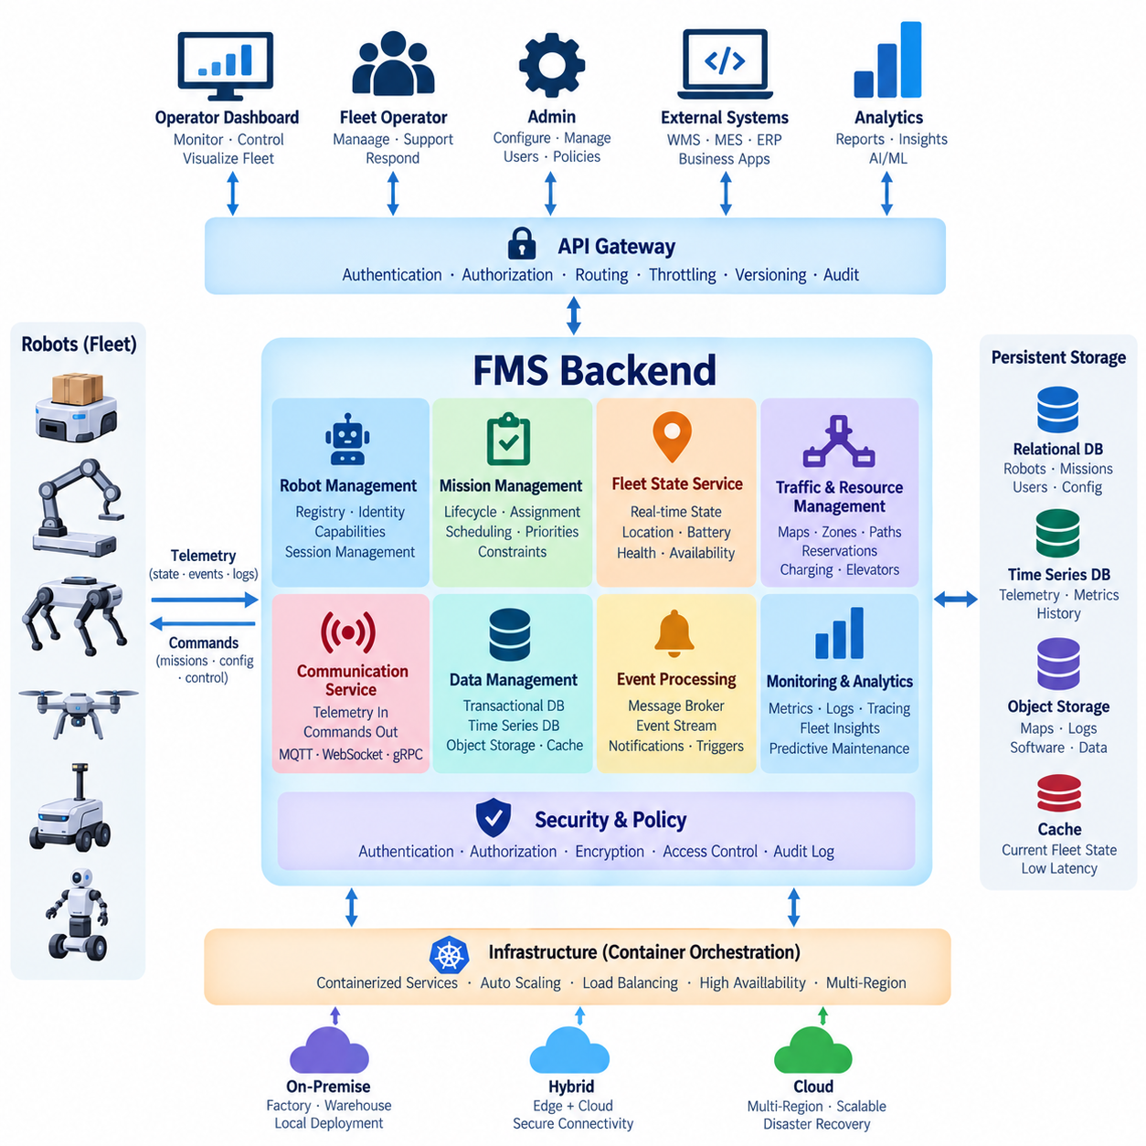
A Fleet Management Server (FMS) backend is the central software layer responsible for coordinating robot operations across a fleet. While individual robots execute perception, localization, navigation, obstacle avoidance, and low-level control locally, the FMS maintains a global operational view. It connects robot state, missions, maps, resources, operators, and enterprise systems so that independent autonomous machines can operate as a coordinated system.
The backend architecture should separate robot autonomy from fleet-level decision making. A robot must remain capable of safe local behavior when communication with the FMS is delayed or temporarily unavailable. The server therefore focuses on functions requiring shared knowledge, including task assignment, traffic coordination, mission lifecycle management, fleet monitoring, resource allocation, operational policy, and synchronization of information used by multiple robots.
A typical FMS backend exposes a communication gateway between robots and cloud services. This gateway receives telemetry such as robot position, velocity, battery state, operating mode, mission progress, health information, and fault events. In the opposite direction, it delivers missions, configuration changes, operational commands, and acknowledgements. MQTT, WebSocket, gRPC, REST APIs, or similar protocols can be selected according to latency, reliability, and integration requirements.
Robot identity and session management form another fundamental backend function. Each connected robot should have a unique identity, authenticated credentials, hardware and software metadata, capability information, and current connection state. The FMS can maintain a robot registry containing model type, payload capability, installed sensors, software version, operational permissions, and supported mission types, allowing higher-level services to determine which robots are suitable for particular tasks.
The fleet state service maintains the current operational representation of every robot. Instead of repeatedly querying physical robots whenever another service requires information, the backend maintains synchronized state derived from telemetry and events. Position, battery level, availability, mission state, alarms, connectivity, and maintenance conditions can therefore be accessed through a consistent interface by dashboards, schedulers, orchestration services, analytics systems, and external applications.
Mission management represents the lifecycle of work assigned to robots. A mission can progress through states such as created, queued, assigned, accepted, executing, completed, cancelled, or failed. The backend records these transitions and associates missions with robots, destinations, priorities, payload requirements, deadlines, and operational constraints. Persistent mission state allows the system to recover correctly after service restarts or temporary communication failures without losing knowledge of active operations.
Task allocation determines which robot should execute each mission. Simple systems may assign the nearest available robot, while larger fleets can consider battery level, estimated travel time, robot capability, workload, charging requirements, congestion, mission priority, and resource availability. The allocation engine should remain logically separated from mission persistence so that scheduling algorithms can evolve without changing the fundamental representation of missions or robot state.
Traffic and resource coordination become important when multiple robots share constrained physical infrastructure. Corridors, intersections, doors, elevators, loading stations, charging points, work cells, and transfer locations may need coordinated access. The FMS backend can represent these resources and manage reservations or permissions, while local navigation remains responsible for immediate collision avoidance. This separation combines global coordination with fast robot-side safety behavior.
An event-driven architecture is useful because fleet operations naturally produce asynchronous state changes. Robot connection, mission completion, low battery, localization failure, blocked path, charging completion, emergency state, and software faults can be represented as events. A message broker or event stream can distribute these events to mission management, notification, monitoring, analytics, and persistence services without requiring every component to communicate directly with every other component.
Persistent storage should be divided according to data characteristics rather than forcing all information into one database. Transactional storage can maintain robot registrations, missions, users, permissions, and configuration. Low-latency caches can hold frequently accessed current fleet state, while time-series storage can preserve telemetry and operational metrics. Object storage may contain maps, diagnostic archives, sensor snapshots, software packages, and other large artifacts generated during fleet operation.
The FMS backend should expose well-defined APIs to operator interfaces and external enterprise systems. Dashboards require fleet state, mission information, alarms, and operational history, while warehouse management systems, manufacturing execution systems, ERP platforms, or customer applications may create tasks and retrieve results. An API gateway can provide authentication, authorization, request routing, throttling, version management, and auditing without exposing internal services directly.
Security is especially important because backend commands can cause physical actions. Authentication verifies robots, operators, and external applications, while authorization determines which fleet resources and operations each identity may access. Sensitive commands such as mission cancellation, remote restart, manual movement requests, configuration changes, or software deployment should be controlled by explicit permissions and recorded in audit logs that support operational and security investigation.
The backend must handle disconnected and intermittently connected robots without corrupting fleet state. Communication sessions should support retries, acknowledgements, sequence information, and appropriate message expiration. When a robot reconnects, the server and robot must reconcile mission status and relevant state rather than assuming that the last cloud record remains correct. Commands that are no longer operationally valid should expire instead of being executed unexpectedly after a long network interruption.
Scalability requires FMS services to avoid unnecessary dependence on local process memory. Stateless API gateways and application services can be replicated horizontally behind load balancers, while persistent state is maintained in databases, distributed caches, and messaging infrastructure. Partitioning fleets by customer, site, region, or logical group can reduce contention and create clear operational boundaries as the number of connected robots and facilities increases.
High availability requires critical FMS components to tolerate infrastructure and software failures. Multiple service instances, replicated databases, redundant message brokers, health checks, automated restart, and controlled failover can prevent individual failures from stopping fleet operation. Robots should simultaneously retain defined offline behavior so that a backend outage results in controlled degradation rather than immediate loss of autonomous safety or basic navigation capabilities.
Observability must connect backend behavior with physical fleet behavior. Metrics such as API latency, message throughput, queue depth, database response time, and service health should be correlated with robot connectivity, mission duration, task failures, battery conditions, blocked states, and command acknowledgement. Structured logging, distributed tracing, and event histories allow engineers to reconstruct how a fleet-level request propagated through backend services and ultimately affected a robot.
Backend deployment can use containers and orchestration platforms to provide reproducible service packaging, horizontal scaling, health management, and controlled software updates. Individual services can be upgraded independently when interfaces remain compatible. However, microservice decomposition should follow meaningful operational boundaries rather than splitting every function unnecessarily, because excessive service fragmentation increases network communication, observability requirements, deployment complexity, and failure modes.
The FMS backend ultimately acts as the coordination plane between autonomous robots and higher-level business operations. Robot-side software provides immediate physical autonomy, while the backend provides shared state, mission orchestration, resource coordination, historical persistence, security, and enterprise integration. A well-designed architecture preserves this boundary and allows robot fleets to grow from a few machines at one site into distributed operational systems without redesigning the fundamental management model.

08.03 Robot Device Provisioning Automation [w/Code]
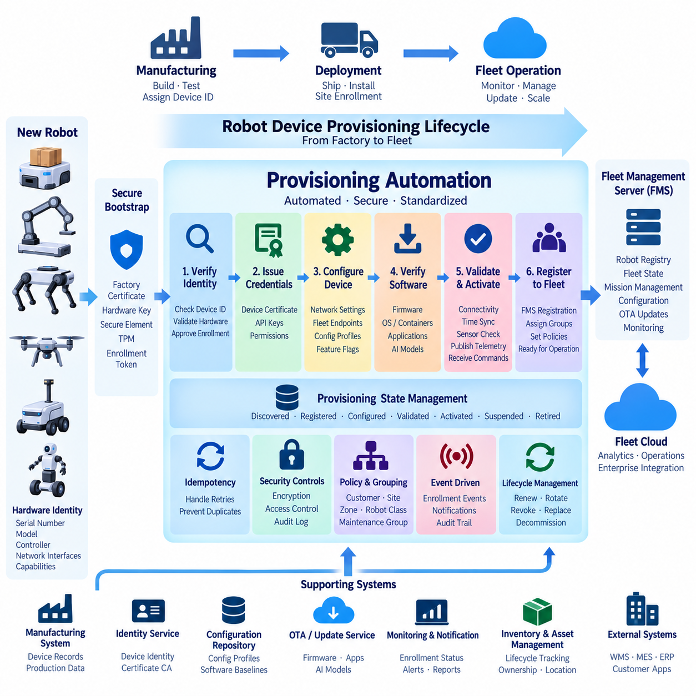
Robot device provisioning is the controlled process of transforming a newly manufactured or reset robot into a trusted, identifiable, and manageable member of a fleet. In small deployments, engineers may configure devices manually, but this approach becomes unreliable as fleet size increases. Provisioning automation replaces repeated manual work with standardized workflows for identity creation, credential installation, configuration, registration, validation, and activation.
The provisioning lifecycle should begin before the robot connects to the operational fleet. Manufacturing or integration systems can assign a unique device identifier linked to hardware information such as serial number, robot model, controller type, network interfaces, and supported capabilities. This identity becomes the reference used throughout deployment, operation, maintenance, software updates, incident investigation, ownership transfer, and eventual device retirement.
A secure bootstrap mechanism establishes the initial trust relationship between the robot and the provisioning service. The robot requires enough trusted information to identify the legitimate server without embedding fleet-wide reusable secrets. Factory-installed certificates, hardware-backed keys, secure elements, TPM-based credentials, or controlled enrollment tokens can provide this bootstrap identity. The objective is to prevent an unauthorized device from registering simply by knowing a fleet endpoint.
When the robot first connects, the provisioning backend verifies its bootstrap identity and determines whether enrollment is permitted. Validation may compare serial numbers, manufacturing records, expected hardware characteristics, ownership information, or previously approved enrollment requests. Successful verification allows the backend to create the robot's operational identity, while failed or suspicious requests can remain quarantined for investigation instead of receiving normal fleet access.
Operational credentials should normally be unique for each robot. After successful enrollment, the provisioning service can issue device certificates, API credentials, messaging permissions, or other authentication material required by the fleet platform. Unique credentials allow one robot to be revoked without affecting the rest of the fleet. They also provide a reliable basis for associating telemetry, commands, audit records, and configuration changes with a specific physical device.
Provisioning automation should register the device with the Fleet Management Server (FMS) at the same time that credentials are established. The registration record can contain robot identity, model, hardware revision, software baseline, payload capability, sensor configuration, communication interfaces, operational site, and supported mission types. This information allows downstream fleet services to understand what the robot is and which tasks or policies are applicable to it.
Configuration assignment can be driven by metadata rather than performed manually on every robot. A provisioning service can associate devices with configuration profiles according to model, customer, site, region, hardware revision, or operational role. Network parameters, fleet endpoints, logging policies, telemetry intervals, map references, feature flags, and application settings can then be delivered consistently while preserving site-specific or robot-specific differences where necessary.
Software baseline verification is another important provisioning step. Before activation, the backend can compare installed firmware, operating system components, containers, robot applications, AI models, and configuration versions against an approved baseline. Devices with outdated or incompatible software can be directed into an update workflow before joining normal operations. This reduces configuration drift and prevents newly deployed robots from starting with inconsistent software environments.
Automated provisioning should be implemented as a stateful workflow rather than a single registration request. A device may progress through states such as discovered, identity verified, registered, credentials issued, configured, validated, activated, suspended, or retired. Recording these transitions makes failures visible and allows interrupted provisioning to resume safely without repeating sensitive operations or creating duplicate identities in the fleet database.
Idempotency is particularly important when network interruptions occur during enrollment. A robot may submit the same provisioning request multiple times because it does not know whether a previous response was received. Backend operations should therefore recognize repeated requests and return the existing result whenever appropriate rather than generating another robot identity or credential set. Transaction identifiers and persistent provisioning state can support this behavior.
The provisioning workflow should include validation before a robot becomes operational. Automated checks can confirm network connectivity, time synchronization, certificate validity, software versions, storage availability, required services, sensor presence, and communication with the FMS. Application-level tests may verify that telemetry can be published and authorized commands can be received. Failed validation should prevent activation until the identified problem has been corrected.
Fleet grouping can also be automated during provisioning. Robots may be assigned to a customer, facility, building, operational zone, robot class, maintenance group, or deployment wave. These groups can later control mission eligibility, monitoring dashboards, configuration policies, OTA deployment schedules, access permissions, and alert routing. Automated grouping reduces administrative effort and makes large fleets easier to manage through policy rather than individual device configuration.
Provisioning services should integrate closely with event-driven backend architecture. Enrollment requests, successful registrations, validation failures, credential issuance, activation, and retirement can generate events consumed by monitoring, notification, inventory, security, and audit services. This approach avoids hard dependencies between provisioning logic and every downstream application while creating a traceable history of how each robot entered and changed within the fleet.
Security controls must continue after initial enrollment. Device certificates and keys may require expiration, renewal, rotation, revocation, and replacement throughout the robot lifecycle. If a robot is compromised, lost, transferred, or decommissioned, its credentials should be invalidated promptly. Automated lifecycle management prevents obsolete credentials from remaining active indefinitely and reduces the operational burden associated with manually maintaining large numbers of robot identities.
Sensitive provisioning data should be protected both in transit and at rest. Private keys should preferably remain in protected hardware or secure storage rather than being exported unnecessarily. Provisioning APIs should use authenticated and encrypted channels, while backend permissions should restrict which services or administrators can issue credentials, modify device identity, or activate robots. Important provisioning operations should also generate immutable or protected audit records.
Manufacturing and deployment environments often require different stages of provisioning. A factory may establish hardware identity and perform initial diagnostics, while a deployment site assigns customer, network, map, and operational configuration. Separating factory provisioning from site enrollment allows robots to be manufactured with a common trusted baseline and later personalized for specific deployments without rebuilding the complete software image for every customer or facility.
Zero-touch provisioning extends automation by allowing a robot to configure itself after power-on with minimal technician involvement. Once connected to an approved network, the robot contacts a known provisioning endpoint, authenticates its bootstrap identity, receives its operational credentials and configuration, validates required services, and registers with the FMS. Human intervention can then focus on physical installation or exceptional failures rather than repetitive software configuration.
At large scale, provisioning infrastructure must handle simultaneous device enrollment and recovery scenarios. A new facility may activate many robots within a short period, while replacement or factory-reset devices may need rapid re-enrollment. Stateless API components can scale horizontally, while persistent workflow state, credential services, device registries, and message queues preserve consistency. Rate limits and admission controls can protect security-sensitive services from unexpected enrollment bursts.
Robot device provisioning automation ultimately creates the trusted bridge between physical robot hardware and fleet cloud operations. By combining unique identity, secure bootstrap, automated registration, configuration profiles, software validation, lifecycle credentials, policy assignment, and activation checks, the system converts deployment from a manual engineering procedure into a repeatable fleet capability. This foundation enables subsequent monitoring, orchestration, OTA management, and large-scale robot operations to begin from a known and verifiable device state.

08.04 Fleet Real-Time Status Dashboard Backend [w/Code]
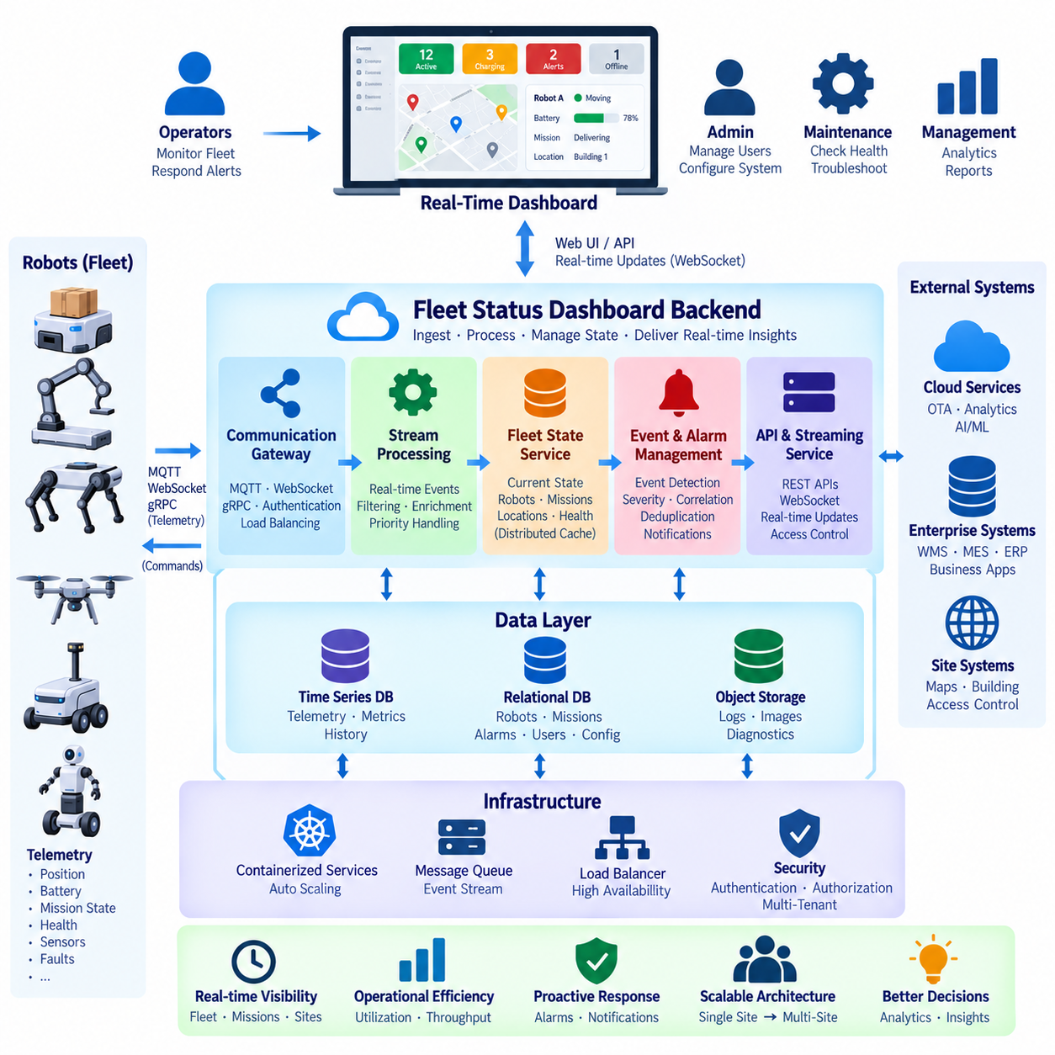
A fleet real-time status dashboard backend provides the data and service layer that converts continuous robot telemetry into an operational view of the entire fleet. The dashboard itself is only the presentation surface; the backend must ingest robot events, maintain current state, detect abnormalities, aggregate metrics, and distribute updates with sufficiently low latency for operators to understand what is happening across robots, missions, sites, and infrastructure.
Real-time monitoring begins with telemetry ingestion from robots and edge systems. Typical messages include position, velocity, heading, battery state, operating mode, mission progress, connectivity, localization quality, sensor health, controller status, and fault information. Because different signals have different update frequencies and importance, the backend should process telemetry according to operational priority rather than treating every incoming message identically.
A communication layer separates robot connections from dashboard consumers. MQTT, WebSocket, gRPC, or other messaging technologies can receive data from robots, while message brokers or event streams distribute updates to backend services. This decoupling prevents visualization clients from connecting directly to robots and allows monitoring, alerting, storage, analytics, and fleet-state services to consume the same operational events independently.
The fleet-state service maintains a current representation of each robot. Instead of reconstructing present conditions from historical telemetry whenever a dashboard request arrives, the backend continuously updates a compact state model containing location, battery, mission, health, connectivity, operating mode, and recent alarms. This state can be stored in memory or a distributed cache for fast access while historical information is written separately to persistent storage.
Real-time dashboards require both initial state retrieval and continuous updates. When an operator opens the dashboard, a REST or similar API can provide the current fleet snapshot, including robots, missions, alarms, and site information. After initialization, a persistent WebSocket or event-stream connection can deliver incremental changes. This approach avoids repeatedly downloading the complete fleet state while still keeping the interface synchronized with backend events.
Update frequency should be designed according to the meaning of the data. Robot position may require frequent updates for map visualization, while software version or maintenance status changes rarely. Sending every sensor value at its maximum source frequency wastes bandwidth and backend resources without improving operator awareness. Sampling, aggregation, change detection, and threshold-based publishing can reduce traffic while preserving information required for operational decisions.
The backend should distinguish between raw telemetry and derived fleet state. Raw messages represent observations received from robots, whereas derived state represents the backend's interpretation of current conditions. For example, multiple heartbeat failures may produce a disconnected state, battery measurements may produce a low-battery condition, and localization diagnostics may produce a degraded localization status. This separation keeps dashboard logic consistent across different robot models.
Event processing converts state changes into meaningful operational events. Mission completion, emergency stop, blocked path, charging start, communication loss, localization failure, hardware fault, or abnormal battery condition can generate events that require different responses. An event-processing service can classify severity, apply suppression or deduplication rules, and route important conditions to dashboards, notification systems, incident management, or automated recovery workflows.
Alarm management should prevent operators from being overwhelmed by repetitive information. A robot reporting the same fault every second should not necessarily generate a new visible alarm each time. The backend can maintain alarm lifecycle states such as active, acknowledged, cleared, or suppressed and associate them with the affected robot and event source. Correlation rules can also combine related symptoms into a smaller number of operationally meaningful incidents.
Historical storage complements real-time state by allowing operators to understand how a condition developed. Time-series databases can store telemetry and operational metrics, while relational databases maintain robots, missions, alarms, users, and configuration records. Object storage can preserve large diagnostic files, logs, images, or sensor snapshots. The dashboard backend can expose these sources through unified APIs without requiring clients to understand each storage technology.
Geospatial data is especially important for mobile robot fleets. The backend may maintain robot coordinates, map identifiers, zones, paths, destinations, and site information so that dashboards can visualize movement within operational environments. Position updates should include timestamps and appropriate reference information because displaying delayed or mismatched coordinates as current data can mislead operators about the actual physical location of a robot.
Multi-site fleets require hierarchical filtering and aggregation. Operators may need to view all robots globally, a particular customer, one facility, a building, an operational zone, or an individual robot. Backend queries and subscriptions should therefore support fleet grouping and scoped access. Aggregated statistics such as available robots, active missions, charging robots, disconnected devices, or critical alarms can be calculated for each organizational or geographical level.
Security must apply to both dashboard APIs and streaming connections. Authentication establishes operator identity, while authorization determines which customers, sites, robots, missions, and administrative functions each user can access. Real-time subscriptions must enforce the same permissions as ordinary API requests so that a user cannot bypass access controls by subscribing directly to an event channel containing data from unauthorized robots or facilities.
Scalability becomes important when many robots publish updates while many operators simultaneously observe the fleet. Stateless API servers can scale horizontally behind load balancers, while distributed caches and messaging systems maintain shared state and event delivery. WebSocket connections may require connection-aware routing or dedicated gateway services. Fleet, site, or tenant partitioning can reduce contention and limit the amount of data processed by individual service instances.
Backpressure handling is necessary when incoming event rates exceed the processing capacity of downstream components. Message queues and streaming platforms can buffer temporary bursts, while lower-priority telemetry can be sampled or aggregated. Critical safety and fault events should receive higher processing priority than routine status information. Without explicit backpressure policies, traffic spikes can increase latency precisely when operators most need timely information during abnormal fleet conditions.
High availability requires dashboard services to tolerate individual backend failures. Multiple API and streaming gateway instances, replicated state stores, redundant message brokers, health checks, and automatic failover can maintain monitoring capability during infrastructure faults. If a component restarts, persistent events and reconstructable fleet state should allow it to recover without forcing every robot to perform a complete manual re-registration or leaving the dashboard permanently inconsistent.
Observability of the dashboard backend itself is essential. Engineers should monitor telemetry ingestion rate, message processing latency, dropped events, queue depth, cache performance, API response time, WebSocket connection count, database latency, and update delivery delay. These technical metrics should be correlated with robot-side timestamps so that teams can distinguish a real robot problem from a network delay, backend bottleneck, or visualization problem.
Data freshness should be represented explicitly rather than assuming that the most recently stored value is current. Each state update should carry timestamps, and the backend can calculate age or freshness indicators. When updates stop arriving, the dashboard should transition the robot toward stale or disconnected status according to defined rules. This prevents an old position, battery level, or mission state from appearing indefinitely as valid real-time information.
The dashboard backend can also provide analytical summaries without turning the real-time path into a heavy analytics pipeline. Fleet utilization, mission throughput, charging ratio, fault frequency, average mission duration, and availability trends can be computed asynchronously from stored data. Keeping complex historical analysis separate from latency-sensitive state distribution protects real-time monitoring performance while still providing operators and managers with broader operational insight.
A well-designed fleet real-time status dashboard backend therefore acts as an operational nervous system for the fleet. It receives telemetry, maintains current state, interprets events, manages alarms, stores history, enforces access control, and distributes low-latency updates to authorized users. By separating ingestion, state management, event processing, persistence, APIs, and streaming delivery, the architecture can scale from a small local fleet to multi-site robot operations while preserving consistent and trustworthy situational awareness.

08.05 Fleet Task Orchestration Service Design [w/Code]
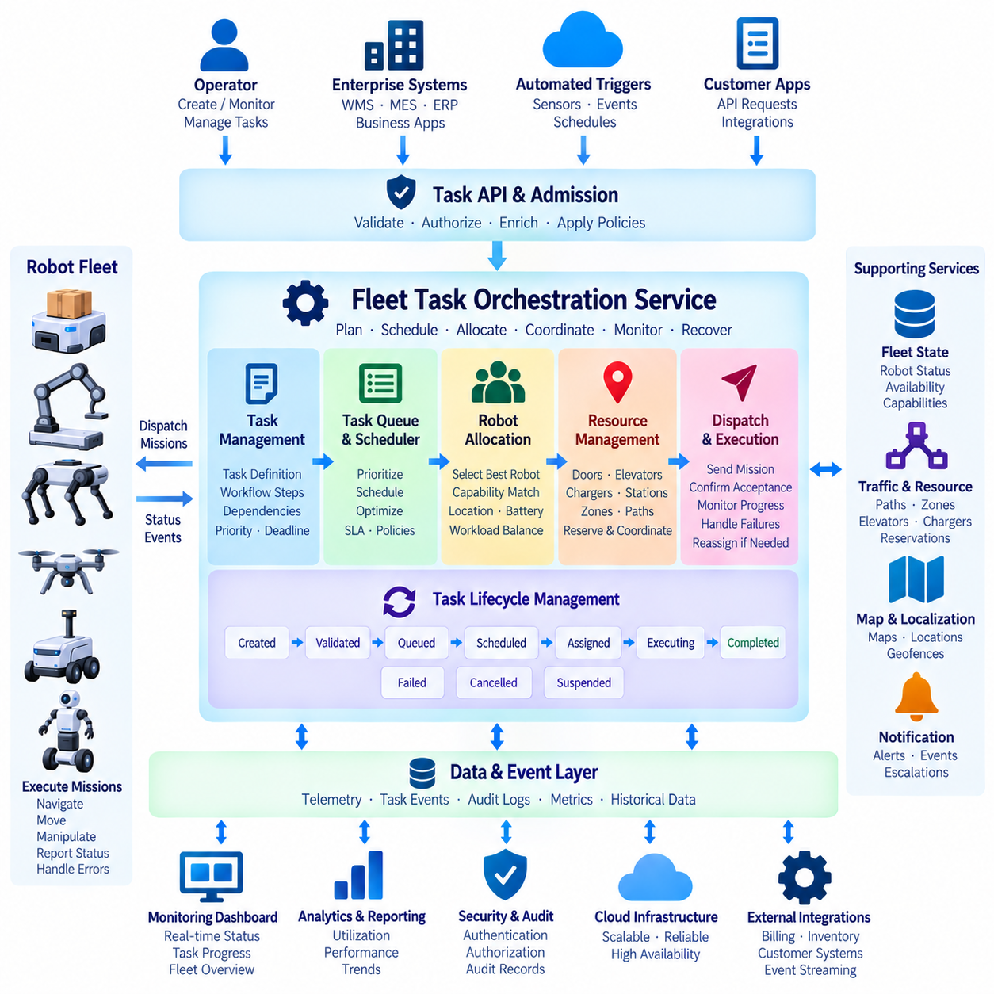
Fleet task orchestration is the service layer that converts business requests and operational goals into coordinated robot missions. While individual robots execute navigation and physical actions locally, the orchestration service determines what work should be performed, when it should begin, which robot should perform it, and how dependencies between tasks should be managed. It therefore connects enterprise-level demand with the real-time capabilities and constraints of the robot fleet.
A task should be represented as a structured operational object rather than a simple command. Its definition can include task type, origin, destination, payload requirements, priority, deadline, required robot capabilities, execution constraints, and business context. This representation allows the orchestration service to reason about work consistently while supporting different applications such as transport, inspection, patrol, delivery, towing, or material handling.
Complex missions can be decomposed into multiple task steps connected by dependencies. A transport mission, for example, may require navigation to a pickup location, confirmation of resource availability, loading, transport, unloading, and return or charging. Representing these steps as a workflow allows the backend to track progress, identify failures precisely, retry appropriate operations, and coordinate actions involving robots, infrastructure, and external systems.
Task lifecycle management provides explicit states for orchestration. A task may progress through created, validated, queued, scheduled, assigned, accepted, executing, completed, failed, cancelled, or suspended states. State transitions should be persistent and auditable so that the system can recover after service restarts or communication failures. Explicit lifecycle rules also prevent ambiguous situations in which multiple services believe that different robots own the same task.
The orchestration service receives work from multiple sources. Operators may create tasks manually, while Warehouse Management Systems, Manufacturing Execution Systems, ERP platforms, customer applications, sensors, or automated workflows can generate requests through APIs or events. An admission layer should validate these requests before scheduling, ensuring that destinations exist, required capabilities are available, parameters are valid, and the requested operation complies with site policies.
Task queues organize validated work awaiting execution. Rather than processing requests only in arrival order, the scheduler can consider priority, deadlines, service-level objectives, customer policies, task age, and operational urgency. Separate logical queues may represent sites, robot classes, customers, or mission categories. Queue policies should prevent low-priority work from being permanently starved while still allowing emergency or time-critical missions to receive rapid service.
Robot selection requires current information from the fleet-state service. Candidate robots can be filtered according to availability, capability, payload capacity, location, battery state, operating mode, maintenance condition, and connectivity. The orchestration service should avoid assigning tasks based only on static device information because a technically compatible robot may currently be charging, executing another mission, unavailable, or operating in a restricted area.
Task allocation can use increasingly sophisticated strategies as fleet complexity grows. A basic implementation may choose the nearest available compatible robot, while advanced allocation can consider estimated travel time, battery consumption, congestion, workload balance, charging plans, mission deadlines, and future task demand. The allocation algorithm should remain separated from task lifecycle storage so that scheduling policies can evolve without redesigning the fundamental orchestration architecture.
Resource constraints must be considered together with robot availability. Tasks may require access to doors, elevators, loading stations, chargers, work cells, transfer points, or restricted zones. Assigning a robot without confirming required resources can create deadlocks or unnecessary waiting. The orchestration service can therefore coordinate with traffic and resource-management services to reserve shared infrastructure or delay execution until required resources become available.
Dispatch converts an assigned task into an executable robot mission. The backend sends a mission containing relevant parameters and associates it with unique task, mission, and robot identifiers. The robot should acknowledge acceptance before the task is considered actively executing. This handshake prevents the backend from assuming successful dispatch when a command was lost because of a network interruption or when the robot rejected the mission because its local state had changed.
Execution monitoring follows the mission after dispatch. Robot events can report acceptance, movement, arrival, action completion, waiting, blocking, failure, cancellation, or final completion. The orchestration service updates persistent task state from these events and can expose progress to dashboards and external systems. Heartbeats and execution timeouts help detect situations in which a mission appears active in the backend but the robot has stopped communicating or progressing.
Failure handling should distinguish between transient and permanent problems. Temporary network loss, resource contention, or a short-lived obstacle may justify waiting or retrying, while hardware failure or an invalid destination may require task reassignment or operator intervention. Retry limits, timeout policies, fallback actions, and escalation rules should be explicit. Blindly repeating physical actions can create unsafe or duplicated operations, especially when completion status is uncertain.
Task reassignment is particularly important in large fleets. If a robot becomes unavailable before executing a task, the scheduler can return the work to the queue and select another compatible robot. Reassignment during execution requires greater caution because physical progress may already have occurred. The orchestration service must determine whether the task is resumable, restartable, transferable, or requires recovery before another robot can continue the operation.
Idempotency protects orchestration against duplicate requests and repeated messages. Enterprise systems may retry task creation when responses are delayed, and robots may resend execution events after reconnecting. Unique request identifiers and persistent state allow the backend to recognize duplicates without creating multiple physical missions. This property is essential because duplicated database records are inconvenient, whereas duplicated robot actions can produce real operational consequences.
Event-driven architecture allows orchestration components to remain loosely coupled. Task creation, assignment, dispatch, progress, completion, failure, cancellation, and reassignment can be published as events. Fleet monitoring, notifications, analytics, billing, inventory, and external business systems can consume these events independently. Durable messaging also helps preserve important transitions when individual downstream services are temporarily unavailable.
Concurrency control is required when several scheduler instances operate simultaneously. Without coordination, two instances could assign the same robot or task at nearly the same time. Database transactions, optimistic locking, distributed locks, leases, or atomic reservation mechanisms can protect ownership transitions. The design should keep locking scopes small because excessive global locking reduces throughput and becomes a bottleneck as the fleet expands.
Scalability can be achieved by partitioning orchestration workloads according to site, customer, fleet, or operational region. Stateless API and scheduling workers can scale horizontally, while persistent task state and message streams preserve coordination. Independent sites can often continue scheduling locally even when other regions experience heavy workloads. This architecture also limits the failure domain and reduces unnecessary cross-region communication for physically local robot operations.
Security must ensure that only authorized identities can create, modify, cancel, or reprioritize tasks. Requests from enterprise systems, operators, and internal services should be authenticated and evaluated against access policies. High-impact operations such as emergency cancellation, manual reassignment, priority override, or restricted-zone missions should generate audit records. Task parameters must also be validated so that authorized API access cannot be abused to issue unsafe or malformed missions.
Observability should reveal both technical service health and operational scheduling performance. Useful information includes queue depth, assignment latency, dispatch success, task duration, retry frequency, failure reasons, robot utilization, waiting time, and resource contention. Distributed tracing can follow a request from an external business system through validation, scheduling, dispatch, robot execution, and completion, helping engineers locate delays across the complete orchestration path.
A well-designed fleet task orchestration service therefore acts as the operational decision layer between business demand and autonomous robot execution. It manages task lifecycles, queues, priorities, allocation, resources, dispatch, progress, failures, and reassignment while preserving consistency and auditability. By separating orchestration from local robot autonomy, fleets can scale toward complex multi-robot operations without moving safety-critical physical control away from the robot itself.

08.06 Fleet Notification Service: Event-Driven Alarm [w/Code]
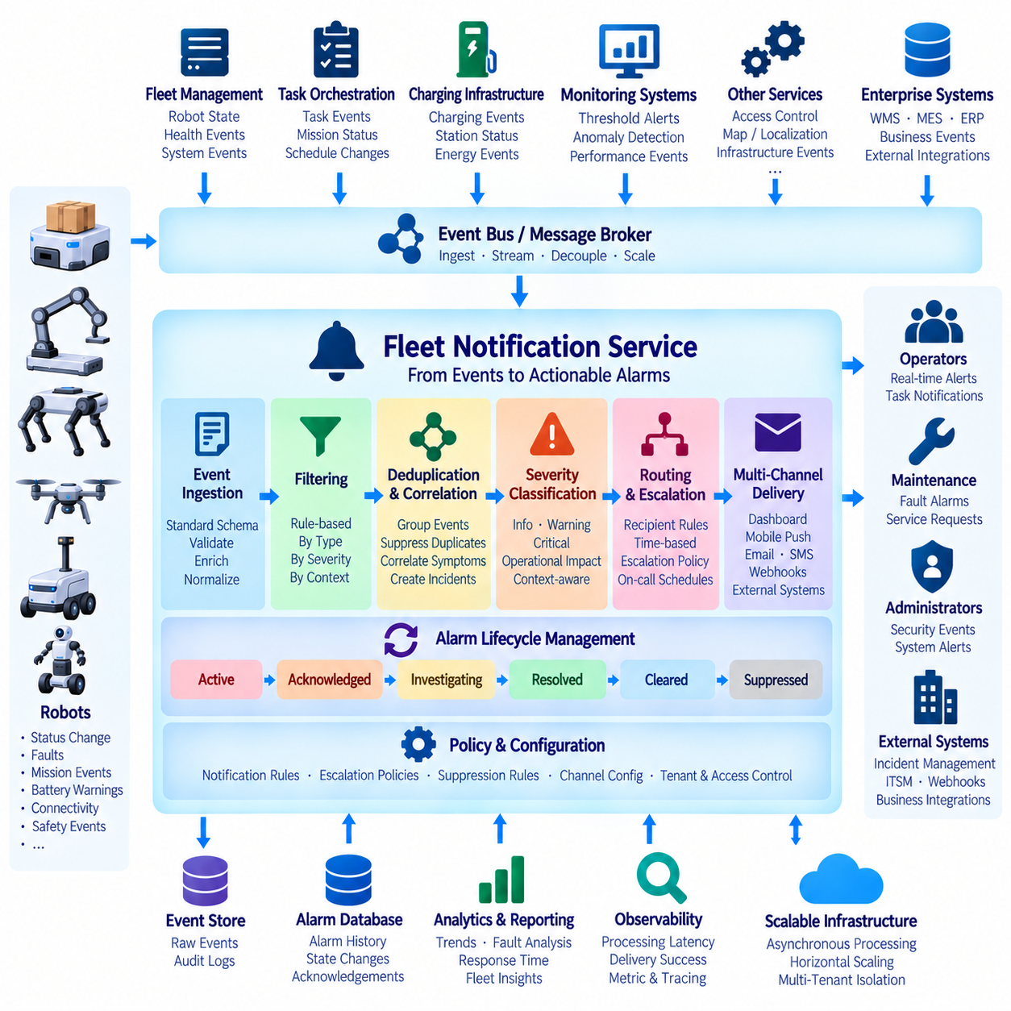
Fleet notification services transform operational events into timely and actionable information for operators, maintenance teams, administrators, and external systems. Robots continuously generate status changes, faults, mission events, battery warnings, connectivity changes, and safety-related conditions. Rather than sending every raw event directly to users, the notification service interprets these signals, applies policies, determines significance, and delivers appropriate alarms through selected communication channels.
An event-driven architecture separates event generation from notification delivery. Robots, Fleet Management Servers, task orchestration services, monitoring systems, charging infrastructure, and other backend components publish events without needing to know who will receive them. A message broker or event-stream platform distributes these events to the notification service, allowing producers and consumers to evolve independently while maintaining scalable asynchronous communication.
Events should follow a standardized schema so that notifications can be processed consistently across different robot models and services. An event may contain a unique identifier, event type, source robot, site, timestamp, severity, current state, related mission, diagnostic information, and contextual metadata. Standardization allows the notification backend to apply common filtering, correlation, routing, and escalation logic instead of implementing separate processing rules for every event producer.
Severity classification determines how urgently an event should be handled. Informational events may simply appear in a dashboard or historical log, while warnings can require operator awareness and critical alarms may demand immediate action. Severity should reflect operational impact rather than only the internal error level of a component. A localization warning affecting an idle robot, for example, may require different treatment from the same condition during an active transport mission.
Event filtering prevents low-value information from overwhelming users and backend systems. High-frequency telemetry changes should not automatically become notifications, and expected state transitions such as normal mission completion may require only dashboard updates. Rules can filter events by type, severity, robot group, site, operating mode, maintenance state, or time period. This allows notification traffic to remain focused on conditions that require awareness or action.
Deduplication is essential because robots and services may repeatedly report the same abnormal condition. A motor controller fault transmitted every second should normally remain one active alarm rather than create hundreds of independent notifications. The service can generate a correlation key from robot identity, component, fault code, and operational context, then update the existing alarm until the underlying condition changes or is cleared.
Alarm correlation extends this concept by combining related events into a more meaningful operational incident. Communication loss may cause telemetry timeout, stale position, mission delay, and heartbeat alarms at nearly the same time. Presenting all of them independently can obscure the root condition. Correlation rules can group symptoms associated with the same robot, subsystem, or time window and expose a consolidated incident to operators while preserving underlying events for diagnosis.
An alarm should have its own lifecycle rather than exist as a one-time message. Typical states include active, acknowledged, investigating, resolved, cleared, or suppressed. The backend records when the alarm was created, who acknowledged it, which actions were taken, and when the condition disappeared. Persistent lifecycle management provides accountability and prevents critical conditions from disappearing merely because an operator closed a notification window.
Routing determines who or what should receive each notification. Policies may consider site, robot group, severity, event category, working schedule, operational responsibility, and user role. A battery warning may be routed to fleet operations, while a motor fault may also reach maintenance personnel. Security-related events may require administrators. Policy-based routing avoids maintaining fixed recipient lists inside robot software and allows organizational responsibilities to change centrally.
Multiple delivery channels can be supported according to urgency and operational environment. Real-time dashboard notifications, mobile push messages, email, SMS, collaboration platforms, webhooks, and enterprise incident-management systems can all serve different purposes. The notification service should separate alarm generation from channel delivery so that adding or replacing a communication method does not require modifications to robot-side software or event producers.
Escalation policies address alarms that remain unresolved. A warning may initially notify the responsible operator, then escalate to a supervisor or maintenance team if it is not acknowledged within a defined period. Critical events can immediately trigger several channels or organizational roles. Escalation timers, acknowledgement conditions, operating schedules, and severity changes should be explicitly represented so that urgent incidents do not depend solely on one recipient noticing a message.
Notification suppression is necessary during known maintenance or controlled operational conditions. A robot undergoing service may intentionally have sensors disconnected, software restarted, or communication interrupted. Maintenance windows and suppression policies can prevent expected events from generating unnecessary alarms while preserving the original event records. Suppression should be time-bounded and auditable so that genuine failures are not accidentally hidden after maintenance has ended.
Rate limiting protects both users and external communication channels during large incidents. A network outage affecting hundreds of robots could otherwise generate thousands of nearly identical notifications within seconds. The service can aggregate alarms by site or event category, limit repeated delivery, and provide summary notifications while maintaining detailed backend records. Critical events should remain visible even when lower-priority notification traffic is being reduced.
Reliable delivery requires explicit handling of failures in downstream channels. Email providers, push services, webhook endpoints, or enterprise applications may temporarily become unavailable. Delivery attempts can therefore be placed in durable queues and retried according to channel-specific policies. Dead-letter queues can preserve messages that repeatedly fail, allowing operators or automated processes to inspect them without blocking successful notifications destined for other channels.
Event ordering and freshness also require careful treatment. Delayed network messages can cause an old alarm event to arrive after a newer recovery event. Timestamps, sequence numbers, event versions, and state-aware processing can prevent stale information from reopening a condition that has already been resolved. Notification systems should therefore interpret events in relation to current alarm state rather than assuming that message arrival order always reflects physical event order.
Security is important because notifications may contain operationally sensitive information and may also trigger automated actions. Producers should be authenticated before publishing events, and consumers should receive only information within their authorized scope. Webhook endpoints and external integrations require protected credentials and encrypted communication. Administrative actions such as changing alarm rules, disabling notifications, or modifying escalation policies should generate audit records.
Multi-tenant fleet platforms require strict isolation between customers and sites. An event from one tenant must never be routed to users, dashboards, or integrations belonging to another tenant. Tenant identifiers and authorization context should remain associated with events throughout ingestion, processing, storage, and delivery. Partitioning event streams or applying tenant-aware routing policies can provide additional isolation as the fleet platform grows.
Scalability depends on asynchronous processing and horizontal expansion. Event consumers, rule engines, notification workers, and delivery adapters can be replicated independently according to workload. Message partitions may distribute events by tenant, site, robot, or event type while preserving ordering where required. This architecture allows a notification platform to support increasing robot populations without forcing every component to scale at exactly the same rate.
Observability should measure both event-processing health and notification effectiveness. Useful metrics include event ingestion rate, processing latency, active alarms, acknowledgement time, escalation frequency, suppressed events, delivery success, retry count, dead-letter volume, and channel latency. Correlating these metrics with robot and mission information helps teams identify whether operational delays result from physical failures, notification policies, backend congestion, or delivery-channel problems.
Historical alarm data can support broader fleet improvement. Repeated faults, frequently affected robot models, sites with high communication-loss rates, average acknowledgement time, and recurring mission-related alarms can reveal systemic problems. Analytical workloads should operate separately from the latency-sensitive notification path, allowing historical information to support reliability engineering and maintenance planning without slowing real-time alarm delivery.
A well-designed fleet notification service therefore acts as the event-to-action layer of fleet operations. It receives distributed events, evaluates severity, filters noise, deduplicates and correlates alarms, manages alarm lifecycles, routes notifications, applies escalation, and records outcomes. Combined with durable messaging, security, observability, and scalable delivery workers, this architecture ensures that important fleet conditions reach the appropriate people and systems without overwhelming them with raw robot events.

08.07 Fleet Remote Access: SSH Tunnel / WebRTC Control [w/Code]
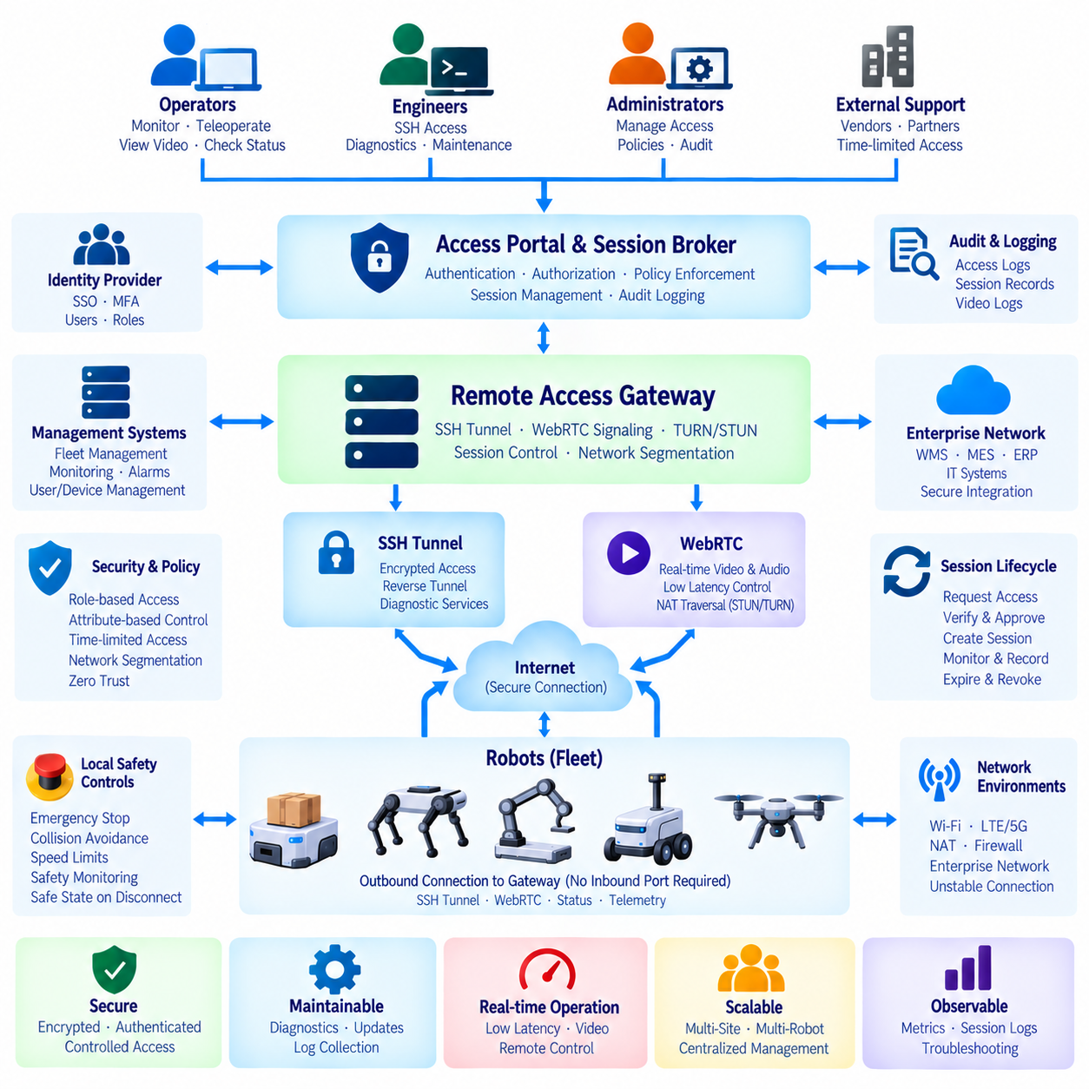
Remote access is an essential operational capability for robot fleets because deployed robots often require diagnosis, maintenance, software inspection, log collection, and limited manual intervention without physical access to the site. A fleet remote-access architecture should provide engineers and operators with controlled connectivity while preventing robots from becoming directly exposed to public networks. SSH tunneling, secure gateways, WebRTC, authentication, authorization, and audit services can be combined to create a layered remote-control environment.
Direct inbound connections to robots should generally be avoided because mobile robots frequently operate behind NAT, firewalls, private LTE or 5G networks, and enterprise security boundaries. Instead, the robot can establish an authenticated outbound connection to a trusted remote-access gateway. Once this session is established, authorized users can request access through the gateway without requiring a publicly reachable robot IP address or permanently opening inbound firewall ports at the deployment site.
SSH provides a practical mechanism for engineering access to robot computers. Through SSH, authorized engineers can inspect processes, review logs, check ROS 2 nodes, examine container status, transfer diagnostic files, or execute approved maintenance commands. Public-key authentication should replace password-based login wherever possible, and individual user identities should be maintained so that access can be attributed to a specific engineer rather than a shared maintenance account.
An SSH tunnel extends this model by forwarding selected network services through an encrypted connection. A robot may establish a reverse SSH tunnel to a fleet gateway, allowing an engineer to reach a protected SSH port, web interface, ROS diagnostic service, or other maintenance endpoint without exposing it publicly. Tunnel creation should be centrally controlled, time-limited, and associated with an authenticated support session rather than operating as an unrestricted permanent backdoor.
A remote-access broker can manage the lifecycle of these sessions. When an engineer requests access to a robot, the broker verifies user identity, robot identity, permissions, site policies, and current robot state. If the request is approved, it can issue short-lived credentials or session tokens and instruct the gateway to create the required connection. When the maintenance window ends, the session and temporary authorization can automatically expire.
Role-based and attribute-based access control can restrict what each user is allowed to do. A fleet operator may be permitted to view status and initiate limited teleoperation, while a maintenance engineer may receive SSH access to diagnostic services. Administrators may manage policies without automatically receiving unrestricted robot control. Access decisions can also consider customer, site, robot group, maintenance window, task state, and requested operation.
Remote maintenance and remote driving should be treated as different access classes. SSH is primarily intended for system administration and diagnosis, whereas interactive robot control requires predictable low-latency communication and continuous state feedback. Separating these functions reduces the possibility that general engineering access accidentally becomes an uncontrolled mechanism for commanding robot motion and allows stronger safety policies to be applied specifically to teleoperation.
WebRTC is suitable for interactive remote operation because it supports low-latency real-time media and data communication. Camera video, microphone audio, operator commands, and selected telemetry can be exchanged through coordinated WebRTC sessions. Signaling services establish the connection, while ICE procedures determine viable network paths. STUN can assist with NAT traversal, and TURN relays can provide connectivity when direct peer-to-peer communication is not possible.
Video streaming should be optimized for operational awareness rather than maximum image quality alone. Resolution, frame rate, codec, bitrate, latency, and camera selection influence both network usage and operator performance. Adaptive bitrate control can reduce video quality when network conditions degrade while preserving command and status communication. Multiple camera streams may be available, but unnecessary streams should remain disabled to conserve wireless and backend resources.
Control commands require stronger treatment than ordinary video packets. Each command should be associated with an authenticated session, authorized operator, robot identifier, sequence information, and validity period. Stale commands should expire rather than execute after a delayed connection recovers. The robot should also verify its local operating mode before accepting remote motion commands so that network authorization alone cannot override physical safety conditions.
Teleoperation authority must be explicitly transferred. A robot should know whether control belongs to autonomous navigation, a local operator, or a remote operator, and conflicting command sources should not control motion simultaneously. The transition into remote-control mode can require predefined conditions such as low speed, safe location, operator confirmation, or local permission. Returning to autonomous operation should similarly follow a controlled state transition.
Safety-critical functions should remain local even during remote operation. Emergency stopping, collision avoidance, actuator limits, speed restrictions, obstacle detection, and basic protective behaviors should continue to execute on the robot regardless of network conditions. Remote commands should therefore be interpreted as requests within local safety constraints rather than direct unrestricted actuator control. Loss of communication must lead to a predefined safe behavior instead of uncontrolled continued motion.
Network quality should be continuously monitored during interactive sessions. Round-trip latency, jitter, packet loss, available bandwidth, video delay, command acknowledgement, and connection state provide indicators of whether remote operation remains reliable. If communication quality falls below defined thresholds, the system can reduce speed, degrade video quality, pause remote movement, or transition the robot into a safe stopped state according to operational policy.
Session recording and audit logging provide accountability for remote access. The backend can record who connected, which robot was accessed, when the session started and ended, which privileges were granted, and which administrative actions were performed. High-impact commands and control-mode changes should receive additional audit records. Video recording may also be supported where organizational policy and applicable privacy requirements permit it.
Credential management should minimize the lifetime and scope of remote-access privileges. Long-lived shared SSH keys create unnecessary risk when engineers, contractors, or devices change. Short-lived certificates, temporary tokens, centralized identity providers, key rotation, and immediate revocation provide stronger control. Robot credentials should identify the device independently from human operator credentials so that both sides of a remote session can be authenticated separately.
Network segmentation limits the consequences of a compromised remote session. Remote-access gateways can be isolated from fleet application services, databases, enterprise networks, and safety-critical robot networks. Only explicitly approved ports and services should be reachable through a session. This zero-trust-oriented approach assumes that successful authentication does not automatically justify unrestricted lateral movement across the robot or cloud infrastructure.
Remote access must also operate across unstable connections. A robot may temporarily move through weak Wi-Fi coverage, cellular handover zones, tunnels, or radio interference. Session services should detect disconnection, invalidate unsafe command streams, and support controlled reconnection. Diagnostic tunnels may resume after authentication, but interactive control should require confirmation that the operator, robot state, and network quality remain suitable before motion authority is restored.
Fleet-scale remote access requires centralized session management rather than individually configured tunnels for every robot. Gateways, signaling services, TURN infrastructure, identity services, and session brokers can scale horizontally while the fleet platform maintains robot presence and connection state. Site or regional gateways can reduce latency and bandwidth consumption while providing a consistent authorization and audit model across geographically distributed deployments.
Observability should cover both access infrastructure and individual sessions. Useful metrics include active SSH tunnels, WebRTC sessions, connection establishment time, authentication failures, TURN relay usage, video bitrate, packet loss, command latency, reconnection frequency, and session termination reasons. Correlating these measurements with robot events allows engineers to distinguish robot faults from access-gateway failures, network degradation, or operator-side connectivity problems.
A well-designed fleet remote-access architecture therefore combines secure engineering access with controlled real-time teleoperation without exposing robots directly to untrusted networks. SSH tunnels support diagnosis and maintenance, while WebRTC provides low-latency media and interactive control. Central identity, session brokering, authorization, auditing, network segmentation, and robot-local safety controls ensure that remote capabilities remain manageable as deployments expand from individual robots to distributed multi-site fleets.

08.08 Fleet Cloud HA Design: Multi.AZ / Multi-Region
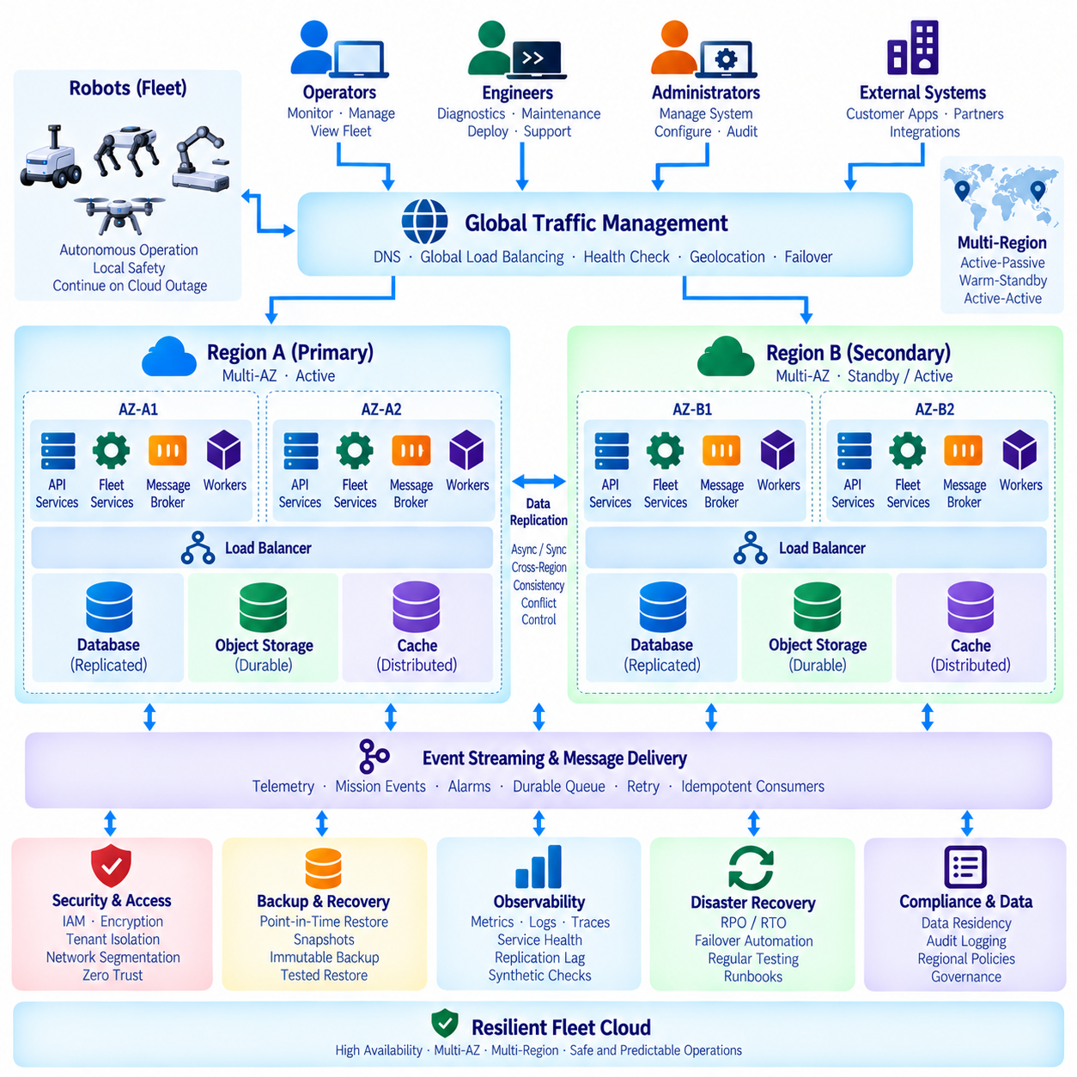
High availability in a fleet cloud must be designed around robot operations rather than conventional server uptime alone. A backend can report high infrastructure availability while robots still lose task coordination, telemetry ingestion, remote supervision, or authentication during failures. The architecture should therefore define which fleet functions must survive component, Availability Zone, and regional failures, while robots retain essential autonomous and safety functions locally.
Multi-Availability Zone architecture provides the first major layer of cloud fault isolation. Application services can run across two or more independent Availability Zones within the same region, with load balancers distributing requests among healthy instances. If one zone experiences compute, networking, or infrastructure failure, traffic can be redirected to surviving zones without requiring robots and operators to change service endpoints manually.
Stateless fleet services are particularly suitable for Multi-AZ deployment because instances can be replaced or scaled without transferring local session data. API gateways, device services, task APIs, notification workers, and telemetry processors should keep durable operational state in shared resilient stores rather than local memory. Temporary caches may remain local or distributed, but the system should be capable of reconstructing important fleet state after an instance disappears.
Stateful components require stronger replication strategies. Robot registries, mission records, task states, user information, configuration, and alarm lifecycles should use databases capable of replication across Availability Zones. Message brokers and event-stream platforms should also replicate partitions or queues so that the loss of one node does not erase important robot events. Storage durability must therefore be considered separately from application-service redundancy.
Load balancing and health checking determine whether redundant capacity actually provides availability. Health checks should verify more than process existence and should detect whether a service can reach its required databases, brokers, caches, or identity systems. Failed instances should be removed from routing quickly, while recovery mechanisms should avoid repeatedly sending traffic toward components that are alive at the operating-system level but unable to perform useful fleet functions.
Multi-Region architecture extends fault isolation beyond a single cloud region. A second region can provide disaster recovery or active service capacity when a large-scale regional outage occurs. Depending on operational requirements, the architecture may use active-passive, warm-standby, or active-active patterns. The appropriate model depends on recovery objectives, data consistency requirements, geographic distribution, complexity, and acceptable operating cost.
In an active-passive design, one region normally serves production traffic while another maintains replicated data and sufficient infrastructure for recovery. This model is comparatively simple but requires a controlled failover process. A warm-standby design keeps more services continuously running in the secondary region, reducing recovery time. The secondary environment should be exercised regularly because an untested standby region may fail precisely when it is needed.
Active-active architecture allows multiple regions to process production traffic simultaneously. Robots and users can connect to geographically appropriate endpoints, reducing latency and providing regional redundancy. However, active-active operation introduces difficult consistency, routing, ownership, and conflict-resolution problems. Mission assignment and robot command ownership require particular care because two regions must never independently issue conflicting operational authority to the same robot.
Global traffic management directs clients toward an appropriate healthy region. DNS-based routing, global load balancing, anycast services, or application-level discovery can select endpoints according to health, latency, geography, or policy. Robot clients should not assume that a single fixed server address will always be available. Connection logic can support endpoint discovery, controlled retries, exponential backoff, and reconnection without producing excessive traffic during large outages.
Data replication between regions must reflect the consistency needs of each information class. Device configuration and historical telemetry may tolerate asynchronous replication, while active mission ownership and command state require stronger controls. Attempting to make every data item globally synchronous can increase latency and reduce availability. The architecture should therefore classify data according to operational criticality and select replication and consistency mechanisms accordingly.
Split-brain prevention is essential when connectivity between regions fails while both regions remain operational. Without ownership controls, separate schedulers could believe they control the same site or robot fleet. Leases, quorum mechanisms, fencing tokens, regional ownership records, or other coordination methods can ensure that only one control authority remains valid. For physical robots, preventing conflicting commands is more important than maximizing theoretical backend availability.
Robots should be designed to tolerate temporary cloud unavailability even when Multi-AZ and Multi-Region protections exist. Local navigation, obstacle avoidance, emergency stopping, current mission safety, and essential control should not depend on continuous cloud connectivity. During a backend outage, robots may complete a safely committed action, pause at a safe location, buffer telemetry, or enter a defined degraded mode according to system policy.
Message delivery should remain durable across service failures. Telemetry, mission events, alarms, and task transitions can pass through replicated message brokers or event streams with acknowledgement and retry mechanisms. Consumers should be idempotent because failover can cause messages to be delivered more than once. Durable messaging allows recovered services to reconstruct processing progress rather than relying entirely on volatile in-memory state.
Recovery Point Objective and Recovery Time Objective provide measurable targets for disaster-recovery design. The Recovery Point Objective defines how much data loss can be tolerated, while the Recovery Time Objective defines how long service restoration may take. Different fleet functions may require different objectives. Historical analytics can often tolerate longer recovery, whereas robot authentication, mission coordination, and operational monitoring may require much faster restoration.
Backup architecture remains necessary even when databases are replicated across zones and regions. Replication protects against infrastructure failure but can also propagate accidental deletion, corrupted data, or incorrect administrative changes. Point-in-time recovery, immutable backups, configuration snapshots, and protected credential backups provide an independent recovery path. Restoration procedures should be tested instead of assuming that successful backup creation guarantees recoverability.
Failover should be automated where the failure condition can be identified reliably, but automation must consider physical operations. Automatically moving stateless APIs between zones is relatively low risk, while transferring command authority between regions can affect moving robots. Failover logic should therefore distinguish ordinary service recovery from control-plane ownership changes and require appropriate fencing, state reconciliation, and safety checks before a new region assumes operational authority.
Observability must span zones, regions, cloud services, networks, and robots. Operators should monitor service availability, replication lag, queue depth, database health, regional latency, failed requests, reconnect rates, and robot communication status. Synthetic health checks can continuously verify important end-to-end paths. Correlating cloud metrics with robot events helps determine whether an incident originates from a service instance, an Availability Zone, a region, or local connectivity.
Disaster-recovery testing should reproduce realistic failure scenarios instead of verifying only individual component restart. Exercises can isolate an Availability Zone, disable a database replica, interrupt inter-region replication, remove a message broker, or make the primary region unavailable. The objective is to verify routing, data recovery, robot reconnection, service ownership, alarm generation, and operator procedures as one coordinated system.
Multi-Region design should also consider data residency, security boundaries, and administrative separation. Robot telemetry or customer information may need to remain within particular geographic regions, while global management services require controlled cross-region visibility. Encryption, regional identity policies, tenant isolation, replication permissions, and audit logging should remain consistent with the fleet platform's security model during both normal operation and failover.
A resilient fleet cloud therefore combines Multi-AZ redundancy for routine infrastructure failures with Multi-Region recovery for larger disruptions. Stateless service replication, durable state stores, global routing, controlled data replication, split-brain prevention, robot-local autonomy, backups, observability, and tested failover procedures work together as one availability strategy. The goal is not simply to keep cloud servers running, but to preserve safe and predictable fleet operation when parts of the cloud inevitably fail.

08.09 Fleet Cloud Cost Optimization: Spot / Reserved Instance
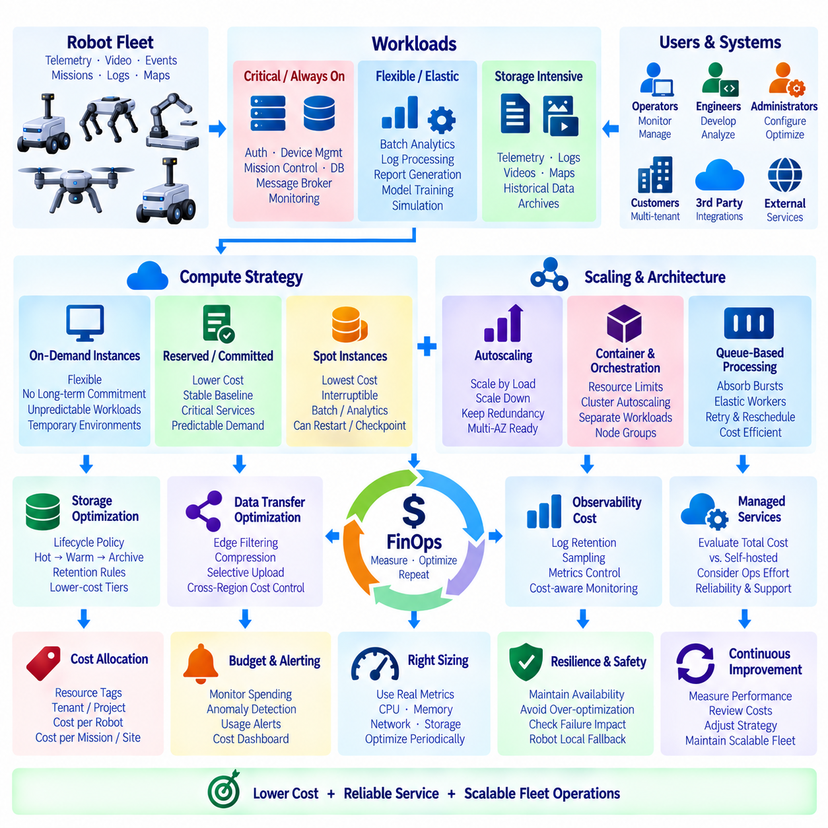
Fleet cloud cost optimization should reduce infrastructure expenditure without weakening robot safety, service availability, or operational predictability. Robot fleets generate continuous telemetry, API traffic, event streams, logs, video, historical data, and periodic analytical workloads, but these resources do not all require the same reliability or compute model. Effective optimization begins by separating steady production workloads from elastic, interruptible, and storage-intensive workloads.
Cost analysis should start with workload classification rather than instance pricing alone. Core fleet services such as authentication, device management, mission coordination, databases, message brokers, and real-time monitoring usually require predictable availability. Batch analytics, log processing, model evaluation, simulation, report generation, and some development workloads are more flexible. Mapping each workload to its operational criticality prevents aggressive cost reduction from affecting essential robot services.
On-demand instances provide flexibility because capacity can be started or stopped without long-term commitment. They are useful for unpredictable workloads, temporary environments, new services whose utilization is not yet understood, and short-term capacity expansion. However, continuously running production services can become expensive when operated entirely with on-demand pricing. Fleet platforms should therefore use on-demand capacity selectively rather than treating it as the default for every persistent backend component.
Reserved capacity or commitment-based pricing is appropriate for predictable baseline workloads. Fleet API servers, databases, monitoring infrastructure, identity services, and message-processing components often maintain relatively stable minimum demand as the fleet operates continuously. Committing to an expected baseline can reduce compute cost compared with permanent on-demand usage. The commitment level should be based on measured utilization and conservative growth assumptions rather than maximum theoretical capacity.
The baseline should not be overcommitted because robot deployments can change over time. Customers may delay projects, sites may operate seasonally, and software architecture may become more efficient. Excessive reservation can convert an expected discount into unused capacity cost. A practical approach is to cover the stable portion of long-term demand with reserved or committed resources while keeping uncertain growth and temporary peaks on flexible capacity.
Spot instances can provide substantial savings for workloads that tolerate interruption. Cloud providers may reclaim this capacity with limited notice, so Spot resources should not become the sole execution environment for critical fleet-control services. They are better suited to batch processing, historical telemetry analysis, simulation, AI training, log transformation, map processing, software testing, and other jobs that can restart, checkpoint, migrate, or wait for replacement capacity.
Spot-aware applications should assume interruption as a normal operating condition. Long-running jobs can periodically checkpoint progress to durable storage, while queues can retain unfinished work for another worker. Containers and orchestration platforms can reschedule terminated tasks onto alternative nodes. Diversifying instance types and capacity pools can further improve availability. The objective is to exploit discounted capacity without allowing interruption to cause data loss or incomplete operational workflows.
A mixed-capacity architecture combines reserved, on-demand, and Spot resources according to workload characteristics. Stable production services can run primarily on committed capacity, temporary demand can use on-demand instances, and interruptible workers can consume Spot capacity. This portfolio approach is more resilient than selecting one purchasing model for the entire fleet cloud and allows cost optimization to remain aligned with service-level requirements.
Autoscaling is another major cost-control mechanism. Stateless APIs, telemetry processors, notification workers, and asynchronous consumers can scale horizontally according to request rate, CPU usage, queue depth, or event throughput. Scaling down during low demand prevents idle resources from remaining permanently allocated. Scaling policies should nevertheless preserve minimum redundant capacity so that cost reduction does not remove the fault tolerance required for Multi-AZ fleet services.
Queue-based workloads are particularly suitable for elastic scaling. Instead of provisioning workers for the maximum possible event rate, durable queues can absorb temporary bursts while worker capacity expands. When backlog decreases, workers can scale down again. This pattern is useful for log processing, analytics, report generation, image processing, and noncritical telemetry transformation because processing capacity can follow actual workload rather than peak theoretical demand.
Compute rightsizing should be based on measured resource utilization. Oversized virtual machines with consistently low CPU or memory consumption waste budget, while undersized instances may create latency and reliability problems. Metrics for CPU, memory, network throughput, storage IOPS, accelerator usage, and request latency can reveal whether instance families and sizes match real workloads. Rightsizing should be performed periodically because fleet software and robot populations continuously evolve.
Containerized services can improve utilization by sharing compute nodes, but resource requests and limits must be configured carefully. Excessively large reservations reduce cluster density, while unrealistically small requests can cause contention during traffic peaks. Cluster autoscaling can add or remove nodes as workloads change. Separating critical services from interruptible batch workloads through node groups, scheduling policies, or priority classes prevents cost-oriented jobs from consuming resources required by fleet operations.
Data storage frequently becomes a major fleet-cloud expense because robots continuously generate telemetry, logs, images, video, maps, and diagnostic files. Not all information requires high-performance storage indefinitely. Recent operational data can remain in fast storage, while older information can move automatically to lower-cost object or archival tiers. Lifecycle policies should reflect retention requirements, diagnostic value, regulatory obligations, and the probability that data will be accessed again.
Data transfer cost must also be considered because robot fleets exchange information across sites, regions, and cloud services. Uploading unnecessary raw sensor data can increase both network and storage expenses. Edge filtering, event-based upload, compression, aggregation, and selective synchronization can reduce cloud traffic. Multi-Region architectures should additionally evaluate cross-region replication and transfer charges because duplicating large telemetry datasets may cost more than the compute services processing them.
Observability costs require active management as well. High-frequency metrics, verbose application logs, distributed traces, and long retention periods can generate unexpectedly large monitoring bills. Logging policies can assign different retention periods to debugging, security, audit, and operational data. Sampling can reduce high-volume traces, while critical alarms and audit records remain complete. Cost optimization should reduce unnecessary observability volume without removing evidence required for diagnosis or security.
Managed cloud services can reduce operational labor but should be evaluated using total cost rather than unit price alone. A managed database or message service may cost more than self-hosted compute while reducing administration, patching, backup, failover, and staffing effort. Conversely, very large predictable workloads may justify more direct infrastructure control. Fleet-cloud architecture should therefore consider engineering effort, operational risk, recovery capability, and infrastructure charges together.
Cost allocation becomes important when a fleet platform supports multiple customers, sites, or robot groups. Resource tags, tenant identifiers, project accounts, and billing dimensions can associate compute, storage, network, database, and observability expenses with their operational source. Unit metrics such as cost per robot, cost per active robot-hour, cost per mission, or cost per site provide more useful management information than total monthly cloud expenditure alone.
Budgets and cost anomaly detection can prevent gradual inefficiency from becoming a major financial problem. Automated monitoring can detect unexpected increases in compute hours, storage growth, data transfer, logging volume, or idle resources. Alerts should identify both the affected cloud service and the fleet workload responsible for the change. Cost dashboards can then be reviewed together with performance and availability metrics instead of treating financial optimization as a separate administrative activity.
Cost optimization must remain subordinate to operational safety and availability. A cheaper architecture is not beneficial if Spot interruption stops mission coordination, aggressive scaling creates unacceptable command latency, or reduced redundancy increases fleet downtime. Each optimization should therefore be evaluated against service criticality, failure behavior, recovery time, and robot-local fallback capability before being applied to production environments.
A mature fleet cloud combines purchasing strategy, autoscaling, rightsizing, storage lifecycle management, edge processing, and cost observability into a continuous FinOps process. Reserved or committed resources support predictable baseline services, on-demand capacity handles uncertainty, and Spot instances reduce the cost of interruptible workloads. By continuously measuring both infrastructure spending and robot-service performance, the platform can reduce cost while preserving scalable, resilient, and predictable fleet operations.

08.10 Robotics Fleet Cloud Reference Architecture
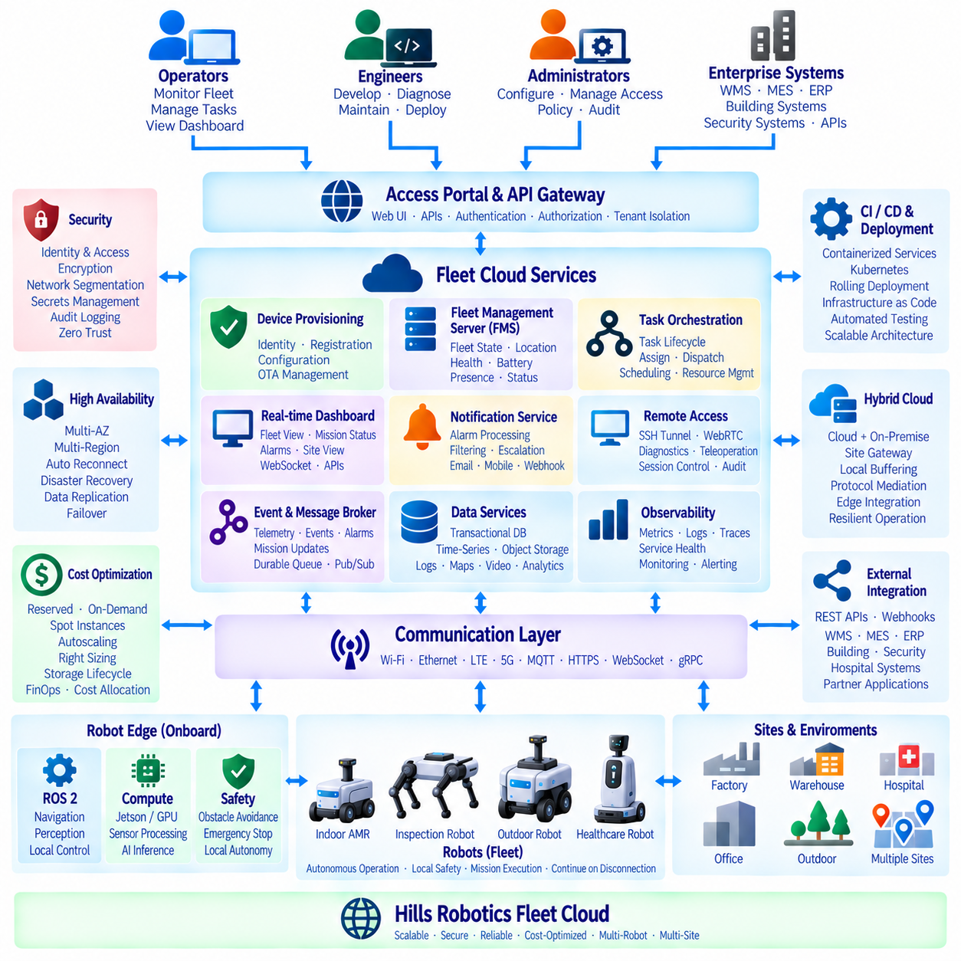
The Robotics Fleet Cloud Reference Architecture provides a common backend foundation for operating indoor AMRs, outdoor autonomous robots, inspection platforms, healthcare robots, and future multi-robot systems. The architecture connects robot-local autonomy with centralized fleet services while preserving the principle that safety-critical motion, obstacle avoidance, localization, and essential control remain executable on the robot even when cloud connectivity is temporarily unavailable.
Each robot operates as an intelligent Edge node rather than a simple cloud-controlled device. Onboard compute platforms execute ROS 2, navigation, perception, sensor processing, local mission execution, diagnostics, and safety supervision. Depending on the robot class, the Edge platform may use NVIDIA Jetson-class computing or higher-performance GPU systems. The fleet cloud exchanges missions, configuration, telemetry, events, software packages, and operational policies with these autonomous Edge systems.
The communication layer provides the secure bridge between deployed robots and fleet services. Robots can connect through Wi-Fi, Ethernet, LTE, private 5G, or other site networks while maintaining authenticated outbound sessions. MQTT or similar messaging protocols can support telemetry and event streams, while HTTPS, REST, WebSocket, or gRPC interfaces can support APIs, dashboards, commands, and service integration according to communication requirements.
A device identity and provisioning layer establishes every robot as a trusted fleet member. Manufacturing or deployment records associate each robot with a unique identity, hardware configuration, software baseline, sensors, compute capability, customer, and deployment site. Automated provisioning can issue credentials, register devices, apply configuration profiles, validate software versions, and activate robots without requiring engineers to manually configure every unit.
The Fleet Management Server forms the primary operational coordination layer. It maintains robot presence, availability, location, battery state, operating mode, health information, active mission, and connectivity status. Instead of replacing local autonomy, the FMS maintains a synchronized global representation of the fleet and provides the information required for operators and higher-level services to coordinate multiple robots across sites.
Task orchestration converts requests from operators and enterprise systems into executable robot missions. Tasks can be validated, queued, prioritized, assigned, dispatched, monitored, completed, cancelled, or reassigned through a persistent lifecycle. Robot selection can consider capability, location, battery level, payload, current workload, connectivity, and maintenance state while traffic and resource services coordinate shared doors, elevators, chargers, corridors, and work areas.
An event-driven backbone decouples robots and backend services. Telemetry, mission transitions, alarms, device-state changes, provisioning events, OTA status, and system events can be published through durable message brokers or event streams. Independent consumers can process these events for dashboards, notifications, analytics, storage, or enterprise integration. This architecture allows individual services to scale or recover without requiring every producer and consumer to remain synchronously connected.
The real-time fleet dashboard provides operators with an operational view derived from fleet-state and event services. It can present robot position, mission progress, battery level, connectivity, alarms, operating mode, and site status while avoiding unnecessary transmission of every raw sensor value. WebSocket or similar streaming mechanisms can push important state changes to clients, while APIs provide historical information and detailed data when requested.
The notification service converts distributed events into actionable alarms. Severity classification, filtering, deduplication, correlation, acknowledgement, suppression, routing, and escalation policies prevent operators from being overwhelmed by raw robot events. Notifications can be delivered through dashboards, mobile channels, email, enterprise systems, or webhooks, while persistent alarm lifecycles preserve who acknowledged an incident, what action occurred, and when the condition was resolved.
Remote access is separated into engineering maintenance and interactive teleoperation. Secure SSH tunnels can provide temporary diagnostic access without exposing robot computers directly to public networks. WebRTC can support low-latency video, audio, telemetry, and remote-control sessions when interactive operation is required. Central authentication, short-lived authorization, session brokering, auditing, and network segmentation restrict access to approved users and services.
Remote commands remain subordinate to robot-local safety. Emergency stopping, obstacle avoidance, actuator limits, collision protection, and defined communication-loss behavior continue locally regardless of cloud or operator state. Control authority should explicitly transition between autonomous, local, and remote modes. If latency, packet loss, or connectivity exceeds operational limits, the robot can reduce speed, stop safely, or return to an approved autonomous state according to policy.
The data architecture separates operational state from high-volume historical information. Transactional databases can store robot registry, mission, task, user, policy, and alarm data, while time-series or analytical stores retain telemetry and performance measurements. Object storage can contain logs, maps, images, video, diagnostic files, AI datasets, and software artifacts. Lifecycle policies move older information toward lower-cost storage according to operational and retention requirements.
Observability spans robot, Edge, network, and cloud layers. Metrics, logs, traces, events, and health information can be correlated using robot, mission, site, and service identifiers. Operators and engineers can monitor service latency, queue depth, database health, telemetry ingestion, robot reconnects, task duration, alarm frequency, network quality, and resource utilization. End-to-end observability allows cloud failures to be distinguished from robot, site-network, or application problems.
Security follows a layered identity and least-privilege model. Robots, users, services, and external applications receive independent identities and permissions. Communication is encrypted, credentials are rotated, administrative operations are audited, and tenant boundaries separate customers and deployment sites. API gateways, network segmentation, policy enforcement, secrets management, and protected device credentials reduce the effect of compromised accounts, robots, or backend components.
High availability begins with Multi-AZ deployment of critical fleet services. Stateless services can run across multiple Availability Zones behind load balancers, while databases, message systems, and durable storage maintain replicated state. Robots should reconnect automatically when service instances change. The architecture treats temporary cloud disconnection as an expected condition and allows robots to preserve essential autonomous operation while buffering information for later synchronization.
Multi-Region capability provides an additional disaster-recovery layer for geographically distributed deployments. Regional services can reduce communication latency and isolate failures, while selected fleet information is replicated according to consistency and data-residency requirements. Control ownership must remain explicit so that two regions cannot issue conflicting authority to the same robot. Regional failover therefore requires fencing, state reconciliation, and validated transfer of operational ownership.
Deployment should use containerized services and automated infrastructure wherever practical. Kubernetes or equivalent orchestration can provide service replication, rolling deployment, health checking, resource scheduling, and horizontal scaling. CI/CD pipelines can build, test, scan, and deploy backend components consistently, while infrastructure-as-code maintains reproducible environments. Service boundaries should remain operationally meaningful rather than dividing the backend into unnecessarily small microservices.
The reference architecture supports hybrid cloud and on-premise deployment because robot sites may have different connectivity, security, latency, and data-governance requirements. Site-local gateways or Edge servers can provide buffering, protocol mediation, local integration, and selected fleet functions close to robots. Central cloud services can provide cross-site fleet visibility, analytics, software distribution, administration, and long-term data management while local operation continues during WAN disruption.
Enterprise integration connects the robot fleet with surrounding operational systems. REST APIs, event interfaces, and secured webhooks can integrate Warehouse Management Systems, Manufacturing Execution Systems, ERP platforms, building systems, security systems, hospital systems, or customer applications. External systems request business-level work, while the fleet platform translates these requests into robot missions and returns execution status without exposing low-level robot control interfaces.
Cost optimization is incorporated without compromising operational requirements. Predictable baseline services can use reserved or committed compute, uncertain demand can use on-demand capacity, and interruptible analytics, simulation, testing, or data-processing workloads can use Spot resources. Autoscaling, compute rightsizing, Edge filtering, storage lifecycle policies, and cost allocation by customer, site, or robot provide a continuous FinOps mechanism for controlling infrastructure expenditure.
The Robotics Fleet Cloud Reference Architecture ultimately establishes a layered control model from robot autonomy through site connectivity, fleet coordination, cloud services, enterprise integration, and operations. Device provisioning, FMS, task orchestration, real-time dashboards, event-driven alarms, remote access, data services, security, high availability, observability, and cost optimization operate as coordinated platform capabilities. This structure provides a scalable foundation for expanding from individual AMRs to distributed multi-site and multi-robot operations.

