Volume 09 Cloud and Edge Robotics

10. Serverless for Robotics

10.01 Serverless Architecture: FaaS / BaaS for Robotics
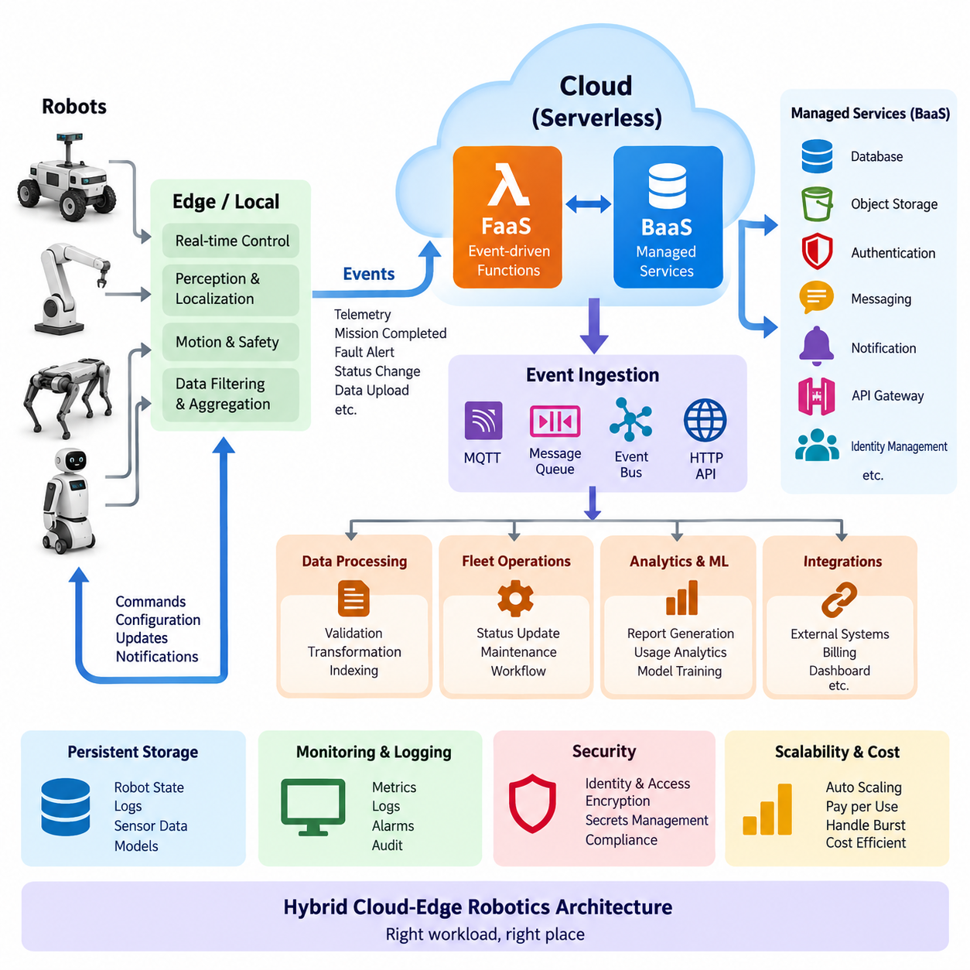
Serverless architecture is a cloud computing model in which developers build and execute application logic without directly provisioning or managing servers. The term does not mean that servers disappear; rather, infrastructure provisioning, operating system maintenance, runtime scaling, and much of the availability management are delegated to a cloud platform. In robotics, this model is useful for backend workloads that are event-driven, intermittent, highly variable, or naturally decomposed into small services.
Function as a Service (FaaS) is the execution-oriented part of serverless architecture. Application logic is packaged as relatively small functions that are invoked when defined events occur. A robot may publish telemetry, report a fault, complete a mission, request configuration data, or upload a diagnostic file. Each event can trigger a function that performs validation, transformation, database updates, notification generation, or another bounded backend operation without requiring a continuously running application server.
Backend as a Service (BaaS) complements FaaS by providing managed backend capabilities that applications can consume through APIs or event interfaces. Typical capabilities include databases, object storage, authentication, messaging, notification, API gateways, and identity management. A robotics system can therefore combine custom functions with managed services rather than implementing every backend component itself. This reduces infrastructure administration while allowing developers to concentrate on robot-specific logic and operational workflows.
A useful robotics serverless architecture separates physical control from cloud-level event processing. Motor control, emergency stopping, localization, obstacle avoidance, trajectory execution, and other deterministic or safety-related functions normally remain on the robot or nearby edge infrastructure. Serverless services instead handle asynchronous activities such as telemetry processing, fleet event handling, report generation, maintenance notifications, data indexing, workflow automation, and integration with external enterprise systems.
This separation is particularly important because serverless execution does not inherently provide deterministic response time. Function invocation may experience platform scheduling delay, network latency, dependency latency, or cold-start overhead when an execution environment must be initialized. Consequently, a robot should not depend on a remote FaaS invocation for control loops that require bounded millisecond-level timing. The robot must retain sufficient local autonomy to continue safe operation when cloud functions are delayed or temporarily unreachable.
Event-driven design provides the architectural bridge between robots and serverless services. Robots or edge gateways publish events through MQTT brokers, message queues, event buses, HTTP endpoints, or cloud IoT services. Events can represent state changes rather than continuous computational requests: battery-low, mission-completed, localization-lost, obstacle-detected, software-update-ready, or sensor-file-uploaded. Functions subscribe to relevant events and independently perform the required backend actions.
This approach introduces loose coupling between robot software and cloud services. The robot does not need detailed knowledge of every downstream application that consumes its information. A single mission-completed event might activate a database update, utilization calculation, customer notification, billing workflow, and operational dashboard refresh. Additional consumers can later be introduced without redesigning the robot-side application, making the backend easier to evolve as fleet requirements expand.
Serverless systems also support elastic fleet operations. A small deployment may generate only a few events per minute, while a large fleet can produce sudden bursts when robots simultaneously reconnect, upload logs, or report operational conditions. FaaS platforms can create multiple execution instances according to demand and reduce them when activity falls. This consumption-driven scaling model can avoid maintaining backend servers sized permanently for occasional peak traffic.
State management requires special attention because functions should generally be treated as stateless execution units. Persistent robot state should therefore reside in external services such as managed databases, object stores, caches, digital-twin repositories, or event stores. A function can read the current state, process an event, and write an updated representation. This design also allows multiple function instances to operate concurrently without relying on local memory that disappears when an execution environment is terminated.
Robotics events frequently arrive more than once, arrive out of order, or are delayed by unstable wireless connectivity. Serverless functions should therefore be designed for idempotency whenever possible. Robot identifiers, event identifiers, timestamps, sequence numbers, and mission identifiers can be used to detect duplicates and preserve ordering semantics. Durable queues and retry mechanisms can prevent temporary backend failures from immediately becoming data loss, while dead-letter handling isolates events that repeatedly fail processing.
FaaS and BaaS can also simplify robot data pipelines. Instead of transmitting every sensor stream directly into a permanently running cloud application, the edge system can filter and aggregate data locally. Significant events or selected files are then transferred to cloud storage, where their arrival triggers functions for metadata extraction, validation, indexing, conversion, or analytics. Large camera, LiDAR, or training datasets remain in appropriate storage systems rather than being passed directly through short-lived function payloads.
Security must remain explicit even when infrastructure management is delegated to the provider. Robots require authenticated identities, encrypted communication, and narrowly scoped authorization. Functions should receive only the permissions required for their tasks, while API gateways and messaging services enforce access policies. Secrets should be stored in managed secret systems rather than embedded in function packages, and audit logs should record sensitive actions such as configuration changes, remote commands, and software deployment requests.
Serverless architecture changes the cost model of robotics backends as well. Conventional servers incur cost while provisioned even when robot traffic is low, whereas serverless platforms commonly charge according to requests, execution duration, allocated resources, and associated managed-service usage. This can be attractive for irregular workloads, but extremely frequent telemetry, long-running computation, large data transfers, or continuously active processing may make containers, virtual machines, edge servers, or Kubernetes-based services more economical.
For this reason, serverless should be treated as one component of a hybrid cloud-edge robotics architecture rather than a universal replacement for conventional computing. Real-time autonomy remains at the robot edge, persistent high-throughput services can run in containers or clusters, GPU-intensive training belongs on suitable accelerated infrastructure, and event-driven backend logic can use serverless functions. This workload-oriented division corresponds naturally with the broader cloud, edge, fleet, and GPU infrastructure structure of the robotics software architecture.
A mature robotics platform can therefore combine FaaS, BaaS, containers, edge computing, and local robot software into a layered execution environment. The central design question is not whether the entire robot system should become serverless, but which workloads benefit from event-triggered execution and managed backend services. When latency, state, safety, connectivity, scalability, security, and cost are evaluated together, serverless architecture becomes a practical mechanism for building scalable fleet services without transferring real-time robotic responsibility away from the physical edge.

10.02 AWS Lambda: Robot Event Trigger [w/Code]
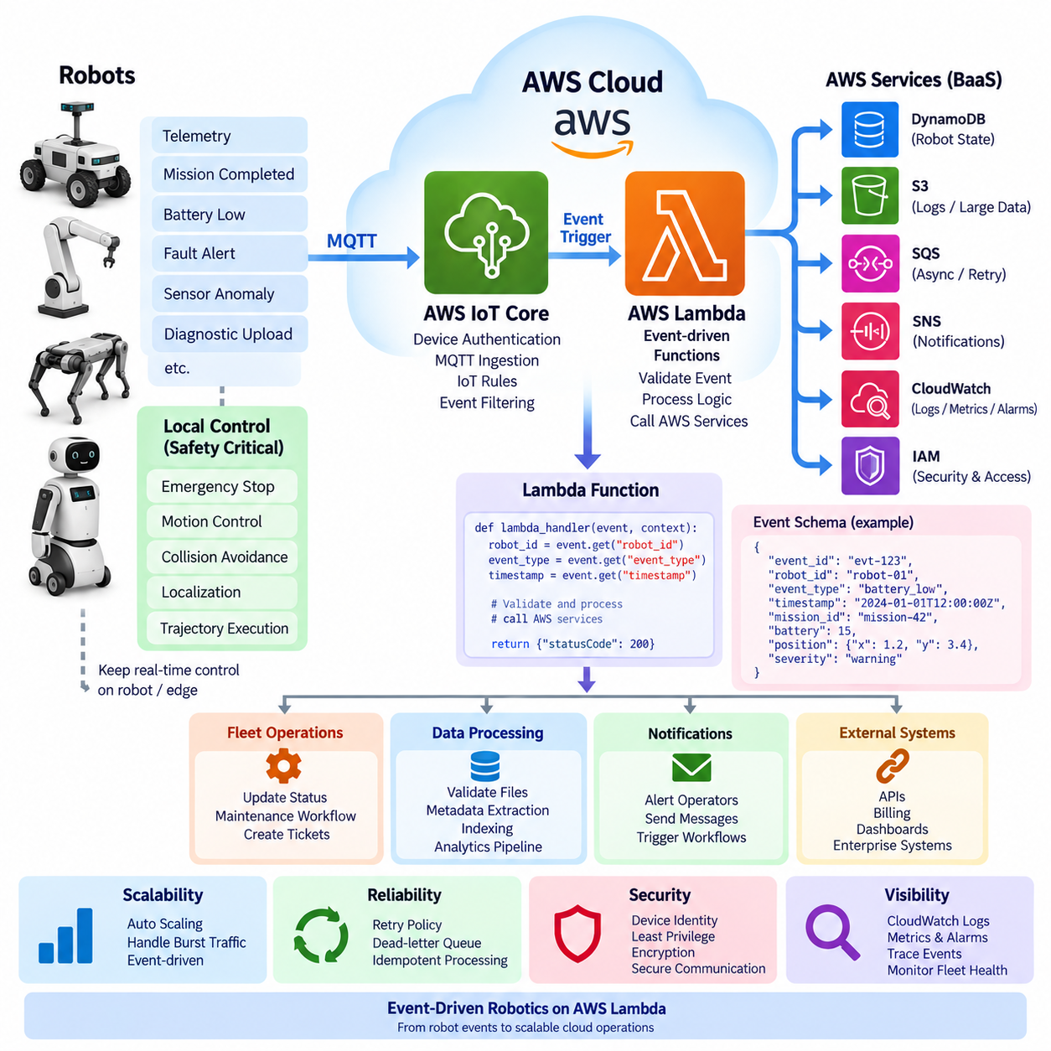
}
```
```
}
```
```
AWS Lambda is a Function as a Service (FaaS) platform that executes application logic in response to events without requiring developers to maintain continuously running servers. In robotics, Lambda can act as an event-processing layer between robots, AWS IoT services, storage, databases, fleet applications, and external systems. A robot generates an operational event, an AWS service receives it, and the event can automatically invoke a Lambda function that performs a specific backend task.
A robot event trigger represents the condition that initiates this serverless execution flow. Events may include battery warnings, mission completion, navigation failures, sensor anomalies, emergency notifications, maintenance conditions, connectivity changes, or diagnostic uploads. Instead of having a permanent backend process continuously poll every robot, the architecture reacts only when relevant events occur. This event-driven approach reduces unnecessary computation and naturally separates robot-side autonomy from cloud-side operational processing.
AWS IoT Core is a common entry point for robot-generated events. A robot or edge gateway can publish telemetry and state messages using MQTT topics, while IoT rules inspect incoming messages and route selected events to Lambda. For example, routine battery telemetry may simply be stored, while a message indicating that battery capacity has crossed a defined threshold can invoke a Lambda function responsible for updating fleet status and initiating a maintenance or charging workflow.
The robot should normally perform safety-critical interpretation locally before relying on a Lambda trigger. Emergency stopping, collision avoidance, motor control, localization recovery, and trajectory execution require predictable response times and must remain within the robot or edge system. Lambda is more appropriate after the local system has determined that an operational event should be reported. The cloud function can then record the event, notify operators, update dashboards, or coordinate non-real-time fleet activities without becoming part of the safety control loop.
A basic Lambda handler receives an event object and execution context. When invoked through AWS IoT Core, the event can contain values such as robot ID, timestamp, event type, battery state, mission ID, position, diagnostic code, and severity. The function validates required fields before performing downstream operations. Keeping a consistent robot event schema is important because the same function may process messages generated by hundreds or thousands of robots running different missions.
```python
import json
def lambda_handler(event, context):
robot_id = event.get(“robot_id”)
event_type = event.get(“event_type”)
timestamp = event.get(“timestamp”)
if not robot_id or not event_type:
return {“statusCode”: 400, “body”: “Invalid robot event”}
print(f”[{timestamp}] {robot_id}: {event_type}“)
return {
“statusCode”: 200,
“body”: json.dumps({“processed”: True})
Robot events should be designed as compact messages rather than unrestricted sensor payloads. A Lambda invocation is suitable for metadata and operational events, but continuous camera images, LiDAR point clouds, video streams, or large ROS bag files should normally be handled through dedicated data pipelines or object storage. The robot can upload a large diagnostic file to Amazon S3 and publish only its object location and metadata. An S3 object-created event can subsequently invoke Lambda for validation, indexing, metadata extraction, or workflow initiation.
Lambda can also connect robot events to persistent state. After receiving a mission-completed event, a function may update the robot's operational record in Amazon DynamoDB, store summarized information in another database, or generate an entry for downstream analytics. Functions should remain stateless themselves, with durable robot state maintained outside the execution environment. This allows AWS to create multiple function instances when event volume increases without requiring shared local memory between invocations.
Asynchronous invocation is particularly useful for fleet events because the robot usually does not need to wait for the entire cloud workflow to finish. A robot can publish an event and continue operating while Lambda processes it independently. If downstream processing fails, retry policies, queues, or dead-letter destinations can preserve failed events for later investigation. This architecture prevents temporary failures in reporting or analytics services from unnecessarily interrupting the physical robot's mission.
Duplicate processing must be considered because distributed event systems can deliver the same logical event more than once. Each robot event can therefore include a unique event ID together with robot ID, timestamp, mission ID, and sequence information. Before performing actions such as creating maintenance tickets or sending notifications, a Lambda function can verify whether the event has already been processed. Idempotent processing prevents repeated delivery from producing duplicated operational actions.
```python
event_id = event.get(“event_id”)
if not event_id:
raise ValueError(“event_id is required”)

Check event_id against a persistent event store.

If already processed, return without repeating the action.
AWS Lambda automatically scales execution capacity as incoming event volume changes, which is useful for robot fleets with bursty traffic. A warehouse may have little event activity during idle periods but generate many simultaneous messages when shifts begin, network connectivity returns, or a fleet-wide operation occurs. Concurrency must nevertheless be controlled because rapidly scaling functions can overload downstream databases, APIs, or notification systems even when Lambda itself can accept additional invocations.
Cold start is another important architectural consideration. When AWS must initialize a new execution environment, the first invocation can take longer than subsequent warm invocations. For ordinary robot telemetry processing, reporting, maintenance workflows, and notifications, this variation may be acceptable. It is inappropriate for deterministic real-time control. Provisioned concurrency or alternative continuously running services can be considered when predictable backend response time is important, but local control should still protect physical safety independently.
Security begins with robot identity and continues through every event-processing stage. Robots communicating through AWS IoT Core should use authenticated device identities and appropriate authorization policies. Lambda functions execute through IAM roles that should grant only the resources required by each function. A telemetry processor that writes to one DynamoDB table, for example, should not receive unrestricted access to unrelated storage, administrative APIs, or other fleet resources.
Operational visibility is essential because serverless execution is distributed across many independent invocations. Lambda logs can be sent to Amazon CloudWatch, where developers can inspect invocation errors, execution duration, throttling, and application messages. Robot identifiers, event identifiers, and mission identifiers should be included in structured logs so that a cloud event can be traced back to the physical robot and operational context that produced it. Metrics and alarms can then detect abnormal processing behavior.
A complete robot event pipeline may therefore follow a simple pattern: the robot detects a condition locally, publishes a structured MQTT event, AWS IoT Core authenticates and routes the message, an IoT rule invokes Lambda, and the function performs a bounded backend action. Managed databases, object storage, messaging, monitoring, and notification services maintain persistent information and continue downstream workflows. The robot remains responsible for real-time autonomy while the cloud provides scalable operational coordination.
Within a broader robotics cloud architecture, AWS Lambda is most effective when functions are small, event-oriented, stateless, independently scalable, and tolerant of variable execution latency. It should not replace ROS 2 nodes, edge perception pipelines, motion controllers, or other continuously running robot processes. Instead, Lambda provides a serverless bridge between physical robot events and cloud workflows, allowing fleet systems to react automatically to operational changes while preserving the separation between real-time robotic control and asynchronous cloud computing.
```python
import json
def lambda_handler(event, context):
robot_id = event.get(“robot_id”)
event_type = event.get(“event_type”)
timestamp = event.get(“timestamp”)
if not robot_id or not event_type:
return {“statusCode”: 400, “body”: “Invalid robot event”}
print(f”[{timestamp}] {robot_id}: {event_type}“)
return {
“statusCode”: 200,
“body”: json.dumps({“processed”: True})
```python
event_id = event.get(“event_id”)
if not event_id:
raise ValueError(“event_id is required”)

Check event_id against a persistent event store.

If already processed, return without repeating the action.

10.03 Azure Functions: Robot Telemetry Processing [w/Code]
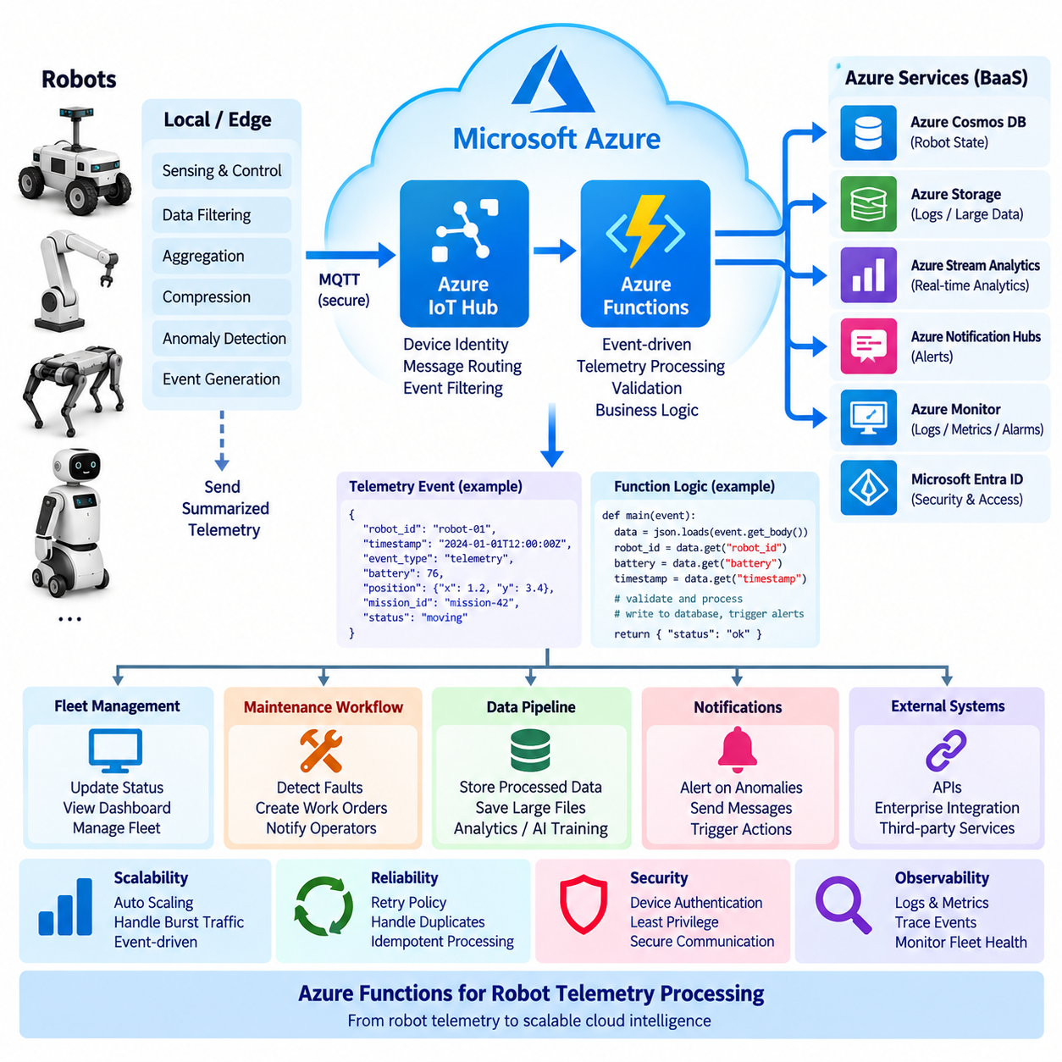
}
```
}
```
Azure Functions is a serverless compute service that executes application logic in response to events without requiring developers to manage continuously running servers. In a robotics system, it can process telemetry generated by robots, edge gateways, or IoT devices and connect that information to cloud databases, storage, monitoring, notification, and fleet-management services. The main architectural purpose is to move asynchronous backend processing away from the robot while keeping real-time control and safety functions on the robot or edge system.
Robot telemetry represents operational information generated during robot operation. Typical data includes robot identity, timestamp, position, battery state, velocity, operating mode, mission status, sensor health, fault codes, and communication status. A robot may publish these values periodically or only when a significant state changes. Azure Functions can receive such messages through services such as Azure IoT Hub or other supported event sources and execute processing logic only when telemetry or an operational event arrives.
A practical telemetry architecture separates high-frequency raw data from meaningful operational information. The robot or edge computer can perform local filtering, aggregation, compression, and anomaly detection before transmitting data to the cloud. For example, instead of continuously sending every sensor measurement, the edge system can calculate battery trends, average velocity, localization quality, or fault conditions and transmit summarized telemetry. Azure Functions can then process these messages and update the corresponding cloud-side robot state.
Azure IoT Hub can provide the device-to-cloud communication layer for a fleet of connected robots. Each robot can have an authenticated device identity and publish telemetry through the IoT communication interface. IoT Hub can route messages according to their content or destination, allowing selected telemetry to reach an Azure Function while other data is directed toward storage or analytics systems. This creates a separation between device communication and application-level telemetry processing.
When a telemetry message reaches an Azure Function, the function should first validate the event structure and required fields. A consistent schema might contain robot_id, timestamp, event_type, battery, position, mission_id, and status information. Validation prevents malformed or incomplete messages from propagating into fleet databases. It also provides a defined interface between robot software and cloud services, allowing different robot models or software versions to communicate with the same backend processing pipeline.
A simple function can extract the robot identity and telemetry values, apply basic processing, and pass the result to another Azure service. The function should remain relatively small and focused on one responsibility. For example, one function can process battery telemetry, another can handle fault events, and another can generate maintenance notifications. Separating these responsibilities makes individual functions easier to test, deploy, monitor, and scale as the robot fleet grows.
```python
import json
def main(event):
data = json.loads(event.get_body().decode(“utf-8”))
robot_id = data.get(“robot_id”)
battery = data.get(“battery”)
timestamp = data.get(“timestamp”)
if not robot_id or battery is None:
raise ValueError(“Invalid robot telemetry”)
return {
“robot_id”: robot_id,
“battery”: battery,
“timestamp”: timestamp
Telemetry processing often requires persistent storage because an Azure Function should not depend on its temporary execution environment for robot state. Processed telemetry can be written to an appropriate Azure data service, while large diagnostic files, images, logs, or other objects can be stored separately. A function may therefore transform an incoming message into a compact operational record while a separate storage pipeline retains larger datasets for later analysis, troubleshooting, or AI training.
An important application is fleet-state management. When a robot reports a new battery level, mission state, fault condition, or connectivity status, an Azure Function can update the corresponding fleet record. A fleet-management application can then retrieve this information to display the current status of individual robots. The same event can also initiate additional workflows, such as creating a maintenance task when repeated faults are detected or notifying an operator when a robot enters a predefined abnormal state.
Serverless telemetry processing must account for duplicate messages, delayed messages, and temporary communication failures. Robot networks can disconnect and reconnect, and distributed event systems may deliver an event more than once. Telemetry records should therefore contain identifiers and timestamps that allow the backend to recognize duplicates and determine the appropriate ordering. Processing should be designed to be idempotent where possible, so that receiving the same logical event twice does not create two maintenance tickets or corrupt the robot's operational state.
Azure Functions also provides a useful mechanism for event-driven anomaly handling. A function can evaluate telemetry against predefined operational rules, such as an unusually rapid battery decrease, repeated localization failures, excessive motor temperature, or repeated communication loss. The function itself should not directly replace the robot's safety controller. Instead, it can classify the reported condition, record the event, update fleet state, and trigger an operator notification or maintenance workflow. Immediate physical protection remains the responsibility of the robot and edge control system.
Scaling is another reason to use Azure Functions for fleet telemetry. A small fleet may generate a modest number of events, while a large fleet can produce significant bursts when many robots start operating, reconnect to the network, or report simultaneous conditions. Serverless execution can increase the number of function instances as demand changes. However, downstream services such as databases and APIs can become bottlenecks, so concurrency, message buffering, retry policies, and resource limits should be considered as part of the complete architecture rather than relying solely on automatic function scaling.
Security must be applied across the complete telemetry path. Each robot should have an authenticated identity, and communication between the robot, IoT service, and cloud backend should be protected. Azure Functions should use managed identities or appropriately scoped credentials when accessing other Azure resources. Permissions should follow the principle of least privilege so that a telemetry-processing function receives only the access required to perform its task. Sensitive credentials should not be embedded directly in robot software or function source code.
Monitoring is essential because telemetry processing is distributed across devices, network connections, event services, functions, databases, and fleet applications. Application logs and metrics can be used to determine whether events are arriving, functions are executing successfully, processing latency is increasing, or failures are being retried. Including robot ID, event ID, mission ID, and timestamps in structured logs makes it possible to trace a cloud-side problem back to the operational context of a particular robot.
The resulting architecture can be understood as a continuous telemetry flow from the physical robot to the cloud. The robot performs real-time sensing, control, localization, and safety processing locally, while selected telemetry is transmitted through the IoT communication layer. Azure Functions receives and processes relevant events, validates the data, updates persistent robot state, and activates downstream workflows such as fleet management, analytics, maintenance, and notification. This division allows cloud computing to scale independently from the physical robot while preserving local autonomy.
Azure Functions is therefore most appropriate for asynchronous and event-driven robotics workloads rather than deterministic robot control. Telemetry transformation, fleet-state updates, fault processing, maintenance workflows, notifications, data indexing, and integration with enterprise systems are suitable examples. Real-time motion control, emergency stopping, collision avoidance, and latency-critical perception should remain on the robot or edge infrastructure. Used in this way, Azure Functions becomes a scalable serverless telemetry-processing layer within a broader hybrid cloud-edge robotics architecture.
```python
import json
def main(event):
data = json.loads(event.get_body().decode(“utf-8”))
robot_id = data.get(“robot_id”)
battery = data.get(“battery”)
timestamp = data.get(“timestamp”)
if not robot_id or battery is None:
raise ValueError(“Invalid robot telemetry”)
return {
“robot_id”: robot_id,
“battery”: battery,
“timestamp”: timestamp

10.04 GCP Cloud Functions: Robot Notification Pipeline [w/Code]
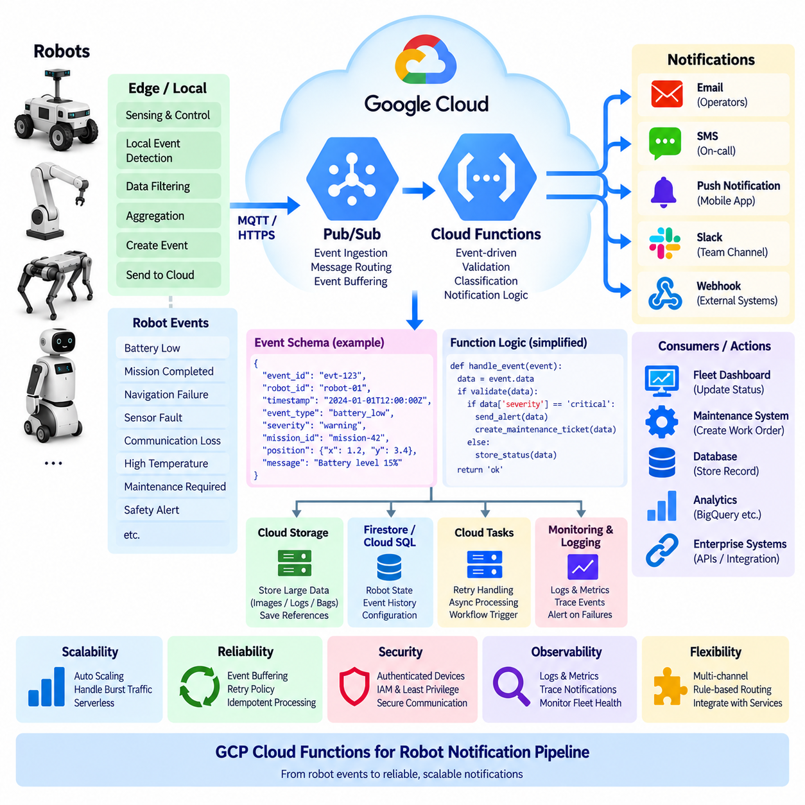
Google Cloud Functions is a serverless execution service that runs application logic in response to events without requiring developers to maintain continuously running servers. In robotics, it can provide a notification-processing layer between robots, edge gateways, telemetry services, event brokers, databases, and operator applications. A robot or fleet service generates an event, the cloud receives and evaluates it, and a function executes the required notification logic only when the corresponding condition occurs.
A robot notification pipeline begins with meaningful operational events rather than every raw sensor measurement. Typical events include low battery, mission completion, navigation failure, sensor malfunction, communication loss, abnormal temperature, maintenance requirements, or safety-related alerts. The robot or edge computer can determine the local condition and publish a structured event. The cloud function then converts that event into an appropriate notification or downstream workflow without placing cloud execution inside the robot's real-time control loop.
Google Cloud Pub/Sub provides a natural event-ingestion mechanism for this architecture. A robot gateway or backend service can publish structured messages to a topic, while subscribers receive only the events relevant to their responsibilities. A Cloud Function can be triggered when a message arrives and can extract the robot identity, event type, severity, timestamp, mission information, and other required metadata. This creates a loosely coupled relationship between robot event generation and notification processing.
The event schema should be standardized across the robot fleet so that different robot models and software versions can use the same notification pipeline. A typical event can contain robot_id, event_id, timestamp, event_type, severity, mission_id, position, and descriptive information. The function should validate these fields before processing the event. Consistent schemas also make downstream logging, analytics, alert filtering, and integration with fleet-management software substantially easier.
A notification function should separate event classification from message delivery. After receiving an event, the function can determine whether the event requires immediate operator attention, routine reporting, maintenance action, or no external notification. A low-priority status update may be stored without generating an alert, while a critical robot fault can activate an operator notification and create a maintenance workflow. This prevents operators from being overwhelmed by high-frequency telemetry that does not require human intervention.
The notification destination can vary according to event severity and operational requirements. A function may forward an event to an application backend, publish another Pub/Sub message, write an operational record to a database, or invoke an external notification service. Different consumers can therefore process the same event independently. For example, the fleet dashboard can update robot status while a maintenance system creates a work order and an operator-facing application displays an alert.
Serverless execution is particularly useful when notification traffic is irregular. A fleet may generate very few alerts during normal operation but experience a sudden increase when many robots reconnect after a network outage or when a common software or hardware problem affects multiple units. The serverless platform can create additional function execution capacity as event volume changes. However, downstream notification systems and databases must still be protected from excessive concurrency and event bursts.
A reliable notification pipeline must also consider duplicate events and retries. Distributed systems may deliver the same logical message more than once, particularly when communication problems or retry mechanisms are involved. Each event should therefore have a unique event_id that can be used to identify previously processed messages. Notification processing should be idempotent where possible so that a repeated event does not generate multiple identical alerts, duplicate maintenance tickets, or inconsistent fleet-state updates.
Temporary cloud or network failures should not cause important robot events to disappear. Pub/Sub-based processing can provide buffering between event production and function execution, allowing the system to absorb temporary differences between event arrival and processing capacity. Retry handling can attempt failed processing again, while messages that repeatedly fail can be isolated for investigation. The robot itself should continue operating according to its local autonomy and safety logic rather than waiting for successful cloud notification delivery.
Notification priority should be based on operational meaning rather than simply on message frequency. A battery warning may require a charging recommendation, while a critical drive-system fault may require immediate operator attention. A mission-completed event may only update a dashboard or operational database. This classification can be implemented inside the function or through event-routing rules so that the same serverless infrastructure supports multiple operational workflows without creating a single monolithic notification service.
Security must be applied to the complete notification path. Robot and gateway identities should be authenticated before events enter the cloud pipeline, and access to Pub/Sub topics and downstream services should be controlled through appropriate identity and authorization mechanisms. A function should receive only the permissions necessary for its task. Credentials and sensitive configuration should not be embedded directly in application code, while logs should avoid exposing unnecessary private or security-sensitive information.
Observability is essential because the notification pipeline spans robots, networks, message brokers, functions, databases, and user-facing applications. Function execution logs and metrics can reveal whether events are arriving, whether processing succeeds, how long execution takes, and whether retries or failures are increasing. Robot IDs and event IDs should be included in structured logs so that an operator or developer can trace a notification from the original robot event through cloud processing to the final operational action.
Large sensor data should normally remain outside the notification message itself. Camera images, LiDAR point clouds, videos, ROS bags, and large diagnostic files can be stored through an appropriate object-storage or data pipeline, while the notification event contains only the relevant metadata and a reference to the stored data. A function can then generate a concise alert such as a sensor fault notification while providing the operator with enough information to locate the corresponding diagnostic dataset.
The overall architecture can therefore be viewed as a flow from robot operation to event-driven cloud notification. The robot and edge system perform sensing, localization, control, safety processing, and local anomaly detection. Selected operational events are published to the cloud event layer, Pub/Sub distributes those events, and Cloud Functions performs validation, classification, notification, persistence, and workflow triggering. The resulting services can update fleet dashboards, notify operators, initiate maintenance, and integrate with external enterprise systems.
Within a broader cloud-edge robotics architecture, Google Cloud Functions is most appropriate for asynchronous notification and workflow processing rather than deterministic robotic control. Its role is to connect meaningful robot events with scalable cloud-side actions while preserving local autonomy at the physical edge. When combined with event buffering, structured event schemas, idempotent processing, controlled concurrency, secure identities, and strong observability, a serverless notification pipeline can support fleet operations from a small deployment to a large population of connected robots.

10.05 Serverless AI Inference: AWS Inferentia [w/Code]
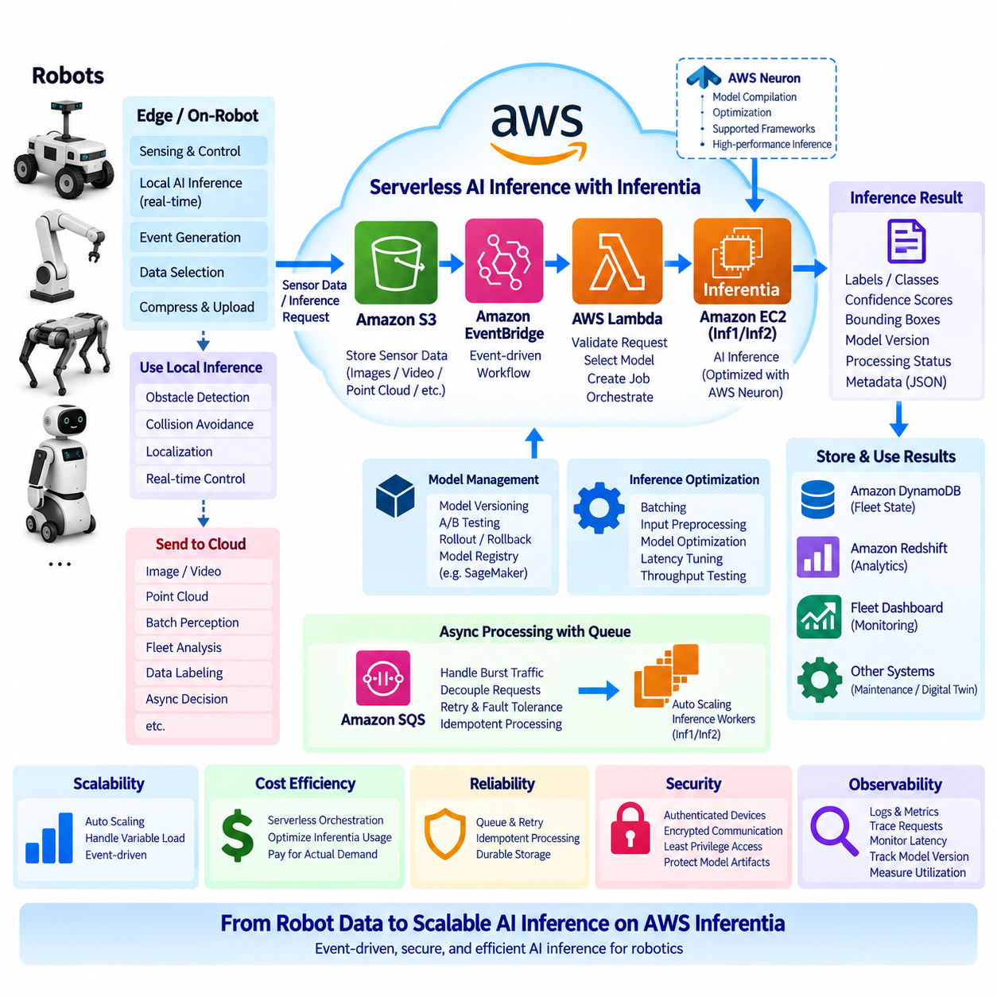
AWS Inferentia is a purpose-built AWS accelerator designed to execute deep learning inference workloads with an emphasis on improving inference efficiency. In a robotics cloud architecture, Inferentia can be used when AI models that normally execute on GPUs need to serve many inference requests in a scalable backend environment. The important architectural distinction is that Inferentia is an accelerator rather than a serverless service itself. Serverless AI inference therefore combines an event-driven or managed serving layer with compute infrastructure equipped with Inferentia.
Robot AI inference can be divided according to latency and operational requirements. Immediate perception, obstacle detection, collision avoidance, localization assistance, and other control-related inference should normally remain on the robot or edge computer because network latency and cloud availability cannot provide deterministic behavior. Cloud inference is more appropriate for workloads such as image reprocessing, batch perception, fleet-level analysis, large-model inference, data labeling assistance, and asynchronous decision-support services that do not directly control the robot.
A typical architecture begins when a robot or edge gateway uploads selected sensor data or generates an inference request. Large images, video segments, point clouds, or other files can be stored in Amazon S3, while a lightweight event can contain the robot ID, data location, model version, timestamp, and inference request type. An event-driven service can then initiate the inference workflow. This separation prevents large sensor payloads from being unnecessarily transferred through short-lived function execution environments and allows inference workers to retrieve the required data directly from persistent storage.
AWS Lambda can participate in the orchestration layer, but it should not automatically be interpreted as the execution environment for the Inferentia model itself. Lambda is well suited to validating an inference request, locating an input object, selecting a model version, creating a job, and returning or recording the result. The actual inference can run on an Inferentia-backed service or instance that is designed to provide the required accelerator resources. This distinction is important when designing a realistic serverless architecture because serverless orchestration and accelerated model execution have different resource and lifecycle requirements.
AWS Neuron provides the software stack used to develop and execute machine-learning workloads on AWS Inferentia. A model must be supported by the relevant Neuron framework and execution environment, and model compilation or optimization may be required before deployment. The deployment process therefore includes more than simply replacing a GPU with an Inferentia accelerator. Model architecture, supported operators, numerical precision, batch size, memory behavior, preprocessing, and inference latency all need to be evaluated against the target workload.
For robotics, model selection should begin with the actual inference pattern rather than the accelerator name. A fleet may generate thousands of relatively small image-classification or object-recognition requests, or it may generate fewer but much larger multimodal requests. Inferentia can become attractive when the workload has sufficiently stable model execution characteristics and enough inference demand to benefit from dedicated acceleration. Conversely, a rapidly changing research model, unsupported operator set, or highly irregular workload may require a different compute platform during development.
Serverless orchestration provides an effective way to absorb irregular inference demand. A fleet may generate little cloud inference traffic during normal operation and then produce a burst when robots upload large numbers of images after a field mission. An event-driven system can place inference requests into a queue and increase processing capacity according to demand. This decoupling also prevents temporary inference congestion from blocking the robot itself because the robot can continue its local operation while asynchronous cloud processing proceeds.
Batching can significantly influence inference efficiency. Instead of launching an independent inference execution for every individual image, the backend can collect compatible requests and process them in batches when application latency permits. Batch size, model execution time, memory usage, and queue delay must be considered together. Robotics applications with strict response requirements may prefer smaller batches, while offline inspection, dataset processing, and fleet analytics can tolerate larger batches in exchange for improved accelerator utilization.
Model optimization is another important part of an Inferentia-based architecture. The same neural network can exhibit different performance characteristics depending on input dimensions, numerical precision, preprocessing, and execution configuration. A robotics team should therefore benchmark the complete inference pipeline rather than measuring only raw accelerator throughput. Image decoding, resizing, normalization, data transfer, model execution, post-processing, storage access, and network communication can all contribute to end-to-end latency.
A cloud inference result should normally be returned as structured metadata rather than as another large data payload. For example, an object-detection request can produce detected classes, confidence values, bounding boxes, timestamps, model version, and processing status. The original image or sensor recording can remain in object storage. This approach reduces unnecessary network transfer and makes the inference result easier to store in a fleet database, analytics system, or digital-twin service.
Model version management becomes particularly important when inference is provided to a large robot fleet. Every result should identify the model version used for processing so that changes in AI behavior can be traced later. A deployment system can maintain multiple model versions during validation and gradually move workloads from one version to another. If an updated model produces unexpected results, the service can route subsequent requests back to a previously validated version without changing the robot's local control software.
Reliability requires the inference pipeline to tolerate duplicated requests, delayed execution, worker failures, and temporary service interruptions. Each inference request should have a unique request ID, together with robot ID, mission ID, input-data reference, and model version. Processing can then be designed to be idempotent so that retrying a request does not unintentionally create multiple operational records. Queues and durable storage can separate request generation from inference execution and preserve work during temporary capacity shortages.
Security is especially important when robots transmit images or other operational data to cloud inference services. Device identities should be authenticated, communication should be encrypted, and access to stored sensor data should be controlled through narrowly scoped permissions. The inference execution environment should receive only the permissions required to read its input data and write its results. Model artifacts should also be protected because unauthorized modification of an AI model could change the behavior of the inference service without requiring any modification to the robot software.
Observability should measure the complete inference path rather than accelerator utilization alone. Useful measurements include request rate, queue depth, invocation or job latency, model execution time, preprocessing time, post-processing time, failure rate, retry count, accelerator utilization, and result-generation latency. Robot ID, request ID, model version, and timestamps provide the correlation information required to trace an individual inference request from the physical robot through cloud processing to the final result.
Cost optimization requires comparing Inferentia with alternative execution environments according to the actual workload. Serverless functions can be economical for lightweight orchestration because they execute only when triggered, while continuously running accelerated inference workers introduce a different cost structure. If the workload is highly intermittent, queue-based processing can reduce idle accelerator capacity. If demand is consistently high, dedicated Inferentia capacity may provide more predictable economics. The correct architecture therefore depends on request volume, model size, latency requirements, utilization, storage, and data-transfer patterns.
The resulting hybrid architecture places real-time AI inference at the edge and asynchronous or high-volume inference in the cloud. The robot performs latency-sensitive perception and control locally, while selected data is uploaded to cloud storage and converted into inference requests. Serverless components manage event handling and workflow orchestration, while Inferentia-backed compute performs the accelerated model execution. Results return to databases, analytics systems, dashboards, or downstream AI pipelines rather than becoming a direct dependency of the robot's safety controller.
AWS Inferentia is therefore best understood as one possible acceleration layer within a broader serverless AI architecture rather than as a replacement for edge AI or as a serverless function platform. Its value in robotics emerges when asynchronous inference workloads can be separated from real-time control, standardized models can be efficiently executed, and cloud-side demand is sufficiently large or variable to justify specialized inference infrastructure. Combined with event-driven orchestration, durable storage, model versioning, security, monitoring, and appropriate workload partitioning, this architecture provides a practical path from individual robot inference requests to scalable fleet-level AI processing.

10.06 Serverless Event Sourcing: EventBridge / Event Grid [w/Code]
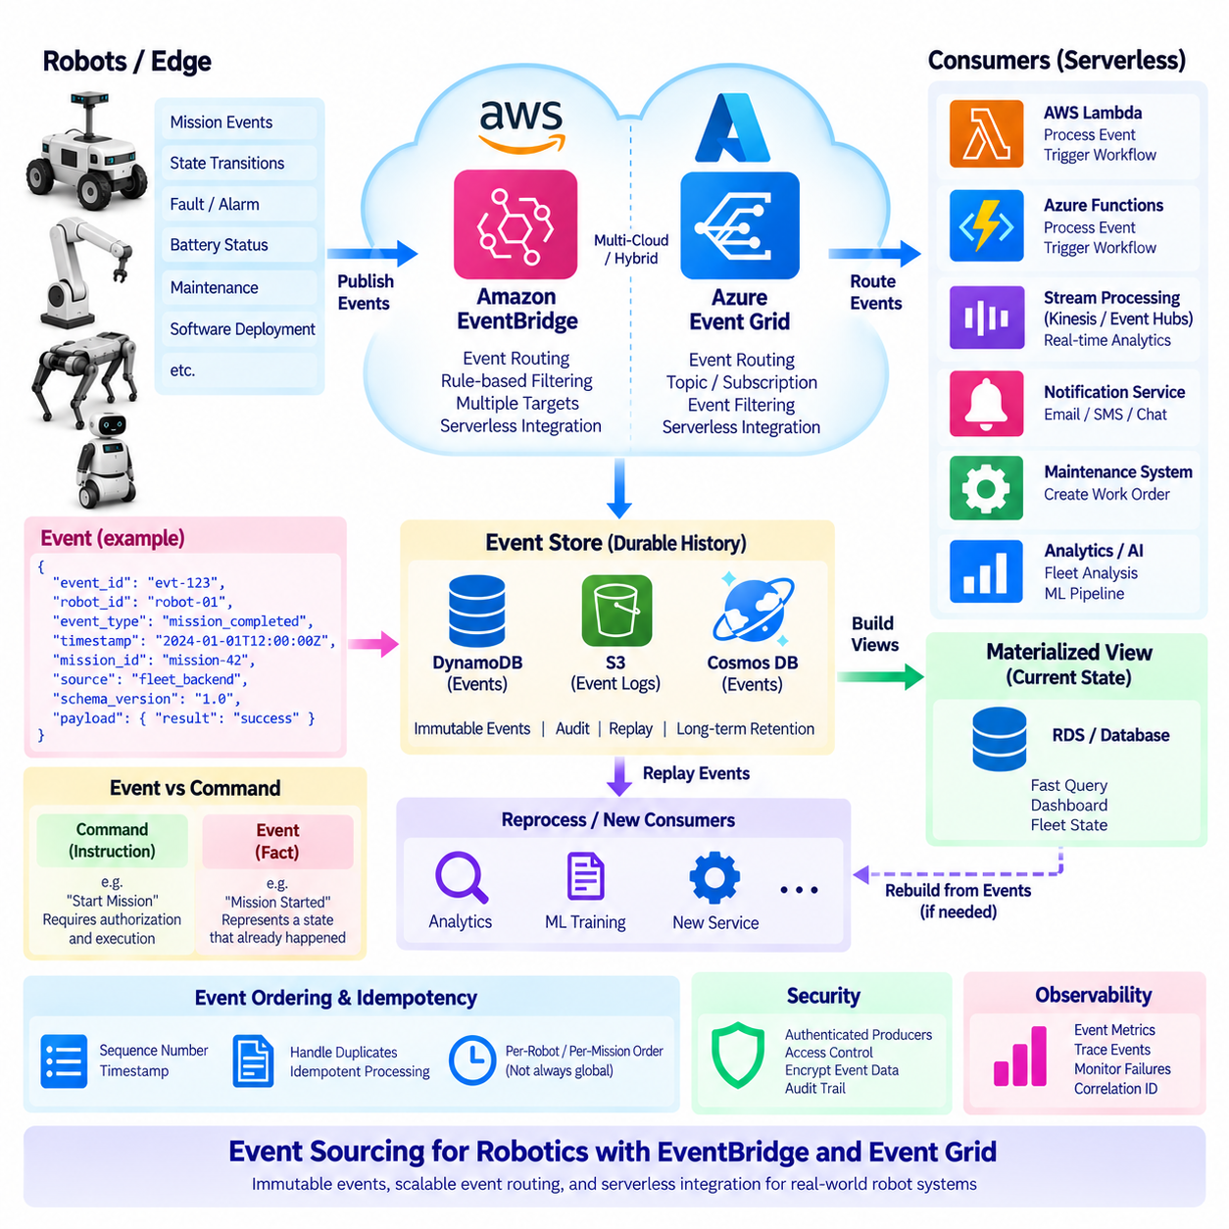
Event sourcing is an architectural pattern in which changes in system state are represented as a sequence of immutable events rather than being stored only as the latest state. In a robotics platform, events can describe meaningful changes such as mission creation, mission completion, robot connection, battery-state transition, navigation failure, maintenance detection, or software deployment. The event history becomes a durable record of what happened and provides a foundation for reconstructing operational state, auditing actions, and triggering downstream workflows.
A robot fleet can generate a large number of operational events during normal operation, but not every sensor measurement should become a business event. Real-time sensor streams normally remain within the robot or edge processing pipeline, while event sourcing focuses on meaningful state transitions. For example, a battery value changing continuously is telemetry, whereas the transition from normal operation to low-battery status can become an event. This distinction prevents the event store from becoming an unnecessarily high-volume replacement for a telemetry database.
In an event-sourced architecture, an event should describe something that has already happened rather than simply representing a command that someone wants to execute. A structured event can contain an event ID, robot ID, event type, timestamp, mission ID, source, schema version, and relevant payload. Once an event is accepted into the event stream, it should normally be treated as immutable. Later processing can create new events when additional state transitions occur, preserving the historical sequence instead of silently overwriting previous information.
Amazon EventBridge provides an event-driven routing service that can connect events from AWS services, applications, and other sources to downstream targets. In a robotics environment, a fleet backend, IoT integration layer, or application service can publish operational events, while EventBridge rules determine which consumers should receive them. A single robot fault event could therefore be routed to a monitoring workflow, a maintenance service, a notification function, and an analytics pipeline without requiring the robot itself to know the implementation details of each downstream system.
Microsoft Azure provides a comparable event-routing capability through Azure Event Grid. Event Grid is designed to distribute events between event publishers and subscribers using event-driven integration patterns. For robotics, this can connect device or application events with Azure Functions, storage workflows, monitoring systems, databases, and other services. The architectural concept remains the same across cloud providers: producers publish meaningful events, an event-routing layer distributes them, and independent consumers perform their own processing.
EventBridge and Event Grid should not be confused with a complete event-sourcing database. Their primary architectural role is event distribution and routing, whereas durable event history may require an appropriate event store, database, object storage system, or streaming platform. A robotics architecture can therefore use an event bus to distribute an event immediately while separately persisting the event for historical analysis and state reconstruction. This separation allows operational routing and long-term event retention to evolve independently.
A useful robotics pattern is to combine event sourcing with a materialized view of current fleet state. When a robot reports a mission-completed event, the event is retained as historical evidence while a consumer updates a current-status database. The dashboard can then read the materialized view for fast access, while analysts can return to the event history when they need to understand how the robot reached that state. If the materialized view must be rebuilt, the stored event sequence can be replayed to reconstruct the required state.
Event replay is one of the most important capabilities of event sourcing. A new service can consume historical events and construct its own representation without requiring the original robot to resend all information. For example, a fleet analytics service introduced after deployment could replay mission, fault, charging, and maintenance events to calculate historical utilization. This makes the architecture extensible because new consumers can derive new views from existing operational history rather than requiring changes to every event producer.
Event ordering and consistency require careful treatment in distributed robotics systems. Multiple robots can generate events simultaneously, and network conditions can cause messages to arrive at different times. A globally ordered event stream may not be necessary for the entire fleet; ordering can instead be defined within an appropriate scope such as a robot, mission, or device. Sequence numbers, timestamps, event IDs, and version information can help consumers determine whether an event is duplicated, delayed, or inconsistent with the state they have already processed.
Idempotency is essential when events can be retried or delivered more than once. A consumer should be able to recognize an event that it has already processed and avoid repeating an irreversible operation. For example, receiving the same maintenance-required event twice should not create two maintenance tickets. Persistent event IDs and processing records provide a practical mechanism for duplicate detection. This principle is especially important when serverless functions consume events because automatic retries can occur after temporary execution failures.
Event-driven robotics systems should also distinguish between commands and events. A command such as “start mission” represents an instruction that requires authorization and execution, while an event such as “mission started” represents a fact about the resulting system state. This distinction improves traceability and makes the architecture easier to reason about. Commands may pass through an appropriate control or fleet-management service, while resulting state transitions are published as events that can be consumed by monitoring, analytics, notification, and audit services.
Security must be applied at the event boundary as well as inside downstream services. Robot and application identities should be authenticated before events enter the event infrastructure, and permissions should restrict which producers can publish to particular event channels and which consumers can subscribe to them. Event payloads should contain only the information required by downstream processing, while sensitive data should be protected through appropriate encryption and access controls. Audit records should make it possible to determine which system generated an event and which services subsequently acted upon it.
Observability becomes more important as the number of event producers and consumers increases. Event IDs, robot IDs, mission IDs, timestamps, schema versions, and correlation identifiers should be propagated through the processing chain. Monitoring can then determine whether events are being published, routed, consumed, retried, delayed, or rejected. When a fleet dashboard shows an unexpected robot state, engineers can trace the corresponding event history rather than inspecting isolated logs from individual services. This provides a stronger operational foundation for distributed fleet systems.
Within a serverless robotics architecture, event sourcing, EventBridge, and Event Grid provide complementary capabilities rather than a single replacement technology. Event sourcing establishes a durable history of meaningful state changes, while EventBridge or Event Grid distributes those events to independent consumers. Serverless functions can transform events and trigger workflows, databases can maintain current materialized state, and analytics systems can consume historical streams. The robot remains responsible for real-time autonomy and safety, while cloud event infrastructure provides scalable coordination, traceability, and integration across the fleet.

10.07 Serverless Cold Start vs Robot Real-Time Requirements
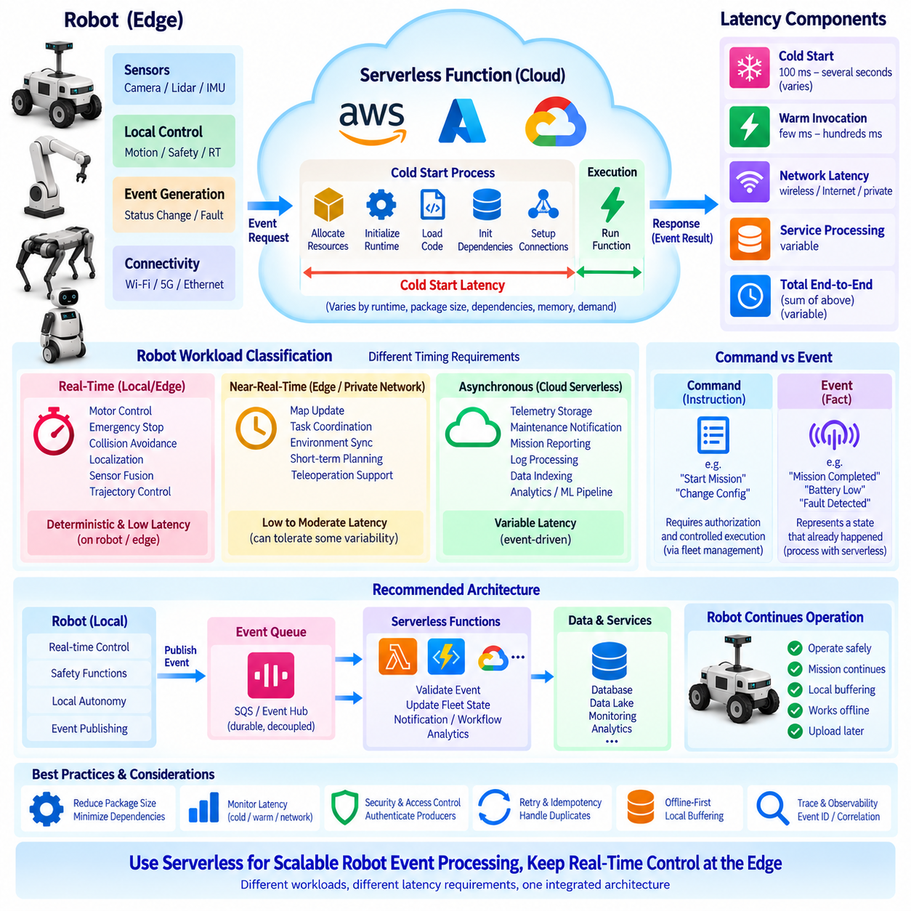
Serverless computing introduces a different latency model from conventional continuously running services. A serverless function is invoked only when an event arrives, and the platform may need to allocate an execution environment before the function can begin processing. This initialization delay is commonly described as a cold start. For robotics, the architectural question is therefore not simply whether serverless execution is fast, but whether its latency characteristics match the timing requirements of the workload. Real-time robot control and serverless event processing must be treated as fundamentally different execution domains.
A cold start occurs when a suitable execution environment is not already available for a function invocation. The platform may need to allocate resources, initialize the runtime, load application code, initialize libraries, and establish required connections before executing the requested logic. Subsequent invocations may reuse a warm environment and therefore avoid much of this initialization work. The resulting latency can vary depending on runtime, package size, dependencies, memory configuration, platform behavior, and current demand. Consequently, average latency alone is insufficient when evaluating serverless services for robotics.
Robot workloads have widely different timing requirements. Motor control, emergency stopping, collision avoidance, actuator commands, localization updates, sensor fusion, and trajectory control can require highly predictable execution. Other workloads, such as telemetry storage, maintenance notification, mission reporting, log processing, data indexing, and cloud analytics, can tolerate variable latency. The correct architecture therefore begins by classifying each workload according to its timing requirement rather than treating all robot software as a single latency class.
The most important boundary is between deterministic local control and asynchronous cloud processing. A robot should retain sufficient local capability to detect hazards, stop safely, continue a mission when appropriate, and recover from temporary network loss. A cloud function should not become a hidden dependency inside a safety-critical control loop. If a robot must wait for a remote function to determine whether an obstacle should be avoided or whether a motor should stop, the architecture has transferred a real-time responsibility to a component whose execution latency is not inherently deterministic.
Serverless functions are instead well suited to event-driven robot operations. A robot can publish a battery warning, mission-completed event, fault notification, diagnostic upload event, or maintenance condition. The cloud platform can invoke a function that validates the event, updates fleet state, creates a notification, records an operational history, or initiates another workflow. The robot does not need to wait for completion of these cloud operations. This separation allows serverless computing to provide scalable backend processing without compromising the local execution path responsible for physical robot behavior.
Network latency must also be considered separately from cold-start latency. Even when a function is already warm, a robot communicating with a remote cloud service experiences wireless transmission, routing, Internet or private-network transport, service processing, and response delays. A cloud architecture may therefore have several variable latency components before the result reaches the robot. For non-critical reporting this may be acceptable, but for time-sensitive control the combined network and cloud latency can make remote execution unsuitable even when the function itself executes quickly.
A useful design principle is to classify robot operations into real-time, near-real-time, and asynchronous categories. Real-time functions remain on the robot or local edge computer. Near-real-time functions may use a nearby edge service or carefully designed private-network architecture when their timing requirements permit some variability. Asynchronous functions can be sent to cloud serverless infrastructure, where event queues and managed services absorb bursts and allow processing to occur independently of the robot's control cycle. This classification creates a clear workload boundary between physical autonomy and cloud automation.
Cold-start sensitivity can be reduced through appropriate platform and application design, but it should not be treated as a reason to move safety functions into the cloud. Smaller deployment packages, reduced dependencies, efficient initialization, appropriate runtime selection, and connection reuse can reduce initialization overhead. Some cloud platforms also provide mechanisms for maintaining pre-initialized execution capacity when predictable startup behavior is important. These techniques can improve serverless responsiveness, but they do not transform a cloud function into a deterministic robot controller.
Event queues provide another important mechanism for separating timing domains. Instead of requiring a robot to synchronously call a cloud function and wait for a response, the robot can publish an event to a durable messaging service. The event is retained while the backend processes it according to available capacity. This approach absorbs traffic bursts, supports retries, and prevents temporary cloud congestion from directly affecting robot operation. The robot can continue executing its local mission while the cloud processes telemetry, maintenance, reporting, and other asynchronous workloads.
The distinction between command and event is particularly important in this architecture. A remote command such as a mission request or configuration change may require authorization and controlled execution, while an event such as mission-completed or battery-low represents a fact that has already occurred. Serverless functions are especially effective at processing these resulting events. For commands that can affect physical motion or safety, an appropriate fleet-control and authorization layer should remain between the external request and the robot's local control system.
Observability should measure latency distributions rather than relying only on average execution time. A robotics serverless deployment should distinguish cold-start latency, warm invocation latency, network latency, queue delay, downstream service latency, and total end-to-end processing time. Robot ID, event ID, mission ID, timestamps, and correlation identifiers allow an individual operation to be traced from the robot through the cloud pipeline. This makes it possible to determine whether a delay originated in the robot, network, function initialization, downstream service, or event queue.
Reliability also requires the robot to operate correctly when cloud execution is delayed or unavailable. Offline-first behavior, local buffering, retry mechanisms, durable event queues, and idempotent processing can prevent temporary cloud failures from becoming physical-system failures. A robot may continue its mission, store important telemetry locally, and upload the information when connectivity returns. When the cloud becomes available again, serverless functions can process the accumulated events without requiring the robot to reconstruct its entire operational history.
Within the serverless architecture defined for robotics, cold start should therefore be understood as an architectural constraint rather than merely a performance defect. Serverless functions provide strong advantages for event-driven, intermittent, and scalable backend workloads, while robots require predictable local execution for physical control and safety. The appropriate solution is a hybrid boundary: keep deterministic and latency-critical functions at the robot or edge, and use serverless services for asynchronous telemetry, notifications, event processing, reporting, maintenance, and cloud workflows. This separation allows the strengths of serverless computing to be used without confusing elastic cloud execution with real-time robotic control.

10.08 Serverless Function Test Automation [w/Code]
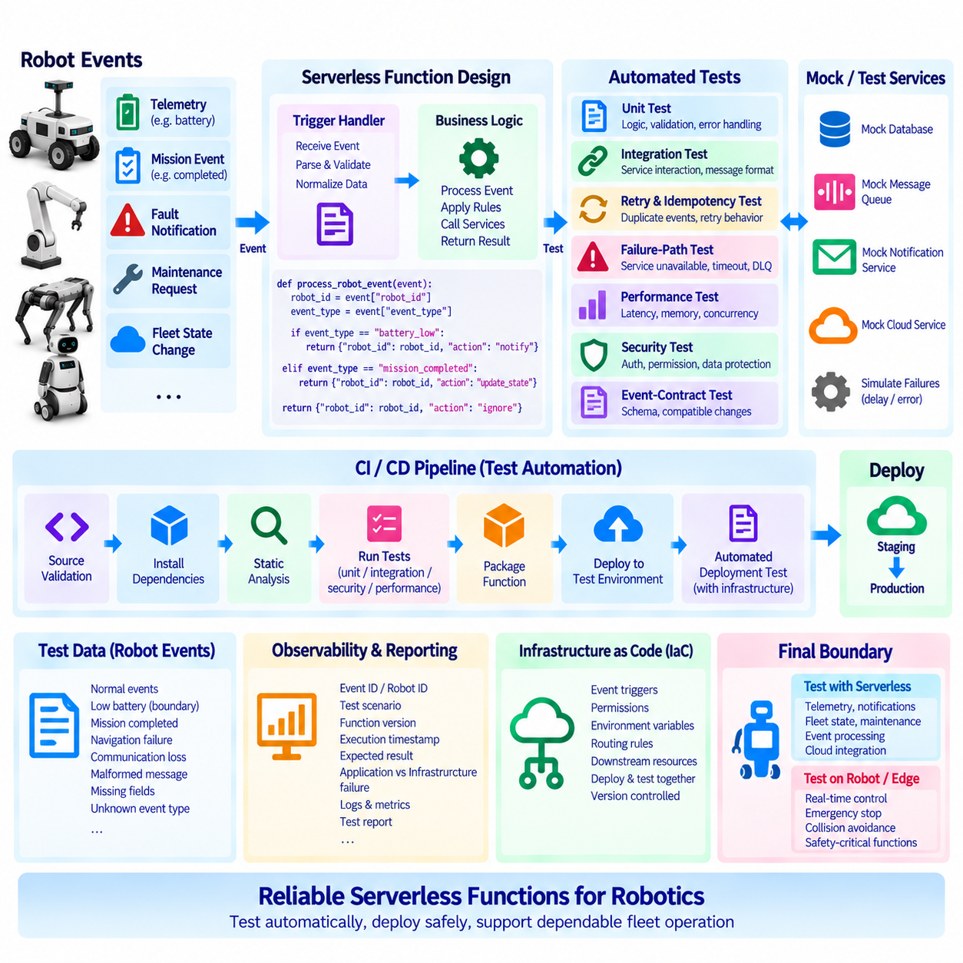
```
```
Serverless functions are short-lived, event-driven components, so automated testing is essential for verifying their behavior before deployment. In a robotics cloud system, a function may process robot telemetry, mission events, fault notifications, maintenance requests, or fleet-state changes. Testing should verify not only whether the function executes successfully, but also whether it handles valid, invalid, duplicated, delayed, and unexpected events correctly. Automated tests provide a repeatable way to validate these behaviors whenever function code or its surrounding infrastructure changes.
The first layer is unit testing, where the function's business logic is tested independently from the cloud platform. Event parsing, field validation, threshold evaluation, state transformation, notification selection, and error handling can be tested using predefined input events. External services should normally be replaced with mocks or test doubles so that the test does not depend on an actual database, message broker, notification service, or robot device. This makes unit tests fast and suitable for execution on every code change.
A serverless robotics function should be designed so that its core logic can be separated from the platform-specific trigger handler. The handler receives an event and converts it into a normalized application object, while a separate function performs the actual business operation. This structure makes testing easier because the business logic can be called directly with controlled test data. It also reduces the amount of cloud-specific code that must be exercised during every unit-test execution.
```python
def process_robot_event(event):
robot_id = event[“robot_id”]
event_type = event[“event_type”]
if event_type == “battery_low”:
return {“robot_id”: robot_id, “action”: “notify”}
if event_type == “mission_completed”:
return {“robot_id”: robot_id, “action”: “update_state”}
return {“robot_id”: robot_id, “action”: “ignore”}
Test data should represent realistic robot events rather than only ideal inputs. A test suite can include normal battery reports, low-battery transitions, mission completion, navigation failures, communication loss, malformed messages, missing robot identifiers, invalid timestamps, and unknown event types. Boundary conditions are particularly important because robot systems often trigger workflows based on thresholds. For example, a battery value exactly at the configured threshold should be tested separately from values just above and below that boundary.
Integration testing verifies that the function communicates correctly with the services surrounding it. A function that receives a message from an event broker and writes the processed result to a database has dependencies that cannot be completely represented by unit tests. Integration tests can therefore use a controlled test environment to verify message formats, authentication, database access, response handling, retries, and failure behavior. The purpose is to confirm that individually correct components also work correctly when connected together.
Event-driven systems require specific testing for retries and duplicate delivery. A cloud platform may invoke a function again when processing fails, and distributed messaging systems may deliver an event more than once. Automated tests should submit the same event repeatedly and verify that the function remains idempotent. For example, processing the same maintenance-required event twice should not create two maintenance records or send two unintended operator notifications. Unique event IDs and persistent processing records can be incorporated into these tests.
Failure-path testing is equally important because cloud services and networks are not permanently available. A test environment should simulate unavailable databases, delayed message delivery, rejected authentication, malformed payloads, timeout conditions, and temporary downstream failures. The expected behavior should be explicitly defined for each condition. Some errors should trigger a retry, some should be sent to a dead-letter mechanism, and some should be rejected immediately. Automated testing makes these failure policies repeatable instead of depending on manual experiments.
Performance testing should focus on the characteristics that matter to the serverless workload. Function execution time, initialization overhead, memory consumption, concurrent invocation behavior, queue delay, and downstream service latency can be measured under representative loads. For robotics, this testing should be connected to the distinction between asynchronous cloud processing and real-time robot control. A function used for telemetry processing may tolerate variable execution latency, while a function placed directly inside a safety-critical control path would create an inappropriate architectural dependency.
Security testing should verify that the function accepts events only from authorized sources and accesses downstream resources using the intended permissions. Automated tests can verify authentication failures, insufficient permissions, malformed credentials, unauthorized event sources, and attempts to access resources outside the function's intended scope. Secrets should be supplied through appropriate configuration or secret-management mechanisms rather than embedded in the test source code. Security tests should also verify that logs do not unintentionally expose sensitive robot or operational information.
A continuous integration pipeline can execute the serverless test suite automatically whenever function code changes. A typical sequence is source validation, dependency installation, static analysis, unit testing, integration testing, security checks, packaging, and deployment to a controlled environment. Only after the automated checks pass should the function be promoted to a staging or production environment. This approach is particularly useful for robotics because cloud functions may be changed frequently while the physical robot fleet continues operating with previously deployed software.
Infrastructure should also be included in automated validation where practical. A function can be correct while its event trigger, permissions, environment variables, routing rules, or downstream resource configuration is incorrect. Infrastructure-as-Code allows these resources to be represented as version-controlled configuration and recreated in a controlled test environment. Automated deployment tests can then verify that the function and the infrastructure surrounding it form a consistent operational unit rather than testing application code in isolation.
Test observability should provide enough information to diagnose failures quickly. Each automated test can include an event ID, robot ID, test scenario, function version, execution timestamp, and expected result. Logs and test reports should distinguish between application failures and infrastructure failures. For example, a test that fails because a database endpoint is unavailable should not be interpreted as a defect in the function's event-processing logic. Clear test metadata makes these distinctions easier to identify in continuous integration systems.
A mature serverless testing strategy should therefore combine unit tests, integration tests, event-contract tests, retry and idempotency tests, failure-path tests, security tests, performance tests, and deployment validation. The objective is not simply to prove that a function can execute, but to demonstrate that it behaves predictably across the distributed conditions encountered by a robot fleet. Tests should be repeatable, automated, version-controlled, and executed as part of the development lifecycle.
For robotics, the final boundary remains important: serverless function testing validates cloud-side asynchronous behavior, not the deterministic safety behavior of the robot itself. Real-time motion control, emergency stopping, collision avoidance, and other safety-critical functions require their own robot- and edge-level validation. Serverless test automation should instead ensure that telemetry, notifications, fleet-state updates, maintenance workflows, event processing, and cloud integrations remain reliable as the software evolves. This creates a continuous verification layer between serverless development and dependable fleet operation.
```python id=“69jpyp”
def process_robot_event(event):
robot_id = event[“robot_id”]
event_type = event[“event_type”]
if event_type == “battery_low”:
return {“robot_id”: robot_id, “action”: “notify”}
if event_type == “mission_completed”:
return {“robot_id”: robot_id, “action”: “update_state”}
return {“robot_id”: robot_id, “action”: “ignore”}

10.09 Serverless Cost Optimization Strategy
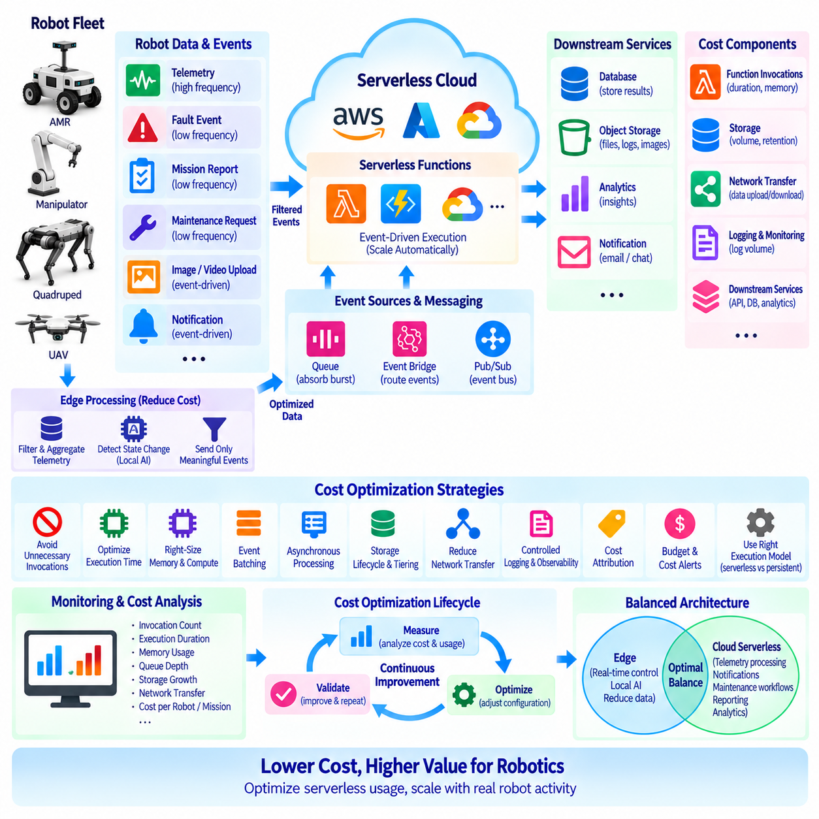
Serverless computing changes the cost model of a robotics cloud platform from continuously provisioned infrastructure toward consumption-based execution. Instead of maintaining servers for peak demand, functions and managed services can allocate resources when robot events arrive and reduce capacity when activity falls. This model can lower idle infrastructure cost, but it does not automatically guarantee a low-cost system. Cost optimization requires understanding invocation frequency, execution duration, memory allocation, storage, messaging, network transfer, logging, and downstream services as one complete architecture.
Robotics workloads are particularly suitable for selective serverless optimization because cloud activity often varies over time. Robots may generate continuous telemetry while producing fault events, mission reports, maintenance requests, image uploads, and notifications only occasionally. Treating every workload identically can create unnecessary cost. High-frequency data paths should therefore be separated from low-frequency operational events so that serverless functions are invoked only when computation or workflow execution is actually required.
The first optimization principle is to avoid unnecessary function invocations. Raw sensor streams can generate enormous numbers of messages if every camera frame, LiDAR measurement, motor status value, or localization update is sent directly into serverless processing. Edge filtering and aggregation can reduce this traffic before it reaches the cloud. A robot can summarize telemetry over an interval, detect meaningful state changes locally, and publish events only when operationally relevant conditions occur. This reduces function execution, message processing, database writes, storage growth, and network traffic simultaneously.
Function execution duration is another major optimization target. Serverless applications should avoid performing unnecessary initialization, repeated configuration loading, inefficient serialization, or redundant downstream calls during every invocation. Frequently reused clients and connections can be initialized efficiently where the execution environment permits reuse. Business logic should remain focused, while large or long-running processing tasks can be delegated to services better suited to their resource requirements. Reducing execution time can improve both responsiveness and cost efficiency.
Memory and compute configuration should be tuned according to measured workload behavior rather than selected arbitrarily. Allocating too many resources can increase the cost of simple event-processing functions, while allocating too few can increase execution time and potentially create a different cost or performance problem. Representative telemetry, notification, and fleet-management workloads should therefore be benchmarked across suitable configurations. Optimization should consider total execution cost and latency together rather than minimizing memory allocation in isolation.
Event batching can reduce the overhead associated with processing high-volume robot telemetry. Instead of invoking a function separately for every small event, compatible messages can be collected and processed together when latency requirements permit. Batch processing reduces repeated initialization and downstream connection overhead and can improve database-write efficiency. However, excessively large batches increase processing latency and failure scope. Batch size should therefore reflect the operational importance and acceptable delay of the robot workload.
Asynchronous processing is an important cost-control mechanism because it decouples robot event generation from backend execution capacity. A queue or event broker can absorb bursts when many robots reconnect, finish missions, or upload accumulated telemetry simultaneously. Backend workers can process these events at a controlled rate instead of scaling every downstream component immediately to peak traffic. This approach can reduce overprovisioning while protecting databases, APIs, and analytics systems from sudden concurrency spikes.
Storage cost should be optimized separately from compute cost. Robot fleets can accumulate large volumes of telemetry, diagnostic logs, images, video, point clouds, maps, and AI inference artifacts. Not all data requires the same retention period or storage performance. Recent operational data may require fast access, while older logs and sensor recordings can move to lower-cost archival tiers or be deleted according to retention policies. Metadata and large binary objects should also be separated so that databases are not used as expensive storage for files better suited to object storage.
Network data transfer can become a significant part of robotics cloud cost because robots generate data in the physical world and frequently transmit it to centralized services. Uploading every raw sensor stream is rarely economical or operationally necessary. Edge compression, filtering, event extraction, selective image upload, and local AI inference can reduce transferred data. Cloud architecture should also minimize unnecessary movement of the same dataset between regions, services, and external systems, since repeated transfers can increase both cost and processing latency.
Logging and observability require their own cost strategy. Serverless functions can generate large quantities of execution logs, especially when every invocation records verbose debugging information. Production environments should use structured logging with appropriate severity levels and retention policies. High-value identifiers such as robot ID, event ID, mission ID, function version, and error information should be retained, while repetitive low-value messages can be reduced. Metrics and sampled traces can often provide operational visibility without storing every detailed execution record indefinitely.
Cost attribution becomes increasingly important as a robot fleet grows. Cloud spending should be traceable to meaningful dimensions such as fleet, robot group, application, environment, function, data pipeline, or customer deployment. Resource tags, account or project separation, naming conventions, and billing reports can provide this visibility. Without cost attribution, a rapidly growing telemetry pipeline may appear only as a general cloud-cost increase, making it difficult to identify which robot service or workload is responsible.
Budgets and automated cost alerts provide a governance layer around technical optimization. Development, staging, simulation, and production environments should have defined spending expectations, and unexpected increases should generate notifications before they become large monthly charges. Cost anomalies can indicate software defects as well as business growth. A retry loop, duplicated event source, excessive logging configuration, or incorrectly configured telemetry frequency can rapidly increase serverless consumption even when the number of physical robots has not changed.
The lowest-cost architecture is not necessarily the architecture that uses serverless functions for every backend task. Stable workloads with continuously high utilization may be more economical on persistent compute, containers, reserved capacity, or specialized accelerators. Serverless execution is strongest when demand is intermittent, event-driven, bursty, or operationally difficult to predict. Cost optimization therefore requires comparing execution models according to actual utilization rather than assuming that either serverless or continuously running infrastructure is universally cheaper.
A hybrid robotics architecture provides additional optimization opportunities by deciding where computation should occur. Real-time control and latency-sensitive AI remain on the robot or edge system for operational reasons, while edge processing can also reduce cloud cost by filtering data before transmission. Serverless cloud services can then handle telemetry transformation, notifications, maintenance workflows, event routing, reporting, and asynchronous analytics. The goal is not simply to minimize cloud usage, but to place each workload where performance, reliability, and cost are balanced appropriately.
Continuous measurement is required because serverless economics change as the fleet scales. An architecture that is efficient for ten robots may behave differently when hundreds or thousands of robots generate events simultaneously. Teams should monitor invocation count, execution duration, memory use, queue depth, storage growth, network transfer, database operations, logging volume, and cost per robot or mission. These measurements connect technical behavior with financial impact and provide evidence for future architecture changes.
Serverless cost optimization for robotics is therefore a lifecycle process rather than a one-time configuration exercise. Effective optimization combines edge filtering, event-driven execution, right-sized functions, batching, asynchronous queues, storage lifecycle policies, network reduction, controlled observability, cost attribution, budgets, and continuous measurement. Serverless services should be applied where elasticity creates operational and economic value, while persistent infrastructure should remain an option for predictable high-utilization workloads. This balanced strategy allows cloud cost to scale more closely with useful robot activity instead of simply scaling with the amount of raw data produced by the fleet.

10.10 Robot Fleet Notification / Reporting Serverless Case
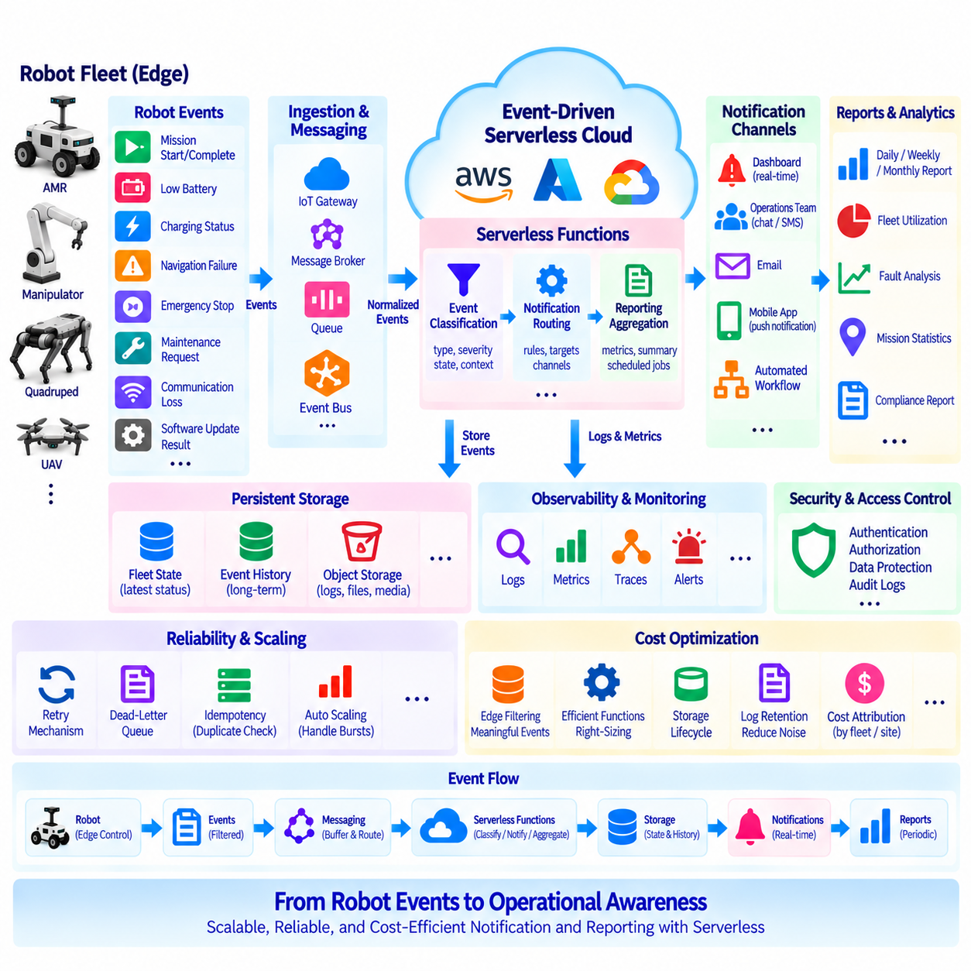
A robot fleet generates operational events continuously across missions, charging cycles, maintenance activities, connectivity changes, and autonomous navigation. A serverless notification and reporting architecture converts these distributed events into useful information without requiring continuously running application servers. Functions execute when meaningful events arrive, update fleet state, classify operational significance, generate notifications, and prepare reporting data. This model is particularly suitable for fleets whose event volume changes with robot activity.
The architecture begins at the robot and edge layer. Each robot maintains real-time control locally while publishing selected operational information to the cloud. Typical events include mission start and completion, low battery, charging status, localization failure, navigation interruption, emergency stop, sensor degradation, communication loss, maintenance requests, and software-update results. High-frequency raw sensor data should normally be filtered or summarized at the edge so that the notification pipeline receives meaningful events rather than every sensor measurement.
Events can enter the cloud through an IoT gateway, message broker, event bus, or managed messaging service. A normalized event schema allows different robot models and software versions to use the same backend processing pipeline. An event can contain fields such as robot ID, fleet ID, event ID, timestamp, event type, severity, mission ID, location, software version, and diagnostic information. Schema versioning is important because a fleet may contain robots operating different software releases during staged deployments.
The ingestion layer should decouple robot communication from notification processing. A queue or event bus can buffer events when many robots report simultaneously, such as after network recovery or a facility-wide charging period. Serverless functions consume these events independently of the robot connection and can scale according to workload. This prevents temporary backend congestion from directly blocking robot operation and allows events to be retried when downstream notification or database services are temporarily unavailable.
The first processing stage classifies the operational meaning of each event. A mission-completed event may require only a fleet-state update, while repeated localization failures may require an operator notification. A critical battery condition, emergency event, or persistent communication failure may require immediate escalation. Classification rules should therefore consider event type, severity, robot state, recent event history, mission context, and operational policy rather than simply sending a notification for every incoming message.
Notification routing determines who or what should receive the processed event. Different event classes may be delivered to a fleet operator dashboard, maintenance team, customer application, messaging platform, email service, mobile notification system, or automated workflow. Routing rules can also depend on facility, customer, robot group, time period, or severity. Separating classification from delivery allows notification channels to change without modifying the robot-side software or the fundamental event-processing logic.
Notification suppression is necessary because a robot can repeatedly report the same condition. Sending an alert every few seconds for one persistent fault can overwhelm operators and hide more important events. Serverless functions can use event IDs, robot state, time windows, and persistent records to detect duplicates and suppress repeated notifications. Related events can also be grouped into a single incident, while escalation logic can generate a new notification if the fault remains unresolved beyond a defined operational period.
Fleet state should be stored independently from the short-lived serverless function. A persistent database can maintain the latest known state of each robot, including availability, mission status, battery condition, connectivity, software version, fault state, and maintenance status. Each incoming event updates the appropriate state while the original event may also be preserved in an event store or historical database. This separation supports both current fleet dashboards and longer-term operational analysis.
Reporting requires a different processing pattern from immediate notification. Notifications answer questions such as what requires attention now, while reports summarize what happened over a longer period. Serverless functions can aggregate mission completion counts, robot utilization, charging activity, fault frequency, communication availability, maintenance events, and other operational indicators. Reports can be generated on event completion or scheduled periodically for daily, weekly, monthly, customer-specific, or facility-specific analysis.
A reporting pipeline should avoid repeatedly scanning all raw events whenever a report is requested. Event-processing functions can incrementally update aggregation records as events arrive, creating summaries by robot, fleet, site, mission, or time period. Scheduled serverless jobs can then transform these aggregates into operational reports. Large historical datasets can remain in object storage or analytical systems, while frequently accessed fleet summaries are maintained in databases optimized for rapid dashboard and reporting access.
Reliability is essential because notification systems often communicate abnormal robot conditions. Event processing should therefore support retries, dead-letter handling, idempotency, and durable storage where appropriate. If a notification provider is unavailable, the original event should not simply disappear. A failed delivery can be retried or stored for later investigation. Unique event identifiers prevent retry processing from creating duplicate incidents, duplicate database updates, or repeated external notifications.
Observability should trace an event from the robot to its final destination. Logs and metrics can record event ID, robot ID, ingestion time, processing function, classification result, notification destination, delivery result, retry count, and total processing latency. Fleet-level monitoring can additionally track queue depth, failed events, notification volume, function errors, and processing delays. These measurements help distinguish robot communication problems from serverless processing failures or external notification-service failures.
Security must be enforced across the entire pipeline. Robots should authenticate before publishing events, and each cloud component should receive only the permissions required for its role. Notification functions should not automatically gain unrestricted access to fleet databases or unrelated cloud resources. Sensitive customer, location, or diagnostic information should be protected during transmission and storage. Audit records should also identify which automated process generated a notification or changed fleet operational state.
Serverless scaling becomes especially valuable when fleet behavior creates burst traffic. Hundreds of robots may reconnect after a network outage and upload queued events within a short period. Functions can scale horizontally to process the backlog, while queues protect downstream databases and notification providers from excessive concurrency. Concurrency limits and controlled consumption rates can prevent automatic scaling at one layer from overwhelming another service that has lower throughput capacity.
Cost efficiency depends on controlling which events enter the serverless workflow. Edge aggregation, meaningful-event detection, notification suppression, incremental reporting, storage lifecycle management, and appropriate log retention reduce unnecessary execution and data growth. Cost can also be attributed by fleet, customer, site, or function so that expanding robot deployments can be connected to their actual cloud consumption. Serverless architecture is most valuable when resource usage follows useful fleet activity rather than raw sensor production.
A complete case architecture therefore follows a clear information path: robots perform real-time control locally, edge software extracts operational events, messaging infrastructure buffers and routes them, serverless functions classify and process them, persistent services maintain fleet state and history, notification channels deliver actionable information, and reporting services summarize long-term operation. The result is a loosely coupled cloud layer that can evolve independently from individual robot software while supporting fleets of different sizes.
The central design principle is to transform robot events into operational awareness rather than simply moving telemetry to the cloud. Immediate notifications, persistent fleet state, historical event records, and periodic reports serve different purposes but can share the same event-driven foundation. By combining edge filtering, managed messaging, serverless processing, durable state, controlled notification routing, and incremental reporting, a robot fleet can support scalable monitoring and reporting without placing cloud dependencies inside its real-time control loop.

