Volume 10 Robot DevOps and MLOps

8. Model Monitoring

8.1. Model Monitoring Concepts Drift Degradation Failure
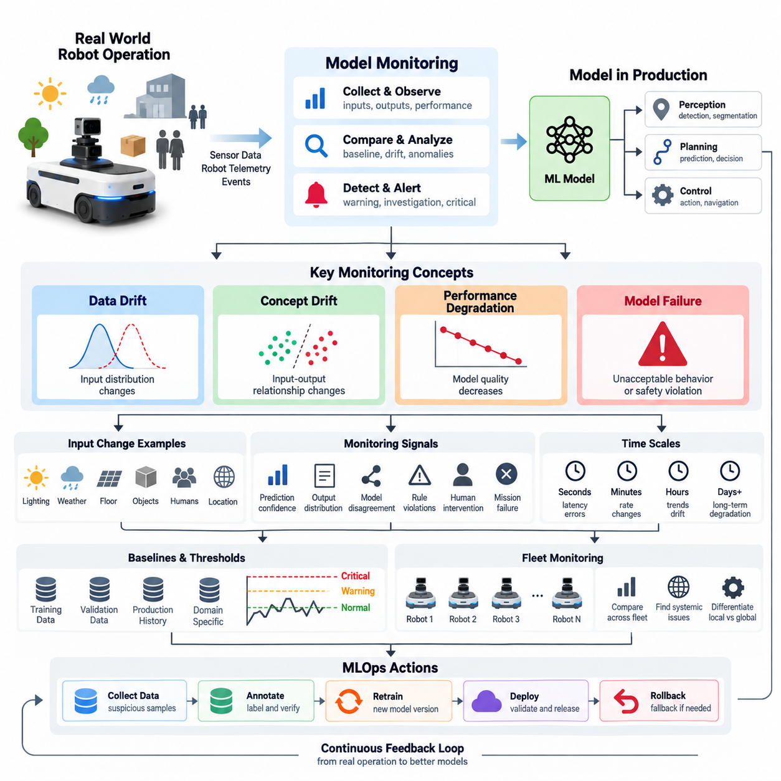
Model monitoring is the continuous process of observing how a deployed machine learning model behaves after it leaves the controlled training and validation environment. In robotics, monitoring must extend beyond conventional prediction accuracy because an AI model interacts with sensors, software, hardware, physical environments, and human activity. A model that performed well during validation may gradually become unreliable when any part of this operational context changes.
The central objective of model monitoring is to determine whether the assumptions under which a model was developed still hold in production. Training data represents only a limited sample of possible operating conditions, while robots may encounter new lighting, weather, floor materials, obstacles, objects, human behaviors, sensor configurations, or geographic regions. Monitoring therefore compares current operational behavior with reference distributions, validation baselines, and previously established performance expectations.
A useful monitoring architecture separates several related but different phenomena: data drift, concept drift, performance degradation, and model failure. These conditions can appear independently or sequentially. Data drift describes changes in the statistical characteristics of model inputs, whereas concept drift represents changes in the relationship between inputs and the desired outputs. Performance degradation describes measurable deterioration in operational quality, while failure represents behavior that exceeds acceptable operational or safety boundaries.
Data drift occurs when the distribution of production inputs becomes different from the distribution represented in the training or reference dataset. For a robot perception model, this might happen when cameras originally trained mainly on indoor daytime scenes begin operating outdoors at night, or when a LiDAR configuration changes. Drift does not automatically mean that the model is incorrect, but it indicates that the operating environment has moved away from conditions for which model behavior was previously validated.
Different forms of drift can affect different parts of a robotic AI pipeline. Changes in brightness, image contrast, object frequencies, point-cloud density, environmental geometry, or sensor noise may alter individual features. More complex changes can affect combinations of features even when individual variables appear stable. Monitoring systems therefore require both feature-level statistics and higher-dimensional representations that reveal changes invisible to simple averages, ranges, or marginal distributions.
Concept drift is more fundamental because the mapping between observed information and the correct decision changes. A perception model may continue receiving visually similar images while the meaning of particular patterns changes because new object types, operational rules, environments, or behaviors have appeared. In robotics, concept drift can also arise when a robot moves into a new domain where previously learned correlations no longer provide reliable information for perception, prediction, planning, or action.
Performance degradation describes the gradual or sudden reduction of model quality relative to an established baseline. Depending on the application, this can appear as lower precision or recall, increased false detections, poorer segmentation quality, larger localization errors, unstable grasp predictions, or reduced navigation success. Operational monitoring should therefore connect statistical model metrics with task-level indicators because apparently small prediction changes can produce disproportionately large effects on physical robot behavior.
Ground truth is often unavailable immediately in production, making degradation difficult to measure directly. A robot may generate thousands of predictions before operators know which predictions were correct. Monitoring systems consequently combine delayed labels with proxy indicators such as prediction confidence, output distributions, disagreement between models, rule violations, human interventions, mission failures, or abnormal downstream behavior. These signals do not replace ground truth, but they can provide early evidence that investigation is required.
Model failure is generally a stronger condition than degradation. Degradation indicates worsening performance, whereas failure means that the model can no longer satisfy an operational requirement or produces unacceptable behavior under particular conditions. Failure may be systematic, intermittent, environment-specific, hardware-dependent, or associated with rare edge cases. For physical robots, the consequence of failure may propagate from perception into planning, control, mission execution, or safety mechanisms.
A critical monitoring principle is therefore to distinguish model failures from failures elsewhere in the robotic system. Reduced detection quality may originate from model drift, but it may also result from camera contamination, calibration changes, vibration, network delay, GPU throttling, corrupted preprocessing, or an incorrect model version. Effective monitoring correlates AI metrics with sensor health, software versions, hardware telemetry, environmental conditions, and robot events rather than interpreting model outputs in isolation.
Monitoring should operate at multiple time scales. Millisecond- or second-level signals can reveal inference latency spikes, missing predictions, numerical errors, or resource exhaustion. Minute- and hour-level aggregation can expose changes in confidence or detection rates, while daily or weekly analysis can identify gradual distribution drift and long-term performance decay. Combining these time scales allows the monitoring system to distinguish transient anomalies from persistent changes that justify deeper investigation or retraining.
Baselines provide the reference against which these changes are interpreted. A baseline may represent training data, validation data, a previous production period, a certified model release, or a specific operating domain. Robotics systems often require multiple baselines because normal behavior differs among warehouses, outdoor environments, weather conditions, robot hardware revisions, and mission types. Comparing every robot against one global distribution can therefore produce misleading alarms or conceal locally important degradation.
Threshold design must also account for operational context. A fixed threshold can be useful for clearly defined safety or latency limits, but statistical drift signals often require adaptive thresholds, historical envelopes, or domain-specific limits. Excessively sensitive thresholds generate alert fatigue, while insensitive thresholds allow degradation to continue unnoticed. Monitoring policies should consequently define warning, investigation, mitigation, and critical levels that correspond to increasingly significant deviations from expected behavior.
Fleet operation adds another important dimension. A single robot may show abnormal behavior because of a local sensor or hardware problem, while simultaneous degradation across many robots may indicate a model, software, dataset, or environmental issue. Fleet-wide monitoring makes it possible to compare robots by hardware version, model version, location, mission, and environmental condition. This turns individual telemetry into population-level evidence that can help separate isolated anomalies from systematic model problems.
Monitoring becomes especially valuable when connected to the broader MLOps lifecycle. Detected drift can trigger deeper evaluation, suspicious samples can enter data collection and annotation workflows, confirmed degradation can initiate validation or retraining, and serious failures can activate rollback or fallback policies. Monitoring is therefore not merely an observability dashboard; it is the feedback mechanism that connects production experience to future datasets, experiments, model releases, and deployment decisions.
For robotic systems, the final objective is controlled adaptation rather than automatic reaction to every statistical change. Drift should be treated as evidence requiring interpretation, degradation as a measurable operational concern, and failure as a condition requiring defined mitigation. A mature monitoring system combines data statistics, model outputs, task performance, robot telemetry, environmental context, and fleet history so that AI behavior can remain traceable, diagnosable, and manageable throughout its production lifecycle.

8.2. Data Drift Detection PSI KL Divergence Methods [w/Code]
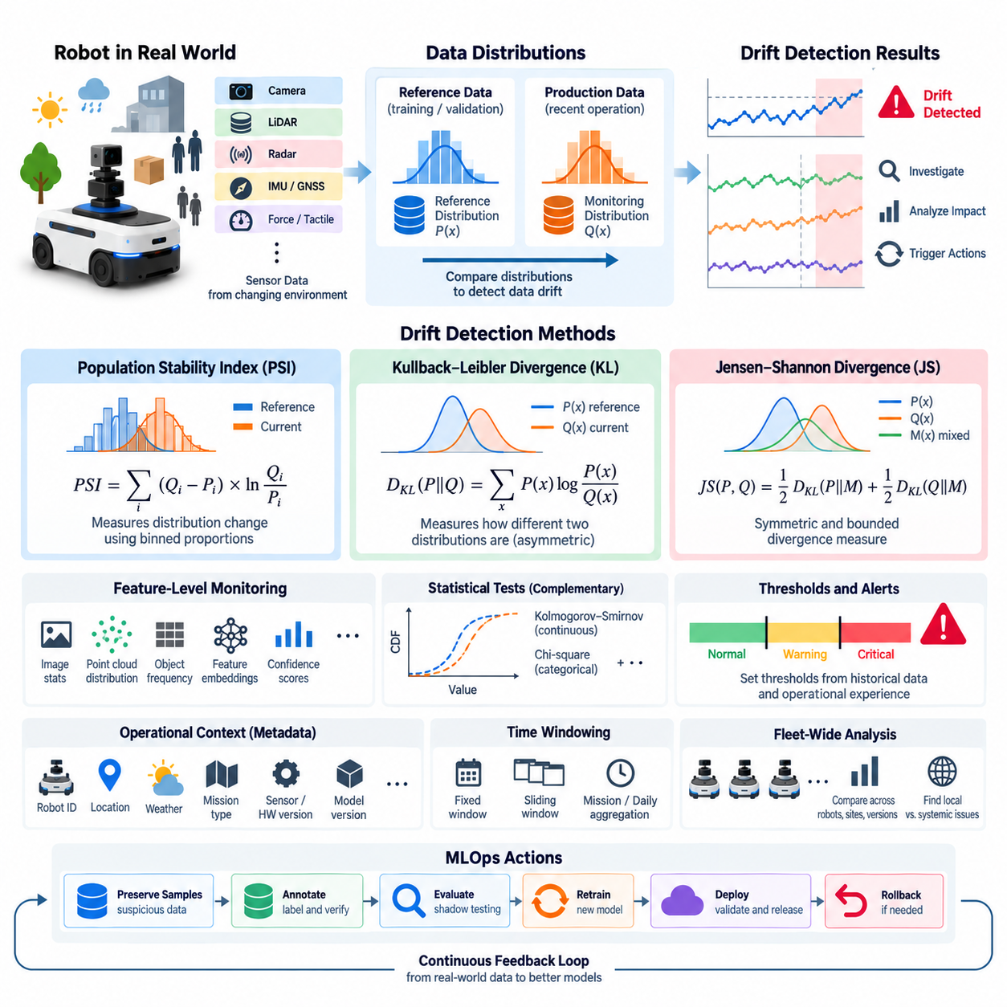
Data drift detection is the process of determining whether the statistical characteristics of data observed in production have changed relative to a reference dataset. In robot AI systems, the reference is commonly derived from training, validation, or previously verified operational data. Production inputs are continuously compared against this baseline so that changes in sensor observations can be detected before they cause significant degradation in model behavior.
Data drift is especially important in robotics because robots operate in physical environments that naturally change over time. Camera images vary with illumination, weather, seasons, contamination, vibration, and viewpoint. LiDAR point clouds vary with reflectivity, environmental geometry, precipitation, and sensor condition. Radar, ultrasonic, GNSS, IMU, force, and tactile measurements can also shift as operating conditions, hardware characteristics, or robot configurations change.
A practical drift monitoring system begins by defining a reference distribution and a monitoring distribution. The reference distribution represents data considered normal or validated, while the monitoring distribution represents recently collected production data. These distributions may be compared over fixed time windows, sliding windows, robot missions, geographic regions, environmental conditions, or fleet segments. The selected comparison strategy should reflect how rapidly the operating domain is expected to change.
Population Stability Index, or PSI, is a commonly used method for measuring changes between two distributions. The values of a feature are divided into bins, and the proportion of observations falling into each bin is calculated for both the reference and current datasets. PSI then summarizes the difference between corresponding proportions. A larger PSI indicates a greater shift between the two populations, making it useful as a compact monitoring indicator.
For bins indexed by i, PSI is commonly expressed as the sum of the difference between current and reference proportions multiplied by the logarithm of their ratio. In conceptual form, PSI = Σ(Currentᵢ − Referenceᵢ) × ln(Currentᵢ / Referenceᵢ). Because zero-valued bins make the logarithm undefined, practical implementations normally introduce a small numerical constant or another smoothing strategy before calculating the ratio.
PSI is attractive for production monitoring because it is relatively simple to calculate, interpret, aggregate, and visualize. It can be applied to sensor statistics, model features, confidence scores, object counts, latency distributions, or other numerical variables. However, PSI depends strongly on binning strategy. Different bin boundaries, sample sizes, or sparse observations can produce different values, so thresholds should be validated against the characteristics of the actual robotic application.
Kullback–Leibler divergence, usually called KL divergence, provides another way to quantify differences between probability distributions. For discrete distributions P and Q, it is expressed as D_KL(P||Q) = Σ P(x) log(P(x)/Q(x)). The value becomes zero when the distributions are identical under the evaluated representation and increases as they diverge. KL divergence therefore provides a mathematically grounded measure for detecting distribution changes.
KL divergence is asymmetric, meaning that D_KL(P||Q) is generally different from D_KL(Q||P). This matters when defining which distribution represents the reference and which represents production observations. KL divergence can also become very large or undefined when the comparison distribution assigns zero probability to an event that has positive probability in the reference distribution. Smoothing, density estimation, or carefully constructed histograms are therefore important in operational implementations.
A related alternative is Jensen–Shannon divergence, which introduces a mixture distribution and measures divergence from both distributions to that mixture. Unlike standard KL divergence, Jensen–Shannon divergence is symmetric and bounded under a fixed logarithm base. These characteristics can make it easier to interpret in monitoring dashboards. Nevertheless, the appropriate metric should be selected according to data characteristics rather than assuming that one statistical distance is universally superior.
Robot monitoring rarely involves only one scalar feature. A perception system may receive millions of image pixels, point-cloud coordinates, embeddings, confidence scores, object categories, and temporal features. Calculating PSI or KL divergence directly over raw high-dimensional sensor data is often impractical. Monitoring systems therefore extract meaningful statistics or representations such as brightness, depth distributions, object frequencies, feature embeddings, prediction confidence, or intermediate neural-network activations.
Feature-level drift monitoring helps identify which parts of the input distribution are changing. For camera perception, the system might monitor image intensity, contrast, blur, detected object frequencies, or embedding distributions. For LiDAR, it might observe point density, range distributions, intensity, missing returns, and spatial occupancy. These indicators can be associated with robot ID, location, weather, mission type, sensor version, and model version to provide operational context.
Statistical tests can complement divergence measures. Tests such as the Kolmogorov–Smirnov test for continuous variables or chi-square tests for categorical distributions can evaluate whether observed differences are statistically significant. Statistical significance alone, however, does not establish operational importance. With sufficiently large fleet datasets, even very small distribution changes may become statistically significant while having negligible impact on model performance or robot behavior.
Sample size and monitoring-window design therefore play critical roles in drift detection. Very small windows produce noisy estimates and frequent false alarms, while excessively large windows can hide rapid environmental changes. Sliding windows can provide continuous sensitivity, whereas mission-based or daily aggregation can improve stability. Large robot fleets may additionally require stratified monitoring so that different sites, hardware versions, environmental domains, or operational modes are not incorrectly mixed into one distribution.
Drift thresholds should be calibrated from historical data and operational experience rather than treated as universal constants. A warning threshold can indicate that a feature distribution is moving away from its baseline, while a higher threshold can trigger investigation or model evaluation. Thresholds may also vary by feature because a small shift in a safety-critical perception signal can be more important than a larger shift in a feature with little influence on downstream decisions.
Detecting drift does not prove that model performance has degraded. A robot may encounter a new but easy environment and maintain excellent performance despite substantial input drift. Conversely, a relatively small distribution shift can expose a weakness in the model and cause significant failures. Drift metrics should therefore be correlated with prediction confidence, accuracy when labels become available, human interventions, planning anomalies, mission outcomes, and safety-related events.
Fleet-wide analysis makes drift detection considerably more informative. If one robot exhibits abnormal camera statistics while other robots at the same site remain stable, the likely cause may be contamination, calibration, or sensor degradation. If many robots using the same model show similar distribution shifts, the cause may be environmental or systemic. Comparing robot, site, hardware, software, and model cohorts helps distinguish local sensor problems from broader changes in the operational domain.
A mature data drift pipeline therefore combines reference datasets, production sampling, feature extraction, statistical comparison, contextual metadata, thresholds, alerting, and downstream investigation. PSI and KL divergence are useful components of this pipeline rather than complete solutions by themselves. Their primary value is to convert changes in production data into measurable signals that can be tracked consistently across time, robots, models, and operating environments.
Within the broader MLOps lifecycle, drift detection forms an early-warning layer between production operation and model improvement. Significant drift can trigger sample preservation, annotation, shadow evaluation, targeted validation, or retraining workflows. By linking statistical drift signals with actual robot performance and fleet telemetry, an organization can transform changing real-world conditions into structured evidence for deciding when a model should be investigated, updated, retrained, or replaced.

8.3. Concept Drift Detection for Robot Perception Models [w/Code]
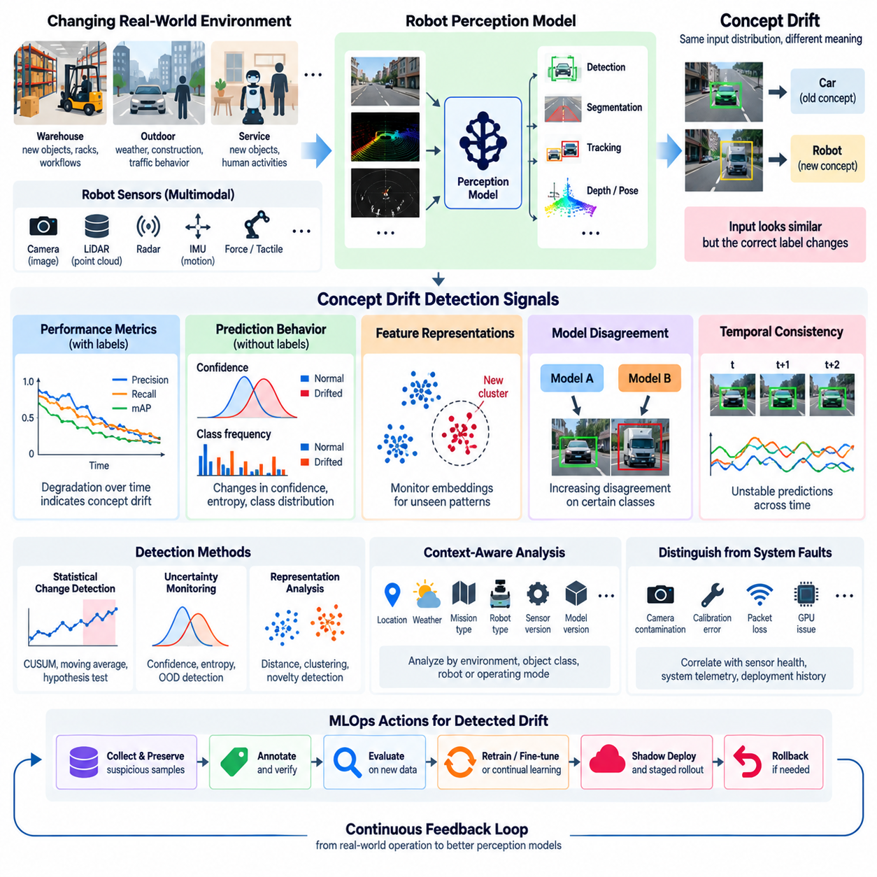
Concept drift occurs when the relationship between input observations and the correct model output changes over time, even when the statistical appearance of the input data may remain relatively stable. For robot perception models, this means that visual, LiDAR, radar, or multimodal observations that previously supported reliable predictions may acquire different meanings under new operational conditions. Detecting this change is essential for maintaining dependable perception after deployment.
Concept drift differs fundamentally from data drift. Data drift describes a change in the distribution of observed inputs, while concept drift concerns a change in the conditional relationship between inputs and targets. A camera may continue producing images with similar brightness and color distributions, for example, while newly introduced objects or changed operational rules alter what the perception model is expected to recognize. Monitoring input statistics alone may therefore fail to reveal important changes.
Robot perception systems are particularly exposed to concept drift because physical environments are open and continuously evolving. Warehouses introduce new packaging, racks, vehicles, uniforms, and workflows. Outdoor robots encounter construction zones, seasonal vegetation, temporary structures, and changing traffic behavior. Service robots interact with new objects and human activities. These changes can invalidate relationships learned from historical training data without producing an obvious sensor malfunction.
Concept drift can appear gradually, suddenly, incrementally, or repeatedly. Gradual drift occurs when the operational environment evolves over weeks or months, while sudden drift can follow a facility redesign, sensor replacement, or introduction of a new object category. Incremental drift accumulates through small changes, and recurring drift appears when previously observed conditions return, such as seasonal environments or different operational modes between daytime and nighttime.
Detecting concept drift is difficult because the correct output, or ground truth, is often unavailable at the moment a robot generates a prediction. In supervised evaluation, model predictions can be directly compared with labels, but production robots may operate for hours or days before annotations become available. Monitoring systems must therefore combine delayed ground truth with indirect indicators capable of revealing suspicious changes before complete labels are collected.
When labels are available, performance-based monitoring provides one of the clearest approaches to concept drift detection. Precision, recall, F1 score, intersection over union, detection accuracy, tracking quality, depth error, or pose estimation error can be calculated over successive windows. Persistent changes in these metrics indicate that the relationship learned by the model may no longer represent current conditions, especially when sensor quality and system configuration remain stable.
Without immediate labels, prediction behavior becomes an important source of evidence. Changes in confidence distributions, entropy, class frequencies, unknown-object rates, temporal consistency, or disagreement between multiple models can indicate that the current environment no longer matches learned concepts. A perception model that becomes increasingly uncertain around a particular object category may reveal an emerging domain that deserves targeted data collection and evaluation.
Representation-level monitoring extends this approach by observing internal feature embeddings rather than only final predictions. Deep perception networks transform raw sensor inputs into latent representations containing information about objects, geometry, semantics, and context. Production embeddings can be compared with reference embeddings or clustered to identify regions that are poorly represented by training data. New clusters or increasing distance from known clusters can provide evidence of novel operating conditions.
Model disagreement is particularly useful when ground truth is delayed. A deployed production model can be compared with a shadow model, an ensemble, or models trained using different datasets. If predictions that previously agreed begin to diverge systematically for particular environments or object classes, the disagreement can be treated as an investigation signal. Disagreement alone does not prove concept drift, but it can efficiently identify samples requiring annotation.
Temporal consistency provides another valuable signal for robotic perception. Physical objects normally evolve continuously across adjacent camera frames, LiDAR scans, or tracking cycles. Unexpected fluctuations in class identity, object confidence, segmentation masks, estimated depth, or tracked trajectories may indicate unstable perception. Monitoring temporal behavior can reveal failures that frame-by-frame accuracy metrics overlook, particularly in dynamic environments where perception feeds directly into planning and control.
Change-detection algorithms can be applied to sequences of performance or proxy metrics. Statistical process-control techniques, cumulative-sum methods, moving averages, adaptive windows, and sequential hypothesis tests can identify persistent changes rather than isolated anomalies. The objective is not simply to detect every fluctuation but to determine whether accumulated evidence suggests that the underlying relationship between observations and expected predictions has changed.
Concept drift analysis should also be segmented by operational context. Aggregating all robot data into one global metric can conceal failures affecting only specific environments. Metrics can instead be grouped by location, object category, lighting condition, weather, robot type, sensor version, model version, mission, or operating mode. A model may remain stable at fleet level while degrading significantly for forklifts in one warehouse or pedestrians under a particular outdoor condition.
It is equally important to distinguish concept drift from sensor and system faults. A sudden reduction in perception accuracy may result from camera contamination, calibration errors, LiDAR misalignment, packet loss, preprocessing changes, GPU problems, or an incorrect software configuration. Effective diagnosis correlates perception metrics with sensor-health information, system telemetry, deployment history, and environmental metadata before concluding that the underlying concept has changed.
Thresholds for concept drift should represent operational significance rather than arbitrary statistical variation. Warning levels may initiate additional logging or sample preservation, while stronger evidence can trigger human review, targeted annotation, shadow evaluation, or restricted operation. Safety-critical applications may require conservative thresholds for classes such as people, vehicles, obstacles, or hazardous regions because small perception changes can have large downstream consequences.
Fleet-wide monitoring strengthens concept drift detection by providing multiple observations of similar conditions. If only one robot shows abnormal predictions, the cause may be local hardware, calibration, or contamination. If multiple robots using the same model exhibit similar changes around the same class or environment, the evidence for a systematic perception problem becomes stronger. Fleet segmentation therefore supports both drift detection and root-cause isolation.
Confirmed drift should lead to structured data collection rather than immediate uncontrolled retraining. Suspicious samples can be preserved together with images, point clouds, predictions, confidence values, robot states, environmental metadata, and model versions. Representative cases can then be annotated and added to targeted evaluation datasets. This creates evidence for determining whether the existing model remains acceptable or whether adaptation is actually required.
When adaptation is justified, new data can enter the MLOps lifecycle through validation, retraining, fine-tuning, or continual-learning workflows. Candidate models should be evaluated against both newly drifted conditions and historical reference scenarios so that adaptation does not introduce regression elsewhere. Shadow deployment and staged rollout can then compare the candidate against the current production model before broader fleet deployment, while rollback remains available if new failures emerge.
Concept drift detection for robot perception is therefore not a single statistical test but a continuous evidence-building process. Reliable systems combine labeled performance, prediction uncertainty, feature representations, temporal consistency, model disagreement, operational context, sensor health, and fleet-level comparisons. By connecting these signals to annotation, evaluation, retraining, deployment, and rollback workflows, perception monitoring becomes a closed feedback mechanism for maintaining model reliability as the physical world changes.

8.4. Model Performance Metrics Collection in Production [w/Code]
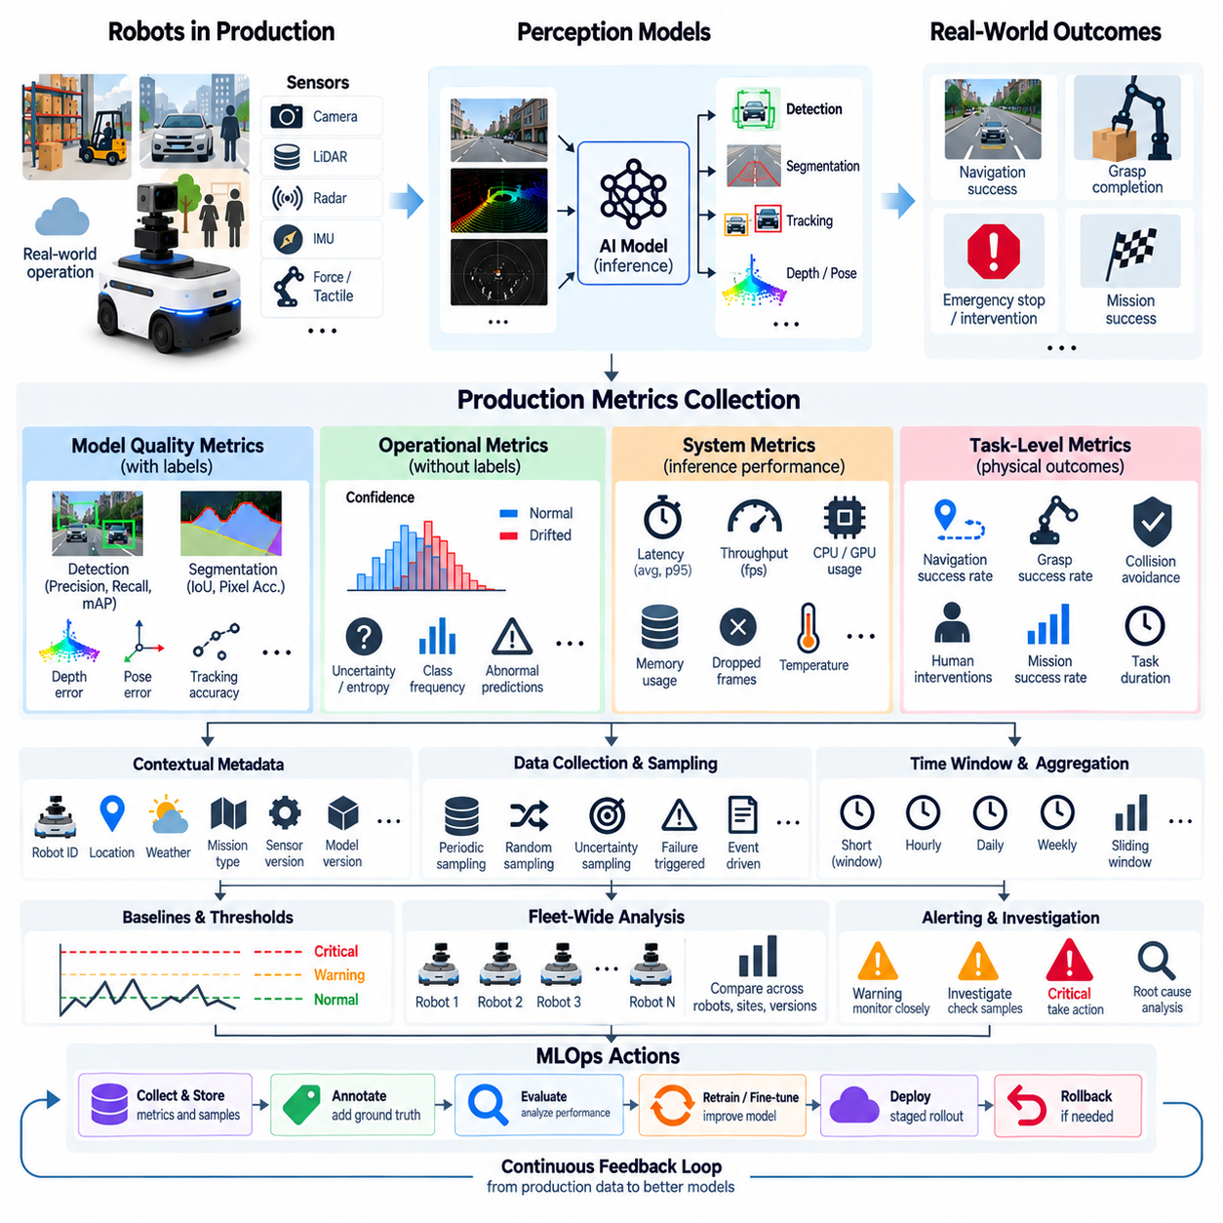
Production model performance monitoring extends evaluation beyond offline validation by continuously collecting evidence about how an AI model behaves after deployment. In robotic systems, this requires observing not only prediction quality but also inference timing, resource consumption, uncertainty, task outcomes, and interaction with downstream planning and control. The objective is to establish measurable operational evidence that a deployed model continues to satisfy its expected behavior under changing real-world conditions.
The first requirement is to define production metrics that correspond to the actual responsibility of each model. An object detector may require precision, recall, false-positive rate, missed-detection rate, and mean average precision, while segmentation models may use intersection over union or pixel accuracy. Depth, pose, tracking, localization, grasping, and navigation models require different error measures. Metrics should therefore reflect model function rather than relying on one generic measure of AI quality.
Production metrics can be divided conceptually into model-quality, operational, system, and task-level measurements. Model-quality metrics describe prediction correctness, while operational metrics characterize confidence, uncertainty, output frequency, and abnormal predictions. System metrics measure inference latency, throughput, memory, GPU utilization, and execution failures. Task-level metrics connect model behavior to physical outcomes such as navigation success, collision avoidance, grasp completion, intervention frequency, or mission success.
Ground-truth availability determines how directly model quality can be measured. In controlled evaluation, predictions are compared immediately with labeled data, but production robots rarely receive complete labels in real time. Ground truth may instead become available through human review, later annotation, inspection results, operator corrections, redundant sensors, or completed task outcomes. Production monitoring architectures must therefore support both immediate proxy metrics and delayed supervised performance measurements.
Prediction confidence is one of the most accessible production signals, but it should not be interpreted as equivalent to accuracy. A model can remain highly confident while producing incorrect predictions, particularly under unfamiliar operating conditions. Monitoring confidence distributions over time is nevertheless useful because changes in mean confidence, low-confidence frequency, entropy, or class-specific confidence can reveal changes in model behavior that warrant further investigation.
Performance data should be collected together with contextual metadata. A detection result becomes significantly more informative when associated with robot ID, timestamp, location, mission, model version, sensor version, software release, environmental condition, and operating mode. This context allows engineers to determine whether degradation is global or concentrated within a specific site, hardware revision, object category, weather condition, or deployment cohort.
Metric collection must preserve the relationship between model inputs, outputs, and downstream events without requiring every raw sensor stream to be permanently stored. A monitoring event may contain model identifiers, prediction summaries, confidence values, latency, selected feature statistics, sensor-health information, and task results. Raw images or point clouds can then be retained selectively for anomalous, uncertain, failed, or sampled cases, reducing storage and communication requirements.
Sampling is especially important for robot fleets because continuous raw telemetry can generate enormous data volumes. Monitoring pipelines may combine periodic sampling, random sampling, uncertainty-based sampling, failure-triggered capture, and event-driven collection. Safety-relevant events can receive higher retention priority than routine successful operation. The sampling policy should preserve enough representative evidence to detect degradation while respecting edge storage, network bandwidth, cloud capacity, and operational cost constraints.
Metrics should be aggregated across appropriate time windows. Short windows can expose sudden failures, latency spikes, or abrupt changes in prediction confidence, whereas hourly, daily, or weekly aggregation can reveal persistent degradation and long-term trends. Sliding windows provide continuous sensitivity, while mission-based aggregation helps relate AI behavior to robot tasks. Multiple windows are often necessary because transient anomalies and sustained deterioration require different operational responses.
Fleet-wide aggregation adds another analytical layer. Metrics can be compared across individual robots, groups of robots, sites, hardware configurations, sensor revisions, software releases, and model versions. If one robot exhibits lower detection performance while comparable robots remain stable, the problem may be local. If a new model version shows degradation across many robots, the evidence points toward a broader model or deployment issue that requires coordinated investigation.
Production monitoring must also measure inference-system performance because model quality is irrelevant if predictions arrive too late for physical action. Inference latency can be measured using average, median, and tail values such as high-percentile latency, while throughput indicates how many observations can be processed within a given interval. Queue delay, dropped frames, missed deadlines, GPU memory usage, CPU utilization, and accelerator temperature can reveal deployment problems that offline accuracy testing cannot detect.
For robotic systems, end-to-end latency can be more meaningful than neural-network inference time alone. A perception pipeline may include sensor acquisition, preprocessing, inference, postprocessing, middleware communication, sensor fusion, and delivery to planning. A fast neural network can still participate in a slow overall pipeline if another component becomes a bottleneck. Production telemetry should therefore distinguish component latency from complete perception-to-decision latency whenever system architecture permits.
Task-level metrics provide the connection between AI performance and actual robot behavior. A perception model may show only a small decline in conventional accuracy while causing more emergency stops, path replanning, operator interventions, failed grasps, or mission delays. Conversely, some statistical changes may have little operational effect. Connecting prediction metrics with downstream outcomes helps determine whether observed changes are technically measurable, operationally important, or safety relevant.
Production metrics should be associated with explicit baselines and service expectations. A baseline may come from validation datasets, previous production periods, a known stable release, or domain-specific operating conditions. Current measurements can then be compared against expected ranges rather than interpreted in isolation. Baselines may need segmentation because normal behavior for an indoor warehouse robot can differ substantially from an outdoor robot operating under weather, illumination, and terrain variability.
Alerting converts collected metrics into operational action. Thresholds may identify warning, investigation, and critical conditions for accuracy proxies, latency, resource usage, intervention rates, or task failures. Static limits are useful for clearly defined requirements, while adaptive thresholds can help detect deviations from historical behavior. Alerts should include sufficient context to identify the affected robot, model version, operating condition, and supporting metrics rather than reporting an isolated numerical violation.
Metric observability must also support traceability across the MLOps lifecycle. Engineers should be able to connect a production prediction to the model artifact, training dataset version, configuration, container or runtime version, deployment event, and relevant telemetry. Without version-aware monitoring, performance changes can be difficult to reproduce or diagnose. Traceability transforms monitoring data from dashboard statistics into evidence that can support debugging, validation, rollback, and future model development.
Monitoring itself must be designed so that it does not interfere with robot operation. Metric collection, serialization, buffering, and transmission consume CPU, memory, storage, and network bandwidth. Edge systems may therefore aggregate metrics locally, limit high-frequency telemetry, compress records, and upload detailed evidence only when connectivity and resources permit. Critical control and safety functions should remain isolated from monitoring workloads so that observability cannot become a source of operational instability.
When production metrics indicate deterioration, the monitoring system should support a structured response rather than automatically assuming that retraining is required. Engineers can inspect affected cohorts, retrieve representative samples, verify sensor health, compare model versions, obtain labels, and reproduce failures. Confirmed model degradation can then initiate shadow evaluation, targeted validation, retraining, fine-tuning, staged deployment, or rollback according to the severity and cause of the problem.
Production metric collection ultimately creates the measurement layer that connects deployed AI with continuous MLOps improvement. By combining prediction quality, uncertainty, latency, resource usage, task outcomes, contextual metadata, and fleet-wide comparisons, organizations can determine how models actually behave outside laboratory datasets. This evidence enables model degradation to be detected, localized, investigated, and converted into controlled data, validation, deployment, and improvement workflows.

8.5. Shadow Mode Evaluation New vs Current Model [w/Code]
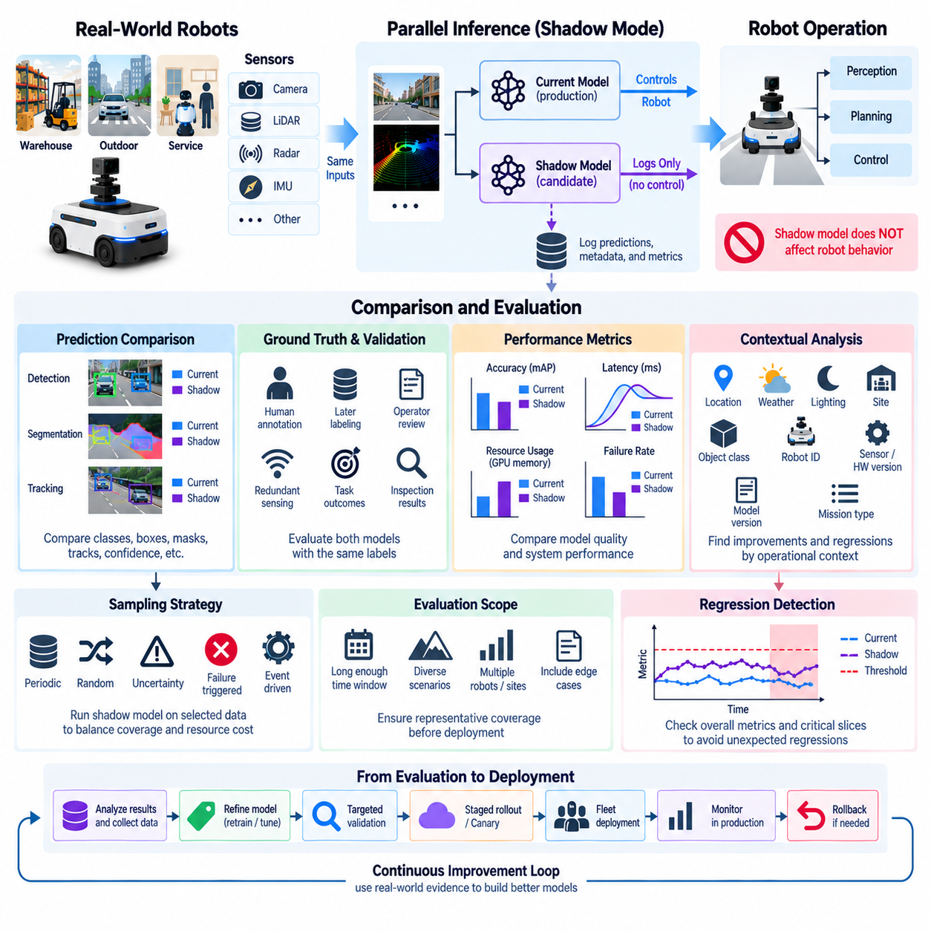
Shadow mode evaluation is a deployment technique in which a new candidate model runs alongside the current production model while the current model remains responsible for operational decisions. Both models receive equivalent production inputs, but outputs from the shadow model are recorded only for evaluation and do not directly control the robot. This approach allows engineers to evaluate new models under real operating conditions without immediately exposing physical behavior to unverified predictions.
The current production model acts as the control reference because its behavior has already passed the organization’s deployment and validation process. The shadow model represents a candidate intended to improve accuracy, robustness, latency, domain coverage, or another operational property. Running both models on the same sensor observations creates a paired comparison in which environmental conditions, robot state, mission context, and input data are naturally aligned.
Shadow evaluation is particularly valuable for robotics because offline datasets cannot reproduce every condition encountered by physical systems. Warehouses change layouts and inventory, outdoor robots experience weather and illumination variation, and mobile platforms encounter unpredictable human behavior. A candidate model that performs better on a benchmark may still behave differently under these conditions. Shadow execution exposes the candidate to real production distributions before it receives authority over physical actions.
The architecture generally duplicates the inference path after sensor acquisition or preprocessing. Camera images, LiDAR point clouds, radar measurements, or fused representations are delivered to both the current and shadow models. The production model continues sending outputs to downstream perception, planning, or control components, while shadow outputs are redirected to a monitoring pipeline. Timestamps and input identifiers should be preserved so that predictions can be compared reliably.
Isolation between the shadow model and operational control is a fundamental design requirement. Shadow predictions must not unintentionally influence navigation, manipulation, safety logic, actuator commands, or mission decisions. This separation may be implemented through dedicated topics, queues, services, processes, or containers. In ROS 2 systems, for example, shadow inference can publish to evaluation-specific interfaces that are not consumed by operational control nodes.
The simplest comparison examines disagreement between current and candidate predictions. For object detection, engineers can compare classes, bounding boxes, confidence values, missed detections, and false detections. Segmentation systems can compare masks and class probabilities, while tracking systems can compare identities and trajectories. Depth, pose, localization, grasping, and other models require corresponding domain-specific differences rather than a single universal disagreement metric.
Model disagreement alone does not determine which model is better. The current model can be wrong while the shadow model is correct, both models can fail simultaneously, or both can produce acceptable but different predictions. When ground truth becomes available, paired predictions should therefore be evaluated against the same labels. Human annotation, operator review, redundant sensing, task outcomes, or later inspection can provide evidence for determining which behavior was more accurate.
Performance comparison should be segmented by operational context rather than reduced to one fleet-wide average. A candidate may improve daytime perception while degrading at night, or perform better in one warehouse while failing with objects unique to another site. Evaluation should therefore preserve metadata such as robot ID, location, weather, lighting, mission type, object class, sensor version, hardware version, and software release so that improvements and regressions can be localized.
Shadow evaluation also provides an opportunity to compare inference-system behavior. A candidate model may improve accuracy while requiring substantially more GPU memory, increasing latency, reducing throughput, or causing thermal throttling. Production suitability therefore depends on both prediction quality and computational behavior. In robotic systems, inference latency and deadline consistency are especially important because delayed perception can affect planning and control even when the prediction itself is correct.
Resource contention must be carefully controlled because running two models simultaneously increases computational demand. The shadow model can consume GPU capacity, CPU cycles, memory, storage bandwidth, and electrical power that would otherwise be available to production workloads. Deployment architecture should ensure that shadow evaluation cannot degrade the current operational model. Dedicated accelerators, resource quotas, reduced sampling rates, or asynchronous execution can be used when edge resources are limited.
Not every production input needs to be processed by the shadow model. Fleet-scale evaluation can use controlled sampling to balance statistical coverage against computational and communication cost. The shadow model may run on selected robots, missions, geographic regions, time periods, or percentages of incoming observations. Sampling should include routine operation as well as difficult conditions so that evaluation does not become biased toward easy or frequently occurring scenarios.
A useful shadow evaluation records paired predictions together with model versions and execution context. Each comparison record can include the input identifier, timestamp, current-model output, candidate-model output, confidence, latency, resource measurements, relevant metadata, and eventual ground truth when available. Version traceability is essential because multiple candidate models may be evaluated simultaneously or sequentially across a fleet, and their results must remain attributable to exact model artifacts.
Evaluation windows should be long enough to represent operational variability. A short test may contain thousands of frames while still missing rare objects, weather conditions, unusual interactions, or safety-relevant edge cases. Coverage can therefore be measured across scenarios rather than only by sample count. Engineers can track whether the candidate has been observed across required environments, object classes, mission types, robot configurations, and known difficult conditions before making a deployment decision.
Regression detection is one of the most important purposes of shadow mode. A new model may improve an aggregate metric while degrading performance for a critical class or scenario. Comparison pipelines should therefore examine both overall metrics and targeted slices. Historical failure cases and previously corrected edge cases can also be replayed alongside live shadow evaluation to verify that improvements in new domains have not reintroduced known weaknesses.
Task-level evidence can complement prediction-level comparison. If shadow outputs can be evaluated through simulation or non-actuating downstream logic, engineers may estimate how candidate predictions would influence planning or mission behavior without allowing them to control the physical robot. Such analysis can reveal whether apparently small perception differences would lead to different obstacle decisions, trajectories, grasp selections, or other operational consequences.
Promotion criteria should be defined before interpreting shadow results. The candidate may be required to satisfy minimum quality, latency, resource, robustness, and scenario-coverage requirements while avoiding unacceptable regression in critical categories. These criteria should be tied to operational requirements rather than selected after results are observed. A model that improves one metric but violates another requirement should remain a candidate until the tradeoff has been investigated and validated.
Shadow mode is different from canary deployment. In shadow mode, the candidate processes real inputs but normally has no authority over robot behavior. In canary deployment, the candidate becomes operational for a limited portion of traffic, robots, or missions. Shadow evaluation can therefore precede canary deployment: first observe the candidate without control authority, then allow restricted operational use after predefined validation criteria have been satisfied.
When shadow evaluation reveals problems, the collected evidence becomes valuable training and validation data. Disagreement cases, low-confidence predictions, computational failures, and scenario-specific regressions can be preserved and annotated. Engineers can use these samples to diagnose failure modes, refine datasets, adjust preprocessing, retrain or fine-tune the candidate, and repeat the shadow evaluation. The process can iterate without replacing the stable production model prematurely.
When a candidate satisfies its evaluation requirements, it can progress through the broader deployment workflow. Typical next stages include targeted validation, staged rollout, canary operation, broader fleet deployment, and continued production monitoring. The former production model can remain available as a rollback target until the new release demonstrates stable behavior. Shadow evaluation therefore acts as an intermediate safety and evidence layer between offline model validation and operational authority.
Within robotic MLOps, shadow mode transforms real-world operation into a controlled comparative experiment. The current and candidate models observe the same environment while only the validated production path controls the robot. By combining paired predictions, ground truth, contextual metadata, resource measurements, scenario coverage, and regression analysis, teams can determine whether a candidate is ready for progressively greater deployment authority while preserving traceability and operational control.

8.6. Automated Retraining Trigger on Performance Degradation [w/Code]
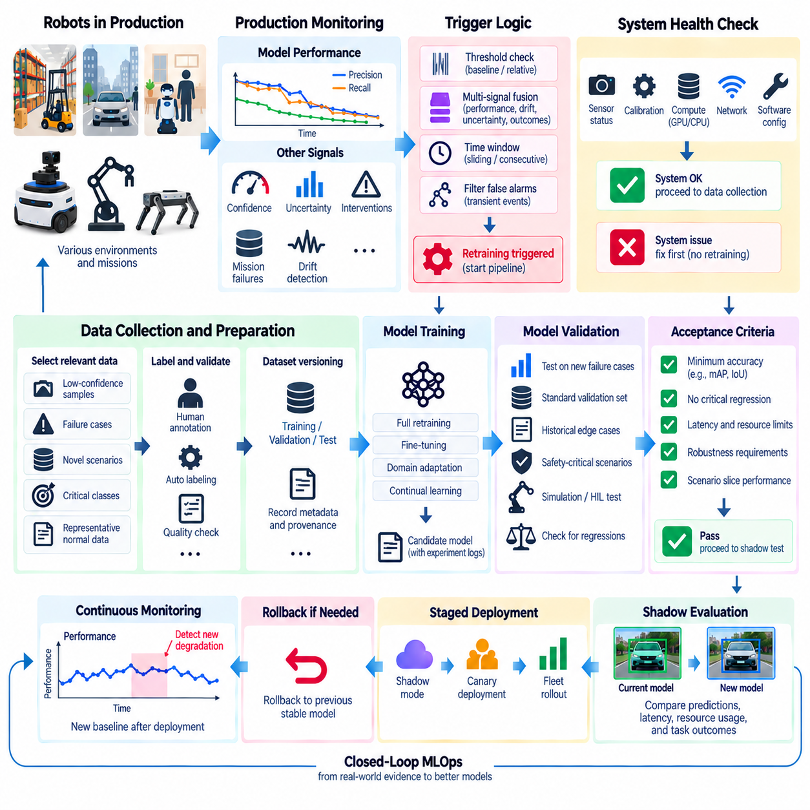
Automated retraining is the controlled process of initiating a new model-training workflow when production evidence indicates that an existing model may no longer satisfy expected performance requirements. In robotic MLOps, the trigger should not be interpreted as permission to replace a deployed model automatically. Instead, it starts a governed pipeline that collects evidence, prepares data, trains a candidate model, validates it, and determines whether deployment should proceed.
Performance degradation can be detected through several complementary signals. Labeled production data may reveal declining precision, recall, F1 score, mean average precision, segmentation IoU, tracking quality, depth error, or pose accuracy. When labels are delayed, proxy signals such as prediction confidence, uncertainty, model disagreement, intervention frequency, mission failures, or abnormal downstream behavior can provide earlier indications that the model requires investigation.
A retraining trigger should normally combine multiple signals rather than respond to a single anomalous measurement. Temporary weather, sensor contamination, network congestion, or an unusual mission can create short-lived metric changes without representing true model degradation. Trigger logic can therefore require a threshold violation to persist across several monitoring windows or combine degradation, drift, uncertainty, and operational outcomes before initiating a retraining workflow.
Thresholds provide the basic decision boundaries for automated triggering. A production metric can be compared with an absolute requirement, a validated baseline, a historical operating range, or a relative decline from previous performance. Different levels may represent normal operation, warning, investigation, and retraining eligibility. Thresholds should be calibrated for individual metrics and operational domains because identical numerical changes can have very different consequences for different robot functions.
Time-window design is essential for distinguishing persistent degradation from noise. Short windows respond quickly but can produce unstable decisions, while long windows provide more reliable estimates at the cost of slower detection. Sliding windows, exponentially weighted statistics, mission-based aggregation, or repeated threshold violations can provide more robust evidence. Safety-critical signals may require faster escalation even when other performance metrics use longer confirmation periods.
Data drift and concept drift can contribute to retraining decisions but should not independently guarantee retraining. A substantial shift in input distribution may have little effect on model performance, while a relatively small change can expose a critical weakness. Drift metrics such as PSI, KL divergence, feature-embedding distance, class-frequency change, or concept-drift indicators should therefore be correlated with model-quality and task-level evidence before expensive training resources are activated.
Robotic systems must also distinguish model degradation from sensor, software, and hardware failures. A sudden reduction in detection performance may originate from a dirty camera lens, calibration error, LiDAR misalignment, corrupted preprocessing, GPU throttling, packet loss, or an incorrect configuration. Automatically retraining on data generated by a faulty system can reinforce undesirable behavior. Trigger pipelines should therefore include system-health checks before accepting degradation as a model-learning problem.
Once a retraining condition is confirmed, the pipeline must identify the data that explains the degradation. Monitoring records can locate low-confidence predictions, disagreement cases, failed missions, human interventions, unusual feature embeddings, or scenario-specific regressions. Relevant images, point clouds, sensor sequences, robot states, environmental metadata, model versions, and task outcomes can then be preserved as candidate training and evaluation data.
Data selection should avoid simply adding every recent production sample to the training set. Large quantities of redundant normal data can dilute rare but important failure cases and increase training cost without improving the model. Sampling can prioritize uncertain predictions, novel environments, critical classes, confirmed failures, underrepresented scenarios, and representative normal examples. Dataset composition should maintain sufficient historical coverage to reduce catastrophic regression on previously solved conditions.
Annotation and data-quality validation form an important gate between trigger detection and training. Automatically collected samples may contain incomplete sensor records, synchronization errors, ambiguous labels, corrupted frames, or duplicated observations. Human annotation, automated labeling, active-learning workflows, or verified task outcomes can provide labels, but quality checks should confirm that the resulting dataset represents the intended correction rather than propagating monitoring or labeling errors.
Dataset versioning is required so that every automated retraining event remains reproducible. The training pipeline should record the production samples selected, historical datasets included, annotation versions, preprocessing configuration, augmentation settings, and train-validation-test partitions. Linking these artifacts to the triggering event allows engineers to reconstruct why a model was retrained and determine which operational evidence influenced the resulting candidate.
The training stage can then execute a predefined pipeline using controlled code, configuration, dependencies, and compute resources. Depending on the model and available evidence, the workflow may perform full retraining, fine-tuning, domain adaptation, or continual learning. Training should produce a new candidate artifact rather than modifying the deployed model directly. Experiment metadata, hyperparameters, checkpoints, logs, and resulting metrics should be registered for later comparison.
Automated validation is the critical gate that prevents retraining from becoming uncontrolled self-modification. The candidate should be evaluated on newly collected degradation cases, standard validation datasets, historical failure cases, and safety-relevant scenarios. Improvements in the affected domain must be balanced against regression elsewhere. A candidate that resolves a new failure but reduces performance on established operating conditions should not automatically progress to deployment.
Acceptance criteria should be defined before training begins. These criteria may include minimum model-quality metrics, maximum allowable regression, inference latency, memory consumption, robustness requirements, and performance on critical scenario slices. Reproducible pass-or-fail gates make retraining pipelines auditable and prevent deployment decisions from being based solely on an improved aggregate metric that may conceal important weaknesses.
Simulation and hardware-in-the-loop evaluation can provide additional validation for robot models before production exposure. Candidate perception outputs can be connected to planning and control in recorded scenarios, simulation environments, or controlled robot tests to determine whether model changes create undesirable physical consequences. This is especially valuable when a statistically improved prediction model could still alter navigation, manipulation, or safety behavior in unexpected ways.
A validated candidate can proceed to shadow mode, where it receives production inputs alongside the current model without controlling the robot. Paired predictions, latency, resource consumption, and task-related evidence can then be compared under real operating conditions. If predefined shadow criteria are satisfied, the candidate can progress to a canary or staged rollout in which operational authority is granted gradually to a limited subset of robots or missions.
Deployment should remain reversible throughout the automated retraining lifecycle. The previous stable model, configuration, and runtime artifacts should remain available so that a candidate can be rolled back if unexpected degradation appears after release. Production monitoring continues after promotion because validation cannot cover every real-world condition. A newly deployed model therefore becomes the next monitored baseline rather than the final endpoint of the process.
Fleet-scale retraining requires additional governance because different robots may operate in substantially different domains. A degradation signal from one site should not necessarily trigger a global model update. Trigger logic can segment evidence by location, robot type, hardware revision, sensor configuration, mission, or environment. This allows organizations to determine whether adaptation should be global, domain-specific, or limited to a particular fleet cohort.
Retraining frequency must also be controlled to prevent feedback loops and unnecessary computation. Repeated triggering from the same unresolved condition can launch redundant training jobs, consume GPU resources, and generate many nearly identical model versions. Cooldown periods, trigger deduplication, minimum new-data requirements, event identifiers, and pipeline state tracking can ensure that each retraining cycle corresponds to meaningful new evidence.
Automated retraining on performance degradation is therefore best understood as a closed-loop MLOps control process rather than a simple threshold-to-training connection. Production monitoring detects deterioration, diagnostic gates verify its cause, targeted data is collected and validated, training creates a candidate, validation and shadow evaluation establish evidence, and staged deployment limits operational risk. Continuous monitoring then closes the loop and provides the evidence for the next controlled adaptation cycle.

8.7. Model Explainability and Failure Root Cause Analysis
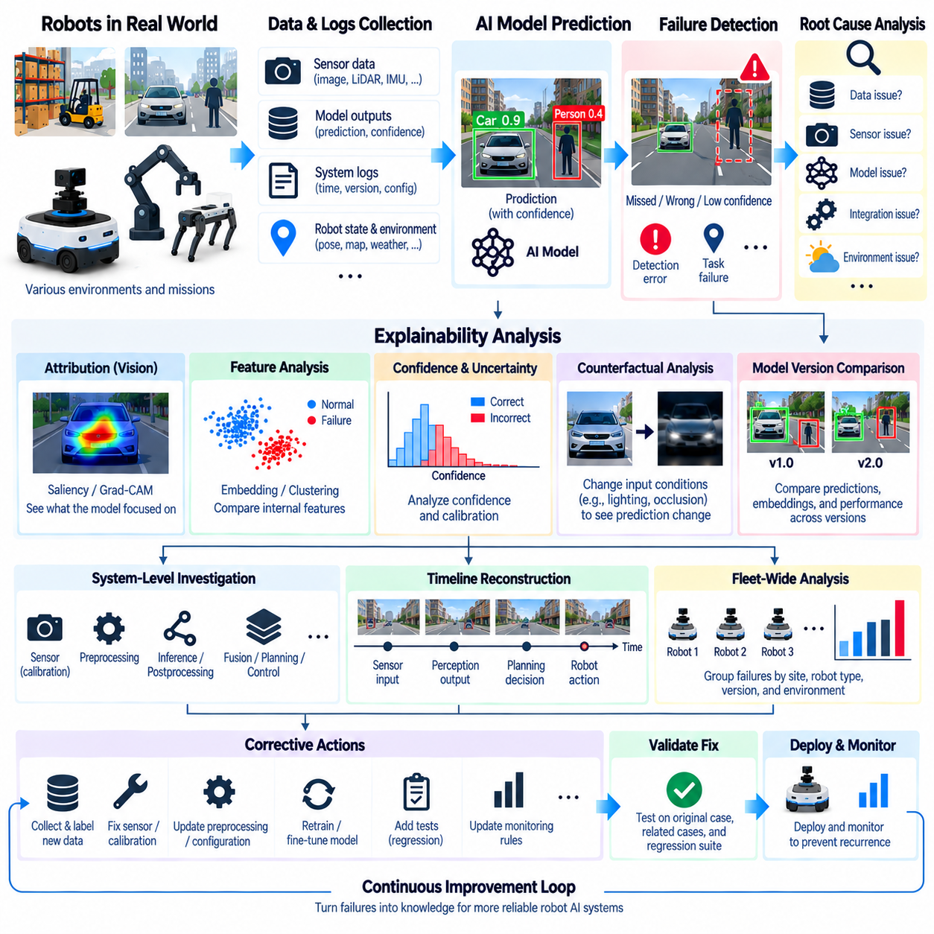
Model explainability is the process of making an AI model’s predictions, internal reasoning signals, and failure patterns understandable enough for engineers to investigate its behavior. In robotic systems, explainability is particularly important because perception outputs can influence planning, navigation, manipulation, and safety decisions. The objective is not merely to visualize a neural network, but to produce evidence that helps explain why a prediction occurred and why a failure propagated into robot behavior.
Explainability and root cause analysis are closely related but serve different purposes. Explainability examines which inputs, features, representations, or model components contributed to a prediction, whereas root cause analysis seeks the underlying reason that an operational failure occurred. A wrong object detection may originate from insufficient training data, sensor degradation, preprocessing errors, domain shift, model architecture limitations, deployment configuration, or interactions with downstream software.
A useful failure investigation begins with reproducibility. Engineers should preserve the sensor inputs, model outputs, timestamps, model version, preprocessing configuration, robot state, software release, hardware configuration, and environmental context associated with an incident. Without this information, an observed failure may be impossible to reproduce. Production monitoring should therefore generate traceable records that connect individual predictions with the complete execution context in which they occurred.
For vision models, attribution methods can indicate which image regions contributed strongly to a prediction. Saliency maps, gradient-based attribution, activation visualization, and class activation mapping can highlight spatial areas associated with model responses. These techniques can help determine whether a detector relied on the intended object, surrounding background, reflections, shadows, or irrelevant visual patterns. Their results should be treated as diagnostic evidence rather than definitive explanations of model reasoning.
Feature-level analysis provides another perspective by examining intermediate representations produced inside the model. Embeddings from normal and failed samples can be compared using distance measures, clustering, or dimensionality reduction. Failure samples that form a distinct cluster may indicate an underrepresented environment, object appearance, sensor condition, or operational domain. Similar embeddings with different prediction outcomes can instead suggest ambiguity near a learned decision boundary.
Confidence and uncertainty analysis can reveal whether the model recognized that a situation was difficult. A low-confidence incorrect prediction differs operationally from a highly confident incorrect prediction. The first may indicate insufficient evidence, while the second can expose poor calibration, dataset bias, or an unfamiliar condition that the model incorrectly maps to a known concept. Confidence should therefore be analyzed together with correctness, class, environment, and historical behavior.
Counterfactual analysis asks how an input would need to change for the model to produce a different prediction. In robot perception, engineers might examine whether changes in illumination, occlusion, object position, scale, background, point density, or sensor noise alter the model decision. Carefully controlled perturbations can reveal sensitivity to particular conditions and help distinguish robust semantic features from fragile correlations learned from the training dataset.
Failure analysis should extend beyond the model because robotic AI operates as part of a larger perception-to-action pipeline. Sensor acquisition, synchronization, calibration, preprocessing, inference, postprocessing, sensor fusion, planning, middleware communication, and control can all contribute to an observed incident. A perception failure reported at the robot level may therefore originate upstream of the neural network or appear only after an otherwise reasonable prediction is interpreted incorrectly downstream.
Timeline reconstruction is especially useful for failures involving dynamic robot behavior. Logs from cameras, LiDAR, IMU, model inference, localization, planning, control, and safety systems can be synchronized around the event. Engineers can then reconstruct the sequence from environmental observation through perception and decision to physical action. This temporal view helps distinguish the first abnormal event from secondary effects that occurred after the original problem had already entered the system.
Root cause analysis should separate correlation from causation. A temperature spike, confidence reduction, and navigation failure may occur at approximately the same time without all three sharing the same cause. Engineers can compare successful and failed runs, reproduce the scenario, disable suspected components, replay recorded data, or modify one variable at a time. Evidence becomes stronger when changing a suspected factor repeatedly causes or eliminates the observed failure.
Comparative analysis across model versions can identify regressions introduced by training or deployment changes. The same recorded sensor sequence can be replayed through the current model, previous stable model, and candidate models. Differences in predictions, confidence, latency, and intermediate representations help isolate whether the problem is model-specific. Linking every result to exact model artifacts and dataset versions makes this comparison reproducible across development cycles.
Fleet-wide evidence can further narrow the cause of a failure. If only one robot exhibits abnormal perception while identical models operate normally elsewhere, investigation can focus on local sensors, calibration, hardware, or configuration. If many robots running the same model version fail under similar conditions, a model or dataset problem becomes a stronger hypothesis. Grouping incidents by site, robot type, sensor revision, software version, and environment supports systematic diagnosis.
Failure taxonomy helps transform isolated incidents into structured engineering knowledge. Failures can be categorized by sensor condition, data quality, domain shift, object class, preprocessing, model inference, calibration, timing, resource exhaustion, integration, or downstream behavior. Consistent categories make it possible to identify repeated failure modes and determine whether multiple incidents share a common origin rather than being treated as unrelated operational anomalies.
Explainability evidence should be connected to training-data provenance. When a model fails on a particular object or environment, engineers should determine whether comparable examples existed in the training dataset, how frequently they appeared, how they were labeled, and whether augmentation represented relevant variations. Dataset lineage can reveal missing scenarios, class imbalance, annotation inconsistencies, or spurious correlations that are difficult to identify by inspecting model outputs alone.
Simulation and replay provide controlled environments for testing root-cause hypotheses. Recorded sensor streams can reproduce perception failures without repeatedly operating the physical robot, while simulation can systematically vary lighting, weather, geometry, sensor noise, object position, or occlusion. Hardware-in-the-loop testing can extend this analysis to timing, communication, and compute behavior. Together, these methods allow suspected causes to be tested under repeatable conditions.
A root cause should lead to a corrective action that corresponds to the actual failure mechanism. Dataset coverage problems may require targeted data collection and annotation, calibration problems require sensor correction, preprocessing defects require software changes, and compute overload may require model optimization or resource reconfiguration. Retraining should therefore be one possible response rather than the default response to every AI-related incident.
Corrective actions must also be verified against the original failure. A candidate fix can be tested using the exact recorded incident, related edge cases, historical validation datasets, and broader regression suites. If a model is retrained, explainability and performance analysis should determine whether the failure was actually corrected rather than merely hidden by changes in aggregate metrics. Previously resolved incidents can then become permanent regression tests for future releases.
Explainability information should be presented at the level required by different engineering roles. ML engineers may need attribution maps, embeddings, calibration plots, and dataset lineage, while robotics engineers may need synchronized sensor and planning timelines. Operations teams may require incident summaries, affected robots, environmental conditions, and recovery actions. A shared incident identifier can connect these views without forcing every team to interpret raw model diagnostics.
The complete process forms an evidence-driven failure analysis loop. Production monitoring detects an abnormal event, traceable telemetry reconstructs its context, explainability methods examine model behavior, system-level analysis tests competing hypotheses, and reproducible experiments identify the most supported cause. Corrective action is then validated and converted into datasets, tests, monitoring rules, or deployment changes that reduce the probability of recurrence.
Model explainability and failure root cause analysis therefore provide the diagnostic layer of robotic MLOps. Their purpose is not to produce attractive visual explanations, but to connect a physical failure to measurable evidence across sensors, data, models, software, hardware, and robot behavior. When combined with versioning, replay, fleet analysis, validation, and continuous monitoring, this diagnostic process turns production failures into structured knowledge for improving the reliability of future robot AI systems.

8.8. Edge Inference Latency and Memory Monitoring [w/Code]
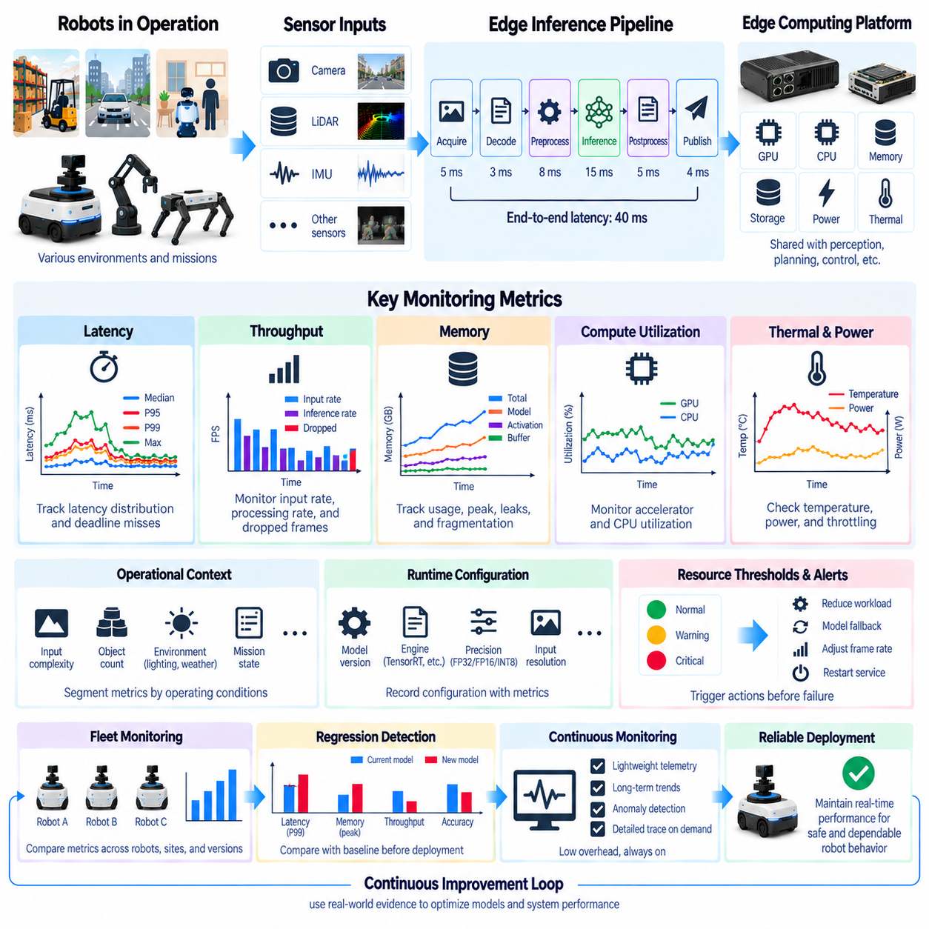
Edge inference monitoring focuses on observing how AI models behave when executed directly on resource-constrained computing platforms deployed inside robots. Unlike cloud inference, edge execution must share limited GPU, CPU, memory, storage, power, and thermal capacity with perception, localization, planning, communication, and control workloads. Continuous latency and memory monitoring is therefore essential for determining whether an AI model can maintain predictable real-time behavior throughout robot operation.
Inference latency represents the time required for a model to transform an input into a usable prediction. For robotic applications, average latency alone is insufficient because occasional long delays can disrupt time-sensitive perception and control loops. Monitoring should therefore include median latency, percentile values such as P95 and P99, maximum observed latency, and deadline-miss frequency. These measurements reveal both normal execution behavior and rare timing events that may threaten operational reliability.
Latency should be measured across the complete inference pipeline rather than only around neural-network execution. Sensor acquisition, decoding, preprocessing, memory transfer, inference, postprocessing, and publication of results can each contribute substantial delay. A model reporting 15 ms of accelerator execution may participate in a 40 ms perception pipeline once preprocessing and communication are included. Component-level timestamps allow engineers to identify where the actual bottleneck occurs.
End-to-end latency becomes especially important when perception results influence physical actions. The relevant measurement may extend from camera exposure or LiDAR acquisition to the moment when a processed result becomes available to planning or control. This sensor-to-decision latency determines the age of information used by the robot. Monitoring it helps identify situations where individually fast components collectively produce stale observations because of queues, synchronization, or communication delays.
Throughput complements latency by measuring how many inputs can be processed during a given interval. A perception model may have acceptable latency for individual frames but still fail to process incoming sensor data at the required rate. When input frequency exceeds sustainable throughput, queues grow, frames are dropped, or increasingly old observations are processed. Monitoring input rate, inference rate, queue depth, and dropped-frame count provides a clearer view of real-time pipeline health.
Memory monitoring must distinguish among several resource types. Edge AI systems can consume system RAM, accelerator memory, shared unified memory, pinned buffers, model weights, activation memory, preprocessing buffers, and middleware queues. Tracking only total memory utilization can hide the component responsible for pressure. Monitoring should therefore associate memory consumption with processes, models, containers, and pipeline stages whenever the deployment platform provides sufficient visibility.
Peak memory usage is often more important than average consumption because short-lived allocation spikes can trigger out-of-memory failures even when normal utilization appears safe. Model initialization, dynamic input shapes, temporary tensors, concurrent inference, and sensor bursts can create transient peaks. Monitoring maximum allocation, reserved memory, free memory, allocation failures, and memory fragmentation helps reveal conditions that may cause an edge application to fail after apparently stable operation.
Memory leaks require observation over longer time periods. A robot may pass a short benchmark while slowly consuming additional memory during hours or days of continuous operation. Increasing process memory, unreleased GPU allocations, growing message queues, retained sensor frames, or accumulated logging buffers can eventually cause swapping, allocation failures, or process termination. Trend monitoring is therefore necessary in addition to instantaneous memory measurements.
GPU and accelerator utilization provide context for latency and memory measurements. High utilization may indicate that the model is efficiently using available compute, but sustained saturation can also eliminate scheduling margin for other workloads. Low utilization combined with high latency may indicate CPU preprocessing, memory transfer, synchronization, or I/O bottlenecks. Utilization should therefore be interpreted together with timing, queue, and pipeline measurements rather than treated as an independent performance objective.
CPU utilization is equally important because many inference pipelines depend heavily on host-side processing. Image decoding, resizing, normalization, point-cloud transformation, non-maximum suppression, middleware serialization, and sensor synchronization may consume substantial CPU resources. Per-core utilization can reveal scheduling imbalance that is hidden by system-wide averages, particularly when a critical preprocessing thread competes with localization, planning, or control tasks.
Thermal behavior directly affects sustained edge inference performance. Embedded GPUs and compact edge computers operate within limited cooling and power envelopes, and prolonged workloads can cause thermal throttling. A model may satisfy latency requirements immediately after startup but become slower after extended operation. Temperature, clock frequency, power mode, throttling events, and inference latency should therefore be correlated during long-duration monitoring to identify thermally induced degradation.
Power consumption is another important operational variable for mobile robots. Higher inference performance can require increased accelerator frequency and electrical power, reducing battery runtime or increasing thermal load. Monitoring power alongside latency allows engineers to understand the tradeoff between computational performance and energy consumption. This is especially relevant when robots dynamically switch between power modes or operate under different battery, mission, and environmental conditions.
Concurrent workloads can significantly change edge inference behavior. Perception models often execute alongside SLAM, localization, mapping, planning, speech processing, communications, logging, and visualization. A model benchmarked in isolation may therefore show very different latency when integrated into the complete robot software stack. Monitoring should reproduce realistic concurrency and identify whether GPU kernels, CPU threads, memory bandwidth, or shared accelerators compete for limited resources.
Runtime configuration must be recorded together with performance metrics. Model version, inference engine, precision mode, batch size, input resolution, accelerator type, driver version, runtime version, power profile, and software configuration can all affect latency and memory consumption. Without this metadata, performance changes observed across deployments may be difficult to reproduce. Version-aware telemetry makes it possible to compare measurements across robot configurations and software releases.
Optimized inference engines can reduce edge latency and memory requirements, but their effects must be measured rather than assumed. FP16 or INT8 execution, graph optimization, operator fusion, tensor reuse, and engine-specific compilation may improve performance while potentially changing numerical behavior. Monitoring should therefore connect runtime optimization settings with both computational metrics and model-quality metrics so that performance gains are not evaluated independently from prediction reliability.
Dynamic workloads require monitoring across operational scenarios rather than under a single synthetic benchmark. Image complexity, number of detected objects, point-cloud density, input resolution, tracking load, and mission state can change computational demand. Measurements should be segmented by relevant operating conditions so that worst-case or scenario-specific behavior is visible. A stable fleet-wide average can otherwise conceal severe latency spikes in complex environments.
Resource thresholds can convert telemetry into actionable operating states. Warning levels may identify rising latency, reduced memory headroom, excessive queue depth, or sustained accelerator saturation before an actual failure occurs. Critical thresholds can trigger workload reduction, model fallback, frame-rate adjustment, controlled restart, or other predefined recovery mechanisms. Thresholds should reflect application deadlines and hardware limits rather than arbitrary percentages.
Monitoring overhead itself must remain bounded. High-frequency profiling, detailed tracing, and continuous collection of large diagnostic records can consume the same resources being measured. Edge monitoring systems should therefore use lightweight counters for continuous operation and activate detailed traces selectively when anomalies occur. Local aggregation, sampling, buffering, and asynchronous telemetry transmission can reduce interference with real-time robot workloads.
Fleet-level monitoring allows engineers to compare latency and memory behavior across multiple robots using the same model. Differences can reveal hardware variation, cooling problems, software configuration errors, sensor workload differences, or gradual device degradation. Grouping metrics by robot model, compute platform, software release, inference engine, and operating environment helps distinguish local anomalies from systematic performance regressions introduced by a deployment.
Performance regression detection should be integrated into the deployment lifecycle. A new model may improve perception accuracy while increasing P99 latency or peak accelerator memory beyond acceptable limits. Candidate releases should therefore be compared against stable baselines using both offline benchmarks and production telemetry. Shadow mode and staged deployment can expose computational regressions before a new model is granted broader operational authority.
Edge inference latency and memory monitoring ultimately provide the computational observability required for reliable physical AI deployment. By combining component and end-to-end latency, throughput, queue behavior, memory trends, accelerator utilization, CPU load, temperature, power, runtime configuration, and fleet comparisons, engineers can determine whether models remain computationally sustainable in real operation. These measurements connect AI performance with the timing and resource constraints that govern safe and dependable robot behavior.

8.9. Fleet Wide AI Model Health Dashboard [w/Code]
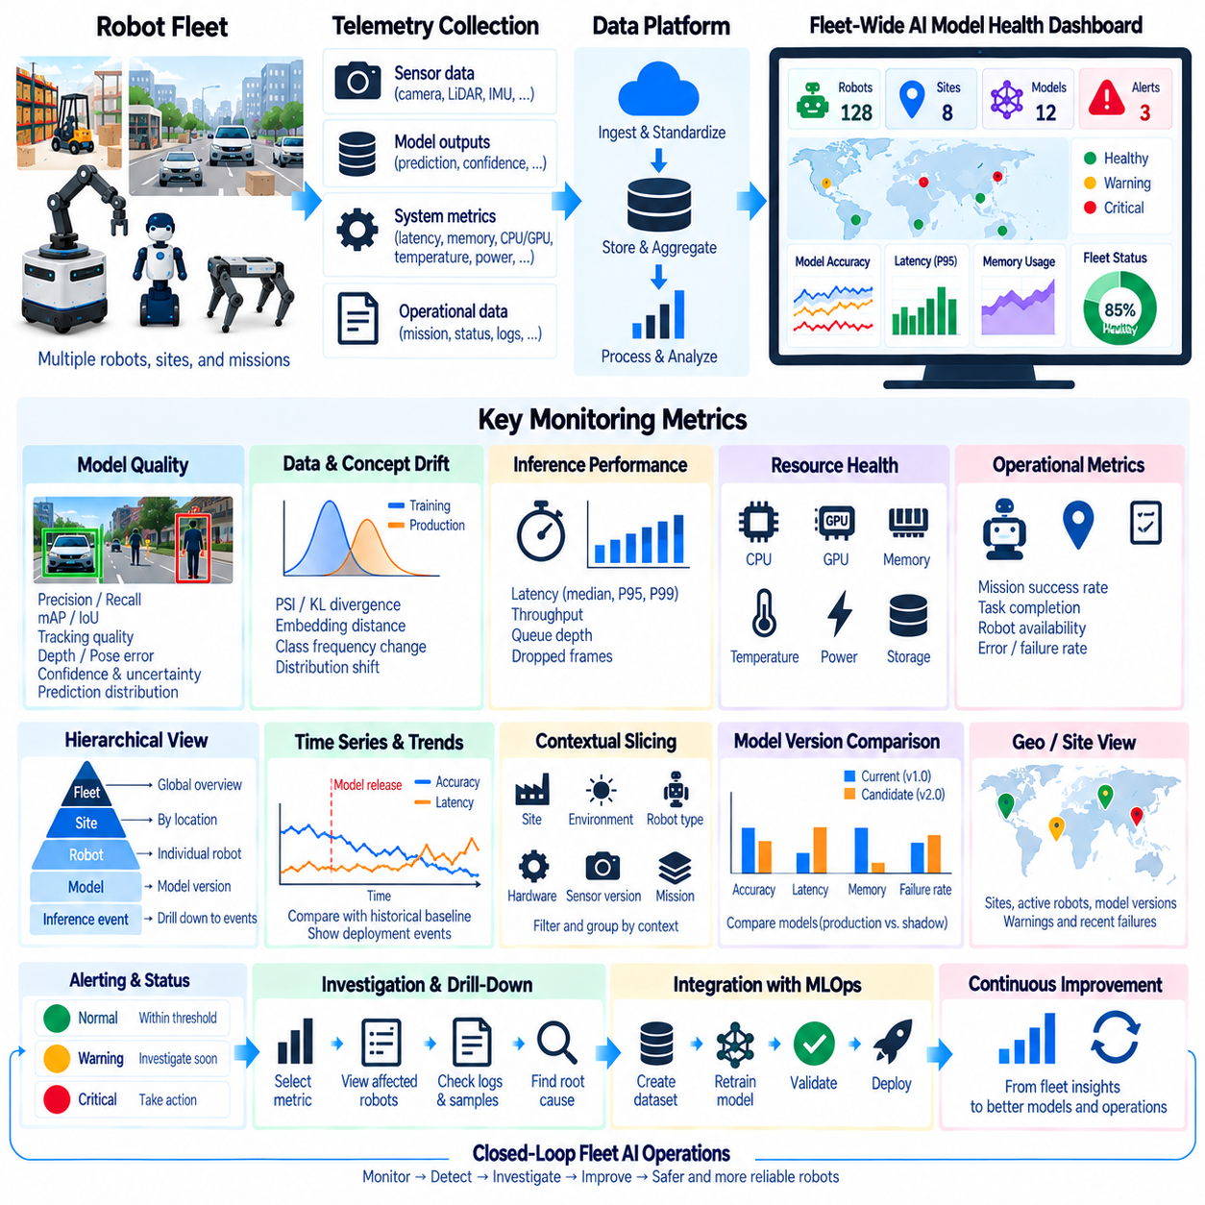
A fleet-wide AI model health dashboard provides a centralized operational view of how deployed AI models behave across many robots, sites, missions, and hardware configurations. Instead of examining telemetry from one robot at a time, the dashboard aggregates model-quality, inference-performance, system-health, and operational signals into a common monitoring layer. Its purpose is to identify degradation, anomalies, and deployment regressions before they become widespread fleet problems.
The dashboard should preserve the hierarchy between fleet, site, robot, model, and individual inference events. Fleet-level summaries provide rapid situational awareness, while drill-down views allow engineers to investigate a specific robot or model version. This hierarchical structure prevents aggregate statistics from hiding localized failures and allows an abnormal fleet metric to be traced back to the machines, environments, and software configurations that produced it.
Model health cannot be represented by a single universal score. Perception models may require precision, recall, mAP, IoU, tracking quality, depth error, or pose accuracy, while models without immediate ground truth may rely on confidence, uncertainty, disagreement, and prediction-distribution statistics. The dashboard should display metrics appropriate to each model responsibility while preserving enough context to distinguish actual degradation from normal operational variation.
Data drift and concept drift indicators provide another dimension of fleet health. PSI, KL divergence, embedding-distance measures, class-frequency changes, and other statistical signals can reveal that production data is moving away from validated conditions. Drift should be displayed alongside model-quality and operational metrics rather than interpreted independently, because distribution change becomes most important when it correlates with declining performance or abnormal robot behavior.
Edge inference health should appear beside model-quality information. Median, P95, and P99 latency, throughput, queue depth, dropped frames, CPU utilization, accelerator utilization, memory consumption, temperature, and power can reveal computational degradation even when prediction accuracy remains stable. Combining these signals helps engineers determine whether an AI problem originates from model behavior, resource contention, thermal throttling, or the surrounding inference pipeline.
Fleet aggregation requires consistent telemetry schemas. Robots should report metrics with common names, units, timestamps, identifiers, and version metadata so that observations from different machines can be compared correctly. Every record should identify relevant dimensions such as robot ID, site, model name, model version, software release, sensor configuration, compute platform, inference engine, and mission type. Standardization is essential for reliable cross-fleet analysis.
Time-series visualization is fundamental because many model-health problems develop gradually. Dashboards should show how accuracy proxies, uncertainty, latency, memory, drift, and failure rates evolve over hours, days, or deployment cycles. Engineers can compare current behavior with historical baselines and deployment events. Overlaying model releases or configuration changes on the timeline helps determine whether degradation began after a particular software or model update.
Fleet health should be segmented by operational context. A model can appear healthy globally while failing at one warehouse, under nighttime illumination, on a particular robot generation, or during a specific mission. Filters and grouped views can separate metrics by site, environment, robot type, hardware revision, sensor version, object class, mission, or model version. Contextual slicing turns fleet averages into actionable engineering evidence.
A geographic or site-oriented view can help organizations operating robots across multiple facilities. Each location can display the number of active robots, model versions in use, warning conditions, recent failures, and aggregate performance. Such a view is not merely a map visualization; it provides a fast way to identify whether an anomaly is isolated to one site or distributed across several locations sharing the same model or configuration.
Model-version comparison is particularly important during staged deployment. The dashboard can compare a stable production model with a candidate running in shadow mode or with a new model deployed to a limited fleet cohort. Prediction quality, disagreement, latency, memory usage, task outcomes, and failure rates can be examined side by side. This provides production evidence for detecting regressions before a release is expanded across the entire fleet.
Alert states should be derived from defined operational thresholds rather than visual appearance alone. Normal, warning, and critical conditions can reflect model-quality degradation, excessive drift, latency deadline violations, memory pressure, thermal problems, or increasing task failures. Alert rules should include persistence and time-window logic so that temporary fluctuations do not generate excessive alarms while sustained deterioration receives appropriate attention.
A useful dashboard connects every alert to an investigation path. Selecting an abnormal metric should reveal affected robots, model versions, time ranges, environments, and related system signals. Engineers should be able to move from a fleet-level warning to robot-level telemetry and then to relevant inference events, logs, sensor samples, or incident records. This drill-down capability transforms the dashboard from a visualization surface into an operational diagnostic interface.
Correlation across metrics is valuable for root cause analysis. Increasing inference latency accompanied by rising GPU temperature may suggest thermal throttling, while increasing memory consumption over several days may indicate a leak. A performance drop limited to one sensor revision can point toward hardware or calibration differences. The dashboard should make such relationships visible without implying causation until additional evidence and reproducible investigation confirm the underlying cause.
Incident and deployment markers provide essential historical context. Model promotions, rollbacks, software updates, calibration changes, hardware replacements, and major operating events can be recorded on monitoring timelines. When a metric changes, engineers can determine whether the change aligns with a known deployment event. This linkage also supports post-incident review by reconstructing which versions and configurations were active when a failure occurred.
Data freshness should itself be monitored because missing telemetry can create a false appearance of system health. Each robot can report heartbeat status, last telemetry timestamp, communication state, and expected reporting interval. Dashboards should distinguish between a healthy robot and a robot for which recent data is unavailable. Fleet coverage indicators can show how much of the deployed population is represented in current health summaries.
The dashboard should support both real-time observation and longer-term trend analysis. Real-time views help operations teams detect immediate failures, while historical views allow ML and robotics engineers to identify gradual drift, recurring environmental patterns, resource degradation, and release-to-release changes. Retention policies can preserve aggregated long-term statistics while storing detailed high-volume telemetry only for selected incidents or diagnostic periods.
Scalability becomes important as fleets grow. Transmitting every raw sensor frame and inference record to a central platform is usually unnecessary and expensive. Robots can compute local summaries, aggregate high-frequency metrics, sample representative events, and upload detailed records when anomalies occur. This edge-to-central monitoring architecture reduces bandwidth and storage requirements while preserving sufficient evidence for fleet-wide analysis and targeted investigation.
Role-specific views can present the same underlying telemetry at different levels of detail. Operations teams may focus on robot availability, active alerts, mission failures, and recovery status, while ML engineers require model metrics, drift, uncertainty, and version comparisons. Platform engineers may emphasize latency, memory, GPU utilization, thermal behavior, and software releases. Shared identifiers allow these views to remain connected to the same incidents.
Fleet dashboards should integrate with the broader MLOps lifecycle rather than operate as isolated reporting systems. Confirmed degradation can create investigation records, preserve relevant samples, initiate annotation workflows, or provide evidence for a controlled retraining trigger. Candidate models can then return through validation, shadow evaluation, staged rollout, and monitoring. The dashboard becomes the operational observation layer connecting deployment with continuous model improvement.
A mature fleet-wide AI model health dashboard therefore acts as an observability and decision-support layer for deployed robotic intelligence. By combining model quality, drift, uncertainty, inference performance, resource health, contextual metadata, version history, alerts, and drill-down evidence, it converts distributed robot telemetry into structured fleet knowledge. This enables teams to detect local and systematic problems while maintaining traceability from fleet-level behavior to individual models, robots, and operational events.

8.10. Model Monitoring Alerting and On Call Runbooks
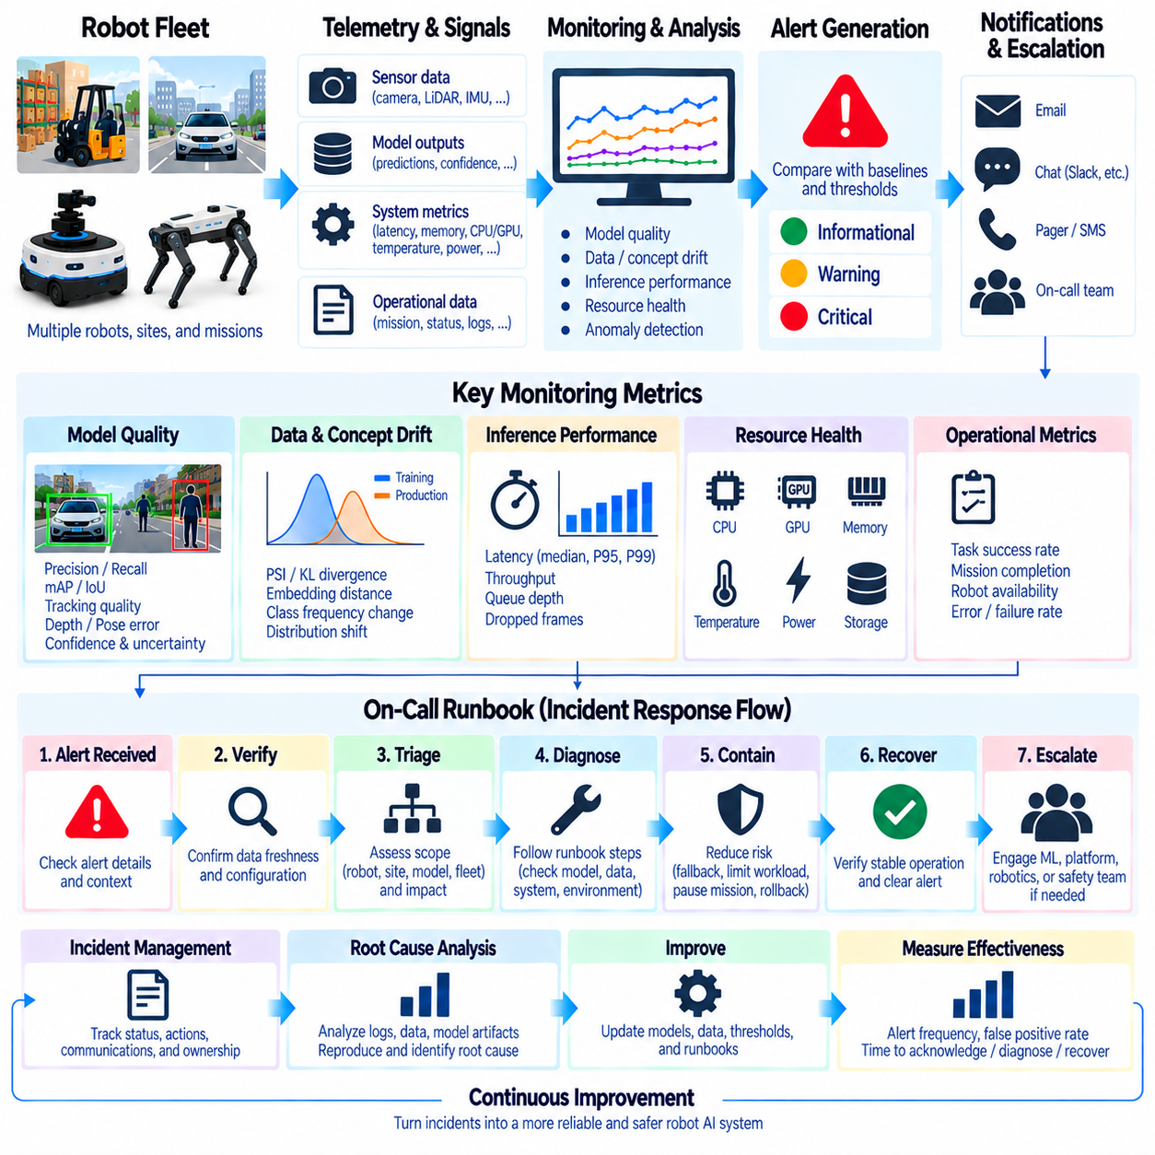
Model monitoring alerting converts continuous production telemetry into actionable signals when deployed AI behavior moves outside expected operating conditions. In robotic systems, alerts can originate from model-quality degradation, data or concept drift, inference latency, memory pressure, resource saturation, abnormal uncertainty, or task failures. The goal is not to report every metric change, but to identify conditions that require investigation or operational intervention before they develop into larger failures.
An alerting architecture normally begins with monitored signals and defined baselines. Each metric should have an expected range derived from validated operation, historical behavior, application requirements, or hardware constraints. Current measurements are evaluated against these references over appropriate time windows. The alerting layer then converts meaningful deviations into events containing severity, affected resources, timestamps, model versions, operational context, and supporting telemetry.
Alert thresholds should reflect operational consequences rather than arbitrary numerical boundaries. A small increase in P99 inference latency may be critical for a high-frequency control-related perception pipeline but insignificant for a low-rate inspection model. Similarly, declining recall for a safety-relevant object class may require faster escalation than an equivalent change in a less important category. Threshold design should therefore connect technical metrics with robot-level requirements.
Multiple severity levels help distinguish conditions requiring different responses. An informational event can record an unusual but nonurgent condition, while a warning may require investigation during normal operations. A critical alert indicates that reliability, mission execution, or safety-related functionality may be affected and requires immediate attention. Severity should determine notification urgency, escalation behavior, response expectations, and whether automated protective actions are permitted.
Alert rules should incorporate persistence and time-window logic to avoid reacting to transient noise. A single latency spike, uncertain prediction, or temporary memory increase does not necessarily indicate a persistent problem. Rules can require repeated threshold violations, moving-average degradation, sustained abnormal behavior, or a minimum number of affected samples. This reduces unnecessary notifications while preserving sensitivity to genuine operational deterioration.
Composite alerts can combine several weak signals into stronger evidence. Rising uncertainty together with increasing data drift and decreasing task success may provide a more meaningful indication of model degradation than any individual metric. Similarly, high inference latency combined with elevated temperature and reduced accelerator frequency can suggest thermal throttling. Multi-signal alert logic helps represent the interconnected behavior of robotic AI systems.
Alert deduplication and grouping become essential at fleet scale. A defective model release may cause hundreds of robots to generate nearly identical alerts within minutes. Treating each notification as an independent incident can overwhelm operators and obscure the shared cause. Alerts can therefore be grouped by model version, site, robot type, software release, failure signature, or time window so that a fleet-wide event is investigated as one coordinated incident.
Every alert should carry enough context to support initial triage. Useful information includes the affected robot or fleet cohort, model name and version, first and most recent occurrence, metric values, threshold conditions, deployment version, sensor configuration, hardware platform, mission state, and relevant environment metadata. Links or identifiers for dashboards, logs, traces, sensor samples, and previous incidents can reduce the time required to begin investigation.
An on-call runbook is a predefined operational procedure that guides responders from an alert toward diagnosis, containment, recovery, and escalation. It should describe what the alert means, why it matters, what evidence should be inspected first, and which actions are considered safe. Runbooks reduce dependence on individual memory and provide consistent responses when failures occur outside normal engineering hours or under time pressure.
The first stage of a runbook is usually verification. Responders should confirm that telemetry is current, the alert is not caused by missing data, and the affected robot is actually operating under the reported configuration. They can compare recent measurements with historical baselines and neighboring robots. This prevents teams from investigating model degradation when the underlying problem is stale telemetry, communication loss, incorrect metadata, or a monitoring-system fault.
Triage then determines the probable scope and operational impact. Engineers can ask whether the problem affects one inference event, one robot, one site, one hardware configuration, one model version, or the entire fleet. They should also determine whether missions continue normally and whether safety mechanisms remain available. Scope assessment helps establish priority and identifies whether local troubleshooting or fleet-level containment is appropriate.
Runbooks should guide responders through common diagnostic branches without assuming that the model is always responsible. A perception-quality alert may originate from sensor contamination, calibration changes, preprocessing defects, domain drift, corrupted model artifacts, or hardware problems. A latency alert may result from CPU contention, GPU saturation, memory pressure, thermal throttling, or queue growth. Diagnostic steps should progressively eliminate competing explanations.
Containment actions are intended to limit operational exposure while investigation continues. Depending on system design, these actions may include reducing workload, lowering sensor or inference frequency, disabling a nonessential model, switching to a validated fallback model, pausing affected missions, isolating a robot cohort, or rolling back a recent deployment. Such actions should be predefined and tested so responders do not improvise risky changes during an active incident.
Automation can execute selected containment actions when conditions are well understood, but automatic responses should have explicit boundaries. A memory threshold might safely restart a noncritical inference service, while a model-quality anomaly may require human confirmation before changing operational authority. Automated actions should be logged with the triggering evidence, configuration, timestamp, and result so that their effects can be reconstructed during later analysis.
Escalation rules define when an incident must move beyond the initial responder. A persistent fleet-wide regression may require ML engineers, platform engineers, robotics developers, site operations, or safety personnel. The runbook should identify escalation criteria and ownership rather than relying on responders to discover the correct team during an incident. Clear responsibility reduces delay and prevents unresolved alerts from circulating between groups.
Communication is part of incident response because several teams may need a consistent view of the event. An incident record can contain the current impact, affected robots, suspected scope, containment actions, investigation status, and next decision point. Updates should distinguish confirmed facts from hypotheses. A shared incident identifier can connect notifications, dashboard events, logs, model versions, corrective actions, and later root cause analysis.
Recovery should require evidence that the affected system has returned to acceptable operating conditions. Clearing an alert because a metric briefly crosses back below its threshold can produce premature closure. Responders should verify sustained recovery across an appropriate observation window and confirm that mission behavior, model metrics, inference performance, and system health have stabilized. Recovery criteria should therefore be defined as explicitly as alert criteria.
After recovery, the incident should transition into root cause analysis when its severity or recurrence justifies deeper investigation. Relevant telemetry, sensor samples, logs, model artifacts, deployment records, and responder actions should be preserved. Engineers can reproduce the failure through replay, simulation, or controlled testing and determine whether corrective action requires new data, retraining, software changes, calibration, hardware repair, or monitoring improvements.
Runbooks themselves should evolve from operational experience. If responders repeatedly perform undocumented steps, those actions should be evaluated and incorporated into the procedure. False-positive alerts may require threshold or persistence adjustments, while missed failures may reveal missing metrics or weak detection logic. Post-incident reviews can therefore improve both the monitored system and the monitoring process that observes it.
Alerting effectiveness should also be measured. Useful operational metrics include alert frequency, false-positive rate, repeated incident rate, time to acknowledge, time to diagnose, time to contain, and time to recover. These measurements reveal whether monitoring produces actionable information or simply generates noise. A mature alerting system minimizes unnecessary interruption while ensuring that meaningful degradation receives timely engineering attention.
Model monitoring alerting and on-call runbooks ultimately form the operational response layer of robotic MLOps. Monitoring detects abnormal behavior, alert logic determines significance, responders use structured runbooks to verify and contain the problem, and root cause analysis converts incidents into corrective actions. By connecting telemetry, severity, ownership, recovery, and continuous improvement, the process turns model observability into dependable operational control for deployed robot AI systems.

