Volume 10 Robot DevOps and MLOps

1. Git and Version Control

1.1. Version Control Fundamentals and Branching Models
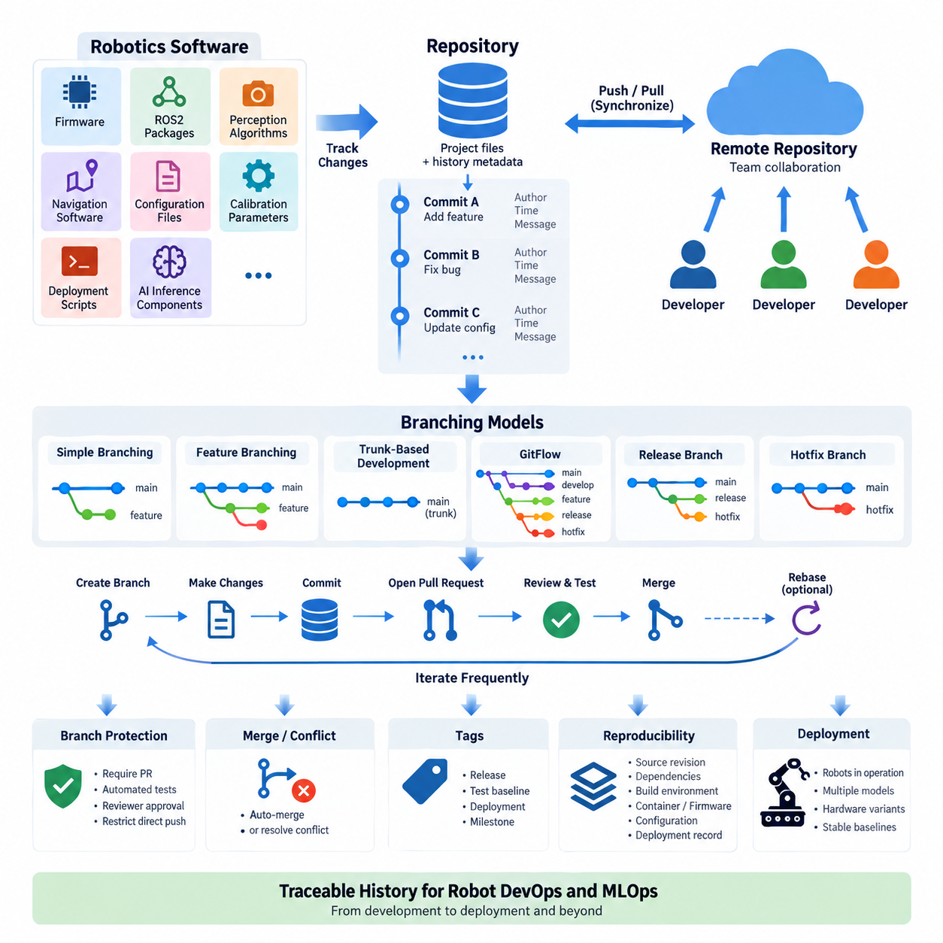
Version control is a systematic method for recording and managing changes to software artifacts over time. Instead of treating source files as isolated documents, a version control system maintains a history of modifications, allowing developers to identify what changed, who made the change, and when it occurred. This history provides the foundation for collaboration, traceability, rollback, and controlled software evolution.
Modern robot software makes version control especially important because a robotic system rarely consists of a single application. A production robot may contain embedded firmware, ROS2 packages, perception algorithms, navigation software, configuration files, calibration parameters, deployment scripts, and AI inference components. Version control provides a common mechanism for coordinating these artifacts while preserving their individual development histories.
A repository is the fundamental storage unit of a version control system. It contains the current project files together with metadata describing their historical states. Developers create commits to capture meaningful snapshots of the repository. Each commit represents a defined state of development and normally includes information about the author, timestamp, parent commit, and a message explaining the purpose of the change.
Commits should represent logical development units rather than arbitrary collections of modified files. For example, correcting a ROS2 localization node, updating its associated configuration, and modifying the corresponding test may belong to one commit. Keeping commits logically focused makes code review, debugging, regression analysis, and rollback easier because engineers can understand the intent and technical scope of each historical change.
Distributed version control systems such as Git allow each developer to maintain a complete local repository containing project history. Developers can therefore create commits, inspect differences, switch development lines, and examine previous versions without continuously communicating with a central server. Remote repositories provide synchronization points through which teams exchange changes and establish shared development states.
Branching allows multiple lines of development to evolve from a common history. A branch can isolate experimental algorithms, new robot capabilities, bug fixes, release preparation, or hardware-specific modifications without immediately changing the stable development line. When work becomes sufficiently validated, its changes can be integrated through merging or another controlled integration process.
The simplest branching approach uses a primary branch as the authoritative development line and creates short-lived branches for individual changes. A developer branches from the current primary state, implements and tests a modification, submits it for review, and integrates it after verification. This approach limits divergence between branches and encourages developers to integrate small changes frequently rather than accumulating large modifications.
Feature branching provides stronger isolation for development activities that require several related commits. A perception engineer might develop a new object-tracking function while navigation engineers continue modifying path-planning components. Both activities can proceed independently until the feature reaches an acceptable integration state. However, branches that remain separated for long periods increase the probability of difficult integration conflicts.
Trunk-based development minimizes long-lived branches by encouraging developers to integrate small changes into a shared primary branch frequently. Incomplete capabilities can remain disabled through configuration or feature flags rather than being maintained in isolated branches for extended periods. This model works well with continuous integration because the shared codebase is repeatedly built and tested as development progresses.
GitFlow introduces more explicit branch roles. A typical structure separates production releases, ongoing development, features, release preparation, and urgent fixes. This provides clear lifecycle boundaries for projects requiring formal release coordination, but it also increases branch-management complexity. Robotics organizations should therefore select such a model according to release requirements rather than assuming that more branches automatically provide better control.
Release branches can be useful when deployed robots must continue operating on a stable software generation while development proceeds toward the next generation. Critical corrections can be applied to the maintained release without introducing unrelated experimental functions. This separation becomes particularly valuable when multiple robot models, customer installations, or hardware revisions require different supported software baselines.
Hotfix branches address urgent defects discovered in an operational release. A correction can be created from the affected stable version, validated independently, and merged into the maintained development lines where appropriate. In robotics, such fixes may involve sensor drivers, communication faults, navigation behavior, or deployment configuration, making accurate identification of the affected software baseline essential.
Merging combines changes from separate development histories. When modifications affect independent files or code regions, Git can often integrate them automatically. Conflicts occur when competing changes cannot be reconciled safely without developer input. A merge conflict should therefore be treated as a semantic engineering decision rather than merely a textual inconvenience, particularly when robot behavior or safety-related logic is involved.
Rebasing provides another mechanism for integrating development histories by replaying commits onto a different base. It can produce a cleaner and more linear history, especially for local feature development, but it rewrites commit ancestry. Teams should establish clear rules governing where rebasing is permitted so that developers do not unexpectedly rewrite history already shared with other contributors.
Branch protection helps convert branching conventions into enforceable development policy. Important branches can require pull requests, successful automated tests, reviewer approval, or restrictions on direct modification. For robot software, these controls create a foundation for later CI/CD processes by ensuring that integration occurs only after defined quality checks rather than through uncontrolled direct changes.
Tags identify important repository states without creating another development line. They are commonly used to mark releases, validated test baselines, field deployments, or milestone versions. When a robot exhibits unexpected behavior in operation, a recorded release tag can help engineers reconstruct the exact source baseline associated with the deployed software and compare it with later or earlier versions.
Version control also supports reproducibility when repository history is connected with build environments, dependencies, configuration, and deployment metadata. A source commit alone may not completely describe an operational robot. Engineers should therefore maintain relationships among source revisions, container versions, firmware releases, AI models, configuration sets, and deployment records wherever these elements jointly determine system behavior.
Robot development introduces hardware dependencies that conventional application projects may not encounter. Different branches can temporarily correspond to prototype sensor configurations, controller revisions, compute platforms, or actuator interfaces. However, using permanent branches solely to represent hardware variants can create extensive divergence. Configuration management and modular interfaces are generally preferable when variants must coexist over long periods.
A practical branching model balances isolation with integration frequency. Too little isolation allows unstable work to disrupt shared development, while excessive branching produces divergent histories and expensive merges. The appropriate model depends on team size, release frequency, hardware diversity, validation requirements, and the operational consequences of software failure. The branch structure should therefore reflect the engineering lifecycle of the robot.
Version control ultimately provides more than file history. It establishes a traceable engineering record connecting development decisions with executable software states. Within the broader Robot DevOps and MLOps architecture, this repository history becomes the starting point for code review, continuous integration, automated testing, release management, container builds, OTA deployment, model management, and fleet-wide software operations.

1.2. Git Internals Objects Refs and Pack Files
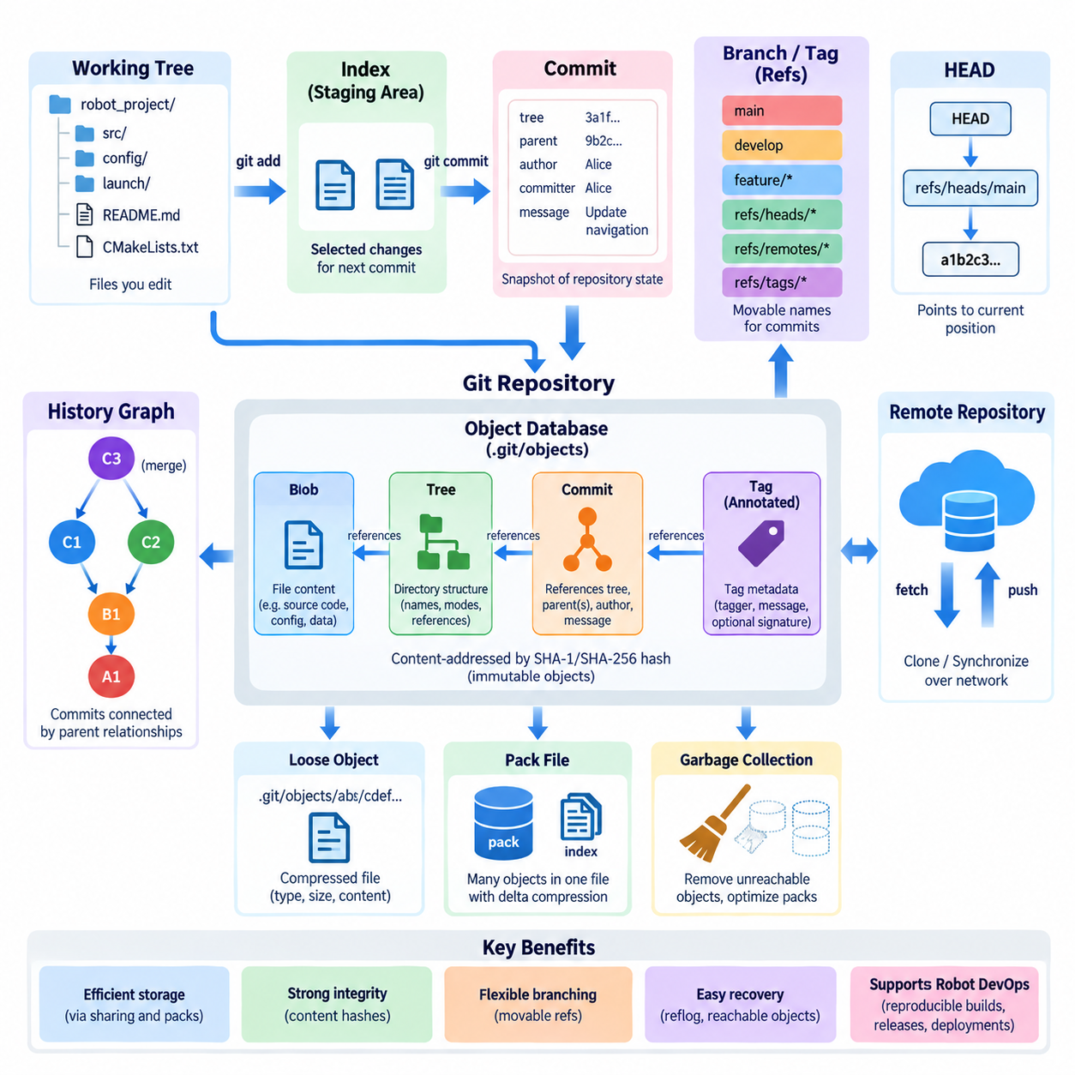
Git is often described as a distributed version control system, but internally it behaves more like a content-addressable object database combined with a set of references. Instead of storing each project version as a complete directory or recording only textual differences between revisions, Git represents repository history through immutable objects identified by cryptographic object IDs. Understanding these objects explains why branching, merging, tagging, rollback, and distributed synchronization can operate efficiently.
At the core of Git are four principal object types: blob, tree, commit, and annotated tag. These objects are stored in the repository’s internal object database and are addressed by hashes derived from their contents. Because an object’s identity depends on its content, identical content can naturally share the same stored object. Modifying content produces a different object ID rather than altering the existing historical object, giving Git its largely immutable historical structure.
A blob object represents file content. It does not inherently contain the original filename, directory location, author, or modification timestamp. If two files contain exactly the same data, Git can reference the same blob object for both. When a file changes, Git creates a new blob representing the changed content while the previous blob remains available to commits that reference the earlier state.
Tree objects describe directory structures. A tree contains entries that associate names and file modes with blob objects or other tree objects. In this way, Git can represent an entire project hierarchy recursively. A source directory containing ROS2 packages, configuration files, launch files, and scripts becomes a graph of trees and blobs rather than a conventional collection of independently versioned files.
A commit object records a particular repository state by referencing a root tree object. It also contains information such as parent commit identifiers, author information, committer information, timestamps, and the commit message. A normal commit usually references one parent, while a merge commit may reference multiple parents. Following these parent relationships backward produces the directed history commonly visualized as the Git commit graph.
This structure means that Git fundamentally records snapshots rather than treating repository history as a sequence of patches. Unchanged files can continue to reference existing blob objects, while changed files receive new objects and affected tree structures are reconstructed accordingly. The resulting graph shares unchanged content efficiently. Conceptually, each commit identifies a complete project state even though Git does not need to duplicate every unchanged file for every revision.
Git objects are normally located beneath the `.git/objects` area of a repository. A loose object is compressed and stored using a path derived from its object ID. The internal representation includes an object type and size together with the content. Developers normally interact with higher-level Git commands rather than manipulating these files directly, but the object database is the persistent foundation beneath familiar operations such as commit, checkout, merge, and reset.
Cryptographic hashes connect Git objects into a content-addressed graph. A tree references blobs and subtrees by object ID, while a commit references its tree and parent commits. Consequently, changing lower-level content produces new identifiers that propagate into newly created higher-level objects. This relationship provides strong integrity characteristics because repository history is structurally connected through content-derived identifiers rather than arbitrary sequential version numbers.
References, commonly called refs, provide human-manageable names for positions in this object graph. Instead of requiring developers to remember a long commit identifier, Git can associate names such as `main`, `develop`, or a release branch with particular commits. A branch is therefore fundamentally a movable reference that normally advances when new commits are created on that branch, rather than a separate physical copy of the project.
Local branch references are typically represented under `refs/heads`, while remote-tracking references appear under `refs/remotes`. Tags are associated with `refs/tags`. These namespaces help Git organize different kinds of symbolic names while ultimately connecting them to repository objects. This distinction is important because a local branch and a remote-tracking branch may point to different commits even when their names appear closely related.
HEAD is a special reference representing the currently checked-out development position. In normal operation, HEAD symbolically refers to a branch such as `refs/heads/main`, and that branch points to a commit. Creating a new commit updates the branch reference while HEAD continues to identify the branch. In a detached HEAD state, HEAD instead identifies a commit directly, allowing inspection or experimentation without automatically advancing a normal branch.
Tags provide relatively stable names for significant historical points. A lightweight tag behaves primarily as a direct reference to an object, while an annotated tag introduces a tag object containing additional metadata such as the tagger, message, and potentially a cryptographic signature. Release tags are particularly useful in robotics because they can associate validated source states with software releases, integration tests, or deployed robot configurations.
Git also maintains the index, often called the staging area, between the working tree and the committed repository history. The working tree contains files currently visible to the developer, while the index describes the content prepared for the next commit. A commit is constructed from the staged state rather than simply copying every file currently present in the working directory. This separation enables precise control over which modifications become part of a particular commit.
As repository history grows, storing every object individually as a loose object would become inefficient. Git therefore uses pack files to combine many objects into compact storage units. Pack files reduce filesystem overhead and can compress related objects efficiently. They are accompanied by index files that allow Git to locate individual objects within the packed representation without scanning the complete pack sequentially.
Pack files can use delta compression between related objects. Rather than storing every similar object independently in full, Git may store one object and represent another through differences relative to a suitable base object. This optimization is primarily an internal storage mechanism and does not change Git’s logical snapshot model. At the conceptual level, commits still describe complete repository states even when the physical representation uses deltas to reduce storage requirements.
Packing becomes especially important during repository maintenance and network transfer. Operations associated with garbage collection can consolidate loose objects, optimize packs, and remove unreachable objects when they are no longer protected by Git’s retention mechanisms. During clone, fetch, and push operations, Git can also exchange packed object data efficiently, reducing the amount of storage and network traffic required to synchronize distributed repositories.
Reachability determines which objects belong to meaningful repository history. Starting from references such as branches and tags, Git follows commits, trees, blobs, and parent relationships to discover reachable objects. Objects that are no longer reachable may temporarily remain in the object database before later cleanup. This behavior explains why some apparently deleted commits can sometimes be recovered before repository maintenance permanently removes their unreachable objects.
The reflog provides another important recovery mechanism by recording recent movements of local references such as branches and HEAD. If a developer accidentally resets a branch or moves it away from a desired commit, the reflog may preserve information needed to locate the previous position. For complex robot software repositories, this can be valuable when recovering development states after incorrect rebasing, resetting, or branch manipulation.
Git’s internal model is particularly useful for robotics projects containing many interconnected software components. Firmware, ROS2 packages, navigation modules, AI inference code, deployment scripts, and configuration files can evolve within a traceable commit graph. Branch references identify active development lines, tags identify validated releases, and object IDs provide precise identities that can be connected with CI results, container images, firmware builds, and deployment records.
Understanding objects, references, and pack files changes Git from a collection of commands into a coherent data model. Blobs preserve content, trees organize project structure, commits connect snapshots into history, refs provide usable names, HEAD identifies the current position, and pack files optimize physical storage and transfer. Together these mechanisms form the internal foundation upon which collaborative development, reproducible builds, release management, and Robot DevOps workflows can be constructed.

1.3. Git Workflow for Robot SW GitFlow Trunk Based [w/Code]
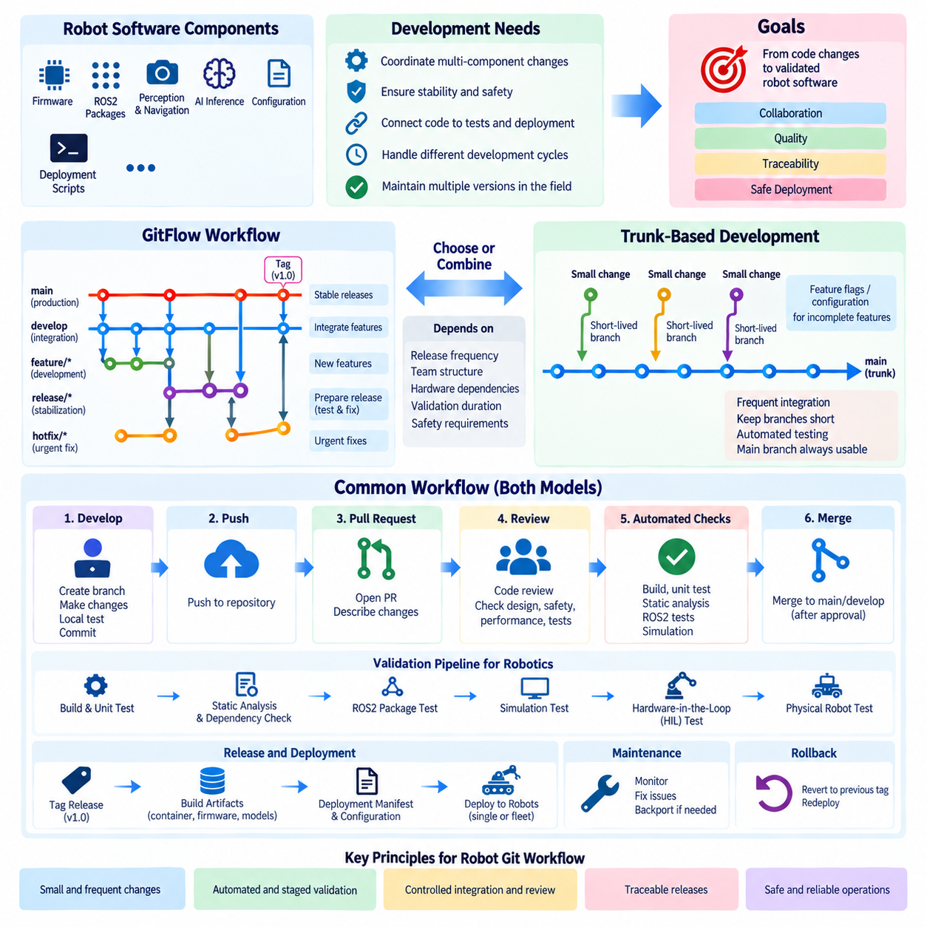
A Git workflow defines how developers create, review, integrate, release, and maintain software changes within a repository. For robot software, the workflow must coordinate components with very different development cycles, including embedded firmware, ROS2 packages, perception and navigation modules, AI inference software, configuration, and deployment scripts. The objective is not merely to organize branches, but to maintain a controlled path from engineering changes to validated robot software.
Robot software development introduces constraints that make workflow design more important than in many conventional applications. A change to a sensor driver can affect perception, localization, navigation, and safety behavior, while firmware modifications may require physical hardware validation. The Git workflow should therefore connect source changes with review, automated testing, simulation, hardware testing, release identification, and deployment rather than treating a successful merge as the end of development.
Two widely applicable approaches are GitFlow and trunk-based development. GitFlow emphasizes explicit branches for different lifecycle stages, while trunk-based development emphasizes frequent integration into a shared primary branch. Neither model is universally superior. The appropriate workflow depends on release frequency, team structure, hardware dependencies, validation duration, safety requirements, and the number of software versions that must remain operational in deployed robots.
GitFlow normally organizes development around persistent `main` and `develop` branches together with temporary feature, release, and hotfix branches. The `main` branch represents production-quality releases, while `develop` acts as the integration line for upcoming development. Engineers create feature branches from `develop`, complete their work, perform reviews and tests, and merge validated changes back into the development branch.
Feature branches provide isolation for work that may temporarily destabilize the system. A navigation engineer can modify path planning while another developer changes a LiDAR driver without immediately affecting the same integration baseline. This isolation is useful when robot functions require several development iterations, but long-lived feature branches should be avoided because increasing divergence makes integration and validation progressively more difficult.
When a planned software generation reaches sufficient maturity, GitFlow can create a release branch from `develop`. Only stabilization activities, such as defect correction, configuration adjustment, documentation, and final validation, should normally occur there. Robot-specific verification can include simulation regression, sensor integration tests, Hardware-in-the-Loop testing, and controlled physical robot tests before the release is merged into the production branch and tagged.
A hotfix branch provides a controlled path for correcting urgent problems discovered in an operational release. It is typically created from the affected production baseline so that unrelated development changes are excluded. After validation, the correction is integrated into the production line and also propagated to the active development history when necessary. This prevents a field correction from disappearing in the next planned software release.
GitFlow provides visible lifecycle boundaries, but those boundaries create operational cost. Developers must maintain several branch categories, synchronize fixes across development lines, and resolve conflicts caused by branch divergence. In robotics projects with long hardware validation cycles this structure can be useful, but excessive branching can delay integration until problems involving sensors, middleware, control, and AI modules become expensive to diagnose.
Trunk-based development takes a different approach. Developers integrate small changes frequently into a shared trunk, commonly represented by `main`, while branches are kept short-lived when they are used at all. Integration happens continuously rather than near the end of a large feature-development period. Automated build, test, static analysis, simulation, and quality gates become essential because the shared branch must remain usable.
Incomplete functions do not necessarily require long-lived branches in trunk-based development. Feature flags, configuration switches, modular interfaces, or disabled runtime paths can keep unfinished capabilities from affecting production behavior. For example, a new perception algorithm can exist in the shared codebase while the deployed configuration continues selecting the validated algorithm until evaluation demonstrates that the new implementation is ready.
Short integration cycles reduce the distance between a developer's local state and the shared repository state. Merge conflicts tend to remain smaller, and failures introduced by recent changes can be associated with a narrower set of commits. This is valuable in robot software because failures may emerge from interactions among multiple subsystems rather than from a single module, making frequent system-level integration an important engineering practice.
A practical robot software workflow can combine principles from both models. Daily development may follow trunk-based practices with small pull requests and rapid integration, while release branches are created only when a deployed robot generation requires extended stabilization or maintenance. This hybrid approach avoids unnecessary permanent branching while still supporting fielded robots that cannot immediately move to the newest development baseline.
Regardless of the branching model, a change should pass through a controlled integration path. A developer begins from an approved baseline, creates a focused change, performs local verification, and commits logically related modifications. The change is then pushed to the shared repository and submitted through a pull request or equivalent review mechanism. Automated checks and human review determine whether it is acceptable for integration.
Pull requests provide an engineering boundary between individual development and shared software. Reviewers can evaluate architecture, interfaces, error handling, concurrency, resource usage, configuration effects, and test coverage before a change enters the primary development line. For robotics, reviewers should also consider whether the modification affects timing, actuator behavior, sensor assumptions, coordinate frames, safety logic, or hardware compatibility.
Continuous integration strengthens the workflow by converting repository policies into repeatable checks. Each proposed change can trigger compilation, unit tests, dependency checks, static analysis, ROS2 package tests, container builds, simulation scenarios, and other automated validation. Failures prevent integration until they are resolved, reducing the probability that the shared branch becomes unusable because of a change that could have been detected automatically.
Not every robot behavior can be validated in software-only CI. Changes involving motors, sensors, timing, communication buses, compute platforms, or physical interaction may require Hardware-in-the-Loop or robot-level testing. The workflow should distinguish tests that execute for every commit from more expensive validation stages triggered before releases or safety-relevant integrations. Git therefore becomes the event source for progressively deeper verification.
Branch protection should enforce the workflow rather than relying entirely on developer discipline. Important branches can prohibit direct pushes, require approved pull requests, demand successful automated checks, and restrict who can perform sensitive merges. Release tags can then identify software states that completed the required validation process, providing a reproducible reference for deployment, incident investigation, and maintenance.
Robot software repositories often support multiple hardware configurations. A tempting strategy is to create permanent branches for every robot model, sensor set, or compute platform, but this can fragment the codebase. Where possible, common software should remain integrated while differences are expressed through configuration, abstraction layers, build options, or platform-specific modules. Branches should represent development or release history rather than becoming substitutes for architecture.
Commit size also influences workflow quality. Small, coherent commits are easier to review, test, revert, and associate with failures than large commits containing unrelated modifications. A robot feature may span several packages, but each commit should still represent a comprehensible engineering step. Clear commit messages and pull-request descriptions further connect implementation changes with their intended behavior and validation evidence.
Release management completes the transition from repository history to operational software. A validated commit can be assigned a release tag and connected with container images, firmware binaries, AI model versions, configuration packages, and deployment manifests. This relationship makes it possible to determine precisely which software combination is operating on a robot and to reproduce that state when diagnosing field failures or preparing a rollback.
Rollback should be designed into the workflow rather than treated as an emergency improvisation. If a newly deployed software version produces unacceptable behavior, the organization should be able to identify the previous validated release, restore its associated artifacts, and redeploy it through a controlled process. Reliable tags, immutable build artifacts, deployment records, and compatible configuration management make this possible.
The most effective Git workflow for robotics therefore combines rapid engineering feedback with controlled operational stability. GitFlow provides explicit release and maintenance boundaries, while trunk-based development promotes continuous integration and limits branch divergence. By adapting these principles to simulation, HIL testing, physical validation, release tagging, and fleet deployment, Git becomes the foundation of a traceable Robot DevOps lifecycle from source modification to field operation.

1.4. Monorepo vs Polyrepo Strategy for Robot Projects
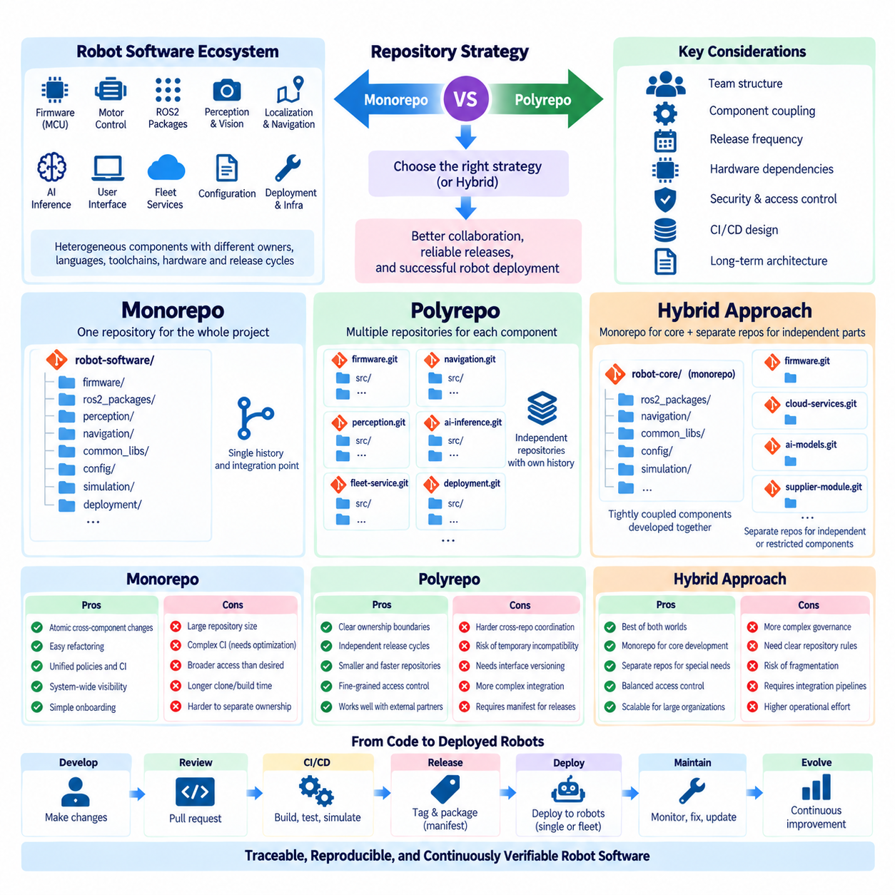
A repository strategy determines how the source code and related engineering assets of a robot system are divided across version-controlled repositories. Two fundamental approaches are the monorepo, where multiple components are maintained in one repository, and the polyrepo, where components are distributed across multiple repositories. The choice influences collaboration, dependency management, CI/CD design, release processes, access control, and long-term software architecture.
Robot projects make this decision particularly important because they combine heterogeneous software layers. A single robot may include MCU firmware, motor-control software, ROS2 drivers, localization and navigation packages, perception pipelines, AI inference modules, user interfaces, fleet services, configuration files, and deployment infrastructure. These components interact at runtime but may have different owners, programming languages, toolchains, hardware targets, and release cycles.
A monorepo places many or all related components under one repository hierarchy. For example, firmware, ROS2 packages, perception software, navigation modules, common libraries, configuration, simulation assets, and deployment scripts can exist as directories within the same repository. Developers can inspect and modify relationships across the complete system while Git maintains one unified history and one common integration point.
One major advantage of a monorepo is atomic cross-component change. If a sensor interface changes together with a ROS2 driver and a perception module, all required modifications can be included in one commit or pull request. The repository therefore captures the relationship among dependent changes directly. This reduces situations in which one repository is updated while another temporarily remains incompatible with the new interface.
A unified repository can also simplify refactoring. Shared APIs, message definitions, libraries, configuration structures, or build conventions can be modified across many components in a coordinated operation. Code review can examine the complete effect of a change rather than reviewing separate repository updates independently. For tightly coupled robot software, this system-wide visibility can make architectural evolution easier to manage.
Monorepos also support centralized engineering policies. Formatting rules, static analysis, test conventions, dependency policies, security scanning, and common CI templates can be maintained consistently. Developers can discover related code more easily, and new engineers can inspect the overall software structure from a single repository. These characteristics are useful when many robot functions are developed by a closely coordinated engineering organization.
However, repository size and dependency complexity can become significant disadvantages. A large robot monorepo may contain software for multiple compute architectures, hardware generations, simulation environments, and AI workloads. Running every build and test for every modification would waste substantial computing resources. Effective monorepo CI therefore requires change detection, dependency graphs, build caching, and selective test execution.
A monorepo can also create broader access than desired. Firmware, cloud services, AI models, customer-specific integrations, and proprietary algorithms may have different confidentiality requirements. Although repository platforms provide various permission mechanisms, repository-level access control is often easier to manage than fine-grained restrictions inside one large repository. Organizational boundaries can therefore become a reason to separate selected components.
A polyrepo strategy assigns independent repositories to components, services, packages, or engineering domains. Firmware might reside in one repository, ROS2 navigation in another, perception in another, and fleet cloud services in additional repositories. Each repository can maintain its own branch policy, CI pipeline, release tags, dependency definitions, maintainers, and permissions according to the requirements of that component.
Independent repositories provide strong ownership boundaries. A firmware team can release controller software without forcing unrelated cloud services to share the same repository lifecycle. An AI team can iterate on inference software independently of low-level motor-control development. Smaller repositories may also be faster to clone, easier to understand locally, and simpler to protect when external partners or suppliers require access to only part of the robot system.
The principal difficulty of polyrepo development is coordination across repository boundaries. A change to a shared interface may require synchronized updates to several repositories. Separate pull requests can be merged at different times, producing temporary incompatibility. Teams therefore need explicit interface versioning, dependency declarations, release coordination, compatibility testing, and integration environments that reconstruct the correct combination of repository versions.
Version identification becomes especially important in polyrepo systems. A deployed robot cannot be described accurately by naming only one Git commit if its software originates from many repositories. A higher-level manifest can record the exact commit, tag, package, container image, firmware version, AI model, and configuration revision used in a validated system. This manifest effectively becomes the reproducible definition of a robot software release.
ROS2 supports both strategies because packages can coexist in a single workspace while their source code originates from one or many Git repositories. A monorepo may directly contain a complete ROS2 workspace, whereas a polyrepo environment can assemble the workspace from multiple repositories. The important architectural distinction is therefore not the runtime ROS2 graph itself, but how ownership, versioning, integration, and change history are managed.
Hardware diversity further affects repository strategy. If several robot products share navigation, perception, communication, and fleet components, duplicating these modules into product-specific repositories can create long-term maintenance problems. Shared libraries or services should generally have explicit ownership and reusable interfaces, while hardware-specific implementations can remain separated where their lifecycle and validation requirements genuinely differ.
Repository boundaries should follow architectural boundaries where practical. A component with a stable interface, independent ownership, independent release lifecycle, and limited coupling is a strong candidate for a separate repository. Conversely, components that change together frequently may become unnecessarily difficult to manage when separated. Repository structure should therefore reflect actual change relationships rather than arbitrary organizational charts.
CI/CD architecture differs substantially between the two approaches. A monorepo pipeline must determine which components are affected by a change and execute only the necessary builds, tests, simulations, and hardware validation. A polyrepo pipeline can remain smaller per repository but requires additional integration pipelines to verify compatibility among released components. Neither architecture eliminates complexity; it moves complexity to different parts of the engineering system.
Release management follows the same pattern. A monorepo can associate one commit or tag with a coordinated system state, although individual components may still require separate version numbers. Polyrepo development naturally supports independent component releases but needs a mechanism for composing them into a validated robot release. Container registries, artifact repositories, package indexes, and deployment manifests can provide the bridge between source repositories and operational software.
Security and supplier collaboration can favor selective repository separation. A motor-controller supplier may require access to firmware interfaces but should not necessarily access proprietary perception algorithms. A customer integration team may need deployment configuration without access to internal AI development. Polyrepo boundaries can provide straightforward isolation, while shared specifications, generated interfaces, or published packages preserve controlled interoperability.
The choice between monorepo and polyrepo does not need to be absolute. Large robotics organizations can use a hybrid repository strategy in which tightly coupled robot runtime software resides in a monorepo while firmware, cloud infrastructure, AI training systems, safety-critical components, or supplier-owned modules remain separate. This preserves atomic development where coupling is high while retaining independent lifecycle and access boundaries where separation provides real value.
A hybrid design requires explicit rules to prevent repository fragmentation from growing without control. Teams should define criteria for creating a new repository, ownership responsibilities, interface versioning, dependency publication, compatibility guarantees, and integration testing. Without such rules, a polyrepo environment can evolve into numerous poorly coordinated repositories, while an unrestricted monorepo can become a large collection of unrelated projects sharing little beyond storage.
For robot projects, repository strategy should ultimately optimize system integration rather than repository count. Monorepos favor coordinated change, unified visibility, and centralized policy, while polyrepos favor independent ownership, lifecycle separation, and access boundaries. A carefully designed hybrid can combine both characteristics. The correct structure is the one that keeps software dependencies explicit, releases reproducible, interfaces controlled, and the complete robot system continuously verifiable within the broader Robot DevOps lifecycle.

1.5. Git Submodules and Subtrees for HW SW Co Repos [w/Code]
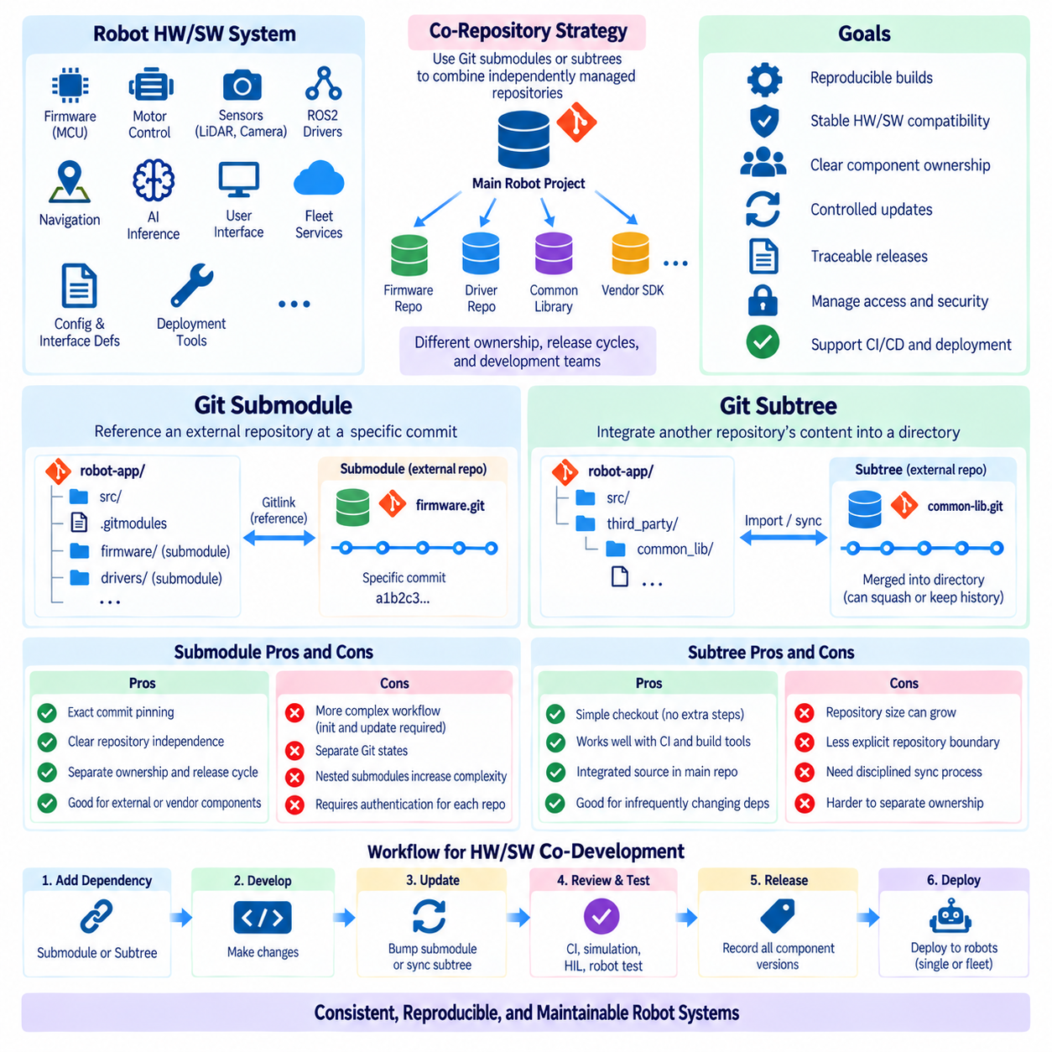
Git submodules and Git subtrees provide two different mechanisms for combining independently managed repositories into a larger software structure. This capability is especially useful in robotics, where a complete system may depend on firmware, hardware-interface libraries, ROS2 drivers, navigation modules, vendor SDKs, and deployment tools maintained with different ownership and release cycles. Both approaches preserve repository boundaries, but they manage dependency relationships differently.
A hardware-software co-repository environment often requires one project to depend on another without copying its development history manually. For example, a robot application repository may depend on a motor-controller firmware repository, a LiDAR driver, or a shared communication library. The engineering problem is therefore not simply how to obtain external source code, but how to identify, reproduce, update, validate, and release an exact combination of dependent repositories.
A Git submodule represents an external Git repository through a specific commit recorded inside the parent repository. The parent does not directly store the complete contents and history of the dependency as ordinary files. Instead, it records a Gitlink referencing a particular commit, while a `.gitmodules` file describes information such as the submodule path and repository location. This creates an explicit relationship between the parent project and an independently versioned repository.
The fixed commit reference is one of the most important characteristics of submodules. If a robot release is validated using a particular motor-control firmware revision, the parent repository can point to that exact firmware commit. Developers checking out the same parent revision can reconstruct the intended dependency version rather than automatically receiving the newest firmware. This behavior supports reproducibility and controlled hardware-software compatibility.
Submodules also preserve strong ownership boundaries. The external repository maintains its own branches, tags, permissions, issues, CI pipelines, and release process. A supplier-developed driver or an independently maintained embedded project can therefore remain autonomous while being referenced from the larger robot software repository. Changes to the dependency are committed in its own repository before the parent repository updates its recorded submodule pointer.
This separation introduces workflow complexity. Cloning the parent repository does not always produce a fully populated working tree unless submodules are initialized and updated. Developers must understand that the parent repository and submodule have distinct Git states. Switching parent branches may also require synchronizing submodules to the commits expected by the newly checked-out revision, otherwise the workspace can contain an unintended combination of component versions.
Nested submodules can increase this complexity further. If a robot project references a navigation repository that itself references additional libraries, dependency initialization can become multi-level. CI runners, container builds, and deployment systems must explicitly retrieve the required submodules, and authentication must be available for every private dependency. Poorly managed submodules can therefore create confusing failures even when the parent repository itself is correctly checked out.
Git subtree takes a different approach by integrating another repository’s content directly into a directory of the parent repository. From the perspective of a normal checkout, the imported files behave like ordinary files in the main repository. Developers do not generally need a separate initialization step to obtain them, making the resulting working tree simpler for users, CI systems, and build environments that only need the combined source state.
Subtree integration can preserve a relationship with the original external repository while allowing updates to be pulled into a designated directory. Changes can also be pushed back when the workflow is intentionally designed for bidirectional synchronization. Git subtree operations may use squashing to condense imported history or preserve more detailed history depending on the chosen process. The parent repository therefore carries more dependency content than with a submodule.
The major operational advantage of subtree is checkout simplicity. A developer cloning the robot project immediately receives the integrated dependency content as part of the repository. Automated build environments do not need additional submodule initialization logic, and archived source snapshots naturally contain the imported files. This can reduce onboarding and CI complexity when dependencies change infrequently or when independent repository manipulation is not required during normal development.
The trade-off is that repository boundaries become less explicit in everyday work. Imported code appears directly within the parent repository, and synchronization with the upstream project must follow a disciplined subtree process. If developers modify imported files without understanding their upstream relationship, later synchronization can become difficult. Repository size can also increase because the parent contains the integrated source rather than merely referencing an external commit.
The choice between submodule and subtree therefore depends strongly on ownership and update behavior. Submodules are attractive when a component must remain clearly independent, has its own release lifecycle, and needs exact revision pinning. Subtrees can be attractive when ease of checkout and build is more important than maintaining a visibly separate repository state during daily development. Neither mechanism eliminates the need for dependency governance.
Hardware-software co-development provides a practical example. Suppose an autonomous robot uses a motor-control board whose firmware is developed separately from the ROS2 vehicle-control stack. A submodule can pin the application repository to the exact firmware revision validated with a particular controller hardware revision. Alternatively, a subtree can import shared protocol definitions or communication libraries that application developers need frequently but update only occasionally.
Interface definitions require particular attention. Firmware and higher-level robot software may share CAN message definitions, register maps, protobuf schemas, ROS2 interfaces, or generated communication code. Duplicating these definitions manually across repositories creates synchronization risk. A dedicated interface repository referenced through a submodule, subtree, generated package, or versioned artifact can establish a controlled source of truth for both hardware and software development.
Dependency updates should be treated as engineering changes rather than routine file synchronization. Updating a submodule pointer or importing a newer subtree revision may alter interfaces, timing behavior, memory requirements, hardware compatibility, or runtime behavior. The update should therefore pass through code review and the same appropriate CI, simulation, Hardware-in-the-Loop, and physical robot validation used for other system-level changes.
CI pipelines must understand the selected dependency mechanism. With submodules, the pipeline should retrieve the exact referenced commits, including nested dependencies where required, before building. Credentials and repository permissions must also be configured for private submodules. With subtrees, source retrieval is simpler because dependency files are already present, but pipelines should still verify compatibility and detect unintended modifications to imported code.
Release management should capture more than the parent repository version. For submodule-based systems, release records should preserve the parent commit and all referenced submodule commits. For subtree-based systems, the parent commit already identifies the imported source state, but recording the upstream version or synchronization point remains useful. These records can be connected with firmware binaries, container images, AI models, configuration packages, and deployment manifests.
Submodules are particularly effective when multiple robot products must consume different validated revisions of the same independently developed component. Each parent repository or release branch can point to the appropriate dependency commit without duplicating the dependency’s complete development process. However, frequent coordinated changes across parent and submodule repositories may become cumbersome because a logically single system modification requires commits and reviews across repository boundaries.
Subtrees can reduce that friction when coordinated editing is more common and strict repository independence is less important. Developers work with imported code as part of the normal source tree, which can simplify cross-component refactoring and local testing. The cost is greater responsibility for maintaining synchronization rules and understanding which changes belong to the parent project versus which should eventually be propagated to the upstream repository.
For large robot platforms, submodules and subtrees should not automatically become the default mechanism for every dependency. Stable third-party libraries may be better consumed through package managers or artifact registries, while binary firmware and AI models may belong in dedicated artifact storage. Git-based repository composition is most valuable when source-level relationships, revision traceability, and coordinated engineering access are genuinely required.
A robust strategy therefore defines why each external repository is connected, who owns it, how revisions are selected, how updates are approved, and how compatibility is verified. Submodules emphasize explicit repository independence and precise commit pinning, while subtrees emphasize integrated source availability and simpler checkout behavior. Applied selectively, both mechanisms can support reproducible hardware-software integration and traceable Robot DevOps workflows across complex robotic systems.

1.6. Git LFS for Large Binary Assets Models Datasets [w/Code]
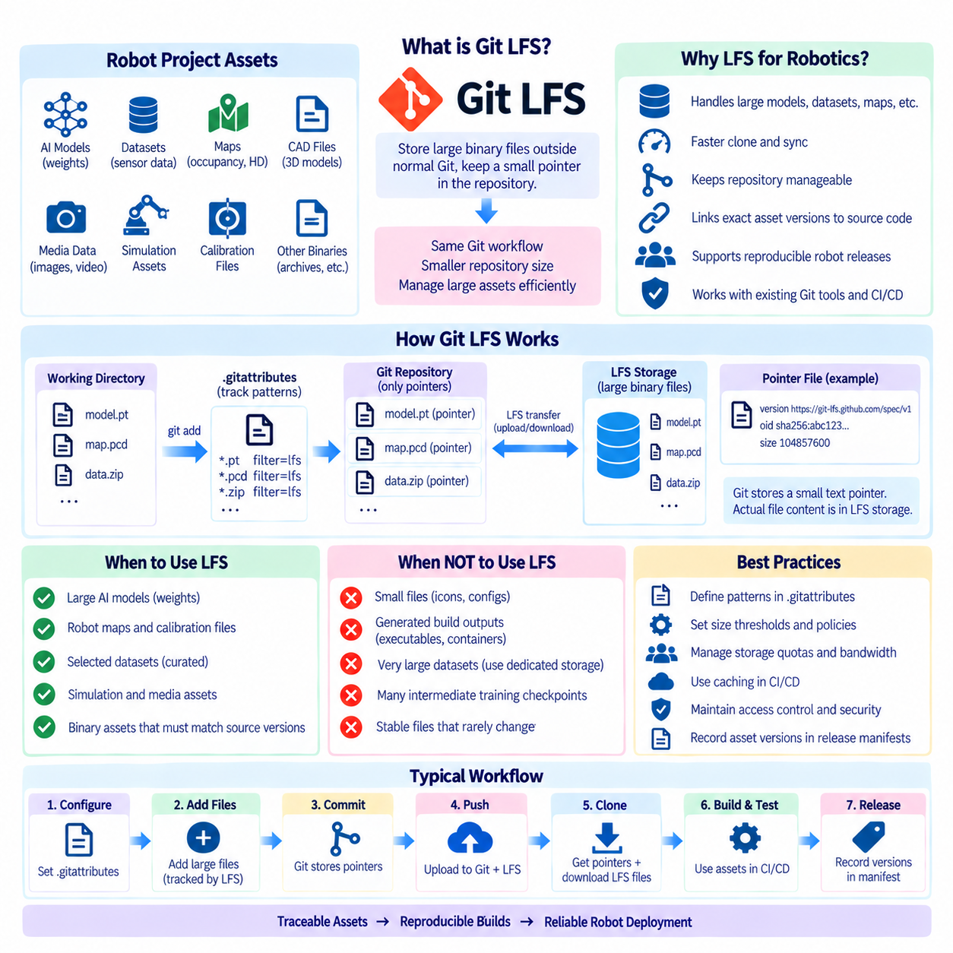
Git Large File Storage, commonly called Git LFS, extends Git so that large binary assets can be managed without placing every binary version directly into the normal Git object database. Instead of committing the full large file as an ordinary Git blob, the repository stores a small pointer file while the actual binary content is maintained in separate LFS storage. This preserves familiar Git workflows while reducing repository growth caused by repeatedly changing large files.
This capability is particularly relevant to robotics and AI projects because their repositories often interact with assets that are much larger than conventional source files. Neural-network weights, trained models, recorded sensor samples, maps, CAD exports, simulation resources, calibration packages, and selected datasets can range from megabytes to many gigabytes. Storing repeated versions of these binaries directly in Git can rapidly increase repository size and make cloning and synchronization inefficient.
Conventional Git is highly effective for source code because textual files are usually relatively small and Git can efficiently organize their historical states. Large binary files behave differently. A small logical modification to a model checkpoint or compressed archive can produce an entirely different binary representation. Git may therefore need to retain large objects for multiple historical revisions, even when developers conceptually regard the change as minor.
Git LFS addresses this problem through indirection. When a configured file is added, Git LFS replaces the content recorded in normal Git history with a lightweight pointer containing metadata that identifies the corresponding LFS object. The actual large file is transferred to LFS object storage. From the developer's working-tree perspective, however, the normal file appears at its expected path after the required LFS content has been retrieved.
The pointer typically identifies the LFS specification version, a cryptographic object identifier, and the size of the referenced object. Because this pointer is small text, normal Git history contains lightweight records rather than complete copies of large binary content. The identifier connects the repository revision to the corresponding binary object, allowing a particular Git commit to specify the exact large-file version expected by that source state.
File tracking is commonly defined through patterns stored in `.gitattributes`. A project can specify that files with extensions associated with model weights, binary maps, archives, or other large assets should pass through Git LFS filters. Because these rules are themselves committed to the repository, team members can share a consistent policy regarding which file types belong in normal Git storage and which should be managed through LFS.
Git LFS does not mean that every non-text file should automatically be tracked through LFS. Small icons, compact configuration binaries, and stable assets may not justify the additional storage and transfer mechanism. Teams should define practical thresholds and asset categories based on file size, update frequency, collaboration requirements, hosting quotas, and reproducibility needs rather than applying LFS indiscriminately to every binary format.
AI model files are a strong LFS use case when the organization needs Git-level association between source code and specific model revisions. A robot perception release might require a particular object-detection weight file, preprocessing configuration, and inference implementation. Tracking the model through LFS can allow the release commit or tag to identify the exact binary required for reproduction while keeping the large content outside the ordinary Git object database.
Robot maps and calibration assets can also benefit from controlled versioning. Occupancy maps, localization maps, camera calibration packages, or sensor-specific binary resources may change less frequently than source code but still need precise release association. If an incorrect map or calibration file is deployed, knowing exactly which asset revision accompanied the robot software can be as important as knowing which source commit produced the executable.
Datasets require more careful treatment because Git LFS is not automatically a complete dataset-management platform. Small or moderately sized curated datasets that must remain closely associated with source revisions may fit well. Very large training corpora, continuously collected fleet data, raw camera recordings, LiDAR sequences, and multi-terabyte datasets are generally better stored in dedicated object storage, dataset repositories, or data-management infrastructure.
A useful architecture therefore separates source versioning from bulk data storage while preserving references between them. Git can maintain training code, metadata, schemas, manifests, and experiment configuration. Git LFS can manage selected large artifacts requiring repository-level versioning, while very large datasets reside in external storage. Dataset manifests can then record locations, checksums, versions, partitions, or other identifiers required to reconstruct a training or evaluation input.
Cloning an LFS-enabled repository involves both Git metadata and LFS-managed content. Git first obtains repository history containing the pointer files, while Git LFS retrieves the binary objects needed for the checked-out state. This distinction matters in CI environments because runners must have Git LFS support installed and correctly configured. Authentication must also permit access to both the Git repository and its associated LFS storage.
Network usage remains an important consideration. Git LFS reduces the amount of large binary history stored directly in ordinary Git objects, but required LFS files still need to be transferred when they are needed. Robot projects containing several gigabytes of models or simulation assets can therefore experience substantial download times. Caching and selective retrieval can reduce repeated transfers across CI runners, developer systems, and build infrastructure.
Storage quotas and bandwidth policies should be included in repository planning. Hosted Git services may apply limits or billing rules to LFS storage and data transfer. Frequent revisions of large model files can consume capacity quickly because historical LFS objects may need to remain available for older commits and releases. Teams should therefore monitor asset growth and avoid using the repository as an uncontrolled dumping location for generated binaries.
Generated build outputs are usually poor candidates for Git LFS simply because they are large. Executables, container images, installation packages, and frequently regenerated artifacts are generally better handled by artifact repositories, container registries, or release systems. Git LFS is most valuable when the large file itself is a meaningful version-controlled input or engineering asset whose relationship to source history must remain explicit.
The same distinction applies to AI training checkpoints. A final validated model used in a robot release may justify controlled LFS tracking, while thousands of intermediate checkpoints produced during training normally should not be committed. Experiment-tracking systems and model registries are better suited to high-volume intermediate artifacts. Only selected models that form part of an engineering baseline may need direct association with Git revisions.
Migration requires caution when a repository already contains large binaries in normal Git history. Simply enabling LFS for future commits does not remove historical blobs from earlier commits. History-rewriting migration tools can convert existing large files to LFS references, but rewriting commit history changes commit identifiers and can disrupt branches, tags, forks, and developer clones. Such migration should therefore be planned as a coordinated repository operation.
Removing a large file from the current working tree similarly does not necessarily remove it from historical storage. Previous commits may still reference the original Git blob or LFS object. Repository cleanup, retention policies, and hosting-provider behavior must therefore be considered separately from ordinary file deletion. Understanding historical reachability is important when teams attempt to reduce repository storage or remove obsolete large assets.
CI/CD pipelines should treat LFS assets as explicit dependencies. A pipeline can verify that required LFS objects are available before compilation, simulation, model packaging, or deployment begins. Build caching can prevent repeated downloads, while integrity checks can confirm that retrieved content corresponds to the expected object identifier. These controls reduce failures caused by missing assets or accidental use of inconsistent model versions.
Release manifests can extend this traceability beyond Git itself. A robot release may record the source commit, Git LFS model identifiers, firmware version, container digest, configuration revision, dataset version, and calibration package. Together these references describe the operational software state more accurately than a Git tag alone. This becomes particularly important when diagnosing fleet incidents or reproducing historical robot behavior.
Security also matters because LFS objects may contain proprietary models, customer-specific maps, sensitive test data, or licensed assets. Access permissions, authentication, retention, encryption, and backup policies should be aligned with the sensitivity of the stored content. Git LFS should not be treated as a mechanism that automatically provides appropriate governance merely because the pointer is stored inside a controlled Git repository.
For Robot DevOps and MLOps, Git LFS is therefore best understood as one layer of a broader artifact-management architecture. Normal Git manages source code and lightweight configuration, LFS manages selected large version-controlled assets, model registries manage model lifecycle, dataset platforms manage large data collections, and artifact or container registries manage build outputs. Clear boundaries prevent Git from becoming overloaded with assets it was not designed to manage.
A disciplined Git LFS strategy connects each large asset with an explicit engineering purpose. Teams should define which assets are tracked, how they are named and versioned, where the underlying objects are stored, how CI retrieves them, and how releases record their identities. Used selectively, Git LFS provides traceable links between source code, models, maps, calibration data, and other large assets while preserving manageable repository performance and reproducible robot software releases.

1.7. Semantic Versioning and Release Tagging for Robot SW [w/Code]
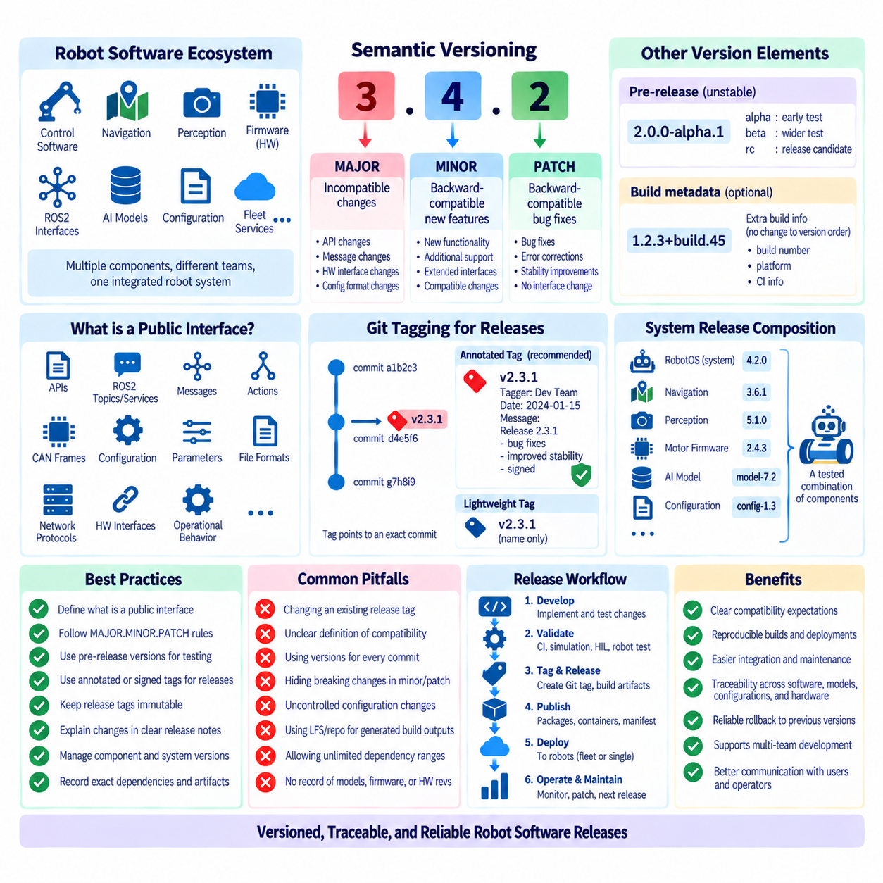
Semantic Versioning provides a structured method for communicating software change through version numbers. In its common form, a release uses the pattern MAJOR.MINOR.PATCH, such as 3.4.2. The numbers are not merely chronological counters; they describe compatibility expectations. For robot software, this convention helps developers, integrators, operators, and CI/CD systems understand whether an update represents an incompatible change, a compatible feature addition, or a compatible correction.
The MAJOR version changes when a release introduces incompatible behavior or interface changes that require dependent components to adapt. In robotics, this may include changing a ROS2 message definition, replacing a control API, modifying a hardware abstraction interface, or restructuring configuration semantics. Increasing the MAJOR number signals that existing software, deployment configurations, or integration procedures may require corresponding changes before the new release can be adopted safely.
The MINOR version normally increases when backward-compatible functionality is added. A navigation package might introduce a new planner while retaining existing interfaces, or a perception component might support an additional camera without disrupting current configurations. The PATCH version represents backward-compatible corrections, such as fixing a memory leak, correcting an error condition, or improving robustness without intentionally changing the public interface expected by dependent software.
Semantic Versioning becomes valuable only when the team clearly defines what constitutes a public interface. For a conventional library this may primarily mean programming APIs, but robot software exposes many additional contracts. ROS2 topics, services, actions, message definitions, CAN frames, configuration schemas, parameter names, network protocols, file formats, hardware interfaces, and operational behaviors can all function as interfaces that other components depend upon.
Compatibility must therefore be evaluated at the system level rather than only at compilation time. A software update may compile successfully while changing timing, coordinate conventions, sensor interpretation, control limits, or parameter defaults in ways that affect robot behavior. A disciplined versioning policy should identify which externally observable behaviors are covered by compatibility guarantees and which internal implementation details may change without requiring a major release.
Pre-release identifiers can represent software that is not yet considered a stable production release. Versions such as `2.0.0-alpha.1`, `2.0.0-beta.2`, or `2.0.0-rc.1` can distinguish experimental, beta, and release-candidate stages. Robot development benefits from these stages because software can progress through simulation, Software-in-the-Loop, Hardware-in-the-Loop, laboratory testing, and controlled field validation before receiving a final production version.
Build metadata can provide additional information without changing the precedence of a Semantic Version. A release identifier may include metadata describing a build, platform, or CI execution when the organization requires it. However, metadata should not become a substitute for reproducible release records. The exact Git commit, dependency versions, compiler environment, container digest, firmware revision, model version, and configuration should remain available through associated release metadata or manifests.
Git tags connect human-readable release versions with precise repository states. A tag such as `v2.3.1` can identify the commit from which a release was created. This establishes a durable relationship between the version communicated to users and the underlying source history. In a controlled release process, the tag should identify source that has passed the required review, automated testing, integration testing, and applicable robot validation stages.
Annotated Git tags are generally useful for formal releases because they can contain tagger information, timestamps, messages, and cryptographic signatures when signing is used. Lightweight tags simply provide names pointing to commits and contain less metadata. A robotics organization can establish a policy in which formal production releases use annotated or signed tags, while temporary development markers follow a separate convention.
Release tags should normally be treated as immutable references. Moving an existing production tag to another commit destroys the assumption that a version uniquely identifies one source state. If a defect is discovered after `v2.3.1` has been released, the correction should normally produce a new version such as `v2.3.2` rather than silently changing the commit referenced by the previous tag. This preserves traceability for robots already deployed with the earlier release.
Tagging also needs coordination with branch strategy. A trunk-based workflow may create release tags directly from validated commits on the main branch, while a release-branch workflow may maintain branches for supported product versions. Hotfixes can be applied to an appropriate maintenance branch and released with a new PATCH version. The important requirement is that the relationship among branches, commits, tags, and deployed versions remains explicit and reproducible.
Robotic systems often contain components with independent version numbers. Navigation software may be versioned separately from firmware, perception software, fleet services, and AI models. A complete robot release therefore cannot always be represented accurately by one component version. A system-level release manifest can identify the exact versions or commits of all components that have been validated together as a deployable robot configuration.
This distinction between component version and system version is important. A robot platform might be released as `RobotOS 4.2.0` while internally containing navigation `3.6.1`, motor firmware `2.4.3`, perception `5.1.0`, and a separately identified AI model. The system release does not replace component versions; it defines a tested composition of them. This allows individual components to evolve while preserving a reproducible integrated baseline.
Hardware revisions should also participate in release compatibility management. Software version `3.0.0` may support controller board revisions B and C but not revision A, while another firmware version may require a specific sensor generation. Release metadata should therefore describe validated hardware-software combinations. This prevents Semantic Versioning from being interpreted as a guarantee that every software release is compatible with every physical robot configuration.
AI models create another versioning dimension. A perception application may retain the same source-code version while deploying a newly trained model that materially changes runtime behavior. Model identity should therefore be recorded independently through a model version, registry identifier, checksum, or immutable artifact digest. Robot releases should associate the application version with the exact validated model rather than assuming that source version alone completely defines behavior.
Configuration requires similar treatment. Navigation parameters, safety thresholds, sensor calibration, feature flags, and site-specific settings can significantly alter robot behavior without changing executable code. A reproducible release should associate software tags with versioned configuration artifacts or configuration commits. For safety-related or operationally important parameters, uncontrolled configuration changes can undermine the traceability provided by otherwise disciplined source versioning.
Automated CI/CD pipelines can enforce release conventions. A pipeline can verify version syntax, ensure that a release tag points to an approved commit, execute required test suites, build artifacts, calculate checksums, generate release notes, and publish packages or containers. Automation reduces manual inconsistencies and makes the transition from validated source to distributable robot software repeatable across releases.
Release notes provide the human-readable interpretation of version changes. They should explain important features, corrected defects, interface changes, known limitations, migration requirements, hardware compatibility, and operational considerations. For a MAJOR release, migration guidance is particularly important because dependent software or configuration may need modification. Release notes complement version numbers rather than expecting the numbers themselves to describe every behavioral difference.
Dependency constraints should use version ranges carefully. Allowing an integration environment to retrieve any newer dependency can undermine reproducibility even when Semantic Versioning suggests compatibility. Robotics validation often depends on exact combinations of software and hardware behavior. Development environments may permit compatible ranges, while production manifests and validated releases can pin exact versions, commits, package hashes, or container digests.
Rollback planning should be part of release design. If a newly deployed version produces unexpected behavior, operators need to identify and restore the previous validated combination of application software, firmware, models, and configuration. Immutable tags and release manifests make this process much more reliable. Rollback should restore a known system state rather than merely checking out an older source branch while leaving other dependencies unchanged.
Version numbers should not be used to encode every internal event. Individual commits, CI builds, experiments, and temporary integration states already have identifiers suited to those purposes. Semantic versions are most useful when they communicate meaningful release compatibility. Excessive version increments without clear semantics reduce their value, while infrequent versioning that hides significant interface changes creates uncertainty for dependent teams.
A mature Robot DevOps process therefore connects Semantic Versioning, Git tags, release manifests, artifact identities, and validation evidence. The version communicates compatibility intent, the tag identifies source state, the manifest records the complete component composition, and CI/CD produces traceable artifacts from that state. Together these mechanisms allow teams to determine not only what software is current, but exactly what was built, tested, deployed, and operated on each robot.
For robot software, effective versioning ultimately serves reproducibility and controlled system evolution. A release should connect source code, firmware, AI models, configuration, hardware compatibility, test evidence, and deployment artifacts through immutable identifiers. When Semantic Versioning and disciplined Git release tagging are combined with these records, teams can evolve complex robotic platforms while preserving clear compatibility expectations, reliable rollback, and end-to-end release traceability.

1.8. Code Review Process Pull Request Policy for Safety SW
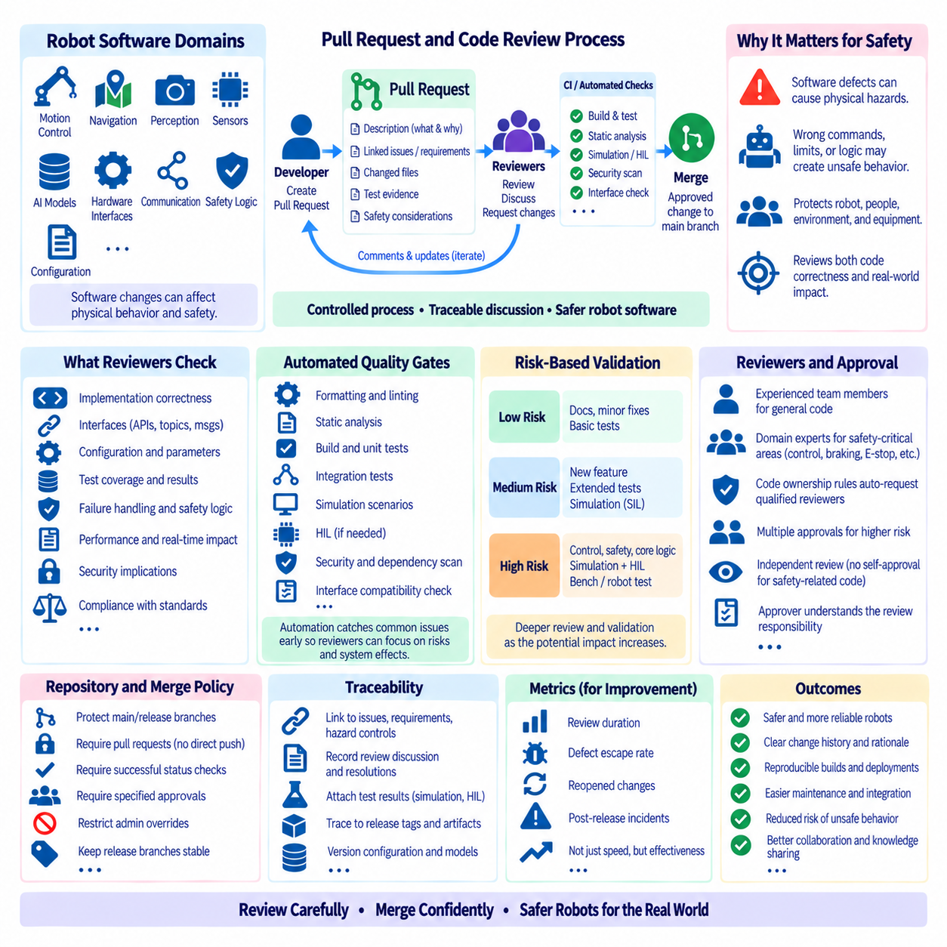
Code review is a systematic engineering process in which software changes are examined by developers other than the original author before integration. In robot software, review is not limited to coding style or readability because changes can influence motion, sensing, localization, control, communication, and safety behavior. A pull request provides a controlled boundary where proposed changes, discussion, automated evidence, approvals, and final integration decisions can be recorded.
Safety-related robot software requires stronger review discipline because a software defect can propagate into physical behavior. Incorrect velocity limits, coordinate transformations, actuator commands, obstacle thresholds, watchdog logic, or emergency-state transitions may create hazards that ordinary application testing cannot adequately represent. The review process should therefore evaluate both software correctness and the possible effect of a change on the robot, environment, operator, and surrounding equipment.
A pull request should clearly describe what is being changed and why the change is necessary. Reviewers need sufficient context to distinguish an intentional behavioral modification from an accidental side effect. For robot software, useful context can include the affected subsystem, interfaces, hardware dependencies, safety implications, configuration changes, expected runtime behavior, test evidence, and any known limitations that remain after the proposed modification.
Small and focused pull requests are generally easier to review reliably than large changes containing unrelated modifications. A change that simultaneously restructures navigation code, modifies sensor interfaces, updates configuration, and performs extensive formatting can hide important behavioral differences. Separating independent concerns allows reviewers to reason about each change, compare it with its stated purpose, and identify unintended consequences with less cognitive load.
Review policy should define who is permitted to approve particular classes of changes. General application code may require approval from an experienced team member, while motor control, braking, safety monitoring, power management, or emergency-stop logic may require reviewers with specific subsystem knowledge. Code ownership rules can automatically request qualified reviewers when files belonging to safety-sensitive areas are modified.
Independence is particularly valuable for safety-related review. The author naturally understands the intended implementation and may unconsciously interpret ambiguous code according to that intention. A reviewer approaches the change from another perspective and may identify assumptions, missing failure cases, or interactions overlooked during implementation. For higher-risk components, organizations can require multiple approvals or a designated safety reviewer before merging.
A review should examine interfaces as carefully as implementation details. Changes to ROS2 topics, services, actions, message definitions, CAN frames, network protocols, parameter schemas, units, coordinate conventions, or timing assumptions can affect components outside the modified repository. Even a locally correct implementation can produce system-level failures when dependent software interprets an interface differently.
Configuration changes deserve similar scrutiny because robot behavior is frequently controlled through parameters rather than source-code modifications. Changing maximum velocity, acceleration, obstacle margins, localization tolerances, watchdog timeouts, or sensor confidence thresholds can materially alter system behavior. Pull-request policies should therefore place safety-relevant configuration under version control and require appropriate review instead of treating configuration as operational data without engineering governance.
Automated quality gates complement human review by checking repeatable properties consistently. A pull request pipeline can execute formatting checks, static analysis, compilation, unit tests, integration tests, security scans, interface compatibility checks, and simulation scenarios. Automation should reject known classes of problems early so that human reviewers can concentrate on architecture, assumptions, failure behavior, and system consequences that automated tools cannot fully judge.
Passing automated tests does not by itself prove that a robot software change is safe. Tests demonstrate behavior only for the conditions they cover, while physical systems operate under uncertainty, sensor noise, communication delays, mechanical variation, environmental disturbances, and hardware faults. Reviewers should therefore examine whether the test scope is appropriate for the risk introduced by the change rather than treating a green CI result as sufficient evidence.
Risk-based review can determine the validation depth required for each modification. A documentation correction may require little additional validation, whereas a change to steering control or collision avoidance can require simulation, Software-in-the-Loop, Hardware-in-the-Loop, bench testing, and controlled robot testing. The objective is not to apply maximum process to every commit, but to increase review and validation rigor as the possible consequence of failure increases.
Simulation is especially useful when a change affects dynamic robot behavior. Reviewers can examine results from repeatable scenarios involving obstacles, localization loss, sensor dropout, communication interruption, degraded perception, or unusual trajectories. Simulation cannot reproduce every physical effect, but it provides scalable evidence that important nominal and failure scenarios were considered before software reaches actual hardware.
Hardware-in-the-Loop testing adds evidence about interactions with controllers, buses, sensors, and timing behavior that pure simulation may not reveal. Changes involving firmware interfaces, CAN communication, actuator commands, watchdogs, or hardware synchronization can require HIL validation before approval. Physical robot testing may then confirm behavior under controlled conditions, particularly when mechanical dynamics or real sensor characteristics influence the safety argument.
Pull requests should preserve traceability between requirements, implementation, and verification where the development process requires it. A change can reference an issue, defect report, requirement, hazard-control item, or engineering change request, while test results provide evidence that the intended behavior was verified. This creates a review history explaining not only what code changed, but why it changed and how the team established confidence in the result.
Reviewer comments and resolutions form part of this engineering record. Significant concerns should be resolved explicitly rather than disappearing through informal communication that cannot later be reconstructed. When a reviewer identifies an unsafe assumption, missing test, or interface conflict, the resulting code modification and discussion provide valuable evidence for future debugging, audits, incident investigation, and maintenance.
Merge policy should prevent unreviewed or insufficiently validated changes from bypassing the normal process. Protected branches can prohibit direct pushes, require pull requests, enforce successful status checks, demand specified approvals, and prevent merging when required conditions are unresolved. Administrative override capabilities should be tightly controlled because routinely bypassing protections can invalidate the purpose of the review system.
The person approving a pull request should understand the meaning of approval. Approval should not merely indicate that the code looks reasonable; it should indicate that the reviewer examined the change according to the responsibilities defined by the project. For safety-sensitive modifications, this may include checking assumptions, failure handling, interface compatibility, test adequacy, rollback implications, and consistency with established safety mechanisms.
Self-approval should generally not replace independent review for safety-relevant code. Small teams may face practical staffing constraints, but the workflow should still preserve meaningful separation where risk justifies it. When immediate emergency corrections are necessary, an organization can define an exceptional process with restricted authority, documented justification, required automated checks, and mandatory retrospective review rather than silently bypassing normal controls.
Changes generated or substantially assisted by automated coding tools should pass through the same review policy as manually written software. Generated code can contain plausible but incorrect assumptions, insecure patterns, incomplete error handling, or interfaces that compile without satisfying system requirements. Responsibility for the merged software remains with the engineering process, so tool-generated changes require verification based on their behavior and risk rather than their origin.
Security review is also relevant because modern robots are networked cyber-physical systems. Changes to authentication, update mechanisms, remote interfaces, communication services, permissions, dependency versions, or externally reachable APIs can influence both cybersecurity and physical operation. Pull-request review should identify whether a modification changes the robot's attack surface or weakens controls protecting safety-critical functions.
Release branches should contain only reviewed and validated changes appropriate for the targeted release. When a defect is corrected through a hotfix, the same traceability and review principles should apply even when schedule pressure is high. The corresponding release tag, artifact, test evidence, and change record should identify exactly which approved source state was deployed, allowing operators to distinguish different software states across a robot fleet.
Metrics can help evaluate the review process, but they should not encourage superficial behavior. Review duration, defect escape rate, failed validation, reopened changes, and post-release incidents can reveal process weaknesses, while simply maximizing pull-request count or minimizing review time may reduce quality. The purpose of measurement is to improve engineering effectiveness and identify recurring failure patterns rather than reward rapid approval.
A mature review culture treats pull requests as engineering decision points rather than administrative obstacles. Authors provide understandable changes and evidence, reviewers actively challenge assumptions, automation verifies repeatable conditions, and higher-risk modifications receive deeper validation. This combination allows software development to remain efficient while ensuring that changes affecting physical robot behavior receive scrutiny proportional to their consequences.
Within Robot DevOps, code review connects development with continuous integration, validation, release management, and operational traceability. A disciplined pull-request policy establishes who may change critical software, who must review it, which evidence must exist before merging, and how decisions are recorded. For safety-related robot software, this process creates a reproducible chain from engineering intent through verified implementation to an identifiable deployed release.

1.9. Git Hooks and Pre Commit Quality Gates [w/Code]
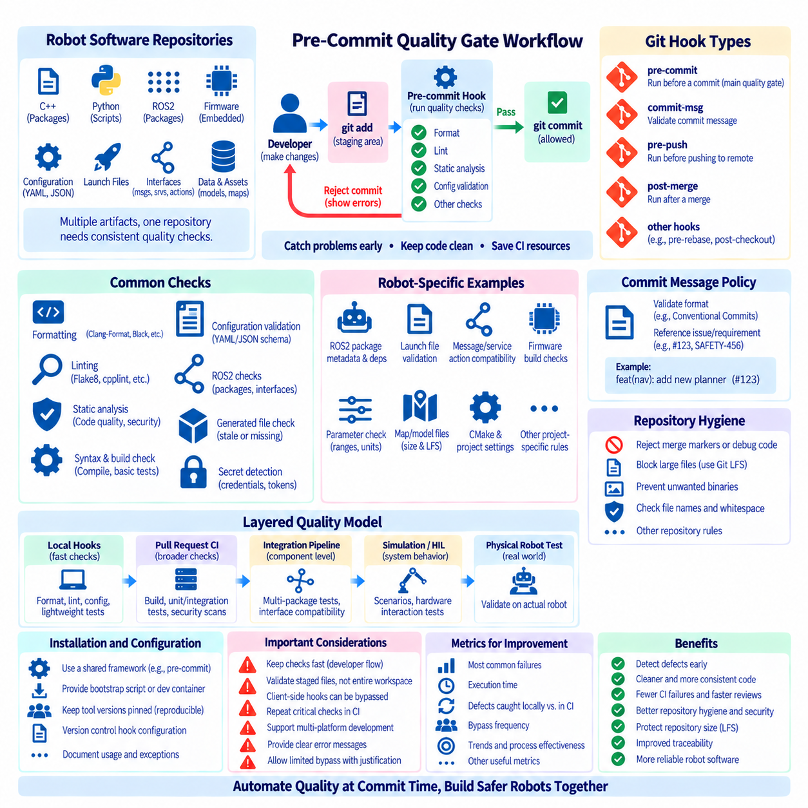
Git hooks are event-driven scripts that Git executes automatically at defined points in a repository workflow. They can run before a commit is created, after a commit is completed, during merges, or around other Git operations. In Robot DevOps, hooks provide an early automation layer close to the developer, allowing common quality problems to be detected before defective code enters shared branches or consumes CI resources.
A pre-commit hook runs before Git finalizes a commit and can inspect the files or changes staged for that commit. If a required check fails, the hook can reject the commit and return diagnostic information to the developer. This creates a local quality gate at the earliest practical point in the development process, reducing the delay between introducing a defect and receiving feedback about it.
Robot software benefits from early checks because a repository may combine C++, Python, ROS2 packages, firmware, configuration, launch files, interface definitions, and deployment scripts. Each artifact type can require different validation. A pre-commit framework can coordinate multiple tools so that formatting, linting, syntax validation, configuration checks, and other lightweight tests are applied consistently before changes become part of repository history.
Formatting checks are a common first quality gate. Tools can verify or automatically normalize C++, Python, YAML, JSON, XML, CMake, and other project files according to agreed conventions. Automated formatting reduces review discussions about presentation and helps reviewers concentrate on behavior and architecture. It also prevents repeated formatting-only changes from obscuring meaningful modifications in later diffs.
Linting and static analysis can identify problems that formatting alone cannot detect. Depending on the language and toolchain, checks can detect unused variables, suspicious expressions, unsafe constructs, import problems, type inconsistencies, or common programming errors. For robot software, these checks are valuable because small implementation mistakes can propagate into control, perception, communication, or hardware-interface behavior.
ROS2 projects can add domain-specific validation to local quality gates. Hooks may inspect package metadata, launch files, interface definitions, dependency declarations, naming conventions, or configuration syntax. Changes to messages, services, actions, and parameters can also trigger compatibility checks. The objective is to detect integration problems before a developer pushes a branch and activates a more expensive multi-package CI workflow.
Firmware repositories can use similar mechanisms for embedded development. A pre-commit gate can verify source formatting, compiler warnings, static-analysis rules, generated interface consistency, register definitions, or protocol files. Lightweight host-side tests may also be practical. However, hardware-dependent validation should normally remain in CI, HIL, or laboratory workflows rather than making every local commit depend on connected physical hardware.
Configuration files deserve explicit validation because malformed or inappropriate parameters can alter robot behavior without modifying executable source code. Hooks can validate YAML structure, schema requirements, parameter names, units, ranges, and prohibited values where such rules are formally defined. This is particularly useful for motion limits, sensor settings, network configuration, and deployment parameters that influence system operation.
Generated files require a clear repository policy. If generated ROS2 interfaces, protocol code, documentation, or configuration outputs are committed, a hook can verify that they match their source definitions. Alternatively, the project may prohibit generated outputs from being committed at all. Detecting stale or unintended generated files locally prevents inconsistent source and generated artifacts from reaching code review.
Pre-commit checks should normally remain fast enough to preserve developer flow. If every commit launches a full robot simulation, builds multiple architectures, downloads large models, and executes extensive integration tests, developers may avoid committing frequently or attempt to bypass the checks. Local gates are most effective when they provide rapid feedback, while computationally expensive validation is delegated to CI and dedicated test infrastructure.
This creates a layered quality model. Local hooks handle fast deterministic checks, pull-request CI performs broader compilation and automated testing, integration pipelines verify interactions among components, and simulation or HIL environments validate system behavior. Physical robot testing addresses effects that cannot be represented adequately in software-only environments. Each layer increases confidence without forcing every validation activity into one stage.
The staged content of a commit is an important consideration. A developer may have additional modifications in the working directory that are not intended for the current commit. A well-designed pre-commit process should evaluate the content that will actually be committed rather than accidentally validating unrelated working-tree changes. This preserves the connection between the accepted quality gate and the precise Git object that enters history.
Hooks can also detect repository hygiene problems. Checks may reject unresolved merge markers, accidental debug statements, oversized files, prohibited file types, trailing whitespace, invalid filenames, or unexpected binary assets. Secret-detection tools can identify patterns resembling credentials, tokens, or private keys before they are committed. Preventing these mistakes locally is substantially easier than removing them after they have entered shared Git history.
Large-file checks are especially useful in robotics and AI repositories. Model weights, datasets, recorded sensor data, bag files, maps, and simulation assets can accidentally be added to ordinary Git storage. A hook can enforce size limits or require designated extensions to use Git LFS or external artifact storage. This protects repository performance and supports the asset-management strategy defined by the project.
Commit-message validation can support traceability when a team uses structured identifiers. A hook may verify that a message follows an agreed format or references an issue, requirement, or change identifier where required. Such checks should serve an engineering purpose rather than impose unnecessary ceremony. In safety-related development, structured references can help connect implementation changes with review records, verification evidence, and release documentation.
Client-side Git hooks have an important limitation: they execute on developer machines and can usually be bypassed or may not be installed correctly. Git does not automatically distribute the contents of the local `.git/hooks` directory through ordinary repository cloning. A team therefore needs a reproducible installation mechanism, such as a shared hook framework, bootstrap script, development environment, or repository-managed configuration.
Because local hooks are not a security boundary, critical quality requirements must be repeated on trusted CI infrastructure. A developer may intentionally bypass a hook, use an incorrectly configured environment, or commit through a tool that does not execute the expected workflow. CI should independently enforce mandatory formatting, tests, security checks, or policy validation before protected branches permit a pull request to merge.
The relationship between hooks and CI should avoid unnecessary duplication while preserving enforcement. Developers benefit when the same underlying commands or configuration files are used locally and remotely. A formatter, linter, or static analyzer should ideally behave consistently in both environments. Shared tool versions and configuration reduce situations in which a local check succeeds but the corresponding CI check fails because the environments apply different rules.
Tool version pinning is therefore important for reproducibility. Different versions of a formatter or analyzer can produce different output or diagnostics even when applied to identical source code. Projects can define exact or controlled tool versions through development containers, package lock files, virtual environments, or pre-commit framework revisions. CI should use compatible definitions so that quality-gate results remain predictable across machines.
Hooks must also handle multi-platform robot development. A repository may be edited on Linux, Windows, and containerized environments while targeting x86, ARM, MCU, or GPU systems. Local gates should avoid unnecessary platform assumptions and clearly distinguish portable checks from target-specific validation. Platform-dependent builds can then be executed by CI runners configured for the required architecture or toolchain.
Failure messages strongly influence whether developers use quality gates effectively. A hook that merely reports failure without identifying the responsible file or corrective action creates friction. Useful output should indicate which check failed and provide enough information to reproduce or correct the problem. Where safe and predictable, formatting or trivial cleanup can be automated, while semantic modifications should remain under developer control.
Bypass mechanisms such as skipping hooks may still be necessary for exceptional situations, but their role should be understood. A local bypass should not allow a change to circumvent mandatory repository policy because protected branches and CI remain authoritative. Teams can permit local flexibility while maintaining centralized enforcement, ensuring that emergency or unusual workflows do not silently weaken the quality requirements applied before integration.
Hook configuration itself should be reviewed and versioned as engineering infrastructure. Adding a new analyzer, changing a formatting rule, excluding directories, or modifying failure thresholds can affect the entire development team. These changes should pass through normal pull-request review so that developers understand why the gate exists and how it relates to repository quality, safety requirements, and CI behavior.
Metrics can reveal whether pre-commit gates are providing useful early feedback. Teams may examine which checks fail most frequently, which CI failures could have been detected locally, or whether particular gates impose excessive execution time. The goal is not to maximize the number of checks but to move appropriate defect detection as early as possible while keeping the developer workflow practical and predictable.
Within Robot DevOps, Git hooks and pre-commit quality gates form the first layer of continuous verification. They cannot replace code review, CI, simulation, HIL, security validation, or physical robot testing, but they can prevent many inexpensive and repetitive defects from progressing to those stages. A well-designed system combines fast local feedback with authoritative centralized checks, creating a development pipeline in which quality is evaluated continuously from the developer workstation to the deployed robot.

1.10. Multi Platform Repo Management ROS2 Firmware AI Models
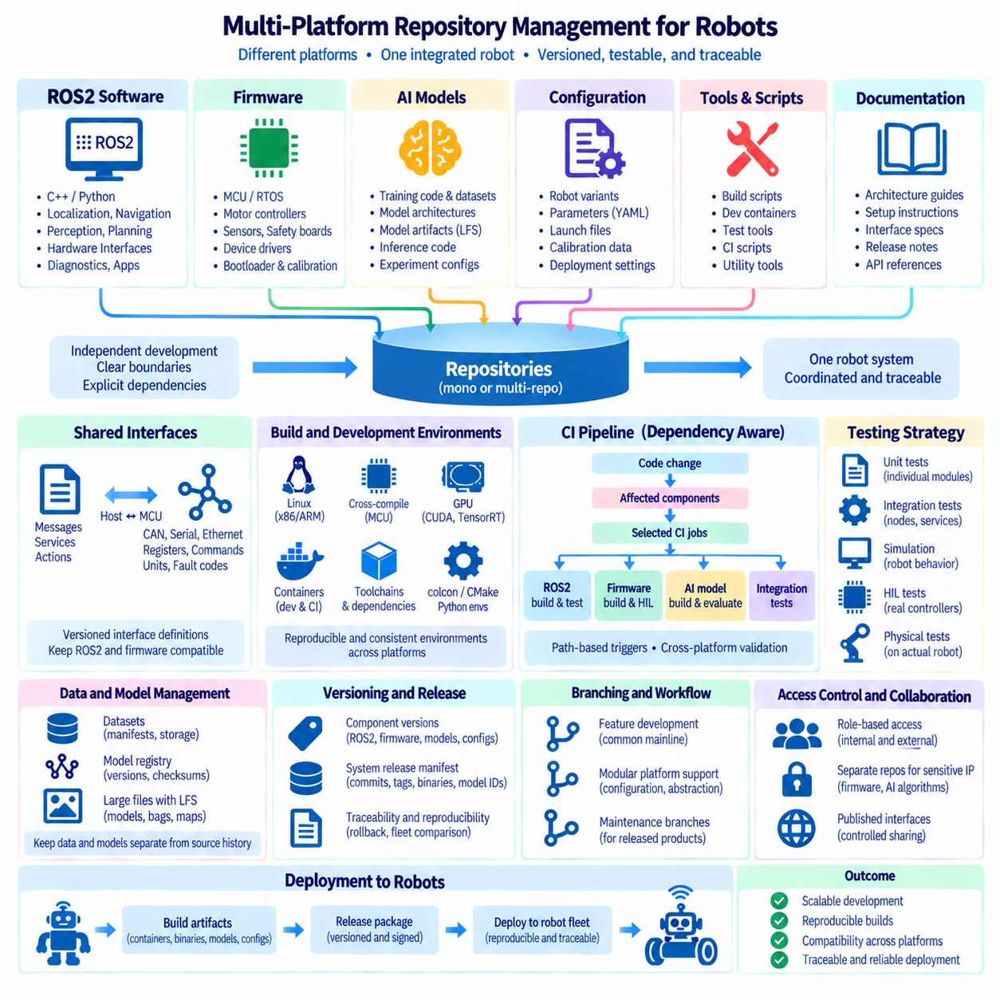
Multi-platform repository management organizes software and engineering assets that must operate across different robot computers, processors, operating environments, and development domains. A modern robot may combine ROS2 applications on Linux, real-time firmware on microcontrollers, GPU-based perception software, AI models, cloud interfaces, and deployment configuration. Repository structure must keep these elements independently manageable while preserving the relationships required to build and validate the complete robot.
The challenge is greater than supporting several programming languages. ROS2 packages may use C++ and Python on x86 or ARM processors, firmware may execute on an MCU under an RTOS, and perception workloads may depend on CUDA-enabled GPUs. AI models introduce separate training and inference lifecycles. Each platform can therefore require different compilers, dependencies, build systems, test environments, release procedures, and hardware validation.
Repository boundaries should reflect both architectural coupling and lifecycle independence. Components that frequently change together can benefit from common version control, while software with independent ownership, release cadence, toolchains, or access requirements may belong in separate repositories. The objective is not to maximize or minimize repository count, but to make dependencies explicit while avoiding unnecessary synchronization among unrelated engineering activities.
ROS2 software commonly forms the integration layer of the robot. Packages for localization, navigation, perception, planning, hardware interfaces, diagnostics, and application logic can share message definitions and runtime communication patterns. Whether maintained in one repository or several repositories, their dependency relationships should remain visible so that developers can reconstruct a consistent ROS2 workspace and reproduce the software composition used on a deployed robot.
Firmware requires a different management perspective because it is tightly coupled to physical electronics. Motor controllers, battery systems, safety boards, sensor interfaces, and auxiliary controllers may use different MCU families and toolchains. Firmware repositories should clearly associate source revisions with target board revisions, bootloaders, communication protocols, calibration assumptions, and binary releases so that software cannot be separated from the hardware context in which it was validated.
Shared interfaces are critical where ROS2 software communicates with firmware. CAN frames, serial protocols, Ethernet messages, register maps, command identifiers, units, scaling rules, and fault codes form contracts between platforms. These definitions should have explicit ownership and versioning. Generated interface code can reduce duplication, but the authoritative specification must remain identifiable so that host software and embedded firmware do not silently evolve into incompatible implementations.
AI components introduce another repository dimension because model development differs fundamentally from application development. Training code, dataset definitions, preprocessing pipelines, experiment configuration, model architectures, inference code, and deployed model artifacts can evolve at different rates. A production robot must identify not only the inference software revision but also the exact model artifact and preprocessing assumptions that were validated with it.
Large AI models should normally be separated conceptually from ordinary source history. Git can manage training and inference code, configuration, manifests, and lightweight metadata, while Git LFS, model registries, or artifact storage can manage selected model binaries. The repository should reference immutable model identities such as versions, checksums, or artifact digests so that changing a model cannot silently change the behavior associated with an existing software release.
Dataset management requires similar separation. Raw camera streams, LiDAR recordings, ROS bags, synthetic datasets, and large training corpora can exceed practical Git storage limits. Repository-controlled manifests can instead identify dataset versions, partitions, checksums, preprocessing rules, and storage locations. This allows training and evaluation experiments to remain reproducible without turning the source repository into a bulk data-storage system.
Build systems must accommodate the different targets represented by the repository architecture. ROS2 may use colcon and CMake, embedded firmware may use vendor toolchains or cross-compilers, and AI components may require Python environments, CUDA libraries, TensorRT, or other accelerators. Each build definition should identify its target environment clearly rather than assuming that every developer workstation can compile every component directly.
Containerization can standardize many host-side development and CI environments. Development containers can pin Linux distributions, ROS2 versions, Python packages, compilers, CUDA dependencies, and build tools. Containers cannot completely abstract hardware-specific requirements such as MCU programmers, GPU architectures, kernel drivers, or physical buses, but they can significantly reduce variation in the software layers surrounding those dependencies.
CI pipelines should use path and dependency awareness to avoid rebuilding every platform for every change. A documentation update should not trigger firmware compilation, GPU model packaging, and complete robot simulation unless relevant dependencies require it. Changes to shared interface definitions, however, may need to activate ROS2 builds, firmware checks, compatibility tests, and integration validation because their impact crosses platform boundaries.
A multi-platform CI architecture therefore benefits from a dependency graph that connects source areas with required validation jobs. ROS2 changes may trigger package builds and simulation, firmware changes may trigger cross-compilation and HIL tests, and AI inference changes may trigger GPU builds and model evaluation. Shared protocol modifications can intentionally fan out into several pipelines, making cross-platform impact explicit rather than relying on developers to remember every dependency.
Cross-compilation is particularly important when development hosts differ from robot targets. Engineers may work on x86 Linux machines while deployment computers use ARM processors and embedded controllers use MCU architectures. Toolchain files, sysroots, compiler versions, target libraries, and build options should be versioned or reproducibly provisioned. A successful native workstation build must not be treated as evidence that the target-platform build will behave identically.
Testing should follow the same layered approach. Unit tests can run independently for individual packages, firmware modules, and AI utilities. Integration tests verify communication among ROS2 nodes and services, while protocol tests verify host-to-firmware behavior. Simulation validates robot-level interactions, HIL introduces real controllers and timing constraints, and physical testing confirms behavior that depends on sensors, actuators, mechanical dynamics, or target compute hardware.
Configuration must be separated from platform-independent logic where practical. Robot models may differ in sensors, motor controllers, GPU availability, network topology, or calibration values while sharing substantial software. Versioned configuration profiles can represent these differences without duplicating entire codebases. Each deployed configuration should identify the hardware variant and software assumptions for which it has been validated.
Hardware abstraction helps prevent platform-specific details from spreading through the entire repository. Stable interfaces can isolate device drivers, communication layers, accelerator backends, and board-specific implementations from higher-level robot logic. This allows ROS2 applications or AI pipelines to evolve against defined contracts while platform-specific implementations handle differences among sensors, controllers, processors, and operating environments.
Branching should generally represent software development history rather than permanent hardware variants. Maintaining long-lived branches for every robot model can create duplicated fixes and divergent behavior. Where possible, shared source should remain on a common development line while hardware differences are represented through modular implementations and configuration. Separate maintenance branches remain useful when released product generations require independent long-term support.
Versioning must distinguish component releases from complete robot releases. ROS2 navigation, MCU firmware, perception applications, AI models, and configuration packages may each have independent versions. A system release manifest can then record the exact combination validated together, including Git commits, release tags, firmware binaries, container digests, model identifiers, configuration revisions, and applicable hardware revisions.
This manifest becomes the software bill of composition for a deployed robot. When an operational problem occurs, engineers should be able to determine exactly which source, firmware, model, and configuration were running on the affected unit. The same information enables rollback, fleet comparison, regression analysis, and reconstruction of historical test conditions without assuming that the current state of each repository represents the deployed system.
Access control may also influence repository organization. Firmware supplied by an external partner, proprietary AI algorithms, customer-specific integrations, and safety-related software may require different permissions. Repository separation can create straightforward security boundaries, while published packages and versioned interfaces allow controlled collaboration. Access boundaries should therefore align with engineering responsibility without unnecessarily hiding information required for integration.
Documentation should explain how the repositories form one robot system. Developers need to know which repositories are required, how compatible versions are selected, how workspaces are assembled, where model artifacts are retrieved, and which pipeline validates the integrated product. Machine-readable manifests and bootstrap tools can complement human documentation by automatically constructing known development or release environments.
A mature multi-platform repository strategy treats source repositories, model registries, artifact stores, container registries, dataset systems, and CI infrastructure as connected parts of one configuration-management architecture. No individual repository contains the complete operational state of a sophisticated robot. Traceability emerges from immutable identifiers and explicit relationships among the engineering assets distributed across these systems.
Effective management ultimately enables independent development without losing system-level control. ROS2 software, firmware, AI models, datasets, hardware configurations, and deployment artifacts can follow workflows suited to their own lifecycles while remaining connected through interfaces, dependency definitions, validation pipelines, and release manifests. This balance allows Robot DevOps to scale across heterogeneous platforms while preserving reproducibility, compatibility, traceability, and reliable deployment.

